▼ This medicinal product is subject to additional monitoring in Australia. This will allow quick identification of new safety information. Healthcare professionals are asked to report any suspected adverse events at www.tga.gov.au/reporting-problems.

AUSTRALIAN PRODUCT INFORMATION
KORSUVA (difelikefalin [as acetate]) solution for injection

NAME OF THE MEDICINE

Difelikefalin acetate

QUALITATIVE AND QUANTITATIVE COMPOSITION

Each vial of 1 mL contains 50 micrograms difelikefalin (as acetate).

Excipients with known effect

This medicinal product contains less than 1 mmol sodium per vial, that is to say essentially sodium-free.

For the full list of excipients, see section 6.1.

PHARMACEUTICAL FORM

Solution for injection.
Clear, colourless solution, free from particles.

CLINICAL PARTICULARS

THERAPEUTIC INDICATIONS

Korsuva is indicated for the treatment of moderate-to-severe pruritus associated with chronic kidney disease in adult patients on haemodialysis.

DOSE AND METHOD OF ADMINISTRATION

The recommended dose of Korsuva is 0.5 micrograms/kg dry body weight (ie, the target postdialysis weight) by intravenous bolus injection three times per week. The total dose volume (mL) required from the vial should be calculated as follows: 0.01 x prescription dry body weight (kg), rounded to the nearest tenth (0.1 mL). Recommended doses are detailed in the Table 1 below:

Table 1: Recommended Korsuva dose

Weight Range*  (Dry Body Weight in kg) | Dose**  (mL)
40 - 44 | 0.4
45 - 54 | 0.5
55 - 64 | 0.6
65 - 74 | 0.7
75 - 84 | 0.8
85 - 94 | 0.9
95 - 104 | 1.0
105 - 114 | 1.1
115 - 124 | 1.2
125 - 134 | 1.3
135 - 144 | 1.4
145 - 154 | 1.5
155 - 164 | 1.6
165 - 174 | 1.7
175 - 184 | 1.8
185 - 194 | 1.9
195 - 204 | 2.0
*The recommended dose for patients with a dry body weight above 204 kg should be calculated as in above text.
** More than 1 vial may be necessary if a dose of more than 1 mL is required

Missed doses

If a regularly scheduled haemodialysis treatment is missed, Korsuva should be administered at the next haemodialysis treatment at the same dose.

Extra treatment

If a 4th haemodialysis treatment is performed, Korsuva should be administered post haemodialysis per the recommended dose. No more than 4 doses per week should be administered even if the number of haemodialysis treatments in a week exceeds 4.

Patients with incomplete haemodialysis treatment

For haemodialysis treatments less than 1 hour, administration of difelikefalin should be withheld until the next haemodialysis session.

Following administration of difelikefalin in haemodialysis subjects, up to 70% is eliminated from the body prior to the next haemodialysis session (see sections 4.9 Overdose and 5.2 Pharmacokinetic Properties). Difelikefalin plasma level remaining at the time of the next haemodialysis is reduced by about 40-50% within one hour of haemodialysis.

Patients with hepatic impairment

Metabolism by hepatic enzymes does not significantly contribute to elimination of difelikefalin. While faecal excretion contributes to elimination, it is not known whether hepatic impairment has a clinically relevant effect on overall difelikefalin clearance in haemodialysis patients (see section 5.2 Pharmacokinetic Properties). Evaluation of available population pharmacokinetic data in haemodialysis patients concluded that no adjustment of intravenous Korsuva dosage is needed in patients with mild to moderate hepatic impairment; however, clinical data following IV dosing in patients with moderate hepatic impairment is currently limited. The influence of severe hepatic impairment on the pharmacokinetics of difelikefalin in haemodialysis patients has not been evaluated; therefore, use in this population is not recommended.

Elderly population (≥65 years of age)

Dosing recommendations for elderly patients are the same as for adult patients.

Method of administration

Korsuva is for single use in one patient only should be administered under the guidance of a health care professional. Discard any residue.

Korsuva should not be diluted and should not be mixed with other medicinal products.

Inspect Korsuva for particulate matter and discoloration prior to administration. The solution should be clear and colorless. Do not use Korsuva vials if particulate matter or discoloration is observed.

Korsuva is administered 3 times per week by intravenous bolus injection into the venous line of the dialysis circuit at the end of the haemodialysis treatment during rinse-back or after rinse-back.

When given after rinse back, at least 10 mL of sodium chloride 9 mg/mL (0.9%) solution rinse-back volume should be administered after injection with Korsuva. If the dose is given during rinse back, no additional sodium chloride 9 mg/mL (0.9%) solution is needed to flush the line.

The dose must be administered within 60 minutes of the completion of the syringe preparation.

CONTRAINDICATIONS

Hypersensitivity to the active substance or to any of the excipients listed in section 6.1. List of Excipients.

SPECIAL WARNINGS AND PRECAUTIONS FOR USE

Korsuva is to be used only for the approved indication as off-label use may not be appropriate due to the complex nature of the drug.

Hyperkalaemia

Hyperkalaemia frequently occurs in chronic kidney disease patients on haemodialysis (see section 4.8 Undesirable Effects (Adverse Effects)). Frequent monitoring of potassium levels is recommended.

Cardiac failure and atrial fibrillation

Difelikefalin has not been studied in patients with New York Heart Association class IV heart failure. In the pivotal clinical studies a small numerical imbalance of cardiac failure and atrial fibrillation events was observed in the difelikefalin treated patients compared to placebo, in particular among patients with a medical history of atrial fibrillation who discontinued or missed their atrial fibrillation treatment. No causal relationship was established.

Patients with hepatic impairment

Clinical data following IV dosing in patients with moderate hepatic impairment is currently limited. The influence of severe hepatic impairment on the pharmacokinetics of difelikefalin in haemodialysis patients has not been evaluated; therefore, use in this population is not recommended.

Patients with impaired blood brain barrier

Difelikefalin is a peripherally acting kappa opioid receptor agonist with restricted access to the central nervous system (CNS). The blood-brain barrier (BBB) integrity is important for minimizing difelikefalin uptake into the CNS (see section 5.1 Pharmacodynamic Properties). Patients with clinically important disruptions to the BBB (e.g., primary brain malignancies, CNS metastases or other inflammatory conditions, active multiple sclerosis, advanced Alzheimer’s disease) may be at risk for difelikefalin entry into the CNS. Korsuva should be prescribed with caution in such patients taking into account their individual benefit-risk balance with observation for potential CNS effects.

Dizziness and somnolence

Dizziness and somnolence have occurred in patients taking difelikefalin and may subside over time with continued treatment (see section 4.8 Undesirable Effects (Adverse Effects)). Concomitant use of sedating antihistamines, opioid analgesics or other CNS depressants may increase the likelihood of these adverse reactions and should be used with caution during treatment with difelikefalin.

Use in the elderly

Please refer to section 4.2 Dose and Method of Administration, Elderly population. Safety results suggested that compared to placebo, the incidence of somnolence was higher in difelikefalin treated subjects 65 years of age and older (7.0%) than in difelikefalin treated subjects less than 65 years of age (2.8%). Therefore, the use of difelikefalin in this patient population should take into account individual benefit-risk assessment and be carefully monitored.

Paediatric use

The safety and efficacy of Korsuva in children aged 0-17 years has not yet been established. There are no data available.

Effects on laboratory tests

No data available

INTERACTIONS WITH OTHER MEDICINAL PRODUCTS AND OTHER FORMS OF INTERACTIONS

No clinical interaction studies have been performed, including studies with drugs that are used to manage hyperparathyroidism in CKD.

Difelikefalin is neither a substrate for CYP1A2, CYP2C8, CYP2C9, CYP2C19, CYP2D6, or CYP3A4, nor an inhibitor of CYP1A2, CYP2B6, CYP2C8, CYP2C9, CYP2C19, CYP2D6, or CYP3A4/5 and has minimal to no potential for induction of human CYP1A2, CYP2B6, or CYP3A. It is not an inhibitor of glucuronidation enzymes either (UGT1A3, UGT1A9, or UGT2B7).

In addition, difelikefalin is not an inhibitor of BCRP, BSEP, LAT1, MATE1, MATE2-K, MRP2, OAT1, OAT3, OATP1A2, OATP1B1, OATP1B3, OCT1, OCT2, OCT3, P-glycoprotein, PEPT1 or PEPT2, and is not a substrate for ASBT, BCRP, BSEP, LAT1, MATE1, MATE2-K, MRP2, OAT1, OAT2, OAT3, OATP1A2, OATP1B1, OATP1B3, OATP2B1, OCT1, OCT2, OCT3, OCTN1, OCTN2, OSTαβ, P-glycoprotein, PEPT1 or PEPT2.

Concurrent administration of medicinal products such as sedating antihistamines, opioid analgesics or other CNS depressants (e.g., clonidine, ondansetron, gabapentin, pregabalin, zolpidem, alprazolam, sertraline, trazodone) may increase the likelihood of dizziness and somnolence (see sections 4.4 Special Warnings and Precautions for Use and 4.8 Undesirable Effects (Adverse Effects)).

FERTILIY, PREGNANCY AND LACTATION

Effects on fertility

Difelikefalin administered via intravenous injection prolonged dioestrus in female rats at doses greater than or equal to 2.5 mg/kg/day. The no adverse effect level was 0.25 mg/kg/day IV (17 times the AUC at the maximum recommended human dose [MRDH] based on AUC comparison). Difelikefalin had no effects on mating index, fertility index, or any ovarian or uterine parameters in female rats at doses up to 25 mg/kg/day (1905 times the AUC at the MRHD). Difelikefalin did not impair male fertility at doses up to 25 mg/kg/day (2912 times the AUC at the MRHD).

Use in pregnancy (Category B1 )

There are either no or only a limited amount of data available from the use of difelikefalin in pregnant women.

In embryofetal development studies in rats and rabbits, there was no evidence of teratogenicity at the highest tested doses; 25 mg/kg/day IV in rats and 0.1 mg/kg/day in rabbits (2134 and 30 times the AUC at the MRHD). In rats, an increased incidence of skeletal variations (wavy ribs, incompletely ossified ribs) was seen at 25 mg/kg/day IV. Maternal toxicity was noted at this dose.

As a precautionary measure, it is preferable to avoid the use of Korsuva during pregnancy.

Use in lactation

There are no data regarding presence of difelikefalin in human milk. Animal studies have shown excretion of difelikefalin in breast milk. When a drug is present in animal milk, it is likely that the drug will be present in human milk

A risk to the newborns/infants cannot be excluded.

A decision must be made whether to discontinue breast-feeding or to discontinue/abstain from Korsuva therapy taking into account the benefit of breast feeding for the child and the benefit of therapy for the woman. Difelikefalin is not detectable in plasma after three dialysis cycles (see section 4.9 Overdose and 5.2 Pharmacokinetic Properties).

EFFECTS ON ABILITY TO DRIVE AND USE MACHINES

Korsuva may have influence the on ability to drive.

Somnolence and/or dizziness have been reported in patients receiving difelikefalin (see section 4.8 Adverse Effects (Undesirable Effects)). Patients should be cautioned about driving or operating hazardous machinery until the effect of difelikefalin on the patient’s ability to drive or operate machinery is known. Somnolence occurred within the first 3 weeks of treatment and tended to subside with continued dosing. Dizziness occurred within the first 9 weeks of treatment and was generally transient.

UNDESIRABLE EFFECTS (ADVERSE EFFECTS)

Summary of the safety profile
The current safety profile is based on a total of 1306 adult patients with chronic kidney disease-associated pruritus and undergoing haemodialysis, who have been exposed to Korsuva in placebo-controlled and uncontrolled phase 3 clinical studies. Of these patients, 711 were continuously treated for at least 6 months, 533 were continuously treated for at least 9 months, and 400 had continuous exposure for at least one year.

Overall, 424 patients of the targeted population have been treated with Korsuva for 12 weeks within two pivotal, double-blind, placebo-controlled phase-3 clinical studies (KALM-1 and KALM-2), both followed by a 52-week open-label extension. In these 2 studies, 43 % of patients in both treatment groups were treated concomitantly with medicinal products intended to relieve pruritus, including most commonly diphenhydramine and hydroxyzine.

Tabulated summary of treatment-emergent adverse events
A summary of the most common treatment-emergent adverse events (TEAEs) occurring in ≥2% of pooled difelikefalin subjects with an incidence ≥1 percentage point higher than in placebo subjects has been provided in Table 2 below. This list includes the most common TEAEs of diarrhoea, dizziness, and nausea, as well as hyperkalaemia, headache, somnolence, mental status changes (including confusional state) and back pain. Most of these events were mild or moderate in severity in the majority of difelikefalin subjects.

Table 2: Incidence of Treatment-emergent Adverse Events Occurring in ≥2% of Difelikefalin Subjects and With ≥1 Percentage Point Higher Incidence Than Placebo by Preferred Term -
 | KALM-1 |  | KALM-2 |  | Pooled
Preferred Term | Placebo  (N = 188)  n (%) | difelikefalin  0.5 mcg/kg  (N = 189)  n (%) | Placebo  (N = 236)  n (%) | difelikefalin  0.5 mcg/kg  (N = 235)  n (%) | Placebo  (N = 424)  n (%) | difelikefalin  0.5 mcg/kg  (N = 424)  n (%)
Subjects with any event | 130 (69.1%) | 142 (75.1%) | 147 (62.3%) | 160 (68.1%) | 277 (65.3%) | 302 (71.2%)
Diarrhoea | 11 (5.9%) | 19 (10.1%) | 13 (5.5%) | 19 (8.1%) | 24 (5.7%) | 38 (9.0%)
Dizziness | 3 (1.6%) | 13 (6.9%) | 13 (5.5%) | 16 (6.8%) | 16 (3.8%) | 29 (6.8%)
Nausea | 9 (4.8%) | 8 (4.2%) | 10 (4.2%) | 20 (8.5%) | 19 (4.5%) | 28 (6.6%)
Hyperkalaemia | 9 (4.8%) | 11 (5.8%) | 6 (2.5%) | 9 (3.8%) | 15 (3.5%) | 20 (4.7%)
Headache | 4 (2.1%) | 9 (4.8%) | 7 (3.0%) | 10 (4.3%) | 11 (2.6%) | 19 (4.5%)
Somnolence | 5 (2.7%) | 6 (3.2%) | 5 (2.1%) | 12 (5.1%) | 10 (2.4%) | 18 (4.2%)
Mental status changes¹ | 6 (3,2%) | 6 (3,2%) | 0 | 8 (3,4%) | 6 (1,4%) | 14 (3,3%)
Back pain | 1 (0.5%) | 7 (3.7%) | 3 (1.3%) | 4 (1.7%) | 4 (0.9%) | 11 (2.6%)
¹ Mental Status Changes included MedDRA preferred terms of confusional state and mental status changes.

In the placebo controlled studies, hyperkalaemia was reported with a frequency of 4.7% in the difelikefalin group (20 / 424 patients) and 3.5% in the placebo group (15 / 424 patients). Hyperkalaemia was one of the most frequently reported treatment emergent adverse event in the pooled phase 3 clinical studies, with a frequency of 8.3 % (108 / 1306 patients). No causal relationship has been established (see section 4.4 Special Warnings and Precautions for Use).

In a Phase 2 study of CKD subjects with pruritus undergoing haemodialysis, there was a dose-dependent increase in incidence of adverse events of increased blood prolactin level in patients administered IV difelikefalin three times per week. In the pooled Phase 3 safety analyses, there was 1 TEAE of blood prolactin increased in a patient treated with Korsuva; however, there were no reported TEAEs potentially indicative of non-clinically significant hyperprolactinaemia (e.g., galactorrhoea, amenorrhoea, oligomenorrhoea, infertility, impotence, or decreased libido) reported in haemodialysis patients exposed to Korsuva for up to 1 year. The clinical relevance of this is unknown.

Summary of adverse reactions

In placebo controlled and uncontrolled phase phase 3 clinical studies, approximately 6.6 % of the patients experienced at least one adverse reaction during Korsuva treatment. The adverse reactions attributed to the treatment with Korsuva in haemodialysis patients are listed in Table 3 below. The MedDRA System Organ Classes most frequently affected by adverse drug reactions were nervous system disorders, gastrointestinal disorders, and psychiatric disorders with somnolence (1.1 %), dizziness (0.9 %), headache (0.6 %), nausea (0.7 %) diarrhea (0.2 %), and mental status changes (including confusional state) (0.3 %) being the most common events that were considered related to Korsuva. All but somnolence occurred in less than 1 % of patients. Most of these events were mild or moderate in severity, did not lead to deleterious consequences, and resolved with on-going therapy. No event was serious and the incidence of events leading to treatment discontinuation was ≤ 0.5% for any of the adverse reactions listed above.

Adverse reactions reported from the use of Korsuva in clinical studies at the target dose of 0.5 micrograms/kg in these patients (n = 1306) are listed in Table 3.

The frequency is classified as common (≥ 1/100 to < 1/10) and uncommon (≥ 1/1,000 to < 1/100).

Within each frequency grouping, adverse reactions are presented in order of decreasing seriousness.

Table 3: Adverse reactions attributed to the treatment with Korsuva in haemodialysis patients
MedDRA System Organ Class | Common | Uncommon
Nervous system disorders | Somnolence | Dizziness; Headache
Gastrointestinal disorders |  | Nausea; Diarrhoea
Psychiatric disorders |  | Mental status changes¹
¹ Mental Status Changes included MedDRA preferred terms of confusional state and mental status changes.

Undesirable Effects from Post-Marketing Spontaneous Reporting

In patients receiving difelikefalin, Drug Reaction with Eosinophilia and Systemic Symptoms (DRESS) has been reported in only one individual case report, and a causal relationship is yet to be established.

Reporting of suspected adverse reactions

Reporting suspected adverse reactions after registration of the medicinal product is important. It allows continued monitoring of the benefit-risk balance of the medicinal product. Healthcare professionals are asked to report any suspected adverse reactions at www.tga.gov.au/reporting-problems

OVERDOSE

Single dose of difelikefalin up to 12 times and multiple doses of difelikefalin up to 5 times the clinical dose of 0.5 mcg/kg were administered in clinical studies in patients undergoing haemodialysis. A dose-dependent increase in adverse events including dizziness, somnolence, mental status changes, paraesthesia, fatigue, hypertension, and vomiting, was observed.

In the event of overdose, provide the appropriate medical attention based on patient’s clinical status. Haemodialysis for 4 hours using a high-flux dialyzer effectively cleared approximately 70-80% of difelikefalin from plasma, and difelikefalin was not detectable in plasma at the end of the second of two dialysis cycles (see section 5.2 Pharmacokinetic Properties).

For information on the management of overdose, contact the Poisons Information Centre on 13 11 26 (Australia).

PHARMACOLOGICAL PROPERTIES

PHARMACODYNAMIC PROPERTIES

Pharmacotherapeutic group: other therapeutic product, ATC code: V03AX04

Mechanism of action

Difelikefalin is a selective kappa opioid receptor agonist with low central nervous system penetration.

The physicochemical properties of difelikefalin (hydrophilic, synthetic D-amino acid peptide with high polar surface area and charge at physiological pH) minimise its passive diffusion (permeability) and active transport across membranes, thus limiting penetration into the central nervous system.

The pathophysiology of chronic kidney disease-associated pruritus is thought to be multifactorial, including systemic inflammation and an imbalance in the endogenous opioid system (e.g., overexpression of mu opioid receptors and concomitant downregulation of kappa opioid receptors).

Opioid receptors are known to modulate itch signals and inflammation, with kappa opioid receptor activation reducing itch and producing immunomodulatory effects.

The activation of kappa opioid receptors on peripheral sensory neurons and immune cells by difelikefalin are considered mechanistically responsible for the antipruritic and anti-inflammatory effects.

Abuse and dependence potential has been examined in rat studies, which do not indicate
likely potential for physical dependence or abuse in rats.

Clinical Trials

Placebo-controlled studies

In two pivotal clinical phase-3 studies of similar double-blind, randomized, placebo-controlled design (KALM-1 and KALM-2), chronic kidney disease patients on haemodialysis with moderate to severe pruritus received either placebo or 0.5 micrograms/kg difelikefalin intravenously 3 times a week following haemodialysis for 12 weeks. This double-blind treatment period was followed by a 52-week open-label extension with active treatment only. The primary endpoint in both studies was the percentage of patients who achieved at least a 3-point reduction from baseline in the Worst Itching-Numerical Rating Scale (WI-NRS) at 12 weeks. The main secondary endpoints which both studies had in common were the percentages of patients with an improvement in the WI-NRS of at least 4 points after 12 weeks and the changes in itch severity and itch-related quality of life (QoL) as measured by the total Skindex-10 and the 5-D Itch score. A responder analysis based on Patient Global Impression of Change was also included.

In the combined studies, 851 patients were enrolled. Mean age was 59 years, 60 % of patients were male. Disease characteristics at baseline such as mean WI-NRS score, use of medicinal products intended to relieve pruritus, time from diagnosis of chronic kidney disease and duration of pruritus, were comparable in active treatment and placebo arms. Overall, 38 % of patients had prior use of medicinal products intended to treat pruritus. Across studies, difelikefalin significantly improved itch severity and itch-related QoL over 12 weeks as shown in Table 4.

Table 4: Summary of primary and key secondary outcomes in KALM-1 and KALM-2 and in pooled database at week 12
Endpoint by  end of week 12 | KALM-1 (n = 378) |  | KALM-2 (n = 473) |  | Pooled (n = 851)
Endpoint by  end of week 12 | difelikefalin  (n = 189) | Placebo  (n = 189) | difelikefalin  (n = 237) | Placebo  (n = 236) | difelikefalin  (n = 426) | Placebo  (n = 425)
WI-NRS
Patients with ≥ 3-point improvement (%) | 51.0 %  (p < 0.001) | 27.6 % | 54.0 %  (p = 0.02) | 42.2 % | 51.1 %  (p < 0.001) | 35.2 %
Patients with ≥ 4-point improvement (%) | 38.9%  (p < 0.001) | 18.0% | 41.2 %  (p = 0.01) | 28.4 % | 38.7 %  (p < 0.001) | 23.4 %
Skindex-10  [points] | -17.2  (p < 0.001) | -12.0 | -16.6  (p = 0.171) | -14.8 | -16.1  (p < 0.001) | -12.8
5-D Itch  [points] | -5.0  (p < 0.001) | -3.7 | -4.9  (p = 0.002) | -3.8 | -4.8  (p < 0.001) | -3.7

Figure 1 shows the mean percentage from pooled KALM-1 and KALM-2 with a ≥ 3-point improvement from baseline in WI-NRS score by study week. Statistically significant improvements favouring the difelikefalin group were seen by week 2 and continued at each subsequent week through week 12. The treatment effect was observed regardless of prior use of medicinal products intended to relieve pruritus. The estimated odds ratio for a ≥ 3-point improvement from baseline with difelikefalin versus placebo at week 12 was 2.37 (95 % CI 1.46, 3.86; p < 0.001) for patients who previously used medicinal products intended to relieve pruritus, and 1.76 (95 % CI 1.22, 2.54; = 0.002) for patients who had not previously used such medicinal products.

Figure 1: Percentage of patients with ≥ 3-point improvement with respect to the WI-NRS score by week - (ITT population - pooled analysis)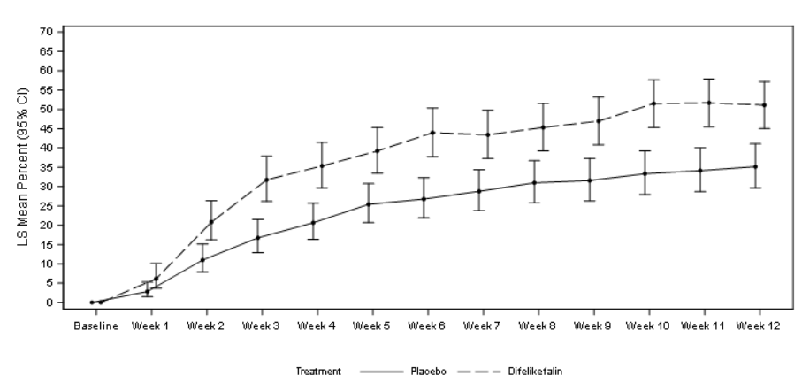CI = confidence interval; LS = least squares; WI-NRS = Worst Itching-Numerical Rating Scale
In addition, a responder analysis based on Patient Global Impression of Change (an exploratory endpoint) showed a difference in responders between difelikefalin and placebo groups (55.9 % vs. 39.5 %; p < 0.001) at the end of the double-blind treatment period.

Open label extension studies
The effect of treatment with difelikefalin for up to 52 weeks was evaluated using the 5-D Itch Scale in single arm, open label extensions of studies KALM-1 and KALM-2 including 712 patients.
A significant improvement was observed in patients switching from placebo to difelikefalin at the end of the double-blind phase (week 12). The significant improvement in 5-D Itch Scale score was maintained throughout the 52 week treatment period as shown in Figure 2.
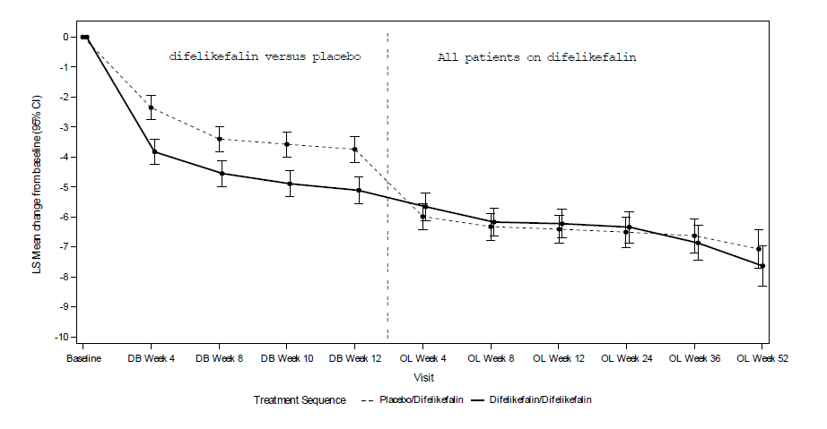
Figure 2: Change from baseline on total 5 D Itch Scale over time
Solid line = data for patients treated with difelikefalin during the double blind (DB) treatment period (through week 12) and who remained on treatment during the open label (OL) extension.
Dashed line = data for patients treated with placebo during the DB treatment period and then switched to difelikefalin for the OL extension (right side of the graph).
DB = double-blind; CI = confidence interval; LS = least squares;

Open label study
Results for itch severity and itch-related QoL were confirmed in another phase-3 (CR845-CLIN-3105), open-label study in 222 patients in the same target population (chronic kidney disease patients on haemodialysis with moderate to severe pruritus). After 12 weeks of treatment with 0.5 micrograms/kg difelikefalin, 73.7 % and 59.3 % of patients reported a WI-NRS score improvement of at least 3 and 4 points, respectively, as well as a mean decrease (± standard deviation) on the Skindex-10 and 5 D Itch scores by -21.0 ± 15.6 and -7.1 ±4.3 points, respectively. In addition, improvements were seen in sleep quality, with 66.0 % and 56.7 % of patients achieving at least a 3 and 4 point improvement on a corresponding Sleep Quality Score. Moreover, the percentage of patients reporting no skin irritation in the EQ-PSO questionnaire increased from 1.4 % at baseline to 28.9 % by end of week 12.

PHARMACOKINETIC PROPERTIES
In patients with severe renal impairment undergoing haemodialysis, total body clearance of difelikefalin is reduced compared to healthy subjects and plasma concentrations decrease slowly until cleared during dialysis. Due to the 70-80% of difelikefalin removed during dialysis, difelikefalin is administered after each haemodialysis session in these patients. The available data on interindividual variability in haemodialysis subjects receiving 0.5 microgram/kg difelikefalin suggest that variability of AUC can exceed 30%.

Distribution
Plasma protein binding of difelikefalin is approximately 30% and remains unaffected by renal impairment. Mean volume of distribution at steady state ranged from 145 to 189 mL/kg in healthy subjects and from 214 to 301 mL/kg in haemodialysis patients with moderate to severe pruritus. Difelikefalin penetration into the central nervous system is limited as shown by physico-chemical, in vitro and animal data.

Metabolism
Difelikefalin undergoes minimal metabolism and is not a substrate of major CYP450 enzymes.

Excretion
In healthy subjects, the primary route of elimination for difelikefalin is renal, accounting for about 81 % of the dose being excreted in urine as compared to 11 % via faecal excretion. In both healthy volunteers and subjects on haemodialysis, most of the dose excreted into urine and faeces was unchanged difelikefalin with minor quantities of putative metabolites, none exceeding 2.5%. Mean total clearance ranged from 54 to 71 mL/h/kg and mean half-lives from 2 to 3 hours. By contrast, in renally impaired haemodialysis patients, elimination was predominantly via faeces, accounting on average for about 59 % of the dose; about 19 % were recovered in dialysate; and about 11 % were found in urine. As compared to subjects with normal renal function, mean total clearance decreased and half-lives increased about 10-fold with ranges of 5.3 to 7.5 mL/h/kg and 23 to 31 hours, respectively.
Dose proportionality
The pharmacokinetics of intravenous difelikefalin in chronic kidney disease patients undergoing HD appear to be dose proportional over a single and multiple dosage range of 0.5 to 2.5 mcg/kg (1 to 5 times the recommended dosage). Steady state was observed after the second administered dosage and the mean accumulation ratio was up to 1.6.

Characteristics in specific groups of subjects or patients
Factors such as age, sex, ethnicity, or mild to moderate hepatic impairment have not been examined.

PRECLINICAL SAFETY DATA

Genotoxicity
Difelikefalin was negative for genotoxicity in a bacterial reverse mutation assay, an in vitro mammalian chromosomal aberration assay, and an in vivo mouse micronucleus assay at IV doses up to 100 mg/kg.

Carcinogenicity
In a 2-year carcinogenicity study in rats, difelikefalin was not carcinogenic when administered via subcutaneous injection at doses up to 1 mg/kg/day (1790 and 6145 times in males and females, respectively, the AUC at the MRHD). Difelikefalin was not carcinogenic in a 6-month carcinogenicity study in transgenic rasH2 mice at subcutaneous doses up to 30 mg/kg/day (1479 times the AUC at the MRHD).

PHARMACEUTICAL PARTICULARS

LIST OF EXCIPIENTS
Acetic acid (pH adjustment)
Sodium acetate trihydrate (pH adjustment)
Sodium chloride
Water for injections

INCOMPATIBILITES

In the absence of compatibility studies, this medicinal product must not be mixed with other medicinal products.

SHELF LIFE
In Australia, information on the shelf life can be found on the public summary of the Australian Register of Therapeutic Goods (ARTG). The expiry date can be found on the packaging.

SPECIAL PRECAUTIONS FOR STORAGE
Store below 30°C. Do not freeze.

NATURE AND CONTENTS OF CONTAINER
Korsuva is supplied in a single use 2 mL glass vial (type I), with a bromobutyl rubber stopper, an aluminium seal and a blue flip-off plastic cap, as 1 mL solution containing 50 micrograms difelikefalin.
Pack sizes of 3 and 12 vials containing 1 mL of solution for injection.
Not all pack sizes may be marketed.

SPECIAL PRECAUTIONS FOR DISPOSAL

Korsuva is for single use in one patient only. Discard any residue.

In Australia, any unused medicine or waste material should be disposed of by taking to your local pharmacy

PHYSICOCHEMICAL PROPERTIES

Chemical structure
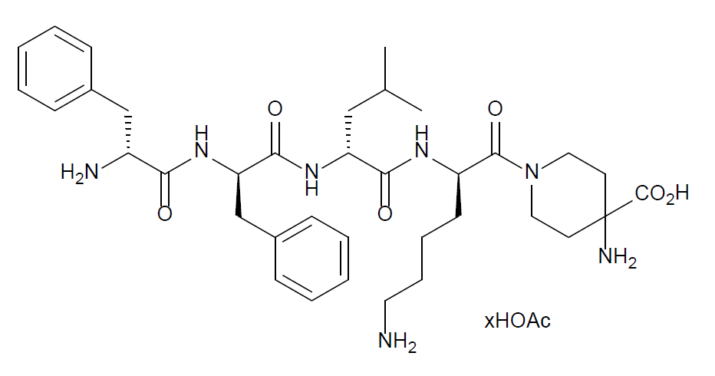

Chemical name
D-phenylalanyl-D-phenylalanyl-D-leucyl-D-lysyl-γ-(4-N-piperidinyl)-amino-carboxylic acid, acetate salt

Difelikefalin is a white to off white amorphous powder with the molecular formula C₃₆H₅₃N₇O₆ (free base) and a molecular weight of 679.9 (free base). Difelikefalin is considered very hygroscopic.

CAS Number
1024829-44-4

MEDICINE SCHEDULE (POISONS STANDARD)

Schedule 4

SPONSOR

Vifor Pharma Pty Ltd
Level 9, 140 William Street
Melbourne VIC 3000
Australia
Tel: 1800 202 674 (Australia)

DATE OF FIRST APPROVAL

10th November 2022

DATE OF REVISION

{MM/YYYY}

Summary table of changes

Section changed | Summary of new information
 | New Product Information

