Australian Public Assessment Report for Jivi
  - Active ingredient: Damoctocog alfa pegol
  - Sponsor: Bayer Australia Ltd
November 2023

About the Therapeutic Goods Administration (TGA)
- The Therapeutic Goods Administration (TGA) is part of the Australian Government Department of Health and Aged Care and is responsible for regulating therapeutic goods, including medicines, medical devices, and biologicals.
- The TGA administers the Therapeutic Goods Act 1989 (the Act), applying a risk management approach designed to ensure therapeutic goods supplied in Australia meet acceptable standards of quality, safety, and efficacy.
- The work of the TGA is based on applying scientific and clinical expertise to decision-making, to ensure that the benefits to the Australian public outweigh any risks associated with the use of therapeutic goods.
- The TGA relies on the public, healthcare professionals and industry to report problems with therapeutic goods. The TGA investigates reports received to determine any necessary regulatory action.
- To report a problem with a therapeutic good, please see the information on the TGA website.

About AusPARs
- The Australian Public Assessment Report (AusPAR) provides information about the evaluation of a prescription medicine and the considerations that led the TGA to approve or not approve a prescription medicine submission. Further information can be found in Australian Public Assessment Report (AusPAR) guidance.
- AusPARs are prepared and published by the TGA.
- AusPARs are static documents that provide information that relates to a submission at a particular point in time. The publication of an AusPAR is an important part of the transparency of the TGA’s decision-making process.
- A new AusPAR may be provided to reflect changes to indications or major variations to a prescription medicine subject to evaluation by the TGA.

Copyright
© Commonwealth of Australia 2023
This work is copyright. You may reproduce the whole or part of this work in unaltered form for your own personal use or, if you are part of an organisation, for internal use within your organisation, but only if you or your organisation do not use the reproduction for any commercial purpose and retain this copyright notice and all disclaimer notices as part of that reproduction. Apart from rights to use as permitted by the Copyright Act 1968 or allowed by this copyright notice, all other rights are reserved and you are not allowed to reproduce the whole or any part of this work in any way (electronic or otherwise) without first being given specific written permission from the Commonwealth to do so. Requests and inquiries concerning reproduction and rights are to be sent to the TGA Copyright Officer, Therapeutic Goods Administration, PO Box 100, Woden ACT 2606 or emailed to <tga.copyright@tga.gov.au>.

Contents
List of abbreviations 4
Product submission 6
Submission details 6
Product background 7
Regulatory status 9
Product Information 9
Registration timeline 9
Submission overview and risk/benefit assessment 10
Quality 10
Nonclinical 11
Clinical 12
Summary of clinical studies 12
Pharmacology 12
Efficacy 15
Safety 26
Risk management plan 32
Risk-benefit analysis 33
Delegate’s considerations 33
Proposed action 34
Independent expert advice 34
Advisory Committee considerations 36
Outcome 37
Specific conditions of registration applying to these goods 37
Attachment 1. Product Information 38

List of abbreviations
Abbreviation | Meaning
ABR | Annualised bleeding rate
ACM | Advisory Committee on Medicines
ADA | Anti-drug antibody
AE | Adverse event
ARTG | Australian Register of Therapeutic Goods
ASA | Australia specific annex
AUC | Area under the concentration-time curve
AUC_{0-tlast} | Area under the concentration-time curve from time zero to the time of the last quantifiable concentration
BMI | Body mass index
CFC | Clotting factor concentrate
CMI | Consumer Medicines Information
COR | Comparable Overseas Regulator
CPD | Certified Product Details
CV | Coefficient of variation
DLP | Data lock point
ED | Exposure day(s)
EMA | European Medicines Agency (European Union)
EU | European Union
FVIII | Factor VIII
Haemo-QoL | Haemophilia-specific quality of life
Ig | Immunoglobulin
ITT | Intention-to-treat
IU | International unit(s)
LoE | Loss of efficacy
PEG | polyethylene glycol
PI | Product Information
PK | Pharmacokinetic(s)
popPK | Population pharmacokinetic(s)
PTP | Previously treated patient
rFVIII | Recombinant Factor VIII
RMP | Risk management plan
SAE | Serious adverse event
TGA | Therapeutic Goods Administration
PSUR | Periodic safety update report

Product submission

Submission details
Type of submission: | New biological entity
Product name: | Jivi
Active ingredient: | Damoctocog alfa pegol
Decision: | Approved
Date of decision: | 21 March 2023
Date of entry onto ARTG: | 27 March 2023
ARTG numbers: | 384590, 384591, 384592, 384593 and 384594
Black Triangle Scheme  for the current submission: | Yes  This product will remain in the scheme for 5 years, starting on the date the product is first supplied in Australia.
Sponsor’s name and address: | Bayer Australia Ltd  875 Pacific Highway  Pymble NSW 2073
Dose forms: | Powder for injection and diluent for injection
Strengths: | 250 international units (IU), 500 IU, 1000 IU, 2000 IU and 3000 IU
Containers: | Vial and prefilled syringe
Pack size: | One
Approved therapeutic use for the current submission: | Jivi, damoctocog alfa pegol, is a long-acting recombinant Factor VIII concentrate indicated for use in previously treated adults and adolescents (12 years of age and older) with haemophilia A for:  - Routine prophylactic treatment to prevent or reduce the frequency of bleeding episodes  - On-demand treatment and control of bleeding episodes  - Per-operative management of bleeding (surgical prophylaxis)  Jivi does not contain von Willebrand factor, and therefore is not indicated in patients with von Willebrand’s disease.
Route of administration: | Intravenous
Dosage: | The dose and duration of substitution therapy depends on the severity of the Factor VIII deficiency, the location and extent of the bleeding and on the patient's clinical condition.  For further information regarding dosage, refer to the Product Information.
Pregnancy category: | B2  Drugs which have been taken by only a limited number of pregnant women and women of childbearing age, without an increase in the frequency of malformation or other direct or indirect harmful effects on the human fetus having been observed.  Studies in animals are inadequate or may be lacking, but available data show no evidence of an increased occurrence of fetal damage.  The use of any medicine during pregnancy requires careful consideration of both risks and benefits by the treating health professional. This must not be used as the sole basis of decision making in the use of medicines during pregnancy. The TGA does not provide advice on the use of medicines in pregnancy for specific cases. More information is available from obstetric drug information services in your state or territory.

Product background
This AusPAR describes the submission by Bayer Australia Limited (the sponsor) to register Jivi (damoctocog alfa pegol) powder for injection, diluent for injection, vial and prefilled syringe for the following proposed indication:
Treatment and prophylaxis of bleeding in previously treated patients (PTPs) ≥ 12 years of age with haemophilia A (congenital Factor VIII deficiency).
Haemophilia A is a bleeding disorder characterised by congenital underproduction of or dysfunction of Factor VIII (FVIII), an essential protein in promoting clot formation. The severity of (and bleeding risk associated with) haemophilia A is classified according to patient’s endogenous FVIII activity in their plasma. Those with FVIII activity levels less than 1% have severe disease; between 1% and 5%, moderate disease; and between 5% and 40%, mild disease. Globally, patients with severe disease account for approximately 40%, moderate disease 25%, and mild disease 35% of all patients with haemophilia A.
Severe haemophilia is characterised by spontaneous, recurrent bleeds into joints and muscles which can lead to chronic arthropathy, muscular atrophy, and deformities. Converting the clinical phenotype of haemophilia from severe to moderate has been the rationale for prophylaxis.
As X-chromosome-linked recessive disorders, haemophilia A and B affect hemizygous males while heterozygous females (carriers) do not typically express haemophilia symptoms.
Clotting factor concentrates (CFCs) are the treatment of choice for people with haemophilia as they are very safe and effective for treating and preventing bleeds. There are two main types of CFCs: virally inactivated plasma-derived products made from plasma donated by human blood donors; and recombinant products manufactured using genetically engineered cells and recombinant technology.
Replacement therapy may be ‘on-demand’ where treatment is given when a haemorrhage occurs, or prophylactic where Factor VIII is administered at regular intervals in an attempt to prevent the onset of haemorrhage. According to current Australian guidelines, regular continuous prophylactic therapy prior to the onset of joint disease is the standard of care in in patients with severe haemophilia in Australia. These products are given intravenously.
There are currently multiple standard half-life recombinant FVIIIs marketed for the treatment of Haemophilia A. These include Xyntha (moroctocog alfa) and Advate (octocog alfa). Extended half-life recombinant FVIII products include Eloctate (efmoroctocog alfa) and Adynovate (rurioctocog alfa pegol). Other coagulation therapies include:
- Novoseven RT (eptacog alfa), a recombinant FVIIa bypassing agent with indications that include the control of bleeding and surgical prophylaxis in patients with inhibitors to coagulation Factors VIII or IX.
- Hemlibra (emicizumab), a humanised monoclonal modified immunoglobulin (Ig)G4 antibody with a bispecific antibody structure bridging Factor IXa and X is indicated for routine prophylaxis to prevent bleeding or reduce the frequency of bleeding episodes in adult and paediatric patients with haemophilia A (congenital Factor VIII deficiency) with or without Factor VIII inhibitors. It is given via subcutaneous injection with weekly through to monthly dose regimens.
- Desmopressin injection (subcutaneous or intravenous) is an alternative treatment option for patients with mild haemophilia A. The anti-fibrinolytic agent tranexamic acid is also used as adjunctive therapy in the treatment of skin and mucosal haemorrhages.
The World Federation of Hemophilia updated its treatment guideline in 2020. The Australia guidelines for management of haemophilia² were published in 2016 and were based on an earlier World Federation of Hemophilia guideline. Longer acting recombinant CFCs were largely approved subsequent to publications of the Australian guideline.
The sponsor outlines the clinical rationale for Jivi:
‘Due to the nature of this condition, regular scheduled intravenous infusions of Factor VIII are required to prevent bleeds. Although there has been major advancement in the prognosis for patients diagnosed with haemophilia A, there are still major opportunities available to further improve quality of life. This is especially the case given that many young adults choose to stop regular infusions because of the high demand in time and frequency of these procedures.
As such products with an extended half-life that are able to overcome the relative short half-life of Factor VIII are still sought after. In addition to the decrease in frequency of infusions, other flow on effects can arise such as increase in adherence and decrease in days lost from work/school. As a chronic disease, this has a significant impact on the day-to-day life of haemophilia patients.
The clinical development program for Jivi was aimed at producing a longer-acting recombinant Factor VIII for prophylaxis whilst also retaining the ability for use in on-demand treatment. The PEGylation of the Factor VIII molecule was found to increase the half-life and result in a higher AUC [area under the concentration-time curve].’
This submission was submitted through the TGA’s Comparable Overseas Regulator B (COR-B) process, using evaluation reports from European Medicines Agency (EMA). The full dossier was submitted to the TGA.

Regulatory status
This product is considered a new biological entity for Australian regulatory purposes.
At the time the TGA considered this submission, similar submissions had been approved United States of America on 29 August 2018, Japan on 21 September 2018, Canada on 18 October 2018, European Union (EU) on 22 November 2018, Switzerland on 18 June 2019 and Brazil on 17 February 2020.

Product Information
The Product Information (PI) approved with the submission which is described in this AusPAR can be found as Attachment 1. For the most recent PI and Consumer Medicines Information (CMI), please refer to the TGA PI/CMI search facility.

Registration timeline
The following table captures the key steps and dates for this submission.
This submission was evaluated under the standard prescription medicines registration process.
Table 1: Timeline for Submission PM-2022-00347-1-6
Description | Date
Submission dossier accepted and first round evaluation commenced | 31 March 2022
First round evaluation completed | 19 July 2022
Sponsor provides responses on questions raised in first round evaluation | 16 September 2022
Second round evaluation completed | 21 October 2022
Delegate’s Overall benefit-risk assessment and request for Advisory Committee advice | 24 January 2023
Sponsor’s pre-Advisory Committee response | Not applicable
Advisory Committee meeting | Not applicable
Registration decision (Outcome) | 21 March 2023
Administrative activities and registration on the ARTG completed | 27 March 2023
Number of working days from submission dossier acceptance to registration decision* | 165
* The COR-B process has a 175 working day evaluation and decision timeframe.

Submission overview and risk/benefit assessment
A summary of the TGA’s assessment for this submission is provided below.
This section is a TGA summary of wording used in TGA’s evaluation report, which discussed numerous aspects of overseas evaluation reports and included some information that was commercial-in-confidence.
Relevant guidelines or guidance documents referred to by the Delegate are listed below:
- Australian Haemophilia Centre Directors’ Organisation and National Blood Authority, Australia Guidelines for the Management of Haemophilia in Australia, 20 July 2016.
- Srivastava A. et al. WFH Guidelines for the Management of Hemophilia, 3rd edition. Hemophilia, 2020; 26(Suppl 6): 1-158.

Quality
There are no quality objections to approval. The quality assessment is based largely on the final EMA review for Jivi damoctocog alfa pegol and EMA’s other evaluation reports provided to the TGA as part of the COR-B process. Additional assessment on the PI, labels and stability was carried out to ensure the product meets Australian requirements.
Jivi (damoctocog alfa pegol, sponsor product development code BAY94-9027) is a recombinant (r) B-domain deleted human coagulation Factor VIII (FVIII) variant, which is site-specifically conjugated with a 60 kDa branched polyethylene glycol (PEG) as shown in Figure 1 below.
Figure 1: Structure of damoctocog alfa pegol
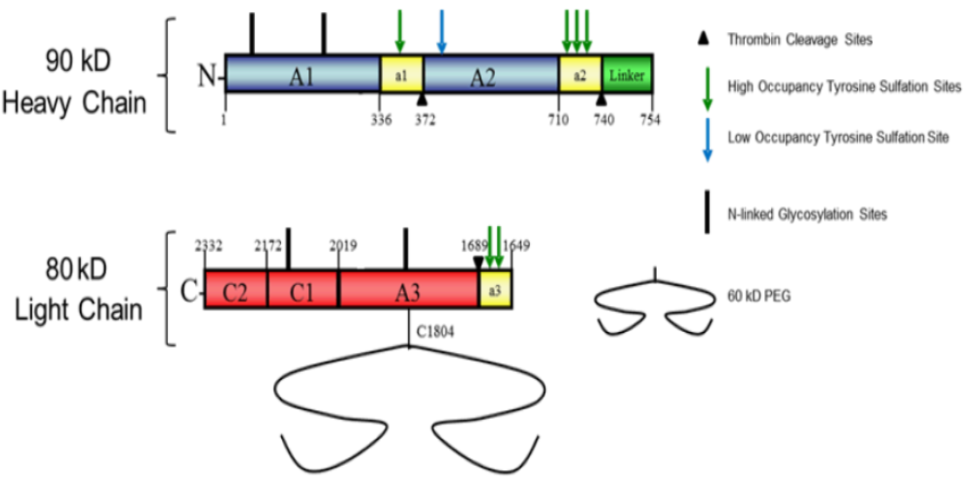
Abbreviation: PEG = polyethylene glycol.
Jivi is presented as lyophilised powder in the dosages of 250, 500, 1000, 2000 and 3000 IU/vial in a 10 ml Type I glass vial, stoppered, and sealed with an aluminium seal and plastic flip top. The product is a composite pack with supplied with one prefilled syringe of 2.5 ml sterile water for injections, one syringe plunger rod, one vial adaptor and one administration set.
The overall quality of the active substance was demonstrated via adequate control of the starting materials, control of critical steps and intermediates, process validation, extensive characterisation using orthogonal and state-of-the-art analytical methods, control of impurities and contaminants, generation of robust reference materials and batch analyses that covered multiple manufacturing campaigns.

Nonclinical
There are no nonclinical objections to the registration of Jivi (damoctocog alfa pegol) for the proposed indication.
The product contains no novel excipients.
The sponsor indicated that ‘there have been no changes in the formulation between the development formulation, the preclinical formulation used for toxicity and pharmacology studies, the formulation for clinical trials, and the formulation to be used commercially’.
Overall, the pharmacokinetic profile of damoctocog alfa pegol in rats, haemophilia A mice and haemophilia A dogs was qualitatively similar to that of humans. Consistent with PEGylation reducing clearance of FVIII, plasma AUC and half-life were greater for damoctocog alfa pegol compared to Kogenate FS (octocog alfa) in rats, haemophilia A mice and haemophilia A dogs. Damoctocog alfa pegol (intravenous) is eliminated faster in rats than other species including humans. Exposure was approximately proportional to dose in immune-deficient rats.
The plasma half-life of PEG-60-Mal-Cys (intravenous) was very long in rats (5 days compared to 8 h for damoctocog alfa pegol). Tissue distribution of 14C-PEG-60-Mal-Cys-derived radioactivity after intravenous administration in rats was slow and wide. Some distribution was seen in the choroid plexus and reproductive organs but only limited penetration into brain was observed. Renal excretion was the major excretion route of PEG-60-Mal-Cys, but faecal excretion was also seen.
Damoctocog alfa pegol had a low order of acute intravenous toxicity in rats and rabbits.
Repeat-dose toxicity studies by the clinical route (intravenous) were conducted with damoctocog alfa pegol in wild-type rats (2 weeks) and immune-deficient nude rats (6 months) and with PEG-60-Mal-Cys (intravenous) in wild-type rats and rabbits (4 weeks). Maximum exposures (AUC) to damoctocog alfa pegol moderate in rats. Maximum exposures achieved for PEG-60-Mal-Cys were low in immune-deficient rats and very high in wild-type rats. Damoctocog alfa pegol and PEG-60-Mal-Cys were well tolerated in both species, with no target organs for toxicity identified.
Standard genotoxicity and carcinogenic studies were not conducted with damoctocog alfa pegol, in line with ICH guidelines. PEG-60-Mal-Cys was not mutagenic in the bacterial mutation assay or clastogenic in vitro (mouse lymphocytes) or in vivo (rat micronucleus test).
Damoctocog alfa pegol enhanced coagulation in vitro in human, rabbit and dog plasma (that is, reduction in activated partial thromboplastin time). In vivo, damoctocog alfa pegol displayed longer lasting prophylactic efficacy in mouse and dog models of haemophilia A (200 IU/kg and 50 IU/kg, respectively) compared to Kogenate FS. This was associated with improved clotting time parameters in dogs (compared to Kogenate FS). Primary pharmacology of damoctocog alfa pegol supports the proposed clinical indication.
Immunohistochemistry assays examining cross-reactivity showed similar tissue staining pattern for damoctocog alfa pegol and Kogenate FS (that is, endothelial cells in heart, kidney, and lung).
No dedicated safety pharmacology studies were conducted with damoctocog alfa pegol. Examination of safety pharmacology parameters (central nervous system and renal functions) were incorporated into the general repeat-dose toxicity studies. No adverse effects on central nervous system and renal function are predicted in patients.
In the EMA nonclinical evaluation reports there was consideration given to the potential for renal and neurological risks in a treatment population with immature and developing brain and kidney function, and discussion on the possible role of the PEG moiety on these potential effects. The sponsor’s summary conclusion was that there is a low risk of PEG having different effects on the nervous system or kidneys in children compared to adults. The choroid plexus and its functions are fully developed at approximately 10 years of age and the kidney function in children aged 2 years is comparable to adults.
The EMA’s evaluation noted that it was established during the initial review that effects on renal and neurological endpoints were minimal, however it was noted that the duration of treatment with either PEG compound was time limited to a maximum of 2 weeks and so any long-term safety risk would be very difficult to pick up.

Clinical

Summary of clinical studies
The clinical dossier consisted of:
- three Phase I pharmacokinetic and safety studies: Studies 13401, 19096, and 19742
- two population pharmacokinetic studies: Studies 17395 and 20155
- one Phase II/III pharmacokinetic, efficacy and safety study: Study 13024 (also known as the PROTECT VIII trial)
- one Phase III pharmacokinetic, efficacy and safety study: Study 15912 (also known as the PROTECT KIDS trial)

Pharmacology

Pharmacokinetics
Pharmacokinetic (PK) data was obtained from 3 Phase I clinical studies (Studies 13401, 13024 and 15912) as tabulated in Table 2 below with additional comparative PK data with efmoroctocog alfa (Elocate) and rurioctocog alfa pegol (Adynovate).
Table 2: Overview of clinical studies containing pharmacokinetic data in the Comparable Overseas Regulator report
Study number | Patient type | Protocol title | Pharmacokinetic patients
Study 13401 | Severe haemophilia A ≥18 years | An open label Phase I trial to evaluate the pharmacokinetics and safety profile of Jivi following single and multiple dose administration in two cohorts of previously treated male patients with severe haemophilia A | 14
Study 13024 (PROTECT VIII trial) | Severe haemophilia A ≥12 years | A Phase II/III, multicentre, partially randomised, open label trial investigating safety and efficacy of on-demand and prophylactic treatment with Jivi in severe Haemophilia A | 22
Study 15912 (PROTECT KIDS trial) | Severe haemophilia A <12 years | A multi-centre, Phase III, non- controlled, open label trial to evaluate the pharmacokinetics, safety, and efficacy of Jivi for prophylaxis and treatment of bleeding in previously treated children (age <12 years) with severe  haemophilia A | 34

Pharmacokinetic values were primarily obtained from patients in Study 13024. In that study, a subset of patients underwent PK assessment following the first and the last dose in Part A. Twenty-two patients aged 12 to 65 years participated in the PK study in Part A of the study. Patients were given a dose of 60 IU/kg following a washout from a previous FVIII dose. Samples were collected for 96 hours. Sixteen patients also participated in a repeat PK assessment at the end of the Part A after approximately 6 months of treatment. Results from those assessments are shown in Table 3 below.
Table 3: Pharmacokinetic parameters following single and multiple doses of damoctocog alfa pegol based on chromogenic assay following a dose of 60 IU/kg (Part A pharmacokinetic analysis population)
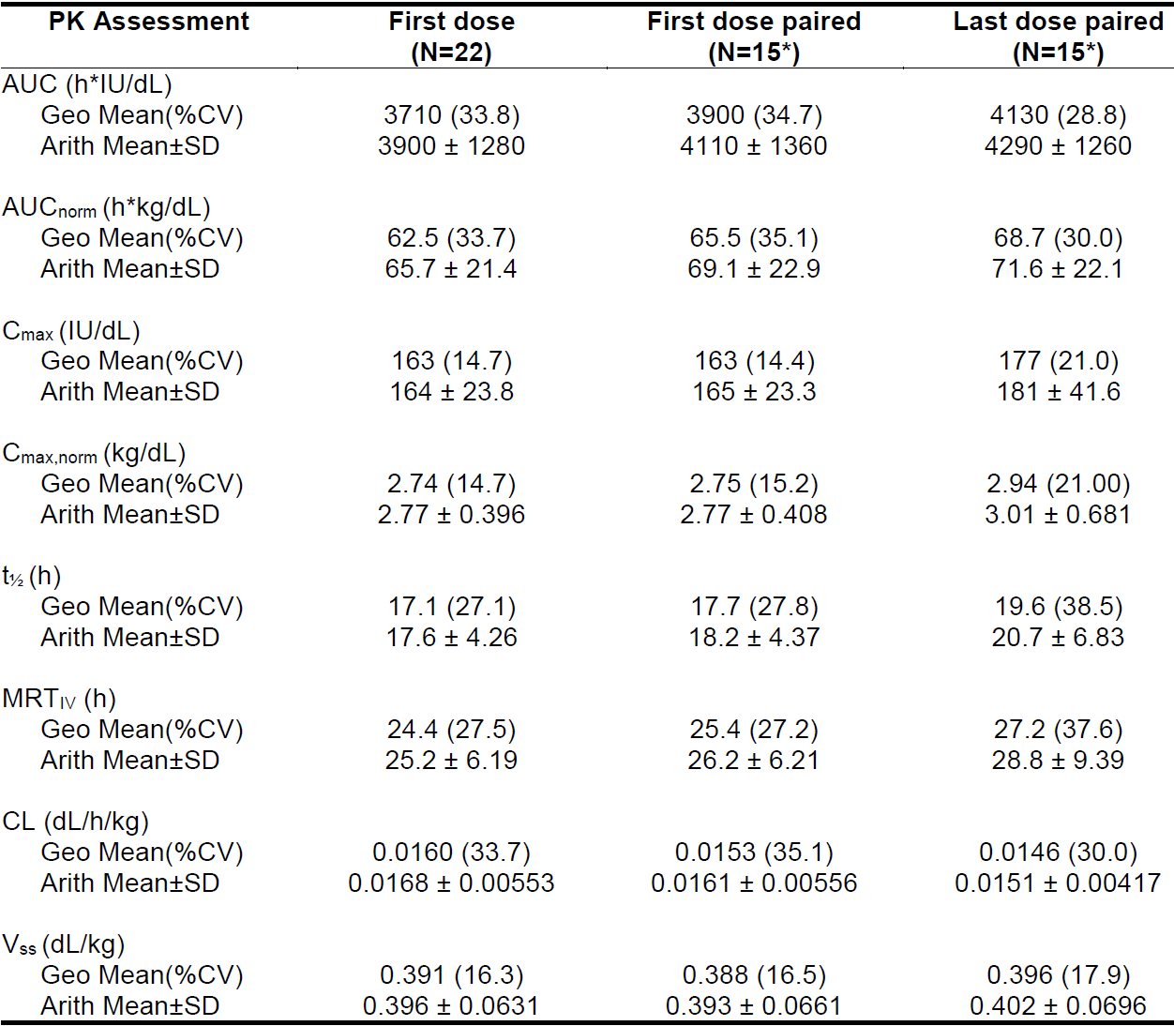
Abbreviations: Arith Mean = arithmetic mean; AUC = area under the concentration-time curve; C_{max} = maximum concentration; CV = coefficient of variation; Geo Mean = geometric mean; IU = international units; MRT_{IV} = Mean Residence Time after intravenous infusion; PK = pharmacokinetic; SD = standard deviation; t1/2 = half-life; V_{SS} = steady state volume of distribution.
* Paired data only available for 15 patients for the chromogenic assay
Values have been rounded to 3 significant digits.
In addition to the above studies there were 2 subsequent PK comparative studies in which the PK of damoctocog alfa pegol was compared with efmoroctocog alfa (Study 19096) and with rurioctocog alfa pegol (Study 19742). These were single dose, open label, randomised, crossover studies in patients with severe haemophilia A. In Study 19096 each of 18 patients received 60 IU of damoctocog alfa pegol and efmoroctocog alfa sequentially with a washout period of at least 72 hours.
In that study damoctocog alfa pegol had a similar geometric mean AUC from time zero to the time of the last quantifiable concentration (AUC_{0-tlast}) to efmoroctocog alfa (2660 h·IU/dL for damoctocog alfa pegol and 2410 h·IU//dL for efmoroctocog alfa).
In Study 19742, each of 18 patients were to receive 50 IU of damoctocog alfa pegol and rurioctocog alfa pegol with a washout period between doses of at least 72 hours, however the actual median (range) of doses was 54.3 IU/kg (51.5 to 56.5 IU/kg) for damoctocog alfa pegol and 61.4 IU/kg (57.1 to 65.3 IU/kg) for rurioctocog alfa pegol. For the primary variable AUC_{0-tlast}, which was derived directly from the observed profile, the geometric mean AUC_{0-tlast} was 2310 h∙IU/dL (coefficient of variation (CV) = 44.0%) for damoctocog alfa pegol and 2150 h∙IU/dL (CV = 39.6%) for rurioctocog alfa pegol. The dose normalised AUC (h·kg/dL) 43.8 (CV = 40.1%) for damoctocog alfa pegol and 36.0 (CV = 40.1%) for rurioctocog alfa pegol, a mean difference of approximately 20%.
Damoctocog alfa pegol is a modified recombinant replacement protein of the naturally occurring coagulation FVIII and is not metabolised by liver enzymes, it is not expected that hepatic impairment will affect the PK of damoctocog alfa pegol. Since renal excretion is not expected for damoctocog alfa pegol, no PK studies in patients with renal impairment were conducted.

Population pharmacokinetic data
A population pharmacokinetic (popPK) study of FVIII concentration data from the Phase I Study 13401, Phase II/III Study 13024 and Phase III Study 15912 based on a 60IU/kg dose of Jivi was performed. PK data was obtained from 206 male patients ranging in age from 2 to 62 years, up to 168 hours post-dose and/or sparse samples (pre-dose and recovery samples collected at approximately 15 to 30 minutes post injection). This resulted in a total of 2224 and 1650 FVIII samples based on chromogenic assay and one-stage assay, respectively, where for 146 out of the 206 patients, measurements using both assays were available.
Model development was performed using data obtained by the standard chromogenic assay. The Factor VIII observations were described by a one-compartment disposition model in terms of central volume of distribution and clearance. Between-subject variability could be identified for clearance and volume of distribution with a correlation between both. In a univariate covariate analysis, age and size-related covariates (body height, body weight, body mass index (BMI), lean body weight) were found to significantly influence clearance and volume of volume of distribution. In addition, baseline lean body weight was identified to strongly influence clearance and volume of distribution of damoctocog alfa pegol and explained a large part of variability between patients. Von Willebrand factor also strongly influenced clearance and was included in the model. The effect estimate was based on data from adults and adolescents (Studies 13024 and 13401) only, since no Von Willebrand factor measurements were made in children less than 12 years of age (Study 15912). The parameter estimates of the final population model are provided in Table 4 below.
The population PK model was used to predicted time to reach certain threshold and the FVIII concentration at certain time points following a dose of 60 IU/kg. For patients age 12 years and older, these numbers show that for approximately 50% of patients a maintenance of FVIII level above 1 IU/dL over approximately 5 days is expected, while for some patients a FVIII levels above 1 IU/dL could also be expected for over 7 days. In the popPK the typical subject over 50 years of age had a 21.5% lower clearance than a subject less than 50 years, there is no data in patients over 65 years old.
Table 4: Predicted time (hours) to reach threshold Factor VIII level of 1, 3 and 5 IU/dL after single dose of 60 IU/kg (median (5th to 95th percentile)) based on the chromogenic assay stratified per age class
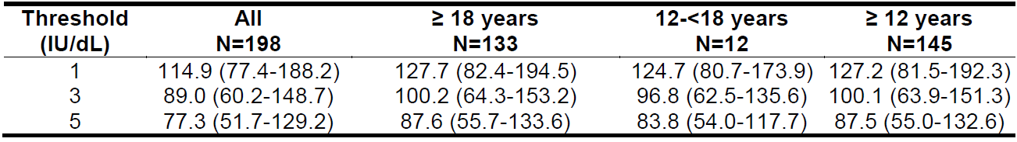
Abbreviations: IU = international unit; N = number of subjects.
Important covariates were weight and von Willebrand factor on clearance, and weight on volume. The exponents for weight on clearance and volume were 0.7 and 0.87. Pre-existing anti-drug antibodies (ADAs) were detected in 21 patients and were mainly anti-PEG IgM antibodies with negative results in the Jivi neutralising assay. Antibody titres were low. Consistent with the negative results in the neutralising assay, Jivi post-infusion activity after the first injection was in the expected range for FVIII recovery for most patients. In some patients, slight decreases in the Jivi activity after the first injection and low Jivi recoveries (less than 1.5 IU/dL per IU/kg) were observed in the presence of anti-PEG antibodies which normalised when antibodies disappeared. Antibody status was not tested as a covariate in the population PK analysis as the incidence (less than 5% of the PK population) was below the prespecified criteria.
The individual predicted clearance and volume for 8 patients with anti-PEG IgM antibodies were within the population average estimated for different age groups and indicated that the presence of antibodies did not affect clearance.

Pharmacodynamics
No specific clinical pharmacodynamic studies were performed. Damoctocog alfa pegol is a recombinant B-domain deleted human coagulation FVIII variant which is site specifically conjugated with a single maleimide-derivatized 60 kDa branched PEG (two 30 kDa PEG) at the cysteine 910 (amino acid 1840 in the full length FVIII sequence). It has the same mechanism of action as unmodified FVIII. The site specific PEGylation results in an increased AUC and extended apparent terminal elimination half-life through reduced clearance from plasma.

Efficacy
Demonstration of the clinical efficacy of Jivi is based on two clinical studies: Study 13024 (PROTECT VIII trial) in PTPs 12 to 65 years of age and Study 15912 (PROTECT KIDS trial) in PTPs less than 12 years of age with severe haemophilia A. Given the sponsor is not proposing that Jivi be indicated in children aged less than 12 years efficacy in the PROTECT KIDS trial will be only briefly summarised in this overview.
The selection of treatment doses in the EMA submission was derived empirically. The dosage and duration of the substitution therapy to achieve haemostasis was individualised according to the patient's needs (weight, severity of disorder of the haemostatic function, the site and extent/severity of the bleeding, and the FVIII level desired), patient characteristics and treatment responses. Dose recommendations for prophylaxis are based on the clinical efficacy demonstrated for the three treatment regimens, twice per week, every 5 and every 7 days, with different dose ranges used during the clinical studies.
In the clinical Phase II/III studies, patients were assigned or randomised to the different regimens based on their clinical assessment, for example, the number of spontaneous bleeds during the 10-week run-in phase. Dose adjustments were possible, if in the patient’s and investigator’s assessment, the dose did not provide sufficient protection against bleeds.
Although PK measures are useful laboratory tools to guide dosing, FVIII activity assays have a poor predictive value for individual bleed risks. The required FVIII level for protection is an individual parameter, which depends on patient characteristics, joint status as well as on lifestyle and level of physical activity. Therefore, the effectiveness of the treatment is based on the events of bleeding rather than a certain FVIII activity level.

Study 13024 (PROTECT VIII trial)
Study 13024 (also known as the PROTECT VIII trial) is a Phase II/III, multicentre, partially randomised, open label study to investigate the safety and efficacy of on-demand and prophylactic treatment with Jivi in severe Haemophilia A. The study (Parts A and B) was conducted at 60 study centres in 20 countries, commencing in April 2012 with the last subject assessment conducted in November 2019. The study consisted of 2 parts with each part having a longer-term extension:
- Part A primarily assessed the efficacy of Jivi in the prevention and treatment of bleeding at different infusion schedules. An optional extension to Part A primarily assessed long term safety and was not fully evaluated in the initial submission to the EMA.
- Part B primarily assessed the safety and efficacy of Jivi in the prevention of bleeding during major surgical procedures. This part also had a long-term safety assessment.

Dosing regimens

Part A

On-demand treatment arm
Dose as indicated is based upon location and severity of bleeds (maximum 60 IU/kg).

Prophylaxis treatment arms
All patients in the prophylaxis arms started with twice per week at a dose of 25 IU/kg for 10 weeks. Thereafter, only patients with one or less breakthrough (spontaneous, no identified trauma) joint and/or muscle bleeds qualified for random assignment to the less frequent dosing regimens. High bleeders continued twice per week infusion. Patients assigned to prophylaxis began treatment at 25 IU/kg twice weekly, and at the end of 10 weeks, bleeding control was assessed. Patients who experienced one or less breakthrough bleed (joint or muscle bleed, no identified trauma) were randomised 1:1 to 45 IU/kg every 5 days or 60 IU/kg every 7 days. Those with 2 or more breakthrough bleeds were not randomised (twice per week failed group), and remained on twice-weekly treatment at higher doses (30 to 40 IU/kg).
Eleven patients had one or fewer bleeds during the run-in period, but were not randomised due to capping of the every 5 days and every 7 days treatment arms. These patients remained on twice per week treatment and increased their dose after the 10-week run-in period to 30 IU/kg/ infusion and could increase their dose to a maximum of 40 IU/kg/infusion if bleeding control was not considered adequate (twice per week ‘forced’ group).¹⁰
Patients in the every 5 days or every 7 days treatment arms could have left the assigned treatment arm if bleeding control was considered inadequate. This decision was left to the discretion of the subject and the investigator.

Prophylaxis treatment dosage
- Twice per week prophylaxis: 25 to 40 IU/kg
- Every 5 days prophylaxis: 45 to 60 IU/kg
- Every 7 days prophylaxis: 60 IU/kg

Part B
Dosage and frequency as required for therapeutically necessary plasma FVIII activity is based on pre-surgical PK measurements.
All doses were rounded to the nearest vial size.
In the main study patients in Part A were to continue for 36 weeks (at least 50 exposure days (ED) for at least 50 patients). Patients completing Part A had the option to extend treatment for a minimum of 6 months and at least 100 total ED, or until marketing authorisation of the drug.
Patients in Part B were to receive study drug for PK sampling, for surgery, and for the post-surgical period up to time of discharge. The post-surgical period was not to exceed a total of 3 weeks.

Selection criteria
Eligible patients were males 12 to 65 years of age, with severe haemophilia A (less than 1% FVIII:C), documented history of at least 150 ED with any FVIII concentrate, no other bleeding disorder, inhibitor negative, immunocompetent, CD4+ lymphocyte count greater than 200/mm³ if human immunodeficiency virus (HIV) positive.
Part B was to be open to all patients participating in Part A and to individuals with severe haemophilia A not otherwise enrolled in this clinical study who met the same inclusion and exclusion criteria as required in Part A. Patients may have participated in Part B more than once.

Efficacy endpoints

Part A

Treatment of bleeds
- Annualised number of bleeds in on demand treatment arm
- Description of bleeding according to location and frequency of total bleeds (spontaneous and trauma), joint bleeds, trauma, spontaneous bleeds and all bleeds
- Number of infusions required to control a bleed
- Subject or investigator assessment of response to treatment of a bleed, as excellent, good, moderate, poor

Prophylaxis groups
- Annualised number of total bleeds (sum of spontaneous bleeds and trauma bleeds) in each prophylaxis treatment arm
- Description of bleeding according to location and frequency of total bleeds (spontaneous and trauma), joint bleeds, trauma, spontaneous bleeds and all bleeds
- Proportion of prophylaxis infusions that were followed by a bleed within 48, 72, 96, 120, 144 and 168 hours.
- Number of patients requiring dose escalation
The primary variables for Part B were blood loss, transfusion, change in haemoglobin or haematocrit, investigator’s assessment of response to treatment (described as excellent, good, moderate, or poor) and recombinant FVIII (rFVIII) usage. Quality of life aspects were also assessed.
The primary variable to be assessed in the optional extension phase of Part B was frequency of inhibitor development.

Part A results
Figure 2: Study 13024 (PROTECT VIII trial) Part A Subject disposition
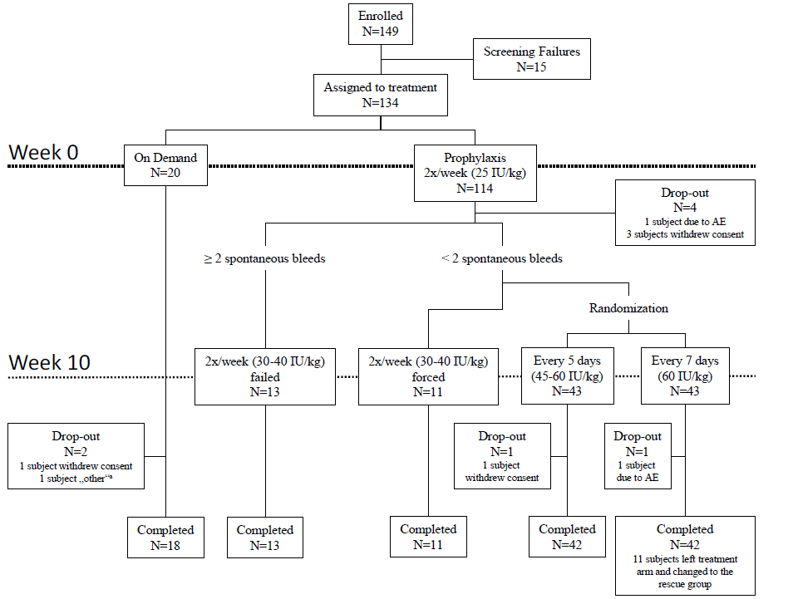
Abbreviations: N = number of subjects.
Note: '2x/week failed' denotes subjects with at least 2 spontaneous bleeds in Weeks 0 to 10 who stayed on twice per week regimen after Week 10 according to the protocol. '2x/week forced' denotes subjects with less than 2 spontaneous bleeds in Weeks 0 to 10 who were forced due to randomisation arm caps to stay on twice per week regimen after Week 10.
a Reasons for not completing the study. ‘Other’ in this case was non-adherence to study protocol.
In Part A most patients were white (88 patients, 65.7%) and all (100%) were male. Mean age was 35.9 years (range: 12 to 62 years), mean weight of 75.5 kg (range: 37 to 126 kg), mean height 174.6 cm (range: 155 to 192 cm), and mean BMI of 24.7 kg/m² (range: 14 to 42 kg/m²). The physical characteristics (height, weight and BMI) were similar between the patients who received on-demand and prophylaxis treatment.
Table 17.115: Study 13024 (PROTECT VIII trial) main study of Part A Disease characteristics
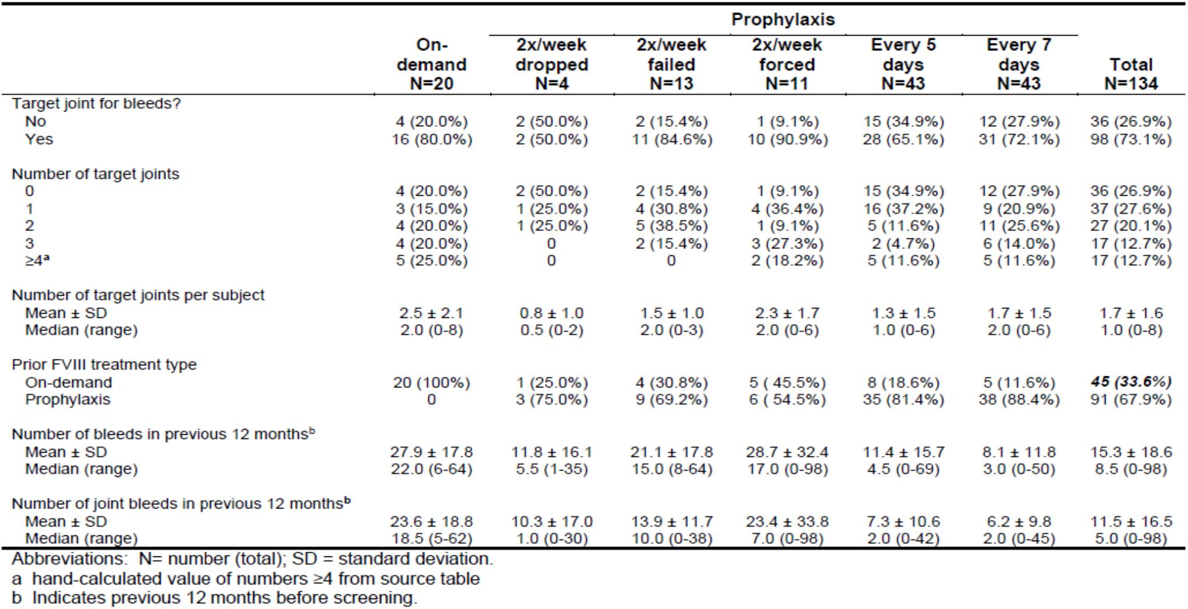
Bleeding logs were reviewed for the 112 patients in the intention-to-treat (ITT) analysis set to determine if effective bleeding control (defined as 0 o 1 joint or muscle bleeds, no identified trauma) during the 10-week run-in period had been obtained using Jivi at a dose of 25 IU/kg twice per week. The actual mean dose (±standard deviation) for the group was 26.7 (±2.5) IU/kg, with 110 patients completed the 10-week run-in period. A total of 13 out of 110 patients were identified as high bleeders (twice per week failed group), with a median of 3 breakthrough (spontaneous, no identified trauma) joint and/or muscle bleeds (range: 2 to 5; median annualised bleeding rate (ABR): 15.81). The rest of the patients (n = 86) had a median of 0 total bleeds (range: 0 to 3), and a median of 0 spontaneous bleeds (range: 0 to 1); and thus qualified for randomisation. These patients were randomised 1:1 to every 5days (n = 43) or every 7days (n = 43) treatment. Eleven patients, who qualified for randomisation, continued twice per week (twice per week forced group) treatment due to capping of the every 5 days and every 7 days treatment arms. Results for weeks 10 to 36 for the Part A ITT population are shown in Table 6 and Table 7 below.
Table 6: Study 13024 (PROTECT VIII trial) Part A Summary of bleeds in Weeks 10 to 36, excluding rescue bleeds (intention-to-treat population)
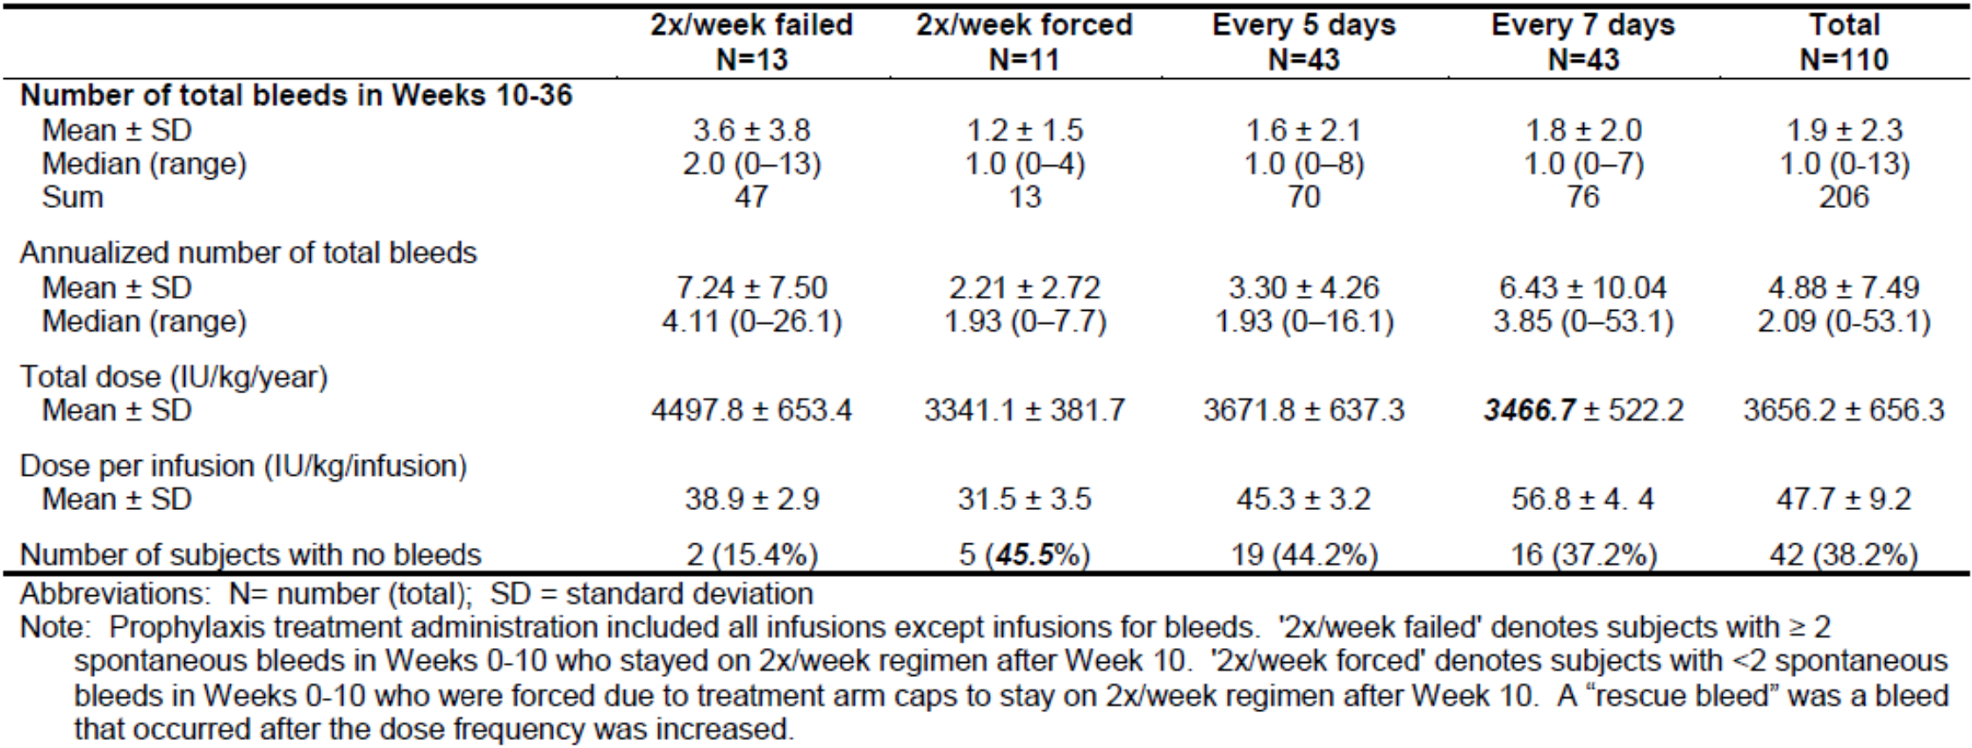
Table 7: Study 13024 (PROTECT VIII trial) Part A Number of patients requiring dose frequency or dose increase during Weeks 10 to 36 (intention-to-treat population)
Patients with less than 9 bleeds per year who did not increase their dosing frequency or drop out were considered responders. If a minimum response rate of 50% for each corresponding treatment arm was achieved, efficacy was determined by comparison of bleeding rates to the on-demand treatment arm. The 50% responder rate was an arbitrary cut-off below which the corresponding regimen would be considered ineffective. A minimum response rate of greater than 50% for each corresponding treatment arm was achieved as in shown in Table 8 below.
Table 8: Study 13024 (PROTECT VIII trial) main study of Part A Responder rates of less than 9 bleeds per year (intention-to-treat population)
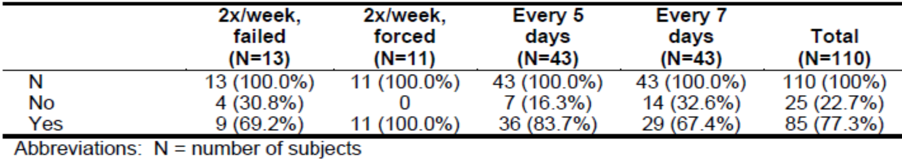
Sensitivity analyses defined responders as prophylaxis patients with less than 3, 5, 7, or 11 bleeds (instead of 9 bleeds) per year who did not increase their dosing frequency, and then calculated the responder rate accordingly to see if the study goal of a 50% responder rate was still achieved under this definition. At each level greater than 3 (5, 7, 9 or 11), a responder rate of at least 50% was achieved for the total Part A population but not for the twice per week failed and every 7 days subgroups when assessed for an annualised rate of less than 3 bleeds per year where 4 (30.8%) and 20 (46.5%) patients respectively had an annualised bleeding rate of less than 3.
None of the patients in the on-demand group remained bleed free. A total of 42 patients (38.2%) in the prophylaxis arms experienced no bleeds after randomisation. The mean annualised number of spontaneous bleeds was 17.11 ± 13.26 bleeds per year in the on-demand group and 3.41 ± 6.72 bleeds per year in the prophylaxis group. Most of the bleeds were joint bleeds (78.5% in on-demand group and 74.4% in prophylaxis group).
Table 9: Study 13024 (PROTECT VIII trial) main study of Part A Summary of bleeds by type and treatment group (intention-to-treat population)
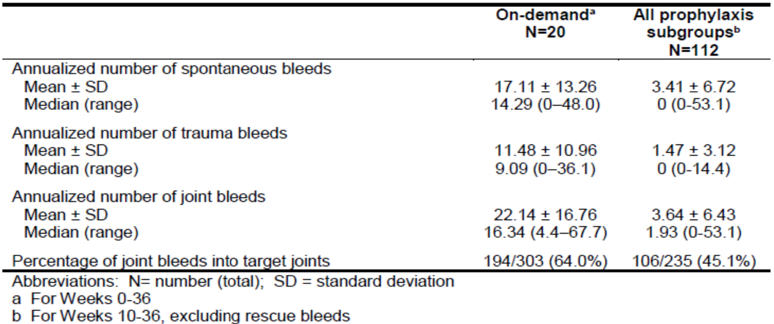
Patients identified as high bleeders remained on twice per week treatment. High bleeding patients experienced improved bleeding control after their dose was increased to a mean of 38.9 IU/kg. The median ABR for these patients over the 26-week treatment period was 4.1 as compared with 17.4 during the 10-week run-in.
A questionnaire was used to capture the full impact of Jivi and the treatment modalities on the subject’s haemophilia-specific quality of life (Haemo-QoL). Haemo-QoL-A was a haemophilia-specific QoL questionnaire for adults aged 18 years and above. The completion of this questionnaire was scheduled at Baseline, Week 10, and Week 36. Overall scores are high, and in favour of prophylaxis treatment.

Part A extension
The primary objective of the extension study of PROTECT VIII trial was to assess the long-term safety of Jivi over at least 100 accumulated exposure days, with an exposure day being a day in which a patient received administration of Jivi.
Table 10: Study 13024 (PROTECT VIII trial) extension study of Part A Patient disposition
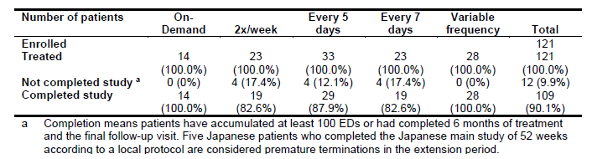
This study had no pre-defined efficacy objectives. However, the sponsor provided data regarding annualised bleed rates, Jivi consumption and other parameters which were consistent with the efficacy results of the main stud of the PROTECT VIII trial. This is a benefit as it provided supportive evidence of the efficacy of Jivi over a longer period of time than in the PROTECT VIII trial alone. In addition, the extension study provided data about patients requiring dose frequency increases.
The majority of the patients in the every 5 days and every 7 days treatment arms stayed in those treatment arms but some patients needed to change to dosing frequency. Those patients were included in the variable dosing arm of the extension phase of the PROTECT VIII trial.
At the start of the extension study, 69% of patients were receiving Jivi every 5 days or every 7 days. By the end of the extension study, 60% of participants were in the Jivi treatment every 5 days or every 7 days arms. 20 patients needed to increase their dose frequency during the extension study, 13 out of 23 (56.5%) patients in the every 7 days arm increased their frequency, with 8 of them moving to the every 5 days arm and the remaining 5 patients moving to the twice per week arm. 7 out of 33 (21.2%) patients in the every 5 days arm at the start of the extension study increased frequency to twice weekly by the end. 15 out of 23 (65.5%) patients in the every 7 days arm had bleeding events during the extension period. In other words, 78% of patients who began the extension study in the every 5 days arm finished in the same arm. 65% of patients who began the extension study in the every 7 days arm finished in the same arm. Patients in the variable treatment arm in the extension phase had switched dosing intervals during the extension phase.
Table 11: Study 13024 (PROTECT VIII trial) extension study of Part A Annualised number of bleeds in patients receiving Jivi prophylaxis
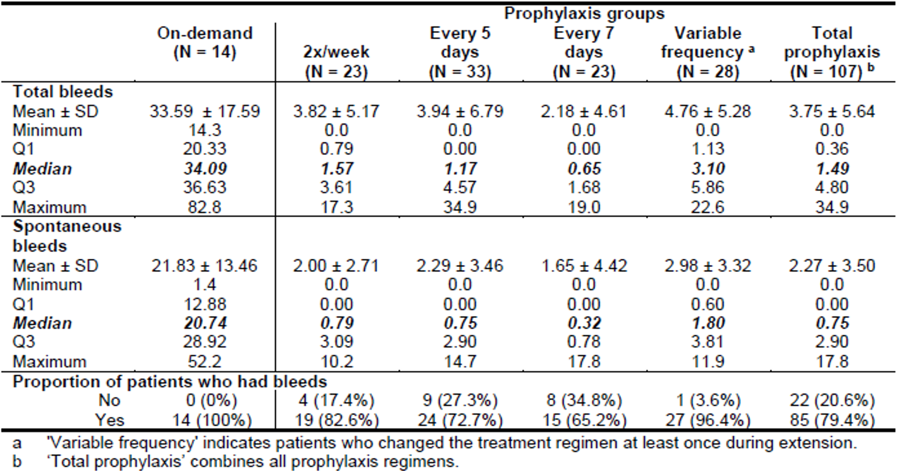
Abbreviations: N = number of subjects; SD= standard deviation.
Table 12: Study 13024 (PROTECT VIII trial) extension study of Part A Jivi consumption (intention-to-treat population)
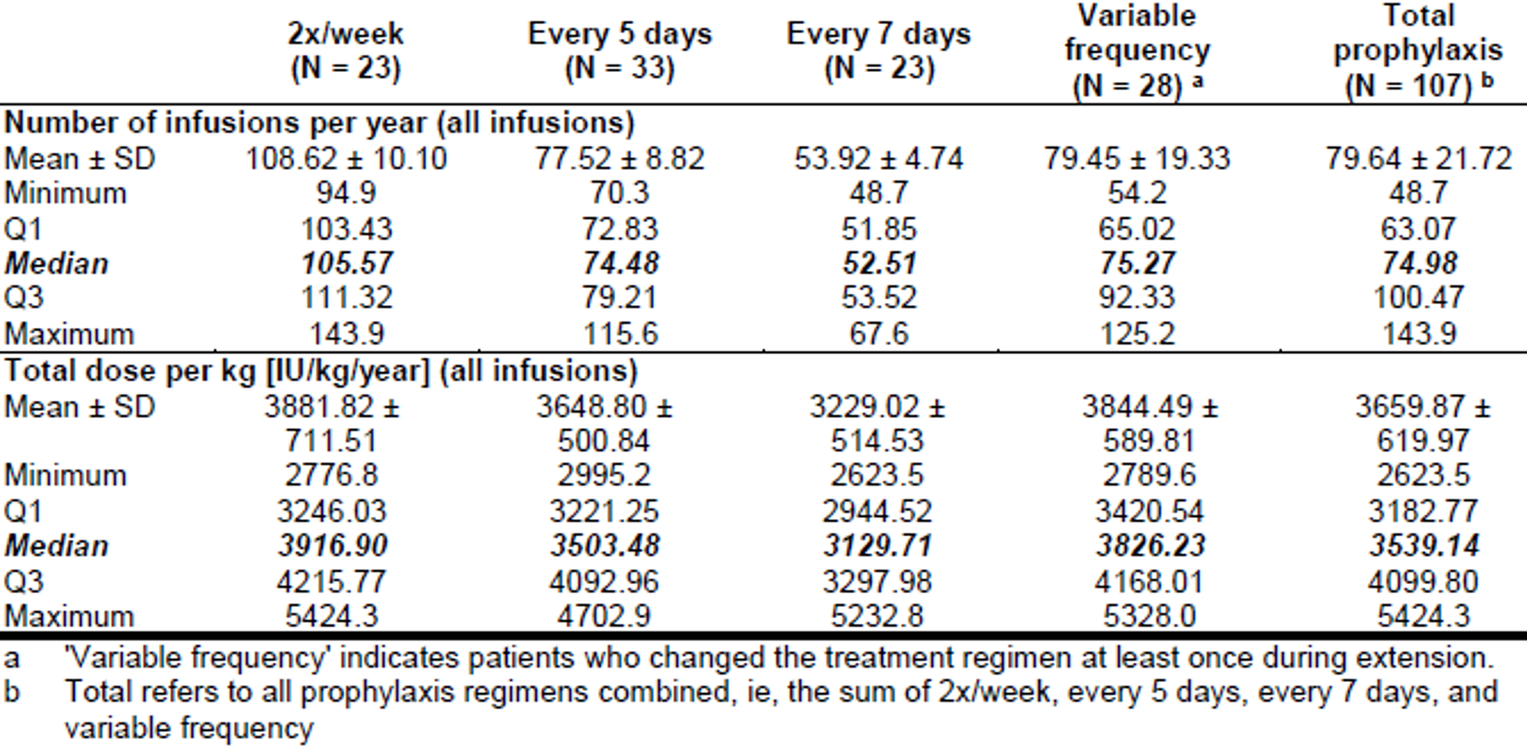
Abbreviations: N = number of subjects; SD= standard deviation.

Part B results
Seventeen patients (Part B ITT population) were included in the efficacy assessment of Jivi during 20 major surgeries. Fifteen (88.2%) were White, all were male, median age was 37 years (range: 13 to 61 years), median weight of 77.7 kg (range: 46 to 99 kg), and median BMI of 25.3 kg/m² (range: 18 to 31 kg/m²).
Twenty-one patients successfully underwent 24 major surgeries in Part B of the main (14 patients with 17 surgeries) or extension study (7 patients with 9 surgeries) using Jivi for haemostasis. In the main study for Part B Jivi pre-surgery doses administered ranged between 2000 and 5000 IU (36.36 IU/kg to 57.14 IU/kg). The median total dose of all infusions for major surgeries was 22710.0 IU with a median total dose of 260.8 IU/kg.
Table 13: Study 13024 (PROTECT VIII trial) main study of Part B Listing of major surgeries (intention-to-treat population)
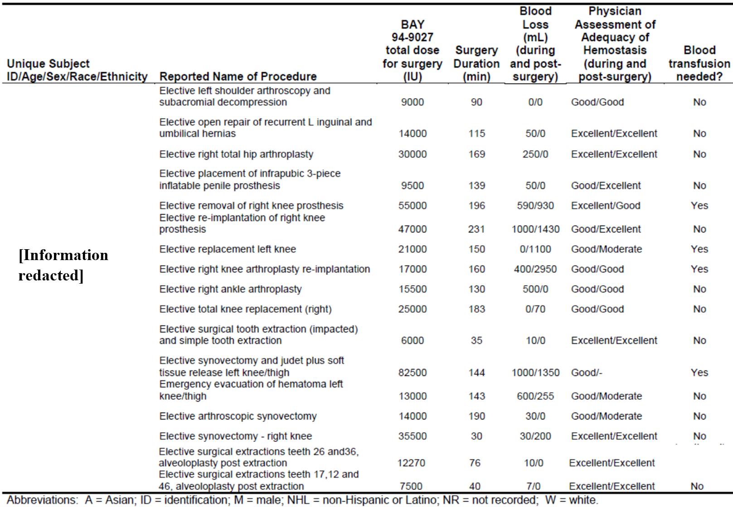
Table 14: Study 13024 (PROTECT VIII trial) extension study of Part B Major surgeries (intention-to-treat population)
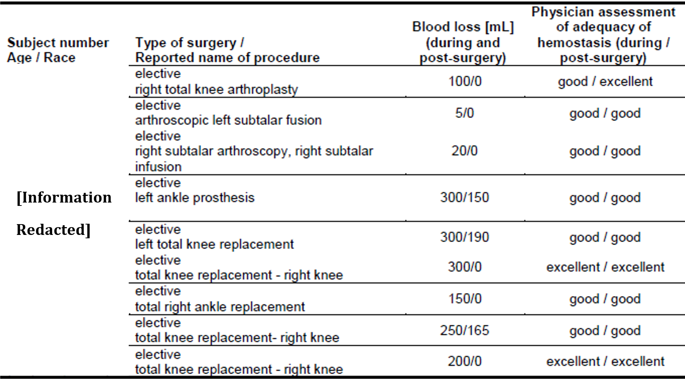
A total of 34 minor surgeries performed in 19 patients were reported during Part A of the PROTECT VIII trial main or interim extension study. More than half of these surgeries were dental extractions or other dental procedures. No patient required blood transfusions.

Extension results

Part A
A total of 109 out of 121 (90.1%) patients completed treatment in the extension, that is, 95 (88.8%) patients in the prophylaxis group and 14 (100%) in the on-demand group. Median treatment duration was 3.2 years, range 0.1 to 6.3 years (reference to the safety update in January 2018). Twenty-three patients were treated twice per week, 33 patients every 5 days, 23 patients every 7 days during total time in the extension study and 28 patients changed treatment regimen. The median dose for prophylaxis was 47.8 IU/kg. The overall median (first Quartile (Q1); third quartile (Q3)) total ABR was 1.49 (0.4; 4.8) and 0.75 (0.0: 2.9) for spontaneous bleeds in the combined prophylaxis groups and total ABR was 34.1 in the on-demand group.

Part B
During the extension phase period of the PROTECT VIII trial, 7 patients had 9 major surgeries, all of which were orthopaedic. Treatment with Jivi provided ‘good’ or ‘excellent’ haemostatic control during all major surgeries. Blood loss was within expected ranges, and none of the patients received blood transfusions. These results were consistent with the findings of the main study.

Study 15912 (PROTECT KIDS trial)
Study 15912 (also known as the PROTECT KIDS trial) is a Phase III multicentre, open label, uncontrolled study to assess the PK, efficacy, and safety of treatment with Jivi for prophylaxis and treatment of bleeds in previously treated children with severe haemophilia A (less than 12 years of age and at least 50 prior ED with any FVIII concentrate). The study was conducted at 31 study centres in 13 countries and commenced in May 2013.
The study consisted of at least 6 months of prophylactic treatment (or the amount of time required for a subject to accumulate a minimum of 50 ED) with Jivi in young PTPs. All patients were treated on a regular schedule, with infusion at least once every 7 days. Doses and dose intervals (2 times weekly, every 5 days, or every 7 days) were determined by the subject’s clinical need, level of activity, and known past bleeding history and may have been adjusted as needed. Jivi was also used for treatment of any breakthrough bleeding events.
All patients completing the main study were offered participation in an optional extension study for collection of observations for at least 50 additional ED. Patients continued to be monitored for inhibitor development every 6 months (±1 week) and at the end of the study.
The main study portion of this clinical trial enrolled patients less than 12 years of age with severe haemophilia A (FVIII less than 1%) and at least 50 prior ED. A total of 61 patients (32 in the age group 0 to less than 6 years and 29 in the age group 6 to less than 12 years) met the inclusion criteria and started treatment. Patients were treated prophylactically with Jivi on a regular schedule, for a minimum of 50 ED, with infusions at least once every 7 days. Doses and dose intervals (twice per week, every 5 days, or every 7 days) were selected by the investigator and may have been adjusted as needed. Investigators were encouraged to start with the least frequent treatment regimen that was clinically appropriate for the subject on the basis of past history, prior treatment, individual PK, observed or known bleeding frequency, activity level, ease of venous access, and other clinical variables. Jivi was also used for treatment of any breakthrough bleeding events.
Fifty-one of the 60 patients remained at the assigned dose frequency during the study. Nine patients changed their dose frequency at least once during the study. This subgroup of 9 patients (15% of total population) accounted for 40 (28%) of the total 140 bleeds. 8 out of 15 (53%) patients assigned to every 7-day infusion increased their dose frequency. One subject, previously on every 5 days, switched to every 7-day infusion.
At the end of the study, 20 patients were treated twice per week, 32 patients treated every 5 days, and 8 patients every 7 days. Fifteen (25%) patients who received prophylaxis treatment across all regimens had zero bleeds.
The ABR was strongly influenced by the 8 patients treated every 7 days who increased their dose frequency. Four of the patients (7%) accounted for 21% of all bleeds in the study. Six patients changed their treatment to every 5 days, and 2 patients to twice per week. All experienced improved bleeding control after a change to a more frequent dosing schedule.
Jivi was effective for the treatment of bleeds with approximately 92% of bleeds effectively treated with one to two infusions.
Extension results: 61 patients completed the main study or Part 2 of the PROTECT KIDS trial and 59 of them entered the extension study. Of these 32 were less than 6 years of age and 27 patients were 6 to less than 12 years old when they were originally enrolled in the main study or Part 2. The last subject visit for the extension study was in February 2020.
The total median duration of the extension study per subject was approximately 5.0 years (range: approximately. 0.4 to 5.9 years), during which the patients in the age group less than 6 years accumulated a median of 354.5 ED (range: 42 to 597 ED) and the patients in the age group 6 to less than 12 years 424 ED (range: 210 to 612 ED). In terms of FVIII consumption during the extension period the median annual consumption per subject in the age group less than 6 years and 6 to less than 12 years were 4239.0 IU/kg/year and 3942.1 IU/kg/year, respectively. The median number of infusions per year in total was 77.5 (less than 6 years old: 76.1; 6 to less than 12 years: 84.6).
Fifty-seven patients completed the extension study, the two who discontinued were both in the less than 6-year-old age group. One discontinued due to a serious adverse event (SAE) and one due to another reason.
At the start of the extension study, 64% of patients were in the every 5 days or every 7 days arms. By the end of the extension study, 51% of patients were in the every 5 days or every 7 days arms. 8 patients had permanently increased their dose frequency to twice weekly. Also, one patient had decreased frequency from every 5 days to every 7 days. No formal efficacy analysis was performed. For all dose groups the median ABR was 1.64 with most bleeding events associated with trauma.
During the extension study period, 14 patients had 17 minor surgeries and there were no major surgeries. Most surgeries related to dental procedures. In 16 of the surgeries, the haemostatic control was considered ‘good’ or ‘excellent’. These results were consistent with the results from the main study.

Safety
The major clinical safety issues attributed to Jivi are the immune response to PEG and its associated loss of efficacy and hypersensitivity reactions.
Safety data was available from the 3 studies in the initial submission to the EMA, from 2 additional comparative PK studies and from the extensions to the PROTECT VIII and PROTECT KIDS trials. There was no integrated safety summary, instead there was safety summary for the initial submission to the EMA, safety addendums for the additional studies and study extensions and 4 periodic safety update reports (PSURs) containing safety information. The median time in the PROTECT VIII extension study was 3.2 years. The median time in the PROTECT KIDS extension study was 5 years.
Approximately 300 patients have been enrolled in company-sponsored interventional clinical trials with Jivi up to the data lock point (DLP) of the most recent PSUR (August 2020). The number of vials sold since marketing authorisation represent a cumulative estimated exposure of 705 patient years up to the August 2020.
In the summary of clinical safety treatment groups from individual studies are combined in one treatment group for the safety analysis irrespective of the dose or frequency and regimen (on-demand or prophylaxis) with ADRs reported in patients grouped by age (less than 12 years, and 12 years and older). A total of 184 adverse events were reported in 148 (83.1%) and 73 (83.6%) of the patients 12 years and older, and less than 12 years of age, respectively. Those events are summarised in Table 15 and Table 16 below. The clinical evaluation didn’t raise new issues of concern regarding the safety results from the extension phases.
Table 15: Studies 13401, Study 13024 (PROTECT VIII trial) and Study 15912 (PROTECT KIDS trial) Overall summary of treatment-emergent adverse events (safety analysis sets)
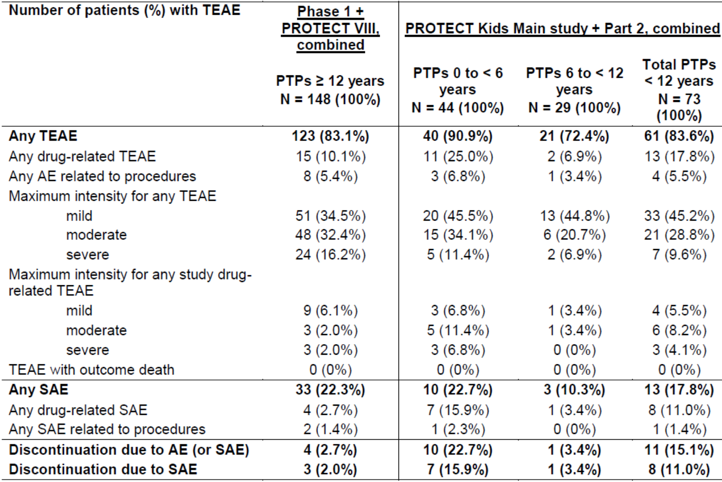
Abbreviations: AE = adverse event; N = number of subjects; PTP = previously treated patient(s); SAE = serious adverse event; TEAE = treatment-emergent adverse event.

Table 16: Number of patients with most common treatment-emergent adverse events (all System Organ Classes, by Preferred Terms if at least 3 patients in any of the total populations) (safety analysis sets)
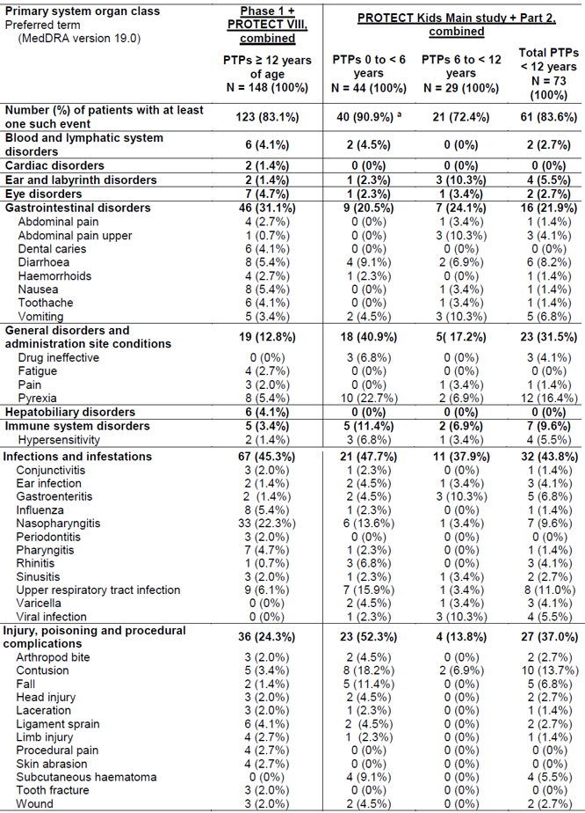

Table 16 continued: Number of patients with most common Treatment-emergent adverse events (all System Organ Classes, by Preferred Terms if at least 3 patients in any of the total populations) (safety analysis sets)
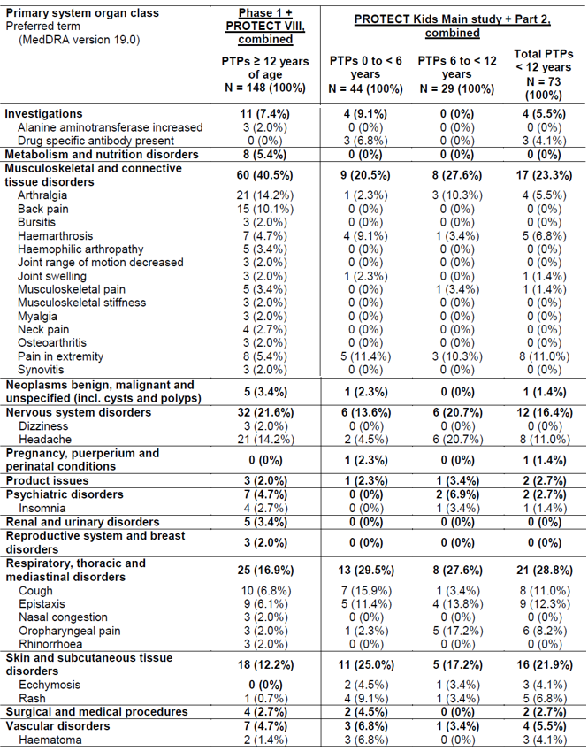
Abbreviations: MedDRA = Medical Dictionary for Regulatory Activities; N = number of subjects; PTP = previously treated patient(s).
a One adverse event in the group less than 6 years of age was uncoded.
Note: Treatment-emergent adverse events are sorted in alphabetical order by primary System Organ Class (SOC) and Preferred Term (PT). A patient is counted only once within each PT or any primary SOC.
With the exception of immune response to PEG and its associated loss of efficacy and hypersensitivity reactions in children, most adverse events were of mild severity and considered unrelated to Jivi. The nature and frequency of adverse events does not give rise to concern and do not reveal unexpected safety signals. Fifteen (10.1%) patients 12 years and older reported adverse events which were considered possibly or probably related to Jivi. Of these, the cases of overdose and pelvic haemorrhage were classified as SAEs. The pelvic haemorrhage occurred in the course of the Phase I study, 6 days after the last Jivi dose. Among PTPs less than 12 years of age, 13 patients had TEAEs classified as drug-related, 11 patients less than 6 years (25.0%) and 2 patients 6 to less than 12 years of age (6.9%).
The most frequently reported adverse reactions in clinical trials in PTPs were headache, cough and pyrexia. The most common adverse events were the following: hypersensitivity, insomnia, headache, dizziness, cough, abdominal pain, nausea, vomiting, erythema, rash, infusion site reactions and pyrexia. Hypersensitivity events were more frequent in children and led to study discontinuation of 4 children.
There were no thromboembolic events and no deaths reported during the clinical development program.
Hypersensitivity and loss of efficacy were designated as events of special interest.

Anti-PEG antibodies
In the PROTECT KIDS trial loss of efficacy (LoE) was defined as adverse events (AEs) of special interest. Anti-drug-antibody (ADA) and FVIII inhibitor testing were also obtained. For a total of 8 patients (all less than 6 years of age), LoE was associated with SAE reporting or was reported as AE of special interest. All of them dropped-out of the study. First symptoms of LoE were observed as bruising or hematoma not responsive to treatment with Jivi and occurred in all these patients during the first 4 exposures to Jivi. No life-threatening bleeds were reported. In patients with a sample following infusion of Jivi, an unexpected low recovery was measured. In all cases, testing for a FVIII inhibitor was negative and all patients could be treated effectively with another FVIII product.
An additional assessment of LoE looking at post-infusion Jivi recovery revealed 3 additional patients who withdrew due to hypersensitivity reactions. All of them were less than 6 years old. ADAs against PEG and neutralising anti-damoctocog alfa pegol antibodies were detected in these patients.
Overall, no PTPs 6 years of age or above experienced clinical LoE. LoE was only observed in the age group less than 6 years and was related to ADAs against PEG (anti-PEG IgM) which developed within the first 4 ED resulting in a low recovery or no detectable activity after the infusion of Jivi. LoE was not observed at any later time points during the main study or extension study. Clinical observations included unexpected bleeding, mainly bruising, or no response to treatment of bleeds. Anti-PEG IgM antibody titres and/or positive results for neutralising anti-damoctocog alfa pegol antibodies were detected in 10 of the 11 patients with signs or symptoms of LoE. Some of these patients had pre-existing anti-PEG IgM antibodies, but pre-existing anti-PEG antibodies did not predict this reaction. It can be concluded, that the LoE was related to neutralising anti-PEG IgM antibodies which developed or increased in case of pre-existing antibodies in all patients within the first 4 ED. The efficacy of the patient’s previous product was not affected. All patients returned to their previous FVIII treatment without any problems.

Patients with pre-existing antibodies
A patient with pre-existing antibody was defined as a patient with a positive measurement at Baseline or screening for either damoctocog alfa pegol antibody, damoctocog alfa pegol neutralising antibodies, PEG antibody or PEG IgM antibody. Results of at least 0.6 BU/mL for damoctocog alfa pegol neutralising antibodies were considered positive.
Pre-existing ADAs were detected in 21 patients, 4 PTPs 12 years and older, and 17 PTPs less than 12 years old. Antibodies were mainly related to PEG. The type of antibodies was IgM. Besides age, no other relevant differences regarding demography and baseline disease characteristics were noticed between patients with or without ADAs prior to treatment. Pre-existing anti-PEG antibodies were associated with a high incidence of hypersensitivity reactions leading to discontinuation. Nevertheless, pre-existing anti-PEG antibodies were not predictive of a clinical reaction, but may have contributed to an increase of the risk of a PEG related immune response which presented as hypersensitivity and/or LoE.
The number of patients with positive findings for ADAs at Baseline was higher for PTPs less than 12 years of age as compared with PTPs 12 years of age and older. The highest frequency of positive ADA findings at Baseline was reported for PTPs less than 6 years (31.8% of 32 patients). For most patients anti-PEG IgM (27.3% in children less than 6 years) could be identified as antibody type. The frequency of ADA decreased to 10.3% in children 6 to less than 12 years of age.
Based on the combined analysis of the PROTECT KIDS main study and Part 2, there were 17 PTPs less than 12 years of age with pre-existing ADAs, 14 patients less than 6 years of age and 3 patients 6 to less than 12 years of age, indicating a trend towards more patients with pre-existing ADAs in the younger group. Besides age, no other relevant differences regarding demography, and baseline disease characteristics were noticed between patients with or without ADAs prior to treatment. The frequency of drug-related TEAEs and AEs or SAEs leading to discontinuation was noticeably higher in patients with pre-existing ADAs. In particular, the frequency of the PTs pyrexia (29.4% versus 12.5%), drug ineffective (11.8% versus 1.8%), hypersensitivity (17.6% versus 1.8%), upper respiratory tract infection (23.5% versus 7.1%), contusion (29.4% versus 8.9%), cough (23.5% versus 7.1%) was higher for patients with pre-existing ADAs compared to those without, whereas the frequency of rash was lower (0% versus 8.9%).
There were only 4 PTPs 12 years and older with positive ADA findings prior to start of treatment: one 19-year-old (White), one 14-year-old (White) and one 15-year-old (White) patients had positive PEG IgM antibodies at Baseline. One 15-year-old (Asian) patient was positive for damoctocog alfa pegol antibodies at Baseline (damoctocog alfa pegol neutralising antibody assay being less than 0.6 BU/mL). The patient had also very low titre positive FVIII inhibitor results (0.2 to 0.3 BU/mL). Both antibody testings were negative at the end of the study.
Except for the 19-year-old (White) patient with drug hypersensitivity reported as drug-related SAE, leading to discontinuation, the AE profile of the other three patients did not reveal any safety concerns as compared to the group of patients without pre-existing antibody findings. No differences in baseline disease characteristics or medical history were noticed between the populations.
In patients without a clinical reaction, pre-existing anti-PEG antibodies disappeared despite continued exposure. Also patients who discontinued Jivi treatment after an increase of antibody titre associated with the clinical reaction demonstrated a decrease of antibodies or disappearance at the final visit. No AEs of special interest were reported after discontinuation of Jivi. No anti-PEG IgG antibodies were induced indicating no long-term immune memory was observed.

Neutralising antibodies to Factor VIII
Neutralising antibodies (inhibitors) to Factor VIII is a known complication in the management of individuals with haemophilia A. These inhibitors are usually IgG immunoglobulins directed against the Factor VIII procoagulant activity. The risk of developing inhibitors is correlated to the severity of the disease as well as the exposure to FVIII, this risk being highest within the first 50 ED but continues throughout life although the risk is uncommon.
The clinical relevance of inhibitor development depends on the titre of the inhibitor, with low titre posing less of a risk of insufficient clinical response than high titre inhibitors.
In PTPs 12 years of age and older, no patients had confirmed positive FVIII inhibitor results above the limit for positivity (at least 0.6 BU/mL) during the Phase I, PROTECT VIII main or its extension. There were two patients in Part B of the PROTECT VIII main study (patients with major surgery) who had low titre FVIII inhibitor antibodies (less than 5 BU/mL; reported as drug-related SAEs. One of these cases was not confirmed. No PTP less than 12 years of age developed confirmed FVIII inhibitor during the PROTECT KIDS main study or in its extension.

Risk management plan
The sponsor has submitted EU-risk management plan (RMP) version 2.1 (dated 17 June 2021; DLP 2 December 2020) and Australia specific annex (ASA) version 1.0 (dated 3 February 2022) in support of this application.
The summary of safety concerns and their associated risk monitoring and mitigation strategies are summarised in Table 17. The TGA may request an updated RMP at any stage of a product's life-cycle, during both the pre-approval and post-approval phases.
Table 17: Summary of safety concerns
Summary of safety concerns |  | Pharmacovigilance |  | Risk minimisation
 |  | Routine | Additional | Routine | Additional
Important identified risks | Development of Factor VIII inhibitors | * | §ǁ |  | –
Important identified risks | Hypersensitivity reactions | * | §ǁ |  | –
Important identified risks | Loss of efficacy associated with anti-PEG antibodies | * | ǁ |  | –
Important potential risks | Off-label use | † | – |  | –
Important potential risks | Long-term potential effects of PEG accumulation in the choroid plexus of the brain and other tissues/organs | * | ‡§ |  | –
Important potential risks | Thromboembolic events |  | – |  | –
Missing information | Use in patients with severe hepatic impairment |  | § | – | –
Missing information | Use in patients with renal insufficiency | * | § | – | –
Missing information | Use in elderly patients over 65 years of age |  | – |  | –
Missing information | Safety profile in women including pregnancy and lactation |  | – |  | –
*Follow-up questionnaires
† Collection and assessment of reports of off-label use
‡ Multinational PASS
§ European Haemophilia Safety Surveillance (EUHASS) registry
ǁ Interventional post-marketing study
The summary of safety concerns is acceptable from an RMP perspective.
Pharmacovigilance activities have been proposed. Routine pharmacovigilance includes follow-up questionnaires for the following: hypersensitivity, renal impairment, neurocognitive disorders and potential loss of efficacy or loss of drug effect reported. Off-label use will be reported on separately. Additional pharmacovigilance activities include multinational PASS, an interventional post marketing study and a European Haemophilia Safety Surveillance (EUHASS) registry. The pharmacovigilance plan is acceptable.
Routine risk minimisation activities only have been proposed. The sponsor has addressed the recommendations regarding the CMI in its response to questions raised by the TGA.

Risk-benefit analysis

Delegate’s considerations
The PK data presented on the whole was skewed towards prophylaxis treatment rather than on-demand treatment. Pharmacokinetics assessment in the pivotal study (Study13024, also known as the PROTECT VIII trial) was focused on demonstrating a longer apparent terminal elimination half-life for Jivi versus Kogenate FS (octocog alpha) (17 versus 13 hours). The sponsor has stated that Jivi was developed to reduce the number of doses of rFVIII required. In comparison with other registered rFVIII products Jivi has a similar dose regimen for routine prophylaxis to Eloctate (efmoroctocog alfa) with regimens allowing for up to 7-day dose intervals. Adynovate (rurioctocog alfa pegol) allows for up to 4 days between prophylactic doses and Xyntha (moroctocog alfa) 2 to 3 days.
Multiple dose PK data suggests minimal Jivi accumulation following once weekly dosing over 6 months. The twice weekly dose showed 1.3 times Jivi accumulation which could have implications for more frequent dose regimes. The PK data did not address accumulation of PEGylated products. From animal studies, there is a possible risk of accumulation of PEG causing vacuolation in tissues such as in the brain structures and kidney as seen in animal studies. The implication of this finding in humans is unclear.
The PK data by age stratification showed decreased apparent terminal elimination half-life for children less than 12 years. As noted by the clinical evaluation, there were only 3 patients aged between 12 to 18 years (n = 3) which may make the PK result in that age range prone to type II error.
During the PROTECT VIII trial, the doses per injection were within the pre-specified ranges of each regimen for the majority of patients. All dose regimens, including every 7 days dosing, achieved good bleeding control with median ABRs approximately one to two bleeds per year for patients who stayed in their regimen, however 11 out of 43 (25%) patients randomised to every 7-day dosing required more frequent dosing to reduce bleeding events. In the PROTECT VIII trial, the target rate of 50% response for prophylactic treatment was achieved overall, so the pre-specified efficacy objective was achieved. Comparisons between different prophylaxis regimes are difficult to interpret as allocation to groups was generally systematic rather than randomised. As expected, the annualised bleeding rate (ABR) was much lower for patients who opted for prophylactic treatment than those who opted for on-demand treatment.
In the extension phase of PROTECT VIII trial, a further 13 of 23 (56.5%) patients who continued in the 7-day dose group required dosing change. This suggests that a large proportion of patients with severe haemophilia A will not be able to stabilise on or maintain every 7-day dosing. Similar poor control was seen in the PROTECT KIDS trial every 7 days treatment group with over half the children requiring more frequent dosing due to bleeding events.
In Part B of the PROTECT VIII trial, Jivi was effective in the treatment of bleeding events and the control of bleeding in patients undergoing major surgery using the regimens proposed.
The overall bleeding control results are comparable to other studies of rFVIII and are in the range of the expected bleed rate with prophylaxis treatment. Of the available rFVIII products none actively recommend an every 7-days dose regimen, though statements that allow for adjustment of dosing amount and frequency of dosing of various rFVIII products are in the various PIs. Given the very common requirement for dose frequency reduction in the PROTECT VIII trial in the every 7 days dosing group, occurring in a group who had initially been selected as able to have excellent control on a twice weekly regimen, I’m reluctant to include the every 7 day regimen as a recommended regimen for patients with severe haemophilia A. It may be suitable for patients with mild or moderate haemophilia A however there are no data to support that use of Jivi. Specialist advice is requested on that issue.
The major safety issues for Jivi are hypersensitivity and loss of efficacy associated with anti-PEG antibodies in patients aged less than 12 years. Mitigation of these effects has been achieved by not indicating use of Jivi in patients aged less than 12 years. Three post-market study commitments have been agreed between the EMA and the sponsor, as described in the RMP evaluation. These studies will provide long term safety and immunogenicity data and an exploration of the potential effects of accumulation of PEG in the choroid plexus of the brain and other tissues or organs. The provision of reports of these studies to the TGA should be conditions of registration.

Proposed action
Following consideration of the independent expert advice, the Delegate is of the view that Jivi should be approved for the following indication:
Jivi, damoctocog alfa pegol, is a long-acting recombinant Factor VIII concentrate indicated for use in previously treated adults and adolescents (12 years of age and older) with haemophilia A for:
- Routine prophylactic treatment to prevent or reduce the frequency of bleeding episodes
- On-demand treatment and control of bleeding episodes
- Per-operative management of bleeding (surgical prophylaxis)
Jivi does not contain von Willebrand factor, and therefore is not indicated in patients with von Willebrand’s disease.

Independent expert advice
The Delegate received the following independent expert advice.
- Do you consider prescribers would benefit from a statement in the indications that Jivi is a rFVIII or a long-acting rFVIII?
Damoctocog alfa pegol (Jivi) is a site specifically PEGylated, B-domain deleted recombinant human coagulation Factor VIII. These molecular modifications to the native protein structure have the effect of increasing FVIII stability and reducing clearance respectively, supported by pharmacokinetic data which demonstrate a terminal half-life that is 1.4 -fold longer and has a dose normalised AUC which is 1.4-fold higher when compared to a native FVIII product. This is an advantage over short half-life products such as earlier generation rFVIII products, as it offers significant clinical improvements particularly in the treatment of acute bleeding episodes, for example in reducing the need for follow-up monitoring and further infusions after a bleeding episode, and in perioperative management, where infusion frequency and monitoring can be reduced, with the promise of smoother control with higher trough levels. It is likely that, given ready availability under national supply arrangements, long-acting FVIII products will largely replace earlier generation shorter acting rFVIII products for almost all indications where a rFVIII preparation is indicated.
For these reasons, it is my view that Jivi is best described as a long-acting rFVIII to distinguish it from other earlier generation rFVIII products, and this would have the added advantage of signalling to clinicians that modified dosage and/or intervals are required.
- Do you consider that readability of the indication is improved by separating specific uses of Jivi such as control and prevention of bleeding episodes, routine prophylaxis and peri-operative management?
The independent expert believes it would materially improve the usefulness and readability of the PI to separate the indications for Jivi into the suggested subheadings of control and prevention of bleeding episodes, routine prophylaxis and peri-operative management, maintaining the same divisions for dosing recommendations.
- Given the relatively high proportion of patients in the pivotal study for this submission requiring an increase in dose frequency from the every 7 days dosing interval do you consider that a 7 day interval should be specifically included in the dosing recommendations for Jivi?
The data from the PROTECT VIII trial and extension suggests that a majority of patients who began prophylactic therapy at a 7-day dosing interval will eventually require more frequent dosing to reduce bleeding events. Dose frequency is particularly important in prophylactic therapy, and even a modest decrease in frequency of intravenous infusions can have a major impact on the burden of patient treatment, compliance and the need for vascular access devices with their concomitant risks of infection and thrombosis. As noted in answers for question 2 above, the vast majority of patients on prophylactic therapy for haemophilia A will now receive emicizumab as the treatment of choice, and prophylaxis with rFVIII products will be restricted to a very small group of patients who cannot tolerate or for other reasons cannot use emicizumab.
Nonetheless, maintaining the longest effective dose interval remains important for this group of patients, and it is therefore appropriate to maintain information regarding the possibility of a 7-day dosing interval in the PI, perhaps accompanied by specific advice regarding the likelihood that in the majority of patients this may not prove therapeutically optimal, and urging appropriate clinical and laboratory monitoring following institution of therapy to individualise treatment as necessary. Patients who are not good candidates for an extended dosing interval were identified during the 10-week run-in period as those who experienced more than one breakthrough bleed (defined as joint or muscle bleeds and no identified trauma), and were not randomised to the more extended dosing intervals during the study. Indeed, in this group, dosing was increased from 25 IU/kg to 30 to 40 IU/kg and continued twice weekly. It may be useful to ensure the PI is clear that all patients should initially begin on a twice weekly prophylaxis regimen for a run-in period of 10 weeks, and only transition to more extended dosing if good bleed control (less than or equal to one breakthrough bleed during the run-in period) is achieved.
The importance of individualising treatment according to the patient’s bleeding history is emphasised in the paper reporting the pivotal study, which also notes that Jivi ‘administered every 7 days provided effective prophylaxis for the majority of patients randomised to that treatment arm’. Almost three-quarters of the patients randomised to every-7-days treatment remained in the treatment group for the duration of the study, and these 32 patients had a low median ABR of 0.96 (comparable to the every-5-days arm). Eleven patients left the every-7-days arm because of inadequate bleed control, the majority of which transitioned to every-5-days prophylaxis, with substantial improvement in ABR. Again, it may be worth ensuring the PI recommends phenotype-guided dosing based on the overall bleeding pattern in each individual patient as part of the dosing recommendations for prophylactic therapy.
- Is the every 7 days regimen likely to be an acceptable alternative to on-demand treatment for patients who refuse more frequent dosing?
As noted above, prophylaxis with rFVIII products is likely to be restricted to a very small group of patients who cannot tolerate or for other reasons cannot use emicizumab. However, one consequence of the widespread use of emicizumab is that this is also likely to be a cohort of patients who have much reduced self-cannulation skills, and whose carers may also have not learned to cannulate. For this group of patients, reduced intravenous infusion frequencies will be very important in promoting adherence to prophylaxis with long-acting rFVIII products, as well as minimising the use of other health-care resources such as haemophilia nurses and ED.
Should a patient refuse to dose more frequently than every-7-days, the data from the pivotal and extension studies suggests that although control may be suboptimal, it will still provide a measure of bleed reduction which is significantly better than on-demand therapy, with concomitant improvement in long-term effects of repeated bleeds. Although the independent expert would not regard such therapy as desirable, it could be argued that it may be better than returning to on-demand therapy.
- Would the every 7 day regimen be suitable for patients with less severe haemophilia A? If so what statement should be provided in the PI to indicate the lack of assessment of Jivi in that patient group?
Although FVIII levels and PK parameters have an association with bleeding risk, many others factors are involved in determining an individual’s pattern of bleeding. Patients with less severe haemophilia are a priori at much lower risk of severe and recurrent bleeding episodes than those with severe disease. These patients have greater than 1% endogenous FVIII levels, and would therefore be expected to attain and maintain higher trough FVIII levels with extended interval prophylaxis dosing, and may be particularly suitable for extended dosing. This view is supported by data from the series of studies of tailored prophylactic therapy with long follow-up published by the Canadian Hemophilia Primary Prophylaxis Study group, which demonstrated that some patients have few bleeds even with once-weekly prophylaxis using a standard half-life FVIII product. It would therefore be reasonable to include a statement to the effect that such patients with less severe haemophilia A who require prophylactic therapy because of a history of more frequent or severe bleeding, may be particularly good candidates for consideration of reduction of prophylactic dosing frequency to every-7-days following a run-in period as described above.

Advisory Committee considerations
The Delegate did not refer this submission to the Advisory Committee on Medicines (ACM) for advice.

Outcome
Based on a review of quality, safety, and efficacy, the TGA approved the registration of Jivi (damoctocog alfa pegol) powder for injection and diluent for injection, vial and prefilled syringe, indicated for
Jivi, damoctocog alfa pegol, is a long-acting recombinant Factor VIII concentrate indicated for use in previously treated adults and adolescents (12 years of age and older) with haemophilia A for:
- Routine prophylactic treatment to prevent or reduce the frequency of bleeding episodes
- On-demand treatment and control of bleeding episodes
- Per-operative management of bleeding (surgical prophylaxis)
Jivi does not contain von Willebrand factor, and therefore is not indicated in patients with von Willebrand’s disease.

Specific conditions of registration applying to these goods
- Jivi (damoctocog alfa pegol) is to be included in the Black Triangle Scheme. The PI and CMI for Jivi must include the black triangle symbol and mandatory accompanying text for five years, which starts from the date that the sponsor notifies the TGA of supply of the product.
- The Jivi EU-risk management plan (RMP) (version 2.1, dated 17 June 2021, data lock point 2 December 2020), with Australian specific annex (version 1.0, dated 3 February 2022), included with Submission PM-2022-00347-1-6, and any subsequent revisions, as agreed with the TGA will be implemented in Australia.
- An obligatory component of risk management plans is routine pharmacovigilance. Routine pharmacovigilance includes the submission of periodic safety update reports (PSURs).
- Reports are to be provided in line with the current published list of EU reference dates and frequency of submission of PSURs until the period covered by such reports is not less than three years from the date of the approval letter.
- The reports are to at least meet the requirements for PSURs as described in the European Medicines Agency’s Guideline on Good Pharmacovigilance Practices (GVP) Module VII-periodic safety update report [Revision 1], Part VII.B Structures and processes. Note that submission of a PSUR does not constitute an application to vary the registration.
- Laboratory testing and compliance with Certified Product Details (CPD)
  - All batches of Jivi damoctocog alfa pegol supplied in Australia must comply with the product details and specifications approved during evaluation and detailed in the Certified Product Details (CPD).
  - When requested by the TGA, the sponsor should be prepared to provide product samples, specified reference materials and documentary evidence to enable the TGA to conduct laboratory testing on the Product. Outcomes of laboratory testing are published biannually in the TGA Database of Laboratory Testing Results http://www.tga.gov.au/ws-labs-index and periodically in testing reports on the TGA website.
- Certified Product Details
The Certified Product Details (CPD), as described in Guidance 7: Certified Product Details of the Australian Regulatory Guidelines for Prescription Medicines (ARGPM), in PDF format, for the above products should be provided upon registration of these therapeutic goods. In addition, an updated CPD should be provided when changes to finished product specifications and test methods are approved in a Category 3 application or notified through a self-assessable change.
- For all injectable products the Product Information must be included with the product as a package insert.

Attachment 1. Product Information
The PI for Jivi approved with the submission which is described in this AusPAR is at Attachment 1. For the most recent PI, please refer to the TGA PI/CMI search facility.

Therapeutic Goods Administration
PO Box 100 Woden ACT 2606 Australia
Email: info@tga.gov.au Phone: 1800 020 653 Fax: 02 6203 1605
https://www.tga.gov.au
Reference/Publication #

This is the original indication proposed by the sponsor when the TGA commenced the evaluation of this submission. It may differ to the final indication approved by the TGA and registered on the Australian Register of Therapeutic Goods.
Australian Haemophilia Centre Directors’ Organisation and National Blood Authority, Australia Guidelines for the Management of Haemophilia in Australia, published on 20 July 2016. Available at: https://www.blood.gov.au/system/files/HaemophiliaGuidelines-interactive-updated-260317v2.pdf.
Xyntha (moroctocog alfa) was first registered on the ARTG on 26 June 2009 (ARTG numbers: 161714, 161715, 161716 and 161717).
Advate (octocog alfa) was first registered on the ARTG on 4 April 2005 (ARTG numbers: 100384, 100385, 100386 and 100387).
Eloctate (efmoroctocog alfa) was first registered on the ARTG on 27 June 2014 (ARTG numbers: 210519, 210520, 210521, 210524 and 210525)
Adynovate (rurioctocog alfa pegol) was first registered on the ARTG on 21 March 2017 (ARTG numbers: 278727, 278728, 278729 and 273517)
Hemlibra (emicizumab) was first registered on the ARTG on 23 February 2018 (ARTG numbers: 293758, 293759, 293760 and 293761).
Srivastava, A. et al. WFH Guidelines for the Management of Hemophilia, 3rd edition, Hemophilia, 2020; 26(Suppl 6): 1-158. DOI: 10.1111/hae.14046.
PEGylation is a biochemical modification process of bioactive molecules with polyethylene glycol (PEG).
'Twice per week failed’ or '2x/week failed’ group denotes subjects with at least two spontaneous bleeds in Weeks 0 to 10 who stayed on twice per week regimen after Week 10 according to the protocol. ‘Twice per week forced’ or '2x/week forced' group denotes subjects with less than two spontaneous bleeds in Weeks 0 to 10 who were forced due to randomisation arm caps to stay on twice per week regimen after Week 10.
The randomised clinical trials analysed by the intention-to-treat (ITT) approach provide unbiased comparisons among the treatment groups. In the ITT population, none of the subjects are excluded, regardless of treatment compliance or attrition due to dropout or crossover, and the subjects are analysed according to the randomisation scheme.
The haemophilia-specific health-related quality of life questionnaire (Haemo-QOL-A) is a questionnaire is validated for detecting quality of life changes of adult patients following standard therapy for haemophilia A, but has not been rigorously evaluated after gene therapy.

