AEMS guidance for sponsors
  - Adverse Event Management System

Version 1.2, November 2023

Copyright
© Commonwealth of Australia 2023
This work is copyright. You may reproduce the whole or part of this work in unaltered form for your own personal use or, if you are part of an organisation, for internal use within your organisation, but only if you or your organisation do not use the reproduction for any commercial purpose and retain this copyright notice and all disclaimer notices as part of that reproduction. Apart from rights to use as permitted by the Copyright Act 1968 or allowed by this copyright notice, all other rights are reserved and you are not allowed to reproduce the whole or any part of this work in any way (electronic or otherwise) without first being given specific written permission from the Commonwealth to do so. Requests and inquiries concerning reproduction and rights are to be sent to the TGA Copyright Officer, Therapeutic Goods Administration, PO Box 100, Woden ACT 2606 or emailed to <tga.copyright@tga.gov.au>.

Confidentiality
All submissions received will be placed on the TGA’s Internet site, unless marked confidential. Any confidential material contained within your submission should be provided under a separate cover and clearly marked “IN CONFIDENCE”. Reasons for a claim to confidentiality must be included in the space provided on the TGA submission form. For submission made by individuals, all personal details, other than your name, will be removed from your submission before it is published on the TGA’s Internet site. In addition, a list of parties making submissions will be published. If you do not wish to be identified with your submission you must specifically request this in the space provided on the submission form.

Contents
Accounts 4
Setup 4
Access 4
Password resets 5
Technical difficulties 6
AEMS reporting dashboard 6
Draft reports 7
Submitted reports 7
Adverse event reporting form 7
Step 1 – Reporter details 7
Step 2 – Case administration details 7
Step 3 – Patient details 8
Step 4 – Product details 8
Step 5 – Reaction details 8
Step 6 – Additional details 8
Step 7 – Summary report 8
Submitting follow-up information 8
Search for adverse events in AEMS portal 9
Perform a search 9
Refine results by report date and modified date range 9
Other search parameters 10
Search results 11
Generate a PCD or CLL report 11
View generated reports 12
Accessing reports submitted via Adverse Drug Reaction System (ADRS) 13

Accounts

Setup
Sponsors can access the Adverse Event Management System (AEMS) using their TGA Business Services (TBS) account.
The TBS account username will be in the following format: 'xxxxx_xxxxx' ('personal identifier '_'organisation ID number'). The number of characters can vary.
If an individual user does not have their own TBS credentials, they will need to get in contact with their organisation's TBS administrator who can create a new user profile.

Access
Once a new user profile has been created, it can be used to access AEMS the next day.
To access AEMS, sponsors can login to the TBS portal and follow the links to the AEMS portal as demonstrated below:
From the top menu bar, select Applications>Adverse Event Reporting>Medicine Adverse Event.
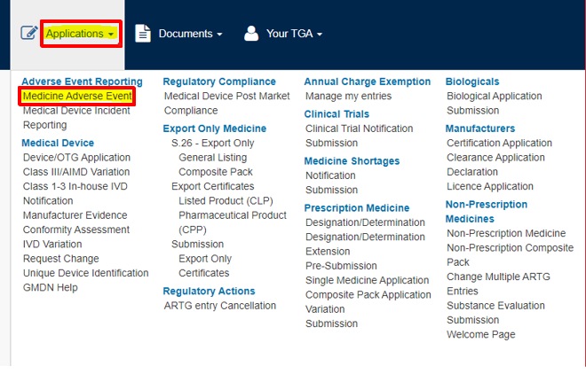
Sponsors can also access the AEMS portal by going directly to the AEMS site and selecting sign in.
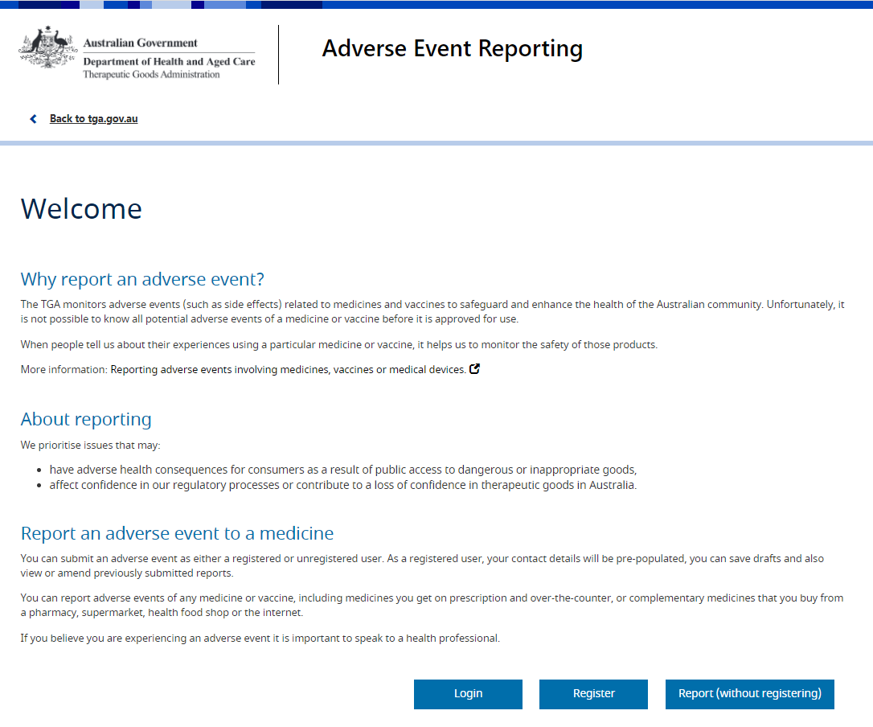

Password resets
AEMS portal passwords will expire every 90 days. After expiry system users will need to reset their password.
If system users need to reset an expired password or have forgotten their password and cannot sign in, they can reset it as follows:
From the login screen, select the ‘Forgotten your password?’ link: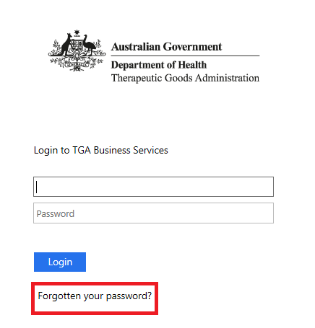
Enter username and select ‘Reset’:
A password reset email will be sent to the email address associated with the account.
Once you receive this email, click the provided link. You will be required to set a new password, and access via the existing password will be revoked.
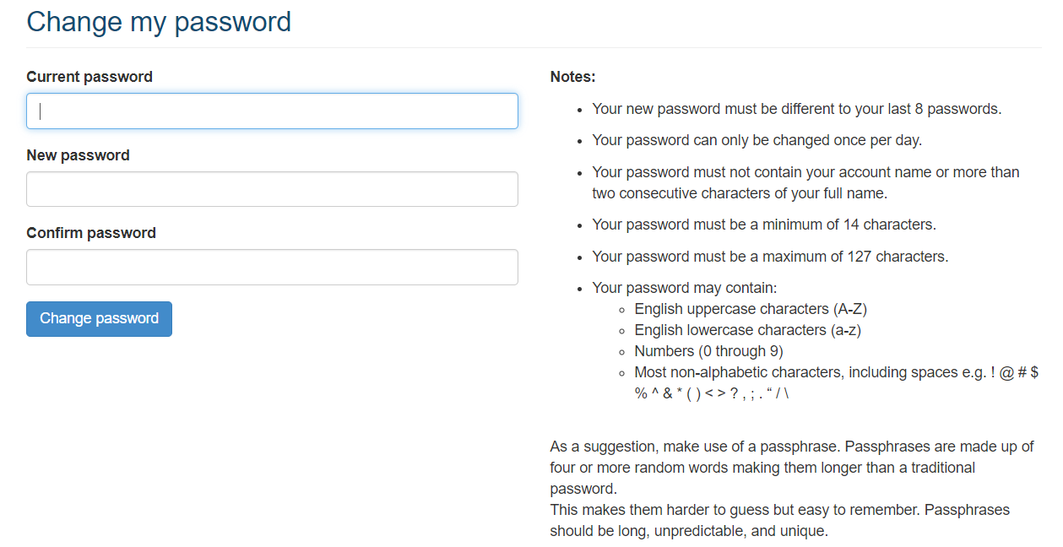

Technical difficulties
If the AEMS portal is unavailable for a period that affects the sponsor’s ability to meet regulatory reporting timeframes, the sponsor must contact the TGA for advice on how to submit their report. In reviewing regulatory reporting timeframe compliance, the TGA will consider relevant periods of unavailability of service and advice given by the TGA to the sponsor.
The TGA will email registered users to notify them that the AEMS portal is not available and then again once it becomes available. The TGA will also advise users, in advance, if the AEMS portal will be unavailable for scheduled maintenance.

AEMS reporting dashboard
All users have a Reporting Dashboard in AEMS that displays information specific to adverse event reports that they, or colleagues within their organisation, have drafted or submitted via the portal. There are two tabs which will display draft reports and submitted reports.
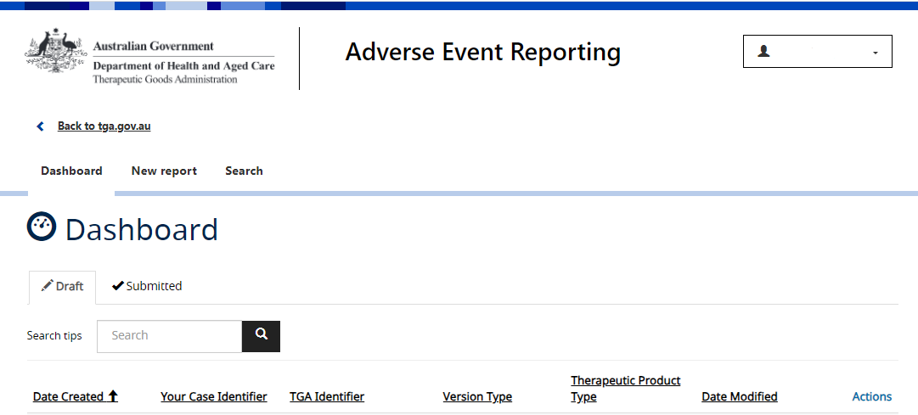

Draft reports
Draft reports are saved when a user has entered information as part of a new adverse event report but has not yet submitted this to the TGA. A draft report can be accessed from the Reporting Dashboard’s ‘Draft’ tab at any point prior to submission.

Submitted reports
All adverse event reports that have been submitted by you or others in your organisation, via the AEMS portal, will appear under the ‘Submitted’ tab. From the ‘Submitted’ tab, users can:
- generate a PDF of an adverse event report (by selecting ‘View’)
- provide follow-up information (by selecting ‘Amend’)
- withdraw a report (by selecting ‘Withdraw’)

Adverse event reporting form
To report an adverse event via the AEMS portal, the user must click on ‘New Report’ from the menu bar.
The reporting form consists of seven steps. All mandatory fields are marked with a red asterisk.

Step 1 – Reporter details
This step displays the reporter, your organisation’s name and contact details. It is prepopulated from the information stored in your TBS profile.
The prepopulated information cannot be changed in the reporting form. To change these details, your organisation’s administrator will need to make updates through the TBS portal. Users may amend their email address and choose an organisation address from options prepopulated from existing registered data.
The TGA identifier for the report will be displayed in the top right-hand corner and will be displayed on each step of the form. Use this identifier in any correspondence with the TGA.

Step 2 – Case administration details
Provide preliminary information about the report including:
- whether it was a spontaneous report, a report from a study or another type of report, or if the report type is unknown.
- when the report was first received from the source
- qualifications of the primary source of the report, for example:
  - physician
  - pharmacist
  - other health professional
  - lawyer
  - consumer or other non-health professional.
The ‘Your identifier’ field should be populated with the internal case identifier used by your organisation.
Some reports may also prompt the user to select the therapeutic product type from a list of options, namely medicine, biological or vaccine, and different pairs of these types.

Step 3 – Patient details
Provide all relevant details relating to the patient.
For the ‘ethnicity’ field, the dropdown options are limited to classifications from the Australian Bureau of Statistics’ Australian Standard Classification of Cultural and Ethnic Groups

Step 4 – Product details
Add all products that have been administered to the patient leading up to the adverse event. There are two parts to this step, with information on any vaccines administered collected first, followed by a page to collect information on medicines and/or biologicals.
At least one product (vaccine and/or medicine and/or biological) must be added and marked as suspected as having a role in the adverse event. If known, please report the tradename of the suspected product.
Once a product has been added, further information such as dosage and indication details can be entered by selecting the ‘View, add and edit items’ link under the ‘Dosage and reason for use’ column.

Step 5 – Reaction details
Add all reactions experienced by the patient. At least one reaction must be listed and a ‘MedDRA LLT’ value and an ‘outcome’ must be provided for each reaction.

Step 6 – Additional details
Add full details on the adverse event narrative if known (a reference to an attachment, e.g. 'see CIOMS' is not sufficient). Other relevant information and supporting documents (e.g. X-rays, medical reports, test reports, photographs, and literature citations) should also be added as supporting documentation.

Step 7 – Summary report
Here you can generate a summary of the recorded adverse event report as a PDF document.
This is the final step – once completed, select ‘Submit report’. You will then be taken to a confirmation page from where you can navigate back to your organisation’s Reporting Dashboard.

Submitting follow-up information
If the initial report was submitted using the AEMS online reporting form, follow-up information can be added via the online portal. From the ‘Submitted’ view on your Reporting Dashboard, locate the relevant report and select ‘Amend’. You will then be able to add any follow-up information and submit it to the TGA.
If the initial report was submitted via any other method such as by email or the decommissioned ADRS service, follow-up reports cannot be submitted using the AEMS online reporting form. These follow-up reports will need to be submitted via email to adr.reports@health.gov.au.

Search for adverse events in AEMS portal
Sponsors can search AEMS portal for adverse event cases relevant to their organisation. Public Case Detail (PCD) and Case Line Listing (CLL) reports can be downloaded from here.

Perform a search
You can look for cases relevant to your organisation using the Search page.
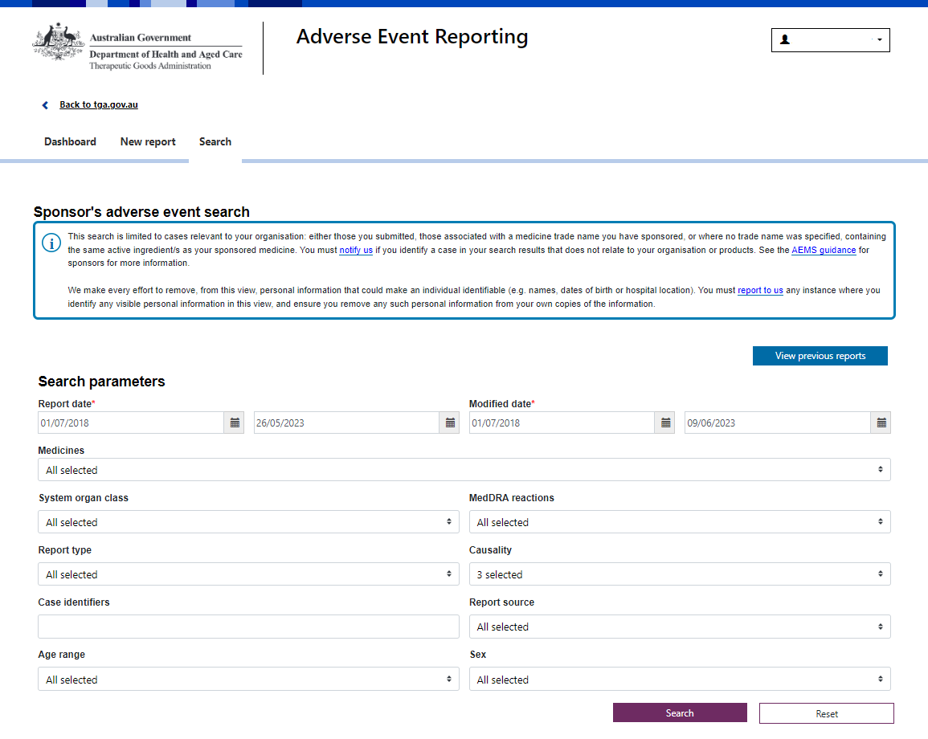
All available information relevant to your organisation is pre-loaded when you land on the search page. Clicking the ‘Search’ button without changing any search parameters will display a summary of all your available cases within the default date range.
You can also use the search parameters to find specific cases.

Refine results by report date and modified date range
The report date is when a case was first created in AEMS. The report date can be selected from 1 July 2018 up to 14 days before the date of access.
Modified date is when the case was last updated in AEMS. These updates may not necessarily result in a change to the visible case data. Modified date can be selected from 1 July 2018 to the date of access. If you enter an invalid modified date, the field will revert to the default date range.
Please note that sponsors can only view the latest completed version of a case in the new AEMS search.
TIP: when searching for new cases, do not limit the modified date range. You can use the modified date range to look for updates to cases.
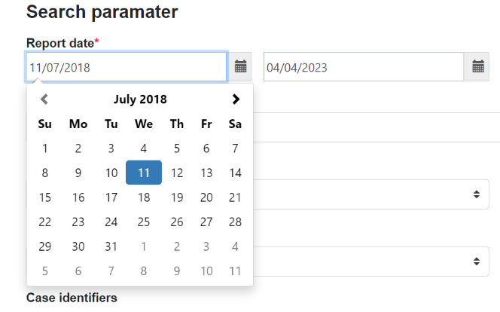
Contact the TGA if you would like to access cases outside the available date ranges.
To change the ‘report date’ or ‘modified date’ range:
- click on the from/to date fields and select dates from the calendar; or
- type your dates in the date field – highlight the numbers in the from/to date field, delete and type in dates in dd/mm/yyyy format.

Other search parameters
You can search for adverse event cases by applying one or more optional search parameters:
- Medicines: Search by specific trade names and/or names of active ingredient(s). Where another sponsor’s tradename is also visible in this list, this product occurs as either a co-suspect or interacting product in a case you have access to. If you cannot see one of your products in this list, it could be because:
    - no cases have ever been reported for that product; or
    - the product is not yet associated to your organisation. Contact us if you think the association is missing, for example if you can see cases for this product in the DAEN - medicines.
- MedDRA system organ classes and/or reaction terms: These are sorted alphabetically.
- Report Type: For example, select whether a case is from a study or not.
- Causality: Select the causality assessment category of the case. Most cases accepted by the TGA use the default term ‘causality possible’.
    - To select only accepted cases, select ‘causality certain’, ‘causality probable/likely’) and ‘causality possible’ (this is the default selection when the page loads or is reset).
    - To select only rejected cases, select ‘causality unlikely’, ‘causality conditional/unclassified’, ‘causality unassessable/unclassifiable’, ‘duplicate’, and ‘foreign report’.
    - To select only withdrawn cases, select causality ‘submitted in error’ and ‘no longer a valid report’.
- Case identifiers: Enter the case identifiers such as TGA case ID, sender’s ID or Worldwide ID. You may also enter multiple identifiers, separated by a semi-colon.
- Report source: Select whether to include cases submitted by your organisation, others, or both.
- Age range
- sex.
You can select parameters by typing the full name in the search fields and/or by choosing one or more options from the drop-down lists. You may also select all options using ‘select all’ at the top of the drop-down list, which is the default selection. Once you have applied your parameters, click the ‘Search’ button at the bottom right of the page.
If you experience issues, consider limiting your search criteria. Larger search queries may also take longer to display results.
The ‘Reset’ button will clear all filters previously selected.

Search results
Once you have run your search, your results will display in a summary table. Click on the column headings to sort your results.
The number of cases displayed in one page can be changed using the ‘show entries’ drop-down list at the top right corner of the table.
Only cases associated with medicines relevant to your organisation should be displayed. These include cases:
- submitted by your organisation
- not submitted by your organisation
  - where the tradename of a reported suspect or interacting medicine in the case is sponsored by your organisation; or
  - where a tradename was not specified, but the name of active ingredient(s) of a reported suspect or interacting medicine in the case relates to your organisation.

Contact the TGA if you believe there are missing reports or your results include cases not relevant to your organisation.

Generate a PCD or CLL report
All cases returned from your search are selected by default. Select/unselect individual cases using the checkboxes against each case or use the table header checkbox to select/unselect all cases. The search results counter at the top of the table will update depending on your selection.
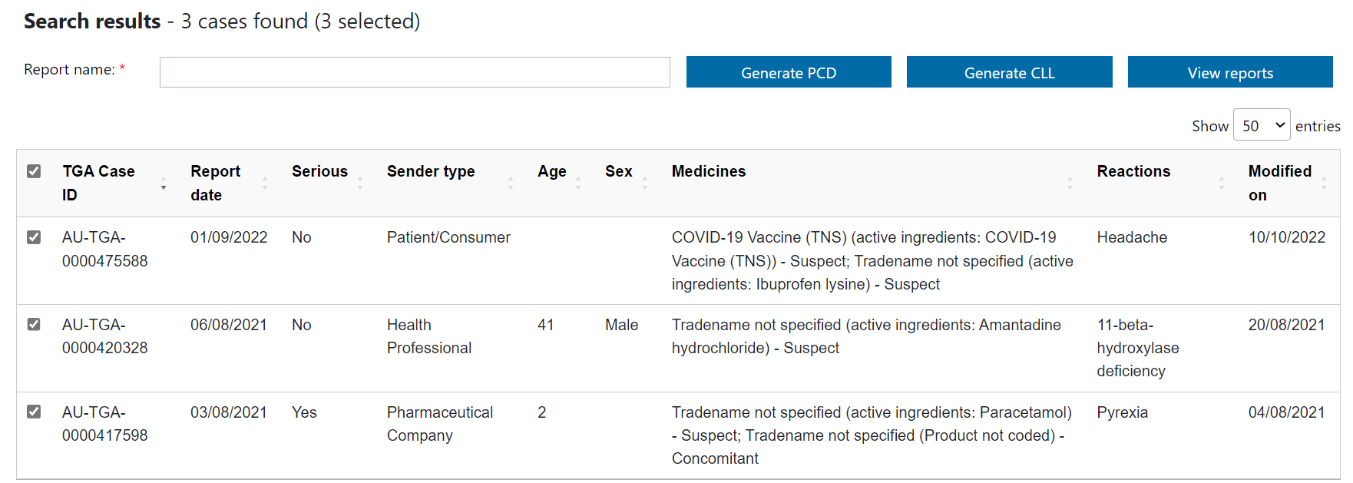

Mock data
Mock data
Mock data
To generate a PCD or CLL report for your selected records, enter a report name in the text box and click ‘Generate PCD’ or ‘Generate CLL’. Please keep your report names short as reports with longer names may have trouble generating.
Report generation may take a few minutes depending on the number of cases selected. To generate PCD reports, we recommend selecting a maximum of 500 cases. If your search has resulted in more than 500 cases, consider narrowing your search criteria by adding another search parameter.
To create both a PCD and CLL for your search results, click on each button prior to navigating to the Generated reports page. Your search parameters will be cleared once you leave the search page.
You can also generate PCD and CLL reports for a search result returning 0 cases (only where there are 0 cases based on all search parameters).

View generated reports
You can view generated PCD and CLL reports from the Generated reports page. To access this page, either:
- click the ‘View previous reports’ button at the top right corner of the search page; or
- after performing a search, click the ‘View reports’ button next to the ‘Generate CLL’ button.
The reports are listed in reverse chronological order by the date the report was generated. You can sort your reports by clicking on the column headings. 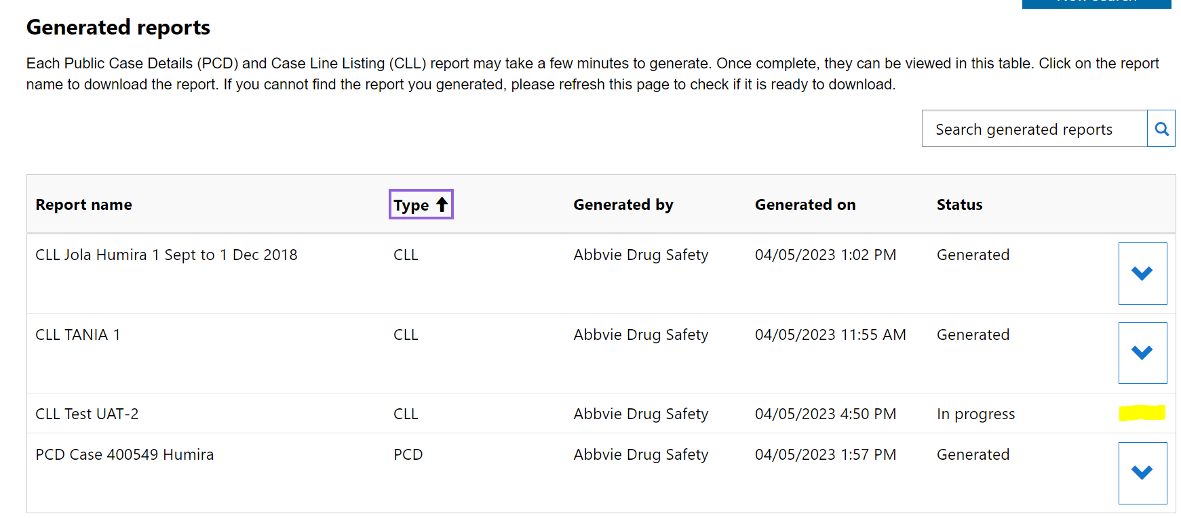
Use the drop-down icon to view and download your reports. This icon will only show for reports with a Generated status. If the report shows as generated but the icon is not available, refresh the page.
In the View report pop-up, click on the report name to download the report.
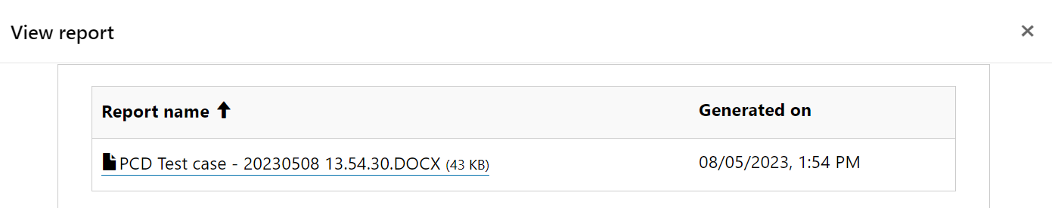
Note: If a report has failed to generate, please try again. Contact the TGA if the issue persists.
To return to the search page for a new search, click the ‘New search’ button at the top right of the generated reports page. This will reset the search parameters.

Accessing reports submitted via Adverse Drug Reaction System (ADRS)
The ADRS was the previous system used by the TGA for medicine adverse events, prior to the Adverse Event Management System (AEMS). We have decommissioned the ADRS. Please contact the TGA If you wish to access your historical reports that had been submitted via the ADRS.

Version history
Version | Description of change | Author | Effective date
V1.0 | Original publication | Pharmacovigilance and Special Access Branch | 7/11/2018
V1.1 | Minor update to correct errors | Pharmacovigilance and Special Access Branch | 17/12/2018
V1.2 | Add adverse event search | Pharmacovigilance Branch | November 2023

Therapeutic Goods Administration
PO Box 100 Woden ACT 2606 Australia
Email: info@tga.gov.au Phone: 1800 020 653 Fax: 02 6203 1605
https://www.tga.gov.au
Reference/Publication D23-5462121

