Australian Public Assessment Report for Gavreto
Active ingredient: Pralsetinib
Sponsor: Roche Products Pty Ltd
October 2023

About the Therapeutic Goods Administration (TGA)
- The Therapeutic Goods Administration (TGA) is part of the Australian Government Department of Health and Aged Care and is responsible for regulating therapeutic goods, including medicines, medical devices, and biologicals.
- The TGA administers the Therapeutic Goods Act 1989 (the Act), applying a risk management approach designed to ensure therapeutic goods supplied in Australia meet acceptable standards of quality, safety, and efficacy.
- The work of the TGA is based on applying scientific and clinical expertise to decision-making, to ensure that the benefits to the Australian public outweigh any risks associated with the use of therapeutic goods.
- The TGA relies on the public, healthcare professionals and industry to report problems with therapeutic goods. The TGA investigates reports received to determine any necessary regulatory action.
- To report a problem with a therapeutic good, please see the information on the TGA website.
About AusPARs
- The Australian Public Assessment Report (AusPAR) provides information about the evaluation of a prescription medicine and the considerations that led the TGA to approve or not approve a prescription medicine submission. Further information can be found in Australian Public Assessment Report (AusPAR) guidance.
- AusPARs are prepared and published by the TGA.
- AusPARs are static documents that provide information that relates to a submission at a particular point in time. The publication of an AusPAR is an important part of the transparency of the TGA’s decision-making process.
- A new AusPAR may be provided to reflect changes to indications or major variations to a prescription medicine subject to evaluation by the TGA.
Copyright
© Commonwealth of Australia 2023
This work is copyright. You may reproduce the whole or part of this work in unaltered form for your own personal use or, if you are part of an organisation, for internal use within your organisation, but only if you or your organisation do not use the reproduction for any commercial purpose and retain this copyright notice and all disclaimer notices as part of that reproduction. Apart from rights to use as permitted by the Copyright Act 1968 or allowed by this copyright notice, all other rights are reserved and you are not allowed to reproduce the whole or any part of this work in any way (electronic or otherwise) without first being given specific written permission from the Commonwealth to do so. Requests and inquiries concerning reproduction and rights are to be sent to the TGA Copyright Officer, Therapeutic Goods Administration, PO Box 100, Woden ACT 2606 or emailed to <tga.copyright@tga.gov.au>.
Contents
List of abbreviations 4
Product submission 6
Submission details for PM-2021-05762-1-4, RET-fusion positive thyroid cancer indication 6
Submission details for PM-2021-05761-1-4, advanced or metastatic RET-mutant medullary thyroid cancer indication 8
Product background 8
Condition 9
Current treatment options 9
Australian regulatory status 10
Regulatory status 11
Product Information 13
Registration timeline 14
Submission overview and risk/benefit assessment 15
Quality 15
Nonclinical 16
Clinical 16
Summary of key findings from clinical pharmacology assessment: 17
Efficacy 20
Safety 30
Risk management plan 38
Risk-benefit analysis 39
Delegate’s considerations 39
Proposed action 45
Advisory Committee considerations 46
Outcome 47
Specific conditions of registration applying to these goods 47
Attachment 1. Product Information 50

List of abbreviations
Abbreviation | Meaning
ACM | Advisory Committee on Medicines
AE | Adverse event
ARTG | Australian Register of Therapeutic Goods
ASA | Australia specific annex
BICR | Blinded independent central review
CBR | Clinical benefit rate
CMI | Consumer Medicines Information
CNS | Central nervous system
CR | Completed response
CSR | Clinical study report
ctDNA | circulating tumour DNA
DCR | Disease control rate
DLP | Data lock point
DOR | Duration of response
DTC | Differentiated thyroid cancer
DVT | Deep vein thrombosis
ECG | Electrocardiogram
ECOG | Eastern Cooperative Oncology Group
E-R | Exposure-response
FDA | Food and Drug Administration (United States)
MKI | Multi-kinase inhibitor
MTD | Maximum tolerated dose
NSCLC | Non-small cell lung cancer
ORR | Overall response rate
OS | Overall survival
PD | Pharmacodynamic
PE | Pulmonary embolism
PFS | Progression free survival
PI | Product Information
PK | Pharmacokinetic
PMR | Post-marketing Requirement
popPK | Population pharmacokinetic
PR | Partial response
PRO | Patient reported outcome
PSUR | Periodic safety update report
PT | Preferred Term
QoL | Quality of life
RAI | Refractory to radioactive iodine
RECIST | Response Evaluation Criteria In Solid Tumours
RET | Rearranged during transfection
RMP | Risk management plan
RP2D | Recommended Phase II dose
SAE | Serious adverse event
TEAE | Treatment emergent adverse event
TGA | Therapeutic Goods Administration
TKI | Tyrosine kinase inhibitor
TLS | Tumour lysis syndrome
VEGFR | Vascular endothelial growth factor receptor

Product submission

Submission details for PM-2021-05762-1-4, RET-fusion positive thyroid cancer indication
Type of submission: | New chemical entity
Product name: | Gavreto
Active ingredient: | Pralsetinib
Decision: | Approved for provisional registration
Date of decision: | 5 April 2023
Date of entry onto ARTG: | 6 April 2023
ARTG number: | 380812
▼Black Triangle Scheme  for the current submission: | Yes  As a provisionally registered product, this medicine will remain in the Black Triangle Scheme for the duration of its provisional registration
Sponsor’s name and address: | Roche Products Pty Limited  Level 8, 30 – 34 Hickson Road  Sydney NSW 2000
Dose form: | Hard capsule
Strength: | 100 mg
Container: | Bottle
Pack sizes: | 60, 90 and 120
Approved therapeutic use for the current submission: | RET-Fusion Positive Thyroid Cancer  Gavreto has provisional approval in Australia for the treatment of adult patients with advanced or metastatic RET-fusion positive thyroid cancer that is refractory to (or unsuitable for) radioactive iodine and who have progressed on or are unable to tolerate lenvatinib or sorafenib.  The decision to approve this indication has been made on the basis of overall response rate (ORR) and duration of response (DOR). Continued approval of this indication depends on verification and description of benefit in confirmatory trials.
Route of administration: | Oral
Dosage: | A validated assay is required for the selection of patients with RET-fusion positive thyroid cancer. RET-fusion status should be established prior to initiation of Gavreto therapy.  The recommended dose of Gavreto for adults is 400 mg given orally, once daily.  For further information regarding dosage, refer to the Product Information.
Pregnancy category: | D  Drugs which have caused, are suspected to have caused or may be expected to cause, an increased incidence of human fetal malformations or irreversible damage. These drugs may also have adverse pharmacological effects. Accompanying texts should be consulted for further details  The use of any medicine during pregnancy requires careful consideration of both risks and benefits by the treating health professional. This must not be used as the sole basis of decision making in the use of medicines during pregnancy. The TGA does not provide advice on the use of medicines in pregnancy for specific cases. More information is available from obstetric drug information services in your State or Territory.

Submission details for PM-2021-05761-1-4, advanced or metastatic RET-mutant medullary thyroid cancer indication
Type of submission: | New chemical entity
Product name: | Gavreto
Active ingredient: | Pralsetinib
Decision: | Sponsor withdrew on 29 June 2023
Date of decision: | Not applicable
Date of entry onto ARTG: | Not applicable
ARTG number: | Not applicable
▼Black Triangle Scheme  for the current submission: | Not applicable
Sponsor’s name and address: | Roche Products Pty Limited  Level 8, 30 – 34 Hickson Road  Sydney NSW 2000
Dose form: | Hard capsule
Strength: | 100 mg
Container: | Bottle
Pack sizes: | Not applicable
Approved therapeutic use for the current submission: | Not applicable
Route of administration: | Oral
Dosage: | Not applicable
Pregnancy category: | Not applicable

Product background
This AusPAR describes the submission by Roche Products Pty Limited (the sponsor) to register Gavreto (pralsetinib) 100 mg, capsule, bottle for the following proposed indications:
RET-fusion positive thyroid cancer
Gavreto is indicated for the treatment of adult and paediatric patients 12 years of age and older with locally advanced or metastatic RET-fusion positive thyroid cancer who require systemic therapy and who are radioactive iodine-refractory (if radioactive iodine is appropriate).
Medullary thyroid cancers
Gavreto is indicated for the treatment of adult and paediatric patients 12 years of age and older with advanced or metastatic RET-mutant MTC who require systemic therapy.

Condition
Thyroid cancer was the ninth most commonly diagnosed cancer in Australia in 2018; it is estimated that 3,981 new cases of thyroid cancer will be diagnosed in Australia in 2022. In 2020, the age-standardised mortality rate was 0.3 deaths per 100,000 persons.
The main histologic types of thyroid carcinoma are differentiated (including papillary, follicular and Hürthle cell), medullary, and anaplastic.

Medullary thyroid cancers
Medullary thyroid cancers (MTC) are rare neuroendocrine neoplasms derived from parafollicular cells of the thyroid, accounting for approximately 5% of thyroid neoplasms. It is hereditary in approximately 20% (as part of multiple endocrine neoplasia syndromes 2A or 2B) and occurs sporadically in approximately 80% of patients. The five year survival for stage IV disease is about 28%; patients with unresectable or metastatic disease may have either slowly progressive or rapidly progressive disease.
Mutations in the rearranged during transfection (RET) proto-oncogene are found in at least 95% of patients with multiple endocrine neoplasia type 2A (MEN2A) and 88% of cases of familial MTC. Mutations associated with MEN2A and familial MTC have been mainly identified in several codons of the cysteine rich extracellular domains of exons 10, 11 and 13; multiple endocrine neoplasia type 2B (MEN2B) and some familial MTC mutations are found within the intracellular exons 14 to 16. Somatic mutations in exons 11, 13 and 16 have also been found in at least 25% of sporadic MTC tumours (particularly the codon 918 mutation) and are associated with poorer prognosis of the patient.

RET fusion-positive thyroid cancer
Differentiated thyroid cancer accounts (DTC) for more than 90% of all newly diagnosed thyroid cancers and is subcategorised into follicular thyroid cancer, papillary thyroid cancer and Hürthle cell thyroid cancer. Papillary thyroid cancers are the most common, accounting for approximately 80% of all thyroid cancer. DTC may become, or are initially, refractory to radioactive iodine (RAI) treatment; RAI refractoriness is seen in about one-third of DTC patients with recurrence or metastases. The prognosis for RAI-refractory DTC is poor, with a five year survival rate of 66% and a ten year survival rate of only 10%.

Current treatment options

Medullary thyroid cancer
In Australia, there are currently no therapies approved specifically for the treatment of patients with RET-mutant MTC. International treatment guidelines recommend the use of kinase inhibitors for select patients with recurrent or persistent unresectable MTC, although these may not be appropriate for patients with stable or slowly progressing indolent disease. Vandetanib and cabozantinib are oral receptor kinase inhibitors that increase progression free survival (PFS) in patients with metastatic MTC. In Australia, vandetanib has been approved for the treatment of patients with symptomatic or progressive medullary thyroid cancer in patients with unresectable locally advanced or metastatic disease.
In 2020, FDA approved two RET inhibitors for RET-mutated MTC requiring systemic therapy: selpercatinib and pralsetinib; the former is also approved for use in the European Union.

RET fusion-positive thyroid cancer
For patients with RAI-refractory DTC, systemic treatment may be appropriate with tyrosine kinase inhibitors (TKIs) targeting the vascular endothelial growth factor receptor (VEGFR, a tyrosine kinase receptor), which inhibits tumour angiogenesis. In Australia, two multi-kinase inhibitors (MKIs), sorafenib and lenvatinib are approved by the TGA for the treatment of locally advanced or metastatic, RAI-refractory DTC, regardless of mutational status. Approval of both of these multi-kinase inhibitors was based on a statistically significant prolongation in PFS in treated patients compared with those receiving placebo.
Pralsetinib is an orally bioavailable kinase inhibitor that targets the RET receptor tyrosine kinase, as well as several other human kinases. The proposed dosing regimen for pralsetinib is 400 mg orally once daily on an empty stomach on a continuous schedule.
This evaluation was facilitated through Project Orbis, an initiative of the United States Food and Drug Administration (FDA) Oncology Center of Excellence. Under this project, the FDA, Health Canada and the TGA collaboratively reviewed the submission. This evaluation process provided a framework for process alignment and management of evaluation issues in real-time across jurisdictions. Each regulator made independent decisions regarding approval (market authorisation) of the new medicine.

Australian regulatory status

Medullary Thyroid Cancer
Pralsetinib was granted provisional determination for evaluation via the provisional approval pathway on 29 November 2021. An outline of the proposed confirmatory study plan was provided during the determination process.
- AcceleRET-MTC trial is a Phase III, open-label, multicenter, randomised, superiority study evaluating the efficacy and safety of pralsetinib compared to cabozantinib or vandetanib in patients with RET-mutant MTC. The primary analysis will occur when approximately 118 BICR-PFS events have been observed; this is anticipated to be available by first quarter of 2028.

RET fusion-positive thyroid cancer
Pralsetinib was granted provisional determination for evaluation via the provisional approval pathway on 29 November 2021. An outline of the proposed confirmatory study plan was provided during the determination process.
The ARROW trial included only a small number of patients with RET-fusion positive thyroid cancer; due to the rarity of this condition, no Phase III trials are proposed in this patient population. The sponsor plans to submit further data from ARROW trial and data from TAPISTRY trial to support conversion from provisional to full registration.
- TAPISTRY trial (Tumour-agnostic precision immuno-oncology and somatic targeting rational for you) is a Phase II, multicenter, open label, multi-cohort study designed to evaluate the safety and efficacy of targeted therapies or immunotherapy as single agents or in rational, specified combinations in patients with unresectable, locally advanced or metastatic solid tumours determined to harbor specific oncogenic genomic alterations. One of the cohorts in this platform study is evaluating pralsetinib in RET fusion-positive solid tumours (excluding non-small cell lung cancer, [NSCLC]). Up to 70 patients (up to 30 with RET fusion positive cancers (excluding thyroid and NSCLC) and up to 40 with RET fusion positive thyroid cancer are planned for enrolment in RET fusion-positive cohort. An integrated analysis is estimated to be available approximately in second quarter of 2025.
The sponsor is also seeking provisional registration of pralsetinib ‘for the treatment of adult patients with RET-fusion positive, locally advanced or metastatic NSCLC’. Pralsetinib was granted provision determination for evaluation of this indication on 29 November 2021.

Regulatory status
This product is considered a new chemical entity for Australian regulatory purposes.
At the time the TGA considered this submission, a similar submission had been approved in the United States of America (USA) on 1 December 2020 and in Switzerland on 12 August 2021. A similar submission was under consideration in Canada (submitted on 30 April 2021) and Singapore (submitted on 2 March 2021)
The following table summarises these submissions and provides the indications where approved.
Table 1: International regulatory status
Region | Status | Approved indications
United States of America | Approved on 1 December 2020 | Gavreto is indicated for the treatment of adult and pediatric patients 12 years of age and older with advanced or metastatic RET-mutant medullary thyroid cancer (MTC) who require systemic therapy  Gavreto is indicated for the treatment of adult and paediatric patients 12 years of age and older with locally advanced or metastatic RET-fusion positive thyroid cancer who require systemic therapy and who are radioactive iodine-refractory (if radioactive iodine is appropriate).
Switzerland | Approved on 12 August 2021 | GAVRETO is indicated for the treatment of adult patients with advanced or metastatic RET-mutant medullary thyroid cancer (MTC) who require systemic therapy and who have experienced progression after prior treatment with tyrosine kinase inhibitors (see “Clinical efficacy”).  Gavreto is indicated for the treatment of adult patients with advanced or metastatic RET-fusion positive thyroid cancer who require systemic therapy and who have experienced progression after prior treatment including radioactive iodine (see ‘Clinical efficacy’).  The efficacy and safety of Gavreto was not studied in patients with other oncogene driver mutations (see ‘Warnings and precautions’).
Canada | Withdrawn on 5 April 2022 | Gavreto is indicated for the treatment of adult and pediatric patients 12 years of age and older with advanced or metastatic RET-mutant positive MTC who require systemic therapy.  Gavreto is indicated for the treatment of adult and pediatric patients 12 years of age and older with advanced or metastatic RET- fusion positive thyroid cancer who require systemic therapy and who are radioactive iodine-refractory (if radioactive iodine is appropriate).
Singapore | Under consideration | Under consideration
The following Post-marketing Requirements (PMR) were specified in relation to Project Orbis # 29 submission (note well: conditions of registration for this submission will be in alignment with these):
PMR 1:
‘Submit the final report including datasets from a multi-centre, randomised, open-label trial comparing pralsetinib to investigator’s choice of either cabozantinib or vandetanib in multi-kinase inhibitor naïve patients with advanced or metastatic RET-mutant medullary thyroid cancer to confirm the clinical benefit of pralsetinib with progression-free survival as primary end point, as assessed by blinded independent central review.’
PMR 2:
‘Submit the final report of integrated datasets, to verify and further characterise the clinical benefit of pralsetinib for the treatment of patients with RET fusion-positive thyroid cancer who have received radioactive iodine (if appropriate for their tumour histology) to provide a more precise estimation of the BICR-assessed overall response rate and duration of response in at least 50 patients in a variety of histologies after all responding patients have been followed for 12 months following onset of response or until disease progression, whichever comes first.’
PMR3:
‘Submit the final report, of an integrated safety analysis from clinical studies that characterise the potential serious risk of long term adverse effects of pralsetinib on growth and development, including assessment of growth plate abnormalities in a sufficient number of adolescent patients 12 years of age and older with RET mutant medullary thyroid cancer (MTC) and RET fusion positive thyroid cancer. Patients will be monitored for growth and development using age-appropriate screening tools such as Tanner staging. Evaluations with growth as measured by height, weight, height velocity and height standard deviation scores, age at adrenarche if applicable (males), age at menarche if applicable (females) and Tanner stage. Patient monitoring will be performed until discontinuation of study treatment or minimum of 5 years from start of treatment, whichever occurs first. Include the datasets with final report. The results from this study may inform product labelling.’
PMR 4:
‘Conduct a rodent carcinogenicity study of pralsetinib in mice to evaluate its potential for carcinogenicity. Submit a carcinogenicity protocol for Special Protocol Assessment (SPA) prior to initiating the study.’
PMR 5:
‘Conduct a rodent carcinogenicity study of pralsetinib in rats to evaluate its potential for carcinogenicity. Submit a carcinogenicity protocol for Special Protocol Assessment (SPA) prior to initiating the study.’
PMR 6:
‘Conduct a rodent fertility study investigating treated male rats (vehicle control and high dose only) mated to untreated female rats to evaluate the potential for pralsetinib to impair male fertility.’

Product Information
The Product Information (PI) approved with the submission which is described in this AusPAR can be found as Attachment 1. For the most recent PI and Consumer Medicines Information (CMI), please refer to the TGA PI/CMI search facility.

Registration timeline
The following table captures the key steps and dates for this submission.
This submission was evaluated under the provisional registration process.
Table 2: Timeline for Submission PM-2021-05762-1-4
Description | Date
Determination (Provisional) | 29 November 2021
Submission dossier accepted and first round evaluation commenced | 31 January 2022
First round evaluation completed | 30 June 2022
Sponsor provides responses on questions raised in first round evaluation | 30 August 2022
Second round evaluation completed | 5 October 2022
Delegate’s Overall benefit-risk assessment and request for Advisory Committee advice | 25 October 2022
Sponsor’s pre-Advisory Committee response | 15 November 2022
Advisory Committee meeting | 1 and 2 December 2022
Registration decision (Outcome) | 5 April 2023
Administrative activities and registration on the ARTG completed | 6 April 2023
Number of working days from submission dossier acceptance to registration decision* | 247
*Statutory timeframe for standard submissions is 255 working days

Table 3: Timeline for Submission PM-2021-05761-1-4
Description | Date
Determination (Provisional) | 29 November 2021
Submission dossier accepted and first round evaluation commenced | 31 January 2022
First round evaluation completed | 30 June 2022
Sponsor provides responses on questions raised in first round evaluation | 30 August 2022
Second round evaluation completed | 5 October 2022
Delegate’s Overall benefit-risk assessment and request for Advisory Committee advice | 25 October 2022
Sponsor’s pre-Advisory Committee response | Not applicable
Advisory Committee meeting | Not applicable
Registration decision (Outcome) | Not applicable
Administrative activities and registration on the ARTG completed | Not applicable
Number of working days from submission dossier acceptance to registration decision* | Not applicable
*Statutory timeframe for standard submissions is 255 working days

Submission overview and risk/benefit assessment
This section is a TGA summary of wording used in TGA’s evaluation report, which discussed numerous aspects of overseas evaluation reports and included some information that was commercial-in-confidence.
Relevant guidelines or guidance documents referred to by the Delegate are listed below:

Quality
Pralsetinib is an oral tyrosine kinase inhibitor, targeting RET fusions and mutations. It is structurally related to other tyrosine kinase inhibitors such as imatinib, mobocertinib (succinate) and ceritinib (not registered in Australia).
The maximum daily dose is 400 mg (4 x 100 mg) orally once daily. They are taken in the fasted state with the PI instructing ‘not to eat for at least 2 hours before and 1 hour after taking Gavreto’. The capsules must be swallowed whole and must not be opened or chewed. The capsules will be packaged in bottles with child resistant closures. Pack sizes are 60, 90 and 120 capsules.
There are no monographs for pralsetinib in the british pharmacopoeia or United States Pharmacopeia. The tradename Gavreto is acceptable.
Figure 1: Chemical structure of pralsetinib
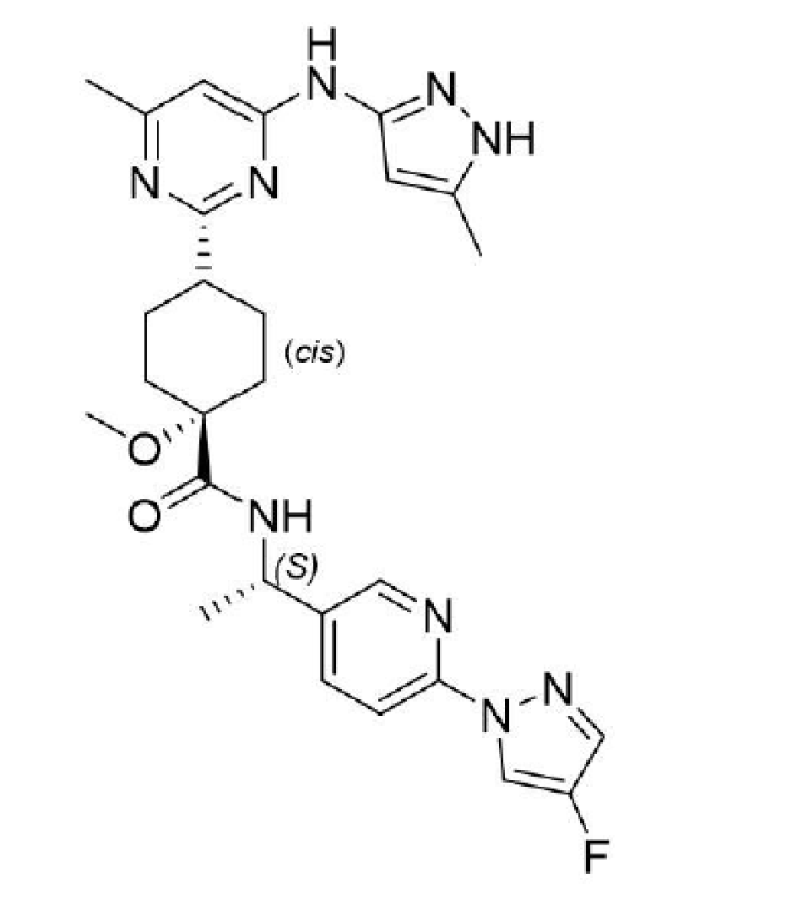

Nonclinical
The Delegate noted that no major deficiencies in nonclinical evaluation were identified.
The primary pharmacology studies demonstrated nonclinical efficacy for the intended target of RET-related kinases and support the use of pralsetinib for the proposed indications. Off target inhibitory activity of pralsetinib was observed against a number of other kinases at clinically relevant concentrations – notably JAK2, FGFR1, FLT1/VEGFR1 and MLK2/MAP3K10 – which explain some of the toxicities observed in animal studies. Major targets of pralsetinib related toxicity included: gastrointestinal tract, bone and teeth (which may have clinical relevance to patients younger than 18 years), lungs, lymphoid tissue (bone marrow, thymus, spleen) and reproductive tissue
There are no nonclinical objections to the registration of Gavreto for the proposed indications.

Clinical
The clinical pharmacology package provided has been reviewed, including the following studies and data analyses: single and repeat-dose pharmacokinetics (PK) studies of pralsetinib in healthy subjects and cancer patients, exposure-response (E-R) analyses for efficacy and safety, and population PK analyses.
The proposed dosing regimen for pralsetinib for the treatment of adult and adolescent patients with RET-altered thyroid cancers (400 mg pralsetinib once daily on an empty stomach) is based on efficacy and safety data in adult patients from Study BLU-667-1101 and supported by E-R analyses for efficacy and safety. Dose selection in adolescent patients is based on population pharmacokinetic (popPK) analysis in adults and simulations of a virtual adolescent population demonstrating that age and body weight had no clinically meaningful effect on the PK of pralsetinib.
The clinical pharmacology evaluation supports approval of pralsetinib for the proposed indication from a clinical pharmacology perspective.

Summary of key findings from clinical pharmacology assessment:
- Absorption:
  - median T_{max} = about 2 hrs after single-dose administration and about 4 hours at steady state
- Distribution:
  - plasma protein binding = 97.1%
  - at a dose of 400 mg once daily in patients with RET-altered thyroid cancers, geometric mean VzF = 322 L after single-dose administration and 346 L at steady state
- Metabolism and elimination:
  - Metabolism is mainly mediated by CYP3A4, and to a lesser extent by CYP2D6 and CYP1A2 (Phase I) and UGT1A4 (Phase II).
  - Unchanged pralsetinib is the predominant component in plasma, urine and faeces, while its metabolites from oxidation and glucuronidation are detected in small to trace amounts (about 5%)
  - Excretion in faeces (72.5%) is major elimination pathway for pralsetinib potentially via hepatobiliary and gastrointestinal secretion
  - Mean elimination t_{1/2} = 17 hours after single-dose administration
  - Mean elimination t_{1/2} = 17.8 hours at steady state (400 mg daily)
  - Geometric mean CL/F = 23.5 L/h after single dose administration and 13.4 L/h at steady state, indicating that pralsetinib is a low clearance drug
- Steady state:
  - Estimated to be reached after 3 to 5 days of treatment in a once daily regimen
- Accumulation:
  - Minor accumulation (about 2-fold) at steady state
- Dose proportionality:
  - Dose dependent increases in systemic exposure were observed over the dose range of 200 to 400 mg in patients with RET-altered thyroid cancers
  - Dose proportionality could only be concluded for the range of 200 to 400 mg after single-dose administration (and not at steady state; the numbers of patients treated with doses at least 300 mg once daily were low compared with those treated with 400 mg once daily).
  - In healthy subjects, dose proportionality was concluded between single doses of 200 to 400 mg, further supporting dose linearity
- Inter-individual variability:
  - About 40% to 65% for C_{max} and AUC parameters
- Healthy subjects versus patients:
  - Based on a pooled popPK analysis (data from patients with RET-altered thyroid cancers, patients with RET-fusion NSCLC and healthy subjects), disease status has no clinically relevant effect on the PK of pralsetinib.

Effect of Intrinsic Factors
- Age, sex, race, body size descriptors:
  - No clinically relevant effect on PK of pralsetinib
- Hepatic impairment:
  - No relevant difference in CL/F was seen in patients with mild or moderate hepatic impairment compared with patients with normal hepatic function
- Renal impairment:
  - No relevant difference in CL/F was seen in patients with mild or moderate renal impairment compared with patients with normal renal function

Effect of Intrinsic Factors
- Food-drug interactions:
  - Food has a significant effect on pralsetinib exposure (greater than 2-fold increase following high fat meal, compared with fasted conditions)
- Drug drug interaction
  - Concomitant treatment with drugs that are CYP3A inhibitors or inducers can increase (with inhibitors) or decrease (with inducers) the exposure to pralsetinib, respectively
  - Concomitant administration of pralsetinib with itraconazole (strong CYP3A inhibitor) led to a 3.5-fold increase in pralsetinib AUC
  - Concomitant administration of pralsetinib with rifampin (strong CYP3A inducer) led to a 68% decrease in pralsetinib AUC
  - popPK analysis predicts no relevant effect of weak CYP3A4 inhibitor on pralsetinib AUC; a CYP3A4 weak inducer results in a minor (19%) decrease in pralsetinib AUC
  - pralsetinib is a P-gp substrate in vitro; P-gp inhibitors may decrease the gastrointestinal secretion of pralsetinib and potentially increase the plasma concentration of pralsetinib
  - the effect of gastric-acid reducing agents on the bioavailability of pralsetinib is not clinically relevant

Extrapolation from adult to adolescent patients with RET-altered thyroid cancers
- PK simulations in adolescents:
  - PK profile of pralsetinib are similar in adult and adolescent patients administered the recommended pralsetinib dose of 400 mg once daily

Pharmacology
- Cardiac repolarisation:
  - Treatment with pralsetinib (400 mg once daily) in patients with RET-fusion NSCLC, RET-altered thyroid cancer and other RET-altered advanced solid tumours was not associated with evidence of QTc prolongation. Mean change from baseline in QTcF was -0.9ms at the observed mean C_{max} for pralsetinib; no effect on HR, PR interval or QRS duration was observed.

Exposure-response analyses
- Efficacy endpoints
  - In patients with RET-altered thyroid cancers, clear relationships were observed between increasing pralsetinib exposure (average concentration) and/or higher starting dose (400 mg once daily versus less than or equal to 300 mg once daily) and longer progression free survival (PFS), DOR, disease control rate (DCR), and clinical benefit rate (CBR).
- Safety endpoints
  - In patients with RET-altered thyroid cancers, increasing pralsetinib exposure (average concentration) caused an increased risk of any Grade ≥ 3 AE, Grade > 3 pneumonia and anaemia, and to a lesser extent Grade > 3 lymphopenia
  - The E-R findings for safety in patients with RET-altered thyroid cancers were similar to the findings from corresponding analyses conducted in patients with NSCLC.
The following is noted from the clinical pharmacology evaluation:
- PopPK analysis assessed the effect of mild (n = 42) and moderate (n = 2) hepatic impairment on the PK of pralsetinib. Mild hepatic impairment does not have a clinically meaningful effect on the PK of pralsetinib and no dose adjustment is needed in patients with mild hepatic impairment
- A dedicated hepatic impairment study in subjects with moderate and severe hepatic impairment is requested as a condition of registration for this submission
- Concomitant treatment with a strong CYP3A inducer should be avoided, and if not, the pralsetinib dose should be increased to double the current dose starting on Day 7 of coadministration
- A number of pharmacology studies are outstanding and will need to be conducted as conditions of registration (as aligned with FDA post-marketing requirements, see below).

Recommendations & outstanding issues:
Overall no major concerns were identified in the clinical pharmacology evaluation that would preclude authorisation. Pralsetinib is considered approvable from a clinical pharmacology perspective, providing studies listed below are conducted as part of post-marketing requirements.
There are several conditions of registration proposed as outlined below;
- Conduct a hepatic impairment clinical trial to evaluate the pharmacokinetics and safety of pralsetinib in subjects with moderate and severe hepatic impairment compared to subjects with normal hepatic function. Design and conduct the trial in accordance with FDA guidance, and submit the datasets with the final report.
- Conduct a clinical drug-drug interaction study to evaluate the effect of of a P-gp inhibitor on the pharmacokinetics of pralsetinib and to inform appropriate dosing strategies for safe co-administration of pralsetinib with P-gp inhibitors. Design and conduct the trial in accordance with FDA guidance, and submit the datasets with the final report.
- Conduct a physiologically-based pharmacokinetic modeling/simulation study to evaluate the effect of repeat doses of a moderate CYP3A inhibitor on the pharmacokinetics of pralsetinib, assess the magnitude of increased pralsetinib exposure, and inform appropriate dosing strategies for safe co-administration of pralsetinib with moderate CYP3A inhibitors. Design and conduct the trial in accordance with FDA guidance, and submit the model with the final report.
- Conduct a physiologically-based pharmacokinetic modeling/simulation study to evaluate the effect of repeat doses of a combined P-gp and moderate CYP3A inhibitor on the pharmacokinetics of pralsetinib, assess the magnitude of increased pralsetinib exposure, and inform appropriate dosing strategies for safe co-administration of pralsetinib with combined P-gp and moderate CYP3A inhibitors. Design and conduct the trial in accordance with FDA guidance, and submit the model with the final report.
- Conduct a clinical drug interaction study to evaluate the effect of repeat doses of pralsetinib on the pharmacokinetics of transporter substrates of P-gp, BCRP, OATP1B1, OATP1B3, MATE-1 and MATE-2K, assess the magnitude of exposure change, and inform appropriate dosing strategies for co-administration of pralsetinib with these transporter substrates. Design and conduct the trial in accordance with FDA guidance, and submit the datasets with the final report.
- Conduct a clinical drug interaction study to evaluate the effect of repeat doses of pralsetinib on the pharmacokinetics of sensitive substrates of CYP3A4/5, CYP2C8, and CYP2C9, assess the magnitude of exposure change, and inform appropriate dosing strategies for safe co-administration of pralsetinib with sensitive substrates of CYP3A4/5, CYP2C8 and CYP2C9. Design and conduct the trial in accordance with FDA guidance, and submit the datasets with the final report.
- Conduct a physiologically-based pharmacokinetic modeling/simulation study to evaluate the effect of repeat doses of a moderate CYP3A inducer on the pharmacokinetics of pralsetinib, assess the magnitude of decreased pralsetinib exposure, and inform appropriate dosing strategies for co-administration of pralsetinib with moderate CYP3A inducers. Design and conduct the trial in accordance with FDA guidance, and submit the model with the final report.

Efficacy
The primary clinical study to support the evaluation of efficacy and safety for the proposed indication is Study BLU-667-1101 (ARROW trial). The submission contains a clinical study report (CSR) with data cut-off date of 13 February 2020, and a 90-day safety and efficacy update for the ARROW trial (data cut-off date 22 May 2020) which forms the basis of the evaluation in this submission as this provided longer follow up for the population of patients who responded to pralsetinib. The 90-day efficacy update contained analyses of the efficacy population of patients with RET-mutant MTC with measurable disease (84 patients treated at 400mg once daily) and patients with RET-fusion thyroid cancer with measurable disease (9 patients treated at 400 mg once daily).

Study BLU-667-1101 (ARROW trial)
Study BLU-667-1101 is a Phase I/II, open label, first in human study designed to evaluate the safety, tolerability, PK, pharmacodynamic (PD) and antineoplastic activity of pralsetinib in patients with advanced, unresectable, RET-altered NSCLC, MTC and other RET-altered solid tumours.
The study included a Phase I dose escalation part (to determine maximum tolerated dose (MTD) and recommended Phase II dose (RP2D) of pralsetinib) followed by a Phase II expansion part to assess the clinical efficacy of pralsetinib in specific tumour types and treatment settings, measured primarily by ORR, and further define the safety and tolerability at the RP2D.
See Figure 2 for an overview of the study design.
Figure 2: BLU-667-1101 study design
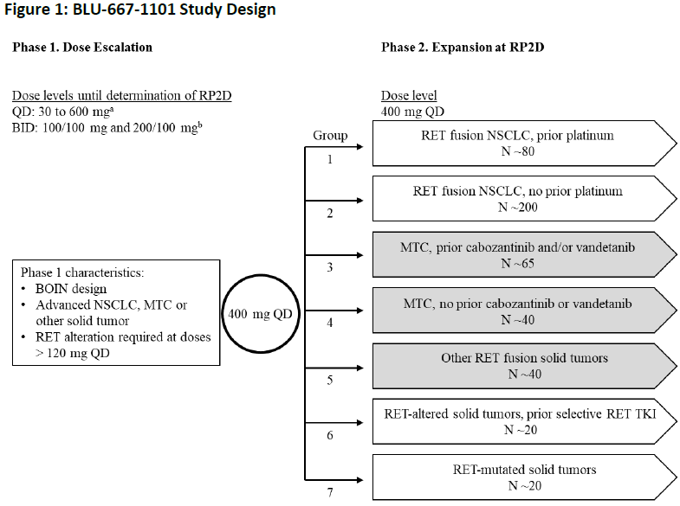

Trial location
Phase I: 6 centres across North America and Europe
Phase II: 67 centres across North America, Europe and Asia
There were no study sites in Australia.

Diagnostic criteria
Patients with confirmed oncogenic RET alteration as determined by local testing of tumour or circulating tumour DNA (ctDNA) in blood except those treated at doses < 120 mg per day or those with MTC, enrolled in Phase I and MTC patients enrolled into Groups 3 and 4 in Phase II.

Key inclusion criteria
- Phase I
  - Men or women, at least 18 years
  - Pathologically documented, definitively diagnosed unresectable advanced solid tumour
  - Progressed on, inadequate response to, intolerant of, or inappropriate for standard therapy, or no accepted standard therapy
  - Eastern Cooperative Oncology Group (ECOG) 0 or 1;
- Phase II
  - Group 3:
- Advanced MTC that progressed within 14 months prior to screening and was previously treated with cabozantinib and/or vandetanib
  - Group 4:⁵
- Advanced MTC that progressed within 14 months prior to screening and was not previously treated with cabozantinib and/or vandetanib
  - Group 5:
- Advanced solid tumour with an oncogenic RET fusion previously treated with standard of care appropriate for the tumour type and not eligible for any of the other groups
- All groups:
  - Men or women at least 18 years
  - Measurable disease per RECIST v1.1;
  - ECOG 0 or 1
  - Progressed on/not adequately responded/intolerant to standard or investigator determined therapy or where no accepted standard therapy

Key exclusion criteria
- Primary driver alteration other than RET
- History of myocardial infarction or unstable angina within previous 6 months; clinically significant cardiovascular disease, uncontrolled hypertension or uncontrolled arrhythmias
- Previous treatment with selection RET inhibitor (except Group 6)
- Any systemic anticancer therapy and all forms of radiotherapy within 14 days or 5 half-lives before first dose of pralsetinib; immunotherapy or other antibody therapy within 28 days before first dose of pralsetinib, or neutrophil growth factor support within 14 days of the first dose of pralsetinib
- Inadequate haematology and clinical chemistry values within 14 days before first dose of pralsetinib
- QTcF > 470 ms and history of prolonged QTS or TdP
- Presence of central nervous system (CNS) metastases or primary CNS tumour that is associated with progressive neurological symptoms or requiring increasing doses of corticosteroids to control CNS disease
- Symptomatic interstitial lung disease or interstitial pneumonitis
- Pregnancy and breastfeeding

Dose selection
Based on Phase I data, a pralsetinib dose of 400 mg once daily was determined to be the RP2D

Study treatments
- Pralsetinib was administered continuously daily without interruption (unless due to interruption and/or discontinuation due to toxicity, progression or other)
- Phase I: pralsetinib once daily (30 to 600 mg) or twice daily (100/100 mg or 200/100 mg) to determine MTD and RP2D
- Phase II: pralsetinib 400 mg once daily (as per RP2D)
No randomisation/blinding, as this was an open label study.
In the dose expansion phase, dose modification guidelines were included for the following adverse events (AE): non-hematologic toxicities, hematologic toxicities, pneumonitis, pneumonia, tumour lysis syndrome, hyperphosphataemia and hypertension.

Concurrent medications apart from the following were permitted: other anticancer therapies, investigational therapeutic agents, neutrophil growth factor within 14 days before C1D1 and throughout cycle 1 (unless patient experienced DLT of neutropenia), strong inhibitors and inducers of CYP3A4, strong dual P-gp and CYP3A4 inhibitors. Sensitive substrates of CYP2C9, strong CYP2D6 inhibitors and strong CYP1A2 inhibitors were permitted but use with caution advised.

Study endpoints
Primary efficacy endpoint
Phase I: not applicable
Phase II: ORR (per RECIST v1.1 as assessed by blinded independent central review (BICR) of local imaging)
Secondary efficacy endpoints
Phase I:
Overall response rate based on RECIST v1.1 as assessed by BICR of local imaging
Phase II:
- Duration of response
- Progression free survival;
- Overall survival (OS)⁷
- Changes in blood calcitonin and CEA (MTC patients only)
Exploratory efficacy endpoints
Phase I:
- Correlation of RET gene status in plasma and/or tumour tissue with ORR, CBR, DOR, PFS, OS and DCR
Phase II:
- CBR
- DCR
- Correlation of RET gene status in plasma and/or tumour tissue with ORR, CBR, DOR, PFS, OS and DCR
- Quality of life (QOL) per European Organisation for Research and Treatment of Cancer 30 items Quality of Life Questionnaire questionnaire;
- Changes in disease related symptoms as reported by bowel movement history (MTC patients only)

Statistical analysis plan and amendments
Efficacy analysis was conducted based on two separate data cutoffs, the original data cutoff date of 13 February 2020, and one corresponding to the 90-day efficacy update (data cutoff date of 22 May 2020).
Timing of final analysis was not pre-specified in the protocol.
Primary analysis of efficacy was conducted separately in patients who had received prior vandetanib and/or cabozantinib and in those who did not receive prior vandetanib and/or cabozantinib.
Version 2 of the statistical analysis plan of 30 October 2019, included assumptions for sample size calculation in the expansion phase for prior vandetanib and/or cabozantinib therapy sub-population and no prior vandetanib and/or cabozantinib therapy sub-population.
In Cohort 3 (includes patients with MTC previously treated with vandetanib and/or cabozantinib), assuming a null hypothesis that ORR = 20% against an alternative hypothesis of ORR = 40% with two sided Type 1 error rate of 0.05, a sample size of 65 provides more than 90% power.
In Cohort 4 (includes patients with MTC not previously treated with vandetanib and/or cabozantinib), enrolled for exploratory analysis.
In Cohort 5 (also includes previously treated patients with RET fusion positive thyroid cancer), assuming a null hypothesis that ORR = 10% against an alternative hypothesis of ORR = 30% with two sided Type 1 error rate of 0.05, a sample size of 40 provides more than 90% power.
For a single arm study, efficacy analysis is based on ORR of adequate magnitude and the corresponding duration of response.
The Delegate noted that the study protocol amendments are not expected to have an any significant impact on the conduct of the study or interpretation of results.

Study results
In the clinical evaluation, the primary efficacy analysis population, based on data cutoff of 22 May 2020, were:
RET mutant MTC with measurable disease, dosed at 400 mg once daily (n = 84), in two subgroups
  - RET mutant MTC with measurable disease who received prior cabozantinib and/or vandetanib (n = 55)
  - RET mutant MTC with measurable disease who received no prior cabozantinib and/or vandetanib (n = 29)
- RET fusion positive thyroid cancer with measurable disease, dosed at 400 mg once daily (n = 9)⁹

Disposition
Based on data cut-off date of 22 May 2020, of the patient population with RET mutant MTC with measurable disease who received prior cabozantinib and/or vandetanib (n = 55):
- 31% discontinued from treatment
- 29% discontinued from study
- Reasons for discontinuation of treatment:
  - PD = 16%
  - AEs (except disease progression) = 7%
- Related AEs = 1.8%
  - Death = 0
  - Withdrawal of consent = 5%
  - Investigator’s decision = 1.8%
- Reasons for discontinuation of study:
  - PD = 7%
  - AEs = 1.8%
- Related AEs = 0
  - Death = 11%
  - Withdrawal of consent = 7%
  - Investigator’s decision = 1.8%
Of the patient population with RET mutant MTC with measurable disease who received no prior cabozantinib and/or vandetanib (n = 29):
- 24% discontinued from treatment
- 17% discontinued from study
- Reasons for discontinuation of treatment:
  - PD = 7%
  - AEs (except disease progression) = 14%
  - Related AEs = 10%
  - Death = 0
  - Withdrawal of consent = 0
  - Investigator’s decision = 0
- Reasons for discontinuation of study:
  - PD = 3.4%
  - AEs = 0
- Related AEs = 0
  - Death = 10%
  - Withdrawal of consent = 3.4%
  - Investigator’s decision = 0
Of the patient population with RET fusion positive thyroid cancer with measurable disease (n = 9):
- 22.2% discontinued from treatment; one patient discontinued due to AE and one withdrew consent.

Protocol violations
Two major protocol deviations were reported in the efficacy population comprised of patients with RET mutant MTC treated at 400 mg (n = 92), with two patients found to have co-existing driver mutations in cell free DNA (excluded from response evaluable population but included in the measurable disease population).

Key demographic and other baseline characteristics
RET mutation positive MTC (measurable disease population) who received prior cabozantinib and/or vandetanib (n = 55):
- median age (min, max) = 59 (25, 83)
- female = 31%
- race: White = 78%; Asian = 5%, unknown = 15%
- region: US = 36%; Europe = 58%; Asia = 5%
- ECOG 0 = 27%, ECOG 1 = 67%, ECOG 2 = 5%
- MKIs: Cabozantinib only = 18%; vandetanib only = 42%
RET mutant MTC with measurable disease who received no prior cabozantinib and/or vandetanib (n = 29):
- median age (min, max) = 61 (19, 81)
- female = 28%
- race: White = 76%; Asian = 17%, unknown = 3.4%
- region: US = 72%; Europe = 14%; Asia = 14%
- ECOG 0 = 62%, ECOG 1 = 38%,
RET fusion positive thyroid cancer with measurable disease (n = 9):
- median age (min, max) = 61 (46, 74)
- female = 33%
- race: White = 78%; Asian = 22%
- region: US = 67%; Europe = 33%
- All patients were considered to be RAI refractory

Efficacy results – primary endpoint
The ORR analysis for this evaluation was based on the data cutoff of 22 May 2020.
RET mutation positive MTC (measurable disease population) who received prior cabozantinib and/or vandetanib (n = 55)
- ORR = 60% (95% CI: 46, 73)
- Complete response (CR) = 1.8%
- Partial response (PR) = 58%
RET mutant MTC with measurable disease who received no prior cabozantinib and/or vandetanib (n = 29):
- ORR = 66% (95% CI: 46, 82)
- CR = 10%
- PR = 55%
RET fusion positive thyroid cancer with measurable disease (n = 9):
- ORR = 88.9% (95% CI: 51.8, 99.7)
- CR = 0
- PR = 88.9%
Only patients with papillary thyroid cancer were included in the RET fusion positive thyroid cancer with measurable disease (previously received RAI) population , however, one PR and two CR were seen in patients in the ARROW trial with undifferentiated thyroid cancer, anaplastic thyroid cancer and poorly differentiated thyroid cancer histologies. Although these patients were not included in the efficacy analysis, response and some durability was observed in other histologies which supports the benefit of pralsetinib in RET fusion positive patients with thyroid cancer who have histologies other than papillary thyroid cancer.
Exploratory analysis of response rates by RET mutation genotype is shown in Table 4.
Table 4: Exploratory analysis of response rates by RET mutation genotype
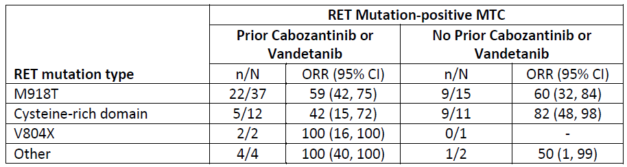
Exploratory analysis of response rates by RET mutation type (hereditary versus sporadic versus unknown) is shown in Table 5.
Table 5: Exploratory analysis of response rates by RET mutation type (hereditary versus sporadic versus unknown)
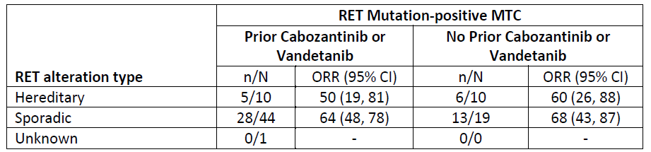

Efficacy results – secondary and other relevant endpoints
Duration of response
Duration of response in patients treated at 400 mg:
- RET mutation positive MTC (measurable disease population) who received prior cabozantinib and/or vandetanib (n = 55)
  - Number of responders = 33
  - Median DOR in months = NR (95% CI: 15.1, NE)
  - DOR at least 6 months = 79%
- RET mutant MTC with measurable disease who received no prior cabozantinib and/or vandetanib (n = 29):
  - Number of responders = 19
  - Median DOR in months = NR (95% CI: NE, NE)
  - DOR at least 6 months = 84%
- RET fusion positive thyroid cancer with measurable disease (n = 9):
  - Number of responders = 8
  - Median DOR in months = NR (95% CI: NE, NE)
  - DOR at least 6 months = 100%
Time-to-event endpoints
Results of these endpoints are considered uninterpretable as this was a single arm study; statistical analyses of PFS and OS under Study BLU-667-1101 are considered descriptive and were not verified during clinical evaluation, nor were analyses related to CBR and DCR.
Quality of life
As this study was open-label, knowledge of treatment assignment may induce bias in the completion of patients reported outcome (PRO) instruments; there was no pre-specified analysis plan for PROs, and therefore no control of Type 1 error threshold for a clinically meaningful difference for these analyses. In addition, since there are no comparative analyses for this non-randomised study, it is difficult to attribute any observed within-patient differences of PROs to the experimental arm, as the results cannot be put into context for this patient population or disease without a control arm.
Subgroup analyses
Exploratory ORR analysis by age, sex, and race subgroup are shown in the Table 6 below; there were no obvious outliers observed in these analyses.
Table 6: Exploratory ORR analysis by age, sex, and race subgroup
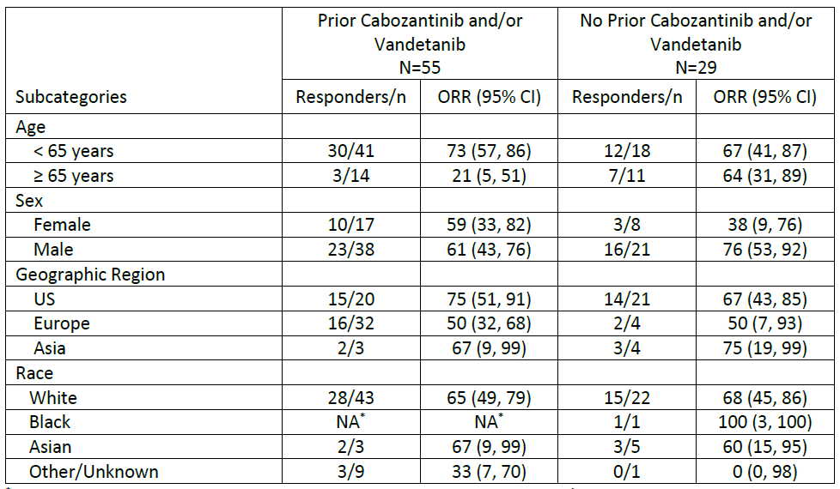

Safety
The safety analysis population consisted of 438 patients treated at 400 mg once daily, including all patients in Study BLU-667-1101 who received at least one dose of pralsetinib (data cutoff 13 February 2020). The population of patients with RET-altered thyroid cancer (138 patients; 119 patients with RET mutation positive MTC and 19 patients with RET fusion positive thyroid cancer) combined in total will be used to inform the relevant sections of the PI.
The most common AEs in all patients treated at 400 mg once daily (in at least 20% of patients) by Preferred Term (PT) included:
- AST increased
- Constipation
- Anaemia
- Hypertension
- ALT increased
- Diarrhea
- Fatigue
- WBC count decreased
- Neutropenia
- Pyrexia

Exposure to pralsetinib
Among the 438 patients treated at 400 mg once daily (including 138 patients, that is 32%, with RET altered thyroid cancer), 47% were exposed to pralsetinib for at least 6 months and 23% were exposed for at least 12 months.
Patient disposition for the RET altered thyroid cancer patient population receiving 400 mg once daily pralsetinib (n = 138) is as follows:
Table 7: Patient disposition
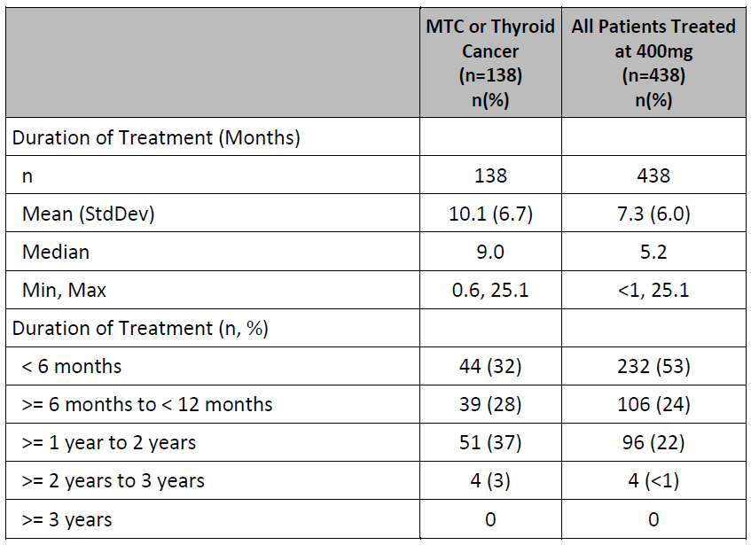

Demographics of safety population:
The demographics and baseline characteristics in the 138 patients with RET altered thyroid cancer and in all patients treated at 400 mg once daily is as follows:
Patients with RET altered thyroid cancer (n = 138)
- Median age = 59 (18-83)
- Male = 65%
- Race: White = 74%; Asian =17%; unknown = 8%
- Region: Asia = 13%; Europe =38%; US = 49%
All patients - treated at 400 mg (n = 438)
- Median age = 59 (18 to 87)
- Male = 55%
- Race: white = 58%; Asian =34%; unknown = 6%
- Region: Asia = 31%; Europe =36%; US = 33%

Deaths
Among all patients treated at 400 mg once daily (n = 438), 9.1% died during the study due to AEs and 4 patients (less than 1%) due to a treatment-related AE (pneumocystis jirovecii pneumonia, pneumonitis and death [two patients with unknown cause report]).
Five deaths occurred in the RET altered thyroid cancer group; two deaths were due to pneumonia, two due to disease progression and one due to pneumonitis. There was no apparent difference between the causes of death between the RET altered thyroid cancer patient population treated at 400 mg once daily and the all patients treated at 400 mg once daily.

Serious Adverse Events
Among all patients treated at 400 mg once daily (n = 438), serious adverse events (SAE) were reported in 45% of patients (Grade 3 = 29%; Grade 4 = 7%). In patients with RET altered thyroid cancer treated at 400 mg once daily, SAEs were reported in 41% of patients (Grade 3 = 30%; Grade 4 = 9%). There was no significant difference in SAEs between the RET altered thyroid cancer patient population treated at 400 mg once daily and the all patients treated at 400 mg once daily.
The most common SAEs (occurring in at least 1% of patients treated at 400 mg) were:
- Pneumonia = 9%
- Urinary tract infection = 3.2%
- Sepsis = 2.5%
- Pneumonitis = 5.0%
- Dyspnoea = 1.6%
- Pleural effusion = 1.4%
- PD = 6%
- Pyrexia = 2.3%
- Fatigue = 1.6%
- Diarrhoea = 1.6%
- Abdominal pain = 1.4%
- Dizziness = 1.6%
- Seizure =1.1%
- Hyponatraemia = 1.4%
- Anaemia = 1.8%
- Neutropenia = 1.6%
- Hypertension = 1.4%
- Musculoskeletal pain = 1.1%

SAEs - off target effects associated with VEGFR, JAK1/2 and FGFR pathways & other

VEGFR pathway
Haemorrhagic events = 16%.
- 2.5 % patients were Grade 3 or higher. Dose modifications occurred as a result of these events.
- One fatal haemorrhagic event was reported.
- All SAEs of haemorrhagic events were associated with potential confounders/risk factors, however, based on the inhibition of the VEGF pathway by pralsetinib, it remains possible that pralsetinib may contribute to the risk of such events. The Delegate commented that the above should be included in the PI.
Hepatotoxicity: serious hepatic events (Grade 3 or higher) = 1.6%
- Of these patients, five required dose modifications.
- No fatalities attributed to hepatic events were identified
- No events met Hy’s law criteria
- The Delegate commented that hepatotoxicity and recommended dose modifications for relevant patients should be included in the PI.
Gastrointestinal perforations/fistulas – 11 events in eight patients
- Based on currently available information, the potential for pralsetinib to impact on the VEGF pathway, and the limited available data from a single arm study, further characterisation of the incidence, presentation, management and outcome of GI perforations/fistulas will be required as a condition of registration.
Impaired wound healing – 4 events in four patients
- Grade 3 event (n = 1) and Grade 1 event (n = 3)
- None required dose modification
- Based on review of preclinical data for pralsetinib and clinical data for multiple drugs that inhibit the VEGF pathway, this may be a class effect; the risk of Impaired Wound Healing and instructions to withhold pralsetinib for at least 2 weeks following surgery until adequate wound healing should be included in the PI.
Cardiac failure
- Analyses for cardiac failure and cardiomyopathy were reviewed and concluded that given the confounding factors associated with the events, it is unlikely that pralsetinib contributed to the occurrence of the reported events of cardiac dysfunction.
Thromboembolic events
- Analyses for thrombotic and embolic events (11 Grade 3 or higher events, including pulmonary embolism (PE), deep vein thrombosis (DVT), portal vein thrombosis, thrombophlebitis superficial, and superior vena cava syndrome) were reviewed and do not suggest a safety signal for pralsetinib for thromboembolic events.

FGFR pathway
Hyperphosphataemia
- Generally moderate; no serious cases reported and no patients had phosphate values of greater than 9mg/dL
- In patients with abnormal phosphate value (at least 5.5 mg/dL) by ‘Phosphate Binder Treated Status Safety Population’ – all patients treated at 400 mg once daily and normal or missing phosphate value at baseline and abnormal phosphate value at post-baseline
- N = 93
- Approximately 50% were not treated with phosphate binders; these patients did not have worsening hyperphosphataemia over time and administration of phosphate binders did not appear to decrease the duration of hyperphosphataemia
- The Delegate commented that hyperphosphataemia should be included in the PI as a potentially clinically significant adverse reaction of pralsetinib
Vision disorders
- Analyses of vision disorders were reviewed and do not suggest a safety signal for pralsetinib for vision disorders

JAK1/2 pathway
Infections/myelosuppression
- Analysis revealed 13 SAEs of sepsis
  - Grade 3: n = 7
  - Grade 4: n = 5
  - Grade 1: n = 1
- In all events, baseline absolute neutrophil count were normal
- six events occurred in association with decreased neutrophil counts
- the primary infection was urinary tract infection in five events and pneumonia in two events
- Evaluation of this analysis concluded that as infections are commonly reported in patients with cancer, and in ARROW these events were not consistently associated with neutropenia, this does not warrant inclusion in the PI.

Dropouts and/or discontinuations due to adverse events
Among all patients treated at 400 mg once daily, AEs that were the primary or contributing reasons for permanent treatment discontinuation were reported in 14.2%, and in 9.2% of patients with RET mutation positive MTC treated at 400 mg once daily. One patient (5.3%) in the population of RET fusion positive thyroid cancer patients treated at 400 mg once daily experienced an AE of pneumonia as the primary or contributing reason for treatment discontinuation (including PD reported as an AE term).
The most common AEs leading to permanent discontinuation in all patients treated at 400 mg once daily were disease progression (2.7%), pneumonia (1.4%) and pneumonitis (1.4%). The most common treatment discontinuation reasons in the patient population with thyroid cancer were: fatigue, anaemia, and pneumonia.

Dose interruption/reduction due to adverse events
In patients with RET-altered thyroid cancer treated with pralsetinib 400 mg once daily:
• Dose interruption due to AE = 67%
  - Most commonly due to neutropenia, fatigue, diarrhoea, hypertension, pneumonitis, pneumonia, anaemia, increased blood creatine kinase, urinary tract infection, musculoskeletal pain, vomiting, stomatitis, dyspnoea, decreased white blood cell count and pyrexia
• Dose reduction due to AE = 44%
  - Most commonly due to neutropenia, anaemia, hypertension, blood creatine kinase increased, pneumonitis, and decreased lymphocyte count
No major differences were noted between the thyroid cancer population and population of all patients treated at 400 mg once daily.

Significant adverse events
The clinical safety evaluation of the ARROW trial is outlined in the concurrent submission PM-2021-05760-1-4 and summarised below for completeness; see corresponding AusPAR.² There were no new major safety signals in the thyroid cancer population compared to the overall safety population.
Neutropenia
- Among all patients treated at 400 mg once daily, neutropenia events were reported in 36% of patients; 33% of patients reported neutropenia events that were related to study drug
- four patients experienced febrile neutropenia; no patient had pralsetinib permanently discontinued for febrile neutropenia
Thrombocytopenia
- Among all patients treated at 400 mg once daily, thrombocytopenia events were reported in 15.1% of patients; 13.2% of patients reported thrombocytopenia events that were related to study drug
Hypertension
- Among all patients treated at 400 mg once daily, hypertension was reported in 29.2% of patients; of these, 49.2% experienced Grade 3 events, none were Grade 4 or 5 events. 21.9% of patients reported hypertension events that were related to study drug
- Pralsetinib was interrupted for hypertension in 7% of patients, 3.2% had dose reduction of pralsetinib for hypertension, and one patient discontinued treatment due to hypertension.
- The Delegate commented that hypertension should be included in the PI as appropriate management will be required to mitigate any adverse outcomes.

Treatment emergent adverse event
The AE profile was similar in patients with thyroid cancer versus all patients treated at 400 mg once daily.
Among all patients treated at 400 mg once daily (n = 438):
- AEs = 99.3%
- AEs related to pralsetinib = 92.2%
- AE of at least Grade 3 = 67.1%
- At least Grade 3 related AEs = 46.1%
- SAEs = 44.5%
- Related SAEs = 17.6%
- Deaths due to AE = 9.1%
- Deaths related to pralsetinib = less than 1%
Among patients with MTC or thyroid cancer treated at 400 mg once daily (n = 138)
- AEs = 100%
- AE of Grade ≥ 3 = 74%
- Deaths due to AEs = 3.6%
- SAEs = 41%
In the thyroid cancer population, a treatment emergent adverse events (TEAE) that was examined further was creatine kinase elevations. Two patients had an SAE of creatine kinase elevations and 11% of patients had a TEAE of creatine kinase elevation. In addition, one patient withdrew from treatment due to creatine kinase evaluation and treatment was interrupted in seven patients and dose reduced in six patients. Creatine kinase elevations should be included in the PI as a clinically significant adverse reaction.
The commonest adverse reactions in patients with RET altered thyroid cancer who received pralsetinib include:
- Musculoskeletal pain = 42%; (Grades 3-4 = 0.7%)
- Constipation = 41%; (Grades 3-4 = 0.7%)
- Hypertension = 40% (Grades 3-4 =21%)
- Fatigue = 38%; (Grades 3-4 = 5.8%)
- Diarrhoea = 34%; (Grades 3-4 = 5.1%)
- Oedema = 29%; (Grades 3-4 = 0)
- Cough = 27%; (Grades 3-4 = 1.4%)
- Rash = 24%; (Grades 3-4 = 0)
- Headache = 24% (Grades 3-4 = 0)
- Pyrexia = 22% (Grades 3-4 = 2.2%)
- Dyspnoea = 22% (Grades 3-4 = 2.2%)
- Peripheral neuropathy = 20% (Grades 3-4 = 0)

Laboratory findings
Results were similar between the all-patients treated at 400 mg once daily safety analysis population and the thyroid cancer population.
Details of selected laboratory abnormalities in patients with RET-altered thyroid cancer are summarised as follows:
Table 8: Selected laboratory abnormalities
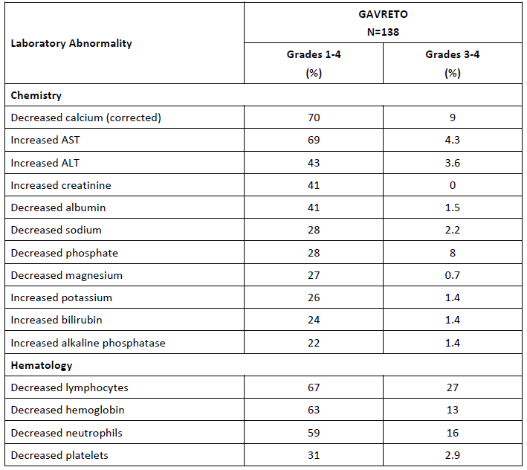

ECG findings
QT prolongation as an AE was reported in 5.3% of patients (all patients treated at 400 mg once daily).
An analysis of data from Phase II of ARROW trial was performed, consisting of 34 patients in the QT/QTc population. Analysis of the regression relationship between ΔQTcF and the plasma concentration of pralsetinib at matching times post-dose showed that pralsetinib had no significant effect on QT prolongation with a linear slope of -0.0003 ms/ng/mL (p-value = 0.841), and no patients had a QTcF value > 500ms
Through the Day 90 safety update period, there were no clinically meaningful differences in changes from baseline electrocardiogram (ECG) results compared with the initial new drug application; clinical evaluation concluded that pralsetinib administration did not have any clinically meaningful effects on ECGs, and was not found to cause QT prolongation.

Submission specific safety issues

Pneumonia
In the safety population of 438 patients treated with pralsetinib at 400 mg once daily, the incidence of pneumonia = 14%. In those with an adverse event of pneumonia, 1.8% permanently discontinued pralsetinib, 7% had treatment interruptions, and 1.8% had dose reductions. Five deaths due to pneumonia were reported.
There was no significant difference in the incidence of pneumonia between the thyroid cancer population treated at 400 mg once daily and all patients treated at 400 mg once daily.

Pneumonitis
Among all patients treated at 400 mg once daily, pneumonitis was reported in 10.3% of patients; 9.1% were related to study drug.
- Grade ≥ 3: 3.0%
- Serious pneumonitis events = 5%
- Serious grouped pneumonitis events related to study drug = 4.3%
There was no significant difference in the incidence of pneumonitis between the thyroid cancer population treated at 400 mg once daily and all patients treated at 400 mg once daily.

Tumour lysis syndrome
This occurred in three patients and 2 out of 3 patients experienced a Grade 3 event requiring hospitalisation; one patient with Grade 3 tumour lysis syndrome (TLS) required administration of rasburicase and allopurinol and prompted hospitalisation, while the other patient was treated with hydration.
The Delegate commented that tumour lysis syndrome should be included in the Warning and Precautions section of the PI given the potential need for mitigation strategies for this AE.

Safety analyses by demographic subgroups
The incidence of Grade ≥ 3 TEAEs and serious TEAEs were approximately 20% higher in the subgroup of patients age ≥ 65 years old than in those under 65 years of age.
For patients with RET-altered thyroid cancer, the incidence of serious TEAEs was approximately 30% higher in the subgroup of patients aged > 65 years than in the subgroup < 65 years old; this difference was slightly smaller in the population of all patients treated at 400 mg. The clinical significance of these differences are uncertain given the relatively limited size of the subgroups.
There was a trend towards increased serious and severe AEs among patients in the ‘other’ race group in both the thyroid cancer populations compared with White or Asians, however, the clinical meaningfulness of this difference is limited by the likely heterogeneity and small patient number of this group.

Risk management plan
Gavreto is proposed to be used for the treatment of adult and paediatric patients 12 years of age and older with advanced or metastatic RET-mutant MTC who require systemic therapy (PM-2021-05761-1-4) and for the treatment of adult and paediatric patients 12 years of age and older with advanced or metastatic RET-fusion positive thyroid cancer who require systemic therapy and who are radioactive iodine-refractory (if radioactive iodine is appropriate) (PM-2021-05762-1-4).
The proposed dosing regimen involves oral administration of four capsules (4 x 100 mg) once daily. The dose is the same for each indication as well as for paediatric patients (12 years and older) and adults. Patients should receive treatment with Gavreto until disease progression or unmanageable toxicity.
The sponsor has submitted the EU-risk management plan (RMP) version 1.0 (dated 15 September 2021; data lock point (DLP) 6 November 2020) and Australia specific annex (ASA) version 1.0 (dated 20 December 2021) in support of these applications. In response to TGA’s questions, the sponsor has submitted EU-RMP version 1.2 (dated 3 February 2022; DLP January 2022) and ASA version 1.1 (dated 26 August 2022) in support of its application.
The summary of safety concerns and their associated risk monitoring and mitigation strategies are summarised in Table 9. The TGA may request an updated RMP at any stage of a product's life-cycle, during both the pre-approval and post-approval phases.
Table 9: Summary of safety concerns
Summary of safety concerns |  | Pharmacovigilance |  | Risk Minimisation
 |  | Routine | Additional | Routine | Additional
Important identified risks | Pneumonitis | ✔ | – | ✔ | –
Important identified risks | Hypertension | ✔ | – | ✔ | –
Important identified risks | Haemorrhage | ✔ | – | ✔ | –
Important identified risks | Transaminase Elevations | ✔ | – | ✔ | –
Important potential risks | Embryo-foetal toxicity | ✔ | – | ✔ | –
Important potential risks | Severe Infections | ✔ | – | ✔ | –
Important potential risks | QT prolongation | ✔ | – | ✔ | –
Missing information | Use in patients with severe hepatic impairment | ✔ | ✔* | ✔ | –
Missing information | Drug-drug Interactions | ✔ | ✔† | ✔ | –
*Study GP43163
†Study GP43162
No new safety concerns have been identified and the summary of safety concerns is acceptable.
Routine and additional pharmacovigilance activities are proposed. Additional pharmacovigilance activities include a drug-drug interaction study (Study GP43162) and a pharmacokinetic study in patients with severe hepatic impairment (Study GP43163). This will provide information on the Missing Information (as listed in the table above). This is acceptable.
Routine risk minimisation activities only are proposed which is acceptable as pralsetinib is an oral medicine prescribed by specialists.

Risk-benefit analysis

Delegate’s considerations
Rearranged during transfection gene rearrangements (fusions) and mutations have been identified as oncogenic drivers in thyroid cancers.
Advanced or metastatic RET mutation positive MTC is a life threatening condition; patients with advanced progressive disease have poor survival with a five year survival of approximately 40%. The current standard of care in Australia for patients with advanced RET mutation positive MTC are as for those with advanced MTC regardless of RET mutation status, that is vandetanib (TGA approved, but not on Pharmaceutical Benefits Scheme) and cabozantinib. Both of these TKIs inhibit RET in addition to other kinases, but are not approved solely for the treatment of patients with RET mutations. The ORRs reported in studies of patients with MTC treated with vandetanib and cabozantinib were 45% and 28% respectively. There is currently no approved therapy in Australia specifically for the treatment of patients with RET mutation-positive thyroid cancer.
Metastatic RET fusion-positive thyroid cancer that is refractory to RAI is a rare disease; five year survival is approximately 50% in patients with distant metastases (regardless of tumour histology); anaplastic is a more aggressive form of thyroid cancer, with patients having a median OS of 5 months and 1 year survival rate of 20%. Patients with RET-fusion positive poorly differentiated or anaplastic thyroid cancer in particular face an unmet medical need. Treatment options for those with RAI refractory disease include TKIs such as lenvatinib and sorafenib, and doxorubicin monotherapy, that is the standard of care for those with DTC refractory to RAI regardless of RET mutation status. The ORRs reported in studies supporting the approval of lenvatinib and sorafenib of patients with RAI refractory DTC were 65% and 12% respectively. There is currently no approved therapy in Australia specifically for the treatment of patients with RET fusion-positive thyroid cancer.
Pralsetinib is an orally bioavailable kinase inhibitor that selectively targets the RET receptor tyrosine kinase.
The sponsor proposes to register pralsetinib, a new therapeutic entity, for the following indications:
- Adult and paediatric patients 12 years of age and older with advanced or metastatic RET-mutant MTC who require systemic therapy
- Adult and paediatric patients 12 years of age and older with RET fusion-positive thyroid cancer who require systemic therapy who are radioactive iodine-refractory (if radioactive iodine is appropriate)
The proposed dosing regimen is 400 mg daily orally, on an empty stomach on a continuous schedule.

Benefits/Uncertainties of benefit
The sponsor has provided adequate evidence of effectiveness to support the provisional approval of pralsetinib for the treatment of adult patients with advanced or metastatic RET-mutant MTC, and for the treatment of adult patients with advanced or metastatic RET-fusion positive thyroid cancer that is radioactive iodine-refractory (if radioactive iodine is appropriate) and who have progressed on lenvatinib or sorafenib.

RET mutation positive medullary thyroid cancer
Study BLU-667-1101 (ARROW trial), a single arm escalation and expansion study, enrolled patients with advanced solid tumours with a RET fusion or mutation. 84 patients with metastatic RET-mutant MTC with measurable disease (55 patients who previously received treatment with cabozantinib or vandetanib, and 29 patients naïve to cabozantinib and vandetanib) were treated with pralsetinib 400 mg once daily.
- The ORR (per BICR) in the treatment naïve patient population was 66% (95% CI: 46, 82) and the median DOR was not reached; 84% of responders had an observed DOR of at least 6 months
- In the population previously treated with cabozantinib or vandetanib, the ORR (BICR) was 60% (95% CI: 46, 73), and the median DOR not reached, with 79% of responders having observed DOR of at least 6 months
Patients with advanced or metastatic RET-mutant medullary thyroid cancer have limited treatment options. In those who have previously received cabozantinib or vandetanib, there are currently no approved therapies available. For patients who have not received prior cabozantinib or vandetanib, overall response rates of pralsetinib at present compare favourably (although indirectly) to either cabozantinib or vandetanib.
Table 10: Arrow trial overall response rates
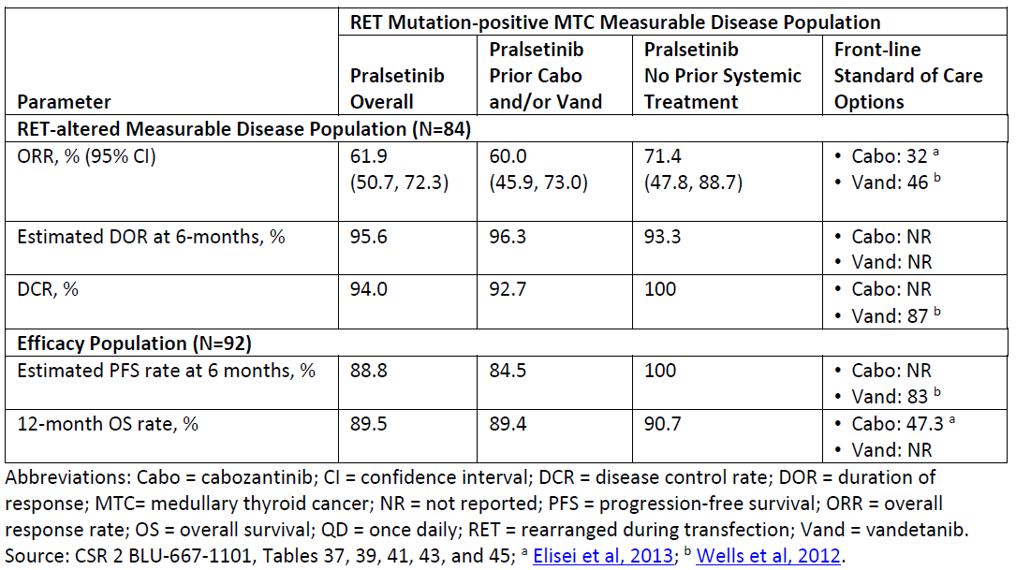
The overall response rates reported in the ARROW trial, with their associated durability of response observed, are considered to be consistent with a clinical meaningful benefit of pralsetinib in adult patients with advanced or metastatic RET-mutant MTC.
If approved, confirmatory data from additional patients with treatment naïve MTC is required post-marketing to confirm clinical benefit of pralsetinib.

RET fusion-positive thyroid cancer
Patients with advanced RET fusion-positive thyroid cancer were eligible for enrolment in ARROW trial if they had previously been treated with standard of care appropriate for the tumour type. The overall efficacy population included nine patients with RET-fusion positive RAI refractory thyroid cancer who were treated with pralsetinib 400 mg once daily; five patients (55.6%) had received lenvatinib and/or sorafenib.
- The ORR was 89% (95% CI: 52, 100); all responders had a DOR at least 6 months, and one with a response of at least 12 months. In the five patients who had received sorafenib or lenvatinib, 80% (95% CI: 28, 99) demonstrated a response. In the four patients who had not received an MKI, 100% demonstrated a response.
There are currently no approved therapies in Australia for patients with RET fusion-positive RAI refractory DTC who have failed treatment with lenvatinib or sorafenib. The observed response rate and associated durability of response is considered sufficient to support the approval of pralsetinib in adult patients with advanced or metastatic RET-fusion positive thyroid cancer that is refractory to (or unsuitable for) radioactive iodine-refractory and who have progressed on lenvatinib or sorafenib.

Uncertainties

RET mutation positive MTC
Although the observed ORR and the associated durability of response are at present considered to be sufficient to support provisional approval of use of pralsetinib in patients with RET mutation-positive MTC, data remains limited, especially in those who have not previously been treated with either cabozantinib or vandetanib.
It is expected that the sponsor will provide further data from the relevant patient population in the ARROW trial, and confirmatory data from AcceleRET-MTC trial (Phase III randomised study comparing the efficacy and safety of pralsetinib in patients with RET-mutant MTC with cabozantinib or vandetanib) in the post-approval setting to confirm clinical benefit.

RET fusion-positive thyroid cancer
The ORR in this rare RET-altered subset of patients compares favourably, although indirectly, to the response rates observed in the studies of lenvatinib (65%) and sorafenib (12%) for the broader population of patients with RAI refractory DTC regardless of RET mutation status. However, it is noted that the ARROW trial inclusion criteria was for patients with an oncogenic RET fusion previously treated with the standard of care appropriate for the tumour type. At the time of study conduct, the standard of care for this patient population was an MKI (that is lenvatinib or sorafenib). Taking into account the ARROW trial population, the overall ORR supports the approval of pralsetinib for use in patients with RET fusion-positive thyroid cancer that is refractory to radioactive iodine (if appropriate) and who have progressed on lenvatinib or sorafenib.
All nine patients with RET fusion-positive DTC in the ARROW trial had papillary thyroid cancer histologic subtype in the primary efficacy population. However, responses were observed in patients with undifferentiated/anaplastic thyroid cancer (n = 2) and poorly differentiated thyroid cancer (n = 1) in the patient group who were treated at lower doses or whose enrolment date did not meet the data cutoff for the population included in the submission. Given the limited treatment options for patients with undifferentiated or poorly differentiated thyroid cancer with RET fusions, the rarity of such tumours, and the significant response rate and strong rationale for use based on the mechanism of action in the RET fusion-positive population, the inclusion of histologies other than papillary thyroid cancer in the indication is considered to be reasonable.
There are limitations to deriving inference from a small, single arm, non-randomised study such as ARROW trial. Further data from additional patients to confirm clinical benefit will be required post-approval setting for patients with RET fusion-positive thyroid cancer.

RET mutation positive MTC and RET fusion-positive thyroid cancer
As the study inclusion criteria included adults only, no adolescent patients were evaluated in the ARROW trial. The efficacy and safety of pralsetinib in this patient population has therefore not been established.
Should pralsetinib be approved for patients with advanced RET mutation positive MTC, and patients with advanced RET fusion-positive thyroid cancer that is refractory radioactive iodine (if appropriate) who have progressed on, or are unsuitable for, lenvatinib or sorafenib, the PI should specify (under 4.4 Special Warnings and Precautions for Use and 4.2 Dose and Method of Administration) that ‘the safety and efficacy of pralsetinib in children and adolescents aged younger than 18 years old have not yet been established. No data are available.’

Risks/Uncertainties of risk
Overall, pralsetinib is considered to have an acceptable safety profile in the context of a life threatening disease, the high activity of pralsetinib observed, and also the toxicity generally associated with alternative treatment options.
In the pooled safety population (of 438 patients with RET altered solid tumours):
• AEs = 99.3%
• AEs related to pralsetinib = 92.2%
• Grade ≥ 3 AEs= 67.1%
• Grade ≥ 3 related AEs = 46.1%
• SAEs = 44.5%
• Related SAEs = 17.6%
• Deaths due to AE = 9.1%
• Deaths related to pralsetinib is less than 1%
The most common treatment related AEs were increased AST (33.6%), increased ALT (22.8%), anaemia (24.4%), constipation (22.6%), and hypertension (21.9%). The most common treatment related SAEs were:
• Pneumonitis = 3.9%
• Pneumonia = 2.1%
• Anaemia =0.9%
• Hypertension is less than 1%
• Neutropenia = 1.4%
• Pneumocystis jirovecii pneumonia is less than 1%
• Sepsis is less than 1%
• Thrombocytopenia is less than 1%
• Blood creatine phosphokinase increased is less than 1%
• Diarrhoea is less than 1%
• Interstitial lung disease is less than 1%
• Platelet count decreased is less than 1%
14.2% of patients reported AEs requiring permanent discontinuation of pralsetinib.
In the primary safety population of patients with thyroid cancer treated with pralsetinib 400 mg once daily (n = 138), the safety profile is generally comparable to that of the NSCLC population.
The commonest adverse reactions in patients with RET altered thyroid cancer who received pralsetinib include:
- Musculoskeletal pain = 42%; (Grades 3 - 4 = 0.7%)
- Constipation = 41%; (Grades 3 - 4 = 0.7%)
- Hypertension = 40%; (Grades 3 - 4 = 21%)
- Fatigue = 38%; (Grades 3 - 4 = 5.8%)
- Diarrhoea = 34%; (Grades 3 - 4 = 5.1%)
- Oedema = 29%; (Grades 3 - 4 = 0)
- Cough = 27%; (Grades 3 - 4 = 1.4%)
- Rash = 24%; (Grades 3 - 4 = 0)
- Headache = 24%; (Grades 3 - 4 = 0)
- Pyrexia = 22%; (Grades 3 - 4 = 2.2%)
- Dyspnoea = 22%; (Grades 3 - 4 = 2.2%)
- Peripheral neuropathy = 20%; (Grades 3 - 4 = 0)
Serious adverse reactions occurred in 39% of patients; the most frequent of these were pneumonia, pneumonitis, urinary tract infection, pyrexia, fatigue, diarrhoea, dizziness, anaemia, hyponatraemia and ascites. Fatal adverse reaction occurred in 2.2% of patients; fatal adverse reaction that occurred in less than one patient included pneumonia. Dose interruption due to AE was reported in 67% of patients, and dose reduction due to an AE in 44%.
Although severe toxicities are observed with pralsetinib, these safety concerns may be adequately addressed by information in the Warnings and Precautions section and the dose modification section of the PI. This includes the significant and serious safety issues identified in the corresponding submission (for advanced NSCLC)² that is:
- Interstitial lung disease/pneumonitis
- Hypertension
- Hepatotoxicity
- Haemorrhagic events
The risk of impaired/delayed wound healing due to inhibition of the VEGF pathway should also be adequately addressed by information in the Warnings and Precautions section of the PI.
Based on the potential serious risk of gastrointestinal perforations/fistulas related to this same mechanism of action, a condition of registration to further evaluate his potential risk is required.
In general, the safety profile observed in patients with thyroid cancer (n = 138) was similar to that observed in patients with the NSCLC patient population. Tumour lysis syndrome was observed solely in patients with MTC and should be included in the Warnings and Precautions section of the PI given the need for provider awareness, the potential seriousness of these events and the potential need for mitigation strategies. In addition, increased creatine phosphokinase was identified as an additional safety signal in 11% of patients with RET-altered thyroid cancer (n = 138); in some cases, these events required dose interruption, dose reduction, and rarely withdrawal of pralsetinib.

Uncertainties
Uncertainty remains regarding the long-term safety profile, including that in the elderly subgroup. In addition, the single arm study design of ARROW trial precludes the direct comparison of safety/toxicity profile of pralsetinib with standard of care (cabozantinib or vandetanib in patients with RET mutation positive MTC, and lenvatinib or sorafenib in patients with RET-fusion positive thyroid cancer). The number of patients with RET-altered thyroid cancer in ARROW trial was relatively small, limiting the ability to fully characterise rare AEs.

Benefit/Risk balance
Overall, the benefit-risk assessment for pralsetinib is favourable in adult patients with advanced or metastatic RET-mutant MTC, and in adult patients with advanced or metastatic RET-fusion positive thyroid cancer that is refractory to (or unsuitable for) radioactive iodine and who have progressed on either lenvatinib or sorafenib. This is based on the high response rates and durable responses seen in a patient population with a life-threatening disease and unmet medical need. The corresponding ORR and DOR are considered to be clinically meaningful and reasonably likely to predict clinical benefit in this population.
Although pralsetinib can cause serious toxicities, the safety profile demonstrated is generally manageable and considered acceptable in the context of the life-threatening nature of advanced/metastatic RET-mutant MTC and advanced/metastatic RET-fusion positive RAI-refractory thyroid cancer, and also considering the lack of available targeted therapy options in Australia for this patient population at present.
The study design limits interpretation of survival; given the limited duration of follow-up for other cohorts and the small number of treatment-naïve patients in the primary efficacy analysis population for this submission, only provisional approval is supported at present. Further data is required in order to confirm clinical benefit, including additional data from Study BLU-667-1101, AcceleRET-MTC study, and TAPISTRY trial. If approved, the sponsor will be required to submit final reports of post-marketing requirement studies for pralsetinib (see International Regulatory Status section, and RMP evaluation report).

Proposed action
The benefit risk assessment for pralsetinib is considered to be favourable in the following:
- adult patients with advanced or metastatic RET-mutant MTC
- adult patients with advanced or metastatic RET-fusion positive thyroid cancer that is refractory to (or unsuitable for) radioactive iodine and who have progressed on lenvatinib or sorafenib.
The Delegate therefore supports provisional registration of pralsetinib for the following indications (providing that any outstanding issues/recommendations outlined in the quality report are satisfactorily addressed):
Gavreto has provisional approval in Australia for the treatment of adult patients with advanced or metastatic RET-mutant medullary thyroid cancer (MTC). The decision to approve this indication has been made on the basis of overall response rate (ORR) and duration of response (DOR). Continued approval of this indication depends on verification and description of benefit in confirmatory trials.
Gavreto has provisional approval in Australia for the treatment of adult patients with advanced or metastatic RET-fusion positive thyroid cancer that is refractory to (or unsuitable for) radioactive iodine and who have progressed on lenvatinib or sorafenib. The decision to approve this indication has been made on the basis of overall response rate (ORR) and duration of response (DOR). Continued approval of this indication depends on verification and description of benefit in confirmatory trials.
In addition to the standard conditions of registration, additional conditions of registration are proposed, that is the sponsor will be required to provide confirmatory data from the following:
- AcceleRET-MTC Study by December of 2028: Submit the final report including datasets from a multi-center, randomised, open-label trial comparing pralsetinib to investigator’s choice of either cabozantinib or vandetanib in multi-kinase inhibitor naïve patients with advanced or metastatic RET-mutant medullary thyroid cancer to confirm the clinical benefit of pralsetinib with progression-free survival as a primary endpoint, as assessed by blinded independent central review.
- TAPISTRY trial (Tumour-Agnostic Precision Immuno-Oncology and Somatic Targeting Rational for You) by June 2025.
- ARROW trial (Study BO42863) by December 2022
- Other conditions of registration as outlined under ‘Clinical Pharmacology’

Advisory Committee considerations
The Advisory Committee on Medicines (ACM), having considered the evaluations and the Delegate’s overview, as well as the sponsor’s response to these documents, advised the following.

Specific advice to the Delegate
The ACM advised the following in response to the Delegate’s specific request for advice:
- Are the results of ARROW, Study BLU-667-1101, sufficient to support the use of pralsetinib in adults with advanced/metastatic RET- fusion positive radioactive iodine-refractory thyroid cancer in the first-line setting, or should use be limited to those who have progressed on lenvatinib or sorafenib?
The ACM expressed strong concern with the sparse data set (n = 9) for adults with advanced/metastatic RET fusion positive radioactive iodine refractory thyroid cancer, despite the positive overall response rate. The ACM was of the view that the sponsor should submit further data from additional patients to confirm clinical benefit including results from the TAPISTRY trial when available.
On balance, the ACM considered that the positive overall response rate in the target population provides just enough evidence for provisional registration as a last line therapy in patients that have progressed on or are unable to tolerate lenvatinib or sorafenib.
- Does ACM support the use of pralsetinib in paediatric patients 12 years of age and older with advanced RET-mutant MTC or advanced RET-fusion positive radioactive iodine-refractory thyroid cancer?
The ACM noted that there was no clinical data on the paediatric patient group aged 12 years and older and does not support the use of pralsetinib in that patient cohort.

Conclusion
The ACM considered this product to have an overall positive benefit-risk profile for the indication:
Gavreto is provisionally indicated for the treatment of adult patients with advanced or metastatic RET-fusion positive thyroid cancer that is refractory to (or unsuitable for) radioactive iodine and who have progressed on or are unable to tolerate lenvatinib or sorafenib. The decision to approve this indication has been made on the basis of overall response rate (ORR) and duration of response (DOR). Continued approval of this indication depends on verification and description of benefit in confirmatory trials.

Outcome
Based on a review of quality, safety, and efficacy, the TGA approved the registration of Gavreto (pralsetinib) strength, 100 mg, capsule, bottle, indicated for:
RET-Fusion Positive Thyroid Cancer
Gavreto has provisional approval in Australia for the treatment of adult patients with advanced or metastatic RET-fusion positive thyroid cancer that is refractory to (or unsuitable for) radioactive iodine and who have progressed on or are unable to tolerate lenvatinib or sorafenib. The decision to approve this indication has been made on the basis of overall response rate (ORR) and duration of response (DOR). Continued approval of this indication depends on verification and description of benefit in confirmatory trials.

The sponsor withdrew the application for the advanced or metastatic RET-mutant medullary thyroid cancer indication on the 29 June 2023.

Specific conditions of registration applying to these goods
- Gavreto (pralsetinib) is to be included in the Black Triangle Scheme. The PI and CMI for Gavreto must include the black triangle symbol and mandatory accompanying text for five years, or the product’s entire period of provisional registration, whichever is longer.
- The Gavreto EU-RMP (version 1.2, dated 3 February 2022 data lock point January 2022), with ASA (version 1.1, dated 26 August 2022), included with submission PM-2021-05760-1-4; PM-2021-05761-1-4 and PM-2021-05762-1-4, and any subsequent revisions, as agreed with the TGA will be implemented in Australia.
- An obligatory component of risk management plans is routine pharmacovigilance. Routine pharmacovigilance includes the submission of periodic safety update reports (PSURs).
- Unless agreed separately between the supplier who is the recipient of the approval and the TGA, the first report must be submitted to TGA no later than 15 calendar months after the date of this approval letter. The subsequent reports must be submitted no less frequently than annually from the date of the first submitted report until the period covered by such reports is not less than three years from the date of this approval letter, or the entire period of provisional registration, whichever is longer.
- The reports are to at least meet the requirements for PSURs as described in the European Medicines Agency’s Guideline on good pharmacovigilance practices (GVP) Module VII-periodic safety update report (Rev 1), Part VII.B Structures and processes. Note that submission of a PSUR does not constitute an application to vary the registration. Each report must have been prepared within ninety calendar days of the data lock point for that report.
- Longer follow up of efficacy evaluable patients from the relevant cohorts of ARROW trial (Study BLU-667-1101).
- Submit the final report of integrated datasets, to verify and further characterise the clinical benefit of pralsetinib for the treatment of patients with RET fusion-positive thyroid cancer who have received radioactive iodine (if appropriate for their tumour histology) to provide a more precise estimation of the BICR-assessed overall response rate and duration of response in at least 50 patients in a variety of histologies after all responding patients have been followed for 12 months following onset of response of until disease progression, whichever comes first.
- Comprehensive analysis evaluating and characterising the incidence, clinical presentation, management and outcome of the potential serious risk of pralsetinib associated gastrointestinal perforations and fistulas. Submit an integrated final report containing data from patient-level and pooled analyses of ongoing and completed clinical trials, post-marketing reports and/or literature reports and a comprehensive pharmacovigilance assessment for this risk.
- Conduct a hepatic impairment clinical trial to evaluate the pharmacokinetics and safety of pralsetinib in subjects with moderate and severe hepatic impairment compared to subjects with normal hepatic function. Design and conduct the trial in accordance with FDA guidance and submit the datasets with the final report.
- Conduct a clinical drug-drug interaction study to evaluate the effect of a P-gp inhibitor on the pharmacokinetics of pralsetinib and to inform appropriate dosing strategies for safe co-administration of pralsetinib with P-gp inhibitors. Design and conduct the trial in accordance with FDA guidance and submit the datasets with the final report.
- Conduct a physiologically-based pharmacokinetic modeling/simulation study to evaluate the effect of repeat doses of a moderate CYP3A inhibitor on the pharmacokinetics of pralsetinib, assess the magnitude of increased pralsetinib exposure, and inform appropriate dosing strategies for safe co-administration of pralsetinib with moderate CYP3A inhibitors. Design and conduct the trial in accordance with FDA guidance, and submit the model with the final report.
- Conduct a physiologically-based pharmacokinetic modeling/simulation study to evaluate the effect of repeat doses of a combined P-gp and moderate CYP3A inhibitor on the pharmacokinetics of pralsetinib, assess the magnitude of increased pralsetinib exposure, and inform appropriate dosing strategies for safe co-administration of pralsetinib with combined P-gp and moderate CYP3A inhibitors. Design and conduct the trial in accordance with FDA guidance, and submit the model with the final report.
- Conduct a clinical drug interaction study to evaluate the effect of repeat doses of pralsetinib on the pharmacokinetics of transporter substrates of P-gp, BCRP, OATP1B1, OATP1B3, MATE-1 and MATE-2K, assess the magnitude of exposure change, and inform appropriate dosing strategies for co-administration of pralsetinib with these transporter substrates. Design and conduct the trial in accordance with FDA guidance, and submit the datasets with the final report.
- Conduct a clinical drug interaction study to evaluate the effect of repeat doses of pralsetinib on the pharmacokinetics of sensitive substrates of CYP3A4/5, CYP2C8, and CYP2C9, assess the magnitude of exposure change, and inform appropriate dosing strategies for safe co-administration of pralsetinib with sensitive substrates of CYP3A4/5, CYP2C8 and CYP2C9. Design and conduct the trial in accordance with FDA guidance, and submit the datasets with the final report.
- Conduct a physiologically-based pharmacokinetic modeling/simulation study to evaluate the effect of repeat doses of a moderate CYP3A inducer on the pharmacokinetics of pralsetinib, assess the magnitude of decreased pralsetinib exposure, and inform appropriate dosing strategies for co-administration of pralsetinib with moderate CYP3A inducers. Design and conduct the trial in accordance with FDA guidance, and submit the model with the final report.

Attachment 1. Product Information
The PI for Gavreto approved with the submission which is described in this AusPAR is at Attachment 1. For the most recent PI, please refer to the TGA PI/CMI search facility.
Therapeutic Goods Administration
PO Box 100 Woden ACT 2606 Australia
Email: info@tga.gov.au Phone: 1800 020 653 Fax: 02 6203 1605
https://www.tga.gov.au

This is the original indication proposed by the sponsor when the TGA commenced the evaluation of this submission. It may differ to the final indication approved by the TGA and registered on the Australian Register of Therapeutic Goods.
AuPAR for Gavreto for non small cell lung cancer, available at (to insert the hyperlink once NSCLC AusPAR publication is approved).
RET-Mutant Medullary Thyroid Cancer (MTC) and RET-Fusion Positive Thyroid Cancer was voluntarily withdrawn The sponsor took the decision to withdraw the New Drug Submission (NDS) for both RET-mutant medullary thyroid cancer (MTC) and RET fusion positive thyroid cancer indications in Canada. This decision to withdraw was not taken for any efficacy or safety concerns, but because Health Canada requested additional mature safety data that is not yet available. This decision does not preclude us from re-submitting in the future once this data is available.
https://www.accessdata.fda.gov/drugsatfda_docs/nda/2020/213721Orig1s000MultidisciplineR.pdf)
ECOG Performance Status: The Eastern Cooperative Oncology Group (ECOG) has developed criteria used by doctors and researchers to assess how a patient's disease is progressing, assess how the disease affects the daily living abilities of the patient, and determine appropriate treatment and prognosis. The following are used: 0 - Fully active, able to carry on all pre-disease performance without restriction 1- Restricted in physically strenuous activity but ambulatory and able to carry out work of a light or sedentary nature, for example, light house work, office work 2 - Ambulatory and capable of all selfcare but unable to carry out any work activities. Up and about more than 50% of waking hours 3 - Capable of only limited selfcare, confined to bed or chair more than 50% of waking hours 4 - Completely disabled. Cannot carry on any selfcare. Totally confined to bed or chair 5 – Dead
RET mutation status was identified retrospectively by central tissue-based NGS or plasma ctDNA test for Group 3 and 4)
The Response Evaluation Criteria In Solid Tumours (RECIST) is a voluntary international standard with unified and easily applicable criteria to define when a patient's tumour has improved ('respond'), stayed the same ('stabilise'), or worsened ('progress') during treatment. The criteria were published in February 2000 by an international collaboration including the European Organisation for Research and Treatment of Cancer (EORTC), National Cancer Institute (NCI) of the United States, and the National Cancer Institute of Canada Clinical Trials Group. Today, the majority of clinical trials evaluating cancer treatments for objective response in solid tumours use RECIST. These criteria were developed and published in February 2000, and subsequently updated in 2009.
The time to event endpoints of PFS and OS are not interpretable in a single arm study, and therefore not confirmed by the clinical evaluation.
The European Organisation for Research and Treatment of Cancer (EORTC) has developed an overall HRQoL summary score based on their traditional and well‐established 30‐item Quality of Life Questionnaire (QLQ‐C30) encompassing all symptom (e.g., pain, fatigue) and functional domains (e.g., emotional and social items) assessed by the QLQ‐C30.
Eight patients with RET mutant MTC and two patients with RET fusion-positive thyroid cancer did not have measurable disease at baseline and were therefore not included in the efficacy analysis.

