Australian Public Assessment Report for Vazkepa
  - Active ingredient: Icosapent ethyl
  - Sponsor: AA-Med Pty Ltd
September 2023

About the Therapeutic Goods Administration (TGA)
- The Therapeutic Goods Administration (TGA) is part of the Australian Government Department of Health and Aged Care and is responsible for regulating therapeutic goods, including medicines, medical devices, and biologicals.
- The TGA administers the Therapeutic Goods Act 1989 (the Act), applying a risk management approach designed to ensure therapeutic goods supplied in Australia meet acceptable standards of quality, safety, and efficacy.
- The work of the TGA is based on applying scientific and clinical expertise to decision-making, to ensure that the benefits to the Australian public outweigh any risks associated with the use of therapeutic goods.
- The TGA relies on the public, healthcare professionals and industry to report problems with therapeutic goods. The TGA investigates reports received to determine any necessary regulatory action.
- To report a problem with a therapeutic good, please see the information on the TGA website.

About AusPARs
- The Australian Public Assessment Report (AusPAR) provides information about the evaluation of a prescription medicine and the considerations that led the TGA to approve or not approve a prescription medicine submission. Further information can be found in Australian Public Assessment Report (AusPAR) guidance.
- AusPARs are prepared and published by the TGA.
- AusPARs are static documents that provide information that relates to a submission at a particular point in time. The publication of an AusPAR is an important part of the transparency of the TGA’s decision-making process.
- A new AusPAR may be provided to reflect changes to indications or major variations to a prescription medicine subject to evaluation by the TGA.

Copyright
© Commonwealth of Australia 2023
This work is copyright. You may reproduce the whole or part of this work in unaltered form for your own personal use or, if you are part of an organisation, for internal use within your organisation, but only if you or your organisation do not use the reproduction for any commercial purpose and retain this copyright notice and all disclaimer notices as part of that reproduction. Apart from rights to use as permitted by the Copyright Act 1968 or allowed by this copyright notice, all other rights are reserved and you are not allowed to reproduce the whole or any part of this work in any way (electronic or otherwise) without first being given specific written permission from the Commonwealth to do so. Requests and inquiries concerning reproduction and rights are to be sent to the TGA Copyright Officer, Therapeutic Goods Administration, PO Box 100, Woden ACT 2606 or emailed to <tga.copyright@tga.gov.au>.

Contents
List of abbreviations 4
Product submission 6
Submission details 6
Product background 7
Regulatory status 8
Product Information 10
Registration timeline 10
Submission overview and risk/benefit assessment 10
Quality 11
Nonclinical 11
Clinical 13
Summary of clinical studies 13
Pharmacology 16
Efficacy 17
Safety 34
Risk management plan 39
Risk-benefit analysis 40
Delegate’s considerations 40
Proposed action 43
Advisory Committee considerations 43
Outcome 44
Specific conditions of registration applying to these goods 44
Attachment 1. Product Information 45

List of abbreviations
Abbreviation | Meaning
ACM | Advisory Committee on Medicines
ACV | Advisory Committee on Vaccines
AE | Adverse event
AESI | Adverse events of special interest
ALT | Alanine aminotransferase
ASA | Australia-specific annex
AST | Aspartate aminotransferase
ARTG | Australian Register of Therapeutic Goods
CHMP | Committee for Medicinal Products for Human Use (European Medicines Agency, European Union)
CI | Confidence interval
CMI | Consumer Medicines Information
COR | Comparable Overseas Regulator
CRP | C-reactive protein
CYP | Cytochrome P450
eGFR | Estimated glomerular filtration rate
EMA | European Medicines Agency (European Union)
EPA | Eicosapentaenoic acid
EU | European Union
GVP | Good Pharmacovigilance Practices
HDL | High-density lipoprotein
hERG | Human ether-a-go-go-related gene
LDL | Low-density lipoprotein
Lp-PLA₂ | Lipoprotein-associated phospholipase A₂
MACE | Major adverse cardiovascular event
OATP | Organic anion transporting polypeptide
PI | Product Information
PK | Pharmacokinetic(s)
PSUR | Periodic safety update report
RMP | Risk management plan
SAE | Serious adverse event
TG | Triglcyerides
TEAE | Treatment-emergent adverse event
TGA | Therapeutic Goods Administration
ULN | Upper limit of normal
US(A) | United States (of America)
VLDL | Very low-density lipoprotein

Product submission

Submission details
Type of submission: | New chemical entity
Product name: | Vazkepa
Active ingredient: | Icosapent ethyl
Decision: | Approved
Date of decision: | 2 November 2022
Date of entry onto ARTG: | 8 November 2022
ARTG number: | 380979, 380980
Black Triangle Scheme  for the current submission: | Yes.  This product will remain in the scheme for 5 years, starting on the date the product is first supplied in Australia.
Sponsor’s name and address: | AA-Med Pty Ltd  Suite 4, Level 10/ 1 Chandos Street  St Leonards NSW 2065
Dose form: | Soft capsule
Strength: | 998 mg
Container: | Blister pack, bottle
Pack sizes: | 8 capsules per blister pack, 120 capsules per bottle
Approved therapeutic use for the current submission: | Vazkepa is indicated to reduce the risk of cardiovascular events in adult statin-treated patients at high cardiovascular risk with elevated triglycerides (≥ 1.7 mmol/L) and  - established cardiovascular disease, or  - diabetes, and at least one other cardiovascular risk factor.
Route of administration: | Oral
Dosage: | The recommended daily oral dose is 4 capsules taken as two 998 mg capsules twice daily.  If a dose is missed, patients should take it as soon as they remember. However, if one daily dose is missed, the next dose should not be doubled.  For further information regarding dosage, refer to the Product Information.
Pregnancy category: | B1  Drugs which have been taken by only a limited number of pregnant women and women of childbearing age, without an increase in the frequency of malformation or other direct or indirect harmful effects on the human fetus having been observed.  Studies in animals have not shown evidence of an increased occurrence of fetal damage.  The use of any medicine during pregnancy requires careful consideration of both risks and benefits by the treating health professional. This must not be used as the sole basis of decision making in the use of medicines during pregnancy. The TGA does not provide advice on the use of medicines in pregnancy for specific cases. More information is available from obstetric drug information services in your state or territory.

Product background
This AusPAR describes the submission by AA-Med Pty Ltd (the sponsor) to register Vazkepa (icosapent ethyl) 998 mg, soft capsule, blister pack or bottle for the following proposed indication:
Vazkepa is indicated to reduce the risk of cardiovascular events in adult statin-treated patients at high cardiovascular risk with elevated triglycerides (≥ 150 mg/dL [≥ 1.7 mmol/L]) and
- established cardiovascular disease, or
- diabetes, and at least one other cardiovascular risk factor.
Cardiovascular disease encompasses a broad group of medical problems that affect the circulatory system (the heart, blood vessels and arteries). Despite medical advances and broader use of available therapies such as statins, cardiovascular disease remains the leading cause of death globally. Established risk factors for cardiovascular disease include smoking, hypertension, diabetes, hypercholesterolaemia and other dyslipidaemias, and family history of cardiovascular disease. Hypertriglyceridaemia has been shown to be an independent risk factor for cardiovascular disease. About one-third of adults have triglyceride levels > 1.7 mmol/L (150 mg/dL).,
Statins are the mainstay of treatment of hyperlipidaemia due to established benefits in reducing cardiovascular morbidity and mortality. The role of statins in both primary and secondary prevention of cardiovascular disease is well established. PCSK9 inhibitors and selective cholesterol absorption inhibitors (for example, ezetimibe) have demonstrated a benefit as add-on therapy when therapeutic goals are not met with statins, or in statin-intolerant patients. Fibrates, niacin, and omega-3-acid ethyl esters have been shown to lower triglyceride levels, but evidence of a cardiovascular benefit is uncertain.
Icosapent ethyl is a stable ethyl ester of the omega-3 fatty acid, eicosapentaenoic acid (EPA). Marine fish are the primary natural dietary source of EPA. The mechanisms of action contributing to reduction of cardiovascular events with icosapent ethyl are not completely understood. The mechanisms are thought to be multi-factorial, including improved lipoprotein profile with reduction of triglyceride-rich lipoproteins, anti-inflammatory and antioxidant effects, reduction of macrophage accumulation, improved endothelial function, increased fibrous cap stability, and antiplatelet effects (Figure 1).
Figure 1: Potential beneficial effects of eicosapentaenoic acid on clinical cardiovascular endpoints
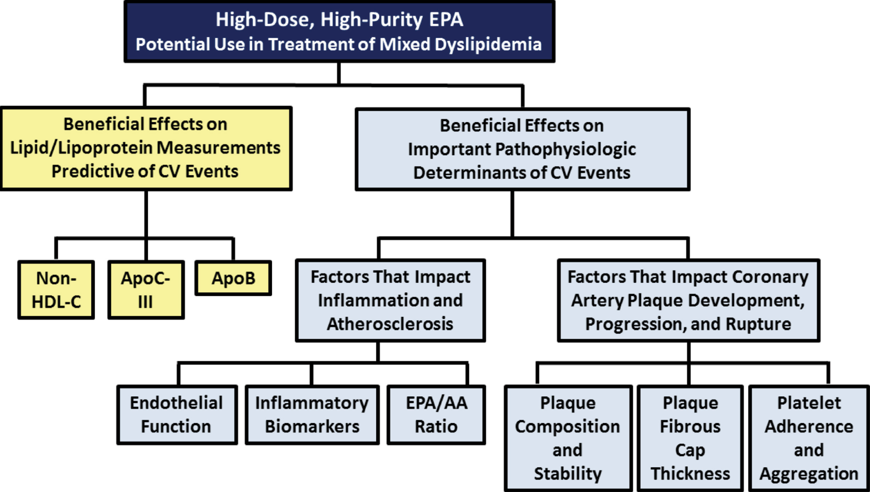
Abbreviations: Apo = apolipoprotein; AA = arachidonic acid; non-HDL-C = non-high-density lipoprotein cholesterol.
Source: this figure is extracted from Borow, K.M et al. Biologic Plausibility, Cellular Effects, and Molecular Mechanisms of Eicosapentaenoic Acid (EPA) in Atherosclerosis, Atherosclerosis, 2015; 242(1): 357-366.
This submission was submitted through the TGA’s Comparable Overseas Regulator B (COR-B) process, using evaluation reports from the European Medicines Agency (EMA). The full dossier was submitted to the TGA.

Regulatory status
This product is considered a new chemical entity for Australian regulatory purposes.
At the time the TGA considered this submission, a similar submission had been approved in the European Union on 26 March 2021, Great Britain 20 April 2021, the United States of America 13 December 2019, Canada on 30 December 2019. A similar submission was under consideration in Switzerland (submitted on 26 April 2021).
The following table summarises these submissions and provides the indications where approved.
Table 1: International regulatory status
Region | Submission date | Status | Approved indications
European Union | 11 November 2019 | Approved on 26 March 2021 | Vazkepa is indicated to reduce the risk of cardiovascular events in adult statin-treated patients at high cardiovascular risk with elevated triglycerides (≥ 150 mg/dL [≥ 1.7 mmol/L]) and  - established cardiovascular disease, or  - diabetes, and at least one other cardiovascular risk factor.
Great Britain | 2 February 2021 | Approved on 20 April 2021 | Vazkepa is indicated to reduce the risk of cardiovascular events in adult statin-treated patients at high cardiovascular risk with elevated triglycerides (150 mg/dL [≥ 1.7 mmol/L]) and  - established cardiovascular disease, or  - diabetes, and at least one other cardiovascular risk factor
United States of America | 28 March 2019 | Approved on 13 December 2019 | Vascepa is approved as an adjunct to maximally tolerated statin therapy to reduce the risk of myocardial infarction, stroke, coronary revascularization, and unstable angina requiring hospitalization in adult patients with elevated triglcyeride (TG) levels (≥ 150 mg/dL) and  - established cardiovascular disease, or  - diabetes mellitus and 2 or more additional risk factors for cardiovascular disease.
Canada | 26 April 2019 | Approved on 30 December 2019 | Vascepa (icosapent ethyl) is indicated to reduce the risk of cardiovascular events (cardiovascular death, non-fatal myocardial infarction, non-fatal stroke, coronary revascularization or hospitalization for unstable angina) in statin-treated patients with elevated triglycerides, who are at high risk of cardiovascular events due to:  - established cardiovascular disease, or  - diabetes, and at least one other cardiovascular risk factor.
Switzerland | 26 April 2021 | Under consideration | Under consideration

Product Information
The Product Information (PI) approved with the submission which is described in this AusPAR can be found as Attachment 1. For the most recent PI and Consumer Medicines Information (CMI), please refer to the TGA PI/CMI search facility.

Registration timeline
The following table captures the key steps and dates for this submission.
This submission was evaluated under the standard prescription medicines registration process.
Table 2: Timeline for Submission PM-2021-05861-1-3
Description | Date
Submission dossier accepted and first round evaluation commenced | 15 February 2022
First round evaluation completed | 31 May 2022
Sponsor provides responses on questions raised in first round evaluation | 24 June 2022
Second round evaluation completed | 11 August 2022
Delegate’s Overall benefit-risk assessment and request for Advisory Committee advice | 2 September 2022
Sponsor’s pre-Advisory Committee response | 19 September 2022
Advisory Committee meeting | 6 and 7 October 2022
Registration decision (Outcome) | 2 November 2022
Administrative activities and registration on the ARTG completed | 8 November 2022
Number of working days from submission dossier acceptance to registration decision* | 157
* The COR-B process has a 175 working day evaluation and decision timeframe.

Submission overview and risk/benefit assessment
A summary of the TGA’s assessment for this submission is provided below.
This section is a TGA summary of wording used in TGA’s evaluation report, which discussed numerous aspects of overseas evaluation reports and included some information that was commercial-in-confidence.
Relevant guidelines or guidance documents referred to by the Delegate are listed below:
- European Medicines Agency (EMA), Committee for Proprietary Medicinal Products (CPMP), ICH guideline M3(R2) on non-clinical safety studies for the conduct of human clinical trials and marketing authorisation for pharmaceuticals, EMA/CPMP/ICH/286/1995, December 2009.
- Food and Drug Administration (FDA), Guidance for Industry Drug-Induced Liver Injury: Premarketing Clinical Evaluation, July 2009.

Quality
Icosapent ethyl is the ethyl ester of the omega-3 fatty acid eicosapentaenoic acid (EPA). The starting material is extracted from fish oil. The active ingredient manufacturing process starts with the crude fish oil ester and is a patented purification process, not involving any additional synthesis or chemical transformation. The active substance is a liquid oil at ambient room temperature with high solubility in organic solvents but no detectable solubility in water.
The capsules evaluated in the Phase III clinical trials are the same as proposed for registration.
The finished product is a soft capsule containing 998 mg of icosapent ethyl to be supplied in two presentations:
- a commercial market presentation comprising 120 capsules in a high density polyethylene (HDPE) bottle with a child-resistant polypropylene closure.
- a physician sample presentation comprising 8 capsules in a blister pack.
The drug substance and finished product specifications are acceptable.
Good Manufacturing Practice clearances are valid for all manufacturing sites.
There are no outstanding quality issues, and approval is recommended by quality evaluation.

Nonclinical
The submitted nonclinical dossier was in accordance with the relevant EMA guideline. The overall quality of the nonclinical dossier was satisfactory. All pivotal safety-related studies were Good Laboratory Practice compliant.
Published in vivo pharmacology studies demonstrated that icosapent ethyl (a form of ethyl-EPA) can attenuate intestinal cholesterol absorption, hepatic cholesterol biosynthesis, hepatic triglyceride synthesis and incorporation into very low-density lipoprotein (VLDL), and enhance hepatic biliary secretion and plasma lipoprotein clearance.
Secondary pharmacological properties of ethyl-EPA were investigated in various disease models, based on published data. These studies suggested roles for ethyl-EPA in modulating coagulation and fibrinolysis related parameters; prostaglandin E₂ production, extracellular signal-regulated kinase, nuclear factor kappa B, cyclooxygenase-2, chemokine-like receptor 1, leukotriene B4 receptor, c-Jun N-terminal kinases and tumour necrosis factor alpha related signalling pathways.
No dedicated safety pharmacological studies were conducted, with the exception of an in vitro human ether-a-go-go-related gene (hERG) channel study, which found no effects of the unesterified free acid EPA on the hERG channel current at concentrations 35 times of the unbound clinical maximum concentration. A review of the general toxicology data in mice, rats, and dogs, and reproductive toxicology and carcinogenicity data in rodents, did not indicate any specific concern for cardiovascular, respiratory, renal, gastrointestinal or neurological systems, so the absence of further safety studies is acceptable.
The pharmacokinetic (PK) profiles in rats and dogs are qualitatively similar to that of humans. Ethyl-EPA is readily absorbed with comparable the time taken to reach the maximum concentration in all species, and is rapidly de-esterified to EPA. EPA is distributed to various tissues through lymph and plasma, and subject to β-oxidation by mitochondria and peroxisomes, mainly in the liver as well as in tissues. Elimination of EPA (and other metabolites) appears to follow the metabolic cycle of fat with long elimination half-lives (longer than 7 days) in all species.
Eicosapentaenoic acid (EPA) is a substrate of cytochrome P450 (CYP)1A1, CYP2E1, CYP4F2 and CYP2J2; thus, inhibitors or inducers of these enzymes could potentially alter the systemic exposure to EPA. EPA did not exhibit significant inhibitory activity against CYP isozymes or efflux and uptake transporters (P-glycoprotein, breast cancer resistance protein, organic anion transporter 1, organic cation transporter 2, organic anion transporting polypeptide (OATP)1B1, OATP1B) in in vitro studies, and is thus unlikely to alter the exposure of co-administered drugs that are substrates of these enzymes and transporters.
No acute toxicity studies were conducted with the Vazkepa ethyl-EPA formulation. Acute toxicity studies using the Epadel ethyl-EPA formulation (for which qualitative and quantitative consistency to Vazkepa was demonstrated in a bridging study) indicated a low order of acute toxicity of ethyl-EPA through the oral route in mice and rats. In repeat-dose toxicity studies by the oral route in mice, rats and dogs, treatment related findings were minor and generally related to pharmacological effects on lipid profiles.
Studies suggest the genotoxic potential of ethyl-EPA is likely to be negligible. Carcinogenicity studies in mice and rats did not identify a treatment-related increase in tumour incidence.
Fertility was not affected in male and female rats treated with ethyl-EPA at exposure levels approximately more than 8-fold the clinical exposure (based on comparative studies). No adverse effects on embryofetal developmental were observed with Vazkepa or EPADEL formulations of ethyl-EPA at similar exposure margins in rat or rabbit studies.
A number of drug substance related impurities proposed at specification levels above the qualification threshold were considered toxicologically qualified based on toxicity data that showed exposures at sufficient safety margins to human exposure.
There are no nonclinical objections to the registration of Vazkepa.

Clinical

Summary of clinical studies
The clinical dossier consisted of:
- five clinical pharmacology studies in healthy volunteers:
  - Studies LA01.01.0009-IR1, LA01.01.0009-IR2, AMR-01-01-0018, AMR-01-01-0020, AMR-01-01-0021 and AMR-01-01-0023 (See Table 3 below)
- one pivotal Phase III study in 8,179 patients with elevated triglyceride on statin therapy and at high cardiovascular risk:
  - Study AMR-01-01-0019, known as the REDUCE-IT trial (see Table 4 below)
- two supportive Phase III studies evaluating efficacy in terms of triglyceride lowering:
  - Study AMR-01-01-0017, known as the ANCHOR trial; and Study AMR-01-01-0016, known as the MARINE trial (see Table 4 below)
- an open-label extension of the MARINE trial:
  - Study AMR-01-01-0016, known as the MARINE-OLE trial
- The dossier also included 8 efficacy and safety studies in other indications:
  - three studies for Huntington’s disease: Studies LA01.01.0005, AN01.01.0011 and AN01.01.0012
  - three studies for depression: Studies LA01.01.0002, LA01.01.0006 and LA01.01.0008A
  - one study for schizophrenia: Study LA01.01.0001
  - one study for age-associated memory impairment: Study AN01.01.0014.
Table 3: Overview of clinical pharmacology studies in healthy volunteers
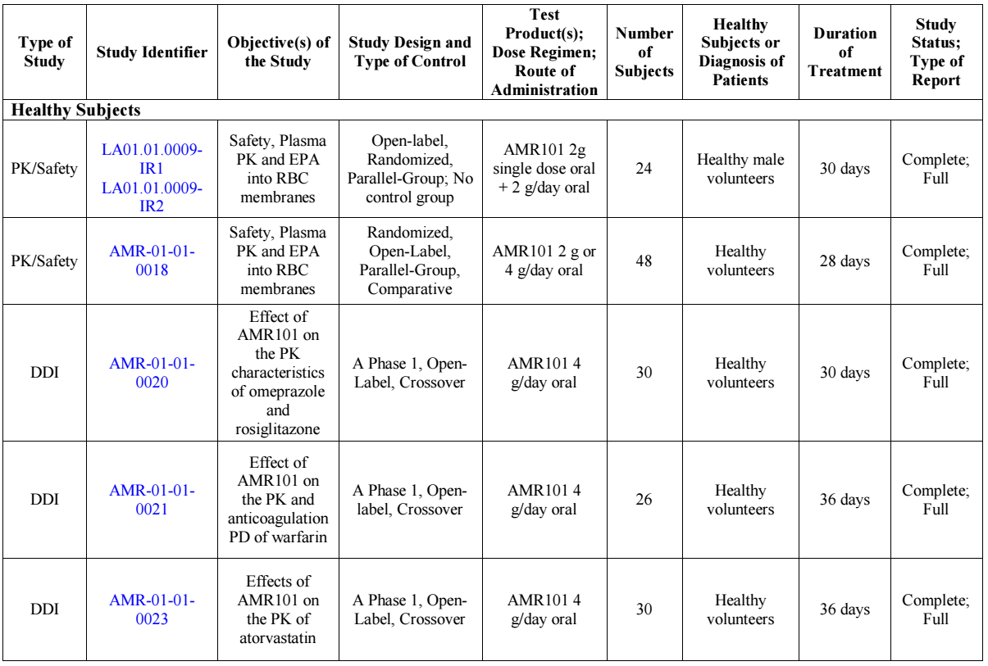
Abbreviations: AMR101 = icosapent ethyl; RBC = red blood cells; EFA = essential fatty acids; PK= pharmacokinetics; DDI= drug-drug interaction; EPA= eicosapentaenoic acid; TG= triglyceride.
Table 4: Phase III randomised, placebo-controlled clinical studies
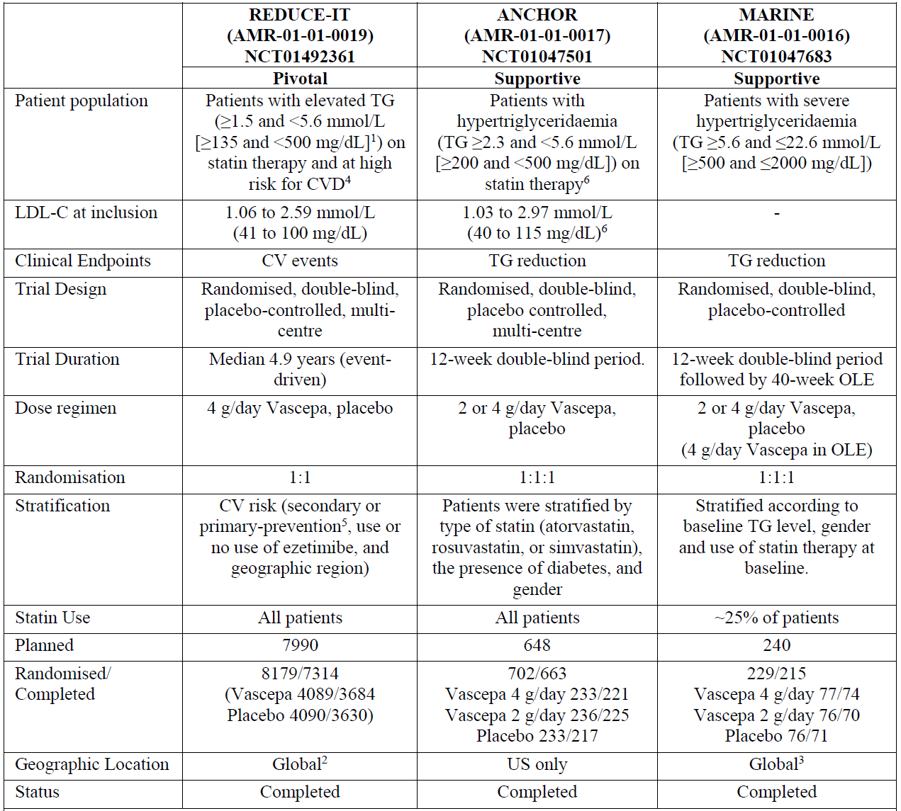
Abbreviations: CV=cardiovascular, CVD=cardiovascular disease, LDL-C = low-density lipoprotein cholesterol, OLE=open-label extension, TG=triglyceride.
To convert the values for TG to mmol/L, multiply by 0.01129.
1. Note that the original protocol stipulated a lower end of the fasting TG level of ≥ 1.52 mmol/L (135 mg/dL), reflecting a 10% allowance from the target lower fasting TG level of ≥ 1.69 mmol/L (150 mg/dL); this 10% allowance was included due to the variability in TG levels. Protocol Amendment 1 (16 May 2013) increased the lower end of fasting TG levels from ≥ 1.52 mmol/L (135 mg/dL) to ≥ 2.26 mmol/L (200 mg/dL) without a variability allowance to increase enrolment of patients with TG levels at or above 2.26 mmol/L (200 mg/dL).
2. United States, the Netherlands, Ukraine, Russian Federation, South Africa, Poland, India, Canada, Romania, Australia, and New Zealand
3. Included sites in United States, South Africa, the Netherlands, Germany, Finland, Italy, Russia, Ukraine, and India
4. At least 45 years old with documented CVD (secondary prevention group) or at least 50 years old with diabetes and with at least one additional risk factor for CVD (primary prevention group)
5. In approximately 30% of enrolled patients
6. To facilitate enrolment, a protocol amendment was implemented after approximately half of patients were randomised: the haemoglobin A1c exclusion criterion was increased from 9.0% to > 9.5%; based on known within patient variability for TG and LDL cholesterol, entry criteria were expanded so the mean of the 2 TG-qualifying values was ≥ 2.09 mmol/L (185 mg/dL) with at least one of the two values ≥ 2.26 mmol/L (200 mg/dL); and the upper limit of the LDL-C entry criteria was increased by 15% to 2.97 mmol/L (≤ 115 mg/dL).

Pharmacology

Pharmacokinetics
After oral administration of icosapent ethyl, the parent drug is completely or nearly completely de-esterified during the absorption process and the active metabolite EPA is absorbed into the systemic circulation via the thoracic duct lymphatic system. The majority of EPA in plasma is esterified into circulating phospholipids, triacylglycerols or triglycerides and cholesteryl esters. Only a small fraction of total circulating EPA is unesterified, that is, free or protein-bound, and not incorporated in these lipids. The major assay for PK evaluations measured total EPA concentration in plasma, which includes EPA incorporated in phospholipids, triacylglycerols, and cholesteryl esters as well as free and protein-bound EPA. EPA is also incorporated in the phospholipids of cell membranes, providing structural properties to the membrane (for example, fluidity in red blood cell membranes). Assays were developed to measure EPA in red blood cells as a marker for tissue exposure. Because of the expected low systemic exposure of the parent drug, ethyl-EPA, plasma concentrations of ethyl-EPA were not routinely measured in the clinical studies. In post-hoc analyses of Studies AMR-01-01-0018, the MARINE and ANCHOR trials, a limited number of plasma samples were analysed for ethyl-EPA. Ethyl-EPA was not quantifiable (< 50 ng/mL) in most samples.
Peak plasma concentrations of EPA were reached approximately 5 hours following a single oral dose of 2 g Vazkepa, with EPA concentrations remaining above Baseline 48 hours after dosing. EPA concentration in plasma and tissues increases to steady state within approximately one month. The PK of EPA appears dose proportional in the dose range of 2 to 4 g/day.
The PK of EPA was assessed only in the fed state. Vazkepa was administered with or following a meal (or snack) in all clinical studies. Ethyl-EPA is a highly lipophilic compound, studies in animals have demonstrated that bile enhances absorption, and published data suggest that omega-3 fatty acids should be taken with food in order to maximise absorption. The proposed dosing guidance is that Vazkepa should be taken with or following a meal.
The increase in EPA after dosing with Vazkepa constitutes only a minor fraction of the total systemic fatty acid pool. EPA constituted 3.4 to 3.6 mol % of the total molar fatty acid concentration in plasma after 12 weeks with 4 g/day Vazkepa, versus 0.4% to 0.5% at Baseline. Similar results were seen in red blood cells. The steady-state volume of distribution of EPA after 28 days administration of Vazkepa was large (approximately 80 L).
The metabolism of EPA is as per standard lipid metabolism: primarily β-oxidation, plus chain elongation and desaturation, and, to a minor extent, CYP-mediated oxidation. Elimination of EPA and its metabolites is similar to that of fatty acids from dietary and endogenous lipids, with the end products (CO₂ and water) principally excreted in expired breath. Renal excretion is minimal. The plasma elimination half-life of EPA is > 3 days.
The PK of EPA appears to be very similar in healthy subjects, patients with hypertriglyceridemia (the MARINE and ANCHOR trials), and patients with hypertriglyceridemia and cardiovascular risk factors (the REDUCE-IT trial). Studies investigating the effect of renal impairment or hepatic impairment on the PK of EPA were not performed. EPA is metabolised and excreted through high-capacity processes that are largely unaffected by variability in renal or hepatic function. No dose adjustment is proposed in patients with renal or hepatic impairment.
No consistent effect of bodyweight on the PK of EPA was observed. Plasma total EPA concentration in patients treated with Vazkepa 4 g/day was higher in patients 65 years or older than patients younger than 65 years. In the REDUCE-IT trial, median (interquartile range) change in plasma EPA concentration from Baseline to Year 1 in patients less than 65 years, from 65 to less than 75 years, and 75 years or older was 111.3 μg/mL (108.4), 124.5 μg/mL (113.8) 127.6 μg/mL (125.5), respectively. No dose adjustment is proposed based on age or bodyweight.
Possible drug-drug interactions were addressed in the submission, and no clinically relevant drug-drug interactions were identified. In vitro studies show that EPA is a weak inhibitor of CYP2C19, CYP2C9, CYP2C8, and to a lesser extent of CYP2B6 and CYP3A. This was addressed by interaction studies with omeprazole (CYP2C19), rosiglitazone (CYP2C8), warfarin (CYP2C9) and atorvastatin (CYP3A4). In subgroup analyses from the MARINE and ANCHOR trials, no consistent effect of antihypertensive drugs, antiplatelet drugs and statins (atorvastatin, rosuvastatin and simvastatin) on EPA concentrations was detected. Due to the diversity of metabolic pathways and widely distributed storage in the body, relevant effects of other drugs on the PK of EPA are considered unlikely.

Pharmacodynamics
The effects of icosapent ethyl on plasma lipids, lipoproteins, and inflammatory parameters in adults with elevated triglyceride were investigated as efficacy endpoints in the MARINE, ANCHOR, and REDUCE-IT trials. The MARINE and ANCHOR trials evaluated efficacy primarily in terms of triglyceride lowering. The pivotal study, the REDUCE-IT trial, evaluated efficacy primarily in terms of reducing cardiovascular events; effect on triglyceride and other plasma biomarkers were tertiary endpoints.
Overall, across the Phase III studies, the icosapent ethyl trial reduced triglyceride, VLDL cholesterol, VLDL-triglyceride, lipoprotein-associated phospholipase A₂ (Lp-PLA₂), and to some degree non-high-density lipoprotein (HDL) cholesterol, and apolipoprotein B. In the MARINE and ANCHOR trials, the effect of icosapent ethyl on triglyceride was dose-dependent and was preserved over one year in the MARINE-OLE trial. Pharmacokinetic-pharmacodynamic analyses showed a clear correlation between dose, concentration in plasma or red blood cells, and triglyceride lowering effect. The effect of icosapent ethyl on low-density lipoprotein (LDL) cholesterol was inconsistent across the studies. Increases in some parameters, including triglyceride, non-HDL cholesterol, LDL cholesterol, apolipoprotein B, and high sensitivity C-reactive protein (CRP), in the placebo (mineral oil) groups raise some concern regarding the extent to which it is an inert comparator.

Efficacy

Study AMR-01-01-0019 (REDUCE-IT trial)
This was a Phase III, multi-centre, multi-national, prospective, randomised, double blind, placebo controlled, event driven study designed to evaluate the effect of icosapent ethyl 2 g twice daily (4 g/day) for preventing cardiovascular events in statin-treated patients with established cardiovascular disease or with diabetes and other cardiovascular risk factors, and moderately elevated triglyceride levels. The study was conducted at 473 sites in 11 countries (United States of America (USA), Netherlands, Ukraine, Russian Federation, South Africa, Poland, India, Canada, Romania, Australia, and New Zealand) between 28 November 2011 and 31 May 2018.
The primary objective of this study was, in patients at LDL cholesterol goal while on statin therapy with established cardiovascular disease or with diabetes and at high risk for cardiovascular disease and elevated triglyceride (fasting triglyceride ≥ 135 mg/dL and < 500 mg/dL (≥ 1.53 mmol/L and < 5.64 mmol/L)), to evaluate the effect of 4 g/day icosapent ethyl on the time from randomisation to the first occurrence of any component of the composite of the following major cardiovascular events:
- cardiovascular death
- Non-fatal myocardial infarction, including silent myocardial infarction
- Non-fatal stroke
- Coronary revascularisation
- Unstable angina determined to be caused by myocardial ischemia by invasive or non-invasive testing and requiring emergent hospitalisation
The key secondary objective of this study was to evaluate the effect of therapy on the time from randomisation to the first occurrence of the composite of cardiovascular death, nonfatal myocardial infarction (including silent myocardial infarction), or nonfatal stroke. Other secondary and tertiary objectives were predefined.
Figure 2: REDUCE-IT trial Study overview
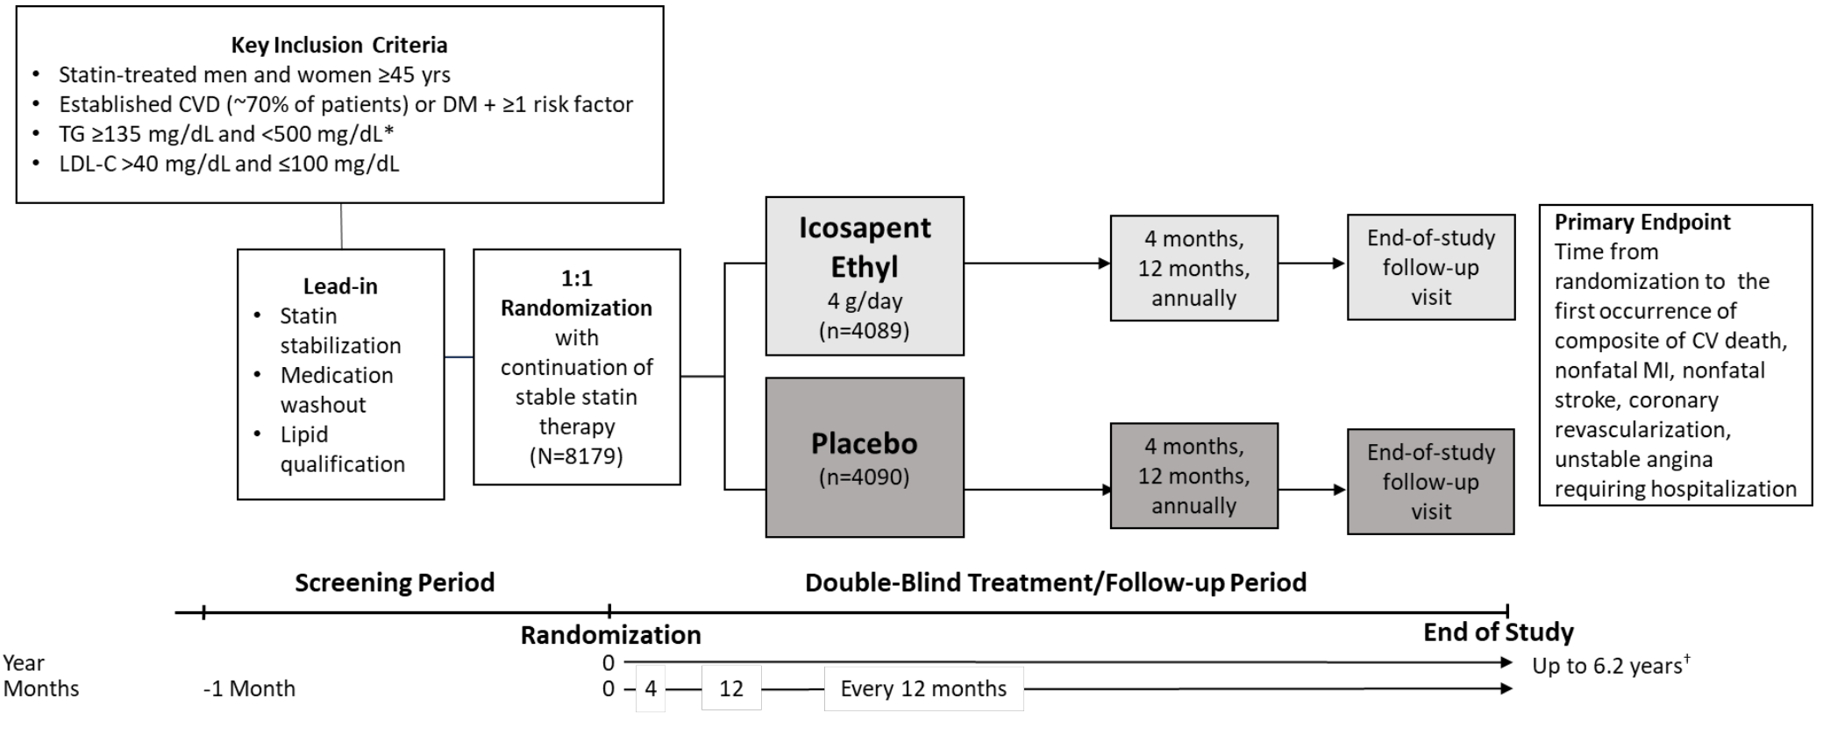
Abbreviations: CV = cardiovascular; CVD = cardiovascular disease; DM = diabetes mellitus; icosapent ethyl = AMR101; LDL-C = low-density lipoprotein cholesterol; MI = myocardial infarction; TG = triglycerides; yrs = years.
* Due to the variability of triglycerides, a 10% allowance from the lower qualifying target of ≥ 150 mg/dL existed in the initial protocol, which permitted patients to be enrolled with qualifying triglycerides ≥ 135 mg/dL. Protocol amendment 1 (May 2013) changed the lower limit of acceptable triglycerides from 135 to 200 mg/dL, with no variability allowance.
† Median trial follow-up duration was 4.9 years (minimum 0.0, maximum 6.2 years).
Source: this figure is extracted from Committee for Medicinal Products for Human Use (CHMP) Assessment Report for Vazkepa (Modified from Bhatt, D.L. et al. Cardiovascular Risk Reduction with Icosapent Ethyl for Hypertriglyceridemia, N Engl J Med, 2019; 380(1): 11-22).

Key inclusion criteria

Criteria related to lipid status
- Fasting triglyceride level ≥ 135 mg/dL (1.53 mmol/L) and < 500 mg/dL (5.64 mmol/L).
- Low-density lipoprotein (LDL) cholesterol > 40 mg/dL (1.04 mmol/L) and ≤ 100 mg/dL (2.60 mmol/L) and on stable therapy with a statin (with or without ezetimibe) for at least 4 weeks prior to the LDL cholesterol and triglyceride baseline qualifying measurements for randomisation.

Criteria related to cardiovascular risk
- cardiovascular risk category 1 (secondary prevention cohort) men and women ≥ 45 years of age with established cardiovascular disease based on:
  - documented coronary artery disease according to predefined criteria;
  - documented cerebrovascular or carotid disease according to predefined criteria;
  - documented peripheral arterial disease according to predefined criteria.
- cardiovascular risk category 2 (primary prevention cohort) men and women ≥ 50 years of age who are at high risk for cardiovascular disease based on having diabetes mellitus (type 1 or 2) requiring treatment with medication and one or more of the following:
  - men ≥ 55 years of age or women ≥ 65 years of age;
  - cigarette smoker or stopped smoking within 3 months before Visit 1;
  - hypertension (blood pressure ≥ 140 mmHg systolic or ≥ 90 mmHg diastolic) or on antihypertensive medication;
  - high-density lipoprotein (HDL) cholesterol ≤ 40 mg/dL for men or ≤ 50 mg/dL for women;
  - high sensitivity C-reactive protein (CRP) > 3.00 mg/L (0.3 mg/dL);
  - renal dysfunction: creatinine clearance > 30 and < 60 mL/min (> 0.50 and < 1.00 mL/sec);
  - retinopathy, defined as any of the following: non-proliferative retinopathy, pre-proliferative retinopathy, proliferative retinopathy, maculopathy, advanced diabetic eye disease, or a history of photocoagulation;
  - microalbuminuria or macroalbuminuria;
  - ankle-brachial index < 0.9 without symptoms of intermittent claudication (patients with ankle-brachial index < 0.9 with symptoms of intermittent claudication were included in cardiovascular risk category 1).

Key exclusion criteria
- severe (New York Heart Association class IV) heart failure
- any life-threatening disease expected to result in death within the next 2 years (other than cardiovascular disease)
- active severe liver disease
- Haemoglobin A1C > 10.0% (or > 86 mmol/mol International Federation on Clinical Chemistry units)
- poorly controlled hypertension
- planned coronary intervention
- known hypersensitivity to fish and/or shellfish
- intolerance or hypersensitivity to statin therapy
- history of acute or chronic pancreatitis
Study treatment was icosapent ethyl capsules or placebo capsules containing pharmaceutical grade light mineral oil, selected to match the colour and consistency of icosapent ethyl, taken at a dose of 2 capsules twice a day (that is 4 capsules/day) with food. Dose selection was based mainly on the findings from the MARINE and ANCHOR trials which demonstrated a correlation between dose and efficacy in terms of triglyceride lowering. Statins were continued at a stable dose throughout the study, and other medications were permitted based on standard of care. Medicines and supplements not permitted during the study included niacin > 200 mg/day, fibrates, medicines, or supplements containing omega-3 fatty acids, and PCSK9 inhibitors.
Following a screening period, eligible patients were randomised to treatment at Visit 2 (Day 0), with subsequent study visits at Day 120 (± 10 days), Day 360 (± 10 days), and then every 360 days (±10 days) until end of study.
The study was event driven. A total of approximately 7,990 patients were planned to be enrolled and randomised 1:1 to either receive icosapent ethyl or placebo (approximately 3,995 patients per treatment group) to observe an estimated 1,612 primary endpoint events. Patients were stratified by cardiovascular risk category (1 or 2), use of ezetimibe (yes/no), and by geographical region (Westernised, Eastern European, and Asia Pacific). Two interim analyses were planned for the primary endpoint when adjudication of approximately 60% and 80% of the total target number of primary endpoint events planned were reached.
19,212 patients were screened, 8,179 patients were randomised, and 7,314 completed the final visit (Figure 3). Independent Data Monitoring Committee interim analysis review meetings conducted in September 2016 (953 events) and August 2017 (1218 events) recommended continuation of the study as planned.
Figure 3: REDUCE-IT trial Patient disposition
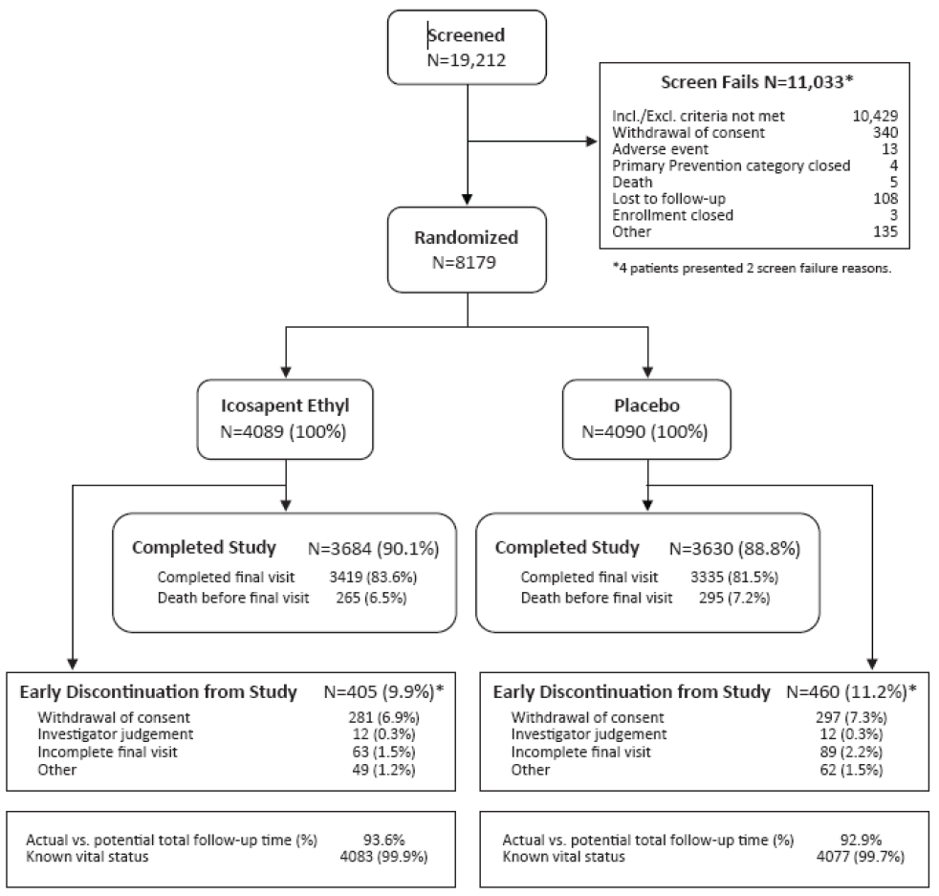
Abbreviations: incl./excl. = inclusion/exclusion; vs. = versus.
* Early discontinuation from study (9.9% icosapent ethyl; 11.2% placebo) includes patients that discontinued after having primary event (25 (0.6%) icosapent ethyl; 52 (1.3%) placebo) and prior to having an event (380 (9.3%) icosapent ethyl; 408 (10.0%) placebo).
Demographic and baseline characteristics across the study populations were comparable. Overall, the majority of patients were male (71.2% (5822 of 8179)) and white (90.2% (7379 of 8179)). The mean age of patients was 63.4 years (range 44 to 92 years), with 46.0% (3763 of 8179) of patients aged 65 years or older. Mean height, weight, and body mass index were 171.3 cm, 93.0 kg, and 31.6 kg/m², respectively. Overall, 58.5% were diabetic (type 1 or 2), 86.6% had hypertension, and 22.2% had renal impairment at Baseline (estimated glomerular filtration rate (eGFR) < 60 mL/min/1.73 m²). At randomisation, all patients were on statin therapy, with over 93% of patients receiving moderate or high intensity statin therapy. Concomitant medications of special interest were similar across the treatment groups (Table 5). Reported cardiovascular disease history and risk factors were balanced (see Committee for Medicinal Products for Human Use (CHMP) Assessment Report for further details).⁹ Of the 8,179 randomised patients, 5,785 (70.7%) were in the secondary prevention cohort and 2,394 (29.3%) were in the primary prevention cohort. Of the 2,394 patients in the primary prevention cohort (diabetes and at least one other pre-specified cardiovascular risk factor), 11.6% had one other cardiovascular risk factor, 35.4% had 2 other cardiovascular risk factors, 36.0% had 3 other cardiovascular risk factors, and 17.0% had at least 4 other cardiovascular risk factors.
Table 5: REDUCE-IT trial Overview of baseline medications of special interest (intent-to-treat population)
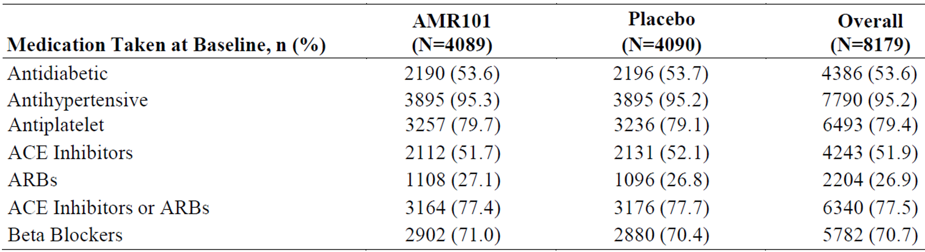
Abbreviations: ACE = angiotensin-converting enzyme; ARB = angiotensin receptor blockers; ITT = intent-to-treat.
Note: Percentages were based on the number of patients randomised to each treatment group in the ITT population (N).
The primary efficacy analysis was performed on the intent-to-treat population (all randomised patients). The 2-sided alpha level for the primary analysis was adjusted to 0.0437 from 0.05 to account for the two interim analyses. For the analysis of all secondary endpoints, the Type 1 error was controlled by testing each endpoint sequentially, starting with the key secondary endpoint, at a significance level of 0.0437 consistent with the primary endpoint.
The primary endpoint was the time from randomisation to the first occurrence of any component of the composite of the following clinical events:
- cardiovascular death
- nonfatal myocardial infarction (including silent myocardial infarction)
- nonfatal stroke
- coronary revascularisation
- unstable angina determined to be caused by myocardial ischemia by invasive or non-invasive testing and requiring emergent hospitalisation.
The key secondary endpoint was the time from randomisation to the first occurrence of any component of the composite of cardiovascular death, nonfatal myocardial infarction (including silent myocardial infarction), and nonfatal stroke.
Other secondary endpoints were (tested in the order listed below):
- composite of cardiovascular death or nonfatal myocardial infarction (including silent myocardial infarction)
- fatal or nonfatal myocardial infarction (including silent myocardial infarction)
- non-elective coronary revascularisation represented as the composite of emergent or urgent classifications
- cardiovascular death
- unstable angina determined to be caused by myocardial ischemia by invasive or non-invasive testing and requiring emergent hospitalisation
- fatal or nonfatal stroke
- composite of total mortality, nonfatal myocardial infarction (including silent myocardial infarction), or nonfatal stroke
- total mortality.
A primary endpoint event occurred in 17.2% (705 of 4089) of patients in the icosapent ethyl group compared to 22.0% (901 of 4090) of patients in the placebo group (hazard ratio 0.752, 95% confidence interval (CI): 0.682, 0.830; p = 0.00000001). The absolute risk reduction for the composite primary endpoint was 4.8%, the relative risk reduction was 24.8%, and number needed to treat was 21 (95% CI: 15, 33). Each of the components of the composite primary endpoint contributed to the outcome (Table 6). The benefit began to appear after approximately one year of treatment (Figure 4).
Table 6: REDUCE-IT trial Stratified analysis of time to the primary composite endpoint from date of randomisation (intent-to-treat population)
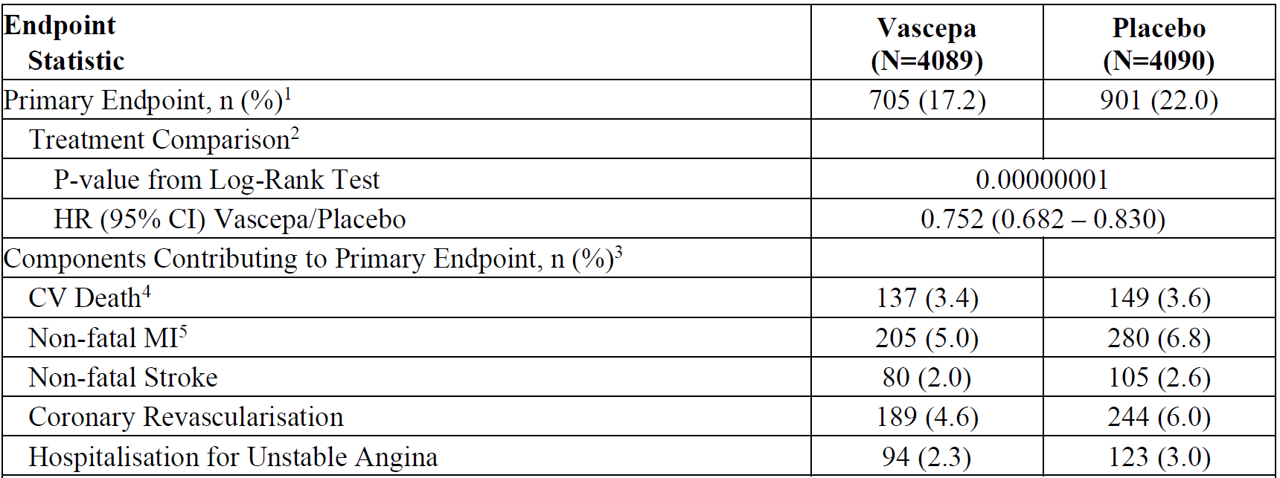
Abbreviations: CI = confidence interval; CV = cardiovascular; ECG = electrocardiogram; HR = hazard ratio; ITT = intent-to-treat; MI = myocardial infarction.
Note: The number of patients with event (n) is the number of patients in the ITT population within each treatment group (N).
1. Primary endpoint includes CV death, non-fatal MI, non-fatal stroke, coronary revascularisation, and hospitalisation for unstable angina determined to be caused by myocardial ischaemia by invasive/non-invasive testing.
2. Log-Rank test statistic and p-value are reported from a Kaplan-Meier analysis, stratified by geographic region, CV risk category, and use of ezetimibe. Hazard ratio and 95% CI are reported from a Cox proportional hazard model with treatment as the covariate, and stratified by geographic region, CV risk category, and use of ezetimibe.
3. Based on a patient’s first post-randomisation occurrence of the event contributing to the primary endpoint.
4. CV death includes adjudicated CV deaths and deaths of undetermined causality.
5. Non-fatal MI includes silent MI, which was assumed to occur on the date of the first post-randomisation ECG tracing indicative of a silent MI.
Figure 4: REDUCE-IT trial Kaplan-Meier curve of time to primary composite endpoint from date of randomisation (intent-to-treat population)
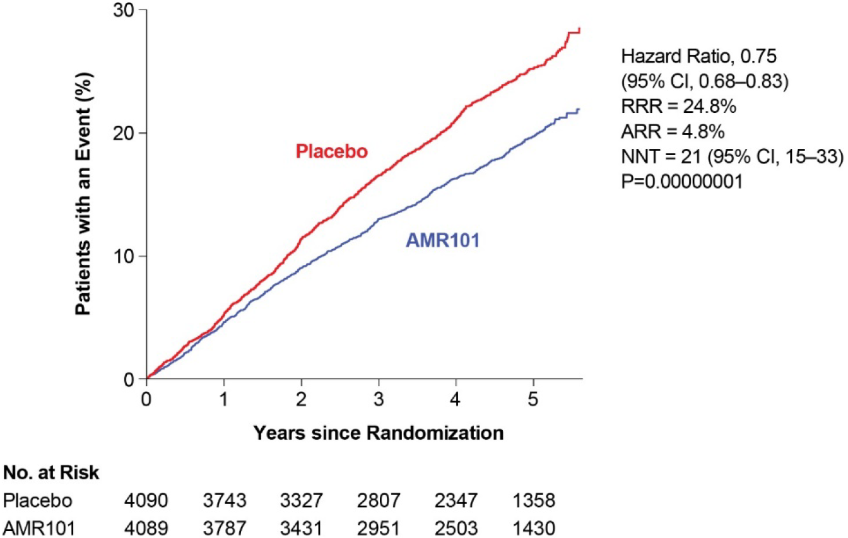
Abbreviations: AMR101 = icosapent ethyl; ARR = absolute risk reduction; CI = confidence interval; ITT = Intent-to-Treat; NNT = number needed to treat; No. = number; P = p-value; RRR = relative risk reduction.
A significant benefit was observed for the key secondary endpoint, a 3-point major adverse cardiovascular event (MACE) composite of cardiovascular death, nonfatal myocardial infarction (including silent myocardial infarction), and nonfatal stroke (Table 7, Figure 5). Each component of the composite contributed to the outcome. A significant benefit was also demonstrated for each of the other secondary endpoints with the exception of total mortality for which there was a trend favouring icosapent ethyl (Figure 6).
Table 7: REDUCE-IT trial Stratified analysis of time to the key secondary composite endpoint from date of randomisation (intent-to-treat population)
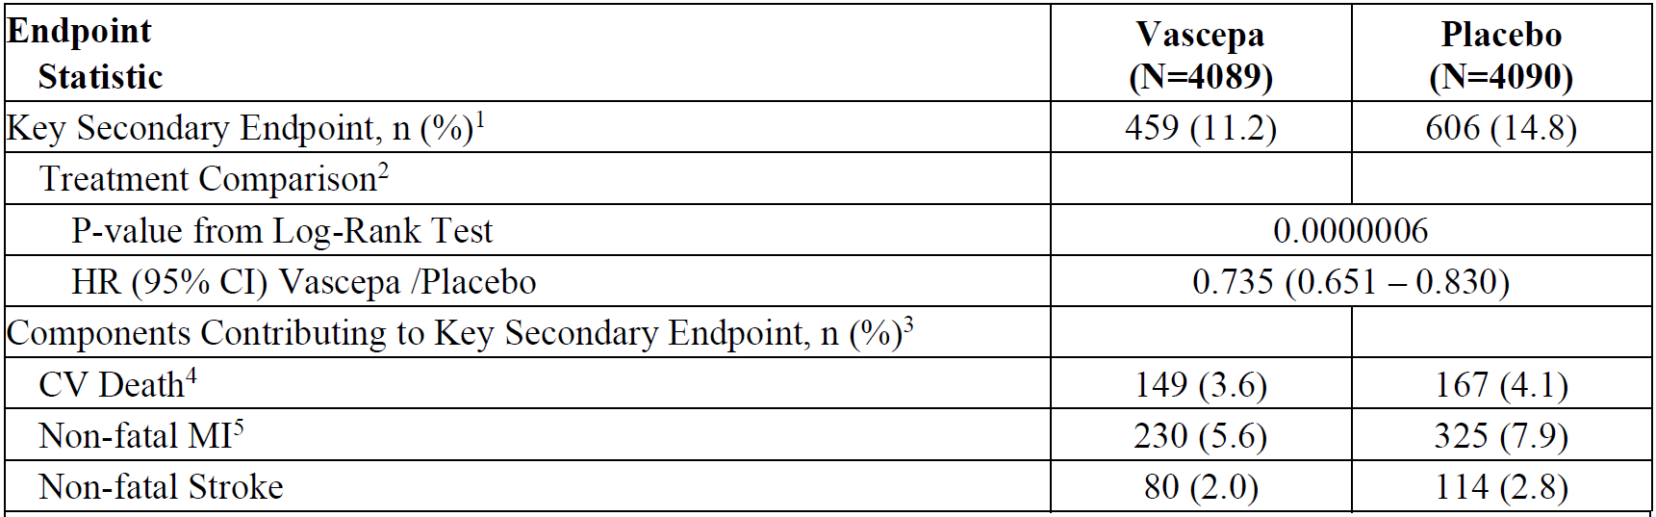
Abbreviations: CI = confidence interval; CV = cardiovascular; ECG = electrocardiogram; HR = hazard ratio; ITT = intent-to-treat; MACE = major adverse cardiovascular event; MI = myocardial infarction.
Note: The number of patients with event (n) is the number of patients in the ITT population within each treatment group (N).
1 The key secondary (i.e., hard MACE) endpoint includes CV death, non-fatal MI, and non-fatal stroke.
2 Log-Rank test statistic and p-value are reported from a Kaplan-Meier analysis, stratified by geographic region, CV risk category, and use of ezetimibe. Hazard ratio and 95% CI are reported from a Cox proportional hazard model with treatment as the covariate, and stratified by geographic region, CV risk category, and use of ezetimibe.
3 Based on a patient’s first post-randomisation occurrence of the event contributing to the key secondary endpoint.
4 CV death includes adjudicated CV deaths and deaths of undetermined causality.
5 Non-fatal MI includes silent MI, which was assumed to occur on the date of the first post-randomisation ECG tracing indicative of a silent MI.
Figure 5: REDUCE-IT trial Kaplan-Meier curve of time to key secondary composite endpoint from date of randomisation (intent-to-treat population)
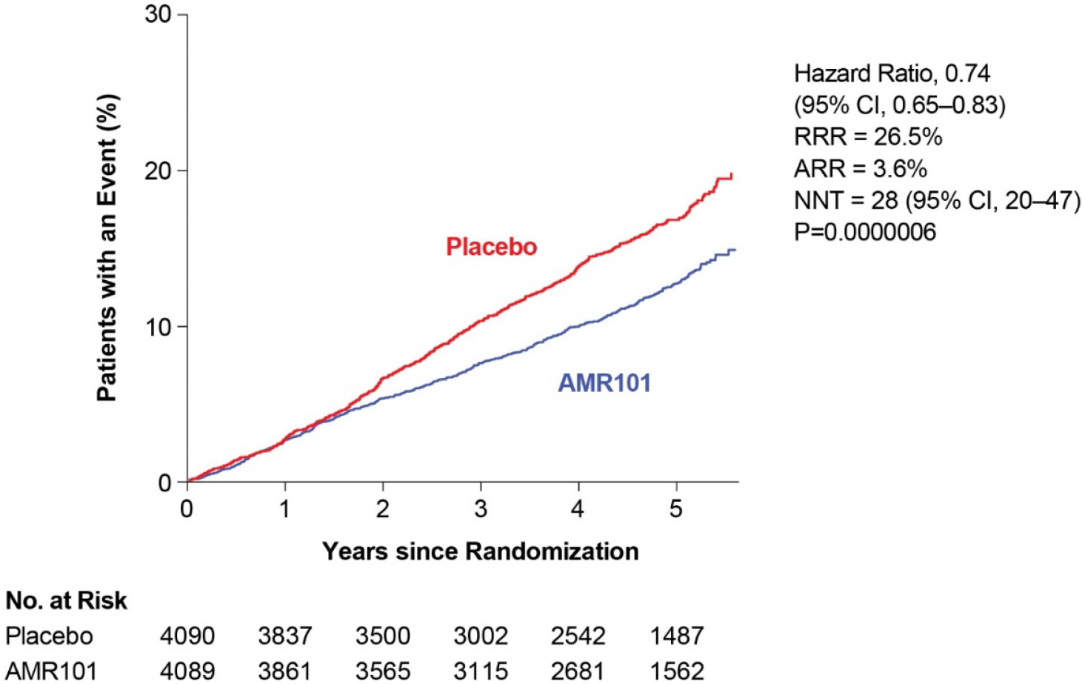
Abbreviations: AMR101 = icosapent ethyl; ARR = absolute risk reduction; CI = confidence interval; ITT = intent-to-treat; NNT = number needed to treat; No. = number; P = p-value; RRR = relative risk reduction.
Figure 6: REDUCE-IT trial Forest plot of analyses of primary and secondary endpoints (intent-to-treat population)
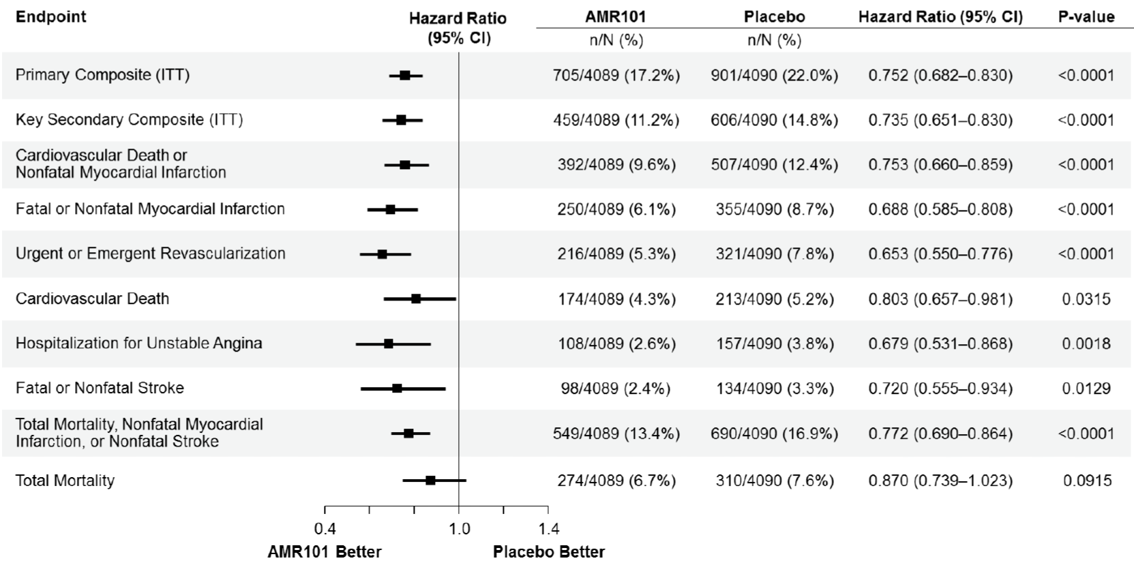
Abbreviations: CI = confidence interval; CV = cardiovascular; ECG = electrocardiogram; ITT = Intent-to-Treat; MI = myocardial infarction.
Note: The number of patients with event (n) is the number of patients in the ITT population within each treatment group (N).
Log-Rank test statistic and p-value are reported from a Kaplan-Meier analysis, stratified by geographic region, CV risk category, and use of ezetimibe. Hazard ratio and 95% CI are reported from a Cox proportional hazard model with treatment as the covariate, and stratified by geographic region, CV risk category, and use of ezetimibe.
Endpoint events are based on a patient’s first post-randomization occurrence of the specified endpoint event.
CV death includes adjudicated CV deaths and deaths of undetermined causality.
Nonfatal MI includes silent MI, which was assumed to occur on the date of the first post-randomization ECG tracing indicative of a silent MI.
Analyses of the primary endpoint in pre-defined subgroups were generally consistent with the primary outcome (Figure 7, Figure 8, and Figure 9). The subgroup analyses suggest a greater cardiovascular benefit in patients less than 65 years compared to 65 years or older. There was a trend towards a greater benefit for secondary prevention compared to primary prevention.
Figure 7: REDUCE-IT trial Forest plot of analyses of the primary endpoint by subgroups (intent-to-treat population)
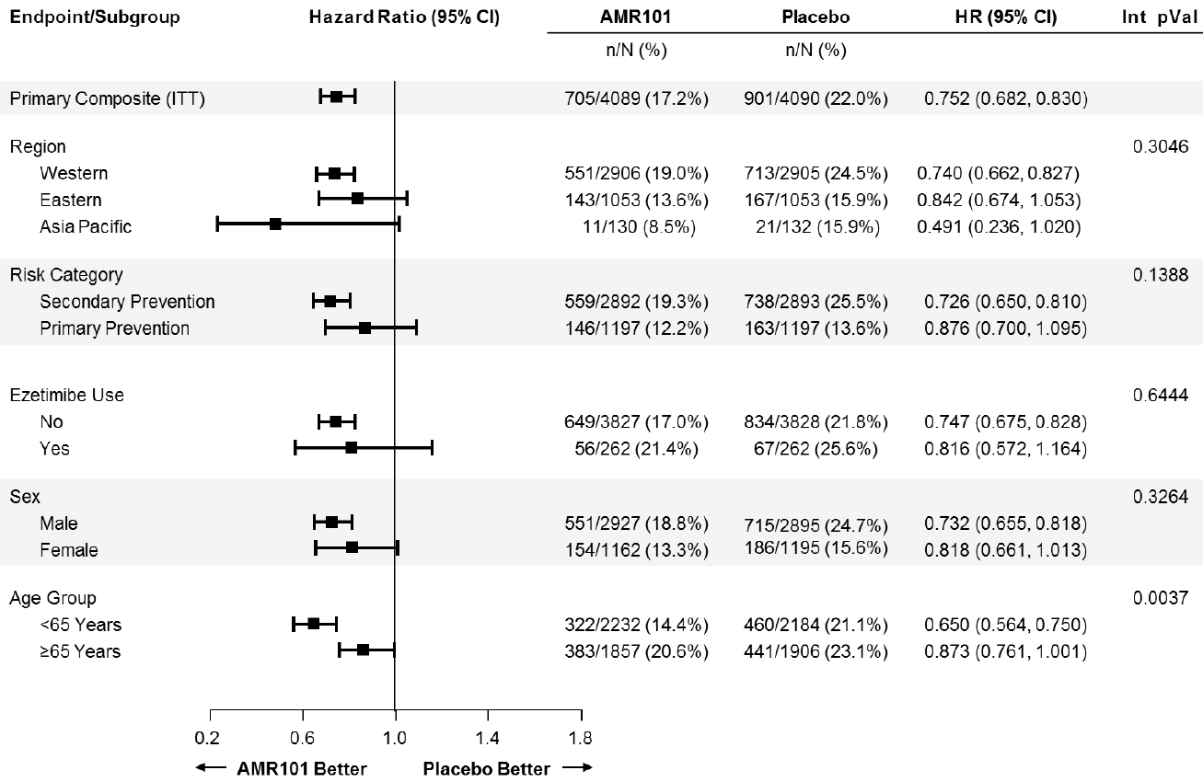
Abbreviations: AMR101 = icosapent ethyl; CI = confidence interval; HR = hazard ratio; Int = interaction; ITT = intent-to-treat; pVal = p-value.
Figure 8: REDUCE-IT trial Forest plot of analyses of the primary endpoint by subgroups (intent-to-treat population)
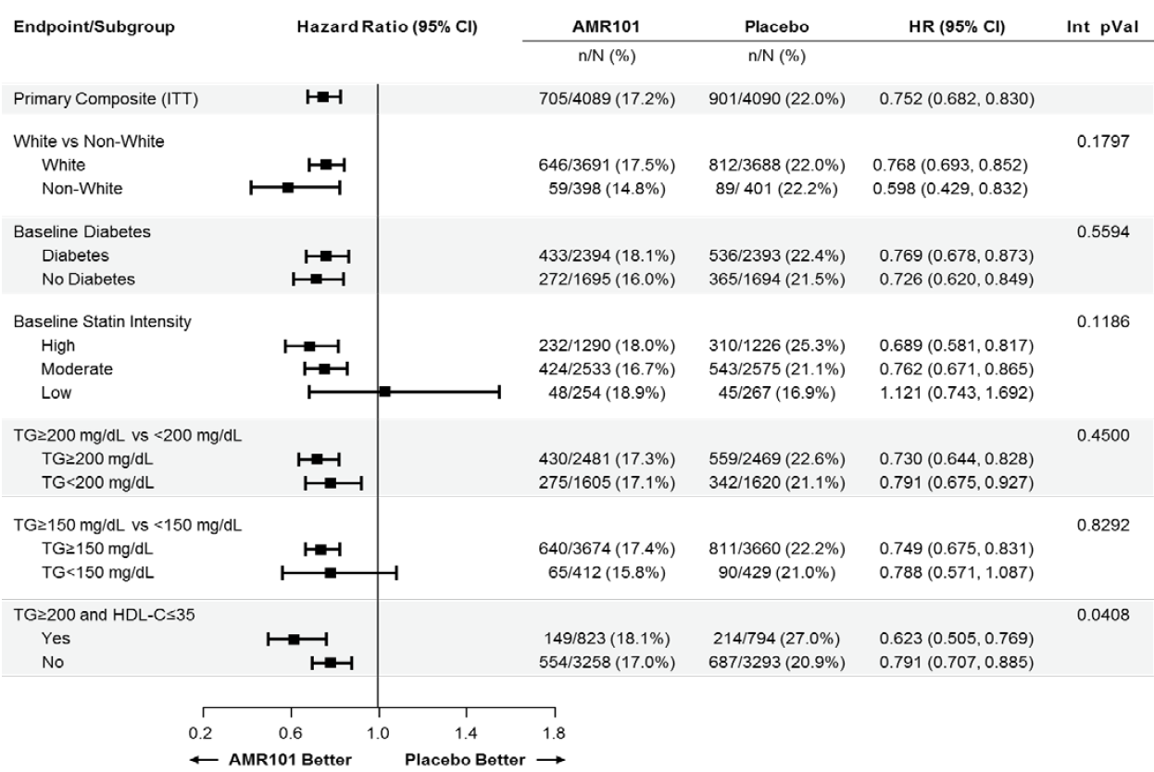
Abbreviations: AMR101 = icosapent ethyl; CI = confidence interval; HDL-C = high-density lipoprotein cholesterol; HR = hazard ratio; Int = interaction; ITT = intent-to-treat; pVal = p-value; TG = triglycerides; vs = versus.
To convert the values for triglycerides to mmol/L, multiply by 0.01129. To convert the values for cholesterol to mmol/L, multiply by 0.02586.
Figure 9: REDUCE-IT trial Forest plot of analyses of the primary endpoint by subgroups (intent-to-treat population)
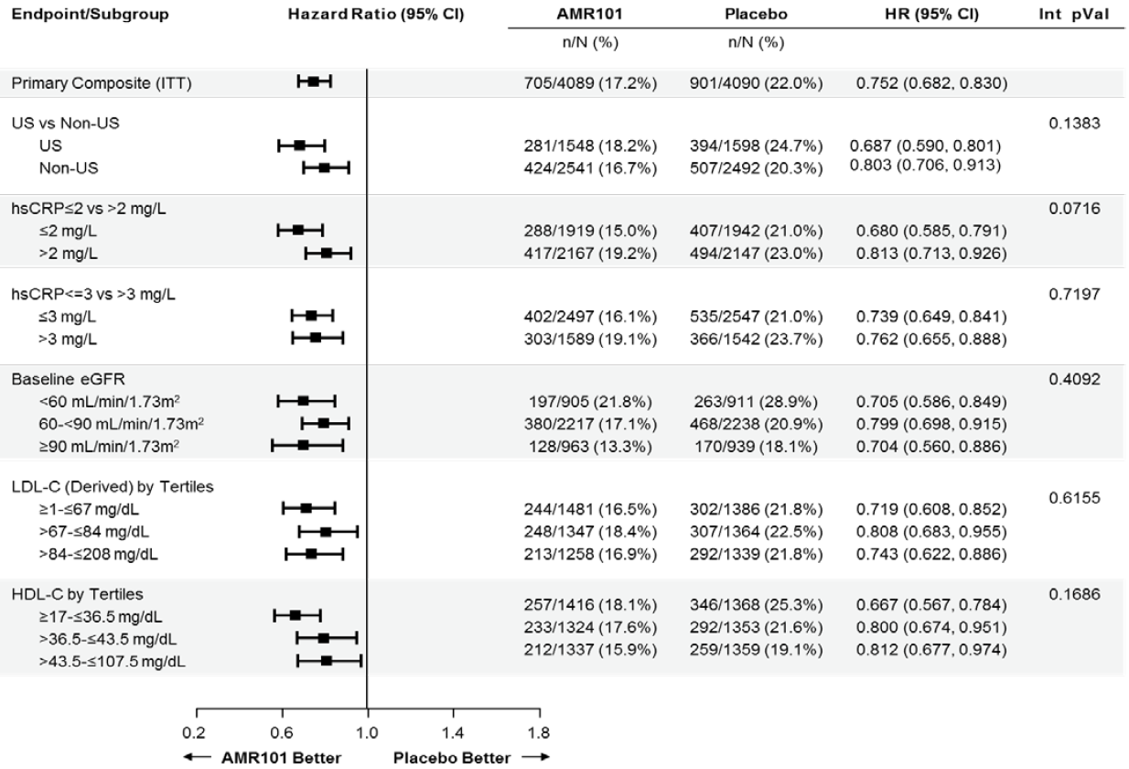
Abbreviations: AMR101 = icosapent ethyl; CI = confidence interval; eGFR = estimated glomerular filtration rate; HDL-C = high-density lipoprotein cholesterol; HR = hazard ratio; hsCRP = high-sensitivity C-reaction protein; Int = interaction; ITT = intent-to-treat; LDL-C = low-density lipoprotein cholesterol; pVal = p-value; US = United States; vs = versus.
Post-hoc exploratory subgroup analyses were performed to address an evaluation question as to whether the proposed indication appropriately reflected the study population with respect to baseline cardiovascular risk (noting that the study was not powered for these post-hoc analyses). The initial analysis (Figure 10) was limited by small sample sizes, so an additional analysis (Figure 11) was performed to provide support for the proposed indication.
Figure 10: Forest plot of primary and key secondary composite endpoints by 1, 2, 3, or ≥4 protocol-specified additional risk factors in the primary prevention cohort (intent-to-treat population)
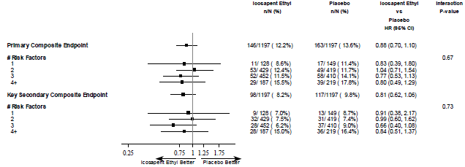
Abbreviations: CI = confidence interval; HR = hazard ratio.
Note: All primary prevention (CV2) cohort subjects had to have diabetes mellitus, were aged ≥ 50 years and had multiple dyslipidaemias (elevated triglyceride s and low-density lipoprotein cholesterol requiring statin control). The number of risk factors included in this figure are based on the number of additional risk factors as collected on the cardiovascular risk category cardiorespiratory fitness page: hypertension and/or on anti-hypertensives, men ≥ 55 years and women ≥ 65 years, high-density lipoprotein cholesterol ≤ 40 for men and ≤ 50 for women, cigarette smoker, high sensitivity C-reactive protein > 3 mg/L, renal dysfunction, micro or macroalbuminuria, retinopathy, ankle-brachial index.
Source: this figure is extracted from EMA Response to Day180 Questions (providing this document is beyond the scope of this AusPAR)
Figure 11: Forest plot of primary and key secondary composite endpoints by ≥1, ≥2, ≥3, or ≥4 protocol-specified additional risk factors in the primary prevention Cohort (intent-to-treat population)
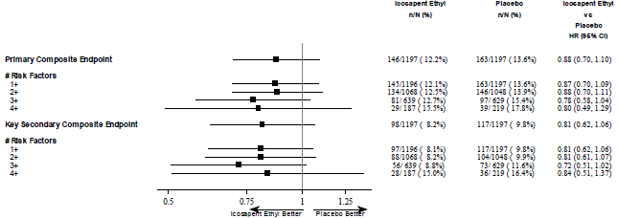
Abbreviations: CI = confidence interval; HR = hazard ratio.
Note: All primary prevention (CV2) cohort subjects had to have diabetes mellitus, were aged ≥ 50 years and had multiple dyslipidaemias (elevated triglyceride s and low-density lipoprotein cholesterol requiring statin control). The number of risk factors included in this figure are based on the number of additional risk factors as collected on the cardiovascular risk category cardiorespiratory fitness page: hypertension and/or on anti-hypertensives, men ≥ 55 years and women ≥65 years, high-density lipoprotein cholesterol ≤ 40 for men and ≤ 50 for women, cigarette smoker, high sensitivity C-reactive protein > 3 mg/L, renal dysfunction, micro or macroalbuminuria, retinopathy, ankle-brachial index.
Source: this figure is extracted from EMA Response to Day180 Questions (providing this document is beyond the scope of this AusPAR).
Effects on plasma biomarkers were tertiary objectives. Fasting lipids (triglyceride, total cholesterol, HDL cholesterol, LDL cholesterol, non-HDL cholesterol, and VLDL cholesterol) were tested at each study visit; other plasma biomarkers (high-sensitivity CRP, apolipoprotein B, high-sensitivity troponin-T) were tested at Day 0, Day 720, and last visit. Findings for key plasma biomarkers are shown in Table 8. The maximal decrease in triglyceride in the icosapent ethyl group was observed at visit 3 (4 months of treatment) and persisted through to the end of study (Figure 12). For some parameters, particularly non-HDL cholesterol, LDL cholesterol (Figure 13), and apolipoprotein B, the observed between-group difference was influenced by an increase from Baseline in the placebo group.
Table 8: REDUCE-IT trial Effects on plasma biomarkers from Baseline to Years 1 or 2 (intent-to-treat population)
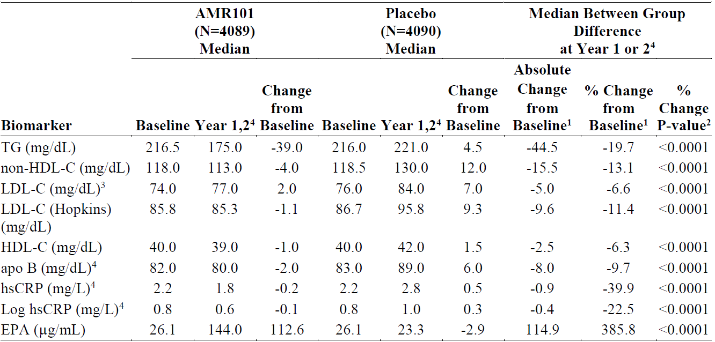
Abbreviations: apo B = apolipoprotein B; EPA = eicosapentaenoic acid; HDL-C = high-density lipoprotein cholesterol; hsCRP = high-sensitivity C-reactive protein; ITT = Intent-to-Treat; LDL-C = low-density lipoprotein cholesterol; TG = triglycerides.
1 Based on Hodges-Lehmann estimation.
2 P-value from Wilcoxon rank-sum test.
3 Derived as defined in the dossier.
4 Apo B, hsCRP, and log hsCRP were measured at Year 2; all other biomarkers presented were measured at Year 1.
5 ‘Log’ denotes natural log.
Figure 12: REDUCE-IT trial Plot of median triglycerides over time (intent-to-treat population)
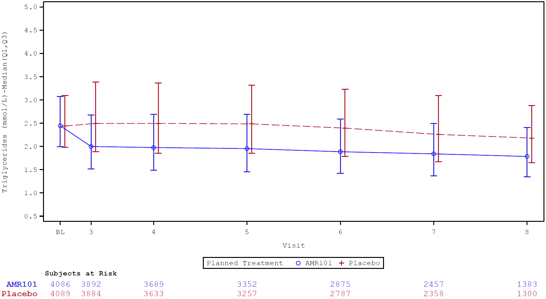
Abbreviation: AMR101 = icosapent ethyl.
Figure 13: REDUCE-IT Plot of median Low-density lipoprotein cholesterol (Hopkins approximation) over time (intent-to-treat population)
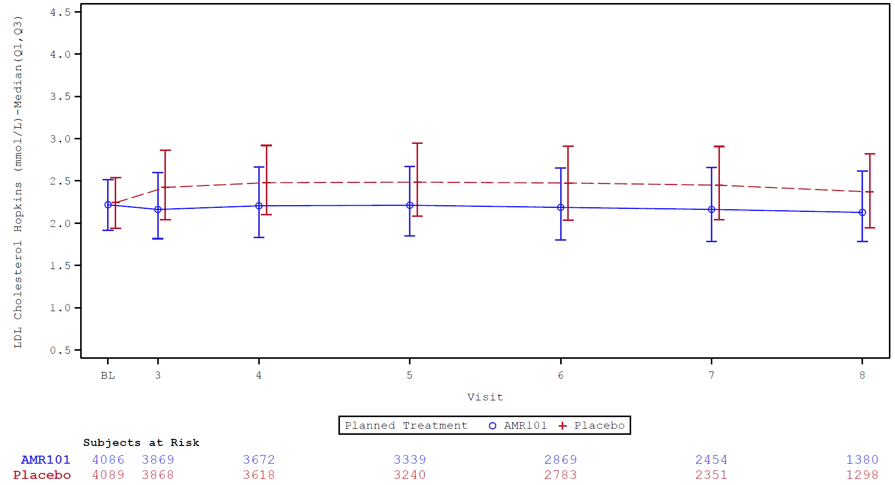
Abbreviations: AMR101 = icosapent ethyl; LDL = low-density lipoprotein.
Study AMR-01-01-0016 (MARINE trial)
This was a Phase III, multi-centre, international, randomised, double blind, placebo controlled, 3-arm, parallel group study to evaluate the efficacy and safety of icosapent ethyl in patients with fasting triglyceride levels ≥ 500 mg/dL and ≤ 2000 mg/dL. The primary objective was to determine the efficacy of icosapent ethyl 2 g daily and 4 g daily, compared to placebo, in lowering fasting triglyceride levels in patients with fasting triglyceride ≥ 500 mg/dL and ≤ 2000 mg/dL (≥ 5.6 mmol/L and ≤ 22.6 mmol/L).
The study included:
- a 6- to 8-week screening period (including a diet and lifestyle stabilisation period, washout period, and triglyceride qualifying period)
- a 12-week double-blind treatment period (icosapent ethyl 2 g/day, icosapent ethyl 4 g/day, or matching placebo (mineral oil) as divided doses)
- a 40-week open-label extension period (icosapent ethyl 4 g/day, as divided doses).
Patients on statin therapy at screening were evaluated by the investigator as to whether it could be safely discontinued at screening. Continuation of statin therapy was permitted provided the dose was stable for ≥ 4 weeks prior to baseline triglyceride measurement. Non-statin lipid-altering treatments had to be discontinued at screening. Patients who completed the 12-week double blind treatment period were eligible to enter the 40-week open-label extension period at Visit 7 (Week 12). During the open-label extension period, changes to the lipid altering regimen were permitted, as guided by standard practice and prescribing information.
A total of 229 patients were randomised to treatment: 77 to icosapent ethyl 4 g/day, 76 to icosapent ethyl 2 g/day, and 76 to placebo. Patients were stratified by baseline triglyceride level, gender, and use of statin therapy at randomisation.
The primary endpoint was percent change in triglyceride from Baseline to Week 12. Percent change in VLDL cholesterol, Lp-PLA₂, and apolipoprotein B from Baseline to Week 12 were secondary endpoints. Other efficacy endpoints were exploratory. No pre-specified efficacy hypothesis was tested in the OLE period.
There were significant, dose-dependent reductions in triglyceride from Baseline to Week 12 in the icosapent ethyl groups compared to an increase in the placebo group (Table 9). Significant decreases in VLDL cholesterol, Lp-PLA₂, and apolipoprotein B were observed in the Vazkepa 4 g/day group but not the 2 g/day group. In the placebo arm, there were increases in some parameters from Baseline to Week 12, including high-sensitivity CRP, VLDL cholesterol, triglyceride, non-HDL cholesterol, total cholesterol and VLDL triglyceride.
Table 9: MARINE trial Median baseline and percent change from Baseline to Week 12 in lipid parameters (intent-to-treat population)
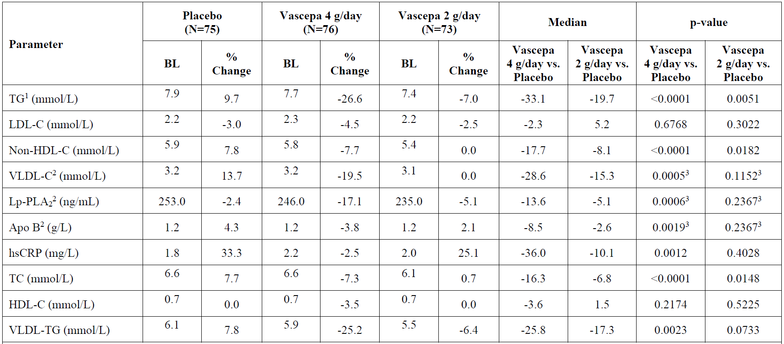
Abbreviations: % Change = Median Percent Change from Baseline; Apo B = apolipoprotein B; BL = Baseline (mg/dL); HDL-C = high-density lipoprotein cholesterol; hsCRP = high sensitivity C-reactive protein; LDL-C = low-density lipoprotein cholesterol; Lp-PLA2 = lipoprotein-associated phospholipase A2; non-HDL-C = non-high-density lipoprotein cholesterol; TC = total cholesterol; TG = triglyceride; VLDL-C = very low-density lipoprotein cholesterol; VLDL-TG = very low-density lipoprotein triglycerides.
Medians are Hodges-Lehmann medians; p-values are from the Wilcoxon rank-sum test.
1 Fasting TG level was the primary efficacy endpoint
2 VLDL-C, Lp-PLA2, and Apo B were secondary efficacy endpoints
3 Adjusted p-values from applying Hommel’s multiple comparison procedure to the p-value from the treatment comparison between 4 or 2 g/day icosapent ethyl with placebo are reported.
Table 10: MARINE-OLE trial Percent change in key lipid and lipoprotein parameters from open-label baseline to Week 52 (extension efficacy population)
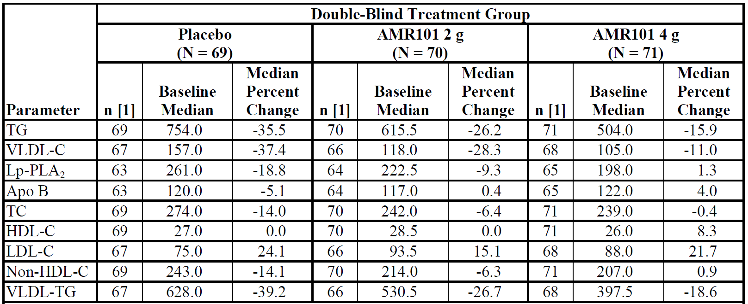
Abbreviations: Apo B = apolipoprotein B; HDL-C = high-density lipoprotein cholesterol; LDL-C = low-density lipoprotein cholesterol; Lp-PLA2 = lipoprotein-associated phospholipase A2; non-HDL-C = non-high-density lipoprotein cholesterol; TC = total cholesterol; TG = triglyceride; VLDL-C = very low-density lipoprotein cholesterol; VLDL-TG = very low-density lipoprotein triglycerides.
For TG, open-label baseline was defined as the average of Visit 6 (Week 11) and Visit 7 (Week 12) measurements during the double-blind treatment period. If the measurement at 1 visit was missing, the other visit was used. If the measurements at both visits were missing, the last valid measurement during the double-blind treatment period was used as the baseline value. For all other lipid and lipoprotein parameters, open-label baseline was defined as the Visit 7 (Week 12) measurement during the double-blind treatment period. If missing, the last valid measurement during the double-blind treatment period was used as the baseline value.
1. Only patients with non-missing open-label baseline and Week 52 endpoint values were included.

Study AMR-01-01-0017 (ANCHOR trial)
This was a Phase III, multi-centre, randomised, double blind, placebo controlled, 12-week, 3-arm study to evaluate the effect of two doses of icosapent ethyl on fasting serum triglyceride levels in patients with persistent high triglyceride levels (≥ 200 mg/dL and < 500 mg/dL) despite statin therapy. The study was conducted at 97 sites in USA between 16 December 2009 and 21 February 2011.
The study included:
- a 6- to 8-week screening period (including a diet and lifestyle stabilisation period, washout period, and triglyceride qualifying period)
- a 12-week double-blind treatment period (icosapent ethyl 2 g/day, icosapent ethyl 4 g/day, or matching placebo (mineral oil), as divided doses morning and evening)
In order to enter the 12-week double-blind treatment period, patients must have had a mean fasting LDL cholesterol level ≥ 40 mg/dL and ≤ 115 mg/dL (based on 2 qualifying visits) and fasting triglyceride levels from 2 qualifying visits within the following ranges:
- mean of the 2 values ≥ 185 mg/dL and at least 1 value ≥ 200 mg/dL, and
- mean of the 2 values < 500 mg/dL.
A total of 702 patients were randomised to treatment: 233 to icosapent ethyl 4 g/day, 236 to icosapent ethyl 2 g/day, and 233 to matching placebo (mineral oil). Patients were stratified by type of statin (atorvastatin, rosuvastatin, or simvastatin), the presence of diabetes, and gender.
The primary efficacy endpoint was percent change in triglyceride from Baseline to Week 12. Secondary efficacy variables included percent changes in LDL cholesterol, non-HDL cholesterol, VLDL cholesterol, Lp-PLA₂, and apolipoprotein B from Baseline to Week 12. Other efficacy variables were exploratory.
There were significant, dose-dependent reductions in triglyceride from Baseline to Week 12 in the icosapent ethyl groups compared to an increase in the placebo group (Table 11). Decreases in LDL cholesterol, non-HDL cholesterol, VLDL cholesterol, Lp-PLA₂, and apolipoprotein B from Baseline to Week 12 in the icosapent ethyl groups relative to placebo were at least partly driven by increases in the placebo arm.
Table 11: ANCHOR trial Median baseline and percent change from Baseline to Week 12 in lipid parameters (intent-to-treat population)
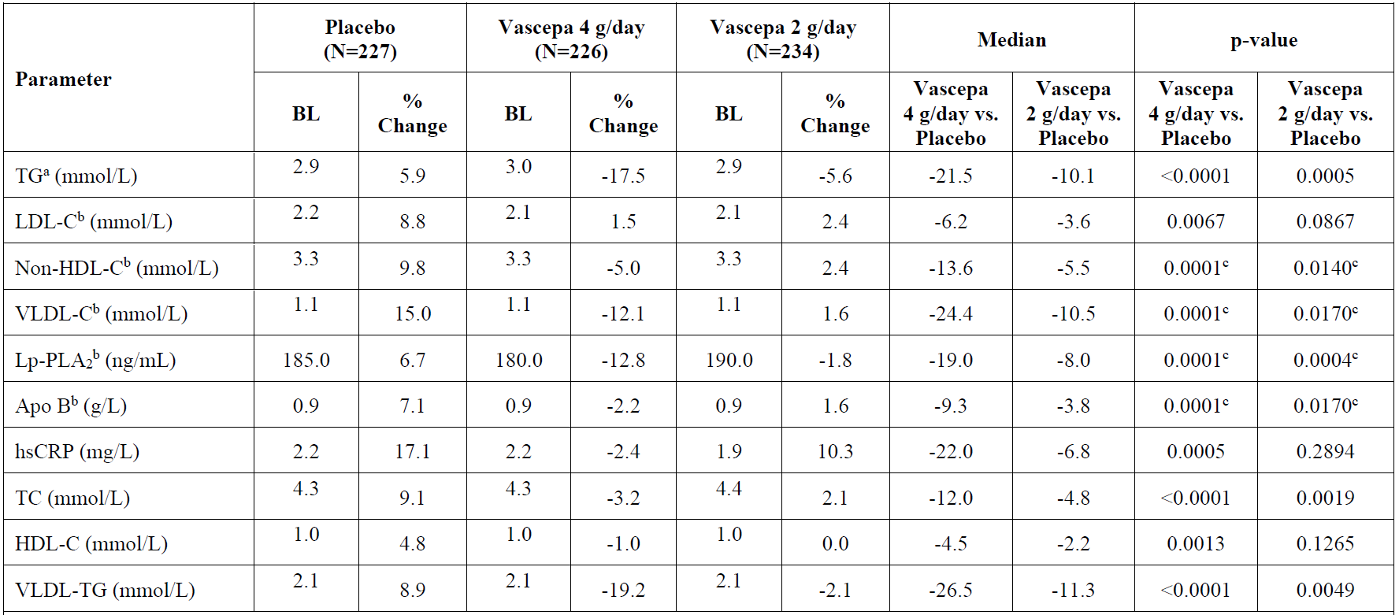
Abbreviations: % Change = Median Percent Change from Baseline; Apo B = apolipoprotein B; BL = Baseline; HDL-C = high-density lipoprotein cholesterol; hsCRP = high sensitivity C-reactive protein; LDL-C = low-density lipoprotein cholesterol; Lp-PLA2 = lipoprotein-associated phospholipase A2; non-HDL-C = non-high-density lipoprotein cholesterol; TC = total cholesterol; TG = triglyceride; VLDL-C = very low-density lipoprotein cholesterol; VLDL-TG = very low-density lipoprotein triglycerides.
Medians are Hodges-Lehmann medians; p-values are from the Wilcoxon rank-sum test.
a Fasting TG level was the primary efficacy endpoint
b LDL-C, non-HDL-C. VLDL-C, Lp-PLA2, and Apo B were secondary efficacy endpoints
c Adjusted p-values from applying Hommel’s multiple comparison procedure to the p-value from the treatment comparison between 4 or 2 g/day icosapent ethyl with placebo are reported.

Safety
The safety of Vazkepa in the proposed indication is informed primarily by the pivotal Phase III study (the REDUCE-IT trial), supported by safety data from the two Phase III studies in patients with hypertriglyceridaemia (the MARINE and ANCHOR trials), five clinical pharmacology studies in healthy subjects, and eight efficacy or safety studies in patients with central nervous system disorders (three for Huntington’s disease, 3 for depression, one for schizophrenia, and one for age-associated memory impairment).
In the REDUCE-IT trial, the median duration of Vazkepa and placebo treatment was 1614 days (4.5 years) and 1512 days (4.2 years), respectively. Overall, 12.3% (1010 of 8179) of patients received study drug for less than one year and 0.5% (37 of 8179) of patients received study drug for at least 6 years (at least 2160 days). In the pooled hypertriglyceridemia studies, mean exposure was 82 days (median 84 days) in all treatment groups (Vazkepa 2 g/day, Vazkepa 4 g/day, and placebo).
An overview of treatment-emergent adverse events (TEAEs) is presented in Table 12. There were no relevant differences in the overall frequency of adverse events (AEs) or serious AEs. Discontinuation of study drug due to TEAE was reported in 8.0% of patients overall and was numerically higher in the placebo group compared to Vazkepa. Discontinuation of study drug due to treatment related TEAE was also slightly higher in the placebo group (4.0%) than the Vazkepa group (3.4%), mainly driven by diarrhoea (1.6% in the placebo group versus 1.0% in the Vazkepa group). In the pooled safety analysis of the MARINE and ANCHOR trials, the overall incidence of TEAEs was lower than the REDUCE-IT trial, reflecting the shorter duration of these studies.
Treatment-emergent adverse events (TEAEs) by System Organ Class and Preferred Term are presented in Table 13. Numerical imbalances included musculoskeletal pain, constipation, oedema peripheral, and atrial fibrillation (more frequent in the Vazkepa group), and anaemia (more frequent in the placebo group). The placebo treatment (mineral oil) can have a laxative effect which may explain the higher rate of constipation in the Vazkepa group (and higher rate of diarrhoea in the placebo group). Among the less frequent TEAEs, numerical imbalances (more frequent in the Vazkepa group) included gout, hyperuricaemia, cardiac conduction disorders, dermatitis, eczema, rash, and allergic conditions (mainly hypersensitivity).
Table 12: REDUCE-IT trial Overview of treatment-emergent adverse events overall and by treatment group (safety population)
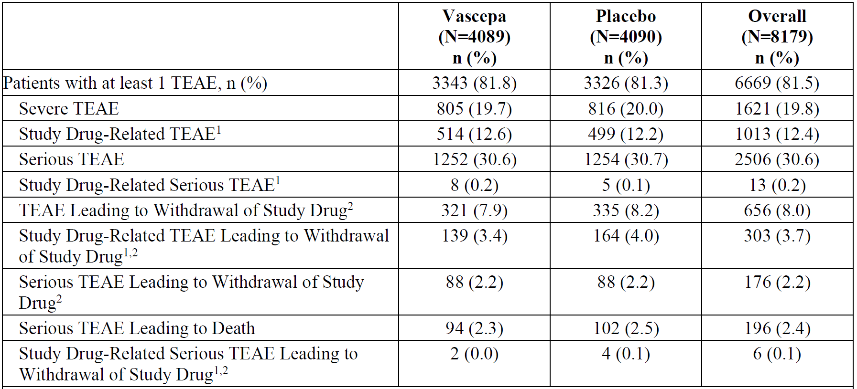
Abbreviation: TEAE = treatment-emergent adverse event.
Note: A TEAE was defined as an event that first occurred or worsened in severity on or after the date of dispensing study drug and within 30 days after the completion or withdrawal from study. Percentages were based on the number of patients randomised to each treatment group in the Safety population (N). Events that were positively adjudicated as clinical endpoints were not included.
1. Study drug related TEAE include those characterised as related, probably related, or possibly related.
2. Withdrawal of study drug excludes patients who were off drug but remained in the study for 30 days or more and restarted study drug.
Table 13: REDUCE-IT trial Treatment-emergent adverse events occurring at an incidence of at least 3% in either treatment group (safety population)
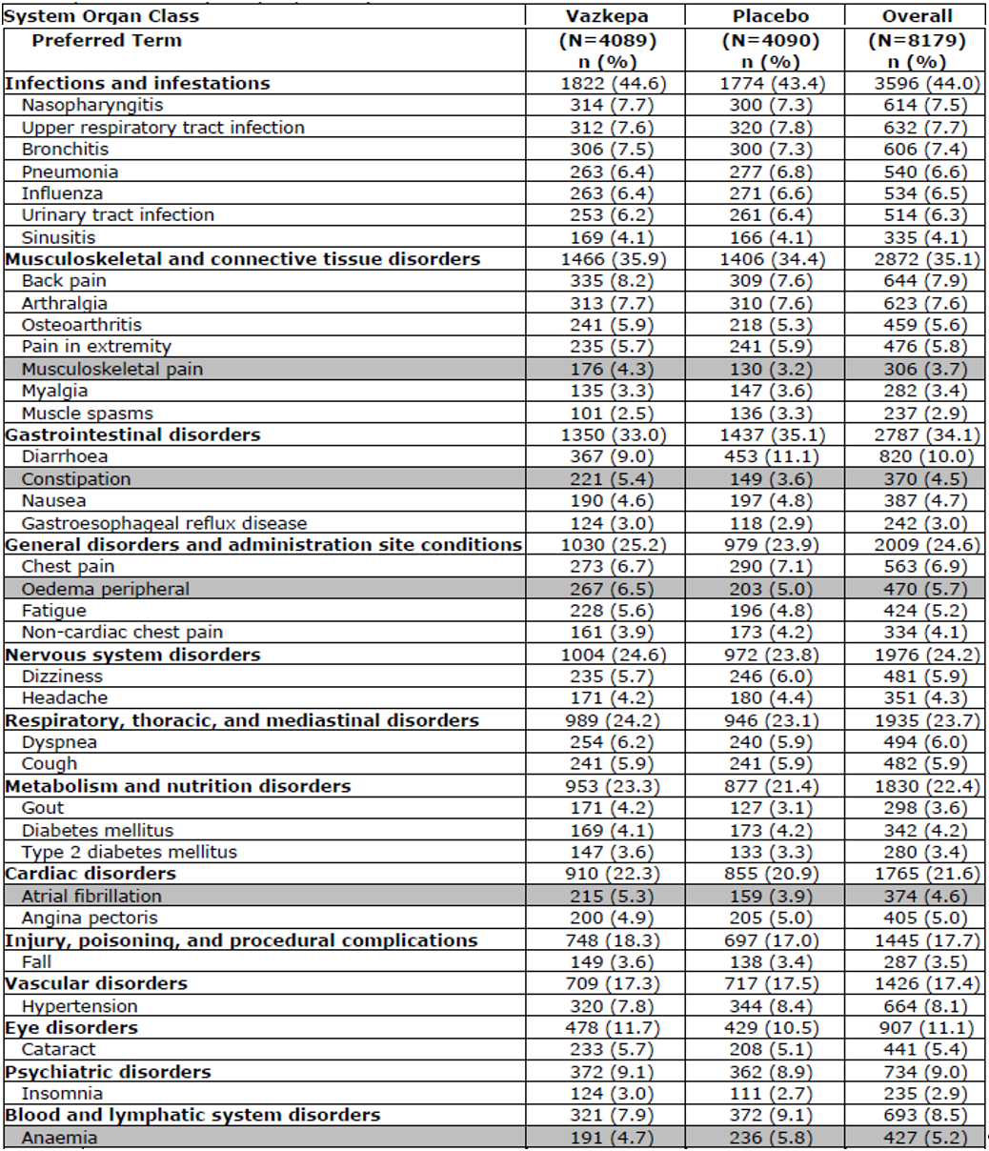
Abbreviations: MedDRA = Medical Dictionary for Regulatory Activities; TEAE = treatment-emergent adverse event
Note: A TEAE was defined as an event that first occurred or worsened in severity on or after the date of dispensing study drug and within 30 days after the completion or withdrawal from study. For each patient, multiple TEAE of the same preferred term were counted only once within each preferred term. TEAE are listed in descending order of icosapent ethyl frequency. Percentages were based on the number of patients randomised to each treatment group in the Safety population (N). Events that were positively adjudicated as clinical endpoints were not included.
1. All adverse events were coded using the MedDRA, Version 20.1.
Total mortality was lower in the Vazkepa group than placebo (274 subjects (6.7%) versus 310 subjects (7.6%)) due to a decrease in cardiovascular mortality (Table 14).
Table 14: REDUCE-IT trial Summary of clinical events committees-adjudicated deaths including cardiovascular death, non-cardiovascular death, undetermined death and total mortality (safety population)
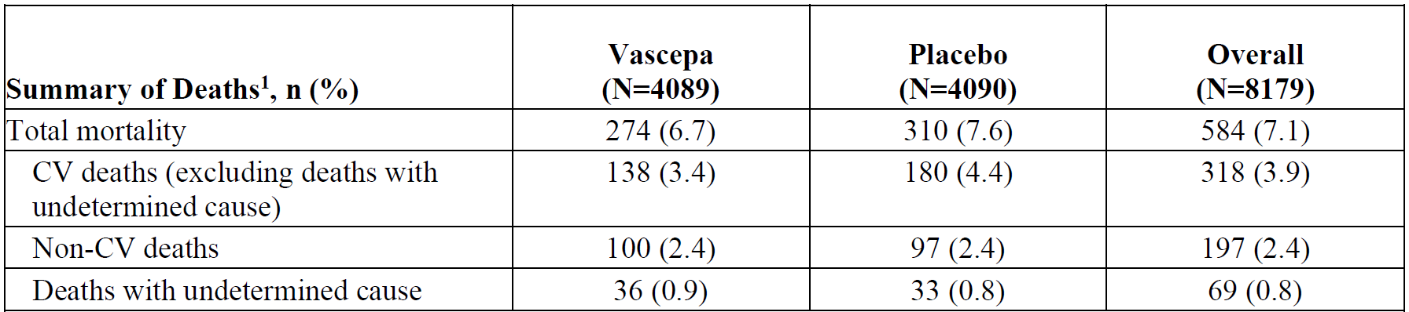
Abbreviations: CV = cardiovascular.
Note: CV deaths (excluding death with undetermined cause) and deaths with undetermined cause were combined as ‘CV death’ for the primary efficacy analysis of CV endpoints.
1. Excludes 3 patient deaths occurring after consent withdrawal.
Bleeding related events were pre-specified as adverse events of special interest (AESI), as doses of omega-3 marine oil in excess of 3 g/day have been linked with an increase in bleeding time. In the REDUCE-IT trial, a higher incidence of bleeding-related AEs was observed in the Vazkepa group compared to the placebo group (11.8% versus 9.9%, p = 0.0055; Table 15). Bleeding related serious adverse events (SAEs) occurred in 2.7% of patients in the Vazkepa group compared to 2.1% in the placebo group, with most involving the gastrointestinal tract (1.5% Vazkepa, 1.1% placebo). Serious central nervous system bleeding events occurred in 0.34% in the Vazkepa group and 0.24% in the placebo group. Concomitant medications, including antiplatelet agents, were balanced across the treatment groups so are thought not to have contributed to the observed differences in bleeding events.
Atrial fibrillation or flutter was not pre-specified as AESI, but was explored post-hoc in response to an observed imbalance between the treatment groups (Table 16).
Table 15: REDUCE-IT trial Overview of pre-specified treatment-emergent adverse events of special interest, bleeding-related disorders (safety population)
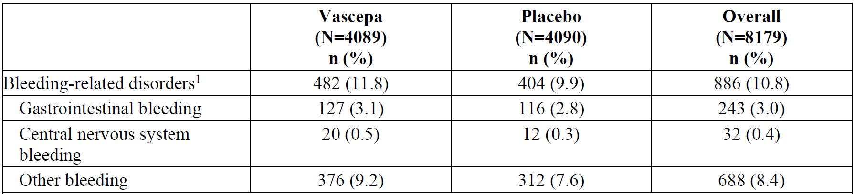
Abbreviations: AE = adverse event; excl = excluding; MedDRA = Medical Dictionary for Regulatory Activities; SMQ = Standardised MedDRA Query; TEAE = treatment-emergent adverse event.
Note: A TEAE was defined as an event that first occurred or worsened in severity on or after the date of dispensing study drug and within 30 days after the completion or withdrawal from study. For each patient, multiple TEAE of the same preferred term were counted only once within each preferred term.
1. Bleeding-related disorders were identified by the SMQs of ‘Gastrointestinal haemorrhage,’ ‘Central Nervous System haemorrhages and cerebrovascular conditions,’ and ‘Haemorrhage terms (excl laboratory terms).’
Table 16: REDUCE-IT trial summary of atrial fibrillation and atrial flutter (intent-to-treat population)
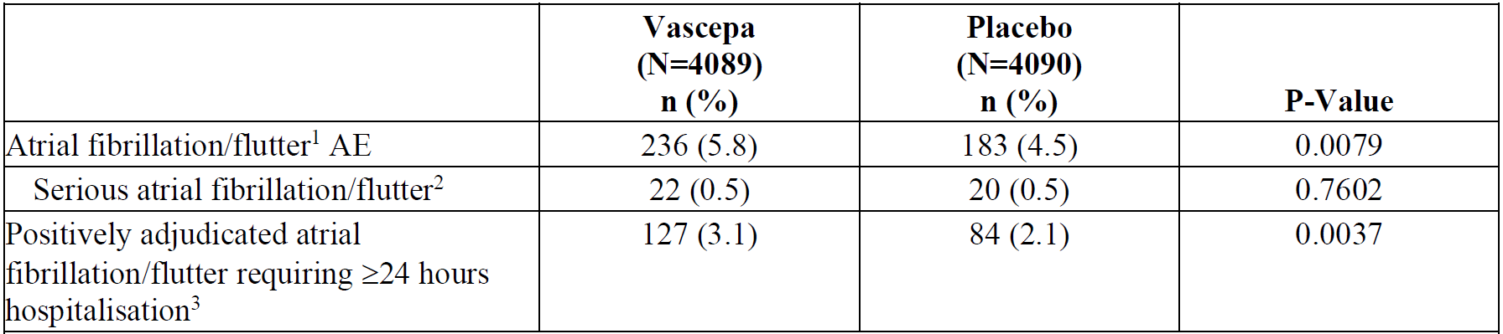
Abbreviations: AE = adverse event; ITT = Intent-to-Treat; MedDRA = Medical Dictionary for Regulatory Activities.
Note: Percentages were based on the number of patients in the ITT population within each treatment group (N). All AE were coded using the MedDRA, Version 20.1.
1 Includes atrial fibrillation/flutter AE. The p-value was based on Fisher’s exact test.
2 Includes atrial fibrillation/flutter AE meeting seriousness criteria. The p-value was based on Fisher’s exact test.
3 Includes positively adjudicated atrial fibrillation/flutter requiring ≥ 24 hours hospitalisation clinical events by the Clinical Endpoint Committee. The p-value was based on stratified log-rank test

Laboratory findings
Median haemoglobin increased slightly in the Vazkepa group compared to placebo after approximately one year of treatment; the difference between the groups did not further increase after approximately three years of treatment.
Effects on lipids, lipoproteins, and inflammatory parameters were evaluated as tertiary efficacy objectives and are described in the efficacy section.
A detailed evaluation of hepatic safety was conducted. There was no mean increase in serum alanine aminotransferase (ALT) or aspartate aminotransferase (AST) levels in any treatment group. There were numerically more patients with elevated ALT after four or five years of treatment in the Vazkepa group (868 (35%)) than in the placebo group (742 (31%)) after four years. More patients in the Vazkepa than in the placebo group had elevated bilirubin after four to five years of treatment (205 (8.4%) versus 67 (2.9%)). This finding was paralleled by a slight increase of mean serum bilirubin in the Vazkepa group (0.51 μmol/L) and a more pronounced decrease of bilirubin in the placebo group (-1.75 μmol/L). An increase of 3 x upper limit of normal (ULN) in ALT or AST and increase of 2 x ULN in total bilirubin was reported in one patient in each treatment group, and an increase of 3 x ULN in ALT or AST, increase of 2 x ULN in total bilirubin, and decrease of ≤ 2 x ULN in alkaline phosphatase was reported in one patient in the Vazkepa group. In each case, the elevated liver enzymes were characterised as not related to study drug and were not considered to be drug induced liver injury. Hy’s Law was considered not to be met in each case, based on assessment against the criteria in the FDA Guidance.
To address safety in patients with hepatic disorders, the sponsor performed an analysis of TEAEs in patients with potential hepatic disorders at study entry, based on prior medical history and/or elevated laboratory values at Baseline. Classification according to the severity of hepatic impairment (for example, Child-Pugh score) was not performed. In the analysis of 517 patients in the REDUCE-IT trial with potential baseline liver disorder, no relevant imbalances in TEAEs were observed between the treatment groups.
To address safety in patients with renal impairment, the sponsor performed an analysis of TEAEs stratified for eGFR (≥ 60 mL/min/1.73 m² versus < 60 mL/min/1.73 m²). In patients with eGFR < 60 mL/min/1.73 m², there was no meaningful imbalance in the frequencies of TEAEs and SAEs between Vazkepa and placebo groups.
In safety analyses stratified by age less than 65 years and 65 years or older, the percentage of patients experiencing at least one TEAE was greater in the older subgroup, but otherwise no relevant differences between treatment groups were apparent.

Post-marketing safety experience
Vazkepa has been marketed in USA since January 2013 for the treatment of severe hypertriglyceridaemia. The US FDA opened a Tracked Safety Issue on 19 February 2016 regarding liver injury, under the classification of ‘standard’. As of 30 June 2016, the FDA had determined that ‘no action is necessary at this time based on available information’. All hepatic reports continue to be monitored as events of special interest as part of the safety surveillance.
Post-approval safety surveillance up to 25 July 2019 produced a total of 1,204 unique reports. The most frequently reported adverse reactions include arthralgia, product taste abnormal, blood triglycerides increased, diarrhoea, nausea, and eructation. No action has been taken for safety reasons during this period. Serious events assessed as possibly related to treatment included two reports of choking or choking sensation, two reports of epistaxis, and one report each of neonatal distress syndrome, elevated liver enzymes, atrial fibrillation, diarrhoea, dyspnoea, hypersensitivity, loss of consciousness, nausea, presyncope, prostate cancer, and syncope.
Review of US Periodic Adverse Drug Experience Reports identified 19 reports of bleeding events, of which 9 were assessed to be possibly causally associated to Vazkepa and non-serious, and 6 reports of atrial fibrillation, of which 2 were serious.

Risk management plan
The sponsor has submitted European Union (EU)-risk management plan (RMP) version 0.4 (dated 18 December 2020; data lock point 6 September 2018) and Australia-specific annex (ASA) version 0.1 (dated December 2021) in support of this application. In response to a TGA request for information, the sponsor has submitted ASA version 0.2 (dated June 2022) to support its application.
The summary of safety concerns and their associated risk monitoring and mitigation strategies are summarised in Table 17. The TGA may request an updated RMP at any stage of a product's life-cycle, during both the pre-approval and post-approval phases.
Table 17: Summary of safety concerns
Summary of safety concerns |  | Pharmacovigilance |  | Risk minimisation
 |  | Routine | Additional | Routine | Additional
Important identified risks | Bleeding in patients on anti-thrombotic therapy |  | – |  | –
Important identified risks | Atrial fibrillation/flutter |  | – |  | –
Important potential risks | None | – | – | – | –
Missing information | Use in pregnant and breast-feeding women | * | – |  | –
*Pregnancy notification and follow-up form and specific breastfeeding follow-up form
The summary of safety concerns is adequate.
Routine pharmacovigilance activities only are proposed. This is acceptable for this COR-B application, which is using the EMA as the comparable overseas regulator.
Routine risk minimisation activities only are proposed. The CMI will be included in the packaging and will be a routine risk minimisation activity as stated in the ASA. Routine risk minimisation activities only are adequate as the medicine is administered orally and does not require any additional instructions for use.

Risk-benefit analysis

Delegate’s considerations

Efficacy
The efficacy of Vazkepa in the proposed indication is based primarily on one pivotal cardiovascular outcomes study (the REDUCE-IT trial), supported by two Phase III studies (the MARINE and ANCHOR trials) which evaluated efficacy in terms of effect on triglyceride and other plasma biomarkers in patients with hypertriglyceridaemia.
The REDUCE-IT trial was a randomised, placebo controlled, event driven clinical trial conducted in patients with moderately elevated triglyceride (≥ 1.5 mmol/L and < 5.6 mmol/L) on statin therapy and at high risk of a cardiovascular event. The study included two cohorts: a secondary prevention cohort comprising men and women 45 years of age or older with established cardiovascular disease, and a primary prevention cohort comprising men and women 50 years of age or older at high risk for cardiovascular disease based on having diabetes mellitus (type 1 or 2) requiring treatment with medication and one or more pre-defined cardiovascular risk factors. The primary objective was to evaluate the efficacy of Vazkepa 4 g/day compared to placebo in reducing the risk of major cardiovascular events.
The dose of Vazkepa evaluated in the REDUCE-IT trial was two capsules twice daily (that is, 4 g/day). Dose selection was informed by efficacy (primarily triglyceride lowering) and safety findings from the MARINE and ANCHOR trials which evaluated doses of 2 g/day and 4 g/day.
The REDUCE-IT trial met its primary endpoint, demonstrating a significant reduction in the 5-point MACE composite primary endpoint (cardiovascular death, non-fatal myocardial infarction (including silent myocardial infarction), non-fatal stroke, coronary revascularisation, unstable angina requiring emergent hospitalisation). A primary endpoint event occurred in 17.2% (705 of 4089) of patients in the Vazkepa group compared to 22.0% (901 of 4090) of patients in the placebo group (hazard ratio 0.752 (95% CI: 0.682, 0.830; p = 0.00000001), relative risk reduction 24.8%, absolute risk reduction 4.8%, number needed to treat 21). Each of the components of the composite primary endpoint contributed to the outcome. A similar benefit was observed for the key secondary endpoint, a 3-point MACE composite of cardiovascular death, nonfatal myocardial infarction (including silent myocardial infarction), and nonfatal stroke. Statistically significant benefits were observed for the other secondary endpoints with the exception of total mortality, the last endpoint in the testing hierarchy. For total mortality, there was a trend favouring Vazkepa (hazard ratio 0.87; 95% CI: 0.739, 1.023) but it was not statistically significant.
An issue raised during the evaluation was the potential for a negative impact on cardiovascular outcomes from the placebo treatment. Mineral oil was chosen as the placebo comparator to match the colour and consistency of Vazkepa; however, findings from the Phase III studies raise some uncertainty as to whether mineral oil is inert with regard to effects on plasma lipids, lipoproteins, and inflammatory parameters. Increases in triglyceride, non-HDL cholesterol, LDL cholesterol, apolipoprotein B, and high-sensitivity CRP were observed in the placebo arm of the pivotal study, and it remains uncertain the extent to which these changes could have impacted on cardiovascular outcomes.
This issue was summarised in the CHMP Assessment Report.⁹ The sponsor presented a worst-case scenario analysis of the maximally conceivable negative impact of the comparator based on the assumptions that all of the observed effects on plasma parameters were due to the mineral oil and that each effect had an independent and additive impact on cardiovascular events. This worst-case scenario analysis estimated that the effects of the mineral oil could increase cardiovascular events by up to 15%. The evaluation acknowledged the substantial limitations of this worst-case scenario analysis and the likelihood that this analysis was overly pessimistic with regard to the possible effect on cardiovascular events.⁹ The sponsor presented additional covariate-based analyses of the pivotal study suggesting that the possible effect of mineral oil on cardiovascular outcomes would be much lower than estimated based on published population-based data, accounting for no more than 0.3% to 3% of cardiovascular events (based on 3-point MACE). Further post hoc analyses of the REDUCE-IT trial were presented, suggesting a correlation between EPA concentration and cardiovascular outcome; however, these analyses were not considered robust due to missing data, sparse sampling, and the impact of imputation rules on the results.
There remains some uncertainty regarding the extent to which the placebo (mineral oil) may have impacted on cardiovascular outcomes through a direct or indirect effect on plasma lipids, lipoproteins, and inflammatory parameters. However, the magnitude of the cardiovascular benefit demonstrated in the REDUCE-IT trial provides assurance that treatment with Vazkepa contributed to a clinically meaningful reduction in cardiovascular events. Even in worst-case scenario analyses, which are considered likely to overestimate the cardiovascular risk associated with mineral oil treatment, there still appears to be a clinically meaningful benefit attributable to Vazkepa.

Safety
The safety of Vazkepa in the proposed indication is informed primarily by the pivotal study (the REDUCE-IT trial), in which over 8,000 patients were treated with Vazkepa or matching placebo for median duration of more than 4 years. In the REDUCE-IT trial, Vazkepa was generally well tolerated and the overall incidence of TEAEs and SAEs was similar between the Vazkepa and placebo groups. TEAEs leading to withdrawal of study drug were reported in 8% of patients overall and were numerically slightly higher in the placebo group.
Treatment-emergent adverse events (TEAEs) reported more frequently in the Vazkepa group compared to placebo included musculoskeletal pain, constipation, oedema peripheral, and atrial fibrillation or flutter. These are all addressed in Section 4.8, and the risk of atrial fibrillation or flutter is also addressed as a precaution in Section 4.4 of the PI. There is not a clearly established mechanism to explain the observed difference in atrial fibrillation or flutter.
Bleeding-related AEs were evaluated as AESI. Overall, there was a higher incidence of bleeding-related AEs in the Vazkepa group compared to the placebo group. Serious bleeding-related events and central nervous system bleeding events were numerically higher with Vazkepa compared to placebo. The increased risk of bleeding events is addressed as a precaution in Section 4.4, as well as in Section 4.8 of the PI.
Total mortality was lower in the Vazkepa group than placebo, driven by a reduction in cardiovascular mortality in the Vazkepa group.

Proposed indication
The proposed indication is the same as the approved indication in the EU. The proposed treatment population reflects the two cardiovascular risk cohorts evaluated in the pivotal study (the REDUCE-IT trial).
In Australia, triglyceride results are typically reported as mmol/L, so the Delegate’s preference is to remove the reference to mg/dL from the indication. Both units can be included in the description of the study in Section 5.1 of the PI as a reference for prescribers.
The description of the pivotal study in Section 5.1 of the PI includes the study criteria for established cardiovascular disease and the cardiovascular risk factors in the primary prevention cohort. This information is relevant to prescribers, but the Delegate’s preference is for the indication not to include a cross reference to Section 5.1. Consequently, the Delegate prefers the following indication:
Vazkepa is indicated to reduce the risk of cardiovascular events in adult statin-treated patients at high cardiovascular risk with elevated triglycerides (≥ 1.7 mmol/L) and
- established cardiovascular disease, or
- diabetes, and at least one other cardiovascular risk factor.

Uncertainties and limitations of the data
There remains uncertainty regarding the mechanism(s) of action for cardiovascular risk reduction with Vazkepa. A triglyceride lowering effect was demonstrated in the Phase III studies, but other triglyceride lowering agents have shown inconsistent findings with regard to cardiovascular risk reduction. This uncertainty is addressed in Section 5.1 of the PI.
Light mineral oil was selected as the placebo in the Phase III studies to match the colour and consistency of Vazkepa; however, findings from the Phase III studies raise some uncertainty as to whether mineral oil is inert with regard to effects on plasma lipids, lipoproteins, and inflammatory parameters. The extent to which changes in lipids, lipoproteins, and inflammatory parameters in the placebo arm of the pivotal study impacted on cardiovascular outcomes remains uncertain.
Dose response was evaluated for effects on triglyceride and other plasma biomarkers in the MARINE and ANCHOR trials, but dose response has not been evaluated for cardiovascular outcomes.

Proposed conditions of registration
- The Vazkepa EU-RMP (version 0.4, dated 18 December 2020, data lock point 6 September 2018), with Australian specific annex (version 0.2, dated June 2022), included with Submission PM-2021-05861-1-3, and any subsequent revisions, as agreed with the TGA will be implemented in Australia.
- An obligatory component of risk management plans is routine pharmacovigilance. Routine pharmacovigilance includes the submission of periodic safety update reports (PSURs).
Reports are to be provided in line with the current published list of EU reference dates and frequency of submission of PSURs until the period covered by such reports is not less than three years from the date of the approval letter.
The reports are to at least meet the requirements for PSURs as described in the European Medicines Agency’s Guideline on Good Pharmacovigilance Practices (GVP) Module VII-periodic safety update report (Revision 1), Part VII.B Structures and processes. Note that submission of a PSUR does not constitute an application to vary the registration.
Vazkepa (icosapent ethyl) is to be included in the Black Triangle Scheme. The PI and CMI for Vazkepa must include the black triangle symbol and mandatory accompanying text for five years, which starts from the date that the sponsor notifies the TGA of supply of the product.

Proposed action
The pivotal study (the REDUCE-IT trial) demonstrated a significant reduction in the risk of cardiovascular events in the Vazkepa group compared to placebo. cardiovascular benefit was consistently demonstrated across the primary and secondary MACE endpoints. Important identified safety risks with Vazkepa include bleeding events and atrial fibrillation or flutter. There remains some uncertainty regarding the extent to which changes in key plasma biomarkers in the placebo arm of the pivotal study may have impacted on cardiovascular outcomes. Although there is a possibility that the mineral oil comparator had some negative impact on cardiovascular outcomes, it is considered that treatment with Vazkepa produced a clinically meaningfully benefit on cardiovascular outcomes. Consequently, the overall benefit-risk of Vazkepa in the proposed indication is considered favourable.

Advisory Committee considerations
The Advisory Committee on Medicines (ACM), having considered the evaluations and the Delegate’s overview, as well as the sponsor’s response to these documents, advised the following.

Specific advice to the Delegate
- What is the committee’s view regarding the clinical significance of the changes in key plasma biomarkers in the placebo arm of the pivotal study?
The ACM discussed the elevated plasma biomarkers in the placebo arm of the pivotal study. This resulted in further post-hoc analysis of the data, which indicated the placebo was not strictly inactive as was originally intended in the study design. Participants in this cohort had approximately 10% increase in their LDL cholesterol levels. The results of this analysis were not published until 2022, after which icosapent ethyl was already registered several other key jurisdictions.
The ACM also noted that the net clinical effect was difficult to ascertain given the potential pathological effect of the placebo. It is possible that a portion of the benefit seen in participants who recorded an improvement in cardiovascular events may have been from the absence of the placebo compound rather than the presence of the active icosapent ethyl therapy.
It is also difficult to conclude from the post-hoc analysis of results if a portion of the worsening of various biomarkers was due to the effects of the placebo or rather natural progression of underlying atherosclerotic disease.
- What is the committee’s view regarding the efficacy of Vazkepa in the pivotal study, REDUCE-IT trial?
The ACM discussed the key outcomes from the REDUCE-IT trial.
The hypothesis of the REDUCE-IT trial was that the risk of cardiovascular events would be lower with icosapent ethyl therapy than with placebo among patients in whom elevated triglyceride levels served as a marker of residual risk despite statin therapy.
The REDUCE-IT trial met its primary endpoint, demonstrating a significant reduction in the 5-point MACE composite endpoint (cardiovascular death, nonfatal myocardial infarction (including silent myocardial infarction), non-fatal stroke, coronary revascularisation, unstable angina requiring emergent hospitalisation). A primary endpoint event occurred in 17.2% (705 of 4089) of patients in the Vazkepa group compared to 22.0% (901 of 4090) of patients in the placebo group.
The results indicated the active drug was effective. Furthermore, the ACM noted that the outcomes were not affected by the participants’ baseline triglyceride level. It was also highlighted by the sponsor that the positive outcomes noted by icosapent ethyl therapy may not be transferrable to other omega-3 fatty acid products.
The ACM concluded that this was still a clinically meaningful result despite the issue with the placebo arm.

Conclusion
The ACM considered this product to have an overall positive benefit-risk profile for the indication:
Vazkepa is indicated to reduce the risk of cardiovascular events in adult statin-treated patients at high cardiovascular risk with elevated triglycerides (≥ 1.7 mmol/L) and
- established cardiovascular disease, or
- diabetes, and at least one other cardiovascular risk factor.

Outcome
Based on a review of quality, safety, and efficacy, the TGA approved the registration of Vazkepa (icosapent ethyl) 998 mg, soft capsule, blister pack or bottle, indicated:
Vazkepa is indicated to reduce the risk of cardiovascular events in adult statin-treated patients at high cardiovascular risk with elevated triglycerides (≥ 1.7 mmol/L) and
- established cardiovascular disease, or
- diabetes, and at least one other cardiovascular risk factor.

Specific conditions of registration applying to these goods
- Vazkepa (icosapent ethyl) is to be included in the Black Triangle Scheme. The PI and CMI for Vazkepa must include the black triangle symbol and mandatory accompanying text for five years, which starts from the date that the sponsor notifies the TGA of supply of the product.
- The Vazkepa EU-risk management plan (RMP) (version 0.4, dated 18 December 2020, data lock point 6 September 2018), with Australian specific annex (version 0.2, dated June 2022), included with Submission PM-2021-05861-1-3, and any subsequent revisions, as agreed with the TGA will be implemented in Australia.
An obligatory component of risk management plans is routine pharmacovigilance. Routine pharmacovigilance includes the submission of periodic safety update reports (PSURs).
Reports are to be provided in line with the current published list of EU reference dates and frequency of submission of PSURs until the period covered by such reports is not less than three years from the date of the approval letter.
The reports are to at least meet the requirements for PSURs as described in the European Medicines Agency’s Guideline on Good Pharmacovigilance Practices (GVP) Module VII-periodic safety update report [Revision 1], Part VII.B Structures and processes. Note that submission of a PSUR does not constitute an application to vary the registration.

Attachment 1. Product Information
The PI for Vazkepa approved with the submission which is described in this AusPAR is at Attachment 1. For the most recent PI, please refer to the TGA PI/CMI search facility.
Therapeutic Goods Administration
PO Box 100 Woden ACT 2606 Australia
Email: info@tga.gov.au Phone: 1800 020 653 Fax: 02 6203 1605
https://www.tga.gov.au
Reference/Publication #

The sponsorship of AUST 380979 and 380980 have been transferred from AA-Med Pty Ltd to Seqirus Pty Ltd to on the 23 June 2023.
This is the original indication proposed by the sponsor when the TGA commenced the evaluation of this submission. It may differ to the final indication approved by the TGA and registered on the Australian Register of Therapeutic Goods.
Bergheanu, S.C. et al. Pathophysiology and Treatment of Atherosclerosis: Current View and Future Perspective on Lipoprotein Modification Treatment, Neth Heart J, 2017; 25: 231-242.
Catapano, A.L. et al., 2016 ESC/EAS Guidelines for the Management of Dyslipidaemias, Eur Heart J, 2016; 37: 2999.
Good Manufacturing Practice (GMP) is a code of standards that describes a set of principles and procedures that when followed helps ensure that therapeutic goods are of high quality.
European Medicines Agency (EMA), Committee for Proprietary Medicinal Products (CPMP), ICH guideline M3(R2) on non-clinical safety studies for the conduct of human clinical trials and marketing authorisation for pharmaceuticals, EMA/CPMP/ICH/286/1995, December 2009.
Good Laboratory Practice (GLP) is a code of standards following the International Council on Harmonisation (ICH) relevant to testing of medicines in laboratories during drug development.
Cytochrome P450 (CYP) enzymes are the major enzymes involved in drug metabolism, accounting for large part of the total metabolism. Most drugs undergo deactivation by CYPs, either directly or by facilitated excretion from the body. Also, many substances are bioactivated by CYPs to form their active compounds. Many drugs may increase or decrease the activity of various CYP isozymes either by inducing the biosynthesis of an isozyme (enzyme induction) or by directly inhibiting the activity of the CYP (enzyme inhibition). This is a major source of adverse drug interactions, since changes in CYP enzyme activity may affect the metabolism and clearance of various drugs. Such drug interactions are especially important to take into account when using drugs of vital importance to the patient, drugs with important side-effects and drugs with small therapeutic windows, but any drug may be subject to an altered plasma concentration due to altered drug metabolism.
European Medicines Agency (EMA), Committee for Medicinal Products for Human Use (CHMP), Assessment report - Vazkepa, EMA/145271/2021, 28 January 2021.
The original protocol stipulated a lower end of the qualifying fasting triglyceride level of ≥ 135 mg/dL, reflecting a 10% allowance from the target lower fasting triglyceride level of ≥ 150 mg/dL; this 10% allowance was included due to the variability in triglyceride levels. Protocol Amendment 1 (16 May 2013) increased the lower end of fasting triglyceride levels from ≥ 135 mg/dL to ≥ 200 mg/dL to increase enrolment of patients with triglyceride levels at or above 200 mg/dL.
New York Heart Association (NYHA) classification: Class I: No limitations. Ordinary physical activity does not cause undue fatigue, dyspnoea or palpitations (asymptomatic left ventricular dysfunction). Metabolic equivalent (MET) > 7. Class II: Slight limitation of physical activity. Ordinary physical activity results in fatigue, palpitation, dyspnoea or angina pectoris (mild congestive heart failure). MET = 5. Class III: Marked limitation of physical activity. Less than ordinary physical activity leads to symptoms (moderate congestive heart failure). MET = 2–3. Class IV: Unable to carry on any physical activity without discomfort. Symptoms of congestive heart failure present at rest (severe congestive heart failure). MET = 1.6.
Containing 998 mg icosapent ethyl and 2 mg tocopherol (antioxidant), same as the proposed Vazkepa capsules.
The randomised clinical trials analysed by the intention-to-treat (ITT) approach provide unbiased comparisons among the treatment groups. In the ITT population, none of the subjects are excluded, regardless of treatment compliance or attrition due to dropout or crossover, and the subjects are analysed according to the randomisation scheme
Food and Drug Administration (FDA), Guidance for Industry Drug-Induced Liver Injury: Premarketing Clinical Evaluation, July 2009.
The Child-Pugh score is used to assess the prognosis of chronic liver disease. The score employs five clinical measures of liver disease. Each measure is scored 1 to 3, with 3 indicating most severe derangement. Class A: 5 to 6 points, least severe liver disease, one to five year survival rate of 95%. Class B: 7 to 9 points, moderately severe liver disease, one to five year survival of 75%. Class C: 10 to 15 points, most severe liver disease, 1 to 5 year survival rate 50%.
Sponsor clarification: the 10.2% increase in LDL cholesterol level within the placebo group was first presented by Bhatt D.L. et al. Cardiovascular Risk Reduction with Icosapent Ethyl for Hypertriglyceridemia, N Engl J Med, 2019; 380: 11-22.

