Australian Public Assessment Report for Spikevax Bivalent Original/Omicron BA.4 - 5
  - Active ingredient/s: Elasomeran and davesomeran
  - Sponsor: Moderna Australia Pty Ltd
September 2023

About the Therapeutic Goods Administration (TGA)
- The Therapeutic Goods Administration (TGA) is part of the Australian Government Department of Health and Aged Care and is responsible for regulating therapeutic goods, including medicines, medical devices, and biologicals.
- The TGA administers the Therapeutic Goods Act 1989 (the Act), applying a risk management approach designed to ensure therapeutic goods supplied in Australia meet acceptable standards of quality, safety, and efficacy.
- The work of the TGA is based on applying scientific and clinical expertise to decision-making, to ensure that the benefits to the Australian public outweigh any risks associated with the use of therapeutic goods.
- The TGA relies on the public, healthcare professionals and industry to report problems with therapeutic goods. The TGA investigates reports received to determine any necessary regulatory action.
- To report a problem with a therapeutic good, please see the information on the TGA website.

About AusPARs
- The Australian Public Assessment Report (AusPAR) provides information about the evaluation of a prescription medicine and the considerations that led the TGA to approve or not approve a prescription medicine submission. Further information can be found in Australian Public Assessment Report (AusPAR) guidance.
- AusPARs are prepared and published by the TGA.
- AusPARs are static documents that provide information that relates to a submission at a particular point in time. The publication of an AusPAR is an important part of the transparency of the TGA’s decision-making process.
- A new AusPAR may be provided to reflect changes to indications or major variations to a prescription medicine subject to evaluation by the TGA.

Copyright
© Commonwealth of Australia 2023
This work is copyright. You may reproduce the whole or part of this work in unaltered form for your own personal use or, if you are part of an organisation, for internal use within your organisation, but only if you or your organisation do not use the reproduction for any commercial purpose and retain this copyright notice and all disclaimer notices as part of that reproduction. Apart from rights to use as permitted by the Copyright Act 1968 or allowed by this copyright notice, all other rights are reserved and you are not allowed to reproduce the whole or any part of this work in any way (electronic or otherwise) without first being given specific written permission from the Commonwealth to do so. Requests and inquiries concerning reproduction and rights are to be sent to the TGA Copyright Officer, Therapeutic Goods Administration, PO Box 100, Woden ACT 2606 or emailed to <tga.copyright@tga.gov.au>.

Contents
List of abbreviations 4
Product submission 6
Submission details 6
Product background 7
Condition 7
Current treatment options 8
Regulatory status 8
Product Information 10
Registration timeline 10
Submission overview and risk/benefit assessment 10
Quality 11
Quality – related proposed conditions of registration 11
Nonclinical 13
Clinical 13
Three MSSR were submitted during evaluation of this application to transition to full registration: 14
Study P205 Part H (mRNA-1273.222) 14
SARS-CoV-2 infection and symptomatic infection 22
Real world effectiveness 23
Risk management plan 29
Proposed wording for conditions of registration 31
Risk-benefit analysis 31
Delegate’s considerations 31
Proposed action 32
Advisory Committee considerations 33
Outcome 34
Specific conditions of registration applying to these goods 34
Attachment 1. Product Information 36

List of abbreviations
Abbreviation | Meaning
ACV | Advisory Committee on Vaccines
AESI | Adverse event of. special interest
ARTG | Australian Register of Therapeutic Goods
ASA | Australia specific annex
CI | Confidence interval
CMI | Consumer Medicines Information
CMR | Cardiovascular magnetic resonance
COVID-19 | Coronavirus disease 2019
DLP | Data lock point
EMA | European Medicines Agency (European Union)
EU | European Union
EUA | Emergency Use Authorization (United States of America)
FDA | Food and Drug Administration (United States of America)
GMFR | Geometric mean fold rise
GMR | Geometric mean ratio
GMT | Geometric mean titre
GSDB | Global safety database
ICU | Intensive care unit
KPSC | Kaiser Permanente Southern California
MAH | Marketing authorisation holder
MSSR | Monthly safety summary report
PI | Product Information
PPIS-Neg | Per protocol immunogenicity set with participants with no prior infection
PPIS-Pos | Per protocol immunogenicity set with participants with prior infection
PSUR | Periodic safety update report
RMP | Risk management plan
rVE | Relative vaccine effectiveness
SARS-CoV-2 | Severe acute respiratory syndrome coronavirus 2
SSR | Seroresponse rates
TGA | Therapeutic Goods Administration
US(A) | United States (of America)
VE | Vaccine effectiveness
VRBPAC | Vaccines and Related Biological Products Advisory Committee
WHO | Word Health Organization

Product submission

Submission details
Type of submission: | Transition from provisional registration to full registration
Product name: | Spikevax Bivalent Original/Omicron BA.4 - 5
Active ingredient: | Elasomeran/davesomeran
Decision: | Approved
Date of decision: | 14 August 2023
Date of entry onto ARTG: | 14 August 2023
ARTG numbers: | 399552 (multidose vial, 399553 (pre-filled syringe) and 406730 (single dose vial)
Black Triangle Scheme  for the current submission: | Yes  This product will remain in the scheme for 5 years, starting from the date that provisional approval was granted.
Sponsor’s name and address: | Moderna Australia Pty Ltd  Level 6, 60 Martin Place  Sydney, NSW, 2000
Dose form: | Suspension for injection
Strength: | 0.1 mg/mL (50 µg/0.5 mL dose)
Containers: | Multidose vial, pre-filled syringe, and single dose vial
Pack sizes: | 10 multiple dose vials (5 doses/vial)  10 pre-filled syringes (single use)
Approved therapeutic use for the current submission: | Spikevax bivalent Original/Omicron BA.4-5 (elasomeran/davesomeran) COVID-19 Vaccine is indicated for:  As a booster dose for active immunisation to prevent coronavirus disease 2019 (COVID 19) caused by SARS-CoV-2 in individuals 12 years of age and older who have previously received at least a primary vaccination course against COVID-19.  The use of this vaccine should be in accordance with official recommendations.
Route of administration: | Intramuscular
Dosage: | One 0.5 mL dose contains 25 µg elasomeran and 25 µg davesomeran, a COVID-19 mRNA vaccine (embedded in lipid nanoparticles).  Individuals 12 years of age and older  One dose of Spikevax bivalent Original/Omicron BA.4-5 (50 µg/0.5 mL) may be given at least 3 months following a primary series and/or previous booster dose with Spikevax (original), Spikevax bivalent Original/Omicron (BA.1) or another authorised/approved COVID-19 vaccine, in accordance with official recommendations.  For further information regarding dosage, refer to the Product Information.
Pregnancy category: | B1  Drugs which have been taken by only a limited number of pregnant women and women of childbearing age, without an increase in the frequency of malformation or other direct or indirect harmful effects on the human fetus having been observed.  Studies in animals have not shown evidence of an increased occurrence of fetal damage.  The use of any medicine during pregnancy requires careful consideration of both risks and benefits by the treating health professional. This must not be used as the sole basis of decision making in the use of medicines during pregnancy. The TGA does not provide advice on the use of medicines in pregnancy for specific cases. More information is available from obstetric drug information services in your State or Territory.

Product background
This AusPAR describes the submission Moderna Australia Pty Ltd (the sponsor) to register Spikevax bivalent Original/Omicron BA.4-5 vaccine (elasomeran and davesomeran) 0.1 mg/mL, suspension for injection for the transition from provisional registration to full registration for the following proposed indication:
As a booster dose for active immunisation to prevent coronavirus disease 2019 (COVID 19) caused by SARS-CoV-2 in individuals 12 years of age and older who have previously received at least a primary vaccination course against COVID-19.
The use of this vaccine should be in accordance with official recommendations.

Condition
Coronavirus disease 2019 (COVID-19) is a disease caused by infection with the pandemic virus Severe acute respiratory syndrome coronavirus 2 (SARS-CoV-2), which was first recognised internationally in late 2019 and in Australia by early 2020. It is manifested by respiratory, systemic and other organ-related symptomatology.
Disease severity is mainly related to respiratory presentations, and generally increases with age. Mortality in unvaccinated individuals with untreated disease is rare in childhood but increases steeply beyond 60 years of age.
In the absence of highly effective prophylactic or therapeutic medicines, active immunisation through vaccination represents the best means of preventing hospitalisation and deaths at an individual level and controlling the pandemic at a societal level.
Emerging mutated SARS-CoV-2 variants of concern pose challenges for current vaccination strategies, which until recently have been based on inducing immunity to the non-mutated spike protein that was sequenced in the original wild type virus.
In November of 2021, the Omicron variant (B.1.1.529; BA.1) emerged as the most antigenically divergent variant at the time with greater than 30 mutations in the spike protein, granting it transmissibility advantages. Soon after its emergence, Omicron rapidly became dominant worldwide. This was followed by emergence of various Omicron subvariants (BA.2, BA.2.75.2, BA.2.12.1, BA.4, BA.5, BQ.1.1, XBB.1 and others). As of January of 2023, BA.5 subvariant remains one of the major lineages in the United States of America (USA) but has been largely taken over by BQ and XBB subvariants.
Benefits of receiving COVID-19 vaccine has been well established. These include protection from SARS-CoV-2 infection as well as progression to severe COVID-19 and death.
COVID-19 continues to be a significant public health issue to Australians. As of 14 June 2023, the 7-day rolling averages are as follows:
- number of cases identified: 4,713
- number of people hospitalised: 2,776
- number of people in intensive care unit (ICU): 72
- number of deaths: 2
Cumulatively, there have been 11,420,039 confirmed cases and 21,063 deaths in Australia due to COVID-19 as of 14 June 2023.

Current treatment options
For COVID-19 vaccines regulatory status, please refer to
COVID-19 vaccines regulatory status | Therapeutic Goods Administration (TGA)

Regulatory status
The TGA provisionally approved Spikevax Original/Omicron BA.1 bivalent vaccine on 29 August 2022. The TGA provisionally approved Spikevax bivalent Original/Omicron BA.4-5 vaccine in individuals 12 years of age and older on 17 February 2023.
Spikevax monovalent vaccine (ARTG ID 370559) was initially provisionally registered for use in adults at least 18 years of age by the TGA on 9 August 2021. Subsequently, it was provisionally registered:
- For individuals at least 12 years of age on 3 September2021.
- Booster dose for individuals at least 18 years of age on 7 December 2021.
- For individuals at least 6 years of age on 17 February 2022.
- For individuals aged 6 months and over on 19 July 2022.
- Booster dose for individuals at least 12 years of age on 19 October 2022.
Spikevax monovalent vaccine transitioned from provisional approval to full registration for use in individuals 6 years of age and older following TGA approval on 21 April 2023.
At the time the TGA considered this submission, a similar submission had been approved in Canada on 4 November 2022, in European Union (EU) on 20 October 2022, in United Kingdom on 21 February 2023, in Japan on 1 November 2023 and in Switzerland on 3 March 2023. An EUA was granted for 18 years+ booster in US on 31 August 2022, and 6-17 years booster in US on 12 October 2022, and 6 months-5 years on 08 December 2022; sBLA was submitted for 12 years+ on 27 March 2023 and is under review. A similar submission was under consideration in Singapore.
The following table summarises these submissions and provides the indications where approved.
Table 1: International regulatory status
Region | Submission date | Status | Approved indications
United States of America | 17 March 2023 | Under consideration | Under consideration
Canada | 12 September 2022 | Approved on 4 November 2022 | As a booster dose for active immunization against COVID-19 caused by the SARS-CoV-2 virus in individuals 18 years of age and older
European Union | 23 September 2022 | 20 October 2022 | For active immunization to prevent COVID-19 caused by the SARSCoV-2 virus in individuals 12 years of age and older, who have previously received at least a primary vaccination course against COVID-19.
United Kingdom | 22 November 2022 | 21 February 2023 | Booster, 12 years of age and older
Singapore | 24 February 2023 | Under consideration | Under consideration
Japan | 5 October 2022 | 1 November 2022 | As a booster dose for active immunization to prevent COVID-19 caused by SARS-CoV-2 in individuals 12 years of age and older.
Switzerland | 14 November 2023 | 3 March 2023 | Booster, 18 years of age and older

Product Information
The Product Information (PI) approved with the submission which is described in this AusPAR can be found as Attachment 1. For the most recent PI and Consumer Medicines Information (CMI), please refer to the TGA PI/CMI search facility.

Registration timeline
The following table captures the key steps and dates for this submission.
Data were provided as a rolling submission. Under normal circumstances, TGA's assessment (for both provisional and general registration) begins once all information to support registration is available. As part of the Department of Health and Aged Care's response to the pandemic, the TGA has agreed to accept rolling data for COVID-19 vaccines and treatments, to enable early evaluation of data as it becomes available.
Description | Date
Submission dossier accepted | 4 May 2023
Delegate’s Overall benefit-risk assessment and request for Advisory Committee advice | 24 July 2023
Sponsor’s pre-Advisory Committee response | 27 July 2023
Advisory Committee meeting | 2 August 2023
Registration decision (Outcome) | 14 August 2023
Administrative activities and registration on the ARTG completed | 14 August 2023
Number of working days from submission dossier acceptance to registration decision* | 71 days
*Statutory timeframe for standard submissions is 255 working days

Submission overview and risk/benefit assessment
A summary of the TGA’s assessment for this submission is provided below.
Relevant guidelines or guidance documents referred to by the Delegate are listed below:
TGA-adopted guidance:
- ACCESS Consortium: Access Consortium: Alignment with ICMRA consensus on immunobridging for authorising new COVID-19 vaccines (14/09/2021).
- ACCESS Consortium: Points to consider for strain changes in authorised COVID-19 vaccines in an ongoing SARS-CoV-2 pandemic (5/03/2021).
- ACCESS Consortium: Access consortium statement on COVID-19 vaccines evidence (4/12/2020).
- EMEA: Guidelines on clinical evaluation of new vaccines (EMEA/CHMP/VWP/164653/2005) (18/10/2006).
- EMEA: Points to Consider on Applications with 1. Meta-Analyses; 2. One Pivotal Study (CPMP/EWP/2330/99) (31/05/2002).
- EMEA: Points to consider on switching between superiority and non-inferiority (CPMP/EWP/482/99) (27/07/2000).
Additional guidance:
- Food and Drug Administration (FDA) (United States of America): Emergency use authorisation for vaccines to prevent COVID-19: guidance for industry (25/05/2021).
- Word Health Organization (WHO): Evaluation of COVID-19 vaccine effectiveness (interim guidance) (17 March 2021).
- European Medicines Agency (EMA): EMA considerations on COVID-19 vaccine approval (EMA/592928/2020) (16/11/2020).
- US FDA: COVID-19: developing drugs and biological products for treatment or prevention: guidance for industry (February 2021).
- US FDA: Development and licensure of vaccines to prevent COVID-19: guidance for industry (June 2020).
- WHO: Guidelines on clinical evaluation of vaccines: regulatory expectations, Annex 9 (2017).
- US FDA: Toxicity Grading Scale for Health Adult and Adolescent Volunteers Enrolled in Preventive Vaccine Clinical Trials: Guidance for Industry (September 2007).
- WHO: Design of vaccine efficacy trials to be used during public health emergencies – points of consideration and key principles (not dated).

Quality
The quality evaluator has confirmed that overall, all the PACs listed for the provisional registrations of the products have been fulfilled and/or found the information submitted acceptable from a manufacturing quality perspective. Overall, the sponsor has provided adequate information to ensure the products’ quality. It is recommended that the products are suitable for full registration with regard to manufacturing quality of:
- Spikevax bivalent Original/Omicron BA.4-5 (elasomeran/davesomeran) COVID-19 Vaccine 0.1 mg/mL suspension for injection vial
- Spikevax bivalent Original/Omicron BA.4-5 (elasomeran/davesomeran) COVID-19 Vaccine 0.1 mg/mL suspension for injection pre-filled syringe
- Spikevax bivalent Original/Omicron BA.4-5 (elasomeran/davesomeran) COVID-19 Vaccine 0.1 mg/mL suspension for injection vial – single dose

Quality – related proposed conditions of registration
Quality
- GMP clearance for listed manufacturers: All relevant manufacturing sites require approved and current GMP Clearances prior to Australian supply. A commitment is required from the sponsor that they maintain the validity of all manufacturer GMP Clearances for the duration of product supply to Australia. Additionally, that adherence to the conditions of GMP Clearance approval is upheld.
- Post-approval stability protocol and stability commitment: The manufacturer has provided commitment to continue the ongoing stability studies presented in the stability studies protocol. Additionally, one (1) batch of drug product per year for all relevant products will be placed on long-term stability program and on accelerated stability testing where significant changes are made to the manufacturing process. The manufacturer has committed to communicate any out of specifications stability test results to the TGA.
- Batch Release Testing and Compliance
It is a condition of registration that all independent batches of Spikevax bivalent (elasomeran/ davesomeran) 0.1 mg/mL suspension for injection vial and pre-filled syringe imported into Australia are not released for sale until samples and the manufacturer’s release data have been assessed and you have received notification acknowledging release from the Laboratories Branch, TGA.
For each independent batch of the product imported into Australia, the sponsor must supply the following:
  - A completed Request for Release Form, available from vaccines@health.gov.au.
  - Complete summary protocols for manufacture and QC, including all steps in production in the agreed format.
  - At least ten (10) vials (samples) of each manufacturing batch of Spikevax bivalent (elasomeran/davesomeran) 0.1 mg/mL suspension for injection vial and thirty (30) pre-filled syringes (samples) with the Australian approved labels, PI and packaging (unless an exemption to supply these has been granted) representative of all batches of product seeking distribution in Australia.
  - At least five (5) vials (samples) of any further consignments of a manufacturing batch of Spikevax bivalent (elasomeran/davesomeran) 0.1 mg/mL suspension for injection vial and fifteen (15) pre-filled syringes (samples) with the Australian approved labels, PI and packaging (unless an exemption to supply these has been granted). Further consignments cover batches previously supplied to TGA for the purposes of batch release testing but are seeking to be supplied again.
  - If the manufacturing batch has been released in Europe or United Kingdom a copy of the EU Official Control Authority Batch Release (OCABR) certificate (or equivalent from the UK) must be provided.
  - Any reagents, reference material and standards required to undertake testing, as requested by Laboratories Branch, TGA.
Sponsors must provide all requested samples and data in sufficient time (at least five (5) business days) prior to any distribution date to allow the TGA to perform testing and review. Distribution of each batch of vaccine is conditional upon fulfilment of these conditions and receipt of a letter from the Laboratories Branch acknowledging release.
Samples and data should be forwarded to the Biotherapeutics Section, Laboratories Branch before release of each batch and with sufficient lead time to allow for Laboratories Branch testing.
The shipments (including reagents) to TGA are the responsibility of the Australian sponsor/agent who will be required to facilitate the import and customs clearance process.
- Certified Product Details
An electronic copy of the Certified Product Details (CPD) as described in Guidance 7: Certified Product Details of the Australian Regulatory Guidelines for Prescription Medicines (ARGPM) https://www.tga.gov.au/guidance-7-certified-product-details should be provided upon registration of the therapeutic good. In addition, an updated CPD, for the above products incorporating the approved changes is to be provided within one (1) month of the date of approval letter. A template for preparation of CPD for biological prescription medicines and Vaccines can be obtained from the TGA website https://www.tga.gov.au/form/certified-product-details-cpd-biological-prescription-medicines]. The CPD should be sent as a single bookmarked PDF document to Vaccines@health.gov.au as soon as possible after registration/approval of the product or any subsequent changes as indicated above.”

Nonclinical
No nonclinical objections to the transition from provisional registration to full registration of the SPIKEVAX BIVALENT ORIGINAL/OMICRON BA.4-5 vaccine.

Clinical
The clinical conditions of provisional registration for Spikevax bivalent Original/Omicron BA.4-5 (elasomeran/davesomeran) are listed in Table 2 below, along with information on availability of data to transition to full registration.
Table 2: Clinical studies to support this Category 1 Type S application for transition from provisional registration to full registration
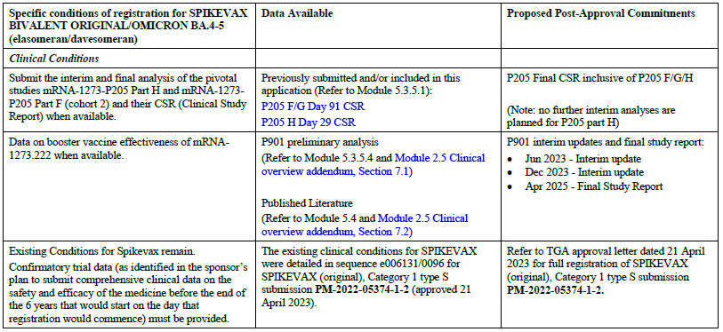
The sponsor has also provided the overview of safety data submitted to fulfil specific conditions of registration by risk management plan (RMP) team and is reviewed by them.
One periodic benefit-risk evaluation report and two monthly safety summary reports (MSSR) have been submitted to TGA for Spikevax bivalent Original/Omicron BA.4-5 as described in Table 3 below.
Table 3: Monthly safety summary reports and periodic benefit-risk evaluation reports submitted for Spikevax bivalent Original/Omicron BA.4-5
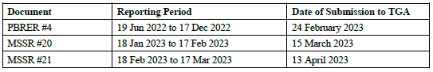

Three MSSR were submitted during evaluation of this application to transition to full registration:
- MSSR #22 reporting period 18 Mar 2023 to 17 Apr 2023, submission date 12 May 2023
- MSSR #23 reporting period 18 Apr 2023 to 17 May 2023, submission date 15 June 2023
- MSSR #24 reporting period 18 May 2023 to 17 June 2023, submission date 13 July 2023.

Study P205 Part H (mRNA-1273.222)
Study mRNA-1273-P205 is an ongoing open label Phase II/III study with multiple, sequentially enrolled cohorts to evaluate the immunogenicity and safety of variant targeting booster candidate vaccines.
Study mRNA-1273-P205 Part H, which evaluated the safety, reactogenicity, and immunogenicity of 50 µg mRNA 1273.222 when administered as a second booster dose in adults who previously received two doses of 100 µg mRNA-1273 as a primary series and a first booster dose of 50 µg mRNA-1273. mRNA-1273.222 is the Omicron BA.4/BA.5 bivalent booster vaccine that contains 25 µg ancestral SARS-CoV-2 Spike mRNA and 25 µg Omicron BA.4/BA.5 Spike mRNA.
The mRNA-1273-P205 Part F (cohort 2) serves as the within study, non-contemporaneous comparator group for the mRNA-1273-P205 Part H in the immunogenicity comparison between the two booster vaccines, 50 µg mRNA-1273.222 and 50 µg mRNA-1273, when administered as second booster doses. Study mRNA-1273-P205 Part F (cohort 2) evaluated the safety, reactogenicity, and immunogenicity of 50 µg mRNA 1273 when administered as a second booster dose in adults who previously received two doses of 100 µg mRNA-1273 as a primary series and a first booster dose of 50 µg mRNA-1273.
Figure 1: Study mRNA-1273-P205 Part H statistical hypotheses testing
The primary immunogenicity objective is considered met if non-inferiority against BA.4/5 and ancestral SARS-CoV-2 D614G based on geometric mean ratio (GMR), seroresponse rates (SRR) difference at Day 29 are demonstrated. Non-inferiority was considered met when the lower bound of the 95% confidence interval (CI) of GMR is greater than 0.667 (1 out of 1.5) and of SRR difference is greater than -10%. Superiority was considered met when the lower bound of the 95% CI of GMR is greater than 1 and for the difference in SRR greater than 0. If non-inferiority was demonstrated for both Omicron BA.4/BA.5 and ancestral SARS-CoV-2 with D614G (based on GMR and SRR), the lower bound of 95% CI of GMR was compared to 1, and if greater than 1, then superiority against Omicron BA.4/BA.5 was demonstrated.
In the 50 µg mRNA-1273.222 booster dose group, 511 participants received the booster dose. Of these, 305 participants (59.7%) enrolled from Study mRNA-1273-P301 where they had received the primary series and the first booster dose of mRNA-1273 and 206 of the 511 participants (40.3%) had received the primary series and the first booster dose of mRNA-1273 under the Emergency Use Authorization (EUA) in the United States. The median follow up time from the 50 µg mRNA-1273.222 booster dose injection was 37 days (range 5 to 45 days). Of the 511 participants who received the 50 µg mRNA-1273.222 booster dose, four participants discontinued from the study (two withdrawal of consent by participant, one death and one lost to follow up).
In the 50 µg mRNA-1273 booster dose group, 379 participants enrolled and 376 received the booster dose. Of the 376 participants, 263 participants (69.9%) enrolled from Study mRNA-1273-P301 where they had received the primary series and the first booster dose of mRNA-1273 and 113 of the 376 participants (30.1%) had received the primary series and the first booster dose of mRNA 1273 under the EUA in the United States. The median follow up time from 50 µg mRNA-1273 booster injection was 127 days (range 64 to 136 days). Of the 376 participants who received the 50 µg mRNA-1273 booster dose, 98.4% participants were still on study by the data cutoff date (6 July 2022).

Immunogenicity results
50 µg mRNA-1273.222 (Study P205 Part H) compared with 50 µg mRNA-1273 (Study P205 Part F)
The primary analysis population for the primary objective was the per protocol immunogenicity set with participants with no prior infection (PPIS-Neg) population.

Non-inferiority testing

Immunogenicity in participants without previous SARS-CoV-2 infection at pre-booster
In the PPIS-Neg set population (participants with no prior infection), the observed GMT (95% CI) against Omicron BA.4/BA.5 at pre-booster was 87.9 (72.2,107.1) and increased to 2324.6 (1921.2, 2812.7) 28 days after the booster dose for mRNA-1273.222 and the geometric mean fold rise (GMFR) (95% CI) for the geometric mean titres (GMT) 28 days after the booster compared to pre-booster was 26.4 (22, 31.9).In the mRNA-1273 group, the observed GMT (95% CIs) at pre-booster was 136.1 (116.3, 159.3) and increased to 488.5 (427.4, 558.4 28 days after the booster dose and GMFR (95% CI) was 3.6 (3.3, 4).

Table 4: Ancestral SARS-CoV-2 (D614G) and Omicron (BA.4/BA.5) neutralising antibody titres (ID₅₀) mRNA-1273.222 50 µg and mRNA-1273 50 µg administered as second booster doses - per-protocol immunogenicity – SARS-CoV-2 negative set (participants without infection at pre-booster)
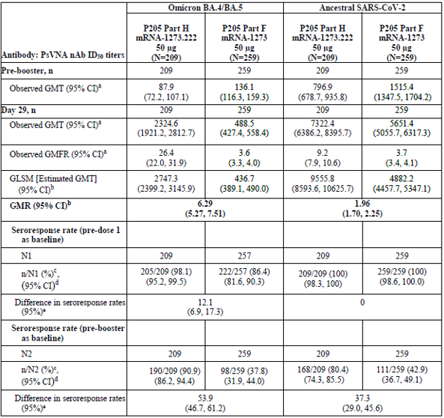

Superiority testing
Given that the four conditions of non-inferiority were met (GMR and SRR difference for Omicron BA.4-5 and GMR and SRR difference for ancestral SARS-CoV-2 D614G), based on the pre-specified testing, the lower bound of the CI of the BA.4-5 GMR was also compared to 1 (pre-specified criterion for superiority) and the superiority criterion was also met (lower bound of CI greater than 1).
Therefore, all primary immunogenicity endpoints were met and 50 µg mRNA-1273.222 elicited superior neutralising antibody responses compared to that of 50 µg mRNA-1273 against Omicron BA.4-5.

Table 5:Ancestral SARS-CoV-2 (D614G) and Omicron (BA.4-5) neutralising antibody titres (ID₅₀) 50 µg mRNA-1273.222 and 50 µg mRNA-1273 administered as second booster doses - per-protocol immunogenicity – SARS-CoV-2 negative set (participants without infection at pre-booster)
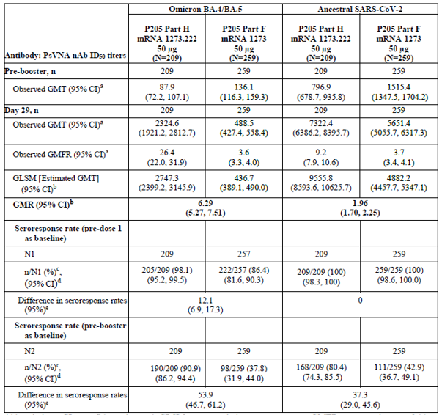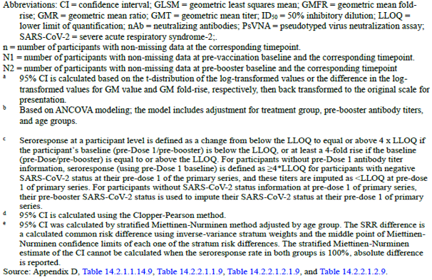
An immunogenicity analysis was also performed to evaluate the neutralising antibody responses in participants with evidence of prior SARS-CoV-2 infection at pre-booster. The GMR and SRR results for the per protocol immunogenicity set with participants with prior infection (PPIS-Pos) population were consistent with the results of the PPIS–Neg population. Overall, the results were consistent in participants with prior infection in that the 50 µg mRNA-1273.222 booster elicited higher neutralising antibody responses than the 50 µg mRNA-1273 booster.
Table 6: Ancestral SARS-CoV-2 and Omicron neutralising antibody titres (ID₅₀) 50 µg mRNA-1273.222 and 50 µg mRNA-1273 administered as second booster doses - per-protocol immunogenicity – SARS-CoV-2 positive set (participants with infection at pre-booster)
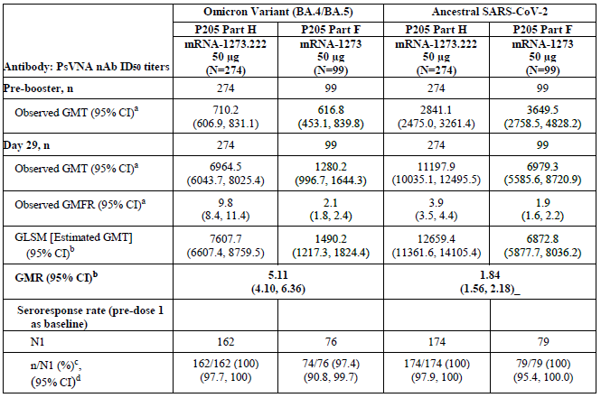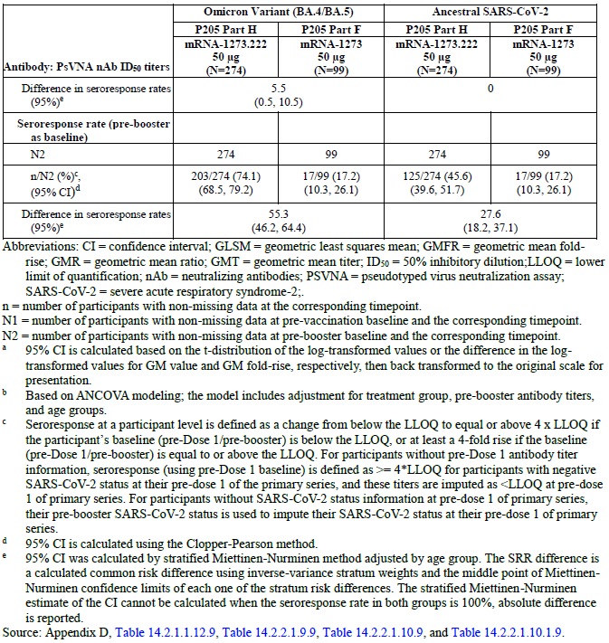
An additional immunogenicity analysis was performed considering all participants regardless of prior SARS-CoV-2 infection (PPIS population regardless of SARS-CoV-2 infection status at pre-booster baseline).
The GMR and SRR results for the PPIS population (all participants) were consistent with the results of the PPIS–Neg population. Overall, the results are consistent in all participants in that the 50 µg mRNA-1273.222 booster elicited higher neutralising antibody responses than the 50 µg mRNA-1273 booster.
Table 7: Ancestral SARS-CoV-2 and Omicron neutralising antibody titres (ID₅₀) 50 µg mRNA-1273.222 and 50 µg mRNA-1273 administered as second booster doses per-protocol immunogenicity set (participants with and without prior SARS-CoV-2 infection)
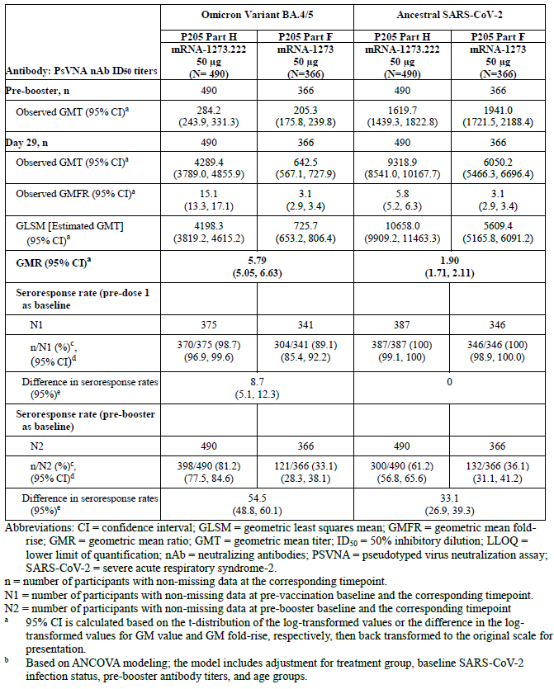
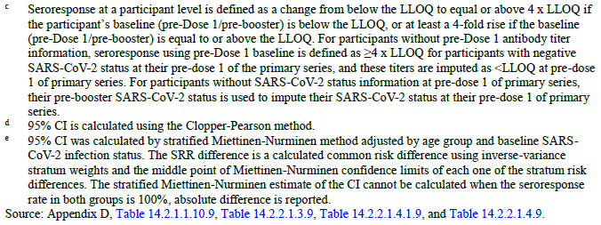
A sensitivity analysis which excluded participants who had SARS-CoV-2 infection after the booster dose and up to Day 29 was also performed in PPIS-Neg population and the results were consistent with the immunogenicity results in the PPIS-Neg population.
A subgroup analysis of the PPIS-Neg population by age group (at least 18 to younger than 65 years and at least 65 years of age) was performed and the results indicate that the immunogenicity responses were similar between the two age groups.
Table 8: Ancestral SARS-CoV-2 (D614G) and Omicron (BA.4-5) neutralising antibody titres (ID₅₀) 50 µg mRNA-1273.222 and 50 µg mRNA-1273 administered as second booster doses - per-protocol immunogenicity – SARS-CoV-2 negative set (participants without infection at pre-booster) by age group
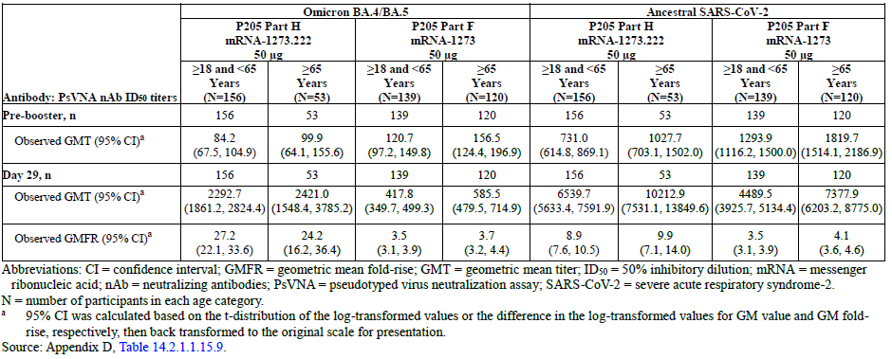

Cross-neutralisation ability of mRNA-1273.222 against the emerging Omicron variants BQ.1.1 and XBB.1.
An exploratory analysis was performed to assess the cross-neutralisation ability of mRNA-1273.222 against the emerging Omicron variants BQ.1.1 and XBB.1. Table below shows the neutralising antibody response against the Omicron BQ.1.1 and XBB.1 variants in a random sample of 40 participants without SARS-CoV-2 infection at pre-booster. For the BQ.1.1, the pre-booster GMT (95% CI) was 31.7 (19.6, 51.3), the post-booster GMT (95% CI) was 621.9 (422.2, 916.2), and the GMFR (95% CI) was 19.6 (11.7, 32.8). For the Omicron XBB.1 variant, the pre-booster GMT (95% CI) was 18.1 (12, 27.1), the post-booster GMT (95% CI) was 222.3 (147.4, 335.2), and the GMFR (95% CI) was 12.3 (7.4, 20.5). The observed GMT was 5.4-fold and 15.1-fold lower for the Omicron BQ.1.1 and XBB.1 variants, respectively, than for the BA.4/BA.5 variant.
Table 9: mRNA-1273.222 Bivalent vaccine exhibits cross-neutralisation against Omicron BQ.1.1 variant (neutralising antibody titres [ID₅₀]) at Day 29 - SARS-CoV-2 negative (N = 40 random sample)
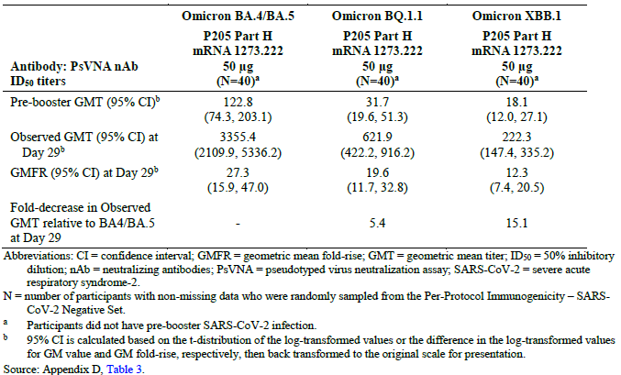
Table 10 shows the neutralising antibody response against the Omicron BQ.1.1 and XBB.1 variants in a random sample of 20 participants with SARS-CoV-2 infection at pre-booster. For the Omicron BQ.1.1 variant, the pre-booster GMT (95% CI) was 124.7 (61.4, 253.2), the post-booster GMT (95% CI) was 1093.5 (536.8, 2227.9), and the GMFR (95% CI) was 8.8 (5, 15.5). For the Omicron XBB.1 variant, the pre-booster GMT (95% CI) was 55.4 (28.4, 108), the post-booster GMT (95% CI) was 381.4 (198.1, 734.4), and the GMFR (95% CI) was 6.9 (4, 11.7). The observed GMT was 8.1-fold and 23.3-fold lower for the Omicron BQ.1.1 and XBB.1 variants, respectively, than for the BA.4/BA.5 variant.
These results indicate that mRNA-1273.222 exhibited cross-neutralisation against BQ.1.1 and XBB.1.
Table 10: mRNA-1273.222 Bivalent vaccine exhibits cross-neutralisation against Omicron BQ.1.1 and XBB.1 variants (neutralising antibody titres [ID₅₀])at Day 29 - SARS-CoV-2 positive (N = 20 random sample)
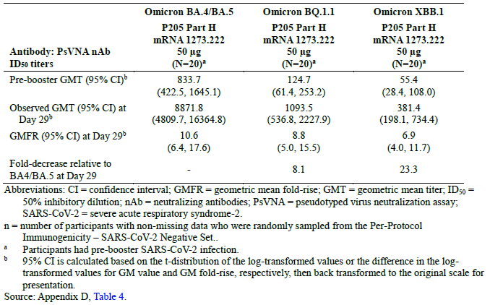

SARS-CoV-2 infection and symptomatic infection

SARS-CoV-2 Incidence rates after the mRNA-1273.222 and mRNA-1273 booster vaccines
Study P205 was not designed to evaluate booster vaccine effectiveness and occurrence of infections after the booster doses reflects the epidemiological environment in the US (August through October 2022) for this interim analysis. Infections were counted starting 14 days after the booster dose (50 µg of mRNA- 1273.222) through the follow up time of this interim analysis.
In the 50 µg mRNA-1273.222 booster dose group of participants without prior infection (per protocol efficacy set) with a median of 37 days of follow up, 12 participants (5.6%) had SARS-CoV-2 infection starting at least 14 days after the 50 µg booster dose. Among the 12 participants with SARS-CoV-2 infection, five participants (2.3%) met the primary case definition of COVID-19 and seven participants (3.2%) met the secondary case definition of COVID-19. The remaining five participants (2.3%) had an asymptomatic infection. No participants with COVID-19 had an emergency room visit or hospitalization due to the COVID-19 event. Similar results were observed for the full analysis set population.
The Day 29 interim analysis infection rates for mRNA-1273 (enrolled in February to March 2022) have been previously published. For reference, in the 50 µg mRNA-1273 booster dose group, with a median of 57 days of follow-up duration, nine participants (2.4%) from per protocol efficacy set had SARS-CoV-2 infection starting at least 14 days after the 50 µg booster dose. Among the nine participants with SARS-CoV-2 infection, two participants (0.5%) met both the primary case definition of COVID-19 and the secondary case definition of COVID-19. The remaining seven participants had an asymptomatic infection.
Table 11: Summary of COVID-19 infections (Second Booster Dose: 50 µg of mRNA-1273.222)
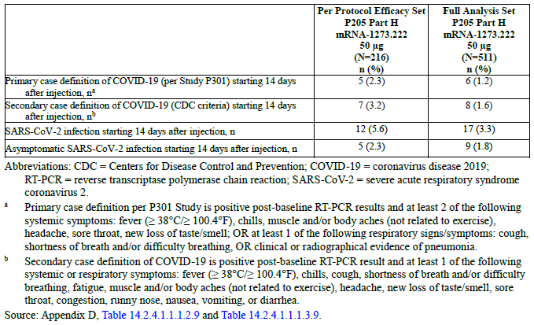
No further interim analyses are planned. The final clinical study report is due 30 April 2024.

Real world effectiveness
Real world effectiveness of the use of mRNA-1273.222 BA.4-5 bivalent vaccine booster is currently being evaluated in the context of an ongoing observational study (Study P901) in a large integrated healthcare system in the United States (Kaiser Permanente Southern California [KPSC]). Briefly, KPSC provides healthcare to approximately 4.6 million individuals living in Southern California and is representative with respect to age and race/ethnicity of the broader California and US population. KPSC collects detailed electronic healthcare data on diagnoses, procedures and medications/vaccinations received in both the outpatient and inpatient setting as well as medical charts for adjudication of study outcomes. This study was initiated in December 2020 as a regulatory commitment under the RMP to the USA FDA, EMA, and other health authorities to conduct ongoing evaluation of real world vaccine effectiveness of mRNA-1273 following approval and use in the USA.
A preliminary analysis of the real world effectiveness of Moderna’s bivalent (BA.4-5) vaccine (mRNA-1273.222) were presented at a recent meeting of the US FDA Vaccines and Related Biological Products Advisory Committee (VRBPAC) held on 26 January 2023. This analysis included 157,435 individuals 6 years of age and older who previously received at least two doses of a COVID-19 mRNA vaccine and a dose of the BA.4-5 bivalent vaccine between 31 August 2022 and 10 November 2022. Bivalent vaccinated individuals were matched on age and race/ethnicity to 314,870 individuals (comparators) who did not receive the bivalent vaccination during the same time period. This comparison group was composed of individuals who previously received at least two doses of a COVID-19 mRNA vaccine only (N = 257,670) or did not receive any COVID-19 vaccine previously (unvaccinated) (N = 57,167). The outcomes of hospitalization due to COVID-19, medically attended SARS-CoV-2 infection resulting in emergency room/urgent care visit, and COVID-19 hospital death were assessed through 31 December 2022. The mean age of the bivalent vaccinated, and comparators was 59 and 58 years, respectively. Among recipients of the bivalent vaccine, the incidence of COVID-19 hospitalisation, medically attended SARS-CoV-2 infection, and death (per 1000 patient-years) was 2.3 (95% CI: 1.76-2.88), 12.7 (95% CI:11.4 to 14.1), and 0.07 (95% CI: 0.02 to 0.3), respectively. Among the matched comparators, the incidence of COVID-19 hospitalisation, medically attended SARS-CoV-2 infection, and death (per 1000 patient-years) was 8.2 (95% CI: 9.1 to 7.4), 23.1 (95% CI: 24.5 to 21.7), and 0.23 (95% CI: 0.43 to 0.12), respectively.
- The relative vaccine effectiveness among individuals who received the bivalent vaccine compared to those who received at least two doses of any mRNA vaccine only was 73.1% (95% CI: 63.8% to 80%) against hospitalisation, 56.4% (95% CI: 50.1% to 61.9%) against medically attended SARS-CoV-2 infection resulting in emergency room/urgent care visit, and 56.4% (95% CI: -62.4% to 92.9%) against COVID-19 death.
- The absolute vaccine effectiveness of receipt of the bivalent vaccine as compared those who were unvaccinated was 82.9% (95% CI: 75% to 88.3%) against hospitalisation, 56.5% (95% CI: 46.5% to 64.6%) against medically attended SARS-CoV-2 infection resulting in emergency room/urgent care visit, and 90% (95% CI: 35.5% to 98.5%) against death.
An updated formal analysis (summary presented below) is currently being conducted with KPSC that will assess outcomes through 31 January 2023 among individuals who received a bivalent vaccination through 31 December 2022. The results of this analysis are planned to be completed and submitted for publication to a scientific journal by second quarter of 2023.
Study Design
- Matched cohort design
- three groups of adults at least 18 years (1:2:1 ratio)
  - Individuals who received at least two doses of any mRNA vaccine + Moderna BA.4-5 booster
  - Individuals who received at least two doses of any mRNA vaccine only
  - Unvaccinated individuals
- Matched on age, sex, race/ethnicity, and the index date
Study Period
- Moderna BA.4-5 bivalent vaccine administered 31 August 2022 to 31 December 2022
- Follow up through 31 January 2023
Figure 2: Study P901 Comparisons for vaccine effectiveness
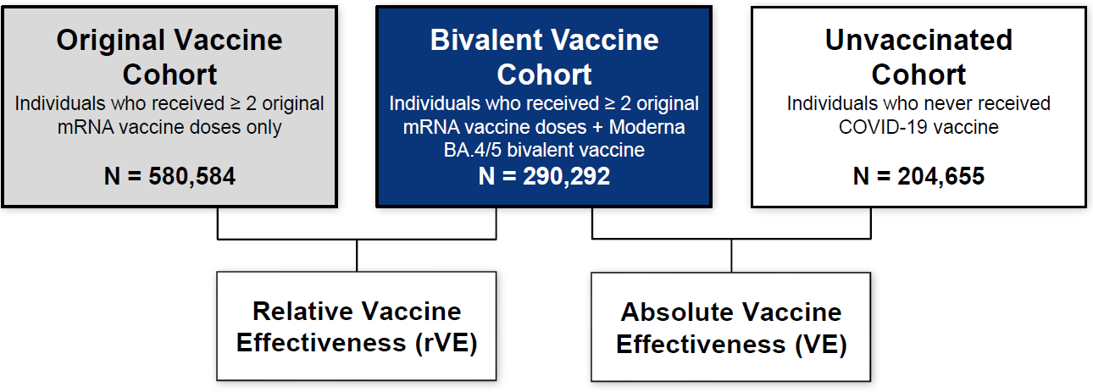
Figure 3: Study P901 SARS-CoV-2 variant distribution, August 2022 to January 2023
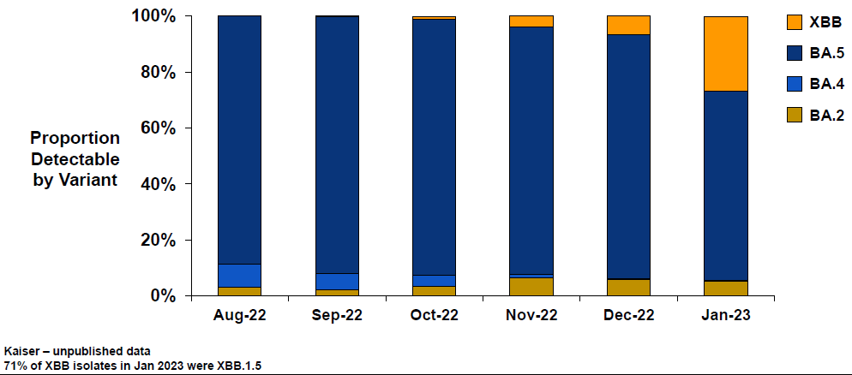
Table 12: Study P901 Population baseline characteristics (31 August 2022 to 31 January 2023)
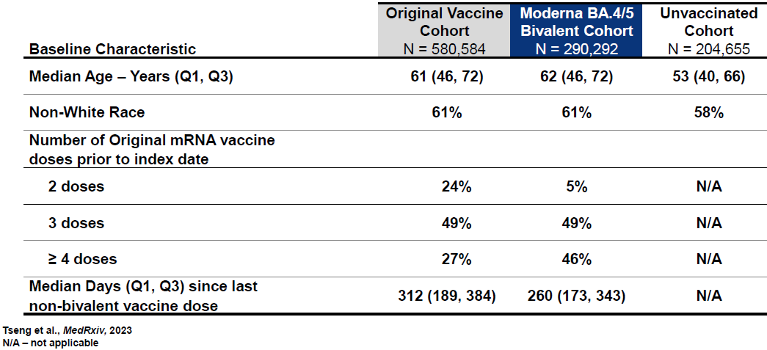
Table 13: Study P901 effectiveness of Moderna BA.4/5 bivalent mRNA vaccine (31 August 2022 to 31 January 2023)
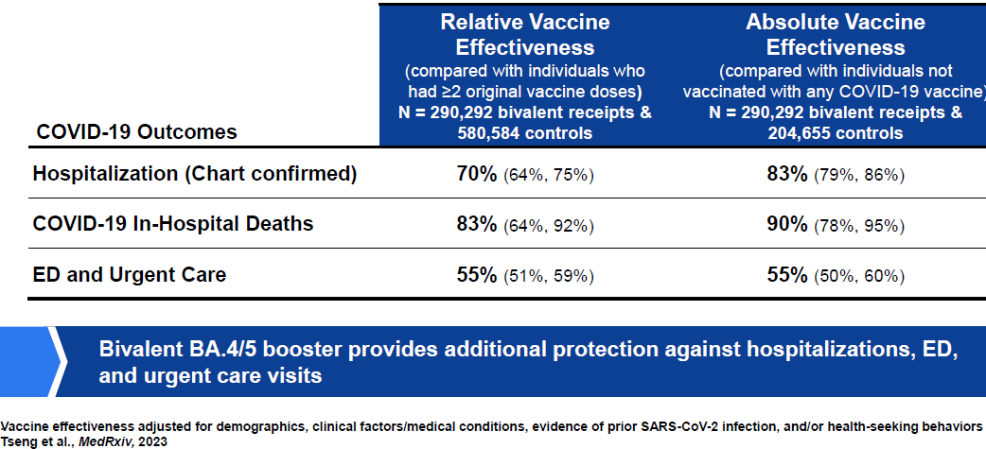
The sponsor concludes that Spikevax BA.4-5 booster was effective against COVID-19 when Omicron BA.5 was the predominant circulating strain. This conclusion is considered acceptable.

Study mRNA-1273-P901 interim update
The interim update (June 2023) evaluated the vaccine effectiveness of an Original/Omicron BA.4-5 bivalent booster vaccine (mRNA-1273.222) in preventing hospitalisation for COVID-19 (primary outcome) and medically attended SARS-CoV-2 infection and hospital death (secondary outcomes). This analysis included 290,292 individuals aged at least 6 years of age (6 to 17 years, N = 2715; median age: 60 years) who received mRNA-1273.222 as a booster dose following receipt of two or more doses of original mRNA vaccines between 31 August 2022 and 31 December 2022 who are matched to 580,584 individuals who received two or more doses of original mRNA vaccine only, and 204,655 unvaccinated individuals by date of vaccination, age, sex, and race/ethnicity.
Table 14: Comparison of baseline characteristics between individuals in the bivalent (original and Omicron BA.4/BA.5) mRNA-1273 COVID-19 vaccine cohort and the at least two monovalent mRNA vaccine cohort
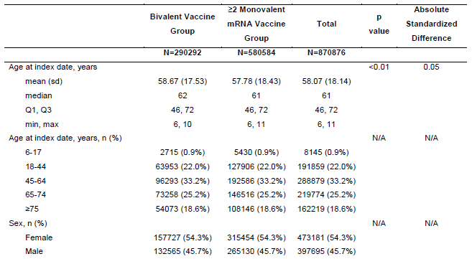
The relative vaccine effectiveness (rVE) of mRNA-1273.222 compared to individuals who received original mRNA vaccine only was 70.3% (95% CI: 64.0% to 75.4%) against COVID-19 hospitalisation, 82.7%% (63.7% to 91.7%) against COVID-19 hospital death, and 55% (50.8% to 58.8%) against medically attended SARS-CoV-2 infection at an emergency department/urgent care visit. The vaccine effectiveness (VE) of mRNA-1273.222 compared to unvaccinated individuals was 82.8%% (78.8% to 86.0%) against COVID-19 hospitalisation, 89.7%% (77.7% to 95.2%) against COVID-19 hospital death, and 55.4%% (50.3% to 60.1%) against medically attended SARS-CoV- 2 infection at an emergency department/urgent care visit.
Figure 4: (a) Relative vaccine effectiveness of the bivalent (original and Omicron BA.4-5) mRNA-1273 COVID-19 vaccine, compared to the at least two monovalent mRNA vaccine group, and (b) Absolute vaccine effectiveness of the bivalent (original and Omicron BA.4-5) mRNA-1273 COVID-19 vaccine, compared to the COVID-19 unvaccinated group and their 95% confidence intervals in preventing hospitalisation for COVID-19, overall and by subgroups
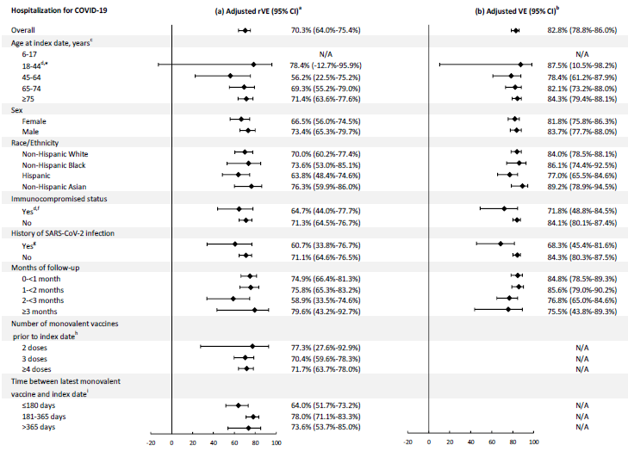

Figure 5: (a) Cumulative incidence of hospitalisation for COVID-19 between individuals in the bivalent (original and Omicron BA.4-5) mRNA-1273 COVID-19 vaccine cohort and the at least two monovalent mRNA vaccine cohort, and (b) Cumulative incidence of hospitalisation for COVID-19 between individuals in the bivalent (original and Omicron BA.4-5) mRNA-1273 COVID-19 vaccine cohort and the COVID-19 unvaccinated cohort
Figure 6: (a) Relative vaccine effectiveness of the bivalent (original and Omicron BA.4/BA.5) mRNA-1273 COVID-19 vaccine, compared to the at least two monovalent mRNA vaccine group, and (b) Absolute vaccine effectiveness of the bivalent (original and Omicron BA.4-5) mRNA-1273 COVID-19 vaccine, compared to the COVID-19 unvaccinated group and their 95% confidence intervals in preventing medically attended SARS-CoV-2 infection and COVID-19 hospital death

Exposure and spontaneous safety reporting data
As per the sponsor, cumulatively, as of 17 March 2023, a total of 196,788,604 booster doses of bivalent mRNA1272.222 (Original/BA.4-5) had been delivered to 40 countries and an estimated total of 108,233,732 doses had been administered. The United States, Canada, Europe, and Asia accounted for approximately 97% of all doses delivered and administered.
Cumulatively, the marketing authorisation holder (MAH) has received 4574 cases (12,081 events, of which 523 events were serious) involving the Spikevax bivalent mRNA1272.222 (Original/BA.4-5) booster. Of the cumulative reported cases, 3801 were medically confirmed, 323 cases were serious, and 34 cases had fatal outcomes. More cases were reported involving females (1585 cases, 34.7%) compared to males (1263 cases; 27.6%), with mean age of 53.7 years (standard deviation: 21.2; median: 58 years). A total of 1726 (37.7%) cases had unknown/unreported gender. Cumulatively, the majority of cases have been reported from the United States (3971 cases, 86.8%) and Canada (283 cases, 6.2%), and Asia (229 cases, 5%). Further evaluation of these case reports is included in the MSSR number 21 (Reporting period 18 February 2023 to 17 March 2023).
As of 17 March 2023, there have been 20 cases (22 events) of myocarditis and pericarditis reported to the Moderna’s global safety database (GSDB). There 15 cases medically confirmed, and no cases have reported a fatal outcome. There were more reports involving males (14; 70%) than females (5; 25%), with one (5%) missing gender information. The mean age of the reports was 33.1 years with a median of 30 (minimum: 13/maximum: 70). There were no important differences in the number of reports after any dose, with most reports reported within seven days after any dose (8; 36.4%). The observed clinical profile of patients experiencing myocarditis/pericarditis following exposure to Spikevax bivalent mRNA1272.222 (Original/BA.4-5) continue to present as events that result with a relatively short period of hospitalization, most cases follow an uncomplicated clinical course and complete resolution of symptoms is rapidly achieved and can be effectively treated with medication treatment with ibuprofen and colchicine, without any cardiovascular magnetic resonance (CMR)-detectable consequence after a greater than 90 days post-myocarditis evaluation.
As of 17 March 2023, the observed reporting rates of none of the medical topics evaluated after use of Spikevax bivalent mRNA1272.222 (Original/BA.4-5) booster has exceeded the expected rates when the lower limit of the 95% CI for rate ratios comparing the observed to expected greater than 1 for any subgroup.
Analysis of the data contained in the Moderna’s global safety database as of 17 March 2023, supports the adequacy of the current company core data sheets (version 16, January 2023) for Spikevax. Additionally, examination of these data supports the conclusion of a favourable benefit-risk profile for Spikevax (Original), Spikevax bivalent mRNA1272.214 (Original/BA.1) booster, and Spikevax bivalent mRNA1272.222 (Original/BA.4-5) booster.
In a recent update from the sponsor, as of 17 June 2023 (MSSR number 24), more than 119 million Spikevax bivalent mRNA1272.222 (Original/BA.4-5) vaccine doses having been administered globally and more than 780 million doses of the Spikevax original vaccine having been administered globally. A review of the data received cumulatively showed a continuous decreasing trend in the number of reported cases as of the most recent reporting period of 18 May 2023 to 17 June 2023. Based on the analysis of all the safety data available as of 17 June 2023, the sponsor considers cases included under the adverse event of. special interest (AESI) of myocarditis and pericarditis to be consistent with the known safety profile of Spikevax and the benefits for Spikevax far outweigh any possible vaccine associated risks, including the risks of myocarditis and pericarditis. Additionally, observed reporting rates for AESIs, including age and gender stratified estimates, remained largely similar to rates described in the most recent summary safety report. There was no meaningful change in interpretation of observed to expected analyses compared to earlier reports that affected the known safety profile. No safety concerns were identified among AESIs analysed. The post-authorisation safety data show that the Spikevax bivalent mRNA1272.222 (Original/BA.4-5) booster is well tolerated, and the safety profiles are similar to that observed during the MAH clinical trials.

Risk management plan
The sponsor has applied to transition elasomeran/ davesomeran (Spikevax bivalent Original/Omicron BA.4-5) from provisional to full registration.
Spikevax Bivalent Original/Omicron BA.4-5 is currently provisionally registered to be used as a booster dose for active immunisation to prevent COVID-19 in individuals 12 years and older. The approved dosing regimen involves one intramuscular injection of 0.5 ml (50 µg), given at least three months following a primary series and/or previous booster dose.
The sponsor has submitted EU-RMP version 6.3 (dated 6 December 2022; data lock point (DLP) 17 September 2022) and Australia specific annex (ASA) version 1.2 (dated 20 December 2022) that were previously provided and evaluated during the application for provisional registration of this product.
The summary of safety concerns and their associated risk monitoring and mitigation strategies are summarised in Table 15. The TGA may request an updated RMP at any stage of a product's life-cycle, during both the pre-approval and post-approval phases.
Table 15: Summary of safety concerns
Summary of safety concerns |  | Pharmacovigilance |  | Risk Minimisation
 |  | Routine | Additional | Routine | Additional
Important identified risks | Myocarditis | ¹ | ² |  | –
Important identified risks | Pericarditis | ¹ | ² |  | –
Important potential risks | Vaccine-associated enhanced disease (VAED) including vaccine associated enhanced respiratory disease (VAERD) | ¹ | ² | – | –
Missing information | Use in pregnancy and while  breastfeeding |  | ³ |  | –
Missing information | Long-term safety |  | ² | – | –
Missing information | Use in immunocompromised subjects |  | – |  | –
Missing information | Interaction with other vaccines |  | – |  | –
Missing information | Use in frail subjects with unstable  health conditions and co-morbidities  (e.g. COPD, diabetes, chronic  neurological disease, cardiovascular  disorders) |  | ² |  | –
Missing information | Use in subjects with autoimmune or  inflammatory disorders |  | ² |  | –
¹Specific adverse reaction follow-up questionnaires
²Clinical trials
³Observational Studies – mRNA-1273-P905 and mRNA-1273-P919
This summary of safety concerns was evaluated and considered acceptable during the application for provisional registration of Spikevax bivalent Original/Omicron BA.4-5. At this stage, the summary of safety concerns continues to be acceptable from an RMP perspective.
The pharmacovigilance plan has been evaluated and accepted during previous submission for provisional registration of Spikevax Bivalent Original/Omicron BA.4-5. The pharmacovigilance plan continues to be acceptable from an RMP perspective.
Only routine risk minimisation activities are proposed for this submission. This plan was approved during the provisional registration of this product. There are risk minimisation measures implemented for COVID-19 vaccines by the Department of Health and Aged Care and State and Territory Governments. The changes proposed in this application do not warrant updates to the currently approved risk minimisation plan.
There are no outstanding or new recommendations for this submission.

Proposed wording for conditions of registration
Any changes to which the sponsor has agreed should be included in a revised RMP and ASA. However, irrespective of whether or not they are included in the currently available version of the RMP document, the agreed changes become part of the risk management system.
The suggested wording is:
‘The Spikevax bivalent Original/Omicron BA.4-5 EU-RMP (version 6.3, dated 6 December 2022, DLP 17 September 2022), with ASA (version 1.2, dated 20 December 2022), included with submission PM-2023-01714-1-2, and any subsequent revisions, as agreed with the TGA will be implemented in Australia.’

Risk-benefit analysis

Delegate’s considerations
The guidance for Transition to full registration of the provisionally registered prescription medicines should be read in conjunction with the standard prescription medicines registration process because the elements for transition to full registration are similar.
‘The collection of confirmatory data on safety and efficacy should lead to submission of a Category 1 Type S application for transition to full registration. The benefit-risk profile of the medicine must be positive, and this must be maintained throughout the period of provisional registration to the transition to full registration. Evidence of having met your RMP obligations. Including the dates when data were submitted and reasons for delays or failure to meet obligations All final results not previously submitted from confirmatory trials in the dossier should be included as per the current requirements for registering a prescription medicine. Clinical trials data must support the indication in the application for full registration.’
The sponsor has listed (Table 2, above) the availability of clinical data to meet the specific conditions (as per the provisional registration) and the current requirements for registering a prescription medicine to support this application.
Study mRNA-1273-P205 Part H, evaluated the safety, reactogenicity, and immunogenicity of 50 µg of mRNA 1273.222 when administered as a second booster dose in adults (individuals older than 18 years of age) who previously received two doses of 100 µg mRNA-1273 as a primary series and a first booster dose of 50 µg mRNA-1273. mRNA-1273.222 is the Omicron BA.4-5 bivalent booster vaccine that contains 25 µg ancestral SARS-CoV-2 Spike mRNA and 25 µg Omicron BA.4-5 Spike mRNA. The mRNA-1273-P205 Part F (cohort 2) serves as the within-study, non-contemporaneous comparator group for Study mRNA-1273-P205 Part H in the immunogenicity comparison between the two booster vaccines. In Study mRNA-1273-P205 Part H Day 29 interim analysis, in adults (individuals older than 18 years of age), all primary objectives were met in participants without prior SARS-CoV-2 infection (PPIS-Neg population), the population pre-specified for the primary analysis. A 50 µg booster dose of mRNA-1273.222 elicited a superior neutralising antibody response to the Omicron BA.4 and BA.5 variants compared to 50 µg of mRNA-1273, 28 days after the booster dose regardless of SARS-CoV-2 infection prior to immunisation. mRNA-1273.222 elicited a non-inferior neutralising antibody response against the ancestral SARS-CoV-2 (D614G), compared to mRNA-1273. A subgroup analysis of the PPIS-Neg population by age group (at least 18 to younger than 65 years and at least 65 years of age) was performed and the results indicate that the immunogenicity responses were similar between the two age groups.
As a supportive study for use in adolescents 12 to 17 years of age, Study P203 Part C is an ongoing now open label Phase II/III study evaluating the safety, reactogenicity, and effectiveness of a primary series of 100 µg elasomeran (original Spikevax); a booster dose of 50 µg elasomeran (original Spikevax) was administered at least five months later. The booster dose effectively boosted serum neutralising antibody levels, as compared with the pre-booster baseline. The GMR of Study P203 booster dose on Day 29 geometric mean concentration in adolescents compared with young adults in Study P301, Day 57 geometric mean concentration was 5.1 (95% CI: 4.5, 5.8), meeting the prespecified non-inferiority criteria. No further interim analyses are planned. The final clinical study report is due second quarter of 2024.
The sponsor also mentions the clinical data from the Study P205 Part F/G (Spikevax bivalent Original/BA.1), with persistence of benefit through Day 91 without any new safety signal, as supportive of this application.
Study mRNA-1273-P901 is an ongoing observational study, provided the real world effectiveness data of an original/BA.4-5 bivalent booster vaccine (mRNA-1273.222) in preventing hospitalisation for COVID-19 (primary outcome) and medically attended SARS-CoV-2 infection and hospital death (secondary outcomes).
This analysis included 290,292 individuals 6 plus years of age (6 to 17 years, N = 2715; median age: 60 years) who received mRNA-1273.222 as a booster dose following receipt of two or more doses of original mRNA vaccines between 31 August 2022 and 31 December 2022 who are matched to 580,584 individuals who received two or more doses of original mRNA vaccine only, and 204,655 unvaccinated individuals by date of vaccination, age, sex, and race/ethnicity. The rVE of mRNA-1273.222 compared to individuals who received original mRNA vaccine only was 70.3% (95% CI: 64.0% to 75.4%) against COVID-19 hospitalisation, 82.7%% (63.7% to 91.7%) against COVID-19 hospital death, and 55% (50.8% to 58.8%) against medically attended SARS-CoV-2 infection at an emergency department/urgent care visit. The VE of mRNA-1273.222 compared to unvaccinated individuals was 82.8%% (78.8% to 86.0%) against COVID-19 hospitalisation, 89.7%% (77.7% to 95.2%) against COVID-19 hospital death, and 55.4%% (50.3% to 60.1%) against medically attended SARS-CoV- 2 infection at an emergency department/urgent care visit. The mRNA-1273.222 bivalent booster provided additional protection against hospitalisation for COVID-19, medically attended SARS-CoV- 2 infection, and COVID-19 hospital death.
In post-authorisation safety data, cumulatively as of 17 June 2023, information received after vaccination with Spikevax bivalent mRNA-1273.222 (Original/BA.4-5) booster supports the conclusion that the safety profile for this vaccine is comparable to that observed during the clinical studies for the vaccine and that the safety data evaluated as of 17 June 2023, does not indicate any changes in the benefit-risk profile of Spikevax bivalent mRNA-1273.222 (Original/BA.4-5) booster.

Proposed action
The sponsor has provided comprehensive, confirmatory, post-provisional registration, clinical effectiveness, and safety data for Spikevax bivalent mRNA-1273.222 (Original/BA.4-5) as a booster for use in individuals 12 years of age and older.
The benefit risk profile of Spikevax bivalent Original/BA.4-5 booster in individuals 12 years of age and older appears well established from the clinical data obtained so far. The post-authorisation safety data also supports the continued favourable benefit risk of Spikevax bivalent Original/BA.4-5 booster in individuals 12 years of age and older. Even from RMP perspective, there are no outstanding or new recommendations for this submission. The pharmacovigilance plan continues to be acceptable from an RMP perspective. The clinical data supports a favourable benefit risk profile for Spikevax bivalent Original/BA.4-5 transitioning from provisional registration to full registration as a booster in individuals 12 years and older.

Advisory Committee considerations
The Advisory Committee on Vaccines (ACV), having considered the evaluations and the Delegate’s overview, as well as the sponsor’s response to these documents, advised the following.

Specific advice to the Delegate
- Please comment on the sponsor’s proposal for the transition from provisional registration to full registration for Spikevax Bivalent Original/Omicron BA.4-5 vaccine as a booster in individuals 12 years of age and older
The ACV advised that the benefit-risk profile supports the transition from provisional registration to full registration for Spikevax bivalent Original/Omicron BA.4-5 COVID-19 vaccine for use as a booster dose in individuals 12 years and over; the ACV had provided advice on provisional registration in February 2023.
The ongoing Study P205 parts H and F have provided supportive immunogenicity data. Study P901 provided supportive, but preliminary, vaccine effectiveness data from real world experience in the USA from over 150,000 people.
Adverse events are well characterised and safety data support the continued favourable benefit risk profile of the bivalent vaccine.
Spikevax now has full registration in Australia. The total quantity of active ingredients (mRNA) is the same in in the Spikevax and the Spikevax bivalent Original/Omicron BA.4-5 COVID-19 vaccines.
The risk management plan for Spikevax bivalent Original/Omicron BA.4-5 COVID-19 vaccine includes ongoing clinical trials or observational studies as additional pharmacovigilance activities to address ‘missing information’ on the use of the vaccine in pregnancy and breastfeeding, long term safety, use in frail individuals with unstable health conditions and co-morbidities, and use in individuals with autoimmune or inflammatory disorders.
The ACV noted that the sponsor has adequately addressed the regulatory conditions specified for provisional registration. It is not expected that remaining outstanding data (to be specified in the conditions of registration associated with full registration) will alter the benefit-risk profile.

Conclusion
The ACV considered this product to have an overall positive benefit-risk profile for the indication:
Spikevax Bivalent Original / Omicron BA.4-5 (elasomeran/davesomeran) COVID-19 Vaccine is indicated for:
As a booster dose for active immunisation to prevent coronavirus disease 2019 (COVID-19) caused by SARS-CoV-2 in individuals 12 years of age and older who have previously received at least a primary vaccination course against COVID-19.
The use of this vaccine should be in accordance with official recommendations.

Outcome
Based on a review of quality, safety, and efficacy, the TGA approved the full registration of Spikevax bivalent Original/Omicron BA.4-5 vaccine (elasomeran and davesomeran) 0.1 mg/mL, suspension for injection indicated for:
Spikevax bivalent Original/Omicron BA.4-5 (elasomeran/davesomeran) COVID-19 Vaccine is indicated for:
As a booster dose for active immunisation to prevent coronavirus disease 2019 (COVID 19) caused by SARS-CoV-2 in individuals 12 years of age and older who have previously received at least a primary vaccination course against COVID-19.
The use of this vaccine should be in accordance with official recommendations.

Specific conditions of registration applying to these goods
RMP condition
- The Spikevax bivalent Original/Omicron BA.4-5 EU-RMP (version 6.3, dated 6 December 2022, DLP 17 September 2022), with ASA(version 1.2, dated 20 December 2022), included with Submission PM-2023-01714-1-2, and any subsequent revisions, as agreed with the TGA will be implemented in Australia.
Clinical condition
- Submit the outstanding clinical data from all the requested data (study reports and/or published data) which were requested, as conditions, and/or part of the Clinical Study Plan, including Studies P205 Part H and P901, for the provisional registration of Spikevax bivalent Original/Omicron BA.4-5 as a booster in individuals 12 years of age and older, when available.
Quality conditions
- GMP clearance for listed manufacturers: All relevant manufacturing sites require approved and current GMP Clearances prior to Australian supply. A commitment is required from the sponsor that they maintain the validity of all manufacturer GMP Clearances for the duration of product supply to Australia. Additionally, that adherence to the conditions of GMP Clearance approval is upheld.
- Post-approval stability protocol and stability commitment: The manufacturer has provided commitment to continue the ongoing stability studies presented in the stability studies protocol. Additionally, one (1) batch of drug product per year for all relevant products will be placed on long-term stability program and on accelerated stability testing where significant changes are made to the manufacturing process. The manufacturer has committed to communicate any out of specifications stability test results to the TGA.
- Batch Release Testing and Compliance
It is a condition of registration that all independent batches of Spikevax bivalent (elasomeran/ davesomeran) 0.1 mg/mL suspension for injection vial and pre-filled syringe imported into Australia are not released for sale until samples and the manufacturer’s release data have been assessed and you have received notification acknowledging release from the Laboratories Branch, TGA.
For each independent batch of the product imported into Australia, the sponsor must supply the following:
  - A completed Request for Release Form, available from vaccines@health.gov.au.
  - Complete summary protocols for manufacture and QC, including all steps in production in the agreed format.
  - At least ten (10) vials (samples) of each manufacturing batch of Spikevax bivalent (elasomeran/davesomeran) 0.1 mg/mL suspension for injection vial and thirty (30) pre-filled syringes (samples) with the Australian approved labels, PI and packaging (unless an exemption to supply these has been granted) representative of all batches of product seeking distribution in Australia.
  - At least five (5) vials (samples) of any further consignments of a manufacturing batch of Spikevax bivalent (elasomeran/davesomeran) 0.1 mg/mL suspension for injection vial and fifteen (15) pre-filled syringes (samples) with the Australian approved labels, PI and packaging (unless an exemption to supply these has been granted). Further consignments cover batches previously supplied to TGA for the purposes of batch release testing but are seeking to be supplied again.
  - If the manufacturing batch has been released in Europe or United Kingdom a copy of the EU Official Control Authority Batch Release (OCABR) certificate (or equivalent from the UK) must be provided.
  - Any reagents, reference material and standards required to undertake testing, as requested by Laboratories Branch, TGA.
Sponsors must provide all requested Samples and data in sufficient time (at least five (5) business days) prior to any distribution date to allow the TGA to perform testing and review. Distribution of each batch of vaccine is conditional upon fulfilment of these conditions and receipt of a letter from the Laboratories Branch acknowledging release.
Samples and data should be forwarded to the Biotherapeutics Section, Laboratories Branch before release of each batch and with sufficient lead time to allow for Laboratories Branch testing.
The shipments (including reagents) to TGA are the responsibility of the Australian sponsor/agent who will be required to facilitate the import and customs clearance process.
- Certified Product Details
An electronic copy of the Certified Product Details (CPD) as described in Guidance 7: Certified Product Details of the Australian Regulatory Guidelines for Prescription Medicines (ARGPM) https://www.tga.gov.au/guidance-7-certified-product-details should be provided upon registration of the therapeutic good. In addition, an updated CPD, for the above products incorporating the approved changes is to be provided within one (1) month of the date of approval letter. A template for preparation of CPD for biological prescription medicines and Vaccines can be obtained from the TGA website https://www.tga.gov.au/form/certified-product-details-cpd-biologicalprescription-medicines]. The CPD should be sent as a single bookmarked PDF document to Vaccines@health.gov.au as soon as possible after registration/approval of the product or any subsequent changes as indicated above

Attachment 1. Product Information
The PI for Spikevax bivalent Original/Omicorn BA.4-5 approved with the submission which is described in this AusPAR is at Attachment 1. For the most recent PI, please refer to the TGA PI/CMI search facility.

Therapeutic Goods Administration
PO Box 100 Woden ACT 2606 Australia
Email: info@tga.gov.au Phone: 1800 020 653 Fax: 02 6203 1605
https://www.tga.gov.au
Reference/Publication #

This is the original indication proposed by the sponsor when the TGA commenced the evaluation of this submission. It may differ to the final indication approved by the TGA and registered on the Australian Register of Therapeutic Goods.
Benefits of Getting A COVID-19 Vaccine | CDC
Coronavirus (COVID-19) case numbers and statistics | Australian Government Department of Health and Aged Care (accessed 28/2/2023).
Australia: WHO Coronavirus Disease (COVID-19) Dashboard With Vaccination Data | WHO Coronavirus (COVID-19) Dashboard With Vaccination Data (accessed 28/2/2023).
Chalkias et al., A Bivalent Omicron-Containing Booster Vaccine against Covid-19. N Engl J Med 2022; 387:1279-1291
https://www.fda.gov/media/164810/download
Tseng et al, Bivalent Vaccine Efficacy (2023) Manuscript.
AusPAR for Spikevax bivalent Original/Omicorn BA.4-5 available at https://www.tga.gov.au/sites/default/files/2023-02/auspar-spikevax-bivalent-original-omicron-ba-4-5-230224.pdf
AusPAR for Spikevax available at https://www.tga.gov.au/sites/default/files/2023-05/auspar-spikevax-230511.pdf

