Australian Public Assessment Report for Keytruda
  - Active ingredient: Pembrolizumab
  - Sponsor: Merck Sharp & Dohme (Australia) Pty Ltd
August 2023

About the Therapeutic Goods Administration (TGA)
- The Therapeutic Goods Administration (TGA) is part of the Australian Government Department of Health and Aged Care and is responsible for regulating therapeutic goods, including medicines, medical devices, and biologicals.
- The TGA administers the Therapeutic Goods Act 1989 (the Act), applying a risk management approach designed to ensure therapeutic goods supplied in Australia meet acceptable standards of quality, safety, and efficacy.
- The work of the TGA is based on applying scientific and clinical expertise to decision-making, to ensure that the benefits to the Australian public outweigh any risks associated with the use of therapeutic goods.
- The TGA relies on the public, healthcare professionals and industry to report problems with therapeutic goods. The TGA investigates reports received to determine any necessary regulatory action.
- To report a problem with a therapeutic good, please see the information on the TGA website.

About AusPARs
- The Australian Public Assessment Report (AusPAR) provides information about the evaluation of a prescription medicine and the considerations that led the TGA to approve or not approve a prescription medicine submission. Further information can be found in Australian Public Assessment Report (AusPAR) guidance.
- AusPARs are prepared and published by the TGA.
- AusPARs are static documents that provide information that relates to a submission at a particular point in time. The publication of an AusPAR is an important part of the transparency of the TGA’s decision-making process.
- A new AusPAR may be provided to reflect changes to indications or major variations to a prescription medicine subject to evaluation by the TGA.

Copyright
© Commonwealth of Australia 2023
This work is copyright. You may reproduce the whole or part of this work in unaltered form for your own personal use or, if you are part of an organisation, for internal use within your organisation, but only if you or your organisation do not use the reproduction for any commercial purpose and retain this copyright notice and all disclaimer notices as part of that reproduction. Apart from rights to use as permitted by the Copyright Act 1968 or allowed by this copyright notice, all other rights are reserved and you are not allowed to reproduce the whole or any part of this work in any way (electronic or otherwise) without first being given specific written permission from the Commonwealth to do so. Requests and inquiries concerning reproduction and rights are to be sent to the TGA Copyright Officer, Therapeutic Goods Administration, PO Box 100, Woden ACT 2606 or emailed to <tga.copyright@tga.gov.au>.

Contents
List of abbreviations 4
Product submission 5
Submission details 5
Product background 6
Current treatment options 7
Pembrolizumab 7
Regulatory status 8
Product Information 13
Registration timeline 13
Submission overview and risk/benefit assessment 14
Quality 14
Nonclinical 14
Clinical 15
Summary of clinical studies 15
Efficacy 15
Safety 33
Risk management plan 40
Risk-benefit analysis 41
Delegate’s considerations 41
Proposed action 45
Questions for the sponsor 46
Advisory Committee considerations 47
Outcome 47
Specific conditions of registration applying to these goods 51
Attachment 1. Product Information 51

List of abbreviations
Abbreviation | Meaning
ACM | Advisory Committee on Medicines
APaT | All participants as treated
ARTG | Australian Register of Therapeutic Goods
BICR | Blinded independent central review
CI | Confidence interval
CMI | Consumer Medicines Information
CPS | Combined positive score
DFS | Disease free survival
DRSS | Disease recurrence-specific survival
EFS | Event free survival
EMA | European Medicines Agency
EORTC QLQ | European Organisation for Research and Treatment of Cancer Quality of Life questionnaire
FDA | Food and Drug Administration
FKSI-DRS | Functional assessment of cancer therapy kidney cancer symptom index - disease related symptoms
ITT | Intent to treat
IV | Intravenous(ly)
NCCN | National Comprehensive Cancer Network
NED | No evidence of disease
PI | Product Information
RCC | Renal cell carcinoma
RMP | Risk management plan
TGA | Therapeutic Goods Administration
ULN | Upper limit of normal
US(A) | United States (of America)

Product submission

Submission details
Type of submission: | Extension of indications
Product name: | Keytruda
Active ingredient: | Pembrolizumab
Decision: | Approved
Date of decision: | 30 September 2022
Date of entry onto ARTG: | 6 October 2022
ARTG number: | 263932
Black Triangle Scheme  for the current submission: | No
Sponsor’s name and address: | Merck Sharp & Dohme (Australia) Pty Ltd  Level 1, Building A, 26 Talavera Road  Macquarie Park, NSW 2113, Australia
Dose form: | Concentrated solution for injection
Strength: | 100 mg/4 mL
Container: | Vial
Pack size: | 1 Vial
Approved therapeutic use for the current submission: | Renal Cell Carcinoma (RCC)  Keytruda (pembrolizumab), as monotherapy, is indicated for the adjuvant treatment of patients with RCC with a clear cell component who are at intermediate-high or high risk of recurrence following nephrectomy, or following nephrectomy and resection of metastatic lesions (see section 5.1, Clinical Trials: Renal Cell Carcinoma).
Route of administration: | Intravenous infusion
Dosage: | Treatment must be initiated and supervised by specialised healthcare professionals experienced in the treatment of cancer.  Keytruda is administered as an intravenous infusion over 30 minutes.  The recommended dose of Keytruda in adults is either:  - 200 mg every 3 weeks or  - 400 mg every 6 weeks  For further information regarding dosage and dose modifications, refer to the Product Information.
Pregnancy category: | D  Drugs which have caused, are suspected to have caused or may be expected to cause, an increased incidence of human fetal malformations or irreversible damage. These drugs may also have adverse pharmacological effects. Accompanying texts should be consulted for further details.  The use of any medicine during pregnancy requires careful consideration of both risks and benefits by the treating health professional. This must not be used as the sole basis of decision making in the use of medicines during pregnancy. The TGA does not provide advice on the use of medicines in pregnancy for specific cases. More information is available from obstetric drug information services in your State or Territory.

Product background
This AusPAR describes the submission by Merck Sharp & Dohme (Australia) Pty Ltd (the sponsor) to register Keytruda pembrolizumab 100 mg/4 mL concentrated solution for injection vial for the following proposed extension of indications:
Keytruda (pembrolizumab), as monotherapy, is indicated for the adjuvant treatment of patients with RCC at intermediate-high or high risk of recurrence following nephrectomy, or following nephrectomy and resection of metastatic lesions.
Kidney cancer ranks seventh among the most diagnosed cancers in Australia, accounting for 944 deaths in 2019. The age-standardised incidence (per 100,000 population) is 17.9 in males and 8.3 in females, with an age-standardised mortality rate of 4.7 and 2.0 per 100,000 males and females, respectively. The overall incidence has increased from 6.2 to 12.9 per 100,000 people between 1982 and 2019. Mean age at diagnosis is 64 years.
Renal cell carcinoma (RCC) accounts for around 90% of all kidney cancers. The majority of renal cell carcinomas (approximately 75%) are of clear cell histology. Risk factors for renal cell carcinomas include smoking, obesity, and hypertension, while around 2% to 3% of cases are hereditary. The classical presentation of flank pain, gross haematuria and an abdominal mass is now uncommon and associated with advanced disease. More than 50% of renal cell carcinomas are diagnosed incidentally.
Prognosis is dependent upon tumour stage, grade, local extent, regional nodal spread, and metastatic disease at presentation. Five-year survival ranges from 93% for localised disease, to 12% for metastatic disease.

Current treatment options
Standard of care for locoregional disease is partial (nephron-sparing) or radical nephrectomy. For select patients with Stage I disease, active surveillance and ablation techniques are also options. Patients with Stage IV disease that is amenable to resection may be candidates for cytoreductive nephrectomy.
The risk of recurrence following surgery increases with tumour stage and is estimated to develop in around 30% to 55% of patients meeting eligibility criteria for adjuvant checkpoint inhibitor trials. Most recurrences occur within the first 3 to 5 years following surgery, although late recurrence is possible.
Adjuvant treatment options are limited. In Australia, there is no drug therapy approved for adjuvant treatment of renal cell carcinoma. National Comprehensive Cancer Network (NCCN) guidelines,5 recommend a clinical trial as an alternative adjuvant option, while post-nephrectomy surveillance (Category 2A) and adjuvant sunitinib (Category 3) are also recommended in the 2021 NCCN guidelines. Based on the outcomes of KEYNOTE-564 trial, these guidelines were recently updated to include Category 2A recommendations for use of adjuvant pembrolizumab for Stage II, Grade 4 tumours with clear cell histology with and without sarcomatoid features, Stage III tumours with clear cell histology, and following metastasectomy within one year of nephrectomy.^{5,}
Sunitinib in Australia has an indication for the treatment of advanced renal cell carcinoma but is not indicated for adjuvant therapy.

Pembrolizumab
Pembrolizumab is a selective, humanized monoclonal antibody of the immunoglobulin G4/kappa isotype that binds to the human programmed cell death-1 (PD-1) receptor and blocks the interaction between PD-1 and its ligands, PD-L1 and PD-L2. This reactivates tumour-specific cytotoxic T lymphocytes in the tumour microenvironment and reactivates anti-tumour immunity.
This evaluation was facilitated through Project Orbis, an initiative of the United States Food and Drug Administration (FDA) Oncology Center of Excellence. Under this project, the FDA, Health Canada, Swissmedic (Switzerland), and the TGA collaboratively reviewed the submission.
This evaluation process provided a framework for process alignment and management of evaluation issues in real-time across jurisdictions. Each regulator made independent decisions regarding approval (market authorisation) of the new medicine.

Regulatory status
Keytruda (pembrolizumab) was initially registered on the Australian Register of Therapeutic Goods (ARTG) for the treatment of advanced melanoma on 16 April 2016.
Since initial registration there have been many subsequent submissions to extend the indications of Keytruda (pembrolizumab). At the time that this extension of indication submission was considered the product was approved for the following indications:
 | Indication
Melanoma | Keytruda (pembrolizumab) is indicated as monotherapy for the treatment of unresectable or metastatic melanoma in adults.  Keytruda (pembrolizumab) is indicated as monotherapy for the adjuvant treatment of patients with melanoma with lymph node involvement who have undergone complete resection.
Non-small cell lung cancer (NSCLC) | Keytruda (pembrolizumab), in combination with pemetrexed and platinum chemotherapy, is indicated for the first-line treatment of patients with metastatic non-squamous NSCLC, with no EGFR or ALK genomic tumour aberrations.  Keytruda (pembrolizumab), in combination with carboplatin and either paclitaxel or nabpaclitaxel, is indicated for the first-line treatment of patients with metastatic squamous NSCLC.  Keytruda (pembrolizumab) is indicated as monotherapy for the first-line treatment of patients with NSCLC expressing PD-L1 [tumour proportion score (TPS) ≥1%] as determined by a validated test, with no EGFR or ALK genomic tumour aberrations, and is  - Stage III where patients are not candidates for surgical resection or definitive chemoradiation, or  - metastatic.  Keytruda (pembrolizumab) is indicated as monotherapy for the treatment of patients with advanced NSCLC whose tumours express PD-L1 with a ≥ 1% TPS as determined by a validated test and who have received platinum-containing chemotherapy. Patients with EGFR or ALK genomic tumour aberrations should have received prior therapy for these aberrations prior to receiving Keytruda.
Head and Neck Squamous Cell Cancer (HNSCC) | Keytruda (pembrolizumab), as monotherapy or in combination with platinum and 5- fluorouracil (5-FU) chemotherapy, is indicated for the first-line treatment of patients with metastatic or unresectable recurrent HNSCC, and whose tumours express PD-L1 [Combined Positive Score (CPS) ≥1] as determined by a validated test.  Keytruda (pembrolizumab) is indicated as monotherapy for the treatment of patients with metastatic or unresectable recurrent HNSCC with disease progression on or after platinum containing chemotherapy and whose tumours express PD-L1 [Combined Positive Score (CPS) ≥1] as determined by a validated test.
Classical Hodgkin Lymphoma (cHL) | Keytruda (pembrolizumab) is indicated as monotherapy for the treatment of adult and paediatric patients with relapsed or refractory classical Hodgkin Lymphoma (cHL):  - following autologous stem cell transplant (ASCT) or  - following at least two prior therapies when ASCT or multi-agent chemotherapy is not a treatment option.  The approval of this indication in paediatric patients is on the basis of objective response rate from patients aged 11 years and older from single arm trial data and extrapolation from adult data (see Section 5.1 Pharmacodynamic properties, Clinical Trials).
Primary mediastinal B-Cell Lymphoma (PMBCL) | Keytruda (pembrolizumab) is indicated for the treatment of adult and paediatric patients with refractory primary mediastinal B-cell lymphoma (PMBCL), or who have relapsed after 2 or more prior lines of therapy. The approval of this indication is on the basis of objective response rate (ORR) and duration of response from non-randomised studies. See Section 5.1 Pharmacodynamic properties, Clinical Trials.
Urothelial carcinoma | Keytruda (pembrolizumab) is indicated as monotherapy for the treatment of patients with locally advanced or metastatic urothelial carcinoma who are not eligible for any platinum containing chemotherapy. This indication is approved based on overall response rate and duration of response in a single-arm study. Improvements in overall survival, progression-free survival, or health-related quality of life have not been established.  Keytruda (pembrolizumab) is indicated as monotherapy for the treatment of patients with locally advanced or metastatic urothelial carcinoma who have received platinum-containing chemotherapy.  Keytruda (pembrolizumab) is indicated for the treatment of patients with Bacillus Calmette-Guerin (BCG)-unresponsive, high-risk, non-muscle invasive bladder cancer (NMIBC) with carcinoma in-situ (CIS) with or without papillary tumours who are ineligible for or have elected not to undergo cystectomy. This indication was approved via the provisional approval pathway based on complete response rate and duration of response. Continued approval of this indication depends on verification and description of benefit in confirmatory trials.
Microsatellite instability-high (MSI-H) or mismatch repair deficient (dMMR) cancer | Colorectal (previously untreated)  Keytruda (pembrolizumab) is indicated for the first-line treatment of patients with unresectable or metastatic colorectal cancer (CRC) that is MSI-H or dMMR as determined by a validated test.  Colorectal (previously treated)  Keytruda (pembrolizumab) is indicated in adult and paediatric patients for the treatment of unresectable or metastatic CRC that is MSI-H or dMMR as determined by a validated test, and that has progressed following treatment with a fluoropyrimidine, oxaliplatin, and irinotecan. This indication was approved via the provisional approval pathway, based on objective response rate and response duration in a single-arm trial. Continued approval for this indication depends on verification and description of clinical benefit in the confirmatory trials.  Non-colorectal  Keytruda (pembrolizumab) is indicated in adult and paediatric patients for the treatment of unresectable or metastatic solid tumours that are MSI-H or dMMR as determined by a validated test, that have progressed following prior treatment and when there are no satisfactory alternative treatment options. This indication was approved via the provisional approval pathway, based on the pooling of data on objective response rate and response duration across multiple different tissue types in a single-arm trial. Sample sizes for individual tissue types were too small to provide data on clinical utility of the MSI-H/dMMR tests for each of the tissue types, individually. The assumption that MSI-H/dMMR-status is predictive of the treatment effect of  Keytruda for every tissue type has not been verified. Continued approval for this indication depends on verification and description of clinical benefit in the confirmatory trials. The safety and effectiveness of Keytruda in paediatric patients with MSI-H/dMMR central nervous system cancers have not been established.
Endometrial carcinoma | Keytruda (pembrolizumab), in combination with lenvatinib, is indicated for the treatment of patients with advanced endometrial carcinoma that is not MSI-H or dMMR, who have disease progression following prior systemic therapy in any setting and are not candidates for curative surgery or radiation.
Cervical Cancer | Keytruda (pembrolizumab) in combination with platinum chemotherapy and paclitaxel, with or without bevacizumab, is indicated for the treatment of patients with persistent, recurrent, or metastatic cervical cancer whose tumours express PD-L1 [Combined Positive Score (CPS) ≥1] as determined by a validated test.
Renal Cell Carcinoma (RCC) | Keytruda (pembrolizumab), in combination with axitinib, is indicated for the first-line treatment of patients with advanced renal cell carcinoma (RCC).  Keytruda in combination with LENVIMA® (lenvatinib) is indicated for the first-line treatment of adult patients with advanced renal cell carcinoma (RCC).
Cutaneous Squamous Cell Carcinoma | Keytruda (pembrolizumab) is indicated as monotherapy for the treatment of adult patients with recurrent or metastatic cutaneous squamous cell carcinoma (cSCC) or locally advanced cSCC that is not curable by surgery or radiation. This indication was approved via the provisional approval pathway based on objective response rate and duration of response from a single-arm study. Improvements in overall survival, progression-free survival, or health related quality of life have not been established. Full registration for this indication depends on submission of further clinical data to confirm the clinical benefit of the medicine.
Oesophageal Cancer | Keytruda (pembrolizumab), in combination with platinum and fluoropyrimidine based chemotherapy, is indicated for the first-line treatment of patients with locally advanced or metastatic carcinoma of the oesophagus or HER2 negative gastroesophageal junction adenocarcinoma (tumour centre 1 to 5 centimetres above the gastroesophageal junction) that is not amenable to surgical resection or definitive chemoradiation.
Tumour Mutational Burden-High (TMB-H) cancer | Keytruda (pembrolizumab) is indicated for the treatment of adult and paediatric patients with unresectable or metastatic tumour mutational burden-high (TMB-H) [≥10 mutations/megabase (mut/Mb)] solid tumours, as determined by a validated test, that have progressed following prior treatment and who have no satisfactory alternative treatment options. This indication was approved via the provisional approval pathway, based on the pooling of data on objective response rate and response duration across multiple different tissue types in a single-arm trial. The assumption that TMB-H status is predictive of the treatment effect of Keytruda for every tissue type has not been verified. Full registration for this indication depends on verification and description of clinical benefit in confirmatory trials.
Triple-Negative Breast Cancer | Keytruda (pembrolizumab) is indicated for the treatment of patients with high-risk early-stage triple-negative breast cancer (TNBC) in combination with chemotherapy as neoadjuvant treatment, and then continued as monotherapy as adjuvant treatment after surgery.  Keytruda (pembrolizumab), in combination with chemotherapy, is indicated for the treatment of patients with locally recurrent unresectable or metastatic TNBC whose tumours express PD-L1 (CPS ≥10) as determined by a validated test and who have not received prior chemotherapy for metastatic disease.
At the time the TGA considered this extension of indication submission, similar submissions had been approved in the United States of America and the European Union and were under consideration in Canada, New Zealand, Singapore and Brazil. A similar submission was withdrawn from Switzerland. The following table summarises these submissions.
Table 1: International regulatory status
Region | Submission date | Status | Approved indications
United States of America | 10 June 2021 | Approved  17 November 2021 | Keytruda is indicated for the adjuvant treatment of patients with RCC at intermediate-high or high risk of recurrence following nephrectomy, or following nephrectomy and resection of metastatic lesions.
European Medicines Agency (EMA, centralised procedure) | 30 June 2021 | Approved  27 January 2022 | Keytruda as monotherapy is indicated for the adjuvant treatment of adults with renal cell carcinoma at increased risk of recurrence following nephrectomy, or following nephrectomy and resection of metastatic lesions (for selection criteria, please see section 5.1).
Switzerland | 30 June 2021 | Withdrawnª
Canada | September 2021 | Approved  18 August 2022 | Keytruda as monotherapy is indicated for the adjuvant treatment of adult patients with RCC at intermediate-high or high risk of recurrence following nephrectomy, or following nephrectomy and resection of metastatic lesions
New Zealand | 9 November 2021 | Approved  16 August 2022 | KEYTRUDA, as monotherapy, is indicated for the adjuvant treatment of patients with RCC at intermediate-high or high risk of recurrence following nephrectomy, or following nephrectomy and resection of metastatic lesions.
Brazil | 1 July 2021 | Approved  13 December 2021 | Keytruda, as monotherapy, is indicated for the adjuvant treatment of patients with RCC at intermediate-high or high risk of recurrence following nephrectomy, or following nephrectomy and resection of metastatic lesions.
ª Swissmedic did not accept a disease free survival endpoint as a surrogate for overall survival. The submission will be re-submitted when additional overall survival data are available.

Product Information
The Product Information (PI) approved with the submission which is described in this AusPAR can be found as Attachment 1. For the most recent PI and Consumer Medicines Information (CMI), please refer to the TGA PI/CMI search facility.

Registration timeline
The following table captures the key steps and dates for this submission.
This submission was evaluated under the standard prescription medicines registration process.
Table 2: Timeline for Submission PM-2021-04316-1-4
Description | Date
Submission dossier accepted and first round evaluation commenced | 1 November 2021
Evaluation completed | 14 April 2021
Delegate’s Overall benefit-risk assessment and request for Advisory Committee advice | 2 May 2021
Sponsor’s pre-Advisory Committee response | 12 May 2021
Advisory Committee meeting | 2 and 3 June 2022
Registration decision (Outcome) | 30 September 2022
Completion of administrative activities and registration on the ARTG | 6 October 2022
Number of working days from submission dossier acceptance to registration decision* | 226
*Statutory timeframe for standard submissions is 255 working days

Submission overview and risk/benefit assessment
A summary of the TGA’s assessment for this submission is provided below.
This section is a TGA summary of wording used in TGA’s evaluation report, which discussed numerous aspects of overseas evaluation reports and included some information that was commercial-in-confidence.
Relevant guidelines or guidance documents referred to by the Delegate are listed below:
- European Medicines Agency. Guideline on the evaluation of anticancer medicinal products in man. EMA/CHMP/205/95/Rev.4; (2012); TGA-adopted, effective date: 1 April 2014.
- European Medicines Agency. Appendix 1 to the guideline on the evaluation of anticancer medicinal products in man: Methodological consideration for using progression-free survival (PFS) or disease-free survival (DFS) in confirmatory trials; TGA-adopted, effective date: 1 April 2014.

Quality
Quality evaluation is not required for this submission as there are no proposed changes to the quality of the currently approved product in Australia. The quality of the currently approved product is suitable for the proposed changes in this submission. A full quality evaluation was conducted at the time this product received initial registration.

Nonclinical
No new nonclinical data or further nonclinical evaluation were required for this submission. The TGA considers that previously submitted and evaluated data satisfactorily address nonclinical aspects of safety/efficacy relating to this submission.

Clinical

Summary of clinical studies
The submission was supported by clinical data from KEYNOTE-564 trial: A Phase III, randomized, double-blind, placebo-controlled clinical trial of pembrolizumab as monotherapy in the adjuvant treatment of renal cell carcinoma post nephrectomy.

Efficacy

Study design and methodology
The first patient first visit was 30 June 2017. The clinical study report was dated 7 June 2021 with the data cut-off date for the first interim analysis occurring on 14 December 2020. The efficacy update report and the safety update report, include update analysis with a data cut-off date of 14 June 2021.
The study was conducted over 212 sites across 21 countries.
The study schema is at Figure 1.
Figure 1: KEYNOTE-564 trial study schema
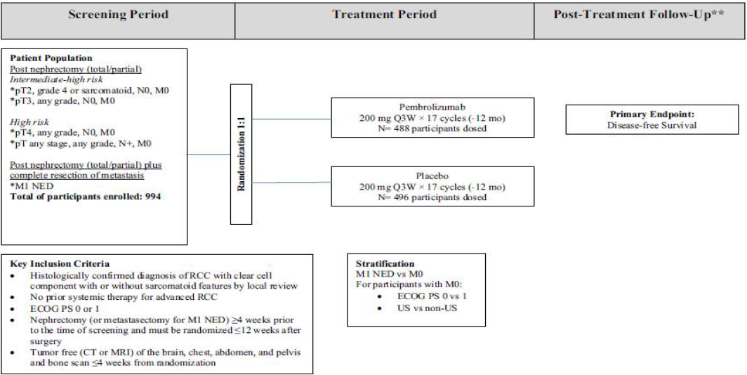
Abbreviations: CT = computed tomography, ECOG PS = Eastern Cooperative Oncology Group Performance Score, mo = month, MRI = magnetic resonance imaging, NED = no evidence of disease, Q3W = once every three weeks, US = United States
** Safety follow-up: 30 days post last dose; Efficacy follow-up: every 12, 16 or 24 weeks; Survival follow-up: every 12 weeks.
There were 994 participants randomised which was the intent to treat (ITT) population. Randomisation was stratified by metastasis status (M0 or M1 no evidence of disease (NED)). The M0 group was further stratified by ECOG PS (0 or 1) and geographic region (US or non-US).
The treatment arms were:
- Pembrolizumab 200 mg once every three weeks by intravenous (IV) infusion (n = 496 randomised)
- Saline solution once every three weeks by intravenous infusion (n = 498 randomised)
Treatment continued once every three weeks for up to 17 cycles (approximately 12 months) or until confirmed recurrence.
Scheduled imaging for assessment of disease free survival was once every 12 weeks during treatment, once every 12 weeks during follow-up in Year 1, once every 16 weeks during follow-up in Years 2 to 4, then once every 24 weeks during follow-up in Year 5 and beyond.
The patient flow for the APaT population at the first interim analysis was:
- All participants as treated (APaT) (received at least one dose): 488 out of 496 pembrolizumab participants; 496 out of 498 placebo participants.
- Completed study treatment: 298 out of 488 pembrolizumab (61.1%) participants; 365 out of 496 placebo (73.6%) participants.
- Discontinued treatment: 190 out of 488 pembrolizumab (38.9%) participants; 130 out of 496 placebo (26.2%) participants.
- Discontinued treatment due to adverse events: 104 out of 488 pembrolizumab (21.3%) participants; 11 out of 496 placebo (2.2%) participants.
- Discontinued treatment due to disease relapse: 51 out of 488 pembrolizumab (10.5%); 101/496 placebo (20.4%) participants.
- Discontinued study due to death: 17 out of 488 pembrolizumab (3.5%) participants; 33 out of 496 placebo (6.7%) participants.
- Ongoing in study: 460 out of 488 pembrolizumab participants (94.3%); 4534 out of 496 placebo (91.3%) participants.
- Median duration of follow up: 23.9 months
At the first interim analysis no patients were continuing pembrolizumab treatment. One patient in the placebo group listed as continuing had received the last dose but did not complete the treatment discontinuation visit.
The patient flow for the intent to treat population in the efficacy update report was:
- Median duration of follow up: 29.7 months which was approximately 6 months longer than at the first interim analysis.
- On-going in study: 458 out of 488 pembrolizumab (93.9%) participants that started study treatment; 442 out of 496 placebo (89.1%) participants that started study treatment.
- Discontinued study due to death: 23 out of 488 pembrolizumab (4.7%) participants that started study treatment; 43 out of 496 placebo (8.7%) that started study treatment.

Key inclusion criteria
The key inclusion criteria were:
- Histologically confirmed diagnosis of renal cell carcinoma with clear cell component with or without sarcomatoid features by local review.
- Had intermediate-high risk, high risk, or M1 no evidence of disease renal cell carcinoma.
  - Intermediate-high risk:
- pT2, Grade 4 or sarcomatoid, N0, M0
- pT3, any Grade, N0, M0
  - High risk:
- pT4, any Grade, N0, M0
- pT, any Stage, any Grade, N+, M0
  - M1 no evidence of disease (primary kidney tumour with solid, isolated, soft tissue metastases that can be completely resected at the time of nephrectomy (or within a year after, as per Amendment 1)).
- Had no prior systemic therapy for advanced renal cell carcinoma.
- Had ECOG PS 0 or 1.
- Underwent a partial nephroprotective or radical complete nephrectomy (and complete resection of metastatic lesion(s) in M1 no evidence of disease participants) with negative surgical margins ≥ 4 weeks prior to screening.
- Was tumour free (computerise tomography or magnetic resonance imaging of the brain, chest, abdomen, and pelvis, and a bone scan ≤ 28 days from randomization) as assessed by the investigator.

Key exclusion criteria
The key exclusion criteria were:
- Major surgery, other than nephrectomy and/or resection of pre-existing metastases for M1 no evidence of disease participants, within 12 weeks prior to randomization.
- Received prior radiotherapy for renal cell carcinoma.
- Had pre-existing brain or bone metastatic lesion.
- Had residual thrombus post nephrectomy in the vena renalis or vena cava.
- Had other medical conditions or history that would interfere with the participant’s participation for the full duration of the study, or was not in the best interest of the participant to participate.

Endpoints

Primary endpoint
The primary endpoint was disease-free survival (DFS) as assessed by the investigator.

Key secondary
The key secondary endpoint was overall survival (OS).

Other secondary endpoints
Other secondary endpoints included disease recurrence-specific survival (DRSS), event-free survival (EFS), disease free survival and overall survival by PD-L1 status, patient-reported outcomes, and safety.
The endpoint definitions are in Table 3.
Table 3: KEYNOTE-564 trial endpoint definitions
Endpoint | Definition
Disease free survival  (assessed by Investigator) | Time from randomization to the first documented local recurrence, or occurrence of distant kidney cancer metastasis(es), or death due to any cause, whichever occurs first.  Hypothesis: Pembrolizumab is superior to placebo
Overall survival | Time from randomization to death due to any cause  Hypothesis: Pembrolizumab is superior to placebo
Disease recurrence specific survival (DRSS)  (assessed by Investigator) | DRSS1: time from randomization to the first documented local recurrence of RCC  DRSS2: time from randomization to the first documented local recurrence with visceral lesion or occurrence of distant kidney cancer metastasis(es) with visceral lesion, whichever occurs first.
Event free survival  (assessed by Blinded independent central review (BICR) | Time from randomization to the first documented local recurrence or occurrence of distant kidney cancer metastasis(es) among participants, which by BICR were considered M0/M1 NED; or disease progression among participants, which by BICR were considered to have M1, or death due to any cause, whichever occurs first.
Disease free survival (assessed by Investigator) and overall survival by PD-L1 expression status | DFS: time from randomization to the first documented local recurrence, or occurrence of distant kidney cancer metastasis(es), or death due to any cause, whichever occurs first  OS: time from randomization to death due to any cause  PD-L1 expression status defined as:  positive: CPS ≥ 1, or  negative: CPS < 1  Samples were tested centrally using the 22C3 PD-L1 IHC PharmDx assay. Calculation method:
To evaluate patient reported outcomes with EORTC-QLQ-C30 and the FKSI-DRS | Mean change from baseline in:  EORTC QLQ-C30 global health status/quality of life scores  EORTC QLQ-C30 functional subscales: physical functioning  FKSI-DRS score  Changes in scores of at least 10 and 3 points were considered clinically meaningful for EORTC QLQ-C30 and FKSI-DRS, respectively.

Statistics
The study was randomised 1:1. The planned analyses are shown in Table 4.
Table 4: KEYNOTE-564 trial planned analyses
Abbreviations: IA: interim analysis; FA: final analysis; IA1 = first interim analysis; IA2 = second interim analysis; IA3 = third interim analysis; DFS = disease free survival; OS = overall survival
The updated analysis (efficacy update report, data cut-off 14 June 2021) with additional six months follow up after the first interim analysis was conducted on request of another regulatory agency.
The sample size was based on a target of 332 disease free survival events (with the first interim analysis at approximately 80% of the target), giving approximately 95% power to detect a hazard ratio of 0.67 at an overall alpha level of 2.5% (one-sided), based on the following assumptions:
- Disease free survival follows a Poisson mixture cure rate model with assumed cure rate of 0.3 and with a median of 45 months for those not cured in the placebo group
- An enrolment period of 27 months
- A yearly drop-out rate of 2%
- A true hazard ratio of 0.67
Analyses of disease free survival and overall survival were event-driven, with a Lan-DeMets O’Brien-Fleming alpha-spending function used to control the Type I error for efficacy. Power for overall survival was conditional on the null hypothesis of disease free survival being rejected. Multiplicity of endpoints and analyses was controlled using the method of Maurer and Bretz. A group sequential approach will allocate the alpha between interim and final analyses.
Treatment differences in the primary and key-secondary endpoint were assessed by the stratified log-rank test. Hazard ratios and 95% confidence intervals (CI) from stratified Cox Model with Efron’s tie handling method were reported. The stratification factors used in the randomisation were used as stratification factors in the primary and key-secondary analysis.
The efficacy population was the intent to treat population. The safety population was all participants as treated.

Protocol amendments and deviations

Amendments
There were four amendments to the protocol. All were considered unlikely to impact the interpretation of the study.

Important protocol deviations
Protocol deviations occurred in 31 participants (6.3%) receiving pembrolizumab and 21 participants (4.2%) receiving placebo. Of these, five participants had protocol deviations which were considered clinically important. Two occurred in the pembrolizumab arm, and three occurred in the placebo arm. While important deviations were somewhat more frequent in the pembrolizumab group than the placebo group, they were overall infrequent and unlikely to have a major bearing on the outcomes.

Participant characteristics
Participant characteristics are shown in Table 5. The median age was 60 years. 75.3% of the participants were positive for PD-L1 expression (that is, had CPS ≥ 1). Most participants fulfilled the intermediate-high risk category for renal cell carcinoma recurrence (pembrolizumab: 85.1%, placebo: 86.9%), while a minority fulfilled the high risk (pembrolizumab: 8.1%, placebo: 7.2%) and M1 no evidence of disease (pembrolizumab: 5.8%, placebo: 5.8%) categories. 85.2% of the participants had ECOG PS = 0.
The median duration of follow up at the first interim analysis was 23.9 months.
Table 5: KEYNOTE-564 trial participant characteristics (intent to treat population)
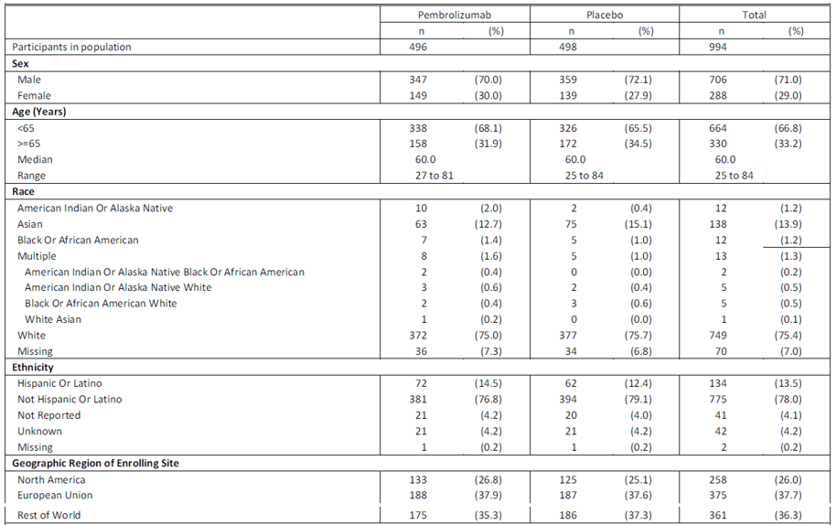
Table 5: KEYNOTE-564 trial participant characteristics (intent to treat population) continued
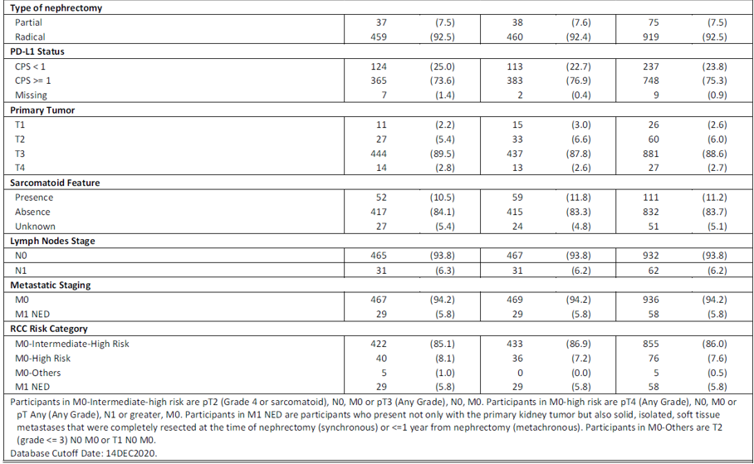

Efficacy results

Primary endpoint
There were 109 disease free survival events in the pembrolizumab arm (22.0%) and 151 in the placebo arm (30.3%), with an absolute rate difference of 8.3%. The hazard ratio was 0.68 (95% CI: 0.53, 0.87), and the one-sided p-value of 0.0010 crossed the prespecified efficacy boundary of 0.0114 (one-sided). Median disease free survival was not reached in either arm. The difference between pembrolizumab and placebo was driven by events of disease recurrence (103 versus 149). There were six primary endpoint death events with pembrolizumab and two with placebo. Of these, one participant in the pembrolizumab group died due to disease progression (this participant had disease at Baseline, was randomised in error and never received pembrolizumab). The remaining five and two participants in the pembrolizumab and placebo group, respectively, died from other reasons (cerebrovascular accident, COVID-19, multiple organ dysfunction syndrome due to a motor vehicle accident, pneumonia, and pneumonia aspiration in the pembrolizumab group; haemorrhage intracranial and sepsis in the placebo group). Considering that one subject that died never received pembrolizumab, and the death due to motor vehicle accident is also unlikely related to pembrolizumab, the overall numeric imbalance in disease free survival deaths between the two arms is small and not of major concern. It is noted that the numeric imbalance in deaths due to adverse events was smaller, two versus one. See Deaths, below.
Table 6: KEYNOTE-564 trial disease free survival based on investigator assessment (primary endpoint, ITT) – first interim analysis
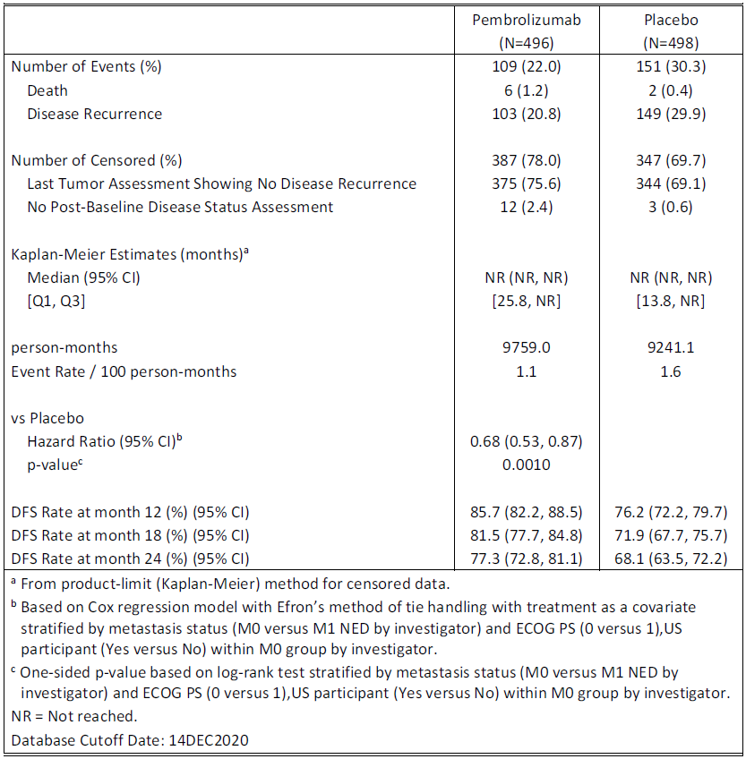
Figure 2: Kaplan-Meier plot of disease free survival based on Investigator assessment (primary endpoint, ITT) – first interim analysis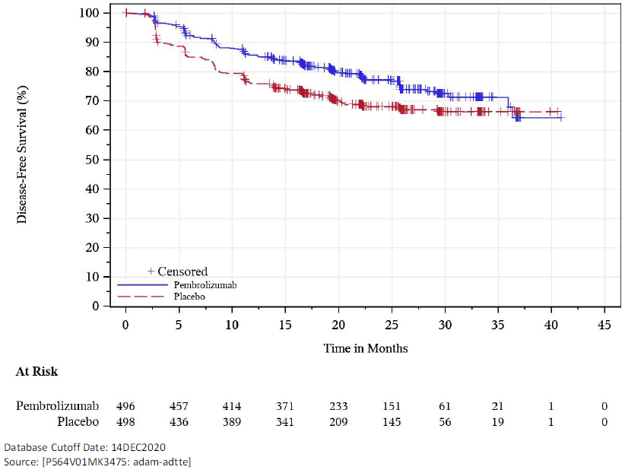
Blinded independent central review (BICR) assessment of disease recurrence was not always the same as that of the investigator. Among participants with disease recurrence based on investigator review (103 in the pembrolizumab group and 149 in the placebo group), BICR determined disease recurrence for 81.6% in the pembrolizumab group and 86.6% in the placebo group. The BICR also determined that there were 19 patients (3.8%) in the pembrolizumab arm and 29 (5.8%) in the placebo arm with evidence of disease at Baseline, based on review of baseline scans only (that is, these patients would have been ineligible for trial entry, according to the BICR). However, analysis of discordance between BICR and investigator assessments did not find any evidence of systematic bias in disease recurrence assessments by investigator. This was concluded based on the difference in discrepancy rates between pembrolizumab and placebo, which fell below the pre-specified thresholds for systematic bias (see Table 7).
Table 7: KEYNOTE-564 trial discordance of disease recurrence assessments (investigator versus BICR; ITT)
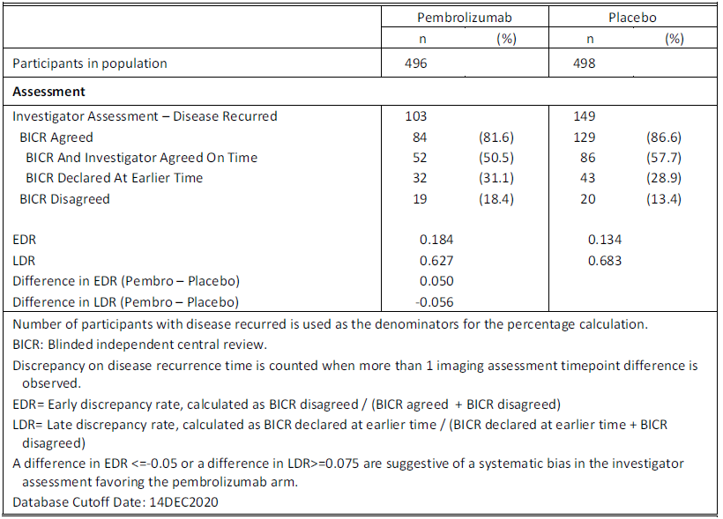
There were three sensitivity analyses of the primary endpoint, which were all generally consistent with the analysis of disease free survival by investigator assessment. Analysis of disease free survival by BICR yielded a hazard ratio of 0.73 (95% CI: 0.56, 0.95; p 0.0097), with patients deemed by the BICR to have evidence of disease at baseline censored at baseline.
Subgroup analyses are shown in Figure 3.
Figure 3: KEYNOTE-564 trial forest plot of disease free survival by subgroups (ITT) – first interim analysis (data cut-off 14 December 2020)
At the efficacy update report analysis data cut-off, 23 additional disease free survival events had occurred, bringing the total number of events to 283 (114 [of which six were deaths] in the pembrolizumab group and 169 [of which three were deaths] in the placebo group). Median disease free survival was not reached in either treatment group. The hazard ratio was 0.63 (95% CI: 0.50, 0.80) and the log-rank test nominal p-value was < 0.0001. Sensitivity analyses remained generally consistent with first interim analysis.
Table 8: KEYNOTE-564 trial disease free survival based on investigator assessment (ITT) (updated data cut-off 14 June 2021)
Subgroup analyses at the efficacy update report data cut-off is in Figure 4.
Figure 4: KEYNOTE-564 trial disease free survival based on investigator assessment, by subgroups, updated analysis (ITT) (data cut-off 14 June 2021)
Some additional post hoc analyses of disease free survival by risk category subgroup were provided by the sponsor at the request of the FDA. These were conducted based on the efficacy update report data cut-off and yielded the estimates in Table 9.
Table 9: KEYNOTE-564 trial additional post hoc analyses of disease free survival by risk category subgroup
Subgroup | Hazard ratio for disease free survival (95% CI), nominal p
Intermediate-high risk (M0) | 0.68 (0.52, 0.89) p= 0.0025
High risk (M0) | 0.60 (0.33, 1.10) p = 0.0484
M1 no evidence of disease | 0.28 (0.12, 0.66) p = 0.0010

Secondary efficacy endpoints
Overall survival data at first interim analysis were immature, with 51 deaths (pembrolizumab: 18, placebo: 33). Median overall survival was not reached in either group. The hazard ratio was 0.54 (95% CI: 0.30, 0.96) (p=0.01640) and the p-value did not cross the statistical hypothesis testing p-value boundary of 9.3 × 10⁻⁶ at first interim analysis. A summary of secondary endpoint results is at Table 10.
Table 10: KEYNOTE-564 trial summary of secondary endpoint results

Overall Survival
A Kaplan-Meier plot of overall survival at the first interim analysis is at Figure 5.
Figure 5: KEYNOTE-564 trial Kaplan-Meier plot of overall survival (ITT) – first interim analysis (data cut-off 14 December 2020)
At the efficacy update report analysis data cut-off, an additional 15 deaths had occurred, bringing the total to 66 (pembrolizumab: 23, placebo: 43). Overall survival data remained immature and the median was not reached in either group. The hazard ratio was 0.52 (95% CI: 0.31, 0.86) and p = 0.0047677, which did not cross the statistical hypothesis testing p-value boundary of 0.000095.
Figure 6: KEYNOTE-564 trial Kaplan-Meier plot of overall survival (ITT) – updated (data cut-off 14 June 2021)
At the efficacy update report analysis data cut-off, disease recurrence-specific survival 1, disease recurrence-specific survival 2 and event free survival by BICR remained generally consistent with first interim analysis.

Disease free survival by PD-L1 expression status
Disease free survival by PD-L1 expression status is shown below (see also Figure 3).
Table 11: KEYNOTE-564 trial disease free survival by PD-L1 expression status (ITT) – first interim analysis (data cut-off 14 December 2020)
 | Pembrolizumab | Placebo
CPS < 1 | N = 124 | N = 113
Deaths  Disease recurrence | 2 (1.6%)  18 (14.5%) | 0  22 (19.5%)
HR versus placebo | 0.83 (95% CI: 0.45, 1.51)
CPS ≥ 1 | N = 365 | N = 383
Deaths  Disease recurrence | 4 (1.1%)  83 (22.7%) | 2 (0.5%)  126 (32.9%)
HR versus placebo | 0.67 (95% CI: 0.51, 0.88)
Updates to these data at the efficacy update report data cut-off are shown below (see also Figure 4).
Table 12: KEYNOTE-564 trial disease free survival by PD-L1 expression status (ITT) – updated (data cut-off 14 June 2021)*
 | Pembrolizumab | Placebo
CPS < 1 | N = 124 | N = 113
HR versus placebo | 0.68 (95% CI: 0.37, 1.24)
CPS ≥ 1 | N = 365 | N = 383
HR versus placebo | 0.63 (95% CI: 0.49, 0.82)
*a breakdown of events by deaths/recurrences could not be found in the efficacy update report, but is not expected to be very different to first interim analysis, since there was only one additional disease free survival death event at the efficacy update report (in the placebo group)

Overall survival by PD-L1 expression status
Analysis of overall survival in patients positive for PD-L1 expression is shown below. The number of death events in CPS < 1 subgroup was too small (six deaths across both arms) to draw any meaningful conclusions, and therefore the analysis result was not provided for this subgroup.
Table 13: KEYNOTE-564 trial analysis of overall survival, CPS ≥ 1 (ITT) – first interim analysis (data cut-off 14 December 2020)
The efficacy update report did not include updated analysis of overall survival by PD-L1 expression.

Patient reported outcomes
The patient reported outcomes for the full analysis set population comprised of subjects who had at least one patient reported outcome assessment available and had received at least one dose of the study medication. Compliance with questionnaires was around 90% in both groups at Baseline and around 85% (of those expected to complete the questionnaire) in both groups at Week 52. Patient reported outcomes for first interim analysis are shown below. The least squares mean changes from baseline at Week 52 in both groups for both scores were below the thresholds defined as clinically meaningful (that is, below 3 points for FKSI-DRS, and 10 points for EORTC QLQ-C30):
Table 14: KEYNOTE-564 trial change from Baseline in FKSI-DRS score to Week 52 (patient reported outcomes FAS population)
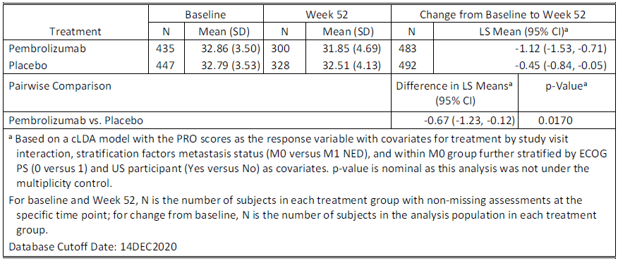
Table 15: KEYNOTE-564 trial change from Baseline in EORTC QLQ-C30 global health status/QOL to Week 52 (patient reported outcome FAS population)
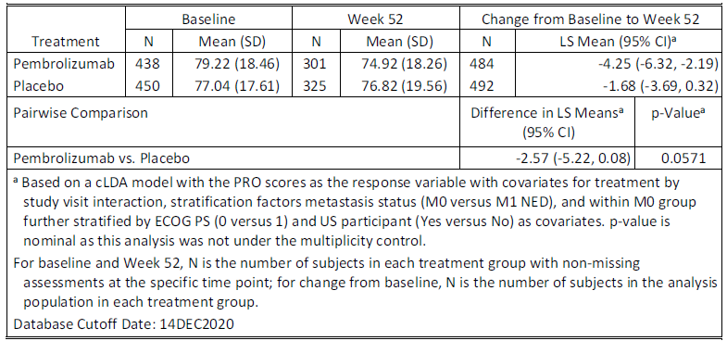
There were no updates to the patient reported outcomes in the updated efficacy report.

Safety
Safety data for the proposed indication were derived from KEYNOTE-564 trial (APaT population). These were compared with a reference safety dataset of pembrolizumab used in monotherapy, as detailed in Table 16.
Table 16: KEYNOTE-564 trial safety datasets
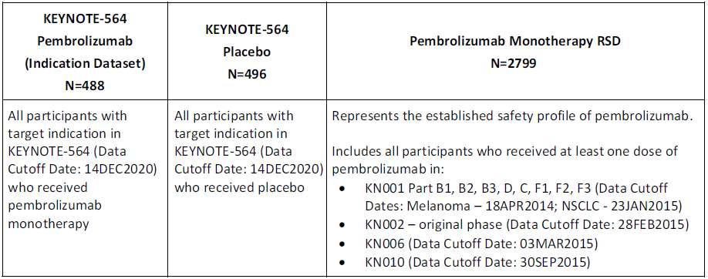
Updated safety data from the KEYNOTE-564 trial were also provided in a safety update report (data cut-off 14 June 2021). It included approximately six months additional follow-up data.

Exposure
The median duration on therapy was 11.1 months (17 doses) in both treatment groups in KEYNOTE-564 trial, compared with 4.2 months (7 doses) in the reference safety dataset.
No patients received treatment during the safety update report period, so exposure remained the same for the safety update report and first interim analysis data cut-offs.

Patient characteristics
Patient characteristics were generally similar between KEYNOTE-564-trial and the reference safety data, with the following notable exceptions:
- The percentage of participants who had ECOG PS = 1 was 14.8% in KEYNOTE-564 trial and 48.1% in the reference safety data, which is consistent with the inclusion of participants with advanced cancers in the reference safety dataset compared with participants who received adjuvant therapy in KEYNOTE-564 trial.
- The age of participants was generally younger in KEYNOTE-564 trial compared with the reference safety dataset (that is, 68.2% of participants in KEYNOTE-564 trial and 56.7% of participants in the reference safety dataset were younger than 65 years).
Table 17: KEYNOTE-564 trial participant characteristics and reference safety data 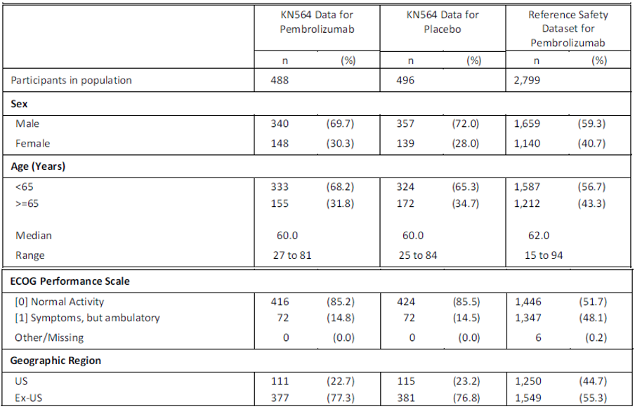

Summary of adverse events
Overall adverse events are summarised below:
Table 18: KEYNOTE-564 trial adverse events summary (APaT population) – first interim analysis
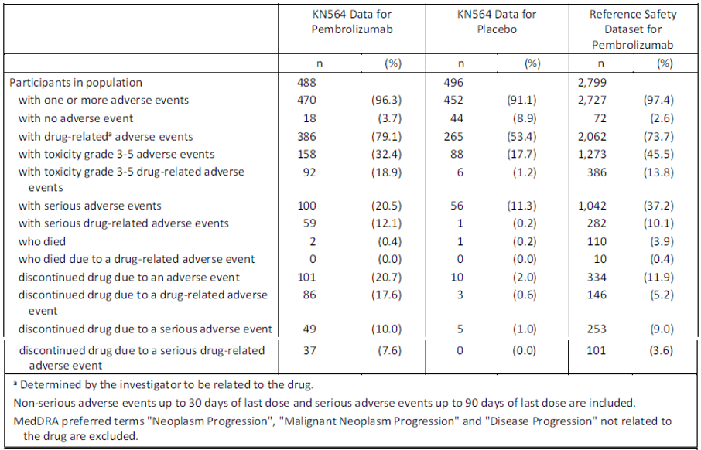
Overall adverse events at the safety update report were consistent with first interim analysis and are summarised below:
Table 19: KEYNOTE-564 trial adverse events summary (APaT population) (updated data cut-off 14 June 2021)

Adverse events
The most common adverse events in KEYNOTE-564 trial were fatigue, diarrhoea, pruritis, arthralgia, hypothyroidism and rash. The pattern of events was generally similar to the reference safety data, except that events of hypothyroidism and hyperthyroidism, and blood creatinine increased, were more frequently reported with pembrolizumab in KEYNOTE-564 trial than in the reference safety data. These are all known adverse events for pembrolizumab. The events of blood creatinine increased may relate to the history of prior nephrectomy in patients in KEYNOTE-564 trial (the frequency was similar for placebo and pembrolizumab – see Table 20, below).
The most common drug-related adverse events in KEYNOTE-564 trial were fatigue (pembrolizumab: 20.3%, placebo: 14.3%), pruritis (pembrolizumab: 18.6%, placebo: 11.5%) and hypothyroidism (pembrolizumab: 17.6%, placebo: 2.6%).
Table 20: KEYNOTE-564 trial patients with adverse events (incidence ≥ 10%) by decreasing frequency of Preferred Term (APaT)
The pattern of events was consistent at the safety update report data cut-off. There were no other notable changes, other than four additional participants who reported hyperthyroidism in the pembrolizumab group, bringing the total incidence to 12.7%.

Grade 3 to 5 adverse events
The proportion of patients with Grade 3 to 5 adverse events in KEYNOTE-564 trial was 32.4% with pembrolizumab and 17.7% with placebo. The reference safety dataset had 45.5% of patients with Grade 3 to 5 adverse events (Table 18). The most frequently reported Grade 3 to 5 events in KEYNOTE-564 trial were hypertension (pembrolizumab: 2.9%, placebo: 2.6%), alanine aminotransferase increased (pembrolizumab: 2.3%, placebo: 0.2%) and aspartate aminotransferase increased (pembrolizumab: 1.6%, placebo: 0.2%). These are all known events reported with pembrolizumab.

Deaths

Overall deaths
At the first interim analysis in KEYNOTE-564 trial, there were 18 deaths in the pembrolizumab arm and 33 in the placebo arm. Most deaths were secondary to disease recurrence (12 in the pembrolizumab group and 31 in the placebo group).

Adverse events leading to death
In KEYNOTE-564 trial there were two adverse events leading to death (0.4%) in the pembrolizumab group and one (0.2%) in the placebo group, while 110 (3.9%) patients in the reference safety dataset died due to adverse events. The deaths in the pembrolizumab group in KEYNOTE-564 trial (Preferred Terms: pneumonia and multiple organ dysfunction syndrome) were not considered drug-related. The difference compared with the reference safety dataset may relate to the underlying differences in characteristics of the populations (that is, adjuvant setting versus advanced cancers).
The participant with multiple organ dysfunction occurred in the context of hospitalisation for a motor vehicle accident.
There were no new deaths due to adverse event in either group during the safety update reporting interval.

Serious adverse events
Serious adverse events were reported more frequently with pembrolizumab (20.5%) than placebo (11.3%) in KEYNOTE-564 trial, but less frequently than the reference safety dataset (37.2%, possibly due to the underlying differences between the populations):
Table 21: KEYNOTE-564 trial serious adverse events up to 90 days post last dose (incidence ≥ 1%) by decreasing frequency of Preferred Term

Discontinuations due to adverse events
Discontinuations of treatment due to adverse events were higher for pembrolizumab (20.7%) compared with placebo (2%) and the reference safety dataset (11.9%). When adjusted for exposure, the rates (events per 100 person-months) of treatment discontinuation due to adverse events were 2.43 and 1.79 in the pembrolizumab arm of KEYNOTE-564 trial and the reference safety dataset, respectively.
Table 22: KEYNOTE-564 trial adverse events leading to discontinuation of treatment by decreasing frequency of Preferred Term
The frequency of patients reporting adverse events leading to dose interruption/reduction was 25.8% with pembrolizumab in KEYNOTE-564 trial, 14.9% with placebo, and 22.2% in the reference safety dataset.

Adverse events of special interest
Adverse events of special interest are immune-mediated events and infusion-related reactions associated with pembrolizumab. These were more frequently reported with pembrolizumab than placebo in KEYNOTE-564 trial and more frequent compared with the reference safety dataset. The same pattern was observed for drug-related adverse events of special interest, Grade 3 to 5 adverse events of special interest, discontinuations due to adverse events of special interest, and serious adverse events of special interests (Table 23).
Table 23: KEYNOTE-564 trial adverse events of special interest (APaT population)
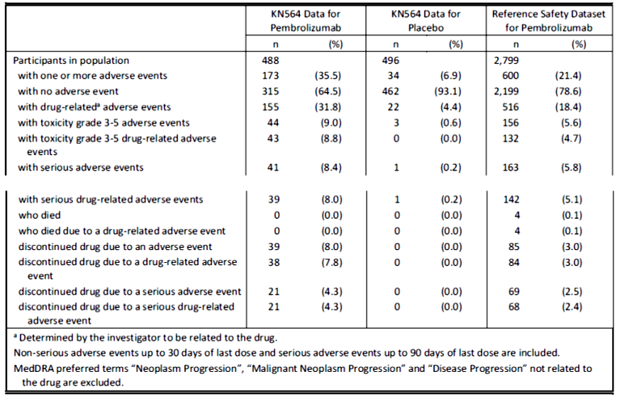
The difference in incidence of adverse events of special interest for pembrolizumab in KEYNOTE-564 trial and the reference safety dataset was primarily driven by the increased incidences of hypothyroidism (21.1% versus 8.5%) and hyperthyroidism (11.9% versus 3.4%). These events were mostly Grade 1 or 2 in KEYNOTE-564 trial (there was one Grade 3 event reported for each of hyperthyroidism and hypothyroidism).
No new adverse events of special interest Preferred Terms were reported. The most frequently reported adverse events of special interest in KEYNOTE-564 trial were as follows (Table 24).
Table 24: KEYNOTE-564 trial adverse events of special interest with incidence ≥ 1% in pembrolizumab arm by decreasing frequency of Preferred Term
 | KEYNOTE-564 trial pembrolizumab  N (%) | KEYNOTE-564 trial placebo  N (%) | reference safety dataset for pembrolizumab  N (%)
Hypothyroidism | 103 (21.1%) | 18 (3.6%) | 237 (8.5%)
Hyperthyroidism | 58 (11.9%) | 1 (0.2%) | 96 (3.4%)
Pneumonitis | 11 (2.3%) | 5 (1.0%) | 94 (3.4%)
Adrenal insufficiency | 10 (2.0%) | 1 (0.2%) | 22 (0.8%)
Type 1 diabetes mellitus | 9 (1.8%) | 0 | 6 (0.2%)
Colitis | 8 (1.6%) | 1 (0.2%) | 48 (1.7%)
Severe skin reactions | 8 (1.6%) | 2 (0.4%) | 39 (1.4%)
Infusion reactions | 7 (1.4%) | 5 (1.0%) | 70 (2.5%)
Thyroiditis | 6 (1.2%) | 1 (0.2%) | 16 (0.6%)
Hepatitis | 6 (1.0%) | 0 | 19 (0.7%)
Median days to onset for the first event of hyperthyroidism was 23 days for pembrolizumab and 193 days for placebo. The median days to onset for the first event of hypothyroidism was 84 days for pembrolizumab and 125.5 days for placebo.
During the safety update report reporting period, there were four additional participants in the pembrolizumab group with events of hyperthyroidism, all Grade 1 to 2.

Other

Laboratory findings
There were no new safety concerns. Three patients in the pembrolizumab arm met drug-induced liver injury screening criteria (concurrent increases in aspartate aminotransferase or alanine aminotransferase to ≥ 3 x upper limit of normal (ULN) plus bilirubin to ≥ 2 x ULN plus alkaline phosphatase to < 2 x ULN), these were all confounded by concomitant medications and were not considered by the Sponsor to be related to pembrolizumab.

Safety in demographic subgroups
There were no new safety concerns based on age, sex, ECOG PS and geographic region. A post hoc analysis of safety based on disease stage subgroup showed that adverse event rates were generally consistent across these subgroups (although interpretation was limited by small subject numbers in the M0 high risk and M1 no evidence of disease categories).

Risk management plan
The TGA decided a risk management plan (RMP) was not required (see TGA’s guidance on ‘when an RMP is required’) as Keytruda is currently approved to treat RCC in combination with axitinib, and patients treated with Keytruda to prevent recurrence are not considered a different population from an RMP perspective as both groups of patients have RCC and it is not anticipated that additional risk minimisation measures will be required when Keytruda is used for prevention of recurrence.
The TGA may request an updated RMP at any stage of a product's life-cycle, during both the pre-approval and post-approval phases. Further information regarding the TGA’s risk management approach can be found in risk management plans for medicines and biologicals and the TGA's risk management approach. Information on the Australia specific annex can be found on the TGA website.

Risk-benefit analysis

Delegate’s considerations
The sponsor proposes an extension of indication for Keytruda for the adjuvant treatment of renal cell carcinoma (RCC). The submission was assessed as part of the Project Orbis collaboration with the US FDA. Approvals have been granted by the FDA and EMA.
Pembrolizumab is a monoclonal antibody which targets the PD-1 immune checkpoint receptor. It was first registered in Australia for the treatment of advanced melanoma in 2016. There have been several subsequent extensions of indication in oncology, including an approval for combination use with axitinib for first-line treatment of advanced renal cell carcinoma.
Data in support of the present submission were confined to a single, pivotal Phase III study: KEYNOTE-564 trial. This is an on-going Phase III, double-blind randomised controlled trial comparing pembrolizumab with placebo as monotherapy in the adjuvant treatment of renal cell carcinoma after nephrectomy. Data are available from a pre-specified interim analysis (first interim analysis; median follow up: 23.9 months), as well as a regulator-requested updated analysis with approximately 6 months additional follow up.
The incidence of kidney cancers in Australia has more than doubled over the past four decades, with renal cell carcinoma accounting for most cases (of which around 70 to 75% are of clear cell histology). Prognosis is generally determined by stage at presentation and mortality rates can be substantial. The standard of care is generally surgical resection with either partial or radical nephrectomy. At present, there is no adjuvant drug therapy approved in Australia. National Comprehensive Cancer Network (NCCN) guidelines were recently updated to include a Category 2A recommendation for the use of pembrolizumab in the adjuvant setting, for patient subsets which generally align with KEYNOTE-564 trial eligibility criteria, including a stipulation for clear cell histology.

Efficacy
The KEYNOTE-564 trial randomised 994 patients in a 1:1 ratio to receive pembrolizumab 200 mg intravenously once every three weeks or placebo for up to 17 cycles (approximately one year) or until confirmed recurrence. Eligible patients had renal cell carcinoma with a clear cell component (other histology types permitted, provided there was a clear cell component), ECOG PS 0 or 1,1010 and were of intermediate-high or high risk of recurrence following nephrectomy (tumour-free at baseline). Most participants fulfilled the M0-intermediate-high risk category (86%). 75.3% of patients expressed PD-L1, defined as a combined positive score (CPS) ≥ 1.
The study met its primary endpoint of disease-free survival at the first interim analysis. This was event-driven in addition to requiring at least 12 months of follow up. The hazard ratio for disease free survival (investigator-assessed) was 0.68 (95% CI: 0.53, 0.87; p = 0.0010) in favour of pembrolizumab, based on 260 disease free survival events (pembrolizumab: 109, placebo: 151), assessed on an intent to treat basis. This result is statistically significant and clinically meaningful. A sensitivity analysis of disease free survival based on BICR review yielded a slightly reduced estimate of pembrolizumab treatment effect; however, this remained statistically significant with a hazard ratio of 0.73 (95% CI: 0.56, 0.95; nominal p = 0.0097). There was no evidence of systematic bias in disease recurrence assessments by investigator.
Disease free survival was generally consistent across pre-specified subgroups, although the interpretation of these analyses is limited by small numbers in some categories. The subgroup analyses suggest that patients with metastatic disease (M1 no evidence of disease) might derive the most benefit (hazard ratio 0.29) compared with M0 disease (hazard ratio 0.74), although treatment appears effective in both groups. At the updated efficacy analysis the gap between these had narrowed, with a hazard ratio of 0.28 for M1 no evidence of disease and 0.68 for M0. In addition, disease free survival estimates for other subgroups were observed to be more consistent at the updated analysis, with a reduction in outlying point estimates for CPS < 1, ECOG 1 and US region. The overall hazard ratio for disease free survival at the updated analysis was 0.63 (95% CI: 0.50, 0.80) based on an additional 23 disease free survival events. This is consistent with first interim analysis.
Data for the key secondary endpoint, overall survival, were not mature at either the first interim analysis or the updated analysis and median overall survival was not reached in either group at either analysis. At the first interim analysis, the hazard ratio for overall survival was 0.54 (95% CI: 0.30, 0.96) based on 18 deaths with pembrolizumab and 33 deaths with placebo. At the updated analysis the hazard ratio for overall survival was consistent with the first interim analysis at 0.52 (95% CI: 0.31, 0.86). The overall survival results to date provide sufficient reassurance that the use of pembrolizumab was not associated with a detrimental effect on survival. They also provide an early signal for potential survival benefit with pembrolizumab which requires confirmation with mature overall survival data.
Patient-reported outcomes were measured by changes from baseline in FKSI-DRS and EORTC QLC-C30 scores at Week 52. The results did not detect any differences between pembrolizumab and placebo groups that were considered clinically meaningful. However, uncertainty remains as to whether the chosen measures were sufficiently specific and sensitive to detect potential detrimental effects of pembrolizumab toxicity on patients’ reported quality of life in this adjuvant treatment setting. Per the protocol: ‘These patient-reported outcomes are not pure efficacy or safety endpoints because they are affected by both disease recurrence and treatment tolerability. Clinical experts have indicated that the FKSI-DRS instrument primarily captures disease-related, as opposed to treatment-related, changes in health related quality of life.’ These data are therefore not taken into account by the Delegate for the purposes of this decision.
The submission of the additional planned overall survival analyses will be imposed as a condition of registration.

Indication
The indication initially proposed by sponsor for this submission was:
Keytruda (pembrolizumab), as monotherapy, is indicated for the adjuvant treatment of patients with RCC at intermediate-high or high risk of recurrence following nephrectomy, or following nephrectomy and resection of metastatic lesions.
The Delegate requested the indication to be amended to:
Keytruda (pembrolizumab), as monotherapy, is indicated for the adjuvant treatment of patients with RCC with a clear cell component who are at intermediate-high or high risk of recurrence following nephrectomy, or following nephrectomy and resection of metastatic lesions (see section 5.1, Clinical Trials: Renal Cell Carcinoma).
In response to the first Delegate’s overview, the sponsor proposed the indication be changed to:
Keytruda (pembrolizumab), as monotherapy, is indicated for the adjuvant treatment of patients with RCC who are at intermediate-high or high risk of recurrence following nephrectomy, or following nephrectomy and resection of metastatic lesions (see section 5.1, Clinical Trials: Renal Cell Carcinoma).
The main uncertainties regarding the sponsor’s proposed indication relate to whether the indicated patient groups should be narrowed to reflect the clinical trial population more closely by stipulating a clear cell component to the renal cell carcinoma histology, and whether the risk categories are likely to be considered meaningful to Australian prescribers.
To justify the treatment of patients with non-clear cell renal cell carcinoma histology (nccRCC), the sponsor referred to a high unmet need for adjuvant treatment options, since guidelines recommend only post-nephrectomy surveillance. In addition, the sponsor stated that they do not expect that efficacy is restricted to clear-cell histology, based on the mechanism of action of pembrolizumab. The sponsor also referred to results of KEYNOTE-427 trial Cohort B, an on-going single-arm study of pembrolizumab monotherapy for the first line treatment of locally advanced/metastatic non-clear cell renal cell carcinoma (n = 165), which support the activity of pembrolizumab with non-clear cell renal cell carcinoma histology (objective response rate 26.7%). The sponsor also clarified that patients with a nccRCC component were not excluded from KEYNOTE-427 trial; however, this was only observed in 10 of 994 (1%) participants. 99% had clear cell histology alone.
The Delegate notes that the National Comprehensive Cancer Network guideline recommendation is limited to patients with clear cell histology; however, the US and European indications do not include such a limitation.
In the sponsor’s response to the earlier Delegate’s overview, they reiterated the unmet clinical need for patients with non-clear cell renal cell carcinoma, citing a 2019 retrospective analysis which suggested similar risk of recurrence post nephrectomy for patients with non-clear cell renal cell carcinoma and clear cell renal cell carcinoma. While this paper reinforces the unmet clinical need, it does not provide any evidence for efficacy of pembrolizumab. The sponsor added that the data from KEYNOTE-427 trial Cohort B ‘are still relevant for the adjuvant setting as the goal of therapy is the eradication of occult micrometastatic disease…’
While the sponsor’s response is acknowledged, the Delegate considers the lack of efficacy data in the adjuvant treatment of non-clear cell renal cell carcinoma to be an important limitation. The proportion of patients included in KEYNOTE-564 trial with a nccRCC component to their histology (1%) is too small to draw any conclusions about efficacy in this subgroup (it would also be difficult to disentangle the relationship between histology and efficacy in these patients, since they had a clear cell component too). There is uncertain generalisability of data to the sizable proportion of the target population with renal cell carcinoma who have non-clear cell histology (approximately 25% to 30%). It is possible that the activity observed for pembrolizumab in advanced/metastatic renal cell carcinoma may not translate into activity in the adjuvant setting, where the goal of treatment is curative and the impact of potential toxicities is greater. The views of the ACM are sought as to whether the sponsor’s rationale for the eradication of occult metastatic disease is sufficient basis on which to extrapolate efficacy data from KEYNOTE-427 trial (which is single arm, open label data in the locally advanced/metastatic nccRCC setting) to the proposed adjuvant indication for nccRCC.
The Delegate remains of the view that the indication should stipulate a clear cell component, in line with the population in which efficacy was demonstrated, subject to the input of the ACM.
It is noted that the sponsor’s clinical development program does not include any planned studies for adjuvant treatment of non-clear cell renal cell carcinoma. Such data would address this limitation and this area of unmet need.
With respect to the risk categories, the sponsor has agreed with the Delegate’s request to add a reference to the Product Information Section 5.1 to the indication, in line with the EMA Summary of Product Characteristics. The rationale is to point prescribers to the study definitions of ‘intermediate-high’ and ‘high’ risk in case they are unfamiliar, and in case there are changes over time to the understanding of risk.

Safety
Safety data from KEYNOTE-564 trial were compared with a reference safety dataset of pembrolizumab used in monotherapy for other indications (advanced melanoma and non-small cell lung cancer). Exposure in KEYNOTE-564 trial was longer compared with the reference safety dataset (11.1 months versus 4.2 months), and the KEYNOTE-564 trial population was somewhat younger (median 60 versus 62 years) with better performance status (85% versus 52% had ECOG PS = 0).
As expected, the incidence of adverse events across all categories was greater with pembrolizumab than placebo in KEYNOTE-564 trial. Compared with the reference safety dataset, the incidence of adverse events with pembrolizumab in KEYNOTE-564 trial across categories was variable, with a greater incidence observed in KEYNOTE-564 trial for:
- Drug-related adverse events (79.1% versus 73.7%)
- Grade 3 to 5 drug-related adverse events (18.9% versus 13.8%)
- Serious drug-related adverse events (12.1% versus 10.1%)
- Discontinuation due to adverse events (20.7% versus 11.9%), drug-related adverse events (17.6% versus 5.2%), serious adverse events (10% versus 9%) and serious drug-related adverse events (7.6% versus 3.6%)
The above differences may be explained by the differences between the underlying patient characteristics and treatment populations, as well as the increased duration of exposure in KEYNOTE-564 trial. Deaths and serious adverse events were less commonly observed with pembrolizumab in KEYNOTE-564 trial compared with the reference safety dataset, in line with the less advanced patient age, performance status and disease status in this study.
Compared with the reference safety dataset, the pattern of events with pembrolizumab in KEYNOTE-564 trial was notable for a greater incidence of hypothyroidism (21.1% versus 8.5%) and hyperthyroidism (11.9% versus 3.4%), although most events were of Grade 1 or 2 and manageable. The incidence of hypothyroidism and hyperthyroidism were more comparable with the incidence observed in the adjuvant treatment of melanoma with pembrolizumab for 9 months in KEYNOTE-564 trial (14.7% and 10.4%, respectively).
The difference between pembrolizumab in KEYNOTE-564 trial and the reference safety dataset in the rate of discontinuations due to adverse events was also notable. Exposure-adjusted event rates were 2.43 in KEYNOTE-564 trial and 1.79 in the reference safety dataset, indicating that the difference was not completely accounted for by the increased exposure in KEYNOTE-564 trial; however, this may also have been influenced by the different treatment settings (that is, adjuvant versus advanced disease).
Very few additional adverse events were reported in the safety update report period, during which all patients were no longer receiving drug treatment. There were four additional reports of hyperthyroidism; however, it is already known that immune-related adverse reactions can occur after discontinuation of treatment with pembrolizumab.
Overall, no new safety concerns emerged in KEYNOTE-564 trial. All events have been previously reported with pembrolizumab. The observed safety profile is considered acceptable in the context of the efficacy which has been demonstrated. It is uncertain whether the safety profile is generalisable to patients with poorer performance status (ECOG > 1), who may be less tolerant of adverse effects.

Dosing regimen
The dosing regimen for pembrolizumab used in KEYNOTE-564 trial was 200 mg intravenously once every three weeks. In October 2021, an application to register an alternative 400 mg intravenous once every six weeks dosing regimen was approved for all approved indications current at the time but that approval did not apply prospectively to new indications. The 400 mg once every six weeks regimen is approved for the proposed indication in the US (via accelerated approval) and in Europe.
No data were provided in the dossier in support of 400 mg once every six weeks dosing for the proposed new indication; however, in response to a Delegate query on this issue, the sponsor confirmed that they consider the justification for once every six weeks dosing outlined in previous application applies equally to adjuvant renal cell carcinoma. A summary of these data was submitted. The proposed dosing is primarily supported by the pharmacokinetic study in advanced melanoma, KEYNOTE-555 trial, as well as physiological based pharmacokinetic modelling.
After consideration of these data, the Delegate agrees that they apply equally to adjuvant renal cell carcinoma and the other indications for which once every six weeks dosing is already approved. The proposed 400 mg intravenously once every six weeks dosing regimen for the proposed new indication is acceptable. The uncertainty is that there are no clinical data for the proposed indication with once every six weeks dosing.

Proposed action
Overall, the risk benefit profile of pembrolizumab for the proposed usage is considered favourable for the amended indication proposed by the Delegate, subject to advice from the ACM.

Questions for the sponsor
The sponsor provided the following response to questions from the Delegate.
- Considering the high unmet need for patients with non-clear cell renal cell carcinoma (nccRCC) histology, what was the rationale for restricting KEYNOTE-564 trial eligibility to patients with a clear cell component?
As summarized in the rational for retaining the revised indication proposed by the sponsor, there was a high unmet need in the adjuvant treatment for patients with non-clear cell renal carcinoma (nccRCC) histology prior to the KEYNOTE-564 trial development in 2016. However, patients with only nccRCC histologies did not receive the same attention despite the growing number of available studies in ccRCC histology. At the time of KEYNOTE-564 trial development in 2016, the available data to justify the treatment of anti-PD-1/L1 agents in the adjuvant disease setting were limited to clinical data in ccRCC patients.
CheckMate-025 trial, a Phase III study of nivolumab versus everolimus in advanced/metastatic ccRCC, showed statistically significant overall survival improvement in nivolumab group, versus everolimus, with greater objective response rate in nivolumab group. In addition, preliminary data from CheckMate-016,Error! Bookmark not defined. a Phase II study of nivolumab plus iplimumab in advanced/metastatic ccRCC, and KEYNOTE-035,, a Phase Ib/II study of pembrolizumab plus axitinib in advanced/metastatic ccRCC, suggested a promising objective response rate and progression free survival, with tolerable toxicity, in ccRCC patients. At that time, there were no data on the use of immune checkpoint inhibitors in patients with nccRCC.
Based on these available data of anti-PD-1 agents in ccRCC patients as of 2016, KEYNOTE-564 trial was designed to enrol RCC patients with a clear cell component, with or without nccRCC. Although the clinical data on pembrolizumab in first line advanced/metastatic nccRCC in KEYNOTE-427 trial Cohort-B was available in the middle of KEYNOTE-564 trial, it was not feasible to change the KEYNOTE-564 trial study population during the course of the study.
Several Phase III studies of anti-PD-1/L1 agents in the adjuvant disease setting (IMmotion-010 trial, and CheckMate-914 trial,) and first line advanced/metastatic setting (KEYNOTE-426 trial, KEYNOTE-581 trial, CheckMate-214 trial, and CheckMate-9ER trial, have similar eligibility criteria of renal cell carcinoma histology with KEYNOTE-564 trial and enrol renal cell carcinoma patients with a clear cell component. In the Australian Product Information, pembrolizumab and nivolumab, in combination with other agents, are indicated for the treatment of the first line advanced/metastatic renal cell carcinoma, irrespective of renal cell carcinoma histology.

Advisory Committee considerations
The Advisory Committee on Medicines (ACM), having considered the evaluations and the Delegate’s overview, as well as the sponsor’s response to these documents, advised the following.

Specific advice to the Delegate
- Can the ACM comment on the indication proposed by the Delegate below?
Keytruda (pembrolizumab), as monotherapy, is indicated for the adjuvant treatment of patients with RCC with a clear cell component who are at intermediate-high or high risk of recurrence following nephrectomy, or following nephrectomy and resection of metastatic lesions (see Section 5.1, Clinical trials: renal cell carcinoma).
The ACM was supportive of the indication proposed by the Delegate. The ACM agreed that it is important to specify renal cell carcinoma with a clear cell component within the indication as this aligns the indication with the clinical trial entry criteria.
The ACM was of the view that there is insufficient clinical data for the use of pembrolizumab for non-clear cell renal cell carcinomas in the adjuvant setting and reiterated that a confirmed diagnosis of renal cell carcinoma with clear cell component with or without sarcomatoid features was a key inclusion criteria for the pivotal trial and all of the study participants had renal cell carcinoma with clear cell component.

Conclusion
The ACM considered this product to have an overall positive benefit-risk profile for the indication:
Keytruda (pembrolizumab), as monotherapy, is indicated for the adjuvant treatment of patients with RCC with a clear cell component who are at intermediate-high or high risk of recurrence following nephrectomy, or following nephrectomy and resection of metastatic lesions (see Section 5.1, Clinical trials: renal cell carcinoma).

Outcome
Based on a review of quality, safety, and efficacy, the TGA approved the registration of Keytruda (pembrolizumab) 100 mg/4 mL, concentrated solution for injection vial, for the following extension of indications:
Keytruda (pembrolizumab), as monotherapy, is indicated for the adjuvant treatment of patients with RCC with a clear cell component who are at intermediate-high or high risk of recurrence following nephrectomy, or following nephrectomy and resection of metastatic lesions (see section 5.1, Clinical Trials: Renal Cell Carcinoma).
As such, the full indications at this time were:
Melanoma
Keytruda (pembrolizumab) is indicated as monotherapy for the treatment of unresectable or metastatic melanoma in adults.
Keytruda (pembrolizumab) is indicated as monotherapy for the adjuvant treatment of patients with melanoma with lymph node involvement who have undergone complete resection.
Non-small cell lung cancer (NSCLC)
Keytruda (pembrolizumab), in combination with pemetrexed and platinum chemotherapy, is indicated for the first-line treatment of patients with metastatic non-squamous NSCLC, with no EGFR or ALK genomic tumour aberrations.
Keytruda (pembrolizumab), in combination with carboplatin and either paclitaxel or nabpaclitaxel, is indicated for the first-line treatment of patients with metastatic squamous NSCLC.
Keytruda (pembrolizumab) is indicated as monotherapy for the first-line treatment of patients with NSCLC expressing PD-L1 [tumour proportion score (TPS) ≥1%] as determined by a validated test, with no EGFR or ALK genomic tumour aberrations, and is
- stage III where patients are not candidates for surgical resection or definitive chemoradiation, or
- metastatic.
Keytruda (pembrolizumab) is indicated as monotherapy for the treatment of patients with advanced NSCLC whose tumours express PD-L1 with a ≥1% TPS as determined by a validated test and who have received platinum-containing chemotherapy. Patients with EGFR or ALK genomic tumour aberrations should have received prior therapy for these aberrations prior to receiving Keytruda.
Head and Neck Squamous Cell Cancer (HNSCC)
Keytruda (pembrolizumab), as monotherapy or in combination with platinum and 5- fluorouracil (5-FU) chemotherapy, is indicated for the first-line treatment of patients with metastatic or unresectable recurrent HNSCC, and whose tumours express PD-L1 [Combined Positive Score (CPS) ≥1] as determined by a validated test.
Keytruda (pembrolizumab) is indicated as monotherapy for the treatment of patients with metastatic or unresectable recurrent HNSCC with disease progression on or after platinum containing chemotherapy and whose tumours express PD-L1 [Combined Positive Score (CPS) ≥1] as determined by a validated test.
Classical Hodgkin Lymphoma (cHL)
Keytruda (pembrolizumab) is indicated as monotherapy for the treatment of adult and paediatric patients with relapsed or refractory classical Hodgkin Lymphoma (cHL):
- following autologous stem cell transplant (ASCT) or
- following at least two prior therapies when ASCT or multi-agent chemotherapy is not a treatment option.
The approval of this indication in paediatric patients is on the basis of objective response rate from patients aged 11 years and older from single arm trial data and extrapolation from adult data (see Section 5.1 Pharmacodynamic properties, Clinical Trials).
Primary mediastinal B-cell lymphoma (PMBCL)
Keytruda (pembrolizumab) is indicated for the treatment of adult and paediatric patients with refractory primary mediastinal B-cell lymphoma (PMBCL), or who have relapsed after 2 or more prior lines of therapy. The approval of this indication is on the basis of objective response rate (ORR) and duration of response from non-randomised studies. See Section 5.1 Pharmacodynamic properties, Clinical Trials.
Urothelial carcinoma
Keytruda (pembrolizumab) is indicated as monotherapy for the treatment of patients with locally advanced or metastatic urothelial carcinoma who are not eligible for any platinum containing chemotherapy. This indication is approved based on overall response rate and duration of response in a single-arm study. Improvements in overall survival, progression-free survival, or health-related quality of life have not been established.
Keytruda (pembrolizumab) is indicated as monotherapy for the treatment of patients with locally advanced or metastatic urothelial carcinoma who have received platinum-containing chemotherapy.
Keytruda (pembrolizumab) is indicated for the treatment of patients with Bacillus Calmette-Guerin (BCG)-unresponsive, high-risk, non-muscle invasive bladder cancer (NMIBC) with carcinoma in-situ (CIS) with or without papillary tumours who are ineligible for or have elected not to undergo cystectomy. This indication was approved via the provisional approval pathway based on complete response rate and duration of response. Continued approval of this indication depends on verification and description of benefit in confirmatory trials.
Microsatellite instability-high (MSI-H) or mismatch repair deficient (dMMR) cancer
Colorectal (previously untreated)
Keytruda (pembrolizumab) is indicated for the first-line treatment of patients with unresectable or metastatic colorectal cancer (CRC) that is MSI-H or dMMR as determined by a validated test.
Colorectal (previously treated)
Keytruda (pembrolizumab) is indicated in adult and paediatric patients for the treatment of unresectable or metastatic CRC that is MSI-H or dMMR as determined by a validated test, and that has progressed following treatment with a fluoropyrimidine, oxaliplatin, and irinotecan. This indication was approved via the provisional approval pathway, based on objective response rate and response duration in a single-arm trial. Continued approval for this indication depends on verification and description of clinical benefit in the confirmatory trials.
Non-colorectal
Keytruda (pembrolizumab) is indicated in adult and paediatric patients for the treatment of unresectable or metastatic solid tumours that are MSI-H or dMMR as determined by a validated test, that have progressed following prior treatment and when there are no satisfactory alternative treatment options. This indication was approved via the provisional approval pathway, based on the pooling of data on objective response rate and response duration across multiple different tissue types in a single-arm trial. Sample sizes for individual tissue types were too small to provide data on clinical utility of the MSI-H/dMMR tests for each of the tissue types, individually. The assumption that MSI-H/dMMR-status is predictive of the treatment effect of
Keytruda for every tissue type has not been verified. Continued approval for this indication depends on verification and description of clinical benefit in the confirmatory trials. The safety and effectiveness of Keytruda in paediatric patients with MSI-H/dMMR central nervous system cancers have not been established.
Endometrial carcinoma
Keytruda (pembrolizumab), in combination with lenvatinib, is indicated for the treatment of patients with advanced endometrial carcinoma that is not MSI-H or dMMR, who have disease progression following prior systemic therapy in any setting and are not candidates for curative surgery or radiation.
Cervical cancer
Keytruda (pembrolizumab) in combination with platinum chemotherapy and paclitaxel, with or without bevacizumab, is indicated for the treatment of patients with persistent, recurrent, or metastatic cervical cancer whose tumours express PD-L1 [Combined Positive Score (CPS) ≥1] as determined by a validated test.
Renal Cell Carcinoma (RCC)
Keytruda (pembrolizumab), in combination with axitinib, is indicated for the first-line treatment of patients with advanced renal cell carcinoma (RCC).
Keytruda in combination with LENVIMA® (lenvatinib) is indicated for the first-line treatment of adult patients with advanced renal cell carcinoma (RCC).
Keytruda (pembrolizumab), as monotherapy, is indicated for the adjuvant treatment of patients with RCC with a clear cell component who are at intermediate-high or high risk of recurrence following nephrectomy, or following nephrectomy and resection of metastatic lesions (see section 5.1, Clinical Trials: Renal Cell Carcinoma).
Cutaneous squamous cell carcinoma
Keytruda (pembrolizumab) is indicated as monotherapy for the treatment of adult patients with recurrent or metastatic cutaneous squamous cell carcinoma (cSCC) or locally advanced cSCC that is not curable by surgery or radiation. This indication was approved via the provisional approval pathway based on objective response rate and duration of response from a single-arm study. Improvements in overall survival, progression-free survival, or health related quality of life have not been established. Full registration for this indication depends on submission of further clinical data to confirm the clinical benefit of the medicine.
Oesophageal cancer
Keytruda (pembrolizumab), in combination with platinum and fluoropyrimidine based chemotherapy, is indicated for the first-line treatment of patients with locally advanced or metastatic carcinoma of the oesophagus or HER2 negative gastroesophageal junction adenocarcinoma (tumour centre 1 to 5 centimetres above the gastroesophageal junction) that is not amenable to surgical resection or definitive chemoradiation.
Tumour mutational burden-high (TMB-H) cancer
Keytruda (pembrolizumab) is indicated for the treatment of adult and paediatric patients with unresectable or metastatic tumour mutational burden-high (TMB-H) [≥10 mutations/megabase (mut/Mb)] solid tumours, as determined by a validated test, that have progressed following prior treatment and who have no satisfactory alternative treatment options. This indication was approved via the provisional approval pathway, based on the pooling of data on objective response rate and response duration across multiple different tissue types in a single-arm trial. The assumption that TMB-H status is predictive of the treatment effect of Keytruda for every tissue type has not been verified. Full registration for this indication depends on verification and description of clinical benefit in confirmatory trials.
Triple-negative breast cancer
Keytruda (pembrolizumab) is indicated for the treatment of patients with high-risk early-stage triple-negative breast cancer (TNBC) in combination with chemotherapy as neoadjuvant treatment, and then continued as monotherapy as adjuvant treatment after surgery.
Keytruda (pembrolizumab), in combination with chemotherapy, is indicated for the treatment of patients with locally recurrent unresectable or metastatic TNBC whose tumours express PD-L1 (CPS ≥10) as determined by a validated test and who have not received prior chemotherapy for metastatic disease.
The above extension of indications are inclusive of the previous approved indications.

Specific conditions of registration applying to these goods
- The sponsor is requested to submit the additional pre-specified analyses for KEYNOTE- 564 [trial] when these become available, including updated analyses of overall survival.
- The Product Information applying to these therapeutic goods must meet the TGA’s approval at all times. Any proposed changes to the approved text of the PI, including safety related changes, must be submitted to, and be approved by, the TGA prior to distribution.
For all Keytruda products, either:
- A “Pack Insert” (being an abbreviated version of the TGA-approved Keytruda Product Information) in a format acceptable to the TGA, or
- The approved Product Information, must be included with the products as a package insert.
Where a “Pack Insert” is provided as a package insert, there is a continuing obligation on the sponsor to ensure that the content is consistent with the PI.

Attachment 1. Product Information
The PI for Keytruda approved with the submission which is described in this AusPAR is at Attachment 1. For the most recent PI, please refer to the TGA PI/CMI search facility.

Therapeutic Goods Administration
PO Box 100 Woden ACT 2606 Australia
Email: info@tga.gov.au Phone: 1800 020 653 Fax: 02 6203 1605
https://www.tga.gov.au
Reference/Publication #

This is the original indication proposed by the sponsor when the TGA commenced the evaluation of this submission. It may differ to the final indication approved by the TGA and registered on the Australian Register of Therapeutic Goods.
Australian Institute of Health and Welfare 2019. Cancer in Australia 2019. Cancer series no.119. Cat. no. CAN 123. Canberra: AIHW.
Gray RE, Harris GT. Renal Cell Carcinoma: Diagnosis and Management. Am Fam Physician. 2019 Feb 1;99(3):179-184.
Howlader N, Noone AM, Krapcho M, et al (eds). SEER Cancer Statistics Review, 1975-2016, National Cancer Institute. Bethesda, MD, https://seer.cancer.gov/csr/1975_2016/, based on November 2018 SEER data submission, posted to the SEER web site, April 2019. (last viewed 15/2/22)
National Comprehensive Cancer Network Kidney Cancer Guidelines Version 4.2022.
Marconi L, Sun M, Beisland C, et al. Prevalence, Disease-free, and Overall Survival of Contemporary Patients With Renal Cell Carcinoma Eligible for Adjuvant Checkpoint Inhibitor Trials. Clin Genitourin Cancer. 2021 Apr;19(2):e92-e99.
Category 2A: uniform NCCN consensus that the intervention is appropriate, based on lower-level evidence. Category 3: major NCCN disagreement that the intervention is appropriate, based on any level of evidence
Choueiri TK, Tomczak P, Park SH, et al. Adjuvant Pembrolizumab after Nephrectomy in Renal-Cell Carcinoma. N Engl J Med. 2021 Aug 19;385(8):683-694.
Metastasis status: The "M" in the TNM system describes whether the cancer has spread to other parts of the body, called metastasis. Common areas where kidney cancer may spread include the bones, liver, lungs, brain, and distant lymph nodes. M0 (M zero): The disease has not metastasized. M1: The cancer has spread to other parts of the body beyond the kidney area.
Eastern Cooperative Oncology Group (ECOG) Performance Status: The ECOG has developed criteriaused by doctors and researchers to assess how a patient's disease is progressing, assess how the diseaseaffects the daily living abilities of the patient, and determine appropriate treatment and prognosis. The following are used: 0 - Fully active, able to carry on all pre-disease performance without restriction 1- Restricted in physically strenuous activity but ambulatory and able to carry out work of a light or sedentary nature, for example, light house work, office work 2 - Ambulatory and capable of all selfcare but unable to carry out any work activities. Up and about more than 50% of waking hours 3 - Capable of only limited selfcare, confined to bed or chair more than 50% of waking hours 4 - Completely disabled. Cannot carry on any selfcare. Totally confined to bed or chair 5 – Dead
FKSI-DRS - Functional Assessment of Cancer Therapy Kidney Cancer Symptom Index - Disease Related Symptoms
EORTC QLQ-C30 – The European Organisation for Research and Treatment of Cancer Quality of Life Questionnaire is a questionnaire developed to assess the quality of life of cancer patients
McDermott DF, Lee JL, Ziobro M, et al. Open-Label, Single-Arm, Phase II Study of Pembrolizumab Monotherapy as First-Line Therapy in Patients With Advanced Non-Clear Cell Renal Cell Carcinoma. J Clin Oncol. 2021 Mar 20;39(9):1029-1039.
Narayan V, Puligandla M, Haas NB, et al. Patterns of Relapse and Implications for Post-Nephrectomy Surveillance in Patients with High Risk Nonclear Cell Renal Cell Carcinoma: Subgroup Analysis of the Phase 3 ECOG-ACRIN E2805 Trial. J Urol. 2019 Jan;201(1):62-68.
Current approved PI for Keytruda at the time of submission.
Motzer et al; Nivolumab versus everolimus in advanced renal cell carcinoma; N Engl J Med. 2015 Nov 5;373(19):1803-13.
Atkins et al.; Axitinib in combination with pembrolizumab in patients (pts) with advanced renal cell carcinoma: Preliminary safety and efficacy results; ESMO 2016
IMmotion-010 trial; ClinicalTrials.gov Identifier: NCT03024996 can be located at https://clinicaltrials.gov/
CheckMate-914 trial; ClinicalTrials.gov Identifier: NCT03138512 can be located at https://clinicaltrials.gov/
KEYNOTE-426 trial; ClinicalTrials.gov Identifier: NCT02853331 can be located at https://clinicaltrials.gov/
KEYNOTE-581 trial; ClinicalTrials.gov Identifier: NCT02811861 can be located at https://clinicaltrials.gov/
CheckMate-214 trial; ClinicalTrials.gov Identifier: NCT02231749 can be located at https://clinicaltrials.gov/
CheckMate-9ER trial, ClinicalTrials.gov Identifier: NCT03141177 can be located at https://clinicaltrials.gov/

