Australian Public Assessment Report for Gardasil 9
  - Active ingredient/s: Human papillomavirus 9-valent vaccine, recombinant
  - Sponsor: Merck Sharp & Dohme (Australia) Pty Ltd
August 2023

About the Therapeutic Goods Administration (TGA)
- The Therapeutic Goods Administration (TGA) is part of the Australian Government Department of Health and Aged Care and is responsible for regulating therapeutic goods, including medicines, medical devices, and biologicals.
- The TGA administers the Therapeutic Goods Act 1989 (the Act), applying a risk management approach designed to ensure therapeutic goods supplied in Australia meet acceptable standards of quality, safety, and efficacy.
- The work of the TGA is based on applying scientific and clinical expertise to decision-making, to ensure that the benefits to the Australian public outweigh any risks associated with the use of therapeutic goods.
- The TGA relies on the public, healthcare professionals and industry to report problems with therapeutic goods. The TGA investigates reports received to determine any necessary regulatory action.
- To report a problem with a therapeutic good, please see the information on the TGA website.

About AusPARs
- The Australian Public Assessment Report (AusPAR) provides information about the evaluation of a prescription medicine and the considerations that led the TGA to approve or not approve a prescription medicine submission. Further information can be found in Australian Public Assessment Report (AusPAR) guidance.
- AusPARs are prepared and published by the TGA.
- AusPARs are static documents that provide information that relates to a submission at a particular point in time. The publication of an AusPAR is an important part of the transparency of the TGA’s decision-making process.
- A new AusPAR may be provided to reflect changes to indications or major variations to a prescription medicine subject to evaluation by the TGA.

Copyright
© Commonwealth of Australia 2023
This work is copyright. You may reproduce the whole or part of this work in unaltered form for your own personal use or, if you are part of an organisation, for internal use within your organisation, but only if you or your organisation do not use the reproduction for any commercial purpose and retain this copyright notice and all disclaimer notices as part of that reproduction. Apart from rights to use as permitted by the Copyright Act 1968 or allowed by this copyright notice, all other rights are reserved and you are not allowed to reproduce the whole or any part of this work in any way (electronic or otherwise) without first being given specific written permission from the Commonwealth to do so. Requests and inquiries concerning reproduction and rights are to be sent to the TGA Copyright Officer, Therapeutic Goods Administration, PO Box 100, Woden ACT 2606 or emailed to <tga.copyright@tga.gov.au>.

Contents
List of abbreviations 4
Product submission 5
Submission details 5
Product background 6
Regulatory status 7
Product Information 8
Registration timeline 8
Submission overview and risk/benefit assessment 10
Quality 10
Nonclinical 11
Clinical 11
Summary of clinical studies 11
Recommendation following the clinical evaluation 11
Risk management plan 11
Risk-benefit analysis 12
Delegate’s considerations 12
Proposed action 12
Questions for the sponsor 12
Independent expert advice 12
Advisory Committee considerations 12
Outcome 13
Specific conditions of registration applying to these goods 13
Final outcome 13
Appeal to the administrative appeals tribunal 14
Attachment 1. Product Information 14

List of abbreviations
Abbreviation | Meaning
9vHPV | 9-valent human papillomavirus vaccine
ACV | Advisory Committee on Vaccines
AE | Adverse event
AIS | Adenocarcinoma in situ
ARTG | Australian Register of Therapeutic Goods
ASA | Australia specific annex
CI | Confidence interval
CIN | Cervical intraepithelial neoplasia
cLIA | Chemiluminescence immunoassay
CMI | Consumer Medicines Information
DLP | Data lock point
EMA | European Medicines Agency
EU | European Union
FDA | Food and Drug Administration (United States)
GMR | Geometric mean ratio
GMT | Geometric mean titre
HPV | Human Papillomavirus
L1 | Recombinant major capsid (L1) protein from HPV
MAP | Middle adult person
mMU | milli-Merck unit
PI | Product Information
PPE | Per-protocol efficacy
PPI | Per-protocol immunogenicity
PSUR | Periodic safety update report
qHPV | Quadrivalent human papillomavirus vaccine
RMP | Risk management plan
SAE | Serious adverse event
TGA | Therapeutic Goods Administration
USA | United States (of America)

Product submission

Submission details
Type of submission: | Extension of indication
Product name: | Gardasil 9
Active ingredient: | Human papillomavirus 9-valent vaccine, recombinant
Decision: | Approved
Date of decision: | 6 April 2023
Date of entry onto ARTG: | 11 April 2023
ARTG numbers: | 224092, 224093
Black Triangle Scheme  for the current submission: | No
Sponsor’s name and address: | Merck Sharp & Dohme (Australia) Pty Limited  Level 1, Building A,  26 Talavera Road  Macquarie Park NSW 2113
Dose form: | Suspension for injection
Strength: | 30 µg of HPV 6 L1 protein, 40 µg of HPV 11 L1 protein, 60 µg of HPV 16 L1 protein, 40 µg of HPV 18 L1 protein, 20 µg of HPV 31 L1 protein, 20 µg of HPV 33 L1 protein, 20 µg of HPV 45 L1 protein, 20 µg of HPV 52 L1 protein, and 20 µg of HPV 58 L1 protein/0.5 mL
Containers: | Syringe and vial
Pack sizes: | 1 and 10
Approved therapeutic use for the current submission: | Gardasil 9 is indicated in males aged 9 to 45 years* for the prevention of anal cancer, precancerous or dysplastic lesions, external genital lesions, and infection caused by Human Papillomavirus (HPV) types 6, 11, 16, 18, 31, 33, 45, 52 and 58 (which are included in the vaccine).  *Evidence of vaccine efficacy is based on the core efficacy population of females aged 16 to 26 years. Immunogenicity studies have been conducted to link efficacy to younger populations (females and males aged 9 to 15 years). Immunogenicity studies of Gardasil 9 have been conducted relating to females over 26 years of age (see section 5.1 Clinical Trials for Gardasil 9).
Route of administration: | Intramuscularly
Dosage: | Gardasil 9 should be administered intramuscularly as three separate 0.5 mL doses according to the following schedule:  First dose: at elected date  Second dose: 2 months after the first dose  Third dose: 6 months after the first dose  Alternatively, in individuals 9 to 14 years of age, Gardasil 9 can be administered according to a two dose schedule; the second dose should be administered between 5 and 13 months after the first dose. If the second vaccine dose is administered earlier than 5 months after the first dose, a third dose should always be administered.  For further information regarding dosage, refer to the Product Information.
Pregnancy category: | Category B2  Drugs which have been taken by only a limited number of pregnant women and women of childbearing age, without an increase in the frequency of malformation or other direct or indirect harmful effects on the human fetus having been observed.  Studies in animals are inadequate or may be lacking, but available data show no evidence of an increased occurrence of fetal damage.

Product background
This AusPAR describes the submission by Merck Sharp and Dohme (Australia) Pty Ltd (the sponsor) to register Gardasil 9 (human papillomavirus 9-valent vaccine, recombinant), 30 µg of human papillomavirus (HPV) 6 recombinant major capsid (L1) protein, 40 µg of HPV 11 L1 protein, 60 µg of HPV 16 L1 protein, 40 µg of HPV 18 L1 protein, 20 µg of HPV 31 L1 protein, 20 µg of HPV 33 L1 protein, 20 µg of HPV 45 L1 protein, 20 µg of HPV 52 L1 protein, and 20 µg of HPV 58 L1 protein/0.5 mL, suspension for injection, syringe and vial, for the following proposed extension of indications:
Gardasil 9 is indicated in females aged 9 to 45 years* for the prevention of cervical, vulvar, vaginal, anal, oropharyngeal and other head and neck cancers, precancerous or dysplastic lesions, genital warts, and infection caused by Human Papillomavirus (HPV) Types 6, 11, 16, 18, 31, 33, 45, 52 and 58 (which are included in the vaccine).
Gardasil 9 is indicated in males 9 to 45* years of age for the prevention of anal, oropharyngeal and other head and neck cancers, precancerous or dysplastic lesions, external genital lesions and infection caused by HPV types 6, 11, 16, 18, 31, 33, 45, 52 and 58 (which are included in the vaccine).
Human papillomavirus (HPV) is a group of more than 200 related viruses, some of which are spread through vaginal, anal, or oral sex. In most cases, HPV infection is cleared by the immune system. However, in some cases the infection may persist, and certain HPV types may cause disease.
High risk HPVs can cause several types of cancer. These include:
- Cervical cancer (nearly all cervical cancers are caused by HPV).
- Oropharyngeal cancers (Most (about 70%) are thought to be caused by HPV and now the most common HPV-related cancer in the United States of America (USA)).
- Anal cancer (Over 90% are caused by HPV).
In addition, HPV is associated with rare cancers (annual incidence less than 1 per 100,000):
- Penile cancer: over 60% are caused by HPV.
- Vaginal cancer: around 75% are caused by HPV.
- Vulvar cancer: around 70% are caused by HPV.
There are at least 14 high risk HPV types including HPV 16, 18, 31, 33, 35, 39, 45, 51, 52, 56, 58, 59, 66, and 68. Two of these (16 and 18) are responsible for most HPV-related cancers, and cause 70% of cervical cancers and pre-cancerous cervical lesions.

Head and neck cancers
Human papillomavirus related head and neck cancer is a serious disease that can lead to significant morbidity and mortality. Head and neck cancers are a heterogeneous group of tumours at different anatomic sites with various aetiologies. Most head and neck cancers are squamous cell carcinoma arising from the mucosal surfaces of the oral cavity, pharynx, and larynx. HPV can infect the mouth and throat and cause cancers of the oropharynx; most head and neck cancers caused by HPV are in these regions. Currently, there is no validated test or test algorithm to identify HPV-driven head and neck cancers at non-oropharyngeal sites; however, it is postulated that some non-oropharyngeal cancers can also be attributed to HPV.
In Australia, 5,104 individuals (3,755 males and 1,349 females) have been estimated to be diagnosed with head and neck cancer (including oropharyngeal cancer) in 2021. (3.4% of all new cancers diagnosed). The estimated number of deaths from head and neck cancer in 2021 was 1,201 (888 males and 313 females) (2.4% of all cancer deaths). The 5 year survival rate between 2013 and 2017 was 72%.

Current treatment options
The initial exposure to HPV occurs during teenage years for most individuals. As a primary prevention, the World Health Organization recommends HPV vaccination at 9 to 14 years of age. The Australian Immunisation Handbook recommends the 9-valent human papillomavirus vaccine (9vHPV, that is Gardasil 9) for adolescents 9 to 18 years of age, with the optimal age for vaccination at 12 to 13 years of age. Catch up vaccines are available through general practitioners and other immunisation providers for young people up to 19 years of age.
Currently, the following HPV vaccine products are registered in Australia:
- Gardasil contains HPV type 6, 11, 16, 18 proteins.
- Cervarix contains HPV type 16 and 18 proteins.
- Gardasil 9 contains HPV type 6, 11, 16, 18, 31, 33, 45, 52, 58 proteins.
There is no specific antiviral therapy for HPV infection.
The main treatments for head and neck cancers are surgery, radiotherapy and chemotherapy (including targeted therapy). These treatments may be given individually, or as a combination. The treatment will depend on the tumour type, size and location, as well as patient factors including age, health, and symptoms.

Regulatory status
The product received initial registration on the Australian Register of Therapeutic Goods (ARTG) on 29 June 2015. At the time that this submission was considered it was approved for the following indications:
Gardasil 9 is indicated in females aged 9 to 45 years for the prevention of cervical, vulvar, vaginal and anal cancers, precancerous or dysplastic lesions, genital warts, and infection caused by Human Papillomavirus (HPV) Types 6, 11, 16, 18, 31, 33, 45, 52 and 58 (which are included in the vaccine).
Gardasil 9 is indicated in males 9 to 26 years of age for the prevention of anal cancer, precancerous or dysplastic lesions, external genital lesions and infection caused by HPV types 6, 11, 16, 18, 31, 33, 45, 52 and 58 (which are included in the vaccine).
Nine valent human papillomavirus vaccine was initially licensed in the USA. in December 2014, in Canada in February 2015, and in the European Union (EU) and Australia in June 2015 under the name Gardasil 9. As of December 2020, 9vHPV vaccine has been licensed in more than 80 countries under the name Gardasil 9 and under the name Silgard 9 in Japan.
In June 2020, 9vHPV vaccine was licensed under accelerated approval in the US for the prevention of oropharyngeal and other head and neck cancers related to HPV 16, 18, 31, 33, 45, 52, or 58. In April 2022, 9vHPV vaccine was approved under the Notice of Compliance with conditions (NoC/c) for the prevention of head and neck cancers caused by HPV (Table 1).
The sponsor has not provided information on the overseas status of the extension of the age range in the population to 45 years of age. The European Medicines Agency (EMA) and the Food and Drug Administration (FDA) United States appeared to have approved the 9vHPV vaccine for use in individuals older than 26 years (with no upper age limit in the EU, and an upper age limit of 45 years in the USA) in June 2015 and October 2018, respectively.
The following table summarises these submissions and provides the indications where approved.
Table 1: International regulatory status
Region | Submission date | Status | Approved indications
United States of America | 13 December 2019 | Approved on 12 June 2020 | Girls and Women  Gardasil 9 is a vaccine indicated in girls and women 9 through 45 years of age for the prevention of the following diseases:  • Cervical, vulvar, vaginal, anal, oropharyngeal and other head and neck cancers caused by Human Papillomavirus (HPV) types 16, 18, 31, 33, 45, 52, and 58  • Genital warts (Condyloma acuminata) caused by HPV types 6 and 11  And the following precancerous or dysplastic lesions caused by HPV types 6, 11, 16, 18, 31, 33, 45, 52, and 58:  • Cervical intraepithelial neoplasia (CIN) grade 2/3 and cervical adenocarcinoma in situ (AIS)  • Cervical intraepithelial neoplasia (CIN) grade 1  • Vulvar intraepithelial neoplasia (VIN) grade 2 and grade 3  • Vaginal intraepithelial neoplasia (VaIN) grade 2 and grade 3  • Anal intraepithelial neoplasia (AIN) grades 1, 2, and 3  Boys and Men  Gardasil 9 is indicated in boys and men 9 through 45 years of age for the prevention of the following diseases:  • Anal, oropharyngeal and other head and neck cancers caused by HPV types 16, 18, 31, 33, 45, 52, and 58  • Genital warts (Condyloma acuminata) caused by HPV types 6 and 11  And the following precancerous or dysplastic lesions caused by HPV types 6, 11, 16, 18, 31, 33, 45, 52, and  58:  • Anal intraepithelial neoplasia (AIN) grades 1, 2, and 3
Canada | 7 April 2021 | Approved 6 April 2022 | Gardasil 9, is a vaccine indicated for:  • individuals 9 through 45 years of age for the prevention of infection caused by the Human Papillomavirus (HPV) types 6, 11, 16, 18, 31, 33, 45, 52 and 58 and the following diseases associated with the HPV types included in the vaccine: Oropharyngeal and other head and neck cancers caused by HPV types 16, 18, 31, 33, 45, 52, and 58  has been issued market authorization with conditions, pending the results of trials to verify its clinical benefit. Patients should be advised of the nature of the authorization. For further information for Gardasil 9 please refer to Health Canada’s Notice of Compliance with conditions - drug products web site  Gardasil 9, is a vaccine indicated for:  • individuals 9 through 45 years of age for the prevention of infection caused by the Human Papillomavirus (HPV) types 6, 11, 16, 18, 31, 33, 45, 52 and 58 and the following diseases associated with the HPV types included in the vaccine:  o Cervical, vulvar, vaginal, and anal cancer caused by HPV types 16, 18, 31, 33, 45, 52, and 58  o Genital warts (condyloma acuminata) caused by HPV types 6 and 11  And the following precancerous or dysplastic lesions caused by HPV types 6, 11, 16, 18, 31, 33, 45, 52, and 58:  o Cervical adenocarcinoma in situ (AIS)  o Cervical intraepithelial neoplasia (CIN) grade 2 and grade 3  o Cervical intraepithelial neoplasia (CIN) grade 1  o Vulvar intraepithelial neoplasia (VIN) grade 2 and grade 3  o Vaginal intraepithelial neoplasia (VaIN) grade 2 and grade 3  o Anal intraepithelial neoplasia (AIN) grades 1, 2, and 3.  has been issued market authorization without conditions.

Product Information
The Product Information (PI) approved with the submission which is described in this AusPAR can be found as Attachment 1. For the most recent PI and Consumer Medicines Information (CMI), please refer to the TGA PI/CMI search facility.

Registration timeline
The following table captures the key steps and dates for this submission.
This submission was evaluated under the standard prescription medicines registration process.
Table 2: Timeline for Submission PM-2021-01645-1-2
Description | Date
Provisional determination  Provisional determination revoked; | 7 January 2021  4 April 2023
Submission dossier accepted and first round evaluation commenced | 1 June 2021
First round evaluation completed | 31 January 2022
Sponsor provides responses on questions raised in first round evaluation | 31 March 2022
Second round evaluation completed | 6 April 2023
Delegate’s Overall benefit-risk assessment and request for Advisory Committee advice | 5 July 2022
Sponsor’s pre-Advisory Committee response | 15 July 2022
Advisory Committee meeting | 3 August 2022
Registration decision (Outcome) | 6 April 2023
Administrative activities and registration on the ARTG completed | 11 April 2023
Number of working days from submission dossier acceptance to registration decision* | 212
*Statutory timeframe for standard submissions is 255 working days

Submission overview and risk/benefit assessment
A summary of the TGA’s assessment for this submission is provided below.

Quality
Quality evaluation is not required for this submission as there are no proposed changes to the quality of the currently approved product in Australia. The quality of the currently approved product is suitable for the proposed changes in this submission. A full quality evaluation was conducted at the time this product received initial registration

Nonclinical
No new nonclinical data or further nonclinical evaluation were required for this submission. The TGA considers that previously submitted and evaluated data satisfactorily address nonclinical aspects of safety/efficacy relating to this submission.

Clinical

Pharmacology
Pharmacokinetic studies are usually not required for vaccines.

Efficacy
The following efficacy studies were included (some have been previously evaluated):
- Mid adult person (MAP) (women and men from 27 to 45 years of age)
  - Gardasil 9: Study V503-004 (comparing the immunogenicity of Gardasil 9 in women 16 to 26 years of age to women 27 to 45 years of age), Study V503-020 (comparing the immunogenicity of Gardasil 9 to Gardasil in men 16 to 26 years of age)
  - Gardasil: Cross-study immunogenicity analysis (Study V501-108 [men 27 to 45 years of age] versus Study V501-020 [men 16 to 26 years of age])
No study data concerning Gardasil 9 in men aged 27 to 45 years has been presented in the sponsor dossier.
- Long term follow up for both Gardasil and Gardasil 9
  - Gardasil 9: Extension studies V503-001-04, V503-002-20, V503-010-01, V503-021-01.
  - Gardasil: Extension studies V501-167, V501-015-021, V501-018, V501-019-21, V501-020-21.
- Oropharyngeal and other head and neck cancers
  - Gardasil 9: Study V503-049
  - General evidence regarding HPV infection prevention from previous Gardasil and Gardasil 9 studies

Study V503-004

Design
Study V503-004 is Phase III, open label, multicentre (24 sites in six European countries) randomised, controlled, safety and immunogenicity study of 9vHPV vaccine in 1210 healthy women aged 16 to 45 years between September 2017 and November 2018. The study was conduct post-licensure in the EU.
The study was designed to demonstrate non-inferior antibody responses to HPV 16, 18, 31, 33, 45, 52, and 58 (the seven high risk HPV types in the vaccine) in 27 to 45 years old women, compared with 16 to 26 years old women (in whom 9vHPV vaccine has been previously demonstrated to be efficacious).

Inclusion criteria
Patients were to have no previous evidence of HPV infection, cervical disease (including abnormal Pap smear results), and never received a prophylactic HPV vaccine.
Patients received a three dose intramuscular deltoid injection regimen (Day 1, Month 2, and Month 6) of the 9vHPV vaccine. Serum samples for immunogenicity testing were collected on Day 1 and Month 7. The time point for comparison of immune responses across age groups was Month 7, or approximately 4 weeks after the administration of third dose. Antibody responses to low risk HPV types 6 and 11, which are responsible for genital warts, were evaluated as a secondary objective.
Primary objective statistics using ANOVA models (1 per HPV type) with a response of log individual Month 7 geometric mean titres (GMT) and a fixed effect for age group, the statistical criterion for non-inferiority corresponded to the lower bound of the two sided 95% confidence interval (CI) for the geometric mean ratio (GMR) of 27 to 45 years old subjects versus 16 to 26 years old subjects being greater than 0.5. Non-inferiority would have to be confirmed for all tested HPV types. No adjustment for multiplicity was deemed necessary.

Disposition
1212 subjects were enrolled, and 1210 subjects received at least one dose of the 9vHPV vaccine. 32 out of 1212 subjects (2.6%) discontinued (similar across vaccination groups); most subjects who discontinued prior to Month 7 either withdrew voluntarily or were lost to follow up. 29 subjects were not randomised (28 did not meet certain inclusion/exclusion criteria, and one had missing information).

Baseline characteristics
The two vaccination groups in the study were generally balanced for baseline characteristics except for certain concomitant medications (for example, ethinyl oestradiol + levonorgestrel oral contraceptive pill (11.2% versus 2.8%)), but this was not considered clinically meaningful. Most subjects were White.

Primary immunogenicity analysis
The GMTs of anti-HPV 16, 18, 31, 33, 45, 52, and 58 at 4 weeks post Dose 3 (Month 7) in 27 to 45 years old women were non-inferior to the corresponding GMTs in 16 to 26 years old women (Table 3).
Table 3: Study V503-004 Primary endpoint results (per-protocol immunogenicity population)
Secondary immunogenicity analyses (per-protocol immunogenicity population)
- At Day 1, the seropositivity for all nine HPV antigens were 0% in both age groups.
- Anti-HPV 16, 18, 31, 33, 45, 52, and 58 seroconversions at 4 weeks post third dose (Month 7):
  - in 27 to 45 years old women ranged from 99.2% to 100% (Table 4, Table 6).
  - in 16 to 26 years old women ranged from 99.6% to 100% (Table 6).
- A trend for lower anti-HPV GMTs were observed for the 27 to 45 years old group compared to the 16 to 26 years old group (Table 5).
Table 4: Study V503-004 Secondary endpoint results: seroconversion percentages at 4 weeks in 27 to 45 years old women (per-protocol immunogenicity population).
Table 5: Study V503-004 Secondary endpoint results: comparison of geometric mean titres between the age groups (per-protocol immunogenicity population)
Table 6: Study V503-004. Secondary endpoint results: seroconversion percentages at 4 weeks in all participants (per-protocol immunogenicity population).

Exploratory immunogenicity analyses
The trends of decreasing anti-HPV GMTs with increasing age observed in the two age groups (16 to 26 versus 27 to 45 years old group) were consistently observed in the four age subgroups (16 to 20 years, 21 to 26 years, 27 to 36 years, and 37 to 45 years).

Study V503-020

Design
Study V503-020 is Phase III, double blind, multicentre (seven sites in three European countries) randomised, controlled, immunogenicity and tolerability study of 9vHPV vaccine in 500 healthy men aged 16 to 26 years old between March 2014 and April 2015.
The study was designed to demonstrate non-inferior HPV 6, 11, 16 and 18 antibody responses elicited by 9vHPV vaccine compared with responses elicited by quadrivalent human papillomavirus vaccine (qHPV) vaccine in men aged 16 to 26 years old (a population in which the efficacy of qHPV vaccine was previously demonstrated).

Main inclusion criteria
16 to 26 years old healthy men with a history of no more than five lifetime female sexual partners.

Main exclusion criteria
Male sexual partners, history of HPV-related external genital or anal lesions, known allergy to any vaccine component, history of severe allergic reaction that required medical intervention, immunosuppressive condition or treatment, autoimmune condition, previously received a marketed HPV vaccine, have participated in an HPV vaccine clinical trial, and any circumstance that might confound the results of the study. HPV seropositivity at Baseline was allowed but these were excluded from the per-protocol immunogenicity (PPI) dataset.

Treatments and visits
Patients received a three-dose intramuscular deltoid injection regimen (Day 1, Month 2, and Month 6) of the 9vHPV vaccine or qHPV vaccine. Serum samples for immunogenicity testing were collected on Day 1 and Month 7. The time point for comparison of immune responses across age groups was Month 7, or approximately 4 weeks after the administration of third dose.

Disposition
Initially 500 subjects were randomised, all of which received Dose 1 (n = 249 for the 9vHPV group, n = 251 for qHPV group). 11 subjects (2.2%) were withdrawn after enrolment: three after receiving 9vHPV vaccine and eight after receiving qHPV vaccine. Of the 11 withdrawn, five were self-withdrawn while six were lost to follow up.
The PPI set served as the primary set of subjects for the analysis of immune responses to each of the 9 HPV types (6, 11, 16, 18, 31, 33, 45, 52, and 58). To be included in the PPI set, subjects had to have all three vaccinations according to the protocol and be seronegative to the relevant HPV type at Day 1. The HPV type-specific PPI included from 454 subjects (90.8%) for HPV 6 and 11 to 472 subjects (94.4%) for HPV 33.

Baseline characteristics
The baseline characteristics of the vaccine and placebo groups were largely similar. The HPV seronegative rates were greater than 95% for any of the HPV types.

Primary immunogenicity analysis
The main analysis was the non-inferiority comparison (9vHPV versus qHPV vaccine) of post-third dose anti-HPV types 6, 11, 16 and 18 GMTs. Non-inferiority of 9vHPV vaccine versus qHPV vaccine was demonstrated for HPV 6, 11, 16 and 18. The lower limit of the 95% CI were 1.04, 0.76, 0.89, and 0.91 for HPV 6, 11, 16 and 18, respectively. Since antibody titres to each HPV type are determined using type-specific monoclonal antibodies, it is not possible to make a direct comparison of assay results across the HPV types (Table 7).
Table 7: Study V503-020 Primary endpoint results (per-protocol immunogenicity set)
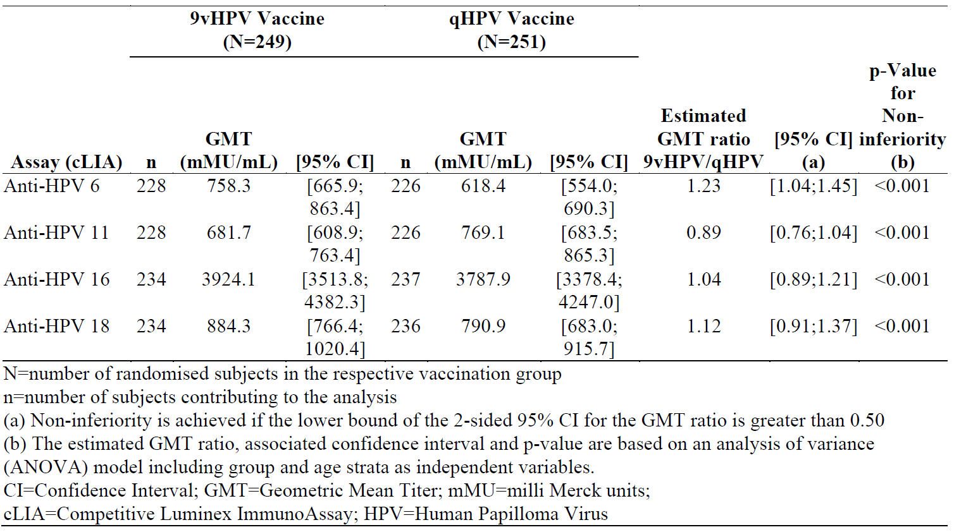

Secondary immunogenicity analyses
Post-third dose anti-HPV 31, 33, 45, 52 and 58 GMTs were much higher in the 9vHPV vaccine group than in the qHPV vaccine group. The GMTs in the 9vHPV vaccine group were 794.4, 460.5, 262.9, 430.7, and 691.0 milli-Merck units (mMU)/mL, respectively; in the qHPV vaccine group, these were 14.8, 3.4, 2.5, 1.9, and 5.7 mMU/ml, respectively (Table 7).
Seroconversion by 4 weeks post-third dose, almost all subjects seroconverted to HPV types 6, 11, 16 and 18 with both vaccines, except 7 subjects who did not seroconvert to HPV 6 (4 having received 9vHPV vaccine and 3 having received qHPV vaccine) and 2 subjects who did not seroconvert to HPV 18 (1 in each group) (Table 8). All of those who received 9vHPV vaccine seroconverted for HPV types 31, 33, 45, 52 and 58 (Table 9).
Table 8: Study V503-020 Secondary endpoint results: comparison of geometric mean titres by group (per-protocol immunogenicity set)
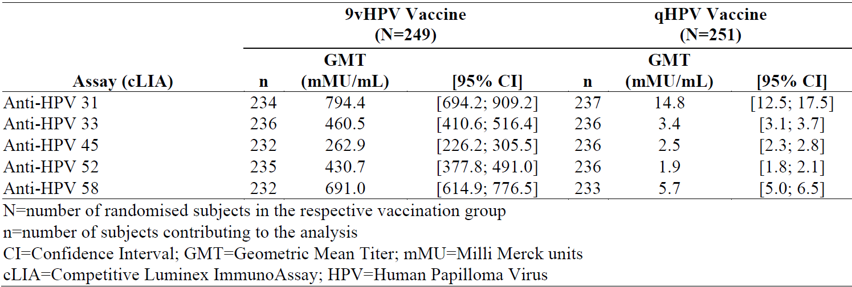
Table 9: Study V503-020 Secondary endpoint results: anti-HPV types 6, 11, 16 and 18 seroconversion percentages at 4 weeks by group (per-protocol immunogenicity set)
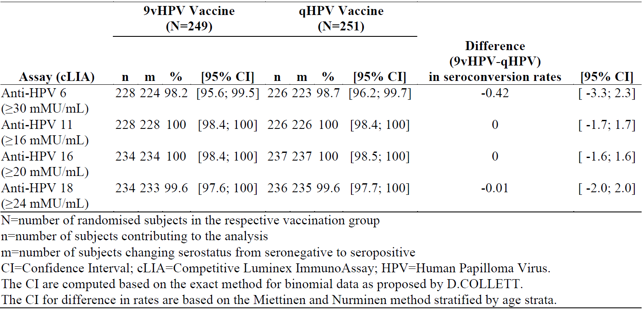
Table 10: Study V503-020 Secondary endpoint results: anti-HPV types 31, 33, 45, 52 and 58 seroconversion percentages at 4 weeks by group (per-protocol immunogenicity set)
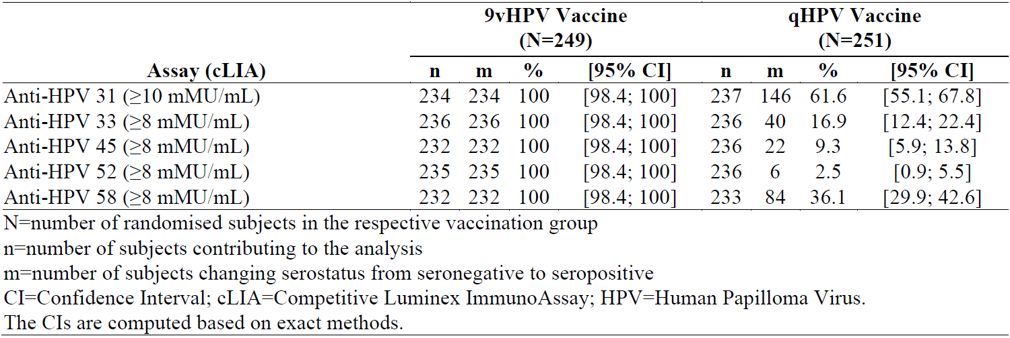

Post-hoc cross-study immunogenicity analysis of Gardasil
Post-hoc cross-study immunogenicity analysis (Study V501-108 versus Study V501-020) conducted to compare HPV 6, 11, 16, and 18 antibody GMTs at Month 7 in men who received three doses of qHPV vaccine:
- Study V501-108: men aged 27 to 45 years old; versus
- Study V501-020: men aged 16 to 26 years old (pivotal efficacy study of qHPV vaccine that demonstrated efficacy in males, previously evaluated)

Primary objective of Study V501-108
Primary objective of Study V501-108 was to establish the immunogenicity of qHPV among mid-adult men. 150 adult men aged 27 to 45y were enrolled to receive a three-dose series of qHPV vaccine (at Day 1, Month 2 and Month 6). Antibody response to HPV 6, 11, 16, and 18 was assessed at Month 7 by chemiluminescence immunoassay (cLIA). The sponsor dossier does not include a clinical study report for Study V501-108, but instead has presented a journal article.

Primary objective of Study V501-020
Primary objective of Study V501-020 was to determine qHPV vaccine efficacy in preventing external genital lesion related to HPV types 6, 11, 16 and/or 18 in men who were naïve to these HPV types at Baseline, following a completion of three dose course of vaccination administered at Day 1, Month 2 and Month 6. The design was randomised, double blind, and placebo controlled. A total of 4,065 men 16 to 26 year of age were enrolled. Antibody response to HPV 6, 11, 16, and 18 was assessed at Month 7.
Based on analysis of the PPI populations, GMT ratios (men aged 27 to 45 years versus men aged 16 to 26 years) ranged from 0.74 to 0.91. The lower bound of the 95% CI of the GMT ratio was greater than 0.50 for each HPV type (ranging from 0.59 to 0.72) (Table 11).
Table 11: Comparison of anti-HPV geometric mean titres at Month 7 in men vaccinated with quadrivalent Human Papillomavirus vaccine 27 to 45 years of age (Study V501-108 †) versus 16 to 26 years of age (Study V501-020), per protocol immunogenicity sets.
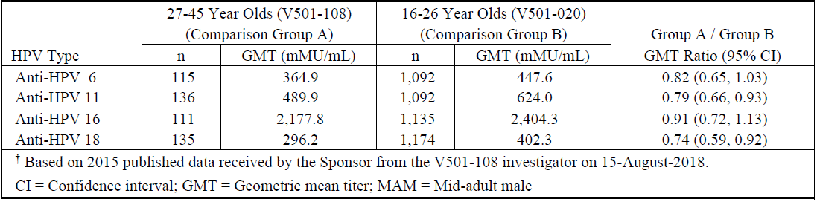
Studies V501-108 and V501-020 were performed as separate clinical trials in different populations and settings, and it is not entirely clear whether the GMTs can be directly compared without bias.
As part of the response to TGA questions, the sponsor stated that the selection criteria for Studies V501-108 and V501-020 were largely similar, and the key characteristics of the two studies were comparable (other than age of the participants). The same immunoassay (HPV-4 cLIA) was used in both studies. There were some differences due to the fact that the two studies were performed in different sites and settings. While comparison of the two studies has some limitations (including that of a post-hoc analysis), the evaluator acknowledged that it offers some insight into how HPV type 6, 11, 16, 18 immunogenicity compares between young and mid-adult men post-vaccination.

Long term follow up study
Gardasil 9 extension studies include Studies V503-001-04, V503-002-20, V503-010-01, V503-021-01.

Study V503-001-04
Study V503-001-04 (previously evaluated in submission PM-2014-01099-1-2): sub-study extension of the Study V503-001 base study to assess persistence of immune response and immune memory following Gardasil 9 vaccination.
The study enrolled a subset of 150 subjects (women aged 16 to 26 years of age) who received three doses of 9vHPV vaccine and completed the base study. After which they were followed in Study V503-001-04 extension study to assess antibody persistence through a five years post-vaccination, and then received a fourth dose at five years post-third dose to assess an anamnestic response consistent with the generation of immune memory.
Figure 1: Study V503-001-04. Longitudinal Anti-HPV chemiluminescence immunoassay geometric mean titres
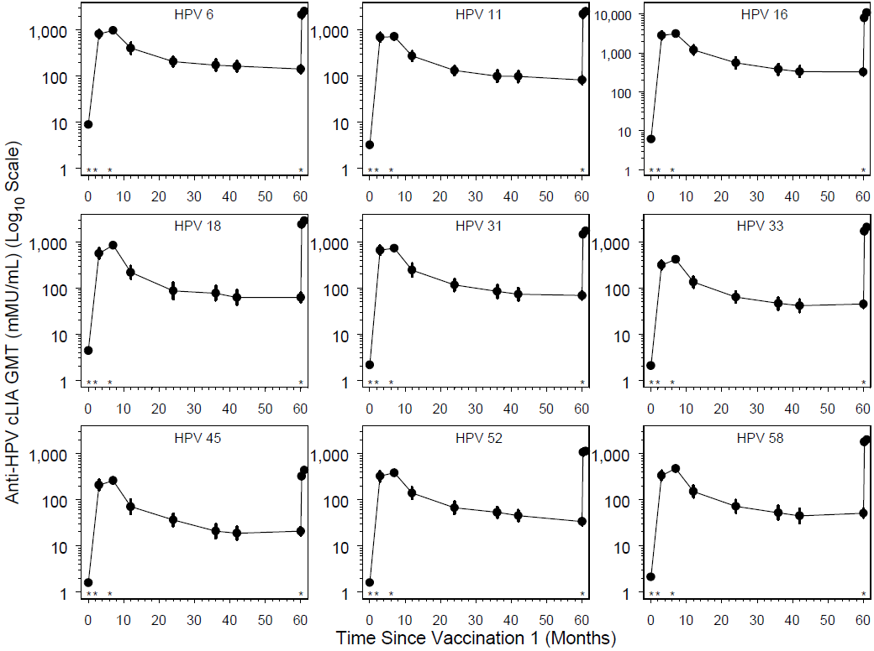
The three dose primary series of 9vHPV vaccine induced substantial antibody responses to the 9 vaccine HPV types. GMTs for the 9 HPV types peaked around Month 7 and declined thereafter, reaching a plateau around Month 24 and remaining stable through Month 60 (Figure 1).
Administration of a fourth dose at Month 60 resulted in a rapid increase of anti-HPV6, 11, 16, 18, 31, 33, 45, 52, and 58 GMTs which were higher than those observed at Month 7 for all 9 HPV types (Figure 1).
Seropositivity rates at Month 7 were 100% for the 9 HPV types. At Month 60, they ranged from 77.5% to 100%, depending on the HPV type. At 1 week after the administration of the fourth dose, seropositivity rates ranged from 99.3% to 100%. They were 100% for the 9 HPV types at 1 month after the fourth dose (Figure 1).

Study V503-002-20
Extension of Study V503-002 (evaluated in previous submission)⁶, an immunogenicity study of the 9vHPV vaccine in 1,935 girls aged 9 to 15 years of age and 669 boys aged 9 to 15 years of age with a non-inferiority comparison to 470 women aged 16 to 26 years of age, to assess immunogenicity and effectiveness of the Gardasil 9 vaccine through 10 years post-third dose. The young women terminated the study at Month 12; girls and boys continued in the first study extension (Study V503-002-10) to assess persistence of antibody response through Month 36.
Study V503-002-20 is an ongoing study extension to provide immunogenicity, effectiveness and safety follow up through Month 126 (10 years post-third dose) for girls and boys aged 9 to 15 years of age who received three doses of 9vHPV vaccine in the base study.
A total of 1125 subjects (864 females and 261 males) who received three doses of the 9vHPV vaccine in the base study participated in the long term follow up study and were followed for effectiveness in the per protocol efficacy (PPE) population for a maximum of 8.2 years (median: 7.6 years) post-third dose. Female subjects were followed for up to 8.2 years (median: 7.6 years) post-third dose; male subjects were followed for up to 8.1 years (median: 7.6 years) post-third dose.
One case of HPV6/11/16/18/31/33/45/52/58-related low grade cervical dysplasia was observed for one female subject 9 to 15 years of age in the PPE population (856 subjects, 2865 person-years follow up).
No cases of HPV6/11/16/18/31/33/45/52/58-related penile intraepithelial neoplasia genital warts, or penile/perineal/perianal cancer were observed in boys 9 to 15 years of age in the PPE population (251 subjects, 808.8 person-years follow up).
Incidence rates of HPV6/11/16/18/31/33/45/52/58-related six-month persistent infection in females and males were 49.2 and 37.3 per 10,000 person-years, respectively, and within ranges expected in vaccinated cohorts (based on results from previous efficacy studies of qHPV and 9vHPV vaccines).
In the response to TGA questions, the sponsor provided the final analysis. Persistence of antibody responses to vaccine targeted HPV types was demonstrated through the end of the study. Based on follow up through Month 126 (10 years post-third dose), no cases of high-grade dysplasia related to vaccine targeted HPV types were observed. Incidence rates of vaccine HPV types related six-month persistent infections in girls and boys observed during the study were 52.4 (95% CI; 33.6 to 78.0) and 54.6 (95% CI; 21.9 to 112.4) per 10,000 person-years, respectively (within ranges of incidence rates expected in vaccinated cohorts of similar age).

Study V503-010-01
Extension of Study V503-010 evaluated in previous submission.
Study V503-010-01: an international immunogenicity study of 9vHPV vaccine conducted in boys and girls aged 9 to 14 years of age and in females aged 16 to 26 years of age enrolled from 15 countries to compare the immunogenicity of two dose and three dose regimens of 9vHPV vaccine.
The study enrolled three cohorts who received two doses, and two cohorts who received three doses, including:
- Group A (girls who were vaccinated at Day 1 and Month 6 (N = 301))
- Group B (boys who were vaccinated at Day 1 and Month 6 (N = 301))
- Group C (girls who were vaccinated at Day 1, Month 2, and Month 6 (N = 301))
- Group D (young women who were vaccinated at Day 1, Month 2, and Month 6 (N = 314))
The Month 36 immunogenicity results demonstrated persistent HPV antibody responses through three years post-vaccination onset in girls and boys 9 to 14 years of age who received a two-dose regimen of 9vHPV vaccine. GMTs in girls and boys 9 to 14 years of age who received two doses of 9vHPV vaccine were non-inferior to GMTs in young women 16 to 26 years of age who received three doses.
Anti-HPV GMTs were highest at 1 month after the completion of the two dose or three dose series, decreased sharply thereafter during the subsequent 6 to 12 months, and then decreased more slowly through Month 36. A similar result was seen for the GMTs assessed by using the IgG line immunoassay.

Study V503-021-01
Study V503-021 is an extension of Study V503-001; the base study was evaluated in previous evaluation.6
Study V503-001 was a Phase IIb/III randomised international, double blind, active controlled (qHPV vaccine), dose ranging, tolerability, immunogenicity and efficacy study of the 9vHPV vaccine in women aged 16 to 26 years of age. Its pivotal analysis was to demonstrate non-inferior immunogenicity in females (16 to 26 years) versus qHPV vaccine. A summary of the main results is shown in Table 12.
Table 12: Study V503-001 main results (per protocol efficacy analysis population).
Study V503-021-01 is an ongoing extension of Study V503-001 base study in Scandinavian countries (women vaccinated at age 16 to 26 years of age). It differs from the base study to allow the establishment of a new, separate clinical electronic database (base study follow up: up to six years, but median four years; extension study follow up: up to an additional 10 years with interim analyses at Years 2, 4, 6, and 8 of the study extension and the final analysis at Year 10).
Primary effectiveness objective: to assess the long-term effectiveness of 9vHPV vaccine by monitoring the combined incidence of HPV16/18/31/33/45/52/58-related cervical intraepithelial neoplasia (CIN) 2, CIN3, AIS, and cervical cancer.
Year 4 interim analysis (January 2014 to January 2018, that is approximately 8 years of follow up after the first dose):
- 1,448 subjects (PPE population) contributed 4,084.2 person-years of follow up since the start of the extension study.
- No cases occurred of HPV16/18/31/33/45/52/58-related:
  - CIN2 or worse (primary endpoint)
  - CIN, vulvar cancer, and vaginal cancer (secondary endpoint).
- Of note, two cases of HPV16/18/31/33/45/52/58-related CIN (1 case each for CIN1 and CIN2) or worse occurred in the Study V503-001 base study.
The follow up for immunogenicity is based on serum collection at Year 5 and Year 10 of the extension (not provided in sponsor dossier). The Year 4 analysis only covers effectiveness (Table 13).
Table 13: Study V503-021-01 Year 4 interim analysis, effectiveness against HPV 16/18/31/33/45/52/58-related CIN2, CIN3, AIS, and cervical cancer by time since the start of the long term follow up study (Cohort 1 – per-protocol efficacy population).

Long term follow up Studies with Gardasil (qHPV)
Gardasil extension studies, Studies V501-015-021, V501-018, V501-019-21, V501-020-21 have been evaluated previously. Study V501-167 is summarised as below.
The base study was a randomised clinical trial that assessed the immunogenicity of a two-dose schedule of the Gardasil in adolescents 9 to 13 years of age compared to a three dose schedule in young women 16 to 26 years of age for up to three years post-vaccination. The extension study conducted provides additional immunogenicity follow up through 10 years post-vaccination.
The study demonstrated that girls who received two doses of qHPV vaccine (N = 259) achieved HPV6, 11, 16, and 18 GMTs at Month 7 that were non-inferior compared with young women 16 to 26 years of age (N = 310) and with girls (N = 261) who received three doses. The non-inferiority criterion required that the lower bound of the 95% CI of the GMT ratio (two dose in adolescents/three dose in women) be > 0.5.
At Month 36, the trend of GMT ratio greater than 0.5 in comparison with young women was maintained through Month 36. The trend of GMT ratio greater than 0.5 in comparison with the girls who received three doses (that is two dose in adolescents/three dose in adolescents) was not maintained through Month 36 for HPV types 6 and 18, suggesting a faster waning of antibodies in girls who receive two doses of qHPV vaccine.
At Month 60, for a post-hoc analysis, a subset of 101 girls who received the two dose (50 girls) or three dose (51 girls) schedule had a follow up serology evaluation at Month 60. Women who received the three-dose schedule were not followed for serology evaluation at Month 60.
At Month 120, for a second post-hoc analysis, a subset of 73 girls who received the two dose (35 girls) or three dose (38 girls) schedule had a follow up serology evaluation at Month 60. Women who received the three-dose schedule were not followed for serology evaluation at Month 60.
The HPV6, 11, 16, and 18 antibody responses (assessed by cLIA) declined through Month 120 at a similar level for both groups (but with seropositivity rates at Month 120 greater than 80% for the two-dose group and greater than 90% for the three dose group).
Seropositivity rates at Month 60 in girls who received two doses were 96%, 100%, 100%, and 84% for HPV6, 11, 16, and 18, respectively. They were 98%, 100%, 100%, and 94% in girls who received three doses (Table 14).
Table 14: Study V501-167. Seropositivity rates and GMTs at Months 36 and 60 among girls aged 9 to 13 years receiving 2 vs 3 doses of qHPV vaccine
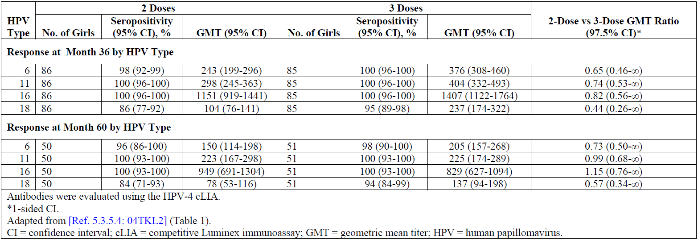
Seropositivity rates at Month 120 for all schedules were greater than 95% for HPV6, 11, and 16 and trended lower for HPV18 (remaining greater than 80% and greater than 90% in girls who received two doses or three doses, respectively; women who received three doses had the lowest seropositivity rate at Month 120: 60%; 95% CI 40.6, 77.3). GMTs are shown in Table 15.
Table 15: Study V501-167. GMTs and GMT ratios at Months 7, 24, and 120 among girls aged 9 to 13 years receiving 2 or 3 doses and women 16 to 26 years receiving 3 doses of qHPV vaccine.
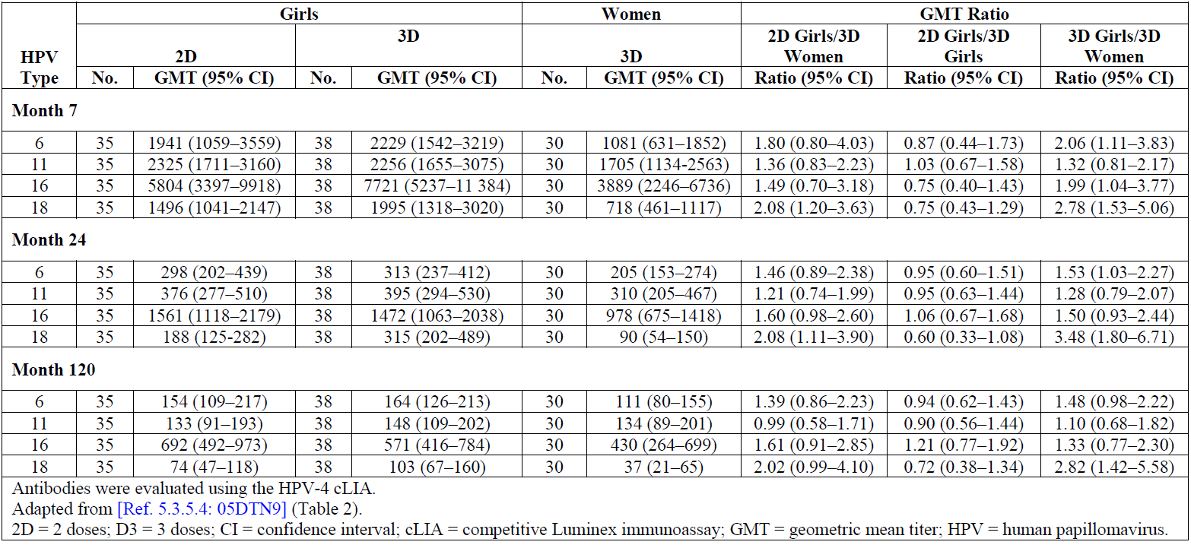

Oropharyngeal and other head and neck cancers
Study V503-049 has no study report; only a study protocol was provided. The overall Gardasil and Gardasil 9 clinical trial program is also used as supportive evidence.

Ongoing Study V503-049
For the head and neck indication, the sponsor is conducting Study V503-049. This is a Phase III, international multicentre, double blind, randomised, placebo controlled trial to study the efficacy, immunogenicity and safety of the 9vHPV vaccine in adult males aged 20 to 45 years of age. This patient population was chosen, as oral infection with high-risk HPV types is approximately 3 to 5 times more prevalent in males than in females.
Participants are randomly assigned in a 1:1 ratio to receive either Gardasil 9 or placebo. Oral rinse and gargle samples will be collected and tested for HPV by polymerase chain reaction to determine the endpoints.
The primary endpoint is HPV-related oral infection persistent for 6 months (plus/minus 1month window) or longer (Table 16). This study will also assess immunogenicity and safety of Gardasil 9 as secondary objectives. It is a case driven study without an interim analysis. The final analysis will be conducted after at least 20 primary endpoint cases are collected. The sponsor estimates that it will require approximately 53 months (4 to 5 years) until 20 cases are collected. This is based on a rate of 0.3% per year in 6000 participants.
The study is ongoing, with the first subject was enrolled on 27 February 2020. The estimated Study completion date is fourth quarter 2025 with the final report expected in third quarter, 2026.
Table 16: Study V503-049 (PN049). Overview of objectives and endpoints
Primary objective | Corresponding primary endpoint
To demonstrate that a 3-dose regimen of the 9vHPV vaccine will reduce the incidence of HPV 16/18/31/33/45/52/58-related oral persistent infection 6 months (± 1-month window) or longer compared with placebo in males 20 to 45 years of age.  Statistical success criterion: lower bound of the 2-sided 95% CI of vaccine efficacy is >20%. | HPV 16/18/31/33/45/52/58-related oral persistent infection 6 months (± 1-month window) or longer.
Secondary objectives | Corresponding secondary endpoints
To demonstrate that a 3-dose regimen of the 9vHPV vaccine will reduce the incidence of HPV 6/11-related oral persistent infection 6 months (± 1-month window) or longer compared with placebo in males 20 to 45 years of age.  Statistical success criterion: lower bound of the 2-sided 95% CI of vaccine efficacy is >0%. | HPV 6/11-related oral persistent infection 6 months (± 1-month window) or longer.
To summarise antibody responses (GMT and seroconversion percentages) to each of HPV 6, 11, 16, 18, 31, 33, 45, 52, and 58 at Month 7. | Serum antibody titre to each of HPV 6, 11, 16, 18, 31, 33, 45, 52, and 58.
To evaluate the safety and tolerability of the 9vHPV vaccine when administered to males 20 to 45 years of age. | Solicited injection-site adverse events.  Systemic adverse events.  Serious adverse events.

Safety

Exposure
Mid adult person studies:
- In Study V503-004, 1210 subjects (570 in the 16 to 26 years group and 640 in the 27 to 45 years group) received at least one dose of study vaccine and were included in the safety analysis.
- In Study V503-020, 500 subjects (249 in the 9vHPV vaccine group and 251 in the qHPV vaccine group) received at least one dose of study vaccine. 496 of the 500 subjects (248 in the 9vHPV vaccine group and 248 in the qHPV vaccine group) were included in the safety analysis
Long-term follow up studies:
- 150 patients received a fourth dose of 9vHPV vaccine at Month 60 in Study V503-001-04 after receiving three doses of 9vHPV vaccine in the Study V503-001 base study.
- 1272 patients enrolled in Study V503-002-20 received at least one dose of 9vHPV vaccine in the Study V503-002 base study.
- 1516 patients received at least one dose of 9vHPV vaccine in Study V503-010-01.
- 2029 and 2036 patients who received 9vHPV and qHPV vaccines in the Study V503-001 base study, respectively, were enrolled in the Study V503-021-01 study in registry searches for safety information.

Adverse event overview
Mid adult person studies:
In Study V503-004, the most common injection-site adverse events (AE) (frequency greater than 5%) were injection-site pain, injection site swelling, and injection site erythema (82.8%, 23.3%, and 16.9% of women 27 to 45 years; and 86.1%, 23.3%, and 19.5% of women 16 to 26 years). The proportion of subjects reporting these AE was similar in the two vaccine groups. Most events were mild or moderate in intensity with severe injection-site pain reported in 1.9% versus 3%. All injection site AEs were non-serious.
An analysis of difference in the percentage of solicited injection site AEs (Day 1 to Day 15 following any vaccination) in the 27 to 45 years group versus the 16 to 26 years group revealed no significant differences (p value greater than 0.05) (Table 17). The incidence of AEs between Day 1 and Month 7 also showed no notable difference between the two age groups.
Table 17: Study V503-004 Analysis of subjects with severe injection site adverse events (incidence greater than 0% in one or more age groups) (Days 1 to 5 following any vaccination visit) (all vaccinated subjects).
The most common vaccine-related systemic AE (frequency greater than 5%) (Day 1 to Day 15 following any vaccination) was headache (13.6% versus 12.6%). 64.4% in the 27to 45 years group and 66.3% in the 16 to 26 years group experienced at least one systemic AE.
Overall, there was no notable difference between the two age groups with respect to the incidence of systemic AEs between Day 1 and Day 15 (Table 18) or between Day 1 and Month 7.
Table 18: Study V503-004 Analysis of subjects with systemic adverse events by System Organ Class (incidence ≥ 1% in one or more age groups) (Days 1 to 15 following any vaccination visit) (all vaccinated subjects)
In Study V503-020, the most common injection site AEs (frequency greater than 5%) were injection site pain, erythema, and swelling (77.8%, 15.3%, and 14.5% of subjects in the 9vHPV vaccine group; and 70.2%, 17.3%, and 9.3% of subjects in the qHPV vaccine group). The proportion of subjects with AEs was similar in the 2 vaccine groups. Most events were mild or moderate in intensity. Severe injection-site reactions occurred in three subjects (1.2%) (9vHPV) and four subjects (1.6%) (qHPV).
Systemic AEs were reported for 40.7% in the 9vHPV group and 40.3% in the qHPV group between Day 1 and Day 15. These AEs were considered vaccine-related for 23.0% versus 21.8% of the subjects. The most frequently reported systemic AEs were headache (all: 11.7% versus 14.9%) (considered vaccine-related: 8.1% versus 8.9%), nasopharyngitis (4.4% versus 5.6%), diarrhoea (2.8% versus 4.8%), pyrexia (3.6% versus 3.2%), and oropharyngeal pain (3.2% versus 3.6%). Overall, there was no notable differences between the two groups.

Long-term follow up studies
In Study V503-001-04, the proportion of subjects who reported at least 1 AEs on Days 1 to 15 following the fourth vaccination (87.3%) was higher compared to Visits 1, 2, and 3 in the main study (80.7%, 76%, 72%). There was a higher rate of injection site AEs following the fourth dose (84%) compared to Dose 1, 2, and 3 (70.7%, 69.3%, and 67.3%). After the fourth dose of 9vHPV vaccine:
- The most common injection site AEs (frequency greater than 2%) reported after the fourth dose of 9vHPV vaccine were injection site pain, injection site swelling, and injection site erythema (82.7%, 32.7%, and 22% of subjects, respectively); most were mild or moderate in intensity.
- The most common vaccine-related systemic AEs (frequency greater than 2%) were headache and pyrexia (6.7% and 3.3% of subjects, respectively).
Studies V503-002-20 and V503-010-01 did not record AEs (only serious adverse events [SAE] and deaths).
Study V503-021-01 collected data related to ‘new medical conditions’ based on registry searches in Scandinavian countries:
- 39.7% of patients who received 9vHPV vaccine in the base study (Cohort 1) and 38.6% of patients who received qHPV vaccine in the base study (Cohort 2) had at least one new medical condition during the first four years of the study extension. Most were in the System Organ Class (SOC) of ‘pregnancy, puerperium and perinatal conditions’ (22.4% and 21.4% of subjects in Cohorts 1 and 2, respectively) and ‘surgical and medical procedures’ (20.1% and 20.4%) that were mostly pregnancy related. Other new medical conditions were diverse and affected various system organ classes.
- There was no specific pattern of new medical conditions within or between the two cohorts.

Deaths
Mid adult person studies: In Studies V503-004 or V503-020, no subject died during the study.
Long term follow up studies: In Study V503-010-01, there was one death (cardiac arrest 466 days post-third dose) considered unrelated to vaccination. There were no reported deaths in the other studies.

Serious adverse events
Mid adult person studies: In Study V503-004, 15 SAEs were reported across 14 subjects (all unrelated to the study vaccine). In Study V503-020, SAEs were reported for six subjects in the qHPV (all unrelated to the study vaccine) and no subject in the 9vHPV vaccine group experienced an SAE.
Long-term follow up studies: In Study V503-010-01, one girl (9 to 14 years group) in the (0, 6) regimen reported an SAE of abdominal pain 15 days after the Month 36 vaccination (resolved after 4 days) considered to be related to the study vaccine. No other SAEs were considered related to the study vaccine.

Discontinuations
Mid adult person studies: In Study V503-010-01, one AE in the 27 to 45 years group (migraine with aura at 11 days after first dose; fully resolved and not considered vaccine related) resulted in discontinuation. In Study V503-020, no AE resulted in discontinuation.
Long term follow up studies: In Study V503-010-01, two subjects discontinued study vaccination due to an AE (one due to vaccine related AE of urticaria and one due to a non-related SAE of radiculopathy). No discontinuations occurred in the other studies.

Post-market data
A post-marketing epidemiologic (non-interventional) study was completed in December 2019, titled ‘Post-Licensure Observational Safety Study of Gardasil 9’ (Protocol V503-028). The objective was to describe the general safety of 9vHPV vaccine in males and females receiving at least one dose of 9vHPV vaccine as part of routine medical care. Findings from the study are consistent with the known safety profile of 9vHPV vaccine based on an analysis that includes > 215,000 males and females aged 9 years and older, and greater than 330,000 doses administered as part of routine medical care.
A review of the worldwide post marketing safety data from the time of market introduction for 9vHPV vaccine (December 2014 to December 2021) indicated that the AE profile for males is similar to that for females. There were no new safety concerns identified for male vaccine recipients in any age group.
An analysis of post-licensure surveillance reports to the U.S. Vaccine Adverse Event Reporting System (VAERS) by the Centers for Disease Control and Prevention (United States) and FDA was published in 2019. In this report, the VAERS data of AEs after 9vHPV vaccine administration from December 2014 to December 2017 were reported. Approximately 28 million doses of 9vHPV were distributed over this period. There were 7,244 reports of AEs, of which 97.4% were non-serious. Dizziness, syncope, headache, and injection site reactions were most commonly reported. Crude AE reporting rates were 259 reports per million 9vHPV doses distributed for all reports and 7 per million doses distributed for serious reports. Nine reports of anaphylaxis post 9vHPV vaccination were identified, five of which involved 9vHPV as the sole vaccine administered. No death due to vaccination was identified. No new or unexpected safety concerns or reporting patterns with clinically important AEs were detected. The authors concluded that the safety profile of 9vHPV is consistent with data from pre-licensure trials and from post-marketing safety data of qHPV vaccine.

Risk management plan
The sponsor has applied to extend the indications of human papillomavirus 9-valent vaccine (Gardasil) to include the prevention of oropharyngeal and other head and neck cancers and also increase the use in males age from 9 to 26 years, to 9 to 45 years through the provisional approval pathway (determination granted 7 January 2021). Gardasil is currently indicated in females aged 9 to 45 years for the prevention of cervical, vulvar, vaginal and anal cancer, precancerous or dysplastic lesions, genital warts, and infection caused by HPV types 6, 11, 16, 18, 31, 33, 45, 52 and 58. Gardasil is also currently indicated for males aged 9 to 26 years for the prevention of anal cancer, precancerous or dysplastic lesions, external genital lesions and infection caused by HPV types 6, 11, 16, 18, 31, 33, 45, 52 and 58.
The most recently evaluated EU-risk management plan (RMP) was version 2.0 (1 December 2015; data lock point (DLP) 20 September 2015) and Australia specific annex (ASA) version 1.2 (October 2016). In support of the extended indications, the sponsor has submitted EU-RMP version 4.1 (3 June 2019; DLP 25 February 2019) and ASA version 2.0 (14 April 2021).
With the response to TGA questions, the sponsor submitted ASA version 2.1 (dated 22 March 2022) and approved EU-RMP version 4.2 (dated 31 August 2021; DLP 9 June 2021) to support this application.
The summary of safety concerns and their associated risk monitoring and mitigation strategies are summarised in Table 3. The TGA may request an updated RMP at any stage of a product's life cycle, during both the pre-approval and post-approval phases.
Table 19: Summary of safety concerns
Summary of safety concerns |  | Pharmacovigilance |  | Risk Minimisation
 |  | Routine | Additional | Routine | Additional
Important identified risks | None | – | – | – | –
Important potential risks | None | – | – | – | –
Missing information | Long term effectiveness and immunogenicity |  | * |  | –
Missing information | Exposure during pregnancy |  | ‡ |  | –
The safety concerns in the approved EU-RMP (version 4.2) align with the ASA (version 2.1). The clinical evaluator did not identify any additional safety concerns. Therefore, the safety concerns are satisfactory.
The sponsor has proposed both routine and additional pharmacovigilance activities. Additional pharmacovigilance activities include US Pregnancy register (now closed), and Study V503-021 and Study V503-002-20 which will provide information regarding long term effectiveness and immunogenicity. The pharmacovigilance plan is acceptable. However, Table 2 and 4 of the ASA need to be aligned.
The sponsor has proposed routine risk minimisation activities only which is acceptable. Amendments to the PI and CMI are anticipated after negotiations with the Delegate relating to the provisional wording in the PI and CMI.

Recommended condition/s of registration
Any changes to which the sponsor has agreed should be included in a revised RMP and ASA. However, irrespective of whether or not they are included in the currently available version of the RMP document, the agreed changes become part of the risk management system.
The suggested wording is:
The Gardasil EU-Risk Management Plan (RMP) (version 4.2, dated 31 Aug 2021, data lock point 9 June 2021), with Australia specific annex (version 2.1, dated 22 March 2022), included with submission PM-2021-01645-1-2, and any subsequent revisions, as agreed with the TGA will be implemented in Australia.
The following wording is recommended for the PSUR requirement:
An obligatory component of risk management plans is routine pharmacovigilance. Routine pharmacovigilance includes the submission of periodic safety update reports (PSURs).
Unless agreed separately between the supplier who is the recipient of the approval and the TGA, the first report must be submitted to TGA no later than 15 calendar months after the date of this approval letter. The subsequent reports must be submitted no less frequently than annually from the date of the first submitted report until the period covered by such reports is not less than three years from the date of the approval letter, or the entire period of provisional registration, whichever is longer.
The reports are to at least meet the requirements for PSURs as described in the European Medicines Agency’s Guideline on good pharmacovigilance practices (GVP) Module VII-periodic safety update report (Rev 1), Part VII.B Structures and processes. Note that submission of a PSUR does not constitute an application to vary the registration. Each report must have been prepared within ninety calendar days of the data lock point for that report.
As Gardasil is being considered for a provisional registration it should be included in the Black Triangle Scheme as a condition of registration. The following wording is recommended for the condition of registration:
Gardasil (Human Papillomavirus 9-valent vaccine) is to be included in the Black Triangle Scheme. The PI and Consumer Medicines Information (CMI) for Gardasil must include the black triangle symbol and mandatory accompanying text for the products entire period of provisional registration.
As Gardasil is being considered for a provisional registration the following wording regarding confirmatory trial data is recommended for the condition of registration:
Confirmatory trial data (as identified in the sponsor’s plan to submit comprehensive clinical data on the safety and efficacy of the medicine before the end of the 6 years that would start on the day that registration would commence) must be provided.
Specifically, the sponsor must conduct studies as described in the clinical study plan in version 2.1 (dated 22 March 2022) of the Australia specific annex. The following study report should be submitted to TGA:
- V503-049 (NCT04199689) by fourth quarter of 2026
Further guidance for sponsors is available on the TGA website.

Risk-benefit analysis

Delegate’s considerations and proposed action

Mid adult person indication for males
In Study V503-004, the immunogenicity of 9vHPV vaccine for 7 high-risk HPV types (16, 18, 31, 33, 45, 52, and 58) were compared between women aged 16 to 26 years and 27 to 45 years. The primary non-inferiority endpoint was met with the GMTs ratio analysis (older versus younger women) fulfilling the pre-defined success criterion. The GMT ratios ranged between 0.66 and 0.81 depending on the HPV type. In addition, the anti-HPV seropositivity percentages were greater than 99% for all 9 HPV types following 3 doses of 9vHPV vaccine in women aged 27 to 45y at Month 7.
In Study V503-020, the immunogenicity of qHPV and 9vHPV vaccines were compared in men aged 16 to 26 years. The primary endpoint was met with the GMT ratio (9vHPV/qHPV) for antibodies against HPV types 6/11/16/18 ranging between 0.89 and 1.23, and thus meeting the predefined success criterion. The seroconversion rates against these four HPV types were high (greater than 98%) in both vaccine groups. As expected, the 9vHPV vaccine also produced a strong antibody response against HPV types 31/33/45/52/58, with the seroconversion rates of 100% against these five HPV types.
The post-hoc cross-study immunogenicity analysis between Study V501-108 (men aged 27 to 45 years) versus Study V501-020 (men aged 16 to 26 years) demonstrated similar anti-HPV 6/11/16/18 antibody GMTs. The GMT ratios (men 27 to 45 years/men 16 to 26 years) ranged from 0.74 to 0.91, with the lower bound of the 95% CI of the GMT ratio greater than 0.50 for each HPV type (ranging from 0.59 to 0.72).
From these studies, the following conclusions can be made:
- The 9vHPV vaccine produces a robust immune response in women aged 27 to 45y and are comparable to the response in women aged 16 to 26 years.
- The 9vHPV vaccine produces a robust immune response against HPV types 6/11/16/18 that are comparable to qHPV vaccine in men aged 16 to 26 years.
- The 9vHPV vaccine produces a robust immune response against HPV types 31/33/45/52/58 in men aged 16 to 26 years.
- The qHPV vaccine produces a comparable level of immune response against HPV types 6/11/16/18 in men aged 16 to 26 years and 27 to 45 years.
The sponsor claims that Gardasil and Gardasil 9 are produced using the same manufacturing process. The main difference is the addition of extra HPV types.
Immunisation at an older age appears to be associated with faster waning of immunity. The duration of protection for individuals who receive the vaccine for the first time in their 40s is not clear. However, the sponsor claims that a less favourable immunogenicity result may not necessarily translate into a less favourable efficacy or effectiveness result.
It is not clear whether HPV vaccination in individuals in their 30s and 40s will be of significant benefit, as these individuals are likely to have been exposed to multiple HPV types.
For females aged 27 to 45 years, the presented studies confirm the existing indication.
For males aged 27 to 45 years, the presented studies only indirectly support an extension of indication. Some of the limitations are discussed below.

Limitations
Limitations of the clinical trial program include:
- Efficacy in men aged 27 to 45 years not demonstrated through efficacy or immunogenicity studies: The studies presented do not provide a direct evidence of immunogenicity or efficacy produced by 9vHPV vaccine in men aged 27 to 45 years. Instead, potential extrapolation may include:
  - The immunogenicity observed in women aged 27 to 45 years could be extrapolated to men of the same age.
  - Given that the qHPV vaccine elicits a comparable immune response in men aged 16 to 26 years and 27 to 45 years (with a decrease in immunogenicity greater than 2-fold ruled out), one could extrapolate the result of Study V503-020 to suggest that the 9vHPV vaccine produces a similar immune response against all 9 HPV types in men aged 27 to 45 years as well.
While the evaluator believes that these extrapolations are justifiable, it would be desirable to conduct a 9vHPV vaccine study in men aged 27 years and older. It is noted that the sponsor, for Study V503-049 (oral HPV infection study), plans to conduct an analysis of efficacy in men from the 20 to 26 years and 27 to 45 years subgroups.
- No specific safety data for the 9vHPV vaccine in men aged 27 to 45 years. However, the sponsor considers that the safety profile in adult men is supported by extensive clinical studies to evaluate the safety of Gardasil in men 27 to 45 years of age, and both Gardasil and Gardasil 9 in women 27 to 45 years of age and younger males.
- Generalisability: For both Study V503-004 and Study V503-020, the inclusion and exclusion criteria were rather stringent, and may not adequately reflect the population perceived as in most need of protection through a 9vHPV vaccine. For example, in Study V503-020, males with a history of more than 5 lifetime female sexual partners, or males with any number of male sexual partner (MSM), were excluded. It is noted, that in Study V501-020 included a MSM population, providing some extrapolation opportunities.
- Post-hoc nature of the cross-study immunogenicity analysis: Post hoc study designs are not ideal. The cross-study immunogenicity analysis used data from earlier studies, but their designs were largely similar, and the same immunoassay (HPV-4 cLIA) was used.
- Post-market data: At least some post-market 9vHPV vaccine data in the relevant age group should be available from the US and Europe. This was not presented in the dossier.
Overall, from the clinical evidence provided, for an Australian context, the proposed increase in patient population (to include males aged 27 to 45 years) can be supported for the existing indication of Gardasil 9.
It is noted that the above increase in patient population is also part of the provisional pathway application. It appears that a regular pathway application has not been submitted.

Long term follow up data
Review the evidence provided (mainly long-term immunogenicity results)
Based on these long term follow up results, the following conclusions were made:
- Based on qHPV and 9vHPV study follow-ups ranging from approximately 3 to 14 years post-first dose, most participants remain seropositive throughout the follow-up period.
- Those studies that assessed clinical effectiveness show long term prevention of anogenital disease in males and females who were aged 9 to 26 years at the time of the primary series.
- qHPV and 9vHPV vaccination in boys and girls aged 9 to 15 years is associated with reduced incidence of persistent HPV infection.
- Children (boys and girls) appear to achieve higher immune response post vaccination (qHPV and 9vHPV) compared to young adults. This is demonstrated in Study V501-167 extension and Study V503-010-01.
- An additional dose of 9vHPV vaccine 5 years post-third dose is associated with anamnestic response, with higher GMTs than achieved after the primary series.
Based on these conclusions, qHPV and 9vHPV vaccines appear to produce long term protection against the HPV-related infections and diseases in females aged 9 to 45 years and males aged 9 to 26 years.
Of note, significant waning over time is noted for antibodies against all HPV types. While this is expected, a number of studies have demonstrated that antibodies against HPV 18 show more pronounced waning (including a reduced seropositivity rate) over time compared to other high-risk HPV types. This was particularly pronounced in women aged 26 to 45 years in Study V501-019-21, where the seropositivity rate against HPV 18 fell to 36% at Month 120.
In response, the sponsor stated that given the high seropositivity rate against HPV18 during long term follow up assessed using a more sensitive immunoassay (IgG-LIA) and the consistent observation of high efficacy against HPV6-, HPV11-, HPV16- and 18-related disease demonstrated in the base studies, and the continued protection observed in the corresponding long term follow up study extensions, the decrease in seropositivity against HPV18 as assessed by cLIA cannot be interpreted as decrease in protection. Therefore, the low seropositivity rate against HPV18 by cLIA observed in LTFU studies appears to be of limited clinical significance.

Oropharyngeal and other head and neck cancer indication
The sponsor’s reasoning in support of an oropharyngeal and other head and neck cancer prevention indication is mainly centred around the following themes:

Burden of disease
HPV-related head and neck cancer is a serious disease with a substantial impact on survival and quality of life.
A significant burden of disease is not disputed. However, the burden of disease is unrelated to clinical evidence that a certain disease may be prevented by a vaccine.

Unmet medical need
The sponsor claims that urgent action is needed to address this unmet medical need and prevent HPV-related head and neck cancer. In June 2020, the 9vHPV vaccine was licensed under accelerated approval in the US for the prevention of oropharyngeal and other head and neck cancers related to HPV 16, 18, 31, 33, 45, 52, or 58.
An unmet medical need is not disputed. However, as for burden of disease, any perceived unmet medical need is unrelated to provision of clinical evidence that a certain disease may be prevented by a vaccine.

Prevention of HPV infection
HPV infection is the prerequisite for HPV-related head and neck cancer. The 9vHPV vaccine can address this by preventing HPV-related head and neck cancers, thereby reducing the associated morbidity and mortality and any sequelae associated with the condition and its treatment.
So far, there has been no robust sponsor-conducted study with interim or final results that provide evidence for the prevention of HPV-related infection. Study V503-049 is currently ongoing with no interim results available.

Biological plausibility and surrogate markers
Anogenital and oral mucosae share histological similarities. HPV disease characteristics at different anatomical sites, vaccine mediated protection, natural history, pathogenesis, and epidemiology may also share similarities. The sponsor claims that prevention of HPV related anogenital persistent infection and disease is a surrogate that is reasonably likely to predict prevention of HPV related oral infection and disease. Clinical data regarding prevention of HPV related anogenital infection and disease are available and form the basis to expand the indication of the 9vHPV vaccine to include prevention of certain HPV-related head and neck cancers.
A biological plausibility may be present, but no definite evidence has been provided. Prevention of HPV related anogenital persistent infection and disease has not been established as a definite surrogate endpoint/marker for prevention of HPV related oral infection and disease. The use of persistent oral HPV infection in Study V503-049 is itself a surrogate indicator for HPV related oropharyngeal and other head and neck cancers.

Clinical evidence ongoing sponsor-conducted clinical study
The sponsor is currently conducting a placebo controlled, double blind, randomised study (Protocol V503-049) with a primary endpoint of HPV16/18/31/33/45/52/58-related oral six month persistent infection (designated as a post-licensure confirmatory study) for the indication of HPV related head and neck cancer.
This study is currently ongoing and there are no interim results available. Only males 20 to 45 years of age (identified as a high risk group) were enrolled, but an extrapolation to females would not be considered unreasonable.

Clinical evidence non-sponsor-conducted studies from the literature
Furthermore, there are additional non-sponsor conducted supportive studies from the literature that show favourable results with regard to prevention of oral HPV infections: a study investigating HIV-infected adults aged 27 years and older (Wilkin et al., 2018); 5 recent observational studies reporting an impact of HPV vaccines on oral HPV infection (including Garland et al., 2016).

Public health and regulatory considerations in the Australian context
It is not disputed that oropharyngeal and other head and neck cancers constitute a significant health and public health problem with significant morbidity and mortality.
It is not disputed that the benefit for the existing indication has been demonstrated.
It is noted that an oropharyngeal and other head and neck cancer prevention indication was provisionally approved for the US.
The situation is Australia may be different. Generally, it is desirable to vaccinate prior to exposure to HPV for the greatest benefit. Through the National Immunisation Program, as part of adolescent vaccination at 12 to 13 years of age, Australia has achieved a much higher prevalence of vaccinated individuals compared to other jurisdictions. Furthermore, the already existing indications may likely provide a large enough incentive for HPV vaccination, even in the absence of an oropharyngeal and other head and neck cancer prevention indication.
Adding an oropharyngeal and other head and neck cancer prevention indication in the absence of definite clinical evidence needs to be carefully considered.
Advice from the Advisory Committee on Vaccines (ACV) is requested.

Advisory Committee considerations
The Advisory Committee on Vaccines (ACV), having considered the evaluations and the Delegate’s overview, as well as the sponsor’s response to these documents, advised the following.

Specific advice to the Delegate
The ACV advised the following in response to the Delegate’s specific request for advice:
- Can the ACV comment on whether the available data are sufficient to support an extension of indication to include prevention of oropharyngeal and other head and neck cancers as proposed by the sponsor?
The ACV advised that the available data were not sufficient to support an extension of indication to include prevention of oropharyngeal and other head and neck cancers for provisional registration.
While it is biologically plausible to suggest that 9vHPV vaccine could prevent a proportion of oropharyngeal and oral cavity cancers caused by HPV, there are no available data to support this indication. The endpoint of prevention of persistent HPV infection as a surrogate for prevention of cancer is not as strong for head and neck cancers as for cancers in other sites
A randomised clinical trial is underway to determine whether Gardasil 9 reduces persistent oral HPV infection, but the trial is not designed to directly demonstrate the prevention of head and neck cancers. However, it is noted that there are no surrogate markers analogous to carcinoma in situ in other sites.
- The committee is also requested to provide advice on any other issues that it thinks may be relevant to a decision on whether or not to approve this application.
The ACV advised that based on previous extensions to the indications for Gardasil there is sufficient evidence on the safety and immunogenicity of Gardasil 9 to extend the upper age limit for males to 45 years of age.

Conclusion
The ACV considered this product to have an overall positive benefit-risk profile for the indication:
Gardasil 9 is indicated in males 9 to 45* years of age for the prevention of anal cancer, precancerous or dysplastic lesions, external genital lesions and infection caused by HPV types 6, 11, 16, 18, 31, 33, 45, 52 and 58 (which are included in the vaccine).
Regarding the proposed extension of indication by provisional registration of:
Gardasil 9 is indicated in females aged 9 to 45 years*, and males aged 9 to 45 years, for the prevention of oropharyngeal and other head and neck cancers caused by Human Papillomavirus (HPV) Types 6, 11, 16, 18, 31, 33, 45, 52 and 58
The ACV considered that an overall positive benefit-risk profile has not been demonstrated and that the outcomes of the ongoing clinical trial, based on surrogate evidence (persistent HPV oral infection) should be awaited.

Outcome
Based on a review of quality, safety, and efficacy, the TGA approved the registration of Gardasil 9 (human papillomavirus 9-valent vaccine, recombinant), 30 µg of human papillomavirus (HPV) 6 recombinant major capsid (L1) protein, 40 µg of HPV 11 L1 protein, 60 µg of HPV 16 L1 protein, 40 µg of HPV 18 L1 protein, 20 µg of HPV 31 L1 protein, 20 µg of HPV 33 L1 protein, 20 µg of HPV 45 L1 protein, 20 µg of HPV 52 L1 protein, and 20 µg of HPV 58 L1 protein/0.5 mL, suspension for injection, syringe and vial, for the following extension of indications:
Gardasil 9 is indicated in males aged 9 to 45 years* for the prevention of anal cancer, precancerous or dysplastic lesions, external genital lesions, and infection caused by Human Papillomavirus (HPV) types 6, 11, 16, 18, 31, 33, 45, 52 and 58 (which are included in the vaccine).
*Evidence of vaccine efficacy is based on the core efficacy population of females aged 16 to 26 years. Immunogenicity studies have been conducted to link efficacy to younger populations (females and males aged 9 to 15 years). Immunogenicity studies of Gardasil 9 have been conducted relating to females over 26 years of age (see section5.1 CLINICAL TRIALS for Gardasil 9).
The full indications are now:
Gardasil 9 is indicated in females aged 9 to 45 years* for the prevention of cervical, vulvar, vaginal and anal cancer, precancerous or dysplastic lesions, genital warts, and infection caused by Human Papillomavirus (HPV) types 6, 11, 16, 18, 31, 33, 45, 52 and 58 (which are included in the vaccine).
Gardasil 9 is indicated in males aged 9 to 45 years* for the prevention of anal cancer, precancerous or dysplastic lesions, external genital lesions, and infection caused by Human Papillomavirus (HPV) types 6, 11, 16, 18, 31, 33, 45, 52 and 58 (which are included in the vaccine).
*Evidence of vaccine efficacy is based on the core efficacy population of females aged 16 to 26 years. Immunogenicity studies have been conducted to link efficacy to younger populations (females and males aged 9 to 15 years). Immunogenicity studies of Gardasil 9 have been conducted relating to females over 26 years of age (see section 5.1 CLINICAL TRIALS for Gardasil 9).

Specific conditions of registration applying to these goods
- As a post-registration commitment, a RMP prepared to the satisfaction of the TGA will be implemented in Australia.
- An obligatory component of risk management plans is routine pharmacovigilance. Routine pharmacovigilance includes the submission of periodic safety update reports (PSURs).
Reports are to be provided in line with the current published list of EU reference dates and frequency of submission of PSURs until the period covered by such reports is not less than three years from the date of the approval letter.
The reports are to at least meet the requirements for PSURs as described in the European Medicines Agency’s Guideline on good pharmacovigilance practices (GVP) Module VII-periodic safety update report (Rev 1), Part VII.B Structures and processes.
Note that submission of a PSUR does not constitute an application to vary the registration.
- The final clinical study report (CSR) for Study V503-021-01 should be provided to the TGA, once available.

Attachment 1. Product Information
The PI for Gardasil 9 approved with the submission which is described in this AusPAR is at Attachment 1. For the most recent PI, please refer to the TGA PI/CMI search facility.

Therapeutic Goods Administration
PO Box 100 Woden ACT 2606 Australia
Email: info@tga.gov.au Phone: 1800 020 653 Fax: 02 6203 1605
https://www.tga.gov.au
Reference/Publication #

This is the original indication proposed by the sponsor when the TGA commenced the evaluation of this submission. It may differ to the final indication approved by the TGA and registered on the Australian Register of Therapeutic Goods.
Gardasil was first registered in Australia on 22 June 2006. ARTG number: 114408, 114410
Cervarix was first registered in Australia on 18 May 2007. ARTG number: 126114, 126115
Gardasil 9 was first registered in Australia on 29 June 2015. ARTG number: 224092, 224093
A provisional determination for the originally proposed extension of indications was granted on 7 January 2021. On 4 April 2023, this determination was revoked at the sponsor’s request. The sponsor applied for the extension of indication regarding an increase of the male age group from 9-26 years to 9-45 years to be considered as an application for full registration, and in this application the sponsor did not include an oropharyngeal and other head and neck cancer component.
International scientific guideline: Guideline on clinical evaluation of new vaccines - EMEA/CHMP/VWP/164653/2005 adopted by the Therapeutic Goods Administration (TGA)
AusPAR for Gardasil (human papillomavirus (Types 6, 11, 16 & 18) quadrivalent recombinant vaccine) available at https://www.tga.gov.au/resources/auspar/auspar-human-papillomavirus-types-6-11-16-18-quadrivalent-recombinant-vaccine
Giuliano AR, et al. Immunogenicity and safety of Gardasil among mid-adult aged men (27-45 years)--The MAM Study. Vaccine. 2015;33(42):5640-5646.
AusPAR for Gardasil 9 (Human Papillomavirus 9 valent vaccine), available at https://www.tga.gov.au/resources/auspar/auspar-human-papillomavirus-9-valent-vaccine
CIN2/3 are abnormal cells are found on the surface of the cervix. CIN 2/3 is usually caused by certain types of human papillomavirus (HPV) and is found when a cervical biopsy is done. CIN 2/3 has features of CIN 2 and CIN 3. It is not cancer, but may become cancer and spread to nearby normal tissue if not treated. Treatment for CIN 2/3 may include cryotherapy, laser therapy, loop electrosurgical procedure (LEEP), or cone biopsy to remove or destroy the abnormal tissue. Also called cervical intraepithelial neoplasia grade 2/3.
AIS is a condition in which abnormal cells are found in the glandular tissue, which lines certain internal organs and makes and releases substances in the body, such as mucus, digestive juices, and other fluids. These abnormal cells may become cancer and spread into nearby normal tissue. AIS occurs most often in the cervix and lung. Also called adenocarcinoma in situ.
Wilkin TJ, et al. 2018. A randomized, placebo-controlled trial of the quadrivalent human papillomavirus vaccine in human immunodeficiency virus-infected adults aged 27 years or older: AIDS Clinical Trials Group protocol A5298. Clin Infect Dis 67(9):1339-46.
Garland SM, et al. 2016. Impact and Effectiveness of the Quadrivalent Human Papillomavirus Vaccine: A Systematic Review of 10 Years of Real world Experience. Clin Infect Dis 63(4):519-27.

