Guidance on the regulation of listed disinfectants in Australia
Version 2.1, July 2023

Copyright
© Commonwealth of Australia 2023
This work is copyright. You may reproduce the whole or part of this work in unaltered form for your own personal use or, if you are part of an organisation, for internal use within your organisation, but only if you or your organisation do not use the reproduction for any commercial purpose and retain this copyright notice and all disclaimer notices as part of that reproduction. Apart from rights to use as permitted by the Copyright Act 1968 or allowed by this copyright notice, all other rights are reserved and you are not allowed to reproduce the whole or any part of this work in any way (electronic or otherwise) without first being given specific written permission from the Commonwealth to do so. Requests and inquiries concerning reproduction and rights are to be sent to the TGA Copyright Officer, Therapeutic Goods Administration, PO Box 100, Woden ACT 2606 or emailed to <tga.copyright@tga.gov.au>.

Contents
Introduction 4
Information required to support your application 4
Formulation 5
Australian approved names (AANs) 5
Proprietary ingredients 5
Microbial efficacy 6
Residual activity 6
Transitional Arrangements 6
Toxicity 6
Packaging requirements 7
Labelling requirements 8
How to make your application to TGA 8
Applications for multiple products 8
Submitting your application 9
Step 1 - Login to TGA Business Services 9
Step 2 - Select the relevant application type 10
Step 3 – Complete the application form and attach all relevant documents 10
Attaching supporting documents 13
Fees and charges 15
Application fee 15
Evaluation fee 15
Annual charges 16
Post-market - ongoing responsibilities 16
Advertising 16
Varying a disinfectant entry that is in the ARTG 17
Notifying TGA of variations to listed disinfectants in the ARTG 17
Fees for variations 17
Proposed changes 18

Introduction
An overview of how products commonly known as disinfectants and sterilants are defined and regulated can be found on the TGA website. This guidance relates to products that meet the definition of a listed disinfectant. Listed disinfectants make specific claims, as outlined in the claim guide, and must be included in the Australian Register of Therapeutic Goods (ARTG) and meet all requirements as set out in the following legislation before they can be supplied:
- Therapeutic Goods Act 1989 (the Act);
- Therapeutic Goods Regulations 1990 (the Regulations);
- Therapeutic Goods Advertising Code (No.2) 2018;
- Therapeutic Goods (Single Therapeutic Goods) Order No.1 of 1991; and
- Therapeutic Goods (Standard for Disinfectants and Sanitary Products (TGO 104) Order 2019(link is external) and TGA Instructions for disinfectant testing.
Depending on the ingredients of your product, you should also ensure that your disinfectant product meets the requirements under:
- The Poisons Standard (the SUSMP) and
- The Australian Dangerous Goods Code.
Poisons which are packed and sold solely for industrial, manufacturing, laboratory or dispensary use are exempt from all labelling requirements included in the SUSMP, as they are covered by Safe Work Australia's Labelling of workplace hazardous chemicals - Code of Practice.

 | If you have a problem with a disinfectant, please tell us about it.  It is an offence to import and/or supply therapeutic goods in Australia that do not conform with a standard applicable to the goods (refer sections 14 and 14A of the Act).
The following guidance contains information about:
- information required to support your application
- formulation
- how to make your application in TBS
- fees and charges
- post-market - ongoing responsibilities.

Information required to support your application
Once the TGA has received your application to list your disinfectant product on the ARTG, the TGA will request a copy of labelling. Alternatively, you can attach the labelling for all products to the application. Based on the labelling information, further information may be requested to support the assessment of the application, as outlined below.
The TGA recommends that you retain the following information, which may be requested from you during either the pre-market evaluation or post-market review of your product(s):
- Information relating to the formulation of ingredients, including fragrance and colourants.
- Microbial efficacy studies refer to TGA instructions for disinfectant testing.
- Stability data, if requested, to the extent that it is available. If you are asked to provide stability data and this information is not complete, you will need to supply preliminary stability data and indicate the protocol to be used for monitoring product performance, until a final shelf life determination is made. Your approach must be consistent with the TGA instructions for disinfectant testing.
- Toxicity data.
- Relevant manufacturing quality control certificates and associated descriptions.
- A Safety Data Sheet (SDS).
- Name and address for all manufacturers involved in the process of producing the disinfectant.
- Details of the manufacturing steps, including the identity of the manufacturer responsible for the process (all disinfectants are exempt from GMP requirements under Item 13 Schedule 7 of the Therapeutic Goods Regulation 1990).
- Records of complaints or adverse events.
Every application for a new product listing will be assessed. Data will be requested to support the specific claims on the label. Additional data as outlined above may be requested. A full pre-market review and safety evaluation of listed disinfectants will only be conducted on products that contain a new chemical entity and/or make new specific claims.

Formulation
All ingredients included in the formulation of therapeutic goods supplied in Australia must be identified using the relevant Australian Approved Names (AANs) or Proprietary ingredients. The Sponsor must include the full formulation of the product within the application prior to approval.

Australian approved names (AANs)
The TGA develops and maintains approved terminology to ensure accuracy and consistency of the information about goods on the ARTG.
These approved terms must be used to identify ingredients in your listed disinfectant:
- When applying to list goods on the ARTG via the TGA Business System (TBS).
- On labels and packaging for therapeutic goods.
- Product Information documents provided with the goods.
You can apply for an AAN for a chemical substance by completing and submitting a Proposed Australian Approved Name (AAN) application form, available on the TGA website.

Proprietary ingredients
Proprietary ingredient formulations for disinfectants are fragrances or colouring ingredients and are considered to be "commercial-in-confidence".
Proprietary ingredients are entered into the TGA Business System (TBS) by the TGA, using details submitted by the supplier of the ingredient by a sponsor (on behalf of the supplier) using the Notification of a new proprietary ingredient form. This allows for the capture of complex formulation details and other relevant information, and the provision of a unique name and number. Sponsors may select proprietary ingredients using the assigned ingredient ID number for use in their application for a listed disinfectant.

Microbial efficacy
You will need to adhere to the test requirements as set out in the TGA instructions for disinfectant testing in order to demonstrate microbial efficacy. If requested, you will need to provide all test methodologies and results - a summary will be insufficient. Full test methodologies and results will need to be in English with clear indexing and organisation. A summary of tests and results in English is not acceptable.
Testing as described above may not be applicable to airborne disinfectant technologies. These include electrostatic sprayers, fogging, misting and vapour applications.

Residual activity
Claims of residual activity can only be made for bacteria, yeast or viruses. If you wish to make a claim of residual activity, you must provide the required test data to support the claim. The test requirements are outlined in the TGA instructions for disinfectant testing and include the approved test methodologies, the acceptance criteria (log reduction) and maximum claim duration (30 days).

Transitional Arrangements
For disinfectants already included in the Register as of 1 January 2022, and for all disinfectant applications received prior to 1 January 2022, the new requirements as outlined in the TGA Instructions for Disinfectant Testing applied from 1 July 2022.
Residual activity is defined as the capability of a disinfectant to continue to reduce the number of viable cells of relevant test organisms on a surface, when the disinfectant is used in accordance with the information provided on the label of the disinfectant.

Toxicity
Manufacturers must take reasonable steps to ensure the disinfectant product is safe when used as intended, or if there is accidental contact with the product.
There is no expectation that studies will need to be initiated to assemble the necessary data. While a new study might be needed for a new chemical entity, it is expected that this section can be satisfied with information available through a competent search of the available literature and databases.
The TGA will accept information generated for other regulatory agencies. It is understood that most available toxicity data will be in relation to the individual components of a formulation rather than the formulation itself.
Toxicity tests on disinfectants used on surfaces should clearly identify any potential hazards of the formulation and risks to the user, through either intended use or accidental body contact. These hazards and risks must be clearly identified on labels and in product information.
Manufacturers should consider the following when determining toxicity of their product:
- Acute oral toxicity
- Inhalation toxicity
- Skin irritation
- Sensitisation
- Eye irritation
- Environmental toxicity
- Any other known toxicity of an active ingredient or where the basic poisons related safety information suggests other forms of toxicity not mentioned above may be a hazard (e.g. neurotoxicity)
- Basic poisons-related safety information is required for all disinfectants. The basic poisons-related safety information is that which would satisfy the Poisons Standard or Safety Data Sheet requirements of:
  - Safe Work Australia's Model Code of Practice: Labelling of workplace hazardous chemicals(link is external).
Additional information should also be supplied for the following, where applicable:
- Acute Oral toxicity: Additional information on acute oral toxicity should be collected unless it can be shown that the disinfectant is unlikely to be used in a way that will cause it to contact the digestive tract. The information should relate to tests conducted at concentrations equivalent to those likely to be encountered in use.
- Inhalation toxicity, skin irritation, sensitisation and eye irritation: Additional information on residue tests should be collected unless it can be shown that the disinfectants or their residues are unlikely to come into contact with skin, mucous membrane or eyes. The basic poisons related safety information is that which would satisfy the Poisons Standard30 or Material Safety Data Sheet (MSDS) requirements of the Safe Work Australia's Model Code of Practice: Labelling of workplace hazardous chemicals.
- Environmental toxicity: Ecotoxicological information should be held for all listable disinfectants, according to the requirements outlined by any relevant state or federal environmental protection legislation. The information provided should be reflected in appropriate handling, storage, transport, use, disposal, waste management and neutralisation instructions. The potential for reuse or recycling should be considered whenever appropriate.
Depending on the ingredients of your product, you may also need to comply with the requirements of the Poisons Standard (the SUSMP) and the Australian Dangerous Goods Code.

Packaging requirements
The container for a disinfectant must:
- be impervious to and incapable of reacting with its contents
- be sufficiently strong to prevent leakage arising from ordinary risks of handling, storage or transport
- have sufficient excess capacity to prevent breakage of the container or leakage of the contents if the contents are likely to expand during handling, storage or transport.

Labelling requirements
All listed disinfectants must have labelling in place that includes the following:
- approved name(s) of all ingredient(s) that are active against pathogenic or food spoilage micro-organisms
- acceptable common name of the Disinfectant (Schedule 1 TGO 104)
- quantity/proportions of ingredients(s) which result or contribute to the disinfectant action, and proportion of available chlorine/bromine/iodine if applicable (expressed as either % w/w, %w/v, % m/m, % m/v or % v/v)
- quantity of disinfectant
- batch number
- expiry date or use by date
- the AUST L number (recommended but not compulsory)
- name and address of the manufacturer or sponsor
- clear and adequate instructions for use, including:
  - details on how to prepare the disinfectant and use it to ensure specifications are met, including details on: type of diluent, the required strength, and any limitations on quality, contact time, allowable temperature range, minimum effective concentration and pH range if significant
  - installation instructions (if applicable)
  - limitations of use, including reuse period (if applicable) and managing dilution factor if disinfectant is reused
  - where reuse is provided for, complete information on how to properly monitor the effectiveness of the reused solution (use of test strips)
  - limitations on storage conditions for stock solutions and activated solution.
- For a disinfectant that contains chlorhexidine, the words:
  - "Not to be used on skin".
Household grade disinfectants and commercial grade disinfectants must not be labelled "hospital grade" or use words implying that they are hospital grade.
Labelling must comply with the requirements of the SUSMP.
Poisons which are packed and sold solely for industrial, manufacturing, laboratory or dispensary use are exempt from all labelling requirements included in the SUSMP as they are covered by Safe Work Australia's Model Code of Practice: Labelling of workplace hazardous chemicals(link is external)

How to make your application to TGA

Applications for multiple products
Many sponsors have a range of listed disinfectants in different presentations or may sell differently branded versions of the same product. Generally, these products are considered to be separate and distinct therapeutic goods under section 16 of the Act and therefore require individual listing on the ARTG.
Listed disinfectants are able to be treated as a single therapeutic good if they have the following common characteristics:
- The sponsor
- The principal manufacturer
- They are a disinfectant with specific claims.
- Are not subject to different standards.
- Contain the same ingredient that is active in their final formulation.
If your listed disinfectants meet these requirements, you can apply for listing of these products with one application.
For further information refer to the Therapeutic Goods (Single Therapeutic Goods) Order No.1 of 1991.
If you wish to enter additional products that come within the requirement of the Single Goods Order onto an existing ARTG entry, you can request a variation of the listing of your therapeutic goods. This can be done by submitting a Device Change Request, which will be considered by the Delegate of the Secretary under section 9D of the Act.
One Device Change Request can be submitted for additional products providing the products share common characteristics as defined in the Therapeutic Goods (Single Therapeutic Goods) Order No.1 of 1991, and the only variation is in presentation of the goods, packaging or branding.
If the composition of the products has changed (i.e. you are now manufacturing/supplying a listed disinfectant that has a different ingredient that is active), this is not a variation and you will need to submit an application for a separate listing of these goods on the ARTG.

Submitting your application
To submit your application for your disinfectant to be listed on the ARTG, you will need access to the TGA's Business Services system (TBS).
Evidence to demonstrate compliance with regulatory requirements must be held by the manufacturer or sponsor for examination on request by the TGA, in the event of a problem arising with the product, or as part of a routine compliance evaluation.
You need to login into your TBS account to access the application forms. If you don't have an account/access, follow the instructions at TGA Business services: getting started with the TGA.

Step 1 - Login to TGA Business Services
Enter your username and password.
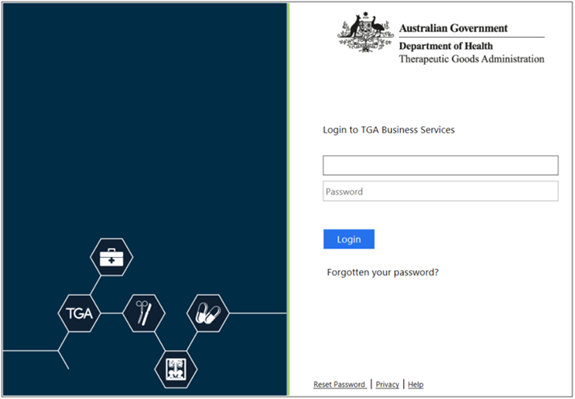

Step 2 - Select the relevant application type
From the Applications menu, under the Medical Device list, select Device/OTG Application.
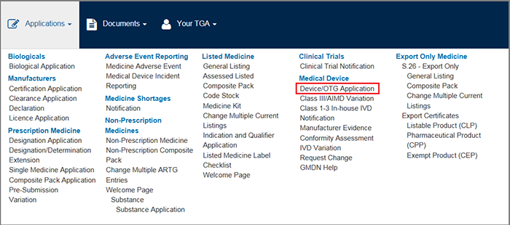

Step 3 – Complete the application form and attach all relevant documents
You'll be taken to Page 1 of the application form to complete/confirm the required details. To begin, select Other Therapeutic Good – Listed disinfectant from the list in the Application for field.
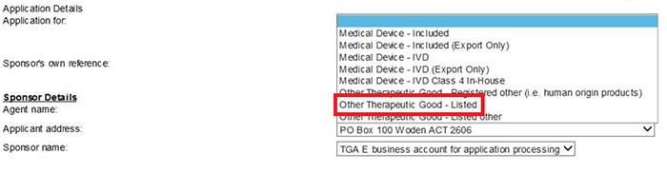
Complete the required details for Page 1, remembering to add a Sponsor's own reference before continuing. Select the Next button to continue.
Business Services system (TBS)
This application pathway is limited only to disinfectants that make specific claims. If your product does not make specific claims and is considered an exempt product it cannot be listed on the ARTG.

Page 2 requires the relevant manufacturer's details.
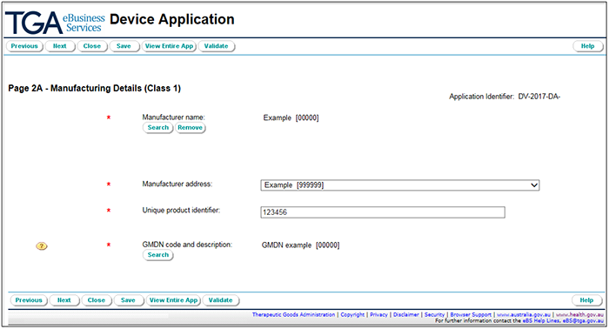
To search for your manufacturer, select the Search button under Manufacturer name which opens the search window.
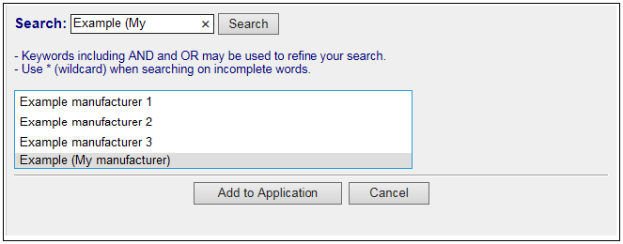
Enter your search term and select the Search button. This will display a list of possible manufacturers which match (or closely match) your search term.
Once you have selected the correct manufacturer, select the Add to Application button.
To select the correct GMDN code for your application, select the Search button under the GMDN code and description field which will open the GMDN search window.
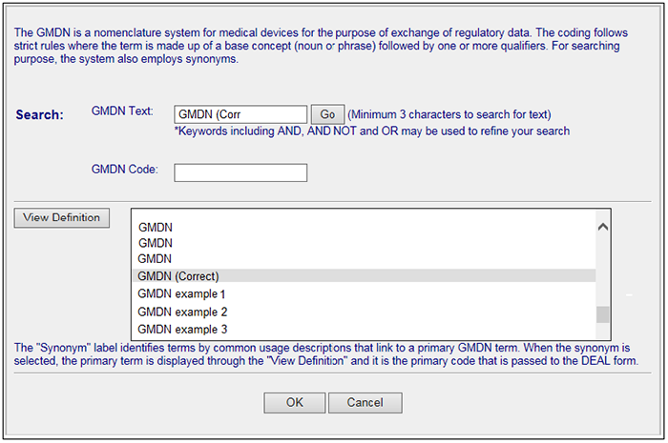
You can search by the GMDN code, or text in the GMDN description. In the case of a hard surface disinfectant the GMDN code is based on the Common name of the product (i.e. Disinfectant, household/commercial grade or Disinfectant, hospital grade). Once you have found the correct GMDN, select it from the search results, and press OK to add the details to your application. Once you have completed Page 2, select Next to continue.
The final page has a:
- summary of the application information for you to review
- section to electronically attach supporting information
- declaration you need to agree to before you can submit your application.
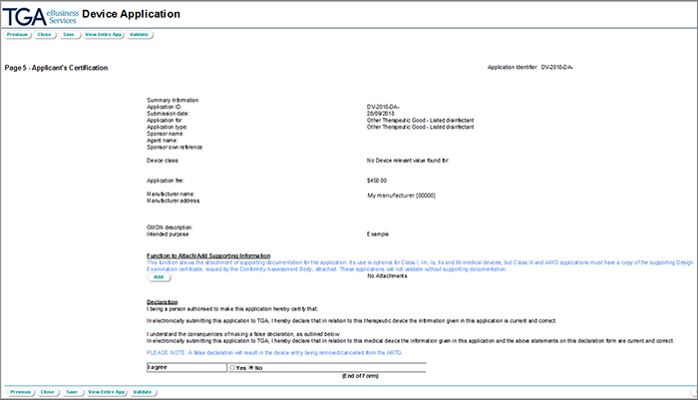
Disinfectant applications must include the full formulation of the product. To input the formulation ensure that you select “yes” your product is formulated and input the formulation with all relevant AAN and PIs.

Attaching supporting documents
To attach supporting information, select the Add button in the Function to Attach/Add Supporting Information field which will open the File Upload window.
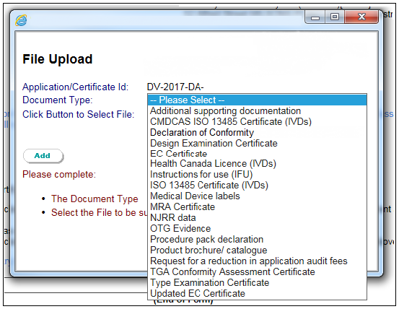
Select the Document type from the dropdown list. You should attach all relevant documents from your computer. Select the Browse button and then select the relevant file from your computer to attach. Select the Add button to attach this file to your application.
Follow this process for each file you need to attach.
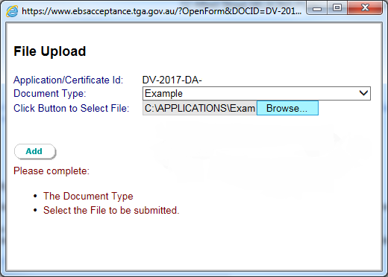
Each attachment will be listed under the Function to Attach/Add Supporting Information field.
If you need to delete any attachments, select Remove next to the attachment you want to delete.
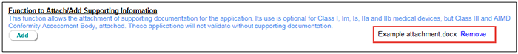
Before you can submit your application, you must agree to the declaration:
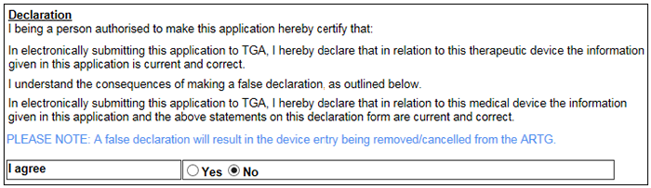
When the form has been completed, select Validate. This will ensure that the form has all the required information to allow your form to be submitted.
Validation of your form is only confirming that you have filled out all required fields in the application. Validation is not an approval of your application or a guarantee that all the required information has been submitted to the TGA.
If there are any issues with the form, they will be identified with blue writing near the top of the page that will link you to the incomplete information when you select it.
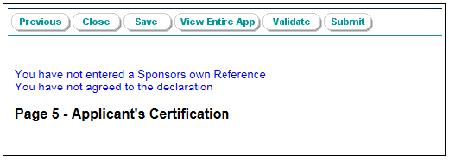
If you filled in all required fields in the application form, you will be able to submit your application.

Fees and charges

Application fee
The current application fee for listed disinfectants can be found in our Schedule of fees and charges under 'Other listed and registered therapeutic goods (OTGs)''. The application fee is specifically stated under 'Listed OTG fees' as 'Application fee'.

Evaluation fee
Listed disinfectants may attract an evaluation fee in addition to the initial application fee if they contain a new ingredient or make new specific claims. The current evaluation fee can be found in our Schedule of fees and charges under 'Other listed and registered therapeutic goods (OTGs)'. The fee is specifically stated under 'Listed OTG fees' as 'Fee for evaluating documents and information relating to the safety of a listed therapeutic device'.
Application and evaluation fees are not refundable. For further information refer to the refunds web page.

Annual charges
Once your product is listed on the ARTG, annual charges for maintaining your listing will apply. The current annual charge for listed disinfectants can be found in our Schedule of fees and charges under 'Other listed and registered therapeutic goods (OTGs)'. The fee is specifically stated under 'Annual charges' as 'Listed OTG: disinfectants'.

Post-market - ongoing responsibilities
Once a disinfectant has been listed on the ARTG, it must continue to meet all the regulatory, safety and performance requirements and standards that were required for the approval.
There are mandatory requirements for all sponsors of disinfectants, including:
- telling us about any changes to the composition of your product
- retaining distribution records for five years
- reporting adverse events
- ensuring the information on your ARTG listing remains current.
The TGA may contact the sponsor to request information to demonstrate that the disinfectant continues to comply with the regulations.
Sponsors of disinfectants should report adverse events relating to your disinfectant product at Report a medical device adverse event (sponsor/manufacturer).

Advertising
Advertising for disinfectants (including the label) must comply with all applicable therapeutic goods advertising requirements. These include:
- If the disinfectant is not included in the ARTG and it is not exempt from the requirement to be included in the ARTG, it cannot be advertised to the public (subsection 42DL (12) of the Act).
- Disinfectants included in the ARTG can only be promoted for those purposes included in the ARTG and (where relevant) the label. The promotion of 'off-label' use to any audience is prohibited (subsections 22(2) to (5) of the Act).
- Advertising to the public for disinfectants must comply with the Therapeutic Goods Advertising Code (the Code). For more information see: The Therapeutic Goods Advertising Code
  - Note there are particular requirements for 'other therapeutic goods' (which includes disinfectants) in section 21 of the Code, which prescribe the mandatory information that must appear in advertising.
- Before advertising disinfectants to consumers, you should check to see if your advertising material (for example, posters, media and social media advertising) contains restricted and/or prohibited representations.
  - If it does, you will need prior approval or permission from the TGA. Refer to TGA guidance on ‘Restricted and prohibited representations’.
  - There is no application process for prohibited representations on labelling, as labelling is reviewed by the TGA as part of your application to list a product on the ARTG.
  - If you believe there is a need for a prohibited representation to be used in the advertising (other than the label) of your disinfectant, please contact advertising.enquiries@tga.gov.au for further advice.
  - Note that the TGA has already permitted the use of certain restricted and prohibited representations in relation to labelling for disinfectants – see Advertising permissions.

Varying a disinfectant entry that is in the ARTG
If your disinfectant product is already listed on the ARTG, and you wish to vary either the labelling, formulation or other aspects of the manufacture of the product, the sponsor must apply to the TGA for approval prior to supplying the product.
You may submit an application to the TGA via a Device Change Request form (DCR) through the TGA Business Services link on the TGA website. Guidance on when an application is required is included in the following table, entitled Notifying TGA of changes to listed disinfectants.
If your disinfectant product is already listed on the ARTG, and you wish to vary the product in a way that does NOT change the formulation or aspects of manufacturer or labelling (i.e. varying the fragrance or colour of a product) the sponsor must submit a Device Change Request as soon as practicable and no later than three months after the implementation of the change. Refer to the following table.
When applying for a variation, you must provide information to validate the variation, as set out in the section below.

Notifying TGA of variations to listed disinfectants in the ARTG
There are two types of changes:
- variations to product information in relation to Registered and Listed Disinfectants. This information relates to the quality, safety and effective use of the goods, including information regarding the usefulness and limitations of the goods;
- additions of products to grouped listings. All changes must be made in accordance with legislative requirements.

Fees for variations
All variations requiring approval attract a processing fee and if approval is required for listed goods, an evaluation fee may also be payable.
See Schedule of fees and charges
A | denotes the sponsor must receive Approval from the TGA prior to change being made. A Device Change request must be submitted.
N | denotes that Notification by the sponsor to the TGA is required as soon as practicable, and no later than three months after implementation of the change. A Device Change request must be submitted.
R | denotes that Notification required directly to the TBS as soon as practicable, and no later than three months after implementation of the change. No fee is required in sponsor address or contact change.
* | denotes the change may require a new registration or listing.
- | denotes No Approval or Notification is required. Changes may be made without reference to the TGA.

Proposed changes
Proposed change | Listed Disinfectant | Additional information
Sponsor/Manufacturer
Change in sponsor name (same sponsor) | R
Sponsor transfer | R
Change in sponsor address | R
Change of principal manufacturer | N* | Test data may be requested
Change of principal manufacturer's name only | N
Change of site of manufacture | N* | Test data may be requested
Finished product details
Change in physical or chemical properties | A | Test data may be requested
Formulation
Change in amount of active ingredient | N | Test data may be requested
Addition or deletion of active ingredient | N* | Test data may be requested
Change in amounts of excipients | N | Test data may be requested
Addition or deletion of excipient | N
Active raw ingredients/excipients
Change in the composition of a proprietary ingredient | N
Quality control
Alteration to TGA accepted test methods:  - Changes which maintain or improve analytical performance  - Other changes  - Swap to another test method | A | Test data may be requested
Narrowing the specification range within existing limits | N
Packaging
Change of supplier of container only (same specifications) | -
Change of container (different material specifications) or container closure | N^ | ^ for products covered by Poison Standard (SUSMP) only
Labelling
Change of information on the label for product's use/description, claims, indications, contact times or shelf life | A | Test data will be requested

Version history
Version | Description of change | Author | Effective date
V1.0 | Original publication | Therapeutic Goods Administration | July 2019
V1.1 | Replaced references to Safe Work Australia's National Code of Practice for the Labelling of Workplace Substances [NOHSC: 2012(1994)] with Safe Work Australia's Model Code of Practice: Labelling of workplace hazardous chemicals | Therapeutic Goods Administration | April 2020
V1.2 | Update box on amendment to Standard | Therapeutic Goods Administration | December 2020
V1.3 | Minor updates | Therapeutic Goods Administration | March 2021
V2.0 | Updates based on TGO 104 changes for residual activity claims and minor amendments | Therapeutic Goods Administration | December 2021
V2.1 | Updates due to changes in fees and charges and advertising code | Medical Devices Authorisation Branch | July 2023

Therapeutic Goods Administration
PO Box 100 Woden ACT 2606 Australia
Email: info@tga.gov.au Phone: 1800 020 653 Fax: 02 6203 1605
https://www.tga.gov.au
Reference/Publication #

