Australian Public Assessment Report for Ultomiris
  - Active ingredient: Ravulizumab
  - Sponsor: Alexion Pharmaceuticals Australasia Pty Ltd
May 2023

About the Therapeutic Goods Administration (TGA)
- The Therapeutic Goods Administration (TGA) is part of the Australian Government Department of Health and Aged Care and is responsible for regulating therapeutic goods, including medicines, medical devices, and biologicals.
- The TGA administers the Therapeutic Goods Act 1989 (the Act), applying a risk management approach designed to ensure therapeutic goods supplied in Australia meet acceptable standards of quality, safety, and efficacy.
- The work of the TGA is based on applying scientific and clinical expertise to Decision-making, to ensure that the benefits to the Australian public outweigh any risks associated with the use of therapeutic goods.
- The TGA relies on the public, healthcare professionals and industry to report problems with therapeutic goods. The TGA investigates reports received to determine any necessary regulatory action.
- To report a problem with a therapeutic good, please see the information on the TGA website.

About AusPARs
- The Australian Public Assessment Report (AusPAR) provides information about the evaluation of a prescription medicine and the considerations that led the TGA to approve or not approve a prescription medicine submission. Further information can be found in Australian Public Assessment Report (AusPAR) guidance.
- AusPARs are prepared and published by the TGA.
- AusPARs are static documents that provide information that relates to a submission at a particular point in time. The publication of an AusPAR is an important part of the transparency of the TGA’s Decision-making process.
- A new AusPAR may be provided to reflect changes to indications or major variations to a prescription medicine subject to evaluation by the TGA.

Copyright
© Commonwealth of Australia 2023
This work is copyright. You may reproduce the whole or part of this work in unaltered form for your own personal use or, if you are part of an organisation, for internal use within your organisation, but only if you or your organisation do not use the reproduction for any commercial purpose and retain this copyright notice and all disclaimer notices as part of that reproduction. Apart from rights to use as permitted by the Copyright Act 1968 or allowed by this copyright notice, all other rights are reserved and you are not allowed to reproduce the whole or any part of this work in any way (electronic or otherwise) without first being given specific written permission from the Commonwealth to do so. Requests and inquiries concerning reproduction and rights are to be sent to the TGA Copyright Officer, Therapeutic Goods Administration, PO Box 100, Woden ACT 2606 or emailed to <tga.copyright@tga.gov.au>.

Contents
List of abbreviations 4
Product submission 6
Submission details 6
Product background 8
Ravulizumab 9
Current treatment options 10
Regulatory status 12
Product Information 15
Registration timeline 15
Submission overview and risk/benefit assessment 15
Quality 15
Nonclinical 16
Clinical 16
Summary of clinical studies 16
Pharmacology 17
Efficacy 27
Safety 47
Risk management plan 57
Risk-benefit analysis 58
Delegate’s considerations 58
Proposed action 61
Independent expert advice 62
Advisory Committee considerations 62
Outcome 64
Specific conditions of registration applying to these goods 64
Attachment 1. Product Information 65

List of abbreviations
Abbreviation | Meaning
ACM | Advisory Committee on Medicines
aHUS | Atypical haemolytic uraemic syndrome
ARTG | Australian Register of Therapeutic Goods
ASA | Australia specific annex
CI | Confidence interval
CKD | Chronic kidney disease
C_{max} | Maximum concentration
CMI | Consumer Medicines Information
CSR | Clinical study report
C_{trough} | Minimum concentration
DLP | Data lock point
eGFR | Estimated glomerular filtration rate
EMA | European Medicines Authority (European Union)
EU | European Union
FAS | Full analysis set
Hb | Haemoglobin
HUS | Haemolytic uraemic syndrome
LDH | Lactate dehydrogenase
pcVPC | Prediction-corrected visual predictive check
PI | Product Information
PNH | Paroxysmal nocturnal haemoglobinuria
PP | Per protocol
PSUR | Periodic safety update report
RMP | Risk management plan
SAE | Serious adverse event
TEAE | Treatment-emergent adverse event
TRAE | Treatment-related adverse event
TGA | Therapeutic Goods Administration
TMA | Thrombotic microangiopathy
ULN | Upper limit of normal

Product submission

Submission details
Type of submission: | Extension of indications
Product name: | Ultomiris
Active ingredient: | Ravulizumab
Decision: | Approved
Date of Decision: | 11 August 2022
Date of entry onto ARTG: | 16 August 2022
ARTG numbers: | 311926, 330566, 336710
Black Triangle Scheme  for the current submission: | Yes  This product will remain in the scheme for five years, starting on the date the new indication was approved.
Sponsor’s name and address: | Alexion Pharmaceuticals Australasia Pty Ltd  Suite 401, Level 4, Building A  20 Rodborough Road  Frenchs Forest NSW 2086
Dose form: | Concentrated solution for intravenous infusion
Strengths: | 300 mg in 30 mL (10 mg/mL)  300 mg in 3 mL (100 mg/mL)  1100 mg in 11 mL (100 mg/mL)
Container: | Vial
Pack size: | Single vial packs
Approved therapeutic use for the current submission: | Ultomiris is indicated for the treatment of patients with:  - Paroxysmal Nocturnal Haemoglobinuria (PNH)  - Atypical Haemolytic Uraemic Syndrome (aHUS)
Route of administration: | Intravenous infusion
Dosage: | Life-threatening meningococcal infections/sepsis have occurred in patients treated with Ultomiris. Refer to the Product Information for vaccination requirements.  Adult patients  The recommended dosing regimen consists of a loading dose followed by maintenance dosing, administered by intravenous infusion. The doses to be administered are based on the patient’s body weight:  Maintenance doses should be administered at a once every 8-week interval, starting 2 weeks after loading dose administration  Paediatric patients  Paediatric patients who weigh 40 kg or more are treated with the adult dosing recommendations above. The weight-based dosing recommendation and dosing interval for paediatric patients less than 40 kg are:  For further information regarding dosage, refer to the Product Information.
  Body Weight Range (kg) | Loading Dose (mg) | Maintenance Dose (mg) | Dosing interval
  ≥ 40 to < 60 | 2400 | 3000 | Every 8 weeks
  ≥ 60 to < 100 | 2700 | 3300 | Every 8 weeks
  ≥ 100 | 3000 | 3600 | Every 8 weeks
  Body Weight Range (kg) | Loading Dose (mg) | Maintenance Dose (mg) | Dosing interval
  ≥ 5 to < 10 | 600 | 300 | Every 4 weeks
  ≥ 10 to < 20 | 600 | 600 | Every 4 weeks
  ≥ 20 to < 30 | 900 | 2100 | Every 8 weeks
  ≥ 30 to < 40 | 1200 | 2700 | Every 8 weeks

Product background
This AusPAR describes the submission by Alexion Pharmaceuticals Australasia Pty Ltd (the sponsor) to register Ultomiris ravulizumab 300 mg in 30 mL (10 mg/mL), 300 mg in 3 mL (100 mg/mL), and 1100 mg in 11 mL (100 mg/mL) concentrated solution for injection by intravenous infusion vial for an extension of indications to include treatment of paediatric patients with paroxysmal nocturnal haemoglobinuria (PNH) and for the treatment of patients with atypical haemolytic uraemic syndrome (aHUS) as follows:
Ultomiris is indicated for the treatment of patients with;
- Paroxysmal Nocturnal Haemoglobinuria (PNH)
- Atypical Haemolytic Uraemic Syndrome (aHUS)
Paroxysmal nocturnal haemoglobinuria (PNH) is a rare, progressive, life-threatening disease characterised by complement-mediated haemolysis, thrombosis, and bone marrow failure. PNH is almost always caused by a somatic mutation in the PIGA gene, resulting in deficiency of the complement-inhibitory proteins CD55 and CD59 on haematopoietic stem cell surfaces and consequent uncontrolled complement activation that accounts for intravascular haemolysis and other PNH manifestations.
The estimated worldwide incidence of PNH is 1.3 per million population. PNH primarily affects adults, with a median age on onset in the thirties. Paediatric cases account for 5 to 10% of reported cases of PNH.
Paroxysmal nocturnal haemoglobinuria can present with symptoms and signs relating to anaemia, bone marrow dysfunction, thrombosis, smooth muscle dystonias (including abdominal pain, dysphagia, and erectile dysfunction) and renal insufficiency. Children with PNH usually present with symptoms of underlying bone marrow disorder, with bone marrow failure syndromes, such as aplastic anaemia and refractory cytopenia, more frequent in children.
Diagnosis is based on clinical findings and flow cytometry. PNH can be classified as:4
- Classical PNH (findings of intravascular haemolysis with mild or no evidence of bone marrow failure)
- Subclinical PNH (PNH detected however no substantial clinical findings and no bone marrow abnormalities)
- PNH with bone marrow failure
Median survival is approximately 10 years in adults and 13.5 years in paediatric patients. Thrombosis is the leading cause of morbidity and mortality for patients with PNH.2,4 Mortality rates in paediatric patients are often difficult to establish due to the challenges in identifying the underlying thrombosis leading to death as a consequence of PNH.
Atypical haemolytic uraemic syndrome (aHUS) is a rare, progressive, life-threatening disorder characterised by haemolytic anaemia, thrombocytopenia, acute renal injury and extra-renal complications. The predominant underlying cause of aHUS is dysregulation of the alternative pathway of complement leading to uncontrolled complement activation. This causes inflammation, endothelial activation and damage, and a prothrombotic/procoagulant state resulting in systemic thrombotic microangiopathy (TMA). Uncontrolled complement activation may be due to genetic mutations or acquired autoantibodies in the alternative pathway of complement. In some cases, aHUS may be caused by a triggering event, including autoimmune disease, pregnancy, infection, organ or tissue transplant and certain medications.,,
The estimated incidence of aHUS is one to two cases per million in the USA.6 In approximately 40% patients, disease onset occurs before 18 years of age.
Patients with aHUS typically present with the triad of thrombocytopenia, haemolytic anaemia and acute kidney injury. Although end-organ damage is most common in the kidneys, the central nervous system (CNS), cardiovascular, gastrointestinal, pulmonary and other organ systems may be involved. At presentation, approximately 20% to 48% of patients have signs and symptoms of extra-renal manifestations, including elevated liver enzymes, pancreatitis, pericarditis, seizures and focal neurologic deficits.6,9
Diagnosis of aHUS is clinical, and is made by excluding other causes of thrombotic microangiopathy that are primarily not related to complement in origin. The main differential diagnoses are thrombotic thrombocytopenic purpura, and Shiga toxin-producing Escherichia coli haemolytic uraemic syndrome (STEC-HUS).6,7
The prognosis of aHUS is poor in the absence of complement inhibitor therapy. In a nationwide study of French paediatric and adult patients with aHUS, Fremeaux-Bacchi et al.,9 reported 56% of adults and 29% of children progressed to end-stage kidney disease or death within the first year of the disease.

Ravulizumab
Ravulizumab is a long-acting humanised monoclonal IgG2/4K antibody produced in Chinese hamster ovary cell culture by recombinant DNA technology. Ravulizumab binds to complement component 5 (C5) with high affinity, inhibiting the enzymatic cleavage of C5 into C5a (the pro-inflammatory anaphylatoxin) and C5b (the initiating subunit of the terminal complement membrane attack complex (C5b-9 complex)).
Ravulizumab is currently approved in Australia for the treatment of adult patients with PNH.
Ravulizumab is administered by intravenous infusion with weight-based loading and maintenance dosing regimen as per Table 1 (below) from the current Ultomiris Product Information (PI). Maintenance doses are administered once every eight weeks, starting two weeks after loading dose administration.
Table 1: Ultomiris (ravulizumab) weight-based dosing regimen for adults with paroxysmal nocturnal haemoglobinuria
Body Weight Range (kg) | Loading Dose (mg) | Maintenance Dose (mg)
≥ 40 to < 60 | 2400 | 3000
≥ 60 to < 100 | 2700 | 3300
≥ 100 | 3000 | 3600
The current weight-based dosing regimen for adult PNH patients with body weight ≥ 40 kg is proposed for aHUS patients with body weight ≥ 40 kg. A single weight-based ravulizumab dosing regimen is proposed for use in paediatric PNH and aHUS patients as per Table 2 (below).
Table 2: Proposed Ultomiris weight-based dosing regimen for paediatric paroxysmal nocturnal haemoglobinuria and atypical haemolytic uraemic syndrome
Body Weight Range (kg) | Loading Dose (mg) | Maintenance Dose (mg) | Maintenance Dose (mg)
≥ 5 to < 10 | 600 | 300 | Every 4 weeks
≥ 10 to < 20 | 600 | 600 | Every 4 weeks
≥ 20 to < 30 | 900 | 2100 | Every 8 weeks
≥ 30 to < 40 | 1200 | 2700 | Every 8 weeks

Current treatment options
Current treatment options for PNH include ravulizumab, eculizumab and pegcetacoplan, with eculizumab also approved for use in aHUS.
Pegcetacoplan (as the product Empaveli) has been approved and registered on the Australian Register of Pharmaceutical Goods since February 2022. The current indications for Empaveli are as follows:
Empaveli is indicated in the treatment of adult patients with paroxysmal nocturnal haemoglobinuria (PNH) who have an inadequate response to, or are intolerant of, a C5 inhibitor.
Pegacetacoplan is a selective immunosuppressant. Pegcetacoplan binds to complement protein C3 and its activation fragment C3b with high affinity, thereby regulating the cleavage of C3 and the generation of downstream effectors of complement activation. In PNH, extravascular haemolysis is facilitated by C3b opsonization while intravascular haemolysis is mediated by the downstream membrane attack complex (MAC). Pegcetacoplan exerts broad regulation of the complement cascade by acting proximal to both C3b and MAC formation, thereby controlling the mechanisms that lead to extravascular and intravascular haemolysis. These functions of pegcetacoplan underlie the observed sustained reduction in complement-mediated haemolytic activity in patients with PNH.
Pegacetacoplan (as Empaveli) is licensed for use in adults with PNH only. It is not licensed for use in paediatrics or use in aHUS.
Eculizumab rmc (as the product Soliris) is a genetically-engineered humanised monoclonal antibody directed against the alpha chain of the C5 complement protein, which binds to C5 with high affinity and inhibits cleavage to C5a and C5b, preventing the generation of the terminal complement complex C5b-9.
Eculizumab (as Soliris) was first registered on the ARTG in July 2020; is approved for use in Australia in adult and paediatric patients with PNH and aHUS as follows:
Soliris is indicated for the treatment of patients with:
- Paroxysmal Nocturnal Haemoglobinuria (PNH) to reduce haemolysis.
- Atypical Haemolytic Uraemic Syndrome (aHUS).
- Adult patients with Neuromyelitis Optica Spectrum Disorder (NMOSD) who are anti-aquaporin-4 (AQP4) antibody-positive.
Soliris is not intended for acute treatment of a NMOSD relapse
Eculizumab is administered via intravenous infusion with weight-based dosing. For patients with PNH and aHUS, the dosing regimen comprises an initial phase (1 to 4 weeks), after which the recommended dose of eculizumab is administered every two weeks for patients with body weight 10 kg or more and every three weeks for patients with body weight from 5 kg to 10 kg.
The rationale provided by the sponsor for the proposed extension of indication for ravulizumab is the eculizumab once every two or three weeks maintenance dosing regimen is burdensome for patients and there is an unmet need for a therapeutic modality with a less frequent dosing schedule. Ravulizumab was developed by substituting four amino acids in the eculizumab heavy chain to extend the half-life of ravulizumab relative to eculizumab, thus allowing for less frequent maintenance dosing of ravulizumab. The maximum number of ravulizumab versus eculizumab infusions in the first treatment year is summarised in Table 3, shown below.
Table 3: Maximum number of infusions for ravulizumab versus eculizumab (in first year of treatment)
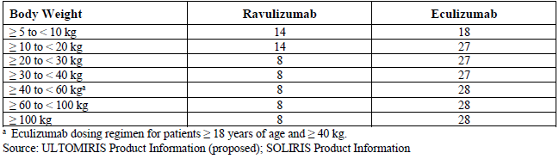

Regulatory status
Ultomiris (ravulizumab) 300 mg in 30 mL (10 mg/mL) concentrated solution for intravenous infusion vial (AUST R 311926) received initial registration on the Australian Register of Therapeutic Goods (ARTG) on 17 October 2019.¹⁰ Additional strengths (300 mg in 3 mL (100 mg/mL) and 1100 mg in 11 mL (100 mg/mL)) were registered on 23 March 2021.
At the time that the TGA considered this submission to extend the indications of Ultomiris, Ultomiris was approved for the following indication:
Ultomiris is indicated for the treatment of adult patients with:
- Paroxysmal Nocturnal Haemoglobinuria (PNH)
A similar submission for the proposed extension of indications had been approved in numerous countries. The approved indications in the United States of America (USA) and the European Union (EU) is summarised in Table 4, below.
Table 4: International regulatory status
Region | Submission date | Status | Approved indications
United States of America | 19 April 2019 | Approved on 18 October 2019 | Complement inhibitor indicated for the treatment of adults and pediatric patients one month of age and older with atypical hemolytic uremic syndrome (aHUS) to inhibit complement-mediated thrombotic microangiopathy (TMA).
United States of America | 7 December 2020 | Approved on 7 June 2021 | Complement inhibitor indicated for the treatment of adult and pediatric patients one month of age and older with paroxysmal nocturnal hemoglobinuria (PNH).
European Union | 25 July 2019 | Approved on 25 June 2020 | Treatment of patients with a body weight of 10 kg or above with atypical haemolytic uremic syndrome (aHUS) who are complement inhibitor treatment-naive or have received eculizumab for at least 3 months and have evidence of response to eculizumab.
European Union | 17 December 2020 | Approved on 1 September 2021 | Ultomiris is indicated in the treatment of adult and paediatric patients with a body weight of 10 kg or above with paroxysmal nocturnal haemoglobinuria (PNH): - in patients with haemolysis with clinical symptom(s) indicative of high disease activity. - in patients who are clinically stable after having been treated with eculizumab for at least the past 6 months.

Product Information
The Product Information (PI) approved with the submission which is described in this AusPAR can be found as Attachment 1. For the most recent PI and Consumer Medicines Information (CMI), please refer to the TGA PI/CMI search facility.

Registration timeline
The following table captures the key steps and dates for this submission.
This submission was evaluated under the standard prescription medicines registration process.
Table 5: Timeline for Submission PM-2021-01659-1-6
Description | Date
Submission dossier accepted and first round evaluation commenced | 1 June 2021
First round evaluation completed | 28 October 2021
Sponsor provides responses on questions raised in first round evaluation | 29 November 2021
Second round evaluation completed | 11 January 2022
Delegate’s Overall benefit-risk assessment and request for Advisory Committee advice | 29 April 2022
Sponsor’s pre-Advisory Committee response | 11 May 2022
Advisory Committee meeting | 3 June 2022
Registration Decision (Outcome) | 11 August 2022
Completion of administrative activities and registration on the ARTG | 16 August 2022
Number of working days from submission dossier acceptance to registration Decision* | 232
*Statutory timeframe for standard submissions is 255 working days

Submission overview and risk/benefit assessment
A summary of the TGA’s assessment for this submission is provided below.

Quality
Quality evaluation is not required for this submission as there are no proposed changes to the quality of the currently approved product in Australia. There were no issues related to bacterial endotoxin testing. The quality of the currently approved product is suitable for the proposed changes in this submission. A full quality evaluation was conducted at the time this product received initial registration.¹⁰

Nonclinical
No new nonclinical data or further nonclinical evaluation were required for this submission. The TGA considers that previously submitted and evaluated data satisfactorily address nonclinical aspects of safety/efficacy relating to this submission.

Clinical

Summary of clinical studies
The clinical dossier consisted of:
- Three pivotal Phase III efficacy and safety studies:
  - Study ALXN1210-aHUS-311 in adults with aHUS
Single arm study of ravulizumab in complement inhibitor treatment-naïve adult and adolescent patients with atypical haemolytic uremic syndrome (aHUS)
  - Study ALXN1210-aHUS-312 in paediatric patients with aHUS
A Phase III, open-label, multi-centre study of ravulizumab in children and adolescents with atypical haemolytic uremic syndrome (aHUS)
  - Study ALXN1210-PNH-304 in paediatric patients with PNH
A Phase III, open-label study of ravulizumab in children and adolescents with Paroxysmal Nocturnal Hemoglobinuria (PNH)
- Six population pharmacokinetic/pharmacodynamic analyses
- Literature references
In all three pivotal Phase III studies to support use in the proposed patient populations, patients received ravulizumab 10 mg/mL as an intravenous infusion with weight-based loading dose administered on Day 1 and weight-based maintenance dosing on Day 15 and either once every four weeks or once every eight weeks thereafter as per Table 6 below. The 10 mg/mL formulation, presentation, and administration of ravulizumab was stated to be identical to those described in the Ultomiris PI.
Table 6 Dosing regimen for Studies ALXN1210-aHUS-311, ALXN1210-aHUS-312 and ALXN1210-PNH-304
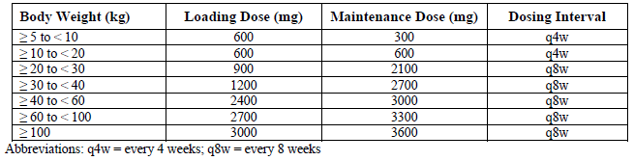
Note: as discussed further below, the initial loading dose for patients with body weight 5 to <10 kg was 300 mg however was increased to 600 mg based an interim analysis of data from paediatric patients in Study ALXN1210-aHUS-312 and subsequent amendments to the study protocols for Study ALXN1210-aHUS-312 and Study ALXN1210-PNH-304.
The sponsor stated ‘the development program in aHUS was initiated concurrently with the PNH program. Prior to initiation of the Phase III clinical study, agreement was reached with the US Food and Drug Administration (FDA) and European Medicines Authority (EMA) on a common ravulizumab dosing strategy for the treatment of aHUS and PNH, and the reliance on a single pivotal trial to support approval in each indication.’

Pharmacology

Pharmacokinetics

Atypical haemolytic uraemic syndrome

Study ALXN1210-aHUS-311 and Study ALXN1210-aHUS-312
The adult pharmacokinetic/pharmacodynamic analysis set included 55 complement inhibitor treatment-naive adults with aHUS. The patient group demographics included 67.3% female, 47.3% White, mean age of 41.2 years and mean body weight of 72.7 kg.
The paediatric pharmacokinetic/pharmacodynamic analysis set included:
- 18 complement inhibitor treatment-naive paediatric patients with aHUS with a median age of 5.2 years at first infusion (range: 0.9 to 17.3 years), of which two patients younger than two years old with body weight 5 to 10 kg.
- 10 eculizumab-experienced aHUS patients with a median age of 12.5 years (range: 1.2 to 15.5 years) of which one patient less than two years old and body weight 5 to 10 kg.
Following the weight-based dosing regimens in complement inhibitor treatment-naive adult patients with aHUS and complement inhibitor treatment-naive or eculizumab-experienced paediatric patients with aHUS, steady-state therapeutic ravulizumab concentrations were achieved and maintained during the 26-week Initial Evaluation Period.

Paediatric paroxysmal nocturnal haemoglobinuria patients

Study ALXN1210-PNH-304
Pharmacokinetic and pharmacodynamic parameters were the primary endpoints for Study ALXN1210-PNH-304.
There were 12 patients in Study ALXN1210-PNH-304 included in the pharmacokinetic and pharmacodynamic analyses at the planned interim analysis: four complement-inhibitor treatment-naive patients aged 11 to 17 years at first infusion and eight eculizumab-experienced patients aged 9 to 17 years, with all patients weighing 30 kg or more.
Following weight-based dosing, steady-state therapeutic ravulizumab concentrations were achieved by Day 15 and sustained through Day 127 in complement inhibitor treatment-naive and eculizumab-experienced patients.
There was no evidence of accumulation (mean accumulation ratios for maximum plasma concentration (C_{max}) and minimum plasma concentration (C_{trough}) were 1.13 and 1.08, respectively).

Population pharmacokinetics data
The extrapolation exercise to support the proposed paediatric dosing regimen relies heavily on modelling and simulation, particularly for patients with body weight less than 20 kg. As this is a key question for the Advisory Committee on Medicines (ACM); see Advisory Committee considerations, below; and a significant component of the Delegate’s considerations (see Delegate’s considerations), a detailed account of this aspect of the submission is provided here.

Atypical haemolytic uraemic syndrome
Weight-based dosing of ravulizumab is based on pharmacokinetic/pharmacodynamic data from earlier studies indicating body weight affected ravulizumab pharmacokinetics. Previous pharmacokinetic/pharmacodynamic analyses suggested that achieving ravulizumab concentrations above the target threshold (C_{trough} > 175 μg/mL) would result in near maximal pharmacodynamic effect.
The dosing regimen used for adult patients (≥ 40 kg) with aHUS is the same dosing regimen approved for the treatment of adult patients with PNH and is based on the same target of achieving immediate, complete and sustained terminal complement inhibition (defined as serum free C5 concentrations < 0.5 µg/mL) which is expected to result in maximal clinical benefit.
The proposed dose regimen for paediatric patients with aHUS in Study ALXN1210-aHUS-312 is shown in Table 7. For children less than 20 kg, once every four weeks maintenance dosing was proposed, as once every eight weeks administration was predicted to result in peak ravulizumab concentrations exceeding those achieved in adult patients.
Table 7: Study ALXN1210-aHUS-312 proposed dose regimen
Body weight (kg) | Loading dose (mg) | Maintenance dose (mg) | Dosing interval
5 to < 10 | 300 | 300 | Once every four weeks
10 to < 20 | 600 | 600 | Once every four weeks
20 to < 30 | 900 | 2100 | Once every eight weeks
30 to < 40 | 1200 | 2700 | Once every eight weeks
In Study ALXN1210-aHUS-312, a pre-specified initial pharmacokinetic/pharmacodynamic analysis of ravulizumab pharmacokinetics and free C5 levels was initiated after four patients weighing 5 to < 40 kg completed dosing through Day 71 to evaluate the adequacy of the paediatric dosing regimen
Based on this analysis, a dose adjustment was recommended for paediatric patients in the 5 to < 10 kg group to increase the loading dose from 300 mg to 600 mg (or two 300 mg doses) followed by 300 mg maintenance dosing once every four weeks thereafter (unchanged) to maintain exposures above the threshold concentration needed to maintain complete and sustained inhibition of free C5. The dosing regimen was considered to be adequate in patients weighing 10 to < 40 kg.
The Study ALXN1210-aHUS-312 protocol was amended to reflect the increased loading dose for the 5 to < 10 kg group (Protocol Amendment 5).
A population pharmacokinetics and pharmacodynamic analysis was performed to support dosing of ravulizumab in patients with aHUS.
The pharmacokinetic population included 69 complement-inhibitor treatment naive aHUS patients; 55 adults from Study ALXN1210-aHUS-311 and 14 paediatric patients from Study ALXN1210-aHUS-312 (including two patients in the 5 to < 10 kg body weight group, once of whom received 300 mg loading dose at Baseline and discontinued on Day 21).
The final population pharmacokinetic model was a linear two-compartment model including allometrically scaled time-varying body weight, central clearance adjustment for transfusion and effect of time-varying body mass index on volume parameters.
A prediction-corrected visual predictive check (pcVPC) was used to assess the model performance for describing pharmacokinetics in adult patients in Study ALXN1210-aHUS-311; paediatric prediction-corrected visual predictive checks were not generated due to the small number of paediatric patients.
The EMA stated the following regarding the pharmacokinetic/pharmacodynamic model in the EPAR for Ultomiris:
‘A pcVPC showed the ability of the model to capture the mean and the dispersion of the data during 26 weeks of treatment in the adult population.’
‘PcVPC from paediatric population were provided stratified by each dosing regimen, showing that the model is slightly biased for the once every four weeks schedule (for paediatric patients with less than 20kg). Other covariates might be affecting the estimation of CL, but due to the low number of paediatric patients, their effect is difficult to estimate.’
‘With regard to the pharmacokinetic/pharmacodynamic model, as the model under predicts the exposure in paediatric patients with body weight less than 20 kg, the proposed change to increase the loading dose (that is from 300 mg to 600 mg) to reach the target concentration based on population PK model is not justified since observed concentrations are already higher than those predicted by the population PK model.’
The pcVPC of paediatric data was provided to the TGA in response to additional questions from TGA. Specific pharmacometrics expert advice was sought with regard to the proposed dosing regimen in paediatric patients with aHUS and PNH.
The pharmacometrics expert stated the Study ALXN1210-aHUS-312 protocol-specified initial pharmacokinetic/pharmacodynamic analysis did not include an adequate description of the data or the modelling methods. Further, based on visual predictive checks, the population pharmacokinetics model failed to adequately describe the pharmacokinetic data for the once every four weeks regimen in children in the body weight groups less than 20 kg (5 to < 10 kg, 10 to < 20 kg).

Paediatric patients with paroxysmal nocturnal haemoglobinuria
Study ALXN1210-PNH-304 included paediatric PNH patients aged 9 to 17 years with body weight 30 kg or more. The sponsor proposes use of ravulizumab in paediatric PNH patients with body weight less than 30 kg based on extrapolation of these data to paediatric PNH patients weighing less than 30 kg using supplementary data from clinical studies of ravulizumab in adult patients with PNH and in patients with aHUS to support ravulizumab dosing recommendations in young children with PNH.
Ravulizumab pharmacokinetics and pharmacodynamics were compared between paediatric patients with PNH and adult patients with PNH or patients with aHUS. Further, observed paediatric ravulizumab serum concentration-time profiles from Study ALXN1210-PNH-304 by age and weight group have been overlaid on simulated median ravulizumab serum concentration-time profiles with 95% prediction intervals from adult patients with PNH using the Final PNH population pharmacokinetic model and from paediatric and adult patients with aHUS using the Final aHUS population pharmacokinetics model in the extrapolation report. The pharmacokinetic simulation methods and results were described (comparison of ravulizumab pharmacokinetic/pharmacodynamics among paediatric and adult patients with PNH and aHUS).

Ravulizumab pharmacokinetic and pharmacodynamic comparison of adolescent and adult patients with paroxysmal nocturnal haemoglobinuria patients
The mean pharmacokinetic parameters of ravulizumab following the first intravenous loading dose and the last intravenous maintenance dose during the primary evaluation period for adolescent and adult patients with PNH is shown in Table 8 .
Table 8: Mean pharmacokinetic parameters of ravulizumab following the first intravenous loading dose and the last intravenous maintenance dose during the primary evaluation period for adolescent and adult patients with PNH
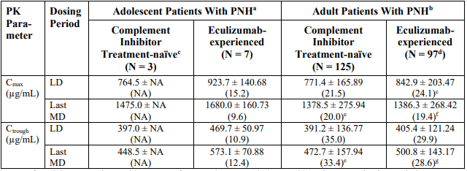
ª Data for adolescent patients with PNH are from Study ALXN1210-PNH-304 Primary Evaluation Period. ^{b} Data for complement inhibitor treatment-naive adult patients with PNH are from Study ALXN1210-PNH-301 and data for eculizumab-experienced adult patients with PNH are from Study ALXN1210-PNH-302, Primary Evaluation Periods. ^{c} Serum ravulizumab concentrations from an adolescent patient (complement inhibitor treatment-naive) were excluded due to administration of packed red blood cell transfusions during the study. Because n = 2, SD and %CV are not applicable. ^{d} Data for a patient were not included due to missing concentration records; thus, n = 96. ^{e} Data for a patient were excluded from the summary statistics for the last MD dosing period due to missing Day 127 dosing information; thus, n = 124. ^{f} In addition to data for patient not included (footnote c above), data for a patient are not included because the Day 127 end of infusion sample was missing; thus, n = 95. ^{g} In addition to data for a patient not included (footnote c above), data for a patient are not included because the Day 183 predose sample was missing; thus, n = 95.
Observed ravulizumab serum concentrations for adolescent patients with PNH are overlaid on the simulated concentration-time profile for adult patients with PNH from Phase III studies using the Final PNH population pharmacokinetics model below. One adolescent patient received multiple packed red blood cell transfusions during the primary evaluation period (data represented as blue points in Figure 1 and Figure 3. Transfusion was identified as significant covariate on ravulizumab pharmacokinetics in the population pharmacokinetics analysis of ravulizumab in patients with aHUS.
Figure 1: Observed pharmacokinetic data from adolescent patients with PNH overlaid on simulations of median serum ravulizumab concentration-time profile (95% prediction interval) for adult patients with PNH from Phase III studies using the final PNH population pharmacokinetic model
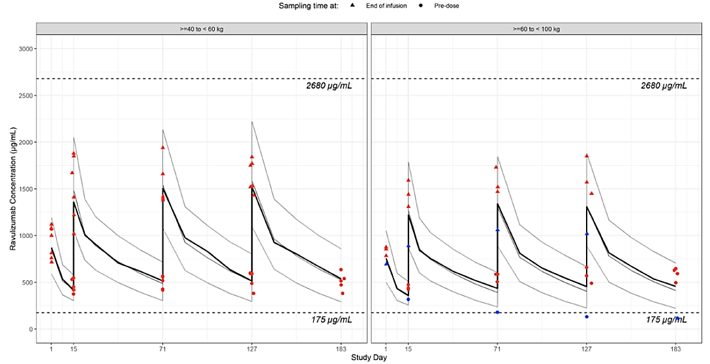
Note: Data for adolescent patients from Study ALXN1210-PNH-304 Primary Evaluation Period are overlaid on pharmacokinetic simulations (N = 500) of Phase III data from adult patients with PNH using the final PNH population PK model. The lower dashed horizontal line indicates serum concentration of 175 μg/mL, the therapeutic PK threshold for ravulizumab, and the upper dashed horizontal line indicates the maximum serum concentration observed in the ravulizumab clinical development program. Observed adolescent ravulizumab serum concentration data from End of Infusion and Predose are displayed using triangles and circles, respectively. Black lines represent median observed data from adult patients with PNH and grey lines represent the simulated data (median and 95% prediction interval) for adult patients with PNH. Ravulizumab serum concentrations for an adolescent patient who received multiple packed red blood cell transfusions during the Primary Evaluation Period of Study ALXN1210-PNH-304 are highlighted in blue.
All post-baseline individual serum free C5 concentrations were less than 0.5 μg/mL in adolescent and adult PNH patients.

Ravulizumab pharmacokinetic and pharmacodynamic comparison of children (birth to < 12 years) and adult patients with PNH
Table 9: Pharmacokinetic parameters of ravulizumab following the first intravenous loading dose and the last intravenous maintenance dose during the Primary Evaluation Period for children and adult patients with PNH
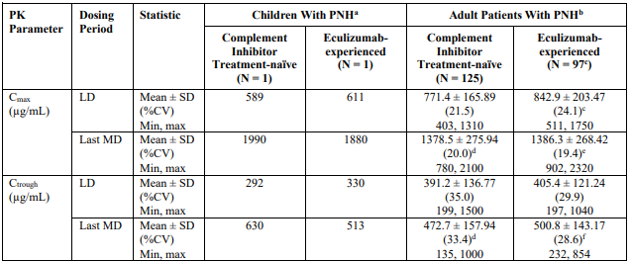
ª Data for children with PNH are from Study ALXN1210-PNH-304. ^{b} Data for complement inhibitor treatment-naive adult patients with PNH are from Study ALXN1210-PNH-301 and data for eculizumab-experienced adult patients with PNH are from Study ALXN1210-PNH-302. ^{c} Data for one patient were not included due to missing concentration records; thus, n = 96. ^{d} Data for one patient were excluded from the summary statistics for the last MD dosing period due to missing Day 127 dosing information; thus, n = 124. ^{e} In addition to data for one patient not included (footnote c above), data for one patient are not included because the Day 127 end of infusion sample was missing; thus, n = 95. ^{f} In addition to data for one patient not included (footnote c above), data for one patient are not included because the Day 183 pre-dose sample was missing; thus, n = 95.
Observed ravulizumab serum concentrations for children with PNH are overlaid on the simulation of the pharmacokinetics for adults with PNH from Phase III studies using the final PNH population pharmacokinetics model. There were no adult PNH patients with body weight 30 to less than 40 kg.
Figure 2: Observed pharmacokinetic data from children with PHN overlaid on simulations of median serum ravulizumab concentration-time profile (95% prediction interval) for adult patients with PNH from the Phase III studies using the final PNH population pharmacokinetic model
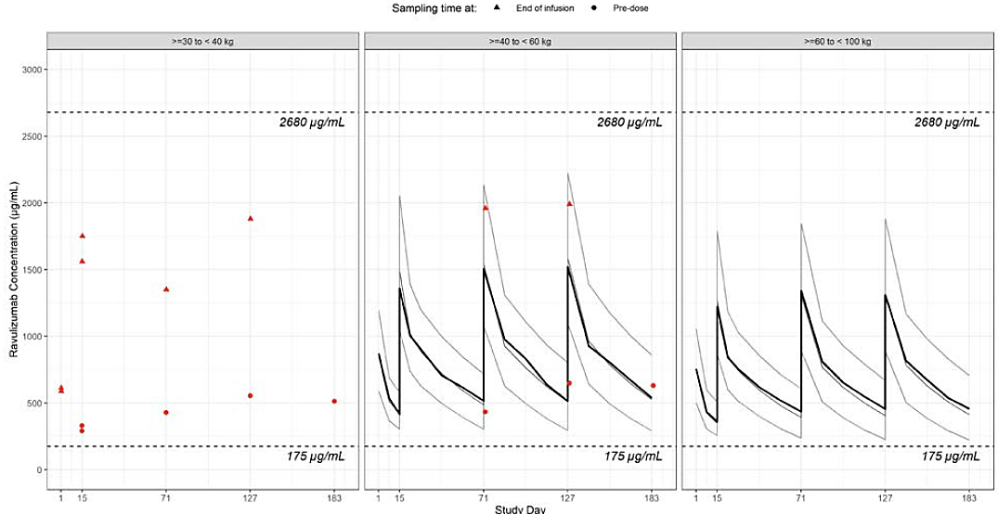
Note: Data for children with PNH from Study ALXN1210-PNH-304 Primary Evaluation Period are overlaid on pharmacokinetic simulations of Phase III data from adult patients with PNH using the final PNH population pharmacokinetic model. The lower dashed horizontal line indicates serum concentration of 175 μg/mL, the therapeutic pharmacokinetic threshold for ravulizumab, and the upper dashed horizontal line indicates the maximum serum concentration observed in the ravulizumab clinical development program. Black lines represent median observed data from adult patients with PNH and grey lines represent the simulated data (median and 95% prediction interval) for adult patients with PNH. Observed ravulizumab serum concentration data for children from End of Infusion and Predose are displayed using triangles and circles, respectively.
All post-baseline individual serum free C5 concentrations were less than 0.5 μg/mL in children and adults with PNH treated with ravulizumab.

Ravulizumab pharmacokinetic and pharmacodynamic comparison of adolescent patients with PNH and patients with aHUS
The mean C_{max} and C_{trough} following the loading dose and last maintenance dose of ravulizumab in adolescent patients with PNH (three complement inhibitor treatment-naive and seven eculizumab-experienced) and adult and paediatric aHUS patients with body weight 20 kg or more (that is those with once every eight weeks maintenance dosing interval) are shown below:
Table 10: Pharmacokinetic parameters of ravulizumab following the first intravenous loading dose and the last intravenous maintenance dose during the Primary Evaluation Period for adolescent patients with PNH and patients with aHUS
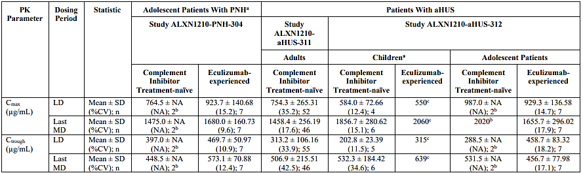
ª Data for children who received ravulizumab once every 4 weeks are not included. ^{b} Because n = 2, SD and %CV are not applicable. ^{c} Observed value only presented as n = 1.
Figure 3: Observed pharmacokinetic data from adolescent patients with PNH overlaid on simulations of median serum ravulizumab concentration-time profile (95% prediction interval) for patients with aHUS from the Phase III studies using the final aHUS population pharmacokinetic model
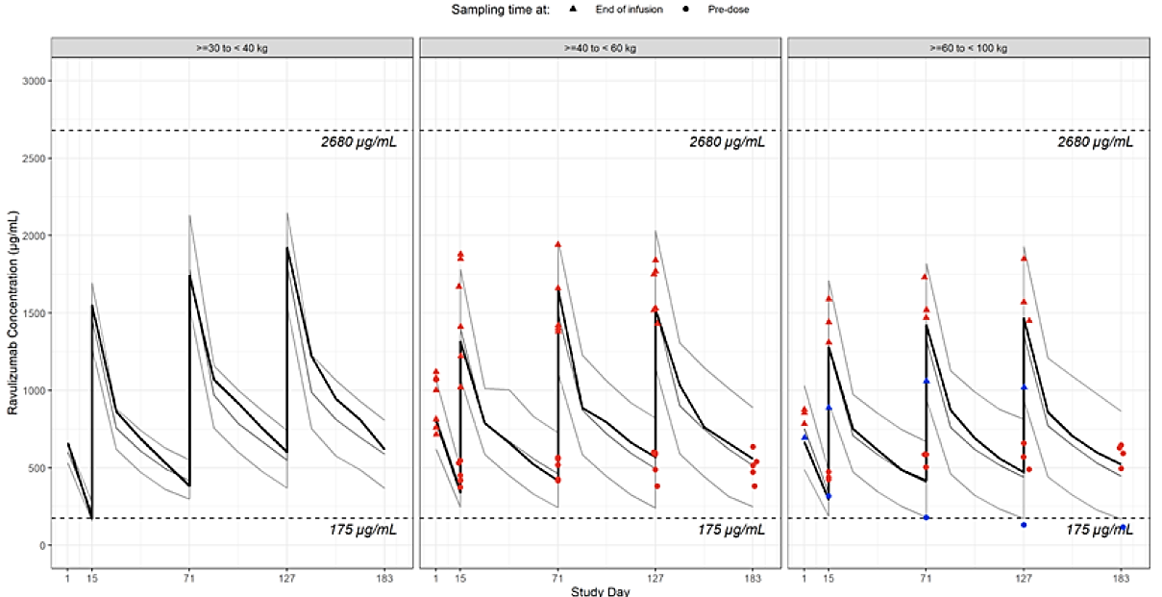
Note: Data for adolescent patients with PNH from Study ALXN1210-PNH-304 Primary Evaluation Period are overlaid on pharmacokinetic simulations of Phase III data from patients with aHUS using the final aHUS population pharmacokinetic model. The lower dashed horizontal line indicates serum concentration of 175 μg/mL, the therapeutic pharmacokinetic threshold for ravulizumab, and the upper dashed horizontal line indicates the maximum serum concentration observed in the ravulizumab clinical development program. Black lines represent median observed data from adult patients with PNH and grey lines represent the simulated data (median and 95% prediction interval) for adult patients with PNH. Observed adolescent ravulizumab serum concentration data from End of Infusion and Predose are displayed using triangles and circles, respectively. Ravulizumab serum concentrations for an adolescent patient who received multiple packed red blood cell transfusions during the Primary Evaluation Period of Study ALXN1210-PNH-304 are highlighted in blue.
All post-baseline individual serum free C5 concentrations were less than 0.5 μg/mL in adolescent PNH patients and greater than 99.5% analysed samples in patients with aHUS.

Ravulizumab pharmacokinetic and pharmacodynamic comparison of children with PNH and patients with aHUS
Pharmacokinetic parameters following the loading dose and last maintenance dose of ravulizumab in children with PNH (one complement inhibitor treatment-naive and one eculizumab-experienced) and adult and paediatric aHUS patients with body weight 20 kg or more are shown below:
Table 11: Pharmacokinetic parameters of ravulizumab following the first intravenous loading dose and the last intravenous maintenance dose during the Primary Evaluation Period for children with PNH and patients with aHUS
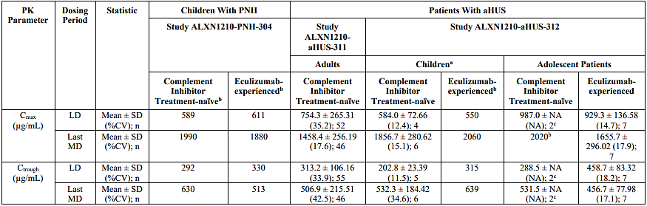
ª Data for children who received ravulizumab once every 4 weeks are not included. ^{b} Observed value only presented as n = 1. ^{c} Because n = 2, SD and %CV are not applicable
Figure 4: Observed pharmacokinetic data from children with PNH overlaid on simulations of median serum ravulizumab concentration-time profile (95% prediction interval) for patients with aHUS from the Phase III studies using the final aHUS population pharmacokinetic model
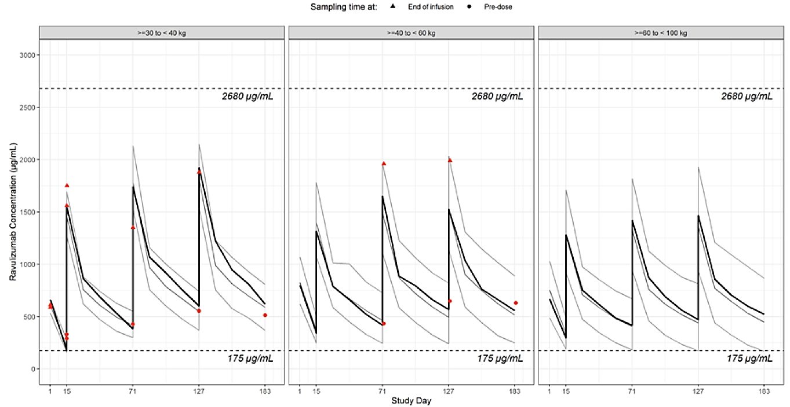
Note: Data for children with PNH from Study ALXN1210-PNH-304 Primary Evaluation Period are overlaid on pharmacokinetic simulations of Phase III data from patients with aHUS using the final aHUS population pharmacokinetic model. The lower dashed horizontal line indicates serum concentration of 175 μg/mL, the therapeutic pharmacokinetic threshold for ravulizumab, and the upper dashed horizontal line indicates the maximum serum concentration observed in the ravulizumab clinical development program. Black lines represent median observed data from adult patients with PNH and grey lines represent the simulated data (median and 95% prediction interval) for adult patients with PNH.
All post-baseline individual serum free C5 concentrations were less than 0.5 μg/mL in children with PNH and more than 99.5% analysed samples in patients with aHUS.

Serum ravulizumab concentrations versus serum free C5 concentrations by age (paediatric and adults) and disease (PNH and aHUS)
Figure 5: Serum ravulizumab concentrations versus time matched serum free C5 concentration for paediatric patients with PNH, adult patients with PNH, paediatric patients with aHUS and adult patients with aHUS
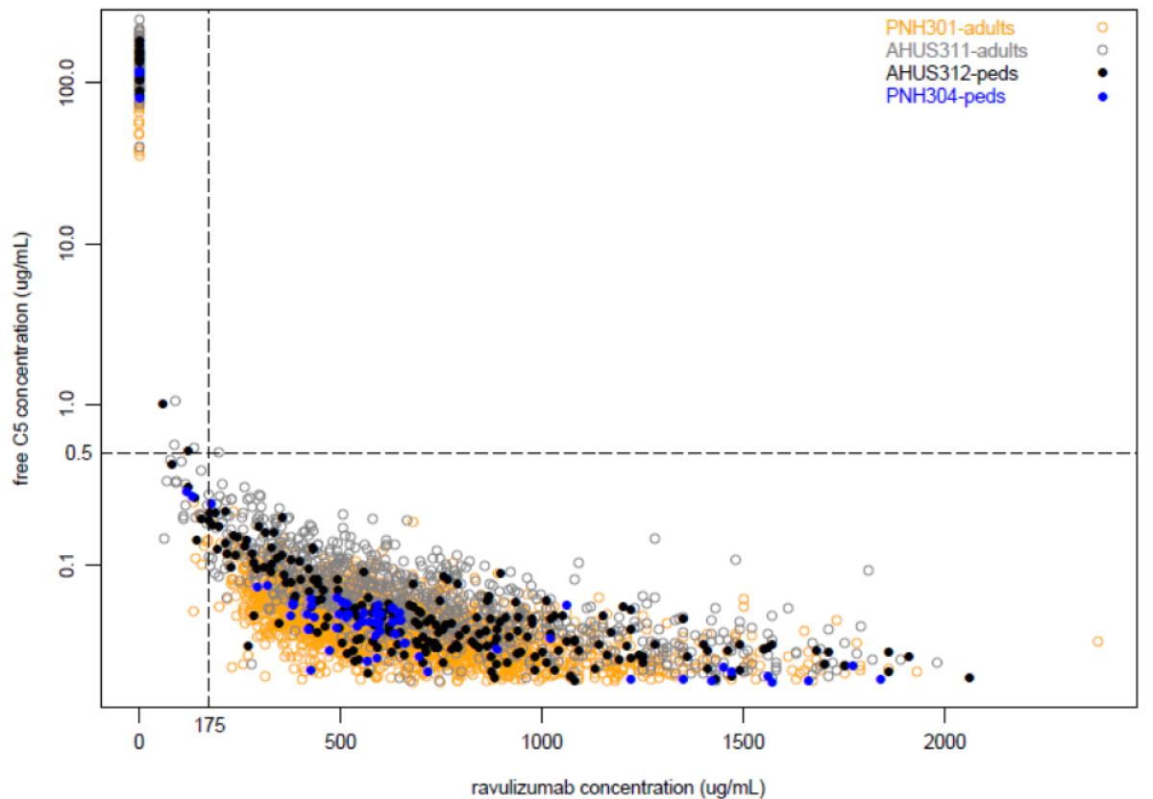
Note: The dashed horizontal line indicates serum free C5 concentration of 0.5 μg/mL, the level at which complete terminal complement inhibition occurs. The dashed vertical line indicates serum ravulizumab concentration of 175 μg/mL, the therapeutic pharmacokinetic threshold for ravulizumab
The pharmacometrics expert reviewed the data from the extrapolation report, with limitations of the data noted.
Advice from the pharmacometrics expert is summarised as follows:
- Based on limited pharmacokinetics data, the once every eight weeks regimens (≥ 20 kg) were adequately described and supports the weight-based dosing for these patients.
- Based on visual predictive checks, the population pharmacokinetic model failed to adequately describe the pharmacokinetic data for the once every four weeks regimen in children in the body weight groups less than 20 kg (5 to < 10 kg, 10 to < 20 kg).
- The data support the weight-based dosing regimen for paediatric PNH patients over the body weight range studied (paediatric PNH patients with body weights ranging from 36.7 to 72.0 kg at Baseline).

Pharmacodynamics
In adult aHUS patients, immediate and complete inhibition of terminal complement (free C5 serum concentration less than 0.5 µg/mL) was observed by the end of the first ravulizumab infusion and sustained throughout the initial evaluation period and during the extension period, with more than 99.5% all collected serum free C5 samples ≤ 0.5 μg/mL.
In paediatric patients with aHUS, complete terminal complement inhibition was sustained throughout the entire treatment period in complement inhibitor treatment-naive patients and eculizumab-experienced patients.
In paediatric patients with PNH, complete terminal complement inhibition was observed at Baseline in eculizumab-experienced patients and by the end of the first ravulizumab infusion in complement inhibitor treatment-naive patients and sustained throughout the primary evaluation period in both groups.
Among aHUS adult and paediatric patients, one treatment-emergent anti-drug antibodies positive result was observed in a complement inhibitor-naive adult aHUS patient on Day 68 with a low titre (< 1:1), no evidence of neutralisation, and no apparent impact on pharmacokinetics/ pharmacodynamics, safety or efficacy. No paediatric PNH patients developed anti-drug antibodies to ravulizumab at any time during the primary evaluation period.
On review of the final aHUS population pharmacokinetics report, the pharmacometrics expert stated no exposure-safety analysis was conducted as there were no clear trends in the frequency of adverse events over quartiles of exposure.

Efficacy

Atypical haemolytic uraemic syndrome

Study ALXN1210-aHUS-311
Study ALXN1210-aHUS-311; is an ongoing Phase III, open-label, multinational, multicentre, single-arm study to evaluate the safety and efficacy of ravulizumab in complement inhibitor treatment-naive adult and adolescent patients with aHUS. The study comprised a 26-week initial evaluation period and extension period (up to 4.5 years).
Data were provided for the 26-week Initial Evaluation Period and for patients who had at least one visit during the Extension Period, including at least 52 weeks of treatment for all ongoing patients as of the data cut-off date (2 July 2019). The study design is summarised in Figure 6, shown below.
Figure 6: Study ALXN1210-aHUS-311 Study design
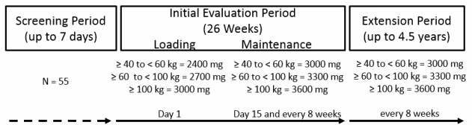
The first patient was treated 18 March 2017. The extension period data cut-off was 2 July 2019. The study centres were across 41 sites in 14 countries (Australia, Austria, Belgium, Canada, France, Germany, Italy, Japan, Korea, Russia, Spain, Taiwan, United Kingdom and the United States).
All patients received ravulizumab loading dose on Day 1 and weight-based maintenance dosing on Day 15 and once every eight weeks thereafter as per Figure 6.

Inclusion and exclusion criteria
The main inclusion criteria were:
- Age ≥ 12 years
- Body weight ≥ 40 kg
- Evidence of thrombotic microangiopathy (TMA) including thrombocytopenia, evidence of haemolysis, and kidney injury based on:
  - platelet count < 150,000/μL and
  - lactate dehydrogenase (LDH) ≥ 1.5 x upper limit of normal (ULN) and haemoglobin (Hb) ≤ lower limit of normal for age and gender and
  - serum creatinine ≥ ULN in adults or ≥ 97.5th percentile for adolescent
- Vaccination against meningococcal infections (and Haemophilus influenzae type b (Hib) and Streptococcus pneumoniae if less than 18 years of age
The main exclusion criteria were:
- ADAMTS13 (a disintegrin and metalloproteinase with a thrombospondin type 1 motif, member 13) deficiency
- Shiga toxin-related HUS
- Positive direct Coombs test
- Identified drug exposure-related HUS
- HUS due to a known genetic defects of cobalamin C metabolism
- Kidney disease other than aHUS
- Chronic dialysis
- Plasma exchange/plasma infusion ≥ 28 days prior to screening
- Prior use of complement inhibitors
- Chronic intravenous immune globin (IVIg) within 8 weeks or chronic rituximab within 12 weeks of screening
- Other immunosuppressive therapies unless confirmed anti-complement factor antibodies requiring immunosuppressive therapy, part of established post-transplant regimen or steroids for another condition
- History of heart, lung, small bowel, pancreas, or liver transplant
- Bone marrow transplant or haematopoietic stem cell transplant within the last 6 months
- History of malignancy within 5 years (except treated non-melanoma skin cancer, carcinoma in situ of cervix)

Efficacy endpoints
The primary endpoints were complete thrombotic microangiopathy response during the 26-week Initial Evaluation Period. This was the composite of normalisation of platelet count, normalisation of lactate dehydrogenase and ≥ 25% improvement in serum creatinine at Baseline (for patients on dialysis at Baseline (within 5 days of first dose study drug), the first valid creatinine value to be used as the baseline value was the first assessment ≥ 6 days post dialysis). The criteria were to be met at two separate assessments ≥ 28 days apart and any measurement in between.
The secondary endpoints were:
- Time to complete thrombotic microangiopathy (TMA) response
- Complete TMA response status over time
- Observed value and change from baseline in haematologic parameters (platelets, lactate dehydrogenase, haemoglobin (Hb))
- Haemoglobin response: Hb increase ≥ 20 g/L from baseline observed at two separate assessments ≥ 28 days apart and any measurements in between
- Dialysis requirement
- Observed value and change from baseline in estimated glomerular filtration rate (eGFR)
- Chronic kidney disease (CKD) stage compared to baseline
- Change from baseline in quality of life

Statistical methods
This was an estimation study, and no formal statistical tests were planned. Efficacy analyses were performed using the full analysis set (FAS) with the primary analysis and selected secondary efficacy analyses repeated on the per protocol (PP) set as sensitivity analyses. For evaluation of the primary endpoint, patients missing an efficacy assessment that was part of the definition of complete thrombotic microangiopathy response while still on study had their last observation carried forward. The number of patients for each set were: FAS: 56 patients; PP set: 44 patients; safety set: 58 patients.

Patient Disposition
Seventy four patients were screened. Of these, 58 were enrolled and treated. Fifty six were included in the FDA submission as two were excluded due to positive stool Shiga toxin test. Forty nine completed the 26-week Initial Evaluation Period as seven discontinued treatment (three due to adverse events, two to death, one due to a major protocol deviation and one due to physician Decision). Forty nine entered the extension study. Eleven discontinued the study drug (five due to patient Decision, four due to physician Decision, one due to protocol violation and one due to other reasons).

Protocol deviations
There were major protocol deviations were reported for 43 (74.1%) patients, mostly related to eligibility and entry criteria. Twelve (20.7%) patients were excluded from the PP set due to major protocol violations relating to eligibility and entry criteria and use of prohibited concomitant medication.
All patients were adults, including 8 (14.3%) aged ≥ 60 years, mostly female (66.1%), White (51.8%) with median age at first infusion 40.1 years (range: 19.5, 76.6). At Baseline 92.9% patients had extra-renal signs or symptoms of aHUS, most commonly in the cardiovascular (69.6%), CNS (51.8%) and pulmonary (44.6%) organ systems. The majority of patients had Stage 5 CKD at Baseline (n = 39 (72.2%)) and 51.8% were receiving dialysis. The study population included 8 (14.3%) patients with kidney transplant and 8 (14.3%) postpartum patients.

Primary endpoint
Complete thrombotic microangiopathy (TMA) response was observed in 30 of 56 (53.6%; 95% confidence interval (CI): 39.6, 67.5) patients in the FAS (Table 12).
Table 12: Study ALXN1210-aHUS-311 Complete thrombotic microangiopathy response and complete thrombotic microangiopathy response components analysis during the 26-Week Initial Evaluation Period (Full Analysis Set)
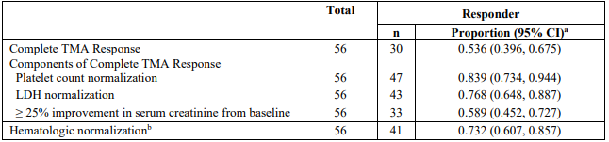
Abbreviations: CI = confidence interval; LDH = lactate dehydrogenase; TMA = thrombotic microangiopathy.
Note: Patients must have met all complete TMA response criteria concurrently, and each criterion must have been met at two separate assessments obtained at least 4 weeks (28 days) apart, and any measurement in between. The proportion of complete TMA response was based on the responders among treated patients. The numerator was the number of patients achieving complete TMA response during the 26-week Initial Evaluation Period and the denominator was the number of patients in the FAS. Platelet values obtained from the day of a blood transfusion of platelets through 3 days after the transfusion were excluded from all analyses. All serum creatinine values obtained while a patient was on dialysis were excluded from all analyses. When a patient was on dialysis at Baseline, then the first valid creatinine value used as the baseline value was the first assessment ≥ 6 days post dialysis. If a patient was on dialysis during the entire 26-week Initial Evaluation Period, then the baseline creatinine was not calculated. 95% confidence intervals (95% CI) for the proportion were based on the asymptotic Gaussian approximation method with a continuity correction. b Hematologic normalization includes normalization of platelet count (≥ 150 × 10⁹ /L) and normalization of LDH (≤ 246 U/L).
As of data cut-off (2 July 2019), an additional four patients had confirmation of a complete thrombotic microangiopathy response during the Extension Period: 34 out of 56 (60.7%; 95% CI: 47.0, 74.4).
Results in the PP set were similar; complete thrombotic microangiopathy response was observed in 22 out of 44 patients (50.0%; 95% CI: 34.1, 65.9) during the 26-week Initial Evaluation Period and in 26 of 44 patients (59.1%; 95% CI: 43.4, 74.8) as of data cut-off date.

Secondary endpoints
Complete thrombotic microangiopathy response was achieved at a median time of 86 days and occurred as early as seven days following the first dose of ravulizumab, with the latest response observed at Day 401.
The 30 patients who achieved complete thrombotic microangiopathy response status during the Initial Evaluation Period had all done so by the Day 141 visit. From the median time to complete thrombotic microangiopathy response the proportion of responders was stable, although some patients who had achieved a complete thrombotic microangiopathy response had transient periods during which not all components of response continued to be met.
Of the three complete thrombotic microangiopathy response components, platelets showed the earliest response, with normalisation of LDH and renal function improvement requiring a longer duration of treatment to show the same extent of improvement.
Figure 7: Study ALXN1210-aHUS-311 Complete thrombotic microangiopathy response components and haematologic normalisation status over time during the Initial Evaluation Period (Full Analysis Set)
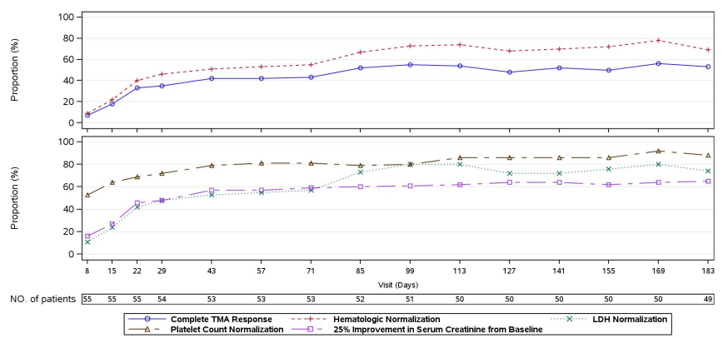
Note: The criteria for complete TMA response are 1) normalization of platelet count; 2) normalization of LDH; and 3) ≥ 25% improvement in serum creatinine from Baseline. A patient was in the analysis for a specific post-baseline time point if it was possible for the result at that time point to be confirmed. Hematologic normalization includes normalization of platelets and LDH. Platelet values obtained from the day of a blood transfusion of platelets through 3 days after the transfusion were excluded from all analyses. All serum creatinine values obtained while a patient was on dialysis were excluded from all analyses. When a patient was on dialysis at Baseline, then the first valid creatinine value to be used as the baseline value was the first assessment ≥ 6 days post dialysis. If a patient was on dialysis during the entire 26-week Initial Evaluation Period, then the baseline creatinine was not calculated
The mean change from baseline in haematologic parameters at Day 183 is shown in Table 13.
Table 13: Study ALXN1210-aHUS-311 Mean change from Baseline in haematologic parameters at Day 183
Haematologic TMA Parameter | Baseline (mean) | Day 183 (mean) | Mean change from Baseline
Platelet count (x 10⁹/L) | 118.52 | 237.96 | 114.79
LDH (U/L) | 702.38 | 194.46 | -519.83
Hb (g/L) | 86.26 | 120.27 | 34.64
Abbreviations: Hb = haemoglobin; LDH = lactate dehydrogenase; TMA = thrombotic microangiopathy
During the Extension Period, mean platelet count remained ≥ 205 x 10⁹/L, mean LDH values remained ≤ 215 U/L and mean haemoglobin values were ≥ 120 g/L.
During the Initial Evaluation Period, 71.4% (40/56; 95% CI: 58.7, 84.2) patients achieved haemoglobin response with an additional five patients achieving haemoglobin response at the time of data cut-off (80.4% (45/56); 95% CI: 69.1, 91.7).
Of the 29 (51.8%) patients requiring dialysis at Baseline:
- 17 (58.6%) discontinued dialysis during the Initial Evaluation Period
- 18 (62.1%) discontinued dialysis during the study as of data cut-off
Of the 27 patients who were not on dialysis at Baseline, 7 (25.9%) initiated dialysis during the Initial Evaluation Period, with 6 remaining on dialysis at Day 183.
Mean estimated glomerular filtration rate (eGFR) increased over time during the Initial Evaluation Period; 15.86 mL/min/1.73 m², 30.63 mL/min/1.73 m² and 51.83 mL/min/1.73 m² at Baseline, Day 15 and Day 183 respectively. During the Extension Period, mean eGFR remained ≥ 50 mL/min/1.73 m² for the 43 patients that reached the Day 407 visit.
For 32 of 47 (68.1%) patients with available data, chronic kidney disease (CKD) stage improved compared to baseline by ≥ 1 stage. CKD stage worsened for two patients (Stage 4 to Stage 5). During the Extension Period, 29 of 42 (69.0%) patients with available baseline and Day 407 data had improvement in CKD stage compared to baseline.

Paediatric patients with atypical haemolytic uraemic syndrome

Study ALXN1210-aHUS-312
Study ALXN1210-aHUS-312; is an ongoing Phase III, open-label, multinational, multicentre, single-arm study to evaluate the safety, efficacy, pharmacokinetics and pharmacodynamics of ravulizumab in complement inhibitor treatment-naive (Cohort 1) and eculizumab-experienced (Cohort 2) paediatric patients with aHUS. The study comprised a 26-week Initial Evaluation Period and Extension Period (up to 4.5 years). Data were presented through data cut-off date of 3 December 2019 and included at least the 52 Week visit for all patients ongoing in the study.
The study design is summarised in Figure 8, below.
Figure 8: Study ALXN1210-aHUS-312 study design
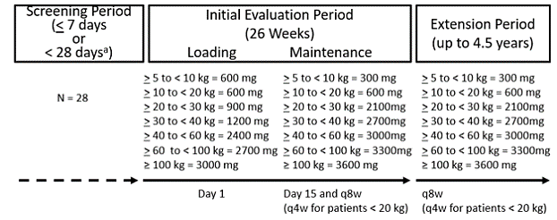
ª The Screening Period was up to 7 days for complement inhibitor treatment-naive patients (that is, Cohort 1) and up to 28 days for eculizumab-experienced adolescent patients (that is, Cohort 2).
The first patient was treated on 1 September 2017. The data cut-off was on 3 December 2019. The study was conducted over 20 sites in 8 countries (Belgium, Germany, Italy, Japan, Korea, Spain, United Kingdom and the USA).
All patients received ravulizumab loading dose on Day 1 and weight-based maintenance dosing on Day 15 and once every eight weeks (body weight ≥ 20 kg) or once every four weeks (body weight < 20 kg) thereafter as above. For eculizumab treated patients, Day 1 of study treatment occurred 14 days after the last dose of eculizumab.
As part of Protocol Amendment 5 (23rd August 2018), the loading dose for patients with body weight 5 to < 10 kg was increased from 300 mg to 600 mg.

Main inclusion and exclusion criteria
The main inclusion criteria were:
- Age < 18 years (Cohort 1 and Japanese sites for Cohort 2); age 12 to < 18 years (non-Japanese sites for Cohort 2)
- Body weight 5 kg or more
- Cohort 1:
Evidence of thrombotic microangiopathy (TMA) including thrombocytopenia, evidence of haemolysis, and kidney injury based on:
  - Platelet count < 150,000/μL and
  - lactate dehydrogenase (LDH) ≥ 1.5 x upper limit of normal (ULN) and haemoglobin (Hb) ≤ lower limit of normal for age and gender and
  - Serum creatinine ≥ 97.5th percentile for age at screening.
- Cohort 2:
  - Documented diagnosis of aHUS
  - Treated with eculizumab for 90 days or longer before screening
  - Clinical evidence of response to eculizumab indicated by stable TMA parameters including LDH < 1.5 x ULN and platelet count ≥ 150,000/μL and urine output/ estimated glomerular filtration rate (eGFR) > 30 mL/min/1.73m² using the Schwarz formula
- Vaccination against meningococcal infections, Haemophilus influenzae type b (Hib) and Streptococcus pneumoniae.
The main exclusion criteria were:
- Cohort 1:
  - Prior use of complement inhibitors
  - Plasma exchange/plasma infusion 28 days or longer prior to screening
- Cohort 2:
  - Prior use of complement inhibitors other than eculizumab
  - Abnormal TMA parameters within 90 days of screening (LDH ≥1.5 x ULN, platelet count less than 150,000/μL or eGFR ≥30 mL/min/1.73m² using the Schwarz formula)
- Other key exclusion criteria as per Study ALXN1210-aHUS-311 (see Inclusion and exclusion criteria of Study ALXN1210-aHUS-311, above).

Efficacy endpoints
The primary endpoint (Cohort 1 only) was complete thrombotic microangiopathy Response during the 26-week Initial Evaluation Period (as defined for Study ALXN1210-aHUS-311, see above).
The secondary endpoints were:
- Time to complete TMA response (Cohort 1 only)
- complete TMA response status over time (Cohort 1 only)
- Dialysis requirement status
- Observed value and change from Baseline in eGFR
- CKD stage compared to Baseline
- Observed value and change from baseline in haematologic parameters (platelets, LDH, Hb)
- Haemoglobin response (as previously defined; Cohort 1 only)
- Change from baseline in quality of life

Statistical methods
This was an estimation study, and no formal statistical tests were planned. The study planned at least four patients in each of the birth groups: < 2 year, 2 to < 6 year and 6 to < 12 year age groups and at least eight patients in the 12 to < 18 year age group.
Efficacy analyses were performed using the FAS with the primary analysis and selected secondary efficacy analyses repeated on the PP set as sensitivity analyses. The analyses for Cohort 1 and Cohort 2 were conducted and reported separately as planned. The number of patients in Cohort 1 was 18 for the FAS, 18 in the PP set and 21 in the safety set. In Cohort 2, the number of patients were 10 in the FAS, 10 in the PP set and 10 in the safety set.

Patient Disposition
In Cohort 1, 21 patients were screened, enrolled and treated. The FAS set comprised of 18 patients as three patients were excluded due to failure to meet eligibility criteria based on laboratory confirmation (LDH/platelet, positive stool Shiga toxin test). Seventeen patients completed the 26-week Initial Evaluation Period as one patient discontinued treatment due to adverse events. Seventeen patients entered the extension study. Sixteen of the patients are ongoing as of the data cut-off; one patient discontinued due to physician’s Decision.
In Cohort 2, there were 10 patients screened, enrolled and treated. All patients were included in the FAS and PP set and completed the 26-week Initial Evaluation Period. All ten patients were ongoing in the Extension Period at the time of data cut-off.

Protocol deviations
Major protocol deviations were reported for 14 (66.7%) patients in Cohort 1, most frequently related to eligibility and entry criteria. One (10.0%) patient in Cohort 2 had a major protocol violation relating to informed consent form.
In both cohorts, all patients included in the FAS were included in the PP set.
Baseline demographics are summarised below in Table 14. In Cohort 1, 72.2% patients had extra-renal signs or symptoms of aHUS, most commonly in the gastrointestinal (61.1%), cardiovascular (50.0%) and skin (50.0%) organ systems at Baseline. The majority of patients had Stage 4 (44.4%) or Stage 5 (33.3%) CKD at Baseline and 6 (33.3%) were receiving dialysis. Among Cohort 2 patients, 1 (10.0%) patient had extra-renal signs or symptoms of aHUS and 80.0% had Stage 1 CKD at Baseline. There were no patients with Stage 4 or 5 CKD and no patients receiving dialysis.
Table 14: Study ALXN1210-aHUS-312 Demographic characteristics (Cohorts 1 and 2, Full Analysis Set)
Variable | Cohort 1  FAS (n = 18) | Cohort 2  FAS (n = 10)
Age at time of first infusion (years)  Mean (SD)  Median (min, max) | 6.4 (4.51)  5.2 (0.9, 17.3) | 11.0 (4.97)  12.5 (1.2, 15.5)
Age at time of first infusion (years) category, n (%)  Birth to < 2 years  2 to < 6 years  6 to < 12 years  12 to < 18 years | 2 (11.1)  9 (50.0)  5 (27.8)  2 (11.1) | 1 (10.0)  1 (10.0)  1 (10.0)  7 (70.0)
Sex, n (%)  Male  Female | 8 (44.4)  10 (55.6) | 9 (90.0)  1 (10.0)
Race, n (%)ª  American Indian or Alaskan Native  Asian  Black or African-American  White  Unknown | 1 (5.6)  5 (27.8)  3 (16.7)  9 (50.0)  1 (5.6) | 0  4 (40.0)  1 (10.0)  5 (50.0)  0
Weight at time of at first infusion (kg)  Mean (SD)  Median (min, max) | 22.2 (14.64)  16.7 (8.4, 69.3) | 41.6 (19.01)  47.8 (8.82, 69)
Weight at time of first infusion (kg) category, n (%)  ≥ 5 to < 10 kg  ≥ 10 to < 20 kg  ≥ 20 to < 30 kg  ≥ 30 to < 40 kg  ≥ 40 to < 60 kg  ≥ 60 to < 100 kg | 2 (11.1)  9 (50.0)  3 (16.7)  3 (16.7)  0  1 (5.6) | 1 (10.0)  1 (10.0)  1 (10.0)  1 (10.0)  5 (50.0)  1 (10.0)
Abbreviations: FAS = full analysis set; SD = standard deviation.
Note: Data as of 3 December 2019. Percentages were based on the total number of patients. ª Patients could have selected multiple races.

Primary endpoint
Complete thrombotic microangiopathy (TMA) response was observed in 14 of 18 (77.8%; 95% CI: 52.4, 93.6) patients in Cohort 1 during the Initial Evaluation Period (see Table 15).
Table 15: Study ALXN1210-aHUS-312 Complete thrombotic microangiopathy response and complete Thrombotic microangiopathy thrombotic microangiopathy response components analysis during the 26-Week Initial Evaluation Period (Cohort 1 Full Analysis Set)
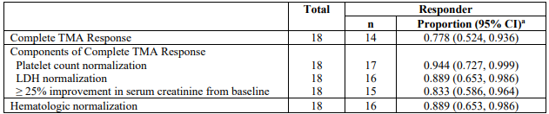
Abbreviations: LDH = lactate dehydrogenase; TMA = thrombotic microangiopathy.
Note: Data as of 3 December 2019. Patients must have met all complete TMA response criteria at two separate assessments obtained at least four weeks (28 days) apart, and any measurement in between. Hematologic normalization includes normalization of platelet count and normalization of LDH. Platelet values obtained from the day of a blood transfusion of platelets through three days after the transfusion were excluded from all analyses. All serum creatinine values obtained while a patient was on dialysis were excluded from all analyses. When a patient was on dialysis at Baseline, then the first valid creatinine value used as the baseline value was the first assessment ≥ 6 days post dialysis. If a patient was on dialysis during the entire 26-week Initial Evaluation Period, then the baseline creatinine was not calculated. A 95% CIs for the proportion were based on exact confidence limits using the Clopper-Pearson method
As of data cut-off, complete thrombotic microangiopathy response was observed in 17 of 18 patients (94.4%; 95% CI: 72.7, 99.9).

Secondary endpoints:

Cohort 1
The median time to complete thrombotic microangiopathy response was 30 days, occurring from Day 15. The response was sustained through the end of the 26-week Initial Evaluation Period for the 14 patients who achieved a complete thrombotic microangiopathy response. Three patients achieved a complete thrombotic microangiopathy response during the Extension Period (Days 295 and 351).
The mean change from baseline in haematologic parameters for Cohort 1 (FAS) at Day 183 is shown in Table 16.
Table 16: Mean change from baseline in haematologic parameters for Cohort 1 (Full Analysis Set) at Day 183
Haematologic TMA Parameter | Baseline (mean) | Day 183 (mean) | Mean change from Baseline
Platelet count (x 10⁹/L) | 60.39 | 304.94 | 245.59
LDH (U/L) | 2223.47 | 262.41 | - 2044.13
Hb (g/L) | 74.42 | 120.06 | 46.50
Abbreviations: Hb = haemoglobin; LDH = lactate dehydrogenase; TMA = thrombotic microangiopathy.
During the Extension Period, mean platelet count remained ≥ 218 x 10⁹/L, mean LDH values remained ≤ 262 U/L and mean haemoglobin values were ≥ 114 g/L as of data cut-off date.
The percentage of patients achieved haemoglobin response during the Initial Evaluation Period was 88.9% (16/18; 95% CI: 65.3, 98.6) with one additional patient achieving haemoglobin response at the time of data cut-off (94.4% (17/18); 95% CI: 72.7, 99.9).
Of the six patients requiring dialysis at Baseline, four had discontinued dialysis by Day 36 and all six had discontinued dialysis by Day 193. No patients initiated dialysis after commencing study treatment.
Mean eGFR increased over time with improvement observed from Day 8 onwards; 26.4 mL/min/1.73 m², 45.6 mL/min/1.73 m² and 108.5 mL/min/1.73 m² at Baseline, Day 8 and Day 183 respectively. Mean eGFR remained greater than 100 mL/min/1.73 m² during the Extension Period for the 14 patients who reached the Day 407 visit.
For the 17 patients with available data at the end of the Initial Evaluation Period, 15 had improvement in CKD stage compared to baseline, with 14 patients improving by ≥ 2 Stages. No patients had worsening of CKD stage during the Initial Evaluation Period. The 14 patients with available baseline and Day 407 data all had improvement in CKD stage compared to baseline.
The two patients in Cohort 1 with body weight 5 to < 10 kg were enrolled prior to Protocol Amendment 5 and both received a ravulizumab loading dose of 300 mg.
One patient withdrew on Day 21 after receiving two doses of ravulizumab due to serious adverse events (SAE) of hypertensive crisis and Grade 3 anaemia.
One patient was a complete thrombotic microangiopathy responder. The Day 15 free C5 level was 0.999 µg/mL, but otherwise remained less than 0.5 µg/mL at later time points.

Cohort 2
In Cohort 2, haematologic parameters (platelet count, LDH, Hb) and eGFR remained stable during the Initial Evaluation Period (Table 17 below) and through the data cut-off date.
Table 17: Study ALXN1210-aHUS-312 Mean change from Baseline in haematologic parameters and eGFR at Day 183 (Cohort 2, Full Analysis Set)
Parameter | Baseline (mean) | Day 183 (mean) | Mean change from Baseline
Platelet count (x 10⁹/L) | 287.90 | 294.60 | 6.70
LDH (U/L) | 219.40 | 216.00 | - 3.40
Haemoglobin (g/L) | 131.50 | 127.40 | -4.10
eGFR (mL/min/1.73m²) | 104.90 | 94.00 | -10.90
Abbreviations: eGFR = estimated glomerular filtration rate; LDH = lactate dehydrogenase.
At the end of the Initial Evaluation Period, there was no change in CKD Stage for seven patients, whilst three patients had worsening of CKD stage (n = 2 by 1 Stage (Stage 1 to Stage 2) and n = 1 by 3 Stages (Stage 1 to Stage 3b0). During the Extension Period, all ten patients had no change in CKD stage compared to baseline at Day 351.
As of data cut-off date, no patients were initiated on dialysis after commencing ravulizumab treatment.
The single patient in Cohort 2 with body weight 5 to < 10 kg received the increased loading dose of 600 mg. The sponsor stated the haematologic and eGFR parameters for this patient were in the normal range at Baseline and remained generally stable at subsequent visits through the data cut-off date. Free C5 values were less than 0.5 µg/mL at Baseline and following initiation of ravulizumab treatment.

Paediatric patients with paroxysmal nocturnal haemoglobinuria

Study ALXN1210-PNH-304
Study ALXN1210-PNH-304; is an ongoing, open-label, multinational, multicentre, single-arm study of ravulizumab in paediatric patients with PNH who were complement inhibitor treatment-naive or eculizumab-experienced. The study comprised a 4-week Screening Period, a 26-week Primary Evaluation Period, and an Extension Period of up to 4 years (ongoing). Thirteen patients were enrolled, with data available for 12 patients completing the Primary Evaluation Period through Week 26 at the time of database lock (27 May 2020) for the planned interim clinical study report (CSR) (n = 4 treatment-naive and n = 8 eculizumab-experienced patients).
An addendum to the interim CSR (release date 17 September 2020) for Study ALXN1210-PNH-304 including data for the thirteenth enrolled patient (14 year-old complement inhibitor treatment-naive male) through the Primary Evaluation Period was provided by the sponsor upon request, in addition to updated safety and efficacy data over at least 52 Weeks (data cut-off date 4 March 2021).

Study design
The first patient was treated on 22 February 2018. The date of the last analysed patient that completed the Primary Evaluation Period was 25 March 2020 (as per interim CSR) for the 12th patient’s Day 183 visit. The addendum to interim CSR is dated 15 September 2020. The study was conducted over nine sites in six countries (United States, United Kingdom, France, Netherlands, Russia and Norway).
All patients received ravulizumab loading dose on Day 1 and weight-based maintenance dosing on Day 15 and once every eight weeks (body weight ≥ 20 kg) or once every four weeks (body weight < 20 kg) thereafter. The dosing regimen shown in Table 18 (below) is consistent with the dosing regimen explored in patients with aHUS through Studies ALXN1210-aHUS-311 and ALXN1210-aHUS-312.
Table 18: Study ALXN1210-PNH-304 Dose regimen
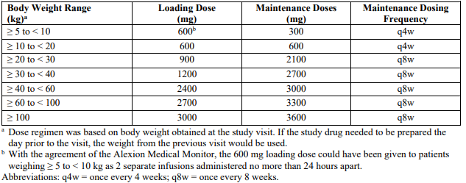
For eculizumab treated patients, Day 1 of study treatment occurred 14 days after the last dose of eculizumab. As part of Protocol Amendment 2 (23 August 2018), the loading dose for patients with body weight 5 to < 10 kg was increased from 300 mg to 600 mg (based on the initial pharmacokinetic/pharmacodynamic analysis from paediatric patients in Study ALXN1210-aHUS-312 as previously described).

Main inclusion and exclusion criteria
The main inclusion criteria were:
- Age < 18 years and body weight ≥ 5 kg
- Documented diagnosis of PNH confirmed by high sensitivity flow cytometry of red blood cells and white blood cells, with granulocyte or monocyte clone size of ≥ 5%.
- Complement inhibitor treatment-naive patients: serum LDH ≥ 1.5 x ULN and at least one PNH symptom or sign within three months of Screening.
- Eculizumab-experienced patients: treated with eculizumab for at least six months and LDH ≤ 1.5 x ULN.
- Vaccination against meningococcal infections, Haemophilus influenzae type b (Hib) and Streptococcus pneumoniae.
The main exclusion criteria were:
- Platelet count < 30 × 10⁹/L
- Absolute neutrophil count < 0.5 × 10⁹/L
- History of bone marrow transplant
- History of N. meningitidis infection or history of unexplained, recurrent infection
- Concomitant use of anticoagulants unless on a stable regimen for ≥ 2 weeks

Endpoints
The primary endpoint was pharmacokinetic/pharmacodynamic parameters at Baseline and Weeks 2, 10, 18 and 26. The pharmacokinetic parameters were C_{max}, C_{trough} and accumulation ratio. The pharmacodynamic parameter was change in free C5 concentration and chicken red blood cell haemolytic activity over time.
The efficacy secondary endpoints were:
- Percent change in LDH from baseline to Day 183 (Week 26)
- Transfusion avoidance: proportion of patients who remained transfusion free and did not require a transfusion through Day 183 (Week 26)
- Change in quality of life from Baseline to Day 183 (Week 26)
- Proportion of patients with stabilised haemoglobin (Hb): avoidance of a ≥ 2 g/dL decrease in haemoglobin from baseline in the absence of transfusion through Day 183 (Week 26)
- Proportion of patients with breakthrough haemolysis: at least one new or worsening symptom or sign of intravascular haemolysis in the presence of elevated LDH as defined per protocol
- Percentage change in free haemoglobin from baseline to Day 183 (Week 26)

Statistical methods
This study was descriptive in nature and not statistically powered for hypothesis testing. A sample size of 10 was expected to be sufficient to adequately describe pharmacokinetics/ pharmacodynamics in paediatric patients with PNH. Efficacy analyses were performed on the FAS.
The planned interim clinical study report FAS had 12 patients (n = 4 complement inhibitor treatment-naive and n = 8 eculizumab-experienced).
The addendum to interim clinical study report FAS had 13 patients (n = 5 complement inhibitor treatment-naive and n = 8 eculizumab-experienced).

Patient Disposition
All 13 enrolled patients completed the Primary Evaluation Period and entered the Extension Period of the study.

Protocol deviations
In the planned interim clinical study report, important protocol deviations were reported for eight (66.7%) patients which were most frequently related to laboratory assessments (five (41.7%)). None of the important protocol deviations were considered to impact the interpretation of efficacy and safety results.
Baseline demographics and disease characteristics are summarised below for the 13 enrolled patients are in Table 19 :
Table 19: Study ALXN1210-PNH-304 Demographics and baseline characteristics (Full Analysis Set)
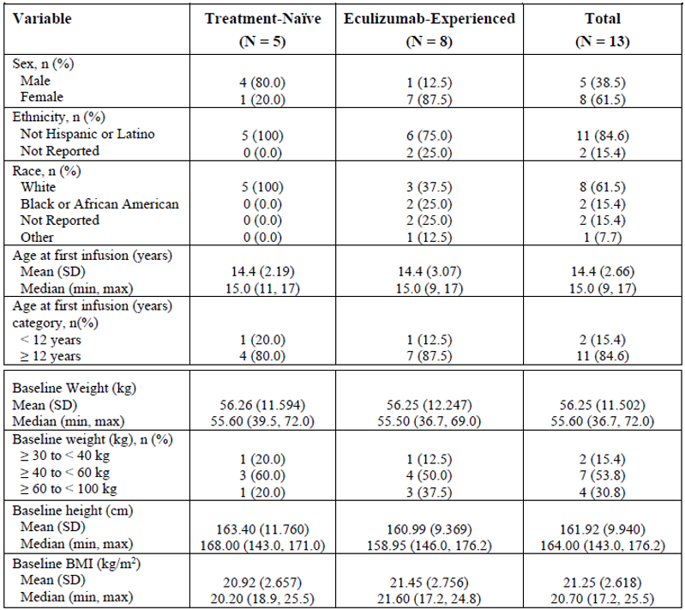
Note: Percentages were based on the total number of patients in each cohort, or overall.
Table 20: Study ALXN1210-PNH-304 Complement inhibitor treatment-naïve patent versus eculizumab experienced patients characteristics
Variable | Complement inhibitor treatment–naive patients (N = 5) | Eculizumab-experienced patients (N = 8)
Age (years) at PNH diagnosis  Mean (SD)  Median (min, max) | 13.8 (2.39)  14.0 (11, 17) | 12.3 (3.11)  12.5 (7, 16)
Years from diagnosis to informed consent  Mean (SD)  Median (min, max) | 0.74 (1.433)  0.10 (0.0, 3.3) | 2.01 (0.999)  1.65 (1.1, 3.8)
Number of patients with packed read blood cells/whole blood transfusions within 12 months prior to first dose (%) | 2 (40.0) | 2 (25.0)
Packed red blood cells/whole blood transfusions within 12 months prior to first dose  Total  Mean (SD)  Median (min, max) | 10  5.0 (1.41)  5.0 (4, 6) | 2  1.0 (0.00)  1.0 (1, 1)
Patients with any PNH-associated conditions before informed consent, n (%)  Anaemia  Haematuria or haemoglobinuria  Aplastic anaemia  Renal failure  Other | 5 (100.0)  2 (40.0)  2 (40.0)  3 (60.0)  2 (40.0)  0 | 8 (100.0)  5 (62.5)  5 (62.5)  1 (12.5)  2 (25.0)  1 (12.5)
Baseline LDH (U/L)  Mean (SD)  Median (min, max) | 957.00 (757.23)  588.50 (444, 2269.7) | 262.75 (106.02)  251.50 (140.5, 487)
One patient in the eculizumab-experienced cohort did not have baseline LDH ≤ 1.5 x ULN.
The main efficacy results are summarised below in Table 21 and Figure 9 for the first 12 enrolled patients:
Table 21: Study ALXN1210-PNH-304 Summary of efficacy results in paediatric patients with paroxysmal nocturnal haemoglobinuria through Primary Evaluation Period (Full Analysis Set)
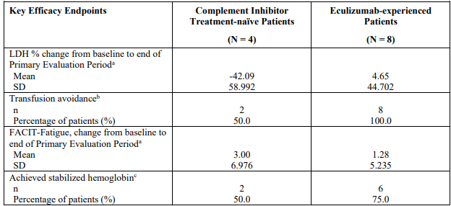
ª End of Primary Evaluation Period was defined as Day 183 for Study ALXN1210-PNH-304. ^{b} Transfusion avoidance was defined as patients who remained transfusion free and did not require a transfusion through Day 183 (Week 26). Percentages were based on the total number of patients in each cohort. ^{c} Stabilized haemoglobin was defined as avoidance of a ≥ 2 g/dL decease in haemoglobin level from baseline in the absence of transfusion through Day 183 (Week 26). Percentages were based on the total number of patients in each cohort.
Figure 9: Study ALXN1210-PNH-304 Mean (95% CI) percentage change from baseline in lactate dehydrogenase over time (Full Analysis Set)
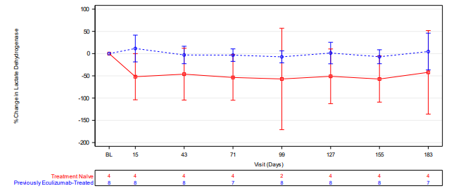
Note: Baseline for LDH was defined as the average of all available values prior to first ravulizumab infusion
The addendum to interim CSR included efficacy data for all five complement inhibitor treatment-naive patients for the Primary Evaluation Period:
- The mean (SD) percent change from baseline in LDH on Day 183 was - 47.91 (52.716)%
- Three patients (60.0%) remained transfusion free
- Three patients (60.0%) achieved haemoglobin stabilisation
- There were no events of breakthrough haemolysis during the Primary Evaluation Period.
- A post hoc analysis of LDH normalisation indicated that two of four (50%) complement inhibitor treatment-naive patients and four of eight (50%) eculizumab-experienced patients had normalised LDH values at Day 183.
- Updated efficacy data for the Extension Period (data cut-off 4 March 2021) for the 13 enrolled patients demonstrated:
  - The mean (SD) percent change from baseline in LDH on Day 351 was - 54.46 (33.456)% in the complement inhibitor treatment-naive group and - 8.48 (19.834)% in the eculizumab-experienced group.
  - Five (100.0%) complement inhibitor treatment-naive patients and seven (87.5%) eculizumab-experienced patients remained transfusion free.
  - Five (100.0%) complement inhibitor treatment-naive patients and seven (87.5%) eculizumab-experienced patients achieved haemoglobin stabilisation.
  - One eculizumab-experienced patient experienced breakthrough haemolysis on Day 666.
In line with measures agreed in the EU Paediatric Investigation Plan, the sponsor conducted an extrapolation exercise to bridge efficacy data for the Primary Evaluation Period from paediatric patients with PNH to supplementary data for the Primary Evaluation Period from four ravulizumab studies in adult patients with PNH; some of which were previously evaluated in the submission for initial registration of Ultomiris.¹⁰ These four studies were: the Phase Ib dose escalation Study ALXN1210-PNH-103; the Phase II Study ALXN1210-PNH-201, and Phase III Study ALXN1210-PNH-301 in complement inhibitor treatment-naive adults; and Phase III Study ALXN1210-PNH-302 in eculizumab-experienced adults). The sponsor considered the similar inclusion/exclusion criteria, study endpoints and visit schedules for the Phase III paediatric and adult PNH studies through the Primary Evaluation Period in the extrapolation plan.
Efficacy responses were also provided separately for adolescents (three complement inhibitor treatment-naive and seven eculizumab-experienced) and children (one each complement inhibitor treatment-naive eculizumab-experienced) based on data for the first 12 patients completing the Primary Evaluation Period (in addition to the overall population as above in Table 21).
Table 22: Study ALXN1210-PNH-304 Efficacy response in adolescents with paroxysmal nocturnal haemoglobinuria through Primary Evaluation Period (Full Analysis Set)
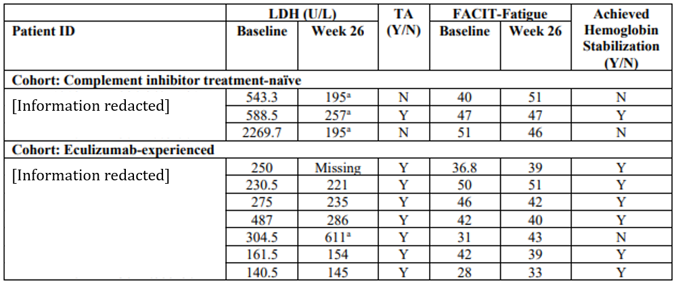
Abbreviation: LDH = lactate dehydrogenase; TA = transfusion avoidance.
ª Sample haemolysed without any associated signs and symptoms.
Note: The Functional Assessment of Chronic Illness Therapy – Fatigue Scale (FACIT-Fatigue) is a 13-item measure that assesses self-reported fatigue and its impact upon daily activities and function.
Table 23: Efficacy response in children with PNH in Study ALXN1210-PNH-304 through Primary Evaluation Period (Full Analysis Set)
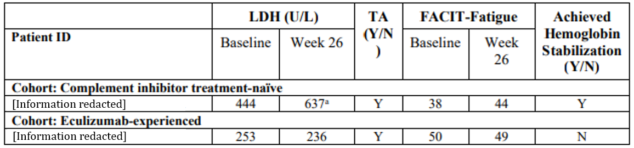
Abbreviation: LDH = lactate dehydrogenase; TA = transfusion avoidance.
ª Sample haemolysed without any associated signs and symptoms.
Note: The Functional Assessment of Chronic Illness Therapy – Fatigue Scale (FACIT-Fatigue) is a 13-item measure that assesses self-reported fatigue and its impact upon daily activities and function.
Similar trends in terms of reduction in LDH from baseline, transfusion avoidance and haemoglobin stabilisation were observed for paediatric patients with PNH and adult patients with PNH:
Table 24: Overview of population characteristics and efficacy results for Phase Ib/II and Phase III ravulizumab studies in adult patients with paroxysmal nocturnal haemoglobinuria
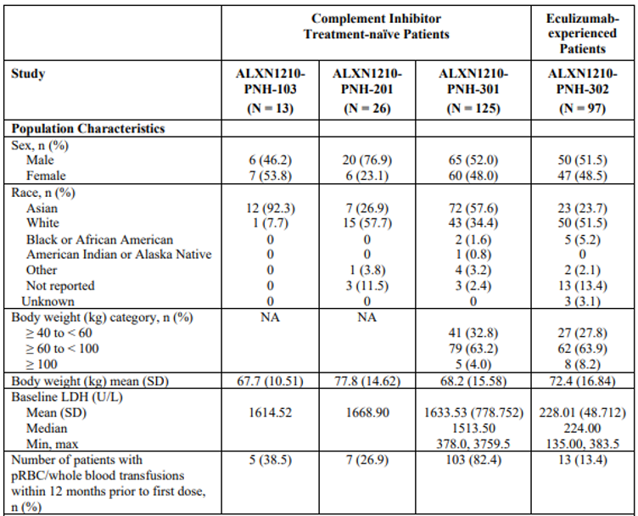
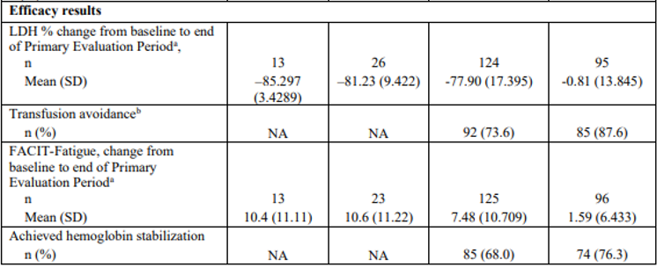
ª End of Primary Evaluation Period was defined as Day 169 for Study ALXN1210-PNH-103, Day 253 (Cohorts 1 through 3) or Day 281 (Cohort 4) for Study ALXN1210-PNH-201, and Day 183 for Studies ALXN1210-PNH-301 and ALXN1210-PNH-302 ^{b} Transfusion avoidance was defined as the proportion of patients who remained transfusion free and did not require a transfusion per protocol-specified guidelines (haemoglobin value of ≤ 9 g/dL with signs or symptoms of sufficient severity to warrant a transfusion, or a haemoglobin value of ≤ 7 g/dL regardless of presence of clinical signs or symptoms) through Day 183 (Week 26). Patients who withdrew from the study during Primary Evaluation Period due to lack of efficacy were considered as non-responders and counted in the group requiring transfusions

Safety

Safety in atypical haemolytic uraemic syndrome

Exposure
There were 58 adults and 31 paediatric patients who received at least one dose of ravulizumab, including 43 (74.1%) adult and 18 (58.1%) paediatric patients with treatment duration of at least 12 months up to the data cut-off (Safety Set).
Table 25: Summary of treatment exposure up to data cut-off in ravulizumab clinical program in aHUS (Safety Set)
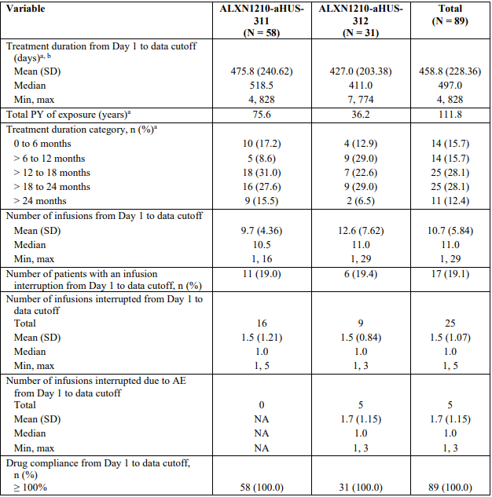
Note: Percentages were based on the number of patients in the Safety Set in each column. The Safety Set comprised of all patients from Study ALXN1210-aHUS-311 or Study ALXN1210-aHUS-312 who received at least 1 dose of study drug. ª Treatment duration = the earliest of (data cutoff date, study discontinuation date, or [treatment discontinuation date + 56 days]) ˗ date of first ravulizumab infusion + 1. ^{b} The result was transferred to weeks.

Safety overview
An overview of safety data from Study ALXN1210-aHUS-311 and Study ALXN1210-aHUS-312 (Safety Set) as of data cut-off dates is provided below in Table 26 and Table 27.
Table 26: Overview of treatment emergent adverse events and serious adverse events (Safety Set)
 | Study 311  (n = 58) | Study 312  (n = 31) | Total  (n = 89)
Treatment-emergent adverse events, n (%)  Severity  Grade 1  Grade 2  Grade 3  Grade 4  Grade 5 | 58 (100.0)  56 (96.6)  48 (82.8)  33 (56.9)  14 (24.1)  3 (5.2) | 31 (100.0)  26 (83.9)  22 (71.0)  11 (35.5)  1 (3.2)  0 | 89 (100.0)  82 (92.1)  70 (78.7)  44 (49.4)  15 (16.9)  3 (3.4)
Treatment-related adverse events, n (%)  TRAEs reported for ≥ 5% patients, n (%)  Headache  Arthralgia  Hypertension | 20 (34.5)  3 (5.2)  3 (5.2)  0 (0.0) | 12 (38.7)  0 (0.0)  0 (0.0)  2 (6.5) | 32 (36.0)  3 (3.4)  3 (3.4)  2 (2.2)
Serious adverse events, n (%)  SAEs reported for ≥ 5% patients, n (%)  Pneumonia  Hypertension  Abdominal pain  Bronchitis  Gastroenteritis viral | 33 (56.9)  3 (5.2)  3 (5.2)  1 (1.7)  0  0 | 15 (48.4)  2 (6.5)  1 (3.2)  2 (6.5)  2 (6.5)  2 (6.5) | 48 (53.9)  5 (5.6)  4 (4.5)  3 (3.4)  2 (2.2)  2 (2.2)
Treatment-related SAEs | 2 (3.4) | 3 (9.7) | 5 (5.6)
TEAEs leading to study drug discontinuation, n (%) | 3 (5.2) | 1 (3.2) | 4 (4.5)
SAEs leading to study drug discontinuation, n (%) | 3 (5.2) | 1 (3.2) | 4 (4.5)
Deathª | 3 (5.2) | 0 | 3 (3.4)
Abbreviations: SAE = serious adverse event; TEAE = treatment-emergent adverse event; TRAE = treatment-related adverse event.
Note: Percentages were based on the number of patients in the Safety Set in each column, that is, % = n/N × 100. Safety Set comprised all patients from Study ALXN1210-aHUS-311 and Study ALXN1210-aHUS-312 who received at least one dose of ravulizumab. Related adverse events were defined as adverse events that were possibly, probably, or definitely related to study drug. Not related adverse events were defined as adverse events that were unlikely or not related to study drug. Grade 1 = mild; Grade 2 = moderate; Grade 3 = severe; Grade 4 = life-threatening; Grade 5 = fatal. ª In addition to TEAEs leading to death, 1 patient reported a pre-treatment adverse event that led to death.
Table 27: Treatment emergent adverse events occurring in ≥ 10% of patients by MedDRA System Organ Class and Preferred Term (Safety Set)
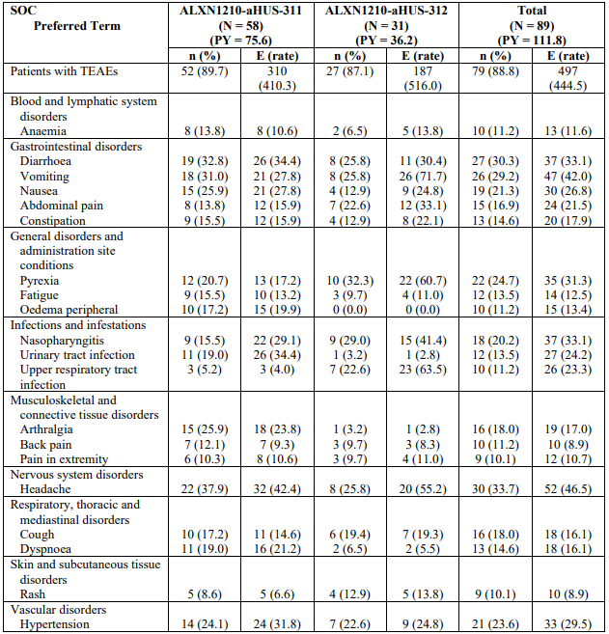
Abbreviations: E = events; MedDRA = Medical Dictionary for Regulatory Activities; PY = patient-years; SAE = serious adverse event; SOC = System Organ Class; TEAE = treatment-emergent adverse event; TRAE = treatment-related adverse event.
Note: Percentages were based on the number of patients in the Safety Set in each column, that is, % = n/N × 100. Rate = rate of adverse event adjusted by patient-year of exposure, defined as (number of events)/100 patient-year. Safety Set comprised all patients from Study ALXN1210-aHUS-311 and Study ALXN1210-aHUS-312 who received at least one dose of ravulizumab. TEAEs were adverse events with a start date and start time on or after the date and time of the first infusion of study drug. Under patient count columns, n (%), if a patient had more than one event for a particular System organ class, the patient was counted only once for that System organ class under n (%). If a patient had more than one event for a particular Preferred Term, the patient was counted only once for that Preferred Term. The data cut-off dates are specified in Table 1. All adverse events were coded using MedDRA Version 21.0
All aHUS patients reported at least one treatment emergent adverse event (TEAE) as of data cut-off, the majority Grade 1 or 2 events. Adverse events (AE) reported by 20% or more patients including headache, diarrhoea, vomiting, pyrexia, nasopharyngitis, nausea and hypertension. treatment emergent adverse events of pyrexia, nasopharyngitis, upper respiratory tract infection and abdominal pain were reported more frequently in paediatric patients.

Serious adverse events
Serious adverse events were reported for approximately 50% patients. In Study ALXN1210-aHUS-311, two patients had serious adverse events considered possibly related to ravulizumab; events of Escherichia pyelonephritis (resolved) and immune thrombocytopenic purpura (study drug discontinued and patient withdrawn from study). There were two patients who discontinued study drug and were withdrawn from the study due to serious adverse events considered not related to study drug (autoimmune haemolytic anaemia, intracranial haemorrhage). There were three paediatric patients with serious adverse events considered related to study treatment; Escherichia pyelonephritis and Escherichia bacteraemia, pyrexia and anaemia. One paediatric patient in Cohort 1 discontinued due to serious adverse events of hypertensive crisis (not considered related) and anaemia.
Serious infections were reported in 24 (27.0%) patients, more frequently in paediatric patients; 14 (24.1%) adults and 10 (32.3%) paediatric patients. Pneumonia was reported for five (5.6%) patients (three [5.2%] adults, two [6.5%] paediatric), with Escherichia pyelonephritis, gastroenteritis, gastroenteritis viral, pharyngitis, septic shock, and urinary tract infection reported by two (2.2%) patients. There were no meningococcal infections reported as of data cut-off in Study ALXN1210-aHUS-311 or Study ALXN1210-aHUS-312.
Two patients had adverse event of infusion-related reaction in Study ALXN1210-aHUS-311; neither event resulted in infusion interruption. There were six adverse events leading to infusion interruption in t (3.4%) paediatric patients in Study ALXN1210-aHUS-312 (n = 2 Cohort 1, n = 1 Cohort 2). One patient had single Grade 2 event of hypertension considered unrelated to study treatment (infusion completed), one patient had three Grade 2 adverse events of drug hypersensitivity (all resolved, infusion able to be completed for 2 events) and one patient had with back pain, pain in extremity (both resolved, infusion completed).
There were four deaths in Study ALXN1210-aHUS-311, none of which were considered related to ravulizumab (two septic shock, one intracranial haemorrhage and one due to pre-treatment adverse event of cerebral arterial thrombosis). It is noted the two cases of septic shock occurred on Day 4 / Day 6 of the study in patients who were ventilated and had histories including atypical pneumonia/ acute respiratory distress syndrome/sepsis and Pseudomonas infection at Baseline. There were no deaths in Study ALXN1210-aHUS-312.

Safety in population subgroups
No safety concerns were noted in pooled analyses of adverse events by age (provided in the Summary of Clinical Safety for patients in age groups: birth to < 6 years (n = 14), 6 to < 18 years (n = 17), 18 to < than 65 years (n = 49) and ≥ older than 65 years (n = 9)) or body weight. An overview of adverse events by body weight group is provided below.
Table 28: Subgroup overview of all treatment emergent adverse events and serious adverse events by body weight group (Safety Set)
 | Body weight group
 | ≥ 5 to < 20 kg  (n = 14) | ≥ 20 to < 40 kg  (n = 8) | ≥ 40 to < 60 kg  (n = 18) | ≥ 60 to < 100 kg  (n = 43) | ≥ 100 kg  (n = 5)
TEAEs, n (%)  Severity  Grade 1  Grade 2  Grade 3  Grade 4  Grade 5 | 14 (100.0)  13 (92.9)  10 (71.4)  7 (50.0)  0  0 | 8 (100.0)  7 (87.5)  5 (62.5)  3 (37.5)  1 (12.5)  0 | 18 (100.0)  15 (83.3)  17 (94.4)  7 (38.9)  4 (22.2)  1 (5.6) | 43 (100.0)  41 (95.3)  32 (74.4)  23 (53.5)  9 (20.9)  2 (4.7) | 5 (100.0)  5 (100.0)  5 (100.0)  3 (60.0)  1 (20.0)  0
Treatment-related adverse events, n (%) | 5 (35.7) | 4 (50.0) | 4 (22.2) | 17 (39.5) | 2 (40.0)
Serious adverse events (SAEs), n (%) | 9 (64.3) | 4 (50.0) | 9 (50.0) | 23 (53.5) | 3 (60.0)
Treatment-related SAEs, n (%) | 2 (14.3) | 1 (12.5) | 0 | 2 (4.7) | 0
TEAEs leading to study drug discontinuation, n (%) | 1 (7.1) | 0 | 1 (5.6) | 2 (4.7) | 0
SAEs leading to study drug discontinuation, n (%) | 1 (7.1) | 0 | 1 (5.6) | 2 (4.7) | 0
Death | 0 | 0 | 1 (5.6) | 2 (4.7) | 0
Note: Percentages are based on the number of patients in the Safety Set in each column that is, % = n/N*100. Safety Set = all patients from Study ALXN1210-aHUS-311 or Study ALXN1210-aHUS-312 who received at least 1 dose of study drug. The data lock dates are 10 Oct 2019 for Study ALXN1210-aHUS-311, 28 January 2020 for Study ALXN1210-aHUS-312. Related adverse events are defined as adverse events that are possibly, probably, or definitely related to study drug. Not related adverse events are defined as adverse events that are unlikely or not related to study drug. Grade 1=mild; Grade 2=moderate; Grade 3=severe; Grade 4=life-threatening; Grade 5=Fatal.
There are limited safety data for patients in the 5 to < 10 kg body weight group; four patients were included in the Safety Set.
Two patients in Cohort 1 enrolled prior to Protocol Amendment 5, receiving the loading dose of 300 mg rather than the proposed 600 mg loading dose of ravulizumab. One patient withdrew on Day 21 after receiving two doses of ravulizumab due to serious adverse events of hypertensive crisis occurring on Day 9 (on background of known hypertension and not considered related to ravulizumab) and Grade 3 anaemia occurring on Day 20 (possibly related). The second patient had a non-serious adverse event of hypertension on Day 15 requiring interruption of the infusion, and a serious adverse event of human bocavirus infection on Day 265 (resolved, not considered related to ravulizumab).
Two patients received the proposed 600 mg loading dose. One patient in Cohort 1 was deemed ineligible due to positive Shiga toxin test result and was withdrawn after receiving two doses of ravulizumab. The second patient in Cohort 2 experienced one Grade 3 adverse event (dehydration, not related), and five serious adverse events of Grade 3 severity (three events of upper respiratory tract infection (Days 29, 76, 210); one event of pneumonia (Day 194) and one event of bronchitis (Day 354); all events resolved and not considered related to study treatment).
One patient in Study ALXN1210-aHUS-311 had a treatment-emergent anti-drug antibodies which was transient, low titer, non-neutralising and did not impact safety or efficacy.
Severe thrombotic microangiopathy complication in aHUS patients after ravulizumab discontinuation is included as an important potential risk in the RMP. There are no data regarding ravulizumab discontinuation in aHUS in the submitted clinical studies however the sponsor has proposed text in Section 4.4 of the Product Information for thrombotic microangiopathy complications with treatment discontinuation in aHUS which is consistent with text in the EU and US product information documents.

Safety in paediatric patients with paroxysmal nocturnal haemoglobinuria

Exposure
All patients received infusions according to the protocol-specified visit schedule during the Primary Evaluation Period, with no missed doses. The median treatment duration was 183.0 to 184.0 days across both cohorts and median number of infusions per patient up to Day 183 was 4.0.

Safety overview
Adverse events during the Primary Evaluation Period for all 13 patients are summarised below.
Table 29: Study ALXN1210-PNH-304 Overview of all treatment emergent adverse events and serious adverse events during the Primary Evaluation Period (Safety Set)
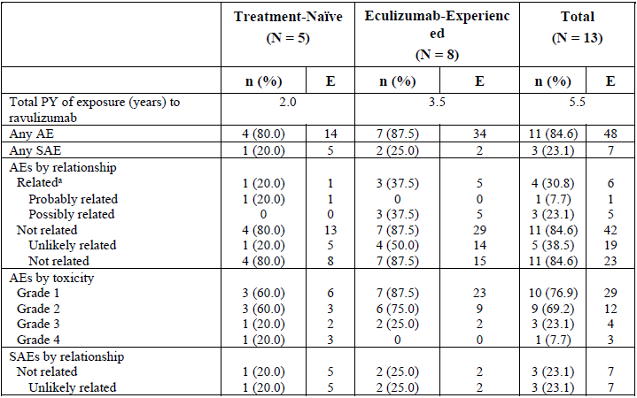
Note: Patients were counted in each relationship and severity category in case of multiple events. % = n/N*100. Treatment-emergent adverse events were adverse events with a start date on or after first dose date in the study. Grade 1 = mild; Grade 2 = moderate; Grade 3 = severe; Grade 4 = life-threatening; Grade 5 = fatal. The toxicity of adverse events was graded using CTCAE Version 4.03 or higher. Adverse events were coded using MedDRA Version 24.0. ª Related adverse events were defined as adverse events that were possibly, probably, or definitely related to study treatment. Not related adverse events were defined as adverse events that were unlikely or not related to study treatment. Abbreviations: AE = adverse event; CTCAE = Common Terminology Criteria for Adverse Events; E = number of events; MedDRA = Medical Dictionary for Regulatory Activities; N = total number of patients; PY = patient-years; SAE = serious adverse event
Eleven (84.6%) paediatric PNH patients experienced at least one treatment emergent adverse event during the Primary Evaluation Period, with most events Grade 1 or 2. The most frequently reported treatment emergent adverse events were abdominal pain, nasopharyngitis and headache (two (15.4%) each), with other events single events. Serious adverse events were reported for three (23.1%) patients; one complement inhibitor treatment-naive patient experienced five serious adverse events (device-related sepsis and staphylococcal infection on Day 43, and multiple organ dysfunction syndrome, septic shock, and device-related thrombosis on Day 44), and two eculizumab-experienced patients were hospitalised for the serious adverse events influenza A virus test positive and viral upper respiratory tract infection. No events were considered related to study drug and all resolved during the Primary Evaluation Period. There were four (30.8%) patients with treatment-related adverse events; single events of blood pressure increased, anaemia, abdominal pain, nausea, fatigue and headache.
Updated safety data though 52 weeks did not give rise to any additional safety concerns. All patients experienced at least one treatment emergent adverse event. There were two serious adverse events during the Extension Period through data cut-off; one event of breakthrough haemolysis on Day 666 considered possibly related to study drug, and serious adverse event of worsening aplastic anaemia in a patient with history of same not considered related to study drug.
During the Primary Evaluation Period and Extension Period (up to data cut-off), there were no deaths, no adverse events leading to discontinuation of study drug, no infusion interruptions due to adverse events and no meningococcal infections reported. No immunogenicity was observed in the study up to data cut-off.
Supplementary data through the Primary Evaluation Period from the ravulizumab PNH and aHUS studies were provided to support the safety of ravulizumab in the proposed paediatric PNH population.
Treatment emergent adverse events during the Primary Evaluation Period for adolescents and children with PNH in Study ALXN1210-PNH-304 are summarised below for the first 12 enrolled patients:
Table 30: Study ALXN1210-PNH-304 Overview of all treatment emergent adverse events and serious adverse events in during the Primary Evaluation Period (Safety Set)
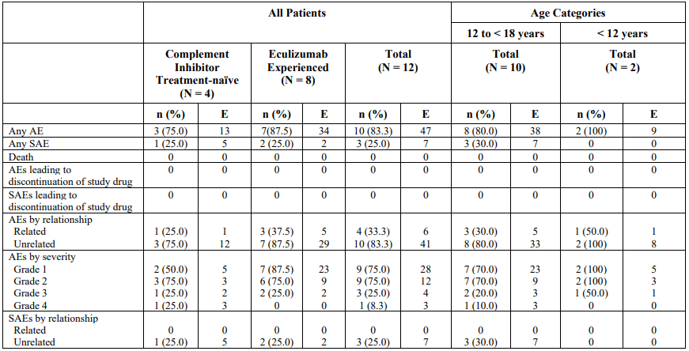
Abbreviations: AE = adverse events; E = events; SAE = serious adverse event; TEAE = treatment-emergent adverse event; TRAE = treatment-related adverse event.

Comparison with safety profile in adults with paroxysmal nocturnal haemoglobinuria
The sponsor noted the frequency of treatment emergent adverse events and serious adverse events in children and adolescents with PNH was consistent with those reported for adults with PNH through the Primary Evaluation Period. An overview of adverse events for the pooled ravulizumab groups in the Phase III adult PNH Study ALXN1210-PNH-301 and ALXN1210-PNH-302 during the Primary Evaluation Period is provided below in Table 31.
Treatment-emergent adverse events were reported for 87.8% patients, the majority Grade 1 or 2 severity and not related to study treatment. There were no deaths, treatment emergent adverse events leading to study drug discontinuation or meningococcal infections. The incidence of immunogenicity was low (< 0.5%), with one treatment-emergent anti-drug antibodies observed with a low titre and no evidence of neutralisation.
Table 31: Overview of all treatment emergent adverse events and serious adverse events in pooled ravulizumab group across Phase III adult PNH studies (Study ALXN1210-PNH-301 and ALXN1210-PNH-302) during the Primary Evaluation Period (Phase III PNH population)
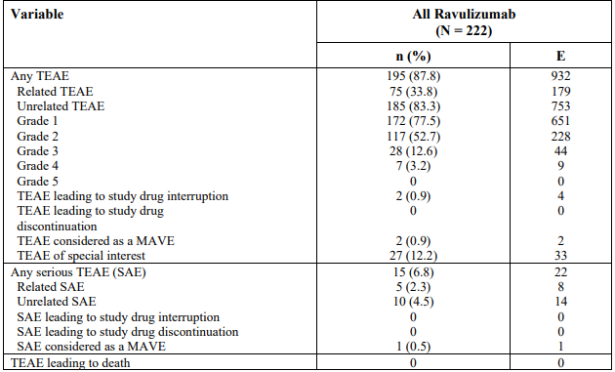
Abbreviations: E = number of events, MAVE = major adverse vascular event

Comparison with safety profile in atypical haemolytic uraemic syndrome
The adverse event profile was comparable for paediatric PNH patients (Table 30) and aHUS patients through the Primary Evaluation Period provided in Table 32 below. Safety data for aHUS patients through the 52-week data cut-off have been discussed above.
Table 32: Overview of all treatment emergent adverse events and serious adverse events across Phase III aHUS studies during the Primary Evaluation Period (Safety Set)
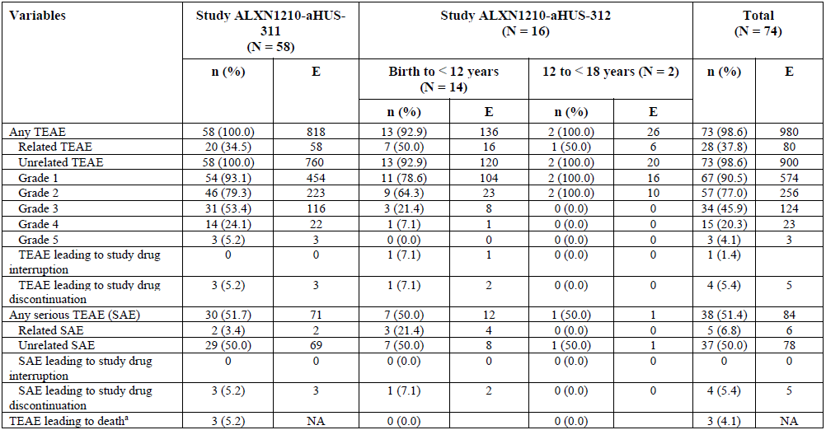
Notes: ª In addition to treatment emergent adverse events leading to deaths, one patient reported a pre-treatment adverse event that led to death.

Risk management plan
The sponsor submitted EU-risk management plan (RMP) version 2.1 (date 10 December 2020; data lock point (DLP) 27 May 2020) and Australia-specific annex (ASA) version 3.0 (date 23 April 2021), and updated EU RMP version 3.0 (date 31 August 2021; DLP 27 May 2020) and ASA version 3.1 (date 17 November 2021) with the section 31 response.
The summary of safety concerns and their associated risk monitoring and mitigation strategies are summarised in Table 33. The TGA may request an updated RMP at any stage of a product's life-cycle, during both the pre-approval and post-approval phases.
The TGA may request an updated RMP at any stage of a product's life-cycle, during both the pre-approval and post-approval phases. Further information regarding the TGA’s risk management approach can be found in risk management plans for medicines and biologicals and the TGA's risk management approach. Information on the Australia specific annex (ASA) can be found on the TGA website.
Table 33: Summary of safety concerns
Summary of safety concerns |  | Pharmacovigilance |  | Risk Minimisation
 |  | Routine | Additional | Routine | Additional
Important identified risks | Meningococcal infection | * | † |  | ^{‡¶ ǁ ∞}
Important potential risks | Serious haemolysis after drug discontinuation in PNH patients |  | † |  | ‡
Important potential risks | Severe thrombotic microangiopathy (TMA) complications in aHUS patients after ravulizumab discontinuation |  | † |  | §
Important potential risks | Immunogenicity |  | † |  | ‡
Important potential risks | Serious infections |  | † |  | ^{‡ ǁ}
Important potential risks | Malignancies and haematologic abnormalities in PNH patients |  | † |  | ‡
Missing information | Use in pregnant and breast‐feeding women | * | † |  | ‡
* Follow-up questionnaire
†Clinical trials
‡Physician’s guide (PNH) Patient’s information brochure (PNH)
§ Physician’s guide (aHUS) Patient’s information brochure (aHUS)
¶Patient’s safety card, Controlled access
ǁ Parent guide
∞ Annual vaccination reminder
The RMP evaluation considered the summary of safety concerns acceptable, noting ‘Severe thrombotic microangiopathy complication in aHUS patients after ravulizumab discontinuation’ has been included in the summary of safety concerns as part of this extension of indication submission. The summary of safety concerns is considered acceptable.
Routine pharmacovigilance activities have been proposed and include follow up questionnaires for the important identified risk and missing information.
The RMP evaluation considered the pharmacovigilance plan and risk minimisation plan to be acceptable. Routine risk minimisation activities have been proposed for all safety concerns. A Physicians Guide and Patient Information Brochure have been updated and separated for each indication (aHUS and PNH) and include information relevant to the paediatric population. A Parent Guide has also been implemented as an additional risk minimisation activity. The risk minimisation plan is considered acceptable.. dditional pharmacovigilance activities include reports from a PNH registry and aHUS registry study reports to be provided every two years.
The proposed conditions of registration include:
- Submission of periodic safety update reports (routine pharmacovigilance);
- Inclusion in the Black Triangle Scheme:
  - ULTOMIRIS (Ravulizumab) is to be included in the Black Triangle Scheme. The PI and CMI for ULTOMIRIS must include the black triangle symbol and mandatory accompanying text for five years, which starts from the date the new indication is registered.
- The following study reports should be submitted to the TGA for evaluation:
  - The final clinical study report for Study ALXN1210-PNH-304
  - The final clinical study report for Study ALXN1210-aHUS-311
  - The final clinical study report for Study ALXN1210-aHUS-312 .

Risk-benefit analysis

Delegate’s considerations

Atypical haemolytic uraemic syndrome indication
The submission proposes to extend the indication to treat patients with atypical haemolytic uraemic syndrome indication (aHUS), based on data from two Phase III multicentre, open-label, single-arm studies in adult and paediatric patients with aHUS. There are inherent limitations of single-arm studies, however, the study design and sample sizes are acknowledged in the rare disease setting.
Study ALXN1210-aHUS-311 provided efficacy and safety data for ravulizumab in complement inhibitor treatment-naive adults with aHUS. The primary endpoint complete thrombotic microangiopathy response was observed in 53.6% patients during the 26-week Initial Evaluation Period. An additional four patients achieved a complete thrombotic microangiopathy response (60.7% overall) during the Extension Period suggesting a durable treatment effect. There were beneficial effects on renal function, with 58.6% of patients requiring dialysis at Baseline discontinuing dialysis during the Initial Evaluation Period, and improvements in estimated glomerular filtration rate (eGFR) observed during the 26-week initial evaluation period sustained during the Extension Period.
Study ALXN1210-aHUS-312 included 18 eligible complement inhibitor treatment-naive paediatric patients (Cohort 1) and 10 eculizumab-experienced paediatric patients with aHUS (Cohort 2). The median age at first infusion was 5.2 years and 12.5 years respectively for Cohort 1 and Cohort 2. Complete thrombotic microangiopathy response was observed in 77.8% patients in Cohort 1 during the Initial Evaluation Period and in 94.4% patients during the Extension Period. Positive effects on renal function were demonstrated with four of six patients requiring dialysis at Baseline discontinuing dialysis by Day 36 and improvements in mean eGFR evident during the Initial Evaluation Period maintained during the Extension Period. In Cohort 2, haematologic parameters (platelet count, lactate dehydrogenase, and haemoglobin concentration) and eGFR remained stable during the Initial Evaluation Period and the Extension Period. No Cohort 2 patients were initiated on dialysis as of data cut-off.
Overall, there were no new safety concerns identified for ravulizumab in aHUS studies as of data cut-off dates for the respective studies, acknowledging the limited sample size. Data from ongoing extension studies and aHUS registry included as an additional pharmacovigilance activity will further inform the long term safety of ravulizumab in aHUS. Additional risk minimisation activities are included in the risk management plan (RMP) relevant to the proposed aHUS indication to communicate the risks of ravulizumab to physicians and patients.
The issues with the proposed aHUS indication are discussed below.

Extrapolation to adult aHUS patients previously treated with eculizumab
Study ALXN1210-aHUS-311 included adults who were complement inhibitor treatment-naive, thus there are no data for adults previously treated with eculizumab. There were ten eculizumab-experienced paediatric patients included in Study ALXN1210-aHUS-312, mostly adolescents (n = 7). The advice of the Committee is sought (see Advisory Committee considerations, below) as to whether the disease is the same in the paediatric population and adults such that data supporting use in eculizumab-experienced paediatric patients with aHUS in Study ALXN1210-aHUS-312 can be extrapolated to adults.

Extrapolation to aHUS patients refractory to eculizumab treatment
Study ALXN1210-aHUS-312 included eculizumab-experienced patients treated with eculizumab for at least 90 days with evidence of clinical response to eculizumab. aHUS patients refractory to eculizumab treatment were not included in Study ALXN1210-aHUS-312, however would potentially be included in the proposed indication ‘treatment of aHUS’. There is uncertainty regarding extrapolation to this population in the absence of evidence. The advice of the Committee is sought (see Advisory Committee considerations, below) regarding whether the indication should specify use in complement inhibitor treatment-naive patients or patients who have received eculizumab for at least three months and have evidence of response to eculizumab.

Use in paediatric aHUS patients with body weight of 5 up to 20 kg
There is uncertainty regarding the body weight limit in paediatric patients that is adequately supported by the evidence as follows:
- Following a planned initial pharmacokinetic/pharmacodynamic analysis in Study ALXN1210-aHUS-312, the ravulizumab loading dose for patients with body weight 5 to < 10 kg was increased from 300 mg to 600 mg. There is uncertainty as to whether the increased loading dose is justified based on the population pharmacokinetic model.
- The pharmacometrics expert stated the population pharmacokinetic model failed to adequately describe the pharmacokinetic data for the once every four-week regimen in children in the body weight groups less than 20 kg (5 kg up to 10 kg, 10 kg up to 20 kg). Although limited, the pharmacokinetic data supported the weight-based dosing regimen for patients with body weight 20 kg or more.
- Efficacy and safety data in paediatric patients with body weight 5 kg up to 10 kg are limited. The full analysis set included three patients with body weight from 5 kg up to 10 kg:
  - One eculizumab-experienced patient received the increased loading dose of ravulizumab (600 mg) and was reported to have stable haematologic and eGFR parameters through data cut-off. This patient did have one Grade 3 adverse event of dehydration and five serious adverse events (upper respiratory tract infection, pneumonia, bronchitis) none of which were considered related to ravulizumab.
  - Two complement inhibitor treatment-naive patients received the 300 mg loading dose. One patient received two ravulizumab doses and discontinued on Day 21 due to serious adverse events (hypertensive crisis (treatment unrelated) and Grade 3 anaemia (treatment-related)). One patient completed the Initial Evaluation Period and was a complete thrombotic microangiopathy responder.
An additional patient with body weight 5 to < 10 kg in Cohort 1 was included in the Safety Set; this patient was withdrawn after two doses of ravulizumab (including 600 mg loading dose) due to study ineligibility.
The Delegate does not consider there is sufficient evidence to support use of ravulizumab in paediatric aHUS patients with body weight 5 up to 10 kg for the following reasons:
- The clinical evidence comprised data from three patients, one of whom received the proposed loading dose of 600 mg. The available clinical data are too limited to draw meaningful conclusions regarding efficacy and safety in this subset of patients.
- There is uncertainty regarding the proposed ravulizumab loading dose in patients with body weight 5 up to 10 kg (600 mg).
- The pharmacometrics data do not support the proposed weight-based dosing regimen for patients with body weight 5 up to 10 kg, acknowledging the methodological limitations of the pharmacometrics data.
The Delegate does consider there is sufficient evidence to support use of ravulizumab in paediatric aHUS patients with body weight of 10 kg or more, as:
- The efficacy and safety data are adequate to support use in patients with body weight of 10 kg or more.
- The pharmacometrics data do not support the proposed weight-based dosing regimen for patients with body weight 10 up to 20 kg (noting the methodological limitations as above). However, the proposed dosage regimen for patients weighing 10 up to 20 kg is considered acceptable given there are clinical data to support use in patients with body weight 10 up to 20 kg.
The advice of the Committee is sought regarding the proposed ravulizumab dosing regimen, and the body weight limit in paediatric patients that is supported by the available pharmacokinetics/ pharmacodynamics, efficacy and safety data.

Paediatric paroxysmal nocturnal haemoglobinuria indication
The submission proposes to extend the indication to treat paediatric paroxysmal nocturnal haemoglobinuria (PNH) patients. Data were provided in the Phase III multicentre, open-label, single-arm Study ALXN1210-PNH-304 in paediatric PNH patients. The study enrolled 13 patients aged 9 to 17 years with body weight ≥ 30 kg; five complement inhibitor treatment-naive and eight eculizumab-experienced. The planned interim clinical study report included data for the first 12 patients completing the 26-week Primary Evaluation Period. An addendum to the interim CSR including data for an additional complement inhibitor treatment-naive patient was provided on request.
The primary endpoints were pharmacokinetic/pharmacodynamic parameters with complete terminal complement inhibition sustained throughout the 26-week Primary Evaluation Period following weight-based ravulizumab dosing demonstrated. Efficacy was a secondary objective of the study; the endpoints were consistent with those in ravulizumab Phase III adult PNH studies. On Day 183, the mean percent change from baseline in lactate dehydrogenase was -47.91% in complement inhibitor treatment-naive patients and 4.65% for eculizumab-experienced patients. There was a clinically meaningful reduction in the need for transfusion; 60% of complement inhibitor treatment-naive patients and all eculizumab-experienced patients remained transfusion free at Day 183. Updated data for the Extension Period support maintenance of treatment effect in both complement inhibitor treatment-naive and eculizumab-experienced patients.
Although there were no new safety concerns for ravulizumab identified in Study ALXN1210-PNH-304 for paediatric PNH patients, the sample size is small, thereby limiting meaningful conclusions regarding safety of ravulizumab in paediatric PNH patients. Pharmacovigilance activities include PNH registry data which will characterise the safety profile of ravulizumab in paediatric PNH patients in the post-market setting and mitigate existing uncertainty regarding safety in this patient population.
The main issue relating to the proposed paediatric PNH indication is the lack of data for paediatric PNH patients < 30 kg. The sponsor proposes use in paediatric PNH patients with body weight < 30 kg based on extrapolation of pharmacokinetic/pharmacodynamic, efficacy and safety data in paediatric PNH patients with body weight ≥ 30 kg using supplementary data from adult PNH patients and patients with aHUS. The extrapolation approach is stated to be in line with the EMA Paediatric Investigation Plan.
The proposed ravulizumab dosing regimen in paediatric PNH patients is identical to the ravulizumab dosing regimen in paediatric aHUS patients. The pharmacometrics expert considered available data supported the weight-based dosing regimen for paediatric PNH patients over the body weight range studied (36.7 to 72.0 kg at Baseline). Efficacy outcomes for common endpoints LDH, transfusion avoidance and haemoglobin stabilisation for paediatric PNH patients were generally consistent with those observed for adult PNH patients treated with ravulizumab. As the disease pathophysiology is similar in adults and children, the Delegate considers an extrapolation approach in principle is acceptable. However, advice from the Committee will be requested regarding the proposed use of ravulizumab in paediatric PNH patients below 30 kg, given the limited clinical data and aforementioned uncertainties regarding the body weight limit in paediatric aHUS patients that is adequately supported by the evidence.

Proposed action
Paroxysmal nocturnal haemoglobinuria and atypical haemolytic uraemic syndrome are rare, progressive and potentially life-threatening diseases. The available data to support the proposed use is acknowledged given the rare disease setting. The Delegate considers there is evidence to support use of ravulizumab in aHUS and in paediatric PNH patients however there are outstanding issues particularly in relation to the body weight limit for use of ravulizumab in paediatric patients, the extrapolation approach to support use in paediatric PNH patients, and the proposed wording of the aHUS indication for which the advice of the Committee is sought.

Independent expert advice
Specific pharmacometrics expert advice was sought by the Delegate as part of the evaluation of this submission, with regard to the proposed dosing regimen in paediatric patients with aHUS and PNH.
Where the advice provided has been relevant (see the Population pharmacokinetics data, Pharmacodynamics, and Delegate’s considerations sections, above), that advice has been integrated into the text and is clearly stated as having being provided by the pharmacometrics expert.

Advisory Committee considerations
The Advisory Committee on Medicines (ACM), having considered the evaluations and the Delegate’s overview, as well as the sponsor’s response to these documents, advised the following.

Specific advice to the Delegate
- The sponsor proposes a single weight-based dosing regimen for paroxysmal nocturnal haemoglobinuria (PNH) and atypical haemolytic uraemic syndrome (aHUS) patients with body weight ≥ 5 kg.
Does the Committee consider the evidence supports use of ravulizumab in patients with body weight ≥ 5 kg, ≥ 10 kg or ≥ 20 kg?
The ACM noted that the clinical trials included a very limited number (three) of patients weighing less than 10 kg and acknowledged that the limited evidence causes some challenges in determining suitability within those weighing less than 10 kg. However, the ACM noted the rareness of these disorders and the difficulty recruiting participants.
The ACM considered the pharmacokinetic modelling which indicated that there are minimal differences in the parameters between adults with PNH and adults and paediatrics with aHUS. This provided the ACM with reassurance regarding the usage of ravulizumab in those weighing less than 10 kg. The ACM did however note that there is potential underprediction of ravulizumab concentrations within the less than 20 kg group in the model, however given the small participant numbers (n = 9) and the coverage of the confidence intervals, this model was considered adequate.
The ACM also highlighted that children would grow over the course of treatment / during the clinical trial period and move into higher weight bands.
On balance, the ACM was of the view that it is not necessary to include weight-based restrictions within the indication as the modelling and kinetics do not indicate there are likely to be any clinically important differences with lower weights.
- There are no data for paediatric PNH patients with body weight < 30 kg.
Does the Committee consider extrapolation of pharmacokinetic/pharmacodynamic and efficacy data to support use in paediatric patients with body weight < 30 kg is adequately supported by the evidence?
The ACM was of the view that the extrapolation of pharmacokinetic/pharmacodynamic and efficacy data to support use in paediatric patients with a body weight of less than 30 kg is adequately supported by the evidence.
In making this recommendation the ACM noted that a risk-based approach is appropriate noting the rareness of the disorder and that obtaining further data within this lower weight range will be difficult.
The ACM also noted that there is no reason to expect a change in kinetics with monoclonal antibodies with a change is weight.
The ACM reiterated that the model demonstrated minimal differences in the parameters between adults with PNH and adults and paediatrics with aHUS and indicated that this learning can be applied to PNH given the similarities between the aHUS and PNH clinical trials.
- Does the Committee consider aHUS to be a similar disease in paediatric and adult patients such that data for eculizumab-experienced paediatric patients can be extrapolated to adults?
The ACM was of the view that it is reasonable to extrapolate the eculizumab-experienced paediatric data to adults as the disease pathophysiology is similar in adults and children. The ACM noted there does not appear to be a pharmacokinetic difference or a pharmacodynamic difference with the key biomarker (C5) between adults and children.
The ACM advised that while the triggers to initiate disease onset may differ between adults and children, the underlying genetic cause is the same. Furthermore, regardless of age of onset the result is a lack of inhibition of the complement pathway with serious consequences.
- There are no data for aHUS patients refractory to eculizumab treatment.
Does the Committee consider the proposed wording of the aHUS indication ‘treatment of aHUS’ acceptable or should the indication specify use in patients who are complement inhibitor treatment-naive or have received eculizumab for at least 3 months and have evidence of response to eculizumab?
The ACM was of the view that the proposed wording of the aHUS indication, being ‘treatment of aHUS’ is appropriate.
The ACM noted that aHUS is a rare and devasting disease and advised that it would be reasonable for ravulizumab to be used for aHUS patients refectory to eculizumab treatment.
- Other advice
The ACM noted the sponsor’s proposed loading dose of 600 mg for both the 5 kg to less than 10 kg and the 10 kg to less than 20 kg body weight ranges and acknowledged the sponsors rationale for a 600 mg loading dose in the 5 kg to less than 10 kg body weight range. The volume of distribution determines the loading dose, and the ACM advised smaller patients would be expected to have a smaller volume of distribution, in this case proportionate to their smaller plasma volume. The apparent observed difference in loading dose exposure in the very small number of participants may therefore relate to inter-individual variability rather than a true population mean effect. The ACM queried why a 300 mg loading dose was not proposed for the 5 kg to less than 10 kg body weight range. However, the ACM did note that the 600 mg dose had been used without safety issues within the clinical trial.

Conclusion
The ACM considered this product to have an overall positive benefit-risk profile for the indication:
Ultomiris is indicated for the treatment of patients with:
- Paroxysmal Nocturnal Haemoglobinuria (PNH)
- Atypical Haemolytic Uraemic Syndrome (aHUS)

Outcome
Based on a review of quality, safety, and efficacy, the TGA approved the registration of Ultomiris (ravulizumab) 300 mg in 30 mL (10 mg/mL), 300 mg in 3 mL (100 mg/mL) and 1100 mg in 11 mL (100 mg/mL) concentrated solution for intravenous infusion vials for the following extension of indications:
Ultomiris is indicated for the treatment of patients with:
- Paroxysmal Nocturnal Haemoglobinuria (PNH)
- Atypical Haemolytic Uraemic Syndrome (aHUS)
The above extension of indications are inclusive of the previous approved indications.

Specific conditions of registration applying to these goods
- Ultomiris (Ravulizumab) is to be included in the Black Triangle Scheme. The PI and CMI for Ultomiris must include the black triangle symbol and mandatory accompanying text for five years, which starts from the date the new indication is registered.
- The Ultomiris EU-Risk Management Plan (RMP) (version 3.0, dated 31 August 2021, data lock point 27 May 2020), with Australian Specific Annex (version 3.1, dated 17 November 2021), included with submission PM-2021-01659-1-6, and any subsequent revisions, as agreed with the TGA will be implemented in Australia.
An obligatory component of risk management plans is routine pharmacovigilance. Routine pharmacovigilance includes the submission of periodic safety update reports (PSURs).
Reports are to be provided in line with the current published list of EU reference dates and frequency of submission of PSURs until the period covered by such reports is not less than three years from the date of this approval letter.
The reports are to at least meet the requirements for PSURs as described in the European Medicines Agency’s Guideline on good pharmacovigilance practices (GVP) Module VII-periodic safety update report (Rev 1), Part VII.B Structures and processes. Note that submission of a PSUR does not constitute an application to vary the registration.
- The following study reports should be submitted to TGA for evaluation:
  - The final clinical study report for Study ALXN1210-PNH-304
  - The final clinical study report for Study ALXN1210-aHUS-311
  - The final clinical study report for Study ALXN1210-aHUS-312
- For all injectable products, the Product Information must be included with the product as a package insert.

Attachment 1. Product Information
The PI for Ultomiris approved with the submission which is described in this AusPAR is at Attachment 1. For the most recent PI, please refer to the TGA PI/CMI search facility.

Therapeutic Goods Administration
PO Box 100 Woden ACT 2606 Australia
Email: info@tga.gov.au Phone: 1800 020 653 Fax: 02 6203 1605
https://www.tga.gov.au
Reference/Publication #

This is the original indication proposed by the sponsor when the TGA commenced the evaluation of this submission. It may differ to the final indication approved by the TGA and registered on the Australian Register of Therapeutic Goods.
Brodsky RA. Paroxysmal nocturnal hemoglobinuria. Blood. 2014;124(18):2804-2811.
Gulbis B, Eleftheriou A, Angastiniotis M, Ball S, Surralles J, Castella M et al. Epidemiology of rare anaemias in Europe. Adv Exp Med Biol. 2010;686:375-396.
Brodsky RA. Clinical manifestations and diagnosis of paroxysmal nocturnal hemoglobinuria. In: Larson RA (Ed), UpToDate, Waltham, MA. www.uptodate.com
van den Heuvel-Eibrink MM. Paroxysmal nocturnal hemoglobinuria in children. Paediatr Drugs. 2007;9(1):11-16.
Campistol JM, Arias M, Ariceta G, Blasco M, Espinosa L, Espinosa M et al. An update for atypical haemolytic uraemic syndrome: diagnosis and treatment. A consensus document. Nefrologia. 2015;35(5):421-447.
Laurence J, Haller H, Mannucci PM, Nangaku M, Praga M, Rodriguez de Cordoba S. Atypical hemolytic uraemic syndrome (aHUS): essential aspects of an accurate diagnosis. Clin Adv Hematol Oncol. 2016;14 Suppl 11(11):2-15.
Avila Bernabeu AI, Cavero Escribano T, Cao Vilarino M. Atypical hemolytic uraemic syndrome (aHUS): new challenges in the complement blockage era. Nephron. 2020;144:537-549.
Fremeaux-Bacchi V, Fakhouri F, Garnier A, Bienaimé F, Dragon-Dury M, Ngo S et al. Genetics and outcome of atypical hemolytic uraemic syndrome: a nationwide French series comparing children and adults. Clin J Am Soc Nephrol. 2013;8:554-562.
An AusPAR documenting the evaluation and approval of Ultromiris (ravulizumab) as a new chemical entity (submission PM-2018-05023-1-6) indicated for the treatment of adult patients with paroxysmal nocturnal haemoglobinuria (PNH) is available online at https://www.tga.gov.au/resources/auspar/auspar-ravulizumab
AusPAR for Empaveli (pegcetacoplan), Apellis Australia Pty Ltd; submission PM-2020-05447-1-6. Available at: https://www.tga.gov.au/resources/auspar/auspar-pegcetacoplan
AusPAR for Soliris (eculizumab), Alexion Pharmaceuticals Australasia Pty Ltd; submission PM-2019-04825-1-1. Available at: https://www.tga.gov.au/resources/auspar/auspar-eculizumab
The European Public Assessment Report for Ultomiris aHUS indication can be accessed at: Ultomiris, INN-ravulizumab (europa.eu)
Study ALXN1210-aHUS-311: Single Arm Study of ALXN1210 [ravulizumab] in Complement Inhibitor Treatment-naïve Adult and Adolescent Patients With Atypical Hemolytic Uremic Syndrome (aHUS). ClinicalTrials.gov Identifier: NCT02949128
Study ALXN1210-aHUS-312: A Phase III, Open-Label, Multicenter Study of ALXN1210 [ravulizumab] in Children and Adolescents With Atypical Hemolytic Uremic Syndrome (aHUS). ClinicalTrials.gov Identifier: NCT03131219.
Study ALXN1210-PNH-304: A Phase 3, Open-Label Study of ALXN1210 in Children and Adolescents With Paroxysmal Nocturnal Hemoglobinuria (PNH). ClinicalTrials.gov Identifier: NCT03406507.

