May 2023

Australian Public Assessment Report for Lumakras
  - Active ingredient: Sotorasib
  - Sponsor: Amgen Australia Pty Ltd

About the Therapeutic Goods Administration (TGA)
- The Therapeutic Goods Administration (TGA) is part of the Australian Government Department of Health and is responsible for regulating therapeutic goods, including medicines, medical devices, and biologicals.
- The TGA administers the Therapeutic Goods Act 1989 (the Act), applying a risk management approach designed to ensure therapeutic goods supplied in Australia meet acceptable standards of quality, safety, and efficacy.
- The work of the TGA is based on applying scientific and clinical expertise to decision-making, to ensure that the benefits to the Australian public outweigh any risks associated with the use of therapeutic goods.
- The TGA relies on the public, healthcare professionals and industry to report problems with therapeutic goods. The TGA investigates reports received to determine any necessary regulatory action.
- To report a problem with a therapeutic good, please see the information on the TGA website.

About AusPARs
- The Australian Public Assessment Report (AusPAR) provides information about the evaluation of a prescription medicine and the considerations that led the TGA to approve or not approve a prescription medicine submission. Further information can be found in Australian Public Assessment Report (AusPAR) guidance.
- AusPARs are prepared and published by the TGA.
- AusPARs are static documents that provide information that relates to a submission at a particular point in time. The publication of an AusPAR is an important part of the transparency of the TGA’s decision-making process.
- A new AusPAR may be provided to reflect changes to indications or major variations to a prescription medicine subject to evaluation by the TGA.

Copyright
© Commonwealth of Australia 2023
This work is copyright. You may reproduce the whole or part of this work in unaltered form for your own personal use or, if you are part of an organisation, for internal use within your organisation, but only if you or your organisation do not use the reproduction for any commercial purpose and retain this copyright notice and all disclaimer notices as part of that reproduction. Apart from rights to use as permitted by the Copyright Act 1968 or allowed by this copyright notice, all other rights are reserved, and you are not allowed to reproduce the whole or any part of this work in any way (electronic or otherwise) without first being given specific written permission from the Commonwealth to do so. Requests and inquiries concerning reproduction and rights are to be sent to the TGA Copyright Officer, Therapeutic Goods Administration, PO Box 100, Woden ACT 2606 or emailed to <tga.copyright@tga.gov.au>.

Contents
List of abbreviations 4
Product submission 6
Submission details 6
Product background 7
Regulatory status 9
Product Information 12
Registration timeline 12
Submission overview and risk/benefit assessment 13
Quality 13
Nonclinical 14
Clinical 15
Risk management plan 40
Risk-benefit analysis 41
Outcome 46
Specific conditions of registration applying to these goods 47
Attachment 1. Product Information 48

List of abbreviations
Abbreviation |  | Meaning
ACM | Advisory Committee on Medicines
AE | Adverse event
ALT | Alanine aminotransferase
aPTT | Activated partial thromboplastin time
ARTG | Australian Register of Therapeutic Goods
ASA | Australia specific annex
AST | Aspartate aminotransferase
BCRP | Breast cancer resistance protein
C_{max} | Maximum observed drug concentration
CI | Confidence interval
CMI | Consumer Medicines Information
CYP | Cytochrome P450
DLP | Data lock point
DOR | Duration of response
ECOG | Eastern Cooperative Oncology Group
EU | European Union
FDA | Food and Drug Administration (United States of America)
GVP | Good Pharmacovigilance Practices
KRAS | Kirsten rat sarcoma viral oncogene
MATE | Multidrug and toxin extrusion protein
NCCN | National Comprehensive Cancer Network
NSCLC | Non-small cell lung cancer
OATP | Organic anion transporting polypeptide
OCT | Organic cation transporter
ORR | Objective response rate/overall response rate
PD-1 | Programmed cell death protein 1
PD-L1 | Programmed death-ligand 1
PI | Product Information
PK | Pharmacokinetic(s)
PopPK | population pharmacokinetics
RECIST | Response Evaluation Criteria In Solid Tumours
RMP | Risk management plan
TGA | Therapeutic Goods Administration
T_{max} | Time after administration of a drug when the maximum plasma concentration is reached

Product submission

Submission details
Type of submission: | New chemical entity
Product name: | Lumakras
Active ingredient: | Sotorasib
Decision: | Approved for provisional registration
Date of decision: | 28 March 2022
Date of entry onto ARTG: | 30 March 2022
ARTG number: | 353210
Black Triangle Scheme: | Yes.  As a provisionally registered product, this medicine will remain in the Black Triangle Scheme for the duration of its provisional registration
Sponsor’s name and address: | Amgen Australia Pty Ltd  Level 11, 10 Carrington Street  Sydney, NSW 2000
Dose form: | Film coated tablet
Strength: | 120 mg
Container: | Blister pack
Pack sizes: | 56 and 240
Approved therapeutic use: | Lumakras has provisional approval in Australia for the treatment of adult patients with KRAS G12C-mutated locally advanced or metastatic non-small cell lung cancer (NSCLC) who have received at least one prior systemic therapy for advanced disease.  The decision to approve this indication has been made on the basis of the objective response rate (ORR) and the duration of response (DOR). Continued approval of this indication depends on the verification and description of benefit in confirmatory trials.
Route of administration: | Oral
Dosage: | The presence of a KRAS G12C mutation using a validated test should be confirmed prior to initiation of Lumakras treatment.  The recommended dose of Lumakras is 960 mg (as eight 120 mg tablets) orally once daily until disease progression or unacceptable toxicity (see Table 2 of the Product Information).  Take Lumakras at the same time each day with or without food. Swallow tablets whole. Do not chew, crush, or split tablets.  If a dose of Lumakras is missed, do not take the dose if 6 hours or more have passed from the scheduled time of dosing. Resume treatment as prescribed the next day.  Do not take an additional dose if vomiting occurs after taking Lumakras. Resume treatment as prescribed the next day.  For further information regarding dosage, refer to the Product Information.
Pregnancy category: | B3  Drugs which have been taken by only a limited number of pregnant women and women of childbearing age, without an increase in the frequency of malformation or other direct or indirect harmful effects on the human fetus having been observed.  Studies in animals have shown evidence of an increased occurrence of fetal damage, the significance of which is considered uncertain in humans.  The use of any medicine during pregnancy requires careful consideration of both risks and benefits by the treating health professional. This must not be used as the sole basis of decision making in the use of medicines during pregnancy. The TGA does not provide advice on the use of medicines in pregnancy for specific cases. More information is available from obstetric drug information services in your State or Territory.

Product background
This AusPAR describes the submission by Amgen Australia Pty Ltd (the sponsor) to register Lumakras (sotorasib) 120 mg film coated tablets, blister pack for the following proposed indication:
The treatment of patients with previously treated KRAS G12C-mutated locally advanced or metastatic non-small cell lung cancer (NSCLC).
In 2018, the age standardised incidence rate of lung cancer was 44 per 100,000 persons in Australia; it is estimated that there will be over 14,500 new diagnoses of lung cancer in 2022. Lung cancer was the most common cause of cancer death in Australia in 2020 with 8,457 deaths reported. Although the five-year relative survival for lung cancer has improved in recent years to 22%, the five-year survival for those with stage 4 disease; remains poor at 3.2%.
Non-small cell lung cancer (NSCLC) accounts for 80% to 90% of lung cancers. Activating Kirsten rat sarcoma viral oncogene homologue (KRAS) mutations are found in approximately 25% to 30% of non-squamous cell NSCLCs, representing the most prevalent genomic driver event. KRAS-mutated NSCLC constitutes a molecularly diverse and clinically heterogeneous group, and standard treatment options in the advanced setting provide only modest clinical benefit. KRAS G12C is the most common of all KRAS mutations (with glycine substitution by cysteine at codon 12), with a prevalence of approximately 13% in lung adenocarcinomas.,
In recent years, improvements in systemic therapy for advanced NSCLC, including checkpoint inhibitors with or without chemotherapy, and targeted therapies (for those with specific oncogenic driver mutations), have led to a significant reduction in mortality.^{1,3} However, the prognosis in patients with advanced NSCLC receiving therapy in the second line setting or beyond remains poor, with response rates of 6% to 20% and median progression free survival of 2 to 4 months associated with chemotherapy or checkpoint inhibitors.⁵
For patients without an actionable oncogenic driver (that is, no EGFR, ALK, ROS1, METex14 skipping, BRAF or RET variants) who have disease progression after receiving anti-programmed death-ligand 1 (anti-PD-L1) or programmed cell death protein 1 (PD-1) therapy and/or platinum based chemotherapy, subsequent systemic therapy options recommended by the National Comprehensive Cancer Network (NCCN) guidelines include immunotherapy (that is, a PD-1 or PD-L1 inhibitor) if not previously received, or chemotherapy (for example, docetaxel with or without ramucirumab; gemcitabine; or pemetrexed for non-squamous NSCLC) if not previously received.⁴ The NCCN guidelines have recently been updated to include sotorasib as the recommended subsequent therapy for patients with KRAS G12C mutation positive disease following initial systemic therapy.
In Australia, for patients with KRAS G12C-mutated advanced NSCLC and disease progression on or after a PD-L1 inhibitor or platinum-based chemotherapy regimen, targeted therapy is not currently available; chemotherapy remains standard of care (that is, docetaxel, pemetrexed or gemcitabine monotherapy if not previously received). Selective KRAS G12C inhibitors have been under investigation in this population. Study 20170543 (also known as the CODEBREAK 100 trial) is a first-in-human trial of sotorasib, an irreversible and specific small molecular inhibitor of KRAS G12C. This study showed promising results including an overall response rate of 36%, a median duration of response of 10.0 months, and disease control rate of 80.6%. Findings from this pivotal Phase II study form the basis of this submission.
Sotorasib is a KRAS G12C inhibitor, which covalently and irreversibly binds to the altered cysteine of KRAS G12C, locking the protein in an inactive state, preventing downstream signalling without affecting wild-type KRAS. Inactivation of KRAS G12C by sotorasib blocked tumour cell signalling and survival, inhibited cell growth, promoted apoptosis, and induced anti-tumour inflammatory responses only in KRAS G12C tumour cell lines. Sotorasib inhibited KRAS G12C in vitro and in vivo with minimal detectable off-target activity. In mouse tumour KRAS G12C xenograft models, treatment with sotorasib led to tumour regressions, anti-tumour immunity and prolonged survival.
This evaluation was facilitated through Project Orbis, an initiative of the United States Food and Drug Administration (FDA) Oncology Center of Excellence. Under this project, the FDA, Health Canada, National Health Surveillance Agency (Brazil), Medicines and Healthcare products Regulatory Agency (United Kingdom), Health Sciences Authority of Singapore, Ministry of Health (Israel) and the TGA collaboratively reviewed the submission. This evaluation process provided a framework for process alignment and management of evaluation issues in real-time across jurisdictions. Each regulator made independent decisions regarding approval (market authorisation) of the new medicine.

Regulatory status
This product is considered a new chemical entity for Australian regulatory purposes.
This product received orphan drug designation on 10 November 2020 for the following indication:
for the treatment of KRAS G12C-mutated non-small cell lung cancer (NSCLC)
At the time the TGA considered this submission, similar submissions had been approved in Brazil on 2 March 2022, Canada on 10 September 2021, European Union on 6 January 2022, Switzerland on 16 December 2021, United Kingdom on 8 September 2021 and United States of America on 28 May 2021. Similar submissions were under consideration in Israel (submitted on 7 June 2021) and Singapore (submitted on 10 June 2021).
The following table summarises these submissions and provides the indications where approved.
Table 1: International regulatory status
Region | Submission date | Status | Approved indications
Brazil | 26 January 2021 | Approved on 2 March 2022 | Lumakras is indicated for the treatment of patients with KRAS G12C-mutated locally advanced or metastatic non-small cell lung cancer (NSCLC) who have received at least one prior systemic therapy.
Canada | 14 January 2021 | Approved on 10 September 2021 | Lumakras for the treatment of adult patients with Kirsten rat sarcoma viral oncogene homolog (KRAS) G12C-mutated locally advanced (not amenable to curative therapy) or metastatic non-small cell lung cancer (NSCLC) who have received at least one prior systemic therapy.  This indication is issued market authorization with conditions based on overall response rate (ORR) and duration of response (DOR) (see 14 Clinical Trials). Continued approval for this indication may be contingent upon verification and description of clinical benefit in a confirmatory trial(s).
European Union | 18 December 2021 | Approved on 6 January 2022 | Lumykras as monotherapy is indicated for the treatment of adults with advanced non-small cell lung cancer (NSCLC) with KRAS G12C mutation and who have progressed after at least one prior line of systemic therapy.
Israel | 7 June 2021 | Under consideration | Under consideration
Singapore | 10 June 2021 | Under consideration | Under consideration
Switzerland | 21 April 2021 | Approved on 16 December 2021 | Lumykras is indicated as monotherapy for the treatment of adult patients with KRAS G12C mutated locally advanced or metastatic non-squamous non-small cell lung cancer (NSCLC) who have experienced progression after prior treatment with platinum-based chemotherapy and/or anti-PD-1/PD-L1 immunotherapy (see ‘Clinical efficacy’).  The efficacy and safety of Lumykras has not been studied in patients with other oncogenic driver
United Kingdom | 15 January 2021 | Approved on 8 September 2021 | Lumykras is indicated as monotherapy for the treatment of adult patients with KRAS G12C mutated locally advanced or metastatic non-small cell lung cancer (NSCLC), who have progressed on, or are intolerant to, platinum-based chemotherapy and/or anti-PD-1/PD-L1 immunotherapy.
United States of America | 16 December 2020 | Approved on 28 May 2021 | Lumakras is indicated for the treatment of adult patients with KRAS G12C mutated locally advanced or metastatic non-small cell lung cancer (NSCLC), as determined by an FDA approved test (see Dosage and Administration (2.1)), who have received at least one prior systemic therapy.  This indication is approved under accelerated approval based on overall response rate (ORR) and duration of response (DOR) (see Clinical Studies (14)). Continued approval for this indication may be contingent upon verification and description of clinical benefit in a confirmatory trial(s).

Product Information
The Product Information (PI) approved with the submission which is described in this AusPAR can be found as Attachment 1. For the most recent PI, please refer to the TGA PI/CMI search facility.

Registration timeline
This submission was evaluated under the TGA’s provisional review pathway.
The following table captures the key steps and dates for this submission.
Table 2: Timeline for Submission PM-2021-00026-1-4
Description | Date
Designation (Orphan) | 10 November 2020
Determination (Provisional) | 7 January 2021
Submission dossier accepted and first round evaluation commenced | 1 March 2021
First round evaluation completed | 30 July 2021
Sponsor provides responses on questions raised in first round evaluation | 31 August 2021
Second round evaluation completed | 13 December 2021
Delegate’s Overall benefit-risk assessment and request for Advisory Committee advice | 3 November 2021  10 January 2022
Sponsor’s pre-Advisory Committee response | 16 November 2021  24 January 2022
Advisory Committee meeting | 2 and 3 December 2021
Additional Advisory Committee meeting | 3 and 4 February 2022
Registration decision (Outcome) | 28 March 2022
Completion of administrative activities and registration on the ARTG | 30 March 2022
Number of working days from submission dossier acceptance to registration decision* | 244
*Statutory timeframe for standard submissions is 255 working days

Submission overview and risk/benefit assessment
A summary of the TGA’s assessment for this submission is provided below.
This section is a TGA summary of wording used in TGA’s evaluation report, which discussed numerous aspects of overseas evaluation reports and included some information that was commercial-in-confidence.
Relevant guidelines or guidance documents referred to by the Delegate are listed below:
- European Medicines Agency (EMA), Committee for Medicinal Products for Human Use (CHMP), ICH Guideline S9 on Nonclinical Evaluation for Anticancer Pharmaceuticals, EMA/CHMP/ICH/646107/2008, May 2010 (TGA-adopted guideline).
- European Medicines Evaluation Agency (EMEA), Committee for Proprietary Medicinal Products (CPMP), ICH Topic Q 3 A (R2) Impurities in new Drug Substances, Note for Guidance on Impurities Testing: Impurities in New Drug Substances, CPMP/ICH/2737/99, October 2006 (TGA-adopted guideline).
- United States Food and Drug Administration (FDA), Guidance for Industry, Clinical Trial Endpoints for the Approval of Cancer Drugs and Biologics, December 2018.
- United States Food and Drug Administration, Guidance for Industry, Pharmacokinetics in Patients with Impaired Hepatic Function: Study Design, Data Analysis, and Impact on Dosing and Labeling, May 2003.
- United States Food and Drug administration, Guidance for Industry, Clinical Drug Interaction Studies - Cytochrome P450 Enzyme and Transporter-Mediated Drug-Drug Interactions, January 2020.

Quality
A full quality evaluation was conducted at the time this product received initial registration.
Sotorasib contains a chiral centre in the (S)-configuration and an atropisomeric axis in the (M) configuration. The chemical structure of sotorasib is show in Figure 1 below. The stereochemistry is adequately controlled in the drug substance specification.
Figure 1: Chemical structure of sotorasib
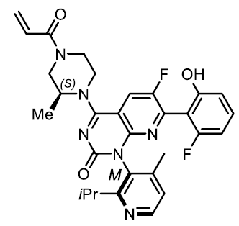
Sotorasib is manufactured as a white to light brown powder. The drug substance specification is adequate to control the quality of the drug substance. All impurity limits are acceptable. The drug substance specification is milled, and the specification includes control of particle size. The particle size limits are based on the particle size distribution of the drug substance batches used to manufacture the batches used in the clinical studies.
Stress studies showed that sotorasib is sensitive to light. The stability data supports a retest period of 24 months when stored below 30°C.
The drug product is an immediate release, yellow, oblong, film coated tablet debossed with ‘AMG’ on one side and ‘120’ on the opposite side. The drug product is a conventionally formulated and manufactured and the manufacturing process is sufficiently controlled. The drug product specification adequately controls the quality of the tablets.
In-use stability data showed that the sotorasib was sufficiently stable when the tablets were dispersed in water for administration to patients that have difficulties swallowing. Photo-stability studies showed that the film coated tablets were not light-sensitive. Long-term and accelerated stability data supported a shelf-life of 24 months when stored below 30°C when packaged in aluminium/polyvinyl chloride blister strips and in aluminium/Aclar blister strips.
Following the TGA’s evaluation of quality and pharmaceutical chemistry, approval for registration of the proposed product is recommended from a quality perspective.

Nonclinical
The pharmacology studies support the use of sotorasib for the proposed indication.
Secondary pharmacodynamics and safety pharmacology studies with sotorasib did not raise safety concerns.
Sotorasib is a substrate of P-glycoprotein, and induces the following cytochrome P450 (CYP) isozymes: CYP3A, CYP2B6, CYP2C8, CYP2C9 and CYP2C19; and inhibits isozymes CYP3A, CYP2C8, and CYP2D6; and inhibits intestinal uptake transporters P-glycoprotein, breast cancer resistance protein (BCRP), hepatic uptake transporters organic anion transporting polypeptide (OATP)1B1, OATP1B3 and organic cation transporter (OCT)1, as well as renal transporters multidrug and toxin extrusion protein (MATE)1, MATE2-K and OAT3 in vitro. Interactions with substrates of these enzymes and transporters may occur in vivo.
The combined animal safety studies revealed the following findings of potential clinical relevance (at low exposure multiples):
- hepatotoxicity
- renal toxicity
- embryofetal toxicity (without teratogenicity)
The effect of sotorasib on the liver is considered to be of concern in humans as it occurred at very low systemic exposure in dogs.
The effect of sotorasib on kidneys seems to be explained by a disproportionate increase in mercapturate pathway metabolites (metabolites M10 and M20) in renal tissue in rats. However, the effects were observed at very low relative exposures, so their clinical significance cannot be ruled out.
Sotorasib is not expected to be mutagenic or carcinogenic.
The Pregnancy Category B3; is considered appropriate for sotorasib.
The proposed limits for several impurities in the drug substance and drug product have not been adequately qualified by submitted toxicity data.
There are no objections on nonclinical grounds to the proposed registration of Lumakras for the proposed indication provided the clastogenicity of impurities [Information redacted] will be studied post-approval.

Clinical

Summary of clinical studies
The clinical dossier consisted of:
- Eleven Phase I studies: Studies 20190316, 20190500, 20190321, 20190315, 20190317, 20190318, 20190319, 20190320, 20200199, 20190135 and 20190147;
- One Phase I/II study: Study 20170543 (also known as the CODEBREAK 100 trial):
The primary efficacy data that are considered in this submission are based on the results from subjects with previously treated KRAS G12C-mutated advanced NSCLC enrolled in the pivotal Phase II portion of this ongoing study;
- One Phase III study: Study 20190009.
The clinical studies relevant to the evaluation of the efficacy and safety of sotorasib in the proposed population set out in the proposed indication for this submission are as detailed in in Table 3 below.
Table 3: All clinical studies included in this submission
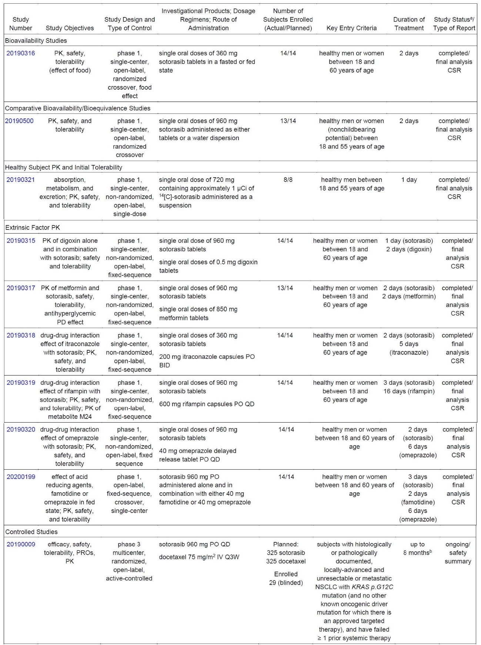
Table 3 (continued): All clinical studies included in this submission
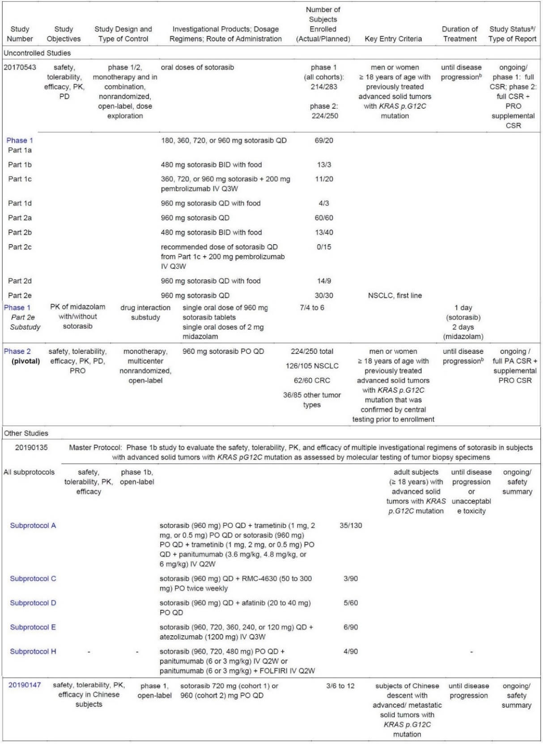
Abbreviations: BID = twice daily; BMI = body mass index; CRC = colorectal cancer; DLT = dose limiting toxicity; FOLFIRI = 180 mg/m2 irinotecan and 400 mg/m2 racemic leucovorin by intravenous infusion over 90 minutes on Day 1 and 5-fluorouracil 400 mg/m2 intravenous bolus on Day 1, followed by 5-fluorouracil 2400 mg/m2 continuous infusion administered over Days 1 and 2; KRAS = Kirsten rat sarcoma viral oncogene homolog; IV = intravenous; NSCLC = non-small cell lung cancer; PA = primary analysis; PD = pharmacodynamics; PK = pharmacokinetics; PO = administered orally; PRO = patient reported outcome; QD = once daily; Q2W = every 2 weeks; Q3W = every 3 weeks; RECIST = response evaluation criteria in solid tumours.
a Status at the time of the marketing application.
b Treatment with investigational product continues until disease progression, intolerance of treatment, initiation of another anticancer therapy, withdrawal of consent, or death.

Pharmacology
Studies on relative bioavailability between sotorasib tablet versus sotorasib tablet pre-dispersed in water, food-effect, mass balance, drug-drug interactions, and QT interval; prolongation potential were evaluated. Analysis of data from clinical studies relating to population pharmacokinetics (PopPK), exposure response for efficacy and safety, and physiological-based pharmacokinetics (PK) were also performed.

Summary of clinical pharmacology assessment
The proposed sotorasib dosage is 960 mg taken orally once daily with or without food. Based on the PK data, sotorasib exhibited saturable absorption over the dose range of 180 to 960 mg with similar systemic exposure (that is, area under the concentration-time curve from time 0 to 24 hour and maximum observed drug concentration (C_{max}) across doses at steady state.
Table 4: Study 20170543 (CODEBREAK 100 trial) Phase I Part 1A Sotorasib steady state pharmacokinetic parameter estimates following oral administration of 180, 360, 720, or 960 mg sotorasib once daily (Day 8, fasted)
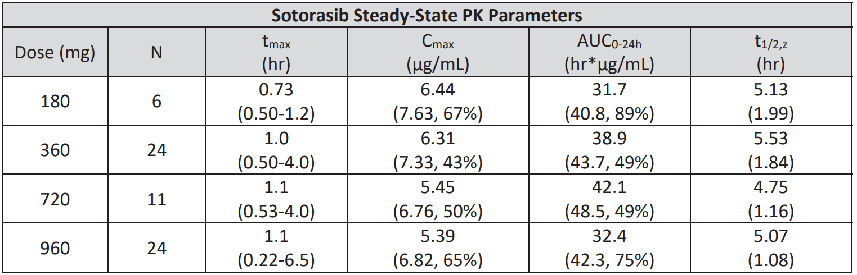
Abbreviations: AUC_{0-24h} = area under the concentration-time curve from time 0 to 24 hour post-dose; C_{max} = maximum observed drug concentration; N = total number of subjects; PK = pharmacokinetic; t_{max} = time to reach C_{max}; t_{1/2,z} = terminal half-life.
Data presented as geometric mean (mean, coefficient of variation %) for all pharmacokinetic parameters except for t_{max}, and t_{1/2,z} which is presented as median (range) and mean (standard deviation), respectively.
Source: data extracted from the United States Food and Drug Administration Multi-Discipline Review and Evaluation for Lumakras (sotorasib).
Sotorasib also showed time dependent PK with a mean accumulation ratio of 0.56 (coefficient of variation: 59%) after repeat doses.
No clear dose-response trend was observed for objective response rate among the tested doses from 180 to 960 mg.
Table 5: Study 20170543 (CODEBREAK 100 trial) Objective response rate following oral administration of 180, 360, 720, or 960 mg sotorasib once daily (fasted)
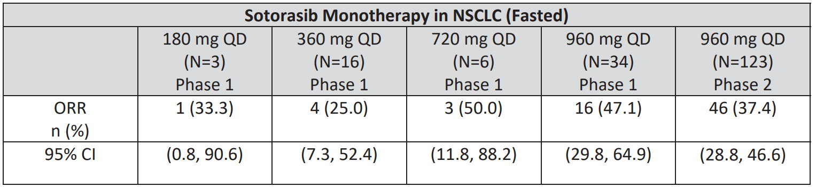
Abbreviations: CI = confidence interval; N = total number of subjects; n = number of subjects in subgroup; NSCLC = non-small cell lung cancer; ORR = objective response rate; QD = once daily.
Source: data extracted from the United States Food and Drug Administration Multi-Discipline Review and Evaluation for Lumakras (sotorasib).⁹
Despite limited sample sizes, the objective response rate data suggests that lower dose levels may provide acceptable anti-tumour activity for the proposed indication. The incidence of gastrointestinal related adverse events (AEs) may be alleviated by administering a lower dose. The pill burden (8 tablets at a time) for patients with the 960 mg dose would also be reduced by taking a lower dose.
In Study 20170543, the following were observed in patients with NSCLC:
- median time to peak plasma concentration of 1 hr
- mean steady state apparent clearance of 32.5 L/hr
- steady state apparent volume of distribution of 367 L
- mean terminal half-life of 5.19 hrs
In vitro unbound fraction of sotorasib to human plasma protein was 0.086 to 0.15 at concentrations of 0.25 to 25 µM.
Primary routine of excretion was in the faeces accounting for a mean of 74.4% of the administered sotorasib, with urine accounting for a mean of 5.81%. On average, 1.47% of the sotorasib was excreted unchanged in the urine, with a geometric mean calculated renal clearance of 0.41 L/hr. Faecal excretion is the primary route of elimination, with sotorasib being the predominant and only component identified in faeces (53% of the radioactive dose administered). In urine, metabolite M10 and sotorasib were identified as two of the major components, neither constituting more than 5% of the dose administered.
Based on healthy subjects, area under the concentration-time curve increased 1.38-fold and T_{max} (time after administration of a drug when the maximum plasma concentration is reached) was delayed by 1.25 hours when 360 mg sotorasib was administered with a high fat meal compared with administration in the fasted state. C_{max} was similar in fasted and fed conditions.
Drug-drug interaction studies performed are summarised in Table 6 below.

Table 6: Summary of drug-drug interaction studies
Study  Number | Evaluation | Results
20190315 | Digoxin DDI (P-gp substrate) | Sotorasib as perpetrator: Geometric least squares mean ratio (test/reference) of digoxin AUC_{inf} and C_{max} were 1.214 and 1.914, respectively, when comparing digoxin coadministered with sotorasib (test) and digoxin administered alone (reference).
20190317 | Metformin DDI (MATE1 and MATE2-K substrate) | Sotorasib as perpetrator: Geometric least squares mean ratio (test/reference) of metformin AUC_{inf} and C_{max} were 0.985 and 0.996, respectively, when comparing metformin coadministered with sotorasib (test) and metformin administered alone (reference).  Sotorasib as victim: Geometric least squares mean ratio (test/reference) of sotorasib AUC_{inf} and C_{max} were 0.910 and 0.812, respectively, when comparing sotorasib coadministered with metformin (test) and sotorasib administered alone (reference).
20190318 | Itraconazole DDI (CYP3A4 and P-gp Inhibitor) | Sotorasib as victim: Geometric least squares mean ratio (test/reference) of sotorasib AUC_{inf} and C_{max} were 1.261 and 1.040, respectively, when comparing sotorasib coadministered with itraconazole (test) and sotorasib administered alone (reference).
20190319 | Rifampin DDI (OATP inhibitor and CYP3A4 inducer) | Sotorasib as victim: Geometric least squares mean ratio (test/reference) of sotorasib AUC_{inf} and C_{max} were 0.766 and 0.840, respectively, when comparing sotorasib coadministered with single-dose rifampin (test) and sotorasib administered as tablets (reference). Geometric least squares mean ratio (test/reference) of sotorasib AUC_{inf} and C_{max} were 0.487 and 0.647, respectively, when comparing sotorasib coadministered with multiple daily dosing of rifampin (test) and sotorasib administered alone (reference).
20190320 | Omeprazole PPI | Sotorasib as victim: Geometric least squares mean ratio (test/reference) of sotorasib AUC_{inf} and C_{max} were 0.582 and 0.431, respectively, when comparing sotorasib administered with omeprazole in the fasted condition (test) and sotorasib administered alone in the fasted condition (reference).
20200199 | Famotidine or omeprazole in fed state (DDI) | Sotorasib as victim: Geometric least-square mean ratios of sotorasib AUC_{inf} and C_{max} were 0.622 and 0.654, respectively when comparing sotorasib coadministered with famotidine (test) and sotorasib alone (reference) in fed conditions. Geometric least-square mean ratios of sotorasib AUC_{inf} and C_{max} were 0.430 and 0.349, respectively when comparing sotorasib coadministered with omeprazole (test) and sotorasib alone (reference) in fed conditions.
20170543 Substudy | Midazolam DDI (CYP 3A4 substrate) | Sotorasib as inhibitor/inducer of CYP3A4: Geometric least squares mean ratio (test/reference) of sotorasib AUC_{inf} and C_{max} were 0.47 and 0.52, respectively, when comparing midazolam coadministered with sotorasib (test) and midazolam administered alone (reference).
Abbreviations: AUC_{inf} = area under the plasma concentration-time curve from time zero to infinity; C_{max} = maximum plasma concentration; CYP3A4 = cytochrome P450 3A; DDI = drug-drug interaction; MATE = multidrug and toxin extrusion protein; OATP = organic anion transporter; P-gp = P-glycoprotein; PPI = proton pump inhibitor.
At the dosing regimen of 960 mg daily, no large mean increase in the corrected QT interval; (greater than 20 msec) was observed.
In terms of therapeutic individualisation:
- No dose adjustment of sotorasib is required based on demographic factors as no clinically significant differences in PK of sotorasib were observed based on these intrinsic factors (for example, weight, age, sex, race).
- Sotorasib can be administered without regard to food. The sotorasib systemic exposure were not significantly impacted when administered a high fat, high calorie meal; no meaningful differences were observed in safety data between patients taking 960 mg dose under fasted conditions versus fed conditions.
- No dose adjustment of sotorasib is required for patients with mild and moderate renal impairment considering that renal elimination is a minor elimination pathway for sotorasib and that no clinically meaningful difference in PK of sotorasib was seen in patients with mild and moderate renal impairment compared to those with normal renal function based on PopPK analysis.
- No dose adjustment of sotorasib is required for patients with mild hepatic impairment based on the PopPK analysis. As the PopPK analysis included only 3 patients with moderate hepatic impairment, further evaluation in subjects with moderate and severe hepatic impairment is required to inform dosage.
- No dose adjustment of sotorasib is required when sotorasib is co-administered with strong CYP3A inhibitors, P-glycoprotein inhibitors and OATA1B1 or OATA1B3 inhibitors.

Key findings
- The proposed sotorasib dosing regimen (960 mg daily) has demonstrated acceptable efficacy and safety, however, in the clinical pharmacology evaluation, it was identified that this dose has not been optimised from PK and efficacy or safety perspectives. Sotorasib showed saturable absorption with similar systemic exposures at steady state across all dose levels ranging from 180 mg to 960 mg. Clinical response was observed at lower doses, and no clear trend observed in the dose response relationship for objective response rate among the studies doses.
- Co-administration of sotorasib with strong CYP3A inducers and gastric acid reducing agents (proton pump inhibitors and H2 receptor antagonists) should be avoided, based on drug-drug interaction studies showing significant decreases in sotorasib exposures and its unknown consequent impact on efficacy.

Recommendations and outstanding issues
Sotorasib was considered approvable from a clinical pharmacology perspective, providing the following clinical pharmacology studies are conducted as post-marketing requirements:
- Dose optimisation study to investigate a lower sotorasib dosage that may provide comparable efficacy with improved safety (especially local gastrointestinal tolerability) as compared to 960 mg dose.
- Hepatic impairment study (in subjects with moderate to severe hepatic impairment) to inform dosage recommendations in this specific population.
- Clinical drug-drug interaction study with BCRP substrates to inform the appropriate dosing strategies for the co-administration of sotorasib with BCRP substrates.

Efficacy

Study 20170543 (CODEBREAK 100 trial)
The pivotal study supporting efficacy and safety for the proposed indication is Study 20170543 (the CODEBREAK 100 trial). It is a Phase I/II open label, single group study evaluating sotorasib in the treatment of subjects with KRAS G12C-mutated solid tumours. The study is ongoing in North America, South America, Australia, Europe and Asia.
The primary evidence for efficacy is based on data for subjects with previously treated KRAS G12C-mutated advanced NSCLC who received sotorasib monotherapy in the pivotal Phase II portion of the Study 20170543 (Phase II NSCLC group).
Data from the Phase I portion of the study for previously treated and treatment naive subjects with KRAS G12C-mutated advanced NSCLC who received sotorasib monotherapy (Phase I NSCLC group and Phase I NSCLC 1L group respectively) are supportive.
Other relevant supportive clinical studies are as summarised in Table 3 above.

Study design
The study design is summarised in the Figure 2 and Figure 3 below.
Figure 2: Study 20170543 (CODEBREAK 100 trial) Phase I study schema on Part 1 (dose exploration) and Part 2 (dose expansion)
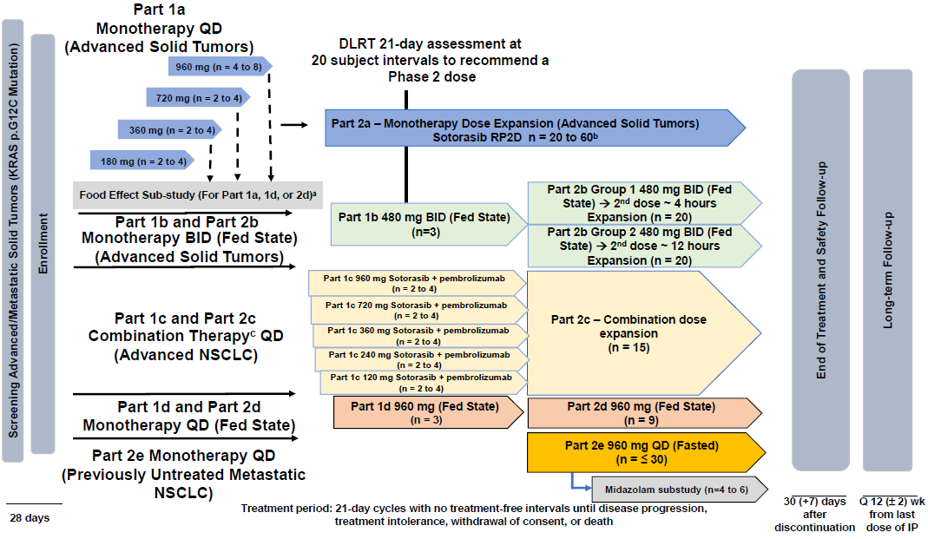
Abbreviations: BID = twice daily; DLT = dose limiting toxicity; DLRT = dose level review team; IP = investigational product; MTD = maximum tolerated dose; n = number of subjects in subgroup; NSCLC = non-small cell lung cancer; Q = every; QD = once daily; RP2D = recommended Phase II dose; wk = weeks.
Figure 3: Study 20170543 (CODEBREAK 100 trial) Transition from Phase I to Phase II study schema
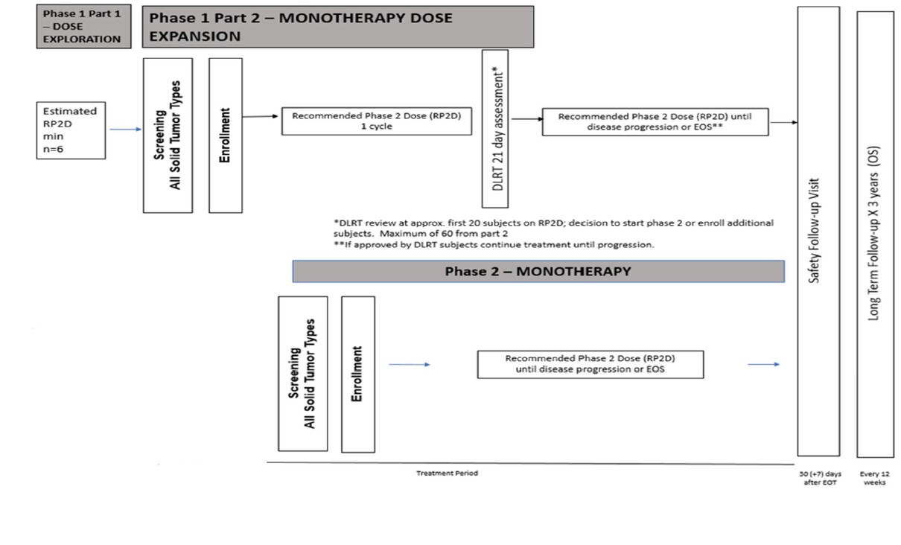
Abbreviations: EOS = end of study; EOT = end of treatment; DLRT = dose level review team; MTD = maximum tolerated dose; n = number of subjects in subgroup; OS = overall survival; RP2D = recommended Phase II dose.
Repeated oral daily dosing with 21 days cycles.
There were no scheduled treatment interruptions.

Primary and secondary objectives
The primary objectives of the Phase I study period (Parts 1 and 2) are to evaluate safety and tolerability of sotorasib; and to estimate the maximum tolerated dose or the recommended Phase II dose of sotorasib in adult patients with KRAS G12C-mutated advanced solid tumours.
The primary objective of the Phase II study period is to evaluate the objective response rate for sotorasib as monotherapy in patients with KRAS G12C-mutated advanced solid tumours
The secondary objectives for both Phase I and II periods of the study are as follows:
- duration of response
- disease control rate
- time to response
- progression free survival
- overall survival
- safety
- pharmacokinetics

Inclusion and exclusion criteria
Phase I sotorasib dosing is shown in Figure 2 above. Subjects in Phase II were treated with sotorasib monotherapy at 960 mg daily as per recommended Phase II dose, and continued sotorasib until disease progression, treatment intolerance, withdrawal of consent, death or other protocol defined reasons. Primary analysis was to occur at approximately 8.5 months after 105 subjects with NSCLC or 60 with colorectal cancer had enrolled in Phase II period of the study.
Key inclusion criteria are as follows:
- adults with KRAS G12C-mutated advanced NSCLC, colorectal cancer, or other solid tumours that were previously documented (Phase I) or identified prospectively using local assessments and confirmed with central laboratory testing for the mutation before enrolment in Phase II portion of the study;
- subjects must have received prior therapy (Phase I, except for the previously untreated metastatic NSCLC cohort), or progressed after receiving prior therapy (Phase II);
- subjects have an Eastern Cooperative Oncology Group (ECOG) performance status; of 0 or 1; and
- subjects have measurable disease per Response Evaluation Criteria In Solid Tumours (RECIST); version 1.1.
Key exclusion criteria are:
- subjects with active untreated brain metastases;
- who have received more than 3 previous lines of therapy; and
- had previous treatment with a direct KRAS G12C inhibitor.

Study endpoints
Study 20170543 Phase II efficacy endpoints include:
- Primary endpoint: objective response rate
- Key secondary endpoint: duration of response;
- Other supportive secondary endpoints: time to response, disease control rate, progression free survival and overall survival.
Study 20170543 Phase I efficacy endpoints include:
- objective response rate,
- duration of response,
- disease control rate,
- progression free survival,
- duration of stable disease,
- time to response.
The final efficacy analysis was based on updated efficacy data with cut-off date of 1 September 2020; duration of response was followed until 1 December 2020.

Statistical analysis plan and protocol amendments
The sponsor submitted the statistical analysis plan (and amendments), and protocol amendments for Study 20170543. The primary efficacy endpoint is objective response rate as assessed by blinded independent central review per RECIST version 1.1. A sample size of 105 subjects for NSCLC would provide approximately 90% probability that the lower limit of the objective response rate 95% confidence interval (CI) exceeds the pre-specified tumour specific benchmark objective response rate of 23%. The minimal observed objective response rate that would exclude the benchmark objective response rate from the 95% CI with this sample size is 32%. The key secondary endpoint is duration of response which is summarised with descriptive statistics.

Study results

Good Clinical Practice
The sponsor’s compliance with Good Clinical Practice; is noted. The data cut-off for the efficacy data was 1 September 2020, with duration of responses followed through to 1 December 2020.

Subject disposition
The updated efficacy data set (submitted 4 February 2021) includes a total of 124 patients.
- A total of 55 patients (44%) were still on study.
- A total of 69 (56%) patients had discontinued study, of which:
  - 57 (46%) died,
  - 10 (8%) withdrew consent, and
  - 2 (1.6%) lost to follow-up.
- A total of 94 (76%) patients had discontinued sotorasib, due to:
  - disease progression (74 patients (60%))
  - adverse event (11 patients (9%))
  - patient request (5 patients (4.0%))
  - death (2 patients (1.6%))
  - non-compliance (one patient (0.8%))
  - requirement for alternative therapy (one patient (0.8%))
The Phase I full analysis set for NSCLC 960 mg daily sotorasib monotherapy (fasted) cohort comprised 34 subjects and was used for analyses.

Protocol violations and deviations
In Study 20170543 Phase II, in NSCLC, 51 patients (41%) had one or more important protocol deviation (total of 89 important protocol deviations overall), as outlined in Table 7 below. The protocol deviations observed for Study 20170543 are unlikely to impact on the efficacy results or interpretation of the observed safety profile of sotorasib.
Table 7: Study 20170543 (CODEBREAK 100 trial) Important protocol deviations amongst patients enrolled in the dose expansion portion of the study
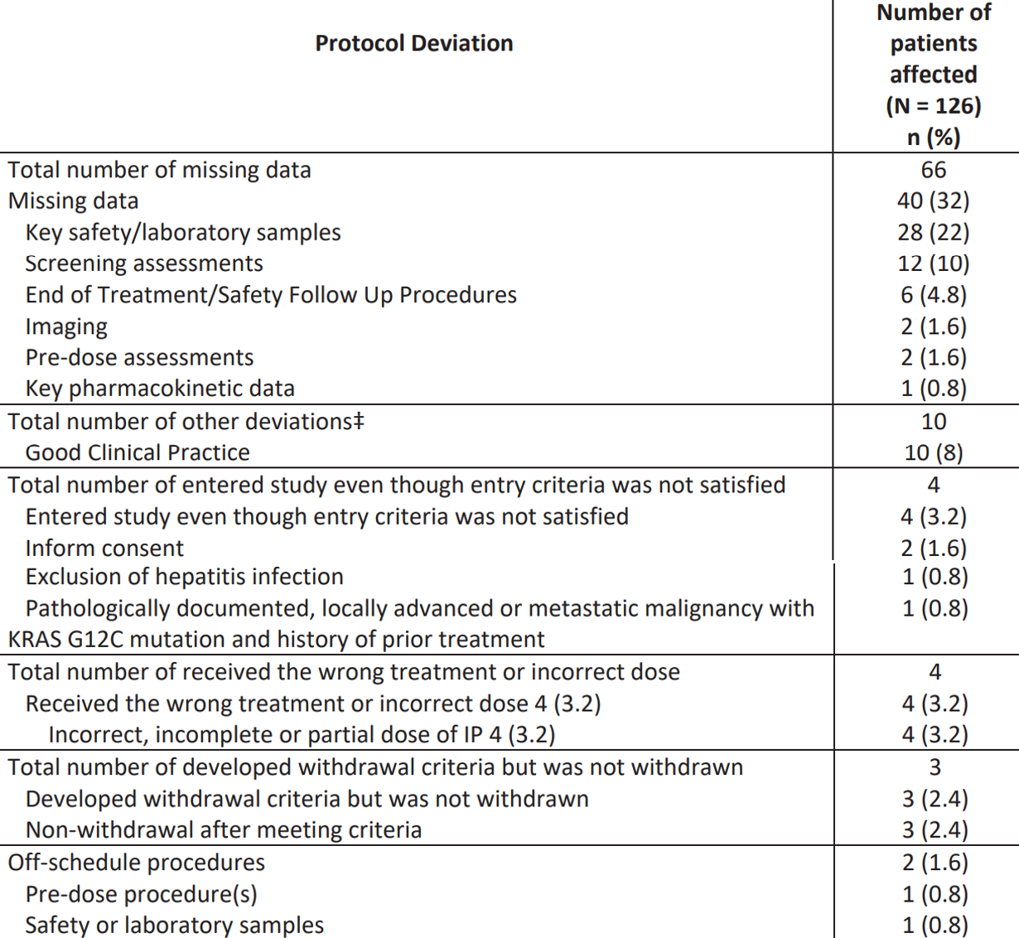
Abbreviation: N = total number of subjects; number of subjects in subgroup.
Source: data extracted from the United States Food and Drug Administration Multi-Discipline Review and Evaluation for Lumakras (sotorasib).⁹

Baseline demographics, disease characteristics and concomitant drugs
The baseline demographic and disease characteristics as analysed by the evaluator using the primary efficacy population of 124 patients, are summarised in Table 8 below.
Table 8: Study 20170543 (CODEBREAK 100 trial) Baseline demographic and disease characteristics
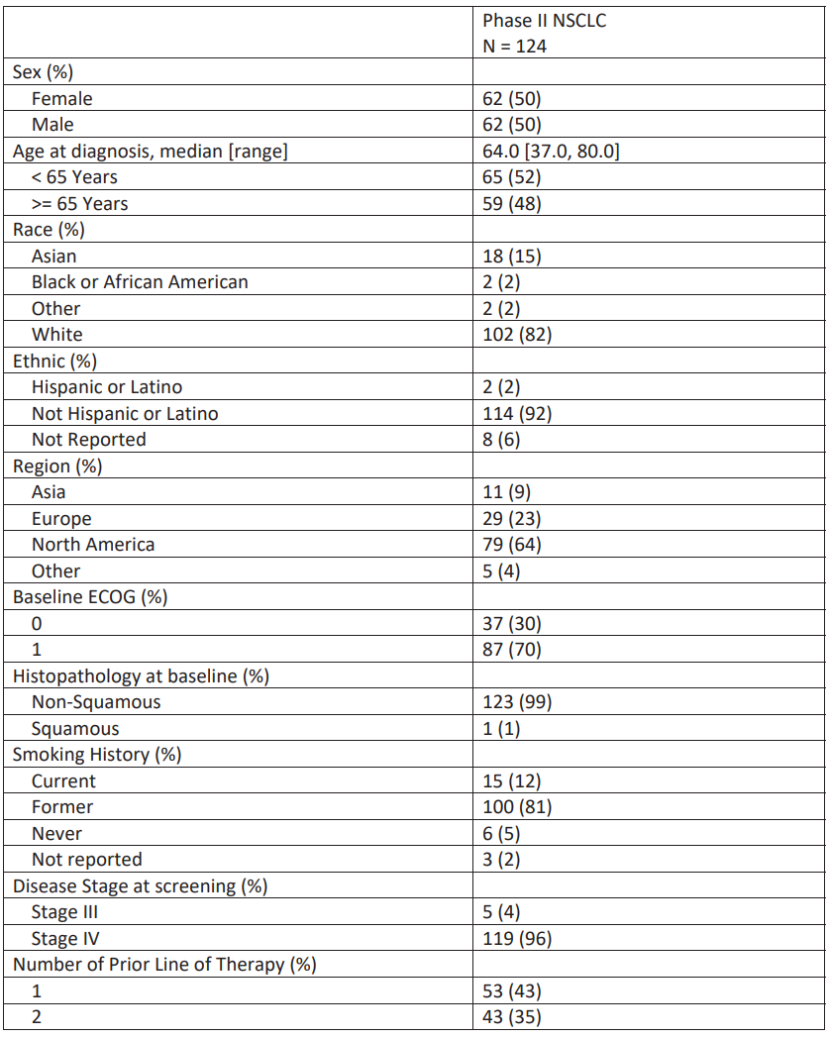
Table 8 (continued): Study 20170543 (CODEBREAK 100 trial) Baseline demographic and disease characteristics
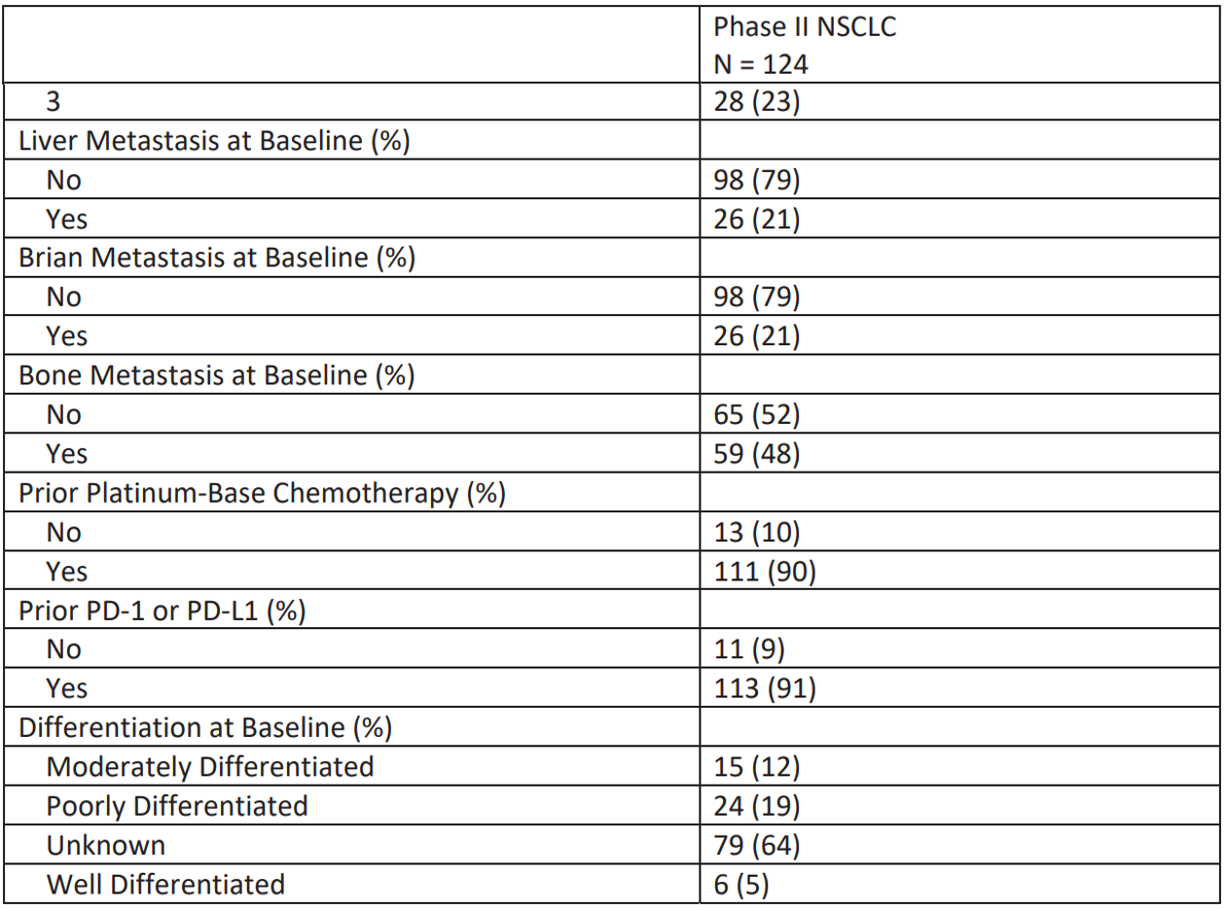
Abbreviations: ECOG = Eastern Cooperative Oncology Group; N = total number of subjects; NSCLC = non-small cell lung cancer; PD-1 = programmed cell death protein 1; PD-L1 = programmed death-ligand 1.
Source: data extracted from the United States Food and Drug Administration Multi-Discipline Review and Evaluation for Lumakras (sotorasib).⁹
The median age of 64 years old patients enrolled in Study 20170543 is similar to that reported in the literature for patients with KRAS G12C-mutated NSCLC as is the high prevalence of current or former smokers (93%). Patients had received a median of two previous lines of systemic therapy; previous therapies included platinum-based chemotherapy in 111 patients (90%) and checkpoint inhibitors in 113 patients (91%).
In Study 20170543, the median daily dose of sotorasib administered was 960 mg, with a median relative dose intensity of 100% for subjects whose planned dose was 960 mg, regardless of tumour type. Concomitant medications used in the study were as per study protocol criteria.

Efficacy results
The key efficacy results provided by the sponsor were based on a primary efficacy population of 123 patients and a data cut-off date of 1 September 2020. At that data cut-off date, 41 of the original 46 responders (89%) had at least 6 months of follow-up post onset of response. The next planned data cut-off was 1 December 2020, at which time all responders had at least 6 months of follow-up response. The evaluation’s assessment of duration of response was therefore based on the later cut-off date to capture sufficiently durable follow-up for all responders.
Following the sponsor’s submission of the updated Summary of Clinical Efficacy on 4 February 2021, (data cut-off date of 1 December 2020), the primary efficacy population included in the efficacy assessment is considered to be based on a total of 124 patients.
One additional patient was assessed as having a partial response and included as a responder in the sponsor’s assessment based on the 1 September 2020 cut-off date (n = 46). However, at the time of efficacy update, two lesions were noted to be increasing in size on follow-up imaging performed after the September data cut-off. The patient’s tumour assessments were reassessed from baseline and with the addition of these two target lesions, the patient’s best overall response changed from partial response to stable disease. Therefore, there are 45 responders included in the assessment of efficacy. Changes to the primary efficacy population that occurred based on imaging re-assessment is detailed in Table 9 below.
Table 9: Study 20170543 (CODEBREAK 100 trial) Summary of patients with imaging re-assessments
Description | Previous assessmentª | Current assessment^{b} | Final FDA analysis^{c}
The patient had progressive disease assigned earlier | Progressive disease | Progressive disease | Progressive disease
The patient had progressive disease assigned earlier | Progressive disease | Progressive disease | Progressive disease
At follow-up 5, two lesions not recorded as either target or non-targets were increasing in size. Re-read of this patient from baseline and adding the two additional targets results in the change in best overall response from partial response to stable disease. | Partial response | Stable disease | Stable disease
The disease status changed from progression at follow-up 1 to partial response at follow-up 6 and 7 after a new lesion at follow up 1 was eliminated | Not originally included in the primary efficacy population as the patient was assessed as not having measurable disease at baseline by investigator. Upon subsequent assessment of the patient’s baseline imaging, blinded independent central review determined that the patient did have measurable disease at baseline. The patient was subsequently added to the primary efficacy population. | Partial response | Stable disease (had an onset of response occurred on 23 September 2020, which is post primary analysis data cut-off of 1 September 2020)
Abbreviation: FDA = Food and Drug Administration (United States).
a Data cut-off for previous assessment: 1 September 2020.
b Data cut-off for current assessment: 1 December 2020.
c Data cut-off for final FDA analysis: 1 September 2020 for objective response rate; 1 December 2020 for duration of response.
Source: data extracted from the United States Food and Drug Administration Multi-Discipline Review and Evaluation for Lumakras (sotorasib).⁹
The Delegate notes the results of an analysis, provided in the evaluation report, of the objective response rate and duration of response observed in the subgroup of patients who received prior treatment with platinum based chemotherapy and an anti-PD-(L1)1 agent, as it is this subgroup that would be the most representative of patients with KRAS G12C-mutated NSCLC who would be eligible for therapy with sotorasib in the USA (retrospective analyses suggest that immunotherapy is an effective treatment for patients with NSCLC with KRAS mutations and may result in improved outcomes over chemotherapy alone, and that immunotherapy and platinum based chemotherapy administered concurrently or sequentially, are the current standard of care for the first line treatment of patients with metastatic NSCLC without an actionable driver mutation in the USA). This would also be relevant in the Australian context.
In the primary efficacy population, the objective response rate was 36% (95% CI: 28, 45) and median duration of response was 10.0 months. The objective response rate was 31% (95% CI: 22, 41) in the subgroup of patients who had previously progressed on chemotherapy and immunotherapy. These results would reasonably be considered to be clinically meaningful and to likely demonstrate an improvement over currently available second line therapies, both in the magnitude of the objective response rate observed and in the durability of response. The follow-up time for duration of response was not sufficiently mature (at median follow-up of 6.9 months) to characterise the upper limit of the 95% CI of duration of response.
Table 10 below summarises the analysis of Study 20170543 objective response rate and duration of response per blinded independent central review.
Table 10: Study 20170543 (CODEBREAK 100 trial) Phase II non-small cell lung cancer - summary of overall response and duration of responses per blinded independent central review (full analysis set)
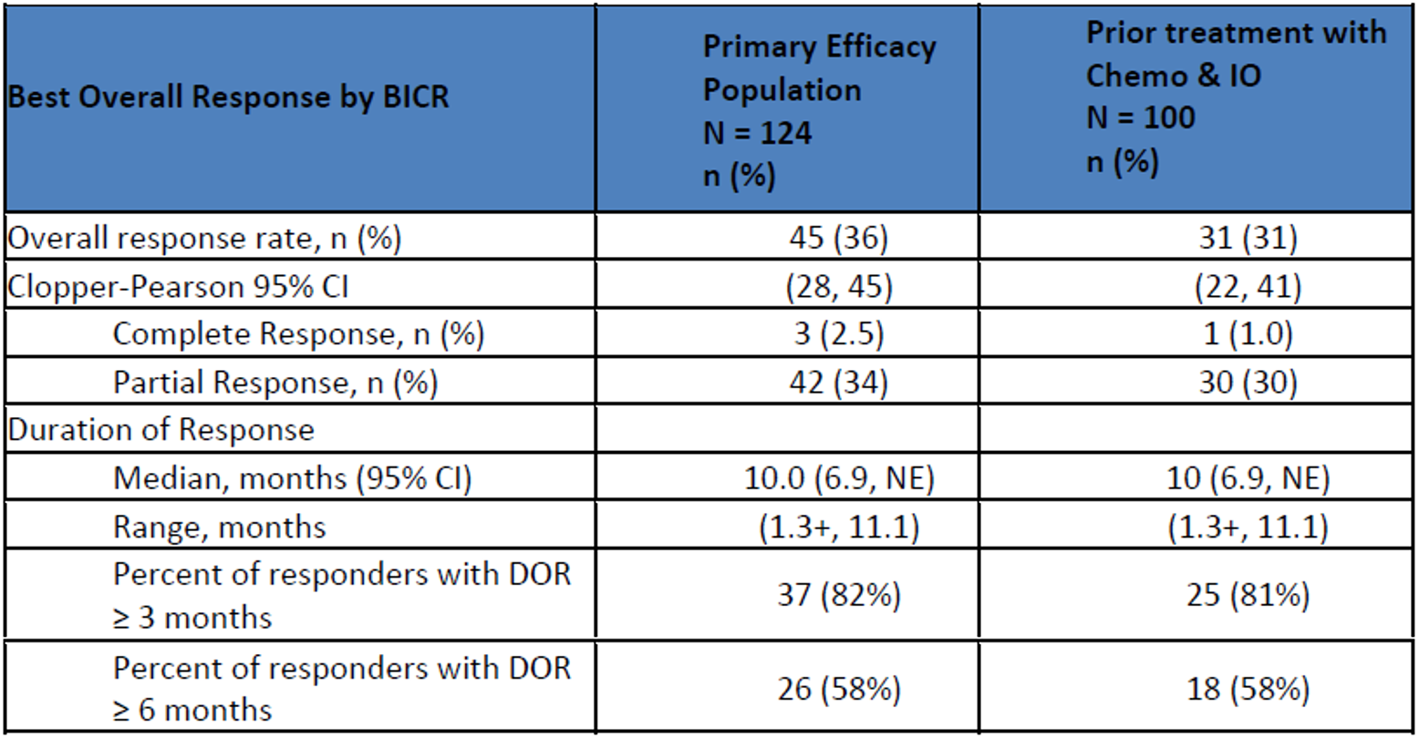
Abbreviations: BICR = blinded independent central review; chemo = chemotherapy; CI = confidence interval; DOR = duration of response; IO = immuno-oncology; N = total number of subjects; n = number of subjects in subgroup; NE = not estimable.
Source: data extracted from the United States Food and Drug Administration Multi-Discipline Review and Evaluation for Lumakras (sotorasib).⁹

Results on other endpoints

Duration of response
The analysis of duration of response is based on a final data cut-off date of 1 December 2020, with a median duration of response of 10.0 months (95% CI: 6.9, upper bound not estimable).

Progression free survival and overall survival
The progression free survival and overall survival analyses are considered to be uninterpretable in this single arm study. For completeness, median progression free survival was 6.7 months based on central review (median follow up time of 8.3 months), and median overall survival of 12.0 months (with median follow-up time of 9.3 months).

Dose and dose response
The clinical evaluation has identified an issue with dosing optimisation and does not agree with the sponsor that the proposed dosing regimen of 960 mg daily is fully supported by the observed efficacy data given that the 95% CI around the objective response rates observed in patients enrolled at lower dose levels were wide due to small sample sizes and included the objective response rate observed in the primary efficacy population. See clinical pharmacology section above.

Patient reported outcome endpoints:
The analyses of patient reported outcome endpoints are considered exploratory and interpretable given the single arm study design.

Integrated review of effectiveness
Study 20170543 is the only study supporting the efficacy for this submission; efficacy data for patients enrolled in the dose escalation and dose expansion portions of Study 20170543 were evaluated separately and no integrated review of effectiveness was performed. Results from 34 patients with NSCLC who were enrolled in the dose escalation portion of the study and received sotorasib 960 mg daily were provided by the sponsor, however, the evaluator has not independently verified these results.

Subpopulations
The results of the objective response rate analysis in select patient subgroups are provided in Table 11 below.
Table 11: Study 20170543 (CODEBREAK 100 trial) Phase II non-small cell lung cancer - summary of overall response in subgroups per blinded independent central review (full analysis set)
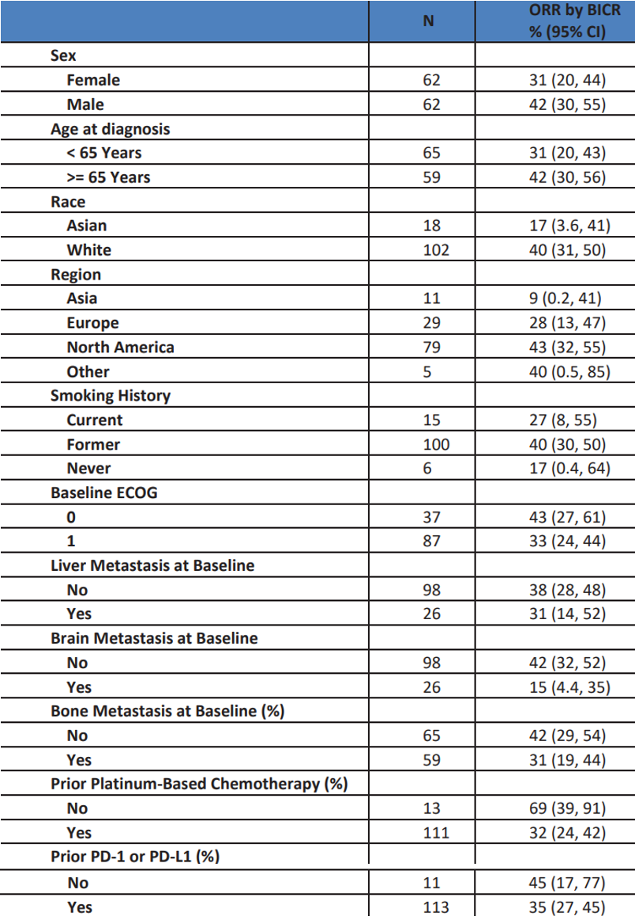
Abbreviations: BICR = blinded independent central review; chemo = chemotherapy; CI = confidence interval; ECOG = Eastern Cooperative Oncology Group; N = total number of subjects; n = number of subjects in subgroup; ORR = objective response rate; PD-1 = programmed cell death protein 1; PD-L1 = programmed death-ligand 1.
Source: data extracted from the United States Food and Drug Administration Multi-Discipline Review and Evaluation for Lumakras (sotorasib).⁹
The responses observed in each subgroup are consistent across the different subgroups except for the following: patients with brain metastasis at baseline (objective response rate: 15%; 95% CI: 4.4, 35), Asian race (objective response rate: 17%; 95% CI: 3.6, 41) and Asian region (objective response rate: 9%; 95% CI: 0.2, 41). The 95% CIs are wide for many of the subgroups (for example, race, regions, current smokers, never smokers, patients who did not receive prior treatment with a PD-(L)1 inhibitor) due to small sample sizes.

Additional efficacy considerations
objective response rates observed in patients enrolled at lower dose levels in the dose escalation portion of Study 20170543 (ranging from 180 to 720 mg), were similar in magnitude to those observed at the 960 mg dose level, with responses at each lower dose level. However, the total number of patients enrolled at all the lower dose levels combined was 24, resulting in wide and overlapping 95% confidence intervals around the objective response rates observed across all doses. Consequently, as the nonclinical data suggests that target saturation can be achieved at exposure levels with lower doses, and that there was not a clear dose response relationship for objective response rate observed across the tested doses, a post-marketing requirement dose optimisation study will be conducted to further characterise the efficacy and safety of sotorasib at a lower dose.

Safety

Safety review approach and overall exposure
In Study 20170543 at data cut-off date, 427 patients had received sotorasib; 204 were those with NSCLC who received sotorasib 960 mg daily. Overall, 357 subjects with any tumour type had received sotorasib at the intended 960 mg dose.
Subjects with NSCLC treated with 960 mg daily received sotorasib monotherapy for a median of 19.5 weeks, with 38.7% of subjects receiving treatment for 6 months or longer and 22.1% of subjects receiving treatment for 9 months or longer. For those whose planned dose was 960 mg daily, the median average daily dose administered was 960 mg and the median relative dose intensity of sotorasib was 100%.
The safety data provided by the sponsor was considered by the evaluator to be sufficient for assessment of sotorasib’s safety profile (with safety database that includes 357 patients with KRAS G12C-mutated solid tumours who received at least one dose of sotorasib 960 mg) and agreed with the sponsor’s safety review approach. The primary safety population consisted of 204 patients enrolled in Study 20170543 with KRAS G12C-mutated NSCLC who received at least one dose of sotorasib 960 mg in the fed or fasted stated. The safety review was completed using the safety dataset from these 204 patients and compared to safety data from patients with KRAS G12C-mutated tumours when appropriate.

Safety results

Deaths
All fatal adverse events (AEs) that occurred within the primary safety population at the data cut-off of 1 September 2020 were reviewed. In general, fatal AEs were rare amongst patients with NSCLC enrolled in Study 20170543. Death due to AEs that were not clearly related to disease progression or an alternative aetiology according to patient narratives were reported for seven patients (3.4%).
The fatal AEs for which sotorasib’s involvement could not be ruled out included one case of each of: cardiac failure, cardiac arrest, gastric ulcer, pneumonitis, pneumonia and two cases of respiratory failure. Of these, the case of pneumonitis was possibly attributable to sotorasib, while the other deaths did not have a clear association with the study drug.

Serious adverse events
The incidence of serious adverse events is outlined in Table 12 below. Serious adverse events occurred in approximately 50% of patients treated with sotorasib. Serious adverse reactions that were not clearly due to disease progression or metastasis occurring in 2% or more of patients were pneumonia (8%), hepatotoxicity (3.4%) and diarrhoea (2%).
Table 12: Study 20170543 (CODEBREAK 100 trial) Summary of serious adverse events by Preferred Term occurring in at least 2% of subjects in any group (integrated safety analysis set)
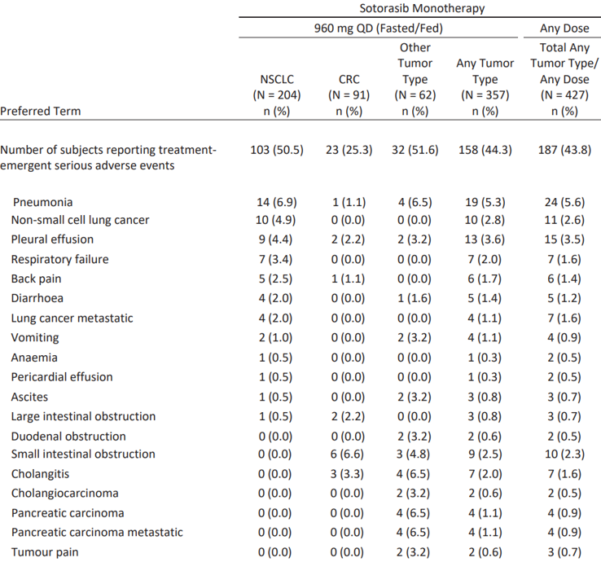
Abbreviations: CRC = colorectal cancer; N = total number of subjects in the analysis set, n = number of subjects with observed data; NSCLC= non-small cell lung cancer; QD = once daily.
Phase I data cut-off date 6 July 2020. Phase II data cut-off date 1 September 2020.
Adverse events were coded using Medical Dictionary for Regulatory Activities; version 23.0. Rows are sorted by Preferred Term (in descending order of frequency in NSCLC Monotherapy 960 mg QD Fasted/Fed column).
Source: data extracted from the United States Food and Drug Administration Multi-Discipline Review and Evaluation for Lumakras (sotorasib).9

Dropouts and/or discontinuations due to adverse events
The incidence of AEs leading to discontinuation of sotorasib that occurred in at least two patients in any group was provided in Table 13 below.
Table 13: Study 20170543 (CODEBREAK 100 trial) Treatment-emergent adverse events by System Organ Class and Preferred Term leading to withdrawal of sotorasib (integrated safety analysis set)
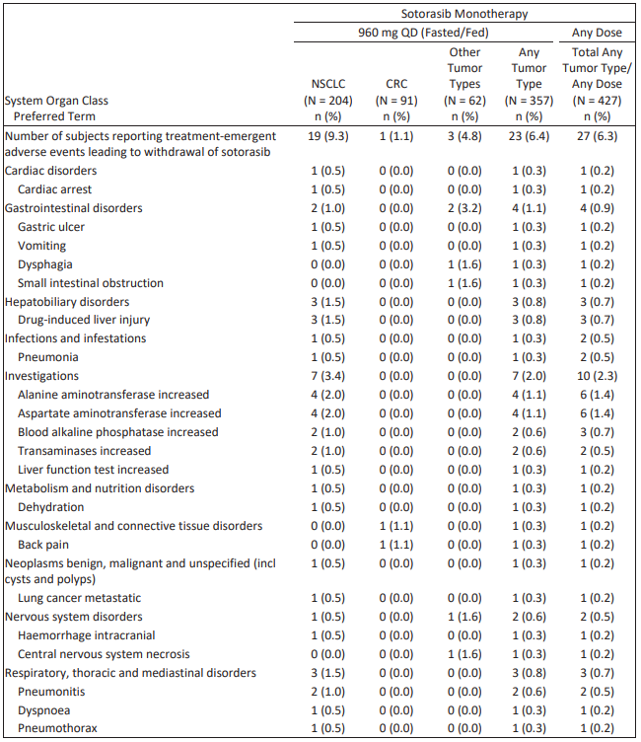
Abbreviations: CRC = colorectal cancer; NSCLC = non-small cell lung cancer; QD = once daily; N = total number of subjects in the analysis set, n = number of subjects with observed data.
Phase I data cut-off date 6 July 2020. Phase II data cut-off date 1 September 2020.
Adverse events were coded using Medical Dictionary for Regulatory Activities;¹⁶ version 23.0. Rows are sorted by System Organ Class (alphabetically) and Preferred Term within System Organ Class (in descending order of frequency in NSCLC column.
Source: data extracted from the United States Food and Drug Administration Multi-Discipline Review and Evaluation for Lumakras (sotorasib).⁹
A total of 18 patients (9%) had AEs leading to sotorasib discontinuation. AEs leading to discontinuation in 2% or more of patients were due to hepatotoxicity (4.9%), including Preferred Terms alanine aminotransferase (ALT) increased, aspartate aminotransferase (AST) increased, drug induced liver injury, liver function test increased, and transaminases increased.

Dose interruption and reductions
At data cut-off of 1 September 2020, 69 patients (34%) had AEs leading to treatment interruption or dose reduction (71 patients based on data cut-off of 1 December 2020).
Adverse events leading to sotorasib treatment interruption in 2% or more of patients included hepatotoxicity (11%), diarrhoea (8%), musculoskeletal pain (3.9%), nausea (2.9%) and pneumonia (2.5%).
Adverse events leading to dose reduction occurred in 10 patients (4.9%); the most frequent AEs (at least 2%) leading to dose reduction were increased ALT (2.9%) and increased AST (2.5%). Following dose reduction, seven patients had resolution of their adverse event.
The majority of patients experiencing AEs leading to treatment interruption or reduction were able to continue with sotorasib therapy.

Significant adverse events
A total of 120 patients (59%) had a Grade 3 or higher AE. The most common Grade 3 or higher AE excluding laboratory abnormalities were musculoskeletal pain (8%), pneumonia (7%), and diarrhoea (5%). These types of events reported were similar across patients with KRAS G12C-mutated tumour types who were treated with sotorasib 960 mg daily.

Treatment-emergent adverse events and adverse reactions
A summary of treatment-emergent adverse events (TEAEs) is shown in Table 14 below.
Table 14: Study 20170543 (CODEBREAK 100 trial) Summary of treatment-emergent adverse events (integrated safety analysis set)
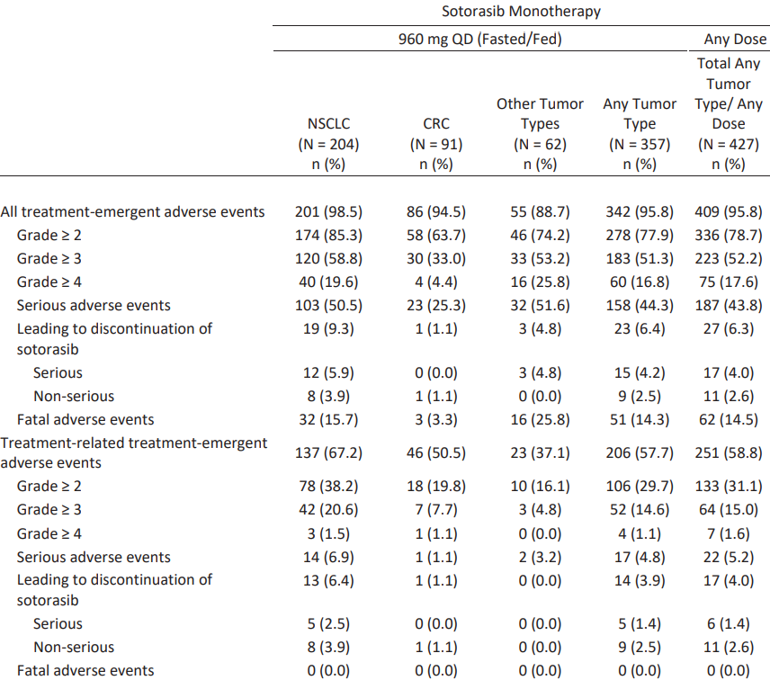
Abbreviations: CRC = colorectal cancer; NSCLC = non-small cell lung cancer; QD = once daily; N = total number of subjects in the analysis set, n = number of subjects with observed data.
Phase I data cut-off date 6 July 2020.
Phase II data cut-off date 1 September 2020.
Severity was graded using Common Terminology Criteria for Adverse Events version 5.0. Adverse events coded using Medical Dictionary for Regulatory Activities;¹⁶ version 23.0. Severity graded using Common Terminology Criteria for Adverse Events; version 5.0.
Source: data extracted from the United States Food and Drug Administration Multi-Discipline Review and Evaluation for Lumakras (sotorasib).⁹
The most common adverse reactions were generally consistent across populations of patients with different tumour types. TEAEs reported in more than 10% of patients are outlined in Table 15 below.
Table 15: Study 20170543 (CODEBREAK 100 trial) Adverse reactions occur in 10% or more in patients with non-small cell lung cancer who received 960 mg sotorasib
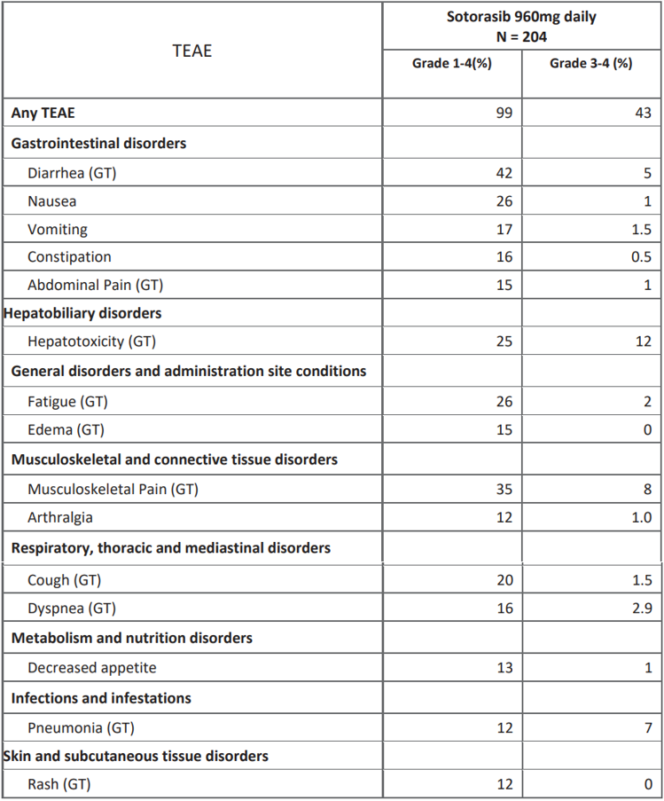
Abbreviations: GT = grouped term; N = total number of subjects; TEAE = treatment-emergent adverse event.
Abdominal pain (GT) includes: abdominal discomfort, abdominal pain, abdominal pain lower, and abdominal pain upper.
Cough (GT) includes: cough, productive cough, and upper-airway cough syndrome.
Diarrhea (GT) includes: colitis, colitis microscopic, diarrhea, and frequent bowel movements.
Dyspnea (GT) includes: dyspnea, and dyspnea exertional.
Fatigue (GT) includes: asthenia and fatigue.
Hepatotoxicity (GT) includes: alanine aminotransferase increased, aspartate aminotransferase increased, blood bilirubin increased, drug-induced liver injury, hepatitis, hepatotoxicity, transaminases abnormal, transaminases increased.
Musculoskeletal pain (GT) includes: back pain, bone pain, musculoskeletal chest pain, musculoskeletal discomfort, musculoskeletal pain, myalgia, neck pain, non-cardiac chest pain, and pain in extremity.
Edema (GT) includes: generalised edema, localised edema, edema, edema peripheral, periorbital edema, and testicular edema.
Pneumonia (GT) includes: pneumonia, pneumonia aspiration, pneumonia bacterial, and pneumonia staphylococcal.
Rash (GT) includes: dermatitis, dermatitis acneiform, rash, rash-maculopapular, rash pustular
Source: data extracted from the United States Food and Drug Administration Multi-Discipline Review and Evaluation for Lumakras (sotorasib).⁹

Laboratory findings
Increases in ALT and AST concentrations of all grades were the most common lab abnormalities, occurring in 39% and 38% of patients respectively. Grade 3 to 4 abnormalities of AST and ALT occurred in 9% and 11% of patients, respectively. A total of 50 patients (23%) were noted to have an activated partial thromboplastin time (aPTT) that was increased from baseline. The sponsor stated that 30 of the 50 patients had an aPTT increase from baseline noted at only one laboratory assessment during the patients’ time on study; the patients’ aPTT values subsequently normalised without intervention; and also that there is no additional clinical or laboratory evidence to indicate that sotorasib is associated with coagulopathy.

Electrocardiograms and QT studies
The evaluator concluded that no dedicated QT studies were conducted and that no evidence of an increased risk of QT prolongation was observed with sotorasib treatment.⁸

Adverse events of special interest

Hepatotoxicity
A grouped term for hepatotoxicity including ‘ALT increased, AST increased, blood bilirubin increased, drug-induced liver injury, hepatitis, hepatotoxicity, liver function test increased, and transaminases increased’ was developed in the evaluation. Overall, 50 patients (25%) had an event of hepatotoxicity and 12% of patients had a grade 3 or 4 event of hepatotoxicity.
Table 16: Study 20170543 (CODEBREAK 100 trial) Hepatotoxicity in patients with non-small cell lung cancer who received 960 mg sotorasib once daily
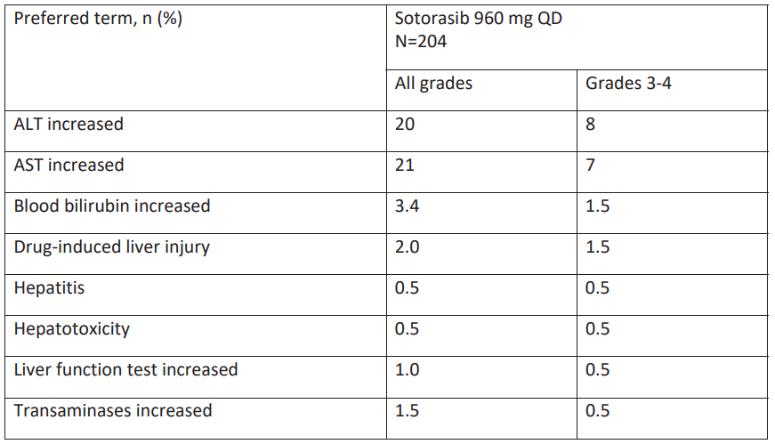
Abbreviations: ALT = alanine aminotransferase; AST = aspartate aminotransferase; N = total number of subjects; QD = once daily.
Source: data extracted from the United States Food and Drug Administration Multi-Discipline Review and Evaluation for Lumakras (sotorasib).⁹
Of the 50 patients who experienced an event of hepatotoxicity, 23 patients (46%) required either a dose reduction or interruption. Hepatotoxicity events resolved in 71 of 78 (91%) of patients following dose reduction or interruption. No events of hepatotoxicity or elevated liver enzymes met Hy’s law criteria and there were no cases of liver failure or fatal cases of hepatotoxicity.

Renal toxicity
Events of renal toxicity were mild to moderate and did not lead to sotorasib dose reduction or discontinuation. The single case of acute kidney injury that occurred in a patient in the primary safety population that led to sotorasib interruption occurred in the setting of significant diarrhoea; both conditions resolved with sotorasib interruption. In the evaluation report, it was concluded that while preclinical data was concerning for nephrotoxicity, review of AE reporting, patient narratives and laboratory data did not reveal an association between sotorasib and nephrotoxicity.

Interstitial lung disease or pneumonitis
An independent analysis was performed of events of interstitial lung disease and pneumonitis in the 357 patients who received sotorasib in Study 20170534, given the known tyrosine kinase inhibitor class effect of pneumonitis. Three cases of interstitial lung disease or pneumonitis (0.8%) were identified, all of which occurred in patients with NSCLC. All cases were grade 3 or 4, and one case was fatal. The case of fatal pneumonitis occurred in a patient who death was attributed to disease progression but for which pneumonitis cannot be excluded as a causative factor.
Interstitial lung disease or pneumonitis leading to dose interruption or reduction occurred in 0.2% of patients in Study 20170543. Sotorasib was discontinued due to interstitial lung disease or pneumonitis in 0.6% of patients in this study. Given that pneumonitis is a serious and potentially fatal event, dose modification guidelines in the Product Information should clearly state that sotorasib should be permanently discontinued for any event of interstitial lung disease or pneumonitis.

Other safety explorations
- Human reproduction and pregnancy: There are no data available in pregnant women. It is not known if sotorasib or its metabolites are present in human milk; because of the potential risk for sotorasib to cause adverse effects in breastfed children, a decision must be made to discontinue breast feeding or discontinue sotorasib while breast feeding. There are no clinical studies to evaluate the effect of sotorasib on fertility.
- Paediatrics and assessment of effects on growth: Sotorasib was not studied in paediatric patients.
- Overdose, drug abuse potential, withdrawal, and rebound: There is no clinical experience with overdose with sotorasib.

Integrated safety assessment
Following the TGA’s clinical evaluation, it was concluded that sotorasib is generally well tolerated with a relatively small number of patients requiring permanent discontinuation of sotorasib due to an AE (9%), and agreed with the identification of hepatotoxicity as an adverse reaction. The Delegate notes that the current version of the proposed Product Information (PI) includes an appropriate description of hepatotoxicity and dose modification guidelines. Interstitial lung disease or pneumonitis should be included in the PI as a serious adverse reaction and dose modification guidelines should be provided.

Risk management plan
The sponsor has submitted European Union (EU)-risk management plan (RMP) version 0.1 (dated 4 December 2020; data lock point (DLP) 1 September 2020) and Australia specific annex (ASA) version 1.0 (dated 21 January 2021) in support of this application. In response to questions raised by TGA, the sponsor has submitted EU-RMP version 0.2 (dated 25 June 2021; DLP 1 September 2020) and ASA version 2.0 (dated 18 August 2021) in support of this application.
The summary of safety concerns and their associated risk monitoring and mitigation strategies are summarised in Table 17. Further information regarding the TGA’s risk management approach can be found in risk management plans for medicines and biologicals and the TGA's risk management approach.
Table 17: Summary of safety concerns
Summary of safety concerns |  | Pharmacovigilance |  | Risk minimisation
 |  | Routine | Additional | Routine | Additional
Important identified risks | None | – | – | – | –
Important potential risks | None | – | – | – | –
Missing information | Use in patients with hepatic impairment |  | * |  | –
*Study 20200362 Post-authorisation safety study
Note: Studies 20170543 and 20200426 have also been included as additional pharmacovigilance activities in the Australia-specific annex.
- The summary of safety concerns is adequate and no further additions are required as the sponsor has adequately addressed the RMP evaluation’s recommendations.
- Routine and additional pharmacovigilance activities have been proposed. Two additional pharmacovigilance activities have been added which were recommended by the FDA as additional post-market requirements.
- Routine risk minimisation activities only have been proposed which is adequate.

Risk-benefit analysis

Delegate’s considerations
Metastatic KRAS G12C-mutated NSCLC is a life threatening condition with poor survival. The median overall survival observed in this patient population treated with immunotherapy is approximately 21 to 28 months compared to 10 to 20 months with chemotherapy alone. There are no approved therapies targeting this oncogenic driver mutation in Australia.
The standard of care of patients with advanced KRAS G12C-mutated NSCLC (that is, no targetable mutation) includes platinum based chemotherapy with or without an immune checkpoint inhibitor in the first line setting. Approved second line options in Australia include immune checkpoint inhibitors (if not previously given), pemetrexed (if not previously given), docetaxel, or gemcitabine.

Proposed indication
The sponsor proposes to register a new therapeutic entity for the following indication:
for the treatment of patients with previously treated KRAS G12C-mutated locally advanced or metastatic non-small cell lung cancer (NSCLC).
The proposed recommended sotorasib dose and treatment schedule is 960 mg (as eight Lumakras 120 mg tablets) taken orally, once daily, until disease progression or unacceptable toxicity.

Benefits
The sponsor has provided substantial evidence of effectiveness to support provisional approval of sotorasib for the treatment of patients with locally advanced or metastatic NSCLC with KRAS G12C mutation following at least one prior systemic therapy. The 0recommendation for provisional approval is supported by results from Study 20170543 (the CODEBREAK 100 trial), a global multicentre, open label single arm Phase I/II study for patients with advanced KRAS G12C-mutated solid tumours (n = 427). The majority of these patients had NSCLC (n = 261); 124 patients with advanced KRAS G12C-mutated NSCLC in the dose expansion portion of the Study 20170543 (the CODEBREAK 100 trial) received sotorasib at the 960 mg daily recommended Phase II dose. Sotorasib provides a clinically meaningful objective response rate and duration of response, which is reasonably likely to predict clinical benefit in the proposed population:
- The objective response rate (per Blinded Independent Review Committee) was 36% (95% CI: 28, 45).
- The median duration of response was 10.0 months (range: 1.3+, 11.1); 58% of patients had a duration of response of at least 6 months.

Uncertainties of benefit
There are limitations to deriving inference from a small, single arm or non-randomised study such as Study 20170543. The study follow-up is not considered sufficiently mature to characterise the upper limit of the 95% confidence interval of duration of response. In addition, the analyses of progression free survival and overall survival are considered uninterpretable in the absence of a comparative arm. In order to address the latter, results of the ongoing confirmatory study (Study 20190009, also known as the CODEBREAK 200 trial), a randomised study comparing sotorasib to docetaxel in patients with KRAS G12C-mutated NSCLC who have received at least one line of prior therapy, will be submitted as a post-marketing requirement to confirm the clinical benefit of sotorasib.
Outcomes in patients with KRAS G12C-mutated advanced NSCLC with active cerebral metastases, and in those with ECOG performance status of 2 or higher;¹¹ remain uncertain as these patients were excluded from the pivotal study. These patient subpopulations are being investigated in ongoing studies.
In the clinical evaluation report, it was identified that dose optimisation of sotorasib remains incomplete; objective response rates ranging from 25% to 50% were observed in patients with NSCLC receiving lower doses of sotorasib, with pharmacokinetic data showing similar systemic exposures at steady state sotorasib levels across dosing levels from ranging from 180 mg to 960 mg. In order to address this issue, a dose finding study comparing 240 mg and 960 mg daily of sotorasib will be conducted as a post-marketing requirement.

Risks
The primary safety population included patients with KRAS G12C-mutated advanced NSCLC who received at least one dose of sotorasib 960 mg daily in Study 20170543 (the CODEBREAK 100 trial, n = 204).
- The commonest (in 20% or more patients) treatment emergent AEs were diarrhoea, musculoskeletal pain, nausea, fatigue, hepatotoxicity, cough, vomiting, constipation, dyspnoea, and abdominal pain.
- Serious adverse events occurred in 50% of patients; those occurring in 2% or more of patients were pneumonia, musculoskeletal pain, hepatotoxicity and diarrhoea.
- Fatal adverse reactions occurred in 3.4% of patients, including respiratory failure (0.8%), pneumonitis (0.4%), cardiac arrest (0.4%), cardiac failure (0.4%), gastric ulcer (0.4%) and pneumonia (0.4%).
- Permanent discontinuation of sotorasib occurred in 9% of patients (primarily due to hepatotoxicity 4.9%).
- Dose interruptions due to an AE occurred in 34% of patients (due to hepatotoxicity, diarrhoea, musculoskeletal pain, nausea and pneumonia).
- Dose reductions due to an AE occurred in 5% of patients (primarily due to elevated ALT or AST).

Uncertainties of risk
The relatively small number of participants in Study 20170543 limits the ability to fully characterise rare adverse events, however, the observed safety profile is acceptable when considered in the context of a life-threatening disease such as that per proposed indication. Although sotorasib can cause severe toxicities, information in the Warnings and Precautions and Dosage and Administration sections of the PI should be able to address these safety issues adequately. In particular, hepatotoxicity and pneumonitis or interstitial lung disease are potentially serious adverse reactions identified during review. interstitial lung disease or pneumonitis occurred in three patients, with one fatal case reported; 25% of patients developed hepatotoxicity, with no related fatalities. These should be outlined in the Warnings and Precautions section of the PI.
No significant safety concerns were identified following the TGA’s clinical evaluation that will require risk management beyond labelling or warranting consideration for Risk Evaluation and Mitigation Strategies.
Finally, the 960 mg dose of sotorasib may not be optimised following clinical pharmacology evaluation (see above). A post-marketing requirement study to assess the efficacy and safety of sotorasib at a lower dose (240 mg) is recommended, in alignment with that of the FDA.

Benefit-risk balance
Overall, the benefit-risk assessment for sotorasib is considered to be favourable to support provisional registration. The objective response rate and duration of response from Study 20170543 are considered to be clinically meaningful and reasonably likely to predict clinical benefit in the proposed population. Although sotorasib can cause serious toxicities, the safety profile demonstrated is acceptable when considered in the context of a life-threatening disease (that is, advanced NSCLC), the significant unmet need in the intended patient population, and the lack of available targeted therapy options in Australia at present.
The study design limits interpretation of survival; although available evidence supports provisional approval, further data is required in order to confirm clinical benefit. The sponsor will be required to submit final reports of post-marketing requirement studies.

Proposed action
The benefit risk assessment for sotorasib is considered to be favourable. Provisional approval of sotorasib for the intended population is therefore recommended for the indication as follows:
This medicine has provisional approval in Australia for the treatment of adult patients with KRAS G12C mutated locally advanced or metastatic non-small cell lung cancer (NSCLC) who have received at least one prior systemic therapy for advanced disease. The decision to approve this indication has been made on the basis of overall response rate (ORR) and duration of response (DOR). Continued approval of this indication depends on verification and description of benefit in confirmatory trials.

Advisory Committee considerations
The Advisory Committee on Medicines (ACM), having considered the evaluations and the Delegate’s overview, as well as the sponsor’s response to these documents, advised the following.

Specific advice to the Delegate
- Does the available data from Study 20170543 (the CODEBREAK 100 trial) support the use of sotorasib at the 960 mg once daily dose in the proposed population, despite incomplete dose optimisation?
The ACM was of the view that the overall benefit-risk profile for sotorasib is considered favourable to support provisional registration of the 960 mg once daily dose in the proposed population.
The ACM stated that the overall response rate and duration of response using the 960 mg dose are clinically meaningful and predictive of a clinical benefit in the proposed population, noting the small data package consisting of a single arm, non-comparative study.
While the ACM acknowledged that sotorasib can cause serious toxicities, on balance, the safety profile of the 960 mg dose appears acceptable. The ACM was of the view that the data also indicates that the 960 mg dose appears generally tolerable.
The ACM considered the severity of advanced non-small cell lung cancer and that there is currently a lack of targeted therapy options available within Australia. The ACM highlighted that there is a clear unmet clinical need for efficacious treatment options within this population.
- The ACM is requested to provide any other advice relevant to this submission.
The ACM noted that the randomised data from Study 20190009 (the CODEBREAK 200 trial), which will be available shortly, will be important to confirm the clinical benefit of sotorasib and to understand the efficacy and safety within organ impaired patients (liver and renal).

Conclusion
The ACM considered this product to have an overall positive benefit-risk profile for the provisional indication:
for the treatment of adult patients with KRAS G12C mutated locally advanced or metastatic non-small cell lung cancer (NSCLC) who have received at least one prior systemic therapy for advanced disease.
The decision to approve this indication has been made on the basis of objective response rate (ORR) and duration of response (DOR). Continued approval of this indication depends on verification and description of benefit in confirmatory trials.

Updated risk-benefit analysis
At the time of the Advisory Committee meeting (2 and 3 December 2021), as described above, the TGA’s nonclinical evaluation for this submission remained in progress. It is a TGA requirement that any outstanding issues that may arise from the nonclinical evaluation must be addressed before a regulatory decision regarding approval is finalised.
The Delegate noted the following regarding impurities from the second round of nonclinical evaluation:
- The proposed specifications for impurities in the drug substance or product have not been adequately qualified. The clastogenicity of impurities [Information redacted] needs to be assessed by an in vitro or in vivo clastogenicity study (these studies can be provided post-registration). The sponsor may alternatively decrease the specification for the impurities to 0.1%, to yield an impurity dose of less than 1 mg/day.
All mutagenic or potential mutagenic impurities should be controlled, in the final product, to the threshold of toxicological concern of 10 μg for a duration of exposure of 1 to 10 years (noting that the range of duration of exposure to Lumakras in clinical trials was 0.2 to 17 months).
The conclusion of the nonclinical evaluation included the following:
- The proposed limit for several impurities in the drug substance and drug product have not been adequately qualified by submitted toxicity data.
- There are no objections on nonclinical grounds to the proposed registration of Lumakras for the proposed indication provided the clastogenicity of impurities [Information redacted] will be studied post-approval.
The Delegate noted the sponsor’s response, received on 21 December 2021. The sponsor states that genotoxicity studies were conducted according to the principles of ICH guideline S9; and the S9 questions and answers document, with reference to ICH guideline Q3A/B. The sponsor believes that the necessary studies have already completed following ICH guidance.
Following a TGA review of the sponsor’s responses to the second round nonclinical evaluation, approval could not be recommended from the nonclinical perspective based on the outstanding issue relating to drug substance impurities, and that the nonclinical evaluation wasn’t in agreement with the sponsor’s interpretation of the ICH guidelines S9 questions and answers regarding the qualification of impurities; and clastogenicity of the impurities should be studied, preferably in an in vivo chromosome aberration assay.
In view of this, the TGA Delegate amended the preliminary view to the following: whilst a decision is yet to be made, the Delegate is not currently in a position to approve sotorasib for the proposed indication as outstanding issues relating to manufacturing and quality control remain unresolved.
As these matters have arisen following the previous consideration of the submission by the ACM (and were not before the Delegate when it was considered in December 2021), the submission will be returned to the Advisory Committee for further advice. The Delegate therefore requests further advice from ACM in relation to the question below.

Advisory Committee considerations (additional questions)
The Advisory Committee on Medicines (ACM), having considered the post-ACM risk-benefit assessment (described above), including the sponsor’s response; in addition to reconsidering the evaluations and the Delegate’s overview, as well as the sponsor’s response to these documents, advised the following.

Specific advice to the Delegate
- Does the benefit-risk profile of sotorasib support its approval for use in the proposed provisional indication, in view of the unresolved toxicology issue relating to the presence of impurities or degradants in the sotorasib product?
The ACM agreed that the safety profile demonstrated for sotorasib is acceptable when considered in the context of a life-threatening disease (advanced non-small cell lung cancer), the significant unmet need in the intended patient population, and the current lack of available targeted therapy options for these patients in Australia.
The ACM noted that in this instance, further studies of impurities or degradants are unlikely to influence the positive overall benefit-risk assessment and the presence of the impurities or degradants in the drug product should not preclude provisional registration of sotorasib in this context and given the unmet clinical need. The ACM was however supportive of these studies being provided post-approval in line with relevant ICH guidance.^{20,21,22}
- The ACM is requested to provide any other advice relevant to this submission.
The ACM agreed that that the proposed warnings as well as recommendations for liver enzyme monitoring in patients included in the draft Product Information are appropriate and sufficient measures.

Conclusion
The ACM considered that this product to have an overall positive benefit-risk profile and supported the December 2021 ACM recommendation for the proposed indication:
For the treatment of adult patients with KRAS G12C mutated locally advanced or metastatic non-small cell lung cancer (NSCLC) who have received at least one prior systemic therapy for advanced disease.
The decision to approve this indication has been made on the basis of objective response rate (ORR) and duration of response (DOR). Continued approval of this indication depends on verification and description of benefit in confirmatory trials.

Outcome
Based on a review of quality, safety, and efficacy, the TGA approved the registration of Lumakras (sotorasib) 120 mg, film coated tablet, blister pack, indicated for:
Lumakras has provisional approval in Australia for the treatment of adult patients with KRAS G12C-mutated locally advanced or metastatic non-small cell lung cancer (NSCLC) who have received at least one prior systemic therapy for advanced disease.
The decision to approve this indication has been made on the basis of the objective response rate (ORR) and the duration of response (DOR). Continued approval of this indication depends on the verification and description of benefit in confirmatory trials.

Specific conditions of registration applying to these goods
- Lumakras (sotorasib) is to be included in the Black Triangle Scheme. The PI and CMI [Consumer Medicines Information] for Lumakras must include the black triangle symbol and mandatory accompanying text for the products entire period of provisional registration.
- The Lumakras EU-risk management plan (RMP) (version 0.2, dated 25 June 2021, data lock point 1 September 2020), with Australian specific annex (version 2.0, dated 18 August 2021), included with Submission PM-2021-00026-1-4, and any subsequent revisions, as agreed with the TGA will be implemented in Australia.
Unless agreed separately between the supplier who is the recipient of the approval and the TGA, the first report must be submitted to TGA no later than 15 calendar months after the date of the approval letter. The subsequent reports must be submitted no less frequently than annually from the date of the first submitted report until the period covered by such reports is not less than three years from the date of the approval letter, or the entire period of provisional registration, whichever is longer.
The reports are to at least meet the requirements for PSURs as described in the European Medicines Agency’s Guideline on Good Pharmacovigilance Practices (GVP) Module VII-periodic safety update report [Revision 1], Part VII.B Structures and processes. Note that submission of a PSUR does not constitute an application to vary the registration. Each report must have been prepared within ninety calendar days of the data lock point for that report.
- Confirmatory trial data (as identified in the sponsor’s plan to submit comprehensive clinical data on the safety and efficacy of the medicine before the end of the 6 years that would start on the day that registration would commence) must be provided. Specifically the sponsor must conduct studies as described in the clinical study plan inversion x2.0 (dated 18 August 2021) of the Australia-specific annex.
The following study report should be submitted to TGA:
  - Study 20190009 by 28 March 2028
- Conduct and submit results of a multi-centre, randomised clinical trial to further characterise serious adverse events, including gastro-intestinal toxicity and compare the safety and efficacy of sotorasib 960 mg daily versus a lower daily dose in patients with locally advanced or metastatic, KRAS G12C-mutated, non-small cell lung cancer who have received at least one prior systemic therapy.
- Conduct and submit results of a hepatic impairment clinical trial to determine a safe and appropriate dose of sotorasib in patients with moderate and severe hepatic impairment. Design and conduct the trial in accordance with the FDA Guidance for Industry titled ‘Pharmacokinetics in Patients with Impaired Hepatic Function: Study Design, Data Analysis, and Impact on Dosing and Labeling.’[]
- Conduct and submit results of a clinical drug interaction study to assess the effect of concomitant sotorasib administration on the systemic exposure of BCRP [breast cancer resistance protein] transporter substrates. Refer to FDA Guidance for Industry for additional details: ‘Clinical Drug Interaction Studies - Cytochrome P450 Enzyme and Transporter-Mediated Drug-Drug Interactions.’[]
- Conduct and submit results of clastogenicity studies (to be assessed by an in vitro or in vivo clastogenicity study, preferably by in vivo chromosome aberration assay) of impurities [Information redacted], these results will need to be submitted before full registration of sotorasib is granted.

Attachment 1. Product Information
The PI for Lumakras approved with the submission which is described in this AusPAR is at Attachment 1. For the most recent PI, please refer to the TGA PI/CMI search facility.

Therapeutic Goods Administration
PO Box 100 Woden ACT 2606 Australia
Email: info@tga.gov.au Phone: 1800 020 653 Fax: 02 6232 8605
https://www.tga.gov.au

Cancer Australia, Australian Government, Lung Cancer in Australia Statistics, updated on 18 August 2022, Available at: https://www.canceraustralia.gov.au/cancer-types/lung-cancer/statistics.
Stage 4 non-small cell lung cancer (NSCLC), also called metastatic (advanced) lung cancer, is subdivided in Stage 4A and Stage 4B cancer: Stage 4A cancer refers to a tumour of any size that may or may not involve nearby lymph nodes or structure, that has either spread within the chest; and/or, has spread to one area outside the chest cavity. - Spread within the chest refers to tumours that may have spread to the other lung; the layers covering the lung (the pleura) or the heart (pericardium); or/and the presence of cancer cells in the fluid between the two layers covering the lung (pleural effusion) or the heart (pericardial effusion). - Spread outside of the chest refers to the presence of a single area of cancer outside the chest to a distant lymph node or to an organ such as the liver, bones or the brain. Stage 4B cancer refers to cancer that has spread to more than one place in the same organ, or to multiple organs of the body.
National Cancer Control Indicators (NCCI) Relative Survival by Stage at Diagnosis (Lung Cancer), Published on 1 April 2019. Available at: https://ncci.canceraustralia.gov.au/outcomes/relative-survival-rate/relative-survival-stage-diagnosis-lung-cancer.
National Comprehensive Cancer Network (NCCN), NCCN Clinical Practice Guidelines in Oncology: Non-small Cell Lung Cancer, Version 5.2021,15 June 15 2021. Available at: https://www.nccn.org/professionals/physician_gls/pdf/nscl.pdf.
Metastatic Non-small Cell Lung Cancer: ESMO Clinical Practice Guidelines for Diagnosis, Treatment and Follow-Up, Ann Oncol, 2018; 29 (suppl 4): iv192-iv237.
Cytochrome P450 (CYP) enzymes are the major enzymes involved in drug metabolism, accounting for large part of the total metabolism. Most drugs undergo deactivation by CYPs, either directly or by facilitated excretion from the body. Also, many substances are bioactivated by CYPs to form their active compounds. Many drugs may increase or decrease the activity of various CYP isozymes either by inducing the biosynthesis of an isozyme (enzyme induction) or by directly inhibiting the activity of the CYP (enzyme inhibition). This is a major source of adverse drug interactions, since changes in CYP enzyme activity may affect the metabolism and clearance of various drugs. Such drug interactions are especially important to take into account when using drugs of vital importance to the patient, drugs with important side-effects and drugs with small therapeutic windows, but any drug may be subject to an altered plasma concentration due to altered drug metabolism.
Pregnancy Category B3: Drugs which have been taken by only a limited number of pregnant women and women of childbearing age, without an increase in the frequency of malformation or other direct or indirect harmful effects on the human fetus having been observed. Studies in animals have shown evidence of an increased occurrence of fetal damage, the significance of which is considered uncertain in humans.
The QT interval is the time from the start of the QRS wave complex to the end of the corresponding T wave. It approximates to the time taken for ventricular depolarisation and repolarisation, that is to say, the period of ventricular systole from ventricular isovolumetric contraction to isovolumetric relaxation.
United States Food and Drug Administration (FDA), Centre for Drug Evaluation and Research, Multi-Discipline Review and Evaluation for Lumakras (sotorasib), Application Number: 214665Orig1s000, January 2020. Available at: https://www.accessdata.fda.gov/drugsatfda_docs/nda/2021/214665Orig1s000MultidisciplineR.pdf.
The corrected QT interval (QTc) estimates the QT interval at a standard heart rate. This allows comparison of QT values over time at different heart rates and improves detection of patients at increased risk of arrhythmias.
ECOG Performance Status: The Eastern Cooperative Oncology Group (ECOG) has developed criteria used by doctors and researchers to assess how a patient's disease is progressing, assess how the disease affects the daily living abilities of the patient, and determine appropriate treatment and prognosis. The following are used: 0 - Fully active, able to carry on all pre-disease performance without restriction 1- Restricted in physically strenuous activity but ambulatory and able to carry out work of a light or sedentary nature, for example, light house work, office work 2 - Ambulatory and capable of all selfcare but unable to carry out any work activities. Up and about more than 50% of waking hours 3 - Capable of only limited selfcare, confined to bed or chair more than 50% of waking hours 4 - Completely disabled. Cannot carry on any selfcare. Totally confined to bed or chair 5 – Dead
The Response Evaluation Criteria In Solid Tumours (RECIST) is a voluntary international standard with unified and easily applicable criteria to define when a patient's tumour has improved ('respond'), stayed the same ('stabilise'), or worsened ('progress') during treatment. The criteria were published in February 2000 by an international collaboration including the European Organisation for Research and Treatment of Cancer (EORTC), National Cancer Institute (NCI) of the United States, and the National Cancer Institute of Canada Clinical Trials Group. Today, the majority of clinical trials evaluating cancer treatments for objective response in solid tumours use RECIST. These criteria were developed and published in February 2000, and subsequently updated in 2009.
Good Clinical Practice (GCP) is a code of international standards and guidance following the International Council on Harmonisation (ICH) concerning the design, conduct, performance, monitoring, auditing, recording, analysis and reporting of clinical trials. Good Clinical Practice provides assurance that a study’s results are credible and accurate and that the rights and confidentiality of the study subjects are protected.
Sebastian, M. et al. KRAS G12C-Mutated Advanced Non-small Cell Lung Cancer: a Real-World Cohort from the German Prospective, Observational, Nation-Wide CRISP Registry (AIO-TRK-0315), Lung Cancer. 2021; 154: 51-61.
United States Food and Drug Administration (FDA), Guidance for Industry, Clinical Trial Endpoints for the Approval of Cancer Drugs and Biologics, December 2018.
The Medical Dictionary for Regulatory Activities (MedDRA) is a single standardised international medical terminology, developed as a project of the International Council for Harmonisation of Technical Requirements for Pharmaceuticals for Human Use (ICH) which can be used for regulatory communication and evaluation of data pertaining to medicinal products for human use. As a result, MedDRA is designed for use in the registration, documentation and safety monitoring of medicinal products through all phases of the development cycle (that is, from clinical trials to post-marketing surveillance). Furthermore, MedDRA supports ICH electronic communication within the ICH’s Electronic Common Technical Document (eCTD) and the E2B Individual Case Safety Report.
Common Terminology Criteria (CTC) is a standardised classification of side effects used in assessing drugs for cancer therapy, in particular. Specific conditions and symptoms may have values or descriptive comment for each level, but the general guideline is 1 – Mild, 2 – Moderate, 3 – Severe, 4 - Life threatening, 5 - Death.
United States Food and Drug Administration, Risk assessment and risk mitigation review(s) for Lumakras (sotorasib). Available at: https://www.accessdata.fda.gov/drugsatfda_docs/nda/2021/214665Orig1s000RiskR.pdf.
United States Food and Drug Administration (FDA), Approval letter for Lumakras (sotorasib). Available at: https://www.accessdata.fda.gov/drugsatfda_docs/appletter/2021/214665Orig1s000ltr.pdf.
European Medicines Agency (EMA), Committee for Medicinal Products for Human Use (CHMP), ICH Guideline S9 on Nonclinical Evaluation for Anticancer Pharmaceuticals, EMA/CHMP/ICH/646107/2008, May 2010.
European Medicines Agency (EMA), Committee for Medicinal Products for Human Use (CHMP), ICH S9 Guideline on Nonclinical Evaluation for Anticancer Pharmaceuticals - Questions and Answers, EMA/CHMP/ICH/453684/2016, 16 May 2018.
European Medicines Evaluation Agency (EMEA), Committee for Proprietary Medicinal Products (CPMP), ICH Topic Q 3 A (R2) Impurities in new Drug Substances, Note for Guidance on Impurities Testing: Impurities in New Drug Substances, CPMP/ICH/2737/99, October 2006.
United States Food and Drug Administration, Guidance for Industry, Pharmacokinetics in Patients with Impaired Hepatic Function: Study Design, Data Analysis, and Impact on Dosing and Labeling, May 2003.
United States Food and Drug administration, Guidance for Industry, Clinical Drug Interaction Studies - Cytochrome P450 Enzyme and Transporter-Mediated Drug-Drug Interactions, January 2020.

