Australian Public Assessment Report for Livtencity
  - Active ingredient: Maribavir
  - Sponsor: Takeda Pharmaceuticals Australia Pty Ltd
May 2023

About the Therapeutic Goods Administration (TGA)
- The Therapeutic Goods Administration (TGA) is part of the Australian Government Department of Health and Aged Care and is responsible for regulating therapeutic goods, including medicines, medical devices, and biologicals.
- The TGA administers the Therapeutic Goods Act 1989 (the Act), applying a risk management approach designed to ensure therapeutic goods supplied in Australia meet acceptable standards of quality, safety, and efficacy.
- The work of the TGA is based on applying scientific and clinical expertise to decision-making, to ensure that the benefits to the Australian public outweigh any risks associated with the use of therapeutic goods.
- The TGA relies on the public, healthcare professionals and industry to report problems with therapeutic goods. The TGA investigates reports received to determine any necessary regulatory action.
- To report a problem with a therapeutic good, please see the information on the TGA website.

About AusPARs
- The Australian Public Assessment Report (AusPAR) provides information about the evaluation of a prescription medicine and the considerations that led the TGA to approve or not approve a prescription medicine submission. Further information can be found in Australian Public Assessment Report (AusPAR) guidance.
- AusPARs are prepared and published by the TGA.
- AusPARs are static documents that provide information that relates to a submission at a particular point in time. The publication of an AusPAR is an important part of the transparency of the TGA’s decision-making process.
- A new AusPAR may be provided to reflect changes to indications or major variations to a prescription medicine subject to evaluation by the TGA.

Copyright
© Commonwealth of Australia 2023
This work is copyright. You may reproduce the whole or part of this work in unaltered form for your own personal use or, if you are part of an organisation, for internal use within your organisation, but only if you or your organisation do not use the reproduction for any commercial purpose and retain this copyright notice and all disclaimer notices as part of that reproduction. Apart from rights to use as permitted by the Copyright Act 1968 or allowed by this copyright notice, all other rights are reserved and you are not allowed to reproduce the whole or any part of this work in any way (electronic or otherwise) without first being given specific written permission from the Commonwealth to do so. Requests and inquiries concerning reproduction and rights are to be sent to the TGA Copyright Officer, Therapeutic Goods Administration, PO Box 100, Woden ACT 2606 or emailed to <tga.copyright@tga.gov.au>.

Contents
List of abbreviations 4
Product submission 5
Submission details 5
Product background 6
Regulatory status 8
Product Information 10
Registration timeline 10
Submission overview and risk/benefit assessment 10
Quality 10
Nonclinical 11
Clinical 12
Summary of clinical studies 12
Pharmacokinetics 12
Efficacy 20
Safety 30
Risk management plan 37
Risk-benefit analysis 38
Delegate’s considerations 38
Proposed action 39
Advisory Committee considerations 40
Outcome 42
Attachment 1. Product Information 42

List of abbreviations
Abbreviation | Meaning
ACM | Advisory Committee on Medicines
ARTG | Australian Register of Therapeutic Goods
ASA | Australia specific annex
AUC | Area under the concentration-time curve
C_{max} | Maximum concentration
CMI | Consumer Medicines Information
CMV | Cytomegalovirus
DLP | Data lock point
DNA | Deoxyribonucleic acid
EU | European Union
FDA | Food and Drug Administration (United States of America)
IAT | Investigator assigned [anti-CMV] therapy/treatment
MRS | Maribavir resistance set
PD | Pharmacodynamic(s)
PI | Product Information
PK | Pharmacokinetic(s)
PRS | Primary resistance set
PSUR | Periodic safety update report
RMP | Risk management plan
TEAE | Treatment-emergent adverse event
TGA | Therapeutic Goods Administration
T_{max} | Time to reach maximum concentration
UGT | Uridine diphosphate-glucuronosyltransferase
US(A) | United States (of America)

Product submission

Submission details
Type of submission: | New chemical entity
Product name: | Livtencity
Active ingredient: | Maribavir
Decision: | Approved
Date of decision: | 27 September 2022
Date of entry onto ARTG: | 7 October 2022
ARTG number: | 380132
Black Triangle Scheme  for the current submission: | Yes  This product will remain in the scheme for 5 years, starting on the date the product is first supplied in Australia.
Sponsor’s name and address: | Takeda Pharmaceuticals Australia Pty Ltd  Level 39; 225 George Street  Sydney NSW 2000
Dose form: | Film coated tablet
Strength: | 200 mg
Container: | Bottle
Pack size: | 28 or 56 tablets
Approved therapeutic use for the current submission: | Treatment of adults with post-transplant cytomegalovirus (CMV) infection and disease resistant, refractory or intolerant to one or more prior therapies (see 4.3 Contraindications and, 4.4 Special warnings and precautions for use)
Route of administration: | Oral
Dosage: | The recommended dose of Livtencity is 400 mg (two 200 mg tablets) twice daily resulting in a daily dose of 800 mg.  Treatment duration may need to be individualised based on the clinical characteristics of each patient.  For further information regarding dosage, refer to the Product Information.
Pregnancy category: | D  Drugs which have caused, are suspected to have caused or may be expected to cause, an increased incidence of human fetal malformations or irreversible damage. These drugs may also have adverse pharmacological effects. Accompanying texts should be consulted for further details  The use of any medicine during pregnancy requires careful consideration of both risks and benefits by the treating health professional. This must not be used as the sole basis of decision making in the use of medicines during pregnancy. The TGA does not provide advice on the use of medicines in pregnancy for specific cases. More information is available from obstetric drug information services in your State or Territory.

Product background
This AusPAR describes the submission by Takeda Pharmaceuticals Australia Pty Ltd (the sponsor) to register Livtencity (maribavir) 200 mg, film coated tablets (bottle) for the following proposed indication:
Treatment of adults with post-transplant cytomegalovirus (CMV) infection and disease resistant or refractory to one or more prior therapies.
Human cytomegalovirus (CMV) is a beta-herpesvirus that commonly infects humans and normally remains latent, causing serious disease almost exclusively in circumstances where an individual’s immune system is severely compromised. Serologic evidence of prior infection ranges from 40% to 100% of various adult populations, and in general, seroprevalence increases with age.
Maribavir is a benzimidazole riboside anti-CMV agent. Maribavir targets CMV directly by attaching to the UL97 encoded viral kinase at the adenosine triphosphate binding site. This results in inhibition of CMV deoxyribonucleic acid (DNA) assembly and egress of viral capsids from the nucleus of infected cells. Figure 1, shown below, provides an overview of the mechanisms of action for various anti-CMV treatments.

Figure 1: Mechanisms of action for various anti-cytomegalovirus drugs
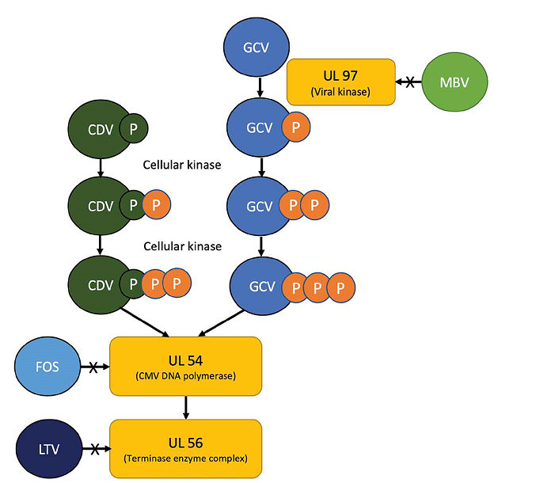
Abbreviation, GCV = ganciclovir; CDV = cidofovir; FOS = foscarnet; MBV = maribavir; LTV = letermovir; P = phosphate. Source: Advances in drug therapies for cytomegalovirus in transplantation: a focus on maribavir and letermovir.
Ganciclovir (GCV), cidofovir (CDV) and foscarnet (FOS) are anti-CMV drugs with similar mechanisms of action by inhibiting UL54-encoded CMV DNA polymerase, hence being collectively known as CMV DNA polymerase inhibitors.
Ganciclovir (and it’s prodrug, valganciclovir) inhibit CMV DNA polymerase by acting as a nucleoside guanosine analogue. Ganciclovir must be phosphorylated to become clinically active, initially catalysed by UL97-encoded CMV kinase. In patients unable to tolerate ganciclovir due to toxicity, or in those with UL97-mutant resistant CMV, alternative drug options for treatment may include cidofovir and foscarnet.
Cidofovir and foscarnet also inhibit UL54-encoded CMV DNA polymerase, but neither are activated by viral protein kinases.
Letermovir (LTV) is specific against human CMV and inhibits UL56-encoded viral terminase complex which is important for CMV DNA cleavage and packaging into capsids.
Maribavir is an oral benzimidazole riboside with activity against CMV. It exerts its anti-CMV effect by acting as UL97 inhibitor and blocking the egress of viral capsids.
Figure adapted from: Jackrapong Bruminhent & R.R. Razonable (2020) Advances in drug therapies for cytomegalovirus in transplantation: a focus on maribavir and letermovir, Expert Opinion on Orphan Drugs, 8:10, 393-401
The current anti-CMV agents inhibits CMV DNA polymerase at UL54. Letermovir is a more recent agent approved for prevention indication and acts at UL56 gene locus.
Currently approved drugs in Australia for treatment and prophylaxis of CMV infection in patients are listed in Table 1.
Table 1: Currently approved drugs in Australia for treatment and prophylaxis of cytomegalovirus infection
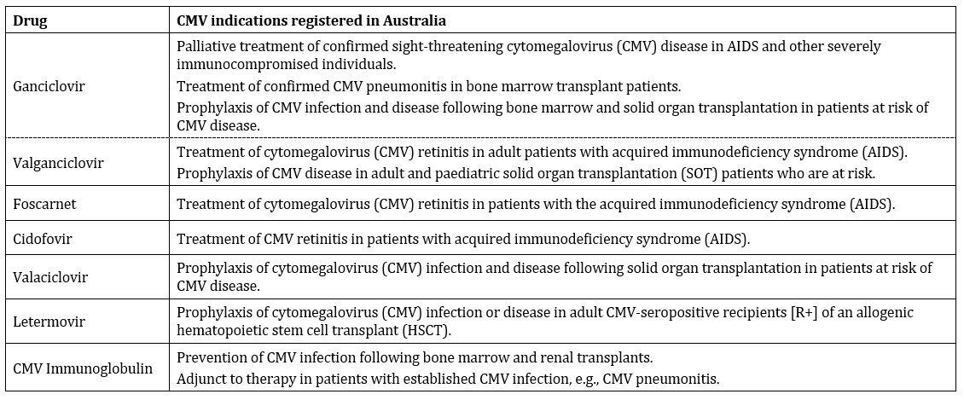
Post-transplant CMV infection is associated with substantially high risk of morbidity and mortality compared to transplant recipients who do not develop post-transplant CMV infection. The management goal is to prevent CMV disease and disease complications during the period of immunosuppression by controlling CMV viremia.

Regulatory status
This product is considered a new chemical entity for Australian regulatory purposes.
This product received orphan drug designation on 21 October 2021 for the following indication:
Treatment of cytomegalovirus infection and/or disease in patients with impaired cell-mediated immunity.
At the time the TGA considered this submission, a similar submission had been approved in United States of America (USA) on 23 November 2021. Similar submissions were also under consideration in the European Union (EU), Switzerland and Canada.
Table 2 summarises these submissions and provides the indications where approved.
Table 2: International regulatory status of selected countries
Region | Submission date | Status | Approved indications
United States of America | 23 March 2021 | Approved on 23 November 2021 | Livtencity is indicated for the treatment of adults and pediatric patients (12 years of age and older and weighing at least 35 kg) with post-transplant cytomegalovirus (CMV) infection/disease that is refractory to treatment (with or without genotypic resistance) with ganciclovir, valganciclovir, cidofovir, or foscarnet
European Union (centralised procedure) | 31 March 2021 | Under consideration | Under consideration
Switzerland | 27 August 2021 | Under consideration | Under consideration
Canada | 16 December 2021 | Under consideration | Under consideration
The Delegate for this submission noted that the dosing approved by the Food and Drug Administration (FDA) United States did not specify the duration of treatment.
The following is an excerpt from the US Prescribing Information (US PI):
The recommended dosage in adults and paediatric patients (12 years of age and older and weighing at least 35 kg) is 400 mg (two 200 mg tablets) taken orally twice daily with or without food [see Use in Specific Population (8.4), Clinical Pharmacology (12.3), Clinical Studies (14)].

Product Information
The Product Information (PI) approved with the submission which is described in this AusPAR can be found as Attachment 1. For the most recent PI and Consumer Medicines Information (CMI), please refer to the TGA PI/CMI search facility.

Registration timeline
The following table captures the key steps and dates for this submission.
This submission was evaluated under the priority registration process.
Table 3: Timeline for Submission PM-2021-05396-1-2
Description | Date
Designation (Orphan) | 21 October 2021
Submission dossier accepted and first round evaluation commenced | 17 January 2022
Second round evaluation completed | 24 June 2022
Delegate’s Overall benefit-risk assessment and request for Advisory Committee advice | 4 July 2022
Sponsor’s pre-Advisory Committee response | 18 July 2022
Advisory Committee meeting | 4 and 5 August 2022
Registration decision (Outcome) | 27 September 2022
Administrative activities and registration on the ARTG completed | 7 October 2022
Number of working days from submission dossier acceptance to registration decision* | 155
*Target timeframe for priority submissions is 150 working days from acceptance for evaluation to the decision.

Submission overview and risk/benefit assessment
A summary of the TGA’s assessment for this submission is provided below.

Quality
Maribavir is a member of a new class of drugs, benzimidazole ribosides, which attach to the human cytomegalovirus pUL97-encoded serine/threonine kinase at the adenosine triphosphate binding site, inhibiting phosphotransferase required for a variety of essential virus processes such as viral DNA assembly and egress of viral capsids from the nucleus of the infected cells. The skeletal structure of maribavir is shown below in Figure 2.
Livtencity is an immediate release blue, film coated, oval shaped, convex tablet. The tablets are packaged in a bottle with child resistant closure. Each container contains 28 or 56 tablets, corresponding to one and two week treatment periods, respectively.
The recommended dose of Livtencity is 400 mg (two 200 mg tablets) twice daily resulting in a daily dose of 800 mg, to be taken with or without food.
Figure 2: Chemical structure of maribavir
Following the TGA evaluation of this product, approval is recommended from a pharmaceutical chemistry and quality control aspect.

Nonclinical
Repeat dose toxicity studies by oral route were conducted in mice (13 weeks), rats (up to 6 months) and Cynomolgus monkeys (up to 12 months) but maximum exposures to maribavir were low (ranging from 0.02 to 1.3). In rats and monkeys the main target organ was the gastrointestinal tract. This manifested as diarrhoea and, at post-mortem as inflammation and/or mucosal cell hyperplasia in large and small intestine in rats and the large intestine in monkeys. The pathological changes were generally mild symptoms, prolonged diarrhoea and dehydration but severe at higher doses leading to death or to animals being euthanised prematurely in extremis. Haematological changes suggested regenerative anaemia in rats and primates at subclinical exposures. The toxicity of maribavir was the limiting factor for the range of doses that could be investigated in repeat dose studies, so that the exposure ratios in most studies were less than the expected clinical exposure. Therefore, it is unlikely that the toxicity of maribavir has been fully elucidated.
Maribavir was not mutagenic in bacterial mutation assay or clastogenic in vivo. However, maribavir demonstrated mutagenic potential in the absence of metabolic activation in the mouse lymphoma assay. The toxicology evaluators were of the view that the negative results of in vivo rat micronucleus assay and negative bacterial mutation assay indicate negligible genotoxic potential considering the proposed short duration of treatment in humans.
Some small treatment related increases in tumour incidence were observed in the two year oral carcinogenicity studies in mice and rats. There was an increase in the incidence of vascular tumours in male mice and an elevated incidence of glandular tumours of the uterus in female mice. The toxicology evaluators were of the view that these effects were overall of borderline significance and unlikely to pose a carcinogenic hazard given the short duration of the proposed use in humans.
No effects on fertility or reproductive performance were noted in rats in a combined fertility and embryofetal development study. However, a decrease in sperm straight line velocity was observed at doses greater or equal to 100 mg/kg/day (exposure ratios via area under the concentration time curve (AUC) of about 1). Maribavir reduced embryofetal survival and increased pre- and post-implantation losses at doses greater than 100 mg/kg. In the pre- and post-natal developmental toxicity study in rats, decreased pup survival associated with a delay in developmental milestones was observed at doses greater than 150 mg/kg/day. Studies in juvenile rats did not reveal any novel toxicity targets. There was no indication of greater sensitivity of juvenile animals to the effects of maribavir (exposure ratios (AUC) about 1). However, the TGA’s toxicology evaluation recommend pregnancy category D; rather than category C; that has been proposed by the sponsor.
Maribavir showed no evidence of skin irritation but was an ocular irritant. Maribavir did not show evidence of antigenicity or phototoxicity.
Overall, the dossier was compliant with the relevant International Council for Harmonisation guideline and the quality of the dossier was considered adequate.
Following the TGA’s nonclinical evaluation of this product, there are no nonclinical objections to registration given the proposed indication and duration of treatment.

Clinical

Summary of clinical studies
The clinical dossier consisted of:
- A suite of 17 Phase I clinical pharmacology studies including pharmacokinetics (PK), food effect, renal impairment study, hepatic impairment study and drug interactions studies.
- Two population PK analyses, two physiologically based PK modelling and two PK-pharmacodynamic (PD) analyses.
- Two supportive Phase II dose ranging studies (Studies SHP620-202 and SHP620-203 (abbreviated as Studies 202 and 203 respectively) and one pivotal Phase III efficacy study (Study SHP620-303, abbreviated as Study 303).
- Reports of three clinical trials (Studies SHP620-200, -300 and -301) in CMV prevention were also submitted but were not directly relevant to this submission.

Pharmacokinetics
In vitro, maribavir is a substrate of P-glycoprotein, organic ion transporter 1, breast cancer resistance protein, uridine diphosphate-glucuronosyltransferase (UGT)1A1, UGT1A3, UGT2B7, and possibly UGT1A9.
Maribavir is primarily eliminated by hepatic metabolism via CYP3A4; (fraction metabolised at least 35%), with secondary contribution from CYP1A2 (fraction metabolised less than 25%). Renal clearance of maribavir is negligible.
The main maribavir metabolic pathways includes N-dealkylation of the isopropyl moiety to form VP44469 (also called metabolite M4) followed by glucuronide conjugation to yield metabolite M1.
In the mass balance study, maribavir and VP44469 accounted for 100% of radioactivity in the plasma during first 24 hours of dosing.
The main metabolite identified in urine and faeces was VP44469. Metabolites M1, M2, M3, M5 and M6 were identified as minor metabolites in urine, and no other metabolite than VP44469 was identified in faeces.
Absolute bioavailability studies has not been undertaken.
The formulation proposed for marketing (Tablet IV) was the version used in the pivotal Phase III Study 303, except for debossing.
Necessary bioequivalence between various formulations has been demonstrated.
The PK of maribavir is dose proportional following single oral dose over the range of 50 mg to 1600 mg and multiple dosing from 300 mg to 2400 mg daily.
A moderately high fat meal decreased maribavir maximum concentration (C_{max}) by 28%, and increased time to reach maximum concentration (T_{max}) by 0.5 hour. In an earlier exploratory food study with 100 mg capsule formulation, a high fat meal decreased AUC and C_{max} by 27% and 28% respectively and caused 2 hour increase in T_{max}.
The PK parameters are summarised in the Table 4 below.
Table 4: Pharmacokinetic properties of maribavir
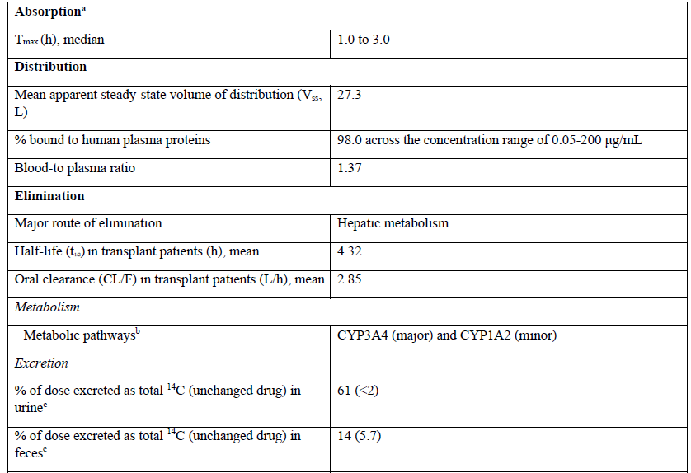
ª when taken orally with moderate fat meal versus fasted. The AUC_{0-∞} and C_{max} (geometric mean ratio [90% CI] of maribavir are 0.864 [0.804, 0.929] and 0.77 [0.656, 0.793], respectively.
^{b} In vitro studies have shown that maribavir is biotransformed into a major circulating inactive metabolite: VP 44469 (N-dealkylated metabolite), with a metabolic rate of 0.15 to 0.2.
^{c} Dosing in mass balance study: single-dose administration of [¹⁴C] maribavir oral solution 400 mg containing 200 nCi of total radioactivity.
Source: US FDA approved label;3
Following 400 mg twice daily dosing in transplant patients with CMV infections, steady state was reached within two days of dosing. Accumulation was low (range 1.24 to 1.49).

Pharmacokinetics in special populations
The systemic exposures at steady state were 27% and 5% higher (AUC and C_{max} respectively) in transplant patients compared to healthy subjects. No clinically relevant impact on maribavir pharmacokinetics (PK) was noted for age (18 to 79 years), gender, race, ethnicity, weight (36 to 141 kg) or transplant type (haematopoietic stem cell transplant versus solid organ transplant) based on population PK analysis.
The PK of maribavir were not clinically significantly different in subjects with mild/moderate renal impairment versus healthy subjects (Table 5).
Table 5: Study 1263-1010 Maribavir pharmacokinetics in mild/moderate renal impairment versus healthy control subjects
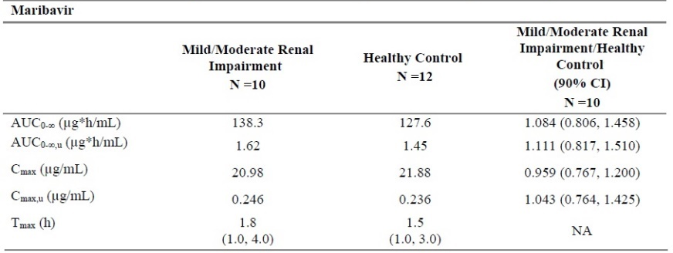
Abbreviation: AUC_{0-∞} = area under concentration time curve from time zero to infinity; C_{max} = maximum concentration; T_{max} = time to reach maximum concentration.
Similarly, the effect on maribavir PK in subjects with severe renal impairment was not clinically significant (Table 6).
Table 6: Study 1263-101 Maribavir pharmacokinetics in severe renal impairment versus health control subjects
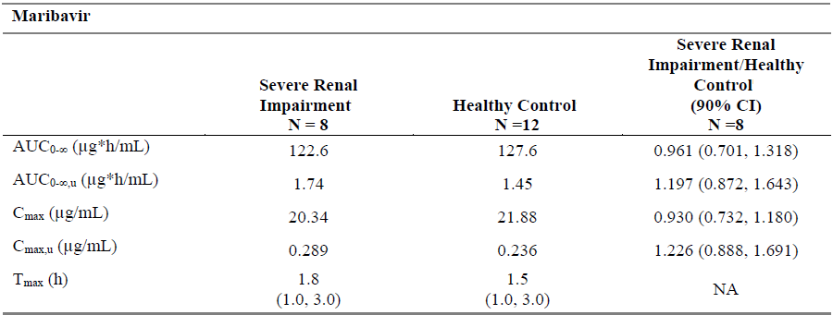
Abbreviation: AUC_{0-∞} = area under concentration time curve from time zero to infinity; C_{max} = maximum concentration; T_{max} = time to reach maximum concentration.
However, VP44469 AUC values were roughly doubled in subjects with renal impairment compared to subjects with normal renal function (Table 7).
Table 7: Study 1263-101 Metabolite VP44469 pharmacokinetics mild/moderate or severe renal impairment versus healthy control subject
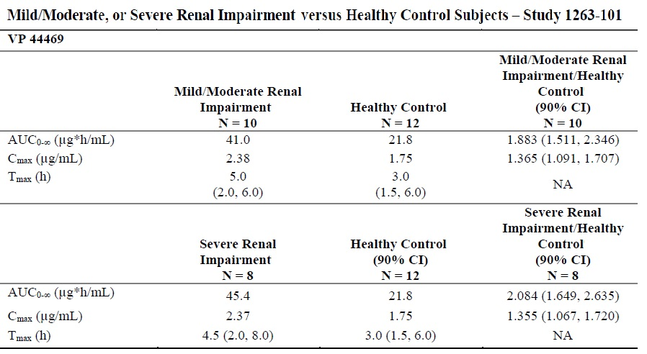
Abbreviation: AUC_{0-∞} = area under concentration time curve from time zero to infinity; C_{max} = maximum concentration; T_{max} = time to reach maximum concentration.
Maribavir has not been studied in subjects with end stage renal disease or patients on dialysis.
A study in moderate hepatic impairment showed that PK of maribavir or its main metabolite were not affected in a clinically meaningful manner (Table 8).
Table 8: Study 1263-101 Maribavir and metabolite VP44469 pharmacokinetics moderate hepatic impairment versus healthy control subject
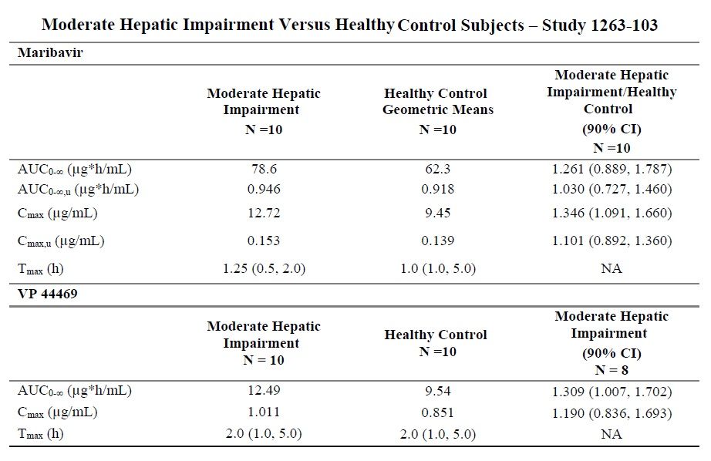
Abbreviation: AUC_{0-∞} = area under concentration time curve from time zero to infinity; C_{max} = maximum concentration; T_{max} = time to reach maximum concentration.
Maribavir has not been studied in severe hepatic impairment.

Drug interactions
Use of maribavir is contraindicated with valganciclovir/ganciclovir due to its mechanism of action involving inhibition of UL97 serine/threonine kinase, which is required for activation (phosphorylation) of ganciclovir.
Dose adjustment of maribavir is needed when maribavir is coadministered with strong or moderate CYP3A4 inducers.⁶
Known and potential drug interactions and dose recommendations as proposed in the draft Australian PI are shown below in Table 9.
Table 9: Maribavir known and potential drug interactions and dose recommendations
Medicinal Product by Therapeutic Area | Geometric Mean Ratio (90 % CI)  (likely mechanism of action) | Recommendation concerning coadministration with maribavir
Acid-Reducing Agents
antacid (aluminium and magnesium hydroxide oral suspension)  (20 mL single dose, maribavir 100 mg single dose) | ↔ maribavir  AUC 0.89 (0.83, 0.96)  C_{max} 0.84 (0.75, 0.94) | No dose adjustment is required.
Famotidine | Interaction not studied. Expected:  ↔ maribavir | No dose adjustment is required.
Omeprazole | ↔ maribavir  ↑ plasma omeprazole/5- hydroxyomeprazole concentration ratio  1.71 (1.51, 1.92)  (CYP2C19 inhibition) | No dose adjustment is required.
Pantoprazole | Interaction not studied. Expected:  ↔ maribavir | No dose adjustment is required.
Anti-arrhythmics
Digoxin  (0.5 mg single dose, 400 mg twice daily maribavir) | ↔ digoxin  AUC 1.21 (1.10, 1.32)  C_{max} 1.25 (1.13, 1.38)  (P-gp inhibition) | No dose adjustment is required.
Antibiotics
Erythromycin | Interaction not studied. Expected:  ↑ maribavir  (CYP3A inhibition) | No dose adjustment is required.
Anti-convulsants
Carbamazepine | Interaction not studied. Expected:  ↓ maribavir  (CYP3A induction) | A dose adjustment of maribavir to 1200 mg twice daily is recommended when co- administration with  carbamazepine.
Phenobarbital | Interaction not studied. Expected:  ↓ maribavir  (CYP3A induction) | A dose adjustment of maribavir to 1200 mg twice daily is recommended when co- administration with  phenobarbital.
Phenytoin | Interaction not studied. Expected:  ↓ maribavir  (CYP3A induction) | A dose adjustment of maribavir to 1200 mg twice daily is recommended when co- administration with phenytoin.
Anti-inflammatories
Sulfasalazine | Interaction not studied. Expected:  ↑ sulfasalazine  (BCRP inhibition) | No dose adjustment is required.
Anti-fungals
Ketoconazole  (400 mg single dose, maribavir 400 mg single dose) | ↑ maribavir  AUC 1.53 (1.44, 1.63)  C_{max} 1.10 (1.01, 1.19)  (CYP3A inhibition) | No dose adjustment is required.
Voriconazole  (200 mg twice daily, maribavir 400 mg twice daily) | Expected:  ↑ maribavir  (CYP3A inhibition)  ↔ voriconazole  AUC 0.93 (0.83, 1.05)  C_{max} 1.00 (0.87, 1.15)  (CYP2C19 inhibition) | No dose adjustment is required.
Anti-hypertensives
Diltiazem | Interaction not studied. Expected:  ↑ maribavir  (CYP3A inhibition) | No dose adjustment is required.
Anti-mycobacterials
Rifabutin | Interaction not studied. Expected:  ↓ maribavir  (CYP3A induction) | Co-administration of maribavir and rifabutin is not recommended due to potential  for a decrease in efficacy of maribavir.
Rifampin  (600 mg once daily, maribavir  400 mg twice daily) | ↓ maribavir  AUC 0.40 (0.36, 0.44)  C_{max} 0.61 (0.52, 0.72)  C_{trough} 0.18 (0.14, 0.25)  (CYP3A and CYP1A2 induction) | Co-administration of maribavir  and rifampin is not  recommended due to potential  for a decrease in efficacy of maribavir.
Anti-tussives
Dextromethorphan  (30 mg single dose, maribavir 400 mg twice daily) | ↔ dextrorphan  AUC 0.97 (0.94, 1.00)  C_{max} 0.94 (0.88, 1.01)  (CYP2D6 inhibition) | No dose adjustment is required.
Herbal Products
St. John's wort (Hypericum perforatum) | Interaction not studied. Expected:  ↓ maribavir (CYP3A induction) | Co-administration of maribavir and St. John's wort is not recommended due to potential for a decrease in efficacy of  maribavir.
HMG-CoA Reductase Inhibitors
atorvastatin fluvastatin simvastatin | Interaction not studied. Expected:  ↑ HMG-CoA reductase inhibitors (BCRP inhibition) | No dose adjustment is required.
rosuvastatinª | Interaction not studied. Expected:  ↑ rosuvastatin (BCRP inhibition) | The patient should be closely monitored for rosuvastatin- related events, especially the occurrence of myopathy and rhabdomyolysis.
Immunosuppressants
cyclosporinª everolimusª sirolimusª | Interaction not studied. Expected:  ↑ cyclosporin, everolimus, sirolimus  (CYP3A/P-gp inhibition) | Frequently monitor cyclosporin, everolimus and sirolimus levels, especially following initiation and after discontinuation of LIVTENCITY and adjust dose,  as needed.
tacrolimusª | ↑ tacrolimus  AUC 1.51 (1.39, 1.65)  C_{max} 1.38 (1.20, 1.57)  C_{trough} 1.57 (1.41, 1.74)  (CYP3A/P-gp inhibition) | Frequently monitor tacrolimus tacrolimus levels, especially following initiation and after discontinuation of LIVTENCITY and adjust dose, as needed.
Oral Anticoagulants
Warfarin  (10 mg single dose, maribavir 400 mg twice daily) | ↔ S-warfarin  AUC 1.01 (0.95, 1.07)  (CYP2C9 inhibition) |  | No dose adjustment is required.
Oral Contraceptives
systemically acting oral contraceptive steroids | Interaction not studied. Expected:  ↔ oral contraceptive steroids  (CYP3A inhibition) |  | No dose adjustment is required.
Sedatives
Midazolam  (0.025 mg/kg IV single dose, maribavir 400 mg twice daily) | ↔ midazolam  midazolam clearance 1.13  (1.01, 1.24)  (CYP3A inhibition) |  | No dose adjustment is required.
↑ = increase, ↓ = decrease, ↔ = no change *AUC_{0-∞} for single dose, AUC₀₋₁₂ for twice daily dose daily.
ª Refer to the respective product information.
Note: the table is not extensive but provides examples of clinically relevant interactions.
The recommendations above for the three anti-convulsant medicines are based on physiological based PK modelling (see Table 10, below).
Table 10: Physiological based pharmacokinetic modelling for carbamazepine, phenobarbital and phenytoin
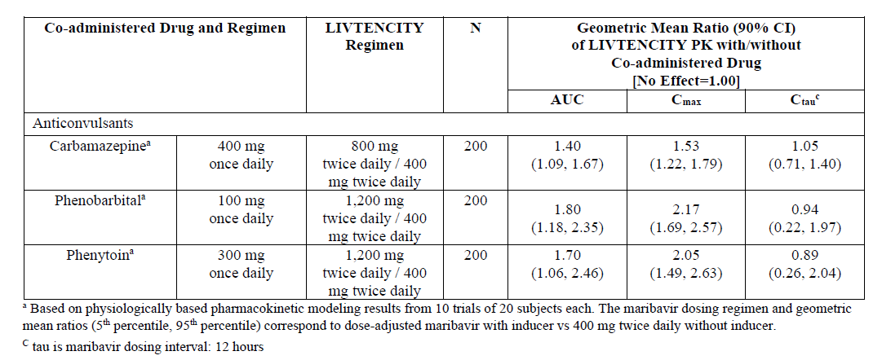
ª Based on physiologically based pharmacokinetic modelling results from 10 trials of 20 subject each. The maribavir dosing regimen and geometric mean ratios (5th percentile, 95th percentile) correspond to dose adjusted maribavir with inducer versus 400 mg daily without inducer.
C_{tau} is maribavir dosing interval: 12 hours
Source: FDA approved label;³
Strong CYP3A4 inhibitors may increase the plasma exposure to maribavir.⁶ Based on less than a three-fold increase in the expected maribavir exposure, the recommendation is to allow co-administration with a strong CYP3A4 inhibitors without dose adjustment.
When immunosuppressants agents such as tacrolimus, cyclosporine, everolimus, or sirolimus are co-administered with maribavir, the recommendation is to frequently monitor drug levels especially when initiating the treatment and after discontinuation of maribavir.
Based on physiological based PK modelling, co-administration of 400 mg maribavir twice daily with rosuvastatin (a sensitive breast cancer resistance protein substrate) is expected to increase the exposure of rosuvastatin (AUC by 2 to 3 fold, and C_{max} by 3.4 to 5 fold). The proposed recommendation is to allow co-administration of maribavir and rosuvastatin with close monitoring for myopathy and rhabdomyolysis.

Pharmacodynamics
Maribavir pharmacological activity is due to the parent drug. Maribavir is not expected to cross the blood brain barrier.
Maribavir at doses up to 1200 mg were examined in single dose, placebo and active (moxifloxacin) controlled trial in healthy subjects and did not indicate clinically relevant effect on QT-interval prolongation.

Efficacy

Dose selection
The dose regimen selected for the pivotal efficacy Study 303 was maribavir 400 mg twice daily orally. This was based on data from two Phase II Studies 202 and 203 in the CMV infection treatment indication.
Maribavir was initially investigated for prevention of CMV infection in transplant recipients. Two Phase III CMV prevention Studies 300 and 301 investigated maribavir at 100 mg twice daily dosing in these studies. These studies failed to demonstrate efficacy, suggesting that higher doses may be needed for effective antiviral activity.
The mean in vitro half maximal inhibitory concentration for clinical CMV isolates is achieved with maribavir trough concentration of greater or equal to 6 µg/mL. In a Phase II CMV prevention study (Study 200) this target concentration was achieved with a maribavir dose of 400 mg twice daily.
Maribavir 400 mg twice daily, 800 mg twice daily and 1200 mg twice daily dose levels were therefore investigated in the two Phase II dose ranging Studies 202 and 203 in the CMV treatment indication. The results from Studies 202 and 203 showed that the three dose levels (400 mg twice daily, 800 mg twice daily, and 1200 mg twice daily) had similar efficacy (viral DNA clearance).
The exposure response relationship in these two Phase II studies was further explored in PK/PD modelling. No significant exposure-response relationships were observed for various efficacy endpoints.
The dose dependent treatment emergent adverse events were dysgeusia (altered sense of taste) and elevations in concomitant immunosuppressant drug levels.
Given these findings, maribavir 400 mg twice daily dose was selected for progression to the confirmatory Phase III Study 303.
Treatment duration
Eight weeks treatment was again selected based on data from the Phase II Study 202 (in resistant/refractory CMV patients) which showed that most patients achieved confirmed undetectable plasma CMV DNA by Week 6 of treatment with maribavir. A fixed 8 weeks treatment duration was selected for the Phase III trial as this was consistent with the current clinical practice of giving two additional weeks of therapy after achieving undetectable plasma CMV DNA levels.

Study 303 (Solstice trial)
The Study SHP620-303 (abbreviated as Study 303) was an open label, multicentre (94 sites in 12 countries), randomised (2:1 ratio for test versus control) trial to investigate the efficacy of maribavir (400 mg twice daily orally) versus investigator assigned [anti-CMV] therapy/treatment (IAT) in the treatment of CMV infection or disease in refractory and/or resistant post-transplant patient population.
This study has also been referred to as the Solstice trial.,
An overview of the study is shown in Table 11, below.

Study overview
Table 11: Study 303 Overview and study design
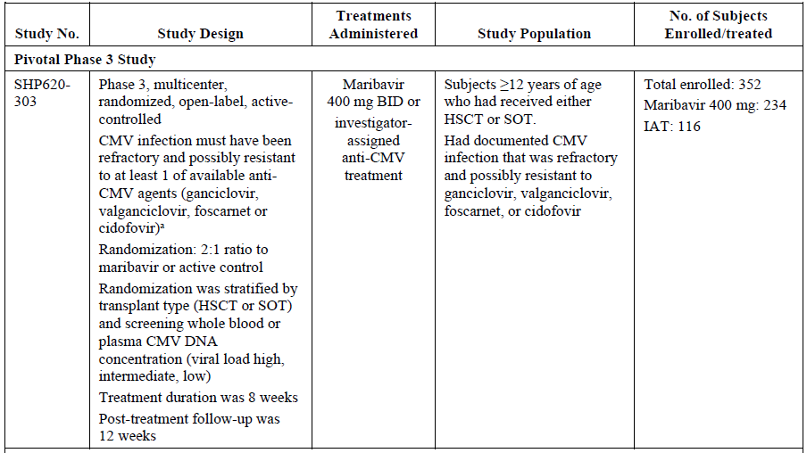
Abbreviations: BID = twice daily; CMV = cytomegalovirus; HSCT = haemopoeitic stem cell transplant; IAT = investigator assigned [anti-CMV] therapy/treatment; SOT = solid organ transplant.
The study comprised a screening phase of up to two weeks, an eight week treatment period and a 12 week follow up phase.
The inclusion criteria required that a subject (at least 12 years of age and at least 35 kg body weight) must have been a recipient of a haematopoietic stem cell transplant or solid organ transplant and must have had documented CMV infection in two consecutive assessments separated by at least one day.
The subjects must have had a current CMV infection that was refractory to the most recently administered of four anti-CMV treatment agents (ganciclovir/valganciclovir, foscarnet or cidofovir). Refractory was defined as documented failure to achieve greater than 1 log₁₀ decrease in CMV DNA level in whole blood or plasma after a 14-day or longer treatment period with intravenous ganciclovir/oral valganciclovir, intravenous foscarnet, or intravenous cidofovir.
The subjects with documentation of one or more CMV genetic mutations associated with resistance to ganciclovir/valganciclovir, foscarnet, and/or cidofovir were also required to meet the above definition of refractory.
Subjects with invasive CMV disease with central nervous system involvement, including retina (CMV retinitis) and human immunodeficiency virus patients were excluded.
Combination therapy with foscarnet and cidofovir was not permitted in the IAT arm due to the potential for serious nephrotoxicity. Other exclusion criteria included subjects receiving leflunomide (unless discontinued at least 14 days prior), letermovir (unless discontinued three days prior), or artesunate when study treatment was initiated.
Randomisation was stratified according to transplant type (haematopoietic stem cell transplant versus solid organ transplant) and CMV viral load at Baseline. The CMV viral load categories were as follows.
Table 12: Study 303 Cytomegalovirus viral load categories
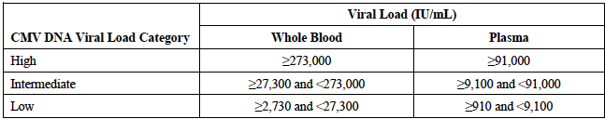
CMV = cytomegalovirus; DNA = deoxyribonucleic acid; IU = international units.
A total of 352 eligible patients were randomised to the two parallel treatment groups (117 in IAT and 235 in maribavir group).
The patients randomised IAT were assigned to monotherapy or combination therapy with currently available anti-CMV medications at the discretion of the investigator.
Patients in the IAT arm who met criteria for lack of improvement or worsening of CMV after three weeks, had the option of crossing over to a maribavir rescue arm, in which they were treated with maribavir for a total of eight weeks.
The demographic and baseline pathologic characteristics were generally comparable between the two treatment groups. The median age of study participants was 55 years. There were more elderly (greater or equal to 65 years) subjects in maribavir arm (23%) versus IAT arm (13.7%). Only a small proportion of subjects in the trial had tissue invasive disease and this was more common in the maribavir arm (5.1%) versus IAT (0.9%). Only 8.2% of subjects had symptomatic CMV infection, as assessed by the independent adjudication committee. Most subjects in the solid organ transplant group were donor+/recipient-, and most in the haematopoietic stem cell transplant group were recipient+. The current episode of CMV infection was the first episode in 68.2% subjects.
Baseline genotyping indicated that overall 190 out of 350 (54.3%) patients had at least one resistance associated amino acid substitution to ganciclovir, foscarnet, and/or cidofovir, and 4 out of 350 (1.1%) had resistance associated amino acid substitution known to be associated with resistance to maribavir. A total of 69 out of 116 (59.5%) patients in IAT arm compared to 121 out of 234 (51.7%) patients in maribavir arm had resistance-associated amino acid substitution conferring resistance to ganciclovir, foscarnet, and/or cidofovir at Baseline.
The inclusion criteria required the participants to have an estimated glomerular filtration rate (eGFR) greater than 30 mL/min/1.73 m². At Baseline, the comparative groups were as follows (Table 13).
Table 13: Study 303 General baseline characteristics by treatment group
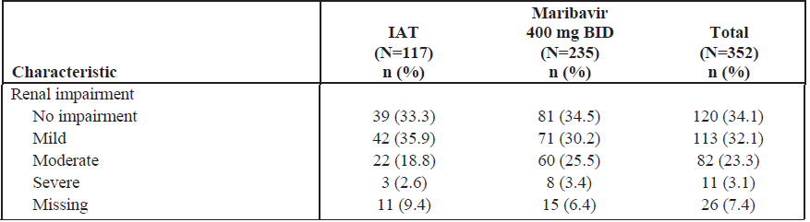
The treatment was to be continued for 8 weeks in both arms. Overall, 220 out of 352 (62.5%) randomised patients completed 8 weeks of study-assigned treatment.
In maribavir arm, 77.9% patients completed the full eight week treatment period, compared with 31.6% in the IAT arm.
Twenty two IAT randomised subjects entered a protocol defined maribavir rescue period after failing to demonstrate adequate virological response to IAT.

Results
The primary outcome was a surrogate measure that is confirmed CMV viremia clearance (after 8 weeks of treatment). This outcome has been shown to predict the development of CMV disease and mortality in transplant recipients.
The primary analysis was based on randomised set.
A total of 131 out of 235 (55.7%) maribavir patients achieved confirmed CMV viremia clearance at Week 8 compared to 28 out of 117 (23.9%) IAT patients. The adjusted treatment difference was 32.8% (95% confidence interval (CI): 22.80%, 42.74%) in favour of maribavir as shown below in Table 14.
Table 14: Study 303 Confirmed cytomegalovirus viremia clearance response at Week 8 by treatment group (randomised set)
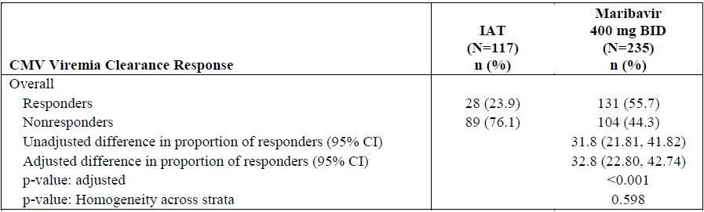
The result was examined using various sensitivity analyses and considered robust. However, completers analysis (patients who completed eight weeks on their randomised treatment: 183 out of 235 maribavir versus 37 out of 117 IAT patients) numerically in favour of maribavir but the 10% treatment difference was statistically not significant (Table 15).
Table 15: Study 303 Sensitivity analysis of confirmed cytomegalovirus viremia clearance in subjects who received 8 weeks of study assigned treatment (randomised set)
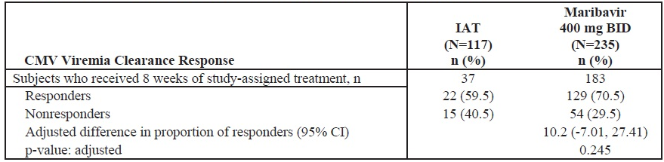
The primary outcome (CMV DNA undetectable at 8 weeks; randomised set) was consistent across various subgroups, noting very low numbers in the high viral load subgroup at Baseline in the Table 16 below.
Table 16: Study 303 responders by subgroup
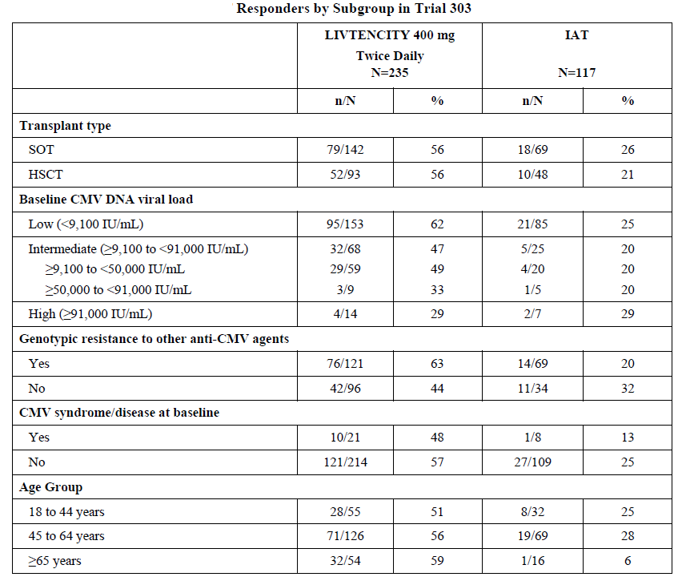
Source: FDA approved label;³

The analysis of failures (reasons for failure) for the primary efficacy outcome was shown in Table 17.
Table 17: Study 303 Analysis of failures for primary efficacy endpoint
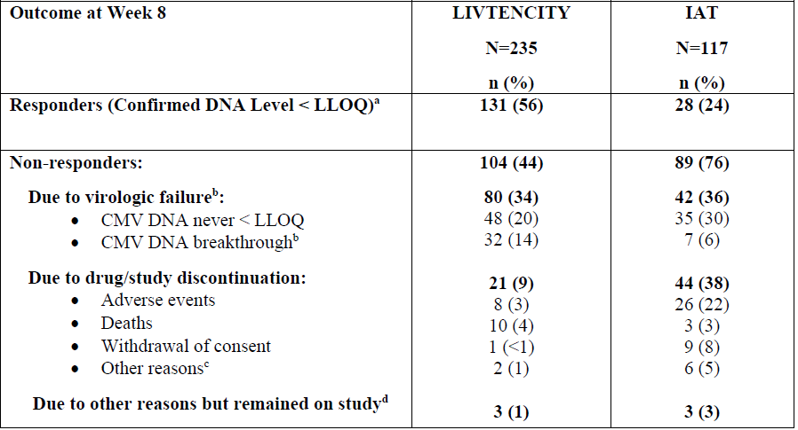
Abbreviation, CMV = cytomegalovirus; IAT = investigator assigned anti-CMV treatment; MBV = maribavir.
Percentages are based on the number of subjects in the randomised set.
ª confirmed CMV DNA level less than lower limit of quantitation at the end of Week 8 (2 consecutive samples separated by at least 5 days with DNA level less than lower limit of quantitation (that is less than 137 IU/mL))
^{b} CMV DNA breakthrough = achieved confirmed CMV DNA level less than lower limit of quantitation and subsequently became detectable.
^{c} Other reasons = other reasons not including adverse events, deaths and lack of efficacy, withdrawal of consent, and non-compliance.
^{d} Includes subjects who completed study assigned treatment and were non-responders.
Source: FDA approved label;³
Overall, 22 IAT randomised patients received maribavir as rescue therapy based on predefined failure criteria. Of the 22 patients, 11 (50%) patients achieved confirmed CMV viremia clearance at 8 weeks of maribavir rescue treatment phase and 11 (50%) were non-responders.
A key secondary endpoint was composite of viral clearance and CMV infection symptom control at Week 8 with maintenance through Week 16. The treatment difference for this outcome was 9.5% (95%CI: 2.02%, 16.88%) in favour of maribavir (see Table 18).

Table 18: Study 303 Key secondary endpoint of achieving confirmed CMV viremia clearance and CMV infection symptom control followed by maintenance through Week 16 by treatment group (randomised set)
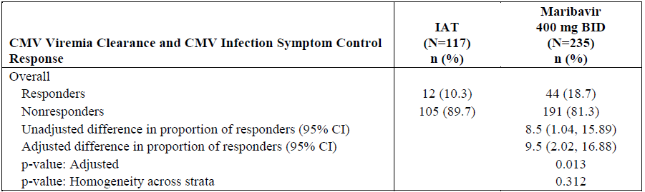
Abbreviation, BID = twice daily; CMV = cytomegalovirus; IAT = investigator assigned anti-CMV treatment.
Source: FDA approved label;³
For both treatment arms, the highest loss in effect occurred between Week 8 and the Week 12 (response rate declined from 55.7% to 22.6% for maribavir and from 23.9% to 10.3% for IAT). The loss of effect from Week 12 to Week 20 was minimal (response rates of 22.6% to 18.3% for maribavir and 10.3% to 9.4% for IAT).
In Study 303, recurrence was assessed using virologic criteria of plasma CMV DNA greater than or equal to lower limit of quantitation in two consecutive samples at least five days apart in subjects who had achieved confirmed viremia clearance. In this analysis, clinically relevant recurrence that is recurrence requiring anti-CMV treatment after Week 8, was reported for 34 out of 131 (26%) maribavir patients compared to 10 out of 28 (35.7%) IAT patients. The median time to recurrence after confirmed CMV viremia clearance was 21 days (range 13 to 80 days) in maribavir group and 22 days (range 14 to 36 days) in IAT group.
Post-baseline, overall, there were 22 cases of new onset of symptomatic CMV infection in 21 patients, with one patient in IAT group having two episodes (see Table 19).
Table 19: Study 303 Summary of post baseline new onset of symptomatic cytomegalovirus infection (randomised set)
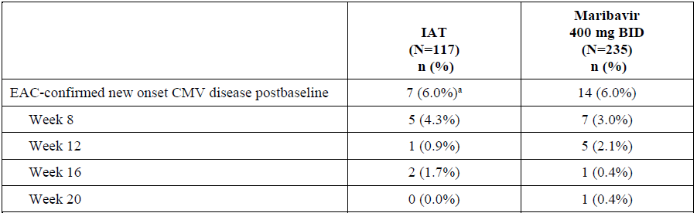
BID = twice daily; CMV = cytomegalovirus; EAC = endpoint adjudication committee; IAT = investigator assigned anto-CMV treatment; N = number of subjects.
ª One subject in the IAT group had new onset of symptomatic CMV infection at both Week 12 and Week 16.
As noted earlier, at Baseline 69 out of 116 (59.5%) patients in IAT arm compared to 121 out of 234 (51.7%) patients in maribavir arm had resistance associated amino acid substitution conferring resistance to IAT, and 3 out of 116 (2.6) patients in IAT arm compared to 1 out of 234 (0.4%) in maribavir arm has resistance associated amino acid substitution conferring resistance to maribavir (Table 20).
Table 20: Baseline resistance profile (modified randomised set)
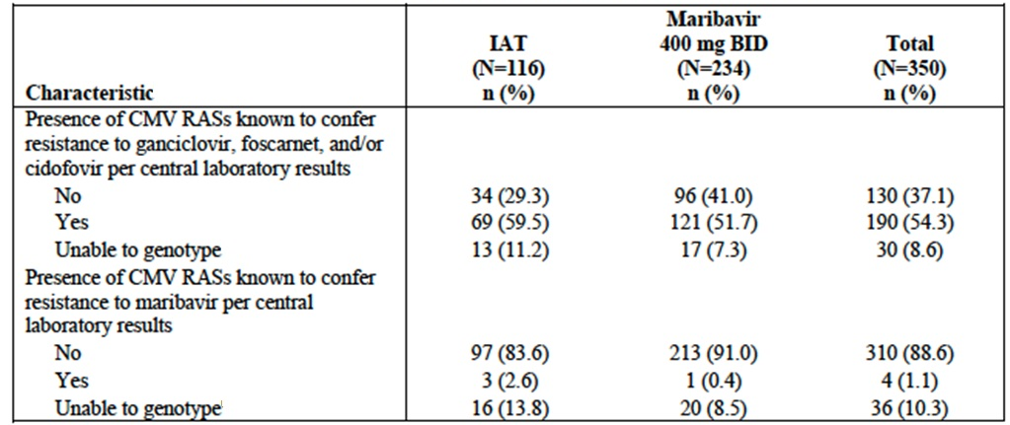
The primary resistance set (PRS) was defined as all subjects with at least one known resistance associated amino acid substitution to IAT in pUL97 (translated protein of UL97) and/or pUL54 at Baseline. Subjects without baseline IAT resistance associated amino acid substitutions were designated non-PRS.
The maribavir resistance set (MRS) was defined as all subjects with at least one known resistance-associated amino acid substitution to maribavir in pUL97 and/or pUL27 at Baseline. Subjects without baseline maribavir resistance-associated amino acid substitutions are designated non-MRS.
The primary outcome at 8 weeks in various populations sets defined by PRS or MRS subpopulations was indicative of relatively smaller treatment difference (maribavir 43.5% versus IAT 32.4%) in non-PRS patients and relatively larger treatment difference (maribavir 62.8% versus IAT 20.3%) in the PRS population (see Table 21 and Table 22).
Table 21: Subjects achieving confirmed clearance of plasma CMV DNA at the end of the study week 8 by analysis group and primary resistance set classification
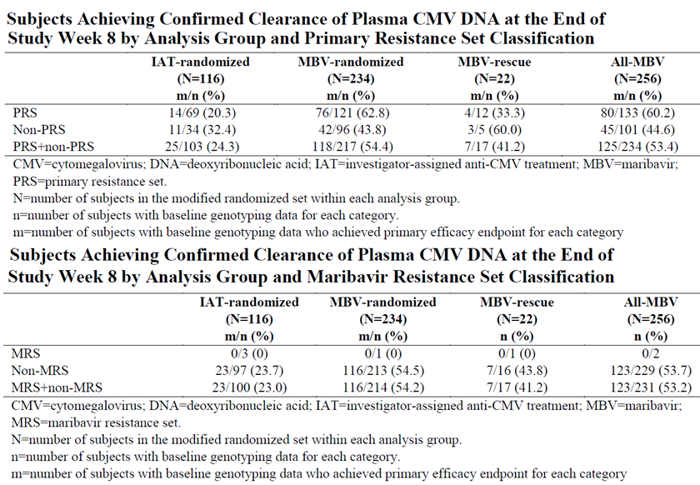
CMV = cytomegalovirus; DNA = deoxyribonucleic acid; IAT = investigator assigned anti-CMV treatment; MBV = maribavir; PRS = primary resistance set.
N = Number of subjects in the modified randomised set within each analysis group.
n = number of subjects with baseline genotyping data for each category.
m = number of subjects with baseline genotyping data who achieved primary efficacy endpoint for each category.

Table 22: Subjects achieving confirmed clearance of plasma CMV DNA at the end of the study week 8 by analysis group and maribavir resistance set classification
CMV = cytomegalovirus; DNA = deoxyribonucleic acid; IAT = investigator assigned anti-CMV treatment; MBV = maribavir; PRS = primary resistance set.
N = Number of subjects in the modified randomised set within each analysis group.
n = number of subjects with baseline genotyping data for each category.
m = number of subjects with baseline genotyping data who achieved primary efficacy endpoint for each category.

Treatment resistance
A total of 28 out of 217 (12.9%) maribavir treated patients and 5 out of 103 (4.9%) IAT treated patients in the combined primary (PRS) and non-primary resistance set populations developed treatment-emergent resistance-associated amino acid substitutions to IAT (see Table 23).
A total of 42 out of 214 (19.6%) maribavir treated patients and zero out of 100 (0%) IAT treated patients in the combined maribavir (MRS) and non-maribavir resistance set populations developed treatment-emergent resistance-associated amino acid substitutions to maribavir (see Table 24).
Table 23: Summary of treatment emergent known resistance associated amino acid substitutions to investigator assigned anti-CMV treatment in primary resistance set plus non-primary resistance set
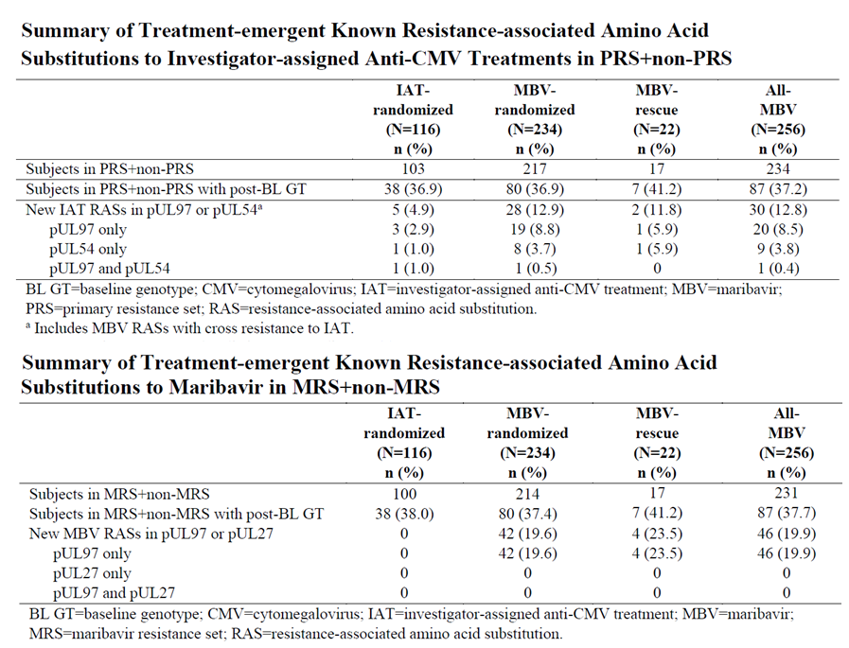
BL GT = baseline genotype; CMV = cytomegalovirus; IAT = investigator assigned anti-CMV treatment; MBV = maribavir; PRS = primary resistance set; RAS = resistance associated amino acid substitution.
ª Includes MBV RAS with cross-resistance to IAT
Table 24: Summary of treatment emergent known resistance associated amino acid substitutions to maribavir in maribavir resistance set plus non-maribavir resistance set
BL GT = baseline genotype; CMV = cytomegalovirus; IAT = investigator assigned anti-CMV treatment; MBV = maribavir; PRS = primary resistance set; RAS = resistance associated amino acid substitution.
Of the 42 maribavir treated patients who developed CMV mutations associated with maribavir resistance, 41 out of 42 (97.6%) did not achieve the primary endpoint of viraemia clearance at Week 8. Of these 42 patients 18 out of 42 (42.9%) did not achieve viraemia clearance at any time point during the study. Of the remaining 24 out of 42 patients 21out of 24 (87.5%) had recurrence on- or off-treatment.

Safety

Exposure
A total of 1555 subjects were exposed to maribavir in the maribavir clinical development program for the treatment indication, of which 1175 received maribavir in the Phase II and III studies including 234 in the pivotal study (Study 3030) (see Table 25). All were adults at least 18 years of age and above.
Table 25: Estimated cumulative subject exposure to maribavir from completed clinical studies by age and gender
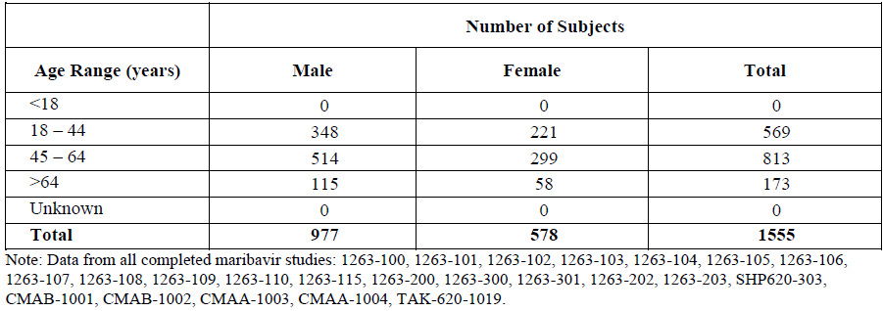
In Study 303, the median duration of exposure was 34 days (range 4, 64) and 57 days (range 2, 64) in IAT and maribavir groups respectively. Results in study 303 are discussed further.
A total of 256 maribavir treated patients experienced a total Person-Time of 13,389 days in Study 303. The distribution of exposure days was as follows indicating 227 patients received maribavir for at least 43 days and above (Table 26).
Table 26: Study 303 Duration of exposure to maribavir 400 mg twice daily
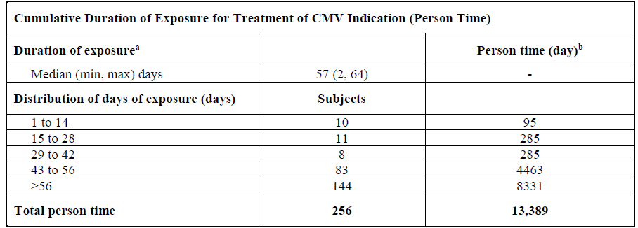
ª Exposure duration: Number of days between the date of the first dose and the date of last dose of maribavir.
^{b} Person time (day) is defined as the total number of days of exposure for all subjects who received maribavir 400 mg twice daily either as the study assigned treatment or as rescue treatment in Study 303.

Treatment-emergent adverse events
Overall, at least one treatment-emergent adverse events (TEAEs) was reported in majority of participants in Study 303 (91.4% versus 97.4% for IAT and maribavir, respectively) (see Table 27).
Table 27: Study 303 Overall treatment-emergent adverse events during the on treatment observation period by treatment group (safety set)
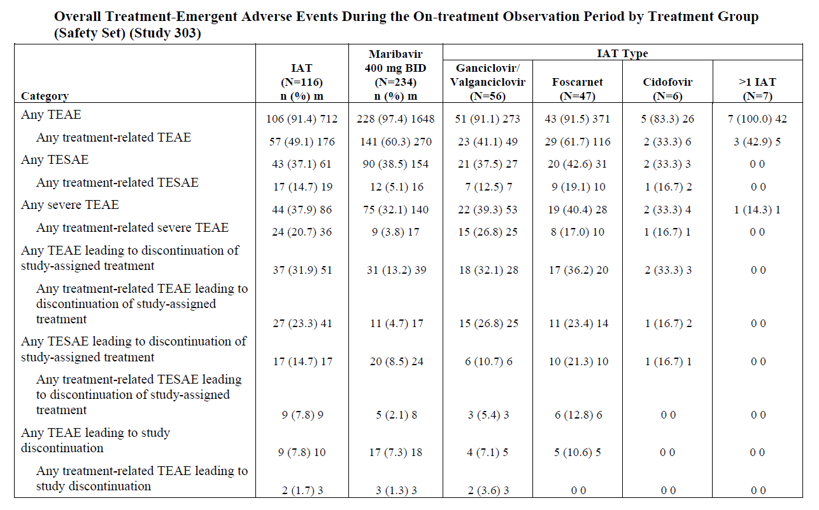
The most frequently (at least 5%) reported TEAEs (by Preferred Term) in the Study 303 during the 8 weeks treatment period were as follows (Table 28).
Table 28: Frequently occurring treatment-emergent adverse events in at least 5% of subjects in the maribavir or investigator assigned anti-CMV treatment during the on treatment observation period by Preferred Term (safety set)
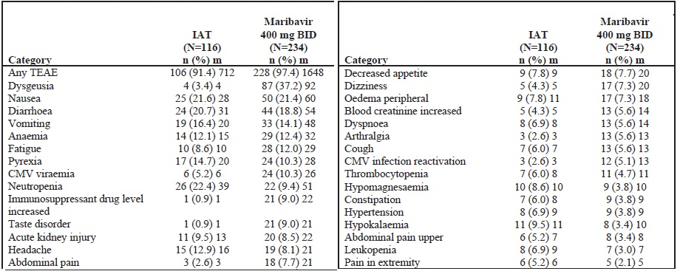

Adverse events of special interest
Neutropenia was one of the TEAEs of special interest and the reported incidence in Study 303 treatment period was 10.3% (maribavir), 25.9% (investigator assigned anti-CMV treatment), 39.3% (ganciclovir/valganciclovir) and 17% (foscarnet) indicative of relative bone marrow suppressive safety with maribavir.
Notably the reported incidence of graft versus host disease was higher in maribavir (9%) compared to 4.3% (investigator assigned anti-CMV treatment), 3.6% (ganciclovir/valganciclovir) and 6.4% (foscarnet).
The reported incidence of concomitant immunosuppressant drug levels increased was 9% (maribavir), 0.9% (investigator assigned anti-CMV treatment), 1.8% (ganciclovir/valganciclovir) and 0% (foscarnet) (Table 29).
Table 29: Treatment-emergent adverse events of special interest during the on treatment observation period by adverse event of special interest class, treatment group, and selected investigator assigned anti-CMV treatment type (safety set)
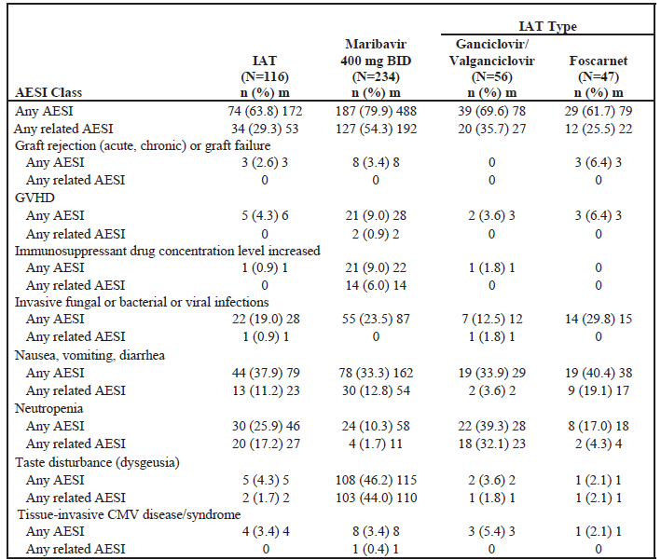
Abbreviations: AESI = adverse event of special interest; GVHD = graft versus host disease.
The reported incidence of renal TEAEs was overall in favour of maribavir (15.8%) compared to 19.0% (investigator assigned anti-CMV treatment) and 31.9% (foscarnet). This advantage was noticeable in patients with baseline normal or mild renal impairment, but not in patients with baseline moderate/severe renal impairment in which the incidence was 32.4% (maribavir), 24.0% (investigator assigned anti-CMV treatment) and 30% (foscarnet) (Table 30).
Table 30: Treatment-emergent adverse events pertaining to renal disorders by treatment group and investigator assigned anti-CMV treatment type (foscarnet) (safety set)
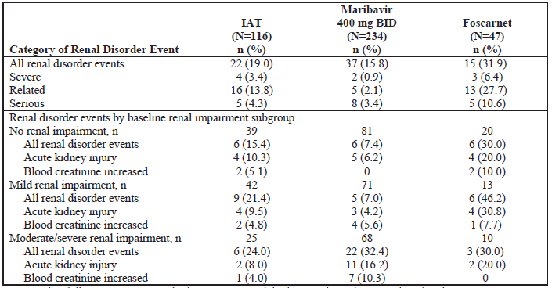
The mean serum creatinine at Baseline, overtime and post-treatment could not be located, but the median number of subjects with post-treatment change were as follows indicative of relatively maribavir renal safety profile (see Table 31).
Table 31: Summary of baseline median and median change from baseline to the last on treatment value in creatinine (µmol/L) by treatment group and selected investigator assigned anti-CMV treatment type (safety set)
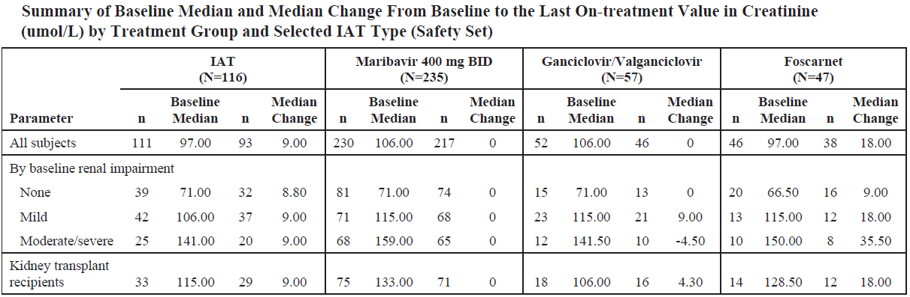

The number of subjects reported with increasing shift in creatinine level (on treatment and overall) (Table 32).
Table 32: Number of subjects with increasing shifts in creatinine from lower grade to first maximum post baseline National Cancer Institute Common Toxicity Criteria Grade 3 or 4 by study period, treatment group, and selected investigator assigned anti-CMV treatment type (safety set)
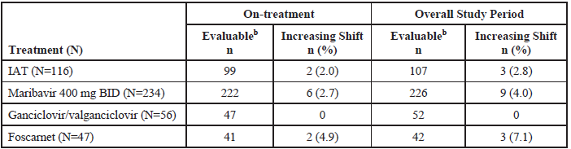
BID = twice daily; CMV = cytomegalovirus; IAT = investigator assigned anti-CMV treatment; ULN = upper limit of normal
ª NCI CTC grade = National Cancer Institute Common Toxicity Criteria, version 4.03; 3 = severe; 4 = life-threatening
^{b} Evaluable was defined by the number of subjects with both baseline and post baseline non-missing data.
Percentages were based on the number of subjects with the evaluable lab data at that study period in each treatment group Grade 3 creatinine increased: ˃ 3 x baseline or 3 to 6 ULN; Grade 4 creatinine: ˃ 6 x ULN.
The number of subjects with creatinine values considered potentially significant (on treatment) (Table 33).
Table 33: Potentially clinically significant creatinine values as determined by the investigator by study period and treatment group (safety set)
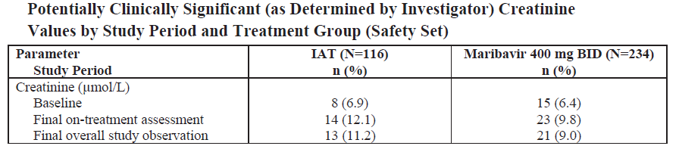
Haematological TEAEs (on treatment and overall) were consistent with the expectation of relative safety with maribavir or foscarnet compared to ganciclovir/valganciclovir (Table 34).

Table 34: Number of subjects with decreasing shifts in hematology laboratory assessments from lower grade to first maximum post baseline National Cancer Institute Common Toxicity Criteria Grade 3 or 4 by study period, treatment group, and selected investigator assigned anti-CMV treatment type (safety set)
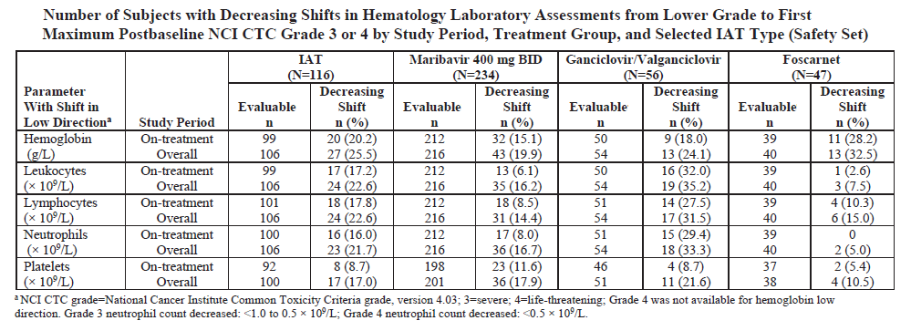
ª NCI CTC grade = National Cancer Institute Common Toxicity Criteria, version 4.03; 3 = severe; 4 = life-threatening; Grade 4 was not available for haemoglobin low direction. Grade 3 neutrophil count decreased: < 1 to 0.5 x 10⁹/L; Grade 4 neutrophil count decreased: < 0.5 x 10⁹/L

All-cause mortality
A total of 6 out of 116 (5.2%) deaths in investigator assigned anti-CMV treatment group compared with 16 out of 234 (6.8%) in maribavir group were reported in the 8 weeks on treatment period in Study 303 (Table 35).
Table 35: Study 303 Overall treatment emergent adverse events during the on treatment observation period by treatment group (safety set)
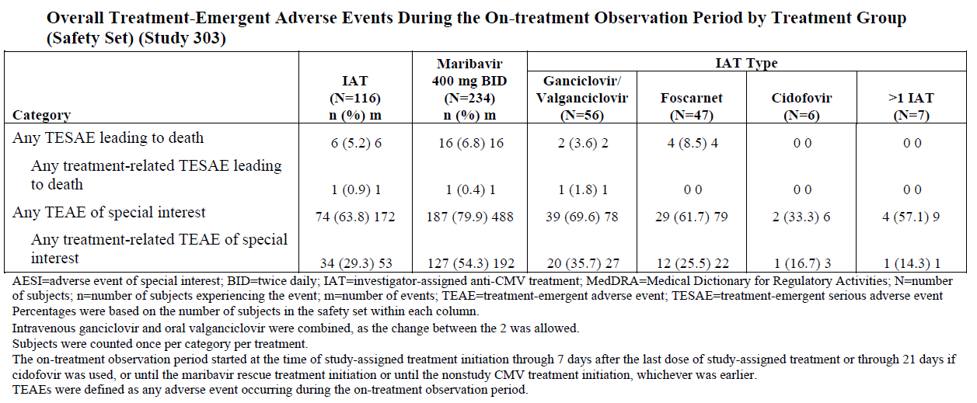
AESI = adverse event of special interest; BID = twice daily; IAT = investigator assigned anti-CMV treatment; MedDRA = Medical Dictionary of Regulatory Activities; N = number of subjects; n = number of subjects experiencing the event; m = number of events; TEAE = treatment emergent adverse event; TESAE = treatment emergent serious adverse event.
Percentages were based on the number of subjects in the safety set within each column
Intravenous ganciclovir and oral valganciclovir were combined, as the change between the 2 was allowed.
Subjects were counted once per category per treatment
The on-treatment observation period started at the time of study assigned treatment initiation through 7 days after the last dose of study assigned treatment or through 21 days if cidofovir was used, or until the maribavir rescue treatment initiation or until the nonstudy CMV treatment initiation, whichever was earlier.
TEAEs were defined as any adverse event occurring during the on-treatment observation period.
A total of 40 deaths comprising 13 out of 116 (11.2%) in investigator assigned anti-CMV treatment group compared with 27 out of 235 (11.5%) deaths were reported over the whole course of follow up in Study 303. The distribution was as follows, noting that no deaths were reported with cidofovir or patients who received combination investigator assigned anti-CMV treatment (Table 36).
Table 36: Study 303 Timing of deaths (based on death date) relative to first dose of study assigned treatment by treatment group and investigator assigned anti-CMV treatment type (safety set)
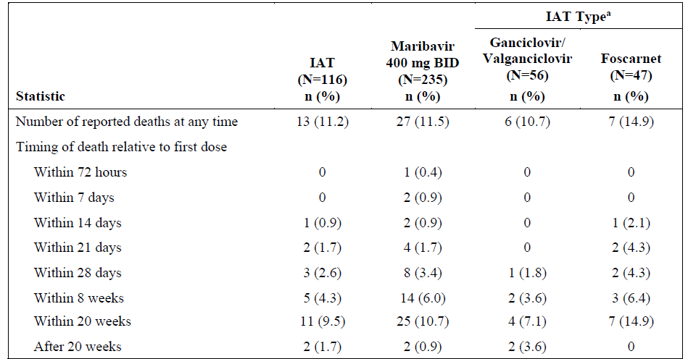
CMV = cytomegalovirus; IAT = investigator assigned anti-CMV treatment
The calculation of death days was (death date – date of first dose of study assigned treatment + 1)
ª No death were reported for subjects who received cidofovir or ˃ 1 investigator assigned anti-CMV treatment.
The observed median time to death was 55 days (range 3, 182) in maribavir group compared to 73 days (range 13 to 186) in IAT group (Table 37).
Table 37: Study 303 Cumulative probability of all cause mortality by treatment group (randomised set)
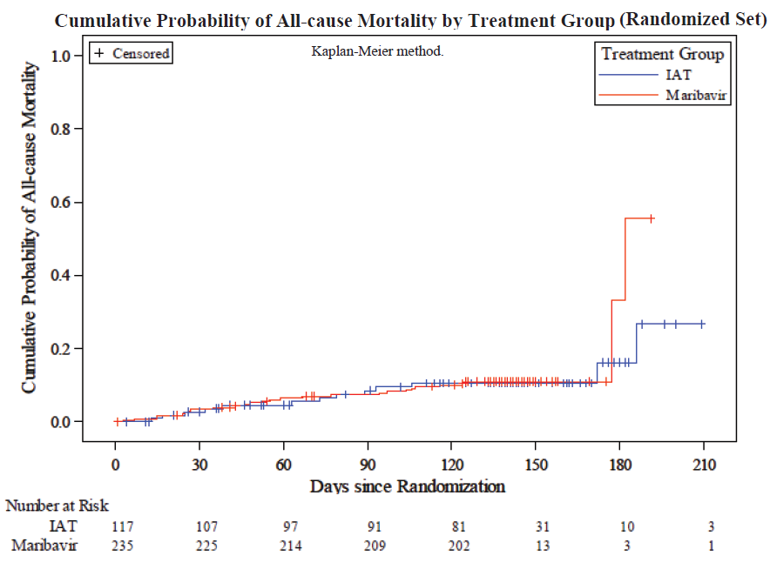
The hazard ratio for treatment with maribavir versus investigator assigned anti-CMV treatment was 1.14 (95% CI: 0.549, 2.357).
For reference, the reported mortality in the placebo-controlled Phase III Study 300 CMV prevention trial (maribavir 100 mg twice daily) (Table 38).
Table 38: Study 303 Incidence of death during 100 day, 6 month and 12 month post-transplant assessment periods (intent to treat set population)
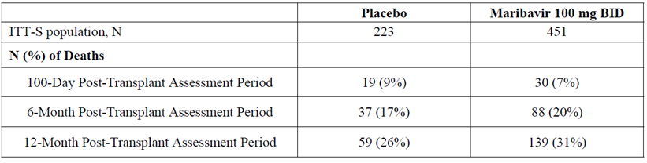
Safety data from the two Phase II treatment indication studies were consistent with the treatment emergent adverse event profile seen in Study 303, with some dose effect with the higher doses.

Risk management plan
The sponsor has submitted EU-risk management plan (RMP) version 0.1 (date 12 April 2021; data lock point (DLP) 17 December 2020) and Australia specific annex (ASA) version 1.0 (date 1 December 2021) in support of this application.
The summary of safety concerns and their associated risk monitoring and mitigation strategies are summarised in Table 39. The TGA may request an updated RMP at any stage of a product's life cycle, during both the pre-approval and post-approval phases.
Table 39: Summary of safety concerns
Summary of safety concerns |  | Pharmacovigilance |  | Risk Minimisation
 |  | Routine | Additional | Routine | Additional
Important identified risks | Immunosuppressant drug level increased |  | – |  | –
Important potential risks | None | – | – | – | –
Missing information | Use in pregnant or lactating women |  | – |  | –
Missing information | Use in patients with severe hepatic impairment |  | – |  | –
Missing information | Use in patients with end stage renal disease (ESRD) including peritoneal dialysis or haemodialysis |  | – |  | –
The summary of safety concerns is acceptable from an RMP perspective.
Only routine pharmacovigilance and routine risk minimisation measures are proposed. Routine risk management measures are acceptable to address the risks associated with this product.
There are no outstanding RMP matters. The RMP conditions of registration have been provided. Maribavir is a new chemical entity and thus meets the inclusion criteria for the Black Triangle Scheme.
The TGA’s evaluation of the RMP noted that the US FDA’s prescribing information includes the following advice:³
‘Virologic failure can occur during and after treatment with Livtencity. Monitor CMV DNA levels and check for resistance if patient does not respond to treatment. Some maribavir pUL97 resistance-associated substitutions confer cross-resistance to ganciclovir and valganciclovir.’
Furthermore, a risk assessment and risk mitigation review for maribavir published by the US FDA states:
‘Virologic failure can occur during and after treatment with maribavir. Failure occurs more frequently during treatment than during the post-treatment period. Relapse following treatment usually occurs within 4-8 weeks after treatment discontinuation.’
The Australian PI does not provide advice on conducting any tests to monitor resistance. This is recommended for inclusion in the Australian PI as a result of the TGA’s evaluation of the proposed RMP.

Risk-benefit analysis

Delegate’s considerations
Maribavir is orally available and a novel, anti-CMV agent. It has moderate to high oral bioavailability with linear pharmacokinetics (no first pass effect expected; moderate food effect) and is subject to various drug interactions by virtue of its metabolism by the hepatic oxidative enzyme system (mainly CYP3A4 but also CYP1A2).⁶
The pivotal Phase III Study 303 examined the efficacy of maribavir in the treatment of adult patients with post-transplant CMV infection that was resistant or refractory to prior therapy.^{8,9}
Maribavir 400 mg twice daily dose was the selected dose, as higher doses (800 mg twice daily and 1200 mg twice daily) showed no efficacy advantage in Phase II studies with flat efficacy response curve but were associated with a higher incidence of elevated immunosuppressant drug levels that were being administered concomitantly in this patient population.
The efficacy outcome in the pivotal Study 303 was plasma CMV DNA clearance after 8 weeks of treatment. This is a validated surrogate outcome for predicting CMV disease progression and consequently mortality.
The result (treatment difference of 32.8% with 95%CI of 22.8%, 42.74% compared to current anti-CMV therapies) was statistically and clinically significant and supported the use of maribavir in this refractory/resistant patient population.
However, this efficacious viral clearance did not translate into any mortality advantage. Based on the current data, all-cause mortality was not different in maribavir and the investigator assigned anti-CMV treatments groups.
However, more data will be of interest to confirm and rule out any adverse trend. It also suggests that any potential beneficial patient survival outcomes may be hard to achieve in unselected clinical practice outside the context of close monitoring in clinical trials.
Maribavir 400 mg twice daily had an overall favourable safety profile than investigator assigned anti-CMV treatments.
Dysgeusia (disturbance in taste) is pathognomonic of maribavir treatment. As expected from studies in the clinical development program of maribavir, the pivotal Study 303 showed that maribavir was advantageous with respect to the two main treatment limiting toxicities with the current anti-CMV drugs that is bone marrow suppression with ganciclovir/valganciclovir and renal toxicity with foscarnet and cidofovir.
Despite benefit on these adverse outcome, the observed lack of advantage on mortality was a disappointing finding. Appropriate use in severely renal impaired patients and close plasma drug monitoring of concomitant immunosuppressant agents may be important factors in optimal use of maribavir.
Viral resistance analyses from the Study 303 indicate that development of genotypic resistance to maribavir is common, develops rapidly and is associated with loss of efficacy.
Maribavir pUL97 resistance-associated substitutions also confer cross-resistance to investigator assigned anti-CMV treatment (ganciclovir/valganciclovir).
A total of 28 out of 217 (12.9%) maribavir treated patients and 5 out of 103 (4.9%) investigator assigned anti-CMV treatment-treated patients in the combined PRS and non-PRS population sets; developed treatment-emergent resistance-associated amino acid substitutions to investigator assigned anti-CMV treatment.
A total of 42 out of 214 (19.6%) maribavir treated patients and 0 out of 100 (0%) investigator assigned anti-CMV treatment-treated patients in the combined MRS and non-MRS population sets; developed treatment emergent resistance-associated amino acid substitutions to maribavir.
The data support 400 mg twice daily maribavir dosing for 8 weeks in the treatment of refractory or resistant CMV infection in post-transplant adult patients. No experience in patients under 18 years of age is currently available from the completed clinical trials.
Apart from the clinical data, the 400 mg twice daily dosing, 8 weeks fixed duration of treatment and use in adult patients are also supported and considered more suitable in view of the findings in repeat-dose toxicology studies and subclinical exposures reported in the nonclinical dossier.

Proposed action
Pending advice from the Advisory Committee on Medicines (ACM), the Delegate proposes to approve maribavir for the following indication:
Treatment of adults with post-transplant cytomegalovirus (CMV) infection and disease resistant or refractory to one or more prior therapies.
Use of maribavir 400 mg twice daily taken orally for 8 weeks is supported based on the pivotal Study 303.

Advisory Committee considerations
The Advisory Committee on Medicines (ACM), having considered the evaluations and the Delegate’s overview, as well as the sponsor’s response to these documents, advised the following.

Specific advice to the Delegate
The ACM advised the following in response to the Delegate’s specific request for advice:
- The Delegate proposes to approve maribavir 400 mg twice daily dosing for fixed period of 8 weeks based on the pivotal Phase III Study 303.
The ACM is requested to advise on:
  - whether this is optimum; or
  - reference to the longer clinical trial experience in Phase II studies; or
  - open ended approval of 400 mg twice daily without specifying duration of treatment will be more appropriate?
The ACM advised that a specific duration of therapy was not appropriate, given:
- maribavir will almost exclusively be prescribed by specialists
- clinical guidelines are likely to be influential in recommending duration given complexity of patient management
- experience with other agents suggests severely immunocompromised people can need longer duration; this evidence might emerge over time for maribavir. An eight week course is unlikely to permanently control CMV in many/most of the target group.
- safety considerations with longer therapy can be mitigated by other monitoring recommendations.
The ACM supported the dosage information in the draft PI that ‘treatment duration may need to be individualised based on the clinical characteristics of each patient’.
- The inclusion criteria for the Phase III Study 303 allowed entry of patients 12 years of age and above (weighing at least 35 kg); however, none of the patients in the clinical trials were under 18 years of age.
A population PK analysis has indicated that dosage regimen of 400 mg twice daily in adolescents is likely to produce systemic exposures comparable to exposures in adults.
The sponsor has requested approval in adults only and the conclusions of the TGA’s clinical evaluation and the Delegate agree with this approach.
The ACM is requested to advise whether this is suitable given the orphan drug status of the drug.
The ACM advised that approval for adults is a reasonable approach prioritising safety, given the clinical data available at this time is confined to adults.
Real-world post-market information in due course might support use in adolescents aged 12 to 18 years of age. The sponsor should be encouraged to collect such data, given the US approval permits use in individuals 12 years and older.
Orphan drug status is a separate regulatory matter for the TGA.
- The recommended indication is:
‘treatment of adults with post-transplant cytomegalovirus (CMV) infection and disease resistant or refractory to one or more prior therapies’.
Necessary advisory statements have been included in the draft Product Information.
The ACM is requested to advise whether these are adequate particularly with respect to drug interactions; the risk of resistance development; and, use in severe renal impairment.
The ACM advised that the special warnings and precautions included in the draft PI are adequate. The medicine will be prescribed in specialist settings, including with advice from specialist pharmacists.
The most serious drug interaction is likely to be antagonism of ganciclovir (and/or it’s prodrug, valganciclovir), if clinicians were to use combination therapy in difficult cases.
Development of resistance will be a significant issue with any new antiviral agent that is used for extended periods in this patient population, especially where viral latency prevents eradication. Resistance testing either before or after use of maribavir is not necessary.
- The ACM is requested to comment on the significance of lack of survival benefit with maribavir treatment despite a large treatment difference (> 30%) on plasma viral clearance.
The ACM advised that Study 303 was not powered to detect a survival benefit (it was powered to detect a 20% difference in viral response).
Individuals with post-transplant CMV infection and disease have significant morbidity and mortality risks prior to maribavir treatment. Mortality rates are similar between maribavir and other antiviral medicines; and the pivotal study did not include a placebo controlled arm for comparison.
- The ACM is also requested to provide any other advice which may be relevant to this submission.
The ACM supported an interpretation/clarification of the indication that ‘refractory’ includes ‘intolerant’ (for example, ganciclovir haematological toxicity in haematopoietic stem cell transplant patients or foscarnet nephrotoxicity in renal transplant patients). The different toxicity profile of maribavir is one of its benefits.
The ACM highlighted that maribavir poorly penetrates the blood-retinal barrier and is not expected to cross the blood-brain barrier. The draft PI states that maribavir is not expected to be effective in treating CMV central nervous system infections (for example, meningo-encephalitis, retinitis). The ACM suggested that this should also be highlighted in the clinical trials section of the PI to support appropriate prescribing.

Conclusion
The ACM considered this product to have an overall positive benefit-risk profile for the indication:
Treatment of adults with post-transplant cytomegalovirus (CMV) infection and disease resistant or refractory to one or more prior therapies.

Outcome
Based on a review of quality, safety, and efficacy, the TGA approved the registration of Livtencity (maribavir) 200 mg, film coated tablet, bottle, indicated for:
Treatment of adults with post-transplant cytomegalovirus (CMV) infection and disease resistant, refractory or intolerant to one or more prior therapies (see 4.3 Contraindications and, 4.4 Special warnings and precautions for use).

Attachment 1. Product Information
The PI for Livtencity approved with the submission which is described in this AusPAR is at Attachment 1. For the most recent PI, please refer to the TGA PI/CMI search facility.

Therapeutic Goods Administration
PO Box 100 Woden ACT 2606 Australia
Email: info@tga.gov.au Phone: 1800 020 653 Fax: 02 6203 1605
https://www.tga.gov.au
Reference/Publication #

This is the original indication proposed by the sponsor when the TGA commenced the evaluation of this submission. It may differ to the final indication approved by the TGA and registered on the Australian Register of Therapeutic Goods.
Boppana SB, Fowler KB. Persistence in the population: epidemiology and transmisson. In: Arvin A, Campadelli-Fiume G, Mocarski E, et al., editors. Human Herpesviruses: Biology, Therapy, and Immunoprophylaxis. Cambridge: Cambridge University Press; 2007. Chapter 44.
Takeda Pharmaceuticals U.S.A., Inc. Livtencity (maribavir) [package insert]. U.S. Food and Drug Administration website. https://www.accessdata.fda.gov/drugsatfda_docs/label/2021/215596lbl.pdf November 2021. Accessed: 8 May 2023.
Pregnancy category D: Drugs which have caused, are suspected to have caused or may be expected to cause, an increased incidence of human fetal malformations or irreversible damage. These drugs may also have adverse pharmacological effects. Accompanying texts should be consulted for further details.
Pregnancy category C: Drugs which, owing to their pharmacological effects, have caused or may be suspected of causing, harmful effects on the human fetus or neonate without causing malformations. These effects may be reversible. Accompanying texts should be consulted for further details.
Cytochrome P450 (CYP) enzymes are the major enzymes involved in drug metabolism, accounting for large part of the total metabolism. Most drugs undergo deactivation by CYPs, either directly or by facilitated excretion from the body. Also, many substances are bioactivated by CYPs to form their active compounds. Many drugs may increase or decrease the activity of various CYP isozymes either by inducing the biosynthesis of an isozyme (enzyme induction) or by directly inhibiting the activity of the CYP (enzyme inhibition). This is a major source of adverse drug interactions, since changes in CYP enzyme activity may affect the metabolism and clearance of various drugs. Such drug interactions are especially important to take into account when using drugs of vital importance to the patient, drugs with important side-effects and drugs with small therapeutic windows, but any drug may be subject to an altered plasma concentration due to altered drug metabolism.
The QT interval is the time from the start of the QRS wave complex to the end of the corresponding T wave. It approximates to the time taken for ventricular depolarisation and repolarisation, that is to say, the period of ventricular systole from ventricular isovolumetric contraction to isovolumetric relaxation.
Study SHP620-303: A Phase 3, Multicenter, Randomized, Open-label, Active-controlled Study to Assess the Efficacy and Safety of Maribavir Treatment Compared to Investigator-assigned Treatment in Transplant Recipients With Cytomegalovirus (CMV) Infections That Are Refractory or Resistant to Treatment With Ganciclovir, Valganciclovir, Foscarnet, or Cidofovir. ClinicalTrials.gov Identifier: NCT02931539
Avery RK, Alain S, Alexander BD, et al. Maribavir for Refractory Cytomegalovirus Infections With or Without Resistance Post-Transplant: Results From a Phase 3 Randomized Clinical Trial [published correction appears in Clin Infect Dis. 2023 Feb 8;76(3):560]. Clin Infect Dis. 2022;75(4):690-701.
US FDA: Risk assessment and risk mitigation review(s); Application number: 215596Orig1s000. Center For Drug Evaluation And Research. Available from the US FDA website: https://www.accessdata.fda.gov/drugsatfda_docs/nda/2021/215596Orig1s000RiskR.pdf Published: November 2021. Accessed: 8 May 2023
Primary Resistance Set (PRS) was defined as all subjects with at least one known resistance-associated amino acid substitution to investigator assigned anti-CMV treatment in pUL97 and/or pUL54 at Baseline. Subjects without baseline investigator assigned anti-CMV treatment resistance-associated amino acid substitutions were designated non-PRS.
Maribavir Resistance Set (MRS) was defined as all subjects with at least one known resistance-associated amino acid substitution to maribavir in pUL97 and/or pUL27 at Baseline. Subjects without baseline maribavir resistance-associated amino acids are designated non-MRS.
Information is available on orphan drug designation in Australia through the TGA website, including the eligibility criteria for such status.

