April 2023

Australian Public Assessment Report for Verorab
  - Active ingredient: Inactivated rabies virus
  - Sponsor: Sanofi-Aventis Australia Pty Ltd

About the Therapeutic Goods Administration (TGA)
- The Therapeutic Goods Administration (TGA) is part of the Australian Government Department of Health and is responsible for regulating therapeutic goods, including medicines, medical devices, and biologicals.
- The TGA administers the Therapeutic Goods Act 1989 (the Act), applying a risk management approach designed to ensure therapeutic goods supplied in Australia meet acceptable standards of quality, safety, and efficacy.
- The work of the TGA is based on applying scientific and clinical expertise to decision-making, to ensure that the benefits to the Australian public outweigh any risks associated with the use of therapeutic goods.
- The TGA relies on the public, healthcare professionals and industry to report problems with therapeutic goods. The TGA investigates reports received to determine any necessary regulatory action.
- To report a problem with a therapeutic good, please see the information on the TGA website.

About AusPARs
- The Australian Public Assessment Report (AusPAR) provides information about the evaluation of a prescription medicine and the considerations that led the TGA to approve or not approve a prescription medicine submission. Further information can be found in Australian Public Assessment Report (AusPAR) guidance.
- AusPARs are prepared and published by the TGA.
- AusPARs are static documents that provide information that relates to a submission at a particular point in time. The publication of an AusPAR is an important part of the transparency of the TGA’s decision-making process.
- A new AusPAR may be provided to reflect changes to indications or major variations to a prescription medicine subject to evaluation by the TGA.

Copyright
© Commonwealth of Australia 2023
This work is copyright. You may reproduce the whole or part of this work in unaltered form for your own personal use or, if you are part of an organisation, for internal use within your organisation, but only if you or your organisation do not use the reproduction for any commercial purpose and retain this copyright notice and all disclaimer notices as part of that reproduction. Apart from rights to use as permitted by the Copyright Act 1968 or allowed by this copyright notice, all other rights are reserved, and you are not allowed to reproduce the whole or any part of this work in any way (electronic or otherwise) without first being given specific written permission from the Commonwealth to do so. Requests and inquiries concerning reproduction and rights are to be sent to the TGA Copyright Officer, Therapeutic Goods Administration, PO Box 100, Woden ACT 2606 or emailed to <tga.copyright@tga.gov.au>.

Contents
List of abbreviations 4
Product submission 5
Submission details 5
Product background 6
Regulatory status 9
Product Information 10
Registration timeline 11
Submission overview and risk/benefit assessment 11
Quality 12
Nonclinical 13
Clinical 14
Risk management plan 34
Risk-benefit analysis 34
Outcome 38
Specific conditions of registration applying to these goods 38
Attachment 1. Product Information 40

List of abbreviations
Abbreviation |  | Meaning
ACV | Advisory Committee on Vaccines
ARTG | Australian Register of Therapeutic Goods
ASA | Australia specific annex
CI | Confidence interval
CMI | Consumer Medicines Information
GMTR | Geometric mean titre ratio
DLP | Data lock point
EU | European Union
GMP | Good Manufacturing Practice(s)
GMT | Geometric mean titre
GVP | Good Pharmacovigilance Practices
IU | International unit(s)
MedDRA | Medical Dictionary for Regulatory Activities
OCABR | Official Control Authority Batch Release (European Union)
PEP | Post-exposure prophylaxis
PI | Product Information
PrEP | Pre-exposure prophylaxis
PSUR | Periodic safety update report
PVRV | Purified Vero cell rabies vaccine
RMP | Risk management plan
SMQ | Standardised MedDRA Query
TGA | Therapeutic Goods Administration
VRVg | Serum free purified Vero rabies vaccine
WHO | World Health Organization

Product submission

Submission details
Type of submission: | New biological entity
Product name: | Verorab
Active ingredient: | Inactivated rabies virus
Decision: | Approved
Date of decision: | 6 October 2022
Date of entry onto ARTG: | 17 October 2022
ARTG number: | 371727
Black Triangle Scheme: | Yes.  This product will remain in the scheme for 5 years, starting on the date the product is first supplied in Australia,
Sponsor’s name and address: | Sanofi-Aventis Australia Pty Ltd  12-24 Talavera Road  Macquarie Park NSW 2113
Dose form: | Powder and solvent for suspension for injection
Strength: | 3.25 international units of rabies antigen
Container: | Vial with diluent pre-filled syringe with attached needle
Pack sizes: | 1 and 10
Approved therapeutic use: | Verorab is indicated for pre-exposure prophylaxis against rabies.  Verorab is indicated for post-exposure prophylaxis against rabies.  Verorab should be used in accordance with official local recommendations.
Routes of administration: | Intramuscular and intradermal
Dosage: | The dose and dosing schedule is identical for adults and paediatric population. The vaccine is administered by intramuscular injection, in the deltoid area for adults and children or the anterolateral area of the thigh muscle in infants and toddlers.  Once the vaccine is reconstituted with 0.5 mL of solvent, one intramuscular dose consists of 0.5 mL of reconstituted vaccine and one intradermal dose consists of 0.1 mL of reconstituted vaccine per injection site.  The dosage depends on multiple factors, including the route of administration, category of exposure, patient immune status, animal status for rabies and if it is used as a pre- or post-exposure prophylaxis treatment.  For dosing in immunocompromised individuals refer to Section 4.2.2 Special Populations of the Product Information.  For further information regarding dosage, refer to the Product Information and the current Australian Immunisation Handbook.
Pregnancy category: | B2  Drugs which have been taken by only a limited number of pregnant women and women of childbearing age, without an increase in the frequency of malformation or other direct or indirect harmful effects on the human fetus having been observed.  Studies in animals are inadequate or may be lacking, but available data show no evidence of an increased occurrence of fetal damage.  The use of any medicine during pregnancy requires careful consideration of both risks and benefits by the treating health professional. This must not be used as the sole basis of decision making in the use of medicines during pregnancy. The TGA does not provide advice on the use of medicines in pregnancy for specific cases. More information is available from obstetric drug information services in your State or Territory.

Product background
This AusPAR describes the submission by Sanofi-Aventis Australia Pty Ltd (the sponsor) to register Verorab (inactivated rabies virus) 3.25 international units (IU) of rabies antigen, powder and solvent for suspension for injection, vial with diluent prefilled syringe with attached needle for the following proposed indication:
Verorab is indicated for pre-exposure and post-exposure prophylaxis against rabies in all age groups.
Verorab should be used in accordance with official local recommendations.
Generally, pre-exposure prophylaxis should be offered to people at high risk of exposure such as those working in rabies diagnostic or research laboratories, veterinarians, animal handlers potentially exposed to rabid animals, as well as other people (especially children) living in or traveling to high-risk areas.

Rabies disease
Rabies is a zoonotic disease classically caused by infection with rabies virus (rabies lyssavirus); however rabies-like disease may be caused by other known lyssaviruses. The clinical disease caused by the rabies virus and by other lyssaviruses appears to be indistinguishable. In the Australian context and for the purposes of this submission and AusPAR, rabies disease describes the disease caused by infection by rabies lyssavirus or other known lyssaviruses including Australian bat lyssavirus;² indeed, the Australian National Handbook states: ‘the term ‘rabies’ refers to disease caused by any of the known lyssavirus species’.
Rabies disease is a disease predominantly affecting the central nervous system. After a variable incubation period with a prodromal phase of generalised non-specific symptoms, it presents as an acute, progressive encephalomyelitis. Without vaccination or prompt treatment, rabies disease is almost always fatal once symptoms occur once clinical symptoms appear.

Rabies virus
Classical rabies disease describes rabies disease resulting from rabies lyssavirus infection. Rabies lyssavirus is transmitted by the virus-laden saliva of an infected animal introduced via a bite or scratch, or by contamination of mucous membranes or broken skin. In up to 99% of cases, dog bites from domestic dogs are responsible for transmission of rabies virus to humans. Rabies virus does not presently occur in land dwelling animals in Australia is declared as being free of rabies virus or ‘terrestrial rabies’.^{4,}
Aside from endemic rabies lyssavirus, two imported human cases of rabies have been reported in Australia, in people traveling from enzootic areas (or areas of the World where rabies lyssavirus exists in animals). Rabies lyssavirus is enzootic in Asia (including Southeast Asia where large numbers of Australians travel), Africa, North and South America and parts of Europe.^{4,6}

Australian bat lyssavirus
Besides classical rabies lyssavirus, other very closely related viruses from the same Lyssavirus genus cause rabies disease.^{2,3} Another lyssavirus, Australian bat lyssavirus, occurs in bats in Australia and can be transmitted from bats to humans and to other animals.² To date, virological and/or serological evidence of Australian bat lyssavirus infection has been found in all four species of flying foxes found in Australia, and at least seven genera of Australian insectivorous bats.⁵ Research indicates that Australian bat lyssavirus is present in less than 1% of all free living bats, however it is more common in sick, injured or orphaned bats, with up to one third of sick or injured bats with signs of central nervous system disease being infected with Australian bat lyssavirus. Only 3 known cases have been documented in humans.,, All 3 cases were fatal and occurred in people who had been scratched or bitten by bats.

Risk factors
The risk groups for exposure include people who handle bats in Australia or overseas; and anyone who comes into contact with wild or domestic land dwelling mammals (especially dogs, cats and monkeys) in a country where there is a rabies virus risk, are at increased risk.² Children are considered at higher risk for exposure to rabies because they may be more likely to approach animals and are less likely to report licks, bites or scratches. Children may be more likely to be bitten on the face which carries a higher risk of infection. The risk of infection after the bite of a rabid animal can range from less than 1% to more than 80%, related to the viral load, severity of bite, nerve density in the area of the bite, proximity of the bite to the central nervous system, vaccination status and immunocompetence.⁵

Clinical features
Clinical stages of rabies can progress from incubation period (days to years) to prodrome state (0 to 10 days) to acute neurologic period (2 to 7 days) to coma (5 to 14 days) to death. The incubation period is typically 2 to 3 months but may vary from a few days to years. Wounds close to the central nervous system or to richly innervated areas (for example, fingers), and wounds with large viral inoculation carry increased infection risk and may result in a shorter incubation period., As the virus spreads to the central nervous system, progressive and fatal inflammation of the brain and spinal cord develops.¹² In furious rabies, prodromal symptoms may precede sensorineural dysfunction, which deteriorates into hyperactivity, excitable behaviour, hydrophobia and sometimes aerophobia. Death from cardiorespiratory arrest occurs after a few days.^{12,13} In contrast, paralytic rabies runs a longer course than the furious form. Muscle paralysis begins at the wound site, a coma slowly develops, and eventually death occurs. This accounts for about 20% of human cases worldwide.¹²

Prevention and treatment
Rabies can be prevented by avoidance of viral exposure and initiation of prompt medical intervention when potential exposure does occur.^{11,} The Australian Immunisation Handbook recommends post-exposure prophylaxis (PEP) for rabies with wound management and rabies vaccine following potential exposures to rabies virus, with the addition of human rabies immunoglobulin in non-immune persons after potential Category 3 exposures to lyssaviruses from a terrestrial animal in a rabies enzootic area, and Category 2 or 2 exposures to lyssavirus from bats in Australia or overseas. Category 2 exposure is defined as nibbling of uncovered skin, minor scratches or abrasions without bleeding. Category 3 exposure is defined as single or multiple transdermal bites or scratches, contamination of mucous membrane or broken skin with saliva from animal licks, or exposure due to direct contact with bats. Current rabies vaccines available in Australia include Merieux Inactivated Rabies Vaccine; and Rabipur inactivated rabies virus vaccine.,
In Australia, pre-exposure prophylaxis (PrEP) with a rabies vaccine is usually only administered to individuals at high risk for being exposed to rabies. The Australian Immunisation Handbook or World Health Organization (WHO) guideline regimens are typically used.¹⁷ This may be a three or two dose regimen, either intramuscular or intradermal. A booster vaccine may be warranted if neutralising antibodies decline below protective levels. Post-exposure prophylaxis involves wound care, supportive treatment, and specifically rabies vaccine with or without rabies immunoglobulin.
Without effective intervention, including the combined approach of passive immunisation with rabies immunoglobulin, and simultaneous rabies vaccination, the infection is universally fatal, with an appalling death experienced by the individual.
The Australian Immunisation Handbook has further information on rabies virus and other lyssavirus infection, including recommendations on post-exposure and pre-exposure prophylaxis.¹⁷

Verorab
Verorab is a sterile stable freeze dried solution of purified and inactivated rabies virus. It is cultured on Vero cell, inactivated with beta-propiolactone and purified by ultracentrifugation. One dose of Verorab vaccine contains 3.25 international units (IU) of rabies antigen (in vitro potency measured using G protein content by enzyme-linked immunosorbent assay) corresponds to ≥ 2.5 IU by National Institutes of Health test.

Regulatory status
This product is considered a new biological entity for Australian regulatory purposes.
At the time the TGA considered this submission, a similar submission had been approved in France on 28 May 1985. Similar submissions were under consideration in New Zealand (submitted on 28 September 2021) and Switzerland (submitted on 1 October 2021).
The following table summarises these submissions and provides the indications where approved.
Table 1: International regulatory status
Region | Submission date | Status | Approved indications
France | 28 May 1985 | Approved on 28 May 1985 | Vaccin Rabique Pasteur is indicated for pre-exposure and post-exposure prophylaxis of rabies in all age groups (see sections 4.2 and 5.1).  Vaccin Rabique Pasteur should be used according to official recommendations.  Pre-exposure prophylaxis should be offered to subjects at high risk of contamination by the rabies virus.  All those at permanent risk, such as the personnel of diagnostic, research or production laboratories working on the rabies virus, should be vaccinated.  Vaccination is also recommended for the following categories:  - chiropterologists and people regularly exposed to the bat rabies virus.  - exposed professionals (veterinary personnel, laboratory personnel handling equipment that is contaminated or likely to be contaminated, slaughterhouse butchers, pound personnel, naturalists, taxidermists, gamekeepers, forest rangers, slaughterhouse personnel).  - adults and children living in or travelling to enzootic areas.  Booster doses are determined based on the risk of exposure and on serological tests in accordance with official recommendations.
New Zealand | 28 September 2021 | Under consideration | Under consideration
Switzerland | 1 October 2021 | Under consideration | Under consideration

Product Information
The Product Information (PI) approved with the submission which is described in this AusPAR can be found as Attachment 1. For the most recent PI, please refer to the TGA PI/CMI search facility.

Registration timeline
The following table captures the key steps and dates for this submission.
Table 2: Timeline for Submission PM-2021-03191-1-2
Description | Date
Submission dossier accepted and first round evaluation commenced | 30 September 2021
First round evaluation completed | 16 May 2022
Sponsor provides responses on questions raised in first round evaluation | 6 June 2022
Second round evaluation completed | 20 June 2022
Delegate’s Overall benefit-risk assessment and request for Advisory Committee advice | 7 July 2022
Sponsor’s pre-Advisory Committee response | 19 July 2022
Advisory Committee meeting | 3 August 2022
Registration decision (Outcome) | 6 October 2022
Completion of administrative activities and registration on the ARTG | 17 October 2022
Number of working days from submission dossier acceptance to registration decision* | 210
*Statutory timeframe for standard submissions is 255 working days

Submission overview and risk/benefit assessment
A summary of the TGA’s assessment for this submission is provided below.
Relevant guidelines or guidance documents referred to by the Delegate are listed below:
- European Medicines Evaluation Agency (EMEA), Committee for Medicinal Products for Human Use (CHMP) Note for Guidance on Clinical Evaluation of New Vaccines, EMEA/CHMP/VWP/164653/2005, 18 October 2006. Effective date in Australia: 6 January 2009.
- European Medicines Evaluation Agency (EMEA), Committee for Proprietary Medicinal Products (CPMP), Note for Guidance on Virus Validation Studies: the Design, Contribution and Interpretation of Studies Validating the Inactivation and Removal of Virus, CPMP/BWP/268/95, 14 February 1996. Effective date in Australia: 1 August 1997.
- International Conference on Harmonisation of Technical Requirements for Registration of Pharmaceuticals for Human Use (ICH) Viral Safety Evaluation of Biotechnology Products Derived from Cell Lines of Human or Animal Origin Q5A(R1), Step 4, 23 September 1999. Effective date in Australia: 1 May 2000.

Quality
Verorab is a sterile freeze dried inactivated purified vaccine to be supplied as a powder for injection with diluent prefilled syringe with attached needle. The powder is a white homogeneous pellet, and the solvent is a clear and colourless solution. Each dose is reconstituted using sterile 0.4% sodium chloride to obtain a 0.5 mL nominal dose, containing at least 3.25 international units (IU) of rabies antigen. After dissolution, the product is limpid and homogeneous.
The drug substance is purified, inactivated rabies virus from strain PM/WI38 1503-3M cultured on Vero cells.
The lyophilised drug product is formulated from drug substance in a diluent containing maltose, 20% albumin solution, Basal Medium Eagle (a synthetic basal medium for cell culture) and water for injections.
The recommended shelf life for the drug product is 36 months at 2°C to 8°C. The drug product should be protected from light and freezing should be avoided.
Two routes of vaccine administration are proposed and currently recommended by the World Health Organization (WHO): intramuscular and intradermal. After reconstitution, one intramuscular dose consists of 0.5 mL of reconstituted vaccine and one intradermal dose consists of 0.1 mL of reconstituted vaccine per injection site.
The sponsor has provided adequate information to ensure the product’s quality for registration. It is recommended that the following product is suitable for approval with regard to manufacturing quality, however there are specific conditions for approval.

Proposed conditions of registration
- Post-approval commitment - viral safety
[The sponsor] must:
  - As agreed by the sponsor, the details of the manufacturing processing and purification steps with viral clearance capacity, or any validation studies using model viruses according to Section 6.1.1 of ICH Q5A (R1) and CPMP/BWP/268/95 must be provided by the end of 2023.,
  - The sponsor should provide the original testing reports of the viral clearance studies using new and aged resin to demonstrate that any potential viral contamination has been managed to an acceptable level. The results must demonstrate that new and end-of-life aged resin log reduction factors are comparable for model viruses under the manufacturing conditions of Verorab.
- Post-approval commitment - stability
Additional data relating to the ongoing stability study for the concentrated bulk drug substance will be submitted for Study 2: stability study to support the change of container closure system from polypropylene vials to high density polyethylene vials up to 48 months, when available.

Nonclinical
The submitted nonclinical dossier was limited to non-Good Laboratory Practice; compliant studies (conducted in the early 1980’s) of acute and repeat dose toxicity, hypersensitivity and general safety studies, and potency test of the batch used in the nonclinical studies. In accordance with the sponsor, the submitted nonclinical data was identical to the dossier submitted to the French regulatory authority at the time of registration application.
No immunogenicity study was submitted. However, a French National Institute of Health and Medical Research potency test in mice for batch release demonstrated that two doses of Verorab provided protection against an intracerebral rabies virus challenge 2 weeks after the first dose (2 doses in total with a dosing interval of one week).
No nonclinical safety pharmacology studies were submitted, and this is acceptable, since no systemic effects suggestive of physiological effects on cardiovascular, respiratory and central nervous system were observed in the toxicity studies.
No acute toxicity was seen in mice and rats (via subcutaneous and intravenous route) and cynomolgus monkeys (intravenous route). Dosing for this study was adequate, where dose in mice, rats and monkeys were multiples of (2000 to 5000 times) of intended intramuscular dose in 50 kg humans.
Repeated administration of Verorab via the subcutaneous route to rats and monkeys for 3 months did not induce systemic toxic effects in rats at doses 400 times the intramuscular human dose in adults and 80 times the intramuscular dose in children (50 and 10 kg body weight, respectively) and monkeys at approximately 80 times the adult dose and approximately 16 times the dose in children. Treatment related findings were limited to a slight increase of serum α-2 and β-globulin in rats, and subcutaneous induration and inflammatory cell infiltration at the injection site in monkeys. However, the group size of the monkey study (2 per sex per group) was small, and only limited number of tissues were assessed.
Guinea pigs sensitised with an intradermal injection of Verorab had immediate hypersensitisation (anaphylactic shock) when challenged with Verorab by intracardiac route. However, no sensitisation was observed in animals pre-treated by intradermal injection of Verorab and challenged by intradermal injection of Verorab, suggesting a low risk of delayed sensitisation in humans. Verorab may contain traces of bovine serum, hence potential hypersensitivity in humans vaccinated with Verorab is not excluded.
No reproductive toxicity studies were submitted, and the reproductive organs were not examined in the toxicity studies. Therefore, the potential risks in pregnant women and postnatal development effects are unknown.

Nonclinical conclusions and recommendations
The product was developed in the early 1980’s. The nonclinical data are insufficient for assessing the immunogenicity and safety of the vaccine.
The vaccine protected mice from rabies virus challenge in National Institute of Health and Medical Research testing.²¹ There were no nonclinical data on neutralising antibodies.
Limited single dose and repeat dose toxicity studies raised no safety concerns.
There are no nonclinical reproductive toxicity data, nor were reproductive toxicity studies in animals for the currently approved inactivated whole rabies virus vaccines. The proposed Pregnancy Category B2; is appropriate.
Nonclinical data are insufficient to support registration of the vaccine. However, given the long history of clinical use, the absence of adequate nonclinical data should not preclude approval of the vaccine provided efficacy, immunogenicity and safety are demonstrated by clinical data.
The draft Product Information is acceptable from a nonclinical perspective.

Clinical

Summary of clinical studies
The clinical dossier consisted of:
- Immunogenicity pre-exposure prophylaxis studies
  - Study 1 intramuscular or subcutaneous injection
  - Study 5 intramuscular booster injection
  - Study 6 intramuscular injection with booster injection at one year or ten years
  - Study 7 intramuscular injection with booster injection at 3 years
  - Study 13 intramuscular injection
  - Study 14 intramuscular injection
  - Study 15 intramuscular injection with Typhim VI vaccine;
  - Study 16 intramuscular or intradermal injection
  - Study 18 intramuscular injection with diphtheria, tetanus, pertussis and polio vaccine
  - Study 20 intramuscular injection with booster injection at one year
  - Study 21 intramuscular or intradermal injection with diphtheria, tetanus, pertussis and polio vaccine, with booster injection at one year and five years
  - Study 27 subcutaneous injection
  - Study 30 intramuscular injection with booster injection at one year
  - Study 36 (pivotal study, also known as the VRV01 trial) intramuscular injection with booster at one year
  - Study 41 subcutaneous injection
- Immunogenicity post-exposure prophylaxis studies
  - Study 2 intramuscular or subcutaneous injection
  - Study 3 subcutaneous injection
  - Study 10 intramuscular injection with or without human rabies immunoglobulin, with booster injection at one year (simulated post-exposure prophylaxis)
  - Study 19 intramuscular injection with equine rabies immunoglobulin
  - Study 22 intramuscular injection with equine rabies immunoglobulin
  - Study 23 intramuscular injection with equine rabies immunoglobulin or human rabies immunoglobulin
  - Study 28 intradermal injection with equine rabies immunoglobulin
  - Study 29 intradermal injection with rabies immunoglobulin
  - Study 32 intramuscular or intradermal injection with purified equine rabies immunoglobulin
  - Study 34 intramuscular or intradermal injection with equine rabies immunoglobulin
  - Study 35 intramuscular injection with purified equine rabies immunoglobulin
  - Study 37 (pivotal study, also known as the RAB40 trial) intradermal injection with booster injection at 5 years
  - Study 38 (pivotal study, also known as the VRV08 trial) intramuscular injection
- Immunogenicity of pre- and post-exposure prophylaxis studies
  - Study 4 intramuscular injection (simulated post-exposure prophylaxis)
  - Study 9 intramuscular injection for post-exposure prophylaxis without rabies immunoglobulin
  - Study 12 intramuscular injection with booster injection
  - Study VAJ00001 (pivotal study) intramuscular or intradermal injection (simulated post-exposure prophylaxis)
- Effectiveness studies
  - Study 11 intramuscular injection with or without human rabies immunoglobulin (post-exposure prophylaxis)
  - Study 17 intramuscular or intradermal injection with booster injection at 400 days (pre-exposure prophylaxis); intramuscular or intradermal injection with or without equine rabies immunoglobulin or human rabies immunoglobulin (post-exposure prophylaxis)
  - Study 31 intradermal injection with purified equine rabies immunoglobulin (post-exposure prophylaxis)
  - Study 33 intramuscular or intradermal injection with or without equine rabies immunoglobulin or human rabies immunoglobulin (post-exposure prophylaxis)

Pharmacology
Pharmacokinetic studies are usually not required for vaccines.

Efficacy

Study overview
An overview of vaccines used or referenced in the clinical studies is shown in Table 3.
Table 3: Overview of vaccines used or referenced in the clinical studies
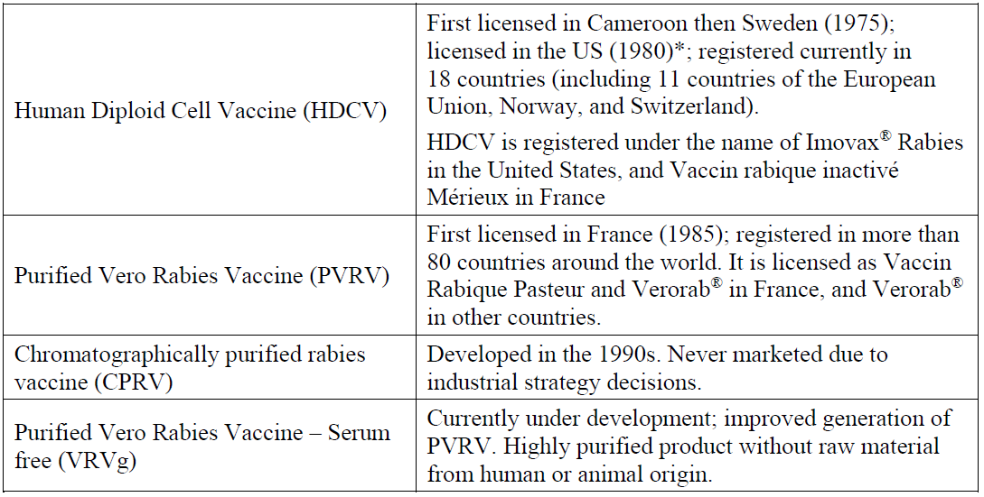
Abbreviations: CPRV = chromatographically purified rabies vaccine; HDCV = human diploid cell vaccine; PVRV = purified Vero rabies vaccine; US = United States; VRVg = serum free purified Vero rabies vaccine.
* Biological license: 103931

Study 37 (RAB40 trial) using purified Vero cell rabies vaccine given intradermally for post-exposure prophylaxis with 5-year booster
Study 37 (the RAB40 trial) is a Phase III, single centre, open label, randomised, controlled trial to evaluate intradermal Verorab post-exposure prophylaxis (PEP) immunogenicity and safety after a one-week, 4-site, intradermal PEP regimen (4-4-4-0-0) followed by a one visit, 4-site, intradermal booster at five years in 598 patients (full analysis set) aged 50 years or younger (actual range: 0 to 49 years old), with WHO Category II or III exposure; within 48 hours prior.
The study was conducted in the Philippines between 29 June 2012 and 14 November 2018.

Primary objective
The primary objective of this study is to demonstrate that PEP using the one-week, 4-site (4-4-4-0-0) intradermal vaccination regimen is not inferior to PEP using the updated Thai Red Cross (2-2-2-0-2) intradermal vaccination regimen in terms of seroconversion rate at Day 14 (Group 1 versus Group 3, and Group 2 versus Group 3).

Product
The sponsor’s purified Vero cell rabies vaccine (PVRV) product contains 2.5 international units (IU) or more of inactivated rabies virus (Wistar rabies strain PM/WI38 1503-3M) with a 0.1 mL dose per intradermal injection site.
Patients exposed to a suspected rabid animal were allocated in a 1:1:1 ratio to one of the following:
- Group 1: patients with WHO Category II exposure received a one-week (4-4-4-0-0), 4-site intradermal vaccination regimen.
- Group 2: patients with WHO Category III exposure received a one-week (4-4-4-0-0), 4-site intradermal vaccination regimen and purified equine rabies immunoglobulin Favirab.
- Group 3: patients with WHO Category III exposure received PEP, using the updated Thai Red Cross (2-2-2-0-2) intradermal vaccination regimen and purified equine rabies immunoglobulin Favirab.
- All groups received a single visit, 4-site booster vaccination 5 years later.
Patients with WHO Category III exposure were randomised in Groups 2 and 3. Patients with WHO Category II exposure were automatically assigned to Group 1.²⁵
Out of the total 600 patients, 509 (84.8%) patients were enrolled and included in the per-protocol; analysis set with 90 (15.0%) excluded, most often due to a missing valid test result.
Non-inferiority would be demonstrated, if the null hypothesis were rejected at significance level of 2.5% (Type I error). Conclusion was based on the lower bound of the two-sided 95% confidence interval (CI) of the difference of anti-rabies virus neutralising antibody titre proportions at Day 14 (using Wilson score method without continuity correction).

Magnitude of the treatment effect and its clinical significance
Following vaccination, nearly all subjects showed anti-rabies virus neutralising antibody titres of 0.5 IU/mL or higher.
At Day 14, seroconversion rates were 100% in Group 1, 99.4% in Group 2, and 98.8% in Group 3. Three subjects did not reach the seroconversion threshold (one in Group 2 and two in Group 3). Geometric mean titres (GMTs) increased from Baseline to values slightly higher in Group 1 (10.8 IU/mL) and Group 2 (9.77 IU/mL) than in Group 3 (5.89 IU/mL).
At Day 90, seroconversion rates were 98.2% in Group 1, 94.9% in Group 2, and 98.2% in Group 3. GMTs decreased from Day 14 values to 3.16 IU/mL in Group 1, 1.76 IU/mL in Group 2, and 2.53 IU/mL in Group 3.
The lower limits of the two-sided 95% CIs of the differences between seroconversion rates were above delta (-5%) for both comparisons, demonstrating the non-inferiority of the ‘one-week 4-site’ intradermal regimen versus the ‘updated 2-site Thai Red Cross’ schedule in both full analysis set and per-protocol analysis set (see Table 4 below).
Table 4: Study 37 (RAB40 trial) Non-inferiority test - proportion of subjects with anti-rabies virus neutralising antibody titre of 0.5 IU/mL or higher at Day 14 according to the group - rapid fluorescent focus inhibition test (per-protocol analysis set)
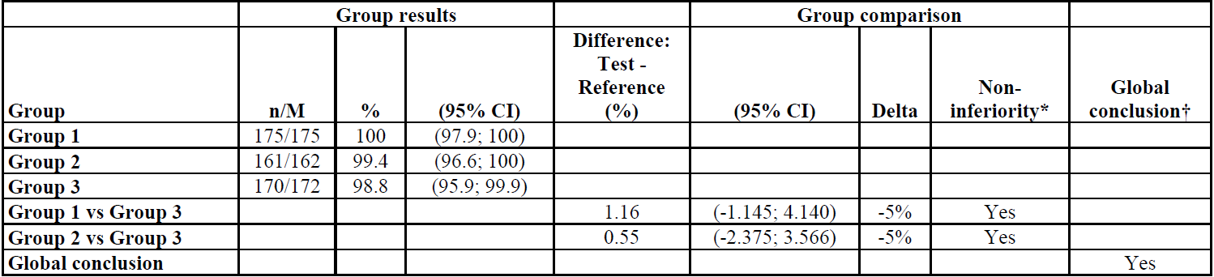
Abbreviations: CI = confidence interval; M = number of subjects with available data for the relevant endpoint; n = number of subjects experiencing the endpoint; vs = versus.
* Non-inferiority concluded if the limit of the two-sided 95% CI of the difference was above delta.
† Global conclusion: primary objective demonstrated if the non-inferiority demonstrated for both scenario: between Group 1 (investigational regimen) and Group 3 (reference regimen) and between Group 2 (investigational regimen) and Group 3 (reference regimen).
Group 1: World Health Organization (WHO) Category II exposure, post-exposure prophylaxis one-week, 4-site (4-4-4-0-0) intradermal regimen
Group 2: WHO Category III exposure, post-exposure prophylaxis one-week, 4-site (4-4-4-0-0) intradermal regimen plus purified equine rabies immunoglobulin Favirab
Group 3: WHO Category III exposure, post-exposure prophylaxis updated 2-site Thai Red Cross (2-2-2-0-2) intradermal regimen plus purified equine rabies immunoglobulin Favirab
All groups received a 4-site intradermal booster vaccination at Year 5.

Descriptive analysis of antibody persistence
Rates of subjects showing anti-rabies virus neutralising antibody titres of 0.5 IU/mL or higher remained globally stable from Year 1 to 5 with higher rates in Group 1 (95.7% or higher), intermediate in Group 2 (80.1% or higher) and lower in Group 3 (from 79.8% on Year 1 to 60.0% on Year 4).
Five years after the last dose of the Primary Vaccination Phase (Year 5) and before the booster vaccination, the percentage showing anti-rabies virus neutralising antibody titres remaining 0.5 IU/mL or higher were 97.6% (Group 1), 84.8% (Group 2), and 64.1% (Group 3) (see Figure 1 below).
Overall, a trend to a slight decrease of GMTs and geometric mean titre ratios (GMTRs) was observed over the persistence period in Groups 1 and 2 while the decrease was more pronounced in Group 3.
Figure 1: Study 37 (RAB40 trial) Seroconversion rate from Day 14 to Year 5 and 11 days (full analysis set)
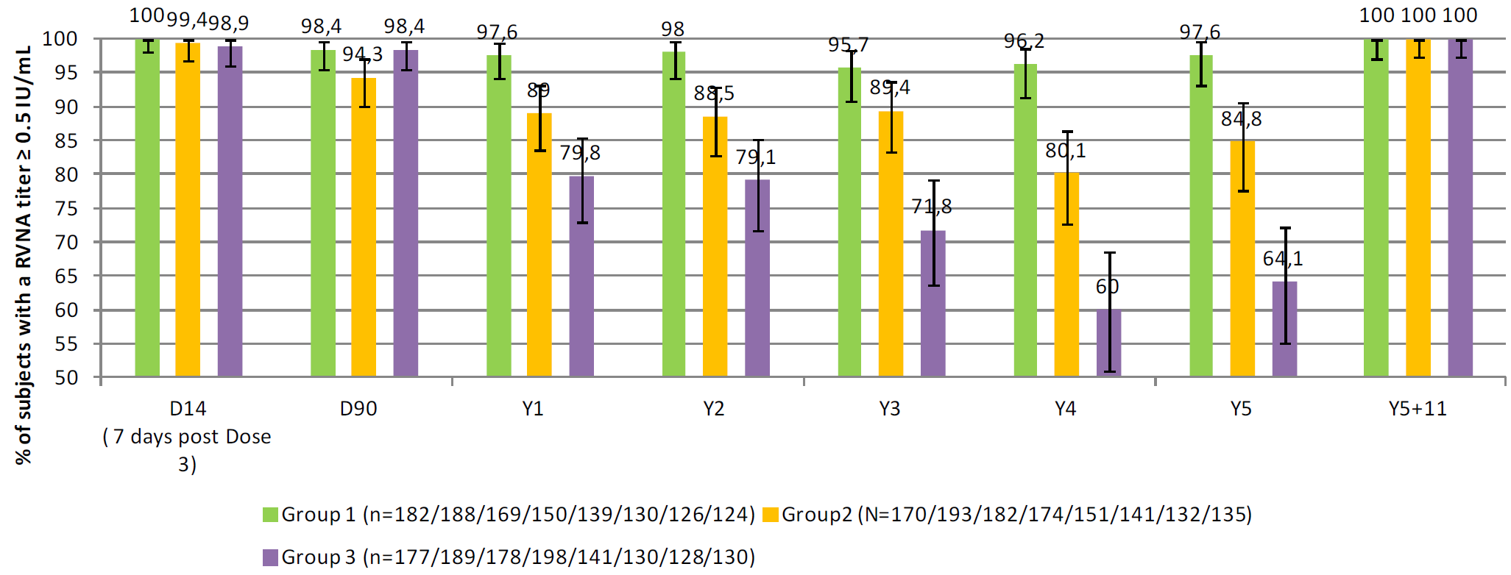
Abbreviations: D =Day; RVNA = rabies virus neutralising antibody; N = number of subjects; n = number of subjects; Y = Year.

Single visit intradermal booster results
All patients in all 3 groups (100%) had anti-rabies virus neutralising antibody titres of 0.5 IU/mL or higher at 11 days after the booster (Year 5 plus 11 days).

Study 38 (VRV08 trial) using serum free purified Vero rabies vaccine or purified Vero cell rabies vaccine given intramuscularly for post-exposure prophylaxis
Study 38 (the VRV08 trial) is a Phase III, single centre, observer blind, randomised, controlled non-inferiority trial to compare the immunogenicity of intramuscular serum free purified Vero rabies vaccine (VRVg) PEP to intramuscular PVRV PEP in 816 patients (randomised) aged 10 to 17 years old, or aged 18 years old post exposure to a rabid animal (Categories I, II, or III).
The study was conducted in China between 17 April 2011 and 10 March 2012.

Primary objective
The primary objective of this study is to demonstrate that VRVg is at least as immunogenic as the reference vaccine, Verorab vaccine, in terms of proportion of subjects with a rabies virus neutralising antibody titre of 0.5 IU/mL or higher at Day 14 in subjects aged 10 to 17 years old and 18 years and older.

Primary endpoint
Day 14 (before the fourth injection) proportion of subjects with an rabies virus neutralising antibody titre of 0.5 IU/mL or higher by rapid fluorescent focus inhibition test.

Products
Patients exposed to a suspected rabid animal were allocated in a 2:1 ratio to one of the following vaccines with the Wistar Pitman Moore rabies strain WI38-1503-3M using one dose of 0.5 mL to be injected via the intramuscular route in a 5-dose schedule (at Days 0, 3, 7, 14 and 28):
- sponsor’s VRVg 2.5 IU or higher
- sponsor’s PVRV (Verorab) 2.5 IU or higher
There were 816 patients randomised. Of these, 544 are in the VRVg group and 272 in the PVRV group. In the two age groups, the mean age was similar, which are 12.8 years old for the VRVg group versus 12.5 years old for the PVRV group for patients aged 10 to 17 years old; and 43.5 years old for the VRVg group and 44.0 years old for the PVRV group for subjects aged 18 years and older. All subjects were Asian.
Non-inferiority would be demonstrated in each age group if the lower limit of the 95% CI of the difference between the two proportions (proportion for VRVg minus the proportion for PVRV) at Day 14 were more than -5%.

Magnitude of the treatment effect and its clinical significance
At Day 14 (before the fourth injection), all subjects aged 10 to 17 years old had a rabies virus neutralising antibody titre of 0.5 IU/mL or higher. In subjects aged 18 years and older, all but 2 subjects, one in each vaccine group, had a rabies virus neutralising antibody titre of 0.5 IU/mL or higher. In the per-protocol analysis set, the non-inferiority of the immunogenicity of VRVg versus that of PVRV (Verorab) in terms of proportion of subjects with an rabies virus neutralising antibody titre of 0.5 IU/mL or higher was demonstrated in both age groups (see Table 5 below).
Table 5: Study 38 (VRV08 trial) Primary endpoint results - proportions of subjects with rabies virus neutralising antibody titre of 0.5 IU/mL or higher at Day 14 according to vaccine group - rapid fluorescent focus inhibition test (per-protocol analysis set)
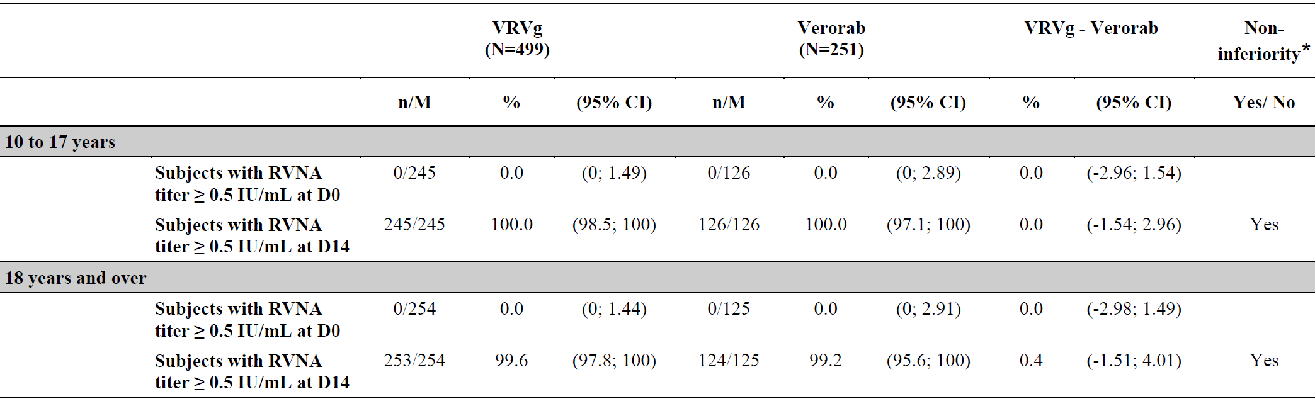
Abbreviations: CI = confidence interval; D = Day; M= number of subjects with available data for the relevant endpoint; N = total number of subjects; n = number of subjects experiencing the endpoint; RVNA = rabies virus neutralising antibody; VRVg = serum free purified Vero rabies vaccine
* Non-inferiority concluded if the low limit of the two-sided 95% CI of the difference serum free purified Vero rabies vaccine Verorab for proportion of subjects with rabies virus neutralising antibody titre of 0.5 IU/mL or higher is more than -5.0%.

Study 36 (VRV01 trial) using serum free purified Vero rabies vaccine or purified Vero cell rabies vaccine given intramuscular with one-year booster for pre-exposure prophylaxis
Study 36 (the VRV01 trial) is a Phase II, blind observed, controlled, randomised (2:1), multicentre (6 sites) study exploring the immunogenicity of the VRVg in comparison with PVRV in pre-exposure use in 384 (full analysis set) healthy adults aged 18 to 60 years old.
The study was conducted in the France between 20 July 2009 and 14 February 2011.

Primary objective
The primary objective of this study is to demonstrate that VRVg is at least as immunogenic as the reference vaccine, Verorab PVRV, in terms of seroconversion rate at Day 42, that is, 14 days after the last vaccination of primary vaccination series.

Primary endpoint
Seroconversion status at Day 42: rabies virus neutralising antibody titre of 0.5 IU/mL or higher by rapid fluorescent focus inhibition test.

Products
Patients were allocated in a 2:1 ratio to one of the following vaccines with the Wistar Pitman Moore rabies strain WI38-1503-3M using one dose of 0.5 mL to be injected via the intramuscular route in a 3-dose schedule (at Days 0, 7, and 28):
- sponsor’s VRVg is 2.5 IU or higher
- sponsor’s PVRV (Verorab) is 2.5 IU or higher
All subjects received 3 vaccinations for primary series (at Days 0, 7 and 28), and a booster vaccination at 12 months after the first vaccination. Subjects randomised to VRVg for the primary series received VRVg for the booster vaccination, and subjects randomised in the Verorab PVRV group for the primary series were randomised to boosting with either VRVg or Verorab PVRV.
There are 385 subjects randomised in the study at Visit 01. Of these, 257 are in VRVg group and 128 are in the Verorab PVRV group. Among the 384 subjects included in the full analysis set at Day 0, 377 (98.2%) were present at Visit 05 (that is, 28 days after the third injection), and 347 subjects (90.7%) completed the follow-up post-primary series and the booster part of the study.
In both groups, the average age of subjects was 39.0 years old, and more than 91% of subjects were White with slightly more female than male subjects in both groups. Baseline characteristics were similar between groups. Similar baseline characteristics were observed in subjects who participated in the booster part of the study.
Non-inferiority would be demonstrated if the lower limit of the 95% CI of the difference between the two proportions (proportion for VRVg minus the proportion for PVRV) at Day 42 were more than -5%.

Magnitude of the treatment effect and its clinical significance
All subjects in the per-protocol analysis set were naïve to rabies prior to vaccination. At Day 42 (that is, 14 days after the third vaccine injection), all but one subject in the VRVg group had a rabies virus neutralising antibody titre of 0.5 IU/mL or higher. In the per-protocol analysis set, the non-inferiority of the immunogenicity of VRVg versus that of Verorab PVRV in terms of proportion of subjects with an rabies virus neutralising antibody titre of 0.5 IU/mL or higher was demonstrated (see Table 6 below). This conclusion was confirmed in the full analysis set.
Table 6: Study 36 (VRV01 trial) Primary endpoint results - proportions of subjects with rabies virus neutralising antibody titre of 0.5 IU/mL or higher at Day 42 according to vaccine group - rapid fluorescent focus inhibition test (per-protocol analysis set)
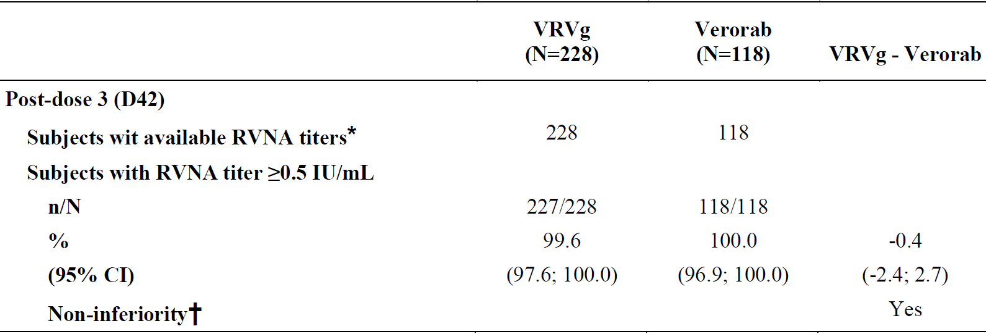
Abbreviations: CI = confidence interval; D = Day; N = total number of subjects; n = number of subjects experiencing the endpoint; RVNA = rabies virus neutralising antibody; VRVg = serum free purified Vero rabies vaccine.
* Available with a valid result
† Non-inferiority concluded if the low limit of the two-sided 95% CI of the difference serum free purified Vero rabies vaccine Verorab for proportion of subjects with rabies virus neutralising antibody titre of 0.5 IU/mL or higher is more than -5.0%.

Antibody persistence 6 and 12 months after the first injection
In the full analysis set, at 6 months after the first vaccine injection, rabies virus neutralising antibody titres decreased in both vaccine groups to values close to 1 IU/mL. The decrease in GMTs tended to be greater for the VRVg group than in for the Verorab PVRV group. GMTs further decreased up to 12 months after the first vaccine injection and were lower than 1 IU/mL in both groups before the booster vaccination. At least 90% of subjects still had detectable rabies virus neutralising antibody titres at 12 months (rabies virus neutralising antibody titres of 0.5 IU/mL or higher were present in 77.5% for the VRVg group and 80.5% for the Verorab PVRV group).

Booster
At 14 days after booster injection, all but one subject included in the VRVg group had protective levels of rabies virus neutralising antibody titres. For VRVg, GMTs increased to 27.1 IU/mL, for Verorab VRVg GMTs increased to 28.4 IU/mL and for Verorab, GMTs increased to 22.5 IU/mL. Regardless of the vaccine received, a strong immune response to booster vaccination was observed.

Study VAJ00001 using sponsor’s purified Vero cell rabies vaccine given intramuscularly or intradermally for pre-exposure and simulated post-exposure prophylaxis
Study VAJ00001 is a Phase III, multicentre, open label, randomised, controlled non-inferiority trial to evaluate the immunogenicity and safety of Imovax and Verorab rabies vaccine in pre-exposure prophylaxis (PrEP) and simulated (at one year) PEP regimens in 570 healthy patients aged 2 years and older.
The study was conducted in the Philippines (endemic rabies area) between 26 September 2018 and 8 April 2020.
Only the secondary objectives are relevant to Verorab: PrEP immunogenicity (at Baseline and 14 days after vaccination), antibody persistence (6 months and one year after the last PrEP vaccination, and simulated PEP immunogenicity. Only descriptive analyses were conducted for the secondary results.

Products
Patients were allocated to one of the following vaccines with the Wistar Pitman Moore rabies strain WI38-1503-3M:
- Imovax human diploid cell vaccine
- Verorab purified Vero cell rabies vaccine

Allocation
There are 570 healthy subjects aged 2 years and older randomised with an allocation ratio of 6:3:2:2:2 to 5 groups:
- Group 1 received one intramuscular dose of Imovax human diploid cell vaccine (1.0 mL) on Days 0 and 7 (short human diploid cell vaccine intramuscular PrEP regimen)
- Group 2 received one intramuscular dose of Imovax human diploid cell vaccine (1.0 mL) on Days 0, 7 and 21 (reference)
- Group 3 received 2 intradermal doses of Imovax human diploid cell vaccine (2 x 0.1 mL) on Days 0 and 7 (short human diploid cell vaccine intradermal PrEP regimen)
- Group 4 received one intramuscular dose of Verorab PVRV (0.5 mL) on Days 0 and 7 (short PVRV intramuscular PrEP regimen)
- Group 5 received 2 intradermal doses of Verorab PVRV (2 times 0.1 mL) on Days 0 and 7 (short PVRV intradermal PrEP regimen)

Intradermal dosing
One intradermal dose is 0.1 mL, that is, one tenth of the intramuscular dose for human diploid cell vaccine, and one fifth of the intramuscular dose for PVRV.
One year after the last PrEP injection (Year 1), subjects received a simulated PEP regimen for pre-immunised individuals consisting of 2 doses administered 3 days apart:
- Groups 1 and 2 received one intramuscular dose of Imovax human diploid cell vaccine on Year 1 and Year 1 plus 3 days
- Group 3 received one intradermal dose of Imovax human diploid cell vaccine on Year 1 and Year 1 plus 3 days
- Group 4 received one intramuscular dose of Verorab PVRV on Year 1 and Year 1 plus 3 days
- Group 5 received one intradermal dose of Verorab PVRV on Year 1 and Year 1 plus 3 days
All the 570 randomised subjects were included in the PrEP full analysis set and in the PrEP safety analysis set. There were 524 (91.9%) subjects included in the PrEP per-protocol analysis set. The composition of PrEP full analysis set and PrEP per-protocol analysis set used for immunogenicity assessments enabled to perform the non-inferiority testing in the primary objective.
There were 514 (90.2%) randomised subjects included in the simulated PEP full analysis set and simulated PEP safety analysis set. There were 488 (85.6%) randomised subjects included in the simulated PEP per-protocol analysis set.
The population consisted of 52.8% female subjects, which was balanced for sex. The mean age at inclusion was 22.5 years old (ranged from 2.0 to 59.0 years old). The majority of subjects (314 (55.1%)) were aged 18 to 64 years old. No elderly subjects were enrolled. Baseline demographics in each analysis set were similar in the PrEP and simulated PEP vaccination phases.

Magnitude of the treatment effect and its clinical significance
The primary objective was to evaluate non-inferiority between different Imovax regimens which was not demonstrated but is not relevant to Verorab. The secondary objectives are relevant to Verorab (Groups 4 and 5).

Immunogenicity at 14 days after the last pre-exposure prophylaxis vaccination
Nearly all subjects showed rabies virus neutralising antibody titres of 0.5 IU/mL or higher, to the exception of 7 subjects in Group 1, one subject from each of Groups 3 and 4, and 2 subjects in Group 5:
- The seroconversion rates were 96.7% (Group 1), 100% (Group 2), 98.6% (Groups 3 and 4) and 97.2% (Group 5).
- Geometric mean titres (IU/mL) increased from Baseline in all groups to reach values from 3.18 in Group 1 up to 12.6 in Group 2 at 14 days after the last PrEP vaccination. GMT was higher in Group 2 (reference intramuscular human diploid cell vaccine regimen) than in all other Group.
- For Groups 1 and 3 (short intramuscular and intradermal human diploid cell vaccine regimens), GMTRs versus Baseline were close to 30. For Groups 4 and 5 (short intramuscular and intradermal Verorab PVRV regimens), GMTRs were equal to 44.9 and 59.2, respectively, while GMTR for Group 2 reached 115.
- Dataset analysis: the immunogenicity results were similar in the PrEP full analysis set and in the PrEP per-protocol analysis set.
- Age analysis: all subjects aged 2 to 17 years old seroconverted in all 5 groups. In addition, GMTs tended to be higher in children than in adults.

Antibody persistence
- At 6 months and one year after the last PrEP vaccination, the percentages of seropositive subjects (rabies virus neutralising antibody titres of 0.2 IU/mL or higher) remained quite high, ranging from 71.8% to 89.0%.
- Seroconversion rates (rabies virus neutralising antibody titres of 0.5 IU/mL or higher) after 6 months were ranged from 45.2% in Group 3 to 65.2% in Group 5. GMTs decreased between 14 days and 6 months after last PrEP vaccination in all 5 Groups.
- Seroconversion rates (rabies virus neutralising antibody titres of 0.5 IU/mL or higher) after one year were ranged from 57.8% in Group 1 to 77.8% in Group 5. GMTs were slightly higher than after 6 months, ranged from 0.607 in Group 1 to 0.934 in Group 5; they were similar in Groups 1, 2, and 3 (human diploid cell vaccine regimens) and in Groups 4 and 5 (PVRV regimens). GMTRs (Day 180/Day 35 and Year 1/Day 35) in Group 2 were lower than GMTRs (Day 180/Day 21 and Year 1/Day 21, respectively) in all other Groups.
- Dataset analysis: Similar results were observed in the PrEP per-protocol analysis set.

Immunogenicity of the simulated post-exposure prophylaxis regimen
- At 7 and 14 days after the first simulated PEP vaccination, all subjects but one in Group 5 (non-responder throughout) showed rabies virus neutralising antibody titres of 0.5 IU/mL or higher.
- In all groups, antibody levels increased rapidly after the simulated PEP vaccination. The highest GMTRs (subject rabies virus neutralising antibody titres ratios 7 and 14 days after the first simulated PEP vaccination/one year after the last PrEP vaccination) were observed in Groups 1 and 4 (short intramuscular PrEP regimens): close to 60 at 7 days and close to 135 at 14 days.
- Age analysis: higher seroconversion rates were observed in the youngest subjects. Overall, GMTRs in the simulated PEP vaccination phase were similar in the different age classes. The highest Ab levels were reached in subjects aged 2 to 11 years from Group 4.
- Dataset analysis: similar results were observed in the simulated PEP per-protocol analysis set.

Other efficacy studies
Additional studies with an efficacy component were provided by the sponsor and were generally consistent with the findings of the pivotal studies.

Safety
Generally, the following terminology was used across studies:
- Immediate events: defined as unsolicited systemic events (including for the integrated analysis) or unsolicited events (not for the integrated analysis) reported within the 30 minutes after vaccine injection.
- Solicited injection site reactions: injection site adverse events in the integrated analysis in 0 to 7 days post-vaccination.
- Solicited systemic reactions: considered vaccine related, and in the integrated analysis stratified by age group.
- Unsolicited non-serious injection site adverse events were considered as adverse reactions. For the integrated analysis, unsolicited adverse events included immediate adverse events or adverse reactions, and excluded solicited reactions that were reported between injections and up to 28 days after the last injection.

Exposure
More than 200 million doses of sponsor’s PVRV vaccine have been administered worldwide. More than 13,000 individuals (aged 2 to 98 years old) have been exposed to sponsor’s PVRV in numerous sponsor’s studies, including 2344 subjects as PrEP and 11,126 subjects as PEP (see Table 7 below).
This included 1,790 subjects who received a sponsor’s PVRV booster dose 1 to 5 years after the primary sponsor’s PVRV immunisation, 202 subjects who received a sponsor’s PVRV booster after a different primary rabies vaccine, more than 1,000 children (under 18 years old), and 150 patients bitten by a confirmed rabid animal.
More than 10,000 individuals have been exposed to Verorab in studies not conducted by the sponsor, including studies with use in pregnancy.
Table 7: Exposure by administration method or dosing regimen
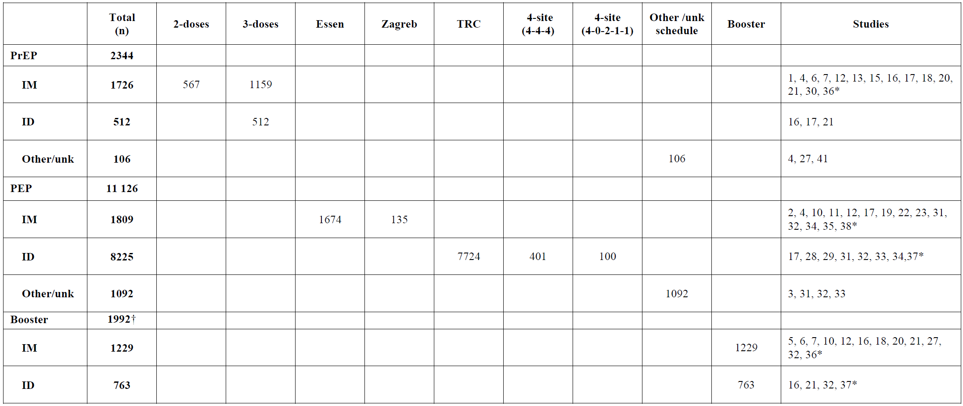
Abbreviations: ID = intradermal; IM = intramuscular; n = number of subjects; PEP = post-exposure prophylaxis; PrEP = pre-exposure prophylaxis; TRC = Thai Red Cross.
*Study included in the integrated analysis
†Including 1,790 subjects previously vaccinated with purified Vero cell rabies vaccine in sponsor’s clinical trial and 202 subjects who had previously received another rabies vaccine or had vaccination history out of the clinical trial settings.
Study 37 (the RAB40 trial) did not include a 6-month safety follow-up.

Exposure in Study VAJ00001
There were 570 subjects in the PrEP group, and 514 subjects in the simulated PEP group.

Adverse event/reaction overview

Integrated safety analysis of pivotal studies (Studies 36, 37 and 38)
Few subjects experienced immediate unsolicited adverse events (0.8%), immediate unsolicited adverse reactions (0.2%), and adverse events leading to study discontinuation (0.6%).
Solicited reactions were reported by 82.4% (under 2 years old; small sample at n = 17), 75.4% (2 to 11 years old), 52.5% (12 to 17 years old), 61.7% (18 years and older). Adverse reactions were generally of mild intensity and appeared within 3 days after vaccination. Most reactions resolved spontaneously within 1 to 3 days after onset. The most frequent systemic adverse reactions in all age groups were headache, malaise, and myalgia.
Injection site pain was the most frequent injection site reaction for both routes of administration. Comparing under 18 years old group and 18 years and older group, the proportion of solicited injection site reactions was 60.9% versus 47.6% (that is, higher in paediatric and adolescent subjects). Injection site reactions (pain, erythema and swelling) were more frequent following intradermal injection versus intramuscular injection.
There were 36.4% of the participants experienced at least one unsolicited non-serious systemic adverse event. They were reported by 82.4% (under 2 years old; small sample at n = 17), 47.5% (2 to 11 years old), 21.3% (12 to 17 years old) and 32.8% (18 years and older).
A summary of solicited and unsolicited systemic and injection site reactions by system organ class and preferred term is provided in Table 8 below.
Table 8: Solicited and unsolicited systemic and injection site adverse reactions (regardless of route of administration) up to 28 days after any sponsor’s purified Vero cell rabies vaccine injection by System Organ Class and Preferred Term
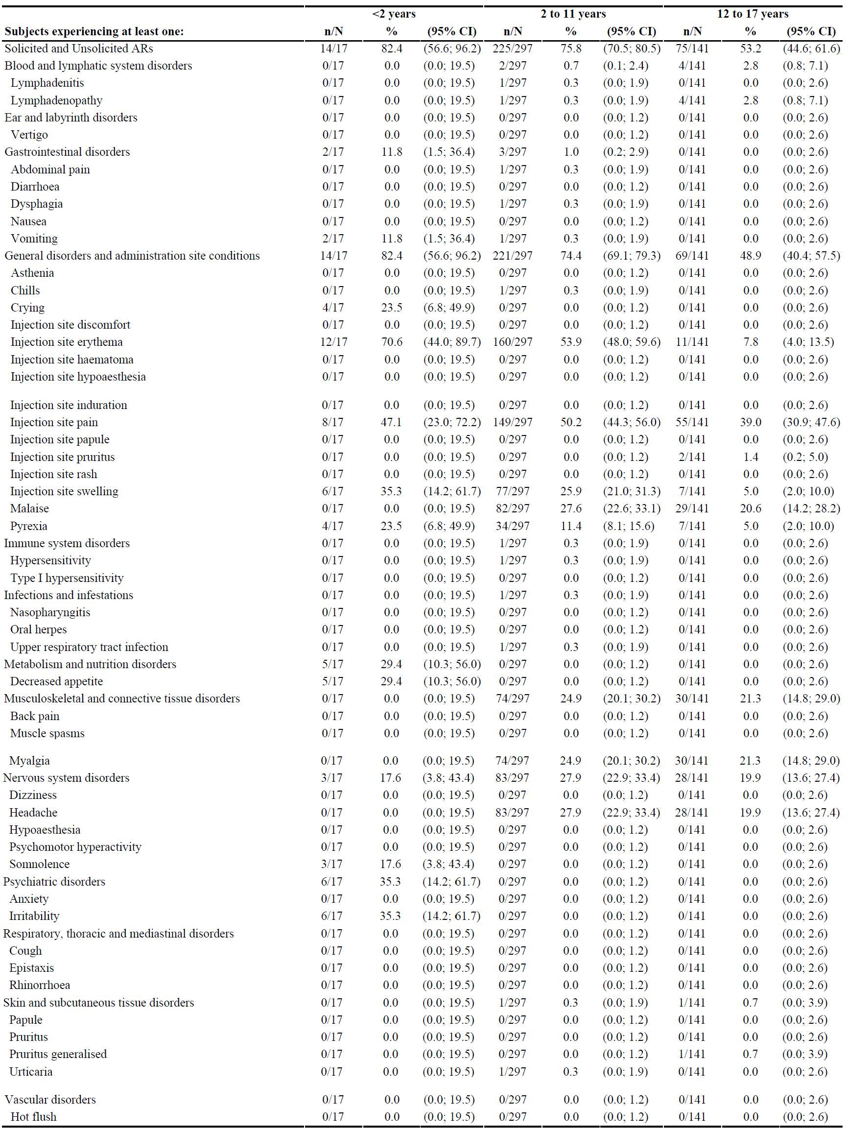
Abbreviations: AR = adverse reaction; CI = confidence interval; N = total number of subjects; n = number of subjects in the subgroup.
Table 8 continued: Solicited and unsolicited systemic and injection site adverse reactions (regardless of route of administration) up to 28 days after any sponsor’s purified Vero cell rabies vaccine injection by System Organ Class and Preferred Term
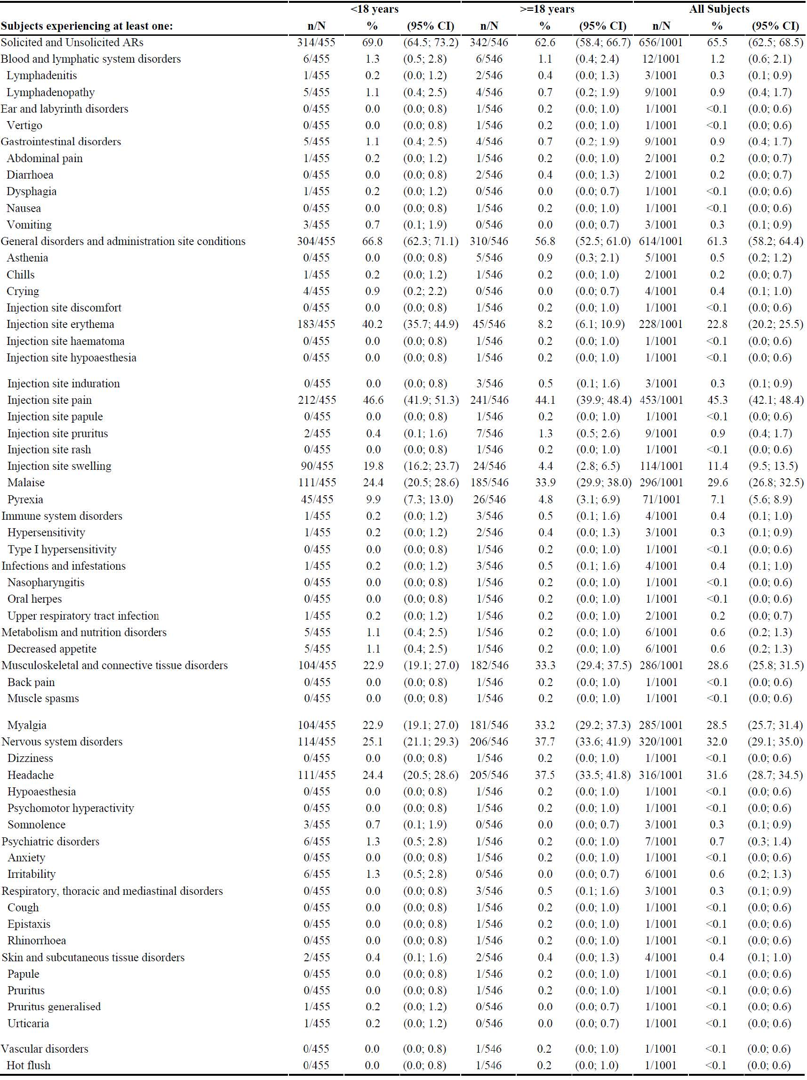
Abbreviations: AR = adverse reaction; CI = confidence interval; N = total number of subjects; n = number of subjects in the subgroup.

Study VAJ0001
Comparing the rates of injection site and systemic reactions in the sponsor’s PVRV groups to the integrated safety analysis data (pivotal studies), they were lower for all events, except for fever in children (with similar rate: 9.9%), and injection site pain for the intramuscular route (Group 4) in children reported more frequently (28% in Study VAJ00001 versus 14% in the previous analysis). This was similar in the simulated PEP phase. Unsolicited adverse reactions were all nonserious and included upper respiratory tract infection, and nasopharyngitis. No unsolicited adverse reactions were reported in the simulated PEP phase.
In other PrEP intramuscular studies, immediate reactions were generally mild in intensity, and resolved quickly, usually without intervention. No severe or Grade 3 immediate adverse events were reported.
The most frequently reported injection site reactions included pain (10% or more), redness, induration, erythema, and itching. Injection site reactions tended to decrease with subsequent intramuscular sponsor’s PVRV vaccinations.
The most frequently reported solicited systemic reactions included insomnia (in infants or toddlers), fever, and headache, reported by 15% or less of subjects in any study. Other systemic reactions of fatigue, asthenia, nausea, vomiting, rash, influenza like symptoms, and arthralgia (in adults) were each reported in less than 10% of subjects. Most were mild or moderate and generally resolved quickly without treatment. Severe or Grade 3 solicited systemic reactions were infrequent and included fever, headache, malaise and myalgia.

Other pre-exposure prophylaxis intradermal studies
Immediate reactions were generally mild or moderate in intensity and resolved quickly, usually without intervention. No severe or Grade 3 immediate adverse events were reported. Higher rates (primarily redness) were seen with intradermal sponsor’s PVRV compared with intramuscular sponsor’s PVRV.
The most frequently reported injection site reactions included induration, pruritus and redness. In a study that compared the incidence of adverse events in intradermal and intramuscular PrEP and PEP, injection site pruritus, often associated with mild regional lymphadenopathy, was reported more often with intradermal sponsor’s PVRV (23% of intradermal sponsor’s PVRV subjects versus 2.7% of intramuscular sponsor’s PVRV subjects), indicating that intradermal sponsor’s PVRV is more reactogenic than intramuscular sponsor’s PVRV.
The most frequently reported solicited systemic reactions included fever, unusual crying (in infants or toddlers), irritability (in infants or toddlers), and insomnia (in infants or toddlers), particularly after the first injection (decreasing with subsequent injections). No severe or Grade 3 solicited systemic reactions were reported.
Other reactions included influenza like symptoms reported in less than 10% of subjects. Most of these reactions were mild or moderate in intensity and generally resolved quickly, usually without treatment. Non-serious unsolicited systemic adverse events were reported infrequently.

Other post-exposure prophylaxis intramuscular studies
Immediate reactions were generally mild or moderate in intensity and resolved within one to two days of onset.
The most frequently reported injection site reactions included pain, redness, induration, erythema, and pruritus. Severe or Grade 3 injection site reactions were reported for less than 3.0% of sponsor’s PVRV treated subjects in any study and included pruritus, rash, and injection site pain.
The most frequently reported solicited systemic reaction was fever (ranged approximately between 2% to 23%). Other reactions included headache, weakness, influenza like symptoms, vertigo, and fatigue (all less than 15% of subjects). Arthralgia was reported in 0.3% to 6.3% of subjects. Most of these reactions were mild or moderate in intensity and generally resolved quickly. Severe or Grade 3 solicited systemic reactions were reported infrequently and included fever, pruritus, dyspnoea, oedema, and urticaria. The rates tended to decrease with subsequent intramuscular sponsor’s PVRV vaccinations. Non-serious unsolicited systemic adverse events were reported infrequently.

Other post-exposure prophylaxis intradermal studies
Immediate reactions were generally mild in intensity and typically resolved within 7 days. The most frequently reported injection site reactions included pain, erythema, pruritus, and redness. In one study, 2 subjects each experienced one episode of severe erythema after the second vaccination administration. The rates injection site reactions tended to decrease with subsequent intradermal sponsor’s PVRV vaccinations.
The most frequently reported solicited systemic reaction was fever (less than 10% of subjects). ‘Influenza like symptom’ reactions were reported in 0.6% of subjects. Most of these reactions were mild or moderate in intensity; only one severe or Grade 3 solicited systemic reaction was reported (fever).
Non-serious unsolicited systemic adverse events were reported infrequently. In one study, an unsolicited adverse event of coughing (rate not specified) was reported within 7 days or more after vaccination. In another study, the most frequently reported non-serious unsolicited adverse events included coughing (9.6%), upper respiratory tract infection (8.0%) and rhinitis (3.2%). They were mild or moderate in intensity.

Deaths

Integrated safety analysis of pivotal studies (Studies 36,37 and 38)
Two deaths were reported in Study 37 (the RAB40 trial) (during the yearly follow-up phase). Neither death was considered related to the study vaccine.

Study VAJ0001
No deaths were reported in the sponsor’s PVRV group.

Other pre-exposure prophylaxis intramuscular studies
No deaths were reported.

Other pre-exposure prophylaxis intradermal studies
No deaths were reported.

Other post-exposure prophylaxis intramuscular studies
Two deaths were reported. Neither was considered as related to the vaccine.

Other post-exposure prophylaxis intradermal studies
In one study, a 6-year old male died due to rabies infection 28 days post-exposure. In another study, 2 deaths were reported during the yearly follow-up phase, which were considered unrelated to vaccine. In a safety survey of 7,660 subjects, 16 deaths were reported, of which 14 were considered not related to rabies exposure or treatment. 7 were due to cardiac conditions, 2 due to gastrointestinal conditions, 2 due to stroke, and one case each of diabetes mellitus, tuberculosis, kidney failure and car accident. The time interval of the reported deaths varied between 35 days and 16 months (with a mean of 7.4 months) after the last vaccination.

Serious adverse events

Integrated safety analysis of pivotal studies (Studies 36, 37 and 38)
There were 2.3% of subjects in Study 36 (the VRV01 trial) and in Study 38 (the VRV08 trial) experienced a serious adverse event up to 6 months after the last vaccination. A higher proportion (11.8%) in the under 2 years old group experienced serious adverse events compared to the other age groups. One subject (0.2%) aged 18 years and older experienced a related serious adverse event (pulmonary embolism). No other serious adverse events were assessed to be vaccine related.

Study VAJ0001
No serious adverse events were reported in the sponsor’s PVRV group.

Other pre-exposure prophylaxis intramuscular studies
Serious adverse events were reported infrequently, and all were assessed as unrelated to sponsor’s PVRV.

Other pre-exposure prophylaxis intradermal studies
No serious adverse events were reported.

Other post-exposure prophylaxis intramuscular studies
No serious adverse events were reported.

Other post-exposure prophylaxis intradermal studies
Serious adverse events were reported infrequently, and all were assessed as unrelated to sponsor’s PVRV.

Discontinuations

Integrated safety analysis of pivotal studies (Studies 36, 37 and 38)
There were 0.6% of all subjects experienced a non-serious adverse event that resulted in discontinuation from the study. Two subjects aged from 2 to 11 years old in Study 36 (the VRV01 trial) discontinued due to non-serious adverse events (Grade 2 urticaria and Grade 1 malaise).

Study VAJ0001
No discontinuations were reported in the sponsor’s PVRV group.

Other pre-exposure prophylaxis intramuscular studies
No discontinuations were reported.

Other pre-exposure prophylaxis intradermal studies
No discontinuations were reported.

Other post-exposure prophylaxis intramuscular studies
No discontinuations were reported.

Other post-exposure prophylaxis intradermal studies
No discontinuations were reported.

Specific safety issues

Allergic reactions
In the integrated analysis, only one case of serious allergic reaction (severe pruritus with skin rash) was reported from clinical trials involving more than 13,000 subjects. This case did not meet the Brighton Collaboration definition for anaphylaxis. However, other serious cases of allergic reactions, including cases of anaphylaxis and angioedema, have been reported from post-marketing surveillance. Overall, among 65 cases retrieved from Global Pharmacovigilance Database using Standardised Medical Dictionary for Regulatory Activities (MedDRA) Query (SMQ) anaphylaxis reaction (algorithmic) for cumulative period from 1993 to 2019, there have been 35 cases meeting the Brighton collaboration definition of anaphylaxis, including 25 cases reported after Verorab (Level 1 has 4 cases, Level 2 has 9 cases, Level 3 has one case, and ‘reported anaphylaxis’ has 11 cases), and 10 cases after vaccination with rabies vaccine from unknown manufacturer from countries in which Verorab has been distributed. This leads to a reporting rate after Verorab of 0.012 per 100,000 doses distributed, with stable reporting over time.

Serum sickness
Cumulatively from worldwide sources (reporting rate of 0.004 per 100,000 doses), all these cases were insufficiently documented to confirm the diagnosis of serum sickness or of serum sickness like reaction. In addition, in the 7 cases in which time to onset was compatible with receipt of rabies prophylaxis, the patients also were taking drugs known to trigger serum sickness or serum sickness like reaction: anti-rabies serum (5 cases) or amoxicillin plus clavulanic acid (co-amoxiclav, 2 cases). In the remaining 2 cases, time to onset and symptoms were not reported. Therefore, these cases of serum sickness reported in temporal association after sponsor’s PVRV administration are not considered as causally associated with Verorab, and serum sickness type reactions are no longer considered as a potential risk for Verorab.

Genotoxicity
No genotoxicity studies have been performed with Verorab.

Carcinogenicity
No carcinogenicity studies have been performed with Verorab.

Serious skin reactions
A causal association between erythema multiforme and Verorab was investigated in 2015 in response to an invitation received from the Uppsala Monitoring Centre (WHO Collaborating Centre for International Drug Monitoring) to comment on a draft WHO signal for rabies vaccine and erythema multiforme or Stevens-Johnson syndrome. A thorough review of the data available in the database did not suggest a causal relationship between vaccination with sponsor’s rabies vaccines and erythema multiforme or Stevens-Johnson syndrome.

Safety in special populations

Paediatric populations
No studies were conducted for pre-term newborns and neonates (birth to 27 days).
For infants and toddlers (28 days to 23 months), at least 298 infants or toddlers received sponsor’s Vero cell rabies vaccine (PVRV) in the sponsor’s clinical trials focused on paediatric population. No significant safety issue was identified for this population.
For children (2 years to 11 years), at least 600 children received the sponsor’s PVRV in sponsor-led clinical trials focused on paediatric population. This is an approximate value, as detailed age split is not available in most of the trials conducted in the 1980’s to 1990’s. No significant safety issue was identified for this population.
For adolescents (12 years to 17 years), at least 201 adolescents received the sponsor’s PVRV in sponsor-led clinical trials. This is an approximate value, as detailed age split is not available in most of trials conducted in 1980’s to 1990’s. No significant safety issue was identified for this population.

Elderly population
Subjects over 65 years of age were included in most of the Sanofi Pasteur sponsored studies conducted in adults or in the general population, and the oldest subject enrolled was 98 years old. However, detailed age split was not available in most of the cases. No significant safety issues were identified in elderly subjects.

Use in pregnancy and lactation
Current WHO guidelines do not recommend the use of PrEP in pregnant women. However, the sponsor states that given the severity of the disease, pregnancy is not a contraindication for rabies vaccination, and the administration of PEP should be considered according to the category of exposure. Verorab as PrEP should be given to pregnant women only if clearly needed and following an assessment of the risks and benefits.
The sponsor did not conduct any studies in pregnant women as part of the clinical development plan. Nonetheless, 14 cases of use in pregnancy were reported due to accidental use in pregnant woman or women becoming pregnant within a few weeks after exposure. No safety issues were observed in these pregnancies.
In addition, data of Verorab administration in pregnant women available from studies conducted by researchers other than the sponsor indicated no safety issues for pregnant and lactating women and infants. Several studies conducted in Thailand and India evaluated the safety of Verorab for PEP during pregnancy. A total of 260 pregnant patients (from 15 to 37 years of age) with WHO Category II and III bites²⁵ received Verorab with or without rabies immunoglobulin through Essen-intramuscular or Thai Red Cross intradermal regimens.
In the case series studies in Thailand, spontaneous abortions occurred in 4.2% of pregnancies, a rate similar to that in the general population. The rates of complications (that is, 4.2% hypertension, 1.6% gestational diabetes mellitus, 1.6% stillbirth, and 2.6% low birth weight) were also comparable with those in non-vaccinated women. Adverse reactions were mild, transient, and required no treatment. The most frequent reactions at the injection site were pain (3.7% to 10.8%), erythema (1.1% to 1.8%), pruritus (1.8% to 10.8%) and lymphadenopathy (1.8% to 9.7%). The most frequent systemic reactions were fever (14% to 18.3%) and myalgia (9.7% to 13.8%). No congenital malformations were detected. All infants were well during one year follow-up.
In the case series studies in India, none of the women experienced any adverse events. The intrauterine growth and development monitored by ultrasound examination were found to be normal and the outcome of pregnancy was satisfactory. There were no congenital anomalies in any of the infants born and they were healthy and had normal growth and development during the one-year follow-up.

Co-administration with other vaccines
Several of the supportive studies explored the impact of administration of Verorab with other childhood vaccines (Studies 18 and 21) or typhoid vaccine (Study 15). There appeared to be no negative impact on immunogenicity or safety of Verorab or the concurrently administered vaccines, and vice versa.

Immunocompromised patients
The sponsor has not conducted any studies in immunocompromised population. Given the vaccine type, no safety issues directly linked to the vaccine are anticipated. There may however be a poor immune response to the vaccine. For patients with impaired immune function, a serological test should be performed 2 to 4 weeks after vaccination to assess the possible need for an additional dose of the vaccine.

Hepatic or renal impairment
Hepatic or renal impairment are not specifically studied.

Post-market data
Data from post-marketing experience support a good safety profile in all ages.

Risk management plan
The sponsor has submitted European Union (EU)-risk management plan (RMP) version 2.1 (dated 3 March 2020; data lock point (DLP) 1 January 2020) and Australia specific annex (ASA) version 1.0 (dated 30 July 2021) in support of this application.
There are no proposed safety concerns and therefore no routine risk minimisation activities. This is consistent with the EU-RMP and is acceptable.
Further information regarding the TGA’s risk management approach can be found in risk management plans for medicines and biologicals and the TGA's risk management approach.

Risk-benefit analysis

Delegate’s considerations

Study design and correlate of protection
For ethical reasons, efficacy trials of rabies vaccines are not performed. Efficacy is indirectly assessed using the immune response as defined by the World Health Organization (WHO); specifically through the immunogenicity profile with a seroprotection threshold of rabies virus neutralising antibodies of 0.5 international unit (IU)/mL or higher using the rapid fluorescent focus inhibition test assay as indicator of adequate adaptive immune response or seroconversion. Both individual rabies virus neutralising antibody and geometric mean rabies virus neutralising antibody titres (geometric mean titre (GMT); 95% confidence interval (CI)) in a given set of subjects are generally assessed.
The rabies virus neutralising antibody titre at the 50% effective dose corresponds to the highest dilution of serum that neutralises 50% of the challenge virus. The endpoint neutralising titre of the test serum is reported in IU/mL after calibration with the endpoint neutralising titre of the reference serum which is tested in the same assay run.
The correlate of protection against the rabies disease widely accepted and used as a reference is a rabies virus neutralising antibody titre of at least 0.5 IU/mL. This cut-off value determines seroconversion or adequate vaccination in all age groups. Day 14 is most commonly cited in the literature as the day by which protective target antibody levels should have been reached for those receiving post-exposure prophylaxis (PEP) even though the antibody measured on that day is a mixture of both passive and active antibody, as passive immunotherapy with rabies immunoglobulin is given with vaccination, unless the subject is already rabies vaccinated.
The rapid fluorescent focus inhibition test has been shown to be at least as sensitive as the mouse neutralisation test in measuring rabies virus neutralising antibody, and results have also been shown to correlate well with other tests such as the soluble antigen fluorescent antibody test, passive haemagglutination, and radio immunoassays.

Efficacy
The immunogenicity and clinical effectiveness of Verorab in paediatric and adult populations for both pre-exposure prophylaxis (PrEP) and PEP has been demonstrated in numerous studies conducted over more than 30 years. The clinical trial program features extensive clinical data of varying quality. The studies identified by the clinical evaluator as pivotal provided the most robust data.
Several PrEP schedules (via both intramuscular and intradermal routes) were assessed in multiple clinical studies. After the primary series, almost all vaccinees reached the WHO defined protective serum antibody titre of 0.5 IU/mL or higher at 14 days after the last vaccination.
Several PEP schedules by intramuscular and intradermal routes with or without immunoglobulin were assessed in multiple clinical studies. Almost all vaccinees reached antibody titres of 0.5 IU/mL or higher at Day 14, and almost all had seroconverted by Day 42.
Several studies involving both paediatric and adult populations have also confirmed the persistence of protection with booster doses triggering a rapid and strong anamnestic response in the same range and lasting up to 10 years (longest period assessed).
Detailed information on the potential effects of age and gender on the immune response across studies were not documented for studies conducted in the 1980s to 1990s; however, no differences in immunogenicity between male and female subjects were anticipated for this inactivated vaccine, and where specifically examined (Study 38 (the VRV08 trial)), there were no significant differences.

Immunogenicity of paediatric population
In PrEP intramuscular studies, subjects aged from 2 months to 76 years received the sponsor’s purified Vero cell rabies vaccine. No individual study included a comparison of immune response based on age.
In PrEP intradermal studies, 2 studies included subjects from 2 to 5 months of age (Study 21) and from 5 to 12 years of age (Study 16). The percentages of subjects with rabies virus neutralising antibody titres of 0.5 IU/mL or higher were 98.9% (93 out of 94) in Study 16, and 100% (116 out of 116) in Study 21, one month after the last dose.
In PEP intramuscular studies, the immunogenicity in subjects aged less than 18 years was established in 6 studies (Studies 11, 22, 23, 32, 35, and 38). The results showed that several different PEP regimens of the sponsor’s purified Vero cell rabies vaccine were highly immunogenic with a range of 98.4% to 100% of subjects reaching 0.5 IU/mL at 14 or 30 days, respectively, after the first dose. No differences in seroconversion rates or GMTs were observed based on age.
In PEP intradermal studies, Study 37 (RAB40 trial) included a direct comparison of the immune response between 4 age subgroups: under 2 years (n = 14), 2 to 11 years (n = 222), 12 to 17 years (n = 50), and 18 to 64 years (n = 233). At Day 14 and Day 90, 100% of subjects aged under 18 years had a rabies virus neutralising antibody titre of 0.5 IU/mL or higher.

Safety
The integrated safety summary includes data from Study 36 (the VRV01 trial), Study 38 (the VRV08 trial) and Study 37 (the RAB40 trial) only. The main reasons are that many of the non-included studies are rather old, and the ways to collect or define safety data differs from recent studies and/or the current standard.
The data from the integrated safety analysis are reassuring. The majority of adverse reactions reported after vaccination via the intramuscular or intradermal routes were characterised as mild and did not induce any change in the vaccination schedule. Taken as a whole, the safety data from integrated safety analysis, the portfolio of sponsor-led clinical studies conducted in adults (including elderly) and in the paediatric population (including infants, toddlers, children and adolescents) have not revealed any serious safety concerns.
The large amount of post-marketing data contributed to the favourable Verorab safety profile in all populations studied or in whom the vaccine has been administered, irrespective of administration route and schedule.

Proposed action
While a decision is yet to be made, at this stage in the submission the Delegate was inclined to approve the registration of the product.

Advisory Committee considerations
The Advisory Committee on Vaccines (ACV), having considered the evaluations and the Delegate’s overview, as well as the sponsor’s response to these documents, advised the following.

Specific advice to the Delegate
- Can the ACV comment on whether the available data are sufficient for registration of Verorab for a pre- and post-exposure prophylaxis indication?
The ACV advised that the available data are sufficient for registration of Verorab for both pre-exposure prophylaxis (PrEP) and post-exposure prophylaxis (PEP) indications. The ACV concurred with the Delegate:
The immunogenicity and clinical effectiveness of Verorab in paediatric and adult populations for both PrEP and PEP has been demonstrated in numerous studies conducted over more than 30 years. … After the primary series, almost all vaccinees reached the World Health Organization (WHO) defined protective serum antibody titre of 0.5 IU/mL or higher at 14 days after the last vaccination.
The ACV highlighted that over 13,000 individuals, including more than 1,000 children under 18 years of age, have been exposed to Verorab vaccine in the sponsor’s clinical studies. Extensive post-marketing experience exceeds 227 million doses being given worldwide.
- Paediatric data in the population under 2 years of age are rather limited. There appear to be no data for those aged under 28 days. The sponsor does not propose an age reference in the indication. Potentially, a reference to the clinical trial section in the Product Information may be appropriate.
Can the ACV comment on the indication with regard to age?
The ACV advised that it supported the proposed indication, which does not include a lower age limit. The ACV agreed that data are limited for the population under 2 years of age and that this could be noted in the Product Information (PI) under the clinical trial information.
The ACV noted that currently registered rabies vaccines and the Australian Immunisation Handbook do not include a lower age limit and that it would be appropriate to have a harmonised approach.
- In the proposed Product Information document, for pre- and post-exposure prophylaxis indications, the wording provides a variety of dosing regimens without necessarily recommending or favouring a particular one.
Some regimens (for example, intradermal regimens) are typically only used in a setting of resource constraint. This may be confusing for prescribers.
A potential solution may be to provide one recommended regimen and several alternative regimens.
Can the ACV comment on this?
The ACV advised that the multiple dosing regimens as presented in the PI appear to be clear and appropriate and give flexibility with route of delivery, dose and course duration. It is important that regimens are selected in conjunction with official local recommendations. Section 4.2.1.2.1 of the draft PI could be amended to read ‘individuals not previously immunised can be vaccinated according to one of the vaccination schedules presented in Table 4 [of the draft PI] and in accordance with official local recommendations’.
Inclusion of a range of regimens is practical to allow for choice in route of administration (for example, not all vaccine providers are skilled in intradermal delivery) and for completion of rabies post-exposure prophylaxis in Australia that started overseas.
The ACV noted that official local recommendations can change over time. As recently as May 2022 the United States Advisory Committee on Immunization Practices amended its recommendation on PrEP whereby a 2-dose (Days 0 and 7) intramuscular series replaced the 3-dose schedule (see Rao et al).
- The committee is also requested to provide advice on any other issues that it thinks may be relevant to a decision on whether or not to approve this application.
The ACV noted that ‘single use only’ is standard advice in a PI when the entire dose of a vial is used for a single intramuscular injection of 0.5 mL. However, the ACV noted that when the smaller 0.1 mL dose is administered intradermal a single vial can provide doses for several people in the same vaccination session. The ACV did not object to this approach and noted that this could overcome some resource constraints or cost issues and so encourage the protection of entire families prior to overseas travel. The ACV also noted that the Australian Immunisation Handbook permits ‘if giving rabies vaccine by the intradermal route, the 1.0 mL dose can be used for more than one person during a single vaccination session’.
The ACV noted the challenges to prescribers who irregularly administer rabies vaccines where conflicts exist between regimen recommendations in the PI and the Australian Immunisation Handbook and concurred that alignment would be preferable. For instance, there are currently no guidelines on intradermal administration for PEP in the Australian Immunisation Handbook. It was also noted that the current intramuscular PEP regimens in the Australian Immunisation Handbook do not align with either of the tabulated options in the PI. The ACV noted that the WHO promotes the use of intradermal administration of rabies vaccines as a safe, immunogenic and cost and dose sparing alternative to intramuscular administration.

Conclusion
The ACV considered this product to have an overall positive benefit-risk profile for the indication:
Verorab is indicated for pre-exposure and post-exposure prophylaxis against rabies in all age groups.
Verorab should be used in accordance with official local recommendations.
Generally, pre-exposure prophylaxis should be offered to people at high risk of exposure such as those working in rabies diagnostic or research laboratories, veterinarians, animal handlers potentially exposed to rabid animals, as well as other people (especially children) living in or traveling to high-risk areas.

Outcome
Based on a review of quality, safety, and efficacy, the TGA approved the registration of Verorab (inactivated rabies virus) 3.25 international units of rabies antigen, powder and solvent for suspension for injection, vial with diluent prefilled syringe with attached needle, indicated for the following:
Verorab is indicated for pre-exposure prophylaxis against rabies.
Verorab is indicated for post-exposure prophylaxis against rabies.
Verorab should be used in accordance with official local recommendations.

Specific conditions of registration applying to these goods
- Verorab is to be included in the Black Triangle Scheme. The PI and CMI [Consumer Medicines Information] for Verorab must include the black triangle symbol and mandatory accompanying text for five years, which starts from the date that the sponsor notifies the TGA of supply of the product.
- The Verorab EU-risk management plan (RMP) (version 2.1, dated 3 March 2020, data lock point 1 January 2020), with Australian specific annex (version 1.0, dated 30 July 2021), included with Submission PM-2021-03191-1-2, and any subsequent revisions, as agreed with the TGA will be implemented in Australia.
An obligatory component of risk management plans is routine pharmacovigilance. Routine pharmacovigilance includes the submission of periodic safety update reports (PSURs).
Unless agreed separately between the supplier who is the recipient of the approval and the TGA, the first report must be submitted to TGA no later than 15 calendar months after the date of the approval letter. The subsequent reports must be submitted no less frequently than annually from the date of the first submitted report until the period covered by such reports is not less than three years from the date of the approval letter. The annual submission may be made up of two PSURs each covering six months. If the sponsor wishes, the six monthly reports may be submitted separately as they become available.
The reports are to at least meet the requirements for PSURs as described in the European Medicines Agency’s Guideline on Good Pharmacovigilance Practices (GVP) Module VII-periodic safety update report ([Revision] 1), Part VII.B Structures and processes. Note that submission of a PSUR does not constitute an application to vary the registration.
- It is a condition of registration that all independent batches of Verorab vaccine imported into Australia are not released for sale until samples and the manufacturer’s release data have been assessed and [the sponsor] have received notification acknowledging release from the Laboratories Branch, TGA.
For each independent batch of the product imported into Australia, the sponsor must supply the following:
  - A completed Request for Release Form, available from vaccines@health.gov.au.
  - Complete summary protocols for manufacture and [quality control], including all steps in production in the agreed format.
  - At least 5 (five) vials (samples) of each manufacturing batch of Verorab vaccine with the Australian approved labels, PI and packaging (unless an exemption to supply these has been granted) representative of all batches of product seeking distribution in Australia.
  - At least 1 (one) vial (samples) of any further consignments of a manufacturing batch of Verorab vaccine with the Australian approved labels, PI and packaging (unless an exemption to supply these has been granted). Further consignments cover batches previously supplied to TGA for the purposes of batch release testing but are seeking to be supplied again.
  - If the manufacturing batch has been released in Europe or United Kingdom a copy of the EU Official Control Authority Batch Release (OCABR) certificate (or equivalent from the [United Kingdom]) must be provided.
  - Any reagents, reference material and standards required to undertake testing, as requested by Laboratories Branch, TGA.
Sponsors must provide all requested Samples and data in sufficient time (at least 5 business days) prior to any distribution date to allow the TGA to perform testing and review. Distribution of each batch of vaccine is conditional upon fulfilment of these conditions and receipt of a letter from the Laboratories Branch acknowledging release.
Samples and data should be forwarded to the Biotherapeutics Section, Laboratories Branch before release of each batch and with sufficient lead time to allow for Laboratories Branch testing.
The shipments (including reagents) to TGA are the responsibility of the Australian sponsor/agent who will be required to facilitate the import and customs clearance process.
- The sponsor must not import or supply the product without compliance with the Therapeutic Goods Order No. 91 - Standard for labels of prescription and related medicines, or without a relevant exemption.
- As agreed by the sponsor, the details of the manufacturing processing and purification steps with viral clearance capacity, or any validation studies using model viruses according to Section 6.1.1 of ICH Q5A (R1) and CPMP/BWP/268/95 must be provided by the end of 2023.
The sponsor should provide the original testing reports of the viral clearance studies using new and aged resin to demonstrate that any potential viral contamination has been managed to an acceptable level. The results must demonstrate that new and end-of-life aged resin log reduction factors are comparable for model viruses under the manufacturing conditions of Verorab.
- All GMP [Good Manufacturing Practice] clearances must be approved prior to registration and supply of product to Australia. A commitment is required from the sponsor that they maintain the validity of all manufacturer GMP clearances for the duration of product supply to Australia. Additionally, that adherence to the conditions of GMP clearance approval is upheld.
- Additional data relating to the ongoing stability study for the concentrated bulk drug substance will be submitted for Study 2: stability study to support the change of container closure system from polypropylene vials to high density polyethylene vials up to 48 months, when available.
- For all injectable products the Product Information must be included with the product as a package insert.

Attachment 1. Product Information
The PI for Verorab approved with the submission which is described in this AusPAR is at Attachment 1. For the most recent PI, please refer to the TGA PI/CMI search facility.

Therapeutic Goods Administration
PO Box 100 Woden ACT 2606 Australia
Email: info@tga.gov.au Phone: 1800 020 653 Fax: 02 6232 8605
https://www.tga.gov.au

International Committee on Taxonomy of Viruses (ACTV) (2019), Subfamily: Alpharhabdovirinae Genus: Lyssavirus. Available at: https://ictv.global/report/chapter/rhabdoviridae/rhabdoviridae/lyssavirus.
Department of Health and Aged Care (2022) Rabies and Other Lyssavirus - CDNA National Guidelines for Public Health Units, version 4.0. Communicable Diseases Network Australia. Available at: https://www.health.gov.au/resources/publications/rabies-and-other-lyssavirus-cdna-national-guidelines-for-public-health-units.
Australian Government Department of Health and Aged Care, Australian Technical Advisory Group on Immunisation (ATAGI) (2022) Rabies and Other Lyssaviruses: Clinical Features, Australian Immunisation Handbook. Available at: https://immunisationhandbook.health.gov.au/contents/vaccine-preventable-diseases/rabies-and-other-lyssaviruses#clinical-features.
World Health Organisation (WHO) (2019) Fact Sheets - Rabies. Available at: https://www.who.int/news-room/fact-sheets/detail/rabies (accessed on 1 September 2020).
New South Wales Health, New South Wales Government (2019) Rabies and Other Lyssavirus Infections (Including Australian Bat Lyssavirus) Control Guidelines. Available at: https://www.health.nsw.gov.au/Infectious/controlguideline/Pages/rabies.aspx (accessed on 1 September 2020).
World Health Organization (WHO) (2018) WHO Expert Consultation on Rabies, WHO Technical Report Series, third report. Available at: https://apps.who.int/iris/bitstream/handle/10665/272364/9789241210218-eng.pdf (accessed on 1 September 2020).
Business Queensland, Queensland Government (2019) Australian Bat Lyssavirus. Available at: https://www.business.qld.gov.au/industries/farms-fishingforestry/agriculture/livestock/animal-welfare/pests-diseases-disorders/australian-batlyssavirus (accessed on 1 September 2020).
Hanna, J.N. et al. Australian Bat Lyssavirus Infection: a Second Human Case with a Long Incubation Period, Med J Aust, 2000; 172(12): 597-599.
Francis, J.R. et al. Australian Bat Lyssavirus in a Child: the First Reported Case, Pediatrics, 2014; 133(4): e1063-7.
Samaratunga, H. et al. Non-Rabies Lyssavirus Human Encephalitis from Fruit Bats: Australian Bat Lyssavirus (Pteropid Lyssaviurs) Infection, Neuropathol Appl Neurobiol, 1998; 24(4): 331-335.
Rupprecht, C. et al., Centres for Disease Control and Prevention (CDC) Use of a Reduced (4-Dose) Vaccine Schedule for Postexposure Prophylaxis to Prevent Human Rabies: Recommendations of the Advisory Committee On Immunization Practices, MMWR, 2010; 59(RR02):1-9.
World Health Organisation (WHO) (2019). WHO Fact Sheets - Rabies. Available from: https://www.who.int/news-room/fact-sheets/detail/rabies (accessed on 1 September 2020).
Merritt, T. et al. Australian Bat Lyssavirus, Aust J Gen Pract, 2018; 47(3): 93-96.
Cabasso, V.J. et al. Rabies Immune Globulin of Human Origin: Preparation and Dosage Determination in Non-exposed Volunteer Subjects, Bull World Health Organ, 1971; 45(3): 303-315.
Merieux Inactivated Rabies Vaccine (rabies virus) was first registered on the ARTG on 21 October 1991 (ARTG number: 26675).
Rabipur (rabies virus) was first registered on the ARTG on 17 April 2018 (ARTG number: 298194).
Australian Technical Advisory Group on Immunisation (ATAGI), Australian Government Department of Health (2018) Rabies and Other Lyssaviruses, Australian Immunisation Handbook. Available at: https://immunisationhandbook.health.gov.au/contents/vaccine-preventable-diseases/rabies-and-other-lyssaviruses (accessed on 1 September 2020).
European Medicines Evaluation Agency (EMEA), Committee for Proprietary Medicinal Products (CPMP), Note for Guidance on Virus Validation Studies: the Design, Contribution and Interpretation of Studies Validating the Inactivation and Removal of Virus, CPMP/BWP/268/95, 14 February 1996.
International Conference on Harmonisation of Technical Requirements for Registration of Pharmaceuticals for Human Use (ICH) Viral Safety Evaluation of Biotechnology Products Derived from Cell Lines of Human or Animal Origin Q5A(R1), Step 4, 23 September 1999.
Good Laboratory Practice (GLP) is a code of standards following the International Council on Harmonisation (ICH) relevant to testing of medicines in laboratories during drug development.
INSERM (Institut national de la santé et de la recherche médicale) is the French National Institute of Health and Medical Research.
Pregnancy Category B2: Drugs which have been taken by only a limited number of pregnant women and women of childbearing age, without an increase in the frequency of malformation or other direct or indirect harmful effects on the human fetus having been observed. Studies in animals are inadequate or may be lacking, but available data show no evidence of an increased occurrence of fetal damage.
Typhim VI (Salmonella typhi Vi polysaccharide) was first registered on the ARTG on 13 December 1993 (ARTG number: 45073).
European Medicines Evaluation Agency (EMEA), Committee for Medicinal Products for Human Use (CHMP) Guideline on Clinical Evaluation of New Vaccines, EMEA/CHMP/VWP/164653/2005, 18 October 2006.
World Health Organization: Categories of contact and recommended post-exposure prophylaxis (PEP) Categories of contact with suspect rabid animal Post-exposure prophylaxis measures Category I - touching or feeding animals, animal licks on intact skin (no exposure) Washing of exposed skin surfaces, no PEP Category II - nibbling of uncovered skin, minor scratches or abrasions without bleeding (exposure) Wound washing and immediate vaccination Category III - single or multiple transdermal bites or scratches, contamination of mucous membrane or broken skin with saliva from animal licks, exposures due to direct contact with bats (severe exposure) Wound washing, immediate vaccination and administration of rabies immunoglobulin/monoclonal antibodies Category II and III exposures require PEP. Extracted from: World Health Organization (2018) WHO Expert Consultation on Rabies in WHO Technical Report Series, third report. Available at: https://apps.who.int/iris/bitstream/handle/10665/272364/9789241210218-eng.pdf
The per-protocol (PP) analysis is restricted to the participants who strictly adhered to the protocol. Also known as ‘on-treatment’ analysis.
Rüggeberg, j.U. et al. Anaphylaxis: Case Definition and Guidelines for Data Collection, Analysis, and Presentation of Immunization Safety Data, Vaccine, 2007; 25(31): 5675-5684.
The Medical Dictionary for Regulatory Activities (MedDRA) is a single standardised international medical terminology, developed as a project of the International Council for Harmonisation of Technical Requirements for Pharmaceuticals for Human Use (ICH) which can be used for regulatory communication and evaluation of data pertaining to medicinal products for human use. As a result, MedDRA is designed for use in the registration, documentation and safety monitoring of medicinal products through all phases of the development cycle (that is, from clinical trials to post-marketing surveillance). Furthermore, MedDRA supports ICH electronic communication within the ICH’s Electronic Common Technical Document (eCTD) and the E2B Individual Case Safety Report.
Standardised MedDRA Queries (SMQs) are groupings of terms from one or more MedDRA System Organ Classes (SOCs) that relate to a defined medical condition or area of interest. They are intended to aid in case identification.
Rao, A.K. et al. Use of a Modified Preexposure Prophylaxis Vaccination Schedule to Prevent Human Rabies: Recommendations of the Advisory Committee on Immunization Practices - United States, 2022, Weekly; 2022: 71(18): 619-627

