Australian Public Assessment Report for Spikevax
  - Active ingredient: Elasomeran
  - Sponsor: Moderna Australia Pty Ltd
May 2023

About the Therapeutic Goods Administration (TGA)
- The Therapeutic Goods Administration (TGA) is part of the Australian Government Department of Health and Aged Care and is responsible for regulating therapeutic goods, including medicines, medical devices, and biologicals.
- The TGA administers the Therapeutic Goods Act 1989 (the Act), applying a risk management approach designed to ensure therapeutic goods supplied in Australia meet acceptable standards of quality, safety, and efficacy.
- The work of the TGA is based on applying scientific and clinical expertise to decision-making, to ensure that the benefits to the Australian public outweigh any risks associated with the use of therapeutic goods.
- The TGA relies on the public, healthcare professionals and industry to report problems with therapeutic goods. The TGA investigates reports received to determine any necessary regulatory action.
- To report a problem with a therapeutic good, please see the information on the TGA website.

About AusPARs
- The Australian Public Assessment Report (AusPAR) provides information about the evaluation of a prescription medicine and the considerations that led the TGA to approve or not approve a prescription medicine submission. Further information can be found in Australian Public Assessment Report (AusPAR) guidance.
- AusPARs are prepared and published by the TGA.
- AusPARs are static documents that provide information that relates to a submission at a particular point in time. The publication of an AusPAR is an important part of the transparency of the TGA’s decision-making process.
- A new AusPAR may be provided to reflect changes to indications or major variations to a prescription medicine subject to evaluation by the TGA.

Copyright
© Commonwealth of Australia 2023
This work is copyright. You may reproduce the whole or part of this work in unaltered form for your own personal use or, if you are part of an organisation, for internal use within your organisation, but only if you or your organisation do not use the reproduction for any commercial purpose and retain this copyright notice and all disclaimer notices as part of that reproduction. Apart from rights to use as permitted by the Copyright Act 1968 or allowed by this copyright notice, all other rights are reserved and you are not allowed to reproduce the whole or any part of this work in any way (electronic or otherwise) without first being given specific written permission from the Commonwealth to do so. Requests and inquiries concerning reproduction and rights are to be sent to the TGA Copyright Officer, Therapeutic Goods Administration, PO Box 100, Woden ACT 2606 or emailed to <tga.copyright@tga.gov.au>.

Contents
List of abbreviations 4
Product submission 6
Submission details 6
Product background 8
Spikevax COVID-19 vaccine (elasomeran) 11
Regulatory status 11
Product Information 12
Registration timeline 12
Submission overview and risk/benefit assessment 13
Quality 14
Nonclinical 14
Clinical 14
Summary of clinical studies 14
Clinical studies in adult populations 20
Clinical studies in adolescent populations 35
Clinical studies in paediatric populations 47
Risk management plan 51
Risk-benefit analysis 52
Delegate’s considerations 52
Proposed action 60
Advisory Committee considerations 61
Outcome 62
Specific conditions of registration applying to these goods 63
Attachment 1. Product Information 64

List of abbreviations
Abbreviation | Meaning
ACV | Advisory Committee on Vaccines
AE | Adverse event
AESI | Adverse event of special interest
ARTG | Australian Register of Therapeutic Goods
CDC | Centers for Disease Control and Prevention (United States of America)
CHMP | Committee for Medicinal Products for Human Use (European Medicines Agency, European Union)
CI | Confidence interval
CMI | Consumer Medicines Information
COVID-19 | Coronavirus disease 2019
CPMP | Committee for Proprietary Medicinal Products (European Medicines Agency, European Union)
DLP | Data lock point
DP | Drug product
EMA | European Medicines Agency (European Union)
EMEA | European Medicines Evaluation Agency (European Union)
FDA | Food and Drug Administration (United States of America)
GM | Geometric mean
GMC | Geometric mean concentration
GMFR | Geometric mean fold rise
GMI | Geometric mean increase
GMT | Geometric mean titre
GMR | Geometric mean ratio
GVP | Good Pharmacovigilance Practices
ID₅₀ | 50% inhibitory dose
MAAE | Medically attended adverse event
MedDRA | Medical Dictionary for Regulatory Activities
MIS-C | Multisystem inflammatory syndrome in children
mITT1 | Modified intent-to-treat 1
mRNA | Messenger ribonucleic acid
PI | Product Information
PSUR | Periodic safety update report
PsVNA | Pseudotyped virus neutralisation assay
RMP | Risk management plan
RT-PCR | Reverse transcription-polymerase chain reaction
SAE | Serious adverse event
SARS-CoV-2 | Severe acute respiratory syndrome coronavirus 2
SMQ | Standardised Medical Dictionary for Regulatory Activities Queries
S-2P | SARS-CoV-2 spike protein modified with 2 proline substitutions within the heptad repeat 1 domain
Study P201 | Study mRNA-1273-P201
Study P203 | Study mRNA-1273-P203
Study P204 | Study mRNA-1273-P204
Study P301 | Study mRNA-1273-P301
TEAE | Treatment emergent adverse event
TGA | Therapeutic Goods Administration
US(A) | United States (of America)
WHO | World Health Organization

Product submission

Submission details
Type of submission: | Transition from provisional registration to full registration
Product name: | Spikevax
Active ingredient: | Elasomeran
Decision: | Approved
Date of decision: | 21 April 2023
Date of entry onto ARTG: | 24 April 2023
ARTG numbers: | 370599, 388244 and 388245
Black Triangle Scheme  for the current submission: | Yes.  This product will remain in the scheme for 5 years, starting on the date the product is first supplied in Australia.
Sponsor’s name and address: | Moderna Australia Pty Ltd  Level 6, 60 Martin Place  Sydney NSW, 2000
Dose form: | Suspension for injection
Strengths: | 0.1 mg/mL and 0.2 mg/mL
Containers: | Vial and prefilled syringe
Pack size: | 10
Approved therapeutic use for the current submission: | Spikevax (elasomeran) COVID-19 Vaccine is indicated for:  Active immunisation to prevent coronavirus disease 2019 (COVID-19) caused by SARS-CoV-2 in individuals 6 years of age and older.  The use of this vaccine should be in accordance with official recommendations.
Route of administration: | Intramuscular
Dosage: | Primary series  Individuals 6 months to < 6 years of age  Spikevax is administered as a course of 2 doses (0.25 mL, 25 µg each) from 0.1 mg/mL multi-dose vial (blue top).  Individuals 6 years to < 12 years of age  Spikevax is administered as a course of 2 doses (0.25 mL, 50 µg each) from 0.2 mg/mL multi-dose vial (red top).  Spikevax is administered as a course of 2 doses (0.5 mL, 50 µg each) from 0.1 mg/mL multi-dose vial (blue top).  Individuals 12 years of age and older  Spikevax is administered as a course of 2 doses (0.5 mL, 100 µg each) from 0.2 mg/mL multi-dose vial (red top).  It is recommended to administer the second dose 28 days after the first dose (see Section 4.4 Special warnings and precautions for use and Section 5.1 Pharmacodynamic properties of the Product Information).  Immunocompromised individuals  A third dose of Spikevax (same quantity as the first two doses) administered at least 28 days following the first two doses of this vaccine is authorised for administration to individuals who have undergone solid organ transplantation, or who are diagnosed with conditions that are considered to have an equivalent level of immunocompromise.  Booster dose  Individuals 12 years to < 18 years of age  Spikevax is administered as a single booster dose (0.25 mL, 50 µg each) from 0.2 mg/mL multi-dose vial (red top) at least 5 months after completing a primary series.  Individuals 18 years of age and older  Spikevax is administered as a single booster dose (0.25 mL or 0.5 mL, 50 µg each) from 0.2 mg/mL multi-dose vial (red top) or from 0.1 mg/mL multi-dose vial (blue top) / prefilled syringe respectively at least 6 months after completing a primary series.  The decision when and for whom to implement a booster (third dose) of Spikevax should be made based on available vaccine safety and effectiveness data (see Sections 4.4 Special warning and precautions for use and Section 5.1 Pharmacodynamic properties of the Product Information), in accordance with official recommendations.  For further information regarding dosage (including the interchangeability of Spikevax with other COVID-19 vaccines), refer to the Product Information.
Pregnancy category: | B1  Drugs which have been taken by only a limited number of pregnant women and women of childbearing age, without an increase in the frequency of malformation or other direct or indirect harmful effects on the human fetus having been observed.  Studies in animals have not shown evidence of an increased occurrence of fetal damage.  The use of any medicine during pregnancy requires careful consideration of both risks and benefits by the treating health professional. This must not be used as the sole basis of decision making in the use of medicines during pregnancy. The TGA does not provide advice on the use of medicines in pregnancy for specific cases. More information is available from obstetric drug information services in your State or Territory.

Product background
This AusPAR describes the submission by Moderna Australia Pty Ltd (the sponsor) to register Spikevax (elasomeran) 0.1 mg/mL and 0.2 mg/mL, suspension for injection, vial and prefilled syringe for the following proposed indication:
Active immunisation to prevent coronavirus disease 2019 (COVID-19) caused by SARS-CoV-2 in individuals 6 years of age and older.
The use of this vaccine should be in accordance with official recommendations.
Coronavirus disease 2019 (COVID-19) is a disease caused by infection with severe acute respiratory syndrome coronavirus 2 (SARS-CoV-2), which was first recognised internationally in late 2019 and in Australia by early 2020, and is the cause of an ongoing global pandemic. It manifests with respiratory, systemic and other organ related symptomatology. Disease severity is mainly related to respiratory presentations, and generally increases with age. Mortality in unvaccinated individuals with untreated disease is rare in childhood but increases steeply beyond 60 years of age.
In the absence of highly effective prophylactic or therapeutic medicines, active immunisation through vaccination represents the best means of preventing hospitalisation and deaths at an individual level and controlling the pandemic at a societal level.
Emerging mutated SARS-CoV-2 variants (both identified variants of concern, and future variants) pose challenges for current vaccination strategies, which until recently have been based on inducing immunity to the non-mutated spike protein that was sequenced in the original wildtype virus. In November 2021, the Omicron variant (B.1.1.529; BA.1) emerged as the most antigenically divergent variant at the time with more than 30 mutations in the spike protein, granting it transmissibility advantages. Soon after its emergence, the Omicron variant rapidly became dominant worldwide. This was followed by the emergence of various Omicron subvariants (BA.2, BA.2.75.2, BA.2.12.1, BA.4, BA.5, BQ.1.1, XBB.1 and others). As of January 2023, the Omicron BA.5 subvariant remains one of the major lineages in the United States of America (USA) but has been largely taken over by BQ and XBB subvariants.
Coronavirus disease 2019 continues to be a significant public health issue to Australians. As of 2 May 2023, for the 7-day rolling average, 31,115 cases of COVID-19 were reported across Australia (an average of 4445 cases per day), of which 2315 cases were hospitalised, 71 cases admitted to intensive care and there were five deaths. Cumulatively, there have been 11,210,651 confirmed cases and 20,119 deaths in Australia due to COVID-19 as of 3 May 2023.
As of 2 May 2023, over 66.7 million total vaccine doses have been administered since the COVID-19 Vaccination program began in February 2021.⁵ The benefits of receiving COVID-19 vaccine has been well established. These include protection from SARS-CoV-2 infection as well as progression to severe COVID-19 and death. At the time that this submission was considered, there were 5 monovalent (see Table 1 below) and 4 bivalent (see Table 2 below) COVID-19 vaccines were provisionally approved and registered in Australia., A bivalent vaccine targets two coronavirus variants, as opposed to a monovalent vaccine that targets only one variant.
Table 1: Provisional approvals for monovalent COVID-19 vaccines in Australia
Monovalent COVID-19 vaccines provisionally approved in Australia
Comirnaty COVID-19 Vaccine
Active ingredient: tozinameran; formerly known as BNT162b2 (mRNA)
Sponsor: Pfizer Australia Pty Ltd
25 February 2021  (initial registration) | Primary series: for individuals aged 16 years and over (AusPAR)  New product: 30 µg/0.3 mL concentrated suspension for injection  ARTG number: 346290
22 July 2021 | Primary series: for individuals aged 12 years and over (AusPAR)
26 October 2021 | Booster dose: for individuals aged 18 years and over (AusPAR)
3 December 2021 | Primary series: for individuals aged 5 years and over (AusPAR)  New strength/formulation: (Tris/sucrose buffer formulation), 10 µg/0.2 mL, 30 µg/0.3 mL  ARTG numbers: 377110, 377111
27 January 2022 | Booster dose: for individuals aged 16 to 17 years old (AusPAR)
7 April 2022 | Booster dose: for individuals aged 12 to 15 years old (AusPAR)
20 September 2022 | Booster dose: for individuals aged 5 to 11 years old (AusPAR)
29 September 2022 | Primary series: for individuals aged 6 months and over (AusPAR)  New strength: 3 µg/0.2 mL concentrated suspension for injection (Tris/sucrose formulation)  ARTG number: 393433
Vaxzevria COVID-19 vaccine (formerly AstraZeneca COVID-19 vaccine)
Active ingredient: ChAdOx1 (viral vector)
Sponsor: AstraZeneca Pty Ltd
15 February 2021  (initial registration) | Primary series: for individuals aged 18 years and over (AusPAR)  New product: 1 x 10¹¹ viral particles/mL, solution for injection  ARTG number: 349072
8 February 2022 | Booster dose: for individuals aged 18 years and over (AusPAR)
COVID-19 Vaccine Janssen
Active ingredient: Ad26.COV2.S (viral vector)
Sponsor: Janssen-Cilag Pty Ltd
25 June 2021  (initial registration) | Primary series: for individuals aged 18 years and over (AusPAR)  New product: 5 x 10¹⁰ virus particles/ 0.5 mL, suspension for intramuscular injection  ARTG number: 350150
Spikevax COVID-19 vaccine
Active ingredient: elasomeran (mRNA)
Sponsor: Moderna Australia Pty Ltd
9 August 2021  (initial registration) | Primary series: for individuals aged 18 years and over (AusPAR)  New product: 0.2 mg/mL, suspension for injection  ARTG number: 370599
3 September 2021 | Primary series: for individuals aged 12 years and over (AusPAR)
7 December 2021 | Booster dose: for individuals aged 18 years and over (AusPAR)
17 February 2022 | Primary series: for individuals aged 6 years and over (AusPAR)
19 July 2022 | Primary series: for individuals aged 6 months and over (AusPAR)  New strength: 0.1 mg/mL suspension for injection  ARTG numbers: 388244, 388245
19 October 2022 | Booster dose: for individuals aged 12 years and over (AusPAR)
Nuvaxovid COVID-19 vaccine
Active ingredient: SARS-CoV-2 rS vaccine with Matrix-M1 adjuvant (protein vaccine)
Sponsor: Biocelect Pty Ltd (on behalf of Novavax Inc)
19 January 2022  (initial registration) | Primary series: for individuals aged 18 years and over (AusPAR)  New product: 5 µg/0.5mL, suspension for injection  ARTG number: 355139
9 June 2022 | Booster dose: for individuals aged 18 years and over as homologous vaccination (AusPAR)
22 July 2022 | Primary series: for individuals aged 12 years and over (AusPAR)
Abbreviations: AusPAR = Australian Public Assessment Report; ARTG = Australian Register of Therapeutic Goods; COVID-19 = coronavirus disease 2019; mRNA = messenger ribonucleic acid; TGA = Therapeutic Goods Administration.
A primary vaccine series involves the vaccine doses needed for initial protection against COVID-19 disease. Typically, a primary COVID-19 vaccine series of 2 doses of the vaccine given 8 to 12 weeks apart. In most situations, the primary course consists of two doses of the same vaccine. In certain age groups or situations, the number of vaccine doses in a primary series may vary. For people with severe immunocompromise, a primary course is defined as 3 doses of a COVID-19 vaccine. ‘Third’ doses are not booster doses, but an additional dose given such as to those considered to be severely immunocompromised.
A booster dose refers to an additional vaccine dose given after the primary vaccine course. The first booster will refer to the first additional vaccine dose given after completing a 2-dose (or sometimes 3-dose) primary vaccine course.
Note: The single dose COVID-19 Vaccine Janssen has been provisionally approved, but isn’t currently being used in Australia.
Further information on vaccines can be found on the TGA website at COVID-19 vaccines, The Australian Immunisation Handbook or at the Australian Government Department of Health and Aged Care website.

Table 2: Provisional approvals for bivalent COVID-19 vaccines in Australia
Bivalent COVID-19 vaccines provisionally approved in Australia
Spikevax Bivalent Original/Omicron COVID-19 vaccine
Active ingredients: elasomeran and imelasomeran (mRNA)
Sponsor: Moderna Australia Pty Ltd
29 August 2022  (initial registration) | Booster dose: for individuals aged 18 years and over (AusPAR)  New product: 0.1 mg/mL suspension for injection. Each 0.5 mL dose contains 25 µg of elasomeran and 25 µg of imelasomeran  ARTG number: 389513
Spikevax Bivalent Original/Omicron BA.4-5 COVID-19 vaccine
Active ingredients: elasomeran and davesomeran
Sponsor: Moderna Australia Pty Ltd
20 February 2023  (initial registration) | Booster dose: for individuals aged 12 years and over (AusPAR)  New product: 0.1 mg/mL suspension for injection. Each 0.5 mL dose contains 25 µg of elasomeran and 25 µg of davesomeran  ARTG number: 399552
Comirnaty Original/Omicron BA.1 COVID-19 vaccine
Active ingredients: tozinameran and riltozinameran (mRNA)
Sponsor: Pfizer Australia Pty Ltd
28 October 2022  (initial registration) | Booster dose for individuals aged 18 years and over (AusPAR)  New Product: 30 µg/0.3 mL suspension for injection. Each 0.3 mL dose contains 15 µg of tozinameran and 15 µg of riltozinameran  ARTG number: 394890
Comirnaty Original/Omicron BA.4-5 COVID-19 vaccine
Active ingredients: tozinameran and famtozinameran (mRNA)
Sponsor: Pfizer Australia Pty Ltd
20 January 2023  (initial registration) | Booster dose: for individuals aged 12 years and over (AusPAR)  New Product: 30 µg/0.3 mL suspension for injection. Each 0.3 mL dose contains 15 µg of tozinameran and 15 µg of famtozinameran  ARTG number: 400874
Abbreviations: AusPAR = Australian Public Assessment Report; ARTG = Australian Register of Therapeutic Goods; COVID-19 = coronavirus disease 2019; mRNA = messenger ribonucleic acid; TGA = Therapeutic Goods Administration.

Spikevax COVID-19 vaccine (elasomeran)
Spikevax (elasomeran) is comprised of synthetic mRNA encoding the full-length SARS-CoV-2 spike protein modified with two proline substitutions. The mRNA is encapsulated in lipid nanoparticles, which facilitates the synthetic mRNA to enter host cells. Once the vaccine is injected, cells can take up the lipid nanoparticle containing the mRNA, express it into a protein chain that resembles the viral spike protein and present the viral antigen onto the cell surface. This elicits host’s antibody and triggers cellular immune responses, which may contribute to protection against COVID-19 caused by SARS-CoV-2.

Regulatory status
The initial provisional registration of Spikevax was approved by the TGA for use as a primary series in individuals aged 18 years and older on 9 August 2021. Use as a primary series was later expanded to include individuals aged 12 years and older on 3 September 2021. Use as a primary series was further expanded to include individuals aged 6 years and older on 17 February 2022, and then to include individuals aged 6 months and older on 19 July 2022.
The use of Spikevax as a booster dose for individuals 18 years of age and older, and use of a third dose for immunocompromised patients was approved on 7 December 2021. This was later expanded to allow for booster doses in individuals 12 years of age and older on 19 October 2022.
Table 1 (shown above) outlines the registration history of Spikevax along with links to AusPARs detailing the evaluation and approval process for each major submission.
This submission is for the transition from provisional registration to full registration of the Spikevax products listed above. Further information on the COVID-19 vaccine approval process can be found on the TGA website.
At the time the TGA considered this submission, full authorisation of Spikevax had been approved in the United States of America on 31 January 2022 for use in individuals aged 18 years and older. Full authorisation was approved in the European Union on 15 September 2022 for individuals 6 years and older, and on 20 October 2022 for individuals from 6 months to less than 6 years of age. In Canada, full authorisation was granted on 16 September 2021 for individuals aged 12 years and older; 17 March 2022 for individuals aged from 6 years to less than 12 years of age, and on 14 July 2022 for individuals aged from 6 months to less than 6 years of age.

Product Information
The Product Information (PI) approved with the submission which is described in this AusPAR can be found as Attachment 1. For the most recent PI and Consumer Medicines Information (CMI), please refer to the TGA PI/CMI search facility.

Registration timeline
The following table captures the key steps and dates for this submission.
Data were provided as a rolling submission. Under normal circumstances, TGA's assessment (for both provisional and general registration) begins once all information to support registration is available. As part of the Department of Health and Aged Care's response to the pandemic, the TGA has agreed to accept rolling data for COVID-19 vaccines and treatments, to enable early evaluation of data as it becomes available. Further information on the COVID-19 vaccine approval process can be found on the TGA website.
Table 3: Timeline for Submission PM-2022-05374-1-2
Description | Date
Submission dossier accepted and first round evaluation commenced | 19 January 2023
Evaluation completed | 24 April 2023
Delegate’s Overall benefit-risk assessment and request for Advisory Committee advice | 30 March 2023
Sponsor’s pre-Advisory Committee response | 4 April 2023
Advisory Committee meeting | 12 April 2023
Registration decision (Outcome) | 21 April 2023
Administrative activities and registration on the ARTG completed | 24 April 2023
Number of working days from submission dossier acceptance to registration decision* | 63
*Statutory timeframe for standard submissions is 255 working days

Submission overview and risk/benefit assessment
A summary of the TGA’s assessment for this submission is provided below.
Relevant guidelines or guidance documents referred to by the Delegate are listed below:
- European Medicines Agency (EMA), Committee for human medicinal products (CHMP), EMA considerations on COVID-19 vaccine approval, EMA/592928/2020, 16 November 2020.
- European Medicines Evaluation Agency (EMEA), Committee for Medicinal Products for Human Use (CHMP), Guidelines on Clinical Evaluation of New Vaccines, EMEA/CHMP/VWP/164653/2005, 18 October 2006.
- European Medicines Evaluation Agency (EMEA), Committee for Proprietary Medicinal Products (CPMP), Points to Consider on Applications with 1. Meta-Analyses; 2. One Pivotal Study, CPMP/EWP/2330/99, 31 May 2001.
- European Medicines Evaluation Agency (EMEA), Committee for Proprietary Medicinal Products (CPMP), Points to Consider on Switching Between Superiority and Non-inferiority, CPMP/EWP/482/99, 27 July 2000.
- Therapeutic Goods Administration (TGA), Access Consortium: Alignment with ICMRA Consensus on Immunobridging for Authorising New COVID-19 Vaccines, 14 September 2021.
- Therapeutic Goods Administration (TGA), Access Consortium Statement on COVID-19 Vaccines Evidence, 4 December 2020
- Therapeutic Goods Administration (TGA), Points to Consider for Strain Changes in Authorised COVID-19 Vaccines in an Ongoing SARS-COV-2 Pandemic, 5 March 2021
- Therapeutic Goods Administration(TGA), Provisional Registration Extension and Transition to Full Registration, A Step-by-Step Guide for Prescription Medicines, 21 January 2021.
- United States Food and Drug Administration (FDA), COVID-19: Developing Drugs and Biological Products for Treatment or Prevention: Guidance for Industry, February 2021.
- United States Food and Drug Administration (FDA), Development and Licensure of Vaccines to Prevent COVID-19: Guidance for Industry, June 2020.
- United States Food and Drug Administration (FDA), Emergency Use Authorisation for Vaccines to Prevent COVID-19: Guidance for Industry, 31 March 2022.
- United States Food and Drug Administration (FDA), Toxicity Grading Scale for Health Adult and Adolescent Volunteers Enrolled in Preventive Vaccine Clinical Trials, Guidance for Industry, September 2007.
- World Health Organization (WHO), Design of Vaccine Efficacy Trials to be Used During Public Health Emergencies - Points of Consideration and Key Principles, no date.
- World Health Organization (WHO), Evaluation of COVID-19 Vaccine Effectiveness, Interim Guidance, 17 March 2021.
- World Health Organization (WHO): Guidelines on Clinical Evaluation of Vaccines: Regulatory Expectations, WHO Technical Report Series 1004, Annex 9, 2017, 21 October 2020.

Quality
Spikevax is a lipid nanoparticle encapsulated messenger ribonucleic acid (mRNA) based vaccine.
The drug product is an mRNA-lipid complex dispersion that contains the drug substance. The drug product is supplied in multidose vial at 0.2 mg/mL (10 doses of 0.5 mL per vial or 20 doses of 0.25 mL per vial); multidose vial at 0.1 mg/mL (10 doses of 0.25 mL per vial); and single dose prefilled syringe at 0.1 mg/mL.
The recommended shelf life for the drug substance is 12 months from date of manufacture when stored under -90° C to -60°C. The recommended shelf life for the drug product is 9 months from the date of manufacture. The recommended storage condition for the drug product is -50°C to -15°C as long-term storage condition, which can include up to 30 days of storage at 2°C to 8°C in unopened or unpunctured vial and protected from light at the point of care site. Up to 24 hours additional in-use time at 8°C to 25°C in unopened or unpunctured vial on the day of dose administration.
Outstanding issues identified in the quality evaluation have been resolved prior to registration. The quality evaluation has confirmed that the sponsor has provided adequate information to ensure the product’s quality under full registration. It is recommended that the products applied in this submission are suitable for approval with regard to manufacturing quality, however there are specific conditions for approval.

Nonclinical
The nonclinical evaluation has confirmed the following:
- There are no nonclinical objections to transition from provisional registration to full registration of the Spikevax COVID-19 vaccine (elasomeran).
- There are no new nonclinical statements, and existing nonclinical statements in the proposed Product Information accompanying the sponsor’s letter (dated 13 December 2022) do not require evaluation or comment.
- Whilst the sponsor did not submit all the requested data (study reports and/or published data) which were requested during the provisional registration, for evaluation in this submission, this is not considered a major deficiency. Submission of the study reports or publication post-approval is acceptable.

Clinical

Summary of clinical studies
At submission the clinical dossier consisted of:
- One Phase I study: Study DMID-20-0003
- One Phase IIa study: Study mRNA-1273-P201 (abbreviated as Study P201)
- Two Phase II/III studies:
  - Study mRNA-1273-P203 (Study P203), and
  - Study mRNA-1273-P204 (Study P204)
- One Phase III study: Study mRNA-1273-P301 (Study P301).
The clinical conditions of moving from provisional to full registration for Spikevax are listed in Table 4 (paediatric population), Table 5 (adolescent population), Table 6 (adult population) and Table 7 (confirmatory trial) below, along with information on availability of clinical data to transition to full registration.
Table 4: Availability of clinical data for paediatric population (6 months to 11 years of age) to transition from provisional to full registration
Specific conditions | Availability of clinical data
Submit the interim and final analysis of Study mRNA-1273 P204 and the CSR for Study P204 when available | The final CSR for the randomised, placebo-controlled, observer-blind study mRNA-1273-P204 is expected to be available for submission 31 March 2024
Abbreviations: CSR = clinical study report; mRNA-1273 = Spikevax (elasomeran) COVID-19 vaccine drug development name.
Table 5: Availability of clinical data for adolescent population (12 through 18 years of age) to transition from provisional to full registration
Specific conditions | Availability of clinical data
Submit safety data for all adolescents 12 to17 years of age in study P203, 6-months post Dose 2, when the data become available. | A CSR for study P203 with 6 months post Dose 2 follow-up for all subjects was submitted to the TGA on 4 November 2022. This CSR included safety data of 2378 participants (95.7%) that have been followed for ≥ 168 days (6 months) or more after Dose 2.
Submit CSR of Study P203 (interim and final), including data up to 24 months after Dose 2 in adolescents 12 to17 years of age, when the data become available. | Interim long-term safety and effectiveness CSR for study P203 Parts A and B was submitted to the TGA on 4 November 2022. As the pandemic evolved and the need for booster doses was evident, Study P203 was amended to offer booster doses to all participants. As such, the follow-up for the primary series doses is limited. Therefore, we believe the CSR that has been submitted with 6 months of safety follow-up is sufficient to transition to full registration for the primary series.  The final CSR including follow up after the booster phase (Part C) is planned for 31 July 2024. As concluded in the EMA assessment report dated 16 August 2022, results from 6 months of follow-up from Study P203 evaluating the overall safety profile of mRNA-1273 in the adolescents aged ≥ 12 to < 18 years are generally consistent with the findings to date in the Phase III Study P301 in adults 18 years of age and older. No new safety signals have been observed so far and it is not expected that the remaining outstanding data in P203 will alter the benefit risk profile of Spikevax in this age group.  The EMA was of the opinion that the comprehensive existing data package for this vaccine warrants transformation of the previous conditional approval into a full marketing authorisation.
Submit safety data in relation to follow-up at 6 months post-Dose 2 for all original Spikevax recipients and at 6 months  post-Dose 4 for original placebo  recipients subsequently vaccinated with Spikevax, when the analysis is available. | Due to the 2:1 (mRNA-1273:placebo) randomisation ratio and the substantial attrition of the participants in the placebo group as these participants sought non-study vaccine, only 91 participants who were originally randomised to placebo stayed in the study and received mRNA-1273 in Part B of the Study (doses 3 and 4). The sponsor believes the limited data from this small subset of participants will not inform further on the benefit risk profile of Spikevax in this age group.
Submit the final analysis of the Booster Phase (Part 1C-1) of Study P203 and the CSR when  available. | The final analysis of the Booster Phase (Part 1C-1) of Study P203 will be available in February 2023.  The final CSR, including follow up after the booster phase (Part C), of study P203 is planned for 31 July 2024.  The final CSR can be provided as a post approval commitment to the TGA, similar to the European Union.
Abbreviations: CSR = clinical study report; EMA = European Medicines Agency; mRNA-1273 = Spikevax (elasomeran) COVID-19 vaccine drug development name.
Table 6: Availability of clinical data for adult population (18 years of age and older) to transition from provisional to full registration
Specific conditions | Availability of clinical data
Submit safety analysis at 6 months post Dose 2 from the Phase II Study P201 when the analysis is available | Phase I Study DMID-20-0003:  The final clinical study report was submitted in to TGA on 4 November 2022.  Phase II Study P201:  The following data, including follow up safety data at 6 months was submitted to TGA on 27 June 2022:  - Primary analysis clinical study report dated 23 February 2021  - Primary analysis clinical study report addendum 1 (end of Part A immunogenicity and safety) dated 13 August 2021  - Primary analysis clinical study report addendum 2 (Part B immunogenicity and safety) dated 24 May 2022.  The final clinical study report for Part C was submitted to TGA on 28 September 2022. This CSR addendum 3 (Part C) provided safety and immunogenicity results for Part C and is considered the last study report  for Study P201 marking the completion of the study.
Submit the clinical study report for Study P301 (Phase III) and Study P201 (Phase II) when ready.  Please also submit the final report for these studies with 24 months follow up duration when it became available. | Phase III Study P301:  The clinical study report (Part A) and addendum 1 dated 5 August 2021 were submitted to TGA on 27 August 2021, and 15 September 2021.  Long-term follow-up Part B and C interim clinical study report is included in this submission. This includes 6 months follow up on more than 3000 participants and will be the last piece of primary series data from Study P301.  The final clinical study report is planned for December 2023.  This CSR will report on the remaining follow up post boost.  As concluded in the EMA assessment report dated 16 August 2022, Study P301 continues to follow the safety and effectiveness of the 2-dose primary series of mRNA- 1273 in adults 18 years of age and older for 24 months.  Data summarising 6 months post dose 2 follow up have been provided and the safety profile demonstrated no unexpected reactogenicity or any new safety signals. It is not expected that the remaining outstanding data in Study P301 will alter the benefit risk profile of Spikevax.  Consequently, Study P301 was reclassified as a category 3 study (post-approval commitment) in the EU.  The EMA was of the opinion that the comprehensive existing data package for this vaccine warrants transformation of the current conditional approval into a full marketing authorisation. The sponsor believes that the existing data will also be sufficient to transition to full registration in Australia.  Phase II Study P201:  The following clinical study reports were submitted to TGA on 27 June 2022:  - Primary analysis clinical study report dated 23 February 2021  - Primary analysis clinical study report addendum 1 (end of Part A immunogenicity and safety) dated 13 August 2021  - Primary analysis clinical study report addendum 2 (Part B immunogenicity and safety) dated 24 May 2022.  Part A is primary series and Part B and C are booster reports.  The final clinical study report for Part C was submitted to TGA on 28 September 2022. This CSR addendum 3 (Part C) provided safety and immunogenicity results for Part C and is considered the last study report for P201 marking the completion of the study.  In the response to questions submitted to TGA on 29 July 2022 and 9 August 2022, it was clarified that 24 months follow up was not planned for Study P201 according to the protocol.
Submit the immunogenicity data for Study P301 | This data was included in P301 clinical study report (Part A) and addendum 1 dated 5 August 2021, which were submitted to TGA on 27 August 2021 and 15 September 2021.  Long-term follow-up Part B and C interim clinical study report is included in this submission.
When available, please provide further data relating to vaccine efficacy against asymptomatic disease, efficacy against SARS-CoV-2 transmission, vaccine efficacy in immunocompromised subjects, efficacy in subjects with autoimmune conditions, efficacy against variants of concern, pregnant women, lactating mothers, and information relating to post market safety and effectiveness studies should be provided to TGA to update the Product information. | As per this condition, further data is only to be provided, when available. Please find below information on the availability of the data.  Vaccine efficacy against asymptomatic disease:  This data was included in P301 clinical study report (Part A) dated 5 August 2021, which was submitted to TGA on 27 August 2021 and 15 September 2021.  Long-term follow-up Part B and Part C interim clinical study report is included in this submission.  Efficacy against SARS-CoV-2 transmission:  No transmission data are available or planned as this was not part of any study design.  Vaccine efficacy in immunocompromised subjects:  A Study P901 manuscript for vaccine efficacy in immunocompromised patients who have completed a 3-dose Spikevax primary vaccination scheme was submitted to TGA on 9 August 2022.  Study P304 is a Phase III study in adult solid organ transplant recipients. This study was included in the clinical study plan. As P304 is not a key study, and other data in IC patients has already been provided in the P901 manuscript, we believe the P304 study report will not be  required to transition to full registration. The final clinical study report is planned for 31 January 2024.  Efficacy in subjects with autoimmune conditions:  No data of autoimmune conditions are available or planned as this was not part of any study design.  Efficacy against variants of concern:  Study P901 manuscript titled ‘Tseng et al 2022 Nature Med- Effectiveness of mRNA-1273 against SARS-CoV-2 Omicron and Delta variants’ was submitted to TGA on 27 June 2022.  Pregnant women:  A review of all available evidence on vaccination in pregnant women and breastfeeding was conducted following a request from EMA. The data was submitted to TGA during evaluation of the Category 1 type A submission PM-2022-02203-1-2 for Spikevax Bivalent Original/Omicron, refer to the consolidation sequence dated 1 September 2022. A Category 1 Type J; Submission PM-2022-03942-1-2 to make the same changes to the Spikevax PI was submitted to TGA on 13 September 2022 and approved by TGA on 10 October 2022.  Study P902 (an observational pregnancy outcome study/pregnancy registry) was included in the original clinical study plan. This study was removed from the EU-RMP version 4.2 submitted to TGA on 8 July 2022 during the Category 1 type A submission PM-2022-02203-1-2 for Spikevax Bivalent Original/Omicron. Enrolment of study P902 has been insufficient to meet study objectives, and further challenges are expected given limited use of Spikevax in individuals < 30 years of age in some European countries.  Further data concerning safety in pregnancy will be obtained based on the ongoing Study P905 in Europe and the new secondary database study in the USA (Study P919). The final study report for Study P905 is planned for 31 December 2023 and the final study report for Study P919 is planned for 31 March 2024.  As data relating to pregnant women has already been provided to TGA in Submissions PM-2022-02203-1-2 and PM-2022-03942-1-2, the sponsor believes this data will be sufficient to transition to full registration.  Lactating mothers:  A review of all available evidence on vaccination in pregnant women and breastfeeding was conducted following a request from EMA. The data was submitted to TGA during evaluation of the Category 1 Type A; Submission PM-2022-02203-1-2 for Spikevax Bivalent Original/Omicron, refer to the consolidation sequence dated 1 September 2022. A Category 1 Type J Submission PM-2022-03942-1-2 to make the same changes to the Spikevax PI was submitted to TGA on 13 September 2022 and approved by TGA on 10 October 2022.  Information relating to post-market safety and effectiveness studies:  P903 is a US PASS, an active safety surveillance study. This study was included in the clinical study plan. A EU RTQ document referencing the Study P903 interim CSR Number 5 was submitted to TGA via email on 22 June 2022 during evaluation of the adolescent booster Submission PM-2022-00685-1-2.  The final clinical study report is planned for 30 June 2023.  If preferred by TGA, interim updates from the PASS Study P903 can be provided with the application to transition to full registration.  Regarding the post-market effectiveness study, refer to the Study P901 mentioned below.
Please also provide Real world post market global/local efficacy data, when available. | Study P901 is the real-world study of the effectiveness of the sponsor’s COVID-19 vaccine in the USA. This study was included in the clinical study plan.  The following Study P901 manuscript was submitted to the TGA on 27 June 2022:  - Tseng et al. (2022) Nature Med - Effectiveness of mRNA-1273 against SARS-CoV-2 Omicron and Delta variants. All other available Study P901 manuscripts/reports were submitted to the TGA on 9 August 2022:  - First and second interim report for the real world Study P901.  - Study P901 manuscript for VE in immunocompromised patients who have completed a 3-dose Spikevax primary vaccination scheme.  - Study P901 Manuscript for VE in patients who have received a 50 μg booster dose.
Abbreviations: COVID-19 = coronavirus disease 2019; CSR = clinical study report; EMA = European Medicines Agency; EU = European Union; mRNA-1273 = Spikevax (elasomeran) COVID-19 vaccine drug development name; PASS = post-authorisation safety study, PI = Product Information; RMP = risk management plan; RTQ = response to question; SARS-CoV-2 = severe acute respiratory syndrome coronavirus 2; USA = United States of America; VE = vaccine efficacy.
Table 7: Availability of clinical confirmatory trial data to transition from provisional to full registration
Specific conditions | Availability of clinical data
Confirmatory trial data (as identified in the sponsor’s plan to submit comprehensive clinical data on the safety and efficacy of the medicine before the end of the 6 years that would start on the day that registration would commence) must be provided. | All clinical studies relating to adults and adolescents as identified in the original Clinical Study Plan are already discussed above.
In response to a request for information by the TGA, the sponsor provide the expected due dates for the final study reports for Studies P301, 203, and 204 and a brief study synopsis for each study and description of information that are currently pending (see update provided to the TGA on 23 March 2023 in Table 8 below.
Table 8: Studies P301, P203 and P204 Study synopsis and summary of pending information
Study number and title | Anticipated date: final study report | Brief study synopsis | Information expected: final study report
Study P301 a Phase III, randomised, stratified, observer blind, placebo controlled study to evaluate the efficacy, safety, and immunogenicity of mRNA-1273 SARS-CoV-2 vaccine in adults aged 18 years and older | 19 December 2023 | Evaluate long-term safety data, immunogenicity data and COVID-19 incidence rates | The final study report which will be clinical study report Addendum 3 (open label observational phase (Part B) and Booster dose phase (Part C)) will include:  - Part B long-term safety  - Part C long-term safety of Spikevax booster dose  - Immunogenicity at late timepoints after Spikevax primary series (Day 209)  - • Immunogenicity at late timepoints after Spikevax booster (booster dose-Day 181)
Study P203 a phase II/III, randomised, observer blind, placebo controlled study to evaluate the safety, reactogenicity, and effectiveness of mRNA-1273 SARS-CoV-2 vaccine in healthy adolescents 12 to < 18 years of age | 15 July 2025 | Evaluate the safety, reactogenicity, and effectiveness of Spikevax. Assess safety and immunogenicity of mRNA-1273.222 | The final study report which will be an addendum to the completed Spikevax primary series CSR (Part 1A and Part 1B) will include:  - Part 1C-1 booster long-term immunogenicity and safety of Spikevax booster dose  - Part 1C-2: primary and secondary objectives of safety and immunogenicity of Spikevax booster as specified in the protocol  - Part 2: primary and secondary objectives of safety and immunogenicity of Spikevax low dose primary series of as specified in the protocol  - Part 3: Primary and Secondary Objectives of Safety and Immunogenicity of low dose primary series of mRNA-1273.222 as specified in the protocol  Note: Exploratory objectives/endpoints or analyses may also be included in the final study report
Study P204 a Phase II/III, two part, open label, dose escalation, age de-escalation and subsequent randomised, observer blind, placebo controlled expansion study to evaluate the safety, tolerability, reactogenicity, and effectiveness of mRNA-1273 in healthy children 6 months to less than 12 years of age | 31 March 2024 | Safety, tolerability, reactogenicity, and effectiveness of up to 3 doses of mRNA-1273 in healthy children 6 months to less than 12 years of age | The final study report which will be an addendum to the Spikevax primary series CSR (Part 1 and Part 2) will include:  - Part 1 and Part 2: Booster dose Spikevax long-term immunogenicity and safety; booster dose mRNA-1273.214 safety, in children 6 months to less than 12 years of age  - Part 3: Spikevax low dose primary series and a third dose immunogenicity and safety in children 6 to less than 12 years of age.  Note: Spikevax primary series analyses including long-term follow-up in Part 1 and Part 2 will be included in interim CSR in July 2023.
Abbreviations: COVID-19 = coronavirus disease 2019; CSR = clinical study report; mRNA-1273 = Spikevax (elasomeran) COVID-19 vaccine drug development name; SARS-CoV-2 = severe acute respiratory syndrome coronavirus-2.

Clinical studies in adult populations
Adult population is defined as those 18 years of age or older.

Study DMID-20-0003
Study DMID-20-0003 is a Phase I, open label, dose ranging study of the safety and immunogenicity of 2019 novel coronavirus vaccine (mRNA-1273) in healthy adults.
The final clinical study report (conducted 6 months post-Dose 2 of vaccine) was provided to the TGA on 4 November 2022. The clinical study report provided the interim analysis of safety and immunogenicity data through the data cut-off date of 7 October 2020 (data freeze date) and includes data through Day 119 for Cohorts 1 through 5, 7, and 8 and through Day 57 for Cohorts 10, 11, and 12.
Table 9: Study DMID-20-0003 Primary and secondary objectives and endpoints
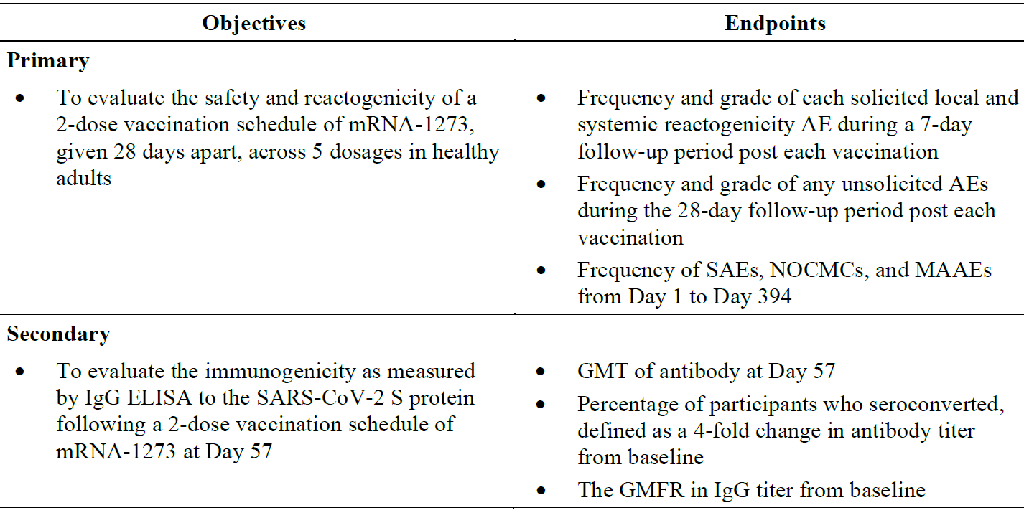
Abbreviations: AE = adverse event; ELISA = enzyme-linked immunosorbent assay; GMFR = geometric mean fold rise; GMT = geometric mean titer; IgG = immunoglobulin G; MAAE = medically attended adverse event; mRNA-1273 = Spikevax (elasomeran) COVID-19 vaccine drug development name; NOCMC = new onset of chronic medical condition; S = spike; SAE = serious adverse event; SARS-CoV-2 = severe acute respiratory syndrome coronavirus 2.
In this study, 25 μg, 50 μg, 100 μg, and 250 μg of mRNA-1273; administered as an intramuscular injection (0.5 mL) into the deltoid muscle on a 2-dose injection schedule on Day 1 and Day 29, with a 28-day interval between doses. The second dose of study vaccine was administered preferably in the same arm as the first dose.

Safety
Study results demonstrated that mRNA-1273 vaccine administered with 2 doses 28 days apart, was safe and immunogenic in healthy adult participants aged 18 years and older. After mRNA-1273 vaccine administration, fatigue, headache, myalgia, feverishness, and injection site pain were the most commonly reported solicited systemic and local adverse reactions, with higher incidence noted after the second injection than after the first injection for the solicited systemic adverse reactions . Most of the solicited adverse reactions were mild or moderate. severe solicited adverse reactions predominantly occurred at the highest dose of (250 μg). The adverse reactions lasted a median of 2 days or less. In general, adverse reactions were less severe and less commonly reported in older than in younger adults. All unsolicited adverse events (AEs) related to mRNA-1273 vaccine were mild or moderate in severity, except for 2 severe AEs reported in one participant from the 250 μg vaccination group (18 to 55 years of age group) in this study.

Immunogenicity
The study showed that mRNA-1273 vaccine induced robust binding antibody responses (SARS-CoV-2 spike protein modified with 2 proline substitutions within the heptad repeat-1 domain (S-2P) and receptor binding domain specific) after 2 injections of vaccine. Notably, 100 μg of mRNA-1273 vaccine resulted in numerically higher S-2P specific binding titres than 25 μg and 50 μg of mRNA-1273 vaccine in all age groups, and higher receptor binding domain specific binding titres in participants aged over 55 years. Two injections of mRNA-1273 vaccine induced robust neutralising antibody responses. The neutralising antibody response increased marginally after the first injection but increased substantially after the second injection. The neutralising antibody response (assessed by a pseudovirus neutralisation assay) at the 100 μg mRNA-1273 vaccine dose level was similar to that at the 250 μg mRNA-1273 vaccine dose level in the 18 to 55 years of age group and numerically higher than that observed at the 25 μg and 50 μg mRNA-1273 vaccine dose levels in the older age groups. The neutralising antibody response at the 100 μg dose was similar across all age groups. mRNA-1273 vaccine also elicited CD4 T-cell responses that, upon stimulation by spike specific peptide pools, were strongly biased toward the expression of type-1 helper cell cytokines.
The sponsor claims that based on the results of safety and immunogenicity at data cut-off, the 100 μg dose provided promising immunogenicity results in adults of all ages with an acceptable safety profile and was the dose selected for further evaluation in the Phase III clinical study.

Study P201
Study mRNA-1273-P201, (study ID abbreviated as Study P201), is a Phase IIa, randomised, observer blind, placebo controlled, dose confirmation study to evaluate the safety, reactogenicity, and immunogenicity of mRNA-1273 vaccine in adults aged 18 years and over.
Table 10: Study P201 Primary and secondary objectives and endpoints
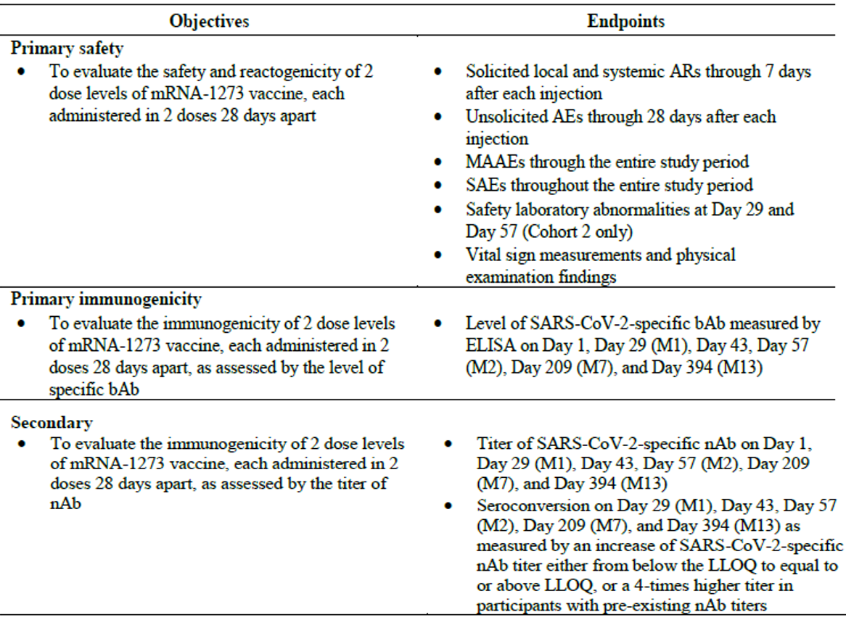
Abbreviations: AE = adverse event; AR = adverse reaction; bAb = binding antibody; ELISA = enzyme-linked immunoabsorbent assay; Ig = immunoglobulin; LLOQ = lower limit of quantification; M=month; mRNA-1273 = Spikevax (elasomeran) COVID-19 vaccine drug development name; MAAE = medically attended adverse event; nAb = neutralising antibody; S = spike; SAE = serious adverse event; SARS-CoV-2 = severe acute respiratory syndrome coronavirus that causes COVID-19.
The primary analysis clinical study report provided the primary analysis of safety and immunogenicity data through Day 57 (data cut-off date of 5 November 2020). The end-of-study clinical study report provides final analysis of all endpoints and will be completed after all participants have completed the Month 13 study procedures and the database is cleaned and locked.
Study P201 consist of 3 parts. Part A, the blinded phase, was randomised, observer blind, and placebo controlled, with adult participants at least 18 years of age. The study included cohorts of 2 age groups, which are adults aged 18 years to less than 55 years and adults 55 years and over. Each participant was to receive 2 injections of mRNA-1273 vaccine or placebo by 0.5 mL intramuscular injection on Day 1 and Day 29.
After the safety and efficacy of mRNA-1273 vaccine to prevent COVID-19 was demonstrated in the Phase III Study P301 and the US Food and Drug Administration’s (FDA) Emergency Use Authorization was given on 18 December 2020 in the USA, this Phase IIa study moved to the Part B open label interventional phase. Part B was designed to offer participants who received placebo in Part A of this study the option to receive 2 injections of open label mRNA-1273 vaccine (100 μg) and participants who received one or two doses of 50 μg or 100 μg mRNA-1273 vaccine in Part A of this study the option to receive a single booster dose of 50 μg mRNA-1273 vaccine. The 50 μg booster dose was selected as the optimal effective dose for boosting in Study P201 Part B booster.
Part C was a proof-of-concept rollover study of approximately 60 participants who were enrolled in the Phase III Study P301, had already been unblinded, and had previously received 2 doses of mRNA-1273 vaccine at least 6 months earlier. Upon enrolment into Part C of this study, participants received a single intramuscular injection of mRNA-1273.351; (20 μg or 50 μg) or mRNA-1273 and mRNA-1273.351 mixture (50 μg total) at least 6 months after receiving the second vaccination in Study P301. Safety assessments for participants in Part C included the following, collected from open label Day 1 through open label Day 181.

Study P201 Part A

Primary analysis clinical study report (dated 23 February 2021)
This study was designed to evaluate the safety, reactogenicity, and immunogenicity of mRNA-1273 COVID-19 vaccine, administered in 2 doses (50 μg or 100 μg) 28 days apart. This report is based on the primary analysis through Day 57. The full study analyses will be presented in the end-of-study clinical study report.

Safety
mRNA-1273 vaccine demonstrated an acceptable safety profile in the participant population enrolled in this study at both dose levels in cohorts from two age groups: Cohort 1 (18 to less than 55 years old) as well as Cohort 2 (55 years and older).

Immunogenicity
Vaccination with mRNA-1273 resulted in significant immune responses to SARS-CoV-2 in participants 18 years and older at both dose levels, confirming the selection of the 100-μg dose that was brought forward in the pivotal Phase III Study P301.

Primary analysis clinical study report Addendum 1 (end of Part A immunogenicity and safety) dated 13 August 2021

Safety
In this end of Part A analysis, the mRNA-1273 vaccine, administered as 2 doses (50 μg or 100 μg) 28 days apart, demonstrated an acceptable safety profile in the participant population enrolled in this study in both age cohorts: Cohort 1 (18 years to less than 55 years) and Cohort 2 (55 years and over). No new safety findings since the primary analysis (Day 57) clinical study report were identified in this end of Part A analysis.

Immunogenicity
Overall, the magnitude and kinetics of immune response for both binding antibody and neutralising antibody was consistent across dose groups and age cohorts. Study P201 provided evidence of persistence of immune response through Day 209 (6 months after the second injection of mRNA-1273 vaccine), which was lower than the peak observed at Day 43 but was higher than that at Day 29 (before the second injection). Vaccination with mRNA-1273 vaccine resulted in robust immune responses to SARS-CoV-2 in participants 18 years and older at both dose levels, and persistence of immune response was observed up to 6 months after the second injection. The titres are numerically higher in participants who received 100 μg compared with 50 μg of mRNA-1273 at Day 209. These results confirm the selection of the 100 μg dose that was brought forward in the pivotal Phase III study (Study P301).

Study P201 Part B

Primary analysis clinical study report Addendum 2 (Part B immunogenicity and safety) dated 24 May 2022
The clinical study report for Part B (known as Addendum 2) presented results for Part B participants who received a 50 μg mRNA-1273 vaccine booster dose after receiving a 50 μg or 100 μg primary vaccination series in Part A (Part B booster) and participants who received a 2-dose series of 100 μg mRNA-1273 vaccine in Part B after receiving placebo in Part A (Part B crossover).

Safety
The 50 μg mRNA-1273 booster vaccination demonstrated no unexpected reactogenicity or safety results. Findings for Part B booster participants and Part B crossover participants were consistent with those of the previously reported mRNA-1273 Part A primary series, further supporting the acceptable benefit-risk profile of the vaccination regimen.

Immunogenicity
Immunogenicity objectives for Study P201 Part B crossover part of the study were not assessed as results are not anticipated to provide any novel or additional information to already available data (Part A of Study P201 as well as in Part A of the Study P301).
Repeat analysis of the Part A samples using the validated pseudotyped virus neutralisation assay (PsVNA) confirmed a higher immunogenic primary dose response with 100 μg compared with 50 μg. The booster injection elicited a robust immune response to SARS-CoV-2 based on neutralising antibody and binding antibody responses that showed increased geometric mean (GM) levels from open label Day 1 (pre-booster) to open label Day 29 (28 days after the booster injection). Immune responses at open label Day 29 also compared favourably with those observed 28 days after the second dose of the primary series in Part A of the study; overall, post-booster geometric mean titre (GMT) 50% inhibitory dose (ID₅₀) (95% confidence interval (CI) (1,892.708 (1728.800, 2072.157) open label Day 29) was higher than GMT ID₅₀ at Day 57 (that is, 28 days after the second primary series injection) for both 50 μg or 100 μg mRNA-1273 doses (629.227 (549.327, 720.749) and 1,271.504 (1091.992, 1480.526), respectively), confirming that a 50 μg booster dose is adequate to boost neutralising antibody. Seroresponse was observed in more than 90% of participants relative to pre-booster baselines (open label Day 1) and in 100% of participants relative to pre-vaccination (Day 1) baselines.
A more than 10%-fold rise increase on binding antibodies against Alpha (B.1.1.7), Beta (B.1.351) and Gamma (P.1) variants was observed by open label Day 29 with a seroresponse rate of more than 95% from pre-booster in all 3 variants. The neutralising antibody GMT ID₅₀ titres against Beta (B.1.351), Delta (B.1.617.2) and Omicron (B.1.1.529) variants showed an increase in neutralising antibody by day open label Day 29 (neutralising antibody increased by 25-fold, 16-fold, and 30-fold, respectively) with a seroresponse rate of more than 85%.
Persistence of immune response in the 100 μg primary series group was observed through open label Day 181 (6 months post-booster). Neutralising antibodies against SARS-CoV-2 original strain and Beta (B.1.351), Delta (B.1.617.2) and Omicron (B.1.1.529) variants on open label Day 181 were lower than the peak observed at open label Day 29 but higher than open label Day 1.
Findings were generally consistent for participants in both age cohorts (18 years to less than 55 years in Cohort 1 and 55 years and over in Cohort 2) and primary series dose groups (50 μg or 100 μg mRNA-1273 vaccine).

Study P201 Part C

Primary analysis clinical study report Addendum 3 (Part C immunogenicity and safety) dated 28 September 2022
The results presented in the clinical study report Addendum 3 (dated 28 September 2022) are for Part C participants who received either 50 μg of mRNA-1273.351, 50 μg of mRNA-1273/mRNA-1273.351, or 20 μg mRNA-1273.351.¹⁶ Data for Part C of the study was collected from open label Day 1 through open label Day 181, which was the end of the Part C booster study (database lock on 23 November 2021).

Safety
Safety analyses, including reactogenicity for up to 7 days post-booster, unsolicited treatment emergent adverse events (TEAEs), medically attended adverse events (MAAEs), and serious adverse events (SAEs) were based on data collected from open label Day 1 to open label Day 181.
All booster vaccines demonstrated no unexpected reactogenicity or safety results. Findings were similar to those of Part A and Part B, as previously reported, thereby further supporting the acceptable benefit-risk profile of the booster vaccination with monovalent and bivalent variant vaccines.

Immunogenicity
Immunogenicity analyses, including neutralising antibody and binding antibody, were based on data collected from open label Day 1 through open label Day 29 for Cohorts 2 and 3, and open label Day 1 to open label Day 181 for Cohort 1.
All booster vaccines elicited robust immune responses to SARS-CoV-2 based on neutralising antibody and binding antibody responses that showed increased GM levels from open label Day 1 (pre-booster) to open label Day 29 (28 days after the booster vaccine). For the Beta variant, by open label Day 181 (180 days after the booster vaccination), the neutralising antibody geometric mean fold rise (GMFR) from open label Day 1 was 4.05 in the mRNA-1273.351 50 μg group suggesting some degree of durability of the immune response (ID₅₀ was not evaluated for the mRNA-1273/mRNA-1273.351 50 μg and mRNA-1273.351 20 μg groups at open label Day 181).¹⁶

Study P301
Study mRNA-1273-P301 (abbreviated here as Study P301) is a Phase III, randomised, stratified, observer blind, placebo controlled study to evaluate the efficacy, safety, and immunogenicity of mRNA-1273 COVID-19 vaccine in adults aged 18 years and older.
Study P301 has two parts: Part A, the blinded phase and Part B, the open label observational phase.
Part A was a randomised, stratified, observer blind, placebo controlled evaluation of the efficacy, safety, and immunogenicity of mRNA-1273 COVID-19 vaccine compared to placebo in adults 18 years of age or older. A total of 30,415 participants were randomly assigned to receive doses of either 100 μg of mRNA-1273 vaccine or placebo in a 1:1 randomisation ratio. Given that the primary efficacy endpoint for mRNA-1273 against COVID-19 was met per the protocol-defined interim analysis, Part B, the open label observational phase of this study, was designed to offer participants who received placebo in Part A of this study and who met the US FDA’s Emergency Use Authorization eligibility an option to request open label mRNA-1273 vaccine. All participants in Part A were to proceed to Part B, starting with a participant decision visit, at which time participants were given the option to be unblinded to their original group assignment. At the initiation of Part B, site personnel who were blinded during Part A were unblinded at the participant level at the participant decision visit.
Part A (blinded phase, randomisation to early unblinding or participant decision visit) of the study provides a median of 148 days of follow-up. Part B (open label observational phase, early unblinding or participant decision visit to data cut-off date) of the study provides additional follow-up of a median of 67 days. The total median follow-up period was 7.6 months from randomisation or6.5 months after Dose 2 across Part A and Part B up to database lock for the analysis.
The purpose of this addendum is to present data (descriptive summaries) from the open label observational phase (Part B) of the study based on the database lock on 4 May 2021 and includes safety and efficacy (case counts) data from early unblinding or the Part B participant decision visit to the data cut-off date (26 March 2021).
Table 11: Study P301 Clinical studies included in this submission that support the development of mRNA-1273 booster
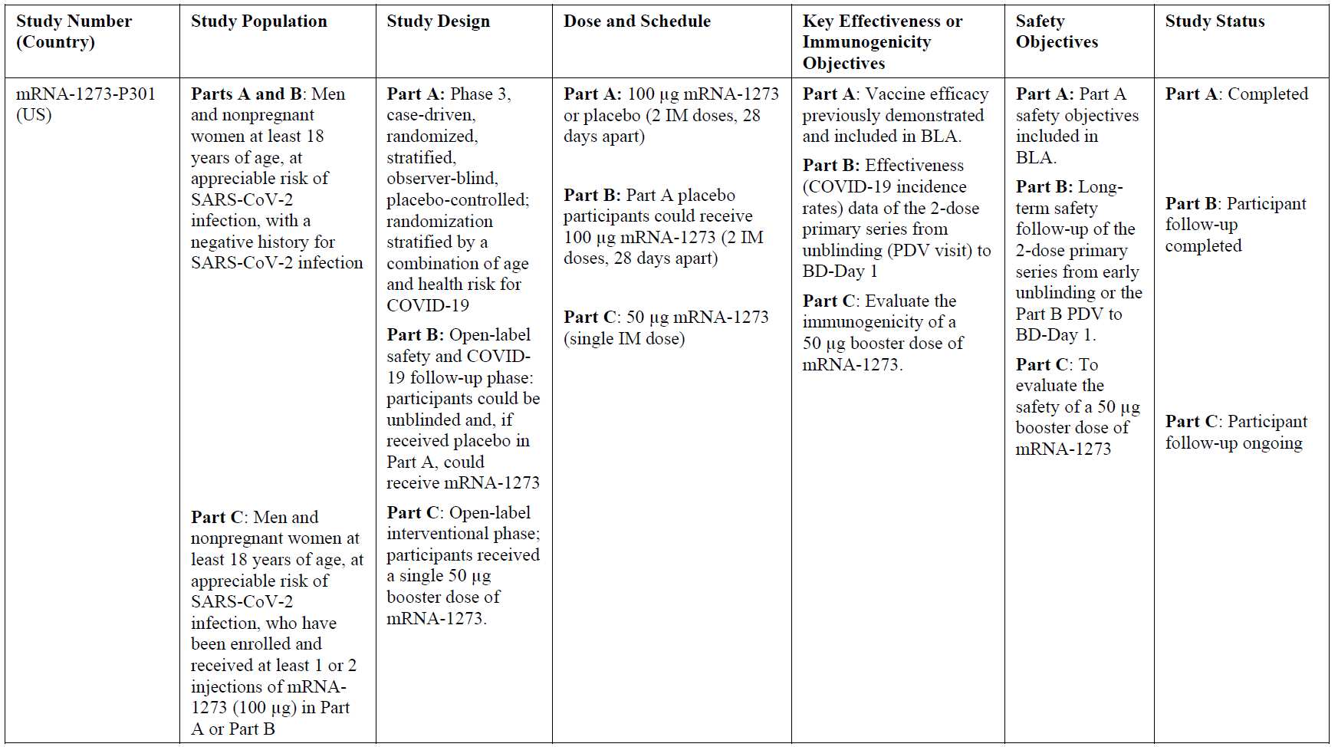
Abbreviations: BD-booster dose; BLA = biologics license application; COVID-19=coronavirus disease 2019; IM = intramuscular; mRNA-1273 = Spikevax (elasomeran) COVID-19 vaccine drug development name; PDV = participant decision visit; SARS-CoV-2 = severe acute respiratory syndrome coronavirus 2; US = United States.

Study P301 Part A and Part B (long-term follow-up for the primary series)
Data from Part A (database lock on 4 May 2021) supported the provisional registration of Spikevax for use in adults 18 years of age and older by the TGA on 9 August 2021. Three analyses of efficacy have been conducted, consistently confirming persistent efficacy over a point estimate of 93% for a median 5.3-month blinded observation period from the time of randomisation in Part A of the study. In the final analysis of the randomised, blinded phase (Part A), mRNA-1273 vaccine primary series demonstrated an acceptable safety profile.
In conclusion, this study was designed to evaluate the efficacy, safety, and immunogenicity of mRNA-1273 COVID-19 vaccine compared to placebo in adults 18 years of age and older who have no known history of SARS-CoV-2 infection but whose occupation or location and living circumstances put them at increased risk of acquiring COVID-19 and/or SARS-CoV-2 infection.
- The final efficacy analysis of the primary endpoint for Part A (4 May 2021) included 799 cases. The results of this analysis were consistent with the results of the interim and primary efficacy analyses, confirming persistent, high efficacy over a substantially larger case database and over a longer median observation period of over 5.3 months. For the final efficacy analysis, the vaccine efficacy point estimate was 93.2% (p < 0.0001) and within the 95% CIs of the vaccine efficacy point estimates for the interim and primary efficacy analyses.
  - Divergence of case incidence began early between mRNA-1273 vaccine and placebo groups, starting in the period from randomisation up to14 days after the first injection. Thereafter, cumulative incidence rate for the placebo group increased steadily while it remained stable and low in the mRNA-1273 vaccine group for the remainder of the observation period.
  - Vaccine efficacy was consistent across subgroups for the primary efficacy endpoint.
  - Vaccine efficacy was also consistent across the secondary endpoints characterised by high vaccine efficacy point estimates and tight 95% CIs, with the lower bounds of the 95% Cis well above 30%.
- mRNA-1273 vaccine was highly immunogenic as measured by both binding antibody and neutralising antibody in both SARS-CoV-2 baseline negative and baseline positive individuals, as indicated by increased binding antibody and neutralising antibody levels one month after first injection (Day 29) and one month after second injection (Day 57).
- mRNA-1273 vaccine demonstrated an acceptable safety profile in the participant population enrolled in this study. mRNA-1273 vaccine has a reactogenicity profile consistent with parenteral vaccination and generally well tolerated. No unexpected findings were identified in this final assessment of the randomised, blinded phase of the study.
As per the sponsor this report is based on the data from the randomised, placebo controlled, blinded phase (Part A) of the study. Data from Part B, in which eligible participants were offered open label mRNA-1273 vaccine, will be included in a clinical study report addendum.

Study P301 Part B (open label observational phase)

Efficacy
According to the sponsor the purpose of this clinical study report addendum is to provide the efficacy results of Part B based on the median follow-up of 67 days. For the placebo/mRNA-1273 vaccine group, incidence rates are not reported as this group had a relative short duration of follow-up after the second dose of mRNA-1273 vaccine in Part B, therefore, efficacy results for the placebo/mRNA-1273 vaccine group are not described in this clinical study report addendum.
For efficacy analyses in Part B, participants at risk were defined as participants who started the open label phase before or on the efficacy data cut-off date, had no prior SARS-CoV-2 infection (defined by positive post-baseline reverse transcription-polymerase chain reaction (RT-PCR) or Elecsys results) and were not a COVID-19 case up to participant decision visit or early unblinding, whichever was earlier.

Primary endpoint
Table 12: Study P301 Parts A and B Primary endpoint
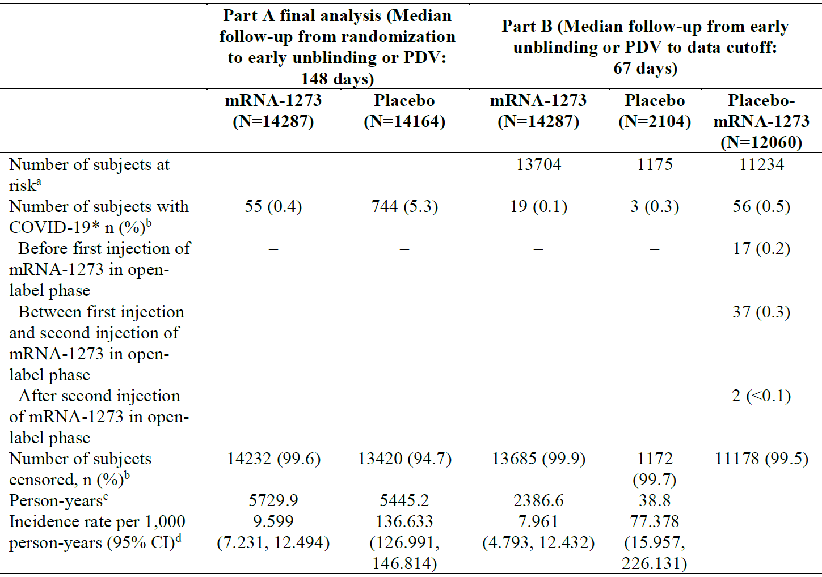
Abbreviations: CI = confidence intervals; COVID-19 = coronavirus disease 2019; mRNA-1273 = Spikevax (elasomeran) COVID-19 vaccine drug development name; N = total number of subjects; n = number of subjects in subgroup; PDV = participant decision visit.
* With the censoring rules for efficacy analyses. COVID-19 case is based on eligible symptoms and positive reverse transcription polymerase chain reaction (RT-PCR) within 14 days. If a subject had positive RT-PCR at scheduled visits without eligible symptoms within 14 days, or positive Elecsys at scheduled visits prior to becoming a COVID-19 case, the subject is censored at the date with positive RT-PCR or Elecsys.
a. Subjects at risk are defined as subjects who started the open label phase before or on efficacy data cut-off date, had no prior SARS-CoV-2 infection (defined by positive postbaseline RT-PCR or Elecsys results) and were not a disease COVID-19 case up to PDV or early unblinding, whichever is earlier.
b. Percentages in Part B are based on number of subjects at risk.
c. Person years is defined as the total years from randomisation date (Part A) or PDV/early unblinding date (Part B) to the date of COVID-19, the date of earliest positive RT-PCR or Elecsys at scheduled visits, last date of study participation, or efficacy data cut-off date, whichever is earlier.
d. Incidence rate is defined as the number of subjects with an event divided by the number of subjects at risk and adjusted by person years (total time at risk) in each treatment group. The 95% CI is calculated using the exact method (Poisson distribution) and adjusted by person years.

Secondary endpoints

Severe COVID-19
The number of severe COVID-19 cases in Part B were too low in the per-protocol; set for any meaningful comparison.

Secondary definition of COVID-19
In the mRNA-1273 vaccine group, of 13,704 participants at risk, 39 (0.3%) COVID-19 cases using the secondary definition for COVID-19 in the per-protocol set were detected. The incidence rate in Part B was 16.357 cases per 1000 person years;(95% CI: 11.631, 22.360). The results are consistent with Part A (10.124 cases per 1000 person years; 95% CI: 7.688, 13.088) and supported the persistence of efficacy of mRNA-1273 vaccine. In the placebo group, of 1175 participants at risk, 4 (0.3%) COVID-19 cases using the secondary definition for COVID-19 in the per-protocol set were detected. The incidence rate in Part B was 103.713 cases per 1000 person years; (95% CI: 28.258, 265.546), and the incidence rate in Part A was 148.525 cases per 1000 person years; (95% CI: 138.453, 159.136).
The RT-PCR results and anti-nucleocapsid binding antibody as measured by Elecsys assay at participant decision visit were included in the analyses of SARS-CoV-2 infection regardless of symptomatology and severity and asymptomatic infection in Part A clinical study report. No further analyses are provided for the open label phase.

Safety
The safety assessments included unsolicited adverse events (AEs), medically-attended adverse events (MAAEs), serious adverse events (SAEs), and adverse events leading to withdrawal from study vaccine and/or study from early unblinding or participant decision visit to data cut-off date.
The purpose of this clinical study report addendum is to provide additional safety follow-up data based on median follow-up of 67 days in Part B for those remaining in the original randomised groups (mRNA-1273 vaccine and placebo groups) beyond early unblinding or the participant decision visit up to the data cut-off date (26 March 2021), which yielded a total observation period of 7.6 months from randomisation or 6.5 months after Dose 2 across Part A and Part B. In addition, data from the placebo group participants who were then vaccinated with mRNA-1273 (placebo/mRNA-1273 group) in Part B were collected to further expand the safety evaluation of mRNA-1273 vaccine from this newly vaccinated group.
Overall, no new safety concerns were identified in Part B.

Unsolicited treatment-emergent adverse events
In the mRNA-1273 vaccine group, 1729 of 15,184 (11.4%) participants experienced 2557 treatment-emergent adverse events (TEAEs) in the safety set. Of these, 22 of 15,184 (0.1%) participants experienced TEAEs related to the study vaccine. No unsolicited TEAE (by Preferred Term) occurred in at least 1% of participants. No unexpected findings or new trend appeared in unsolicited TEAEs in the mRNA-1273 vaccine group.
The most common unsolicited TEAEs (at least 1% of participants) were injection site pain (451 (3.6%) participants), headache (233 (1.8%) participants), fatigue (211 (1.7%) participants), pain (175 (1.4%) participants), pyrexia (167 (1.3%) participants), chills (136 (1.1%) participants), and hypertension (129 (1.0%) participants). The commonly reported events were generally consistent with reactogenicity, and the unsolicited AEs reported within the 28-day follow-up period after vaccination in the mRNA-1273 vaccine group observed in Part A of this study.

Deaths
As of the data cut-off date of this clinical study report addendum, 12 participants died in Part B. A total of 8 out of 15,184 (less than 0.1%) participants in the mRNA-1273 vaccine group died (median time from participant decision visit: 46.5 days) during Part B: cardiac TEAEs in 3 participants (cardiac arrest, myocardial infarction, and acute myocardial infarction in one participant each); head injury in one participant; pulmonary embolism, gastrointestinal haemorrhage, and pulseless electrical activity in one participant; cerebrovascular accident in one participant; and sudden death (unknown cause) for one participant. One participant experienced an SAE of pulmonary mass before participant decision visit (during Part A) and died during Part B.
None of the participants died due to COVID-19. None of the deaths were considered to be related to the study vaccine.

Serious adverse events
In the mRNA-1273 vaccine group, 141 of 15,184 (0.9%) participants reported 181 SAEs. All individual SAEs (by Preferred Term) were reported in less than 0.1% of participants. No SAEs were considered related to the study vaccine. Overall, no new safety concern was identified.
In the placebo, followed by mRNA-1273 vaccine group (placebo/mRNA-1273), 148 of 12,648 (1.2%) participants reported 190 SAEs. All individual SAEs (Preferred Term) were reported in less than 0.1% of participants. SAEs considered by the investigator to be related to the study vaccine were reported in 4 participants: paraesthesia, muscular weakness, spontaneous abortion, and autoimmune thyroiditis. All events resolved within 2 days except autoimmune thyroiditis which was ongoing at the time of data cut-off. In addition, one participant experienced an SAE (considered as related to the study vaccine by the investigator) of pericardial effusion in Part B before data cut-off but was reported by site after the database lock.

Unsolicited treatment-emergent adverse events leading to discontinuation from the study vaccine and the study
The participant incidence of TEAEs leading to study discontinuation was low (7 of 15,184 participants in the mRNA-1273 vaccine group, 1 of 2514 participant in the placebo group, and 4 of 12,648 participants in the placebo/mRNA-1273 group); none of the events was considered related to study vaccine by the investigator.

Medically attended adverse events
In the mRNA-1273 vaccine group, 1457 of 15,184 (9.6%) participants experienced 2067 MAAEs. Of these, 9 (less than 0.1%) participants experienced MAAEs related to the study vaccine. All MAAEs (by Preferred Term) were reported in less than 1% of participants. The most common MAAEs (at least 0.4% of participants) were hypertension (69 of 15,184 (0.5%) participants), urinary tract infection (65 of 15,184 (0.4%) participants), and COVID-19 (32 of 15,184 (0.2%) participants). Overall, no new safety concern was identified related to MAAEs.

Pregnancies
According to the safety database, a total of 37 pregnancies were reported (19 in the placebo/mRNA-1273 group and 18 in the mRNA-1273 group) during Part B of the study. Of the outcomes known as of 4 May 2021, 4 participants (3 in the placebo/mRNA-1273 group and one in the mRNA-1273 group) experienced spontaneous abortion; of these, the event in one participant in the placebo/mRNA-1273 group was considered related to the study vaccine by the investigator.

Study P301 Part C (booster dose phase)
The Part C booster dose phase provided for administration of a booster dose of mRNA-1273 vaccine for participants who were enrolled in Study P301 Part B, had received at least one dose of mRNA-1273 vaccine in Study P301, and chose to receive a booster dose.
The clinical study report (Addendum 2) presents long-term safety follow-up and effectiveness (COVID-19 incidence rates) data for the 2-dose primary series starting after the first dose of mRNA-1273 (inclusive of Part A and Part B, prior to booster), and an interim analysis of the safety, effectiveness (COVID-19 incidence rates), and immunogenicity of a 50 μg booster dose administered in Part C based on the database lock on 16 May 2022 from booster dose Day 1 up to the data cut-off date (5 April 2022).

Efficacy endpoints
The clinical study report (Addendum 2) includes the following descriptive efficacy endpoints:
- COVID-19 cases
- Severe COVID-19 cases
- COVID-19 cases using secondary definition of COVID-19
- Asymptomatic SARS-CoV-2 infection
- SARS-CoV-2 infection regardless of symptomatology and severity
- Death caused by COVID-19

Safety endpoints
Safety assessments in Part B and Part C included monitoring and recording of the following for each participant:
- Unsolicited AEs observed or reported during the 28 days after the booster dose in Part C (booster dose Day 1 through booster dose Day 29).
- MAAEs, SAEs, adverse events of special interest (AESIs) (Part C only), and AEs leading to discontinuation from study vaccine (Part B only) and/or study participation.

Immunogenicity endpoints
Immunogenicity assessments in Part C included the following:
- Serum neutralising antibody titre against SARS-CoV-2 (D614G); as measured by PsVNA (VAC62).
- Serum binding antibody levels against SARS-CoV-2 2 (D614G) as measured by ligand binding assay specific to the SARS-CoV-2 spike protein and receptor binding domain of spike protein, and nucleocapsid protein (which is not contained in the mRNA-1273 vaccine) via Meso Scale Discovery assay (VAC72).

Efficacy

Part A and Part B: Long-term follow-up analyses of COVID-19 incidence rates prior to booster
Long-term follow-up of COVID-19 incidence rates following the mRNA-1273 primary series was analysed starting from the day of Dose 1 of mRNA-1273 vaccine in Part A (mRNA-1273 group) or Part B (placebo/mRNA-1273 group) and ending on the day of booster administration (if applicable). Direct comparison of incidence rates across these 2 groups (mRNA-1273 versus placebo/mRNA-1273 group) is confounded, as they have become increasingly de-randomised throughout the course of the study. A median of approximately 13.6 months of follow-up was reported from Dose 1 of the mRNA-1273 vaccine primary series to one day before the date of booster if received (booster dose Day 1), the last date of study participation, or data cut-off date (whichever was the earliest).
The main conclusions regarding COVID-19 incidence rates in Part A and Part B are as follows:
- Although there are limitations to comparisons across the treatment groups (which became increasingly de-randomised throughout the study), COVID-19 incidence rates during both the Delta and the Omicron waves were similar between the mRNA-1273 (earlier vaccinated) and the placebo/mRNA-1273 (later vaccinated) groups, suggesting durability of protection after the primary series in the mRNA-1273 vaccine group despite the longer interval. However, the higher incidence in both groups during the Omicron variant wave demonstrates the need to boost immune responses to enhance protection.
- The COVID-19 incidence rate of adjudicated cases starting 14 days after Dose 2 of the primary series was 3.974 cases per 1000 person months (95% CI: 3.730, 4.228) in participants who received 2 doses of the mRNA-1273 primary series in either Part A or Part B.
  - The COVID-19 incidence rate of adjudicated cases was highest during the timeframe from 1 December 2021 to the data cut-off, coinciding with the Omicron wave (42.439 cases per 1000 person months (95% CI: 37.120, 48.306)).
- Severe COVID-19 incidence rates of adjudicated cases starting 14 days after Dose 2 of the primary series were low: 0.390 cases per 1000 person months (95% CI: 0.317, 0.475).
- Severe COVID-19 incidence rates of adjudicated cases starting 14 days after Dose 2 of the primary series were low: 0.390 cases per 1000 person months (95% CI: 0.317, 0.475).
- A total of 4 COVID-19 related deaths occurred during Part A and Part B of the study.

Part C: booster dose phase COVID-19 incidence rates
Analyses of effectiveness (COVID-19 incidence rates) in Part C included participants who received the mRNA-1273 vaccine primary series (mRNA-1273, and placebo/mRNA-1273 groups) and received the booster dose in Part C of the study. The follow-up period for Part C participants was a median of approximately 5.3 months from booster dose Day 1 up to the data cut-off, with at least 6 months of safety follow-up reported for at least 3000 participants.
Part C effectiveness (incidence rates) main conclusions are as follows:
- The COVID-19 incidence rate of adjudicated cases for participants who received 2 doses of the mRNA-1273 vaccine primary series in either Part A or Part B followed by a 50 μg mRNA-1273 booster dose and who had a negative pre-booster SARS-CoV-2 status (Part C per-protocol set) was 20.411 cases per 1000 person months (95% CI: 19.378, 21.484) starting 14 days after the booster dose.
  - The majority of COVID-19 cases were detected during the Omicron variant wave (1 December 2021 through data cut-off): COVID-19 incidence rate of 24.428 cases per 1000 person months (95% CI: 23.187, 25.717).
  - Starting 14 days after the booster dose, COVID-19 incidence rates for pre-booster SARS-CoV-2 negative and pre-booster SARS-CoV-2 positive participants were 20.437 per 1000 person months (95% CI: 19.418, 21.496) and 13.707 per 1000 person months (95% CI: 7.494, 22.998), respectively, for the Part C safety set.
- Severe COVID-19 incidence rates of adjudicated cases were low: 0.997 cases per 1000 person months; (95% CI: 0.784, 1.250).
- There were 3 COVID-19 related deaths after the booster in Part C, including one participant who was symptomatic and had a positive RT-PCR test on booster dose Day 1, the day of booster administration.

Effectiveness of the mRNA-1273 vaccine booster
Booster participants showed significantly lower COVID-19 incidence rates when compared to non-booster participants throughout both the Delta variant wave (reduction in incidence rate booster versus non-booster of 0.773 (95% CI: 0.668, 0.850)) and the Omicron variant wave (0.453 (95% CI: 0.369, 0.524)). Note that the interpretation of this analysis is limited, as the booster and non-booster groups are not randomised.
Data through booster dose Day 29 provide evidence of the robust immunogenicity of the mRNA-1273 vaccine 50 μg booster dose administered to participants who had received the 100 μg mRNA-1273 vaccine primary series.

Antibody response
- The mRNA-1273 vaccine booster dose induced a robust immunogenicity response one-month post-boost (booster dose Day 29) as demonstrated by the increase in the neutralising antibody geometric mean concentrations (GMCs) (GMFR = 50.4) and the spike protein binding antibody GM levels (GMFR = 45.7) from pre-booster levels. Seroresponse (4-fold rise) from pre-booster baseline was achieved by more than 90% of the participants for both neutralising antibody (94.5%) and binding antibody (93.9%).
- The SARS-CoV-2 pre-booster positive subset had significantly higher pre-booster baseline neutralising antibody GMCs and spike protein binding antibody GM levels compared with the SARS-CoV-2 pre-booster negative subset. Nevertheless, in the SARS-CoV-2 pre-booster positive subset, the mRNA-1273 booster dose induced an increase of 3-fold in both neutralising antibody GMC (GMFR = 3.4) and spike protein binding antibody GM levels (GMFR = 3.3) by booster dose Day 29, with approximately a third of these participants achieving a 4-fold rise above pre-booster baseline (seroresponse rate: neutralising antibody = 28.9 % and spike protein binding antibody = 30.8%), demonstrating beneficial hybrid immunity.
- Pre-booster baseline SARS-CoV-2 neutralising antibody GMCs and spike protein binding antibody GM levels were significantly lower in the older age group (65 years ad older) compared to the younger age group (18 to less than 65 years). However, the mRNA-1273 vaccine booster dose induced increases by booster dose Day 29 in both age groups to a similar level.
- SARS-CoV-2 neutralising antibody GMCs and spike protein binding antibody GM levels were comparable in both sexes (male and female). This trend was independent of SARS-CoV-2 baseline status.

Immunobridging results
- Superiority of the booster as compared with the 100 μg mRNA-1273 primary series (Part C booster dose Day 29 / Part A Day 57) was demonstrated based on neutralising antibody (geometric mean ratio (GMR): 7.4 (95% CI: 6.9, 8.0) and seroresponse rate difference: 0.9 % (95% CI: 0.1, 1.7)) in the per-protocol immunogenicity set. Results of binding antibody spike protein were consistent with neutralising antibody.
Overall, a robust immune response for both neutralising antibody and binding antibody at booster dose Day 29 following booster dose was observed. Superiority of the booster as compared with the 100 μg mRNA-1273 primary series was demonstrated.

Safety

In participants who received blinded mRNA-1273 vaccine in Part A of study, prior to vaccine booster
Long-term follow-up for participants (n = 15,185) who received primary vaccination with 100 μg mRNA-1273 vaccine during Part A of the study ended at administration of the booster (if applicable).
During this period, 2497 participants (16.4%) had TEAEs considered by the investigator to be related to study vaccine. The TEAEs occurred within 6 months after Dose 1 for most participants (13.9% within a median of 5 months). The same was true for MAAEs considered related to vaccine. No new SAEs considered related to vaccine were reported beyond 6 months of follow-up.
Among 49 participants who had a fatal event, all of the fatal events were considered by the investigator to be unrelated to study vaccine, and fatal events were spread throughout the follow-up period, without temporal patterns. Long-term follow-up data are also available for participants who remained in the placebo group after unblinding (and did not receive open label mRNA-1273 vaccine; n = 2513), but the utility of data comparison is severely limited by de-randomisation and attrition. During Part A, before unblinding, the types and frequencies of TEAEs (other than adverse reactions) were similar in the placebo group to those of the mRNA-1273 vaccine group.

In participants who received placebo in Part A of study followed by mRNA-1273 vaccine in Part B of study, prior to vaccine booster
Among participants (n = 12,649) who received primary vaccination with 100 μg mRNA-1273 vaccine during Part B of the study, unsolicited TEAEs that were considered by the investigator to be related to study vaccine were reported for 957 participants (7.6%), 7 participants (less than 0.1%) had SAEs that were considered by the investigator to be related to vaccination, and 118 participants (0.9%) had MAAEs that were considered by the investigator to be related to vaccination. The types and incidence of events was consistent with observations from the double-blind phase.

In participants who received mRNA-1273 vaccine booster in Part C of study
Among participants (n = 19,609) who received the 50 μg mRNA-1273 vaccine booster dose in Part C of the study, 4461 participants (22.7%) had TEAEs within 28 days of booster vaccine administration that were considered by the investigator to be related to study vaccine and 5 participants (less than 0.1%) had SAEs that were considered related to vaccine. Six participants (less than 0.1%) experienced a TEAE with fatal outcome within 28 days. These events are also reported as having resulted in discontinuation from the study. The TEAEs that occurred within 28 days after booster and were considered related to vaccine were generally associated with reactogenicity and were mild and transient. No anaphylaxis or severe hypersensitivity reactions were reported within 30 minutes after injection. Safety findings were consistent between participants with positive pre-booster SARS-CoV-2 status and those with negative status.

Clinical studies in adolescent populations
Adolescent populations refer to persons aged from 12 to 17 years of age.

Study P203
Study mRNA-1273-P203 (abbreviated as Study P203) is an ongoing Phase II/III, initially designed as a randomised, observer blind, placebo controlled study to evaluate the safety, reactogenicity, and effectiveness of mRNA-1273 COVID-19 vaccine in healthy adolescents 12 to less than 18 years of age.
This is now a three-part study being conducted in the USA and several other countries around the world: Part 1 (consisting of Parts 1A, 1B (primary series), and 1C (booster phase)), Part 2 (was added to assess 50 µg primary series of mRNA-1273 vaccine), and Part 3 was added to assess safety, reactogenicity, and effectiveness of a 50 µg primary series of mRNA-1273.222 COVID-19 vaccine; in healthy adolescents 12 to less than 18 years of age. Here, the results of Parts 1A, 1B, and 1C will be described.

Study P203 Part 1A (randomised, placebo-controlled, blinded phase)
Participants in Part 1A, the randomised, placebo controlled, blinded phase of the study, were randomly assigned to receive 2 injections of either 100 μg of mRNA-1273 vaccine or a placebo control 28 days apart in a 2:1 randomisation ratio. This study in adolescents monitored all participants for approximately 12 months following Dose 2 of mRNA-1273 vaccine or placebo.
A total of 3733 participants were randomly assigned to study treatment in a 2:1 ratio: 1243 participants in the placebo group and 2490 participants in the mRNA-1273 vaccine group.

Study P203 Part 1B (open label phase)
Part 1B, the open label phase of the study, was prompted by the authorisation of a non-study COVID-19 vaccine as described above. Protocol Amendment 1 (23 March 2021) described the process of individual participant unblinding.

Immunogenicity
The primary objective of the study was to infer efficacy of mRNA-1273 vaccine (100 μg, 2 doses 28 days apart) based on serum antibody responses obtained 28 days after Dose 2 of mRNA-1273 (Day 57). Since a serum antibody threshold of vaccine protection against COVID-19 was not established at the time of the analysis, efficacy was inferred based on establishing noninferiority of adolescents (12 to less than 18 years in Study P203) to young adults (18 to 25 years in Study P301) in both GMT and seroresponse rate of serum neutralising antibody at 28 days after Dose 2 of mRNA-1273.
The study was considered to meet the primary immunogenicity objective if noninferiority based on comparison of coprimary endpoints GMT and seroresponse rate at Day 57 was demonstrated at a 2-sided alpha of 0.05, between Study P203 participants and Study P301 young adults (mRNA-1273 vaccine recipients).

Efficacy
A secondary objective in the blinded phase (Part 1A) was to assess incidence rates of COVID-19, SARS-CoV-2 infection regardless of symptoms, and asymptomatic infection compared between mRNA-1273 and placebo groups.

Safety
All safety analyses were based on the safety set, except analyses of solicited adverse reactions, which were based on the solicited safety set. All safety analyses were provided by treatment group.

Long-term analysis
Long-term analyses were performed and included data collected in the blinded phase (Part 1A) and the open label phase (Part 1B), and prior to booster dose (if a booster dose was received). In the long-term immunogenicity analysis, to assess the persistence of immunogenicity response after 2 doses of mRNA-1273 vaccine, neutralising antibody and binding antibody values were summarised over time at specified timepoints in an immunogenicity subset specifically for the long-term analysis.

Results
A total of 3733 participants were randomly assigned to study treatment in a 2:1 ratio: 1243 participants in the placebo group and 2490 participants in the mRNA-1273 vaccine group.
The study blinding was maintained for as long as feasible following authorisation of a (non-study) COVID-19 vaccine for the 12 years and older age group on 10 May 2021. However, in total, 78.6% of participants in the placebo group discontinued from the study during the blinded phase (Part 1A).
In the safety set, a total of 3726 participants (100%) received Dose 1 and 3702 participants (99.4%) received Dose 2 in Part 1A. Among participants who received an injection in Part 1B (subjects who received placebo in Part 1A, were unblinded, and went on to receive mRNA-1273 vaccine in Part 1B of the study), a total of 91 participants (100%) received Dose 1 and 79 participants (86.8%) received Dose 2.
In the long-term analysis for the safety set, the original mRNA-1273 vaccine group (n = 2486) had a median duration of follow-up after Dose 2 of 312 days (first to third quartile: 295 to 327, range: 0 to 389); 2378 participants (95.7%) in this group have been followed for 168 days (6 months) or more after Dose 2.
Overall, in the safety set of the blinded phase, participant demographics and baseline characteristics were similar between the placebo and mRNA-1273 vaccine groups. Due to the loss of Part 1A placebo recipients starting in May 2021, the majority of participants in the long-term analysis were those originally randomised to mRNA-1273 vaccine. Participant demographics and baseline characteristics in Long-term analysis safety set were generally similar between the placebo/mRNA-1273 and mRNA-1273 groups despite the lower number of participants in the former group.

Efficacy
The mRNA-1273 vaccine induced potent neutralising antibody responses in the per-protocol immunogenicity subset: compared to Baseline, neutralising antibody levels measured 28 days after Dose 2 (Day 57) were 148-fold higher (GMFR = 148.832; GMT = 1401.670) and 98.8% met criteria for a seroresponse. Marked increases in Day 57 neutralising antibody responses (GMFR = 43.111; GMT = 2982.642) were similarly observed in adolescents who were SARS-CoV-2 positive at Baseline, showing that the mRNA-1273 primary series triggered robust responses in adolescents regardless of baseline SARS-CoV-2 status.
The potent responses observed in vaccinated adolescents successfully met the prespecified noninferiority criteria.
- The GMR of adolescent GMT compared to young adults GMT at Day 57 was 1.078 (95% CI: 0.940, 1.237), meeting the 1.5-fold noninferiority criterion (that is, lower bound of the 95% CI for GMR is more than 0.667). Similarly, the seroresponse rate difference between adolescents and young adults at Day 57 was -0.2 (95% CI: -2.1, 1.9), meeting the 10% noninferiority criterion (lower bound of the 95% of the seroresponse rate difference is more than -10%).
A secondary objective of Study P203 was to assess vaccine efficacy against COVID-19 and against SARS-CoV-2 infection. Beyond 31 May 2021, the loss of placebo participants precluded meaningful analysis of vaccine efficacy.
- Study P301 case definition: The observed vaccine efficacy against confirmed cases occurring 14 days or more after Dose 2 was 100.0% (95% CI: 61.2%, not estimated). The case split was 0 per 2142 cases in the mRNA-1273 vaccine group and 6 per 1044 cases in the placebo group (21.539 cases per 1000 person years).
- Centers for Disease Control and Prevention (CDC) case definition: vaccine efficacy against cases occurring 14 days or more after Dose 2 was 89.9% (95% CI: 51.0%, 98.9%). The case split was 2 per 2142 cases (3.286 cases per 1000 person years) in the mRNA-1273 group and 9 per 1044 cases (32.386 per 1000 person years) in the placebo group.

Long-term assessment of incidence rates (exploratory endpoint-Parts 1A and 1B)
Table 13: Study 203 Long-term analysis of incidence rate of COVID-19 using Study P301 case definition of combined blinded and open label phases (per-protocol set for efficacy)
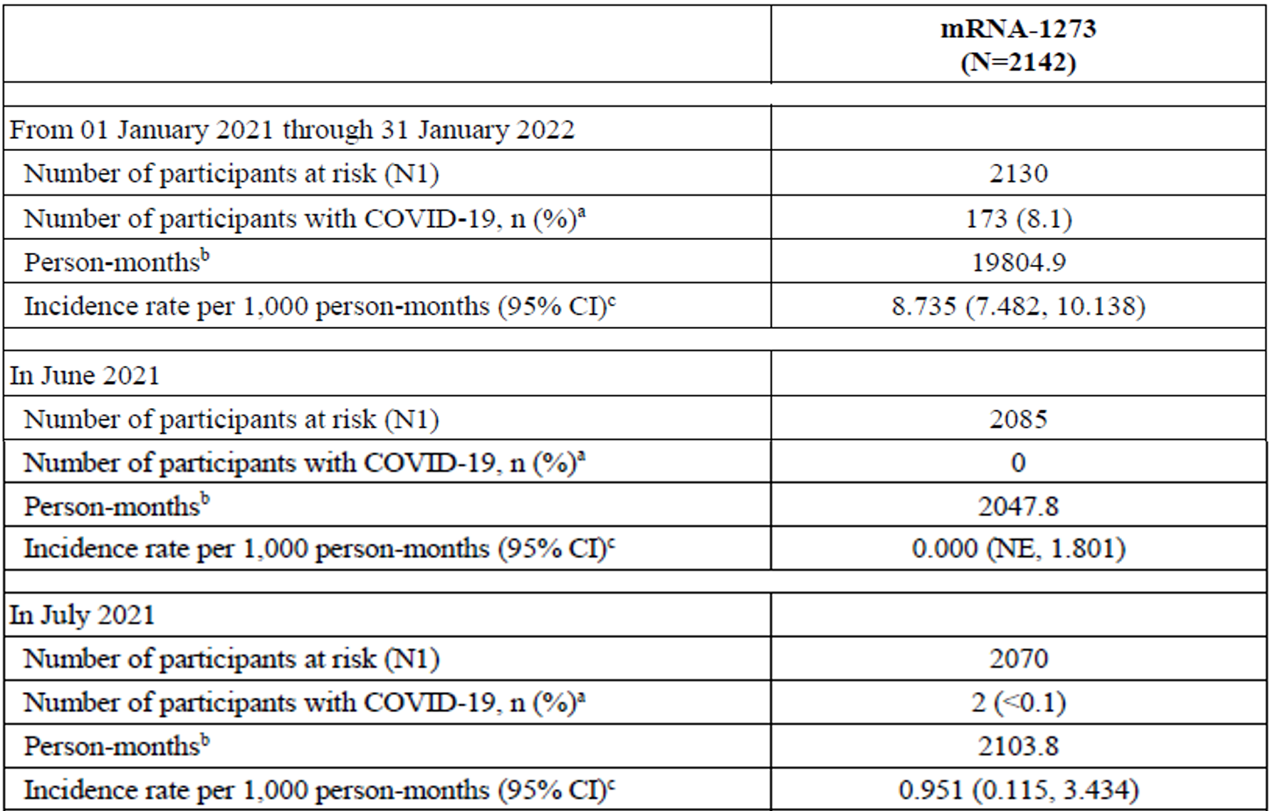
Table 13 (continued): Study 203 Long-term analysis of incidence rate of COVID-19 using Study P301 case definition of combined blinded and open label phases (per-protocol set for efficacy)
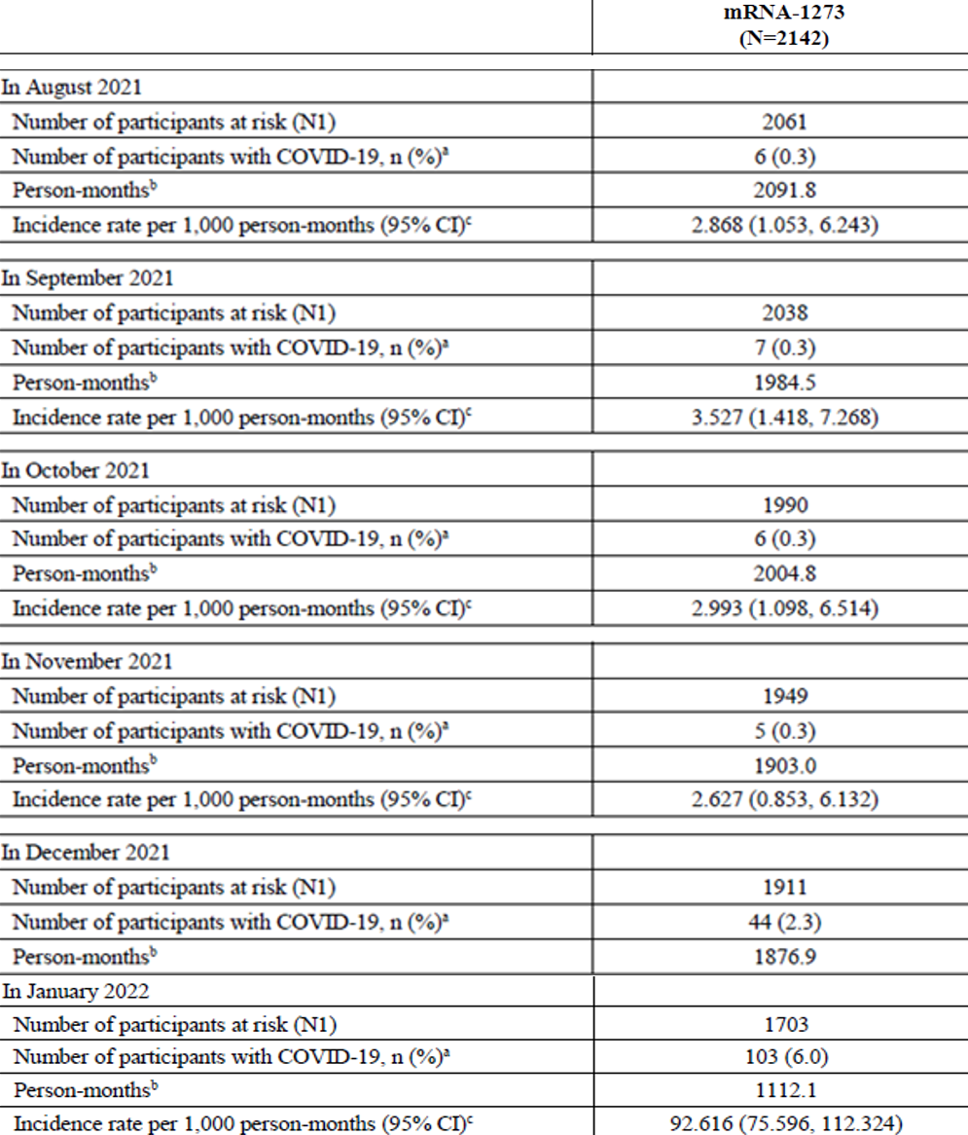
Abbreviations: CI = confidence interval; COVID-19 = coronavirus disease 2019; mRNA-1273 = Spikevax (elasomeran) COVID-19 vaccine drug development name; N1 = number of participants with non-missing data at Baseline and the corresponding timepoint; NE = not estimated.
One month =30.4375 days. Using Study P301 case definition starting 14 days after second dose by calendar month, mRNA-1273 group.
a. Percentages are based on N1.
b. Person months for each time period is defined as the total months from the earlier date of the start of each time period or 14 days after second dose to the earliest date of the first occurrence of COVID-19, the end of each time period, study discontinuation, non-study COVID-19 vaccination, booster dose, or data cut-off.
c. Incidence rate for each time period is defined as the number of participants with an event during the time period divided by number of participants at risks during the time period and adjusted by person months (total time at risk) in each treatment group. The 95% CI is calculated suing the exact method (Poisson distribution) and adjusted by person-months.
Table 14: Study P203 Long-term analysis of incidence rate of COVID-19 using Centers for Disease Control and Prevention case definition of combined blinded and open label phases (per-protocol set for efficacy)
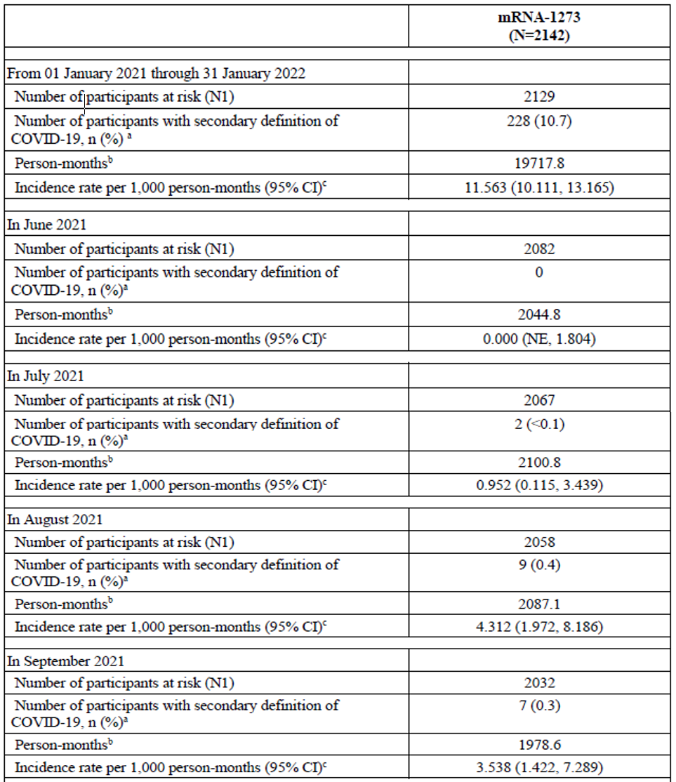
Table 14 (continued): Study P203 Long-term analysis of incidence rate of COVID-19 using Centers for Disease Control and Prevention case definition of combined blinded and open label phases (per-protocol set for efficacy)
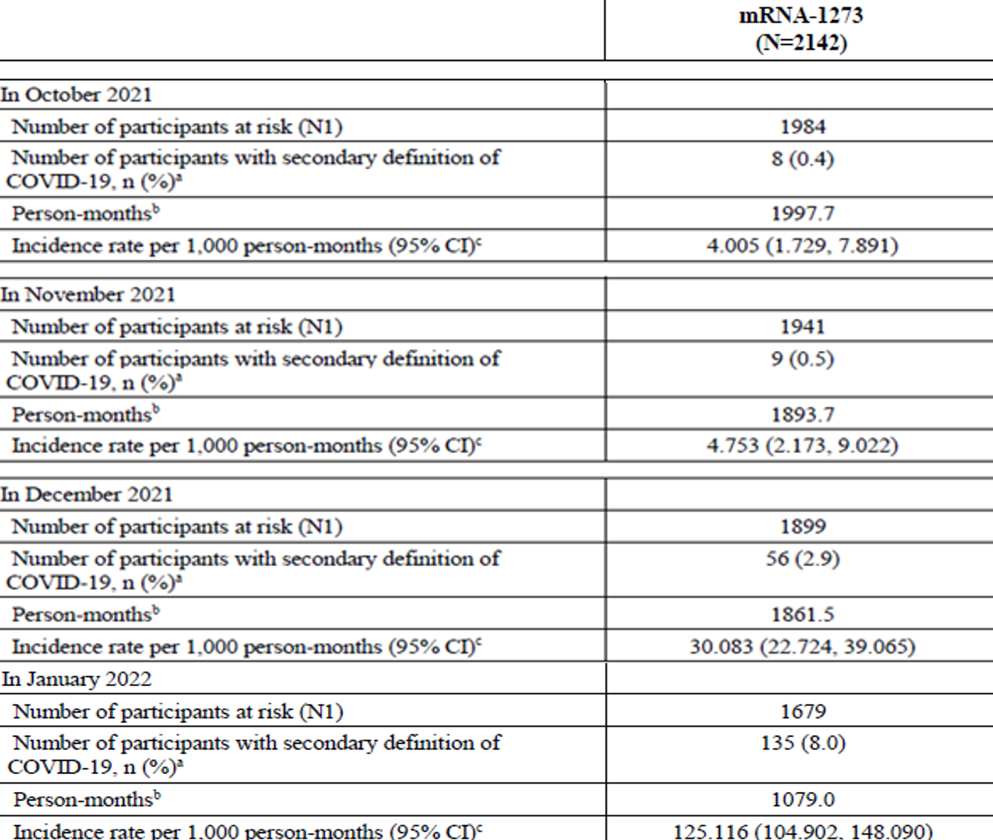
Abbreviations: CI = confidence interval; COVID-19 = coronavirus disease 2019; mRNA-1273 = Spikevax (elasomeran) COVID-19 vaccine drug development name; N1 = number of participants with non-missing data at Baseline and the corresponding timepoint; NE = not estimated.
One month =30.4375 days.
Using the United States Food and Drug Administration/Centers for Disease Control and Prevention (CDC) case definition starting 14 days after second dose by calendar month.
a. Percentages are based on N1.
b. Person months for each time period is defined as the total months from the earlier date of the start of each time period or 14 days after second dose to the earliest date of the first occurrence of COVID-19, the end of each time period, study discontinuation, non-study COVID-19 vaccination, booster dose, or data cut-off.
c. Incidence rate for each time period is defined as the number of participants with an event during the time period divided by number of participants at risks during the time period and adjusted by person months (total time at risk) in each treatment group. The 95% CI is calculated suing the exact method (Poisson distribution) and adjusted by person-months.
The sponsor presents that by calendar month among all participants who received mRNA-1273 vaccine as randomised and remained on study up to 31 January 2022 (combined blinded and unblinded) showed low monthly incidence rates of COVID-19 until November 2021. Even during the time when the Delta SARS-CoV-2 variant was the predominant circulating strain in the USA (from July to November 2021), incidence rates among vaccinated study participants generally remained stable. Not unexpectedly, an increase in COVID-19 incidence rates was observed in December 2021 and January 2022, when the Omicron variant prevailed. These findings are consistent with real world increases in COVID-19 incidence during the US Omicron surge (December 2021 to January 2022).,

Safety
As of the cut-off date of 31 January 2022, the mRNA-1273 vaccine, administered as 2 injections (100 μg) 28 days apart, demonstrated an acceptable safety profile in the adolescent study population (12 to less than 18 years).
Overall, the reactogenicity profile was consistent with that seen in adults (Study P301). Solicited local and systemic adverse reactions had a higher incidence in the mRNA-1273 vaccine group (94.2%) than in the placebo group (36.8%). Most events were considered Grade 1 or 2 in severity and most events had an onset within one to two days after injection with a mean duration of approximately three days. The most common solicited local adverse reaction was pain, and the most common solicited systemic adverse reactions were fatigue, headache, myalgia, and arthralgia. There was no notable difference between age groups (12 to less than 16 years and 16 to less than 18 years) in the incidence of solicited adverse reactions.

Long-term analysis of safety (open label phase)
For the long-term analysis, the mRNA-1273 vaccine group comprised all participants who received mRNA-1273 vaccine in Part 1A, were unblinded, and continued in the study. The placebo/mRNA-1273 vaccine group comprised all participants who received placebo in Part 1A, were unblinded to treatment, and received mRNA-1273 vaccine in Part 1B. All participants in the long-term analysis received at least one dose of mRNA-1273 vaccine.
Due to the 2:1 (mRNA-1273 vaccine: placebo) randomisation ratio and the substantial attrition of the placebo group, only 91 participants who were originally randomised to placebo stayed in the study and received mRNA-1273 vaccine, and the median follow-up duration of the placebo mRNA group was 71 days. Therefore, the long-term safety analysis is mostly representative of participants who had been randomised to mRNA-1273 vaccine (2486 participants) in Part 1A; the median follow-up duration in this group was 312 days. The sponsor claims that no comparisons were made between the groups, and text will primarily focus on the mRNA-1273 vaccine group as it provides the most robust reflection of long-term safety in this study.
In the mRNA-1273 group, at least one unsolicited AE was reported by 1398 of 2486 participants (56.2%) in the long-term analysis safety set at any time in the study. Few events warranted discontinuation from treatment.
Overall, the incidence of SAEs in the mRNA-1273 vaccine group for the long-term analysis was low (0.8%). There were no SAEs in the long-term analysis assessed as related to the vaccine, no deaths, and no cases of multisystem inflammatory syndrome in children (MIS-C). There were 13 participants (0.5%) with AESIs other than MIS-C in the long-term analysis, all were assessed as not related to the vaccine by the investigator.
Medically attended adverse events (MAAEs) were reported for 991 participants (39.9%) and of those, 27 participants (1.1%) reported events considered to be related to mRNA-1273 vaccine by the investigator.
From randomisation through the time of data cut-off, no SAEs were assessed by investigators as related to the investigational product and there were no fatal events.
In the long-term analysis of the mRNA-1273 vaccine group, 21 participants (0.8%) reported 29 SAEs. The most commonly reported SAEs were from the psychiatric disorders System Organ Class in which 12 SAEs occurred in 11 participants (0.4%), all depression and suicide related events. The majority of cases occurred more than 2 months after the most recent injection, and most had pre-existing psychiatric diagnoses and/or precipitating events such as being bullied, problems at school, and difficult home situations. The only SAE outside of the psychiatric disorder System Organ Class that occurred in more than one participant was appendicitis (n = 2). All of the other SAEs reported occurred in only one participant each.
There were no additional participants who were discontinued from mRNA-1273 vaccine in Part 1B of the study. All unsolicited AEs leading to discontinuation of the investigational product occurred in Part 1A. There were no participants in the long-term analysis who reported unsolicited AEs leading to discontinuation from study participation.
In the long-term analysis, a total of 991 of 2486 participants (39.9%) in the mRNA-1273 group experienced at least one MAAE. Of those, 35 of 2486 (1.4%) were considered severe. The most commonly reported events occurred in the System Organ Classes of infection and infestations (710 of 2486 participants (28.6%)); injury, poisoning and procedural complications (193 of 2486 participants (7.8%)); and psychiatric disorders (120 of 2486 participants (4.8%)).
The most commonly reported event in the infection and infestations System Organ Class was COVID-19 in 354 of 2486 participants (14.2%). Additionally, 21 of 2486 participants (0.8%) reported cases of ‘asymptomatic COVID-19.’ There were no SAEs of COVID-19 and all of the nonserious MAAEs of COVID-19 were of mild or moderate intensity.
In the injury, poisoning and procedural complications System Organ Class, the most commonly reported events were concussion (22 of 2486 participants (0.9%)), ligament sprain (22 of 2486 participants (0.9%)), and procedural pain (17 of 2486 participants (0.7%)).
Anxiety and depression were the two most commonly reported events in the psychiatric disorders System Organ Class. The MAAE of anxiety occurred in 47 participants (1.9%) and depression in 42 participants (1.7%).
For the long-term analysis in the mRNA-1273 vaccine group, a total of 13 of 2486 participants (0.5%) reported 17 adverse events of special interest (AESIs); 2 of 2486 participants (less than 0.1%) reported severe events.
- Anosmia (loss of smell), ageusia (loss of taste): 10 participants reported a total of 12 (combined) events: 8 anosmia (0.3%), 4 ageusia (0.2%). All but one event were associated with COVID-19; one participant reported anosmia suspected to be due to a viral upper respiratory infection.
- Appendicitis: two events of appendicitis were reported as AESIs in two participants, both of which were also classified as SAEs due to hospitalisation. Both events resolved after laparoscopic appendectomy and were assessed by the investigator as being not related to the investigational product.
Two events of seizure and idiopathic generalised epilepsy were reported in a 14-years old male. Two days later, the event resolved with sequelae (sequelae: diagnosis of generalised epileptiform discharges). The investigator assessed the events as not related to the investigational product.
One event of nonserious, moderate aseptic meningitis was reported in a 12-years old male The investigator assessed the event as not related to the investigational product and reported the event as secondary to Chiari decompression surgery. The event resolved after 7 days.

Myocarditis and pericarditis
By the narrow and broad scope, events in the cardiomyopathy Standardised Medical Dictionary for Regulatory Activities (MedDRA) Queries (SMQ) occurred in 20 of 2486 participants (0.8%) in the mRNA-1273 vaccine group; the most common event was syncope, which occurred in 0.5% of participants. There were 2 events in 2 of 91 participants (2.2%) in the placebo mRNA⁻1273 vaccine group.
- Twelve participants reported 13 events of syncope (fainting), all but one resolving the same day (one with the verbatim event term of intermittent vasovagal syncope), and all mild to moderate in severity. None were considered related to the investigational product.
- Eight events of dyspnoea (shortness of breath) occurred in 7 participants. Three of the 8 events of dyspnoea and the single event of palpitations occurred in Part 1A. Three of the 8 events of dyspnoea occurred 36, 182, and 215 days, respectively, after Dose 2 in 3 participants, and none were considered related to the investigational product.
In summary, one case of probable acute myocarditis was identified upon review of these events. One nonserious unsolicited AE of chest pain was adjudicated as a probable case of acute myocarditis that was moderate in severity, did not require hospitalisation, resolved by 8 days after onset of symptoms, and no sequelae were present at 5 months of follow-up. An additional search of the safety database for specific events or symptoms that might indicate potential events of clinical interest did not identify previously unreported events of myocarditis or pericarditis.
Table 15: Study P203 Subject incidence of cardiomyopathy by Preferred Term in long-term analysis of narrow and broad scope (long-term analysis safety set)
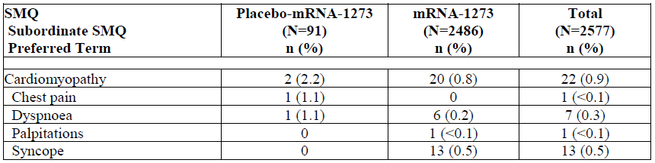
Abbreviations: AE = adverse event; mRNA-1273 = Spikevax (elasomeran) COVID-19 vaccine drug development name; N = total number of subjects; n = number of subjects in subgroup; SMQ = Standardised MedDRA Query.
For placebo/mRNA-1273 group, only AEs occurring after the crossover mRNA-1273 first dose are included; for mRNA-1273 group, any AE occurring after mRNA-1273 first dose are included.
Percentages are based on the number of participants in the safety set (long-term analysis).
Medical Dictionary for Regulatory Activities (MedDRA) version 23.0

Hypersensitivity
For the long-term analysis, AESIs in the hypersensitivity SMQ in the narrow and broad scope analysis were reported by 101 of 2486 participants (4.1%). AESIs of hypersensitivity that were considered related to mRNA-1273 vaccine were low, reported by 20 participants (0.8%). The related events included injection site hypersensitivity, rash, and urticaria; photosensitivity reaction; pruritic rash; sneezing; throat tightness; urticaria; and wheezing; all were reported within 28 days and thus, reflect events from Part 1A.

Long-term analysis of immunogenicity
Primary mRNA-1273 vaccination of adolescents induced robust functional (neutralising antibody) and binding antibody serum responses, and antibody responses were still evident at least 12 months after vaccination. mRNA-1273 induced antibody responses in adolescents regardless of whether they were SARS-CoV-2 positive or negative at Baseline; the mRNA-1273 vaccine was potent in both populations.
In the per-protocol immunogenicity subset, neutralising antibody peaked at Day 57 (28 days after Dose 2 (GMC = 1868.363)). Neutralising antibody responses at 6 months (GMC = 625.363) and 12 months (GMC = 550.262) after Dose 2 remained markedly higher than baseline levels. Compared to Baseline (pre-Dose 1), neutralising antibody levels at 6 months after Dose 2 (Day 209) remained 55-fold higher than Baseline (GMFR). The persistence of neutralising antibody responses was paralleled by the persistence of serum binding antibody (directed against spike protein) through Day 394.
Binding Antibodies at Day 57: The measure of SARS-CoV-2-specific binding antibody after 2 doses of mRNA-1273 was a secondary immunogenicity endpoint. Vaccination induced an increase of 7817-fold (GMFR = 7817.085 (6520.086, 9372.087)) in the binding antibody against SARS-CoV-2 spike protein measured 28 days after Dose 2 (Day 57 GM level 331,274.010 (293,044.888, 374,490.305)) from pre-vaccination (Day 1 GM level 42.378 (37.288, 48.164) (Meso Scale Discovery VAC72 assay). Seroresponse (4-fold rise) on Day 57 compared to baseline binding antibody levels was achieved by nearly all participants (98.8% (97.0, 99.7)). These results were consistent with Study P301 subgroup data.

Immunobridging analysis of binding antibodies
The binding antibody immunobridging response of adolescents (Study P203) were also compared to those of young adults (Study P301); similar to results of neutralising antibody, the binding antibody responses were noninferior based on evaluation of GMR (GMR: 1.285 (95% CI: 1.087, 1.520)) and seroresponse rate difference (-0.5 (95% CI: -2.4, 1.5)).
This report represents all data collected from Part 1A and Part 1B of the study through the data cut-off of 31 January 2022. Data from ongoing and future parts of the study (including Part 1C) will be presented in clinical study report addendums.

Long-term analysis of adolescent serum neutralising antibody levels by baseline SARS-CoV-2 status
The number of adolescents who were SARS-CoV-2 positive at Baseline who contributed to long-term immunogenicity follow-up was small (n = 14). Despite the higher neutralising antibody GMCs at Baseline among SARS-CoV-2 baseline positive adolescents (110.694 (55.980, 218.885)) compared to SARS-CoV-2 baseline negative adolescents (11.249 (10.712, 11.812)), a GMFR of 53-fold (95%CI: 32.213, 85.909) was observed for SARS-CoV-2 baseline positive adolescents by Day 57. The kinetics of the long-term assessment of neutralising antibody GMC in this SARS-CoV-2 positive group paralleled that of adolescents negative at Baseline: responses peaked at Day 57 (5823.150 (3322.580, 10,205.646)), decreased to Day 209 (1,717.844 (960.202, 3073.300)) and slightly further by Day 394 (1,356.832 (856.701, 2148.931). Neutralising antibody GMC remained elevated when comparing pre-dose, Day 1 values (110.694 (55.980, 218.885). The GMFR in SARS-CoV-2 positive adolescents was 15.519 (9.124, 26.397) on Day 209 and was 12.258 (7.346, 20.453) on Day 394. Furthermore, nearly all participants remained 4-fold above pre-vaccination by Day 394 (seroresponse rate of 92.9% (66.1, 99.8) at Day 209 and Day 394).
Figure 1: Study P203 Line plot of long-term analysis on pseudovirus neutralising antibody values (VAC62) by baseline SARS-CoV-2 status (immunogenicity subset)
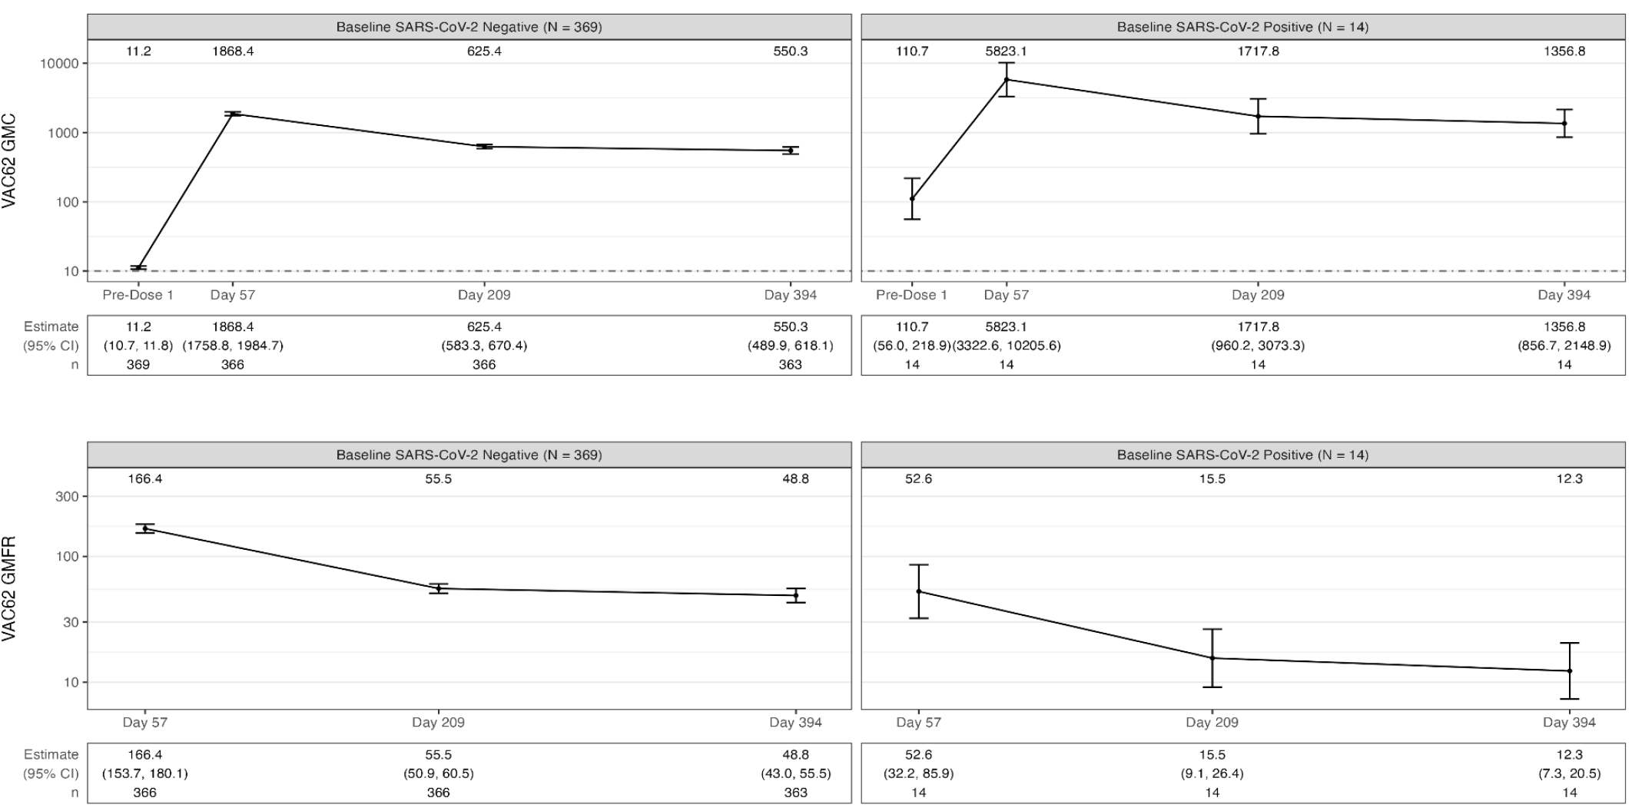
Abbreviations: CI=confidence interval; GMC=geometric mean concentration; GMFR=geometric mean fold rise; N= total number of subjects; n = number of subjects in subgroup; SARS-CoV-2 = severe acute respiratory syndrome coronavirus 2.

Neutralising antibodies among participants with SARS-CoV-2 infection during study
Ten participants were diagnosed with intercurrent SARS-CoV-2 infection at or before Day 209 (per-protocol immunogenicity subset) and an additional 54 participants were diagnosed with SARS-CoV-2 at or before Day 394.
In summary, participants experiencing an intercurrent SARS-CoV-2 infection developed neutralising antibody levels higher than those of uninfected participants. This increase in neutralising antibody levels following natural infection of mRNA-1273 vaccine primed adolescents (‘hybrid immunity’), may reflect a beneficial response. The sponsor claims that while exposure to native SARS-CoV-2 effectively ‘boosted’ mRNA-1273 vaccine primed responses, such boosting was not necessary to maintain persistence of the neutralising antibody responses induced by mRNA-1273 alone. Measurable neutralising antibody levels were evident at 12 months following completion of the mRNA-1273 vaccination primary series.

Long-term analysis of binding antibodies
The persistence of neutralising antibody responses was paralleled by the persistence of serum binding antibody (directed against spike protein) through Day 394. In the per-protocol immunogenicity subset, binding antibody increased 5252-fold from Baseline as measured 28 days after Dose 2. While a decline in serum binding antibody was observed at 6 and 12 months after Dose 2, binding antibody responses at these late timepoints remained markedly higher than baseline levels. Compared to Baseline (pre-Dose 1), binding antibody levels at 6 months after Dose 2 were 1210-fold higher than Baseline (GMFR). Relatively little additional decline was observed between 6 and 12 months after Dose 2 (Day 394 level was 894-fold higher than Baseline). Similarly, seroresponse rates, once achieved, were maintained through the 12-month timepoint.
As expected, the baseline neutralising antibody and binding antibody were higher in participants who were baseline positive for SARS-CoV-2 than participants who were baseline negative. Nevertheless, marked increases in neutralising antibody and binding antibody were similarly observed in adolescents who were SARS-CoV-2 positive at Baseline, showing that mRNA-1273 vaccine primary series triggered robust responses in adolescents regardless of baseline SARS-CoV-2 status.
Vaccination with prototype mRNA-1273 induced binding antibody responses against all SARS-CoV-2 variants included in the testing panel (Alpha (B.1.1.7), Beta (B.1.351), Gamma (P.1) and Delta (B.1.617.2) variants). Paralleling prototype responses tested binding antibody responses peaked at Day 57; measurable binding antibody responses against tested variants persisted out to 12 months after Dose 2.

Clinical studies in paediatric populations
Paediatric populations are defined here as persons from 6 to 11 years of age.

Study P204
Study mRNA-1273-P20 (abbreviated here as Study P204) is a Phase II/III, two-part, open label, dose escalation, age de-escalation and subsequent randomised, observer blind, placebo controlled expansion study to evaluate the safety, tolerability, reactogenicity, and effectiveness of mRNA-1273 vaccine in healthy children from 6 months to less than 12 years of age.
In Part 1 safety and immunogenicity for 50 µg and 100 µg dose levels were explored in children 6 to less than 12 years of age (n = 380 and 371 respectively). There appeared to be a dose response relationship, with higher reactogenicity from the 100 µg dose compared to the 50 µg dose, evident in the rate of adverse events (AEs) of Grade 3 severity and above. In Part 2, the 50 µg dose was administered to 4000 participants, randomised in a 3:1 ratio (mRNA-1273 vaccine: placebo).
The data submitted and reviewed in the provisional registration of Spikevax in 6 to 11 years of age (Submission PM-2021-05269-1-2), at a data cut-off of 10 November 2021) is included.

Immunogenicity
This larger per-protocol Immunogenicity subset (n = 319) derives from the blinded, placebo controlled phase (Part 2) of Study P204. The Day 57 neutralising antibody GMT measured by PsVNA ID50 (pseudovirus neutralising antibody level by pseudovirus neutralising assay) from this subset was 1610.2 (95% CI 1456.6, 1780.0: n = 319) with 99.1% of children achieving seroresponse. The GMFR in neutralising antibody from Baseline to D57 was 174.0 (95% CI: 157.2, 192.5). The GMT of 1610.2 from this larger Part 2 per-protocol immunogenicity subset falls between that observed for the dose selection subset (1204.6: 95% CI: 1047.2, 1385.8; n = 67) and for the Part 1 per-protocol immunogenicity subset (1964.6, 95% CI: 1722.4, 2240.9; n = 134). Results from this subset (with the 10 November 2021 interim analysis) successfully met non-inferiority criteria for both GMR and seroresponse rate difference compared to young adults (18 to 25 years) in the pivotal Study P301. Comparison of GMT between the Part 2 per-protocol immunogenicity subset in Study P204 and the per-protocol immunogenicity subset of young adults in Study P301 shows a GMR of 1.239 (95% CI: 1.072, 1.432) and a seroresponse rate difference of 0.1 (95% CI: -1.9, 2.1).
Table 16: Study P204 Part 2 Co-primary immunobridging at Day 57 (per-protocol immunogenicity subset)
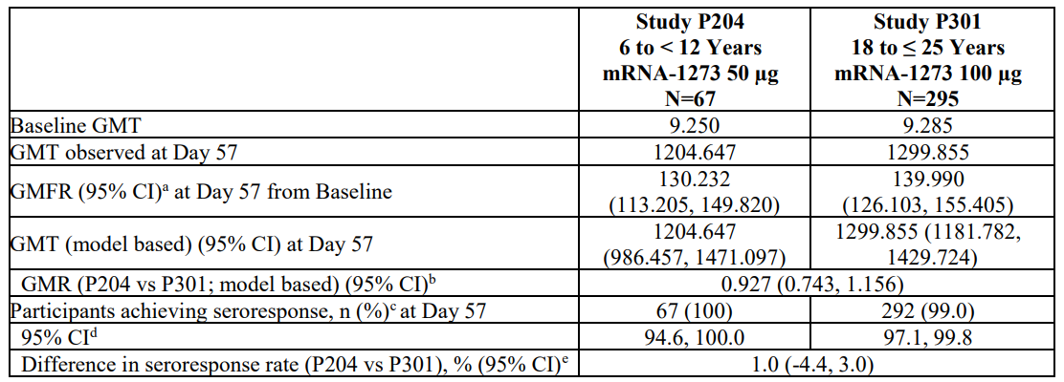
Abbreviations: CI = confidence interval; GMFR = geometric mean fold ratio; GMR = geometric mean ratio; GMT = geometric mean titre (noted as observed or model based, which is estimated by geometric least squares mean); mRNA-1273 = Spikevax (elasomeran) COVID-19 vaccine drug development name; N= total number of subjects; vs = versus.
Antibody values reported as below the lower limit of quantification (LLOQ) are replaced by 0.5 x LLOQ. Values greater than upper limit of quantification (ULOQ) are replaced by the ULOQ if actual values are not available.
Study P301 mRNA-1273 group includes young adults (18 to 25 years of age).
The ULOQ for selected Study P301 participants tested previously was different.
a. 95% CI is calculated based on the t-distribution of the log-transformed values or the difference in the log-transformed values for GMT and GMFR, respectively, then back transformed to the original scale for presentation.
b. The log-transformed antibody levels are analysed using an analysis of covariance (ANCOVA) model with the group variable (children in Study P204 and young adults in Study P301) as fixed effect. The resulted LS means, difference of least squares means, and 95% CI are back transformed to the original scale for presentation.
c. Seroresponse at a participant level is defined as a change from below the LLOQ to equal or above 4 x LLOQ, or at least a 4-fold rise if baseline is equal to or above the LLOQ. Percentages are based on the number of participants with non-missing data at baseline and the corresponding timepoint.
d. 95% CI is calculated using the Clopper-Pearson method.
e. 95% CI is calculated using the Miettinen-Nurminen (score) confidence limits.
The geometric mean increase (GMI) and seroresponse rate both successfully meet non-inferiority criteria of the 50 µg mRNA-1273 in children 6 to less than 12 years compared to young adults receiving 100 µg of mRNA-1273.

Efficacy
The median follow-up duration is 82 days after Dose 1 and 51 days after Dose 2 in Part 2 blinded phase, efficacy endpoints accumulated after the first dose (that is occurring starting 14 days post-Dose 1 and measured in the modified intention-to-treat 1 (mITT1) population); outnumber the efficacy endpoints accumulated after the two-dose regimen (that is starting 14 days post-Dose 2). Limiting endpoint analysis to endpoints occurring 14 days post-Dose 2 yield a total of only 7 cases, too few to perform meaningful analysis. Nonetheless, using either of two COVID-19 case definitions (CDC definition or the Study P301 case definition); the incidence of cases among placebo participants exceeds that of the vaccine recipients.
Where more cases are accrued (that is, when endpoints are counted starting earlier, 14 days post-Dose 1; mITT1 population), a total of 25 cases were accrued. This allowed a calculation of vaccine efficacy in which the LB of the 95% CI was 70%, providing confidence in the estimate of efficacy. In the mITT1 population starting 14 days after the first dose, the incidence of COVID-19 using the CDC case definition was 117 per 1000 person years in the placebo group compared to 14 per 1000 person years in the vaccine group, yielding a vaccine efficacy of 88% (95% CI: 70.0%, 95.8%). Using the Study P301 case definition (definition employed in the pivotal adult efficacy trial of mRNA-1273 vaccine), a vaccine efficacy of 91.8% was observed (95% CI: 74.2, 98.0%).

Safety
In this 10 November 2021 interim analysis safety analysis, a median follow-up of 56 days post-Dose 2 was provided for a total of 3387 exposed (50ug) participants across study Parts 1 and 2 from the blinded and open label phases. From Part 2, median follow-up of 55 days post-Dose 2 is provided for 4002 participants (3007 exposed to 50 µg, and 995 placebo). Analysis of the clinical safety database showed no clinically meaningful changes in the mRNA-1273 vaccine safety profile in this age group. Rates of SAEs, AESIs, MAAEs, and predefined SMQs in either Part 1 or Part 2 of Study P204 were similar to the earlier data snapshot of 6 October 2021 (which provided a median follow up of 20 days post-Dose 2 for 2987 mRNA-1,273 recipients). This 10 November 2021 interim analysis reported no SAEs considered related to study vaccine, no deaths, no cases of MIS-C and no cases of myocarditis or pericarditis.

Post-authorisation safety data in paediatrics age groups
The sponsor has provided the following post-authorisation evidencing safety in paediatric age group populations.
The exposure data by age group in the USA is summarised below in Table 17. This data encompasses all exposure of the Spikevax vaccine up until 15 February 2023. As of this date, over 9 million children under the age of 18 years have received a 2-dose primary series with Spikevax in the United States.
Table 17: United States exposure data for Spikevax vaccine by age group and nature of vaccine dose (primary series, first and second booster doses)
Abbreviation: n = number of subjects.
Total number of people who have received COVID-19 vaccine doses manufactured by Moderna and total Moderna BA4/5 doses were reported on the United States (US) Centers for Disease Control and Prevention (CDC). Doses were allocated to demographic categories base do percent of people with the selected exposure category across COVID-19 vaccine brands for the selected demographic category, assuming no brand preference within the demographic category. The exposure categories were defined by the US CDC.
a. The denominator of the column percentages, except for the total row, were the sub of doses across strata of demographic groups.
b. The column sum across strata of demographic groups does not add up the total row of Moderna COVID-19 vaccine doses (which was directly reported by the US CDC) due to imprecision and rounding of available percentages by demographic group across COVID-19 brands. The differences of column sum across strata of demongraphic groups and the total row were less than 1%.
Source: Table 17 of this AusPAR has been extracted from the COVID Data Tracker page on the CDC website.
The Marketing Authorisation Holder queried the global safety database cumulatively from 18 December 2020 through 17 February 2023 for valid, spontaneous case reports received from health care professionals, health authorities, consumers, and literature, worldwide, reported for Spikevax (Original), Spikevax Bivalent.214 (Original/BA.1), and Spikevax Bivalent (Original/BA.4-5) using the following search criteria:
- ‘Age group 0-5 months’
- ‘Age group 6 months to 5 years’
- ‘Age group 6 to 11 years’
- ‘Age group 12 to 17 years'
Cumulatively and during the reporting period, information received for children less than 18 years of age after vaccination with Spikevax (Original) (elasomeran); Spikevax Bivalent (Original/Omicron BA.1) booster (containing elasomeran/imelasomeran), and Spikevax Bivalent (Original/Omicron BA.4-5) booster (containing elasomeran/davesomeran) supports the conclusion that the safety profile for the three vaccines is comparable to that observed during the clinical studies for the vaccines and that the safety data evaluated as of 17 February 2023, does not indicate any changes in the benefit-risk profile of Spikevax (Original), Spikevax Bivalent (Original/Omicron BA.1) booster, and Spikevax Bivalent (Original/Omicron BA.4-5) booster.
There were 17 serious cases in children less than 18 years of age who have been vaccinated with Spikevax (Original). Among these cases, there was one case each reported for myocarditis and pericarditis, which is an important identified risk for Spikevax. Many of the other serious cases lacked critical clinical information to adequately assess a relationship to vaccine administration other than temporality.
Overall, most cases were nonserious. When serious, these cases often had serious events reported once that did not demonstrate any unusual groupings by medical concept. Many events were classified as serious as important medical events secondary to inclusion on the EMA important medical event list without evidence of hospitalisation. Furthermore, cases very often had minimal to no information provided such as vaccination and event dates, medical history, concomitant medications, diagnostic evaluation, and clinical course, thus precluding further assessment for causality. Cumulatively, there were total of 45 serious cases reported for children less than 18 years of age who received Spikevax Bivalent (Original/Omicron BA.1) (5 cases) and Spikevax Bivalent (Original/Omicron BA.4-5) (40 cases). No new safety concerns were identified in these reports.
Based on the review of information received cumulatively, there is no change in the favourable benefit-risk assessment in relation to global safety data referring to Spikevax (Original), Spikevax Bivalent (Original/Omiron BA.1) booster, and Spikevax Bivalent (Original/Omicron BA.4-5) booster. The majority of the reported events for the children sub-population involved events related to product administration errors and issues, with all of them not associated with any adverse events, followed by events considered relate to reactogenicity. Routine pharmacovigilance monitoring will continue.

Risk management plan
The sponsor has submitted European Union (EU)-RMP version 6.1 (date 30 October 2022; data lock point (DLP) 12 September 2022) and Australia specific annex version 3.0 (date 13 December 2022) in support of this submission.
The summary of safety concerns and their associated risk monitoring and mitigation strategies are summarised in Table 18. The TGA may request an updated RMP at any stage of a product's life-cycle, during both the pre-approval and post-approval phases.
Table 18: Summary of safety concerns
Summary of safety concerns |  | Pharmacovigilance |  | Risk Minimisation
 |  | Routine | Additional | Routine | Additional
Important identified risks | Myocarditis | * | † |  | –
Important identified risks | Pericarditis | * | † |  | –
Important potential risks | Vaccine-associated enhanced disease (VAED) including vaccine-associated enhanced respiratory disease (VAERD) | * | † | – | –
Missing information | Use in pregnancy and while breast-feeding |  | # |  | –
Missing information | Long-term safety |  | † | – | –
Missing information | Use in immunocompromised subjects |  | † |  | –
Missing information | Interaction with other vaccines |  | † |  | –
Missing information | Use in frail subjects with unstable health conditions and co-morbidities (for example, chronic obstructive pulmonary disease (COPD), diabetes, chronic neurological disease, cardiovascular disorders) |  | † |  | –
Missing information | Use in subjects with autoimmune or inflammatory disorders |  | † |  | –
* Follow-up questionnaires
† Clinical studies
# Observational pregnancy outcome study
- This summary of safety concerns is the same as the summary that was evaluated and considered acceptable for the previous submissions for Spikevax COVID-19 vaccines. At this stage, this summary of safety concerns continues to be acceptable from an RMP perspective.
- The pharmacovigilance plan has been evaluated during previous submissions and found to be acceptable. The pharmacovigilance plan continues to be acceptable from an RMP perspective. The sponsor has provided monthly safety summary report, bimonthly safety summary reports and periodic safety update reports up to now, as required by the TGA.
- There are risk minimisation measures implemented for COVID-19 vaccines by the Department of Health and Aged Care and State and Territory Governments. The changes proposed in this submission do not warrant changes to the currently approved risk minimisation plan as part of the RMP.

Risk-benefit analysis

Delegate’s considerations
The guidance; for Transition to full registration of the provisionally registered prescription medicines should be read in conjunction with the standard prescription medicines registration process; because the elements for transition to full registration are similar.
The collection of confirmatory data on safety and efficacy should lead to submission of a Category 1 Type S application; for transition to full registration. The benefit-risk profile of the medicine must be positive, and this must be maintained throughout the period of provisional registration to the transition to full registration. Evidence of having met your risk management plan (RMP) obligations. Including the dates when data were submitted and reasons for delays or failure to meet obligations All final results not previously submitted from confirmatory trials in the dossier should be included as per the current requirements for registering a prescription medicine. Clinical trials data must support the indication in the application for full registration.
The sponsor has listed (Table 4, Table 5, Table 6 and Table 7 above) the availability of clinical data to meet the specific conditions (as per the provisional registration) and the current requirements for registering a prescription medicine to support this submission.

Use in adult populations
In support of the use of the sponsor’s Spikevax (elasomeran) vaccine in adults (that is, those 18 years of age and older), the following were submitted to the TGA. The final clinical study report Phase I Study DMID-20-0003 was submitted on 4 November 2022. For the Phase II Study P201: The following data, including follow up safety data at 6 months was submitted to TGA on 27 June 2022 Primary analysis clinical study report, Primary analysis clinical study report Addendum 1 and 2. For the Phase III Study P301 the clinical study report (Part A) and Addendum 1 were submitted on 15 September 2021. Long-term follow-up Parts B and C interim clinical study report is included in this submission. This includes 6 months follow up on more than 3000 participants and as per the sponsor will be the last piece of primary series data from Study P301.

Study DMID-20-0003 (Phase I)
As was required, the sponsor submitted the final clinical study report (6 months post-Dose 2) for Study DMID-20-0003 on 4 November 2022.¹³ It had an acceptable safety profile. Based on the results of safety and immunogenicity at data cut-off, the 100 μg dose provided promising immunogenicity results in adults of all ages with an acceptable safety profile and was the dose selected for further evaluation in the Phase III clinical study.

Study P201 (Phase II)
As was required, the sponsor has submitted final clinical study reports for Parts A, B and C of Study mRNA-1273-P201 (Study P201);¹⁵ including the safety data at 6 months.

Study P201 Part A
Part A of this study was designed to evaluate the safety, reactogenicity, and immunogenicity of mRNA-1273 vaccine, administered in 2 doses (50 μg or 100 μg) given 28 days apart.

Safety
In this ‘end of Part A’ analysis, the mRNA-1273 vaccine, administered as 2 doses (50 μg or 100 μg) given 28 days apart, demonstrated an acceptable safety profile in the participant population enrolled in this study in both age cohorts: Cohort 1 (18 to less than 55 years old) and Cohort 2 (55 years and older). No new safety findings since the primary analysis (Day 57) clinical study report were identified in this end of Part A analysis.

Immunogenicity
Overall, the magnitude and kinetics of immune response for both binding antibody and neutralising antibody was consistent across dose groups and age cohorts. Study P201 provided evidence of persistence of immune response through Day 209 (6 months after the second injection of mRNA-1273 vaccine), which was lower than the peak observed at Day 43 but was higher than that at Day 29 (before the second injection).

Study P201 Part B
Part B participants received a 50 μg mRNA-1273 vaccine booster dose after receiving a 50 μg or 100 μg primary vaccination series in Part A (Part B booster) and participants who received a 2-dose series of 100 μg mRNA-1273 vaccine in Part B after receiving placebo in Part A (Part B crossover).

Safety
The 50 μg mRNA-1273 booster vaccination dose demonstrated no unexpected reactogenicity or safety results. Findings for Part B booster participants and Part B crossover participants were consistent with those of the previously reported mRNA-1273 vaccine Part A primary series, further supporting the acceptable benefit-risk profile of the vaccination regimen.

Immunogenicity
Repeat analysis of the Part A samples using the validated PsVNA confirmed a higher immunogenic primary-dose response with 100 μg compared with 50 μg of vaccine. The booster injection elicited a robust immune response to SARS-CoV-2 based on neutralising antibody and binding antibody responses.

Study P201 Part C
Part C was a proof-of-concept rollover study of approximately 60 participants who were enrolled in the Phase III Study P301, had already been unblinded, and had previously received 2 doses of mRNA-1273 vaccine at least 6 months earlier.

Safety
Safety analyses, including reactogenicity for up to 7 days post-booster, unsolicited treatment emergent adverse events (TEAEs), medically attended adverse events (MAAEs), and serious adverse events (SAEs) were based on data collected from open label Day 1 to open label Day 181. All booster vaccines demonstrated no unexpected reactogenicity or safety results. Findings were similar to those of Part A and Part B, as previously reported, thereby further supporting the acceptable benefit-risk profile of the booster vaccination with monovalent and bivalent variant vaccines.

Immunogenicity
Immunogenicity analyses, including neutralising antibody and binding antibody, were based on data collected from open label Day 1 through open label Day 29 for Cohorts 2 and 3, and open label Day 1 to open label Day 181 for Cohort 1. All booster vaccines elicited robust immune responses to SARS-CoV-2 based on neutralising antibody and binding antibody responses that showed increased geometric mean (GM) levels.

Study P301 (Phase III)
Study mRNA-1273-P301 (Study P301) was comprised of 3 parts: Part A, the blinded phase; Part B, the open label observational phase; and Part C, the booster dose phase.¹⁷

Study P301 Part A
Data from Part A (database lock on 4 May 2021) supported the Provisional registration of Spikevax for use in adults 18 years of age and older by the TGA on 9 August 2021.

Study P301 Part B
In conclusion, efficacy of mRNA-1273 to prevent COVID-19 persisted in Part B. The safety profile of mRNA-1273 remained acceptable, similar to that observed in Part A, and no new safety concerns were noted. The benefit-risk profile of mRNA-1273 remains favourable through 6.5 months median follow-up after Dose 2.
The long-term follow-up Part B and C interim clinical study reports (clinical study report addendum) are included in this submission. This includes 6 months follow-up on more than 3000 participants and according to the sponsor will be the last piece of primary series data from Study P301.
In summary, this clinical study report Addendum 2 provides longer-term safety follow-up and effectiveness (COVID-19 incidence rates) data following the 2-dose primary series (Part A and Part B), with a median follow-up of 353 days following Dose 1 and 324-days following Dose 2 as of the data cut-off of 5 April 2022.
For the Part C booster dose phase, safety and effectiveness results are based on a median follow-up of 161 days following booster dose administration, with at least 6 months of safety follow-up reported for at least 3000 participants.

Efficacy
Long-term COVID-19 incidence rates for the mRNA-1273 vaccinated group; and the placebo group (later vaccinated with mRNA-1273 vaccine), in Part A and Part B of the study were highest during the Omicron variant wave (42.439 cases per 1,000 person months (95% confidence interval (CI): 37.120, 48.306)). Although direct comparison of incidence rates across the mRNA-1273 and placebo/mRNA-1273 groups is confounded, COVID-19 incidence rates during both the Delta and the Omicron variant waves were similar between the mRNA-1273 (earlier vaccinated) and the placebo/mRNA-1273 (later vaccinated) groups, suggesting durability of protection after the primary series in the mRNA-1273 group despite the longer interval. However, the higher incidence in both groups during the Omicron variant wave demonstrates the need to boost immune responses to enhance protection.
Analysis of incidence rates in Part C booster participants showed the majority of COVID-19 cases were detected during the Omicron variant wave (24.428 cases per 1,000 person months (95% CI: 23.187, 25.717)). Additionally, booster participants showed a significantly lower COVID-19 incidence rate when compared to non-booster participants during both the Delta variant wave (reduction in incidence rate booster versus non-booster of 0.773 (95% CI: 0.668, 0.850)) and the Omicron variant wave (0.453 (95% CI: 0.369, 0.524)), although the analysis was limited given that the booster and non-booster groups were not randomised.

Safety
Long-term follow-up data for participants who received the mRNA-1273 primary series vaccination in Part A, representing 16,818.4 person years of follow-up, do not suggest any safety concerns based on events occurring beyond 6 months after vaccination. Safety findings for participants who received the primary series during the open label phase of the study were consistent with those for the double-blind period in Part A. Based on post-authorisation data (subsequent to reporting of the double-blind period), myocarditis and pericarditis are included in the CCDS and labels as an important identified risk.
The mRNA-1273 vaccine 50 μg booster dose was well-tolerated and no new safety concerns were identified based on 27,233.7 person years of follow-up, including at least 3000 participants with at least 6 months of follow-up after the booster dose. The incidence of all TEAEs, including those considered by the investigator to be related to study vaccine, as well as the types and frequencies of events by System Organ Class and Preferred Term, were similar among participants with positive SARS-CoV-2 status at pre-booster baseline compared with participants with negative status. In the overall population of participants who received a booster dose, the types and incidence of reported events were generally consistent with observations for the primary series and with known risks, including very rare events of myocarditis and pericarditis.

Immunogenicity
Overall, a robust immune response for both neutralising antibody and binding antibody one month following booster dose (booster dose Day 29) was observed. Neutralising antibody geometric mean concentrations (GMCs) and spike protein binding antibody GM levels increased by 50.4-fold and 45.7-fold, respectively. Seroresponse (4-fold rise) from pre-booster baseline was achieved by more than 90% of the participants for both neutralising antibody (94.5%) and binding antibody (93.3%). Furthermore, an increase of 3-fold in both neutralising antibody and binding antibody was observed in SARS-CoV-2 pre-booster positive participants one month (booster dose Day 29) after mRNA-1273 vaccine booster dose administration, despite relatively high pre-booster GMCs and GM levels compared with pre-booster negative participants. These results suggest that participants with prior infection benefit from the booster dose (hybrid immunity).
Superiority of the booster as compared with the 100 μg mRNA-1273 vaccine primary series (Part C booster dose Day 29 / Part A Day 57) was demonstrated based on neutralising antibody (geometric mean ratio (GMR): 7.4 (95% CI: 6.9, 8.0) and seroresponse rate difference: 0.9% (95% CI: 0.1, 1.7)) in the per-protocol immunogenicity set. Results of binding antibody spike protein were consistent with neutralising antibody.

Summary for use of Spikevax in adults
Long-term clinical effectiveness data suggest durability of protection after primary series. Additionally, booster participants showed a significantly lower COVID-19 incidence rate when compared to non-booster participants during both the Delta variant wave and the Omicron variant wave although the analysis was limited given that the booster and non-booster groups were not randomised.
The sponsor has provided comprehensive, confirmatory long-term post-provisional registration safety data for mRNA-1273 vaccine in adults (individuals 18 years of age and over). for the primary series and booster. No unexpected reactogenicity or new safety signal of concern is detected. This appears acceptable.
The available clinical data appears comprehensive and confirmatory with a favourable benefit risk profile to support for the transition from Provisional Registration to Full Registration for the Spikevax in adults (individuals 18 years of age and over). The outstanding clinical data from Study P301 can be made a post-approval commitment.

Use in adolescent populations
In support of the use of Spikevax (elasomeran) vaccine in adolescents (that is, persons from 12 years to 17 years of age, the sponsor submitted the following data. A clinical study report for Study P203 with 6 months post-Dose 2 follow-up for all subjects was submitted on 4 November 2022. This clinical study report included safety data of 2378 participants (95.7%) that have been followed for at least168 days (6 months) or more after Dose 2.
The sponsor claims that as the pandemic evolved and the need for booster doses was evident, Study P203 was amended to offer booster doses to all participants. Therefore, the sponsor believes that the clinical study report that has been submitted with 6 months of safety follow-up is sufficient to transition to full registration for the primary series. This is now a three-part, Phase II/III, study being conducted in the USA and several countries outside of the USA: Part 1 (consisting of Parts 1A, 1B, and 1C), Part 2, and Part 3.
Long-term analyses were performed and included data collected in the blinded phase (Part 1A) and the open label phase (Part 1B), and prior to booster dose (if a booster dose was received). In the long-term immunogenicity analysis, to assess the persistence of immunogenicity response after 2 doses of mRNA-1273, neutralising antibody and binding antibody values were summarised over time at specified timepoints in an immunogenicity subset specifically for the long-term analysis. In the long-term analysis for the safety set, the original mRNA-1273 group (n-= 2486) had a median duration of follow-up after Dose 2 of 312 days (first to third quartile: 295 to 327, range: 0 to 389); 2378 participants (95.7%) in this group have been followed for 168 days (6 months) or more after Dose 2.

Study P203 (Phase II/III)
Study mRNA-1273-P203 (Study P203, also known as the TeenCove trial) was a Phase II/III study in adolescents aged between 12 and 17 years of age.²¹
Primary mRNA-1273 vaccination of adolescents on Study P203 induced robust functional (neutralising antibody) and binding antibody serum responses, and these responses were durable through at least 12 months after vaccination. mRNA-1273 induced these responses in adolescents regardless of whether they were SARS-CoV-2 positive or negative at Baseline and whether they had or had no subsequent SARS-CoV-2 infection; the mRNA-1273 vaccine was potent in both populations.

Study P203 Part 1A and 1B Long-term assessment of incidence rates (exploratory endpoint)
By calendar month among all participants who received mRNA-1273 as randomised and remained on study up to 31 January 2022 (combined blinded and unblinded) showed low monthly incidence rates of COVID-19 until November 2021. Even during the time when Delta was the predominant circulating strain in the US (July to November 2021), incidence rates among vaccinated study participants generally remained stable. Not unexpectedly, an increase in COVID-19 incidence rates was observed in December 2021 and January 2022, when the Omicron variant prevailed. These findings are consistent with real world increases in COVID-19 incidence during the US Omicron surge (December 2021 to January 2022).^{23,24}
Safety: As of the cut-off date of 31 January 2022, the mRNA-1273 vaccine, administered as 2 injections (100 μg) 28 days apart, demonstrated an acceptable safety profile in the adolescent study population (12 to less than 18 years).

Study P203 Part 1C Monovalent booster data in individuals 12 to 17 years of age
The clinical study report for Part 1C-1 of Study P203 (data cut-off 15 August 2022). Study P203 was amended (Protocol Amendment 3 (4 November 2021)) to evaluate the tolerability, safety, and immunogenicity of a 50 μg mRNA-1273 booster dose. Participants were offered an optional booster dose starting at least 5 months after Dose 2 of the mRNA-1273 primary series; 1405 participants received a booster dose in Part 1C-1. After administration of the booster dose, participants were followed for a median of 204 days (range: 1 to 232 days); 1204 of 1405 (85.7%) participants were followed for at least 168 days (approximately 6 months).
The primary objective of the Booster Phase was to infer effectiveness of the mRNA-1273 booster dose (50 μg) by comparing adolescent neutralising antibody levels at booster dose Day 29 in Study P203 to those of young adults (18 to 25 years) at Day 57 after primary series mRNA-1273 in Study P301. Neutralising antibody responses from boosted adolescents successfully met pre-specified non-inferiority criteria for the coprimary endpoints of GMR and seroresponse rate difference between the 2 groups. Neutralising antibody responses were measured against prototype SARS-CoV-2 PsVNA (expressing the spike protein of D614G).
The GMR of adolescent neutralising antibody GMC (booster dose Day 29) compared to young adult neutralising antibody GMC (Day 57) was 5.071 (95% CI: 4.477, 5.745), meeting the non-inferiority criteria for GMR (that is, lower bound of the 95% CI > 0.667; point estimate ≥ 0.8). The difference in adolescent seroresponse rate compared to young adult seroresponse rate was 0.7% (95% CI: -0.8, 2.4), meeting the non-inferiority criterion (lower bound of the 95% CI of the seroresponse rate difference is more than -10%).
Participants with evidence of SARS-CoV-2 infection pre-booster had higher neutralising antibody and binding antibody levels at booster dose Day 1 than participants without prior infection. Nonetheless, booster dose administration enhanced neutralising antibody and binding antibody levels measured on booster dose Day 29 in both groups. This report also summarises that administration of the mRNA-1273 booster dose induced measurable binding antibody responses against the Alpha, Beta, Delta, and Gamma variants.
As an additional exploratory analysis, monthly incidence rates of COVID-19 were evaluated among booster participants and non-booster participants. In the month of January 2022 (the peak of the Omicron surge), using the Study P301 COVID-19 case definition, the rate of COVID-19 among boosted participants (0 cases per 1000 person months) was lower than the rate among non-booster participants (95.766 cases per 1000 person months). Lower rates in booster participants were also observed in this time period using the Centers for Disease Control and Prevention (CDC) COVID-19 case definition (15.653 cases per 1000 person months among booster participants vs 128.308 cases per 1000 person months among non-booster participants). No COVID-19 cases were assessed as severe, and none led to hospitalisation or death.
Review of safety data show that the 50 μg booster dose was well tolerated. There were no new safety findings observed in the mRNA-1273 Booster Phase of Study P203 and in general, the booster dose showed less reactogenicity than the primary series. Overall, most solicited adverse reactions were Grade 1 or 2 in severity and had onset within the first 2 days after injection, with a median duration of 3 days for solicited local adverse reactions and 2 days for solicited systemic adverse reactions. The most frequently reported solicited local adverse reaction was pain, and the most frequently reported systemic solicited adverse reactions were headache and fatigue. Solicited local adverse reactions were similar in participants with and without SARS-CoV-2 infection prior to booster dose (that is, SARS-CoV-2 pre-booster positive and SARS-CoV-2 pre-booster negative). However, reported rates of solicited systemic adverse reactions (particularly adverse reactions of fever, headache, fatigue, and chills) were lower among SARS-CoV-2 pre-booster positive participants (68.9%) compared to SARS-CoV-2 pre-booster negative participants (80.7%).
Overall, the booster dose resulted in less reactogenicity than the primary series, as demonstrated by fewer Grade 3 or higher local and systemic adverse reactions after booster dose (4.6% and 8.2%, respectively,) compared with after Dose 2 of the primary series (9.8% and 13.4%, respectively).
The profiles of unsolicited adverse events (AEs) and MAAEs, primarily reflective of infection and reactogenicity related events, demonstrated events typically observed in an adolescent population during the COVID-19 pandemic. There were no SAEs and no adverse events of special interest (AESIs) reported within 28 days after booster dose.
Starting 28 days after booster dose and up to the data cut-off (15 August 2022), SAEs were reported for 6 participants and AESIs were reported for 2 participants; none were related to vaccine. There were no reported deaths or cases of multisystem inflammatory syndrome in children (MIS-C), and even with the enhanced surveillance implemented in this study, no TEAEs indicative of myocarditis or pericarditis was identified.

Summary for use of Spikevax in adolescents
Overall, the reactogenicity profile was consistent with that seen in adults. Long-term safety was demonstrated through a median of 312 days after Dose 2 in the mRNA-1273 group. There were no deaths, related SAEs, or cases of MIS-C in the long-term follow-up or evidence of new, delayed-onset safety concerns. In summary, no new trends or safety concerns were identified as of the cut-off date of Part 1C-1 of Study P203 (15 August 2022) and the safety findings were consistent with the known safety profile of mRNA-1273 and events typical in an adolescent population.
Overall, mRNA-1273 is generally well-tolerated. No unexpected findings were identified. In this clinical study, mRNA-1273 in an adolescent population was observed to have a favourable benefit-risk profile.
The sponsor has provided comprehensive, confirmatory long-term post-provisional registration safety data for mRNA-1273 in for the primary series and booster in adolescent (12 to17 years of age). No unexpected reactogenicity or new safety signal of concern is detected.
The available clinical data appears comprehensive and confirmatory with a favourable benefit risk profile to support for the transition from Provisional Registration to Full Registration for the Spikevax in in Adolescent (12 to17 years of age). The outstanding clinical data from Study P203 can be made a post-approval commitment.

Use in paediatric populations
Data from Study P204 (at cut-off of 10 November 2021) supported the Provisional registration (Submission PM-2021-05269-1-2) of Spikevax for use in children 6 to 11 years of age on 17 February 2022.²⁸

Study P204 (Phase II/III)
Study mRNA-1273-P204 (Study P204) is a Phase II/III, two-part, open label, dose escalation, age de-escalation and subsequent randomised, observer blind, placebo controlled expansion study to evaluate the safety, tolerability, reactogenicity, and effectiveness of mRNA-1273 in healthy children 6 months to less than 12 years of age.²⁷
In Part 1 safety and immunogenicity for 50 µg and 100 µg dose levels of vaccine were explored in children from 6 to less than 12 years of age (n = 380 and 371 respectively). There appeared to be a dose response relationship, with higher reactogenicity from the 100 µg vaccine dose compared to the 50 µg dose, evident in the rate of AEs Grade 3 and above. In Part 2, the 50 µg dose was administered to 4000 participants, randomised in a 3:1 ratio (mRNA-1273: placebo).

Immunogenicity
Co-primary immunobridging at Day 57 per-protocol immunogenicity subset (Part 2 Study P204): The GMI and seroresponse rate both successfully meet non-inferiority criteria of the 50 µg mRNA-1273 vaccine in children 6 to less than 12 years compared to young adults receiving 100 µg of mRNA-1273 vaccine.

Efficacy
The median follow-up duration is 82 days after Dose 1 and 51 days after Dose 2 in Part 2 blinded phase, efficacy endpoints accumulated after the first dose (that is, occurring starting 14 days post-Dose 1 and measured in the mITT1 population) outnumber the efficacy endpoints accumulated after the two-dose regimen. Nonetheless, using either of two COVID-19 case definitions (CDC definition or the Study P301 case definition), the incidence of cases among placebo participants exceeds that of the vaccine recipients.

Safety
In this 10 November 2021 interim analysis safety analysis, a median follow-up of 56 days post-Dose 2 was provided for a total of 3387 exposed (50ug) participants across study Parts 1 and 2 from the blinded and open label phases. Analysis of the clinical safety database showed no clinically meaningful changes in the mRNA-1273 vaccine safety profile in this age group.

Additional safety follow-up
Data supporting provisional registration of primary series in children 6 to 11 years old was based on a data cut in October 2021 and represented a median of 2 months of safety follow-up after Dose 2 in at least 1000 participants (n = 4753). This data supported registration based upon successfully meeting the primary immunobridging effectiveness endpoints as well as demonstration of an acceptable safety profile.
Since that data analysis, additional data have become available. First, a data cut in February 2022, with longer term safety follow-up, was conducted at the request of the US FDA to support an Emergency Use Authorization for children 6 to 11 years of age in the USA. This same data was provided to the European Medicines Agency (EMA) to support full MAA in the European Union.
In this February 2022 data cut-off safety analysis, a median follow-up of 158 days post-Dose 2 is provided for a total of 4072 exposed (50 μg) participants across study Parts 1 and 2 from the blinded and open label phases. Discussion and tables or listings of unsolicited AEs, SAEs, AESIs, and severe COVID-19 are available. Analysis of the data in the longer-term safety set showed no clinically meaningful changes in the mRNA-1273 safety profile in this age group. Rates of unsolicited AEs, SAEs, and AESIs were generally reflective of the longer duration of exposure and increased reporting of infectious related events typical seeing in the winter months as well as influenced by the Omicron surge. Further, there were no deaths, no cases of MIS-C and no cases of myocarditis or pericarditis reported. As such, the favourable benefit: risk assessment based on the earlier October 2021 data cut was further supported in this long-term safety follow-up analysis (February 2022).

Interim analysis
This interim analysis was based on follow-up in the blinded phase and open label phase for Part 2 participants. A total of 4016 participants enrolled in the 6 to 11 years age group for the 50 μg dose level: 3012 participants assigned to mRNA-1273 vaccine and 1004 participants assigned to placebo. In this analysis, the median study duration was 295 days from Dose 1 and 267 days from Dose 2 for the 6 to 11 years age group; 75.0% of participants had at least 224 days follow-up from Dose 2. The analysis also included long-term neutralising and binding antibody titres through 12 months.
Effectiveness of the primary series in 6 to 11 years old was demonstrated through immunobridging to the pivotal efficacy study, Study P301, and was included in the provisional registration application. Additional longer term immunogenicity data are now available. Primary mRNA-1273 vaccination of children 6 to 11 years of age in Study P204 induced robust functional (neutralising antibody) and binding antibody serum responses, and these responses were durable through at least 12 months after vaccination. mRNA-1273 vaccine induced these responses in children regardless of whether they were SARS-CoV-2 positive or negative at Baseline and whether they had or had no subsequent SARS-CoV-2 infection; the mRNA-1273 vaccine was potent in both populations. The persistence of neutralising antibody responses was paralleled by the persistence of serum binding antibody (directed against spike protein) through Day 394. Vaccination with prototype mRNA-1273 induced binding antibody responses against all SARS-CoV-2 variants included in the testing panel (Alpha (B.1.1.7), Beta (B.1.351), Gamma (P.1), Delta (AY.4), and Omicron (B.1.529) variants).
In this primary, randomised, placebo controlled observer blinded analysis, mRNA-1273 vaccine as a 50 μg dose administered as 2 injections 28 days apart demonstrated an acceptable safety profile in children aged 6 to 11 years, largely similar to that described in the initial provisional application to the TGA. There were no SAEs related to the study vaccine, no deaths, no cases of MIS-C, myocarditis, pericarditis, or anaphylaxis within 28 days after any injection during the blinded phase. Enhanced aggregate analysis of the Standardised Medical Dictionary for Regulatory Activities (MedDRA) Queries (SMQ) of cardiomyopathy along with specific medical evaluations for potential cases of myocarditis or pericarditis showed no evidence for any unreported cases of myocarditis, pericarditis, or myopericarditis during the study. Long-term safety was demonstrated through a median of 267 days after Dose 2 in the mRNA-1273 group with no new safety signals or new important potential risks were identified during the study. The safety data reported were consistent with events commonly seen in a paediatric population of this age, and with the known safety profile for the mRNA-1273 vaccine.

Summary for use of Spikevax in children
No new safety signals have been observed so far. The overall safety profile of two doses of mRNA-1273 vaccine observed in Study P204 was consistent with the known safety profile to date observed in the pivotal Study P301 as well as post-marketing surveillance. The benefit risk profile of Spikevax in children 6 to 11 years of age continues to remain favourable.

Proposed action
The sponsor has provided comprehensive, confirmatory and long-term data beyond provisional registration, outlining the clinical effectiveness and safety of mRNA-1273 (Spikevax) for use in adults (individuals 18 years of age and over); adolescents (individuals 12 to 17 years of age for the primary series and booster) and in children (individuals 6 to 11 years of age for primary series).
The benefit-risk profile of Spikevax (elasomeran) vaccine in individuals 6 years of age and older appears well established from the clinical data obtained so far. The post-authorisation safety data also supports the continued favourable benefit risk of Spikevax in individuals 6 years of age and older. Even from the risk management plan perspective, there are no outstanding pharmacovigilance obligations for the products being considered in this submission that would impede the transition from provisional registration to full registration. This clinical data supports a favourable benefit risk profile for Spikevax transitioning from provisional registration to full registration for use in individuals 6 years and older.

Advisory Committee considerations
The Advisory Committee on Vaccines (ACV), having considered the evaluations and the Delegate’s overview, as well as the sponsor’s response to these documents, advised the following.

Specific advice to the Delegate
- Please comment on the sponsor’s proposal for the transition from provisional registration to full registration of Spikevax for use in individuals 6 years of age and older.
The ACV advised that the benefit-risk profile supports the transition from provisional registration to full registration of the primary series for individuals 6 years and older and as a booster dose for individuals 12 years and older.
In providing this advice the ACV considered:
- widespread and extensive use of Spikevax, including administration of over one billion vaccines internationally including 9 million children in the United States of America (USA);
- data on efficacy supported by longer term results and real-world evidence;
- data on safety confirming the initial safety profile; and
- registration by comparable international regulators.
The ACV noted that the sponsor has adequately addressed the regulatory conditions specified for provisional registration, substantiating the benefit-risk profile with longer-term follow-up data. The risk management plan and ongoing pharmacovigilance commitments are considered acceptable.
Real-world evidence continues to accrue, and multiple studies; ^{10,,} demonstrate the effectiveness of Spikevax at different phases of the pandemic.
The ACV reaffirmed that Spikevax should be used ‘in accordance with official recommendations’, which are not static.
It was noted that while the overall benefit-risk profile for use of Spikevax is positive this evolved since introduction and is likely to continue to do so in the future given the evolving nature of the virus variants now causing infection and population immunity. Effectiveness has varied against evolving severe acute respiratory syndrome coronavirus 2 (SARS-CoV-2) variants and will continue to do so; the ancestral strain used in the development of Spikevax is no longer in circulation.
The ACV has previously noted emerging evidence on a range of factors, including immune imprinting by prior antigenic exposure, which can influence development of robust immunity against future SARS-CoV-2 variants, depending on vaccine composition.
The ACV concluded that the benefit-risk profile for Spikevax in individuals 6 years of age and older is well established by cumulative clinical and post-authorisation data, for use as both primary course (6+ years) and booster (12+ years). It is not expected that remaining outstanding data (to be specified in the Conditions of registration associated with full registration) will alter the benefit-risk profile. Such comprehensive existing data for this vaccine warrant transition from provisional registration to full registration, in keeping with comparable overseas regulators.

Conclusion
The ACV considered this product to have an overall positive benefit-risk profile for the indication:
Spikevax (elasomeran) COVID-19 vaccine has provisional approval for the indication below:
Active immunisation to prevent coronavirus disease 2019 (COVID-19) caused by SARS-CoV-2 in individuals 6 months of age to <6 years of age.
The use of this vaccine should be in accordance with official recommendations.
The decision has been made on the basis of short-term efficacy and safety data. Continued approval depends on the evidence of longer term efficacy and safety from ongoing clinical trials and post-market assessment.
Spikevax (elasomeran) COVID-19 vaccine is indicated for:
Active immunisation to prevent coronavirus disease 2019 (COVID-19) caused by SARS-CoV-2 in individuals 6 years of age and older.
The use of this vaccine should be in accordance with official recommendations.

Outcome
Based on a review of quality, safety, and efficacy, the TGA approved the registration of Spikevax (elasomeran) 0.1 mg/mL and 0.2 mg/mL, suspension for injection, vial and prefilled syringe, indicated for:
Active immunisation to prevent coronavirus disease 2019 (COVID-19) caused by SARS-CoV-2 in individuals 6 years of age and older.
The use of this vaccine should be in accordance with official recommendations.
At this time, Spikevax will remain provisionally registered in relation to the following indication:
Spikevax (elasomeran) COVID-19 vaccine has provisional approval for the indication below:
Active immunisation to prevent coronavirus disease 2019 (COVID-19) caused by SARS-CoV-2 in individuals 6 months of age to <6 years of age.
The use of this vaccine should be in accordance with official recommendations.
The decision has been made on the basis of short-term efficacy and safety data. Continued approval depends on the evidence of longer term efficacy and safety from ongoing clinical trials and post-market assessment.

Specific conditions of registration applying to these goods
Risk management plan conditions:
- The Spikevax (elasomeran) EU-risk management plan (RMP) (version 6.1, dated date 30 October 2022; DLP 12 September 2022), with Australian specific annex (version 3.0, dated 13 December 2022), included with Submission PM-2022-05374-1-2, and any subsequent revisions, as agreed with the TGA will be implemented in Australia.
- An obligatory component of risk management plans is routine pharmacovigilance. Routine pharmacovigilance includes the submission of periodic safety update reports (PSURs).
Reports are to be provided in line with the current published list of EU reference dates and frequency of submission of PSURs until the period covered by such reports is not less than three years from the date of the approval letter.
The reports are to at least meet the requirements for PSURs as described in the European Medicines Agency’s Guideline on Good Pharmacovigilance Practices (GVP) Module VII-periodic safety update report (Rev 1), Part VII.B Structures and processes. Note that submission of a PSUR does not constitute an application to vary the registration. Each report must have been prepared within ninety calendar days of the data lock point for that report.
Clinical conditions:
- Submit the outstanding clinical data from all the requested data (study reports and/or published data) which were requested, as conditions, and/or part of the clinical study plan, including Studies P301, P203 and P204, for the provisional registration of Spikevax in individuals 6 years of age and older when available.
Quality conditions:
- [Good Manufacturing Practice][] GMP clearance for listed manufacturers: All relevant manufacturing sites require approved and current GMP Clearances prior to Australian supply. A commitment is required from the sponsor that they maintain the validity of all manufacturer GMP clearances for the duration of product supply to Australia. Additionally, that adherence to the conditions of GMP clearance approval is upheld.
- Post-approval stability protocol and stability commitment: The manufacturer has provided a commitment to continue the ongoing stability studies presented in the stability studies protocol. Additionally, 1 batch of drug product (DP) per year for all relevant products will be placed on long-term stability program and on accelerated stability testing where significant changes are made to the manufacturing process. The manufacturer has committed to communicate any out of specifications stability test results to the TGA.
Toxicology conditions:
- The requested report ‘Antigen expression in tissues’ should be provided when it becomes available (anticipated by July 2023).
- For all injectable products the Product Information must be included with the product as a package insert.

Attachment 1. Product Information
The PI for Spikevax approved with the submission which is described in this AusPAR is at Attachment 1. For the most recent PI, please refer to the TGA PI/CMI search facility.

Therapeutic Goods Administration
PO Box 100 Woden ACT 2606 Australia
Email: info@tga.gov.au Phone: 1800 020 653 Fax: 02 6203 1605
https://www.tga.gov.au
Reference/Publication #

This is the original indication proposed by the sponsor when the TGA commenced the evaluation of this submission. It may differ to the final indication approved by the TGA and registered on the Australian Register of Therapeutic Goods.
World Health Organization (2020) WHO Director-General speeches: WHO Director-General's opening remarks at the media briefing on COVID-19 - 11 March 2020; WHO. Available at: https://www.who.int/director-general/speeches/detail/who-director-general-s-opening-remarks-at-the-media-briefing-on-covid-19---11-march-2020.
Levin, A.T. et al. Assessing the Age Specificity of Infection Fatality Rates for COVID-19: Systematic Review, Meta-analysis, and Public Policy Implications, Eur J Epidemiol, 2020; 35:1123–1138.
Callaway, E. Coronavirus Variant XBB.1.5 Rises in the United States - is It a Global Threat?, Nature, 2023; 613(7943): 222-223.
Department of Health and Aged Care (2023), Coronavirus (COVID-19) case numbers and statistics. Available at: https://www.health.gov.au/health-alerts/covid-19/case-numbers-and-statistics (accessed on 2 May 2023).
World Health Organization (2023) WHO Health Emergency Dashboard WHO (COVID-19) Homepage, Australia Situation. Available at: https://covid19.who.int/region/wpro/country/au (accessed on 3 May 2023).
Centers for Disease Control and Prevention (2022) Benefits of Getting A COVID-19 Vaccine. Available at: https://www.cdc.gov/coronavirus/2019-ncov/vaccines/vaccine-benefits.html (accessed on 28 February 2023).
As part of the provisional approval pathway, the provisional registration process will allow certain medicines to be provisionally registered in the Australian Register of Therapeutic Goods (ARTG) for a limited duration. These medicines are registered on the basis of preliminary clinical data, where there is the potential for a substantial benefit to Australian patients. The TGA will re-assess risks related to the absence of evidence through data provided at a later stage, as part of the confirmatory data. Confirmatory data should confirm the relationship between outcomes predicted by the surrogate endpoint, or other preliminary data, and the clinical benefit as demonstrated by direct clinical outcomes. The sponsor may apply to transition to full registration at any time up until the provisional registration lapse date, once they have completed the obligations outlined for the provisional registration period and complete confirmatory data on safety and efficacy are available.
Department of Health and Aged Care (2023) COVID-19 vaccine: Provisional registrations. Available at: https://www.tga.gov.au/products/covid-19/covid-19-vaccines/covid-19-vaccine-provisional-registrations (accessed on 21 April 2022)
Tseng, H.F. et al. Effectiveness of mRNA-1273 against SARS-CoV-2 Omicron and Delta variants, Nat Med, 2022; 28(5): 1063-1071.
Category 1 Type J application refers to ‘ variation to Register entry resulting in a change of product information requiring evaluation of clinical, nonclinical, or bioequivalence data.’
Category 1 Type A application refers to ‘new biological entity’.
Study DMID-20-0003: Safety and Immunogenicity Study of 2019-nCoV Vaccine (mRNA-1273) for Prophylaxis of SARS-CoV-2 Infection (COVID-19). ClinicalTrials.gov Identifier: NCT04283461.
Note, mRNA-1273 is the drug development name for elasomeran, the active ingredient in the Spikevax COVID-19 vaccine.
Study mRNA-1273-P201: Dose-Confirmation Study to Evaluate the Safety, Reactogenicity, and Immunogenicity of mRNA-1273 COVID-19 Vaccine in Adults Aged 18 Years and Older. ClinicalTrials.gov Identifier: NCT04405076
mRNA-1273.351 is a modified version of the active ingredient in the Spikevax mRNA-1273 (elasomeran) vaccine. The mRNA-1273.351 modification encodes for the spike protein of the Beta (B.1.351) SARS-CoV-2 variant. It was used in the investigational vaccine development program but is not a component of Spikevax or any other currently approved vaccine.
Study mRNA-1273-P301: A Study to Evaluate Efficacy, Safety, and Immunogenicity of mRNA-1273 Vaccine in Adults Aged 18 Years and Older to Prevent COVID-19. ClinicalTrials.gov Identifier: NCT04470427.
Baden, L.R. et al. COVID-19 in the Phase 3 Trial of mRNA 1273 during the Delta-Variant Surge, medRxiv, 2021; 2021.09.17.21263624 (reprint).
The per-protocol (PP) analysis is restricted to the participants who strictly adhered to the protocol. Also known as ‘on-treatment’ analysis.
D614G is a mutation in the SARS-CoV-2 spike protein, characterised by an aspartic acid to glycine shift at the amino acid position 614 of the protein.
Study mRNA-1273-P203: A Study to Evaluate the Safety, Reactogenicity, and Effectiveness of mRNA-1273 Vaccine in Adolescents 12 to <18 Years Old to Prevent COVID-19 (also known as the TeenCove trial). ClinicalTrials.gov Identifier: NCT04649151
mRNA-1273.222 refers to a vaccine containing a combination of mRNA-1273 (elasomeran, the active ingredient in Spikevax COVID-19 vaccine and the subject of this AusPAR) along with davesomeran, a modified version of mRNA-1273 targeted for the spike protein of the Omicron (BA.4/BA.5) SARS-CoV-2 variant. This bivalent vaccine, as Spikevax Bivalent Original/Omicron BA.4-5 COVID-19 vaccine (containing elasomeran and davesomeran) has received provisional registration in Australia (ARTG number: 399552) and was approved on 20 February 2023. See the related AusPAR for further information.
Centers for Disease Control and Prevention (2022) Rates of Laboratory-Confirmed COVID-19 hospitalizations by vaccination status, Available at: https://covid.cdc.gov/covid-data-tracker/#covidnet-hospitalizations-vaccination (accessed on 21 March 2022)
Wang, L. et al. Comparison of Outcomes from COVID Infection in Pediatric and Adult Patients before and after the Emergence of Omicron, medRxiv, 2022; 2021.12.30.21268495.
The Medical Dictionary for Regulatory Activities (MedDRA) is a single standardised international medical terminology, developed as a project of the International Council for Harmonisation of Technical Requirements for Pharmaceuticals for Human Use (ICH) which can be used for regulatory communication and evaluation of data pertaining to medicinal products for human use. As a result, MedDRA is designed for use in the registration, documentation and safety monitoring of medicinal products through all phases of the development cycle (that is, from clinical trials to post-marketing surveillance). Furthermore, MedDRA supports ICH electronic communication within the ICH’s Electronic Common Technical Document (eCTD) and the E2B Individual Case Safety Report.
Standardised MedDRA Queries (SMQs) are groupings of terms from one or more MedDRA System Organ Classes (SOCs) that relate to a defined medical condition or area of interest. They are intended to aid in case identification.
Study mRNA-1273-P204: A Study to Evaluate Safety and Effectiveness of mRNA-1273 COVID-19 Vaccine in Healthy Children Between 6 Months of Age and Less Than 12 Years of Age. ClinicalTrials.gov Identifier: NCT04796896
Further information on the Spikevax (elasomeran) COVID-19 vaccine submission (PM-2021-05269-1-2) and provisional registration (22 February 2022) as a primary series for individuals aged 6 years and over can be found in the following AusPAR.
The randomised clinical trials analysed by the intention-to-treat (ITT) approach provide unbiased comparisons among the treatment groups. In the ITT population, none of the subjects are excluded, regardless of treatment compliance or attrition due to dropout or crossover, and the subjects are analysed according to the randomisation scheme. A modified intention-to-treat analysis (mITT) may sometimes be conducted excluding subjects post-randomisation.
Centers for Disease Control and Prevention (2023) COVID Data Tracker, Vaccination Distribution & Coverage. Available at: https://covid.cdc.gov/covid-data-tracker/#vaccine-delivery-coverage (data current as of 15 February 2023).
Therapeutic Goods Administration (TGA), Provisional registration extension and transition to full registration, A step-by-step guide for prescription medicines, last updated 21 January 2021. Available at: https://www.tga.gov.au/resources/resource/guidance/provisional-registration-extension-and-transition-full-registration#transition-to-full.
Therapeutic Goods Administration (TGA), Prescription Medicines Registration Process, Phase 7: Decision, last updated 12 August 2021. Available at: https://www.tga.gov.au/how-we-regulate/supply-therapeutic-good-0/supply-prescription-medicine/application-process/prescription-medicines-registration-process/phase-7-decision.
Category 1 Type S application in here refers to ‘transition from provisional registration to full registration’.
Bruxvoort, K.J. et al. Real-World Effectiveness of the mRNA-1273 Vaccine Against COVID-19: Interim Results from a Prospective Observational Cohort Study, Lancet Reg Health Am, 2022; 6: 100134.
Chemaitelly, H. et al. mRNA-1273 COVID-19 Vaccine Effectiveness against the B.1.1.7 and B.1.351 Variants and Severe COVID-19 Disease in Qatar, Nat Med, 2021; 27(9): 1614-1621.
In Australia, official recommendations include those advised by the Australian Technical Advisory Group on Immunisation (ATAGI), including those within the National Immunisation Program (NIP), and the Australian Immunisation Handbook.
Good Manufacturing Practice (GMP) is a code of standards that describes a set of principles and procedures that when followed helps ensure that therapeutic goods are of high quality.

