May 2023

Australian Public Assessment Report for Keytruda
  - Active ingredient: Pembrolizumab
  - Sponsor: Merck Sharp & Dohme (Australia) Pty Ltd

About the Therapeutic Goods Administration (TGA)
- The Therapeutic Goods Administration (TGA) is part of the Australian Government Department of Health and is responsible for regulating therapeutic goods, including medicines, medical devices, and biologicals.
- The TGA administers the Therapeutic Goods Act 1989 (the Act), applying a risk management approach designed to ensure therapeutic goods supplied in Australia meet acceptable standards of quality, safety, and efficacy.
- The work of the TGA is based on applying scientific and clinical expertise to decision-making, to ensure that the benefits to the Australian public outweigh any risks associated with the use of therapeutic goods.
- The TGA relies on the public, healthcare professionals and industry to report problems with therapeutic goods. The TGA investigates reports received to determine any necessary regulatory action.
- To report a problem with a therapeutic good, please see the information on the TGA website.

About AusPARs
- The Australian Public Assessment Report (AusPAR) provides information about the evaluation of a prescription medicine and the considerations that led the TGA to approve or not approve a prescription medicine submission. Further information can be found in Australian Public Assessment Report (AusPAR) guidance.
- AusPARs are prepared and published by the TGA.
- AusPARs are static documents that provide information that relates to a submission at a particular point in time. The publication of an AusPAR is an important part of the transparency of the TGA’s decision-making process.
- A new AusPAR may be provided to reflect changes to indications or major variations to a prescription medicine subject to evaluation by the TGA.

Copyright
© Commonwealth of Australia 2023
This work is copyright. You may reproduce the whole or part of this work in unaltered form for your own personal use or, if you are part of an organisation, for internal use within your organisation, but only if you or your organisation do not use the reproduction for any commercial purpose and retain this copyright notice and all disclaimer notices as part of that reproduction. Apart from rights to use as permitted by the Copyright Act 1968 or allowed by this copyright notice, all other rights are reserved, and you are not allowed to reproduce the whole or any part of this work in any way (electronic or otherwise) without first being given specific written permission from the Commonwealth to do so. Requests and inquiries concerning reproduction and rights are to be sent to the TGA Copyright Officer, Therapeutic Goods Administration, PO Box 100, Woden ACT 2606 or emailed to <tga.copyright@tga.gov.au>.

Contents
List of abbreviations 4
Product submission 6
Submission details 6
Product background 7
Regulatory status 10
Product Information 16
Registration timeline 16
Submission overview and risk/benefit assessment 17
Quality 17
Nonclinical 17
Clinical 17
Risk management plan 51
Risk-benefit analysis 52
Outcome 60
Specific conditions of registration applying to these goods 63
Attachment 1. Product Information 63

List of abbreviations
Abbreviation |  | Meaning
ACM | Advisory Committee on Medicines
AE | Adverse events
AESI | Adverse events of special interest
ALT | Alanine aminotransferase
ARTG | Australian Register of Therapeutic Goods
CI | Confidence interval
CPS | Combined positive score
dMMR | Mismatch repair deficient
ECOG PS | Eastern Cooperative Oncology Group performance status
EFS | Event-free survival
EMA | European Medicines Agency (European Union)
EORTC QLQ | European Organisation for Research and Treatment of Cancer Quality of Life Questionnaire
FA | Final analysis
FDA | Food and Drug Administration (United States of America)
HER2 | Human epidermal growth factor receptor 2
HR | Hazard ratio
IA | Interim analysis
IHC | Immunohistochemistry
IV | Intravenous
ITT | Intent to treat
NSCLC | Non-small cell lung cancer
MSI-H | High microsatellite instability
OS | Overall survival
pCR | Pathological complete response
PD-1 | Programmed cell death receptor
PD-L1 | Programmed cell death ligand-1
PD-L2 | Programmed cell death ligand-2
PFS | Progression free survival
PT | Preferred Term
RMP | Risk management plan
SAE | Serious adverse event
TGA | Therapeutic Goods Administration
TNBC | Triple negative breast cancer
TMB | Tumour mutational burden
TPC | Treatment of physician’s choice
US(A) | United States (of America)

Product submission

Submission details
Type of submission: | Extension of indications
Product name: | Keytruda
Active ingredient | Pembrolizumab
Decision: | Approved
Date of decision: | 2 September 2022
Date of entry onto ARTG: | 7 September 2022
ARTG number: | 263932
Black Triangle Scheme: | No (for this submission)
Sponsor’s name and address: | Merck Sharp & Dohme (Australia) Pty Limited  Locked Bag 2234  North Ryde NSW 1670
Dose form: | Concentrated injection
Strength: | 100 mg/4 mL
Container: | Vial
Pack size: | One
Approved therapeutic use: | Triple-Negative Breast Cancer  Keytruda (pembrolizumab) is indicated for the treatment of patients with high-risk early-stage triple-negative breast cancer (TNBC) in combination with chemotherapy as neoadjuvant treatment, and then continued as monotherapy as adjuvant treatment after surgery.  Keytruda (pembrolizumab), in combination with chemotherapy, is indicated for the treatment of patients with locally recurrent unresectable or metastatic TNBC whose tumours express PD-L1 (CPS ≥ 10) as determined by a validated test and who have not received prior chemotherapy for metastatic disease.
Route of administration: | Intravenous infusion
Dosage: | Treatment must be initiated and supervised by specialised healthcare professionals experienced in the treatment of cancer.  Recommended Dosing  The recommended dose of Keytruda in adults is either 200 mg every 3 weeks or 400 mg every 6 weeks, administered as an intravenous infusion over 30 minutes.  When administering Keytruda as part of a combination with chemotherapy, Keytruda should be administered first. See the Product Information for the chemotherapy agents administered in combination with Keytruda.  For neoadjuvant and adjuvant treatment of high-risk early-stage triple negative breast cancer, patients should be treated with neoadjuvant Keytruda in combination with chemotherapy for eight doses of 200 mg every three weeks or four doses of 400 mg every six weeks or until disease progression that precludes definitive surgery or unacceptable toxicity, followed by adjuvant treatment with Keytruda as monotherapy for nine doses of 200 mg every three weeks or five doses of 400 mg every six weeks or until disease recurrence or unacceptable toxicity. Patients who experience disease progression that precludes definitive surgery or unacceptable toxicity related to Keytruda as neoadjuvant treatment in combination with chemotherapy should not receive Keytruda monotherapy as adjuvant treatment.  Dose modifications are not recommended.  For further information regarding dosage, refer to the Product Information.
Pregnancy category: | D  Drugs which have caused, are suspected to have caused or may be expected to cause, an increased incidence of human fetal malformations or irreversible damage. These drugs may also have adverse pharmacological effects. Accompanying texts should be consulted for further details.  The use of any medicine during pregnancy requires careful consideration of both risks and benefits by the treating health professional. This must not be used as the sole basis of decision making in the use of medicines during pregnancy. The TGA does not provide advice on the use of medicines in pregnancy for specific cases. More information is available from obstetric drug information services in your State or Territory.

Product background
This AusPAR describes the submission by Merck Sharp & Dohme (Australia) Pty Limited (the sponsor) to register Keytruda (pembrolizumab) 100 mg/4 mL concentrated injection for the following proposed extension of indications:
Triple-Negative Breast Cancer (TNBC)
Keytruda (pembrolizumab), in combination with chemotherapy, is indicated for the treatment of patients with locally recurrent unresectable or metastatic TNBC whose tumours express PD-L1 (CPS ≥ 10) as determined by a validated test.
Keytruda (pembrolizumab), is indicated for the treatment of patients with high-risk early-stage TNBC in combination with chemotherapy as neoadjuvant treatment, and then continued as monotherapy as adjuvant treatment after surgery.
Breast cancer is the most common cancer in Australian women. Triple negative breast cancer (TNBC) has been estimated to comprise of between 12% to 17% of diagnoses. TNBC can also occur in men (although it is very rare).
TNBC is termed triple negative because of a lack of estrogen receptor and progesterone receptor expression and the absence of human epidermal growth factor receptor 2 (HER2) overexpression or amplification.
TNBC tends to be more aggressive than other breast cancer subtypes, and is associated with higher tumour grade at diagnosis, a higher risk of distant disease recurrence, and poorer overall survival. Patients with TNBC experience distant recurrence more frequently (approximately 34% versus approximately 20%) and earlier (mean time to distant (or metastatic) recurrence 2.6 years versus 5.0 years) compared with patients with other types of breast cancer. The peak of recurrence for TNBC is within one to three years after initial diagnosis and decreases significantly thereafter. Patients with TNBC also have shorter median overall survival compared to patients with non-TNBC (4.2 years versus 6.0 years).⁴ They tend to relapse with distant metastases rather than local recurrences and are more likely to develop visceral metastases and central nervous system involvement.
TNBC is more strongly associated with BRCA mutation positive breast cancer than other breast cancer. TNBC is more commonly diagnosed in women under 40 years of age compared with hormone receptor positive breast cancer.,,

Current treatment options
In Australia, there are no therapeutic goods with fully registered indications specifically for the treatment of TNBC in first line therapy. However, standard of care therapies are available and are congruent with the comparator arms of both submitted pivotal trials.

Neoadjuvant/adjuvant early triple negative breast cancer
Patients with high risk, early stage TNBC will generally be treated with neoadjuvant chemotherapy prior to surgery or adjuvant chemotherapy alongside surgery, with or without radiation therapy. Standard of care chemotherapy for TNBC includes anthracycline, alkylator, and taxane-based regimens. Platinum-based therapy is also used in some patients, leading to improvements in pathological complete response; but not in longer term outcomes like event-free survival or overall survival.8
While patients who achieve a pathological complete response after neoadjuvant chemotherapy have an improved prognosis, they are still at risk for disease recurrence (five year event-free survival is approximately 86%) and death (five year overall survival rate is approximately 89%).

Locally recurrent/unresectable/metastatic triple negative breast cancer
Poly adenosine diphosphate ribose polymerase inhibitors may be an option for a subset of patients with BRCA mutations.
Patients with metastatic TNBC without a BRCA mutation have limited options at the time the TGA considered this submission; available treatment includes:
- Single-agent chemotherapy, such as a platinum-based agent or a taxane
- Atezolizumab (see below)
Later line options:
- Sacituzumab govitecan (not approved for first line use)
- Pembrolizumab (if the provisional indication for high microsatellite instability (MSI-H)/mismatch repair deficient (dMMR) and high tumour mutational burden is fulfilled, although these mutations are rare in breast cancer).
Atezolizumab currently has provisional approval in Australia for the following indication, based on progression-free survival results from the IMpassion130 trial:
Tecentriq, in combination with nanoparticle albumin-bound paclitaxel, is indicated for the treatment of adult patients with unresectable locally advanced or metastatic triple-negative breast cancer (TNBC) whose tumours express PD-L1 (PD-L1 stained tumour-infiltrating immune cells [IC] of any intensity covering ≥ 1% of the tumour), as determined by a validated test and who have not received prior chemotherapy for metastatic disease.
In 2021, the sponsor for atezolizumab withdrew its TNBC indication in the USA. This was due to the confirmatory IMpassion131 trial failing to meet its primary endpoint (progression-free survival in the PD-L1-positive population) in the context of a changed therapeutic landscape in the USA.

Pembrolizumab
Pembrolizumab is a selective, humanised monoclonal antibody of the immunoglobulin G4/kappa isotype that binds to the human programmed cell death-1 (PD-1) receptor and blocks the interaction between PD-1 and its ligands, programmed cell death ligand-1 (PD-L1) and programmed cell death ligand-2 (PD-L2). This reactivates tumour specific cytotoxic T lymphocytes in the tumour microenvironment and reactivates anti-tumour immunity.
This evaluation was facilitated through Project Orbis, an initiative of the United States (US) Food and Drug Administration (FDA) Oncology Center of Excellence.
Under this project, the US FDA, Health Canada, Health Sciences Authority (Singapore), and the TGA collaboratively reviewed this submission. This evaluation process provided a framework for process alignment and management of evaluation issues in real-time across jurisdictions. Each regulator made independent decisions regarding approval (market authorisation) of this submission.

Regulatory status
Keytruda (pembrolizumab) was first approved and registered on the Australian Register of Therapeutic Goods (ARTG) on 16 April 2015 for use ‘as monotherapy for the treatment of unresectable or metastatic melanoma’.
Since initial registration, Keytruda (pembrolizumab) has been approved for use in multiple indications in different forms of cancer (see Table 1, below). The specific product initially registered was Keytruda (pembrolizumab) 50 mg powder for injection (vial). This product is no longer registered in Australia, having been replaced by Keytruda (pembrolizumab) 100 mg/4 mL concentrated injection (vial) which received ARTG registration on 8 March 2016 and is the product considered in this submission.
At the time this submission was under consideration, pembrolizumab was registered in Australia for multiple indications, as listed in Table 1.
Table 1: Previously approved indications for Keytruda (pembrolizumab) in Australia, as of 2 September 2022
Tumour type | Indication wording
Melanoma | Keytruda (pembrolizumab) is indicated as monotherapy for the treatment of unresectable or metastatic melanoma in adults.  Keytruda (pembrolizumab) is indicated as monotherapy for the adjuvant treatment of patients with melanoma with lymph node involvement who have undergone complete resection.
Non-small cell lung cancer (NSCLC) | Keytruda (pembrolizumab), in combination with pemetrexed and platinum chemotherapy, is indicated for the first-line treatment of patients with metastatic non-squamous NSCLC, with no EGFR or ALK genomic tumour aberrations.  Keytruda (pembrolizumab), in combination with carboplatin and either paclitaxel or nab-paclitaxel, is indicated for the first-line treatment of patients with metastatic squamous NSCLC.  Keytruda (pembrolizumab) is indicated as monotherapy for the first-line treatment of patients with NSCLC expressing PD-L1 [tumour proportion score (TPS) ≥ 1%] as determined by a validated test, with no EGFR or ALK genomic tumour aberrations, and is  - stage III where patients are not candidates for surgical resection or definitive chemoradiation, or  - metastatic.  Keytruda (pembrolizumab) is indicated as monotherapy for the treatment of patients with advanced NSCLC whose tumours express PD-L1 with a ≥ 1% TPS as determined by a validated test and who have received platinum-containing chemotherapy. Patients with EGFR or ALK genomic tumour aberrations should have received prior therapy for these aberrations prior to receiving Keytruda
Head and Neck Squamous Cell Cancer (HNSCC) | Keytruda (pembrolizumab), as monotherapy or in combination with platinum and 5-fluorouracil (5-FU) chemotherapy, is indicated for the first-line treatment of patients with metastatic or unresectable recurrent HNSCC, and whose tumours express PD-L1 [Combined Positive Score (CPS) ≥ 1] as determined by a validated test.  Keytruda (pembrolizumab) is indicated as monotherapy for the treatment of patients with metastatic or unresectable recurrent HNSCC with disease progression on or after platinum containing chemotherapy and whose tumours express PD-L1 [Combined Positive Score (CPS) ≥ 1] as determined by a validated test.
Classical Hodgkin Lymphoma (cHL) | Keytruda (pembrolizumab) is indicated as monotherapy for the treatment of adult and paediatric patients with relapsed or refractory classical Hodgkin Lymphoma (cHL):  - following autologous stem cell transplant (ASCT) or  - following at least two prior therapies when ASCT or multi-agent chemotherapy is not a treatment option.  The approval of this indication in paediatric patients is on the basis of objective response rate from patients aged 11 years and older from single arm trial data and extrapolation from adult data (see Section 5.1 Pharmacodynamic Properties, Clinical Trials).
Primary mediastinal B-Cell Lymphoma (PMBCL) | Keytruda (pembrolizumab) is indicated for the treatment of adult and paediatric patients with refractory primary mediastinal B-cell lymphoma (PMBCL), or who have relapsed after 2 or more prior lines of therapy. The approval of this indication is on the basis of objective response rate (ORR) and duration of response from non-randomised studies. See Section 5.1 Pharmacodynamic Properties, Clinical Trials.
Urothelial carcinoma | Keytruda (pembrolizumab) is indicated as monotherapy for the treatment of patients with locally advanced or metastatic urothelial carcinoma who are not eligible for any platinum containing chemotherapy. This indication is approved based on overall response rate and duration of response in a single-arm study. Improvements in overall survival, progression-free survival, or health-related quality of life have not been established.  Keytruda (pembrolizumab) is indicated as monotherapy for the treatment of patients with locally advanced or metastatic urothelial carcinoma who have received platinum containing chemotherapy.  Keytruda (pembrolizumab) is indicated for the treatment of patients with Bacillus Calmette- Guerin (BCG)-unresponsive, high-risk, non-muscle invasive bladder cancer (NMIBC) with carcinoma in-situ (CIS) with or without papillary tumours who are ineligible for or have elected not to undergo cystectomy. This indication was approved via the provisional approval pathway based on complete response rate and duration of response. Continued approval of this indication depends on verification and description of benefit in confirmatory trials.
Microsatellite instability -high (MSI-H) or mismatch repair deficient (dMMR) cancer | Colorectal (previously untreated) Keytruda (pembrolizumab) is indicated for the first-line treatment of patients with unresectable or metastatic colorectal cancer (CRC) that is MSI-H or dMMR as determined by a validated test.  Colorectal (previously treated)  Keytruda (pembrolizumab) is indicated in adult and paediatric patients for the treatment of unresectable or metastatic CRC that is MSI-H or dMMR as determined by a validated test, and that has progressed following treatment with a fluoropyrimidine, oxaliplatin, and irinotecan. This indication was approved via the provisional approval pathway, based on objective response rate and response duration in a single-arm trial. Continued approval for this indication depends on verification and description of clinical benefit in the confirmatory trials.  Non-colorectal  Keytruda (pembrolizumab) is indicated in adult and paediatric patients for the treatment of unresectable or metastatic solid tumours that are MSI-H or dMMR as determined by a validated test, that have progressed following prior treatment and when there are no satisfactory alternative treatment options. This indication was approved via the provisional approval pathway, based on the pooling of data on objective response rate and response duration across multiple different tissue types in a single-arm trial. Sample sizes for individual tissue types were too small to provide data on clinical utility of the MSI-H/dMMR tests for each of the tissue types, individually. The assumption that MSI-H/dMMR-status is predictive of the treatment effect of Keytruda for every tissue type has not been verified. Continued approval for this indication depends on verification and description of clinical benefit in the confirmatory trials.  The safety and effectiveness of Keytruda in paediatric patients with MSI-H/dMMR central nervous system cancers have not been established.
Endometrial carcinoma | Keytruda (pembrolizumab), in combination with lenvatinib, is indicated for the treatment of patients with advanced endometrial carcinoma that is not MSI-H or dMMR, who have disease progression following prior systemic therapy in any setting and are not candidates for curative surgery or radiation.
Cervical Cancer | Keytruda (pembrolizumab) in combination with platinum chemotherapy and paclitaxel, with or without bevacizumab, is indicated for the treatment of patients with persistent, recurrent, or metastatic cervical cancer whose tumours express PD-L1 [Combined Positive Score (CPS) ≥ 1] as determined by a validated test.
Renal Cell Carcinoma (RCC) | Keytruda (pembrolizumab), in combination with axitinib, is indicated for the first-line treatment of patients with advanced renal cell carcinoma (RCC).  Keytruda in combination with Lenvima (lenvatinib) is indicated for the first-line treatment of adult patients with advanced renal cell carcinoma (RCC).
Cutaneous Squamous Cell Carcinoma | Keytruda (pembrolizumab) is indicated as monotherapy for the treatment of adult patients with recurrent or metastatic cutaneous squamous cell carcinoma (cSCC) or locally advanced cSCC that is not curable by surgery or radiation. This indication was approved via the provisional approval pathway based on objective response rate and duration of response from a single-arm study. Improvements in overall survival, progression-free survival, or health related quality of life have not been established. Full registration for this indication depends on submission of further clinical data to confirm the clinical benefit of the medicine.
Oesophageal Cancer | Keytruda (pembrolizumab), in combination with platinum and fluoropyrimidine based chemotherapy, is indicated for the first-line treatment of patients with locally advanced or metastatic carcinoma of the oesophagus or HER2 negative gastroesophageal junction adenocarcinoma (tumour centre 1 to 5 centimetres above the gastroesophageal junction) that is not amenable to surgical resection or definitive chemoradiation.
Tumour Mutational Burden-High (TMB-H) cancer | Keytruda (pembrolizumab) is indicated for the treatment of adult and paediatric patients with unresectable or metastatic tumour mutational burden-high (TMB-H) [≥ 10 mutations/megabase (mut/Mb)] solid tumours, as determined by a validated test, that have progressed following prior treatment and who have no satisfactory alternative treatment options. This indication was approved via the provisional approval pathway, based on the pooling of data on objective response rate and response duration across multiple different tissue types in a single-arm trial. The assumption that TMB-H status is predictive of the treatment effect of Keytruda for every tissue type has not been verified. Full registration for this indication depends on verification and description of clinical benefit in confirmatory trials.
At the time the TGA considered this submission, similar submissions for treatment of locally recurrent unresectable or metastatic TNBC were approved in the United States of America (USA) on 13 November 2020, the European Union on 19 October 2021, Switzerland on 9 March 2022 and Canada on 19 November 2021. A similar submission was also under consideration in New Zealand (submitted 15 November 2021).
Similar submissions for treatment of high risk early stage TNBC were approved in the USA on 26 July 2021 and Canada on 15 April 2022. The European Union had a positive recommendation on 25 April 2022 and similar submissions are under review by Switzerland (submitted 15 September 2021) and New Zealand (submitted 15 November 2021).
Table 2 summarises these submissions and provides the indications where approved.
Table 2: International regulatory status
Region | Submission date | Status | Approved indications
United States of America | 28 May 2020 | Approved on 13 November 2020 | Pembrolizumab, in combination with chemotherapy, is indicated for the treatment of patients with locally recurrent unresectable or metastatic triple negative breast cancer (TNBC) whose tumors express PD-L1 (CPS ≥10)
United States of America | 29 June 2021 | Approved on 26 July 2021 | Keytruda is indicated for the treatment of patients with high-risk early-stage triple-negative breast cancer (TNBC) in combination with chemotherapy as neoadjuvant treatment, and then continued as a single agent as adjuvant treatment after surgery.
European Union | 19 November 2020 | Approved on 19 October 2021 | Keytruda, in combination with chemotherapy, is indicated for the treatment of locally recurrent unresectable or metastatic triple negative breast cancer in adults whose tumours express PD-L1 with a CPS ≥ 10 and who have not received prior chemotherapy for metastatic disease
European Union | 27 July 2021 | CHMP positive recommendation 25 April 2022 | Keytruda, in combination with chemotherapy as neoadjuvant treatment, and then continued as monotherapy as adjuvant treatment after surgery, is indicated for the treatment of adults with locally advanced, inflammatory, or early stage triple negative breast cancer at high risk of recurrence.
Switzerland | 15 March 2021 | Approved on 9 March 2022 | Keytruda, in combination with chemotherapy, is indicated for the treatment of locally recurrent unresectable or metastatic triple-negative breast cancer in adults whose tumours express PD-L1 with a CPS ≥ 10 and who have not received prior chemotherapy for metastatic disease.
Switzerland | 15 September 2021 | Under consideration | Proposed indication for high-risk early-stage TNBC
Canada | 16 November 2020 | Approved on 19 November 2021 | Keytruda, in combination with chemotherapy, is indicated for the treatment of adult patients with locally recurrent unresectable or metastatic triple-negative breast cancer (TNBC), who have not received prior chemotherapy for metastatic disease and whose tumors express PD-L1 (Combined Positive Score [CPS] ≥10) as determined by a validated test.
Canada | 15 September 2021 | Approved on 14 April 2022 | Keytruda is indicated for the treatment of adult patients with high-risk early-stage triple-negative breast cancer (TNBC) in combination with chemotherapy as neoadjuvant treatment, and then continued as monotherapy as adjuvant treatment after surgery.
New Zealand | 15 November 2021 | Under consideration | Keytruda® in combination with chemotherapy, is indicated for the treatment of patients with locally recurrent unresectable or metastatic TNBC whose tumours express PD-L1 (CPS ≥10) as determined by a validated test.
New Zealand | 15 November 2021 | Under consideration | Proposed for high-risk early stage TNBC

Product Information
The Product Information (PI) approved with the submission which is described in this AusPAR can be found as Attachment 1. For the most recent PI, please refer to the TGA PI/CMI search facility.

Registration timeline
This submission was evaluated via the TGA’s priority review pathway. Priority determination was granted on 14 September 2021 for the following indications:
Keytruda (pembrolizumab) in combination with chemotherapy, is indicated for the treatment of patients with locally recurrent unresectable or metastatic triple-negative breast cancer (TNBC) whose tumours express PD-L1 (CPS ≥ 10) as determined by a validated test.
and
The treatment of patients with high-risk early-stage triple-negative breast cancer (TNBC) in combination with chemotherapy as neoadjuvant treatment, and then continued as monotherapy as adjuvant treatment after surgery.
The following table captures the key steps and dates for this submission.
Table 3: Timeline for Submission PM-2021-04831-1-4
Description | Date
Determination (Priority) | 14 September 2021
Submission dossier accepted and first round evaluation commenced | 24 November 2021
Evaluation completed | 30 March 2022
Delegate’s Overall benefit-risk assessment and request for Advisory Committee advice | 3 June 2022
Sponsor’s pre-Advisory Committee response | 16 May 2022
Advisory Committee meeting | 3 June 2022
Registration decision (Outcome) | 2 September 2022
Completion of administrative activities and registration on the ARTG | 7 September 2022
Number of working days from submission dossier acceptance to registration decision* | 142
*Target timeframe for priority submissions is 150 working days from acceptance for evaluation to the decision.

Submission overview and risk/benefit assessment
A summary of the TGA’s assessment for this submission is provided below.
This section is a TGA summary of wording used in TGA’s evaluation report, which discussed numerous aspects of overseas evaluation reports and included some information that was commercial-in-confidence.

Quality
There was no requirement for a quality evaluation for this submission. The quality of the product approved at the time of registration was deemed acceptable for the proposed extension of injection.
A full quality evaluation was conducted at the time this product received initial registration.

Nonclinical
There was no requirement for a nonclinical evaluation for this submission.
A full nonclinical evaluation was conducted at the time this product received initial registration.

Clinical overview
This proposed indications included in this submission are made up of two parts based on disease and population characteristics. As such, the presentation of clinical efficacy and safety data submitted and evaluated in support of each part of the proposed indications is presented separately.
The following guidance and summary of clinical studies is applicable to the overall submission.

Guidance
The following guidance documents were considered relevant to this submission:
- European Medicines Agency (EMA): Guideline on the evaluation of anticancer medicinal products in man, (EMA/CHMP/205/95/Rev.4); 13 December 2012.
Adopted by the TGA; effective date: 1 April 2014
- United States Food and Drug Administration (US FDA): Pathological Complete Response in Neoadjuvant Treatment of High-Risk Early-Stage Breast Cancer: Use as an Endpoint to Support Accelerated Approval; Guidance for Industry (Rev 1); July 2020.

Summary of clinical studies
The clinical data provided to support the proposed indications are given below.

Studies in neoadjuvant/adjuvant early triple negative breast cancer
The following study was considered by the Delegate for evaluation of efficacy and safety:
- Study KN-522 (KEYNOTE 522 trial): A Phase III, randomised, double blind study to evaluate pembrolizumab plus chemotherapy versus placebo plus chemotherapy as neoadjuvant therapy and pembrolizumab versus placebo as adjuvant therapy for triple negative breast cancer.
Data from the following study not considered by the Delegate for the following reasons:
- Study KN-173 (KEYNOTE 173 trial): A single arm safety study of pembrolizumab with chemotherapy as neoadjuvant treatment for TNBC.
This was a small, open label, Phase Ib proof of concept study (n = 60), conducted in cohorts of 10 patients, each with different neoadjuvant chemotherapy regimens. Due to small numbers, differing treatment regimens, lack of adjuvant phase, and open label design, the data are not considered informative for the proposed indication.

Studies in locally recurrent unresectable metastatic triple negative breast cancer
The following studies were considered by the Delegate for evaluation of efficacy and safety:
- Study KN-355 (KEYNOTE 355 trial): A randomised, double-blind, Phase III study of pembrolizumab plus chemotherapy versus placebo plus chemotherapy for previously untreated locally recurrent inoperable or metastatic triple negative breast cancer.
- Study KN-119 (KEYNOTE 119 trial): An open label randomised controlled trial of pembrolizumab monotherapy for patients receiving second or third line treatment for triple negative breast cancer.

Other data
Pooled safety data was also considered by the Delegate. Data from patients treated with pembrolizumab as monotherapy for metastatic TNBC in single arm studies Study KN-012 and Study KN-086, and in Study KN-119 were compared with a reference safety dataset of patients treated with pembrolizumab monotherapy in studies of advanced melanoma and non-small cell lung cancer.
An overseas regulator report was only available for the Study KN-355 second Interim Analysis (IA2) data. A supplementary TGA clinical evaluation was generated to cover the final analysis data.
The Study KN-522 event-free survival (EFS) results supported conversion to full approval of the locally recurrent and metastatic indication by the overseas regulator (prior to the availability of overall survival results from Study KN-355). The Study KN-522 data were not considered in the TGA’s clinical evaluation. Given there are now longer term outcome data (that is, overall survival data) available from Study KN-355, the results from Study KN-522 have not been considered as supporting evidence of efficacy by the Delegate for the locally recurrent and metastatic indication. These data were obtained in a different setting (early TNBC) and are therefore less relevant.

Indication: Neoadjuvant/adjuvant early triple negative breast cancer
Study KN-522 (the KEYNOTE 522 trial) was considered by the Delegate for the evaluation of efficacy and safety (and is presented below) for the following part of the proposed indications:
Triple-Negative Breast Cancer (TNBC)
Keytruda (pembrolizumab), is indicated for the treatment of patients with high-risk early-stage TNBC in combination with chemotherapy as neoadjuvant treatment, and then continued as monotherapy as adjuvant treatment after surgery.

Study KN-522/KEYNOTE 522 trial

Study overview
Study KN-522 is a Phase III, randomised, double blind study of pembrolizumab with chemotherapy versus placebo with chemotherapy as neoadjuvant therapy; and pembrolizumab versus placebo as adjuvant therapy.
The first patient visit was 7 March 2017. The data cut-off date for the fourth Interim Analysis (IA4) was 23 March 2021. The clinical study report date for IA4 is dated 26 July 2021. The IA4 data and previous analyses have been published., The study was conducted at 194 sites across 21 countries, including Australia.
The study schema is described in Figure 1 below.
Figure 1: Study KN-522 (KEYNOTE 522 trial) Study schema
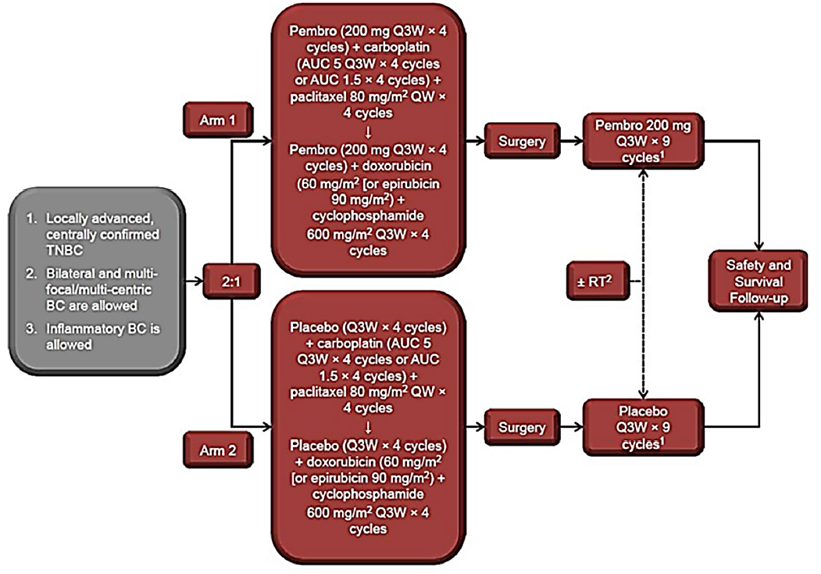
Abbreviations: AUC = area under the curve; BC = breast cancer; TNBC = triple negative breast cancer; pembrolizumab = pembrolizumab; QW = once every week; Q3W = once every three weeks; RT = radiation therapy
¹ No crossover from placebo to pembrolizumab was permitted.
² If postoperative radiation therapy was indicated, adjuvant pembrolizumab or placebo may have been started either concurrently with radiation therapy or 2 weeks post-radiation therapy.
There were 1174 randomised patients comprising of the intent to treat (ITT) population which was also the primary efficacy population. Randomisation was stratified by nodal status (positive versus negative), tumour size (T1/T2 versus T3/T4); and carboplatin regimen (every three weeks versus weekly).

Study treatments
The treatment arms were randomised in a 2:1 ratio as follows:
- Arm 1: pembrolizumab with chemotherapy as neoadjuvant therapy (pembrolizumab once every three weeks with paclitaxel weekly and carboplatin once every three weeks or weekly, for four cycles, followed by pembrolizumab with doxorubicin or epirubicin, with cyclophosphamide once every three weeks, for four cycles) as neoadjuvant therapy prior to surgery; followed by nine cycles of pembrolizumab once every three weeks as adjuvant therapy post-surgery.
- Arm 2: placebo with chemotherapy as neoadjuvant therapy (placebo once every three weeks with paclitaxel weekly and carboplatin every three weeks or weekly, for four cycles, followed by placebo with doxorubicin or epirubicin, with cyclophosphamide once every three weeks, for four cycles) as neoadjuvant therapy prior to surgery; followed by nine cycles of placebo once every three weeks as adjuvant therapy post-surgery.
Surgery was performed approximately three to six weeks after completion or discontinuation of the neoadjuvant phase. The study treatment continued for 17 cycles of pembrolizumab or placebo or until a protocol specified event. Imaging was performed at the investigator’s discretion, per local standard of care; disease assessments were conducted per RECIST version 1.1, if applicable.

Patient flow
The patient flow as at the fourth Interim Analysis (IA4) is listed below. Arm 1 is described as ‘pembrolizumab’ and Arm 2 is described is ‘placebo’:
- Randomised: 1174 patients (pembrolizumab 784, placebo 390)
- Treated: 1172 patients (pembrolizumab 783, placebo 389)
- Completed all treatments: pembrolizumab 487 out of 784 patients (62.1%); placebo 283 out of 390 patients (72.6%)
- Discontinued all treatments:
  - Pembrolizumab 291 out of 784 patients (37.1%), of which:
    - 190 out of 784 (24.2%) discontinued in neoadjuvant phase. 112 (14%) were due to adverse events.
    - 101 out of 784 (12.9%) discontinued in adjuvant phase. 42 (5%) were due to adverse events and 20 (3%) due to relapse or recurrence.
  - Placebo 106 out of 390 patients (27.2%), of which:
    - 58 out of 390 patients (14.9%) discontinued in neoadjuvant phase. 20 (5%) were due to adverse events.
    - 48 out of 390 patients (12.3%) discontinued in adjuvant phase. 18 (5%) were due to relapse or recurrence and 10 (3%) were due to adverse events.
- Had surgery: pembrolizumab 768 out of 784 patients (98%), placebo 381 out of 390 patients (98%).
- Median follow up: pembrolizumab 37.8 months, placebo 37.6 months.
- No patients were continuing study treatment as of IA4.
- Ongoing in study follow up: pembrolizumab 88.6%, placebo 84.1% (most discontinuations from study were due to death).

Key inclusion criteria
The key inclusion criteria included:
- Newly diagnosed, centrally confirmed TNBC, per most recent ASCO/CAP guidelines.
- Had previously untreated, locally advanced, non-metastatic TNBC assessed by Investigator to be either:15
  - T1c, N1-N2
  - T2, N0-N2
  - T3, N0-N2
  - T4a-d, N0-N2
- Provided a core needle biopsy (at least two separate cores from the primary tumour) at screening to central laboratory.
- Had an Eastern Cooperative Oncology Group Performance Status (ECOG PS) 0 or 1.

Key exclusion criteria
- Received prior chemotherapy, targeted therapy or radiation therapy within the past 12 months.
- A history of non-infectious pneumonitis that required steroids, or current pneumonitis.
- Significant cardiovascular disease.

Study endpoints
The primary endpoint was pathological complete response rate (pCR) for ypT0/Tis ypN0 and event-free survival, as defined in Table 4, below.
The key secondary endpoint was overall survival.
Other secondary endpoints were pCR rate using alternative definition as described in Table 4 below, safety and tolerability and patient-reported outcomes.
PD-L1 expression in tumour samples was assessed at a central laboratory using the PD-L1 Immunohistochemistry (IHC) 22C3 pharmDx assay (Agilent Technologies). A combined positive score was defined as the number of PD-L1 positive cells (tumour cells, lymphocytes, and macrophages) divided by the total number of tumour cells, multiplied by 100.
Table 4: Study KN-522 (KEYNOTE 522 trial) Endpoint definitions
Endpoint | Definition
pCR rate (ypT0/Tis ypN0)* | The proportion of participants without residual invasive cancer on hematoxylin and eosin evaluation of the complete resected breast specimen and all sampled regional lymph nodes following completion of neoadjuvant systemic therapy by AJCC staging criteria;^{15,,} assessed by the local pathologist at the time of definitive surgery.  Hypothesis: pembrolizumab is superior to placebo
Event-free survival (investigator assessed) | The time from randomization to the first occurrence of any of the following events:# progression of disease that precludes definitive surgery, local or distant recurrence, second primary malignancy, or death due to any cause.  Hypothesis: pembrolizumab is superior to placebo
Overall survival | Time from randomisation to death due to any cause.  Hypothesis: pembrolizumab is superior to placebo
pCR rate using alternative definition (ypT0 ypN0)$ | The proportion of participants without residual invasive and in situ cancer on hematoxylin and eosin evaluation of the complete resected breast specimen and all sampled regional lymph nodes following completion of neoadjuvant systemic therapy by AJCC staging criteria assessed by the local pathologist at the time of definitive surgery.
pCR rate using alternative definition (ypT0/Tis) | The proportion of participants without invasive cancer in the breast irrespective of ductal carcinoma in situ or nodal involvement following completion of neoadjuvant systemic therapy per current AJCC staging criteria assessed by the local pathologist at the time of definitive surgery.
Patient reported outcomes | Health-related quality of life assessments using the EORTC QLQ-C30 and EORTC QLQ-BR23.
Notes: *ypT0/Tis ypN0: no invasive residual in breast or nodes; non-invasive breast residuals allowed.
# Events also included ‘positive margin at last surgery’. Second primary excluded basal or squamous cell carcinoma of the skin, carcinoma in situ of the cervix, or second primary breast.
$ ypT0 ypN0: no invasive or non-invasive residual in breast or nodes.

Statistical analysis
The analysis populations are:
- Efficacy: Intent to treat population (all randomized patients) n = 1174.
- Safety: All subjects as treated (who received at least one study drug treatment and/or had surgery) n = 1172.
Planned efficacy analyses are described in Table 5, below. The overall survival will be tested when the null hypothesis for evert free survival is rejected.
Table 5: Study KN-522 (KEYNOTE 522 trial) Planned efficacy analyses
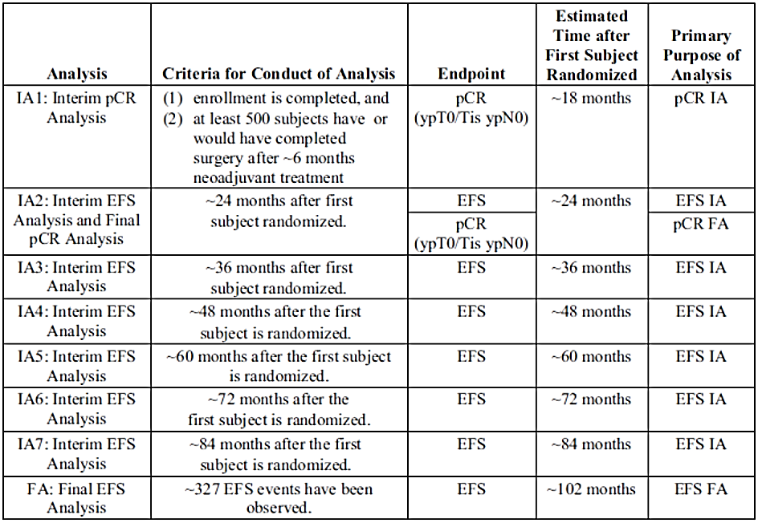
FA = final analysis, IA = interim analysis
The final analysis is event-free survival (EFS) event driven. The planned sample size is approximately 1150 subjects (driven by EFS), to provide the following power:
- pCR rate (ypT0/Tis ypN0): overall approximately 95% power to detect a true pCR rate difference of 15 percentage points (pembrolizumab versus placebo at alpha = 0.5% (one-sided) with approximately 1000 subjects who have or would have completed surgery after approximately 6 months neoadjuvant treatment at IA2).
- Event-free survival: overall approximately 80% power at a one-sided 2.0% alpha level if the true hazard ratio = 0.71.
- Overall survival: overall approximately 79.7% power at a one-sided 2.0% alpha level if the true hazard ratio = 0.70.
The Type I error rate over the two primary endpoints was to be strongly controlled at 2.5% (one-sided), with 0.5% allocated to pCR and 2% allocated to event-free survival. The graphical approach of Maurer and Bretz was to be applied to reallocate alpha among hypotheses for pCR (ypT0/Tis ypN0), event-free survival and overall survival. Group sequential methods were to be used to allocate alpha between interim and final analyses.
The study was to be considered a success if pCR (ypT0/Tis ypN0) or event-free survival was demonstrated to be statistically significant at either an interim analysis or the final analysis under multiplicity control.
Treatment comparisons of pCR rate were performed using the stratified Miettinen and Nurminen method. Treatment comparisons for time to event endpoints were evaluated using a stratified log rank test, with the hazard ratio estimated using a stratified Cox model.

Protocol amendments and deviations
There were four amendments to the protocol. Most are considered unlikely to impact the interpretation of the study. ‘Positive margins at last surgery’ was added as an event-free survival event with Amendment 2. This could lead to potentially overestimated progression rates, as positive margins may not necessarily reflect true progression (these events turned out to be infrequent). Pre-operative cortisol measurement was added with Amendment 2.
The number of participants with more than one important protocol deviation was pembrolizumab 64 (8.2%), placebo 19 (4.9%). The number of clinically important deviations were pembrolizumab 28 (3.6%), placebo 8 (2.1%). No patients were excluded from efficacy analyses due to these protocol deviations. While important deviations were somewhat more frequent in the pembrolizumab group than the placebo group, they were overall infrequent and unlikely to have a major bearing on the outcomes.

Patient demographics and disease characteristics
Treatment arms were balanced with respect to demographics and baseline disease characteristics. The median age was 49 years. All but one patient (in the pembrolizumab group) was female. Most patients (88.8%) were younger than 65 years and most (86.8%) were of ECOG PS = 0 (or fully active).¹⁸ Most patients (82.9%) had PD-L1 expression status (combined positive score) CPS ≥ 1.
Table 6: Study KN-522 (KEYNOTE 522) Summary of participant characteristics for the intent to treat population
 | Pembrolizumab + chemotherapy (n = 784) |  | Placebo + chemotherapy  (n = 390) |  | Total  (n = 1174)
 | n | % | n | % | n | %
Male  Female | 1  783 | 0.1  99.9 | 0  390 | 0  100 | 1  1173 | 0.1  99.9
Median age (range) in years | 49.0 (22, 80) |  | 48.0 (24, 79) |  | 49.0 (22, 80)
< 65 years  ≥ 65 years | 700  84 | 89.3  10.7 | 342  48 | 87.7  12.3 | 1042  132 | 88.8  11.2
American Indian/Alaska native  Asian  Black/African American  Multiple race  Native Hawaiian/Pacific Is.  White  Missing | 14  149  38  13  1  504  65 | 1.8  19.0  4.8  1.7  0.1  64.3  8.3 | 7  89  15  6  0  242  31 | 1.8  22.8  3.8  1.5  0  62.1  7.9 | 21  238  53  19  1  746  96 | 1.8  20.3  4.5  1.6  0.1  63.5  8.2
North America  Europe  Australia  Asia  Rest of World | 166  388  23  166  41 | 21.2  49.5  2.9  21.2  5.2 | 78  180  16  91  25 | 20.0  46.2  4.1  23.3  6.4 | 244  568  39  257  66 | 20.8  48.4  3.3  21.9  5.6
ECOG 0  ECOG 1 | 678  106 | 86.5  13.5 | 341  49 | 87.4  12.6 | 1019  155 | 86.8  13.2
Carboplatin regimen (actual)  Once every three weeks  Weekly  Missing | 334  444  6 | 42.6  56.6  0.8 | 167  220  3 | 42.8  56.4  0.8 | 501  664  9 | 42.7  56.6  0.8
Tumour size T1/T2  Tumour size T2/T4 | 580  204 | 74.0  26.0 | 290  100 | 74.4  25.6 | 870  304 | 74.1  25.9
Nodes positive  Nodes negative | 405  379 | 51.7  48.3 | 200  190 | 51.3  48.7 | 605  569 | 51.5  48.5
PD-L1 CPS ≥ 1  PD-L1 CPS < 1  Unknown | 656  128  0 | 83.7  16.3  0 | 317  69  4 | 81.3  17.7  1.0 | 973  197  4 | 82.9  16.8  0.3
For definitions of tumour size;¹⁵ ECOG performance status scores;¹⁸ and combined positive scores (CPS),²³ see the relevant footnotes.
Concomitant systemic corticosteroids were received by a similar proportion of patients in each group: pembrolizumab 98.3%, placebo 97.2%. The proportion of patients receiving adjuvant radiotherapy was somewhat imbalanced, with 57.9% in the pembrolizumab group and 66.9% in the placebo group.

Efficacy

Primary endpoints (dual)
The success criterion for pathological complete response (pCR) of ypT0/Tis ypN0 (see Table 4 for definitions) was met at the first interim analysis point (IA1), with an increase in pCR rate for pembrolizumab and chemotherapy compared with placebo and chemotherapy (rate difference 13.6% (95% confidence interval (CI): 5.4, 21.8), p = 0.00055). This remained statistically significant at IA2 (the final analysis of pCR).
Analysis of pCR at IA4 was not subject to formal testing but supportive estimates were provided using data from all randomised subjects. The rate difference in pCR is noted to have become smaller with each additional analysis, as the proportion of the population with data increased (see Table 7).
Table 7: Study KN-522 (KEYNOTE 522 trial) Summary of pathological complete response (ypT0/Tis ypN0) results for the intent to treat population
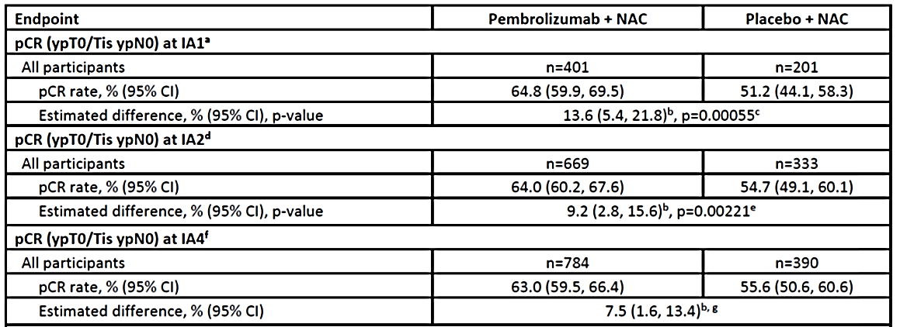
Abbreviations: CI = confidence interval; IA – interim analysis; NAC – neoadjuvant chemotherapy; pCR = pathological complete response; ypT0/Tis ypN0 = no invasive residual in breast or nodes; non-invasive breast residuals allowed
See Table 4 for definition of pCR response.
ª First 602 participants randomly assigned to study treatment who were eligible for the analysis of pCR at IA1 (24 September 2018 data cut-off).
^{b} Based on Miettinen & Nurminen method stratified by nodal status (positive versus negative), tumor size (T1/T2 versus T3/T4), and choice of carboplatin (Cb) (once every three weeks versus weekly).
^{c} One-sided p-value for testing H0: difference in % = 0 versus H1: difference in % > 0. The result was statistically significant compared with the prespecified p value boundary of 0.003.
^{d} First 1002 participants randomly assigned to study treatment who were eligible for the analysis of pCR at IA2 (24 April 2019 data cutoff).
^{e} KEYNOTE-522 met the success criterion for the primary hypothesis of pCR at IA1. At IA2, the updated data continue to be statistically significant (prespecified p value boundary of 0.0028).
^{f} All participants in ITT population (n = 1174) (23 March 2021 data cutoff)
^{g} Per the statistical analysis plan, pCR was not formally tested at IA4. Updated data are provided for estimation purposes.
Analyses of the primary endpoint were generally consistent across subgroups, although the point estimates favoured placebo for ECOG PS = 1 and for HER2 status of 2+ by immunohistochemistry (IHC) fluorescence in situ hybridisation negative (FISH-). Interpretation of these outliers is limited by the lower patient numbers in these subgroups. The point estimates in those who were PD-L1 positive and negative were similar. The subgroup analysis pattern was generally similar between IA1, IA2 and IA4 (shown below for IA4 in Figure 2).
Figure 2: Study KN-522 (KEYNOTE 522 trial) Pathological complete response subgroup analysis (IA4) for the intent to treat population
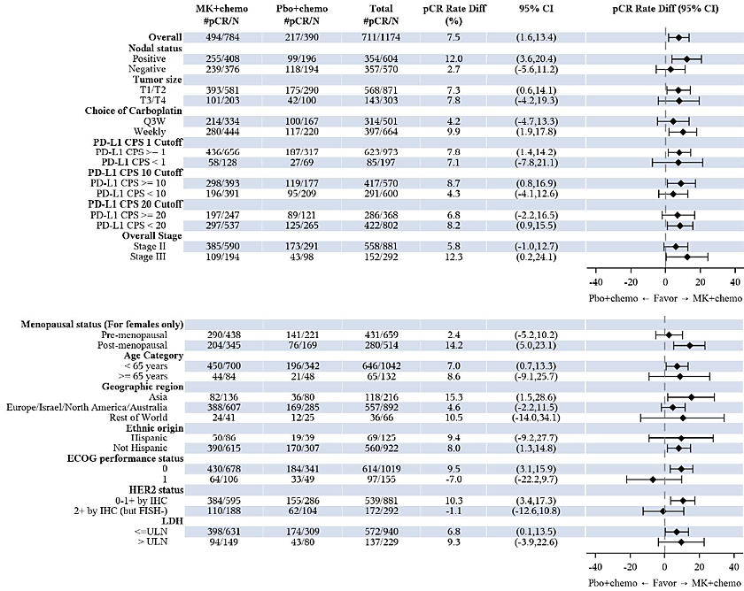
Abbreviations: MK = MK-3475 (pembrolizumab), Pbo = placebo, chemo = chemotherapy, pCR = pathological complete response, CI = confidence interval, PD-L1 = programmed cell death ligand-1, CPS = combined positive score, HER2 = human epidermal growth factor receptor 2, IHC = immunohistochemistry.
For the fourth Interim Analysis (IA4) for event-free survival, the criteria for conduct of analysis is that the interim analysis is due to be carried out approximately 48 months after the first subject enrolment.
Analysis in the overall population and PD-L1 subgroup is based on stratified Miettinen & Nurminen method); for other subgroups, analysis is based on the unstratified Miettinen & Nurminen method.

Event-free survival
The success criterion for event-free survival (EFS) was met at the fourth interim analysis (IA4), with a 37% reduction in the risk of disease progression precluding definitive surgery, recurrence, second primary malignancy, or death for pembrolizumab compared with placebo; The hazard ratio was 0.63 (95% CI: 0.48, 0.82), with a one-sided p-value of 0.0003093 which crossed the efficacy boundary (see Table 8). The point estimate was consistent with IA2 (0.63) and IA3 (0.65).
Table 8: Study KN-522 (KEYNOTE 522 trial) Summary of event-free survival results (IA4) for the intent to treat population
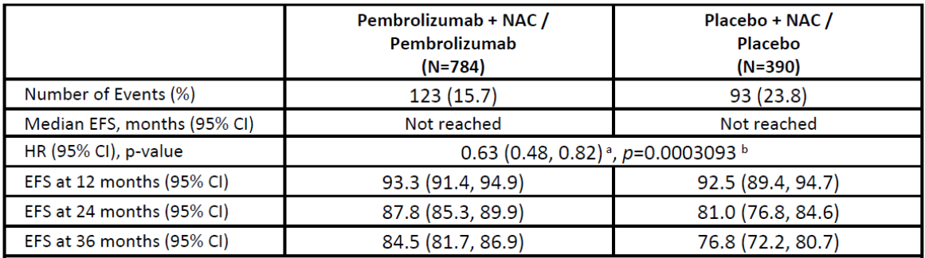
Abbreviations: CI = confidence interval; EFS = event-free survival; NAC = neoadjuvant chemotherapy
For the fourth Interim Analysis (IA4) for event-free survival, the criteria for conduct of analysis is that the interim analysis is due to be carried out approximately 48 months after the first subject enrolment.
For definitions of tumour size;¹⁵ see the relevant footnote.
ª Based on Cox regression model with Efrons’ method of tie handling with treatment as a covariate by nodal status (positive versus negative), tumor size (T1/T2 versus T3/T4) and choice of carboplatin (Cb) (every three weeks versus weekly)
^{b} One-sided p value based on log-rank test by nodal status (positive versus negative), tumor size (T1/T2 versus T3/T4) and choice of carboplatin (Cb) (every three weeks versus weekly). The result was statistically significant compared with the prespecified p-value boundary of 0.0051941.
The database cutoff date was 23 March 2021.
Figure 3: Study KN-522 (KEYNOTE 522 trial) Kaplan-Meier estimates of event-free survival (IA4) for the intent to treat population
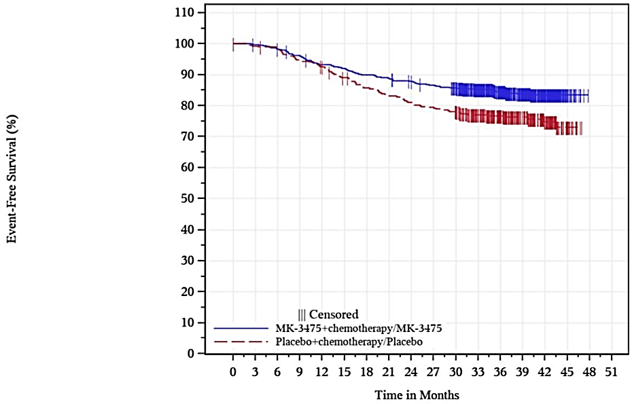
Abbreviation: MK-3475 = drug development code for pembrolizumab
For the fourth Interim Analysis (IA4) for event-free survival, the criteria for conduct of analysis is that the interim analysis is due to be carried out approximately 48 months after the first subject enrolment.
The most common EFS event in both arms was ‘distant recurrence’, followed by ‘local recurrence’. Those with ‘positive margin at last surgery’ formed a minority of EFS events, so if some of these did not represent true progression, it was unlikely to substantially influence the outcome. This was supported by a sensitivity analysis excluding these events: hazard ratio = 0.65 (95% CI: 0.50, 0.85), which was consistent with the primary endpoint. The breakdown of events is shown in Table 9, below.
Table 9: Study KN-522 (KEYNOTE 522 trial) Summary of event-free survival events for the intent to treat population (IA4)
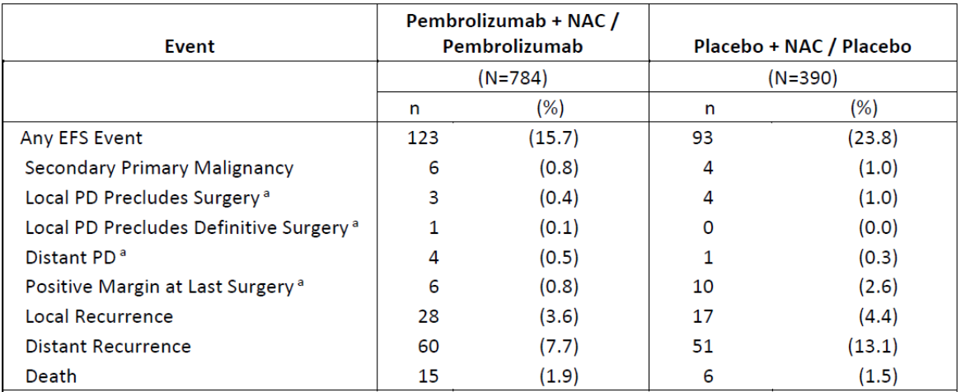
Abbreviations: EFS = event-free survival; ITT = intent to treat; NAC = neoadjuvant chemotherapy; PD = progressive disease
For the fourth Interim Analysis (IA4) for event-free survival, the criteria for conduct of analysis is that the interim analysis is due to be carried out approximately 48 months after the first subject enrolment.
ª Progression of disease that precludes definitive surgery includes Local PD Precludes Surgery; Local PD Precludes Definitive Surgery, Distant PD, and Positive Margin at Last Surgery.
Database cutoff date: 23 March 2021
EFS was generally consistent across subgroups (see Figure 4).
Figure 4: Study KN-522 (KEYNOTE 522 trial) Event-free survival by subgroups for the intent to treat population (IA4)
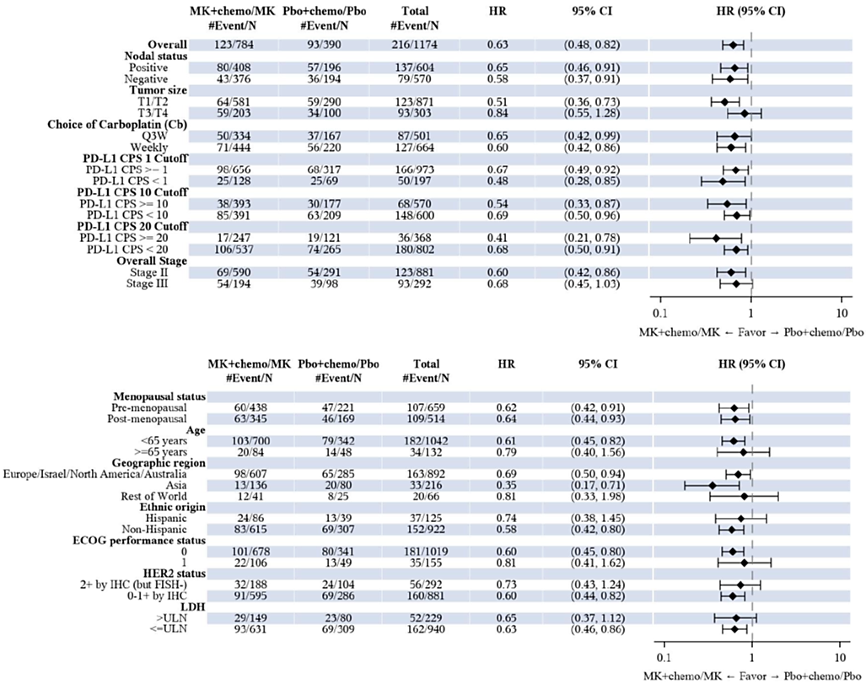
Abbreviations: MK = MK-3475 (pembrolizumab), Pbo = placebo, chemo = chemotherapy, HR = hazard ratio, CI = confidence interval, PD-L1 = programmed cell death ligand-1, CPS = combined positive score, HER2 = human epidermal growth factor receptor 2, IHC = immunohistochemistry.
For definitions of tumour size and nodal status;¹⁵ ECOG performance status scores;¹⁸ and combined positive scores (CPS),²³ see the relevant footnotes.
For the fourth Interim Analysis (IA4) for event-free survival, the criteria for conduct of analysis is that the interim analysis is due to be carried out approximately 48 months after the first subject enrolment.
Analysis (HR and 95% CI) in the overall population and PD-L1 subgroup is based on stratified Cox model; for other subgroups, analysis is based on the unstratified Cox model.

Key secondary endpoint
Overall survival was formally assessed at IA4 analysis according to the prespecified plan, since the null hypothesis was rejected for EFS at this analysis. The information fraction was approximately 45% of the events needed for final analysis (135 out of 297), and the observed p-value did not cross the boundary for efficacy: hazard ratio = 0.72 (95% CI: 0.51, 1.02), p = 0.0321377. See Table 10 and Figure 5, below.
Table 10: Study KN-522 (KEYNOTE 522 trial) Summary of overall survival for the intent to treat population (IA4)
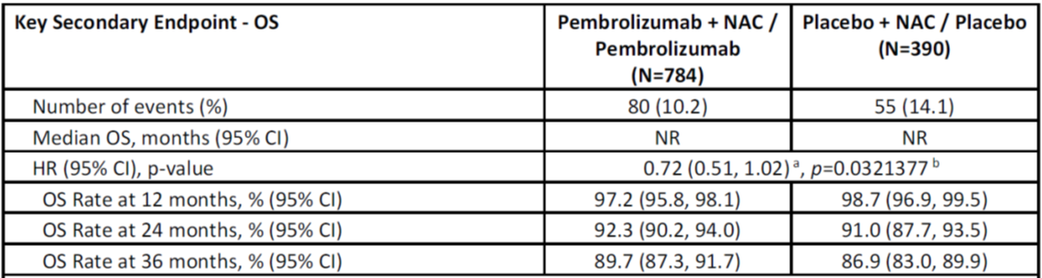
Abbreviations: CI = confidence interval; OS = overall survival; NAC = neoadjuvant chemotherapy.
For definitions of tumour size;¹⁵ ECOG performance status scores;¹⁸ and combined positive scores (CPS),²³ see the relevant footnotes.
For the fourth Interim Analysis (IA4) for event-free survival, the criteria for conduct of analysis is that the interim analysis is due to be carried out approximately 48 months after the first subject enrolment.
ª Based on Cox regression model with Efron’s method of tie handling with treatment as a covariate by nodal status (positive versus negative), tumour size (T1/T2 versus T3/T4) and choice of carboplatin (Cb) (every three weeks versus weekly).
^{b} One-sided p value based on log-rank test by nodal status (positive versus negative), tumour size (T1/T2 versus T3/T4) and choice of carboplatin (Cb) (every three weeks versus weekly).
Database cut-off date: 23 March 2021
Figure 5: Study KN-522 (KEYNOTE 522 trial) Kaplan-Meier estimate of overall survival for the intent to treat population (IA4)
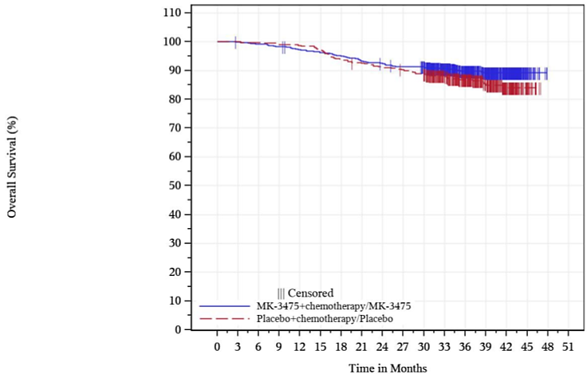
Abbreviation: MK-3475 = drug development code for pembrolizumab
For the fourth Interim Analysis (IA4) for event-free survival, the criteria for conduct of analysis is that the interim analysis is due to be carried out approximately 48 months after the first subject enrolment.
Subgroup analyses were generally consistent with the intent to treat population analysis.

Other secondary endpoints
These endpoints were not under multiplicity control and will only be mentioned briefly here.

Pathological complete response (pCR) using alternative definitions
Analyses of pCR using alternative definitions ypT0 ypN0 and ypT0/Tis were consistent with the primary endpoint (see Table 4 for definitions of pCR).

Key endpoints by PD-L1 status
Analyses in participants with tumours that expressed PD-L1 (CPS ≥ 1) were all consistent with the intent to treat (ITT) analysis. This is not surprising, given this group comprised 82.9% of the ITT population. The analyses in those with CPS < 1 were also generally consistent with the ITT analyses (see Table 11).
Table 11: Study KN-522 (KEYNOTE 522 trial) Key endpoints by PD-L1 expression status (IA4)
Endpoint | CPS ≥ 1 | CPS < 1
pCR rate difference (95% CI) | 7.8% (1.4, 14.2) | 7.1% (-7.8, 21.1)
EFS hazard ratio (95% CI) | 0.67 (0.49, 0.92) | 0.48 (0.28, 0.85)
Abbreviations: CPS = combined positive score; EFS = event-free survival; pCR = pathological complete response.
For definitions of combined positive scores (CPS),²³ see the relevant footnote. For definition of pathological complete response (pCR) see Table 4.
For the fourth Interim Analysis (IA4) for event-free survival, the criteria for conduct of analysis is that the interim analysis is due to be carried out approximately 48 months after the first subject enrolment.

Patient reported outcomes
There was no prespecified definition for a clinically relevant between-group difference in the longitudinal analysis of patient reported outcome score changes over time.
The EORTC QLQ-BR23 has been validated for use across all stages of breast cancer.
Patient reported outcomes were assessed in both the neoadjuvant and adjuvant phases, and scores were overall generally similar between pembrolizumab and placebo groups. The difference between groups in least squares mean change from baseline in EORTC QLQ-C30 global scores and EORTC QLQ-BR23 scores in both treatment phases were small (approximately ≤ 1) and the confidence intervals crossed zero.

Safety

Exposure
The median duration of exposure to study drugs across both phases of the study was 58.1 weeks: pembrolizumab (57.9 weeks), and placebo (59.1 weeks) with a median of 17 administration of study drug. Exposure to chemotherapy was very similar in both groups.
No patient remained on pembrolizumab at the fourth interim analysis (IA4).
It is noted that the safety population included all subjects who received at least one study treatment including any study drug and surgery (n = 1172). Of these, 1167 received at least one dose of pembrolizumab (n = 778) or placebo (n = 389) respectively. This small difference (1167 versus 1172) is unlikely to influence the results for comparisons between pembrolizumab and placebo.

Safety overview
Overall adverse events (AE) across both treatment phases are summarised in Table 12. Events in all categories were generally more frequent during the neoadjuvant than the adjuvant phase.
Table 12: Study KN-522 (KEYNOTE 522 trial) Adverse event summary of combined neoadjuvant and adjuvant phases for all subjects as treated (IA4)
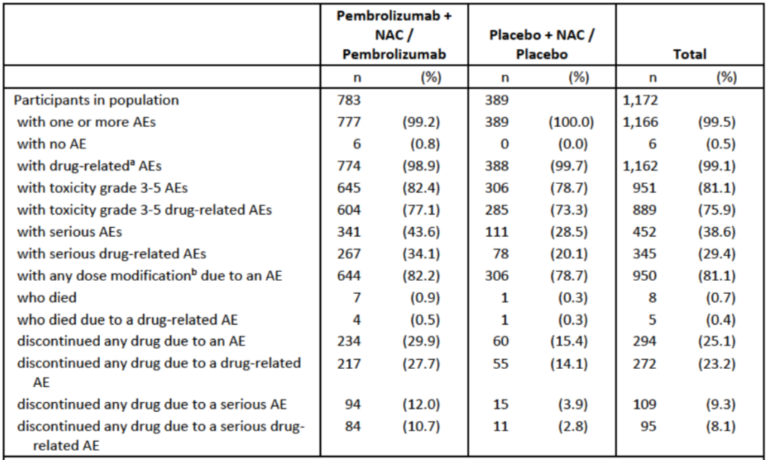
ª Determined by the investigator to be related to the drug.
^{b} Defined as an action taken of dose reduced, drug interrupted or drug withdrawn
Notes: Grades are based on NCI CTCA version 4.0
For the fourth Interim Analysis (IA4) for event-free survival, the criteria for conduct of analysis is that the interim analysis is due to be carried out approximately 48 months after the first subject enrolment.
Included adverse events started from the first treatment including definitive surgery and radiation therapy and up to 30 days of the last treatment including definitive surgery and radiation therapy for the non-serious adverse events and up to 90 days of the last treatment including definitive surgery and radiation therapy for the serious adverse events.
MedDRA preferred terms ‘Neoplasm Progression’, ‘Malignant Neoplasm Progression’ and ‘Disease progression’ not related to the drug are excluded.
Database cut-off date 23 March 2021

Adverse events
Across the neoadjuvant and adjuvant treatment phases combined, the most commonly reported AEs were nausea (66.5%), alopecia (60.0%), anaemia (59.0%), neutropenia (48.3%) and fatigue (45.5%). These were reported with a similar frequency in both treatment arms. This pattern was similar in the neoadjuvant phase.
In the adjuvant phase, AEs were somewhat less frequent (proportion of subjects: pembrolizumab 92.2%, placebo 88.8%) and the pattern of Preferred Terms (PT) differed. The most commonly reported events in the adjuvant phase were radiation skin injury (19.9%), arthralgia (18.8%), headache (9.2%), diarrhoea (8.8%) and fatigue (8.8%). These most frequent events had generally similar incidence in both arms.
Most AEs occurred in the first three months of study initiation. The exposure adjusted event rate declined thereafter.
The AEs with the biggest imbalance between treatment groups across both treatment phases are presented below, sorted by risk difference. The biggest imbalances (pembrolizumab greater than placebo, sorted by decreasing difference in absolute incidence) were observed for events of pyrexia (9.7%), hypothyroidism (9.4%), diarrhoea (6.4%), rash (6.2%), and decreased appetite (6%).
During the adjuvant phase, the risk differences between treatment groups for common AEs were all below 5%.
Figure 6: Study KN-522 (KEYNOTE 522 trial) Between-treatment comparisons in adverse events (incidence ≥ 15% in either group), sorted by risk difference, across combined phases (all subjects as treated) (IA4)
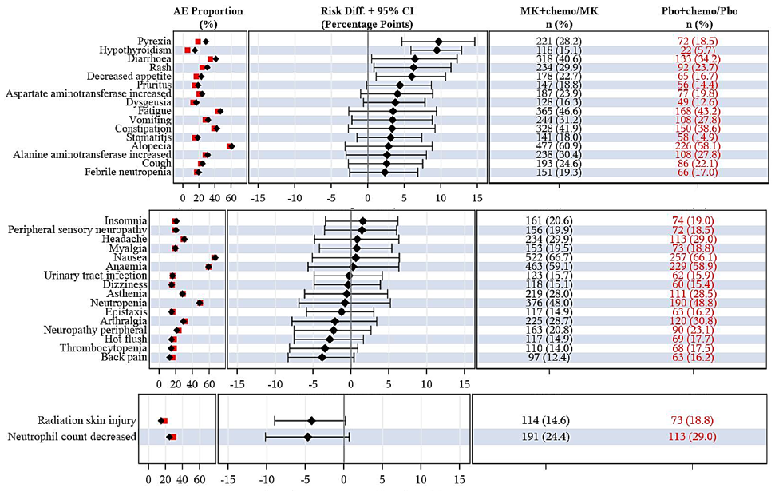
Note: CI = confidence interval; MK = MK-3475 (drug development code for pembrolizumab); Pbo = placebo, chemo = chemotherapy, AE = adverse events
For the fourth Interim Analysis (IA4) for event-free survival, the criteria for conduct of analysis is that the interim analysis is due to be carried out approximately 48 months after the first subject enrolment.

Treatment-related adverse events
The overall incidence of treatment-related AEs was similar between both groups. The frequencies of each event were generally similar between both groups (see Table 13).
Table 13: Study KN-522 (KEYNOTE 522 trial) Treatment-related adverse events by decreasing incidence (10 most frequent events); combined study phases (all subjects as treated; IA4)
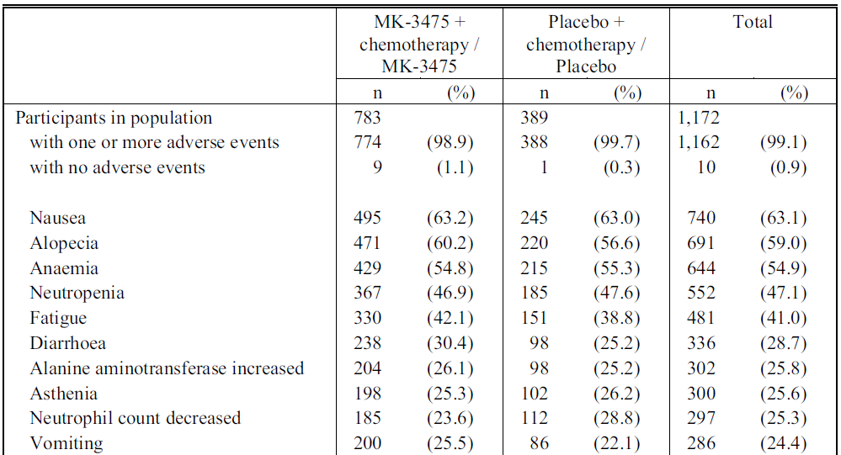
Notes: MK-3475 = drug development code for pembrolizumab.
Original table (incidence ≥ 5%) has been edited for brevity.
For the fourth Interim Analysis (IA4) for event-free survival, the criteria for conduct of analysis is that the interim analysis is due to be carried out approximately 48 months after the first subject enrolment.
The overall incidence of drug-related AEs as determined by the investigator during the adjuvant phase was generally similar between the pembrolizumab group (53.7%) and the placebo group (48.6%). The most frequent were arthralgia (pembrolizumab 8.5%, placebo 6.9%), asthenia (pembrolizumab 4.6%, placebo 5.1%), rash (pembrolizumab 6.0%, placebo 2.4%) and pruritis (pembrolizumab 5.1%, placebo 2.1%).

Grade 3 to 5 adverse events
Across the combined treatment phases, the incidence of Grade 3 to 5 AE was similar in the pembrolizumab (82.4%) and placebo (78.7%) groups. The biggest imbalances (pembrolizumab greater than placebo, absolute difference in incidence) were observed for anaemia (3.9%) and alanine aminotransferase increased (3.6%). The most frequent events are summarised in Table 14.

Table 14: Study KN-522 (KEYNOTE 522 trial) Grade 3 to 5 adverse events (incidence ≥ 5%) across combined phases (all subjects as treated) (IA4)
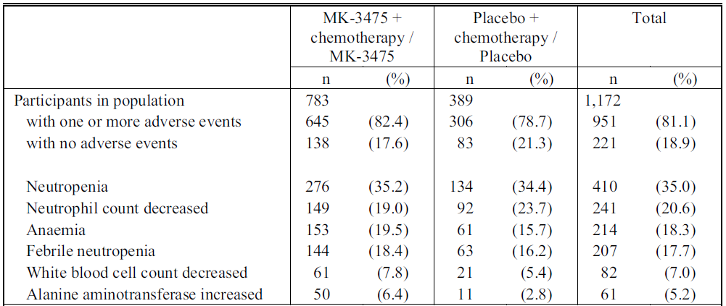
Notes: MK-3475 = drug development code for pembrolizumab.
Every participant is counted a single time for each applicable specific adverse event.
For the fourth Interim Analysis (IA4) for event-free survival, the criteria for conduct of analysis is that the interim analysis is due to be carried out approximately 48 months after the first subject enrolment.
A specific adverse event appears on this report only if its incidence in one or more of the columns meets the incidence criterion in the report title, after rounding.
Included adverse events started from the first treatment including definitive surgery and radiation therapy and up to 30 days of the last treatment including definitive surgery and radiation therapy for the nonserious adverse events and up to 90 days of the last treatment including definitive surgery and radiation therapy for the serious adverse events.
Grades are based on NCI CTCAE version 4.0.
MedDRA preferred terms ‘Neoplasm progression’, ‘Malignant neoplasm progression’ and ‘Disease progression’ not related to the drug are excluded.
Database Cut-off Date: 23 March 2021
Grade 3 to 5 AEs were infrequent during the adjuvant phase (pembrolizumab 15.0%, placebo 11.5%). The most frequent was radiation skin injury (0.9%). No PT had an incidence greater than 1% in either arm.

Serious adverse events
Across both treatment phases, serious adverse events (SAEs) were more frequently reported with pembrolizumab (43.6%) than placebo (28.5%). The ten most frequently reported SAEs are presented in Table 15. The event with the biggest imbalance (pembrolizumab greater than placebo) was pyrexia (absolute incidence difference 3.2%). No new safety concerns were suggested.
Table 15: Study KN-522 (KEYNOTE 522 trial) Participants with serious adverse events (10 most frequent events) across combined phases (all subjects as treated) (IA4)
Note: MK-3475 = drug development code for pembrolizumab
Serious adverse events (SAEs) are reported up to 90 days after last dose of study drug.
Original table (with all events) has been edited for brevity.
For the fourth Interim Analysis (IA4) for event-free survival, the criteria for conduct of analysis is that the interim analysis is due to be carried out approximately 48 months after the first subject enrolment.
SAEs were infrequent during the adjuvant treatment phase (pembrolizumab 7.0%, placebo 4.2%). The most common events were pneumonia (pembrolizumab 0.5%, placebo 0.6%) and pneumonitis (pembrolizumab 0.7%, placebo 0.3%).

Deaths
Deaths due to adverse events were more frequently reported with pembrolizumab (seven (0.9%)) than with placebo (one (0.3%)). Of these deaths, four and one, respectively, were considered treatment related (that is, to pembrolizumab/placebo or chemotherapy) by investigator. Three deaths were considered related to pembrolizumab. No individual PT was reported more than once. No new safety concerns were suggested.
Most deaths (six of eight) were reported during the neoadjuvant phase. Two (both in the pembrolizumab group) were reported in the adjuvant phase.
Review of the narratives suggests four of the seven deaths in the pembrolizumab group were potentially immune mediated (shock (with adrenal insufficiency), pneumonitis, sudden death (with hepatitis) and autoimmune encephalitis).
The death due to shock occurred in a patient one day following breast conserving surgery. This patient was found to have a cortisol level of 3 nmol/L (reference range: 172 to 497 nmol/L) 21 days pre-operatively, suggestive of possible pembrolizumab-related adrenal insufficiency, although this was confounded by concomitant dexamethasone for chemotherapy-induced nausea and vomiting. Pulmonary thromboembolism could also not be excluded in this case. Note that preoperative cortisol measurement was added with Protocol Amendment 2 (probably after this event; the narrative was not dated so this cannot be ascertained from the data supplied by sponsor).
Table 16: Study KN-522 (KEYNOTE 522 trial) Participants with adverse events leading to death; combined phases (all subjects as treated) (IA4)
MK-3475 = drug development code for pembrolizumab.
For the fourth Interim Analysis (IA4) for event-free survival, the criteria for conduct of analysis is that the interim analysis is due to be carried out approximately 48 months after the first subject enrolment.

Discontinuation due to adverse events
Discontinuation of study treatment due to adverse events (AEs) across both study phases was more frequent in the pembrolizumab arm than the placebo arm. Participants with one or more AE leading to:
- Discontinuation of pembrolizumab/placebo only: pembrolizumab 20.1%, placebo 8.0% (for adverse events)
- Discontinuation of neoadjuvant chemotherapy: pembrolizumab arm 16.6%, placebo arm 10.3% (for drug related adverse events)
The higher rate of discontinuation of study intervention in the pembrolizumab group was primarily driven by events that each occurred in less than 1% of participants. The most common were alanine aminotransferase increase (pembrolizumab 3.1%, placebo 1.3%), neutropoenia (pembrolizumab 2.0%, placebo 1.5%) and aspartate transaminase increase (pembrolizumab 1.8%, placebo 0%).
Dose modifications due to AEs were generally similar in both arms.
AE leading to discontinuation of study treatment were less frequent during the adjuvant phase: pembrolizumab 5.4%, placebo 2.4%.

Adverse events of special interest
Adverse events of special interest (AESI) are immune-mediated events and infusion-related reactions associated with pembrolizumab.
The types of AESI reported in the pembrolizumab group were consistent with the known safety profile of pembrolizumab monotherapy. As expected, AESI were more frequent in the pembrolizumab group (43.6%) than the placebo group (21.9%). The most common were infusion reactions (pembrolizumab 18.0%, placebo 11.6%) and hypothyroidism (pembrolizumab 15.1%, placebo 5.7%).
In the pembrolizumab arm, 114 out of 118 of the hypothyroidism events were Grades 1 to 2. Four were Grade 3 events.
Grade 3 to 5 AESI were reported in the following proportions of subjects: pembrolizumab 14.9%, placebo 2.1%. Grade 4 infusion reactions in the pembrolizumab arm included three subjects with cytokine release syndrome and two subjects with anaphylactic reaction. The remaining infusion reactions were Grade 1 to 3. Severe skin reactions in the pembrolizumab arm included one Grade 4 erythema multiforme and one Grade 4 Stevens-Johnson syndrome, the remaining 43 subjects had Grade 1 to 3 events.
Table 17: Study KN-522 (KEYNOTE 522 trial) Subjects with adverse events of special interest across combined phases (all subjects as treated) (IA4)
Abbreviations: MK-3475 = drug development code for pembrolizumab; NAC = neoadjuvant chemotherapy
For the fourth Interim Analysis (IA4) for event-free survival, the criteria for conduct of analysis is that the interim analysis is due to be carried out approximately 48 months after the first subject enrolment.
AESI were less frequent during the adjuvant phase: pembrolizumab 10.2%, placebo 6.0%. The most common was hypothyroidism: pembrolizumab 2.9%, placebo 3.6%.

Adverse events in special populations

Advanced age
In the pembrolizumab group, the following event categories were all more common in those older than 65 years than in those aged under 65: Grade 3 to 5 AEs (86.9% versus 81.8%), SAEs (53.6% versus 42.3%), dose modification due to AEs (86.9% versus 81.7%), deaths (2.4% versus 0.7%) and discontinuations due to AEs (44.0% versus 28.2%); however, the data should be interpreted with caution due to the low number of participants (n = 84; 10.7%) in the greater than 65 years age category in the pembrolizumab group.
Similar trends were not consistently observed in the placebo group (but again, interpretation is limited by low numbers of participants aged over 65).

Performance status
Comparing those with an ECOG performance status (PS) of 1 versus 0;¹⁸ in the pembrolizumab group, Grade 3 to 5 AEs (90.6% versus 81.1%), SAEs (48.1% versus 42.8%), dose modification due to AEs (85.8% versus 81.7%), and deaths (2.8% versus 0.6%) were all more common in those with ECOG PS = 1 compared with those with ECOG PS = 0. A similar pattern was generally observed in the placebo group.

Indication: Locally recurrent or metastatic triple negative breast cancer
Study KN-355 (also known as the KEYNOTE 355) and Study KN-199 (the KEYNOTE 199 trial, providing supportive data) were considered by the Delegate for evaluation of efficacy and safety for the following part of the proposed indications:
Triple-Negative Breast Cancer (TNBC)
Keytruda (pembrolizumab), in combination with chemotherapy, is indicated for the treatment of patients with locally recurrent unresectable or metastatic TNBC whose tumours express PD-L1 (CPS ≥ 10) as determined by a validated test.

Study KN-355 (KEYNOTE 355 trial)

Study overview
Data were submitted from the final analysis (final analysis; data cut-off 15 June 2021) of Study KN-355. Earlier analyses have been published.
Study KN-355 is a randomised (in a 2:1 ratio), double blind, placebo-controlled study comparing pembrolizumab with placebo as add-on to chemotherapy (paclitaxel, nab-paclitaxel or gemcitabine/carboplatin).
Eligible patients were adults with previously untreated, locally recurrent, inoperable or metastatic TNBC (centrally confirmed), with ECOG PS 0 or 1;¹⁸ and measurable disease per RECIST 1.1 by local review.¹⁶ Patients were enrolled regardless of tumour PD-L1 expression status, which was centrally assessed using the PD-L1 IHC 22C3 pharmDx assay. Previous treatment for Stage 1 to 3 cancer with curative intent was allowed if greater than six months had elapsed before the first documented local or distant recurrence.
Exclusion criteria were generally consistent with other pembrolizumab trials. Patients with active central nervous system metastases were excluded (known, stable metastases were allowed). Systemic steroid therapy was excluded.
Figure 7: Study KN-355 (KEYNOTE 355 trial) Study design
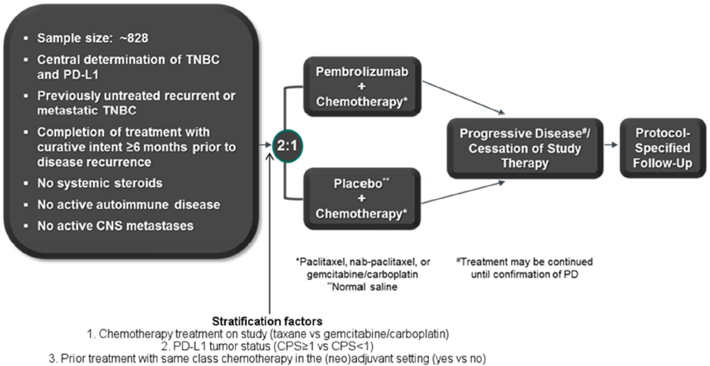
Abbreviations: CNS = central nervous system; CPS = combined positive score; PD-L1 = programmed cell death ligand 1; TNBC = triple negative breast cancer
For definitions of combined positive scores (CPS),²³ see the relevant footnote.
* Paclitaxel, nab-paclitaxel, or gemcitabine/carboplatin
** Normal saline
# Treatment was to continue until confirmation of disease progression or cessation of study treatment.
Randomisation was stratified by the type of on-study chemotherapy therapy received (taxane or gemcitabine-carboplatin), tumour PD-L1 expression at Baseline (CPS ≥ 1 or CPS < 1);²³ and previous treatment with the same class of chemotherapy in the neoadjuvant or adjuvant setting (yes/no).

Study treatments
Patients received either blinded pembrolizumab 200 mg intravenously (IV) once every three weeks (n = 566) or saline placebo (n = 281), plus one of the three open label chemotherapy regimens listed below (per investigator discretion):
- Nab-paclitaxel 100 mg/m² IV infusion on Days 1, 8, and 15, every 28 days.
- Paclitaxel 90 mg/m² IV infusion on Days 1, 8, and 15, every 28 days.
- Gemcitabine/carboplatin 1000 mg/m² and area under the concentration-time curve (AUC) in plasma of 2, respectively, IV infusion on Days 1 and 8, every 21 days.
Pembrolizumab and placebo were continued up to 35 administrations, until confirmed progression or unacceptable toxicity. Tumour assessments were performed centrally every eight weeks until Week 24, then every 9 weeks during the first year and every 12 weeks thereafter.

Study endpoints
There were dual primary endpoints: progression free survival (met at IA2) and overall survival (met at the final analysis). Endpoints (aside from overall survival) were assessed by blinded independent central review using RECIST 1.1.

Statistical analysis
The statistical methods were provided. Originally, the primary endpoints were to be tested in both the CPS > 1 and the intent to treat (ITT) populations. Of note, a protocol amendment (Amendment 5) made just prior to IA2 introduced formal testing of the primary and secondary endpoints in patients with a higher CPS cut-off of ≥ 10. The multiplicity strategy was updated to test this group first, and there was also an extension of follow up to ensure adequate power (as the CPS ≥ 10 group formed a smaller proportion of the overall population). The amendment was based on emerging evidence from Studies KN-119 and IMpassion130 trial, which demonstrated enriched treatment effects with greater PD-L1 expression. It was made while the sponsor was still blinded to the results of IA1. A Bonferroni approach eliminated the alpha that had been already spent at IA1. The CPS cutoff of 10 was not a stratification factor, but the proportion of patients in each arm with CPS ≥ 10 was similar: pembrolizumab 38.9%, placebo 36.7% (38.1% overall).
Groups were generally balanced with respect to demographics and prognostic baseline characteristics in the ITT population. These were somewhat less balanced among the cohort with CPS ≥ 10, as expected since this was not a stratification factor. The imbalance does not seem large enough to substantially influence the results.
Among the ITT population, 75.1% had CPS ≥ 1 and 24.9% had CPS < 1.
All patients were women (although men were eligible), with median age 53 years. Among the efficacy population (CPS ≥ 10), 68.9% were White. Gemcitabine/carboplatin was the most common chemotherapy regime (56.2%), followed by nab-paclitaxel (30.1%) and paclitaxel (13.7%). Prior treatment with the same class of chemotherapy in the neoadjuvant or adjuvant setting occurred in 18.9% of the patients. The portion of patients that had any prior neoadjuvant or adjuvant chemotherapy was 59.8%. 60.6% had ECOG PS = 0. Most patients had metastatic TNBC (recurrent [63.7%] or de novo [32.3%]) at Baseline. A minority of patients (4.0%) had locally recurrent inoperable disease.
Complete BRCA mutational status data are not yet available. Seventeen of 100 patients with available data are known to be BRCA mutation positive.
Demographic and baseline characteristics for the ITT population were similar to those with CPS ≥ 10.

Efficacy

Primary efficacy results
At the final analysis, the median duration of follow-up in the ITT population was 16.7 months, which was similar for both treatment groups. It was 17.0 months in participants with PD-L1 combined positive score (CPS) ≥ 1 and 20.2 months in participants with PD-L1 CPS ≥ 10.²³
The success criterion for progression free survival (PFS) (for CPS ≥ 10) was met at IA2 analysis, with a hazard ratio of 0.65 (95% CI: 0.49, 0.86, 1-sided p=0.0012). PFS events were reported in 61.8% of patients with pembrolizumab and 76.7% with placebo, with a median PFS of 9.7 months and 5.6 months, respectively. At the final analysis, the hazard ratio for PFS (0.66) remained consistent with IA2.
The success criterion for overall survival (for CPS ≥ 10) was met at the final analysis, with 155 events (70.5%) in the pembrolizumab arm and 84 (81.6%) in the placebo arm; hazard ratio = 0.73 (95% CI: 0.55, 0.95, 1-sided p=0.0093).
Objective response rate differences did not meet criteria for efficacy.
Final analysis results are summarised in Table 18.
Table 18: Study KN-355 (KEYNOTE 355 trial) Summary of efficacy in participants with CPS ≥ 10; final analysis (ITT)
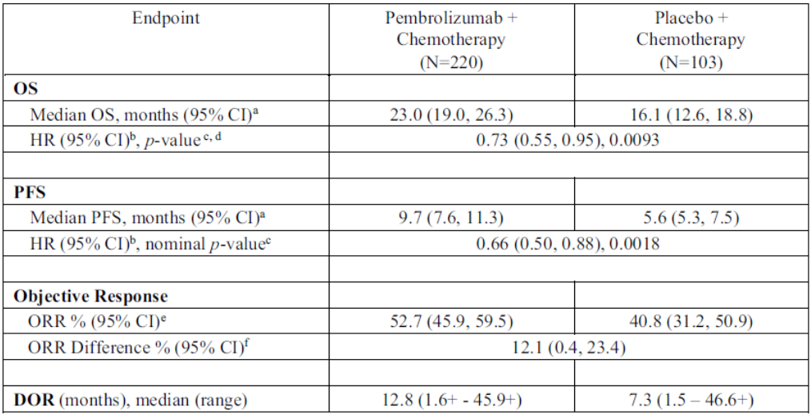
Abbreviations: CI = confidence interval; DOR = duration of response; ORR = objective response rate; OS = overall survival; PFS = progression free survival
Confirmed responses are included.
‘+’ indicates there is no progressive disease by the time of last disease assessment.
ª From product-limit (Kaplan-Meier) method for censored data.
^{b} Based on Cox regression model with Efron’s method of tie handling with treatment as a covariate stratified by chemotherapy on study (taxane vs gemcitabine/carboplatin) and prior treatment with same class of chemotherapy in the (neo)adjuvant setting (yes versus no).
^{c} One-sided p-value based on log-rank test stratified by chemotherapy on study (taxane versus gemcitabine/carboplatin) and prior treatment with same class of chemotherapy in the (neo)adjuvant setting (yes versus no).
^{d} The multiplicity-adjusted one-sided nominal alpha level was 0.0113.
^{e} Based on the binomial exact confidence interval method for binomial data.
^{f} Based on Miettinen & Nurminen method stratified by chemotherapy on study (taxane versus gemcitabine/carboplatin) and prior treatment with same class of chemotherapy in the (neo)adjuvant setting (yes versus no).
Data cutoff: 15 June 2021

Subgroup analysis
Analyses of overall survival and progression-free survival (PFS) appeared generally consistent across subgroups. The point estimates of the hazard ratios for patients receiving gemcitabine/carboplatin were closer to one compared with patients receiving taxanes. However, these subgroups were not individually powered to demonstrate a treatment effect by chemotherapy partner, and the results of this subgroup analysis should be interpreted with caution.
The success criteria were not met for the analyses of PFS and overall survival in patients with CPS ≥ 1, so per the multiplicity schema, these outcomes were not subject to formal statistical testing for the full ITT population (that is, all participants regardless of PD-L1 expression status).
The primary efficacy results are compared below by PD-L1 expression status in Table 19.
Table 19: Study KN-355 (KEYNOTE 355) trial Primary efficacy results by PD-L1 expression status
 | CPS ≥ 10 |  | CPS ≥ 1 |  | ITT
 | Pembro  +chemo  N=220 | PLB  +chemo  N=103 | Pembro  +chemo  N=425 | PLB  +chemo  N=211 |  | Pembro  +chemo  N=566 | PLB  +chemo  N=281
Progression free survival (IA2)
Median, months (95% CI)ª | 9.7  (7.6, 11.3) | 5.6  (5.3, 7.5) | 7.6  (6.6, 8.0) | 5.6  (5.4, 7.4) |  | 7.5  (6.3, 7.7) | 5.6  (5.4, 7.3)
HR (95% CI)^{b}  P value^{c} | 0.65 (0.49, 0.86)  0.0012 |  | 0.74 (0.61, 0.90)  0.0014 |  |  | 0.82 (0.69, 0.97)  0.0112 (nominal)
Rate (%) at 12 months (95% CI) | 39 (32, 46) | 23 (15, 32) | 32 (27, 37) | 19 (14, 26) |  | 30 (26, 34) | 21 (16, 27)
Overall survival (FA)
Median, months (95% CI)ª | 23.0  (19.0, 26.3) | 16.1  (12.6, 18.8) | 17.6  (15.5, 19.5) | 16.0  (12.8, 17.4) |  | 17.2  (15.3, 19.0) | 15.5  (13.9, 17.2)
HR (95% CI)^{b}  P value^{c} | 0.73 (0.55, 0.95)  0.0093 |  | 0.86 (0.72, 1.04)  0.0563 |  |  | 0.89 (0.76, 1.05)  0.0797 (nominal)
Rate (%) at 6 months (95% CI) | 89 (84, 92) | 88 (80, 93) | 87 (83, 90) | 89 (84, 93) |  | 86 (83, 89) | 88 (83, 91)
Rate (%) at 12 months (95% CI) | 71 (64, 76) | 64 (54, 73) | 64 (60, 69) | 63 (56, 70) |  | 65 (60, 68) | 62 (56, 68)
Rate (%) at 18 months (95% CI) | 58 (51, 65) | 45 (35, 54) | 48 (44, 53) | 41 (35, 48) |  | 48 (44, 52) | 42 (36, 48)
Rate (%) at 24 months (95% CI) | 48 (41, 55) | 34 (25, 43) | 38 (33, 42) | 30 (24, 36) |  | 36 (32, 40) | 30 (25, 36)
Abbreviations: PLB = placebo; Pembro = pembrolizumab; Chemo = chemotherapy; CI = confidence interval; CPS = Combined Positive Score; HR = hazard ratio; ITT = intent to treat; PFD = progression free survival; OS = overall survival; FA = final analysis
Note: Bold text = statistically significant per prespecified significance bounds
For definition of combined positive scores (CPS),²³ see the relevant footnote.
ª From product-limit (Kaplan-Meier) method for censored data.
^{b} Based on a stratified Cox regression model with Efron’s method of tie handling.
^{c} One-sided p-value based on a stratified log-rank test.

Figure 8: Study KN-355 (KEYNOTE 355 trial) Kaplan-Meier estimates of overall survival in subjects with CPS ≥ 10 (ITT) (final analysis)
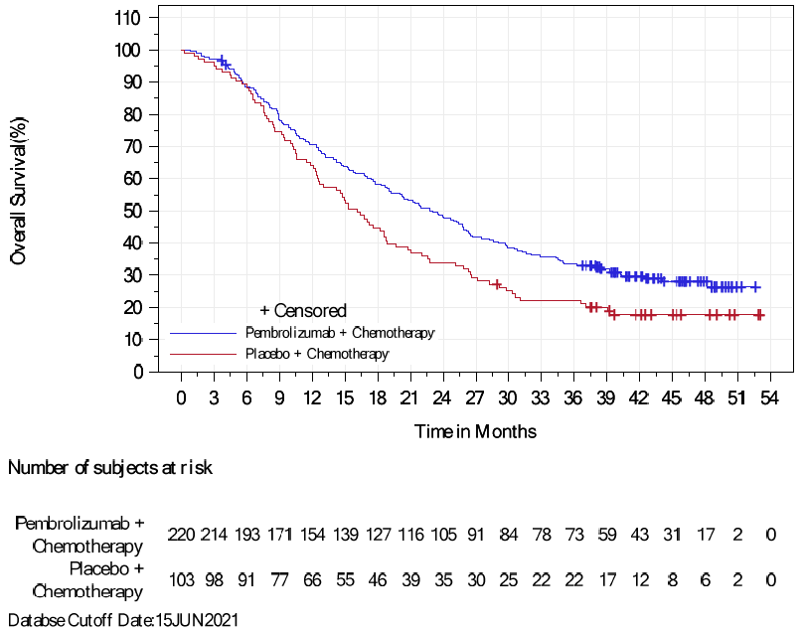

Figure 9: Study KN-355 (KEYNOTE 355 trial) Kaplan-Meier estimates of progression free survival by blinded independent central radiology review assessment per RECIST 1.1; subjects with CPS ≥ 10 (ITT) (IA2)
For definition of combined positive scores (CPS),²³ see the relevant footnote.

Study KN-119 (KEYNOTE 119 trial)

Study overview
Study KN-119 was a randomised, open-label, Phase III trial of pembrolizumab versus single drug chemotherapy in patients with metastatic TNBC who had already received one or two previous systemic therapies for metastatic TNBC and had previously received an anthracycline and/or taxane in the (neo)adjuvant or metastatic setting.
Patients received pembrolizumab 200 mg once every three weeks (n = 312) or treatment (chemotherapy) of physician’s choice (TPC; capecitabine or eribulin or gemcitabine or vinorelbine) (n = 310), continued until disease progression or unacceptable toxicity.
Of the participants, 99.7% of participants were women (two were men, both assigned to TPC), with median age 52 years. 58.4% were White. 65.1% had PD-L1 CPS ≥ 1 and 31.2% had CPS ≥ 10.
Most patients discontinued treatment due to progressive disease. Discontinuations due to adverse events were similar in each arm (pembrolizumab 4.5% and TPC 5.5%).
Median duration of follow up at the final analysis (data cut off: 11 April 2019) was 9.9 months for pembrolizumab and 10.9 months for the TPC arm.

Efficacy
The success criterion for the primary efficacy endpoint of overall survival was not met, either in patients with CPS ≥ 10, CPS ≥ 1, or in all participants. There was an apparent trend for lower hazard ratio with greater PD-L1 expression. Results are shown in Table 20.
Table 20: Study KN-119 (KEYNOTE 119 trial) Summary of overall survival (final analysis; data cut-off 11 April 2019)
 | CPS ≥ 10 |  | CPS ≥ 1 |  | ITT
 | Pembro  N=96 | TPC  N=98 | Pembro  N=203 | TPC  N=202 |  | Pembro  N=312 | TPC  N=310
Overall survival
Median, months (95% CI)ª | 12.7  (9.9, 16.3) | 11.6  (8.3, 13.7) | 10.7  (9.3, 12.5) | 10.2  (7.9, 12.6) |  | 9.9  (8.3, 11.4) | 10.8  (9.1, 12.6)
HR (95% CI)^{b}  P value^{c} | 0.78 (0.57, 1.06)  p = 0.0574 |  | 0.86 (0.69, 1.06)  p = 0.0728 |  |  | 0.97 (0.82, 1.15)  p = 0.3802
Rate (%) at 21 months (95% CI) | 27 (19, 36) | 25 (17, 34) | 24 (18, 30) | 21 (16, 27) |  | 24 (19, 28) | 24 (19, 29)
Abbreviations: CPS = Combined Positive Score; ITT = intent to treat; Pembro = pembrolizumab; TPC = treatment (chemotherapy) of physicians choice; OS = overall survival; HR = hazard ratio
ª From product-limit (Kaplan-Meier) method for censored data.
^{b} Based on a stratified Cox regression model with Efron’s method of tie handling.
^{c} One-sided p-value based on a stratified log-rank test.

Safety

Studies providing safety data
Safety data for pembrolizumab were presented compared with placebo as add-on to chemotherapy in Study KN-355 (KEYNOTE 355 trial). There were also integrated analyses of safety comparing these data from Study KN-355, with pooled safety data. The ‘pooled mTNBC dataset’ for pembrolizumab used as monotherapy for metastatic TNBC comprised of populations from Study KN-012 (KEYNOTE 12 trial), Study KN-086 (KEYNOTE 86 trial) and Study KN-119 (KEYNOTE 119 trial). The ‘reference safety dataset’ comprised of populations treated with pembrolizumab used as monotherapy in melanoma and non-small cell lung cancer (NSCLC).

Study KN-355 (KEYNOTE 355 trial)

Exposure
Median exposure to pembrolizumab in Study KN-355 was 6.2 months, which was longer than placebo (5.3 months), pembrolizumab monotherapy in metastatic TNBC (2.1 months) and pembrolizumab in the reference safety data set (4.2 months). Patients in Study KN 355 were younger compared with the reference safety data set: 77.0% aged less than 65 years versus 56.7% aged less than 65 years.

Safety overview
Adverse events in each category are summarised below (Table 21) except for adverse events of special interest (AESI), which are summarised in Table 22. In Study KN-355, the pattern is notable for numeric increases in Grade 3 to 5 AE, dose modification due to adverse events (AE), serious adverse events (SAEs), deaths, and discontinuations due to AEs for pembrolizumab compared with placebo.
The data from Study KN-355 are the most relevant to consider for the proposed indication, because they allow assessment of the relative toxicity of pembrolizumab and placebo in patients receiving concomitant chemotherapy.
The incidence of SAEs and deaths for pembrolizumab in Study KN-355 was slightly lower than in the reference safety data set, while the incidence of Grade 3 to 5 AEs and dose modification due to AE was considerably higher compared with the reference safety data set. AESIs were somewhat more frequent compared with the reference safety data set (Table 22). Note that the datasets are not directly comparable, as the reference safety data set included patients treated with pembrolizumab as monotherapy, over a shorter duration, in older patients, with different cancer types.
Overall, safety for the proposed indication was consistent with the known profile of pembrolizumab and no new concerns were identified.
Table 21: Summary of safety events across Study KN-355, plus ‘pooled mTNBC’ and ‘reference safety’ datasets (all subjects as treated) 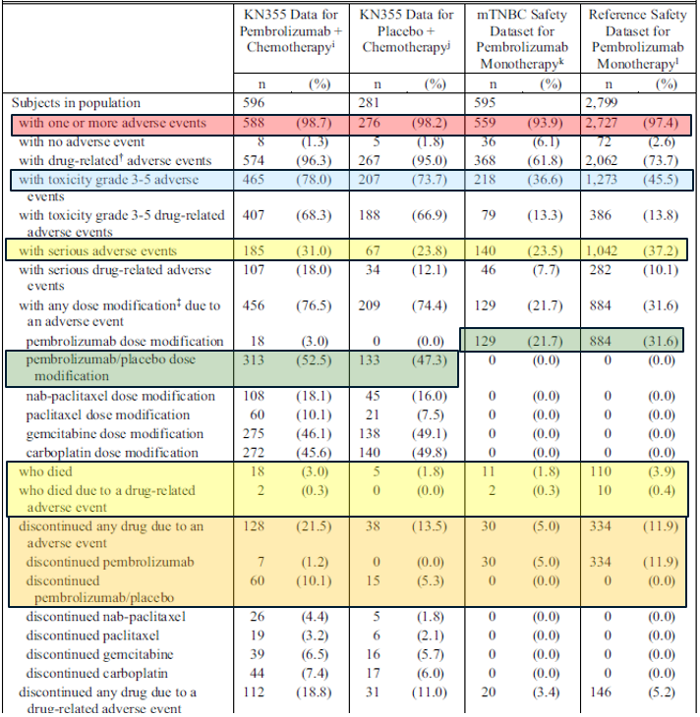

Table 21: Summary of safety events across Study KN-355, plus ‘pooled mTNBC’ and ‘reference safety’ datasets (all subjects as treated)
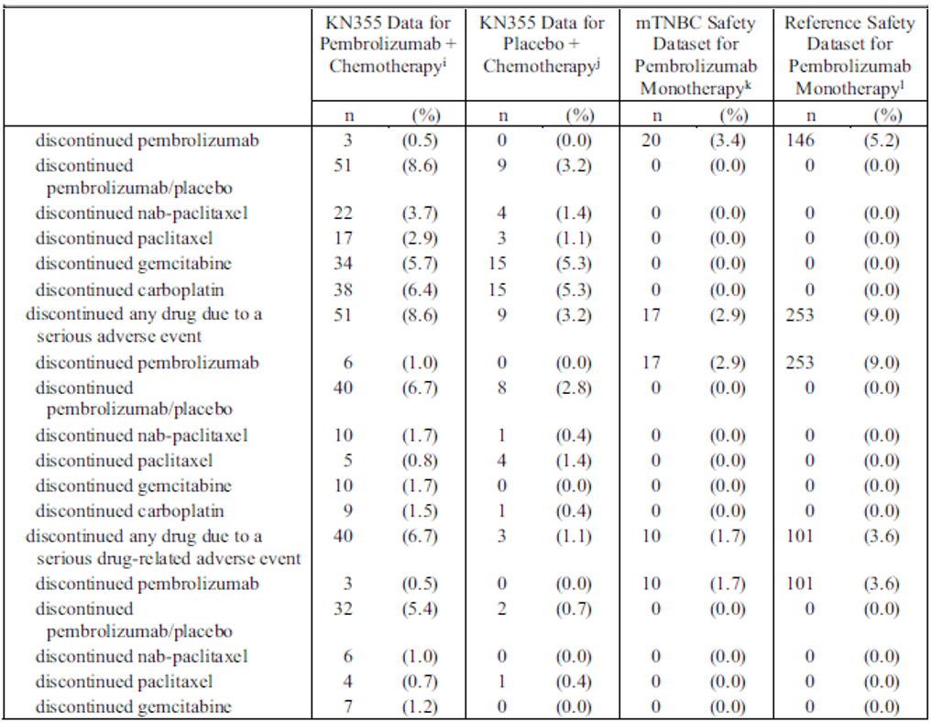Note: The table includes data for an additional 34 patients who received pembrolizumab during the safety run-in phase of Study KN-355 (AKA Part 1). This part of the study was unblinded and open-label, and in view of small numbers will not be considered further. Data in this Overview are quoted for Part 2 subjects only, unless stated otherwise.

Adverse events
The most frequently reported adverse events (AEs) in Study KN-355 were anaemia, nausea, neutropenia, alopecia and fatigue, with a similar frequency in the pembrolizumab and placebo groups.
The adverse event with the biggest imbalance in incidence (pembrolizumab greater than placebo) were hypothyroidism (15.8% versus 3.2%), rash (19.6% versus 12.1%), aspartate aminotransferase increase (23.8% versus 16.7%) and decreased appetite (21.4% versus 14.2%).

Grade 3 to 5 adverse events
Grade 3 to 5 AE were more frequently reported with pembrolizumab (77.9%) than placebo (73.7%) in Study KN-355. Imbalances between pembrolizumab and placebo for individual Grade 3 to 5 Prefer Terms were all small (< 5%). The most common events (neutropenia, anaemia, neutrophil count decreased, thrombocytopenia and white cell count decreased) were reported at a similar frequency for pembrolizumab and placebo in Study KN-355, and were infrequently reported in the monotherapy datasets, suggesting that these events reflected mainly the concomitant chemotherapy.

Serious adverse events
Serious adverse events (SAE) were reported in 30.1% of patients with pembrolizumab and 23.8% of patients with placebo in Study KN-355. The most frequent events in the pembrolizumab group (all 2% incidence) were anaemia, pneumonia and thrombocytopenia. The biggest imbalance (pembrolizumab > placebo) in incidence was for events of pneumonitis (1.1% versus 0%). The types and incidence of other SAE was generally similar between the groups.

Deaths
There were 17 deaths (3.0%) in the pembrolizumab arm and five deaths (1.8%) in the placebo arm in Study KN-355. There was no clustering of Preferred Terms in either arm. Two deaths, both in the pembrolizumab arm, were considered treatment related (acute kidney injury and pneumonia).

Adverse events leading to treatment discontinuation
In Study KN-355 there were twice as many subjects with adverse events leading to discontinuation of pembrolizumab/placebo in the pembrolizumab arm (10.7%) than in the placebo arm (5.3%). The most common events (in the pembrolizumab arm versus placebo arm) were alanine aminotransferase increase (2.1% versus 1.4%), aspartate aminotransferase increase (1.6% versus 0.7%) and pneumonitis (1.2% versus 0%).
Adverse events leading to discontinuation of chemotherapy were somewhat more common in the pembrolizumab arm compared with the placebo arm in Study KN-355 (14.9% versus 11.4%). The most common event leading to discontinuation of chemotherapy was neutropenia (pembrolizumab 1.8% versus placebo 0.4%).

Adverse events of special interest
The proportion of patients with adverse events of special interest (AESI) in Study KN-355 was 27.9% in the pembrolizumab arm and 11.0% in the placebo arm, with 5.7% and 0% respectively being of Grade 3 to 5. The most common event categories (pembrolizumab versus placebo) were hypothyroidism (15.8% versus 3.2%), hyperthyroidism (4.3% versus 1.1%), infusion reactions (3.7% versus 5.0%) and pneumonitis (2.5% versus 0%).
No new AESIs were identified in Study KN-355.
AESIs were more frequent in Study KN-355 compared with the reference safety data set (28.7% including KN355 Part 1 and Part 2 subjects versus 21.4%), primarily driven by events of hypothyroidism (15.8% versus 8.5%; mostly Grade 1 or 2).

Table 22: Summary of adverse events of special interest across Study KN-355, plus ‘pooled mTNBC’ and ‘reference safety’ datasets (all subjects as treated)
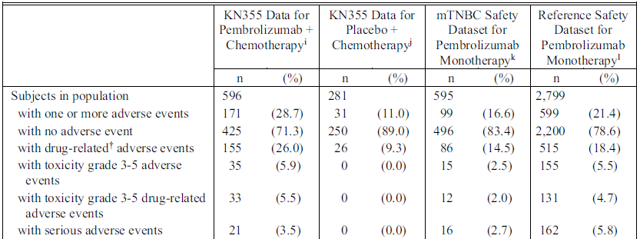
Note: table adapted for brevity. Includes subjects from Part 1 safety run-in (Study KN-355).
† Determined by the investigator to be related to the drug.
^{i} Includes all subjects who received at least one dose of pembrolizumab or chemotherapy in KN355.
^{j} Includes all subjects who received at least one dose of placebo or chemotherapy in KN355.
^{k} Includes all subjects who received at least one dose of pembrolizumab in KN012-Cohort A, KN086 and KN119.
^{l} Includes all subjects who received at least one dose of pembrolizumab in KN001 Part B1, B2, B3, D, C, F1, F2, F3, KN002 (original phase), KN006, and KN010.

Adverse events in special populations

Advanced age
The frequency of adverse events in each category in Study KN-355 was mostly similar in those older than 65 years and younger than 65 years. SAEs, deaths, dose modifications and discontinuations due to adverse events were more frequent in those aged over 65, but this pattern was similar for the pembrolizumab and placebo groups, likely reflecting underlying risk.

Performance status
The adverse event profile in the pembrolizumab group was generally similar between participants who had an ECOG PS;¹⁸ of 0 or 1 at Baseline, except that the incidence of Grade 3 to 5 AEs, SAEs, and drug-related SAEs in the pembrolizumab group was higher (≥ 5% difference) in participants with ECOG PS of 1 at Baseline. A similar pattern was observed in the placebo arm, likely reflecting underlying risk.

Pregnancy
No pregnancies were reported in Study KN-355.

Post marketing data
Post-marketing data for the proposed indication were reviewed. Of 55 cases of interest, no new safety concerns were identified.

Risk management plan
The submission of a new risk management plan is not required for this submission. The sponsor is required to comply with product vigilance and risk minimisation requirements.

Risk-benefit analysis

Delegate’s considerations
The sponsor proposes an extension of indications for Keytruda to include the neoadjuvant and adjuvant treatment of early triple negative breast cancer (TNBC) and the treatment of locally recurrent, unresectable or metastatic TNBC. Both indications received priority determination for evaluation (see Registration timeline). The submission was assessed as part of the Project Orbis collaboration with the US Food and Drug Administration (FDA). Both indications are US FDA approved.
Pembrolizumab is a monoclonal antibody which targets the PD-1 immune checkpoint receptor. It was first registered in Australia for the treatment of advanced melanoma in 2016.¹² There have been several subsequent extensions of indication in oncology. This would be the first specific breast cancer indication and the first neoadjuvant indication for pembrolizumab in Australia.

Neoadjuvant and adjuvant treatment of early triple negative breast cancer
The proposed neoadjuvant and adjuvant indication is supported by efficacy and safety data from the fourth interim analysis (IA4) of Study KN-522, also known as the KEYNOTE 522 trial.14 This is an ongoing, pivotal Phase III study in which patients with early stage TNBC were randomised in a 2:1 ratio to receive neoadjuvant therapy with eight cycles of pembrolizumab (200 mg once every three weeks) plus chemotherapy (n = 784) or placebo plus chemotherapy (n = 390). After definitive surgery, the patients received adjuvant pembrolizumab or placebo every three weeks for up to nine cycles.
The primary endpoints were a pathological complete response (pCR) at the time of definitive surgery and event-free survival in the intent to treat (ITT) population (see Table 4 for definitions of pCR). These endpoints are acceptable and generally in line with guidance. pCR is a surrogate efficacy endpoint which may not necessarily translate into event-free survival or overall survival benefit. Had the EFS data not been available for confirmation, the pCR data alone are unlikely to have been sufficient to support approval. It is noted that a submission to the US FDA based on an earlier analysis (before the event-free survival endpoint was met) was deferred by the US FDA.
The trial population was generally representative of the expected Australian population to which the proposed indication applies. Patients were enrolled regardless of PD-L1 expression status, although most (82.9%) were positive (defined as a combined positive score²³ (CPS) ≥ 1).
The success criterion for pCR was met at the first interim analysis (IA1), when 602 of 1174 participants would have completed surgery. The pCR rate was 64.8% for pembrolizumab and 51.2% for placebo, with a rate difference of 13.6% (95% CI: 5.4, 21.8), p = 0.00055. The pCR rate difference remained statistically significant at the multiplicity-controlled final analysis (IA2) when 1002 subjects were available, though this had reduced to 9.2% (95% CI: 2.8, 15.6) p = 0.00221. At IA4, when the complete ITT population was available, a supportive, descriptive analysis yielded a more modest pCR rate difference of 7.5% (95% CI: 1.6, 13.4).
Only the IA1 result is proposed for inclusion in the Product Information (PI). Since the IA2 analysis of pCR included a greater proportion of subjects and was under multiplicity control, this is likely closer to the true result and should be included in the PI too. The IA4 analysis is also considered clinically relevant information which should be included in the PI, since it included the complete population and may be closer to the true result. Requests to this effect were made. The Delegate notes that only the IA4 analysis of pCR is included in the US PI.
The success criterion for event-free survival was met at IA4, with a hazard ratio of 0.63 (95% CI: 0.48, 0.82; p = 0.0003093) for a reduction in the risk of disease progression precluding definitive surgery, recurrence, second primary malignancy, or death for pembrolizumab compared with placebo. There were 123 (15.7%) patients with event-free survival events in the pembrolizumab arm and 93 (23.8%) in the placebo arm. Median event-free survival was not yet reached in either arm (future planned analyses are expected to be informative in this respect).
Key secondary endpoint overall survival was not met at IA4, with data not yet mature (approximately 45% of the information fraction available); however, the point estimate was below one and not suggestive of a detrimental effect of pembrolizumab on survival: hazard ratio = 0.72 (95% CI: 0.51, 1.02), p = 0.0321377. There were 80 deaths (10.2%) in the pembrolizumab arm and 55 deaths (14.1%) in the placebo arm. A condition of registration is proposed for the sponsor to submit the final analysis of Study KN-522, including any interim analysis at which overall survival in the ITT population reaches statistical significance or the hazard ratio exceeds one, are to be submitted when these become available.
Subgroup analyses of pCR, event-free survival and overall survival were all generally consistent with the ITT analyses. These do not suggest a reduction of efficacy in patients with negative PD-L1 expression status (as defined by CPS < 1), although such participants comprised only 16.8% of the study population and the study was not powered on this outcome. Results were also similar regardless of nodal status.
The finding that results were consistent across PD-L1 expression subgroups differs from studies of this medication class in metastatic TNBC (for example, Study KN-355 (discussed above) and the IMpassion130 trial); which demonstrated survival benefits only in patients with higher levels of PD-L1 expression. This is an area of uncertainty. The disparate result of this study might be a chance finding, or it could be explained by differences in disease stage, PD-L1 assays, concomitant treatments, and other elements of study design. No further studies are planned for the proposed indication to address this uncertainty.
Adjuvant radiotherapy (optional per protocol) was received by 57.9% of patients in the pembrolizumab group and 66.9% in the placebo group. This could have confounded the efficacy results, although the imbalance is likely to favour placebo.
Patient reported outcomes were assessed as a secondary endpoint outside of multiplicity control. They are therefore requested to be removed from the PI.
Almost all patients in each group reported at least one adverse event (AE). The overall pattern was notable for an increase in serious adverse events (SAEs; 43.6% versus 28.5%), discontinuations due to AEs (29.9% versus 15.4%) and deaths (0.9% versus 0.3%) in the pembrolizumab group compared with the placebo group. The most common AEs (nausea, alopecia, anaemia, neutropenia and fatigue) were reported with a similar frequency in each group, mainly reflecting the concomitant chemotherapy. Most AEs occurred during the first three months of treatment, declining in incidence thereafter.
The imbalance in AEs appeared to be primarily driven by increases in the pembrolizumab arm in adverse events of special interest (AESI) as a category (43.6% versus 21.9%), and by individual Preferred Terms of diarrhoea, rash, pyrexia, decreased appetite and hypothyroidism. The most common AESIs in the pembrolizumab group were infusion reactions (18.0%; with 0.6% Grade 4) and hypothyroidism (15.1%, most Grade 1 to 2). The biggest imbalances in Grade 3 to 5 AEs (pembrolizumab > placebo) were observed for anaemia (19.5% versus 15.7%) and alanine aminotransferase increase (6.4% versus 2.8%). Four of the seven deaths in the pembrolizumab group were considered treatment-related, compared with one death in the placebo group.
Adrenal insufficiency was observed in 20 (2.6%) patients in the pembrolizumab group (of which 12 had Grade 1 to 2 events) and no patients in the placebo group. The events included a patient who died of shock post-operatively who was found to have a cortisol level of 3 nmol/L 21 days pre-operatively. An assessment of causality was confounded by concomitant dexamethasone and multiple comorbid risk factors for surgical complications. While adrenal insufficiency is a known event with pembrolizumab and there is a current warning in section 4.4 (Special warnings and precautions for use) of the Australian PI that patients should be monitored for its signs and symptoms, the Delegate requests this be strengthened. This is important since this will be the first neoadjuvant treatment indication for pembrolizumab, and the patients will (by definition) be anticipating surgery. Patients with adrenal insufficiency undergoing surgery are at risk of perioperative hypotensive crisis and death. The sponsor is requested to include a specific recommendation for pre-operative cortisol monitoring, in line with the US PI.
Overall, the safety profile of pembrolizumab was consistent with its known safety profile and there were no new safety signals. Immune-related toxicity was mostly low grade but there was a small percentage (14.9%) with Grade 3 to 5 AESIs, and there was a numeric imbalance in deaths compared with placebo (seven (0.9%) versus one (0.3%)). This is of concern in the neoadjuvant and adjuvant setting, where the goal of treatment is curative and the impact of toxicities is high; however, when viewed in the context of the efficacy results and the poor underlying prognosis for TNBC, this increase in toxicity can be considered acceptable.
Taken together, the Delegate considers these data are sufficient to support approval for the proposed indication. The uncertainty is that this is based on a single pivotal study (Study KN-522), considering the experience with atezolizumab has highlighted that results in the setting of TNBC may not necessarily be replicable (discussed further below).

Locally recurrent, unresectable or metastatic triple negative breast cancer
The proposed indication in locally recurrent and metastatic TNBC is supported primarily by efficacy and safety data from the ongoing pivotal Study KN-355 (also known at the KEYNOTE 355 trial). The TGA’s clinical evaluation recommended approval of the proposed indication.
Study KN-355 is a randomised (in a 2:1 ratio), double-blind, placebo-controlled study comparing pembrolizumab (n = 566) with placebo (n = 281) as add-on to chemotherapy in adults with previously untreated, locally recurrent, inoperable or metastatic TNBC. Patients were enrolled regardless of tumour PD-L1 expression status. Based on emerging evidence of improved outcomes for immunotherapy in TNBC with higher PD-L1 expression, a late protocol change led to formal testing of the primary endpoints first in patients with combined positive score (CPS) ≥ 10.²³ Such patients comprised a balanced proportion of each treatment group: pembrolizumab 38.9% and placebo 36.7%. While the protocol change was clinically warranted and does not appear to substantially affect trial integrity (the sponsor remained blinded to the preceding analysis), its scope and its timing (three years after the trial commenced) do make the interpretation of the results more challenging. Had the change not been implemented, the study would have been negative (that is, the primary endpoints would not have been met based on the original hypothesis testing in all patients and those with CPS ≥ 1).
The study population appeared broadly consistent with the intended population in Australia. No data were available in men. Gemcitabine and carboplatin was the most common chemotherapy regime in the ITT population (54.7%), and this was used in 16 of the 20 participants recruited from sites in Australia. The sponsor conducted a local chart review of patients with TNBC which was consistent with the chemotherapy regimens in the study but may be outdated (data from 2012 to 2015).
The primary endpoints were both met in patients with CPS ≥ 10: progression-free survival was met at IA2, while OS was met at the final analysis. The hazard ratio for progression-free survival was 0.65 (95% CI: 0.49, 0.86) 1 sided p=0.0012, with a median progression-free survival gain of 4.1 months in the pembrolizumab group. The hazard ratio for overall survival was 0.73 (95% CI: 0.55, 0.95) 1-sided p=0.0093, with a median overall survival gain of 6.9 months in the pembrolizumab arm. These results are clinically meaningful in the context of the intended population.
Efficacy success criteria were not met for the analyses of progression-free survival and overall survival in patients with CPS ≥ 1, so these were not formally tested in the full ITT population (according to the statistical testing hierarchy). The hazard ratios remained below one for both outcomes in both groups. It is appropriate that the indication is restricted to patients with CPS ≥ 10, per the sponsor’s proposal, although its measurement is an area of uncertainty (see Companion diagnostic considerations, below).
Efficacy data were not available in men with TNBC; however, there does not seem to be any evidence barring extrapolation to this small population. The safety profile of pembrolizumab has been well established in men for other indications.
Subgroup analyses were suggestive of less benefit in patients treated with gemcitabine and carboplatin compared with taxanes; however, the study was not powered on the subgroup analyses and a chance finding cannot be excluded.
Additional efficacy data (Study KN-119 (or the KEYNOTE 119 trial)) in patients with metastatic TNBC treated with pembrolizumab monotherapy in the second or third line setting showed no benefit in overall survival (the primary endpoint) compared with chemotherapy. There was a trend for lower hazard ratios with increasing PD-L1 expression, but none reached significance. Note that Study KN-119 was included in the dossier but was not specifically presented as supportive data by the sponsor. The study is considered relevant by the Delegate. While this open-label study evaluated pembrolizumab monotherapy (and the proposed indication is for combination use with chemotherapy), the negative result casts doubt on the likely efficacy of treatment beyond first line. Considering also that only patients with previously untreated metastatic disease were eligible for Study KN-355, the sponsor is requested to amend the proposed indication to exclude patients with prior therapy for metastatic disease. This is noted to be in line with the European Medicines Agency (EMA) approved indication.
Safety for the proposed usage is supported primarily by data from Study KN-355, as well as pooled safety data from three studies of patients treated with pembrolizumab monotherapy for metastatic TNBC, which were both compared with a reference safety database of pembrolizumab used as monotherapy in advanced melanoma and non-small cell lung cancer. Overall, safety for the proposed indication was consistent with the known profile of pembrolizumab and no new concerns were identified.
Compared with placebo, the pattern was notable for a numeric increase in Grade 3 to 5 AEs, dose modification due to AEs, SAEs, deaths, and discontinuations due to AEs for pembrolizumab. The difference seemed to be mainly driven by AESIs, reported in 27.9% with pembrolizumab and 11.0% with placebo (most commonly hypothyroidism; 15.8% versus 3.2%). This increase in toxicity is expected and is considered acceptable in the context of the efficacy results, considering the otherwise poor prognosis.
As expected, AEs tended to be less frequent with pembrolizumab used as monotherapy compared with pembrolizumab used with chemotherapy for the proposed indication (reflecting the added toxicity of the chemotherapy). SAEs and deaths were less frequently observed in Study KN-355 compared with the reference safety data set, despite longer exposure. This may be due to the younger age of participants compared with the reference safety data set.
Overall, the Delegate considers the data are sufficient to support approval for the Delegate’s amended indication, although there are uncertainties. The main source of uncertainty is from studies in metastatic TNBC external to Study KN-355. Some of these demonstrated improved efficacy with greater PD-L1 expression, leading to the protocol change focusing on patients with CPS ≥ 10 in Study KN-355. In this regard, Study KN-355 was consistent, as the endpoints were met for those with CPS ≥ 10 (and not for those < 10); however, the contradictory results for the IMpassion130 trial;²⁸ and the IMpassion131 trial, of atezolizumab add further uncertainty in this space.10,11 In addition, success was not demonstrated for pembrolizumab monotherapy in second or third line in Study KN-119 (even for patients with CPS ≥ 10).
An additional Phase II/III study is planned in the same population (KEYLYNK-009 trial); but it has a different design (comparing pembrolizumab and olaparib with pembrolizumab and chemotherapy following induction with pembrolizumab and chemotherapy) and so is unlikely to address these uncertainties.

Companion diagnostic considerations
PD-L1 expression status was determined centrally in both pivotal trials using the PD-L1 IHC 22C3 pharmDx kit (Agilent Technologies). Agilent’s commercially available PD-L1 IHC 22C3 assay is TGA approved (ARTG ID 282596) for companion diagnostic use in NSCLC and urothelial carcinoma, and analytic use in melanoma. Approval of the intended use for PD-L1 testing in patients with TNBC is pending at the time of the TGA review.
According to the sponsor, Australian pathologists generally prefer an alternative Laboratory Developed Test (LDT) platform (Ventana BenchMark) over the Agilent test.
Considering different PD-L1 assays are known to give potentially inconsistent results, this lends some uncertainty to the expected efficacy in patients with locally recurrent unresectable or metastatic TNBC whose PD-L1 expression status is determined using assays other than the IHC 22C3 (that is, if someone who would be found ineligible (CPS < 10) for treatment using IHC 22C3 is found eligible using other assays). It could also mean that some patients who would be eligible for therapy according to IHC 22C3 might miss out if another assay gave a different result. Analytical validity by comparison to IHC 22C3 pharmDx should be assessed if the use of another diagnostic to select patients for treatment under this indication is being considered.
While the issue above is important, the approval status of the companion diagnostic is outside the scope of the present submission. Explicit directives regarding its use (such as ‘as determined by a validated test’ in the indication) are not required in the Keytruda PI. Adequate detail about the assay used in the trial has been included in section 5.1 (Pharmacodynamic properties) of the Australian PI. However, the Delegate recognises the sponsor’s position and agrees to keep the reference to the need for a validated test in the indication. It should be noted that the TGA position on references to companion diagnostics within the indications may change in future.

Proposed dosage regimen
The proposed dosage for the new indications is 200 mg every 3 weeks or 400 mg once every 6 weeks as an intravenous (IV) infusion over 30 minutes. In the pivotal studies Study KN-355 and Study KN-522, the administered dose of pembrolizumab was 200 mg once every three weeks. There were no clinical data submitted for the proposed indications with 400 mg once every six weeks dosing.
The alternative of 400 mg once every six weeks dosing regimen was approved by the TGA in October 2021 for all approved indications current at the time (via submission PM-2020-03028-1-4) but that approval did not apply prospectively to new indications. It was primarily supported by the pharmacokinetic study in advanced melanoma, Study KN-555 (the KEYNOTE-555 trial), as well as physiological based pharmacokinetic modelling.
The dosage, 400 mg once every six weeks dosing is approved by the US FDA and EMA for their TNBC indications.
In response to a Delegate query, the sponsor confirmed that they consider the justification for once every six weeks dosing outlined in PM-2020-03028-1-4 applies equally to TNBC. A summary of these data was submitted.
After consideration of these data, the Delegate agrees that they apply equally to TNBC and the other indications for which once every six weeks dosing is already approved. The proposed 400 mg intravenously once every six weeks alternate dosing regimen for the proposed new indications is acceptable. The uncertainty is that there are no clinical data for the proposed indications with once every six weeks dosing.
Note that use of this alternate regimen results in patients potentially receiving an extra 200 mg of pembrolizumab over the course of adjuvant treatment (5 x 400 mg once every six weeks versus 9 x 200 mg once every three weeks) which was not tested in
Study KN-522. This is acceptable, considering the extra dose is marginal and the safety profile of pembrolizumab is well established over the proposed treatment duration.

Proposed action
Overall, the Delegate considers the benefit-risk balance for the proposed indications (as amended by the Delegate) to be positive. Advice from the Advisory Committee on Medicines (ACM) is sought as to whether the risk-benefit profile remains positive when taking into account the uncertainties detailed above, in particular the conflicting results of relevant studies external to this dossier and this product, IMpassion130 trial;²⁸ and IMpassion-131 trial.³⁰

Advisory Committee considerations
The Advisory Committee on Medicines (ACM) having considered the evaluations and the Delegate’s overview, as well as the sponsor’s response to these documents, advised the following.
- Considering the uncertainty relating to the use of immunotherapy for TNBC, are the data sufficient to support approval of both indications?
The ACM considered the data sufficient to support the use of pembrolizumab with chemotherapy in the metastatic setting. The ACM advised that the clinical trials demonstrated complete metastatic response, though in patients who have had multiple lines of treatment the response may only last a few months. The ACM also considered the data to support the neoadjuvant indication to be sufficient due to the improved pathological complete response.
The ACM advised that for first line treatment in the metastatic setting, the optimal duration of treatment is unclear based on published clinical trial data. The ACM noted that some patients improved while taking pembrolizumab and obtained complete pathological and metabolic response in up to two cycles and did not continue the treatment thereafter. Therefore, questions on duration remain.
The ACM noted the uncertainty in the relationship between programmed death ligand 1 (PD-L1) expression status and therapeutic efficacy of pembrolizumab as this relates to different clinical trials for another PD-L1 inhibitor (the IMpassion130 trial;²⁸ and IMpassion-131 trial)³⁰ using different PD-L1 assays from those used in the KEYNOTE-522 and KEYNOTE-355 trials. The ACM noted that the findings in these other trials cannot necessarily be applied to the current studies.
- Does the ACM agree with the Delegate’s amended indication to include only patients who have not received prior chemotherapy for metastatic disease?
The ACM agreed with the Delegate that the indication should be used with chemotherapy but not in heavily pre-treated patients.
The ACM advised that stating ‘as determined by a validated test’ in the indication would be beneficial. The ACM was of the view that in circumstances where patient selection is determined by the outcome of a PD-L1 test, a validated test is important as it helps avoid unnecessary exposure to patients unlikely to respond to this treatment, or patients potentially missing out on this treatment option based on the outcome of a less sensitive, inappropriate or unvalidated assay. The ACM further noted that the term ‘validated test’ refers to both laboratory developed and commercial assays and the inclusion of this statement should not restrict usage to one form, rather any validated laboratory developed or commercial assay could be utilised.
The KEYNOTE-522 and KEYNOTE-355 trials used a specific commercially developed assay for PD-L1 expression status; PD-L1 immunohistochemistry 22C3 pharmDx kit (Agilent Technologies). The ACM noted that this kit is not currently widely available in Australia. For PD-L1 testing of non-small cell lung cancer within Australia a laboratory developed test with the SP263 clone is commonly used, and this has shown approximate equivalency to 22C3 in assessing tumour cells. The ACM however advised that not all tests are interchangeable as different clones of PD-L1 antibodies are utilised within different tests and utilising a test not validated for TNBC may produce incorrect results. The ACM was of the view that for TNBC, there are currently no good data showing equivalency of the SP263 laboratory developed tests with the commercial 22C3 assays. It is anticipated that for this indication 22C3 laboratory developed tests may be developed, and these will require internal validation and appropriate quality assurance programs.

Conclusion
The ACM considered this product to have an overall positive benefit-risk profile for the following indication:
Triple-Negative Breast Cancer
Keytruda (pembrolizumab) is indicated for the treatment of patients with high-risk early-stage triple-negative breast cancer (TNBC) in combination with chemotherapy as neoadjuvant treatment, and then continued as monotherapy as adjuvant treatment after surgery.
Keytruda (pembrolizumab), in combination with chemotherapy, is indicated for the treatment of patients with locally recurrent unresectable or metastatic TNBC whose tumours express PD-L1 (CPS ≥10) as determined by a validated test and who have not received prior chemotherapy for metastatic disease.

Outcome
Based on a review of quality, safety, and efficacy, the TGA approved the registration of Keytruda (pembrolizumab) 100 mg/4 mL, concentrated injection vial, for the following extension of indications or change in dose regime:
Triple-Negative Breast Cancer
Keytruda (pembrolizumab) is indicated for the treatment of patients with high-risk early-stage triple-negative breast cancer (TNBC) in combination with chemotherapy as neoadjuvant treatment, and then continued as monotherapy as adjuvant treatment after surgery.
Keytruda (pembrolizumab), in combination with chemotherapy, is indicated for the treatment of patients with locally recurrent unresectable or metastatic TNBC whose tumours express PD-L1 (CPS ≥10) as determined by a validated test and who have not received prior chemotherapy for metastatic disease.
As such, the full indications at this time were:
Melanoma
Keytruda (pembrolizumab) is indicated as monotherapy for the treatment of unresectable or metastatic melanoma in adults.
Keytruda (pembrolizumab) is indicated as monotherapy for the adjuvant treatment of patients with melanoma with lymph node involvement who have undergone complete resection.
Non-small cell lung cancer (NSCLC)
Keytruda (pembrolizumab), in combination with pemetrexed and platinum chemotherapy, is indicated for the first-line treatment of patients with metastatic non-squamous NSCLC, with no EGFR or ALK genomic tumour aberrations.
Keytruda (pembrolizumab), in combination with carboplatin and either paclitaxel or nab-paclitaxel, is indicated for the first-line treatment of patients with metastatic squamous NSCLC.
Keytruda (pembrolizumab) is indicated as monotherapy for the first-line treatment of patients with NSCLC expressing PD-L1 [tumour proportion score (TPS) ≥1%] as determined by a validated test, with no EGFR or ALK genomic tumour aberrations, and is
- stage III where patients are not candidates for surgical resection or definitive chemoradiation, or
- metastatic.
Keytruda® (pembrolizumab) is indicated as monotherapy for the treatment of patients with advanced NSCLC whose tumours express PD-L1 with a ≥1% TPS as determined by a validated test and who have received platinum-containing chemotherapy. Patients with EGFR or ALK genomic tumour aberrations should have received prior therapy for these aberrations prior to receiving Keytruda.
Head and Neck Squamous Cell Cancer (HNSCC)
Keytruda (pembrolizumab), as monotherapy or in combination with platinum and 5- fluorouracil (5-FU) chemotherapy, is indicated for the first-line treatment of patients with metastatic or unresectable recurrent HNSCC, and whose tumours express PD-L1 [Combined Positive Score (CPS) ≥1] as determined by a validated test.
Keytruda (pembrolizumab) is indicated as monotherapy for the treatment of patients with metastatic or unresectable recurrent HNSCC with disease progression on or after platinum containing chemotherapy and whose tumours express PD-L1 [Combined Positive Score (CPS) ≥1] as determined by a validated test.
Classical Hodgkin Lymphoma (cHL)
Keytruda (pembrolizumab) is indicated as monotherapy for the treatment of adult and paediatric patients with relapsed or refractory classical Hodgkin Lymphoma (cHL):
- following autologous stem cell transplant (ASCT) or
- following at least two prior therapies when ASCT or multi-agent chemotherapy is not a treatment option.
The approval of this indication in paediatric patients is on the basis of objective response rate from patients aged 11 years and older from single arm trial data and extrapolation from adult data (see Section 5.1 PHARMACODYNAMIC PROPERTIES, Clinical Trials).
Primary mediastinal B-Cell Lymphoma (PMBCL)
Keytruda (pembrolizumab) is indicated for the treatment of adult and paediatric patients with refractory primary mediastinal B-cell lymphoma (PMBCL), or who have relapsed after 2 or more prior lines of therapy. The approval of this indication is on the basis of objective response rate (ORR) and duration of response from non-randomised studies. See Section 5.1 Pharmacodynamic Properties, Clinical Trials.
Urothelial carcinoma
Keytruda (pembrolizumab) is indicated as monotherapy for the treatment of patients with locally advanced or metastatic urothelial carcinoma who are not eligible for any platinum containing chemotherapy. This indication is approved based on overall response rate and duration of response in a single-arm study. Improvements in overall survival, progression-free survival, or health-related quality of life have not been established.
Keytruda (pembrolizumab) is indicated as monotherapy for the treatment of patients with locally advanced or metastatic urothelial carcinoma who have received platinum-containing chemotherapy.
Keytruda (pembrolizumab) is indicated for the treatment of patients with Bacillus Calmette-Guerin (BCG)-unresponsive, high-risk, non-muscle invasive bladder cancer (NMIBC) with carcinoma in-situ (CIS) with or without papillary tumours who are ineligible for or have elected not to undergo cystectomy. This indication was approved via the provisional approval pathway based on complete response rate and duration of response. Continued approval of this indication depends on verification and description of benefit in confirmatory trials.
Microsatellite instability-high (MSI-H) or mismatch repair deficient (dMMR) cancer
Colorectal (previously untreated)
Keytruda (pembrolizumab) is indicated for the first-line treatment of patients with unresectable or metastatic colorectal cancer (CRC) that is MSI-H or dMMR as determined by a validated test.
Colorectal (previously treated)
Keytruda (pembrolizumab) is indicated in adult and paediatric patients for the treatment of unresectable or metastatic CRC that is MSI-H or dMMR as determined by a validated test, and that has progressed following treatment with a fluoropyrimidine, oxaliplatin, and irinotecan. This indication was approved via the provisional approval pathway, based on objective response rate and response duration in a single-arm trial. Continued approval for this indication depends on verification and description of clinical benefit in the confirmatory trials.
Non-colorectal
Keytruda (pembrolizumab) is indicated in adult and paediatric patients for the treatment of unresectable or metastatic solid tumours that are MSI-H or dMMR as determined by a validated test, that have progressed following prior treatment and when there are no satisfactory alternative treatment options. This indication was approved via the provisional approval pathway, based on the pooling of data on objective response rate and response duration across multiple different tissue types in a single-arm trial. Sample sizes for individual tissue types were too small to provide data on clinical utility of the MSI-H/dMMR tests for each of the tissue types, individually. The assumption that MSI-H/dMMR-status is predictive of the treatment effect of Keytruda for every tissue type has not been verified. Continued approval for this indication depends on verification and description of clinical benefit in the confirmatory trials.
The safety and effectiveness of Keytruda in paediatric patients with MSI-H/dMMR central nervous system cancers have not been established.
Endometrial carcinoma
Keytruda (pembrolizumab), in combination with lenvatinib, is indicated for the treatment of patients with advanced endometrial carcinoma that is not MSI-H or dMMR, who have disease progression following prior systemic therapy in any setting and are not candidates for curative surgery or radiation.
Cervical Cancer
Keytruda (pembrolizumab) in combination with platinum chemotherapy and paclitaxel, with or without bevacizumab, is indicated for the treatment of patients with persistent, recurrent, or metastatic cervical cancer whose tumours express PD-L1 [Combined Positive Score (CPS) ≥1] as determined by a validated test.
Renal Cell Carcinoma (RCC)
Keytruda (pembrolizumab), in combination with axitinib, is indicated for the first-line treatment of patients with advanced renal cell carcinoma (RCC).
Keytruda in combination with LENVIMA® (lenvatinib) is indicated for the first-line treatment of adult patients with advanced renal cell carcinoma (RCC).
Cutaneous Squamous Cell Carcinoma
Keytruda (pembrolizumab) is indicated as monotherapy for the treatment of adult patients with recurrent or metastatic cutaneous squamous cell carcinoma (cSCC) or locally advanced cSCC that is not curable by surgery or radiation. This indication was approved via the
provisional approval pathway based on objective response rate and duration of response from a single-arm study. Improvements in overall survival, progression-free survival, or health related quality of life have not been established. Full registration for this indication depends on submission of further clinical data to confirm the clinical benefit of the medicine.
Oesophageal Cancer
Keytruda (pembrolizumab), in combination with platinum and fluoropyrimidine based chemotherapy, is indicated for the first-line treatment of patients with locally advanced or metastatic carcinoma of the oesophagus or HER2 negative gastroesophageal junction adenocarcinoma (tumour centre 1 to 5 centimetres above the gastroesophageal junction) that is not amenable to surgical resection or definitive chemoradiation.
Tumour Mutational Burden-High (TMB-H) cancer
Keytruda (pembrolizumab) is indicated for the treatment of adult and paediatric patients with unresectable or metastatic tumour mutational burden-high (TMB-H) [≥ 10 mutations/megabase (mut/Mb)] solid tumours, as determined by a validated test, that have progressed following prior treatment and who have no satisfactory alternative treatment options. This indication was approved via the provisional approval pathway, based on the pooling of data on objective response rate and response duration across multiple different tissue types in a single-arm trial. The assumption that TMB-H status is predictive of the treatment effect of Keytruda for every tissue type has not been verified. Full registration for this indication depends on verification and description of clinical benefit in confirmatory trials.
Triple-Negative Breast Cancer
Keytruda (pembrolizumab) is indicated for the treatment of patients with high-risk early-stage triple-negative breast cancer (TNBC) in combination with chemotherapy as neoadjuvant treatment, and then continued as monotherapy as adjuvant treatment after surgery.
Keytruda (pembrolizumab), in combination with chemotherapy, is indicated for the treatment of patients with locally recurrent unresectable or metastatic TNBC whose tumours express PD-L1 (CPS ≥10) as determined by a validated test and who have not received prior chemotherapy for metastatic disease.

Specific conditions of registration applying to these goods
- The final analysis of [Study] KN-522, and any interim analysis at which OS [overall survival] in the ITT [intent to treat] population reaches statistical significance or the hazard ratio exceeds 1, are to be submitted when these become available.
- The Product Information applying to these therapeutic goods must meet the TGA’s approval at all times. Any proposed changes to the approved text of the PI, including safety related changes, must be submitted to, and be approved by, the TGA prior to distribution.
For all Keytruda products, either:
a) A ‘Pack Insert’ (being an abbreviated version of the TGA-approved Keytruda Product Information) in a format acceptable to the TGA, or
b) The approved Product Information, must be included with the products as a package insert.
Where a ‘Pack Insert’ is provided as a package insert, there is a continuing obligation on the sponsor to ensure that the content is consistent with the PI.

Attachment 1. Product Information
The PI for Keytruda approved with the submission which is described in this AusPAR is at Attachment 1. For the most recent PI, please refer to the TGA PI/CMI search facility.

Therapeutic Goods Administration
PO Box 100 Woden ACT 2606 Australia
Email: info@tga.gov.au Phone: 1800 020 653 Fax: 02 6232 8605
https://www.tga.gov.au

Australian Institute of Health and Welfare. Cancer in Australia 2021 can be found at https://www.aihw.gov.au/.
Foulkes WD, et al. Triple-negative breast cancer. N Engl J Med. 2010 Nov 11;363(20):1938-48.
Brenton JD, Carey LA, Ahmed AA, Caldas C. Molecular classification and molecular forecasting of breast cancer: ready for clinical application? J Clin Oncol. 2005 Oct 10;23(29):7350-6
Dent R, et al. Triple-Negative Breast Cancer: Clinical Features and Patterns of Recurrence. Clin. Cancer Res. 2007;13:4429– 4434
Peshkin BN, et al. BRCA1/2 mutations and triple negative breast cancers. Breast Dis. 2010;32(1-2):25-33.
Armstrong N, et al. A systematic review of the international prevalence of BRCA mutation in breast cancer. Clin Epidemiol. 2019 Jul 11;11:543-561.
Gonzalez-Angulo AM, et al. Incidence and outcome of BRCA mutations in unselected patients with triple receptor-negative breast cancer. Clin Cancer Res. 2011 Mar 1;17(5):1082-9
Anders CK and Carey LA. ER/PR negative, HER2-negative (triple-negative) breast cancer. In Hayes DF and Burstein HJ (Eds) UpToDate; last updated 15 Mar 2022 (accessed 11 Apr 2022)
Pathological complete response (pCR): the absence of any signs of cancer in tissue samples or biopsies following appropriate therapeutic intervention. The specific definition and criteria may vary.
Schmid P, Adams S, Rugo HS, et al. Atezolizumab and Nab-Paclitaxel in Advanced Triple-Negative Breast Cancer. N Engl J Med. 2018 Nov 29;379(22):2108-2121
Miles D, Gligorov J, André F, et al. Primary results from IMpassion131, a double-blind, placebo-controlled, randomised phase III trial of first-line paclitaxel with or without atezolizumab for unresectable locally advanced/metastatic triple-negative breast cancer. Ann Oncol. 2021 Aug;32(8):994-1004.
Further information on the submission for initial registration of Keytruda (pembrolizumab) (as 50 mg powder for injection (vial)) can be found via the AusPAR for Keytruda pembrolizumab (rch); submission PM-2014-01928-1-4.
Schmid P, Cortes J, Pusztai L, et al. Pembrolizumab for Early Triple-Negative Breast Cancer. N Engl J Med. 2020 Feb 27;382(9):810-821.
Schmid P, Cortes J, Dent R, at al. Event-free Survival with Pembrolizumab in Early Triple-Negative Breast Cancer. N Engl J Med. 2022 Feb 10;386(6):556-567.
In the TNM staging system for breast cancer, tumour (T) stages/sizes are described as follows: T1: tumour is 2 cm across or less at its widest point. T2: tumour is more than 2 cm but no more than 5 cm across. T3: tumour is bigger than 5 cm across. T4: tumour is divided into 4 groups: T4a: tumour has spread into the chest wall (the structures surrounding and protecting the lungs) T4b: tumour has spread into the skin and the breast might be swollen T4c: tumour has spread to both the skin and the chest wall T4d: inflammatory carcinoma. The lymph nodes (N) staging are described as follows: N0: Either, no cancer was found in the lymph nodes; or the only areas of cancer smaller than 0.2 mm are in the lymph nodes. N1: Cancer has spread to 1 to 3 axillary lymph nodes and/or the internal mammary lymph nodes. N2: Cancer has spread to 4 to 9 axillary lymph nodes; or, spread to the internal mammary lymph nodes, but not the axillary lymph nodes. N3: Cancer has spread to 10 or more axillary lymph nodes, or it has spread to the lymph nodes located under the clavicle, or collarbone. It may have also spread to the internal mammary lymph nodes. Cancer that has spread to the supraclavicular lymph nodes, is also described as N3.
New response evaluation criteria in solid tumours: Revised RECIST guideline (version 1.1), European Journal of Cancer (2009) 228 – 247
ASCO: American Society of Clinical Oncology; CAP: College of American Pathologists. ASCO guidelines can be found at ASCO Hub – American Society of Clinical Oncology
Eastern Cooperative Oncology Group (ECOG) Performance Status: The ECOG has developed criteria used by doctors and researchers to assess how a patient's disease is progressing, assess how the disease affects the daily living abilities of the patient, and determine appropriate treatment and prognosis. The following are used: 0 - Fully active, able to carry on all pre-disease performance without restriction 1- Restricted in physically strenuous activity but ambulatory and able to carry out work of a light or sedentary nature, for example, light house work, office work 2 - Ambulatory and capable of all selfcare but unable to carry out any work activities. Up and about more than 50% of waking hours 3 - Capable of only limited selfcare, confined to bed or chair more than 50% of waking hours 4 - Completely disabled. Cannot carry on any selfcare. Totally confined to bed or chair 5 – Dead
Hortobagyi GN, Connolly JL, D’Orsi CJ, Edge SB, Mittendorf EA, et al. Breast. In: Amin MB, Edge S, Greene F, et al, eds; American Joint Committee on Cancer. AJCC cancer staging manual. 8th ed. New York, NY: Springer. 2017.
The American Joint Committee on Cancer (AJCC) staging system is traditionally based on the anatomical or surgical stage (by TNM staging). The eighth edition of the AJCC staging for breast cancer (2018) incorporates contemporary biologic factors (biomarkers) into the traditional anatomic staging system, including tumour grade and the status of the biomarkers human epidermal growth factor receptor 2 (HER2), estrogen receptor (ER), and progesterone receptor (PR).
European Organisation for Research and Treatment of Cancer Quality of Life questionnaires (EORTC QLQ) are used to assess the quality of life of cancer patients. See https://qol.eortc.org/ for further information.
A graphical approach for group-sequential designs by Maurer and Bretz.
The combined positive score (CPS) is defined as the number of PD-L1–staining cells (tumour cells, lymphocytes, and macrophages) divided by the total number of viable tumour cells, multiplied by 100). The CPS was first defined in the following publication: Kulangara K, Zhang N, Corigliano E, Guerrero L, Waldroup S, Jaiswal D, et al. Clinical utility of the combined positive score for programmed death ligand-1 expression and the approval of pembrolizumab for treatment of gastric cancer. Arch Pathol Lab Med 2019;143:330–7.
Cortes J, Cescon DW, Rugo HS, et al. Pembrolizumab plus chemotherapy versus placebo plus chemotherapy for previously untreated locally recurrent inoperable or metastatic triple-negative breast cancer (KEYNOTE-355): a randomised, placebo-controlled, double-blind, phase 3 clinical trial. Lancet. 2020 Dec 5;396(10265):1817-1828
FDA ‘Pathological Complete Response in Neoadjuvant Treatment of High-Risk Early-Stage Breast Cancer: Use as an Endpoint to Support Accelerated Approval; Guidance for Industry (Rev 1), July 2020, can be found on the FDA website.
Merck press release, 21 Mar 2021; Merck Receives Complete Response Letter From US FDA for Supplemental Biologics License Application (sBLA) for KEYTRUDA (pembrolizumab) in High-Risk Early Stage Triple-Negative Breast Cancer (TNBC) (accessed Apr 2022)
US Prescribing information for KEYTRUDA (accessed 07 Apr 2022), can be found on the FDA website, www.fda.gov
IMpassion 130 trial: A study of atezolizumab in combination with nab-paclitaxel compared with placebo with nab-paclitaxel for participants with previously untreated metastatic triple-negative breast cancer. ClinicalTrials.gov Identifier: NCT02425891.
Jung C, Inder WJ. Management of adrenal insufficiency during the stress of medical illness and surgery. Med J Aust. 2008 Apr 7;188(7):409-13.
The IMpassion 131 trial: A study of atezolizumab and paclitaxel versus placebo and paclitaxel in participants with previously untreated locally advanced or metastatic triple negative breast cancer (TNBC). ClinicalTrials.gov Identifier: NCT03125902
Study MK-7339-009/KEYLYNK-009 trial: Study of olaparib plus pembrolizumab versus chemotherapy plus pembrolizumab after induction with first-line chemotherapy plus pembrolizumab in triple negative breast cancer (TNBC) ClinicalTrials.gov Identifier: NCT04191135
Rugo HS, Loi S, Adams S, et al. PD-L1 Immunohistochemistry Assay Comparison in Atezolizumab Plus nab-Paclitaxel–Treated Advanced Triple-Negative Breast Cancer. J Natl Cancer Inst. 2021 Jun 7;113(12):1733–43.

