Australian Public Assessment Report for Filpegla
  - Active ingredient: Pegfilgrastim
  - Sponsor: Cipla Australia Pty Ltd
May 2023

About the Therapeutic Goods Administration (TGA)
- The Therapeutic Goods Administration (TGA) is part of the Australian Government Department of Health and Aged Care and is responsible for regulating therapeutic goods, including medicines, medical devices, and biologicals.
- The TGA administers the Therapeutic Goods Act 1989 (the Act), applying a risk management approach designed to ensure therapeutic goods supplied in Australia meet acceptable standards of quality, safety, and efficacy.
- The work of the TGA is based on applying scientific and clinical expertise to decision-making, to ensure that the benefits to the Australian public outweigh any risks associated with the use of therapeutic goods.
- The TGA relies on the public, healthcare professionals and industry to report problems with therapeutic goods. The TGA investigates reports received to determine any necessary regulatory action.
- To report a problem with a therapeutic good, please see the information on the TGA website.

About AusPARs
- The Australian Public Assessment Report (AusPAR) provides information about the evaluation of a prescription medicine and the considerations that led the TGA to approve or not approve a prescription medicine submission. Further information can be found in Australian Public Assessment Report (AusPAR) guidance.
- AusPARs are prepared and published by the TGA.
- AusPARs are static documents that provide information that relates to a submission at a particular point in time. The publication of an AusPAR is an important part of the transparency of the TGA’s decision-making process.
- A new AusPAR may be provided to reflect changes to indications or major variations to a prescription medicine subject to evaluation by the TGA.

Copyright
© Commonwealth of Australia 2023
This work is copyright. You may reproduce the whole or part of this work in unaltered form for your own personal use or, if you are part of an organisation, for internal use within your organisation, but only if you or your organisation do not use the reproduction for any commercial purpose and retain this copyright notice and all disclaimer notices as part of that reproduction. Apart from rights to use as permitted by the Copyright Act 1968 or allowed by this copyright notice, all other rights are reserved and you are not allowed to reproduce the whole or any part of this work in any way (electronic or otherwise) without first being given specific written permission from the Commonwealth to do so. Requests and inquiries concerning reproduction and rights are to be sent to the TGA Copyright Officer, Therapeutic Goods Administration, PO Box 100, Woden ACT 2606 or emailed to <tga.copyright@tga.gov.au>.

Contents
List of abbreviations 4
Product submission 5
Submission details 5
Product background 6
Condition 6
Current treatment options 7
Regulatory status 7
Product Information 8
Registration timeline 8
Submission overview and risk/benefit assessment 9
Quality 10
Biosimilarity 10
Microbiology and sterility 11
Conclusions 11
Nonclinical 11
Clinical 12
Summary of clinical studies 12
Pharmacokinetics and Pharmacodynamics 12
Efficacy 19
Safety 23
Risk management plan 27
Risk-benefit analysis 28
Delegate’s considerations 28
Proposed action 30
Advisory Committee considerations 30
Outcome 30
Specific conditions of registration applying to these goods 31
Attachment 1. Product Information 31

List of abbreviations

Abbreviation | Meaning
ACM | Advisory Committee on Medicines
ADA | Anti-drug antibodies
ALT | Alanine aminotransferase
ANC | Absolute neutrophil count
ANCOVA | Analysis of covariance
ANOVA | Analysis of variance
AST | Aspartate aminotransferase
AUEC | Area under the effect curve
AUC_{0-inf} | Area under the concentration time curve from time zero to infinity
AUC_{0-last} | Area under the concentration time curve from time zero to time of last quantifiable concentration
CI | Confidence interval
C_{max} | Maximum concentration
CMI | Consumer Medicines Information
DSN | Duration of severe neutropenia
EMA | European Medicines Agency
E_{max} | Maximum observed effect
EU | European Union
G-CSF | Granulocyte colony-stimulating factor
IMP | Investigational medicinal product
PEG | Polyethylene glycol
PI | Product Information
RMP | Risk management plan
TGA | Therapeutic Goods Administration
PD | Pharmacodynamic(s)
PK | Pharmacokinetic(s)
PSUR | Periodic safety update report

Product submission

Submission details
Type of submission: | New biosimilar medicine
Product name: | Filpegla
Active ingredient: | Pegfilgrastim
Decision: | Approved
Date of decision: | 1 August 2022
Date of entry onto ARTG: | 19 August 2022
ARTG number: | 366760
Black Triangle Scheme  for the current submission: | No
Sponsor’s name and address: | Cipla Australia Pty Ltd  Level 1/132-136 Albert Road,  South Melbourne, VIC, 3205
Dose form: | Solution for injection
Strength: | 6 mg/0.6 mL
Container: | Syringe
Pack size: | One
Approved therapeutic use for the current submission: | Filpegla is indicated for the treatment of cancer patients following chemotherapy, to decrease the duration of severe neutropenia and so reduce the incidence of infection, as manifested by febrile neutropenia.
Route of administration: | Subcutaneous
Dosage: | The recommended dosage of Filpegla is a single subcutaneous injection of 6 mg administered once per chemotherapy cycle. Filpegla should be administered approximately 24 hours after the administration of cytotoxic chemotherapy. In clinical studies, pegfilgrastim has been safely administered 14 days before chemotherapy (see Section 4.4 Special warnings and precautions for use).  For further information regarding dosage, refer to the Product Information.
Pregnancy category: | B3  Drugs which have been taken by only a limited number of pregnant women and women of childbearing age, without an increase in the frequency of malformation or other direct or indirect harmful effects on the human fetus having been observed.  Studies in animals have shown evidence of an increased occurrence of fetal damage, the significance of which is considered uncertain in humans.  The use of any medicine during pregnancy requires careful consideration of both risks and benefits by the treating health professional. This must not be used as the sole basis of decision making in the use of medicines during pregnancy. The TGA does not provide advice on the use of medicines in pregnancy for specific cases. More information is available from obstetric drug information services in your State or Territory.

Product background
This AusPAR describes the submission by Cipla Australia Pty Ltd (the sponsor) to register Filpegla (pegfilgrastim) 6 mg/0.6 mL, solution for subcutaneous injection, syringe for the following proposed indication:
Filpegla is indicated for the treatment of cancer patients following chemotherapy, to decrease the duration of severe neutropenia and so reduce the incidence of infection, as manifested by febrile neutropenia.

Condition
Neutropenia is a condition marked by a reduction in the number of neutrophils in the blood. Causes of neutropenia can be congenital or acquired, with the underlying mechanisms resulting in neutropenia described in terms decreased production, accelerated utilisation, increased destruction, or change in location of neutrophils, or any combination of these processes.
Drug-induced neutropenia is the second most common cause after infection. Certain medications can cause neutropenia as a side effect include chemotherapy drugs, which target rapidly dividing cells including and suppressing those in the bone marrow.
Consequences of neutropenia following chemotherapy include increased vulnerability to infection and increased risk of hospitalisation. Febrile neutropenia is a significant concern and refers to the development of a fever in an individual with severe neutropenia. As individuals with low neutrophil counts are more susceptible to infections, even a minor infection has the potential to quickly become severe in the absence of a robust immune response, thus febrile neutropenia is considered to be a medical emergency.
In patients with cancer receiving chemotherapy neutropenia can also necessitate dose reductions, and/or delays to receiving planned chemotherapy treatment. Severe neutropenia increases the mortality risk both in the short term (from infections) and long term (from insufficient dose intensity of chemotherapy).

Current treatment options
Pegfilgrastim is a conjugate of recombinant human granulocyte colony-stimulating factor (G-CSF) and polyethylene glycol, with the polyethylene glycol moiety providing a longer half-life than the endogenous molecule. Following binding to the G-CSF receptor, pegfilgrastim activates several downstream signalling pathways, increasing proliferation and differentiation of granulocyte progenitor cells leading to the development of mature neutrophils.
Pegfilgrastim was marketed initially under the trade name of Neulasta and first approved in Australia in 2002; other biosimilar pegfilgrastim products are registered in Australia, for example, Ristempa, Ziextenzo, Tezmota, Neutropeg, Fulphila, and Pelgraz.

Regulatory status
This product is considered a new biosimilar medicine for Australian regulatory purposes.
The product proposed for registration is USV pegfilgrastim (Filpegla), a new biosimilar to innovator product Neulasta pegfilgrastim.4 The proposed indication is identical to that approved in Australia for Neulasta.
The dose, dose form and route of administration of Filpegla in this submission are identical to that currently approved in Australia for the reference product, Neulasta.
At the time the TGA considered this submission, a similar submission had been approved in the European Union (EU) on 20 June 2019.
This product is referred to by the product name Grasustek in the EU. The clinical development has been stated to be in accordance with European Medicines Agency (EMA) guidelines, scientific advice received from the EMA, and the known characteristics of Neulasta/pegfilgrastim/filgrastim.
The following table summarises the submission to the EMA and provides the indication approved in the EU.
Table 1: International regulatory status
Region | Submission date | Status | Approved indications
European Union (EU) | 6 November 2017 | Approved on 20 June 2019 | Reduction in the duration of neutropenia and the incidence of febrile neutropenia in adult patients treated with cytotoxic chemotherapy for malignancy (with the exception of chronic myeloid leukaemia and myelodysplastic syndromes).
The sponsor states that there are no differences between Grasustek (USV pegfilgrastim approved in the EU) and Filpegla in formula or manufacturing, and that USV pegfilgrastim has not been the subject of a withdrawn or rejected application elsewhere.

Product Information
The Product Information (PI) approved with the submission which is described in this AusPAR can be found as Attachment 1. For the most recent PI and Consumer Medicines Information (CMI), please refer to the TGA PI/CMI search facility.

Registration timeline
The following table captures the key steps and dates for this submission.
This submission was evaluated under the standard prescription medicines registration process.
Table 2: Timeline for Submission PM-2021-00464-1-6
Description | Date
Submission dossier accepted and first round evaluation commenced | 1 June 2021
First round evaluation completed | 3 November 2021
Sponsor provides responses on questions raised in first round evaluation | 23 December 2021
Second round evaluation completed | 18 February 2022
Delegate’s Overall benefit-risk assessment and request for Advisory Committee advice | 28 Feb 2022
Sponsor’s pre-Advisory Committee response | 24 March 2022
Advisory Committee meeting | 1 April 2022
Registration decision (Outcome) | 1 August 2022
Completion of administrative activities and registration on the ARTG | 19 August 2022
Number of working days from submission dossier acceptance to registration decision* | 194
*Statutory timeframe for standard submissions is 255 working days

Submission overview and risk/benefit assessment
A summary of the TGA’s assessment for this submission is provided below.
Relevant guidelines or guidance documents referred to by the Delegate are listed below:
- TGA: Guideline on biosimilar medicines regulation by Australian Government Department of Health, Version 2.2.
Last updated April 2018
- TGA: Guidance on Biopharmaceutic studies: Section 15.6 choice of the reference product for bioequivalence of generic medicines; The conditions for bioequivalence studies using an overseas reference product.
Guideline on Biopharmaceutic studies by Australian government department of health. Version 1.2. Last updated: December 2019
- European Medicines Agency (EMA): Guideline on similar biological medicinal products. (CHMP/437/04 Rev. 1).
TGA-adopted, effective date: 25 May 2015.
- EMA: Guideline on similar biological medicinal products containing biotechnology-derived proteins as active substance: non-clinical and clinical issues (EMEA/CHMP/BMWP/42832/2005 Rev. 1).
TGA-adopted, effective date: 1 July 2015.
- EMA: Annex to guideline on similar biological medicinal products containing biotechnology-derived proteins as active substance: Non-clinical and clinical issues
Guidance on similar medicinal products containing recombinant granulocyte-colony stimulating factor. (EMEA/CHMP/BMWP/31329/2005).
TGA-adopted, effective date: 29 September 2006.
- EMA: Guideline on immunogenicity assessment of biotechnology-derived therapeutic proteins (EMEA/CHMP/BMWP/14327/2006).
TGA-adopted, effective date: 22 June 2009
- EMA: Guideline on Comparability of Biotechnology-Derived Medicinal Products after a change in the Manufacturing Process - Non-Clinical and Clinical Issues (EMEA/CHMP/BMWP/101695/2006)
TGA-adopted, effective date: 12 May 2005
- EMA: Guidance on similar medicinal products containing recombinant granulocyte-colony stimulating factor. EMEA/CHMP/BMWP/31329/2005

Quality
Pegfilgrastim is a N-terminally pegylated form of the recombinant human granulocyte colony stimulating factor (G-CSF) or Filgrastim. Filgrastim is expressed in E. coli cells. Pegfilgrastim is produced by covalent attachment of a polyethylene glycol (PEG) molecule to the amino terminal of the Filgrastim protein.
Filgrastim consists of 175 amino acids and has a molecular weight of approximately 18.8 kDa. The protein has two intramolecular disulfide bridges which form two small loop structures that maintain the biologically active conformation of granulocyte colony stimulating factor.
Figure 1: Structural representation of pegfilgrastim
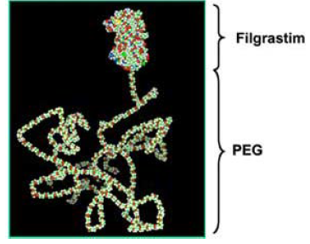
Source: G. Molineux, 2004.
Based upon stability data submitted by the sponsor, the recommended shelf life and storage conditions of Filpegla is 36 months stored at 2 to 8 °C.

Biosimilarity
During the development of Filpegla, Neulasta;4 was used as the main reference product to demonstrate biosimilarity in terms of quality and via a nonclinical comparability exercise. In accordance with guidance; an additional bridging comparability study was performed between EU-sourced and Australian-sourced Neulasta to demonstrate EU-sourced Neulasta as being representative of the Australian registered product (Neulasta). Overall, Filpegla in terms of physicochemical characteristics and biological activity is similar to EU-sourced Neulasta and Australian-sourced Neulasta.
Extensive characterisation studies involving comparison of primary, secondary and tertiary structures, physicochemical properties and biological activities showed that Filpegla and Neulasta are generally similar.
Overall, the sponsor has demonstrated that Filpegla is comparable to Neulasta in terms of structure, species, function and degradation profile (that is, physicochemically and biologically).

Microbiology and sterility
From a microbiological perspective, there are no objections for the application to register Filpegla pegfilgrastim 6 mg/0.6 mL solution for injection.

Conclusions
All outstanding quality issues have been resolved prior to approval. From a quality and manufacturing perspective there are no objections to the approval of Filpegla.
The following quality-related conditions of registration were proposed.

Quality-related proposed conditions of registration
- Laboratory testing & compliance with Certified Product Details (CPD)
  - All batches of Filpegla supplied in Australia must comply with the product details and specifications approved during evaluation and detailed in the Certified Product Details (CPD).
  - When requested by the TGA, the Sponsor should be prepared to provide product samples, specified reference materials and documentary evidence to enable the TGA to conduct laboratory testing on the Product. Outcomes of laboratory testing are published biannually in the TGA Database of Laboratory Testing Results http://www.tga.gov.au/ws-labs-index and periodically in testing reports on the TGA website.
- Certified Product Details
The Certified Product Details (CPD), as described in Guidance 7: Certified Product Details of the Australian Regulatory Guidelines for Prescription Medicines (ARGPM) http://www.tga.gov.au/industry/pm-argpm-guidance-7.htm, in PDF format, for the above products should be provided upon registration of these therapeutic goods. In addition, an updated CPD should be provided when changes to finished product specifications and test methods are approved in a Category 3 application or notified through a self-assessable change.

Nonclinical
The nonclinical dossier contained comparative studies on pharmacology, pharmacokinetics and repeat dose toxicity. The scope of the nonclinical program is adequate under the relevant EU and TGA guidelines.12,, These studies were conducted using EU-sourced Neulasta as the reference product. No data were provided in the nonclinical dossier to verify the comparability of the EU-sourced and Australian-sourced Neulasta.
No meaningful differences between Filpegla and Neulasta;4 were observed in the comparative pharmacology, pharmacokinetic and toxicity studies, supporting biosimilarity.
No injection site reactions were observed in pharmacology, toxicity and local tolerance studies.
The ability of the nonclinical studies to support comparability to Australian Neulasta depended on the conclusion of the quality evaluator regarding the identity of Neulasta products across jurisdictions. Provided that EU-sourced Neulasta is considered to be identical or highly comparable to the Australian product, there are no nonclinical objections to the registration of Filpegla.

Clinical

Summary of clinical studies
The clinical dossier consisted of:
- Two Phase I studies:
  - Study PEGF/USV/P1/001, a pharmacokinetic/ pharmacodynamic (PK/PD) crossover study comparing USV pegfilgrastim with EMA-approved Neulasta single injection 6 mg in 156 healthy subjects
  - Study PEGF/USV/P1/003, a PK/PD crossover study of USV pegfilgrastim with Neulasta single injection 2 mg in healthy male subjects
- One Phase III randomised study:
  - Study PEGF/USV/P3/003, a Phase III, randomised active controlled, parallel group study comparing the efficacy and safety of USV pegfilgrastim with Neulasta in female patients with breast cancer.

Pharmacokinetics and Pharmacodynamics
In line with TGA-adopted guidance for recombinant G-CSF;¹⁴ pharmacokinetic (PK) and pharmacodynamic (PD) characteristics of Filpegla were compared with a reference medicinal product in single dose crossover studies.
Two Phase I studies in healthy adults were submitted for evaluation, Study PEGF/USV/P1/001 (main study) and Study PEGF/USV/P1/003 (PK parameters were not compared formally in this study). The objectives were to demonstrate comparability to the reference pegfilgrastim product Neulasta with respect to PK and PD variables and safety.

Study PEGF/USV/P1/001
Study PEGF/USV/P1/001 was a randomised, double blind, two treatment, two period, two sequence crossover study.

Study objectives
- Primary objectives
  - To compare the PD of USV pegfilgrastim and Neulasta following a single subcutaneous dose of 6 mg
  - To compare the PK of USV pegfilgrastim and Neulasta following a single subcutaneous dose of 6 mg
- Secondary objectives
  - To provide additional safety and local tolerance information for USV pegfilgrastim and Neulasta

Primary endpoints
- Pharmacokinetics
  - Exposure/area under the concentration time curve from time zero to time of last quantifiable concentration (AUC_{0-last}) and maximum concentration (C_{max})
- Pharmacodynamics
  - Absolute neutrophil count (ANC)

Participants
A total 156 healthy male and female subjects randomised (78 subjects to sequence AB: USV pegfilgrastim followed by EU-sourced Neulasta and 78 subjects to sequence BA: EU-sourced Neulasta followed by USV pegfilgrastim).

Key inclusion criteria
- Healthy male subjects or non-pregnant/non-lactating healthy female subjects
- Aged between 18 and 55 years
- Body mass index (BMI) between 18 and 32 kg/m²
- Body weight above 55 kg

Key exclusion criteria
- Hypersensitivity to any of investigational medicinal products (IMPs) or their constituents
- Prior exposure to filgrastim, pegfilgrastim or lenograstim
- Contraindication to paracetamol and non-steroidal anti-inflammatory drugs
- Absolute neutrophil count outside the reference range of 2.0 to 7.5 x 10⁹/L
- Platelet count outside the limits of reference range of 150 to 400 x 10⁹/L

Study drugs
- Test product: USV pegfilgrastim, single 6 mg/0.6mL subcutaneous injection
- Reference product: EU-sourced Neulasta, single 6 mg subcutaneous injection
There was a washout period of at least 28 days between Period 1 and Period 2.

Statistical analysis
- Pharmacokinetic equivalence: the 90% confidence interval (CI) for the ratio of adjusted geometric means of AUC_{0-last} for USV pegfilgrastim to EU-sourced Neulasta should be within 80% to 125%
- Pharmacodynamic equivalence: the 95% CI for the ratio of adjusted geometric means of absolute neutrophil count (ANC) for USV pegfilgrastim to EU-sourced Neulasta should be within 90% and 111.11%.
The two study periods (for either treatment sequence AB or BA) were separated by a washout interval period of at least 28 days. During each period, the test or reference product was administered on the morning of Day 1 after a light breakfast; PD, PK and safety assessments were performed on Days 8, 10 and 14; a final safety assessment on Day 29 (+/-3 days) of Period 2 was also performed.
The overall estimation of 132 evaluable subjects assumed an 80% power to demonstrate bioequivalence (90% CI of 80% to 125%) and a true ratio of 1.05 using an intra-subject variability of 60%, allowing for a potential dropout of 15% to yield a randomisation number of 156 subjects into a two-way crossover design study.

Pharmacokinetics
The primary PK endpoint was AUC_{0-last}. Pharmacokinetic parameters AUC_{0-last}, area under the concentration time curve from time zero to infinity (AUC_{0-inf}) and C_{max} for pegfilgrastim were analysed using analysis of variance (ANOVA) techniques for a crossover design, including terms for treatment, period, sequence and subject within sequence. A 90% CI for the ratio of the adjusted geometric means for test (USV pegfilgrastim; Treatment A) and reference (Neulasta; Treatment B) products were calculated. The 90% CI for the ratio of adjusted geometric means of AUC_{0-last} for USV pegfilgrastim versus EU-sourced Neulasta should be within 80% to 125%.
Table 3: Study PEGF/USV/P1/001 Adjusted geometric mean estimates (geometric coefficient of variation) of key pharmacokinetic parameters for USV pegfilgrastim and Neulasta
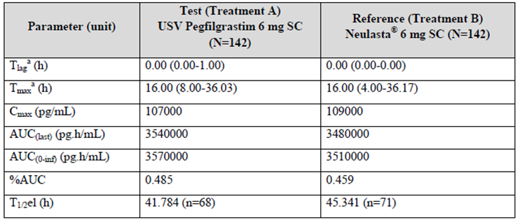
Abbreviations: SC = subcutaneous, T_{lag} = time prior to the time at which pegfilgrastim was first detected, T_{max} = time to reach maximum concentration, C_{max} = maximum concentration, AUC_{0-last} = area under the concentration time curve from time zero to time of last quantifiable concentration, AUC_{0-inf} = area under the concentration time curve from time zero to infinity, AUC = area under the concentration-time curve, T_{1/2} = half life.
a: median (range)
Table 4: Study PEGF/USV/P1/001 Statistical analysis of key pharmacokinetic parameters for USV pegfilgrastim and Neulasta
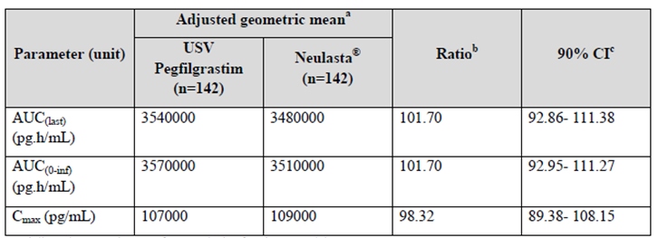
Abbreviations: C_{max} = maximum concentration, AUC_{0-last} = area under the concentration time curve from time zero to time of last quantifiable concentration, AUC_{0-inf} = area under the concentration time curve from time zero to infinity, CI = confidence interval
a: Adjusted geometric mean from analysis of variance model
b: Ratio of adjusted geometric means defined as USV pegfilgrastim versus Neulasta
c: Confidence interval for ration of adjusted geometric means comparability was to be established if the 90% CI for primary PK endpoint AUC_{0-last} was entirely within the range of 80% to 125%
A total of 142 of the 156 subjects had evaluable data for both test and reference products and were included in the PK dataset. High intra- and inter-subject variability was observed.
Mean PK profiles for USV pegfilgrastim and the reference product were similar:
- Median time to reach maximum concentration was 16 hours for both products.
- Half life (h) estimates, based on data from a limited number of subjects, were 41.8 hours for USV pegfilgrastim and 45.3 hours for Neulasta.
- Geometric mean estimates for C_{max} and AUC_{0-last} were similar for both treatments.
Based on the primary PK endpoint AUC_{0-last}, the ratio of adjusted geometric mean for USV pegfilgrastim/Neulasta was 101.7 (90% CI 92.86, 111.38), meeting the pre-specified criteria to demonstrate that treatments were comparable.
The 90% CI for geometric mean for the secondary PK endpoints area under the concentration time curve from time zero to infinity (AUC_{0-inf}) and C_{max} were also similar and both contained 100%.
A period effect with ANOVA in this study was noted; given there is no sequence effect and that the PK parameters and concentration-time curves for individual subjects are widely variable, the clinical evaluation concluded that this observation is unlikely to have any clinical significance on the biosimilarity profile of USV pegfilgrastim, and that the finding is potentially related to individual variation in ANC stimulation due to the target mediated clearance of pegfilgrastim.

Pharmacodynamics
Primary pharmacodynamic (PD) endpoint: absolute neutrophil count was used as an efficacy marker, as per EU guidance documents;^{13,14} CD34+ cell count (an indicator of peripheral blood progenitor cell mobilisation) was a secondary endpoint.
The results are shown in the following tables:
Table 5: Study PEGF/USV/P1/001 Geometric mean estimates (geometric coefficient of variation) of key pharmacodynamic parameters for absolute neutrophil count
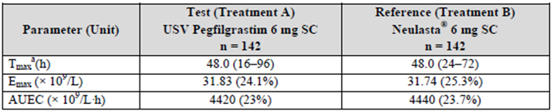
Abbreviations: SC = subcutaneous, T_{max} = time to reach maximum concentration, E_{max} = maximum observed effect, AUEC = area under the effect curve
a: median (range)
Table 6: Study PEGF/USV/P1/001 Geometric mean estimates (geometric coefficient of variation) of key pharmacodynamic parameters for CD34+ counts
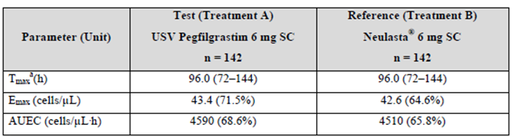
Abbreviations: SC = subcutaneous, T_{max} = time to reach maximum concentration, E_{max} = maximum observed effect, AUEC = area under the effect curve
a: median (range)
Table 7: Study PEGF/USV/P1/001 Assessment of comparability of pharmacodynamic parameters for absolute neutrophil counts and CD34+ viable counts
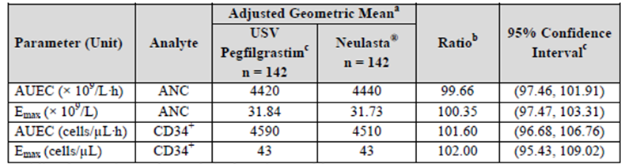
Abbreviations: E_{max} = maximum observed effect, AUEC = area under the effect curve
a: Adjusted geometric mean from analysis of covariance model
b: Ratio of adjusted geometric means defined as USV pegfilgrastim/Neulasta
c: Confidence interval for the ratio of adjusted geometric means comparability was to be established if the confidence interval for the primary pharmacodynamic endpoint AUEC for ANC was entirely within the range (90%, 111.11%)
ANCOVA model estimates of intra-subject variability (CV%): ANC AUEC, 9.54%, ANC Emax, 12.4%; CD34+ Emax, 21.4%, CD34+ Emax, 28.9%
Pharmacodynamic parameters area under the effect curve (AUEC) and maximum observed effect (E_{max}) for ANC and CD34+ viable counts were analysed using analysis of covariance (ANCOVA) techniques for a crossover design, including terms for treatment, period, sequence and subject within sequence.
The adjusted geometric mean estimate for AUEC following each treatment was similar. The 95% CI for the ratio of adjusted geometric means of AUEC (ANC) for USV pegfilgrastim versus EU-sourced Neulasta was 97.46 and 101.91, falling within the pre-specified 90% and 111.11% acceptance limit, demonstrating comparability between USV pegfilgrastim and the reference product for the PD endpoint. CD34+ response also supports comparability.

Study PEGF/USV/P1/003
As advised by the EMA, the sponsor performed a similar study at lower dose lying on the steep part of the dose response curve. Study PEGF/USV/P1/003 compared single 2 mg subcutaneous doses of USV pegfilgrastim and Neulasta in a two-way crossover two period PD/PK study in 64 healthy males aged 18 to 55 years. The primary objective was to compare the PD (E_{max} and AUEC for absolute neutrophil count (ANC)) of USV pegfilgrastim and EU-sourced Neulasta following a single 2 mg subcutaneous dose. Secondary objectives were to compare PK parameters (no formal statistical analysis was performed for the PK data) and to provide additional safety information. The study design and methodology were generally as for Study PEGF/USV/P1/001 (described above).
Figure 2: Study PEGF/USV/P1/003 Arithmetic mean serum polyethylene glycol granulocyte colony-stimulating factor concentrations for USV pegfilgrastim (Treatment A) and Neulasta (Treatment B) presented on a linear/linear scale
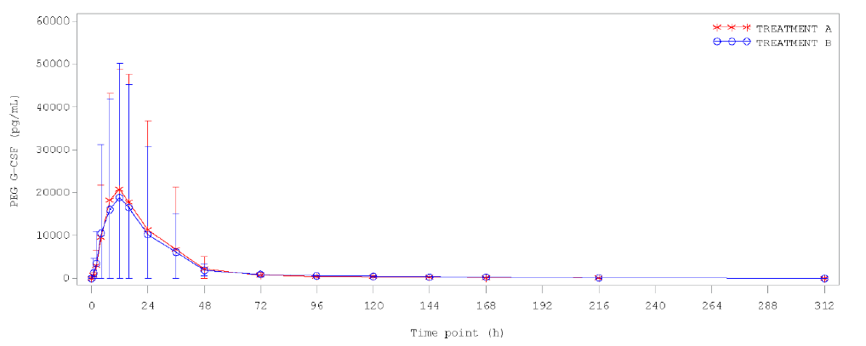
Treatment A: 2 mg (0.2 mL) USV pegfilgrastim solution for subcutaneous injection into the abdomen
Treatment B: 2 mg (0.2 mL) EU-sourced Neulasta solution for subcutaneous injection into the abdomen
Table 8: Study PEGF/USV/P1/003 Geometric mean ratio (geometric coefficient of variation) polyethylene glycol granulocyte colony-stimulating factor pharmacokinetic parameters for USV pegfilgrastim (Treatment A) and Neulasta (Treatment B)
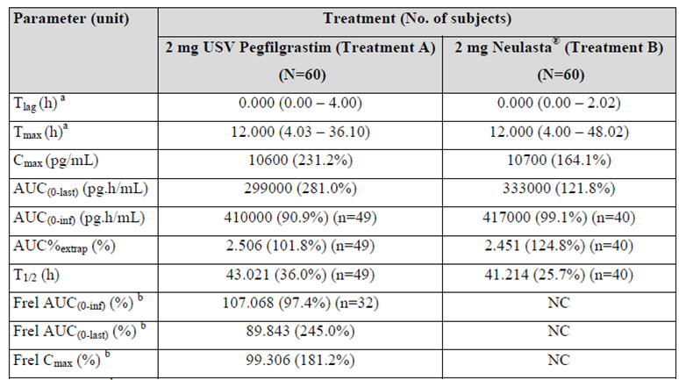
Abbreviations: T_{lag} = time prior to the time at which pegfilgrastim was first detected, T_{max} = time to reach maximum concentration, Cmax = maximum concentration, AUC_{0-last} = area under the concentration time curve from time zero to time of last quantifiable concentration, AUC_{0-inf} = area under the concentration time curve from time zero to infinity, AUC = area under the concentration-time curve, T_{1/2} = half life, NC = not calculated.
a: median (range)
b: within subject ratio of AUC_{0-inf}, AUC_{0-last} and _{Cmax}
Very high inter-subject and intra-subject variability was noted by the clinical evaluator.
Two subjects had below the limit of quantification for almost all values for USV pegfilgrastim concentrations; the clinical evaluator noted that the administration of a low volume of subcutaneous injection may be a possible source for variability resulting in low serum pegfilgrastim concentrations.
For C_{max} and AUC_{0-inf} geometric mean, obtained from data for a limited number of subjects, relative bioavailability values for USV pegfilgrastim compared to Neulasta were 99.306% and 107.068%, respectively.
Table 9: Study PEGF/USV/P1/003 Geometric mean estimates (geometric coefficient of variation) whole blood absolute neutrophil count pharmacodynamic parameters for USV pegfilgrastim (Treatment A) and Neulasta (Treatment B)
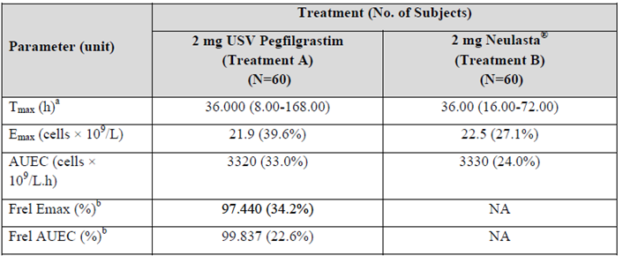
Abbreviations: T_{max} = time to reach maximum concentration, Emax = maximum observed effect, AUEC = area under the effect curve, NA = not applicable.
a: median (range)
b: within subject ratio of E_{max} or AUEC
Table 10: Study PEGF/USV/P1/003 Assessment of comparability for primary pharmacodynamic endpoints maximum observed effect and area under the effect curve for absolute neutrophil count
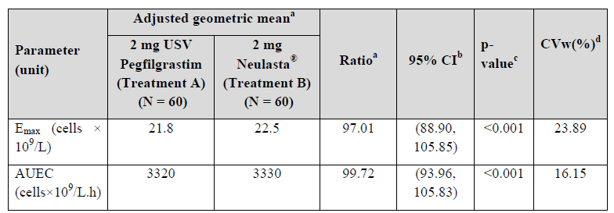
Abbreviations: E_{max} = maximum observed effect, AUEC = area under the effect curve
Results obtained from ANCOVA model of natural log transformed PD parameters including terms for treatment, sequence, period and subject within sequence fitted as fixed effects and baseline fitted as a covariate.
a: Ratio of adjusted geometric means for USV pegfilgrastim/Neulasta
b: CI = confidence interval for ratio of adjusted geometric means
c P-value for ratio of adjusted geometric means using a two 1-sided test
d CVw = Intra-subject variability. Equivalence is concluded if CI is entirely within the range (80%, 125%)
A total of 60 of the 64 subjects had evaluable data for both test and reference products and were included in the PD analysis dataset.
For the primary endpoints, ANC E_{max} and AUEC, the 95% CI for the ratio of the adjusted geometric means for USV pegfilgrastim versus EU-sourced Neulasta were contained within the acceptance limits of 80% and 125%. CD34+ cell counts also support comparability.

Summary of pharmacokinetics and pharmacodynamics
The PK and PD profiles of Filpegla and Neulasta have been compared in two trials of healthy volunteers using the same study design at the 6 mg therapeutic dose and a sub-therapeutic 2 mg dose; the 6 mg dose is considered to be sufficiently sensitive for both PK and PD comparison as it lies on the steep part of the dose concentration and dose response curves.
The pivotal Study PEGF/USV/P1/001 demonstrated PK comparability of the 6 mg dose, with the 90% CI of the geometric mean ratio for AUC_{0-last} (90% CI: 92.86, 111.38), AUC_{0-inf} and C_{max} all contained within the pre-specified and standard bioequivalence range of 80% to 125%. The second Study PEGF/USV/P1/001 was not powered to establish PK equivalence.
Analysis of PD parameters (AUEC and E_{max} for ANC, and CD34+ cell count) showed that the 95% CI for the ratio of geometric means for Filpegla and Neulasta all fall within the pre-specified bioequivalence limit of 90% and 111.11% in the pivotal study and 80% to 125% in the supportive study.
The PK and PD profile of Filpegla and Neulasta are therefore considered comparable.

Efficacy

Study PEGF/USV/P3/003
Study PEGF/USV/P3/003 was a Phase III randomised, assessor blinded, active controlled, parallel group study of efficacy and safety of USV pegfilgrastim versus EU-sourced Neulasta in patients with stage IIa, IIb or IIIa breast cancer eligible for adjuvant TAC chemotherapy. The primary objective was to demonstrate comparability in therapeutic efficacy of USV pegfilgrastim and EU-sourced Neulasta (reference product) during the first chemotherapy cycle. The primary efficacy endpoint was the duration of severe neutropenia (DSN) as defined by an absolute neutrophil count (ANC) below 0.5 x 10⁹/L, during Cycle 1 of treatment.
Secondary objectives were further comparisons of efficacy, safety, and immunogenicity.

Study objectives
- Primary objectives
  - To assess the efficacy of USV pegfilgrastim compared to Neulasta with respect to the mean DSN defined as the mean number of days with Grade 4 neutropenia; (ANC less than 0.5 x 10⁹/L) during Cycle 1 of chemotherapy treatment.
- Secondary objective
  - To further compare USV pegfilgrastim and Neulasta with respect to efficacy, safety and immunogenicity.

Study design and duration
Randomised, assessor blinded, active controlled, parallel group Phase III study.
- 254 women (18 years of age or older) eligible for TAC chemotherapy as adjuvant treatment for breast cancer
- Randomised 2:1 to USV pegfilgrastim (n = 172) or EU Neulasta (n = 82)
- Treatment period is up to 18 weeks (6 cycles of TAC)
- Safety follow up period is six months after last administration of IMP

Primary endpoints
- Primary efficacy endpoint
  - Mean DSN during Cycle 1
- Secondary efficacy endpoints
  - Mean DSN during Cycles 2 to 6; depth of ANC nadir in Cycles 1 to 6; number or proportion of subjects with febrile neutropenia; time to neutrophil recovery, number/proportion of subjects hospitalised; number/proportion of subjects with documented infections; use of intravenous antibiotics.
- Safety endpoints
  - Probability of occurrence and severity of the most common adverse events associated with pegfilgrastim treatment and other adverse events (including mortality during treatment for any cause); injection site tolerability; systemic tolerance; immunogenicity assessments.

Key inclusion criteria
- Women 18 years of age or older
- Body weight between 40 and 120 kg
- Chemotherapy naïve
- Histologically proven breast cancer (stage IIa, IIb, or IIIa) eligible for six cycles of adjuvant TAC chemotherapy

Key exclusion criteria
- Presence of distant metastasis
- Severe chronic neutropenia
- History of chronic myeloid leukaemia, myelodysplastic syndrome or sickle cell disease

Study treatment
- Test product: USV pegfilgrastim, 6 mg subcutaneous injection
- Reference product: EU-sourced Neulasta, 6 mg subcutaneous injection
The choice of study design, population, inclusion and exclusion criteria, and study treatments including adjuvant TAC regimen, premedication and antibiotics is considered to be appropriate. The choice of efficacy endpoint and equivalence margin (of 1 day) is acceptable, as per EMA Committee for Medicinal Products for Human Use (CHMP) guidance.
Subjects were randomised 2:1 to receive USV pegfilgrastim or the reference product (EU-sourced Neulasta) and received up to six cycles of adjuvant TAC chemotherapy (docetaxel, doxorubicin and cyclophosphamide), which were administered at standard three weekly intervals.
A single subcutaneous injection of 6 mg USV pegfilgrastim (IMP) or EU-sourced Neulasta, as per randomisation, was administered to each subject once on Day 2 of each chemotherapy cycle.
A sample size of 216 evaluable subjects (144 in USV pegfilgrastim arm, 72 in Neulasta arm) was considered sufficient to achieve a 90% power at a 2.5% level of significance to reject both one-sided null hypotheses, that is, the null hypothesis that the ratio of means was less than 0.65 day, and the null hypothesis that the ratio of means greater than 1.55 day. Equivalence was to be concluded if the 95% CI of the ratio of means was entirely contained in the interval (0.65, 1.55). The upper limit of that acceptance range corresponded to a 1 day difference on the additive scale, assuming a reference mean of 1.8 days. The lower limit was calculated to be symmetrical around 1 on a multiplicative scale.
Both treatment arms are considered to be balanced with respect to patient demographics and tumour stage. During all cycles of TAC, exposure to pegfilgrastim was high.
Table 11: Study PEGF/USV/P3/003 Drug exposure summary
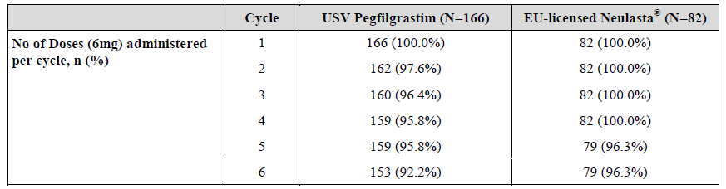

Efficacy results for the primary endpoint
For the full analysis set, the mean standard deviation DSN in Cycle 1 in the USV pegfilgrastim treatment arm was 1.58 (±1.207) days and in the Neulasta treatment arm it was 1.65 (±1.231).
Table 12: Study PEGF/USV/P3/003 Descriptive statistics of duration of severe neutropenia in Cycle 1
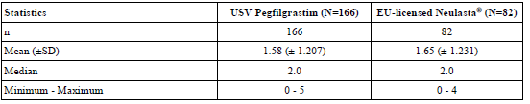
Abbreviations: SD = standard deviation, EU = European Union
The following table (Table 13) shows the least square mean (95% CI) of Cycle 1 DSN in the two treatment arms and their ratio estimated within a negative binomial model accounting for treatment, applying a log link, for both the full analysis set and the per-protocol analysis set.
Table 13: Study PEGF/USV/P3/003 Duration of severe neutropenia in Cycle 1
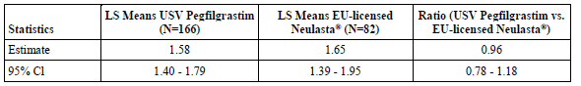
Abbreviations: LS = least square, EU = European Union, CI = confidence interval
Least square means (95% Cl) of treatment arms and their ratio, estimated within a generalised linear model accounting for the treatment effect assuming a negative binomial distribution (full analysis set)
Equivalence was concluded if the 95% CI of the ratio of means was entirely contained in the interval (0.65, 1.55). The upper limit of this acceptance range was established to correspond to a 1 day difference on the additive scale, assuming a reference mean of 1.8 days.
For the full analysis set, the least square mean ratio of USV pegfilgrastim and Neulasta treatment arms was 0.96; the 95% CI (0.78 to 1.18) was within the pre-specified equivalence limits.
For the pre-protocol population, the least square ratio of USV pegfilgrastim and Neulasta treatment arms was 0.93 and the 95% CI (0.76 to 1.16) was within the pre-specified equivalence limits.

Efficacy results for other outcomes
- Least square mean DSN during Cycles 2 to 6 ranged from 0.96 to 1.12, ratios (95% CI) USV pegfilgrastim to Neulasta ranged from 0.88 (0.64 to 1.20) in Cycle 3 to 1.05 (0.74 to 1.50) in Cycle 4.
- Mean depth of ANC nadir in Cycle 1 was 0.510 x 10⁹/L for USV pegfilgrastim versus 0.470 x 10⁹/L for EU Neulasta.
- The overall proportion of patients with febrile neutropenia in Cycles 1 to 6 was higher in the USV pegfilgrastim arm (5.4%) than in the Neulasta arm (2.4%), as was the case for Cycle 1 (3.6% in the USV pegfilgrastim arm versus 1.2% in the Neulasta arm). These observed incidences of febrile neutropenia are not significantly higher than that described in the literature.
- During Cycle 1 all 248 subjects had ANC recovery before the start of Cycle 2; in USV pegfilgrastim treatment arm mean time to recovery was 7.5 (± 4.63) days and in Neulasta treatment arm it was 8.0 (± 5.18) days.
The following table (Table 14) shows the number and proportion of subjects hospitalised, duration of hospitalisations, and time in the intensive care unit, likely reflecting the reported febrile neutropenia rate.
Table 14: Study PEGF/USV/P3/003 Descriptive studies of hospitalisation and intensive care unit stay due to neutropenia complications
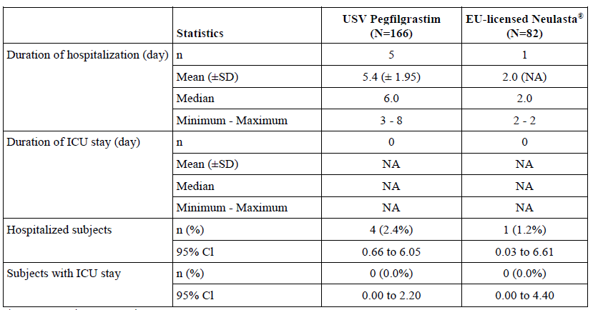
Abbreviations: EU = European Union, ICU = intensive care unit, CI = confidence interval, NA = not applicable, SD = standard deviation.
- Ten (10) subjects, all from the USV pegfilgrastim treatment arm, had documented infections.
- There were 5 subjects, all from the USV pegfilgrastim treatment arm, who required intravenous antibiotic use (3 out of 5 required intravenous antibiotic therapy due to febrile neutropenia).

Summary of clinical efficacy
The primary efficacy analysis showed the 95% CI for the mean DSN ratios for both the full analysis set and the pre-protocol analysis sets were entirely contained within the pre-specified equivalence interval of 0.65 to 1.55, (that is, 0.78 to 1.18 for the full analysis set and 0.76 to 1.16 for the pre-protocol analysis set), demonstrating therapeutic equivalence of Filpegla and Neulasta.
In terms of secondary efficacy data, the proportion of subjects with febrile neutropenia, infections, hospitalisations, and use of antibiotics was higher in the Filpegla arm than Neulasta. Of particular note, the incidence of febrile neutropenia in Filpegla arm was 5.4% (95% CI 2.51 to 10.04) versus 2.4% (95% CI 0.3 to 8.53) in the Neulasta arm. Given the overall low incidence of this outcome, the unequal treatment allocation (2:1), and as the study was not powered for comparison of secondary outcomes, this finding is unlikely to preclude the determination of efficacy bioequivalence.

Safety
Safety data was provided for the three comparative studies, Study PEGF/USV/P1/001, Study PEGF/USV/P1/003 and Study PEGF/USV/P3/003, as shown in Table 15, below.
Table 15: Exposure to USV pegfilgrastim and comparator Neulasta in clinical studies (any dose, any duration)
Study type/  Indication | Controlled studies |  | Uncontrolled studies | Total  USV pegfilgrastim
Study type/  Indication | USV pegfilgrastim | Neulasta* | USV pegfilgrastim | Total  USV pegfilgrastim
Clinical pharmacology Studies P1/001 and P1/003 | 150 + 62 | 149 + 62 | - | 212
Indication: Treatment of cancer patients after chemotherapy to decrease duration of severe neutropenia |  |  | -
Main study  Study P3/003 breast cancer patients | 166 | 82 |  | 166
Total | 378 | 293 | - | 378
* Control / comparator

Study PEGF/USV/P1/001
No overall difference in safety profiles following USV pegfilgrastim and Neulasta were noted.
For USV pegfilgrastim 86% (129 out of 150) of subjects reported adverse events versus 82.6% (123 out of 149) for Neulasta. A total of 56 adverse events were reported as moderate, by 20 (13.3%) and 23 (15.4%) subjects after USV pegfilgrastim and Neulasta respectively. Back pain and headache were the most frequently reported adverse events, followed by extremity pain and musculoskeletal pain, all of which are reported adverse reactions for pegfilgrastim. Transient increases in alanine aminotransferase (ALT), aspartate aminotransferase (AST), and alkaline phosphatase were observed after both treatments.
No adverse events were serious or severe, and no adverse events were reported that led to death.
Two subjects withdrew from the study following USV pegfilgrastim: one had moderate neutropenia (related to USV pegfilgrastim) 13 days post administration, and one had moderate ALT/AST elevation, possibly related to USV pegfilgrastim, with pancytopenia recorded. A third subject experienced a moderate adverse event (abdominal pain that was considered possibly related to Neulasta), three days after Neulasta administration.

Study PEGF/USV/P1/003
No overall difference in safety profiles following USV pegfilgrastim and Neulasta were noted.
The incidence and frequency of adverse events was comparable between treatments; 56.5% (35 out of 62) of subjects reported treatment-emergent adverse events after USV pegfilgrastim versus 59.7% (37 out of 60) after Neulasta, and the majority of adverse events were mild. Back pain was most frequently reported. No deaths or serious adverse events were reported during the study.
One (1.6%) subject experienced a severe adverse event of increased ALT six days after dosing with Neulasta in Period 1. A total of 5 (8.1%) and 3 (4.8%) subjects reported one or more moderate adverse events following dosing with USV pegfilgrastim and Neulasta, respectively.
Two subjects withdrew from study with elevated liver function tests, one after USV pegfilgrastim and one after Neulasta.

Study PEGF/USV/P3/003
The overall safety profile of USV pegfilgrastim was similar to EU-sourced Neulasta, with no notable differences reported between treatment arms for the total number of treatment-emergent adverse events, severity, incidence and types of the most common treatment-emergent adverse events.
The majority of adverse events were assessed as not related to USV pegfilgrastim or comparator (that is, Neulasta).
Table 16: Study PEGF/USV/P3/003 Frequency table of subjects with treatment-emergent adverse events sorted by System Organ Class, Preferred Term and relationship to USV pegfilgrastim and EU-sourced Neulasta
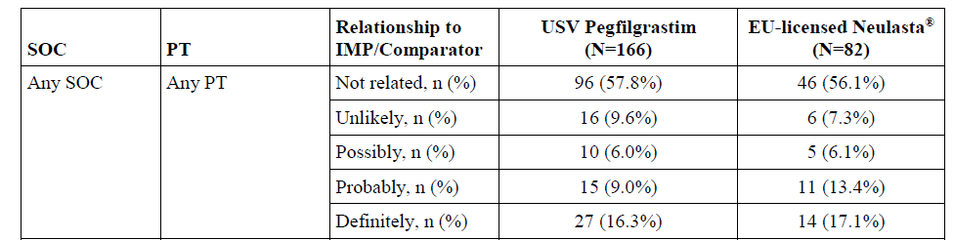
Abbreviations: SOC = System Organ Class, PT = Preferred Term, IMP = investigational medicinal product.
Investigational Medicinal Product (IMP) was USV pegfilgrastim; *comparator was EU-sourced (EU-licensed) Neulasta.
Each subject was counted only once in each SOC/PT category with her strongest relationship to IMP/comparator.
The denominator for percentages was the number of subjects in the safety analysis set, in the respective treatment arm.
The proportion of subjects with treatment-emergent adverse events was 52 (31.3%) subjects in the USV pegfilgrastim arm and 30 (36.6%) subjects in the Neulasta arm. A total of 17 serious treatment-emergent adverse events were reported by 12 subjects: nine (5.4%) from the USV pegfilgrastim treatment arm and three (3.7%) from the Neulasta treatment arm.
There were higher rates reported for some adverse events in the USV pegfilgrastim arm:
- Febrile neutropenia was reported in six (3.6%) subjects in the USV pegfilgrastim treatment arm and two (2.4%) subjects in the Neulasta arm.
- Severe bone pain was reported in 16 (9.6%) subjects in the USV pegfilgrastim arm, compared to six (7.3%) subjects in the Neulasta arm.
- Thrombocytopenia was reported by 25 (15.1%) of subjects in USV pegfilgrastim arm versus eight (9.8%) for Neulasta; and for severe thrombocytopenia, 3.6% versus 1.2%.
- Injection site reaction was reported in 22 (13.3%) subjects in the USV pegfilgrastim treatment arm versus eight (9.8%) in the Neulasta treatment arm. Most of the reported reactions were mild and there were no severe injection site reactions. None of the subjects discontinued the study due to an injection site reaction.
Overall frequencies for bone pain adverse events are shown in Table 17 below:
Table 17: Study PEGF/USV/P3/003 Frequency of investigational medicinal product and comparator related bone pains by severity and location
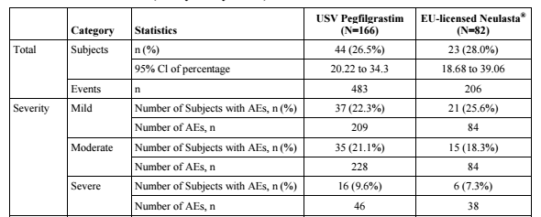
Abbreviations: CI = confidence interval, AEs = adverse events
Each subject can be counted more times, for each level of intensity and each location.
The denominator for percentages was the number of subjects in the safety analysis set, in the respective treatment arm.
None of the serious treatment-emergent adverse events reported during treatment period were assessed as related to USV pegfilgrastim or comparator (EU-sourced Neulasta).
Three subjects withdrew from the study, all in the USV pegfilgrastim arm; adverse events were all considered to be unrelated to study drug (one had acute respiratory distress syndrome, one had severe diarrhoea and one had moderate herpes zoster).
In the safety follow up period, five treatment-emergent adverse events were reported by three subjects, all in the USV pegfilgrastim arm. Three were assessed as moderate (ALT increased, AST increased, metastases to central nervous system) and two as severe (peripheral T-cell lymphoma unspecified and skin disorder); none of these events were assessed as related to the USV pegfilgrastim treatment.

Summary of safety
Overall, USV pegfilgrastim demonstrates a safety profile similar to the documented safety profile for commercially available EU-sourced Neulasta, as outlined in the EU Summary of Product Characteristics (SmPC).

Immunogenicity
Anti-drug antibodies (ADA) were evaluated as part of immunogenicity assessment in all three comparability studies; the sponsor stated that a multi-tier approach of validated screening assays, confirmatory assays, endpoint titre determination assay and neutralisation assay for pegfilgrastim antibodies was followed.
- In Study PEGF/USV/P1/001, all screening assay results for the presence of ADA were either negative, or if positive, were subsequently confirmed as negative in the endpoint titre assay.
- In Study PEGF/USV/P1/003, three (10%) subjects randomised to Sequence AB (USV pegfilgrastim in Period 1 followed by Neulasta in Period 2) had a positive confirmatory assay result for pegfilgrastim ADA post-dose in Period 1. In two of these subjects, a positive result was also observed post-dose in Period 2. However, for all three subjects, the neutralising antibody assays were negative, and the positive immune response had no notable impact on their PK, PD or safety profiles.
- In Study PEGF/USV/P3/003, 25 out of 951 samples screened positive for ADA (anti-pegfilgrastim antibody method); in the confirmatory assay, two from 949 samples from randomised patients were confirmed positive. One was a pre-dose sample (and all results at Cycle 4 Day 3, end of treatment visit, and study termination visit were negative) and was not characterised further. The other confirmed ADA positive test was at the end of treatment visit (Cycle 4), following negative test at Cycle 4 Day 3. This was also positive in the neutralising antibody assay, both showing low titres of 2 on further testing. The subject received USV pegfilgrastim in this study; the ADA was considered to have developed from Cycle 4 onwards. Of note, duration of severe neutropenia was six days from Cycle 4 compared to 3 or 4 days in Cycles 1 to 3.
Table 18: Study PEGF/USV/P3/003 Efficacy data (absolute neutrophil count) in a single subject with neutralising antibody assay positive test
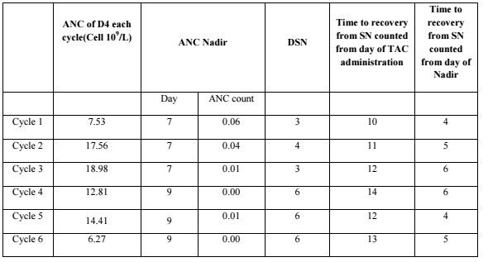
Abbreviations: ANC = absolute neutrophil count, D4 = Day 4, DSN = duration of severe neutropenia, SN = severe neutropenia; TAC (regimen) = six chemotherapy cycles with docetaxel in combination with doxorubicin and cyclophosphamide
The sponsor states that the neutralising antibody that developed in this subject in the Filpegla arm was transient in nature, with a low titre, and that the development of the neutralising antibody did not cause adverse events or reduce clinical response. At study termination visit, antidrug antibodies were undetectable. The clinical study report states that this isolated case was not considered significant.
In this subject, the main concern relating to the development of neutralising ADAs (likely against the G-CSF moiety) during Cycle 4 is that it appears to have prolonged the duration of severe neutropenia in the last chemotherapy cycles. However, this finding occurs in the context of an overall low incidence of ADA development in the three comparability studies; the impact of this single finding is therefore unlikely to preclude a conclusion of comparable immunogenicity profile of Filpegla and Neulasta.

Risk management plan
The sponsor is required to comply with product vigilance and risk minimisation requirements.
The TGA decided a risk management plan (RMP) was not required (see TGA’s guidance on ‘when an RMP is required’).
The TGA may request an updated RMP at any stage of a product's life cycle, during both the pre-approval and post-approval phases. Further information regarding the TGA’s risk management approach can be found in risk management plans for medicines and biologicals and the TGA's risk management approach. Information on the Australia specific annex (ASA) can be found on the TGA website.
The clinical evaluation requested the provision of post-marketing safety update reports for USV pegfilgrastim (which was approved in the EU in 2019) by the sponsor, as potential clinically significant differences between biosimilars may be detected in the post-market setting. A periodic safety update report (PSUR) is due for submission in Europe in mid-2022 as per European Union reference dates list, which the sponsor has agreed to also provide to TGA by when available. The Delegate has therefore requested an RMP evaluation and review of relevant post-marketing PSURs.

Risk-benefit analysis

Delegate’s considerations
The comparability exercise is based on quality data, nonclinical evaluation, and clinical data from two pharmacokinetic and pharmacodynamic (PK/PD) trials (Study PEGF/USV/P1/001 and Study PEGF/USV/ P1/003) in healthy volunteers, and a supportive efficacy/safety study (PEGF/USV/P3/003) in patients with breast cancer undergoing a highly myelosuppressive chemotherapy regimen.

Quality
All outstanding quality issues were resolved prior to approval, and there are no quality objections to the registration of Filpegla.

Nonclinical
Results of the comparative pharmacology, pharmacokinetic and toxicology studies were considered by the nonclinical evaluator to support biosimilarity of Filpegla and EU-sourced Neulasta. The ability of nonclinical studies to support comparability to Australian-sourced Neulasta depends on the conclusion of the TGA’s quality evaluation regarding the identity of Neulasta products across jurisdictions. Provided that EU-sourced Neulasta is considered to be identical or highly comparable to the Australian product, there are no nonclinical objections to the registration of Filpegla.

Clinical
Studies PEGF/USV/P1/001, PEGF/USV/P1/003 and PEGF/USV/P3/003 show comparable PK/PD characteristics, efficacy and safety profiles, and support comparability between Filpegla and EU-sourced Neulasta. Comparability between Filpegla, EU-sourced Neulasta and Australian-sourced Neulasta as per the bridging study provided has been confirmed by the through the TGA’s quality evaluation.

Filpegla versus EU-sourced Neulasta
Pharmacokinetic comparability is considered established based on the results of pivotal Study PEGF/USV/P1/001 which showed that the 90% CI of the geometric mean ratio for AUC_{0-last} (90% CI: 92.86, 111.38), AUC_{0-inf} and C_{max} are all contained within the pre-specified bioequivalence range of 80% and 125%. Results of the Study PEGF/USV/P1/001 were not powered to establish PK equivalence but support comparability.
Pharmacodynamic comparability is considered established based on results of Study PEGF/USV/P1/001 and Study PEGF/USV/P1/003, in which the 95% CI for the ratio of geometric means for AUEC and E_{max} for ANC, and CD34+ cell count all fall within the pre-specified bioequivalence limit of 90% and 111.11% in the pivotal study and 80% and 125% in the supportive study.
The efficacy profile is also considered established, with the primary efficacy analysis showing that the 95% CI for the mean DSN ratios for both the full analysis set and per-protocol analysis sets were entirely contained within the pre-specified equivalence interval of 0.65 to 1.55, (that is, 0.78 to 1.18 for the full analysis set, and 0.76 to 1.16 for the per-protocol analysis set).
Overall, Filpegla demonstrates a safety profile similar to the reference product (as documented in the Neulasta Product Information).

Uncertainties
The incidence of several adverse events was higher in the Filpegla arm compared to EU-sourced Neulasta, for example, febrile neutropenia, infections and thrombocytopenia; however, in the context of small absolute patient numbers, this difference is unlikely to be of significance. The safety data from Study PEGF/USV/P3/003 are mainly considered to be supportive, due to the small size of the study, and unbalanced randomisation; reported rare adverse reactions such as acute respiratory distress syndrome therefore do not preclude a determination of biosimilarity.
In terms of immunogenicity, neutralising antidrug antibodies were detected for one patient with breast cancer who received Filpegla in Study PEGF/USV/P3/003. This subject had negative ADA results at Cycle 4 Day 3 pre-dose and post-dose, followed by positive low titre (titres of 2) ADA and neutralising antibody assays at the end of treatment visit. At the study termination visit, ADAs were undetectable. The neutralising antibodies (likely against the G-CSF moiety) seem to have prolonged the duration of severe neutropenia in this patient during the last three chemotherapy cycles. It is noted that neutralising ADAs are infrequently reported for Neulasta or other biosimilar products.
The same observation is true for Neulasta amongst healthy subjects in Study PEGF/USV/P1/003, that is, where no confirmed ADAs developed against Neulasta versus three cases against USV pegfilgrastim.
The significance of the induction of anti-pegfilgrastim neutralising antibodies in one patient, at one post-dose time point, is uncertain. However, in view of the associated low level of incidence of ADA development overall, this single report of the development of neutralising ADA within the context of the available immunogenicity data, whilst unexpected, is not likely to be of sufficient concern to preclude a conclusion of comparable immunogenicity profile of USV pegfilgrastim with the reference product. The Delegate will seek further expert opinion regarding the comparability of Filpegla with the reference product in terms of the immunogenicity profile.

Proposed action
Comparability assessment supports biosimilarity of Filpegla to EU-sourced Neulasta, in terms of pharmacokinetic and pharmacodynamic characteristics, efficacy and safety profiles; further advice from the Advisory Committee on Medicines (ACM) will be sought regarding immunogenicity comparability.
The Delegate supports approval of the application.

Advisory Committee considerations
The Advisory Committee on Medicines (ACM), having considered the evaluations and the Delegate’s overview, as well as the sponsor’s response to these documents, advised the following.

Specific advice to the Delegate
- Does the ACM have any clinical concerns regarding the immunogenicity profile of Filpegla (when compared to Neulasta) that would preclude product registration?
The ACM did not identify any clinical concerns regarding the immunogenicity profile of Filpegla that should preclude registration.
From the submitted studies, the ACM noted that the incidence of antidrug antibodies was low post-treatment in both healthy subjects and patients with breast cancer. While there was one participant where a neutralising antibody was found, it was at a very low titre and was transient at chemotherapy Cycle 4 only. Based on this, the ACM was of the view that the presence of antidrug antibodies does not appear to have a clinical effect on the efficacy of Filpegla. The ACM however encouraged post-market monitoring within this space.
The ACM explored the clinical significance of E. coli infections and whether this increased the risk and impact of antidrug antibodies. The ACM was of the opinion that there was no clinical evidence available to support this view.
- Do the clinical findings from the comparability studies support the registration and use of Filpegla as a pegfilgrastim biosimilar?
The ACM explored the comparability studies and while some numerical differences within the adverse event profiles were noted, the ACM was of the view that comparability has been satisfactorily established for Filpegla as a pegfilgrastim biosimilar.

Conclusion
The ACM considered this product to have an overall positive benefit-risk profile for the indication:
Filpegla is indicated for the treatment of cancer patients following chemotherapy, to decrease the duration of severe neutropenia and so reduce the incidence of infection, as manifested by febrile neutropenia.

Outcome
Based on a review of quality, safety, and efficacy, the TGA approved the registration of Filpegla (pegfilgrastim) 6 mg/0.6 mL, solution for subcutaneous injection, syringe indicated for:
Filpegla is indicated for the treatment of cancer patients following chemotherapy, to decrease the duration of severe neutropenia and so reduce the incidence of infection, as manifested by febrile neutropenia.

Specific conditions of registration applying to these goods
- Laboratory testing & compliance with Certified Product Details (CPD)
i. All batches of Filpegla supplied in Australia must comply with the product details and specifications approved during evaluation and detailed in the Certified Product Details (CPD).
ii. When requested by the TGA, the Sponsor should be prepared to provide product samples, specified reference materials and documentary evidence to enable the TGA to conduct laboratory testing on the Product. Outcomes of laboratory testing are published biannually in the TGA Database of Laboratory Testing Results http://www.tga.gov.au/ws-labs-index and periodically in testing reports on the TGA website.
- Certified Product Details
The Certified Product Details (CPD), as described in Guidance 7: Certified Product Details of the Australian Regulatory Guidelines for Prescription Medicines (ARGPM) https://www.tga.gov.au/guidance-7-certified-product-details, in PDF format, for the above products should be provided upon registration of these therapeutic goods. In addition, an updated CPD should be provided when changes to finished product specifications and test methods are approved in a Category 3 application or notified through a self-assessable change.
- Reports are to be provided in line with the current published list of EU reference dates and frequency of submission of PSURs until the period covered by such reports is not less than three years from the date of the approval letter.
The reports are to at least meet the requirements for PSURs as described in the European Medicines Agency’s Guideline on good pharmacovigilance practices (GVP) Module VII-periodic safety update report (Rev 1), Part VII.B Structures and processes. Note that submission of a PSUR does not constitute an application to vary the registration. The Periodic Safety Update Report (PSUR) will be submitted in 2022, when available.
- For all injectable products the Product Information must be included with the product as a package insert.

Attachment 1. Product Information
The PI for Filpegla approved with the submission which is described in this AusPAR is at Attachment 1. For the most recent PI, please refer to the TGA PI/CMI search facility.
Therapeutic Goods Administration
PO Box 100 Woden ACT 2606 Australia
Email: info@tga.gov.au Phone: 1800 020 653 Fax: 02 6203 1605
https://www.tga.gov.au
Reference/Publication #

This is the original indication proposed by the sponsor when the TGA commenced the evaluation of this submission. It may differ to the final indication approved by the TGA and registered on the Australian Register of Therapeutic Goods.
Andres E, Federici L, Weitten T, et al. Recognition and management of drug-induced blood cytopenias: the example of drug-induced acute neutropenia and agranulocytosis. Expert Opin Drug Saf. 2008 Jul;7(4):481-9.
Georges, Q., Azoulay, E., Mokart, D. et al. Influence of neutropenia on mortality of critically ill cancer patients: results of a meta-analysis on individual data. Crit Care 22, 326 (2018).
Neulasta was first registered in Australia on 26 September 2002. ARTG number: 82873.
Ristempa was first registered in Australia on 30 January 2017. ARTG number: 283847.
Ziextenzo was first registered in Australia on 06 September 2019. ARTG number 308367.
Tezmota was first registered in Australia on 23 March 2018. ARTG number 298402.
Neutropeg was first registered in Australia on 19 August 2019. ARTG number 308176.
Fulphila was first registered in Australia on 17 August 2018. ARTG number 282830.
Pelgraz was first registered in Australia on 19 August 2019. ARTG number 308177.
G. Molineux. The design and development of pegfilgrastim (PEG-rmetHuG-CSF, Neulasta), Current Pharmaceutical Design, 2004; 10: 1235-1244.
TGA Guidance on Biosimilar medicines regulation (April 2018). Available online at: https://www.tga.gov.au/publication/biosimilar-medicines-regulation
EMA/EMEA (2005); Guideline on similar biological medicinal products containing biotechnology-derived proteins as active substance: non-clinical and clinical issues (EMEA/CHMP/BMWP/42832/2005 Rev. 1).
EMA/EMEA (2005): Annex to guideline on similar biological medicinal products containing biotechnology-derived proteins as active substance: Non-clinical and clinical issues Guidance on similar medicinal products containing recombinant granulocyte-colony stimulating factor (EMEA/CHMP/BMWP/31329/2005).
TAC regimen: six chemotherapy cycles with docetaxel in combination with doxorubicin and cyclophosphamide.
Grades are based on National Cancer Institute Common Terminology Criteria for Adverse Events (NCI CTCAE) v 4.03. available from Common Terminology Criteria for Adverse Events (CTCAE) (nih.gov)
European Medicines Agency (EMA): Neulasta Product Information; Annex I: Summary of Product Characteristics (SmPC). Available at: Neulasta, INN-pegfilgrastim (europa.eu)
Bellon, A. et al. A large multicentre, randomized, double‐blind, cross‐over study in healthy volunteers to compare pharmacokinetics, pharmacodynamics and safety of a pegfilgrastim biosimilar with its US‐ and EU‐reference biologics, British Journal of Clinical Parmacology, 2020; 86(6): 1139-1149.

