Australian Public Assessment Report for Bimzelx
  - Active ingredients: Bimekizumab
  - Sponsor: UCB Pharma
  - April 2023

About the Therapeutic Goods Administration (TGA)
- The Therapeutic Goods Administration (TGA) is part of the Australian Government Department of Health and is responsible for regulating therapeutic goods, including medicines, medical devices, and biologicals.
- The TGA administers the Therapeutic Goods Act 1989 (the Act), applying a risk management approach designed to ensure therapeutic goods supplied in Australia meet acceptable standards of quality, safety, and efficacy.
- The work of the TGA is based on applying scientific and clinical expertise to decision-making, to ensure that the benefits to the Australian public outweigh any risks associated with the use of therapeutic goods.
- The TGA relies on the public, healthcare professionals and industry to report problems with therapeutic goods. The TGA investigates reports received to determine any necessary regulatory action.
- To report a problem with a therapeutic good, please see the information on the TGA website.

About AusPARs
- The Australian Public Assessment Report (AusPAR) provides information about the evaluation of a prescription medicine and the considerations that led the TGA to approve or not approve a prescription medicine submission. Further information can be found in Australian Public Assessment Report (AusPAR) guidance.
- AusPARs are prepared and published by the TGA.
- AusPARs are static documents that provide information that relates to a submission at a particular point in time. The publication of an AusPAR is an important part of the transparency of the TGA’s decision-making process.
- A new AusPAR may be provided to reflect changes to indications or major variations to a prescription medicine subject to evaluation by the TGA.

Copyright
© Commonwealth of Australia 2023
This work is copyright. You may reproduce the whole or part of this work in unaltered form for your own personal use or, if you are part of an organisation, for internal use within your organisation, but only if you or your organisation do not use the reproduction for any commercial purpose and retain this copyright notice and all disclaimer notices as part of that reproduction. Apart from rights to use as permitted by the Copyright Act 1968 or allowed by this copyright notice, all other rights are reserved, and you are not allowed to reproduce the whole or any part of this work in any way (electronic or otherwise) without first being given specific written permission from the Commonwealth to do so. Requests and inquiries concerning reproduction and rights are to be sent to the TGA Copyright Officer, Therapeutic Goods Administration, PO Box 100, Woden ACT 2606 or emailed to <tga.copyright@tga.gov.au>.

Contents
List of abbreviations 4
Product submission 6
Submission details 6
Product background 7
Regulatory status 13
Product Information 14
Registration timeline 14
Submission overview and risk/benefit assessment 15
Quality 15
Nonclinical 16
Clinical 17
Risk management plan 97
Risk-benefit analysis 100
Outcome 108
Specific conditions of registration applying to these goods 108
Attachment 1. Product Information 109

List of abbreviations
Abbreviation |  | Meaning
ACM | Advisory Committee on Medicines
AE | Adverse event
AI | Autoinjector
ARTG | Australian Register of Therapeutic Goods
ASA | Australia specific annex
AUC | Area under concentration time curve
CHMP | Committee for Medicinal Products for Human Use (European Union)
CI | Confidence interval
CL/F | Oral clearance
C_{max} | Maximum concentration
CMH | Cochran-Mantel-Haenszel
CMI | Consumer Medicines Information
C_{min} | Minimum concentration
CV% | Coefficient of variation
DLP | Data lock point
DLQI | Dermatology Life Quality Index
EMA | European Medicines Agency
EU | European Union
FDA | Food and Drug Administration of United States
HCV | Hepatitis C virus
HIV | Human immunodeficiency virus
IGA | Investigator’s Global Assessment
IgG | Immunoglobulin G
IL | Interleukin
IMP | Investigational medicinal product
PASI | Psoriasis Area Severity Index
PD | Pharmacodynamic(s)
PGA | Physician’s Global Assessment
PI | Product Information
PK | Pharmacokinetic(s)
PopPK | Population pharmacokinetic(s)
PSD | Patient symptom diary
RMP | Risk management plan
SD | Standard deviation
SS | Safety syringe
TEAE | Treatment-emergent adverse event
TGA | Therapeutic Goods Administration
TN | True North syringe
TNF | Tumour necrosis factor
ULN | Upper limit of normal
US(A) | United States (of America)
V/F | Volume of distribution

Product submission

Submission details
Type of submission: | New biological entity
Product name: | Bimzelx
Active ingredient: | Bimekizumab
Decision: | Approved
Date of decision: | 17 March 2022
Date of entry onto ARTG: | 24 March 2022
ARTG numbers: | 353268 and 353269
Black Triangle Scheme: | Yes. This product will remain in the scheme for 5 years, starting on the date the product is first supplied in Australia
Sponsor’s name and address: | UCB Pharma  Level 1, 1155 Malvern Road  Malvern, VIC 3144
Dose form: | Solution for injection
Strength: | 160 mg/1 mL
Containers: | Prefilled syringe and prefilled pen
Pack size: | 2
Approved therapeutic use: | Bimzelx is indicated for the treatment of moderate to severe plaque psoriasis in adult patients who are candidates for systemic therapy or phototherapy.
Route of administration: | Subcutaneous
Dosage: | The recommended dose of Bimzelx for adult patients with plaque psoriasis is 320 mg (given as 2 subcutaneous injections of 160 mg each) at Week 0, 4, 8, 12, 16 and every 8 weeks thereafter.  For some patients with a body weight equal to or greater than 120 kg, a dose adjustment of 320 mg every 4 weeks after Week 16 may be considered (see Section 5.1 Pharmacodynamic properties, clinical trials).  For further information refer to the Product Information.
Pregnancy category: | C  Drugs which, owing to their pharmacological effects, have caused or may be suspected of causing, harmful effects on the human fetus or neonate without causing malformations. These effects may be reversible. Accompanying texts should be consulted for further details.  The use of any medicine during pregnancy requires careful consideration of both risks and benefits by the treating health professional. This must not be used as the sole basis of decision making in the use of medicines during pregnancy. The TGA does not provide advice on the use of medicines in pregnancy for specific cases. More information is available from obstetric drug information services in your State or Territory.

Product background
This AusPAR describes the submission by UCB Pharma (the sponsor) to register Bimzelx (bimekizumab) 160 mg/1 mL, solution for injection for the following proposed indication:
Bimzelx is indicated for the treatment of moderate to severe plaque psoriasis in adult patients who are candidates for systemic therapy or phototherapy.
Psoriasis is a chronic inflammatory skin condition characterised by clearly defined raised areas of skin (termed plaques) that are typically red in colour, itchy and scaly in appearance. These inflamed plaques may occur anywhere on the body, but most often on the extremities, scalp, elbows, knees, nails, palms, and soles of feet.
The cause of psoriasis is not fully understood, however a combination of autoimmune, genetic and environmental factors are implicated. The sequence of pathological events triggering the immune response in psoriasis is thought to start with an initiation phase, in which certain factors (such as skin trauma, infection, or certain medications) lead to activation of the immune system; followed by the maintenance phase, consisting of chronic progression of the disease.
Psoriasis is characterised by an abnormally excessive and rapid growth of the epidermal layer of the skin (see Figure 1, below). Skin cells are replaced every 3 to 5 days in psoriasis rather than the usual 28 to 30 days. These changes are believed to stem from the premature maturation of keratinocytes induced by an inflammatory cascade in the dermis involving dendritic cells, macrophages and T cells.1^{,3}
Figure 1: Schematic representation of normal and psoriasis skin
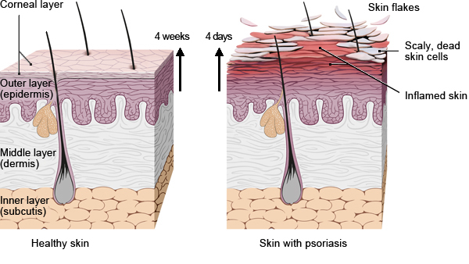
The outermost layer of skin (epidermis) is made up of cells that divide, move to the surface of the skin, die there and harden. These cells are known as keratinocytes.
It usually takes about four weeks for keratinocytes to move up through the outermost layer of skin and be shed as dead cells. In psoriasis, they divide about ten times as quickly and it only takes four days for them to reach the surface of the skin. The dead cells can't be shed fast enough so they build up, creating thick and scaly patches of skin that flake off. The skin is often red due to the inflammation and increased blood flow.
Diagram adapted from: InformedHealth.org (Internet). Cologne, Germany: Institute for Quality and Efficiency in Health Care (IQWiG); 2006-. Psoriasis: Overview. 2013 Jul 31 (Updated 2017 May 18).
These immune cells move from the dermis to the epidermis and secrete inflammatory chemical signals (cytokines) such as interferon gamma, interleukin 36y, tumour necrosis factor (TNF) alpha, interleukins (IL) 1, IL-1β, IL-6, IL-17, IL-22 and IL-23. Interleukin 23 (IL-23) is known to induce the production of IL-17 and IL-22.^{3,} Interleukin 22 (IL-22) works in combination with IL-17 in inducing keratinocytes to secrete neutrophil attracting cytokines (Figure 2). These secreted inflammatory signals are believed to stimulate keratinocytes to proliferate.
Dendritic cells bridge the innate immune and adaptive immune systems and these dendritic cells accumulate in psoriatic lesions and induce the proliferation of T cells and T helper 1 cells.
Targeted immunotherapy, as well as psoralen and ultraviolet A therapy, can reduce the number of dendritic cells and favours a T helper 2 cell cytokine secretion pattern over a T helper 1/T helper 17 cell cytokine profile.
Figure 2: Cells and cytokines involved in psoriasis pathogenesis
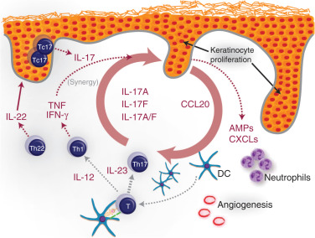
Abbreviations: AMP =antimicrobial peptides; CXCLs = CXC ligands; DC = dendritic cell; Tc = T cytotoxic; Th17 = T-helper 17; TNF = tumour necrosis factor.
A model for the central role of IL-17 in psoriasis pathogenesis. This model includes core inflammatory elements that establish a self-reinforcing cycle, including T-helper 17 (Th17) skewing of naive T cells in the presence of IL-23 leading to the local production of IL-17 ligands. Keratinocytes in turn are stimulated by these IL-17 ligands, leading to an aberrant differentiation program and elevated production of proinflammatory factors including antimicrobial peptides (AMPs) and chemokines (including CCL20, which attracts both Th17 cells and dendritic cells (DCs)). These keratinocyte-derived factors in turn stimulate further recruitment of inflammatory cells, including IL-17–producing cells, and establish a self-sustaining inflammatory feedback loop.
Diagram adapted from: Martin, D, Towne, J, Kricorian G, Klekotk, P, Gudjonsson J, Krueger J, Russell C. The Emerging Role of IL-17 in the Pathogenesis of Psoriasis: Preclinical and Clinical Findings. Journal of investigative dermatology. 2012; 133(10);1038.
Gene mutations of proteins involved in the skin's ability to function as a barrier have been identified as markers of susceptibility for the development of psoriasis.,
It is one of the most common human skin disorders, affecting between 2 to 3% of the Australian population. Chronic plaque psoriasis is the commonest form of psoriasis, representing approximately 85% to 90% of patients with plaque psoriasis., Approximately 10% of patients with chronic plaque psoriasis have severe disease. Psoriasis is a lifelong condition that can impact the emotional and social wellbeing of affected people.

Psoriasis may be rated into three groups:
- mild;
- moderate;
- severe.
Assessment of disease rating incorporates:
- Grading of psoriasis symptoms, based on area coverage and plaque appearance using Psoriasis Area Severity Index (PASI) score (see section Psoriasis Area and Severity Index);
- Quality of life indicators (Dermatology Life Quality Index [DLQI]).
The Australasian College of Dermatologists (2017) issued a consensus statement for health professionals on the treatment goals for psoriasis. As part of this guidance, the severity of psoriasis was defined as mild-to-moderate, and severe disease. A copy of this definition is shown in Table 1, shown below.,
Table 1: ACD Consensus Statement (2017): recommendations for health professionals; definition of psoriasis disease severity
Definition of disease severity
Mild to moderate plaque psoriasis (PASI ≤ 10 and DLQI ≤ 10)
Treatment recommendations
According to current treatment guidelines, mild to moderate psoriasis should be treated with topical agents.
If PASI ≤ 10 but DLQI > 10, psoriasis can be considered severe. Systemic therapy may be initiated when the patient’s disease cannot be controlled by topical treatment.
The presence of one or more features may significantly impair quality of life and alter the classification of mild to moderate disease to severe disease, thus indicating the possible need for phototherapy and/or systemic treatment. These include:
  - involvement of visible areas
  - involvement of major parts of the scalp
  - involvement of genitals
  - involvement of palms and/or soles
  - onycholysis or onychodystrophy of at least two fingernails
  - pruritus leading to excoriation.
Severe plaque psoriasis (PASI > 10 and/or DLQI > 10)
Treatment recommendations
According to current treatment guidelines, severe psoriasis warrants the use of phototherapy or systemic treatments.
A PASI >10 indicates severe disease, irrespective of the DLQI, and also indicates the likely need for phototherapy or systemic therapy.

Current treatment options
A treatment pathway discussing treatment options for psoriasis (including topical and systemic therapies) from the same consensus statement as discussed in Table 1 (above) is summarised below in Figure 3.^{12,13}
Figure 3: ACD Consensus Statement (2018): recommendations for health professionals; Treatment goals algorithm for patients with psoriasis in Australia
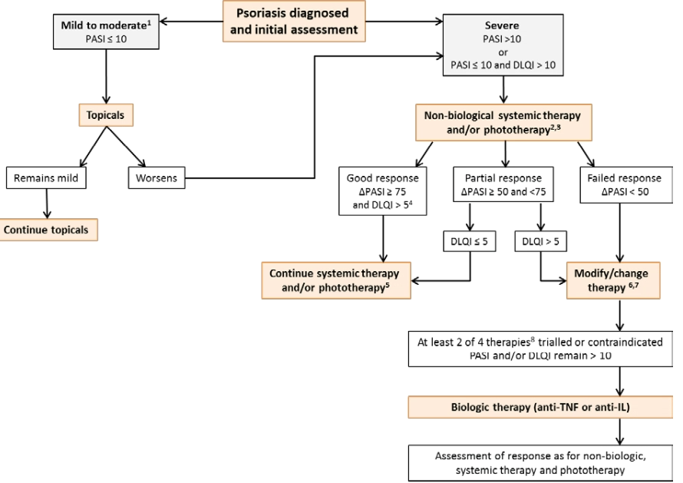
Source: Australian College of Dermatologists Consensus
1) In absence of modifying features such as visible site, genital, palmoplantar, nails involvement, pruritus with excoriation (see definition on Page 3).
2) Appropriate time to review varies with each treatment and the range is 6 to 24 weeks.
3) Non-biologic therapies include methotrexate, cyclosporin and acitretin.
4) Psoriasis area severity index (ΔPASI (change in PASI)) ≥ 75 but dermatological quality of life index (DLQI) ≥5 may occur if modifying features such as the visible site, genital, palmoplantar, nail involvement or pruritus are present or the response is discordant with patient’s expectations. Physician assessment whether to continue, modify or change therapy.
5) Continuation/discontinuation is modulated by toxicity and contraindication.
6) Treatment change to take into account patient wishes.
7) In addition to change of treatment, modify may include adding topicals, adding other systemic treatment, increasing dose or frequency or hospital admission.
8) The Australian consensus group propose that two of four therapies as reasonable and best practice. The current requirement of the Australian reimbursement body, the Pharmaceutical Benefits Scheme, is three of four therapies.
According to the current treatment guidelines, severe psoriasis (a PASI greater than 10 indicates severe disease, irrespective of the DLQI) and warrants the use of phototherapy or systemic treatment.
Systemic therapies that are approved for the treatment of psoriasis in Australia include:
Non-biological medicines such as:
- Methotrexate; is used most frequently; it is indicated in severe, disabling psoriasis unresponsive to other treatments;
- Ciclosporin; is indicated in severe psoriasis unresponsive to other treatments. Limit continuous use to 2 years due to the risk of nephrotoxicity;
- Hydroxycarbamide; is used occasionally but is less effective than methotrexate or ciclosporin;
- Acitretin; is a vitamin A like compound and is less effective at treating plaque psoriasis. May be combined with phototherapy or calcipotriol. Acitretin has a high risk of teratogenicity;
- Apremilast; inhibits phosphodiesterase 4, reducing production of pro-inflammatory cytokines, such as TNF α, IL-17 and IL-23, and increasing anti-inflammatory cytokines such as IL-10; it is used to treat moderate-to-severe chronic plaque psoriasis.
Biological medicines include:
- Adalimumab, certolizumab, etanercept; and infliximab; are TNF alpha antagonists;
- Guselkumab, tildrakizumab; and risankizumab; are agents that inhibit the activity of IL-23;
- Ustekinumab; inhibits the activity of the cytokines, IL-12 and IL-23.
- Ixekizumab; and secukinumab; are agents that inhibit the activity of IL-17a.
The rational for Bimzelx is that IL-17A and IL-17F are closely related pro-inflammatory cytokines that share overlapping biology and are believed to play important roles in autoimmune and inflammatory diseases including psoriasis. Bimekizumab is a humanised, full-length monoclonal antibody of immunoglobulin Gl (IgG 1) subclass with two identical antigen binding regions that potently and selectively bind and neutralise IL-17 A, IL-17F, and IL-17 AF cytokines; it is proposed that inhibition of these cytokines will be more efficacious than inhibition of IL-17A alone.

Regulatory status
This product is considered a new biological entity for Australian regulatory purposes.
At the time the TGA considered this submission, similar submissions had been approved in the European Union (EU) on 20 August 2021 and the United Kingdom on 25 August 2021. Similar submissions were under consideration in the United States of America (USA), Canada, Switzerland and Japan.
The following table summarises these submissions and provides the indications where approved.
Table 2: International regulatory status
Region | Submission date | Status | Approved indications
European Union (centralised procedure) | July 2020 | Approved on 20 August 2021 | Bimzelx is a medicine used to treat plaque psoriasis, a disease that causes red, scaly patches on the skin. It is used in adults with moderate to severe disease who need systemic treatment (treatment with medicines affecting the whole body).
United Kingdom | July 2020 | Approved on 25 August 2021 | Bimzelx is indicated for the treatment of moderate to severe plaque psoriasis in adults who are candidates for systemic therapy.
United States of America | July 2020 | Under consideration | Under consideration
Canada | January 2021 | Under consideration | Under consideration
Switzerland | June 2021 | Under consideration | Under consideration
Japan | February 2021 | Under consideration | Under consideration
The applicant did not seek guidance from the TGA. Regulatory guidance was sought from the US Food and Drug Administration (FDA) and European Medicines Agency (EMA). The feedback from both FDA and EMA was considered in the final clinical development plan by the sponsor. The design of the program is consistent with the Committee for Medicinal Products for Human Use (CHMP) Guideline on Clinical Investigation of Medicinal Products Indicated for the Treatment of Psoriasis.
Prior to initiating the global Phase II and Phase III studies, EMA scientific advice was sought and obtained on the nonclinical, quality, and clinical development plan for psoriasis and for the development of the device presentations and neutralising antibody assay format. In parallel, input from the FDA on the proposed psoriasis development program was obtained through a pre-investigational new drug meeting.
The TGA has adopted the EU ‘Guideline on clinical investigation of medicinal products indicated for the treatment of Psoriasis’.30

Product Information
The Product Information (PI) approved with the submission which is described in this AusPAR can be found as Attachment 1. For the most recent PI, please refer to the TGA PI/CMI search facility.

Registration timeline
The following table captures the key steps and dates for this submission.
Table 3: Timeline for Submission PM-2020-06299-1-1
Description | Date
Submission dossier accepted and first round evaluation commenced | 1 March 2021
First round evaluation completed | 26 July 2021
Sponsor provides responses on questions raised in first round evaluation | 24 September 2021
Second round evaluation completed | 11 November 2021
Delegate’s Overall benefit-risk assessment and request for Advisory Committee advice | 23 December 2021
Sponsor’s pre-Advisory Committee response | 17 January 2022
Advisory Committee meeting | 3 and 4 February 2022
Registration decision (Outcome) | 17 March 2022
Completion of administrative activities and registration on the ARTG | 24 March 2022
Number of working days from submission dossier acceptance to registration decision* | 216
*Statutory timeframe for standard submissions is 255 working days

Submission overview and risk/benefit assessment
A summary of the TGA’s assessment for this submission is provided below.

Quality
Bimzelx is available in two containers, a pre-filled syringe and pre-filled pen.
The Bimzelx 160 mg solution for injections in pre-filled syringe presentation is as follows: A one millilitre (1 mL) pre-filled syringe with a rubber stopper, staked 27G, ½” thin wall needle, and a needle shield assembled in a passive safety device. Pack size of two pre-filled syringes.
The Bimzelx 160 mg solution for injections in pre-filled pen presentation is as follows: One millilitre (1 mL) pre-filled pen containing a pre-filled syringe with a rubber stopper, staked 27G, ½” thin wall needle, and a needle shield. Pack size of two pre-filled pens.
The monoclonal antibody structure of Bimzelx (bimekizumab) is shown below in the following diagram.
Figure 4: Antibody structure of Bimzelx (bimekizumab)
As a result of the TGA’s evaluation of this medicine, there are no objections on quality grounds to the approval of:
- Bimzelx (bimekizumab) 160 mg/1 mL solution for injection auto-injector
- Bimzelx (bimekizumab) 160 mg/1 mL solution for injection safety syringe

Nonclinical
The submitted nonclinical dossier was in accordance with the relevant ICH guideline for the nonclinical assessment of biological medicines. The overall quality of the nonclinical dossier was high. All pivotal safety-related studies were Good Laboratory Practice compliant.
Bimekizumab had high affinity for human interleukin (IL)-17 (or IL-17A), human IL-17F and and human IL-17A/F (a disulfide-linked heterodimer of IL-17A and IL-17F). Bimekizumab also bound monkey IL-17A and IL-17F but did not bind murine IL-17A, IL-17F or IL-17A/F. Neutralisation of IL-17A and IL-17F with bimekizumab suppressed cytokine responses and neutrophil chemotaxis in vitro with greater impact on inflammatory signals compared with that of anti-IL-17A or anti-IL-17F alone. No in vivo studies were conducted due to the absence of appropriate animal models for psoriasis.
Bimekizumab did not show any cross-reactive binding to a panel of human and monkey tissues, suggesting no off target activities. Bimekizumab is not expected to induce complement dependent cytotoxicity or antibody dependent cellular cytotoxicity.
No effects on the function of the central nervous system, cardiovascular and respiratory systems are predicted at clinical exposures based on the examination of safety pharmacology parameters in general, repeat-dose toxicity studies in monkeys, and also due to the protein nature of bimekizumab.
The pharmacokinetics of bimekizumab in monkeys and human subjects was generally similar and consistent with the protein nature of the drug: slow absorption by the subcutaneous route and long half-lives. The submitted toxicity studies were not compromised by anti-bimekizumab antibodies.
Low order of acute toxicity was observed in monkeys following bimekizumab administration.
Repeat-dose toxicity studies by the subcutaneous and intravenous route were conducted in cynomolgus monkeys (up to 26 weeks). Only two doses were used in the pivotal study and bimekizumab was administered weekly instead of the proposed clinical dosage schedule of monthly dosing. Adverse effects (dose dependent skin effects associated with superficial dermatitis and microbial infection) were observed at much higher bimekizumab exposure than the clinical exposure (exposure ratio based on area under concentration time curve (AUC) up to 109) and were attributed to the exaggerated pharmacological effects of bimekizumab. In multiple toxicity studies, an increase in gastrointestinal infections was also seen. Due to the dose selection, a no observable adverse effect level was not established in the pivotal study. Clinical use identified a heightened risk of infections following bimekizumab use.
No genotoxicity or carcinogenicity studies were conducted. Given the protein nature of the drug and the lack of activity in rodents, this is considered acceptable. A literature review on the role of IL-17A and IL-17F signalling in carcinogenesis was submitted. The evidence submitted in the review investigating the potential carcinogenicity risk of bimekizumab is considered equivocal. However, the carcinogenic risk with bimekizumab is not considered greater than that of registered anti-IL-17A antibodies.
Bimekizumab had no effect on sperm parameters or menstrual cycles nor caused histopathological changes to reproductive tissues in monkeys as examined via the repeat dose studies. Placental transfer of bimekizumab was noted in the enhanced pre-/post-natal study. There were no adverse effects on embryofetal development, nor to postnatal developmental parameters (morphometric and neurobehavioral assessments). Slight reductions in neutrophil count in male infants and treatment-related reduced IgG response to keyhole limpet haemocyanin were noted in infants from findings in the 50 mg/kg dose group animals indicating potential immunotoxicity. Potentially treatment associated skin effects in maternal animals and infants, due to the pharmacological action of bimekizumab, support the placental transfer of bimekizumab.
Even though the immunotoxicity potential of bimekizumab was low as assessed via immunophenotyping or T-cell dependent antibody response assays incorporated in repeat dose studies, immunomodulatory effects (infections) by bimekizumab in monkeys indicate a potential impact of bimekizumab on immune function in patients.
In conclusion, the primary pharmacology studies lend some support for the proposed indication. The following safety concerns due to the pharmacological action of bimekizumab were identified; these are increased risk of infection, and dermatitis.
Due to placental transfer of bimekizumab, adverse effects usually seen in maternal animals due to the pharmacological action of bimekizumab can potentially be seen in infants. Pregnancy Category C; is appropriate, to minimise the risks in infants.
There are no nonclinical objections to registration.

Clinical

Summary of clinical studies
The clinical dossier consisted of:
- A total of sixteen pharmacology studies:
  - Five studies were chiefly pharmacokinetic (PK) and/or pharmacodynamic studies:
    - Studies UP0008 and PA0007: to evaluate the PK and pharmacodynamics and tolerability in study participants.
    - Study UP0042: to evaluate the impact of ethnicity on the PK of bimekizumab in healthy Japanese and Caucasian study participants.
    - Study UP0034: to evaluate the impact of bimekizumab on the influenza vaccine antibody titres in healthy study participants.
  - Seven studies on biopharmaceutics, efficacy, safety, and immunogenicity of bimekizumab provide supportive data. These include:
    - Studies RA0124 and UP0031: bioavailability studies.
    - Study UP0033: a bioequivalence study.
    - Studies DV0002 and DV0006: supportive studies evaluating self-administration of bimekizumab using either an auto-injector or pre-filled safety syringe.
- Seven efficacy and safety studies:
  - Studies PS0008, PS0009, and PS0013 are considered by the sponsor to be pivotal for the proposed indication of psoriasis. All three studies are Phase III:
    - Study PS0008: a Phase III, randomised, double blind, parallel group, active comparator controlled multicentre study, to evaluate the efficacy and safety of bimekizumab in adults with moderate to severe plaque psoriasis.
    - Study PS0009: a Phase III, randomised, double blind, parallel group, active comparator controlled multicentre study to evaluate the efficacy and safety of bimekizumab in adults with moderate to severe plaque psoriasis.
    - Study PS0013: a Phase III, randomised, double-blind, placebo-controlled multicentre study to evaluate the efficacy and safety of bimekizumab in adults with moderate to severe chronic plaque psoriasis.
  - Study PS0014 is an ongoing, open label multicentre study:
    - Study PS0014 is designed to assess the long term safety, tolerability, and efficacy of bimekizumab in eligible adult study participants with moderate to severe plaque psoriasis who complete one of the Phase III feeder studies (Studies PS0008, PS0009, or PS0013).
- Three population pharmacokinetics (popPK)/PK/pharmacodynamics (PD) analyses.
The Delegate noted that the submission did not include paediatric data. The sponsor’s paediatric investigation plan was adopted by the EMA with an agreed completion date of fourth quarter of 2030. Two clinical studies are planned. A waiver for children less than 6 years of age has been granted.

Guidance
The following is a key guideline consulted in evaluation and assessment of this submission and referenced in this document.
- EMA/EMEA: Guideline on clinical investigation of medicinal products indicated for the treatment of psoriasis (CHMP/EWP/2454/02 corr).
TGA-adopted (with annotations); effective date: 28 July 2005.

Pharmacology
Table 4: Submitted pharmacokinetics studies
Pharmacokinetic topic | Subtopic | Study ID
Pharmacokinetics in healthy subjects | General pharmacokinetics (single dose) | RA0124  UP0042  UP0031  UP0034
Pharmacokinetics in healthy subjects | Bioequivalence† | UP0033
Pharmacokinetics in special populations | Pharmacokinetics in the target population§  (single dose) | UP0008  PS0011  PS0010  PS0018
Pharmacokinetics in special populations | Multi-dose | PS0016
Pharmacokinetics in special populations | Other: Influence of ethnicity | UP0042
Pharmacokinetic interactions | Influenza vaccine | UP0034
Pharmacokinetic interactions | Target population | CL0446  CL0485
Pharmacokinetic interactions | Bioavailability in target population and healthy subjects | CL0453
† Bioequivalence of different formulations.
§ Subjects who would be eligible to receive the drug if approved for the proposed indication.
Two different formulations were used during clinical development, Formulation A and Formulation B.
Formulation B is proposed for commercial marketing and was used in all Phase I to III studies, except for Studies RA0124, UP0008 and PA0007.
Study UP0031 investigated the PK of both formulations.

Pharmacokinetics in healthy subjects
A summary of the pharmacokinetics (PK) of bimekizumab in healthy subjects (that is, healthy volunteers without the indication (psoriasis) proposed to be treated in this submission) is as follows:
- In single dose studies (see Table 5), bimekizumab exhibited dose-dependent linear PK
- Exposure (by area under concentration-time curve (AUC) and maximum concentration (C_{max}) increased in proportion to the dose in the tested dose range (80 mg to 320 mg).
- The terminal elimination half-life ranged from 19 to 26 days (median values) in healthy subjects.
Table 5: Bimekizumab plasma pharmacokinetics parameters following administration of single subcutaneous doses in healthy study participants
Healthy study participants

Study ID | UP0042 |  |  |  |  |  | UP0033 |  |  | UP0034
Dose | 80 mg |  | 160 mg |  | 320 mg |  | 320 mg
Parameter | Jap | Cauc | Jap | Cauc | Jap | Caus | BKZ-  TN | BKZ-  ss | BKZ-AI
N | 5 | 6 | 6 | 6 | 6 | 6 | 63 | 63 | 63 | 28
t_{max}  (days) | 4.02  (4.02,  6.05) | 5.04  (4.03, 6.06) | 6.04  (4.03,  6.20) | 6.05  (4.03, 6.05) | 6.04  (4.01,  6.04) | 6.04  (4.04, 6.05) | 5.03  (1.97,  12.1) | 5.999  (2.95,  15) | 6.963  (2.99,  13.0) | 7  (2,  14)
C_{max} µg/mL (g/mL) | 9.294  (17.6) | 8.808  (20.2) | 19.8  (8.9) | 17.17  (20.6) | 41.33  (16) | 33.6  (19.7) | 31.18  (30.5) | 30.10  (28.0) | 30.63  (22.9) | 33.44  (23.1)
AUC (μg.day/mL | 342.3  (29.6) | 284.8  (14.2) | 679.4  (19.0) | 673.2  (22.9) | 1278  (17.8) | 1450  (13.2) | 1080  (32.0) | 1083  (31.1) | 1129 (29.9) | 1200 (33.4)
t_{1/2} (days) | 21.99  (16.3,  28.2) | 20.81  (16.6, 33 .1) | 22.35  (19.1,  24.3) | 25.00  (20.4, 32.4) | 19.06  (14.8,  30.6) | 25.91  (23.2, 32.6) | 22.48  (14.7,  35.5) | 24.14  (10.3,  37.2) | 23.56  (13.2,  39.8) | 22.96  (14.2,  35.7)
AUC = area under the plasma concentration-time curve from time 0 to infinity; AUCss = area under the plasma concentration-time curve at steady state; BKZ-AI = bimekizumab auto-injector; BKZ-SS = bimekizumab safety syringe; BKZ-TN = bimekizumab True North device presentation; Cmax = maximum concentration; CSR = clinical study report; CV = coefficient of variation; PK = pharmacokinetic; PSO = psoriasis; sc = subcutaneous; t½ = apparent terminal half-life; tmax = time of occurrence of Cmax
Similar results were seen across studies involving healthy subjects.

Study RA0124
Study RA0124 investigated the (absolute) bioavailability of single 80 mg and 160 mg doses of bimekizumab per subcutaneous relative to per intravenous, as shown in Figure 5, below.
Figure 5: Study RA0124 Bioavailability of bimekizumab as a single subcutaneous dose of 80 mg, and singles doses of 160 mg subcutaneously and intraveously
Abbreviations: IV = intravenous; SC = subcutaneous; UCB4940 = development code for bimekizumab.
The geometric mean plasma concentration-time profiles for the two subcutaneous doses (80 mg and 160 mg) showed linearity in their elimination phases.
The plasma concentration time profiles for the two doses in their elimination phases were similar between the subcutaneous and intravenous routes.
The absolute bioavailability of the two subcutaneous doses relative to the intravenous doses, was similar (0.656 and 0.631 respectively for the 80 mg and 160 mg bimekizumab doses).

Study UP0031
Study UP0031 (an open label, parallel group study) was designed to determine the relative bioavailability (of a 160 mg subcutaneous dose of bimekizumab, given as 2 x 80 mg doses (Formulation A) versus 1 x 160 mg dose (Formulation B), as shown in Table 6 below.
Note, Formulation B is the proposed formulation and the commercial product proposed in this submission.
Table 6: Study UP0031 Relative bioavailability of Formulation A and Formulation B of bimekizumab
AUC = area under the plasma concentration-time curve; CI = confidence interval; GeoMean = geometric mean; PKPPS = Pharmacokinetic Per-Protocol Set, sc = subcutaneous
Note: Formulation A = two 1mL injections of 80 mg each of bimekizumab
Note: Formulation B = a single injection of bimekizumab 160 mg as a 1 mL injection. Formulation B is the formulation proposed for approval and marketing in this submission.
a Relative bioavailability (F_{rel}[%])=(AUC_{sc} [1 x 160 mg]/AUC_{sc} [2 x 80mg])*100
b 95% CI for relative bioavailability = [F_{rel}(%) x exp(-t0.975,df x SE), F_{rel}(%) x exp(+t0.975,df x SE)]
The geometric means for AUC were similar between Formulation A and B treatment groups (653.8 day*µg/mL and 628.3 day*µg/mL, respectively).
A similar C_{max} was observed between the bimekizumab 2 x 80 mg and 1 x 160 mg treatment groups (geometric means of 21.29 μg/mL and 18.20 μg/mL, respectively).
The relative bioavailability of bimekizumab in Formulation B versus Formulation A was 96.1% (95% confidence interval (CI): 72.7%, 127%).
The TGA’s clinical evaluation expressed that it was unclear why the sponsor used 95% CI as opposed to the accepted limits of 90% CI to establish bioequivalence. There was no estimation of CI for the parameter C_{max} has been undertaken. The TGA’s clinical evaluation also expressed that any difference in bioequivalence is unlikely to be of clinical significance. Importantly the formulation (Formulation B) used in most of the PK studies and the pivotal Phase III studies, is that intended for commercialisation.
The Delegate commented that the differential quantification between 90% CI and 95% CI would not have contributed significantly to the relative bioavailability (that is bioequivalence) determination of the two formulations.

Study UP0033
Study UP0033 compared the PK bioequivalence parameters of bimekizumab as a single 320 mg dose when administered subcutaneously by the 3 different delivery devices:
- bimekizumab- administered with True North syringe (BKZ-TN),
- bimekizumab- administered with 1 mL safety syringe (BKZ-SS-1mL),
- bimekizumab- administered using 1 mL autoinjector (BKZ-AI-1mL).
The bimekizumab-SS-1mL and bimekizumab-AI-1mL presentations were those intended for commercialisation. The results are as shown in Table 7 below
Table 7: Study UP0033 Pharmacokinetics parameters for bimekizumab
Parameter (unit) | Statistic | BKZ-TN | BKZ-SS-1mL | BKZ-AI-1mL
Parameter (unit) | Statistic | N = 63 | N = 63 | N = 63
AUC_{(0-t)} (day*µg/mL) | GeoMean | 1080 | 1055 | 1098
AUC_{(0-t)} (day*µg/mL) | GeoCV(%) | 32.0 | 30.6 | 28.8
AUC  (day*µg/mL) | GeoMean | 1107 | 1083 | 1129
AUC  (day*µg/mL) | GeoCV(%) | 32.1 | 31.1 | 29.9
C_{max}  (µg/mL) | GeoMean | 31.18 | 30.10 | 30.63
C_{max}  (µg/mL) | GeoCV(%) | 30.5 | 28.0 | 22.9
T_{max}  (day) | Median | 5.031 | 5.999 | 6.963
T_{max}  (day) | Min, max | 1.97, 12.1 | 2.95, 15.0 | 2.99, 13.0
t_{1/2}  (day) | Mean | 22.76 | 23.70 | 24.02
t_{1/2}  (day) | SD | 4.187 | 5.737 | 5.765
Abbreviation: AUC = area under the plasma concentration-time curve; AUC_{(O-t)} = area under the plasma concentration-time curve from time zero to time of last quantifiable concentration; BKZ = bimekizumab; BKZ-AI-lmL=BKZ 320 mg administered using 2 x l mL autoinjector; BKZ-SS-l mL=BKZ 320 mg administered using 2 x l mL safety syringe; BKZ-TN = BKZ 320 mg administered using 2 x 1mL True North syringe; C_{max} = maximum observed plasma drug concentration; CV = coefficient of variation; Geo=geometric; max=maximum; Min = minimum; SD=standard deviation; T_{max}, time of observed C_{max}; t_{1/2} apparent terminal half-life.
Note: geometric means, standard deviations, and coefficient of variations were only calculated if at least two-thirds of the parameters were properly determined parameters. A data from 1 study participant in this group was excluded from the AUC, AUC(0-t), and t½ calculations due to missing data after Day 28.
The Delegate noted that PK parameters were similar regardless of the method of administration.
The PK parameters of the single 320 mg bimekizumab dose via bimekizumab-SS-1 mL and bimekizumab-AI-1 mL, were compared to those via bimekizumab-TN, as reference (that is relative bioequivalence wise) as per Table 8.
Table 8: Study UP0033 Statistical analysis of bioequivalence
Parameter (unit) | Test | Reference | Test versus Reference
Parameter (unit) | Test | BKZ-TN (n = 63)
Parameter (unit) | Geo LSMean | Geo LSMean | Estimate (%) of  Geo LSMean  ratio | 95%CI
BKZ-SS-l mL (n = 62)
AUC_{(0-t)} (day*µg/mL) | 1055 | 1080 | 97.70 | 87.7, 108.9
AUC (day*µg/mL) | 1083 | 1107 | 97.82 | 87.7, 109.1
C_{max} (µg/mL) | 30.10 | 31.18 | 96.53 | 87.3, 106.8
BKZ-AI-l mL (n = 63)
AUC_{(0-t)} (day*µg/mL) | 1098 | 1080 | 101.7 | 91.6, 113.0
AUC (day*µg/mL) | 1129 | 1107 | 102.0 | 91.6, 113.5
C_{max} (µg/mL) | 30.63 | 31.18 | 98.25 | 89.5, 107.9
AUC = area under the plasma concentration-time curve; AUC_{(0-t)} = area under the plasma concentration-time curve from time zero to time of last quantifiable concentration; BKZ = bimekizumab; BKZ-AI- l mL=BKZ 320 mg administered using 2xlmL autoinjector; BKZ-SS-l mL=BKZ 320 mg administered using 2 x l mL safety syringe; BKZ-TN = BKZ 320 mg administered using 2 x 1 mL True North syringe; CI = confidence interval; C_{max} = maximum observed plasma drug concentration; Geo = Geometric; LSMean = least-squares mean.
The clinical evaluation noted that centre and centre-by-treatment interaction was tested, but not included in the model, because both tests were not significant at a 0.1 for AUCs (same model was used for C_{max}).

Dose proportionality
Dose proportionality with regards to plasma concentration was investigated in Studies UP0008 and UP0042.

Study UP0008
In Study UP0008, healthy subjects received either 8 mg, 40 mg, 160 mg, 480 mg or 640 mg of bimekizumab intravenously, as shown in Figure 6.
Figure 6: Study UP0008 Plot of geometric mean bimekizumab plasma concentration-time profile by dose following intravenous administration of a single dose
Abbreviation: UCB4940 = bimekizumab
Following intravenous dosing, bimekizumab exhibited a biphasic disposition and linear elimination. Dose proportionality was demonstrated for AUC at steady state, C_{max} and minimum concentration (C_{min}).

Study UP0042
Study UP0042 was a randomised, double blind, placebo controlled, single dose, parallel group study to evaluate the safety, tolerability, and PK of bimekizumab administered as a subcutaneous injection of 80 mg, 160 mg, 320 mg bimekizumab or placebo to Japanese and Caucasian healthy subjects.
- In both Japanese and Caucasian subjects, the bimekizumab plasma concentration time profiles increased with increasing doses of bimekizumab and showed a linear elimination of bimekizumab for the three doses investigated (80 mg, 160 mg, and 320 mg).
- In both Japanese and Caucasian subjects, exposure (AUC and C_{max}) increased with increasing bimekizumab dose in a proportional manner and were dose proportional for the three dose levels.
The Delegate noted that bioavailability during multiple dosing was not investigated in healthy subjects. The Delegate commented that bimekizumab dosing interval is stated as 0, 4, 8, 12, 16 weeks, followed by 8 weekly intervals (except for overweight patients at 4 weekly intervals) after Week 16. Given that the estimated half-life of bimekizumab is about 3 weeks, the stated dosing interval is expected to yield a steady bioavailability profile of bimekizumab with minimal accumulation.

Effect of administration timing
No studies have been undertaken to investigate the timing of administration in healthy subjects

Volume of distribution/plasma protein binding

Study UP0008
Results from Study UP0008 demonstrated a geometric mean volume of distribution (V/F) in the range of 4.2L to 5.8 L. This apparent volume of distribution approximates closely to plasma circulating volume, thereby suggesting limited distribution to other tissues.

Study UP0042
Results from study UP0042 indicate that the V/F was approxinmately 8.5 L in Caucasian and 7.2 L in Japanese healthy subjects, following subcutaneous administration.

Plasma protein binding
Bimekizumab is a monoclonal antibody with specific binding sites at the IL-17A, IL-17F and IL-17AF cytokine proteins and therefore, no specific study was undertaken to determine the binding to other proteins.

Tissue distribution
Tissue distribution was not investigated in healthy subjects.

Metabolism
As a human IgG1 monoclonal antibody, bimekizumab in common with other monoclonal antibodies, is expected to be degraded into small peptides and amino acids via catabolic pathways in the same manner as endogenous IgG. Therefore, the metabolic pathway of bimekizumab has not been specifically characterised.

Excretion

Study UP0042
Results from Study UP0042 demonstrated that following either the 80 mg, 160 mg or 320 mg dose of bimekizumab, the apparent terminal half-life ranged between 19 to 26 days, as previously stated.

Routes and mechanisms of excretion/metabolic elimination
Bimekizumab is a human IgG immunoglobulin with a molecular mass of approximately 150 kDa, and in common with other IgG of this mass, will not be filtered by the kidney. Most of the IgG metabolic elimination will occur via intracellular catabolism, following fluid phase or receptor mediated endocytosis.

Intra- and inter-individual variability of pharmacokinetics
Following single subcutaneous injection of either 80 mg, 160 mg, or 320 mg bimekizumab to healthy subjects, the coefficient of variation (CV%) regarding inter subject variability ranged between 13.2% to 22.7% for Caucasians and 18% to 29.6% for Japanese populations.

Pharmacokinetics in the target population

Study PA0007
Study PA0007 was a randomised, double blind placebo controlled study that investigated pharmacokinetics (PK) and pharmacodynamics (PD) of multiple doses of bimekizumab intravenous in study participants with active psoriasis.
Like in healthy subjects, the PK parameters was linear across the dose range and was not altered by repeated dosing. The estimated half-life was approximately 24 days.

Study PS0010
Study PS0010 investigated the dose proportionality of bimekizumab in patients with severe plaque psoriasis, across the dose range of 64 mg to 480 mg delivered subcutaneously.
Overall, geometric mean plasma bimekizumab concentrations increased with dose in a linear fashion and were within the expected concentration ranges at each visit.

Study PS0011
Study PS0011 was an open label extension to Study PS0010. Study participants either remained on the dosing regimen they received in PS0010 or could move across dose levels.
The geometric mean plasma bimekizumab concentrations were within the expected concentration ranges at each visit, demonstrating linear pharmacokinetics. The plasma bimekizumab concentrations decreased after bimekizumab was discontinued, as per Figure 7.
Figure 7: Study PS0011 Bimekizumab geometric mean plasma concentrations by week (with 95% confidence intervals)
Abbreviation: BKZ = bimekizumab
The clinical evaluation noted that dose proportionality and multiple dosing have been investigated in the target patient population.

Study PS0016
Study PS0016 was a Phase II study undertaken in patients with severe plaque psoriasis. The study also investigated plasma concentrations of bimekizumab and was a parallel group study whereby, patients who had moderate to severe plaque psoriasis received (Figure 8):
- Either 320 mg bimekizumab plus placebo switched over to 320 mg bimekizumab administered subcutaneously at Baseline and Week 4, and placebo administered at Week 16 (N = 32).
- Or 320 mg bimekizumab switched over to 320 mg bimekizumab administered subcutaneously at Baseline and Weeks 4 and 16 (N = 17).
Plasma concentrations were similar in both dose groups and were in the ranges that may be predicted by the results in Study PS0010.
Figure 8: Study PS0016 Bimekizumab geometric mean plasma concentrations of versus scheduled time by treatment (with 95% confidence intervals)
Abbreviation: BKZ = bimekizumab; PBO = placebo
The Delegate commented that Figure 8 depicts the tendency of bimekizumab to fall weekly, edging close to zero, 3 months after the second dose at Week 4 and, rising again post the dose at Week 16. The above plasma concentrations of bimekizumab versus scheduled time appears to vindicate the proposed 4-weekly dosing regimen, followed by the 8-weekly regimen.

Study PS0018
Study PS0018 was a 48 week open label extension to Study PS0016. In total, 43 study participants were enrolled to Study PS0018 and received bimekizumab 160 mg 4-weekly with an option to increase to 320 mg subcutaneously, depending on response to treatment. Plasma concentrations were within the expected ranges demonstrated in other studies that had PK as an endpoint.
The clinical evaluation noted that pharmacokinetic parameters were also investigated as part of the three Phase III studies evaluated and, the results are included in the population PK analysis below.

Pharmacokinetics in special populations

Genetic factors

Study UP0042
Study UP0042 which investigated the PK in Japanese and Caucasian subjects, found that differences in body weight between the two racial groups showed no significant different effect on PK parameters for the two groups that is equally affected.

Other special population/with other population characteristics

Body weight
The population pharmacokinetic (popPK) analysis described below identified body weight as a covariate effecting bioavailability.

Anti-drug antibodies
Treatment emergent anti-drug antibodies occurred as early as 4 weeks post first dose (that is baseline dose) at the first anti-drug antibodies sampling time point, and cumulative counts increased over time thereafter.
The PK of bimekizumab is impacted in the presence of anti-drug antibodies, with a slightly lower bimekizumab plasma concentration and an 8% higher apparent clearance in anti-drug antibody-positive compared with anti-drug antibody-negative study participants.
The PK of bimekizumab was also impacted in the presence of antibodies with neutralising antibody activity, and the impact of with neutralising antibody on PK was larger than for anti-drug antibodies positivity.

Population pharmacokinetics
The sponsor undertook three popPK analysis via Study CL0453 to estimate bioavailability; Study CL0446 to establish the dose-exposure relationship between bimekizumab and response to the PASI at the end of Phase II; and Study CL0485 is an updated dose exposure relationship analysis of PASI and Investigator’s Global Assessment (IGA) at the end of Phase III.

Analysis CL0453
Analysis CL0453 included pooled data from the following Studies UP0008, UP0031, UP0042 and RA0124 and, includes data from 104 subjects.
Findings from the estimation of the key parameters are as follows:
- Clearance = 0.179 L/day (21.4%), inter-compartment clearance = 0.296 L/day,
- Volume of central compartment = 3.03 L (23.9%), volume of peripheral compartment = 2.13 L, and the SC absorption rate = 0.172 /day (25.5%).
- Absolute bioavailability of SC administration = 70.1% (45.9%).
- Body weight was identified as a covariate on both elimination clearance and volume of central compartment, and the estimated exponent values were 0.54 and 0.60 respectively.
- Different drug formulations (Formulation A versus Formlation B (the to-be-marketed formulation) and manufacturing processes (processes 1, 2 and 3) did not result in different bioavailability or absorption rate of SC administration.
- The absolute bioavailability of 70.1%, is reflective of the results for Study RA0124 that specifically examined bioavailability of bimekizumab.

Analysis CL0446
Analysis CL0446 used pooled data from Studies PS0010 and PS0016 to develop a PK/PD model to establish a dose response relationship between bimekizumab and PASI in adult with moderate to severe plaque psoriasis.
The PK results from this analysis demonstrated the following:
- Bimekizumab has linear PK following a one-compartment model with linear absorption and elimination.
- Bodyweight was a significant covariate on clearance and volume of distribution ([0.362 x (WT/87.8) 0.897] L/day and [11.5 x (WT/87.8)0.77] L) indicating plasma concentrations decrease with increased bodyweight, at absorption rate constant of 1.7 Day 1.
- No impact of the formation of anti-drug antibody was demonstrated.
- No difference in the PK between Japanese and Caucasian populations after accounting for body weight differences.

Analysis CL0485
Analysis CL0485 used pooled data from the Phase II studies PS0010, 11 and 16 and the Phase III Studies PS0008 and PS0009 to develop a PK/PD model to establish a dose response relationship between bimekizumab and PASI in adult with moderate to severe plaque psoriasis.
Analysis CL0485 found :
- The final population PK model was a one-compartment model with first-order absorption, supported by CL/F and V/F estimates.
- Among the tested covariates (baseline body weight, baseline age, baseline alanine transaminase, baseline bilirubin, race, sex, anti-drug antibodies status, anti-drug antibodies titre, prior biologics therapy and region), baseline body weight, gender, race and anti-drug antibodies status were statistically significant covariates on CL/F, and body weight was a statistically significant covariate on apparent volume of distribution (V/F that is volume of distribution/bioavailability).
- Several covariates were identified for CL/F including anti-drug antibodies positive at any time point, race (Asian/Japanese) and gender (female). These covariates were identified in addition to the covariate effect of body weight, included allometrically on CL/F and V/F in the base model.
  - anti-drug antibodies positive study participants had an 8% higher CL/F than negative study participants.
  - Asian/Japanese study participants had higher CL/F than non-Asian/Japanese study participants.
  - Female study participants had a 10% higher CL/F than male study participants.
    - As a note, Asian/Japanese study participants and female participants had a lower body weight compared to non-Asian/Japanese male participants.
    - Disregarding weight from the calculation, the largest and smallest median AUCSS in the subpopulations (assuming 320 mg every 4-weekly dosing) were 1010 and 790, respectively.
  - Plasma levels of bimekizumab that is average observed plasma concentration over the dosing intervals, was mostly impacted by body weight, particularly evident for study participants with body weight greater than 120 kg, where average concentration is 30% lower compared to the typical participants in the study.
  - Similarly, study participants with body weight < 60kg are predicted to have 50% higher average concentration compared to the typical study participants in the study.
  - The terminal half life of bimekizumab was estimated to be 23 days.
  - The overall accumulation ratio for all simulated subpopulations receiving 320 mg every 4 weeks was 1.67. Steady state was achieved by Week 16 on a every 4 weeks regimen and subjects on 320 mg every 4 weeks followed by a 320 mg every 8 weeks regimen achieved a new steady state 16 weeks after the change in dose.
The Delegate commented that there is the possibility of drug accumulation should the dose frequency be maintained at every 4 weeks instead of every 8 weeks, post four months of treatment in those greater than 120 kg to compensate for the perceived low average concentration, due to larger volume of distribution in the one compartmental model. The kinetic profile then moves towards zero kinetic. The race (Japanese) and gender (female) issues really relate to the noted weight differential. In addition, anti-drug antibody positivity tends to slightly increase CL/F, the implication on long term efficacy of bimekizumab needs to be considered.

Pharmacokinetic interactions
No studies examined the interaction of bimekizumab with other drugs in either healthy subjects or the target population. The sponsor states
‘Given the mode of action of bimekizumab and results from studies conducted with other IL-17 and IL-23 inhibitors, minimal impact is expected on the exposure of drugs metabolized by the cytochrome P450 system indicating, that bimekizumab can be co-administered with other compounds metabolized with cytochrome P450, with continued therapeutic monitoring for narrow therapeutic window drugs.’
The Delegate commented that the PI should state:
‘Given that the phagocytic cells of the immune system such as macrophages and monocytes are the major players in the elimination of bimekizumab and endogenous IgG, any proteolysis in the liver via P450 will be minimal. As such, drugs metabolized by the cytochrome P450 system may be co-administered with bimekizumab. However, monitoring of therapeutic plasma level and effect of drugs with narrow therapeutic index, metabolised via cytochrome P450 system is recommended.’

Co-administration of bimekizumab with the influenza vaccine

Study UP0034
Study UP0034 was an open label, randomised, parallel group, single dose study to evaluate the effectiveness of influenza vaccination, following concomitant exposure to a single dose of bimekizumab 320 mg administered subcutaneously in healthy adult male and female study participants. The key findings from Study UP0034 are shown below in Table 9.

Table 9: Study UP0034 Summary of bimekizumab pharmacokinetics parameters
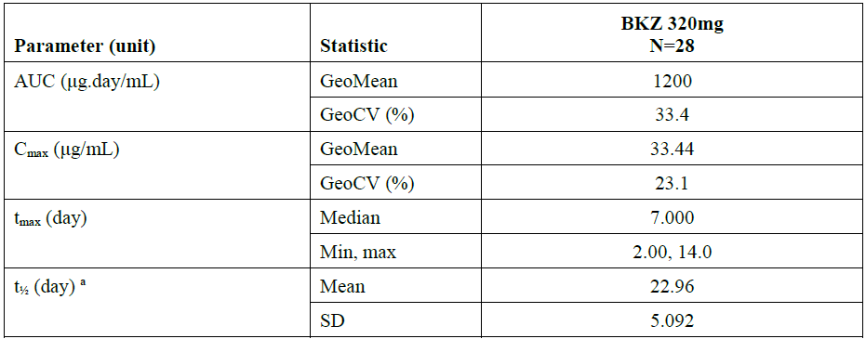
AUC = area under the plasma concentration-time curve from time 0 to infinity; BKZ = bimekizumab; C_{max} = maximum plasma concentration; CSR = clinical study report; CV = coefficient of variation; GeoCV = geometric coefficient of variation; GeoMean = geometric mean; max = maximum; min = minimum; sc = subcutaneous; SD = standard deviation; t½ = apparent terminal half-life; t_{max} = time of occurrence of C_{max}
Note: If at least two-thirds of the participants had a PK parameter reported, then descriptive statistics were calculated, otherwise only minimum and maximum were reported for the PK parameter.
Note: BKZ 320 mg: Single sc dose administered as a 2x1mL 160 mg/mL injection on Day 1 followed by single intramuscular dose of inactivated influenza vaccine on Day 15.
a The t½ was determined over a time interval equal to at least 2 x t½, using at least 3 data points. If the time interval was less than 2 x t½, the terminal half-life was flagged.
The results for PK parameters were similar to those seen in other PK studies, where subjects did not receive influenza vaccine.

Summary of pharmacokinetic findings
The clinical evaluation noted that two different formulations were used during clinical development: Formulation A and Formulation B (with Formulation B being the formulation proposed for clinical use). Study UP0031 investigate the PK of both formulations, the Formulation B is that proposed for commercialisation and was used in all Phase I to III studies except for Studies RA0124, UP0008 and PA0007.
No estimation of confidence intervals for the ratio of the means for C_{max} has been undertaken. Any difference in bioequivalence is unlikely to be of clinical significance. Importantly, the formulation used in most PK studies and the pivotal Phase III studies is that intended for commercialisation. The pharmacokinetic program adequately characterises the PK parameters of bimekizumab.
The PK of bimekizumab was similar between healthy participants and patients with moderate to severe psoriasis. Bimekizumab exhibited dose-dependent linear PK, in healthy participants after single SC doses in the range of 80 to 320 mg and in patients with moderate to severe psoriasis after multiple SC doses in the range of 64 to 480 mg.
The data presented are adequate to develop a proposed dose regimen.
Exposure of bimekizumab is inversely correlated with body weight and dose adjustment based on extremes of body weight may be necessary. This is adequately reflected in the proposed PI.
Based on the population PK analysis, bimekizumab CL/F or V/F was not impacted by age.
Bimekizumab is a humanised IgG antibody, thus it is anticipated that the potential for interaction is low as it undergoes protein degradation and has no effect on important enzyme systems. In common with other monoclonal antibodies no specific interaction studies have been undertaken.
The Delegate commented that it is more precise to state that after a certain weight limit (greater than 120 kg), Bimekizumab exposure may be inversely correlated with body weight. There is a possibility of drug accumulation should the dose frequency remain at every 4 weeks dosing intervals, the induction treatment dosing in those greater than 120 kg, instead of shifting to the maintenance treatment every 8 weeks dosing , post four months of the induction treatment every four weeks dosing . Remaining at every 4 weeks dosing is probably aimed at compensating for the perceived low average concentration due to larger volume of distribution, in the one compartmental (overweight) model. The kinetic profile may then shift towards zero kinetic, which is undesirable. The Delegate commented that there may be need for a precautionary statement in the PI to warn against the possibility of drug dose accumulation.

Pharmacodynamics
Submitted pharmacodynamic studies are listed in Table 10, shown below.
Table 10: Submitted pharmacodynamic studies.
PD Topic | Subtopic | Study ID
Primary pharmacology | Effect on IL-17 levels | UP0008  PS0010
Primary pharmacology | Effect on PASI and PGA/IGA | UP0008  PS0016  PS0010
Primary pharmacology | Effect on biomarkers (exploratory objectives) | UP0008  PS0016
Primary pharmacology | Effect on lesion severity | UP0008
Pharmacodynamic interactions | Influenza vaccine | UP0034
Population pharmacodynamic and pharmacokinetic/ pharmacodynamic analyses | Target population | CL0446  CL0485
The Delegate commented that based on the definition of pharmacodynamics (PD), only the studies assessing the (a) effect of bimekizumab on IL-17 levels, (b) the interaction study with influenza vaccine in healthy individuals and (c) population pharmacodynamics, strictly met the requirement for PD studies. The rest of the PD listed studies falls into the realm of bimekizumab efficacy assessment in psoriasis, that is the condition being treated.
The clinical evaluation noted that on the mechanism of action, bimekizumab is an IgG monoclonal antibody that binds with high specificity and affinity to IL-17A, and IL-17F. Bimekizumab has no affinity for other members of the IL-17 family of cytokines. (IL-17B, C, D, or E (IL-25)). The Delegate commented that by inference, there would less production of both IL-17A, and IL-17F.
Interleukin 17 levels were measured in Studies UP0008 and PS0010 in patients with plaque psoriasis. Dosing regimen in Study PS0008 was bimekizumab administered every 4 weeks loading for 16 weeks followed by either every 4 weeks dosing of 320 mg bimekizumab versus every eight weeks dosing of 320 mg bimekizumab. There were no differences in IL-17 levels observed between treatment groups and this is likely due to the small number of patients or there was no significant difference between the dosing intervals and the binding of IL-17.
On PD interactions, Study UP0034 evaluated the effectiveness of influenza vaccine following a single dose of 320 mg bimekizumab in heathy adult males and females. There was no significant difference in the seroconversion rate between subjects who received bimekizumab versus those who received no treatment prior to vaccination.
Overall, the PD results from the Phase II studies revealed what may be expected from IL-17A inhibition by bimekizumab and, which had also been demonstrated by the other monoclonal antibodies inhibiting IL-17a, in relation to the treatment of psoriasis, Bimekizumab differs from other agents in that it also inhibits IL-17F. Pharmacokinetics/PD modelling predicts body weight as an important co-variate influencing the PD effect of bimekizumab and appropriate dose changes are included in the proposed prescribing information. Bimekizumab does not appear to influence the seroconversion rates following administration of inactivated influenza vaccine. No study has been undertaken to investigate effects on co-administration with live vaccine and this is appropriately reflected in the proposed prescribing information.

Dose finding studies

Study PS0010
Study PS0010 evaluated the dose response of bimekizumab administered subcutaneously every 4 weeks for 12 weeks in the treatment of subjects with moderate-to-severe chronic plaque psoriasis.
One group was randomised to bimekizumab or placebo, with randomised treatment administered subcutaneously at Baseline, Week 4, Week 8, and Week 12. Like those on placebo, subjects on active bimekizumab treatment received either 64 mg, 160 mg, 320 mg, or 480 mg every 4 weeks from Baseline.
In another group, 320 mg bimekizumab loading dose was administered subcutaneously at Baseline, followed by 160 mg every 4 weeks.
The primary efficacy variable was PASI 90 response (see section, Error! Reference source not found.); at Week 12. The secondary objective was IGA (see section, Error! Reference source not found.) at Week 12. A linear dose response relationship was established with the PASI 90 response, lowest for the 64 mg every 4 weeks dosing and maximal response at the 320 mg every 4 weeks dosing. The 480 mg every 4 weeks dosing and the 320 mg baseline loading dose followed by 160 mg every 4 weeks did not demonstrate a clinically meaningful difference from the 320 mg every 4 weeks dosing group.
The Delegate commented that given the above, the possibility of bimekizumab 320 mg every 4 weeks baseline loading dose, followed by 160 mg every 4 weeks dosing, as opposed to 320 mg every 4 weeks dosing in the first 16 weeks of treatment deserves a consideration as an alternative regimen during the induction (initial) treatment phase, for the sake of side effects, especially infections, infestations & neutropenia.

Study PS0016
Study PS0016 evaluated the time course of PASI responses over a 28-weeks period, following the administration of bimekizumab given at Baseline and Week 4, to subjects with moderate to severe chronic plaque psoriasis.
Subjects received either:
- bimekizumab 320 mg administered subcutaneously at Baseline and Week 4, followed by placebo administered at Week 16; or
- bimekizumab 320 mg administered subcutaneously at Baseline and Weeks 4 and 16.
Mean changes from Baseline were observed for both treatment groups in PASI score at Week 28. The results showed:
- mean changes and mean percentage changes from Baseline in PASI score were larger for the group administered bimekizumab 320 mg at Weeks 4 and 16 without placebo (-19.74 points and -86.68%, respectively) compared with the group administered bimekizumab 320 mg at Week 4, followed by placebo at Week 16 (-10.76 points and -62.07%, respectively).
The Delegate commented that the above outcome indicates the tendency of bimekizumab’s effect to wear out with time if doses are missed.
The PK/PD model also provided information on the dose selection for the Phase III studies. No dose related treatment emergent adverse events were identified in the Phase II studies. The Phase III pivotal studies investigating more than one dose regimen

Study PS0008
Study PS0008 is a Phase III pivotal study with an active comparator, that investigated bimekizumab 320 mg loading, administered every 4 weeks for 16 weeks, followed by either every 4 weeks dosing of bimekizumab 320 mg or every 8 weeks dosing of bimekizumab 320 mg, as shown in Figure 9 below.
Figure 9: Study PS0008 Schematic diagram of study design and flow
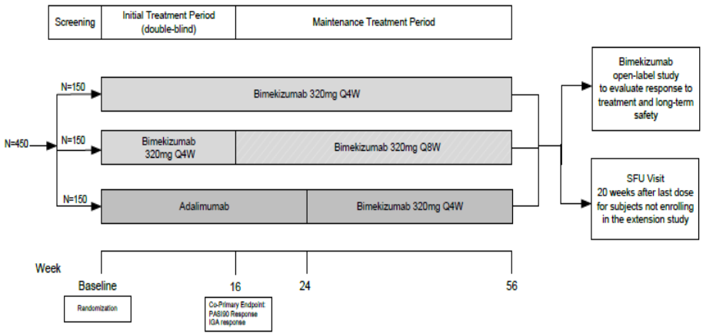
Abbreviation: every 4 weeks = every 4 weeks, every 8 weeks = every 8 weeks; SFU = safety follow up
Findings indicate that
- The PASI 90 response rate was similar for the bimekizumab 320 mg every 4 weeks and the bimekizumab 320 mg every 4 weeks/every 8 weeks groups (84.8% and 82.6%, respectively).
- The IGA 0/1 (see section, Investigator’s Global Assessment) response rate was similar between the bimekizumab 320 mg once every 4 weeks group and the bimekizumab 320 mg every 4 weeks/every 8 weeks group (82.3% and 83.2%, respectively).
The Delegate commented that given that the efficacy outcomes between the bimekizumab’s dosing at every 4 weeks and every 8 weeks is very similar, there is no substantive rationale to maintain patients on every 4 weeks induction dosing, considering the possibility of the earlier mentioned drug accumulation, leading to undesirable zero order kinetics. The Delegate commented that if every 4 weeks maintenance dosing is indeed contemplated in greater than 120 kg as proposed in the draft PI, then there could be consideration for a precautionary statement in the ‘Dose and Administration’ section of the PI.
The TGA’s clinical evaluation noted that the dose selection strategy was based on results of two Phase II studies plus PK modelling across the Phase I and II studies. A dose response was seen between the different doses tested with a maximal response at 320 mg bimekizumab administered subcutaneously every 4 weeks. The dose response was linear across the dose range 64 mg to 320 mg.

Assessment of clinical responses

Psoriasis Area and Severity Index (PASI)
The Psoriasis Area and Severity Index (PASI) originated in 1978; and use of PASI score as a primary endpoint in the evaluation of efficacy in psoriasis (in conjunction with others) is well established; validated; and discussed in relevant TGA-adopted guidance. It’s use is also well established in Australasian College of Dermatologists (ACD) guidelines.¹³
Copies of the Department of Health forms used in Australia for PASI calculation (with body diagram) for face, hand and foot (PB114) and for the whole body (PB115) can be found online. A blank excerpt taken from Form PB115 is shown below in Figure 10.
Figure 10: Example of a form used for documenting a Psoriasis Area and Severity Index (PASI) score
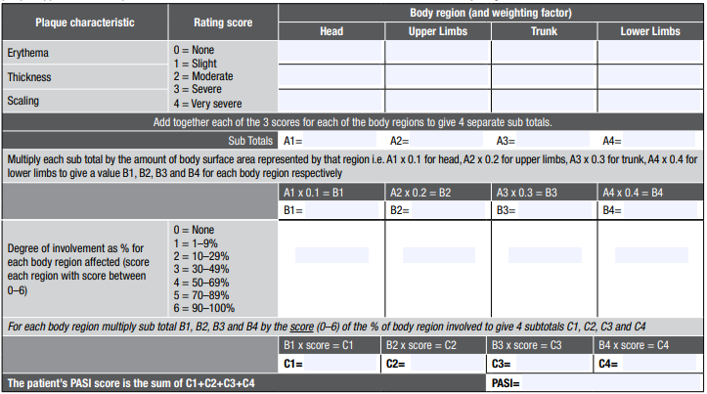

Calculation
For the assessment of PASI score, the body is divided in 4 regions: head and neck, upper limbs, trunk (including front, back and groin areas), and the lower limbs (as described in Table 11 below).
Table 11: Definition of Psoriasis Area and Severity Index (PASI) body regions
Body region | Body area | Details of area
1 | Head | Face, back of head
2 | Upper limbs | Left, right, upper lower, flexor surface, extensor surface
3 | Trunk | Front, back, groin
4 | Lower limbs | Left, right, upper lower, flexor surface, extensor surface, including buttocks
The intensity of psoriasis is assessed separately for each of the 4 body regions.
First, a representative area of psoriasis within that body region is selected. Within that area, an assessment is made for each of the following 3 characteristics of psoriasis: redness (erythema); thickness (induration) and scaling (desquamation). Each of these 3 characteristics is assigned an score of zero (absent), 1 (mild), 2 (moderate), 3 (severe) or 4 (very severe). Then the 3 scores of each characteristic is added for that body region, creating four body region intensity subtotals (A1, A2, A3, and A4).
Visual guides assessing each of these 3 psoriasis characteristics can be found online.
As the amount of skin covering each body region is different, the subtotals are multiplied by the body surface area represented by that region:
- A1 (head and neck) x 0.1 = B1
- A2 (upper limbs) x 0.2 = B2
- A3 (trunk) x 0.3 = B3
- A4 (lower limbs) x 0.4 = B4.
Separately, each of the 4 body regions are assessed for the proportion of skin within that body region estimated to be affected by psoriasis.
A score of between zero and 6 according to the score categories shown in Table 12.
Table 12: Psoriasis Area and Severity Index (PASI) body region area scores
Score | Area of skin in body region affected by psoriasis
0 | No skin affected
1 | 1% to < 10% affected
2 | 10% to < 30% affected
3 | 30% to < 50% affected
4 | 50% to < 70% affected
5 | 70% to < 90% affected
6 | 90% to 100% affected
Finally, each regional intensity totals (B1, B2, B3, and B4) is multiplied by the body region area score for that region (between 0 to 6, as shown in the table above) to produce a total score for each of the 4 body regions (known as C1, C2, C3 and C4).
The final (total) PASI score is calculated by adding all 4 scores (C1 + C2 + C3 + C4). An example of the calculation of the final PASI is shown below.
Figure 11: Example of Psoriasis Area and Severity Index (PASI) calculation
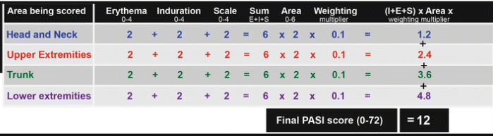
In the above example, this individual has a moderate intensity (score of 2) for the 3 psoriasis characteristics (erythema, induration and scale) in all 4 body region, and an area score of 2 (between 10% to < 30% of skin affected) in all 4 body regions, producing a final PASI score of 12.

Interpretation
The highest final score possible is 72 and the higher the final score, the more severe is the psoriasis.
Definitions of mild, moderate and severe psoriasis vary, but a final (absolute) PASI score of more than 10 points is frequently used to define severe disease;¹³ (see also Table 1).
Beyond final (or absolute) PASI scores, other scores derived from PASI scores, notably PASI responses.
A patient achieving a PASI 75 response is a patient who achieves a 75% or more reduction in their PASI score compared to their final (or absolute) PASI score at Baseline.
The PASI is widely used in clinical trials of therapies to treat psoriasis. Although absolute PASI score is often used to define entry into a trial, it is response to treatment that is important to measure efficacy and outcomes. This is usually presented as a percentage response rate; for example, PASI 75 responses can be presented as the percentage (or number) of patients who have achieved a 75% or more reduction in their final (or absolute) PASI scores recorded at Baseline.
Other PASI responses exist, for example PASI 50, PASI 90 and PASI 100 responses represent either an individuals response of 50, 90, and 100% response rate compared to absolute PASI score at Baseline.
This can also be represented in clinical trials as the percentage (or number) of patients who have achieved a 50, 90, or 100% reduction in their absolute PASI score at Baseline.
PASI 100 indicates patients who have achieved a complete resolution of all disease.
By definition a patient who has achieved PASI 75 has also achieved PASI 50. There is a gradual tendency, as therapies become more effective to report higher efficacy rates in clinical trials.

Investigator’s Global Assessment (IGA)
Investigator’s Global Assessment Scale or Physician’s Global Assessment (PGA) that is PGA-IGA Scale is a global assessment tool for psoriasis. The sponsor used a five-point static scale in the developmental programme (see Table 13, below).
Table 13: Investigator’s Global Assessment scale
Score | Short descriptor | Detailed descriptor
0 | Clear | No signs of Psoriasis; post inflammatory hyperpigmentation may have been present
1 | Almost clear | No thickening; normal to pink coloration; no to minimal focal scaling
2 | Mild | Just detectable to mild thickening; pink to light red coloration; predominately fine scaling
3 | Moderate | Clearly distinguishable to moderate thickening; dull to bright red; moderate scaling
4 | Severe | Severe thickening with hard edges; bright to deep dark red coloration; severe/coarse scaling covering almost all or all lesions
A static IGA for scalp psoriasis (scalp IGA) was used to assess disease severity on the scalp. Only study participants with scalp involvement at Baseline completed the scalp IGA.
Scalp lesions were assessed in terms of clinical signs of redness, thickness, and scaliness using a 5-point scale (see Table 14).
Table 14: Investigator’s Global Assessment for scalp psoriasis
Score | Short descriptor | Detailed descriptor
0 | Clear | Scalp had no signs of Psoriasis; post inflammatory hyperpigmentation may have been present
1 | Almost clear | Scalp had no thickening; normal to pink coloration; no to minimal focal scaling
2 | Mild | Scalp had just detectable to mild thickening; pink to light red  coloration; predominately fine scaling
3 | Moderate | Scalp had clearly distinguishable to moderate thickening; dull to bright red, moderate scaling
4 | Severe | Scalp had severe thickening with hard edges; bright to deep dark red coloration; severe/coarse scaling covering almost all or all lesions

Patient symptom diary
Patient symptom diaries (PSD) was used for a secondary endpoint in some studies and it is a patient outcome measure developed by the applicant.
The PSD consists of 14 items, measuring the following psoriasis related signs, symptoms, and functional impacts:
- redness,
- scaling,
- cracking,
- lesions,
- thickening,
- itch,
- pain,
- burning,
- dryness,
- irritation,
- sensitivity,
- fatigue,
- embarrassment,
- choice of clothing.
Each item has a recall period of the past 24 hours. All items are scored on a 0 to 10 scale, with a higher score meaning greater severity or impact and, with verbal anchors at the extreme responses (0 and 10).
The TGA’s clinical evaluation noted that:
- Standard efficacy variables were used to assess the efficacy of bimekizumab in both the pivotal Phase III studies and the Phase II developmental programme.
- In the TGA-adopted Guideline on Psoriasis;³⁷ a global assessment scale is recommended as a co-primary endpoint in addition to PASI. The sponsor has followed this guideline.
- All the Phase III studies had the same co-primary efficacy variables, the endpoints used following scientific advice from the EMA and a pre-investigational new drug meeting with the FDA. The endpoint is consistent with accepted guidelines and registration studies for other products approved for the treatment of psoriasis.
- The PSD is an unvalidated tool developed by the applicant, it was used as a secondary outcome measure in selected geographies in selected studies. The significance of this outcome measure is unknown.
- The scalp IGA has been used in registration studies for other medications used for the treatment of psoriasis, such as guselkumab.

Efficacy

Study PS0008
Study PS0008 is a Phase III, randomised, double blind, parallel group, active comparator controlled multicentre study, to evaluate the efficacy and safety of bimekizumab in adults with moderate to severe plaque psoriasis.

Study design
The study design, as depicted schematically below in Figure 12, consisted of four periods:
- A one week screening period,
- 16 weeks initial treatment period,
- 40 weeks maintenance treatment period,
- 20 weeks follow up period.
Figure 12: Study PS0008 Schematic diagram
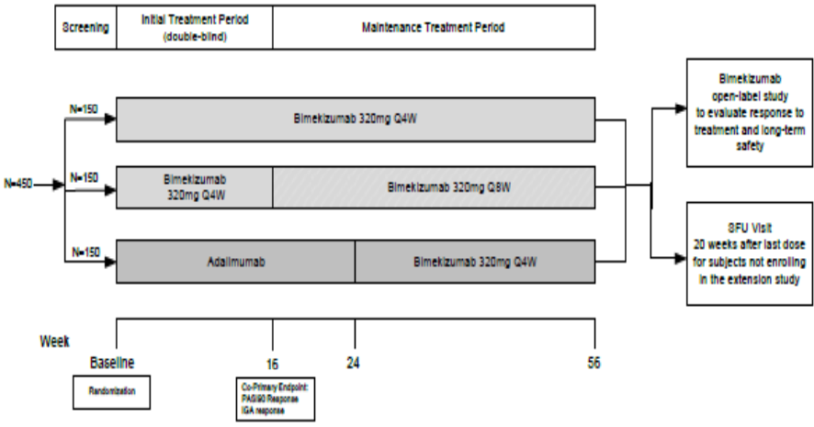
Abbreviations: IGA = Investigator’s Global Assessment; N = number; PASI = Psoriasis Area and Severity Index; Q4W = every 4 weeks; Q8W = every 8 weeks; SFU = Safety follow up.
The primary objective is to evaluate the efficacy and safety of bimekizumab in adults with moderate to severe plaque psoriasis.
Main inclusion criteria is that the study participants must have been adults with a diagnosis of moderate to severe psoriasis (Baseline PASI score greater than 12, body surface area affected by psoriasis greater or equal to 10% and IGA score greater or equal to 3), who were candidates for systemic psoriasis therapy and/or phototherapy.
Exclusion criteria includes:
- Female study participant who was breastfeeding, pregnant, or planned to become pregnant during the study or within 20 weeks following the final dose of investigational medicinal product (IMP).
- Study participant had previously participated in a bimekizumab clinical study who received at least one dose of the IMP (including placebo).
- Study participant was currently participating in another study of a medication (systemic) under investigation. Study participant must have been washed out of the medication for 12 weeks or at least five half lives prior to the Baseline visit, whichever was greater.
- Study participant was currently participating in another study of a topical medication under investigation. Study participant must have been washed out of the medication for four weeks prior to the Baseline visit.
- Study participant was currently or was within the four weeks prior to the Baseline visit, participating in another study of a medical device under investigation.
- Study participant had a known hypersensitivity to any excipients of bimekizumab or adalimumab.
- Study participant had a form of psoriasis other than chronic plaque type (for example, pustular, erythrodermic and guttate psoriasis, or drug induced psoriasis).
- Study participant had an active infection or history of infection(s) as follows:
  - Any active infection (except common cold) within 14 days prior to Baseline.
  - A serious infection, defined as requiring hospitalization or iv anti-infective(s) within two months prior to the Baseline visit.
  - A history of opportunistic, recurrent, or chronic infections that, in the opinion of the Investigator, might have caused this study to be detrimental to the study participant. Opportunistic infections were infections caused by uncommon pathogens (for example, pneumocystis jirovicii, cryptococcosis) or unusually severe infections caused by common pathogens (for example, cytomegalovirus, herpes zoster).
- Study participant had concurrent acute or chronic viral hepatitis B or C or human immunodeficiency virus (HIV) infection. Study participants who had evidence of or tested positive for hepatitis B or hepatitis C were excluded. A positive test for the hepatitis B virus was defined as: 1) positive for hepatitis B surface antigen (HBsAg+) or 2) positive for anti-hepatitis B core antibody (HBcAb+). A positive test for the hepatitis C virus (HCV) was defined as: 1) positive for hepatitis C antibody (anti-HCV Ab) and 2) positive via a confirmatory test for HCV (for example, HCV polymerase chain reaction).
- Study participant had received any live (includes attenuated) vaccination within the 8 weeks prior to the Baseline visit (for example, inactivated influenza and pneumococcal vaccines were allowed but nasal influenza vaccination was not permitted).
- Study participant had received Bacillus Calmette-Guerin vaccinations within one year prior to the Baseline visit.
- Study participant had known tuberculosis infection, was at high risk of acquiring tuberculosis infection, or had current or history of nontuberculous mycobacterium infection. A study participant with latent tuberculosis (a positive interferon-gamma release assay and diagnosis confirmed by tuberculosis specialist) may have been rescreened once and enrolled after receiving at least 8 weeks of appropriate latent tuberculosis infection therapy and if no evidence of therapy-related hepatotoxicity had occurred prior to the first injection (alanine aminotransferase/aspartate aminotransferase remain three times upper limit of normal [ULN]).
- Study participant had a past history of active tuberculosis involving any organ system unless adequately treated according to World Health Organization/Centers for Disease Control therapeutic guidance and proven to be fully recovered upon consult with a tuberculosis specialist.
- Study participant had a history of a lymphoproliferative disorder including lymphoma or current signs and symptoms suggestive of lymphoproliferative disease.
- Study participant had any active malignancy or history of malignancy within five years prior to the screening visit except treated and considered cured cutaneous squamous or basal cell carcinoma, or in situ cervical cancer.
- Study participant had a diagnosis of inflammatory conditions other than psoriasis or psoriatic arthritis, including but not limited to rheumatoid arthritis, sarcoidosis, or systemic lupus erythematosus. Study participants with a diagnosis of Crohn's disease or ulcerative colitis were allowed as long as they had no active symptomatic disease at Screening or Baseline.
- Study participant had major surgery (including joint surgery) within the three months prior to the Baseline visit or planned major surgery within six months after entering the study.
- Study participant had any systemic disease (that is cardiovascular, neurological, renal, liver, metabolic, gastrointestinal, haematological, immunological and more) considered by the investigator to be uncontrolled, unstable, or likely to progress to a clinically significant degree during the course of the study.
- Study participant had a myocardial infarction or stroke within the six months prior to the screening visit.
- Study participant had laboratory abnormalities at screening, including any of the following:
  - Greater than three times the ULN of any of the following: alanine aminotransferase, aspartate aminotransferase, alkaline phosphatase; or greater than ULN total bilirubin (2:l.5 x ULN total bilirubin if known Gilbert's syndrome).
  - White blood cell counts less than 3 x 10/L.
  - Absolute neutrophil counts less than 1.5 x 10%/L.
  - Lymphocyte counts less than 500 cells/µL.
  - Haemoglobin less than 8.5 g/dL.
  - Any other laboratory abnormality, which, in the opinion of the investigator, would have prevented the study participant from completing the study or would have interfered with the interpretation of the study results.
  - Individual screening tests for which the results were in error, borderline, or indeterminate for inclusion in the study could have been repeated once for confirmation during the screening period. Upon retesting, study participants whose results remained outside this threshold should not have been randomised.
- Study participant had any other condition, including medical or psychiatric, which, in the investigator’s judgment made the study participant unsuitable for inclusion in the study.
- Study participant had previous exposure to adalimumab.
- Study participant had experienced primary failure (no response within 12 weeks) to one or more IL-17 biologic response modifier (for example, brodalumab, ixekizumab, secukinumab) or more than 1 biologic response modifier other than an IL-17.
- Study participant was taking psoriasis medications other than stable doses (that is, stable for at least one week prior to the screening visit) of nonsteroidal anti-inflammatory drugs or analgesics.
- Study participant had a history of chronic alcohol or drug abuse within 6 months prior to Screening as evaluated by the Investigator based on medical history, site interview, and/or results of the specified urine drug screen.
- Presence of active suicidal ideation, or positive suicide behavior using the ‘screening’ version of the electronic Columbia Suicide Severity Rating Scale and with either of the following criteria:
  - History of a suicide attempt within the five years prior to the Screening Visit. Study participants with a history of a suicide attempt more than five years ago should have been evaluated by a mental healthcare practitioner before enrolling into the study.
  - Suicidal ideation in the past month prior to the screening visit as indicated by a positive response (‘Yes’) to either Question 4 or Question 5 of the ‘screening’ version of the electronic Columbia Suicide Severity Rating Scale.
  - Study participant had presence of moderately severe major depression or severe major depression, indicated by a score of greater than l5 using the screening PHQ-9. Medication used to treat depression should have been stable for 8 weeks prior to Baseline.
- Study participant was taking or has taken prohibited psoriasis medications without meeting the mandatory washout period relative to the Baseline visit
The TGA’s clinical evaluation noted that the requirement of a PASI of greater or equal to 12, IGA of greater or equal to 3 and a total body surface area of greater or equal to 10% reflects published guidelines;³⁷ as adopted by the TGA.

Study treatments and schedule
Eligible study participants were randomised in a 1:1:1 ratio to receive the following, in a blinded fashion:
- bimekizumab 320 mg every 4 weeks throughout the study for 56 weeks (designated by the Delegate and referred to as Group A in this AusPAR);
- bimekizumab 320 mg every 4 weeks until Week 16, followed by bimekizumab every 8 weeks for 40 weeks (designated by the Delegate as Group B); or
- adalimumab for 24 weeks, followed by bimekizumab every 4 weeks for 32 weeks (designated by the Delegate as Group C).
As per the schematic diagram above and the differences in the dosing schedule between bimekizumab and adalimumab, all study participants received two injections subcutaneously on Weeks 0 (Baseline), 4, 8, 12, 16, 20, and 24, and one injection subcutaneous in other weeks.
Group A:
- Study participants randomised to receive bimekizumab 320 mg every 4 weeks throughout the study received two bimekizumab 160 mg injections subcutaneously every 4 weeks at Weeks 0 (Baseline), 4, 8, 12, 16, 20, 24, 28, 32, 36, 40, 44, 48, 52 and 56.
- These study participants received one placebo injection at Weeks 1, 3, 5, 7, 9, 11, 13, 15, 17, 19, 21, and 23.
Group B:
- Study participants randomised to receive bimekizumab 320 mg every 4 weeks/every 8 weeks received two bimekizumab 160 mg injections every 4 weeks at Weeks 0 (Baseline), 4, 8, 12 and 16.
- Study participants then received 2 bimekizumab 160 mg injections subcutaneously every 8 weeks at Weeks, 24, 32, 40, 48 and 56.
Group C:
- Study participants randomised to receive adalimumab received two adalimumab 40 mg injections subcutaneously at Week 0 (Baseline). At Weeks 1, 3, 5, 7, 9, 11, 13, 15, 17, 19, 21, and 23, they received one adalimumab 40 mg injection subcutaneously.
- These study participants received two placebo injections at Weeks 4, 8, 12, 16, 20 and 24.
- These study participants then received bimekizumab 320 mg every 4 weeks given as two bimekizumab 160 mg injections subcutaneously every 4 weeks at Weeks 28, 32, 36, 40, 44, 48, 52 and 56.
The investigational study medications or active comparator were supplied as follows:
- bimekizumab was supplied in a l mL prefilled syringe at a concentration of 160 mg/mL;
- adalimumab was supplied as a prefilled syringe for subcutaneous injection (at a concentration of 40 mg/0.8 mL or 40 mg/0.4 mL depending on regional availability) in a single use syringe; and
- placebo was supplied as 0.9% sodium chloride aqueous solution (physiological saline, preservative-free) in a 1 mL prefilled syringe for subcutaneous injection.
The TGA’s clinical evaluation commented that Study PS0008 is an active comparator study that complies with relevant guidelines. Adalimumab;20 is a TNF inhibitor that is indicated for the treatment of severe chronic plaque psoriasis in children and adolescent patients from 4 years of age who have had an inadequate response to or are inappropriate candidates for topical therapy and phototherapy (amongst other indications), and is an acceptable active comparator. No placebo controlled arm is included. This is acceptable according to relevant guidelines which state: ‘For trials aiming to show superiority of a new drug to the known active treatment, two-arm trials without placebo control are acceptable’.
The sponsor used an interactive response technology system was used for assigning eligible study participants to a treatment regimen, based on a pre-determined production randomisation and/or packaging schedule provided by sponsor.
At screening, each study participant was assigned a five digit number that served as the study participant identifier throughout the study. The study participant number was required in all communications between the Investigator or designee and the interactive response technology regarding a particular study participant.
At the Baseline visit, a study participant was randomised into the study. The investigator or designee used the interactive response technology for randomisation. The interactive response technology automatically informed the investigator or designee of the study participant's identification number. The interactive response technology allocated kit numbers to the study participant, based on the study participant’s number during the study. The kits were blinded.
Due to differences in presentation between the bimekizumab and adalimumab, special precautions were taken to ensure study blinding and, study sites had blinded and unblinded personnel.
All sponsor and investigator site personnel involved in the study were blinded to the randomised investigational treatment assignment with the following exceptions:
- Unblinded study staff were responsible for preparation (breaking tamper proof sticker on kit and more) of the clinical trial material, including recording the administration information on source documents, and administration of the IMP as subcutaneous injections. The unblinded personnel were not involved in the study in any way other than assuring the medication was taken from the correct kit and administering the drug to the study participants.
- Bioanalytical staff analysing blood samples for bimekizumab and anti-drug/anti-bimekizumab antibody determination.
During the study, the sponsor provided blinded and unblinded site monitors for the purposes of verifying safety, efficacy, drug administration and documentation records. Unblinded study site personnel needed to be available in order to resolve queries. Study monitors and study site personnel blinded to treatment assignment did not discuss or have access to any drug-related information.
Study sites were required to have a written blinding plan in place, signed by the principal investigator, which detailed the site's steps for ensuring that the double blind nature of the study was maintained. Sites were instructed to keep study participants blind to the investigational medical treatment as detailed in the site blinding plan.
The TGA’s clinical evaluation commented that randomisation and blinding were adequate.

Endpoints
The co-primary study endpoints for Study PS0008 include:
- PASI 90 responses at Week 16; and
- The IGA 0/1 response; at Week 16.
Secondary endpoints for Study PS0008 include:
- PASI 90 response at Week 24.
- IGA 0/1 response at Week 24.
- PASI 75 response at Week 4.
- PASI 100 response at Weeks 16 and 24.
- PASI 90 response at Week 56.
- IGA 0/1 response at Week 56.
The TGA’s clinical evaluation noted that the main efficacy endpoints in this study were appropriate and complied with relevant regulatory guidelines.

Subject disposition
Figure 13 shown below, summarises subject disposition and patient flow for the initial treatment period (that is, from Week 0 to Week 24).

Figure 13: Study PS0008 Disposition and discontinuation reasons (initial treatment period through Week 24)
Disposition | BKZ 320 mg  every 4 weeks/every 8 weeks  N = 161  n (%) | BKZ 320 mg  every 4 weeks  N = 158  n (%) | BKZ  Total  N = 319  n (%) | ADA  N = 159  n (%) | All study  participants  N = 478  n (%)
Started Initial Treatment Period | 161 (100) | 158 (100) | 319 (100) | 159 (100) | 478 (100)
Completed Initial Treatment | 154 | 153 | 307 | 150 | 457
Period | (95.7) | (96.8) | (96.2) | (94.3) | (95.6)
Discontinued study during | 7 (4.3) | 5 (3.2) | 12 (3.8) | 9 (5. 7) | 21 (4.4)
Initial Treatment Period
Primary reason for study discontinuation during Initial Treatment Period
AE | 2 (1.2) | 2 (1.3) | 4 (1.3) | 4 (2.5) | 8 (1. 7)
Lack of efficacy | 0 | 0 | 0 | 1 (0.6) | 1 (0.2)
Protocol violation | 0 | 0 | 0 | 2 (1.3) | 2 (0.4)
Lost to follow up | 0 | 2 (1.3) | 2 (0.6) | 1 (0.6) | 3 (0.6)
Consent withdrawn | 4 (2.5) | 1 (0.6) | 5 (1.6) | 1 (0.6) | 6 (1.3)
Other | 1 (0.6) | 0 | 1 (0.3) | 0 | 1 (0.2)
Completed Week 24 | 149  (92.5) | 152  (96.2) | 301  (94.4) | 149  (93.7) | 450  (94.1)
Discontinued between Week 16 and Week 24 | 5 (3.1) | 1 (0.6) | 6 (1.9) | 1 (0.6) | 7 (1.5)
Primary reason for study discontinuation between Week 16 and Week 24
AE | 3 (1.9) | 1 (0.6) | 4 (1.3) | 0 | 4 (0.8)
Lack of efficacy | 1 (0.6) | 0 | 1 (0.3) | 0 | 1 (0.2)
Protocol violation | 0 | 0 | 0 | 0 | 0
Lost to follow up | 0 | 0 | 0 | 1 (0.6) | 1 (0.2)
Consent withdrawn | 1 (0.6) | 0 | 1 (0.3) | 0 | 1 (0.2)
Other | 0 | 0 | 0 | 0 | 0
Abbreviations: ADA = adalimumab; AE = adverse event; BKZ = bimekizumab.
Overall, 457 study participants (95.6%) completed the initial treatment period.
The percentages of study participants who completed the initial treatment period were high and similar in the bimekizumab total group (96.2%) and adalimumab group (94.3%).
The frequency of study discontinuation during the initial treatment period was low and similar across treatment groups.
Figure 14: Study PS0008 Disposition and discontinuation reasons (period Week 24 to Week 56)
Disposition | BKZ 320 mg  every 4 weeks/every 8 weeks  N = 149  n (%) | BKZ 320 mg  every 4 weeks  N = 152  n (%) | ADA/BKZ  320 mg every 4 weeks  N = 149  n (%) | BKZ Total  N = 450  n (%)
Started Week 24 | 149 (100) | 152 (100) | 149 (100) | 450 (100)
Completed Week 56 | 143 (96.0) | 143 (94.1) | 133 (89.3) | 419 (93.1)
Discontinued between Week 24  and Week 56 | 6 (4.0) | 9 (5.9) | 16 (10.7) | 31 (6.9)
Primary reason for study discontinuation
AE | 3 (2.0) | 4 (2.6) | 6 (4.0) | 13 (2.9)
Lack of efficacy | 0 | 1 (0. 7) | 1 (0. 7) | 2 (0.4)
Protocol violation | 0 | 0 | 0 | 0
Lost to follow up | 0 | 2 (1.3) | 5 (3.4) | 7 (1.6)
Consent withdrawn | 3 (2.0) | 1 (0. 7) | 4 (2. 7) | 8 (1.8)
Other | 0 | 1 (0. 7) | 0 | 1 (0.2)
Abbreviations: ADA = adalimumab; AE = adverse event; BKZ = bimekizumab.
Overall, 419 study participants (93.1%) completed Week 56; the percentage of study participants who completed Week 56 was high across treatment groups, with slightly higher percentages in the bimekizumab 320 mg every 4 weeks group (94.1%) and the bimekizumab 320 mg every 4 weeks/every 8 weeks group (96.0%) compared with the adalimumab/bimekizumab 320 mg every 4 weeks group (89.3%).
The frequency of study discontinuation between Week 24 and Week 56 was low across treatment groups, with slightly lower rates in the bimekizumab 320 mg every 4 weeks group and the bimekizumab 320 mg every 4 weeks/every 8 weeks group compared with the adalimumab/bimekizumab 320 mg every 4 weeks group.
The most frequently reported primary reason for discontinuation between Week 24 and Week 56 was due to an adverse event (AE) (13 study participants (2.9%)).

Analysis of populations
The following analysis sets were used:
- The enrolled set consisted of all study participants who gave informed consent.
- The randomised set consisted of all randomised study participants.
- The safety set consisted of all study participants who received at least one dose of study medication.
- The full analysis set consisted of all randomised study participants who received at least one dose of study medication and had a valid measurement for each of the co-primary efficacy variables at Baseline.
- The bimekizumab set consisted of all study participants who received at least one dose of bimekizumab in this study.
- The bimekizumab Week 24 Set consisted of all study participants who received at least one dose of bimekizumab on or after Week 24.
- The maintenance set consisted of all study participants who received at least one dose of active treatment (bimekizumab or adalimumab) in the maintenance treatment period (at Week 16 or later).
- The per-protocol set consisted of all study participants in the randomised set who had no important protocol deviations affecting the primary efficacy variables. Important protocol deviations were predefined, and study participants with important protocol deviations were evaluated during ongoing data cleaning meetings prior to unblinding of the data.
Analysis set per treatment arm is as shown in Figure 15.
Figure 15: Study PS0008 Analysis set per treatment arm
Analysis set | BKZ  320 mg every 4 weeks / every 8 weeks  N = 161  n (%) | BKZ  320 mg every 4 weeks  N = 158  n (%) | BKZ Total  N = 319  n (%) | ADA/BKZ  320 mg every 4 weeks  N = 159  n (%) | All study participants  N = 478  n (%)
Randomised | 161 (100) | 158 (100) | 319(100) | 159 (100) | 478 (100)
Safety set | 161 (100) | 158 (100) | 319(100) | 159 (100) | 478 (100)
Full analysis set | 161 (100) | 158 (100) | 319(100) | 159 (100) | 478 (100)
Bimekizumab set | 161 (100) | 158 (100) | 319(100) | 149 (93.7) | 468 (97.9)
Bimekizumab Week 24 set | 149 (92.5) | 152 (96.2) | 301 (94.4) | 149 (93.7) | 450 (94.1)
Per protocol set | 156 (96.9) | 157 (99.4) | 313 (98.1) | 156 (98.1) | 469 (98.1)
Pharmacokinetics per protocol set | 161 (100) | 158 (100) | 319(100) | 146 (91.8) | 465 (97.3)
Maintenance set | 154 (95.7) | 153 (96.8) | 307 (96.2) | 149 (93.7) | 456 (95.4)
Abbreviation: BKZ = bimekizumab; FAS = full analysis set; MS = maintenance set; PK-PPS = pharmacokinetics per protocol set; PPS = per protocol set; RS = randomised set; SS = safety set.

Sample size
Sample size calculations were based on the testing of superiority to adalimumab for PASI 90 and IGA 0/1 at Week 16.
Given the above assumptions and a sample size of 150 in the adalimumab arm and 300 in the pooled bimekizumab arms, the power to detect a statistically significant difference between bimekizumab and adalimumab was greater than 99% for PASI 90 response and 97% for IGA 0/1 response. This assumed a two-sided significance level of 0.05. Because both co-primary endpoints were highly powered independently, and because PASI and IGA 0/1 responses tend to be highly correlated, the overall power for achieving superiority on both co-primary endpoints was not calculated.
The clinical evaluator noted that the noninferiority testing procedure was based on a one sided significance level of 0.025 and a noninferiority margin of 10%. The power to demonstrate noninferiority to adalimumab was greater than 99% for both PASI 90 and IGA 0/1 responses.
The TGA’s clinical evaluation noted that the study was adequately powered

Statistical methods
The statistical analysis of the co-primary efficacy variables and selected secondary efficacy variables accounted for multiplicity and control, the familywise Type I error rate at a two sided alpha level of 0.05 by using a fixed sequence testing procedure.
The hypotheses comparing bimekizumab versus placebo or bimekizumab versus adalimumab were tested at a two sided alpha level of 0.05. The pairwise comparisons followed the sequential testing sequence in figure below and, the formal evaluation of statistical significance of each comparison was dependent upon the previous comparison achieving statistical significance at the 5%, two sided level.
Figure 16: Study PS0008 Sequence of hypothesis testing
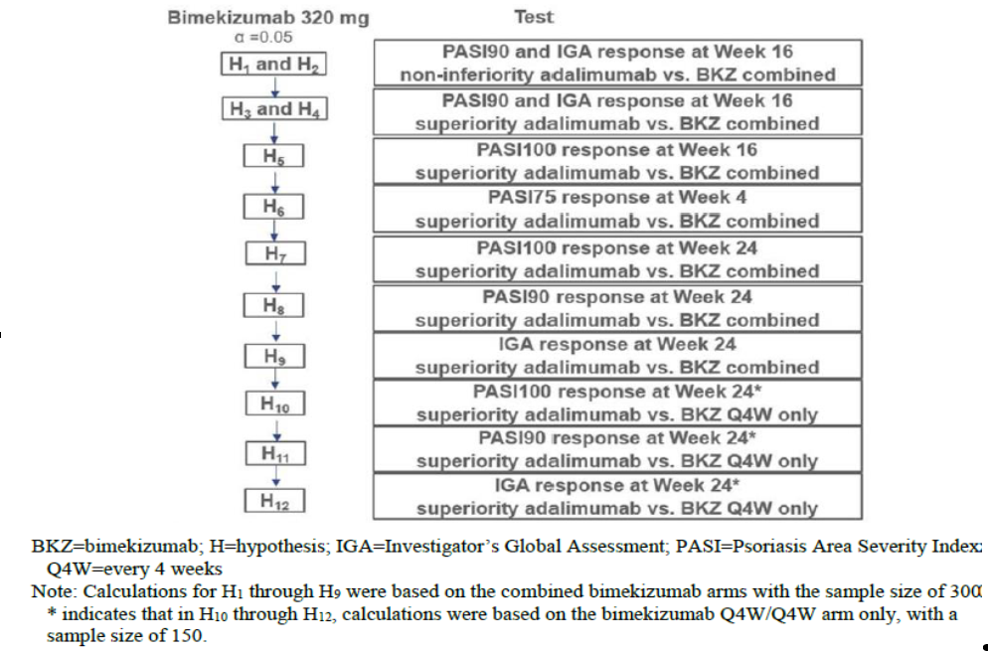
The co-primary efficacy variables’ analyses for this study were based on the randomised set.
The primary efficacy analysis was based on the stratified Cochran-Mantel-Haenszel (CMH) test, where region and prior biologic exposure (yes/no) were used as stratification variables. The odds ratio and associated CI based on the Wald test were presented.
Non-responder imputation was used to account for missing data in the primary analysis. Specifically, any study participant who withdrew from IMP prior to Week 16 or who had missing data for the co-primary efficacy variables at the Week 16 time point, was considered as a non-responder.
The clinical evaluator commented that the statistical method is adequate and follows intention to treat principles.

Baseline demographic characteristics
The age range across the study participants was 18 to younger than 85 years, with a mean ± standard deviation (SD) of 44.9 ± 13.6. There were more males 328 (68.6%) than females 150 (31.4%), as per Table 15. There were also more Caucasian subjects (421 (88.1%)) than subjects of all other races (11.9%) (Table 15).
Table 15: Study PS0008 Subject demographics
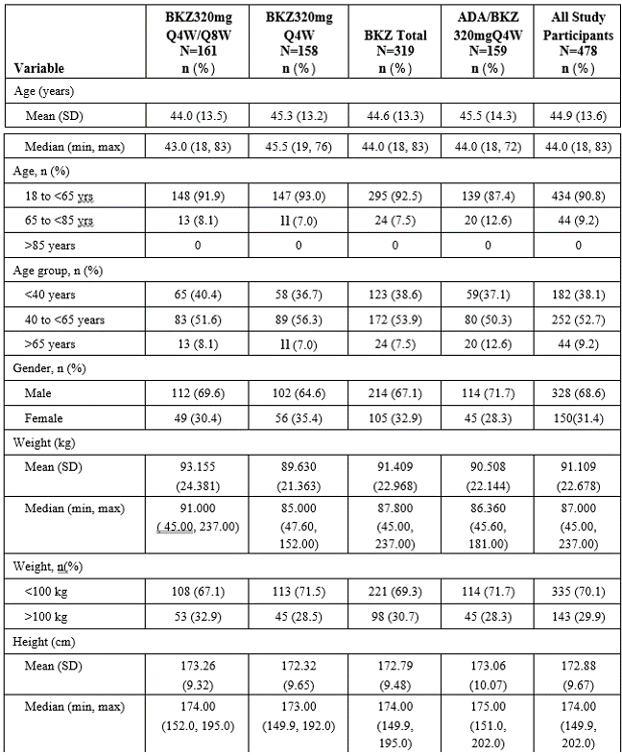
Abbreviations: ADA = adalimumab; BKZ = bimekizumab; BMI = body mass index; EudraCT = European Union Drug Regulating Authorities Clinical Trials; max = maximum; min = minimum; Q4W = every 4 weeks; Q8W = every 8 weeks; SD = standard deviation; SS = Safety Set
Note: Study participants were summarized according to randomised treatment at Baseline in the Initial Treatment Period.
Note: No study participants were younger than 18 years at time of informed consent.
a EudraCT age categories
The TGA’s clinical evaluation noted that patient demographics were balanced across treatment groups.
Table 16: Study PS0008 Baseline disease characteristics
Variable |  |  | BKZ 320 mg  every 4 weeks/every 8 weeks  N = 161  n (%) | BKZ 320 mg  every 4 weeks  N = 158  n (%) |  | BKZ Total  N = 319  n (%) |  |  | ADA/BKZ  320 mg every 4 weeks  N = 159  n (%) |  | All Study  Participant  N = 478  n (%)
Body surface area (%)
n |  |  | 161 | 158 |  | 319 |  |  | 159 |  | 478
Mean (SD) |  |  | 25.2 (12.4) | 26.5 (15.9) |  | 25.9 (14.2) |  |  | 25.0 (14.4) |  | 25.6 (14.3)
Median |  |  | 22.0 | 20.0 |  | 20.0 |  |  | 20.0 |  | 20.0
Min, max |  |  | 10, 80 | 10, 81 |  | 10, 81 |  |  | 10, 76 |  | 10, 81
PASI score
n |  |  | 161 | 158 |  | 319 |  |  | 159 |  | 478
Mean (SD) |  |  | 19.93 (6.08) | 20.46 (6.93) |  | 20.19 (6.51) |  |  | 19.05 (5.94) |  | 19.81 (6.34)
Median |  |  | 19.00 | 18.10 |  | 18.50 |  |  | 17.40 |  | 18.00
Min, max |  |  | 12.0, 42.6 | 12.0, 44.1 |  | 12.0, 44.1 |  |  | 12.0, 38.0 |  | 12.0, 44.1
mNPASI total score ª
n |  |  | 90 | 91 |  | 181 |  |  | 95 |  | 276
Mean (SD) |  |  | 20.3 (19.9) | 23.7 (23.7) |  | 22.0 (21.9) |  |  | 18.3 (18.1) |  | 20.7 (20.7)
Median |  |  | 12.5 | 17.0 |  | 14.0 |  |  | 13.0 |  | 13.0
Min, max |  |  | 1, 100 | 1, 128 |  | 1, 128 |  |  | 1, 91 |  | 1, 128
PGADA score ^{b}
n |  |  | 161 | 158 |  | 319 |  |  | 159 |  | 478
Mean (SD) |  |  | 24.7 (27.9) | 24.6 (28.4) |  | 24.7 (28.1) |  |  | 27.6 (30.4) |  | 25.6 (28.9)
Median |  |  | 11.0 | 13.0 |  | 11.0 |  |  | 14.0 |  | 12.5
Min, max |  |  | 0, 100 | 0, 100 |  | 0, 100 |  |  | 0, 100 |  | 0, 100
DLQI total score
n |  |  | 161 | 158 |  | 319 |  |  | 159 |  | 478
Mean (SD) |  |  | 10.8 (6.2) | 11.1 (6.5) |  | 10.9 (6.3) |  |  | 10.5 (7.4) |  | 10.8 (6.7)
Median |  |  | 10.0 | 10.0 |  | 10.0 |  |  | 9.0 |  | 10.0
Min, max |  |  | 0,28 | 1, 29 |  | 0,29 |  |  | 0,30 |  | 0,30
 | Duration of disease (years)
 | n | 161 |  |  | 158 |  | 319 | 159 |  | 478
 | Mean (SD) | 17.300 |  |  | 20.372 |  | 18.821 | 16.159 |  | 17.936
 | Mean (SD) | (10.862) |  |  | (13.247) |  | (12.180) | (11.942) |  | (12.154)
 | Median | 15.640 |  |  | 19.510 |  | 16.690 | 14.320 |  | 15.875
 | Min, max | 0.57, 53.53 |  |  | 0.45, 56.70 |  | 0.45, 56.70 | 0.57, 56.55 |  | 0.45, 56.70
 | Duration of disease, n (%)
 | median years | 84 (52.2) |  |  | 68 (43.0) |  | 152 (47.6) | 87 (54.7) |  | 239 (50.0)
 | median years | 77 (47.8) |  |  | 90 (57.0) |  | 167 (52.4) | 72 (45.3) |  | 239 (50.0)
 | IGA score, n (%)
 | 3 (Moderate) | 111 (68.9) |  |  | 102 (64.6) |  | 213 (66.8) | 114 (71.7) |  | 327 (68.4)
 | 4 (Severe) | 50 (31.1) |  |  | 56 (35.4) |  | 106 (33.2) | 45 (28.3) |  | 151 (31.6)
Abbreviations: ADA = adalimumab; BKZ = bimekizumab; BSA = body surface area affected by psoriasis; DLQI = Dermatology Life Quality Index; IGA = Investigator's Global Assessment; max = maximum; min = minimum; mNAPSI = Modified Nail Psoriasis Severity Index; pp-IGA = palmoplantar Investigator’s Global Assessment; PASI = Psoriasis Area and Severity Index; PGADA = Patient’s Global Assessment of Disease Activity; PSD = Patient Symptom Diary; PSO = psoriasis; Q4W = every 4 weeks;
Q8W = every 8 weeks; SD = standard deviation; SS = Safety Set; TNF = tumour necrosis factor
Note: Study participants were summarized according to randomised treatment at Baseline in the Initial Treatment Period.
Note: Duration of disease (years) = (Date of randomization – date of onset of plaque PSO)/365.25.
Note: Baseline nail, scalp, and palmoplantar involvement were based on the number of study participants achieving mNAPSI > 0, Scalp IGA > 0, and pp-IGA > 0, respectively.
Note: For PSD, in cases where there was > 1 diary record completed on a particular day, all available records within the 7-day window (including any double entries on one day) were used in the calculation of weekly average scores. If this resulted in having >7 available scores to calculate the weekly average, the 7 records closest to the visit were used.
a mNAPSI total score for study participants with nail involvement (that is mNAPSI > 0) at Baseline.
b PGADA for arthritis visual analogue scale score.
The TGA’s clinical evaluation notedthat the population studied is representative of patients with moderate to severe plaque psoriasis. The mean PASI and IGA scores were balanced across treatment groups (see Table 16). The mean duration of disease was higher in the bimekizumab group versus adalimumab group; however, this should not have a bearing on overall treatment outcomes. Minor differences exist in baseline disease characteristics for the co-primary/secondary outcomes, with disease severity generally being slightly greater in the bimekizumab group versus the adalimumab group. The population studied is representative of patients with moderate to severe plaque psoriasis. The mean PASI and IGA scores were balanced across treatment groups. The mean duration of disease was higher in the bimekizumab group versus adalimumab group; however, this should not have a bearing on overall treatment outcomes.
The Delegate reiterated that the definition of plaque psoriasis severity scale is that a mild case is a PASI score of less than 7 and DLQI score of less than 7; while moderate case is PASI score of 7 to 15 and DLQI score of 5 to 15 (classified as severe when difficult to treat sites are affected or when there is a significant psychosocial impact) and severe case is a PASI score of greater than 15, independently of the DLQI score. The above minor baseline differences should not significantly contribute to the overall assessment of efficacy outcome for both bimekizumab and adalimumab.

Baseline therapies
The use of any prior medications was generally similar between the bimekizumab total group (77.4%) and the adalimumab/bimekizumab 320 mg every 4 weeks group (81.1 %). The notable differences include:
- The incidence of prior corticosteroids use was slightly lower in the bimekizumab total group (19.4%) compared with the adalimumab/bimekizumab 320 mg every 4 weeks group (23.3%).
- The incidence of prior blood glucose lowering drugs (excluding insulins) use was lower in the bimekizumab total group (8.2%) compared with the adalimumab/bimekizumab 320 mg every 4 weeks group (12.6%).
- The incidence of prior emollients and protectives use was slightly higher in the bimekizumab total group (5.6%) compared with the adalimumab/bimekizumab 320 mg.
The use of any past psoriasis medications and biological treatment was generally similar between the bimekizumab total group (99.4%) and the adalimumab/bimekizumab 320 mg every 4 weeks group (96.9%) every 4 weeks group (3.1%).
The proportion of study participants who received past anti-IL 17 treatment was similar in the bimekizumab total group (21.9%) and the adalimumab/bimekizumab 320 mg every 4 weeks group (22.0%).
The incidence of prior nonbiologic systemic agent use was higher in the bimekizumab total group (50.2%) compared with the adalimumab/bimekizumab 320 mg every 4 weeks group (43.4%).

Co-primary endpoint outcome
For the co-primary endpoint of PASI 90 response rate at Week 16, as per Table 17:
- the bimekizumab total group was superior compared with the adalimumab group (86.2% versus 47.2%, respectively);
- this difference was statistically significant, with an odds ratio versus adalimumab of 7.459 (95% CI: 4.709, 11.816; p < 0.001).

Table 17: Study PS0008 PASl 90 response at Week 16
 | BKZ total  N = 319 | ADA  N = 159
PASI 90 response rate
n (%) | 275 (86.2) | 75 (47.2)
n/Nsub (%) | 275/303 (90.8) | 75/148 (50.7)
Odds ratio versus ADA a | 7.459 | -
95% CI for odds ratio | 4.709, 11.816 | -
p-value b | <0.001 | -
Risk difference c | 39.3 | -
95% CI for risk difference | 30.9, 47.7 | -
ADA = adalimumab; BKZ = bimekizumab; CI = Confidence Interval; CMH = Cochran-Mantel-Haenszel; NRI = nonresponder imputation; OC = observed case; PASI = Psoriasis Area and Severity Index; RS = Randomized Set
Note: In the n (%) row, study participants with missing data at a given week were counted as nonresponders (NRI).
Note: In the n/Nsub (%) row, Nsub represented the number of study participants with a nonmissing measurement for PASI at the given week, and percentages were calculated accordingly (OC).
Note: The evaluation of noninferiority was tested at a 1-sided alpha level of 0.025 and based on a 1-sided 97.5% CI and a noninferiority margin of 10%.
a Odds ratio for BKZ/ADA was calculated using stratified CMH test with region and prior biologic exposure as stratification variables.
b P-values for the comparison of treatment groups were based on the CMH test from the general association.
c Risk difference for BKZ/ADA was calculated using stratified CMH.
For the co-primary endpoint of Investigator’s Global Assessment 0/1 [IGA 0/1] response rate at Week 16, as per Table 18:
- the BKZ total group was superior compared with the adalimumab group (85.3% versus 57.2%, respectively);
- this difference was statistically significant with an odds ratio versus adalimumab of 4.341 (95% CI: 2.785, 6.765; p<0.001).

Table 18: Study PS0008 IGA 0/1 response rates at Week 16
 | BKZ total  N = 319 | ADA  N = 159
IGA 0/1 response rate
n (%) | 272 (85.3) | 91 (57.2)
n/Nsub (%) | 272/303 (89.8) | 91/148 (61.5)
Odds ratio versus ADA a | 4.341 | -
95% CI for odds ratio | 2.785, 6.765 | -
p-value b | <0.001 | -
Risk difference c | 28.2 | -
95% CI for risk difference | 19.7, 36.7 | -
Abbreviations: ADA = adalimumab; BKZ = bimekizumab; CI = Confidence Interval; CMH = Cochran-Mantel-Haenszel; IGA = Investigator’s Global Assessment; NRI = nonresponder imputation; OC = observed case; RS = Randomized Set
Note: In the n (%) row, study participants with missing data at a given week were counted as nonresponders (NRI).
Note: In the n/Nsub (%) row, Nsub represented the number of study participants with a nonmissing measurement for IGA at the given week, and percentages were calculated accordingly (OC).
Note: The evaluation of noninferiority was tested at a 1-sided alpha level of 0.025 and based on a 1-sided 97.5% CI and a noninferiority margin of 10%.
a Odds ratio for BKZ/ADA was calculated using stratified CMH test with region and prior biologic exposure as stratification variables.
b P-values for the comparison of treatment groups were based on the CMH test from the general association.
c Risk difference for BKZ/ADA was calculated using stratified CMH.

Secondary endpoints outcome
For the PASI 100 response at Week 16 and Week 24, as per Table 19.
- the bimekizumab total group had a higher PASI 100 response rate compared with the adalimumab group at Week 16 (60.8% versus 23.9%, respectively; p < 0.001) and Week 24 (66.8% versus 29.6%, respectively; p < 0.001), a difference that was statistically significant at both time points;
- In addition, the bimekizumab 320 mg every 4 weeks group demonstrated a statistically significant superior PASI 100 response rate compared to the adalimumab group at Week 24 (67.7% versus 29.6%, respectively; p < 0.001).

Table 19: Study PS0008 PASI 100 response rates at Week 16 and Week 24
Visit | BKZ320 mg  every 4 weeks/every 8 weeks  N = 161 | BKZ320 mg  every 4 weeks  N = 158 | BKZ Total  N = 319 | ADA  N = 159
Week 16
PASI 100 response rate
n (%) | - | - | 194 (60.8) | 38 (23.9)
n/Nsub (%) | - | - | 194/303 (64.0) | 38/148 (25.7)
Odds ratio versus ADA a | - | - | 4.974 | -
95% CI for odds ratio | - | - | 3.230, 7.661 | -
p-value b | - | - | <0.001 | -
Week 24
PASI 100 response rate
n (%) | 106 (65.8) | 107 (67.7) | 213 (66.8) | 47 (29.6)
n/Nsub (%) | 106/149 (71.1) | 107/149 (71.8) | 213/298 (71.5) | 47/147 (32.0)
Odds ratio versus ADA a | 4.689 | 5.249 | 4.974 | -
95% CI for odds ratio | 2.904, 7.573 | 3.207, 8.593 | 3.257, 7.594 | -
p-value b | <0.001 C | <0.001 | <0.001 | -
Abbreviations: ADA = adalimumab; BKZ = bimekizumab; CI = confidence interval; CMH = Cochran-Mantel-Haenszel; NRI = nonresponder imputation; OC = observed case; PASI = Psoriasis Area and Severity Index; Q4W = every 4 weeks; Q8W = every 8 weeks; RS = Randomised Set
Note: In the n (%) row, study participants with missing data at a given week were counted as nonresponders (NRI).
Note: In the n/Nsub (%) row, Nsub represented the number of study participants with a nonmissing measurement for PASI at the given week, and percentages were calculated accordingly (OC).
a Odds ratio for BKZ/ADA was calculated using stratified CMH test with region and prior biologic exposure as stratification variables.
b P-values for the comparison of treatment groups were based on the CMH test from the general association.
c Nominal p-value
For the PASl 75 response rate at Week 4, as per Table 20:
- the bimekizumab total group had a higher PASI 75 response rate compared with the
- adalimumab group at Week 4 after only a single dose of bimekizumab (76.5% versus 31.4%, respectively; p<0.001), which was a statistically significant difference.

Table 20: Study PS0008 PASI 75 response at Week 4
 | BKZ Total | ADA
 | N = 319 | N = 159
\PASI75 response rate
n (%) | 244 (76.5) | 50 (31.4)
n/Nsub (%) | 244/309 (79.0) | 50/152 (32.9)
Odds ratio versus ADA a | 7.103 | -
95% CI for odds ratio | 4.637, 10.880 | -
p-value b | <0.001 | -
Abbreviations: ADA = adalimumab; BKZ = bimekizumab; CI = confidence interval; CMH = Cochran-Mantel-Haenszel; NRI = nonresponder imputation; OC = observed case; PASI = Psoriasis Area and Severity Index; RS = Randomised Set
Note: In the n (%) row, study participants with missing data at a given week were counted as nonresponders (NRI).
Note: In the n/Nsub (%) row, Nsub represented the number of study participants with a nonmissing measurement for PASI at the given week, and percentages were calculated accordingly (OC).
a Odds ratio for BKZ/ADA was calculated using stratified CMH test with region and prior biologic exposure as stratification variables.
b P-values for the comparison of treatment groups were based on the CMH test from the general association.
For the PASl 90 response rate at Week 24 and Week 56, as per Table 21:
- the BKZ total group had a higher PASI 90 response rate compared with the adalimumab group at Week 24 (85.6% versus 51.6%, respectively, p < 0.001), which was a statistically significant difference;
- for the bimekizumab total group, the PASI 90 response rate observed at Week 24 was sustained through Week 56 (83. 7%);
- in addition, the bimekizumab 320 mg every 4 weeks group demonstrated a statistically significant and superior PASI 90 response rate compared to the adalimumab group at Week 24 (86.1 % versus 51.6%, respectively, p < 0.001);
- the PASI 90 response rate observed at Week 56 was similar for the bimekizumab 320 mg every 4 weeks group (84.8%) and the bimekizumab 320 mg every 4 weeks/every 8 weeks group (82.6%).

Table 21: Study PS0008 PASI90 response rates at Week 24
 | BKZ320 mg  every 4 weeks/every 8 weeks  N = 161 | BKZ320 mg  every 4 weeks  N = 158 | BKZ Total  N = 319 | ADA  N = 159
PASI90 response rate
n (%) | 137 (85.1) | 136 (86.1) | 273 (85.6) | 82 (51.6)
n/Nsub (%) | 137/149 (91.9) | 136/149 (91.3) | 273/298 (91.6) | 82/147 (55.8)
Odds ratio versus ADA a | 5.284 | 6.231 | 5.750 | -
95% CI for odds ratio | 3.084, 9.054 | 3.515, 11.046 | 3.657, 9.041 | -
p-value b | <0.001 C | <0.001 | <0.001 | -
ADA = adalimumab; BKZ = bimekizumab; CI = confidence interval; CMH = Cochran-Mantel-Haenszel; NRI = nonresponder imputation; OC = observed case; PASI = Psoriasis Area and Severity Index; Q4W = every 4 weeks; Q8W = every 8 weeks; RS = Randomised Set
Note: In the n (%) row, study participants with missing data at a given week were counted as nonresponders (NRI).
Note: In the n/Nsub (%) row, Nsub represented the number of study participants with a nonmissing measurement for PASI at the given week, and percentages were calculated accordingly (OC).
a Odds ratio for BKZ/ADA was calculated using stratified CMH test with region and prior biologic exposure as stratification variables.
b P-values for the comparison of treatment groups were based on the CMH test from the general association.
c Nominal p-value
For the IGA 0/1 response rates at Week 24 and Week 56, as per Table 22 and Table 23:
- the bimekizumab total group had a higher IGA 0/1 response rate compared with the adalimumab group at Week 24 (86.5% versus 57.9%, respectively; p < 0.001), which was a statistically significant difference;
- for the bimekizumab total group, the IGA 0/1 response rate observed at Week 24 was sustained through Week 56 (82.8%);
- in addition, the bimekizumab 320 mg every 4 weeks group demonstrated a statistically significant superior IGA 0/1 response rate compared to the adalimumab group at Week 24 (86.1 % versus 57.9%, respectively; p < 0.001);
- The IGA 0/1 response rate observed at Week 56 was similar for the bimekizumab 320 mg every 4 weeks group (82.3%) and the bimekizumab 320 mg every 4 weeks/every 8 weeks group (83.2%).

Table 22: Study PS0008 IGA 0/1 response rates at Week 24
 | BKZ 320 mg  every 4 weeks/every 8 weeks  N = 161 | BKZ 320 mg  every 4 weeks  N = 158 | BKZ Total  N = 319 | ADA  N = 159
IGA 0/1 response rate
n (%) | 140 (87.0) | 136 (86.1) | 276 (86.5) | 92 (57.9)
n/Nsub (%) | 140/149 (94.0) | 136/149 (91.3) | 276/298 (92.6) | 92/147 (62.6)
Odds ratio versus ADA a | 4.779 | 4.724 | 4.762 | -
95% CI for odds ratio | 2.737, 8.345 | 2.683, 8.318 | 3.014, 7.523 | -
p-value b | < 0.001 C | < 0.001 | < 0.001 | -
Abbreviations: ADA = adalimumab; BKZ = bimekizumab; CI = confidence interval; CMH = Cochran-Mantel-Haenszel; IGA = Investigator’s Global Assessment; NRI = nonresponder imputation; OC = observed case; Q4W = every 4 weeks; Q8W = every 8 weeks; RS = Randomised Set
Note: In the n (%) row, study participants with missing data at a given week were counted as nonresponders (NRI).
Note In the n/Nsub (%) row, Nsub represented the number of study participants with a nonmissing measurement for IGA at the given week, and percentages were calculated accordingly (OC).
a Odds ratio for BKZ/ADA was calculated using stratified CMH test with region and prior biologic exposure as stratification variables.
b P-values for the comparison of treatment groups were based on the CMH test from the general association.
c Nominal p-value
Table 23: Study PS0008 IGA 0/1 response rates at Week 56
 | BKZ320 mg  every 4 weeks/every 8 weeks  N = 161 | BKZ320 mg  every 4 weeks  N = 158 | BKZ Total  N = 319
IGA 0/1 response rate
n (%) | 134 (83.2) | 130 (82.3) | 264 (82.8)
n/Nsub (%) | 134/143 (93.7) | 130/140 (92.9) | 264/283 (93.3)

Subgroup analyses
Subgroup analyses were conducted for PASI 90 response, IGA 0/1 response, and PASI 100 response rates across the following subgroups:
- age (younger than 40 years, 40 to younger 65 years, greater or equal to 65 years);
- gender (male, female); duration of disease (younger than median (15.88) years, greater or equal to median (15.88) years);
- geographic region (North America, Western Europe, Central/Eastern Europe, Asia/Australia);
- body weight (less or equal to 100kg, greater than 100kg), BMI (less than 25 kg/m², greater or equal to 25 to less than 30 kg/m², greater or equal to 30 kg/m²);
- prior systemic phototherapy or chemo-phototherapy (yes, no);
- prior biological exposure (yes, no);
- prior systemic therapy (yes, no);
- baseline PASI score less than 20, greater or equal to 20).
All analyses demonstrated a difference in PASI 90, PASI 100 and IGA 0/1 response rates in the bimekizumab groups compared with the adalimumab group at Week 16 and Week 24;
The PASI 90, PASI100, and IGA 0/1 response rates through Week 56 were generally similar across all subgroups for the bimekizumab 320 mg every 4 weeks group and the bimekizumab 320 mg every 4 weeks/every 8 weeks group.
The TGA’s clinical evaluation noted that the co-primary endpoint was relevant for patients with moderate to severe plaque psoriasis and, consistent with adopted guidelines;30
- Treatment with bimekizumab resulted in a statistically and clinically significant reduction in the disease burden of psoriasis as measured by PASI and IGA versus patients treated with adalimumab;
- The reduction was evident four weeks after treatment and, was sustained through 56 weeks of treatment;
- There was little difference in response rate for patients that received bimekizumab every 4 weeks versus those that received bimekizumab every 8 weeks following the first 16 weeks of treatment;
- Importantly, adalimumab is approved in Australia for the treatment of moderate to severe plaque psoriasis and, an appropriate dose regimen was used in this study.
The Delegate contended that the adalimumab dose used in the trial was suboptimal for the purpose of determining bimekizumab superiority over adalimumab.

Study PS0009
Study PS0009 is a Phase III, randomised, double blind, parallel group, active comparator controlled multicentre study to evaluate the efficacy and safety of bimekizumab in adults with moderate to severe plaque psoriasis.

Study design
The study design, as depicted schematically below, consisted of four periods:
- One week screening period;
- 16 weeks initial treatment period;
- 36 weeks maintenance treatment period;
- 20 weeks safety follow up period.
Figure 17: Study PS0009 Schematic diagram
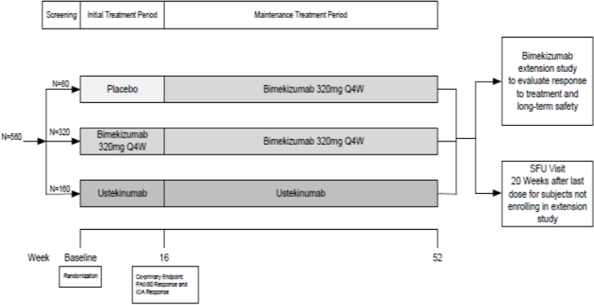
The primary objective is to evaluate the efficacy and safety of bimekizumab in adults with moderate to severe plaque psoriasis.
Main inclusion criteria include study participants must have been adults with a diagnosis of moderate to severe psoriasis (Baseline PASI greater or equal to 12 and body surface area affected by psoriasis greater or equal to 10% and IGA score greater or equal to 3 who were candidates for systemic psoriasis therapy and/or phototherapy.
Exclusion criteria were identical to those for Study PS0008 apart from study participant had a known hypersensitivity to any excipients of bimekizumab or ustekinumab.
The TGA’s clinical evaluation noted that the requirement of a PASI of greater or equal to 12, IGA of greater or equal to 3 and a total body surface area of greater or equal to 10% reflects published guidelines, as adopted by the TGA.³⁷

Study treatments and schedule
Eligible study participants were randomised 4:2:1 ratio to receive the following, in a blinded fashion:
- bimekizumab 320 mg once every 4 weeks throughout the study for 52 weeks (N = 320) was designated by the Delegate as Group A (and discussed as such in this AusPAR);
- ustekinumab throughout 52 weeks (N = 160) was designated by the Delegate as Group B; or
- Placebo for 16 weeks, then bimekizumab for 36 weeks (N = 80) designated by the Delegate as Group C.
As per the schematic diagram and randomisation grouping above and, in order to maintain blinding because of differences in the dosing schedule between bimekizumab (once every 4 weeks) and ustekinumab (once every 4 weeks, then once every 12 week). ustekinumab dosing is also based on weight, the dosing schedule for the initial treatment period was:
Group A:
- Study participants randomised to receive bimekizumab 320 mg every 4 weeks received two bimekizumab 160 mg injections subcutaneously at Weeks 0 (Baseline), 4, 8, 12 and 16.
Group B:
- only received one ustekinumab 45 mg injection subcutaneously + one placebo injection subcutaneously at Weeks 0, 4, 16 for participants less than 100 kg;
- received two placebo injections each at Weeks 8, 12 for participants less than 100 kg;
- only received two ustekinumab 45 mg injections subcutaneously at Weeks 0, 4, 16 for participants greater than 100 kg;
- received two placebo injections subcutaneously at Weeks 8, 12 for participants greater 100 kg.
Group C:
- Study participants randomised to receive placebo received two placebo injections subcutaneously every 4 weeks from Baseline (Week 0) for 16 weeks that is Weeks 4, 8, 12 and 16.
The dosing schedule for the maintenance treatment period was:
Group A:
- received two bimekizumab 160 mg injections subcutaneously every 4 weeks at Weeks 20, 24, 28, 32, 36, 40, 44, 48 and 52
Group B:
- only received one ustekinumab 45 mg injection subcutaneously + one placebo injection subcutaneously every 12 weeks after Week 16 dose (that is Weeks 28, 40 and 52) for participants less than 100 kg;
- received two placebo injections subcutaneously on Weeks 20, 24, 32, 36, 44, and 48 for participants less than 100 kg;
- only received two ustekinumab 45 mg injections subcutaneously every 12 weeks after Week 16 dose (that is Weeks 28, 40, 52) for participants greater than 100 kg;
- received two placebo injections subcutaneously on Weeks 20, 24, 32, 36, 44, and 48 for participants greater than 100 kg;
Group C:
- Study participants who initially received placebo up to 16weeks, transferred to bimekizumab 320 mg every 4 weeks at two bimekizumab 160 mg injections subcutaneously (Weeks 20, 24, 28, 32, 36, 40, 44, 48 and 52).
The TGA’s clinical evaluation noted that this is an active comparator study that complies with relevant guidelines. Ustekinumab is a human monoclonal antibody that inhibits the activity of the cytokines, IL-12 and IL‑23 that is indicated for the treatment of adult patients (18 years or older) with moderate to severe plaque psoriasis who are candidates for phototherapy or systemic therapy (amongst other indications) and is an acceptable active comparator.

Endpoints
The primary endpoints for Study PS0009 include:
- PASI 90 response at Week 16; and
- IGA 0/1 response at Week 16.
Secondary endpoints include:
- PASI 100 response at Week 16;
- IGA response (Clear [0] with at least a two category improvement relative to Baseline) at Week 16;
- PASI 75 response at Week 4;
- PSD responses for pain, itch, and scaling at Week 16;
- Scalp IGA response (clear [0] or almost clear [1]) at Week 16 for study participants with scalp psoriasis at Baseline;
- PASI 90 response at Week 12 and 52;
- IGA response (clear [0] or almost clear [1] with at least a two category improvement relative to Baseline) at Week 12 and 52.
The TGA’s clinical evaluation noted that the main efficacy endpoints in this study were appropriate and complied with relevant regulatory guidelines.

Subject disposition
Table 24: Study PS0009 Disposition and discontinuation reasons, initial treatment period
Disposition | Placebo  N = 83  n (%) | BKZ320 mg  every 4 weeks  N = 321  n (%) | Uste  N = 163  n (%) | All Study  participants  N = 567  n (%)
Started initial treatment period | 83 (100) | 321 (100) | 163 (100) | 567 (100)
Completed initial treatment period | 74 (89.2) | 306 (95.3) | 157 (96.3) | 537 (94.7)
Discontinued initial treatment period | 9 (10.8) | 15 (4.7) | 6 (3.7) | 30 (5.3)
Primary reason for discontinuation
AE | 6 (7.2) | 6 (1.9) | 3 (1.8) | 15 (2.6)
Lack of efficacy | 2 (2.4) | 1 (0.3) | 0 | 3 (0.5)
Protocol violation | 0 | 0 | 2 (1.2) | 2 (0.4)
Lost to follow up | 0 | 3 (0.9) | 0 | 3 (0.5)
Consent withdrawn | 1 (1.2) | 2 (0.6) | 1 (0.6) | 4 (0.7)
Other | 0 | 3 (0.9) | 0 | 3 (0.5)
Abbreviations: BKZ = bimekizumab; initial treatment period = initial treatment period; PBO = placebo; Q4W = every 4 weeks; Uste = ustekinumab.
A total of 735 study participants signed the informed consent form and were screened for the study (Table 24).
168 of the 735 participants were screen failures, the most common reason for being a screen failure was ineligibility (151 study participants).
A total of 567 study participants were randomised and started the initial treatment period as follows:
- 321 study participants in the bimekizumab 320 mg once every 4 weeks group,
- 163 study participants in the ustekinumab group,
- 83 study participants in the placebo group.
Overall, the percentages of study participants who completed the initial treatment period were higher in the bimekizumab 320 mg once every 4 weeks group (95.3%) and ustekinumab (96.3%) groups compared with the placebo group (89 .2%).
The frequency of study discontinuation during the initial treatment period was low across the treatment groups.

Table 25: Study PS0009 Disposition and discontinuation reasons, maintenance treatment period
Disposition | PBO/BKZ  320 mgevery 4 weeks  N = 74  n (%) | BKZ320 mg  every 4 weeks  N = 306  n (%) | Uste  N = 157  n (%) | All Study  participants  N = 537  n (%)
Started MTP | 74 (100) | 306 (100) | 157 (100) | 537 (100)
Completed MTP | 69 (93.2) | 283 (92.5) | 141 (89.8) | 493 (91.8)
Discontinued study MTP | 5 (6.8) | 23 (7.5) | 16 (10.2) | 44 (8.2)
Primary reason for discontinuation
AE | 3 (4.1) | 12 (3.9) | 4 (2.5) | 19 (3.5)
Lack of efficacy | 0 | 1 (0.3) | 4 (2.5) | 5 (0.9)
Protocol violation | 1 (1.4) | 1 (0.3) | 0 | 2 (0.4)
Lost to follow up | 0 | 4 (1.3) | 3 (1.9) | 7 (1.3)
Consent withdrawn | 1 (1.4) | 4 (1.3) | 4 (2.5) | 9 (1.7)
Other | 0 | 1 (0.3) | 1 (0.6) | 2 (0.4)
Abbreviations: BKZ = bimekizumab; PBO = placebo; MTP = maintenance treatment period Q4W = every 4 weeks; Uste = ustekinumab
A total of 537 study participants started the maintenance treatment period as follows (see Table 25):
- 306 study participants in the bimekizumab 320 mg every 4 weeks group;
- 157 study participants in the ustekinumab group;
- 74 study participants in the placebo/bimekizumab 320 mg every 4 weeks group.
Overall, the percentages of study participants who completed the study were high and similar in the bimekizumab 320 mg every 4 weeks group (92.5%), the ustekinumab (89.8%) group, and the placebo/bimekizumab 320 mg every 4 weeks group (93.2%).
The frequency of study discontinuation during the maintenance treatment period was low and similar across the treatment groups. The most frequently reported primary reason for study discontinuation during the maintenance treatment period was due to an AE in 19 study participants (3.5%) including 12 study participants (3.9%) in the bimekizumab 320 mg every 4 weeks group, four study participants (2.5%) in the ustekinumab group, and three study participants (4.1 %) in the placebo/bimekizumab 320 mg every 4 weeks group.

Analysis of populations
The following analysis sets were used:
- The enrolled set consisted of all study participants who gave informed consent;
- The randomised set consisted of all randomised study participants;
- The safety set consisted of all study participants who received at least one dose of study medication;
- The full analysis set consisted of all randomised study participants who received at least one dose of study medication and had a valid measurement for each of the co-primary efficacy variables at Baseline;
- The active medication set consisted of all study participants who had received at least one dose of active IMP (bimekizumab or ustekinumab). The active medication set was used for summaries of safety that included all data from the initial treatment period and/or maintenance treatment period;
- The bimekizumab set consisted of all study participants who received at least one dose of bimekizumab in this study;
- The bimekizumab Week 24 Set consisted of all study participants who received at least one dose of bimekizumab on or after Week 24;
- The maintenance set consisted of all study participants who received at least one dose of active investigational intervention (bimekizumab or ustekinumab) in the maintenance treatment period (at Week 16 or later);
- The per protocol set consisted of all study participants in the randomised set who had no important protocol deviations affecting the primary efficacy variables. Important protocol deviations were predefined, and study participants with important protocol deviations were evaluated during ongoing data cleaning meetings prior to unblinding of the data.
Table 26:Study PS0009 Study populations
 | PBO/ BKZ 320 mg  every 4 weeks  N = 83  n (%) | BKZ 320 mg every 4 weeks  N = 321  n (%) |  | All Study
 | PBO/ BKZ 320 mg  every 4 weeks  N = 83  n (%) | BKZ 320 mg every 4 weeks  N = 321  n (%) | Uste | participants
 | PBO/ BKZ 320 mg  every 4 weeks  N = 83  n (%) | BKZ 320 mg every 4 weeks  N = 321  n (%) | N = 163 | N = 567
Analysis set | PBO/ BKZ 320 mg  every 4 weeks  N = 83  n (%) | BKZ 320 mg every 4 weeks  N = 321  n (%) | n (%) | n (%)
Randomised set | 83 (100) | 321 (100) | 163 (100) | 567 (100)
Safety set | 83 (100) | 321 (100) | 163 (100) | 567 (100)
Full analysis set | 83 (100) | 321 (100) | 162 (99.4) | 566 (99.8)
Active medication set | 74 (89.2) | 321 (100) | 163 (100) | 558 (98.4)
Maintenance set | 74 (89.2) | 306 (95.3) | 157 (96.3) | 537 (94.7)
Per protocol set | 81 (97.6) | 312 (97.2) | 159 (97.5) | 552 (97.4)
Pharmacokinetics per protocol set | 83 (100) | 321 (100) | 163 (100) | 567 (100)
AMS = Active Medication Set; BKZ = bimekizumab; FAS = Full Analysis Set; MS = Maintenance Set; PBO = placebo; PPS = Per-Protocol Set; PK- PPS = Pharmacokinetics Per-Protocol Set; Q4W = every 4 weeks; RS = Randomised Set; SS = Safety Set; Uste = ustekinumab.

Sample size
The primary efficacy analysis was based on the comparison of bimekizumab to placebo for the co-primary efficacy variables of PASI 90 response and IGA 0/1 response at Week 16.
However, Week 16 comparisons of bimekizumab against ustekinumab for PASI 90 response and IGA 0/1 response were also part of a fixed sequence testing procedure to control for multiplicity. Therefore, this study was powered to show statistical superiority to ustekinumab, based on the co-primary endpoints.
The assumed response rates for PASI 90 at Week 16 were 75%, 58%, and 2% for bimekizumab, ustekinumab, and placebo, respectively. Additionally, the assumed response rates for IGA 0/1 were 85%, 68%, and 5% for bimekizumab, ustekinumab, and placebo, respectively. The assumed response rates for bimekizumab were based on the Phase IIb Study PS0010 data (see Study PS0010, above). The power to show statistical superiority of bimekizumab relative to placebo under these assumptions was greater than 99% for the co-primary endpoints.
The power to detect a statistically significant difference between bimekizumab and ustekinumab at a two sided significance level of 0.05 was 95% for PASI 90 response and 98% for IGA 0/1 response. Because both co-primary endpoints were highly powered independently, and because PASI and IGA response tend to be highly correlated, the overall power for achieving superiority on both co-primary endpoints was not calculated.
Note that the power for the non-inferiority testing between bimekizumab and ustekinumab for both PASI 90 and IGA 0/1 responses was greater than 99% based on a one sided significance level of 0.025 and a non-inferiority margin of 10%.

Statistical methods
The primary analysis was based on the stratified CMH test, where region and prior biologic exposure (yes/no) were used as stratification variables.
For the assessment of noninferiority, a noninferiority margin of 10% was used and evaluated based on the CI for the stratified CMH risk difference between bimekizumab and ustekinumab. A noninferiority margin of 10% has been selected, as this is considered to be a clinically relevant difference that could influence the choice of interventions used to treat chronic plaque psoriasis. Therefore, a difference within the 10% noninferiority margin would suggest a similar impact on efficacy between the treatments. The evaluation of superiority to placebo used pairwise treatment comparisons based on the CMH test using the P-value for the general association. The odds ratio and associated CI based on the Wald test was presented. If one of the treatment groups had 0 or very low response where CMH could no longer be used, the logit method was applied instead.
Non-responder imputation was used to account for missing data in the primary analysis. Specifically, any study participant who withdrew from treatment prior to Week 16 or who had missing data for the co-primary efficacy variables at the Week 16 time point was considered as a non-responder.

Baseline demographic characteristics
The age range across the study participants was from 18 to 84 years. There were more males (406 (71.6%)) than females (161 (28.4%)), as per Table 27.

Table 27: Study PS0009 Baseline demographic characteristics
Variable | PBO/BKZ 320 mg  every 4 weeks  N = 83  n (%) | BKZ320 mg  every 4 weeks  N = 321  n (%) | Uste  N = 163  n (%) | All Study  participants  N = 567  n (%)
Age, n (%)
18 to < 65 years | 73 (88.0) | 287 (89.4) | 145 (89.0) | 505 (89.1)
65 to < 85 years | 10 (12.0) | 34 (10.6) | 18(11.0) | 62 (10.9)
> 85 years | 0 | 0 | 0 | 0
Age group
< 40 years | 19 (22.9) | 123 (38.3) | 57 (35.0) | 199 (35.1)
40 to < 65 years | 54(65.1) | 164 (51.1) | 88 (54.0) | 306 (54.0)
> 65 years | 10 (12.0) | 34 (10.6) | 18(11.0) | 62 (10.9)
Gender, n (%)
Male | 60 (72.3) | 229 (71.3) | 117 (71.8) | 406 (71.6)
Female | 23 (27.7) | 92 (28.7) | 46 (28.2) | 161 (28.4)
Weight (kg)
Mean (SD) | 89.059 (26.402) | 88. 731 (23.059) | 87.244 (21.078) | 88.352 (23.006)
Median (min, max) | 83.400  (44.50, 179.60) | 87.300  (42.90, 217.90) | 86.300  (42.05, 142.43) | 86.400  (42.05, 217.90)
Weight, n (%)
< 100kg | 60 (72.3) | 226 (70.4) | 122 (74.8) | 408 (72.0)
> l00kg | 23 (27.7) | 95 (29.6) | 41 (25.2) | 159 (28.0)
Height (cm)
Mean (SD) | 171.58 (8.86) | 172.91 (9 .45) | 172.12 (10.57) | 172.49 (9. 70)
Median (min, max) | 171.90  (153.7, 194.0) | 172.70  (150.0, 202.0) | 172.70  (147.5, 196.0) | 172.70  (147.5, 202.0)
BMI (kg/m)
Mean (SD) | 30.01 (7.55) | 29.57 (7.00) | 29.35 (6.43) | 29.57 (6.92)
Median (min, max) | 28.27  (17.4, 52.8) | 28.50  (17.4, 72.6) | 28.36  (15.9, 47.8) | 28.37  (15.9, 72.6)
Abbreviations: BKZ = bimekizumab; BMI = body mass index; max = maximum; min = minimum; PBO = placebo; Q4W = every 4 weeks; RS = Randomised Set; SD = standard deviation; Uste = ustekinumab
There were also more Caucasian subjects (420 (74%)) than those of all other races (26%).
Overall, demographic characteristics were well balanced between treatment groups. The mean body weight and mean BMI were 88.35 kg and 29.57 kg/m², respectively. The incidence of study participants who weighed more than 100 kg was 29.6% in the bimekizumab 320 mg every 4 weeks group, 27.7% in the placebo group, and 25.2% in the ustekinumab group.

Baseline disease characteristics
Table 28 summarises the disease characteristics of the randomised populations in Study PS0009.
Table 28: Study PS0009 Baseline disease characteristics
Variable | PBO/BKZ 320 mg  every 4 weeks  N = 83  n (%) |  | BKZ 320 mg every 4 weeks  N = 321 | Uste  N = 163 | All Study  participants  N = 567
BSA (%)
Mean (SD) | 27.0 (16.3) |  | 29.0 (17.1) | 27.3 (16.7) | 28.2 (16.9)
Median | 21.0 |  | 23.0 | 22.0 | 22.0
Min, max | 11, 84 |  | 10, 88 | 10, 97 | 10, 97
PASI score
Mean (SD) | 20.05 (6.81) |  | 22.04 (8.55) | 21.32 (8.29) | 21.54 (8.26)
Median | 17.60 |  | 19.40 | 18.45 | 19.00
Min, max | 12.0, 39.2 |  | 11.7, 58.5 | 12.0, 51.4 | 11.7, 58.5
mNAPSI total | 51 |  | 194 | 109 | 354
score, n a
Mean (SD) | 18.3 (19.5) |  | 20.5 (20.1) | 21.0 (21.0) | 20.3 (20.2)
Median | 12.0 |  | 15.0 | 14.0 | 14.0
Min, max | 1, 102 |  | 1, 110 | 1, 103 | 1, 110
PGADA score b
Mean (SD) | 18.4 (23.9) |  | 20.2 (28.0) | 20.6 (28.2) | 20.1 (27.5)
Median | 7.0 |  | 4.0 | 4.0 | 5.0
Min, max | 0, 88 |  | 0, 100 | 0,95 | 0, 100
PGADA score category b
0 | 22 (26.5) |  | 111 (34.6) | 47 (28.8) | 180 (31.7)
>O | 61 (73.5) |  | 209 (65.1) | 115 (70.6) | 385 (67.9)
Missing | 0 |  | 1 (0.3) | 1 (0.6) | 2 (0.4)
DLQI total score
Mean (SD) | 10.0 (6.8) |  | 9.9 (6.3) | 11.0 (6.9) | 10.2 (6.6)
Median | 8.0 |  | 9.0 | 10.0 | 9.0
Min, max | 1, 27 |  | 0,29 | 0,30 | 0,30
DLQI score category
0 | 0 |  | 2 (0.6) | 1 (0.6) | 3 (0.5)
>O | 83 (100) |  | 319(99.4) | 161 (98.8) | 563 (99.3)
Missing | 0 |  | 0 | 1 (0.6) | 1 (0.2)
Duration of disease (years)
Mean (SD) | 19.690 (13.760) |  | 16.015 (11.611) | 17.845 (11.597) | 17.079 (11.998)
Median | 17.520 |  | 13.650 | 15.620 | 14.660
Min, max | 1.20, 58.97 |  | 0.62, 57.68 | 0.48, 56.49 | 0.48, 58.97
Duration of disease, n (%)
<median years | 36 (43.4) |  | 172 (53.6) | 74 (45.4) | 282 (49.7)
(14.66 years)
median years | 47 (56.6) |  | 149 (46.4) | 89 (54.6) | 285 (50.3)
(14.66 years)
IGA score, n (%)
2 (Mild) | 1 (1.2) |  | 1 (0.3) | 1 (0.6) | 3 (0.5)
3 (Moderate) | 54(65.1) |  | 201 (62.6) | 96 (58.9) | 351 (61.9)
4 (Severe) | 28 (33.7) |  | 119 (37.1) | 66 (40.5) | 213 (37.6)
PASI score, n (%)
<20 | 54(65.1) |  | 170 (53.0) | 102 (62.6) | 326 (57.5)
220 | 29 (34.9) |  | 151 (47.0) | 60 (36.8) | 240 (42.3)
Missing | 0 |  | 0 | 1 (0.6) | 1 (0.2)
Nail involvement, n (%)
Yes | 51 (61.4) |  | 194 (60.4) | 109 (66.9) | 354 (62.4)
No | 32 (38.6) |  | 127 (39.6) | 54(33.1) | 213 (37.6)
Scalp involvement, n (%)
Yes | 73 (88.0) |  | 302 (94.1) | 155 (95.1) | 530 (93.5)
No | 10 (12.0) |  | 19 (5.9) | 8 (4.9) | 37 (6.5)
Palmoplantar involvement, n (%)
Yes | 33 (39.8) |  | 129 (40.2) | 65 (39.9) | 227 (40.0)
No | 50 (60.2) |  | 192 (59.8) | 98 (60.1) | 340 (60.0)
Variable | n (%) |  | N = 321 | N = 163 | N = 567
PSD: pain
N | 67 |  | 260 | 124 | 451
Mean (SD) | 5.052 (2.887) |  | 5.682 (2.853) | 5.746 (2.929) | 5.606 (2.882)
Median | 5.333 |  | 6.000 | 6.450 | 6.000
Min, max | 0.00, 10.00 |  | 0.00, 10.00 | 0.00, 10.00 | 0.00, 10.00
PSD: itch
N | 67 |  | 260 | 124 | 451
Mean (SD) | 6.107 (2.517) |  | 6.584 (2.402) | 6.824 (2.387) | 6.524 (2.416)
Median | 6.000 |  | 6.833 | 7.00 | 6.833
Min, max | 0.00, 10.00 |  | 0.00, 10.00 | 0.71, 10.00 | 0.00, 10.00
PSD: scaling

n | 67 |  | 260 | 124 | 451
Mean (SD) | 6.570 (2.254) |  | 6.677 (2.264) | 6.824 (2.388) | 6.702 (2.294)
Median | 6.333 |  | 6.714 | 7.310 | 6.800
Min, max | 2.00, 10.00 |  | 1.00, 10.00 | 1.40, 10.00 | 1.00, 10.00
Abbreviations: max =maximum; min = minimum; mNAPSI = Modified Nail Psoriasis Severity Index; PASI = Psoriasis Area and Severity Index; placebo = PBO; PGADA = Patient's Global Assessment of Disease Activity; PSD = Patient Symptom Diary; Q4W = every 4 weeks; RS = randomised set; SD = standard deviation; TNF = tumour necrosis factor; Uste = ustekinumab
Overall, the baseline characteristics were reflective of a population with moderate to severe plaque psoriasis (see Table 28 above). The mean PASI score was 21.54.
All but three study participants had an IGA score greater than three. Those three study participants had a Baseline IGA score of 2 (mild) (1 in each treatment group), but also had a pre-treatment IGA score of 3 (moderate) at Screening and this was not considered an important protocol deviation.
Treatment groups were generally well balanced with respect to psoriasis-related and other baseline characteristics. The notable differences include:
- The proportion of study participants with a PASI score of greater than 20 at Baseline was numerically higher in the bimekizumab 320 mg every 4 weeks group (151 study participants (47.0%)) compared with the ustekinumab group (60 study participants (36.8%)) and the placebo group (29 study participants (34.9%)). Overall, the mean PASI score was 21.54.
- The proportion of study participants with an IGA score of 4 (severe) at Baseline was higher in the bimekizumab 320 mg every 4 weeks group (119 study participants [37.1 %]) and the ustekinumab group (66 study participants [ 40.5%]) compared with the placebo group (28 study participants [33.7%]).
The Delegate commented that the slight baseline variation in disease severity between bimekizumab and ustekinumab participants, should not significantly favour either bimekizumab or ustekinumab when it comes to assessing the efficacy parameters’ outcome.

Baseline therapies
Table 29: Study PS0009 Baseline therapies
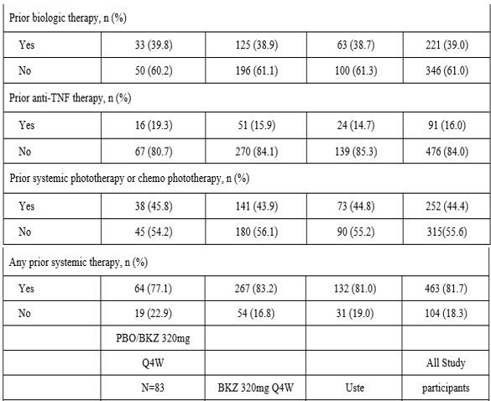
The use of prior medications was generally similar across the bimekizumab 320 mg every 4 weeks (91.0%), placebo (94%), and ustekinumab groups (90.2%), and any differences observed were not considered to be clinically meaningful (Table 29).
The use of concomitant medications was generally similar across the bimekizumab 320 mg every 4 weeks (89.1%), placebo (90.4%), and ustekinumab groups (82.8%).
Antifungals for topical use were used at a higher incidence in the bimekizumab 320 mg every 4 weeks (9.7%) and placebo/bimekizumab 320 mg every 4 weeks groups (7.2%) compared with the ustekinumab group (2.5%).
- The clinical evaluator commented that the population studied is representative of patients with moderate to severe plaque psoriasis;
- The mean PASI and IGA scores were balanced across treatment groups;
- There are no apparent differences that would bias outcomes towards one treatment group.

Major protocol violations/deviations
The incidence of study participants with at least one important protocol deviation during the initial treatment period was 10 (3.1%), 5 (3.1%) and 2 (2.4%) respectively for the bimekizumab, ustekinumab and placebo groups. In the same period, the study participants excluded from the per protocol set were 9 (2.8%),4 (2.5%) and 2 (2.4%) respectively for the bimekizumab, ustekinumab and placebo groups.
The most common protocol deviation in the initial treatment period was procedural non-compliance: 7 (2.2%), 4 (2.5%) and one (1.2%) respectively for bimekizumab, ustekinumab and placebo. The most common protocol deviation for study participants excluded from per protocol set in the initial treatment period was also procedural noncompliance: six (1.9%),four (2.5%) and one (1.2%) respectively for bimekizumab, ustekinumab and placebo.
There were no important protocol deviations in the maintenance treatment period.
The clinical evaluator commented that the incidence of important protocol deviations was low overall and similar in the bimekizumab 320 mg every 4 weeks (3.1 %), ustekinumab (3.1 %), and placebo groups (2.4%). Overall, the most common important protocol deviation was procedural noncompliance, with an incidence of 2.2% in bimekizumab 320 mg every 4 weeks group, 2.5% in the ustekinumab group, and 1.2% in the placebo group. The most common reason for procedural noncompliance was having a Week 16 visit outside of the ± 7 days window.

Co-primary endpoint outcomes
For the co-primary endpoint of PASI 90 response rate at Week 16, as per Table 30:
- the bimekizumab 320 mg every 4 weeks group was superior compared with the placebo group (85% versus 4.8%, respectively);
- the difference was statistically significant, with an odds ratio versus placebo of 99.869 (p < 0.001);
- the bimekizumab 320 mg every 4 weeks group PASI 90 response rate was also superior compared with the ustekinumab group at Week 16 (85.0% versus 49.7%, respectively), with an odds ratio versus ustekinumab of 6.056 (p < 0.001).
Table 30: Study PS009 PASI90 response rates at Week 16
 | PBO  N = 83 | BKZ 320 mg every 4 weeks  N = 321 | Uste  N = 163
PASI 90 response rate
n (%) | 4 (4.8) | 273 (85.0) | 81 (49.7)
n/Nsub (%) | 4/76 (5.3) | 273/307 (88.9) | 81/155 (52.3)
Odds ratio versus PBO a | - | 99.869 | -
95% CI for odds ratio | - | 34.020, 293.175 | -
p-value b | - | <0.001 | -
Odds ratio versus Uste a | - | 6.056 | -
95% CI for odds ratio | - | 3.874, 9.466 | -
p-value b | - | <0.001 | -
Risk difference c, d | 79.9 | - | 35.2
95% CI for risk difference | 74.0, 85.9 | - | 27.0, 43.4
Abbreviations: BKZ = bimekizumab; CI = confidence interval; CMH = Cochran-Mantel-Haenszel; NRI = nonresponder imputation; PASI = Psoriasis Area and Severity Index; PBO = placebo; Q4W = every 4 weeks; RS = Randomised Set; Uste = ustekinumab
Note: Study participants with missing data at a given week were counted as nonresponders.
Note: Nsub represented the number of study participants with a non-missing measurement for PASI at the given week, and percentages were calculated accordingly.
a Odds ratio was calculated using stratified CMH test with region and prior biologic exposure as stratification variables.
b p-values for the comparison of treatment groups were based on the CMH test from the general association.
c Risk difference: BKZ-PBO or BKZ-Uste were calculated based on stratified CMH.
d The evaluation of noninferiority was tested at a 1-sided alpha level of 0.025 and based on a 1-sided 97.5% CI and a noninferiority margin of 10%.
For the co-primary endpoint of IGA 0/1 response rate at Week 16, as per Table 31:
- the bimekizumab 320 mg every 4 weeks group was superior compared with the placebo group (84.1 % versus 4.8%, respectively);
- the difference was statistically significant, with an odds ratio versus placebo of 118.762 (p < 0.001);
- the bimekizumab 320 mg every 4 weeks group was also superior compared with the ustekinumab group (84.1 % versus 53.4%, respectively), with an odds ratio versus ustekinumab of 4.809 (p < 0.001).
Table 31: Study PS0009 IGA 0/1 response rates at Week 16
 | PBO  N = 83 | BKZ 320 mg every 4 weeks  N = 321 | Uste  N = 163
IGA 0/1 response rate
n (%) | 4 (4.8) | 270 (84.1) | 87 (53.4)
n/Nsub (%) | 4/76 (5.3) | 270/307 (87.9) | 87/156 (55.8)
Odds ratio versus PBO a | - | 118.762 | -
95% CI for odds ratio | - | 36.701, 384.307 | -
p-value b | - | <0.001 | -
Odds ratio versus U ste a | - | 4.809 | -
95% CI for odds ratio | - | 3.096, 7.470 | -
p-value b | - | <0.001 | -
Risk difference c | 78.9 | - | 30.4
95% CI for risk difference | 72.9, 84.8 | - | 22.2, 38.7
Abbreviations: BKZ = bimekizumab; CI = confidence interval; CMH = Cochran-Mantel-Haenszel; IGA = Investigator’s Global Assessment; NRI = nonresponder imputation; PBO = placebo; Q4W = every 4 weeks; RS = Randomised Set; Uste = ustekinumab
Note: Study participants with missing data at a given week were counted as nonresponders.
Note: Nsub represents the number of study participants with a nonmissing measurement for IGA at the given week, and percentages were calculated accordingly.
Note: The evaluation of noninferiority was tested at a 1-sided alpha level of 0.025 and based on a 1-sided 97.5% CI and a noninferiority margin of 10%.
Note: IGA 0/1 response is defined as Clear (0) or almost clear (1) with at least a 2 category improvement from Baseline.
a Odds ratio calculated using stratified CMH test with region and prior biologic exposure as stratification variables.
b P-values for the comparison of treatment groups were based on the CMH test from the general association.
c Risk difference: BKZ-PBO or BKZ-Uste were calculated using stratified CMH

Secondary endpoints outcome
For the PASl 100 response rate at Week 16:
- the bimekizumab 320 mg every 4 weeks group had a higher PASI 100 response rate compared with the placebo group (58.6% versus 0%, respectively; p < 0.001);
- the bimekizumab 320 mg every 4 weeks group also had a higher PASI 100 response rate compared with the ustekinumab group (58.6% versus 20.9%, respectively: nominal p < 0.001;)
For the PASl 75 response rate at Week 4:
- the bimekizumab 320 mg every 4 weeks group had a higher PASI 75 response rate compared with the placebo and ustekinumab groups after only a single dose of bimekizumab (76.9% bimekizumab versus 2.4% placebo and 76.9% bimekizumab versus 15.3% ustekinumab; p < 0.001 for both comparisons), differences that were statistically significant
For the PASl 90 response rate at Week 12 and Week 52:
- the bimekizumab 320 mg every 4 weeks group had a higher PASI 90 response rate at Week 12 compared with the placebo and ustekinumab groups (85% bimekizumab versus 2.4% placebo and 85% bimekizumab versus 43.6% ustekinumab; p < 0.001 for both comparisons);
- the bimekizumab 320 mg every 4 weeks group sustained the PASI 90 response rate from Week 16 to Week 52, which was higher compared with the ustekinumab group at Week 52 (81.6% versus 55.8%, respectively; p < 0.001).
For the IGA 0/1 response rate at Week 16:
- the bimekizumab 320 mg every 4 weeks group had a higher IGA 0/1 response rate compared with the placebo group at Week 16 (58.6% versus 0% respectively; p<0.001);
- the bimekizumab 320 mg every 4 weeks group also had a higher IGA 0/1 response rate compared with the ustekinumab group at Week 16 (58.6% versus 22.1 %, respectively: nominal p<0.001).
For the IGA 0/1 response rates at Week 12 and Week 52:
- the bimekizumab 320 mg every 4 weeks group had a higher IGA 0/1 response rate at Week 12 compared with the placebo and ustekinumab groups (81.9% bimekizumab versus 4.8% and 81.9% bimekizumab versus 52.1 % ustekinumab; p < 0.001 for both comparisons);
- the bimekizumab 320 mg every 4 weeks group had a sustained IGA 0/1 response rate from Week 16 to Week 52, which was higher compared with the ustekinumab group at Week 52 (77.9% versus 60.7%, respectively; p < 0.001)
For scalp IGA 0/1 response at Week 16 for study participants with scalp psoriasis at Baseline (a scalp IGA 0/1 response was defined as clear (0) or almost clear (1) with at least a two category improvement from Baseline. Only study participants with a Baseline score of greater than two was included in the responder analysis).
- the bimekizumab 320 mg every 4 weeks group had a higher scalp IGA 0/1 response rate at Week 16 compared with the placebo and ustekinumab groups (84.2% bimekizumab versus 15.3% placebo and 84.2% bimekizumab versus 70.5% ustekinumab; p < 0.001 and nominal p < 0.001, respectively), a difference that was statistically significant compared with placebo.

For PSD at Week 16:
- the bimekizumab 320 mg every 4 weeks group had higher PSD response rates based on pain, itch, and scaling item scores compared with the placebo group, differences that were statistically significant (77.3% versus 16.7%, 76.6% versus 13.1 %, and 78.5% versus 12.7% respectively; p < 0.001 for all comparisons);
- the bimekizumab 320 mg every 4 weeks group had higher PSD response rates based on pain, itch, and scaling item scores compared with the ustekinumab group (77.3% versus 68.2%. nominal p = 0.053; 76.6% versus 65.8%; nominal p = 0.035, and 78.5% versus 59.5%, nominal p < 0.001, respectively).

Subgroup analyses
Subgroup analyses were conducted for PASI 90 response, IGA 0/1 response, and PASI 100 response rates across the following subgroups:
- age (younger than 40 years, 40 to younger than 65 years, greater or equal to 65 years);
- gender (male, female);
- duration of disease (less than median (14.66) years, greater or equal to median (14.66) years);
- geographic region (North America, Western Europe, Eastern/Central Europe, Asia/Australia);
- body weight (less than 100kg, greater or equal to 100kg), BMI (less than 25 kg/m², greater than 25 kg/m² to less than 30 kg/m², greater than 30kg/m²);
- prior systemic phototherapy or chemo phototherapy (yes, no);
- prior systemic therapy (yes, no);
- prior biologic therapy (yes, no);
- baseline PASI score (less than 20, greater or equal to 20);
- antidrug antibody positivity (confirmatory assay: negative or positive).
All subgroups demonstrated a difference favouring treatment with bimekizumab for PASI 90 and IGA 0/1 response rates in the bimekizumab groups compared with the placebo and ustekinumab groups at Week 16 and the ustekinumab group at Week 52.
The TGA’s clinical evaluation noted that the co-primary endpoint was relevant for patients with moderate to severe psoriasis and consistent with adopted guidelines. Treatment with bimekizumab resulted in a statistically and clinically significant reduction in the disease burden of psoriasis as measured by PASI and IGA versus patients treated with placebo and ustekinumab. The reduction was evident four weeks after treatment and was sustained through the study
Importantly, ustekinumab is approved in Australia for the treatment of moderate to severe plaque psoriasis and an appropriate dose regimen was used in this study
The Delegate contends that the ustekinumab dose used in the trial was suboptimal for the purpose of determining bimekizumab superiority over ustekinumab.

Study PS0013
Study PS0013 is a Phase III, randomised, double-blind, placebo-controlled multicentre study to evaluate the efficacy and safety of bimekizumab in adults with moderate to severe chronic plaque psoriasis.
The study design, as depicted schematically below, consisted of four periods:
- screening period (2 to 5 weeks);
- placebo controlled initial treatment period (16 weeks);
- placebo controlled randomised withdrawal period (40 weeks);
- safety follow up period (20 weeks after the final dose of IMP).
Figure 18: Study PS0013 Design schema
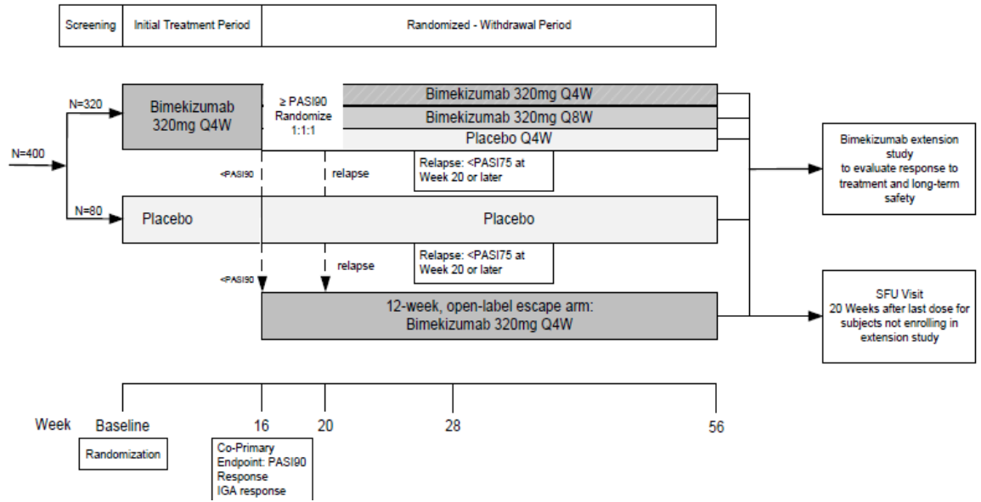
Abbreviations: IGA = Investigator’s Global Assessment; PASI = Psoriasis Area and Severity Index; PASI 75 = at least 75% improvement from Baseline in the PASI score; PASI 90 = at least 90% improvement from Baseline in the PASI score; Q4W = every 4 weeks; Q8W = every 8 weeks; SFU = safety follow up
Elaborating on the above study design:
- Study participants who did not achieve a PASI 90 response at Week 16 of the initial treatment period were allocated to the 12 week open label escape treatment arm;
- All study participants who relapsed (defined as not achieving a PASI 75 response) at Week 20 or later during the randomised-withdrawal period (up to Week 56), consisting of bimekizumab 320 mg every 4 weeks (n = 80), bimekizumab 320 mg every 8 weeks (n = 80) and placebo every 4 weeks (n = 80) were allocated to the 12 week open label escape treatment arm;
- Study participants who achieved a minimum PASI 50 response at Week 12 of the open label escape treatment arm were allowed to enrol in PS0014 (open label study to assess the long term safety, tolerability, and efficacy of bimekizumab in eligible adult study participants with moderate to severe plaque psoriasis who complete one of the Phase III feeder studies (Studies PS0008, PS0009, or PS0013)).
- After completing the study, eligible participants were allowed to enrol in the open label Study PS0014. Study participants who enrolled into Study PS00 14 did not have the Study PS0013 safety follow up visit.
The Delegate commented that the treatment profile in the extension Study PS0014 was a mixture of bimekizumab 320 mg every 4 weeks and every 8 weeks. Stratification in Study PS0014 regarding PASI score at entry from Study PS0013 was as above that is greater than 50 score (that is 50, 75, 90).
The primary objective is to evaluate the efficacy and safety of bimekizumab in adults with moderate to severe plaque psoriasis.
The main inclusion criteria include study participants must have been adults with a diagnosis of moderate to severe chronic plaque psoriasis (Baseline PASI greater than 12 and BSA affected by psoriasis 10% and IGA score greater than 3, on a 5-point scale) who were candidates for systemic psoriasis therapy and/or phototherapy.
The exclusion criteria were essentially similar to those for the other pivotal studies discussed above (Studies PS0008 & PS0009).
The TGA’s clinical evaluation noted that the requirement of a PASI greater or equal to 12, IGA greater or equal to 3 and a total BSA greater or equal to 10% reflects published guidelines as adopted by the TGA.30

Study treatments
For the double blinded initial treatment period:
- Study participants randomised to receive bimekizumab 320 mg every 4 weeks, received two bimekizumab 160 mg injections subcutaneously every 4 weeks.
- Study participants randomised to receive placebo, received two placebo injections SC every 4 weeks.
For randomised withdrawal period:
- Study participants (N = 80) who were re-randomised to receive 320 mg every 4 weeks received two bimekizumab 160 mg injections subcutaneously every 4 weeks;
- Study participants (N = 80) re-randomised to receive bimekizumab 320 mg every 8 weeks alternated between receiving bimekizumab (two bimekizumab 160 mg injections subcutaneously) followed 4 weeks later by placebo (two placebo injections subcutaneously);
- Study participants (N = 80) re-randomised to receive placebo received two placebo injections every 4 weeks;
- Study participants in the placebo treatment arm in the initial treatment period who achieved PASI 90 at Week 16 and greater than PASI 75 at Week 20 or later, continued to receive placebo every 4 weeks at Week 16 and later visits;
- Study participants who did not achieve a PASI 90 response at Week 16 and all study participants who relapsed at Week 20 or later during the randomized withdrawal period (up to Week 56) received open label bimekizumab 320 mg every 4 weeks for 12 weeks (escape treatment).
The Delegate commented that the above design has two placebo arms.

Endpoints
The co-primary endpoints include:
- PASI 90 response at Week 16.
- The IGA 0/1 response at Week 16.
The secondary endpoints include:
- PASI 100 response at Week 16;
- IGA 0/1 response at Week 16;
- PASI 75 response at Week 4;
- PSD responses for pain, itch, and scaling at Week 16;
- Scalp IGA 0/1 response (clear [0] or almost clear [ 1] with at least a two category improvement from Baseline) at Week 16 for study participants with scalp psoriasis at Baseline;
- PASI 90 response at Week 56, among Week 16 PASI 90 responders.
Other endpoints include:
- PASI 90 in the escape treatment period
- Time to relapse following withdrawal of treatment.

Study flow chart
A total of 576 study participants signed the informed consent form and were screened for the study.
- 141 of the 576 study participants were rated screen failures;
- the most common reason for being a screen failure was ineligibility (129 study participants).
A total of 435 study participants were randomised into the study.
- N = 349 for bimekizumab 320 mg every 4 weeks group;
- N = 86 for placebo group.
Overall, the percentage of study participants who completed the initial treatment period was high and similar in the bimekizumab 320 mg every 4 weeks (340 out of 349 = 97.4%) and placebo (82 out of 86 = 95.3%) groups.
The frequency of study discontinuation during the initial treatment period was low and similar between the treatment groups [bimekizumab=9, placebo= 4].
A total of eligible 312 study participants from initial treatment period (also known as Week 16 responder set, comprising 317 eligible bimekizumab group minus 6 incorrect escapers from the group into the escape treatment period = 311, plus one placebo group) were randomised into the randomised withdrawal period.
For the 311 bimekizumab group, randomisation was in a 1:1:1 ratio as follows:
- 106 study participants in the bimekizumab 320 mg every 4 weeks/every 4 weeks group;
- 100 study participants in the bimekizumab 320 mg every 4 weeks/every 8 weeks group;
- 105 study participants in the bimekizumab 320 mg every 4 weeks/placebo group.
For the placebo group:
- the only one eligible study participant responder with greater than PASI 90 at Week 16 post initial treatment period, randomised to the placebo group, entered, and completed the randomised withdrawal period, as placebo/placebo treatment group
Overall, the percentage of study participants who completed the randomised withdrawal period was higher in the bimekizumab 320 mg every 4 weeks/every 4 weeks group (94 out of 106 = 88.7%) and the bimekizumab 320 mg every 4 weeks/every 8 weeks group (93 out of 100 = 93.0%) compared with the bimekizumab 320 mg every 4 weeks/placebo group (33 out of 105 = 31.4%).
The percentage of study participants who received escape treatment was lower in the bimekizumab 320 mg every 4 weeks/every 4 weeks group (7 out of 106 = 6.6%) and the bimekizumab 320 mg every 4 weeks/every 8 weeks group (4 out of 100 = 4%) compared with the bimekizumab 320 mg every 4 weeks/placebo group ( 67 out of 105 = 63.8%).
Figure 19: Study PS0013 Participant flow
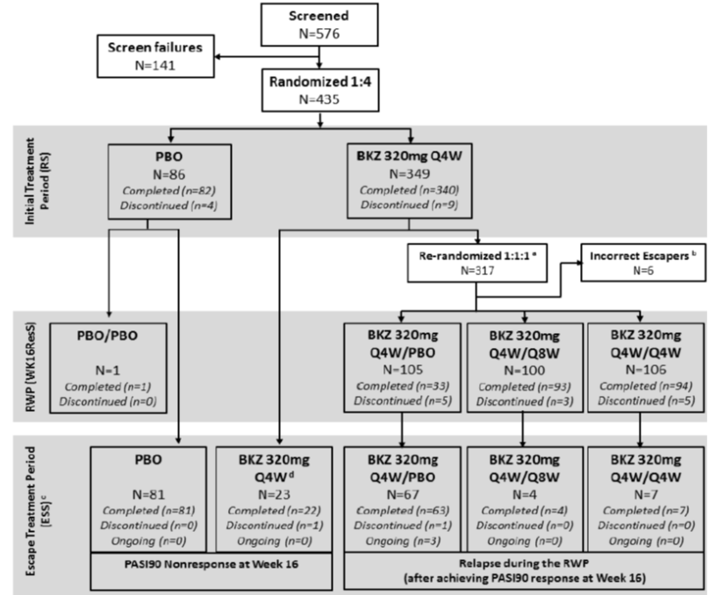
Abbreviations: BKZ = bimekizumab; ESS = Escape Study Participant Set; PASI = Psoriasis Area and Severity Index; PBO = placebo; Q4W = every 4 weeks; Q8W = every 8 weeks; RS = randomised set; RWP = randomised withdrawal period; WK16ResS = Week 16 responder set
The Delegate commented that the higher percentage of bimekizumab 320 mg every 4 weeks/placebo study participants entered the escape treatment period from the randomised withdrawal period compared to either the bimekizumab 320 mg every 4 weeks/every 4 weeks group or bimekizumab 320 mg every 4 weeks/every 8 weeks group.
The Delegated noted that slightly more percentage of bimekizumab 320 mg every 4 weeks/every 4 weeks group (6.6%) compared to the bimekizumab 320 mg every 4 weeks/every 8 weeks group (4%), entered the escape treatment period and questioned if that indicate that bimekizumab 320 mg every 8 weeks dosing is more effective than bimekizumab 320 mg every 4 weeks dosing.
The most frequently reported primary reason for study discontinuation in all study participants during the initial treatment period was due to an adverse event (1.1%).
The frequency of study discontinuation during the randomised withdrawal period was low and similar across the treatment groups.
The most frequently reported primary reasons for study discontinuation in all study participants during the randomised withdrawal period were due to an AE and lost to follow up (1.6% each).
A total of 182 study participants started the escape treatment period.
The percentage of study participants who completed the escape treatment period was high and similar across treatment groups (range: 94% to 100%).
Three study participants (1.6%) in the escape treatment period were ongoing in the study as of the clinical cut-off date; all ongoing study participants were in the bimekizumab 320 mg every 4 weeks/placebo group (relapse during the randomised withdrawal period).
The frequency of study discontinuation during the escape treatment period was low and similar across the treatment groups.
The primary reasons for study discontinuations during the escape treatment period were due to adverse events and consent withdrawn (0.5% each).
Table 32: Disposition by treatment sequence while on bimekizumab, placebo or bimekizumab/placebo before entry into the escape treatment period, discontinuation reasons post entry into the escape treatment period
Disposition | PASI 90 Nonresponse at  Week 16 |  | Relapse during the Randomised-Withdrawal Period  (after achieving PASI 90 response at Week 16) |  |  | All study  participants  N = 182  n (%)
Disposition | PBO  N = 81  n (%) | BKZ320 mg  every 4 weeks  N = 23  n (%) | BKZ320 mg  every 4 weeks/PBO  N = 67  n (%) | BKZ320 mg  every 4 weeks/every 8 weeks  N = 4  n (%) | BKZ320 mg  every 4 weeks/Q4w  N = 7  n (%) | All study  participants  N = 182  n (%)
Started Escape Treatment Period | 81 (100.0) | 23 (100.0) | 67 (100.0) | 4 (100.0) | 7 (100.0) | 182 (100.0)
Completed Escape Treatment | 81 (100.0) | 22 (95.7) | 63 (94.0) | 4 (100.0) | 7 (100.0) | 177 (97.3)
Period | 81 (100.0)
Ongoing in study | 0 | 0 | 3 (4.5) | 0 | 0 | 3 (1.6)
Discontinued study | 0 | 1 (4.3) | 1 (1.5) | 0 | 0 | 2 (1.1)
Primary reason for discontinuation
AE | 0 | 1 (4.3) | 0 | 0 | 0 | 1 (0.5)
Lack of efficacy | 0 | 0 | 0 | 0 | 0 | 0
Protocol violation | 0 | 0 | 0 | 0 | 0 | 0
Lost to follow up | 0 | 0 | 0 | 0 | 0 | 0
Consent withdrawn | 0 | 0 | 1 (1.5) | 0 | 0 | 1 (0.5)
Other | 0 | 0 | 0 | 0 | 0 | 0
Abbreviations: AE = adverse event; BKZ = bimekizumab; ESS = escape study participant set; PASI = Psoriasis Area and Severity Index; PBO = placebo; Q4W=every 4 weeks; Q8W=every 8 weeks.
The Delegate commented that given the slightly higher discontinuation number in the bimekizumab 320 mg every 4 weeks/every 4 weeks group (n = 7) compared to that in the bimekizumab 320 mg every 4 weeks/every 8 weeks group, the latter observation might simply reflect the study participants’ injection frequency compliance preference between bimekizumab 320 mg every 4 weeks/every 4 weeks and bimekizumab 320 mg every 4 weeks/every 8 weeks and, it is possibly embedded in what has been referred to as ‘lost to follow up’ in the randomised withdrawal period.

Analysis of populations
The following analysis sets were used (Table 33):
- The enrolled set consisted of all study participants who gave informed consent;
- The randomised set consisted of all randomised study participants;
- The safety set consisted of all study participants who received at least 1 dose of study medication;
- The full analysis set consisted of all randomised study participants who received at least one dose of study medication and had a valid measurement for each of the co-primary efficacy variables at Baseline;
- The escape study participant set consisted of all study participants who received at least one dose of escape bimekizumab 320 mg treatment either due to not achieving a PASI 90 response at Week 16 or experiencing a relapse after entering the randomized withdrawal period. Summaries based on the escape study set were split between study participants who entered the escape arm: 1) due to PASI 90 nonresponse at Week 16 or 2) due to relapse during the randomized withdrawal period (after achieving PASI 90 response at Week 16);
- The Week 16 responder set onsisted of all study participants who achieved a PASI90 response at Week 16 and received at least one dose of the investigational medical product during the randomised-withdrawal period at Week 16 or later;
- The active medication set consisted of all study participants who had received at least one dose of active the investigational medical product (bimekizumab). The active medication set was used for summaries of safety that included all data from the initial treatment period and/or maintenance treatment period;
- The per-protocol set consisted of all study participants in the randomised set who had no important protocol deviations affecting the primary efficacy variables. Important protocol deviations were predefined, and study participants with important protocol deviations were evaluated during ongoing data cleaning meetings prior to unblinding of the data.

Table 33: Study PS0013 Disposition of analysis sets
Analysis Set | PBO  N = 86  n (%) | BKZ 320 mg  every 4 weeks  N = 349  n (%) | All study  participants  N = 435  n (%)
Randomised set | 86 (100) | 349 (100) | 435 (100)
Safety set | 86 (100) | 349 (100) | 435 (100)
Full analysis set | 86 (100) | 349 (100) | 435 (100)
WK16ResS | 1 (1.2) | 311 (89.1) | 312 (71.7)
ESS | 81 (94.2) | 101 (28.9) | 182 (41.8)
AMS | 81 (94.2) | 349 (100) | 430 (98.9)
PPS | 84 (97.7) | 344 (98.6) | 428 (98.4)
Abbreviations: AMS = Active Medication Set; BKZ = bimekizumab; ESS = escape study set; FAS = Full Analysis Set; PBO = placebo; PPS = Per-Protocol Set; PK- PPS = Pharmacokinetics; Per-Protocol Set; Q4W = every 4 weeks; RS = Randomised Set; SS = Safety Set.

Sample size
Approximately 400 study participants were to be randomly assigned in a 4: 1 ratio to the following treatment groups:
- bimekizumab 320 mg (approximately 320 study participants)
- placebo (approximately 80 study participants)
The assumed response rates for PASI 90 at Week 16 were 75% and 2% for bimekizumab and placebo, respectively.
Additionally, the assumed response rates for IGA 0/1 response were 85% and 5% for bimekizumab and placebo, respectively. The assumed response rates for bimekizumab were based on the Phase IIb Study PS00l0 data.
The power to show statistical superiority of bimekizumab relative to placebo under these assumptions was greater than 99% for the co-primary endpoints.

Statistical methods
The co-primary efficacy variables for this study were PASI 90 response and IGA 0/1 response at Week 16.
The corresponding analyses were based on the randomised set.
A study participant was classified as a PASI 90 responder if the PASI score at Week 16 has improved 90% from Baseline.
An IGA 0/1 responder was any study participant with a score of 0 or 1 (Clear or Almost Clear) with at least a two category improvement from Baseline to Week 16 in IGA score.
The primary analysis was based on the stratified CMH test where region and prior biologic exposure (yes/no) were used as stratification variables.
Pairwise treatment comparisons were made based on the CMH test using the p-value for the general association.
The odds ratio and associated CI based on the Wald test were provided.
If one of the treatment groups had zero or very low response where the CMH odds ratio could no longer be calculated, the logit method was applied instead.
Non-responder imputation was used to account for missing data in the primary analysis. Specifically, any study participant who withdrew from IMP prior to Week 16 or who had missing data for the co-primary efficacy variables at the Week 16 time point was considered a non-responder.

Baseline demographic characteristics
The age range across the study participants was 18 to <85 years, with a mean ± SD of 44.3 ±12.9. There were more males 313 (72 %) than females 122 (28 %), as per Table 34.
Table 34: Study PS0013 Demographics
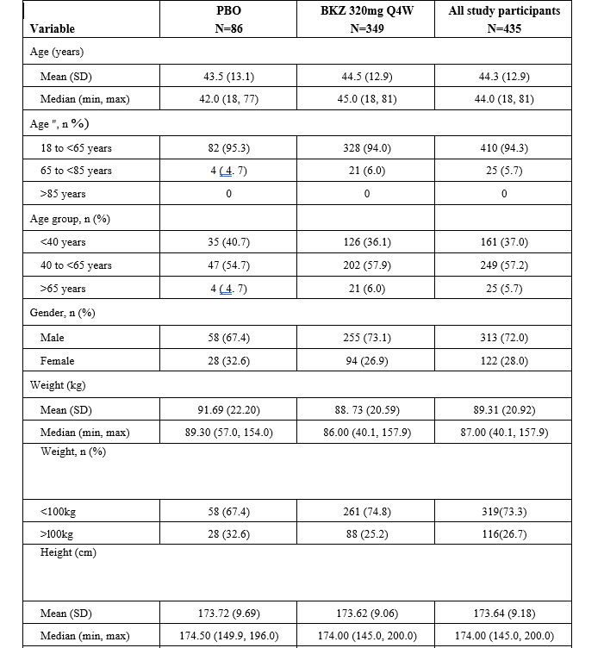
BKZ = bimekizumab; BMI = body mass index; EudraCT = European Union Drug Regulating Authorities Clinical Trials; max = maximum; min = minimum; PBO = placebo; Q4W = every 4 weeks; RS = randomised set; SD = standard deviation
Note: Study participants were summarized according to randomized treatment at Baseline in the Initial Treatment Period.
“ EudraCT age categories
There were also more Caucasians 403 (92.6 %) than all other race (7.4%).
The TGA’s clinical evaluation noted that demographic characteristics were well balanced between the bimekizumab 320 mg every 4 weeks group and the placebo group. The proportions of study participants enrolled in each region were similar between treatment groups (region was a stratification factor for randomisation).

Baseline disease characteristics
Table 35: Baseline disease characteristics
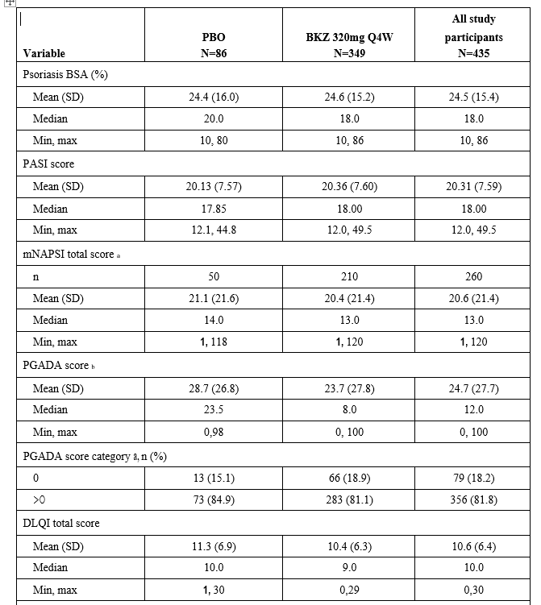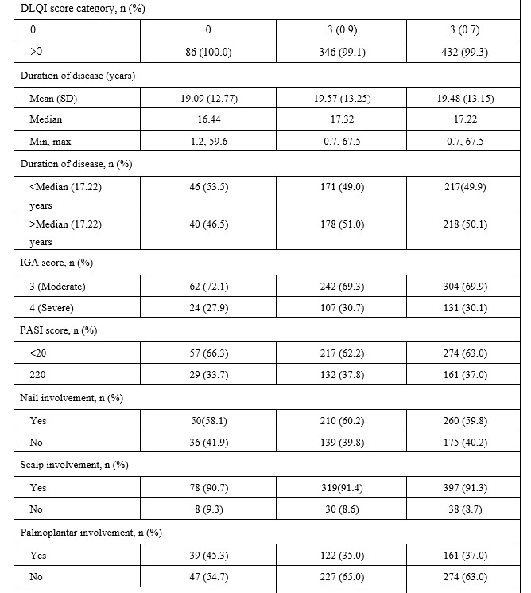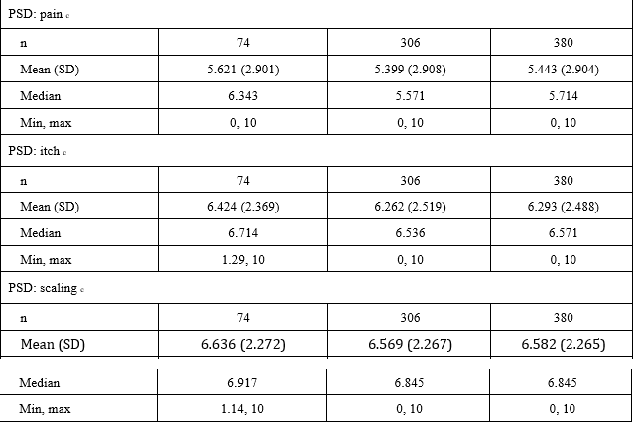
BKZ = bimekizumab; BSA = surface area; DLQI = Dermatology Life Quality Index; IGA = Investigator’s Global Assessment; max = maximum; min = minimum; mNAPSI = Modified Nail Psoriasis Severity Index; PASI = Psoriasis Area and Severity Index; PBO = placebo; PGADA = Patient Global Assessment of Disease Activity; PSD = Patient Symptom Diary; Q4W = every 4 weeks; RS = randomised set; SD = standard deviation; TNF = tumor necrosis factor; VAS = visual analog scale
Note: Duration of disease (years) = (Date of randomization – date of onset of plaque psoriasis)/365.25
Note: Study participants were summarized according to randomized treatment at Baseline in the initial treatment period.
a mNAPSI total score for study participants with nail involvement (that is mNAPSI>0)
b PGADA for arthritis VAS score
c Baseline data were only summarized if the study participant had ≥ 4 nonmissing values.
The clinical evaluator noted that the mean PASI score was 20.31 and mean percent BSA affected by psoriasis was 24.5%. All study participants had an IGA score > 3, which is consistent with the requirements of the criterion inclusion. Treatment groups were generally well balanced with respect to psoriasis-related and other Baseline characteristics (Table 35).
The clinical evaluator commented that the notable differences included:
- The incidence of study participants with palmoplantar involvement of psoriasis was lower in the bimekizumab 320 mg every 4 weeks group (35%) compared with the placebo group (45.3%);
- Median PGADA scores were lower in the bimekizumab 320 mg every 4 weeks group (8) compared with the placebo group (23.5) due to skewed score distributions in both treatment groups (mean PGADA scores were similar between the treatment groups (23.7 and 28.7, respectively)).
The Delegate commented that the observed differential would not have significant altered the efficacy outcomes in favour of bimekizumab.

Baseline therapies
Table 36: Study PS0013 Baseline therapies
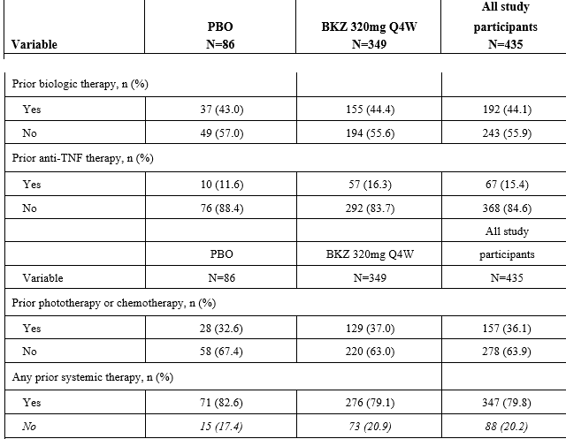
BKZ = bimekizumab; PBO = placebo; Q4W = every 4 weeks; TNF = tumor necrosis factor
The incidence of prior phototherapy or chemotherapy use was higher in the bimekizumab 320 mg every 4 weeks group (37%) compared with the placebo group (32.6%) (Table 36).
The incidence of prior anti-TNF therapy use was higher in the bimekizumab 320 mg every 4 weeks group (16.3%) compared with the placebo group (11.6%) (Table 36).
The Delegate commented that the slightly observed difference between bimekizumab and Placebo regarding prior use of phototherapy, chemotherapy and anti-TNF therapy should not significantly contribute to the overall observed efficacy outcome.

Major protocol violations/deviations
For the initial treatment period, the incidence of study participants with at least one important protocol deviation was 7 (2%) and 2 (2.3%) respectively for the bimekizumab 320 mg every 4 weeks and placebo groups.
In the initial treatment period, the study participants excluded from the per protocol set were 5 (1.4) and 2 (2.3) respectively for the bimekizumab and placebo groups.
Most study participants (97.9%) had no important protocol deviations during the initial treatment period.
The incidence of important protocol deviations during the initial treatment period was low overall and, similar between the bimekizumab 320 mg every 4 weeks group (2%) and the placebo group (2.3%).
The most common important protocol deviation in the initial treatment period was procedural noncompliance (1.1%), and the most common reason for procedural noncompliance was having a Week 16 Visit outside of the ± 7-day window.
In the initial treatment period, one (0.3%) and one (1.2%) of the study participants were excluded from the Pharmacokinetics per protocol set respectively for the bimekizumab and placebo groups.
For the randomised withdrawal period. the incidence of study participants with at least one important protocol deviation was 0 (0%), 1 (0.9%) and 0 (0%) respectively for the bimekizumab 320 mg every 4 weeks/every 4 weeks, bimekizumab 320 mg every 4 weeks/every 8 weeks and every 4 weeks/placebo groups.
In the randomised withdrawal period, most study participants (99.7%) had no important protocol deviations. One study participant in the bimekizumab 320 mg every 4 weeks/every 4 weeks group had an important protocol deviation of prohibited concomitant medication use.
No study participants were excluded from the PK-PPS due to protocol deviations during the randomised withdrawal period.

Initial treatment period co-primary endpoints
For the co-primary endpoint of PASI 90 response rate at Week 16, as per Table 37 below:
- the bimekizumab 320 mg every 4 weeks group was better than the placebo every 4 weeks group (90.8% versus 1.2%, respectively);
- this difference was statistically significant, with an odds ratio of 496.32 (p < 0.001)
For the co-primary endpoint of Investigator’s Global Assessment 0/1 response rate at Week 16, as per the table below:
- the bimekizumab 320 mg every 4 weeks group was better than the placebo every 4 weeks group (92.6% versus 1.2%, respectively);
- this difference was statistically significant, with an odds ratio of 657.25 (p < 0.001).

Table 37: Study PS0013 Summary of co-primary and secondary efficacy analysis results based on the predefined fixed testing sequence
Ordered Sequential  Procedure | Variables | Visit | Response rate |  | p-value | Significant
Ordered Sequential  Procedure | Variables | Visit | PBO  n (%) | BKZ  n (%) | p-value | Significant
#1: BKZ 320 mg every 4 weeks  versus PBO | PASI 90 | Week 16 | 1 (1.2) | 317 (90.8) | < 0.001 | Yes
#2: BKZ 320 mg every 4 weeks  versus PBO | IGA 0/1 | Week 16 | 1 (1.2) | 323 (92.6) | < 0.001 | Yes
Abbreviations: BKZ = bimekizumab; PBO = placebo; Q4W = every 4 weeks;

Initial treatment period secondary endpoints
The bimekizumab 320 mg every 4 weeks group had a higher PASI l00 response rate compared with the placebo group at Week 16. This was statistically significant (68.2% versus 1.2%, respectively; p < 0.001) (Table 38).
The bimekizumab 320 mg every 4 weeks group had a higher IGA 0/1 response rate compared with the placebo group at Week 16. This was statistically significant (69 .6% versus 1.2%, respectively; p < 0.001) (Table 38).
The bimekizumab 320 mg every 4 weeks group had a higher PASI75 response rate compared with the placebo group at Week 4 after only a single dose of bimekizumab. This was statistically significant (75.9% versus 1.2%, respectively; p < 0.001) (Table 38).
The bimekizumab 320 mg every 4 weeks group had higher PSD response rates based on pain, itch, and scaling item scores compared with the placebo group at Week 16. These were statistically significant (78.8% versus 9%, 75.5% versus 5.6%, and 78% versus 5.7%, respectively; p < 0.001 for all comparisons) (Table 38).
A scalp IGA 0/1 response was defined as clear (0) or almost clear (1) with at least a two category improvement from Baseline. Only study participants with a Baseline score of greater than 2 were included in the responder analysis. The bimekizumab 320 mg every 4 weeks group had a higher scalp IGA 0/1 response rate compared with the placebo group at Week 16, this was statistically significant (92.3% versus 6.8%, respectively; p < 0.001).
Table 38: Study PS0013 Initial treatment period secondary endpoints
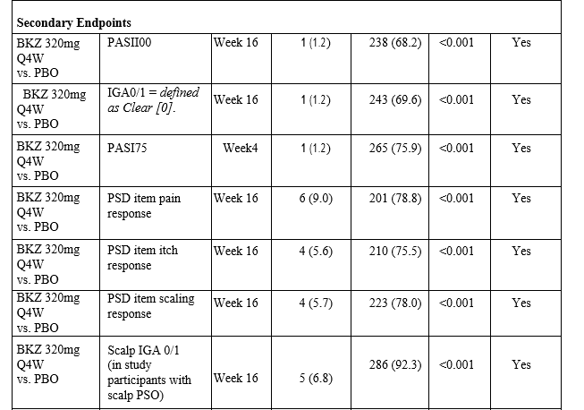
Abbreviations: BKZ = bimekizumab; IGA = Investigator’s Global Assessment; PASI = Psoriasis Area and Severity Index; PBO = placebo; PSD = Patient Symptom Diary; Q4W = every 4 weeks

Randomised withdrawal period co-primary endpoints
For the co-primary endpoint of PASI 90 response rate during the randomised withdrawal period, as per Table 39.
Among Week 16 PASI 90 responders, the bimekizumab 320 mg every 4 weeks/every 4 weeks and bimekizumab 320 mg every 4 weeks/every 8 weeks groups had a higher PASI 90 response rate compared with the bimekizumab 320 mg every 4 weeks/placebo group at Week 56, this was statistically significant (88.8% versus 16.2%, respectively; p < 0.001).
Table 39: Study PS0013 Randomised withdrawal period co-primary endpoints
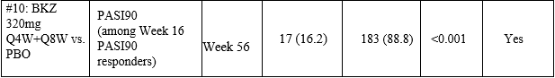
BKZ = bimekizumab; IGA = Investigator’s Global Assessment; PASI = Psoriasis Area and Severity Index; PBO = placebo; Q4W = every 4 weeks

Escape treatment period endpoint
For the co-primary endpoint of PASI 90 response rate regarding escape treatment period, as per Table 40.
The PASI 90 response rates of all the study participants group at escape baseline (0.5%) rapidly increased by the next assessment time point at escape Week 4 (50.5%) and continued to increase through escape Week 12 (78%) (Table 40).
The Delegate commented that incorrect escapers (n = 6) would probably account for the observed baseline PASI 90 recording of 0.5%. The majority of study participants (N = 81) who received placebo in the initial treatment period and who were PASI 90 non responders at Week 16, achieved a PASI 90 response by Escape Week 12 (85.2%) (Table 40).
In addition, the majority of study participants receiving bimekizumab 320 mg every 4 weeks during the initial treatment period and who were PASI 90 non responders at Week 16, achieved a PASI 90 response by escape Week 12 (56.5%) (Table 40).
Study participants (N = 67) who:
- (i) received bimekizumab 320 mg every 4 weeks in the initial treatment period,
- (ii) were Week 16 PASI 90 responders,
- (iii) were re- randomised to withdrawal from bimekizumab 320 mg every 4 weeks treatment (that is to receive placebo, as in bimekizumab 320 mg every 4 weeks/placebo group) and;
- (iv) relapsed, had comparable PASI 90 response rates after 12 weeks of escape treatment (83.6%), as those observed after 12 weeks of bimekizumab 320 mg treatment during the initial treatment period.
Few study participants in the bimekizumab 320 mg every 4 weeks/every 4 weeks (n = 7) and bimekizumab 320 mg every 4 weeks/every 8 weeks (n = 4) groups relapsed during the randomised withdrawal period and entered the escape treatment period (Table 40).
Table 40:Study PS0013 Escape treatment period endpoint
 | PASI 90 Nonresponse at Week 16 |  | Relapse during the Randomized-Withdrawal Period  (after achieving PASI 90 response at Week 16)
 | PBO  N = 81  n (%) | BKZ320 mg  every 4 weeks  N = 23  n (%) | BKZ320 mg  every 4 weeks/PBO  N = 67  n (%) | BKZ320 mg  every 4 weeks/every 8 weeks  N = 4  n (%) | BKZ320 mg  every 4 weeks/Q4w  N = 7  n (%) | All study  participants  N = 182  n (%)
Escape Baseline | 0 | 1 (4.3) | 0 | 0 | 0 | 1 (0.5)
Escape Week 4 | 35 (43.2) | 9(39.1) | 44 (65.7) | 2 (50.0) | 2 (28.6) | 92 (50.5)
Escape Week 8 | 63 (77.8) | 14 (60.9) | 56 (83.6) | 1 (25.0) | 5 (71.4) | 139 (76.4)
Escape Week 12 | 69 (85.2) | 13 (56.5) | 56 (83.6) | 1 (25.0) | 3 (42.9) | 142 (78.0)
For the time to relapse:
- The study participants who were re-randomised to withdrawal into placebo from bimekizumab 320 mg treatment, relapsed more rapidly than study participants continuing to receive bimekizumab 320 mg either every 4 weeks or every 8 weeks;
- The median time to relapse after re-randomisation was 197 days (95% CI: 170,224) for the bimekizumab 320 mg every 4 weeks/placebo group and not calculable for the combined bimekizumab 320 mg every 4 weeks/every 4 weeks and every 4 weeks/ every 8 weeks groups.
The TGA’s clinical evaluation noted that the co-primary endpoint was relevant for patients with moderate to severe psoriasis and consistent with adopted guidelines;30
- Treatment with bimekizumab resulted in a statistically and clinically significant reduction in the disease burden of psoriasis as measured by PASI and IGA versus patients treated with placebo; the reduction was sustained throughout the study;
- Continued treatment with bimekizumab maintained the improvements observed in plaques psoriasis as measured by PASI;
- The use of placebo was associated with a higher allocation to escape treatment in the study.
The Delegate commented that not all the initial 320 patients randomised to bimekizumab 320 mg every 4 weeks reached PASI 90, post the initial treatment period at Week 16, and not all those randomised to bimekizumab 320 mg every 4 weeks or bimekizumab 320 mg every 8 weeks in the randomised-withdrawal period reached PASI 75, not alone PASI 90. In addition, the escape treatment period is a 12 week open label trial study and therefore, has its limitations with regard to efficacy outcome.

Study PS0014
Study PS0014 is an ongoing, open label multicentre study to assess the long term safety, tolerability, and efficacy of bimekizumab in eligible adult study participants with moderate to severe plaque psoriasis who complete one of the Phase III feeder studies (Studies PS0008, PS0009, or PS0013). Study participants will receive either bimekizumab 320 mg every 4 weeks or 320 mg every 8 weeks, based on their treatment regimen and PASI response in the feeder study.
Figure 20: Study PS0014 Schematic diagram
Study PS0014 is still ongoing and efficacy data are not presented.

Studies DV0002 and DV0006
Studies DV0002 and DV0006 were conducted to evaluate the safe and effective self-injection of bimekizumab with two device presentations, a single-use, 1mL safety syringe (bimekizumab-SS-1mL) and a single-use 1mL auto-injector (bimekizumab-AI-1mL), in study participants with psoriasis who were enrolled in Study PS0014. Both studies were open label.

Study design
The safe and effective use of the bimekizumab-SS-1mL (safety syringe) and bimekizumab-AI-1mL (autoi-injector device) presentations by study participants, was evaluated at Baseline and at Week 8. Safe and effective self-injection was evaluated by the study personnel and, was defined as complete dose delivery (confirmed by a visual inspection of the investigational device presentation) and no adverse device effects that precluded continued use of the investigational device.

Primary endpoint
Primary endpoint is the percentage of study participants able to self-administer safe and effective injections using the investigational device presentations at Week 8. Safe and effective self-injection was evaluated by the study personnel and was defined as:
- Complete dose delivery: Study participant self-injected the complete dose of bimekizumab as confirmed by a visual inspection of the investigational device presentation, which showed that the investigational medical product was delivered completely (that is container was empty).
- No adverse device effects that precluded continued use of the investigational device presentation for self-injection (that is no serious adverse device effects and/or adverse device effects that led to withdrawal from the sub study).
The TGA’s clinical evaluation noted that both studies met their primary endpoints and participants were able to safely self-administer medication following an 8-week training period.
The Delegate commented that while patients can be trained to use either of the two delivery mechanisms to self- administer bimekizumab, the crux of the matter is that only the pre-filled syringe (bimekizumab-SS-1mL) was used in the evaluated clinical trials.

Pooled and meta-analyses
Table 41: Overview of pooled analyses for efficacy
Pool name | Studies included in pool | Treatment groups included in pool | Treatment Periods included in pool | Purpose of pool
E1 | PS0009  PS0013 | Study participants randomised to placebo every 4 weeks in PS0009 and PS0013 plus study participants randomised to BKZ 320 mg every 4 weeks in PS0013. | Initial Treatment Period  (Weeks 0 to 16) | Investigate subgroups.  add precision to treatment effect (BKZ versus PBO)  through Week 16 in applicable Phase III studies
E2 | PS0008  PS0009  PS0013 | Maintenance dose regimens depicting treatment with :  BKZ 320 mg every 4 weeks  BKZ 320 mg every 8 weeks  BKZ 320 mg every 8 weeks | Maintenance Treatment Period (Weeks 16 to 52) | Assess maintenance of response through to Week 52 on 2 BKZ dose regimens among study participants with an initial response at Week 16
E3 | PS0008  PS0009 | Study participants randomised to:  BKZ 320 mg every 4 weeks (Study PS0009)  BKZ 320 mg every 4 weeks (Study PS0008) | Initial and Maintenance  Treatment Periods  (Weeks 0 to 52) | Obtain pooled estimates of efficacy after one year on BKZ 320 mg every 4 weeks based on the ITT principle
The applicant developed three analysis pools viz: E1, E2 and E3 (Table 41).

E1 pooled population
Pooling of data was undertaken to investigate results in subgroups in Pool E1.
- There were no notable differences in PASI 90 or IGA 0/1 responder rates in the key subgroups of disease severity (PASI less than 20, PASI greater or equal to 20) or weight, and no notable difference in PASI 100 responder rates with disease severity (PASI less than 20, PASI greater or equal to 20);
- Importantly the presence of neutralising antibodies had no clinically significant impact on efficacy.

E2 pooled population
Pooling of data was undertaken to investigate maintenance treatment response in Pool E2.
- Following the initial treatment response at Week 16, study participants in both the bimekizumab 320 mg every 4 weeks and bimekizumab 320 mg every 8 weeks maintenance treatment groups maintained response for the co-primary efficacy endpoints of PASI 90 and IGA 0/1 and the key secondary efficacy endpoints of PASI 100 and IGA 0 through Week 52;
- In the maintenance treatment period, efficacy results through Week 52 were similar for both the bimekizumab 320 mg every 4 weeks and bimekizumab 320 mg every 8 weeks maintenance treatment groups. No notable differences were observed between the treatment groups at any time point for all outcomes;
- Regarding neutralising antibody (Nab) status:
  - In Pool E2 Week 16 responders, NAb status had no impact on efficacy;
  - Higher PASI 90 and IGA 0/1 response rates at Week 52 were noted in NAb-positive study participants compared to NAb-negative participants in the bimekizumab 320 mg every 4 weeks group, whereas a smaller opposite trend was observed in the bimekizumab 320 mg every 8 weeks group;
  - There were no notable differences noted in the PASI 100 neutralising antibodies subgroup analyses.

E3 pooled population
Evaluated persistence of efficacy and estimated efficacy, over one year.
- The analyses demonstrated that study participants achieved a response for all primary (PASI 90 and IGA 0/1) and secondary (PASI 100, IGA 0, scalp IGA 0/1) outcomes, at 4 weeks and that, the response was sustained through Week 52.
Overall summary on clinical efficacy
- The main efficacy analyses are based on three large pivotal Phase III trials, with patients randomised to bimekizumab, placebo, adalimumab or ustekinumab;
- The study design and efficacy endpoints of the Phase II and III studies complied with the CHMP guidelines for evaluation of systemic treatments for psoriasis, as adopted by the TGA;
- The Phase II program allowed for appropriate dose and regimen selection for the Phase III studies;
- The population studied in Phase II and III was in line with precedent and health authority recommendations and reflective of the proposed target population;
- The pivotal Phase III program demonstrated the responder rates to PASI 90 and IGA 0 to be statistically significantly different from placebo in all studies, in favour of bimekizumab;
- Bimekizumab demonstrated superior efficacy over placebo for the treatment of patients with moderate to severe plaque psoriasis on both co-primary endpoints (PASI 90 and IGA 0/1), and secondary endpoints;
- A treatment response was seen at 4 weeks and was sustained for up to 48 weeks of treatment. Pooled analyses estimation suggested continued response out to 1-year of treatment;
- Relapse was demonstrated on withdrawal of bimekizumab in PS0013 with a medium time to relapse of 197-days (approximately 28-weeks) which is similar to other monoclonal antibodies for the treatment of plaque psoriasis;
- The efficacy of bimekizumab was similar when administered every 8 weeks versus every 4 weeks following an initial 16-week every 4 weeks loading period.
- Subgroup analysis did not find a difference, based on body weight. However, in the proposed PI, the applicant puts forward the following dosing instructions:
  - The recommended dose of Bimzelx for adult patients with plaque psoriasis is 320 mg (given as two subcutaneous injections of 160 mg each) at Week 0, 4, 8, 12, 16 and every 8 weeks thereafter.
  - For some patients with a body weight greater or equal to 120 kg, 320 mg every 4 weeks after Week 16 may be considered.
- The proposed dosing regimen suggesting a every 4 weeks frequency may be needed (after 16-weeks) according to increased body eight appears to be based solely on PK/PD modelling. Given that the subgroup analysis for the pivotal studies did not appear to find differences based on body weight.
The Delegate commented that sponsor should submit the outcome of Study PS0014 and the safety follow up studies to TGA when available.

Safety
The safety profile for bimekizumab 320 mg administered subcutaneously is derived from a clinical development program in which exposure is extensive and of an adequate duration for a product intended for long-term use.
The safety profile of bimekizumab is by-and-large consistent with IL-17 inhibitors that are approved for the treatment of moderate to severe plaque psoriasis.

Adverse events
As may be expected for an IL-17 inhibitor, the commonest adverse events (AEs) are related to infection of which, local fungal infections are the most frequent.
Neutropenia is observed with bimekizumab. It is generally mild and isn’t associated with severe infection.
An increased rate of hypersensitivity reaction was associated with treatment with bimekizumab, no anaphylactic reactions were observed. The hypersensitivity reactions manifested as rash or dermatitis; the majority were mild to moderate in nature and did not result in discontinuation of medication.
In the pooled analysis, the rate of major adverse cardiovascular events was very low.
In the S2 safety pool, approximately 1% (99 study participants) experienced hepatic treatment-emergent adverse events (TEAE); of these:
- 23 subjects who experienced hepatic TEAEs discontinued study medication.
- 26 had drug-related hepatic TEAEs.
- 12 study participants had severe hepatic TEAEs.
Although the rates of hepatic TEAEs between placebo and bimekizumab were similar in Weeks 0 to 16, the data raised a signal that bimekizumab is linked to hepatic dysfunction over the longer term, notably increases in hepatic enzymes, and this should be included in the product information.
The safety profile for bimekizumab has been adequately characterised in order to undertake an evaluation of benefit versus risk.

Risk management plan
The sponsor has submitted EU-risk management plan (RMP) version 0.1 (date 26 June 2020; data lock point (DLP) 1 November 2019) and Australia specific annex (ASA) version 1.0 (date 18 January 2021) in support of this application. At second round of RMP evaluation, the sponsor submitted EU-RMP version 1.0 (date 26 August 2021; DLP 1 November 2019) and ASA version 2.0 (date 13 September 2021).
The summary of safety concerns and their associated risk monitoring and mitigation strategies are summarised in Table 42. Further information regarding the TGA’s risk management approach can be found in the TGA's risk management approach.

Table 42: Summary of safety concerns
Summary of safety concerns |  | Pharmacovigilance |  | Risk Minimisation
 |  | Routine | Additional | Routine | Additional
Important identified risks | Serious infections |  | *§ |  | –
Important potential risks | Serious hypersensitivity reactions |  | *§ |  | –
Important potential risks | Inflammatory bowel disease (Crohn’s disease and ulcerative colitis) |  | *§ |  | –
Important potential risks | Major adverse cardiovascular events (MACE) |  | *§ | – | –
Important potential risks | Malignancy |  | *§ | – | –
Missing information | Use during pregnancy and lactation |  | †‡ |  | –
Missing information | Long term safety data |  | § | – | –
* Real world outcomes study (planned)
† Pregnancy registry
‡ Exposure during pregnancy study
§ Ongoing studies (Studies PS0014 and PS0015)
The summary of safety concerns in the ASA aligns with the EU-RMP. The sponsor is requested to add ‘deranged hepatic function/liver injury’ as an important potential risk as requested by the clinical evaluator, and to reclassify ‘serious infections’ to an important identified risk rather than an important potential risk.
At the second round of RMP evaluation, the sponsor did not agree to add a liver injury safety concern, with justification approved by the TGA’s clinical evaluation but has upgraded ‘serious infections’ to an important identified risk.
Missing information ‘Administration of live vaccines’ and ‘Use in patients with hepatitis B, hepatitis C, or human immunodeficiency virus infection’ has been removed from the ASA to align with the EU-RMP. The summary of safety concerns is acceptable.
Routine pharmacovigilance is proposed for all safety concerns. Additional pharmacovigilance has been included for all of the proposed important identified risks, and the missing information ‘use in pregnancy’ and ‘long term safety’. Australian patients are included in long term safety studies.
The pharmacovigilance plan was acceptable at first round of RMP evaluation.
At the second round of RMP evaluation, the pharmacovigilance plan has been updated to add a wider range of safety concerns to ongoing studies. With these minor changes, the pharmacovigilance plan remains acceptable.
Routine risk minimisation is proposed for the important potential risks of ‘serious infections’, ‘serious hypersensitivity reactions’, and ‘inflammatory bowel disease’, and for the missing information ‘use in pregnancy and lactation’. Additional risk minimisation is not proposed.
Routine risk minimisation has been requested for the liver injury safety concern recommended through the clinical evaluation, as well as a commitment to include instructions for use in the product packaging as this is a parenteral product.
At the second round of RMP evaluation, routine risk minimisation has not been included for liver injury, and this has been accepted as part of the clinical evaluation.
The sponsor commits to presentation of specific instructions for use in the product packaging and the Consumer Medicines Information (CMI) has generally been revised as requested.
The risk minimisation plan is acceptable, subject to further changes to the CMI.

Risk-benefit analysis

Delegate’s considerations

Plaque psoriasis
Psoriasis is a multifactorial, relapsing condition associated with the triggering of the immune system. An initiation phase often precedes a maintenance phase.
Psoriatic plaques, mostly on the extremities, scalp, elbows, knees, nails, palms, and soles of feet, are visual manifestation of abnormally excessive and rapid growth of the epidermal skin layer. Psoriatic plaques possibly stem from the premature maturation of keratinocytes, as a result of proliferation of keratinocytes, induced by an inflammatory cascade in the dermis, involving dendritic cells, macrophages and T cells.
These immune cells secrete inflammatory chemical signals (cytokines) such as interferon-gamma, TNF-alpha, and interleukins (IL) -36y , IL-1, IL-1β, IL-6, IL-17, IL-22 and IL-23. Interleukin-23 is known to induce the production of IL-17 and IL-22. Interleukin-22 works in combination with IL-17 to induce keratinocytes to secrete neutrophil attracting cytokines.
Dendritic cells bridge the innate immune and adaptive immune systems. They are increased in psoriatic lesions and induce the proliferation of T cells and Type 1 helper T cells.
Susceptibility to psoriasis has connotation to gene mutation;^{7,} and, psoriasis is one of the most common human skin disorders affecting between 2 to 3% of the Australian population.⁹ Chronic plaque psoriasis is the commonest form of psoriasis, representing approximately 85% to 90% of patients with plaque psoriasis.^{10,11} Approximately 10% of patients with chronic plaque psoriasis have severe disease. Psoriasis is a lifelong condition that can impact the emotional and social wellbeing of affected people.¹¹

Current treatments
According to the current treatment guidelines, severe psoriasis (a PASI score greater than 10) warrants the use of phototherapy or systemic treatment;^{12,13} (see also the Australasian College of Dermatologists Consensus statement (guidelines) on the treatment of psoriasis in Table 1 and Figure 3).
There are both non-biological (for example methotrexate, apremilast) and biological medicines (for example adalimumab and etanercept which are TNF-alpha antagonists; guselkumab and tildrakizumab which inhibit the activity of IL‑23; ustekinumab which inhibits the activity of the cytokines, IL‑12 and IL‑23; ixekizumab and secukinumab which inhibit the activity of IL‑17A approved for the treatment of psoriasis in Australia (see also Current treatment options, above).

Clinical rationale
As per the sponsor, IL-17A and IL-17F are closely related pro-inflammatory cytokines that share overlapping biology and are believed to play important roles in autoimmune and inflammatory diseases including psoriasis. Bimekizumab is a humanised, full length monoclonal antibody of IgG 1 subclass with two identical antigen binding regions that potently and selectively bind and neutralise IL-17 A, IL-17 F, and IL-17 AF cytokines; it is proposed that inhibition of these cytokines will be more efficacious than inhibition of IL-17A alone.

Clinical evidence
From the clinical perspective, the TGA’s clinical evaluation has recommended approval of bimekizumab for the treatment of moderate to severe plaque psoriasis in adult patients, who are candidates for systemic therapy or phototherapy. The latter is based on the evaluation outcome of three pivotal studies via:
- Two Phase III studies, randomised, double blind, parallel group, active comparator, controlled (adalimumab for Study PS0008 (see Study PS0008) and ustekinumab for Study PS0009 (see Study PS0009, above) multicentre studies, to evaluate the efficacy and safety of bimekizumab in adults with moderate to severe plaque psoriasis.
- One Phase III, randomised, double blind, placebo controlled (Study PS0013 (see Study PS0013, above)) multicentre study to evaluate the efficacy and safety of bimekizumab in adults with moderate to severe chronic plaque psoriasis.
It is to be noted that two different formulations were used during clinical development, the histidine-based formulation (Formulation A) and the acetate-based formulation (Formulation B).
The acetate formulation is that proposed for commercial marketing and was used in all Phases I to III studies. The relative bioavailability of bimekizumab in Formulation B versus Formulation A was 96.1% (95% CI: 72.7%, 127%). The Delegate agrees with the TGA’s clinical evaluation that the slight difference in bioavailability is unlikely to be of clinical significance.
The Delegate also agrees with the TGA’s clinical evaluation, that adequate evidence had been documented for the efficacy of bimekizumab, adalimumab and ustekinumab in moderate to severe plaque psoriasis, as per Studies PS0008 and PS0009. Those studies revealed significant improvements from baseline for bimekizumab 320 mg every 4 weeks, adalimumab 40 mg every 2 weeks and ustekinumab every 12 weeks for both the co-primary endpoints (PASI 90 and IGA 0/1 response) at Week 16 and, the secondary endpoints; see Assessment of clinical responses for descriptions of the Psoriasis Area and Severy Index (PASI) and Investigator’s Global Assessment (IGA) instruments).
The improvement with bimekizumab 320 mg every 4 weeks regarding PASI 90 at Week 16, was apparently statistically significant over adalimumab (bimekizumab 86.2% versus adalimumab 47.2%: odds ratio versus adalimumab of 7.45 (95% CI: 4.709, 11.816; p < 0.001)) and over ustekinumab (bimekizumab 85% versus ustekinumab 49.7%: odds ratio versus ustekinumab of 6.05 (p < 0.001)). Likewise, the improvement with bimekizumab 320 mg every 4 weeks regarding IGA 0/1 at Week 16 was apparently statistically significant over adalimumab (bimekizumab 85.3% versus adalimumab 57.2%: odds ratio versus adalimumab of 4.34 (95% CI: 2.78, 6.76; p < 0.001)) and over ustekinumab (bimekizumab 84.1% versus ustekinumab 53.4%: odds ratio versus ustekinumab of 4.8 (p < 0.001)).
The preferred adequate wording in the clinical evaluation report is simply to state that bimekizumab 320 mg every 4 weeks is statistically significant over adalimumab and ustekinumab in the doses tested and, not superior to either adalimumab or ustekinumab for the following reasons:
For adalimumab:
The recommended dose following suboptimum response at Week 16 that is 40 mg weekly was not applied.
For ustekinumab:
The recommended dose following suboptimum response at Week 28, which was either 45 mg weekly for participants weighing less than 100 kg or 90 mg weekly for participants weighing greater than 100 kg was not applied; the dose regimen of every 12 weeks, as opposed to the top dose regimen of every 8 weeks was applied.
Both Studies PS0008 and PS0009 were neither designed nor powered to test superiority. It is noted that the sponsor has not claimed superiority of bimekizumab over either adalimumab or ustekinumab.
Again, the Delegate agrees with the TGA’s clinical evaluation that adequate evidence had been documented for the efficacy of bimekizumab over placebo in moderate to severe plaque psoriasis, as per Study PS0013. The latter study revealed significant improvements from Baseline for bimekizumab 320 mg every 4 weeks compared to placebo every 4 weeks for both the co-primary endpoints (PASI 90 and IGA 0/1 response) at Week 16 and, the secondary endpoints.
The improvement with bimekizumab 320 mg every 4 weeks regarding PASI 90 at Week 16, was statistically significant over placebo (bimekizumab 90.8% versus placebo 1.2%: odds ratio versus placebo of 496.3 (p < 0.001)). For the IGA 0/1 at Week 16, the corresponding values were bimekizumab 92.6% versus placebo 1.2%: odds ratio of 657.2 (p < 0.001).
It is noteworthy that Study PS0009 also had a placebo (placebo every 4 weeks) arm to compare with bimekizumab 320 mg every 4 weeks for up to Week 16. For the co-primary endpoint of PASI 90 at Week 16, the bimekizumab response rate was 85% compared to placebo 4.8% (the difference was statistically significant, with an odds ratio versus placebo of 99.86 (p < 0.001)). The corresponding values for IGA 0/1 at Week 16 were bimekizumab 84.1% and placebo 4.8% (the difference was statistically significant, with an odds ratio versus placebo of 118.76 (p < 0.001)).
It is observed from Study PS0013 that slightly higher proportion (6.6%) of the bimekizumab 320 mg every 4 weeks/every 4 weeks patient group compared to (4%) of the bimekizumab 320 mg every 4 weeks/every 8 weeks patient group (4%), entered the escape treatment period or joined the escape study participant set. That observation may be a soft hint that bimekizumab 320 mg every 4 weeks/every 4 weeks that is maintenance of bimekizumab 320 mg at every 4 weeks post initiation at bimekizumab 320 mg every 4 weeks for up to Week 16 is probably not as good efficacy-wise, as bimekizumab 320 mg every 4 weeks/every 8 weeks that is maintenance of bimekizumab 320 mg at every 8 weeks post initiation at bimekizumab 320 mg every 4 weeks for up to Week 16. In fact, in the pooled E2 analysis (a pooled population of participants from Studies PS0008, PS0009, and PS0013) bimekizumab 320 mg every 4 weeks versus bimekizumab 320 mg every 8 weeks as maintenance treatment, efficacy results through Week 52 were similar for both the bimekizumab 320 mg every 4 weeks and bimekizumab 320 mg every 8 weeks (see also E2 pooled population above). No notable differences were observed between the treatment groups at any time point for all outcomes.
The above finding from Study PS0013 is particularly relevant given, the proposed statement in the draft Product Information.
‘The recommended dose of Bimzelx for adult patients with plaque psoriasis is 320 mg (given as 2 subcutaneous injections of 160 mg each) at Week 0, 4, 8, 12, 16 and every 8 weeks thereafter.
For some patients with a body weight ≥ 120 kg, 320 mg every 4 weeks after Week 16 may be considered’.
Following a TGA request that the sponsor to either justify or delete the section in the draft Product Information regarding on going treatment with bimekizumab 320 mg every 4 weeks as maintenance dosing, the sponsor re-presented data from a population pharmacokinetic (PopPK) analysis (Analysis CL0485, see Figure 21 below). While data simulation purported lower separation rate in terms of PASI 90 for the higher weights greater than 120 kg for bimekizumab 320 mg every 8 weeks, the available evidence from the submitted and evaluated clinical trial, Study PS0013 suggested otherwise, that is that there is no significant difference between the bimekizumab 320 mg every 4 weeks and the every 8 weeks dosing.
Figure 21: Analysis CL0485 Simulated PASI response rate versus time for different weight categories, based on the final exposure response model for PASI
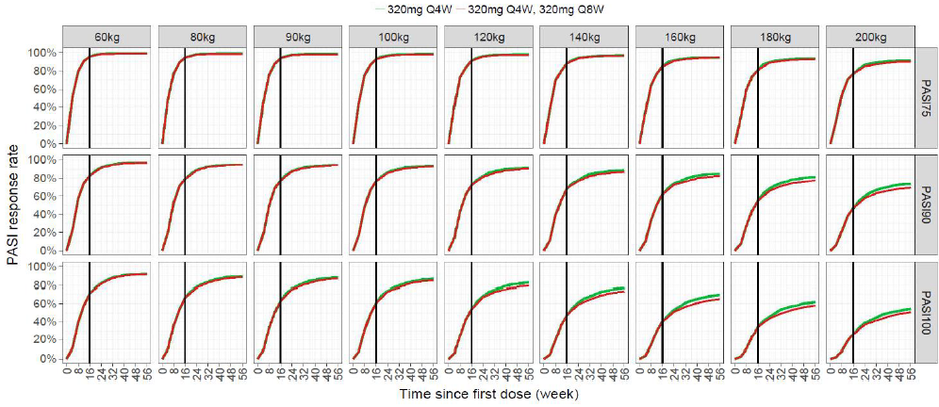
PASI = Psoriasis Area and Severity Index; PASI 75 = 75% improvement from baseline in PASI; PASI 90 = 90% improvement from baseline in PASI; PASI 100 = 100% improvement from baseline in PASI; Q4W = every 4 weeks; Q8W = every 8 weeks; 320mg Q4W, 320 mg Q8W = 320 mg Q4W followed by 320 mg Q8W from Week 16 onwards
Note: Coloured lines represent different treatment groups.
The vertical line shows the time (Week 16) when the study participants in the second treatment group switch from 320mg Q4W regimen to 320mg Q8W regimen.
The sponsor also provided additional clinical efficacy and safety data in response to questions posed by the TGA, based on integrated analysis of the pivotal Phase III studies (Studies PS0008, PS0009 and PS0013) with the available data from an on going Phase IIIb Study PS0015. From the analysis, the difference with bimekizumab 320 mg every 4 weeks dosing between less than 120 kg and greater than 120 kg weights is 9.3% for both PASI 90 and IGA 0/1 responses, at Week 16. The Delegate rates the latter as being numerical with no statistical reference, as there was no statistical analysis.
Also, from the re-presented data from the PopPK Analysis CL0485, patients weighing 120 kg are anticipated to have 30% lower concentration of product compared to a patient of 90 kg, and patients weighing approximately 200 kg are anticipated to have a 60% lower plasma concentration.
In assessing the above anticipations, the Delegate believes that the issue of possible drug accumulation at the proposed maintenance treatment dose of bimekizumab 320 mg every 4 weeks in patients greater than 120kg ought to be carefully reviewed, as the first order kinetics of bimekizumab can quickly shift to zero order kinetics, which is not desirable. However, should the bimekizumab 320 mg every 4 weeks maintenance dose in patients greater than 120 kg be acceptable, the Delegate recommends that a statement in the ‘Precautionary Section’ of the PI warning against the possibility of drug accumulation is recommended.
As explained below, there is also the issue of hepatic dysfunction signalling in bimekizumab clinical trials and such adverse effects might be magnified, should the maintenance treatment be 320 mg every 4 weeks, as opposed to every 8 weeks in greater than 120kg patients.
The phagocytic cells of the immune system, such as macrophages and monocytes, are the major players in the elimination of bimekizumab and endogenous IgG with minimal proteolysis via CYP450 enzymes in the liver. Despite the latter, there is signalling for hepatic dysfunction in the bimekizumab psoriatic clinical trials as per the TGA’s clinical evaluation and, in bimekizumab psoriatic arthritis clinical trials. Taken together, the observed hepatic signalling in those clinical trials is suggestive of the need to include a statement under the ‘Hepatic Section’ of the PI, for example:
‘Hepatic dysfunction has been reported in Bimekizumab clinical trials, albeit without explained direct causality to Bimekizumab’.
It is noted that the draft PI carries a statement that:
‘Bimzelx has not been studied in these patient populations. Dose adjustments are not considered necessary based on pharmacokinetics’.
As there are no PK data in patients with hepatic impairment, it is recommended that the current statement under ‘Use in hepatic impairment‘ section of the PI, on the line for the comparator drugs (adalimumab and ustekinumab), should be expanded to:
‘No specific PK studies using Bimzelx have been pursued in patients with underlying impaired hepatic function and, caution is therefore required in patients with underlying hepatic dysfunction’

Neutralising antibody status
In E2 pooled population of Week 16 responders, neutralising antibody status had no impact on efficacy, in the short term (Week 16). Higher PASI 90 and IGA 0/1 response rates at Week 52 were however noted in neutralising antibody positive study participants compared to neutralising antibody negative participants in the bimekizumab 320 mg every 4 weeks group, whereas a smaller trend was observed in the bimekizumab 320 mg every 8 weeks group.
The observed higher efficacy in neutralising antibody positive study participants and the smaller trend in the bimekizumab 320 mg every 8 weeks can be expected. The above neutralising antibody positivity relative to co-primary efficacy outcomes should be reflected in the PI.

Anti-drug antibody status
Although the effect of anti-drug antibodies on bimekizumab efficacy outcome was not mentioned in the clinical trials, the PK studies showed that treatment-emergent anti-drug antibodies occurred as early as 4 weeks post first dose (that is baseline dose) at the first anti-drug antibodies sampling time point, and cumulative counts increased over time thereafter. The PK of bimekizumab is impacted in the presence of anti-drug antibodies, with a slightly lower bimekizumab plasma concentration and an 8% higher apparent clearance in anti-drug antibodies positive compared with anti-drug antibodies negative study participants.
The impact of neutralising antibody positivity on PK of bimekizumab was larger than that for anti-drug antibodies positivity.
Given the above, the long-term effect of anti-drug antibodies positivity on bimekizumab efficacy is yet to be determined and, ought to be reflected in the PI.

Drug delivery mechanism
Studies DV0002 and DV0006 compared the ability of patients to use either of two delivery mechanisms that is a pre-filled syringe (bimekizumab-SS-1mL) and auto-injector prefilled pen (bimekizumab-AI-1mL) to self-administer bimekizumab. It was established that patients can be trained to use either of the two delivery mechanisms to self-administer bimekizumab. As per below, the container safety evaluator has no objection to registering the two delivery systems.
It is noted that only the pre-filled syringe (bimekizumab-SS-1mL) was used in the evaluated clinical trials. However, the submitted comparative bioavailability (that is bioequivalence) study revealed similar AUC and C_{max} values for drug delivery via both bimekizumab-SS-1ml and bimekizumab-AI-1 mL systems. Therefore, the Delegate also has no objection to registering the two delivery systems.

Summary
The TGA’s quality evaluations have not raised objections to the registration of bimekizumab.
The container safety assessor stated that bimekizumab (Bimzelx) 160 mg/1 mL solution for injection via auto-injector and safety syringe are acceptable for registration.
While there are no objections to the registration of bimekizumab from the non-clinical perspective, modifications to the draft PI have been suggested and the sponsor has fully complied.
While the jury is still out on the causality of the liver dysfunction signalling noted in bimekizumab clinical trials, and given that the first worldwide marketing authorisation for Bimzelx was only approved in the European Union on 20 August 2021, it is preferable that hepatic dysfunction be listed in the Australia-specific annex (ASA) of the risk management plan (RMP) until proven otherwise, by a high volume of periodic safety update report (PSUR) data further down the line.
The TGA’s evaluation of the RMP has recommended modifications to the CMI for the sponsor’s compliance.
The reported adverse effects in the clinical trials include:
- Upper respiratory tract infections;
- Fungal infections;
- Neutropaenia;
- Serious hypersensitivity reactions, including anaphylactic reactions;
- Immunogenicity via development of both neutralising antibody and anti-drug antibody.
The above and others are already included, as per stratified frequency, in the PI.
Regarding pharmacodynamic interactions, the Delegate suggests an expansion for clarity as follows:
‘No CYP450 interaction studies have been performed in humans. There is no direct evidence for the role of IL-17A or IL-F in the expression of CYP450 enzymes. Given that the (1) phagocytic cells of the immune system such as macrophages and monocytes are the major players in the elimination of bimekizumab and endogenous IgG, any proteolysis in the liver via CYP450 will be minimal and (2) formation of some CYP450 enzymes which is suppressed by elevated levels of cytokines during inflammation (as in psoriasis), will be reversed by inflammatory suppressors, like IL-17A and IL-17F inhibitor bimekizumab, the resultant outcome will be an abundance of CYP450. Extrapolation of the latter means that drugs metabolized by the CYP450 system may be co-administered with bimekizumab. However, monitoring of therapeutic plasma level and clinical effect of drugs with narrow therapeutic index (e.g. warfarin) metabolized via CYP450 system is recommended, due to the probability of a reduction in therapeutic plasma concentration.’
Both the TGA’s clinical evaluation and the Delegate accept the sponsor’s proposed indication:
Bimekizumab (Bimzelx) is indicated for the treatment of moderate to severe plaque psoriasis in adult patients who are candidates for systemic therapy or phototherapy.
The Delegate has requested that the sponsor submits the outcome of the open label Study PS0014 (long-term safety/efficacy of bimekizumab) and the safety follow up visit when available to TGA.

Proposed action
The efficacy and safety of bimekizumab in the management of moderate to severe plaque psoriasis in adult patients who are candidates for systemic therapy or phototherapy have been documented in three pivotal trials (Studies PS0008, PS0009 and PS0013).
The outcome of the open label Study PS0014 (long-term safety /efficacy of bimekizumab) and data from the safety follow up visit will be required to assess the risk/benefit of bimekizumab long term.

Advisory Committee considerations
The Advisory Committee on Medicines (ACM), having considered the evaluations and the Delegate’s overview, as well as the sponsor’s response to these documents, advised the following.

Specific advice to the Delegate
- The ACM is asked to advise on the proposed maintenance dose treatment at bimekizumab 320 mg every 4 weeks in patients weighing more than 120 kg.
The ACM advised that a shorter dosing interval of every 4 weeks for patients weighing > 120 kg is an acceptable option based on the PK and safety data. The ACM advised that the treatment regime for heavier patients should be left to clinician discretion based on clinical response as a study has not been conducted to compare the efficacy based on weight characteristics.
The ACM advised that it should be made clear that increasing the dosing frequency in heavier patients has not been shown to result in greater efficacy but may be used to increase plasma concentrations of bimekizumab in heavier patients.
- The ACM is asked to advice on the inclusion of reported hepatic dysfunction in bimekizumab clinical trials.
The ACM advised that any significant liver adverse events had been thoroughly investigated and did not appear to be drug related. As such, no additions to the PI are required based on the current reported cases of liver dysfunction.
- The ACM is asked to advise on expanding the current statement under hepatic impairment section.
The ACM noted that absence of data in those with hepatic dysfunction, as well as renal dysfunction. The ACM advised that the PI could state that:
‘caution should be taken in people with hepatic and renal dysfunction due to the absence of data from these populations in the studies.’
- The ACM is asked to comment on the reflection of both neutralising antibody and anti-drug antibody positivity in the Product Information.
The ACM advised that the proposed wording appears appropriate based on current data:
‘No evidence of altered clinical response, or safety profile was associated with development of anti-bimekizumab antibodies and neutralising antibodies’.
- The TGA is asked to comment on expansion of the statement on the rather pharmacodynamic interaction of bimekizumab with CYP450 metabolised drugs.
The ACM advised that the proposed additions to Section 4.5 of the PI are generally acceptable, but recommended the sentence be tempered as below to avoid overstating the potential of a reduction in plasma concentration;
From:
‘However, monitoring of therapeutic plasma level and clinical effect of drugs with narrow therapeutic index (e.g. warfarin) metabolised via CYP450 system should be considered due to the probability of a reduction in therapeutic plasma concentration.’
Amended to:
‘However, monitoring of therapeutic plasma level and clinical effect of drugs with narrow therapeutic index (e.g. warfarin) metabolised via CYP450 system should be considered.’
- The ACM is asked for its preference for hepatic dysfunction to be listed in the Australian specific annex of the risk management plan until proven otherwise, by a high volume of periodic safety update report data further down the line.
The ACM did not think this measure is required based on the current safety profile (see also advice given to Question 2, above).
- The ACM is asked to advise on the approvability or otherwise of the submission.
Based on the available efficacy and safety data, the ACM advised that the benefit risk profile of Bimzelx is positive for the proposed indication:
‘Bimzelx is indicated for the treatment of moderate to severe plaque psoriasis in adult patients who are candidates for systemic therapy or phototherapy.’
- The ACM is asked to provide any other relevant advice on the submission.
The ACM advised that the instructions in the Consumer Medicines Information (CMI) regarding administration should be expanded, including whether to angle the needle or to stretch or pinch the skin when injecting. The infographics showing the generally accepted sites for injection should be amended to depict the anterolateral (rather than only anterior) thighs and the posterior (rather than posterolateral) arms.
The ACM agreed that the statement in the proposed PI that ‘Live vaccines should not be given in patients treated with Bimzelx’ is important and, noting that administration of live vaccines was not assessed in the trials, advised that this could instead be listed as a contraindication (must not) instead of a special warning/precaution (should not).

Conclusion
The ACM considered this product to have an overall positive benefit-risk profile for the indication:
Bimzelx is indicated for the treatment of moderate to severe plaque psoriasis in adult patients who are candidates for systemic therapy or phototherapy.

Outcome
Based on a review of quality, safety, and efficacy, the TGA approved the registration of Bimzelx (bimekizumab) 160 mg/1 mL, solution for injection, auto-injector and safety syringe, indicated for:
Bimzelx is indicated for the treatment of moderate to severe plaque psoriasis in adult patients who are candidates for systemic therapy or phototherapy

Specific conditions of registration applying to these goods
- Bimzelx (bimekizumab) is to be included in the Black Triangle Scheme. The PI and CMI for Bimzelx must include the black triangle symbol and mandatory accompanying text for five years, which starts from the date that the sponsor notifies the TGA of supply of the product.
- The Bimzelx EU-risk management plan (RMP) (version 1.0, dated 26 August 2021, data lock point 1 November 2019), with ASA (version 2.0, dated 13 September 2021), included with submission PM-2020-06299-1-1, and any subsequent revisions, as agreed with the TGA will be implemented in Australia.
An obligatory component of risk management plans is routine pharmacovigilance. Routine pharmacovigilance includes the submission of periodic safety update reports (PSURs).
Reports are to be provided in line with the current published list of EU reference dates and frequency of submission of PSURs until the period covered by such reports is not less than three years from the date of the approval letter.
The reports are to at least meet the requirements for PSURs as described in the European Medicines Agency’s Guideline on good pharmacovigilance practices (GVP) Module VII-periodic safety update report (Rev 1), Part VII.B Structures and processes. Note that submission of a PSUR does not constitute an application to vary the registration.
- For all injectable products the Product Information must be included with the product as a package insert.

Attachment 1. Product Information
The PI for Bimzelx approved with the submission which is described in this AusPAR is at Attachment 1. For the most recent PI, please refer to the TGA PI/CMI search facility.

Therapeutic Goods Administration
PO Box 100 Woden ACT 2606 Australia
Email: info@tga.gov.au Phone: 1800 020 653 Fax: 02 6232 8605
https://www.tga.gov.au

Rendon A, Schäkel K. Psoriasis Pathogenesis and Treatment. International Journal of Molecular Sciences. 2019; 20(6):1475.
Takeshita J, Grewal S, Langan S, Mehta N, Ogdie A, Van Voorhees A et al. Psoriasis and comorbid diseases: epidemiology. J Am Acad Dermatol. 2017; 76: 377-390.
Hawkes J, Chan T, Krueger J. Psoriasis pathogenesis and the development of novel targeted immune therapies. Journal of Allergy and Clinical Immunology. 2017; 140(3): 645-653.
Kim J, Krueger JG. Highly effective new treatments for psoriasis target the IL-23/Type 17 T cell autoimmune axis. Annu Rev Med 2017; 68: 255–269.
Blauvelt A, Chiricozzi A. The Immunologic Role of IL-17 in Psoriasis and Psoriatic Arthritis Pathogenesis. Clin Rev Allergy Immunol. 2018;55(3):379-390.
Zaba L, Fuentes-Duculan J, Eungdamrong N, Abello M, et al. Psoriasis Is Characterized by Accumulation of Immunostimulatory and Th1/Th17 Cell-Polarizing Myeloid Dendritic Cells, Journal of Investigative Dermatology, 2009;129(1)
Capon F. The Genetic Basis of Psoriasis. Int J Mol Sci. 2017;18(12):2526.
Stawczyk-Macieja M, Szczerkowska-Dobosz A, Rębała K, Purzycka-Bohdan D. Genetic background of skin barrier dysfunction in the pathogenesis of psoriasis vulgaris. Postepy Dermatol Alergol. 2015;32(2):123-126.
Parisi R, Iskandar I, Kontopantelis E, Augustin M, Griffiths C, Ashcroft D. (2020). National, regional, and worldwide epidemiology of psoriasis: systematic analysis and modelling study on behalf of the Global Psoriasis Atlas. British Medical Journal. 2020;369. 1590;(10).
Palfreeman AC, McNamee KE, McCann FE. New developments in the management of psoriasis and psoriatic arthritis: a focus on apremilast. Drug Design, Development and Therapy. 7: 201–10.
Boehncke WH, Schön MP. Psoriasis. Lancet. 2015;386 (9997): 983–94.
Publication adapted from Baker C, et al. Treatment goals for moderate to severe psoriasis: An Australian consensus. Australas J Dermatol. 2013 May;54(2):148-54
Consensus statement available from the Australasian College of Dermatologists website (as at the time of AusPAR publication); available at: https://www.dermcoll.edu.au/wp-content/uploads/ACD-Consensus-Statement-Treatment-goals-for-psoriasis-March-2017.pdf
Methotrexate was first registered in Australia on 9 July 1991, ARTG number: 10777
Ciclosporin was first registered in Australia on 21 August 1991. ARTG number: 13341
Hydroxycarbamide was first registered in Australia on 18 January 1991. ARTG number: 47486
Acitretin was first registered in Australia on 26 May 1995. ARTG number: 52455.
Calcipotriol was first registered in Australia on 26 April 1994. ARTG number: 46683.
Apremilast was first registered in Australia on 19 March 2015. ARTG number: 220423.
Adalimumab was first registered in Australia on 28 August 2012. ARTG number: 199410.
Certolizumab was first registered in Australia on 20 January 2010. ARTG number: 154726.
Etanercept was first registered in Australia on 20 January 2010. ARTG number: 154726.
Infliximab was first registered in Australia on 2 August 2000. ARTG number: 73827.
Guselkumab was first registered in Australia on 15 March 2018. ARTG number: 286020.
Tildrakizumab was first registered in Australia on 10 September 2018. ARTG number: 290683.
Risankizumab was first registered in Australia on 16 July 2019. ARTG number: 304226.
Ustekinumab was first registered in Australia on 28 July 2009. ARTG number: 149549.
Ixekizumab was first registered in Australia on 6 September 2016. ARTG number: 253892.
Secukinumab was first registered in Australia on 12 January 2015. ARTG number: 218798.
European Medicines (Evaluation) Agency: CHMP/EWP/2454/02: Guideline on Clinical Investigation of Medicinal Products Indicated for the Treatment of Psoriasis.
European Medicines Agency (EMA): CHMP/ICH/731268/1998: ICH guideline S6 (R1) preclinical safety evaluation of biotechnology-derived pharmaceuticals.
Drugs which, owing to their pharmacological effects, have caused or may be suspected of causing, harmful effects on the human fetus or neonate without causing malformations. These effects may be reversible. Accompanying texts should be consulted for further details.
PASI90 is an improvement of 90% or better with respect to baseline Psoriasis Area and Severity Index.
Fredriksson T, Pettersson U. Severe psoriasis--oral therapy with a new retinoid. Dermatologica. 1978;157(4):238-244.
Feldman S, Krueger G. Psoriasis assessment tools in clinical trials. Annals of the Rheumatic Diseases 2005;64:ii65-ii68.
Puzenat E, Bronsard V, Prey S, et al. What are the best outcome measures for assessing plaque psoriasis severity? A systematic review of the literature. J Eur Acad Dermatol Venereol. 2010;24 Suppl 2:10-16.
EMA/EMEA: Guideline on clinical investigation of medicinal products indicated for the treatment of psoriasis (CHMP/EWP/2454/02 corr). TGA-adopted (with annotations); effective date: 28 July 2005.
Dr A. Oakley, PASI score, DermNet NZ: clear description with photos of the different redness, thickness and scaling levels. Available at: PASI (psoriasis area and severity index) | DermNet (dermnetnz.org)
IGA 0/1 is defined as Clear [0] or Almost Clear [1] with at least a two category improvement relative to Baseline
Dand N, Mahil SK, Capon F, Smith CH, Simpson MA, Barker JN. Psoriasis and Genetics. Acta Derm Venereol. 2020;100(3):adv00030

