March 2023

Australian Public Assessment Report for Vabysmo
  - Active ingredient: Faricimab
  - Sponsor: Roche Products Pty Limited

About the Therapeutic Goods Administration (TGA)
- The Therapeutic Goods Administration (TGA) is part of the Australian Government Department of Health and is responsible for regulating therapeutic goods, including medicines, medical devices, and biologicals.
- The TGA administers the Therapeutic Goods Act 1989 (the Act), applying a risk management approach designed to ensure therapeutic goods supplied in Australia meet acceptable standards of quality, safety, and efficacy.
- The work of the TGA is based on applying scientific and clinical expertise to decision-making, to ensure that the benefits to the Australian public outweigh any risks associated with the use of therapeutic goods.
- The TGA relies on the public, healthcare professionals and industry to report problems with therapeutic goods. The TGA investigates reports received to determine any necessary regulatory action.
- To report a problem with a therapeutic good, please see the information on the TGA website.

About AusPARs
- The Australian Public Assessment Report (AusPAR) provides information about the evaluation of a prescription medicine and the considerations that led the TGA to approve or not approve a prescription medicine submission. Further information can be found in Australian Public Assessment Report (AusPAR) guidance.
- AusPARs are prepared and published by the TGA.
- AusPARs are static documents that provide information that relates to a submission at a particular point in time. The publication of an AusPAR is an important part of the transparency of the TGA’s decision-making process.
- A new AusPAR may be provided to reflect changes to indications or major variations to a prescription medicine subject to evaluation by the TGA.

Copyright
© Commonwealth of Australia 2023
This work is copyright. You may reproduce the whole or part of this work in unaltered form for your own personal use or, if you are part of an organisation, for internal use within your organisation, but only if you or your organisation do not use the reproduction for any commercial purpose and retain this copyright notice and all disclaimer notices as part of that reproduction. Apart from rights to use as permitted by the Copyright Act 1968 or allowed by this copyright notice, all other rights are reserved, and you are not allowed to reproduce the whole or any part of this work in any way (electronic or otherwise) without first being given specific written permission from the Commonwealth to do so. Requests and inquiries concerning reproduction and rights are to be sent to the TGA Copyright Officer, Therapeutic Goods Administration, PO Box 100, Woden ACT 2606 or emailed to <tga.copyright@tga.gov.au>.

Contents
List of abbreviations 4
Product submission 6
Submission details 6
Product background 8
Regulatory status 9
Product Information 11
Registration timeline 11
Submission overview and risk/benefit assessment 12
Quality 12
Nonclinical 13
Clinical 15
Risk management plan 60
Risk-benefit analysis 62
Outcome 69
Specific conditions of registration applying to these goods 69
Attachment 1. Product Information 70

List of abbreviations
Abbreviation |  | Meaning
ACM | Advisory Committee on Medicines
ADA | Anti-drug antibody
ADR | Adverse drug reaction
AE | Adverse event
AESI | Adverse event of special interest
AMD | Age-related macular degeneration
Ang-2 | Angiopoietin-2
APTC | Anti-platelet Trialists’ Collaboration
ARGPM | Australian Regulatory Guidelines for Prescription Medicines
ARTG | Australian Register of Therapeutic Goods
ASA | Australia specific annex
BCVA | Best corrected visual acuity
CI | Confidence interval
C_{max} | Maximum concentration
CMI | Consumer Medicines Information
COVID-19 | Coronavirus disease 2019
CPD | Certified Product Details
CST | Central subfield thickness
CV | Coefficient of variation
DLP | Data lock point
DME | Diabetic macular edema (US English)
DMO | Diabetic macular oedema (Australian English)
DNA | Deoxyribonucleic acid
ETDRS | Early treatment diabetic retinopathy study
EU | European Union
Fc | Fragment crystallisable
FcRn | Neonatal fragment crystallisable receptor
FcγR | Fragment crystallisable gamma receptor
GVP | Good Pharmacovigilance Practice
HbA1c | Haemoglobin A1c
IgG | Immunoglobulin G
ITT | Intent(ion)-to-treat
nAMD | Neovascular age-related macular degeneration (also known as ‘wet’ age-related macular degeneration)
PD | Pharmacodynamic(s)
PDF | Portable Document Format
PI | Product Information
PK | Pharmacokinetic(s)
PopPK | Population pharmacokinetic(s)
PSUR | Periodic safety update report
PTI | Personalised treatment interval
QTc | Corrected QT interval
RMP | Risk management plan
SAE | Serious adverse event
SmPC | Summary of product characteristics (European Union)
TGA | Therapeutic Goods Administration
US(A) | United States (of America)
VEGF | Vascular endothelial growth factor

Product submission

Submission details
Type of submission: | New biological entity
Product name: | Vabysmo
Active ingredient: | Faricimab
Decision: | Approved
Date of decision: | 4 August 2022
Date of entry onto ARTG: | 8 August 2022
ARTG number: | 369935
Black Triangle Scheme: | Yes.  This product will remain in the scheme for 5 years, starting on the date the product is first supplied in Australia.
Sponsor’s name and address: | Roche Products Pty Limited  Level 8, 30-34 Hickson Road  Sydney NSW 2000
Dose form: | Solution for injection
Strength: | 120 mg/mL
Container: | Vial
Pack size: | One
Approved therapeutic use: | Vabysmo is indicated for the treatment of:  - Neovascular (wet) age-related macular degeneration (nAMD)  - Diabetic macular oedema (DMO).
Route of administration: | Intravitreal injection (within the vitreous cavity of the eye)
Dosage: | Vabysmo must be administered by a qualified physician experienced in intravitreal injections. Each vial should only be used for the treatment of a single eye.  Neovascular (wet) age-related macular degeneration (nAMD)  The recommended dose for Vabysmo is 6 mg (0.05 mL) administered by intravitreal injection every 4 weeks for the first 4 doses. Thereafter, an assessment of disease activity based on anatomic and/or visual outcomes is recommended 20 to 24 weeks after treatment initiation so treatment can be individualised. Based on this assessment, in patients without disease activity, administration of Vabysmo every 16 weeks should be considered. Based on this assessment, in patients with disease activity, treatment every 8 weeks or 12 weeks should be considered (see Section 5.1 of the Product Information).  Diabetic macular oedema (DMO)  The recommended dose for Vabysmo is 6 mg (0.05 mL) administered by intravitreal injection every 4 weeks for the first 4 doses. Thereafter, treatment may be individualised using a treat-and-extend approach following an assessment of the individual patient's anatomic and/or visual outcomes. Following the outcome of this assessment, the dosing interval may remain at every 4 weeks, or may be extended in 4 week increments up to every 16 weeks. If anatomic or visual outcomes change, the treatment interval should be adjusted accordingly (see Section 5.1 of the Product Information).  Continued monitoring of disease activity and individualisation of dosing is recommended. Monitoring between the dosing visits should be scheduled based on the patient's status and at the physician's clinical judgement.  Duration of treatment  Vabysmo is intended for long-term treatment. The duration of treatment for DMO is adjusted accordingly to clinical response. The duration of treatment for nAMD is likely to be long-term treatment.  If visual and/or anatomic outcomes indicate that the patient is not benefitting from continued treatment, Vabysmo should be discontinued.  For further information regarding dosage, refer to the Product Information.
Pregnancy category: | D  Drugs which have caused, are suspected to have caused or may be expected to cause, an increased incidence of human fetal malformations or irreversible damage. These drugs may also have adverse pharmacological effects. Accompanying texts should be consulted for further details.  The use of any medicine during pregnancy requires careful consideration of both risks and benefits by the treating health professional. This must not be used as the sole basis of decision making in the use of medicines during pregnancy. The TGA does not provide advice on the use of medicines in pregnancy for specific cases. More information is available from obstetric drug information services in your State or Territory.

Product background
This AusPAR describes the submission by Roche Products Pty Limited (the sponsor) to register Vabysmo (faricimab) 120 mg/mL, solution for injection for the following proposed indication:
Vabysmo is a bispecific angiopoietin-2 (Ang-2) and vascular endothelial growth factor (VEGF) inhibitor indicated for the treatment of:
- Neovascular (wet) age-related macular degeneration (nAMD)
- Diabetic macular oedema (DME).
Age-related macular degeneration (AMD) is a chronic eye disease characterised by progressive degeneration in the central retina (macula). It is one of the most common eye diseases to cause vision loss after age 60. AMD can be categorised using the Age-Related Eye Disease Study Scale: no AMD, early AMD, intermediate AMD and advanced AMD which includes neovascular AMD (wet AMD or nAMD) or advanced dry AMD (geographic atrophy involving the macula). The neovascular form of the disease is present in about 10% of all AMD cases, but it accounted for approximately 90% of the severe vision loss from AMD. Without treatment, most affected eyes will develop poor central vision (20 of 200 or less) within 12 months.
Neovascular AMD (nAMD) is characterised by neovascularisation from the subjacent choroid into the sub-retinal pigment epithelium space and the subretinal space, a process termed choroidal neovascularisation. These newly formed vessels have an increased likelihood to leak blood and serum, causing separation of Bruch’s membrane, retinal pigment epithelium and retina from each other and resulting in the accumulation of sub- retinal pigment epithelium, sub-retinal or intra-retinal fluid. Fluid accumulation leads to a generalised thickening of the retina and/or the formation of cystic spaces. These pathological manifestations of the retina cause the photoreceptors to become misaligned and eventually degenerative changes occur with cell loss and eventual fibrosis and scar tissue formation. This damage to the retina results in progressive, severe, and irreversible central vision loss.
Current treatment options for nAMD include intravitreal injection of anti-vascular endothelial growth factor (anti-VEGF) agents, for example, Lucentis (ranibizumab), Eylea (aflibercept) and Beovu (brolucizumab). Previous therapy approaches such as photodynamic therapy, thermal laser photocoagulation and surgery are not frequently or no longer recommended.
Diabetic macular oedema (DMO), alternatively, diabetic macular edema (DME) is a common complication of both Type 1 and 2 diabetes as well as a leading cause of central vision loss in patients with diabetic retinopathy. Both DMO and diabetic retinopathy share the same underlying pathophysiological processes. Hyperglycaemia may lead to microvasculopathy. The loss of pericytes, retinal micro-aneurysms, dilated capillaries, and vascular inflammation lead to the destabilisation of retinal vasculature, breakdown of the inner blood retinal barrier, and pathological increase in vascular permeability. Fluid and macromolecules leak from the intraretinal vasculature into the interstitial spaces of the surrounding retina. The underlying diabetic retinopathy in DMO patients slowly and insidiously progresses from early non-proliferative diabetic retinopathy to the advanced stages of proliferative diabetic retinopathy characterised by neovascularisation. The accumulation of intraretinal fluid within the macula causes DMO, with or without cystoid changes, resulting in photoreceptor degeneration, which can lead to irreversible loss of central vision.
The primary treatment goals for DMO are improving or maintaining visual acuity, reducing retinal fluid, improving the underlying diabetic retinopathy and preventing irreversible damage to the macula. Treatment options include (some off-label) photocoagulation (macular laser); steroids (periocular or intravitreal steroids and steroid implants (limitations of severe side effects such as cataract and glaucoma)); anti-VEGF treatments (intravitreal administration of ranibizumab (Lucentis) or aflibercept (Eylea)).
Vabysmo (faricimab) is a humanised bispecific immunoglobulin G1 (IgG1) antibody that selectively binds and neutralises VEGF-A and angiopoietin-2 (Ang-2). Ang-2 and VEGF are two key mediators in the pathogenesis of the proposed indications. Ang-2 causes vascular instability by promoting endothelial destabilisation, pericyte loss, and pathological angiogenesis, thus potentiating vascular leakage and inflammation. It also sensitises blood vessels to the activity of VEGF-A resulting in further vascular destabilisation. Ang-2 and VEGF-A synergistically increase vascular permeability and stimulate neovascularisation. The dual inhibition of Ang-2 and VEGF-A with faricimab is expected to reduce vascular permeability and inflammation, inhibit pathological angiogenesis, and restore vascular stability. It could potentially translate into improved durability and/or efficacy in nAMD and DMO when compared to anti-VEGF therapy alone.
This submission was evaluated as part of the Australia-Canada-Singapore-Switzerland-United Kingdom (ACCESS) New Active-Substance Work-Sharing Initiative (NASWSI) with work-sharing between the TGA, Health Canada, Health Sciences Authority Singapore, Swissmedic and the Medicines and Healthcare Products Regulatory Agency. Each regulator made independent decisions regarding approval (market authorisation) of the new medicine.

Regulatory status
This product is considered a new biological entity for Australian regulatory purposes.
At the time the TGA considered this submission, similar submissions had been approved in the United States of America (USA) on 28 January 2022, the United Kingdom on 16 May 2022, Canada on 30 May 2022, Singapore on 16 June 2022, Switzerland on 25 May 2022, and Japan on 28 March 2022. Similar submissions were under consideration in the European Union (EU) (submitted on 28 May 2021), and New Zealand (submitted on 20 July 2022)
The following table summarises these submissions and provides the indications where approved.

Table 1: International regulatory status
Region | Submission date | Status | Approved indications
United States of America | 28 May 2021 | Approved on 28 January 2022 | Vabysmo is a vascular endothelial growth factor (VEGF) and angiopoietin-2 (Ang-2) inhibitor indicated for the treatment of patients with:  - neovascular (wet) age-related macular degeneration (nAMD)  - diabetic macular edema (DME)
European Union | 28 May 2021 | Under consideration | Under consideration
United Kingdom | 21 June 2021 | Approved on 16 May 2022 | Vabysmo is indicated for the treatment of adult patients with:  - neovascular (wet) age-related macular degeneration (nAMD)  - visual impairment due to diabetic macular oedema (DMO)
Canada | 21 June 2021 | Approved on 30 May 2022 | Vabysmo (faricimab injection) is indicated for the treatment of:  - neovascular (wet) age-related macular degeneration (nAMD)  - diabetic macular edema (DME).
Singapore | 21 June 2021 | Approved on 16 June 2022 | Vabysmo is indicated for the treatment of adult patients with:  - neovascular (wet) age-related macular degeneration (nAMD)  - visual impairment due to diabetic macular edema (DME).
Switzerland | 21 June 2021 | Approved on 25 May 2022 | Treatment of neovascular (wet) age-related macular degeneration (nAMD).  Treatment of diabetic macular edema (DME).
New Zealand | 20 July 2022 | Under consideration | Under consideration
Japan | 11 June 2021 | Approved on 28 March 2022 | - Age-related macular degeneration associated with subfoveal choroidal neovascularization  - Diabetic macular edema

Product Information
The Product Information (PI) approved with the submission which is described in this AusPAR can be found as Attachment 1. For the most recent PI, please refer to the TGA PI/CMI search facility.

Registration timeline
The following table captures the key steps and dates for this submission.
Table 2: Timeline for Submission PM-2021-02671-1-5
Description | Date
Submission dossier accepted and first round evaluation commenced | 4 August 2021
First round evaluation completed | 2 December 2021
Sponsor provides responses on questions raised in first round evaluation | 28 January 2022
Second round evaluation completed | 28 April 2022
Delegate’s Overall benefit-risk assessment and request for Advisory Committee advice | 3 May 2022
Sponsor’s pre-Advisory Committee response | 18 May 2022
Advisory Committee meeting | 2 and 3 June 2022
Registration decision (Outcome) | 4 August 2022
Completion of administrative activities and registration on the ARTG | 8 August 2022
Number of working days from submission dossier acceptance to registration decision* | 188
*Statutory timeframe for standard submissions is 255 working days

Submission overview and risk/benefit assessment
A summary of the TGA’s assessment for this submission is provided below.
This section is a TGA summary of wording used in TGA’s evaluation report, which discussed numerous aspects of overseas evaluation reports and included some information that was commercial-in-confidence.
The following guideline was referred to by the Delegate as being relevant to this submission:
- European Medicines Agency (EMA), Committee for medicinal products for human use (CHMP), ICH Guideline S6 (R1) - Preclinical Safety Evaluation of Biotechnology-Derived Pharmaceuticals, EMA/CHMP/ICH/731268/1998, June 2011.

Quality
Faricimab is a humanised bispecific antibody, which composed of two different heavy chains and two different light chains. One arm of the antibody binds vascular endothelial growth factor A (VEGF-A) and the other arm binds angiopoietin-2 (Ang-2). The bispecific antibody is produced in Chinese hamster ovary cell culture by recombinant deoxyribonucleic acid (DNA) technology.
Based upon the stability data submitted by the sponsor, it is recommended to store the drug substance at -40°C for no longer than 36 months; to store the drug product at 2°C to 8°C for no longer than 30 months and protected from light; to store the opened product at 2°C to 8°C for no longer than 24 hours and protected from light. No temperature excursion was requested.
Vabysmo (faricimab) is administered as an intravitreal injection. The product is available in type I glass vial with a rubber stopper, an aluminium seal and a plastic flip-off cap. It is presented as a single 2 mL vial containing 28.8 mg faricimab in 0.24 mL solution. This provides a usable amount to deliver a single dose of 0.05 mL solution containing 6 mg of faricimab.
There are no objections on quality grounds to the approval of Vabysmo (faricimab) 120 mg/mL solution for injection vial. The quality of this product is considered to be acceptable when used in accordance with the conditions defined in the Product Information, labels, Consumer Medicines Information (CMI) and the Australian Register of Therapeutic Goods (ARTG).

Proposed conditions of registration
- Laboratory testing and compliance with Certified Product Details (CPD)
All batches of Vabysmo faricimab supplied in Australia must comply with the product details and specifications approved during evaluation and detailed in the Certified Product Details (CPD).
When requested by the TGA, the sponsor should be prepared to provide product samples, specified reference materials and documentary evidence to enable the TGA to conduct laboratory testing on the product. Outcomes of laboratory testing are published biannually in the TGA Database of Laboratory Testing Results http://www.tga.gov.au/ws-labs-index and periodically in testing reports on the TGA website.
- Certified Product Details
The Certified Product Details (CPD), as described in Guidance 7: Certified Product Details of the Australian Regulatory Guidelines for Prescription Medicines (ARGPM) http://www.tga.gov.au/industry/pm-argpm-guidance-7.htm, in Portable Document Format (PDF), for the above products should be provided upon registration of these therapeutic goods. In addition, an updated CPD should be provided when changes to finished product specifications and test methods are approved in a Category 3; application or notified through a self-assessable change.

Nonclinical
The submitted nonclinical dossier was in accordance with the relevant TGA-adopted guideline. The overall quality of the nonclinical dossier was satisfactory. Pivotal safety-related studies were Good Laboratory Practice; compliant.
In vitro, faricimab bound to vascular endothelial growth factor A (VEGF-A) and angiopoietin-2 (Ang-2) with nanomolar affinity (binding to VEGF-A was comparable to anti-VEGF antibody ranibizumab). Faricimab had no affinity for fragment crystallisable gamma receptors (FcγRs) or neonatal fragment crystallisable receptor (FcRn). In a cynomolgus monkey model of neovascular age-related macular degeneration (nAMD), faricimab reduced the severity of laser-induced choroidal neovascularisation lesions to levels that were comparable to ranibizumab, providing nonclinical demonstration of efficacy for the proposed clinical indications.
Faricimab-positive staining correlated with cells associated with vascularisation and function, with high cytoplasmic staining in vascular endothelial cells, reticular cells, haematopoietic cells, mononuclear leukocytes and vascular smooth muscle. Faricimab is not expected to induce complement-dependent cytotoxicity or antibody-dependent cellular cytotoxicity due to modifications made to its fragment crystallisable (Fc)-region that reduces its affinity for Fc-receptors.
Examination of safety pharmacology (incorporated into general repeat dose toxicity studies) did not reveal any effects of faricimab on central nervous system or respiratory function, or on electrocardiogram in monkeys dosed by either the intravitreal or intravenous route.
The pharmacokinetics (PK) of faricimab in monkeys and human subjects was generally consistent with the protein nature of the drug (long half-lives and limited distribution). The long half-life of faricimab is a function of slow distribution from the vitreous humour into the systemic circulation, where it then undergoes elimination through normal protein degradation pathways for immunoglobulin G (IgG) molecules.
Faricimab showed a low order of acute toxicity in monkeys with either the intravenous route or the clinical route (intravitreal route).
Repeat dose toxicity studies using the clinical route (intravitreal dosing) were conducted in cynomolgus monkeys (up to 26 weeks). Severe inflammation in rabbit caused by development of anti-drug antibody (ADA)-related immune complexes, precluded their further use for toxicity assessments. Monkeys had better tolerability to faricimab and achieved systemic exposures that achieved sufficiently high multiples of clinical exposures. Vitreal concentrations of faricimab achieved in monkeys were similar to those proposed for patients. Immune-mediated ocular inflammation of dose-dependent severity was seen in most treated animals. Few ocular findings of note in recovery groups. Consistent with relatively low systemic exposures and faster systemic clearance, there was little evidence of systemic toxicities by either the intravitreal or the intravenous route.
No genotoxicity studies were conducted. Given the protein nature of the drug this is acceptable. No carcinogenicity studies were conducted. There was no evidence of proliferative lesions in the repeat dose toxicity study.
Effects of faricimab on reproduction function and development were assessed in monkeys, as the responsive species, and based on observations from repeat dose toxicity studies and an embryofetal development study. Faricimab did not induce any changes in male and female reproductive organs that would indicate adverse effects on fertility. No treatment-related effects on embryofetal development were observed in monkeys that were dosed intravenously. Whilst maternal systemic exposures were sufficiently high (based on comparisons to clinical maximum concentration (C_{max})), faricimab was below detectable levels in fetal samples, likely due to low affinity of faricimab for FcRn, which is required for placental transfer of maternal antibodies to the fetus. As an anti-VEGF, anti-angiogenic agent, faricimab may be potentially teratogenic. See discussion of pregnancy category under the nonclinical Conclusions and Recommendations section, below.
Faricimab-induced immunogenicity in monkeys (as well as rabbits in the 2-week tolerance study) had a variable influence on local and systemic exposures. Although inflammation observed in the animal studies was ascribed to ADA-mediated, immune-related responses with low relevance to patients, intraocular inflammation is an identified risk in the risk management plan (RMP).

Conclusions and recommendations
Primary pharmacology studies demonstrated affinity of faricimab for the intended pharmacological targets, VEGF-A and Ang-2, and adequately demonstrated efficacy in an animal model of nAMD.
Modification of the Fc-region of faricimab reduces interactions with FcγRI, FcγRII, FcγRIII and FcRn, preventing antibody-dependent effector responses such as antibody-dependent cellular cytotoxicity and complement-dependent cytotoxicity.
Faricimab-induced ocular inflammation was due to ADA development and immune complex formation and deposition in non-human species exposed to a humanised antibody. This response is unlikely to be relevant to humans.

Pregnancy category
The proposed Pregnancy Category C; is not acceptable and should be revised to Category D, based on mechanism of action as an anti-VEGF, anti-angiogenic agent which is potentially teratogenic.
Faricimab immunogenicity had variable effects on systemic exposures; however, ADA-mediated development of immune complexes underpinned the ocular inflammation, which was seen in dosed animals. Intraocular inflammation has been noted in some clinical studies.
There are no nonclinical objections to the registration, noting that intraocular inflammation was seen in all nonclinical species and has also been observed in patients.

Clinical

Summary of clinical studies
The clinical dossier consisted of:
- 2 Phase I pharmacokinetic (PK) study: Study BP28936 and Study JP39844;
- 3 Phase II supportive studies:
  - neovascular age-related macular degeneration (nAMD) studies: Study CR39521 (STAIRWAY trial) and Study BP29647 (AVENUE trial),
  - diabetic macular oedema (DMO) study: Study BP30099 (BOULEVARD trial);
- Phase III efficacy and safety studies:
  - nAMD pivotal studies: Study GR40306 (TENAYA trial) and Study GR40844 (LUCERNE trial),
  - DMO pivotal studies: Study GR40349 (YOSEMITE trial) and Study GR40398 (RHINE trial).
- In addition, the sponsor submitted one population pharmacokinetic (popPK) analysis of the 9 Phase I, II and III clinical studies.
An overview of all clinical studies is shown in Table 3 below.
Table 3: Overview of clinical studies
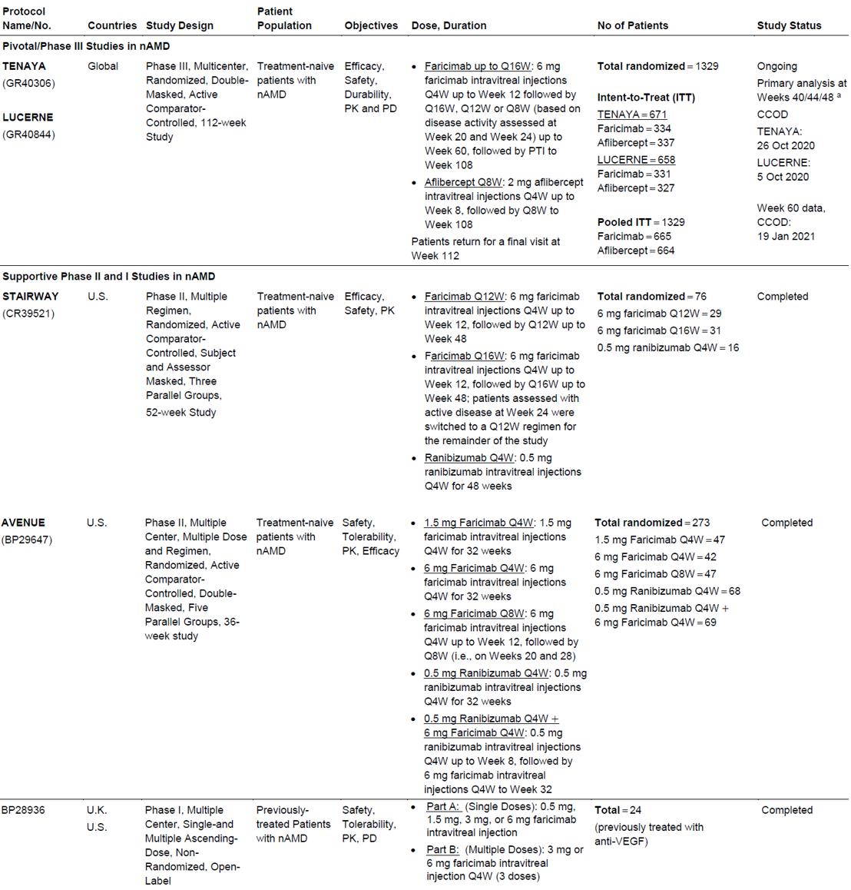
Table 3 continued: Overview of clinical studies
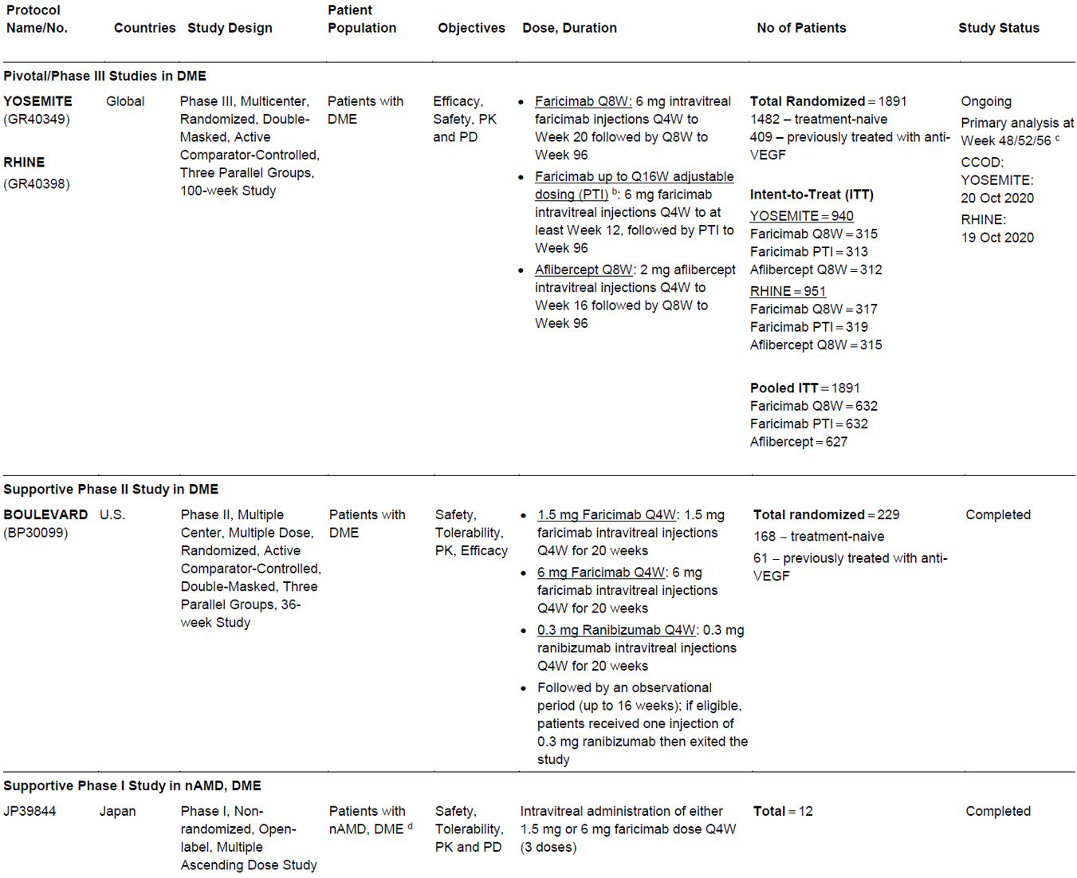
Abbreviations: CCOD = clinical cut-off date; DME = diabetic macular oedema; ITT = intent-to-treat; nAMD = neovascular age-related macular degeneration; PD = pharmacodynamic(s); PK = pharmacokinetic(s); PTI = personalised treatment interval (up to every 16 weeks adjustable dosing in diabetic macular oedema); Q4W = every 4 weeks; Q8W = every 8 weeks; Q12W = every 12 weeks; Q16W = every 16 weeks; U.K. = United Kingdom; U.S. = United States; VEGF = vascular endothelial growth factor.
a. The primary endpoint, change from Baseline in best corrected visual acuity (BCVA), was averaged over Weeks 40, 44, and 48.
b. Study drug dosing for patients on the PTI is extended, reduced, or maintained at study drug dosing visits using 4-week increments to a maximum of every 16 weeks or a minimum of every 4 weeks based on the relative change of the central subfield thickness (CST) and BCVA compared with the patient’s reference CST and reference BCVA.
c. The primary endpoint, defined as the change from Baseline in BCVA, was averaged over Weeks 48, 52, and 56.
d. Study JP39844, sponsored by Japanese co-development partner Chugai Pharmaceutical Co., Ltd., enrolled 4 patients with nAMD. and 8 patients with DME.

Pharmacology

Pharmacokinetics

Absorption
Faricimab is administered intravitreally. Following administration of faricimab 6 mg every 4 weeks followed by every 8 weeks, maximum concentrations in the vitreous are reached immediately upon administration with an estimated median maximum concentration (C_{max}) of 1340 μg/mL in both nAMD and DMO populations. Faricimab is cleared from the vitreous through the aqueous humour, then via plasma. In plasma, a median C_{max} of 0.22 µg/mL in the nAMD population and 0.21 µg/mL in the DMO population are reached after approximately 2 to 3 days. Maximum free faricimab concentrations in plasma are predicted to be approximately 600 and 6000-fold lower than in aqueous humour and vitreous, respectively. Absolute bioavailability was not determined due to lack of intravenous studies.

Distribution
The apparent volume of distribution in aqueous humour was 0.253 mL, and in plasma compartment was 1.48 L (derived from the final pharmacokinetics (PK) model). Maximum free faricimab concentrations in plasma are predicted to be approximately 600 and 6000-fold lower than in aqueous humour and vitreous humour, respectively. The systemic volume of distribution of 1.48 L, is consistent with a limited distribution.

Metabolism
Faricimab was engineered to abolish binding to neonatal fragment crystallisable receptor (FcRn), which is responsible for the recycling of immunoglobulin G (IgG) and the long terminal half-life of normal IgG of approximately 21 days. Therefore, faricimab metabolism is through IgG proteolysis, without recycling, leading to rapid systemic elimination.

Excretion and elimination
Faricimab is expected to be catabolised in lysosomes to small peptides and amino acids, which may be excreted renally, in a similar manner to the elimination of endogenous IgG.
Faricimab vitreous humour elimination was slow, with an estimated half-life of 7.46 days based on the population pharmacokinetic (PopPK) analysis. Due to flip-flop kinetics, the apparent decline in aqueous humour and plasma concentration is parallel to the vitreous concentrations.
The apparent aqueous humour half-life and apparent plasma half-life in Study BP28936 ranged from 6 to 8 days for patients receiving faricimab 6 mg, consistent with the vitreous and aqueous humour half-life from the PopPK analysis (see section: Population pharmacokinetic data, below).
The estimate of the plasma apparent clearance was 2.33 L/day, corresponding to a rapid half-life of approximately 0.44 days.

Dose proportionality
The Phase I Study BP28936 tested doses ranging from 0.5 mg every 4 weeks to 6 mg every 4 weeks. Plasma faricimab exposure increased approximately dose proportionally up to 3 mg faricimab without an apparent increase in systemic exposure for the 6 mg dose (compared to 3 mg).
The Phase II Study BP29647 (also known as the AVENUE trial) compared faricimab 6 mg every 4 weeks to 1.5 mg every 4 weeks treatment arm at 4 weeks and 12 weeks post-dose, and found an approximately 4-fold higher and 3-fold higher plasma concentration, respectively. This suggests dose proportionality up to 6 mg every 4 weeks.

Accumulation
No faricimab accumulation in the ocular or plasma compartments was observed, with steady state reached by the end of the every 4 weeks dosing.

Immunogenicity (population pharmacokinetic report)
Anti-drug antibodies (ADAs) were detected at least once after the start of faricimab administration in 218 (9.7%) patients, with ADA incidence rate similar for Phase I and II, and Phase III studies, and for patients with nAMD and DMO. ADAs were included in the model as a time-varying covariate. In some patients, they appeared after start of dosing but then disappeared. The ADA detection rate was below 1.5% for the first 12 weeks, increased to about 7% by Week 24, and then fluctuated between 7 and 8%. Patients with ADAs detected had a 30.4% greater vitreous elimination rate (a finding not considered to be clinically meaningful).

Intra- and inter-individual variability
For the individual clinical studies, high inter-patient variability was observed in aqueous humour (coefficient of variation (CV): 40% to 394%) and plasma (CV: 44% to 144%)) faricimab concentrations. Vitreous humour data appears not to be available.

Population pharmacokinetic data

Methods

Pharmacokinetic clinical data source
Studies BP28936, JP39844, BP29647, CR39521, BP30099, GR40306, GR40844, GR40349, and GR40398. The exposure-response analyses were performed using only the Phase III data from Studies GR40306 and GR40844 for nAMD and Studies GR40349 and GR40398 for DMO. Exposure-safety relationships, for intra-ocular inflammation, were performed by indication, using the Phase III study data.

Model
The PopPK analysis was conducted via nonlinear mixed-effects modelling with the NONMEM software and R.

Results and conclusions

Model
The model parameters were estimated with a good precision. Visual predictive check, prediction-corrected visual predictive check, and normalised prediction distribution errors plots showed that the model reflects that PK data adequately.
The PK of intravitreal administered faricimab in plasma and aqueous humour was best described by a linear 3-compartment catenary model, composed of the vitreous humour compartment, where the drug is injected, aqueous humour compartment, and the plasma compartment with clearance and volume. Due the absence of intravenous administration data, only apparent clearance, and apparent volume of distribution were estimated. Assumptions were: F = 1; volume of vitreous humour compartment = 0.0045 L (literature value).
The model was characterised by a slow release from vitreous humour with a half-life of 7.5 days and a rapid plasma clearance of 2.33 L/day. Due to flip-flop kinetics, the plasma concentrations declined in parallel with those in the aqueous humour. The disease indication (nAMD or DMO) did not affect the PK of faricimab. Maximum free faricimab concentrations in plasma were predicted to be approximately 600- and 6000-fold lower than in aqueous humour and vitreous, respectively

Covariates
The covariate effects of this model are shown in Table 4 (see below), and results are summarised here.
The covariates affecting ocular disposition were:
- Anti-drug antibodies (ADA): The presence of plasma ADA resulted in a shorter vitreous humour half-life.
- Age: longer vitreous humour half-life in older patients.
- Formulation: shorter aqueous humour half-life with the Phase III formulation (compared to the Phase I/II formulation(s)).
The covariates affecting plasma disposition were:
- Body weight: apparent clearance and apparent volume of distribution both increasing with body weight.
- Biological sex: lower clearance apparent clearance in women compared with men.
- Formulation: effect on apparent clearance leading to lower plasma exposure with the Phase III formulation (compared to the Phase I/II formulation(s)).
No other covariates (including ethnicity and race, patient disease characteristics at Baseline and the effect of disease (that is, nAMD versus DMO), prior medication or treatment, fellow eye treatment, concomitant use of intraocular pressure lowering agents, hepatic or renal function) affected the faricimab PK parameters.
Patients with longer vitreous half-life have a higher probability of needing less frequent dosing. Patients with higher exposure tended to have longer duration of ocular target suppression.
There was a flat relationship between vitreous exposure and central subfield thickness (CST) and best corrected visual acuity (BCVA).

Target population pharmacokinetic estimates
For a reference male patient with DMO or nAMD (80 kg body weight, 65 years old, treated with the Phase III formulation and without ADAs): the vitreous humour elimination rate constant equals 0.0929/day. The aqueous humour elimination rate constant equals 15.6/day, the volume of plasma compartment equals 1.48 L, and plasma clearance equals 2.33 L/day.
Table 4: Population pharmacokinetic analysis covariate effects of faricimab estimated by the population pharmacokinetics (final model)
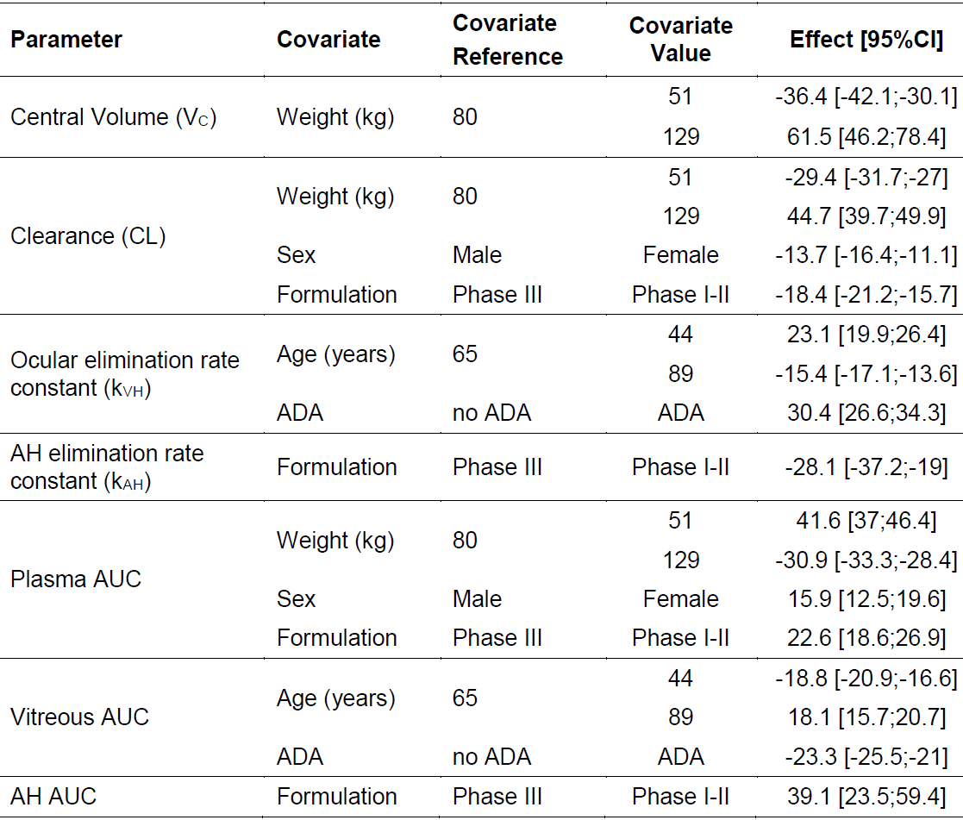
Abbreviations: ADA = antidrug antibodies; AH = aqueous humour; AUC = area under the concentration-time curve; CI = confidence interval; CL = clearance; k_{AH} = aqueous humour elimination rate constant; k_{VH} = ocular elimination rate constant; V_{C} = central volume.

Pharmacokinetic parameter results based on dosing regimen
The model was also used to predict PK parameters for the different dosing regimens used in the clinical trial program, including up to every 16 weeks maintenance dosing (see Table 5 (below) and results of the analysis graphically represented by indication in Figure 1 and Figure 2 below).
Table 5: Population pharmacokinetic analysis summary of individual estimates of faricimab steady state exposures by final dosing regimen (patients from Phase III studies): mean (standard deviation)
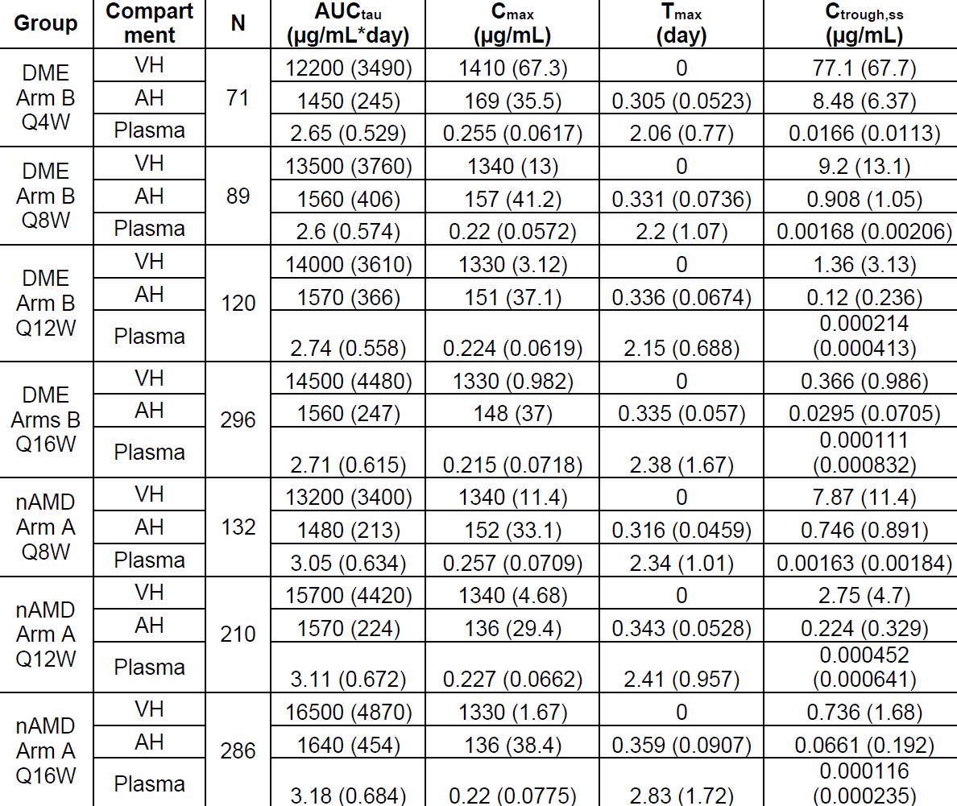
Abbreviations: AH = aqueous humour, AUC_{tau} = area under the concentration-time curve over inter-dose period; C_{max} = maximum plasma concentration; C_{trough,ss} = steady state trough concentration; DME = diabetic macular oedema; N = number of subjects; nAMD = neovascular age-related macular degeneration; Q4W = every 4 weeks; Q8W = every 8 weeks; Q12W = every 12 weeks; Q16W = every 16 weeks; T_{max} = time to achieve maximum plasma concentration; VH = vitreous humour.
Figure 1: Population pharmacokinetic analysis Steady state median faricimab concentration-time graphs by dosing regimen - predictions of final model, following 6 mg doses administered to patients with neovascular age-related macular degeneration from Phase III studies
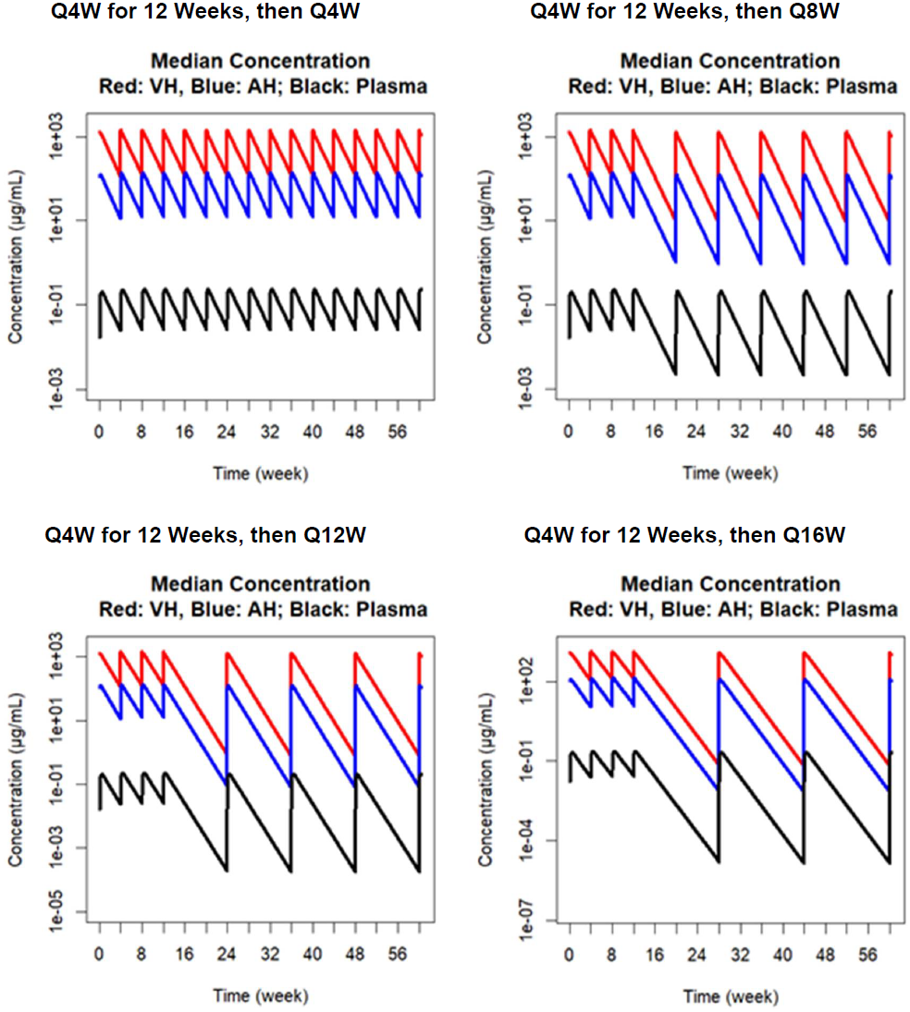
Abbreviations: AH = aqueous humour, Q4W = every 4 weeks; Q8W = every 8 weeks; Q12W = every 12 weeks; Q16W = every 16 weeks; VH = vitreous humour.
Solid lines: medians of individual predictions.
Figure 2: Population pharmacokinetic analysis Steady state median faricimab concentration-time graphs by dosing regimen - predictions of final model, following 6 mg doses administered to patients with diabetic macular oedema from Phase III studies
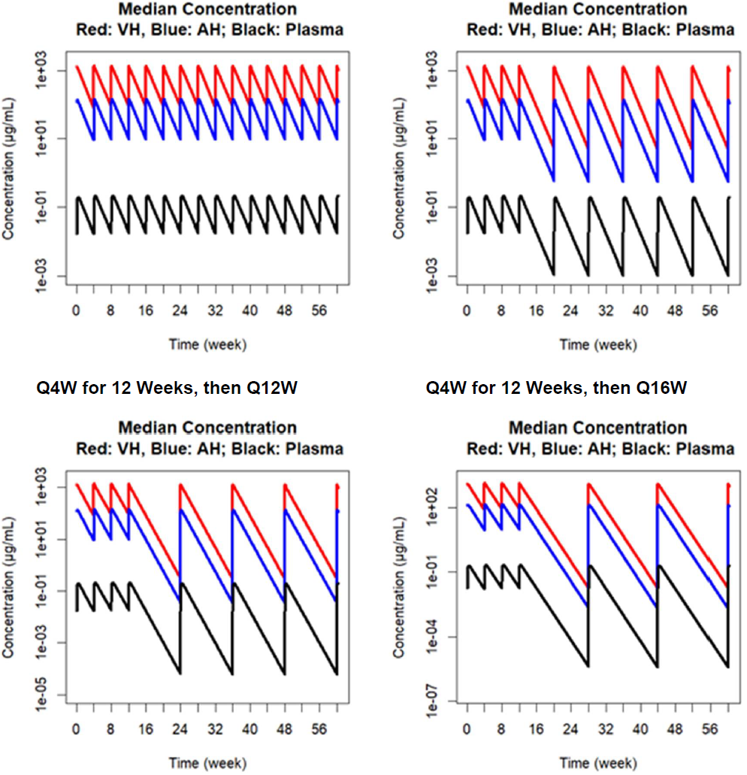
Abbreviations: AH = aqueous humour, Q4W = every 4 weeks; Q8W = every 8 weeks; Q12W = every 12 weeks; Q16W = every 16 weeks; VH = vitreous humour.
Solid lines: medians of individual predictions.

Pharmacodynamics
The pharmacodynamic profile of faricimab has been reasonably well characterised.

Mechanism of action
Faricimab acts through inhibition of two distinct pathways by dual selective inhibition and neutralisation of both angiopoietin-2 (Ang-2) and vascular endothelial growth factor A (VEGF-A). This appears to reduce vascular permeability and inflammation, inhibit pathological angiogenesis, and restore vascular stability.

Pharmacodynamic variables

Exposure efficacy analyses
Pharmacodynamic (PD) assessments in the clinical studies showed that faricimab caused a significant reduction in the targets (Ang-2 and VEGF-A) in the aqueous humour without any notable suppression of those targets in the systemic circulation. A robust effect in the anatomical and functional effects of reducing the targets was shown by the robust reduction in the central subfield thickness (CST) and gain in best corrected visual acuity (BCVA) from Baseline.

Exposure safety analyses
The incidence rate of intraocular inflammation (assessed with logistic regression models) was low and less than 2% in each of the disease indications. It appeared not to increase with faricimab vitreous humour exposure.

Exposure response analysis
The exposure response analyses could not establish a clear increase in response with increasing exposure. This may be partly due to the data on the range for exposure being based on individual variability in exposure at the 6 mg dose level rather than a comparison of the PD difference across different doses. However, it appeared that with increasing exposure the need for a more frequent dosing was reduced due to longer duration of effects or half-life.

Limitations
Limitations include:
- No specific secondary PD studies were conducted.
- The potential for PD interactions has not been specifically investigated.
- No dedicated corrected QT interval (QTc); study has been performed because monoclonal antibodies are unlikely to cause QT prolongation; plasma concentrations were relatively low; clinical study electrocardiograms did not suggest cardiac safety signals.

Efficacy for neovascular age-related macular degeneration indication
This submission provides analyses at the primary endpoint (Week 48) and up to the Week 60 study visit from the pivotal Phase III studies (Studies GR40306 and GR40844; also known as the TENAYA and LUCERNE trials), to support a fixed dosing regimen.

Pivotal Phase III studies
The pivotal Phase III studies were Study GR40306 (known as the TENAYA trial) and Study GR40844 (known as the LUCERNE trial). Due to the similarity of these studies, they are discussed together below.

Study GR40306 (TENAYA trial)
The TENAYA trial is a pivotal, ongoing, 112-week, Phase III, randomised, double masked, multicentre (149 centres in 15 countries), 2-arm parallel group (1:1), actively controlled study to assess the efficacy and safety of faricimab in 671 adult patients 50 years of age and older with neovascular age-related macular degeneration (nAMD) between 19 February 2019 and 26 October 2020.

Study GR40844 (LUCERNE trial)
The LUCERNE trial is a pivotal, ongoing, 112-week, Phase III, randomised, double masked, multicentre (122 centres in 20 countries), 2-arm parallel group (1:1), actively controlled study to assess the efficacy and safety of faricimab in 658 adult patients 50 years of age and older with nAMD between 11 March 2019 and 5 October 2020.

Efficacy objectives
The primary efficacy objective is to evaluate the efficacy of intravitreal injections of the 6 mg dose of faricimab on best corrected visual acuity (BCVA) outcomes compared with aflibercept.
The key secondary efficacy objectives are:
- to evaluate the efficacy of faricimab on additional BCVA outcomes;
- to evaluate the frequency of study drug administration;
- to evaluate the efficacy of faricimab on anatomic outcome measures using optical coherence tomography; and
- to evaluate the efficacy of faricimab on anatomic outcome measures using fundus fluorescein angiography.
Figure 3: Studies GR40306 and GR40844 (TENAYA and LUCERNE trials) Study design
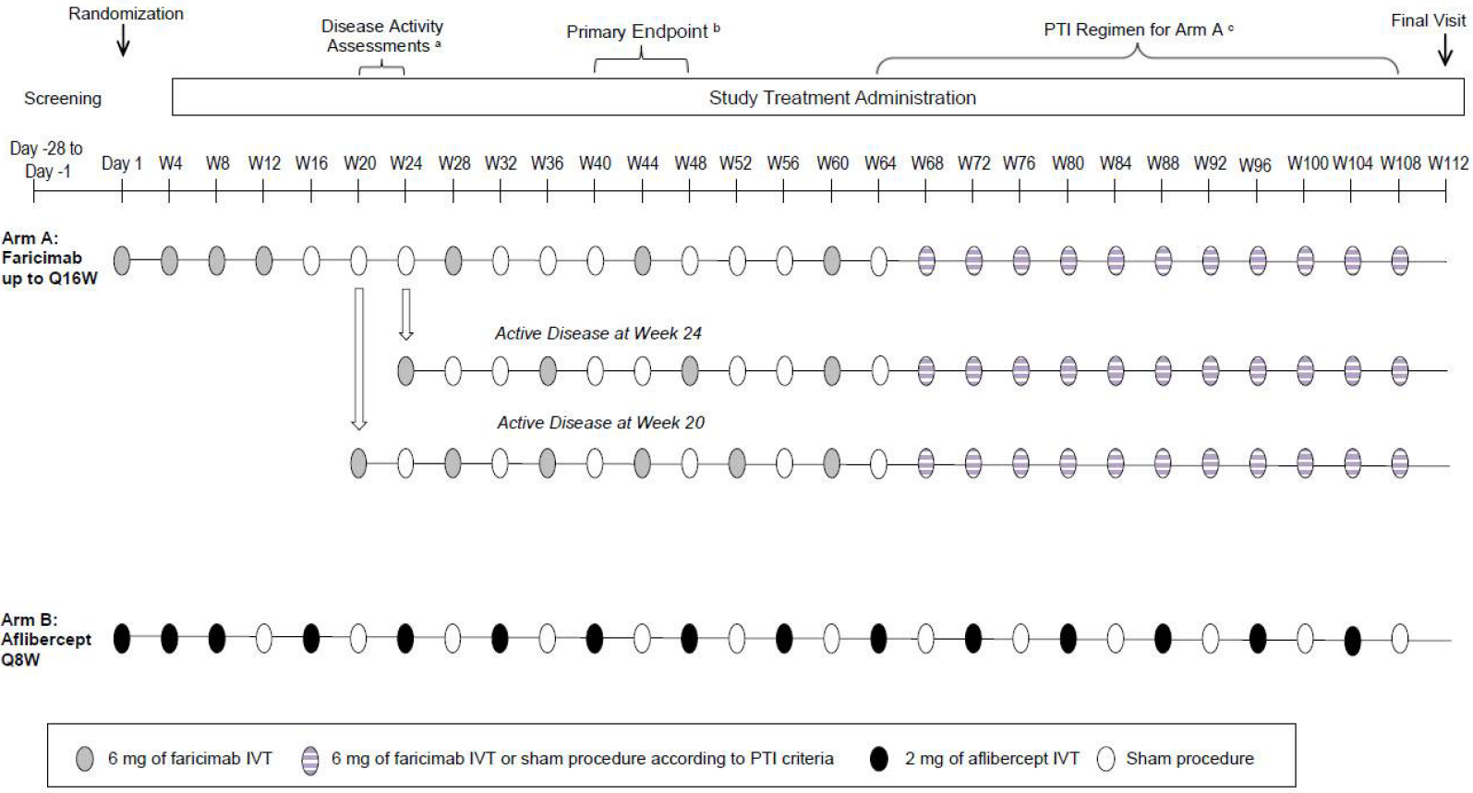
Abbreviations: BCVA = best corrected visual acuity; ETDRS = Early Treatment Diabetic Retinopathy Study; IVT = intravitreal; PTI = personalised treatment interval; Q8W =every 8 weeks; Q16W = every 16 weeks; W = Week.
a. At Weeks 20 and 24, patients underwent a disease activity assessment. Patients with anatomic or functional signs of disease activity at these time points received every 8 or 12 weeks dosing, respectively, up until Week 60. Patients with no disease activity at these two time points received every 16 weeks dosing up until Week 60.
b. The primary endpoint is the change from Baseline in BCVA (as assessed on the ETDRS chart at a starting distance of 4 meters) based on an average at Weeks 40, 44, and 48.
c. From Week 60 onward, patients in the faricimab up to every 16 weeks arm are treated according to a PTI dosing regimen (between every 8 and 16 weeks).

Inclusion criteria
Main inclusion criteria include:
- patients aged 50 years and older with treatment-naïve choroidal neovascularisation secondary to nAMD;
- Subfoveal choroidal neovascularisation or juxtafoveal/extrafoveal choroidal neovascularisation with a subfoveal component related to the choroidal neovascularisation activity identified by fundus fluorescein angiography or optical coherence tomography;
- choroidal neovascularisation lesion of any type with defined characteristics;
- best corrected visual acuity of 78 to 24 letters using the early treatment diabetic retinopathy study (ETDRS) protocol and assessed at the initial testing distance of 4 metres on Day 1;
- sufficiently clear ocular media and adequate pupillary dilation to allow acquisition of good quality retinal images to confirmed diagnosis.

Exclusion criteria
Main exclusion criteria include:
- active ocular inflammation or suspected or active ocular or periocular infection in either eye; retinal pigment epithelial tear involving the macula;
- subretinal haemorrhage or fibrosis or atrophy of > 50% of the total lesion area and/or that involves the fovea;
- any prior or concomitant treatment for choroidal neovascularisation or vitreomacular-interface abnormalities, or ocular surgical intervention for the study eye; prior periocular pharmacological or intravitreal treatment (including anti-vascular endothelial growth factor (anti-VEGF) medication) for other retinal diseases for the study eye; stroke (cerebral vascular accident) or myocardial infarction within 6 months prior.

Treatments
- Faricimab arm: faricimab up to every 16 weeks (n = 334 in the TENAYA trial, n = 331 in the LUCERNE trial) arm:
  - 6 mg of intravitreal faricimab every 4 weeks up to Week 12 (4 injections).
  - At Week 20, following a protocol defined assessment of disease activity, patients with active disease received faricimab at that visit and continued on a fixed every 8 weeks dosing regimen (injections at Weeks 20, 28, 36, 44, 52, and 60).
  - At Week 24, following a second protocol-defined assessment of disease activity, patients with active disease (excluding those with active disease at Week 20) received faricimab at that visit, and continued on a fixed every 12 weeks dosing regimen (injections at Weeks 24, 36, 48, and 60).
  - Patients without active disease at Week 20 and Week 24 were treated with a fixed every 16 weeks dosing regimen of faricimab until Week 60 (that is, injections at Weeks 28, 44, and 60).
  - The fixed regimens continued until Week 60 with no supplementary therapy allowed.
  - From Week 60 onwards: personalised treatment interval (PTI) dosing regimen (between every 8 weeks and every 16 weeks) up to Week 108. The dosing interval could be extended, reduced, or maintained based on optical coherence tomography, BCVA, and clinical assessment made at study drug dosing visits.
- Aflibercept arm: aflibercept every 8 weeks (comparator arm, n = 337 in the TENAYA trial, n = 327 in the LUCERNE trial): 2 mg every 4 weeks up to Week 8, followed by 2 mg every 8 weeks until Week 108.

Randomisation
Randomisation was conducted using a stratified permuted block randomisation scheme.

Primary efficacy endpoint
The primary efficacy endpoint was the change from Baseline in BCVA (as measured on the ETDRS chart) averaged over Weeks 40, 44, and 48.

Baseline characteristics
In the TENAYA and LUCERNE trials, patient demographics were comparable between treatment arms in the intent-to-treat (ITT) and per-protocol (PP) populations (see Table 6 below).
Table 6: Studies GR40306 and GR40844 (TENAYA and LUCERNE trials) Baseline demographics in individual and pooled Phase III neovascular age-related macular degeneration studies (intent-to-treat population)
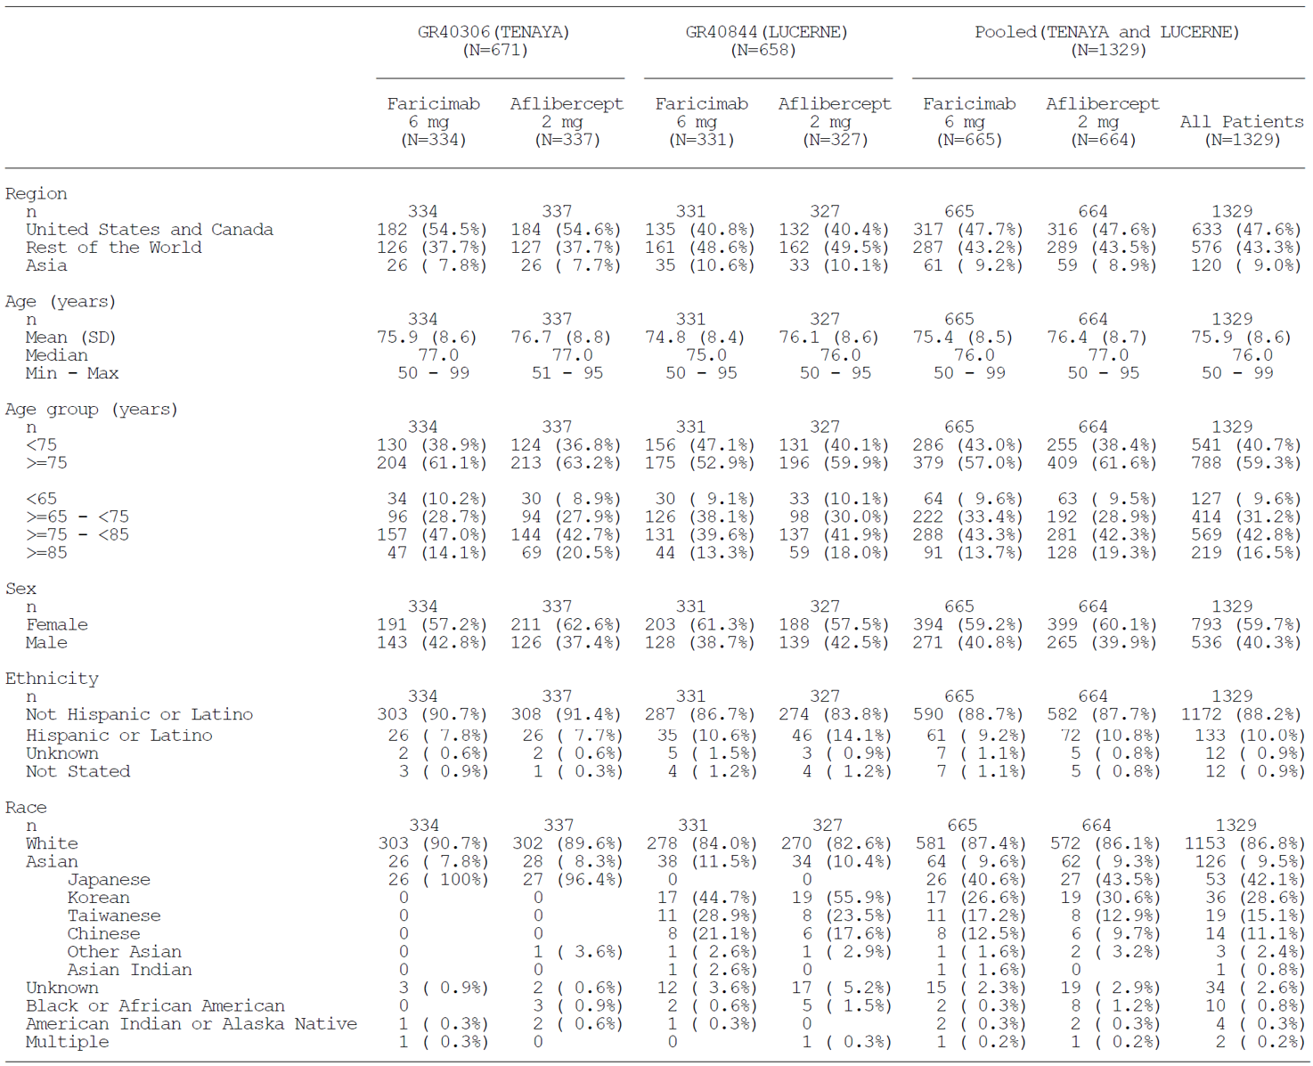
Abbreviations: Max = maximum; Min = minimum; N = number of subjects; n = number of subjects in group; SD = standard deviation.
Age is at randomisation.
In the pooled ITT population, the mean patient age was 75.9 years (ranged 50 to 99 years). Patient demographics were comparable between treatment arms. The majority of patients in the faricimab arm and aflibercept arm were female (59.2% versus 60.1%), 75 years of age or older (57.0% versus 61.6%), and White (87.4% versus 86.1%).
At the time of screening, patient reported time since AMD diagnosis was comparable between treatment arms in the TENAYA and LUCERNE trials, and in the pooled ITT population: the mean (median (range)) time since nAMD diagnosis was 2.4 (0.6 (0 to 187)) months in the faricimab arm and 1.4 (0.7 (0 to 51)) months in the aflibercept arm.
At Baseline, ocular characteristics were generally comparable between arms and comparable across studies. In the pooled ITT population, for the faricimab and aflibercept arms respectively, mean BCVA values were 60.0 versus 60.2 letters; mean low luminance deficit values were 25.1 versus 25.9 letters; mean baseline central subfield thickness (CST) was 356.8 µm versus 357.5 µm; and the mean total area of choroidal neovascularisation lesion was 4.7 mm² versus 4.4 mm². 56.6% of patients had a lens status of phakic and 43.4% were pseudophakic. Intraretinal fluid was absent in 53.6% of patients, subretinal fluid was absent in 32.4%, and pigment epithelial detachment was absent in 7.9%.
The choroidal neovascularisation lesion location was most commonly subfoveal (59.2%), followed by juxtafoveal (25.1%) and extrafoveal (13.7%). The most common choroidal neovascularisation lesion types were occult (49.8%), classic (27.4%), and minimally classic (9.3%).

Magnitude of the treatment effect and its clinical significance
The final results at Week 112 are not available (not provided by the sponsor).

Study GR40306 (TENAYA trial)
For the ITT population, at Weeks 40, 44 and 48, the adjusted mean change from Baseline in BCVA was 5.8 and 5.1 letters in the faricimab and aflibercept arms, respectively; the difference between the faricimab arm and the aflibercept arm was 0.7 letters (95% confidence interval (CI): -1.1, 2.5) (see Table 7 below).
Table 7: Study GR40306 (TENAYA trial) Overview of primary and select efficacy endpoints (intent-to-treat population) and supplementary analysis (per-protocol population)
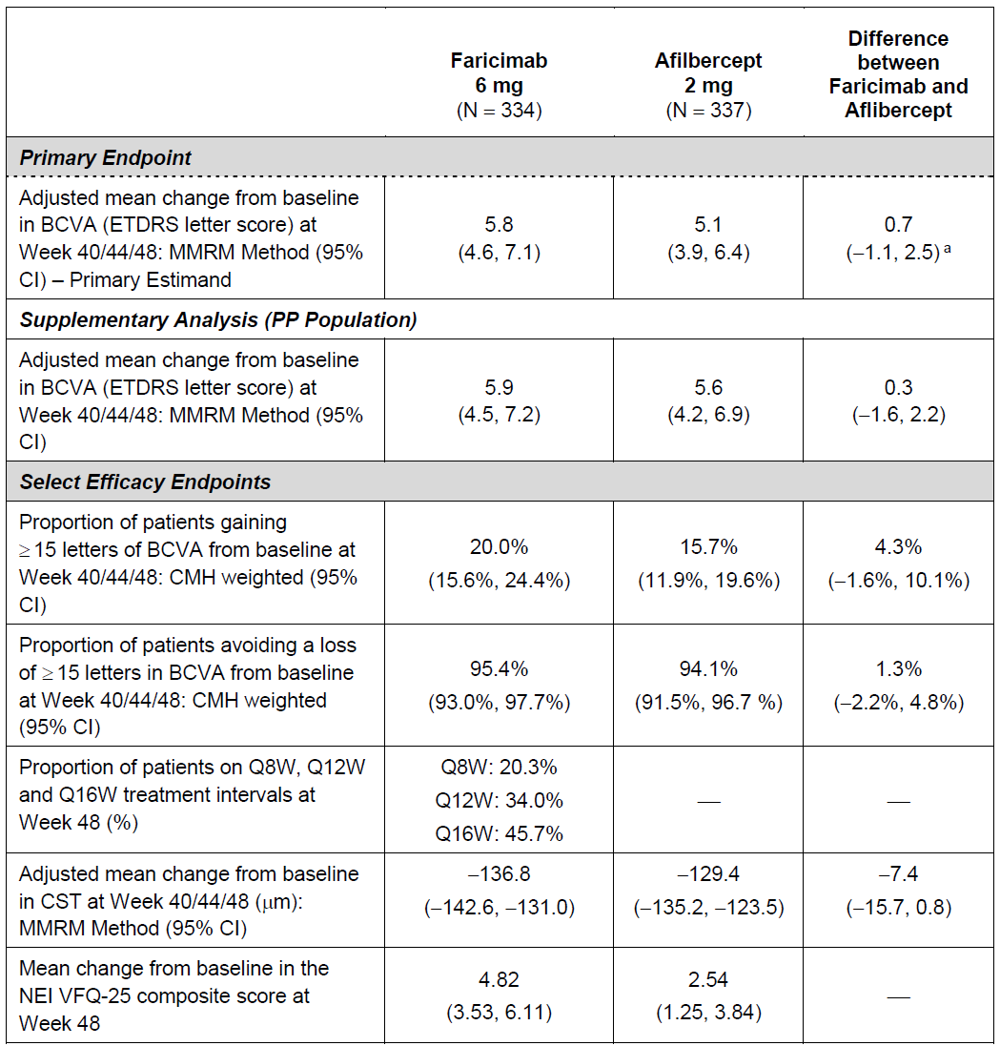
Abbreviations: BCVA = best corrected visual acuity; CI = confidence interval; CMH = Cochran-Mantel-Haenszel; ETDRS = Early Treatment Diabetic Retinopathy Study; MMRM = mixed model for repeated measures; N = number of subjects; NEI VFQ-25 = National Eye Institute 25-Item Visual Function Questionnaire; PP = per-protocol; Q8W = every 8 weeks; Q12W = every 12 weeks; Q16W = every 16 weeks.
For the MMRM analysis, the model is adjusted for treatment arm, visit, visit-by-treatment arm interaction, baseline BCVA (continuous), baseline BCVA score (≥ 74 letters, 73 to 55 letters, and ≤ 54 letters), LLD (< 33 letters and versus ≥ 33 letters), and region (United States and Canada, Asia, and the rest of the world).
An unstructured covariance structure is used. 95% CI is a rounding of 95.03% CI.
For the CMH analysis, the weighted estimate is based on CMH test stratified by baseline BCVA (≥ 74 letters, 73 to 55 letters, and ≤ 54 letters), baseline LLD (< 33 letters and ≥ 33 letters), and region (United States and Canada versus the rest of the world). Asia and rest of the world regions are combined due to a small number of enrolled patients. Treatment policy strategy and hypothetical strategy were applied to non-coronavirus disease 2019 (non-COVID-19)-related and COVID-19-related intercurrent events, respectively. Missing data were not imputed. Invalid BCVA values are excluded from analysis. 95% CI is a rounding of 95.03% CI and estimates below 0% or above 100% are imputed as 0% or 100% respectively.
a. For the primary analysis, if the lower bound of a two-sided 95.03% CI for the difference in adjusted means of the two treatments is greater than -4 letters (the non-inferiority margin), then faricimab is considered non-inferior to aflibercept.

Study GR40844 (LUCERNE trial)
For the ITT population, at Weeks 40, 44 and 48, the adjusted mean change from Baseline in BCVA was 6.6 and 6.6 letters in the faricimab and aflibercept arms, respectively; the difference between the faricimab arm and the aflibercept arm was 0.0 letters (95% CI: -1.7, 1.8) (see Table 8 below).
The primary results are consistent with non-inferiority, as the lower bound of the 95% CIs for the adjusted mean difference between the faricimab and aflibercept arms was greater than -4 letters.
Results from the primary endpoint analysis was consistent between the ITT and PP populations and were generally supported by sensitivity and supplementary analyses.
The mean change from Baseline in BCVA were generally maintained over 60 weeks.

Table 8: Study GR40844 (LUCERNE trial) Overview of primary and select efficacy endpoints (intent-to-treat population) and supplementary analysis (per-protocol population)
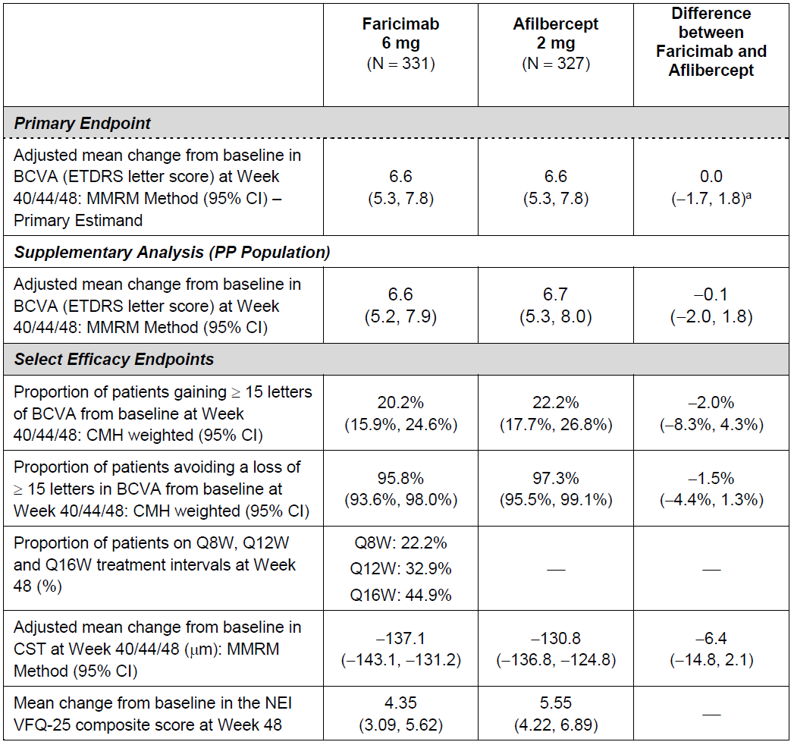
Abbreviations: BCVA = best corrected visual acuity; CI = confidence interval; CMH = Cochran-Mantel-Haenszel; ETDRS = Early Treatment Diabetic Retinopathy Study; MMRM = mixed model for repeated measures; N= number of subjects; NEI VFQ-25 = National Eye Institute 25-Item Visual Function Questionnaire; PP = per-protocol; Q8W = every 8 weeks; Q12W = every 12 weeks; Q16W = every 16 weeks.
For the MMRM analysis, the model is adjusted for treatment arm, visit, visit-by-treatment arm interaction, baseline BCVA (continuous), baseline BCVA score (≥ 74 letters, 73 to 55 letters, and ≤ 54 letters), LLD (< 33 letters and versus ≥ 33 letters), and region (United States and Canada, Asia, and the rest of the world).
An unstructured covariance structure is used. 95% CI is a rounding of 95.03% CI.
For the CMH analysis, the weighted estimate is based on CMH test stratified by baseline BCVA (≥ 74 letters, 73 to 55 letters, and ≤ 54 letters), baseline LLD (< 33 letters and ≥ 33 letters), and region (United States and Canada versus the rest of the world). Asia and rest of the world regions are combined due to a small number of enrolled patients. Treatment policy strategy and hypothetical strategy were applied to non-coronavirus 2019 (non-COVID-19)-related and COVID-19-related intercurrent events, respectively. Missing data were not imputed. Invalid BCVA values are excluded from analysis. 95% CI is a rounding of 95.03% CI and estimates below 0% or above 100% are imputed as 0% or 100% respectively.
a. For the primary analysis, if the lower bound of a two-sided 95.03% CI for the difference in adjusted means of the two treatments is greater than -4 letters (the non-inferiority margin), then faricimab is considered non-inferior to aflibercept.

Key secondary endpoints
The proportions of patients with 15 letter or more gain and avoiding 15 letter or more loss from Baseline at Weeks 40, 44 and 48 and at Weeks 52, 56 and 60 were similar between faricimab and aflibercept arms in each study and supported the primary efficacy outcomes (pooled TENAYA and LUCERNE trials, faricimab versus aflibercept):
- Gain of 15 letter or more: 20% versus 19% (Weeks 40, 44 and 48); 21% versus 20% (Weeks 52, 56 and 60).
- Avoiding 15 letter or more loss: 96% versus 96% (Weeks 40, 44 and 48); 95% versus 95% (Weeks 52, 56 and 60).
Patients in the faricimab and aflibercept arms had similar reductions in CST from Baseline at Weeks 40, 44 and 48 and at Weeks 52, 56 and 60 in each study (pooled TENAYA and LUCERNE trials, faricimab versus aflibercept): -137 µm versus -130 µm (Weeks 40, 44 and 48) and -135 µm versus -136 µm (Weeks 52, 56 and 60). The reductions in CST from Baseline were generally maintained over 60 weeks.

Supportive Phase II studies

Study CR39521 (STAIRWAY trial)
The STAIRWAY trial is a multicentre, randomised, active comparator controlled, subject and outcome-assessor masked, 3-arm parallel group (2:2:1), 52-week study investigating the efficacy, safety, and pharmacokinetics (PK) of faricimab in patients with nAMD. Its primary objective was to evaluate the efficacy of faricimab on visual acuity when administered at 12- and 16-week intervals.
Eligible patients were randomised in a 2:2:1 ratio to one of three intravitreal treatment arms:
- Faricimab every 12 weeks: 6 mg every 4 weeks up to Week 12, then 6 mg every 12 weeks up to Week 48.
- Faricimab every 16 weeks: 6 mg every 4 weeks up to Week 12, then 6 mg every 16 weeks up to Week 48. At Week 24, patients with active disease received a 6 mg every 12 weeks dosing interval until the end of study.
- Ranibizumab every 4 weeks (comparator): 0.5 mg ranibizumab every 4 weeks for 48 weeks.
Figure 4: Study CR39521 (STAIRWAY trial) Study design
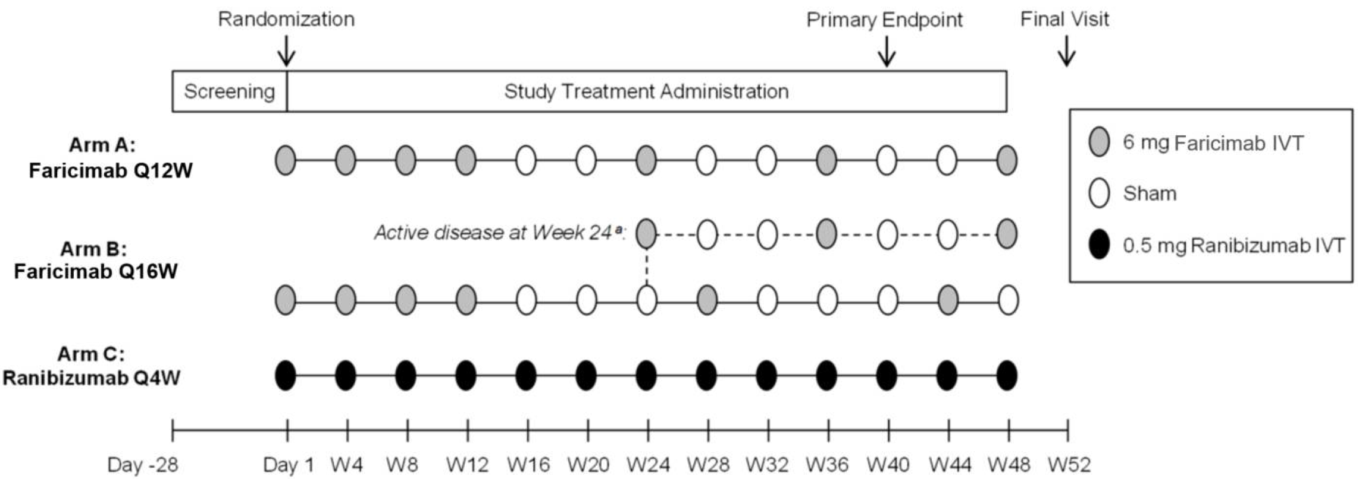
Abbreviations: IVT = intravitreal; Q4W = every 4 weeks; Q12W = every 12 weeks; Q16W = every 16 weeks; W = week.
a. All patients were assessed for disease activity at Week 24. Patients in faricimab every 16 weeks arm who were assessed with active disease at Week 24 then received a faricimab every 12 weeks dosing interval for the remainder of the study.
A total of 76 treatment-naïve patients with nAMD were enrolled in the study at 25 sites in the USA. Five patients in the faricimab every 12 weeks arm were excluded from the analysis due to Good Clinical Practice; violations. Thus, efficacy results are based on 71 patients (n = 24, 31, and 16 for the faricimab 6 mg every 12 weeks, faricimab 6 mg every 16 weeks, and ranibizumab 0.5 mg every 4 weeks treatment arms, respectively). The majority of patients (64 of 71, 90.1%) completed the Week 40 visit and were assessed for efficacy for the primary endpoint.
The mean age of patients was 80.3, 77.7 and 77.3 years; baseline BCVA was 57.8, 60.4, and 55.3 letters for the faricimab 6 mg every 12 weeks, faricimab 6 mg every 16 weeks, and ranibizumab 0.5 mg every 4 weeks treatment arms, respectively.
The primary efficacy endpoint was the mean change from Baseline in BCVA at Week 40. There was no formal correction of type I error for multiple testing.

Key efficacy results
The least squares mean change from Baseline in BCVA at Week 40 resulted in a -2.1 ETDRS letter difference in the 6 mg faricimab every 12 weeks arm compared with the ranibizumab every 4 weeks arm (80% CI: -6.8, 2.6). The difference between the faricimab every 16 weeks arm and the ranibizumab every 4 weeks arm was 1.1 letters (80% CI: -3.4, 5.5).
An overview of the primary and selected secondary endpoints is in Table 9 below.
Table 9: Study CR39521 (STAIRWAY trial) Overview of primary and selected secondary efficacy endpoints at Week 40 or 52 (intent-to-treat population)
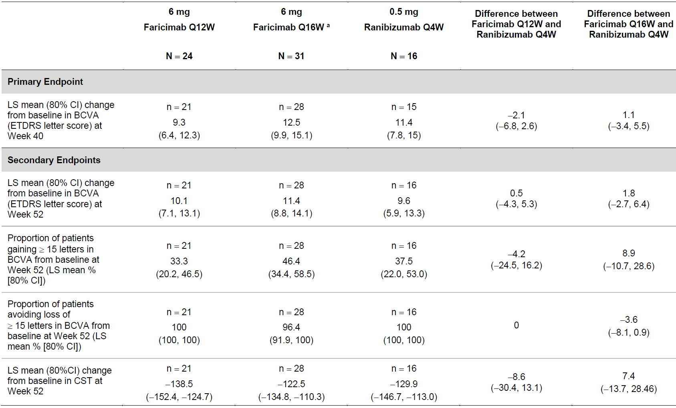
Abbreviations: BCVA = best corrected visual acuity; CI = confidence interval; CST = central subfield thickness; ETDRS = Early Treatment Diabetic Retinopathy Study; ITT = intent-to-treat; LS = least squares; N = number of subjects; n = number of subjects in group; Q4W = every 4 weeks; Q12W = every 12 weeks; Q16W = every 16 weeks
a. Includes patients who had disease activity at Week 24 and subsequently switched to a faricimab 6 mg every 12 weeks dosing regimen for the remainder of the study.

Study BP29647 (AVENUE trial)
The AVENUE trial is a multicentre, multiple dose and regimen, randomised, active comparator controlled, double-masked, five parallel group (treatment arms A to E), 36-week study in patients with choroidal neovascularisation secondary to AMD. Its primary objective was to evaluate the efficacy of faricimab compared to ranibizumab monotherapy in treatment-naive and anti-VEGF-incomplete-responder patients with nAMD.
Eligible patients (n = 273) were randomised in a 3:2:2:2:3 ratio into five treatment arms:
- Arm A: 0.5 mg ranibizumab every 4 weeks for 32 weeks.
- Arm B: 1.5 mg faricimab every 4 weeks for 32 weeks.
- Arm C: 6 mg faricimab every 4 weeks for 32 weeks.
- Arm D: 6 mg faricimab every 4 weeks up to Week 12, followed by 6 mg faricimab every 8 weeks.
- Arm E: 0.5 mg ranibizumab every 4 weeks up to Week 8, followed by 6 mg faricimab every 4 weeks.
Figure 5: Study BP29647 (AVENUE trial) Study design
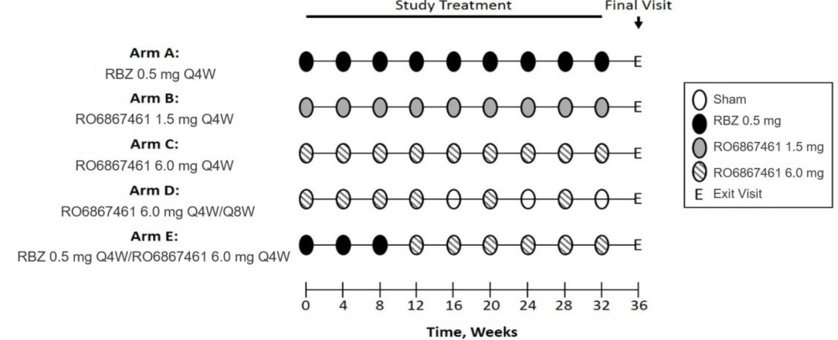
Abbreviations: E = exit visit; Q4W = every 4 weeks; Q8W = every 8 weeks; RBZ = ranibizumab; RO6867461 = faricimab.
A total of 273 treatment-naïve patients at 58 sites in the USA were enrolled and randomised. 10 were excluded due to Good Clinical Practice;¹³ violations. Efficacy results are based on 263 patients (all patients population, n = 68, 46, 39, 46 and 64 for Arms A, B, C, D and E, respectively), of which the majority (92.8%, 244 patients) completed the Week 36 visit and were assessed for efficacy for the primary endpoint.
The mean age was 76.4, 78.2, 78.0, 80.0, and 79.2 years; mean baseline BCVA letter scores in the study eye were 55.2, 56.7, 56.2, 56.3 and 55.7 for Arms A to E. The population was predominately White (98.1%), with a higher proportion of women (65.4%).
The primary efficacy endpoint was the change in BCVA from Baseline to Week 36 using the ETDRS-modified charts (comparison of Arm A and Arms B, C, or D). For the primary endpoints, a statistically significant difference at Week 36 between any of the treatment Arms B, C, or D and Arm A would be concluded if the corresponding unadjusted two-sided p-value was below 0.2. There was no formal correction of type I error for multiple testing.

Evaluation in the anti-vascular endothelial growth factor incomplete responder population
For the evaluation of efficacy in the anti-VEGF incomplete responder population, Population C consisted of patients in Population B (all patients randomised to the treatment Arms A and E) with a BCVA of 68 or lower at Week 12.

Key efficacy results
The superiority of faricimab (in any faricimab Arms B, C, and D) compared to 0.5 mg ranibizumab every 4 weeks in the BCVA least squares mean change from Baseline at Week 36 was not demonstrated. The mean change in BCVA from Baseline at Week 36 in the faricimab 6 mg arms (every 4 weeks: 6.0 letters, every 8 weeks: 6.1 letters) was similar to that in the ranibizumab 0.5 mg every 4 weeks (7.6 letters). However, the results for Arm B (1.5 mg faricimab every 4 weeks) show no statistically significant difference to Arm A either.
In the subset of anti-VEGF incomplete responders, faricimab 6 mg every 4 weeks treatment (Arm E) after ranibizumab 0.5mg every 4 weeks 3 monthly loading doses, did not demonstrate an additional benefit compared to 0.5 mg ranibizumab 0.5 mg every 4 weeks (Arm A).
An overview of the primary and selected secondary endpoints is in Table 10 below.
Table 10: Study BP29647 (AVENUE trial) Overview of primary and selected secondary and exploratory efficacy endpoints at Week 36 (intent-to-treat population, treatment-naive patients, and anti-vascular endothelial growth factor incomplete responders)
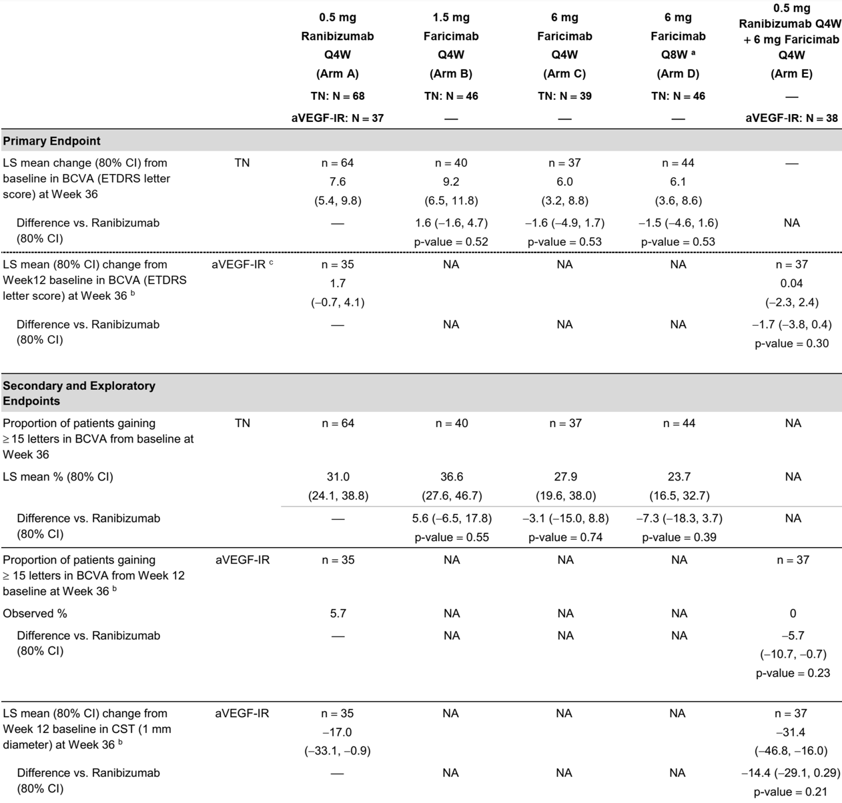
Abbreviations: aVEGF-IR = anti-vascular endothelial growth factor incomplete responder; BCVA = best corrected visual acuity; CI = confidence interval; CST = central subfield thickness; ETDRS = Early Treatment Diabetic Retinopathy Study; ITT = intent-to-treat; LS = least squares; N = number of subjects; n = number of subjects in group; NA = not applicable; Q4W = every 4 weeks; Q8W = every 8 weeks; TN = treatment-naive patients.
a. The 6 mg faricimab every 8 weeks arm included patients randomised to receive 6 mg faricimab every 4 weeks up to Week 12 (4 injections), followed by 6 mg faricimab every 8 weeks on Weeks 20 and 28.
b. For the aVEGF-IR population, the Week 12 visit was considered as the baseline for all efficacy evaluations unless otherwise specified.
c. The aVEGF-IR population is a subgroup of patients from treatment Arms A and E who had a BCVA score of ≤ 68 letters at Week 12.

Efficacy for diabetic macular oedema indication
This submission provides analyses at the primary endpoint at Week 56 from the pivotal Phase III studies (Studies GR40349 and GR40398; also known as the YOSEMITE and RHINE trials, respectively), to support an up to every 16 weeks adjustable dosing (PTI). Additional data from Week 56 to end of the study at Week 100 (Year 2) was provided to the TGA in updated clinical study reports. Both studies are completed (YOSEMITE trial last patient last visit: 3 September 2021; RHINE trial last patient last visit of global enrolment phase: 27 August 2021).
One completed dose response study (the Phase II Study BP30099, also known as the BOULEVARD trial) supports the selection of the dosing regimen for the DMO Phase III studies.
Even though Study GR41987 (the RHONE-X trial) is an ongoing long-term extension study for patients who have completed either of the pivotal Phase III studies (the YOSEMITE and RHINE trials), efficacy data from the long-term extension study are not part of this submission due to the limited number of patients enrolled, and limited and variable follow-up time at the time of the primary analysis for the two pivotal Phase III studies.
The similarities between the YOSEMITE and RHINE trials mean both trials are discussed together below.

Pivotal Phase III studies

Study GR40349 (YOSEMITE trial)
The YOSEMITE trial is a pivotal, 100-week, Phase III, randomised, double masked, multicentre (179 centres in 16 countries), 3-arm parallel group (1:1:1), actively controlled study to assess the efficacy and safety of faricimab in 940 adult patients with DMO between 5 September 2018 and 20 October 2020.

Study GR40398 (RHINE trial)
The RHINE trial is a pivotal, 100-week, Phase III, randomised, double masked, multicentre (174 centres in 24 countries), 3-arm parallel group (1:1:1), actively controlled study to assess the efficacy and safety of faricimab in 951 adult patients with DMO between 9 October 2018 and 19 October 2020.
The study included patients-naïve to anti-VEGF therapy in the study eye and patients previously treated with anti-VEGF therapy in the study eye (if last treatment was more than 3 months prior to Day 1; the target is 10 to 25% of patients at enrolment).

Inclusion criteria
The main inclusion criteria are:
- patients aged 18 years and older with diabetes mellitus (Type 1 or Type 2), current regular diabetes treatment with insulin or other injectable drugs and/or oral anti-hyperglycaemic agents;
- haemoglobin A1c (HbA1c) of 10% or less within 2 months prior to the Day 1 visit date.
The ocular inclusion criteria for the study eye are:
- macular thickening secondary to DMO involving the centre of the fovea with CST 325 µm or high, as measured on Spectralis spectral domain optical coherence tomography, or 315 µm or higher, as measured on Cirrus spectral domain optical coherence tomography or Topcon spectral domain optical coherence tomography at screening;
- BCVA of 73 to 25 letters, inclusive (20 of 40 to 20 of 320 approximate Snellen equivalent), using the ETDRS protocol at the initial testing distance of 4 meters on Day 1;
- sufficiently clear ocular media and adequate pupillary dilatation to allow acquisition of good quality colour fundus photographs (including ETDRS 7 modified fields or 4 wide angle fields to permit grading of diabetic retinopathy and assessment of the retina) and other imaging modalities.

Exclusion criteria
The main exclusion criteria included anti-VEGF injection within 3 months prior;
- untreated diabetes mellitus or serious systemic condition;
- pregnancy or breastfeeding or intention to become pregnant;
- high-risk proliferative diabetic retinopathy;
- certain laser treatments and implants.
Figure 6: Studies GR40349 and GR40398 (YOSEMITE and RHINE trials) Study design
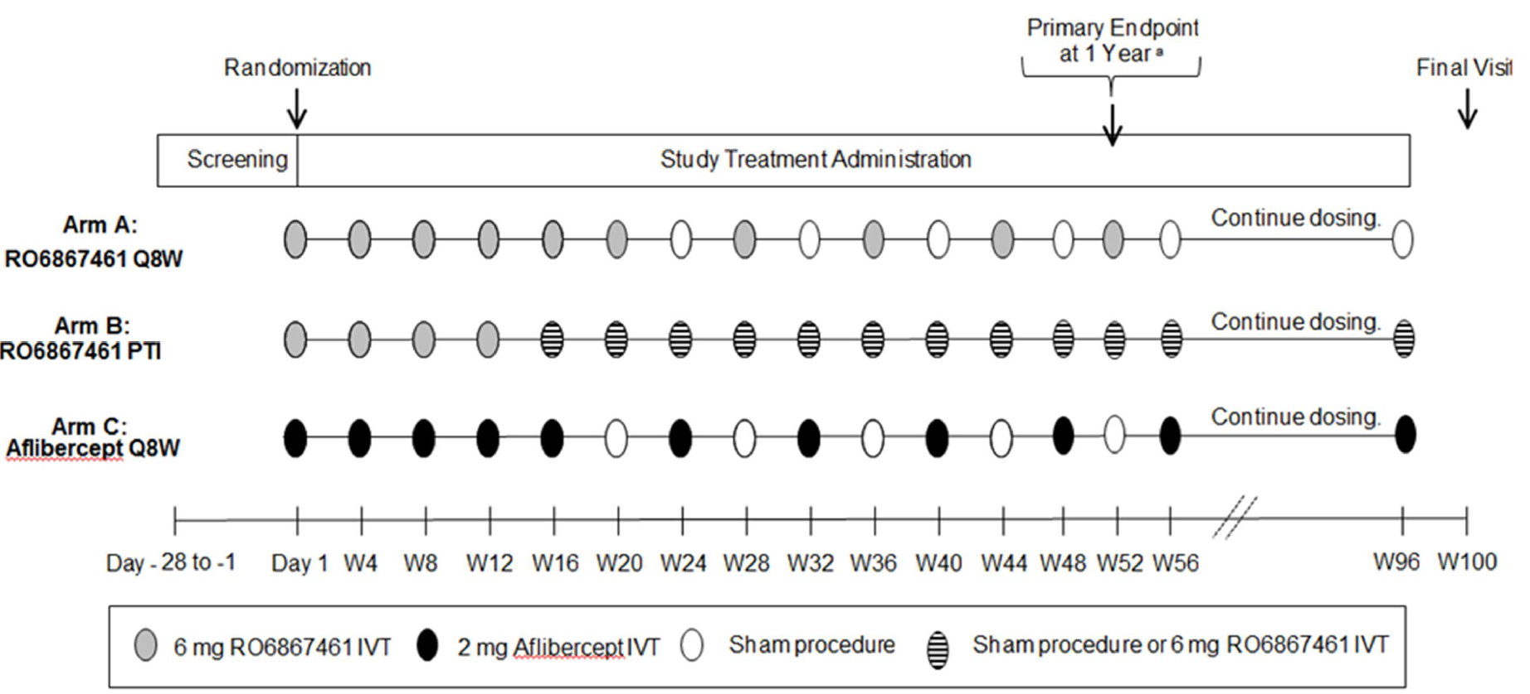
Abbreviations: IVT = intravitreal; Q8W = every 8 weeks; RO6867461 = faricimab; PTI = personalised treatment interval; Q8W = every 8 weeks; W = week.
a. The definition of one year used for the primary efficacy endpoint is defined as the change from Baseline in best corrected visual acuity (BCVA), as measured on the Early Treatment Diabetic Retinopathy Study (ETDRS) chart at a starting distance of 4 meters at one year, is the average of the Weeks 48, 52, and 56 visits.

Treatments
- Faricimab every 8 weeks: 6 mg intravitreal faricimab injections every 4 weeks to Week 20, followed by 6 mg every 8 weeks to Week 96
- Faricimab PTI: 6 mg intravitreal faricimab injections every 4 weeks to at least Week 12 (4 injections), followed by PTI dosing up to every 16 weeks of 6 mg to Week 96 (see Figure 7 below).
- Aflibercept every 8 weeks: 2 mg intravitreal aflibercept injections every 4 weeks to Week 16, followed by 2 mg every 8 weeks to Week 96.
Figure 7: Studies GR40349 and GR40398 (YOSEMITE and RHINE trials) Personalised treatment interval dosing algorithm
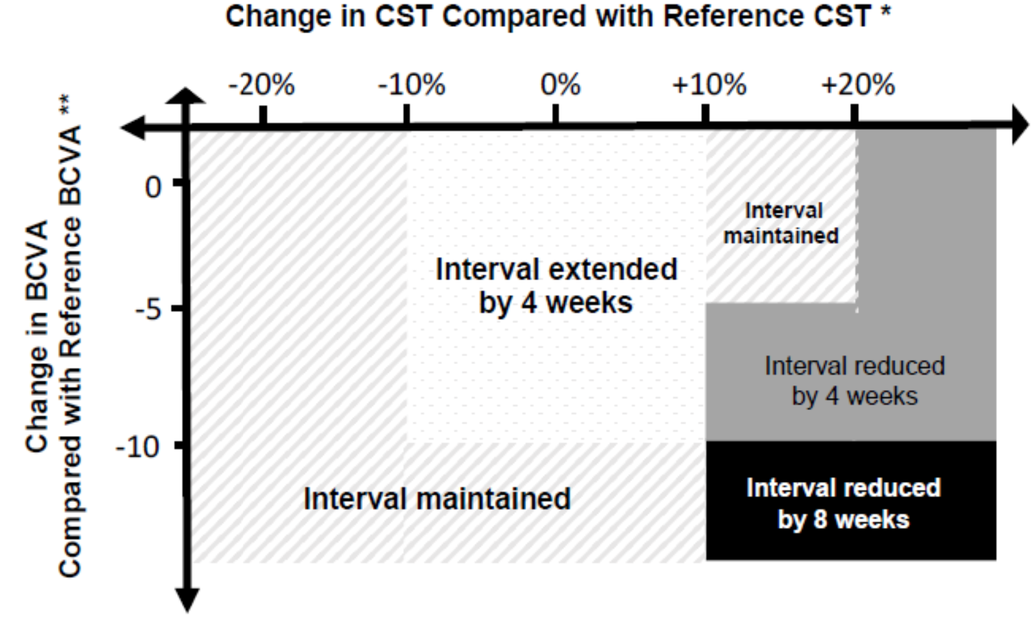
Abbreviations: BCVA = best corrected visual acuity; CST = central subfield thickness.
* Reference CST: the CST value when initial CST threshold criteria are met. Reference CST was adjusted if CST decreased by > 10% from the previous reference CST for two consecutive study drug dosing visits and the values obtained were within 30 µm. The CST value obtained at the latter visit served as the new reference CST, starting immediately at that visit.
** Reference BCVA: the mean of the three best BCVA scores obtained at any prior study drug dosing visit.

Randomisation
Randomisation was stratified by:
- baseline BCVA Early Treatment Diabetic Retinopathy Study (ETDRS) letter score (64 letters or higher versus less than 64 letters);
- prior intravitreal anti-VEGF treatment (yes versus no);
- region (US and Canada, Asia, and the rest of the world).

Efficacy objectives
The primary efficacy objective is to evaluate the efficacy of intravitreal injections of the 6 mg dose of faricimab on BCVA outcomes.
The key secondary efficacy objective is to evaluate the efficacy of faricimab on diabetic retinopathy severity outcomes.
- Primary efficacy endpoint: the primary efficacy endpoint was the change from Baseline in BCVA (as measured on the ETDRS chart at a starting distance of 4 meters) at one year (averaged over Weeks 48, 52, and 56).
- Key secondary efficacy endpoint: the proportion of patients with a 2-step diabetic retinopathy severity improvement or higher from Baseline on the ETDRS Diabetic Retinopathy Severity Scale at Week 52.
For each of the two faricimab arms (every 8 weeks and PTI), three hypotheses were tested separately against the active comparator (aflibercept every 8 weeks) at an overall significance level of 0.0496 using a graph-based testing procedure to control for the overall type I error rate:
- Non-inferiority of faricimab compared with aflibercept every 8 weeks in the ITT population with a non-inferiority margin of 4 letters.
- Superiority of faricimab compared with aflibercept every 8 weeks in the treatment-naïve population.
- Superiority of faricimab compared with aflibercept every 8 weeks in the ITT population.

Baseline characteristics
In the YOSEMITE and RHINE trials, patient demographics were comparable across treatment arms in the ITT and treatment-naïve populations (see Table 11 below). The majority of patients in the faricimab every 8 weeks, faricimab PTI, and aflibercept arms were male (60.3%, 62.7%, and 58.1%), less than 65 years of age (57.6%, 55.7%, and 57.9%), White (77.7%, 77.4%, and 80.7%).
The ocular baseline characteristics were generally comparable across arms (see Table 12 below). approximately 78% in both studies were anti-VEGF treatment-naïve in the study eye.
Table 11: Studies GR40349 and GR40398 (YOSEMITE and RHINE trials) Baseline demographics of patients in individual and pooled Phase III diabetic macular oedema studies (intent-to-treat population)
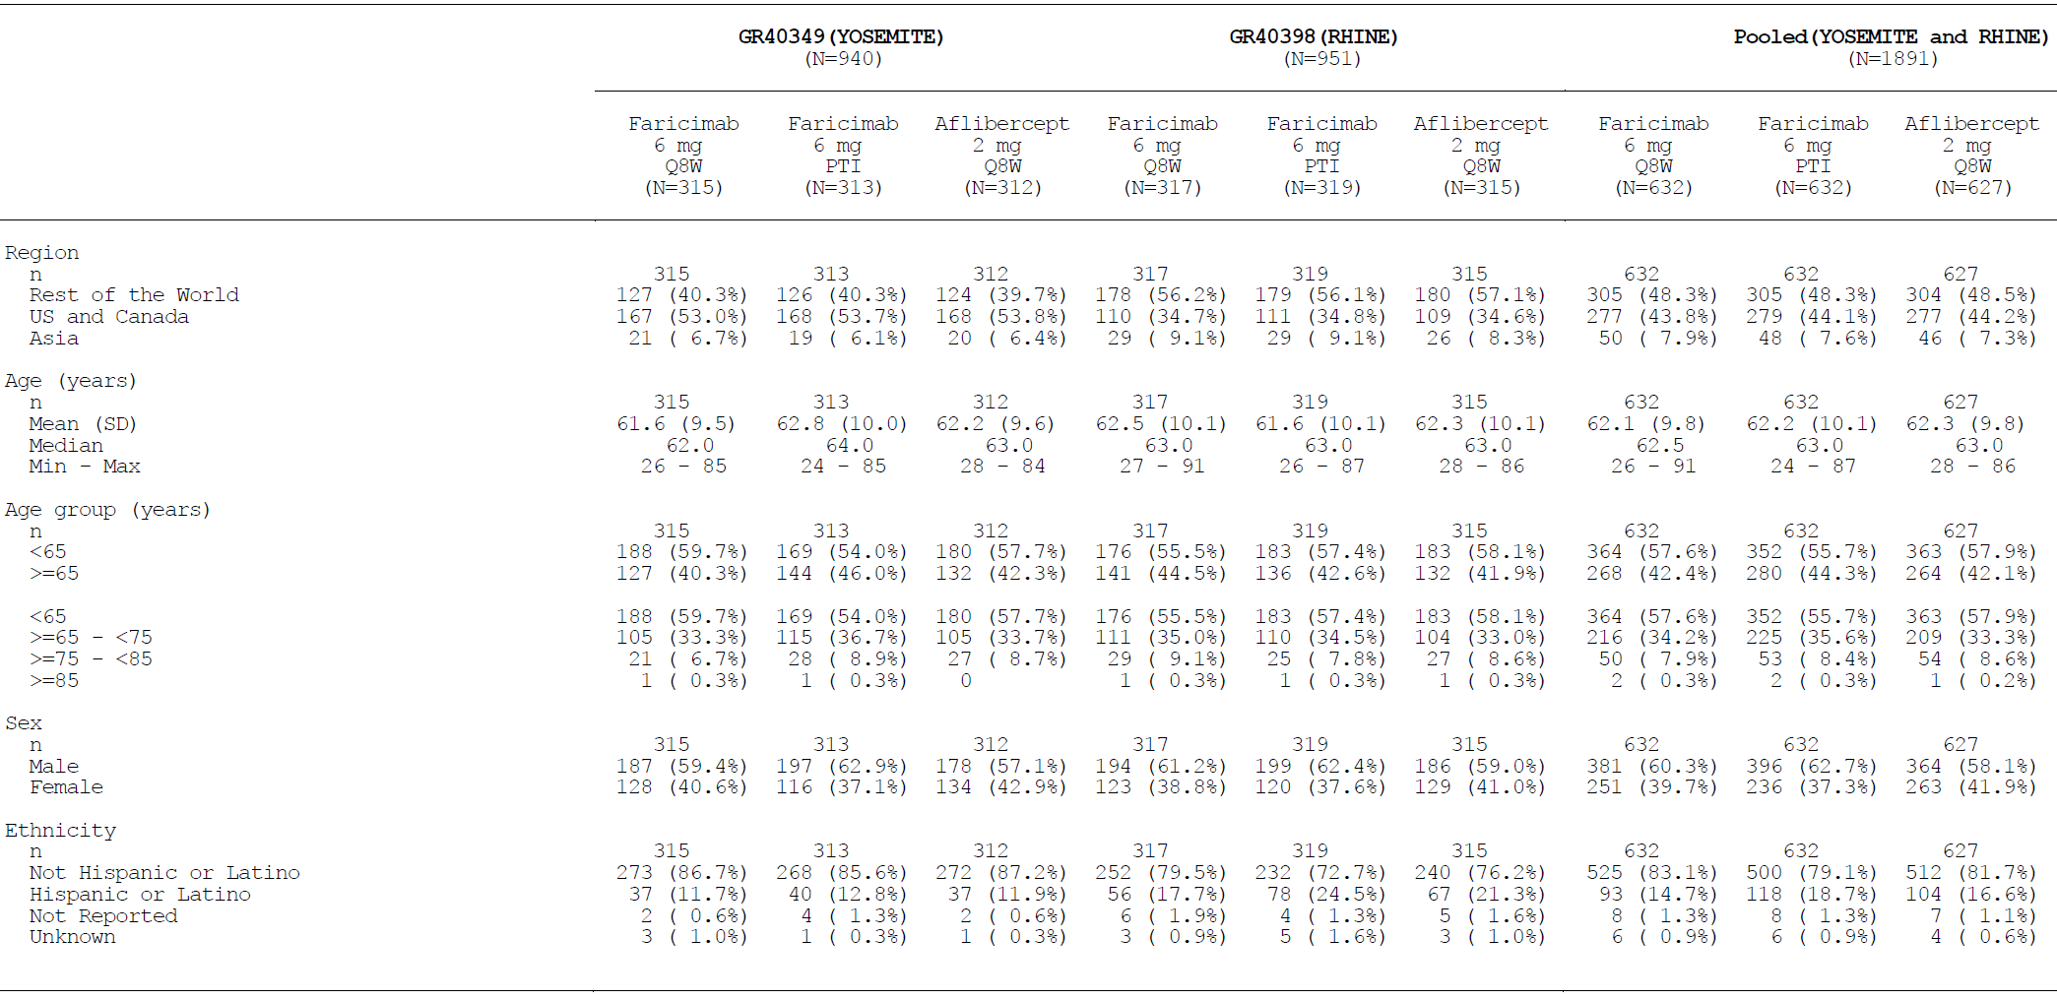
Abbreviations: Max = maximum; Min = minimum; N = number of subjects; n = number of subjects in group; PTI = personalised treatment interval; Q8W = every 8 weeks; SD = standard deviation.
Personalised treatment interval is from every 4 weeks up to every 16 weeks.
Age is at randomisation.
Table 12: Studies GR40349 and GR40398 (YOSEMITE and RHINE trials) Baseline ocular disease characteristics in the study eye from individual and pooled Phase III diabetic macular oedema studies (intent-to-treat population)
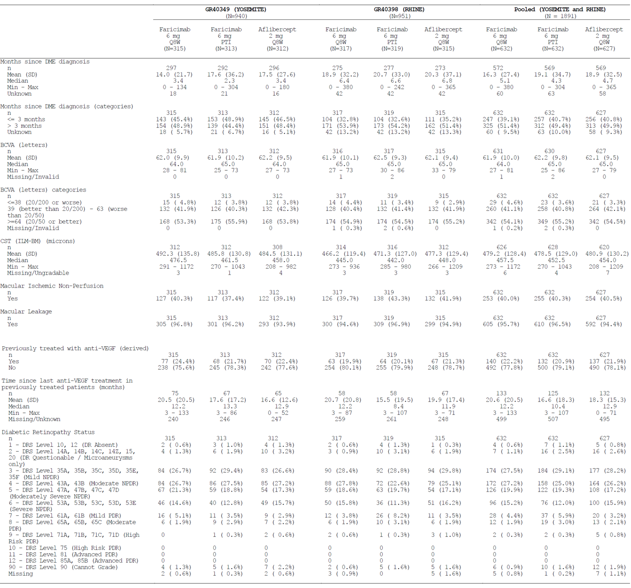
Abbreviations: BCVA = best corrected visual acuity; CRC = Central Reading Center; CST = central subfield thickness; ETDRS = Early Treatment Diabetic Retinopathy Study; ILM = internal limiting membrane; N = number of subjects; n = number of subjects in group; NPDR = non-proliferative diabetic retinopathy; PTI = personalised treatment interval; PDR = proliferative diabetic retinopathy; SD = standard deviation; VEGF = vascular endothelial growth factor.
Personalised treatment interval is from every 4 weeks up to every 16 weeks.
Baseline is the last available value taken on or prior to randomisation. Invalid BCVA values are excluded from analysis. CST is defined as the distance between ILM and Bruch's membrane as assessed by the CRC.
In the pooled ITT population (YOSEMITE plus RHINE trials), in the faricimab every 8 weeks, faricimab PTI, and aflibercept arms, respectively: mean BCVA values were 61.9, 62.2, and 62.1 letters; mean baseline CST values were 479.2, 478.5, and 480.9 µm; mean (standard deviation) time since DMO diagnosis was 16.3 (27.4), 19.1 (34.7), and 18.9 (32.5) months.
In the pooled treatment-naïve population (YOSEMITE plus RHINE trials), the mean (standard deviation) time since DMO diagnosis was 10.8 (24.1), 15.2 (34.3), and 12.1 (28.4) months.

Magnitude of the treatment effect and its clinical significance

Study GR40349 (YOSEMITE trial at Weeks 48, 52 and 56)
For the ITT population, the adjusted mean change from Baseline in BCVA was 10.7, 11.6, and 10.9 letters in the faricimab every 8 weeks, faricimab PTI, and aflibercept every 8 weeks arms, respectively. The difference in adjusted mean change from Baseline in BCVA between the faricimab every 8 weeks and faricimab PTI arms when compared with the aflibercept every 8 weeks arm was -0.2 letters (97.5% CI: -2.0, 1.6) and 0.7 letters (97.5% CI: -1.1, 2.5), respectively (see Table 13 below).
For the treatment-naïve population, the difference in adjusted mean change from Baseline in BCVA between the faricimab every 8 weeks and faricimab PTI arms when compared with the aflibercept every 8 weeks arm was -0.7 letters (97.5% CI: -2.8, 1.4) and 0.0 letters (97.5% CI: -2.1, 2.2), respectively(see Table 13 below).

Study GR40349 (YOSEMITE trial at Weeks 92, 96 and 100)
For the ITT population, the adjusted mean change from Baseline in BCVA was 10.7, 10.7, and 11.4 letters in the faricimab every 8 weeks, faricimab PTI, and aflibercept every 8 weeks arms, respectively. The difference in adjusted mean change from Baseline in BCVA between the faricimab every 8 weeks and faricimab PTI arms when compared with the aflibercept every 8 weeks arm was -0.7 letters (95% CI: -2.6, 1.2) and -0.7 letters (95% CI: -2.5, 1.2), respectively (see Table 14 below).
For the treatment-naïve population, the difference in adjusted mean change from Baseline in BCVA between the faricimab every 8 weeks and faricimab PTI arms when compared with the aflibercept every 8 weeks arm was -1.0 letters (95% CI: -3.3, 1.2) and -0.9 letters (95% CI: -3.1, 1.4), respectively (see Table 14 below).
Table 13: Study GR40349 (YOSEMITE trial) Overview of primary, key secondary, and select secondary efficacy endpoints in the Phase III diabetic macular oedema study at Weeks 48, 52 and 56
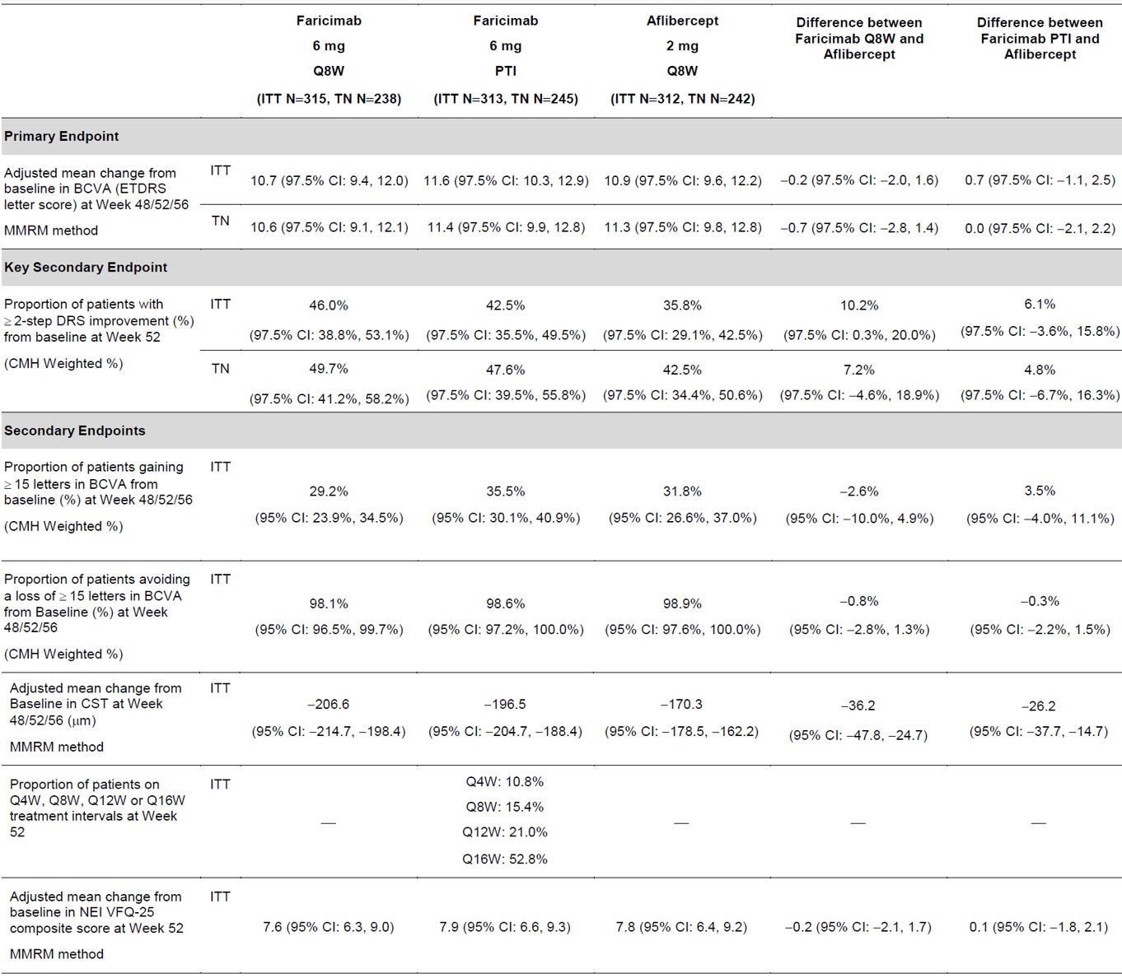
Abbreviations: BCVA = best corrected visual acuity; CMH = Cochran-Mantel-Haenszel; CI = confidence interval; CST = central subfield thickness; ETDRS DRS = Early Treatment Diabetic Retinopathy Study diabetic retinopathy severity; ITT = intent-to-treat; MMRM = mixed-model repeated-measures; N = number of subjects; NEI VFQ-25 = National Eye Institute 25-Item Visual Function Questionnaire; PTI = personalised treatment interval; Q8W = every 8 weeks; Q12W = every 12 weeks; Q16W = every 16 weeks; SE = standard error; TN = treatment naive.
For the MMRM analysis, the model adjusted for treatment group, visit, visit-by-treatment group interaction, baseline BCVA (continuous), baseline BCVA (< 64 letters versus ≥ 64 letters), region (United States and Canada, Asia, and the rest of the world), and for the ITT population prior intravitreal anti-vascular endothelial growth factor (anti-VEGF) therapy (yes versus no). An unstructured covariance structure is used. The estimate of the difference between the two groups uses a composite contrast over Weeks 48, 52 and 56. Treatment policy strategy and hypothetical strategy were applied to non-coronavirus 2019 (non-COVID-19)-related and COVID-19-related intercurrent events, respectively. Missing data were implicitly imputed by MMRM. Invalid BCVA values are excluded from analysis.
Cochran-Mantel-Haenszel (CMH) weighted % for aflibercept arm presented for faricimab every 8 weeks versus aflibercept comparison, however the corresponding CMH weighted % for faricimab PTI versus aflibercept comparison is similar to the one shown above; the weighted estimate is based on CMH test stratified by baseline BCVA score (< 64 letters versus ≥ 64 letters), region (United States and Canada versus the rest of the world), and for ITT population prior intravitreal anti-VEGF therapy (yes versus no). Asia and rest of the world regions are combined due to a small number of enrolled patients. Treatment policy strategy and hypothetical strategy were applied to non-COVID-19-related and COVID-19-related intercurrent events, respectively. Missing assessments were not imputed. Baseline is defined as the last available measurement obtained on or prior to randomisation.
97.5% CI is a rounding of 97.52% CI; 95% CI is a rounding of 95.04% CI.
Table 14: Study GR40349 (YOSEMITE trial) Summary of change from Baseline in best corrected visual acuity in the study eye at Weeks 92, 96 and 100 (intent-to-treat population)
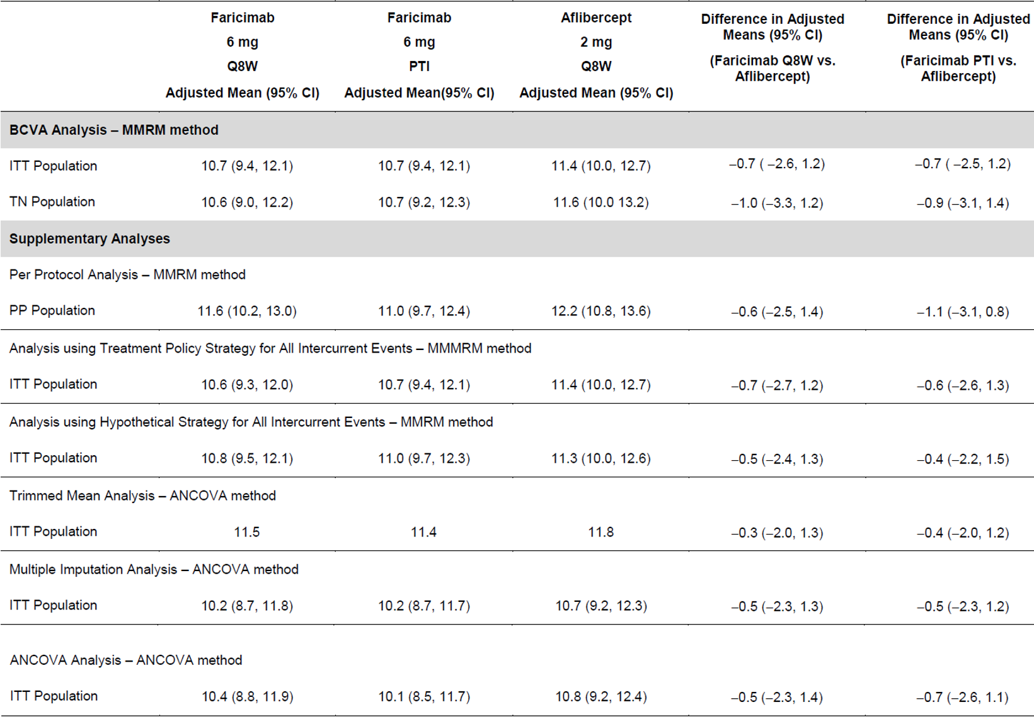
Abbreviations: ANCOVA = analysis of covariance; BCVA = best corrected visual acuity; CI = confidence interval; ITT = intent-to-treat; MMRM = mixed model for repeated measures; PTI = personalised treatment interval; Q8W = every 8 weeks; TN = treatment naïve; vs. = versus.
Personalised treatment interval is from every 4 weeks up to every 16 weeks.
Intent-to-treat (ITT) population: faricimab every 8 weeks = 315, faricimab PTI = 313, aflibercept = 312; TN population: faricimab every 8 weeks = 238, faricimab PTI = 245, aflibercept = 242; PP population: faricimab every 8 weeks = 251, faricimab PTI = 275, aflibercept = 274.
For the MMRM analysis, the model adjusted for treatment group, visit, visit-by-treatment group interaction, baseline BCVA (continuous), baseline BCVA (< 64 letters versus ≥ 64 letters), region (United States and Canada, Asia, and the rest of the world), and for the ITT and PP population prior intravitreal anti-vascular endothelial growth factor (anti-VEGF) therapy (yes versus no). An unstructured covariance structure was used. The estimate of the difference between the two groups used a composite contrast over Weeks 92, 96 and 100.For the treatment policy analysis, observed BCVA assessments were used regardless of the occurrence of intercurrent events. For the hypothetical strategy analysis, hypothetical strategy was applied to non-coronavirus 2019 (non-COVID-19)-related and COVID-19-related intercurrent events. For the MMRM analyses, missing data were implicitly imputed by MMRM.
For trimmed mean analysis, distribution of the test statistics was estimated by permutation test with 30,000 samples. Patients were considered to have the worst outcomes and were trimmed if any of the following occurred: 1. Patient has intercurrent events that are not related to COVID-19 prior to Week 92, 2. Patient has a missing BCVA assessment at Week 92 and has intercurrent events that are not related to COVID-19 at Week 92, 3.Patient has missing BCVA assessments at Weeks 92 and 96, and has intercurrent events that are not related to COVID-19 in either one of these two visits, 4.Patient has missing BCVA assessments at Weeks 92, 96 and 100, and has intercurrent events that are not related to COVID-19 in either one of these three visits.
For multiple imputation, the analysis is the same as described for ANCOVA below except missing post-baseline BCVA assessments after the occurrence of intercurrent events that were not due to COVID-19 were imputed using multiple imputation (MI) assuming not missing at random (MAR). BCVA assessments after censoring due to COVID-19-related intercurrent events were imputed using MI assuming MAR. Other missing post-baseline BCVA assessments were imputed assuming MAR.
For the ANCOVA analysis, the model used the average of non-missing change from Baseline in BCVA at Weeks 92, 96 and 100 as the response variables adjusted for the treatment group, baseline BCVA (continuous), baseline BCVA (< 64 letters versus ≥ 64 letters), prior intravitreal anti-VEGF therapy (yes versus no), and region (United States and Canada, Asia, and the rest of the world). Treatment policy strategy and hypothetical strategy were applied to non-COVID-19-related and COVID-19-related intercurrent events, respectively. Missing data were not imputed. Invalid BCVA values were excluded from analysis.
95% CI is a rounding of 95.04% CI.

Study GR40398 (RHINE trial at Weeks 48, 52 and 56)
For the ITT population, the adjusted mean change from Baseline in BCVA was 11.8, 10.8, and 10.3 letters in the faricimab every 8 weeks, faricimab PTI, and aflibercept every 8 weeks arms, respectively. The difference in adjusted mean change from Baseline in BCVA between the faricimab every 8 weeks and faricimab PTI arms when compared with the aflibercept every 8 weeks arm was 1.5 letters (97.5% CI: -0.1, 3.2) and 0.5 letters (97.5% CI: -1.1, 2.1), respectively (see Table 15 below).
For the treatment-naïve population, the difference in adjusted mean change from Baseline in BCVA between the faricimab every 8 weeks and faricimab PTI arms when compared with the aflibercept every 8 weeks arm was 1.1 letters (97.5% CI: -0.7, 3.0) and 0.6 letters (97.5% CI: -1.2, 2.4), respectively (see Table 15 below).

Study GR40398 (RHINE trial at Week 92, 96 and 100)
For the ITT population, the adjusted mean change from Baseline in BCVA was 10.9, 10.1, and 9.4 letters in the faricimab every 8 weeks, faricimab PTI, and aflibercept every 8 weeks arms, respectively. The difference in adjusted mean change from Baseline in BCVA between the faricimab every 8 weeks and faricimab PTI arms when compared with the aflibercept every 8 weeks arm was 1.5 letters (95% CI: -0.5, 3.6) and 0.7 letters (95% CI: -1.3, 2.7), respectively (see Table 16 below).
For the treatment-naïve population, the difference in adjusted mean change from Baseline in BCVA between the faricimab every 8 weeks and faricimab PTI arms when compared with the aflibercept every 8 weeks arm was 1.0 letters (95% CI: -1.3, 3.3) and 1.0 letters (95% CI: -1.3, 3.3), respectively (see Table 16 below).
Table 15: Study GR40398 (RHINE trial) Overview of primary, key secondary, and select secondary efficacy endpoints in the Phase III diabetic macular oedema study at Weeks 48, 52 and 56
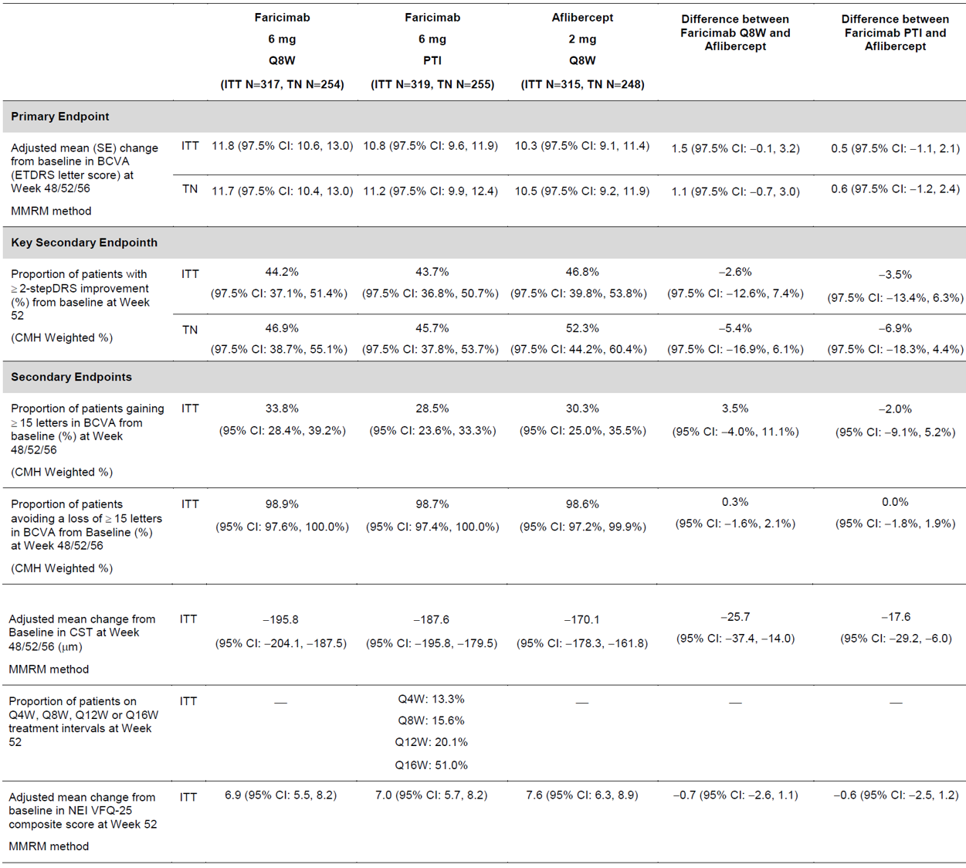
Abbreviations: BCVA = best corrected visual acuity; CMH = Cochran-Mantel-Haenszel; CI = confidence interval; CST = central subfield thickness; ETDRS DRS = Early Treatment Diabetic Retinopathy Study diabetic retinopathy severity; ITT = intent-to-treat; MMRM = mixed-model repeated-measures; N= number of subjects; NEI VFQ-25 = National Eye Institute 25-Item Visual Function Questionnaire; PTI = personalised treatment interval; Q8W = every 8 weeks; Q12W = every 12 weeks; Q16W = every 16 weeks; SE = standard error; TN = treatment naive.
For the MMRM analysis, the model adjusted for treatment group, visit, visit-by-treatment group interaction, baseline BCVA (continuous), baseline BCVA (< 64 letters versus ≥ 64 letters), region (United States and Canada, Asia, and the rest of the world), and for the ITT population prior intravitreal anti-vascular endothelial growth factor (anti-VEGF) therapy (yes versus no). An unstructured covariance structure is used. The estimate of the difference between the two groups uses a composite contrast over Weeks 48, 52 and 56. Treatment policy strategy and hypothetical strategy were applied to non-coronavirus disease 2019 (non-COVID-19)-related and COVID-19-related intercurrent events, respectively. Missing data were implicitly imputed by MMRM. Invalid BCVA values are excluded from analysis.
Cochran-Mantel-Haenszel (CMH) weighted % for aflibercept arm presented for faricimab every 8 weeks versus aflibercept comparison, however the corresponding CMH weighted % for faricimab PTI versus aflibercept comparison is similar to the one shown above; the weighted estimate is based on CMH test stratified by baseline BCVA score (< 64 letters versus ≥ 64 letters), region (United States and Canada versus the rest of the world), and for ITT population prior intravitreal anti-VEGF therapy (yes versus no). Asia and rest of the world regions are combined due to a small number of enrolled patients. Treatment policy strategy and hypothetical strategy were applied to non-COVID-19-related and COVID-19-related intercurrent events, respectively. Missing assessments were not imputed. Baseline is defined as the last available measurement obtained on or prior to randomisation.
97.5% CI is a rounding of 97.52% CI; 95% CI is a rounding of 95.04% CI.
Table 16: Study GR40398 (RHINE trial) Summary of change from Baseline in best corrected visual acuity in the study eye at Weeks 92, 96 and 100
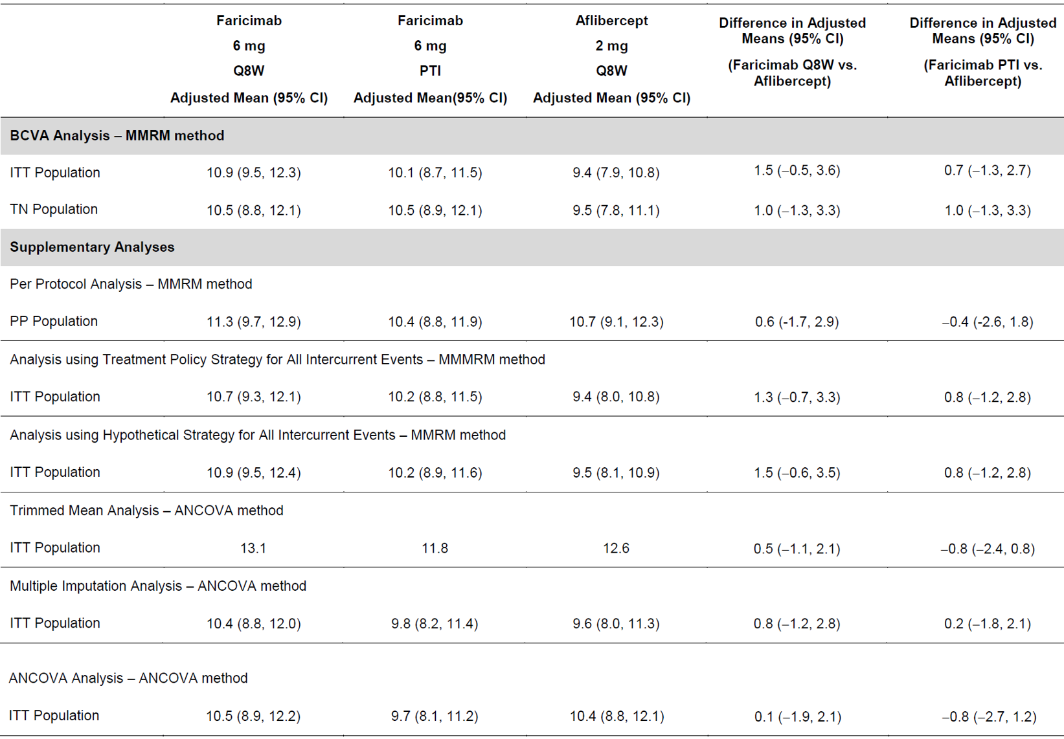
Abbreviations: ANCOVA = analysis of covariance; BCVA = best corrected visual acuity; CI = confidence interval; ITT = intent-to-treat; MMRM = mixed model for repeated measures; PTI = personalised treatment interval; Q8W = every 8 weeks; TN = treatment naïve; vs. = versus.
Personalised treatment interval is from every 4 weeks up to every 16 weeks.
Intent-to-treat (ITT) population: faricimab every 8 weeks = 317, faricimab PTI = 319, aflibercept = 315; TN population: faricimab every 8 weeks = 254, faricimab PTI = 254, aflibercept = 248; PP population: faricimab every 8 weeks = 227, faricimab PTI = 244, aflibercept = 237.
For the MMRM analysis, the model adjusted for treatment group, visit, visit-by-treatment group interaction, baseline BCVA (continuous), baseline BCVA (< 64 letters versus ≥ 64 letters), region (United States and Canada, Asia, and the rest of the world), and for the ITT and PP population prior intravitreal anti-vascular endothelial growth factor (anti-VEGF) therapy (yes versus no). An unstructured covariance structure was used. The estimate of the difference between the two groups used a composite contrast over Weeks 92, 96 and 100.For the treatment policy analysis, observed BCVA assessments were used regardless of the occurrence of intercurrent events. For the hypothetical strategy analysis, hypothetical strategy was applied to non-coronavirus disease 2019 (non-COVID-19)-related and COVID-19-related intercurrent events. For the MMRM analyses, missing data were implicitly imputed by MMRM.
For trimmed mean analysis, distribution of the test statistics was estimated by permutation test with 30,000 samples. Patients were considered to have the worst outcomes and were trimmed if any of the following occurred: 1. Patient has intercurrent events that are not related to COVID-19 prior to Week 92, 2. Patient has a missing BCVA assessment at Week 92 and has intercurrent events that are not related to COVID-19 at Week 92, 3.Patient has missing BCVA assessments at Weeks 92 and 96, and has intercurrent events that are not related to COVID-19 in either one of these two visits, 4.Patient has missing BCVA assessments at Weeks 92, 96 and 100, and has intercurrent events that are not related to COVID-19 in either one of these three visits.
For multiple imputation, the analysis is the same as described for ANCOVA below except missing post-baseline BCVA assessments after the occurrence of intercurrent events that were not due to COVID-19 were imputed using multiple imputation (MI) assuming not missing at random (MAR). BCVA assessments after censoring due to COVID-19-related intercurrent events were imputed using MI assuming MAR. Other missing post-baseline BCVA assessments were imputed assuming MAR.
For the ANCOVA analysis, the model used the average of non-missing change from Baseline in BCVA at Weeks 92, 96 and 100 as the response variables adjusted for the treatment group, baseline BCVA (continuous), baseline BCVA (< 64 letters versus ≥ 64 letters), prior intravitreal anti-VEGF therapy (yes versus no), and region (United States and Canada, Asia, and the rest of the world). Treatment policy strategy and hypothetical strategy were applied to non-COVID-19-related and COVID-19-related intercurrent events, respectively. Missing data were not imputed. Invalid BCVA values were excluded from analysis.
95% CI is a rounding of 95.04% CI.
Table 17: Studies GR40349 and GR40398 (YOSEMITE and RHINE trials) Summary of primary endpoint at Weeks 48, 50 and 52 testing procedure outcomes
Test | YOSEMITE trial outcome | RHINE trial outcome
Non-inferiority of faricimab compared with aflibercept every 8 weeks in the intent-to-treat population with a non-inferiority margin of 4 letters | Demonstrated | Demonstrated
Superiority of faricimab compared with aflibercept every 8 weeks in the treatment-naïve population | Not demonstrated | Not demonstrated
Superiority of faricimab compared with aflibercept every 8 weeks in the intent-to-treat population | Not demonstrated | Not demonstrated
A summary of primary endpoint at Weeks 48, 50 and 52 testing procedure outcomes are demonstrated in Table 17 above. The above outcomes were also achieved in the PP population.

Supportive Phase II study

Study BP30099 (BOULEVARD trial)
The BOULEVARD trial is a Phase II, 36-week, multicentre (77 centres in the USA), multiple dose, randomised, active comparator-controlled, double masked, 3-arm parallel group (1:1:1) study investigating the safety, tolerability, PK and efficacy of faricimab at two different dose levels in 229 adult patients (168 treatment-naïve and 61 previously-treated) with DMO between 1 April 2016 and 14 December 2017.
A total of 168 treatment-naïve patients were randomised 1:1:1 to received either 1.5 mg faricimab every 4 weeks; 6 mg faricimab every 4 weeks; or 0.3 mg ranibizumab every 4 weeks.
There were 61 previously treated patients randomised 1:1 to 6 mg faricimab every 4 weeks or 0.3mg ranibizumab every 4 weeks.
At the end of the treatment phase at Week 20, patients went into an observational period up to Week 36 during which they were evaluated every 4 weeks. Any patient who met both the pre-specified criteria (that is, CST increased by 50 µm or more and BCVA decreased by 5 letters or more due to DMO) received a single dose of 0.3 mg ranibizumab and exited the study. Otherwise, patients exited the study once they had completed the observational visit at Week 36.
This was a superiority study where the primary objective was to evaluate the efficacy of faricimab compared with the active comparator with aflibercept in treatment-naïve patients with centre-involving DMO.

Results
The mean change from Baseline in BCVA at Week 24 resulted in a statistically significant 3.6 ETDRS letter difference in the 6 mg faricimab every 4 weeks arm compared with the 0.3 mg ranibizumab every 4 weeks arm (p = 0.03, 80% CI: 1.5, 5.6). The difference between the 1.5 mg faricimab every 4 weeks arm and the 0.3 mg ranibizumab every 4 weeks arm was not statistically significant (difference of 1.4 letters, p = 0.37, 80% CI: -0.6, 3.4).
An overview of the primary and selected secondary and exploratory endpoints is in Table 18 below.
Table 18: Study BP30099 (BOULEVARD trial) Overview of primary and selected secondary and exploratory efficacy endpoints at Week 24 (intent-to-treat population, treatment-naive and previously treated patients)
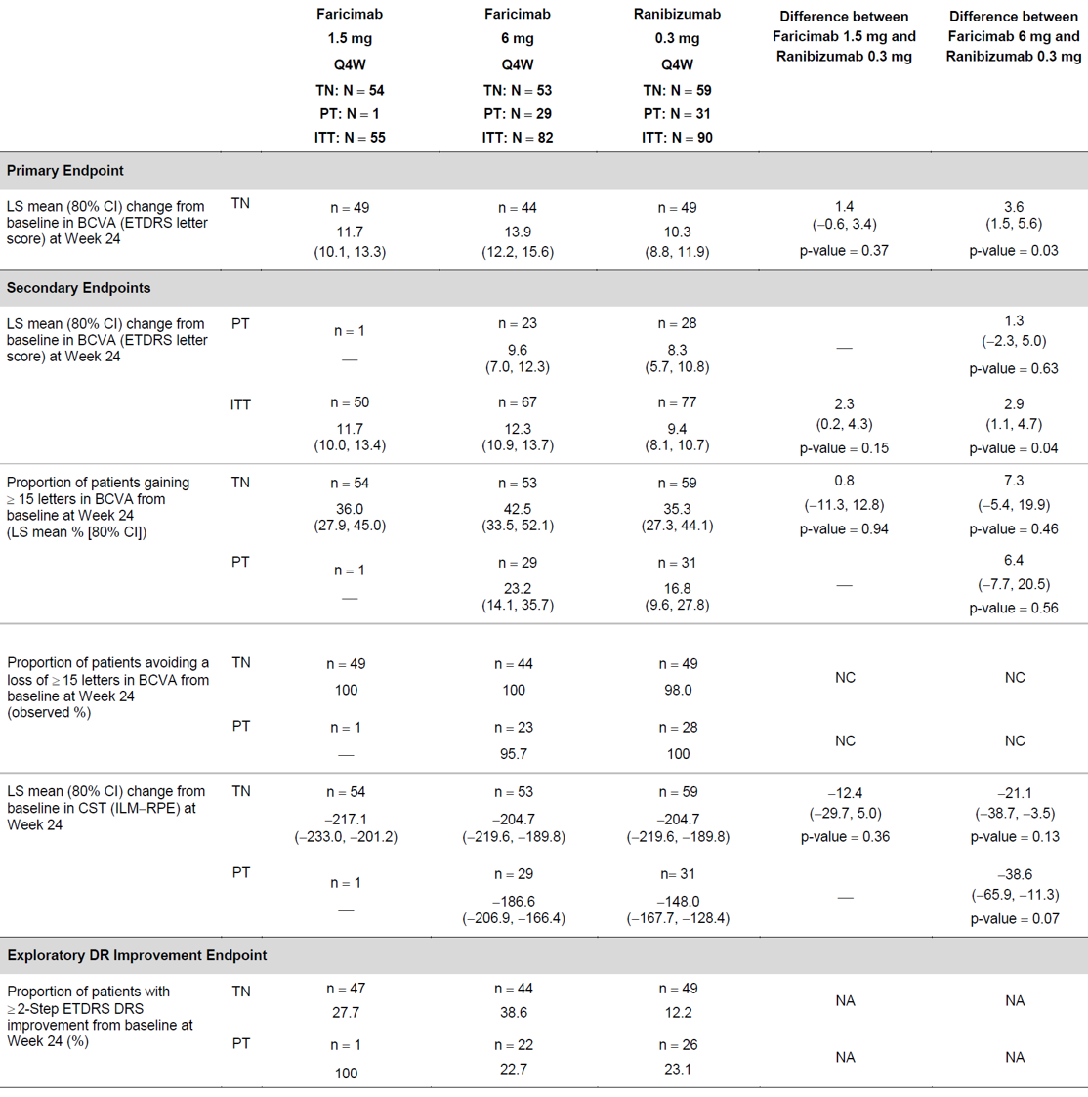
Abbreviations: BCVA = best corrected visual acuity; CI = confidence interval; CST = central subfield thickness; DR = diabetic retinopathy; DRS = diabetic retinopathy severity; ETDRS = Early Treatment Diabetic Retinopathy Study; ILM = internal limiting membrane; ITT = intent-to-treat; LS = least squares; N = number of subjects; NA = not applicable; NC = not calculated; PT = previously treated patients; Q4W = every 4 weeks; RPE = retinal pigment epithelium; TN = treatment-naïve patients.
For the MMRM analysis, the model adjusted for treatment group, visit, and visit-by-treatment group interaction, baseline BCVA (continuous), and randomisation stratification factors. An unstructured covariance is used. The model-based estimates of the difference between each of the treatment (faricimab) arms and the control (ranibizumab) group at Week 24 are reported with 80% confidence interval and value (for superiority tests). There was no formal Type I correction for multiple testing.
For binary endpoints, the 80% CI for the proportion in each treatment group, absolute risk differences, as well as odds ratios were estimated using generalised estimating equations (GEE). The GEE model included the categorical covariates of treatment group, visit, and visit-by-treatment group interaction term. AR (1) covariance structure was used to account for correlation over time. Fisher’s exact test was used for the comparisons between the two arms when GEE models did not converge.

Safety

Exposure

Pooled Phase III neovascular age-related macular degeneration studies (Study GR40306 (TENAYA trial) and Study GR40844 (LUCERNE trial))
The safety profile of faricimab in nAMD population is mainly based on the pooled safety data analysis of the Phase III studies (TENAYA and LUCERNE trials, n = 664 with faricimab and n = 662 with aflibercept) up to Week 60. The median duration of treatment exposure was 48 weeks (through Week 48) and 60 weeks (through Week 60) in both faricimab and aflibercept arms. The mean number of study drug administration was (faricimab versus aflibercept): 6.4 versus 7.4 (through Week 48) and 7.4 versus 8.5 (through Week 60) (see Table 19 below).
Table 19: Pooled Studies GR40306 and GR40844 (TENAYA and LUCERNE trials) Summary of study treatment exposure in the study eye through Week 48 from individual and pooled Phase III neovascular age-related macular degeneration studies (pooled safety evaluable population)
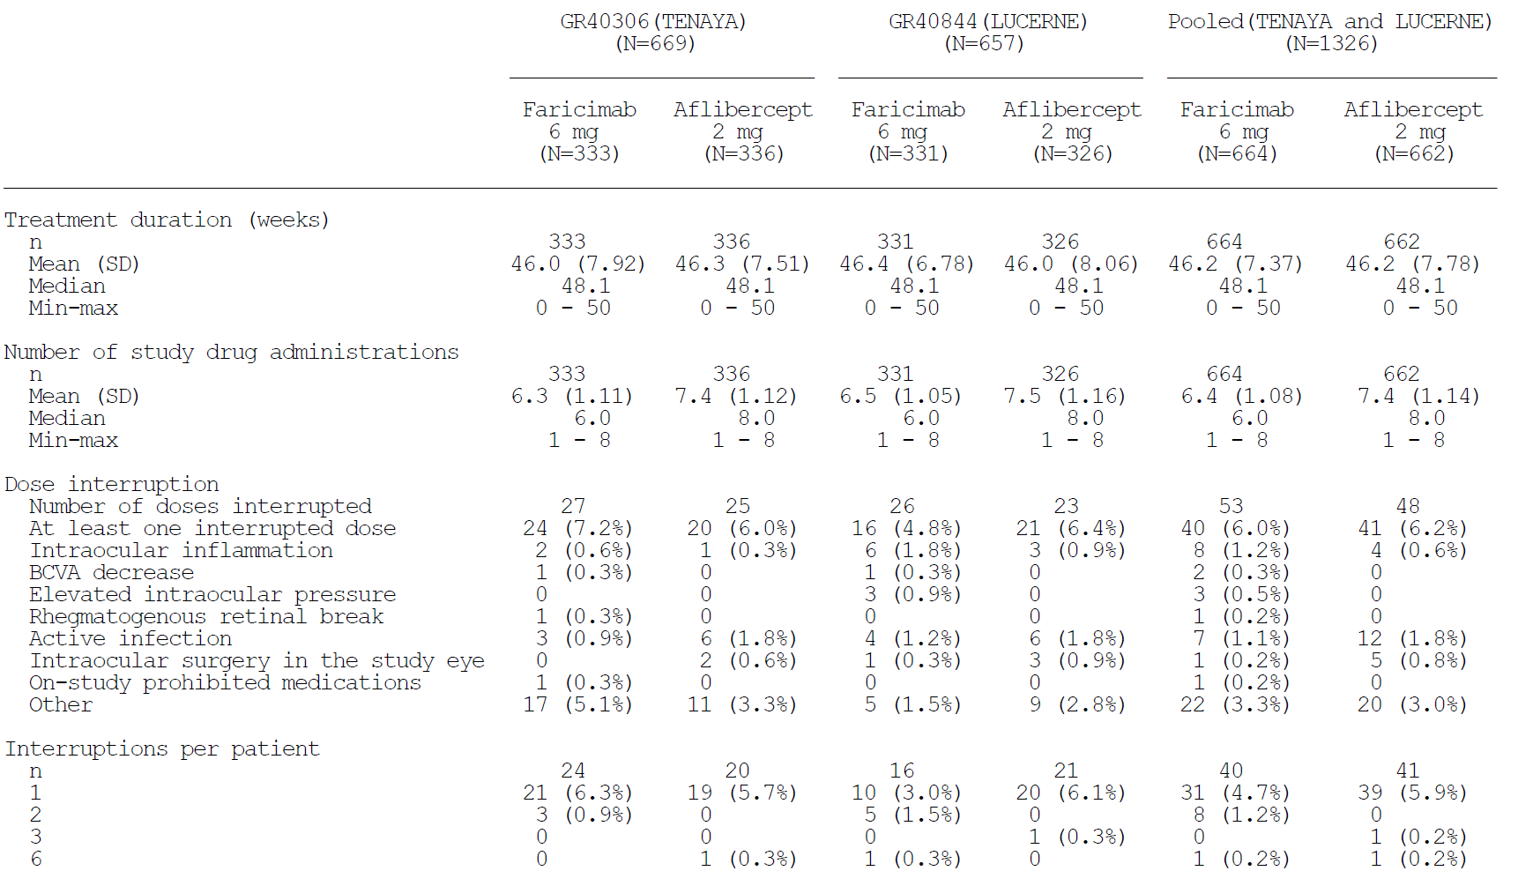
Abbreviations: Max = maximum; Min = minimum; N = number of subjects; n = number of subjects in group; SD = standard deviation.
Study drug corresponds to faricimab or aflibercept. Study treatment corresponds to faricimab, aflibercept or sham. Treatment duration is the (maximum of the date of the last dose of study treatment and the date of the last treatment dose hold) minus the date of the first dose plus one day.
Includes study treatment received and dose hold on or prior to Day 349 (last day of Week 48 analysis visit window). Percentages are based on N in the column headings. The number of study drug administrations may include any active drug administered including medication errors. The number of injections does not take into account the use of prohibited therapies.

Pooled Phase III diabetic macular oedema studies (Study GR40349 (YOSEMITE trial) and Study GR40398 (RHINE trial))
The median duration of exposure was 96.1 weeks for all arms. 1887 patients received 8536, 7454, and 8349 injections in the study eye, in the faricimab every 8 weeks, faricimab personalised treatment interval (PTI), and aflibercept every 8 weeks arms, respectively. 70.5%, 69.0%, and 68.5% of patients received at least one anti-vascular endothelial growth factor (anti-VEGF) administration in the fellow eye (see Table 20 below).
Table 20: Pooled Studies GR40349 and GR40398 (YOSEMITE and RHINE trials) Summary of study treatment exposure in the study eye
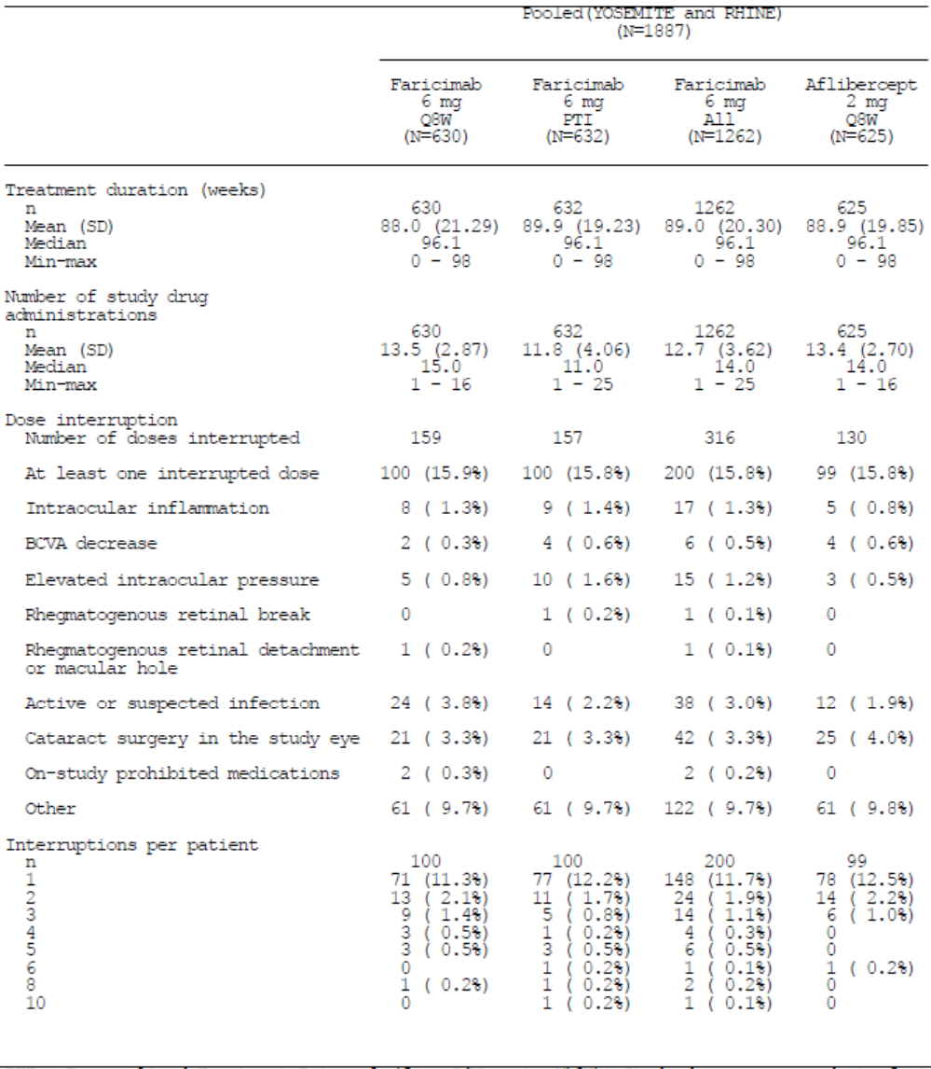
Abbreviations: BCVA = best corrected visual acuity; Max = maximum; Min = minimum; N = number of subjects; n = number of subjects in group; PTI = personalised treatment interval; SD = standard deviation.
Personalised treatment interval is from every 4 weeks up to every 16 weeks.
Study drug corresponds to faricimab or aflibercept. Study treatment corresponds to faricimab, aflibercept or sham. Treatment duration is the (maximum of the date of the last dose of study treatment and the date of the last treatment dose hold) minus the date of the first dose plus one day. Includes study treatment received and dose hold through the end of study. Percentages are based on N in the column headings. The number of study drug administrated may include any active drug administered including medication errors. The number of injections does not take into account the use of prohibited therapies.

Adverse events

Pooled Phase III neovascular age-related macular degeneration studies (Study GR40306 (TENAYA trial) and Study GR40844 (LUCERNE trial))
The most frequently reported adverse events (AEs) leading to permanent discontinuation of faricimab were intraocular inflammation (0.6%), which included, uveitis, vitritis, and iridocyclitis (see Table 21 below).
The incidence of ocular AEs in the study eye was generally similar between the treatment arms (faricimab and aflibercept): 38% versus 37% at Week 48; 42% versus 40% at Week 60.
Through Week 60, the most common ocular AEs (5% or more incidence in any treatment arm) in the study eye by Preferred Term were (faricimab versus aflibercept): conjunctival haemorrhage (8% versus 8%), wet AMD (7% versus 6%) and cataract (5% versus 3%).
Adverse events (AEs) by faricimab dosing intervals: The incidences of ocular AEs, adverse events of special interest (AESI) and serious adverse events (SAEs) were higher in the faricimab every 8 weeks arm (versus faricimab every 12 weeks versus faricimab every 16 weeks versus aflibercept):
- Ocular AEs: 49% versus 42% versus 39% versus 40%.
- Adverse events of special interest: 3.5% versus 1.4% versus 0.7% versus 2.4%.
- Ocular SAEs: 4.9% versus 1.8% versus 0.7% versus 2.6%.
- Retinal pigment epithelial tear: 7.7% versus 1.8% versus 1.0% versus 1.5%.
- Serious retinal pigment epithelial tear: 1.4% versus 0.5% versus 0% versus 0%.
- Intraocular inflammation: 4.9% versus 2.3% versus 1% versus 1.5%.
- Serious intraocular inflammation: 2.1% versus 0.5% versus 0.3% versus 0.4%.
- Vitritis: 2.8% versus 0 versus 0 versus 0.2%.
- Non-ocular AEs: 60% versus 61% versus 56% versus 60%.
Table 21: Pooled Studies GR40306 and GR40844 (TENAYA and LUCERNE trials) Ocular adverse events with an incidence of 1% or higher through Week 48 in the study eye in the faricimab versus aflibercept arms (pooled safety evaluable population)
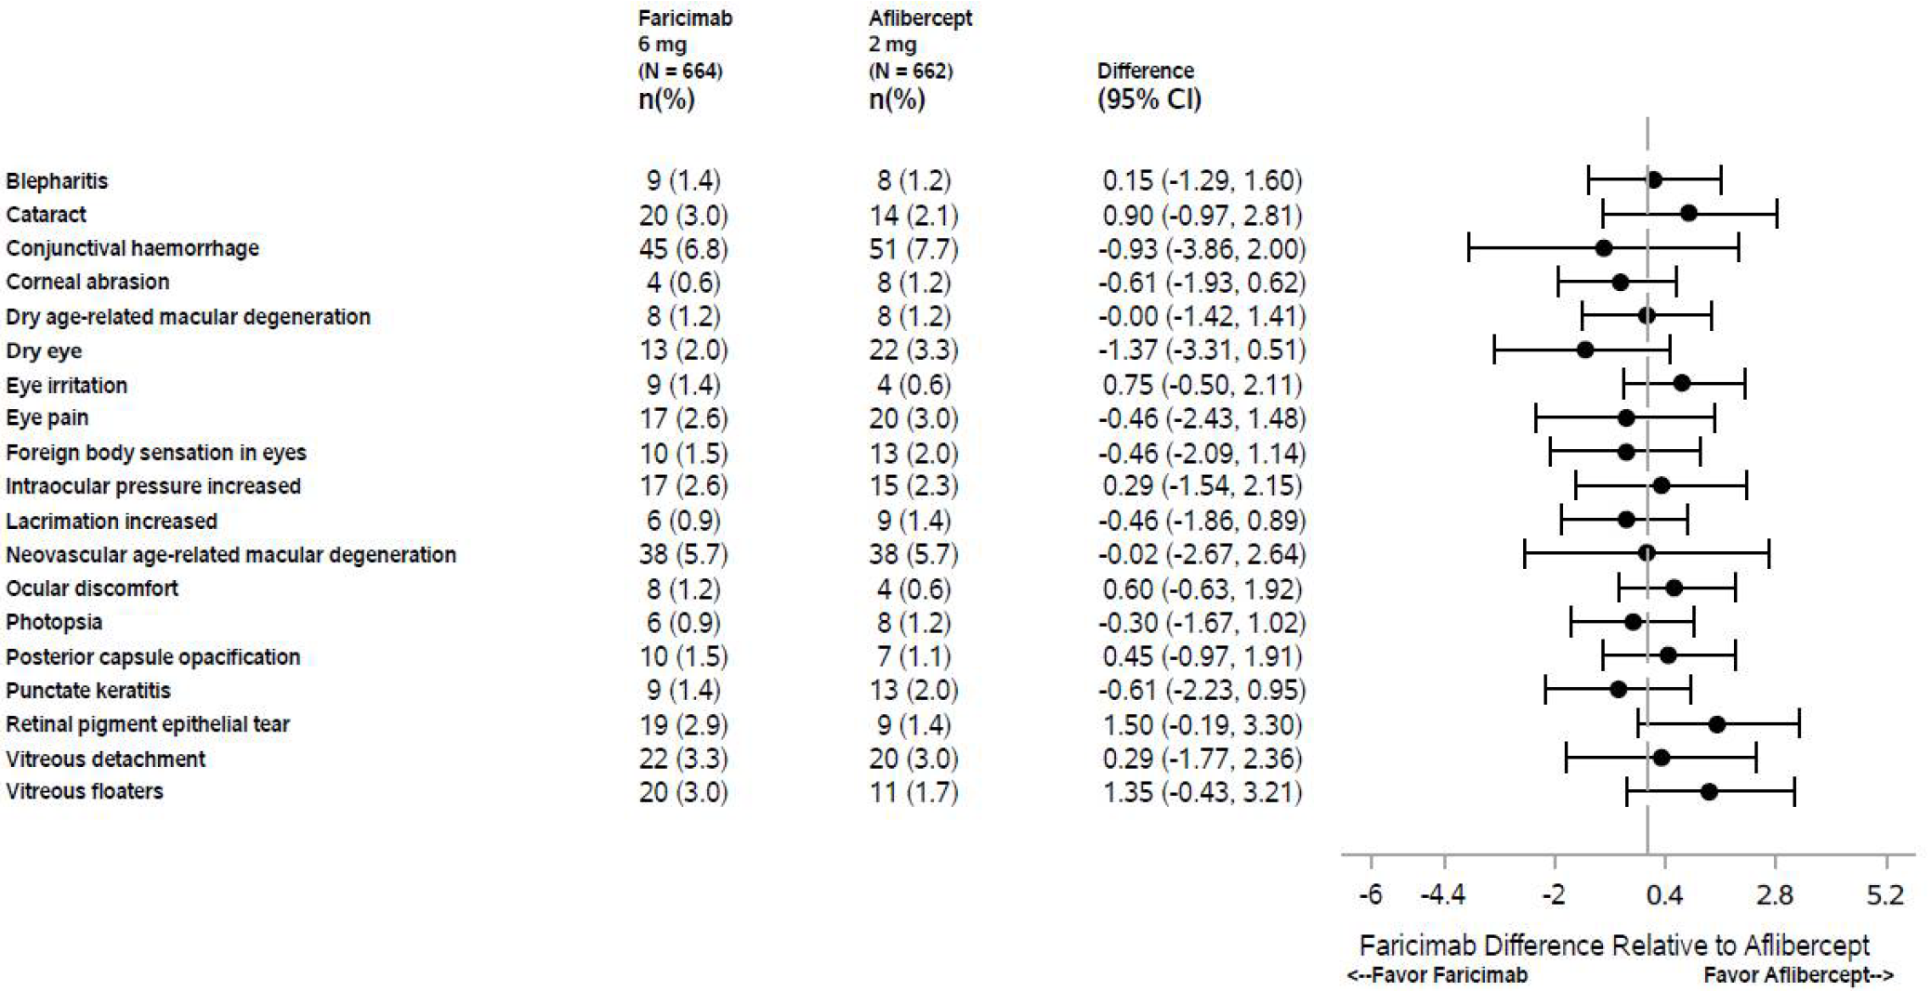
Abbreviations: CI = confidence interval; N = number of subjects; n = number of patients with at least one applicable adverse event.
Investigator text for adverse events encoded using Medical Dictionary for Regulatory Activities (MedDRA) version 23.1.
Percentages are based on N in the column headings. Includes events with onset up to Day 349 (last day of Week 48 analysis visit window). Newbombe with continuity correction method is used for the difference and 95% CI. The bars represent 95% CI.

Pooled Phase III diabetic macular oedema studies (Study GR40349 (YOSEMITE trial) and Study GR40398 (RHINE trial))
The ocular AE incidence (study eye) was comparable across arms (49.7%, 49.2% and 45.4%) with the exception (2% or more difference in all arms) of cataract (16.0%, 13.6% and 12.2%), intraocular pressure increased (5.1%, 3.3% and 2.6%), and vitreous floaters (5.2%, 2.5% and 2.9%) (see Table 22 and Table 23 below).
The most common ocular AEs in the study eye (2% or higher incidence) by Preferred Term were cataract (16.0%, 13.6% and 12.2%), conjunctival haemorrhage (8.3%, 7.0% and 6.6%), vitreous detachment (4.9%, 4.4% and 4.2%), dry eye (4.6%, 4.3% and 2.7%), intraocular pressure increased (5.1%, 3.3% and 2.6%), vitreous floaters (5.2%, 2.5% and 2.9%), eye pain (2.1%, 3.0% and 3.4%), diabetic retinal oedema (1.7%, 2.7% and 2.2%), conjunctivitis (1.6%, 2.1% and 1.8%), cataract subcapsular (2.2%, 1.6% and 1.3%), blepharitis (2.5%, 1.4% and 0.6%), and diabetic retinopathy (0.6%, 2.1% and 1.1%).
Ocular AEs with a difference of 1% or higher between the faricimab every 8 weeks and PTI arms, respectively, were cataract (16.0% versus 13.6%), conjunctival haemorrhage (8.3% versus 7.0%), intraocular pressure increased (5.1% versus 3.3%), vitreous floaters (5.2% versus 2.5%), diabetic retinal oedema (1.7% versus 2.7%), blepharitis (2.5% versus 1.4%), diabetic retinopathy (0.6% versus 2.1%), lacrimation increased (0.6% versus 1.7%), and visual impairment (0.3% versus 1.3%).
Adjusted for number of injections: The number of ocular AEs (study eye) per 1000 injections was higher in the faricimab PTI arm compared to the faricimab every 8 weeks arm, and both were higher than the aflibercept every 8 weeks arm (78.26, 85.59 and 59.41). For every 1000 injections, there were approximately 20 to 25 more ocular AEs in the faricimab arms compared to the aflibercept arm.
Adjusted for patient years: Exposure adjusted incidence rates (events per 100 patient years) for ocular AEs (study eye) was similar between the two faricimab arms but higher compared with the aflibercept arm (58.65 of 100, 55.13 of 100 and 43.58 of 100 patient years). For every 100 patient years, there were approximately 15 and 12 more ocular AEs in the faricimab arms compared to the aflibercept arm.
Table 22: Pooled Studies GR40349 and GR40398 (YOSEMITE and RHINE trials) Ocular adverse events with an incidence of 1% or higher in the study eye in the faricimab every 8 weeks versus aflibercept every 8 weeks arms (pooled safety evaluable population)
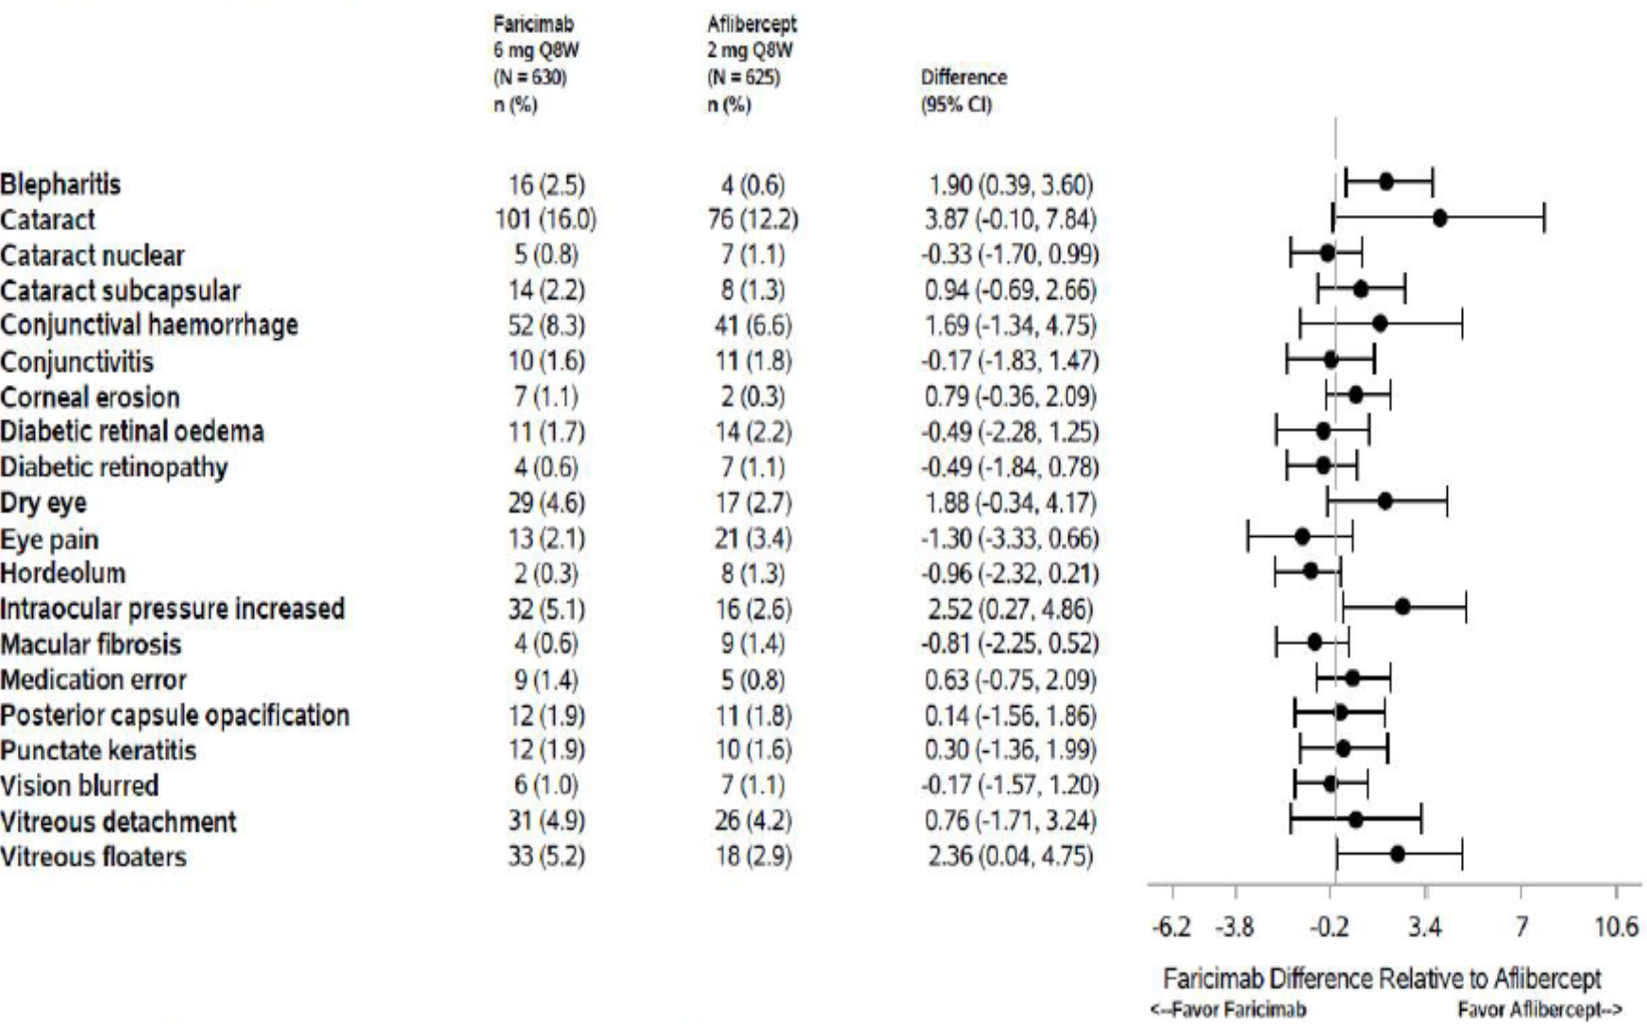
Abbreviations: CI = confidence interval; N = number of subjects; n = number of patients with at least one applicable adverse event; Q8W = every 8 weeks.
Table 23: Pooled Studies GR40349 and GR40398 (YOSEMITE and RHINE trials) Ocular adverse events with an incidence of 1% or higher in the study eye in the faricimab personalised treatment interval versus aflibercept every 8 weeks arms (pooled safety evaluable population)
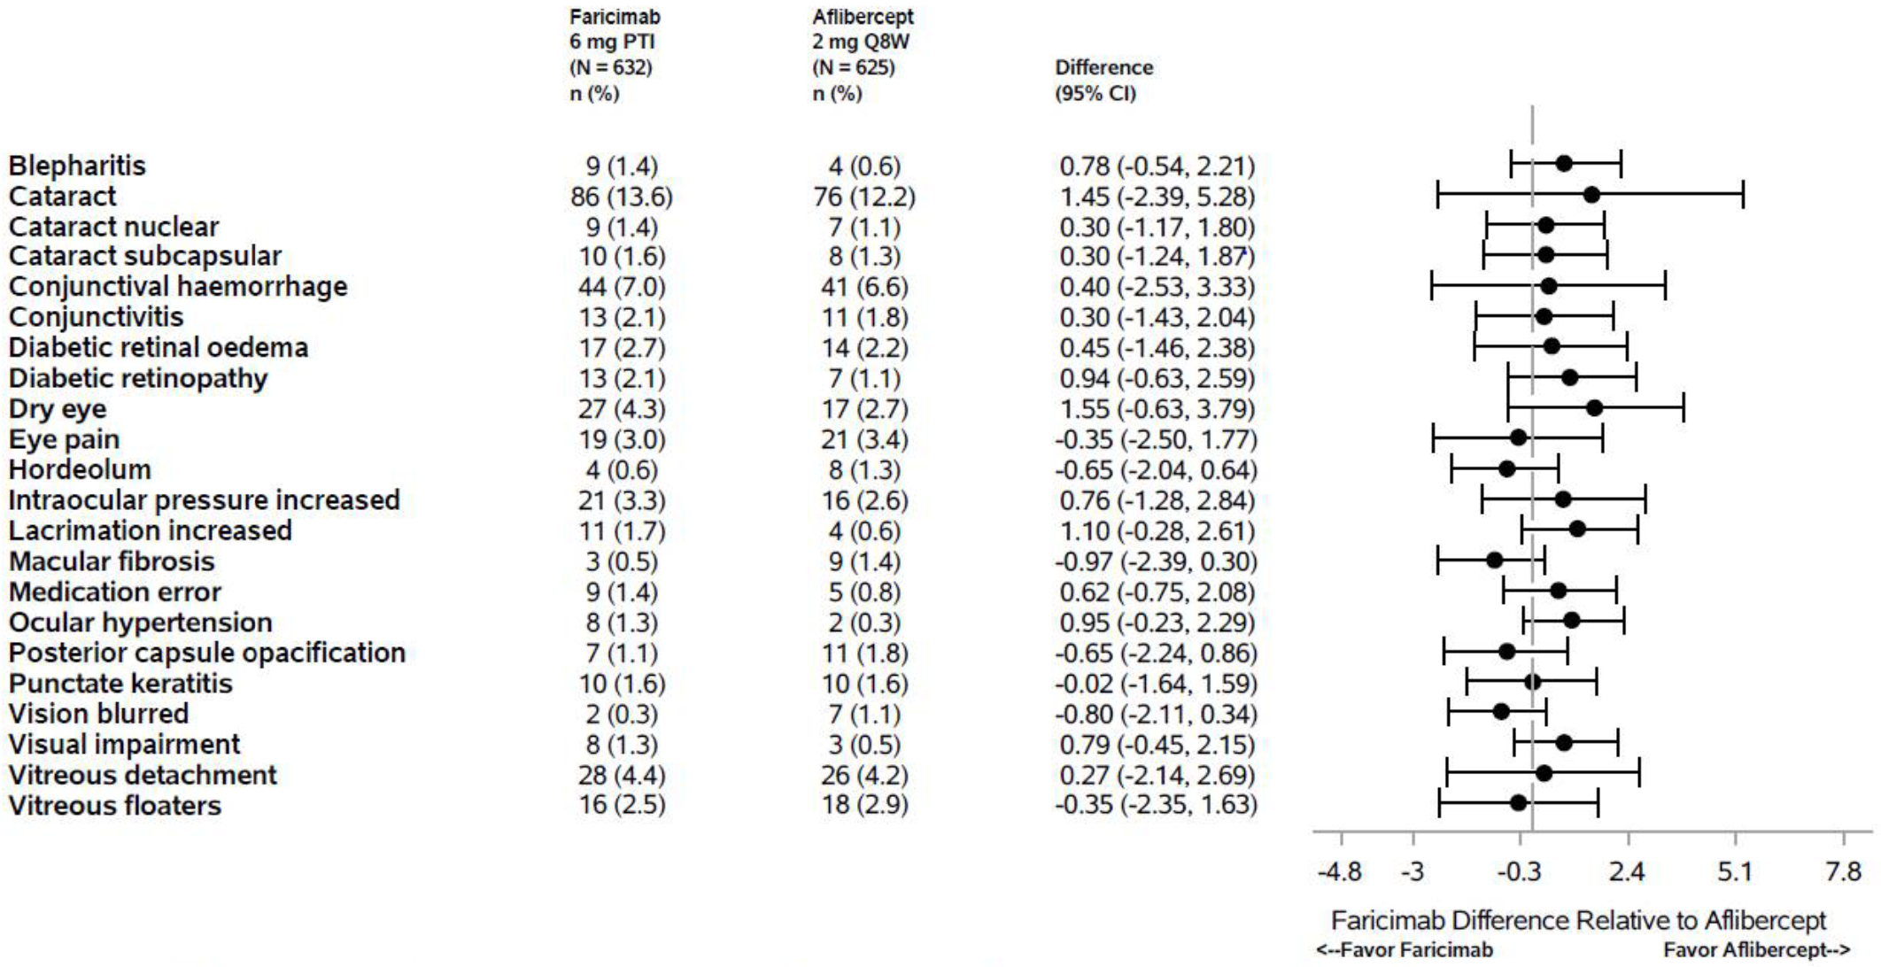
Abbreviations: CI = confidence interval; N = number of subjects; n = number of patients with at least one applicable adverse event; Q8W = every 8 weeks.

Treatment-related adverse events (adverse drug reaction)

Pooled Phase III neovascular age-related macular degeneration (Studies GR40306 (TENAYA trial) and GR40844 (LUCERNE trial)) and diabetic macular oedema studies (Study GR40349 (YOSEMITE trial) and Study GR40398 (RHINE trial))
The most common pooled adverse drug reactions (ADRs) (2% or higher incidence in any treatment arm: combined faricimab arms versus aflibercept arm) by Preferred Term were cataract (10.7% versus 7.0%), conjunctival haemorrhage (7.3% versus 7.1%), intraocular pressure increased (3.6% versus 2.4%), vitreous floaters (3.6% versus 2.3%), and eye pain (2.5% versus 3.2%)(see Table 24 below).
The most common pooled serious ADRs (2 or more patients) were cataract (0.9% versus 0.6%), uveitis (0.3% versus 0.1%), retinal pigment epithelial tear (nAMD only; 0.2% versus 0), endophthalmitis (0.3% versus 0.2%), vitreous haemorrhage (0.1% versus 0.1%), vitritis (0.1% versus 0), intraocular pressure increased (0.1% versus 0) and retinal tear (0.2% versus 0). The majority of the serious ADRs resolved, resolved with sequelae, or were resolving by Week 48 for nAMD events and by the end of the study for diabetic macular oedema (DMO) events. The serious ADRs not resolved were retinal pigment epithelial tear (4 events), cataract (one event), and uveitis (one event) for the nAMD indication; and cataract (7 events), visual acuity reduced (2 events) and endophthalmitis (one event) for DMO.
The most common pooled sight threatening ADRs were cataract (0.9% versus 0.6%), retinal pigment epithelial tear (0.1% versus 0) and endophthalmitis (0.1% versus 0). The majority of the pooled sight threatening ADRs resolved, resolved with sequelae, or were resolving by Week 48 for the nAMD events and by the end of the study for DME events. The ADRs not resolved were retinal pigment epithelial tear (2 events), vitreous haemorrhage (one event), and cataract for the nAMD indication; and cataract (8 events), visual acuity reduced (2 events), vitreous haemorrhage (2 events), and endophthalmitis (one event) (for DMO).
Table 24: Pooled Studies GR40306 (TENAYA trial), GR40844 (LUCERNE trial), GR40349 (YOSEMITE trial) and GR40398 (RHINE trial) Adverse drug reactions in the study eye through Week 48 for neovascular age-related macular degeneration and during the entire study for diabetic macular oedema (pooled safety evaluable population)
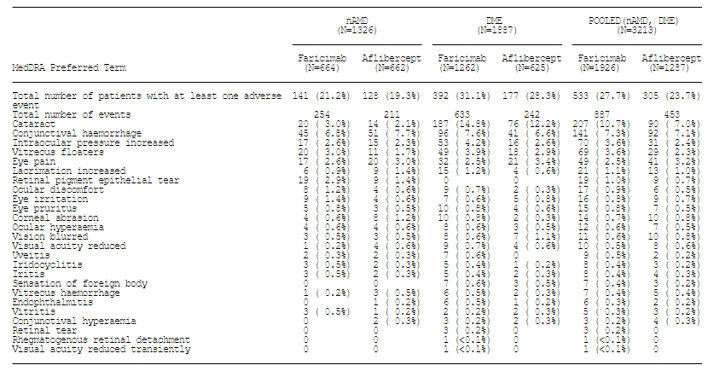
Abbreviations: DME = diabetic macular oedema; MedDRA = Medical Dictionary for Regulatory Activities; N = number of subjects; nAMD = neovascular age-related macular degeneration.
Investigator text for adverse events (AEs) encoded using MedDRA;¹⁵ version 23.1 and MedDRA version 24.0 for DME.
Percentages are based on N in the column headings.
Personalised treatment interval is from every 4 weeks up to every 16 weeks.
For frequency counts by Preferred Term, multiple occurrences of the same adverse event in an individual are counted only once. For frequency counts of ‘total number of events’ rows, multiple occurrences of the same AE in an individual are counted separately.
For nAMD: Includes AEs with onset up to Day 349 (last day of Week 48 analysis visit window).
For DME: Includes events with onset from the first dose of the study drug through the end of study.
Adverse drug reaction terms: uveitis, iritis, vitritis, iridocyclitis, endophthalmitis, rhegmatogenous retinal detachment, retinal tear, retinal pigment epithelial tear, intraocular pressure increased, conjunctival haemorrhage, ocular hyperaemia, lacrimation increased, vision blurred, visual acuity reduced transiently, vitreous haemorrhage, vitreous floaters, eye pruritus, eye irritation, ocular discomfort, eye pain, sensation of foreign body, corneal abrasion, cataract, visual acuity reduced and conjunctival hyperaemia.

Deaths

Pooled Phase III neovascular age-related macular degeneration studies (Studies GR40306 (TENAYA trial) and GR40844 (LUCERNE trial))
The incidences of deaths were (faricimab versus aflibercept): 1.4% versus 1.2% through Week 48 and 1.8% versus 1.2% through Week 60. The most common reason for deaths was cardiac disorders in 2 (0.3%) and 3 (0.5%) patients in faricimab and aflibercept arms, respectively. None of the deaths were suspected by the investigator to be related to study treatment.

Pooled Phase III diabetic macular oedema studies (Study GR40349 (YOSEMITE trial) and Study GR40398 (RHINE trial))
Death was reported in 81 patients (28 patients (4.4%), 30 patients (4.7%), and 23 patients (3.7%) in the faricimab every 8 weeks, faricimab PTI, and aflibercept every 8 weeks arms. None of the deaths were suspected by the investigator to be related to study treatment.

Serious adverse events

Pooled Phase III neovascular age-related macular degeneration studies (Studies GR40306 (TENAYA trial) and GR40844 (LUCERNE trial))
The incidence of ocular SAEs in the study eye was generally similar between the treatment arms (faricimab and aflibercept): Week 48 SAEs: 1.7% versus 2.0%; Week 60 SAEs: 2.1% versus 2.6%.
At Week 60, the most common ocular SAEs in the study eye (0.3% (2 patients) or more in any treatment arm) by Preferred Term were retinal pigment epithelial tear (0.6% versus 0%), nAMD (0.5% versus 0.5%), viral uveitis (0.3% versus 0%), uveitis (0.3% versus 0.2%) and vitritis (0.3% versus 0%).

Pooled Phase III diabetic macular oedema studies (Study GR40349 (YOSEMITE trial) and Study GR40398 (RHINE trial))
The incidence of ocular SAEs in the study eye was slightly higher in the faricimab PTI arm compared to the faricimab every 8 weeks arm, and the aflibercept every 8 weeks arm (26 patients (4.1%), 34 patients (5.4%), and 20 patients (3.2%)).
The most common ocular SAEs in the study eye (2 or more patients) were cataract (1.3% versus 1.4% versus 1.3%), diabetic retinal oedema (0.6% versus 0.5% versus 0.2%), endophthalmitis (0.3% versus 0.6% versus 0.2%), diabetic retinopathy (0.2% versus 0.2% versus 0.5 %).

Adverse events of special interest

Pooled Phase III neovascular age-related macular degeneration studies (Studies GR40306 (TENAYA trial) and GR40844 (LUCERNE trial))
- Sight threatening AESIs in the study eye were generally similar between treatment arms (faricimab versus aflibercept): 1.2% versus 1.8% through Week 48; 1.7% versus 2.4% through Week 60. Through Week 60, the most common (2 or more patients (0.3%)) sight threatening AESIs which caused a decrease of 30 or more best corrected visual acuity (BCVA) letters in the study eye was (faricimab versus aflibercept): nAMD (0.3% versus 0.3%), retinal pigment epithelial tear (0.3% versus 0%), and intraocular inflammation (0.3% versus 0.2%).
- Intraocular inflammation was numerically higher for faricimab versus aflibercept: 2.0% versus 1.2% (serious: 0.5% versus 0.2%) at Week 48; 2.3% versus 1.5% (serious: 0.5% versus 0.2%) at Week 60. The per-injection rate of intraocular inflammation was 0.38% versus 0.18% at Week 48. At Week 60, the most frequent intraocular inflammations (0.5% or higher) were iritis (0.6% versus 0.3%), vitritis (0.6% versus 0.2%), uveitis (0.5% versus 0.3%), iridocyclitis (0.5% versus 0.2%) and post procedural inflammation (0 versus 0.5%). The rates of intraocular inflammation were higher in patients on the faricimab every 8 weeks interval than every 12 weeks or every 16 weeks. The majority of intraocular inflammation events occurred after 4 to 5 injections of faricimab (range: 1 to 8) and after 4 or 6 injections of aflibercept (range: 3 to 8). The rates of intraocular inflammation were higher in the anti-drug antibody (ADA)-positive subgroup (5 out of 75 patients (6.8%)) than in the ADA-negative subgroup (7 out of 582 patients (1.2%)) with a trend for intraocular inflammation onset after an increase in ADA titre.
- Endophthalmitis was reported in one (0.2%) patient in aflibercept arm and none in faricimab arm at Week 60.
- Retinal vasculitis and retinal vascular occlusive disease were not reported in the study period.
- Retinal pigment epithelial tear was numerically higher for faricimab versus aflibercept: 2.9% versus 1.4% (serious: 0.6% versus 0%) at Week 48; 2.9% versus 1.5% (serious: 0.6% versus 0%) at Week 60. One patient (0.2%) in the faricimab arm experienced rhegmatogenous retinal detachment.

Pooled Phase III diabetic macular oedema studies (Study GR40349 (YOSEMITE trial) and Study GR40398 (RHINE trial))
It is generally comparable across treatment arms (4.0% versus 5.2% versus 3.2%). The exposure adjusted incidence rates for ocular AESIs were comparable across all treatment arms.
- Sight threatening AESIs in the study eye: the most common sight threatening AEs in which caused a decrease of 30 or more letters in visual acuity score lasting more than one hour were cataract (1.1% versus 1.4% versus 1.3%), diabetic retinal oedema (0.6% versus 0.5% versus 0.2%), diabetic retinopathy (0.2% versus 0.2% versus 0.5%), retinal vein occlusion (0 versus 0.5% versus 0), endophthalmitis (0 versus 0.3% versus 0), and visual impairment (0 versus 0.3% versus 0).
- Intraocular inflammation: higher incidence in the faricimab arms as compared to aflibercept (1.4%, 1.7% and 1.1%).
- Endophthalmitis: 0.3% versus 0.6% versus 0.2%.
- Retinal vasculitis and retinal vascular occlusive disease: 0.3% versus 0.9% versus 0.6%.
- Retinal pigment epithelial tear: this was not considered an AESI for DMO.

Non-ocular adverse events

Pooled Phase III neovascular age-related macular degeneration studies (Studies GR40306 (TENAYA trial) and GR40844 (LUCERNE trial))
The incidence of non-ocular AEs or SAEs was generally similar between treatment arms (faricimab versus aflibercept): through Week 48: 52% versus 55% (SAEs: 10% versus 12%) and through Week 60: 58% versus 60% (SAEs: 11% versus 14%).
The incidence of externally adjudicated Anti-platelet Trialists’ Collaboration (APTC)-defined arterial thromboembolic events were (faricimab versus aflibercept): 1.1% versus 0.9% through Week 48 and 2.0% versus 1.5% through Week 60. The most common APTC-defined arterial thromboembolic events (0.5% or higher) were cerebrovascular accident, acute myocardial infarction, and cardiac failure which were reported in similar incidences between treatment arms.

Pooled Phase III diabetic macular oedema studies ((Study GR40349 (YOSEMITE trial) and Study GR40398 (RHINE trial))
The incidence of non-ocular AEs or SAEs was generally similar between treatment arms: 73.0%, 74.2%, 75.7% with the incidence of non-ocular AEs suspected by the investigator to be related to study treatment being comparable across all treatment arms (0.6%, 0.8%, 1.1%).
The following events had a 2% or more difference: nasopharyngitis (9.2%, 7.1%, 10.9%), urinary tract infection (4.9%, 5.1%, 8.2%), coronavirus disease 2019 (COVID-19) (4.9%, 7.3%, and 4.3%), sinusitis (4.1%, 2.1%, 2.9%), diabetes mellitus (2.9%, 2.5%, 0.8%), back pain (4.4%, 2.2%, 2.1%), hypertension (7.0%, 9.3% 8.8%), and chronic kidney disease (4.6%, 1.7%, 3.0%).
The most common non-ocular AEs (5% or higher incidence were nasopharyngitis (9.2%, 7.1%, 10.9%), hypertension (7.0%, 9.3%, 8.8%), urinary tract infection (4.9%, 5.1%, 8.2%), COVID-19 (4.9%, 7.3, 4.3%), and fall (5.6%, 4.7%, and 3.8%).
The number of adjudicated APTC-defined arterial thromboembolic events per 1000 injections during the entire study was 3.98, 4.02, and 3.83. The number of APTC-defined deaths per 1000 injections was 1.87, 2.01, and 1.68.

Immunogenicity and anti-drug antibodies
Through end of the DMO studies (up to Week 100), 128 patients were antidrug antibody (ADA)-positive at any point, of which 8 patients were treatment-unaffected ADA-positive.
The incidence of treatment-emergent ADA-positive patients was low and comparable across the faricimab treatment arms (9.8% in the faricimab every 8 weeks arm and 9.4% in the faricimab PTI arm with a similar median time to onset of ADA (approximately 28 weeks).
There were differences in incidence when comparing ADA-positive versus ADA-negative pooled groups:
- Ocular AEs: 60.9% versus 48.5%.
- Ocular SAEs: 10.9% versus 4.0%.
- Adverse events leading to withdrawal from study treatment: 7.0% versus 0.7%.
- Intraocular inflammation: 11.7% (15 out of 128 patients) versus 0.4% (5 out of 1124 patients).
The numbers may be too small to draw definite conclusions. A neutralising antibody assay was not conducted.

Risk management plan
The sponsor has submitted EU-risk management plan (RMP) version 1.0 (dated 19 May 2021; data lock point (DLP) 26 October 2020) and Australia specific annex (ASA) version 1.0 (dated 21 June 2021) in support of this submission. At the second round of evaluation, the sponsor provided draft EU-RMP version 1.1 (no date; DLP 3 September 2021) and ASA version 1.1 (dated 28 January 2022). At the third round of evaluation, the sponsor submitted EU-RMP version 1.1 (dated 4 March 2022; DLP 31 October 2021) and ASA version 1.2 (date 30 March 2022). In response to the third round of RMP evaluation report, the sponsor submitted ASA version 1.3 (dated 28 April 2022).
The summary of safety concerns and their associated risk monitoring and mitigation strategies are summarised in Table 25. Further information regarding the TGA’s risk management approach can be found in risk management plans for medicines and biologicals and the TGA's risk management approach.
Table 25: Summary of safety concerns
Summary of safety concerns |  | Pharmacovigilance |  | Risk Minimisation
 |  | Routine | Additional | Routine | Additional
Important identified risks | Infectious endophthalmitis | * |  |  | †
Important identified risks | Intraocular inflammation | * |  |  | †
Important identified risks | Retinal tear/detachment (ASA only) | – | – |  | †
Important potential risks | None | – | – | – | –
Missing information | Long-term safety |  | ‡ | – | –
* Follow up questionnaires
† Patient/Carer Guide
‡ Study GR42691 and Study GR41987
- The summary of safety concerns aligns with the EU-RMP, however the sponsor at the first round of evaluation is requested to include the important identified risks of ‘retinal tear/detachment’ and ‘hypersensitivity and immunogenicity’ to the summary of safety concerns. This recommendation remains outstanding at the second round of evaluation, and the sponsor is again asked to add ‘retinal detachment/tear’ to the safety specification. As changes to the PI relating to ‘hypersensitivity and immunogenicity’ have mitigated this risk, it is acceptable from an RMP perspective not to include this safety concern. At the second round of evaluation, the sponsor has responded to questions from the clinical evaluation, which are relevant to the RMP, and changes have been made to the Summary of Product Characteristics (SmPC) and PI. At the third round of evaluation, the sponsor has added the missing information ‘long-term safety’ to the ASA to align with the EU-RMP, and added the important identified risk of ‘retinal detachment/tear’ to the summary of safety concerns as requested. The summary of safety concerns is acceptable.
- Routine pharmacovigilance is proposed for all safety concerns. At the second round of evaluation, the sponsor has included follow-up questionnaires as a routine pharmacovigilance activity in the EU-RMP and ASA. A planned EU only activity to evaluate the effectiveness of risk minimisation materials has been removed from the EU-RMP, and two open label extension studies have been added. At the third round of evaluation, the sponsor has added these studies to the ASA as requested. However, there are administrative errors in the pharmacovigilance plan in the ASA, and these should be corrected with the next RMP update. The pharmacovigilance plan is acceptable, subject to administrative corrections to the ASA that the sponsor is instructed to make. In response to the third round of RMP evaluation report, the sponsor has corrected the pharmacovigilance plan in the ASA as requested and the pharmacovigilance plan is acceptable.
- Routine and additional risk minimisation is proposed for all safety concerns. At the second round of evaluation, the sponsor does not agree to add a traumatic cataract warning to the PI and Consumer Medicines Information (CMI) as requested. This is acceptable from an RMP perspective, subject to the outcome of the negotiation by the clinical evaluation. Additional risk minimisation is proposed in the form of a patient/carer guide, which the sponsor has provided for review as requested. The guide is acceptable. The sponsor agrees to evaluate the effectiveness of additional risk minimisation materials in Australia using outcome indicators, and the ASA has been updated accordingly. The sponsor commits to development of patient materials in audio format, and this commitment has been added to the ASA at the third round of evaluation. The CMI has been revised as requested and the risk minimisation plan is acceptable.

Risk-benefit analysis

Delegate’s considerations

Proposed indication: neovascular age-related macular degeneration
Faricimab has been evaluated in two identically designed Phase III studies (Studies GR40306 and GR40844; also known as the TENAYA and LUCERNE trials) as compared to aflibercept in patients with neovascular age-related macular degeneration (nAMD).

Non-inferiority to aflibercept
Both Phase III studies (TENAYA and LUCERNE trials) demonstrated that faricimab was non-inferior to aflibercept at the primary endpoint, defined as the mean change from Baseline in best corrected visual acuity (BCVA) in the study eye based on an average at Weeks 40, 44 and 48. The adjusted mean difference (95% CI) between the faricimab and aflibercept arms was 0.7 (-1.1, 2.5) and 0.0 (-1.7, 1.8) in the TENAYA and LUCERNE trials, respectively. The lower bound of the 95% CI was greater than the pre-specified non-inferiority margin, -4 BCVA letters.
The non-inferiority finding for the primary endpoint was supported in the per-protocol (PP) population and sensitivity or supplementary analyses with different handling strategies for intercurrent event and missing data. Primary efficacy in evaluable subgroups (for example, age, gender, race, baseline visual acuity, choroidal neovascularisation lesion location) was generally consistent with the results in the overall population.
The non-inferiority finding of the mean change from Baseline in BCVA at Weeks 40, 44 and 48 was also supported by the mean change from Baseline in BCVA at Weeks 52, 56 and 60. The adjusted mean difference (95% CI) between the faricimab and aflibercept arms at Weeks 52, 56 and 60 was 0.7 (-1.2, 2.7) and -0.6 (-2.4, 1.3) in the TENAYA and LUCERNE trials, respectively. The mean change from Baseline in BCVA were generally maintained over 60 weeks.
Superiority of faricimab over aflibercept was not shown.

Studied patient population
The studied patient population was patients aged 50 years and older with treatment-naïve choroidal neovascularisation secondary to nAMD. The indication may need to be restricted to the population group studied (for example, treatment-naïve patients).

Dosing considerations: Dosing regimen implications on efficacy
At Week 48, 22%, 33% and 45% of patients received faricimab treatment on every 8 weeks, every 12 weeks and every 16 weeks intervals, respectively. At Week 60, the percentages were 21%, 33% and 46%, respectively. However, these results depended on the non-validated disease activity criteria used in the clinical trials.
The mean change in BCVA from Baseline in patients on faricimab every 16 weeks interval was numerically greater than those on aflibercept every 8 weeks at Weeks 40, 44 and 48 and at Week 52, 56 and 60 (see Table 26 below). This was not tested statistically. The mean BCVA changes from Baseline in the study eye on three faricimab treatment intervals were generally maintained through Week 60.
Up to Week 60, patients treated with faricimab 6 mg every 16 weeks could have received two injections less than patients treated with aflibercept 2 mg every 8 weeks dosing (see Table 27 below), while achieving a change in BCVA which was similar to aflibercept 2 mg every 8 weeks with an acceptable safety profile. A personalised dosing regimen beyond Week 60 has not been assessed for the nAMD indication as the studies were still ongoing.
Table 26: Studies GR40306 and GR40844 (TENAYA and LUCERNE trials) Change from Baseline in best corrected visual acuity in the study eye averaged over Weeks 52, 56 and 60 by faricimab treatment interval (intent-to-treat population)
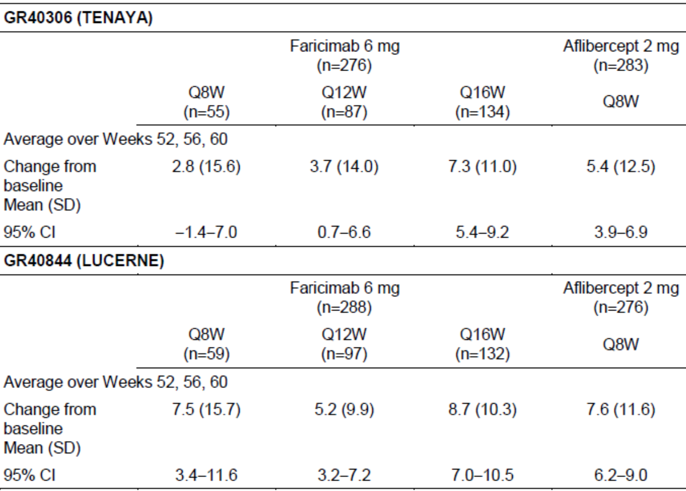
Abbreviations: CI = confidence interval; n = number of subjects in group; Q8W = every 8 weeks; Q12W = every 12 weeks; Q16W = every 16 weeks; SD = standard deviation.
95% CI is a rounding of 95.03% CI.
n is patients with at least one non-missing assessment at Weeks 52, 56 and 60.
Table 27: Studies GR40306 and GR40844 (TENAYA and LUCERNE trials) Distribution of number of injections until Week 60 (intent-to-treat population)
Abbreviation: N = number of subjects.

Translation to clinical practice
In the proposed PI, the sponsor proposes the following posology wording for nAMD:
The recommended dose for Vabysmo is 6 mg (0.05 mL) administered by intravitreal injection every 4 weeks (monthly) for the first 4 doses. Thereafter, based on the physician’s judgment of the individual patient’s visual and/or anatomic outcomes, Vabysmo should be administered every 16 weeks (4 months) with some patients requiring dosing at 12 week (3 month) or 8 week (2 month) intervals. Monitoring between the dosing visits should be scheduled based on the patient's status and at the physician's discretion.
For nAMD, the main dosing issues appear to be:
- The proposed regimen does not exactly follow the regimen tested in the pivotal trials (for example, the first dose adjustment assessment in clinical trial occurred at Week 20, leading to the fifth injection given at least 8 weeks after the fourth by default). However, the proposed dosing may give prescriber more freedom.
- The wording is rather vague and non-prescriptive regarding the nature of the ocular assessment needed to adjust the dose (other than a reference to the clinical trial Section 5.1 of the PI).
- The wording is rather vague and non-prescriptive with regard to the dose adjustments to be made.
- There is no recommendation on when treatment should be stopped.

Proposed indication: diabetic macular oedema
Faricimab is a bispecific antibody which targets vascular endothelial growth factor A (VEGF-A) and angiopoietin-2 (Ang-2), both of which are implicated in the pathophysiology of diabetic macular oedema (DMO).
Faricimab has been evaluated in two identically designed Phase III studies (YOSEMITE and RHINE trials) as compared to aflibercept in patients with DMO. Both studies evaluated two dosing regimens of faricimab: every 8 weeks and personalised treatment interval (PTI) dosing.

Non-inferiority to aflibercept
Both studies met their primary endpoint and demonstrated non-inferiority of both dosing regimens (every 8 weeks and PTI) as compared to aflibercept every 8 weeks regimen on the primary endpoint of mean change from Baseline in BCVA averaged over 48, 52 and 56 weeks.
The pooled data from both studies showed that the mean change from Baseline in BCVA in the intent-to-treat (ITT) population at Weeks 48, 52 and 56 was 11.2, 11.2 and 10.5 letters in the faricimab every 8 weeks, faricimab PTI and aflibercept arms. The difference in adjusted mean (95% CI) was 0.7 (-0.4, 1.7) and 0.6 (-0.4, 1.7) for the faricimab every 8 weeks versus aflibercept and the faricimab PTI versus aflibercept.
Pooled data for the results at Weeks 92, 96 and 100 appear not to be available, but the results appear to be similar (individual study results in Table 14 and Table 16 above).
This is a clinically meaningful improvement in visual acuity in patients with DMO in both treatment-naïve and ITT populations.
Neither of the dosing regimens achieved superiority over aflibercept in either the ITT population or in the treatment-naïve sub-group.

Supportive non-primary endpoints
The conclusion of non-inferiority from the primary endpoint was well supported by the results from the key secondary endpoint and other secondary endpoints. These endpoints included parameters of visual function (for example, proportion of good responders on BCVA and change in BCVA over time), disease severity (for example, 2, 3 or 4-step change or higher in diabetic retinopathy severity from Baseline to Week 52 as measured by the early treatment diabetic retinopathy study (ETDRS) Diabetic Retinopathy Severity Scale), anatomical or morphological changes (for example, central subfield thickness (CST)) and patient reported outcomes (National Eye Institute 25-Item Visual Function Questionnaire).
Both dosing regimens of faricimab showed comparable effects to aflibercept on all these endpoints, but for some of the anatomical endpoints such as CST, both faricimab regimens showed a numerically, but not statistically significant greater reduction (compared to aflibercept) across both studies. However, the clinical relevance of this has not been established.
On the key secondary endpoint of proportion of patients with a 2-step diabetic retinopathy severity improvement or higher from Baseline on the ETDRS Diabetic Retinopathy Severity Scale with a clinically relevant benefit in all three treatment arms. For this endpoint, non-inferiority was only demonstrated in the YOSEMITE trial and the pooled data, but not in the RHINE trial.

Dosing considerations: anatomical endpoint (for example, central subfield thickness) implications on personalised treatment interval dosing
The sponsor considers that the greater effect on anatomical endpoints could translate to a longer duration of action for faricimab allowing it to be administered less frequently than aflibercept. This was tested in the PTI regimen, where based on a clinical algorithm, patients were progressively treated at longer intervals provided they did not show any significant progression of disease based on change in CST and BCVA.

Dosing considerations: efficacy comparison of faricimab every 8 weeks versus personalised treatment interval dosing
As the clinical experience with the extended intervals of every 12 weeks and every 16 weeks is for limited cycles in a proportion of the patient population randomised to PTI in the 52-week data presented, the sponsor has submitted updated clinical study reports of both studies including data through week 100. The change from Baseline to Week 100 in BCVA as determined as an average of Weeks 92, 96 and 100 in faricimab PTI arm was shown to be comparable to both faricimab every 8 weeks and aflibercept every 8 weeks in both studies.
Further, all other secondary endpoints also showed a similar relevant and significant effect in the faricimab PTI arm comparable to the other two arms. This effect was achieved with 60% and 64.5% of patients in the PTI arms of the YOSEMITE and RHINE trials, respectively reaching every 16 weeks dosing frequency at Week 100 (an increase from the 52.8% and 51% who had achieved this dosing frequency at Week 52).
In the YOSEMITE trial, the faricimab PTI results were marginally numerically better than for faricimab every 8 weeks, while the opposite is observed in the RHINE trial. This may be due to variability.

Dosing considerations: injection number comparison of faricimab every 8 weeks versus personalised treatment interval dosing
The distribution of number of injections until Week 96 in the ITT population in the YOSEMITE and RHINE trials is shown in Table 28 below.
In both studies, most patients in the faricimab every 8 weeks received 14 to 15 injections, and mostly 9 to 14 injections in the PTI arm. A lower number of injections may be able to reduce ADRs and comparatively improve compliance and quality of life.
But differences in exposure (see Figure 1 above), in particular for every 16 weeks maintenance dosing, appeared not to have affected efficacy.
Table 28: Studies GR40349 and GR40398 (YOSEMITE and RHINE trials) Distribution of number of injections until Week 96 (intent-to-treat population)
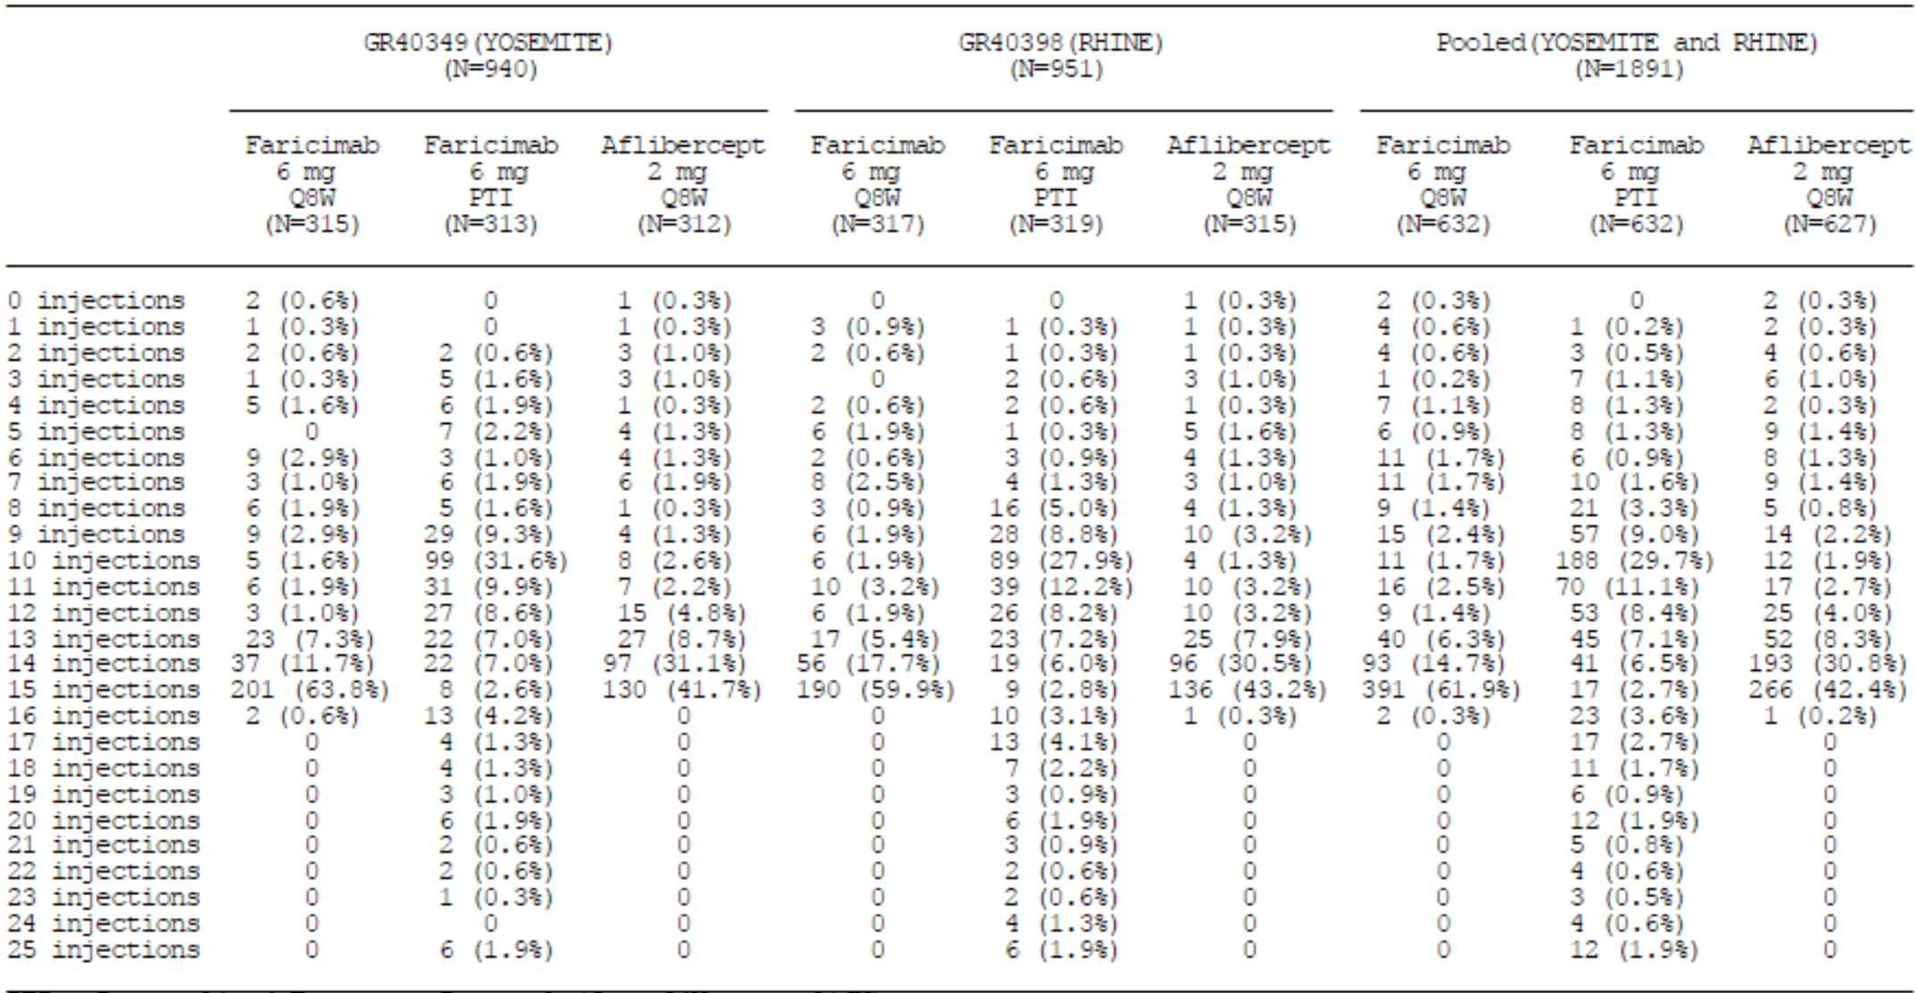
Abbreviations: N = number of subjects; PTI = personalised treatment interval; Q8W = every 8 weeks.
personalised treatment interval is from every 4 weeks up to every 16 weeks.

Translation to clinical practice
The proposed dosing initially follows the PTI dosing regimen in the YOSEMITE and RHINE trials: 4 injections until Week 12. This is followed by a treat and extend approach, presumably based on the PTI schedule used in the Phase III clinical trials.
In the proposed PI, the sponsor proposes the following posology wording for DMO:
The recommended dose for Vabysmo is 6 mg (0.05 mL) administered by intravitreal injection every 4 weeks (monthly) for the first 4 doses. Thereafter, treatment may be individualised using a treat-and-extend approach. Based on the physician's judgement of the individual patient’s anatomic and/or visual outcomes, the dosing interval may be extended up to every 16 weeks (4 months), in increments of up to 4 weeks. If anatomic and/or visual outcomes change, the treatment interval should be adjusted accordingly (see Section 5.1).
Monitoring between the dosing visits should be scheduled based on the patient's status and at the physician's discretion.
For DMO, the main issues appear to be:
- The wording is rather vague and non-prescriptive regarding the nature of the ocular assessment needed to adjust the dose (other than a reference to the clinical trial Section 5.1 of the PI).
- The wording is rather vague and non-prescriptive with regard to the dose adjustments to be made.
- There is no recommendation on when treatment should be stopped.

Safety
In the pivotal studies, the overall incidence of all adverse events (AEs) and ocular AEs was generally comparable across the treatment arms.
Overall, faricimab appears to have an acceptable safety profile which is comparable to or may have a slightly worse safety profile as compared to aflibercept.
Given the short treatment duration (60 weeks) and few numbers of intravitreal injections in the faricimab nAMD clinical trials, the safety of faricimab beyond that study period could not be sufficiently assessed.

Immunogenicity
Anti-drug antibodies were detected in over 9% of DMO patients receiving faricimab (9.8% in the faricimab every 8 weeks arm and 9.4% in the faricimab PTI arm with a similar median time to onset of anti-drug antibody (ADA) (approximately 28 weeks). The incidence of intraocular inflammation in DMO patients with ADAs in 11.7% as compared to 0.4% in the non-ADA population suggests a causative link. The numbers are too small to draw definite conclusions. A neutralising antibody assay was not conducted for any of the studies.
The situation in the nAMD studies was comparable to the DMO studies, but fewer data were available (Week 112 data are not available).
The population pharmacokinetic (PopPK) covariate analyses showed that plasma ADA had an effect on vitreous elimination half-life (30.4% higher ocular elimination rate). ADA-positive patients had 23.4% lower ocular exposure at steady state compared with ADA-negative patients. Presence of plasma ADA had no effect on the plasma exposure.

Proposed action
While a decision was yet to be made, at the time, the Delegate was inclined to approve the registration of the product.
Were the registration supported, the Delegate would propose the following additional conditions of registration:
- Submission of final reports for all relevant ongoing studies.

Advisory Committee considerations
The Advisory Committee on Medicines (ACM), having considered the evaluations and the Delegate’s overview, as well as the sponsor’s response to these documents, advised the following.

Specific advice to the Delegate
- The final Week 112 data from Studies GR40306 and GR40844 (the TENAYA and LUCERNE trials) are not available at this stage. From the available data, only non-inferiority, but not superiority over aflibercept has been demonstrated for the neovascular age-related macular degeneration (nAMD) indication. The sought nAMD indication is broader than the population studied and includes non-treatment-naïve patients.
Can the ACM comment on whether the available data are sufficient for registration of a neovascular age-related macular degeneration indication and whether the indication should be restricted further?
The ACM was of the view that the available data are sufficient for the registration of the nAMD indication as proposed.
The ACM agreed that non-inferiority has been satisfactorily established with treatment over 60 weeks and this is acceptable. The ACM did however note that submission of the final Week 112 data once available would provide greater reassurance, particularly regarding safety outcomes.
- Assuming Vabysmo is registered for neovascular age-related macular degeneration, can the ACM comment on the appropriateness of the sponsor-proposed dosing regimen, and also comment on the appropriate communication of a suitable regimen to the prescriber in the Product Information or otherwise?
The ACM commented that the translation of the clinical trial dosing regimen into clinical practice would be difficult. The ACM noted that within Australia, physicians use the treat and extend dosing interval approach as standard for nAMD patients. The ACM acknowledged the importance of aligning with the regimen outlined within the clinical trial wherever possible but also agreed that it is important to take into consideration the Australian clinical context and as such recommended that the Product Information dosing section should include the option for the physician to treat per disease activity and at the physician’s discretion, and suggested the following wording:
The recommended dose for Vabysmo is 6 mg (0.05 mL) administered by intravitreal injection every 4 weeks (monthly) for the first 4 doses. Thereafter, an assessment of disease activity based on anatomic and visual outcomes is recommended so treatment can be individualised. In patients without disease activity, administration of Vabysmo up to 16 weeks (4 months) should be considered. In patients with disease activity, treatment every 4 to 12 weeks (3 months) should be considered.
Continued monitoring of disease activity is recommended. Monitoring between the dosing visits should be scheduled based on the patient's status and at the physician's clinical judgment.
- Based on the data up to Week 100 data from Studies GR40349 and GR40398 (the YOSEMITE and RHINE trials), only non-inferiority, but not superiority over aflibercept has been demonstrated for the diabetic macular oedema indication.
Can the ACM comment on whether the available data are sufficient for registration of a diabetic macular oedema indication?
The ACM discussed and commented that non-inferiority of faricimab to an existing treatment for diabetic macular oedema (DMO) / diabetic macular edema (DME) is appropriate and sufficient for registration of the DMO/DME indication. Further, the ACM noted that the effect was durable over 100 weeks.
- Assuming that Vabysmo is registered for diabetic macular oedema, can the ACM comment on the appropriateness of the sponsor-proposed dosing regimen, and also comment on the appropriate communication of a suitable regimen to the prescriber in the Product Information or otherwise?
The ACM suggested the following wording for the dosing regimen:
The recommended dose for Vabysmo is 6 mg (0.05 mL) administered by intravitreal injection every 4 weeks (monthly) for the first 4 doses. Thereafter, treatment may be individualised using a treat-and-extend approach. Based on the physician's judgment of the individual patient’s anatomic and visual outcomes, the dosing interval may be extended up to every 16 weeks (4 months). If anatomic or visual outcomes change, the treatment interval should be adjusted accordingly (see Section 5.1).
Continued monitoring of disease activity and individualisation of dosing is recommended. Monitoring between the dosing visits should be scheduled based on the patient's status and at the physician's clinical judgment.
- The committee is also requested to provide advice on any other issues that it thinks may be relevant to a decision on whether or not to approve this submission.
The ACM discussed the spelling of edema / oedema and advised that within Australia oedema is generally used, but to avoid confusion the ACM advised that both spellings of diabetic macular edema (DME) and diabetic macular oedema (DMO) should be listed in the Product Information (PI).
The ACM noted the lack of clinical validity of the composite disease assessment criteria in the PI. The ACM advised that the PI should include the clinical trial assessment criteria.
The ACM queried the reason for the withholding treatment statement within the PI noting that anti-VEGF at or around the time of cataract surgery is common in patients with DMO/DME. The ACM advised that the following statement in the PI, ‘Withholding treatment - ‘performed or planned intraocular surgery within the previous or next 28 days; treatment should not be resumed earlier than the next scheduled treatment’ should include ‘at the physician's discretion’ to allow the physician to assess the individual patient and their condition.
The ACM indicated that additional clarification regarding the duration of treatment could be beneficial and suggested that ‘Duration of treatment for DMO/DME is adjusted accordingly to clinical response’ and ‘Duration of treatment for nAMD is likely to be long-term treatment’ could be used within the PI.

Conclusion
The ACM considered this product to have an overall positive benefit-risk profile for the indication:
Vabysmo is a bispecific angiopoietin-2 (Ang-2) and vascular endothelial growth factor (VEGF) inhibitor indicated for the treatment of:
- Neovascular (wet) age-related macular degeneration (nAMD)
- Diabetic macular oedema (DMO).

Outcome
Based on a review of quality, safety, and efficacy, the TGA approved the registration of Vabysmo (faricimab) 120 mg/mL, solution for injection, vial, indicated for:
Vabysmo is indicated for the treatment of:
- Neovascular (wet) age-related macular degeneration (nAMD)
- Diabetic macular oedema (DMO).

Specific conditions of registration applying to these goods
- Vabysmo (faricimab) is to be included in the Black Triangle Scheme. The PI and CMI for Vabysmo must include the black triangle symbol and mandatory accompanying text for five years, which starts from the date that the sponsor notifies the TGA of supply of the product.
- The Vabysmo EU-risk management plan (RMP) (version 1.1, dated 4 March 2022, data lock point 31 October 2021), with Australian specific annex (version 1.2, dated 30 March 2022), included with Submission PM-2021-02671-1-5, to be revised to the satisfaction of the TGA, and any subsequent revisions, as agreed with the TGA, will be implemented in Australia.
An obligatory component of risk management plans is routine pharmacovigilance. Routine pharmacovigilance includes the submission of periodic safety update reports (PSURs).
Unless agreed separately between the supplier who is the recipient of the approval and the TGA, the first report must be submitted to TGA no later than 15 calendar months after the date of the approval letter. The subsequent reports must be submitted no less frequently than annually from the date of the first submitted report until the period covered by such reports is not less than three years from the date of the approval letter. The annual submission may be made up of two PSURs each covering six months. If the sponsor wishes, the six monthly reports may be submitted separately as they become available.
If the product is approved in the EU during the three years period, reports can be provided in line with the published list of EU reference dates no less frequently than annually from the date of the first submitted report until the period covered by such reports is not less than three years from the date of the approval letter.
The reports are to at least meet the requirements for PSURs as described in the European Medicines Agency’s Guideline on Good Pharmacovigilance Practices (GVP) Module VII-periodic safety update report ([Revision] 1), Part VII.B Structures and processes. Note that submission of a PSUR does not constitute an application to vary the registration. Each report must have been prepared within ninety calendar days of the data lock point for that report.
- The final clinical study reports (CSR) for Study GR40306 [TENAYA trial] and Study GR40844 [LUCERNE trial] should be submitted to the TGA, once available.
- For all injectable products the Product Information must be included with the product as a package insert.

Attachment 1. Product Information
The PI for Vabysmo approved with the submission which is described in this AusPAR is at Attachment 1. For the most recent PI, please refer to the TGA PI/CMI search facility.

Therapeutic Goods Administration
PO Box 100 Woden ACT 2606 Australia
Email: info@tga.gov.au Phone: 1800 020 653 Fax: 02 6232 8605
https://www.tga.gov.au

Davis, M.D. et al. The Age-Related Eye Disease Study Severity Scale for Age-Related Macular Degeneration: AREDS Report No. 17,. Arch Ophthalmol. 2005; 123(11):1484-1498.
Lucentis (ranibizumab) was first registered on the ARTG on 10 November 2008 (ARTG number: 148325).
Eylea (aflibercept) was first registered on the ARTG on 7 March 2012 (ARTG numbers: 180859 and 180860).
Beovu (brolucizumab) was first registered on the ARTG on 16 January 2020 (ARTG number: 313680 and 313681).
A Category 3 application relates to updates to the quality data of medicines already included on the Australian Register of Therapeutic Goods (ARTG) which, in the opinion of the TGA, do not need to be supported by clinical, non-clinical or bioequivalence data.
European Medicines Agency (EMA), Committee for medicinal products for human use (CHMP), ICH guideline S6 (R1) - preclinical safety evaluation of biotechnology-derived pharmaceuticals, EMA/CHMP/ICH/731268/1998, June 2011.
Good Laboratory Practice is a code of standards following the International Council on Harmonisation (ICH) relevant to testing of medicines in laboratories during drug development.
Pregnancy Category C: Drugs which, owing to their pharmacological effects, have caused or may be suspected of causing, harmful effects on the human fetus or neonate without causing malformations. These effects may be reversible. Accompanying texts should be consulted for further details.
Pregnancy Category D: Drugs which have caused, are suspected to have caused or may be expected to cause, an increased incidence of human fetal malformations or irreversible damage. These drugs may also have adverse pharmacological effects. Accompanying texts should be consulted for further details.
The QT interval is the time from the start of the QRS wave complex to the end of the corresponding T wave. It approximates to the time taken for ventricular depolarisation and repolarisation, that is to say, the period of ventricular systole from ventricular isovolumetric contraction to isovolumetric relaxation. The corrected QT interval (QTc) estimates the QT interval at a standard heart rate. This allows comparison of QT values over time at different heart rates and improves detection of patients at increased risk of arrhythmias.
The randomised clinical trials analysed by the intention-to-treat (ITT) approach provide unbiased comparisons among the treatment groups. In the ITT population, none of the subjects are excluded, regardless of treatment compliance or attrition due to dropout or crossover, and the subjects are analysed according to the randomisation scheme. A modified intention-to-treat analysis (mITT) may sometimes be conducted excluding subjects post-randomisation.
The per-protocol (PP) analysis is restricted to the participants who strictly adhered to the protocol. Also known as ‘on-treatment’ analysis.
Good Clinical Practice is a code of international standards and guidance following the International Council on Harmonisation (ICH) concerning the design, conduct, performance, monitoring, auditing, recording, analysis and reporting of clinical trials. Good Clinical Practice provides assurance that a study’s results are credible and accurate and that the rights and confidentiality of the study subjects are protected.
Haemoglobin A1c or glycated haemoglobin (HbA1c) is a minor component of haemoglobin chemically linked to glucose. Levels of HbA1c vary and are relative to the overall blood glucose concentration. Unlike a blood glucose concentration, levels of HbA1c are not influenced by daily fluctuations in the blood glucose concentration but reflect the average glucose levels over the prior 6 to 8 weeks. Measurement of HbA1c is used in the diagnosis of diabetes mellitus and is useful indicator of how well the blood glucose level has been controlled in the recent past and may be used to monitor the effects of diet, exercise, and drug therapy on blood glucose in patients with diabetes. In healthy people without diabetes, the HbA1c level is less than 7 percent of total haemoglobin.
The Medical Dictionary for Regulatory Activities (MedDRA) is a single standardised international medical terminology, developed as a project of the International Council for Harmonisation of Technical Requirements for Pharmaceuticals for Human Use (ICH) which can be used for regulatory communication and evaluation of data pertaining to medicinal products for human use. As a result, MedDRA is designed for use in the registration, documentation and safety monitoring of medicinal products through all phases of the development cycle (that is, from clinical trials to post-marketing surveillance). Furthermore, MedDRA supports ICH electronic communication within the ICH’s Electronic Common Technical Document (eCTD) and the E2B Individual Case Safety Report.
The National Eye Institute 25-Item Visual Function Questionnaire (NEI VFQ-25) is a survey that measures the dimensions of self-reported vision-targeted health status that are most important for persons who have chronic eye diseases.

