This medicinal product is subject to additional monitoring in Australia. This will allow quick identification of new safety information. Healthcare professionals are asked to report any suspected adverse events at www.tga.gov.au/reporting-problems.
❑

Australian PI – RINVOQ®

upadacitinib - tablet

Name of the medicine
Upadacitinib

Qualitative and quantitative composition
RINVOQ contains upadacitinib hemihydrate, equivalent to 15 mg or 30 mg of upadacitinib, a Janus Kinase (JAK) inhibitor.
The tablets do not contain gluten or lactose.
For the full list of excipients, see Section 6.1 LIST OF EXCIPIENTS.

Pharmaceutical form
RINVOQ 15 mg modified release tablets are purple, biconvex oblong, with dimensions of 14 x 8 mm, and debossed with ‘a15’ on one side.
RINVOQ 30 mg modified release tablets are red, biconvex oblong, with dimensions of 14 x 8 mm, and debossed with ‘a30’ on one side.

Clinical particulars

Therapeutic indications

Rheumatoid Arthritis
RINVOQ is indicated for the treatment of moderate to severe active rheumatoid arthritis in adult patients who have responded inadequately to, or who are intolerant to, one or more disease-modifying anti-rheumatic drugs (DMARDs).

RINVOQ may be used as monotherapy or in combination with methotrexate or other conventional synthetic disease-modifying anti-rheumatic drugs (csDMARDs).

Psoriatic Arthritis
RINVOQ is indicated for the treatment of moderate to severe active psoriatic arthritis in adult patients who have responded inadequately to, or are intolerant to one or more DMARDs.
RINVOQ may be used as monotherapy or in combination with a non-biological DMARD.

Ankylosing Spondylitis
RINVOQ is indicated for the treatment of adults with active ankylosing spondylitis.

Atopic Dermatitis

RINVOQ is indicated for use in adults and adolescents aged 12 years and above who weigh at least 40 kg, for the treatment of moderate to severe atopic dermatitis which is inadequately controlled with active topical pharmacotherapies and for whom systemic therapy is indicated.

Dose and method of administration
Therapy with RINVOQ should be initiated and monitored by a rheumatologist, dermatologist, paediatrician, or specialist physician well versed in the use of immunomodulatory therapeutic agents like RINVOQ with expertise in the management of the indicated conditions.
RINVOQ should not be initiated in patients with an absolute lymphocyte count (ALC) less than 500 cells/mm³, an absolute neutrophil count (ANC) less than 1000 cells/mm³ or who have haemoglobin levels less than 8 g/dL (see 4.4 SPECIAL WARNINGS AND PRECAUTIONS FOR USE and 4.8 ADVERSE EFFECTS).
RINVOQ tablets should be taken orally with or without food.
RINVOQ tablets should be swallowed whole. RINVOQ should not be split, crushed, or chewed.

Rheumatoid Arthritis
The recommended dose of RINVOQ is 15 mg once daily.
RINVOQ may be used as monotherapy or in combination with methotrexate or other csDMARDs.

Psoriatic Arthritis
The recommended dose of RINVOQ is 15 mg once daily.
RINVOQ may be used as monotherapy or in combination with a non-biological DMARD.

Ankylosing Spondylitis
The recommended dose of RINVOQ is 15 mg once daily.

Atopic Dermatitis

Adults
The recommended starting dose of RINVOQ is 15 mg once daily for adults.
In adults aged less than 65 years, the dose may be increased to 30 mg once daily from 4 weeks after initiation of treatment, if clinically warranted and based on benefit-risk assessment.
The lowest effective dose for maintenance should be considered.
Adolescents (from 12 to 17 years of age)
The recommended dose of RINVOQ is 15 mg once daily for adolescents weighing at least 40kg. RINVOQ has not been studied in adolescents weighing less than 40 kg.
RINVOQ should be ceased if a satisfactory clinical response is not achieved after 16 weeks.

Dose Interruption
RINVOQ treatment should be interrupted if a patient develops a serious infection until the infection is controlled (see 4.4 SPECIAL WARNINGS AND PRECAUTIONS FOR USE).
Interruption of dosing may be needed for management of laboratory abnormalities as described in Table 1.

Table 1. Recommended Dose Interruptions for Laboratory Abnormalities
Laboratory measure | Action
Absolute Neutrophil Count (ANC) | Treatment should be interrupted if ANC is <1000 cells/mm³ and may be restarted once ANC return above this value
Absolute Lymphocyte Count (ALC) | Treatment should be interrupted if ALC is <500 cells/mm³ and may be restarted once ALC return above this value
Haemoglobin (Hb) | Treatment should be interrupted if Hb is <8 g/dL and may be restarted once Hb return above this value
Hepatic transaminases | Treatment should be temporarily interrupted if drug-induced liver injury is suspected

Missed Dose
If a dose of RINVOQ is missed, it should be taken as soon as possible. The subsequent dose should be taken at the regularly scheduled time.
Dosing in Special Populations:

Paediatric Use

Atopic Dermatitis
The safety and efficacy of RINVOQ in adolescents weighing <40 kg and in children aged 0 to less than 12 years have not yet been established. No data are available.

Rheumatoid Arthritis
The safety and efficacy of RINVOQ in children and adolescents aged 0 to less than 18 years have not yet been established. No data are available.

Use in the Elderly
No dose adjustment is required in patients aged 65 years and older.

Use in Renal Impairment
No dose adjustment is recommended for patients with stage 2 kidney disease (glomerular filtration rate (GFR) of 60 mL/min/1.73 m² or higher). Patients with kidney disease stages 3 to 5 (GFR <60 mL/min/1.73 m²) may have increased plasma exposures to upadacitinib which may increase potential for adverse events. There are no evaluable data on use of upadacitinib in stage 5 kidney disease (GFR < 15 mL/min/1.73 m² or on dialysis; see 5.2 PHARMACOKINETIC PROPERTIES). While the majority of upadacitinib elimination occurs through non-renal clearance, prudent dosing is recommended in patients with kidney disease stages 3 to 5; 15mg is the maximum recommended daily dose in these patients.

Use in Hepatic Impairment
No dose adjustment is required in patients with mild (Child-Pugh A) or moderate (Child-Pugh B) hepatic impairment. RINVOQ is not recommended for use in patients with severe hepatic impairment (Child-Pugh C) (see 5 PHARMACOLOGICAL PROPERTIES).

Contraindications
Hypersensitivity to the active substance or to any of the excipients.
RINVOQ must not be used in combination with biologic disease-modifying anti-rheumatic drugs (bDMARDs).

Special warnings and precautions for use
Therapy with RINVOQ should be initiated and monitored by a rheumatologist, dermatologist, paediatrician, or specialist physician well versed in the use of immunomodulatory therapeutic agents like RINVOQ, with expertise in the management of the indicated conditions.
Combination with other potent immunosuppressants such as azathioprine, cyclosporine, tacrolimus, and biologic DMARDs or other JAK inhibitors has not been evaluated in clinical studies and is not recommended as a risk of additive immunosuppression cannot be excluded (see 4.3 CONTRAINDICATIONS).

Serious Infections
Serious and sometimes fatal infections have been reported in patients receiving RINVOQ. The most frequent serious infections reported with RINVOQ included pneumonia and cellulitis (see 4.8 ADVERSE EFFECTS). Cases of bacterial meningitis have been reported in patients receiving upadacitinib. Among opportunistic infections, tuberculosis, multi-dermatomal herpes zoster, oral/oesophageal candidiasis, cryptococcosis, pneumocystosis and eczema herpeticum, were reported with RINVOQ.
Avoid use of RINVOQ in patients with an active, serious infection, including localised infections. Consider the risks and benefits of treatment prior to initiating RINVOQ in patients:
• with chronic or recurrent infection
• who have been exposed to tuberculosis
• with a history of a serious or an opportunistic infection
• who have resided or travelled in areas of endemic tuberculosis or endemic mycoses; or
• with underlying conditions that may predispose them to infection.
Closely monitor patients for the development of signs and symptoms of infection during and after treatment with RINVOQ. Interrupt RINVOQ if a patient develops a serious or opportunistic infection. A patient who develops a new infection during treatment with RINVOQ should undergo prompt and complete diagnostic testing appropriate for an immunocompromised patient; appropriate antimicrobial therapy should be initiated, the patient should be closely monitored, and RINVOQ should be interrupted if the patient is not responding to antimicrobial therapy. RINVOQ may be resumed once the infection is controlled.
As there is a higher incidence of infections in the elderly and in the diabetic populations in general, caution should be used when treating the elderly and patients with diabetes.

Tuberculosis
Patients should be screened for tuberculosis (TB) before starting RINVOQ therapy. RINVOQ should not be given to patients with active TB. Anti-TB therapy should be considered prior to initiation of RINVOQ in patients with previously untreated latent TB or active TB in whom an adequate course of treatment cannot be confirmed, and for patients with a negative test for latent TB but who have risk factors for TB infection.
Consultation with a physician with expertise in the treatment of TB is recommended to aid in the decision about whether initiating anti-TB therapy is appropriate for an individual patient.
Monitor patients for the development of signs and symptoms of TB, including patients who tested negative for latent TB infection prior to initiating therapy.

Viral Reactivation
Viral reactivation, including cases of herpes virus reactivation (e.g., herpes zoster) and hepatitis B virus reactivation, were reported in clinical studies (see 4.8 ADVERSE EFFECTS). The risk of herpes zoster appears to be higher in patients treated with RINVOQ in Japan. If a patient develops herpes zoster, consider temporarily interrupting RINVOQ until the episode resolves.
Screening for viral hepatitis and monitoring for reactivation should be performed in accordance with clinical guidelines before starting and during therapy with RINVOQ. Patients who were positive for hepatitis C antibody and hepatitis C virus RNA, were excluded from clinical studies. Patients who were positive for hepatitis B surface antigen or hepatitis B virus DNA were excluded from clinical studies. However, cases of hepatitis B reactivation were still reported in patients enrolled in the Phase 3 studies of RINVOQ. If hepatitis B virus DNA is detected while receiving RINVOQ, a liver specialist should be consulted.

Vaccination
No data are available on the response to vaccination with live or inactivated vaccines in patients receiving RINVOQ. Use of live, attenuated vaccines during, or immediately prior to, RINVOQ therapy is not recommended. Prior to initiating RINVOQ, it is recommended that patients be brought up to date with all immunisations, including prophylactic zoster vaccinations, in agreement with current immunisation guidelines.

Thrombosis
Thrombosis, including deep venous thrombosis, pulmonary embolism and arterial thrombosis, have occurred in patients treated for inflammatory conditions with Janus kinase (JAK) inhibitors, including RINVOQ. Many of these adverse events were serious and some resulted in death.
Consider the risks and benefits of RINVOQ treatment prior to treating patients who may be at increased risk of thrombosis. If symptoms of thrombosis occur, upadacitinib treatment should be temporarily interrupted and patients should be evaluated promptly, followed by appropriate treatment.

Cardiovascular Risk
Rheumatoid arthritis patients have an increased risk for cardiovascular disorders. Patients treated with upadacitinib should have risk factors (e.g., hypertension, hyperlipidaemia) managed as part of usual standard of care.

Embryo-Fetal Toxicity
RINVOQ may cause fetal harm based on animal studies. Advise females of reproductive potential of the potential risk to a fetus and to use effective contraception (see 4.6 FERTILITY, PREGNANCY AND LACTATION).

Malignancy
The risk of malignancies including lymphoma is increased in patients with rheumatoid arthritis. Immunomodulatory medications may increase the risk of malignancies including lymphoma. The clinical data are currently limited and long-term studies are ongoing.
Malignancies (including lymphomas) have been observed in clinical studies of RINVOQ (see 4.8 ADVERSE EFFECTS). Consider the risks and benefits of RINVOQ treatment prior to initiating therapy in patients with a known malignancy other than a successfully treated non-melanoma skin cancer (NMSC) or when considering continuing RINVOQ in patients who develop a malignancy.

Non-Melanoma Skin Cancer
NMSCs have been reported in patients treated with RINVOQ. Periodic skin examination is recommended for patients who are at increased risk for skin cancer.

Laboratory Tests

Neutropenia
Treatment with RINVOQ was associated with an increased incidence of neutropenia (ANC <1000 cells/mm³).
Evaluate neutrophil counts at baseline and thereafter according to routine patient management. Avoid initiation of or interrupt RINVOQ treatment in patients with a low neutrophil count (i.e., ANC less than 1000 cells/mm³) [see 4.2 DOSE AND METHOD OF ADMINISTRATION].

Lymphopenia
ALCs <500 cells/mm³ were reported in RINVOQ clinical studies.
Evaluate lymphocyte counts at baseline and thereafter according to routine patient management. Avoid initiation of or interrupt RINVOQ treatment in patients with a low lymphocyte count (i.e., less than 500 cells/mm³) [see 4.2 DOSE AND METHOD OF ADMINISTRATION].

Anaemia
Decreases in haemoglobin levels to <8 g/dL were reported in RINVOQ clinical studies.
Evaluate haemoglobin at baseline and thereafter according to routine patient management. Avoid initiation of or interrupt RINVOQ treatment in patients with a low haemoglobin level (i.e., less than 8 g/dL) [see 4.2 DOSE AND METHOD OF ADMINISTRATION].

Lipids
Treatment with RINVOQ was associated with increases in lipid parameters, including total cholesterol, low-density lipoprotein (LDL) cholesterol, and high-density lipoprotein (HDL) cholesterol (see 4.8 ADVERSE EFFECTS). Elevations in LDL cholesterol decreased to pre-treatment levels in response to statin therapy. The effect of these lipid parameter elevations on cardiovascular morbidity and mortality has not been determined.
Patients should be monitored 12 weeks after initiation of treatment and thereafter according to the international clinical guidelines for hyperlipidaemia.

Liver Enzyme Elevations
Treatment with RINVOQ was associated with increased incidence of liver enzyme elevation compared to placebo.
Evaluate at baseline and thereafter according to routine patient management. Prompt investigation of the cause of liver enzyme elevation is recommended to identify potential cases of drug-induced liver injury.
If increases in ALT or AST are observed during routine patient management and drug-induced liver injury is suspected, RINVOQ should be interrupted until this diagnosis is excluded.

Use in Hepatic Impairment
See 4.2 DOSE AND METHOD OF ADMINISTRATION and 5 PHARMACOLOGICAL PROPERTIES.

Use in Renal Impairment
See 4.2 DOSE AND METHOD OF ADMINISTRATION and 5 PHARMACOLOGICAL PROPERTIES.

Use in the Elderly
Of the 4381 patients treated in the five Phase 3 clinical studies, a total of 906 rheumatoid arthritis patients were 65 years of age or older. Of the 1827 patients treated in the two psoriatic arthritis Phase 3 clinical studies, a total of 274 patients were 65 years of age or older. No differences in effectiveness were observed between these patients and younger patients; however, there was a higher rate of overall adverse events, including serious infections, in the elderly. There are limited data in patients aged 75 years and older.

Of the 2485 patients treated in the atopic dermatitis Phase 3 clinical studies, 115 were 65 years of age or older. In the elderly, a higher rate of overall adverse events was observed compared to younger patients and in the RINVOQ 30 mg dose group compared to the 15 mg dose group.

Paediatric Use

Atopic Dermatitis
The safety and efficacy of RINVOQ in adolescents weighing <40kg and in children aged 0 to less than 12 years have not yet been established. No data are available.

Rheumatoid Arthritis
The safety and efficacy of RINVOQ in children and adolescents aged 0 to less than 18 years have not yet been established. No data are available.

Effects on Laboratory Tests
No data suggest that RINVOQ will affect the function of any laboratory test.

Interactions with other medicines and other forms of interactions

Strong CYP3A4 Inhibitors
Upadacitinib exposure is increased when co-administered with strong CYP3A4 inhibitors (such as ketoconazole, itraconazole, posaconazole, voriconazole and clarithromycin) (see 5 PHARMACOLOGICAL PROPERTIES). RINVOQ 15 mg once daily should be used with caution in patients receiving chronic treatment with strong CYP3A4 inhibitors. RINVOQ 30 mg once daily dose is not recommended for patients receiving chronic treatment with strong CYP3A4 inhibitors.

Strong CYP3A4 Inducers
Upadacitinib exposure is decreased when co-administered with strong CYP3A4 inducers (such as rifampicin and phenytoin), which may lead to reduced therapeutic effect of RINVOQ (see 5 PHARMACOLOGICAL PROPERTIES). Patients should be monitored for changes in disease activity if RINVOQ is co-administered with strong CYP3A4 inducers.

Potential for Other Drugs to Affect the Pharmacokinetics of Upadacitinib
Upadacitinib is metabolised in vitro by CYP3A4 with a minor contribution from CYP2D6. The effect of co-administered drugs on upadacitinib plasma exposures is provided in Table 2.
Upadacitinib is a substrate of P-glycoprotein and BCRP. The clinical relevance of this is unknown.

Table 2. Change in Pharmacokinetics of Upadacitinib in the Presence of Co-administered Drugs
 |  | Ratio (90% CI)ª
Co-administered Drug | Regimen of  Co-administered Drug | C_{max} | AUC
Methotrexate | 10 to 25 mg/week | 0.97 (0.86-1.09) | 0.99 (0.93-1.06)
Strong CYP3A4 inhibitor:  Ketoconazole | 400 mg once daily x 6 days | 1.70  (1.55-1.89) | 1.75  (1.62-1.88)
Strong CYP3A4 inducer:  Rifampicin | 600 mg once daily x 9 days | 0.49  (0.44-0.55) | 0.39  (0.37-0.42)
OATP1B inhibitor: Rifampiciin | 600 mg single dose | 1.14 (1.02-1.28) | 1.07 (1.01-1.14)
CI: Confidence interval
ª Ratios for C_{max} and AUC compare co-administration of the medication with upadacitinib vs. administration of upadacitinib alone.

Methotrexate, inhibitors of OATP1B transporters, and pH modifying medications (e.g., antacids or proton pump inhibitors) have no effect on upadacitinib plasma exposures. CYP2D6 metabolic phenotype had no effect on upadacitinib pharmacokinetics, indicating that inhibitors of CYP2D6 have no clinically relevant effect on upadacitinib exposures.

Potential for Upadacitinib to Affect the Pharmacokinetics of Other Drugs
In vitro studies indicate that upadacitinib does not inhibit or induce the activity of cytochrome P450 (CYP) enzymes (CYP1A2, CYP2B6, CYP2C8, CYP2C9, CYP2C19, CYP2D6, and CYP3A4) at clinically relevant concentrations. In vitro studies indicate that upadacitinib does not inhibit the transporters P-gp, BCRP, BSEP, OATP1B1, OATP1B3, OCT1, OCT2, OAT1, OAT3, MATE1, and MATE2K at clinically relevant concentrations.
Clinical studies indicate that upadacitinib has no clinically relevant effects on the pharmacokinetics of co-administered drugs. Summary of results from clinical studies which evaluated the effect of upadacitinib on plasma exposures of other drugs is provided in Table 3.

Table 3. Change in Pharmacokinetics of Co-administered Drugs or In Vivo Markers of CYP Activity in the Presence of Upadacitinib
 |  | Ratio (90% CI)ª
Co-administered Drug or CYP Activity Marker | Multiple-Dose Regimen of Upadacitinib | C_{max} | AUC
Methotrexate | 6 mg to 24 mg twice daily^{b} | 1.03  (0.86-1.23) | 1.14  (0.91-1.43)
Sensitive CYP1A2 Substrate:  Caffeine | 30 mg once daily^{c} | 1.13  (1.05-1.22) | 1.22  (1.15-1.29)
Sensitive CYP2D6 Substrate:  Dextromethorphan | 30 mg once daily^{c} | 1.09  (0.98-1.21) | 1.07  (0.95-1.22)
Sensitive CYP2C9 Substrate:  S-Warfarin | 30 mg once daily^{c} | 1.07  (1.02-1.11) | 1.11  (1.07-1.15)
Sensitive CYP2C19 Marker:  5-OH Omeprazole to Omeprazole metabolic ratio | 30 mg once daily^{c} | -- | 1.09  (1.00-1.19)
CYP2B6 Substrate: Buproprion | 30 mg once daily^{c} | 0.87  (0.79-0.96) | 0.92  (0.87-0.98)
Sensitive CYP3A Substrate:  Midazolam | 30 mg once daily^{c} | 0.74  (0.68-0.80) | 0.74  (0.68-0.80)
Rosuvastatin | 30 mg once daily^{c} | 0.77  (0.63-0.94) | 0.67  (0.56-0.82)
Atorvastatin | 30 mg once daily^{c} | 0.88  (0.79-0.97) | 0.77  (0.70-0.85)
Ethinylestradiol | 30 mg once daily^{c} | 0.96  (0.89-1.02) | 1.11  (1.04-1.19)
Levonorgestrel | 30 mg once daily^{c} | 0.96  (0.87-1.06) | 0.96  (0.85-1.07)
CYP: cytochrome P450; CI: Confidence interval
ª Ratios for C_{max} and AUC compare co-administration of the medication with upadacitinib vs. administration of medication alone
^{b} Immediate-release formulation
^{c}Modified-release formulation

Fertility, pregnancy and lactation

Effects on Fertility
Based on findings in rats, treatment with upadacitinib does not reduce fertility in males or females of reproductive potential.
Upadacitinib had no effect on fertility in male or female rats at doses up to 50 mg/kg/day in males and 75 mg/kg/day in females in a fertility and early embryonic development study, respectively (approximately 46 and 132 times the clinical dose of 15 mg and approximately 24 and 69 times the clinical dose of 30 mg on an AUC basis for males and females, respectively).

Use in Pregnancy (Pregnancy Category D)
RINVOQ should not be used during pregnancy. There are limited human data on the use of upadacitinib in pregnant women. Based on findings in animal studies, RINVOQ may cause foetal harm when administered to a pregnant woman. Administration of upadacitinib to rats and rabbits during organogenesis caused increases in fetal malformations. Pregnant women should be advised of the potential risk to a fetus.
Advise females of reproductive potential that effective contraception should be used during treatment and for 4 weeks following the final dose of RINVOQ.
Upadacitinib crossed the placenta in both rats (significantly) and rabbits (to a lesser degree). Teratogenicity was seen in both species when pregnant animals received upadacitinib during the period of organogenesis. In rats, an increased incidence of skeletal malformations (misshapen humerus, bent scapula and bent bones of the fore- and hind-limbs) and variations (bent ribs) was seen at doses greater than or equal to 4 mg/kg/day. No adverse embryofetal effects were seen at 1.5 mg/kg/day (exposures below the AUC from a clinical dose of 15 mg or 30 mg). In rabbits, an increased incidence of fetal cardiac malformations (dilated aortic arch, discontinuous interventricular septum, constricted or smaller pulmonary trunk, absent pulmonary valve and a larger ventricle) was seen following maternal exposure to 25 mg/kg/day. Embryofoetal lethality and abortions were also seen at this dose. Exposures at the no effect level were marginally above the AUC from a clinical dose of 15 mg and approximately the same as the AUC from a clinical dose of 30 mg.

Use in Lactation
It is unknown whether upadacitinib/metabolites are excreted in human milk. Data in animals have shown excretion of upadacitinib in milk. Following administration of upadacitinib to lactating rats, the concentrations of upadacitinib in milk over time was approximately 30-fold higher exposure in milk relative to maternal plasma. Approximately 97% of drug-related material in milk was parent drug.
A risk to newborns/infants cannot be excluded. RINVOQ should not be used during breast-feeding.

Effects on ability to drive and use machines
RINVOQ has no or negligible influence on the ability to drive and use machines.

Adverse effects (Undesirable effects)
Adverse Events Reported in Clinical Trials

Rheumatoid Arthritis
A total of 4443 patients with rheumatoid arthritis were treated with upadacitinib in clinical studies representing 5263 patient-years of exposure, of whom 2972 were exposed to upadacitinib for at least one year. In the Phase 3 studies, 2630 patients (2655.1 patient-years of drug exposure) received at least 1 dose of RINVOQ 15 mg, of whom 1607 were exposed for at least one year.
Three placebo-controlled studies were integrated (1035 patients on RINVOQ 15 mg once daily and 1042 patients on placebo) to evaluate the safety of RINVOQ 15 mg in combination with csDMARDs in comparison to placebo for up to 12/14 weeks after treatment initiation. Two methotrexate (MTX)-controlled studies were integrated (534 patients on RINVOQ 15 mg and 530 patients on MTX) to evaluate the safety of RINVOQ 15 mg as monotherapy in comparison to MTX monotherapy for up to 12/14 weeks.

Table 4 Summary of Adverse Events reported by ≥ 1% of rheumatoid arthritis patients treated with RINVOQ (all causalities) – double-blind, placebo controlled, adalimumab (ADA), and MTX controlled up to 12/14 weeks.
Body System/ Adverse Event | Combination Therapy |  |  |  | Monotherapy
Body System/ Adverse Event | RINVOQ 15 mg + csDMARDs  N=1035  n (%) |  | Placebo  + csDMARDs  N=1042  n (%) | ADA  + MTX  N=327  n (%) | RINVOQ 15 mg  N=534  n (%) | MTX  N=530  n (%)
Infections and infestations
Bronchitis | 32 (3.1) |  | 21 (2.0) | 8 (2.4) | 8 (1.5) | 11 (2.1)
Gastroenteritis | 16 (1.5) |  | 7 (0.7) | 0 | 1 (0.2) | 7 (1.3)
Influenza | 11 (1.1) |  | 5 (0.5) | 2 (0.6) | 0 | 3 (0.6)
Nasopharyngitis | 46 (4.4) |  | 33 (3.2) | 8 (2.4) | 15 (2.8) | 13 (2.5)
Pharyngitis | 15 (1.4) |  | 8 (0.8) | 7 (2.1) | 5 (0.9) | 4 (0.8)
Sinusitis | 15 (1.4) |  | 7 (0.7) | 4 (1.2) | 6 (1.1) | 8 (1.5)
Upper respiratory tract infection | 53 (5.1) |  | 38 (3.6) | 6 (1.8) | 17 (3.2) | 23 (4.3)
Urinary tract infection | 42 (4.1) |  | 34 (3.3) | 13 (4.0) | 23 (4.3) | 17 (3.2)
Blood and lymphatic system disorders
Anaemia | 10 (1.0) | 16 (1.5) |  | 4 (1.2) | 5 (0.9) | 5 (0.9)
Leukopenia | 16 (1.5) | 5 (0.5) |  | 2 (0.6) | 7 (1.3) | 5 (0.9)
Lymphopenia | 13 (1.3) | 11 (1.1) |  | 2 (0.6) | 2 (0.4) | 4 (0.8)
Neutropenia | 19 (1.8) | 2 (0.2) |  | 1 (0.3) | 6 (1.1) | 2 (0.4)
Metabolism and nutrition disorders
Hypercholesterolemia | 11 (1.1) | 2 (0.2) |  | 4 (1.2) | 2 (0.4) | 0
Nervous system disorders
Headache | 33 (3.2) | 38 (3.6) |  | 4 (1.2) | 9 (1.7) | 7 (1.3)
Dizziness | 10 (1.0) | 8 (0.8) |  | 5 (1.5) | 6 (1.1) | 6 (1.1)
Vascular disorders
Hypertension | 24 (2.3) | 22 (2.1) |  | 4 (1.2) | 9 (1.7) | 9 (1.7)
Respiratory, thoracic and mediastinal disorders
Cough | 23 (2.2) | 10 (1.0) |  | 4 (1.2) | 9 (1.7) | 5 (0.9)
Gastrointestinal disorders
Constipation | 11 (1.1) | 5 (0.5) |  | 2 (0.6) | 5 (0.9) | 2 (0.4)
Diarrhoea | 30 (2.9) | 26 (2.5) |  | 10 (3.1) | 8 (1.5) | 9 (1.7)
Nausea | 36 (3.5) | 23 (2.2) |  | 8 (2.4) | 17 (3.2) | 13 (2.5)
Vomiting | 11 (1.1) | 7 (0.7) |  | 4 (1.2) | 3 (0.6) | 2 (0.4)
Musculoskeletal and connective tissue disorders
Back pain | 21 (2.0) | 14 (1.3) |  | 4 (1.2) | 4 (0.7) | 1 (0.2)
Rheumatoid arthritis (worsening) | 11 (1.1) | 36 (3.5) |  | 5 (1.5) | 4 (0.7) | 18 (3.4)
General disorders and administration site conditions
Pyrexia | 12 (1.2) | 0 |  | 1 (0.3) | 3 (0.6) | 5 (0.9)
Injury, poisoning and procedural complications
Fall | 10 (1.0) | 5 (0.5) |  | 2 (0.6) | 4 (0.7) | 4 (0.8)
Investigations
Alanine aminotransferase increased | 28 (2.7) | 27 (2.6) |  | 5 (1.5) | 14 (2.6) | 7 (1.3)
Aspartate aminotransferase increased | 21 (2.0) | 21 (2.0) |  | 6 (1.8) | 10 (1.9) | 6 (1.1)
Blood creatine phosphokinase increased | 26 (2.5) | 9 (0.9) |  | 1 (0.3) | 11 (2.1) | 1 (0.2)
Weight increased | 10 (1.0) | 3 (0.3) |  | 1 (0.3) | 2 (0.4) | 4 (0.8)

Adverse Drug Reactions
The frequency of adverse reactions listed below is defined using the following convention: very common (≥ 1/10); common (≥ 1/100 to < 1/10); uncommon (≥ 1/1,000 to < 1/100). Within each frequency grouping, undesirable effects are presented in order of decreasing seriousness.

Infections and infestations
Very Common: Upper respiratory tract infections (URTI)*
Uncommon: Pneumonia, Herpes zoster, Herpes simplex**, Oral candidiasis

Blood and lymphatic system disorders
Common: Neutropenia

Metabolism and nutrition disorders
Common: Hypercholesterolemia
Uncommon: Hypertriglyceridemia

Respiratory, thoracic and mediastinal disorders
Common: Cough

Gastrointestinal disorders
Common: Nausea

General disorders
Common: Pyrexia

Investigations
Common: Blood creatine phosphokinase (CPK) increased, ALT increased, AST increased, weight increased

* URTI includes: acute sinusitis, laryngitis, nasopharyngitis, oropharyngeal pain, pharyngitis, pharyngotonsillitis, rhinitis, sinusitis, tonsillitis, viral upper respiratory tract infection
** Herpes simplex includes: oral herpes

Specific Adverse Reactions

Infections
In placebo-controlled clinical studies with background DMARDs, the frequency of infection over 12/14 weeks in the RINVOQ 15 mg group was 27.4% compared to 20.9% in the placebo group. In MTX-controlled studies, the frequency of infection over 12/14 weeks in the RINVOQ 15 mg monotherapy group was 19.5% compared to 24.0% in the MTX group. The overall long-term rate of infections for the RINVOQ 15 mg group across all five Phase 3 clinical studies (2630 patients) was 93.7 events per 100 patient-years.
In placebo-controlled clinical studies with background DMARDs, the frequency of serious infection over 12/14 weeks in the RINVOQ 15 mg group was 1.2% compared to 0.6% in the placebo group. In MTX-controlled studies, the frequency of serious infection over 12/14 weeks in the RINVOQ 15 mg monotherapy group was 0.6% compared to 0.4% in the MTX group. The overall long-term rate of serious infections for the RINVOQ 15 mg group across all five Phase 3 clinical studies was 3.8 events per 100 patient-years. The most frequently reported serious infections were pneumonia and cellulitis. The rate of serious infections remained stable with long-term exposure.
There was a higher rate of serious infections in patients ≥ 75 years of age, although data are limited.
The frequencies of infection Adverse Drug Reactions (ADRs) for upadacitinib compared to placebo were: URTI (13.5% vs 9.5%), pneumonia (0.5% vs 0.3%), herpes zoster (0.7% vs 0.2%), herpes simplex (0.8% v 0.5%), and oral candidiasis (0.4% vs. <0.1%). Most of the herpes zoster events involved a single dermatome and were non-serious.

Tuberculosis
In placebo-controlled clinical studies with background DMARDs, there were no active cases of TB reported in any treatment group. In MTX-controlled studies, there were no cases over 12/14 weeks in either the RINVOQ 15 mg monotherapy group or the MTX group. The overall long-term rate of active TB for the RINVOQ 15 mg group across all five Phase 3 clinical studies was 0.1 events per 100 patient-years.

Opportunistic Infections (excluding tuberculosis)
In placebo-controlled clinical studies with background DMARDs, the frequency of opportunistic infections over 12/14 weeks in the RINVOQ 15 mg group was 0.5% compared to 0.3% in the placebo group. In MTX-controlled studies, there were no cases of opportunistic infection over 12/14 weeks in the RINVOQ 15 mg monotherapy group and 0.2% in the MTX group. The overall long-term rate of opportunistic infections for the RINVOQ 15 mg group across all five Phase 3 clinical studies was 0.6 events per 100 patient-years.

Malignancy
In placebo-controlled clinical studies with background DMARDs, the frequency of malignancies excluding NMSC over 12/14 weeks in the RINVOQ 15 mg group was <0.1% compared to <0.1% in the placebo group. In MTX-controlled studies, the frequency of malignancies excluding NMSC over 12/14 weeks in the RINVOQ 15 mg monotherapy group was 0.6% compared to 0.2% in the MTX group. The overall long-term incidence rate of malignancies excluding NMSC for the RINVOQ 15 mg group in the clinical trial program was 0.8 per 100 patient-years.

Gastrointestinal Perforations
In placebo-controlled clinical studies with background DMARDs, the frequency of gastrointestinal perforations in the RINVOQ 15 mg group was 0.2% compared to 0% in the placebo group. In MTX-controlled studies, there were no gastrointestinal perforations over 12/14 weeks in either the RINVOQ 15 mg monotherapy group or the MTX group. The overall long-term rate of gastrointestinal perforation for the RINVOQ 15 mg group across all five Phase 3 clinical studies was 0.08 events per 100 patient-years.

Thrombosis
In placebo-controlled studies with background DMARDs, there were two (0.2%) venous thrombosis events (pulmonary embolism or deep vein thrombosis) in the RINVOQ 15 mg group compared to one event (0.1%) in the placebo group. In MTX-controlled studies, there was one venous thrombosis event (0.2%) over 12/14 weeks in the RINVOQ 15 mg monotherapy group and there were no events in the MTX group. The overall long-term incidence rate of venous thrombosis events for the RINVOQ 15 mg group across all five Phase 3 clinical studies was 0.6 per 100 patient-years.

Hepatic transaminase elevations
In placebo-controlled studies with background DMARDs, for up to 12/14 weeks, alanine transaminase (ALT) and aspartate transaminase (AST) elevations ≥ 3 x upper limit of normal (ULN) in at least one measurement were observed in 2.1% and 1.5% of patients treated with RINVOQ 15 mg, compared to 1.5% and 0.7%, respectively, of patients treated with placebo. Most cases of hepatic transaminase elevations were asymptomatic and transient.
In MTX-controlled studies, for up to 12/14 weeks, ALT and AST elevations ≥ 3 x ULN in at least one measurement were observed in 0.8% and 0.4% of patients treated with RINVOQ 15 mg, compared to 1.9% and 0.9%, respectively, of patients treated with MTX.
The pattern and incidence of elevation in ALT/AST remained stable over time including in long-term extension studies.

Lipid elevations
Upadacitinib 15mg treatment was associated with dose-dependent increases in lipid parameters including total cholesterol, triglycerides, LDL cholesterol and HDL cholesterol. There was no change in the LDL/HDL ratio. Elevations were observed at 2 to 4 weeks of treatment and remained stable with longer-term treatment. Among patients in controlled studies with baseline values below the specified limits, the following frequencies of patients were observed to shift above the specified limits on at least one occasion during 12/14 weeks (including patients who had an isolated elevated value):
• Total cholesterol ≥ 5.17 mmol/L (200 mg/dL): 62% vs. 31%, in the upadacitinib 15 mg and placebo groups, respectively
• LDL cholesterol ≥ 3.36 mmol/L (130 mg/dL): 42% vs. 19%, in the upadacitinib 15 mg and placebo groups, respectively
• HDL cholesterol ≥ 1.03 mmol/L (40 mg/dL): 89% vs. 61%, in the upadacitinib 15 mg and placebo groups, respectively
• Triglycerides ≥ 2.26 mmol/L (200 mg/dL): 25% vs. 15%, in the upadacitinib 15 mg and placebo groups, respectively

Creatine phosphokinase elevations
In placebo-controlled studies with background DMARDs, for up to 12/14 weeks, increases in creatine phosphokinase (CPK) values were observed. CPK elevations > 5 x ULN were reported in 1.0%, and 0.3% of patients over 12/14 weeks in the RINVOQ 15 mg and placebo groups, respectively. Most elevations > 5 x ULN were transient and did not require treatment discontinuation. Mean CPK values increased by 4 weeks with a mean increase of 60 U/L at 12 weeks and then remained stable at an increased value thereafter including with extended therapy.

Neutropenia
In placebo-controlled studies with background DMARDs, for up to 12/14 weeks, decreases in neutrophil counts, below 1000 cells/mm³ in at least one measurement occurred in 1.1% and <0.1% of patients in the RINVOQ 15 mg and placebo groups, respectively. In clinical studies, treatment was interrupted in response to ANC <1000 cells/mm³. The pattern and incidence of decreases in neutrophil counts remained stable at a lower value than baseline over time including with extended therapy.

Lymphopenia
In placebo-controlled studies with background DMARDs, for up to 12/14 weeks, decreases in lymphocyte counts below 500 cells/mm³ in at least one measurement occurred in 0.9% and 0.7% of patients in the RINVOQ 15 mg and placebo groups, respectively.

Anaemia
In placebo-controlled studies with background DMARDs, for up to 12/14 weeks, haemoglobin decreases below 8 g/dL in at least one measurement occurred in <0.1% of patients in both the RINVOQ 15 mg and placebo groups.

Psoriatic Arthritis
A total of 1827 patients with psoriatic arthritis were treated with upadacitinib in clinical studies representing 1639.2 patient-years of exposure, of whom 722 were exposed to upadacitinib for at least one year. In the Phase 3 studies, 907 patients received at least 1 dose of RINVOQ 15 mg, of whom 359 were exposed for at least one year.
Two placebo-controlled studies were integrated (640 patients on RINVOQ 15 mg once daily and 635 patients on placebo) to evaluate the safety of RINVOQ 15 mg in comparison to placebo for up to 24 weeks after treatment initiation.
Overall, the safety profile observed in patients with active psoriatic arthritis treated with RINVOQ 15 mg was consistent with the safety profile observed in patients with rheumatoid arthritis. During the 24-week placebo-controlled period, the frequencies of herpes zoster and herpes simplex were >1% (1.1% and 1.4%, respectively) with RINVOQ 15 mg and 0.8% and 1.3%, respectively, with placebo. A higher incidence of acne and bronchitis was also observed in patients treated with RINVOQ 15 mg (1.3% and 3.9%, respectively) compared to placebo (0.3% and 2.7%, respectively).

Ankylosing Spondylitis
A total of 182 patients with ankylosing spondylitis were treated with RINVOQ 15 mg in the clinical study representing 237.6 patient-years of exposure, of whom 160 were exposed to RINVOQ 15 mg for at least one year.
Overall, the safety profile observed in patients with active ankylosing spondylitis treated with RINVOQ 15 mg was consistent with the safety profile observed in patients with rheumatoid arthritis. No new safety findings were identified.

Atopic Dermatitis
A total of 2893 patients with atopic dermatitis were treated with upadacitinib in clinical studies representing approximately 2096 patient-years of exposure, of whom 614 were exposed to at least one year. In the three global Phase 3 studies, 1238 patients received at least 1 dose of RINVOQ 15 mg, of whom 246 were exposed for at least one year and 1242 patients received at least 1 dose of RINVOQ 30 mg, of whom 263 were exposed for at least one year.
Four global placebo-controlled studies (one Phase 2 study and three Phase 3 studies) were integrated (899 patients on RINVOQ 15 mg once daily, 906 patients on RINVOQ 30 mg once daily and 902 patients on placebo) to evaluate the safety of RINVOQ 15 mg and 30 mg in comparison to placebo for up to 16 weeks after treatment initiation.

Table 5. Adverse Events Reported in ≥1% of Atopic Dermatitis Patients Treated with RINVOQ 15 mg or 30 mg in Placebo-Controlled Studies
Body System /  Adverse Event | UPA 15 mg QD  (N=899)  n (%) | UPA 30 mg QD  (N=906)  n (%) | Placebo  (N=902)  n (%)
All adverse events | 574 (63.8) | 630 (69.5) | 528 (58.5)
Infections and infestations
Folliculitis | 19 (2.1) | 29 (3.2) | 10 (1.1)
Gastroenteritis | 9 (1.0) | 12 (1.3) | 13 (1.4)
Herpes simplex | 15 (1.7) | 21 (2.3) | 5 (0.6)
Herpes zoster | 14 (1.6) | 14 (1.5) | 5 (0.6)
Impetigo | 9 (1.0) | 9 (1.0) | 10 (1.1)
Influenza | 19 (2.1) | 14 (1.5) | 3 (0.3)
Nasopharyngitis | 79 (8.8) | 94 (10.4) | 64 (7.1)
Oral herpes | 23 (2.6) | 47 (5.2) | 9 (1.0)
Pharyngitis | 10 (1.1) | 7 (0.8) | 2 (0.2)
Upper respiratory tract infection | 70 (7.8) | 83 (9.2) | 58 (6.4)
Urinary tract infection | 12 (1.3) | 22 (2.4) | 18 (2.0)
Viral upper respiratory tract infection | 12 (1.3) | 11 (1.2) | 6 (0.7)
Blood and lymphatic system disorders
Anaemia | 2 (0.2) | 9 (1.0) | 2 (0.2)
Neutropenia | 7 (0.8) | 21 (2.3) | 2 (0.2)
Nervous system disorder
Dizziness | 10 (1.1) | 11 (1.2) | 3 (0.3)
Headache | 50 (5.6) | 57 (6.3) | 39 (4.3)
Vascular disorders
Hypertension | 6 (0.7) | 11 (1.2) | 8 (0.9)
Respiratory, thoracis and mediastinal disorders
Asthma | 11 (1.2) | 6 (0.7) | 13 (1.4)
Cough | 29 (3.2) | 27 (3.0) | 13 (1.4)
Oropharyngeal pain | 19 (2.1) | 20 (2.2) | 9 (1.0)
Gastrointestinal disorders
Abdominal pain | 10 (1.1) | 10 (1.1) | 4 (0.4)
Abdominal pain upper | 16 (1.8) | 11 (1.2) | 3 (0.3)
Diarrhoea | 31 (3.4) | 29 (3.2) | 23 (2.5)
Dyspepsia | 9 (1.0) | 9 (1.0) | 1 (0.1)
Nausea | 24 (2.7) | 24 (2.6) | 5 (0.6)
Vomiting | 6 (0.7)) | 11 (1.2) | 6 (0.7)
Skin and subcutaneous tissue disorders
Acne | 86 (9.6) | 137 (15.1) | 20 (2.2)
Dermatitis acneiform | 5 (0.6) | 11 (1.2) | 0
Dermatitis atopic | 31 (3.4) | 14 (1.5) | 74 (8.2)
Urticaria | 8 (0.9) | 14 (1.5) | 3 (0.3)
Musculoskeletal and connective tissue disorders
Arthralgia | 10 (1.1) | 11 (1.2) | 7 (0.8)
Back pain | 9 (1.0) | 10 (1.1) | 12 (1.3)
Myalgia | 9 (1.0) | 16 (1.8) | 7 (0.8)
General disorders and administration site conditions
Fatigue | 12 (1.3) | 17 (1.9) | 5 (0.6)
Influenza like illness | 13 (1.4) | 17 (1.9) | 8 (0.9)
Pyrexia | 15 (1.7) | 19 (2.1) | 9 (1.0)
Investigations
Blood creatine phosphokinase increased | 41 (4.6) | 50 (5.5) | 21 (2.3)
Weight increased | 16 (1.8) | 17 (1.9) | 5 (0.6)

The adverse reactions listed below are uncommon (≥ 1/1,000 to < 1/100). Within each grouping, undesirable effects are presented in order of decreasing seriousness.
Infections and Infestations
Uncommon: Pneumonia, oral candidiasis
Metabolism and nutrition disorders
Uncommon: Hypercholesterolemia, hypertriglyceridemia

Investigations
Uncommon: ALT increased; AST increased

The safety profile of RINVOQ with long term treatment was similar to the safety profile observed at Week 16.

Specific Adverse Reactions

Infections
In placebo-controlled clinical studies, the frequency of infection over 16 weeks in the RINVOQ 15 mg and 30 mg groups was 39% and 43% respectively, compared to 30% in the placebo group. The long-term rate of infections for the RINVOQ 15 mg and 30 mg groups was 123.7 and 139.1 events per 100 patient-years, respectively.
In placebo-controlled clinical studies, the frequency of serious infection over 16 weeks in the RINVOQ 15 mg and 30 mg groups were 0.8% and 0.4% respectively, compared to 0.6% in the placebo group. The long-term rate of serious infections for the RINVOQ 15 mg and 30 mg groups was 2.4 and 3.4 events per 100 patient-years, respectively. The most frequently reported serious infection was pneumonia.
Tuberculosis
In placebo-controlled clinical studies over 16 weeks, there were no active cases of tuberculosis reported in any treatment group. The overall long-term rate of tuberculosis for both the RINVOQ 15 mg and 30 mg groups was 0.1 events per 100 patient-years.
Opportunistic Infections (excluding tuberculosis)
All opportunistic infections (excluding tuberculosis and herpes zoster) reported in the global atopic dermatitis studies were eczema herpeticum. In placebo-controlled clinical studies, the frequency of eczema herpeticum over 16 weeks in the RINVOQ 15 mg and 30 mg groups was 0.7% and 0.8% respectively, compared to 0.4% in the placebo group. The long-term rate of eczema herpeticum for the RINVOQ 15 mg and 30 mg groups was 2.1 and 2.2 events per 100 patient-years, respectively.
The long-term rate of herpes zoster for the RINVOQ 15 mg and 30 mg groups was 3.8 and 5.3 events per 100 patient-years, respectively. Most of the herpes zoster events involved a single dermatome and were non-serious.
Malignancy
In placebo-controlled clinical studies, the frequency of malignancies excluding NMSC over 16 weeks in the RINVOQ 15 mg and 30 mg groups was 0% and 0.4% respectively, compared to 0% in the placebo group. The long-term incidence rate of malignancies excluding NMSC for the RINVOQ 15 mg and 30 mg groups was 0 and 0.7 per 100 patient years, respectively.
Gastrointestinal Perforations
There were no cases of gastrointestinal perforations reported in any treatment group.
Thrombosis
In placebo-controlled studies over 16 weeks, there were no venous thrombosis events (pulmonary embolism or deep vein thrombosis) in the RINVOQ 15 mg and 30 mg groups compared to 1 event (0.1%) in the placebo group. The long-term incidence rate of venous thrombosis for RINVOQ treatment across the atopic dermatitis clinical studies was <0.1 per 100 patient-years.
Hepatic transaminase elevations
In placebo-controlled studies, for up to 16 weeks, alanine transaminase (ALT) ≥ 3 x upper limit of normal (ULN) in at least one measurement were observed in 0.7%, 1.4% and 1.1% of patients treated with RINVOQ 15 mg, 30 mg and placebo, respectively. In these trials, aspartate transaminase (AST) elevations ≥ 3 x upper limit of normal (ULN) in at least one measurement were observed in 1.2%, 1.1% and 0.9% of patients treated with RINVOQ 15 mg, 30 mg and placebo, respectively. Most cases of hepatic transaminase elevations were asymptomatic and transient. The pattern and incidence of elevation in ALT/AST remained stable over time including in long-term extension studies.
Lipid elevations
RINVOQ 15 mg and 30 mg treatment was associated with dose-dependent increases in lipid parameters including total cholesterol, LDL cholesterol and HDL cholesterol. Among patients in the controlled studies with baseline values below the specified limits, the following frequencies of patients were observed to shift to above the specified limits on at least one occasion during 16 weeks (including patients who had an isolated elevated value):
- Total cholesterol ≥ 5.17 mmol/L (200 mg/dL): 43.0%, 49.1% and 24.7% in the upadacitinib 15 mg, 30 mg, and placebo groups, respectively

- LDL cholesterol ≥ 3.36 mmol/L (130 mg/dL): 28.1%, 31.6% and 18.9% in the upadacitinib 15 mg, 30 mg, and placebo groups, respectively

- HDL cholesterol ≥ 1.03 mmol/L (40 mg/dL): 90.7%, 93.1% and 69.7% in the upadacitinib 15 mg, 30 mg, and placebo groups, respectively

- Triglycerides ≥ 2.26 mmol/L (200 mg/dL): 19.2%, 19.7% and 17.7% in the upadacitinib 15 mg, 30 mg, and placebo groups, respectively
Small increases in LDL cholesterol were observed after Week 16.
Creatine phosphokinase elevations
In placebo-controlled studies, for up to 16 weeks, dose-related increases in creatine phosphokinase (CPK) values were observed. CPK elevations > 5 x ULN were reported in 3.3%, 4.4% and 1.7% of patients over 16 weeks in the RINVOQ 15 mg, 30 mg and placebo groups, respectively. Most elevations > 5 x ULN were transient and did not require treatment discontinuation.
Neutropenia
In placebo-controlled studies, for up to 16 weeks, dose-related decreases in neutrophil counts, below 1000 cells/mm³ in at least one measurement occurred in 0.4%, 1.3% and 0% of patients in the RINVOQ 15 mg, 30 mg and placebo groups, respectively. In clinical studies, treatment was interrupted in response to ANC <1000 cells/mm³. The pattern and incidence of decreases in neutrophil counts remained stable at a lower value than baseline over time including with extended therapy.
Lymphopenia
In placebo-controlled studies, for up to 16 weeks, decreases in lymphocyte counts below 500 cells/mm³ in at least one measurement occurred in 0.1%, 0.3% and 0.1% of patients in the RINVOQ 15 mg, 30 mg and placebo groups, respectively.
Anaemia
In placebo-controlled studies, haemoglobin decreases below 8 g/dL in at least one measurement occurred in 0%, 0.1% and 0% of patients in the RINVOQ 15 mg, 30 mg and placebo groups, respectively.
Paediatric population
A total of 343 adolescents aged 12 to 17 years weighing at least 40kg with atopic dermatitis were enrolled in the Phase 3 studies. The safety profile for RINVOQ 15 mg was similar in adolescents and adults.

Reporting suspected adverse effects
Reporting suspected adverse reactions after registration of the medicinal product is important. It allows continued monitoring of the benefit-risk balance of the medicinal product. Healthcare professionals are asked to report any suspected adverse reactions at www.tga.gov.au/reporting­problems.

Overdose
Upadacitinib was administered in clinical trials up to doses equivalent in daily AUC to 60 mg modified release once daily. Adverse events were comparable to those seen at lower doses and no specific toxicities were identified. Approximately 90% of upadacitinib in the systemic circulation is eliminated within 24 hours of dosing (within the range of doses evaluated in clinical studies). In case of an overdose, it is recommended that the patient be monitored for signs and symptoms of adverse reactions. Patients who develop adverse reactions should receive appropriate treatment.
For information on the management of overdose in Australia contact the Poisons Information Centre on 131126.

Pharmacological properties

Pharmacodynamic properties
ATC code: L04AA44.

Mechanism of action
Janus Kinases (JAKs) are important intracellular enzymes that transmit cytokine or growth factor signals involved in a broad range of cellular processes including inflammatory responses, haematopoiesis and immune surveillance. The JAK family of enzymes contains four members, JAK1, JAK2, JAK3 and TYK2 which work in pairs to phosphorylate and activate signal transducers and activators of transcription (STATs). This phosphorylation, in turn, modulates gene expression and cellular function. JAK1 is important in inflammatory cytokine signals while JAK2 is important for red blood cell maturation and JAK3 signals play a role in immune surveillance and lymphocyte function.
Upadacitinib is a selective and reversible inhibitor of JAK1. Upadacitinib more potently inhibits JAK1 compared to JAK2 and JAK3. In cellular potency assays that correlated with the in vivo pharmacodynamic responses, upadacitinib demonstrated 33-197-fold greater selectivity for JAK1-associated signalling over JAK2-JAK2 signalling. In enzyme assays, upadacitinib had >50-fold selectivity for JAK1 over JAK3. Atopic dermatitis pathogenesis is driven by pro-inflammatory cytokines (including IL-4, IL-13, IL-22, TSLP, IL-31 and IFN-γ) that transduce signals via the JAK1 pathway. Inhibiting JAK1 with upadacitinib reduces the signaling of many mediators which drive the signs and symptoms of atopic dermatitis such as eczematous skin lesions and pruritis.

Pharmacodynamics

Inhibition of IL-6 Induced STAT3 and IL-7 Induced STAT5 Phosphorylation
In healthy volunteers, the administration of upadacitinib (immediate release formulation) resulted in a dose- and concentration-dependent inhibition of IL-6 (JAK1/JAK2)-induced STAT3 and IL-7 (JAK1/JAK3)-induced STAT5 phosphorylation in whole blood. The maximal inhibition was observed 1 hour after dosing which returned to near baseline by the end of dosing interval.

Lymphocytes
In patients treated with rheumatoid arthritis, treatment with upadacitinib was associated with a small, transient increase in mean ALC from baseline up to Week 36 which gradually returned to, at or near baseline levels with continued treatment.

Immunoglobulins
In patients with rheumatoid arthritis, small decreases from baseline in mean IgG and IgM levels were observed with upadacitinib treatment in the controlled period; however, the mean values at baseline and at all visits were within the normal reference range.

High-Sensitivity (hs) CRP
In patients with rheumatoid arthritis, treatment with upadacitinib was associated with significant decreases from baseline in mean hsCRP levels as early as Week 1 which were maintained with continued treatment.

Cardiac Electrophysiology
The effect of upadacitinib on QTc interval was evaluated in subjects who received single and multiple doses of upadacitinib. Upadacitinib does not prolong QTc interval at therapeutic or supratherapeutic plasma concentrations.

Clinical trials

Rheumatoid Arthritis
The efficacy and safety of RINVOQ 15 mg once daily was assessed in five, Phase 3 randomised, double-blind, multicentre studies in patients with moderately to severely active rheumatoid arthritis and fulfilling the ACR/EULAR 2010 classification criteria (see Table 6). Patients 18 years of age and older were eligible to participate. The presence of at least 6 tender and 6 swollen joints and evidence of systemic inflammation based on elevation of hsCRP was required at baseline. Four studies included long-term extensions for up to 5 years and one study (SELECT-COMPARE) included a long-term extension for us to 10 years.

Table 6. Clinical Trial Summary
Study Name | Population  (n) | Treatment Arms | Key Outcome Measures
SELECT EARLY  24-week monotherapy trial | MTX-naïveª  (947) | - Upadacitinib 15 mg  - Upadacitinib 30 mg  - MTX  Monotherapy | Primary Endpoint:  - ACR 50 at Week 12
SELECT EARLY  24-week monotherapy trial | MTX-naïveª  (947) |  | - Key Secondary Endpoints:  - Low Disease Activity (DAS28-CRP ≤ 3.2) at Week 12  - Clinical Remission  (DAS28-CRP <2.6) at Week 24  - Δ Physical Function (HAQ-DI) at Week 12  - Radiographic progression (ΔmTSS) at Week 24  - Δ SF-36 PCS at Week 12
SELECT MONOTHERAPY  14-week monotherapy trial | MTX-IR^{b}  (648) | - Upadacitinib 15 mg  - Upadacitinib 30 mg  - MTX  Monotherapy | Primary Endpoint:  - ACR20 at Week 14
SELECT MONOTHERAPY  14-week monotherapy trial | MTX-IR^{b}  (648) |  | - Key Secondary Endpoints:  - Low Disease Activity (DAS28-CRP ≤ 3.2) at Week 14  - Clinical Remission (DAS 28-CRP <2.6) at Week 14  - Δ Physical Function (HAQ-DI) at Week 14  - Δ SF-36 PCS at Week 14  - Δ Morning stiffness at Week 14
SELECT NEXT  12-week trial | csDMARD IR^{c}  (661) | - Upadacitinib 15 mg  - Upadacitinib 30 mg  - Placebo  On background csDMARDs | Primary Endpoint:  - ACR20 at Week 12
SELECT NEXT  12-week trial | csDMARD IR^{c}  (661) |  | - Key Secondary Endpoints:  - Clinical Remission (DAS28- CRP <2.6) at Week 12  - Δ Physical Function HAQ-DI at Week 12  - Low Disease Activity (DAS28-CRP ≤ 3.2) at Week 12  - Δ SF-36 PCS at Week 12  - Δ Morning stiffness at Week 12  - Δ FACIT-F at Week 12
SELECT COMPARE  48-week trial | MTX-IR^{d}  (1629) | - Upadacitinib 15 mg  - Placebo  - Adalimumab 40 mg  On background MTX | Primary Endpoint:  - ACR20 at Week 12
SELECT COMPARE  48-week trial | MTX-IR^{d}  (1629) |  | - Key Secondary Endpoints:  - Low Disease Activity (DAS28-CRP ≤3.2) at Week 12  - Clinical Remission  - (DAS28-CRP <2.6) at Week 12;  - ACR50 vs adalimumab at Week 12;  - Δ Physical Function  (HAQ-DI) vs adalimumab at Week 12;  - Δ Patient’s Assessment of Pain vs adalimumab at Week 12  - Radiographic progression (ΔmTSS) at Week 26  - Δ SF-36 PCS at Week 12  - Δ Morning stiffness at Week 12  - Δ FACIT-F at Week 12
SELECT BEYOND  12-week trial | bDMARD-IR^{e}  (499) | - Upadacitinib 15 mg  - Upadacitinib 30 mg  - Placebo  - On background csDMARDs | Primary Endpoint:  - ACR20 at Week 12
SELECT BEYOND  12-week trial | bDMARD-IR^{e}  (499) |  | Key Secondary Endpoint:  - Low Disease Activity  - (DAS28-CRP ≤3.2) at Week 12  - Δ Physical Function (HAQ-DI) at Week 12  - Δ SF-36 PCS at Week 12
Abbreviations:
ACR20 (or 50) = American College of Rheumatology ≥20% (or ≥50%) improvement
bDMARD = biologic Disease-Modifying Anti-Rheumatic Drug
CRP = C-Reactive Protein
DAS28 = Disease Activity Score 28 joints
FACIT-F = Functional Assessment of Chronic Illness Therapy-Fatigue
mTSS = modified Total Sharp Score
csDMARD = conventional synthetic Disease-Modifying Anti-Rheumatic Drug
HAQ-DI = Health Assessment Questionnaire Disability Index
IR = Inadequate Responder
MTX = methotrexate
SF-36 = Short Form (36) Health Survey
PCS = Physical Component Summary
ª Patients were naïve to MTX or received no more than 3 weekly MTX doses
^{b} Patients had inadequate response to MTX
^{c} Patients who had an inadequate response to csDMARDs; patients with prior exposure to at most one bDMARD were eligible (up to 20% of total number of patients) if they had either limited exposure (< 3 months) or had to discontinue the bDMARD due to intolerability
^{d} Patients who had an inadequate response to MTX; patients with prior exposure to at most one bDMARD (except adalimumab) were eligible (up to 20% of total study number of patients) if they had either limited exposure (< 3 months) or had to discontinue the bDMARD due to intolerability
^{e} Patients who had an inadequate response or intolerance to at least one bDMARD

Clinical Response

ACR Response
In all studies, significantly more patients treated with RINVOQ 15 mg achieved ACR20, ACR50, and ACR70 responses at 12/14 weeks compared to placebo or MTX except for ACR70 in SELECT-BEYOND (Table 7). Time to onset of efficacy was rapid across measures with greater responses seen as early as Week 1 for ACR20. Durable response rates were observed (with or without MTX), with ACR20/50/70 responses maintained for at least 1 year. In SELECT-COMPARE, a higher proportion of patients treated with RINVOQ 15 mg achieved ACR20 (Figure 1) and ACR70 at Weeks 12 through 48 compared to placebo or adalimumab. In a multiplicity-controlled comparison, RINVOQ was superior to adalimumab for ACR50 at Week 12.
Treatment with RINVOQ 15 mg, alone or in combination with csDMARDs, resulted in greater improvements in individual ACR components, including tender and swollen joint counts, patient and physician global assessments, HAQ-DI, pain assessment, and hsCRP, compared to placebo or MTX monotherapy. In SELECT-COMPARE, a higher proportion of patients treated with RINVOQ 15 mg achieved ACR20/50/70 at Weeks 12 through 48 compared to adalimumab. At Week 12, RINVOQ was superior to adalimumab for pain reduction in a multiplicity-controlled comparison. Greater pain reduction was seen as early as Week 1 compared to placebo and as early as Week 4 compared to adalimumab.

Figure 1. Percent of Patients Achieving ACR20 in SELECT COMPARE

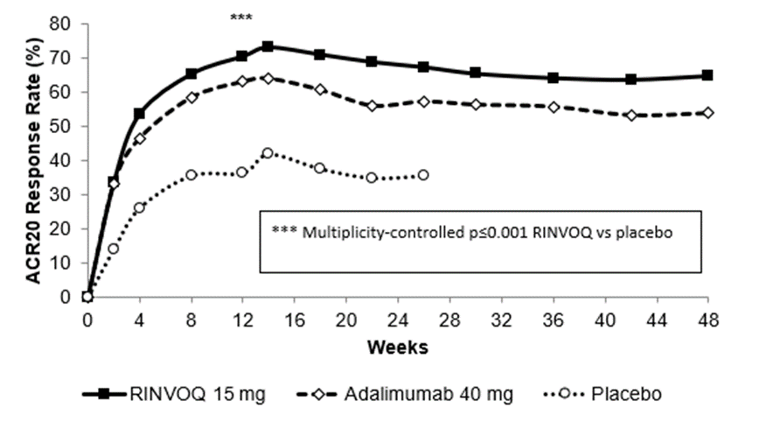

Remission and low disease activity
In the studies, a significantly higher proportion of patients treated with upadacitinib 15 mg achieved low disease activity (DAS28-CRP ≤3.2) and clinical remission (DAS28-CRP <2.6) compared to placebo, MTX, or adalimumab (Table 7). Overall, both low disease activity and clinical remission rates were consistent across patient populations, with or without MTX.

Table 7. Response and Remission
Study | SELECT  EARLY  MTX- Naïve |  | SELECT  MONO  MTX-IR |  | SELECT  NEXT  csDMARD-IR |  | SELECT  COMPARE  MTX-IR |  |  | SELECT  BEYOND  bDMARD-IR
 | MTX | UPA  15mg | MTX | UPA  15mg | PBO | UPA  15mg | PBO | UPA  15mg | ADA  40mg | PBO | UPA  15mg
N | 314 | 317 | 216 | 217 | 221 | 221 | 651 | 651 | 327 | 169 | 164
Week
ACR20 (% of patients)
12ª/14^{b} | 54 | 76^{g} | 41 | 68e | 36 | 64e | 36 | 71^{e,i} | 63 | 28 | 65e
24^{c}/26^{d} | 59 | 79^{g} |  |  |  |  | 36 | 67^{g,i} | 57
48 | 57 | 74^{g} |  |  |  |  |  | 65^{i} | 54
ACR50 (% of patients)
12ª/14^{b} | 28 | 52e | 15 | 42^{g} | 15 | 38^{g} | 15 | 45^{g,h,} | 29 | 12 | 34^{g}
24^{c}/26^{d} | 33 | 60^{g} |  |  |  |  | 21 | 54^{g,i} | 42
48 | 43 | 63^{g} |  |  |  |  |  | 49^{i} | 40
ACR70 (% of patients)
12ª/14^{b} | 14 | 32^{g} | 3 | 23^{g} | 6 | 21^{g} | 5 | 25^{g,i} | 13 | 7 | 12
24^{c}/26^{d} | 18 | 44^{g} |  |  |  |  | 10 | 35^{g,i} | 23
48 | 30 | 52^{g} |  |  |  |  |  | 36^{i} | 23
LDA DAS28-CRP ≤3.2 (% of patients)
12ª/14^{b} | 28 | 53^{f} | 19 | 45e | 17 | 48e | 14 | 45^{e,i} | 29 | 14 | 43e
24^{c}/26^{d} | 32 | 60^{g} |  |  |  |  | 18 | 55^{e,i} | 39
48 | 40 | 62^{g} |  |  |  |  |  | 50^{i} | 35
CR DAS28-CRP <2.6 (% of patients)
12ª/14^{b} | 14 | 36^{g} | 8 | 28e | 10 | 31e | 6 | 29^{e,i} | 18 | 9 | 29^{g}
24^{c}/26^{d} | 18 | 48^{f} |  |  |  |  | 9 | 41^{e,i} | 27
48 | 30 | 50^{g} |  |  |  |  |  | 38^{i} | 28
SDAI ≤3.3 (% of patients)
12ª/14^{b} | 6 | 16^{g} | 1 | 14^{g} | 3 | 10^{g} | 3 | 12^{g,i} | 7 | 5 | 9
24^{c}/26^{d} | 9 | 28^{g} |  |  |  |  | 5 | 24^{g,i} | 14
48 | 17 | 33^{g} |  |  |  |  |  | 25^{i} | 17
CDAI ≤2.8 (% of patients)
12ª/14^{b} | 6 | 16^{g} | 1 | 13^{g} | 3 | 9^{g} | 3 | 13^{g,i} | 8 | 5 | 8
24^{c}/26^{d} | 11 | 28^{g} |  |  |  |  | 6 | 23^{g,i} | 14
48 | 18 | 33^{g} |  |  |  |  |  | 25^{i} | 17
Abbreviations:
ACR20 (or 50 or 70) = American College of Rheumatology ≥20% (or ≥50% or ≥70%) improvement;
ADA = adalimumab;
bDMARD = biologic Disease-Modifying Anti-Rheumatic Drug
CDAI = Clinical Disease Activity Index
CR = Clinical Remission
CRP = c-Reactive Protein
DAS28 = Disease Activity Score 28 joints
IR = Inadequate Responder
LDA = Low Disease Activity
MTX = methotrexate
PBO = placebo
SDAI = Simple Disease Activity Index
UPA= upadacitinib
ª SELECT-NEXT, SELECT-EARLY, SELECT-COMPARE, SELECT-BEYOND
^{b} SELECT-MONOTHERAPY
^{c} SELECT-EARLY
^{d} SELECT-COMPARE
^{e} multiplicity-controlled p≤0.001upadacitinib vs placebo or MTX comparison
^{f} multiplicity-controlled p≤0.01 upadacitinib vs placebo or MTX comparison
^{g} nominal p≤0.05 upadacitinib vs placebo or MTX comparison
^{h} multiplicity-controlled p≤0.001 upadacitinib vs adalimumab comparison
^{i} nominal p≤0.05 upadacitinib vs adalimumab comparison

Radiographic Response
Inhibition of progression of structural joint damage was assessed using the modified Total Sharp Score (mTSS) and its components, the erosion score, and joint space narrowing score at Weeks 26 and 48 (SELECT-COMPARE) and Week 24 (SELECT-EARLY).
Treatment with RINVOQ 15 mg resulted in significantly greater inhibition of the progression of structural joint damage compared to placebo at Weeks 26 and 48 in SELECT-COMPARE and as monotherapy compared to MTX at Week 24 in SELECT-EARLY (Table 8). Analyses of erosion and joint space narrowing scores were consistent with the overall scores. The proportion of patients with no radiographic progression (mTSS change ≤ 0) was significantly higher with RINVOQ 15 mg compared to placebo at Weeks 26 and 48 (SELECT-COMPARE) and compared to MTX at Week 24 (SELECT-EARLY).

Table 8. Radiographic Changes
Study | SELECT EARLY  MTX-Naive |  |  | SELECT COMPARE  MTX-IR
Treatment Group | MTX |  | UPA  15 mg | PBO^{g} | UPA  15mg |  |  | ADA 40mg
Modified Total Sharps Score, mean change from baseline
Week 24ª/26^{b} | 0.7 | 0.1e |  | 0.9 |  | 0.2^{d} | 0.1
Week 48 |  |  |  | 1.7 |  | 0.3^{d} | 0.4
Erosion Score, mean change from baseline
Week 24ª/26^{b} | 0.3 | 0.1^{d} |  | 0.4 |  | 0^{d} | 0
Week 48 |  |  |  | 0.8 |  | 0.1^{d} | 0.2
Joint Space Narrowing Score, mean change from baseline
Week 24ª/26^{b} | 0.3 | 0.1^{f} |  | 0.6 |  | 0.2^{d} | 0.1
Week 48 |  |  |  | 0.8 |  | 0.2^{d} | 0.2
Proportion of patients with no radiographic progression^{c}
Week 24ª/26^{b} | 77.7 | 87.5e |  | 76.0 |  | 83.5e | 86.8
Week 48 |  |  |  | 74.1 |  | 86.4^{d} | 88.0
Abbreviations:
ADA = adalimumab
IR = Inadequate Responder
MTX = methotrexate
PBO = placebo
UPA= upadacitinib
ª SELECT-EARLY
^{b} SELECT-COMPARE
^{c} No progression defined as mTSS change ≤0.
^{d} p≤0.001 upadacitinib vs placebo or MTX comparison
^{e}p≤0.01 upadacitinib vs placebo or MTX comparison
^{f} p≤0.05 upadacitinib vs placebo or MTX comparison
^{g} All placebo data at Week 48 derived using linear extrapolation

Physical Function Response and Health-Related Outcomes
Treatment with upadacitinib 15 mg, alone or in combination with csDMARDs, resulted in a significantly greater improvement in physical function compared to all comparators as measured by HAQ-DI at Week 12/14 (Table 9 with RINVOQ being superior to adalimumab in a multiplicity-controlled comparison.

Table 9. Mean change from baseline in HAQ-DI ^{a,b}
Study | SELECT  EARLY  MTX-Naїve |  | SELECT  MONO  MTX-IR |  | SELECT  NEXT  csDMARD-IR |  | SELECT  COMPARE  MTX-IR |  |  | SELECT  BEYOND  BIO-IR
Treatment group | MTX | UPA  15mg | MTX | UPA  15mg | PBO | UPA  15mg | PBO | UPA  15mg | ADA  40mg | PBO | UPA  15mg
N | 313 | 317 | 216 | 216 | 220 | 216 | 648 | 644 | 324 | 165 | 163
Baseline score, mean | 1.6 | 1.6 | 1.5 | 1.5 | 1.4 | 1.5 | 1.6 | 1.6 | 1.6 | 1.6 | 1.7
Week 12^{c}/14^{d} | -0.5 | -0.8^{g} | -0.3 | -0.7^{g} | -0.3 | -0.6^{g} | -0.3 | -0.6^{g,i} | -0.5 | -0.2 | -0.4^{g}
Week 24e/26^{f} | -0.6 | -0.9^{h} |  |  |  |  | -0.3 | -0.7^{h,j} | -0.6
Abbreviations: ADA = adalimumab; HAQ-DI = Health Assessment Questionnaire Disability Index; IR = Inadequate Responder; MTX = methotrexate; PBO = placebo; UPA = upadacitinib
ª Data shown are mean
^{b} Health Assessment Questionnaire-Disability Index: 0=best, 3=worst; 20 questions; 8 categories: dressing and grooming, arising, eating, walking, hygiene, reach, grip, and activities.
^{c} SELECT-EARLY, SELECT-NEXT, SELECT-COMPARE, SELECT-BEYOND
^{d} SELECT-MONOTHERAPY
^{e} SELECT-EARLY
^{f} SELECT-COMPARE
^{g} multiplicity-controlled p≤0.001 upadacitinib vs placebo or MTX comparison
^{h} nominal p≤0.001 upadacitinib vs placebo or MTX comparison
^{i} multiplicity-controlled p≤0.01 upadacitinib vs adalimumab comparison
^{j} nominal p≤0.01 upadacitinib vs adalimumab comparison
In the studies SELECT-MONOTHERAPY, SELECT-NEXT, and SELECT-COMPARE, treatment with upadacitinib 15 mg resulted in a significantly greater improvement in the mean duration of morning joint stiffness compared to placebo or MTX at Week 12/14.
In the clinical studies, upadacitinib treated patients reported significant improvements in patient-reported quality of life, as measured by the Short Form (36) Health Survey (SF-36) Physical Component Score compared to placebo and MTX. Moreover, upadacitinib treated patients reported significant improvements in fatigue at Week 12, as measured by the Functional Assessment of Chronic Illness Therapy-Fatigue score (FACIT-F) compared to placebo.

Psoriatic Arthritis
The efficacy and safety of RINVOQ 15 mg once daily was assessed in two Phase 3 randomised, double-blind, multicentre, placebo-controlled studies in patients 18 years of age or older with moderately to severely active psoriatic arthritis (Table 10). All patients had active psoriatic arthritis for at least 6 months based upon the Classification Criteria for Psoriatic Arthritis (CASPAR), at least 3 tender joints and at least 3 swollen joints, and active plaque psoriasis or history of plaque psoriasis. In SELECT-PsA 1, 81.7% of participants were taking stable doses of at least one non-biological DMARD (predominantly methotrexate) at baseline. In SELECT-PsA 2, 46.2% of participants were taking stable doses of at least one non-biological DMARD at baseline. The studies include long-term extensions for up to 5 years (SELECT-PsA 1) and 3 years (SELECT-PsA 2).

Table 10. Clinical Trial Summary
Study Name | Population (n) | Treatment Arms | Key Outcome Measures
SELECT-PsA 1 | Non-biological DMARD-IRª  (1705) | • Upadacitinib 15 mg  • Upadacitinib 30 mg  • Placebo  • Adalimumab 40 mg | Primary Endpoint:  • ACR20 at Week 12
SELECT-PsA 1 | Non-biological DMARD-IRª  (1705) |  | Key Secondary Endpoints:  • MDA at Week 24  • Resolution of enthesitis (LEI=0) and dactylitis (LDI=0) at Week 24  • PASI75 at Week 16  • sIGA at Week 16  • SAPS at Week 16  • Radiographic progression (ΔmTSS) at Week 24  • Δ Physical Function (HAQ-DI) at Week 12  • SF-36 PCS at Week 12  • FACIT-F at Week 12  • ACR20, pain, and Δ Physical Function (HAQ-DI) vs adalimumab at Week 12
SELECT-PsA 2 | bDMARD-IR^{b}  (642) | • Upadacitinib 15 mg  • Upadacitinib 30 mg  • Placebo | Primary Endpoint:  • ACR20 at Week 12
SELECT-PsA 2 | bDMARD-IR^{b}  (642) | • Upadacitinib 15 mg  • Upadacitinib 30 mg  • Placebo | Key Secondary Endpoints:  •MDA at Week 24  •PASI75 at Week 16  •sIGA at Week 16  •SAPS at Week 16  •Δ Physical Function (HAQ-DI) at Week 12  •SF-36 PCS at Week 12  •FACIT-F at Week 12
Abbreviations:
ACR20 = American College of Rheumatology ≥20% improvement
bDMARD = biological Disease-Modifying Anti-Rheumatic Drug
FACIT-F = Functional Assessment of Chronic Illness Therapy-Fatigue score
HAQ-DI = Health Assessment Questionnaire-Disability Index
IR = Inadequate Responder
MDA = Minimal Disease Activity
mTSS = modified Total Sharp Score
PASI = Psoriasis Area and Severity Index
SAPS = Self-Assessment of Psoriasis Symptoms
SF-36 PCS = Short Form (36) Health Survey (SF-36) Physical Component Summary
sIGA = static Investigator Global Assessment of psoriasis
ª Patients who had an inadequate response or intolerance to at least one non-biological DMARD
^{b} Patients who had an inadequate response or intolerance to at least one bDMARD

Clinical Response
In both studies, a significantly greater proportion of patients treated with RINVOQ 15 mg achieved ACR20 response compared to placebo at Week 12 (Table 11, Figure 2). In SELECT PsA 1, RINVOQ 15 mg achieved non-inferiority compared to adalimumab in the proportion of patients achieving ACR20 response at Week 12. A higher proportion of patients treated with RINVOQ 15 mg achieved ACR50 and ACR70 responses at Week 12 compared to placebo. Time to onset of efficacy was rapid across measures with greater responses seen as early as Week 2 for ACR20.
Treatment with RINVOQ 15 mg resulted in improvements in individual ACR components, including tender/painful and swollen joint counts, patient and physician global assessments, HAQ-DI, pain assessment, and hsCRP compared to placebo (Table 12). Treatment with RINVOQ 15 mg resulted in greater improvement in pain compared to adalimumab at Week 24.
In both studies, consistent responses were observed alone or in combination with non-biological DMARDs for primary and key secondary endpoints.
The efficacy of RINVOQ 15 mg was demonstrated regardless of subgroups evaluated including baseline BMI, baseline hsCRP, number of prior non-biological DMARDs (≤ 1 or >1).
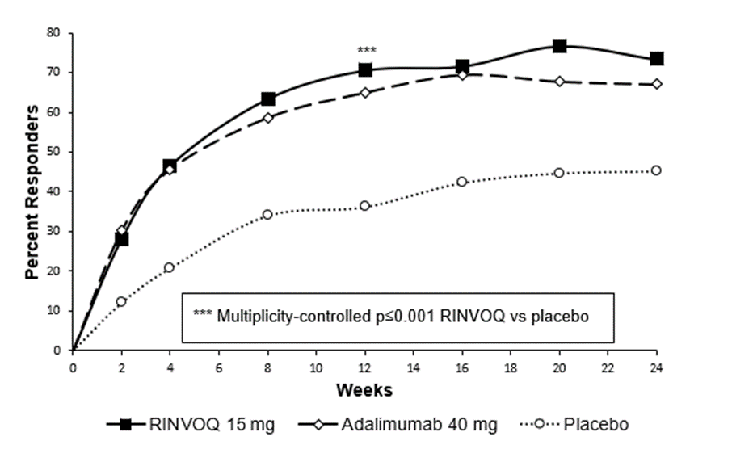
Figure 2. Percent of Patients Achieving ACR 20 in SELECT- PsA 1

Table 11. Clinical Response
Study | SELECT-PsA 1  non-biological DMARD-IR |  |  | SELECT-PsA 2  bDMARD-IR
Treatment Group | PBO | UPA  15 mg | ADA  40 mg | PBO | UPA  15 mg
N | 423 | 429 | 429 | 212 | 211
ACR20 (% of patients)
Week 12 | 36 | 71e | 65 | 24 | 57e
Week 24 | 45 | 73^{f,h} | 67 | 20 | 59^{f}
ACR50 (% of patients)
Week 12 | 13 | 38^{f} | 38 | 5 | 32^{f}
Week 24 | 19 | 52^{f,h} | 44 | 9 | 38^{f}
ACR70 (% of patients)
Week 12 | 2 | 16^{f} | 14 | 1 | 9^{f}
Week 24 | 5 | 29^{f,h} | 23 | 1 | 19^{f}
MDA (% of patients)
Week 12 | 6 | 25^{f} | 25 | 4 | 17^{f}
Week 24 | 12 | 37e | 33 | 3 | 25e
Resolution of enthesitis (LEI=0; % of patients)ª
Week 12 | 33 | 47^{f} | 47 | 20 | 39^{f}
Week 24 | 32 | 54e | 47 | 15 | 43^{f}
Resolution of dactylitis (LDI=0; % of patients)^{b}
Week 12 | 42 | 74^{f} | 72 | 36 | 64^{g}
Week 24 | 40 | 77^{f} | 74 | 28 | 58^{g}
PASI75 (% of patients)^{c}
Week 16 | 21 | 63e | 53 | 16 | 52e
Week 24 | 27 | 64^{f} | 59 | 19 | 54^{f}
PASI90 (% of patients)^{c}
Week 16 | 12 | 38^{f} | 39 | 8 | 35^{f}
Week 24 | 17 | 42^{f} | 45 | 7 | 36^{f}
PASI100 (% of patients)^{c}
Week 16 | 7 | 24^{f} | 20 | 6 | 25^{f}
Week 24 | 10 | 27^{f} | 28 | 5 | 22^{f}
sIGA 0/1 (% of patients)^{d}
Week 16 | 11 | 42e | 39 | 9 | 37e
Week 24 | 12 | 45^{f} | 41 | 10 | 33^{f}
Abbreviations:
ACR20 (or 50 or 70) = American College of Rheumatology ≥20% (or ≥50% or ≥70%) improvement
ADA = adalimumab
bDMARD = biological Disease-Modifying Anti-Rheumatic Drug
IR = Inadequate Responder
MDA = Minimal Disease Activity
PASI75 (or 90 or 100) = ≥75% (or ≥90% or 100%) improvement in Psoriasis Area and Severity Index
PBO = placebo
sIGA = static Physician Global Assessment
UPA= upadacitinib
Patients who discontinued randomized treatment or were missing data at week of evaluation were imputed as non-responders in the analyses. For MDA, resolution of enthesitis, and resolution of dactylitis at Week 24, the subjects rescued at Week 16 were imputed as non-responders in the analyses.

ª In patients with enthesitis at baseline (n=241, 270, and 265, respectively, for SELECT-PsA 1 and n=144 and 133, respectively, for SELECT-PsA 2)
^{b} In patients with dactylitis at baseline (n=126, 136, and 127, respectively, for SELECT-PsA 1 and n=64 and 55, respectively, for SELECT-PsA 2)
^{c} In patients with ≥ 3% BSA psoriasis at baseline (n=211, 214, and 211, respectively, for SELECT-PsA 1 and n=131 and 130, respectively, for SELECT-PsA 2)
^{d} In patients with sIGA ≥ 2 at baseline (n=313, 322, and 330, respectively, for SELECT-PsA 1 and n=163 and 171, respectively, for SELECT-PsA 2)
^{e} multiplicity-controlled p≤0.001 upadacitinib vs placebo comparison
^{f} nominal p≤0.001 upadacitinib vs placebo comparison
^{g} nominal p≤0.01 upadacitinib vs placebo comparison
^{h} nominal p<0.05 upadacitinib vs adalimumab comparison

Table 12. Components of ACR Response (mean change from baseline)
Study | SELECT-PsA 1  non-biological DMARD-IR |  |  | SELECT-PsA 2  bDMARD-IR
Treatment Group | PBO | UPA  15 mg | ADA  40 mg | PBO | UPA  15 mg
N | 423 | 429 | 429 | 212 | 211
Number of tender/painful joints (0-68)
Week 12 | -7.1 | -11.3 | -10.3 | -6.2 | -12.4
Week 24 | -9.2 | -13.7 | -12.5 | -6.6 | -14.0
Number of swollen joints (0-66)
Week 12 | -5.3 | -7.9 | -7.6 | -4.8 | -7.1
Week 24 | -6.3 | -9.0 | -8.6 | -5.6 | -8.3
Patient assessment of painª
Week 12 | -0.9 | -2.3 | -2.3 | -0.5 | -1.9
Week 24 | -1.4 | -3.0 | -2.6 | -0.7 | -2.2
Patient global assessmentª
Week 12 | -1.2 | -2.7 | -2.6 | -0.6 | -2.3
Week 24 | -1.6 | -3.4 | -2.9 | -0.8 | -2.6
Disability index (HAQ-DI)^{b}
Week 12 | -0.14 | -0.42 | -0.34 | -0.10 | -0.30
Week 24 | -0.19 | -0.51 | -0.39 | -0.08 | -0.33
Physician global assessmentª
Week 12 | -2.1 | -3.6 | -3.4 | -1.4 | -3.1
Week 24 | -2.8 | -4.3 | -4.1 | -1.8 | -3.8
hsCRP (mg/L)
Week 12 | -1.3 | -7.1 | -7.6 | 0.3 | -6.6
Week 24 | -2.1 | -7.6 | -7.3 | -0.9 | -6.3
Abbreviations:
ACR = American College of Rheumatology
ADA = adalimumab
hsCRP = high sensitivity C-Reactive Protein
HAQ-DI = Health Assessment Questionnaire-Disability Index
IR = Inadequate Responder
PBO = placebo
UPA = upadacitinib
ª Numeric rating scale (NRS): 0 = best, 10 = worst
^{b} Health Assessment Questionnaire-Disability Index: 0=best, 3=worst; 20 questions; 8 categories: dressing and grooming, arising, eating, walking, hygiene, reach, grip, and activities.

In both studies, response rates for ACR20/50/70, MDA, PASI75/90/100, sIGA, enthesitis resolution, and dactylitis resolution in patients treated with RINVOQ 15 mg were maintained through Week 56.

Radiographic Response
In SELECT-PsA 1, inhibition of progression of structural damage was assessed radiographically and expressed as the change from baseline in modified Total Sharp Score (mTSS) and its components, the erosion score and the joint space narrowing score, at Week 24.
Treatment with RINVOQ 15 mg resulted in significantly greater inhibition of the progression of structural joint damage compared to placebo at Week 24 (Table 13). Statistically significant results were also achieved for both erosion and joint space narrowing scores. The proportion of patients with no radiographic progression (mTSS change ≤ 0.5) was higher with RINVOQ 15 mg compared to placebo at Week 24.

Table 13. Radiographic Changes in SELECT-PsA 1
Treatment Group | PBO | UPA  15 mg | ADA  40 mg
Modified Total Sharp Score, mean change from baseline
Week 24 | 0.25 | -0.04^{b} | 0.01
Erosion Score, mean change from baseline
Week 24 | 0.12 | -0.03^{c} | 0.01
Joint Space Narrowing Score, mean change from baseline
Week 24 | 0.10 | -0.00^{d} | -0.02
Proportion of patients with no radiographic progressionª
Week 24 | 92 | 96^{d} | 95
Abbreviations:
ADA = adalimumab; PBO = placebo; UPA= upadacitinib
ª No progression defined as mTSS change ≤0.5
^{b} multiplicity-controlled p≤0.001 upadacitinib vs placebo comparison
^{c} nominal p≤0.001 upadacitinib vs placebo comparison
^{d} nominal p<0.05 upadacitinib vs placebo comparison

Physical Function Response and Health-Related Outcomes
In both studies, patients treated with RINVOQ 15 mg showed significant improvement in physical function from baseline compared to placebo as assessed by HAQ-DI at Week 12 (Table 14), which was maintained through Week 56.
The proportion of HAQ-DI responders (≥ 0.35 improvement from baseline in HAQ-DI score) at Week 12 in SELECT-PsA 1 and SELECT-PsA 2 was 58% and 45%, respectively, in patients receiving RINVOQ 15 mg, 33% and 27%, respectively, in patients receiving placebo, and 47% in patients receiving adalimumab (SELECT-PsA 1).
Health-related quality of life was assessed by SF-36. In both studies, patients receiving RINVOQ 15 mg experienced significantly greater improvement from baseline in the Physical Component Summary score compared to placebo at Week 12. Greater improvement was also observed compared to adalimumab. Greater improvement was observed in the Mental Component Summary score and all 8 domains of SF-36 (Physical Functioning, Bodily Pain, Vitality, Social Functioning, Role Physical, General Health, Role Emotional, and Mental Health) compared to placebo. Improvements from baseline were maintained through Week 56 in both studies.
Patients receiving RINVOQ 15 mg experienced significantly greater improvement from baseline in fatigue, as measured by FACIT-F score, at Week 12 compared to placebo in both studies. Improvements from baseline were maintained through Week 56 in both studies.
Greater improvement in patient-reported psoriasis symptoms, as measured by the Self-Assessment of Psoriasis Symptoms (SAPS), was observed in both studies at Week 16 in patients treated with RINVOQ 15 mg compared to placebo and adalimumab. Improvements from baseline were maintained through Week 56 in both studies.
Among patients with psoriatic spondylitis, in both studies patients treated with RINVOQ 15 mg showed improvements from baseline in Bath Ankylosing Spondylitis Disease Activity Index (BASDAI) and Ankylosing Spondylitis Disease Activity Score (ASDAS) compared to placebo at Week 24. Greater improvements were also observed compared to adalimumab. Improvements from baseline were maintained through Week 56 in both studies.

Ankylosing Spondylitis
The efficacy and safety of RINVOQ 15 mg once daily were assessed in a randomised, double-blind, multicentre, placebo-controlled study in patients 18 years of age or older with active ankylosing spondylitis based upon the Bath Ankylosing Spondylitis Disease Activity Index (BASDAI) ≥4 and Patient’s Assessment of Total Back Pain score ≥4 (Table 14). In SELECT-AXIS 1, 16% of participants were taking stable doses of cDMARD at baseline. The study included a long-term extension for up to 2 years.

Table 14. Clinical Trial Summary
Study  Name | Population  (n) | Treatment Arms | Key Outcome Measures
SELECT-  AXIS 1 | NSAID-IR^{a,b} bDMARD-naïve  (187) | - Upadacitinib 15 mg  - Placebo | Primary Endpoint:  - ASAS40 at Week 14
SELECT-  AXIS 1 | NSAID-IR^{a,b} bDMARD-naïve  (187) | - Upadacitinib 15 mg  - Placebo | Key Secondary Endpoints at Week 14:  - ASAS Partial Remission  - BASDAI 50  - ASDAS-CRP  - BASFI  - SPARCC MRI score (spine)
Abbreviations:
ASAS40 = Assessment of SpondyloArthritis international Society ≥40% improvement
ASDAS-CRP = Ankylosing Spondylitis Disease Activity Score C-Reactive Protein
BASDAI = Bath Ankylosing Spondylitis Disease Activity Index
BASFI = Bath Ankylosing Spondylitis Functional Index
bDMARD = biological Disease-Modifying Anti-Rheumatic Drug
IR = Inadequate Responder
NSAID = Nonsteroidal Anti-inflammatory Drug
SPARCC MRI = Spondyloarthritis Research Consortium of Canada Magnetic Resonance Imaging
ªPatients who had an inadequate response to at least two NSAIDs or had intolerance to or contraindication for NSAIDs
^{b}At baseline, approximately 16% of the patients were on a concomitant csDMARD.

Clinical Response
In SELECT-AXIS 1, a significantly greater proportion of patients treated with RINVOQ 15 mg achieved an ASAS40 response compared to placebo at Week 14 (Table 15, Figure 3). Time to onset of efficacy was rapid across measures with greater responses seen as early as Week 2 for ASAS40 which was maintained through Week 64.
Treatment with RINVOQ 15 mg resulted in improvements in individual ASAS components, including patient global assessment of disease activity, total back pain assessment, inflammation, and function compared to placebo (Table 16).
The efficacy of RINVOQ 15 mg was demonstrated regardless of subgroups evaluated including gender, baseline BMI, symptom duration of AS, and baseline hsCRP.
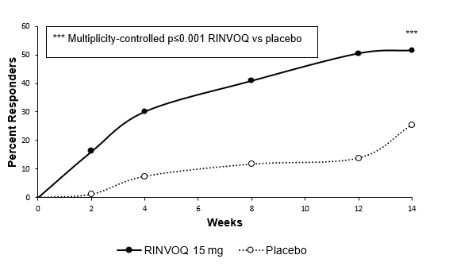
Figure 3. Percent of Patients Achieving ASAS40

Table 15. Clinical Response in SELECT-AXIS 1
Treatment Group | PBO | UPA 15 mg
N | 94 | 93
ASAS40 (% of patients)
Week 14 | 25.5 | 51.6ª
Week 52 |  | 80.2
ASAS20 (% of patients)
Week 14 | 40.4 | 64.5^{c}
Week 52 |  | 87.7
ASAS Partial Remission (% of patients)
Week 14 | 1.1 | 19.4ª
Week 52 |  | 50.0
BASDAI 50 (% of patients)
Week 14 | 23.4 | 45.2^{b}
Week 52 |  | 77.8
Change from baseline in ASDAS-CRP
Week 14 | -0.54 | -1.45ª
Week 52 |  | -2.05
ASDAS Inactive Disease (% of patients)
Week 14 | 0 | 16.1^{c}
Week 52 |  | 46.2
ASDAS Low Disease Activity (% of patients)^{d}
Week 14 | 10.6 | 49.5^{c}
Week 52 |  | 85.9
ASDAS Major Improvement (% of patients)
Week 14 | 5.3 | 32.3^{c}
Week 52 |  | 55.8
Abbreviations:
ASAS20 (or 40) = Assessment of SpondyloArthritis international Society ≥20% (or ≥40%) improvement
ASDAS-CRP = Ankylosing Spondylitis Disease Activity Score C-Reactive Protein
BASDAI = Bath Ankylosing Spondylitis Disease Activity Index
PBO = placebo
UPA= upadacitinib
ª multiplicity-controlled p≤0.001 upadacitinib vs placebo comparison
^{b} multiplicity-controlled p≤0.01 upadacitinib vs placebo comparison
^{c} nominal p≤0.001 upadacitinib vs placebo comparison
^{d} post-hoc analysis
For binary endpoints, Week 14 results are based on non-responder imputation analysis. For continuous endpoints, Week 14 results are based on the least squares mean change from baseline using mixed models for repeated measure analysis. For binary and continuous endpoints, Week 52 results are based on as-observed data.

Table 16. Components of ASAS Response (mean change from baseline)
Treatment Group | PBO | UPA 15 mg
N | 94 | 93
Patient Global Assessment of Disease Activityª
Week 14 | -1.31 | -2.96
Week 52 |  | -4.54
Total Back Painª
Week 14 | -1.68 | -3.21
Week 52 |  | -4.75
BASFI^{b}
Week 14 | -1.30 | -2.29
Week 52 |  | -3.71
Inflammation^{c} (0-10)
Week 14 | -1.90 | -3.15
Week 52 |  | -4.80
Abbreviations:
ASAS = Assessment of SpondyloArthritis international Society
BASFI = Bath Ankylosing Spondylitis Functional Index
PBO = placebo
UPA= upadacitinib
Week 14 results are based on the least squares mean change from baseline using mixed models for repeated measures analysis; Week 52 results are based on as-observed data.
ª Numeric rating scale (NRS): 0 = best, 10 = worst
^{b} BASFI: 0 = best, 10 = worst
^{c} mean of BASDAI questions 5 and 6 assessing morning stiffness severity and duration: 0 = best, 10 = worst

Physical Function and Health-Related Outcomes
Patients treated with RINVOQ 15 mg showed significant improvement in physical function from baseline compared to placebo as assessed by the BASFI at Week 14 (Table 16). These improvements were maintained through Week 64.
Patients treated with RINVOQ 15 mg showed greater improvement in back pain as assessed by the Total Back Pain component of ASAS response compared to placebo at Week 14. Improvement in the overall level of neck, back, or hip pain was demonstrated using BASDAI Question 2. Improvements were also demonstrated for peripheral pain and swelling (assessed by BASDAI question 3 on overall pain in joints other than in the neck, back, or hips) and nocturnal back pain. Improvements in total and nocturnal back pain were observed as early as Week 2. Pain improvements were maintained through Week 64.

Objective Measures of Inflammation
Signs of inflammation were assessed by MRI and expressed as change from baseline in the SPARCC score for spine and sacroiliac joints. At Week 14, significant improvement of inflammatory signs in the spine was observed in patients treated with RINVOQ 15 mg compared to placebo. Additionally, patients treated with RINVOQ 15 mg demonstrated greater improvement of inflammatory signs in sacroiliac joints compared to placebo.
At Week 14, patients treated with RINVOQ 15 mg demonstrated greater improvement of inflammatory signs as measured by hsCRP compared to placebo. Decrease in hsCRP was maintained through Week 64.

Atopic Dermatitis
The efficacy and safety of RINVOQ 15 mg and 30 mg once daily was assessed in three Phase 3 randomised, double-blind, multicentre studies (MEASURE UP 1, MEASURE UP 2 and AD UP) in a total of 2584 patients (12 years of age and older) (Table 17). RINVOQ was evaluated in 344 adolescent and 2240 adult patients with moderate to severe atopic dermatitis, not adequately controlled by topical medication(s). At baseline, patients had to have all the following: an Investigator's Global Assessment (vIGA-AD) score ≥3 in the overall assessment of atopic dermatitis (erythema, induration/papulation, and oozing/crusting) on an increasing severity scale of 0 to 4, an Eczema Area and Severity Index (EASI) score ≥16 (composite score assessing extent and severity of erythema, edema/papulation, scratches and lichenification across 4 different body sites), a minimum body surface area (BSA) involvement of ≥10%, and weekly average Worst Pruritus Numerical Rating Scale (NRS) ≥4.
In all three studies, patients received RINVOQ once daily doses of 15 mg, 30 mg or matching placebo for 16 weeks. In the AD UP study, patients also received concomitant topical corticosteroids (TCS).
Following completion of the double-blinded period, patients originally randomised to RINVOQ were to continue receiving the same dose until week 136. Patients in the placebo group were re-randomised in a 1:1 ratio to receive RINVOQ 15 mg or 30 mg until Week 136.

Table 17. Clinical Trial Summary
Study  Name | Treatment  Arms | Key Outcome  Measures
MEASURE UP 1 and MEASURE UP 2 | - Upadacitinib 15 mg  - Upadacitinib 30 mg  - Placebo | Co-Primary Endpoints at Week 16:  - EASI 75  - vIGA-AD 0/1
MEASURE UP 1 and MEASURE UP 2 | - Upadacitinib 15 mg  - Upadacitinib 30 mg  - Placebo | Key Secondary Endpoints (at Week 16 except where noted)  - EASI 90/100  - EASI 75 at Week 2  - % change in EASI  - % change in SCORAD  - Worst Pruritus NRS improvement ≥ 4 at Week 1 and 16  - Worst Pruritus NRS improvement ≥ 4 at Day 2 (30mg), Day 3 (15mg)  - % change in Worst Pruritus NRS  - EASI increase ≥ 6.6 points (flare) during double-blind period  - ADerm-SS TSS-7 improvement ≥ 28  - ADerm-SS Skin Pain improvement ≥ 4  - ADerm-IS Sleep improvement ≥ 12  - ADerm-IS Emotional State improvement ≥ 11  - ADerm-IS Daily Activities improvement ≥ 14  - POEM improvement ≥ 4  - HADS-A < 8 and HADS-D < 8  - DLQI 0/1  - DLQI improvement ≥ 4
AD UP | - Upadacitinib 15 mg  - Upadacitinib 30 mg  - Placebo | Co-Primary Endpoints at Week 16:  - EASI 75  - vIGA-AD 0/1
AD UP | - Upadacitinib 15 mg  - Upadacitinib 30 mg  - Placebo | Key Secondary Endpoints (at Week 16 except where noted)  - EASI 75 at Week 2 and 4  - EASI 90 at Week 4 and 16  - EASI 100 (30mg)  - % change in EASI  - Worst Pruritus NRS improvement ≥ 4 at Week 1, 4 and 16  - % change in Worst Pruritus NRS
Abbreviations:
SCORAD = SCORing Atopic Dermatitis
POEM = Patient Oriented Eczema Measure
DLQI = Dermatology Life Quality Index
HADS = Hospital Anxiety and Depression Scale
ADerm-SS = Atopic Dermatitis Symptom Scale
ADerm-IS = Atopic Dermatitis Impact Scale

Clinical Response
Monotherapy Studies (MEASURE UP 1 AND MEASURE UP 2)
In the MEASURE UP studies, a significantly greater proportion of patients treated with RINVOQ 15 mg or 30 mg achieved vIGA-AD 0 or 1 response and achieved EASI 75 compared to placebo at Week 16 (Table 18). A rapid improvement in skin clearance (defined as EASI 75 by Week 2) was achieved for both doses compared to placebo (p < 0.001).
A significantly greater proportion of patients treated with RINVOQ 15 mg or 30 mg achieved clinically meaningful improvement in itch (defined as a ≥ 4-point reduction in the Worst Pruritus NRS) compared to placebo at Week 16. Rapid improvement in itch (defined as a ≥ 4-point reduction in Worst Pruritus NRS by Week 1) was achieved for both doses compared to placebo (p < 0.001), with differences observed as early as 1 day after initiating RINVOQ 30 mg (Day 2, p < 0.001) and 2 days after initiating RINVOQ 15 mg (Day 3, p < 0.001).
A significantly smaller proportion of patients treated with RINVOQ 15 mg or 30 mg had a disease flare, defined as a clinically meaningful worsening of disease (increase in EASI by ≥ 6.6), during the initial 16 weeks of treatment compared to placebo (p < 0.001).
Figure 4 and Figure 5 show the proportion of patients achieving an EASI 75 response and the proportion of patients with ≥4-point improvement in the Worst Pruritus NRS, respectively up to Week 16.

Table 18. Efficacy results of RINVOQ monotherapy studies at Week 16
Study | MEASURE UP 1 |  |  | MEASURE UP 2
Treatment Group | PBO | UPA  15 mg | UPA  30 mg | PBO | UPA  15 mg | UPA  30 mg
Number of subjects  randomised | 281 | 281 | 285 | 278 | 276 | 282
% responders
vIGA-AD 0/1^{a,b} | 8.4 | 48.1^{f} | 62.0^{f} | 4.7 | 38.8^{f} | 52.0^{f}
EASI 75ª | 16.3 | 69.6^{f} | 79.7^{f} | 13.3 | 60.1^{f} | 72.9^{f}
EASI 90ª | 8.1 | 53.1^{f} | 65.8^{f} | 5.4 | 42.4^{f} | 58.5^{f}
EASI 100ª | 1.8 | 16.7^{f} | 27.0^{f} | 0.7 | 14.1^{f} | 18.8^{f}
Worst Pruritus NRS^{c}  (≥ 4-point improvement) | 11.8  N=272 | 52.2^{f} N=274 | 60.0^{f} N=280 | 9.1  N=274 | 41.9^{f}  N=270 | 59.6^{f}  N=280
Worst Pruritus NRS 0 or 1^{d} | 5.5  N=275 | 36.6^{g}  N=279 | 47.5^{g} N=282 | 4.3  N=277 | 26.9^{g}  N=275 | 44.1^{g}  N=281
Mean percent change (SE)^{e}
EASI | -40.7 (2.28) | -80.2^{f} (1.91) | -87.7^{f} (1.87) | -34.5 (2.59) | -74.1^{f}  (2.20) | -84.7^{f}  (2.18)
SCORAD | -32.7 (2.33) | -65.7^{f} (1.78) | -73.1^{f} (1.73) | -28.4 (2.50) | -57.9^{f}  (2.01) | -68.4^{f}  (2.04)
Worst Pruritus NRS | -26.1 (5.41) | -62.8^{f} (4.49) | -72.0^{f} (4.41) | -17.0 (2.73) | -51.2^{f}  (2.34) | -66.5^{f}  (2.31)
Abbreviations:
UPA= upadacitinib (RINVOQ); PBO = placebo
ª Based on number of subjects randomised
^{b} Responder was defined as a patient with vIGA-AD 0 or 1 (“clear” or “almost clear”) with a reduction of ≥ 2 points on a 0-4 ordinal scale
^{c} N = number of patients whose baseline Worst Pruritus NRS is ≥ 4
^{d} N = number of patients whose baseline Worst Pruritus NRS is > 1
^{e} % change = least squares mean percent change relative to baseline
^{f} multiplicity-controlled p < 0.001 upadacitinib vs placebo comparison
^{g} nominal p<0.001 upadacitinib vs placebo comparison

Figure 4. Proportion of patients achieving an EASI 75 response in monotherapy studies
MEASURE UP 1
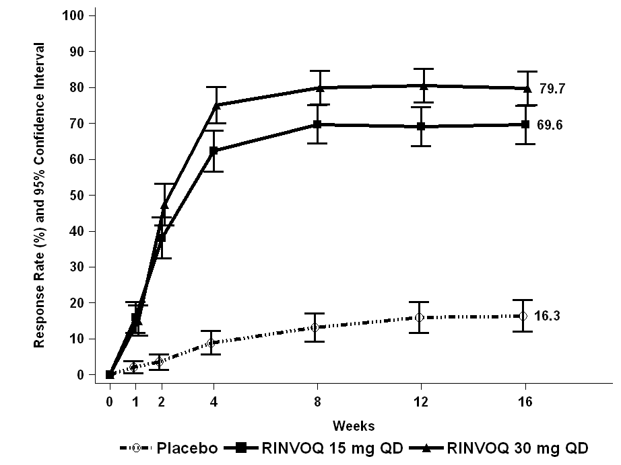

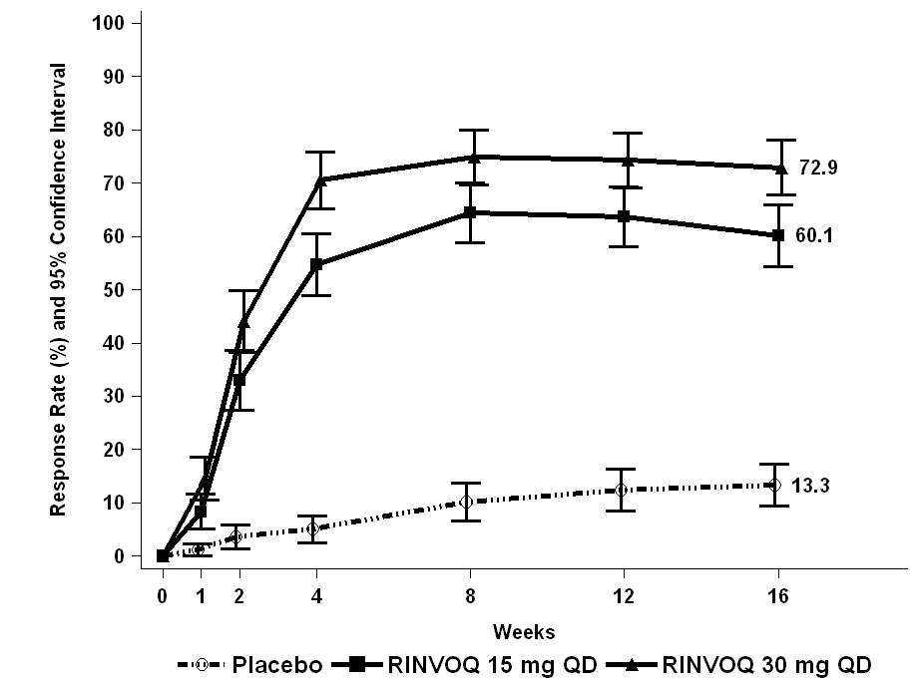
MEASURE UP 2

Figure 5: Proportion of patients with ≥4-point improvement in the Worst Pruritus NRS in monotherapy studies
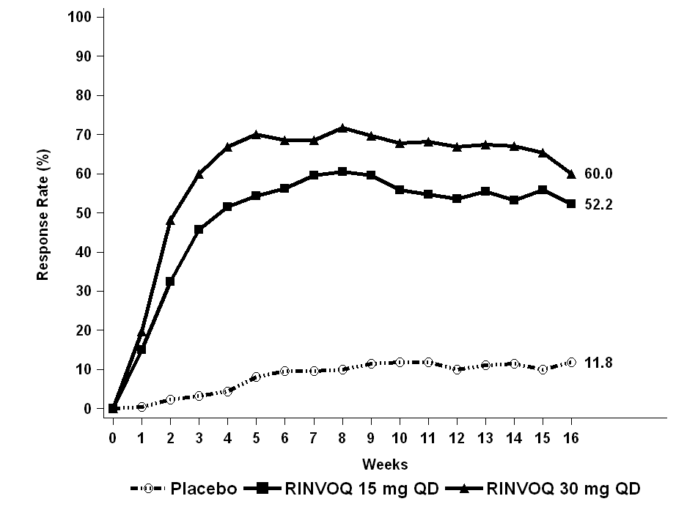
MEASURE UP 1

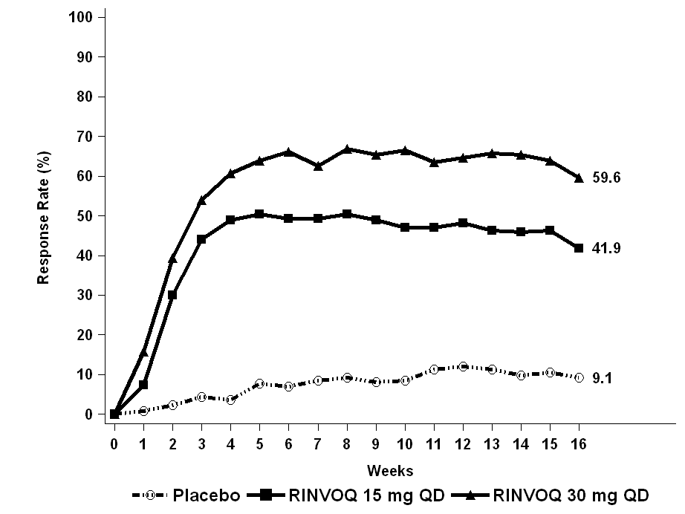
MEASURE UP 2

In both studies, results at Week 16 continued to be observed through Week 52 in patients treated with RINVOQ 15 mg or 30 mg.
Treatment effects in subgroups (weight, age, gender, race, and prior systemic treatment with immunosuppressants) in both studies were consistent with the results in the overall study population.
Concomitant TCS Study (AD UP)
In AD UP, a significantly greater proportion of patients treated with RINVOQ 15 mg + TCS or 30 mg + TCS achieved vIGA-AD 0 or 1 response and achieved EASI 75 compared to placebo + TCS at Week 16 (Table 19). A rapid improvement in skin clearance (defined as EASI 75 by Week 2) was achieved for both doses compared to placebo + TCS (p < 0.001). In addition, a higher EASI 90 response rate was achieved at Week 4 for both doses compared to placebo + TCS (p < 0.001).
A significantly greater proportion of patients treated with RINVOQ 15 mg + TCS or 30 mg + TCS achieved a clinically meaningful improvement in itch (defined as a ≥ 4-point reduction in the Worst Pruritus NRS) compared to placebo + TCS at Week 16. A rapid improvement in itch (defined as a ≥ 4-point reduction in Worst Pruritus NRS by Week 1) was achieved for both doses compared to placebo + TCS (p < 0.001).
Figure 6 and Figure 7 show the proportion of patients achieving an EASI 75 response and the proportion of patients with ≥4-point improvement in Worst Pruritus NRS, respectively up to Week 16.

Table 19. Efficacy results of RINVOQ + concomitant TCS at Week 16
Treatment Group | Placebo + TCS | UPA 15 mg + TCS | UPA 30 mg + TCS
Number of subjects  randomised | 304 | 300 | 297
% responders
vIGA-AD 0/1^{a,b} | 10.9 | 39.6^{f} | 58.6^{f}
EASI 75ª | 26.4 | 64.6^{f} | 77.1^{f}
EASI 90ª | 13.2 | 42.8^{f} | 63.1^{f}
EASI 100ª | 1.3 | 12.0 ^{g} | 22.6^{f}
Worst Pruritus NRS^{c}  (≥ 4-point improvement) | 15.0  N=294 | 51.7^{f}  N=288 | 63.9^{f}  N=291
Worst Pruritus NRS 0 or 1^{d} | 7.3  N=300 | 33.1^{g}  N=296 | 43.0^{g}  N=293
Mean percent change (SE)^{e}
EASI | -45.9 (2.16) | -78.0^{f} (1.98) | -87.3^{f} (1.98)
SCORAD | -33.6 (1.90) | -61.2^{g} (1.70) | -71.0^{g} (1.71)
Worst Pruritus NRS | -25.1 (3.35) | -58.1^{f} (3.11) | -66.9^{f} (3.12)
Abbreviations: UPA= upadacitinib (RINVOQ); PBO = placebo
ª Based on number of subjects randomised
^{b} Responder was defined as a patient with vIGA-AD 0 or 1 (“clear” or “almost clear”) with a reduction of ≥ 2 points on a 0-4 ordinal scale
^{c} N = number of patients whose baseline Worst Pruritus NRS is ≥ 4
^{d} N = number of patients whose baseline Worst Pruritus NRS is > 1
^{e} % change = least squares mean percent change relative to baseline
^{f} multiplicity-controlled p < 0.001 upadacitinib + TCS vs placebo + TCS comparison
^{g} nominal p <0.001 upadacitinib + TCS vs placebo + TCS comparison

Figure 6. Proportion of patients achieving an EASI 75 response AD UP Study
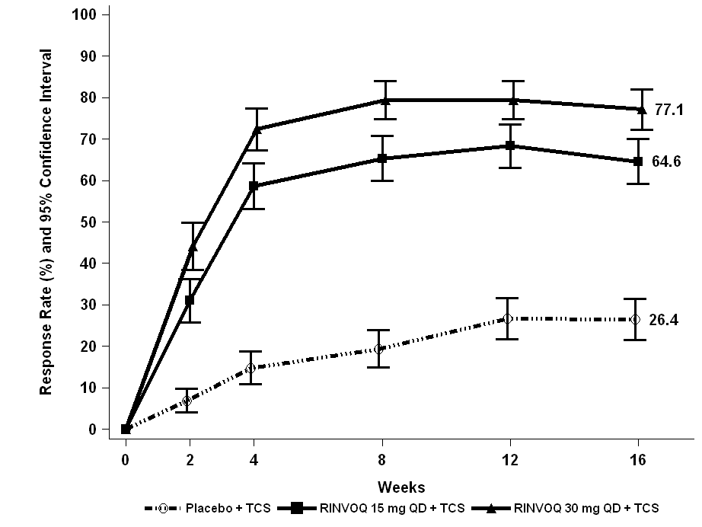

Figure 7. Proportion of patients with ≥4-point improvement in the Worst Pruritus NRS in AD UP Study
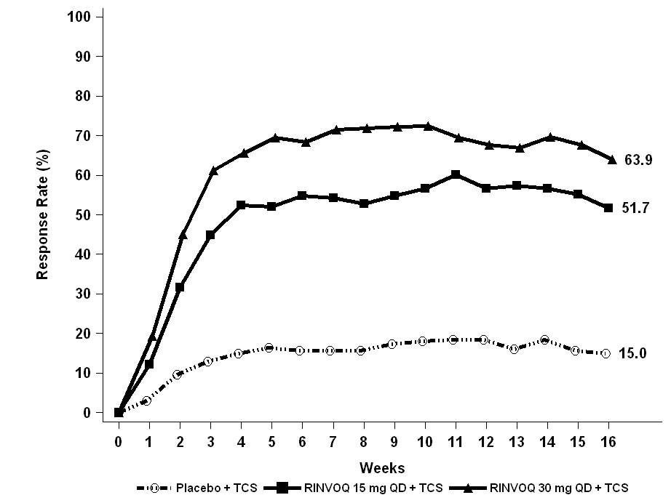

Treatment effects in subgroups (weight, age, gender, race, and prior systemic treatment with immunosuppressants) in AD UP were consistent with the results in the overall study population.
Subjects treated with either RINVOQ 15 mg or 30 mg had significantly more days free of TCS use with a concurrent EASI 75 response (mean = 33.5 and 47.5 days, respectively) over the 16-week period, compared to placebo group (mean = 7.9 days).
Results at Week 16 continued to be observed through Week 52 in patients treated with RINVOQ 15 mg or 30 mg.
Quality of Life/Patient Reported Outcomes
In the MEASURE UP studies, a significantly greater proportion of patients treated with RINVOQ 15 mg or 30 mg reported clinically meaningful reductions in the symptoms of AD atopic dermatitis and the impact of atopic dermatitis on health-related quality of life compared to placebo at Week 16 (Table 20). A significantly greater proportion of patients treated with RINVOQ achieved clinically meaningful reductions in atopic dermatitis symptom severity as measured by ADerm-SS TSS-7 and ADerm-SS Skin Pain compared to placebo at Week 16. A greater proportion of patients treated with RINVOQ achieved clinically meaningful reductions in the patient-reported effects of atopic dermatitis on sleep, daily activities and emotional state as measured by the ADerm-IS domain scores compared to placebo at Week 16. Similarly, compared to placebo at Week 16, a greater proportion of patients treated with RINVOQ achieved clinically meaningful improvements in atopic dermatitis symptom frequency and health-related quality of life as measured by the POEM and DLQI.
Anxiety and depression symptoms as measured by the HADS score were significantly reduced; in patients with baseline HADS-anxiety or HADS-depression subscale scores ≥ 8 (the cut-off value for anxiety or depression), a greater proportion of patients in the RINVOQ 15 mg or 30 mg groups achieved HADS-anxiety and HADS-depression scores < 8 at Week 16 compared to placebo (Table 20).

Table 20. Patient-reported outcomes results of RINVOQ monotherapy studies at Week 16
Study | MEASURE UP 1 |  |  | MEASURE UP 2
Treatment group | PBO | UPA  15 mg | UPA  30 mg | PBO | UPA  15 mg | UPA  30 mg
Number of subjects  randomised | 281 | 281 | 285 | 278 | 276 | 282
% responders
ADerm-SS TSS-7  (≥ 28-point improvement) ^{a,b} | 15.0  N=226 | 53.6 ^{h} N=233 | 67.9 ^{h} N=246 | 12.7  N=244 | 53.0^{h}  N=230 | 66.2^{h}  N=234
ADerm-SS Skin Pain  (≥ 4-point improvement)ª | 15.0 N=233 | 53.6 ^{h} N=237 | 63.5^{h}  N=249 | 13.4  N=247 | 49.4^{h} N=237 | 65.1^{h}  N=238
ADerm-IS Sleep  (≥ 12-point improvement) ^{a,c} | 13.2 N=220 | 55.0^{h} N=218 | 66.1 ^{h} N=218 | 12.4 N=233 | 50.2^{h}  N=219 | 62.3^{h}  N=228
ADerm-IS Daily Activities  (≥ 14-point improvement) ^{a,d} | 20.3 N=197 | 65.0 ^{h} N=203 | 73.2 ^{h} N=205 | 18.9 N=227 | 57.0^{h}  N=207 | 69.5^{h}  N=223
ADerm-IS Emotional State  (≥ 11-point improvement) ^{a,e} | 19.8 N=212 | 62.6 ^{h} N=227 | 72.6 ^{h} N=226 | 16.7 N=234 | 57.0^{h}  N=228 | 71.5^{h}  N=228
DLQI  (DLQI 0/1)^{f} | 4.4 N=252 | 30.3^{h} N=258 | 41.5^{h}  N=261 | 4.7  N=257 | 23.8^{h}  N=252 | 37.9^{h}  N=256
DLQI  (≥ 4-point improvement) ª | 29.0 N=250 | 75.4^{h} N=254 | 82.0^{h}  N=256 | 28.4 N=250 | 71.7^{h}  N=251 | 77.6^{h}  N=251
POEM  (≥ 4-point improvement) ª | 22.8 N=276 | 75.0^{h} N=278 | 81.4^{h}  N=280 | 28.7 N=268 | 70.9^{h}  N=268 | 83.5^{h}  N=269
HADS  (HADS-A < 8 and HADS-D < 8) ^{g} | 14.3 N=126 | 45.5^{h} N=145 | 49.2^{h}  N=144 | 11.4 N=140 | 46.0^{h}  N=137 | 56.1^{h}  N=146
Abbreviations: UPA= upadacitinib (RINVOQ); PBO = placebo
The threshold values specified correspond to the minimal clinically important difference (MCID) and was used to determine response.
ª N = number of patients whose baseline score is greater than or equal to the MCID.
^{b} ADerm-SS TSS-7 assesses itch while asleep, itch while awake, skin pain, skin cracking, pain caused by skin cracking, dry skin, and flaking due to AD.
^{c} ADerm-IS Sleep assesses difficulty falling asleep, sleep impact, and waking up at night due to AD.
^{d} ADerm-IS Daily Activities assesses AD’s effect on household activities, physical activities, social activities, and concentration.
^{e} ADerm-IS Emotional State assesses self-consciousness, embarrassment, and sadness due to AD.
^{f} N = number of patients whose baseline DLQI score is > 1.
^{g} N = number of patients whose baseline HADS-A or HADS-D is ≥ 8.
^{h} multiplicity-controlled p < 0.001 upadacitinib vs placebo comparison.

Adolescent Population
A total of 344 adolescents aged 12 to 17 years with moderate-to-severe atopic dermatitis were randomised across the three Phase 3 studies and received either 15 mg (N=114) or 30 mg (N=114) RINVOQ or matching placebo (N=116), in monotherapy or combination with topical corticosteroids. Efficacy was consistent between the adolescents and adults (Table 21). The adverse event profile in adolescents was generally similar to that in adults. Safety and efficacy of RINVOQ in adolescents weighing less than 40kg and in patients less than 12 years of age with atopic dermatitis have not been established.

Table 21. Efficacy results of RINVOQ for adolescents at Week 16
Study | MEASURE UP 1 |  | MEASURE UP 2 |  | AD UP
Treatment Group | PBO | UPA  15 mg | PBO | UPA  15 mg | PBO +  TCS | UPA  15 mg + TCS
Number of adolescents subjects  randomised | 40 | 42 | 36 | 33 | 40 | 39
% responders
vIGA-AD 0/1 ^{a,b} | 7.5 | 38.1 | 2.8 | 42.4 | 7.5 | 30.8
EASI 75ª | 8.3 | 71.4 | 13.9 | 66.7 | 30.0 | 56.4
Worst Pruritus NRS^{c}  (≥ 4-point improvement) | 15.4  N=39 | 45.0  N=40 | 2.8  N=36 | 33.3  N=30 | 13.2  N=38 | 41.7  N=36
Abbreviations: UPA= upadacitinib (RINVOQ); PBO = placebo
ª Based on number of subjects randomised
^{b} Responder was defined as a patient with vIGA-AD 0 or 1 (“clear” or “almost clear”) with a reduction of ≥ 2 points on a 0-4 ordinal scale
^{c} N = number of patients whose baseline Worst Pruritus NRS is ≥ 4

Phase 2b Dose-Ranging Monotherapy Study
RINVOQ 7.5 mg, 15 mg and 30 mg once daily were assessed in a Phase 2b randomised, placebo-controlled, double-blind, dose-ranging, multicenter study (M16-048) of adult patients with moderate to severe atopic dermatitis inadequately controlled by topical medication(s) (Table 22). Based on the results of this study, the 15 mg and 30 mg once daily doses were selected for further investigation in the Phase 3 program.
Table 22: Phase 2b Efficacy Results of RINVOQ at Week 16
Treatment Group | PBO | UPA  7.5 mg | UPA  15 mg | UPA  30 mg
Number of subjects randomised | 41 | 42 | 42 | 42
Mean percent change (SE)ª, EASI | -23.0 (6.42) | -39.4 (6.24) ^{c} | -61.7 (6.12) ^{e} | -74.4 (6.13) ^{e}
EASI75, % responders ^{b} | 9.8 | 28.6 ^{c} | 52.4 ^{e} | 69.0 e
Mean percent change (SE)ª, Pruritus NRS | -9.7 (8.30) | -39.6 (8.04) ^{d} | -48.0 (8.08) ^{e} | -68.9 (7.79) ^{e}
Abbreviations: UPA= upadacitinib (RINVOQ); PBO = placebo; SE= standard error
ª % change = least squares mean percent change relative to baseline
^{b} Based on number of subjects randomised
^{c} Nominal p =< 0.05 upadacitinib vs placebo comparison
^{d} Nominal p =< 0.01 upadacitinib vs placebo comparison
^{e} Nominal p<0.001 upadacitinib vs placebo comparison

Pharmacokinetic properties
Upadacitinib plasma exposures are proportional to dose over the therapeutic dose range. Steady-state plasma concentrations are achieved within 4 days with minimal accumulation after multiple once-daily administrations. The pharmacokinetic properties of RINVOQ are provided in Table 23.

Table 23. Pharmacokinetic Properties of RINVOQ
Absorption
T_{max} (h) | 2-4
Effect of high-fat meal (relative to fasting) | No clinically relevant effect  AUC: ↑ 29%, C_{max} ↑ 39%
Distribution
% Bound to human plasma proteins | 59
Blood-to-plasma ratio | 1.0
Metabolism
Metabolism | CYP3A4, CYP2D6 (minor)  No active metabolites
Elimination
Terminal phase elimination t_{1/2} (h) | 9-14
% of dose excreted unchanged in urineª | 24
% of dose excreted unchanged in faecesª | 38
% of dose excreted as metabolitesª | 34
ªBased on single dose administration of [¹⁴C] upadacitinib immediate-release solution in a mass balance study.

Pharmacokinetics in special populations

Renal Impairment
Upadacitinib AUC was 18%, 33%, and 44% higher in subjects with stage 2 (estimated GFR [eGFR] of 60-89 mL/min/1.73 m²), stage 3 (eGFR 30-59 mL/min/1.73 m²) and stage 4 (eGFR 15-29 mL/min/1.73 m²) renal impairment, respectively, compared to subjects with normal renal function (eGFR ≥ 90 mL/min/1.73 m²). Upadacitinib C_{max} was similar in subjects with normal and impaired renal function. For dosing in patients with renal impairment, see 4.2 Dose and method of administration – Use in Renal Impairment.

Hepatic Impairment
Mild (Child-Pugh A) and moderate (Child-Pugh B) hepatic impairment has no clinically relevant effect on upadacitinib exposure. Upadacitinib AUC was 28% and 24% higher in subjects with mild and moderate hepatic impairment, respectively, compared to subjects with normal liver function. Upadacitinib C_{max} was unchanged in subjects with mild hepatic impairment and 43% higher in subjects with moderate hepatic impairment compared to subjects with normal liver function. Upadacitinib was not studied in patients with severe hepatic impairment (Child-Pugh C).

Other Intrinsic Factors
Age, sex, body weight, race, and ethnicity did not have a clinically meaningful effect on upadacitinib exposure. Upadacitinib pharmacokinetics are consistent between rheumatoid arthritis, psoriatic arthritis, ankylosing spondylitis and atopic dermatitis patients.

Preclinical safety data
Upadacitinib is teratogenic in both rats and rabbits (see 4.6 Fertility, Pregnancy and Lactation)

Genotoxicity
Upadacitinib was not mutagenic in a bacterial mutagenicity assay or clastogenic in an in vitro chromosomal aberration assay (human peripheral blood lymphocytes) or an in vivo rat bone marrow micronucleus assay.

Carcinogenicity
The carcinogenic potential of upadacitinib was evaluated in Sprague-Dawley rats and Tg.rasH2 mice. No evidence of tumourigenicity was observed in male or female rats that received upadacitinib for up to 101 weeks at oral doses up to 15 or 20 mg/kg/day, respectively (approximately 5 and 12 times the clinical dose of 15 mg and 2 and 6 times the clinical dose of 30 mg on an AUC basis for males and females, respectively). No evidence of tumourigenicity was observed in Tg.rasH2 mice that received upadacitinib for 26 weeks at oral doses up to 20 mg/kg/day in male or female mice (approximately 3 times the clinical dose of 15 mg and 2 times the clinical dose of 30 mg on an AUC basis).

Pharmaceutical particulars

List of excipients
Each 15 mg modified release tablet contains the following inactive ingredients: microcrystalline cellulose, hypromellose, mannitol, tartaric acid, colloidal anhydrous silica, and magnesium stearate. Film coating contains polyvinyl alcohol, macrogol 3350, talc, titanium dioxide, ferrosoferric oxide and iron oxide red.
Each 30 mg modified release tablet contains the following inactive ingredients: microcrystalline cellulose, hypromellose, mannitol, tartaric acid, colloidal anhydrous silica, and magnesium stearate. Film coating contains polyvinyl alcohol, macrogol 3350, talc, titanium dioxide, and iron oxide red.

Incompatibilities
Incompatibilities were either not assessed or not identified as part of the registration of this medicine.

Shelf life
In Australia, information on the shelf life can be found on the public summary of the Australian Register of Therapeutic Goods (ARTG). The expiry date can be found on the packaging.

Special precautions for storage
Store below 30°C.
Store in the original blister in order to protect from moisture.

Nature and contents of container
RINVOQ 15 mg modified release tablets are purple, biconvex oblong, with dimensions of 14 x 8 mm, and debossed with ‘a15’ on one side.
RINVOQ 30 mg modified release tablets are red, biconvex oblong, with dimensions of 14 x 8 mm, and debossed with ‘a30’ on one side.
The following presentations are available:
Starter Pack 15 mg (7 tablets) - 1 carton containing one PVC/PE/PCTFE/Aluminium blister with 7 tablets.
Monthly Pack 15 mg (28 tablets) - 1 carton containing four PVC/PE/PCTFE/Aluminium blisters with 7 tablets in each blister. Not all presentations may be marketed.
Starter Pack 30 mg (7 tablets) - 1 carton containing one PVC/PE/PCTFE/Aluminium blister with 7 tablets.
Monthly Pack 30 mg (28 tablets) - 1 carton containing four PVC/PE/PCTFE/Aluminium blisters with 7 tablets in each blister.

Special precautions for disposal
In Australia, any unused medicine or waste material should be disposed of in accordance with local requirements.

Physicochemical properties

Description
Upadacitinib is a white to light brown powder.

Chemical name
(3S,4R)-3-Ethyl-4-(3H-imidazo[1,2-a]pyrrolo[2,3-e]pyrazin-8-yl)-N-(2,2,2-trifluoroethyl)pyrrolidine-1-carboxamide hydrate (2:1).

Strength equivalency
The strength of upadacitinib is based on anhydrous upadacitinib.

Solubility
The solubility of upadacitinib in water is 38 to less than 0.2 mg/mL across a pH range of 2 to 9 at 37ºC.

Molecular weight and formula
Upadacitinib has a molecular weight of 389.38 g/mol and a molecular formula of C₁₇H₁₉F₃N₆O • ½ H₂O.

Chemical structure
The chemical structure of upadacitinib is:

CAS number
1310726-60-3

Medicine schedule (Poisons Standard)
Prescription Only Medicine – Schedule 4

Sponsor
AbbVie Pty Ltd
241 O’Riordan Street
Mascot NSW 2020
AUSTRALIA
Ph: 1800 043 460
www.abbvie.com.au

Date of first approval
17 January 2020

Date of revision
20 September 2021

Summary table of changes
Section Changed | Summary of new information
3 Pharmaceutical Form | Inclusion of RINVOQ 30 mg tablet description
4.1 Therapeutic Indications | Inclusion of atopic dermatitis indication
4.2 Dose and Method of Administration | Inclusion of dosing for atopic dermatitis (including for special populations)
4.4 Special warnings and precautions for use | Inclusion of warning related to embryo-fetal toxicity  Addition of eczema herpeticum
4.5 Interactions with Other Medicines and Other Forms of Interactions | Inclusion of information for RINVOQ 30 mg strength
4.8 Adverse Effects | Updated information for atopic dermatitis
5.0 Pharmacological properties | Updated clinical trial data for atopic dermatitis
5.2 Pharmacokinetic Properties | Update to Other Intrinsic Factors
6.1 List of Excipients | Inclusion of information for RINVOQ 30 mg tablets
6.5 Nature and contents of container | Inclusion of information for RINVOQ 30 mg tablets

