February 2023

Australian Public Assessment Report for Maviret
  - Active ingredients: Glecaprevir/pibrentasvir
  - Sponsor: AbbVie Pty Ltd

About the Therapeutic Goods Administration (TGA)
- The Therapeutic Goods Administration (TGA) is part of the Australian Government Department of Health and Aged Care and is responsible for regulating therapeutic goods, including medicines, medical devices, and biologicals.
- The TGA administers the Therapeutic Goods Act 1989 (the Act), applying a risk management approach designed to ensure therapeutic goods supplied in Australia meet acceptable standards of quality, safety, and efficacy.
- The work of the TGA is based on applying scientific and clinical expertise to decision-making, to ensure that the benefits to the Australian public outweigh any risks associated with the use of therapeutic goods.
- The TGA relies on the public, healthcare professionals and industry to report problems with therapeutic goods. The TGA investigates reports received to determine any necessary regulatory action.
- To report a problem with a therapeutic good, please see the information on the TGA website.

About AusPARs
- The Australian Public Assessment Report (AusPAR) provides information about the evaluation of a prescription medicine and the considerations that led the TGA to approve or not approve a prescription medicine submission. Further information can be found in Australian Public Assessment Report (AusPAR) guidance.
- AusPARs are prepared and published by the TGA.
- AusPARs are static documents that provide information that relates to a submission at a particular point in time. The publication of an AusPAR is an important part of the transparency of the TGA’s decision-making process.
- A new AusPAR may be provided to reflect changes to indications or major variations to a prescription medicine subject to evaluation by the TGA.

Copyright
© Commonwealth of Australia 2023
This work is copyright. You may reproduce the whole or part of this work in unaltered form for your own personal use or, if you are part of an organisation, for internal use within your organisation, but only if you or your organisation do not use the reproduction for any commercial purpose and retain this copyright notice and all disclaimer notices as part of that reproduction. Apart from rights to use as permitted by the Copyright Act 1968 or allowed by this copyright notice, all other rights are reserved, and you are not allowed to reproduce the whole or any part of this work in any way (electronic or otherwise) without first being given specific written permission from the Commonwealth to do so. Requests and inquiries concerning reproduction and rights are to be sent to the TGA Copyright Officer, Therapeutic Goods Administration, PO Box 100, Woden ACT 2606 or emailed to <tga.copyright@tga.gov.au>.

Contents
List of abbreviations 4
Product submission 6
Submission details 6
Product background 7
Regulatory status 8
Product Information 10
Registration timeline 10
Submission overview and risk/benefit assessment 11
Quality 11
Nonclinical 12
Clinical 13
Risk management plan 24
Risk-benefit analysis 26
Outcome 29
Specific conditions of registration applying to these goods 30
Attachment 1. Product Information 30

List of abbreviations
Abbreviation |  | Meaning
AE | Adverse event
ASA | Australia specific annex
AusPAR | Australian Public Assessment Report
AUC | Area under the concentration time curve
AUC_{0-24h} | Area under the concentration time curve during 24 hours
CMI | Consumer Medicine Information
DAA | Direct acting agent
DLP | Data lock point
EU | European Union
F1 | First filial (generation)
GT | Genotype
HCV | Hepatitis C virus
HIV | Human immunodeficiency virus
ITT | Intent to treat or intention to treat
NS3 | Non-structural protein 3
NS4 | Non-structural protein 4
NS5A | Non-structural protein 5A
PEG | Polyethylene glycol
PegIFN | Pegylated interferon
PI | Product Information
PK | Pharmacokinetic(s)
popPK | Population pharmacokinetic(s)
PSUR | Periodic safety update reports
RMP | Risk management plan
SVR12 | Sustained virologic response for 12 weeks post treatment
SVR24 | Sustained virologic response for 24 weeks post treatment
TGA | Therapeutic Goods Administration
US(A) | United States (of America)

Product submission

Submission details
Type of submission: | Major variation and extension of indication
Product name: | Maviret
Active ingredients: | Glecaprevir and pibrentasvir
Decision: | Approved
Date of decision: | 25 January 2022
Date of entry onto ARTG: | 7 February 2022
ARTG numbers: | 284948, 325401 and 352573
Black Triangle Scheme: | Yes  This product will remain in the scheme for 5 years, starting on the date the new indication was approved
Sponsor’s name and address: | AbbVie Pty Ltd  241 O’Riordan Street  Mascot NSW 2020
Dose forms: | Tablet and granule
Strengths: | 100 mg glecaprevir/40 mg pibrentasvir and 50 mg glecaprevir/20 mg pibrentasvir
Containers: | Blister pack, bottle and sachet
Pack sizes: | 84 tablets and 28 sachets
Approved therapeutic use: | Maviret is indicated for the treatment of adult and paediatric patients 3 years and older with chronic hepatitis C virus (HCV) genotype (GT) 1, 2, 3, 4, 5, or 6 infection with or without compensated cirrhosis. This includes patients with HCV GT1 infection who were previously treated with either a regimen of an NS5A inhibitor or with an NS3/4A protease inhibitor but not both classes of inhibitors (see 4.2 Dose and Method of Administration and 5.1 Pharmacodynamic Properties – Clinical trials)
Route of administration: | Oral
Dosage: | The recommended oral dosage of Maviret for adults and adolescents 12 years and older or weighing at least 45 kg is three tablets (total daily dose: glecaprevir 300 mg and pibrentasvir 120 mg) once daily at the same time with food.  The dosage for paediatric patients of 3 years to less than 12 years old and weighing 12 kg to less than 45 kg is based on body weight.  For further information regarding dosage, refer to the Product Information.
Pregnancy category: | B1  Drugs which have been taken by only a limited number of pregnant women and women of childbearing age, without an increase in the frequency of malformation or other direct or indirect harmful effects on the human fetus having been observed.  Studies in animals have not shown evidence of an increased occurrence of fetal damage.  The use of any medicine during pregnancy requires careful consideration of both risks and benefits by the treating health professional. This must not be used as the sole basis of decision making in the use of medicines during pregnancy. The TGA does not provide advice on the use of medicines in pregnancy for specific cases. More information is available from obstetric drug information services in your State or Territory.

Product background
This AusPAR describes the submission by AbbVie Pty Ltd (the sponsor) to register Maviret (glecaprevir and pibrentasvir) 100 mg/40 mg tablets and 50 mg/20 mg granules for the following extension of indications:
Maviret is indicated for the treatment of adult and paediatric patients 3 years and older with chronic hepatitis C virus (HCV) genotype (GT) 1, 2, 3, 4, 5, or 6 infection with or without compensated cirrhosis. This includes patients with HCV GT1 infection who were previously treated with either a regimen of an NS5A inhibitor or with an NS3/4A protease inhibitor but not both classes of inhibitors (see 4.2 Dose and Method of Administration and 5.1 Pharmacodynamic Properties – Clinical trials).
Hepatitis C is a liver disease caused by the hepatitis C virus (HCV). HCV is a single stranded, enveloped RNA virus that is mainly transmitted parenterally through blood products or contaminated needles, but other modes of transmission are possible. Unlike hepatitis A (caused by Hepatitis A virus) and hepatitis B (caused by Hepatitis B virus), no effective vaccination is available for hepatitis C. Most patients infected with HCV will remain asymptomatic during their acute infection and throughout the course until they develop chronic liver disease. Most patients progress to chronic liver disease and progression to cirrhosis and/or hepatocellular cancer occurs in a significant proportion of patients.
At the end of 2020, it was estimated that there were 117 814 people in Australia living with chronic hepatitis C.,
The prevalence of paediatric HCV infection is mainly due to perinatal transmission., Compared to adults, the progression is generally slower and spontaneous clearance occurs more frequently.³
In Australia, the most common HCV genotypes are genotype 1 and genotype 3.¹
For children aged under three years, deferral of treatment until age three years is usually recommended. Children younger than 12 years that have cirrhosis are rare.³
In Australia, no direct acting antiviral agent (DAA) is currently indicated for HCV treatment in children younger than 12 years. Relevant international and some Australian guidelines;^{3,} recommend the use of DAAs in that age group for naïve patients without cirrhosis, and in Australia, this would currently be off label. Options recommended include sofosbuvir and velpatasvir (Epclusa); or glecaprevir and pibrentasvir (Maviret); for any genotype, or sofosbuvir and ledipasvir (Harvoni); for genotypes 1, 4, 5, or 6 only (Harvoni is not genotype restricted in the Australian indication, but genotype 2 and 3 data are limited).
Maviret is a combination of the non-structural protein 3 (NS3)/non-structural protein 4 (NS4) protease inhibitor glecaprevir and the non-structural protein 5A (NS5A) inhibitor pibrentasvir and is currently registered for the treatment of adult and adolescent patients 12 years and older with chronic hepatitis C virus genotype 1, 2, 3, 4, 5, or 6 infection with or without compensated cirrhosis. This includes patients with HCV genotype 1 infection who were previously treated with either a regimen of an NS5A inhibitor or with an NS3/4A protease inhibitor but not both classes of inhibitors.
This submission was evaluated as part of the Australia-Canada-Singapore-Switzerland-United Kingdom (ACCESS) Consortium with work-sharing between the TGA and Health Canada. Each regulator made independent decisions regarding approval (market authorisation) of the new medicine.

Regulatory status
The product received initial registration on the Australian Register of Therapeutic Goods (ARTG) on 2 January 2018 for the following indication:
Maviret is indicated for the treatment of adult patients with chronic hepatitis C virus (HCV) genotype 1, 2, 3, 4, 5, or 6 infection with or without compensated cirrhosis. This includes patients with HCV genotype 1 infection who were previously treated with either a regimen of an NS5A inhibitor or with an NS3/4A protease inhibitor but not both classes of inhibitors.
At the time the TGA considered this submission, a similar submission had been approved in the European Union (EU) (22 June 2021) and the United States of America (USA) (10 June 2021). A similar submission was under consideration in Canada (submitted as part of the ACCESS workshare with Australia) and Great Britain (submitted on 20 May 2021).
The following table summarises these submissions and provides the indications where approved.
Table 1: International regulatory status
Region | Submission date | Status | Approved indications
European Union | 6 March 2020 | Approved on 22 June 2021 | Maviret is indicated for the treatment of chronic hepatitis C virus (HCV) infection in adults and children 3 years and older (see sections 4.2, 4.4. and 5.1).  Maviret coated granules is indicated for the treatment of chronic hepatitis C virus (HCV) infection in children 3 years and older (see sections 4.2, 4.4. and 5.1).
United States of America | 10 December 2020 | Approved on 10 June 2021 | Maviret is indicated for the treatment of adult and paediatric patients 3 years and older with chronic hepatitis C virus (HCV) genotype 1, 2, 3, 4, 5 or 6 infection without cirrhosis or with compensated cirrhosis (Child-Pugh A).  Maviret is indicated for the treatment of adult and pediatric patients 3 years and older with HCV genotype 1 infection, who previously have been treated with a regimen containing an HCV NS5A inhibitor or an NS3/4A protease inhibitor (PI), but not both [see Dosage and Administration (2.2) and Clinical Studies (14)].
Canada | 18 December 2020 | Submitted as part of ACCESS workshare with Australia; approved on 29 November 2021 | Maviret (glecaprevir and pibrentasvir) is indicated for the treatment of chronic hepatitis C virus (HCV) infection in adults and pediatric patients 3 years of age and older and weighing ≥ 12 kg (see 4 Dosage and Administration and14 Clinical Trials).
Great Britain | 20 May 2021 | 27 August 2021 | Maviret is indicated for the treatment of chronic hepatitis C virus (HCV) infection in adults and children aged 3 years and older (see sections 4.2, 4.4. and 5.1).

Product Information
The Product Information (PI) approved with the submission which is described in this AusPAR can be found as Attachment 1. For the most recent PI, please refer to the TGA PI/CMI search facility.

Registration timeline
The following table captures the key steps and dates for this submission.
Table 2: Timeline for Submission PM-2020-06602-1-2
Description | Date
Submission dossier accepted and first round evaluation commenced | 1 February 2021
First round evaluation completed | 30 June 2021
Sponsor provides responses on questions raised in first round evaluation | 28 July 2021
Second round evaluation completed | 3 September 2021
Delegate’s Overall benefit-risk assessment and request for Advisory Committee advice | 2 November 2021
Sponsor’s pre-Advisory Committee response | 10 November 2021
Advisory Committee meeting | 2 December 2021
Registration decision (Outcome) | 25 January 2022
Completion of administrative activities and registration on the ARTG | 7 February 2022
Number of working days from submission dossier acceptance to registration decision* | 210
*Statutory timeframe for standard submissions is 255 working days

Submission overview and risk/benefit assessment
A summary of the TGA’s assessment for this submission is provided below.
This section is a TGA summary of wording used in TGA’s evaluation report, which discussed numerous aspects of overseas evaluation reports and included some information that was commercial-in-confidence.

Quality

Drug substance
Glecaprevir and pibrentasvir drug substances have poor aqueous solubility over the physiological pH range in their crystalline forms as manufactured. Therefore, they are processed separately as an amorphous solid dispersion of the drug substances.
The glecaprevir and pibrentasvir drug substances and the amorphous solid dispersion used to manufacture the granules are the same as that for the approved 100 mg/40 mg glecaprevir and pibrentasvir film coated tablets currently indicated for adults and adolescents.

Drug Product
The drug product consists of glecaprevir, as pink, film coated granules and pibrentasvir, as yellow, film coated granules, 2 mm in size, round and biconvex in shape, and co-filled into a sachet laminate. Each sachet contains 50 mg of glecaprevir and 20 mg of pibrentasvir.
The excipients are the same, including the grade, as those used for the film coated tablets, and the glecaprevir and pibrentasvir coated granules are manufactured from their corresponding extrudates via a manufacturing process consisting of milling, blending, compression, and coating.
Compatibility in use stability studies demonstrated that there were no significant changes to the quality of the granules after a hold time of 60 minutes when suspended in peanut butter, chocolate hazelnut spread, and jam. Furthermore, the sponsor has provided data to demonstrate that there is no significant degradation of the drug substances when dispersed in foods with relatively higher water contents such as Greek yoghurt and cream cheese for 15 minutes. Though there was evidence that the pibrentasvir drug substance was diffusing into the Greek yoghurt and cream cheese mediums, with pibrentasvir granule assay levels decreasing by 10% and 23.5%, respectively, within 15 minutes.
It is recommended that the mixture of food and granules be swallowed immediately (within 15 minutes of preparation) and the granules should not be crushed or chewed.
The provided stability data support the shelf life of 24 months when stored below 30°C. Storage of the open sachet is not appropriate and the sponsor has been asked to provide clear instructions that the drug product be used immediately after opening in the Product Information and on the labels.

Biopharmaceutics
The objectives of Study M17-142 were to determine the bioavailability of the glecaprevir and pibrentasvir paediatric formulation relative to the reference Phase III adult formulation under fasting and non-fasting conditions (Part 1) and to assess the effect of high fat and low fat meals on the experimental glecaprevir and pibrentasvir paediatric formulation relative to fasting conditions (Part 2).
Under fasting conditions, the administration of 300 mg glecaprevir and 120 mg pibrentasvir pellets compared to 300 mg glecaprevir and 120 mg pibrentasvir tablets resulted in slightly lower exposures (area under the concentration time curve (AUC)) of glecaprevir (39% decrease) and pibrentasvir (14% decrease). Under non-fasting conditions, the administration of 300 mg glecaprevir and 120 mg pibrentasvir pellets compared to 300 mg glecaprevir and 120 mg pibrentasvir tablets resulted in comparable glecaprevir and pibrentasvir exposures (AUC) to that of the adult formulation (differences of less than or equal to 22%).
Food increased the bioavailability of the paediatric formulations. Compared to fasting conditions, glecaprevir exposures (AUC) were 2.3 to 2.7 fold and pibrentasvir exposures were 1.6 to 2.1 fold following a low or high fat breakfast relative to the exposures evaluated under fasting conditions. Fat content in the meals had minimal impact on glecaprevir and pibrentasvir exposures for the paediatric formulations.
Since the formulations have different pharmacokinetic profiles, the tablets and the granules are not interchangeable.
The overseas regulator bioequivalence review report for the food effect study for Maviret was reviewed by the TGA and there were no further comments from a pharmaceutical chemistry perspective.

Recommendation
Approval is recommended for registration of the proposed product from a pharmaceutical chemistry perspective.

Nonclinical
No toxicity studies have been submitted with the current submission. In the original registration submission;⁹ a rat prenatal and postnatal developmental study for glecaprevir at maternal doses up to 120 mg/kg/day and a mouse prenatal and postnatal developmental study for pibrentasvir at maternal doses up to 100 mg/kg/day showed no significant effect on the body weight gain and sexual maturation of the first filial (F1) generation exposed through maternal exposures (maternal exposures 47 and 74 times clinical exposures for two drugs). However, drug concentrations in F1 generation blood samples were not available (except for pibrentasvir in pre-weaned mice on postnatal Day 14). Therefore, exposure ratios for F1 generation animals of relevant age to the current submission are not available. A juvenile animal study was also not submitted with the original Maviret registration submission. This is considered a deficiency however it was noted that the pharmacological targets of glecaprevir and pibrentasvir have no role in organ development.
The glecaprevir and pibrentasvir film coated granule sachet contains propylene glycol monocaprylate type II (4 mg per sachet) and tocopherol polyethylene glycol (PEG) succinate (41 mg per sachet). The proposed paediatric dose is three to five sachets per day, which will result in maximum daily doses of 12 to 20 mg for propylene glycol monocaprylate and 123 to 205 mg for tocopherol polyethylene glycol succinate. In the original registration submission, a 28 day oral rat study, an embryofetal developmental study and Ames assay were submitted for propylene glycol monocaprylate (Capryol 90).
The European Medicine Agency guidance on the use of propylene glycol as an excipient; states a threshold value of 50 mg/kg/day for propylene glycol and its esters if taken by children below five years of age (except neonates). Thus, the maximum oral daily dose of 12 to 20 mg propylene glycol monocaprylate in the proposed product is not expected to be a health risk for paediatric patients (3 to 12 years old, weighing 12 to 45 kg).
The US Food and Nutrition Board has established a tolerable upper intake limit for vitamin E in children aged 4 to 8 years of 300 mg per day based on the potential for haemorrhagic effects. The maximum daily dose of vitamin E from tocopherol polyethylene glycol (PEG) succinate in the proposed granule formulation is estimated to be about 60 mg/day, which is not expected to be a health risk for paediatric patients.
However, the proportion of polyethylene glycol (PEG; about 80 to 130 mg) in maximum daily dose of tocopherol polyethylene glycol (PEG) succinate in the Maviret granule formulation may exceed the European Food Safety Authority recommended acceptable daily intake (5 mg/kg/day for PEG 300 to 4000) for lower weight children in the recommended dose groups (12 to 15 kg children taking three sachets per day).
The recommended treatment duration for Maviret sachet granules is only 8 to 16 weeks and the Joint Food and Agriculture Organization (FAO) of the United Nations (UN) and World Health Organisation (WHO) Expert Committee on Food Additives recommended acceptable daily intake for PEG 200 to 10000 is set at 10 mg/kg/day. Thus, it is unlikely that the daily intake of PEG in Maviret granules will be a significant health risk for paediatric patients.

Recommendation
The proposed extension of indications for the new Maviret sachet granule formulation, to include children aged between three and 12 years and weighing between 12 and 45 kg, is only recommended if the safety of medicine is clinically justified.
No changes are required to the nonclinical sections of the glecaprevir and pibrentasvir (Maviret) Product Information (PI).

Clinical
The Maviret development program for this submission consisted of one clinical efficacy, safety and pharmacokinetics (PK) study, one clinical PK (food effect) study, and one population pharmacokinetics (popPK) analysis:
- Study M16-123 (DORA trial) (Part 2): A Phase II/III, open label, single arm, multicentre (38 centres; 24 centres for Part 2) study to evaluate the PK, efficacy, and safety of glecaprevir and pibrentasvir for 8, 12, or 16 weeks in HCV genotype 1 to 6 infected paediatric patients aged greater than or equal to 3 to less than 18 years, with and without compensated cirrhosis, with or without human immunodeficiency virus (HIV) co-infection, who were either treatment naive, treatment experienced with pegylated interferon (pegIFN) with or without ribavirin or treatment exposure with sofosbuvir and ribavirin with or without pegIFN.
- Study M17-142: A bioavailability and food effect PK study of an experimental glecaprevir and pibrentasvir paediatric formulation in healthy adult subjects, which evaluated the relative bioavailability of the paediatric formulation compared to the adult formulation under fasting and non-fasting conditions in healthy adult subjects (Part 1) and also assessed the effect of high fat and low fat meals on the paediatric formulation relative to fasting conditions in healthy adult subjects (Part 2).
- Population pharmacokinetics Analysis RD200613: A population pharmacokinetic analysis of glecaprevir and pibrentasvir in paediatric subjects greater than or equal to 3 to less than 12 years of age with genotype 1 to 6 chronic HCV infection (using data from Phase II/III Study M16-123 (Part 2) combining intensive and sparse pharmacokinetic data).

Pharmacology

Pharmacokinetics
The Study M16-123 (Part 2) primary PK endpoint was the AUC at steady-state of glecaprevir and pibrentasvir to be estimated by non-compartmental PK analysis or population PK analysis, including AUC at 2 weeks in subjects with intensive PK samples and AUC in all subjects with or without intensive PK samples. Sparse pharmacokinetic blood samples for the glecaprevir and pibrentasvir assays were collected by venepuncture.
The initial proposed formulation on which dosing was to be based was the 40 mg glecaprevir and 15 mg pibrentasvir dose ratio. The sponsor changed this to a 50 mg glecaprevir and 20 mg pibrentasvir dose ratio, for the following reasons. After analysis of the PK data using the 40 mg glecaprevir and 15 mg pibrentasvir dose ratio (with a regimen based on this) in 17 HCV infected noncirrhotic paediatric patients, each Part 2 cohort experienced both lower glecaprevir and lower pibrentasvir geometric mean exposures (up to 65% and 39% lower for glecaprevir and pibrentasvir, respectively) than the targeted adult exposures (geometric mean glecaprevir and pibrentasvir area under the concentration time curve from time 0 to 24 hours (AUC_{0-24h}) values of 4800 ng x hr/mL and 1430 ng x hr/mL, respectively).
One of the patients in Cohort 2 on the initial lower dosing regimen experienced virologic relapse.
The final proposed formulation on which dosing was to be based was the 50 mg glecaprevir and 20 mg pibrentasvir dose ratio. The sponsor claims that the results for this demonstrated that the Week 2 intensive PK exposures of glecaprevir and pibrentasvir in 38 HCV infected noncirrhotic paediatric patients were within the range of exposures observed in HCV infected noncirrhotic adult subjects (AUC_{0-24h} values range from 123 to 297000 ng x hr/mL and 148 to 14200 ng x hr/mL, respectively, for glecaprevir and pibrentasvir).
The exposures for all Japanese subjects were contained within the exposure range of non-Japanese paediatric subjects. Their exposures were also falling within the efficacious range observed in Japanese adult subjects.

Pharmacokinetic food effect
The objectives of Study M17-142 were to determine the bioavailability of the glecaprevir and pibrentasvir paediatric formulation relative to the reference Phase III adult formulation under fasting and non-fasting conditions (Part 1) and to assess the effect of high fat and low fat meals on the experimental glecaprevir and pibrentasvir paediatric formulation relative to fasting conditions (Part 2).

Population pharmacokinetics data
The objectives of the population pharmacokinetics analysis (Analysis RD200613) were to characterise the popPK of glecaprevir and pibrentasvir when administered as a combination to paediatric patients infected with HCV genotypes 1 to 6, who were aged from 3 years to under 12 years of age, and to identify demographic, pathophysiologic and treatment factors that may contribute to the variability in the pharmacokinetics of glecaprevir and pibrentasvir. The results will inform the dose regimens in this patient group.

Pharmacokinetics clinical data source
One hundred and twenty-six (126) paediatric and adolescent patients aged from 3 years to less than 18 years from Study M16-123 (also known as the DORA trial) were included in the popPK analysis. The adolescent subjects (Part 1, Cohort 1) received 300 mg/120 mg glecaprevir and pibrentasvir once daily adult formulation, and the paediatric subjects (Part 2, Cohorts 2, 3 and 4) received body weight group based glecaprevir and pibrentasvir paediatric formulation.

Modelling
Nonlinear mixed effect models were developed to characterise the popPK in the 79 paediatric patients. The final models were evaluated based on goodness of fit plots, visual predictive checks and prediction corrected visual predictive checks, and nonparametric bootstrap. Nonlinear mixed effects modelling was used for all data analysis and simulation based dose justification.
As the data from the 79 paediatric patients aged from 3 years to less than 12 years (Part 2) were scarce, those data were combined with the adolescent PK dataset (Part 1) for the analysis. The difference in formulations used in the paediatric subjects versus adolescents was accounted for by parameterising the relative bioavailability based on results from Phase I bioavailability Study M17-142, even though the formulation used in that study differed from the formulation used in Study M16-123. This approach taken by the sponsor was considered adequate by the Delegate.

Covariates
Covariates investigated for influence on glecaprevir and pibrentasvir pharmacokinetics (apparent clearance and apparent volume of distribution of the central compartment) included body weight (kg), body surface area (m²), age (years), sex (male versus female), race (White versus others), Japanese race (Japanese versus non-Japanese). Body weight was included as a covariate in the structural model. Those covariates were tested using the stepwise covariate model for forward selection and backward elimination of covariates to the model.

Dose-exposure relationship
Simulations were performed with 10,000 subjects in each weight group to obtain realistic estimates of exposures for the glecaprevir and pibrentasvir proposed body weight group based doses in paediatric subjects.

Results and conclusions
The individual glecaprevir concentrations were described using a one compartment PK model with first order absorption and elimination. The prediction corrected visual predictive checks showed potential issues in the absorption and elimination phases (see Figure 1, below).
Figure 1: Analysis RD200613 Population pharmacokinetics, prediction corrected visual predictive check of glecaprevir concentration versus time since last dose
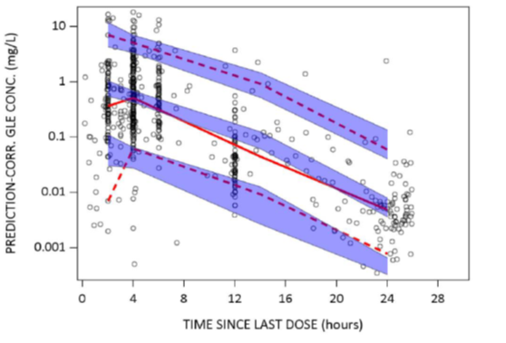

The shaded blue areas represent the 90% prediction interval of the 5th, 50th, and 95th percentiles of simulated glecaprevir concentrations, the solid red line represents median of observed glecaprevir concentration and dashed red lines represent the 5th and 95th percentile of the observed glecaprevir concentration. The open circles represent observed glecaprevir concentrations. Note: visual predictive checks are cut at 24 hours after last dose, as data are too sparse beyond.
The individual pibrentasvir concentration time data were described using a two compartment PK model with a lag time followed by first order absorption and elimination. The prediction corrected visual predictive checks showed potential issues in the elimination phase, as shown below in Figure 2.
Figure 2: Analysis RD200613 Population pharmacokinetics, prediction corrected visual predictive check of pibrentasvir concentration versus time since last dose.
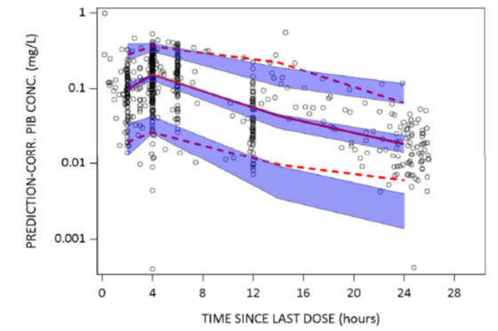
The shaded blue areas represent the 90% prediction interval of the 5th, 50th and 95th percentiles of simulated pibrentasvir concentrations, the solid red line represents median of observed pibrentasvir concentration and dashed red lines represent the 5th and 95th percentile of observed pibrentasvir concentration. The open circles represent observed pibrentasvir concentrations. Note: visual predictive checks are cut at 24 hours after last dose, as data are too sparse beyond.
All tested covariates except race (White versus others) did not significantly affect the pharmacokinetics of glecaprevir or pibrentasvir in HCV infected paediatric subjects after including body weight based allometric scaling of apparent clearance and apparent volume of distribution as a structural covariate in the model. The race covariate could not be assessed due to limited patient numbers.
Body surface area, age and weight were highly correlated in paediatric patients and thus can be considered significant alternative covariates (that is the model could have body surface area or age as significant variable instead of the body weight).
For dose exposure relationship, the post hoc estimated glecaprevir and pibrentasvir exposure ranges in HCV infected paediatric subjects (N = 61) and adolescents (N = 44) were generally consistent with the ranges in HCV infected noncirrhotic adults (N = 1804) (see Table 3, below). Most of the simulated individuals were exposed within a range of 0.5 to 2 times the geometric mean adult exposure.
However, the estimated paediatric geometric mean exposures (AUC_{0-24h}) were higher (up to 77% for glecaprevir (Cohort 4) and up to 44% for pibrentasvir (Cohort 2)) than the reported geometric mean glecaprevir and pibrentasvir AUC_{0-24h} (values of 4800 ng x hr/mL and 1430 ng x hr/mL, respectively) in HCV infected noncirrhotic adults receiving 300 mg/120 mg (Table 3). There was a very large difference in sample sizes and rather large variability (high or moderate to high coefficient of variation (%CV)), and hence caution is required for interpretation, but may still be acceptable.
Table 3: Analysis RD200613 Population pharmacokinetics, model predicted glecaprevir and pibrentasvir steady state area under the concentration time curve from time 0 to 24 hours
AUC24 (area under the plasma concentration time curve from time 0 to 24 hours at steady state), CV (coefficient of variation calculated as$\%CV=100 ∙\sqrt{e[σ (In(P))]2- 1}$ where σ is the standard deviation and P is the pharmacokinetic parameter of interest, QD (once daily), Range is minimum to maximum value of the pharmacokinetic parameter of interest.

Efficacy

Study M16-123 (Dora trial)
Study M16-123 (also known as the DORA trial; Part 2 only) was a Phase II/III, open label, single arm, multicentre (38 centres; 24 centres for Part 2) study to evaluate the PK, efficacy, and safety of glecaprevir and pibrentasvir for 8, 12, or 16 weeks in HCV genotype 1 to 6 infected paediatric patients aged equal to or greater than 3 to less than 18 years, with and without compensated cirrhosis, with or without HIV coinfection, who were either treatment naive, treatment experienced with pegIFN with or without ribavirin, or treatment experienced with sofosbuvir and ribavirin with or without pegIFN. Parts 1 & 2 of the study were conducted between 20 March 2017 and 21 May 2020.
The study was divided into 2 parts (only DORA trial Part 2 was considered for this application):
- Part 1 enrolled 48 (47 subjects were treated) HCV genotype 1 to 6 infected adolescent patients aged from 12 up to 18 years and used the adult formulation of glecaprevir and pibrentasvir (Cohort 1). This part was not considered in this application.
- Part 2 enrolled 81 (80 subjects were treated) HCV genotype 1 to 6 infected paediatric patients divided into 4 cohorts: from 9 to under 12 years of age (Cohort 2), from 6 to under 9 years (Cohort 3), and from 3 to under 6 years (Cohort 4) age groups, who received the paediatric formulation of glecaprevir and pibrentasvir. In each cohort, subjects were enrolled first into the intensive PK portion, followed by the non-intensive PK safety and efficacy portions. Subjects in each cohort were enrolled in parallel (see Figure 3, below).
Figure 3: Study M16-123 (DORA trial) Study design
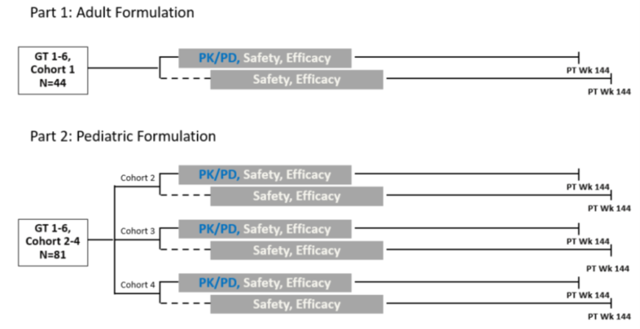
Abbreviations: GT (genotype), PK (pharmacokinetic). PD (pharmacodynamic), PT WK (post treatment week)
The primary objectives of this study were to:
- Assess the AUC, and to assess the PK of glecaprevir and pibrentasvir in paediatric subjects following multiple dosing by age group.
- Evaluate the safety and tolerability of glecaprevir and pibrentasvir by age group, cirrhosis status, and across all subjects.
- Evaluate the percentage of subjects with sustained virologic response for 12 weeks post-treatment (SVR12) in HCV genotype 1 to 6 infected paediatric subjects.
The main inclusion criteria were age greater than or equal to 3 to less than 18 years (greater than or equal to 3 to less than 12 years for Part 2), chronic HCV genotype 1, 2, 3, 4, 5, or 6 infection, if participating in the intensive PK part, HIV-1 negative and HCV treatment naive. The main exclusion criteria were pregnancy, hepatitis B virus infection; Child-Pugh stages B or C; and hepatocellular carcinoma.

Endpoints
The primary efficacy endpoint was SVR12. The secondary efficacy variables were on treatment virologic failure (for example breakthrough), post treatment relapse, subjects with new HCV infection (that is reinfection), and assessment of palatability/acceptability of the paediatric formulation.

Study treatment
Patients in Part 2 were dosed based on a weight based regimen (as per Table 4, shown below). Even though age ranges were matched with the three weight ranges, the weight took precedent for dosing, that is some patients were in either a higher or lower weight based group and were dosed accordingly.
The maximum dose of glecaprevir and pibrentasvir did not exceed 300 mg and 120 mg, respectively, per day for up to 16 weeks. 17 paediatric patients received the lower doses for the whole treatment period (8 weeks, as none of the 17 were assigned a 12 or 16 week duration). After a PK analysis showing low exposure the regimen was changed to a higher dose. 62 patients across the three age cohorts were assessed on the final doses in Part 2. 78 subjects were assigned to the 8 week treatment duration and one subject each was assigned to the 12 and 16 week treatment duration.
Table 4: Study M16-123 (DORA trial) Glecaprevir and pibrentasvir doses
Abbreviations: GLE (glecaprevir), PIB (pibrentasvir), yr (year).
a. each sachet contains 50 mg/20 mg unit dose of glecaprevir and pibrentasvir granules.

Baseline characteristics
Most patients were White (68.8%), with 17.5% being Asian. Most patients matched the weight band for their age group. Most patients had genotype 1 (72.5%) or genotype 3 (22.5%). None had cirrhosis, most were treatment naive (97.5%), and one patient (1.3%) had a HIV coinfection.

Subject disposition
Eighty-one (81) subjects were enrolled in Part 2 of the study. One subject (Cohort 4) enrolled but was never dosed. Two subjects prematurely discontinued study drug. One subject (Cohort 4) refused the study drug and one subject (Cohort 2) experienced a study drug related adverse event (AE) of erythematous rash. Overall, 78 patients completed the Part 2 study.

Magnitude of the treatment effect and its clinical significance

Primary efficacy endpoint
Sustained virologic response 12 weeks post end of treatment (SVR12) was achieved by 96.3% (77 out of 80) of the intention to treat (ITT) population and consistent with adults (see Table 5).
In Cohort 2, one Asian patient experienced virologic relapse by 12 weeks post treatment, and one patient prematurely discontinued study treatment due to a rash (rash on Day 1; discontinued on Day 4). All other patients achieved SVR12. In Cohort 3, all patients achieved SVR12. In Cohort 4, one patient refused the study drug. All other patients achieved SVR12. No Part 2 subjects on the final 50 mg/20 mg dose ratio experienced virologic failure.
The results of the SVR12 endpoint (77 out of 80) are generally supported by the sustained virologic response for 24 weeks post treatment (SVR24) endpoint: 89.6% (43 out of 48) (see Table 6, below).
Table 5: Study M16-123 (DORA trial, Part 2) Primary efficacy endpoint: sustained virologic response for 12 weeks post treatment in intention to treat population
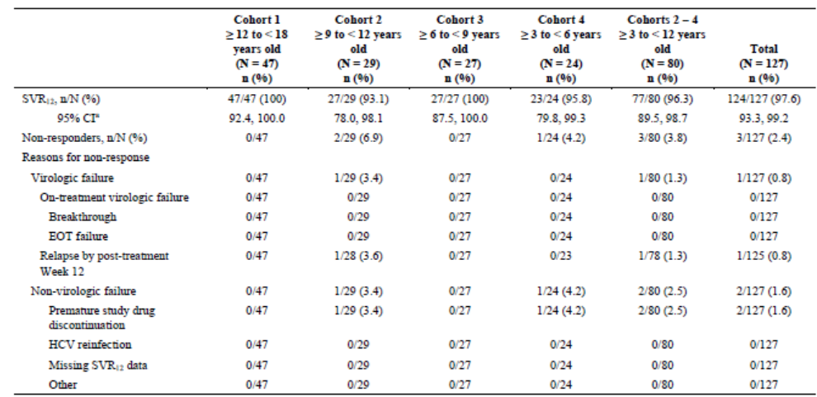
Abbreviations: CI (confidence interval), EOT (end of treatment), HCV (hepatitis C virus), ITT (intention to treat), SVR12 (sustained virologic response for 12 weeks post treatment).
Table 6: Study M16-123 (DORA trial, Part 2) Other efficacy endpoint: sustained virologic response for 24 weeks post treatment in intention to treat population intensive pharmacokinetic subjects only.
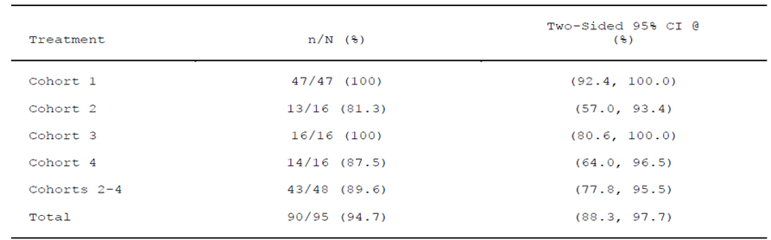
Abbreviations: CI (confidence interval), HCV (hepatitis C virus), ITT (intention to treat), SVR24 (sustained virologic response for 24 weeks post treatment).
Cohort 1: 12 to less than 18 years old; Cohort 2: 9 to less than 12 years old; Cohort 3: 6 to less than 12 years old; Cohort 4: 3 to less than 6 years old
SVR24 – HCV RNA less than lower limit of quantification (LLOQ) in the SVR 24 window (24 weeks after the last actual dose of the study drug) without any confirmed quantifiable (greater than or equal to LLOQ) post treatment value before or during the SVR window.
Note: Backward imputation, where applicable, was used to impute missing data. After applying backward imputation, if there is still no value in the window but there is an HCV RNA value from a local laboratory present, then it will be imputed into the SVR window. Otherwise, subjects with missing data are counted as failures.
@ CI – confidence interval calculated using Wilson’s score method.

Sensitivity analyses

Initially proposed dose versus final dose (further stratified by weight based dosing)
- For subjects on the initial 40 mg/15 mg dose ratio: the SVR12 rate was 88.9% (16 out of 18) (95% CI: 67.2%, 96.9%).
- For subjects on the final 50 mg/20 mg dose ratio: the SVR12 rate was:
  - 95.8% (23 out of 24) (95% CI: 79.8%, 99.3%) for the 250 mg glecaprevir and 100 mg pibrentasvir dose.
  - 100% (21 out of 21) (95% CI: 84.5%, 100.0%) for the 200 mg glecaprevir and 80 mg pibrentasvir dose.
  - 100% (17 out of 17) (95% CI: 81.6%, 100.0%) for the 150 mg glecaprevir and 60 mg pibrentasvir dose.

Japanese subjects compared to non-Japanese subjects
All 13 of the Japanese subjects (100%) achieved SVR12. No difference in efficacy was observed.

Baseline polymorphisms
There was no definite evidence that baseline polymorphisms had an impact on treatment outcome.

Safety
Safety data are based on Study M16-123 (the DORA trial), as this was the only study in the target population and also used for pharmacology data.

Exposure
Most patients received treatment for eight weeks across all cohorts, with only a limited number exposed to 12 to 16 weeks (two in the relevant Cohorts 2 to 4) (see Table 7, below).
Table 7: Study M16-123 (DORA trial, Part 2) Exposure; duration of treatment in days in intention to test population
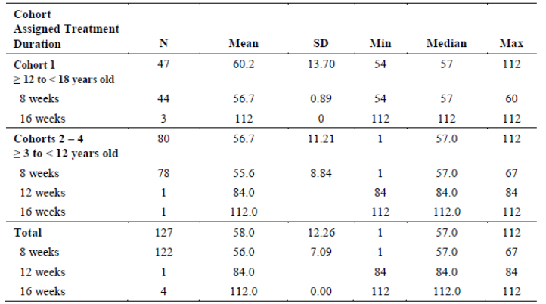
Abbreviations: CSR (clinical study report), ITT (intention to treat), min (minimum), max (maximum), PT (post treatment), SD (standard deviation).
Note: duration of treatment is the last study drug dose date minus the first study drug dose date plus one day.

Adverse event overview
The majority of adverse events (AEs) were mild. The most frequently reported AEs for paediatric subjects (Cohorts 2 to 4 combined) were headache, vomiting, and diarrhoea (see Table 8 for a breakdown of treatment-emergent adverse events in this study). Gastrointestinal events such as diarrhoea, nausea and vomiting, fatigue and headache all occurred at a higher incidence than in the adult population. All events of nasopharyngitis and upper respiratory tract infection were assessed as not study drug related.
Table 8: Study M16-123 (DORA trial) Treatment-emergent adverse events reported in greater than or equal to 5% of all subjects in the safety population
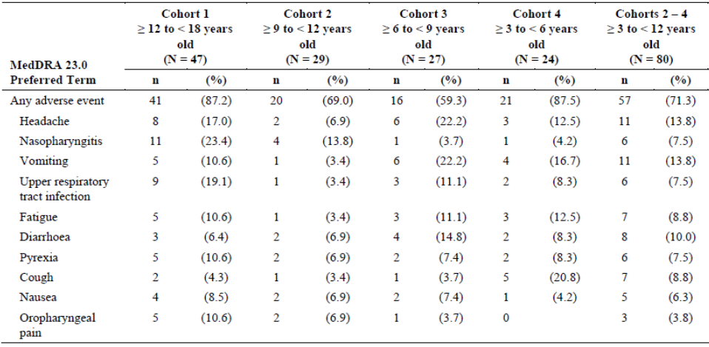
Abbreviations: CSR (clinical study report), MedDRA (medical dictionary for regulatory activities), PT (Preferred Term)
Note: subjects are counted once in each row, regardless of the number of events they may have had.
Cross reference: Study M16-123 all Part 1 and Part 2 PT Week 12 primary data CSR.

Treatment related adverse event overview
Twenty-three (28.8%) paediatric subjects experienced study drug related AEs with the most frequently reported (greater than or equal to 5% subjects overall) being fatigue, headache, and vomiting.

Deaths
No adverse events leading to death were reported during the study.

Serious adverse events
No subjects experienced a treatment-emergent serious adverse event during the study. One subject in Cohort 4 experienced a post-treatment serious adverse event of osteomyelitis (not considered study drug related).

Discontinuations
One subject (an 11 year old female) prematurely discontinued study drug on treatment Day 4 due to a nonserious AE, considered drug related: an erythematous rash on treatment Day 1 (treated with cetirizine, potentially erythema multiforme). A 9 year old male had a nonserious respiratory tract infection AE leading to a 4 day interruption of study drug.

Adverse events of special interest

Treatment emergent hepatic decompensation/hepatic failure
None identified. The was no occurrence of a clinically significant laboratory abnormality, and no cases of suspected drug induced liver injury or liver related toxicities.

Postbaseline events of hepatocellular carcinoma
None identified.

Growth and Development
Growth rate, weight and height z score, and body mass index standardised score were analysed. The sponsor states that there were no clinically important trends in growth and development.

Laboratory abnormalities
One paediatric subject had a single low neutrophil count that was not considered clinically significant and improved over time. No other clinically significant laboratory abnormalities were seen.

Cardiovascular events
Two paediatric subjects had a clinically significant abnormal electrocardiogram finding. One subject was found to have left ventricular hypertrophy at screening and one subject was assessed as having a possible atrial septal defect on treatment Day 15. No cardiovascular AEs were reported for either subject.

Post market experience
No paediatric (3 to 12 years) data available.

Risk management plan
The most recently evaluated European Union risk management plan (RMP) was version 4.1 (date November 2018; data lock point (DLP) 20 July 2018) and Australia specific annex (ASA) version 4.2 (date July 2019). In support of the extended indications, the sponsor has submitted Core RMP version 5.0 (date February 2020; DLP 14 June 2019) and ASA version 5.0 (date December 2020). At the first round the sponsor submitted EU RMP version 8.0 (date April 2021; DLP 25 July 2020) and ASA version 7.0 (date July 2021).
The summary of safety concerns and their associated risk monitoring and mitigation strategies are summarised in Table 9. Further information regarding the TGA’s risk management approach can be found in risk management plans for medicines and biologicals and the TGA's risk management approach.
Table 9: Summary of safety concerns
Summary of safety concerns |  | Pharmacovigilance |  | Risk Minimisation
 |  | Routine | Additional | Routine | Additional
Important identified risks | None
Important potential risks | Recurrence of hepatocellular carcinoma | – | § | – | –
Important potential risks | Emergence of hepatocellular carcinoma | – | ‡ | – | –
Missing information | Safety in patients with moderate hepatic impairment (Child-Pugh B) | –* | – |  | –
Missing information | Safety in patients with previous hepatocellular carcinoma | – | § | – | –
* Targeted follow up form
‡ Study B20-146
§ PASS study B16-959
No new safety concerns have been proposed for the new formulation and indication. The Australian specific safety concern ‘use in patients below 12 years of age’ has been removed from the summary of safety concerns, in support of the application to extend the use of Maviret in paediatric patients. At the first round the important identified risks of ‘HBV [hepatitis B virus] reactivation’ and ‘resistance development’, the important potential risk of ‘drug-drug interaction’, and the missing information ‘safety in pregnant and breastfeeding patients’ were removed from the ASA to align with a revised EU RMP. The summary of safety concerns aligns with the EU RMP and no new safety concerns were raised during the current evaluation. The summary of safety concerns is acceptable.
The sponsor has updated the ‘summary of the RMP’ table in the ASA to include routine pharmacovigilance for all safety concerns as requested. A targeted follow up form has been included in the ASA for the missing information ‘safety in patients with moderate hepatic impairment (Child-Pugh B)’, in alignment with the EU RMP. Additional pharmacovigilance activities were proposed at round 1 for risks of ‘resistance development’, ‘recurrence/emergence of hepatocellular carcinoma’ and ‘safety in patients with previous hepatocellular carcinoma’. At the second round the sponsor has confirmed the completion and consequently the removal of Study M13-576 and confirmed the status of the remaining additional pharmacovigilance activities. The pharmacovigilance plan is acceptable.
Routine risk minimisation activities remain unchanged from ASA version 4.2. Additional risk minimisation activities are not proposed. An instruction for use leaflet will be included in the product packaging for the proposed granules formulation to guide user compliance. At round 2 the sponsor has incorporated agreed changes to the PI, Consumer Medicines Information (CMI) and instruction for use (IFU) to strengthen the communication and help minimise the risk of medication error due to lack of interchangeability between existing film coated tablet and newly proposed granular dosage forms. At third round the sponsor updated the CMI and PI to ensure a full course of treatment with the same presentation and with instructions should vomiting occur but has not agreed to include the Black Triangle Scheme statement and wording on the IFU document. This issue will not be pursued. The risk minimisation plan is considered acceptable.
There are no new or outstanding recommendations.

Proposed wording for conditions of registration
Any changes to which the sponsor has agreed should be included in a revised RMP and ASA. However, irrespective of whether or not they are included in the currently available version of the RMP document, the agreed changes become part of the risk management system.
The suggested wording is:
‘The Maviret EU-Risk Management Plan (RMP) (version 8.0, dated April 2021, data lock point 25 July 2020), with Australian Specific Annex (version 7.0, dated July 2021), included with submission PM-2020-06602-1-2, and any subsequent revisions, as agreed with the TGA will be implemented in Australia.’
The following wording is recommended for the PSUR requirement:
‘An obligatory component of risk management plans is routine pharmacovigilance. Routine pharmacovigilance includes the submission of periodic safety update reports (PSURs).
Reports are to be provided in line with the current published list of EU reference dates and frequency of submission of PSURs until the period covered by such reports is not less than three years from the date of the approval letter.
The reports are to at least meet the requirements for PSURs as described in the European Medicines Agency’s Guideline on good pharmacovigilance practices (GVP) Module VII-periodic safety update report (Rev 1), Part VII.B Structures and processes. Note that submission of a PSUR does not constitute an application to vary the registration.’
As the indications for Maviret are being extended into a significantly different (paediatric) population it should be included in the Black Triangle Scheme as a condition of registration. The following wording is recommended for the condition of registration:
‘Maviret (glecaprevir/pibrentasvir) is to be included in the Black Triangle Scheme. The PI and CMI for Maviret must include the black triangle symbol and mandatory accompanying text for five years, which starts from the date the new indication is registered.’

Risk-benefit analysis

Delegate’s considerations

Pharmacokinetic data and proposed weight based dosing

Dose change during the clinical trial program
The sponsor originally trialled a lower dose ratio (40 mg glecaprevir/15 mg pibrentasvir) with multiples thereof for dosing in 17 patients. This resulted in lower pharmacokinetic exposure compared to adult exposure. One patient in the lower dose cohort experienced virologic failure. Consequently, the treatment was altered to a different formulation (50 mg glecaprevir/20 mg pibrentasvir) with multiples thereof for dosing in 62 patients. With the increased dose, no patients experienced virologic failure.
The sponsor claims that the new dosing which would lead to exposure was comparable to that of the adult dose in adults.

Population pharmacokinetic data issues
The provided population PK analysis generally supports the use of the proposed body weight group based dosing for paediatric subjects. Intensive PK sampling only occurred in 29 patients.
However, there were some issues with the population PK data which include:
- There were no patients with genotype 5 or 6 HCV, or cirrhotic patients. However, if pharmacokinetic data are comparable to data in adults, it would not be unreasonable to extrapolate to those genotypes, given the rarity of patients with genotype 5 or 6 HCV.
- The reported plots and discussion involved PK exposure ranges and did not include the definition or the investigation of an efficacious range.
- The prediction corrected visual predictive checks showed potential issues in the absorption and elimination phases for glecaprevir, and the elimination phase for pibrentasvir. Modelling was made more difficult by the nonlinear PK characteristics of both pibrentasvir and glecaprevir.
- Assuming that the model was reasonably robust to provide valid results, the estimated paediatric geometric mean AUC_{0-24h} were higher (up to 77% for glecaprevir (Cohort 4) and up to 44% for pibrentasvir (Cohort 2)) than the reported geometric mean glecaprevir and pibrentasvir AUC_{0-24h} in HCV infected noncirrhotic adults receiving 300 mg/120 mg. There was a very large difference in sample sizes and rather large variability (high or moderate to high %CV), and hence caution is required for interpretation, but may still be acceptable.
The popPK evaluator states that based on the post hoc estimates and even with consideration of the simulated exposures, the description of the exposure as similar or comparable across the age groups (paediatric subjects (including adolescent subjects)) versus adults is vague and does not seem to be informative and providing further descriptive data about the PK exposure is recommended in this context.

Chosen dosing regimen
The sponsor concludes (mainly based on population PK data) that with the 50 mg/20 mg formulation as a weight based regimen (see Table 10), the exposure of glecaprevir and pibrentasvir in paediatric patients aged 3 years to less than 12 years and weighing greater than or equal to 12 kg appears to be consistent with that of the adult noncirrhotic HCV infected population.
This conclusion is not fully supported, as there were issues with the small sample size of the source population, and issues with model fit further complicated by the nonlinear PK characteristics of both active compounds. It may be stated instead that the proposed dose regimen appears to be in the efficacious range.
All but two patients received study treatment for 8 weeks (one each for 12 and 16 weeks; both on the final dose regimen). Even though an efficacious range was not defined for PK purposes, the weight based regimen used led to 96.3% of study patients (Cohorts 2 to 4, ITT) achieving SVR12 (percentage of subjects with sustained virologic response for 12 weeks post-treatment).
The adult/adolescent tablet formulation and the paediatric formulation have very different pharmacokinetic properties and cannot be used interchangeably.
Table 10: Final weight based dosing regimen
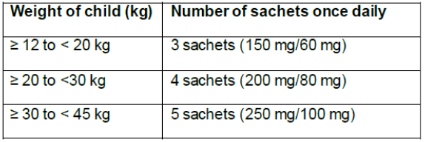

Efficacy, safety and proposed indication

Clinical trial population
The proposed indication is based on a dedicated Phase II/III study in 80 paediatric patients between the ages of 3 and 12 years who were infected with HCV genotypes 1 to 4, no cirrhosis, with some previously treated with interferon and/or ribavirin containing regimens, and one patient who was coinfected with HIV-1. There is some uncertainty about the efficacy and safety in patients infected with HCV genotype 5 or 6 and/or with cirrhosis and/or previously treated with an NS5A inhibitor, as these subpopulations were not studied. There was a good distribution across weight and age groups for the proposed 3 to 12 years indication.

Efficacy results
Sustained virologic response 12 weeks post end of treatment (SVR12) was achieved by 96.3% (77 out of 80) of the ITT population and consistent with adults (typically SVR12 greater than 94% in noncirrhotic treatment naive adults treated with Maviret). The results of the SVR12 endpoint (77 out of 80) are generally supported by the SVR24 endpoint (sustained virologic response 24 weeks post end of treatment): 89.6% (43 out of 48). For subjects on the initial 40 mg/15 mg dose ratio, the SVR12 proportion was 88.9% (16 out of 18).
The conduct of an efficacy and safety study dedicated to paediatric population is an advantage. 17 paediatric patients received the lower dosing regimen for their whole treatment period of 8 weeks. Changing the dose during the trial was not ideal leaving only data for 62 patients that received the higher (final) dosing regimen for the whole treatment period.
If registered for the proposed indication, Maviret would provide a pangenotypic direct acting antiviral (DAA) treatment option for HCV infected paediatric patients aged 3 years to less than 12 years of age.

Safety
Overall, the safety of the drug in this studied population was similar to that seen in treatment naive noncirrhotic HCV infected adult patients who were treated for 8, 12 or 16 weeks. Maviret appears to have a significantly better safety profile than interferon/ribavirin based regimens.
No potentially concerning or unknown adverse drug reactions were detected in the Phase II/III study in the paediatric population from 3 to less than 12 years of age group (with the potential exception of the erythematous rash), but for detection of uncommon events, the sample size was too small (80 subjects). Ongoing post market reviews are essential.
Furthermore, the known clinical harms associated with Maviret use in adults include interactions with several drugs that can result in loss of therapeutic effectiveness or clinically significant adverse reactions.
One subject (11 year old female) prematurely discontinued study drug on treatment Day 4 due to a nonserious adverse event, considered drug related: an erythematous rash on treatment Day 1 (potentially erythema multiforme). More information was requested from the sponsor.

Summary of deficiencies of data
- Only data from genotypes 1 to 4 in noncirrhotic patients were available from the provided study.
- No paediatric data is available for cirrhotic patients.
- The PK model fit was not entirely satisfactory, especially for the glecaprevir component.
- Overall, there was a small target population sample size, in particular for safety considerations.

Advisory Committee considerations
The Advisory Committee on Medicines (ACM), having considered the evaluations and the Delegate’s overview, as well as the sponsor’s response to these documents, advised the following.

Specific advice to the Delegate
The ACM advised the following in response to the Delegate’s specific request for advice:
- Can the ACM comment on the appropriateness of the proposed weight based dosing for the target population?
The ACM considered weight based dosing to be an acceptable approach based on the available population pharmacokinetic model based analyses and prediction, together with clinical data.
- Can the ACM comment on the appropriateness of extrapolating the existing data to paediatric patients with HCV genotype 5 or 6 and/or with cirrhosis and/or previously treated with an NS5A inhibitor?
The ACM found this extrapolation to be a reasonable approach, acknowledging that it would have been difficult to conduct a larger patient study due to small patient numbers. The ACM noted that the pharmacokinetic data in children were comparable to adult patients and considered it reasonable to assume similar efficacy in children. The ACM also noted that children have less comorbidities such as obesity, diabetes and alcohol use which could positively influence their outcomes on therapy compared to adults.
- The committee is also requested to provide advice on any other issues that it thinks may be relevant to a decision on whether or not to approve this application.
The ACM commented that it is important to treat affected children as early as possible, especially before adolescence, to minimise the progression to liver disease. The ACM was of the view that the lower age bracket in the proposed indication is a welcome addition in this clinical space.
The ACM noted the importance of ensuring good compliance in young children.

Conclusion
The ACM considered this product to have an overall positive benefit-risk profile for the indication:
Maviret is indicated for the treatment of adult and paediatric patients 3 years and older with chronic hepatitis C virus (HCV) genotype (GT) 1, 2, 3, 4, 5, or 6 infection with or without compensated cirrhosis. This includes patients with HCV GT1 infection who were previously treated with either a regimen of an NS5A inhibitor or with an NS3/4A protease inhibitor but not both classes of inhibitors (see 4.2 dose and method of administration and 5.1 pharmacodynamic properties – Clinical trials).

Outcome
Based on a review of quality, safety, and efficacy, the TGA approved the registration of Maviret (glecaprevir and pibrentasvir) 100 mg/40 mg tablets and 50 mg/20 mg granules for the following extension of indications:
Maviret is indicated for the treatment of adult and paediatric patients 3 years and older with chronic hepatitis C virus (HCV) genotype (GT) 1, 2, 3, 4, 5, or 6 infection with or without compensated cirrhosis. This includes patients with HCV GT1 infection who were previously treated with either a regimen of an NS5A inhibitor or with an NS3/4A protease inhibitor but not both classes of inhibitors (see 4.2 dose and method of administration and 5.1 pharmacodynamic properties – Clinical trials).
The above extension of indication is inclusive of the previous approved indications.

Specific conditions of registration applying to these goods
- Maviret (glecaprevir/pibrentasvir) is to be included in the Black Triangle Scheme. The PI and CMI for Maviret must include the black triangle symbol and mandatory accompanying text for five years, which starts from the date the new indication is registered.
- The Maviret EU-RMP (version 8.0, dated April 2021, DLP 25 July 2020), with ASA (version 7.0, dated July 2021), included with submission PM-2020-06602-1-2, and any subsequent revisions, as agreed with the TGA will be implemented in Australia.
An obligatory component of risk management plans is routine pharmacovigilance. Routine pharmacovigilance includes the submission of periodic safety update reports (PSURs).
Reports are to be provided in line with the current published list of EU reference dates and frequency of submission of PSURs until the period covered by such reports is not less than three years from the date of the approval letter.
The reports are to at least meet the requirements for PSURs as described in the European Medicines Agency’s Guideline on good pharmacovigilance practices (GVP) Module VII-periodic safety update report (Rev 1), Part VII.B Structures and processes. Note that submission of a PSUR does not constitute an application to vary the registration.

Attachment 1. Product Information
The PI for Maviret approved with the submission which is described in this AusPAR is at Attachment 1. For the most recent PI, please refer to the TGA PI/CMI search facility.

Therapeutic Goods Administration
PO Box 100 Woden ACT 2606 Australia
Email: info@tga.gov.au Phone: 1800 020 653 Fax: 02 6232 8605
https://www.tga.gov.au

Hepatitis C Virus Infection Consensus Statement Working Group. Australian recommendations for the management of hepatitis C virus infection: a consensus statement (2022). Melbourne: Gastroenterological Society of Australia, 2022.
Kirby Institute. HIV, viral hepatitis and sexually transmissible infections in Australia: annual surveillance report 2021. Hepatitis C. Sydney: Kirby Institute, UNSW Sydney, 2021. https://kirby.unsw.edu.au/report/asr2021
Australasian Society for HIV, Viral Hepatitis and Sexual Health Medicine (ASHM) Australian (AU) Commentary on the AASLD-IDSA HCV Guidance: HCV in Children. ASHM 2021
Jhaveri R. Diagnosis and management of hepatitis C virus-infected children. Pediatr Infect Dis J. 2011;30(11):983- 985.
American Association for the Study of Liver Diseases (AASLD)- Infectious Diseases Society of America (AASLD-IDSA). HCV in Children. Recommendations for testing, managing, and treating hepatitis C. (2021) https://www.hcvguidelines.org/unique-populations/children
Epclusa (sofosbuvir and velpatasvir) was first registered in Australia on 19 December 2016. ARTG number: 266823
Maviret (glecaprevir and pibrentasvir) was first registered in Australia on 2 January 2018. ARTG number: 284948
Harvoni (sofosbuvir and ledipasvir) was first registered in Australia on 13 May 2015. ARTG number: 222848
AusPAR for Maviret (glecaprevir and pibrentasvir) AbbVie Pty Ltd. submission PM-2017-00210-1-2. Published 23 January 2019. Available at: AusPAR: Glecaprevir / pibrentasvir | Therapeutic Goods Administration (TGA)
European Medicines Agency (EMA), Committee for Medicinal Products for Human Use (CHMP), Questions and answers on propylene glycol used as an excipient in medicinal products for human use EMEA/CHMP/704195/2013, October 2017.
The Child-Pugh score is a system for assessing the prognosis and required strength of treatment and necessity of liver transplant of chronic liver disease, primarily cirrhosis. The Child-Pugh score is determined by scoring five clinical measures of liver disease (total bilirubin, serum albumin, prothrombin time, ascites, hepatic encephalopathy) and the possibility of eventual liver failure. A score of 1, 2 or 3 is given to each measure with 3 being the most severe. Class A: 5 to 6 points, least severe liver disease, one to five year survival rate of 95%. Class B: 7 to 9 points, moderately severe liver disease, one to five year survival rate of 75%. Class C: 10 to 15 points, most severe liver disease, one to five year survival rate of 50%.

