March 2023

Australian Public Assessment Report for Eligard
  - Active ingredient: Leuprorelin acetate
  - Sponsor: Mundipharma Pty Ltd

About the Therapeutic Goods Administration (TGA)
- The Therapeutic Goods Administration (TGA) is part of the Australian Government Department of Health and is responsible for regulating therapeutic goods, including medicines, medical devices, and biologicals.
- The TGA administers the Therapeutic Goods Act 1989 (the Act), applying a risk management approach designed to ensure therapeutic goods supplied in Australia meet acceptable standards of quality, safety, and efficacy.
- The work of the TGA is based on applying scientific and clinical expertise to decision-making, to ensure that the benefits to the Australian public outweigh any risks associated with the use of therapeutic goods.
- The TGA relies on the public, healthcare professionals and industry to report problems with therapeutic goods. The TGA investigates reports received to determine any necessary regulatory action.
- To report a problem with a therapeutic good, please see the information on the TGA website.

About AusPARs
- The Australian Public Assessment Report (AusPAR) provides information about the evaluation of a prescription medicine and the considerations that led the TGA to approve or not approve a prescription medicine submission. Further information can be found in Australian Public Assessment Report (AusPAR) guidance.
- AusPARs are prepared and published by the TGA.
- AusPARs are static documents that provide information that relates to a submission at a particular point in time. The publication of an AusPAR is an important part of the transparency of the TGA’s decision-making process.
- A new AusPAR may be provided to reflect changes to indications or major variations to a prescription medicine subject to evaluation by the TGA.

Copyright
© Commonwealth of Australia 2023
This work is copyright. You may reproduce the whole or part of this work in unaltered form for your own personal use or, if you are part of an organisation, for internal use within your organisation, but only if you or your organisation do not use the reproduction for any commercial purpose and retain this copyright notice and all disclaimer notices as part of that reproduction. Apart from rights to use as permitted by the Copyright Act 1968 or allowed by this copyright notice, all other rights are reserved, and you are not allowed to reproduce the whole or any part of this work in any way (electronic or otherwise) without first being given specific written permission from the Commonwealth to do so. Requests and inquiries concerning reproduction and rights are to be sent to the TGA Copyright Officer, Therapeutic Goods Administration, PO Box 100, Woden ACT 2606 or emailed to <tga.copyright@tga.gov.au>.

Contents
List of abbreviations 4
Product submission 5
Submission details 5
Product background 6
Regulatory status 7
Product Information 8
Registration timeline 8
Submission overview and risk/benefit assessment 9
Quality 9
Nonclinical 10
Clinical 10
Risk management plan 21
Risk-benefit analysis 22
Outcome 25
Specific conditions of registration applying to these goods 25
Attachment 1. Product Information 26

List of abbreviations
Abbreviation |  | Meaning
ACM | Advisory Committee on Medicines
ARTG | Australian Register of Therapeutic Goods
AUC | Area under the concentration-time curve
CI | Confidence interval
CPP | Central precocious puberty
C_{max} | Maximum concentration
CMI | Consumer Medicine Information
FSH | Follicle stimulating hormone
GnRH | Gonadotropin hormone releasing hormone
GnRHa | Gonadotropin hormone releasing hormone agonist
ITT | Intention to treat
LH | Luteinising hormone
PI | Product Information
PK | Pharmacokinetic(s)
PD | Pharmacodynamic(s)
PSUR | Periodic safety update report
RMP | Risk management plan
SD | Standard deviation
TEAE | Treatment-emergent adverse event
TGA | Therapeutic Goods Administration
T_{max} | Time to maximum concentration

Product submission

Submission details
Type of submission: | Extension of indications
Product name: | Eligard (Eligard 6 month)
Active ingredient: | Leuprorelin acetate
Decision: | Approved
Date of decision: | 6 July 2022
Date of entry onto ARTG: | 11 July 2022
ARTG number: | 101581
Black Triangle Scheme: | Yes  This product will remain in the scheme for 5 years, starting on the date the new indication was approved.
Sponsor’s name and address: | Mundipharma Pty Ltd  11/10 Carrington Street  Sydney NSW 2000
Dose form: | Modified release injection
Strength: | 45 mg
Container: | Syringe
Pack size: | Single injection composite pack containing: syringe A (delivery system) and syringe B (containing leuprorelin acetate).
Approved therapeutic use: | Central precocious puberty (CPP)  Eligard 45 mg 6 month is indicated for the treatment of children 2 years of age and older with central precocious puberty (CPP).
Route of administration: | Subcutaneous
Dosage: | For use in central precocious puberty (CPP)  Central precocious puberty is defined as: clinical evidence of onset of breast development in girls less than 8 years of age, or bilateral testicular enlargement over 4 mL in boys less than 9 years of age, plus raised luteinising hormone/follicle stimulating hormone, oestradiol or testosterone; see the Product Information for further information.  Eligard (Eligard 6 month) is designed to deliver 45 mg of leuprorelin acetate at a controlled rate over a 6 month therapeutic period.  For further information regarding dosage, refer to the Product Information.
Pregnancy category: | D  Drugs which have caused, are suspected to have caused or may be expected to cause, an increased incidence of human fetal malformations or irreversible damage. These drugs may also have adverse pharmacological effects. Accompanying texts should be consulted for further details.  The use of any medicine during pregnancy requires careful consideration of both risks and benefits by the treating health professional. This must not be used as the sole basis of decision making in the use of medicines during pregnancy. The TGA does not provide advice on the use of medicines in pregnancy for specific cases. More information is available from obstetric drug information services in your State or Territory.

Product background
This AusPAR describes the submission by Mundipharma Pty Ltd (the sponsor) to register Eligard (leuprorelin acetate) 45 mg modified release injection for the following proposed extension of indications:
Eligard 6 month is indicated for the treatment of children with central precocious puberty (CPP).
Precocious puberty is when puberty occurs earlier than normal, that is, before 97.5% of the population of children. Precocious puberty is defined as an onset of puberty before 8 years of age in females and 9 years in males;, but pubertal development has also been classified as being precocious when it occurs before age six in Black girls and before age seven years in all other girls; hence, incidence and definitions of precocious puberty may differ between different populations.
The most common mechanism of precocious puberty is central precocious puberty, also known as gonadotropin dependent precocious puberty. This is due to the early activation of pulsatile gonadotropin hormone releasing hormone (GnRH) secretion from the hypothalamus. This initiates the hormonal changes of puberty through secretion from the pituitary of luteinising hormone (LH) and follicle stimulating hormone (FSH), which act on the ovaries or testes. The secretion of estrogens from the ovaries or testosterone from the testes result in the development of the secondary sexual characteristics. Central precocious puberty may be due to underlying medical conditions such as hypothalamic hamartomas, McCune Albright syndrome, underlying genetic conditions, brain injury or brain tumour.
Early age at puberty can result in other physical and psychological conditions including short stature, adverse psychosocial outcomes and increases the risks of cardiovascular disease, obesity, diabetes, and some cancers, for example, breast cancer.
Diagnosis and management of the condition are complicated and require paediatric endocrinology referral. This is because of the differential diagnosis and potentially underlying conditions. Diagnosis is on the basis of clinical findings and investigations. Biochemical diagnostic criteria for central precocious puberty include a serum LH concentration great then 5 units (U)/L after GnRH or leuprorelin administration or a basal LH greater than 0.3 U/L using ultrasensitive assays.⁴ In girls, a less commonly used criterion is a ratio of peak LH/peak FSH over 0.66 after GnRH stimulation.

Current treatment options
Treatment of central precocious puberty involves suppression of LH and FSH secretion by the hypothalamus. Endogenous GnRH is secreted in a pulsatile manner. GnRH analogues provide a continuous effect and suppress the normal pulsatile pattern of secretion. This in turn suppresses LH and FSH secretion.
In Australia, only one formulation of leuprorelin acetate is currently approved for treatment of central precocious puberty, that is, Lucrin Depot Paediatric leuprorelin acetate 30 mg powder for injection, 3 month administration (AUST R 218936).
Diphereline (triptorelin (as embonate)) 22.5 mg, 6 month formulation only, is also indicated in Australia for the treatment of children two years and older with central precocious puberty (AUST R 159173).

Regulatory status
The product, Eligard (leuprorelin acetate), received initial registration on the Australian Register of Therapeutic Goods (ARTG) on 26 November 2003. The Eligard (Eligard 6 month) 45 mg modified release injection was first registered on 16 September 2005. Extension to indications were approved 12 October 2017. The approved indications at the time of this submission were:
Eligard is indicated for the:
- Palliative treatment of advanced prostate cancer
- Treatment of high-risk localised and locally advanced hormone dependent prostate cancer in combination with radiotherapy.
At the time the TGA considered this submission, a similar submission for extension of indications for leuprolide acetate; had been approved in the United States of America (USA) on 1 May 2020. The approved indication in the USA is:
Fensolvi is a gonadotropin releasing hormone (GnRH) agonist indicated for the treatment of pediatric patients 2 years of age and older with central precocious puberty.

Product Information
The Product Information (PI) approved with the submission which is described in this AusPAR can be found as Attachment 1. For the most recent PI, please refer to the TGA PI/Consumer Medicine Information (CMI) search facility.

Registration timeline
The following table captures the key steps and dates for this submission.
Table 1: Timeline for Submission PM-2021-01406-1-5
Description | Date
Submission dossier accepted and first round evaluation commenced | 30 June 2021
First round evaluation completed | 22 December 2022
Sponsor provides responses on questions raised in first round evaluation | 8 March 2022
Second round evaluation completed | 22 April 2022
Delegate’s Overall benefit-risk assessment and request for Advisory Committee advice | 11 May 2022
Sponsor’s pre-Advisory Committee response | 12 May 2022
Advisory Committee meeting | 3 June 2022
Registration decision (Outcome) | 6 July 2022
Completion of administrative activities and registration on the ARTG | 11 July 2022
Number of working days from submission dossier acceptance to registration decision* | 204
*Statutory timeframe for standard submissions is 255 working days

Submission overview and risk/benefit assessment
A summary of the TGA’s assessment for this submission is provided below.
The following guidelines apply to this submission:
- EMEA: Committee for Medicinal Products for Human Use (CHMP), Guideline on Clinical Trials in Small Populations (CHMP/EWP/83561/2005); 27 July 2006
- International Council for Harmonisation (ICH) E11, Note for Guidance on Clinical Investigation of Medicinal Products in the Paediatric Population (CPMP/ICH/2711/99); January 2001.

Quality
Quality data is generally not required for this type of submission. A full quality evaluation was conducted at the time the product received initial registration.
Eligard (Eligard 6 month) contains 45 mg of leuprorelin acetate. The structure of leuprorelin is shown in Figure 1, as follows.
Figure 1: Structure of leuprorelin acetate
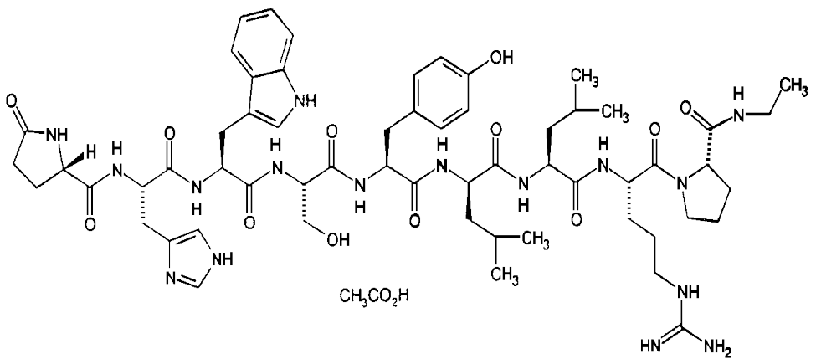
Eligard is a modified release suspension syringe, available in a single use kit. It is supplied as two separate, pre-filled sterile syringes. Syringe A contains a delivery system and Syringe B contains leuprorelin acetate. The two syringes must be joined and the contents mixed until homogenous immediately prior to administration. It is administered subcutaneously where it forms a solid drug delivery depot.
The product pack contents consist of a two-syringe mixing system (Syringes A and B); a 18-gauge 5/8-inch needle, a silica desiccant pouch to control moisture uptake, and package insert for constitution and administration procedures. Each syringe is individually packaged. Syringe B, made of cyclic olefin copolymer and sealed with a chlorobutyl closure, contains aseptically filled, lyophilized leuprorelin acetate. Syringe A, constructed of polypropylene and sealed with a polypropylene or polyethylene cap, contains the Atrigel Delivery System.
Eligard should be stored below 8°C (refrigerate). The patient may store Eligard below 25°C in intact packaging for a period of 8 weeks prior to administration. The shelf-life is 2 years when stored below 8 °C.

Nonclinical
Non-clinical data is generally not required for this type of submission. A full non-clinical evaluation was conducted at the time this product received initial registration.

Clinical

Summary of clinical studies
The clinical dossier mainly consisted of:
- Study TOL2581A: an open-label, single arm, multicentre study of the efficacy, safety and pharmacokinetics of leuprolide acetate 45 mg for injectable suspension, controlled release, in paediatric patients with central precocious puberty.
- Post-market data from a US Food and Drug Administration (FDA) Periodic Adverse Drug Experience Report (PADER) for Fensolvi (leuprolide acetate);⁹ New Drug Application number: 213150, covering the time period of 1 November 2020 to 31 January 2021.
- Australia specific risk management plan.

Pharmacology

Pharmacokinetics
The pharmacokinetics (PK) of leuprorelin acetate (modified release injection) was investigated in Study TOL2581A.

Absorption
Eligard (leuprorelin acetate) 45 mg modified release injection, is administered by subcutaneous injection. It is in a delayed release formulation, with absorption over a six month period.
In an adult population, the mean maximum concentration (C_{max}) is 102.4 ng/mL (standard deviation (SD), 72.1 ng/mL) and time to peak concentration (T_{max}) is 4.75 (SD 2.0) hours. This reflects an initial burst phase following the injection, which is followed by a plateau phase with relatively constant plasma concentration in the range of 0.2 to 2.0 ng/mL.
In a paediatric population from Study TOL2581A, plasma concentrations of leuprorelin were maintained from Week 4 through to Week 44, with some decrease to Week 48 (see Figure 2 below). Following administration of a single subcutaneous injection of leuprorelin acetate 45 mg injectable suspension, the mean serum leuprorelin concentration peaked at mean (SD) 212315 (161806) pg/mL at 4 hours after the injection. After the initial rise occurring immediately after the injection, the mean (SD) serum concentration declined to 633.1 (551.9) pg/mL at 4 weeks post injection. By 12 weeks after the initial dose, mean (SD) serum leuprorelin concentrations declined to 348.8 (1460.6) pg/mL, and remained relatively constant until Week 24 indicating a sustained and constant release of leuprorelin.
Figure 2: Study TOL2581A Plot of mean basal leuprorelin concentration over time population for the revised intention to treat population
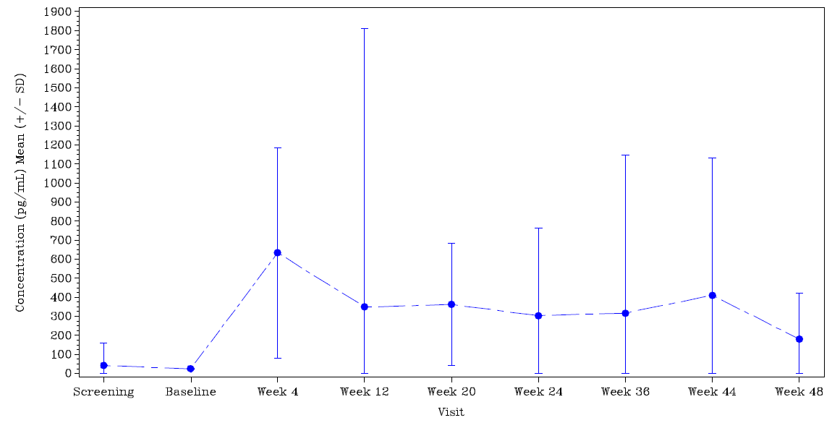
Abbreviations: SD = standard deviation.
Note: The screening time point was excluded for 8 subjects due to improbable concentration values. The Week 12 time point for one subject, and the Week 36 time point for another subject were also excluded due to improbable concentration values.

The mean (SD) PK parameters for exposure (as area under the curve (AUC)), C_{max} and T_{max} are summarised below in Table 2.
Table 2: Study TOL2581A Summary of leuprorelin pharmacokinetic parameters for intention to treat population
Pharmacokinetic parameter | Mean (SD)
AUC_{0-169 days} | 2749931 (2590395) day.pg/mL
AUC_{0-6 hours} | 40894 (30672) day.pg/mL
AUC_{Day 7-Month 6} | 1789780 (2042869) day.pg/mL
AUC_{0-inf,observed} | 2945264 (942347) day.pg/mL
C_{max0-6 hours} | 223155 (171564) pg/mL
C_{max(Injection 1)} | 223155 (171564) pg/mL
C_{max(Injection 2)} | 699 (968) pg/mL
T_{max0-6 hours} | 3.6 (1.41) h
T_{max (Injection 1)} | 3.6 (1.41) h
T_{max(Injection 2)} | 248 (68) day
Abbreviations: AUC = area under the concentration-time curve); AUC0-inf,observed = observed area under the concentration-time curve extrapolated from time zero to infinity; Cmax = maximum concentration; Tmax = time of maximum concentration.

Distribution
The mean steady state volume of distribution of leuprorelin following intravenous bolus administration to healthy male volunteers was 27 L.
The distribution of leuprorelin following Eligard administration was not evaluated in paediatric patients.
In vitro binding to human plasma proteins ranged from 43% to 49%.

Metabolism
In healthy male volunteers, a 1 mg bolus of leuprorelin administered intravenously revealed that the mean systemic clearance was 7.6 L/h, with a terminal elimination half-life of approximately three hours based on a two compartment model.
Drug metabolism studies were not conducted with Eligard. Upon administration with a different leuprorelin acetate formulations, the major metabolite (metabolite M1) of leuprorelin acetate is a pentapeptide.
Clearance was not determined in paediatric patients

Excretion
Drug excretion studies were not conducted with Eligard.

Pharmacodynamics
In Study TOL2581A following administration of leuprorelin acetate 45 mg modified release formulation, serum LH concentrations were suppressed from Week 4 to Week 48 (Figure 3). Mean (SD) basal LH concentrations were 3.48 (9.59) IU/L at Baseline, 0.57 IU/L (0.52) at Week 24 and 0.60 IU/L (0.69) at Week 48.
There were reductions in estradiol, testosterone and FSH that were maintained from Week 4 through to Week 48. Basal FSH concentrations were approximately halved from Baseline levels from Week 4 through to Week 48. Basal estradiol concentrations were also halved, and basal testosterone decreased by 90%.
Figure 3: Plot of mean basal luteinising hormone over time for the revised intention to treat population
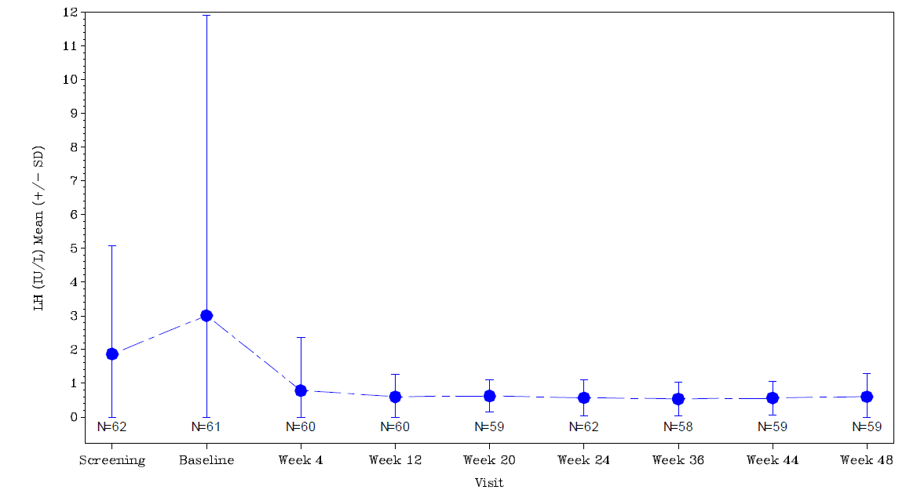
Abbreviations: SD = standard deviation.
Note: Subjects may have had more than one sample done per scheduled visit.

Efficacy
There were no dose ranging studies. However, the PK and pharmacodynamic (PD) data indicate sufficient suppression of pituitary gonadotropin secretion and suppression of estradiol and testosterone secretion at the proposed dosage. The data also indicate an acceptable onset and time course of effect with the proposed dosage. The dose was selected to provide a similar exposure to leuprorelin as is provided with the currently available treatment for central precocious puberty (that is, Lucrin Depot Paediatric leuprorelin acetate 30 mg powder for injection, 3 month administration);⁶ with the additional benefit of a prolonged dosing interval of six months. The prolonged dosing interval was chosen because of the increased acceptability of less frequent dosing (by injections) in the paediatric population. This is considered acceptable.

Study TOL2581A
Study TOL2581A was an open label, single arm, multicentre study of the efficacy, safety, and PK of leuprorelin acetate 45 mg for injectable suspension, controlled release, in patients with central precocious puberty (CCP). The primary objective of the study was to determine the effectiveness of leuprorelin acetate for injectable suspension, 45 mg for treatment of children with CPP. The study duration was 12 months. The study was conducted at 25 sites in six countries, but not all sites successfully recruited patients. The countries and site were as follows: Argentina (one site, 13 patients), Chile (three sites, nine patients), Canada (four sites, two patients), Mexico (two sites, seven patients), USA (12 sites, 31 patients) and New Zealand (three sites, two patients). The study was conducted from August 2015 to September 2018.

Study design
Figure 4, shown below, summarises the design of Study TOL2581A.
Figure 4: Study TOL2581A Study design
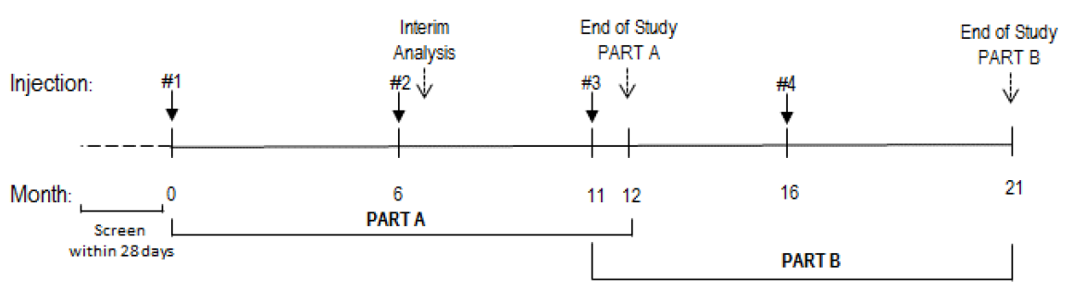
Note: subjects would only receive Injection #3 and #4 if Part B was conducted, based on Part A interim data.

Key inclusion criteria
Key inclusion criteria were:
- Females aged 2 to 8 years (inclusive) or males aged 2 to 9 years (inclusive)
- Confirmed diagnosis of CPP within 12 months of Baseline Visit (Day 0) but had not received prior GnRH agonist treatment for CPP
- Pubertal type LH response following an abbreviated gonadotropin releasing hormone agonist (GnRHa) stimulation test before treatment initiation greater than 5 IU/L
- Clinical evidence of puberty, defined as Tanner stage, ≥ 2 for breast development in females or testicular volume ≥ 4 mL in males
- Willing and able to participate in the study
- Difference between bone age (Greulich and Pyle method); and chronological age ≥ 1 year
- Signed Institutional Review Board/Independent Ethics Committee approved Informed Consent Form by one or both parents (per Institutional Review Board/Independent Ethics Committee requirements), by the custodial parent or by the legal guardians (if required)
- Signed Assent by subjects as per Institutional Review Board/Independent Ethics Committee requirements

Key exclusion criteria
Key exclusion criteria consisted of:
- Gonadotropin independent (peripheral) precocious puberty: extra pituitary secretion of gonadotropins or gonadotropin independent gonadal or adrenal sex steroid secretion
- Prior or current GnRH treatment for CPP
- Non-progressing isolated premature thelarche (that is, the appearance of breast development in girls)
- Presence of an unstable intracranial tumour or an intracranial tumour requiring neurosurgery or cerebral irradiation. Subjects with hamartomas not requiring surgery were eligible
- Any other condition, chronic illness, or treatment that, in the opinion of the investigator, might have interfered with growth or other study endpoints for example, chronic steroid use (except mild topical steroids), renal failure, diabetes, moderate to severe scoliosis, previously treated intracranial tumour
- Prior or current therapy with medroxyprogesterone acetate, growth hormone or insulin-like growth factor 1
- Major medical or psychiatric illness that could have interfered with study visits
- Diagnosis of short stature that is, 2.25 SD below the mean height for age
- Positive urine pregnancy test.

Study treatments
The study treatment was: Eligard leuprorelin acetate 45 mg modified release formulation. Two doses were given, the first on Day 0, and the second on Week 24. Administered as a subcutaneous injection into the abdominal area.
There was no comparator or placebo treatment.

Efficacy variables and outcomes
The primary efficacy outcome variable was the percentage of subjects with serum LH concentrations less than 4 IU/L at 30 minutes following an abbreviated GnRHa stimulation test at Month 6.
The secondary efficacy outcome measures were:
- The percentage of subjects with serum LH concentrations less than 4 IU/L at 30 minutes following an abbreviated GnRHa stimulation test for any available measurement other than the measurement constituting the primary outcome variable
- The percent change from Baseline in height at each available post-baseline measurement. Percent change was defined as follows:
  - (change from Baseline / Baseline) x 100
- The growth velocity of height in cm/year at each available post-Baseline measurement. Growth velocity was defined for each visit as:
  - change from Baseline / (number of weeks since Baseline / 52)
- The ratio of bone age at each given measurement point to chronological age at the same measurement points
- Baseline to end of study stage shifts for each Tanner category;¹⁰
- The percent change from Baseline in hormonal concentration (LH, FSH, testosterone, and estradiol) at each available post Baseline measurement. Percent change was defined as:
  - (change from Baseline / Baseline) x 100
- The percent change from Baseline in systemic leuprorelin concentration at each available post-baseline measurement. Percent change was defined as:
  - (change from Baseline / Baseline) x 100.

Statistical methods
The study was open label and there was no randomisation or blinding. The sponsor states that the expected final sample size was to be between 25 and 50 subjects. Suppression to less than 4 IU/L in 70% of the subjects was considered to be clinically important. Thus the sample size was thought to be adequate.
The statistical methods were summary statistics and changes from Baseline. Leuprorelin acetate for injectable suspension, 45 mg, was considered effective for the treatment of children with CPP if greater than or equal to 80% of subjects exhibited LH suppression less than 4 IU/L at Visit 5, Week 24 (Month 6) visit.
For calculation of mean serum concentrations and generation concentration time profiles for LH, FSH, estradiol and testosterone, all values below the limit of quantitation or detection were set to the lower limit for that assay.
If a missing concentration datum was surrounded by non-missing values, interpolation was used in the calculation of exposure (AUC), C_{max} and T_{max}. Otherwise, the nearest non-missing point in time was used. If missing date and time values were evident in data not used to develop PK parameters, a missing date and time algorithm could be applied.

Study results
There were 114 patients screened and 64 received study drug and 50 patients who failed screening.
There were 62 (96.9%) treated patients who were included in the intention to treat (ITT) population and 60 (93.8%) treated patients completed the study. Four (6.2%) patients terminated early: one for lack of efficacy, one for a change in the patient’s condition, one for a protocol deviation and one due to excessive blood collections.
No patients withdrew because of adverse events. There were 43 (67.2%) patients included in the per protocol population.

Baseline data
In the ITT population, there were 62 (96.9%) females, two (3.1%) males and the age range was 4 to 9 years. All patients had a pubertal type LH response (greater than 5 IU/L) before treatment initiation, in the abbreviated GnRHa stimulation test. All 62 enrolled girls had a Tanner stage¹⁰ of 2 or higher for breast development and both boys in the study had a Tanner stage of 3 for development of external genitalia at Baseline. For one patient, the difference between bone age (using the Greulich and Pyle method);¹¹ and chronological age was less than one year.
There were 173 medical conditions other than CPP reported in 40 (62.5%) patients. Some of these were underlying conditions that may lead to CPP, such as characteristics of McCune Albright syndrome and central nervous system disorders. The most frequently reported ongoing medical conditions were asthma (eight patients), constipation (five patients), headache (five patients), seasonal allergy (five patients), acne (four patients) and eczema (four patients).
Study treatment was administered by study staff, and therefore supervised.

Primary efficacy outcome
There were 62 patients in the ITT population at the six month visit, of whom 54 responded (see Table 3, below). The success rate was 87.1%. In the per protocol population, 37 of 43 patients responded to treatment; the success rate was 86.0%.
At Week 48, 50 (86.2%) of 58 patients in the ITT population had responded to treatment.
Table 3: Study TOL2581A Summary of serum luteinising hormone suppression response for the intention to treat population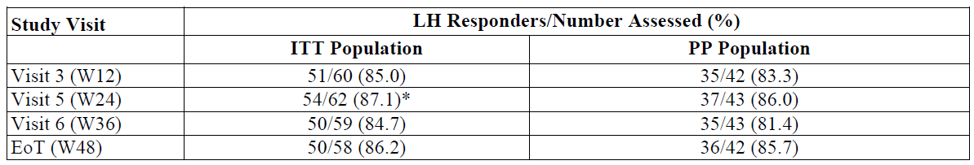
Abbreviations: EoT = end of treatment; ITT = intention to treat; LH = luteinising hormone; PP = per protocol; W = week,.
Asterisk (*) denotes the primary endpoint.
Note: Response is defined as serum LH concentrations < 4 IU/L at 30 minutes following an abbreviated GnRHa stimulation test. Subjects may have had more than one sample assessed per scheduled visit.
For the primary efficacy outcome the sponsor has provided the (exact) 95% confidence intervals (CI) as follows:
- ITT population:
  - 95% CI lower limit: 0.7615 (76.1%)
  - 95% CI upper limit: 0.9426 (94.3%)
- Per protocol population:
  - 95% CI lower limit: 0.7207 (72.1%)
  - 95% CI upper limit: 0.9470 (94.7%)

Results for secondary efficacy outcomes
The percentage of subjects with serum LH concentrations less than 4 IU/L at 30 minutes following an abbreviated GnRHa Stimulation Test for any available measurement other than the measurement constituting the primary outcome variable is summarised in Table 3, shown above.
There was an increase in mean height at each time point as shown in Table 4.
Table 4: Study TOL2581A Summary of standing height for the intention to treat population
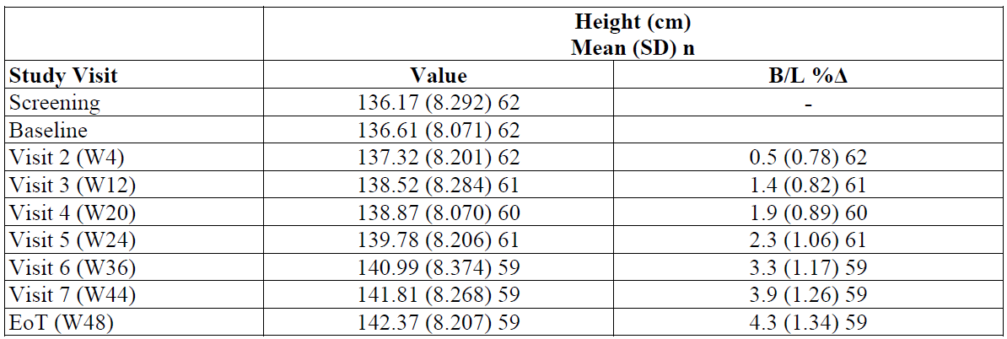
Abbreviations: B/L = baseline; B/L %Δ = percentage change from Baseline; cm = centimetres; EoT = end of treatment; SD = standard deviation; W = week.
Note: Baseline is defined as the last non-missing height measurement collected prior to or on the date of first injection. Percent change from Baseline is: 100 x (the change from Baseline value at the post-baseline visit / baseline value).
The growth velocity was maintained during the study period at greater than 6 cm/year from Baseline, as summarised in Table 5.
Table 5: Study TOL2581A Summary of growth velocity for the intention to treat population
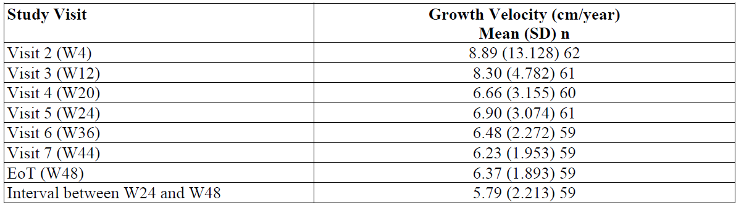
Abbreviations: B/L = baseline; cm = centimetres; EoT = end of treatment; SD = standard deviation; W = week.
Note: Growth velocity is defined for each visit as change from Baseline / ([number of weeks since baseline]/52). For the interval between Week 24 and Week 48, growth velocity is defined as change from Week 24 to Week 48 / ([number of weeks since week 24]/52).
Bone age was constant in relation to chronological age during the treatment period, as shown below in Table 6. The mean (SD) ratio of bone age to chronological age was 1.39 (0.160) at Baseline, 1.34 (0.138) at Week 24 and 1.32 (0.143) at Week 48.
Table 6: Study TOL2581A Summary of bone age ratio and bone age for the intention to treat population
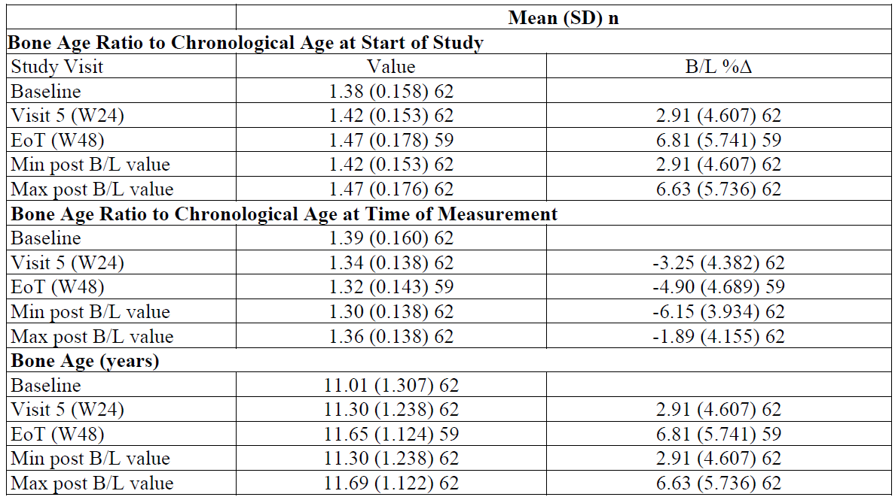
Abbreviations: B/L = baseline; B/L %Δ = percentage change from Baseline; cm = centimetres; EoT = end of treatment; SD = standard deviation; W = week.
Note: Percent change from Baseline is: 100 x (the change from Baseline value at the post-baseline visit / baseline value). Bone Age Ratio to Chronological Age at Start of Study is bone age/age at first injection. Bone Age Ratio to Chronological Age at Time of Measurement is bone age/age at bone age assessment.
Mean Tanner stage¹⁰ decreased during the study, as shown below in Table 7.
Table 7: Study TOL2581A Summary of Tanner Stages for the intention to treat population
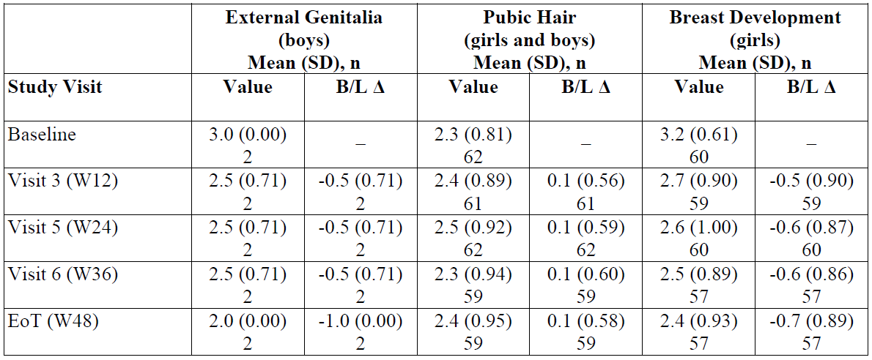
Abbreviations: B/L Δ = change from Baseline; SD = standard deviation; W = Week.
The percent change from Baseline in hormonal concentration (LH, FSH, testosterone, and estradiol) at each available post-baseline measurement was reported as a PD outcome.
The percent change from Baseline in systemic leuprorelin concentration at each available post-baseline measurement was reported as a PK outcome.
Suppression of FSH at Week 24 was achieved by 41 (66.1%) patients, estradiol by 59 (98.3%) patients and testosterone by two (100%) patients. Suppression of FSH at Week 48 was achieved by 32 (55.2%) patients, estradiol by 56 (100%) patients and testosterone by one (50%) patient.

Safety

Study TOL2581A
There was one pivotal efficacy study, Study TOL2581A, where safety data were also reported. In Study TOL2581A there were 64 patients who received at least one dose of leuprorelin acetate 45 mg, and 60 patients who received a second dose.
Treatment-emergent adverse events (TEAEs) were reported in 53 (82.8%) patients. The most commonly reported TEAEs were: injection site pain in 20 (31.3%) patients, nasopharyngitis in 14 (21.9%), pyrexia in 11 (17.2%) and headache in 10 (15.6%) patients.
There were no deaths. There were two serious adverse events both reported in one patient; these were wheezing, and rash.
There were no TEAEs resulting in study discontinuation. One (1.6%) patient discontinued/interrupted treatment due to a TEAE listed as drug administration error.
One patient had elevated alanine transaminase and elevated gamma glutamyl transferase levels which resolved and were not attributed to treatment.
The safety data were limited by the small number of patients who have been exposed to leuprorelin acetate 45 mg. There were less than 500 patients exposed to leuprorelin acetate 45 mg for CPP in the data presented in the sponsor’s dossier. The follow up period for these patients was less than or equal to 12 months. Hence, uncommon and rare adverse reactions will not have been identified in the data.
No abnormalities in renal function were reported.
There were no abnormalities in endocrine assays that were reported as adverse events.
There were decreases in mean heart rate, respiratory rate, systolic blood pressure and diastolic blood pressure from Baseline that might reflect children becoming more comfortable with the clinic visits. There was an increase in mean weight over the course of the study: 8.26% to Week 24 and 15.44% to Week 48. A summary of vital sign measurements is shown in Table 8, below.
Table 8: Study TOL2581A Summary of vital sign measurements for the safety population
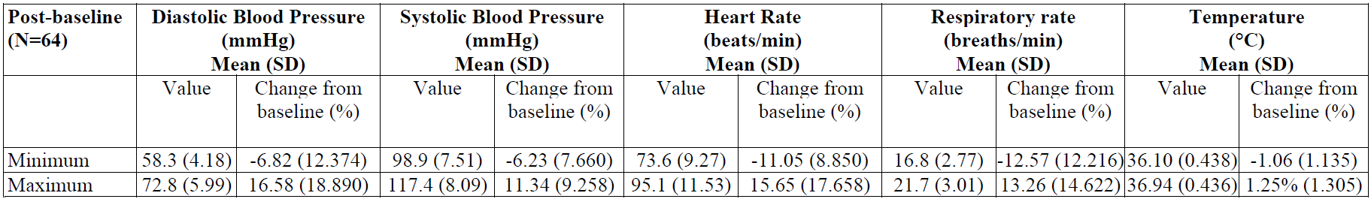
Abbreviation: SD = standard deviation.
Note: Baseline is defined as the last non-missing assessment done prior to or on the date of first injection. The mean minimum and maximum values are taken from measurements across all visits. All other changes in assessment values were within approximately 10% of baseline.

Post marketing experience
Post-market data was supplied from a US Food and Drug Administration (FDA) Periodic Adverse Drug Experience Report (PADER) for Fensolvi (leuprolide acetate);^{9,} New Drug Application number: 213150, covering the time period of 1 November 2020 to 31 January 2021.
Post-marketing data do not indicate any emerging safety concerns.

Risk management plan
The Australian risk management plan (RMP) version 0.2 (dated 7 April 2022; data-lock point 20 April 2021) was evaluated.
The summary of safety concerns and their associated risk monitoring and mitigation strategies are summarised in Table 9. Further information regarding the TGA’s risk management approach can be found in risk management plans for medicines and biologicals and the TGA's risk management approach.
Table 9: Summary of safety concerns
Summary of safety concerns |  | Pharmacovigilance |  | Risk minimisation
 |  | Routine | Additional | Routine | Additional
Important identified risks | Initial rise in gonadotropin and sex steroid levels |  | – |  | –
Important identified risks | Psychiatric events |  |  |  | –
Important identified risks | Convulsions |  | – |  | –
Important potential risks | Medication error leading to lack of efficacy |  | – | * | –
Missing Information | None | – | – | – | –
*Pack insert mixing procedure
The sponsor has confirmed that ‘Medication error’ (that is, handling errors) will be identified as an issue of special concern in the periodic safety update report (PSUR).
There are no new or outstanding RMP recommendations.

Risk management plan evaluator recommendations regarding conditions of registration

Wording for conditions of registration
Any changes to which the sponsor has agreed should be included in a revised RMP and Australia specific annex. However, irrespective of whether or not they are included in the currently available version of the RMP document, the agreed changes become part of the risk management system.
The suggested wording is:
The Eligard AU-Risk Management Plan (RMP) (version 0.2, dated 7 April 2022, data lock point 20 April 2021), included with submission PM-2021-01406-1-5, and any subsequent revisions, as agreed with the TGA will be implemented in Australia.
The following wording is recommended for the PSUR:
An obligatory component of risk management plans is routine pharmacovigilance. Routine pharmacovigilance includes the submission of periodic safety update reports (PSURs).
Reports are to be provided in line with the current published list of EU reference dates and frequency of submission of PSURs until the period covered by such reports is not less than three years from the date of this approval letter.
The reports are to at least meet the requirements for PSURs as described in the European Medicines Agency’s Guideline on good pharmacovigilance practices (GVP) Module VII-periodic safety update report (Rev 1), Part VII.B Structures and processes. Note that submission of a PSUR does not constitute an application to vary the registration.
As the indications for Eligard are being extended into a significantly different population and condition it should be included in the Black Triangle Scheme as a condition of registration. The following wording is recommended for the condition of registration:
Eligard (leuprorelin acetate) is to be included in the Black Triangle Scheme. The PI and CMI for Eligard must include the black triangle symbol and mandatory accompanying text for five years, which starts from the date the new indication is registered.

Risk-benefit analysis

Delegate’s considerations

Efficacy
The pharmacokinetics (PK) of Eligard (leuprorelin acetate) 45 mg modified release injection, to be given a once every 6 months injection (Eligard 6 month) in the paediatric population and in the proposed usage have been adequately characterised. The submitted data demonstrate adequate, and sustained exposure to leuprorelin over a six month period. The data indicate no significant accumulation with a second dose.
The data were not suitable for determining clearance or half-life. The formulation and release characteristics of Eligard (Eligard 6 month) result in a constant infusion of leuprorelin, but as the rate of infusion is not identifiable with the data presented in Study TOL2581A, neither is the rate of elimination. This is considered acceptable as exposure to leuprorelin is the main consideration for this application.
The pharmacodynamics (PD) of Eligard (Eligard 6 month) in the paediatric population and in the proposed usage have been adequately characterised. The submitted data demonstrate onset and time course of effect. The data indicate suppression of pituitary gonadotropin secretion and suppression of estradiol and testosterone secretion.
There were no dose ranging studies. However, the PK and PD data indicate sufficient suppression of pituitary gonadotropin secretion and suppression of estradiol and testosterone secretion at the proposed dosage. The data also indicate acceptable onset and time course of effect with the proposed dosage.
It appears that it would have been difficult to design a blinded study. The delivery system for Eligard does not enable a placebo to be developed. There is a two syringe system that requires mixing immediately prior to administration. This means that blinding of investigators and participants to treatment would not be possible. This is considered acceptable.
The study inclusion criteria are in alignment with diagnostic criteria for central precocious puberty (CPP), hence, the study population were representative of the target population in Australia. The study treatment was administered at the same dose and in the same manner as that proposed in Australia. This is considered acceptable.
While the study only included two males, the ratio of boys to girls in the study population is comparable to the general population of children with CPP. Organic forms of CPP are common in males, but study eligibility excluded intracranial tumours making the final enrolled population highly likely to have idiopathic CPP and more weighted toward females.
Efficacy can be extrapolated from females to males because the underlying mechanism of CPP (dysfunction of the hypothalamic pituitary gonadal axis) is the same for both sexes and suppression of luteinising hormone (LH) is a direct measure of the pharmacological effect of leuprorelin acetate on the hypothalamic pituitary gonadal axis, regardless of sex. Treatment of CPP is the same for both males and females; in other studies, evaluating gonadotrophin release hormone (GnRH) agonists in patients with CPP, no major differences in efficacy have been observed related to patient sex. This is considered acceptable.
The outcome measures reflected diagnostic and monitoring criteria for CPP. The primary outcome measure was the outcome that is used to determine the presence of CPP. Hence, the principal outcome measure reflects clinical practice. The sample size calculation was based on demonstrating success greater than 70%. The proportion (95% confidence intervals (CI)) for success was 87.1 (76.1 to 94.3) % (using Stata Version 16 software to calculate the 95% CIs for proportions), hence, using this approach, the study demonstrated an acceptable response rate. This is considered acceptable.
In summary, in the primary analysis, 87% of patients achieved pre-pubertal levels of GnRH stimulated LH (less than 4 IU/L) at 24 weeks, and a similar level of LH suppression (86%) was also seen at 48 weeks. Secondary efficacy endpoints supported the primary endpoint findings. Consistent with suppression of LH, estradiol levels were decreased to pre-pubertal levels in 98% and 100% of girls at 24 and 48 weeks, respectively, and testosterone was decreased to pre-pubertal levels in the two boys in the study at 24 weeks, although one boy had an increase in testosterone to just above the pre-pubertal level at Week 48. In addition, growth velocity, which is accelerated in CPP, was consistently decreased from Baseline at both 24 and 48 weeks and there was limited further pubertal maturation as measured by Tanner staging;¹⁰ in both girls and boys.
Overall, the study provides evidence of efficacy in the proposed usage in Australia. The study has demonstrated a success rate of 87.1% in arresting puberty for a 12 month period in the target population.

Safety
Eligard (leuprorelin acetate) 45 mg modified release injection (as a once every 6 month injection) has a favourable safety profile. Treatment-emergent adverse events (TEAEs) were related to administration site pain or common paediatric conditions. Treatment related TEAEs were predominantly related to administration site pain. There were no deaths. There were no serious adverse events attributed to study treatment. The most frequently reported GnRH antagonist-like reaction was injection site pain, reported by nine (15.3%) patients after the first injection and 15 (26.3%) patients after the second injection. Flares or hot flashes were reported by four (6.8%) patients following the first injection. Post-marketing data do not indicate any emerging safety concerns.

Proposed action
Overall, the study provides evidence of efficacy in the proposed usage in Australia. The study has demonstrated a success rate of 87.1% in arresting puberty for a 12 month period in the target population. Eligard (leuprorelin acetate) 45 mg modified release injection (as a 6 monthly injection (Eligard 6 month)) has a success rate of 87.1% after the first dose and 86.2% after the second. Hence Eligard 6 month appears to have acceptable efficacy for treating CPP.
Eligard 6 month has a favourable safety profile. Adverse events were predominantly related to injection site pain or common childhood conditions. There were no deaths or serious adverse events attributable to study treatment.
Overall, the Delegate considers that the benefit risk balance of Eligard 6 month is favourable in the following indication:
Eligard 45 mg 6 month is indicated for the treatment of children 2 years of age and older with central precocious puberty (CPP).

Advisory Committee considerations
The Advisory Committee on Medicines (ACM) having considered the evaluations and the Delegate’s overview, as well as the sponsor’s response to these documents, advised the following.

Specific advice to the Delegate
- Please comment on the revised indication:
Eligard 45 mg 6 month is indicated for the treatment of children 2 years of age and older with central precocious puberty (CPP).
The ACM was supportive of the revised indication as below:
Eligard 45 mg 6 month is indicated for the treatment of children 2 years of age and older with central precocious puberty (CPP).
It was noted that the wording of this indication is consistent with the results of the provided clinical trial. The ACM also agreed with the inclusion of ‘2 years of age and older’ noting that CPP is rare before the age of 2 years.
The ACM acknowledged the importance of a clear CPP diagnosis prior to initiation of treatment. To aid in diagnosis and reduce misuse the ACM agreed that CPP must be clearly defined within the PI. The ACM suggested the following definition:
Clinical and biochemical evidence of onset of breast development in girls < 8 years or bilateral testicular enlargement > 4 mL in boys < 9 years plus raised LH/FSH, oestradiol or testosterone.
While the ACM agreed that the CPP definition does not need to be included within the indication, it was strongly emphasised that it must be prominent within the PI.
- The committee is also requested to provide advice on any other issues that it thinks may be relevant to a decision on whether or not to approve this application
The ACM highlighted the importance of establishing a cause of CPP before administering treatment and agreed that endocrinologists would be aware of this requirement. The ACM noted that 70% of all CPP in males has an identified organic cause compared to 10% in females, the remainder of cases are functional (with emerging evidence of genetic associations) in origin. The ACM suggested a statement regarding this be included within the PI to assist with establishing causality.
The ACM also discussed administration challenges associated with the use of Eligard and noted that clinicians administrating this treatment must clearly understand the full mixing and administration process prior to preparation. The ACM highlighted that Eligard must be administered immediately following preparation. The ACM agreed that this process must be clearly outlined to clinicians to ensure accurate delivery of the dose.

Conclusion
The ACM considered this product to have an overall positive benefit risk profile for the indication:
Eligard 45 mg 6 month is indicated for the treatment of children 2 years of age and older with central precocious puberty (CPP).

Outcome
Based on a review of quality, safety, and efficacy, the TGA approved the registration of Eligard leuprorelin acetate 45 mg modified release injection syringe (Eligard 6 month) indicated for the following extension of indications:
Central precocious puberty (CPP)
Eligard 45mg 6 month is indicated for the treatment of children 2 years of age and older with central precocious puberty (CPP).
As such, the full indications at this time were:
Prostate cancer
Eligard 7.5 mg 1 month, Eligard 22.5 mg 3 month, Eligard 30 mg 4 month and Eligard 45 mg 6 month are indicated for the:
Palliative treatment of advanced prostate cancer.
Treatment of high-risk localised and locally advanced hormone-dependent prostate cancer in combination with radiotherapy.
Central precocious puberty (CPP)
Eligard 45 mg 6 month is indicated for the treatment of children 2 years of age and older with central precocious puberty (CPP).

Specific conditions of registration applying to these goods
- Eligard (leuprorelin acetate) is to be included in the Black Triangle Scheme. The PI and CMI for Eligard must include the black triangle symbol and mandatory accompanying text for five years, which starts from the date the new indication is registered.
- The Eligard AU-Risk Management Plan (RMP) (version 0.2, dated 7 April 2022, data lock point 20 April 2021), included with submission PM-2021-01406-1-5, and any subsequent revisions, as agreed with the TGA will be implemented in Australia.
An obligatory component of risk management plans is routine pharmacovigilance. Routine pharmacovigilance includes the submission of periodic safety update reports (PSURs).
Reports are to be provided in line with the current published list of EU [European Union] reference dates and frequency of submission of PSURs until the period covered by such reports is not less than three years from the date of this approval letter.
The reports are to at least meet the requirements for PSURs as described in the European Medicines Agency’s Guideline on good pharmacovigilance practices (GVP) Module VII-periodic safety update report (Rev 1), Part VII.B Structures and processes. Note that submission of a PSUR does not constitute an application to vary the registration.
- For all injectable products the Product Information must be included with the product as a package insert.

Attachment 1. Product Information
The PI for Eligard approved with the submission which is described in this AusPAR is at Attachment 1. For the most recent PI, please refer to the TGA PI/CMI search facility.
.

Therapeutic Goods Administration
PO Box 100 Woden ACT 2606 Australia
Email: info@tga.gov.au Phone: 1800 020 653 Fax: 02 6232 8605
https://www.tga.gov.au

The Black Triangle Scheme provides a simple means for practitioners and patients to identify certain types of new prescription medicines, including those being used in new ways and to encourage the reporting of adverse events associated with their use. The Black Triangle does not denote that there are known safety problems, just that the TGA is encouraging adverse event reporting to help us build up the full picture of a medicine's safety profile.
Latronico AC, Brito VN, Carel J-C. Causes, diagnosis, and treatment of central precocious puberty. Lancet Diabetes Endocrinol 2016; 4: 265–74
Antoniazzi F, Zamboni G. Central precocious puberty: current treatment options. Paediatr Drugs. 2004;6(4):211-31.
Fuqua JS. Treatment and outcomes of precocious puberty: an update. J Clin Endocrinol Metab. 2013 Jun;98(6):2198-207.
Herman-Giddens ME, Slora EJ, Wasserman RC, et al. Secondary sexual characteristics and menses in young girls seen in office practice: a study from the Pediatric Research in Office Settings network. Pediatrics. 1997;99(4):505-512.
Lucrin Depot (leuprorelin acetate) 30 mg powder for injection prefilled dual chamber syringe, Abbvie Pty Ltd was first registered on the ARTG in Australia on 13 October 2014 (AUST R 218936).
Diphereline (triptorelin (as embonate) 22.5 mg powder for suspension vial and water for injections ampoule, Ipsen Pty Ltd was first registered on the ARTG in Australia on 27 July 2010 (AUST R 159173).
An AusPAR for Eligard extension of indications for treatment of high-risk localised and locally advanced hormone-dependant prostrate cancer submission PM-2016-02330-1-4 is available at https://www.tga.gov.au/resources/auspar/auspar-leuprorelin
Note the International Non-proprietary Name (INN) for this drug, as used in Australia, is leuprorelin. Leuprolide is an alternative (United Stated Adopted Name (USAN)) name used in the USA and some other regions overseas. Except for name, leuprorelin and leuprolide are the same drug.
The Tanner scale (also known as the Tanner stages or sexual maturity rating (SMR)) is an objective classification system documenting the physical development of secondary sex characteristics of children during puberty (that is, from the onset of adolescence and into adulthood). Tanner Stage 1 corresponds to the pre-pubertal form for all three sites of development with progression to Tanner Stage 5, the final adult state.
The Greulich and Pyle method is used to assess the bone age of children. A bone age assessment require a left hand and wrist radiograph. The Greulich and Pyle method makes use of a standard bone age atlas that the reporter can compare their image to and make an estimation of bone age.
Fensolvi is a tradename in the USA for leuprolide (leuprorelin) acetate for injectable suspension (extended release) made by Tolmar International Limited (USA).

