March 2023

Australian Public Assessment Report for Dupixent
  - Active ingredient: Dupilumab
  - Sponsor: Sanofi-Aventis Australia Pty Ltd

About the Therapeutic Goods Administration (TGA)
- The Therapeutic Goods Administration (TGA) is part of the Australian Government Department of Health and is responsible for regulating therapeutic goods, including medicines, medical devices, and biologicals.
- The TGA administers the Therapeutic Goods Act 1989 (the Act), applying a risk management approach designed to ensure therapeutic goods supplied in Australia meet acceptable standards of quality, safety, and efficacy.
- The work of the TGA is based on applying scientific and clinical expertise to decision-making, to ensure that the benefits to the Australian public outweigh any risks associated with the use of therapeutic goods.
- The TGA relies on the public, healthcare professionals and industry to report problems with therapeutic goods. The TGA investigates reports received to determine any necessary regulatory action.
- To report a problem with a therapeutic good, please see the information on the TGA website.

About AusPARs
- The Australian Public Assessment Report (AusPAR) provides information about the evaluation of a prescription medicine and the considerations that led the TGA to approve or not approve a prescription medicine submission. Further information can be found in Australian Public Assessment Report (AusPAR) guidance.
- AusPARs are prepared and published by the TGA.
- AusPARs are static documents that provide information that relates to a submission at a particular point in time. The publication of an AusPAR is an important part of the transparency of the TGA’s decision-making process.
- A new AusPAR may be provided to reflect changes to indications or major variations to a prescription medicine subject to evaluation by the TGA.

Copyright
© Commonwealth of Australia 2023
This work is copyright. You may reproduce the whole or part of this work in unaltered form for your own personal use or, if you are part of an organisation, for internal use within your organisation, but only if you or your organisation do not use the reproduction for any commercial purpose and retain this copyright notice and all disclaimer notices as part of that reproduction. Apart from rights to use as permitted by the Copyright Act 1968 or allowed by this copyright notice, all other rights are reserved, and you are not allowed to reproduce the whole or any part of this work in any way (electronic or otherwise) without first being given specific written permission from the Commonwealth to do so. Requests and inquiries concerning reproduction and rights are to be sent to the TGA Copyright Officer, Therapeutic Goods Administration, PO Box 100, Woden ACT 2606 or emailed to <tga.copyright@tga.gov.au>.

Contents
List of abbreviations 4
Product submission 6
Submission details 6
Product background 8
Regulatory status 10
Product Information 12
Registration timeline 12
Submission overview and risk/benefit assessment 13
Quality 13
Nonclinical 14
Clinical 14
Risk management plan 31
Risk-benefit analysis 32
Outcome 37
Specific conditions of registration applying to these goods 38
Attachment 1. Product Information 38

List of abbreviations
Abbreviation |  | Meaning
ACM | Advisory Committee on Medicines
ADA | Anti-drug antibody
ARTG | Australian Register of Therapeutic Goods
AUC | Area under the concentration-time curve
CI | Confidence interval
C_{max} | Maximum concentration
C_{max,ss} | Maximum concentration at steady state
CMI | Consumer Medicines Information
CRSwNP | Chronic rhinosinusitis with nasal polyposis
C_{trough} | Trough concentration
C_{trough.ss} | Trough concentration at steady state
E-R | Exposure-response
FeNO | Fractional exhaled nitric oxide
FEV1 | Forced expiratory volume in 1 second
GINA | Global Initiative for Asthma
ICS | Inhaled corticosteroid
Ig | Immunoglobulin
IL | Interleukin
IL-4R | Interleukin-4 receptor
IL-4Rα | Interleukin-4 receptor alpha subunit
ITT | Intention to treat
LABA | Long-acting beta 2 agonist
MedDRA | Medical Dictionary for Regulatory Activities
PI | Product Information
PK | Pharmacokinetic(s)
PopPK | Population pharmacokinetic(s)
ppb | Parts per billion
PT | Preferred Term
PY | Patient-year(s)
RMP | Risk management plan
SAE | Serious adverse event
SC | Subcutaneous
SOC | System Organ Class
TGA | Therapeutic Goods Administration
TEAE | Treatment-emergent adverse event

Product submission

Submission details
Type of submission: | Extension of indications and major variation (new strength)
Product name: | Dupixent
Active ingredient: | Dupilumab
Decision: | Approved
Date of decision: | 23 June 2022
Date of entry onto ARTG: | 29 June 2022
ARTG numbers: | 283127, 302463 and 364590
Black Triangle Scheme: | Yes  This product will remain in the scheme for 5 years, starting on the date the new indication was approved.
Sponsor’s name and address: | Sanofi-Aventis Australia Pty Ltd  12-24 Talavera Road  Macquarie Park NSW 2113
Dose form: | Solution for injection
Strengths: | 100 mg/0.67 mL (150 mg/mL)  200 mg/1.14 mL (175 mg/mL)  300 mg/2 mL (150 mg/mL)
Container: | Pre-filled syringe with needle shield
Pack sizes: | 100 mg/0.67 mL: 1, 2, 3 and 6 syringes  200 mg/1.14 mL: 1, 2, 3 and 6 syringes  300 mg/2 mL: 1, 2, 3 and 6 syringes  Starter packs registered for 200 mg/1.14 mL and 300 mg/2 mL strengths, each containing either one or 2 syringes
Approved therapeutic use: | Asthma  Dupixent is indicated as add on maintenance treatment in patients aged 6 years and older with moderate to severe asthma with type 2 inflammation (elevated eosinophils or elevated FeNO) that is inadequately controlled despite therapy with other medicinal products for maintenance treatment (see Section 5.1 Pharmacodynamic Properties – Clinical Trials).
Route of administration: | Subcutaneous
Dosage: | Asthma  Dupixent treatment should be prescribed by a specialist experienced in the diagnosis and treatment of asthma including paediatric specialists.  Maintenance treatment should be optimised prior to commencement of and during therapy with Dupixent.  Paediatric patients (6 to 11 years of age)  The recommended dose of Dupixent for paediatric patients 6 to 11 years of age is specified below [reproduced from Table 2 of the Product Information].  Dose of Dupixent for subcutaneous administration paediatric patients 6 to 11 years of age with asthma  For paediatric patients (6-11 years old) with asthma and co-morbid severe atopic dermatitis, the recommended dose should be followed in Table 1 [of the Product Information].  For further information regarding dosage, refer to the Product Information.
  Body weight | Initial and subsequent doses
  15 to < 30 kg | 100 mg every other week (q2w) or  300 mg every four weeks (q4w)
  30 to < 60 kg | 200 mg every other week (q2w) or  300 mg every four weeks (q4w)
  ≥ 60 kg | 200 mg every other week (q2w)
Pregnancy category: | B1  Drugs which have been taken by only a limited number of pregnant women and women of childbearing age, without an increase in the frequency of malformation or other direct or indirect harmful effects on the human fetus having been observed.  Studies in animals have not shown evidence of an increased occurrence of fetal damage.  The use of any medicine during pregnancy requires careful consideration of both risks and benefits by the treating health professional. This must not be used as the sole basis of decision making in the use of medicines during pregnancy. The TGA does not provide advice on the use of medicines in pregnancy for specific cases. More information is available from obstetric drug information services in your State or Territory.

Product background
This AusPAR describes the submission by Sanofi-Aventis Australia Pty Ltd (the sponsor) to register Dupixent (dupilumab) 200 mg/1.14 mL, solution for injection (pre-filled syringe); and Dupixent (dupilumab) 300 mg/2 mL, solution for injection (pre-filled syringe), for following proposed extension of indications:
Dupixent is indicated as add on maintenance treatment in patients aged 6 years and older with moderate to severe asthma with type 2 inflammation (elevated eosinophils or elevated FeNO).
Dupixent is indicated as an add on maintenance therapy for oral corticosteroid dependent asthma.
This extension of indications is a broadening of the currently approved treatment of asthma indication to include the treatment of children from 6 to 11 years of age (see Regulatory status for further information).
In addition, for the proposed new indication shown above and the existing indications approved in Australia (see Regulatory status for further information), the sponsor has proposed to register a new strength product as follows:
Dupixent (dupilumab) 100 mg/0.67 mL, solution for injection (pre-filled syringe).

Asthma with type 2 inflammation
Asthma is a chronic inflammatory airway disease characterised by airway inflammation and bronchial hyper-responsiveness (bronchoconstriction), with recurrent episodes of airway obstruction, breathlessness, wheeze and cough.,
Genetic factors related to the development and severity of asthma include specific human leukocyte antigen (HLA) haplotypes; and polymorphisms in genes encoding for, or related to, interleukin (IL) 4, immunoglobulin type E (IgE), CD14, T cell receptor alpha (TCRα), and the ADAM33 gene.,,,
Modifying environmental factors include infections, aeroallergens, animals, day care and environmental triggers such as atmospheric pollutants and viral infections.
Interactions between genetic and environment factors and triggers lead to an increased expression and response of CD4⁺ T helper 2 cells which leads to B cell switching to IgE, eosinophil and basophil recruitment and mast cell differentiation., This in turn causes airway hyperreactivity, mucous hypersecretion, epithelial damage and fibrosis (including matrix metalloproteinases), and airway smooth muscle hypertrophy, leading to the characteristic symptoms of asthma.¹⁰

Current treatment options
The cornerstone of treatment for people with asthma is with regular daily use of an inhaled corticosteroid (ICS) as a controller therapy, and a beta 2 agonist.^{2,} In patients with asthma with type 2 inflammation that cannot be adequately controlled with maximum permitted doses of ICS and long acting beta 2 agonists (LABA) add on treatments can be given. These add-on treatments include anti-Ig E agents (such as omalizumab), anti-IL 5/5 receptor agents (mepolizumab and benralizumab for adults and adolescents 12 years of age and over, and reslizumab) or anti-IL-4 receptor agents (dupilumab, currently approved for adults and adolescents from 12 years of age).

Dupixent (dupilumab)
Dupilumab is a recombinant, human, monoclonal immunoglobulin G4 (IgG4) antibody that inhibits the signalling pathways of IL-4 and IL-13 by binding to the IL-4Rα subunit of the IL-4 and IL-13 receptor complex (type I and II cytokine receptors). IL-4 and IL-13 are key type 2 cytokines involved in the inflammatory response in asthma with type 2 inflammation.
This submission was evaluated as part of the Australia-Canada-Singapore-Switzerland-United Kingdom (ACCESS) Consortium with work-sharing between the TGA, Health Canada, Health Sciences Authority Singapore and Swissmedic. Each regulator made independent decisions regarding approval (market authorisation) of the submission.

Regulatory status
Dupixent (dupilumab) received initial registration on the Australian Register of Therapeutic Goods (ARTG) on 24 January 2018, indicated for the treatment of atopic dermatitis in adults.
Of relevance to this submission, on 28 May 2019, the TGA approved a submission to extend the indications of Dupixent to allow for the treatment of asthma. This indication is as follows:
Dupixent (solution for injection) is now also indicated as add on maintenance treatment in patients aged 12 years and older with moderate to severe asthma with type 2 inflammation (elevated eosinophils or elevated FeNO).
Dupixent is now also indicated as maintenance therapy for oral corticosteroid dependent asthma.
Another submission was approved to extend the indications of Dupixent (dupilumab) including extending the indication for the treatment of atopic dermatitis to include adolescents aged 12 years and older on 31 October 2019. A further submission was approved to include treatment of younger children (from the age of 6 years) to the atopic dermatitis indication on 17 August 2021. For the same submission, an indication for the treatment of chronic rhinosinusitis with nasal polyposis in adults was approved on the same date.¹⁴
The full indications approved at the time that this submission was considered were as follows:
‘Dupixent is indicated for the following type 2 inflammatory diseases:
Atopic Dermatitis
Adults and adolescents
Dupixent is indicated for the treatment of moderate to severe atopic dermatitis in patients aged 12 years and older who are candidates for chronic systemic therapy. Dupixent is not intended for episodic use.
Children 6 to 11 years of age
Dupixent is indicated for the treatment of severe atopic dermatitis in patients aged 6 to 11 years old who are candidates for chronic systemic therapy. Dupixent is not intended for episodic use.
Asthma
Dupixent is indicated as add on maintenance treatment in patients aged 12 years and older with moderate to severe asthma with type 2 inflammation (elevated eosinophils or elevated FeNO).
Dupixent is indicated as maintenance therapy for oral corticosteroid dependent asthma.
Chronic rhinosinusitis with nasal polyposis (CRSwNP)
Dupixent is indicated as an add-on maintenance treatment in adult patients with inadequately controlled chronic rhinosinusitis with nasal polyposis (CRSwNP).
At the time the TGA considered this submission, a similar submission had been approved in the United States of America (USA) on 20 October 2021 and by the European Union (EU) on 27 January 2022. A similar submission was under consideration Switzerland (submitted 30 April 2022), Canada (submitted 30 April 2022) and Singapore (submitted 30 April 2022).
The following table summarises these submissions and provides the comparable indications where approved.
Table 1: International regulatory status
Region | Submission date | Status | Approved indications
United States of America | 21 December 2020 | 20 October 2021 | Dupixent is indicated as an add-on maintenance treatment of adult and pediatric patients aged 6 years and older with moderate-to-severe asthma characterized by an eosinophilic phenotype or with oral corticosteroid dependent asthma
European Union | 5 March 2021 | 27 January 2022 | Dupixent is indicated in children 6 to 11 years old as add-on maintenance treatment for severe asthma with type 2 inflammation characterised by raised blood eosinophils and/or raised fraction of exhaled nitric oxide (FeNO), see section 5.1, who are inadequately controlled with medium to high dose inhaled corticosteroids (ICS) plus another medicinal product for maintenance treatment.
Switzerland | 30 April 2022 | 28 April 2022 | Dupixent is indicated in adults and children (6 years and older) as an add-on maintenance treatment for severe asthma with the following criteria:  • number of eosinophil cells in the blood ≥ 0.15 G/litre (i.e. ≥ 150 cells/µL), no complete control of the asthma and at least 1 severe exacerbation during the preceding 12 months, despite treatment combining inhaled corticosteroids and long-acting bronchodilators;  • or requiring permanent treatment with systemic corticosteroids.
Canada | 30 April 2022 | 25 March 2022 | Dupixent is indicated as an add-on maintenance treatment in patients aged 6 years and older with severe asthma with a type 2/ eosinophilic phenotype or oral corticosteroid-dependent asthma.
Singapore | 30 April 2022 | 30 March 2022 | Dupixent is indicated in patients 6 years and older as an add-on maintenance treatment for severe asthma with type 2 inflammation characterized by elevated blood eosinophils and/or elevated FeNO.  Dupixent is indicated as maintenance therapy for oral corticosteroid-dependent asthma.

Product Information
The Product Information (PI), approved with the submission which is described in this AusPAR can be found as Attachment 1. For the most recent PI, please refer to the TGA PI/CMI search facility.

Registration timeline
The following table captures the key steps and dates for this submission.
Table 2: Timeline for Submission PM-2021-01682-1-5
Description | Date
Submission dossier accepted and first round evaluation commenced | 1 June 2021
First round evaluation completed | 1 October 2021
Sponsor provides responses on questions raised in first round evaluation | 2 December 2021
Second round evaluation completed | 1 February 2022
Delegate’s Overall benefit-risk assessment and request for Advisory Committee advice | 2 March 2022
Sponsor’s pre-Advisory Committee response | 17 March 2022
Advisory Committee meeting | 1 April 2022
Registration decision (Outcome) | 23 June 2022
Completion of administrative activities and registration on the ARTG | 29 June 2022
Number of working days from submission dossier acceptance to registration decision* | 219
*Statutory timeframe for standard submissions is 255 working days

Submission overview and risk/benefit assessment
A summary of the TGA’s assessment for this submission is provided below.
This section is a TGA summary of wording used in TGA’s evaluation report, which discussed numerous aspects of overseas evaluation reports and included some information that was commercial-in-confidence.
The following TGA-adopted guidance was of relevance to this submission:
- European Union/Committee for Medicinal Products for Human Use (CHMP): Guideline on the clinical investigation of medicinal products for the treatment of asthma (CHMP/EWP/2922/01), adopted by TGA on 7 January 2009.
In addition, the following medical guidelines are discussed in appraisal of this submission:
- Global Initiative for Asthma (GINA). Global strategy for asthma management and prevention. Global Initiative for Asthma. Available from: https://www.ginasthma.org/reports

Quality
Dupilumab is a covalent heterotetramer consisting of two disulfide linked human heavy chains, each covalently linked through a disulfide bond to a human kappa light chain (see Figure 1, below). There is a single N linked glycosylation site in each heavy chain, located within the CH2 domain of the fragment crystallisable (Fc) constant region of the molecule. The dupilumab heavy chain has an immunoglobulin (Ig) G4P isotype constant region. IgG4P is an IgG4 constant region with a single amino acid substitution in the hinge region that recreates the IgG1 hinge sequence in order to stabilise IgG4 dimer formation. The variable domains of the heavy and light chains combine to form the interleukin-4 receptor (IL-4Rα) binding site within the antibody.
Figure 1: Chemical structure of dupilumab
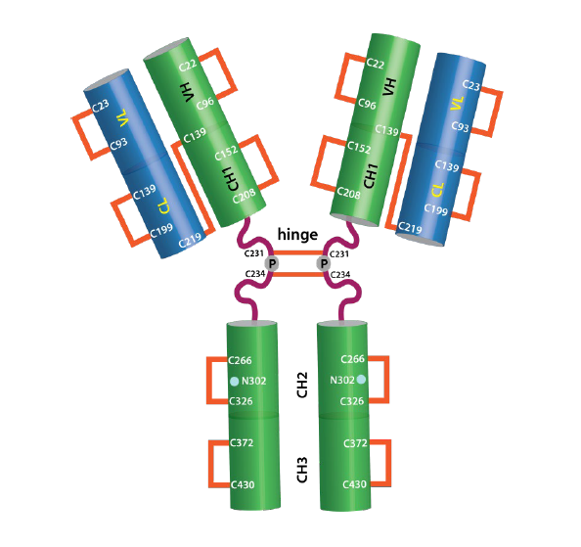
Abbreviations: CH = heavy constant region; CL = light constant region n; VH = heavy variable region; VL = light variable region.
Dupilumab antibody structure, comprised of two heavy chains, and two light chains, linked together. The heavy chains contain a single, conserved N-glycosylation site (Asn302) in the fragment crystallisable (Fc) region of each heavy chain subunit. Dupilumab heavy chains contain a serine to proline mutation at amino acid 233, which is located in the hinge region of the Fc domain.

Proposed new strength
The proposed new 100 mg/0.67 mL strength contains the same active ingredient as the previously registered Dupixent products (that is, the 200 mg/1.14 mL, and 300 mg/2 mL formulations). It is packaged in a prefilled syringe with needle shield. The recommended shelf-life is 36 months when stored at 2 to 8°C and protected from light.

Conclusions and recommendation
All concerns raised in the evaluation have been adequately addressed by the sponsor. There are no further outstanding issues.
The quality evaluation recommended the approval of Dupixent from a quality perspective.

Nonclinical
There was no requirement for a nonclinical evaluation in a submission of this type. This is an extension of indications with new indication of treatment of asthma in individuals from 6 years of age (compared with from 12 years of age as currently approved); the younger age group is consistent with that sought in an earlier application for a paediatric extension of indications, for treatment of atopic dermatitis (submission PM 2020-03043-1-5);¹⁴ see Regulatory status for further information. In addition:
- there were no new relevant carcinogenicity information identified from an updated literature search;
- there is no increase in administered strength; and
- there are no nonclinical PI changes.
Dupixent (dupilumab) underwent a full nonclinical evaluation at the time of initial registration to the satisfaction of the TGA.

Clinical

Summary of clinical studies
The clinical dossier mainly consisted of:
- Study EFC14153 (LIBERTY ASTHMA VOYAGE trial): A pivotal Phase III clinical efficacy, safety and pharmacokinetic study in children aged 6 to under 12 years with uncontrolled persistent asthma.
- Study LTS14424 (LIBERTY ASTHMA EXTENSION trial): An extension study to study a safety, tolerability, and long-term efficacy in patients who participated Study EF14153.
- Analysis POH0766: A population pharmacokinetic analysis based upon data from Studies EFC14153 and LTS14424
- Analysis CTS0077: A pharmacokinetic/pharmacodynamic analysis with an exposure-response analysis based upon data from Study EFC14153

Pharmacology

Pharmacokinetics
The pharmacokinetic (PK) profile of dupilumab is well established for adult and adolescent population. It was assessed in healthy adult subjects and in patients with atopic dermatitis (6 years and above), asthma (12 years and above), and chronic rhinosinusitis with nasal polyposis (in adults).
Dupilumab is well absorbed with an estimated subcutaneous (SC) bioavailability of 63% and distributes primarily within the vascular compartment; the volume of distribution is 3.7 L.
For the proposed extension of indications, for the treatement of patients aged from 6 to less than 12 years, population pharmacokinetics (popPK) data are available.

Population pharmacokinetics

Analysis POH0766
The pharmacokinetics of dupilumab in children with asthma aged 6 and less than 12 years of age was investigated in a popPK analysis (Report POH0766). The objectives were to:
- develop a popPK model to characterise dupilumab PK in children 6 to younger than younger than 12 years of age with asthma, based on a previously developed global popPK base model.
- assess the influence of intrinsic and extrinsic factors on dupilumab PK in children 6 to younger than 12 years of age with asthma.
- generate post hoc individual dupilumab PK exposures in children 6 to younger than years 12 of age with asthma who received 100 mg once every two weeks or 200 mg once every two weeks in two Phase III studies.
- simulate dupilumab exposure for the alternative regimen of 300 mg once every four weeks in children 6 to younger than 12 years of age with asthma.

Methods
The PK clinical data were sourced from Studies EFC14153 and LTS14424. These provided sparse PK data (1772 concentrations in 377 children). A 200 mg SC injection of dupilumab given once every two weeks was given to 272 patients (72.1%) greater than 30 kg, and a 100 mg SC injection given once every two weeks dose was given to 105 patients (27.9%) weighing less than or equal to 30 kg. A loading dose, as for the treatment of atopic dermatitis, was not administered.
It was planned to administer 300 mg once every four weeks to children less than or equal to 30 kg in Study LTS14424, but as only two children actually received this (14 in the interim analysis), the exposure estimates for this regimen were essentially entirely simulation based.
Using non-linear mixed-effects modelling (NONMEN), a popPK model developed with data of healthy adult subjects, adult atopic dermatitis patients, and adult and adolescent asthma patients was applied to the data of the paediatric asthma patients. The base model was a two-compartment model with mixed linear and non-linear elimination including allometric weight scaling of volume and clearance terms. Due to sparse paediatric PK data some model parameters were fixed.
The validation of the final paediatric popPK model was performed using visual predictive checks and comparison of bootstrap estimates with the final model parameter estimates.
To simulate dupilumab concentrations over time for the alternative regimen of 300 mg SC given once every four weeks in children 6 to younger than 12 years of age with asthma, a virtual paediatric population (6 to younger than 12 years of age, N = 1201) created from data from the Centers of Disease Control (USA) was used.
The effect of age, gender, race, creatinine clearance, anti-drug antibody (ADA) status, concomitant medications and other factors on dupilumab PK was investigated. None of these covariates reached statistical significance. The base model was the final model and body weight the only covariate with a significant impact on dupilumab PK.

Results and conclusions
The PK of dupilumab in children 6 to younger than 12 years of age with asthma was adequately described by a two-compartment model with parallel linear and nonlinear elimination with first order absorption. The final model described the data of the paediatric asthma patients reasonably well. Visual predictive check plots by body weight group were provided by the sponsor.
The median time to steady state is 14 weeks for 100 mg once every two weeks and 200 mg once every two weeks dosing based on popPK analysis. After the last dose at the steady state, the median time for the serum concentration to decrease to below the lower limit of quantitation was 14 weeks for dupilumab 100 mg once every two weeks and 200 mg once every two weeks dosing.
The observed concentration time profiles in children from 6 to younger than 12 years of age with asthma appeared to be similar to those observed in the adults and adolescents with asthma except that, due to the absence of a loading dose in children 6 to younger than 12 years of age, dupilumab concentrations increased less rapidly in the first few weeks after initiation of treatment.
The observed dupilumab trough concentration at steady state (C_{trough,ss}) values in children 6 to younger than 12 years of age with asthma appeared to be similar to those observed in children of the same age with atopic dermatitis when dosed with 100 mg once every two weeks and 200 mg once every two weeks.
Dupilumab exposures in paediatric asthma patients weighing greater than 30 kg receiving 200 mg once every two weeks were approximately 50% greater than the exposures in patients weighing less than 30 kg on 100 mg once every two weeks. They were also greater in the 6 to 9 years of age group compared to 9 to 12 years of age group, independent of the administered dose. The area under the concentration time curve (AUC) 18% and 23% increased after 100 mg or 200 mg once every two weeks.
Dupilumab exposure appeared to increase with increasing albumin levels. It was greater in ADA-negative patients compared to ADA-positive patients (AUC 73% and 27% increased after 100 mg or 200 mg once every two weeks). There were no gender differences. Systemic corticosteroids and long-acting beta 2 agonists did not appear to have a major impact on dupilumab exposure. The number of patients receiving concomitant methylxanthines or leukotriene antagonists was too low to draw meaningful conclusions.
For patients weighing less than 30 kg, dosed with 100 mg once every two weeks, the changes of dupilumab exposure relative to the ‘typical patient’ were less than 20% (decrease) for the heavier patients (95th percentile), while for the patients with lower body weight (5th percentile), increases of dupilumab exposure up to 46% were observed.
For patients weighing greater than or equal to 30 kg, dosed with 200 mg once every two weeks, increases of exposure up to 35% were observed for patients with lower body weight (5th percentile), while decreases of up to 46% were observed for heavier patients (95th percentile).
These changes were lower or of similar magnitude as the inter-individual variability of the dupilumab exposures in the paediatric patient population.
For simulation of an alternative dosing regimen of 300 mg SC once every four weeks, there appeared to be some overlap in the typical dupilumab concentration time profiles of the different regimens, but may be difficult to interpret graphically. The median time to steady state concentration for the 300 mg once every four weeks regimen was 16 weeks compared to 14 weeks for the 100 mg once every two weeks or 200 mg once every two weeks regimens.
The data suggest that the dupilumab maximum concentration at steady state following the 300 mg once every four weeks dosing regimen (in paediatric asthma patients weighing from 15 kg up to 30 kg) exceeded the maximum concentration in adults observed after 300 mg once every two weeks dosing regimen but was consistent with non-approved adult 300 mg once a week dosing (see Figure 2, below). Data were consistent with the 300 mg once every four weeks dosing regimen in paediatric atopic dermatitis patients weighing less than 30 kg (see Figure 3).
Figure 2: Analysis POH0766 Box-plot of dupilumab maximum concentration at steady-state by dosing regimen in subjects with asthma (includes simulated adult 300 mg once a week dosing regimen)
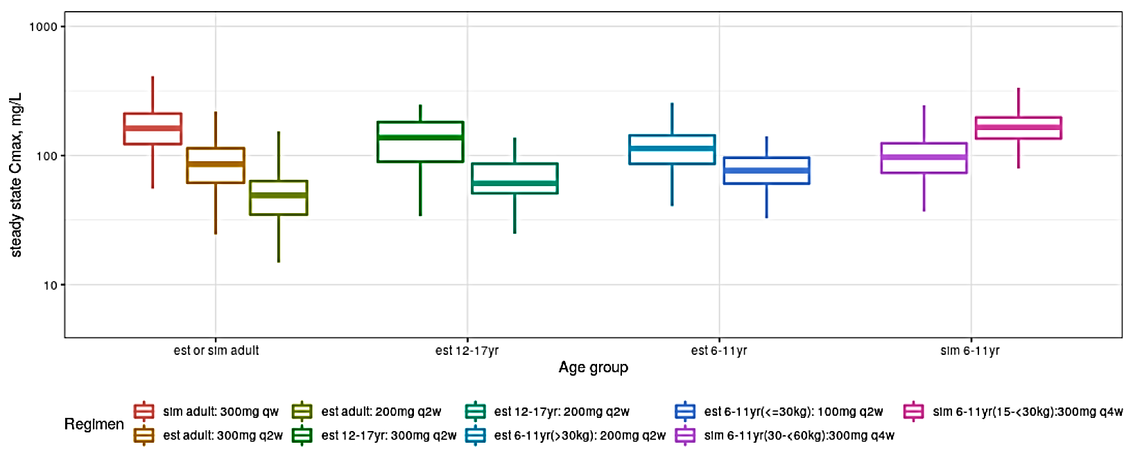
Abbreviation: C_{max} = maximum concentration; C_{max,ss} = maximum concentration at steady state; est = estimated; q2w = every two weeks; q4w = every 4 weeks; sim = simulated based on virtual pediatric population from NHANES¹⁵
Note: Exposure (C_{max,ss}) simulated based on popPK model for 300 mg q4w; Observed C_{max,ss} estimated from popPK model predicted individual post hoc parameters for all other regimens. The upper whisker of the box plot is the largest dataset number smaller than 1.5 interquartile range (IQR) above the third quartile. Similarly, the lower whisker of the box plot is the smallest dataset number larger than 1.5 IQR below the first quartile.
Figure 3: Analysis POH0766 Box-plot of dupilumab maximum concentration at steady-state by asthma and atopic dermatitis dosing regimen in subjects aged 6 and younger than 12 years
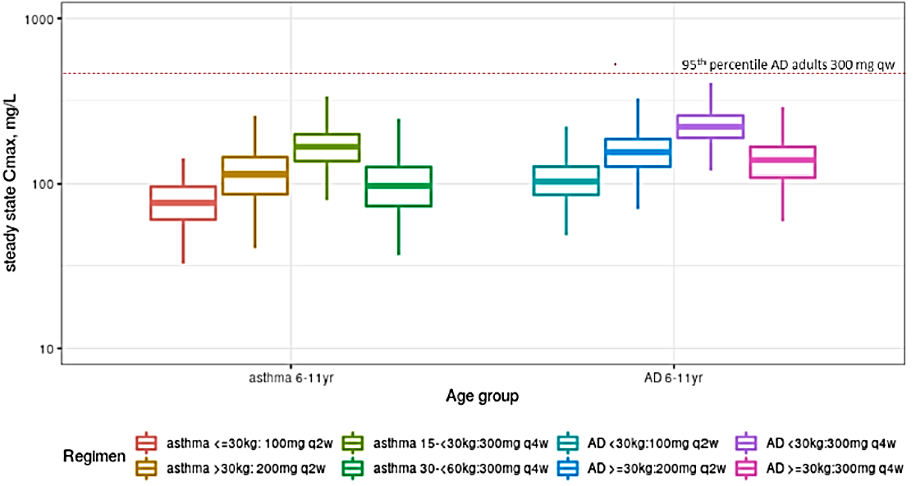
Abbreviation: AD: atopic dermatitis; Cmax: maximum concentration; q2w: every 2 weeks; q4w: every 4 weeks
Note: Exposure (C_{max,ss}) simulated based on asthma pediatric popPK model for 300 mg q4w in children with asthma, C_{max,ss} estimated from popPK model predicted individual post hoc parameters for 100 mg and 200 mg q2w in children with asthma and Cmax,ss simulated based on AD children popPK model for all regimens in children with AD. The upper whisker of the box plot is the largest dataset number smaller than 1.5 interquartile range (IQR) above the third quartile. Similarly, the lower whisker of the box plot is the smallest dataset number larger than 1.5 IQR below the first quartile.

Exposure-response analysis

Analysis CTS0077
The exposure-response (E-R) relationship (plasma concentration and effect) for the key clinical efficacy endpoints in 408 children 6 to younger than 12 years of age with asthma in Study EFC14153 was investigated in Analysis CTS0077. It comprised of 135 children that received the placebo, 93 children receiving the dupilumab 100 mg once every two weeks and 180 children receiving dupilumab 200 mg once every two weeks.
Both univariate descriptive and model-based analyses were used in the intention to treat (ITT) population with a sensitivity analysis in those with the type 2 inflammatory asthma phenotype.

Methods
The E-R relationship was explored by the average concentration over the 52 week treatment period for the primary efficacy endpoint (annualised rate of severe exacerbation events) and by quartiles of trough concentration (C_{trough}) at Week 12 for the key secondary endpoint (change from Baseline in pre-bronchodilator % predicted forced expiratory volume in one second (FEV1) at Week 12).
Several factors, including demographics (for example, age, weight, race), baseline disease characteristics, and baseline biomarkers were evaluated in the model-based pharmacokinetic/pharmacodynamic analyses, to investigate their contribution to the variability of dupilumab treatment response.

Results
The model based analyses predicted a clinically significant reduction for both assessed endpoints for both pivotal trial dosing regimens (dupilumab 100 mg once every two weeks and 200 mg once every two weeks). The final model predicted the severe exacerbation event ratio (relative risk) after 200 mg once every two weeks reasonably well, but it over-predicted the relative risk after 100 mg once every two weeks. The results suggest a plateau at the 200 mg once every two weeks dose, with only a marginal improvement in response at 300 mg once every two weeks.
For the modelling of the 300 mg once every four weeks dose regimen, the observed and predicted exacerbation risk in the two weight groups was similar to the observed and predicted values after 100 mg and 200 mg once every two weeks dosing.

Efficacy
The efficacy claims are based on one pivotal study and its long-term extension in a total of 408 randomised paediatric patients aged 6 to younger than 12 years.

Study EFC14153

Design
Study EFC14153 (also known as the LIBERTY ASTHMA VOYAGE trial) was a pivotal Phase III, randomised, multicentre (90 centres in 17 countries), double-blind, placebo controlled, parallel group study to evaluate the efficacy and safety of subcutaneously administered dupilumab (for a maximum of 52 weeks) in 408 children aged 6 to less than 12 years with uncontrolled persistent asthma. The study was conducted between 21 April 2017 and 26 August 2020.
There were three periods with a total duration of 68 ± 1 weeks for each patient: screening period (4 ± 1 weeks), randomised treatment period (up to 52 weeks), and post-treatment period (12 weeks) for patients who did not participate in the one year long-term extension study (Study LTS14424).
The population was randomised in a 2:1 ratio to receive SC dupilumab. The dose was based on weight: those weighing greater than 30 kg receiving 200 mg once every two weeks, or those weighing 30 kg or less receiving 100 mg once every two weeks, or matching placebo (Figure 4).
Dupilumab was given as add on therapy to high dose inhaled corticosteroids (ICS) alone or medium dose or high dose ICS in combination with a second controller medication. Patients were allowed to use salbutamol or levosalbutamol (short-acting beta-2 agonists) as reliever medication.
Figure 4: Study EFC14153 Study design
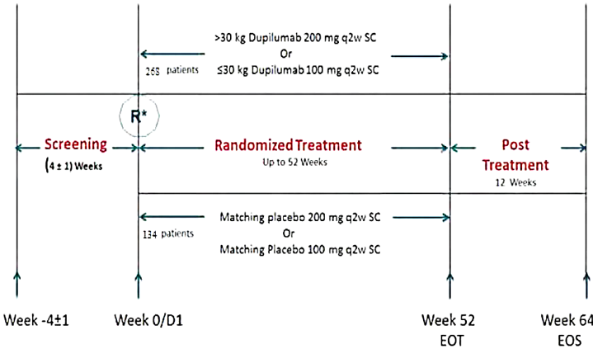
Abbreviation: D: day; EOT: end of treatment; EOS: end of study; ICS: inhaled corticosteroid; q2w: every two weeks; R: randomisation; SC: subcutaneous.
Note: Background medication: medium dose inhaled corticosteroid + second controller or high dose inhaled corticosteroid or with second controller.
The primary objectives of this study were to evaluate the efficacy of dupilumab in children from 6 to younger than 12 years of age with uncontrolled persistent asthma.

Inclusion and exclusion criteria
The main inclusion criteria were for patients between of 6 years to younger than 12 years of age with uncontrolled persistent asthma. Prior to and during the screening period, patients were required to be on a stable dose background therapy of medium dose ICS with a second controller medication or high dose ICS alone or high dose ICS with a second controller, for at least three months, with a stable dose greater than or equal to one month.
Patients must have experienced, within one year prior to screening Visit 1, any of the following events: treatment with oral or parenteral systemic corticosteroid prescribed by a healthcare professional for worsening asthma at least once or, hospitalisation or emergency medical care visit for worsening asthma.
Patients also must have reversibility of at least 10% in FEV1; after the administration of a short-acting beta-2 agonist (200 to 400 µg salbutamol or 45 to 90 µg levosalbutamol).
The main exclusion criteria were patients requiring a third controller medication for their asthma; patients with less than 16 kg body weight; and patients with active parasitic infection (helminths).

Endpoints
The primary efficacy endpoint was the annualised rate of severe exacerbation events during the 52-week placebo controlled treatment period. The key secondary endpoint was the change from Baseline in pre-bronchodilator FEV1 at Week 12.

Statistics
To control the Type I error rate for the analysis of efficacy endpoints, a hierarchical testing procedure was applied at a two-sided 5% significance level. The primary endpoint adjustment occurred using a negative binomial model with the total number of events onset from randomisation up to Week 52 visit or last contact date as the response variable, with the treatment group, age, baseline weight group, region, baseline eosinophil level, baseline fractional exhaled nitric oxide (FeNO) level, baseline ICS dose level and number of severe exacerbation events within one year prior to the study as covariates, and log transformed standardised observation duration as an offset variable.

Baseline demographics and population characteristics
The baseline demographics were similar and balanced between treatment arms in the ITT population and in the individual populations defined by markers of type 2 inflammation.
In the type 2 inflammatory asthma phenotype population, most patients had impaired lung function with a mean pre-bronchodilator FEV1 percent predicted at Baseline of 77.89% and a mean Asthma Control Questionnaire (ACQ-7-IA) score of 2.14; and a high disease burden with mean Paediatric Asthma Caregivers Quality of Life Questionnaire (PAQLQ/PAQLQ(S)-IA) scores of 4.94.,
Patients on average had FEV1 reversibility of 19.61%, used 2.46 rescue puffs daily at Baseline, and had a history of a mean of 2.47 severe asthma exacerbations in the year. Nearly 70% of enrolled children had at least one asthma exacerbation that required hospitalisation or an urgent care visit in the prior year. Mean baseline serum total immunoglobulin type E (IgE) was elevated (905.5 IU/mL) with 83.4% of patients with levels ≥ 100 IU/mL. 94.0% had an ongoing atopic medical condition. The population with blood eosinophil count ≥ 0.3 x 10⁹ L showed similar disease characteristics at Baseline as those in the type 2 inflammatory asthma phenotype population with the notable exception of higher baseline type 2 inflammatory biomarkers.
All patients were using background asthma controller (preventer) therapy at stable doses which continued throughout the study. The protocol allowed an increase in background medications for greater than or equal to two severe exacerbations, but this occurred for no patient during the study.
At Baseline, most patients (97.3%) were using two types of controller medications, the majority medium or high dose ICS in combination with LABA (85.8%); 2.2% received ICS only. The proportion of high, medium, and low dose ICS recipients was 44.1%, 55.1%, and 0.7%, respectively.
With regard to subject disposition, 408 patients were randomised in the ITT population: 273 in the dupilumab group (n = 93 for 200 mg once every two weeks, and n = 180 for 100 mg once every two weeks) and 135 in the placebo group. Of these, there were 350 patients (85.8% of the ITT) with the type 2 inflammatory asthma phenotype. There were 236 patients in the dupilumab group and 114 in the placebo group. 259 patients (63.5% of the ITT) had baseline blood eosinophils ≥ 0.3 x 10⁹/L, including 175 in the dupilumab group and 84 in the placebo group. 56 patients had both baseline blood eosinophils < 0.15 x 10⁹/L and FeNO < 20 parts per billion (ppb), including 35 in the dupilumab group and 21 in the placebo group.
The treatment discontinuation rate was low, but numerically higher in the dupilumab group (reasons included receiving live attenuated vaccine). The most frequent major protocol deviations were related to missing assessments and procedures (10.3% in the dupilumab group versus 12.6% for placebo) and the use of concomitant medications (9.5% versus 13.3%).

Results for the efficacy endpoints
The annualised rate of severe exacerbation events during the 52 week placebo-controlled treatment period was more favourable overall in the dupilumab group (see Table 3, below).
The study reported the following:
- overall annualised rate of severe exacerbation events (all ITT population): the relative risk 95% confidence interval (CI) was 0.458 (0.313, 0.671);
- type 2 inflammatory asthma phenotype: the relative risk (95% CI) was 0.407 (0.274, 0.605)
- baseline blood eosinophils (0.3 x 10⁹/L): the relative risk (95% CI) was 0.353 (0.222, 0.562)
For the ITT population, the unadjusted annualised exacerbation rate was 0.346 and 0.642 in the dupilumab and placebo groups, respectively.
Furthermore, the results were also favourable for the subgroup with baseline blood eosinophils ≥ 0.15 x 10⁹/L, or baseline FeNO ≥ 20 ppb (parts per billion) (see Table 3). However, the results were indeterminate (likely due to small subgroup sample size) for the baseline blood eosinophils < 0.15 x 10⁹/L with FeNO < 20 ppb, and the baseline blood eosinophils < 0.15 x 10⁹/L with FeNO ≥ 20 ppb subgroups (Table 3).
The proportion of patients with no severe asthma exacerbation events during the 52-week treatment period was greater in the dupilumab group (ITT: 77.3% versus 63.0%; type 2 inflammatory asthma phenotype: 77.1% versus 59.6%; baseline blood eosinophils 0.3 x 10⁹/L: 78.9 versus 58.3%).
Table 3: Study EFC14153 Forest plot comparison of the primary endpoint (annualised rate of severe exacerbation events) results; overall (all intention to treat population) and by subgroups
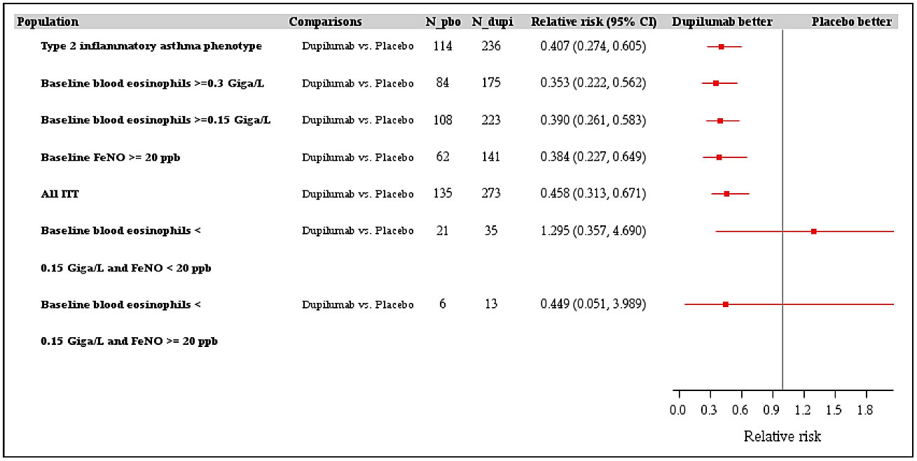
Abbreviations: CI = confidence interval; FENO = fractional exhaled nitric oxide; ITT = intention to treat; N_dupi = dupixent treated patients; N_pho = matched placebo treated patients.
Type 2 inflammatory asthma phenotype population is defined as the randomised patients with baseline blood eosinophils greater than or equal to 0.15 x 10⁹/L or baseline FeNO greater than or equal to 20 ppb.
For the key secondary endpoint, the change from Baseline in pre-bronchodilator percent predicted FEV1 at Week 12 more favourable overall in the dupilumab group (see Table 4, below). The results for the key secondary endpoint are as follows:
- overall (all ITT population): the least squares mean (LSM) difference (95% CI) was 4.68% (1.87, 7.49);
- type 2 inflammatory asthma phenotype:²⁰ the LSM difference (95% CI) was 5.21% (2.14, 8.27);
- baseline blood eosinophils 0.3 x 109/L: the LSM difference (95% CI) was 5.32% (1.76, 8.88).
Table 4: Study EFC14153 forest plot of key secondary endpoint (percentage change from Baseline in pre-bronchodilator predicted FEV1 at Week 12) results overall and by subgroup
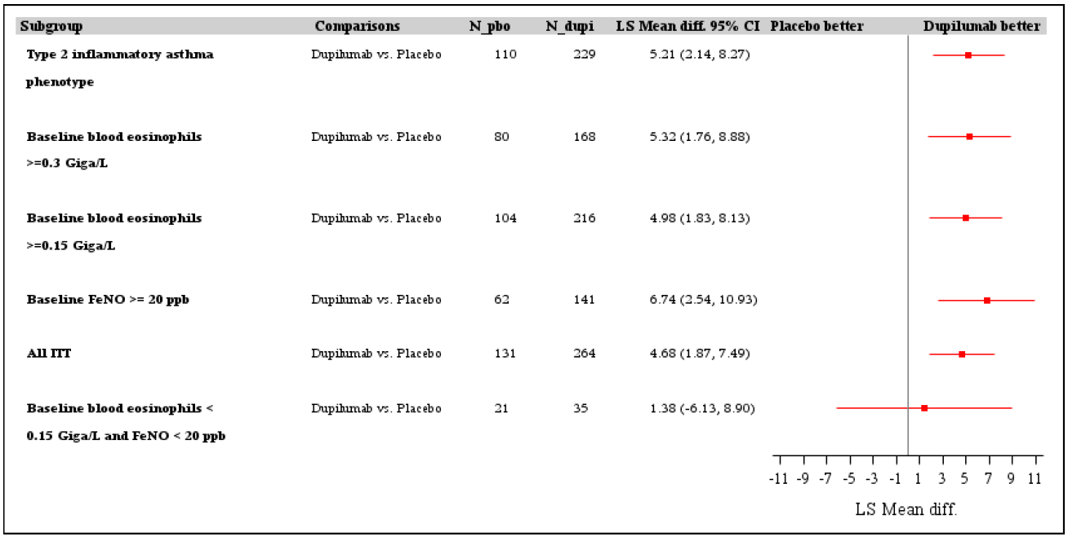
Abbreviations: CI = confidence interval; FENO = fractional exhaled nitric oxide; ITT = intention to treat; N_dupi = dupixent treated patients; N_pho = matched placebo treated patients.
Type 2 inflammatory asthma phenotype population is defined as the randomised patients with baseline blood eosinophils greater than or equal to 0.15 x 10⁹/L or baseline FeNO greater than or equal to 20 ppb.
Subgroup analyses showed advantages for dupilumab over placebo for both investigated weight categories and dosages, including in patients taking ICS-LABA and those taking high dose ICS. However, the bronchodilating effects tended to be weaker in patients taking high dose ICS.

Study LTS14424

Design
Study LTS14424 (also known as the LIBERTY ASTHMA EXTENSION trial) was a Phase III, open label, multicentre (67 centres in 17 countries), single arm one year treatment study to evaluate safety, tolerability and long-term efficacy of subcutaneously (SC) administered dupilumab given for a period of 52 weeks in 365 patients who participated in Study EFC14153 (see section: Study EFC14153, above). The study started on 21 June 2018 and is ongoing. The cut-off date for the interim analysis was 18 August 2020.
The placebo-dupilumab group had 125 patients that is patients that received matched placebo in Study EFC14153, and the dupilumab-dupilumab group had 240 patients.
The duration of observation was 64 weeks, which included a 52-week treatment period and a 12-week follow up period.
The dose regimens were:
- Patients with body weight 30 kg or less: 100 mg SC once every two weeks (prior to protocol amendment 03, dated 12 December 2019) or 300 mg SC once every four weeks (after protocol amendment 03).
- Patients with body weight greater than 30 kg: 200 mg SC once every two weeks. Patients who started with or switched to 200 mg once every two weeks continued the same dose regimen through the remaining treatment period irrespective of whether they remained greater than 30 kg or not.
Dupilumab was given as add on therapy to high dose ICS alone or medium dose or high dose ICS in combination with a second controller. Patients were allowed to use reliever medication.
Figure 5: Study LTS14424 Study design
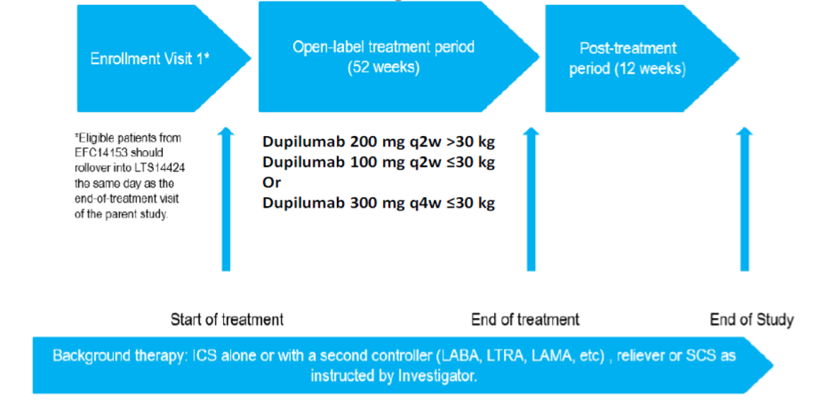
Abbreviations: ICS: inhaled corticosteroid; LABA: long acting beta 2 agonist; LAMA: long acting muscarinic antagonist; LTRA: leukotriene receptor antagonist; q2w = once every two weeks; SCS: systemic corticosteroids.
* Due to the COVID-19 pandemic patients may enrol in Study LTS14424 at, or up to 12 weeks after the Study EFC14153 end of study visit.
The main inclusion criteria were paediatric patients with asthma who completed the treatment in Study EFC14153. Patients who were not able to complete their treatment in Study EFC14153 due to the COVID-19 pandemic were allowed to enrol into Study LTS14424.
At the data cut-off date of 18 August 2020, 365 patients in Study LTS14424 were enrolled and treated from Study EFC14153. Of these, 303 (83.0%) patients were treated with dupilumab for at least 24 weeks, and 189 (51.8%) patients were treated for at least 52 weeks. 196 (53.7%) patients completed the study treatment period. The mean duration of study treatment in Study LTS14424 was 283.8 days.
Fourteen patients were exposed to the 300 mg once every four weeks dose regimen for a total of 1.6 patient-years (PY). At the data cut-off date of 25 June 2021, 18 asthma patients with a cumulative exposure of 10.5 PY had been treated with that regimen.

Results
Efficacy evaluation was not the main objective of the study. In the full analysis set (all patients exposed to all doses), the unadjusted annualised asthma exacerbation event rate was 0.134 (0.136 for the dupilumab-dupilumab category and 0.131 for the placebo-dupilumab category). No severe exacerbations occurred for 336 out of 365 (92%) patients for the duration of the study. In contrast, pivotal Study EFC14153, the unadjusted annualised exacerbation rate was 0.346 and 0.642 in the dupilumab and placebo groups, respectively.
In the Study LTS14424 full analysis set, the mean change in percent predicted FEV1 from Baseline of the parent study (77.68%) was maintained at Week 24 of the extension study (9.59%%), and at Week 52 (8.75%) among the 196 out of 365 patients that had completed the Week 52 visit.
There are 155 (42.5%) patients are still ongoing in the study.
For the small 300 mg once every four weeks subgroup (n = 14), there were no asthma exacerbations during a mean duration of exposure of 42.6 days. The percent predicted FEV1 remained stable.

Safety

Exposure
Safety data in children with asthma aged from 6 to less than 12 years are principally based on the results from Study EFC14153 and the ongoing Study LTS14424 (data cut-off date: 18 August 2020). As of the cut-off date for Study LTS14424, 365 of the 392 patients who had completed Study EFC14153 continued into Study LTS14424 (240 who received dupilumab in the parent study (dupilumab-dupilumab category) and 125 who received placebo in the parent study (placebo-dupilumab category)). In both studies 296 children were exposed to dupilumab. The controlled experience was 255.6 PY, while the additional experience from the uncontrolled long term study is 283.6 PY to date. Exposure is summarised in Table 5.
Table 5: Dupilumab exposure in patients with asthma by age group and gender
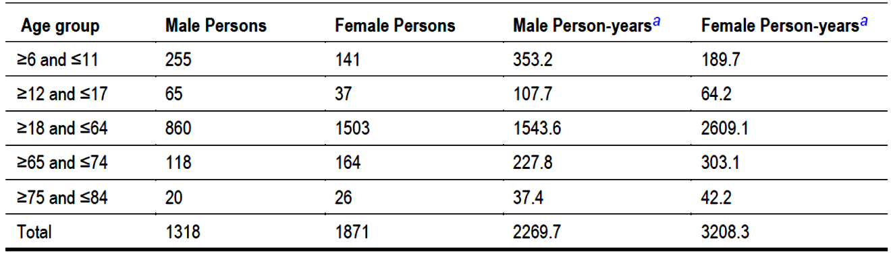
Note: According to age at Baseline in the initial placebo-controlled study
Includes dupilumab-exposed patients in three Phase II studies, (Studies ACT11457, DRI12544 and PDY14192); two Phase III studies, (Studies EFC13579, EFC13691 and EFC14153); and three open-label extension studies (Studies LTS12551, LPS15023 (patients from unblinded Studies DRI12544, EFC13579, EFC13692 and PDY14192 studies) and LTS14424 (patients from unblinded Study EFC14152). Data cut-off date for Study LPS15023 is 28 September 2020, for Study EFC14153 is 25 August 2020 and Study LTS14424 is 18 August 2020; all other studies are completed.
Duration of exposure in weeks is defined as: (last injection data with x days minus first injection date)/7 where x is dosing dependent (for example, seven for once a week dosing and 14 for once every two weeks dosing) regardless of intermittent discontinuations, except for Study LTS12551 patients receiving dupilumab in Study DRI12544 where the protocol defined 16 week follow up period is excluded.
ªPerson year for each category was calculated as the sum of duration of exposure in years for all patients in each category

Adverse events
For Study EFC14153, treatment-emergent adverse events (TEAE) in the dupilumab group compared with the placebo group occurred in 83.0% and 79.9% of patients, respectively (see Table 6, below).
The System Organ Class with TEAEs more frequently reported in the dupilumab group (versus placebo) were:
- Blood and lymphatic system disorders (8.5% versus 3%) driven by eosinophilia (5.9% versus 0.7%)
- Infections and infestations, driven parasitic infections (2.6% versus 0.7%), and viral upper respiratory tract infection (12.2% versus 9.7%)
- Gastrointestinal disorders (14.8% versus 9.7% in the placebo group), mainly driven by abdominal pain, nausea, and constipation
- Psychiatric disorders (1.1% versus 0%)
For Study LTS14424, overall, 201 (55.1%) patients experienced at least one TEAE during the study. The exposure adjusted incidence rate of TEAEs (adjusted based on time in study) was higher in the placebo-dupilumab category than in the dupilumab-dupilumab category (153.1 versus 102.0 per 100 PY).
Table 6: Study EFC14153 Number (%) of patients with treatment-emergent adverse events that occurred with a frequency of 5% or more in any treatment group by primary System Organ Class and Preferred Term (Safety population)
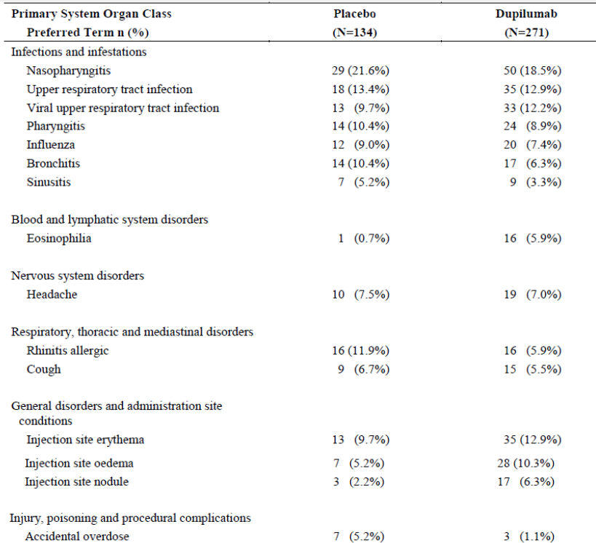
Abbreviations: TEAE: treatment-emergent adverse event; SOC: System Organ Class; PT: Preferred Term; n(%): number and percentage of patients with at least one TEAE.
Note: table sorted by MedDRA (Medically Dictionary of Regulatory Activities) System Organ Class (SOC) internationally agreed order and decreasing percentage of Preferred Terms (PT) in dupilumab group. Only PT with at least one 5% in at least one group are presented.

Treatment related adverse event (adverse drug reaction) overview
The primary assessment for adverse drug reaction was conducted in the placebo controlled Study EFC14153 safety population (405 patients) (Table 8).
Parasitic enterobiasis and injection site reactions are considered adverse drug reactions despite not meeting the sponsor’s quantitative threshold based on the observed imbalance between treatment groups.

Deaths
There were no deaths reported during either study.

Serious adverse events
For Study EFC14153, the incidence of treatment-emergent serious adverse events (SAE) was 4.8% in the dupilumab group and 4.5% in the placebo group. SAEs considered related to dupilumab included two patients, both in the dupilumab group, who had treatment emergent SAEs of pneumonia and eosinophilia with headache and blurred vision.
For Study LTS14424, five (1.4%) patients experienced a SAE during the study.

Discontinuations
For Study EFC14153, the rate of treatment discontinuation due to TEAEs between dupilumab and placebo groups was 1.8% and 1.5%, respectively. In the dupilumab group, one patient experienced erythema multiforme and another patient experienced eosinophilia, both leading to permanent treatment discontinuation.
For Study LTS14424, two (0.5%) patients experienced TEAEs leading to permanent treatment discontinuation (pulmonary tuberculosis and conjunctivitis allergic). Both events were considered as related to dupilumab.

Adverse events of special interest
In Study EFC14153, treatment-emergent adverse events of special interest and other selected adverse event groupings were less frequently reported in the dupilumab group when compared to placebo (greater than or equal to 2% for placebo). These included hypersensitivity (1.8% versus 3.7%), conjunctivitis narrow (2.6% versus 6.7%) and conjunctivitis broad (3.0% versus 7.5%).
Opportunistic infections, malignancy, pregnancy or symptomatic overdose were not reported, except for one case of pulmonary tuberculosis in the dupilumab group in Study LTS14424.
In Study EFC14153, all hypersensitivity events were mild or moderate, except one case of anaphylactic reaction due to peanut ingestion in the placebo group, which was severe. In Study LTS14424, no events were assessed as related to dupilumab. None of the patients with anaphylactic reaction or hypersensitivity events were anti-drug antibody (ADA) positive.
In Study EFC14153, injection site reactions (duration greater than 24 hours) were reported for two (0.7%) patients in the dupilumab group and none in the placebo group. In both cases, the event was considered to be related to dupilumab and led to permanent treatment discontinuation. Overall, a higher incidence of injection site reactions was reported in the dupilumab group compared to placebo (48 (17.7%) versus 18 (13.4%) patients).
The percentage of patients who experienced severe or serious infections was low in Study EFC14153, (1.5% versus 2.2% patients). One (0.4%) patient in the dupilumab group experienced severe or serious infection (pneumonia) related to dupilumab. All patients recovered.
In Study EFC14153, parasitic infections were reported in seven (2.6%) patients in the dupilumab group versus one in the placebo group. Five cases of enterobiasis, one case of ascariasis, and one case of lice infestation were reported in the dupilumab group. None were assessed as related to dupilumab. Five out of six patients with enterobiasis or ascariasis were from endemic areas for soil transmitted helminthic infection. In Study LTS14424, four (1.1%) patients experienced parasitic infections (enterobiasis in three patients and ascariasis in one patient), none of which were serious and none led to permanent treatment discontinuation. In two patients, the events were considered to be related to dupilumab.
In Study EFC14153, the incidence of potentially drug related hepatic disorders was low (one (0.4%) patient in the dupilumab group (aspartate aminotransferase (AST) increased) and one (0.7%) patient in the placebo group (hepatic steatosis and alanine aminotransferase increased)). None of the events were assessed as related to dupilumab. There were no cases of abnormal liver function tests meeting the Hy's law criteria.
In Study EFC14153, the incidence of conjunctivitis was lower in the dupilumab group compared to placebo (conjunctivitis narrow (2.6% versus 6.7%) and conjunctivitis broad (3.0% versus 7.5%)). In Study LTS14424, three out of ten events were considered to be related to dupilumab and one event led to permanent treatment discontinuation.
Eosinophilia (defined as eosinophil count greater than 3 x 10⁹/L) was considered an adverse event, even if asymptomatic). In Study EFC14153, a higher incidence was reported in the dupilumab group: 18 (6.6%) versus one (0.7%) patient. Most TEAEs of eosinophilia (16 out of 18 in the dupilumab group) were self-limiting laboratory findings without any associated symptoms. Two events were considered to be SAEs, both in the dupilumab group. One of them was associated with clinical symptoms (headache and dizziness (reported as blurred vision)), was severe, and led to permanent treatment discontinuation. The patients recovered.
In the dupilumab group, a transient increase in the mean blood eosinophil count was observed at the first post-Baseline assessment at Week 12; the mean eosinophil count returned to the Baseline values by Week 36. The apparent trend to a subsequent increase at Week 52 may be due to a single outlier patient.
In Study LTS14424, TEAEs of eosinophilia were reported in 13 (3.6%) patients overall, with higher incidence in the placebo-dupilumab category than in the dupilumab-dupilumab category (6.4% versus 2.1%, or 7.42 versus 2.34 per 100 PY). In all cases, eosinophilia were laboratory findings without symptoms.
For immunogenicity, in Study EFC14153, persistent ADA responses were observed in 3.3% versus 0.8% of patients. In Study LTS14424, the rate was 2.2% (4.4% in the updated 2021 dataset). High titre ADA response (greater than 10,000) was observed in one case. Six (1.9%) patients treated with dupilumab had neutralising antibodies compared to one patient (0.8%) in the placebo group.
There is no data available for growth and development.

Post-market experience
There is no data in the 6 to younger than 12 years of age group available for the proposed indication for the treatment of asthma.
Table 7: Study LTS14424 Number (%) of patients with treatment-emergent adverse events that occurred with a frequency greater than or equal to 5% in any treatment group by primary System Organ Class and Preferred Term (full analysis set)
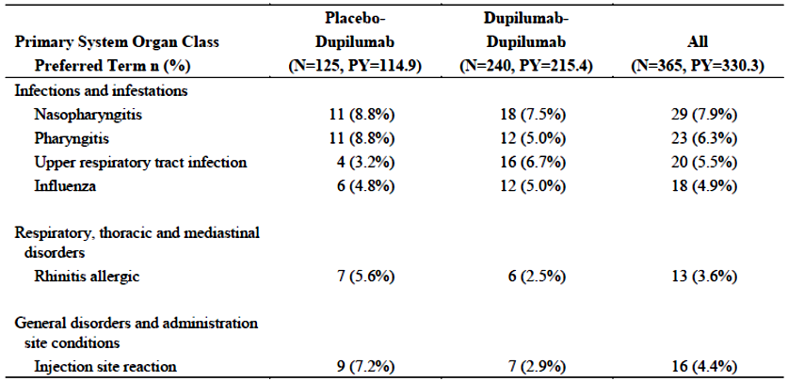
Abbreviations: TEAE: treatment emergent adverse event; SOC: System Organ Class; PT: Preferred Term; n(%): number and percentage of patients with at least one TEAE, PY: total patient-years.
Note: table sorted by Medical Dictionary for Regulatory Affairs (MedDRA) SOC internationally agreed order and by decreasing frequency of PT in the overall category.
Table 8: Study EFC14153 Forest plot of relative risk ratios of all common treatment-emergent adverse events (events by Preferred Term reported in 1% or more) in dupilumab- versus placebo-treated subjects (Safety population).
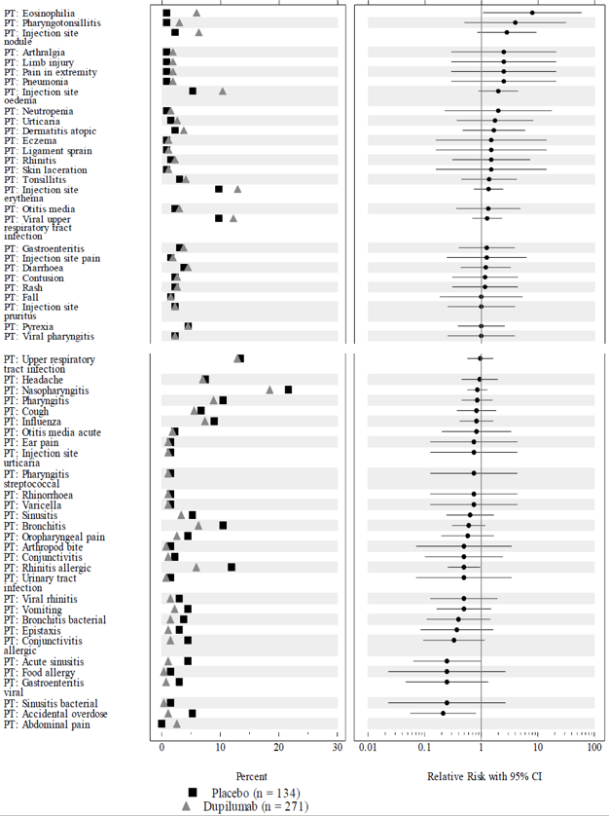
Abbreviations: CI = confidence interval; PT = Preferred Term.

Risk management plan
A risk management plan (RMP) was not requested by the RMP evaluation area for this submission. However, the provided RMP was evaluated as part of a submission to extend the indications of Dupixent to treat atopic dermatitis in children, and treat adults with chronic nasal polyposis (submission PM-2020-03043-1-5);¹⁴ and is unchanged.
The Dupixent EU-Risk Management Plan (RMP) (version 6.0, dated 15 February 2021, data lock point 28 September 2020), with Australian Specific Annex (version 5.0, dated 30 April 2021), included with submission PM-2020-03043-1-5, and any subsequent revisions, as agreed with the TGA will be implemented in Australia.
The summary of safety concerns and their associated risk monitoring and mitigation strategies are summarised in Table 9. Further information regarding the TGA’s risk management approach can be found in risk management plans for medicines and biologicals and the TGA's risk management approach.
Table 9: Summary of safety concerns
Summary of safety concerns |  | Pharmacovigilance |  | Risk minimisation
 |  | Routine | Additional | Routine | Additional
Important identified risks | Systemic hypersensitivity (including events associated with immunogenicity) |  | – |  | –
 | Conjunctivitis and keratitis related events in atopic dermatitis patients | – | † |  | –
Important potential risks | None | – | – | – | –
Missing Information | Use in pregnant and lactating women |  | ‡ |  | –
Missing Information | Long term safety | – | § |  | –
† Ophthalmology sub study
‡ Pregnancy registry study and outcomes database study
§ Open-label extension study

Risk-benefit analysis

Delegate’s considerations
Dupixent (dupilumab) is currently authorised for use in patients aged 12 years and older with severe asthma (see Regulatory status for a list of all approved indications).
In the current submission, the sponsor has submitted data to support the extension of indication to include children with asthma aged 6 to less than 12 years.
The proposed subcutaneous (SC) dupilumab dosing regimen in these patients is body weight based, as follows:
- ≥ 15 kg to < 30 kg: 100 mg once every two weeks or 300 mg once every four weeks
- ≥ 30 kg to < 60 kg: 200 mg once every two weeks or 300 mg once every four weeks
- ≥ 60 kg: 200 mg once every two weeks

Efficacy
The provided efficacy data adequately demonstrate statistically and clinically significant and consistent treatment differences between dupilumab and placebo as add on therapy in paediatric asthma patients aged from 6 to less than 12 years.

Indication wording
The proposed indication wording reflects the population in the clinical trial program. Even though asthma patients without the type 2 inflammation were eligible and were part of the program, the focus of the Study EFC14153 (and its extension study, Study LTS14424) appeared to have been on the type 2 inflammation population. There are potential reservations with regard to the pathogenic model of type 2 inflammation, but the clinical trial description in the PI adequately defined type 2 inflammation as blood eosinophils levels of ≥ 150 cells/μL or fractional exhaled nitric oxide (FeNO) ≥ 20 ppb for clinical trial purposes.

Safety
There are some safety issues, but the benefit risk balance appears to remain positive, if addressed appropriately, for example, through adequate labelling.
In the pivotal trial, blood eosinophilia and parasitosis (primarily enterobiasis) occurred more frequently in the dupilumab group compared to placebo. Numerical imbalances were also observed in gastrointestinal disorders, psychiatric disorders, upper respiratory tract infections and local reactions. One case of pulmonary tuberculosis occurred with dupilumab in the extension study, but this was not considered drug-related by the sponsor.

Outstanding issues

Potential lack of preventer treatment optimisation in the pivotal trial
In the pivotal Study EFC14153, patients were administered dupilumab or placebo as add on therapy to high dose inhaled corticosteroids alone or medium dose or high dose inhaled corticosteroids in combination with a second preventer. It is unknown (not captured in the sponsor case report forms) whether the preventer therapy doses were optimised for maximum benefit and whether asthma control could have been achieved without dupilumab. This may have been achieved with dose or inhaler technique optimisation. A significant proportion of participants were on medium dose inhaled corticosteroids and may have benefitted from a dose increase, and this may have also applied to the long-acting beta 2 agonist dosing. However, the investigators were required to follow the Global Initiative for Asthma (GINA) guidelines available at the time to ensure optimal asthma control prior to enrolment.² Furthermore, the adverse effects associated with inhaled corticosteroid therapy (especially at higher doses) and to a lesser extent with other preventers may have determined to the dose regimen chosen by the treating clinician.

Potential dosing issues
The Delegate highlighted the following:
- the absence of loading dose for the asthma indication;
- the rationale for not including a loading dose for the asthma indication includes the following: non-use for acute exacerbations and observation of some beneficial effects prior to achieving steady state; and
- the proposed alternative 300 mg once every four weeks dosing regimen
It is acknowledged that less frequent dosing may improve compliance, in particular with more intrusive SC administration. However, the sponsor states that there appears to be no patient compliance or treatment satisfaction disadvantage with the 200 mg once every two week regimen compared to 300 mg once every four weeks. There are some uncertainties and potential issues with regard to the 300 mg once every four weeks regimen as follows.

Insufficient sample size
There are insufficient data available to support a positive benefit risk balance for that dosing regimen. The regimen was only tested in a rather small group in the extension Study LTS14424 only, namely 18 patients with asthma with a cumulative exposure of 10.5 patient-years (PY) at the time of the data cut-off date of 25 June 2021). However, the original dossier only contained even more limited data of 14 patients. There appear to be no definite safety reservations for the use of that regimen, but the sample size was too small for definite safety or efficacy conclusions, including immunogenicity conclusions. The sponsor has provided a response with regard to PK, safety, and immunogenicity, but despite this, the sample size remains very small at 18 patients. It is unclear why pivotal Study EFC14153 did not systematically investigate a 300 mg once every four weeks dose, given that this is an alternative dosage regimen desired by the sponsor.

Validity issues
Potential validity issues include lack of exposure analysis (by area under the concentration versus time (AUC) analysis) and predictive power of the exposure-response models. For nearly all popPK analyses, and for all analyses relevant to the alternative 300 mg once every four weeks dose regimen, AUC analyses were not provided. For drugs at steady state, this may be considered a reasonable approach in some instances, but exposure data analyses should also have been provided.
In the pharmacokinetic/pharmacodynamic exposure-response analysis, the exposure-response relationship was defined based on two dose levels only. The models included a considerable number of non-significant covariates. The wide spread of the error bars in the observed FEV1;¹⁶ and exacerbation data sorted by exposure quartile suggests that no robust conclusions can be drawn regarding the predictive power of the exposure-response models. The exposure-response model of severe exacerbation events did not predict the data of children less than 30 kg on 100 mg once every two weeks very well. In general, the results of the pharmacokinetic/pharmacodynamic exposure-response study are only of limited use.

Paucity of available relevant data
The submitted data do not indicate whether the extension of the administration interval from 2 to 4 weeks can lead to increased anti-drug antibodies formation or other safety issues.

Drug exposure
The data suggest that the dupilumab maximum concentration at steady state following the 300 mg once every four weeks dosing in paediatric asthma patients weighing 15 kg or more and less than 30 kg exceeded the adult maximum concentration observed after 300 mg once every two weeks dosing, but was consistent with adult 300 mg once a week dosing, and consistent with 300 mg once every four weeks dosing in paediatric atopic dermatitis patients weighing less than 30 kg. The 300 mg once weekly dose is the highest tested adult dose and not actually approved for adult asthma patients, and using its exposure equivalent as a benchmark for paediatric exposure is not necessarily appropriate, in particular in the presence of a more suitable and tested dosing regimen based on more robust data.

Comparison to patients with atopic dermatitis
A dose of 300 mg once every four weeks is approved in Australia for atopic dermatitis patients weighing 15 up to 30 kg. The sponsor referenced the study in children with atopic dermatitis (Study R668-AD-1652), in which 61 children (with a body weight less than 30 kg) were administered dupilumab 300 mg once every four weeks. However, this was not part of the data package supporting this application and in support of a different indication. Furthermore, the treatment duration was much shorter (16 weeks) and included a loading dose.
Furthermore, the sponsor claims that atopic dermatitis patients require more drug exposure for an efficacious outcome. In this case, comparable exposures in the asthma and atopic dermatitis population would not support a 300 mg once every four weeks regimen, as the exposure would be unnecessarily high in asthma patients.

Package insert removal issues
The sponsor has proposed to remove the package insert currently provided with Dupixent (consisting of PI, Consumer Medicine Information (CMI)) and instructions for use (IFU)) and instead add a QR code to the product carton with a descriptor to inform patients and carers about the product. The QR codes would link to the sponsor’s Australian website and will contain links to the PI, CMI and IFU and injection training videos.
There may be not necessarily an objection to adding a QR code, but removing the package insert entirely may not be helpful for those without access to working device that is enabled to read QR codes.

Proposed action
While a decision is yet to be made, at the time, the Delegate was inclined to approve the registration of the product for an indication that includes paediatric asthma patients aged six years and above (subject to consideration by the Advisory Committee on Medicines (ACM),and subject to conditions of registration to be specified).

Advisory Committee considerations
The Advisory Committee on Medicines (ACM), having considered the evaluations and the Delegate’s overview, as well as the sponsor’s response to these documents, advised the following.

Specific advice to the Delegate
- Can the ACM comment on the proposed alternative dosing regimen, 300 mg Q4W?
The ACM considered this question from a hybrid bridging approach rather than a purely bioequivalence/biosimilarity perspective. The ACM acknowledged that:
- the safety profile for 300 mg once every four weeks in all weights less than 60 kg has been considered acceptable in the context of treatment benefit for atopic dermatitis;
- the basis of approval of 300 mg once every four weeks dosing is to provide prescriber choice and to allow tailored dosing to the individual; and
- the exposure and hence efficacy, based on the pharmacokinetic-pharmacodynamics, of 300 mg once every four weeks dosing is similar or greater in all body weights less than 60 kg compared with the 'standard' dose and is associated with statistically and clinically meaningful reductions in exacerbation rates in the cohort studied.
The ACM noted the concern that the 15 to 30 kg cohort demonstrated a significantly higher exposure (based on provided maximum concentration) and that this may reduce the benefit-risk ratio compared to the pharmacokinetically equivalent dose. The ACM highlighted that the 15 to 30 kg cohort exposure remained within an acceptable therapeutic window. Further commenting that biological agents generally have wider therapeutic windows than traditional medicines and are therefore frequently dosed higher on the concentration effect curve to support single dose/coarser dose adjustment schedules and that individuals with lower total volume of distributions are exposed to higher average concentrations, with these dosing schedules, which is generally accepted as part of these dosing schedules provided an acceptable safety profile is maintained.
The ACM did highlight the longer dosing interval results in greater consequences should there be a lack of compliance however acknowledged the benefits for the once every four weeks dosing regimen for quality of life for the patient and family should not be underestimated.
Based on these considerations the ACM was supportive of the alternative 300 mg once every four weeks regimen for patients weighing less than 60 kg. The ACM supported providing this as a secondary dose option to support clinician tailoring of dosing to individual patient factors.
The dossier mainly relied on an analysis of maximum and minimum (trough) concentration data. The ACM did highlight that exposure (AUC) data should have been provided.
- Can the ACM comment on the proposed package insert removal and replacement with online information?
The ACM noted that dupilumab will be prescribed by a specialist and that while patient and caregiver education is likely to occur at the time of prescribing it remains important that the patient and caregivers have continued access to information on the product.
The ACM discussed consumer awareness and accessibility to online information and QR codes and while the ACM agreed that that there is growing awareness and use of QR codes, concerns remain regarding internet access and availability.
On balance, the ACM was of the view that the proposed package insert should remain within the box at this point in time and that consideration should be given to wider consultation within this space.
- Other advice
The ACM agreed that dupilumab should be initiated and prescribed in consultation with a paediatric respiratory specialist or paediatric immunologist. The ACM commented that this specialist oversight would likely also be needed to access FeNO testing.
The ACM discussed the place in treatment for dupilumab and noted that the GINA guidelines state that dupilumab is a Step 4 drug.² Based on this, the ACM was of the view that there will be maximum treatment with other therapies prior to initiating dupilumab and that this should be clearly highlighted within the PI. The ACM further commented that the indication could also be reworded to emphasis this important point.
The ACM noted that the current and proposed asthma indications for Dupixent make reference to oral corticosteroids and that this was not adequately reflecting the clinical trial program. The ACM suggested that appropriate amendments be made.
The ACM suggested that these amendments were also suitable to apply to the asthma indication in the age group 12 years and above but noted that this age range had not specifically been the subject of this application.
The ACM noted that within section 4.2 Dose and Method of Administration of PI the sentence ‘Dupixent treatment should be prescribed by a specialist experienced in the diagnosis and treatment of asthma’ should be moved above the ‘Adults and adolescents’ subheading.

Conclusion
The ACM considered this product to have an overall positive benefit risk profile for the indication:
Dupixent is indicated as add on maintenance treatment in patients aged 6 years and older with moderate to severe asthma with type 2 inflammation (elevated eosinophils or elevated FeNO) that is poorly controlled despite optimised preventative therapy.

Outcome
Based on a review of quality, safety, and efficacy, the TGA approved the registration of Dupixent (dupilumab) 300 mg/2 mL solution for injection, pre-filled syringe; Dupixent (dupilumab) 200 mg/1.14 mL solution for injection pre-filled syringe; and a new strength presentation, Dupixent (dupilumab) 100 mg/0.67 mL solution for injection pre-filled syringe for the following extension of indications:
Asthma
Dupixent is indicated as add on maintenance treatment in patients aged 6 years and older with moderate to severe asthma with type 2 inflammation (elevated eosinophils or elevated FeNO) that is inadequately controlled despite therapy with other medicinal products for maintenance treatment (see Section 5.1 Pharmacodynamic Properties – Clinical Trials).
In addition, the newly registered Dupixent (dupilumab) 100 mg/0.67 mL solution for injection, pre-filled syringe was also approved for all previously approved indications (see below).
As such, at this time, the full indications for Dupixent (dupilumab) 300 mg/2 mL; 200 mg/1.14 mL; and 100 mg/0.67 mL, solution for injection, pre-filled syringe, were as follows:
Dupixent is indicated for the following type 2 inflammatory diseases:
Atopic Dermatitis
Adults and adolescents
Dupixent is indicated for the treatment of moderate to severe atopic dermatitis in patients aged 12 years and older who are candidates for chronic systemic therapy. Dupixent is not intended for episodic use.
Children 6 to 11 years of age
Dupixent is indicated for the treatment of severe atopic dermatitis in patients aged 6 to 11 years old who are candidates for chronic systemic therapy. Dupixent is not intended for episodic use.
Asthma
Dupixent is indicated as add on maintenance treatment in patients aged 6 years and older with moderate to severe asthma with type 2 inflammation (elevated eosinophils or elevated FeNO) that is inadequately controlled despite therapy with other medicinal products for maintenance treatment (see Section 5.1 Pharmacodynamic Properties – Clinical Trials).
Chronic rhinosinusitis with nasal polyposis (CRSwNP)
Dupixent is indicated as an add-on maintenance treatment in adult patients with inadequately controlled chronic rhinosinusitis with nasal polyposis (CRSwNP).

Specific conditions of registration applying to these goods
- Dupixent (dupilumab) is to be included in the Black Triangle Scheme. The PI and CMI for Dupixent must include the black triangle symbol and mandatory accompanying text for five years, which starts from the date the new indication is registered.
- The Dupixent EU-RMP (version 6.0, dated 15 February 2021, data lock point 28 September 2020), with Australia specific annex (version 5.0, dated 30 April 2021), included with submissions PM-2020-03043-1-5 and PM-2021-01682-1-5, and any subsequent revisions, as agreed with the TGA will be implemented in Australia.
An obligatory component of risk management plans is routine pharmacovigilance. Routine pharmacovigilance includes the submission of periodic safety update reports (PSURs).
Reports are to be provided in line with the current published list of EU reference dates and frequency of submission of PSURs until the period covered by such reports is not less than three years from the date of this approval letter.
The reports are to at least meet the requirements for PSURs as described in the European Medicines Agency’s Guideline on good pharmacovigilance practices (GVP) Module VII-periodic safety update report (Rev 1), Part VII.B Structures and processes. Note that submission of a PSUR does not constitute an application to vary the registration.
- For all injectable products the Product Information must be included with the product as a package insert.

Attachment 1. Product Information
The PI for Dupixent approved with the submission which is described in this AusPAR is at Attachment 1. For the most recent PI, please refer to the TGA PI/CMI search facility.

Therapeutic Goods Administration
PO Box 100 Woden ACT 2606 Australia
Email: info@tga.gov.au Phone: 1800 020 653 Fax: 02 6232 8605
https://www.tga.gov.au

The Black Triangle Scheme provides a simple means for practitioners and patients to identify certain types of new prescription medicines, including those being used in new ways and to encourage the reporting of adverse events associated with their use. The Black Triangle does not denote that there are known safety problems, just that the TGA is encouraging adverse event reporting to help us build up the full picture of a medicine's safety profile.
Global Initiative for Asthma. Global strategy for asthma management and prevention. Global Initiative for Asthma; 2022. Available from: https://www.ginasthma.org/
Croisant S. Epidemiology of asthma: prevalence and burden of disease. Adv. Exp. Med. Biol. 2014;795:17-29
Kontakioti E, Domvri K, Papakosta D, Daniilidis M. HLA and asthma phenotypes/endotypes: a review. Hum Immunol. 2014; 75(8):930-939.
Shirakawa T, et al. Atopy and asthma: genetic variants of IL-4 and IL-13 signalling, Immunology Today, 2000; 21(2):60-64 Pages 60-64,
March M et al. Genetic polymorphisms and associated susceptibility to asthma. Int J Gen Med. 2013; 6:253-265.
Baldini, M, et al. (May 1999). A Polymorphism in the 5' flanking region of the CD14 gene is associated with circulating soluble CD14 levels and with total serum immunoglobulin E. American Journal of Respiratory Cell and Molecular Biology. 1999;20 (5): 976–983.
Van Eerdewegh, P, et al. Association of the ADAM33 gene with asthma and bronchial hyperresponsiveness. Nature 418, 426–430 (2002).
Gautier C and Charpin S (2017) Environmental triggers and avoidance in the management of asthma, Journal of Asthma and Allergy, 10:, 47-56,
Brandt EB, Sivaprasad U. Th2 Cytokines and Atopic Dermatitis. J Clin Cell Immunol. 2011 Aug 10;2(3). 25 p.
Woodruff P, et al. T-helper type 2-driven inflammation defines major subphenotypes of asthma. . 2009 Sep 1;180(5):388-95.
National Asthma Council Australia. Australian Asthma Handbook. National Asthma Council Australia, Melbourne, 2023. Website. Available from: http://www.asthmahandbook.org.au
The AusPAR for Dupixent (dupilumab) as new biological entity (submission PM-2016-04087-1-1, for the treatment of atopic dermatitis in adults) can be found at https://www.tga.gov.au/resources/auspar/auspar-dupilumab
An AusPAR for Dupixent (dupilumab) as an extension of indications for the treatment atopic dermatitis in children; and the treatment of adults with chronic rhinosinusitis with nasal polyposis (submission PM-2020-03043-1-2) can be found at https://www.tga.gov.au/resources/auspar/auspar-dupilumab-0
Data was sourced from National Health and Nutrition Examination Survey (NHANES) from the National Center for Health Statistics (part of the Centers of Disease Control) in the USA.
Forced expiratory volume in one second (FEV1) is the maximum volume of air that a subject can forcibly expel (exhale) during the first second following maximal inhalation.
The Asthma Control Questionnaire (7-item, interviewer assisted; ACQ-7-IA) is a validated 7-item questionnaire to measure the adequacy of asthma control and change in asthma control which occurs either spontaneously or as a result of treatment. The ACQ has a multidimensional construct assessing symptoms (5 items, self-administered) and rescue bronchodilator use (1 item, self-administered), and FEV1% (1 item) completed by clinic staff. Items are scored on a 7-point scale (zero = no impairment, 6 = maximum impairment for symptoms and rescue use; and 7 categories for FEV1%). Overall score is the mean score across item, ranging between 0 (totally controlled asthma) and 6 (severely uncontrolled asthma).
The Paediatric Asthma Caregivers Quality of Life Questionnaire (PAQLQ) is a validated disease-specific questionnaire available in both interviewer-administered (IA) and self-administered formats, designed for children aged 7 to 17 years of age. The PAQLQ includes three patient-specific questions in the activity domain, in which the patient identifies activities that are limited because of asthma. The patient is asked at each subsequent visit how much they have been bothered by each of these three activities. There are 23 items arranged over 3 domains (symptoms (10 items); activity limitations (5 items, 3 are individualised), emotional function (8 items). All items are equally weighted and are scored on a 7-point likert scale. Mean scores are calculated across all items within each domain. Overall (total) score is the mean across all items.
The Standardised Paediatric Asthma Quality of Life Questionnaire (PAQLQ(S)) is a version of the PAQLQ with the the three patient-specific questions being replaced by generic activity questions incorporating the activities that were most frequently chosen by children when we used the original PAQLQ.
Type 2 inflammatory asthma phenotype population is defined as the randomised patients with baseline blood eosinophils greater than or equal to 0.15 x 109/L or baseline FeNO greater than or equal to 20 ppb.
Hy’s Law: Evidence of hepatocellular injury with a rise in alanine aminotransferase (ALT) and/or aspartate aminotransferase (AST) > 3 x the upper limit of normal (ULN) and total bilirubin > 2 x ULN, and no other reason to explain rise in aminotransferases and total bilirubin. Hy's law is a rule of thumb that a patient is at high risk of a fatal drug-induced liver injury if given a medication that causes hepatocellular injury with jaundice.

