This medicinal product is subject to additional monitoring in Australia. This will allow quick identification of new safety information. Healthcare professionals are asked to report any suspected adverse events at www.tga.gov.au/reporting-problems
▼

Australian product Information - DUPIXENT® (dupilumab) solution for injection

Name of the medicine
Dupilumab (rch)

Qualitative and quantitative composition

300 mg Pre-Filled Syringe with needle shield
Each pre-filled syringe contains 300 mg dupilumab in 2 mL (150 mg/mL solution). It is supplied as a single-use pre-filled syringe with a needle shield.

300 mg Pre-Filled Pen
Each single-use pre-filled pen contains 300 mg dupilumab in 2 mL (150 mg/mL) solution. It is supplied as a single-use pre-filled pen with a needle cap.

200 mg Pre-Filled Syringe with needle shield
Each single-use pre-filled syringe contains 200 mg dupilumab in 1.14 mL (175mg/mL) solution. It is supplied as a single-use pre-filled syringe with a needle shield.

200mg Pre-filled Pen
Each pre-filled pen is designed to deliver 200 mg of dupilumab in 1.14 mL (175 mg/mL) solution. It is supplied as a single-use pre-filled pen with a needle cap.

100 mg Pre-Filled Syringe with needle shield
Each single-use pre-filled syringe with needle shield contains 100 mg dupilumab in 0.67 mL (150 mg/mL) solution. It is supplied as a single-use pre-filled syringe with a needle shield.
Dupilumab is a fully human monoclonal antibody produced by recombinant DNA technology in Chinese Hamster Ovary cell suspension culture.
For the full list of excipients, see Section 6.1 - List of excipients.

Pharmaceutical form
Solution for injection.
Dupixent is a sterile, preservative-free, clear to slightly opalescent, colourless to pale yellow solution for subcutaneous injection which is free from visible particulates, pH 5.9.

Clinical particulars

Therapeutic indications
Dupixent is indicated for the following type 2 inflammatory diseases:

Atopic Dermatitis
Adults and adolescents
Dupixent is indicated for the treatment of moderate to severe atopic dermatitis in patients aged 12 years and older who are candidates for chronic systemic therapy. Dupixent is not intended for episodic use.
Children 6 to 11 years of age
Dupixent is indicated for the treatment of severe atopic dermatitis in patients aged 6 to 11 years old who are candidates for chronic systemic therapy. Dupixent is not intended for episodic use.

Asthma
Dupixent is indicated as add on maintenance treatment in patients aged 6 years and older with moderate to severe asthma with type 2 inflammation (elevated eosinophils or elevated FeNO) that is inadequately controlled despite therapy with other medicinal products for maintenance treatment (see Section 5.1 Pharmacodynamic Properties – Clinical Trials).

Chronic rhinosinusitis with nasal polyposis (CRSwNP)
Dupixent is indicated as an add-on maintenance treatment in adult patients with inadequately controlled chronic rhinosinusitis with nasal polyposis (CRSwNP).

Dose and method of administration

Atopic dermatitis
Dupixent treatment should be initiated and supervised by a dermatologist or immunologist.
Dupixent can be used with or without topical therapy, including corticosteroids and/or calcineurin inhibitors as appropriate.

Adults
The recommended dose of Dupixent for adult patients is as follows:
Initial dose of 600 mg by subcutaneous injection (two 300 mg injections consecutively in different injection sites), followed by 300 mg given every other week.

Paediatric and Adolescent patients (6 to 17 years of age)
The recommended dose of Dupixent for paediatric and adolescent patients 6 to 17 years of age is specified in Table 1
Table 1 ­ Dose of Dupixent for subcutaneous administration in paediatric and adolescent patients 6 years to 17 years of age with atopic dermatitis
Body Weight of Patient | Initial Dose | Subsequent Doses
15 kg - < 30 kg | 600 mg (two 300 mg injections) | 300 mg every 4 weeks (q4w)
30kg - < 60 kg | 400 mg (two 200 mg injections) | 200mg every other week (q2w)
≥ 60 kg | 600 mg (two 300 mg injections) | 300mg every other week (q2w)
The pre-filled pen is not intended for use in children below 12 years of age. For children 6 to 11 years of age with atopic dermatitis, the pre-filled syringe is the presentation appropriate for this population.
Treatment interruption
If Dupixent treatment interruption becomes necessary, patients can still be successfully re-treated.

Asthma
Dupixent treatment should be prescribed by a specialist experienced in the diagnosis and treatment of asthma including paediatric specialists. Maintenance treatment should be optimised prior to commencement of and during therapy with Dupixent.

Adults and adolescents
The recommended dose of Dupixent for adults and adolescents (12 years of age and older) is:
- Initial dose of 400 mg by subcutaneous injection (two 200 mg injections consecutively in different injection sites) followed by 200 mg given every other week.
Patients with oral corticosteroids-dependent asthma or with co-morbid moderate-to-severe atopic dermatitis or adults with co-morbid severe chronic rhinosinusitis with nasal polyposis for which Dupixent is indicated;
- Initial dose of 600 mg by subcutaneous injection (two 300 mg injections consecutively in different injection sites) followed by 300 mg given every other week

Paediatric patients (6-11 years of age)
The recommended dose of Dupixent for paediatric patients 6 to 11 years of age is specified in Table 2.
Table 2 ­ Dose of Dupixent for Subcutaneous Administration Paediatric Patients 6 to 11 Years of Age with Asthma
Body Weight | Initial and Subsequent Doses
15 – < 30 kg | 100 mg every other week (q2w)  or  300 mg every four weeks (q4w)
30 – <60 kg | 200 mg every other week (q2w)  or  300 mg every four weeks (q4w)
≥ 60 kg | 200 mg every other week (q2w)
For paediatric patients (6-11 years old) with asthma and co-morbid severe atopic dermatitis, the recommended dose should be followed in Table 1.

Chronic Rhinosinusitis with Nasal Polyposis
The recommended dose of Dupixent for adult patients is an initial dose of 300 mg followed by 300 mg given every other week.
Dupixent is intended for long-term treatment. Consideration should be given to discontinuing treatment in patients who have shown no response after 24 weeks of treatment for CRSwNP. Some patients with initial partial response may subsequently improve with continued treatment beyond 24 weeks.
If after 24 weeks of treatment a patient’s disease is stable, Dupixent may be given at a dose of 300 mg every four weeks in patients with CRSwNP who do not have comorbid asthma.

Missed dose
If an every other week dose is missed, instruct the patient to administer the injection within 7 days from the missed dose and then resume the patient's original schedule. If the missed dose is not administered within 7 days, instruct the patient to wait until the next dose on the original schedule.
If an every 4 week dose is missed, instruct the patient to administer the injection within 7 days from the missed dose and then resume the patient's original schedule. If the missed dose is not administered within 7 days, instruct the patient to administer the dose, starting a new schedule based on this date.
Product is for single use in one patient only. Discard any residue.

Special Populations

Paediatric patients

Atopic dermatitis
Safety and efficacy in children below the age of 6 years with atopic dermatitis have not been established (see Section 5.2 - Pharmacokinetic Properties).

Asthma
Safety and efficacy in patients younger than 6 years with asthma have not been established (see Section 5.2- Pharmacokinetic Properties).

Chronic Rhinosinusitis with Nasal Polyposis
CRSwNP does not normally occur in children. Safety and efficacy in paediatric patients with CRSwNP younger than 18 years have not been established. (see Section 5.2- Pharmacokinetic Properties).

Elderly patients
No dose adjustment is recommended for elderly patients (see Section 5.2 - Pharmacokinetic Properties).

Hepatic impairment
No data are available in patients with hepatic impairment (see Section 5.2- Pharmacokinetic Properties).

Renal impairment
No dosage adjustment is needed in patients with mild or moderate renal impairment. No data are available in patients with severe renal impairment (see Section 5.2 - Pharmacokinetic Properties).

Body weight
No dose adjustment for body weight is recommended for patients with asthma 12 years of age and older or in adults with atopic dermatitis or CRSwNP (see Section 5.2 - Pharmacokinetic Properties).
Refer to Table 1 and Table 2 for dose adjustments based on body weight for adolescent and paediatric patients with atopic dermatitis and for paediatric patients with asthma.

Preparation and Handling
Before injection, remove Dupixent pre-filled syringe/pre-filled pen from the refrigerator to allow to reach to room temperature.
300 mg syringe/pre-filled pen; Wait for 45 min without removing the needle cap.
200 mg syringe/pre-filled pen; wait for 30 min without removing the needle cap.
100 mg syringe: wait for 30 min without removing the needle cap.
Inspect Dupixent visually for particulate matter and discolouration prior to administration. Dupixent is a clear to slightly opalescent, colourless to pale yellow solution. Do not use if the liquid contains visible particulate matter, is discoloured or cloudy (other than clear to slightly opalescent, colourless to pale yellow).
Dupixent does not contain preservatives; therefore, discard any unused product remaining in the pre-filled syringe.
Comprehensive instructions for administration are given in the package leaflet.
If necessary, pre-filled syringes or pens may be kept at room temperature up to 25°C for a maximum of 14 days. Do not store above 25°C. After removal from the refrigerator, Dupixent must be used within 14 days or discarded.
The pre-filled syringe or pen should not be exposed to heat or direct sunlight.
Any unused medicinal product or waste material should be disposed. A puncture-resistant container for disposal of syringes should be used and should be kept out of the reach of children.

Administration
The pre-filled pen is not intended for use in children below 12 years of age. For children 6 to 11 years of age with atopic dermatitis, the pre-filled syringe is the presentation appropriate for this population.
Dupixent is intended for use under the guidance of a healthcare provider. The patient's caregiver may administer Dupixent or the patient may self-inject it after guidance has been provided by a healthcare professional on proper subcutaneous injection technique. Provide proper training to patients and/or caregivers on the preparation and administration of Dupixent prior to use according to the instruction leaflet inside the pack.
Administer subcutaneous injection into the thigh or abdomen, except for the 5 cm (2 inches) around the navel, using a single-dose pre-filled syringe. If somebody else administers the injection, the upper arm can also be used. Rotate the injection site with each injection.
DO NOT inject Dupixent into skin that is tender, damaged or has bruises or scars.
In the absence of compatibility studies, this medicinal product must not be mixed with other medicinal products.

Contraindications
Dupixent is contraindicated in patients who have known hypersensitivity to dupilumab or any of its excipients (see Section 4.4 – Special Warnings and Precautions for Use).

Special warnings and precautions for use
In order to improve the traceability of biological medicines, the tradename and the batch number of the administered product should be clearly recorded in the patient’s medical record and/or dispensing record.

Hypersensitivity
Hypersensitivity reactions, including anaphylaxis, serum sickness or serum sickness-like reactions and angioedema, have been reported. Anaphylactic reactions and angioedema have occurred from minutes to up to seven days after the dupilumab injection (see Section 4.8 – Adverse Effects (Undesirable Effects)). If a systemic hypersensitivity reaction occurs, administration of Dupixent should be discontinued immediately and appropriate therapy initiated.

Helminth Infection
Patients with known helminth infections were excluded from participation in clinical studies. It is unknown if Dupixent will influence the immune response against helminth infections. Treat patients with pre-existing helminth infections before initiating Dupixent. If patients become infected while receiving treatment with Dupixent and do not respond to anti-helminth treatment, discontinue treatment with Dupixent until infection resolves. Cases of enterobiasis were reported in children 6 to 11 years old who participated in the paediatric asthma. development program see Section 5.1 Pharmacodynamic Properties (Clinical Trials).

Conjunctivitis and Keratitis
Conjunctivitis and keratitis have been reported with Dupixent, predominantly in atopic dermatitis patients. Some patients reported visual disturbances (eg: blurred vision) associated with conjunctivitis or keratitis. In patients with CRSwNP, the frequency of conjunctivitis was low, although the frequency in the Dupixent group was higher than in the placebo group. Advise patients to report new onset or worsening eye symptoms to their healthcare provider. Patients treated with Dupixent who develop conjunctivitis that does not resolve following standard treatment or signs and symptoms suggestive of keratitis should undergo ophthalmological examination, as appropriate (see Section Section 4.8 – Adverse Effects (Undesirable Effects)).

Concomitant Atopic Conditions
Patients with atopic dermatitis or CRSwNP and comorbid atopic conditions (such as asthma) should be advised not to adjust their treatment without consultation with their physicians. When discontinuing Dupixent consider the potential effects on other atopic conditions.
Eosinophilic Conditions
Patients being treated for asthma may present with serious systemic eosinophilia sometimes presenting with clinical features of eosinophilic pneumonia or vasculitis consistent with eosinophilic granulomatosis with polyangiitis, conditions which are often treated with systemic corticosteroid therapy. These events usually, but not always, may be associated with the reduction of oral corticosteroid therapy. Physicians should be alert to vasculitic rash, worsening pulmonary symptoms, cardiac complications, and/or neuropathy presenting in their patients with eosinophilia. Cases of eosinophilic pneumonia were reported in adult patients who participated in the asthma development program and cases of vasculitis consistent with eosinophilic granulomatosis with polyangiitis (EGPA) have been reported with Dupixent in adult patients who participated in the asthma development program as well as in adult patients with co-morbid asthma in the CRSwNP development program. A causal association between Dupilumab and these conditions has not been established.

Acute Asthma Symptoms or Deteriorating Disease
Dupixent should not be used to treat acute asthma symptoms or acute exacerbations. Do not use Dupixent to treat acute bronchospasm or status asthmaticus.

Reduction of Corticosteroid Dosage
Do not discontinue systemic, topical, or inhaled corticosteroids abruptly upon initiation of therapy with Dupixent. Reductions in corticosteroid dose, if appropriate, should be gradual and performed under the direct supervision of a physician. Reduction in corticosteroid dose may be associated with systemic withdrawal symptoms and/or unmask conditions previously suppressed by systemic corticosteroid therapy.

Use in the elderly
Of the 1472 patients with atopic dermatitis exposed to Dupixent in a phase 2 dose-ranging study or phase 3 placebo-controlled studies, a total of 67 were 65 years or older. Although no differences in safety or efficacy were observed between older and younger adult atopic dermatitis patients, the number of patients aged 65 and over is not sufficient to determine whether they respond differently from younger patients.
Of the 1977 patients with asthma exposed to Dupixent, a total of 240 patients were 65 years or older and 39 patients were 75 years or older. Efficacy and safety in this age group was similar to the overall study population.

Paediatric use

Atopic Dermatitis
Safety and efficacy in children below the age of 6 years with atopic dermatitis have not been established.

Asthma
Safety and efficacy in children below the age of 6 years with asthma have not been established (see Section 5.2 – Pharmacokinetic Properties).

Effects on laboratory tests
There is no known interference between Dupixent and routine laboratory tests.

Interactions with other medicines and other forms of interactions

Live Vaccines
The safety and efficacy of concurrent use of Dupixent with live vaccines has not been studied.

Non-Live Vaccines
Immune responses to vaccination were assessed in a study in which patients with atopic dermatitis were treated once weekly for 16 weeks with 300 mg of dupilumab. After 12 weeks of dupilumab administration, patients were vaccinated with a Tdap vaccine (T cell-dependent) and a meningococcal polysaccharide vaccine (T cell-independent) and immune responses were assessed 4 weeks later. Antibody responses to both tetanus vaccine and meningococcal polysaccharide vaccine were similar in dupilumab-treated and placebo-treated patients. No adverse interactions between either of the non-live vaccines and dupilumab were noted in the study.
Therefore, patients receiving Dupixent may receive concurrent inactivated or non-live vaccinations.

Interactions with CYP450 Substrates
In a clinical study of AD patients, the effects of dupilumab on the PK of CYP substrates were evaluated. The data gathered from this study did not indicate clinically relevant effect of dupilumab on CYP1A2, CYP3A, CYP2C19, CYP2D6, or CYP2C9 activity.

Other
There are no data on the safety of Dupixent when co-administered with other immunomodulators.

Use with Other Drugs for Treatment of Asthma
An effect of dupilumab on the PK of co-administered medications is not expected.
Based on the population analysis, commonly co-administered medications had no effect on dupilumab pharmacokinetics on patients with moderate to severe asthma.

Fertility, pregnancy and lactation

Effects on fertility
Fertility studies conducted in male and female mice using a surrogate antibody against IL-4Rα showed no impairment of fertility. The no-observed-effect-level (NOEL) was the maximum dose studied, 200 mg/kg/week administered subcutaneously which yielded a high multiple of the exposure (serum AUC) in patients at the recommended dose.

Use in pregnancy (Category B1)
There are limited amount of data from the use of dupilumab in pregnant women. Animal studies do not indicate direct or indirect harmful effects with respect to reproductive toxicity.
Dupixent should be used during pregnancy only if the potential benefit justifies the potential risk to the foetus. Like other IgG antibodies, dupilumab is expected to cross the placental barrier.
In an enhanced pre-and postnatal development study, pregnant cynomolgus monkeys were administered a surrogate antibody against IL-4Rα by subcutaneous injection once weekly at doses up to 100 mg/kg/week, from the beginning of organogenesis to parturition. The surrogate antibody used displayed considerably lower affinity for monkey IL-4Rα compared to dupilumab for human IL-4Rα, but the doses used in the study were sufficient to saturate maternal IL-4Rα receptors throughout the treatment period. No treatment-related effects on embryofetal survival, malformations, or on growth, functional development or immunology were observed in the offspring, monitored from birth through to 6 months of age.

Use in lactation
There are no specific data on the presence of dupilumab in human milk, but human IgG is known to be excreted in human milk. A decision must be made whether to discontinue breast-feeding or to discontinue Dupixent therapy taking into account the benefit of breast feeding for the child and the benefit of therapy for the woman.

Effects on ability to drive and use machines
Dupixent has no or negligible influence on the ability to drive or operate machinery.

Adverse effects (Undesirable effects)

Atopic Dermatitis

Adults
In the overall exposure pool, a total of 2526 patients with atopic dermatitis were treated with Dupixent in controlled and uncontrolled clinical trials. 739 patients were exposed for at least 1 year. In controlled trials, 1564 patients received Dupixent alone (monotherapy) and 740 received Dupixent with concomitant topical corticosteroid therapy. The monotherapy study was of 16 weeks duration. The concomitant topical corticosteroid therapy study was of 52 weeks duration and, 739 patients were exposed for at least 1 year.
In the monotherapy study, the reported co-morbid atopic conditions were asthma (39.6%), allergic rhinitis (49%), food allergy (37%), and allergic conjunctivitis (23.1%). In the concomitant topical corticosteroid therapy study, the reported co-morbid atopic conditions were asthma (39.3%), allergic rhinitis (42.8%), food allergy (33.4%), and allergic conjunctivitis (23.2%)”.
In the interim analysis of a phase 3, multicentre, open label extension (OLE) study (AD-1225), the long-term safety of repeat doses of Dupixent was assessed in adults with moderate-to-severe AD who had previously participated in controlled studies of Dupixent or had been screened for a phase 3 study (SOLO1 or SOLO2). The safety data in AD-1225 reflect the exposure to Dupixent in 2677 adult atopic dermatitis patients, including 2254 who completed at least 52 weeks, 1192 who completed at least 100 weeks and 357 who completed at least 148 weeks of the study. The majority of the patients in AD-1225 (99.7%) were exposed to Dupixent 300 mg weekly dosing (QW). The long-term safety profile observed in this interim analysis of up to 3 years was generally consistent with that observed in controlled studies.
The adverse reactions in the following table are listed by system organ class and frequency using the following convention: Very common > 10%; Common > 1 and < 10%; Uncommon > 0.1 and < 1%, Rare > 0.01 and <0.1%; Very rare <0.01%; Not known *(cannot be estimated from available data).
Table 3 ­ List of adverse reactions in clinical studiesª
System Organ Class | Frequency | Adverse Reaction
Infections and infestations | Common | Conjunctivitis (4.0 %)  Oral herpes (3.8%)  Conjunctivitis bacterial (1.9%)  Herpes simplex^{b} (1.7 %)
Blood and lymphatic system disorders  Eye disorders | Common  Common | Eosinophilia (1.7%)  Conjunctivitis allergic (7.0%)  Eye pruritus (2.9 %)  Blepharitis (4.5%)  Dry eye (1.8 %)
General disorders and administration site conditions | Very common | Injection site reactions (15.9 %)
ª Pooled data from placebo-controlled monotherapy clinical studies (SOLO 1, SOLO 2, and a phase 2, dose-ranging study data) and placebo-controlled concomitant therapy with TCS study (CHRONOS) in AD, patients exposed to 300 mg every other week or 300 mg once weekly with or without topical corticosteroids, up to 16 weeks
^{b} In clinical trials, herpes simplex cases were mucocutaneous, generally mild to moderate in severity, and did not include eczema herpecticum. Eczema herpeticum cases were reported separately and incidence was numerically lower in patients treated with Dupixent compared to placebo.
Table 4 summarises the adverse reactions that occurred in ≥1% of patients treated with Dupixent during the first 16-weeks of treatment in placebo-controlled trials.
Table 4 ­ Adverse Reactions Occurring in ≥1% of Patients with Atopic Dermatitis Treated with Dupixent through Week 16 in Placebo-controlled Trials
Adverse Reaction | Dupixentª Monotherapy |  |  | Dupixent^{b} + TCS
Adverse Reaction | Placebo  N=517 n (%) | Dupixent  300 mg Q2W  N=529 n (%) | Dupixent  300 mg QW  N=518 n (%) | Placebo +TCS  N=315 n (%) | Dupixent  300 mg Q2W + TCS  N=110  n (%) | Dupixent  300 mg QW + TCS  N=315 n (%)
Injection site reactions | 28 (5.4%) | 51 (9.6%) | 72 (13.9%) | 18 (5.7%) | 11 (10.0%) | 50 (15.9%)
Conjunctivitis allergic | 5 (1.0%) | 16 (3.0%) | 12 (2.3%) | 10 (3.2%) | 7 (6.4%) | 22 (7.0%)
Blepharitis | 1 (0.2%) | 2 (0.4%) | 6 (1.2%) | 2 (0.6%) | 5 (4.5%) | 8 (2.5%)
Conjunctivitis | 3 (0.6%) | 21 (4.0%) | 20 (3.9%) | 1 (0.3%) | 0 | 1 (0.3%)
Oral herpes | 8 (1.5%) | 20 (3.8%) | 13 (2.5%) | 5 (1.6%) | 3 (2.7%) | 8 (2.5%)
Eye pruritus | 1 (0.2%) | 3 (0.6%) | 2 (0.4%) | 2 (0.6%) | 2 (1.8%) | 9 (2.9%)
Conjunctivitis bacterial | 2 (0.4%) | 7 (1.3%) | 8 (1.5%) | 2 (0.6%) | 1 (0.9%) | 6 (1.9%)
Dry eye | 0 | 1 (0.2%) | 6 (1.2%) | 1 (0.3%) | 2 (1.8%) | 3 (1.0%)
Herpes simplex^{c} | 4 (0.8%) | 9 (1.7%) | 4 (0.8%) | 1 (0.3%) | 1 (0.9%) | 4 (1.3%)
Eosinophilia | 2 (0.4%) | 9 (1.7%) | 1 (0.2%) | 0 | 1 (0.9%) | 1 (0.3%)
a Safety Data from SOLO 1, SOLO 2, and a phase 2, dose-ranging study
b Safety Data from CHRONOS. Patients were on background TCS therapy.
c In clinical trials, herpes simplex cases were mucocutaneous, generally mild to moderate in severity, and did not include eczema herpeticum. Eczema herpeticum cases were reported separately and incidence was numerically lower in patients treated with Dupixent compared to placebo.
The safety profile of Dupixent + TCS through week 52 is consistent with the safety profile observed at week 16.

Adolescents with atopic dermatitis (12 to 17 years of age)
The safety of Dupixent was assessed in a study of 250 patients 12 to 17 years of age with moderate-to-severe atopic dermatitis (AD-1526). The safety profile of Dupixent in these patients followed through Week 16 was similar to the safety profile from studies in adults with atopic dermatitis.
The long-term safety of Dupixent was assessed in an open-label extension study in patients 12 to 17 years of age with moderate-to-severe atopic dermatitis (AD-1434). The safety profile of Dupixent in patients followed through Week 52 was similar to the safety profile observed at Week 16 in AD-1526 study. The long-term safety profile of Dupixent observed in adolescents was consistent with that seen in adults with atopic dermatitis.

Paediatric patients (6 to 11 years of age) with atopic dermatitis
The safety of Dupixent was assessed in a trial of 367 patients 6 to 11 years of age with severe atopic dermatitis (AD-1652). The safety profile of Dupixent + TCS in these patients through Week 16 was similar to the safety profile from studies in adults and adolescents with atopic dermatitis.
The long-term safety of Dupixent + TCS was assessed in an open-label extension study of 368 patients 6 to 11 years of age with atopic dermatitis (AD-1434). Among patients who entered this study, 110 (29.9%) had moderate and 72 (19.6%) had severe atopic dermatitis at the time of enrolment in study AD-1434. The safety profile of Dupixent + TCS in patients followed through Week 52 was similar to the safety profile observed at Week 16 in AD-1652. The long-term safety profile of Dupixent + TCS observed in paediatric patients was consistent with that seen in adults and adolescents with atopic dermatitis.

Asthma

Adults and adolescent patients
A total of 2888 adult and adolescent patients with moderate-to-severe asthma were evaluated in 3 randomised, placebo-controlled, multicentre trials of 24 to 52 weeks duration (DRI12544, Quest, and Venture).
Of these, 2678 had a history of 1 or more severe exacerbations in the year prior to enrollment despite regular use of medium to high-dose inhaled corticosteroids plus an additional controller(s) (DRI12544 and Quest).
A total of 210 patients with oral corticosteroid-dependent asthma receiving high-dose inhaled corticosteroids plus up to two additional controllers were enrolled (Venture).
Table 5 summarises the adverse reactions that occurred at a rate of at least 3% of patients treated with Dupixent and at higher rate than in their respective comparator groups in DRI12544 and Quest studies.
Table 5 ­ Adverse Reactions Occurring in ≥1% of the DUPIXENT Groups in Asthma Trials 1 and 2 and Greater than Placebo (6 Month Safety Pool)
Adverse Reaction | AS Trials 1 and 2
 | DUPIXENT  200 mg Q2W  N=779  n (%) | DUPIXENT  300 mg Q2W  N=788  n (%) | Placebo  N=792  n (%)
Injection site reactionsª | 111 (14%) | 144 (18%) | 50 (6%)
Oropharyngeal pain | 13 (2%) | 19 (2%) | 7 (1%)
Eosinophilia^{b} | 17 (2%) | 16 (2%) | 2 (<1%)
ª Injection site reactions cluster includes erythema, edema, pruritus, pain, and inflammation
^{b} Eosinophilia = blood eosinophils ≥ 3,000 cells/mcL,or deemed by the investigator to be an adverse event. None met the criteria for serious eosinophilic conditions

Table 6 ­ List of adverse reactions in asthma clinical studies
System Organ Class | Frequency | Adverse Reaction
General disorders and administration site conditions | Very common  Common  Common | Injection site erythema (14.6%)  Injection site oedema (4.8%)  Injection site pruritus (4.7%)
The long-term safety of Dupixent was assessed in an open-label extension study in 2282 patients 12 years and older with moderate-to-severe asthma (TRAVERSE). In this study, patients were followed for up to 96 weeks, resulting in 3169 patient-years cumulative exposure to Dupixent. The safety profile of Dupixent in TRAVERSE was consistent with the safety profile observed in pivotal asthma studies for up to 52 weeks of treatment. No additional adverse reactions were identified.

Chronic Rhinosinusitis with nasal polyposis
A total of 722 adult patients with chronic rhinosinusitis with nasal polyposis (CRSwNP) were evaluated in 2 randomised, placebo-controlled, multicentre trials of 24 to 52 weeks duration (SINUS-24 and SINUS-52). The safety pool consisted of data from the first 24 weeks of treatment.
In the safety pool, the proportion of subjects who discontinued treatment due to adverse events was 2.0% of the Dupixent 300 mg Q2W group and 4.6% of the placebo group.
Table 7 summarises the adverse reactions that occurred at a rate of at least 1% in patients treated with Dupixent and at a higher rate than in their respective comparator group in SINUS-24 and SINUS-52
Table 7 ­ Adverse Reactions Occurring in ≥1% of the Dupixent Group in SINUS-24 and SINUS-52 and Greater than Placebo (24-Week Safety Pool)
Adverse Reaction | SINUS-24 and SINUS-52
Adverse Reaction | Dupixent  300 mg Q2W  N=440  n (%) | Placebo  N=282  n (%)
Injection site reactionsª | 20 (4.5%) | 6 (2.1%)
Conjunctivitis | 6 (1.4%) | 0 (0%)
ª Injection site reactions cluster includes injection site reactions and swelling

Table 8 ­ List of adverse reactions in CRSwNP clinical studies
System Organ Class | Frequency | Adverse Reaction
Infections and infestations | Common | Conjunctivitis (1.4%)
General disorders and administration site conditions | Common | Injection site reaction (3.4%)  Injection site swelling (1.4%)
The safety profile of Dupixent through Week 52 was generally consistent with the safety profile observed at Week 24.

Paediatric patients (6 to 11 years of age)
The safety of Dupixent was assessed in 405 patients 6 to 11 years of age with moderate-to-severe asthma (VOYAGE). The safety profile of Dupixent in these patients through Week 52 was similar to the safety profile from studies in adults and adolescents with moderate-to-severe asthma, with the additional adverse reactions of enterobiasis and eosinophilia. Enterobiasis was reported in 1.8% (5 patients) in the Dupixent groups and none in the placebo group. All enterobiasis cases were mild to moderate and patients recovered with anti-helminth treatment without Dupixent treatment discontinuation. Eosinophilia (blood eosinophils ≥3,000 cells/mcL or deemed by the investigator to be an adverse event) was reported in 6.6% of the Dupixent groups and 0.7% in the placebo group.

Description of selected adverse reactions:

Hypersensitivity
Hypersensitivity reactions, including anaphylaxis and serum sickness or serum sickness-like reactions, have been reported (see Section 4.3 - Contraindications and Section 4.4 Special Warnings and Precautions for Use).

Conjunctivitis and keratitis related events
Conjunctivitis was the most frequently reported eye disorder in atopic dermatitis patients who received Dupixent in the placebo controlled atopic dermatitis studies. Most subjects with conjunctivitis recovered or were recovering during the treatment period. The respective rates of conjunctivitis and keratitis remained similar at 3 years in long-term OLE study (AD-1225). Among asthma patients the frequency of conjunctivitis was low and similar between Dupixent and placebo.
In the atopic dermatitis clinical program, keratitis was reported in <1% of the Dupixent group (1 per 100 subject-years) and in 0% of the placebo group (0 per 100 subject-years) in the 16-week monotherapy trials. In the 52-week Dupixent+ topical corticosteroids (TCS) trial in patients with atopic dermatitis, keratitis was reported in 4% of the Dupixent+TCS group (12 per 100 subject-years) and in 0% of the placebo + TCS group (0 per 100 subject-years). Most subjects with keratitis recovered or were recovering during the treatment period. Advise patients to report new onset or worsening eye symptoms to their healthcare provider.

Eosinophils
Dupixent-treated patients had a greater mean initial increase from baseline in eosinophil count compared to patients treated with placebo. Eosinophil counts declined to near baseline levels during study treatment.
Across all indications, the incidence of treatment-emergent eosinophilia (≥500 cells/mcL) was similar in Dupixent and placebo groups. Treatment-emergent eosinophilia (≥5,000 cells/mcL) was reported in <2% of Dupixent-treated patients and <0.5% in placebo-treated patients (SOLO1, SOLO2, DRI12544, QUEST, SINUS-24 and SINUS-52 studies).
Eosinophil counts continued to decline below baseline during the open-label extension study in asthma patients.

Cardiovascular
In the 1-year placebo controlled trial in subjects with asthma (Quest), cardiovascular thromboembolic events (cardiovascular deaths, non-fatal myocardial infarctions, and non-fatal strokes) were reported in 1 (0.2%) of the Dupixent 200 mg Q2W group, 4 (0.6%) of the Dupixent 300 mg Q2W group, and 2 (0.3%) of the placebo group.
In the 1-year placebo controlled trial in subjects with atopic dermatitis (CHRONOS), cardiovascular thromboembolic events (cardiovascular deaths, non-fatal myocardial infarctions, and non-fatal strokes) were reported in 1 (0.9%) of the Dupixent + TCS 300 mg Q2W group, 0 (0.0%) of the Dupixent + TCS 300 mg QW group, and 1 (0.3%) of the placebo + TCS group.

Overall Infections
In atopic dermatitis, asthma, and CRSwNP, the rate of serious infections was similar between Dupixent and placebo-treated patients.
No increase was observed in the overall incidence of infections or serious infections with Dupixent compared to placebo in atopic dermatitis clinical studies. In the 16-week monotherapy clinical studies, serious infections were reported in 1.0% of patients treated with placebo and 0.5% of patients treated with Dupixent. In the 52-week CHRONOS study serious infections were reported in 0.6% of patients treated with placebo and 0.2% of patients treated with Dupixent. The rates of serious infections remained stable at 3 years in the long-term OLE study (AD-1225).
No increase was observed in the overall incidence of infections with Dupixent compared to placebo in the safety pool for asthma clinical studies. In the 24-week safety pool, serious infections were reported in 1.0% of patients treated with Dupixent and 1.1% of patients treated with placebo. In the 52-week QUEST study, serious infections were reported in 1.3% of patients treated with Dupixent and 1.4% of patients treated with placebo.
No increase was observed in the overall incidence of infections with Dupixent compared to placebo in the safety pool for CRSwNP clinical studies. In the 24-week safety pool, serious infections were reported in 0.7% of patients treated with Dupixent and 1.1% of patients treated with placebo. In the 52-week SINUS-52 study, serious infections were reported in 1.3% of patients treated with Dupixent and 1.3 % of patients treated with placebo.

Immunogenicity
As with all therapeutic proteins, there is a potential for immunogenicity with dupilumab.
Approximately 5% of patients with atopic dermatitis, asthma or CRSwNP who received Dupixent 300 mg Q2W for 52 weeks developed anti-drug antibodies (ADA) to dupilumab; approximately 2% exhibited persistent ADA responses and approximately 2% had neutralizing antibodies. Similar results were observed in paediatric patients (6 to 11 years of age) with atopic dermatitis who received Dupixent 200 mg Q2W or 300 mg Q4W for 16 weeks and paediatric patients (6-11 years of age) with asthma who received Dupixent 100 mg Q2W or 200 mg Q2W for 52 weeks.
Approximately 16% of adolescent patients with atopic dermatitis who received Dupixent 300 mg or 200 mg Q2W for 16 weeks developed antibodies to dupilumab; approximately 3% exhibited persistent ADA responses, and approximately 5% had neutralising antibodies.
Approximately 9% of patients with asthma who received Dupixent 200 mg Q2W for 52 weeks developed antibodies to dupilumab; approximately 4% exhibited persistent ADA responses and approximately 4% had neutralizing antibodies.
Approximately 5% of patients with atopic dermatitis or asthma in the placebo groups in the 52 week studies were positive for antibodies to Dupixent; approximately 2% exhibited persistent ADA responses and approximately 1% had neutralizing antibodies.
Regardless of age or population, approximately 2 to 4% of patients in the placebo groups were positive for antibodies to Dupixent; approximately 2% exhibited persistent ADA responses and approximately 1% had neutralising antibodies. ADA responses were not generally associated with impact on Dupixent exposure, safety, or efficacy. Less than 1% of patients who received Dupixent 300 mg Q2W and less than 1% of patients who received Dupixent 200 mg Q2W exhibited high titer ADA responses associated with reduced exposure and efficacy. In addition, there was one patient with serum sickness and one with serum sickness-like reaction (<0.1%) associated with high ADA titers (see Section 4.4 Special Warnings and Precautions for Use).
The observed incidence of persistent ADA responses and neutralizing activity in the assay are highly dependent on the sensitivity and specificity of the assay used. Additionally, the observed incidence of antibody positivity in an assay may be influenced by several factors, including assay methodology, sample handling, timing of sample collection, concomitant medications, and underlying disease status of the individual patient. For these reasons, comparison of the incidence of antibodies to Dupixent with the incidence of antibodies to other products may be misleading.
Post Marketing Experience
The following additional adverse reactions have been reported during post-approval use of Dupixent. The adverse reactions are derived from spontaneous reports and therefore, the frequency is “not known” (cannot be estimated from the available data).
Eye disorders: Keratitis, ulcerative keratitis
Immune system disorders: Angioedema
Musculoskeletal and connective tissue disorders: Arthralgia
Skin and subcutaneous tissue disorders: Facial rash

Reporting Suspected Adverse Effects
Reporting suspected adverse reactions after registration of the medicinal product is important. It allows continued monitoring of the benefit-risk balance of the medicinal product. Healthcare professionals are asked to report any suspected adverse reactions at
www.tga.gov.au/reportingproblems

Overdose
In clinical studies, no safety issues were identified with single intravenous doses up to 12 mg/kg.
In the event of overdosage, monitor the patient for any signs or symptoms of adverse reactions and institute appropriate symptomatic treatment immediately.
For information on the management of overdose, contact the Australian Poison Information Centre on 131126.

Pharmacological properties

Pharmacodynamic properties

Mechanism of action
Dupixent is a recombinant human IgG4 monoclonal antibody that inhibits interleukin-4 and interleukin-13 signalling by specifically binding to the IL-4Rα subunit shared by the IL-4 and IL-13 receptor complexes. Dupixent inhibits IL-4 signalling via the Type I receptor (IL-4Rα/γc), and both IL-4 and IL-13 signalling through the Type II receptor (IL-4Rα/IL-13Rα).
IL-4 and IL-13 are key type 2 (including Th2) cytokines involved in atopic disease.
Type 2 inflammation plays an important role in the pathogenesis of multiple atopic conditions including asthma, where it contributes to airflow limitation and increases risk of exacerbations. IL-4 and IL-13 act as major drivers of type 2 inflammation by activating multiple cell types (e.g., mast cells, lymphocytes, eosinophils, neutrophils, macrophages) and inducing multiple mediators (e.g., IgE, histamine, eicosanoids, leukotrienes, chemokines and cytokines, including eotaxin/CCL11, TARC/CCL17, and IL-5) involved in Type 2 inflammation. Blocking the IL-4/IL-13 pathway with dupilumab in patients decreases many of these markers of Type 2 inflammation, including IgE, periostin, and multiple proinflammatory cytokines and chemokines (e.g. eotaxin, TARC), as well as fractional exhaled nitric oxide (FeNO), a marker of lung inflammation. Blocking the IL-4/IL-13 pathway with dupilumab in humanised animal models has been shown to prevent the downstream actions of these cytokines and chemokines, including goblet cell hyperplasia, airway smooth muscle hyperreactivity, eosinophilic lung inflammation, as well as other lung inflammatory processes, while also preventing lung function impairment; the decrease in eosinophilic lung inflammation occurs despite the presence of normal or increased blood eosinophil levels.

Pharmacodynamic Effects

Atopic dermatitis
In clinical trials involving patients with atopic dermatitis, treatment with Dupixent was associated with decreases from baseline in concentrations of type 2-associated biomarkers, such as thymus and activation regulated chemokine (TARC/CCL17), total serum IgE and allergen-specific IgE in serum. A reduction of lactate dehydrogenase (LDH), a biomarker associated with AD disease activity and severity, was observed with Dupixent treatment.
Dupixent suppressed TARC relative to placebo as early as week 2, with a trend of continued decline to a maximal and sustained suppression by Week 12. The majority of patients treated with Dupixent in CHRONOS (87.0% and 84.9% of patients in the Dupixent 300 mg every two week dosing (Q2W) and 300 mg weekly dosing (QW), respectively) achieved normalised TARC levels compared to 20.0% in the placebo group at week 52.
Total IgE was reduced -74.8% and -73.9% by Week 52 (median change from baseline) with Dupixent 300 mg Q2W and 300 mg QW, respectively compared to -0% in the placebo group. Similar trends were observed for allergen specific IgEs. After 52 weeks of treatment, total IgE was normalised in 11.7% and 15.9% of patients receiving Dupixent 300 mg Q2W and 300 mg QW, respectively, compared to 4.4% in receiving placebo. Similar trends were observed with antigen-specific IgEs such as those against S. aureus specific enterotoxin A, grass and tree allergens.

Asthma
Consistent with inhibition of IL-4 and IL-13 signaling, dupilumab treatment markedly decreased FeNO and circulating concentrations of eotaxin-3, total IgE, allergen specific IgE, TARC, and periostin in asthma subjects relative to placebo. These reductions in biomarkers of inflammation were comparable for the 200 mg Q2W and 300 mg Q2W regimens. These markers were near maximal suppression after 2 weeks of treatment, except for IgE which declined more slowly. These effects were sustained throughout treatment.

CRSwNP
Among CRSwNP subjects, urinary LTE4 (leukotriene E4), a marker associated with mast cell, basophil, and eosinophil activation was also suppressed by dupilumab treatment.

Clinical trials

Atopic dermatitis - Adults
The efficacy and safety of Dupixent as monotherapy and with concomitant topical corticosteroids (TCS) were evaluated in three pivotal randomised, double-blind, placebo-controlled studies, Study 1334, (SOLO 1), Study 1416 (SOLO 2), and Study 1224 (CHRONOS) 2119 patients 18 years of age and older with moderate to severe atopic dermatitis (AD) defined by Investigator’s Global Assessment (IGA) score ≥3, an Eczema Area and Severity Index (EASI) score ≥16, and a minimum body surface area (BSA) involvement of ≥10%. Eligible patients enrolled into the three studies had previous inadequate response to topical medication.
In all three studies, patients received
- an initial dose of 600 mg Dupixent (two 300 mg injections) on day 1, followed by 300 mg once every other week (Q2W);
- an initial dose of 600 mg Dupixent on day 1, followed by 300 mg once weekly (QW); or
- matching placebo.
Dupixent was administered by subcutaneous (SC) injection in all studies. If needed to control intolerable symptoms, patients were permitted to receive rescue treatment at the discretion of the investigator. Patients who received rescue treatment were considered non-responders.
- Study 1334 enrolled 671 patients (224 to placebo, 224 to Dupixent 300 mg Q2W, and 223 to Dupixent 300 mg QW) and had a treatment period of 16 weeks.
- Study 1416 enrolled 708 patients (236 to placebo, 233 to Dupixent 300 mg Q2W, and 239 to Dupixent 300 mg QW) and had a treatment period of 16 weeks.
- Study 1224) enrolled 740 patients (315 to placebo + TCS, 106 to Dupixent 300 mg Q2W + TCS, and 319 to Dupixent 300 mg QW +TCS) and had a treatment period of 52 weeks. Patients received Dupixent or placebo with concomitant use of TCS starting at baseline using a standardised regimen. Patients were also permitted to use topical calcineurin inhibitors (TCI).

Endpoints
In all three pivotal studies, the endpoints were the proportion of patients with IGA 0 or 1 (“clear” or “almost clear”) and a reduction of ≥ 2 points on a 0-4 IGA scale and the proportion of patients with improvement of at least 75% in EASI (EASI-75) from baseline to Week 16. Other evaluated outcomes included the proportion of patients with improvement of at least 50% or 90% in EASI (EASI-50 or EASI -90, respectively), reduction in itch as measured by the peak pruritus Numerical Rating Scale (NRS) and percent change in the SCORing Atopic Dermatitis (SCORAD) scale from baseline to Week 16. Additional secondary endpoints included mean change from baseline to week 16 in the Patient Oriented Eczema Measure (POEM), Dermatology Life Quality Index (DLQI), and Hospital Anxiety and Depression Scale (HADS) scores. In Study 1224, efficacy was also evaluated at Week 52.
IGA reflects physician’s overall assessment (whole body average) of AD skin lesions. EASI is a composite score (ranging from 0-72) based on the extent and severity of the AD lesions assessed systematically for erythema, induration/papulation/edema, excoriation, and lichenification for each anatomical region. The pruritus NRS is a patient-reported measure which assesses maximum itch intensity in the previous 24-hours using a 0-10-point scale (0 = no itch; 10 = worst itch imaginable.) The SCORAD is used to assess extent and severity of AD signs and includes two visual analogue scales for symptoms (itch and sleep). The POEM evaluates frequency of AD symptoms (including itch) and the impact of AD on sleep (score ranging from 0-28). The DLQI evaluates the health-related quality of life in dermatological patients (score ranging from 0-30). The HADS measures anxiety and depression symptoms (total score ranging from 0-42).

Baseline Characteristics
In the monotherapy studies (Study 1334 and Study 1416), across all treatment groups, 51.6% of patients had a baseline IGA score of 3 (moderate AD), 48.3% of patients had a baseline IGA of 4 (severe AD) and 32.4 % of patients had received prior systemic immunosuppressants. The baseline mean EASI score was 33.0, the baseline weekly averaged pruritus NRS was 7.4
In the concomitant TCS study (Study 1224), across all treatment groups, 53.1% of patients had a baseline IGA score of 3 and 46.9% of patients had a baseline IGA of 4 and 33.6 % of patients received prior systemic immunosuppressants. The baseline mean EASI score was 32.5, the baseline weekly pruritus NRS was 7.3.

Clinical Response

16-Week Monotherapy Studies [SOLO 1 (Study 1334) and SOLO 2 (Study 1416)]
In SOLO 1 and SOLO 2, from baseline to week 16, a significantly greater proportion of patients randomised to Dupixent achieved an IGA 0 or 1 response, EASI-75, and/or an improvement of ≥ 4 points on the pruritus NRS compared to placebo (see Table 9).
A significantly greater proportion of patients randomised to Dupixent achieved a rapid improvement in the pruritus NRS compared to placebo (defined as ≥4-point improvement as early as week 2; p <0.01) and the proportion of patients responding on the pruritus NRS continued to increase through the treatment period. The improvement in pruritus NRS occurred in conjunction with the improvement of objective signs of atopic dermatitis.
Figure 1 and Figure 2 show the proportion of patients who achieved an IGA 0 or 1 response and EASI-75, respectively, up to Week 16.
EASI-90 response at Week 16 was achieved in 7.6% of patients in the placebo group, 35.7% in the Dupixent 300 mg Q2W group, and 33.2% in the Dupixent 300 mg QW group, respectively in Study 1334 and 7.2%, 30%, and 30.5% of patients, respectively in Study 1416.
EASI-50 response at Week 16 was achieved 24.6% of patients in the placebo group, 68.8% in the Dupixent 300 mg Q2W group, and 61.0% in the Dupixent 300 mg QW group, respectively in Study 1334 and 22%, 65.2%, and 61.1% of patients, respectively in Study 1416.
Table 9 ­ Efficacy Results of Dupixent Monotherapy at Week 16 (FAS)
 |  | SOLO 1 (Study 1334) (FAS)ª |  |  | SOLO 2 (Study 1416) (FAS)ª
 | Placebo |  | Dupixent  300 mg Q2W | Dupixent  300 mg QW |  | Placebo | Dupixent  300 mg Q2W | Dupixent 300 mg QW
Patients randomised | 224 |  | 224 | 223 |  | 236 | 233 | 239
IGA 0 or 1^{b}, % responders^{c} | 10.3 % |  | 37.9 %* | 37.2 %* |  | 8.5% | 36.1 %* | 36.4 %*
EASI-75, % responders^{c} | 14.7 % |  | 51.3 %* | 52.5 %* |  | 11.9 % | 44.2 %* | 48.1 %*
EASI, LS mean % change from baseline (+/- SE) | -37.6%  (3.28) |  | -72.3 % * (2.63) | -72.0 %* (2.56) |  | -30.9 % (2.97) | -67.1 % * (2.52) | -69.1 %*  (2.49)
Pruritus NRS, LS mean % change from baseline (+/- SE) | -26.1%  (3.02) |  | -51.0%*  (2.50) | -48.9*  (2.60) |  | -15.4%  (2.98) | -44.3%*  (2.28) | -48.3*  (2.35)
Number of patients with baseline pruritus NRS score ≥ 4 | 212 |  | 213 | 201 |  | 221 | 225 | 228
Pruritus NRS (≥4-point improvement), % responders^{c, d} | 12.3 % |  | 40.8 %* | 40.3 %* |  | 9.5% | 36.0 %* | 39.0 %*
a Full analysis set (FAS) includes all patients randomised.
b Responder was defined as a patient with IGA 0 or 1 (“clear” or “almost clear”) with a reduction of ≥ 2 points on a 0-4 IGA scale.
c Patients who received rescue treatment or with missing data were considered as non-responders.
d a significantly greater proportion of patients on Dupixent had improvement in pruritus NRS of ≥4 points compared to placebo at week 2 (p<0.01).
*p-value <0.0001
LS = least squares SE= standard error
Figure 1 ­ Proportion of Patients with IGA 0 or 1a in SOLO 1 (Study 1334) and SOLO 2 (Study 1416) (FAS)
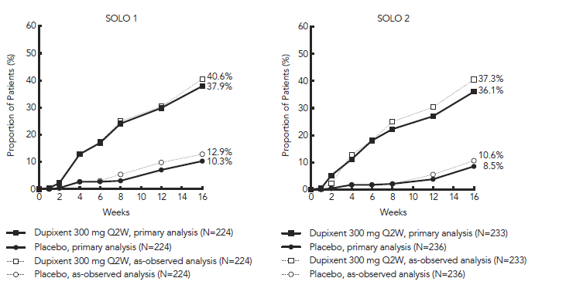a Responder was defined as a patient with IGA 0 or 1 (“clear” or “almost clear”) with a reduction of ≥ 2 points on a 0-4 IGA scale.
b In the primary analyses of the efficacy endpoints (solid line above), patients who received rescue treatment were considered non-responders for the purpose of this statistical analysis. The as-observed analyses (dotted line above) included all data regardless of rescue treatment. In both cases, patients with missing data were considered as non-responders.
c Full analysis set (FAS) includes all patients randomised.

Figure 2 ­ Proportion of Patients with EASI-75 in SOLO 1 (Study 1334) and SOLO 2 (Study 1416) (FAS^{b})
SOLO 1 | SOLO 2
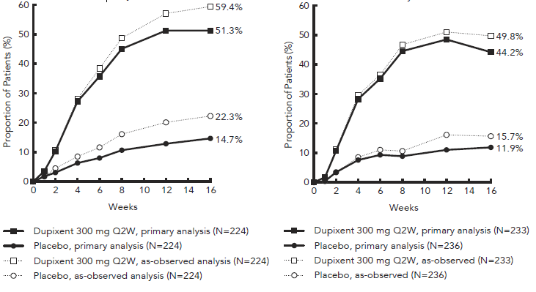
ª In the primary analyses of the efficacy endpoints (solid line above), patients who received rescue treatment were considered non-responders for the purpose of this statistical analysis. The as-observed analyses (dotted line above) included all data regardless of rescue treatment. In both cases, patients with missing data were considered as non-responders.
^{b} Full analysis set (FAS) includes all patients randomised.
Treatment effects in subgroups (weight, age, gender, race, and background treatment, including immunosuppressants) in Study 1334 and Study 1416 were in general consistent with the results in the overall study population.

52-Week Concomitant TCS Study – CHRONOS (Study 1224)
In CHRONOS (Study 1224), a significantly greater proportion of patients randomised to Dupixent 300 mg Q2W + TCS achieved an IGA 0 or 1 response, EASI-75, and/or an improvement of ≥ 4 points on the pruritis NRS from baseline to week 16 and week 52 compared to placebo + TCS (see Table 10).
A significantly greater proportion of patients randomised to Dupixent + TCS achieved a rapid improvement in the pruritus NRS compared to placebo + TCS (defined as ≥4-point improvement as early as week 2; p <0.05) and the proportion of patients responding on the pruritus NRS continued to increase through the treatment period (see Figure 3). The improvement in pruritus NRS occurred in conjunction with the improvement of objective signs of atopic dermatitis.

Figure 3 and Figure 4 show the proportion of patients who achieved an IGA 0 or 1 response and EASI 75, respectively, up to Week 52 in Study 1224.
EASI-90 response was achieved in 15.5% of patients in the placebo group, 50.6% in the Dupixent 300 mg Q2W group, and 50.7% in the Dupixent 300 mg QW group, respectively in the Study 1224 study at Week 52.
EASI-50 response was achieved in 29.9% of patients in the placebo group, 78.7% in the Dupixent 300 mg Q2W group, and 70.0% in the Dupixent 300 mg QW group, respectively in Study 1224 at Week 52.

Table 10 ­ Efficacy Results of Dupixent with Concomitant TCSª at Week 16 and Week 52 in CHRONOS (Study 1224)
 | Week 16 (FAS)^{b} |  |  | Week 52 (FAS Week 52)^{b}
 | Placebo + TCS | Dupixent  300 mg Q2W + TCS | Dupixent  300 mg QW + TCS | Placebo +  TCS | Dupixent  300 mg Q2W + TCS | Dupixent  300 mg QW + TCS
Patients randomised | 315 | 106 | 319 | 264 | 89 | 270
IGA 0 or 1^{c}, % responders ^{d} | 12.4 % | 38.7 %* | 39.2 %* | 12.5 % | 36.0%* | 40.0 %*
EASI-75, % responders ^{d} | 23.2 % | 68.9 %* | 63.9 %* | 21.6 % | 65.2 %* | 64.1 %*
EASI, LS mean % change from baseline (+/- SE) | -48.4 % (3.82) | -80.5 %* (6.34) | -81.5 %* (5.78) | -60.9 % (4.29) | -84.9 %# (6.73) | -87.8 % ‡ (6.19)
Pruritus NRS, LS mean % change from baseline (+/- SE) | -30.3  (2.36) | -56.6*  (3.95) | -57.1  (2.11) | -31.7  (3.95) | -57.0§  (6.17) | -56.5  (3.26)
Number of patients with baseline pruritus NRS score ≥ 4 | 299 | 102 | 295 | 249 | 86 | 249
Pruritus NRS (≥4-point improvement), % responders ^{d e} | 19.7 % | 58.8 %* | 50.8 %* | 12.9 % | 51.2 %* | 39.0 %*
* p-value <0.0001,
‡ p-value = 0.0003,
§ p-value = 0.0005,
# p-value = 0.0015
a All patients were on background TCS therapy and patients were permitted to use topical calcineurin inhibitors.
b Full analysis set (FAS) includes all patients randomised. FAS Week 52 includes all patients randomised at least one year before the cut-off date of the primary analysis.
c Responder was defined as a patient with IGA 0 or 1 (“clear” or “almost clear”) with a reduction of ≥ 2 points on a 0-4 IGA scale.
d Patients who received rescue treatment or with missing data were considered as non-responders.
e a significantly greater proportion of patients on Dupixent had improvement in pruritus NRS of ≥4 points compared to placebo at week 2 (p<0.05).
LS = least square SE = standard error

Figure 3 ­ Proportion of Patients with IGA 0 or 1ª in CHRONOS (Study 1224) (FAS Week 52^{c})
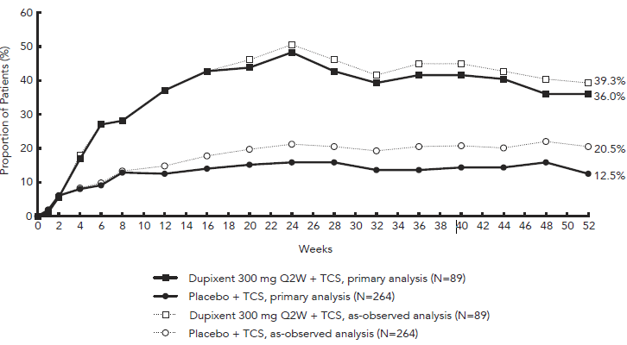
a Responder was defined as a patient with IGA 0 or 1 (“clear” or “almost clear”) with a reduction of ≥ 2 points on a 0-4 IGA scale.
b In the primary analyses of the efficacy endpoints (solid line above), patients who received rescue treatment were considered non-responders for the purpose of this statistical analysis. The as-observed analyses (dotted line) included all data regardless of rescue treatment. In both cases, patients with missing data were considered as non-responders.
c FAS Week 52 includes all patients randomised at least one year before the cut-off date of the primary analysis.
Figure 4 ­ Proportion of Patients with EASI-75 in CHRONOS (Study 1224) (FAS Week 52^{b})
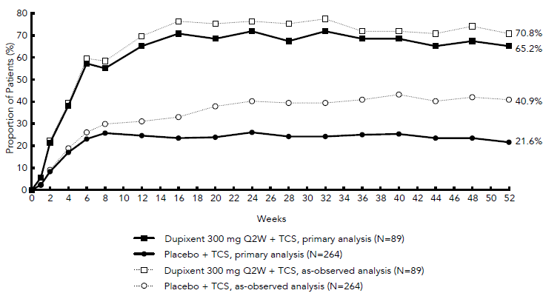
a In the primary analyses of the efficacy endpoints (solid line above), patients who received rescue treatment were considered non-responders for the purpose of this statistical analysis. The as-observed analyses (dotted line) included all data regardless of rescue treatment. In both cases, patients with missing data were considered as non-responders.
b FAS Week 52 includes all patients randomised at least one year before the cut-off date of the primary analysis.
Treatment effects in evaluable subgroups (weight, age, gender, race, and background treatment, including immunosuppressants) in Study 1224 were in general consistent with the results in the overall study population.

Clinical Response in Patients for whom Cyclosporin Treatment was Inadvisable
In the monotherapy studies, across both Dupixent treatment groups, patients for whom cyclosporin treatment was inadvisable (uncontrolled with or ineligible to receive cyclosporin) had generally more severe AD at baseline based on mean EASI (36.3 vs 31.4), IGA (3.6 vs 3.4), mean BSA involvement (58.9 % vs 52.5 %), peak pruritus NRS (7.5 vs 7.3) and DLQI (16.2 vs 14.5) scores relative to the remainder of patients in these studies. Similar findings were observed for patients for whom cyclosporin treatment was inadvisable in the concomitant TCS study.
In patients for whom cyclosporin treatment was inadvisable, treatment with Dupixent monotherapy, across both Dupixent treatment groups, resulted in significant improvements in signs and symptoms of AD, compared to placebo-treated patients. A greater percentage of Dupixent-treated patients than placebo-treated patients achieved IGA 0 or 1 and a reduction from baseline of ≥2 points at week 16 (29.5% vs 6.8%), EASI-75 at week 16 (38% vs 11.4%), and a ≥4 points reduction in pruritus NRS from baseline to week 16 (34.9% vs 8%) (p <0.001 for all 3 endpoints).
Similar results were observed in patients who received Dupixent concomitantly with TCS. The efficacy of Dupixent + TCS was sustained at week 52. In the combination therapy of Dupixent + TCS the proportion of patients achieving EASI-75 at week 16 was significantly higher in the dupilumab 300 mg Q2W + TCS (62.6%) and dupilumab 300 mg QW + TCS (59.1%) groups than the placebo + TCS group (29.6%). Both comparisons were statistically significant (p<0.0001 for each). The efficacy of Dupixent + TCS was sustained at week 52.

Maintenance and Durability of Response (SOLO CONTINUE study)
To evaluate maintenance and durability of response, subjects treated with Dupixent for 16 weeks in SOLO 1 and SOLO 2 studies who achieved IGA 0 or 1 or EASI-75 were re-randomised in the SOLO CONTINUE study to an additional 36-week treatment of Dupixent or placebo, for a cumulative 52-week study treatment. Endpoints were assessed at weeks 51 or 52.
The co-primary endpoints were the difference between baseline (week 0) and week 36 in percent change in EASI from SOLO 1 and SOLO 2 studies baseline and percentage of patients with EASI-75 at week 36 in patients with EASI-75 at baseline.
Patients who continued on the same dose regimen received in the SOLO 1 and SOLO 2 studies (300 mg Q2W or 300 mg QW) showed the optimal effect in maintaining clinical response while efficacy for other dose regimens diminished in a dose-dependent manner.
Primary and secondary endpoints for the 52 week SOLO CONTINUE study are summarised in Table 11.

Table 11 ­ Results of the primary and secondary endpoints in the SOLO CONTINUE study
Placebo |  | Dupilumab 300 mg
 | N=83 | Q8W N=84 | Q4W N=86 | Q2W/QW N=169
Co-Primary Endpoints
LS mean change (SE) between baseline and week 36 in percent change in EASI Score from Parent Study baseline | 21.7 (3.13) | 6.8*** (2.43) | 3.8*** (2.28) | 0.1***  (1.74)
Percent of patients with EASI-75 at week 36 for patients with EASI-75 at baseline, n (%) | 24/79 (30.4%) | 45/82* (54.9%) | 49/84** (58.3%) | 116/162*** (71.6%)
Key Secondary Endpoints
Percent of patients whose IGA response at week 36 was maintained within 1 point of baseline in the subset of patients with IGA (0,1) at baseline, n (%) | 18/63 (28.6) | 32/64† (50.0) | 41/66** (62.1) | 89/126*** (70.6)
Percent of patients with IGA (0,1) at week 36 in the subset of patients with IGA (0,1) at baseline, n (%) | 9/63 (14.3) | 21/64† (32.8) | 29/66** (43.9) | 68/126*** (54.0)
Percent of patients whose peak pruritus NRS increased by ≥3 points from baseline to week 35 in the subset of patients with peak pruritus NRS ≤7 at baseline, n (%) | 56/80 (70.0) | 45/81 (55.6) | 41/83† (49.4) | 57/168*** (33.9)
†P<0.05, *P<0.01, **P<0.001, ***P≤0.0001
In SOLO CONTINUE, a trend for increased treatment-emergent ADA positivity with increased dosing intervals was observed. Treatment-emergent ADA: QW: 1.2%; Q2W: 4.3%; Q4W: 6.0%; Q8W: 11.7%. ADA responses lasting more than 12 weeks: QW: 0.0%; Q2W: 1.4%; Q4W: 0.0%; Q8W: 2.6%.

Adolescent atopic dermatitis (12 to 17 years of age)
The efficacy and safety of Dupixent monotherapy in adolescent patients was evaluated in a multicentre, randomised, double-blind, placebo-controlled study (AD-1526) in 251 adolescent patients 12 to 17 years of age with moderate-to-severe atopic dermatitis (AD) defined by Investigator’s Global Assessment (IGA) score ≥3 in the overall assessment of AD lesions on a severity scale of 0 to 4, an Eczema Area and Severity Index (EASI) score ≥16 on a scale of 0 to 72, and a minimum body surface area (BSA) involvement of ≥10%. Eligible patients enrolled into this study had previous inadequate response to topical medication.
Patients received one of the following regimens:
- an initial dose of 400 mg Dupixent (two 200 mg injections) on day 1, followed by 200 mg once every other week (Q2W) for patients with baseline weight of <60 kg or an initial dose of 600 mg Dupixent (two 300 mg injections) on day 1, followed by 300 mg Q2W for patients with baseline weight of ≥ 60 kg;
- an initial dose of 600 mg Dupixent (two 300 mg injections) on day 1, followed by 300 mg every 4 weeks (Q4W) regardless of baseline body weight;
- matching placebo.
Dupixent was administered by subcutaneous (SC) injection. If needed to control intolerable symptoms, patients were permitted to receive rescue treatment at the discretion of the investigator. Patients who received rescue treatment were considered non-responders.
At baseline 46.2% of patients had a baseline IGA score of 3 (moderate AD), 53.8% of patients had a baseline IGA of 4 (severe AD), the mean BSA involvement was 56.5%, and 42.4 % of patients had received prior systemic immunosuppressants. Also at baseline the mean Eczema Area and Severity Index (EASI) score was 35.5, the baseline weekly averaged pruritus Numerical Rating Scale (NRS) was 7.6, the baseline mean Scoring Atopic Dermatitis (SCORAD) score was 70.3. Overall, 92.0% of patients had at least one co-morbid allergic condition; 65.6% had allergic rhinitis, 53.6% had asthma, and 60.8% had food allergies.
The co-primary endpoint was the proportion of patients with IGA 0 or 1 (“clear” or “almost clear”) and at least a 2-point improvement. The other co-primary endpoint was the proportion of patients with EASI-75 (improvement of at least 75% in EASI). Both co-primary endpoints were measured from baseline to Week 16. Other evaluated outcomes included the proportion of subjects with EASI-50 or EASI-90 (improvement of at least 50% or 90% in EASI from baseline respectively), reduction in itch as measured by the peak pruritus NRS, and percent change in the SCORAD scale from baseline to Week 16. Additional secondary endpoints included mean change from baseline to week 16 in the POEM and CDLQI scores.

Clinical Response

The efficacy results at Week 16 for adolescent atopic dermatitis study are presented in Table 12 .
Table 12 ­ Efficacy results of Dupixent in the adolescent atopic dermatitis study at Week 16 (FAS)ª
 | AD-1526(FAS)ª
 | Placebo | Dupixent 200 mg (<60 kg) and  300 mg (≥60 kg) Q2W*
Patients randomised (n) | 85ª | 82ª
IGA 0 or 1^{b}, % responders^{c} | 2.4% | 24.4%
EASI-50, % responders^{c} | 12.9% | 61.0%
EASI-75, % responders^{c} | 8.2% | 41.5%
EASI-90, % responders^{c} | 2.4% | 23.2%
EASI, LS mean % change from baseline  (+/-SE) | -23.6%  (5.49) | -65.9%  (3.99)
SCORAD, LS mean % change from baseline (+/- SE) | -17.6%  (3.76) | -51.6%  (3.23)
Pruritus NRS, LS mean % change from baseline (+/- SE) | -19.0%  (4.09) | -47.9%  (3.43)
Pruritus NRS (>4-point improvement), % responders^{c} | 4.8% | 36.6%
BSA LS mean % change from baseline  (+/- SE) | -11.7%  (2.72) | -30.1%  (2.34)
ª Full Analysis Set (FAS) includes all patients randomised.
^{b} Responder was defined as a subject with IGA 0 or 1 (“clear” or “almost clear”) with a reduction of ≥2 points on a 0-4 IGA scale.
^{c} Patients who received rescue treatment or with missing data were considered as non-responders (58.8% and 20.7% in the placebo and dupixent arms, respectively.
* All p-values <0.0001
A larger percentage of patients randomised to placebo needed rescue treatment (topical corticosteroids, systemic corticosteroids, or systemic non-steroidal immunosuppressants) as compared to the Dupixent group (58.8% and 20.7%, respectively).
A significantly greater proportion of patients randomised to Dupixent achieved a rapid improvement in the pruritus NRS compared to placebo (defined as >4-point improvement as early as week 4; nominal p<0.001) and the proportion of patients responding on the pruritus NRS continued to increase through the treatment period (see Figure 5). The improvement in pruritus NRS occurred in conjunction with the improvement of objective signs of atopic dermatitis.
Figure 5 ­ Proportion of adolescent patients with ≥4-point improvement on the pruritus NRS in AD-1526 studyª (FAS)^{b}
ª In the primary analyses of the efficacy endpoints, subjects who received rescue treatment or with missing data were considered non-responders.
^{b} Full Analysis Set (FAS) includes all subjects randomised.
The long-term efficacy of Dupixent in adolescent patients with moderate-to-severe AD who had participated in previous clinical trials of Dupixent was assessed in open-label extension study (AD-1434). Efficacy data from this study suggests that clinical benefit provided at week 16 was sustained through week 52.

Paediatric Atopic Dermatitis (6 to 11 years of age)
The efficacy and safety of Dupixent in paediatric patients concomitantly with TCS was evaluated in a multicentre, randomised, double-blind, placebo-controlled study (AD-1652) in 367 subjects 6 to 11 years of age, with AD defined by an IGA score of 4 (scale of 0 to 4), an EASI score ≥21 (scale of 0 to 72), and a minimum BSA involvement of ≥15%. Eligible patients enrolled into this trial had previous inadequate response to topical medication. Enrollment was stratified by baseline weight (<30 kg; ≥30 kg).
Patients in the Dupixent Q2W + TCS group with baseline weight of <30 kg received an initial dose of 200 mg on Day 1, followed by 100 mg Q2W from Week 2 to Week 14, and patients with baseline weight of ≥30 kg received an initial dose of 400 mg on Day 1, followed by 200 mg Q2W from week 2 to week 14. Patients in the Dupixent Q4W + TCS group received an initial dose of 600 mg on Day 1, followed by 300 mg Q4W from week 4 to week 12, regardless of weight. Patients were permitted to receive rescue treatment at the discretion of the investigator. Patients who received rescue treatment were considered non-responders.
In this study, the mean age was 8.5 years, the median weight was 29.8 kg, 50.1% of patients were female, 69.2% were White, 16.9% were Black, and 7.6% were Asian. At baseline, the mean BSA involvement was 57.6%, and 16.9% had received prior systemic non-steroidal immunosuppressants. Also, at baseline the mean EASI score was 37.9, and the weekly average of daily worst itch score was 7.8 on a scale of 0-10, the baseline mean SCORAD score was 73.6, the baseline POEM score was 20.9, and the baseline mean CDLQI was 15.1. Overall, 91.7% of subjects had at least one co-morbid allergic condition; 64.4% had food allergies, 62.7% had other allergies, 60.2% had allergic rhinitis, and 46.7% had asthma.
The primary endpoint was the proportion of patients with an IGA 0 (clear) or 1 (almost clear) at week 16. Other evaluated outcomes included the proportion of patients with EASI-75 or EASI-90 (improvement of at least 75% or 90% in EASI from baseline, respectively), percent change in EASI score from baseline to week 16, and reduction in itch as measured by the peak pruritus NRS (≥4-point improvement). Additional secondary endpoints included mean change from baseline to week 16 in the POEM and CDLQI scores.

Clinical Response
Table 13 presents the results by baseline weight strata for the approved dose regimens.
Table 13 ­ Efficacy Results of Dupixent with Concomitant TCS in AD-1652 at Week 16 (FAS)ª
 | Dupixent  300 mg Q4W^{d}  + TCS | Placebo +TCS | Dupixent  200 mg Q2W^{e}  + TCS | Placebo  + TCS
 | (N=61) | (N=61) | (N=59) | (N=62)
 | <30 kg | <30 kg | ≥30 kg | ≥30 kg
IGA 0 or 1^{b}, % responders^{c} | 29.5% | 13.1% | 39.0% | 9.7%
EASI-50, % responders^{c} | 95.1% | 42.6% | 86.4% | 43.5%
EASI-75, % responders^{c} | 75.4% | 27.9% | 74.6% | 25.8%
EASI-90, % responders^{c} | 45.9% | 6.6% | 35.6% | 8.1%
EASI, LS mean % change from baseline (+/-SE) | -84.3%  (3.08) | -49.1%  (3.30) | -80.4%  (3.61) | -48.3%  (3.63)
SCORAD, LS mean % change from baseline (+/- SE) | -65.3%  (2.87) | -28.9%  (3.05) | -62.7%  (3.14) | -30.7%  (3.28)
Pruritus NRS, LS mean % change from baseline (+/- SE) | -55.1%  (3.94) | -27.0%  (4.24) | -58.2%  (4.01) | -25.0%  (3.95)
Pruritus NRS (≥4-point improvement), % responders^{c} | 54.1% | 11.7% | 61.4% | 12.9%
BSA, LS mean change from baseline (+/- SE) | -43.2  (2.16) | -23.9  (2.34) | -38.4  (2.47) | -19.8  (2.50)
CDLQI, LS mean change from baseline (+/-SE) | -11.5  (0.69) | -7.2  (0.76) | -9.8  (0.63) | -5.6  (0.66)
CDLQI, (≥6-point improvement), % responders | 81.8% | 48.3% | 80.8% | 35.8%
POEM, LS mean change from baseline (+/- SE) | -14.0  (0.95) | -5.9  (1.04) | -13.6  (0.90) | -4.7  (0.91)
POEM, (≥6-point improvement), % responders | 81.4% | 32.8% | 79.3% | 31.1%
ªFull Analysis Set (FAS) includes all patients randomised.
^{b}Responder was defined as a patient with an IGA 0 or 1 (“clear” or “almost clear”).
^{c}Patients who received rescue treatment or with missing data were considered as non-responders.
^{d}At Day 1, patients received 600 mg of dupilumab.
^{e}At Day 1, patients received 200 mg (baseline weight <30 kg) or 400 mg (baseline weight ≥30 kg) of dupilumab.
A greater proportion of patients randomised to Dupixent + TCS achieved an improvement in the peak pruritus NRS compared to placebo + TCS (defined as ≥4-point improvement at week 4). See Figure 6.
Figure 6 ­ Proportion of Paediatric Subjects with ≥4-point Improvement on the Peak Pruritus NRS in AD-1652ª (FAS)^{b}
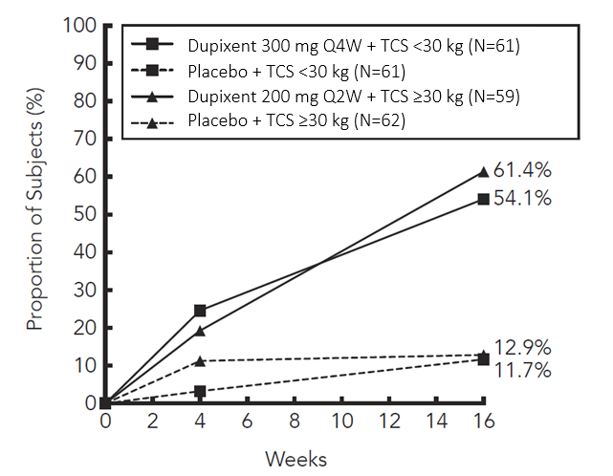

ªIn the primary analyses of the efficacy endpoints, patients who received rescue treatment or with missing data were considered non-responders.
^{b}Full Analysis Set (FAS) includes all patients randomised

The Dupixent groups significantly improved patient-reported symptoms, the impact of AD on sleep and health-related quality of life as measured by POEM, SCORAD, and CDLQI scores at 16 weeks compared to placebo.
The long-term efficacy of Dupixent + TCS in paediatric patients with atopic dermatitis who had participated in the previous clinical trials of Dupixent + TCS was assessed in an open-label extension study (AD-1434). Efficacy data from this trial suggests that clinical benefit provided at Week 16 was sustained through Week 52.

Asthma
The asthma development program included three randomised, double-blind, placebo-controlled, parallel-group, multi-centre studies (DRI12544, Quest, and Venture) of 24 to 52 weeks in treatment duration which enrolled a total of 2888 patients (12 years of age and older).
Patients enrolled in DRI12544 and Quest studies were required to have a history of 1 or more asthma exacerbations that required treatment with systemic corticosteroids or emergency department visit or hospitalization for the treatment of asthma in the year prior to study entry. Patients enrolled in Venture study required dependence on daily oral corticosteroids in addition to regular use of high-dose inhaled corticosteroids plus an additional controller(s).
The effects of Dupixent treatment discontinuation on severe exacerbations and FEV1 were assessed in the DRI12544 study during the 16-week follow-up period. Patients in both the overall and the baseline blood eosinophil count of ≥ 300 cells/mcL populations experienced a gradual return to baseline asthma status, with no evidence of rebound effect.
In all 3 studies, patients were enrolled without requiring a minimum baseline blood eosinophil or other Type 2 biomarker (e.g. FeNO or IgE) level.
In the Quest and Venture studies, patients with baseline blood eosinophil level of >1500 cells/mcL (<1.3%) were excluded.
Dupixent was administered as add-on to background asthma treatment.
Patients continued background asthma therapy throughout the duration of the studies except in Venture study in which OCS dose was tapered as described below.

DRI12544 study
DRI12544 was a 24- week dose-ranging study which included 776 patients (18 years of age and older). Dupixent compared with placebo was evaluated in adult patients with moderate to severe asthma on a medium- or-high dose inhaled corticosteroid and a long acting beta agonist.
Patients were randomised to receive either 200 mg (N= 150) or 300 mg (N= 157) Dupixent every other week or 200 mg (N= 154) or 300 mg (N= 157) Dupixent every 4 weeks following an initial dose of 400 mg, 600 mg or placebo (N= 158), respectively.
The primary endpoint was change from baseline to Week 12 in FEV1 (L). Other endpoints included percent change from baseline in FEV1 and annualised rate of severe asthma exacerbation events during the 24-week placebo controlled treatment period.
Results were evaluated in the overall population and subgroups based on baseline blood eosinophil count (≥ 300 cells/mcL and < 300 cells/mcL).
Additional secondary endpoints included mean change from baseline and responder rates in the patient reported Asthma Control Questionnaire (ACQ-5) and Asthma Quality of Life Questionnaire, Standardised Version (AQLQ(S)) scores.

EFC13579 (Quest) study
Quest was a 52-week study which included 1902 patients (12 years of age and older). Dupixent compared with placebo was evaluated in 107 adolescent and 1795 adult patients with moderate-to-severe asthma on a medium- or high- dose inhaled corticosteroid (ICS) and a minimum of one and up to two controller medications.
Patients requiring a third controller were allowed to participate in this study. Patients were randomised to receive either 200 mg (N=631) or 300 mg (N=633) Dupixent every other week (or matching placebo for either 200 mg [N = 317] or 300 mg [N= 321] every other week) following an initial dose of 400 mg, 600 mg or placebo respectively.
The primary endpoints were the annualised rate of severe exacerbation events during the 52-week placebo controlled period and change from baseline in pre-bronchodilator FEV1 at Week 12 in overall population (unrestricted by minimum baseline eosinophils or other Type 2 biomarkers).
Additional secondary endpoints included exacerbation rates and FEV1 in patients with different baseline levels of eosinophils as well as mean change from baseline and responder rates in the ACQ-5 and AQLQ(S) scores.

EFC13691 (Venture) study
Venture was a 24-week oral corticosteroid-reduction study in 210 patients with asthma who required daily oral corticosteroids in addition to regular use of high dose inhaled corticosteroids plus an additional controller.
After optimizing the OCS dose during the screening period, patients received 300 mg Dupixent (N=103) or placebo (N=107) once every other week for 24 weeks following an initial dose of 600 mg or placebo.
Patients continued to receive their existing asthma medicine during the study; however their OCS dose which was reduced every 4 weeks during the OCS reduction phase (Week 4-20), as long as asthma control was maintained. The OCS reduction was performed according to algorithm specified in the protocol.
The primary endpoint was the percent reduction of oral corticosteroid dose at Week 24 compared with the baseline dose, while maintaining asthma control in the overall population (unrestricted by minimum baseline eosinophils or other Type 2 biomarkers). The key secondary endpoints were the proportion of patients achieving a reduction of 50% or greater in their OCS dose compared with baseline and proportion of patients achieving a reduction of OCS dose to <5 mg/day at Week 24 while maintaining asthma control.
Additional secondary endpoints included the annualised rate of severe exacerbation events during treatment period and mean change from baseline and responder rate in the ACQ-5 and AQLQ(S) scores.
The demographics and baseline characteristics of these 3 studies are provided in Table 14 below.
Table 14 ­ Demographics and Baseline Characteristics of Asthma Trials
Parameter | DRI12544  (n = 776) | Quest  (n = 1902) | Venture  (n=210)
Mean age (years) (SD) | 48.6 (13.0) | 47.9 (15.3) | 51.3 (12.6)
% Female | 63.1 | 62.9 | 60.5
% White | 78.2 | 82.9 | 93.8
Body Mass Index ≥30 kg/ m2 (%) | 40.2 | 39.5 | 41.4
Duration of Asthma (years), mean (± SD) | 22.03 (15.42) | 20.94 (15.36) | 19.95 (13.90)
Never smoked, (%) | 77.4 | 80.7 | 80.5
Mean exacerbations in previous year (± SD) | 2.17 (2.14) | 2.09 (2.15) | 2.09 (2.16)
High dose ICS use* (%) | 49.5 | 51.5 | 88.6
Pre-dose FEV1 (L) at baseline (± SD) | 1.84 (0.54) | 1.78 (0.60) | 1.58 (0.57)
Mean percent predicted FEV1 at baseline (%) (±SD) | 60.77 (10.72) | 58.43 (13.52) | 52.18 (15.18)
% Reversibility (± SD) | 26.85 (15.43) | 26.29 (21.73) | 19.47 (23.25)
Mean ACQ-5 score (± SD) | 2.74 (0.81) | 2.76 (0.77) | 2.50 (1.16)
Mean AQLQ score (± SD) | 4.02 (1.09) | 4.29 (1.05) | 4.35 (1.17)
Atopic Medical History % Overall  (AD %, NP %, AR %) | 72.9  (8.0, 10.6, 61.7) | 77.7  (10.3, 12.7, 68.6) | 72.4  (7.6, 21.0, 55.7)
Mean FeNO ppb (± SD) | 39.10 (35.09) | 34.97 (32.85) | 37.61 (31.38)
% patients with FeNO ppb  ≥25  ≥50 | 49.9  21.6 | 49.6  20.5 | 54.3  25.2
Mean total IgE IU/mL (± SD) | 435.05 (753.88) | 432.40 (746.66) | 430.58 (775.96)
Mean baseline Eosinophil count (± SD) cells/mcL | 350 (430) | 360 (370) | 350 (310)
% patients with EOS  ≥ 150 cells/mcL  ≥ 300 cells/mcL | 77.8  41.9 | 71.4  43.7 | 71.4  42.4
ICS = inhaled corticosteroid; LABA = Long-acting beta2-agonist; FEV1 = Forced expiratory volume in 1 second; ACQ-5 = Asthma Control Questionnaire-5; AQLQs = Asthma Quality of Life Questionnaire, Standardised Version; AD = atopic dermatitis; NP = nasal polyposis; AR = allergic rhinitis; FeNO = fraction of exhaled nitric oxide; EOS = blood eosinophil
* High dose ICS was defined as > 500 mcg fluticasone equivalent per day.

Exacerbations
The DRI12544, Quest, and Venture studies evaluated the frequency of severe asthma exacerbations. Exacerbations were defined as deterioration of asthma requiring the use of systemic corticosteroids for at least 3 days or hospitalization or emergency room visit due to asthma that required systemic corticosteroids. For patients on maintenance corticosteroids, an asthma exacerbation was defined as a temporary increase in oral corticosteroid dose for at least 3 days.
In the overall population, patients receiving either Dupixent 200 mg or 300 mg every other week had significant reductions in the rate of severe asthma exacerbations compared to placebo (see Table 15).
In the pooled analysis of the DRI12544 and Quest studies, the rate of severe exacerbations leading to hospitalizations and/or emergency room visits was reduced by 25.5% and 46.9% with Dupixent 200 mg or 300 mg every other week, respectively.
Table 15 ­ Rate of Severe Exacerbations in DRI12544, Quest, and Venture (Overall Populationª)
Study | Treatment (N) | Exacerbations per Year |  | Percent Reduction
Study | Treatment (N) | Rate (95% CI) | Rate Ratio (95%CI)
All Severe Exacerbations
DRI12544 | Dupixent  200 mg Q2W (n= 150) | 0.27 (0.16, 0.46) | 0.30 (0.16, 0.57) | 70%
DRI12544 | Dupixent  300 mg Q2W (n = 157) | 0.27 (0.16, 0.45) | 0.30 (0.16, 0.55) | 70%
DRI12544 | Placebo (n = 158) | 0.90 (0.62, 1.30)
Quest | Dupixent  200 mg Q2W (n= 631) | 0.46 (0.39, 0.53) | 0.52 (0.41, 0.66) | 48%
 | Placebo (n = 317) | 0.87 (0.72, 1.05)
 | Dupixent  300 mg Q2W (n =633) | 0.52 (0.45, 0.61) | 0.54 (0.43, 0.68) | 46%
 | Placebo (n = 321) | 0.97 (0.81, 1.16)
Venture^{b} | Dupixent  300 mg Q2W (n = 103) | 0.65 (0.44, 0.96) | 0.41 (0.26, 0.63) | 59%
Venture^{b} | Placebo (n = 107) | 1.60 (1.25, 2.04)
a Overall population is unrestricted by minimum baseline eosinophils or other Type 2 biomarkers
b OCS withdrawal study

Prespecified subgroup analyses of DRI12544, Quest, and Venture studies demonstrated that there were greater reductions in severe exacerbations in patients with higher baseline levels of markers for Type 2 inflammation such as eosinophil level and FeNO.
Prespecified subgroup analyses of AS Trials 1 and 2 demonstrated that there were greater reductions in severe exacerbations in subjects with higher baseline blood eosinophil levels. In AS Trial 2, reductions in exacerbations were significant in the subgroup of subjects with baseline blood eosinophils ≥ 150 cells/mcL. In subjects with baseline blood eosinophil count < 150 cells/mcL, similar severe exacerbation rates were observed between DUPIXENT and placebo.
In all studies, when compared to placebo greater reductions in severe exacerbations were also seen in patients with baseline FeNO ≥25 ppb.
In the Quest study, patients receiving medium dose ICS showed a similar reduction in rate of severe asthma exacerbations compared to patients receiving high dose ICS.
Table 16 ­ Rate of Severe Exacerbations in DRI12544, Quest, and Venture by Subgroups
Study | Treatment | Baseline Blood EOS
Study | Treatment | ≥150 cells/mcL |  |  |  | ≥300 cells/mcL
Study | Treatment | Exacerbations per Year |  |  | Percent Reduction | Exacerbations per Year |  |  | Percent Reduction
Study | Treatment | N | Rate  (95% CI) | Rate Ratio (95%CI) |  | N | Rate  (95% CI) | Rate Ratio (95%CI)
All Severe Exacerbations
DRI12544 | Dupixent  200 mg Q2W | 120 | 0.29  (0.16, 0.53) | 0.28  (0.14, 0.55) | 72% | 65 | 0.30  (0.13, 0.68) | 0.29  (0.11, 0.76) | 71%
DRI12544 | Dupixent 300 mg Q2W | 129 | 0.28  (0.158, 0.496) | 0.27  (0.14, 0.52) | 73% | 64 | 0.20  (0.08, 0.52) | 0.19  (0.07, 0.56) | 81%
DRI12544 | Placebo | 127 | 1.05  (0.69, 1.60) |  |  | 68 | 1.04  (0.57, 1.90)
Quest | Dupixent 200 mg Q2W | 437 | 0.45  (0.37, 0.54) | 0.44  (0.34,0.58) | 56% | 264 | 0.37  (0.29, 0.48) | 0.34  (0.24,0.48) | 66%
Quest | Placebo | 232 | 1.01  (0.81, 1.25) |  |  | 148 | 1.081  (0.846, 1.382)
Quest | Dupixent 300 mg Q2W | 452 | 0.43  (0.36, 0.53) | 0.40  (0.31,0.53) | 60% | 277 | 0.40  (0.32, 0.51) | 0.33  (0.23,0.45) | 67%
Quest | Placebo | 237 | 1.08  (0.88, 1.33) |  |  | 142 | 1.24  (0.97, 1.57)
Ventureª | Duixent 300 mg Q2W | 69 | 0.64  (0.43, 0.97) | 0.42  (0.25, 0.69) | 58% | 48 | 0.50  (0.26, 0.98) | 0.29  (0.14,0.60) | 71%
Ventureª | Placebo | 81 | 1.54  (1.14. 2.07) |  |  | 41 | 1.74  (1.20, 2.53)
a OCS withdrawal trial

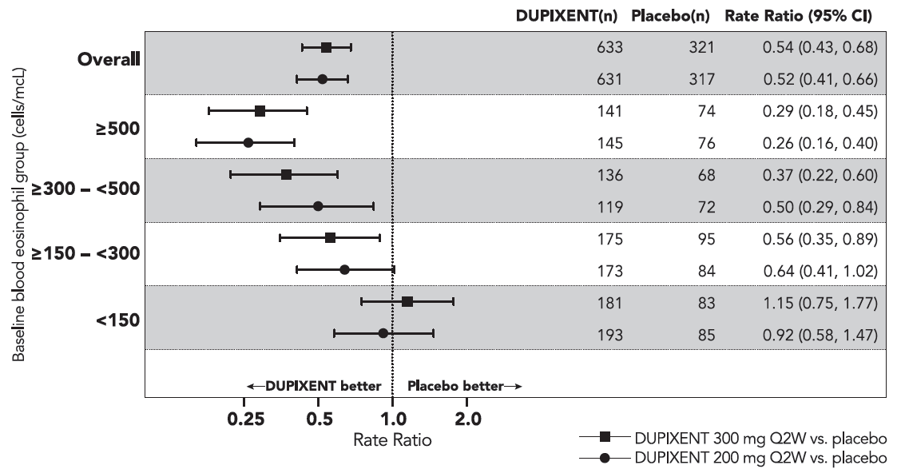
Figure 7 ­ Relative Risk in Annualised Event Rate of Severe Exacerbations across Baseline Blood Eosinophil Count (cells/mcL) in Quest
The cumulative mean number of severe exacerbation events in DRI12544, Quest, and Venture studies (Overall Population and Baseline Eosinophils ≥300 cells/mcL) during the 24- or 52-week treatment period is shown in Figure 8.
Figure 8 ­ Cumulative Mean Function for the Number of Severe Exacerbation Events During 24-or 52-week Treatment Period (Overall Populationª and Baseline Eosinophils ≥ 300 cells/mcL)
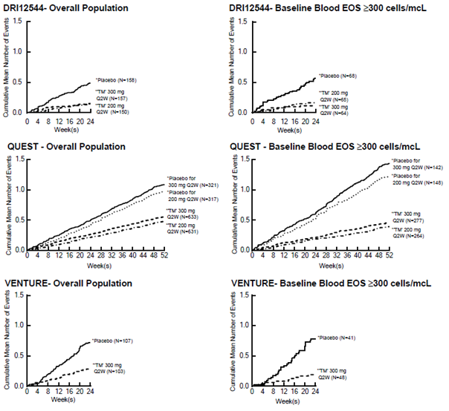ª Overall population is unrestricted by minimum baseline eosinophils or other Type 2 biomarkers
Over the course of the studies, patients in both Dupixent dose groups had lower cumulative number of events compared with patients in their respective placebo groups.

Lung Function
Significant increases in pre-bronchodilator FEV1 were observed at week 12 for DRI12544 and Quest trials in the primary analysis populations (subjects with baseline blood eosinophil count of ≥ 300 cells/mcL in DRI12544 and the overall population in the Quest trial.
Subgroup analysis of DRI12544, Quest, and Venture studies demonstrated that patients with baseline blood eosinophil count of ≥150 and ≥300 cells/mcL showed greater improvement in FEV1 compared with the overall population (Table 17).
Clinically meaningful improvements in FEV1 were observed in patients with baseline eosinophils <300 cell/mcL, although less than in the population with baseline blood eosinophil count ≥300 cells/mcL. Magnitude of effect was directly correlated with baseline eosinophil counts at all baseline eosinophil levels studied.
In the Quest study, compared to placebo, greater improvements in FEV1 were also seen in patients with FeNO ≥25 and ≥ 50 ppb.
Improvement in FEV1 was similar whether patients were receiving medium dose ICS, high dose ICS, or OCS.
Table 17 ­ Mean Change from Baseline in Pre-Bronchodilator FEV1 at Week 12 in DRI12544 and Quest and Week 24 in Venture (Overall Populationª and Baseline Blood Eosinophil Levels ≥150 and ≥300 cells/mcL)
Study | Treatment | Overall Populationª |  |  | Baseline Blood EOS
Study | Treatment |  |  |  | ≥150 cells/mcL |  |  | ≥300 cells/mcL
Study | Treatment | N | LS mean Δ From baseline  L (%) | LS Mean Difference vs. placebo  (95% CI) | N | LS Mean Δ From baseline  L (%) | LS Mean  Difference vs. placebo (95% CI) | N | LS mean Δ From baseline  L (%) | LS Mean  Difference vs. placebo (95% CI)
DRI12544 | Dupixent 200 mg Q2W | 150 | 0.31 (18.0) | 0.20  (0.11, 0.28) | 108 | 0.32 (18.25) | 0.23  (0.13, 0.33) | 65 | 0.43 (25.9) | 0.26  (0.11, 0.40)
DRI12544 | Dupixent 300 mg Q2W | 157 | 0.28 (17.8) | 0.16  (0.08, 0.25) | 120 | 0.26 (17.1) | 0.18  (0.08, 0.27) | 64 | 0.39 (25.8) | 0.21  (0.06, 0.36)
DRI12544 | Placebo | 158 | 0.12 (6.1) |  | 102 | 0.09 (4.36) |  | 68 | 0.18 (10.2)
Quest | Dupixent 200 mg Q2W | 631 | 0.32 (21.3) | 0.14  (0.08, 0.19) | 425 | 0.36 (23.6) | 0.17  (0.11, 0.23) | 264 | 0.43 (29.0) | 0.21  (0.13, 0.29)
Quest | Placebo | 317 | 0.18 (12.1) |  | 224 | 0.18 (12.4) |  | 148 | 0.21 (15.6)
Quest | Dupixent 300 mg Q2W | 633 | 0.34 (23.1) | 0.13  (0.08, 0.18) | 434 | 0.37 (25.3) | 0.15  (0.09, 0.21) | 277 | 0.47 (32.5) | 0.24  (0.16, 0.32)
Quest | Placebo | 321 | 0.21 (13.7) |  | 229 | 0.22 (14.2) |  | 142 | 0.22 (14.4)
Venture^{b} | Dupixent 300 mg Q2W | 103 | 0.22 (19.9) | 0.22  (0.09, 0.34) | 76 | 0.32 (26.0) | 0.22  (0.06, 0.38) | 48 | 0.44 (35.1) | 0.32  (0.10, 0.54)
Venture^{b} | Placebo | 107 | 0.01 (4.8) |  | 66 | 0.06  (9.1) |  | 41 | 0.12 (10.5)
ª Overall population is unrestricted by minimum baseline eosinophils or other Type 2 biomarkers
^{b} For Venture, the OCS withdrawal study, change from baseline in pre-brochodilator FEV1 at week 24 was reported to allow time for OCS reduction to reach optimization

Table 18 ­ Mean Change from Baseline in Pre-Bronchodilator FEV1 at Week 12 and Week 52 in QUEST by Baseline FeNO Subgroups
Treatment |  | At Week 12 |  | At Week 52
Treatment | N | LS Mean Δ From baseline L (%) | LS Mean Difference vs. placebo (95% CI) | LS Mean Δ From baseline L (%) | LS Mean Difference vs. placebo (95% CI)
FeNO ≥ 25 ppb
Dupilumab 200 mg Q2W | 288 | 0.44 (29.0%) | 0.23 (0.15, 0.31)ª | 0.49 (31.6%) | 0.30 (0.22, 0.39)ª
Placebo | 157 | 0.21 (14.1%) |  | 0.18 (13.2%)
Dupilumab 300 mg Q2W | 295 | 0.45 (29.8%) | 0.24 (0.16, 0.31)ª | 0.45 (30.5%) | 0.23 (0.15, 0.31)ª
Placebo | 167 | 0.21 (13.7%) |  | 0.22 (13.6%)
FeNO ≥ 50 ppb
Dupilumab 200 mg Q2W | 114 | 0.53 (33.5%) | 0.30 (0.17, 0.44)ª | 0.59 (36.4%) | 0.38 (0.24, 0.53)ª
Placebo | 69 | 0.23 (14.9%) |  | 0.21 (14.6%)
Dupilumab 300 mg Q2W | 113 | 0.59 (37.6%) | 0.39 (0.26, 0.52)ª | 0.55 (35.8%) | 0.30 (0.16, 0.44)ª
Placebo | 73 | 0.19 (13.0%) |  | 0.25 (13.6%)
ª p-value < 0.0001

Figure 9 ­ LS Mean Difference in Change from Baseline vs Placebo to Week 12 in Pre-Bronchodilator FEV₁ across Baseline Blood Eosinophil Counts (cells/mcL) in Quest
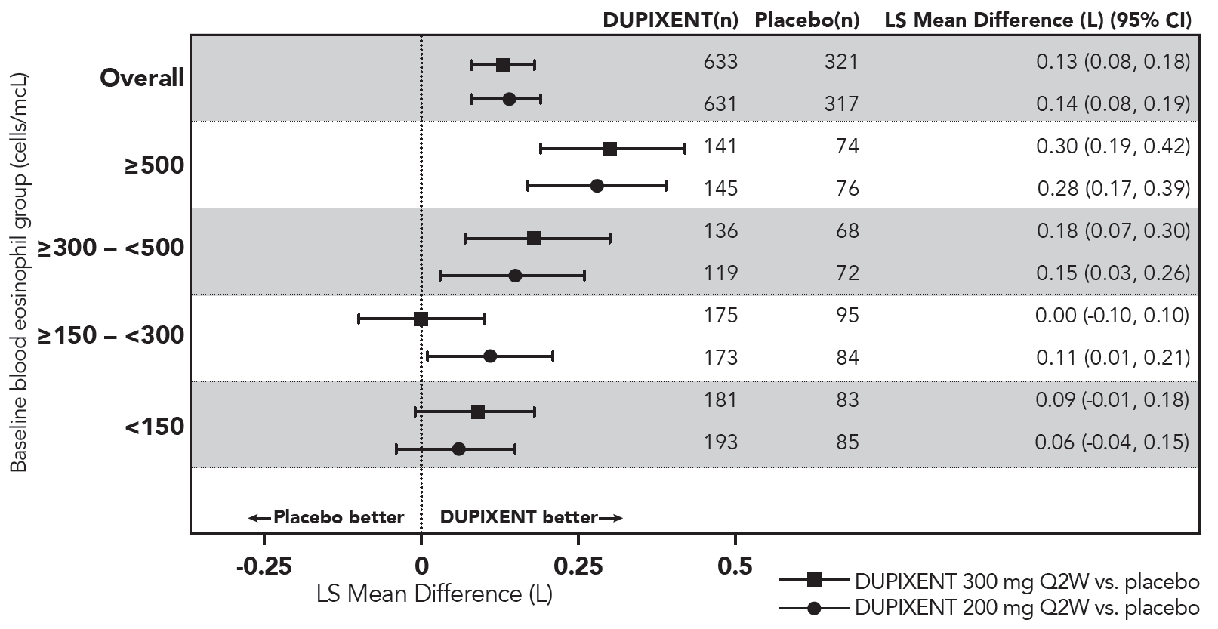

Significant improvements in FEV1 were observed as early as Week 2 (DRI12544, Quest, and Venture) following the first dose of Dupixent for both the 200 mg and 300 mg dose strengths and were maintained through Week 24 (DRI12544 and Venture) and Week 52 (Quest) (Figure 10).
Figure 10 ­ Mean Change from Baseline in Pre-Bronchodilator FEV1 (L) Over Time (Overall Populationª and Baseline Eosinophils ≥ 300 cells/mcL
a Overall population is unrestricted by minimum baseline eosinophils or other Type 2 biomarkers.

Additional Secondary Endpoints
ACQ-5 and AQLQ(S) were analysed at both a cohort level (mean change from baseline) and an individual-level (responder analyses) at 24 weeks (DRI12544) and at 52 weeks (Quest).
The responder rate was defined as an improvement in score of 0.5 or more (scale range 0-6 for ACQ-5 and 1-7 for AQLQ(S)). Improvements in ACQ-5 and AQLQ(S) were observed as early as Week 2 and maintained for 24 weeks in DRI12544 study and 52 weeks in Quest study.
Similar results were observed in the Venture study. In asthma patients with comorbid upper airway disease Dupixent treatment also reduced upper airway symptoms.
Patients with asthma and comorbid chronic rhinosinusitis (CRS) with or without nasal polyposis, and/or comorbid allergic rhinitis (AR), reported their health-related quality of life on disease-specific questionnaires; the 22-Item Sino Nasal Outcome Test (SNOT-22) for CRS patients and Standardised Rhinoconjunctivitis Quality of Life Questionnaire (RQLQ (S)+ 12) for AR patients. Mean change from baseline in total scores on SNOT-22 and RQLQ(S)+12 were pre-specified endpoints in these subpopulations. Improvements in SNOT-22 and RQLQ(S)+12 total score were observed with Dupixent compared to placebo as early as week 12 and sustained over 52 weeks.

Oral Corticosteroid Reduction (Venture)
The Venture study evaluated the effect of Dupixent on reducing the use of maintenance oral corticosteroids. The baseline mean oral corticosteroid use was 11.75 mg in the placebo group and 10.75 mg in the group receiving Dupixent.
Compared with placebo, patients receiving Dupixent achieved greater reductions in daily maintenance oral corticosteroid dose, while maintaining asthma control.
The results for primary and secondary endpoints of the Venture study are presented in the Table 19.
Table 19 ­ Results of the Primary and Secondary Endpoints in Venture (Overall Population)
 | Overall population
 | Dupixent 300 mg  N=103 | Placebo  N=107
Primary endpoint (week 24)
Percent reduction in OCS from baseline
Mean overall percent reduction from baseline (%)  Difference (% [95 % CI])(Dupixent vs. placebo) | 70.1  28.2  (15.81, 40.67) | 41.9
Secondary endpoint (week 24)
Proportion of patients achieving a reduction ≥ 50% OCS dose from base line | 79.6 | 53.3
Proportion of patients achieving a reduction of OCS dose to <5 mg/day | 69 | 33
Odds ratio (95% CI) | 4.48  (2.39, 8.39)

Long-term extension trial (TRAVERSE)
The long-term efficacy of Dupixent in 2282 adults and adolescents with moderate-to-severe asthma, and adults with oral corticosteroid-dependent asthma, who had participated in previous clinical trials of Dupixent, was assessed in the open-label extension study (TRAVERSE). In this study, the clinical benefit of Dupixent, including reduction in exacerbations and improvement in lung function, was sustained up to 96 weeks in patients with moderate to severe asthma with type 2 inflammation (see Table 19 and Table 20). In the population with oral-corticosteroid-dependent asthma, there was sustained reduction in exacerbations and maintained improvement in lung function, despite continued decrease or discontinuation of oral corticosteroid dose up to 96 weeks (see Table 20). Similar maintenance of effect was also observed for ACQ-5 and AQLQ(S) at week 48 (see Table 20). Consistent results were also observed in the subgroup of patients on high dose ICS.
Table 20 ­ Rate of Severe Exacerbations, Mean Change from Baseline in FEV1, ACQ-5 and AQLQ(s) Responder Rates in TRAVERSEª (Baseline Blood Eosinophil Levels ≥ 150 and ≥ 300 cells/mcL and FeNO ≥ 25 ppb)
Treatment | EOS  ≥ 150 cells/mcL |  | EOS  ≥ 300 cells/mcL |  |  | FeNO  ≥ 25 ppb
Unadjusted severe exacerbations rate over week 96
 | N | Rate |  | N | Rate |  | N | Rate
Dupixent 300 mg Q2W | 1496 | 0.30 |  | 905 | 0.27 |  | 1050 | 0.26
Mean Change from Baseline in FEV1 at week 96
 | N | Mean Δ From baseline L (%) |  | N | Mean Δ From baseline  L (%) |  | N | Mean Δ From baseline L (%)
Dupixent 300 mg Q2W | 865 | 0.33 (21.1) |  | 511 | 0.42 (27.3) |  | 596 | 0.39 (24.6)
ACQ-5 at week 48^{b}
 | N | Responder rate % |  | N | Responder rate % |  | N | Responder rate %
Dupixent 300 mg Q2W | 1412 | 87.3 |  | 855 | 88.8 |  | 998 | 88.7
AQLQ(S) at week 48^{b}
 | N | Responder rate % |  | N | Responder rate % |  | N | Responder rate %
Dupixient 300 mg Q2W | 1366 | 77.8 |  | 829 | 81.7 |  | 967 | 79.1
a In TRAVERSE study patients rolled over from DRI12544 and QUEST pivotal asthma studies.
b ACQ-5 and AQLQ(S) were not collected after week 48.

Table 21 ­ Rate of Unadjusted Severe Exacerbations and Mean Change from Baseline in Pre-Bronchodilator FEV1 over week 96 in TRAVERSE– patients rolled over from DRI12544, QUEST, and VENTURE studies
Populations | Parent Study | Treatment | Exacerbations |  | FEV1
Populations | Parent Study | Treatment | N | Rate | N | Mean Δ From baseline L
EOS  ≥ 150 cells/mcL/ FeNO  ≥ 25 ppb | DRI12544  QUEST | Dupixent 300 mg Q2W | 1679 | 0.305 | 958 | 0.32
OCS dependent | VENTURE | Dupixent 300 mg Q2W | 187 | 0.345 | 60 | 0.31

Paediatric asthma ( patients aged 6-11 years of age)
The efficacy and safety of Dupixent in paediatric patients was evaluated in a 52-week multicenter, randomized, double-blind, placebo-controlled study (VOYAGE) in 408 patients 6 to 11 years of age, with moderate-to-severe asthma on a medium- or high- dose ICS and one controller medication or high dose ICS alone. Patients were randomized to Dupixent (N=273) or matching placebo (N=135) every other week based on body weight ≤30 kg or >30 kg, respectively. The efficacy was evaluated in the populations with type 2 inflammation defined as blood eosinophils levels of ≥150 cells/mcL or FeNO ≥20 ppb.
The primary endpoint was the annualized rate of severe exacerbation events during the 52-week placebo-controlled period and the key secondary endpoint was the change from baseline in pre-bronchodilator FEV₁ percent predicted at Week 12. Additional secondary endpoints included mean change from baseline and responder rates in the ACQ-7-IA and PAQLQ(S)-IA scores.
The demographics and baseline characteristics for VOYAGE are provided in Table 22 below.
Table 22 ­ Demographics and Baseline Characteristics for VOYAGE
Parameter | EOS ≥ 150 cells/mcL or FeNO ≥ 20 ppb  (N = 350) | EOS  ≥ 300 cells/mcL  (N = 259) | ITT  (N=408)
Mean age (years) (SD) | 8.9 (1.6) | 9.0 (1.6) | 8.9 (1.6)
% Female | 34.3 | 32.8 | 35.8
% White | 88.6 | 87.3 | 88.2
Mean body weight (kg) | 36.09 | 35.94 | 35.91
Mean exacerbations in previous year (± SD) | 2.47 (2.30) | 2.64 (2.58) | 2.44 (2.18)
ICS dose (%)  Medium  High | 55.7  43.4 | 54.4  44.4 | 55.1  44.1
Pre-dose FEV₁ (L) at baseline (± SD) | 1.49 (0.41) | 1.47 (0.42) | 1.48 (0.41)
Mean percent predicted FEV1 (%) (±SD) | 77.89 (14.40) | 76.85 (14.78) | 78.07 (14.72)
Mean % Reversibility (± SD) | 27.79 (19.34) | 22.59 (20.78) | 19.58 (20.76)
Mean ACQ-7-IA score (± SD) | 2.14 (0.72) | 2.16 (0.75) | 2.13 (0.73)
Mean PAQLQ(S)-IA score (± SD) | 4.94 (1.10) | 4.93 (1.12) | 4.91 (1.13)
Atopic Medical History % Overall  (AD %, AR %) | 94  (38.9, 82.6) | 96.5  (44.4, 85.7) | 92.4  (36.3, 81.9)
Median total IgE IU/mL (± SD) | 905.52 (1140.41) | 1077.00 (1230.83) | 792.28 (1093.46)
Mean FeNO ppb (± SD) | 30.71 (24.42) | 33.50 (25.11) | 27.71 (23.84)
% patients with FeNO ppb  ≥20 | 58 | 64.1 | 49.7
Mean baseline Eosinophil count (± SD) cells/mcL | 570 (380) | 710 (360) | 500 (400)
% patients with EOS  ≥ 150 cells/mcL  ≥ 300 cells/mcL | 94.6  74 | 0  100 | 81.1  63.5
ICS = inhaled corticosteroid; FEV1 = Forced expiratory volume in 1 second; ACQ-7-IA = Asthma Control Questionnaire-7 Interviewer Administered; PAQLQ(S)-IA = Paediatric Asthma Quality of Life Questionnaire with Standardised Activities–Interviewer Administered; AD = atopic dermatitis; AR = allergic rhinitis; EOS = blood eosinophil; FeNO = fraction of exhaled nitric oxide
Exacerbations were defined as deterioration of asthma requiring the use of systemic corticosteroids for at least 3 days or hospitalization or emergency room visit due to asthma that required systemic corticosteroids. Dupixent significantly reduced the annualized rate of severe asthma exacerbation events during the 52-week treatment period compared to placebo in the population with type 2 inflammation and in population defined by baseline blood eosinophils ≥300 cells/mcL or by baseline FeNO ≥20 ppb. Clinically significant improvements in percent predicted pre-bronchodilator FEV₁ were observed at Week 12. Improvements were also observed for ACQ-7-IA and PAQLQ(S)-IA at Week 24 and were sustained at Week 52. Greater responder rates were observed for ACQ-7-IA and PAQLQ(S)-IA compared to placebo at Week 24. The efficacy results for VOYAGE are presented in Table 23.
In the population with type 2 inflammation, the LS mean change from baseline in pre-bronchodilator FEV₁ at Week 12 was 0.22 L in the Dupixent group and 0.12 L in the placebo group, with an LS mean difference versus placebo of 0.10 L (95% CI: 0.04, 0.16). The treatment effect was sustained over the 52-week treatment period, with an LS mean difference versus placebo at Week 52 of 0.17 L (95% CI: 0.09, 0.24).
In the population defined by baseline blood eosinophils >300 cells/mcL, the LS mean change from baseline in pre-bronchodilator FEV₁ at Week 12 was 0.22 L in the dupilumab group and 0.12 L in the placebo group, with an LS mean difference versus placebo of 0.10 L (95% CI: 0.03, 0.17). The treatment effect was sustained over the 52-week treatment period, with an LS mean difference versus placebo at Week 52 of 0.17 L (95% CI: 0.09, 0.26).
Table 23 ­ Rate of Severe Exacerbations, Mean Change from Baseline in FEV₁, ACQ-7-IA and PAQLQ(S)-IA Responder Rates in VOYAGE
Treatment | EOS ≥ 150 cells/mcL  or FeNO ≥ 20 ppb |  |  | EOS  ≥ 300 cells/mcL |  |  | FeNO  ≥20 ppb
Annualized severe exacerbations rate over 52 weeks
 | N | Rate  (95% CI) | Rate Ratio  (95% CI) | N | Rate  (95% CI) | Rate Ratio  (95% CI) | N | Rate  (95% CI) | Rate Ratio  (95% CI)
Dupixent  100 mg Q2W  (<30 kg)/  200 mg Q2W  (≥30 kg) | 236 | 0.305  (0.223, 0.416) | 0.407  (0.274, 0.605) | 175 | 0.235  (0.160, 0.345) | 0.353  (0.222, 0.562) | 141 | 0.271  (0.170, 0.432) | 0.384  (0.227, 0.649)
Placebo | 114 | 0.748  (0.542, 1.034) |  | 84 | 0.665  (0.467, 0.949) |  | 62 | 0.705  (0.421, 1.180)
Mean Change from Baseline in percent predicted FEV1 at Week 12
 | N | LS mean Δ from baseline in percent predicted FEV1 |  | N | LS mean Δ from baseline in percent predicted FEV1 |  | N | LS mean Δ from baseline in percent predicted FEV1
Dupixent  100 mg Q2W  (<30 kg)/  200 mg Q2W  (≥30 kg) | 229 | 10.53 |  | 168 | 10.15 |  | 141 | 11.36
Placebo | 110 | 5.32 |  | 80 | 4.83 |  | 62 | 4.62
ACQ-7-IA at Week 24ª
 | N | Responder rate % | OR vs. placebo  (95% CI) | N | Responder rate % | OR vs. placebo  (95% CI) | N | Responder rate % | OR vs. placebo  (95% CI)
Dupixent  100 mg Q2W  (<30 kg)/  200 mg Q2W  (≥30 kg) | 236 | 79.2 | 1.82  (1.02, 3.24) | 175 | 80.6 | 2.79  (1.43, 5.44) | 141 | 80.9 | 2.60  (1.21, 5.59)
Placebo | 114 | 69.3 |  | 84 | 64.3 |  | 62 | 66.1
PAQLQ(S)-IA at Week 24ª
 | N | Responder rate % | OR vs. placebo  (95% CI) | N | Responder rate % | OR vs. placebo  (95% CI) | N | Responder rate % | OR vs. placebo  (95% CI)
Dupixent  100 mg Q2W  (<30 kg)/  200 mg Q2W  (≥30 kg) | 211 | 73.0 | 1.57  (0.87, 2.84) | 158 | 72.8 | 1.84  (0.92, 3.65) | 131 | 75.6 | 2.09  (0.95, 4.61)
Placebo | 107 | 65.4 |  | 81 | 63.0 |  | 61 | 67.2
ª The responder rate was defined as an improvement in score of 0.5 or more (scale range 0-6 for ACQ-7-IA and 1-7 for PAQLQ(S))
Response rates by baseline blood eosinophils and FeNO for VOYAGE are shown in Figure 11
Figure 11 ­ Relative Risk in Annualized Event Rate of Severe Exacerbations Across Baseline Blood Eosinophil Count (cells/mcL) and Baseline FeNO Group (ppb) in VOYAGE

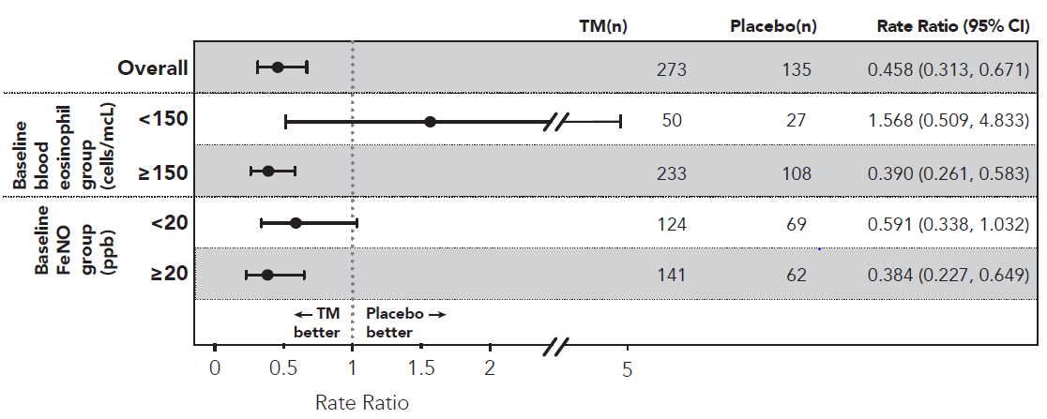
Improvements in percent predicted FEV₁ by baseline blood eosinophils and FeNO for VOYAGE are shown in Figure 12
Figure 12 ­ LS Mean Change from Baseline vs Placebo to Week 12 in percent predicted Pre-Bronchodilator FEV1 across Baseline Blood Eosinophil Counts (cells/mcL) Baseline FeNO group (ppb) in VOYAGE
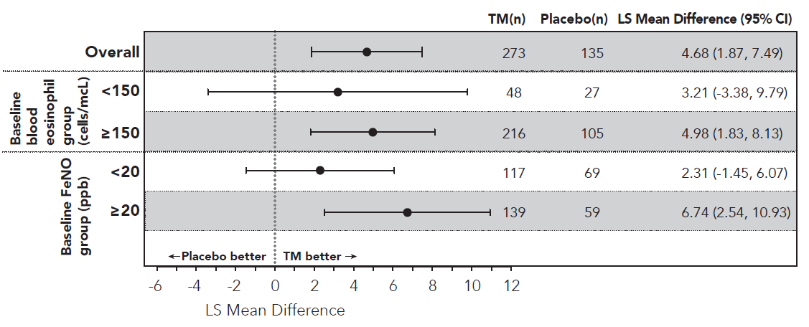
Significant improvements in percent predicted FEV₁ were observed as early as Week 2 and were maintained through Week 52 in VOYAGE study.
Improvements in percent predicted FEV₁ over time in VOYAGE are shown in Figure 13
Figure 13 ­ Mean Change from Baseline in Percent Predicted Pre-Bronchodilator FEV₁ (L) Over Time in VOYAGE (Baseline Blood Eosinophils ≥ 150 cells/mcL or FeNO ≥ 20 ppb, Baseline Eosinophils ≥ 300 cells/mcL, and Baseline FeNO ≥ 20 ppb)
Baseline Blood Eosinophils ≥ 150 cells/mcL or FeNO ≥ 20 ppb | Baseline Blood Eosinophils  ≥ 300 cells/mcL | Baseline  FeNO ≥ 20 ppb
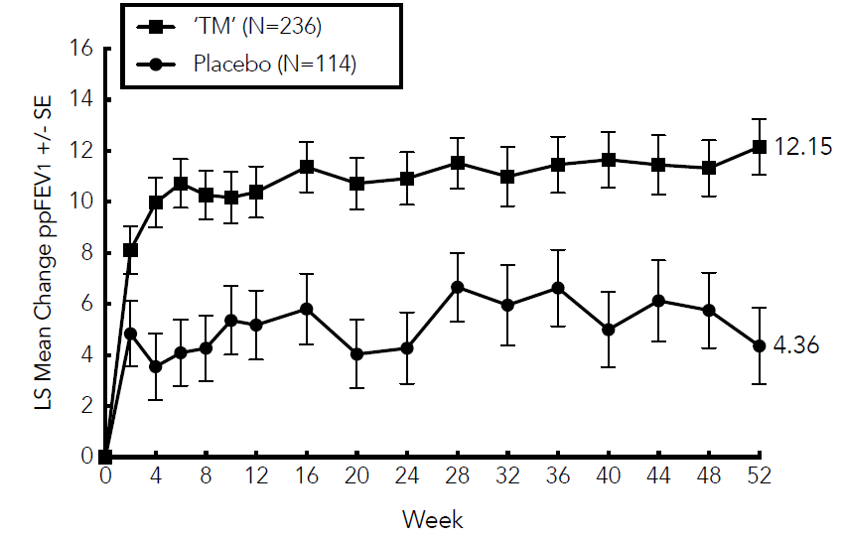 | 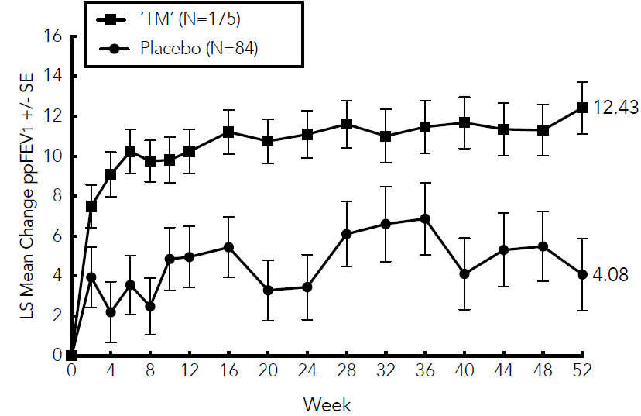 | 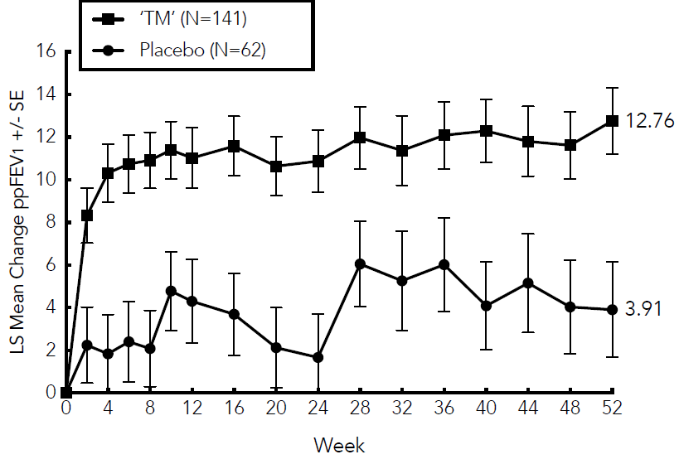
In VOYAGE, in the population with type 2 inflammation, the mean annualized total number of systemic corticosteroid courses due to asthma was reduced by 59.3% versus placebo (0.350 [95% CI: 0.256, 0.477] versus 0.860 [95% CI: 0.616, 1.200]). In the population defined by baseline blood eosinophils >300 cells/mcL, the mean annualized total number of systemic corticosteroid courses due to asthma was reduced by 66.0% versus placebo (0.274 [95% CI: 0.188, 0.399] versus 0.806 [95% CI: 0.563, 1.154].
Dupixent improved the overall health status as measured by the European Quality of Life 5-Dimension Youth Visual Analog Scale (EQ-VAS) in both type 2 inflammation and the baseline blood eosinophil count of >300 cells/mcL population at Week 52; the LS mean difference versus placebo was 4.73 (95% CI: 1.18, 8.28), and 3.38 (95% CI: -0.66, 7.43), respectively.
Dupixent reduced the impact of paediatric patient’s asthma on the caregiver quality of life as measured by the Paediatric Asthma Caregiver Quality of Life Questionnaire (PACQLQ) in both type 2 inflammation and the baseline blood eosinophil count of >300 cells/mcL population at Week 52; the LS mean difference versus placebo was 0.47 (95% CI: 0.22, 0.72), and 0.50 (95% CI: 0.21, 0.79), respectively.
A total of 408 children aged 6 to 11 years with moderate-to-severe asthma was enrolled in the VOYAGE study, which evaluated doses of 100 mg Q2W and 200 mg Q2W. The efficacy of Dupixent 300 mg Q4W in children aged 6 to 11 years is extrapolated from the efficacy of 100 mg and 200 mg Q2W in VOYAGE and 200 mg and 300 mg Q2W in adults and adolescents (QUEST). Patients who completed the treatment period of the VOYAGE study could participate in the open label extension study (EXCURSION). Fourteen patients (≥15 to <30 kg) out of 365 patients were exposed to 300 mg Q4W in this study, and the safety profile was similar to that seen in VOYAGE. Safety, efficacy, and pharmacokinetics in paediatric patients (< 6 years of age) with asthma have not been studied.

Chronic Rhinosinusitis with Nasal Polyposis
The chronic rhinosinusitis with nasal polyposis (CRSwNP) development program included two randomised, double-blind, parallel group, multicentre, placebo-controlled studies (SINUS-24 and SINUS-52) in 724 patients aged 18 years and older on background intranasal corticosteroids (INCS). These studies included patients with severe CRSwNP despite prior sino-nasal surgery or treatment with, or who were ineligible to receive, systemic corticosteroids in the past 2 years. Rescue with systemic corticosteroids or surgery was allowed during the studies at the investigator’s discretion.
In SINUS-24, a total of 276 patients were randomised to receive either 300 mg Dupixent (N=143) or placebo (N=133) every other week for 24 weeks.
In SINUS-52, 448 patients were randomised to receive either 300 mg Dupixent (N=150) every other week for 52 weeks, 300 mg Dupixent (N=145) every other week until week 24 followed by 300 mg Dupixent every 4 weeks until week 52, or placebo (N=153).
All patients had evidence of sinus opacification on the Lund MacKay (LMK) sinus CT scan and 73% to 90% of patients had opacification of all sinuses. Patients were stratified based on their histories of prior surgery and co-morbid asthma/nonsteroidal anti-inflammatory drug exacerbated respiratory disease (NSAID-ERD). A total of 63% of patients reported previous sinus surgery, with a mean number of 2.0 prior surgeries, 74% used systemic corticosteroids in the previous 2 years with a mean number of 1.6 systemic corticosteroid courses in the previous 2 years, 59% had co-morbid asthma, and 28% had NSAID-ERD.
The co-primary efficacy endpoints were change from baseline to week 24 in bilateral endoscopic nasal polyps score (NPS; 0-8 scale) as graded by central blinded readers and change from baseline to week 24 in nasal congestion/obstruction score averaged over 28 days (NC; 0-3 scale), as determined by patients using a daily diary. For NPS, polyps on each side of the nose were graded on a categorical scale (0=no polyps; 1=small polyps in the middle meatus not reaching below the inferior border of the middle turbinate; 2=polyps reaching below the lower border of the middle turbinate; 3=large polyps reaching the lower border of the inferior turbinate or polyps medial to the middle turbinate; 4=large polyps causing complete obstruction of the inferior nasal cavity). The total score was the sum of the right and left scores. Nasal congestion was rated daily by the subjects on a 0 to 3 categorical severity scale (0=no symptoms; 1=mild symptoms; 2=moderate symptoms; 3=severe symptoms).
In both studies, key secondary endpoints at week 24 included change from baseline in: LMK sinus CT scan score, total symptoms score (TSS), University of Pennsylvania smell identification test (UPSIT), daily loss of smell, and 22-item sinal-nasal outcome test (SNOT-22). The LMK sinus CT scan score evaluated the opacification of each sinus using a 0 to 2 scale (0=normal; 1=partial opacification; 2=total opacification) deriving a maximum score of 12 per side and a total maximum score of 24 (higher scores indicate more opacification). Olfactory function was assessed by UPSIT which is a 40-odorant test (score range 0-40) used to distinguish patients (mild [score of 31 34], moderate [score of 26 30], severe microsmia [score of 19 25]) or anosmia [score of 0 18]). In the pool of the two studies, the reduction in the proportion of patients rescued with systemic corticosteroid and/or sino-nasal surgery as well as the improvement in FEV1 in the asthma subgroup were evaluated. Additional secondary endpoints included 6-item Asthma Control Questionnaire (ACQ-6) in the co-morbid asthma subgroup.
The demographics and baseline characteristics of these 2 studies are provided in Table 24 below:
Table 24 ­ Demographics and Baseline Characteristics of CRSwNP Studies
Parameter | SINUS-24  (N=276) | SINUS-52  (N=448)
Mean age (years) (SD) | 50.49 (13.39) | 51.95 (12.45)
% Male | 57.2 | 62.3
Mean CRSwNP duration (years)(SD) | 11.11 (9.16) | 10.94 (9.63)
Patients with ≥ 1 prior surgery (%) | 71.7 | 58.3
Patients with systemic corticosteroid use in the previous 2 years (%) | 64.9 | 80.1
Mean Bilateral endoscopic NPSª (SD), range 0–8 | 5.75 (1.28) | 6.10 (1.21)
Mean Nasal congestion (NC) scoreª (SD) range 0–3 | 2.35 (0.57) | 2.43 (0.59)
Mean LMK sinus CT total scoreª (SD), range 0–24 | 19.03 (4.44) | 17.96 (3.76)
Mean Smell test (UPSIT) scoreª (SD), range 0–40 | 14.56 (8.48) | 13.61 (8.02)
Mean Sense of smell loss scoreª (AM), (SD) range 0–3 | 2.71 (0.54) | 2.75 (0.52)
Mean SNOT-22 total scoreª (SD), range 0–110 | 49.40 (20.20) | 51.86 (20.90)
Mean Rhinosinusitis severity scaleª (VAS), (SD) 0–10 cm | 7.68 (2.05) | 8.00 (2.08)
Mean blood eosinophils (cells/mcL)(SD) | 437 (333) | 431 (353)
Mean total IgE IU/mL (SD) | 211.97 (275.73) | 239.84 (341.53)
Atopic (type 2 inflammatory disease) Medical History % Overall | 75.4% | 82.4%
Asthma (%) | 58.3 | 59.6
Mean FEV1 (L)(SD) | 2.69 (0.96) | 2.57 (0.83)
Mean FEV1 percent predicted (%) (SD) | 85.30 (20.23) | 83.39 (17.72)
Mean ACQ-6 scoreª (SD) | 1.62 (1.14) | 1.58 (1.09)
NSAID-ERD (%) | 30.4 | 26.8
ª Higher score indicate greater disease severity except UPSIT where higher scores indicate lower disease severity; SD=standard deviation; AM = morning; NPS = nasal polyps score; UPSIT = University of Pennsylvania smell identification test;
SNOT-22 = 22-item sino-nasal outcome test; VAS = visual analogue scale; FEV1 = Forced expiratory volume in 1 second; ACQ-6 = Asthma Control Questionnaire-6; NSAID-ERD= asthma/nonsteroidal anti-inflammatory drug exacerbated respiratory disease

Clinical Response (SINUS-24 and SINUS-52)
The results for primary and secondary endpoints in CRSwNP studies are presented in the Table 25.
Table 25 ­ Results of the Primary and Secondary Endpoints in CRSwNP trials
 | SINUS -24 |  |  |  |  |  | SINUS -52
 | Placebo  (n=133) |  | Dupixent  300mg Q2W  (n=143) |  | LS mean  difference vs. Placebo (95%CI) |  | Placebo  (n=153) |  | Dupixent  300mg Q2W  (n=295) |  | LS mean  difference vs. Placebo (95%CI)
 | Primary Endpoints at Week 24
Scores | Baseline  mean | LS mean change | Baseline  mean | LS mean  change |  |  | Baseline  mean | LS mean  change | Baseline  mean | LS mean  change
NPS | 5.86 | 0.17 | 5.64 | -1.89 | -2.06  (-2.43, -1.69) |  | 5.96 | 0.10 | 6.18 | -1.71 | -1.80  (-2.10, -1.51)
NC | 2.45 | -0.45 | 2.26 | -1.34 | -0.89  (-1.07, -0.71) |  | 2.38 | -0.38 | 2.46 | -1.25 | -0.87  (-1.03, -0.71)
 | Key Secondary Endpoints at Week 24
Scores | Baseline  mean | LS mean change | Baseline  mean | LS mean change |  |  | Baseline  mean | LS mean  change | Baseline  mean | LS mean  change
LMK sinus CT scan score | 19.55 | -0.74 | 18.55 | -8.18 | -7.44  (-8.35, -6.53) |  | 17.65 | -0.09 | 18.12 | -5.21 | -5.13  (-5.80, -4.46)
Total symptom score | 7.28 | -1.17 | 6.82 | -3.77 | -2.61  (-3.04, -2.17) |  | 7.08 | -1.00 | 7.30 | -3.45 | -2.44  (-2.87, -2.02)
UPSIT | 14.44 | 0.70 | 14.68 | 11.26 | 10.56  (8.79, 12.34) |  | 13.78 | -0.81 | 13.53 | 9.71 | 10.52  (8.98, 12.07)
Loss of smell | 2.73 | -0.29 | 2.70 | -1.41 | -1.12  (-1.31, -0.93) |  | 2.72 | -0.23 | 2.77 | -1.21 | -0.98  (-1.15, -0.81)
SNOT-22 | 50.87 | -9.31 | 48.0 | -30.43 | -21.12  (-25.17, -17.06) |  | 53.48 | -10.40 | 51.02 | -27.77 | -17.36  (-20.87, -13.85)
VAS | 7.96 | -1.34 | 7.42 | -4.54 | -3.20  (-3.79, -2.60) |  | 7.98 | -1.39 | 8.01 | -4.32 | -2.93  (-3.45, -2.40)
A reduction in score indicates improvement, except UPSIT where an increase indicates improvement.
NC = nasal congestion, NPS = nasal polyposis score; LMK = Lund-MacKay total CT score; UPSIT = University of Pennsylvania smell identification test; SNOT-22 = 22-item sino-nasal outcome test; TSS = total symptom score; VAS = visual analogue scale for rhinosinusitis
(all p values <0.0001, nominal for VAS)

The results of SINUS-52 study at week 52 are presented in Table 26.
Table 26 ­ Results of the efficacy at week 52 in SINUS-52 study
 | Placebo  (n=153) |  | Dupixent  300mg Q2W  (n=150) |  | LS mean  difference vs. Placebo (95%CI) |  |  | Dupixent  300mg Q2W-Q4W  (n=145) |  |  | LS mean  difference vs. Placebo (95%CI)
 | Baseline  mean | LS mean  change | Baseline  mean | LS mean  change |  |  |  |  | Baseline  mean | LS mean  change
NPS | 5.96 | 0.15 | 6.07 | -2.24 | -2.40  (-2.77, -2.02) |  |  | 6.29 |  | -2.06 | -2.21  (-2.59, -1.83)
NC | 2.38 | -0.37 | 2.48 | -1.35 | -0.98  (-1.17, -0.79) |  |  | 2.44 |  | -1.48 | -1.10  (-1.29, -0.91)
LMK sinus CT scan score | 17.65 | 0.11 | 18.42 | -6.83 | -6.94  (-7.87, -6.01) |  |  | 17.81 |  | -5.60 | -5.71  (-6.64, -4.77)
Total symptoms score | 7.08 | -0.94 | 7.31 | -3.79 | -2.85  (-3.35, -2.35) |  |  | 7.28 |  | -4.16 | -3.22  (-3.73, -2.72)
UPSIT | 13.78 | -0.77 | 13.46 | 9.53 | 10.30  (8.50, 12.10) |  |  | 13.60 |  | 9.99 | 10.76  (8.95, 12.57)
Loss of Smell | 2.72 | -0.19 | 2.81 | -1.29 | -1.10  (-1.31, -0.89) |  |  | 2.73 |  | -1.49 | -1.30  (-1.51, -1.09)
SNOT-22 | 53.48 | -8.88 | 50.16 | -29.84 | -20.96  (-25.03, -16.89) |  |  | 51.89 |  | -30.52 | -21.65  (-25.71, -17.58)
VAS | 7.98 | -0.93 | 8.24 | -4.74 | -3.81  (-4.46, -3.17) |  |  | 7.78 |  | -4.39 | -3.46  (-4.10, -2.81)
A reduction in score indicates improvement, except UPSIT where an increase indicates improvement.
NC = nasal congestion, NPS = nasal polyposis score; LMK = Lund-MacKay total CT score; UPSIT = University of Pennsylvania smell identification test; SNOT-22 = 22-item sino-nasal outcome test; TSS = total symptom score; VAS = visual analogue scale for rhinosinusitis
(all p values <0.0001)

Statistically significant and clinically meaningful efficacy was observed in SINUS-24 with regard to improvement in bilateral endoscopic NPS score at week 24. In the post-treatment period when patients were off dupilumab, the treatment effect diminished over time (see Figure 14).
Figure 14 ­ LS mean change from baseline in bilateral nasal polyps score (NPS) up to Week 48 in SINUS-24 - ITT population
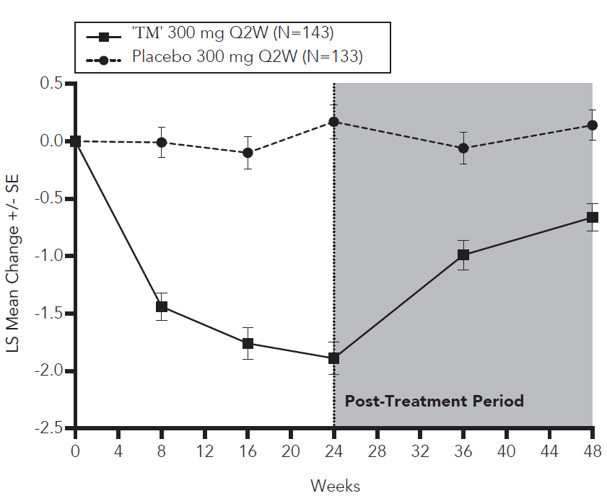

Statistically significant and clinically meaningful results were also seen in SINUS-52 at both week 24 and week 52 with a progressive improvement over time (see Figure 15).
Figure 15 ­ LS mean change from baseline in bilateral nasal polyps score (NPS) up to Week 52 in SINUS-52 - ITT population

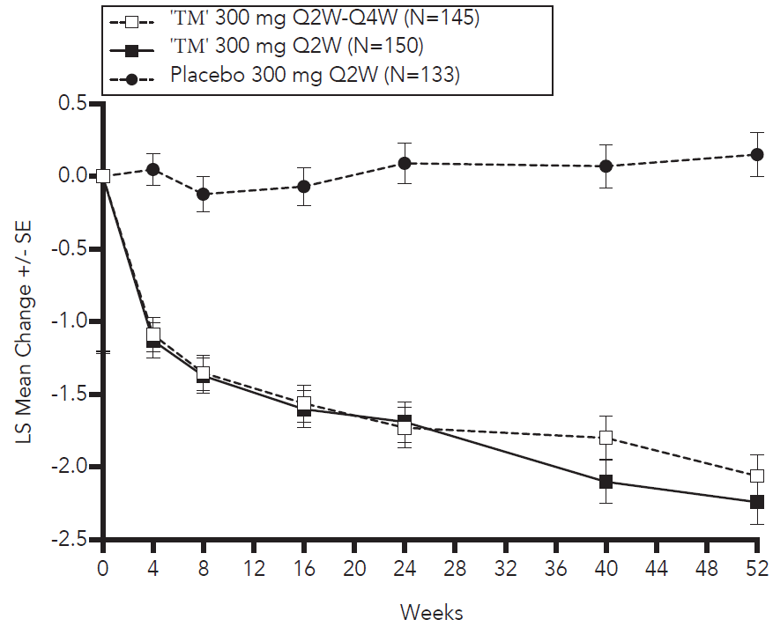
A significant decrease in LMK sinus CT scan score was also observed in SINUS-52 study at week 24 with further improvement at week 52 (see Figure 16). Similar results were seen in SINUS-24 study at week 24.
Figure 16 ­ LS mean change from baseline in LMK sinus CT scan score at Week 24 and Week 52 ITT population in SINUS-52
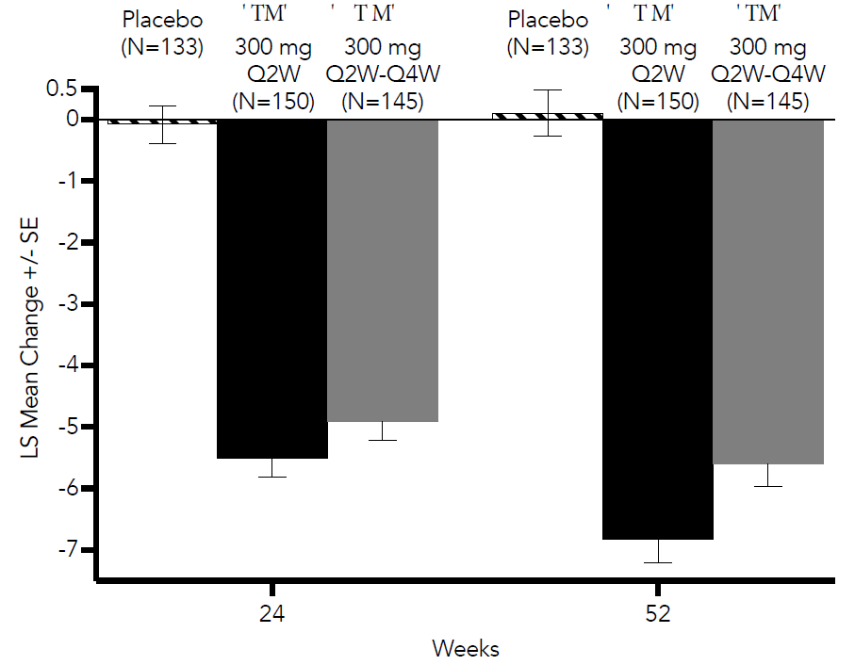
In both studies, significant improvements in NC and daily loss of smell severity were observed as early as the first assessment at Week 4. The LS mean difference for NC at Week 4 in the Dupixent group versus placebo was ­0.41 (95% CI: ­0.52, ­0.30) in SINUS-24 and -0.37 (95% CI: -0.46, -0.27) in SINUS-52. The LS mean difference for loss of smell at Week 4 in the Dupixent group versus placebo was ­0.34 (95% CI: -0.44, -0.25) in SINUS-24 and -0.31 (95% CI: -0.41, -0.22) in SINUS-52.
Improvement in nasal peak inspiratory flow (NPIF) was observed in SINUS-24 and SINUS-52 at week 24. The LS mean difference in the dupilumab group versus placebo was 40.4 L/min (95% CI: 30.4, 50.4) and 36.6 L/min (95% CI: 28.0, 45.3), respectively.
A reduction in the proportion of patients with anosmia from 74% at baseline to 24% at week 24 was observed in the Dupixent arm of SINUS-24 study compared to no change (78% at both time points) in the placebo arm. A reduction in the proportion of subjects with anosmia from 79% at baseline to 30% at week 24 was observed in the Dupixent arm of SINUS-52 compared to no change (77% at both time points) in the placebo arm.
In SINUS-24, among the patients with rhinosinusitis VAS score >7 at baseline, a higher percentage of patients achieved VAS in a non-severe category (≤7) in the Dupixent group compared with the placebo group (83.3% versus 39.4%) at week 24. In SINUS-52, among the patients with rhinosinusitis VAS score >7 at baseline, at week 24, a higher percentage of patients had a VAS in a non-severe category (≤7) in the Dupixent 300 mg Q2W group compared with the placebo group (75.0% versus 39.3%).
In the pre-specified multiplicity-adjusted pooled analysis of two studies, treatment with Dupixent resulted in significant reduction of systemic corticosteroid use and need for sino-nasal surgery versus placebo (HR of 0.24; 95% CI: 0.17, 0.35) (see Figure 17). The proportion of patients who required systemic corticosteroids was reduced by 74% (HR of 0.26; 95% CI: 0.18, 0.38). The total number of systemic corticosteroid courses per year was reduced by 75% (RR of 0.25; 95% CI: 0.17, 0.37). The mean individual annualised prescribed total dose of systemic corticosteroids (in mg) during the treatment period was 71% lower in the pooled dupilumab group compared with the pooled placebo group (60.5 [531.3] mg versus 209.5 [497.2] mg, respectively). The proportion of patients who required surgery was reduced by 83% (HR of 0.17; 95% CI: 0.07, 0.46).
Figure 17 ­ Kaplan Meier Curve for time to first systemic corticosteroid use and/or sino-nasal surgery during treatment period - ITT population [SINUS-24 and SINUS-52 pooled]
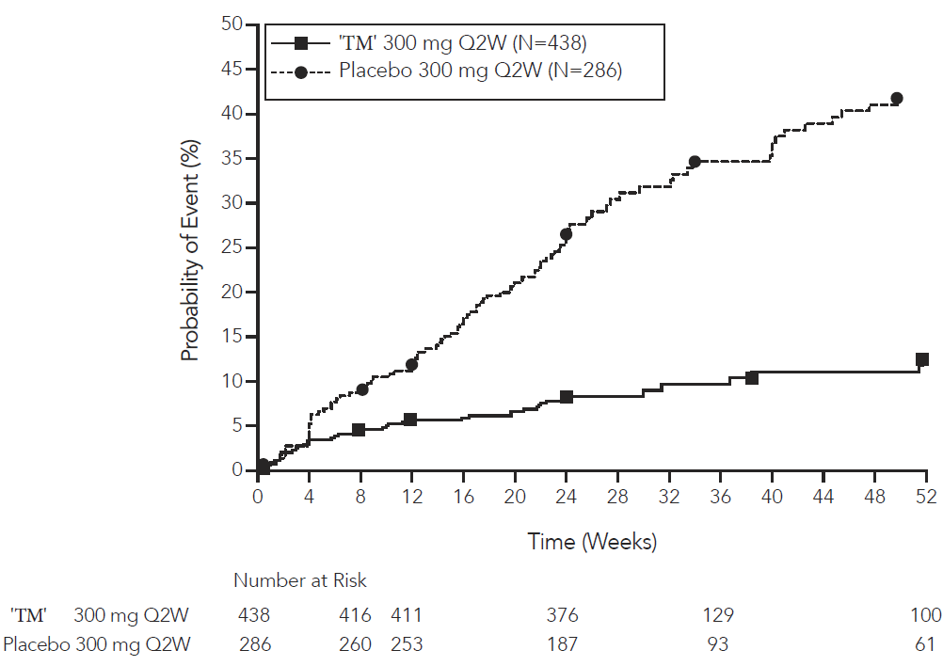
In patients with co-morbid asthma, significant improvement in pre-bronchodilator FEV1 were observed at Week 24 in the pre-specified multiplicity-adjusted pool of the two studies irrespective of baseline blood eosinophils levels. The LS Mean change from baseline in FEV1 at Week 24 for Dupixent 300 mg Q2W was 0.14 vs -0.07 L for placebo, for a difference of 0.21 L (95% CI: 0.13, 0.29).
In addition, improvements in FEV1 were noted from the first post baseline assessment, at in Week 8 SINUS-24 and Week 4 in SINUS-52 (see Figure 18
Figure 18 ­ LS mean change from baseline in FEV1 (L) by visit for patients with asthma up to Week 24 - ITT population
Sinus – 24 Sinus-52
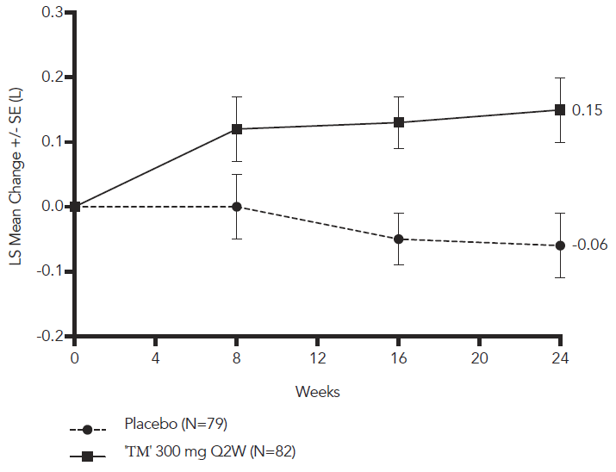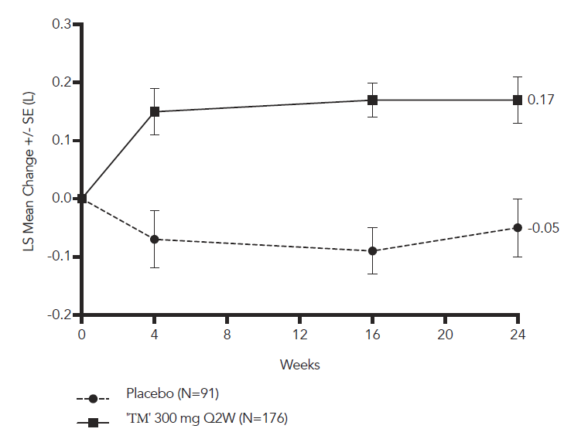
Improvements in ACQ-6 in patients with co-morbid asthma were observed in both studies. A response was defined as an improvement in score of 0.5 or more. In SINUS-24, at Week 24, the LS mean difference in the Dupixent group versus placebo was ­0.76 (95% CI: ­1.00 to ­0.51).432 In SINUS-52, at Week 52, the LS mean difference in the Dupixent group versus placebo was ­0.94 (95% CI: ­1.19, ­0.69).
The ACQ-6 responder rate for Dupixent 300 mg Q2W for SINUS-24 at Week 24 was 56% versus 28% in placebo (odds ratio 3.17; 95% CI: 1.65, 6.09). The ACQ-6 responder rate for Dupixent 300 mg Q2W for SINUS-52 was 46% versus 14% placebo at Week 52 (odds ratio 7.02; 95% CI: 3.10, 15.90).
In patients with NSAID-ERD, the effects of Dupixent on the primary endpoints of NPS and NC and the key secondary endpoint of LMK sinus CT scan score were consistent with that observed in the overall CRSwNP population.

Pharmacokinetic properties
The pharmacokinetics of dupilumab is similar in patients with atopic dermatitis, asthma and CRSwNP.

Absorption
After a single subcutaneous (SC) dose of 75-600 mg dupilumab, median times to maximum concentration in serum (tmax) were 3-7 days. The absolute bioavailability of dupilumab following a SC dose is similar between AD and asthma patients and CRSwNP, ranging from 61% to 64%, as determined by a population pharmacokinetics (PK) analysis.
Administration of a single loading dose of 600 mg on Day 1 leads to rapid attainment of clinically effective concentrations within 2 weeks.
For every other week dosing (Q2W) with either 200 mg or 300 mg, starting with a respective loading dose of 400 mg or 600 mg, population PK analysis determined steady state concentrations to be achieved by 16 weeks in a typical patient. Mean steady state trough concentration were 39 mg/L at 200 mg Q2W and 70-74 mg/ at 300 mg Q2W.
For weekly dosing (QW) with 300 mg, starting with a loading dose of 600 mg, population PK analysis determined steady state concentrations to be achieved after 13 weeks in a typical patient. Mean steady state trough concentration was 189 mg/L.

Distribution
A volume of distribution for dupilumab of approximately 4.6L was estimated by population PK analysis, indicating that dupilumab is distributed primarily in the vascular system.

Metabolism
Specific metabolism studies were not conducted, because dupilumab is a protein. Dupilumab is expected to degrade to small peptides and individual amino acids.

Excretion
Dupilumab elimination is mediated by parallel linear and nonlinear pathways. At higher concentrations, dupilumab elimination is primarily through a non-saturable proteolytic pathway, while at lower concentrations, the non-linear saturable IL-4R α target-mediated elimination predominates.
After the last steady state dose, the median time for dupilumab concentrations to decrease below the lower limit of detection, determined by population PK analysis, was 9 weeks for the 200 mg Q2W, 10-11 weeks for the 300 mg Q2W regimen and 13 weeks for the 300 mg QW regimen.

Dose Linearity
Due to nonlinear clearance, dupilumab exposure, as measured by area under the concentration-time curve, increases with dose in a greater than proportional manner following single SC doses from 75-600 mg.

Special Populations

Gender
Gender was not found to be associated with any clinically meaningful impact on the systemic exposure of dupilumab determined by population PK analysis.

Elderly
Age was not found to be associated with any clinically meaningful impact on the systemic exposure of Dupixent determined by population PK analysis.

Race
Race was not found to be associated with any clinically meaningful impact on the systemic exposure of dupilumab by population PK analysis.

Paediatric Patients

Atopic Dermatitis
For adolescents 12 to 17 years of age with atopic dermatitis receiving every other week dosing (Q2W) with either 200 mg (<60 kg) or 300 mg (≥60 kg), mean ±SD steady state trough concentration of dupilumab was 54.5±27.0 mcg/mL.
For children 6 to 11 years of age with atopic dermatitis receiving every other week dosing (Q2W) with 200 mg (≥30 kg) or every four week dosing (Q4W) with 300 mg (<30 kg), mean ± SD steady state trough concentration was 86.0±34.6 mcg/mL and 98.7±33.2 mcg/mL, respectively.
The pharmacokinetics of dupilumab in paediatric patients below 6 years of age with atopic dermatitis have not been fully established.

Asthma
A total of 107 adolescents (range: 30 kg to 122 kg) aged 12 to 17 years with moderate to severe asthma were enrolled in the Quest study and received either 200 mg (N=21) or 300 mg (N=18) Dupixent (or matching placebo either 200 mg [N=34] or 300 mg [N=34]) every other week. Efficacy with respect to asthma exacerbations and lung function was observed in both adolescents and adults.
For both the 200 mg and 300 mg every other week doses, significant improvements in FEV1 (LS mean change from baseline at Week 12) were observed (0.36 L and 0.27 L, respectively). For the 200 mg every other week dose, patients had a reduction in the rate of severe exacerbations that was consistent with adults.
The mean ±SD steady-state trough concentrations of dupilumab were 46.7±26.9 mcg/mL and 107± 51.6 mcg/mL, respectively, for 200 mg or 300 mg administered every other week.
The long-term safety and efficacy of Dupixent was assessed in 89 adolescent patients who were enrolled in an open-label extension study in moderate-to-severe asthma (TRAVERSE). In this study, patients were followed for up to 96 weeks, resulting in 99 patient-years cumulative exposure to Dupixent. The safety profile of Dupixent in TRAVERSE was consistent with the safety profile observed in asthma pivotal studies for up to 52 weeks of treatment. No additional adverse reactions were identified. In this study, the clinical benefit of Dupixent, including reduction in exacerbations and improvement in lung function observed in pivotal asthma studies, was sustained up to 96 weeks.
The adverse event profile in adolescents was generally similar to the adults (See Section 4.8 – Adverse Effects (Undesirable Effects)).

Children 6 to 11 years of age
In the VOYAGE study, dupilumab pharmacokinetics was investigated in 270 patients with moderate-to-severe asthma following subcutaneous administration of either 100 mg Q2W (for 91 children weighing <30 kg) or 200 mg Q2W (for 179 children weighing >30 kg). The mean ± SD steady-state trough concentration was 58.4±28.0 mcg/mL and 85.1±44.9 mcg/mL, respectively. Simulation of a 300 mg Q4W subcutaneous dose in children aged 6 to 11 years with body weight of ≥15 to <30 kg and >30 to <60 kg resulted in predicted steady-state trough concentrations similar to the observed trough concentrations of 200 mg Q2W (≥30 kg) and 100 mg Q2W (<30 kg), respectively. In addition, simulation of a 300 mg Q4W subcutaneous dose in children aged 6 to 11 years with body weight of >15 to <60 kg resulted in predicted steady-state trough concentrations similar to those demonstrated to be efficacious in adults and adolescents.

CRSwNP
CRSwNP does not normally occur in children. The pharmacokinetics of dupilumab has not been studied in children (<18 years of age) with CRSwNP.

Hepatic Impairment
Dupilumab, as a monoclonal antibody, is not expected to undergo significant hepatic elimination. No clinical studies have been conducted to evaluate the effect of hepatic impairment on the pharmacokinetics of dupilumab.

Renal Impairment
Dupilumab, as a monoclonal antibody, is not expected to undergo significant renal elimination. No clinical studies have been conducted to evaluate the effect of renal impairment on the pharmacokinetics of dupilumab. Population PK analysis did not identify mild or moderate renal impairment as having a clinically meaningful influence on the systemic exposure of dupilumab. No data are available in patients with severe renal impairment.

Preclinical safety data

Genotoxicity
No genotoxicity studies were conducted. As a monoclonal antibody, dupilumab is not expected to interact with DNA or other chromosomal material.

Carcinogenicity
Carcinogenicity studies have not been conducted with dupilumab. An evaluation of the available evidence related to IL-4Rα inhibition and animal toxicology data with surrogate antibodies does not suggest an increased risk of cancer for dupilumab.

Pharmaceutical particulars

List of excipients

300 mg Pre-Filled Syringe/Pre-filled Pen
Arginine hydrochloride (10.5 mg), histidine (5.4 mg), histidine hydrochloride monohydrate (1 mg), polysorbate 80 (4 mg), sodium acetate trihydrate (2.6 mg), sucrose (100 mg), glacial acetic acid (0.3 mg) and water for injections.

200 mg Pre-Filled Syringe/Pre-filled Pen
Arginine hydrochloride (12.01 mg), histidine (3.10 mg), histidine hydrochloride monohydrate (0.6 mg), polysorbate 80 (2.28 mg), sodium acetate trihydrate (1.5 mg), sucrose (57 mg), glacial acetic acid (0.19 mg) and water for injections.

100 mg Pre-Filled Syringe
Arginine hydrochloride (25 mM), histidine (20 mM), polysorbate 80 (0.2% (w/v)), sodium acetate trihydrate (12.5 mM), sucrose (5% (w/v)), and water for injection and glacial acetic acid.

Incompatibilities
Incompatibilities were either not assessed or not identified as part of the registration of this medicine.

Shelf life
The expiry date can be found on the packaging.

Special precautions for storage
Store in the refrigerator at 2°C to 8°C in the original carton to protect from light. Do not freeze. Do not expose to heat. Do not shake.
If necessary, pre-filled syringes may be kept at room temperature up to 25°C for a maximum of 14 days. Do not store above 25°C. After removal from the refrigerator, Dupixent must be used within 14 days or discarded.
Do not use after the expiry date stamped on the carton and container label.

Nature and contents of container

100 mg*, 200 mg and 300 mg Pre-Filled Syringe:
Dupixent pre-filled syringes are available in pack sizes of 1* or 2, 3* and 6* per carton in the following presentations.
- Pre-Filled Syringe with needle shield - the pre-filled syringe has a needle shield to reduce the risk of accidental needle stick injuries. The needle cap is not made with natural rubber latex.

200 mg and 300 mg Pre-Filled Pen:
Dupixent pre-filled pens are available in pack sizes of 1*, 2*, 3* and 6* per carton.
* Presentations currently not marketed

Special precautions for disposal
Any unused medicine should be disposed of by taking to your local pharmacy. The syringe and the needle cap should be disposed of in a sharps container.

Physicochemical properties

Chemical structure
Dupilumab is a covalent heterotetramer consisting of two disulfide-linked human heavy chains, each covalently linked through a disulfide bond to a human kappa light chain. There is a single N-linked glycosylation site in each heavy chain, located within the CH2 domain of the Fc constant region of the molecule. The Dupilumab heavy chain has an immunoglobulin (Ig) G4P isotype constant region. IgG4P is an IgG4 constant region with a single amino acid substitution in the hinge region that recreates the IgG1 hinge sequence in order to stabilise IgG4 dimer formation. The variable domains of the heavy and light chains combine to form the IL-4Rα binding site within the antibody. Dupilumab has a molecular weight of approximately 147 kDa.

CAS number
1190264-60-8

Medicine schedule (Poisons Standard)
Schedule 4 (Prescription Only Medicine)

Sponsor
Australia
sanofi-aventis australia pty ltd
12-24 Talavera Road
Macquarie Park NSW 2113
Tel: 1800 818 806

Date of first approval
24 January 2018

Date of revision
29 June 2022

Summary table of changes
Section Changed | Summary of new information
2 | Addition of Qualitative And Quantitative Composition for 100 mg prefilled syringe
4.1 | Change to asthma indication age range
4.2 | Addition of dose information for asthma (6-11 years)
4.4 | Addition of Special Warnings and Precautions for use – asthma (6-11 years)
4.8 | Additional information Adverse Effects (Undesirable Effects) ‐ asthma (6-11 years)
5.1 | Addition of clinical trial information – asthma (6-11 years)
5.2 | Addition of Pharmacokinetic Properties information – asthma (6-11 years)
6.1 | Addition of excipients for 100 mg pre-filled syringe
6.5 | Addition of 100 mg presentation

