January 2023

Australian Public Assessment Report for Comirnaty Original/Omicron BA.4-5 COVID-19 vaccine
  - Active ingredients: Tozinameran and famtozinameran
  - Sponsor: Pfizer Australia Pty Ltd

About the Therapeutic Goods Administration (TGA)
- The Therapeutic Goods Administration (TGA) is part of the Australian Government Department of Health and is responsible for regulating therapeutic goods, including medicines, medical devices, and biologicals.
- The TGA administers the Therapeutic Goods Act 1989 (the Act), applying a risk management approach designed to ensure therapeutic goods supplied in Australia meet acceptable standards of quality, safety, and efficacy.
- The work of the TGA is based on applying scientific and clinical expertise to decision-making, to ensure that the benefits to the Australian public outweigh any risks associated with the use of therapeutic goods.
- The TGA relies on the public, healthcare professionals and industry to report problems with therapeutic goods. The TGA investigates reports received to determine any necessary regulatory action.
- To report a problem with a therapeutic good, please see the information on the TGA website.

About AusPARs
- The Australian Public Assessment Report (AusPAR) provides information about the evaluation of a prescription medicine and the considerations that led the TGA to approve or not approve a prescription medicine submission. Further information can be found in Australian Public Assessment Report (AusPAR) guidance.
- AusPARs are prepared and published by the TGA.
- AusPARs are static documents that provide information that relates to a submission at a particular point in time. The publication of an AusPAR is an important part of the transparency of the TGA’s decision-making process.
- A new AusPAR may be provided to reflect changes to indications or major variations to a prescription medicine subject to evaluation by the TGA.

Copyright
© Commonwealth of Australia 2023
This work is copyright. You may reproduce the whole or part of this work in unaltered form for your own personal use or, if you are part of an organisation, for internal use within your organisation, but only if you or your organisation do not use the reproduction for any commercial purpose and retain this copyright notice and all disclaimer notices as part of that reproduction. Apart from rights to use as permitted by the Copyright Act 1968 or allowed by this copyright notice, all other rights are reserved, and you are not allowed to reproduce the whole or any part of this work in any way (electronic or otherwise) without first being given specific written permission from the Commonwealth to do so. Requests and inquiries concerning reproduction and rights are to be sent to the TGA Copyright Officer, Therapeutic Goods Administration, PO Box 100, Woden ACT 2606 or emailed to <tga.copyright@tga.gov.au>.

Contents
List of abbreviations 4
Product submission 5
Submission details 5
Product background 7
Regulatory status 15
Product Information 16
Registration timeline 16
Submission overview and risk/benefit assessment 17
Quality 17
Nonclinical 19
Clinical 21
Risk management plan 53
Risk-benefit analysis 55
Outcome 61
Specific conditions of registration applying to these goods 62
Attachment 1. Product Information 64

List of abbreviations
Abbreviation |  | Meaning
ACV | Advisory Committee on Vaccines
AE | Adverse event
AESI | Adverse event of special interest
ARTG | Australian Register of Therapeutic Goods
ASA | Australia specific annex
CDC | Centers for Disease Control and Prevention, United States of America
CI | Confidence interval
COVID-19 | Coronavirus disease 2019
DLP | Data lock point
EU | European Union
FDA | Food and Drug Administration, United States of America
FRNT | Focus reduction neutralisation test
GMFR | Geometric mean fold rise
GMR | Geometric mean ratio
GMT | Geometric mean titre
NAb | Neutralising antibody
PI | Product Information
RMP | Risk management plan
SAE | Serious adverse event
SARS-CoV-2 | Severe acute respiratory syndrome coronavirus 2
TGA | Therapeutic Goods Administration
US(A) | United States (of America)
VE | Vaccine effectiveness
WHO | World Health Organization

Product submission

Submission details
Type of submission: | New biological entity and new combination of active ingredients
Product name: | Comirnaty Original/Omicron BA.4-5 COVID-19 vaccine
Active ingredients: | Tozinameran and famtozinameran
Decision: | Approved for provisional registration
Date of decision: | 20 January 2023
Date of entry onto ARTG: | 23 January 2023
ARTG number: | 400874
Black Triangle Scheme: | Yes  As a provisionally registered product, this medicine will remain in the Black Triangle Scheme for the duration of its provisional registration.
Sponsor’s name and address: | Pfizer Australia Pty Ltd  Level 17, 151 Clarence Street,  Sydney NSW 2000
Dose form: | Suspension for injection
Strength: | 15 µg of tozinameran and 15 µg of famtozinameran/0.3 mL
Container: | Multidose vial
Pack size: | 10 vials and 195 vials
Approved therapeutic use: | Comirnaty Original/Omicron BA.4-5 vaccine has provisional approval for the indication below:  As a booster dose for active immunisation to prevent coronavirus disease 2019 (COVID-19) caused by SARS-CoV-2, in individuals 12 years of age and older.  The use of this vaccine should be in accordance with official recommendations.  The decision has been made on the basis of short term immunogenicity and safety data. Continued approval depends on the evidence of longer term efficacy and safety from ongoing clinical trials and post-market assessment.
Route of administration: | Intramuscular
Dosage: | Booster dose in individuals 12 years of age and older  A booster dose of Comirnaty Original/Omicron BA.4-5 may be administered intramuscularly at least 3 months after the completion of a COVID-19 vaccine primary series in individuals 12 years of age and older.  Comirnaty Original/Omicron BA.4-5 may be administered to individuals 12 years of age and older at least 3 months after a previous booster dose of any COVID 19 vaccine.  The decision when and for whom to implement a booster dose should be made based on available vaccine safety and immunogenicity data (see Sections 4.4 Special warnings and precautions for use and 5.1 Pharmacodynamic properties of the Product Information), in accordance with official recommendations.  Method of administration  Comirnaty Original/Omicron BA.4-5 should be administered intramuscularly. The preferred site of administration is the deltoid muscle of the upper arm.  Do not inject Comirnaty Original/Omicron BA.4-5 intravascularly, subcutaneously or intradermally. Comirnaty Original/Omicron BA.4-5 should not be mixed in the same syringe with any other vaccines or medicinal products.  For precautions to be taken before administering Comirnaty Original/Omicron BA.4-5, see Section 4.4 Special warnings and precautions for use.  Comirnaty Original/Omicron BA.4-5 does not require dilution.  For instructions for administration, see Section 4.2 Method of Administration. in the Product Information. For instructions on the handling, thawing and dose preparation of the vaccine before administration see Handling instructions.  For further information regarding dosage, refer to the Product Information.
Pregnancy category: | B1  Drugs which have been taken by only a limited number of pregnant women and women of childbearing age, without an increase in the frequency of malformation or other direct or indirect harmful effects on the human fetus having been observed.  Studies in animals have not shown evidence of an increased occurrence of fetal damage.  The use of any medicine during pregnancy requires careful consideration of both risks and benefits by the treating health professional. This must not be used as the sole basis of decision making in the use of medicines during pregnancy. The TGA does not provide advice on the use of medicines in pregnancy for specific cases. More information is available from obstetric drug information services in your State or Territory.

Product background
This AusPAR describes the submission by Pfizer Australia Pty Ltd (the sponsor) to register Comirnaty Original/Omicron BA.4-5 COVID-19 vaccine (tozinameran and famtozinameran) 15 µg of tozinameran and 15 µg of famtozinameran/0.3 mL, suspension for injection for the following proposed indication:
As a booster dose for active immunisation to prevent coronavirus disease 2019 (COVID-19) caused by SARS-CoV-2, in individuals 12 years of age and older.
The use of this vaccine should be in accordance with official recommendations
Coronavirus disease 2019 (COVID-19) is an infectious disease caused by the coronavirus, severe acute respiratory syndrome coronavirus 2 (SARS-CoV-2), an enveloped, positive-sense, single-stranded RNA virus, that first appeared in late 2019. COVID-19 is predominantly a respiratory illness that also has systemic manifestations and may affect other organs. Disease symptoms and severity vary, with many people presenting with asymptomatic or mild disease and some progressing to severe respiratory tract disease including pneumonia and acute respiratory distress syndrome, leading to multiorgan failure and death. All ages may present with the disease, but notably, case fatality rates are elevated in persons greater than 60 years of age. Comorbidities are also associated with increased case fatality rates including cardiovascular disease, diabetes, hypertension, and chronic respiratory disease.
SARS-CoV-2 has spread rapidly and globally since its emergence in late 2019, causing the disease COVID-19. The World Health Organization (WHO) declared that the outbreak to be a pandemic on 11 March 2020. Globally, there have been approximately 660 million confirmed cases of COVID-19, including 6.6 million deaths. Of these, approximately 1.2 million cases and 17,349 deaths have been reported in Australia (see Table 1 and Figure 1).
Vaccines to protect against COVID-19 are critical to mitigate the current SARS-CoV-2 pandemic and to prevent future disease outbreaks. The SARS-CoV-2 spike glycoprotein, binds to its receptor human angiotensin converting enzyme 2 to initiate infection. Monovalent COVID-19 mRNA vaccines were developed against the spike protein of the ancestral SARS-CoV-2 virus and were found to provide cross-reactive immune protection against Alpha and Delta SARS-CoV-2 variants.
Despite availability of COVID 19 vaccinations in Australia, cases and hospitalisations continue, (see Figure 1 and Table 1) likely related to the emergence of the newer variants which are able to evade immunity provided by monovalent vaccines. In the last week of reporting (up to 10 January 2023), there were 45,810 cases of COVID-19 reported across Australia, (an average of 6544 cases/day) and hospitalisations remain high.
Figure 1: Weekly COVID-19 cases in hospital and intensive care unit and case notifications, Australia, 1 January to 10 January 2023
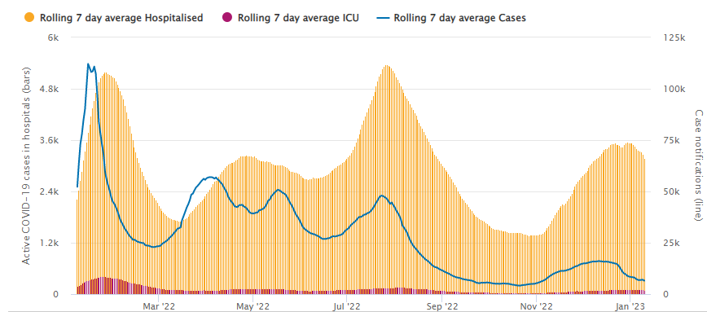
Table 1: Seven days rolling average figures for hospitalisations and intensive care unit between 1 January and 10 January 2023
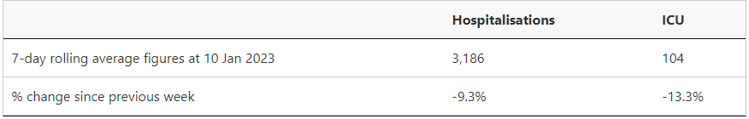
The SARS-CoV-2 Omicron variant emerged in November 2021 and diversified into sublineages. The Omicron variant contained an alarming number of mutations (more than 30) in the spike protein, including at least 15 mutations in the receptor binding domain, the primary target of neutralising antibodies. These Omicron sublineages were associated with decreased protection from vaccination with monovalent vaccine. The WHO recommendation is for an updated vaccine composition that contains both index virus and Omicron (the most antigenically distinct SARS-CoV-2 variant of concern to date) which may provide a broader antibody response against circulating and emerging variants, while retaining cross-reactive immunity and cross-protection from severe illness caused by other variants of concern. Fortunately, SARS-CoV-2 variants have not evolved to resist the protection against severe disease offered by vaccination or previous infection.4
The proposed Comirnaty Original/Omicron BA.4-5 bivalent vaccine, includes tozinameran targeting the ancestral strain and famtozinameran targeting the Omicron BA.4/BA.5 variant, which can broaden the protection as compared to monovalent Comirnaty vaccination. The active ingredient famtozinameran encodes the spike protein of the Omicron subvariants BA.4 and BA.5.

Drug class and therapeutic indication
Comirnaty Original/Omicron BA.4-5 is a COVID-19 vaccine that contains mRNA encapsulated in lipid nanoparticles. The newly proposed vaccine (Comirnaty Original/Omicron BA.4-5 bivalent vaccine) is a fixed combination product that contains active substances of the mRNAs encoding spike proteins for the ancestral strain of SARS-CoV-2 and also the Omicron BA.4-5 sublineage. This is similar in concept to the existing Comirnaty Original/Omicron BA.1 (tozinameran/riltozinameran) bivalent vaccine. The proposed dosage is the same dose of 30 µg mRNA that is present in the monovalent Comirnaty original (that is BNT162b2) and Comirnaty Original/Omicron BA.1 bivalent vaccine.

Current treatment options
Tables 2 and 3 summarise the approval history of the COVID-19 vaccines provisionally registered on the Australian Register of Therapeutic Goods (ARTG) for use in Australia. Further information on an approval is available from the associated AusPAR.
Table 2 lists the monovalent COVID-19 vaccines that were provisionally approved for use in Australia at the time that this submission was considered. A monovalent COVID-19 vaccine targets one strain of SARS-CoV-2.
Table 2: Provisional approvals for monovalent COVID-19 vaccines in Australia
Monovalent COVID-19 vaccines provisionally approved in Australia
Comirnaty COVID-19 Vaccine
Active ingredient: tozinameran (mRNA); formerly known as BNT162b2
Sponsor: Pfizer Australia Pty Ltd
25 February 2021 (initial registration) | Primary series: for individuals aged 16 years and over (AusPAR).  New product: 30 µg/0.3 mL concentrated suspension for injection. ARTG number: 346290
22 July 2021 | Primary series: for individuals aged 12 years and over (AusPAR)
26 October 2021 | Booster dose: for individuals aged 18 years and over (AusPAR)
3 December 2021 | Primary series: for individuals aged 5 years and over (AusPAR)  New strength/formulation: (Tris/sucrose buffer formulation), 10 µg/0.2 mL, 30 µg/0.3 mL. ARTG numbers: 377110, 377111
27 January 2022 | Booster dose: for individuals aged 16 to 17 years old (AusPAR)
7 April 2022 | Booster dose: for individuals aged 12 to 15 years old (AusPAR)
20 September 2022 | Booster dose: for individuals aged 5 to 11 years old (AusPAR)
29 September 2022 | Primary series: individuals aged 6 months to ≤ 5 years old (AusPAR)  New strength: 3 µg/0.2 mL concentrated suspension for injection (Tris/sucrose formulation. ARTG number: 393433
Spikevax COVID-19 vaccine
Active ingredient: elasomeran (mRNA)
Sponsor: Moderna Australia Pty Ltd
9 August 2021 (initial registration) | Primary series: for individuals aged 18 years and over (AusPAR)  New product: 0.2 mg/mL, suspension for injection.  ARTG number: 370599
3 September 2021 | Primary series: for individuals aged 12 to 18 years (and over) (AusPAR)
7 December 2021 | Booster dose: for individuals aged 18 years and over (AusPAR)
17 February 2022 | Primary series: for individuals aged 6 to 12 years (and over) (AusPAR)
19 July 2022 | Primary series: for individuals aged 6 months to 6 years (AusPAR)  New strength: 0.1 mg/mL suspension for injection  ARTG numbers: 388244, 388245
19 October 2022 | Booster dose: for individuals aged 12 years and over (AusPAR)
Nuvaxovid COVID-19 vaccine
Active ingredient: SARS-CoV-2 rS vaccine with Matrix-M1 adjuvant (protein vaccine)
Sponsor: Biocelect Pty Ltd (on behalf of Novavax Inc)
19 January 2022 (initial registration) | Primary series: for individuals aged 18 years and over (AusPAR)  New product: 5 µg/0.5mL, suspension for injection  ARTG number: 355139
9 June 2022 | Booster dose: for individuals aged 18 years and over as homologous vaccination (AusPAR)
9 June 2022 | Booster dose: for indivudals aged 18 years and over, as heterologous vaccination (AusPAR)
22 July 2022 | Primary series: for individuals aged 12 years and over (AusPAR)
Vaxzevria COVID-19 vaccine (formerly AstraZeneca COVID-19 vaccine)
Active ingredient: ChAdOx1 (viral vector)
Sponsor: AstraZeneca Pty Ltd
15 February 2021 (initial registration) | Primary series: for individuals aged 18 years and over (AusPAR)  New product: 1 x 10¹¹ viral particles (vp)/mL, solution for injection. ARTG number: 349072
8 February 2022 | Booster dose: for individuals aged 18 years and over (AusPAR)
COVID-19 Vaccine Janssen
Active ingredient: Ad26.COV2.S (viral vector)
Sponsor: Janssen-Cilag Pty Ltd
25 June 2021 (initial registration) | Primary series: for individuals aged 18 years and over (AusPAR)  New product: 5 x 10¹⁰ virus particles (VP)/ 0.5 mL, suspension for intramuscular injection. ARTG number: 350150
A primary vaccine series involves the vaccine doses needed for initial protection against COVID-19 disease. Typically, a primary COVID-19 vaccine series of 2 doses of the vaccine given 8 to 12 weeks apart. In most situations, the primary course consists of two doses of the same vaccine. In certain age groups or situations, the number of vaccine doses in a primary series may vary. For people with severe immunocompromise, a primary course is defined as 3 doses of a COVID-19 vaccine. ‘Third’ doses are not booster doses, but an additional dose given such as to those considered to be severely immunocompromised.
A booster dose refers to an additional vaccine dose given after the primary vaccine course. The first booster will refer to the first additional vaccine dose given after completing a 2-dose (or sometimes 3-dose) primary vaccine course.
Note: The single dose COVID-19 Vaccine Janssen has been provisionally approved, but isn’t currently being used in Australia.
Further information on vaccines can be found on the TGA website at COVID-19 vaccines, The Australian Immunisation Handbook or at the Australian Government Department of Health and Aged Care website.
Table 3 lists the bivalent COVID-19 vaccines approved in Australia at the time that this submission was considered. A bivalent vaccine targets two coronavirus strains, as opposed to a monovalent vaccine that targets only one variant.
Table 3: Provisional approvals for bivalent COVID-19 vaccines in Australia
Bivalent COVID-19 vaccines provisionally approved in Australia
Spikevax Bivalent Original/Omicron COVID-19 vaccine
Active ingredients: elasomeran and imelasomeran (mRNA)
Sponsor: Moderna Australia Pty Ltd
29 August 2022 (initial registration) | Booster dose: for individuals aged 18 years and over (AusPAR)  New product: 0.1 mg/mL suspension for injection. Each 0.5 mL dose contains 25 µg of elasomeran and 25 µg of imelasomeran. ARTG number: 389513
Comirnaty Original/Omicron BA.1 COVID-19 vaccine
Active ingredients: tozinameran and riltozinameran (mRNA)
Sponsor: Pfizer Australia Pty Ltd
28 October 2022 | Booster dose for individuals aged 18 years and over (AusPAR)  New Product: 30 µg/0.3 mL suspension for injection. Each 0.3 mL dose contains 15 µg of tozinameran and 15 µg of riltozinameran. ARTG number: 394890
There are only two vaccines provisionally approved as booster doses for individuals from 12 to younger than 18 years of age: these being Comirnaty (tozinameran), and Spikevax (elasomeran). These are both based on the original ancestral strain of SARS-CoV-2.
There are two vaccines provisionally approved as booster doses for individuals older or equal to 18 years of age that induce specific immunity to both the ancestral and Omicron BA.1 strain, Comirnaty Original/Omicron BA.1 (tozinameran and riltozinameran) and Spikevax bivalent Original/Omicron (elasomeran and imelasomeran).
There are presently no provisionally approved vaccines designed to specifically induce active immunity to the Omicron BA.4/5 spike protein.
There are a number of treatments for COVID 19 that have been provisionally approved by the TGA (see Table 4). Further information on an approval can be found in the associated AusPAR.
Table 4: Provisional approvals for COVID-19 treatments and prophylactics in Australia
COVID-19 treatments and prophylactics provisionally approved in Australia
Veklury (remdesivir); Gilead Sciences Pty Ltd
ARTG numbers: 338419, 338420
10 July 2020 (initial registration) | Treatment: adults and adolescents (≥ 12 years and ≥ 40 kg) with pneumonia, requiring supplemental oxygen (AusPAR)
6 May 2022 | Treatment: adults and paediatric patients (≥ 4 weeks of age and ≥ 3 kg) with pneumonia due to SARS-CoV-2, requiring supplemental oxygen; and, adults and paediatric patients (≥ 40 kg) who do not require supplemental oxygen and who are at high risk of progressing to severe COVID-19 (AusPAR)
Xevudy (sotrovimab); GlaxoSmithKline Australia Pty Ltd
ARTG number: 364110
20 August 2021 | Treatment: Adults and adolescents (≥ 12 years and ≥ 40 kg) with COVID-19 who do not require initiation of oxygen due to COVID-19 and who are at increased risk of progression to hospitalisation or death (AusPAR)
Ronapreve (casirivimab + imdevimab); Roche Products Pty Ltd
ARTG numbers: 373839 and 374310
15 October 2021 | In patients ≥ 12 years and ≥ 40 kg:  Treatment: In patients not requiring supplemental oxygen for COVID-19, with increased risk of severe COVID-19.  Prevention: of COVID-19 in those exposed to SARS-CoV-2 and unlikely to respond to or be protected by vaccination due to illness, or who are not vaccinated against COVID-19. (AusPAR)
Actemra (tocilizumab); Roche Products Pty Ltd
ARTG numbers: 149402, 149403, and 149404
2 December 2021 | Treatment: of COVID-19 in hospitalised adults who are receiving systemic corticosteroids and require supplemental oxygen or mechanical ventilation (AusPAR)
Regkirona (regdanvimab); Celltrion Healthcare Australia Pty Ltd
ARTG number: 374190
6 December 2021 | Treatment: of adults with COVID-19 who do not require supplemental oxygen and are at increased risk of progressing to severe COVID-19 (AusPAR)
Paxlovid (nirmatrelvir + ritonavir); Pfizer Australia Pty Ltd
ARTG number: 377572
18 January 2022 | Treatment: of COVID-19 in adults ≥ 18 years of age, who do not require initiation of supplemental oxygen due to COVID-19 and are at increased risk of progression to hospitalisation or death (AusPAR)
Lagevrio (molnupiravir); Merck Sharp & Dohme (Australia) Pty Ltd
ARTG number: 372650
18 January 2022 | Treatment: of adults with COVID 19 who do not require initiation of oxygen due to COVID-19 and who are at increased risk for hospitalisation or death (AusPAR)
Evusheld (tixagevimab/cilgavimab); AstraZeneca Pty Ltd
ARTG number: 378245
24 February 2022 | Pre-exposure prophylaxis of COVID-19 in adults and adolescents aged 12 years and older weighing at least 40 kg and at high risk or vaccination is contraindicated (AusPAR)
12 December 2022 | Treatment of adults with COVID-19, who do not require supplemental oxygen and who are at increased risk of progressing to severe COVID-19 (AusPAR)

Regulatory status
This product is considered a new biological entity and new combination of active ingredient for Australian regulatory purposes.
At the time the TGA considered this submission, similar submissions had been approved in United States of America (USA) on 31 August 2022 and 12 October 2022, the European Union (EU) on 12 September 2022, Canada on 7 October 2022 and Singapore on 11 October 2022. Similar submissions were under consideration in Switzerland and New Zealand.
The following table summarises these submissions and provides the indications where approved.
Table 5: International regulatory status
Region | Status | Approved indications
United States of America | Emergency Use Authorization amendment approved on 31 August 2022 and 12 October 2022 | Pfizer-BioNTech COVID-19 Vaccine, Bivalent is authorized for use in individuals 12 years of age and older as a single booster dose administered at least 2 months after either:  - completion of primary vaccination with any authorized or approved monovalent1 COVID-19 vaccine, or  - receipt of the most recent booster dose with any authorized or approved monovalent COVID-19 vaccine.
European Union | Approved on 12 September 2022 | Comirnaty Original/Omicron BA.4-5 (15/15 micrograms) /dose dispersion for injection is indicated for active immunisation to prevent COVID-19 caused by SARS-CoV-2, in individuals 12 years of age and older who have previously received at least a primary vaccination course against COVID-19 (see sections 4.2 and 5.1).  The use of this vaccine should be in accordance with official recommendations.
Canada | Approved on 7 October 2022 | The Pfizer-BioNTech Comirnaty Original and Omicron BA.4/BA.5, bivalent COVID-19 vaccine is approved as a booster for people who are 12 years of age and older. Its safety and effectiveness in younger people has not yet been established.
Singapore | Approved 11 October 2022 | Pfizer-BioNTech COVID-19 Vaccine, Bivalent is authorized for use in individuals 12 years of age and older as a single booster dose administered at least 2 months after either:  - completion of primary vaccination with any authorized or approved monovalent1 COVID-19 vaccine, or - receipt of the most recent booster dose with any authorized or approved monovalent COVID-19 vaccine.
Switzerland | Under consideration | Under consideration
New Zealand | Under consideration | Under consideration

Product Information
The Product Information (PI) approved with the submission which is described in this AusPAR can be found as Attachment 1. For the most recent PI, please refer to the TGA PI/CMI search facility.

Registration timeline
Data were provided as a rolling submission. Under normal circumstances, TGA's assessment (for both provisional and general registration) begins once all information to support registration is available. As part of the Department of Health's response to the pandemic, the TGA has agreed to accept rolling data for COVID-19 vaccines and treatments, to enable early evaluation of data as it becomes available.
Table 6: Timeline for Submission PM-2022-05306-1-2
Description | Date
Determination (Provisional) | 15 November 2022
Submission dossier accepted and first round evaluation commenced | 13 December 2022
Evaluation completed | 19 January 2023
Delegate’s Overall benefit-risk assessment and request for Advisory Committee advice | 12 January 2023
Sponsor’s pre-Advisory Committee response | 16 January 2023
Advisory Committee meeting | 18 January 2023
Registration decision (Outcome) | 20 January 2023
Completion of administrative activities and registration on the ARTG | 23 January 2023
Number of working days from submission dossier acceptance to registration decision* | 23
*Statutory timeframe for standard submissions is 255 working days

Submission overview and risk/benefit assessment
A summary of the TGA’s assessment for this submission is provided below.
The Delegate referred to the following TGA-adopted guidance:
- ACCESS Consortium: Alignment with ICMRA consensus on immunobridging for authorising new COVID-19 vaccines (14 September 2021).
- ACCESS Consortium: Points to consider for strain changes in authorised COVID-19 vaccines in an ongoing SARS-CoV-2 pandemic (5 March 2021).
- ACCESS Consortium: Access consortium statement on COVID-19 vaccines evidence (4 December 2020).
- EMEA: Guidelines on clinical evaluation of new vaccines (EMEA/CHMP/VWP/164653/2005) (6 January 2009)
The Delegate referred to the following additional guidance:
- EMA: EMA considerations on COVID-19 vaccine approval (EMA/592928/2020) (19 November 2020)
- Food and Drug Administration (FDA), US: Development and licensure of vaccines to prevent COVID-19: guidance for industry (June 2020)
- Food and Drug Administration, US: Emergency use authorization for vaccines to prevent COVID-19: guidance for industry (25 May 2021)
- Food and Drug Administration, US: COVID-19: developing drugs and biological products for treatment or prevention: guidance for industry (February 2021)
- World Health Organization: Design of vaccine efficacy trials to be used during public health emergencies – points of consideration and key principles (2019)

Quality

Presentation
Comirnaty Original/Omicron BA.4-5 is supplied as a multidose vial with a grey cap, not to be diluted prior to use.
Each vial (2.25 mL) contains 6 doses of 0.3 mL. One dose (0.3 mL) contains 15 micrograms of tozinameran and 15 micrograms of famtozinameran, a COVID-19 mRNA Vaccine (embedded in lipid nanoparticles).
In addition, Comirnaty Original/Omicron BA.4-5 contains the following excipients: ALC-0315, ALC-0159, distearoylphosphatidylcholine (DSPC), cholesterol, trometamol, trometamol hydrochloride, sucrose and water for injections
Comirnaty Original/Omicron BA.4-5 is supplied as a 2 mL clear multidose vial (Type I glass) with a stopper (synthetic bromobutyl rubber) and a grey flip-off plastic cap with aluminium seal. Each vial contains 6 doses. Vials are supplied in pack sizes of 10 vials, and 195 vials.

Storage and handling

Unopened vials
Unopened vials have a shelf life of 12 months when stored at -90°C to -60°C.
Comirnaty Original/Omicron BA.4-5 may be received frozen at -90°C to -60 °C or at -25 °C to -15 °C. Frozen vaccine can be stored either at -90 °C to -60 °C or 2°C to 80 °C upon receipt. Once removed from frozen storage, the unopened vial may be stored refrigerated at 2 °C to 8°C for a single period of up to 10 weeks within the 12-month shelf life.
Upon moving the product to 2 °C to 8 °C storage, the updated expiry date must be written on the outer carton and the vaccine should be used or discarded by the updated expiry date. The original expiry date should be crossed out.
If the vaccine is received at 2 °C to 8 °C it should be stored at 2 °C to 8 °C. Check that the expiry date on the outer carton has been updated to reflect the refrigerated expiry date and that the original expiry date has been crossed out.
When stored frozen at -90 °C to -60 °C, the vaccine can be thawed at either 2 °C to 8 °C or at temperatures up to 30 °C.
Vaccine may be stored at temperatures between 8 °C to 30 °C for up to 24 hours, including any time within these temperatures following first puncture.
Thawed vials can be handled in room light conditions. Once thawed, the vaccine should not be re-frozen.

Opened vials
Chemical and physical in-use stability has been demonstrated for 12 hours at 8 °C to 30 °C. From a microbiological point of view, the product should be used immediately after the first puncture. If not used immediately, in-use storage times and conditions cannot be longer than 12 hours at 8°C to 30°C.

Storage conditions
Comirnaty Original/Omicron BA.4-5 can be stored in a refrigerator at 2°C to 8°C for a single period of up to 10 weeks, not exceeding the original expiry date (EXP). Alternatively, the vaccine may be stored in a freezer at -90°C to -60°C. The expiry date for storage at -90°C to -60°C is printed on the vial and outer carton after ‘EXP’.
The vaccine may be received frozen at -90°C to -60°C or at -25°C to -15°C. Frozen vaccine can be stored either at -90°C to -60°C or 2°C to 8°C upon receipt. Upon moving the product to 2°C to 8°C storage, the updated expiry must be written on the outer carton and the vaccine should be used or discarded by the updated expiry date. The original expiry date should be crossed out.
If the vaccine is received at 2°C to 8°C it should be stored at 2°C to 8°C. Check that the expiry date has been updated to reflect the refrigerated EXP date and that the original expiry date has been crossed out.
Store in the original package in order to protect from light. During storage, minimise exposure to room light, and avoid exposure to direct sunlight and ultraviolet light.
When stored frozen at -90°C to -60°C, the vaccine can be thawed at either 2°C to 8°C or at room temperature (up to 30°C). For detailed instructions see Section 4.2 Dose and method of administration, Handling instructions (Handling prior to use).
Once thawed, the vaccine cannot be re-frozen. Thawed vials can be handled in room light conditions

Conclusions and recommendation
There are no significant issues identified from the quality evaluation of the submitted data that would indicate the product should not be provisionally registered on the basis of quality, or safety-related issues arising from the quality of the product. The manufacturing quality information submitted by the sponsor support the provisional registration of Comirnaty Original/Omicron BA.4-5 bivalent COVID-19 vaccine,15 µg tozinameran / 15 µg famtozinameran per 0.3 mL suspension for injection, vial.

Nonclinical
The mRNA of the Omicron BA.4-5 variant is manufactured using the same processes as for the original monovalent vaccine (tozinameran) followed by combining the Omicron BA.4-5 variant mRNA with tozinameran mRNA in equal amounts (15 µg each) prior to lipid nanoparticle formation.
Nonclinical dossier comprised of a pharmacology study in mice comparing the immunogenicity of the Omicron BA.4-5 monovalent and the Original/Omicron BA.4-5 bivalent vaccines against the ancestral strain and Omicron BA.1, BA.2 and BA.4-5 and Delta (sub)variants either as part of the primary series of immunisation or as boosters following the primary series of immunisation with the original vaccine (Study VR-VTR-10976). To compare immune responses elicited by the original, Omicron BA.1 and Omicron BA.4/BA.5 variant modified vaccine candidates, mouse sera from the study with the Comirnaty Original/Omicron BA.1 bivalent vaccine (Study VR-VTR-10944) were also tested concurrently with one month post third dose sera from the new study in the same pseudovirus neutralisation assay runs. The following summary is based on overseas regulator evaluations and the TGA evaluation and review of immunogenicity data one month after the third (booster) dose.
The Comirnaty Original/Omicron BA.4-5 bivalent vaccine as a booster dose after two primary series of the original vaccine (tozinameran) induced cross-variant neutralisation against the original ancestral strain, Delta and Omicron lineages BA.1, BA.2, BA.2.12.1 and BA.4-5. Both the BA.4-5 monovalent and Comirnaty Original/BA.4-5 bivalent vaccines induced higher neutralising antibody (NAb) titres against all Omicron sublineages tested (newer subvariants such as BQ.1.1 and XBB.1 not tested) than the original monovalent vaccine, and higher NAb titres against BA.4-5 than the original/BA.1 bivalent vaccine. Interestingly, NAb titres against Omicron BA.2 and BA.4-5 sublineages (as well as the ancestral strain and Delta variant) were lower for the Original/BA.4-5 bivalent vaccine than the BA.4-5 monovalent vaccine (see Table 7), possibly related to the lower BA.4-5 mRNA dose in the bivalent vaccine. However, the BA.4-5 monovalent and Original/BA.4-5 bivalent vaccines induced similar B- and T-cell responses, with low cross-reactive B cell response to the ancestral and Omicron BA.1 strains, but similar T-cell response to the ancestral and BA.4-5 strains.
Table 7: Neutralising antibody titres one month after a booster dose of monovalent or bivalent vaccine formulations following a primary series of immunisation with the original vaccine in mice model
Vaccines | Variants
Vaccines | Ancestral | Delta | BA.1 | BA.2 | BA2.12.1 | BA.4-5
Neutralising antibody (NAb) titre
Original | 70546 | 17911 | 1308 | 1378 | 973 | 603
BA.1 monovalent | 21998 | 8454 | 7575 | 7030 | 404 | 1136
Original/B.1 bivalent | 65839 | 28865 | 3366 | 16677 | 10385 | 15522
BA.4-5 monovalent | 65839 | 28865 | 3366 | 16677 | 10385 | 15522
Original/BA.4-5 bivalent | 34457 | 13291 | 3537 | 5391 | 4294 | 5446
Neutralising antibody (NAb) titre ratio
BA.1 monovalent : Original | 0.31 | 0.47 | 5.8 | 5.1 | 4.2 | 1.9
Original/BA.1 bivalent : BA.1 monovalent | 3.0 | 2.3 | 1.0 | 1.4 | 1.1 | 1.1
BA.4-5 monovalent : Original | 0.93 | 1.6 | 2.6 | 12 | 11 | 26
Original/BA.4-5 bivalent : Original | 0.49 | 0.74 | 2.7 | 3.9 | 4.4 | 9.0
Original/BA.4-5 bivalent : BA.4-5 monovalent | 0.52 | 0.46 | 1.1 | 0.32 | 0.41 | 0.35
Overall, the Comirnaty Original/Omicron BA.4-5 bivalent vaccine as a booster dose induced broader NAb responses than the original monovalent vaccine. NAb titres against Omicron BA.2 and BA.4-5 sublineages (as well as the ancestral strain and Delta variant) were lower for the Original/BA.4-5 bivalent vaccine (0.25 + 0.25 µg) than the BA.4-5 monovalent vaccine (0.5 µg) in mice studies; however, B and T cell responses were similar for the monovalent and bivalent vaccines in mice studies.
There were no protection studies for the Comirnaty Original/Omicron BA.4-5 bivalent vaccine. No toxicity studies on the bivalent vaccine were submitted. This is acceptable since the new mRNA (famtozinameran) uses the same backbone and manufacture platform as tozinameran and there are no changes to vaccine formulation except for the additional mRNA.
The original/Omicron BA.4-5 bivalent vaccine as a booster dose was immunogenic in mice and induced significantly higher neutralising antibodies against Omicron sublineages (newer sublineages such as BQ.1.1 and XBB.1 not tested) than the original monovalent vaccine. NAb titres against Omicron BA.2 and BA.4-5 sublineages (as well as the ancestral strain and Delta variant) were lower for the Original/BA.4-5 bivalent vaccine (0.25 + 0.25 µg) than the BA.4-5 monovalent vaccine (0.5 µg) in mice studies; however, B and T cell responses were similar for the monovalent and bivalent vaccines in mice studies.
There are no nonclinical objections to the provisional approval of the original/Omicron BA.4-5 bivalent vaccine.

Clinical

Summary of clinical studies
The key studies discussed in this overview are briefly summarised here. The pivotal study is derived from Study C4591044, with Studies C4591001 and C4591031 providing supportive data.
Study C4591001 is an ongoing, randomised, placebo controlled, Phase I/II/III safety, immunogenicity, and efficacy registration study. It was started as a Phase I/II study in adults and has expanded to a global Phase II/III study (commenced March 2021) and to include adolescents (12 to younger than 18 years of age). Immunogenicity and safety evaluations of a booster dose were conducted in a subset of Phase III participants who received a third dose of tozinameran 30 µg at least six months after their second dose. Results have been evaluated in previous TGA submissions and will not be discussed further in this overview (see Table 2 for further details on Comirnaty previous submissions including links to AusPARs summarising these).
Study C4591031 is an ongoing Phase III master study evaluate tozinameran boosting strategies in healthy individuals previously vaccinated with tozinameran. Substudies D (commenced February 2022) and E (commenced January 2022) enrolled tozinameran-experienced participants to receive booster dose(s) of either the tozinameran prototype vaccine or an Omicron BA.1 variant modified vaccine and have been evaluated.
Study C4591044 provides the pivotal data to support the booster dose indication for Comirnaty bivalent Original/Omicron BA.4-BA.5 COVID-19 vaccine. The current submission includes immunogenicity and safety data up to 1 month after receipt of omicron bivalent tozinameran + famtozinameran (30 µg).
The dose of tozinameran 30 µg that is provisionally approved for adolescents and adults in the primary series and as a booster dose is based on the Phase I component of Study C4591001 and available nonclinical data. Study C4591044 Cohort 2 (Phase II/III) investigates Comirnaty Original/Omicron BA.4-5 bivalent vaccine at 30 µg as a second booster (that is fourth dose) dose in participants older or equal to 12 years of age, and also 60 µg doses in participants older or equal to 18 years of age only.
The higher dose of Comirnaty Original/Omicron BA.4-5 bivalent vaccine at 60 µg used in a subset of adults in Cohort 2 was informed by experience in a subset of Study C4591031, Substudy E participants who received Comirnaty Original/Omicron BA.1 COVID-19 vaccine at 60 µg as a fourth dose. Participants older than 55 years of age from Substudy E who received monovalent or bivalent Omicron modified BA.1 at 60 µg dose experienced more reactogenicity than those at 30 µg dose level.

Efficacy
Clinical efficacy for the booster dose for Comirnaty Original/Omicron BA.4-5 bivalent vaccine (30 µg) was not assessed in any of the submitted studies. Early real world effectiveness data from the USA (three studies) and Israel (one study) are discussed in the later in section: Real-world effectiveness data.

Immunogenicity
This submission includes the available immunogenicity results at one month after booster (fourth dose) administration of Comirnaty Original/Omicron BA.4-5 bivalent vaccine to adults in Study C4591044. Results include data from a comparator subset of adults in Study C4591031 Substudy E who received Comirnaty Original/Omicron BA.1 bivalent vaccine at 30 µg as a booster (fourth dose).
Immunogenicity results were based on validated assays for 50% SARS-CoV-2 neutralising titres against Omicron BA.4/BA.5, Omicron BA.1 and the reference strain (USA-WA-1/2020).

Study C4591044
This is an ongoing randomised, active controlled, Phase II/III study (commenced October 2022) investigating the safety, tolerability, and immunogenicity of Comirnaty bivalent mRNA vaccine candidates as a booster dose in COVID-19 vaccine experienced healthy individuals. As the vaccines being studied were similar to the bivalent vaccine being studied in Study C4591031 Substudy E (that is Comirnaty Original/Omicron BA.1) in which there had been no identified safety concerns, Study C4591044 was conceived as a Phase II/III study. The study duration for each participant is intended to be approximately six months. The study was designed so that cohorts could be studied in a staggered or parallel manner (See Figure 2). There were up to 31 locations all within the USA.

Participants
This study consisted of three cohorts:
- Cohort 1 evaluated bivalent COVID-19 vaccines not relevant to this evaluation (Comirnaty Original/Omicron BA.2) 30 µg and Comirnaty Original/Omicron BA.1 30 µg) in adults, 18 to 55 years of age, and hence, is not further discussed.
- Cohort 2 participants (sample size is about 500, Phase II study) received either a 30 µg (that is 15 µg tozinameran/15 µg famtozinameran) or 60 µg (that is 30 µg tozinameran /30 µg famtozinameran) dose of Comirnaty Original/Omicron BA.4-5 (see Table 8)
- Cohort 3 participants (sample size is about 400; Phase III study) received 30 µg dose of Comirnaty Original/Omicron BA.4-5. (see Table 9). The purpose of Cohort 3 was to combine with and expand the numbers of participants in Cohort 2 to examine additional safety and immunogenicity objectives, including formal superiority analysis (Report expected first quarter of 2023).
Figure 2: Study C3491044 Overall schema
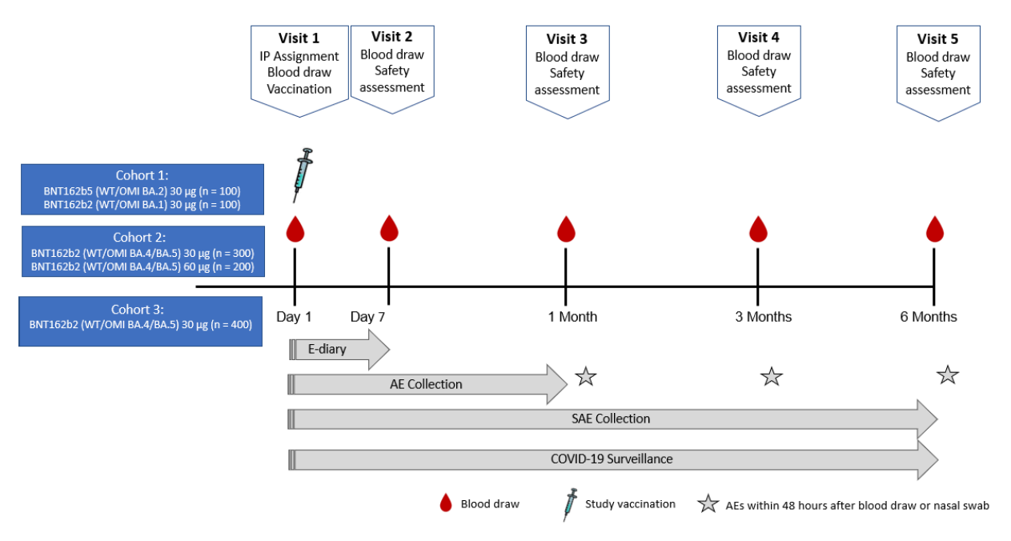
Abbreviations: AE = adverse event; IP = investigational product; SAE = serious adverse event
BNT162b2 (WT/OMI BA.4/BA.5) = tozinameran /famtozinameran (Comirnaty Original/Omicron BA.4-5 (bivalent) vaccine)
Note: Cohort 1 refers to a population given a vaccination not evaluated in this submission.
Table 8: Study C4591044 Cohort 2 design
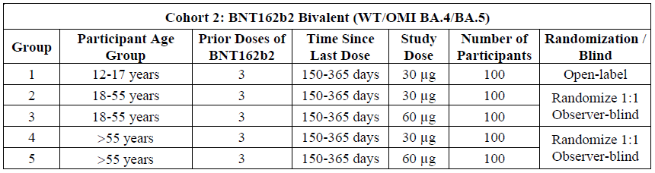
.BNT162b2 (WT/OMI BA.4/BA.5) = tozinameran /famtozinameran (Comirnaty Original/Omicron BA.4-5 (bivalent) vaccine)

Table 9: Study C4591044 Cohort 3 design
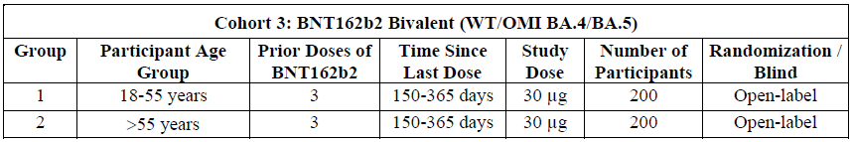
BNT162b2 (WT/OMI BA.4/BA.5) = tozinameran /famtozinameran (Comirnaty Original/Omicron BA.4-5 vaccine)
Notable features regarding the inclusion criteria included:
- Healthy participants inclusive of those with stable pre-existing disease.
- Cohort 1
  - Documented receipt of one booster dose of a USA authorised COVID-19 vaccine at least 90 or more days prior to Visit 1 (Day 1).
- Cohorts 2 and 3
  - Documented receipt of three prior doses of monovalent Comirnaty at 30 µg, with the last dose being 150 to 365 days before Visit 1 (Day 1).
Notable features regarding the exclusion criteria were:
- Bleeding diathesis.
- Immunocompromising condition or therapy.
- Pregnancy or breastfeeding.
- Recent use of antibody products that could interfere with vaccine immunity.

Study C4591031
Study C4591031 is an ongoing Phase III randomised, observer blinded master study to evaluate Comirnaty Original COVID-19 vaccine boosting strategies in healthy individuals previously vaccinated with tozinameran. The study is being conducted in the USA, and is ongoing, with the study initiation date being 22 February 2022. Substudies D and E have been designed to assess the safety, tolerability, and immunogenicity of monovalent and bivalent Omicron variant modified vaccine in tozinameran-experienced participants enrolled to receive booster dose(s) of either the Comirnaty prototype vaccine or an Omicron BA.1 variant modified vaccine. Study C4591031 (Substudy E) utilised the Comirnaty Omicron BA.1 variant modified vaccine (riltozinameran) as a monovalent vaccine or a bivalent vaccine in combination with tozinameran.
A historical control group was selected from Study C4591031, Substudy E, to aid in the evaluation of the immunogenicity objectives. This was to comprise a subset of about 100 participants from each age (18 to 55 years of age; older than 55 years of age) and dose group (30 µg, 60 µg) from the C4591031 Substudy E expanded cohort who received Comirnaty Original/Omicron BA.1 at 30 µg as a second booster dose.

Objectives and endpoints
The primary endpoints are to assess the safety and immunogenicity of Comirnaty Original/Omicron BA.4-5 vaccination as a second booster dose to monovalent Comirnaty experienced participants.
- Geometric mean titres (GMT) of the SARS-CoV-2 Omicron (BA.4/BA.5), Omicron (BA.1), and reference strain neutralising antibody levels for Comirnaty Original/Omicron BA.4-5 bivalent vaccine at 30 µg or 60 µg and Comirnaty Original/Omicron BA.1 bivalent vaccine at 30 µg or 60 µg at:
  - Day 1 (before study vaccination), 1 week, 1 month, 3 months and 6 months after study vaccination.
- Geometric mean fold rises (GMFR) of SARS-CoV-2 Omicron (BA.4/BA.5), Omicron (BA.1), and reference strain neutralising antibody levels for Comirnaty Original/Omicron BA.4-5 bivalent vaccine at 30 µg or 60 µg and Comirnaty Original/Omicron BA.1 bivalent vaccine at 30 µg or 60 µg.
Time frame from:
  - Day 1 to 1 week after study vaccination, Day 1 to 1 month after study vaccination, Day 1 to 3 months after study vaccination and Day 1 to 6 months after study vaccination
- Percentage of participants with seroresponse to Comirnaty Original/Omicron BA.4-5 bivalent vaccine at 30 µg or 60 µg and Comirnaty Original/Omicron BA.1 bivalent vaccine at 30 µg or 60 µg for GMTs of SARS-CoV-2 Omicron (BA.4/BA.5), Omicron (BA.1), and reference strain neutralising antibody levels. Time frame from:
  - Day 1 to 1 week after study vaccination, Day 1 to 1 month after study vaccination, Day 1 to 3 months after study vaccination and Day 1 to 6 months after study vaccination.
- Participants older than 55 years of age.
  - Superiority analysis: Geometric mean ratio (GMR) of SARS-CoV-2 Omicron (BA.4/BA.5) neutralising antibody levels for Comirnaty Original/Omicron BA.4-5 bivalent vaccine at 30 µg to monovalent Comirnaty at 30 µg (Study C4591031, Substudy E), at one month after study vaccination.
  - Noninferiority analysis: Differences in percentages of participants with seroresponse to SARS-CoV-2 Omicron BA.4/BA.5 after vaccination with Comirnaty Original/Omicron BA.4-5 bivalent vaccine at 30 µg or monovalent Comirnaty 30 µg (Study C4591031, Substudy E), at one month after study vaccination.
- Participants between 18 to 55 years compared to older than 55 years.
  - Noninferiority analysis: GMR of SARS-CoV-2 Omicron (BA.4/BA.5)-neutralising antibody levels for Comirnaty Original/Omicron BA.4-5 bivalent vaccine at 30 µg in participants 18 to 55 years compared to participants older than 55 years, at one month after study vaccination.
  - Noninferiority analysis: Differences in percentages of pts with seroresponse to SARS-CoV-2 Omicron BA.4/BA.5 after vaccination with Comirnaty Original/Omicron BA.4-5 bivalent vaccine at 30 µg in participants 18 to 55 years compared to participants older than 55 years, at one month after study vaccination.
An exploratory descriptive immunogenicity assessment looking at additional new variant neutralisation data (data cut-off date: 12 October 2022) will be performed for to characterise Omicron BA.4.6, BA.2.75.2, BQ.1.1, and XBB neutralisation responses following a booster dose (fourth dose) of Comirnaty Original/Omicron BA.4-5 bivalent vaccine at 30 µg compared to the monovalent Comirnaty at 30 µg vaccine.
Only descriptive immunogenicity has been provided with current submission. Results for the primary immunogenicity objectives that are based on statistical testing, including formal superiority and non-inferiority testing are to follow in 2023. The data presented in this AusPAR only pertain to participants 18 to 55 years of age and older than 55 years of age. Immunogenicity data for participants 12 to 17 years of age will be provided in a separate report.

Immunogenicity analysis
The immunogenicity analysis (data cut-off date: 2 December 2022) included approximately 100 randomised participants per vaccine group (Table 10). All participants 18 to 55 and older than 55 years of age in the Comirnaty Original/Omicron BA.4-5 bivalent vaccine at 30 µg groups from Study C4591044 Cohort 2 were included. One hundred participants in each of the 18 to 55 and older than 55 years of age groups in Study C4591031 Substudy E expanded cohort who received Comirnaty Original/Omicron BA.1 bivalent vaccine at 30 µg were selected as the reference group. The demographic characteristics for the subset used for the descriptive immunology analysis are shown in Table 11.
Table 10: Study C4591044 Cohort 2 and Study C4591031 Substudy E expanded cohort Immunogenicity populations Comirnaty Original/Omicron BA.4-5 bivalent vaccine groups
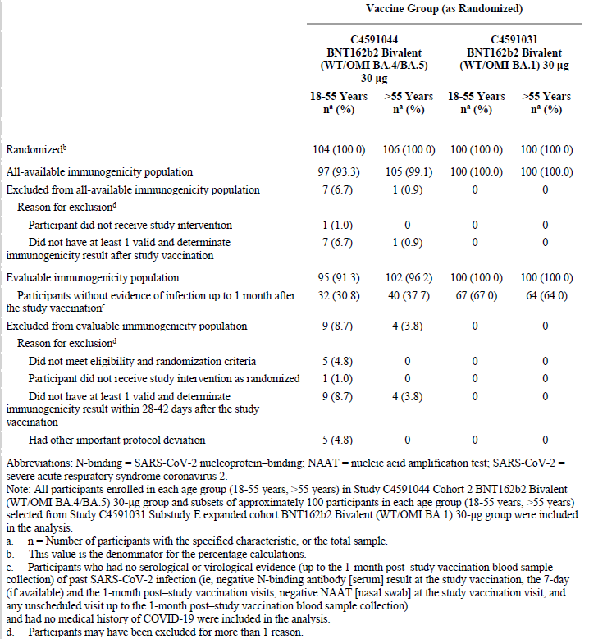
Abbreviations: N-binding = SARS-CoV-2 nucleoprotein binding; NAAT = nucleic acid amplification test; SARS-CoV-2 = severe acute respiratory syndrome coronavirus 2.
Note: All participants enrolled in each age group (18 to 55 years, older than 55 years) in Study C4591044 Cohort 2 BNT162b2 bivalent (WT/OMI BA.4-5) 30µg group and subsets of approximately 100 participants in each age group (18 to 55 years, older than 55 years) selected from Study C4591031 Substudy E expanded cohort BNT162b2 bivalent (WT/OMI BA.1) 30 µg group were included in the analysis
a n = number of participants with the specified characteristic, or the total sample.
b This vale is the denominator for the percentage calculations.
c Participants who had no serological or virological evidence (up to one month post-study) vaccination blood sample collection) of past SARS-CoV-2 infection (that is negative N-binding antibody (serum) result at the study vaccination, the 7 day (if available) and the one month post-study vaccination visits, negative NAAT (nasal swab) at the study vaccination visit, and any unscheduled visit up to the one month post-study vaccination blood sample collection) and had no medical history of COVID-19 were included in the analysis.
d Participants may have been excluded for more than one reason.
Table 11: Study C4591044 Cohort 2 and Study C4591031 Substudy E expanded cohort demographic characteristics one month immunogenicity analysis participants with or without evidence of infection up to one month after study vaccination (evaluable immunogenicity population)
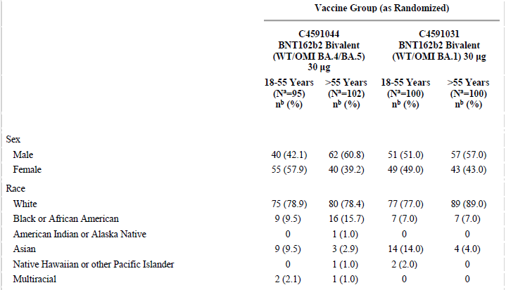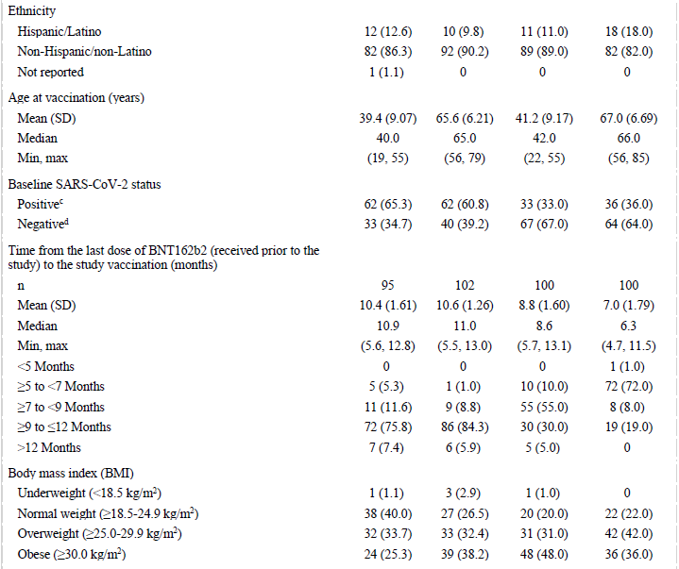
Abbreviations: N-binding = SARS-CoV-2 nucleoprotein binding; NAAT = nucleic acid amplification test; SARS-CoV-2 = severe acute respiratory syndrome coronavirus 2.
Note: All participants enrolled in each age group (18 to 55 years, older than 55 years) in Study C4591044 Cohort 2 BNT162b2 bivalent (WT/OMI BA.4-5) 30µg group and subsets of approximately 100 participants in each age group (18 to 55 years, older than 55 years) selected from Study C4591031 Substudy E expanded cohort BNT162b2 bivalent (WT/OMI BA.1) 30 µg group were included in the analysis
a N= number of participants in the specified group, or the total sample. This value is the denominator for the percentage calculations.
b n = number of participants with the specified characteristic.
c Positive N-binding antibody result at Baseline, positive NAAT result at Baseline, or medical history of COVID-19.
d Negative N-binding antibody result at Baseline, negative NAAT result at Baseline, and no medical history of COVID-19.
All participants from Study C4591044 Cohort 2 were included and their risk of prior exposure was 65.3% (18 to 55 years of age) and 60.8% (older than 55 years of age). Recruitment of the control reference group from Study C4591031 Substudy E had dual aims: include about 100 participants in each age group and as far as possible, try and achieve balance or prior exposure risk with the study group. Even after including all baseline positive controls, supplemented with ‘randomly selected’ baseline negative controls, baseline positive rates were 33% (18 to 55 years of age) and 36% (older than 55 years of age) in the reference group.
There are also some differences regarding time since last vaccination; generally being shorter in the reference subjects. In Study C4591044, the median time since third dose was 10.9 and 11 months in those 18 to 55 years of age and older than 55 years of age respectively, and the majority in both aged groups received their third dose between ≥ 9 to ≤ 12 months prior (75.8% ,84.3% respectively). In the Comirnaty Original/Omicron BA.1 group, the median time since third dose was 8.6 (18 to 55 years of age) and 6.3 months (older than 55 years of age), and the majority aged 18 to 55 years received their third dose between ≥7 to < 9 months prior (55%), whereas the majority aged older than 55 years received their third dose between ≥ 5 to < 7 months prior (72%).

Results for immunogenicity outcomes

Geometric mean titres and geometric fold rises
Omicron BA.4/5, BA 1 and reference strain neutralising GMTs at one month after study vaccination are shown in Table 12 and Figure 3 for participants 18 to 55 years of age and older than 55 years of age with or without evidence of infection. The corresponding GMFRs are shown in Table 12. These results are stratified by baseline positive versus baseline negative SARS-CoV-2 exposure and are also shown for those groups combined.
Table 12: Subset of Study C4591044 Cohort 2 and Study C4591031 Substudy E expanded cohort geometric mean titres, by baseline SARS-CoV-2 status, one month immunogenicity analysis (evaluable immunogenicity population)
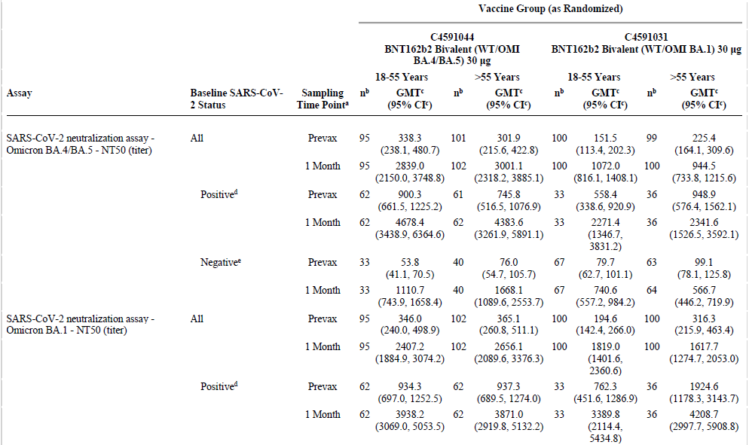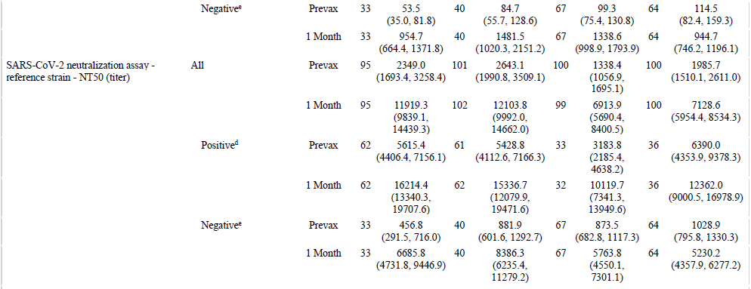
Abbreviations: GMT = geometric mean titre; LLOQ = lower limits of quantification; N-binding = SARS-CoV-2 nucleoprotein binding; NAAT = nucleic acid amplification test; NT50 = 50% neutralising titre; SARS-CoV-2 = severe acute respiratory syndrome coronavirus 2.
Note: All participants enrolled in each age group (18 to 55 years, older than 55 years) in Study C4591044 Cohort 2 BNT162b2 bivalent (WT/OMI BA.4-5) 30µg group and subsets of approximately 100 participants in each age group (18 to 55 years, older than 55 years) selected from Study C4591031 Substudy E expanded cohort BNT162b2 bivalent (WT/OMI BA.1) 30 µg group were included in the analysis
a Protocol specified timing for blood sample collection.
b n = Number of participants with valid and determinate assay results for the specified assay at the given sampling time point.
c GMTs and two sided 95% confidence intervals were calculated by exponentiating the mean logarithm of the titres and the corresponding confidence intervals (based on Student t distribution). Assay results below LLOQ were set to 0.5 x LLOQ.
d Positive N-binding antibody result at Baseline, positive NAAT result at Baseline, or medical history of COVID-19.
e Negative N-binding antibody result at Baseline, negative NAAT result at Baseline, and no medical history of COVID-19.
Figure 3: Comirnaty bivalent 30 μg groups of Cohort 2 and Substudy E expanded cohort, geometric mean titre and 95% confidence interval, by baseline SARS-CoV-2 Status of 50% neutralising titre (evaluable immunogenicity population)
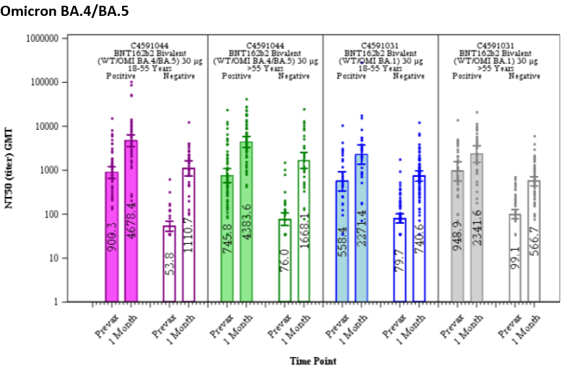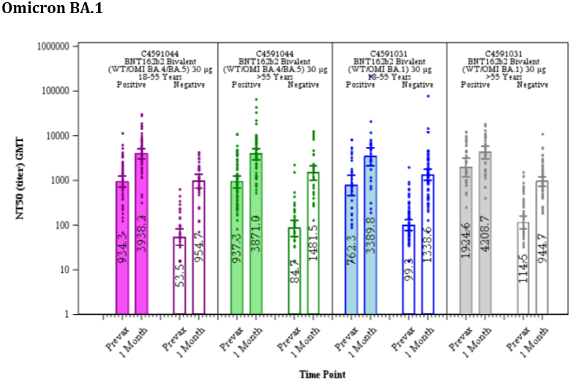
Figure 3: Continued, Comirnaty bivalent 30 μg groups of Cohort 2 and Substudy E expanded cohort, geometric mean titre and 95% confidence interval, by baseline SARS-CoV-2 Status of 50% neutralising titre,(evaluable immunogenicity population)
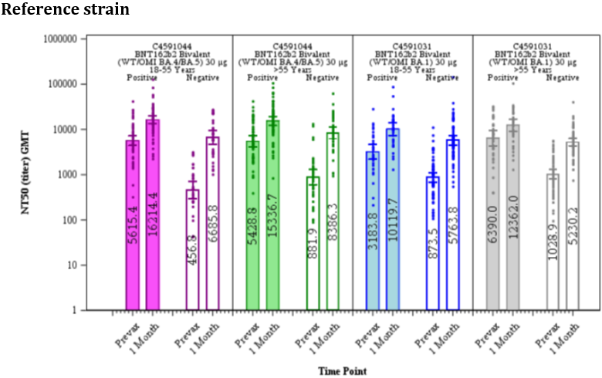
Abbreviations: GMT = geometric mean titre; N-binding = SARS-CoV-2 nucleoprotein binding; NAAT = nucleic acid amplification test; NT50 = 50% neutralising titre; SARS-CoV-2 = severe acute respiratory syndrome coronavirus 2.
Note: All participants enrolled in each age group (18 to 55 years, older than 55 years) in Study C4591044 Cohort 2 BNT162b2 bivalent (WT/OMI BA.4-5) 30µg group and subsets of approximately 100 participants in each age group (18 to 55 years, older than 55 years) selected from Study C4591031 Substudy E expanded cohort BNT162b2 bivalent (WT/OMI BA.1) 30 µg were included in the analysis.
Note: Dots represent individual antibody levels
Note: Number within each bar denotes geometric mean
Note: Positive N-binding antibody result at Baseline, positive NAAT result at Baseline, or medical history of COVID-19.
Note: Negative N-binding antibody result at Baseline, negative NAAT result at Baseline, and no medical history of COVID-19.
Table 13: Study C4591044 Cohort 2 and subset of Study C4591031 Substudy E expanded cohort Geometric mean fold rises from before study vaccination to each subsequent time point, by baseline SARS-CoV-2 Status (evaluable immunogenicity population)
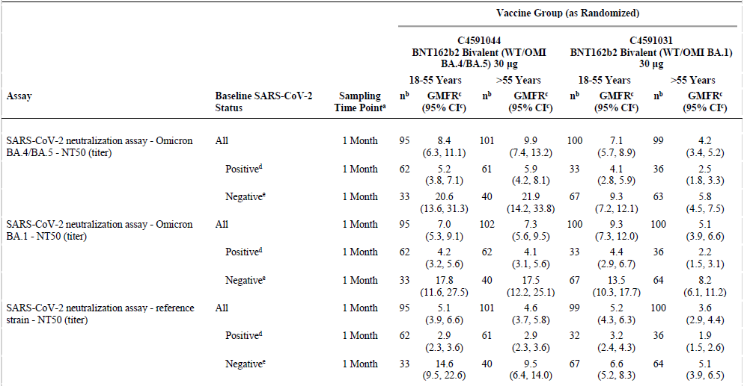
Abbreviations: GMFR = geometric mean fold rise; LLOQ = lower limits of quantification; N-binding = SARS-CoV-2 nucleoprotein binding; NAAT = nucleic acid amplification test; NT50 = 50% neutralising titre; SARS-CoV-2 = severe acute respiratory syndrome coronavirus 2.
Note: All participants enrolled in each age group (18 to 55 years, older than 55 years) in Study C4591044 Cohort 2 BNT162b2 bivalent (WT/OMI BA.4-5) 30µg group and subsets of approximately 100 participants in each age group (18 to 55 years, older than 55 years) selected from Study C4591031 Substudy E expanded cohort BNT162b2 bivalent (WT/OMI BA.1) 30 µg group were included in the analysis
a Protocol specified timing for blood sample collection.
b n = Number of participants with valid and determinate assay results for the specified assay at both the pre-vaccination time point and the given sampling time point.
c GMFRs and two sided 95% confidence intervals were calculated by exponentiating the mean logarithm of fold rises and the corresponding confidence intervals (based on Student t distribution). Assay results below LLOQ were set to 0.5 x LLOQ in the analysis.
d Positive N-binding antibody result at Baseline, positive NAAT result at Baseline, or medical history of COVID-19.
e Negative N-binding antibody result at Baseline, negative NAAT result at Baseline, and no medical history of COVID-19.
The below list the key results summary for GMT and GMFR:
- Observed GMTs at pre-vaccination and one month after study vaccination were higher for participants in both age groups who had evidence of prior SARS-CoV-2 infection (Baseline positive) compared with those without evidence of prior SARS-CoV-2 infection baseline negative.
- Geometric mean fold rises from before study vaccination to one month after study vaccination were lower for participants in both vaccine groups who were baseline positive compared with those who were baseline negative for SARS-CoV-2.
The below list the key results summary for Omicron BA.4-5 neutralisation:
- Observed BA.4-5 neutralising GMTs at one month after study vaccination in both age groups were higher for in the Comirnaty Original/Omicron BA.4-5 bivalent vaccine at 30 µg group compared to participants in the Comirnaty Original/Omicron BA.1 bivalent vaccine at 30 µg groups.
- Observed GMFRs at one month were higher in Comirnaty Original/Omicron BA.4-5 bivalent vaccine at 30 µg recipients versus Comirnaty Original/Omicron BA.1 bivalent vaccine at 30 µg recipients in both age groups.
The below list the key results summary for Omicron BA.1 neutralisation
- Within baseline positive groups, the Omicron BA.1 neutralising GMTs at one month after study vaccination in both age groups were similar for participants in the Comirnaty Original/Omicron BA.4-5 bivalent vaccine at 30 µg group and participants in the Comirnaty Original/Omicron BA.1 bivalent vaccine at 30 µg groups.
- Within baseline negative groups, the Omicron BA.1 neutralising GMTs at one month after study vaccination were higher for those older than 55 years of age and lower for participants 18 to 55 years of age in the Comirnaty Original/Omicron BA.4-5 bivalent vaccine at 30 µg when compared to corresponding age groups in the Comirnaty Original/Omicron BA.1 bivalent vaccine at 30 µg group.
- Observed GMFRs at one month were similar or higher in Comirnaty Original/Omicron BA.4-5 bivalent vaccine at 30 µg recipients versus Comirnaty Original/Omicron BA.1 bivalent vaccine at 30 µg recipients across both age groups.
The below list the key results summary for reference strain neutralisation
- Within the baseline positive Comirnaty Original/Omicron BA.4-5 bivalent vaccine at 30 µg group had higher reference strain neutralising GMTs at one month after study vaccination the Comirnaty Original/Omicron BA.1 bivalent vaccine at 30 µg groups.
- Within baseline negative groups, reference strain neutralizing GMTs at 1 month after study vaccination were higher or similar for the Comirnaty Original/Omicron BA.4-5 bivalent vaccine at 30 µg groups compared with the Comirnaty Original/Omicron BA.1 bivalent vaccine at 30 µg group.
- Observed GMFRs at 1 month were higher or similar in Comirnaty Original/Omicron BA.4-5 bivalent vaccine at 30 µg recipients versus Comirnaty Original/Omicron BA.1 bivalent vaccine at 30 µg recipients across both age groups.

Seroresponse rates
Omicron BA.4-5, BA.1 and reference strain seroresponse rates are shown in Table 14. Seroresponse rates reflect greater or equal to four-fold rises in post-dose versus pre-dose antibody titres so it would be expected to be higher in baseline SARS-CoV-2 negative participants then SARS-CoV-2 positive participants due to relatively lower pre-dose titres (even if post-dose GMTs are higher in baseline positive participants). This pattern was observed for both vaccines, in both age groups for all neutralisation responses studied (Omicron BA.4/5, Omicron BA.1 and reference strain). Seroresponse rates were also generally higher or similar for both age groups in the Comirnaty Original/Omicron BA.4-5 bivalent vaccine at 30 µg group compared to those in the Comirnaty Original/Omicron BA.1 bivalent vaccine at 30 µg.
Table 14: Studies C4591044/C4591031 Number (%) of participants achieving seroresponse, by baseline SARS-CoV-2 Status (evaluable immunogenicity population)
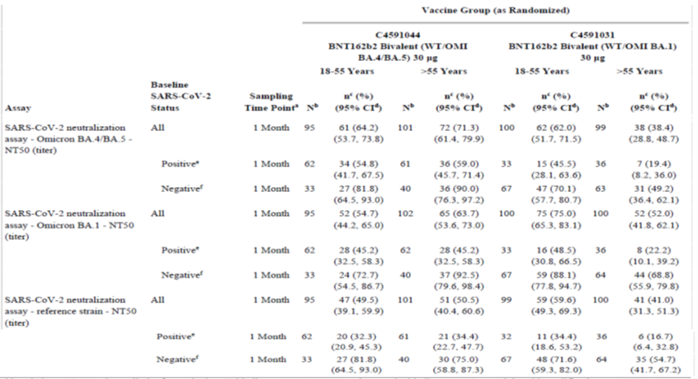
Abbreviations: LLOQ = lower limits of quantification; N-binding = SARS-CoV-2 nucleoprotein binding; NAAT = nucleic acid amplification test; NT50 = 50% neutralising titre; SARS-CoV-2 = severe acute respiratory syndrome coronavirus 2.
Note: All participants enrolled in each age group (18 to 55 years, older than 55 years) in Study C4591044 Cohort 2 BNT162b2 bivalent (WT/OMI BA.4-5) 30µg group and subsets of approximately 100 participants in each age group (18 to 55 years, older than 55 years) selected from Study C4591031 Substudy E expanded cohort BNT162b2 bivalent (WT/OMI BA.1) 30 µg group were included in the analysis.
Note: Seroresponse is defined as achieving a ≥ 4-fold rise from Baseline. If the baseline measurement is below LLOQ, a post-vaccination assay result ≥ 4 x LLOQ is considered a seroresponse
a Protocol specified timing for blood sample collection.
b N = Number of participants with valid and determinate assay results for the specified assay at both the pre-vaccination time point and the given sampling time point. These values are the denominators for the percentage calculations
c n = Number of participants with seroresponse for the given assay at the given dose/sampling time point.
d Exact two sided confidence interval, based on the Clopper and Pearson method.
e Positive N-binding antibody result at Baseline, positive NAAT result at Baseline, or medical history of COVID-19.
f Negative N-binding antibody result at Baseline, negative NAAT result at Baseline, and no medical history of COVID-19.

New variant neutralisation data (data cut-off date 12 October 2022)
Descriptive immunogenicity analyses for Omicron BA.4.6, BA.2.75.2, BQ.1.1, and XBB neutralisation responses following a booster dose (fourth dose) of Comirnaty Original/Omicron BA.4-5 bivalent vaccine at 30 µg compared to the monovalent Comirnaty at 30 µg vaccine were performed.
The analysis subset included about 40 randomised participants per group from participants in C4591044 Cohort 2 who received of Comirnaty Original/Omicron BA.4-5 bivalent vaccine at 30 µg and participants older than 55 years of age group in Study C4591031 Substudy E who received monovalent Comirnaty at 30 µg.
There was deliberate selection to enable roughly equal numbers of baseline SARS-CoV-2 positive versus negative participants.
There were 36 participants in the bivalent group and 40 in the monovalent group. Median ages were 66 years for Comirnaty Original/Omicron BA.4-5 bivalent vaccine at 30 µg subset and 65.5 years for monovalent Comirnaty at 30 µg. Median times from third dose of monovalent Comirnaty 30 µg to the study vaccination (fourth dose) were 11.3 and 6.3 months respectively.
Irrespective of prior SARS-CoV-2 exposure, one month post-dose GMTs for the four variants were higher for Comirnaty Original/Omicron BA.4-5 bivalent vaccine at 30 µg groups compared to monovalent Comirnaty groups (Figure 4).
In recipients of Comirnaty Original/Omicron BA.4-5 bivalent vaccine at 30 µg, neutralisation (based on GMFR) was least effective against Omicron XBB. (Table 15). In terms of the seroresponse in the SARS-CoV-2 negative group, seroresponses were seen against Omicron BA.4.6, BA.2.75.2, BQ.1.1, and XBB in 94.1%, 70.6%, 76.5%, and 41.2% of participants respectively in the Comirnaty Original/Omicron BA.4-5 bivalent vaccine at 30 µg group but only 15%, 5%, 0%, and 0% in the monovalent Comirnaty 30 µg group.

Figure 4: Geometric mean titres and 95% confidence intervals, by Baseline SARS-CoV-2 Status: fluorescent focus reduction neutralisation assay, 50% neutralising titre – (A) Omicron BA.4.6, (B) Omicron BA.2.75.2, (C) Omicron BQ.1.1, (D) Omicron XBB – subset of Study C4591044 Cohort 2 and Study C4591031 Substudy E – participants older than 55 years of age (evaluable immunogenicity population)
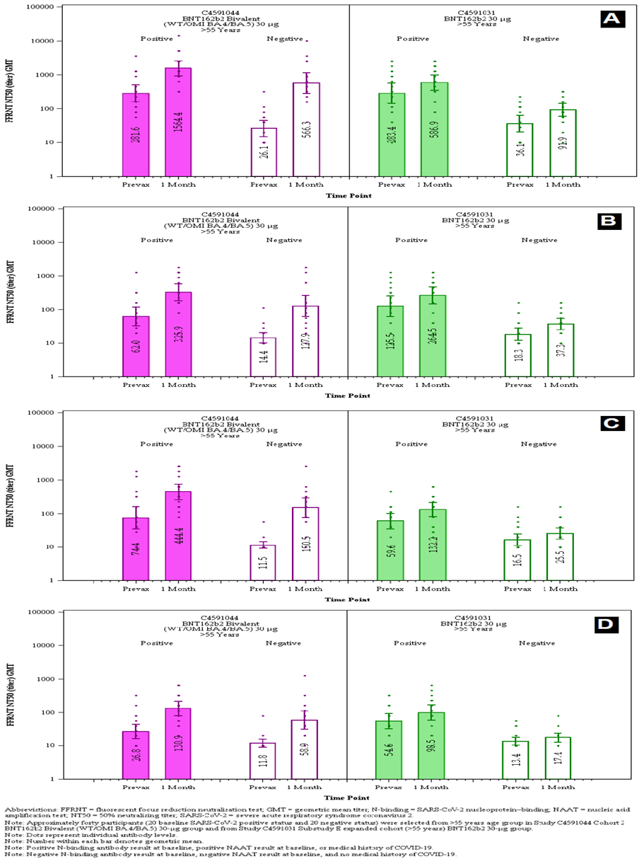Abbreviation: FFRNT = fluorescent focus reduction neutralisation test; GMT = geometric mean titre; N-binding = SARS-CoV-2 nucleoprotein binding; NAAT = nucleic acid amplification test; NT50 = 50% neutralising titre; SARS-CoV-2 = severe acute respiratory syndrome coronavirus 2.
Note: Approximately forty participants (20 baseline SARS-Cov-2 positive status and 20 negative status) were selected from the older than 55 years age group in Study C4591044 Cohort 2 BNT162b2 bivalent (WT/OMI BA.4-5) 30µg group and from Study C4591031 Substudy E expanded cohort (older than 55 years old) BNT162b2 30 µg group.
Note: Dots represent individual antibody levels
Note: Number within each bar denotes geometric mean
Note: Positive N-binding antibody result at Baseline, positive NAAT result at Baseline, or medical history of COVID-19.
Note: Negative N-binding antibody result at Baseline, negative NAAT result at Baseline, and no medical history of COVID-19
Table 15: Geometric mean fold rises from before study vaccination to each subsequent time point, by baseline SARS-CoV-2 Status – new variants neutralisation – subset of Study C4591044 Cohort 2 and Study C4591031 Substudy E – participants older than 55 years of age (evaluable immunogenicity population)
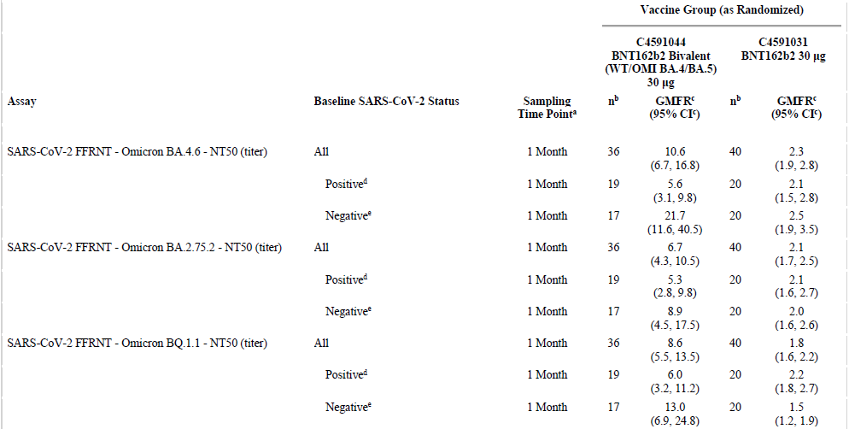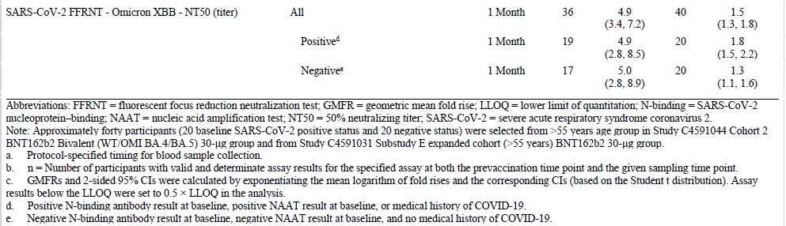
Abbreviation: FFRNT = fluorescent focus reduction neutralisation test; GMFR = geometric mean fold rise; LLOQ = lower limits of quantification; N-binding = SARS-CoV-2 nucleoprotein binding; NAAT = nucleic acid amplification test; NT50 = 50% neutralising titre; SARS-CoV-2 = severe acute respiratory syndrome coronavirus 2.
Note: Approximately forty participants (20 baseline SARS-Cov-2 positive status and 20 negative status) were selected from the older than 55 years age group in Study C4591044 Cohort 2 BNT162b2 bivalent (WT/OMI BA.4-5) 30µg group and from Study C4591031 Substudy E expanded cohort (older than 55 years old) BNT162b2 30 µg group.
a Protocol specified timing for blood sample collection.
b n = Number of participants with valid and determinate assay results for the specified assay at both the pre-vaccination time point and the given sampling time point.
c GMFRs and two sided 95% confidence intervals were calculated by exponentiating the mean logarithm of fold rises and the corresponding confidence intervals (based on Student t distribution). Assay results below LLOQ were set to 0.5 x LLOQ in the analysis.
d Positive N-binding antibody result at Baseline, positive NAAT result at Baseline, or medical history of COVID-19.
e Negative N-binding antibody result at Baseline, negative NAAT result at Baseline, and no medical history of COVID-19.

Study C4591031
The present submission includes new clinical data from Study C4591031, a Phase III master study evaluating Comirnaty boosting strategies in healthy individuals previously vaccinated with Comirnaty. These data include data from:
- approximately 1840 participants older than 55 years of age from Study C4591031 Substudy E (Comirnaty experienced participants), including safety and immunogenicity data up to one month after receipt of a single dose (fourth dose) of Comirnaty Original (30 µg or 60 µg), monovalent Omicron BA.1 (30 µg or 60 µg), or Comirnaty Original/Omicron BA.1 bivalent vaccine (15 µg /15 µg or 30 µg /30 µg).
- approximately 640 participants older or equal to 18 to younger or equal to 55 years of age from ongoing Study C4591031, Substudy D, Cohort 2 (Comirnaty experienced participants), including safety and immunogenicity to one month after receipt of an additional booster (fourth) dose of an Omicron.
- Substudy D, Cohort 3 (Comirnaty naïve participants) involving about 30 healthy adults older or equal to 18 to younger or equal to 55 years of age and was designed to evaluate safety, tolerability, and immunogenicity of monovalent Comirnaty Omicron 30 µg compared to Comirnaty 30 µg administered as a two dose primary series to Comirnaty naïve participants.
Given that these data are not directly relevant to this submission, they are not discussed further in this document.

Real world immunogenicity data

Neutralisation against BA.2.75.2, BQ.1.1, and XBB from mRNA bivalent booster (Davis-Gardner et al. 2023)
Since the approval and distribution of Omicron BA 5 bivalent vaccines, additional subvariants containing key mutations that further enhance the ability of the virus to escape from vaccine elicited antibodies and regulatory approved monoclonal antibodies have been identified. Of particular concern is the R346T mutation, which has arisen in multiple omicron subvariants, including BA.2.75.2, BQ.1.1, and XBB.

Methods
Serum samples were obtained from participants who had received either one or two monovalent boosters or the bivalent booster to determine the neutralisation efficiency of the booster vaccines against wild-type virus (SARS-CoV-2 WA1/2020 strain) and primary isolates of Omicron subvariants BA.1, BA.5, BA.2.75.2, BQ.1.1, and XBB using an in vitro, live virus focus reduction neutralisation test (FRNT).
Three cohorts of participants were included: the first cohort (n = 12) 7 to 28 days after one monovalent booster; the second, cohort 2 (n = 11) 16 to 57 days after a second monovalent booster; and Cohort 3 (n = 12) 16 to 42 days after a bivalent booster.
The differences in neutralising antibody were quantitated by comparing the FRNT₅₀ GMTs of neutralising antibodies against the omicron subvariants with that against the ancestral SARS-CoV-2 WA1/2020 strain. Serum samples in which the GMT fell below the limit of detection (1:20) were given an arbitrary FRNT50 value of 10.

Results and conclusions
In all three cohorts, neutralisation activity was lower against all omicron subvariants than against the ancestral strain; neutralising activity was lowest against the XBB subvariant (see Figure 5).
- Cohort1: the GMTs were 857 against ancestral strain, 60 against Omicron BA.1, 50 against Omicron BA.5, 23 against Omicron BA.2.75.2, 19 against BQ.1.1, and below the limit of detection against XBB
- Cohort, 2: the GMTs were 2352 against ancestral strain, 408 against Omicron BA.1, 250 against Omicron BA.5, 98 against Omicron BA.2.75.2, 73 against BQ.1.1, and 37 against XBB.
- Cohort 3: the neutralising activity against all the omicron subvariants as compared with that against ancestral strain was better than Cohorts 1 and 2. GMTTs were 2481 against ancestral strain, 618 against Omicron BA.1, 576 against Omicron BA.5, 201 against Omicron BA.2.75.2, 112 against BQ.1.1, and 96 against XBB
- Cohort 3: the neutralisation titres against Omicron BA.1 and BA.5 were 4 times as low as against ancestral strain and titres against Omicron BA.2.75.2, BQ.1.1, and XBB that were 12 to 26 times as low as that against ancestral strain.
These serologic data show an overall neutralisation benefit with bivalent booster immunisations.
Figure 5: Neutralising responses against the ancestral strain (SARS-CoV-2 WA1/2020) and Omicron subvariants
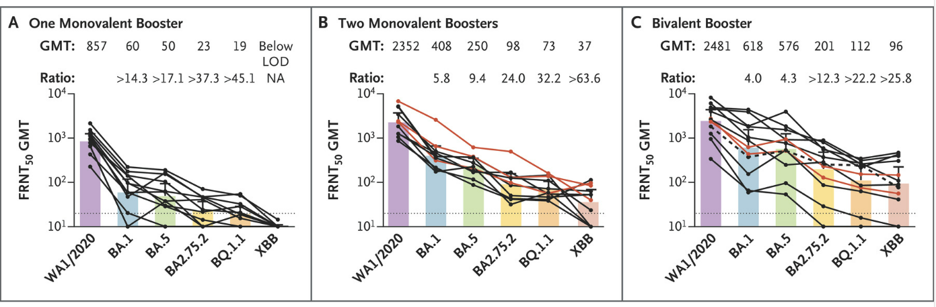

Limitations
Limitations include the small cohort size, differences in age among the cohorts, the unknown effect of previous exposure to SARS-CoV-2, and comparison of the vaccines at a single time point.

Immunogenicity of BA.5 bivalent mRNA vaccine boosters (USA) (Collier et al. 2023)

Methods
Immune responses in 15 participants who had received the original monovalent mRNA boosters and in 18 participants who had received the bivalent mRNA boosters of the two vaccines were evaluated.
Participants received a median of three doses of vaccine against SARS-CoV-2, and 33% had documentation of SARS-CoV-2 infection during the Omicron surge (higher number likely).

Results and conclusions
- Both the monovalent and bivalent mRNA boosters led to preferential expansion of ancestral strain neutralising antibody titres and lower Omicron BA.5 neutralising antibody titres The median Omicron BA.5 neutralising antibody titre increased from 184 to 2829 after monovalent mRNA boosting and from 211 to 3693 after bivalent mRNA boosting.
- Binding antibody responses were similar after monovalent and bivalent mRNA boosting.
- Spike specific CD8⁺ and CD4⁺ T-cell responses increased modestly after monovalent and bivalent mRNA boosting.
- The median Omicron BA.5 CD8⁺ T-cell response increased from 0.027% to 0.048% after monovalent and from 0.024% to 0.046% after bivalent boosting.
- The median Omicron BA.5 CD4⁺ T-cell response increased from 0.060% to 0.130% after monovalent and from 0.051% to 0.072% after bivalent mRNA boosting.
- The median Omicron BA.5 memory B-cell response was 0.079% after monovalent mRNA boosting and 0.091% after bivalent mRNA boosting.
- These data indicate that both monovalent and bivalent mRNA boosters markedly increased antibody responses but did not substantially augment T-cell responses.
- Neutralising antibody titres against the ancestral strain were higher than against Omicron BA.5 after both monovalent and bivalent boosting. The median Omicron BA.5 neutralising antibody titre was similar after monovalent and bivalent mRNA boosting; modest trend towards bivalent booster (factor of 1.3).
- These data are consistent with the modest benefits with a Omicron BA.1 containing bivalent mRNA booster.
- ‘Our findings suggest that immune imprinting by previous antigenic exposure5 may pose a greater challenge than is currently appreciated for inducing robust immunity against SARS-CoV-2 variants.’8

Antibody response to Omicron BA.4–BA.5 bivalent booster (USA) (Wang et al. 2023)
Serum samples from participants who had received three doses of either of the original monovalent mRNA vaccines followed by one dose of a bivalent vaccine targeting BA.4–BA.5 were analysed. Neutralizing-antibody levels in these samples were compared with levels in samples obtained from three other groups of participants: 3-dose and 4-dose monovalent mRNA groups and those with a history of BA.4–BA.5 infection after 3 or 4 doses of monovalent mRNA vaccine and those with a history of BA.4–BA.5 breakthrough infection after three or four doses of monovalent mRNA vaccine.
The authors concluded that:
- Boosting with new bivalent mRNA vaccines targeting both the BA.4-BA.5 variant and the D614G conta strain did not elicit a discernibly superior virus neutralising peak antibody response as compared with boosting with the original monovalent vaccines.
- Limitations include a small sample size.

Real-world effectiveness data
On 1 September 2022, in the USA, a single booster dose of bivalent mRNA vaccine (Comirnaty or Spikevax) containing an updated Omicron BA.4/BA.5 component was recommended by the Centers for Disease Control and Prevention (CDC) USA. This recommendation was a booster to anyone older or equal to 12 years of age (Comirnaty) or older or equal to 18 years of age (Spikevax) who had completed at least a primary series of any FDA authorised or approved monovalent vaccine (including non-mRNA vaccines) at least two or more months earlier. This expanded to 5 to 11 years of age on 12 October 2022.

Effectiveness of bivalent mRNA vaccines in preventing symptomatic SARS-CoV-2 infection; increasing community access to testing program (USA, September to November 2022) (Link-Gelles et al. 2022)

Methods
The study data; derived from the Increasing Community Access to Testing program, which was implemented to provide free access to COVID-19 diagnostic testing through pharmacies in areas with high social vulnerability.
The period covered was 14 September 2022 through 11 November 2022, during which Omicron BA.4-BA.5 predominated initially (81% of tests were taken during that period) and transitioned to other sublineages (including Omicron BA.4.6, BA.5.2.6, BF.7, BQ.1, and BQ.1.1) toward the end of the study.
The analysis was performed using a test negative design where case patients were those recording a positive laboratory based nucleic acid amplification test for SARS-CoV-2 in the presence of one or more compatible symptoms and control patients were those who recorded a negative result. This allows comparison of the odds of receiving a bivalent booster dose (after second, third or fourth monovalent doses) to being in a non-boosted control group. Vaccine effectiveness was calculated as (1 – odds ratio) x 100.
Absolute vaccine effectiveness was calculated using a vaccinated group who had received a bivalent COVID-19 mRNA booster dose compared to a control group who had been unvaccinated. Relative vaccine effectiveness was calculated using a control group who had received ≥ 2 prior doses of a COVID-19 vaccine and the effect of waning immunity was examined by stratifying those whose last monovalent dose was 2 to 3, 4 to 5, 6 to 7 or greater or equal to 8 months prior.

Results and conclusions
Among those aged older or equal to 18 years reporting COVID-19 compatible symptoms, 360,626 tests were included; of these, 34% were positive. Among these case patients, 24% reported being unvaccinated, 72% had received second, third or fourth monovalent vaccine doses and 5% had received a bivalent booster dose. Among 238,939 control patients who had negative test results, 30% reported being unvaccinated, 63% had received second, third or fourth monovalent vaccine doses, and 7% had received a bivalent booster dose. In those receiving a booster, the median time from dosing to testing was one month and did not vary by case status.
- After two or more doses of a monovalent vaccine, absolute vaccine effectiveness of a bivalent booster dose (compared to being unvaccinated) was 43% in participants 18 to 49 years of age, 28% in 50 to 64 years of age and 22% in older or equal to 65 years of age (see Table 16).
- The relative vaccine effectiveness of a bivalent booster dose (compared to two or more monovalent vaccine doses) increased along with the number of months since the last monovalent dose (Table 17.) At 2 to 3 months and greater or equal to 8 months after receipt of the most recent monovalent dose, relative vaccine effectiveness of a bivalent mRNA COVID-19 vaccine dose was 30% and 56% among persons aged 18 to 49 years, 31% and 48% among persons aged 50 to 64 years, and 28% and 43% among persons aged older or equal to 65 years, respectively.
- Although results were not shown, the authors reported that, ‘Results limited to the period of BA.4/BA.5 predominance were not meaningfully different from the results shown, which include data from the period when BA.4/BA.5 sub lineages (including BA.4.6, BA.5.2.6, BF.7, BQ.1, and BQ.1.1) predominated.’
- During this period of Omicron BA.4/5 and its sublineage predominance, that supports use of bivalent COVID-19 mRNA vaccine as the preferred booster in each of those pre-dose scenarios.
Table 16: Link-Gelles et al. (2022) Absolute vaccine effectiveness against symptomatic SARS-CoV-2 infection for a single bivalent mRNA COVID-19 booster dose received after second, third or fourth doses of monovalent vaccine compared with no doses, by age group and number of monovalent COVID-19 vaccine doses between September to November 2022
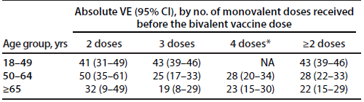
Abbreviations: NA = not applicable; VE = vaccine effectiveness.
* Person aged younger than 50 years old without moderate or severe immunocompromise were not eligible for a fourth monovalent (second booster) dose.

Table 17: Link-Gelles et al. (2022) Relative vaccine effectiveness of a single bivalent mRNA COVID-19 booster dose against symptomatic SARS-CoV-2 infection* received after second, third and fourth monovalent vaccine doses, by age group, number of monovalent COVID-19 vaccine doses received, and interval since last monovalent dose between September to November 2022
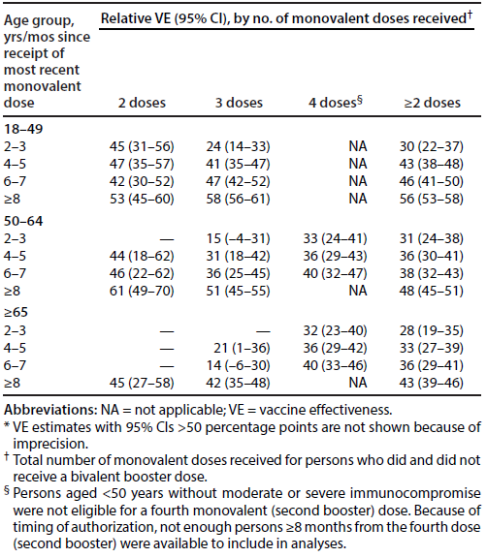
Abbreviations: NA = not applicable; VE = vaccine effectiveness.
* VE estimates with 95% confidence intervals greater than 50 % points are not shown because of imprecision.
† Total number of monovalent doses received for persons who did and did not receive a bivalent booster dose.
§ Persons aged younger than 50 years old without moderate or severe immunocompromise were not eligible for a fourth monovalent (second booster) dose. Because of timing of authorisation, not enough persons ≥ 8 months from the fourth dose (second booster) were available to include in the analyses.

Study limitations
Limitations to this study which may impact on the interpretation of the results include that the type of mRNA vaccine used (Comirnaty/Spikevax) was not recorded, the study did not compare use of a bivalent vaccine with an additional booster dose of monovalent vaccine, vaccination status, previous infection history and underlying medical conditions was estimated by self-reporting, bias may be present related to factors such as early vaccine seeking behaviours, test seeking behaviours, and the population studied (by study design) is one of higher social vulnerability in the USA.

Tenforde et al. (2022) Early estimates of bivalent mRNA vaccine effectiveness in preventing COVID-19 associated emergency department or urgent care encounters and hospitalisations among immunocompetent adults - VISION network, nine states, September to November 2022

Methods
The study; was conducted in in nine USA states between 13 September 2022 and 18 November 2022. During this time, Omicron BA.5 was predominant and new Omicron BA.4/5 subvariants were emerging.
The vaccine effectiveness (VE) was estimated using a test-negative case control design, comparing the odds of having received versus having not received a bivalent booster dose among case patients (those who received a positive SARS-CoV-2 test result) and control patients (those with a negative SARS-CoV-2 test result).
- Analysis 1: emergency department/urgent care encounter.
- Analysis 2: Hospitalisation for a COVID-19-like illness.
Evaluated VE in adults older or equal to 18 years of age (immunocompromised adults were excluded) who had received second, third or fourth prior monovalent mRNA doses compared to: (1) no previous vaccination; and (2) previous receipt of second, third or fourth monovalent only mRNA doses.
- The odds of having a bivalent booster was compared among case patients (that is having received a positive SARS-CoV-2 test) and control patients (that is having received a negative SARS-CoV-2 test).
- Odds ratio and 95% confidence intervals (CIs) were calculated using multivariable logistic regression that adjusted for age, race & ethnicity, sex, calendar day (days since 1 January 2021), geographic region and local SARS-CoV-2 circulation (proportion of positive SARS-CoV-2 results in regions surrounding the facility).

Results and conclusions
- Among 78,303 emergency department/urgent care encounters with COVID-19 like illness that met inclusion criteria, 9,009 (12%) case patients and 69,294 (89%) control patients were identified. Among 15,527 hospitalizations with COVID-19 like illness that met inclusion criteria, 1,453 (9%) case patients and 14,074 (91%) control patients were identified.
- Vaccine effectiveness of a bivalent booster dose (after second, third or fourth monovalent doses) against COVID-19 associated emergency department/urgent care encounters was 56% compared with no vaccination, 31% compared with monovalent vaccination only with last dose 2 to 4 months earlier, and 50% compared with monovalent vaccination only with last dose greater or equal to 11 months earlier.
- Vaccine effectiveness of a bivalent booster dose (after second, third or fourth monovalent doses) against COVID-19 associated hospitalisations was 57% compared with no vaccination, 38% compared with monovalent vaccination only with last dose 5 to 7 months earlier, and 45% compared with monovalent vaccination only with last dose greater or equal to 11 months earlier.
- Bivalent vaccines administered after second, third or fourth monovalent doses were effective in preventing medically attended COVID-19 compared with no vaccination and provided additional protection compared with past monovalent vaccination only, with relative protection increasing with time since receipt of the last monovalent dose.

Study limitations
Limitations to this study that may affect results and generalisability include that the VE of Comirnaty versus Spikevax mRNA vaccines was not studied separately, the study did not compare use of a bivalent vaccine with an additional booster dose of monovalent vaccine, there was no estimate of prior natural SARS-CoV-2 infection which may have affected baseline immunity, bias may be present related to factors such as vaccine and antiviral seeking behaviours, leading to skewed populations, only people from 9 of the 50 USA states were studied, and may not be representative of the entire population, and the study wasn’t powered to separate the effects of second versus third versus fourth prior doses of mRNA vaccine.

Surie D et al. (2022) Early estimates of bivalent mRNA vaccine effectiveness in preventing COVID-19 associated hospitalisation among immunocompetent adults aged older than or equal to 65 Years - IVY Network, 18 States, 8 September 2022 to 30 November 2022

Methods
This study; was conducted in 22 hospitals in 18 states between 8 September 2022 and 30 November 2022. During this time, Omicron BA.5 was predominant and new Omicron BA.4/5 subvariants were emerging.
The VE was estimated using a test-negative case control design, in patients hospitalised for a COVID-19 like illness and who were tested for SARS-CoV-2.
Evaluated VE in adults older than or equal to 65 years of age who had received two or more prior monovalent mRNA doses compared to: (1) no previous vaccination; and (2) previous receipt of two or more monovalent mRNA doses.
The odds of having a bivalent booster was compared among case patients (that is having received a positive SARS-CoV-2 test) and control patients (that is having received a negative SARS-CoV-2 test).
ORs and 95% CIs were calculated using multivariable logistic regression that adjusted for ‘U.S. Department of Health and Human Services region, admission date in 2-week intervals, continuous age, sex, race, and Hispanic or Latino (Hispanic) ethnicity.’
Exclusions included immunocompromised adults and control patients testing positive on PCR for influenza ‘because of potential correlation between COVID-19 and influenza vaccination behaviours’.

Results and conclusions
- There were 798 patients included (381 case patients and 417 control patients) and 74% had multiple underlying conditions.
- When compared with those unvaccinated, VE of bivalent booster dose given at least 7 days or more before illness onset (median = 29 days) against COVID-19 associated hospitalisation was 84%.
- Compared with persons who received two or more monovalent-only mRNA vaccine doses, relative VE of a bivalent booster dose was 73%.
- These early findings show that a bivalent booster dose provided strong protection against COVID-19 associated hospitalisation in older adults and additional protection among persons with previous monovalent-only mRNA vaccination.
- When compared with patients whose last monovalent dose was 6 to 11 months and greater than or equal to 12 months before illness onset, relative VE of a bivalent booster dose was 78% and 83%, respectively.

Study limitations
Limitations to this study that may affect its interpretation and generalisability include that the type of mRNA vaccine used (Pfizer/Moderna) was not recorded, the study did not compare use of a bivalent vaccine with an additional booster dose of monovalent vaccine, there was no estimate of prior natural SARS-CoV-2 infection which may have affected baseline immunity, bias may be present related to factors such as vaccine and antiviral seeking behaviours, leading to skewed populations, only people from 18 of the 50 USA states were studied, and may not be representative of the entire population, and the study was not powered to separate the effects second versus third versus fourth prior doses of mRNA vaccine.

Arbel R et al. (2022) Effectiveness of the Bivalent mRNA Vaccine in Preventing Severe Covid-19 Outcomes: an observational cohort study

Methods
This was a retrospective cohort study; conducted in Israel from 24 September 2022 to 12 December 2022.
Participants (all aged older or equal to 65 years of age) were all members of Clalit Health Services (large healthcare organisation that covers about two thirds of the Israeli population aged 65 years of age or older), eligible for a bivalent booster. Only Comirnaty Original/Omicron BA.4-5 bivalent vaccine (tozinameran and famtozinameran) was utilised. Hospitalisations and death due to COVID-19 among participants who received the bivalent vaccine were compared with those who did not.
A Cox proportional hazards regression model with time dependent covariates was used to estimate the association between the bivalent vaccine and COVID-19 outcomes while adjusting for demographic factors and coexisting illnesses.

Results and conclusions
- A total of 622,701 participants met the eligibility criteria. Of those, 14% received a bivalent vaccine booster during the 70-day study period.
- Hospitalisation due to COVID-19 occurred in six bivalent vaccine recipients and 297 participants who did not, adjusted hazard ratio: 0.19 (95% CI, 0.08-0.43).
- Death due to COVID-19 occurred in one bivalent recipient and 73 participants who did not, adjusted hazard ratio 0.14: (95% CI, 0.02-1.04).
- Vaccine effectiveness is 81% for COVID-19 related hospitalizations and 86% for COVID-19 death.
- Bivalent booster vaccination of adults aged older or equal to 65 years of age is an effective and essential tool for reducing their risk for COVID-19 hospitalisations and death.

Study limitations
Limitations to this study that may affect its interpretation and generalisability include likelihood that some COVID infections may have been missed (asymptomatic, self-diagnosed in home antigen tests that are not recorded in the database), information was primarily obtained based on hospital records, so data may have been missed or inaccurately recorded, and there may have been confounding clinical and sociodemographic characteristics may have biased the observed effectiveness.

Safety
Study C4591044 Cohort 2 safety analysis
The study design has been described in the Immunogenicity section. Pertinent points in relation to safety outcomes included the following:
- Reactogenicity and antipyretic/pain medication use was recorded for seven days after study vaccination using prompts from an electronic diary (e-diary).
- Adverse events (AE) were collected from the study vaccination up to one month after the study vaccination, and serious adverse events (SAE) were collected from study vaccination up to six months post-dose. Data cut-off date: 12 October 2022
- Myocarditis and pericarditis are designated of adverse event of special interest (AESI).
- Narratives for safety events were prepared for participants in cases of death, vaccine-related SAE, safety-related withdrawal, and/or AE of clinical interest.
The safety population included 528 participants older or equal to 12 years of age who received a booster dose (fourth dose) of Comirnaty Original/Omicron BA.4-5 bivalent vaccine at 30 µg or 60 µg. Overall, median follow up time after study vaccination was 1.6 months. Baseline demographics are shown in Table 18.
Table 18: Study C4591044 Cohort 2 demographic characteristics, one month visit post-dose (safety population)
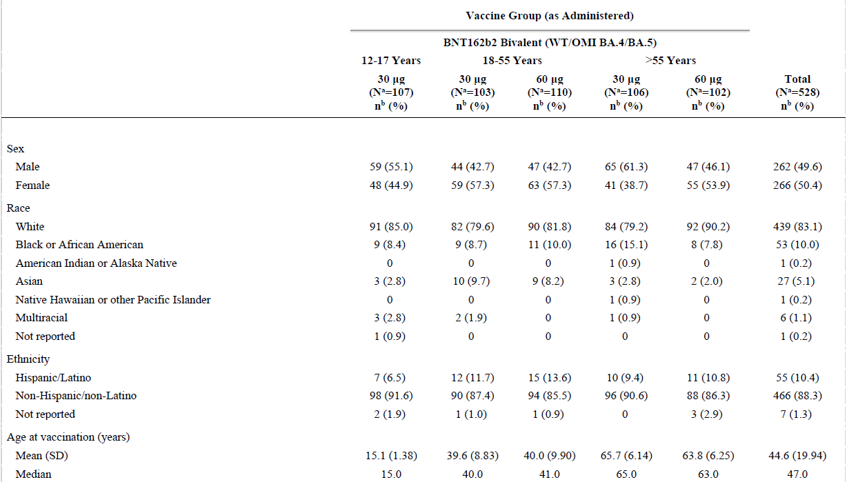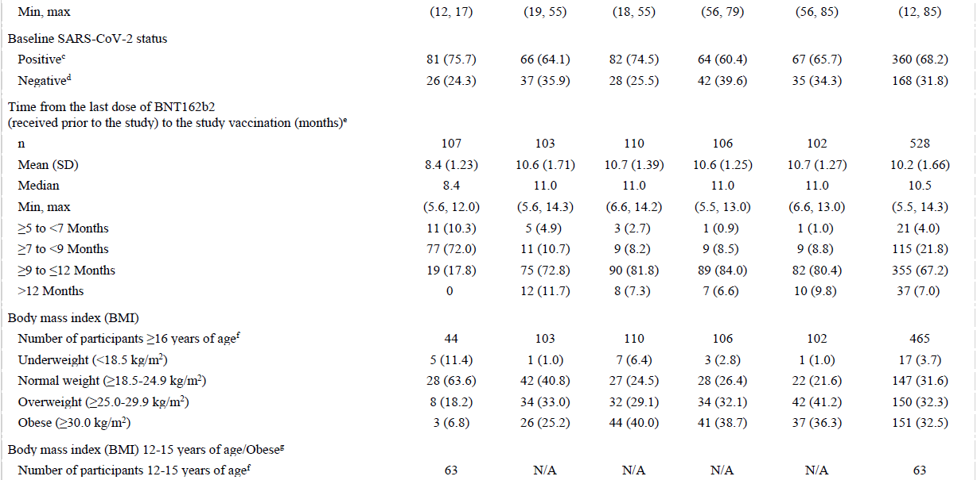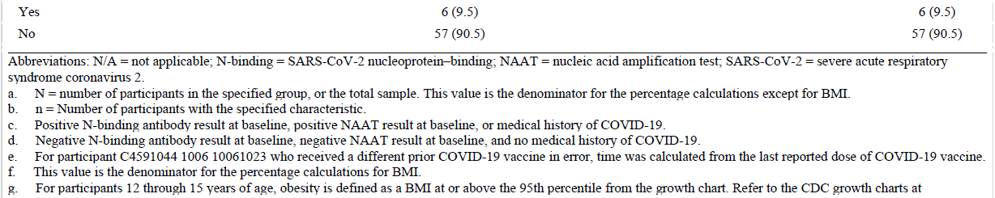
Abbreviation: N/A = not applicable; N-binding = SARS-CoV-2 nucleoprotein binding; NAAT = nucleic acid amplification test; SARS-CoV-2 = severe acute respiratory syndrome coronavirus 2.
a N = Number of participants in the specified group, or the total sample. This value is the denominators for the percentage calculations, except for body mass index.
b n = number of participants with the specified characteristic.
c Positive N-binding antibody result at Baseline, positive NAAT result at Baseline, or medical history of COVID-19.
d Negative N-binding antibody result at Baseline, negative NAAT result at Baseline, and no medical history of COVID-19.
e For participant [Information redacted] who received a different prior COVID-19 vaccine in error, time was calculated from the last reported dose of COVID-19 vaccine.
f This value is the denominator for the percentage calculations for body mass index.
g For participants 12 through 15 years of age, obesity is defined as a BMI at or above the 95th percentile from the growth chart.
Most participants were White (83.1%), and the median age was 47 years overall (15 years in the 12 to 17 years of age group; 40 and 41 years for 30 µg and 60 µg dosing in the 18 to 55 years of age group; and 65 and 63 years respectively in the older than 55 years of age group). There was an even gender split, and about two thirds had evidence of prior SARS-CoV-2 infection.
The median time since last vaccination was 11 months in both the 18 to 55 and older than 55 years of age groups (30 µg and 60 µg dosing); and was 8.4 months in those 12 to 17 years of age. The majority (72%) of 12 to 17 years of age participants received their third doses at least 7 months to less than 9 months prior, whereas the majorities (72.8 to 84%) of participants in the 18 to 55 and older than 55 years of age groups received their third doses at least 9 months to less than 12 months prior. Obesity was present in 5.6% of participants 12 to 17 years of age and 25.2% and 40.7% in the 18 to 55 and older than 55 years of age groups.

Local reactogenicity
The frequency of local reactions by severity within 7 days of study vaccination is shown in Figure 6.
Pain at the injection site was the commonest local reaction, followed by swelling and redness. In the Comirnaty Original/Omicron BA.4-5 bivalent vaccine at 30 µg recipients, the frequency of any local reaction was 70.1% in those 12 to 17 years of age, 83.3% in those 18 to 55 years of age and 57.1% in those older than 55 years of age. The incidences of local reactions were higher in participants who received 60 µg dose of the Comirnaty Original/Omicron BA.4-5 bivalent vaccine within each age group (93.6% and 71.6% in the 18 to 55, and older than 55 years of age groups respectively).
Most local reactions were mild or moderate in severity; severe reactions were reported by one participant in the 12 to 17 years of age group who received a booster dose of the Comirnaty Original/Omicron BA.4-5 bivalent vaccine at 30 µg (severe pain) and one participant in the 18 to 55 years of age group who received a booster dose of the Comirnaty Original/Omicron BA.4-5 bivalent vaccine at 60 µg (severe redness). No Grade 4 local reactions were reported in any group. The median onset for all local reactions was 1 to 3 days, and all events resolved within a median duration of 1 to 3 days.
The pattern of local reactions within seven days after the Comirnaty Original/Omicron BA.4-5 bivalent vaccine was generally similar to those previously observed in association with the Comirnaty Original/Omicron BA.1 bivalent vaccine bivalent vaccine and the original monovalent Comirnaty vaccine within the respective age groups. At each dose level, the frequency of reactions tended to be lower in the participants older than 55 years of age (see Table 20).
Figure 6: Study C4591044 Cohort 2 Local reactions by maximum severity within seven days after the study vaccination (safety population)
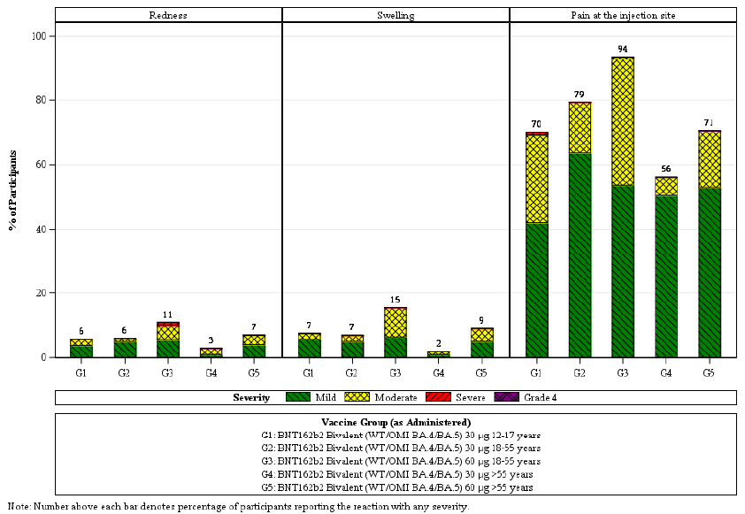
Note: Number above each bar denotes percentage of participants reporting the reaction with any severity

Systemic reactogenicity
Systemic reactions frequency by severity within seven days of study vaccination is shown in Figure 7.
Fatigue was the commonest systemic reaction, followed by headache, and muscle pain, with chills, joint pain, diarrhoea, fever, and vomiting being less frequent. In the Comirnaty Original/Omicron BA.4-5 bivalent vaccine at 30 µg dose recipients, the frequency of any systemic reaction was 80.4% in those 12 to 17 years of age, 75.5% in those 18 to 55 years of age and 56.2% in those older than 55 years of age. The frequency and severity of systemic reactions was higher for most types of reactions in the respective 60 µg dosing age subgroups. Use of antipyretic or pain medication was reported about a third of participants in each group.
Most systemic events were mild or moderate in severity. In the Comirnaty Original/Omicron BA.4-5 bivalent vaccine at 30 µg dose group, severe systemic events of fever (n = 1), fatigue (n = 3), and diarrhea (n = 1) were reported. In the Comirnaty Original/Omicron BA.4-5 bivalent vaccine at 60 µg dose group, severe systemic events of fever (n = 4), fatigue (n = 5), headache (n = 2), chills (n = 1), muscle pain (n = 2), and joint pain (n = 2) were reported. No Grade 4 systemic events were reported in any group. The median onset for all systemic events was 2 to 4 days, and all events resolved within a median duration of 1 to 2 days after onset.
The frequencies and severities of systemic reactions for the Comirnaty Original/Omicron BA.4-5 bivalent vaccine at 30 µg were in keeping with the pattern of prior booster studies for monovalent Comirnaty 30 µg dose and Comirnaty Original/Omicron BA.1 bivalent vaccine at 30 µg. Frequencies and severities were lower in those older than 55 years of age for most systemic reactions, in keeping with earlier studies also. For each type of systemic reaction, severe reactions were experienced by less than or equal to 2% of participants in any of the 30 µg dosing groups and no Grade 4 reactions were reported in either the 30 µg or 60 µg dosing groups.
The pattern of systemic events within seven days after the Comirnaty Original/Omicron BA.4-5 bivalent vaccine was generally similar to those previously observed in association with a Comirnaty Original/Omicron BA.1 bivalent vaccine and to the original monovalent Comirnaty vaccine within the respective age groups. At each dose, the frequency of events tended to be lower in those older than 55 years of age (see Table 20).
Figure 7: Study C4591044 Cohort 2 Systemic events by maximum severity within seven days after the study vaccination (safety population)
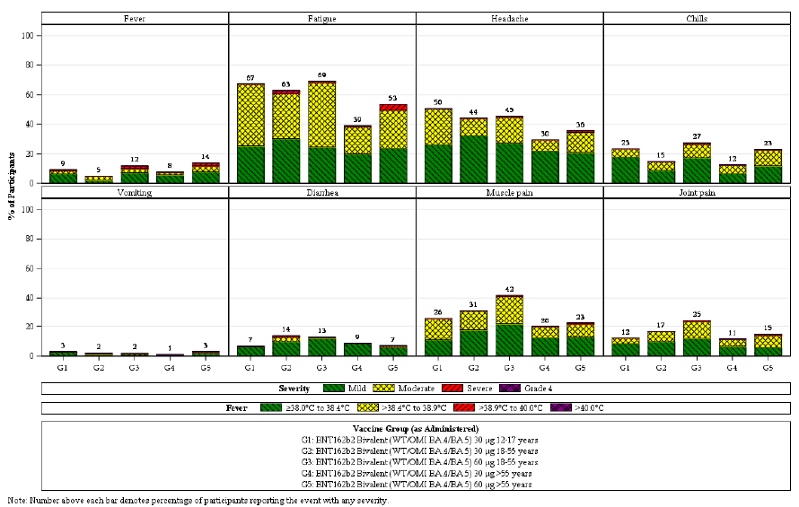
Note: Number above each bar denotes percentage of participants reporting the event with any severity

Adverse Events
An overview of AEs reported through to 1 month after vaccination are in Table 19.
In total, 31 (5.9%) participants reported any AE. Related AEs were reported by 12 (2.3%) participants. Most of the related events were reactogenicity events. There were no AEs (outside of reactogenicity related events) that were reported in more than two participants.
There were two AEs of lymphadenopathy, both in participants 18 to 55 years of age and one each in the 30 µg and 60 µg dosing groups. There was one Grade 2 AE of ‘Troponin increased’ in a 79 year old Asian male in the 30 µg dosing group. This occurred on Day 22. The same participant experienced a Grade 3 serious adverse event of ‘Dyspnoea/Shortness of Breath’ on Day 15 and Grade 1 AEs of ‘Supraventricular extrasystoles/Premature Atrial Complexes’ and ‘Rales/Right Basilar Crackles’ on Day 31. All four AEs were deemed unrelated to the vaccine. There was one AE of ‘Menstruation irregular’ in a participant 18 to 55 years of age in the 60 µg dosing group which was deemed related to vaccine.
There were no deaths and no AEs leading to study withdrawal. There was only the one severe (but non-life threatening) AE that was also recorded as a severe serious SAE.
Table 19: Study C4591044 Cohort 2 Number (%) of participants reporting at least one adverse event from the study vaccination through one month after the study vaccination (safety population)
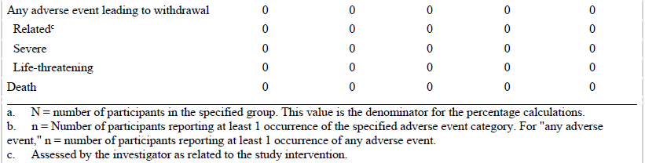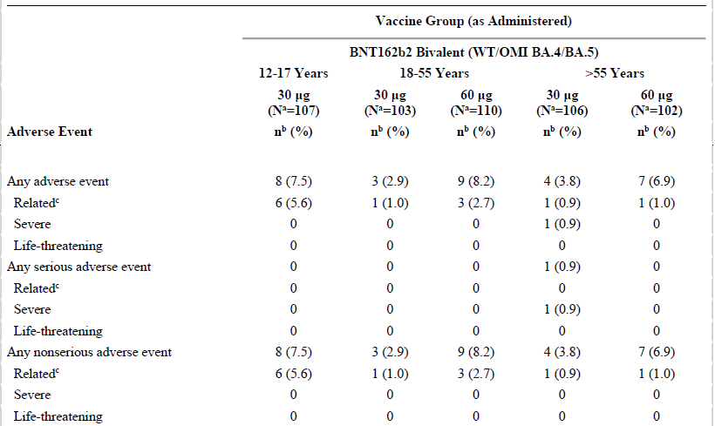
a N = number of participants in the specified group. This value is the denominator for the percentage calculations.
b n = number of participants reporting at least 1 occurrence of the specified adverse event category. For ‘any adverse event’, n = number of participants reporting at least 1 occurrence of any adverse event.
c Assessed by the investigator as related to the study intervention.

Supportive safety data
The following were considered as being supportive for evaluation of safety:
- Study C4591001 who received a booster dose (third dose) of the original monovalent Comirnaty 30 µg or of Beta variant-modified vaccine 30 µg.
- Study C4591031 Substudy D who received a booster dose (fourth dose) of either the original monovalent Comirnaty 30 µg or monovalent Omicron BA.1 variant-modified Comirnaty 30 µg.
- Study C4591031 Substudy E who received a booster dose (fourth dose) of either the original monovalent Comirnaty 30 µg, monovalent Omicron BA.1 variant-modified Comirnaty 30 µg or Comirnaty Original/Omicron BA.1 bivalent vaccine 30 µg.
The safety data for these studies was evaluated in the submission for provisional registration of Comirnaty Original/Omicron BA.1 bivalent vaccine.6

Table 20: Studies C4591031 Substudy D (Cohort 2), C4591031 Substudy E, and C4591044 Cohort 2 Participants reporting local reactions and systemic events within seven days post-fourth dose of Comirnaty, monovalent Comirnaty Omicron BA.1, Comirnaty Original/Omicron BA.1 bivalent vaccine or Comirnaty Original/Omicron BA.4-5 bivalent vaccine at 30 µg or 60 µg dose level
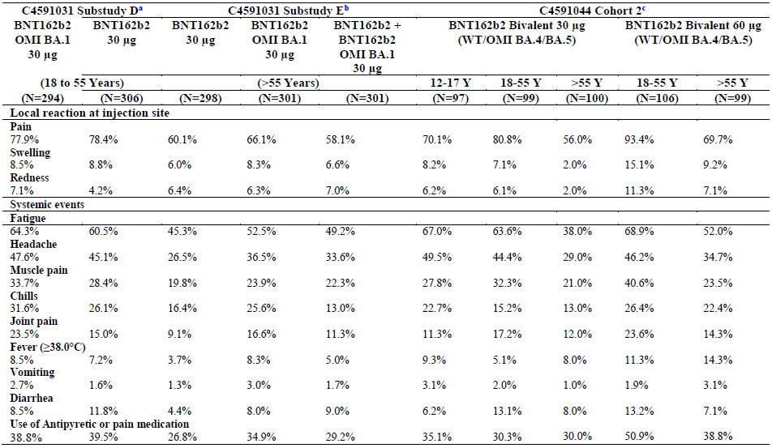
Abbreviation: BNT162b2 = monovalent Comirnaty vaccine, BNT162b2 Omicron = Comirnaty Omicron BA.1 vaccine, BNT162b2 bivalent = Comirnaty Original/Omicron BA.4-5 bivalent vaccine.
a BNT162b2 experienced participants (18 to 55 years of age) who received either BNT162b2 30µg or BNT162b2 Omicron 30 µg as a booster (fourth dose) approximately 3 to 6 months (90 to 180 days) after their last dose (third dose)
b BNT162b2 experienced participant (older than 55 years of age) who received BNT162b2 30 µg or BNT162b2 Omicron 30 µg or BNT162b2 + BNT162b2 Omicron 30 µg as a booster dose (fourth dose) approximately 5 to 12 months after their last dose (third dose)
c BNT162b2 experience participants (older or equal to 12 years of age) who received BNT162b2 bivalent (WT/Omicron BA.4-5) 30µg or 60µg as a booster dose (fourth dose) approximately 150 to 365 days after their last dose (third dose)

Post marketing experience

Report: Safety monitoring of bivalent COVID-19 mRNA vaccine booster doses among persons aged older or equal to 12 years in United States between 31 August 2022 to 23 October 2022
The US CDC has reported safety monitoring data from the first seven weeks of the rollout (31 August 2022 to 23 October 2022) from v-safe; and the vaccine adverse event reporting system program.,
During the seven week period, 22.6 million booster doses were administered in the USA. These included 14.4 million persons aged older or equal to 12 years of age received Comirnaty Original/Omicron BA.4-5 bivalent vaccine at 30 µg and 8.2 million adults older than or equal to 18 years of age received the Spikevax bivalent vaccine.
In this seven-week period, there were 211,959 v-safe participants who reported receiving a bivalent booster dose. Co-administration of another vaccine occurred in nearly 40% of those (influenza vaccine (98.3%)). Receipt of medical care was reported by 0.8% of registrants.
Vaccine adverse event reporting system received 5542 reports of AEs during the surveillance period, of which 95.5% were non-serious (94.3% for Comirnaty Original/Omicron BA.4-5 bivalent vaccine at 30 µg and 96.8% for the Spikevax bivalent vaccine). Vaccination errors were among the most common events reported to vaccine adverse event reporting system (34.5%); most (88.2%) of which did not list an adverse health event. A total of seven people (0.4%) were ‘error with serious health event’.
Among the 251 AEs classified as serious, there were five reports of myocarditis and four reports of pericarditis.
Conclusions reached by the CDC’s authors included:
- ‘Reporting frequencies of reactions and health impacts among the 211,959 v-safe registrants aged older or equal to 12 years who received an age appropriate bivalent booster vaccination are similar to those described after receipt of first and second booster vaccine doses among adults aged older or equal to 50 years.’
- ‘Among adults aged older or equal to 18 years, reporting frequencies of local and systemic reactions after bivalent booster vaccination decreased with increasing age. This reporting pattern was also observed for primary series COVID-19 vaccination.’
- Caveats that v-safe is voluntary therefore may not be representative, vaccine adverse event reporting system is subject to reporting biases (especially under-reporting of non-serious events) and the surveillance period was relatively short (7 weeks).

Risk management plan
The sponsor has submitted EU-risk management plan (RMP) version 9.0 (dated 4 November 2022; data lock point (DLP) for Original/Omicron BA.4-5 Vaccine - Module SIII 16 May 2022 (Study C4591031 Substudy E), 11 March 2022 (Study C4591031 Substudy D - Cohort 2); Module SVII.3 Sentinel cohort 5 April 2022 and expanded cohort cutoff date: 16 May 2022 (Pfizer Clinical Database C4591031 Substudy E). 11 March 2022 (Pfizer Clinical Database C4591031 Substudy D - Cohort 2)) and Australia specific annex (ASA) version 0.7 (dated December 2022) in support of this application.
The summary of safety concerns and their associated risk monitoring and mitigation strategies are summarised in Table 21. Further information regarding the TGA’s risk management approach can be found in risk management plans for medicines and biologicals and the TGA's risk management approach.

Table 21: Summary of safety concerns
Summary of safety concerns |  | Pharmacovigilance |  | Risk Minimisation
 |  | Routine | Additional | Routine | Additional
Important identified risks | Myocarditis and pericarditis |  | * |  | –
Important potential risks | Vaccine-associated enhanced disease (VAED) including Vaccine-associated enhanced respiratory disease (VAERD) | † | * | – | –
Missing information | Use in pregnancy and while breast feeding |  | *≠ |  | –
Missing information | Use in immunocompromised patients |  | * |  | –
Missing information | Use in frail patients with co-morbidities (e.g. chronic obstructive pulmonary disease (COPD), diabetes, chronic neurological disease, cardiovascular disorders) |  | * |  | –
Missing information | Use in patients with autoimmune or inflammatory disorders |  | * | – | –
Missing information | Interaction with other vaccines |  | * |  | –
Missing information | Long term safety data |  | * | – | –
†Data Capture Aid (Adverse drug reaction follow-up forms)
≠Post-authorisation safety study
*Clinical trial
The RMP evaluation made the following conclusions and recommendations
- The conclusion on the acceptability of the summary of safety concerns will made once the advice from the clinical and nonclinical evaluators and, the Advisory Committee on Vaccines (ACV) is available.
- The pharmacovigilance plan is acceptable from an RMP perspective. The acceptability of the clinical study plan will be assessed by the Delegate.
- Only routine risk minimisation measures are proposed by the sponsor. There are risk minimisation measures implemented for COVID-19 vaccines by the Department of Health and Aged Care and State Governments for the COVID-19 vaccines supplied in Australia, including the Comirnaty vaccines. Introduction of Comirnaty Original/Omicron BA.4-5 vaccine is not expected to warrant additional risk minimisation measures as part of the RMP.
The following data from Study C4591044 Cohort 2 are yet to be provided and must be provided as soon as possible.
- Data pertaining to the primary immunogenicity objectives that are based on statistical testing, including formal superiority and non-inferiority testing are to follow in 2023
- Immunogenicity data for participants 12 to 17 years of age will be provided in a separate report.
The three clinical studies (Study C4591044 Cohort 2, and Study C4591031 Substudy D and Substudy E) are ongoing. These data must be provided when available.

Risk-benefit analysis

Delegate’s considerations
Australia is experiencing ongoing COVID-19 cases, and high rates of hospitalisations, and further deaths as a result of Omicron subvariants. This leads to significant disruption to the normal way of life and has various health and economic implications for the country. Certain populations are at increased risk, such as those 60 years of age and older, and people with immunosuppression and those with a wide range of comorbid conditions and risk factors.
Currently provisionally approved COVID-19 vaccines that can be given as a booster dose are Comirnaty (monovalent original) and Comirnaty Original/Omicron BA.1 bivalent vaccine, Vaxzevria (monovalent original), Spikevax monovalent (original) and Spikevax bivalent Original/Omicron BA.1. See Tables 2 and 3 for further details. There is still a need for a booster vaccines which provide a broader range of immunity, covering the currently circulating variants/subvariants for the Australian population.
The TGA has provisionally approved Comirnaty (tozinameran) vaccine for use in Australia on 25 January 2021, and Comirnaty Original/Omicron BA.1 (tozinameran and riltozinameran) on 28 October 2022. Provisional determination for Comirnaty Original/Omicron BA.4-5 bivalent vaccine (tozinameran and famtozinameran) was granted on 15 November 2022.
Detailed data on immunogenicity and safety profiles by vaccine type are valuable to make informed decisions on booster regimens. Immunogenicity and safety data from Study C4591044 (Cohort 2) provides important insight regarding this. Study C4591044 (Cohort 3) provides supportive data. Early real world evidence is also helpful in making regulatory decisions, and some such data have been included in this overview.

Immunogenicity
Analysis of immunogenicity data at one month post-study vaccination from the pivotal Study C4591044 Cohort 2 for Comirnaty experienced participants 18 to 55 years and older than 55 years of age who received a booster dose (fourth dose) of Comirnaty Original/Omicron BA.4-5 bivalent vaccine at 30 µg demonstrated a robust vaccine elicited immune response. As expected, the data show that a booster dose (fourth dose) of Comirnaty Original/Omicron BA.4-5 bivalent vaccine at 30 µg elicited higher Omicron BA.4/BA.5 specific neutralisation titres at one month after study vaccination in both age groups of (18 to 55, older than 55 years of age) compared with historical comparator groups who received the Comirnaty Original/Omicron BA.1 bivalent vaccine at 30 µg booster doses (fourth dose) in Comirnaty experienced participants. Furthermore, immune responses against Omicron BA.1 and reference strain at one month after vaccination with Comirnaty Original/Omicron BA.4-5 bivalent vaccine at 30 µg were comparable to responses in participants who received Comirnaty Original/Omicron BA.1 bivalent vaccine at 30 µg.
Increased neutralising responses with the Comirnaty Original/Omicron BA.4-5 bivalent vaccine and the Comirnaty Original/Omicron BA.1 bivalent vaccine were observed regardless of baseline SARS-CoV-2 infection status, with the greatest GMFRs observed in participants without prior infection and the highest neutralising titres observed in participants with a history of prior infection.
Of note, these immunogenicity data only pertain to adults older or equal to 18 years of age and do not include adolescents. Furthermore, in the pivotal study there were only approximately 100 participants per group, making analysis of specific subgroups difficult. When comparisons are made, participant numbers were relatively small with wide 95% CIs that were non-overlapping in most pairwise subgroup comparisons and the analyses were descriptive rather than a statistical examination of superiority and/or non-inferiority. Furthermore, the control group in the pivotal study is an historical control, with lower baseline SARS-CoV-2 positivity, and were studied during the presence of previous subvariant circulation, and these factors may affect the interpretation of the results.
When immunogenicity data looking at neutralisation against the new variants Omicron subvariants (BA.4.6, BA.2.75.2, BQ.1.1, and XBB) the data provide support for the conclusions that a fourth dose of Comirnaty Original/Omicron BA.4-5 bivalent vaccine at 30 µg induces superior immune responses than monovalent Comirnaty 30 µg to the four new variants studied in baseline positive and negative SARS-CoV-2-exposure groups. Omicron XBB was least effectively neutralised subvariant whereas Omicron BA.4.6 responses were only slightly lower than those for Omicron BA.4/5 in parallel analyses. Only small numbers of participants were included in the two groups; Comirnaty Original/Omicron BA.4-5 bivalent vaccine at 30 µg (36 participants), and Comirnaty 30 µg (40 participants).
Real word immunogenicity data have also been provided in this overview. These data generally show an overall neutralisation benefit with bivalent booster immunisations, although the results are modest. These data indicate that both monovalent and bivalent mRNA boosters markedly increased antibody responses but did not substantially augment T-cell responses. In the study by Collier et al. (2023),8 neutralising antibody titres against the ancestral strain were found to be higher than against the Omicron BA.5 subvariant after both monovalent and bivalent boosting. However, the median Omicron BA.5 neutralising antibody titre was similar after monovalent and bivalent mRNA boosting; with a modest trend towards bivalent booster (by a factor of 1.3). These data are consistent with the modest benefits with a Omicron BA.1 containing bivalent mRNA booster.

Vaccine efficacy
There was no vaccine efficacy data provided in the pivotal or supporting studies.
The real world evidence of vaccine effectiveness from the USA and Israel suggests that a combination wild type/Omicron BA.4-5 mRNA booster vaccine provides additional protection against symptomatic and moderate to severe COVID-19 relative to no booster but with many caveats. The magnitude of that protection is likely relatively greater as the time since prior vaccination lengthens. Vaccine efficacy estimates from the real world evidence were greatest in the highest risk group older or equal to 65 years of age and against the highest severity of illness studied (that is hospitalisation).

Safety
The study design has been described in the immunogenicity section. The size of the group is just over 300 participants which is in line with the number recommended in the ACCESS consortium statement; for variant-modified vaccines as being sufficient to adequately characterise the reactogenicity profile.
The safety profile within one month post-vaccination (fourth dose) with Comirnaty Original/Omicron BA.4-5 bivalent vaccine at the 30 µg and 60 µg dose levels was generally well tolerated across all age groups, with mostly mild or moderate reactogenicity and few reported adverse events. It was also generally similar to that previously observed in association with booster doses of an Comirnaty Original/Omicron BA.1 bivalent vaccine and to the original monovalent Comirnaty vaccine within the respective age groups.
Both local reactions and systemic events for participants tended to be lower for adults older than 55 years of age compared to younger participants (12 to 55 years of age) and were less for 30 µg groups. This is consistent with prior observations for Comirnaty Original/Omicron BA.1 bivalent vaccine and monovalent Comirnaty vaccines.
The adverse event profile within one month post-vaccination consisted primarily of reactogenicity events or lymphadenopathy. No adverse events were life threatening or led to withdrawal, and there were no deaths. No new or concerning safety findings were noted in these one month post-vaccination data.
Real world data provides further reassurance regarding the safety of mRNA vaccines, including booster vaccines.

Overall data limitations
- Safety and immunogenicity data for bivalent vaccine available only for four weeks post booster dose.
- No safety and immunogenicity data after second or the fourth dose.
- Immunogenicity data from booster dose against the currently circulating variants is very small and the assay method for the Omicron BA.4.6, BA.2.75.2, BQ.1.1, and XBB variants are currently not validated
- Data related to persistence of immune response was not available in the submitted study.
- Current safety sample size is small.
- No supportive data from the sponsor for use as heterologous booster.
- For the 12 to 18 years of age group, there is no immunogenicity data.
- Insufficient safety and immunogenicity data in immunocompromised patients or patients with background autoimmune disease.
- No safety data on pregnant women and breastfeeding women.
- Short term safety data, which may not provide information on rare adverse events and there may be adverse events that have a long latency period including adverse events of special interest.
- Data on vaccine efficacy of the booster are lacking. Booster efficacy in the real world cannot be extrapolated with certainty, especially in view of currently circulating Omicron variant and its subvariants exhibiting significant change in the viral morphology, immune escape, and clinical presentation.
- Data in the elderly with frailty and with unstable health conditions and co-morbidities are not available.

Proposed action
From the currently available data, it can be concluded that Comirnaty Original/Omicron BA.4-5 bivalent vaccine booster is efficacious in protecting individuals against symptomatic COVID-19. The safety profile is in line with what has been observed in adults, and no new safety signals have been identified. It is unclear as to how effective this booster vaccine will be against newer variants of concern which are currently circulating in Australia.
Considering the current COVID 19 situation in Australia with ongoing cases, hospitalisation, and deaths, and noting the high short term efficacy with acceptable safety demonstrated in the submitted studies, the Delegate is of the view that provisional registration that provisional approval for Comirnaty Original/Omicron BA.4-5 COVID-19 vaccine to be used as a booster for above 12 years age who are primed with an mRNA COVID-19 vaccine, is appropriate. The longer term efficacy and safety data are to be submitted to the TGA for evaluation before a full registration can be considered.
Delegate’s proposed indication:
Comirnaty Original/Omicron BA.4-5 COVID-19 vaccine has provisional approval for the indication below:
As a booster dose for active immunisation to prevent coronavirus disease 2019 (COVID-19) caused by SARS-CoV-2, in individuals 12 years of age and older.
The use of this vaccine should be in accordance with official recommendations.
The decision has been made on the basis of short-term immunogenicity and safety data.
Continued approval depends on the evidence of longer-term efficacy and safety from ongoing clinical trials and post-market assessment.
The final decision will be made following the ACV discussion and the satisfactory negotiation of the Product Information and the Conditions of provisional registration.

Questions for the sponsor
The sponsor provided the following response to questions from the Delegate.
- Please provide response to the latest questions from the clinical evaluation.
Responses to all outstanding questions will be provided.
- Please confirm if the trial vaccine formulation is same to the one planned for supply.
The trial vaccine formulation is same to the one planned for commercial supply.
- Please confirm the timing for availability of immunogenicity data for 12 to 17 years and the immunogenicity analysis data (non-inferiority and superiority)
These results will be reported in a Clinical Study Report due to be finalised by the end of first quarter in 2023.
- Please confirm the timing for availability of data for Study C4591044 Cohort 3
These results will be reported in a Clinical Study Report due to be finalised by the end of first quarter in 2023.
- Please confirm timing of availability of results for the primary immunogenicity objectives that are based on statistical testing, including formal superiority and non-inferiority testing
These results will be reported in a Clinical Study Report due to be finalised by the end of first quarter in 2023.
- Please provide an updated PI with data tables completed.
The sponsor provides an assurance that an updated PI with data tables completed will be provided once these data are available.

Advisory Committee considerations
The Advisory Committee on Vaccines (ACV), having considered the evaluations and the Delegate’s overview, as well as the sponsor’s response to these documents, advised the following.

Specific advice to the Delegate
- Does the ACV consider that there is a favourable benefit-risk balance to recommend provisional approval of the Comirnaty Original/Omicron Bivalent BA.4-5 COVID-19 vaccine as a homologous and heterologous booster in individuals aged 18 years and older?
The ACV was of the view that there is a favourable benefit-risk balance for provisional registration. Vaccine immunogenicity showed a modest improvement over use of the original monovalent vaccine, with improved neutralising antibodies against almost all strains. This included against Omicron subvariant XBB, although substantially less compared to other (sub)variants. Safety data (although from small number of participants in the pivotal trial) appeared satisfactory and similar to that of the original monovalent vaccine.
The ACV advised that the vaccine may be given at least 3 months following a primary series and/or previous booster dose with Comirnaty (original) vaccine or another authorised/ approved COVID-19 vaccine, in accordance with official recommendations, and noted these would be provided by the ATAGI. This regulatory wording is consistent with that used in the Product Information for another recently approved bivalent booster COVID-19 vaccine.
While there was no data on heterologous boosting, there was no reason to limit the vaccine to homologous use.
The ACV noted that the US CDC has identified a preliminary COVID-19 vaccine safety signal of ischemic stroke in people ages 65 years and older who received Comirnaty Original/Omicron BA.4-5 vaccine in one of their surveillance systems. This signal has not been confirmed by other surveillance systems in the US population or by other international regulators.
- Does the ACV consider that the indication for Comirnaty Original/Omicron BA.4-5 as a homologous and heterologous booster should include individuals from 12 to 17 years of age?
The ACV advised that the vaccine may be given as homologous and heterologous booster to individuals aged 12 years and older. Previous data for the original monovalent vaccine shows comparable immune response in the 12 to 17 year age group compared to adults aged from 18 to 24 years.
The ACV noted that the vaccine has been in use in the 12 to 17 years age group in the USA, EU, UK and Canada for up to 4 months and no new safety signal had been identified in this population.
The ACV noted that adolescents and young adults are at highest risk of myocarditis, the most important known safety risk following mRNA COVID-19 vaccines. The risk of myocarditis following boosting with the original Comirnaty monovalent vaccine is lower than following the second dose in the primary series of the original monovalent vaccine. There is no evidence to date that the rate of myocarditis has increased with the use of bivalent vaccine compared to monovalent vaccine.
The ACV noted that administration of booster doses in the 12 to 17 years age group would be the subject of official recommendations and clinical guidance.
The ACV noted that immunogenicity data from individuals between 12 and 17 years of age and analysis from Study C4591044 would be finalised by the end of February 2023, with high level results to be publicly presented to an FDA committee on 26 January 2023.
- Can the ACV comment on the real-world data influence (if any) on decision making regarding this submission?
The ACV highlighted the following from the real-world evidence:
- the bivalent Comirnaty Original/Omicron BA.4-5 vaccine produces greater neutralising antibody responses against several Omicron subvariants (including BA.2.27.2 and BQ.1.1, but less against XBB.1) than bivalent BA.1 vaccine;
- there are clear benefits with reductions in hospitalisation and death that favour vaccination over natural immunity without vaccination; and
- there is emerging evidence on immune imprinting by previous antigenic exposure, which may influence development of robust immunity against future SARS-CoV-2 variants, depending on vaccine composition.
- Can the ACV comment if overall safety is acceptable given the small sample size in Study C4591044?
The ACV noted the small sample size; there were 100 participants in each group of participants aged between 12 and 17 years, 18 and 55 years, and over 55 years.
Based on data to date, the Comirnaty Original/Omicron BA.4-5 vaccine has a similar, and acceptable, safety profile to the original monovalent Comirnaty vaccine.
The ACV noted that the early post-market experience (published data for initial 7 weeks available) in the USA, from over 14 million doses of Comirnaty Original/Omicron BA.4-5 vaccine, was unremarkable. Post-market experience, now extending to about 4 months, has not shown any signals of concern.
- Does the ACV consider it is reasonable to use the bivalent Comirnaty Original/Omicron BA.4-5 as a first booster dose (Dose 3) or a third booster dose (Dose 5) where appropriate given the absence of any data on these situations?
The ACV advised it is reasonable to use Comirnaty Original/Omicron BA.4-5 COVID-19 vaccine for any booster dose following the primary series.
The ACV noted that it could be impractical and not necessary to limit use of Comirnaty Original/Omicron BA.4-5 bivalent vaccine to a second booster dose (Dose 4).
- Can the ACV comment on any specific risk mitigation strategies required for the booster dose?
One-third of adverse events reported in the USA have been vaccination errors. If approved, there will be 6 formulations commencing with the word Comirnaty on the ARTG and prescribing and dispensing software. Effective communications and logistics coordination will be needed to minimise confusion for vaccine providers with the entry of another COVID-19 vaccine into the market.
The ACV highlighted the importance of product differentiation in record-keeping, especially for the Australian Immunisation Register, to ensure that any adverse event and safety signal is attributed to the correct vaccine.
The ACV noted ‘long term safety data’ is an area of ‘missing information’ in the Risk Management Plan.
- The committee is also requested to provide advice on any other issues that it thinks may be relevant to a decision on whether or not to approve this application.
The ACV supported where possible and across the COVID-19 vaccine brands, a consistent approach on the recommended and the minimum dose interval for a booster dose following a prior dose should be followed. The minimum (as compared with a routinely recommended) dose interval is most relevant to individuals with changing risks (for example, exposure to emerging new variants, overseas travel).

Conclusion
The ACV considered this product to have an overall positive benefit-risk profile for the indication:
As a booster dose for active immunisation to prevent coronavirus disease 2019 (COVID-19) caused by SARS-CoV-2, in individuals 12 years of age and older.
The use of this vaccine should be in accordance with official recommendations.
The decision has been made on the basis of short term immunogenicity and safety data. Continued approval depends on the evidence of longer term efficacy and safety from ongoing clinical trials and post-market assessment.

Outcome
Based on a review of quality, safety, and efficacy, the TGA approved the registration of Comirnaty Original/Omicron BA.4-5 COVID-19 vaccine (tozinameran and famtozinameran) 15 µg of tozinameran and 15 µg of famtozinameran/0.3 mL, suspension for injection, multidose vial, indicated for:

Comirnaty Original/Omicron BA.4-5 vaccine has provisional approval for the indication below:
As a booster dose for active immunisation to prevent coronavirus disease 2019 (COVID-19) caused by SARS-CoV-2, in individuals 12 years of age and older.
The use of this vaccine should be in accordance with official recommendations.
The decision has been made on the basis of short term immunogenicity and safety data. Continued approval depends on the evidence of longer term efficacy and safety from ongoing clinical trials and post-market assessment.

Specific conditions of registration applying to these goods
- Comirnaty Original/Omicron BA.4-5 is to be included in the Black Triangle Scheme. The PI and CMI for that Comirnaty Original/Omicron BA.4-5 must include the black triangle symbol and mandatory accompanying text for the products entire period of provisional registration.
The Comirnaty Original/Omicron BA.4-5 EU- RMP (version 9, dated 4 November 2023) with ASA (version 0.7 dated December 2022), and any subsequent revisions, as agreed with the TGA will be implemented in Australia.
An obligatory component of risk management plans is routine pharmacovigilance. Routine pharmacovigilance includes the submission of periodic safety update reports (PSURs). Unless agreed separately between the supplier who is the recipient of the approval and the TGA, the first report must be submitted to TGA no later than 15 calendar months after the date of the approval letter. The subsequent reports must be submitted no less frequently than annually from the date of the first submitted report until the period covered by such reports is not less than three years from the date of the approval letter, or the entire period of provisional registration, whichever is longer.
The reports are to at least meet the requirements for PSURs as described in the European Medicines Agency’s Guideline on good pharmacovigilance practices (GVP) Module VII-periodic safety update report (Rev 1), Part VII.B Structures and processes. Note that submission of a PSUR does not constitute an application to vary the registration. Each report must have been prepared within ninety calendar days of the data lock point for that report.
Additional to the submission of routine PSURs, expedited monthly summary safety reports (including safety data for patients in Australia) are to be provided for the first 6 months from the date of first supply in Australia, and thereafter at intervals specified by the TGA.
Any changes to which the sponsor has agreed should be included in a revised RMP and ASA. However, irrespective of whether or not they are included in the currently available version of the RMP document, the agreed changes become part of the risk management system.
Clinical Conditions
- An update of the Australian PI via a future submission is required for inclusion of adolescent immunogenicity data in 12 to17 years old age group based on the Study C4591044. This may be undertaken after Clinical Evaluation Report (Round 2) by the TGA for the current submission PM-2022-05306-1-2 has been issued to the sponsor.
- Final Clinical Study Report for the Study C4591044 is to be provided to the TGA when it becomes available to the sponsor.
Quality Conditions
- GMP clearance for listed manufacturers: All relevant manufacturing sites require approved and current GMP clearances prior to Australian supply. A commitment is required from the sponsor that they maintain the validity of all manufacturer GMP clearances for the duration of product supply to Australia. Additionally, that adherence to the conditions of GMP clearance approval is upheld.
- Post-approval stability protocol and stability commitment: The manufacturer has provided commitment to continue the ongoing stability studies presented in the stability studies protocol. Additionally, 1 batch of drug product per year for all relevant products will be placed on long term stability program and on accelerated stability testing where significant changes are made to the manufacturing process. The manufacturer has committed to communicate any out of specifications stability test results to the TGA.
Batch Release Testing and Compliance
- It is a condition of registration that all independent manufacturing batches of Comirnaty Original/Omicron BA.4-5 (tozinameran/famtozinameran) COVID-19 Vaccine 15/15 micrograms/0.3 mL suspension for injection vial to be supplied in Australia are not released for supply by or on behalf of the sponsor until the manufacturer’s release data have been assessed by, and you have received notification acknowledging authorisation to release from, the Laboratories Branch, TGA.
In complying with the above, the sponsor must supply the following for each independent batch of the product imported or proposed to be imported into Australia:
  - a completed Request for Release Form, available from vaccines@health.gov.au; and
  - complete summary protocols for manufacture and QC, including all steps in production in the agreed format
  - at least ten (10) vials (samples) of each manufacturing batch of Comirnaty Original/Omicron BA.4-5 (tozinameran/famtozinameran) COVID-19 Vaccine 15/15 micrograms/0.3 mL suspension for injection vial with the Australian approved labels, PI, and packaging (unless an exemption to supply these has been granted) representative of all batches of product seeking distribution in Australia.
  - at least five (5) vials (Samples) of any further consignments of a manufacturing batch of Comirnaty Original/Omicron BA.4-5 (tozinameran/famtozinameran) COVID-19 Vaccine 15/15 micrograms/0.3 mL suspension for injection vial with the Australian approved labels, PI, and packaging (unless an exemption to supply these has been granted). Further consignments cover batches previously supplied to TGA for the purposes of batch release testing but are seeking to be supplied again.
  - if the manufacturing batch has been released in Europe or United Kingdom, a copy of the EU Official Control Authority Batch Release (OCABR) certificate (or equivalent from the UK) must also be provided; and
  - any reagents, reference material and standards required to undertake testing as requested by Laboratories Branch, TGA.
Sponsors must provide all requested samples and data in sufficient time (at least 5 business days) prior to any distribution date to allow the TGA to perform testing and review. Distribution of each batch of vaccine is conditional upon fulfilment of these conditions and receipt of a letter from the Laboratories Branch acknowledging release.
Samples and data should be forwarded to the Biotherapeutics Section, Laboratories Branch before release of each batch and with sufficient lead time to allow for Laboratories Branch testing.
The shipments (including reagents) to TGA are the responsibility of the Australian Sponsor/Agent who will be required to facilitate the import and customs clearance process.
Certified Product Details
- An electronic copy of the Certified Product Details (CPD) as described in Guidance 7: Certified Product Details of the Australian Regulatory Guidelines for Prescription Medicines (ARGPM) https://www.tga.gov.au/guidance-7-certified-product-details should be provided upon registration of the therapeutic good. In addition, an updated CPD, for the above products incorporating the approved changes is to be provided within one month of the date of approval letter. A template for preparation of CPD for biological prescription medicines and Vaccines can be obtained from the TGA website https://www.tga.gov.au/form/certified-product-details-cpd-biological-prescription-medicines]. The CPD should be sent as a single bookmarked PDF document to Vaccines@health.gov.au as soon as possible after registration/approval of the product or any subsequent changes as indicated above.

Attachment 1. Product Information
The PI for Comirnaty Original/Omicron BA.4-5 COVID-19 vaccine approved with the submission which is described in this AusPAR is at Attachment 1. For the most recent PI, please refer to the TGA PI/CMI search facility.

Therapeutic Goods Administration
PO Box 100 Woden ACT 2606 Australia
Email: info@tga.gov.au Phone: 1800 020 653 Fax: 02 6232 8605
https://www.tga.gov.au

World Health Organization (2020) WHO Director-General speeches: WHO Director-General's opening remarks at the media briefing on COVID-19 - 11 March 2020. Available from the WHO website.
WHO COVID-19 (coronavirus) dashboard. World Health Organization. Available at: https://covid19.who.int/ (assessed on 13 January 2023)
Department of Health and Aged Care, Coronavirus (COVID-19) case numbers and statistics. Available at www.health.gov.au/health-alerts/covid-19/case-numbers-and-statistics#covid19-case-notifications (accessed on 13 January 2023)
Paul A Offit. Bivalent Covid-19 Vaccines — A Cautionary Tale. NEJM January 11, 2023.
World Health Organization. Interim Statement on the Composition of Current COVID-19 Vaccines. Available at: Interim statement on the composition of current COVID-19 vaccines (who.int). Accessed 13 January 2023.
Anatomical Therapeutic Chemical Classification System (ATC) code J07BX03 – COVID vaccines.
AusPAR for Comirnaty Original/Omicron BA.1 COVID-19 vaccine available at https://www.tga.gov.au/resources/auspar/auspar-comirnaty-original-omicron-ba1-covid-19-vaccine
Davis-Gardner, et al. Neutralization against BA.2.75.2, BQ.1.1, and XBB from mRNA Bivalent Booster. N Engl J Med, 2023; 388:183-185
Collier, et al. Immunogenicity of BA.5 Bivalent mRNA Vaccine Boosters. N Engl J Med, 2023
Wang, et al. Antibody Response to Omicron BA.4–BA.5 Bivalent Booster. N Engl J Med, 2023
Link-Gelles, et al. Effectiveness of Bivalent mRNA Vaccines in Preventing Symptomatic SARS-CoV-2 Infection - Increasing Community Access to Testing Program, United States, September-November 2022. MMWR. Morbidity and mortality weekly report, 2022; 71(48), 1526–1530.
The CDC Increasing Community Access to Testing program supports no-cost COVID-19 testing for people who are experiencing symptoms related to COVID-19 or have been exposed to someone with COVID-19 in the USA. More information available at www.cdc.gov
Tenforde MW, et al. Early Estimates of Bivalent mRNA Vaccine Effectiveness in Preventing COVID-19–Associated Emergency Department or Urgent Care Encounters and Hospitalizations Among Immunocompetent Adults — VISION Network, Nine States, September–November 2022. MMWR Morb Mortal Wkly Rep, 2022; 71:1616–1624.
Surie D, et al. Early Estimates of Bivalent mRNA Vaccine Effectiveness in Preventing COVID-19–Associated Hospitalization Among Immunocompetent Adults Aged ≥65 Years - IVY Network, 18 States, September 8 -November 30, 2022. MMWR Morb Mortal Wkly Rep, 2022; 71:1625–1630.
Arbel, R, et al. Effectiveness of the Bivalent mRNA Vaccine in Preventing Severe COVID-19 Outcomes: An Observational Cohort Study. Preprints, Lancet.
Voluntary smart phone monitoring via daily health survey in first week
Vaccine adverse event reporting system is passive surveillance of adverse events mapped to MedDRA Preferred Term.
Hause AM, et al. Safety Monitoring of Bivalent COVID-19 mRNA Vaccine Booster Doses Among Persons Aged ≥12 Years — United States, August 31–October 23, 2022. MMWR Morb Mortal Wkly Rep, 2022; 71:1401–1406.
Access Consortium statement on COVID-19 vaccines evidence | Therapeutic Goods Administration (TGA)
CDC & FDA Identify Preliminary COVID-19 Vaccine Safety Signal for Persons Aged 65 Years and Older. Available at https://www.cdc.gov/coronavirus/2019-ncov/vaccines/safety/bivalent-boosters.html

