February 2023

Australian Public Assessment Report for Bijuva 1/100
  - Active ingredients: Estradiol hemihydrate and progesterone
  - Sponsor: Theramex Australia Pty Ltd

About the Therapeutic Goods Administration (TGA)
- The Therapeutic Goods Administration (TGA) is part of the Australian Government Department of Health and is responsible for regulating therapeutic goods, including medicines, medical devices, and biologicals.
- The TGA administers the Therapeutic Goods Act 1989 (the Act), applying a risk management approach designed to ensure therapeutic goods supplied in Australia meet acceptable standards of quality, safety, and efficacy.
- The work of the TGA is based on applying scientific and clinical expertise to decision-making, to ensure that the benefits to the Australian public outweigh any risks associated with the use of therapeutic goods.
- The TGA relies on the public, healthcare professionals and industry to report problems with therapeutic goods. The TGA investigates reports received to determine any necessary regulatory action.
- To report a problem with a therapeutic good, please see the information on the TGA website.

About AusPARs
- The Australian Public Assessment Report (AusPAR) provides information about the evaluation of a prescription medicine and the considerations that led the TGA to approve or not approve a prescription medicine submission. Further information can be found in Australian Public Assessment Report (AusPAR) guidance.
- AusPARs are prepared and published by the TGA.
- AusPARs are static documents that provide information that relates to a submission at a particular point in time. The publication of an AusPAR is an important part of the transparency of the TGA’s decision-making process.
- A new AusPAR may be provided to reflect changes to indications or major variations to a prescription medicine subject to evaluation by the TGA.

Copyright
© Commonwealth of Australia 2023
This work is copyright. You may reproduce the whole or part of this work in unaltered form for your own personal use or, if you are part of an organisation, for internal use within your organisation, but only if you or your organisation do not use the reproduction for any commercial purpose and retain this copyright notice and all disclaimer notices as part of that reproduction. Apart from rights to use as permitted by the Copyright Act 1968 or allowed by this copyright notice, all other rights are reserved, and you are not allowed to reproduce the whole or any part of this work in any way (electronic or otherwise) without first being given specific written permission from the Commonwealth to do so. Requests and inquiries concerning reproduction and rights are to be sent to the TGA Copyright Officer, Therapeutic Goods Administration, PO Box 100, Woden ACT 2606 or emailed to <tga.copyright@tga.gov.au>.

Contents
List of abbreviations 4
Product submission 5
Submission details 5
Product background 6
Regulatory status 7
Product Information 8
Registration timeline 8
Submission overview and risk/benefit assessment 9
Quality 9
Nonclinical 10
Clinical 10
Risk management plan 16
Risk-benefit analysis 16
Outcome 18
Attachment 1. Product Information 18

List of abbreviations
Abbreviation |  | Meaning
ARTG | Australian Register of Therapeutic Goods
CI | Confidence interval
E2 | Estradiol
EMA | European Medicines Agency (European Union)
EU | European Union
HRT | Hormone replacement therapy
LS | Least square
mITT | Modified intent to treat
PI | Product Information
PK | Pharmacokinetic(s)
TGA | Therapeutic Goods Administration
US(A) | United States (of America)
VMS | Vasomotor symptoms

Product submission

Submission details
Type of submission: | New combination of active ingredients
Product name: | Bijuva 1/100
Active ingredients: | Estradiol hemihydrate and progesterone
Decision: | Approved
Date of decision: | 27 April 2022
Date of entry onto ARTG: | 3 May 2022
ARTG number: | 367690
Black Triangle Scheme: | No
Sponsor’s name and address: | Theramex Australia Pty Ltd  Level 22, 60 Margaret Street,  Sydney NSW 2000
Dose form: | Capsule
Strength: | 1 mg estradiol hemihydrate and 100 mg of progesterone
Container: | Blister pack
Pack sizes: | 28 and 84 capsules
Approved therapeutic use: | Bijuva 1/100 is indicated for use during continuous combined hormone replacement therapy (HRT) for estrogen deficiency symptoms in postmenopausal women with an intact uterus and with at least 12 months since last menses.
Route of administration: | Oral
Dosage: | Bijuva 1/100 is a combined hormone replacement therapy (HRT). The recommended oral dose for the initiation and continuation of treatment of postmenopausal symptoms should be the lowest effective dose, taken for the shortest duration (see Section 4.4 Special warnings and precautions for use of the Product Information). Take one capsule each evening with food.  Continuous combined treatment may be started with Bijuva 1/100 depending on the time since menopause and severity of symptoms. Women experiencing a natural menopause should commence treatment with Bijuva 1/100 12 months after their last natural menstrual bleed. For surgically induced menopause, treatment may start immediately. Patients changing from a continuous sequential or cyclical preparation should complete the 28 day cycle and then change to Bijuva 1/100.  Patients changing from another continuous combined preparation may start therapy at any time.  Bijuva 1/100 is indicated for the treatment of postmenopausal symptoms, HRT should only be initiated for symptoms that adversely affect quality of life. In all cases, a careful appraisal of the risks and benefits should be undertaken at least annually, and HRT should only be continued if the benefit outweighs the risk.  Evidence regarding the risks associated with HRT in the treatment of premature menopause is limited. Due to the low level of absolute risk in younger women, however, the balance of benefits and risks for these women may be more favourable than in older women.  Bijuva 1/100 is not indicated for use in women with childbearing potential. Bijuva 1/100 is not indicated during pregnancy. If pregnancy occurs during medication with Bijuva 1/100 treatment should be withdrawn immediately.  Bijuva 1/100 is not indicated for use in children. Experience in treating women over the age of 65 years with Bijuva 1/100 is limited.  For further information regarding dosage, refer to the Product Information.
Pregnancy category: | D  Drugs which have caused, are suspected to have caused or may be expected to cause, an increased incidence of human fetal malformations or irreversible damage. These drugs may also have adverse pharmacological effects. Accompanying texts should be consulted for further details.  The use of any medicine during pregnancy requires careful consideration of both risks and benefits by the treating health professional. This must not be used as the sole basis of decision making in the use of medicines during pregnancy. The TGA does not provide advice on the use of medicines in pregnancy for specific cases. More information is available from obstetric drug information services in your State or Territory.

Product background
This AusPAR describes the submission by Theramex Australia Pty Ltd (the sponsor) to register Bijuva 1/100 (1 mg estradiol hemihydrate and 100 mg of progesterone), capsule for the following proposed indication:
Bijuva is indicated for use during continuous combined hormone replacement therapy (HRT) for the treatment of estrogen deficiency symptoms in postmenopausal women with an intactuterus and with at least 12 months since last menses.
A number of continuous combined formulations of estrogen (also spelled oestrogen) and a progestogen (either progesterone, or one of a group of natural or synthetic steroid hormones that mimic progesterone by binding to and activating the progesterone receptors) are registered in Australia, as listed below in Table 1.
Table 1: Currently registered combined formulation for estrogen with progestogen
 | estrogen | progestogen | ARTG ID
Angeliq 1/2 | 1 mg estradiol | 2 mg drospirenone | 114816
Femoston-Conti | 1 mg estradiol (as hemihydrate) | 5 mg dydrogesterone | 75889, 78654, 219882
Kliovance | 1 mg estradiol (as hemihydrate) | 0.5 mg norethisterone acetate | 67440
This is the first submission from the sponsor to register Bijuva 1/100, a new fixed dose combination of 1 mg estradiol (as hemihydrate) and micronised 100 mg progesterone in a soft capsule for daily administration.
This submission was submitted through the TGA’s Comparable Overseas Regulator B (COR-B) process, using evaluation reports from European Medicines Agency (EMA). The full dossier was submitted to the TGA.

Regulatory status
This product is considered a new combination of active ingredients medicine for Australian regulatory purposes.
At the time the TGA considered this submission, a similar submission had been approved in European Union (EU) on 25 February 2021, in United States of America (USA) on 28 October 2018 and in Canada on 17 September 2020.
The following table summarises these submissions and provides the indications where approved.
Table 2: International regulatory status
Region | Submission date | Status | Approved indications
European Union | January 2018 | Approved on 25 February 2021 | Bijuva is indicated for continuous combined hormone replacement therapy (HRT) for estrogen deficiency symptoms in postmenopausal women with intact uterus and with at least 12 months since last menses.
United States of America | 28 December 2017 | Approved on 28 October 2018 | Bijuva is a combination of an estrogen and progesterone indicated in a woman with a uterus for the treatment of moderate to severe vasomotor symptoms due to menopause.
Canada | 9 September 2019 | 17 September 2020 | Treatment of moderate to severe vasomotor symptoms associated with menopause in women with intact uterus.

Product Information
The Product Information (PI) approved with the submission which is described in this AusPAR can be found as Attachment 1. For the most recent PI, please refer to the TGA PI/CMI search facility.

Registration timeline
The following table captures the key steps and dates for this submission.
Table 3: Timeline for Submission PM-2021-02236-1-5
Description | Date
Submission dossier accepted and first round evaluation commenced | 14 May 2021
First round evaluation completed | 20 October 2021
Sponsor provides responses on questions raised in first round evaluation | 3 December 2021
Second round evaluation completed | 1 February 2022
Delegate’s Overall benefit-risk assessment | 28 March 2022
Sponsor’s pre-Advisory Committee response | Not applicable
Advisory Committee meeting | Not applicable
Registration decision (Outcome) | 27 April 2022
Completion of administrative activities and registration on the ARTG | 3 May 2022
Number of working days from submission dossier acceptance to registration decision* | 160
*The COR-B process has a 175 working day evaluation and decision timeframe.

Submission overview and risk/benefit assessment
This section is a TGA summary of wording used in TGA’s evaluation report, which discussed numerous aspects of overseas evaluation reports and included some information that was commercial-in-confidence.
The relevant TGA adopted EMA guidance document for this application is the Guideline on clinical investigation of medicinal products for hormone replacement therapy of oestrogen deficiency symptoms in postmenopausal women (EMEA/CHMP/021/97 Rev. 1). The ‘Note to Evaluators’ states that the pivotal Phase III clinical study (Study TXC 12-05) has been conducted in accordance with this guideline.

Quality
The chemical structure for estradiol hemihydrate and progesterone is shown below.
Figure 1: Chemical structure for estradiol hemihydrate
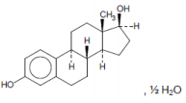
Figure 2: Chemical structure for progesterone
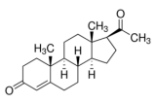
The drug product is an immediate release oral softgel formulation capsule consisting of fixed dose combination of estradiol hemihydrate (micronised) and progesterone (micronised), that has been developed for the treatment of the estrogen deficiency symptoms in postmenopausal women with an intact uterus. A soft capsule containing 1 mg estradiol hemihydrate and 100 mg of progesterone is intended for commercialisation.
The soft gel capsules are oval, opaque, light pink on one side and dark pink on the other side, printed in while ink as ‘1C1’ and filled with lipophilic suspension containing the drug substances formulated with 300 mg fill mass. Capsules are oval and approximately 5.2 to 6 mm in size.
The drug product is presented in blister packs with push through foil lidding containing 14 capsules. Two blisters are packaged into cartons containing 28 capsules, and six blisters are packaged into cartons containing 84 capsules. A shelf-life of 24 months is proposed with a storage condition of Store below 25˚C.
Approval was recommended from a pharmaceutical chemistry perspective

Nonclinical
The nonclinical evaluator commented that daily doses of the individual agents in this product do not exceed those already approved for other oral estradiol- and/or progesterone-containing products registered in Australia (see Table 1 above).
The submitted nonclinical information was entirely literature based. The combination of these pharmacological classes (an estrogen and a progestogen) is not novel in Australia.
There were no objections on nonclinical grounds to the registration of Bijuva 1/100 (estradiol and progesterone) soft capsules.

Clinical

Overview
The following were evaluated or referred to for this submission:
- two Phase I studies:
  - Study TXC16-01, evaluating the pharmacokinetics of Bijuva in healthy postmenopausal women aged 40 to 65 years as single- and repeat-doses (7 days).
  - Study TXC17-02, evaluating the pharmacokinetics of Bijuva in healthy postmenopausal women aged 40 to 65 years as single-doses.
- one pivotal Phase III:
  - Study TXC12-05, an efficacy and safety study in postmenopausal women age 40 to 65 years with an intact uterus treated continuously with Bijuva for up to 52 weeks for the relief of vasomotor symptoms (VMS) associated with menopause. This also provided PK data in the target population.
- the European Medicines Agency (EMA) final assessment report for Bijuva (1 mg/ 100 mg estradiol/progesterone capsules).
The sponsor also submitted three, single-dose, Phase I bioequivalence/bioavailability studies comparing combined 2 mg estradiol/200 mg progesterone capsules with 2 mg estradiol plus 200 mg progesterone) tablets in healthy postmenopausal women. These were unsuitable for evaluation (see below).

Pharmacology

Pharmacokinetics
The submission included two key Phase I studies (Studies TXC16-01 and TXC17-02) evaluating the pharmacokinetics (PK) of Bijuva by national competent authorities in healthy postmenopausal women aged 40 to 65 years: that is, single and repeat dose (7 days) data in Study TXC 16-01; and single dose data in Study TXC17-02.
In addition, to the two Phase I studies the submission included PK data from the pivotal Phase III efficacy and safety study (Study TXC12-05) in postmenopausal women aged 40 to 65 years with an intact uterus treated continuously with Bijuva for up to 52 weeks for the relief of vasomotor symptoms associated with menopause (Study TXC12-05).
There was no PK data in healthy subjects. All PK data was based on postmenopausal women treated with Bijuva.
No clinical PK studies were submitted in special populations. No clinical drug-drug PK interaction studies between Bijuva and other medicines were submitted.
There were no formal clinical bioequivalence studies comparing the Bijuva formulations used in the Phase I studies (Studies TXC16-01 and TXC17-02) and the Phase III study. The overseas evaluators commented that ‘despite some minor manufacturing differences and not fully compliant dissolution test it can be concluded that the quality of the commercial formulation is comparable or slightly better than the product used in the Phase III study’.
In addition to the two, valid Phase I studies (Studies TXC16-01 and TXC17-02), the submission also included three, single dose, Phase I bioequivalence/bioavailability studies, performed in India, comparing combined 2 mg estradiol/200 mg progesterone capsules with 2 mg Estrace (estradiol) plus 200 mg Prometrium (progesterone) tablets in healthy postmenopausal women. These studies could not be accepted as a basis for marketing authorisation in the EU due to Good Clinical Practice issues at the research organisation making the bioequivalence/bioavailability data unreliable. They were not taken into consideration by the EMA or the TGA during clinical evaluation.
The clinical evaluation was satisfied that the pharmacokinetics of Bijuva (active substances estradiol and progesterone) have been adequately characterised in the overseas (EMA) evaluation report supported by the updated clinical overview (Edition 3, dated 6 January 2021) summarising the PK literature for the two active substances.

Pharmacodynamics
In the overseas regulator (EMA) evaluation report, there were no reports of clinical pharmacodynamic data from Studies TXC16-01, TXC17-02, or TXC12-05. The updated clinical overview (6 January 2021) included a brief summary of the pharmacodynamics of 17β-estradiol and progesterone. As the mechanism of action and clinical pharmacodynamics of estradiol and progesterone are well known, this was deemed to be acceptable.

Efficacy

Study TXC12-05
The submission included one pivotal Phase III study (Study TXC12-05) providing evaluable efficacy data.
The clinical evaluation considered that the overseas regulator (EMA) report had a number of limitations, in particular relating to the summary of the outcomes of the primary and secondary efficacy endpoints. Consequently, an assessment was undertaken of the pivotal efficacy data based on the complete study report for Study TXC12-05 dated 22 September 2017 to supplement the information provided in the overseas regulatory report.
The study included postmenopausal women aged 40 to 65 years with an intact uterus seeking treatment or relief for vasomotor symptoms (VMS) associated with menopause and were in otherwise good health. The participating women were required to meet all the inclusion and exclusion criteria.

Objectives
- Vasomotor symptoms: To determine whether an oral fixed dose combination of estradiol (as hemihydrate) and micronised progesterone given in a continuous fashion is effective at reducing the frequency and severity of moderate to severe VMS associated with menopause when compared with placebo at Weeks 4 and 12.
- Endometrial safety: To determine whether an oral fixed dose combination of estradiol (as hemihydrate) and micronised progesterone given in a continuous fashion is effective at achieving a less than or equal to 1% incidence proportion of endometrial hyperplasia following 12 months of therapy.
All randomised subjects were required to self-administer two capsules at bedtime with food for 12 months. Two different capsule sizes were necessary to accommodate the different active doses. A double dummy technique was used to maintain blinding.
The treatment groups were as follows:
- Treatment 1: Combined estradiol 1 mg/progesterone 100 mg (1 mg E2/100 mg P)
- Treatment 2: Combined estradiol 0.5 mg/progesterone 100 mg (0.5 mg E2/100 mg P)
- Treatment 3: Combined estradiol 0.5 mg/progesterone 50 mg (0.5 mg E2/50 mg P)
- Treatment 4: Combined estradiol 0.25 mg/progesterone 50 mg (0.25 mg E2/50 mg P)
- Treatment 5: Placebo.

Analysis populations
The modified intent to treat-vasomotor symptoms (mITT-VMS) population was the primary efficacy population. To be included in the mITT-VMS population, subjects must have been randomised to the VMS substudy, had taken at least one dose (two capsules) of Bijuva, and:
- had at least five days of VMS diary data for baseline measurement of frequency and severity of moderate to severe hot flushes; and
- had at least four days of VMS diary data for one on treatment week of reporting of frequency and severity of hot flushes following initiation of Bijuva. Analysis was based on the treatment group to which the subject had been randomised.

Sample size
The relevant TGA-adopted EMA guideline relating to the clinical investigation of HRT of estrogen deficiency symptoms in postmenopausal women; indicates that for the assessment of endometrial safety for new HRT:
‘a reasonable requirement is that the incidence [of endometrial events] should be statistically less than 2% after one year of treatment, that is the upper limit of a two-sided 95% confidence interval (CI) of the observed frequency of endometrial events should not exceed 2%’.
The guideline goes on to state that:
‘under the assumption that the new combination does not increase the frequency of hyperplasia as compared to recently authorised combinations, a sample size of 300 patients treated for one year should provide more than 80% statistical power’.
The clinical evaluation reports reflect the discussion between the regulators and the sponsor regarding the results of the analysis of the incidence of endometrial hyperplasia and the statistical requirements recommended in the EMA guideline. The sponsor was requested to provide a calculation for the incidence of endometrial hyperplasia which meets the requirement of the guidelines. In response, the sponsor provided the requested endometrial safety analysis that showed that for the incidence of endometrial hyperplasia the upper limit of the two-sided 95% confidence intervals (CIs) for the 1 mg estradiol/ 100 mg progesterone dose was 1.83%, which is below the 2% limit recommended in the EMA guidance. Additionally, the incidence rate and 95% CIs of endometrial hyperplasia was comparable across the three highest estradiol/progesterone dose groups.

Participant flow
A total of 5020 subjects were screened for enrolment: 3175 were screen failures and 1845 subjects were randomised into the trial (1079 to the ‘non-substudy’ and 766 to the VMS substudy). Only subjects in the VMS substudy were randomised to placebo. Figure 3, shown below, provides an overview of subject disposition and subject flow through Study TXC12-05.
Figure 3: Study TXC12-05 Disposition of subjects and study flow
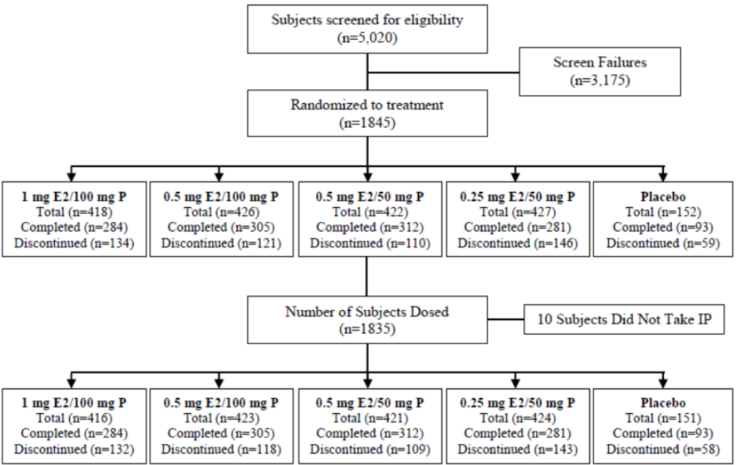
Note: E2/P refers to dose of estradiol (E2) and dose of progesterone. IP refers to investigational product.
Treatment groups: Combined estradiol 1 mg/progesterone 100 mg (1 mg E2/100 mg P); Combined estradiol 0.5 mg/progesterone 100 mg (0.5 mg E2/100 mg P); Combined estradiol 0.5 mg/progesterone 50 mg (0.5 mg E2/50 mg P); Combined estradiol 0.25 mg/progesterone 50 mg (0.25 mg E2/50 mg P).
The mITT-VMS population was the primary population for the efficacy assessment.

Results
The baseline demographic data in the mITT-VMS population were generally comparable across the five treatment groups (see Table 4).
Table 4: Study TXC12-05 Baseline values for co-primary and selected secondary endpoints for modified intent to treat-vasomotor symptoms (mITT-VMS) population
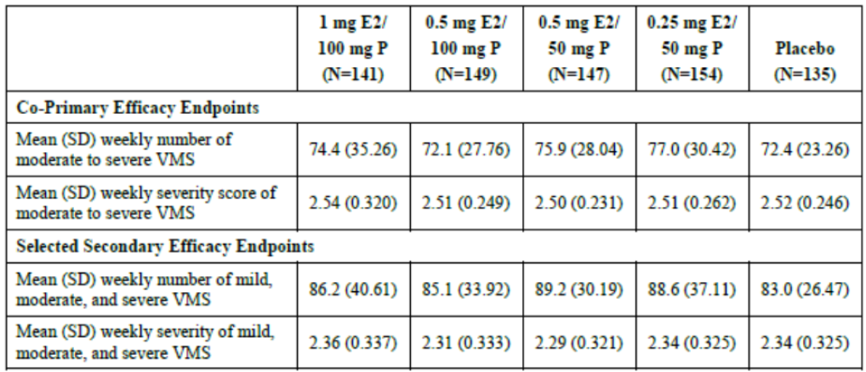
Abbreviations: mITT-VMS = modified intent to treat-vasomotor symptom; E2 = 17β-estradiol; P = progesterone; SD = standard deviation.
Treatment groups: Combined estradiol 1 mg/progesterone 100 mg (1 mg E2/100 mg P); Combined estradiol 0.5 mg/progesterone 100 mg (0.5 mg E2/100 mg P); Combined estradiol 0.5 mg/progesterone 50 mg (0.5 mg E2/50 mg P); Combined estradiol 0.25 mg/progesterone 50 mg (0.25 mg E2/50 mg P).
The baseline values, mean changes from Baseline, and least square (LS) mean changes from placebo in the severity of weekly moderate to severe VMS at Weeks 4 and 12 for the mITT-VMS population are summarised below in Table 5. Data on the subjects with ≥ 36 and ≥ 39 reductions in frequency of moderate to severe vasomotor symptom from Baseline to Week 4 and Week 12 is shown in Table 6.
Table 5: Study TXC12-05 Change from Baseline and placebo in the mean weekly severity scores of vasomotor symptom at Week 4 and Week 12 (modified intent to treat-vasomotor symptoms (mITT-VMS) population)
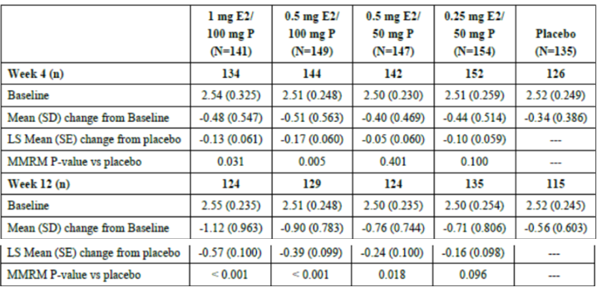
Abbreviation: mITT-VMS = modified intent to treat-vasomotor symptom; E2 = 17β-estradiol; P = progesterone; LS = least square; SE = standard error; MMRM = mixed model repeated measures.
Treatment groups: Combined estradiol 1 mg/progesterone 100 mg (1 mg E2/100 mg P); Combined estradiol 0.5 mg/progesterone 100 mg (0.5 mg E2/100 mg P); Combined estradiol 0.5 mg/progesterone 50 mg (0.5 mg E2/50 mg P); Combined estradiol 0.25 mg/progesterone 50 mg (0.25 mg E2/50 mg P).
Table 6: Study TXC12-05 Number (%) of subjects with ≥ 36 and ≥ 39 reductions in frequency of moderate to severe vasomotor symptom from Baseline to Week 4 and Week 12 (modified intent to treat-vasomotor symptoms mITT-VMS) population)
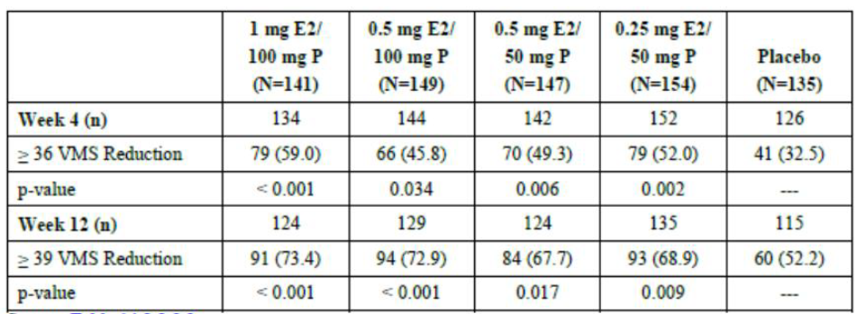
Abbreviation: mITT-VMS = modified intent to treat-vasomotor symptom; E2 = 17β-estradiol; P = progesterone.
Treatment groups: Combined estradiol 1 mg/progesterone 100 mg (1 mg E2/100 mg P); Combined estradiol 0.5 mg/progesterone 100 mg (0.5 mg E2/100 mg P); Combined estradiol 0.5 mg/progesterone 50 mg (0.5 mg E2/50 mg P); Combined estradiol 0.25 mg/progesterone 50 mg (0.25 mg E2/50 mg P).
The TGA evaluation commented that each of the four pre-specified co-primary efficacy endpoints of change from Baseline to Weeks 4 and 12 in frequency (number) and severity of moderate to severe VMS demonstrated statistically significant reduction in LS means in women treated with 1 mg estradiol/100 mg progestrone compared to placebo (mITT-VMS population). The LS mean reductions from placebo were numerically higher in the 1 mg estradiol/100 mg progesterone group than in the other active treatment groups at Week 4 and Week 12 for frequency and at Week 12 for severity.

Safety

Study TXC12-05
The safety profile of the estradiol/progestrone combinations, including 1 mg estradiol/100 mg progesterone, were consistent with the known safety profile of postmenopausal women treated with combination estrogen and progesterone for VMS.
The results for an updated analysis of endometrial hyperplasia in the endometrial safety population requested by the overseas regulator are summarised in the Table 7. The overseas regulator (EMA) noted that the upper limit of the two-sided 95% CI for the 1 mg estradiol/100 mg progesterone dose was 1.83%, which is below the 2% limit in the EMA guidance. The incidence rate and 95% CI of endometrial hyperplasia were comparable across the three highest estradiol/progesterone dose active treatment groups.
Table 7: Study TXC12-05 Incidence of endometrial hyperplasia (endometrial safety population)
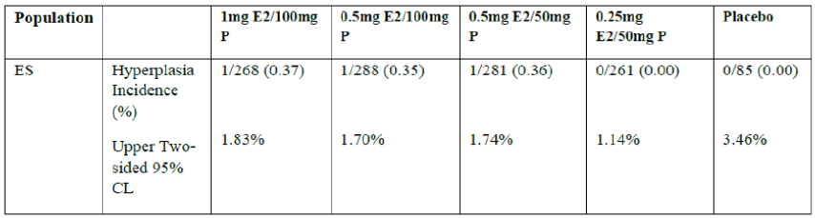
Abbreviations: E2 = 17β-estradiol; ES = endometrial safety (population); P = progesterone; CL = confidence limit.
Treatment groups: Combined estradiol 1 mg/progesterone 100 mg (1 mg E2/100 mg P); Combined estradiol 0.5 mg/progesterone 100 mg (0.5 mg E2/100 mg P); Combined estradiol 0.5 mg/progesterone 50 mg (0.5 mg E2/50 mg P); Combined estradiol 0.25 mg/progesterone 50 mg (0.25 mg E2/50 mg P).

Risk management plan
No risk management plan (RMP) evaluation was required for this submission. The sponsor is required to comply with product vigilance and risk minimisation requirements.
Further information regarding the TGA’s risk management approach can be found in risk management plans for medicines and biologicals and the TGA's risk management approach.

Risk-benefit analysis

Delegate’s considerations
Overall, the risk/benefit for the approval for Bijuva 1/100 is favourable. Discussion is warranted regarding the lower strength 0.5 mg/100 mg capsule, given the recent approval of this formulation by the US Food Drug Administration (FDA) in December 2021, and by Health Canada, and the similar efficacy of both formulations in the pivotal clinical trial (Study TXC12-05).
It is acknowledged that currently registered products for continuous HRT (fixed dose combination) in Australia include 1 mg estradiol (see Table 1 above). The issue of a lower dose formulation not being made available is significant, when the product information states that, in line with clinical guidelines:1
‘The recommended oral dose for the initiation and continuation of treatment of postmenopausal symptoms should be the lowest effective dose, taken for the shortest duration’
The TGA therefore requests that the sponsor submit a Category 1 application (an application for variation of a registered new chemical entity/or new combination of active ingredients) to register the lower strength 0.5 mg/100mg capsule in Australia.

Proposed action
The Delegate supports the conclusions of the overseas regulator (EMA) reports and the TGA evaluations in recommending approval of Bijuva 1/100 for use during continuous combined hormone replacement therapy (HRT) for estrogen deficiency symptoms in postmenopausal women with an intact uterus and with at least 12 months since last menses.

Questions for the sponsor
The sponsor provided the following response to questions from the Delegate.
- Foreign regulatory information in the sponsor submitted dossier states that the EMA decentralised procedure application was approved on 25 February 2021, while the ‘Note to the Evaluator letter’ in dossier indicates a Marketing Authorisation has only been granted by the UK and Belgium.
Has the application been approved in the Netherlands, Spain, Germany, France, Italy, Luxembourg or Poland? Please can the sponsor clarify.
The Sponsor confirms that the application has been approved in the Netherlands, Spain, Germany, France, Italy, Luxembourg and Poland.
- The Delegate notes that the lower strength 0.5 mg/100 mg capsule has recently been approved by the FDA in December 2021, consistent with Health Canada.
Please provide further information about this decision. Was this application submitted at the request of the FDA? Please also provide information on this decision by Health Canada.
The efficacy supplement for the Bijuva 0.5/100 was submitted subsequent to a successful legal appeal to the US FDA. It was not submitted at the request of the FDA but was submitted based on the successful outcome of the appeal. The FDA has not published the review documents for this supplement, only the letter and label. [Information redacted].
The application in Canada is held by [Information redacted]. Other than the product monograph, there are no publicly available documents from Health Canada. [Information redacted]
- In light of the recent decision by the FDA, the results for Study TXC12-05 and taking into consideration that the product information states that ‘estrogens with or without progestogens should be prescribed at the lowest effective doses…’, the TGA requests that the sponsor submit a Category 1 application to register the lower strength 0.5mg/100mg capsule in Australia. Please indicate the possible timing of this application.
The Sponsor has initiated discussions with the TGA. [Information redacted]
- Regarding Table 1 in Note to evaluators letter, MHT fixed dose combination products approved for supply in Australia for continuous MHT, please clarify the following:
- Kliovance should be included.
- Femoston-Conti has been spelt incorrectly.
The Sponsor has provided an updated Table 1.

Advisory Committee considerations
The Delegate did not refer this submission to the Advisory Committee on Medicines (ACM) for advice.

Outcome
Based on a review of quality, safety, and efficacy, the TGA approved the registration of Bijuva 1/100 (1 mg estradiol hemihydrate and 100 mg of progesterone), capsule, blister pack, indicated for:
Bijuva 1/100 is indicated for use during continuous combined hormone replacement therapy (HRT) for estrogen deficiency symptoms in postmenopausal women with an intact uterus and with at least 12 months since last menses.

Attachment 1. Product Information
The PI for Bijuva 1/100 approved with the submission which is described in this AusPAR is at Attachment 1. For the most recent PI, please refer to the TGA PI/CMI search facility.

Therapeutic Goods Administration
PO Box 100 Woden ACT 2606 Australia
Email: info@tga.gov.au Phone: 1800 020 653 Fax: 02 6232 8605
https://www.tga.gov.au

EMEA/CHMP/021/97 rev.1, October 2005, Guideline on clinical investigation of medicinal products for hormone replacement therapy of oestrogen deficiency symptoms in postmenopausal women.
EMEA/CHMP/021/97 rev.1, October 2005, Guideline on clinical investigation of medicinal products for hormone replacement therapy of oestrogen deficiency symptoms in postmenopausal women.

