January 2023

Australian Public Assessment Report for Evusheld
  - Active ingredients: Tixagevimab and cilgavimab
  - Sponsor: AstraZeneca Pty Ltd

About the Therapeutic Goods Administration (TGA)
- The Therapeutic Goods Administration (TGA) is part of the Australian Government Department of Health and is responsible for regulating therapeutic goods, including medicines, medical devices, and biologicals.
- The TGA administers the Therapeutic Goods Act 1989 (the Act), applying a risk management approach designed to ensure therapeutic goods supplied in Australia meet acceptable standards of quality, safety, and efficacy.
- The work of the TGA is based on applying scientific and clinical expertise to decision-making, to ensure that the benefits to the Australian public outweigh any risks associated with the use of therapeutic goods.
- The TGA relies on the public, healthcare professionals and industry to report problems with therapeutic goods. The TGA investigates reports received to determine any necessary regulatory action.
- To report a problem with a therapeutic good, please see the information on the TGA website.

About AusPARs
- The Australian Public Assessment Report (AusPAR) provides information about the evaluation of a prescription medicine and the considerations that led the TGA to approve or not approve a prescription medicine submission. Further information can be found in Australian Public Assessment Report (AusPAR) guidance.
- AusPARs are prepared and published by the TGA.
- AusPARs are static documents that provide information that relates to a submission at a particular point in time. The publication of an AusPAR is an important part of the transparency of the TGA’s decision-making process.
- A new AusPAR may be provided to reflect changes to indications or major variations to a prescription medicine subject to evaluation by the TGA.

Copyright
© Commonwealth of Australia 2023
This work is copyright. You may reproduce the whole or part of this work in unaltered form for your own personal use or, if you are part of an organisation, for internal use within your organisation, but only if you or your organisation do not use the reproduction for any commercial purpose and retain this copyright notice and all disclaimer notices as part of that reproduction. Apart from rights to use as permitted by the Copyright Act 1968 or allowed by this copyright notice, all other rights are reserved, and you are not allowed to reproduce the whole or any part of this work in any way (electronic or otherwise) without first being given specific written permission from the Commonwealth to do so. Requests and inquiries concerning reproduction and rights are to be sent to the TGA Copyright Officer, Therapeutic Goods Administration, PO Box 100, Woden ACT 2606 or emailed to <tga.copyright@tga.gov.au>.

Contents
List of abbreviations 4
Product submission 6
Submission details 6
Product background 8
Regulatory status 12
Product Information 14
Registration timeline 14
Submission overview and risk/benefit assessment 15
Quality 15
Nonclinical 15
Clinical 17
Risk management plan 44
Risk-benefit analysis 45
Outcome 51
Specific conditions of registration applying to these goods 51
Attachment 1. Product Information 52

List of abbreviations
Abbreviation |  | Meaning
ACE-2 | Angiotensin converting enzyme-2
ACM | Advisory Committee on Medicines
AE | Adverse event
AESI | Adverse event of special interest
ARTG | Australian Register of Therapeutic Goods
ASA | Australia specific annex
COVID-19 | Coronavirus disease 2019
DLP | Data lock point
EU | European Union
FDA | Food and Drug Administration, United States of America
GM | Geometric mean
GMT | Geometric mean titre
IC₅₀ | 50% (half-maximal) inhibitory concentration
IC₈₀ | 80% inhibitory concentration
IQR | Interquartile range
PI | Product Information
PK | Pharmacokinetic(s)
PopPK | Population pharmacokinetics
PT | Preferred Term
RBD | Receptor binding domain
RMP | Risk management plan
SAE | Serious adverse event
SARS-CoV-2 | Severe acute respiratory syndrome coronavirus 2
SOC | System Organ Class
TGA | Therapeutic Goods Administration
US(A) | United States (of America)
VOC | Variant of concern

Product submission

Submission details
Type of submission: | New biological entity and change in dosage and change to Product Information requiring evaluation of new data
Product name: | Evusheld
Active ingredients: | Tixagevimab and cilgavimab
Decision: | Approved for provisional registration
Date of decision: | 12 December 2022
Date of entry onto ARTG: | 13 December 2022
ARTG number: | 378245
Black Triangle Scheme: | Yes  As a provisionally registered product, this medicine will remain in the Black Triangle Scheme for the duration of its provisional registration
Sponsor’s name and address: | AstraZeneca Pty Ltd  66 Talavera Road  Macquarie Park, NSW 2113
Dose form: | Solution for injection
Strength: | 100 mg/mL of tixagevimab and 100 mg/mL of cilgavimab
Container: | Vial
Pack size: | Each carton (composite pack) of Evusheld contains two vials:  - 150 mg of tixagevimab in 1.5 mL solution (100 mg/mL)  - 150 mg of cilgavimab in 1.5 mL solution (100 mg/mL)
Approved therapeutic use: | Evusheld has provisional approval for the treatment of adults with COVID-19, who do not require supplemental oxygen and who are at increased risk of progressing to severe COVID-19. See Section 4.2 Dose and method of administration and Section 5.2 Pharmacokinetic properties.  This decision has been made on the basis of short-term efficacy and safety data. Continued approval depends on the evidence of longer-term efficacy and safety data from ongoing clinical trial.
Route of administration: | Intramuscular injection
Dosage: | Indication: Pre-exposure prophylaxis for COVID-19  The recommended dose is 600 mg of Evusheld, administered as two separate 3 mL, sequential injections containing:  - 300 mg of tixagevimab, and  - 300 mg of cilgavimab  Repeat doses of 600 mg of Evusheld (300 mg of tixagevimab and 300 mg of cilgavimab) is optional and may be given once every 6 months at the discretion of the treating health care professional. The decision for whom to implement repeat dosing should be based on the available evidence and patient circumstances. Repeat-dosing should only be considered if the treatment benefit outweighs the associated risks.  The dose recommendations for prophylaxis at the 600mg dose of Evusheld are based on the totality of the available data including clinical pharmacology, pharmacokinetics (PK), antiviral activity, and clinical trial data (see Section 4.8 Adverse effects (Undesirable effects); Section 5.1 Pharmacodynamic properties; and Section 5.2 Pharmacokinetic properties of the Product Information). Evusheld has only been studied at the 300 mg dose in clinical studies for the prophylaxis of COVID-19. The clinical safety of a 600 mg Evusheld dose is supported by safety data from the TACKLE trial in adult patients with mild to moderate COVID-19 (see Section 4.8 Adverse effects (Undesirable effects) for further information).  Indication: Treatment of COVID-19  The recommended dose is 600 mg of Evusheld, administered as two separate 3 mL, sequential injections of:  - 300 mg of tixagevimab  - 300 mg of cilgavimab  Evusheld should be given as soon as possible after a positive viral test for SARS-CoV-2 and within 7 days after the onset of symptoms of COVID-19 (see Section 5.1 Pharmacodynamic properties).  For further information regarding dosage, refer to the Product Information.
Pregnancy category: | B2  Drugs which have been taken by only a limited number of pregnant women and women of childbearing age, without an increase in the frequency of malformation or other direct or indirect harmful effects on the human fetus having been observed.  Studies in animals are inadequate or may be lacking, but available data show no evidence of an increased occurrence of fetal damage.  The use of any medicine during pregnancy requires careful consideration of both risks and benefits by the treating health professional. This must not be used as the sole basis of decision making in the use of medicines during pregnancy. The TGA does not provide advice on the use of medicines in pregnancy for specific cases. More information is available from obstetric drug information services in your State or Territory.

Product background
This AusPAR describes the submission by AstraZeneca Pty Ltd (the sponsor) to register Evusheld (tixagevimab and cilgavimab) 100 mg/mL of tixagevimab and 100 mg/mL of cilgavimab, solution for injection, for the following indication and proposed change in dose regime and updates to the Product Information (PI):
Treatment indication
Evusheld has provisional approval for the treatment of mild to moderate COVID-19 in adults and adolescents aged 12 years and older weighing at least 40 kg, see Section 4.2 Dose and method of administration and Section 5.2 Pharmacokinetic properties. The decision has been made on the basis of short term efficacy and safety data. Continued approval depends on the evidence of longer term efficacy and safety data from ongoing clinical trials.
Proposed changes in dose regimen for the pre-exposure prophylaxis indication and updates to the Product Information
The recommended dose for the pre-exposure prophylaxis of COVID-19 is proposed to be increased from 300 mg to 600 mg via intramuscular (IM) injection and it is proposed to introduce a repeat dosing recommendation of 600 mg IM every 6 months to provide ongoing protection.
The proposed updates to the posology and other sections of the PI are based on emerging in vitro neutralisation data for new variants of concern and clinical data presented in a PROVENT clinical trial 12-month update report based on a data-cut off of April 2022, a PROVENT trial anti-drug antibodies (ADA) update report (Day 183), a PROVENT trial repeat dose substudy interim analysis report, safety data from a Phase III study in treatment of mild to moderate COVID-19 (TACKLE trial), and available post-authorisation/marketing safety and real world effectiveness data.
Evusheld is a combination of two human monoclonal antibodies (tixagevimab and cilgavimab) specific to severe acute respiratory syndrome coronavirus 2 (SARS-CoV-2), the virus responsible for causing COVID-19 disease.
The two different monoclonal antibodies bind to two distinct parts (two non-overlapping epitopes) of the receptor-binding domains located on the SARS-CoV-2 spike protein. As a result, the combination of monoclonal antibodies block the interaction between the SARS-CoV-2 virus and the human angiotensin converting enzyme 2 (ACE-2) host cellular receptor, resulting in a blockade of virus entry, effectively neutralising the SARS-CoV-2 virus effectively neutralising the SARS-CoV-2 virus and the virus’ capacity to infect healthy cells.
Evusheld (tixagevimab and cilgavimab) was first listed on the Australian Register of Therapeutic Goods (ARTG) on 26 February 2022; and at the time of this submission, was currently approved for the indication:
Evusheld (tixagevimab and cilgavimab) has provisional approval for the pre-exposure prophylaxis of COVID-19 in adults and adolescents aged 12 years and older weighing at least 40 kg,
- Who have moderate to severe immune compromise due to a medical condition or receipt of immunosuppressive medications or treatments that make it likely that they will not mount an adequate immune response to COVID‐19 vaccination or
- For whom vaccination with any approved COVID‐19 vaccine is not recommended due to a history of severe adverse reaction (e.g., severe allergic reaction) to a COVID-19 vaccine(s) and/or COVID‐19 vaccine component(s).
The sponsor has proposed to extend the use of Evusheld beyond the pre-exposure prophylaxis of COVID-19 indication, and include a treatment indication of mild to moderate COVID-19 in adults and adolescents aged 12 years and older weighing at least 40 kg.
The indication for treatment of COVID-19 was previously discussed at an Advisory Committee on Medicine (ACM) meeting in February 2022, where Evusheld was also considered for the prophylactic indication that was subsequently approved.¹
At that time, it was considered that additional long term data was required to make a conclusion with regards to the efficacy and safety of Evusheld for the treatment of COVID-19 disease. The sponsor has now included additional data to support the proposed treatment indication.
In addition to the new proposed COVID-19 treatment indication, with this submission the sponsor has proposed a change in the dosage regimen of Evusheld for pre-exposure prophylaxis.
The currently approved dosage regimen for pre-exposure prophylaxis is single, one-time only dose of 300 mg Evusheld in the form of two separate, sequential 1.5 mL injections, one containing 150 mg tixagevimab, and the other containing cilgavimab.
The sponsor proposes that the Evusheld dosage regimen for pre-exposure prophylaxis be changed from the current dose to a new dose of 600 mg Evusheld (that is, 300 mg tixagevimab and 300 mg cilgavimab), and that administration of Evusheld can be repeated at 6 month intervals.
The rationale for the increased dose from the current 300 mg dose to 600 mg for the pre-exposure prophylaxis indication and the provision of repeat administration of Evusheld on a 6 month basis is based on the rationale that a higher dose may enable greater neutralisation activity for Evusheld against the Omicron variants of concern (VOCs), compared to 300 mg. The pharmacokinetics (PK) modelling to support this change in dosage is based on the in vitro findings. At this stage, no clinical data is available to support the efficacy and safety of the 600 mg dose being repeated at 6 months intervals.

Currently approved COVID-19 treatments
Multiple treatments for COVID-19 disease have received provisional approval in Australia, although Evusheld (tixagevimab and cilgavimab) is the only approved non-vaccine product for pre-exposure prophylaxis for COVID-19. Table 1 summarises the COVID-19 treatments and prophylactic medicines provisionally approved in Australia at the time that this submission was considered for approval.
Further information on an approval can be found in the associated AusPAR.

Table 1: Provisional approvals for COVID-19 treatments and prophylactics in Australia
COVID-19 treatments and prophylactics provisionally approved in Australia
Veklury (remdesivir); Gilead Sciences Pty Ltd
ARTG numbers: 338419, 338420
10 July 2020 (initial registration) | Treatment: adults and adolescents (≥ 12 years and ≥ 40 kg) with pneumonia, requiring supplemental oxygen (AusPAR)
6 May 2022 | Treatment: adults and paediatric patients (≥ 4 weeks of age and ≥ 3 kg) with pneumonia due to SARS-CoV-2, requiring supplemental oxygen; and, adults and paediatric patients (≥ 40 kg) who do not require supplemental oxygen and who are at high risk of progressing to severe COVID-19 (AusPAR)
Xevudy (sotrovimab); GlaxoSmithKline Australia Pty Ltd
ARTG number: 364110
20 August 2021 | Treatment: Adults and adolescents (≥ 12 years and ≥ 40 kg) with COVID-19 who do not require initiation of oxygen due to COVID-19 and who are at increased risk of progression to hospitalisation or death (AusPAR)
Ronapreve (casirivimab + imdevimab); Roche Products Pty Ltd
ARTG numbers: 373839 and 374310
15 October 2021 | In patients ≥ 12 years and ≥ 40 kg:  Treatment: In patients not requiring supplemental oxygen for COVID-19, with increased risk of severe COVID-19.  Prevention: of COVID-19 in those exposed to SARS-CoV-2 and unlikely to respond to or be protected by vaccination due to illness, or who are not vaccinated against COVID-19. (AusPAR)
Actemra (tocilizumab); Roche Products Pty Ltd
ARTG numbers: 149402, 149403, and 149404
2 December 2021 | Treatment: of COVID-19 in hospitalised adults who are receiving systemic corticosteroids and require supplemental oxygen or mechanical ventilation (AusPAR)
Regkirona (regdanvimab); Celltrion Healthcare Australia Pty Ltd
ARTG number: 374190
6 December 2021 | Treatment: of adults with COVID-19 who do not require supplemental oxygen and are at increased risk of progressing to severe COVID-19 (AusPAR)
Paxlovid (nirmatrelvir + ritonavir); Pfizer Australia Pty Ltd
ARTG number: 377572
18 January 2022 | Treatment: of COVID-19 in adults ≥ 18 years of age, who do not require initiation of supplemental oxygen due to COVID-19 and are at increased risk of progression to hospitalisation or death (AusPAR)
Lagevrio (molnupiravir); Merck Sharp & Dohme (Australia) Pty Ltd
ARTG number: 372650
18 January 2022 | Treatment: of adults with COVID 19 who do not require initiation of oxygen due to COVID-19 and who are at increased risk for hospitalisation or death (AusPAR)
Evusheld (tixagevimab/cilgavimab); AstraZeneca Pty Ltd
ARTG number: 378245
24 February 2022 | Pre-exposure prophylaxis of COVID-19 in adults and adolescents aged 12 years and older weighing at least 40 kg and at high risk or vaccination is contraindicated (AusPAR)

Regulatory status
The product received initial registration on the Australian Register of Therapeutic Goods (ARTG) on 26 February 2022 for pre-exposure prophylaxis of COVID-19.
Evusheld (tixagevimab and cilgavimab) has provisional approval for the pre-exposure prophylaxis of COVID-19 in adults and adolescents aged 12 years and older weighing at least 40 kg
- who have moderate to severe immune compromise due to a medical condition or receipt of immunosuppressive medications or treatments that make it likely that they will not mount an adequate immune response to COVID-19 vaccination, or
- for whom vaccination with any approved COVID-19 vaccine is not recommended due to a history of severe adverse reaction (for example., severe allergic reaction) to a COVID-19 vaccine(s) and/or COVID‐19 vaccine component(s). See Section 4.2 Dose and method of administration and Section 5.2 Pharmacokinetic properties.
Evusheld is not recommended as a substitute for vaccination in individuals for whom COVID-19 vaccination is recommended.
This decision has been made on the basis of short-term efficacy and safety data. Continued approval depends on the evidence of longer-term efficacy and safety data from ongoing clinical trials.
At the time the TGA considered this submission, similar submissions for the new treatment indication, had been approved in Canada (18 October 2022), and the European Union (16 September 2022). Similar submissions for a treatment indication were under consideration in the USA, New Zealand, Singapore and Switzerland.
Table 2, shown below, summarises these submissions for a similar treatment indication and provides the indications where approved.
Table 2: International regulatory status (new treatment indication)
Region | Submission date | Status | Approved indications
Canada | 22 June 2022 | 18 October 2022 | Treatment of mild to moderate COVID-19 in adults and adolescents (≥ 12 years of age weighing at least 40 kg).
European Union | 14 April 2022 | 16 September 2022 | Evusheld is indicated for the treatment of adults and adolescents (aged 12 years and older weighing at least 40 kg) with COVID-19, who do not require supplemental oxygen and who are at increased risk of progressing to severe COVID-19.
New Zealand | 19 August 2022 | Under consideration
Singapore | 28 September 2022 | Under consideration
Switzerland | 28 June 2022 | Under consideration
United States of America | 28 February 2022 | Under consideration

For the proposed change in dosage regimen for the pre-exposure prophylaxis of COVID-19 indication, at the time the TGA considered this submission similar submissions were under consideration in Canada, the European Union, New Zealand and Singapore. A similar submission had been approved (via an Emergency Use Authorization) in the United States of America (USA) on 24 February 2022.
Table 3, shown below, summarises similar submissions overseas for an increased dose for the pre-exposure prophylaxis indication.
Table 3: International regulatory status (increased dose in pre-exposure prophylaxis indication)
Region | Submission date | Status | Approved indications
Canada | 28 July 2022 | Under consideration | Under consideration
European Union | 15 July 2022 | Under consideration | Under consideration
New Zealand | 12 August 2022 | Under consideration | Under consideration
Singapore | 1 August 2022 | Under consideration | Under consideration
United States of America |  | Emergency Use Authorization  600 mg dosage: 24 February 2022  Repeat dosing: 29 June 2022

Product Information
The Product Information (PI) approved with the submission which is described in this AusPAR can be found as Attachment 1. For the most recent PI, please refer to the TGA PI/CMI search facility.

Registration timeline
Table 4, shown below, captures the key steps and dates for this submission.
Data were provided as a rolling submission. Under normal circumstances, TGA's assessment (for both provisional and general registration) begins once all information to support registration is available. As part of the Department of Health's response to the pandemic, the TGA has agreed to accept rolling data for COVID-19 vaccines and treatments, to enable early evaluation of data as it becomes available.
Table 4: Timeline for Submission PM-2022-03097-1-2
Description | Date
Submission dossier accepted and first round evaluation commenced | 4 August 2022
Evaluation completed | 17 October 2022
Delegate’s Overall benefit-risk assessment and request for Advisory Committee advice | 17 October 2022
Sponsor’s pre-Advisory Committee response | 28 October 2022
Advisory Committee meeting | 10 November 2022
Registration decision (Outcome) | 12 December 2022
Completion of administrative activities and registration on the ARTG | 13 December 2022
Number of working days from submission dossier acceptance to registration decision* | 91
*Statutory timeframe for standard submissions is 255 working days
The treatment indication was a continuation of the original new biological entity application, submission PM-2021-05375-1-2, in which Evusheld was granted provisional approval for pre-exposure prophylaxis for COVID-19. A summary of this initial submission is available on the TGA website.¹
The treatment indication was approved on 12 December 2022.

Submission overview and risk/benefit assessment
A summary of the TGA’s assessment for this submission is provided below.

Quality
A full quality evaluation was conducted at the time this product received initial registration. Further information can be found in the relevant AusPAR.¹

Nonclinical
The nonclinical evaluator has no objections to the approval of the treatment indication; or the pre-exposure prophylaxis of COVID-19 indication with a single intramuscular dose of 600 mg of Evusheld.
The nonclinical data supplied by the sponsor comprised in vitro neutralisation data against the SARS-CoV-2 Omicron BA.1, BA.1.1, BA.2, BA.3 and BA.4/5 subvariants for tixagevimab alone, cilgavimab alone, and Evusheld (the combination of tixagevimab and cilgavimab).
Evusheld showed reduction in neutralisation activity against Omicron subvariants BA.1 (26- to 232-fold), BA.1.1 (176-fold), BA.2 (5.4- to 8-fold), BA.3 (65-fold) and BA.4/5 (14- to 65-fold) compared with inhibition against the ancestral (wild-type) SARS-CoV-2 strain. Fold reduction in activity was not significantly different between authentic virus and pseudovirus assays. The published neutralisation data are generally in line with the neutralisation data used by the sponsor in their modelling of clinical efficacy summarised during the clinical evaluation of this submission. Based on the summary results, Evusheld is unlikely to be active against the Omicron BA.4/5 variant.
Tixagevimab and cilgavimab have differing activities against Omicron variants. All Omicron sublineages are highly resistant to tixagevimab with in vitro neutralisation 50% inhibitory concentration (IC₅₀) values increased by 2 to 3 magnitudes for Omicron BA.1 and BA.2 and complete resistance for Omicron BA.3 and Omicron BA.4/5 (IC₅₀ > 10,000 ng/mL). The loss of activity against Omicron BA.4/5 was largely due to the mutation at the F486 region, which is at the critical receptor binding site of tixagevimab, although other mutations which are common to Omicron variants may also contribute to reduced susceptibility.
Cilgavimab retains activity against Omicron subvariants BA.2, BA.3 and BA.4/5 (a 1- to 10-fold reduction in susceptibility relative to the ancestral strain), but exhibits reduced activity against Omicron BA.1 (≥ 16 fold reduction in susceptibility) and a complete loss of activity against Omicron BA.1.1 (IC₅₀ > 50,000 ng/mL), most likely due to the R346K mutation of Omicron BA.1.1 at the critical receptor binding site for cilgavimab. However, because of the different binding sites for the two monoclonal antibodies, the combination of tixagevimab and cilgavimab retained activity against all Omicron variants, with reduced activity by 26- to 232-fold against the Omicron BA.1, 176-fold against the Omicron BA1.1, 5.4- to 8-fold against the Omicron BA.2, 65-fold against the Omicron BA.3 and 14- to 65-fold against the Omicron BA.4/5 subvariants.
Summary results of neutralisation activity against Omicron BA.4.6 in studies conducted by the Oxford University and Monogram Biosciences in conjunction with Food and Drug Administration (FDA) United States indicate that Omicron BA.4.6 is completely resistant to Evusheld, most likely due to the substitutions at both R346 (conferring resistance to cilgavimab) and F486 (conferring resistance to tixagevimab).
No toxicity was observed in a single dose study in monkeys at intravenous or intramuscular doses 50 and 12.5 times the proposed clinical dose of 600 mg. No repeat dose toxicity studies have been conducted to support the proposed repeated dosing in humans. This is considered a major deficiency of the nonclinical data.
There are no nonclinical objections to the provisional approval of treatment or prophylaxis of COVID-19 with a single intramuscular dose of 600 mg Evusheld. However, there are no repeat dose toxicity studies supporting repeated dosing in humans.

Clinical

PROVENT trial Substudy D8850C002A01
Taken as an excerpt of the AusPAR for the initial provisional approval for Evusheld;¹ Study D8850C00002 (the PROVENT trial) is a Phase III randomised control trial to assess the safety and efficacy of a single intramuscular dose of Evusheld compared to placebo for the prevention of COVID-19 in adults:
- having an increased risk for inadequate response to active immunisation (predicted poor responders to vaccines or intolerant of vaccine); or
- having an increased risk for SARS-CoV-2 infection, defined as those whose locations or circumstances put them at appreciable risk of exposure to SARS-CoV-2 and COVID-19.
The PROVENT trial Substudy D8850C002A01 was designed to investigate whether an additional dose of Evusheld has an acceptable safety profile and whether repeat dosing can maintain serum levels associated with protection against COVID-19.
Data for repeat dosing of the 300 mg Evusheld dosage derived from Substudy D8850C002A01 (repeat-dose substudy, interim analysis) is described below.

Objectives
The objectives for Substudy D8850C002A01 were:
- To investigate whether an additional dose of Evusheld has an acceptable safety profile (that is all primary endpoints are safety endpoints).
- To determine whether repeat dosing can maintain serum levels associated with protection against COVID-19, by evaluating serum concentrations and determining the effect (if any) of anti-drug antibody on serum concentrations.

Study overview and design
Enrolled participants from Group 1 of the PROVENT trial (that is, those participants who received active intramuscular injection during the parent study) were to receive a second dose of Evusheld 300 mg intramuscular at 12 (±2) months (Day 1 of substudy), with follow up at Day 29.
Included enrolees at potentially increased benefit from repeat dosing on the basis of:
- immunocompromise and/or at increased risk of inadequate response to COVID-19 vaccination, or
- at increased risk of severe COVID-19.
The target sample size for the substudy is about 500 participants, which would allow a probability of greater than 99% to detect at least one adverse event (AE) with a true event rate of 1%. This interim analysis was planned once greater or equal to 50 participants had completed Day 29 follow up (data cut-off date of 25 February 2022).
Figure 1: PROVENT trial Substudy D8850C002A01 Study design for 300 mg repeat-dose cohort
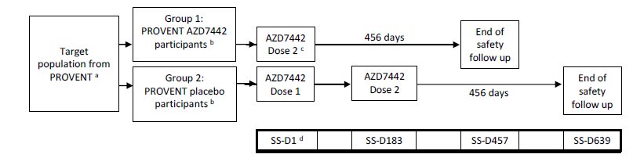
Abbreviations: AZD7442 = tixagevimab and cilgavimab; SS-D = substudy day
a. Participants from PROVENT parent study who may benefit from a repeat dose of Evusheld.
b. Based on randomisation in the parent study.
c. Participants were eligible for the substudy once they reached 12 ± 2 months post-dose in the double-blind parent study. Therefore, in Group 1, the dosing interval between Dose 1 (parent study) and Dose 2 (SS-D1) is approximately 12 months.
d. For participants who have not undergone a Day 366 visit in the parent study, the Day 366 assessments were performed at SS-D1.
The Delegate noted a protocol amendment, at 6 months following the first dose of Evusheld in the substudy: a subset of participants from US sites in Group 1 and Group 2 (evenly distributed between groups) will be assigned to a new arm (Group 3) and will receive 600 mg Evusheld every 6 months until end of study.
The primary objective of the substudy was to evaluate the safety and tolerability of repeat doses of Evusheld 300 mg intramuscularly.
The secondary objectives were to evaluate the PK, anti-drug antibody responses and neutralising levels following repeat doses of Evusheld 300 mg given intramuscularly.
In the safety analysis set, the 305 participants in the Group 1 received their first dose of Evusheld 300 mg intramuscularly in the PROVENT trial and their second dose of Evusheld 300 mg intramuscularly in the substudy.
The 138 participants in Group 2 received placebo in the PROVENT trial and their first dose of Evusheld 300 mg intramuscularly in the substudy.
No participant in Group 2 had received a second dose at the time of the data cut-off for this analysis.

Pharmacology

TACKLE trial (Study D8550C00003)
The TACKLE trial was first evaluated at the time the TGA granted provisional approval to Evusheld, for use as pre-exposure prophylaxis in COVID-19.¹ For the submission described in this current AusPAR, the sponsor has included longer term efficacy and safety data for TACKLE trial.
The data supplied with the initial submission was for the primary data cut-off date of 21 August 2021; For the updated, longer term efficacy and safety data from the TACKLE trial, the median duration of follow up at the primary data cut-off (21 August 2021) was 84 days and at the key secondary data cut-off (14 January 2022) was 170 days. The study provided intensive follow up for first 28 days.
A brief summary of the TACKLE trial study design and objectives is given below.

TACKLE trial (Study D8550C00003) Summary
The TACKLE trial (Study D8550C00003) is a Phase III randomised, double-blind, placebo-controlled, multicentre study to determine the safety and efficacy of a single 600 mg intramuscular dose of Evusheld for the treatment of COVID-19 in non-hospitalised adults.
At the time of the primary analysis data cut-off date (21 August 2021), 1014 participants had been enrolled, 910 participants had been randomised (Evusheld: 456; placebo: 454), and 452 participants received treatment with Evusheld.
Adults with a documented positive SARS-CoV-2 test (from a sample collected ≤ 3 days prior to the study entry) who were within 7 days of symptom onset were randomised in a 1:1 ratio to receive a single dose (of 2 x intramuscular injections) of Evusheld 600 mg or placebo on Day 1, with planned follow up to Day 457 (15 months).
Figure 2: Study D8550C00003 (TACKLE trial) Study schema
At least 60% of participants were anticipated to meet the protocol definition of being at high risk of progression to severe COVID-19 as defined by any of the following:
- persons aged 65 years and older at randomisation
- persons aged < 65 years and having at least one of the following conditions: cancer; chronic lung disease or moderate to severe asthma; obesity ; hypertension; cardiovascular disease (including history of stroke); diabetes; chronic kidney disease; chronic liver disease; immunocompromised state from solid organ transplant, blood or bone marrow transplant, immune deficiencies, HIV, use of corticosteroids, or use of other immunosuppressive medicines; sickle cell disease; or smoking (current or former).
Randomisation was stratified by:
- Time from symptom onset (≤ 5 days versus > 5 days)
- High-risk versus low-risk of progression to severe COVID-19 (high-risk is defined above)
Participants were enrolled into one of two independent cohorts:
- Cohort 1, underwent more intensive testing to characterise their virological and immunological status, and to correlate that status with clinical outcomes.
- Cohort 2, was followed for clinical outcomes
Key inclusion criteria were:
- adults with laboratory-confirmed SARS-CoV-2 infection from a sample collected ≤ 3 days prior to Day 1
- no more than 7 days from COVID-19 symptom onset
- oxygen saturation ≥ 92% at rest (unless regularly receives oxygen for pre-existing chronic lung condition)
The trial planned to enrol at least 60% of patients at high risk of progression to severe COVID-19 (based on age over 65 years or the presence of comorbidity).
Key exclusion criteria were:
- hospitalisation for COVID-19
- any prior receipt of COVID-19 vaccine or other monoclonal antibody/biologic indicated for SARS-CoV-2 (or expected administration immediately after enrolment).
Study endpoints:
The primary endpoint was a composite of either severe COVID-19 or death from any cause through Day 29 (binary outcome).
A key secondary endpoint was composite of either death from any cause or hospitalisation for COVID-19 complications or sequelae during the 168-day post-dose period (binary outcome; not part of the primary analysis as it falls outside the data cut-off date period).

Population pharmacokinetics data
The PK addendum was similar in structure and content to the previous PK addendum (addendum to pooled population pharmacokinetics report, dated 20 December 2021,) and included the same subjects and observations.
Subjects were from the TACKLE trial (Study D8851C00001; design summarised above) in which subjects received 600 mg Evusheld by intramuscular injection. The structural population PK model was unchanged and the covariates were similar to those reported previously.
Tixagevimab and cilgavimab serum concentration profiles following 600 mg Evusheld every 6 months was simulated using the population PK model.
Pharmacokinetics modelling, based on in vitro neutralisation, of predicted Evusheld concentrations in nasal lining fluid, using 80% inhibitory concentration (IC₈₀) (IC₅₀ × 4) as a target and a 1.8% partition ratio, show that a dose of 300 mg intramuscular injection only exceeds the minimum protective concentration for Omicron BA.4 or BA.5 for approximately the first three months post-dosing.
Figure 3: PopPK report; Evusheld concentrations in serum with 300 mg dose and duration of protection against variants of concern
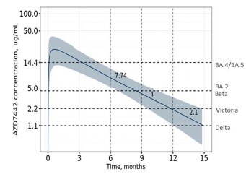
Abbreviation, AZD7442 = tixagevimab and cilgavimab.
Solid line = median PK, ribbon = 20% to 80% prediction interval of PK; dashed horizontal lines: serum target corresponding to respective IC80 values of VOCs; dashed vertical lines PK at 6, 9 and 12 months. Abbreviation: IC₈₀, 80% maximal inhibitory concentration; NLF, nasal lining fluid; PK, Pharmacokinetics; VOC, variant of concern.
At a dose of 600 mg intramuscularly, the percent of individuals at or above the modelled minimum protective concentration for Omicron BA4/5 at 3, 6, 12 months is projected to be 97%, 61%, and 86% respectively.
Figure 4: PopPK report; Evusheld concentrations in serum with 600 mg dose and duration of protection against variants of concern
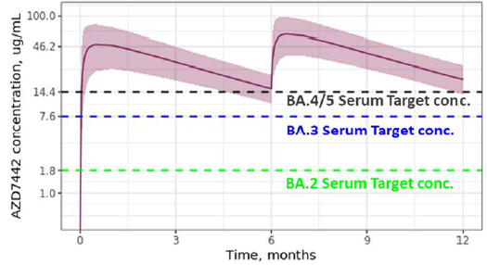
Abbreviation, AZD7442 = tixagevimab and cilgavimab.
Solid line = median PK, ribbon = 20% to 80% prediction interval of PK; dashed horizontal lines: serum target concentration for BA.2, BA.3 and BA.4/5 calculated using IC80 from pseudotyped VLP assay and NLF partition ratio of 1.8%
Abbreviation: IC₈₀, 80% maximal inhibitory concentration; NLF, basal lining fluid; PK, Pharmacokinetics; VLP, virus like particle; VOC, variant of concern.
In the model, the sponsor made an assumption of 6.5% penetration ratio for lower respiratory tract distribution. Based on this assumption, a dosage regimen of 600 mg intramuscularly every 6 months results in 61% of subjects above the modelled minimum protective concentration at 6 months, 86% at 12 months and 100% at 15 months.
Figure 5: PopPK model; Predicted serum Evusheld concentration over time for the 600 mg initial dose and 600 mg intramuscularly maintenance dose every 6 months for Omicron BA.4 and BA.5 subvariants
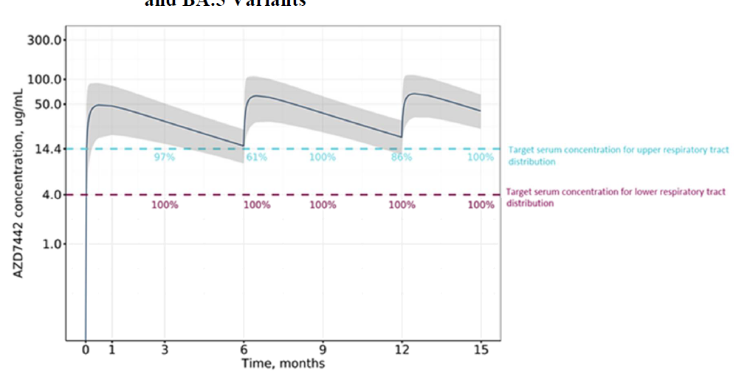
Abbreviation, AZD7442 = tixagevimab and cilgavimab.
% number next to blue dashed line represent % subjects predicted to be above serum target level 14.4 µg/mL (using 1.8% penetration ratio) for Omicron BA.4 and BA.5, assuming upper respiratory tract distribution.
% number next to purple dashed line represent % subjects predicted to be above serum target level 4 µg/ml (using 6.5% penetration ratio) for Omicron BA.4 and BA.5, assuming lower respiratory tract distribution.
Minimum protective concentration values were verified, in the assumption that the tissue penetration values are appropriate.
The PK evaluation concluded that ‘It is noted that while the simulations were extrapolated beyond the range of the actual data and these results remain to be verified, the 6 month interdose interval is consistent with results presented from the PROVENT study.’
The population pharmacokinetics model predictions were overlaid on PK data collected up to 6 months after dose administration in the STORM CHASER trial and the TACKLE trial studies and up to 12 months after dose administration in the PROVENT trial. The error bars at the 6 and 12 month timepoints generally extended lower than the modelled lower 90% prediction interval, suggesting greater variability at 6 and 12 months than predicted by the model. There was a reasonable correlation between observed and model predicted median Evusheld concentrations at these extended time points.

Figure 6: PopPK model; Predicted median (90% prediction intervals) and observed serum tixagevimab and cilgavimab concentration following administration of Evusheld 300 mg or 600 mg intramuscularly (Phase I and Phase III Studies)
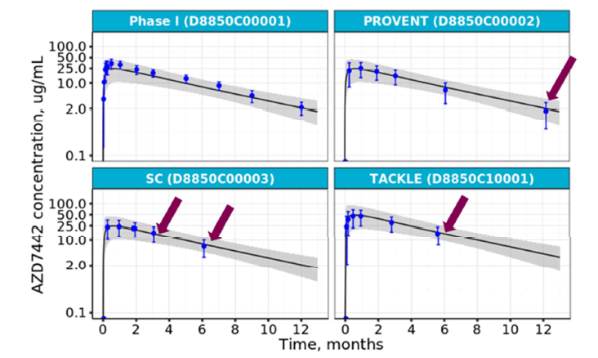
Abbreviation, AZD7442 = tixagevimab and cilgavimab. Arrows corresponds to observed data that was not part of pop-pk model.
Overall, a good agreement between observed and model predicted median Evusheld concentrations at Day 183 was noted. However, the clinical evaluator commented that the observed variability was substantially greater than that predicted by the model.
The clinical evaluation considered that ‘the implication of this finding is the proportion of subjects estimated to have an Evusheld concentration higher than the minimum protective concentration for BA4/5 (Clinical Overview Addendum, 12 July, 2022) at 6 months and at 12 months may have been overestimated.’
Table 5: Phase III trials and PopPK model; Pre-dose pharmacokinetics parameters, trough serum concentration after Evusheld 300 or 600 mg prior to repeat dose at 6 months
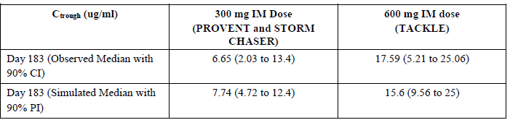
Abbreviation: CI = confidence interval; C_{trough} = trough serum concentration; IM = intramuscular; PI = prediction interval.
In terms of the safety implications, the PK evaluator concluded that ‘the influence of underestimated PK variability on exposure distributions is moot since exposure-safety modelling was not performed due to few safety events in the Phase III studies.’

Pharmacodynamics of 600 mg Evusheld dosage

SARS-CoV-2 neutralising antibodies
Neutralising antibody responses were measured using a validated assay at Baseline and on study Days 6, 15, 29, 85, 169 and 366 in both the Evusheld 600 mg intramuscularly and placebo study groups.
In the placebo group, there was a 3.8-fold rise in geometric mean titres (GMTs) relative to baseline on Day 6 and 2.6-fold rise on Day 15, reflecting the natural immune response to SARS-CoV-2 infection. The corresponding increases in the Evusheld group at Day 6 and 15 relative to baseline were 59.4-fold and 36.3-fold respectively. In the Evusheld group, GMTs were 16-fold, 14-fold, 22-fold, 18-fold and 5-fold over placebo responses at Day 6, 15, 29, 85 and 169 respectively.
The Delegate commented that these data are proposed for inclusion in Section 5.1 of the PI.

PROVENT trial, first dose parent study
New text is proposed for the PI about the immunogenicity of first dosing and for repeat dosing in the PROVENT trial in Section 5.1 Pharmacodynamic properties of the PI. This data is summarised and discussed below.

Anti-drug antibody results
The prevalence (that is present at Baseline and/or through the substudy) and treatment emergent incidence (that is newly apparent or boosted baseline response) of anti-drug antibody up to Day 183 of the PROVENT trial is shown in Table 6.
The majority of participants had anti-drug antibody observable at Baseline, with a lesser proportion developing treatment emergent anti-drug antibody (for Evusheld, overall prevalence = 13.6% and treatment emergent incidence = 4.9%). Day 183 median titres in treatment emergent anti-drug antibody plus participants were close to baseline and were no higher in the Evusheld group than in the placebo group (the same was true for the tixagevimab and cilgavimab components) (Table 6). Earlier analyses at Day 29 and Day 58 showed similar percentages of anti-drug antibody plus participants as were present at Baseline (shown longitudinally in Figure 7).

Table 6: PROVENT trial; Summary of antidrug antibody responses to tixagevimab, cilgavimab following administration of 300 mg intramuscular Evusheld over 183 Days (antidrug antibody evaluable analysis set)
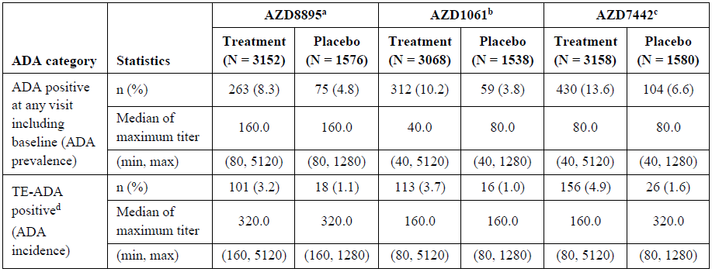
Abbreviations: ADA, antidrug antibody; AZD8895 = tixagevimab; AZD1061 = cilgavimab; AZD7442 = Evusheld; IM, intramuscular; mAb, monoclonal antibody; max, maximum; min, minimum; N, number of ADA-evaluable participants; n, number of participants with a positive result at the specific visit; TE-ADA, treatment emergent ADA.
ª Lowest reportable titre = 80 ^{b} Lowest reportable titre = 40. ^{c} ADA positive to AZD7442 is defined as ADA positive to AZD8895 and/or AZD1061; TE-ADA positive to AZD7442 is defined as TE-ADA positive to AZD8895 and/or AZD1061. ^{d} Either ADA negative at baseline and ADA positive at ≥ 1 post-baseline assessments with ADA titre ≥ 2 times the lowest reportable titre of the respective mAb, or baseline positive ADA titre that was boosted to ≥ 4-fold during the study period.
Figure 7: PROVENT trial; Percentage of tixagevimab, cilgavimab, and Evusheld antidrug antibody plus participants by timepoint and study group up to Day 183 (antidrug antibody evaluable analysis set)
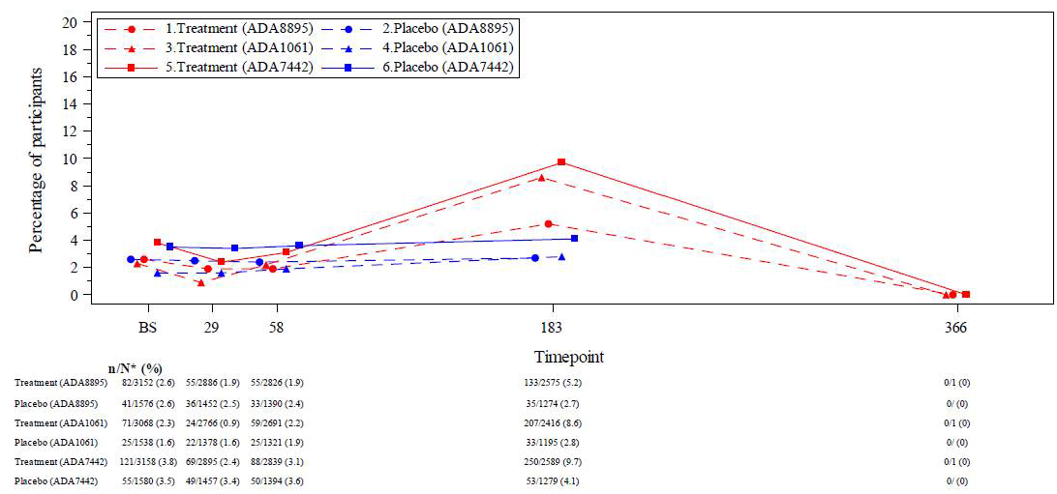
Time points are in days.
Abbreviations: ADA, antidrug antibodies; ADA8895, AZD8895 antibody; ADA1061, AZD1061 antibody; ADA7442, AZD7442 antibody (positive to AZD8895 and/or AZD1061); BS, baseline; DCO, data cut-off.

Anti-drug antibody effect on pharmacokinetics
The geometric mean serum concentrations of Evusheld at Day 183 were 26.3% lower in treatment emergent anti-drug antibody plus participants (geometric mean (GM) of 4.229 µg/mL) compared to anti-drug antibody negative participants (5.736 µg/mL). For tixagevimab, they were 28.7% lower and for cilgavimab they were 17.9% lower respectively. This is represented visually by clustering of the Day 183 serum concentrations from treatment emergent anti-drug antibody plus participants (with a titre of greater or equal to 1280) below the median of serum concentrations seen in anti-drug antibody negative participants (see Figure 8).
The sponsor states that GM serum concentration in treatment emergent anti-drug antibody plus participants of 4.229 µg/mL was still above the minimum protection level for the original SARS-CoV-2 strain (greater than 2.2 µg/mL, interquartile range (IQR) of 1.1 to 5.0 µg/mL) for prophylaxis of symptomatic COVID-19 disease. The sponsor states the minimum protection level for Omicron BA.2 subvariant is also in the range of the ancestral (wild-type) SARS-CoV-2 strain. They conclude that, ‘Overall, there was no apparent effect of anti-drug antibody on the PK of AZD7442 [Evusheld]’ and ‘As such, the presence of anti-drug antibody is not expected to result in loss of efficacy.’
Figure 8: PROVENT trial; Individual Evusheld serum drug concentrations (μg/mL) versus time, by antidrug antibody status (pharmacokinetics analysis set)
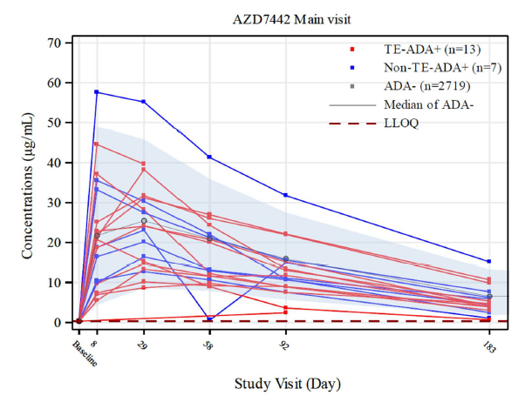
Abbreviations: AZD7442 = Evusheld; AZD8895 = tixagevimab; AZD1061 = cilgavimab, ADA, antidrug antibodies; LLOQ, lower limit of quantification; n, number of subjects in the ADA category, TE, treatment-emergent.
TE-ADA+ to AZD7442 is defined as TE-ADA+ to AZD8895 and/or AZD1061. Non-TE-ADA+ is defined as ADA+ but not fulfilling the conditions for TE-ADA+. ADA negative is defined as ADA negative at all assessments, including baseline and post-baseline. Horizontal dotted line denotes the lower limit of quantification of the PK assay (0.3 μg/mL). TE-ADA+ only shows participants with titre of ≥ 1280 for either ADA8895 and/or ADA1061. ADA-negative group, the median (black line with open circles) and the 5th and 95th percentiles (shaded areas) are presented.
The Delegate noted that as seen in the TACKLE trial (see section: Anti-drug antibody effect on pharmacokinetics, below) the emergence of anti-drug antibody following treatment is associated with measurably lower GM serum drug concentrations at about 6 months of approximately 25% compared to anti-drug antibody negative participants (more pronounced for tixagevimab then cilgavimab). This was of a similar pattern and order of magnitude to what was seen on Day 169 following the 600 mg Evusheld dosage in the TACKLE trial.

Anti-drug antibody effect on safety
The sponsor stated that in the 13 treatment emergent antidrug antibodies plus participants with a titre greater or equal to 1280, there were no reported adverse events of hypersensitivity or anaphylaxis, injection site reactions, or cardiac disorders.
The Delegate commented that the study above represents a very focused analysis of safety restricted to some specified adverse event Preferred Terms and only to participants with the highest level of observable treatment emergent antidrug antibodies. This is a different approach to the analyses of safety in the PROVENT trial (see section: PROVENT trial, repeat dosing substudy (Substudy, below) and TACKLE trial (see section: TACKLE trial below). No conclusions about the overall relationship between anti-drug antibody and safety should be drawn from this and this uncertainty should be reflected in the PI.

PROVENT trial, repeat dosing substudy (Substudy D8850C002A01)

Anti-drug antibody results
There were 54 participants from Group 1 of the PROVENT trial in whom at least one sample was collected for an anti-drug antibody assessment, but repeat sampling was only available for anti-drug antibody assessment in 48 (tixagevimab), 49 (cilgavimab) and 49 (Evusheld) participants. The prevalence (that is present at Baseline and/or through the substudy) and treatment emergent incidence (that is newly apparent or boosted baseline response) of anti-drug antibody up to Day 29 of the substudy (note well in repeat dosing happened on ‘Day 1’) is shown in Table 7. The medians of the maximum anti-drug antibody titres were low and close to the level of detection for the respective assays. These levels were no higher than those seen at Day 29 following the first Evusheld dose.

Table 7: PROVENT trial (Substudy D8850C002A01) Summary of anti-drug antibody responses to tixagevimab, cilgavimab, and Evusheld during the study (anti-drug antibody evaluable analysis set)
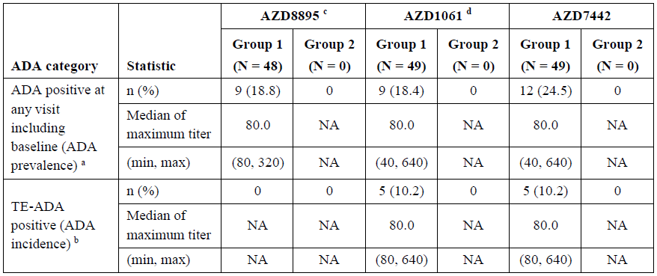
Abbreviations: ADA, antidrug antibody; AZD8895 = tixagevimab; AZD1061 = cilgavimab; AZD7442 = Evusheld; DCO, data cut-off; Min, Minimum; Max, Maximum; N, number of participants in the analysis set; n, number of participants; NA, not applicable; TE-ADA, treatment-emergent ADA.
ª ADA prevalence is the proportion of ADA-positive participants (positive ADA result at any time, baseline or post-baseline) in the AZD8895 ADA-evaluable population, AZD1061 ADA-evaluable population, or AZD7442 ADA-evaluable population, respectively. Either AZD8895 ADA positive or AZD1061 ADA positive is considered AZD7442 ADA positive.
^{b} ADA incidence is the proportion of treatment-emergent participants (either treatment-induced ADA or treatment-boosted ADA) in the AZD8895 ADA-evaluable population, AZD1061 ADA-evaluable population, or AZD7442 ADA-evaluable population, respectively.
^{c} Lowest reportable titre (lower limit of detection) = 80.
^{d} Lowest reportable titre (lower limit of detection) = 40.
Group 1 = AZD7442 participants from the parent study; Group 2 = Placebo participants from the parent study. The first AZD8895 dose for Group 1 participants occurred in the parent study, and the first AZD8895 dose for Group 2 participants occurred in the substudy. Baseline is defined as the last non-missing measurement taken prior to the first dose of AZD7442 (including unscheduled measurements, if any). If a participant has more than one titre result, the maximum titre result is used whether it is baseline or post-baseline. For any specific sample, higher titre between AZD8895 and AZD1061 is considered for AZD7442 titre. The AZD8895 ADA-evaluable set consists of all participants in the Safety Analysis Set who have a non-missing baseline AZD8895 ADA and at least one non-missing post-baseline AZD8895 ADA result. The AZD1061 ADA-evaluable set consists of all participants in the Safety Analysis Set who have a non-missing baseline AZD1061 ADA and at least one non-missing post-baseline AZD1061 ADA result. The ADZ7442 ADA-evaluable set consists of all participants in the Safety Analysis Set who are AZD8895 ADA-evaluable or AZD1061 ADA-evaluable. The denominator is the number of AZD8895 ADA-evaluable participants, AZD1061 ADA-evaluable participants, or AZD7442 ADA-evaluable participants in the treatment group. Denominators are denoted as N in the treatment group.
The Delegate commented that the kinetics of anti-drug antibody following Dose 2 versus Dose 1 of Evusheld may be different and are unknown to the clinical evaluator; however, in the parent study (above), treatment emergent anti-drug antibody did not become evident until sometime between Day 58 and Day 183. The available Day 29 data was noted; however, this may be too early to observe anti-drug antibody following the repeat dose. In response to the TGA’s question, the sponsor provided response. The response is considered as acceptable by Delegate.

Anti-drug antibody effect on pharmacokinetics
The Day 29 serum concentrations of Evusheld in the five treatment emergent anti-drug antibody plus participants and the six non-treatment emergent anti-drug antibody plus participants were encompassed within the range of serum concentrations of the 37 anti-drug antibody negative participants (see Figure 9). The same was true for the component tixagevimab and cilgavimab serum concentrations. Due to the small numbers, the sponsor stated that, ‘As such, it was not possible to formally assess the potential impact of anti-drug antibody on pharmacokinetics.]’. However, the sponsor also concluded that, ‘Overall, there was no apparent effect of anti-drug antibody on the pharmacokinetics of AZD7442 [Evusheld].’
The Delegate is of view that the levels were taken too early and the number of participants too small to make any reliable conclusions regarding the effect of anti-drug antibody on pharmacokinetics following repeat dosing.
Figure 9: PROVENT trial (Substudy D8850C002A01) Individual serum drug concentrations (μg/mL) versus time, by anti-drug antibody status and monoclonal antibody components (Pharmacokinetics analysis set)
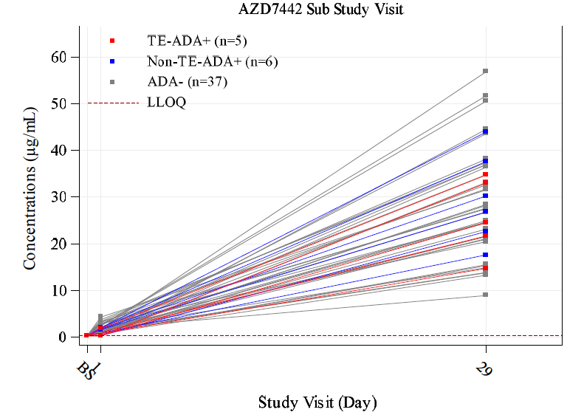
Abbreviations: ADA, anti-drug antibodies; AZD8895 = tixagevimab; AZD1061 = cilgavimab; AZD7442 = Evusheld; BS, baseline; LLOQ, lower limit of quantification; mAb, monoclonal antibody; n, number of subjects in the ADA category; TE-ADA, treatment-emergent ADA.
Group 1 = AZD7442 participants from the parent study; Group 2 = Placebo participants from the parent study.
TE-ADA positive is defined as either treatment-induced ADA positive (ADA negative at Baseline and post-baseline ADA positive) or treatment-boosted ADA positive (ADA positive at baseline and the baseline titer is boosted 4 fold or higher post-baseline during the study period). Baseline is defined as the last non-missing measurement taken prior to the first dose of AZD8895, AZD1061 (including unscheduled measurements, if any). The first AZD8895/AZD1061 dose for Group 1 participants occurred in the parent study, and the first AZD8895/AZD1061 dose for Group 2 participants occurred in the substudy.
Non-TE-ADA positive is defined as subjects who are ADA positive but not fulfilling the conditions for TEADA+.
ADA negative is defined as subjects who are ADA negative at all assessments, including baseline and postbaseline.
Data cut-off date: 25 February 2022

Anti-drug antibody effect on safety
None of the participants who were anti-drug antibody positive during the substudy reported AEs. This observation is limited by the low number of subjects. The Delegate considers that there is inadequate data to make any conclusions regarding the effect of anti-drug antibody on safety and pharmacokinetics of Evusheld.

TACKLE trial
New text is proposed for the PI about the immunogenicity of 600 mg Evusheld dosing in the TACKLE trial in section 5.1 Pharmacodynamic properties of the PI.

Anti-drug antibody results
Anti-drug antibody responses over 168 days post-dose are shown in Table 8 for tixagevimab, cilgavimab or either component of Evusheld. The incidence of treatment emergent antidrug antibody was 5.2% ,10.7% and 10.7% for each of these compounds respectively. Maximum titres were generally low level (close to the limits of detection) and similar to the maximum titres emergent in placebo recipients (albeit at lower incidence). These incidences were less than 50% of the prevalence of anti-drug antibody in each instance.
Longitudinal examination of anti-drug antibody showed similar titres for positive results at Baseline, Day 29, Day 85 and Day 169 respectively in both the Evusheld and placebo groups (see Figure 10), suggesting no maturation of anti-drug antibody against Evusheld over time. Despite, the prevalence of participants with anti-drug antibody increased over time, the large majority had levels close to the low level of detection, without evident maturation. The potential impact of repeat dose on this observation in unclear.
Figure 10: TACKLE trial; Anti-drug antibody titres by time point, line plot (anti-drug antibody evaluable analysis set)
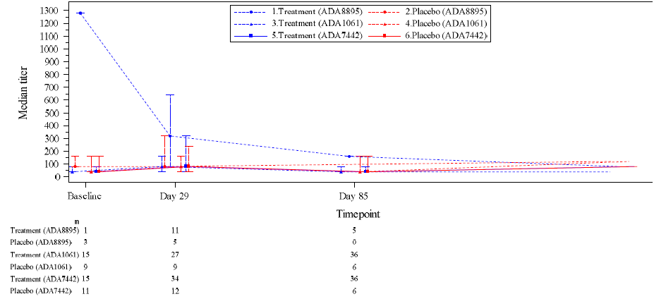
Abbreviation: ADA = anti-drug antibodies; AZD8895 = tixagevimab; AZD1061 = cilgavimab; AZD7442 = Evusheld Note: AZD7442 antibody (positive to AZD8895 and/or AZD1061).
Error bars represent the 25th and 75th percentiles

Table 8: TACKLE trial; Summary of anti-drug antibody responses to tixagevimab, cilgavimab, and Evusheld following administration of 600 mg intramuscular Evusheld over 168 days post-dose (anti-drug antibody evaluable analysis sets for tixagevimab, cilgavimab, and Evusheld)
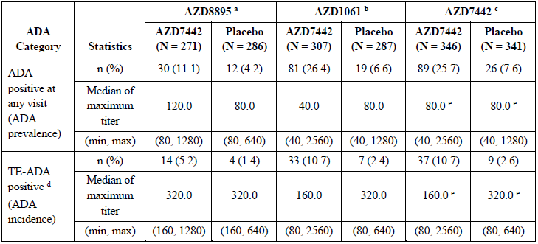
Abbreviation: ADA, anti-drug antibody; AZD8895 = tixagevimab; AZD1061 = cilgavimab; AZD7442 = Evusheld; IM, intramuscular; mAb, monoclonal antibody; min, minimum; max, maximum; N, number of participants in treatment group; n, number of participants included in analysis; TE-ADA, treatment-emergent ADA.
ª Limit of detection = 80, ^{b} Limit of detection = 40, ^{c} ADA positive to AZD7442 is defined as ADA positive to AZD8895 and/or AZD1061; TE-ADA positive to AZD7442 is defined as TE-ADA positive to AZD8895 and/or AZD1061. ^{d} Either ADA negative at Baseline and ADA positive at ≥ 1 post-baseline assessments with ADA titer ≥ 160 for AZD8895 or ≥ 80 for AZD1061 or baseline positive ADA titer that was boosted to ≥ 4-fold during the study period. ^{e} AZD7442 titer is defined as the higher of the 2 titers to the individual mAbs.
The Delegate noted that treatment emergent anti-drug antibody became evident over time and was maintained at generally low titres, as seen in the PROVENT parent trial. Similarly, a higher proportion of participants at anti-drug antibody observable at Baseline than the incidence of treatment emergent anti-drug antibody over the approximately 6 months following dosing (Table 8).

Anti-drug antibody effect on pharmacokinetics
Participants with treatment emergent anti-drug antibody had lower geometric serum concentrations of Evusheld than anti-drug antibody negative participants at all scheduled post-baseline anti-drug antibody time points (see Table 9). ‘The percent difference (n of treatment emergent anti-drug antibody +) in drug concentration between treatment emergent anti-drug antibody + and anti-drug antibody negative participants were -22.3% (37), -24.3% (29), and -30.0% (28) at Day 29, Day 85, and Day 169, respectively.’
Table 9: TACKLE trial; Summary of serum tixagevimab, cilgavimab, and Evusheld concentration by visit and anti-drug antibody category (pharmacokinetics analysis set)
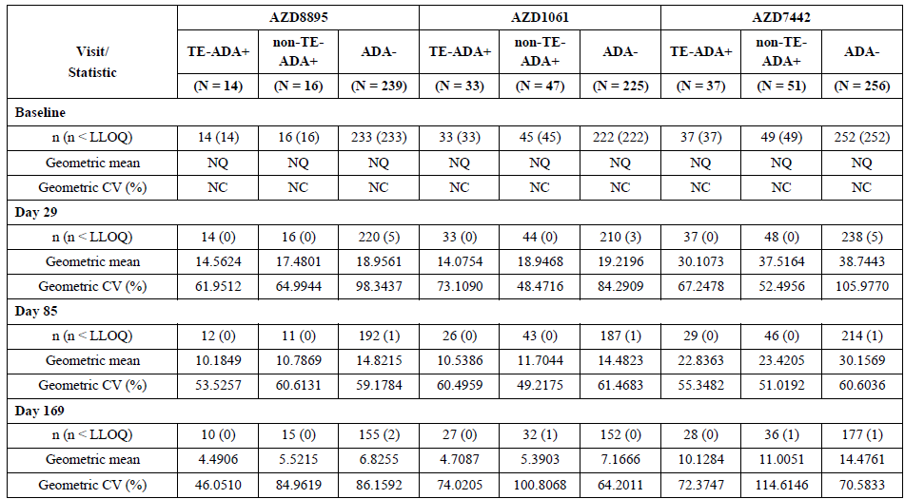
Abbreviations: ADA = anti-drug antibody; AZD8895 = tixagevimab; AZD1061 = cilgavimab; AZD7442 = Evusheld; CV = coefficient of variation; LLOQ = lower limit of quantification; N = number of participants in treatment group; n = number of participants included in analysis; NC = not calculated; NQ = not quantifiable; PK = pharmacokinetic; TE = treatment emergent
Visual inspection of the individual Evusheld plus serum concentration time profiles of Evusheld treatment emergent anti-drug antibody plus participants is shown in Figure 11. The sponsor interpreted that as showing responses ‘…generally within the range of those in antidrug antibody negative participants…’ Overall, the sponsor concluded that ‘…anti-drug antibody had no clear clinically relevant effect on AZD7442 [Evusheld] PK. As such, the presence of anti-drug antibody is not expected to result in loss of efficacy.’
Figure 11: TACKLE trial; Individual serum concentrations versus time, by anti-drug antibody status and monoclonal antibody components (pharmacokinetics analysis set)
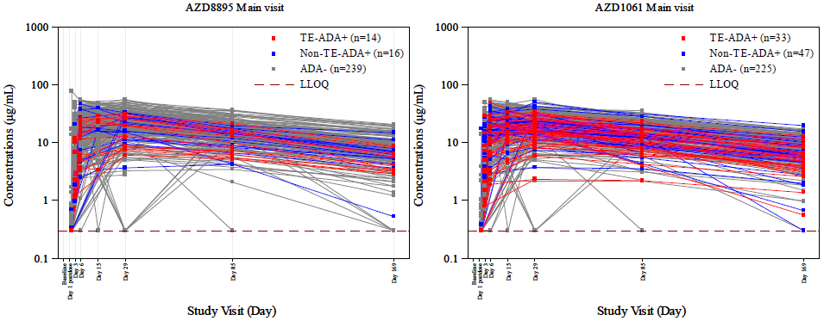
Abbreviation: ADA = anti-drug antibody; AZD8895 = tixagevimab; AZD1061 = cilgavimab; LLOQ = lower limit of quantification; PK = pharmacokinetic; TE ADA = treatment emergent anti-drug antibody.
Note: TE-ADA positive is defined as either treatment-induced ADA positive (ADA negative at baseline and post-baseline ADA positive) or treatment-boosted
Note: ADA positive (ADA positive at baseline and the baseline titre is boosted 4 fold or higher post-baseline during the study period).
Note: Non TE-ADA positive is defined as subjects who are ADA positive but not fulfilling the conditions for TE-ADA (+).
Note: ADA negative is defined as subjects who are ADA negative at all assessments, including baseline and post-baseline.
Note: ADA = Anti-drug antibodies. n = Number of subjects in the ADA category. PK = Pharmacokinetic(s). LLOQ = Lower limit of quantification.
The Delegate commented that Table 9 shows geometric serum concentrations to be 22.3 to 30% lower between Days 29 and 169 in treatment emergent anti-drug antibody plus participants than antidrug antibody negative participants and visual inspection of Figure 11 suggests responses to be proportionately lower in those with antidrug antibody to tixagevimab relative to cilgavimab. The Delegate commented that in the PROVENT parent trial, treatment emergent anti-drug antibody appears to have a consistent effect on lowering serum concentrations of Evusheld; however, the significance of this is uncertain. The Delegate is of view that the uncertainty should be reflected in the PI.

Anti-drug antibody effect on safety and efficacy
The four participants in the Evusheld group with cardiac or thromboembolic serious adverse events (SAE) (see section: Safety, below) were anti-drug antibody negative, hence those particular SAEs were not related to anti-drug antibody.
There were 18 participants in the Evusheld 600 mg intramuscularly group with a primary event of either severe COVID-19 or death at the key secondary data cutoff and 12 were evaluable for anti-drug antibody, of whom seven (58%) were anti-drug antibody negative, two (17%) were non-treatment emergent anti-drug antibody positive and three (25%) were treatment emergent anti-drug antibody plus (note that, the incidence of treatment emergent anti-drug antibody plus through 168 days was 10.7%,Table 8). Two of the three treatment emergent anti-drug antibody plus participants first tested positive following the event. The third was anti-drug antibody plus at Baseline and on Day 29, which bracketed the event.
The Delegate noted that the available data reflect very small numbers and are insufficient to reach a conclusion about potential loss of efficacy in anti-drug antibody plus participants. The sponsor has not presented an analysis of safety data comparing anti-drug antibody positive and antidrug antibody negative participants beyond the sentence in the clinical study report about cardiac disorders and thromboembolic events, hence this lack of evidence does not assuage any potential safety concerns. The Delegate commented that this uncertainty should be reflected in the PI.

In vitro neutralisation data for new variants of concern
The nonclinical review of data will be considered to assess whether the data supports proposed neutralisation changes to Table 6 in section 5.1 of the PI, and also deletion of some text there.

Efficacy
No new clinical data was submitted that demonstrates the efficacy of the proposed 600 mg Evusheld administered 6 monthly as a pre-exposure prophylaxis.
For the TACKLE trial, additional clinical data was submitted following repeated analyses for primary and secondary endpoints at the key secondary data cut-off (dated 14 January 2022).
Overall, the magnitude of treatment benefit appears to be consistent across the primary and secondary data cutoff analyses.
Table 10: Overview of analysis hierarchy for primary and key secondary data cut-offs
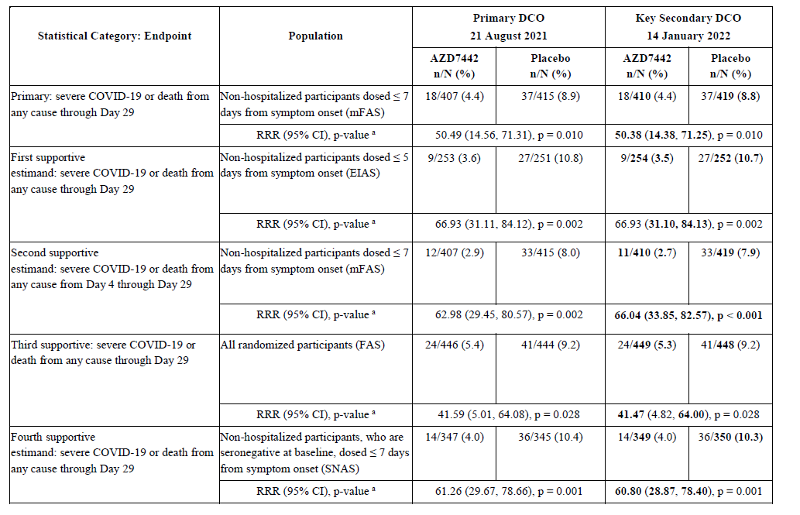
Abbreviations: AZD7442 = Evusheld; DCO = data cutoff.
Text in bold indicates change from the primary data cutoff to key secondary data cutoff.
It was also noted that in participants who received treatment ≤ 5 days or ≤ 3 days from symptom onset, Evusheld reduced the risk of developing severe COVID-19 or death versus placebo by 66.93% (95% CI: 31.11, 84.12) and 88.01% (95% CI: 9.40, 98.41), respectively.
At the key secondary data cut-off, the number of participants hospitalised for the disease under study (including COVID-19 complications) through Day 29 and through Day 169, was numerically fewer in the Evusheld group (17 (4.1%)) compared with the placebo group (40 (9.5%)). Of these hospitalised participants, fewer were admitted to the intensive care unit (ICU) in the Evusheld group (3 (0.7%)) compared to placebo (11 (2.6%)).
Overall, the treatment benefit appears to be consistent and achieved statistical significance for the Evusheld group, compared to placebo.

Safety

Safety of repeat dosing of 300 mg Evusheld
The PROVENT trial substudy (Substudy D8850C002A01) was designed to investigate whether an additional dose of Evusheld has an acceptable safety profile and whether repeat dosing can maintain serum levels associated with protection against COVID-19.
This interim report summarizes the substudy primary endpoint (safety and tolerability data) for all 443 participants who received Evusheld and available secondary endpoint results (pharmacokinetics and anti-drug antibody data) for the approximately 50 participants in Group 1 who had reached the Day 29 visit. None of the subjects in Group 2 had received a repeat dose at the time of this interim analysis.
Participants who could benefit from a repeat dose included those that: (a) were immunocompromised and/or may be at increased risk for an inadequate response to a COVID-19 vaccination, or (b) were at increased risk of severe COVID-19.
Group 1 (approximately 12 month repeat dose interval): Participants who received Evusheld 300 mg intramuscularly on Day 1 of the parent study receive their second dose of Evusheld 300 mg intramuscularly on substudy Day 1.
Group 2 (approximately 6 month repeat dose interval): Participants who received placebo on Day 1 in the parent study receive their first dose of Evusheld 300 mg intramuscularly on sub-study Day 1 followed by a second dose on substudy Day 183.
Figure 12: PROVENT trial (Substudy D8850C002A01) design
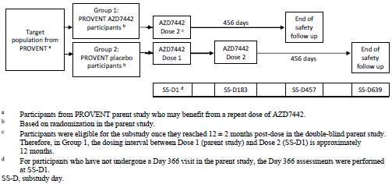
At the time of interim analysis, there were 305 subjects enrolled in Group 1 and 138 subjects enrolled in Group 2. Mean age was around 60 years. Around 94% of subjects had a negative SARS-CoV-2 reverse transcription polymerase chain reaction status at Baseline. Around 93 % of subjects in Group 2 and 88% of subjects in Group 1 were at high risk for COVID-19.

Exposure
Up to the data cut-off date of 25 February 2022, the median (minimum, maximum) durations of followup in the substudy were similar in Group 1 and Group 2: 17 days (1, 36) and 17.5 days (1, 36), respectively (see Table 11). The median duration from first dose to last assessment was longer in Group 1 than Group 2 (8 versus 2 days).
Table 11: PROVENT trial (Substudy D8850C002A01) Duration of assessment
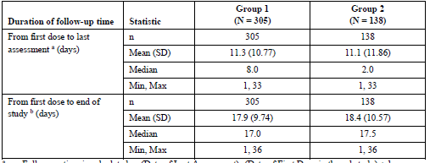

Adverse events
14.4% of subjects in Group 1 and 8.7% of subjects in Group 2 experienced adverse events (AEs). 0.3% of subjects in Group 1 and 1.4% of subjects in Group 2 experienced serious adverse events (SAEs). None of the AEs or SAEs led to treatment discontinuation.
Overall, the most common adverse events by were headache (2.5%), fatigue (2.3%), asymptomatic COVID-19 (1.8%), COVID-19 (1.8%), cough (1.6%), oropharyngeal pain (1.4%), dyspnoea (1.1%), and pain (1.1%). The most common AEs in the sub-study up to 25 February 2022 were generally consistent with those observed in the PROVENT parent trial primary analysis.
Nil major changes from Baseline for cardiac biomarkers (D-Dimer, P-Selectin, S-Thrombin antithrombin complex) were reported up to the data cutoff of 25 of February 2022, no participant experienced cardiac ischemia, cardiac failure, or a thrombotic event.

Safety of 600 mg Evusheld dosage
The sponsor proposes adding a paragraph to the ‘Summary of the Safety Profile’ in section 4.8 of the PI to the effect that the overall safety profile for 600 mg Evusheld used for treatment of mild to moderate COVID-19 was similar to the 300 mg dosage used in prophylaxis studies, with an additional footnote to the ‘Adverse reactions’ table on the frequency of hypersensitivity, injection related reactions and injection site reaction.

Extent of exposure
Safety data for the 600 mg Evusheld dosage was derived from Study D8851C00001 (TACKLE trial). The safety analysis set was identical to the full analysis set and comprised 903 participants (452 Evusheld and 451 placebo recipients). Median followup at the primary data cutoff was 84 days in both groups (minimum 1 day (both groups), maximum 177 days (Evusheld) and 183 days (placebo)). Median follow-up at the key secondary data cut-off was 170 days in both groups (minimum 1 day (both groups), maximum 330 days (Evusheld) and 326 days (placebo)).

Adverse events
Adverse events are summarised in Table 12. There were no apparent imbalances in adverse events with a frequency of greater or equal to 1% in either study group by Preferred Term (PT) other than for COVID-19 pneumonia (5.8% Evusheld versus 10.9% placebo) and COVID-19 (1.5% Evusheld versus 3.3% placebo).
Table 12: Number of participants with adverse events in any category (safety analysis set)
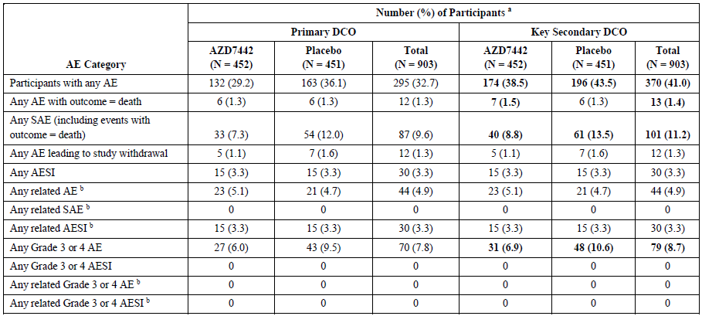
Abbreviation: AE, adverse event; AESI, adverse events of special interest; DCO, data cut-off; MedDRA, Medical Dictionary for Regulatory Activities; N, numbers of participants in the treatment group; SAE, serious AE.
ª Participants with multiple events in the same category are counted only once in that category. Participants with events in more than one category are counted once in each of those categories.
^{b} Possibly related, as assessed by the Investigator. Text in bold indicates change from the primary data cutoff to key secondary data cutoff.
Related adverse events were well balanced between groups with no increase in frequency between the primary and key secondary data cut-off (see Table 13). ‘Injection site pain’ was the commonest related AE, occurring in 1.8% Evusheld and 2.5% placebo recipients.
Table 13: Number of participants with adverse events, assessed by investigator as possibly related to intervention, by System Organ Class (safety analysis set), key secondary data cut-off
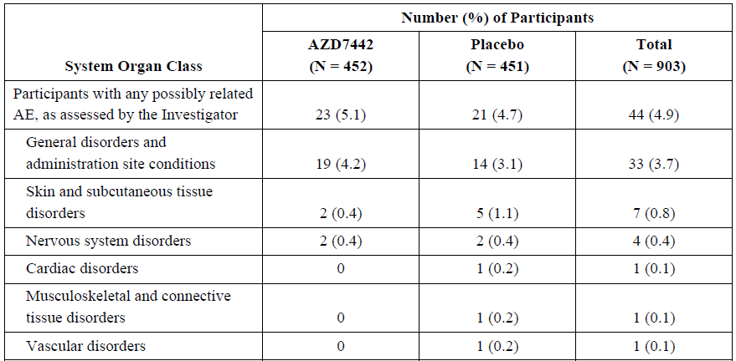
There were fewer Grade 3 (severe) or Grade 4 (life threatening) AEs in the Evusheld than placebo group, which largely reflected differences in the occurrence of COVID-19 pneumonia (4.2% versus 6.4% respectively) and COVID-19 (0% versus 1.8% respectively) (see Table 14).
Table 14: Number of participants with Grade 3 or 4 adverse events, by System Organ Class and Preferred Term (safety analysis set), key secondary data cut-off
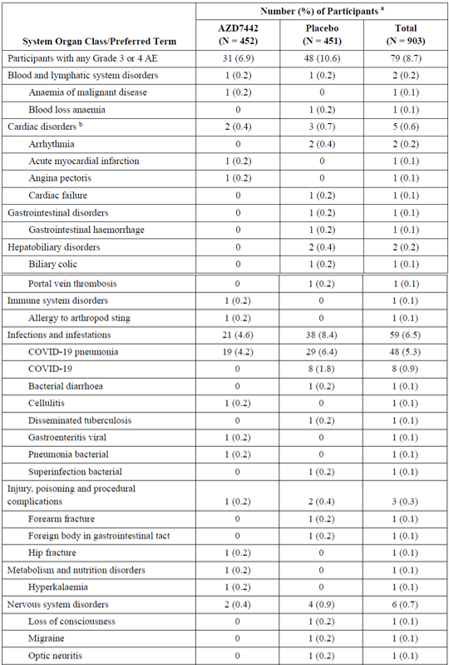
Table 14 (continued): Number of participants with Grade 3 or 4 adverse events, by System Organ Class and Preferred Term (safety analysis set), key secondary data cut-off
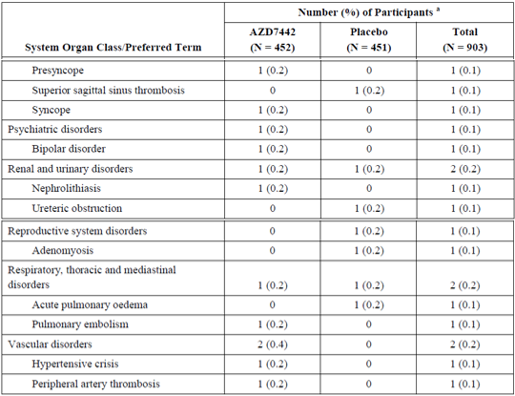
Abbreviations: AE, adverse event; COVID-19; coronavirus disease 2019; DCO, data cut-off; MedDRA, Medical Dictionary for Regulatory Activities; N, number of participants in treatment group; PT, preferred term; SAE, serious adverse event; SOC, System Organ Class.
a Number (%) of participants with a Grade 3 or 4 AE, sorted alphabetically by SOC, and within each SOC, PTs sorted by decreasing order of total frequency.
b For further details on Cardiac disorders and participant narratives see section on SAEs (below)
Participants with multiple events of the same preferred term are counted only once in that preferred term. Participants with events in more than one preferred term within the same SOC were counted only once in that SOC row. Includes adverse events that occurred through the Key Secondary DCO.
Note: AE severity ratings are defined in protocol (beyond scope of this AusPAR), COVID-19 AEs represent a deterioration of pre-existing COVID-19 disease.
Grade 3 or 4 AEs in the System Organ Class (SOC) ‘Cardiac disorders’ were seen in two participants (0.4%) in the Evusheld group (one each for ‘Acute myocardial infarction’ and ‘Angina pectoris’) and three participants (0.7%) in the placebo group (two of ‘Arrhythmia’ and one of ‘Cardiac failure’) (Table 14). Only one of the five events was a non-SAE, the case of Grade 3 angina pectoris occurring in a 54 year old White male on Day 66 with risk factors of prior smoking, diabetes, hypertension and obesity. The rest of the events are considered below in Serious adverse events
Two Grade 3 or 4 thromboembolic events were reported in the Evusheld Group, 1 (0.2%) each of ‘Pulmonary embolism’ and ‘Peripheral artery thrombosis’. Another two were reported in the placebo group, one (0.2%) each of ‘Portal vein thrombosis’ and ‘Superior sagittal vein thrombosis’ (see Table 14). All four events were considered SAEs (see section: Serious adverse events, below).

Deaths
There were seven deaths in the Evusheld group and six deaths in the placebo group from the TACKLE trial, none of which were deemed treatment related by the investigator. Causes of death in the Evusheld group (by PT) were: Acute left ventricular failure; Sudden cardiac death; COVID-19 pneumonia (n = 2); COVID-19; Colorectal cancer metastatic; Gastric cancer. Causes of death in the placebo group (by PT) were: COVID-19 pneumonia (n = 4); COVID-19; Septic shock.
The two cardiac deaths (both in Evusheld recipients) occurred in participants with prior risk factors.
One participant [identifying information redacted] was an 83 year old white male who experienced an SAE of Grade 3 acute myocardial infarction on Day 8 in the setting of prior acute myocardial infarction (13 months earlier), congestive heart failure, hypertension, arteriosclerosis and chronic kidney disease. He was hospitalised on the day of the acute myocardial infarction and died from acute left ventricular failure 5 days later.
One participant [identifying information redacted] was a 78 year old white male who experienced sudden cardiac death on Day 20 in the setting of prior coronary artery disease and hypertension. He died suddenly at home without preceding symptoms and an autopsy was refused by the family.

Serious adverse events
Serious adverse events (SAEs) from the TACKLE trial are summarised Table 15. There was imbalance in the frequency of ‘Any SAE’ between study groups (8.8% Evusheld versus 13.5% placebo), which reflected imbalance in the frequency of ‘COVID-19 pneumonia’ and/or ‘COVID-19’. Otherwise, SAEs were balanced by System Organ Class (SOC) and Preferred Term (PT) and none of the SAEs were deemed treatment related by the investigator.
Table 15: Number of participants with serious adverse events, by System Organ Class and Preferred Term (safety analysis set), key secondary data cut-off
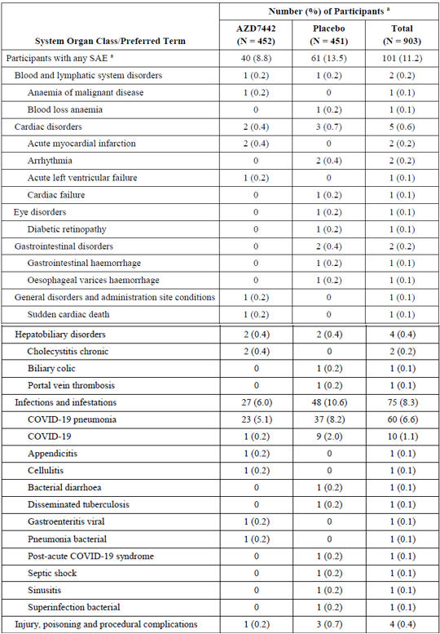

Table 15 (continued): Number of participants with serious adverse events, by System Organ Class and Preferred Term (safety analysis set), key secondary data cut-off
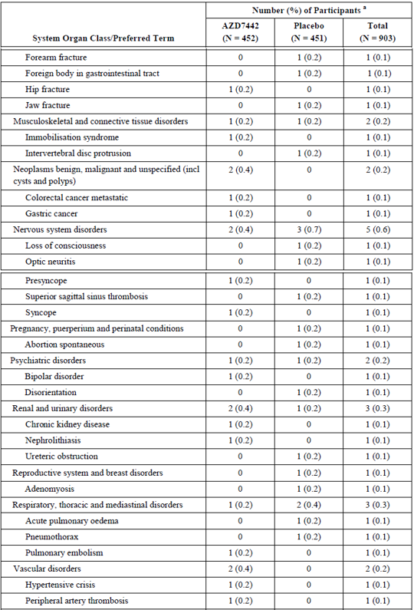
Abbreviations: COVID-19, coronavirus disease 2019; DCO, data cut-off; MedDRA, Medical Dictionary for Regulatory Activities; PT, preferred term; SAE, serious adverse event; SOC, system organ class.
a Number (%) of Participants with an SAE, sorted alphabetically by SOC, and within each SOC, PTs sorted by decreasing order of total frequency.
Participants with multiple events of the same preferred term are counted only once in that preferred term. Participants with events in more than one preferred term within the same SOC were counted only once in that SOC row. Includes adverse events that occurred through the key secondary DCO.
Cardiac and thromboembolic events:
- Participant [identifying information redacted] was a 67 year old white, Hispanic or Latino male who experienced a Grade 2 SAE of ‘Acute myocardial infarction’ Ten days after receiving 600 mg Evusheld. This occurred in the setting of prior smoking (since ceased], chronic kidney disease, systemic vasculitis, hypertension, myocardial ischaemia, and nephrogenic anaemia. The acute myocardial infarction was managed with angioplasty. A concurrent SAE was Grade 2 worsening of ‘Chronic kidney disease’, managed with haemodialysis. He recovered and was discharged from hospital on study Day 31.
- Participant [identifying information redacted] was a 46 year old white female who experienced a Grade 3 SAE of ‘Pulmonary embolism’ 28 days after receiving 600 mg Evusheld. There was no significant prior medical history other than obesity. She had an earlier Grade 3 SAE of ‘COVID-19 pneumonia’ requiring 14 days hospital admission, which began on the day of investigational product administration. The investigator ascribed causation of the pulmonary embolism to COVID-19. The participant recovered.
- Participant [identifying information redacted] was a 69 year old white male who experienced a Grade 3 SAE of ‘Peripheral artery thrombosis’ (An arterial thrombosis in the left axillary and brachial arteries) 13 days after receiving 600 mg Evusheld. There was a prior history of acute myocardial infarction, atrial fibrillation, coronary artery disease, hypertension and myocardial fibrosis. The participant recovered.

Discontinuation due to adverse events
Most discontinuations due to AEs from TACKLE trial reflected deaths and there were no additional Evusheld recipients who withdrew because of AEs.

Adverse events of special interest and other adverse events
Protocol defined adverse events of special interest (AESIs) for Evusheld were anaphylaxis, other serious hypersensitivity reactions (including immune complex disease) and injection site reactions. AESIs from TACKLE trial were balanced between groups (n = 15 (3.3%) in each) and 27 of the 30 AESIs represented injection site reactions; the only additional AESI in the Evusheld group was an event of Grade 2 skin erythema.
Three pregnancies occurred during the TACKLE trial in one Evusheld recipient and two placebo recipients. One of the placebo recipients’ pregnancies ended in spontaneous abortion, whereas the outcome of the other two pregnancies was unknown at the key secondary data cut-off.

Clinical laboratory evaluations, vital signs and electrocardiograms
There were no clinical differences noted between study groups for any of these parameters in TACKLE trial.
Clinically significant electrocardiogram abnormalities were reported in five Evusheld recipients and two placebo recipient, but in only one participant (Evusheld group) were they reported as AEs. One participant [identifying information redacted] was a 38 year old Asian man with no prior identified risk factors who experienced mild AEs (non-SAEs) of ‘Atrioventricular block first degree’ and ‘Nodal rhythm’ on study Day 29. These were deemed not related to investigational product by the investigator and with an outcome of ‘Not recovered / not resolved’.

Conclusion on safety
The Delegate noted that in the existing PI under ‘PROVENT/Cardiac Serious Adverse Events’ (section 4.8 in PI) there is a summary of ‘Cardiac SAEs’ from the PROVENT trial (utilising 300 mg Evusheld intramuscularly) by PT (Table 4 of the PI, beyond scope of this AusPAR). This shows all relevant cardiac SAEs, not just those deemed treatment related. In the text it is noted that ‘All subjects who experienced cardiac SAEs had cardiac risk factors and/or a prior history of cardiovascular disease at Baseline.’ and that one SAE resulted in death.
Similarly, under ‘PROVENT/Thromboembolic Serious Adverse Events’ there is a summary of thromboembolic events by PT (Table 5 of the PI, beyond scope of this AusPAR) that shows all relevant AEs, not just those deemed treatment related.
The data on cardiac SAEs (including cardiac deaths) and thromboembolic SAEs from the TACKLE trial (discussed above, see Serious adverse events) complement those existing data from PROVENT trial and are the only sponsor generated safety data for this SOC for the 600 mg Evusheld dosage. The Delegate is of view that those SAEs from the TACKLE trial should also be presented in the PI, with reference to the number, frequency and type (by PT) of events, including mention of the two cardiac deaths. The Delegate suggests this be presented in a new section headed ‘TACKLE’ between the sections on ‘PROVENT’ and the newly proposed ‘Repeat dosing’ section in the PI.

Risk management plan
The most recently evaluated Core-risk management plan (RMP) was version 1 (dated 2 February 2022; data lock point (DLP) 21 August 2021) and Australia specific annex (ASA) version 1.0 succession 2 (dated 19 January 2022) during submission PM-2021-05375-1-2. The sponsor provided EU-RMP version 1 succession 4 (dated 11 April 2022; DLP 29 June 2021) and ASA version 2 succession 1 (dated 12 May 2022) to the TGA as RMP update. In support of the current submission, the sponsor has provided EU-RMP version 2 succession 2 (dated 12 July 2022; DLP 30 June 2022) and ASA version 4 succession 1 (19 July 2022). For clarity, all changes since the previous submission, PM-2021-05375-1-2, will be highlighted in this report.
It is noted that EU-RMP version 2 succession 1 (dated 7 April 2022; DLP 28 February 2022) and ASA version 3 succession 1 (dated 8 June 2022) have been provided as part of supplementary information for submission PM-2021-05375-1-2 to extend the indication. As such, these documents are out of scope of this report.
The summary of safety concerns and their associated risk monitoring and mitigation strategies are summarised in Table 16. Further information regarding the TGA’s risk management approach can be found in risk management plans for medicines and biologicals and the TGA's risk management approach.

Table 16: Summary of safety concerns
Summary of safety concerns |  | Pharmacovigilance |  | Risk Minimisation
 |  | Routine | Additional | Routine | Additional
Important identified risks | None | – | – | – | –
Important potential risks | Cardiac serious adverse events^ | ✓¹ | – | ✓ | –
Important potential risks | Antiviral resistance due to emerging viral variants^ | ✓¹ | – | ✓ | –
Missing information | Immunocompromised/immunosuppressed patients^ | ✓ | – | – | –
Missing information | Use in pregnant women | ✓ | ✓² | ✓ | –
^Australia-specific safety concern
1. Follow-up questionnaire
2. Study D8850R00006 - Post-authorisation observational study of women exposed to Evusheld during pregnancy
The summary of safety concerns has been updated to change missing information ‘use in pregnant and breast-feeding women’ to ‘use in pregnant women’ to align with EU-RMP. This is acceptable from an RMP perspective.
The sponsor has updated the pharmacovigilance plan, since the previous submission, to include targeted follow up form for the potential risk of antiviral resistance due to emerging viral variants. This is considered acceptable from an RMP perspective. The acceptability of the clinical study plan will be assessed by the Delegate.
Only routine risk minimisation measures are proposed by the sponsor. This approach was deemed acceptable during the previous evaluation. The changes proposed by the current submission are not expected to require additional risk minimisation measures as part of the RMP.

Risk-benefit analysis

Delegate’s considerations
The sponsor’s proposed modified dosing regimen relies on in vitro neutralisation data and PK modelling based on that data. The sponsor’s rationale for doubling the dose and the six monthly repeated administration is that the increased dose will enable Evusheld to achieve the required capability to neutralise the Omicron variant of concerns in Australia. Based on the in vitro neutralisation data, it appears that there is a greater heterogeneity in the magnitude of in vitro neutralisation for tixagevimab and cilgavimab against the Omicron variants. A loss activity for tixagevimab is apparent for all Omicron subvariants, particularly the Omicron BA.3 and BA.4/5 subvariants. It should be noted that, at the time this submission was considered, the Omicron BA.4/5 subvariants are the most prevalent variants in Australia. The mechanistic basis of resistance for tixagevimab appears to be due to a mutation at the F486 region, which is at the critical binding site of tixagevimab. Based on this mechanism, it is unlikely for an increase in dose to provide benefit with an increase in the neutralisation activity of tixagevimab against the Omicron BA.4/5 subvariants. Although to a reduced magnitude (around 7.5-fold reduction), the preserved neutralisation activity of cilgavimab against the Omicron BA.4/5 subvariant was noted. This will be the sole source of neutralisation activity of Evusheld against the Omicron subvariants, when given as a ‘combination therapy’. The single source of neutralisation activity relates this therapy to a monotherapy, rather than a combination therapy. It is accepted that monoclonal antibody therapy by definition targets only a single epitope within the receptor binding domain (RBD). Escape mutations that were observed after in vitro and in vivo selection by the monoclonal antibodies were single amino acid substitutions localised almost exclusively to the RBDs. These escape mutations were largely observed from in vitro studies with single monoclonal antibody. These mutations were largely prevented by non-overlapping monoclonal antibody cocktails and from a clinical perspective, that is the rationale to prefer a cocktail (fixed dose combination) monoclonal antibody, over a monotherapy. The potential for the development of escape mutations due to the sole neutralising activity from cilgavimab when Evusheld will be administered to immunocompromised individuals exposed to Omicron BA.4/5 subvariants should be considered. It should also be considered that patients will be subjected to an additional intramuscular injection (tixagevimab) as part of the treatment with Evusheld, without expected benefits.
The PK modelling for repeated dose of 600 mg indicates that Evusheld would maintain a targeted serum concentration for the Omicron BA.4/5 subvariants. This is based on the assumption that both tixagevimab and cilgavimab have a comparable neutralisation activity against the Omicron BA.4/5 subvariants, which is not the case. Hence the Delegate is not convinced about the ability to translate the PK modelling data and the related assumptions to efficacy of Evusheld in a clinical setting. The half-life of Evusheld is around 90 days. Complete clearance of Evusheld will be at around 360 to 450 days. The proposed repeated dose is at 6 months (180 days) following the first dose, when around 25% of the medicine from the previous administration remains in the system. The repeated dose at this timepoint and further timepoints could potentially lead to cumulative effects. Clinical and/or toxicology data to examine any potential negative (safety) effects due to repeated dosing of 600 mg Evusheld is lacking. This is particularly important, considering the following safety events that were reported with 300 mg of Evusheld:
- Temporal relationship between Evusheld and cardiac events (increased incidence of cardiac events within 14 days after administration of Evusheld).
- Numerically high and greater than 2 times the proportion of subjects in the Evusheld arm experienced cardiovascular SAEs, compared to placebo.
- Greater number of cardiac deaths in Evusheld arm, compared to placebo (4 versus 0)
The systemic exposure from a dose of 300 mg of Evusheld administered at 12 months (± 2 months) in the repeat-dose substudy of the PROVENT trial (Substudy D8850C002A01) is not comparable to the proposed 600 mg of Evusheld administered at six months and hence the substudy results are not considered as contributing to the evidence to support the efficacy and safety of the proposed dosage regimen.
The TACKLE trial was performed among outpatient adults (greater or equal to 18 years of age) at a high risk of progression to severe COVID-19 with a positive polymerase chain reaction (PCR) test performed less than or equal to 3 days prior to study entry and with less than or equal 7 days of symptoms of COVID-19 at study entry. Treatment commenced less than or equal 5 days of the onset of symptoms resulted in a greater treatment benefit, compared to greater than 5 days. The magnitude of treatment benefits for patients with appears to be persistent at Day 169 of the TACKLE trial, with around 50% risk reduction in terms of developing severe COVID-19 or death from any cause in non-hospitalised adults who had been symptomatic for 7 days or less. The treatment difference was statistically significant, compared to placebo. The secondary efficacy outcomes were generally consistent at Day 169 and supportive. Treatment benefits in patients affected with Omicron BA.4/5 subvariants is unknown.
The extent of reported exposure to single dose Evusheld 600 mg comprises 452 participants in the TACKLE trial followed up for a median of 170 of the intended 457 days, so the likelihood of detecting rare events is limited. However, overall, AEs were generally balanced between Evusheld and placebo recipients with notable differences due to excess COVID-19 and COVID-19 pneumonia in the placebo group.
Serious adverse events were observed due to cardiac and thromboembolic disorders in both study groups, with both deaths due to cardiac events occurring in the Evusheld group. Affected participants generally had pre-existing risk factors and none of the severe AEs or SAEs in those categories were deemed treatment related by the investigator. Notably though, treatment attribution of AEs can be uncertain for therapeutics with a long half-life that may potentially exacerbate underlying conditions. Precautionary statements to highlight the risks associated with treatment with Evusheld in patients with cardiovascular risks are recommended to be highlighted in the PI. The safety events that occurred in TACKLE trial should also be mentioned in the PI.
Overall, the incidence and type of safety adverse events from the primary data cut-off to secondary data cut-off appears to be consistent.

Proposed action
Heterogeneity in the neutralisation activity between tixagevimab and cilgavimab limits the ability to translate the assumptions based on PK modelling to treatment benefits against Omicron subvariants of concerns in Australia in a clinical setting.
The Delegate seeks the Advisory Committee on Medicine’s (ACM’s) advice regarding whether there is enough evidence to support treatment benefits with the double dose and six monthly regimen for immunocompromised individuals affected with Omicron BA.4/5 subvariants. The Delegate also seeks the ACM’s advice on the potential risks associated with treatment effects from a single agent (cilgavimab) and whether those risks outweigh the treatment benefits, particularly in the absence of clinical data.
There is lack of clinical and nonclinical safety data to assess any potential impact of the cumulative exposure due to the proposed repeated doses.
Additional efficacy and safety data from TACKLE trial is consistent with the previously submitted data. Treatment benefits in patients affected with Omicron BA.4/5 subvariants is unknown.

Advisory Committee considerations
The Advisory Committee on Medicines (ACM), having considered the evaluations and the Delegate’s overview, as well as the sponsor’s response to these documents, advised the following.

Specific advice to the Delegate
- Please comment on the adequacy of PK modelling and the non-clinical data to support the proposed modified dosing regimen.
The ACM was of the view that the pharmacokinetic (PK) modelling and non-clinical data adequately supports the proposed modified dosing regimen.
The ACM noted that the PK modelling is justifiable, and the results are consistent with the available PK sampling. The PK modelling and simulation are informed by Phase I (included doses up to 3000 mg) and PROVENT prophylaxis, STORM CHASER 'post-prophylaxis' (used 300 mg doses) and the TACKLE Phase III treatment study (used 600 mg doses). The simulated median doses within the model appeared well matched to the observed data from the actual doses used.
The ACM discussed the appropriateness of pharmacodynamic equivalence as the basis of bridging and the extrapolation of pharmacodynamic relationships to prior demonstrated efficacy metrics in a non-static disease state and queried whether the stable disease state assumption implicitly utilised in the modelling is appropriate given transmission and virulence of COVID-19 has modified since the PROVENT prophylaxis study for reasons additional to immune escape.
The ACM commented that the methodology of dose selection is not novel, however not testing the dose in a clinical trial is novel. The ACM noted that this is a challenge within the infectious diseases space where there is often high mutation potential.
- Does the committee have any concerns regarding the loss activity of tixagevimab against Omicron BA.3 and BA.4/5 subvariants and the loss of activity of Evusheld against the Omicron BA.4.6 subvariant?
If so, please comment on its potential implications.
The ACM discussed the potential for resistance to either tixagevimab or cilgavimab or both towards the current or future variants and noted that a loss of activity of Evusheld is of significance. The ACM noted the emergence of Omicron BA.4/5 subvariants and sublineages as almost completely non-responsive to tixagevimab. Further noting that a subsequent loss of activity of cilgavimab would result in overall loss of activity of Evusheld.
The ACM agreed that it is important to monitor resistance profiles however highlighted that current resistance does not preclude the later re-emergence of activity with newer sublineages.
On balance, the ACM agreed that it is important that the PI appropriately outline the potential for loss of activity, however, was of the view that this concern should not preclude provisional registration noting that the current resistance profiles may not persist with the emergence of new variants of concern.
The magnitude of benefit with doubling the dose was discussed. The mechanism of resistance of BA.4/5 subvariants to tixagevimab and cilgavimab was noted as the mutations at the respective binding sites. In view of the above, the ACM noted treatment with a double dose of Evusheld may still provide some benefits due to the mixed population of the COVID-19 virus that may consist of variants against which Evusheld still retains neutralisation activity. It was also considered that there is a potential for these mutations to change in the same variant (dynamic nature) and in subsequent variants. For these reasons, doubling the dose of Evusheld was considered to provide some treatment benefit. However, the risks associated at the higher dose will also need to be considered.
- Does the committee agree that the sponsor has adequately demonstrated that doubling the dose and 6 monthly administration has increased the efficacy of Evusheld 600 mg, compared to 300 mg against Omicron variants of concern in Australia?
Will it provide greater protection for the indicated population against the Omicron subvariants of concern in Australia?
The ACM was of the view that the 600 mg dose will provide greater protection than the 300 mg however noted that this is realised predominately as a longer duration of protection. The ACM therefore noted that the magnitude (and meaningfulness) of this greater protection is not certain and will diminish over time. The ACM also noted the lack of clinical data to demonstrate the greater clinical efficacy of 600 mg intramuscular Evusheld.
- Is the committee satisfied that the safety profile of the proposed modified dosing regimen has been adequately demonstrated?
The ACM noted that the modified dosing regimen does not appear to have increased the rate of adverse events. The ACM noted that this is demonstrated by the lack of an adverse event dose response relationship in Phase I/II, Phase III treatment and real-world post-marketing evidence from the USA.
The ACM however highlighted that the repeat dose safety data are limited, and most of the data are related to 300 mg and not the proposed 600 mg of Evusheld. The ACM concluded that continued monitoring would be required to ensure the safety of repeat dosing.
With regards to the TACKLE trial and the treatment indication, the ACM discussed cardiac complications and reiterated the views expressed at the February 2022 ACM meeting. The ACM noted the higher rates of adverse cardiac events in the treatment population in the TACKLE trial, compared to placebo. The ACM noted that all of the reported cardiac deaths were in the Evusheld arm and none in the placebo.
The ACM was of the view that there is a real signal for cardiac events, noting that the mechanism is not currently identified. The ACM agreed the cardiac signal is highly relevant and important and emphasised that it must be highlighted in the PI. The ACM further noted that it would be helpful to include the table comparing the death rates between the Evusheld and placebo groups within the PI.
- Please comment whether the proposed PI changes adequately reflect the non-clinical data and the efficacy and safety profile of Evusheld.
The ACM was of the view that it is important to highlight resistance and breakthrough infection within the PI and was supportive of the inclusion of the ‘Breakthrough infection or treatment failure due to antiviral resistance’ wording proposed in Section 4.4 of the PI. The ACM did advise that prophylaxis should be included in the final paragraph, stating:
Decisions regarding the use of Evusheld for the prophylaxis or treatment of COVID-19 should take into consideration what is known about the characteristics of the circulating SARS-CoV-2 viral variants, including geographical prevalence and local guidelines.
The ACM noted the US Food and Drug Administration (FDA) updates on variants not neutralised by Evusheld and agreed that similar statements should be included in the PI, as it was considered important that prescribers are aware of this type of information.
The ACM commented that it is difficult to present the resistance information however agreed that the table included in the PI is sufficient for the purpose.
- Does ACM support the provisional registration of Evusheld with the modified dosing regimen?
The ACM was, on balance, supportive of the provisional registration of the modified dosing regimen for Evusheld associated with the pre-exposure prophylaxis indication. The ACM commented on the favourable drug interactions profile and the potential benefits of this intramuscular injection formulation for adherence.
The ACM noted that the data provided in support of the proposed modified dosing regimen for prophylaxis is a hybrid bridging type application, primarily based on pharmacodynamic equivalence from modelling/simulation and in-vitro results, and also included a range of Phase I and Phase II data, a randomised controlled trial and real-word evidence to support safety or efficacy.
The ACM noted that the currently approved pre-exposure prophylaxis indication limits usage to those who are unlikely to mount an adequate immune response to COVID-19 vaccination or for whom vaccination is not recommended. In the Australian context this is generally immunocompromised individuals. While the ACM highlighted that there is limited data within this population, the 600 mg dose is likely to provide greater protection than the current 300 mg dose in this population with a need for protection.
The ACM discussed the value of a repeat dose at 6 months and noted that the use of a second dose is dependent on patient circumstances (that is disease progression and/or treatment options) and the COVID-19 landscape at the time. Based on these factors the ACM agreed that it would be appropriate for the repeat dosing at 6 month intervals to be optional. The ACM agreed that statements to this effect should be included in the PI and that the limited repeat dose data be highlighted. The ACM agreed that the 6 monthly dosing should be at the treating physician’s discretion and based on the available evidence and public health priorities at the time. The ACM noted that this information should be highlighted in the dose and administration section of the PI.
- Does ACM support the provisional registration of Evusheld for the treatment indication?
The ACM was on balance supportive of the provisional registration of Evusheld for a treatment indication with the recommended dosage of 600 mg; additionally
- the ACM agreed that the indication should be limited to use in adults, noting that this aligns with the clinical trial population and the safety risks are uncertain for a younger age group;
- the ACM reiterated that the cardiac signal must be clearly highlighted in the PI;
- the ACM also advised that the initiation of therapy criteria utilised in the clinical trial should be included within the clinical trials and/or administration section of the PI;
- the ACM discussed the potential for variant resistance and emphasised the public health advice and the current circulating virus needs to be considered when prescribing Evusheld;
- the ACM commented on the challenges associated with having COVID-19 positive patients entering standard GP clinics to receive the injections and queried its place in therapy.

Conclusion
The ACM emphasised that this therapy is not an alternative or substitute for vaccination. The ACM reiterated its view that vaccination is the preferred and primary option to prevent COVID-19.
The ACM considered this product to have a provisionally positive benefit-risk profile for the indication:
Evusheld has provisional approval for the treatment of adults with COVID-19, who do not require supplemental oxygen and who are at increased risk of progressing to severe COVID-19.
This decision has been made on the basis of short-term safety data. Continued approval depends on the evidence of longer-term safety data from ongoing clinical trial
Evusheld is not intended to be used as a substitute for vaccination against COVID‐19.
The ACM also considered the modified dosing regimen to have a positive benefit-risk profile within the context of a provisional registration, however agreed that the repeat 6-month dosing for pre-exposure prophylaxis should be optional.

Outcome
Based on a review of quality, safety, and efficacy, the TGA approved the registration of Evusheld (tixagevimab and cilgavimab) 100 mg/mL of tixagevimab and 100 mg/mL of cilgavimab, solution for injection, vial, indicated for and change in dose regime:
Evusheld has provisional approval for the treatment of adults with COVID-19, who do not require supplemental oxygen and who are at increased risk of progressing to severe COVID-19. See Section 4.2 Dose and method of administration and Section 5.2 Pharmacokinetic properties.
This decision has been made on the basis of short-term efficacy and safety data. Continued approval depends on the evidence of longer-term efficacy and safety data from ongoing clinical trial.
Changes in dose regime (as per Product Information)
The recommended dose to be increased from 300 mg to 600 mg intramuscular (IM) and repeat doses of 600 mg of Evusheld (300 mg of tixagevimab and 300 mg of cilgavimab) is optional and may be given once every 6 months at the discretion of the treating health care professional for pre-exposure prophylaxis indication.

Specific conditions of registration applying to these goods
- The Evusheld EU-RMP (version 2.2, dated 12 July 2022, data lock point 30 June 2022), with ASA (version 4.1, dated 19 July 2022), included with submission PM-2022-03097-1-2, and any subsequent revisions, as agreed with the TGA will be implemented in Australia.
An obligatory component of risk management plans is routine pharmacovigilance. Routine pharmacovigilance includes the submission of periodic safety update reports (PSURs).
Unless agreed separately between the supplier who is the recipient of the approval and the TGA, the first report must be submitted to TGA no later than 15 calendar months after the date of this approval letter. The subsequent reports must be submitted no less frequently than annually from the date of the first submitted report until the period covered by such reports is not less than three years from the date of this approval letter, or the entire period of provisional registration, whichever is longer.
The reports are to at least meet the requirements for PSURs as described in the European Medicines Agency’s Guideline on good pharmacovigilance practices (GVP) Module VII-periodic safety update report (Rev 1), Part VII.B Structures and processes. Note that submission of a PSUR does not constitute an application to vary the registration. Each report must have been prepared within ninety calendar days of the data lock point for that report.
- The final study reports for the following study will have to be submitted before a definitive authorisation can be considered: TACKLE trial.
- All relevant conditions imposed under the original decision dated 24 February 2022 still apply.

Attachment 1. Product Information
The PI for Evusheld approved with the submission which is described in this AusPAR is at Attachment 1. For the most recent PI, please refer to the TGA PI/CMI search facility.

Therapeutic Goods Administration
PO Box 100 Woden ACT 2606 Australia
Email: info@tga.gov.au Phone: 1800 020 653 Fax: 02 6232 8605
https://www.tga.gov.au

AusPAR for Evusheld (tixagevimab and cilgavimab), AstraZeneca Pty Ltd; submission PM-2021-05375-1-2. Published 11 March 2022; provisional and initial approval of Evusheld, indicated for the pre-exposure prophylaxis of COVID-19. Available online at: AusPAR: Tixagevimab and cilgavimab | Therapeutic Goods Administration (TGA)
Tuekprakhon et al. Antibody escape of SARS-CoV-2 Omicron BA.4 and BA.5 from vaccine and BA.1 serum, Cell, 2022. 185,14 :2422-2433.
Case J, Mackin S, Errico J et al (2022) Resilience of S309 and AZD7442 monoclonal antibody treatments against 2 infections by SARS-CoV-2 Omicron lineage strains. Nature Communications 13, 3824 (2022).

