November 2022

Australian Public Assessment Report for Utrogestan 200
  - Active ingredient: Progesterone
  - Sponsor: Besins Healthcare Australia Pty Ltd

About the Therapeutic Goods Administration (TGA)
- The Therapeutic Goods Administration (TGA) is part of the Australian Government Department of Health and is responsible for regulating therapeutic goods, including medicines, medical devices, and biologicals.
- The TGA administers the Therapeutic Goods Act 1989 (the Act), applying a risk management approach designed to ensure therapeutic goods supplied in Australia meet acceptable standards of quality, safety, and efficacy.
- The work of the TGA is based on applying scientific and clinical expertise to decision-making, to ensure that the benefits to the Australian public outweigh any risks associated with the use of therapeutic goods.
- The TGA relies on the public, healthcare professionals and industry to report problems with therapeutic goods. The TGA investigates reports received to determine any necessary regulatory action.
- To report a problem with a therapeutic good, please see the information on the TGA website.

About AusPARs
- The Australian Public Assessment Report (AusPAR) provides information about the evaluation of a prescription medicine and the considerations that led the TGA to approve or not approve a prescription medicine submission. Further information can be found in Australian Public Assessment Report (AusPAR) guidance.
- AusPARs are prepared and published by the TGA.
- AusPARs are static documents that provide information that relates to a submission at a particular point in time. The publication of an AusPAR is an important part of the transparency of the TGA’s decision-making process.
- A new AusPAR may be provided to reflect changes to indications or major variations to a prescription medicine subject to evaluation by the TGA.

Copyright
© Commonwealth of Australia 2022
This work is copyright. You may reproduce the whole or part of this work in unaltered form for your own personal use or, if you are part of an organisation, for internal use within your organisation, but only if you or your organisation do not use the reproduction for any commercial purpose and retain this copyright notice and all disclaimer notices as part of that reproduction. Apart from rights to use as permitted by the Copyright Act 1968 or allowed by this copyright notice, all other rights are reserved, and you are not allowed to reproduce the whole or any part of this work in any way (electronic or otherwise) without first being given specific written permission from the Commonwealth to do so. Requests and inquiries concerning reproduction and rights are to be sent to the TGA Copyright Officer, Therapeutic Goods Administration, PO Box 100, Woden ACT 2606 or emailed to <tga.copyright@tga.gov.au>.

Contents
List of abbreviations 4
Product submission 5
Submission details 5
Product background 7
Regulatory status 10
Product Information 10
Registration timeline 10
Submission overview and risk/benefit assessment 11
Quality 11
Nonclinical 11
Clinical 11
Risk management plan 37
Risk-benefit analysis 37
Outcome 40
Specific conditions of registration applying to these goods 41
Attachment 1. Product Information 41

List of abbreviations
Abbreviation |  | Meaning
ACM | Advisory Committee on Medicines
ADR | Adverse drug reaction
AE | Adverse event
ART | Assisted reproductive technology
ARTG | Australian Register of Therapeutic Goods
CI | Confidence interval
GRADE | Grading of Recommendations Assessment, Development and Evaluation (working group/framework)
IVF | In vitro fertilisation
LPD | Luteal phase deficiency
NICE | National Institute for Health and Care Excellence (United Kingdom)
PBRER | Periodic benefit-risk evaluation report
PI | Product Information
PSUR | Periodic safety update report
RCT | Randomised controlled trial(s)
RR | Relative risk ratio
TGA | Therapeutic Goods Administration
UK | United Kingdom

Product submission

Submission details
Type of submission: | Extension of indications
Product name: | Utrogestan 200
Active ingredient: | Progesterone
Decision: | Approved
Date of decision: | 17 February 2022
Date of entry onto ARTG: | 22 February 2022
ARTG number: | 232824
Black Triangle Scheme: | No
Sponsor’s name and address: | Besins Healthcare Australia Pty Ltd  Level 16, Tower 2, Darling Park,  201 Sussex Street, Sydney, NSW 2000
Dose form: | Pessary (soft capsule)
Strength: | 200 mg
Container: | Blister pack
Pack size: | 7 pessaries (trade or starter pack), and packs of 14, 15, 21, 28, 30, 42, 45, 56, 84 or 90 pessaries
Approved therapeutic use: | Treatment of unexplained threatened miscarriage in women with bleeding in the current pregnancy and a history of at least three or more previous miscarriages.  Use in women with less than three miscarriages may be warranted in those with reduced chances of future pregnancy such as those undergoing IVF treatment with limited viable egg and/or embryo availability or advanced fertility age. However, the benefit of treatment in clinical trials was limited to women with three or more miscarriages. (See Section 5 Pharmacological properties; Clinical trials; Threatened unexplained miscarriage)
Route of administration: | Intravaginal
Dosage: | The use of Utrogestan 200 is for adults only, and it is not applicable to children and the elderly.  The average total daily dosage is 200 to 800 mg (1 to 4 pessaries) of progesterone per day to be introduced deep into the vagina. Dosage is based on multiple factors, including the purpose of Utrogestan 200 being used and may be increased depending on the patient's response. Higher total daily doses may be divided into two or three doses depending on the clinical scenario.  During pregnancy, Utrogestan 200 should be used for the recommended timeframes for each indicated use (see Section 4.2 Dose and administration of the Product Information for details of timeframes of days of cycle, week and trimester depending on indication). Utrogestan 200 should only be used by the vaginal route.  Utrogestan 200 is not suitable for use as a contraceptive.  Luteal phase support  The recommended dosage is 600 mg/day (3 pessaries), in three divided doses (one pessary, three times a day), from the day of embryo transfer until at least the seventh week of pregnancy and not later than the twelfth week of pregnancy.  Prevention of preterm birth  The usual dose is 200 mg/day (one pessary), recommended to be administered at bedtime. Treatment can be initiated during the second trimester (16 to 24 weeks gestation) and is to be continued to the end of the thirty sixth week of gestation or until delivery.  Threatened miscarriage  The usual dose is 400 mg (two pessaries) twice a day (morning and night). Treatment should be initiated at the first sign of vaginal bleeding during the first trimester of pregnancy (see Section 4.4 Special warnings and precautions for use) and should continue to at least the sixteenth week of gestation.  For further information regarding dosage, refer to the Product Information.
Pregnancy category: | A  Drugs which have been taken by a large number of pregnant women and women of childbearing age without any proven increase in the frequency of malformations or other direct or indirect harmful effects on the fetus having been observed.  The use of any medicine during pregnancy requires careful consideration of both risks and benefits by the treating health professional. This must not be used as the sole basis of decision making in the use of medicines during pregnancy. The TGA does not provide advice on the use of medicines in pregnancy for specific cases. More information is available from obstetric drug information services in your State or Territory.

Product background
This AusPAR describes the submission by Besins Healthcare Australia Pty Ltd (the sponsor) to register Utrogestan 200 (progesterone) 200 mg, pessary (soft capsule) for the following proposed extension of indications:
Support during pregnancy
  - Prevention of miscarriage in women with threatened miscarriage or with a history of recurrent miscarriage.
Early pregnancy loss is common, occurring in 15 to 20% of all clinically recognised pregnancies. Approximately 80% of all cases of pregnancy loss occur within the first trimester. Miscarriage is defined as the spontaneous loss of pregnancy before the fetus reaches viability and includes all pregnancy losses from the time of conception until 24 weeks of gestation. In the first trimester, the terms miscarriage, spontaneous abortion and early pregnancy loss are used interchangeably, and there is no consensus on terminology in the literature. However, miscarriage is distinct from sub-fertility, which generally describes delay in conception, or any form of reduced fertility with prolonged time of unprotected intercourse without contraception and requires a structured diagnostic and therapeutic approach.
Threatened miscarriage is manifested by vaginal bleeding, with or without abdominal pain, while the cervix is closed, and the fetus remains viable inside the uterine cavity. Vaginal bleeding during pregnancy can be a clinical presentation of a non-viable pregnancy, in which the corpus luteum or placenta no longer produces adequate progesterone. Increased bleeding intensity and duration is significantly associated with an increased risk of clinical pregnancy loss, while the number of bleeding episode is not.⁴ Half of pregnancies with threatened miscarriage result in miscarriage and once the cervix begins to dilate, miscarriage and pregnancy loss are inevitable. Although many women who have threatened miscarriage go on to have a successful pregnancy, there is an increase in risk of miscarriage in the same pregnancy and 17% of women with threatened miscarriage continue to experience further complications in the same pregnancy. Women who experience bleeding between 6 and 8 weeks’ gestation are at an increased risk of experiencing clinical pregnancy loss compared to those women who do not experience vaginal bleeding between 2 and 8 weeks’ gestation.⁴ Heavy bleeding during the first trimester of pregnancy (similar or greater that that seen during a women’s normal menses) and heavy bleeding accompanied by pain is strongly predictive of miscarriage.
Recurrent miscarriage is defined as the loss of three or more consecutive pregnancies by the Royal College of Obstetricians and Gynaecologists (United Kingdom),¹ while the European Society of Human Reproduction and Embryology defines recurrent pregnancy loss as loss of 2 or more pregnancies. The prevalence of recurrent miscarriage is significantly higher than that expected by chance alone (0.4%). About 50% of miscarried fetuses and embryos have normal chromosomes;⁵ while remaining 50% of miscarriages are termed aneuploid miscarriages and result from numeric chromosome errors such as trisomy, polyploidy and monosomy X. Aneuploidy is thought to occur on a random basis and as such, the risk of subsequent miscarriage is not increased. However, euploid miscarriages are more frequently diagnosed with increasing number of previous miscarriages and as the number of miscarriages increases, the risk of euploid pregnancy loss increases.¹ Other risk factors for recurrent miscarriages include anatomical (cervical insufficiency, congenital uterine malformations), endocrine or infective factors and epidemiological factors (advancing maternal age, obesity, smoking, alcoholism). Miscarriage can cause excessive bleeding, infection, and complications associated with surgical treatment, as well as substantial psychological harm, including anxiety, depression, and post-traumatic stress.⁵
Strategies to prevent miscarriage in women with a history of miscarriage or women presenting with bleeding in early pregnancy are limited. Bed rest (used commonly) and uterine muscle relaxants (rarely used) have limited evidence to support their use. When a definite or likely cause for recurrent pregnancy loss is discovered, therapy is commonly initiated such as anticoagulant therapy for patients with inherited thrombophilia or aspirin and heparin for a patient diagnosed with anti-phospholipid syndrome. However, there are limited therapeutic options for preventing miscarriage in women with idiopathic recurrent miscarriage.
Approximately 20% of pregnancies miscarry in the first trimester and many women will experience some bleeding and/or pain in early pregnancy that does not cause miscarriage. In many countries, women with bleeding and/or pain will be treated with progesterone or progestogens in an effort to decrease the risk of miscarriage although there is limited evidence to support this.
Currently, there are no registered treatments in Australia for the prevention of miscarriage in women with threatened miscarriage or with a history of recurrent miscarriage.
The clinical rationale for the sponsor to develop Utrogestan 200 (progesterone) is as follows:
Plasma progesterone increases during pregnancy from conception to delivery and several studies have demonstrated that low serum progesterone levels are associated with poor pregnancy outcomes;⁶ and may be the leading cause of threatened miscarriage; compared to women with normal pregnancy, serum progesterone levels are low in non-viable gestations (by approximately 22 to 38 nmol/L) and in women with threatened miscarriage (by approximately 10 nmol/L).¹⁴ Therefore, the potential therapeutic opportunity for progesterone is greatest in women with a large number of previous miscarriages.¹⁰ However, there are no standardised miscarriage risk assessment tools and no accepted standardised progesterone cut-off levels to categorise women as ‘low risk’ or ‘high-risk’ of miscarriage.⁶
Luteal phase deficiency (LPD) is one of the many aetiologies associated with early pregnancy loss and approximately 35% of women with recurrent pregnancy losses are attributed to LPD resulting in inadequate levels of progesterone (cut-off of 35 nmol/L had negative predictive value of 92%). A functioning corpus luteum is essential to early pregnancy survival. LPD can also be caused by an inadequate endometrial response to estradiol and progesterone and to a failure of the corpus luteum to produce adequate progesterone several weeks into the pregnancy, before the placenta is the predominant source of progesterone although there are no reliable tests to identify patients who may have LPD.,
Progesterone supplementation is an important aspect of any assisted reproductive technology (ART) treatment and vaginal progesterone has become the mainstay of luteal supplementation during in vitro fertilisation (IVF) because of cost, ease of use, low incidence of side effects and safety during pregnancy. Full benefit from progesterone supplementation may only be realised if progesterone is administered from the luteal phase rather than after a positive pregnancy test.⁸ Women without luteal phase defects but at risk of miscarriage due to immunological factors, luteinic and neuroendocrine deficiencies and myometrial hypercontractility; may also benefit from progesterone therapy to prevent miscarriage. This is due to its unique pharmacodynamic profile because progesterone modulates maternal immune responses to protect the fetus, improves the utero-placental circulation, maintains cervical integrity throughout pregnancy, promotes myometrial relaxation, inhibits prostaglandin production and possesses anti-inflammatory properties.,, The role of progesterone in the pathophysiology of pregnant women is crucial from conception until delivery and, therefore, there is strong biological plausibility to support exogenous progesterone for the management of prevention of recurrent and threatened miscarriage.¹³
The vaginal route of administration has the potential advantage of higher uterine bioavailability with few systemic side effects. Vaginal progesterone is advantageous because it is self-administered, locally available, associated with few side effects and is considered safe in pregnancy (Utrogestan 200 PI). However, natural progesterone has a short half-life and therefore requires daily treatment.

Regulatory status
The product received initial registration on the Australian Register of Therapeutic Goods (ARTG) on 12 July 2016. At the time that this submission was considered it was approved for the following indications:
Luteal phase support
- Luteal Support of assisted reproductive technology (ART) cycles
Support during pregnancy
- Prevention of preterm birth in women with singleton pregnancy who have a short cervix (mid-trimester sonographic cervix ≤ 25 mm) and/or a history of spontaneous preterm birth.
At the time the TGA considered this submission, similar submissions relating to threatened and recurrent miscarriage had been approved in many countries including Singapore in April 2018, and in Europe (Belgium on 9 January 2006, France on 16 April 1999, Italy in January 2004, Spain in July 2002 and Finland on 12 March 2003).

Product Information
The Product Information (PI) approved with the submission which is described in this AusPAR can be found as Attachment 1. For the most recent PI, please refer to the TGA PI/CMI search facility.

Registration timeline
The following table captures the key steps and dates for this submission.
Table 1: Timeline for Submission PM-2020-06063-1-5
Description | Date
Submission dossier accepted and first round evaluation commenced | 4 January 2021
First round evaluation completed | 28 May 2021
Sponsor provides responses on questions raised in first round evaluation | 30 August 2021
Second round evaluation completed | 30 August 2021
Delegate’s Overall benefit-risk assessment and request for Advisory Committee advice | 2 November 2021
Sponsor’s pre-Advisory Committee response | 16 November 2021
Advisory Committee meeting | 2 and 3 December 2021
Registration decision (Outcome) | 17 February 2022
Completion of administrative activities and registration on the ARTG | 22 February 2022
Number of working days from submission dossier acceptance to registration decision* | 215
*Statutory timeframe for standard submissions is 255 working days

Submission overview and risk/benefit assessment
A summary of the TGA’s assessment for this submission is provided below.
TGA guidance at pre-submission meetings is nonbinding and without prejudice.

Quality
A full quality evaluation was conducted at the time this product received initial registration.
Further quality information can be found in an AusPAR for a similar past submission.

Nonclinical
A full nonclinical evaluation was conducted at the time this product received initial registration.
Further nonclinical information can be found in an AusPAR for a similar past submission.²⁴

Clinical

Summary of clinical studies
This was a literature-based submission. Pre-submission advice was sought from the TGA.
There were 22 studies included in the submission as evidence for the assessment of efficacy of the proposed indication (two of which were pivotal investigator-sponsored Phase III trials: the PRISM and PROMISE trial), and 14 studies were included as evidence of safety (see Table 2 below).
Table 2: Summary of clinical efficacy and safety studies evaluated in this submission
Type of study | Study name and/or publication reference
Pivotal investigator-sponsored studies
Efficacy/safety | PRISM trial  Coomarasamy, A. et al. A Randomized Trial of Progesterone in Women with Bleeding in Early Pregnancy, N Engl J Med, 2019; 380: 1815-1824.
Efficacy/safety | PRISM trial  Coomarasamy, A. et al. Progesterone to Prevent Miscarriage in Women with Early Pregnancy Bleeding: the PRISM RCT, Health Technol Assess, 2020; 24(33): 1-70.
Efficacy/safety | PROMISE trial  Coomarasamy, A. et al. A Randomized Trial of Progesterone in Women with Recurrent Miscarriages, N Engl J Med, 2015; 373: 2141-2148.
Efficacy/safety | PROMISE trial  Coomarasamy, A. et al. PROMISE: First-Trimester Progesterone Therapy in Women with a History of Unexplained Recurrent Miscarriages - a Randomised, Double-Blind, Placebo-Controlled, International Multicentre Trial and Economic Evaluation, Health Technol Assess, 2016; 20(41): 1-92.
Supporting investigator sponsored studies
Efficacy/safety | Molvarec, A and Szalay, J. Preliminary Results with the Vaginal Application of the Natural Micronized Progesterone in the Prevention of Recurrent Early Spontaneous Abortions and in the Treatment of Habitual Aborters Suffer from Luteal Insufficiency, Magyar Noorvosok Lapja, 2001; 64: 303-308.
Efficacy/safety | Russu, M. et al. Pregnancy Outcomes Following Preconception, Early and Late Administration of Vaginal Micronized Progesterone for Recurrent Pregnancy Loss, Gineco ro, 2009; 5: 10‐15.
Efficacy/safety | Vignali, M and Centinaio, G Efficacy of the Vaginal Administration of Natural Progesterone in Patients with Recurrent Spontaneous Hormone Caused Abortion, Minerva Ginecol, 2000; 52(9): 367-374.
Efficacy | Gerhard, I. et al. Double-Blind Controlled Trial of Progesterone Substitution in Threatened Abortion, Biol Res Pregnancy Perinatol, 1987; 8(1 1ST Half): 26-34.
Efficacy | Stephenson, M.D. et al. Luteal Start Vaginal Micronized Progesterone Improves Pregnancy Success in Women with Recurrent Pregnancy Loss, Fertil Steril, 2017 Mar;107(3): 684-690.e2.
Efficacy | Check, J.H et al. Progesterone Therapy to Decrease First-Trimester Spontaneous Abortions in Previous Aborters, Int J Fertil, 1987; 32(3): 192-193, 197-199.
Efficacy | Ghosh, S. et al. Assessment of Sub-Endometrial Blood Flow Parameters Following Dydrogesterone and Micronized Vaginal Progesterone Administration in Women with Idiopathic Recurrent Miscarriage: a Pilot Study, J Obstet Gynaecol Res, 2014; 40: 1871-1877.
Efficacy | PRISM trial  Okeke Ogwulu, C.B. et al. The Cost-Effectiveness of Progesterone in Preventing Miscarriages in Women with Early Pregnancy Bleeding: an Economic Evaluation Based on the PRISM Trial, BJOG, 2020; 127(6): 757-767.
Safety | Prasad,V.K. et al. Hepatic Focal Nodular Hyperplasia in Infant Antenatally Exposed to Steroids, Lancet, 1995; 346(8971): 371.
Pivotal literature studies
Efficacy/safety | Coomarasamy, A. et al. Micronized Vaginal Progesterone to Prevent Miscarriage: a Critical Evaluation of Randomized Evidence, Am J Obstet Gynecol, 2020; 223(2): 167-176.
Efficacy/safety | Haas, D.M. et al. Progestogen for Preventing Miscarriage in Women with Recurrent Miscarriage of Unclear Etiology, Cochrane Database Syst Rev, 2019; 2019(11): CD003511.
Efficacy/safety | Wahabi, H.A. et al. Progestogen for Treating Threatened Miscarriage, Cochrane Database Syst Rev, 2018; 8(8): CD005943.
Efficacy/safety | Rasmark Roepke, E. Treatment Efficacy for Idiopathic Recurrent Pregnancy Loss - a Systematic Review and Meta-Analyses, Acta Obstet Gynecol Scand, 2018; 97(8): 921-941.
Supporting literature studies
Efficacy/safety | Li, L. et al. Effect of Progestogen for Women with Threatened Miscarriage: a Systematic Review and Meta-Analysis, BJOG, 2020; 127(9): 1055-1063.
Efficacy/safety | Saccone, G. et al. Supplementation with Progestogens in the First Trimester of Pregnancy to Prevent Miscarriage in Women with Unexplained Recurrent Miscarriage: a Systematic Review and Meta-Analysis of Randomized, Controlled Trials, Fertil Steril, 2017; 107(2): 430-438.e3.
Efficacy | Wang, X.X. et al. Efficacy of Progesterone on Threatened Miscarriage: Difference in Drug Types, J Obstet Gynaecol Res, 2019, 45(4):794-802.
Efficacy | Yan, Y. et al. Efficacy of Progesterone on Threatened Miscarriage: an Updated Meta-Analysis of Randomized Trials, Arch Gynecol Obstet, 2021; 303(1): 27-36.
Efficacy | United Kingdom Royal College of Obstetricians and Gynaecologists (RCOG), The Investigation and Treatment of Couples with Recurrent First Trimester and Second-trimester Miscarriage, Green-top Guideline No. 17, April 2011.
Efficacy | European Society of Human Reproduction and Embryology (ESHRE) Guideline Group on RPL et al. ESHRE Guideline: Recurrent Pregnancy Loss, Hum Reprod Open, 2018; 2018 (2), hoy004.
Whenever Utrogestan 200 was used in the studies, it was clearly identified. However, there were many studies or systematic reviews where other vaginal preparations of progesterone were used. The sponsor stated that all vaginal progesterone formulations were considered as suitable evidence for the proposed indication as they have data to support bioequivalence of Utrogestan 200 to other vaginal progesterone preparations such as Crinone gel, which was approved and received ARTG registration following the original TGA assessment of Utrogestan 200 (Submission PM-2014-03908-1-5).²⁴

Pharmacology
The pharmacological profile of progesterone following vaginal administration was assessed during the initial Submission PM-2014-03908-1-5.²⁴ No new pharmacokinetic and pharmacodynamic data were presented in this submission.
No specific studies evaluating mechanisms of action of vaginal progesterone for prevention of miscarriage in women with threatened miscarriage or with a history of recurrent miscarriage were provided in the current dossier.

Efficacy

PRISM trial
The PRISM trial, reported in multiple publications,, was a multicentre, randomised, parallel group, double blind, placebo controlled study to investigate whether treatment with progesterone would result in a higher incidence of live births among women with bleeding in early pregnancy than placebo.
The trial was conducted at clinics at 48 hospitals that were part of the trial research network of the Tommy’s National Centre for Miscarriage Research; which is funded by Tommy’s Baby Charity, United Kingdom (UK).
In addition to the study publication, a health technology assessment report was also provided which included a detailed description of the study and assessment of the relative cost effectiveness of progesterone compared with placebo.²⁷

Inclusion criteria
The main inclusion criteria were:
- age between 16 and 39 years,
- had completed less than 12 weeks of pregnancy,
- presented with vaginal bleeding,
- had an intrauterine gestational sac visible on ultrasonography.
The study treatment was a 400 mg/dose of progesterone in the form of two 200 mg pessaries of Utrogestan 200 (micronised vaginal progesterone) administered vaginally twice daily (every morning and every evening) for a total daily dose of 800 mg progesterone (four pessaries), from the time of randomisation through to 16 completed weeks of gestation (or earlier if the pregnancy ended before 16 weeks). Placebo pessaries were vaginal pessaries encapsulated in the same form as the investigational medicinal product, and identical in colour, shape and weight, for use in the placebo arm.

Efficacy outcomes

Primary efficacy outcome
The primary efficacy outcome was live births at or beyond 34 completed weeks of gestation, as a proportion of all women randomised.

Secondary efficacy outcome
Secondary outcomes included the time from conception to the end date of pregnancy, ongoing pregnancy at 12 weeks of gestation, miscarriage (defined as loss of pregnancy before 24 weeks of gestation), live birth before 34 weeks of gestation, ectopic pregnancy, stillbirth (defined as intrauterine death after at least 24 weeks of gestation), termination of pregnancy, the week of gestation at delivery, birth weight, size (small or large) for gestational age, preeclampsia, Apgar scores, survival at 28 days of neonatal life, and congenital abnormalities, as well as other antenatal, intrapartum, postpartum, and neonatal outcomes.¹
The secondary outcomes listed above are quoted from the published study.

Sample size
A total of 1972 women would need to be included in each trial group to provide 90% power to detect a minimally important absolute difference of 5 percentage points between the progesterone group and placebo group in the incidence of live births after at least 34 weeks of gestation (65% versus 60%), at a two-sided alpha level of 0.05. This minimally important difference was chosen on the basis of a national survey of clinical practitioners in the UK. Overall, 4150 women were included in the study to account for an expected 5% loss to follow-up.

Participant flow
There were 4153 participants randomly assigned to receive either progesterone (2079) or placebo (2074). Overall, 115 women either withdrew or were lost to follow-up, and 4038 women (97%) were analysed for the primary outcome (see Figure 1 below for details of participant flow). The women were enrolled at centres spread across all regions of UK. Baseline demographic and disease characteristics were similar in the two treatment groups (see Table 3 below). The majority were less than 35 years (77%), White (83%) with body mass index over 30 kg/m² (76.5%) and non-smokers (89%). and 55.5% had no history of prior miscarriages at less than 24 weeks of gestation.
Figure 1: Coomarasamy et al. (2019) PRISM trial Participant flow
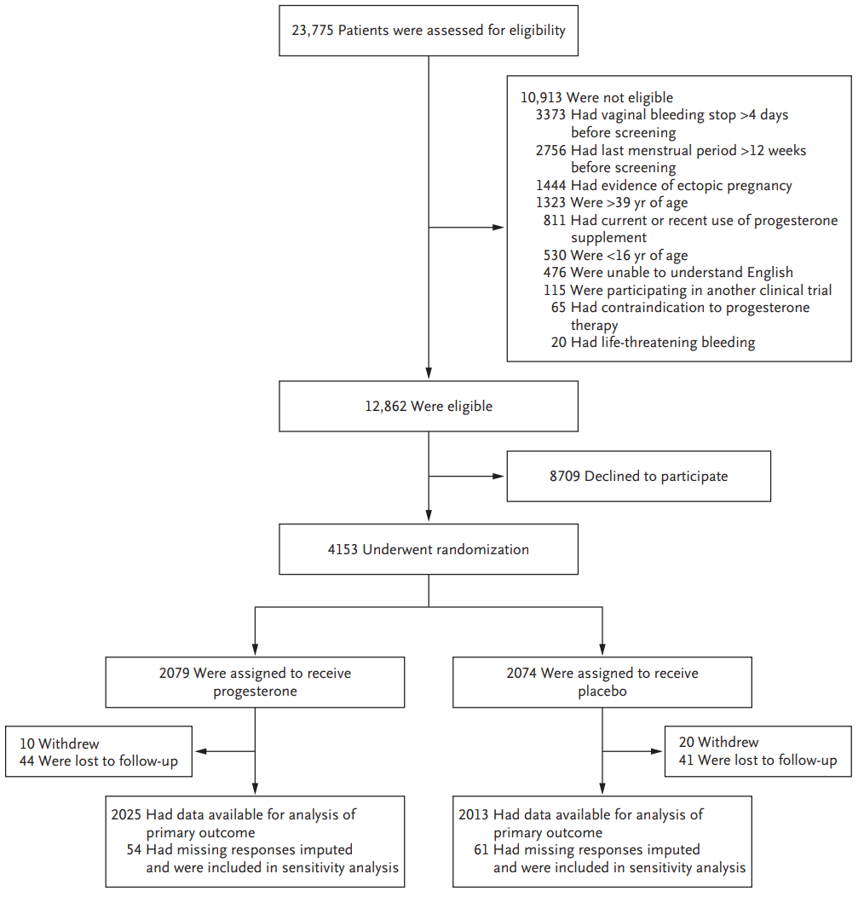
Abbreviation: yr = year.
Source: extracted from Figure 1 in Coomarasamy, A. et al. A Randomized Trial of Progesterone in Women with Bleeding in Early Pregnancy, N Engl J Med, 2019; 380: 1815-1824.
Table 3: Coomarasamy et al. (2020) PRISM trial Demographic and baseline characteristics of the participants
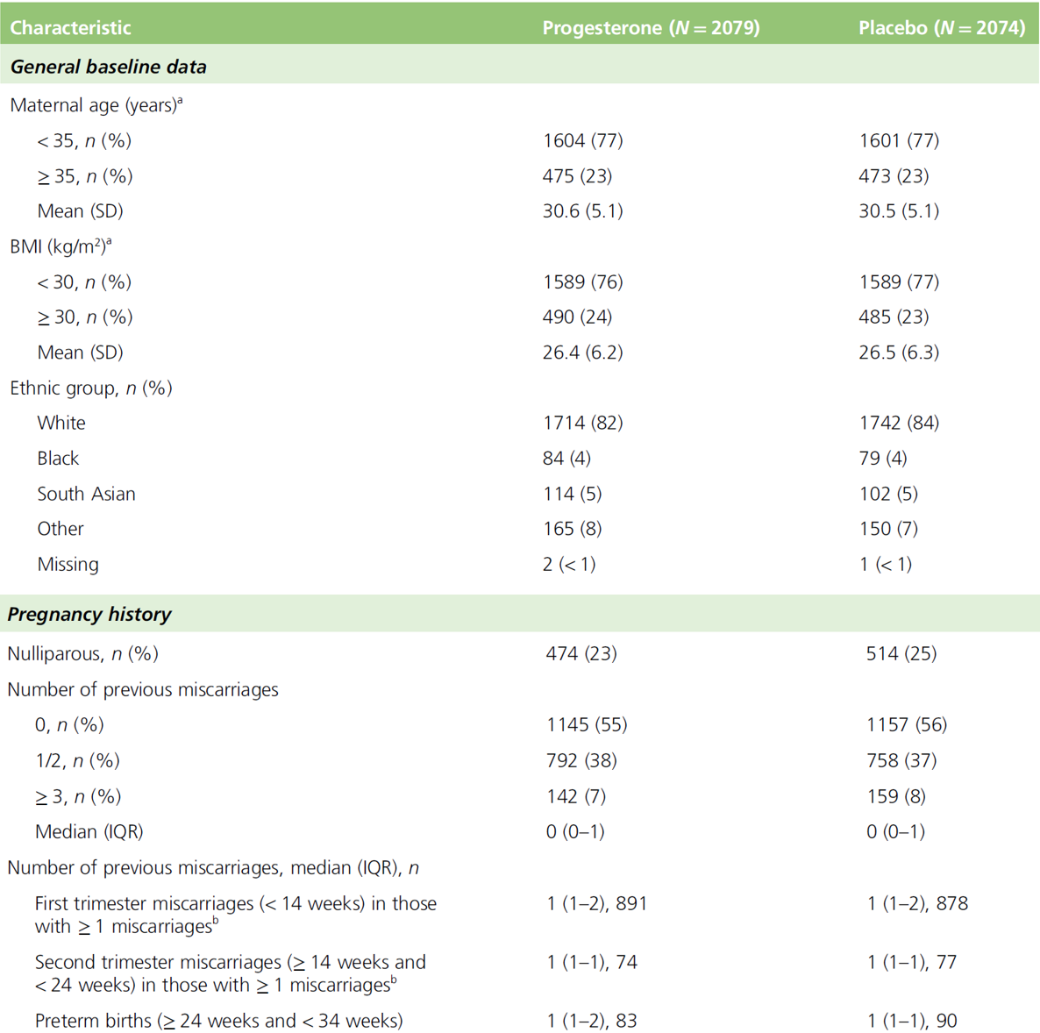
Table 3 continued: Coomarasamy et al. (2020) PRISM trial Demographic and baseline characteristics of the participants
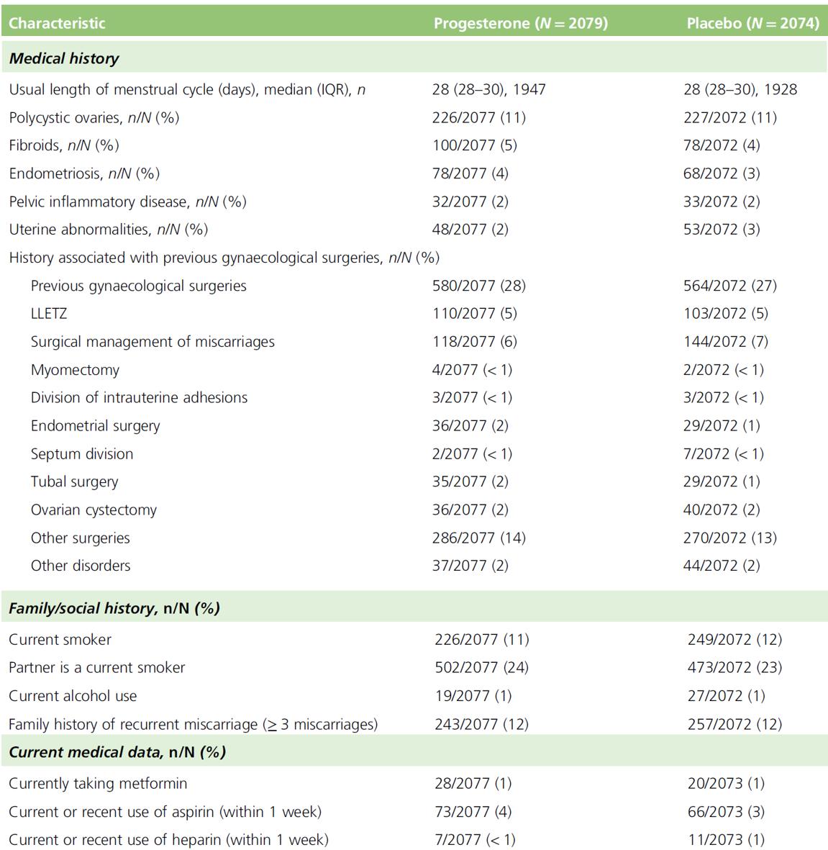
Table 3 continued: Coomarasamy et al. (2020) PRISM trial Demographic and baseline characteristics of the participants
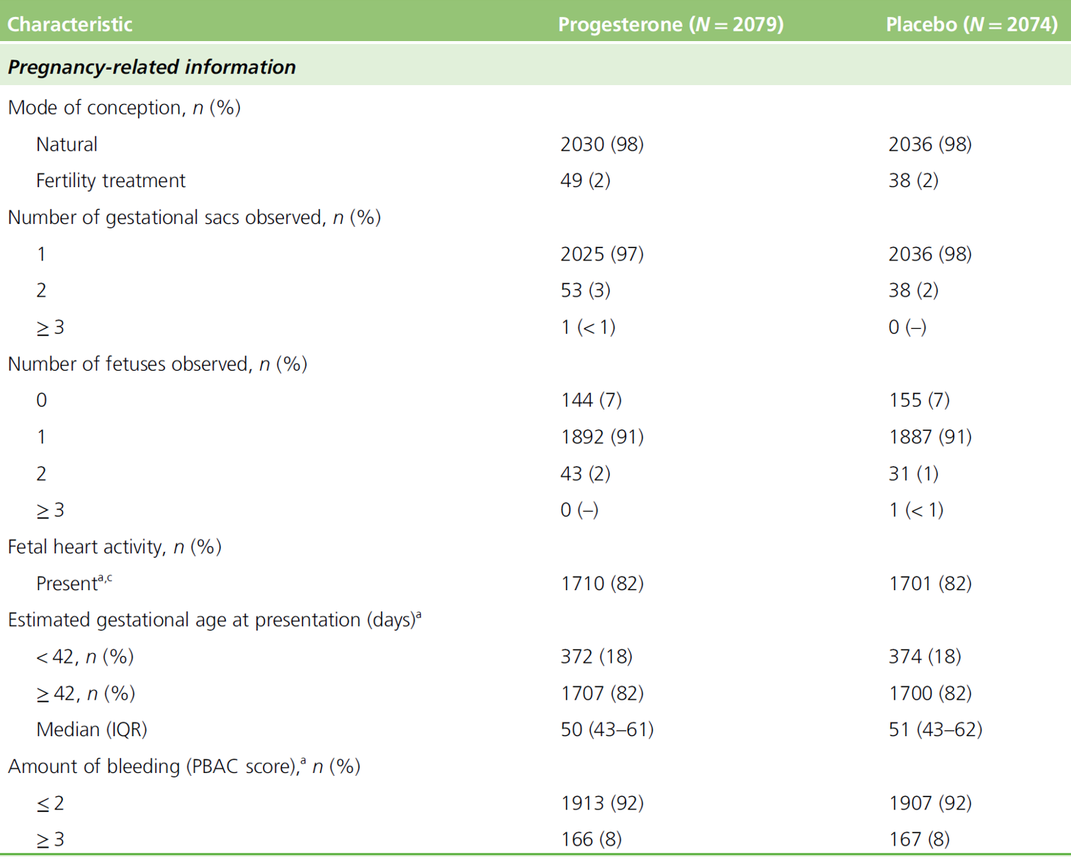
Abbreviations: IQR = interquartile range; LLETZ = large loop excision of the cervical transformation zone; N = number of subjects; n = number of subjects in group; PBAC = Pictorial Blood Loss Assessment Chart; SD = standard deviation.
a Minimisation variable.
b Numbers presented are for those who have provided gestational age at first and second trimester miscarriage.
c If more than one fetus, this is classified as any with heart activity present.
Source: extracted from Table 4 in Coomarasamy, A. et al. Progesterone to Prevent Miscarriage in Women with Early Pregnancy Bleeding: the PRISM RCT, Health Technol Assess, 2020; 24(33): 1-70.

Study results

Primary outcome results
The incidence of live births after at least 34 weeks of gestation (see Table 4 below) was numerically higher in the progesterone group (75% (1513 of 2025)) compared with the placebo group (72% (1459 of 2013)), but the difference was not statistically significant (adjusted relative risk ratio (RR) = 1.03; 95% confidence interval (CI): 1.00, 1.07; P = 0.08)).
Table 4: Coomarasamy et al. (2019) PRISM trial Primary and secondary outcomes
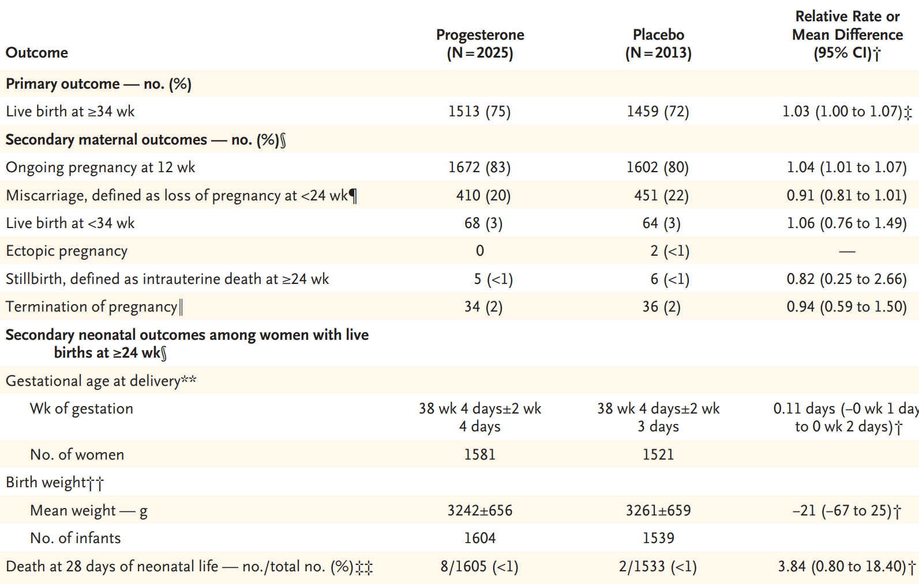
Abbreviations: CI = confidence interval; N = number of subjects; no = number; wk = week(s).
* Plus-minus values are means ± standard deviation.
† Relative rates are shown for the primary outcome, all secondary maternal outcomes, and the secondary neonatal outcome of death at 28 days of neonatal life. The mean difference is shown for the secondary neonatal outcomes of gestational age at delivery and birth weight. For binary outcomes, a relative rate of less than 1 favours the progesterone group, except for live birth after at least 34 weeks of gestation and ongoing pregnancy at 12 weeks, for which a relative rate greater than 1 would favour progesterone. For continuous outcomes, a mean difference of less than 0 favours the progesterone group. The widths of the confidence intervals were not adjusted for multiplicity, so the intervals should not be used to infer definitive treatment effects.
‡ P = 0.08.
§ Five women in the progesterone group and three women in the placebo group had both a live birth after at least 34 weeks of gestation and a miscarriage; one woman in the placebo group had both a termination of pregnancy and a miscarriage; and one woman in the placebo group had both a live birth before 34 weeks and a stillbirth.
The median gestational age was 8 weeks (interquartile range, 7 to 10) in both trial groups.
‖ The reasons for termination of pregnancy in the progesterone group were social for 13 women and medical for 21 women. The reasons for termination of pregnancy in the placebo group were social for 12 women and medical for 24 women. The median gestational age was 14 weeks (interquartile range, 12 to 19) in the progesterone group and 15 weeks (interquartile range, 11 to 18) in the placebo group.
** The gestational age at delivery was unknown for the infants of two women in the placebo group.
†† The birth weight was unknown for the infants of 6 women in the progesterone group and 6 women in the placebo group.
‡‡ The neonatal vital status at 28 days of life was unknown for 17 women (5 in the progesterone group and 12 in the placebo group).
Source: extracted from Table 2 in Coomarasamy, A. et al. A Randomized Trial of Progesterone in Women with Bleeding in Early Pregnancy, N Engl J Med, 2019; 380: 1815-1824.

Secondary outcome results
The incidence of ongoing pregnancy (see Table 4 above) at 12 weeks was significantly greater (RR = 1.04; 95% CI: 1.01, 1.07; p = 0.01) in the progesterone group (83% (1672 of 2025)) compared with the placebo group (80% (1602 of 2013)), while incidence of miscarriage at less than 24 weeks was non-significantly lower (RR = 0.91; 95% CI: 0.81, 1.01; p = 0.09) in the progesterone group (20% (410 of 2025)) compared with the placebo group (22% (451 of 2013)). Other secondary maternal and neonatal outcomes (see Table 5 below) did not show significant difference between progesterone and placebo treatment groups with exception of significantly reduced incidence of emergency caesarean section in the progesterone group (15% versus 19%, adjusted RR = 0.80; 95% CI: 0.69, 0.94; p = 0.006).
It is commented in the clinical evaluation that analysis of the secondary outcomes did not include a provision for correction for multiplicity, limiting interpretation of results for statistical significance.
Table 5: Coomarasamy et al. (2020) PRISM trial Other secondary maternal and neonatal outcomes
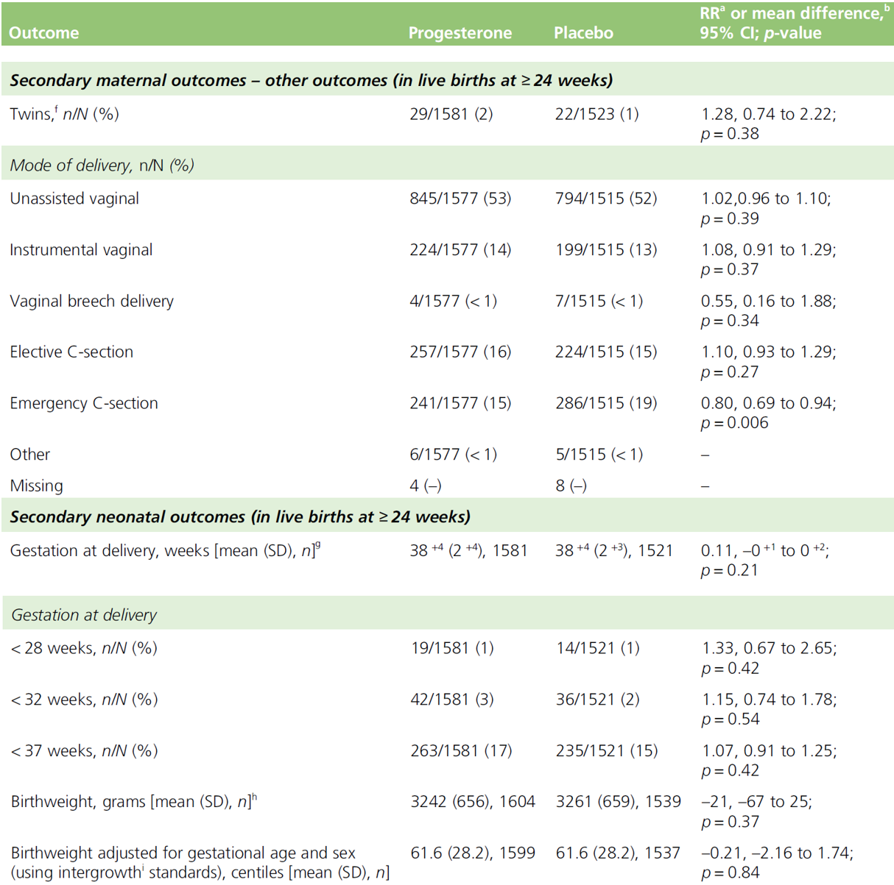
Table 5 continued: Coomarasamy et al. (2020) PRISM trial Other secondary maternal and neonatal outcomes
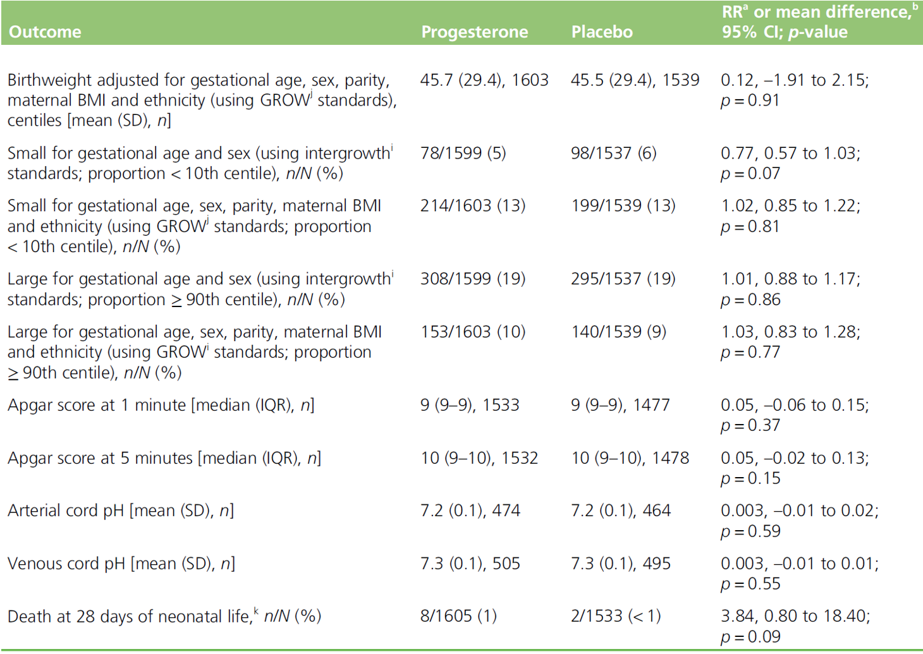
Abbreviations: CI = confidence interval, GROW = gestation-related optimal weight; IQR = interquartile range; N = number of subjects; n = number of subjects in subgroup; RR = relative risk ratio; SD = standard deviation.
a For binary outcomes, RR < 1 favours the progesterone group apart from live birth at ≥ 34 weeks and ongoing pregnancy at 12 weeks where RR > 1 would favour progesterone.
b For continuous outcomes, mean difference < 0 favours the progesterone group.
c A total of five women on progesterone and three women on placebo had both a live birth ≥ 34 weeks and a miscarriage; one woman on placebo had both a termination and a miscarriage; and one woman on placebo had both a live birth < 34 weeks and a stillbirth.
d Median gestational age (IQR) in progesterone group, 8 (7–10) weeks; median gestational age (IQR) in placebo group, 8 (7–10) weeks.
e Reasons in progesterone group: social, n = 13; medical, n = 21. Reasons in placebo group: social, n = 12; medical, n = 24.
Median gestational age (IQR) in progesterone group, 14 (12–19) weeks; median gestational age (IQR) in placebo group, 15 (11–18) weeks.
f Total number of babies, N = 3155: progesterone group, n = 1610; placebo group, n = 1545.
g Unknown gestational age: placebo group, n = 2.
h Unknown birthweights: progesterone group, n = 6; placebo group, n = 6.
i Chatfield, A. et al. Translating Research into Practice: the Introduction of the INTERGROWTH-21st Package of Clinical Standards, Tools and Guidelines into Policies, Programmes and Services, BJOG, 2013; 120(Suppl 2): 139-142.
j Gardosi, J. et al. An Adjustable Fetal Weight Standard, Ultrasound Obstet Gynecol, 1995; 6(3): 168-174.
k Unknown outcome at 28 days of neonatal life: progesterone group, n = 5; placebo group, n = 12.
Source: extracted from Table 7 in Coomarasamy, A. et al. Progesterone to Prevent Miscarriage in Women with Early Pregnancy Bleeding: the PRISM RCT, Health Technol Assess, 2020; 24(33): 1-70.
In conclusion, treatment with the proposed vaginal progesterone dosing regimen (from 4 days within onset of bleeding up to 16 weeks of gestation) was not associated with statistically significant benefit in terms of proportion of live births after 34 weeks compared to the placebo group (75% versus 72%; RR = 1.03; 95% CI: 1.00, 1.07; P = 0.08).
Incidence of miscarriage at less than 24 weeks (20% versus 22%; RR = 0.91; 95% CI: 0.81, 1.01; p = 0.09) was also similar in the progesterone and placebo groups. None of the other maternal or neonatal secondary outcome measures showed significant benefit of progesterone over placebo.
Although pre-defined subgroup analysis did show significant benefit over placebo for primary outcome of live births in a subgroup of women with history of more than 3 miscarriages (72% versus 52%; RR = 1.28; 95% CI: 1.00, 1.12), interpretation was limited as only 7 to 8% of study population (142 and 159 women in progesterone and placebo groups, respectively) had a history of more than 3 prior miscarriages.
The published paper also highlighted that ‘previous reports have indicated a steep and proportionate increase in the loss of chromosomally normal pregnancies (that is, euploid miscarriages) with increasing number of previous miscarriages. Given that the potential benefit of progesterone therapy would be expected to be specific to euploid pregnancies, an increasing level of benefit in women with increasing number of previous miscarriages is consistent with our understanding of the biologic factors associated with risk of miscarriage.’²⁷

PROMISE trial
The PROMISE trial, reported in multiple publications,^{,9} was a randomised, double blind, placebo controlled, international multicentre study to evaluate whether progesterone treatment would increase rates of live births and newborn survival among women with unexplained recurrent miscarriage.

Objectives

Primary objective
The primary objective was to evaluate if progesterone (400 mg/dose progesterone, as two 200 mg progesterone vaginal capsules given twice daily (total daily dose 800 mg) given soon after positive pregnancy test (but no later than 6 weeks of gestation) up to 12 weeks of gestation) increases live births beyond 24 completed weeks of pregnancy compared to placebo by at least 10% in women with unexplained recurrent miscarriage.

Secondary objectives
Secondary objectives were to assess if progesterone would improve various pregnancy and neonatal outcomes (such as reduced miscarriage rates and improvements in survival at 28 days of neonatal life). These are:
- to assess if progesterone, compared with placebo, would not incur serious adverse events in either the mother or the neonate (such as genital abnormalities in the neonate);
- to explore differential or subgroup effects of progesterone in various prognostic subgroups, including subgroups of maternal age (no more than 35 years or over 35 years), number of previous miscarriages (3 or at least 4), presence or absence of polycystic ovaries;
- to perform an economic evaluation for cost effectiveness.

Efficacy outcomes

Primary efficacy outcome
The primary outcome measure was live birth after 24 completed weeks of gestation.

Secondary efficacy outcomes
- Clinical pregnancy at 6 to 8 weeks (defined as the presence of a gestational sac, with or without a yolk sac or fetal pole).
- Ongoing pregnancy at 12 weeks (range 11 to 13 weeks) (defined as the presence of a fetal heartbeat).
- Miscarriage (defined as loss of pregnancy before 24 weeks of gestation).
- Gestation at delivery.
- Survival at 28 days of neonatal life.
- Congenital anomalies, and specifically genital abnormalities.

Inclusion criteria
The main include criteria include:
- having a diagnosis of unexplained recurrent miscarriage (three or more consecutive or non-consecutive first-trimester losses);
- aged 18 to 39 years at randomisation;
- trying to conceive naturally;
- willing and able to give informed consent.

Sample size
A sample size with 376 women randomised to each treatment group would be able to detect a minimally important difference of 10% in rates of live birth after at least 24 weeks (from 60% to 70%, odds ratio = 1.56), for an alpha error rate of 5% and beta error rate of 20% (that is, 80% power). Assuming a loss to follow-up rate of 5%, the total number of participants required would be 790 (395 each in the progesterone and placebo arms).

Participant flow
There were 836 women randomised to study treatment (404 to the progesterone group and 432 to the placebo group). Some of these participants (17 women receiving progesterone and 9 receiving placebo) did not receive the allocated intervention (most often as a result of pregnancy loss before treatment could commence), and 10 participants (6 and 4, respectively) were lost to follow-up. Primary outcome data were available for 826 out of 836 (98.8%) participants (398 and 428, respectively) (see Figure 2 below). The baseline demographics and characteristics were similar across the progesterone and placebo treatment groups (see Table 6 below).
Figure 2: Coomarasamy et al. (2016) PROMISE trial Participant flow
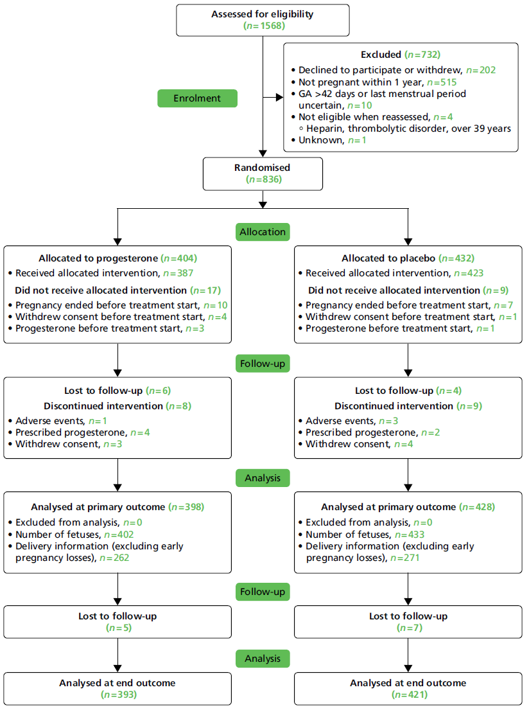
Abbreviations: GA = gestational age; n = number of subjects in subgroup.
Source: extracted from Figure 6 in Coomarasamy, A. et al. PROMISE: First-Trimester Progesterone Therapy in Women with a History of Unexplained Recurrent Miscarriages - a Randomised, Double-Blind, Placebo-Controlled, International Multicentre Trial and Economic Evaluation, Health Technol Assess, 2016; 20(41): 1-92.
Table 6: Coomarasamy et al. (2016) PROMISE trial Baseline characteristics by randomised treatment
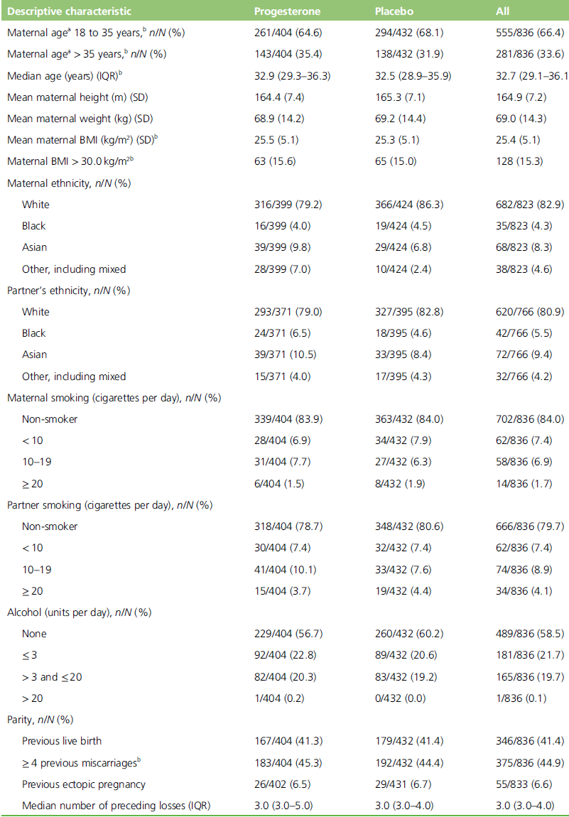
Table 6 continued: Coomarasamy et al. (2016) PROMISE trial Baseline characteristics by randomised treatment
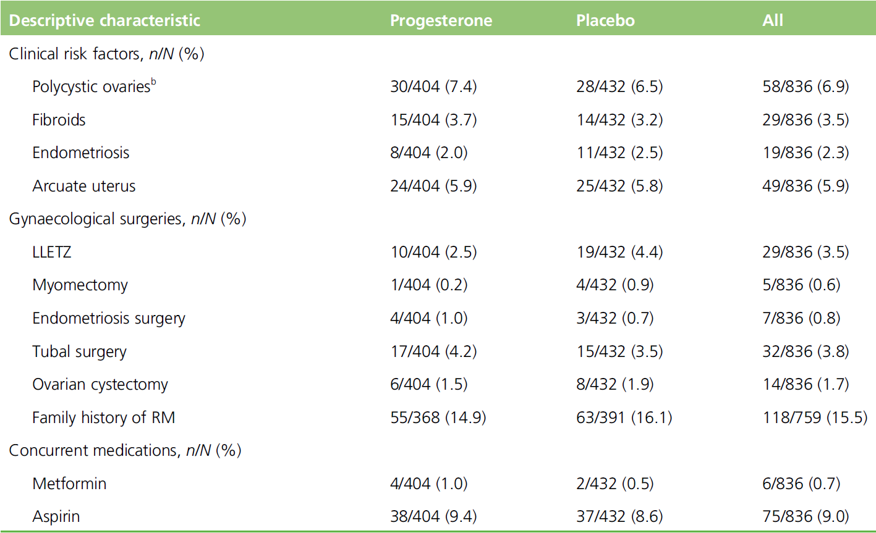
Abbreviations: BMI = body mass index; IQR = interquartile range; LLETZ = large loop excision of the cervical transformation zone; N = number of subjects; n = number of subjects in subgroup; RM = recurrent miscarriage; SD = standard deviation.
a Maternal age at the time of randomisation.
b Treatment allocation was balanced by minimisation on previous miscarriages, maternal age, polycystic ovaries and obesity (BMI ≤ 30.0 kg/m² or > 30.0 kg/m²).
Source: extracted from Table 3 in Coomarasamy, A. et al. PROMISE: First-Trimester Progesterone Therapy in Women with a History of Unexplained Recurrent Miscarriages - a Randomised, Double-Blind, Placebo-Controlled, International Multicentre Trial and Economic Evaluation, Health Technol Assess, 2016; 20(41): 1-92.

Study results

Primary outcome results
The rate of live births after 24 weeks of gestation was 65.8% (262 of 398 pregnancies) in the progesterone group, versus 63.3% (271 of 428 pregnancies) in the placebo group (RR = 1.04; 95% CI: 0.94, 1.15; absolute rate difference, 2.5 percentage points; 95% CI: -4.0, 9.0).

Secondary outcome results
Rates of miscarriage (see Table 7 below) were not significantly different between the groups randomised to receive progesterone or placebo (32.2% (128 of 398) versus 33.4% (143 of 428); RR = 0.96; 95% CI: 0.79, 1.17; p = 0.70). Other secondary outcomes showed similar results in both treatment groups.
Table 7: Coomarasamy et al. (2015) PROMISE trial Primary and secondary outcomes
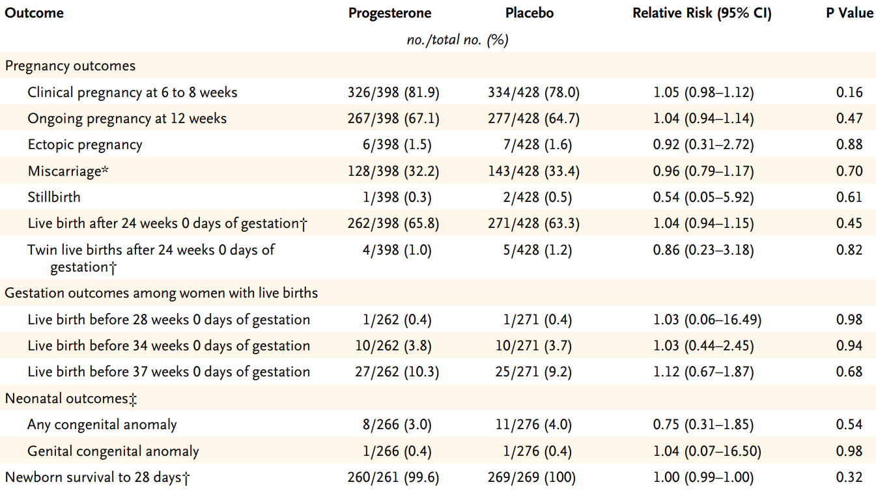
Abbreviations: CI = confidence interval; no = number.
* The median gestational age at miscarriage was 7.3 weeks (interquartile range, 6.0 to 8.7) in the progesterone group and 7.1 weeks (interquartile range, 6.0 to 8.5) in the placebo group (relative risk = 0.0; 95% CI: -0.6, 0.4; P = 0.87).
† The end point is listed per trial participant.
‡ The end point is listed per neonate
Source: extracted from Table 2 in Coomarasamy, A. et al. A Randomized Trial of Progesterone in Women with Recurrent Miscarriages, N Engl J Med, 2015; 373: 2141-2148.
In conclusion, progesterone therapy in the first trimester of pregnancy did not result in a significant increase in the rate of live births among women with a history of unexplained recurrent miscarriages.

Literature providing supportive evidence of efficacy
The clinical evaluation has summarised relevant supporting studies, systematic reviews and meta-analyses and an expert review of the PRISM and PROMISE trials.
The following concerns were raised in the clinical evaluation regarding the supporting literature studies:
- The studies differed in terms of methodology, level of reporting, study quality, and other characteristics such as primary efficacy measures, and types and doses of progesterone administered. The selection of the proposed dose of 400 mg twice daily has not been adequately justified. Apart from the PRISM and PROMISE trials, none of the other submitted studies evaluated the proposed dosing regimen of vaginal progesterone.
- Treatment with vaginal progesterone was commenced sometime during the first trimester of pregnancy, that is, from confirmation of pregnancy up to week 12 to 16 of gestation in all the submitted studies.

Systematic reviews and meta-analyses on threatened miscarriage
Reviews by Wahabi et al. (2018),⁵ Wang et al. (2019),³ Li et al. (2020),³⁵ and Yan et al. (2020) were discussed in the clinical evaluation report. The main findings of the review by Li et al. (2020) are summarised below.

Li et al. (2020)
Li et al. (2020) was deemed to be the most well-conducted review of those submitted. The 10 randomised controlled trials were published between 1967 and 2019 with the study population ranging from 35 to 4153 patients (the PRISM trial). Progestogens varied across trials, with five trials using vaginal progesterone, five using oral progesterone, and none using injectable progestogen. Six trials used placebo as a control, and the other four trials used no additional treatment in the control group. Older trials had more unclear risk of bias assessments, while the two latest trials had more favourable assessments (see Table 8 below).
Table 8: Li et al. (2020) Characteristics of studies included in the systematic review of progestogens for management of threatened miscarriage
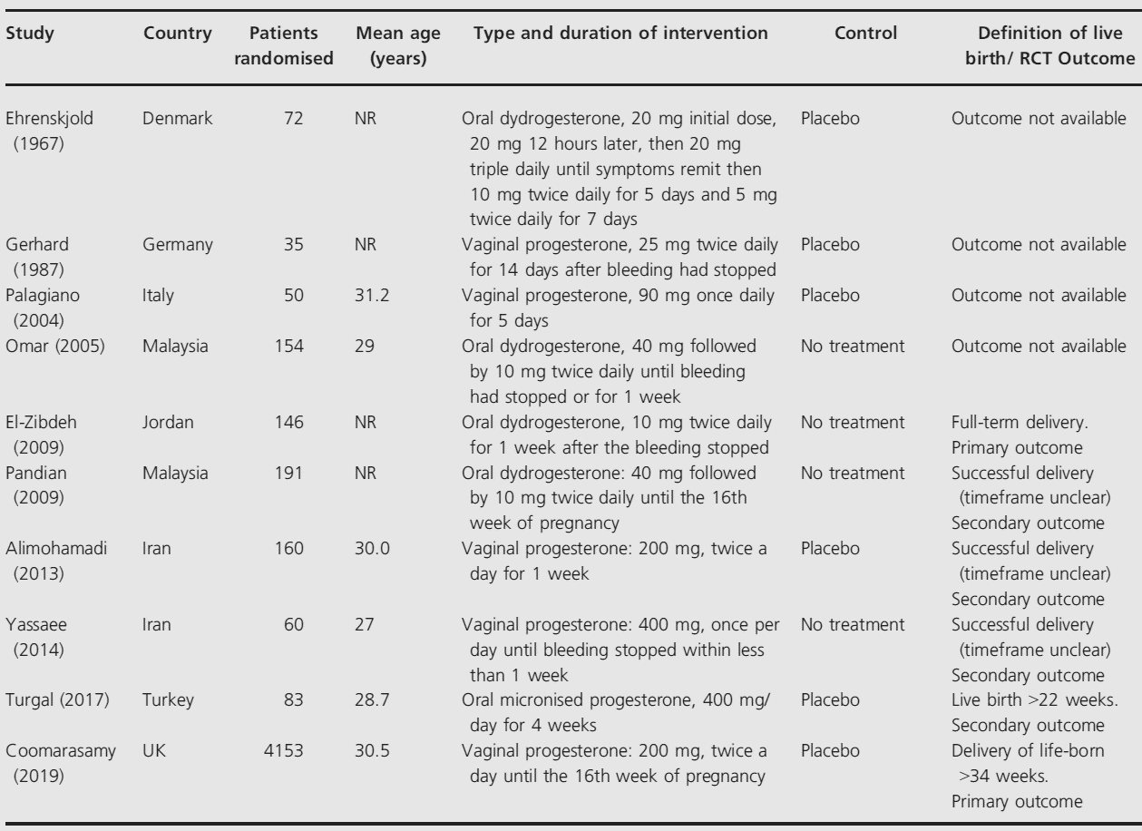
Abbreviations: NR = not recorded; RCT = randomised controlled trials; UK = United Kingdom.
Source: extracted from Table 1 in Li, L. et al. Effect of Progestogen for Women with Threatened Miscarriage: a Systematic Review and Meta-Analysis, BJOG, 2020; 127(9): 1055-1063.
Analysis of the 10 randomised controlled trials involving 5056 women showed that use of progesterone increased the incidence of live birth (72.9% (1759 of 2411) versus 69.7% (1660 of 2379); RR = 1.07; 95% CI: 1.00, 1.15; P = 0.04; I² = 18%) with moderate quality evidence suggesting 49 more live births per 1000 births (95% CI: 0, 105).
Administration of oral progesterone resulted in a higher incidence of live birth (RR = 1.17; 95% CI: 1.04, 1.31; I² = 0%; 117 more events per 1000 (95% CI: 27, 213; low quality evidence) while administration of vaginal progesterone resulted in no significant difference (RR = 1.04; 95% CI: 1.00, 1.08; I² = 0%; P = 0.07; 28 more events per 1000; 95% CI: 0, 56; moderate quality evidence) (see Figure 3 below).
Sensitivity analyses by excluding trials at each time, using fixed effect models or excluding trials with less than 100 patients, yielded similar results for live birth.
Figure 3: Li et al. (2020) Results for primary outcome of live births, stratified by oral and vaginal progesterone
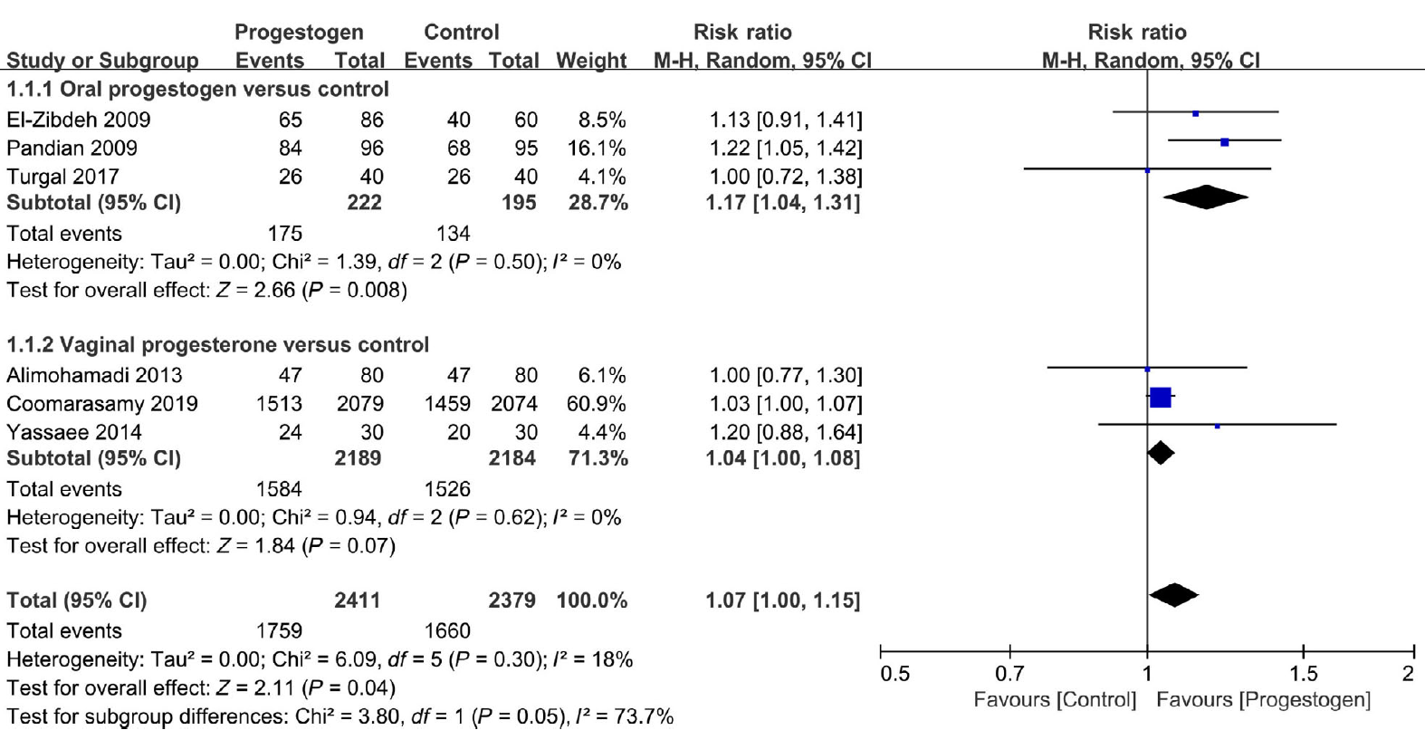
Abbreviations: Chi² = difference between the observed and expected frequencies of the outcomes of a set of variables; CI = confidence interval; df = degree of freedom; H = high; I2 = percentage of variance due to heterogeneity rather than sampling error; M = medium; p = p-value; Tau² = between-study variance; Z = z-score.
Source: extracted from Figure 2 in Li, L. et al. Effect of Progestogen for Women with Threatened Miscarriage: a Systematic Review and Meta-Analysis, BJOG, 2020; 127(9): 1055-1063.
Progestogen reduced the risk of miscarriage (18.5% (483 of 2598) versus 21.9% (566 of 2582); RR = 0.73; 95% CI: 0.59, 0.92; I² = 22 %) with high quality evidence suggesting 59 less events per 1000 (95% CI: -8, -90)).
Reduction in miscarriages was only seen following use of oral progestogen (RR = 0.58; 95% CI: 0.42, 0.80; low quality evidence) and not vaginal progesterone (RR = 0.90; 95% CI: 0.80, 1.01; moderate quality evidence, p for interaction = 0.01) (see Figure 4 below).
There was no difference in incidence of preterm birth (progesterone versus control: 3.8% (92 of 2398) versus 3.8% (90 of 2367); RR = 1.00; 95% CI: 0.76, 1.33; I² = 0%; high quality evidence), congenital abnormalities (RR = 1.00; 95% CI: 0.72, 1.39; I² = 0%; high quality evidence) or low birth weight (RR = 1.01; 95% CI: 0.77, 1.31; I² = 53 %; moderate quality evidence).
Figure 4: Li et al. (2020) Results for incidence of miscarriage, stratified by oral and vaginal progesterone
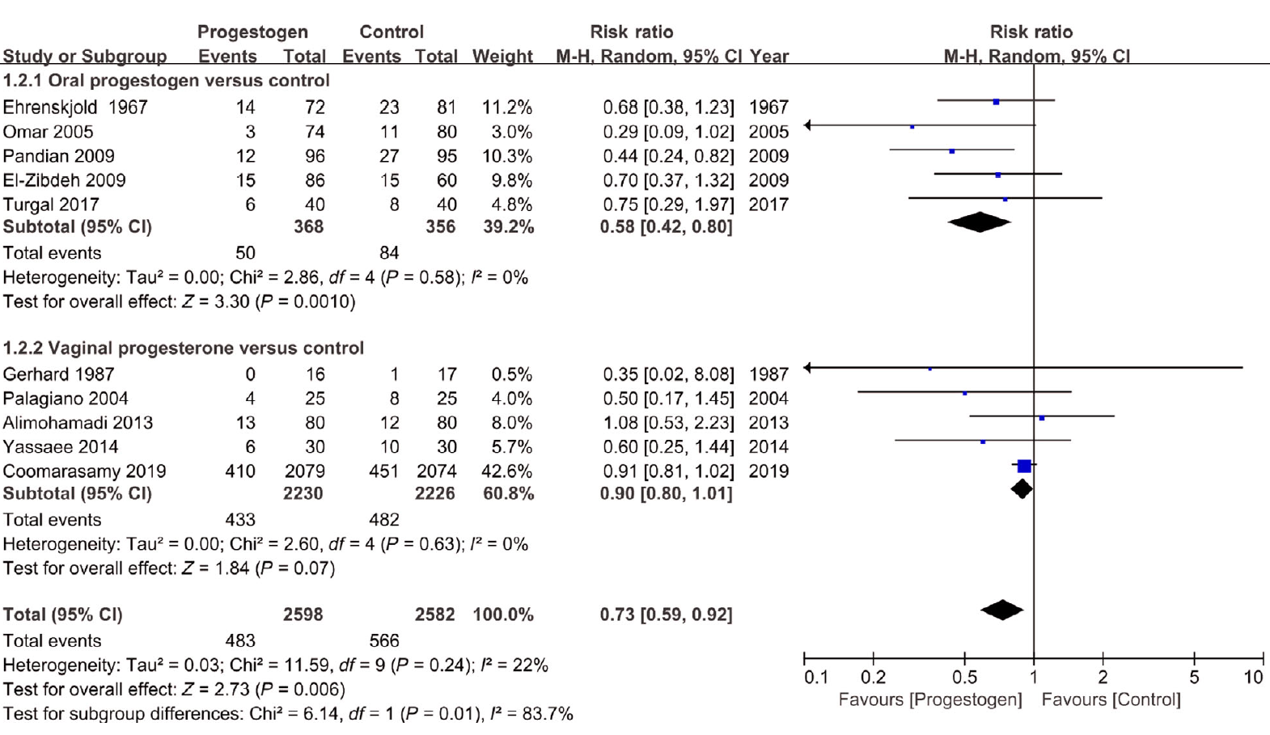
Abbreviations: Chi² = difference between the observed and expected frequencies of the outcomes of a set of variables; CI = confidence interval; df = degree of freedom; H = high; I2 = percentage of variance due to heterogeneity rather than sampling error; M = medium; p = p-value; Tau² = between-study variance; Z = z-score.
Source: extracted from Figure 3 in Li, L. et al. Effect of Progestogen for Women with Threatened Miscarriage: a Systematic Review and Meta-Analysis, BJOG, 2020; 127(9): 1055-1063.
Results of this review were driven largely by results of the PRISM trial, which used vaginal progesterone. An increase in live births following progesterone treatment was suggested, although benefit was not observed following vaginal progesterone which is the proposed route of administration for this submission.
The definitions of the primary outcome of live births across studies varied and the number of previous miscarriages was different across the studies.
There were uncertainties regarding the dosing regimen (initiation and duration of treatment).

Systematic reviews and meta-analyses on recurrent miscarriage
Reviews by Haas et al. (2019), Rasmark Roepke (2018),¹² and Saccone et al. (2017) were summarised in the clinical evaluation report.³⁴ The main findings of the review by Haas et al. (2019) are summarised below.

Haas et al. (2019)
This meta-analysis by Haas et al. (2019)³⁶ included 12 randomised controlled trials involving 1856 women and assessed efficacy and safety of progestogens as preventative therapy against recurrent miscarriage. It included randomised or quasi-randomised trials comparing progestogens with placebo or no treatment given in an effort to prevent miscarriage.
Routes, dosage and duration of progestogen treatment varied across the trials but the majority (7) of the studies administered progesterone orally, 3 administered treatments intramuscularly and only one study used the proposed dosing regimen of 400 mg vaginal micronised progesterone.³¹ Duration of treatment was 12 to 16 weeks gestation for the more recent studies, up to 20 weeks gestation for one study. Duration of treatment was 24 weeks, 36 weeks or ‘not specified’ for the older studies.
Ten trials (1684 women) contributed data to the analyses. The meta-analysis of all women suggested that there may be a reduction in the number of miscarriages for women given progestogen supplementation compared to placebo or controls (average RR = 0.73; 95% CI: 0.54, 1.00; moderate quality evidence).
A subgroup analysis comparing placebo controlled versus non-placebo controlled trials, trials of women with three or more prior miscarriages compared to women with two or more miscarriages and different routes of administration showed no clear differences between subgroups for miscarriage.³²
Figure 5: Haas et al. (2019) Analysis 1.3 Comparison 1 Progestogen versus placebo or no treatment, Outcome 3 Miscarriage (women with previous recurrent miscarriage only)
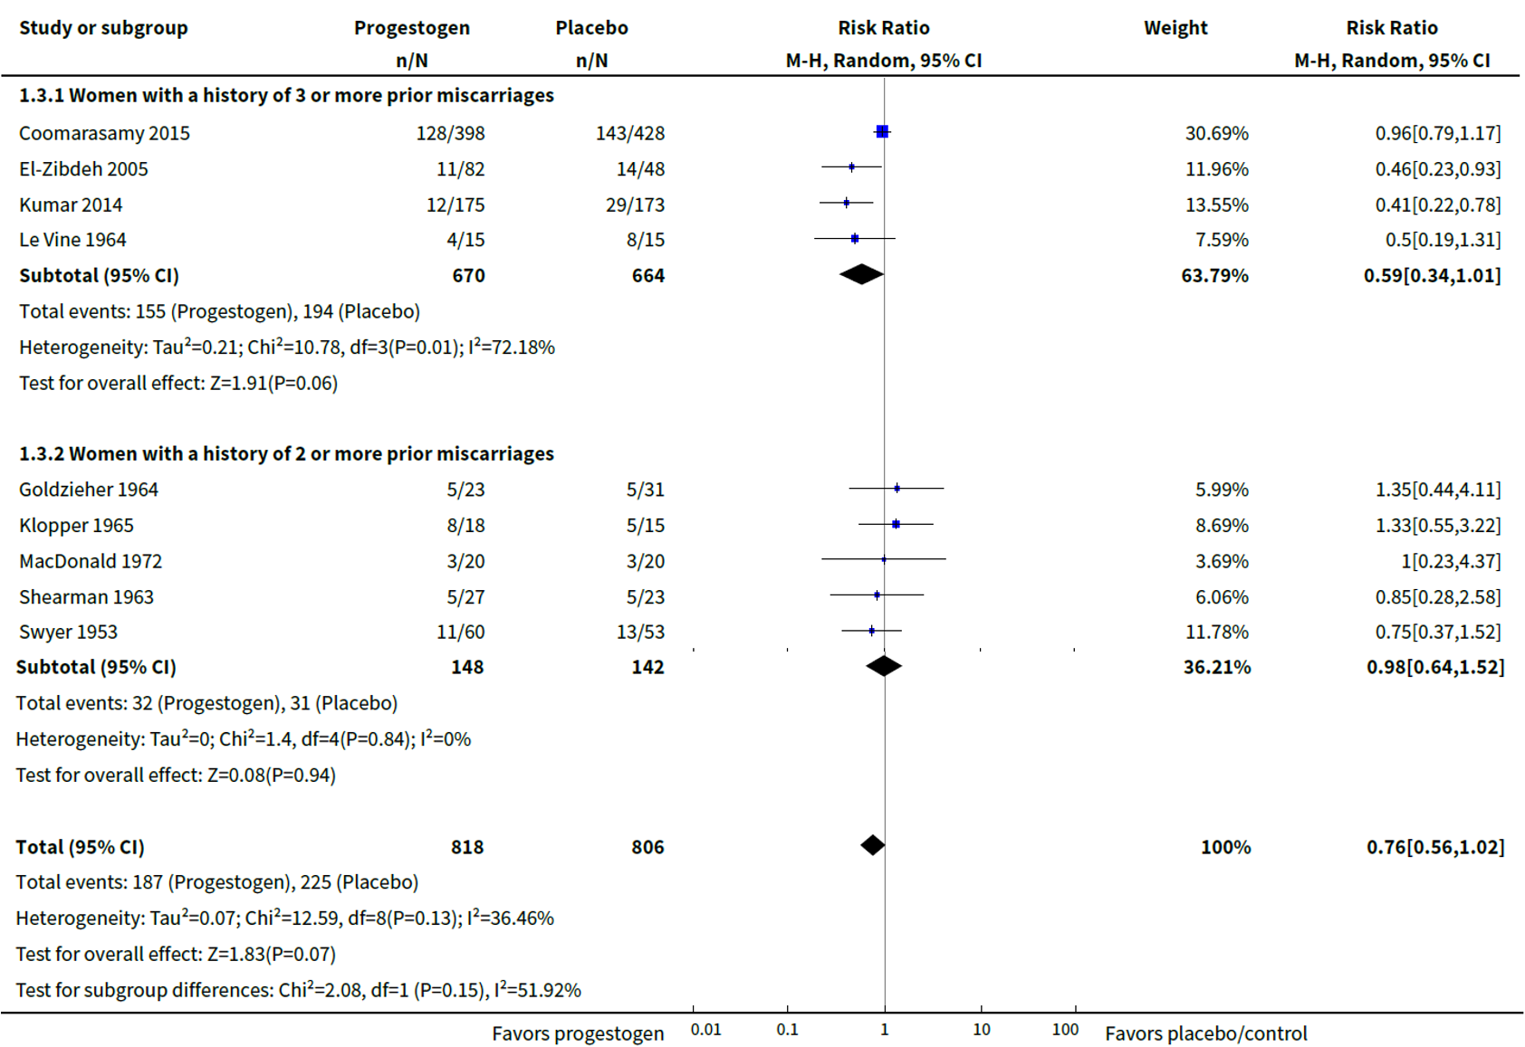
Abbreviations: Chi² = difference between the observed and expected frequencies of the outcomes of a set of variables; CI = confidence interval; df = degree of freedom; H = high; I2 = percentage of variance due to heterogeneity rather than sampling error; M = medium; N= number of subjects; n = number of subjects in subgroup; p = p-value; Z = z-score.
Source: extracted from Analysis 1.3 in Haas, D.M. et al. Progestogen for Preventing Miscarriage in Women with Recurrent Miscarriage of Unclear Etiology, Cochrane Database Syst Rev, 2019; 2019(11): CD003511.
Only one study (the PROMISE trial) included in the meta-analysis used the vaginal route of administration proposed for this submission.

Coomarasamy et al. (2020) expert review
This review was published by the same first author as the pivotal submitted trials and summarised the results of the pre-specified sub-group analyses.³² It also included post-hoc subgroup analyses with further stratification according to the number of previous miscarriages, which had also been reported in the Supplementary Appendix for the PRISM trial.
Figure 6: Coomarasamy et al. (2020) PRISM trial Data on live birth more than 34 weeks by the number of previous miscarriages
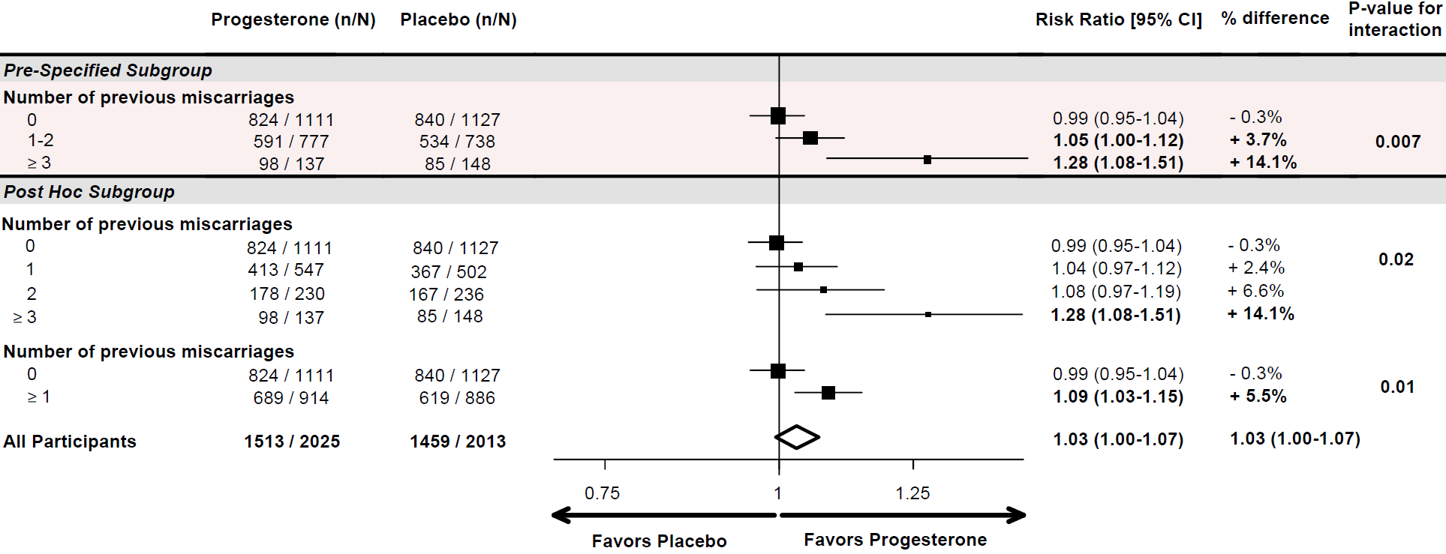
Abbreviations: CI = confidence interval; N = number of subjects; n = number of subjects in subgroup.
Source: extracted from Figure 2 in Coomarasamy, A. et al. Micronized Vaginal Progesterone to Prevent Miscarriage: a Critical Evaluation of Randomized Evidence, Am J Obstet Gynecol, 2020; 223(2): 167-176.
The finding of these post-hoc analyses were also provided to support the revised indication by the sponsor proposed in response to questions raised by the TGA.

Safety
The evidence for safety for vaginal progesterone for the proposed indication was provided by company sponsored clinical study, investigator initiated clinical studies, periodic safety update reports (PSURS) and recent publications (including clinical practice guidelines, meta-analyses, and systematic reviews).
It is noted in the clinical evaluation report that the submitted studies provided limited safety data following use of vaginal progesterone for threatened miscarriage and recurrent miscarriage. In those trials that did report on the incidence and nature of adverse events (AEs), the AEs were generally mild and transient, and the incidence of AEs was no greater than those reported for placebo or no treatment. These AEs were consistent with the general use of vaginal progesterone and the approved Utrogestan 200 PI. None of the studies assessed longer term outcomes in the infant or child following this first trimester exposure to progesterone.
The dossier included post-marketing data for Utrogestan 200, including results of a PSUR dated 29 April 2018 to 28 April 2019 and a drug analysis print for progesterone from the UK Medicines and Healthcare products Regulatory Agency covers a reporting period from the earliest reported reaction date, 22 July 1975, up to September 2020. Utrogestan 200 was one of the seven drug products included in the drug analysis print. When filtered for vaginal use only, the safety profile of progesterone was confirmed by drug analysis print reported data, with a total of 170 adverse drug reactions (ADRs), 166 of which were serious; the reported ADRs were consistent with what might be expected for the type of progesterone formulations used, the diseases treated, and progesterone’s mode of action (see Table 9 below).
Table 9: UK MHRA Drug analysis print; Overview of reported adverse drug reactions by System Organ Class (reporting period 1975 to 2020)
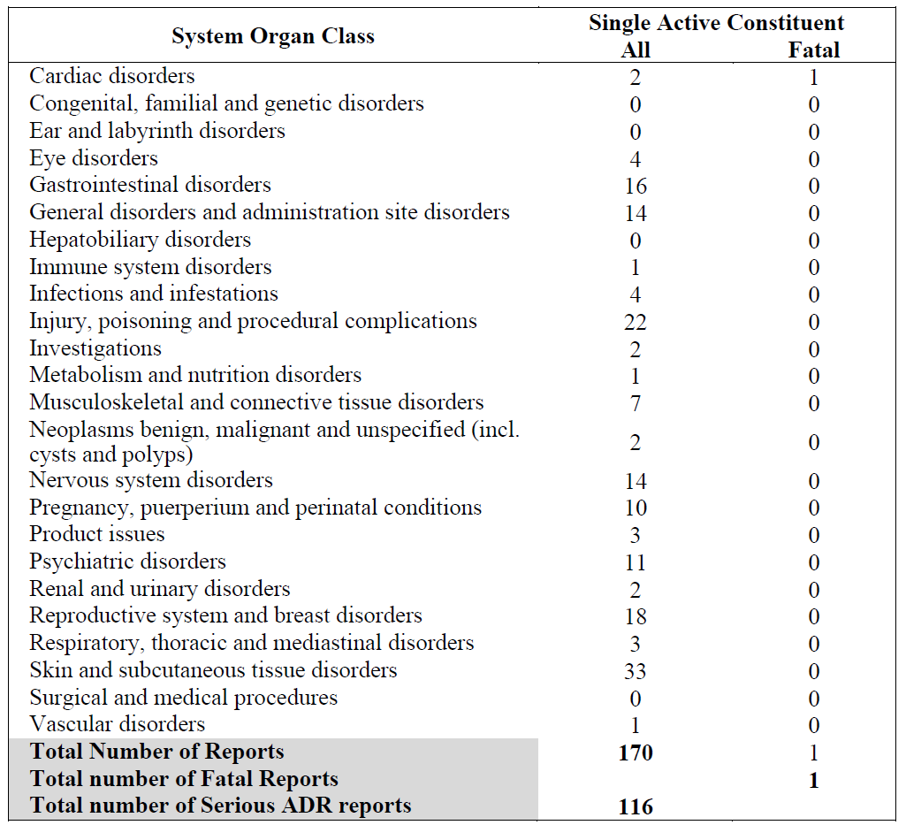
Abbreviation: ADR = adverse drug reaction; incl. = including; UK MHRA = United Kingdom Medicines and Healthcare products Regulatory Agency
The data covers a reporting period from 22 July 1975 to November 2020.
Source: data reported in the United Kingdom (UK) Medicines and Healthcare Products Regulatory Agency (MHRA) Interactive Drug Analysis Profile (iDAP) for vaginal use of progesterone.
There is considerable post-marketing experience with Utrogestan 200 for other indications. It is noted that the dose proposed for the proposed indication is higher than the dose approved for luteal phase support of assisted reproductive technology (ART) cycles (as 600 mg given as 200 mg three times daily) and for prevention of preterm birth (200 mg once daily).

Clinical evaluation’s recommendation
Following the first round of evaluation, the clinical evaluation recommended rejection of the submission, due to lack of adequate evidence of efficacy and safety.
It was appropriately highlighted that the proposed dose for the new indication (400 mg twice daily) exceeds the current maximum daily recommended dose in the current PI (600 mg daily in 3 divided doses).
It was concluded in the clinical evaluation report that evidence to support use of vaginal progesterone (Utrogestan 400 mg twice daily) for proposed indications was not adequate. The selection of the proposed dose of 400 mg twice daily had not been adequately justified. Besides the PRISM and PROMISE trials which failed to demonstrate significant improvements for their primary outcomes, none of the other submitted studies evaluated the proposed dosing regimen of vaginal progesterone. Interpretation of the submitted studies was limited by lack of consistency between trials with the choice of progestogen, route of administration and duration of treatment. The studies provided in the dossier indicated some evidence of efficacy in women with threatened miscarriage and history of unexplained recurrent miscarriage (defined as more than 3 prior miscarriages). However, this limited evidence was only based on subgroup analysis from both pivotal studies, both of which failed to demonstrate efficacy for any of its primary or secondary outcomes.
It has also been highlighted that all studies submitted in this dossier evaluated women with unexplained or idiopathic recurrent miscarriage, although this has not been specified in the proposed indication wording in the PI which appears to suggest that all women with first sign of vaginal bleeding or history of prior miscarriage should be treated with the proposed vaginal progesterone therapy.
In response to questions raised by the TGA during the second round of evaluation, the sponsor further discussed a network meta-analysis by Devall et al. (2020) to support their revised indication:
Prevention of unexplained threatened miscarriage in women with bleeding in the current pregnancy and a history of at least one or more previous miscarriages.
The following agents were used in the trial: vaginal micronised progesterone; dydrogesterone; oral micronised progesterone; and 17-E-hydroxyprogesterone. The authors stated that it was not possible to perform a network meta-analysis and rank the available progestogens, because of the limited number of trials.
It was concluded that for:
- Women with threatened miscarriage:
  - the available progestogen treatments overall make little to no difference in live birth and miscarriage rates for women with threatened miscarriage. Vaginal micronised progesterone was the only treatment that showed it may improve the live birth rates in comparison to placebo; however, this improvement in live birth was only observed in women with early pregnancy bleeding and a previous history of at least one miscarriage.
The pre-specified subgroup analysis by number of previous miscarriages was only possible for vaginal micronised progesterone in women with threatened miscarriage. In women with no previous miscarriages and early pregnancy bleeding, there is probably little or no improvement in the live birth rate (RR = 0.99; 95% CI: 0.95, 1.04; high certainty evidence) when treated with vaginal micronised progesterone compared to placebo. For women with one or more previous miscarriages and early pregnancy bleeding, vaginal micronised progesterone increased the live birth rate compared to placebo (RR = 1.08; 95% CI: 1.02, 1.15; high certainty evidence; Grading of Recommendations Assessment, Development and Evaluation (GRADE), Classification).
- Women with recurrent miscarriage:
  - Vaginal micronised progesterone made little or no difference to live birth rate when compared with placebo for women with recurrent miscarriage.
Figure 7: Devall et al. (2021) Analysis 1.8 Comparison 1: Threatened miscarriage: Vaginal micronised progesterone versus placebo, Outcome 8: Live birth (subgrouped by no previous miscarriages and one or more previous miscarriages)
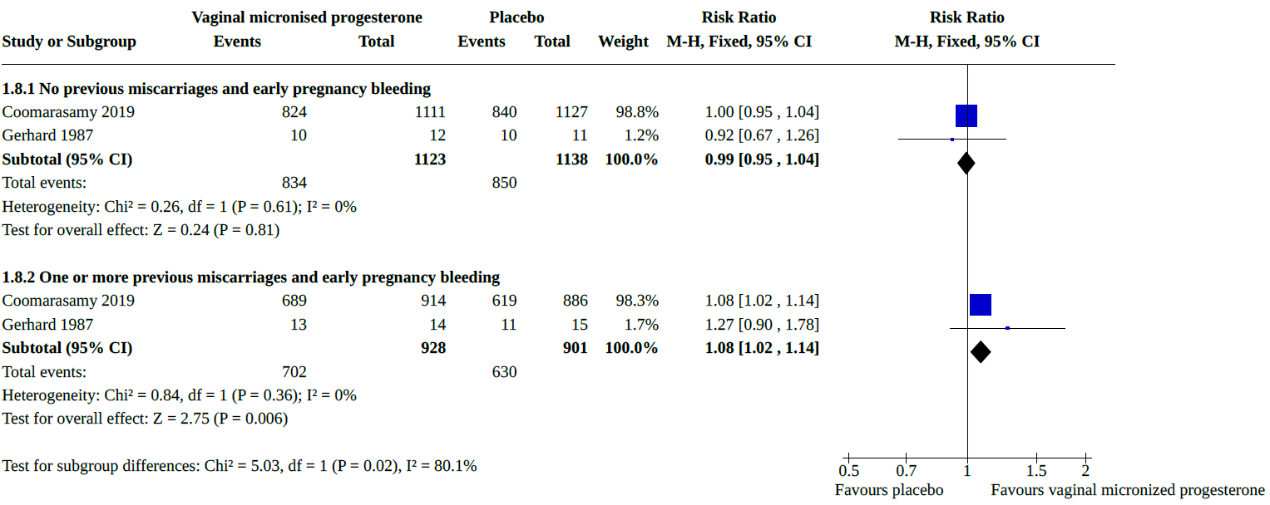
Abbreviations: Chi² = difference between the observed and expected frequencies of the outcomes of a set of variables; CI = confidence interval; df = degree of freedom; H = high; I2 = percentage of variance due to heterogeneity rather than sampling error; M = medium; p = p-value; Z = z-score.
Soruce: extracted from Analysis 1.8 in Devall, A.L. et al. Progestogens for Preventing Miscarriage: a Network Meta-Analysis, Cochrane Database Syst Rev, 2021; 4(4): CD013792.
The clinical evaluation recommended approval for the revised indication:
Prevention of unexplained threatened miscarriage in women with bleeding in the current pregnancy and a history of at least one or more previous miscarriages
Contingent on review of the UK National Institute for Health and Care Excellence (NICE) 2021 guidelines; and expert opinion (if considered necessary by the Delegate) and recommended changes to the PI.
The Delegate commented that results of the meta-analysis by Devall et al. (2020)¹⁰ in Analysis 1.8 to support the revised indication proposed by the sponsor are largely driven by results of the PRISM trial, with the other study by Gerhard et al. (1987) including a small number of patients, n = 27 (progesterone) and n = 29 (placebo), completed in 1984. The dose of vaginal progesterone used in this study was much lower (25 mg twice daily) than the proposed dose for registration and the study evaluated the effect of bed rest in addition to vaginal suppositories.
In response to the second round of evaluation, the sponsor acknowledged the outstanding issues raised in the clinical evaluation and has made appropriate changes to the PI as requested.

Risk management plan
The sponsor is required to comply with product vigilance and risk minimisation requirements.

Risk-benefit analysis

Delegate’s considerations
The proposed extension of indications for this submission for progesterone supplementation in early pregnancy includes two conditions:
- threatened miscarriage (that is, to salvage a pregnancy in women who present with bleeding in early pregnancy), and
- to prevent miscarriage in women with a history of recurrent miscarriage.
The updated indication has been made more specific in including both threated miscarriage and a history of one or more previous miscarriages. The clinical evaluation supports the revised indication, provided NICE 2021 guidelines;⁴³ are considered and expert opinion sought at the discretion of the Delegate. While the updated NICE guidelines will be acknowledged when available, regulatory decisions are based on the studies submitted to support efficacy and safety for the proposed indication rather than published clinical guidelines.
Uncertainty remains as to the optimal dose of progesterone for this indication. The sponsor acknowledges in their response to questions raised by the TGA that the ideal dose of progesterone for the prevention of threatened and/or recurrent miscarriage is unknown. The Delegate accepts the reasoning for the proposed dose of 400 mg twice daily, based on the clinical trial data submitted and the experience in women receiving progesterone pessaries for luteal support in in vitro fertilisation practice.
The clinical evaluation expressed concerns that many of the submitted studies included progesterone administered by different routes, including oral and intramuscular, and the results may not be extrapolated to the proposed route of administration.
The pivotal studies have been submitted by the same research group, who have also contributed to publication of the Health Technology Assessment reports,²⁷ funded by the UK National Institute for Health Research, and the recent meta-analysis.⁴⁰ An expert statement was provided for this submission.

Proposed action
Considering the totality of the evidence presented, the Delegate requests a more specific indication be considered:
Prevention of unexplained threatened miscarriage in women with bleeding in the current pregnancy and a history of at least three or more previous miscarriages.
This revised indication is supported by the pre-specified sub-group analysis in the PRISM trial and takes into account the biological gradient of effect, with the improvement in live birth rate greatest in women with three or more previous miscarriages, noted in the recent meta-analysis.⁴⁰ Uncertainty remains as to whether the evidence is sufficient to support the proposed indication, noting the relatively small number of patients in this sub-group in the PRISM trial.

Questions for the sponsor
The sponsor provided the following response to questions from the Delegate.
- The pivotal studies have been submitted by the same research group, who have also contributed to publication of the Health Technology Assessment reports;^{27,9} and the recent meta-analysis by Devall et al.⁴⁰ An expert statement has also been provided for this application.
Could the sponsor please clarify whether the author or research group have received sponsorship from the sponsor of this submission?
The company confirms that neither the research group nor the expert who provided the expert statement has received any sponsorship from the sponsor in relation to this or any other submission or study conducted by this author or group in relation to Utrogestan 200 or any of the sponsors range of products.
- Please provide the most recent periodic safety update report if available, with the pre-Advisory Committee on Medicines response.
The sponsor notes the paragraph under Safety comments within the Delegate’s overview,³⁴ states the dossier included post-marketing data for Utrogestan 200, including results of a periodic safety update report (PSUR) dated April 2018 to 28 April 2019 is not entirely correct. The periodic benefit-risk evaluation report (PBRER) was evaluated as part of previous submission and was submitted as routine pharmacovigilance activity in December 2019 as the final report to complete the initial products condition of approval. The PSUR or PBRER schedule has now moved to international timelines with the next PBRER due in the European Union on 12 August 2025.
- Please submit the updated National Institute for Health and Care Excellence 2021 guideline when available.
The National Institute for Health and Care Excellence (NICE) 2021 guidelines;⁴³ were published on 24 November 2021 and a copy was provided to the Delegate and Advisory Committee on Medicines (ACM) prior to the ACM meeting.

Advisory Committee considerations
The Advisory Committee on Medicines (ACM), having considered the evaluations and the Delegate’s overview, as well as the sponsor’s response to these documents, advised the following.

Specific advice to the Delegate
- Please comment on the Delegate’s recommendation and revised indication, in light of the submitted data. Does the ACM agree with a positive recommendation and the wording of the indication?
Is the evidence presented sufficient to support the proposed indication?
The ACM was supportive of the Delegate’s proposed restriction of the indication to women with a history of at least three or more previous miscarriages. The ACM was of the view that this indication is in line with the PRISM trial findings;^{26,27} which demonstrated a benefit of progesterone treatment for this subgroup of participants, noting the small numbers. The ACM advised that the submitted evidence does not provide sufficient evidence for the broader indication proposed by the sponsor for threatened miscarriage and a history of one or more miscarriage.
The ACM advised that the word ‘unexplained’ should be included in the indication, as other causes of threatened miscarriage, such as balanced translocations and autoimmune diseases, should be investigated before progesterone is prescribed.
The ACM commented that the word ‘prevention’ is incorrect in this context of threatened miscarriage, and that ‘treatment’ would be the more accurate term.
Therefore, the wording of the indication proposed by the ACM was:
Treatment of unexplained threatened miscarriage in women with bleeding in the current pregnancy and a history of at least three or more previous miscarriages.
- Does the ACM agree with the proposed duration of treatment in Section 4.2 (Dose and method of administration) of the Product Information for this indication?
The ACM commented that there is limited clinical reason to continue treatment with progesterone after 12 weeks gestation, as the placenta has taken over the progesterone production by this stage of pregnancy.
However, the ACM acknowledged that continuing treatment for up to 16 weeks gestation would be in line with the clinical trial data in the PRISM trial;^{26,27} and that there were no significant safety concerns shown in the trial.
On balance, the ACM was satisfied with a duration of treatment for up to 16 weeks gestation.
- Does the ACM agree with the revisions to Section 5.1 (Pharmacodynamic properties) of the Product Information, requested by the Delegate?
The ACM supported the Delegate’s proposed revisions to Section 5.1 of the PI.
- Could the ACM comment on the wording of the indications approved in many countries overseas, including France, Singapore, Belgium and Israel, given the criteria for diagnosing luteal phase deficiency are not clear?
The ACM advised that other than in stimulated in vitro fertilisation cycles, it is not clear if luteal phase deficiency is a true phenomenon. Luteal phase deficiency is also difficult to diagnose, and the luteal phase can vary from cycle to cycle within the same patient.
In light of this, the ACM agreed that progesterone should be commenced once pregnancy is diagnosed and that ‘luteal phase deficiency’ or ‘luteal insufficiency’ should not be included in the indication.
- The clinical evaluation expressed concerns that many of the submitted studies included progesterone administered by different routes, including oral and intramuscular, and the results may not be extrapolated to the proposed route of administration. Does the committee have further comments about this?
The ACM discussed the limited available evidence comparing progesterone intravaginal administration with other routes of administration. The ACM commented that there are a number of small studies comparing oral and intravaginal administration, but that the studies have some design flaws which limit the interpretation of the data. The ACM also highlighted the limited information about the pharmacokinetics of vaginally administered progesterone in pregnancy. Based on these considerations, the ACM advised that the concentration/dose-effect relationships and the potential impact of the formulation are unclear. The ACM agreed that evidence from the specific product is important for decision making purposes, as bioavailability is likely to differ between routes of administration and between formulations.
- Other advice.
The ACM noted the recently updated NICE guidelines;^{43,} which included the recommendation of progesterone 400 mg twice daily for use in women with threatened miscarriage and a history of a previous miscarriage. The ACM advised that while they view clinical guidelines with interest, their recommendations are primarily based on the efficacy and safety evidence from the dossier presented to them.

Conclusion
The ACM considered this product to have an overall positive benefit-risk profile for the indication:
Treatment of unexplained threatened miscarriage in women with bleeding in the current pregnancy and a history of at least three or more previous miscarriages.

Outcome
Based on a review of quality, safety, and efficacy, the TGA approved the registration of Utrogestan 200 (progesterone) 200 mg, pessary (soft capsule), blister pack, for the following extension of indications:
Treatment of unexplained threatened miscarriage in women with bleeding in the current pregnancy and a history of at least three or more previous miscarriages.
Use in women with less than three miscarriages may be warranted in those with reduced chances of future pregnancy such as those undergoing IVF treatment with limited viable egg and/or embryo availability or advanced fertility age. However, the benefit of treatment in clinical trials was limited to women with three or more miscarriages. (See Section 5 Pharmacological properties; Clinical trials; Threatened unexplained miscarriage)
As such, the full indications at this time were:
Luteal phase support
- Luteal Support of assisted reproductive technology (ART) cycles
Support during pregnancy
- Prevention of preterm birth in women with singleton pregnancy who have a short cervix (mid-trimester sonographic cervix ≤ 25 mm) and/or a history of spontaneous preterm birth.
- Treatment of unexplained threatened miscarriage in women with bleeding in the current pregnancy and a history of at least three or more previous miscarriages.
Use in women with less than three miscarriages may be warranted in those with reduced chances of future pregnancy such as those undergoing IVF treatment with limited viable egg and/or embryo availability or advanced fertility age. However, the benefit of treatment in clinical trials was limited to women with three or more miscarriages. (See Section 5 Pharmacological properties; Clinical trials; Threatened unexplained miscarriage)

Specific conditions of registration applying to these goods
- The approval does not impose any requirement for the submission of periodic safety update reports [PSURs]. [The sponsor] should note that it is a requirement that all existing requirements for the submission of PSURs as a consequence of the initial registration or subsequent changes must be completed.

Attachment 1. Product Information
The PI for Utrogestan 200 approved with the submission which is described in this AusPAR is at Attachment 1. For the most recent PI, please refer to the TGA PI/CMI search facility.

Therapeutic Goods Administration
PO Box 100 Woden ACT 2606 Australia
Email: info@tga.gov.au Phone: 1800 020 653 Fax: 02 6232 8605
https://www.tga.gov.au

United Kingdom Royal College of Obstetricians and Gynaecologists (RCOG), The Investigation and Treatment of Couples with Recurrent First Trimester and Second-trimester Miscarriage, Green-top Guideline No. 17, April 2011.
C. Gnoth, et al, Definition and prevalence of subfertility and infertility, Human Reproduction, Volume 20, Issue 5, 1 May 2005, Pages 1144–1147
Wang, X.X. et al. Efficacy of Progesterone on Threatened Miscarriage: Difference in Drug Types, J Obstet Gynaecol Res, 2019, 45(4):794-802.
DeVilbiss, E.A. Vaginal Bleeding and Nausea in Early Pregnancy as Predictors of Clinical Pregnancy Loss, Am J Obstet Gynecol, 2020; 223(4): 570.e1-570.e14.
Wahabi, H.A. et al. Progestogen for Treating Threatened Miscarriage, Cochrane Database Syst Rev, 2018; 8(8): CD005943.
Abrar, S. et al. Role of Progesterone in the Treatment of Threatened Miscarriage in First Trimester, J Med Sci, 2017; 25(4): 407-410.
Hasan, R. et al. Association Between First-Trimester Vaginal Bleeding and Miscarriage, Obstet Gynecol, 2009; 114(4): 860-867.
European Society of Human Reproduction and Embryology (ESHRE) Guideline Group on RPL et al. ESHRE Guideline: Recurrent Pregnancy Loss, Hum Reprod Open, 2018; 2018 (2), hoy004.
Coomarasamy, A. et al. PROMISE: First-Trimester Progesterone Therapy in Women with a History of Unexplained Recurrent Miscarriages - a Randomised, Double-Blind, Placebo-Controlled, International Multicentre Trial and Economic Evaluation, Health Technol Assess, 2016; 20(41): 1-92.
Devall, A.J. and Coomarasamy, A. Sporadic Pregnancy Loss and Recurrent Miscarriage, Best Pract Res Clin Obstet Gynaecol, 2020; 69: 30-39.
Qureshi, N.S. Treatment Options for Threatened Miscarriage, Maturitas, 2009; 65 Suppl 1: S35-41.
Rasmark Roepke, E. Treatment Efficacy for Idiopathic Recurrent Pregnancy Loss - a Systematic Review and Meta-Analyses, Acta Obstet Gynecol Scand, 2018; 97(8): 921-941.
United Kingdom National Institute for Health and Care Excellence (NICE), Ectopic Pregnancy and Miscarriage: Diagnosis and Initial Management, NICE Guideline, 17 April 2019.
Ku, C.W. et al. Serum Progesterone Distribution in Normal Pregnancies Compared to Pregnancies Complicated by Threatened Miscarriage from 5 to 13 Weeks Gestation: a Prospective Cohort Study, BMC Pregnancy Childbirth, 2018; 18(1): 360.
Ku, C.W. et al. Spontaneous Miscarriage in First Trimester Pregnancy is Associated with Altered Urinary Metabolite Profile, BBA Clin, 2017, 19; 8: 48-55.
Mesen, T.B. et al. Progesterone and the Luteal Phase: A Requisite to Reproduction, Obstet Gynecol Clin North Am, 2015; 42(1): 135-151.
Check, J.H et al. Progesterone Therapy to Decrease First-Trimester Spontaneous Abortions in Previous Aborters, Int J Fertil, 1987; 32(3): 192-193, 197-199.
Duan, L. et al. Effect of Progesterone Treatment Due to Threatened Abortion in Early Pregnancy for Obstetric and Perinatal Outcomes, Early Hum Dev, 2010; 86(1): 41-43.
Check, J.H. A Practical Approach to the Prevention of Miscarriage: Part 1-Progesterone Therapy, Clin Exp Obstet Gynecol, 2009; 36(4): 203-208.
Piette, P.C.M The Pharmacodynamics and Safety of Progesterone, Best Pract Res Clin Obstet Gynaecol, 2020; 69: 13-29.
Romero, R. et al. Vaginal Progesterone for Preventing Preterm Birth and Adverse Perinatal Outcomes in Singleton Gestations with a Short Cervix: a Meta-Analysis of Individual Patient Data, Am J Obstet Gynecol, 2018; 218(2): 161-180.
Conde-Aguledo, A. and Romero, R. Vaginal Progesterone to Prevent Preterm Birth in Pregnant Women with a Sonographic Short Cervix: Clinical and Public Health Implications, Am J Obstet Gynecol, 2016; 214(2): 235-242.
Utrogestan 200 (progesterone) was first registered on the ARTG on 12 July 2016 (ARTG number 232824).
AusPAR for Prometrium/Utrogestan (progesterone), Besins Healthcare Australia Pty Ltd, extension of indications, published in June 2017. Available at: https://www.tga.gov.au/sites/default/files/auspar-progesterone-170601.pdf.
Crinone (progesterone) was first registered on the ARTG on 25 September 2002 (ARTG number: 83166).
Coomarasamy, A. et al. A Randomized Trial of Progesterone in Women with Bleeding in Early Pregnancy, N Engl J Med, 2019; 380: 1815-1824.
Coomarasamy, A. et al. Progesterone to Prevent Miscarriage in Women with Early Pregnancy Bleeding: the PRISM RCT, Health Technol Assess, 2020; 24(33): 1-70.
Tommy’s National Centre for Miscarriage Research (United Kingdom) was founded in 2016 with the primary research focus of better understanding miscarriage, its prevention, treatment and clinical interventions. It is a research partnership of the University of Birmingham, University of Warwick and Imperial College London, and a network of 4 specialist research clinics at Birmingham Women’s Hospital, University Hospitals Coventry and Warwickshire, Queen Charlotte’s and Chelsea Hospital, and St Mary’s Hospital, London.
Supplied by Besins Healthcare International (Besins Healthcare, Montrouge, France).
Apgar scores are clinical indicators of a baby’s condition shortly after birth. The score is based on 5 characteristics of the baby: skin colour, pulse, breathing, muscle tone and reflex irritability. Each characteristic is given between 0 and 2 points, with a total score between 0 and 10 points. An Apgar score of 7 or more at 5 minutes after birth indicates that the baby is adapting well to the environment, while a score of less than 7 indicates complications for the baby. Data on Apgar scores is limited to liveborn babies.
Coomarasamy, A. et al. A Randomized Trial of Progesterone in Women with Recurrent Miscarriages, N Engl J Med, 2015; 373: 2141-2148.
Coomarasamy, A. et al. Micronized Vaginal Progesterone to Prevent Miscarriage: a Critical Evaluation of Randomized Evidence, Am J Obstet Gynecol, 2020; 223(2): 167-176.
Yan, Y. et al. Efficacy of Progesterone on Threatened Miscarriage: an Updated Meta-Analysis of Randomized Trials, Arch Gynecol Obstet, 2021; 303(1): 27-36.
Inclusion of this information is beyond the scope of the AusPAR.
Li, L. et al. Effect of Progestogen for Women with Threatened Miscarriage: a Systematic Review and Meta-Analysis, BJOG, 2020; 127(9): 1055-1063.
Haas, D.M. et al. Progestogen for Preventing Miscarriage in Women with Recurrent Miscarriage of Unclear Etiology, Cochrane Database Syst Rev, 2019; 2019(11): CD003511.
Saccone, G. et al. Supplementation with Progestogens in the First Trimester of Pregnancy to Prevent Miscarriage in Women with Unexplained Recurrent Miscarriage: a Systematic Review and Meta-Analysis of Randomized, Controlled Trials, Fertil Steril, 2017; 107(2): 430-438.e3.
Australian Product Information (PI) for Utrogestan 200 (progesterone) soft capsule (for vaginal use). Available at: https://www.ebs.tga.gov.au/ebs/picmi/picmirepository.nsf/pdf?OpenAgent=&id=CP-2016-PI-02351-1&d=20220926172310101.
United Kingdom (UK) Medicines and Healthcare Products Regulatory Agency (MHRA) Interactive Drug Analysis Profile (iDAP) for Progesterone, filtered for Vaginal Use under Route of Administration. Available at: https://info.mhra.gov.uk/drug-analysis-profiles/dap.html?drug=./UK_EXTERNAL/NONCOMBINED/UK_NON_000829672059.zip&agency=MHRA.
Devall, A.L. et al. Progestogens for Preventing Miscarriage: a Network Meta-Analysis, Cochrane Database Syst Rev, 2021; 4(4): CD013792.
Grading of Recommendations, Assessment, Development and Evaluations (GRADE) is a method that develops, evaluates and assesses the quality of evidence for making clinical practice recommendations. GRADE rates quality of evidence in four categories: high, moderate, low and very low.
Guyatt, G.H. et al. GRADE: an Emerging Consensus on Rating Quality of Evidence and Strength of Recommendations, BMJ, 2008; 336(7650): 924-926.
United Kingdom National Institute for Health and Care Excellence (NICE), Ectopic Pregnancy and Miscarriage: Diagnosis and Initial Management, NICE Guideline, published on 17 April 2019, last updated on 24 November 2021.
Gerhard, I. et al. Double-Blind Controlled Trial of Progesterone Substitution in Threatened Abortion, Biol Res Pregnancy Perinatol, 1987; 8(1 1ST Half): 26-34.
Siew, J.Y.S et al.The Randomised Controlled Trial of Micronised Progesterone (Utrogestan) and Dydrogesterone (TRoMaD) for Threatened Miscarriage, Eur J Obstet Gynecol Reprod Biol, 2018; 228: 319-324.
Boelig, R.C. et al. Pharmacokinetics of Vaginal Progesterone in Pregnancy, Am J Obstet Gynecol, 2019; 221(3): 263.e1-263.e7.
NICE guidelines are evidence-based recommendations for health and care in England and the United Kingdom, formulated and published by the National Institute for Health and Care Excllence (UK).

