December 2022

Australian Public Assessment Report for Kozenis
  - Active ingredients: Tafenoquine
  - Sponsor: GlaxoSmithKline Australia Pty Ltd

About the Therapeutic Goods Administration (TGA)
- The Therapeutic Goods Administration (TGA) is part of the Australian Government Department of Health and is responsible for regulating therapeutic goods, including medicines, medical devices, and biologicals.
- The TGA administers the Therapeutic Goods Act 1989 (the Act), applying a risk management approach designed to ensure therapeutic goods supplied in Australia meet acceptable standards of quality, safety, and efficacy.
- The work of the TGA is based on applying scientific and clinical expertise to decision-making, to ensure that the benefits to the Australian public outweigh any risks associated with the use of therapeutic goods.
- The TGA relies on the public, healthcare professionals and industry to report problems with therapeutic goods. The TGA investigates reports received to determine any necessary regulatory action.
- To report a problem with a therapeutic good, please see the information on the TGA website.

About AusPARs
- The Australian Public Assessment Report (AusPAR) provides information about the evaluation of a prescription medicine and the considerations that led the TGA to approve or not approve a prescription medicine submission. Further information can be found in Australian Public Assessment Report (AusPAR) guidance.
- AusPARs are prepared and published by the TGA.
- AusPARs are static documents that provide information that relates to a submission at a particular point in time. The publication of an AusPAR is an important part of the transparency of the TGA’s decision-making process.
- A new AusPAR may be provided to reflect changes to indications or major variations to a prescription medicine subject to evaluation by the TGA.

Copyright
© Commonwealth of Australia 2022
This work is copyright. You may reproduce the whole or part of this work in unaltered form for your own personal use or, if you are part of an organisation, for internal use within your organisation, but only if you or your organisation do not use the reproduction for any commercial purpose and retain this copyright notice and all disclaimer notices as part of that reproduction. Apart from rights to use as permitted by the Copyright Act 1968 or allowed by this copyright notice, all other rights are reserved, and you are not allowed to reproduce the whole or any part of this work in any way (electronic or otherwise) without first being given specific written permission from the Commonwealth to do so. Requests and inquiries concerning reproduction and rights are to be sent to the TGA Copyright Officer, Therapeutic Goods Administration, PO Box 100, Woden ACT 2606 or emailed to <tga.copyright@tga.gov.au>.

Contents
List of abbreviations 4
Product submission 5
Submission details 5
Product background 7
Regulatory status 8
Product Information 8
Registration timeline 9
Submission overview and risk/benefit assessment 9
Quality 9
Nonclinical 10
Clinical 11
Risk management plan 14
Risk-benefit analysis 15
Outcome 20
Specific conditions of registration applying to these goods 20
Attachment 1. Product Information 21

List of abbreviations
Abbreviation |  | Meaning
ACM | Advisory Committee on Medicines
ARTG | Australian Register of Therapeutic Goods
ASA | Australia specific annex
AUC | Area under concentration time curve
CMI | Consumer Medicine Information
DLP | Data lock point
G6PD | Glucose-6-phosphate dehydrogenase
HCP | Healthcare practitioner
IFU | Instructions for Use
P.falciparum | Plasmodium falciparum
P.vivax | Plasmodium vivax
PI | Product Information
PK | Pharmacokinetic(s)
popPK | Population pharmacokinetic(s)
RMP | Risk management plan
TGA | Therapeutic Goods Administration
USA | United States of America

Product submission

Submission details
Type of submission: | Extension of indications and change in dose form and strength
Product name: | Kozenis
Active ingredient: | Tafenoquine
Decision: | Approved
Date of decision: | 8 March 2022
Date of entry onto ARTG: | 9 March 2022
ARTG number: | 297214, 350774
Black Triangle Scheme: | Yes  This product will remain in the scheme for 5 years, starting on the date the new indication was approved.
Sponsor’s name and address: | GlaxoSmithKline Australia Pty Ltd,  Level 4, 436 Johnston Street,  Abbotsford, Victoria, 3067
Dose form: | Film-coated dispersible tablet and film-coated tablet
Strengths: | 50 mg and 150 mg
Container: | Blister pack
Pack sizes: | 150 mg: 2 film-coated tablet pack  50 mg: 30 film-coated dispersible tablet pack
Approved therapeutic use: | Tafenoquine is indicated, in combination with chloroquine, for the radical cure (prevention of relapse) of Plasmodium vivax (P. vivax) malaria (see Section 4.2 Dose and method of adminstration).
Route of administration: | Oral
Dosage: | Tafenoquine should be co-administered with chloroquine on Day 1 or 2 of the three days chloroquine administration for the treatment of acute P. vivax malaria.  Tafenoquine is not indicated for the treatment of acute P. vivax malaria. Consideration should be given to official guidance on the appropriate use of antimalarial medicinal products in areas where chloroquine is not recommended.  Concomitant use of tafenoquine with dihydroartemisinin-piperaquine is not recommended. The efficacy and safety of tafenoquine with antimalarials other than chloroquine have not been established.  Before taking this medicine  All patients must be tested for glucose-6-phosphate dehydrogenase (G6PD) deficiency prior to prescribing tafenoquine (see Section 4.3 Contraindications and Section 4.4 Special warnings and precautions for use, Haemolytic anaemia and G6PD deficiency).  Dose in adults, adolescents and children weighing greater than 35 kg  A single 300 mg dose (two 150 mg tafenoquine tablets) is recommended to be given on Day 1 or Day 2 of the 3 day course of chloroquine (see Section 5.1 Pharmacodynamic properties).  Dose in Adolescents and children (2 years of age or older) weighing above 10 kg and up to 35 kg  The recommended dose of tafenoquine dispersible tablets is determined according to weight.  *Single dose to be taken on Day 1 or Day 2 of the 3-day course of chloroquine  The use of tafenoquine in children less than 2 years of age is not recommended as the safety and efficacy of tafenoquine have not been established in this age group.  For further information regarding dosage, refer to the Product Information.
  Body weight (kg) | Total dose* | Number of tablets
  > 10 to ≤ 20 | 100 mg | Two 50 mg dispersible tablets
  > 20 to ≤ 35 | 200 mg | Four 50 mg dispersible tablets
Pregnancy category: | C  Drugs which, owing to their pharmacological effects, have caused or may be suspected of causing, harmful effects on the human fetus or neonate without causing malformations. These effects may be reversible. Accompanying texts should be consulted for further details.  The use of any medicine during pregnancy requires careful consideration of both risks and benefits by the treating health professional. This must not be used as the sole basis of decision making in the use of medicines during pregnancy. The TGA does not provide advice on the use of medicines in pregnancy for specific cases. More information is available from obstetric drug information services in your State or Territory.

Product background
This AusPAR describes the submission by GlaxoSmithKline Australia Pty Ltd (the sponsor) to register Kozenis (tafenoquine) 50 mg film coated dispersible tablets, and 150 mg film coated tablets for the following extension of indications:
Tafenoquine is indicated for the radical cure (prevention of relapse) of Plasmodium vivax (P. vivax) malaria in patients aged 6 months and older (≥ 5 kg body weight) who are receiving appropriate antimalarial therapy for the acute P. vivax infection.
Globally, malaria is a highly prevalent parasitic infection; however, the World Health Organization declared Australia to be free of endemic malaria in 1981. Only rare sporadic cases of local transmission have occurred in Northern Australia; although the area remains receptive to the propagation of Anopheles mosquitos as a vector. Cases are also reported in returned travellers to Australia. Consequently, this is an orphan designated submission based on the prevalence criterion in Australia.
In endemic areas, the burden of Plasmodium vivax (P. vivax) disease is stated to be higher in children than in adults., The peak incidence of P. vivax occurs from 1 to 9 years of age.^{5,} There is less clarity on rate of incidence in younger than 1 year of age, but the infection doubtless occurs in all ages including infants and toddlers.
The current WHO guidelines; for the treatment of P. vivax malaria are the same both for adults and children, comprising chloroquine for clearing acute parasitaemia, followed by primaquine daily for up to 2 weeks for clearing hepatic hypnozoites and prevent disease relapse. In some parts of the world artemisinin-based combination therapies are increasingly favoured in place of chloroquine for acute malaria due to widespread chloroquine resistance particularly for P. falciparum.,
Tafenoquine was first approved in September 2018 as a 150 mg film-coated tablet; for use in adults (16 years of age and older) for the radical cure prevention of relapse) of P. vivax malaria, for use in combination with receiving chloroquine as an appropriate antimalarial therapy for the acute infection.
Tafenoquine is an 8-aminoquinoline which can prevent relapse of P. vivax malaria by eradicating latent P. vivax hypnozoites in liver. Tafenoquine is a synthetic analogue of primaquine. The use of primaquine in this context may be relatively advantageous with lower relapse rate, but tafenoquine offers advantages due to single dose administration. Poor compliance is associated with reduced effectiveness of primaquine treatment for radical cure which is dependent on the total dose administered; a 3- to 4-fold increase in malaria recurrences has been reported in one study when more than 3 doses of primaquine are missed.,
The use of single dose tafenoquine for relapse prevention of P. vivax malaria is limited to concomitant chloroquine treatment as the use with artemisinin based combination therapies in this context was found to be ineffective.
In light of the efficacy and safety of tafenoquine in adults and the appeal of a single-dose regimen, the sponsor and their co-development partners, are seeking to expand the indication of tafenoquine to include children aged from 6 months up to 16 years.

Regulatory status
This product received orphan drug designation on 15 October 2020 for the following indication:
Tafenoquine is indicated for the radical cure (prevention of relapse) of PIasmodium vivax (P. vivax) malaria in patients aged 6 months and older (weighing >. 5 kg) who are receiving appropriate antimalarial therapy for the acute P.vivax infection.
The product received initial registration on the Australian Register of Therapeutic Goods (ARTG) on 13 September 2018 for below indication:^{13,14}
Tafenoquine is indicated for the radical cure (prevention of relapse) of Plasmodium vivax (P. vivax) malaria in patients aged 16 years and older who are receiving appropriate antimalarial therapy for the acute P. vivax infection (see Section 4.2 Dose and method of administration).
The approved dose (for adults ≥ 16 years of age) is 300 mg single dose (2 x 150 mg tablets) taken on first or second day of the three day course of chloroquine.
Tafenoquine (single dose for preventing relapse of P. vivax malaria) is approved in the United States of America (USA) in patients from 16 years of age similar to its Australian approval. The current paediatric submission is exclusive to Australia and may form the basis of overseas regulatory action or supply elsewhere.

Product Information
The Product Information (PI) approved with the submission which is described in this AusPAR can be found as Attachment 1. For the most recent PI, please refer to the TGA PI/CMI search facility.

Registration timeline
The following table captures the key steps and dates for this submission.
Table 1: Timeline for Submission PM-2020-05985-1-2
Description | Date
Designation, Orphan | 15 October 2020
Submission dossier accepted and first round evaluation commenced | 4 January 2021
First round evaluation completed | 9 July 2021
Sponsor provides responses on questions raised in first round evaluation | 28 July 2021
Second round evaluation completed | 23 September 2021
Delegate’s Overall benefit-risk assessment and request for Advisory Committee advice | 20 December 2021
Sponsor’s pre-Advisory Committee response | 17 January 2022
Advisory Committee meeting | 3 and 4 February 2022
Registration decision (Outcome) | 8 March 2022
Completion of administrative activities and registration on the ARTG | 9 March 2022
Number of working days from submission dossier acceptance to registration decision* | 250 days
*Statutory timeframe for standard submissions is 255 working days

Submission overview and risk/benefit assessment
A summary of the TGA’s assessment for this submission is provided below.
TGA guidance at pre-submission meetings is nonbinding and without prejudice.

Quality
A quality evaluation was required for the new dispersible tablet. However, the relative bioavailability (bioequivalence) is assumed between the 50 mg dispersible and the current conventional 150 mg oral tablet based on population pharmacokinetics (PK) that is, an in vivo bioequivalence study was not done. The chemical structure of tafenoquine is shown in Figure 1.
Figure 1: Structure of tafenoquine

The 50 mg film-coated dispersible tablets for oral administration proposed in this submission are yellow, film-coated, round-shaped dispersible tablets, plain on one side and debossed with ‘GS INC’ on the other side.
The 50 mg dispersible tablets supplied in child-resistant, aluminium foil, perforated blister strips, containing 2 tablets on one side and 1 tablet plus a dummy pocket on the other side.
The pack contains 10 blisters, with 30 tablets (bulk pack), to support weight-based dosing of multiple patients.
A visual example can be seen in Figure 2, in Section: Questions for the sponsor.
The previously approved^{13,14} 150 mg film-coated tablets for oral administration are pink, film-coated, capsule-shaped tablets, plain on one side and debossed with ‘GS J11’ on the other side.
The 150 mg tablets supplied in a child-resistant aluminium foil blister strip. The pack contains 2 tablets.
Kozenis should be stored below 30°C in the original package to protect from moisture. The 50 mg dispersible tablets have a shelf life of 24 months, and the 150 mg film-coated tablets have a shelf-life of 60 months.

Recommendation
Registration of the 50 mg dispersible tablet is recommended from pharmaceutical chemistry perspective. There are no outstanding issues.

Nonclinical
A full nonclinical evaluation was conducted at the time this product received initial registration.¹⁴ The sponsor provided one rat study to assess the palatability of the dispersible tablet in this submission.
There are no nonclinical objections to the proposed extension of use in children from 6 months of age and above. No toxicology related changes to the current PI are required.

Clinical

Study TAF113577 (TEACH trial)
Study TAF113577 (also known as the TEACH trial) was a prospective, open label, single arm study in children (aged older or equal to 6 months to younger than 16 years) carried out in four centres in two countries (Colombia and Vietnam) between 2017 to 2020. The participants were to have positive P. vivax smear and a history of fever within 48 hours prior to enrolment and were required to have normal levels Glucose-6-phosphate dehydrogenase (G6PD).
The study was a pharmacokinetics study designed for dose selection by bridging adult efficacy and systemic exposure data to children aged older or equal to 6 months to younger than 16 years. A secondary objective was to assess parasitological efficacy of tafenoquine for radical cure of P. vivax in children with acute P. vivax malaria being treated with concomitant chloroquine.
The protocol defined weight bands for dose characterisation were as follows:
- ≥ 5 kg to ≤ 10 kg
- > 10 kg to ≤ 20 kg
- > 20 kg to ≤ 35 kg
- > 35 kg
The goal was to achieve a median tafenoquine exposure of 96 μg.hr/mL in each weight band comparable to the median exposure of tafenoquine observed in adults and adolescents aged ≥ 16 years following administration of 300 mg single dose. The proposed dosing, using a population pharmacokinetic (popPK) model from adult/adolescent data in Part 1 of Study TAF112582 (previously evaluated) incorporating allometric scaling for body weight (Table 2).
Table 2: Study TAF113577 (TEACH trial) Weight bands for tafenoquine dosing
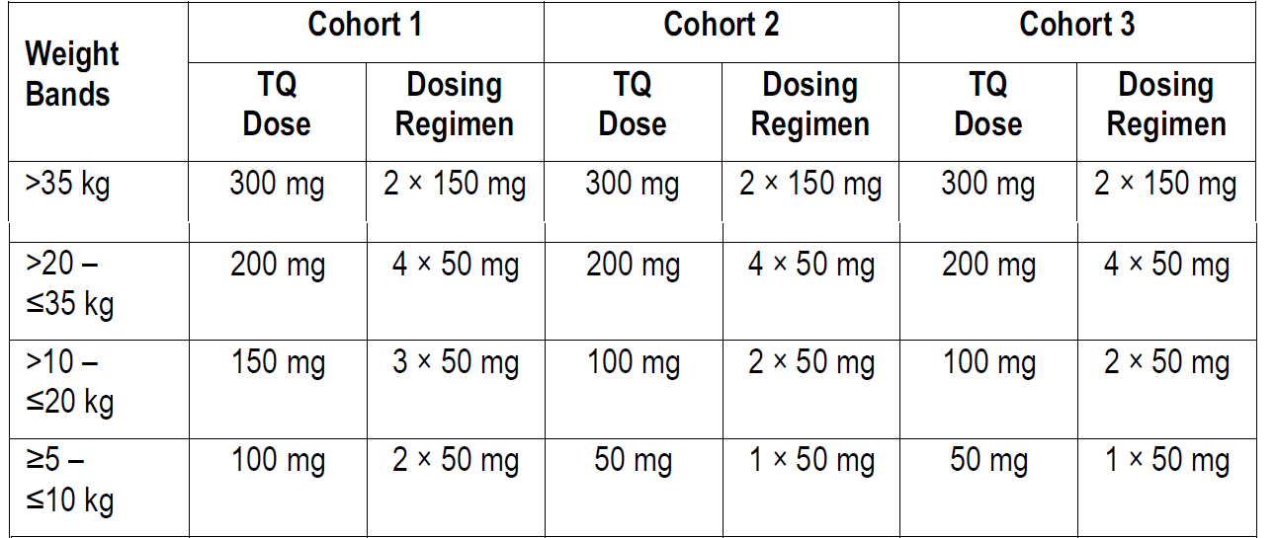
Note: The tafenoquine (TQ) dose is based on achieving a target AUC (0-infinty) of 96 µg.hr/mL
The initial group for recruitment and dosing in the study consisted of children who were at least 2 years to younger than 16 years. At the first interim analysis, although exposures in these participants, at doses as proposed above, were within pre-specified limit (area under concentration time curve (AUC) < 192 µg.hr/mL, that is about two times the target), dose reduction in lower weight bands (from 100 mg to 50 mg in the greater or equal to 5 kg to 10kg group and, 150 mg to 100mg in the greater than10 kg to less than or equal to 20 kg group) was undertaken so that exposures closer to the intended 96 μg.hr/mL could be achieved at lower doses. The updated dosing regimen was confirmed at the second interim analysis without any further dosing alterations and are being also proposed for registration (Table 3).
Table 3: Study TAF113577 (TEACH trial) Population pharmacokinetic model predicted exposures at the proposed final dosing regime
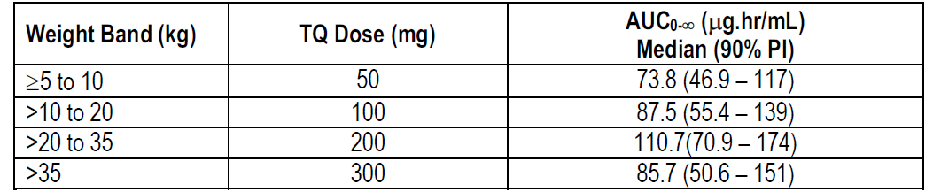
Abbreviations: AUC0-∞ = Area under concentration-time curve from zero to infinity. PI = Prediction interval, TQ = tafenoquine.
The lowest dose (50 mg) weight band (greater or equal to 5kg to 10kg) opened for recruitment after the second interim analysis. However, despite repeated attempts over 9 months, no children aged older or equal to 6 months to younger or equal to 2 years (body weight 5 kg) could be recruited.
Thus, participation in the study (N = 60) were limited to children between 2 to 15 years of age with body weight ranging from 12 kg to 62 kg (Table 4).
Table 4: Study TAF113577 (TEACH trial) Demographic and baseline characteristics (safety population)
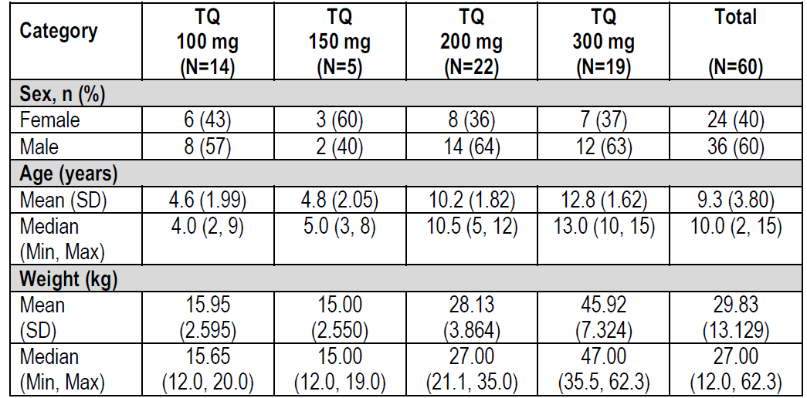
Abbreviations: Max = maximum, Min = minimum, SD = standard deviation, TQ = tafenoquine.
The mean G6PD enzyme activity was 10.461 IU/gram of haemoglobin. All had G6PD enzyme activity at least 70% of the site median for males with normal G6PD normal production.
Participants with a body weight greater than 35 kg had the choice of taking the adult tafenoquine 150 mg tablet or the dispersible tafenoquine 50 mg tablet. All children in the 100 mg, 150 mg (prior to first interim analysis) and 200 mg dose groups received the 50 mg dispersible tablet. Overall, 45 out of 60 participants received the dispersible tablet. Chloroquine (25 mg/kg total dose) was administered according to local protocol divided over three days.
All except four participants were P. vivax smear positive at Baseline. The four P. vivax negative children on Day 1 had positive P. vivax smears during the screening period and were possibly negative due to chloroquine treatment up to 48 hours prior to the tafenoquine administration. All participants were Plasmodium falciparum (P. falciparum) smear negative on Day 1.
A total of 58 out of 60 children were successfully dosed in the study (53 out of 60 on first attempt). Of the seven children who vomited or spat out first dose (within an hour of dosing), all had received the 50 mg dispersed tablet. Of these, 5 out of 7 were successfully dosed on second attempt. Two children also vomited or spat out on second dosing attempt (one in the 150 mg group and one in the 300 mg group) and were excluded from the PK analysis.
At four months of follow up, 53 out of 60 (88%) participants were confirmed to be recurrence free. The Kaplan-Meier estimate of recurrence-free rate was 95% (95% CI: 85%, 98%) (Table 5)
Table 5: Study TAF113577 (TEACH trial) Survival analysis of recurrence free efficacy over 4 months (modified intent to treat population)
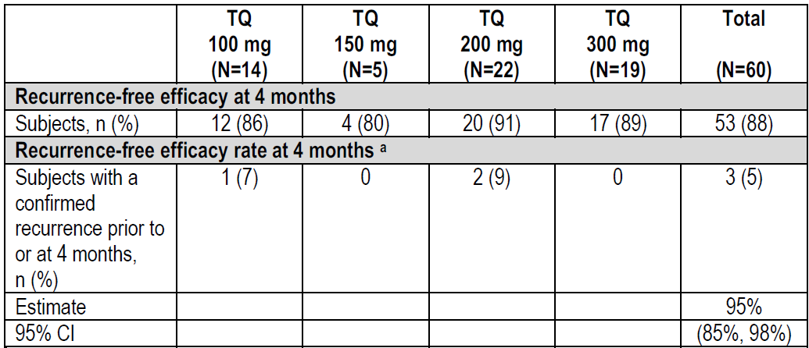
Note: Weight bands were: tafenoquine (TQ) 100 mg: ˃ 10 to ≤ 20 kg (cohort 2 and 3); TQ 150 mg: ˃ 10 to ≤ 20 kg (cohort 1); TQ 200mg: ˃ 20 to ≤ 35 kg; TQ 300 mg: ˃ 35 kg.
a Kaplan-Meier methodology
The Delegate noted that ‘recurrence’ was defined as a positive blood smear with or without P. vivax malaria symptoms. Note this is not a formal treatment effect as the study was uncontrolled. It was also not possible to determine, with the available genetic techniques, if a recurrence was a relapse (liver stage treatment failure), or a re-infection (that is new infection), or a recrudescence (blood stage treatment failure). For the purposes of this study, recurrence represents any malaria that re-occurred after the study treatment.

Pharmacokinetic Working Group review
The sponsor’s population pharmacokinetics modelling was reviewed by the TGA’s Pharmacokinetics Working Group. The working group also reviewed the sponsor’s response to TGA’s questions and found the responses satisfactory, commenting that the data did not have participants younger than two years of age and that while this may be a clinical issue, the sponsor’s justification for modelling decisions was acceptable.

Clinical safety
No data are currently available on the clinical use of 50 mg dispersible tablet in children younger than 2 years of age (weighing less than 10 kg). Therefore, the safety and adverse effects profile in children younger than 2 years is unknown. The available safety dataset in 2 to 15 years of age (N = 60) from Study TAF113577 is also very limited. No new or unexpected safety signals were identified in this dataset as compared to the adult and adolescent data other than the additional issue of vomiting and/or spitting out of the dose (within one hour) requiring re-dosing.

Risk management plan
Kozenis (tafenoquine) as a 150 mg film-coated tablet is currently approved for the radical cure (prevention of relapse) of P. vivax malaria in patients aged 16 years and older who are receiving appropriate antimalarial therapy for the acute P. vivax infection.¹⁴
The current recommended dosage for patients aged 16 years and older is a single 300 mg dose (2 x 150 mg tafenoquine tablets) given on Day 1 or Day 2 of a three day course of chloroquine.
The most recently evaluated Australian (Aus)-risk management plan (RMP) was version 1.2 (dated 24 August 2018; data lock point (DLP) 11 January 2018). The sponsor has submitted AUS-RMP version 2.0 (dated 17 November 2020; DLP 19 July 2020) in support of the extended indications.
The summary of safety concerns and their associated risk monitoring and mitigation strategies are summarised in Table 6. Further information regarding the TGA’s risk management approach can be found in risk management plans for medicines and biologicals and the TGA's risk management approach.
Table 6: Summary of safety concerns
The sponsor is required to comply with product vigilance and risk minimisation requirements.
Summary of safety concerns |  | Pharmacovigilance |  | Risk Minimisation
 |  | Routine | Additional | Routine | Additional
Important identified risks | Haemolytic anaemia (in G6PD deficiency). | * | – |  | –
Important identified risks | Use in pregnancy |  | – |  | –
Important potential risks | Serious psychiatric events in individuals with a past or current history of significant psychiatric disorders |  | – |  | –
Important potential risks | Use in lactating women |  | – |  | –
Missing information | Use in children aged 6 months to under 2 years |  | – |  | –
Missing information | Use in children under 6 months of age |  | – |  | –
Missing information | Use in patients aged 65 years or older |  | – |  | –
Missing information | Use in patients with renal impairment |  | – |  | –
Missing information | Use in patients with hepatic impairment |  | – |  | –
*Includes a Follow-up questionnaire
The summary of safety concerns is very similar to the previous submission;¹⁴ with the exception of the change to the ages for use in children included under Missing Information. The ages are consistent with the current application to change the patient group and the information that is missing. Therefore, the summary of safety concerns is acceptable.
Only routine pharmacovigilance activities are proposed which includes a follow-up questionnaire for haemolytic anaemia. This is the same as the previous application which was considered acceptable.
Only routine risk minimisation activities are proposed which includes an Instructions for Use leaflet to be included as a package insert in the 50 mg dispersible tablet box. As previously, no additional risk minimisation activities are proposed which is appropriate, but the sponsor should make some amendments to the PI, Consumer Medicine Information (CMI) and package insert as described in detail in Section 4.2 (Dose and Method of Administration) of the PI.
There are no outstanding or new recommendations.

Risk-benefit analysis

Delegate’s considerations and proposed action
The dose recommendations derived from population pharmacokinetics modelling are supported including the youngest weight band of children ≥ 5 kg to 10 kg (at least 6 months of age).
The lack of data in 6 months to 2 years age group for an infection which affects millions including children every year worldwide is not satisfactory. However, an unmet need, a paediatric formulation and accepted principle of extrapolating efficacy and safety from adults to children are important considerations. It is expected that in due course post-market data or further studies will fill the current information gap.
However, a lack of in vivo experience in dosing young children (aged 6 months to 2 years) with the proposed dispersible tablet is an additional aspect for which advice from Advisory Committee on Medicines (ACM) is requested.
This is an important deficiency as practical experience of administering this formulation in very young children, even in a highly supervised circumstance such as a clinical trial, is not available at present to inform actual clinical use whether supervised or unsupervised.
The clinical evaluation is supportive of approval in all age groups and has emphasised that administration in children should occur in supervised setting to ensure dosing guidance is followed. The Australian-specific RMP also states that dosing in children will likely occur in a hospital setting.
As regards the finished product, the proposed blister pack for 50 mg dispersible tablets contains three tablets and a bulk pack not for dispensing will contain ten blister packs. Therefore, the dispensing pack is not an exact dose for any age group. Cost, supply and dispensing are stated to be the reasons for this presentation. However, two tablets dispensing pack will be more logical. Note the adult dispensing pack is two 150 mg tablets (that is one single dose).

Questions for the sponsor
The sponsor provided the following response to questions from the Delegate.
- Further comments are requested from the sponsor in its pre-ACM response about potential problems when trying to dose very young children with the dispersed tablet.
- Further information on taste and palatability and ways to promote safe use and correct dosing in children 6 months to 2 years of age should also be included.
The proposed commercial pack for tafenoquine dispersible tablets is a blister pack containing three tablets in an orientated polyamide/aluminium foil/polyvinyl chloride laminate, sealed with a child-resistant 20 micron push through aluminium lidding foil with a vinyl acrylic heat seal coating. The proposed blister pack provides adequate protection to the drug product from moisture vapour and protection through distribution and use and hence ensures the requirements of the quality target product profile are met. Data from stability studies show acceptable physical and chemical stability of the drug product in the proposed blister pack at both accelerated and long-term storage conditions.
Ten blisters (30 tablets) will be packed into a bulk pack with the supporting package insert as per country/language requirements. The proposed blister presentation supplied to the healthcare practitioner contains a perforation, as shown in Figure 2. This has been designed to enable an individualised weight based dose to be dispensed by the practitioner. The format of the blister presentation has been chosen to maximise access by minimising cost of goods and supply chain burden for clinics without impacting patient safety. The blister perforation can be used by the healthcare practitioner to enable the required dose for patient administration and maximises the number of potential patients that can be treated from a single bulk pack. The three tablet perforated blister reduces potential waste, as doses of one, two or four tablets can be provided without impacting the integrity of the remaining tablets in the other half of the blister pack. Each part of the separated blister contains necessary information, dosing table, number of tablets on the respective side of the blister, lot details and expiry date. This ensures patient relevant information is always retained.
The commercial bulk pack of ten blisters (30 tablets) was optimised in field studies, performed in Brazil and India, in anticipation of the expected dispensing scenarios from an healthcare practitioner clinical setting and provision of the required dose directly to the patient in-clinic. The design of the blister pack presentation also accommodates situations where the required dose can be provided to the patient’s carer for administration outside of a clinical setting and sufficient package inserts are included to accompany the maximum possible doses from the bulk pack. Comprehension of the blister presentation and package insert was confirmed in the field studies by interview with healthcare practitioner and caregivers, covering a range of literacy levels and geographic settings.
Figure 2: Proposed Kozenis blister format
A sensory analysis study was performed to determine the acceptability of a formulation representative of that presented in the description and composition of the drug product. Three variations of the formulation were trialled in 12 adult male volunteers [Information redacted]. The sensory analysis study determined that the addition of [Information redacted] made the dispersion acceptable and that a level of [Information redacted] in a tafenoquine dispersible tablet was more acceptable than formulations containing [Information redacted].
The acceptability of the formulation was further verified by i) additional in vitro assessment, ii) an additional human sensory study performed on the proposed commercial formulation and iii) the successful completion of Study TAF113577 (TEACH trial) using the proposed commercial formulation. Development of the dosing regimen during the Study TAF113577 refined the administration procedure to minimise instances of intolerance (vomiting). Vomiting is a well-recognised symptom of P. vivax malaria in children;, and was also the most common adverse event reported during the pivotal paediatric Study TAF113577 and post-dose vomiting/spitting following the initial dose of tafenoquine within an hour of administration was also observed. Re-dosing was recommended following vomiting/spitting out within one hour of administration and did not impact tafenoquine bioavailability by a clinically relevant amount and none of these subjects experienced a recurrence of P. vivax malaria and thus did not impact the benefit/risk profile of tafenoquine.
To mitigate the risk of an ineffective dose in the event of vomiting or spitting out of medication wording is proposed in the labelling that in the event of vomiting within an hour of dosing, a repeat dose should be given. Paediatric patients should be monitored for vomiting or for spitting out of their dose. Re-dosing should not be attempted more than once and is not recommended if vomiting or spitting out occurs more than an hour after initial dosing.
The predicted exposures at the proposed doses indicate in the event where a double dosing were to occur, that is in the unlikely event that both the dose and the re-dose on vomiting are absorbed, the exposure would be within 2-fold of the median exposure, comparable to those seen at the tafenoquine 600 mg dose studied in adults in Study TAF112582 Part 1, tafenoquine dose ranging study, tafenoquine has been dosed up to 1200 mg achieving tafenoquine exposures with an acceptable safety profile. Thus, the PK analysis supports the recommendation that subjects should be re-dosed if they vomit or spit out their medication within one hour of initial dosing.
Unit dose is assured by the individual tablet and dose flexibility to enable weight based dosing is achieved by number of unit doses dispensed by the healthcare practitioner, no further adjustment or dilution is required following preparation for dosing. The principal of preparation and administration was assessed in the field studies, with children and infants, performed in Brazil and India. These field studies involved healthcare practitioner and caregivers, across a range of literacy levels, and confirmed the Instructions for Use / Australian package insert were understood.
The Instructions for Use pictorially show a small cup for dose preparation and a small cup and spoon for administration. While dosing devices are not provided for single dose products, comprehension of the selection of age appropriate dosing devices was confirmed by interview of healthcare practitioner and caregivers in the field studies. Qualitative data collected in the field studies showed that healthcare practitioner had, or were able to procure, appropriate devices to facilitate preparation and administration of medicines to paediatric patients. These options would be available in the clinic and could be provided by the healthcare practitioner for home administration if required.
Based on this information sponsor believe there are no reasons why the product could not be correctly dosed safely in children 6 months to 2 years of age.

Advisory Committee considerations
The Advisory Committee on Medicines (ACM) having considered the evaluations and the Delegate’s overview, as well as the sponsor’s response to these documents, advised the following.

Specific advice to the Delegate
- The committee is requested advise whether it is clinically appropriate and safe to register the 50 mg dispersible tablet for use in children 6 months to 2 years of age despite lack of any clinical experience in this age group at present.
The ACM does not consider it clinically appropriate and safe to register the new dosage form for use in children as young as 6 months to 2 years of age as there was no data in children younger than 2 years of age. The ACM was of the view that extrapolating exposure from adults to children is particularly fraught in the very young age group proposed by the sponsor as the PK profile in this age group is likely to be different, presenting a definite risk of incorrect dosing and suboptimal exposure. Suboptimal exposure will reduce the efficacy and affect the outcome of treatment.
In addition, the ACM commented that there are alternative safe and effective options (primaquine) and therefore there is not an unmet need, particularly in Australia where the number of children under 2 years of age affected by malaria is low. The ACM noted that in Australia, malaria is a disease associated with residing in or travelling to overseas areas with endemic transmission.
The ACM was also of the opinion that the sponsor could have recruited children younger than 2-year-old infants to a carefully selected clinical study centre. The ACM concluded that data is needed before tafenoquine can safely be approved for use in the 6 months to 2 years age group.
- Does the ACM have any other advice regarding this submission?
The ACM recommended amendments to the proposed Australian PI as follows:
‘Populations:
Note that clinical trial experience with KOZENIS in children is limited to patients above 2 years of age, as no patients in the 6 months to 2 years age group or weighing < 10kg could be were enrolled in the paediatric clinical trial (see Section 5.1 PHARMACODYNAMIC PROPERTIES, Clinical Trials). The dose recommendations in Table 1 above are based on pharmacokinetic modelling. The doses across the 3 body-weight bands were selected to achieve plasma drug levels comparable to those in adults & adolescents at the approved clinical dose.’
The ACM also advised that relevant places in the PI should specify that quantitative G6PD testing is required. Even patients with partial deficiency that may be missed by qualitative testing are at risk for haemolysis. Therefore, physicians must perform quantitative G6PD testing before prescribing tafenoquine.

Conclusion
The ACM considered this product to have an overall positive benefit-risk profile for the following indication:
Tafenoquine is indicated for the radical cure (prevention of relapse) of Plasmodium vivax (P. vivax) malaria in patients aged 2 years and older who are receiving chloroquine for acute P. vivax infection.
Its use should include quantitative G6PD testing to exclude patients with enzyme activity < 70%.
The ACM did not support the indication to include children as young as 6 months and older (≥ 5 kg body weight).

Outcome
Based on a review of quality, safety, and efficacy, the TGA approved the registration of Kozenis (tafenoquine) 50 mg film-coated dispersible tablets, and 150 mg, film coated tablets, blister pack, for the following extension of indications and change in dose form and strength:
Tafenoquine is indicated, in combination with chloroquine, for the radical cure (prevention of relapse) of Plasmodium vivax (P. vivax) malaria (see Section 4.2 Dose and method of administration).
As such, the full indications at this time were:
Tafenoquine is indicated, in combination with chloroquine, for the radical cure (prevention of relapse) of Plasmodium vivax (P. vivax) malaria (see Section 4.2 Dose and method of administration).

Specific conditions of registration applying to these goods
- Kozenis (tafenoquine succinate) is to be included in the Black Triangle Scheme. The PI and CMI for Kozenis must include the black triangle symbol and mandatory accompanying text for five years, which starts from the date the new indication is registered.
- The Kozenis AUS-RMP (version 2.0; dated 17 November 2020; DLP 19 July 2020) included with submission PM-2020-05985-1-2, and any subsequent revisions, as agreed with the TGA will be implemented in Australia.
An obligatory component of risk management plans is routine pharmacovigilance. Routine pharmacovigilance includes the submission of periodic safety update reports (PSURs).
Unless agreed separately between the supplier who is the recipient of the approval and the TGA, the first report must be submitted to TGA no later than 15 calendar months after the date of the approval letter. The subsequent reports must be submitted no less frequently than annually from the date of the first submitted report until the period covered by such reports is not less than three years from the date of the approval letter. The annual submission may be made up of two PSURs each covering six months. If the sponsor wishes, the six monthly reports may be submitted separately as they become available.
If the product is approved in the [European Union] EU during the three years period, reports can be provided in line with the published list of EU reference dates no less frequently than annually from the date of the first submitted report until the period covered by such reports is not less than three years from the date of this approval letter.
The reports are to at least meet the requirements for PSURs as described in the European Medicines Agency’s Guideline on good pharmacovigilance practices (GVP) Module VII-periodic safety update report (Rev 1), Part VII.B Structures and processes. Note that submission of a PSUR does not constitute an application to vary the registration. Each report must have been prepared within ninety calendar days of the data lock point for that report.

Attachment 1. Product Information
The PI for Kozenis approved with the submission which is described in this AusPAR is at Attachment 1. For the most recent PI, please refer to the TGA PI/CMI search facility.

Therapeutic Goods Administration
PO Box 100 Woden ACT 2606 Australia
Email: info@tga.gov.au Phone: 1800 020 653 Fax: 02 6232 8605
https://www.tga.gov.au

World Health Organization. Synopsis of the world malaria situation in 1981. Weekly Epidemiological Record. WHO 1983;58(25):189-92.
Preston-Thomas A, et al. An outbreak of Plasmodium falciparum malaria in the Torres Strait. Commun Dis Intell Q Rep. 2012;36(2):E180-E185.
Webb, Doggett, Russell. A guide to mosquitoes of Australia (2016). CSIRO Publishing.
Robinson, P et al. (2001). Imported Malaria Treated in Melbourne, Australia: Epidemiology and Clinical Features in 246 Patients. Journal of travel medicine. 8. 76-81.
Phimpraphi W, et al. Longitudinal study of Plasmodium falciparum and Plasmodium vivax in a Karen population in Thailand. Malaria journal 2008; 7: 99-99.
Douglas N, et al. Mortality attributable to Plasmodium vivax malaria: a clinical audit from Papua, Indonesia. BMC Med 2014; 12: 217.
Feged-Rivadeneira A, et al. Malaria intensity in Colombia by regions and populations. PLoS One 2018; 13(9): e0203673.
WHO: Guidelines for the treatment of malaria. Third edition. 2015 World Health Organization: Geneva, Switzerland. Available at: http://www.who.int/malaria/publications/atoz/9789241549127/en/
Sumawinata IW, et al. Very high risk of therapeutic failure with chloroquine for uncomplicated Plasmodium falciparum and P. vivax malaria in Indonesian Papua. Am J Trop Med and Hyg. 2003;68(4): 416-420.
Sutanto I, et al. Evaluation of chloroquine therapy for vivax and falciparum malaria in southern Sumatra, western Indonesia. Malaria Journal. 2010;9:52.
Kozenis tafenoquine 150 mg film-coated tablet blister pack was first registered on 13 September 2018 (ARTG R 297214)
AusPAR for Kozenis (tafenoquine (as succinate)) GlaxoSmithKline Australia Pty Ltd, submission PM-2017-04578-1-2 297214. Available at: AusPAR: Tafenoquine (as succinate) | Therapeutic Goods Administration (TGA)
Abreha T, et al. Comparison of artemether-lumefantrine and chloroquine with and without primaquine for the treatment of Plasmodium vivax infection in Ethiopia: a randomized controlled trial. PLoS Med. 2017; 14(5):e1002299.
Takeuchi R, et al. Directly-observed therapy (DOT) for the radical 14-day primaquine treatment of Plasmodium vivax malaria on the Thai-Myanmar border. Malaria J. 2010;9:308
Ketema T, et al. Plasmodium vivax associated severe malaria complications among children in some malaria endemic areas of Ethiopia. BMC Public Health 2013; 13: 637.
Demissie Y, et al. Complicated malaria symptoms associated with Plasmodium vivax among patients visiting health facilities in Mendi town, Northwest Ethiopia. BMC Infect Dis 2016; 16(1): 436.

