October 2022

Australian Public Assessment Report for Yuflyma
  - Active ingredient: Adalimumab
  - Sponsor: Celltrion Healthcare Australia Pty Ltd

About the Therapeutic Goods Administration (TGA)
- The Therapeutic Goods Administration (TGA) is part of the Australian Government Department of Health and is responsible for regulating therapeutic goods, including medicines, medical devices, and biologicals.
- The TGA administers the Therapeutic Goods Act 1989 (the Act), applying a risk management approach designed to ensure therapeutic goods supplied in Australia meet acceptable standards of quality, safety, and efficacy.
- The work of the TGA is based on applying scientific and clinical expertise to decision-making, to ensure that the benefits to the Australian public outweigh any risks associated with the use of therapeutic goods.
- The TGA relies on the public, healthcare professionals and industry to report problems with therapeutic goods. The TGA investigates reports received to determine any necessary regulatory action.
- To report a problem with a therapeutic good, please see the information on the TGA website.

About AusPARs
- The Australian Public Assessment Report (AusPAR) provides information about the evaluation of a prescription medicine and the considerations that led the TGA to approve or not approve a prescription medicine submission. Further information can be found in Australian Public Assessment Report (AusPAR) guidance.
- AusPARs are prepared and published by the TGA.
- AusPARs are static documents that provide information that relates to a submission at a particular point in time. The publication of an AusPAR is an important part of the transparency of the TGA’s decision-making process.
- A new AusPAR may be provided to reflect changes to indications or major variations to a prescription medicine subject to evaluation by the TGA.

Copyright
© Commonwealth of Australia 2022
This work is copyright. You may reproduce the whole or part of this work in unaltered form for your own personal use or, if you are part of an organisation, for internal use within your organisation, but only if you or your organisation do not use the reproduction for any commercial purpose and retain this copyright notice and all disclaimer notices as part of that reproduction. Apart from rights to use as permitted by the Copyright Act 1968 or allowed by this copyright notice, all other rights are reserved, and you are not allowed to reproduce the whole or any part of this work in any way (electronic or otherwise) without first being given specific written permission from the Commonwealth to do so. Requests and inquiries concerning reproduction and rights are to be sent to the TGA Copyright Officer, Therapeutic Goods Administration, PO Box 100, Woden ACT 2606 or emailed to <tga.copyright@tga.gov.au>.

Contents
List of abbreviations 4
Product submission 6
Submission details 6
Product background 8
Regulatory status 10
Product Information 10
Registration timeline 11
Submission overview and risk/benefit assessment 11
Quality 12
Nonclinical 13
Clinical 14
Risk management plan 33
Risk-benefit analysis 34
Outcome 37
Specific conditions of registration applying to these goods 38
Attachment 1. Product Information 39

List of abbreviations
Abbreviation |  | Meaning
ACM | Advisory Committee on Medicines
ACR | American College of Rheumatology
ACR20/50/70 | 20%/50%/70% improvement in American College of Rheumatology criteria
ADA | Anti-drug antibody
AESI | Adverse event of special interest
ANCOVA | Analysis of covariance
ARGPM | Australian Regulatory Guidelines for Prescription Medicines
ARTG | Australian Register of Therapeutic Goods
ASA | Australia specific annex
AU | Australian
%AUC_{extrap} | Percentage of the area extrapolated for calculation of AUC_{0-inf} (area under the concentration time curve from time zero to infinity)
AUC_{0-inf} | Area under the concentration time curve from time zero to infinity
AUC_{0-last} | Area under the concentration time curve from time zero to time of last quantifiable serum concentration
CDAI | Clinical Disease Activity Index
CHMP | Committee for Medicinal Products for Human Use (European Medicines Agency, European Union)
CI | Confidence interval
C_{max} | Maximum serum concentration
CMI | Consumer Medicine Information
COR-B | Comparable Overseas Regulator B
CPD | Certified Product Details
CRP | C-reactive protein
CT-P17 | Sponsor’s drug development code for Yuflyma (adalimumab)
C_{trough} | Trough concentration
DAS28 | Disease Activity Score 28
DAS28 CRP | Disease Activity Score 28 plus C-reactive protein
DAS28 ESR | Disease Activity Score 28 plus erythrocyte sedimentation rate
DLP | Data lock point
DMARD | Disease modifying antirheumatic drug
EMA | European Medicines Agency (European Union)
ESR | Erythrocyte sedimentation rate
EU | European Union
EULAR | European League against Rheumatism
GVP | Good Pharmacovigilance Practices
ITT | Intent-to-treat
NAb | Neutralising antibody
PD | Pharmacodynamic(s)
PDF | Portable document format
PI | Product Information
PK | Pharmacokinetic(s)
PP | Per-protocol
PSUR | Periodic safety update report
RMP | Risk management plan
SDAI | Simplified Disease Activity Index
TEAE | Treatment-emergent adverse event
TESAE | Treatment-emergent serious adverse event
TGA | Therapeutic Goods Administration
TNFα | Tumour necrosis factor alpha
US(A) | United States (of America)

Product submission

Submission details
Type of submission: | New biosimilar medicine
Product name: | Yuflyma
Active ingredient: | Adalimumab
Decision: | Approved
Date of decision: | 28 February 2022
Date of entry onto ARTG: | 25 March 2022
ARTG numbers: | 358350, 367770 and 367771
Black Triangle Scheme: | No
Sponsor’s name and address: | Celltrion Healthcare Australia Pty Ltd  Suite 13-03, 31 Market Street,  Sydney, NSW 2000
Dose form: | Solution for injection
Strength: | 40 mg/0.4 mL
Containers: | Pre-filled syringe, pre-filled syringe with safety guard, and pre-filled syringe in auto-injector pen
Pack sizes: | 1, 2, 4 and 6
Approved therapeutic use: | Rheumatoid arthritis  Yuflyma is indicated for reducing signs and symptoms, as well as inhibiting the progression of structural damage in adult patients with moderate to severely active rheumatoid arthritis. This includes the treatment of patients with recently diagnosed moderate to severely active disease who have not received methotrexate.  Yuflyma can be used alone or in combination with methotrexate.  Juvenile idiopathic arthritis  Polyarticular juvenile idiopathic arthritis  Yuflyma in combination with methotrexate is indicated for reducing the signs and symptoms of moderately to severely active polyarticular juvenile idiopathic arthritis in patients 2 years of age and older who have had an inadequate response to one or more disease modifying antirheumatic drugs (DMARDs). Yuflyma can be given as monotherapy in case of intolerance to methotrexate or when continued treatment with methotrexate is inappropriate.  Enthesitis-related arthritis  Yuflyma is indicated for the treatment of enthesitis-related arthritis in children, who have had an inadequate response to, or who are intolerant to, conventional therapy.  Psoriatic arthritis  Yuflyma is indicated for the treatment of signs and symptoms, as well as inhibiting the progression of structural damage, of moderate to severely active psoriatic arthritis in adult patients where response to previous DMARDs has been inadequate.  Ankylosing spondylitis  Yuflyma is indicated for reducing signs and symptoms in patients with active ankylosing spondylitis.  Crohn’s disease in adults and children (≥ 6 years)  Yuflyma is indicated for the treatment of moderate to severe Crohn’s disease, to reduce the signs and symptoms of the disease and to induce and maintain clinical remission in patients;  - who have had an inadequate response to conventional therapies or,  - who have lost response to or are intolerant to infliximab  Ulcerative colitis  Yuflyma is indicated for the treatment of moderate to severe ulcerative colitis in adult patients who have had an inadequate response to conventional therapy or who are intolerant to or have medical contraindications for such therapies. Patients should show a clinical response within 8 weeks of treatment to continue treatment beyond that time. (see 5.1 Pharmacodynamic properties - clinical trials).  Psoriasis in adults and children  Yuflyma is indicated for the treatment of moderate to severe chronic plaque psoriasis in adult patients who are candidates for systemic therapy or phototherapy.  Yuflyma is indicated for the treatment of severe chronic plaque psoriasis in children and adolescent patients from 4 years of age who have had an inadequate response to or are inappropriate candidates for topical therapy and phototherapy.  Hidradenitis suppurativa in adults and adolescents (from 12 years of age)  Yuflyma is indicated for the treatment of active moderate to severe hidradenitis suppurativa (acne inversa) in patients with an inadequate response to conventional systemic hidradenitis suppurativa therapy.  Uveitis  Yuflyma is indicated for the treatment of non-infectious intermediate, posterior and pan-uveitis in adult patients who have had an inadequate response to corticosteroids, in patients in need of corticosteroid sparing, or in whom corticosteroid treatment is inappropriate.
Route of administration: | Subcutaneous
Dosage: | Yuflyma is intended for use under the guidance and supervision of a physician.  Dosage of Yuflyma is based on multiple factors including the condition being treated, the age and the body weight of the patient.  For further information regarding dosage, refer to the Product Information.
Pregnancy category: | C  Drugs which, owing to their pharmacological effects, have caused or may be suspected of causing, harmful effects on the human fetus or neonate without causing malformations. These effects may be reversible. Accompanying texts should be consulted for further details.  The use of any medicine during pregnancy requires careful consideration of both risks and benefits by the treating health professional. This must not be used as the sole basis of decision making in the use of medicines during pregnancy. The TGA does not provide advice on the use of medicines in pregnancy for specific cases. More information is available from obstetric drug information services in your State or Territory.

Product background
This AusPAR describes the submission by Celltrion Healthcare Australia Pty Ltd (the sponsor) to register Yuflyma (adalimumab) 40 mg/0.4 mL, solution for injection for the following proposed indication:
Rheumatoid arthritis
Yuflyma is indicated for reducing signs and symptoms, as well as inhibiting the progression of structural damage in adult patients with moderate to severely active rheumatoid arthritis. This includes the treatment of patients with recently diagnosed moderate to severely active disease who have not received methotrexate.
Yuflyma can be used alone or in combination with methotrexate.
Juvenile idiopathic arthritis
Polyarticular juvenile idiopathic arthritis
Yuflyma in combination with methotrexate is indicated for reducing the signs and symptoms of moderately to severely active polyarticular juvenile idiopathic arthritis in patients 2 years of age and older who have had an inadequate response to one or more disease modifying anti-rheumatic drugs (DMARDs). Yuflyma can be given as monotherapy in case of intolerance to methotrexate or when continued treatment with methotrexate is inappropriate.
Enthesitis-related arthritis
Yuflyma is indicated for the treatment of enthesitis-related arthritis in children, who have had an inadequate response to, or who are intolerant to, conventional therapy.
Psoriatic arthritis
Yuflyma is indicated for the treatment of signs and symptoms, as well as inhibiting the progression of structural damage, of moderate to severely active psoriatic arthritis in adult patients where response to previous DMARDs has been inadequate.
Ankylosing spondylitis
Yuflyma is indicated for reducing signs and symptoms in patients with active ankylosing spondylitis.
Crohn’s disease in adults and children (≥ 6 years)
Yuflyma is indicated for the treatment of moderate to severe Crohn’s disease, to reduce the signs and symptoms of the disease and to induce and maintain clinical remission in patients;
- who have had an inadequate response to conventional therapies or,
- who have lost response to or are intolerant to infliximab
Ulcerative colitis
Yuflyma is indicated for the treatment of moderate to severe ulcerative colitis in adult patients who have had an inadequate response to conventional therapy or who are intolerant to or have medical contraindications for such therapies. Patients should show a clinical response within 8 weeks of treatment to continue treatment beyond that time. (see 5.1 Pharmacodynamic properties - clinical trials).
Psoriasis in adults and children
Yuflyma is indicated for the treatment of moderate to severe chronic plaque psoriasis in adult patients who are candidates for systemic therapy or phototherapy.
Yuflyma is indicated for the treatment of severe chronic plaque psoriasis in children and adolescent patients from 4 years of age who have had an inadequate response to or are inappropriate candidates for topical therapy and phototherapy.
Hidradenitis suppurativa in adults and adolescents (from 12 years of age)
Yuflyma is indicated for the treatment of active moderate to severe hidradenitis suppurativa (acne inversa) in patients with an inadequate response to conventional systemic hidradenitis suppurativa therapy.
Uveitis
Yuflyma is indicated for the treatment of non-infectious intermediate, posterior and pan-uveitis in adult patients who have had an inadequate response to corticosteroids, in patients in need of corticosteroid sparing, or in whom corticosteroid treatment is inappropriate.
Yuflyma (adalimumab) (previously known as ‘CT-P17’, the sponsor’s drug development code) is a recombinant human monoclonal antibody that selectively binds directly to human tumour necrosis factor alpha (TNFα), a cytokine that is involved in normal inflammatory and immune responses but dysregulated responses in inflammatory diseases. The sponsor has developed Yuflyma as a proposed similar biological product to Humira (sponsor: Abbvie Pty Ltd). Humira is the first adalimumab drug approved for use in Australia, and is therefore considered to be the ‘innovator’ medicine. It was registered in 2003 for the treatment of rheumatoid arthritis, and has subsequently been approved for a range of other inflammatory conditions including juvenile idiopathic arthritis, enthesitis related arthritis in children, psoriatic arthritis, ankylosing spondylitis, Crohn’s disease, ulcerative colitis, psoriasis, hidradenitis suppurativa and uveitis.
To date, the TGA has approved other adalimumab alternatives considered as biosimilars to the innovator in Australia: Hyrimoz (sponsor: Sandoz Pty Ltd), Hadlima (sponsor: Samsung Bioepis AU Pty Ltd), Idacio (sponsor: Fresenius Kabi Australia Pty Ltd), and Amgevita (sponsor: Amgen Australia Pty Ltd), Abrilada (sponsor: Pfizer Australia Pty Ltd), and most recently Hulio (Alphapharm Pty Ltd).
The proposed indications for Yuflyma are same with all indications currently approved for European Union (EU) approved Humira, rheumatoid arthritis, juvenile idiopathic arthritis, axial spondyloarthritis, psoriatic arthritis, psoriasis, paediatric plaque psoriasis, hidradenitis suppurativa, Crohn’s disease, paediatric Crohn’s disease, ulcerative colitis, uveitis and paediatric uveitis.
This submission was submitted through the TGA’s Comparable Overseas Regulator B (COR-B) process, using evaluation reports from European Medicines Agency (EMA). The full dossier was submitted to the TGA.

Regulatory status
This product is considered as a new biosimilar medicine for Australian regulatory purposes.
At the time the TGA considered this submission, a similar submission had been approved in the EU on 11 February 2021. Similar submissions were under consideration in the United States of America (USA) (submitted on 24 November 2020) and the United Kingdom (submitted on 21 January 2021).
In the EU, Yuflyma was approved for essentially the same conditions as requested in Australia. In the EU, Yuflyma has also been approved for axial spondyloarthritis, paediatric plaque psoriasis, paediatric ulcerative colitis and paediatric uveitis.

Product Information
The Product Information (PI) approved with the submission which is described in this AusPAR can be found as Attachment 1. For the most recent PI, please refer to the TGA PI/CMI search facility.

Registration timeline
The following table captures the key steps and dates for this submission.
Table 1: Timeline for Submission PM-2021-01170-1-3
Description | Date
Submission dossier accepted and first round evaluation commenced | 1 June 2021
First round evaluation completed | 29 September 2021
Sponsor provides responses on questions raised in first round evaluation | 29 October 2021
Second round evaluation completed | 16 December 2021
Delegate’s Overall benefit-risk assessment | 4 January 2022
Sponsor’s pre-Advisory Committee response | Not applicable
Advisory Committee meeting | Not applicable
Registration decision (Outcome) | 28 February 2022
Completion of administrative activities and registration on the ARTG | 25 March 2022
Number of working days from submission dossier acceptance to registration decision* | 165
*The COR-B process has a 175 working day evaluation and decision timeframe.

Submission overview and risk/benefit assessment
A summary of the TGA’s assessment for this submission is provided below.
This section is a TGA summary of wording used in TGA’s evaluation report, which discussed numerous aspects of overseas evaluation reports and included some information that was commercial-in-confidence.
Relevant guidelines or guidance documents referred to by the Delegate are listed below:
- European Medicines Agency (EMA), Committee for Medicinal Products for Human Use (CHMP), Guideline on Similar Biological Medicinal Products Containing Monoclonal Antibodies - Non-clinical and Clinical Issues, EMA/CHMP/BMWP/403543/2010, 30 May 2012.
- European Medicines Agency (EMA), Committee for Medicinal Products for Human Use (CHMP), Guideline on Similar Biological Medicinal Products Containing Biotechnology-Derived Proteins as Active Substance: Quality Issues (Revision 1), EMA/CHMP/BWP/247713/2012, 22 May 2014.
- European Medicines Agency (EMA), Committee for Medicinal Products for Human Use (CHMP), Guideline on Similar Biological Medicinal Products, CHMP/437/04 Rev 1, 23 October 2014.

Quality
The active substance, adalimumab, is a recombinant human monoclonal immunoglobulin G1 antibody subclass antibody that selectively binds directly to human TNFα. The finished product is presented as a sterile solution for injection containing 40 mg of adalimumab as the active substance. The product is available in 0.4 mL single dose pre-filled syringe, pre-filled syringe with needle safety guard or pre-filled pen (auto-injector).
A comprehensive comparability exercise comparing the physicochemical and biological properties of Yuflyma to EU-approved Humira and US-licensed Humira demonstrated high similarity for physicochemical and biological quality attributes. In particular, high similarity was demonstrated for the following properties:
- Primary and higher order structure
- Content and extractable volume
- Size heterogeneity
- Charge variants (with some minor exceptions)
- Glycan profiles
- Binding to soluble and transmembrane TNFα and neutralisation of TNFα
- Reverse signalling activity
- Binding to Fc-receptors (FcγRIIIa (V, F), FcγRIIIb, FcγRIIa, FcγRIIb, FcγRI and FcRn)
- Binding to C1q and complement dependent cytotoxicity activity
- Antibody dependent cellular cytotoxicity activity
- Inhibition of TNFα-induced apoptosis, interleukin-8 and vascular cell adhesion protein-1 release
- Induction of regulatory macrophages and subsequent T-cell anti-proliferation
- Stability under accelerated and stressed conditions and forced degradation.
Minor differences were observed in charge variants, and in mannosylated and afucosylated glycans, but the observed differences were small and deemed unlikely to have a clinical impact.
A bridging study demonstrated high similarity between Australian-sourced Humira and EU-approved Humira, supporting a conclusion of biosimilarity of Yuflyma with the Australian reference product.
The PI, Consumer Medicine Information (CMI), and Labels are acceptable from a quality perspective.
All outstanding issues are resolved prior to approval.

Quality related proposed conditions of registration
Laboratory testing and compliance with certified product details
- All batches of Yuflyma supplied in Australia must comply with the product details and specifications approved during evaluation and detailed in the Certified Product Details (CPD).
- When requested by the TGA, the sponsor should be prepared to provide product samples, specified reference materials and documentary evidence to enable the TGA to conduct laboratory testing on the product. Outcomes of laboratory testing are published biannually in the TGA Database of Laboratory Testing Results http://www.tga.gov.au/ws-labs-index and periodically in testing reports on the TGA website.

Certified Product Details
The CPD, as described in Guidance 7: Certified Product Details of the Australian Regulatory Guidelines for Prescription Medicines (ARGPM) (http://www.tga.gov.au/industry/pm-argpm-guidance-7.htm), in portable document format (PDF), for the above products should be provided upon registration of these therapeutic goods. In addition, an updated CPD should be provided when changes to finished product specifications and test methods are approved in a Category 3 application; or notified through a self-assessable change.
The CPD should be emailed to biochemistry.testing@health.gov.au as a single PDF document.

Nonclinical
The nonclinical dossier was consistent with the EMA guideline. The overall quality of the nonclinical dossier was high. The nonclinical dossier contained comparative studies (Yuflyma versus EU-approved Humira) on pharmacology, pharmacokinetics (PK) and repeat dose toxicity.
Comparable biological activity was demonstrated between Yuflyma and EU-approved Humira to support all proposed indications (Table 2 summarises the mechanism of action of adalimumab). Yuflyma was similar to EU-approved Humira in binding to soluble TNFα and transmembrane TNFα, C1q and Fc receptors, and in TNFα neutralisation, complement dependent cytotoxicity, antibody dependent cellular cytotoxicity and apoptotic activity (reverse signalling). Yuflyma and EU-approved Humira had comparable inhibition of TNFα-induced apoptosis, interleukin-8 and vascular cell adhesion protein-1 release, regulatory macrophage induction and subsequent T-cell anti-proliferation. The minor differences in glycosylation between Yuflyma and EU-approved Humira had no meaningful difference in bioassays.
Table 2: Summary of mechanism of action of adalimumab
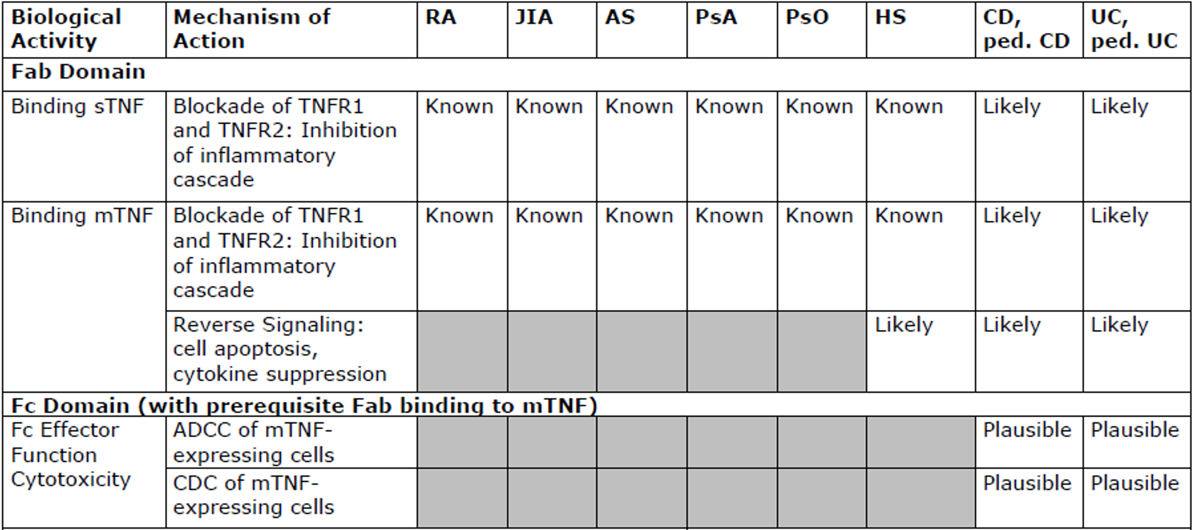
Abbreviations: ADCC = antibody dependent cellular cytotoxicity; AS = ankylosing spondylitis; CD = Crohn’s disease; CDC = complement dependent cytotoxicity; HS = hidradenitis suppurativa; JIA = juvenile idiopathic arthritis; mTNF = membrane associated tumour necrosis factor; Ped = paediatric; PSA = psoriatic arthritis; PsO = plaque psoriasis; RA = rheumatoid arthritis; sTNF = soluble tumour necrosis factor; TNFR = tumour necrosis factor receptor; UC = ulcerative colitis.
At equivalent doses, comparable serum kinetic profiles after subcutaneous administration were evident for Yuflyma and EU-approved Humira in toxicokinetic data obtained from monkeys.
A Good Laboratory Practices;compliant 28-day repeat dose toxicity study in monkeys showed similar findings for Yuflyma and EU-approved Humira at equivalent doses. The proposed product for commercialisation was not used in the repeat dose toxicity study, but the test product was shown to be sufficiently similar to the proposed commercial product based on physicochemical characterisation.

Clinical

Summary of clinical studies
The clinical dossier consisted of five clinical studies:
- 3 Phase I studies:
  - Study CT-P17 1.1 (PK study for biosimilarity): Phase I, randomised, double blind, three arm, parallel group, single dose study to compare the PK and safety of Yuflyma, EU-approved Humira, and US-licensed Humira in healthy subjects.
  - Study CT-P17 1.2 (pilot study): Phase I randomised, double blind, two arm, parallel group, single dose study to evaluate the safety (treatment-emergent adverse events (TEAEs)) and PK of Yuflyma pre-filled syringe and EU-approved Humira pre-filled syringe in 30 healthy male subjects. This was a pilot study with limited PK data collected as a secondary endpoint, so the evaluation findings informed the safety assessment but did not affect the overall assessment of biosimilarity.
  - Study CT-P17 1.3 (PK study comparing auto-injector and pre-filled syringe): Phase I, randomised, open label, two arm, parallel group, single dose study designed to compare the PK and safety of Yuflyma via subcutaneous administration by auto-injector and pre-filled syringe in healthy subjects.
- 2 Phase III studies:
  - Study CT-P17 3.1 (comparative efficacy and safety study): Phase III, randomised, active controlled, double blind multicentre study to compare efficacy, PK, pharmacodynamics (PD), safety, and usability of multiple single doses (40 mg) of Yuflyma pre-filled syringe with EU-approved Humira pre-filled syringe when co-administered with methotrexate in patients with moderate to severe active rheumatoid arthritis.
  - Study CT-P17 3.2 (auto-injector usability study): Phase III, open label, single arm, multiple dose study designed to evaluate usability, safety, and efficacy of subcutaneous administration via auto-injector of Yuflyma in patients with moderate to severe active rheumatoid arthritis.

Pharmacology

Pharmacokinetics

Study CT-P17 1.1
Study CT-P17 1.1 was the pivotal comparative PK study. It was a Phase I, randomised, double blind, three-arm, parallel group, single dose study to compare the PK and safety of Yuflyma and Humira (US-licensed Humira and EU-approved Humira) in healthy subjects. Subjects were randomly assigned to one of three treatment groups in a 1:1:1 ratio. In each treatment group, all subjects received a single 40 mg dose of either Yuflyma, US-licensed Humira, or EU-approved Humira by subcutaneous injection on Day 1 followed by 10 weeks (70 days) during which PK, safety, and immunogenicity measurements were made. The three primary endpoints of the study were area under the concentration time curve from time zero to infinity (AUC_{0-inf}), area under the concentration time curve from time zero to time of last quantifiable serum concentration (AUC_{0-last}), and maximum serum concentration (C_{max}).
A total of 312 subjects were randomised. Four randomised subjects did not receive the study drug. A total of 5 subjects discontinued after study drug administration: 2 subjects were lost to follow-up, 2 subjects due to withdrawal by subject, and one subject due to an adverse event. The PK population consisted of 290 subjects: subjects whose terminal elimination rate constant could not be estimated as not having at least 3 time points following C_{max} were excluded from the PK population as per-protocol. In addition, the percentage of the area extrapolated for calculation of AUC_{0-inf} (%AUC_{extrap}) was required to be ≤ 20% to retain the subject’s AUC_{0-inf} in statistical analysis.
The primary serum PK parameters of adalimumab are summarised by treatment for the PK population in Table 3. Mean serum concentrations of adalimumab versus time profiles for the PK population are presented in Figure 1. Statistical analyses of the PK parameters for the PK population supported a conclusion of PK equivalence between Yuflyma and EU-approved and US-licensed Humira (Table 4). Supplementary analyses based on all subjects who received a full dose also supported a conclusion of PK equivalence.
The majority of subjects had anti-drug antibodies (ADA) following the single adalimumab subcutaneous injection. An additional analysis of covariance (ANCOVA) performed in subjects identified as having a positive ADA status also demonstrated equivalent PK. The small number of ADA negative subjects (3 (3.1%), 5 (5.4%), 5 (5.0%) in the Yuflyma, US-licensed Humira, and EU-approved Humira treatment groups, respectively) did not allow ANCOVA for ADA negative subjects.
Figure 1: Study CT-P17 1.1 Mean (± standard deviation) serum concentrations of adalimumab versus time (pharmacokinetic population)
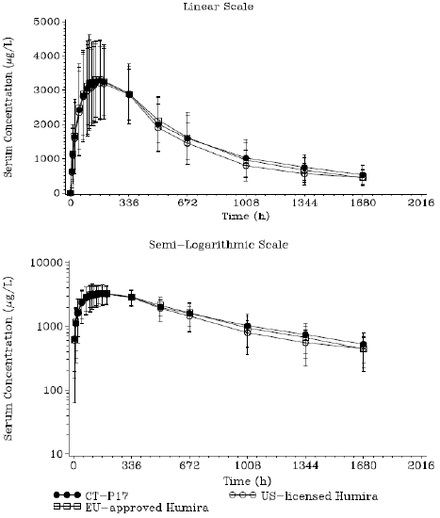
Abbreviations: CT-P17 = Yuflyma (adalimumab); EU = European Union; US = United States.
Table 3: Study CT-P17 1.1 Primary pharmacokinetic parameters of adalimumab by treatment group (pharmacokinetic population)
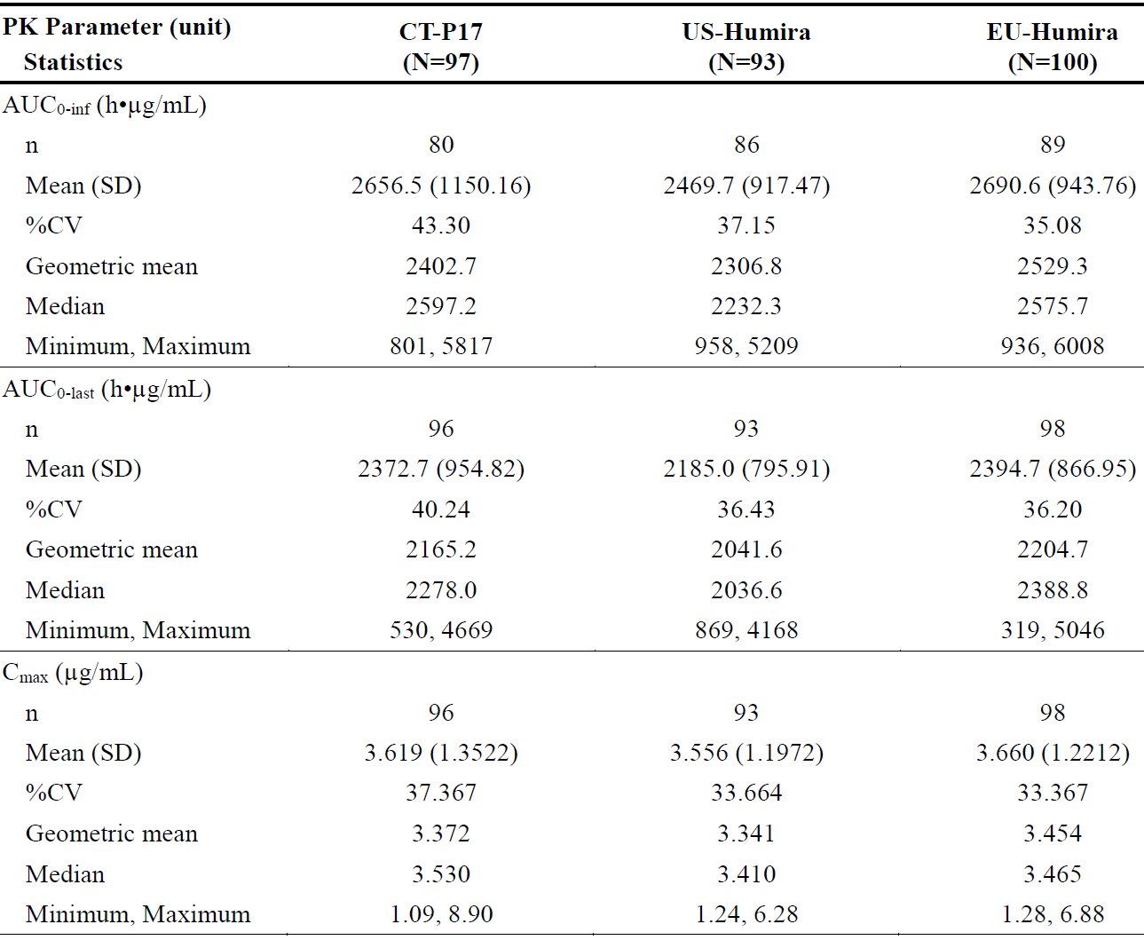
Abbreviations: AUC_{0-inf} = area under the concentration time curve from time zero to infinity; AUC_{0-last} = area under the concentration time curve from time zero to the last quantifiable concentration; C_{max} = maximum serum concentration; CT-P17 = Yuflyma (adalimumab); %CV = percentage coefficient of variation; EU = European Union; N = number of subjects; n = number of subjects in group; PK = pharmacokinetics; SD = standard deviation; US = United States.
Table 4: Study CT-P17 1.1 Statistical analysis (analysis of covariance) of primary pharmacokinetic parameters for adalimumab by treatment (pharmacokinetic population)
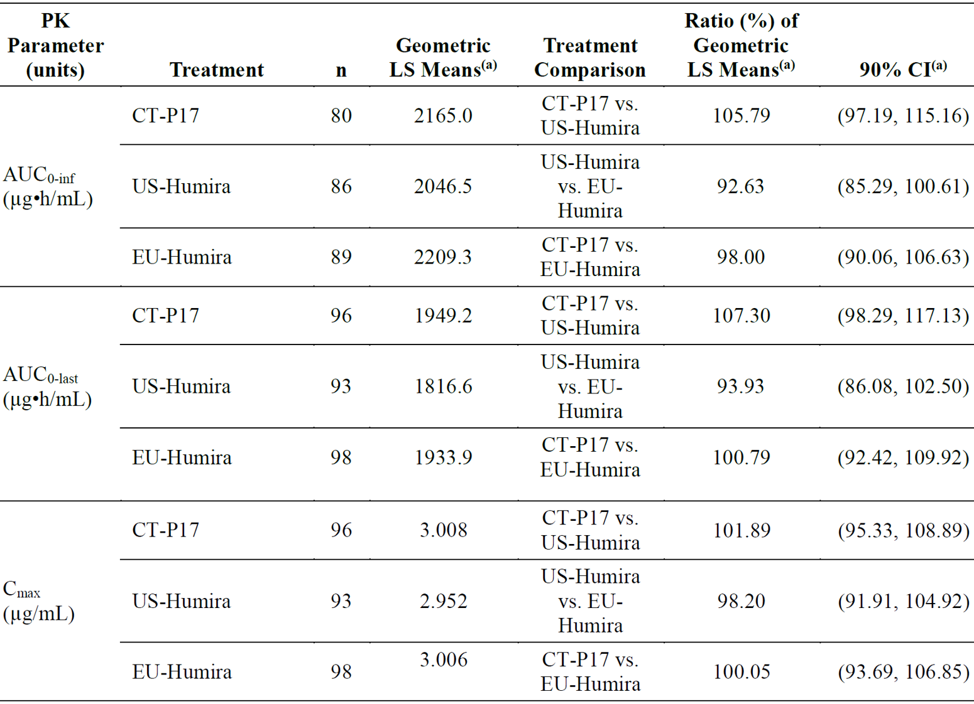
Abbreviations: AUC_{0-inf} = area under the serum concentration time curve from time 0 to infinity; AUC_{0-last} = area under the serum concentration-time curve from time zero to the last quantifiable concentration; CI = confidence interval; C_{max} = maximum serum concentration; CT-P17 = Yuflyma (adalimumab); EU = European Union; n = number of subjects in group; LS = least squares; PK = pharmacokinetic; US = United States.
An analysis of covariance was performed with the natural log-transformed PK parameters as the dependent variable, treatment as a fixed effect and gender (male or female), Day -1 body weight, and study centre as covariates.
AUC_{0-inf} values were excluded from the statistical analysis after not meeting one or more of the following criteria; an adjusted correlation coefficient r² of ≥ 0. 85 and an %AUC_{extrap} (percentage of the area extrapolated for calculation of AUC_{0-inf}) ≤ 20%.
(a) The least squares mean differences and 90% CIs for the differences were exponentiated to provide estimates of the ratio of geometric LS means and 90% CIs for the ratios.

Study CT-P17 1.3
Study CT-P17 1.3 was a randomised, open label, two arm, parallel group, single dose study, which was designed to compare the PK and safety of Yuflyma via subcutaneous administration by auto-injector and pre-filled syringe in healthy subjects. 193 subjects were randomised 1:1 to two treatment groups to receive a single 40 mg dose of Yuflyma via either auto-injector or pre-filled syringe on Day 1, followed by 10 weeks during which PK, safety, and immunogenicity measurements were made. The three primary endpoints of the study were AUC_{0-inf}, AUC_{0-last}, and C_{max}. The PK population consisted of 164 subjects.
Statistical analyses for the PK population (Table 5), as well as supplementary analyses for all subjects who received a full dose, supported the conclusion of comparable PK for Yuflyma administered by auto-injector and by pre-filled syringe.
The majority of subjects (82 out of 84 subjects in the Yuflyma auto-injector treatment group and 78 out of 80 subjects in the Yuflyma pre-filled syringe treatment group) had at least one ADA positive post-treatment result.
Figure 2: Study CT-P17 1.3 Mean (± standard deviation) serum adalimumab concentrations (pharmacokinetic population)
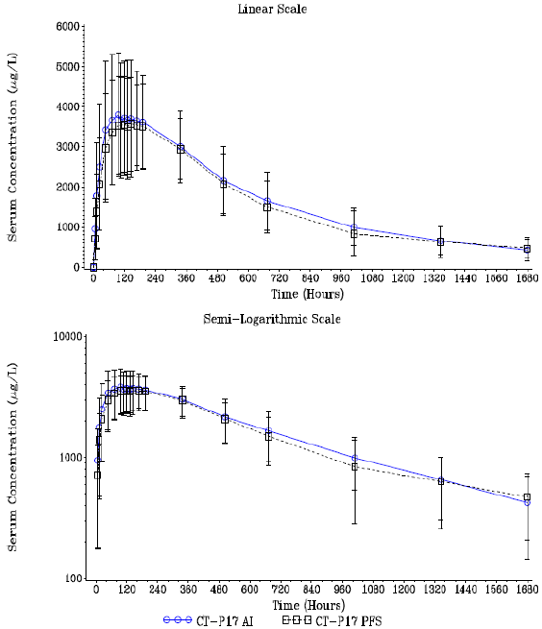
Abbreviations: AI = auto-injector; CT-P17 = Yuflyma (adalimumab); PFS = pre-filled syringe.
Table 5: Study CT-P17 1.3 Statistical analysis (analysis of covariance) of primary pharmacokinetic parameters (pharmacokinetic population)
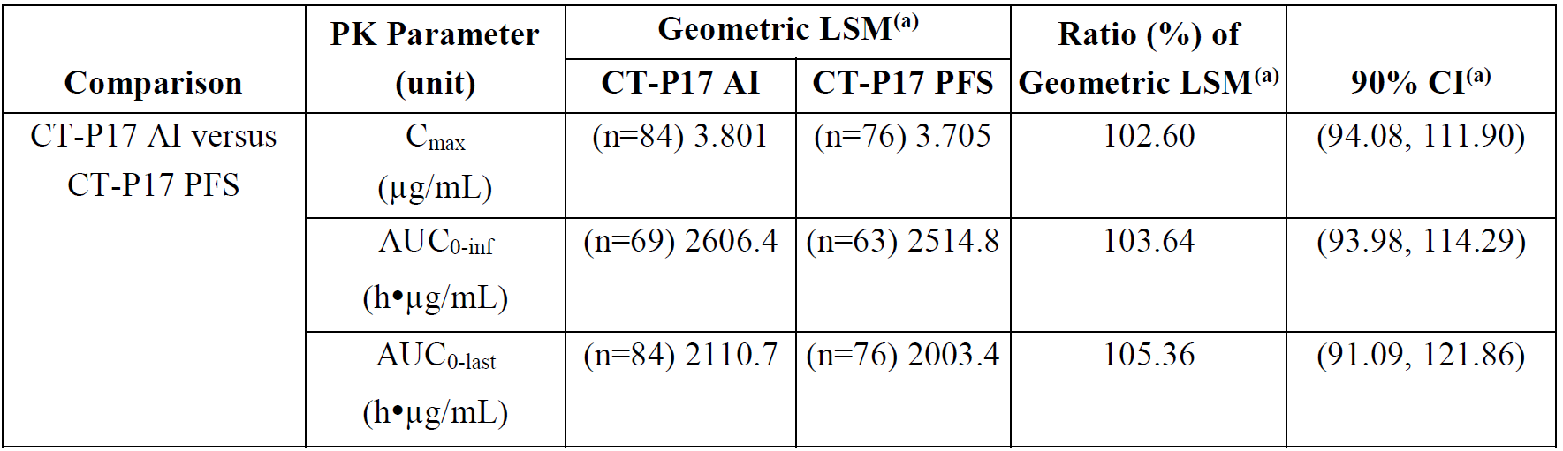
Abbreviations: AI = auto-injector; AUC_{0-inf} = area under the serum concentration time curve from time zero to infinity; AUC_{0-last} = area under the serum concentration time curve from time zero to the last quantifiable concentration; CI = confidence interval; C_{max} = maximum serum concentration; CT-P17 = Yuflyma (adalimumab); LSM = least squares means; n = the number of subjects with non-zero pharmacokinetic values; PFS = pre-filled syringe; PK = pharmacokinetic.
An analysis of covariance (ANCOVA) was performed with the natural log-transformed PK parameters as the dependent variable, treatment as a fixed effect and stratification factors (gender (male or female), study centre, and body weight as measured on Day -1) as covariates.
AUC_{0-inf} PK parameter values were excluded from the statistical analysis after not meeting one or more of the following criteria; terminal elimination rate constant was calculated with an adjusted correlation coefficient r² of ≥ 0.85 and/or a %AUC_{extrap} (percentage of the area extrapolated for calculation of AUC_{0-inf}) ≤ 20%.
(a) The LSM differences and 90% CIs for the differences were exponentiated to provide estimates of the ratio of geometric LSM (Yuflyma AI/Yuflyma PFS) and 90% CIs for the ratios.

Study CT-P17 3.1
Study CT-P17 3.1 was a randomised, double blind, study designed to evaluate efficacy and safety of multiple single doses (40 mg every 2 weeks) of either Yuflyma or EU-approved Humira administered by subcutaneous injection via pre-filled syringe in combination with methotrexate in patients with moderate to severe active rheumatoid arthritis. Serum adalimumab trough concentrations (C_{trough}) were measured as a secondary endpoint. The PK population consisted of all patients who received at least one full dose of either of the study drugs and had at least one post-treatment adalimumab concentration data.
The mean C_{trough} of adalimumab for both treatment groups in the PK population and by ADA status increased following the first doses and appeared to reach the plateau before Week 22 (Figure 3). The mean C_{trough} of adalimumab was slightly (9% to 13%) higher in the Yuflyma treatment group compared with the Humira treatment group. Adalimumab concentrations were lower in the ADA positive subgroup than the ADA negative subgroup in both treatment groups. C_{trough} tended to be lower in patients with higher ADA titre.
Figure 3: Study CT-P17 3.1 Mean (± standard deviation) adalimumab trough concentration by treatment and anti‐drug antibody status (pharmacokinetic population)
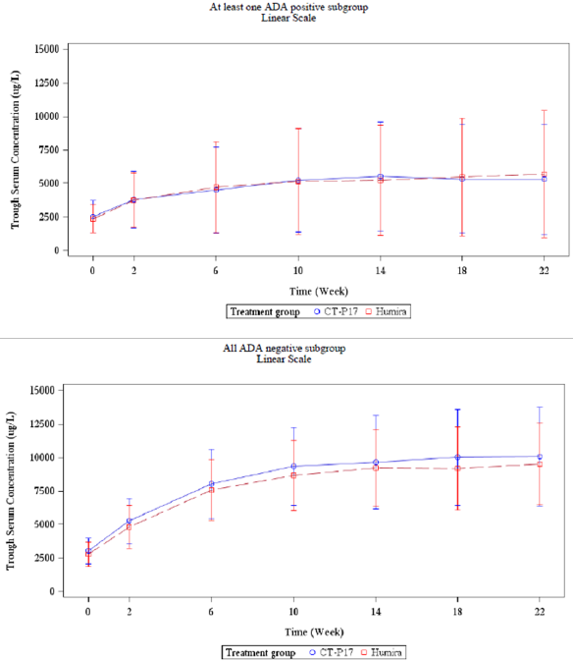
Abbreviations: ADA = anti-drug antibody; CT-P17 = Yuflyma (adalimumab).

Efficacy

Study CT-P17 3.1
The main efficacy study, Study CT-P17 3.1, was a Phase III, randomised, active controlled, double blind, multicentre study designed to evaluate efficacy, PK, PD, usability, overall safety and immunogenicity of multiple single doses (40 mg) of either Yuflyma or EU-approved Humira administered by subcutaneous injection via pre-filled syringe every other week in combination with methotrexate in patients with moderate to severe active rheumatoid arthritis.
The primary objective was to demonstrate that Yuflyma is equivalent to EU-approved Humira in terms of efficacy as determined by clinical response according to the American College of Rheumatology (ACR) definition of a 20% improvement (ACR20) at Week 24. The secondary objectives were to evaluate additional efficacy, PK, PD, and overall safety outcomes, including immunogenicity and biomarker data, and device usability (in centres in Bulgaria and Poland only).
The study duration was 58 weeks (per-protocol), including screening (up to 6 weeks), two treatment periods from Week 0 to Week 48, and a 4-week off-dose period prior to the end-of-study visit (Figure 4). In Treatment Period I (Week 0 to Week 24), 648 patients were randomised 1:1 to receive either Yuflyma (40 mg/0.4 mL) or EU-approved Humira (40 mg/0.4 mL) as a subcutaneous injection via pre-filled syringe every other week up to Week 24. All patients received methotrexate (between 12.5 to 25 mg/week, or 10 mg/week if intolerant to a higher dose), and folic acid (≥ 5 mg/week, oral dose). In Treatment Period II (after Week 24 to Week 48), there was a second randomisation process prior to dosing at Week 26. Patients who were initially randomly assigned to EU-approved Humira were randomised 1:1 to either continue EU-approved Humira or transition to Yuflyma. All patients who were initially randomly assigned to Yuflyma continued treatment with Yuflyma. Participant flow is shown in Figure 5.
Figure 4: Study CT-P17 3.1 Overview of study design
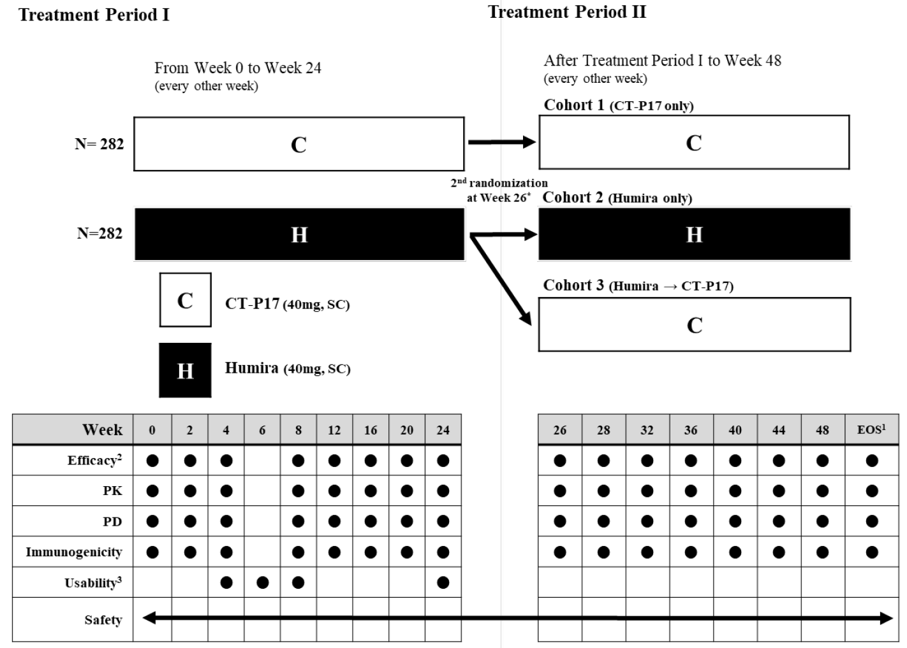
Abbreviations: C = CT-P17; CT-P17 = Yuflyma (adalimumab); EOS = end-of-study; H = Humira; N = number of patients; PD = pharmacodynamics; PK = pharmacokinetics; SC = subcutaneous.
* Prior to dosing at Week 26, all patients underwent the second randomisation process. Patients who were initially randomly assigned to European Union (EU)-approved Humira were randomised again in a ratio of 1:1 to either continue EU-approved Humira or undergo transition to Yuflyma. All patients who were initially randomly assigned to Yuflyma at Day 1 (Week 0) continued their treatment with Yuflyma. Patients who were randomised to Yuflyma or EU-approved Humira received assigned study drug every other week from Week 26 and thereafter up to Week 48. Only the study centre visit is presented in this figure.
1. An end of study visit occurred at Week 52 for all patients who completed or discontinued study treatment. The patients who discontinued early from the study treatment also visited the study centre until Week 52 by regular scheduled time interval for efficacy and safety assessments, even if they initiated rheumatoid arthritis medication changes (including those prohibited by the protocol).
2. An independent joint count assessor assigned to each study centre assessed joint counts. If possible, it was recommended that the joint count assessments were performed independently by the same person at each study centre throughout the entire study period.
3. Usability assessments were performed only for patients who self-injected the study drug (study centres in Bulgaria and Poland only). For patients who the caregiver or trained study centre staff injected the study drug, usability assessment was unnecessary.
Figure 5: Study CT-P17 3.1 Summary of patient disposition
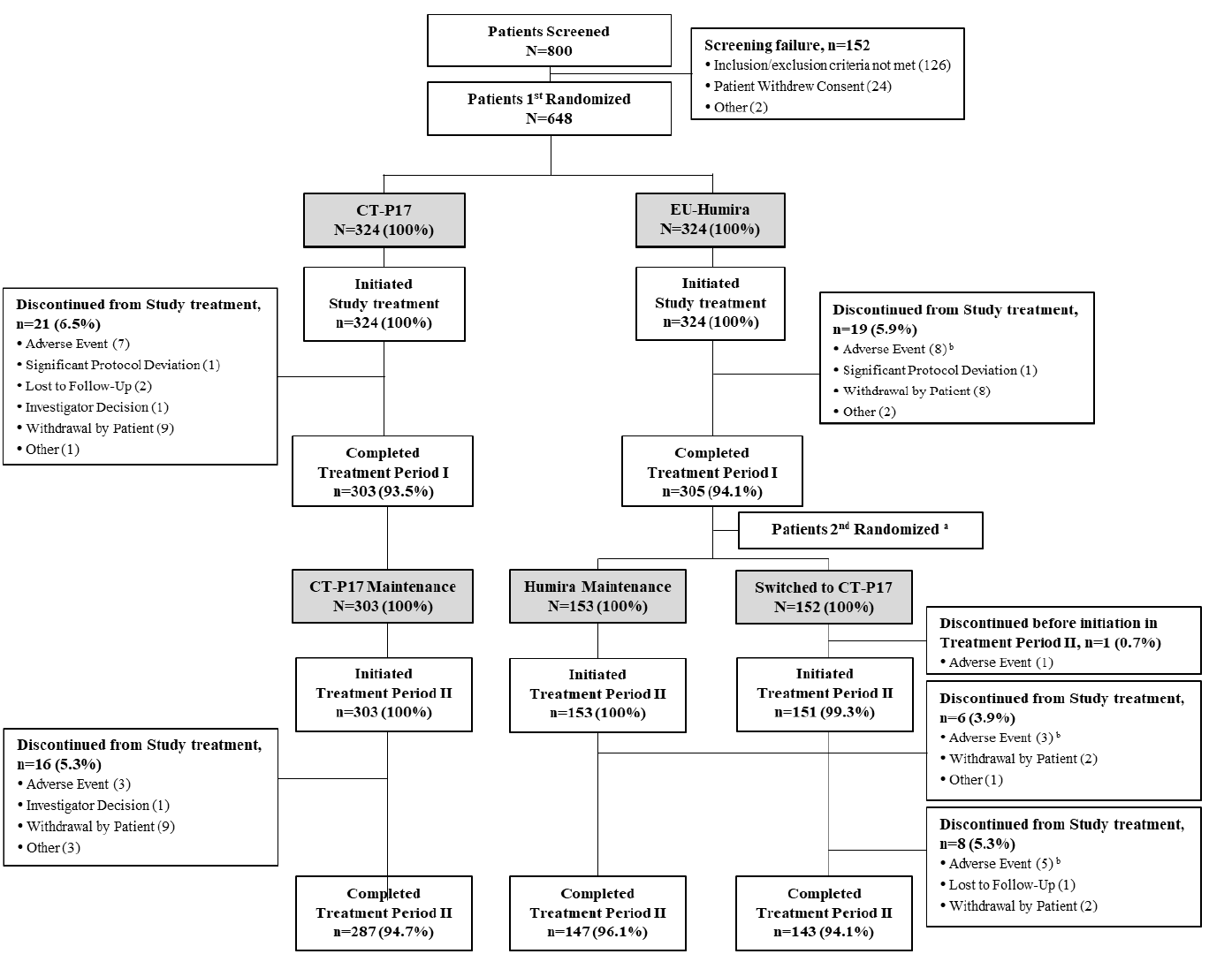
Abbreviations: CT-P17 = Yuflyma (adalimumab); N = number of subjects; n = number of subjects in group.
a Prior to dosing at Week 26, all patients underwent the second randomisation process. Patients who were initially randomly assigned to European Union (EU)-approved Humira were randomised again in a ratio of 1:1 to either continue EU-approved Humira or undergo transition to Yuflyma. All patients who were initially randomly assigned to Yuflyma at Day 1 (Week 0) continued their treatment with Yuflyma.
b The numerical difference between patients who discontinued the study treatment due to adverse event (AE) in patient disposition and summary of treatment-emergent adverse event (TEAE) leading to discontinuation is due to the fact that patient disposition’s summary was based on the number of patients discontinued in each treatment period and the summary of TEAE leading to discontinuation was based on the start date of AE.
The study population was representative of rheumatoid arthritis patients in general, and the treatment groups were well balanced in terms of basic demographic characteristics, disease duration, disease severity and use of concomitant medication.
The primary efficacy endpoint was the proportion of patients achieving ACR20 response at Week 24 in the intent-to-treat (ITT) population. Equivalence was defined as a 95% confidence interval (CI) for the estimate of treatment difference entirely within the predefined equivalence margin of -15% to 15%. The sponsor provided a justification for this equivalence margin based on a meta-analysis of two global studies., The evaluation concluded that the predefined equivalence margin of -15% to 15% was statistically justified.
The primary endpoint was met, as the 95% CI for the estimate of treatment difference in ACR20 response was entirely within the predefined equivalence margin of -15% to 15% (see Table 6). Analysis of ACR20 response in the per-protocol (PP) population produced a similar finding, as did sensitivity analyses based on country and disease activity. Additional analyses of the treatment difference in ACR20 response at Week 12 for the ITT and PP population stratified by disease activity, country, geographical region, ADA status, age, sex and body mass index were also supportive of the primary endpoint.
Table 6: Study CT-P17 3.1 Proportion of patients achieving response according to American College of Rheumatology 20 criteria at Week 24 (intention-to-treat and per-protocol populations)
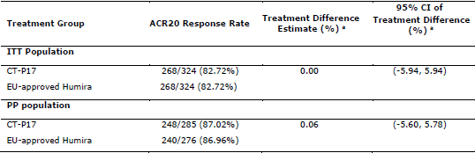
Abbreviations: ACR20 = American College of Rheumatology criteria 20% improvement; CI = confidence interval; CT-P17 = Yuflyma (adalimumab); EU = European Union; ITT = intention-to-treat.
Patients who were terminated from the study prior to the week of interest, who continued the study or study treatment but did not visit the site for the evaluation of ACR20 at the week of interest, and with incomplete data for evaluation of ACR20 criteria at the week of interest are considered as non-responder.
* Estimate of the difference in proportion and 95% confidence interval between the two treatment groups are estimated using the exact binomial method using a Farrington-Manning score method.
Secondary efficacy endpoints included ACR20, ACR50, and ACR70;¹² responses, individual components of the ACR, hybrid ACR responses, Disease Activity Score 28; with erythrocyte sedimentation rate (DAS28 ESR), DAS28 with C-reactive protein (DAS28 CRP), individual components of DAS28, European League against Rheumatism (EULAR) response, Clinical Disease Activity Index (CDAI), Simplified Disease Activity Index (SDAI), 36-item short form health survey (SF-36), and joint damage progression. Safety, immunogenicity and device usability were also assessed as secondary endpoints.
The proportions of patients achieving ACR20, ACR50, and ACR70 responses were similar at all time points up to Week 52 between the Yuflyma and EU-approved Humira treatment groups in both the ITT and PP populations, and similar efficacy was also maintained in patients who switched from EU-approved Humira to Yuflyma from Week 26 (Figure 6). All individual components of the ACR criteria as well as the hybrid ACR response measure showed similar response between treatment groups across different visit time points in both ITT and PP populations.
The actual values and changes from Baseline of disease activity as measured by DAS28 CRP and DAS28 ESR across different visit time points in both ITT and PP populations were similar between treatment arms. The difference between the mean change from Baseline in DAS28 CRP at different visit time points did not exceed 0.6 in DAS28 CRP score, generally considered to be the minimal difference of clinical importance. The 95% CI for the estimate of treatment difference in DAS28 CRP at Week 24 in the ITT population was -0.01 (95% CI: -0.19, 0.16). Efficacy findings based on EULAR response, CDAI, SDAI, SF-36 were similar for Yuflyma and EU-approved Humira.
Figure 6: Study CT-P17 3.1 Proportions of patients achieving response according to American College of Rheumatology 20/50/70 criteria during overall period (intention-to-treat and per-protocol populations)
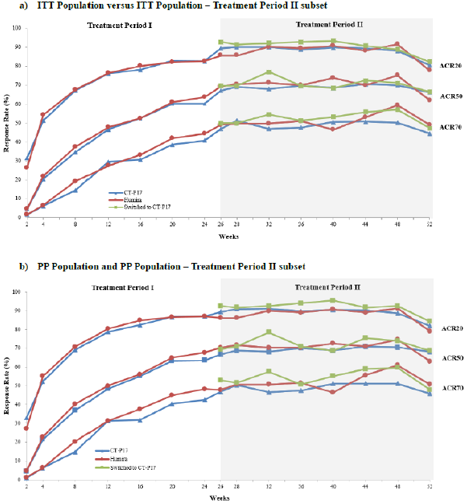
Abbreviations: ACR20/50/70 = American College of Rheumatology criteria 20%/50%/70% improvement; CT-P17 = Yuflyma (adalimumab); ITT = intention-to-treat.
The submission included subgroup analyses of efficacy by ADA status. The impact of ADA on efficacy in terms of ACR20/50/70 in Treatment Period I is shown in Figure 7. From Week 26 onward, the mean differences between treatment arms grew slightly bigger, in particular among ADA positive patients (Table 7). Among ADA negative patients’ differences between treatment arms in ACR20 response were small, with 95% CIs falling within the ± 15% range. Overall, ADA status did not have a clinically meaningful impact on efficacy.
Figure 7: Study CT-P17 3.1 Proportion of patients achieving American College of Rheumatology 20/50/70 criteria by post-treatment anti‐drug antibody status up to Week 24 (intention-to-treat population)
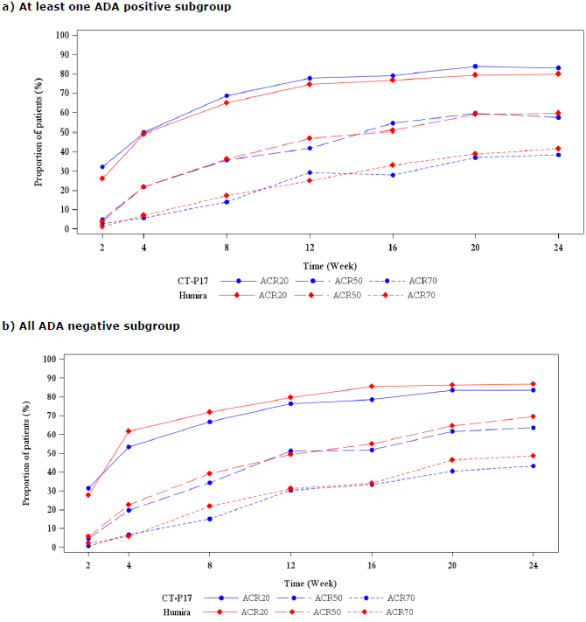
Abbreviations: ADA = anti-drug antibody; ACR20/50/70 = American College of Rheumatology criteria 20%/50%/70% improvement; CT-P17 = Yuflyma (adalimumab).
Table 7: Study CT-P17 3.1 Truncated summary of American College of Rheumatology 20% improvement by visit based anti‐drug antibody status (Treatment Period II Subset; intention-to-treat population)
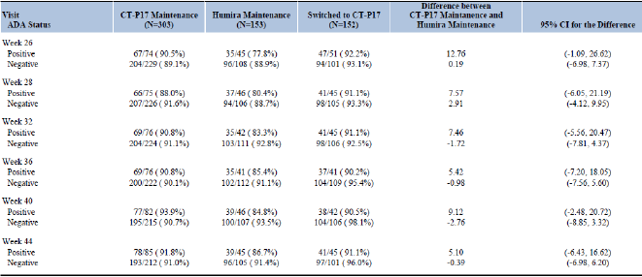
Abbreviations: ADA = anti-drug antibody; ACR20/50/70 = American College of Rheumatology criteria 20%/50%/70% improvement; CI = confidence interval; CT-P17 = Yuflyma (adalimumab); N= number of subjects.

Safety
The clinical safety dataset included 1,166 subjects who were exposed to at least one dose of Yuflyma, EU-approved Humira or US-licensed Humira in 4 clinical studies. The main safety study was the Phase III study in patients with rheumatoid arthritis (Study CT-P17 3.1). The 3 single dose Phase I studies in healthy volunteers (PK study for biosimilarity (Study CT-P17 1.1), PK pilot study (Study CT-P17 1.2), and PK study comparing auto-injector and pre-filled syringe (Study CT-P17 1.3)) supported the assessment of similar safety. The evaluation also assessed safety and auto-injector usability data for 62 patients with rheumatoid arthritis in Study CT-P17 3.2.
Table 8: Studies CT-P17 1.1, 1.2, 1.3 and 3.1 Number of subjects who received at least one dose of Yuflyma or reference product (safety population)
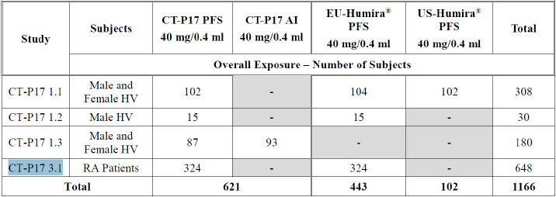
Abbreviations: AI = auto-injector; CT-P17 = Yuflyma (adalimumab); EU = European Union; HV = healthy volunteer; PFS = pre-filled syringe; RA = rheumatoid arthritis.

Study CT-P17 3.1
The Phase III study evaluated the safety of Yuflyma compared to EU-approved Humira in patients with moderate to severe active rheumatoid arthritis up to Week 52. A summary of TEAEs is presented in Table 9. Overall, 1,531 TEAEs were reported in 447 (69.0%) patients in the initial randomisation and 1,418 TEAEs in 416 patients in the second randomisation. The proportion of patients who experienced at least one TEAE was similar between the Yuflyma and Humira treatment groups, and between the Yuflyma maintenance, Humira maintenance, and switched to Yuflyma groups. Treatment-emergent serious adverse events (TESAEs) and TEAEs leading to study drug discontinuation were generally similar between the treatment groups. The most frequently reported TEAEs by Preferred Term are summarised in Table 10. TEAEs considered by the investigator to be related to the study drug are summarised in Table 11.
Adverse events of special interest (AESIs) included hypersensitivity/allergic reactions, injection site reactions, infections, malignancies, demyelinating disease, haematological reactions, heart failure, lupus like syndrome, and liver enzyme elevations. Overall, the frequencies of AESIs were similar across the treatment groups. Small differences in TEAEs of haematological reactions and liver enzyme elevations in the Yuflyma switch group were considered not to be clinically meaningful. There were no events of demyelinating disease or lupus like syndrome in the Yuflyma studies, and subjects with a history of moderate to severe heart failure were excluded from the studies.
Table 9: Study CT-P17 3.1 Summary of treatment-emergent adverse events (overall period; safety population)
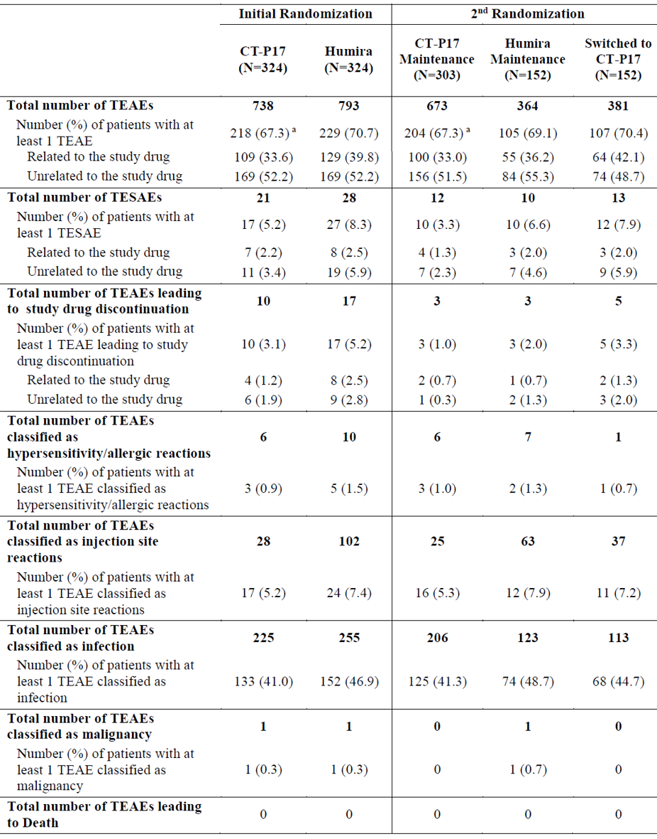
Abbreviations: CT-P17 = Yuflyma (adalimumab); N= number of subjects; TEAE = treatment-emergent adverse event; TESAE = treatment-emergent serious adverse event.
The total number of TEAEs count included all patient events. At each level of summarisation, a patient was counted once if they reported one or more events. The event was considered to be related if the relationship was defined as ‘possible’, ‘probable’ or ‘definite’.
a A patient in the Yuflyma maintenance group reported Grade 1 TEAE of lung disorder which of causality was assessed as unknown by the investigator since this event occurred after end-of-study visit and diagnosis was not completed until the time of last report.
Table 10: Study CT-P17 3.1 Treatment-emergent adverse events reported for ≥ 5% of patients in any treatment group using Preferred Term (overall period; safety population)
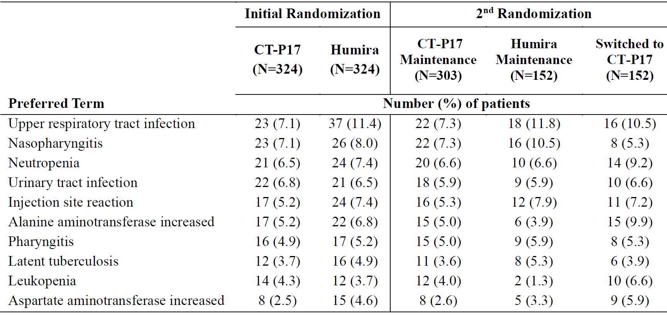
Abbreviations: CT-P17 = Yuflyma (adalimumab); N = number of subjects.
At each level of summarisation, a patient was counted only once if they reported one or more events. Preferred terms were arranged by decreasing total percentage and coded using Medical Dictionary for Regulatory Activities (MedDRA) dictionary, Version 22.0.
Table 11: Study CT-P17 3.1 Treatment-emergent adverse events considered by the investigator to be related to the study drug reported for ≥ 5% of patients in any treatment group using Preferred Term (overall period; safety population)
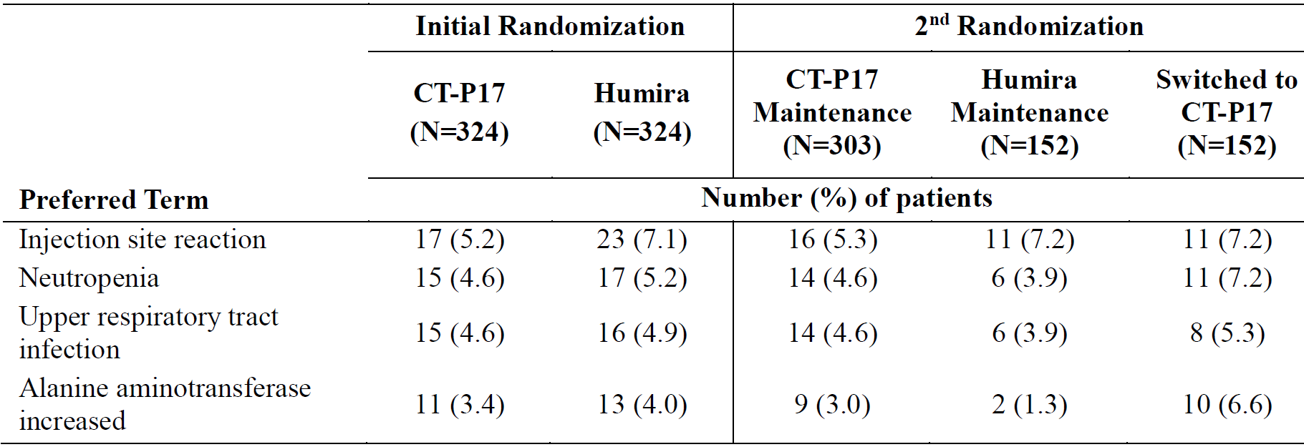
Abbreviations: CT-P17 = Yuflyma (adalimumab); N = number of subjects.
At each level of summarisation, a patient was counted only once if they reported one or more events. Preferred terms were arranged by decreasing total percentage and coded using Medical Dictionary for Regulatory Activities (MedDRA) dictionary, Version 22.0.

Immunogenicity
Comparative immunogenicity evaluations were conducted in three single dose studies in healthy volunteers (Studies CT-P17 1.1, CT-P17 1.2, CT-P17 1.3) and in one multiple dose study in rheumatoid arthritis patients (Study CT-P17 3.1).
In Study CT-P17 1.1, the rates of antidrug antibody (ADA) conversion and neutralising antibody (NAb) conversion, as well as ADA titre results, were comparable for Yuflyma and Humira in healthy subjects following a single dose.
In Study CT-P17 3.1, the proportion of patients with ADA positive results up to Week 24 (Treatment Period I) was slightly lower in the Yuflyma treatment group. According to the EMA guideline,¹⁰ a lower immunogenicity for the biosimilar does not preclude biosimilarity. ADA titre levels were similar between the Yuflyma and Humira treatment groups. In Treatment Period II, the proportion of patients with ADA/NAb positive results was overall comparable between treatment groups up to Week 52. ADA conversion was less frequent in Treatment Period II than in Treatment Period I (Table 12). Switching from Humira to Yuflyma at Week 26 did not have a significant effect on ADA conversion.
Table 12: Study CT-P17 3.1 Summary of positive conversion in anti‐drug antibody or neutralising antibody (safety population)
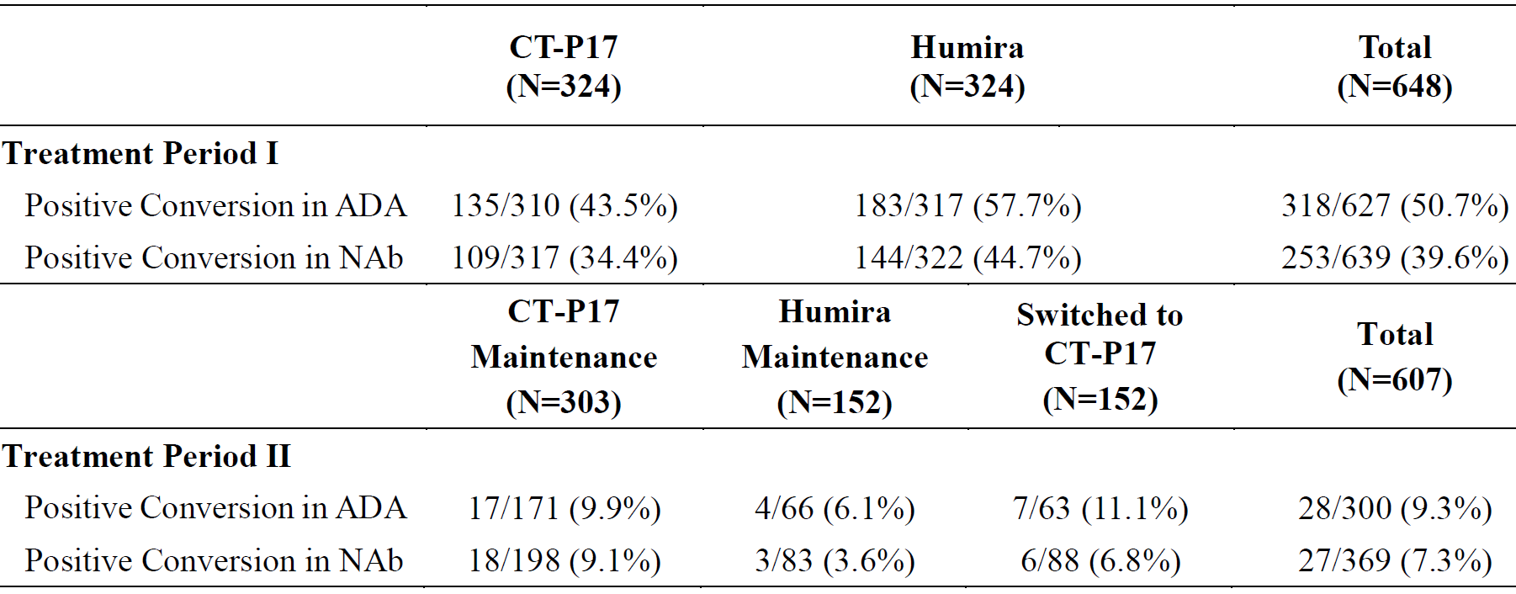
Abbreviations: ADA = antidrug antibody; CT-P17 = Yuflyma (adalimumab); N = number of subjects; NAb = neutralising antibody.
For Treatment Period I, the numerator is the number of patients with at least one ADA or NAb positive result after first study drug administration in Treatment Period I and before the first study drug administration in Treatment Period II. The denominator is the number of patients who had at least one ADA result after first study drug administration in Treatment Period I and before the first study drug administration in Treatment Period II, and had not any ADA positive (in case of ADA summary) or NAb positive (in case of NAb summary) result before the first study drug administration. For Treatment Period II, the numerator is the number of patients with at least one ADA or NAb positive result after first study drug administration in treatment period II (including the end-of-study (EOS) visit). The denominator is the number of patients who had at least one ADA result after first study drug administration in Treatment Period II (including the EOS visit), and had not any ADA positive (in case of ADA summary) or Nab positive (in case of NAb summary) result before the first study drug administration in Treatment Period II.
In Study CT-P17 3.1, the frequency of TEAEs was slightly higher among ADA positive than ADA negative patients, but a similar difference was observed in both treatment arms. There were no meaningful differences between treatment groups in the proportion of patients experiencing TEAEs for System Organ Classes infections and infestations, investigations and general disorder and administrative site conditions within the ADA positive patient subgroups.

Risk management plan
The sponsor has submitted EU-risk management plan (RMP) version 1.0 (dated 17 February 2021; data lock point (DLP) 25 June 2020) and Australia specific annex (ASA) version 1.0 (dated 15 March 2021) in support of this application. At the second round of evaluation, the sponsor submitted EU-RMP version 1.1 (dated 19 April 2021; DLP 15 April 2021) and ASA version 2.0 (dated 19 October 2021). In response to the second round of evaluation recommendations, the sponsor submitted ASA version 3.0 (dated 22 December 2021).
The summary of safety concerns and their associated risk monitoring and mitigation strategies are summarised in Table 13. Further information regarding the TGA’s risk management approach can be found in risk management plans for medicines and biologicals and the TGA's risk management approach.
Table 13: Summary of safety concerns
Summary of safety concerns |  | Pharmacovigilance |  | Risk minimisation
 |  | Routine | Additional | Routine | Additional
Important identified risks | Serious infections |  | – |  | *
Important identified risks | Tuberculosis |  | – |  | *
Important identified risks | Malignancies |  | – |  | *
Important identified risks | Demyelinating disorders (including multiple sclerosis, Guillain-Barre syndrome and optic neuritis) |  | – |  | *
Important identified risks | Bacillus Calmette-Guérin disease following live Bacillus Calmette-Guérin vaccination in infants with in utero exposure to Yuflyma |  | – |  | *
Important potential risks | Progressive multifocal leukoencephalopathy |  | – | – | –
Important potential risks | Reversible posterior leukoencephalopathy syndrome |  | – | – | –
Important potential risks | Adenocarcinoma of colon in ulcerative colitis patients |  | – |  | –
Missing information | Patients with immune-compromised conditions |  | – |  | –
Missing information | Long-term safety information in the treatment of children aged from 6 years to less than 18 years with Crohn’s disease |  | – | – | –
Missing information | Episodic treatment in psoriasis, ulcerative colitis, and juvenile idiopathic arthritis |  | – | – | –
Missing information | Long-term safety data in the treatment of children with uveitis |  | – | – | –
Missing information | Long-term safety information in the treatment of children from 6 years to less than 18 years with ulcerative colitis |  | – | – | –
* Adult and paediatric patient reminder cards
- The summary of safety concerns generally aligns with Humira however, as noted by the clinical evaluator, the missing information ‘long-term safety information in the treatment of children from 6 years to less than 18 years with ulcerative colitis’ has been added to the summary of safety concerns for Humira but has not been included for Yuflyma. At the second round of evaluation the sponsor included the requested safety concern. The summary of safety concerns for Yuflyma is acceptable as it aligns with the EU-RMP and with the innovator.
- Routine pharmacovigilance is proposed for all safety concerns. Additional pharmacovigilance is not proposed in the EU-RMP or ASA. At the second round of evaluation the sponsor adequately justified not participating in patient registries. The pharmacovigilance plan otherwise aligns with other adalimumab biosimilars and is considered acceptable.
- Routine risk minimisation is proposed for all of the important identified risks, for the important potential risk ‘adenocarcinoma of colon in ulcerative colitis patients’, and for the missing information ‘patients with immune compromised conditions’. This aligns with the routine risk minimisation wording listed in the ASA for Humira, and with the information provided in the PI. The sponsor proposes an additional risk minimisation activity in the form of patient reminder cards for adult and paediatric patients. At the second round of evaluation the risk minimisation plan is acceptable, subject to revision of the additional risk minimisation materials for relevance in Australia.

Risk-benefit analysis

Delegate’s considerations

Biosimilarity

Quality
A comprehensive similarity exercise comparing the physicochemical and biological quality attributes of Yuflyma, EU-approved Humira and US-licensed Humira was conducted, in line with the general principles described in the EMA guideline. Similarity of physicochemical and biological quality attributes has been satisfactorily demonstrated.
A bridging study demonstrated high similarity between Australian-sourced Humira and EU-approved Humira, supporting a conclusion of biosimilarity of Yuflyma with the Australian reference product.

Nonclinical
The findings from the nonclinical studies support a conclusion of biosimilarity. The similarity in biological activity (Yuflyma versus EU-approved Humira) supports the proposed indications.

Clinical pharmacology
The comparative PK study, Study CT-P17 1.1, demonstrated PK equivalence of Yuflyma with both EU-approved and US-licensed Humira. The study design was acceptable and complied with the CHMP guideline.¹⁰ The main efficacy and safety study, Study CT-P17 3.1, provided supportive comparative PK data (C_{trough} following repeated subcutaneous injections) in a target patient population (rheumatoid arthritis). In both Yuflyma and EU-approved Humira treatment groups, patients with ADA had lower C_{trough} levels compared with patients without ADA. Study CT-P17 1.3 demonstrated comparable PK for Yuflyma administered by auto-injector and by pre-filled syringe.
The clinical PK data support a conclusion of biosimilarity.

Clinical efficacy
Similar efficacy of Yuflyma to EU-approved Humira was demonstrated in Study CT-P17 3.1, a Phase III, randomised, active controlled, double blind, multicentre study conducted in 648 subjects with moderate to severe active rheumatoid arthritis who had an inadequate response to methotrexate therapy. The design of the study was in line with the EMA guideline on assessment of biosimilarity.
Patients were initially randomised in a 1:1 ratio to receive 40 mg/0.4 mL of either Yuflyma or EU-approved Humira as a subcutaneous injection via pre-filled syringe every other week up to Week 24 (Treatment Period I). Prior to dosing at Week 26, patients underwent a second randomisation process. Patients who were initially assigned to EU-approved Humira were randomised again in a 1:1 ratio to either continue EU-approved Humira or switch to Yuflyma (Treatment Period II). All patients who were initially assigned to Yuflyma continued treatment with Yuflyma in Treatment Period II.
The primary endpoint was the proportion of patients achieving ACR20 response at Week 24 in the ITT population. 82.72% of patients in each treatment arm achieved ACR20 response at Week 24 (treatment difference estimate 0.00%; 95% CI: -5.94, 5.94). The primary endpoint was met, as the 95% CI for the treatment difference was within the pre-defined equivalence margin of -15% to 15%. The pre-defined equivalence margin was statistically justified, and was in line with previous adalimumab biosimilar evaluations. Sensitivity analyses were supportive of the primary endpoint. Secondary efficacy endpoints, including ACR20, ACR50, ACR70, DAS28 ESR, DAS28 CRP, EULAR response, CDAI, SDAI, and SF-36, were supportive of similar efficacy of Yuflyma to EU-approved Humira. Similar efficacy was maintained through to Week 52, including in patients who switched from EU-approved Humira to Yuflyma from Week 26. ADA status did not have a clinically meaningful impact on efficacy.
The clinical efficacy data support a conclusion of biosimilarity.

Clinical safety
The safety population is sufficient for evaluation of similarity of safety. The safety of Yuflyma was comparable to EU-approved Humira in the main efficacy and safety study, Study CT-P17 3.1. The types and frequencies of TEAEs were generally similar for Yuflyma and EU-approved Humira, and consistent with historical data for Humira. No major differences in frequency or pattern of TESAEs, TEAEs leading to discontinuation of study drug, or AESIs were observed.
Immunogenicity findings were similar for Yuflyma and EU-approved Humira in terms of ADA formation, ADA titre levels, neutralising antibody formation, and the impact of ADA formation on clinical safety.
The clinical safety and immunogenicity data support a conclusion of biosimilarity.

Limitations of the data
This application does not include 20 mg or 80 mg strengths. The lack of a 20 mg strength means that the proposed products are not suitable to deliver the 20 mg dose recommended in some paediatric settings. The draft PI has been amended to highlight that there is no dosage form of Yuflyma that is suitable to deliver a 20 mg dose, and that an alternative product should be used for patients requiring a 20 mg dose. The lack of an 80 mg strength is less critical, as 80 mg and 160 mg doses can be achieved with 2 or 4 injections of Yuflyma, respectively. Whilst this may be less convenient than one or two injections of Humira 80 mg, it is not critical to the efficacy and safety of the product. Other adalimumab biosimilar products have been registered without 20 mg and/or 80 mg strengths.
The clinical efficacy of Yuflyma has been evaluated only in patients with rheumatoid arthritis. The sponsor provided a justification for extrapolation to the other indications approved for Humira based on the similarity shown in structural analysis, functional assays, and the clinical similarity of PK, efficacy, safety and immunogenicity. A comprehensive comparability exercise assessing the similarity in potency and drug related effects on Fc-receptors and effector cells has shown that Yuflyma is highly similar to Humira across all studied known and suggested modes of action, supporting extrapolation of efficacy to all indications.

Proposed indications
The proposed indications are the same as the approved Australian indications for Humira. The demonstration of biosimilarity to the Australian reference product, Humira, supports the use of Yuflyma in the proposed indications. The proposed indications are similar to the approved EU indications for Yuflyma. There are some differences in the wording of the EU and Australian indications, but these differences do not meaningfully impact on the benefit-risk. There are several indications approved in the EU which are not approved for Humira in Australia (axial spondyloarthritis without radiographic evidence of ankylosing spondylitis, paediatric ulcerative colitis, paediatric uveitis), but these indications are not proposed in this application.

Proposed action
The submitted data support a conclusion of biosimilarity of Yuflyma to the Australian reference product, Humira. Only one strength (40 mg/0.4 mL) is proposed in this submission. The proposed products are not suitable to deliver a 20 mg dose, so the paediatric dosing guidance in the PI has been amended to address this limitation.
There are no outstanding clinical issues requiring expert advice. The issues with Good Manufacturing Practice; clearances were resolved prior to approval.

Advisory Committee considerations
The Delegate did not refer this submission to the Advisory Committee on Medicines (ACM) for advice.

Outcome
Based on a review of quality, safety, and efficacy, the TGA approved the registration of Yuflyma (adalimumab) 40 mg/0.4 mL, solution for injection, pre-filled syringe, pre-filled syringe with safety guard and pre-filled syringe in auto-injector pen, indicated:
Rheumatoid arthritis
Yuflyma is indicated for reducing signs and symptoms, as well as inhibiting the progression of structural damage in adult patients with moderate to severely active rheumatoid arthritis. This includes the treatment of patients with recently diagnosed moderate to severely active disease who have not received methotrexate.
Yuflyma can be used alone or in combination with methotrexate.
Juvenile idiopathic arthritis
Polyarticular juvenile idiopathic arthritis
Yuflyma in combination with methotrexate is indicated for reducing the signs and symptoms of moderately to severely active polyarticular juvenile idiopathic arthritis in patients 2 years of age and older who have had an inadequate response to one or more disease modifying antirheumatic drugs (DMARDs). Yuflyma can be given as monotherapy in case of intolerance to methotrexate or when continued treatment with methotrexate is inappropriate.
Enthesitis-related arthritis
Yuflyma is indicated for the treatment of enthesitis-related arthritis in children, who have had an inadequate response to, or who are intolerant to, conventional therapy.
Psoriatic arthritis
Yuflyma is indicated for the treatment of signs and symptoms, as well as inhibiting the progression of structural damage, of moderate to severely active psoriatic arthritis in adult patients where response to previous DMARDs has been inadequate.
Ankylosing spondylitis
Yuflyma is indicated for reducing signs and symptoms in patients with active ankylosing spondylitis.
Crohn’s disease in adults and children (≥ 6 years)
Yuflyma is indicated for the treatment of moderate to severe Crohn’s disease, to reduce the signs and symptoms of the disease and to induce and maintain clinical remission in patients;
- who have had an inadequate response to conventional therapies or,
- who have lost response to or are intolerant to infliximab.
Ulcerative colitis
Yuflyma is indicated for the treatment of moderate to severe ulcerative colitis in adult patients who have had an inadequate response to conventional therapy or who are intolerant to or have medical contraindications for such therapies. Patients should show a clinical response within 8 weeks of treatment to continue treatment beyond that time. (see 5.1 Pharmacodynamic properties - clinical trials).
Psoriasis in adults and children
Yuflyma is indicated for the treatment of moderate to severe chronic plaque psoriasis in adult patients who are candidates for systemic therapy or phototherapy.
Yuflyma is indicated for the treatment of severe chronic plaque psoriasis in children and adolescent patients from 4 years of age who have had an inadequate response to or are inappropriate candidates for topical therapy and phototherapy.
Hidradenitis suppurativa in adults and adolescents (from 12 years of age)
Yuflyma is indicated for the treatment of active moderate to severe hidradenitis suppurativa (acne inversa) in patients with an inadequate response to conventional systemic hidradenitis suppurativa therapy.
Uveitis
Yuflyma is indicated for the treatment of non-infectious intermediate, posterior and pan-uveitis in adult patients who have had an inadequate response to corticosteroids, in patients in need of corticosteroid sparing, or in whom corticosteroid treatment is inappropriate.

Specific conditions of registration applying to these goods
- The Yuflyma EU-risk management plan (RMP) (version 1.1, dated 19 April 2021, data lock point 15 April 2021), with Australian specific annex (version 3.0, dated 22 December 2021), included with Submission PM-2021-01170-1-3, and any subsequent revisions, as agreed with the TGA will be implemented in Australia.
An obligatory component of risk management plans is routine pharmacovigilance. Routine pharmacovigilance includes the submission of periodic safety update reports (PSURs).
Reports are to be provided in line with the current published list of EU reference dates and frequency of submission of PSURs until the period covered by such reports is not less than three years from the date of the approval letter.
The reports are to at least meet the requirements for PSURs as described in the European Medicines Agency’s Guideline on Good Pharmacovigilance Practices (GVP) Module VII-periodic safety update report (Rev 1), Part VII.B Structures and processes. Note that submission of a PSUR does not constitute an application to vary the registration.
- Laboratory testing and compliance with Certified Product Details (CPD)
  - All batches of Yuflyma supplied in Australia must comply with the product details and specifications approved during evaluation and detailed in the Certified Product Details (CPD).
  - When requested by the TGA, the sponsor should be prepared to provide product samples, specified reference materials and documentary evidence to enable the TGA to conduct laboratory testing on the product. Outcomes of laboratory testing are published biannually in the TGA Database of Laboratory Testing Results http://www.tga.gov.au/ws-labs-index and periodically in testing reports on the TGA website.
- Certified Product Details
The Certified Product Details (CPD), as described in Guidance 7: Certified Product Details of the Australian Regulatory Guidelines for Prescription Medicines (ARGPM) (http://www.tga.gov.au/industry/pm-argpm-guidance-7.htm), in PDF format, for the above products should be provided upon registration of these therapeutic goods. In addition, an updated CPD should be provided when changes to finished product specifications and test methods are approved in a Category 3 application or notified through a self-assessable change.
The CPD should be emailed to biochemistry.testing@health.gov.au as a single PDF document.
- For all injectable products the Product Information must be included with the product as a package insert.

Attachment 1. Product Information
The PI for Yuflyma approved with the submission which is described in this AusPAR is at Attachment 1. For the most recent PI, please refer to the TGA PI/CMI search facility.

Therapeutic Goods Administration
PO Box 100 Woden ACT 2606 Australia
Email: info@tga.gov.au Phone: 1800 020 653 Fax: 02 6232 8605
https://www.tga.gov.au

Humira was first registered on the ARTG on 28 August 2012 (ARTG numbers: 199410, 199411 and 199412).
An innovator reference medicine is the existing medicine already on the market that biosimilar medicines are developed to be similar to.
Hyrimoz was first registered on the ARTG on 1 March 2019 (ARTG numbers: 291937 and 291938).
Hadlima was first registered on the ARTG on 24 January 2018 (ARTG numbers: 284248 and 284249).
Idacio was first registered on the ARTG on 17 June 2020 (ARTG numbers: 320241, 320242 and 320243).
Amgevita was first registered on the ARTG on 9 November 2017 (ARTG number: 273536).
Abrilada was first registered on the ARTG on 22 February 2021 (ARTG numbers: 334496, 334497, 334498 and 334499).
Hulio was first registered on the ARTG on 14 May 2021 (ARTG number: 334800, 334801, 334802).
A Category 3 application relates to updates to the quality data of medicines already included on the Australian Register of Therapeutic Goods (ARTG) which, in the opinion of the TGA, do not need to be supported by clinical, non-clinical or bioequivalence data.
European Medicines Agency (EMA), Committee for Medicinal Products for Human Use (CHMP), Guideline on Similar Biological Medicinal Products Containing Monoclonal Antibodies - Non-clinical and Clinical Issues, EMA/CHMP/BMWP/403543/2010, 30 May 2012.
Good Laboratory Practice is a code of standards following the International Council on Harmonisation (ICH) relevant to testing of medicines in laboratories during drug development.
The ACR (American College of Rheumatology) criteria are a standardised measure of disease improvement widely used in rheumatology trials, but less so clinically. The ACR20 is a composite measure defined as both improvement of 20% in the number of tender and number of swollen joints, and a 20% improvement in three of the following five criteria: patient global assessment, physician global assessment, a patient functional ability measure (most often the Health Assessment Questionnaire (HAQ), Visual Analog Scale (VAS) for Pain, and erythrocyte sedimentation rate (ESR) or C-reactive protein (CRP). ACR50 and ACR70 are the same instruments with an improvement of 50% and 70% respectively.
The randomised clinical trials analysed by the intention-to-treat (ITT) approach provide unbiased comparisons among the treatment groups. In the ITT population, none of the subjects are excluded, regardless of treatment compliance or attrition due to dropout or crossover, and the subjects are analysed according to the randomisation scheme. A modified intention-to-treat analysis (mITT) may sometimes be conducted excluding subjects post-randomisation.
Keystone, E.C. et al. Radiographic, Clinical, and Functional Outcomes of Treatment With Adalimumab (a Human Anti-tumor Necrosis Factor Monoclonal Antibody) in Patients With Active Rheumatoid Arthritis Receiving Concomitant Methotrexate Therapy: a Randomized, Placebo-Controlled, 52-Week Trial, Arthritis Rheum. 2004; 50(5): 1400-1411.
Weinblatt, M.E. et al. Adalimumab, a Fully Human Anti-tumor Necrosis Factor Alpha Monoclonal Antibody, for the Treatment of Rheumatoid Arthritis in Patients Taking Concomitant Methotrexate: the ARMADA Trial, Arthritis Rheum, 2003; 48(1): 35-45.
The per-protocol (PP) analysis is restricted to the participants who strictly adhered to the protocol. Also known as ‘on-treatment’ analysis.
The Disease Activity Score 28 (DAS28) is a system developed and validated by the European League Against Rheumatism (EULAR) to measure the progress and improvement of rheumatoid arthritis. Calculation of a DAS28 score involves the combination of an examination of 28 specified joints for tenderness upon touching and swelling, either the erythrocyte sedimentation rate (ESR, known as DAS28 ESR) or C-reactive protein (CRP, known as DAS28 CRP) level via blood sample, and the patient’s subjective assessment of disease activity during the preceding 7 days on a scale between 0 (‘no activity’)and 100 (‘highest activity possible’. DAS28 is often used in clinical trials for the development of rheumatoid arthritis (RA). DAS28 values range from 2.0 to 10.0; higher values mean a higher disease activity.
EULAR response criteria = The European League against Rheumatism (EULAR) response criteria are based on the assessment of disease activity using the Disease Activity Score (DAS), a statistically-derived index consisting of number of tender joints, number of swollen joints, erythrocyte sedimentation rate, and global disease activity.
The SF-36 is a multi-purpose, short-form health survey with only 36 questions. It yields an 8-scale profile of functional health and well-being scores as well as psychometrically-based physical and mental health summary measures and a preference-based health utility index. It measures eight domains of health: physical functioning, role limitations due to physical health, bodily pain, general health perceptions, vitality, social functioning, role limitations due to emotional problems, and mental health. It yields scale scores for each of these eight health domains, and two summary measures of physical and mental health. It is a generic measure, as opposed to one that targets a specific age, disease, or treatment group. The SF-36 is available for two recall periods: standard (4-week recall) and acute (1-week recall).
The Medical Dictionary for Regulatory Activities (MedDRA) is a single standardised international medical terminology, developed as a project of the International Council for Harmonisation of Technical Requirements for Pharmaceuticals for Human Use (ICH) which can be used for regulatory communication and evaluation of data pertaining to medicinal products for human use. As a result, MedDRA is designed for use in the registration, documentation and safety monitoring of medicinal products through all phases of the development cycle (that is, from clinical trials to post-marketing surveillance). Furthermore, MedDRA supports ICH electronic communication within the ICH’s Electronic Common Technical Document (eCTD) and the E2B Individual Case Safety Report.
European Medicines Agency (EMA), Committee for Medicinal Products for Human Use (CHMP), Guideline on Similar Biological Medicinal Products Containing Biotechnology-Derived Proteins as Active Substance: Quality Issues (Revision 1), EMA/CHMP/BWP/247713/2012, 22 May 2014.
European Medicines Agency (EMA), Committee for Medicinal Products for Human Use (CHMP), Guideline on Similar Biological Medicinal Products, CHMP/437/04 Rev 1, 23 October 2014.
Good Manufacturing Practice (GMP) describes a set of principles and procedures that when followed helps ensure that therapeutic goods are of high quality.

