November 2022

Australian Public Assessment Report for Spikevax
  - Active ingredients: Elasomeran
  - Sponsor: Moderna Australia Pty Ltd

About the Therapeutic Goods Administration (TGA)
- The Therapeutic Goods Administration (TGA) is part of the Australian Government Department of Health and is responsible for regulating therapeutic goods, including medicines, medical devices, and biologicals.
- The TGA administers the Therapeutic Goods Act 1989 (the Act), applying a risk management approach designed to ensure therapeutic goods supplied in Australia meet acceptable standards of quality, safety, and efficacy.
- The work of the TGA is based on applying scientific and clinical expertise to decision-making, to ensure that the benefits to the Australian public outweigh any risks associated with the use of therapeutic goods.
- The TGA relies on the public, healthcare professionals and industry to report problems with therapeutic goods. The TGA investigates reports received to determine any necessary regulatory action.
- To report a problem with a therapeutic good, please see the information on the TGA website.

About AusPARs
- The Australian Public Assessment Report (AusPAR) provides information about the evaluation of a prescription medicine and the considerations that led the TGA to approve or not approve a prescription medicine submission. Further information can be found in Australian Public Assessment Report (AusPAR) guidance.
- AusPARs are prepared and published by the TGA.
- AusPARs are static documents that provide information that relates to a submission at a particular point in time. The publication of an AusPAR is an important part of the transparency of the TGA’s decision-making process.
- A new AusPAR may be provided to reflect changes to indications or major variations to a prescription medicine subject to evaluation by the TGA.

Copyright
© Commonwealth of Australia 2022
This work is copyright. You may reproduce the whole or part of this work in unaltered form for your own personal use or, if you are part of an organisation, for internal use within your organisation, but only if you or your organisation do not use the reproduction for any commercial purpose and retain this copyright notice and all disclaimer notices as part of that reproduction. Apart from rights to use as permitted by the Copyright Act 1968 or allowed by this copyright notice, all other rights are reserved, and you are not allowed to reproduce the whole or any part of this work in any way (electronic or otherwise) without first being given specific written permission from the Commonwealth to do so. Requests and inquiries concerning reproduction and rights are to be sent to the TGA Copyright Officer, Therapeutic Goods Administration, PO Box 100, Woden ACT 2606 or emailed to <tga.copyright@tga.gov.au>.

Contents
List of abbreviations 4
Product submission 6
Submission details 6
Product background 8
Regulatory status 11
Product Information 11
Registration timeline 11
Submission overview and risk/benefit assessment 12
Quality 12
Nonclinical 12
Clinical 13
Risk management plan 40
Risk-benefit analysis 41
Post advisory committee considerations 52
Additional clinical data 52
Second risk-benefit analysis 64
Outcome 67
Specific conditions of registration applying to these goods 67
Attachment 1. Product Information 68

List of abbreviations
Abbreviation |  | Meaning
ACV | Advisory Committee on Vaccines
AE | Adverse event
AESI | Adverse events of special interest
AR | Adverse reaction
ARTG | Australian Register of Therapeutic Goods
ASA | Australia specific annex
BMI | Body mass index
CI | Confidence interval
COVID-19 | Coronavirus disease 2019
DLP | Data lock point
DMID | Division of Microbiology and Infectious Diseases (National Institute of Allergy and Infectious Disease, United States of America)
EMA | European Medicines Agency (European Union)
EUA | Emergency Use Authorization (United States of America)
FDA | Food and Drug Administration (United States of America)
GLSM | Geometric least squares mean
GMC | Geometric mean concentration
GMFR | Geometric mean fold rise
GMR | Geometric mean ratio
GMT | Geometric mean titre
ID₅₀ | Median (50%) infectious dose
IRR | Incidence rate ratio
IS/ID | Immunostimulation/immunodynamic
LLPC | Long lived plasma cell
MAA | Marketing Authorisation Application (European Medicines Agency)
MAAE | Medically attended adverse event
MIS-C | Multisystem inflammatory syndrome in children
NI | Non-inferiority
PASS | Post-authorisation safety study
PI | Product Information
PP | Per-protocol
PT | Preferred Term
RMP | Risk management plan
SAE | Serious adverse event
SARS-CoV-2 | Severe acute respiratory syndrome coronavirus 2
SD | Standard deviation
SLPC | Short lived plasma cell
SOC | System Organ Class
SRR | Seroresponse rate
TEAE | Treatment emergent adverse event
TGA | Therapeutic Goods Administration
TTO | Time to onset
US(A) | United States of America
VE | Vaccine efficacy
WHO | World Health Organization

Product submission

Submission details
Type of submission: | Major variation (dose regimen and patient group)
Product name: | Spikevax
Active ingredient: | Elasomeran
Decision: | Approved for provisional registration
Date of decision: | 19 October 2022
Date of entry onto ARTG: | 21 October 2022
ARTG number: | 370599
Black Triangle Scheme: | Yes  As a provisionally registered product, this medicine will remain in the Black Triangle Scheme for the duration of its provisional registration
Sponsor’s name and address: | Moderna Australia Pty Ltd  Level 6, 60 Martin Place  Sydney, NSW, 2000
Dose form: | Suspension for injection
Strength: | 0.2 mg/mL
Container: | Multidose vial
Pack size: | 10 x 5 mL multidose vials (0.2 mg/mL)
Approved therapeutic use: | Spikevax (elasomeran) COVID-19 Vaccine has provisional approval for the indication below:  Active immunisation to prevent coronavirus disease 2019 (COVID-19) caused by SARS-CoV-2 in individuals 6 months of age and older.  The use of this vaccine should be in accordance with official recommendations.  The decision has been made on the basis of short-term efficacy and safety data. Continued approval depends on the evidence of longer term efficacy and safety from ongoing clinical trials and post-market assessment.
Route of administration: | Intramuscular
Dosage: | Dosage is based on multiple factors, including the vaccination type (primary series, booster dose and immunocompromised individuals), and the age group of the patient.  Primary series  It is recommended to administer the second dose 28 days after the first dose.  Individuals 6 months to less than 6 years of age  Spikevax is administered as a course of 2 doses of Spikevax 0.1 mg/mL solution via intramuscular injection.  Each 0.25 mL dose of Spikevax 0.1 mg/mL contains 25 µg elasomeran.  Individuals 6 years to less than 12 years of age  Spikevax is administered as a course of 2 doses of either Spikevax 0.1 mg/mL; or Spikevax 0.2 mg/mL solution via intramuscular injection.  Each 0.5 mL dose of Spikevax 0.1 mg/mL contains 50 µg elasomeran.  Each 0.25 mL dose of Spikevax 0.2 mg/mL contains 50 µg elasomeran  Individuals 12 years of age and older  Spikevax is administered as a course of 2 doses of Spikevax 0.2 mg/mL solution via intramuscular injection.  Each 0.5 mL dose of Spikevax 0.2 mg/mL contains 100 µg elasomeran.  Immunocompromised individuals  Individuals 6 months to less than 6 years of age  A third dose of Spikevax 0.1 mg/mL solution for intramuscular injection may be given at least 28 days after the second dose of the primary series of vaccination.  Each 0.25 mL dose of Spikevax 0.1 mg/mL contains 25 µg elasomeran.  Individuals 12 years of age and older  A third dose of Spikevax 0.2 mg/mL solution for intramuscular injection may be given at least 28 days after the second dose of the primary series of vaccination.  Each 0.5 mL dose of Spikevax 0.2 mg/mL contains 100 µg elasomeran.  Booster dose  The decision when and for whom to implement a booster (third dose) of Spikevax should be made based on available vaccine safety and effectiveness data in accordance with official recommendations.  Individuals 12 to 17 years of age  A third dose of Spikevax 0.2 mg/mL solution for intramuscular injection is administered at least 5 months after the second dose of the primary series of vaccination.  Each 0.25 mL dose of Spikevax 0.2 mg/mL contains 50 µg elasomeran.  Individuals 18 years of age and older  A third dose of either Spikevax 0.1 mg/mL; or Spikevax 0.2 mg/mL solution for intramuscular injection is administered at least 6 months after the second dose of the primary series of vaccination.  Each 0.5 mL dose of Spikevax 0.1 mg/mL contains 50 µg elasomeran.  Each 0.25 mL dose of Spikevax 0.2 mg/mL contains 50 µg elasomeran.  For further information regarding dosage (including the interchangeability of Spikevax with other COVID-19 vaccines), refer to the Product Information.
Pregnancy category: | B1  Drugs which have been taken by only a limited number of pregnant women and women of childbearing age, without an increase in the frequency of malformation or other direct or indirect harmful effects on the human fetus having been observed.  Studies in animals have not shown evidence of an increased occurrence of fetal damage.  The use of any medicine during pregnancy requires careful consideration of both risks and benefits by the treating health professional. This must not be used as the sole basis of decision making in the use of medicines during pregnancy. The TGA does not provide advice on the use of medicines in pregnancy for specific cases. More information is available from obstetric drug information services in your State or Territory.

Product background
This AusPAR describes the submission by Moderna Australia Pty Ltd (the sponsor) to register Spikevax (elasomeran) 0.2 mg/mL, suspension for injection, for the following change in dose regime and patient group:
To extend the use of a 50 μg (0.25 mL) booster dose, currently approved for adults 18 years and older, to adolescents (12 to < 18 years) at a dosing interval of at least 3 months after the second dose.
To extend the use of a third dose, currently approved for immunocompromised individuals 12 years and older, to immunocompromised children 6 through 11 years of age at a dose of 50 μg (0.25 mL).
Severe acute respiratory syndrome coronavirus 2 (SARS-CoV-2) is an enveloped, positive-sense, single stranded RNA beta coronavirus. Since its emergence, the SARS-CoV-2 virus has spread rapidly around the globe. It was officially declared a pandemic by World Health Organization (WHO) on 11 March 2020. As of 28 October 2022, there have been over 626 million confirmed cases of coronavirus disease 2019 (COVID-19) with mortality surpassing 6.56 million deaths worldwide. In the United States of America (USA) alone, there have been over 1 million deaths in the United States of America (USA).
In the USA, there have been 4.5 million cases of COVID-19 reported among adolescents aged 12 to 17 years and 595 deaths among this age group. Through 31 January 2022, there were a total of 6851 cases of multisystem inflammatory syndrome in children (MIS-C) reported in the USA with approximately 20% reported among the 12 to 17 year old age group and 10.5% reported among the 18 to 20 year old age group.
In Australia, there have been 210,732 cases (male) and 225,048 (female) cases and 5 deaths due to COVID-19 among the age group 10 to 19 years.

Current treatment options
There are currently six vaccines on the Australian Register of Therapeutic Goods (ARTG), and all are approved under the provisional pathway.,:
- Comirnaty (tozinameran, previously known at BNT162b2 (mRNA)); also commonly known as the Pfizer/BioNTech (mRNA) vaccine is provisionally approved for active immunisation to prevent COVID-19 caused by SARS-CoV-2, in individuals 5 years of age and older.,,,,,,
- COVID-19 Vaccine AstraZeneca (ChAdOx1-S), an adenoviral vectored vaccine, is provisionally approved for active immunisation to prevent COVID-19 caused by SARS-CoV-2, in individuals 18 years of age and older.,
- Janssen (Ad26.COV2.S), an adenoviral vectored vaccine, is provisionally approved for active immunisation to prevent COVID-19 caused by SARS-CoV-2, in individuals 18 years of age and older.,
- Spikevax (elasomeran) COVID-19 vaccine, also known as the Moderna (mRNA) vaccine, is provisionally approved for active immunisation to prevent COVID-19 caused by SARS-CoV-2, in individuals 6 months of age and older.,,,,
- Spikevax bivalent original/Omicron COVID-19 Vaccine (elasomeran and imelasomeran), is provisionally approved as a booster dose for active immunisation to prevent coronavirus disease 2019 (COVID-19) caused by SARS-CoV-2 in individuals 18 years of age and older.
- Nuvaxovid (SARS-CoV-2 recombinant spike protein with Matrix-M adjuvant) COVID-19 vaccine, also known as the Novavax recombinant spike protein vaccine, is provisionally approved for active immunisation to prevent COVID-19 caused by SARS-CoV-2 in individuals 12 years of age and older.,,
At the time of this overview, provisional approval for booster dosing using Comirnaty has been given for individuals older or equal to 12 years of age. Provisional approval for a third dose of Comirnaty has been given for severely immunocompromised individuals older or equal to 12 years of age. No other COVID-19 vaccine has been approved for booster dosing for individuals younger than 18 years of age.

Regulatory status
The product received initial provisional registration on the Australian Register of Therapeutic Goods (ARTG) 9 August 2021. Subsequently, provisional registration has been amended to broaden the age group recommended for vaccination as follows:
- For individuals older or equal to 12 years of age on 3 September 2021
- Booster dose for individuals older or equal to 18 years of age on 7 December 2021
- For individuals older or equal to 6 years of age on 17 February 2022
- For individuals 6 months to less than 6 years of age on 19 July 2022
At the time the TGA considered this submission,a similar submission has been approved in European Union for below indication:
Spikevax may be used to boost individuals 12 years of age and older who have received a primary series with Spikevax or a primary series comprised of another mRNA vaccine or adenoviral vector vaccine at least 3 months after completion of the primary series (see section 5.1).
A similar submission was under consideration in United Kingdom (submitted on 22 February 2022).

Product Information
The Product Information (PI) approved with the submission which is described in this AusPAR can be found as Attachment 1. For the most recent PI, please refer to the TGA PI/CMI search facility.

Registration timeline
The following table captures the key steps and dates for this submission.
Data were provided as a rolling submission. Under normal circumstances, TGA's assessment (for both provisional and general registration) begins once all information to support registration is available. As part of the Department of Health's response to the pandemic, the TGA has agreed to accept rolling data for COVID-19 vaccines and treatments, to enable early evaluation of data as it becomes available.
Table 1: Timeline for Submission PM-2022-00685-1-2
Description | Date
Submission dossier accepted and first round evaluation commenced | 8 March 2022
Evaluation completed | 26 September 2022
First Delegate’s Overall benefit-risk assessment and request for Advisory Committee advice | 13 May 2022
Sponsor’s first pre-Advisory Committee response | 17 May 2022
First Advisory Committee meeting | 20 May 2022
Second Delegate’s Overall benefit-risk assessment and request for Advisory Committee advice | 26 September 2022
Sponsor’s second pre-Advisory Committee response | 29 September 2022
Second Advisory Committee meeting | 5 October 2022
Registration decision (Outcome) | 19 October 2022
Completion of administrative activities and registration on the ARTG | 21 October 2022
Number of working days from submission dossier acceptance to registration decision* | 70 days
*Statutory timeframe for standard submissions is 255 working days

Submission overview and risk/benefit assessment
A summary of the TGA’s assessment for this submission is provided below.

Quality
A full quality evaluation was conducted at the time this product received initial registration.

Nonclinical
A full nonclinical evaluation was conducted at the time this product received initial registration.

Clinical
The Delegate refer to the following relevant guidance documents for this submission include:
TGA-adopted guidance:
- ACCESS Consortium: Access consortium statement on COVID-19 vaccines evidence (4 December 2020)
- ACCESS Consortium: Access Consortium: Alignment with ICMRA consensus on immunobridging for authorising new COVID-19 vaccines (14 September 2021)
- European Medicines Evaluation Agency (EMEA): Guidelines on clinical evaluation of new vaccines (EMEA/CHMP/VWP/164653/2005) (18 October 2006)
Additional guidance:
- European Medicines Agency (EMA): EMA considerations on COVID-19 vaccine approval (EMA/592928/2020) (19 November 2020)
- United States Food and Drug Administration (US FDA): Development and licensure of vaccines to prevent COVID-19: guidance for industry (June 2020)
- US FDA: Emergency use authorization for vaccines to prevent COVID-19: guidance for industry (25 May 2021)
- US FDA: COVID-19: developing drugs and biological products for treatment or prevention: guidance for industry (February 2021)
- WHO: Design of vaccine efficacy trials to be used during public health emergencies – points of consideration and key principles.(not dated)

Pharmacology

Pharmacodynamics

Population immunostimulation/immunodynamic model
The sponsor presented this model to characterise the neutralising antibodies response to the mRNA-1273 COVID-19 vaccine; to provide dose justification and a modelling and simulation approach for adolescent booster dose.

Objectives
- ‘Develop a population Immunostimulation/Immunodynamic (IS/ID) model to characterize the dynamics of the neutralising antibody (nAb) responses following vaccination with different doses of mRNA-1273.’
- ‘To evaluate a 50 µg booster for the adolescent after a 100 µg prime dose.’

Population
Subjects, a total of 2781, were included from Studies P201 Part A and B, P203, P204 and P301 and only included per-protocol observations with actual measurement (not imputed) after a vaccine dose of mRNA-1273. Study P204 involved participants’ older or equal to 6 months to younger than 12 years of age doses with either 25 µg, 50 µg or 100 µg of mRNA-1273.

Statistics
The population IS/ID model was developed using non-linear mixed effects modelling software. The model was designed to describe neutralising antibody titre dynamics (broadly) and to predict neutralising antibody levels following a booster dose in adolescents (specifically). Antibody titre dynamics were attributed to several populations of B cells, including active B cells, plasma cells (short-lived and long-lived) and memory B cells.
Fixed system-level parameters in relation to B cells were based on literature and included: B cell activation rate, transition rate to memory cells (to a maximum number), death rate of activated B cells and short lived plasma cells (SLPCs), transition rate to long lived plasma cells (LLPCs), secretion rate of antibody by plasma cells (different for SLPCs and LLPCs;), death rate of LLPCs, death rate of memory B cells, elimination rate for antibody, and proliferation rate of memory B cells.
Non-system level parameters that were estimated included volume (a scaling factor), the covariate effect of age and dose on the volume parameter, the between subject variability of volume, a slope that captures the impact of dose on memory B cell replication and the residual errors. Age, sex and body weight were available for all subjects.

Model Development
The sequential process of model development is shown in Figure 1 below. Initially only the primary vaccination data (that is levels after the primary series) were used. ‘The developed model for two doses was then extended to the booster assuming the revaccination response mechanism to be similar.’ This meant that for the booster model, ‘…the parameters from the primary vaccination model were fixed and only the parameters relevant to booster dose were estimated.’ It was stated that, ‘This allowed more flexibility as only a fraction of patients in the entire dataset received the booster’. Inter-individual variability was estimated for the scaling factor (volume); residual variability (that is within an individual) was described by means of a log additive error model.
The final IS/ID model with booster dose included was used to simulate two separate neutralising antibody titres (that is one immediately prior to a six month booster dose and another 28 days booster dose), from which the geometric mean fold rise (GMFR) and 95% confidence intervals (CIs) were estimated (that is predicted geometric mean titre (GMT) post-booster divided by the predicted GMT pre-booster (95% CIs)). Specifically, Bayes estimates from the IS/ID model fits were used to simulate booster dosing in Study P203 adolescent participants who provided data. The GMFRs and 95% CIs from adolescents were compared to those of adults 18 to 25 years of age and adults 18 to 55 years of age.
Figure 1: Flow chart of major model development steps
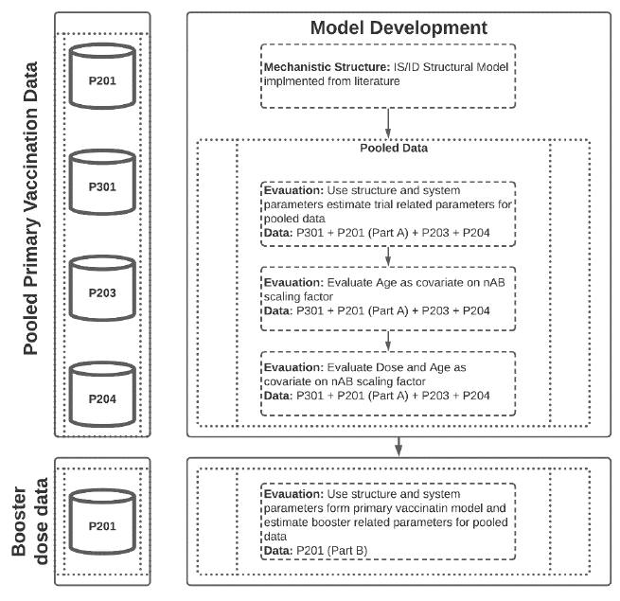
This is a complex model that is highly parameterised. In the sponsor submitted report on the model (full coverage is beyond the scope of this AusPAR), there are 23 parameters, at least seven of which are ‘fixed based on sensitivity analysis’ (fitted) and six ‘fixed to literature values’. Some others have been ‘estimated for post-booster analysis’ but the source of the remaining parameter values is less clear.
The sponsor submitted report on the modelling employs a very complex model that requires a large number of assumptions. It is unclear the question could not be answered using a simpler statistical model of the relationship between peak antibody levels and age/dose (since for most subjects only this early timepoint is available). A multiple regression/fixed effects model would potentially provide a much clearer answer to any associations between age, dose, and neutralising antibody response.

Results
There were 2781 participants (including 379 adolescents (13.6%)) who contributed data to the model. All booster dosing data were obtained from Study P201 (that is 392 adults (14.3% of model participants)).
Table 2: Distribution of subjects, across studies, dose and age groups used in theimmunostimulation/immunodynamic analysis
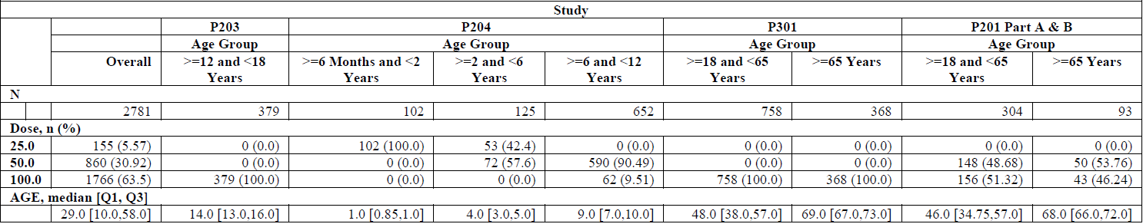
For all age groups other than adults, data from only one timepoint were collected. In adults, there were up to four time points and only in adults were any data pre- or post-booster collected. There were no pre- or post-booster available from adolescents, who were the subjects of the predictive model. Adolescents and children older or equal to 6 months to younger than 2 years of age were only studied at one dose level and the most at any other age was two dose levels. Hence the data are very sparse for attempting to fit such a complex model and large number of parameters. This is of particular concerning for predicting the longevity of response (for example, pre-booster) given the lack of longitudinal data for most age/dose combinations.

Exploratory data analysis
Distribution plots of GMT of neutralising antibody grouped by dose and age group against time are presented in Figure 2.
Figure 2: Distribution plots of observed log end point neutralisation titres versus time by age group and dose
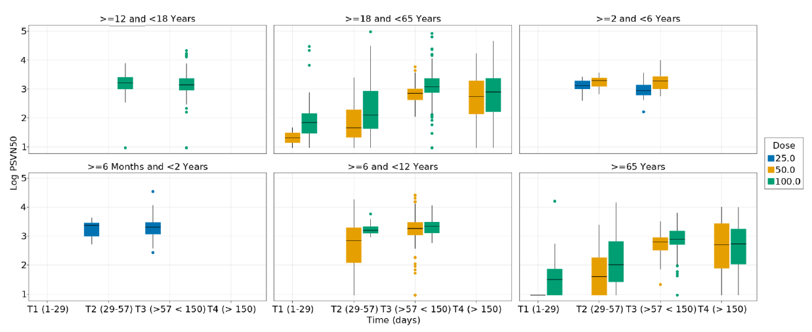
Note: Except Study P201 and P301 that represent the older or equal to 18-year age group, all other studies and age groups had only one time point collected per subject (as per protocol). In the older or equal to 18-year-old subjects, the neutralising antibody (nAB) titre increases with time and the values collected at Day 57 on an average match the Day 57 titres observed with lower doses in other age groups. GMTs in the T4 group represented in the figure indicate levels after a booster dose collected from 201 Part B. The booster dose in this arm was given anywhere between 180 days to 275 days after the second vaccine dose.
Figure 3: Structure diagram of the immunostimulation/immunodynamic model
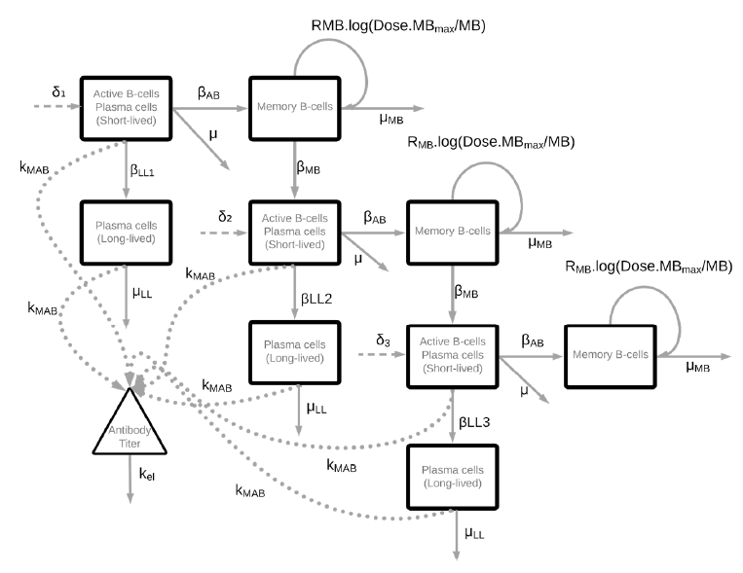
Footnote: δ1 = B cell activation rate on first vaccination; βAB = Transition rate to memory cells; μ = Death rate of activated B cells and short-lived plasma cells; βLL1 =Transition rate to long-lived plasma cells after first vaccination; k_{mAb} = Secretion rate of antibody by plasma cells; μLL = Death rate of long-lived plasma cells; μMB = Death rate of memory B cells; k_{el} = Elimination rate for antibody; δ2 = B cell activation rate on second vaccination; βMB = Activation rate of memory B cells on second or third vaccination; RMB = proliferation rate of memory B cells; MBmax = maximum number of memory B cells; MB = Number of memory B cells; βLL2 = Transition rate to long-lived plasma cells after second vaccination; δ3 = B cell activation rate on third vaccination; βLL3 = Transition rate to long-lived plasma cells after third vaccination.

Data from pooled pre-booster Studies P301, P201, P204 and P203
Using only data from the primary vaccination series (that is two doses), three models were evaluated:
- Base model;
- Age as a covariate on scaling factor, volume;
- Dose and age as a covariate on the scaling factor, volume.
There was an improvement in model metrics across the three models. Age was an important covariate where the scaling factor Volume increases with age. Dose had an impact on multiple factors; on the input function that generated the antigens and hence the initial B-cell response, a non-linear impact on the memory B cell production and finally on the scaling factor volume.

Post-booster Study P201 Part B data
Following fixing of the system parameters to those used or estimated in the pre-booster model, the booster data from Study P201 Part B was added to the analysis dataset and the third dose (δ3 (B cell activation rate on third vaccination)) was activated to fit the data.
Goodness of fit plots where shown for the final combined post-booster model in the ‘mRNA 1273 ISID Modelling Booster Report’ (not in scope of this AusPAR). These were interpreted by the report’s author as showing ‘…the model was able to capture the data well.’
Representative individual fits for a few participants from Study P201 are shown below in Figure 4.
Figure 4: Representative individual fits for Study P201 Part A 50 µg
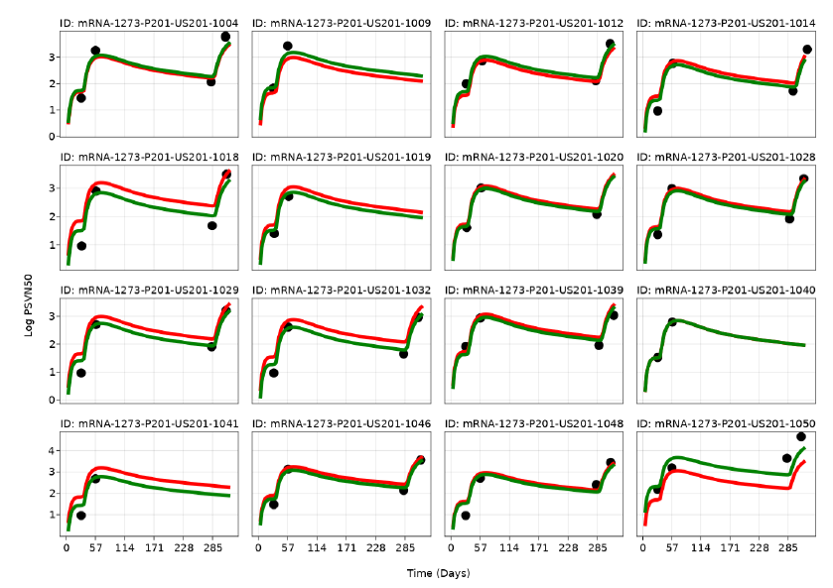
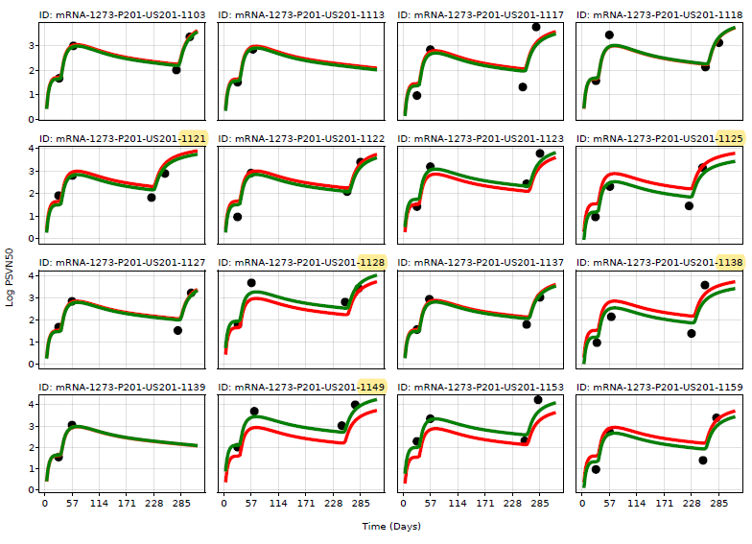
Green line: individual predictions, red line: population predictions, black dots: observed data.

Predictive performance of the model
A comparison of observed (that is known) and model predicted Day 57 neutralising antibody GMT data across age and dose groups is shown below. This was interpreted by the report’s author that ‘…observed and model predicted values match well.’ Similarly, in the clinical overview, the sponsor stated that, ‘Model predicted GMTs correlate well with observed data across age groups and dose levels’ (see Table 3).
Table 3: Comparison of observed and model predicted Day 57 neutralising antibodies geometric mean titre across age and dose groups
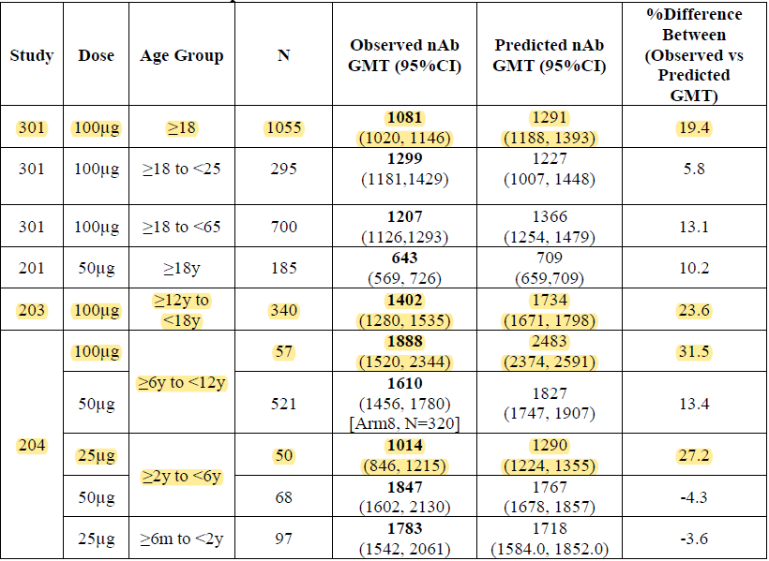
Note: Instances where the 95% confidence intervals for the observed and predicted data do not overlap are highlighted in yellow.

Adolescent booster dose predictions
Empirical Bayes estimates from the IS/ID model were used to predict both the pre- and post-booster neutralising antibody GMTs in the 379 adolescents from Study P203, assuming a 50 µg of mRNA-1273 booster dose was given following a 100 µg primary series. It was assumed the booster was administered on day 208 (that is exactly 180 days (6 months) following the primary series). As the timing of the 50 µg booster for adults in Study P201 ranged from 180 to 275 days (6 to 9 months), the observed GMFR in those adults was reflective of that distribution (that is potentially lower than had it been calculated at 6 months). The report’s author notes that because of these factors, ‘…it is expected that the mean predicted GMFR is lower than the observed across the age groups.’
The GMFR (95% CI) of 28-day post-booster compared to pre-booster GMTs was calculated. These values have been compared to the observed GMFR of adults from Study P201 Part B below in Table 4 and Table 5.
Table 4: Comparison of observed (18 to 25 years) and model predicted (12 to 18 years) geometric mean fold rise for 6-month 50 µg booster after 100 µg primary dose
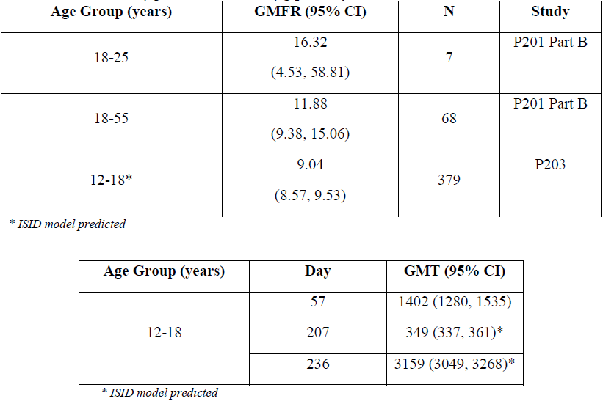
Table 5: Model predicted (12 to 18 years) geometric mean titre for 50 µg booster at Day 57, 207 and 236

Efficacy
The proposal of extension of use of a 50 µg dose booster of mRNA-1273 to adolescents (12 to younger than 18 years of age) in this submission is based on the following immunogenicity and efficacy data:
- Established efficacy in adults and young adults from clinical Study P301-Pivotal, Phase III, clinical efficacy and safety trial of a primary series of 100 µg of mRNA-1273 in adults older or equal to 18 years of age.
- Immunogenicity in young adults (18 to 25 years of age) receiving booster doses in clinical Studies: Study P201B, Division of Microbiology and Infectious Diseases (DMID) Study 21-0012, Study P301, and post licensure.
- Immunobridging of the primary vaccination was achieved in adolescents (12 to younger than 18 years of age) using immunogenicity data (100 µg dose) from Study P203 (Phase II/III trial of 100 µg of mRNA-1273 in adolescents 12 to younger than 18 years of age) to young adults in Study P301 (18 to 25 years of age).

Study P301
Study P301 is a Phase III, pivotal randomised, observer blind, placebo controlled, stratified, efficacy, immunogenicity, and safety trial of a primary series of 100 µg of mRNA-1273 in adults older or equal to 18 years of age.
- Part A: Blinded phase.
- Part B: Open-label crossover of placebo recipients from Part A to receive mRNA-1273.
- Part C: Booster dose for eligible participants.

Results
Those data were accepted for licensure of Spikevax. The final efficacy analysis of Part A (blinded phase) based on a database lock of 4 May 2021 demonstrated vaccine efficacy (VE) of 93.2% (95% CI: 91, 94.8; p < 0.0001), which was consistent with results of the interim and primary analyses, confirming persistent, high efficacy over a substantially larger case database and over a median 5.3 month blinded observation period from randomisation in Part A.
Table 6: Study P301 Vaccine efficacy primary analysis, confirmed COVID-19 cases regardless of severity starting 14 days after the second dose (per-protocol set)
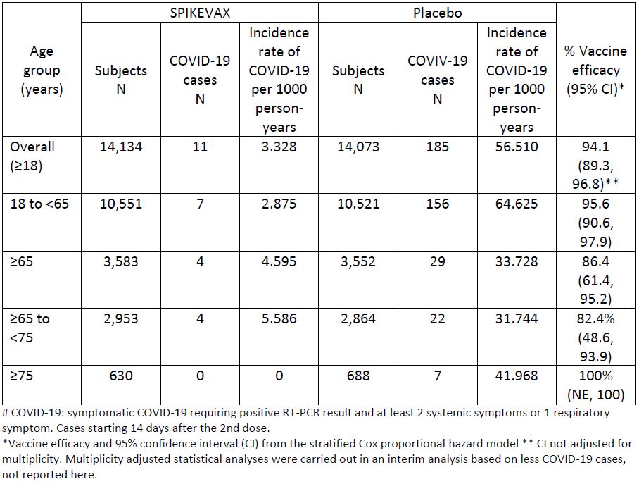
# COVID-19: symptomatic COVID-19 requiring positive RT-PCR results and at least two systemic symptoms or one respiratory symptom. Cases starting 14 days after second dose.
* Vaccine efficacy and 95% confidence interval (CI) from the stratified Cox proportional hazard model
** CI not adjusted for multiplicity. Multiplicity adjusted statistical analyses were carried out in an interim analysis based on less COVID-19 cases, not reported here.

Study P203
Study P203 is an ongoing Phase II/III randomised, placebo controlled, observer blind, clinical study to evaluate the safety, reactogenicity, and effectiveness of Spikevax (100 µg of mRNA-1273) in adolescents 12 to younger than 18 years of age in the US.
Vaccine effectiveness in adolescents aged older or equal to 12 to younger than 18 years was inferred by demonstrating non-inferiority of both serum neutralising antibodies GMTs and seroresponse rates (SRR) from adolescents compared with those from young adults enrolled in Study P301 (aged older or equal to 18 to younger or equal to 25 years).
- Part A: Dose confirmation trial of the 100 µg mRNA dose.
- Part B: Crossover of placebo participants from Part A to receive 100 µg of mRNA-1273 and booster dosing of 50 µg of mRNA-1273; for all eligible participants from Parts A and B.
- Part C: Proof of concept study of booster dosing with either mRNA-1273 wild type booster or a mixed wild type/Beta (B.1.351) variant booster for 60 eligible participants from Study P301.

Result
Non-inferiority was demonstrated in antibody levels and immune responses between adolescents and young adults older or equal to 18 to younger or equal to 25 years of age. GMTs were slightly higher in adolescents; however, 95% CIs substantially overlapped those of the young adults (see Table 7). The data can be interpreted as showing that immunogenicity in adolescents is no worse than in young adults and may be slightly more robust.
Table 7: Study P203 Analysis of serum antibody level and seroresponse at Day 57 by pseudovirus neutralisation assay with ANCOVA model (per-protocol immunogenicity subset for SARS-CoV-2-specific neutralising antibody).
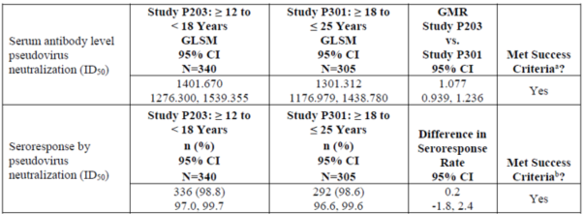
Abbreviations: ANCOVA = analysis of covariance; CI = confidence interval; GLSM = geometric least squares mean; GMR = geometric mean ratio; ID₅₀ = 50% inhibitory dilution or median infectious dose; LLOQ = lower limit of quantification ; LS = least square; n = number of subjects with non-missing data at the corresponding timepoint; nAb = neutralising antibody; ULOQ = upper limit of quantification.
a The lower bound of the 95% CI of the GMR rules out 0.67 (lower bound > 0.67) using a non-inferiority margin of 1.5, and the GNR point estimate > 0.8 (minimum threshold).
b The lower bound of the 95% CI of the seroresponse rate difference rules out – 10% (that is lower bound > - 10%) using the non-inferiority margin of 10% and the seroresponse rate difference point estimate > -5% (minimum threshold).

Study P201
This is an ongoing Phase II, randomised, observer blind, placebo controlled, dose confirmation study to evaluate the safety, reactogenicity, and immunogenicity of Spikevax in participants 18 years of age and older. In particular, to determine the dose confirmation and booster studies in adults older or equal to 18 years of age.
- Part B: An open label interventional phase that was prompted by the authorisation of a COVID-19 vaccine under Emergency Use Authorization (EUA) in the USA. This permitted all ongoing participants the option to receive a single 50 µg (homologous) booster dose of mRNA-1273.

Results
Data for the primary endpoint are shown in Table 8 below. Included in this table are data from a post-hoc analysis from the 18 to 25 years of age group, with comparisons to age group 18 to 55 years of age and all age groups. The post-booster dose GMTs met pre-specified non-inferiority criteria for the post-primary series GMTs and seroresponse (across all age groups).
Table 8: Study P201 Summary of pseudovirus neutralising antibody 50% inhibitory dose titres after 50 µg booster injection
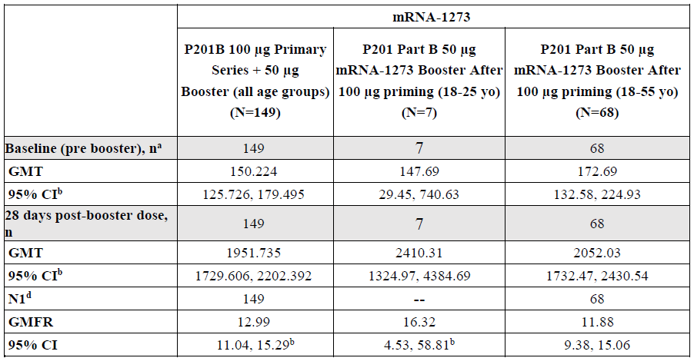
Abbreviations: CI = confidence interval; GMFR = geometric mean fold rise (post-baseline versus baseline titres); GMT = geometric mean titre; ID₅₀ = median infectious dose; LLOQ = lower limit of quantification; N1 = number of participants with non-missing data at Baseline and corresponding visit; ULOQ = upper limit of quantification.
Antibody values reported as below the LLOQ are replaced by 0.5 x LLOQ. Values that are greater than the ULOQ are converted to the ULOQ if actual values are not available. Percentages are based on the number of participants in per-protocol set with non-missing data at baseline and corresponding visit (N1).
a Number of participants with non-missing baseline
b 95% CI was calculated based on the t-distribution of the log transformed values or the difference in the log-transformed values for GMT and GMFR, respectively, then back-transformed to the original scale for presentation.
c 95% CI was calculated using the Clopper-Pearson method.
d Number of participants in the per protocol set with non-missing data at the corresponding visit.

Immunogenicity of booster dose for Delta and Omicron variants
A single dose of 50 µg of mRNA-1273 in the Study P201B also demonstrated 32- to 44-fold increases in neutralising antibody responses against all test variants, including a 42-fold increase against the Delta variant.
In the Study P301 (the COVE trial); the 50 µg booster was associated with median (50%) infectious dose (ID₅₀) GMTs against the Omicron variant that were 20 times higher than those assessed one month after the second vaccination.

Immunobridging comparison of Study P201 Part B booster to Study P301 primary series against wild-type SARS-CoV-2 (homologous boosting)
Geometric mean titres from day 28 post-booster (Study P201 Part B) were compared to GMTs from Day 57 in Study P301 (that is, the timepoint at which efficacy was demonstrated) and the geometric mean ratio (GMR) was calculated to be 1.71 (95% CI: 1.519, 1.929). This was above the lower bound of the 95% CI of 0.67 (corresponding to non-inferiority margin = 1.5) needed to meet the pre-specified non-inferiority margin. Of note, these data combined two different prime series (50 µg and 100 µg of mRNA-1273 priming).
These same data were analysed by stratifying the Study P201 Part B participants into the 50 µg of mRNA-1273 prime group and the 100 µg of mRNA-1273 prime group, and immunobridging their post-booster GMTs with those from Day 57 in Study P301 as discussed above.
Geometric least squares means (GLSM) were very similar post-booster whether primed with a 50 µg of mRNA-1273 primary series (GLSM 1716.185 (95% CI: 1469.496, 2004.286)) or 100 µg of mRNA-1273 primary series (GLSM 1802.426 (95% CI: 1548.020, 2098.643)), leading to very similar GLSM-ratios.
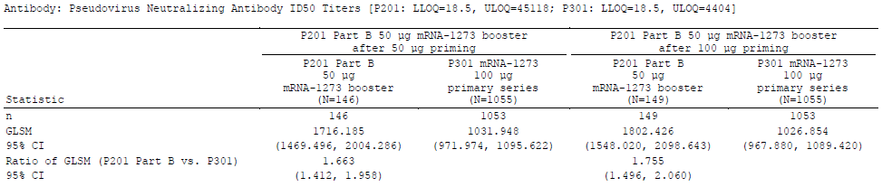
Table 9: Study P201 Analysis of pseudovirus neutralising antibody 50% and 80% inhibitory dose titres by priming groups per-protocol immunogenicity set
Note: Study P201: LLOQ = 18.5, ULOQ = 45118; Study P301: LLOQ = 18.5, ULOQ = 4404
GLSM = geometric least squares mean, CI = confidence interval.
n = number of subjects with non-missing data at the corresponding timepoint.
Antibody values reported as below the lower limit of quantification (LLOQ) are replaced by 0.5 x LLOQ. Value greater than the upper limit of quantification (ULOQ) are replaced by the ULOQ if actual value are not available.
Separate analysis of covariance (ANCOVA) modes were used for Study P201 50 µg priming + 50 µg booster (group variables: Study P201 50 µg priming, and Study P301) and Study P201 100 µg priming + 50 µg booster (group variables: Study P201 100 µg priming, and Study P301)
The sponsor has been able to re-analyse booster data from the youngest age subgroup available, which shows immune responses to be higher than those from all age groups studied, including a subgroup of adults younger or equal to 55 years of age (albeit with very wide confidence intervals given only seven subjects were available aged 18 to 25 years of age). The results do not raise any concerns that immunogenicity would be any lower in this youngest age subgroup.
The sponsor has also re-presented data demonstrating that post-booster antibody responses in the study of adults were very similar whether priming was with a 50 µg of mRNA-1273 dose or a 100 µg of mRNA-1273 dose (noting that the primary series for adolescents 12 to younger than 18 years of age that is currently recommended in the Australian PI is 100 µg of mRNA-1273 (50 µg doses are recommended for children 6 to 11 years of age)).
In relation to the Omicron variant, the higher GMFRs post-booster relative to wild type purely reflect that the pre-booster Omicron titres had waned to very low levels since the primary series (hence the GMFRs were coming off a lower baseline); the post-booster GMTs for Omicron were less than for wild type and waned more in the successive five months. Still, the results show that mRNA-1273 substantially boosts responses against Omicron and that GMTs were still higher at six months post-booster than they had been pre-booster.

DMID Study 21-0012
The US National Institutes of Health (NIH( Division of Microbiology and Infectious Diseases (DMID) Study 21-0012 is a Phase I/II trial of heterologous booster dosing with mRNA-1273 in adults older or equal to 18 years of age using doses of either 50 µg or 100 µg of mRNA-1273
This is a sponsor-independent Phase I/II heterologous SARS-CoV-2 vaccine dosing (Spikevax (mRNA-1273) booster) study of the various vaccines authorised under the Emergency Use Authorization (EUA) legistlation in the USA (Janssen COVID‑19 vaccine, Spikevax, or Comirnaty) in participants’ older or equal to 18 years of age. The study complements Study P201 Part B, which examined the immunogenicity of homologous booster doses.

Results
Comparing GMT obtained 12 to 20 weeks after two doses of 100 µg mRNA-1273 with GMT obtained 14 days after a 100 µg booster dose, show a significant increase in neutralising antibody titres with a GMFR of 10.17 following the booster dose (95%: 8.05, 12.85). This GMFR is consistent with that observed in earlier sections for the 50 µg booster, (GMFR 12.99, 95% CI: 11.04, 15.29).
Data from this study also illustrate that a booster dose of mRNA-1273 can enhance neutralising antibody responses induced by alternate primary vaccination regimens, regardless of the vaccine used for priming. Study participants had completed authorised regimens of the Janssen vaccine (n = 52 participants) or Comirnaty (n = 50 participants) 12 to 20 weeks prior to obtaining a ‘baseline’ serum sample. Of note, these ‘baseline’ GMTs measured in these groups were lower than that following the authorised two dose Spikevax regimen (366.31 following Spikevax compared with 36.81 following Janssen vaccine and 102.44 following Comirnaty). Regardless of the initial vaccine regimen, boosting with 50 or 100 µg dose of Spikevax resulted in a significant increase in neutralising antibody titre.
In line with the results from Study P201 Part B, the older adult cohort aged older or equal to 56 years had a GMFR consistent with the younger age cohort 18 to 55 years of age.
Geometric mean fold rises comparing GMT after different primary vaccination schemes prior to the 100 µg mRNA-1273 booster to the GMT 14 days after mRNA-1273 booster were 75.91 (primary series Janssen), 10.17 (primary series Spikevax) and 31.69 (primary series Comirnaty). These results emphasise that fold increase is influenced by baseline titres: two doses of mRNA-1273 achieved relatively high ‘baseline’ titres (366.31) compared with ‘baseline’ titres achieved by either the Janssen or Comirnaty vaccines (36.81 and 102.44, respectively). The relatively higher titers achieved after two doses of 100 µg of mRNA-1273 result in a relatively lower GMFR than for participants initially given Janssen or Comirnaty vaccines (86% versus 100%, respectively).
In the DMID Study 21-0012, the Day 15 GMFR following a 100 µg of mRNA-1273 booster dose, given after a 100 µg of mRNA-1273 primary series, was 10.17 (95% CI: 8.05, 12.85) (Table 10). This compares to an analogous result of 12.99 (95% CI: 11.04, 15.29) for the 50 µg booster dose used in Study P201 Part B.
Table 10: Study 21-0012 Neutralisation antibodies titre (ID₅₀) to spike-pseudotyped virus SARS-CoV-2 D614G, by group and timepoint
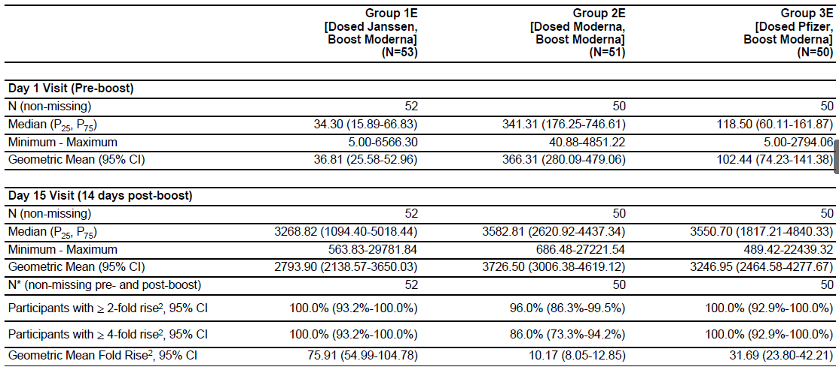
1 Values below the lower limit of detection (LLOD = 10) were assigned the value of LLOD/2. Values between the LLOD and the lower limit of quantification (LLOQ = 18.5) are taken as reported, or a value of LLOQ/2 is assigned if observations are reported as <LLOQ but no value is provided. Values greater than the upper limit of quantification (ULOQ = 45118) are taken as reported, or a ceiling value equivalent to the ULOQ is assigned if values are not provided.
2 Relative to pre-vaccination (Day 1 Visit) levels, among participants with no-missing observations at both pre- and post-boost timepoints.
The initial part of the study used a 100 µg of mRNA-1273 booster (these data were previously evaluated by the TGA) and the later part used a 50 µg of mRNA-1273 booster (these data were newly provided with the current submission).
Results of the DMID 21-0012 study using a booster dose of mRNA-1273 both 50 µg and 100 µg, firstly reinforce findings observed after the 50 µg boosting dose (P201 Part B), and secondly, demonstrate the utility of mRNA-1273 regardless of the COVID-19 vaccine initially administered.
Of note though, there are no data directly from adolescents 12 to younger than 18 years of age and responses against the Omicron variant were not presented for this study.

Published literature and reports from post-licensure use of Spikevax
The sponsor has highlighted data from the US Centers for Disease Control (CDC) showing rates of COVID-19 hospitalisations to be lower in those who had received a booster dose of COVID-19 vaccine than in those who were fully vaccinated but not boosted.

Real-world vaccine effectiveness of an mRNA-1273 primary series in United States of America
Real world vaccine efficacy was examined in a prospective cohort study by US healthcare provider Kaiser Permanente Southern California (Table 11).
Table 11: Bruxvoort KJ, et al. (2022) Incidence rates, hazard ratios, and vaccine efficacy of two doses of mRNA-1273 vaccine in preventing COVID-19 infection, hospitalisation, and hospital death
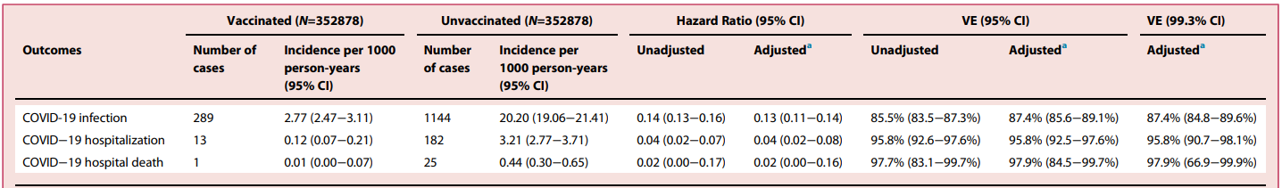
a Adjusted for covariates age, sex, race/ethnicity, frailty index (in quartiles), history of COVID-19 infection, history of SARA-CoV-2 molecular test, number of outpatient and virtual visits, preventive care, Medicare, neighbourhood median household income, Kaiser Permanente Southern California physician/employee status, medical center area.
This was a large study conducted just as the Delta wave was becoming evident in the US. Vaccine efficacy (VE) was high against asymptomatic, symptomatic and severe infection, and hospital death. This held across all demographic subgroups and was just as high in those 18 to 44 years of age (that is the youngest age group study) as in older cohorts.
As expected, natural immunity from prior infection with SARS-CoV-2 likely provided substantial protection against future infection and disease severity, so VE was lower in those subgroups; however, an additional benefit of vaccination was shown beyond that of natural immunity.
Of note, there were no data available from adolescents, the study did not examine booster doses, VE against the Delta variant was not specifically examined, and the study had concluded well before the onset of the Omicron outbreak in late 2021.

Real-world vaccine effectiveness of mRNA-1273 booster dosing in Qatar
A retrospective cohort study conducted in Qatar among over 2.2 million persons vaccinated with two doses was conducted to investigate the effectiveness of booster vaccination against symptomatic SARS-CoV-2. For mRNA-1273, cumulative symptomatic infection incidence was 1.9% (95% CI: 1.7, 2.2) in the booster dose cohort and 3.5% (95% CI: 3.2, 3.9) in the primary series cohort, after 35 days of follow up. The adjusted hazard ratio for symptomatic infection was 0.49 (95% CI: 0.43, 0.57). Booster effectiveness relative to primary series was 50.8% (95% CI: 43.4, 57.3). There were fewer cases of severe COVID-19 in booster dose cohorts than in primary series cohorts, but cases of severe COVID-19 were rare in all cohorts indicating booster vaccination is associated with modest effectiveness against symptomatic infection with Omicron.
Another study including all ages eligible for vaccination (including young adults) that investigated the association between three doses of mRNA COVID-19 vaccines and symptomatic SARS-CoV-2 infection with Omicron and Delta variants using a test negative case control analysis. In an analysis that included age matched cases and controls a comparison of three doses versus two doses among Omicron cases and controls, the adjusted odds ratio versus two doses was 0.34 (95% CI: 0.32, 0.36); among Delta cases and controls, the adjusted odds ratio was 0.16 (p < 0.001). When models were stratified by mRNA product, the adjusted odds ratios for Omicron were 0.35 (95% CI: 0.32, 0.37) for three doses of Comirnaty versus two doses and 0.31 (95% CI: 0.28, 0.34) for three doses of Spikevax versus two doses. For Delta, the adjusted odds ratios were 0.17 (95% CI: 0.16, 0.19) for three doses of Comirnaty versus two doses and 0.13 (95% CI: 0.11, 0.15) for three doses of Spikevax versus two doses. Q values for all comparisons (Omicron versus Delta) of product specific odds ratios were less than 0.001 doses (versus two doses), with values closer to zero representing a stronger magnitude of association (Table 12).
Table 12: Association between Omicron or Delta symptomatic SARS-CoV-2 infection and prior mRNA COVID-19 vaccination among adults 18 Years or older tested in the increasing community access to testing platform (10 December 2021, to 1 January 2022)
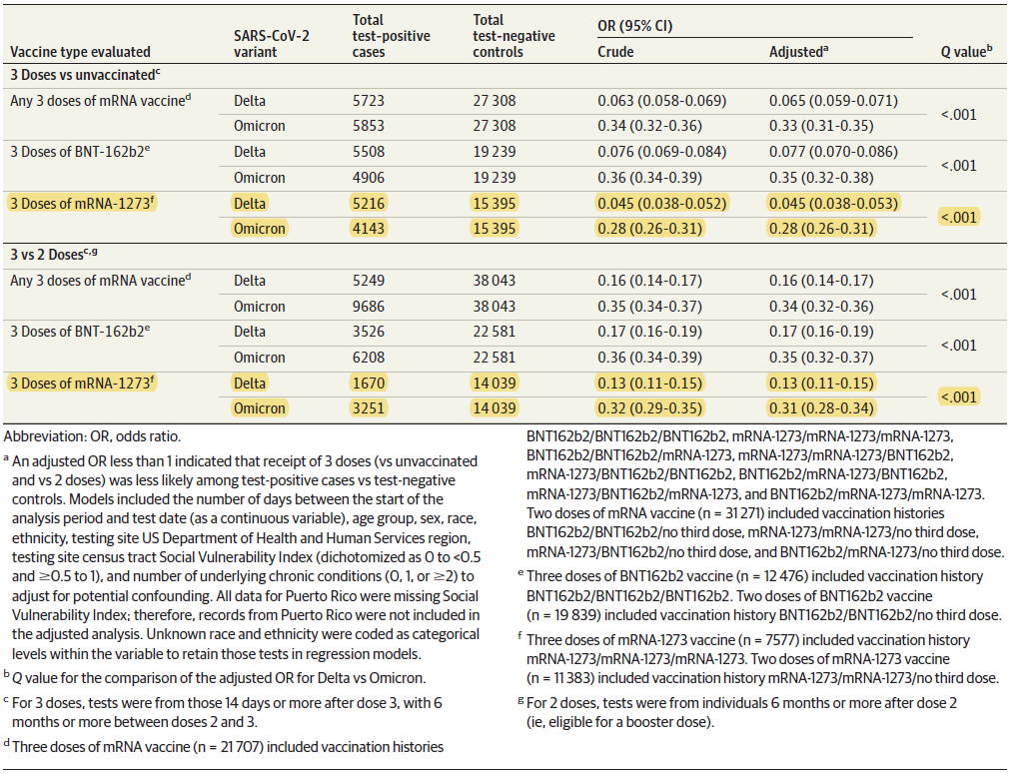

Primary series in adolescents
Vaccine effectiveness in adolescents aged older or equal to 12 to younger than 18 years of age was inferred by demonstrating non-inferiority of both serum neutralising antibody GMTs and SRR from adolescents compared with those from young adults enrolled in Study P301 (aged older or equal to 18 to younger or equal to 25 years (Table 13). The GMR of adolescent (Study P203) to young adult (Study P301) neutralising antibody titres at Day 57 was 1.077 (95% CI: 0.939, 1.236), meeting the pre-specified 1.5-fold non-inferiority criterion (that is lower bound of the 95% CI for GMR is > 0.67) . The difference in adolescent to young adult neutralising antibody SRRs at Day 57 was 0.2 (95% CI: -1.8, 2.4), meeting the pre-specified 10% non-inferiority criterion (lower bound of the 95% CI of the SRR difference is > -10%). Since both coprimary endpoints of Study P203 met the pre-specified success criteria for non-inferiority, the primary immunogenicity objective is considered to be met.
Table 13: Analysis of serum antibody level and seroresponse at Day 57 by pseudovirus neutralisation assay (ID₅₀) with ANCOVA model (per protocol immunogenicity subset for SARS-CoV-2 specific neutralisation antibody)
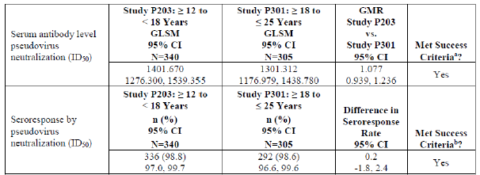
Abbreviations: ANCOVA = analysis of covariance; CI = confidence interval; GLSM = geometric least squares mean; GMR = geometric mean ratio; ID₅₀ = 50% inhibitory dilution or median infectious dose; LLOQ = lower limit of quantification; LS = least square; n = number of subjects with non-missing data at the corresponding timepoint; nAb = neutralising antibody; ULOQ = upper limit of quantification.
a The lower bound of the 95% CI of the GMR rules out 0.67 (lower bound > 0.67) using a non-inferiority margin of 1.5, and the GNR point estimate > 0.8 (minimum threshold).
b The lower bound of the 95% CI of the seroresponse rate difference rules out – 10% (that is lower bound > - 10%) using the non-inferiority margin of 10% and the seroresponse rate difference point estimate > -5% (minimum threshold).
Notes: The ULOQ for selected P301 participants tested previously was different. Antibody values reported as below the LLOQ are replaced by 0.5 x LLOQ. Values greater than the ULOQ are replaced by the ULOQ if actual vales are not available. The log-transformed antibody levels are analysed using an ANCOVA model with the group variable (adolescents in Study P203 and young adults in Study P301) as fixed effect. The resultant LS means, difference of LS means, and 95% CI were back transformed to the original scale for presentation.

Safety
The two main endpoints for safety are listed below:
- Established safety profile of two doses of 100 µg of mRNA-1273 primary series given at least four weeks apart, from data in clinical studies (Study P201, Study P203, and Study P301) and post licensure data.
- Demonstrated booster safety in adults including young adults (18 to younger than 25 years) in clinical studies (P201B, DMID Study 21-0012 and post-authorisation.

Study P301
Study P301 is a pivotal, Phase III, clinical efficacy and safety trial of a primary series of 100 µg of mRNA-1273 in adults older or equal to 18 years of age. Safety analysis of Study P301 has been previously evaluated (PM-2021-02994-1-2). In this study, there were 30,351 participants who received at least one dose of 100 µg mRNA-1273 (n = 15,185) or placebo (n = 15,166). These participants were older or equal to 18 years of age.

Summary
- Reactogenicity events (solicited adverse events (AEs)) reported in the 7 days following each dose of vaccine were much higher in the vaccine group (92.4% versus 29.3%).
- Injection site pain was the most common local solicited AE (92% for the subjects in the vaccine group versus 26.6% of participants in the placebo group after any dose).
- Majority of Grade 3 AEs were due to pain, in the vaccine group (6.1% versus 0.6%).
- Solicited systemic AEs were reported in the majority of vaccine recipients (84.1%) and much more frequently when compared to placebo (53.5%). Higher rates of systemic AEs were recorded post second dose as compared with first dose.
- After any dose, fatigue was the most common solicited systemic AE (70% of participants in the vaccine group versus 36.6% of participants in the placebo group). Headache (64.7% of subjects in the vaccine group versus 37% of participants in the placebo group) and myalgia (61.5% versus 20.5%) were other common systemic AEs.
- Grade 3 or 4 AEs were reported in 3% of vaccine recipients post first dose, which increased to 17.3% post second dose. Grade 3 or 4 fatigue after any dose was reported in 10.1% of participants in the vaccine group versus 1.3% of participants in the placebo group, followed by myalgia (9.1% versus 0.6%) and headache (5.7% versus 2.2%).
- Most events occurred within the first 1 to 2 days post dose and lasted for a median duration of 1 to 3 days and were reported with higher frequencies in younger adults.
- Overall, unsolicited AEs considered to be related to study vaccination were reported in 8.2% in the mRNA-1273 group versus 4.5 % in placebo. In the vaccine group, treatment related AEs reported in greater or equal to 1% of participants in the 28 days after any injection included fatigue (1.3% of participants in the vaccine group versus 1% of participants in the placebo group) and headache (1.3% versus 0.8%). The most frequently reported severe AEs in the vaccine group were consistent with reactogenic events such as headache, fatigue, myalgia arthralgia, injection site erythema and injection site swelling. The most common serious adverse events (SAEs) in the vaccine group, which were numerically higher than the placebo group, were myocardial infarction, cholecystitis and nephrolithiasis.
- The proportion of participants who reported severe unsolicited AEs was low and generally balanced in both groups (1.5% in vaccine group and 1.3% in placebo).
- Overall rate of SAEs, death, and discontinuations due to AEs were largely balanced across the study groups.

Study P203
Safety analysis of Study P203 has been previously evaluated.35 The study involved assessment of mRNA-1273 given to healthy adolescents 12 to younger than 18 years of age as a primary series at 100 µg per dose. As of 8 May 2021 (data snapshot date), there were 3,726 subjects included in the safety set, of which 2,486 had received mRNA-1273 and 1,240 received placebo.

Summary
- Any solicited local AE after any dose was recorded for 97.8% of subjects in the mRNA-1273 vaccine group (2,431 out of 2,485) and for 48.5% of subjects (602 out of 1,240) in the placebo group.
- The most frequently reported local solicited AE in the mRNA-1273 and the placebo group after any dose was injection site pain reported by 97.2% of subjects in the mRNA-1273 vaccine group and by 45.9% of subjects in the placebo group. This was followed by axillary swelling or tenderness (34.6% versus 10.7%), swelling (27.7% versus 1.9%), and erythema/redness (25.8% versus 1.5%).
- Majority of the solicited local AEs were mild to moderate. Grade 3 solicited local adverse reaction (AR) after any dose was recorded for 13.8% of subjects in the mRNA-1273 vaccine group and for 0.3% in the placebo group. No Grade 4 solicited local AE was recorded.
- The severity slightly increased from first dose to second dose, and 6.8% of subjects reported any Grade 3 local solicited AE post first dose versus 8.9% post second dose.
- Solicited local AEs usually persisted for a median of three days.
- Any solicited systemic AE after any dose was recorded for 91.9% of subjects in the mRNA-1273 vaccine group (2,284 out of 2,485) and for 66.9% of subjects (830 out of 1,240) in the placebo group.
- The most frequently reported systemic solicited AE in the mRNA-1273 group after any dose was headache, reported by 78.4% of subjects in the mRNA-1273 vaccine group and by 50.3% of subjects in the placebo group. This was followed by fatigue (75.2% versus 47.5%), myalgia (54.3% versus 23.5%), chills (49.1% versus 16.2%), arthralgia (34.6 versus 16.9%), and nausea (29.3% versus 15.2%).
- Fever of any grade was reported in 13.7% versus 1.9% of subjects. The incidence of solicited systemic AEs was notably higher after second dose compared with first dose.
- Majority of systemic solicited AEs were mild to moderate and any Grade 3 solicited systemic AR after any dose was recorded for 16.5% of subjects in the mRNA-1273 vaccine group (versus 4.6% in the placebo group).
- Grade 3 systemic solicited AEs were mostly recorded for fatigue (8.5% of subjects in the mRNA-1273 vaccine group after any dose), followed by headache (6.4%), myalgia (5.8%), arthralgia (2.7%), fever (2.2%), chills (0.5%), and nausea (0.2%).
- The majority of solicited systemic AEs in the mRNA-1273 vaccine group occurred within the first 1 to 2 days after any dose (89.1% of subjects).
- The frequency of reported solicited AEs were generally similar and there were no notable differences in the reported rates of unsolicited AEs observed between participants aged older or equal to 12 to younger than 16 years and participants aged older or equal to 16 to younger than 18 years.
- Unsolicited treatment emergent adverse events (TEAEs) irrespective of causality up to 28 days after any dose were reported by 20.5% of subjects in the mRNA-1273 group (510 out of 2,486 subjects) compared to 15.9% of participants in the placebo group (197 out of 1,240 subjects).
- The most commonly recorded unsolicited axillary lymphadenopathy (4.3% versus 0.4%), injection site erythema (1.9% versus 0.2%), fatigue (1.9% each), injection site induration (1.1% versus 0.2%), and injection site pain (1.1 versus 0.6%).
- There was no severe unsolicited AEs that occurred in the mRNA-1273 vaccine group that were considered vaccine related.
- The most frequently reported hypersensitivity events considered being vaccine related in the mRNA-1273 group were injection site hypersensitivity (eight subjects, 0.3%), injection site urticaria (0.2%, four subjects), rash (0.2%, four subjects) and urticaria (0.2%, six subjects). three subjects (0.1%) reported a type IV hypersensitivity reaction; this included a non-urticarial rash at the upper arm, and a pruritic rash of lower legs. There was no case of anaphylaxis considered to be related to mRNA-1273.
- No SAEs considered to be related to the vaccine was identified in the 28 days after any dose of mRNA-1273.
- No deaths were reported.
- No cases of myocarditis was reported at the time of the data snapshot. There were three subjects in the mRNA-1273 vaccine group that reported symptoms that could be consistent with myocarditis or pericarditis.
- The safety set size was considered to be relatively small and therefore not sufficient for the detection of rare adverse reactions.
The use of mRNA-1273 as a booster dose regimen in adolescents (12 to younger than 18 years of age) is currently investigated in clinical Study P203 Part C which is currently ongoing.

Comparison of solicited adverse events in participants 12 to younger than 18 years of age versus 18 to 25 years of age
A post-hoc comparison of solicited AEs in adolescents (12 to younger than 18 years of age, n = 878) from Study P203 and young adults (18 to 25 years of age, n = 2482) from Study P301 have been presented by the sponsor (see Table 14 and Table 15)
Table 14: Studies P203 and P301 Frequency of solicited local adverse events within seven days after first and second injection by Grade in participants 12 to 17 years of age and 18 to 25 years of age (solicited safety analysis set)
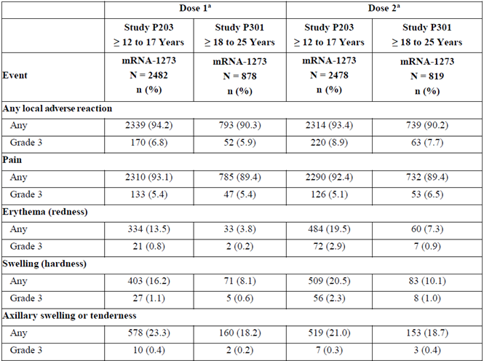
Abbreviations: Any = Grade 1 or higher; AR = adverse reaction; eDiary = electronic diary; N = number of exposed participants who submitted any data for the event; SAR = solicited adverse reaction.
Note: Any = Grade 1 or higher. Percentages are based on the number of exposed participants who submitted any data for the event (N1). The solicited safety set consists of all participants who were randomised and received any study injection and contributed any solicited AR data (that is, had at least 1 post-baseline solicited safety assessment). The first (second) injection solicited safety set consists of all participants in the solicited safety se who received the first (second) injection and contributed any SAR data from the time of the first (second) study injection through the following 6 days.
a The first and second injection solicited safety set consists of all participants in the solicited safety set who received the first or second dose and contributed any SAR data (eDiary) from the time of first or second dose through the following 6 days.
b Pain Grade 3: any use of prescription pain reliever/prevents daily activity.
c Erythema (redness) and swelling (hardness) Grade 3: ˃ 100mm/˃10cm.
d Axillary swelling or tenderness Grade 3: any use of prescription pain reliever/ prevents daily activity.
Table 15: Study P203 and 301 Frequency of solicited systemic adverse events within seven days after first and second injection by Grade in participants 12 to 17 years of age and 18 to 25 years of age (solicited safety analysis set)
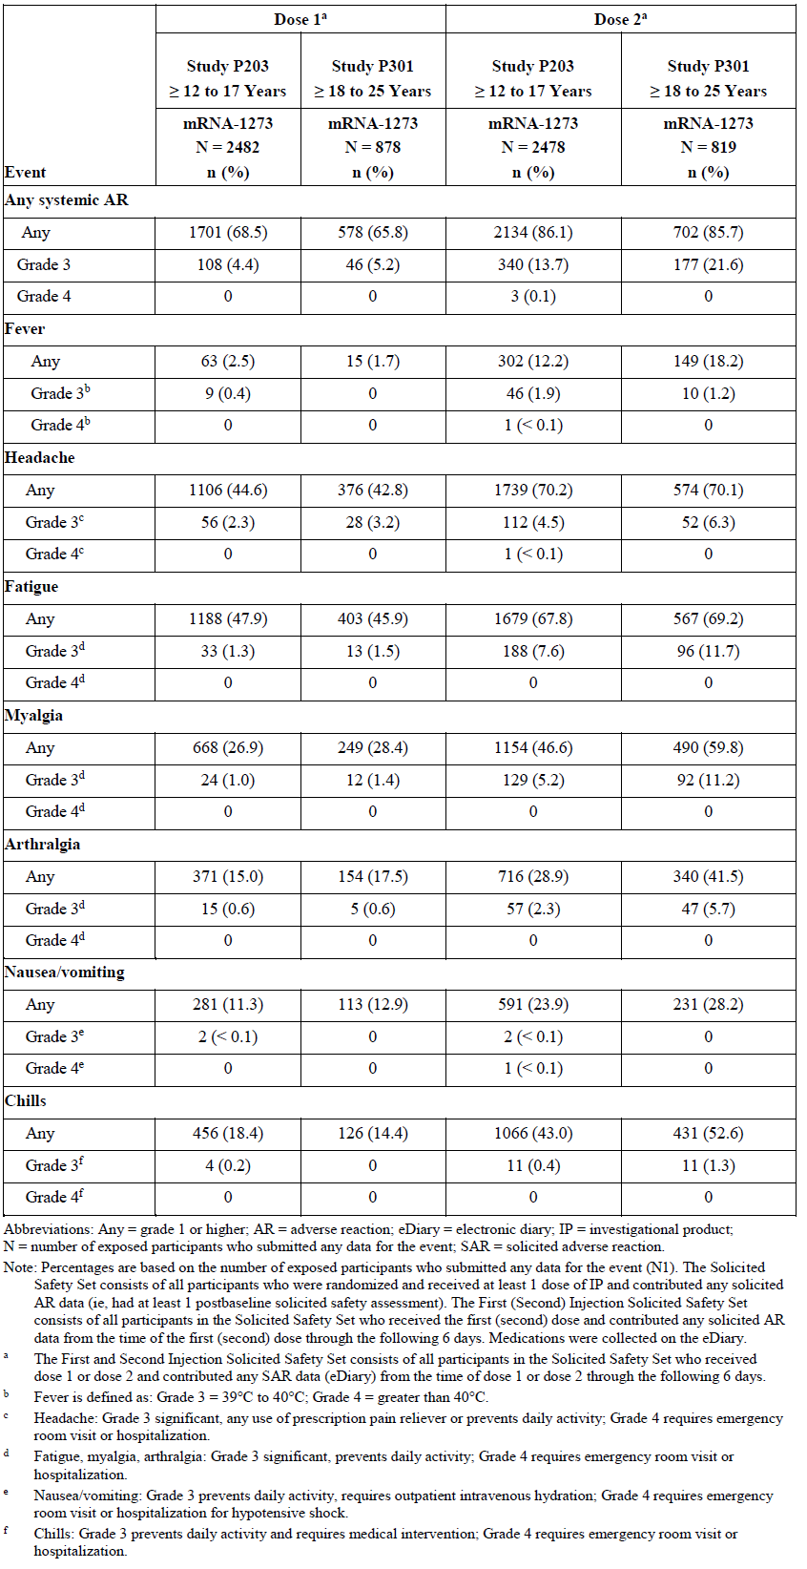
Abbreviations: Any = grade 1 or higher; AR = adverse reaction; eDiary = electronic diary; IP = investigational product; N = number of exposed participants who submitted any data for the event; SAR = solicited adverse reaction.
Note: Percentages are based on the number of exposed participants who submitted any data for the event (N1). The solicited safety set consists of all participants who were randomised and received at least 1 dose of IP and contributed any solicited AR data (that is, had at least one post-baseline solicited safety assessment). The first (second) injection solicited safety set consists of all participants in the solicited safety set who received first (second) dose and contributed any solicited AR data from the time of the first (second) dose through the following 6 days. Medications were collected on the eDiary.
a The first and second injection solicited safety set consists of all participants in the solicited safety set who received the first or second dose and contributed any SAR data (eDiary) from the time of first or second dose through the following 6 days.
b Fever is defined as: Grade 3 = 39ºC to 40ºC; Grade 4 = greater than 40ºC.
c Headache: Grade 3 significant, any use of prescription pain reliever or prevents daily activity; Grade 4 requires emergency room visit or hospitalisation.
d Fatigue, myalgia, arthralgia: Grade 3 significant, prevents daily activity; Grade 4 requires emergency room visit or hospitalisation.
e Nausea/vomiting: Grade 3 prevents daily activity, requires outpatient intravenous hydration; Grade 4 requires emergency room visit or hospitalisation.
f Chills: Grade 3 prevents daily activity and requires medical intervention; Grade 4 requires emergency room visit or hospitalisation.

Unsolicited adverse events
Incidences of unsolicited AEs were similar between the age groups, occurring in 21% of adolescents and 26% in young adults within 28 days after any injection. Most events were considered not related and were not severe (Table 16). Of note, there was no related SAEs or severe AEs, and no AEs leading to discontinuation of the study in adolescents.
Table 16: Summary of unsolicited adverse events in participants 12 to younger than 18 years of age compared with 18 to 25 years of age
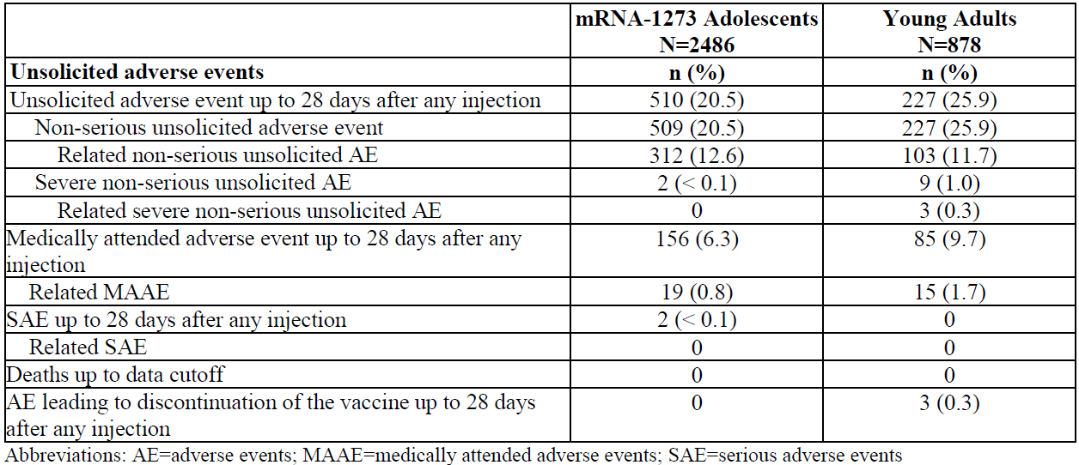
Abbreviations; AE = adverse events; MAAE = medically attended adverse events; SAE = serious adverse events.
The two pivotal studies in adults older or equal to 18 years of age (Study P301) and adolescents 12 to younger or equal to 18 years of age (Study P203) offer some insight into the safety profile of mRNA-1273. Of note, mRNA-1273 showed acceptable safety in these studies when given as two 100 µg doses.
A comparison of adolescents and young adults (18 to 25 years of age) from Studies P203 and P301 has shown that more frequent solicited local AEs were seen in adolescents, particularly for erythema and swelling. However, Grade 3 AEs were low in frequency, and no Grade 4 AEs were reported. No clinical meaningful difference could be observed for solicited systemic ARs. A comparison between adolescents and young adults suggests that the incidence of severe (Grade 3) systemic ARs is somewhat lower for adolescents (4.4% Dose 1, 13.7% Dose 2), compared to young adults (5.2% Dose 1, 21.6% Dose 2). Results must be interpreted with caution since the sample size in the age cohort 12 to younger than 18 years was three fold higher than in the age cohort 18 to 25 years of age and it is a historical control group.
Due to the comparable reactogenicity profile observed for adolescents and young adults 18 to 25 years of age after mRNA-1273 primary vaccination and taking into consideration results from the ongoing safety monitoring in Study P203 extrapolation of reactogenicity profile after the booster dose from young adults to adolescents maybe taken into consideration.

Post marketing experience
To further support the approval of the booster dose of Spikevax for adolescent, the applicant submitted a cumulative overview and high level analysis of post-authorisation safety data, extrapolating from the proportion of US vaccine recipients to the estimated global use. The reporting period for the booster dose/third dose is 18 December 2020 to 31 December 2021.
The collected safety data do not fully distinguish between individuals who received a third 100 µg dose, indicated for immunocompromised patients in some settings, and a 50 µg booster dose. Current data also do not distinguish the different dosing intervals that have been recommended for booster implementation in different countries. The recommended intervals range from 3 to 5 months, that is for example, France (three months), Germany (three months), United Kingdom (three months), Canada - Ontario (three months), Switzerland (four months), and US (five months).
It should be noted that the initially estimated exposure stated in the sponsor submitted overview was inconsistent. A corresponding clarification was requested from the sponsor. Within the response, the sponsor clarified that in the Bi-Monthly Safety Summary Report # 1 (BSSR 1) it was stated, that the prior safety summary report (Data Lock Point: 31 December 2021) had a systematic error that overestimated the governmental donation doses by approximately 93 million doses. The error was clerical in nature: all estimated bilateral donations (124,091,211 doses) were included as administered rather than the stated assumption of 25% of estimated bilateral donation (31,022,803 doses). At the same time estimation of individuals receiving each dose number was also over estimated.
The sponsor response with regards to third dose exposure revealed that the exposure number is rather based on assumptions than on reported information. To estimate global use, the sponsor extrapolates from the proportion of US vaccine recipients. In the response, the applicant estimates that as of 31 December 2021 a total of 827,274,740 doses have been distributed and 466,804,529 doses have been administered. The sponsor states that the correct number of estimated global use of Spikevax as of 31 December 2021 was 216,113,851 individuals receiving a first dose, 176,800,748 receiving a second dose, and 73,889,930 receiving a third dose. The sponsor states that taking this most extreme scenario of third dose use in adolescents as only 0.02% of the total global administered doses, an estimate of approximately 120,000 doses compared to the original estimate of approximately 3 million.
The sponsor believes that the review of revised observed to expected analyses for the affected data did not materially change interpretation of safety assessment for any topic evaluated.

Summary of cumulative safety data after a third or booster dose (18 December 2020 to 31 December 2021)
Regarding a booster dose of 50 μg or a third dose of 100μg, cumulatively, the sponsor has received 17,511 cases with 52,354 events, of which 29,181 events were serious, for recipients after an estimated 88.6 million third dose or booster dose of Spikevax. Of these, 5171 cases were medically confirmed, 8346 cases were serious, and 142 cases had fatal outcomes. The majority of cases were reported in females (11,673; 66.7%) compared to males (4,896; 28%) with the mean age of 52.8 years (standard deviation (SD): 16.6; median: 53 years). Age and gender distribution of cases after a third dose is shown in Table 17 (a low absolute number of reported cases in individuals below 18 years of age post third dose).
Table 17: Distribution of cases after a third dose or booster dose of Spikevax (estimated 88.6 million doses) by age group and gender, cumulative
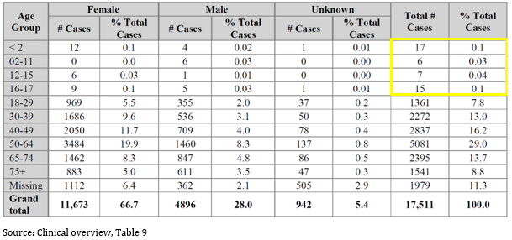
There were only 45 paediatric cases (younger than 18 year of age). Of these, 21 cases were reported as a medication error under the Preferred Term (PT) of ‘Product administered to patient of inappropriate age’, while four cases co-reported ‘Product administered to patient of inappropriate age’ and ‘Inappropriate schedule of product administration’. There were 17 cases who were younger than 2 years of age; these were either pregnancy related exposures or exposures through breast milk.
It appears that cumulatively, only a few cases post-third dose (that is, either a 50 µg booster or a 100 µg third dose in case of immunosuppressed condition) are recorded for adolescents. There were low absolute number of cases in individuals below 18 years of age. Only for 42 of 45 reported cases information is available in the overview. The reported AEs were due to medication error under the PT of ‘Product administered to patient of inappropriate age’ and ‘Inappropriate schedule of product administration’. The applicant was asked to submit information with regard to the nature and severity of the remaining cases and events in children below 18 years of age including a causality assessment. The clinical information for the remaining three cases has been submitted by the applicant as has been described above. Two of the cases represent expected reactogenicity events that are labelled for Spikevax. One of these two cases occurred after heterologous booster administration (Comirnaty primary vaccination without an adverse reaction, booster with Spikevax three month after primary vaccination). The third case describes a myasthenia gravis crisis in a 16 year old girl with a known history of myasthenia gravis that was acquired after COVID-19. The time frames of COVID-19 and the vaccination with three doses of Spikevax is not provided. A causal relationship cannot be excluded.

Overview of cumulative safety data in adolescents (12 to 17 years of age)
The sponsor has confirmed that for all three doses (Doses 1, 2 and 3) combined, for 12 to 17 years old cumulative as of 31 December 2021 (5808 cases (9981 events, of which 1081 events were serious)) cumulative, regardless of dose number. Of these, 4,936 cases were medically confirmed, 443 cases were serious, and 7 cases had fatal outcomes. The number of cases were slightly higher in females (54.3%, 3,153) compared to males (41.6%, 2,415) with the mean age of 15.9 years (standard deviation (SD): 1.5; median: 16.0 years). There were 1,375 (23.7%) cases in the 12 to 15 years of age group, and 4,433 (76.3%) cases in the 16 to 17 year of age group.
Table 18: Distribution of reported cases with adverse events for adolescents (12 to 17 years of age) by age group and gender
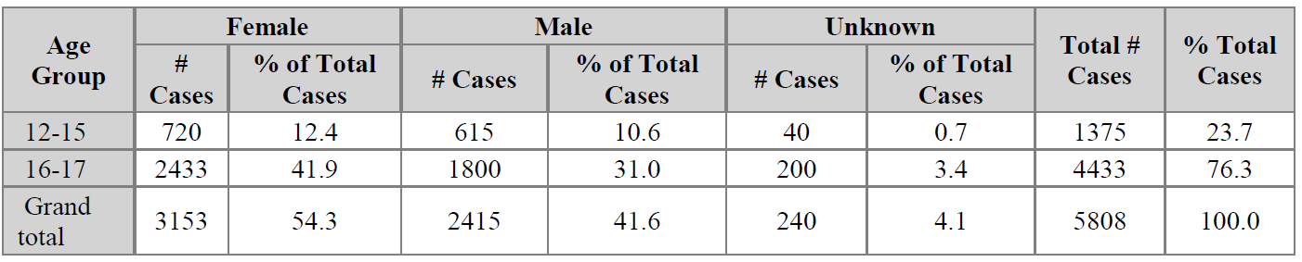
Of the 9,981 AEs, the majority of the events were reported after first dose (5,791; 58%), of which most (5,186; 89.6%) occurred in the first two days following vaccination.
The most common AEs reported (by Preferred Term (PT)) in adolescents were pyrexia, headache, and local site pain.
Table 19: Ten most common adverse events by Preferred Term for adolescents (12 to 17 years of age), cumulative
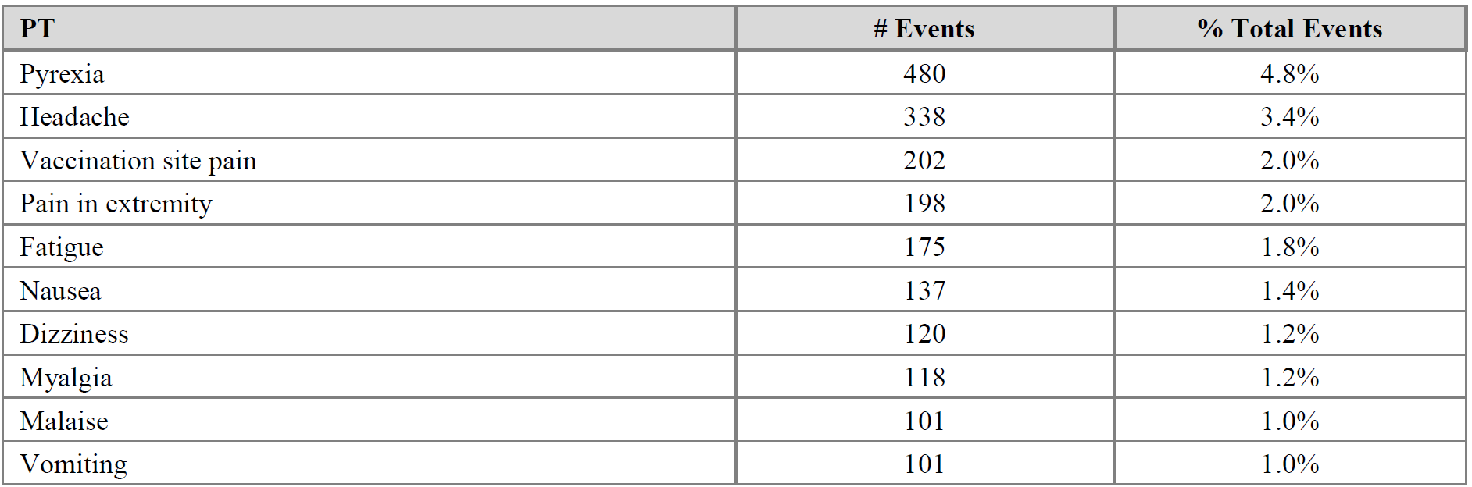

Analysis of adverse events of special interest

Overview of myocarditis and pericarditis (all ages)
Cumulatively, through 31 December 2021, a total of 3,818 cases (4,075 events) of myocarditis and/or pericarditis have been reported, with 2,836 (74.3%) cases medically confirmed. In 227 cases, events of both myocarditis and pericarditis were reported. There were 39 cases with fatal outcomes. The majority of cases reporting myocarditis and/or pericarditis involved male patients (2,651, 69.4%) and female patients (1,108, 29%) (Table 20). The mean age of the patients was 36.3 years (SD: 16.8), with a median age of 31 years (range: 12 to 94 years); 387 cases were missing age data.
The greatest proportion of cases reporting myocarditis and pericarditis events involved males between the ages of 18 to 39 years old (1,652, 43.3%). Overall, there were 2,137 cases that reported myocarditis and pericarditis events in patients 18 to 39 years of age, which represented 56% of all cases. Myocarditis and pericarditis events occurred most frequently after the second dose (1,664; 40.8%). Regardless of the dose number, almost half of the events had an onset less than 7 days from vaccination (1,821, 44.7%), and the median time to onset (TTO) was 3 days.
Cumulatively, there were 134 cases (141 events) with myocarditis and pericarditis following a third or booster dose of Spikevax, which included 80 events of myocarditis (including one event of hypersensitivity myocarditis) and 61 events of pericarditis. The cases involved 82 males (61.2%) and 52 females (38.8%), with a mean age of 46.7 years (SD: 18.7) and a median age of 43.5 years (range: 18 to 86 years). The TTO from vaccination was less than 7 days for 113 (80.1%) of the events.
Table 20: Number and percentage of cases reporting myocarditis and pericarditis by age and gender (cumulative cases)
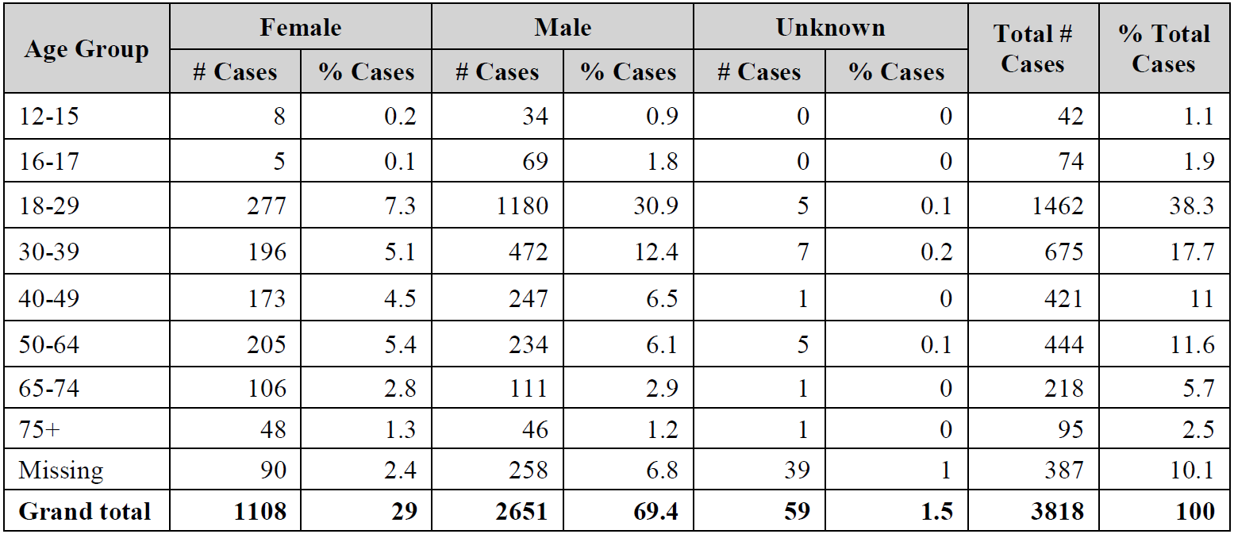
Table 21: Moderna Global Safety Database; analyses of observed versus expected cases of myocarditis, reported within seven days of a known dose, cumulative through 31 December 2021
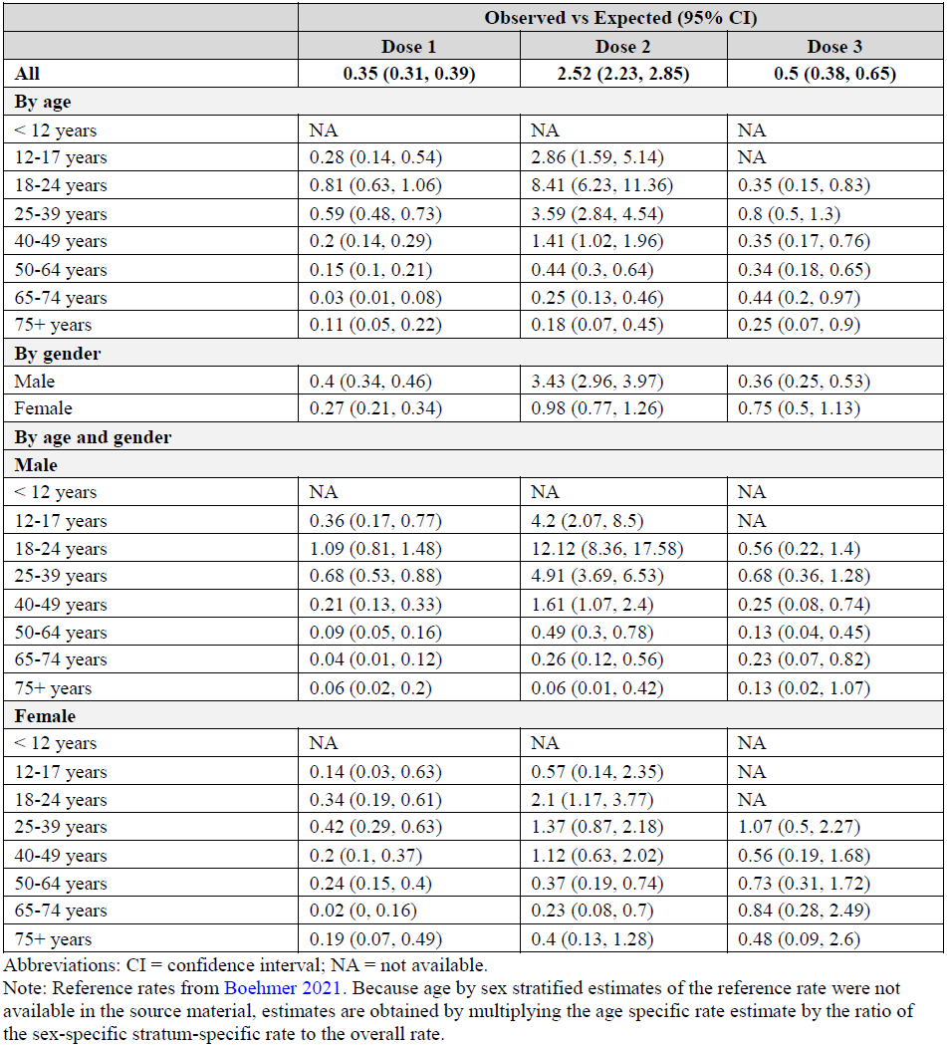
Abbreviations: CI = confidence interval; NA = not available.
Note: Reference rates from Boehmer 2021. Because age by sex stratified estimates of the reference rate were not available in the source material, estimates are obtained by multiplying the age specific rate estimate by the ratio of the sex-specific stratum-specific rate to the overall rate.

Data from the United States post-authorisation safety study (Study mRNA-1273-P903)
In the Spikevax US post-authorisation safety study (PASS) interim report 4 of Study mRNA-1273-P903 (dated 31 January 2022), a higher risk of myocarditis was seen among adults aged 18 to 29 years (incidence rate ratio (IRR): 5.44, 95% CI: 3.19 to 9.28) as shown by self-controlled risk interval analysis for all doses. Age subgroup effect estimates were most elevated among males aged 18 to 29 years (IRR = 6.81, 95% CI: 3.60 to 12.89) and somewhat attenuated among females aged 18 to 29 years (IRR = 3.03, 95% CI: 1.07 to 8.52). Effect estimates were also elevated for males aged 30 to 39 years (IRR = 2.81, 95% CI: 1.16 to 6.80) and aged 40 to 49 years (IRR = 3.44, 95% CI: 1.38 to 8.57). As described in observed vs expected analyses, the association was strongest in men ages 18 to 29 years following second dose (IRR 9.98, 95% CI 4.57 to 21.83).

Overview of adolescents (12 to 17 years of age) analysis of myocarditis and pericarditis (cumulative to 31 December 2021)
Cumulatively, there were 116 cases (122 events) of myocarditis and pericarditis in adolescents 12 to 17 years of age (3% of all cases reported), with 98 cases medically confirmed. There were 103 (88.8%) cases reported in males and 13 (11.2%) in females. The mean age of the adolescents was 15.7 years (SD: 1.3) and the median age was 16 years (range: 12 to 17). The majority (59.5%) of the cases reported in adolescents were in males aged 16 to 17 years (Table 22).
Table 22: Number and percentage of myocarditis and pericarditis cases in adolescents (12 to 17 year of age) by age and gender (any dose), cumulative to 31 December 2021
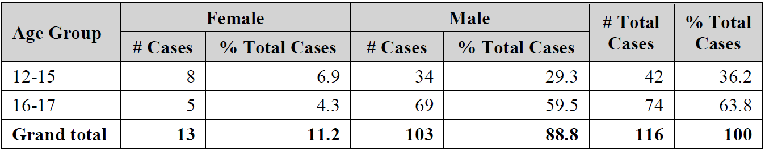
Cumulatively, there were 101 events of myocarditis reported in adolescents (including one event of infectious myocarditis), with the greatest proportion of the events (46; 45.5%) occurring after the second dose compared to first dose (18; 17.8%), with 37 cases (36.6%) of unknown TTO. Most of the cases with known TTO (55; 85.9%) had an onset of less than 7 days from vaccination.
As for pericarditis, 21 events were reported. The greatest proportion of the events (10; 47.6%) occurred post second dose compared to three events (14.3%) post first dose. In eight cases (38.1%), the TTO was unknown. The majority of the cases with known TTO (10; 76.9%) had an onset of less than 7 days from vaccination.
The majority of the myocarditis and pericarditis events in adolescents, cumulatively, were reported as resolved or resolving (80; 65.6%). There have been no fatal reports in adolescents due to myocarditis or pericarditis.

Adolescents’ analysis of myocarditis after booster
According to the clinical overview, there has been no cases of myocarditis in adolescents 12 to 17 years of age following booster dose (Table 23).
Table 23: Moderna Global Safety Database; Reporting rates of myocarditis within 7 days after Dose 1, 2, and 3 per million doses administered of Spikevax stratified by age and sex (cumulative to 31 December 2021)
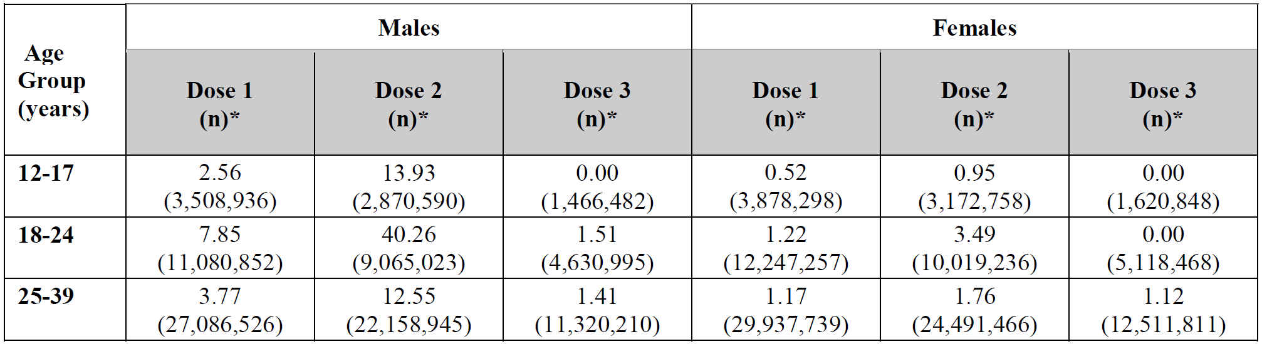

Adverse events of special interest (other than myocarditis and pericarditis
As of 31 December 2021, adverse events of special interest (AESIs) in third dose recipients 18 to 24 years of age included: convulsions, myocarditis, pericarditis, arrhythmia, Bell’s palsy, narcolepsy/hypersomnia, erythema multiforme, pancreatitis, and thyrotoxicosis. These AESIs occurred at a reporting rate that were below the expected based on population based studies estimating background incidence (Table 24). There was no AESI outcome for which the observed to expected rate ratio was higher for third dose than for the overall global safety database.
Table 24: Observed versus expected analyses of AESI, vaccine recipients aged 18 to 24 years, data through 31 December 2021
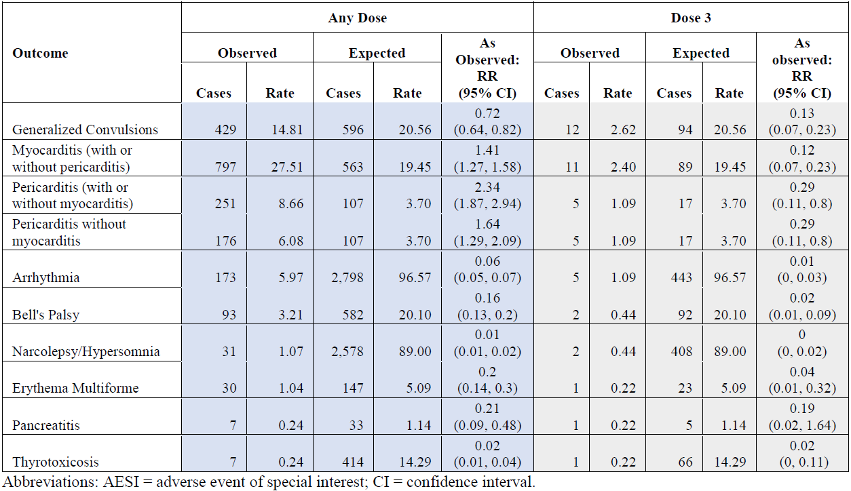
Abbreviations: AESI = adverse events of special interest; CI = confidence interval.

Risk management plan
The sponsor did not provide an risk management plan (RMP) specific for this submission and stated the current RMP version remains valid.
The sponsor is required to comply with product vigilance and risk minimisation requirements.

Risk-benefit analysis

Delegate’s considerations
The data package submitted in support of this proposed extension of indication is rather heterogeneous and contains information compiled from multiple sources and study scenarios.

Efficacy
No specific data for efficacy, immunogenicity, or effectiveness of booster vaccination in the targeted age group of adolescents have been provided by the applicant. Rather, evidence from multiple clinical studies, mostly not including the adolescent age group, and ‘real world data’ from effectiveness studies have been compiled to substantiate the proposed indication extension. These include:
- Efficacy of a primary vaccination series in adults and young adults from Study P301
- Immunogenicity results in young adults (older or equal to 18 to 25 years of age) receiving booster doses in Studies P201B, DMID Study 21-0012, P301, and post-licensure.
- Immuno-bridging for primary vaccination responses in adolescents and young adults based on immunogenicity data from Study P203 (12 to younger than18 years of age) and Study P301 (older or equal to18 to 25 years of age).
- Study DMID 21-0012 results for a heterologous booster indication in adults
- Published Post-licensure Booster Vaccine Effectiveness data

Modelling for immunogenicity
Of note, the applicant has developed a population IS/ID model to support the extension of the 50 µg booster dose in the adolescent population. The modelling approach as such has been soundly evaluated and certain weaknesses and deficiencies have been identified.
In summary this report employs a very complex model that requires a large number of assumptions. It is unclear the question could not be answered using a simpler statistical model of the relationship between peak antibody levels and age/dose (since for most subjects only this early timepoint is available). A multiple regression/mixed effects model would potentially provide a much clearer answer to any associations between age, dose, and neutralising antibody response. The model and data do not appear suitable for predicting neutralising antibody responses after boosting with different doses in different age groups and with different dose schedules.
There were multiple issues raised to the sponsor as part of evaluation which are detailed in the sponsor’s response to clinical questions with a revised ‘Population immunostimulation/immunodynamic model’ report provided by the sponsor.
The sponsor has provided some clarification and correction of the original documentation. However, there is no evidence presented that materially changes the previous assessment of the modelling and its suitability.
It is therefore deemed premature and inappropriate for this context. Importantly, the model has not been included in the regulatory decision-making for the present application.
The sponsor reports that the pivotal Study P301 in the final efficacy analysis of Part A (blinded phase) based on a database lock of 4 May 2021 demonstrated VE of 93.2%. Although no correlate of protection has been defined yet, the results of this huge study lay the basis to apply neutralising antibody titres as an immunological indicator of vaccine efficacy.
Regarding booster vaccination in Study P201 Part B the sponsor reports that potent serum neutralising titres were measured after the 50 µg booster vaccination, meeting pre-specified criteria for non-inferiority (NI) in terms of GMTs (relative to neutralising titres observed after a two dose primary series with 100 µg mRNA-1273 in Study P301). These results are obtained in the overall study populations, that is adults older or equal to 18 years of age. However, in a recent ad-hoc analysis focusing on the 18 to 25 year age group of Study P201 Part B, although containing only a small number of participants (n = 7), the 50 µg booster post 100 µg primary series led to an increase in baseline titres, with GMFR (28 days post booster to pre-Dose 1) of 16.32 (95% CI: 4.53, 58.81). The use of mRNA-1273 as a booster dose regimen in adolescents (12 to younger than 18 years of age) is currently investigated in Study P203 Part C which is currently ongoing.
As part of immunobridging a comparison of peak pseudovirus neutralisation assay ID₅₀ titres has been performed between Study P201 Part B (adults older of equal to 18 years of age) and the pivotal Study P301 (adults older or equal to 18 years of age). When compared to the peak pseudovirus neutralisation assay ID₅₀ titres in Study P301 Part A (Day 57 post primary vaccination with two vaccine doses), where clinical efficacy was demonstrated, the geometric mean ratio in relation to pseudovirus neutralisation assay ID₅₀ titres of Study P201 Part B after a 50 µg booster dose (GMR; Study P201 Part B Day 29 versus Study P301 Day 57) was 1.71 (95% CI: 1.519, 1.929). The lower bound of the 95% CI was greater than 0.67 (corresponding to NIM = 1.5) thus successfully meeting the pre-specified NIM criterion. These data indicate that applying a 50 µg booster dose is effective to increase post-primary vaccination neutralisation antibody titres.
Study DMID 21-0012 is investigating efficacy and immunogenicity of a heterologous boost in adults older or equal to 18 years of age. The data from this shows that a Spikevax booster dose increases pre-boost neutralisation antibody irrespective of the primary vaccination scheme, underlining the basic applicability the heterologous boost approach.
The sponsor reports that post-licensure analysis demonstrates 87.4% vaccine effectiveness against COVID-19 infection in individuals older or equal to 18 years of age after receiving two doses of mRNA-1273 (Spikevax). Vaccine efficacy against COVID-19 hospitalisation and hospital death was 95.8% and 97.9%, respectively. The sponsor further reports an immunobridging as determined by neutralising antibody titres and seroresponse rates after primary vaccination from Study P203 (adolescent older or equal to 12 years to younger than 18 years) with young adults from Study P301 (older or equal to 18 to younger than 25 years of age). Vaccine effectiveness in adolescents aged older or equal to 12 to younger than 18 years was inferred by demonstrating non-inferiority of both serum neutralising antibodies antibody GMTs and SRR from adolescents compared with those from young adults enrolled in Study P301 (aged older or equal to 18 to younger or equal to 25 years). The GMR of adolescent (Study P203) to young adult (Study P301) neutralising antibodies titres at Day 57 was 1.077 (95% CI: 0.939, 1.236), meeting the pre-specified 1.5-fold non-inferiority criterion (that is lower bound of the 95% CI for GMR is greater than 0.67). The difference in adolescent to young adult neutralising antibodies SRRs at Day 57 was 0.2 (95% CI: -1.8, 2.4), meeting the pre-specified 10% non-inferiority criterion (lower bound of the 95% CI of the SRR difference is greater than -10%). Since both co-primary endpoints of Study P203 met the pre-specified success criteria for non-inferiority, the primary immunogenicity objective is met. These data indicate that the vaccine-induced immune response in terms of neutralising antibodies titres after primary vaccination in adolescents is similar to that in young adults to support the basis for the extrapolation of the immune response after applying a booster dose from young adults to adolescents. Currently there appears no scientifically justified reason to assume that booster immune responses in these two age groups should differ significantly while primary vaccination responses are highly comparable.
The use of mRNA-1273 (Spikevax) as a booster dose regimen in adolescents (12 to younger than18 years of age) is currently investigated in clinical Study P203 Part C which is currently ongoing.
The sponsor justifies the booster interval of three months in adolescents with the extrapolation approach from young adults (Study P201B). There was no discussion of slower rate decline of immune response and the duration of protection in this population. The sponsor mentions that they intend to provide regulatory agency flexibility to best meet their local dosing interval recommendations. Clarification has been asked from the sponsor.

Provision of a third dose to severely immunocompromised children 6 to under 18 years of age
The rationale for this change is to align with recommendations made by Australian Technical Advisory Group on Immunisation (ATAGI; published on 11 February 2022) and the EMA, as reflected in the EU Summary of Product Characteristics (SmPC) (and Canada, Switzerland) based on extrapolation of clinical data from adults. Supporting clinical data from this age group were not provided.
The sponsor responded to the TGA’s query stating that similar, extrapolation has been established for immunocompromised adolescents, in accordance with guideline on paediatric extrapolation; based on similarity of the existing adult data to paediatric patients (successful immunobridging established in Study P204) and the strong benefit when weighed against potential risks in the immunocompromised paediatric population. Individuals with immunocompromising conditions have been recognised as being at increased risk of severe outcomes due to COVID-19. This is for discussion at the Advisory Committee on Vaccine (ACV).

Safety
The safety database submitted is also quite diverse. It includes safety data from above mentioned clinical trials in adults and adolescents for primary vaccination and booster vaccination in adults. Further, post-authorisation data and data from pharmacovigilance monitoring are included. No study data are currently available as regards the safety profile of a booster dose in adolescents. The submission is based on the extrapolation of safety data from young adults (18 to 25 years of age).
Data from primary vaccination studies indicate that the local reactogenicity in the age cohort 12 to younger than 18 years is slightly increased when compared to the age cohort 18 to 25 years of age. No clinical meaningful difference could be observed for solicited systemic adverse reactions. The incidence of systemic solicited adverse reactions tended to be comparable or slightly higher in the age cohort 18 to 25 years of age compared with the adolescents after primary immunisation. Due to the comparable reactogenicity and safety profile observed for adolescents and young adults 18 to 25 years of age after mRNA-1273 (Spikevax) primary vaccination and taking into consideration results from the ongoing safety monitoring in Study P203 with Spikevax, extrapolation of reactogenicity profile after the booster dose from young adults to adolescents could in principle be considered.
The reporting rates for all of the events for adolescent and young adults, including all events, SAEs, non-serious AEs, and AESIs are not higher post third dose compared to post second dose. The observed versus expected analysis of myocarditis as well as the reporting rates per million doses of Spikevax administered in adolescents confirm, what is currently known about mRNA COVID-19 associated myocarditis, that is reporting rates are highest post second dose, and higher in males compared with females. The highest rate of myocarditis was reported for males 18 to 24 years of age post second dose. No cases of myocarditis in adolescents 12 to 17 years of age after a third/booster dose of Spikevax was reported to date. In young adults 18 to 24 years of age, no AESIs except for myocarditis and pericarditis after any dose occurred at a reporting rate that exceeded the expected population based studies estimating background incidence. There was no AESI for which the observed to expected rate ratio was higher for third dose than for the overall Global Safety Database. In adolescent, so far, no cases of myocarditis post third dose have been recorded in the Moderna safety data bank.

Post-authorisation safety data
To further support the approval of a booster dose in adolescents the sponsor submitted a summary of spontaneous post-authorisation adverse event reported to Moderna (the sponsor) with a cut-off date 31 December 2021. The collected safety data do not fully distinguish between individuals who received a third 100 µg dose, indicated for immunocompromised patients in some settings, and a 50 µg booster dose. Current data also do not distinguish the different dosing intervals that have been recommended for booster implementation in different countries. There appear uncertainties regarding the methodology of spontaneous reporting submitted specially to support the extrapolation approach.
In the summary of cumulative safety data after a third or booster dose (18 December 2020 to 31 December 2021), it appears that cumulative only few cases post third dose (that is either a 50 µg booster or a 100 µg third dose in case of immunosuppressed condition) are recorded for adolescents. There were low absolute number of cases in individuals below 18 years of age. Only for 42 of 45 reported cases information is available in the sponsor submitted overview.
The summary of distributed and administered doses overall, and by age has been inconsistently presented in the clinical overview. The applicant’s clarification response with regards to third dose exposure revealed that the exposure number is rather based on assumptions than on reported information, more due to the reporting system. In their response the sponsor justified the discrepancy/overestimation as a systematic and clerical error. In fact, the previously reported third dose exposure estimation of approximately three million doses (after being questioned as far too high) was re-estimated/corrected by the sponsor to be 120,000 third doses administered to individuals below 18 years of age (also individuals below 12 years of age).
The sponsor has been asked to provide more available information from the US PASS study to support its extrapolation approach for safety in this application.

Proposed action
No specific data for efficacy, immunogenicity, or effectiveness of booster vaccination in the targeted age group of adolescents have been provided by the applicant. The comparison of vaccine-induced neutralising antibody titres after primary vaccination in young adults and adolescents confirm the equivalence of the measured immune responses in these two age groups. Currently there appears no scientifically justified reason to assume that booster immune responses in these two age groups should differ significantly while primary vaccination responses are highly comparable.
The submission is based on the extrapolation of safety data from young adults (18 to 25 years of age). Comparable reactogenicity and safety profile observed for adolescents and young adults 18 to 25 years of age after mRNA-1273 (Spikevax) primary vaccination. The spontaneous post-authorisation adverse event submitted has uncertainties regarding its methodology and the exposure number is based on assumptions with inconsistencies. The sponsor has been asked to provide more updated data/comprehensive comparison available of the reactogenicity and safety profile from the US post-authorisation safety study for adolescents versus young adults.
The benefit-risk balance of Spikevax as a booster in the adolescent is dependent on satisfactory responses to the outstanding questions to the sponsor. At this stage, the Delegate is inclined to wait for satisfactory responses to the below outstanding questions.
The final decision will be made following the ACV discussion.

Questions for the sponsor
The sponsor provided the following response to questions from the Delegate.
- Can the sponsor please provide updated observed/expected analyses (stratified by age) of myocarditis, if available?
Considering data through 15 April 2022, myocarditis (with or without pericarditis) was reported in 3,514 cases cumulatively (reporting rate 9.65 per 100,000 person-years) across all age groups. This reporting rate was similar to population-based data estimates derived from individuals without a diagnosis of COVID-19, between March 2020 and January 2021, from the US Premier Healthcare Database.
As has been described previously, rare events of myocarditis and pericarditis were observed more frequently in young adult males shortly after the second 100 ug dose. Time-to-onset was often less than 7 days, and a large proportion were reported as either resolved or resolving. Of note, events of myocarditis and pericarditis after a 50 ug booster dose have been consistently less frequent in multiple sources, particularly in young adult males (Table 25) (UK Coronavirus vaccine: Weekly summary of Yellow Card Reporting, 13 May 2022) (AUS Covid-19 Vaccine Weekly Safety Report, 5 May 2022). There have been no fatal reports due to myocarditis or pericarditis following a third dose.
Table 25: Observed versus expected analyses of myocarditis, cases occurring within 7 Days of a known dose, cumulative through April 2022 (comparison Boehmer, et al. (2021)*
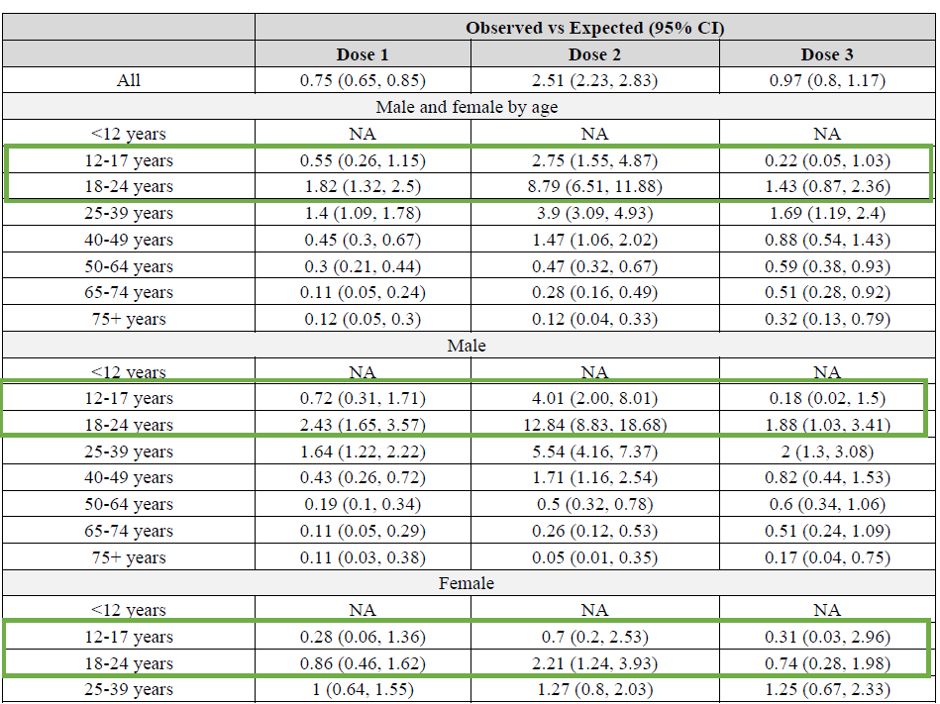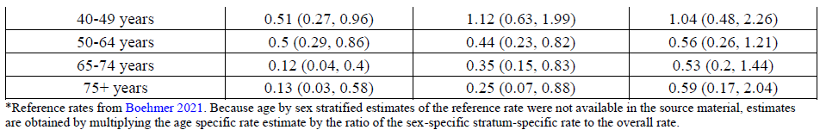
Table 25 uses previously described methodology for estimation of adolescent recipients of a third dose, in which an estimated 633,071,724 administered doses of vaccine are grouped by age, sex, and dose according to published demographic distributions. The Sponsor would also like to further clarify the estimated number of adolescent third dose recipients of the vaccine to date (Table 26). Global data on the demographic characteristics of vaccine recipients are limited to what has been published by health authorities, and these estimates (as is standard practice and has been agreed by HAs) have been used to estimate the number of adolescents vaccinated globally. Regardless of whether the CDC age distribution-based estimate of >3 million doses (basis for all global Safety Summary Reports) is considered or the most conservative estimation (and likely an underestimate) of > 120,000 doses is considered, no new risks have been identified in a substantial population.
Table 26: Cases and reporting rates based on alternative estimation methods for administered doses, cumulative through April 2022 (comparison Boehmer, et al. (2021)*
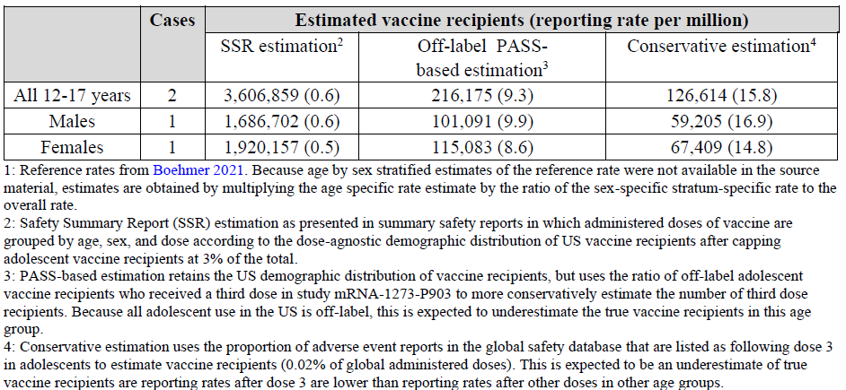
- Is there any more updated data/ comprehensive comparison available of the reactogenicity and safety profile from the US Post-authorisation Safety Study (mRNA-1273-P903):
- of adolescents versus young adults
- post dose 2 versus post dose 3 in young adults
The reactogenicity post-booster (50ug booster) has been noted to be less than that post-Dose 2 (100 µg dose) in clinical trials in adults (Study 201B and Study 301). This has been confirmed in V-Safe system health check-in survey monitoring conducted by the US CDC, in all adults. The sponsor would like to further clarify that no additional PASS data is available beyond what has been previously provided during review, and further that reactogenicity is not captured in post-authorisation studies. Please refer to Overview of Safety (inclusion is beyond the scope of this AusPAR) for a detailed analysis of (i) reactogenicity and safety profile of a 100 µg primary series in adolescents & young adults from clinical studies and post-authorisation; (ii) summary of reactogenicity and safety profile of a 50 µg booster dose (see also, the Spikevax booster series submission PM-2021-05131-1-2).
There are two ongoing PASS that include children and adolescents using Spikevax in routine clinical practice. Both studies include vaccine recipients of all ages and are designed to characterise risk of adverse events of special interest to support enhanced understanding of the safety profile of Spikevax. Because both studies are conducted using routinely collected administrative healthcare data, they are poorly suited to characterisation of reactogenicity. The majority of reactogenicity events are expected to be managed at home, and they are considered expected and are often transient in duration. These events are not well captured in administrative databases, given that the inclusion of diagnosis codes used in case ascertainment is driven by reimbursement of healthcare encounters. As such, reactogenicity outcomes have not been included in study protocols as has been previously discussed and approved by the EMA and US FDA.
- Regarding the dosing interval of 3 months for the third booster dose after initial vaccination in the adolescent age group (≤ 12 to 18 years), please provide available immunogenicity data,
- comparing the decline of antibodies in adolescents and young adults 18 to 25 years of age beyond of the data from Study P203
- on the duration of protection in the two age cohorts
Reference is made to the sponsor’s response to the TGA’s clinical questions (evaluated as part of this submissions). In brief, the shortened interval of 3 month was requested to provide regulatory agencies the flexibility to best comply with local dosing interval recommendations, the current surge in cases linked to the emergence of variants of concern (VOC) such as Omicron, and the potential for emergence of other VOCs. Indeed, the currently approved interval for Spikevax booster administration to adults (≥ 18 years) in Australia is 6 months (intervals from 3 to 6 months are approved/recommended globally based on clinical Studies P201B & DMID 21-0012). Based on demonstrated immunobridging of the primary series of mRNA-1273 between adolescents and young adults (in Study P203), extrapolation from adult booster recipients to adolescents is applied here. Accordingly, a similar interval of 6 months can be considered for adolescent boosters in Australia, if the TGA deems it appropriate.
Recent data from adolescent Study P203 regarding the monthly incidence rates (graphed per person-months) allows examination of the influence of emerging variants on duration of protection (Figure 5). This figure provides long-term assessment of monthly incidence rates among all mRNA-1273 adolescent recipients remaining on study as of the 31 January 2022 data cut off. Although no placebo control group is available (as the study had unblinded and placebo participants had sought vaccination), results shows low monthly incidence rates of COVID-19 among participants until November 2021. Even during the US Delta surge (July to September 2021), incidence rates among vaccinated study participants (adolescents) generally remained stable. Not unexpectedly, an increase in COVID 19 incidence was observed in the months of December 2021 and January 2022 (9 to 12 months after Dose 2), when the Omicron variant prevailed. These findings are consistent with real-world increases in COVID-19 incidence during the US Omicron surge (December to January).,
This surge occurred 9 to 12 months after receipt of Dose 2 of mRNA-1273 in those who were initially randomised to mRNA-1273. The rise in incidence among study participants coincided with the prevalence of the Omicron variant with its more divergent sequence and potentially with concurrent waning immunity after Dose 2.
Figure 5: Incidence of COVID-19 Cases in Study P203 over time
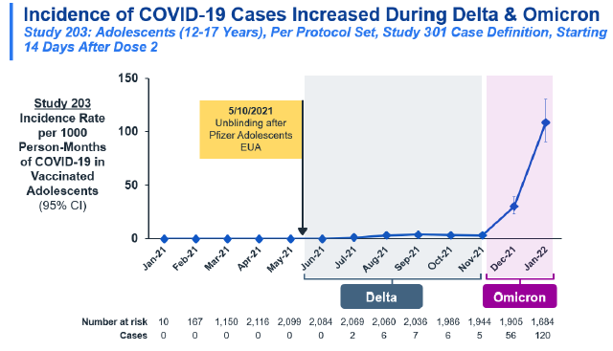
Although long-term (> 6 months post-dose 2) adolescent primary series antibody data is not available, Moderna (the sponsor) has been tracking the persistence and durability of the immune response against the ancestral strain as well as variants in adult clinical trials where booster doses are being investigated. Administration of the mRNA-1273 booster leads to increase in neutralising antibody titres against the ancestral strain, Beta variant and Delta variant (see also, Booster series submission PM-2021-05131-1-2;³⁹ for young adult/adult antibody persistence). Immunogenicity data against the Omicron variant (N = 20) over time demonstrates detectable nAb ID₅₀ titres at 1 month post-dose 2, which wanes over 6 months to a value which is at the limit of detection.
As described in the clinical overview (full inclusion of this is beyond the scope of this AusPAR), a 50 μg boost in Study P201 Part B resulted in a 15.06 GMFR between pre-booster and post-booster titres, against the prototype strain. The 50 μg boost also resulted in marked higher titres compared with the Day 28 post-primary series (post-dose 2) titre in Study P301, in which efficacy was established. This booster also induced ID₅₀ GMTs against the Omicron variant that were 20 fold higher than those assessed 1 month after the second vaccination.42
Corresponding with these induced increases in nAb levels, booster inoculation (50 µg mRNA-1273) of adults enrolled in the ongoing vaccine effectiveness study with Kaiser Southern California demonstrated enhanced vaccine effectiveness against both Delta and Omicron SARS-CoV-2 infection. Vaccine effectiveness against Omicron infection increased from 44% after Dose 2 to 72% after booster (Figure 6).
Figure 6: Spikevax vaccine effectiveness against variants of concern, post-primary and booster dose in adults
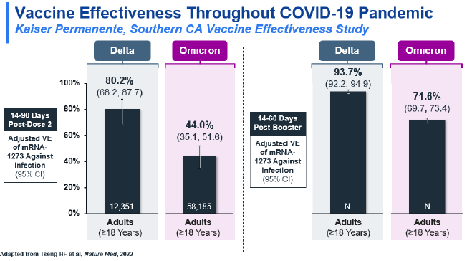
The demonstrated similar immunobridging and effectiveness profiles of two doses of 100 µg in adolescents and in adults (Study P203) forms the basis to extrapolate the behavior of the 50 µg mRNA booster dose. Data from adults shows that booster administration enhances nAb levels (including against the Omicron variant) and adult vaccine effectiveness studies show improved effectiveness against Omicron. These same benefits would thus be anticipated to be conferred to adolescents receiving the mRNA1273 booster (50 µg). As also noted by the TGA Delegate, there is currently no scientifically justified reason to assume that booster immune responses in these two age groups should differ significantly while primary vaccination responses are highly comparable.
- When are the results/report of clinical Study P203 Part C (the use of mRNA-1273 as a booster dose regimen in adolescents (12 ≤ 18 years of age) expected?
The sponsor would like to refer to our response to TGA clinical questions. In summary, the generation of an interim analysis on at least the first 1000 subjects boosted with at least 2 months follow-up post booster, is currently planned to be available third quarter of 2022. This will include a clinical overview, while a full clinical study report will be available late first quarter 2023 with a median of 6 months of follow-up post booster.

Advisory Committee considerations
The Advisory Committee on Vaccines (ACV), having considered the evaluations and the Delegate’s overview, as well as the sponsor’s response to these documents, advised the following.

Specific advice to the Delegate
- Please comment on the adequacy of characterisation of safety to support the proposed booster dosing in adolescents (12 to 18 years).
The ACV noted that this submission is not based on empirical data for adolescents. The ACV advised that there are insufficient data to characterise the safety of the proposed booster dosing in adolescents. Specifically, there is no immunogenicity and reactogenicity data on the proposed dose in the proposed population.
In providing this advice the ACV highlighted that there appears to be evidence of a connection between vaccination interval and myocarditis rates and stressed that this must be taken into consideration within any program decisions and post-market monitoring for myocarditis.
- Please comment on the benefit risk of the proposed variation (booster dosing in adolescents) including the dosing interval.
The ACV noted that this submission is not based on empirical data for adolescents. Rather, the proposed booster dose (dose and dose interval) is based on a population immunostimulation/immunodynamic model for immunogenicity/efficacy. The model relied on data from 2781 subjects (all ages) administered various doses (25, 50 or 100 µg) of vaccine in the primary series; the only booster dose data used in the model were from 392 adults.
The ACV highlighted the complexity of the modelling with its extrapolation and numerous assumptions.
The ACV advised that in the absence of immunogenicity and reactogenicity data on the proposed dose in the proposed population it was not possible to conclude that the benefit-risk was positive.
The ACV noted that an interim report from Study P203 is expected in third quarter 2022.
The ACV noted that dosing intervals used in clinical trials and other post-marketing data would be noted in the Product Information. The ACV noted that the booster dose interval may be the subject of Australian Technical Advisory Group on Immunisation (ATAGI) guidelines. The ACV discussed safety considerations in relation to reducing the dosing interval to a minimum of 3 months, noting that the model reflected data from adults after a booster dose interval of 5 months.
- Please comment on the proposed provision of a third dose to severely immunocompromised children 6 to younger than 18 years of age.
Given the higher need within this group the ACV was of the view that there was benefit to a third dose in severely immunocompromised children. In providing this advice the ACV highlighted that there would need to be a strong statement within the PI regarding the limitations within the data.
- The committee is also requested to provide advice on any other issues that it thinks may be relevant to a decision on whether or not to approve this application.
The ACV advised that further, comprehensive post-market data are required with clear denominator and numerators.
Additional data should be considered from the ongoing Study P203 of the proposed dose in adolescents, and post booster rates of myocarditis (including any effect for the dose interval between primary series and booster dose).

Conclusion
The ACV advised that it supported the approval of changes to the Product Information of Spikevax to include a booster (third) dose for immunocompromised persons over 6 years of age, in accordance with official recommendations.
The ACV was of the view that there was insufficient data (immunogenicity and reactogenicity) to support an overall benefit-risk balance at this time for Spikevax at the proposed dose for use as a booster dose in individuals 12 years and older.
In providing this advice the ACV noted availability of alternative booster vaccine for this age group and no current urgency for a booster in this age group based on indicators such as relatively low rates of hospitalisation due to COVID-19 in this age group. The ACV also noted that the highest rate of post-mRNA myocarditis has been observed in 16 to 17 years old in unpublished Victorian data and that higher rates have been observed with Spikevax compared to Comirnaty.

Post advisory committee considerations
The Delegate has requested for further data on booster dose in individuals aged 12 years and older from sponsor. The sponsor submitted this requested data on 2 September 2022.
The submitted data include the booster phase (Part 1C-1) of the healthy adolescents Study P203, and some post market safety data.
The Delegate has evaluated the new additional data and its evaluation and considerations is listed below.

Additional clinical data

Pharmacology

Pharmacodynamics

Study mRNA-1273-P203
Study P203 is an ongoing, Phase II/III study originally designed as a randomised (in a 2:1 vaccine: placebo ratio), observer-blind, placebo-controlled study evaluating the safety, reactogenicity, and effectiveness of a two-dose mRNA-1273 vaccine (Spikevax 100 μg) primary series in healthy adolescents 12 to 17 years.

Overview of booster phase (Part 1C-1)
In November 2021, Protocol Amendment 3 was implemented to evaluate administration of a 50 µg mRNA-1273 booster dose to ongoing study participants in Part 1A and Part 1B. A booster dose was administered at least five months after completion of the mRNA-1273 primary series. Participants receiving a booster dose were followed for safety and immunogenicity.
Figure 7: Study P203 Part 1C-1 Overall design schema
Abbreviations: BD = booster dose; EUA = Emergency Use Authorization
Parts 1A, 1B and 1C-1 are described in the text above. Part 1C-2 offered an mRNA-1273 booster dose to eligible participants who completed a primary COVID-19 vaccination series with an non-Moderna mRNA COVID-19 vaccine under EUA. Part II is evaluating a 50 µg primary series and booster dose in adolescents between 12 and 17 years of age. Neither Part 1C-2 nor Part II are discussed in this submission but rather included in Figure 7 for completeness.
The primary immunogenicity objective of the booster phase of Study P203 was to infer effectiveness of the 50 µg booster of mRNA-1273 by comparing post-booster immune responses (Day 29) in adolescents to those obtained post-second dose of the primary series (Day 57) in young adults (18 to 25 years of age) in Study P301.
The primary analysis of immunogenicity is the interim analysis of immunogenicity, safety, and efficacy that was to be performed after Day 57 immunogenicity data are available for the immunogenicity subset and at least 1,500 participants (1,000 participants receiving mRNA-1273) have completed Day 57 (1 month after second dose, Part A). The final analysis of all applicable endpoints will be performed after all participants have completed all planned study procedures. Results of this analysis will be presented in a final clinical study report, including individual listings.
Effectiveness of the 50 µg mRNA-1273 booster dose is inferred if post-booster dose immune responses (neutralising antibody geometric mean concentration (GMC) and SRR) meet pre-specified non-inferiority criteria (for both GMC and SRR) compared to those measured following completion of the 100 µg mRNA-1273 primary series among a subset of young adults (18 to 25 years) in the pivotal mRNA-1273 efficacy study (Study P301).
Successful demonstration of noninferiority requires meeting criteria defined for both hypotheses. Success criteria require that:
- the lower bound of the 95% CI of the GMR (GMC of Study P203 booster dose on Day 29/GMC of Study P301 young adult on Day 57) should be greater than 0.667 (1/1.5) and have a point estimate greater or equal to 0.8, and
- the lower bound of the 95% of the SRR difference greater than -10%. The detailed criteria for non-inferiority has been prespecified in the Study P203 statistical analysis plan (version 4.0).

Disposition
A total of 1346 participants 12 to 17 years of age who completed the 100 µg mRNA-1273 primary series in Study P203 Part 1A, received a 50 µg mRNA-1273 booster dose. A total of 11 participants (0.8%) in the mRNA-1273 booster group discontinued the study due to withdrawal of consent by participant (six participants), lost to follow up (four participants), and ‘other’ reasons (one participant). ‘Other’ reasons from withdrawal or discontinuation from study were due to logistical issues with compliance with protocol procedures. No participants discontinued the study due to adverse events.

Analysis populations
The analysis sets in the study is listed in Table 27.
Table 27: Study P203 Part 1C-1 Population analysis sets
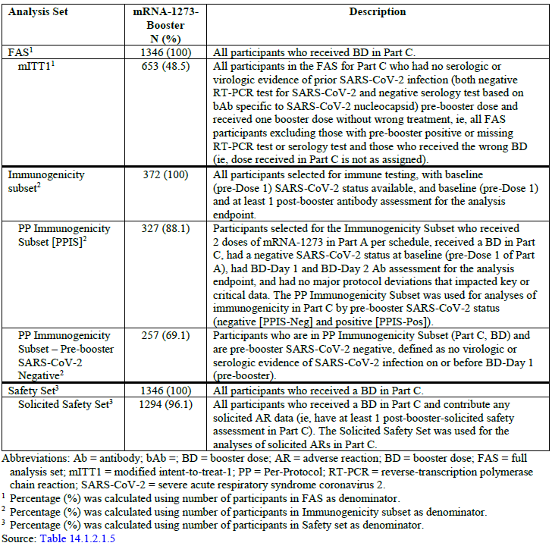
Abbreviations: Ab = antibody; BD = booster dose; AR = adverse reaction; BD = booster dose; FAS = full analysis set; mITT1 = modified intent to treat 1; PP = per protocol; RT-PCR = reverse-transcription polymerase chain reaction; SARS-CoV-2 = severe acute respiratory syndrome coronavirus 2.
1 Percentage (%) was calculated using number of participants in FAS as denominator.
2 Percentage (%) was calculated using number of participants in Immunogenicity subset as denominator.
3 Percentage (%) was calculated using number of participants in Safety set as denominator.

Per-protocol immunogenicity subset
The per-protocol (PP) immunogenicity subset supported the primary immunogenicity analysis between adolescents boosted in Study P203 and the young adult (18 to 25 years) comparator group from the pivotal Study P301 study.
The Study P203 immunogenicity subset included 372 participants in the mRNA-1273 booster group. Of these, 45 participants were excluded from the PP immunogenicity subset for the following reasons: 26 had no immunogenicity data at booster dose-Day 29, 14 had positive baseline SARS-CoV-2 status in Part A of the study, and five had no immunogenicity data at booster dose-Day 1.
The PP immunogenicity subset included 295 Study P301 young adults 18 through 25 years of age, whose immune response elicited by the primary series (Day 57) were used to compare the immune response elicited by a booster dose in young adults 12 through 17 years of age (Study P203, Day 29 post-booster). The same Study P301 young adults PP immunogenicity subset (N = 295) has been used as the reference/comparison group for immunobridging of the primary series in participants 6 months to 17 years old.

Demographics and baseline characteristics
A total of 327 boosted adolescents were included in the Study P203 PP immunogenicity subset, and 295 young adults were included in the Study P301 PP immunogenicity subset. The mean and median ages were 14 years for both the Study P203 safety set and PP immunogenicity subset; participants and 22.4 and 23 years, respectively for these sets, for Study P301 young adults. Proportions of males and females were similar between Studies P203 and P301 young adults.
In the Study P203 safety set, 7.7% of participants had a measured a body mass index (BMI) greater or equal to 30 kg/m². In the PP immunogenicity sets for Studies P203 and P301, 6.1% and 22.7% of participants had a measured BMI greater or equal to 30 kg/m² respectively. SARS-CoV-2 status was evaluated by serology and reverse-transcription polymerase chain reaction before receipt of the booster dose on booster dose-Day 1. A total of 536 participants (39.8%) were positive for SARS-CoV-2 status on booster dose-Day 1 (before receipt of booster dose).
After administration of the booster dose, participants in the booster group were followed for a median of 117 days (range: 2 to 141 days); 95.8% were followed up for more than or equal to 56 days. The median time from second dose of the primary series to booster dose was 316 days (range: 274 to 422 days).

Results
In the Study P203 PP immunogenicity subset-neg (n = 257), pre-booster (booster dose-Day 1) neutralising antibody GMC was 400.4 (95% CI: 370.0, 433.4; Table 28); on booster dose-Day 29, the GMC was 7172.0 (95% CI: 6610.4, 7781.4). Post-booster booster dose-Day 29 GMC increased approximately 18-fold from pre-booster GMC.
Table 28: Study P203 Summary of serum neutralising antibody (pseudovirus neutralisation assay) geometric mean concentration and seroresponse rate among booster recipients by pre-booster SARS-CoV-2 Status (per-protocol immunogenicity subset for Part C, booster dose)
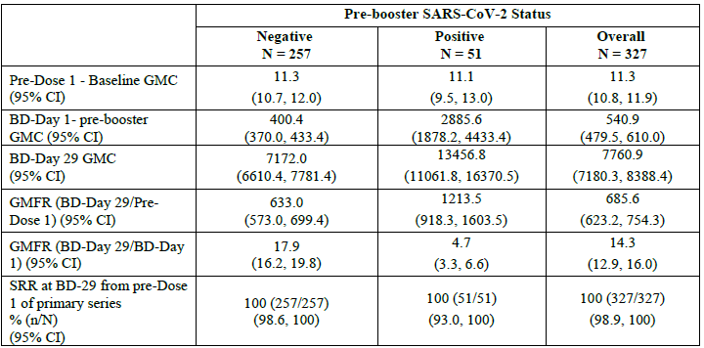
Abbreviations: BD = booster dose; GMC = geometric mean concentration; GMFR = geometric mean fold rise; PsVNA = pseudovirus neutralisation assay; SARS-CoV-2 status = severe acute respiratory syndrome coronavirus-2; SRR= seroresponse rate.
The t-distribution of the log-transformed values or the difference in the log-transformed values is used for the mean 95% CI calculation, then back-transformed to the original scale for presentation of GMC or GMFR 95% CI.
SSR at booster dose-Day 29 is defined as the % participants with a change from below the lower limits of quantification (LLOQ) to equal or above 4 x LLOQ , or at least 4-fold rise if baseline is equal to above LLOQ. SRR 95% CI is calculated using the Clopper-Pearson method.
Results confirm that regardless of pre-booster status, administration of a booster dose induces measurable increases in neutralising antibody levels relative to pre-booster levels.
Table 29: Analysis of serum neutralising antibody (pseudovirus neutralisation assay) geometric mean concentration and seroresponse rate among recipients in Study P203 post-booster dose compared with young adults in Study P301 post-primary series: (per-protocol immunogenicity subset – pre-booster SARS-CoV-2 negative)
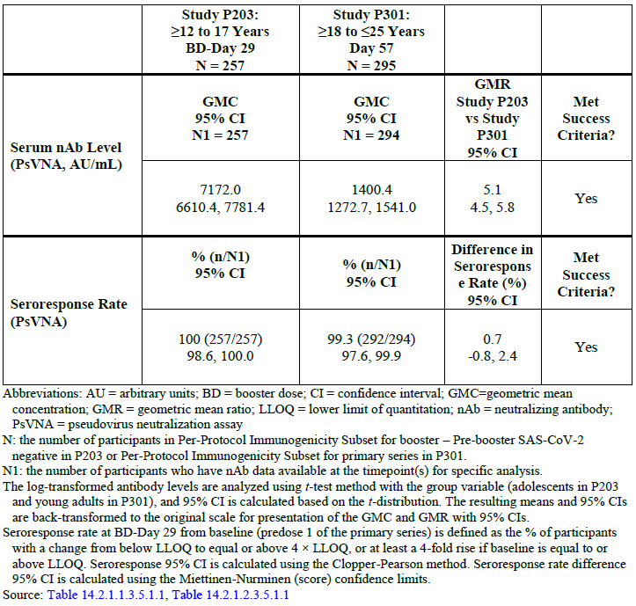
Abbreviations: AU = arbitrary units; BD = booster dose; CI = confidence interval; GMC = geometric mean concentration; GMR = geometric mean ratio; LLOQ = lower limit of quantitation; nAB = neutralising antibody; PsVNA = pseudovirus neutralisation assay.
N = the number of participants in per-protocol immunogenicity subset for booster – pre-booster SARS-CoV-2 negative in Study P203 or per-protocol immunogenicity subset for primary series in Study P301.
N1 = the number of participants who have nAb data available at the timepoint(s) for specific analysis.
The log transformed antibody levels are analysed using t-test method with group variable (adolescents in Study P203 and young adult in Study P301), and 95% CI is calculated based on the t-distribution. The resulting means and 95% CIs are back-transformed to the original scale for presentation of GMC and GMR with 95% CIs.
Seroresponse rate at booster dose-Day 29 from baseline (pre-first dose of the primary series) is defiened as the % of participants with a change from below LLOQ to equal or above 4 x LLOQ, or at least a 4 fold rise if baseline is equal to or above LLOQ. Seroresponse 95% CI is calculated using the Clopper-Pearson method. Seroresponse rate difference 95% CI is calculated using the Miettinen-Nurminen (score) confidence limits.
The GMR of Study P203 booster dose-Day 29 GMC compared with young adults in Study P301, Day 57. GMR was 5.1 (95% CI: 4.5, 5.8), meeting the non-inferiority criteria (that is, lower bound of the 95% CI greater than 0.667 (1/1.5); point estimate greater or equal to 0.8); the SRR difference was 0.7% (95% CI: -0.8, 2.4), meeting the non-inferiority criteria (lower bound of the 95% of the SRR difference greater than -10%). The sponsor states that as the prespecified success criteria for the primary immunogenicity objective were met, thus enabling the inference of vaccine effectiveness from Study P301.This appears acceptable.

COVID-19 incidence rate assessment
The reverse-transcription polymerase chain reaction confirmed COVID-19 case monitoring continued beyond unblinding. After unblinding, however, the reference group of the placebo comparator was lost, limiting the interpretation of the incidence rate. Incidence of SARS-CoV-2 infection was an exploratory endpoint; thus, severity of COVID-19 cases was not systematically ascertained, and cases were not reviewed by an endpoint adjudication committee.

Results
In adolescents boosted with a 50 µg booster dose, the COVID-19 incidence rate was 4.676 cases/1000 person-months from January 2022 to May 2022. In January 2022, the COVID-19 incidence rate was 88.9 cases/1000 person-months among Study P203 participants completing the primary series, but not yet boosted (1696 participants at risk; data cut-off 31 January 2022, data snapshot of 2 March 2022). In contrast, during this same month of observation, the COVID-19 incidence rate in adolescents boosted with a 50 µg booster dose was 9.778 cases/1000 person-months (1 case out of 353 participants at risk). Although highly dependent on the force of infection in the community, the incidence rates post-booster were lower than those among adolescents receiving only primary series. None of the COVID-19 cases following booster dose were assessed by the investigator to be severe.

Safety

Study mRNA-1273-P203 booster phase (Part 1C-1)
Safety data are presented from start of the booster phase up to the data cut-off of 16 May 2022. Safety assessments included monitoring of solicited adverse reactions (collected for seven days after booster dose), collection of all unsolicited adverse events (up to 28 days after booster dose) and collection of serious adverse events (SAEs), medically attended adverse events (MAAEs), adverse events of special interest (AESIs), and adverse events (AEs) leading to discontinuation through the entire study period post-booster dose. Serum samples were collected for immunogenicity analysis at the pre-booster visit (booster dose-Day 1) and again on Day 28 post-booster dose. Serum levels of SARS-CoV-2 specific antibody were measured.
Rates and profile of solicited adverse reactions and unsolicited adverse events reported after booster dose were presented side-by-side with those reported after completion of the primary vaccine series to provide context for evaluation of post-booster reactogenicity.

Solicited adverse reactions
Table 30: Summary of Study P203 participants with solicited adverse reactions within seven days after booster and primary series (solicited safety set, Part C, booster dose)
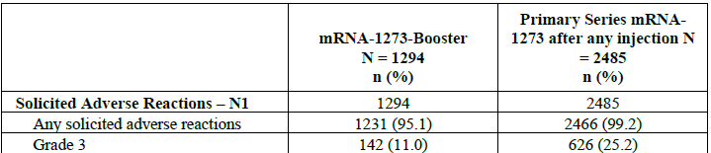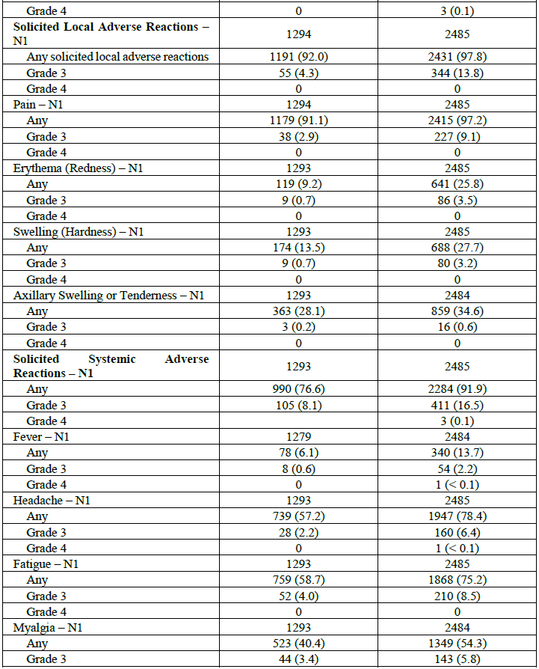
Table 30 (continued): Summary of Study P203 participants with solicited adverse reactions within seven days after booster and primary series (solicited safety set, Part C, booster dose)
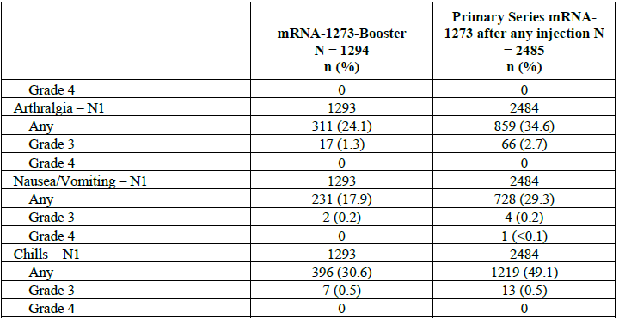
Abbreviations: N1 = number of exposed participants who submitted any data for the event. Aby = Grade 1 or higher.
Percentages are based on the number of exposed participants who submitted any data for the event (N1).
Toxicity grade for erythema (redness) is defined as: Grade 1 = 25 to 50 mm; Grade 2 = 51 to 100 mm; Grade 3: greater or equal to 100 mm. Toxicity grade for fever is defined as Grade 1 = 38 to 38.4 ºC; Grade 2 = 38.5 to 38.9 ºC; Grade 3 = 39 to 40 ºC; Grade 4 = higher or equal to 40 ºC.
Solicited adverse reactions were reported by most (95.1%) participants in the booster group; 11% reported a Grade 3 solicited adverse reaction and none reported a Grade 4 solicited adverse reaction. Most solicited adverse reactions occurred within 1 to 2 days after booster dose and generally persisted for a median of three days. Few participants (0.5%) reported solicited adverse reactions with onset after Day 7.
Solicited local adverse reactions were reported by 92% of participants in the booster group; 4.3% reported Grade 3 local adverse reaction. Pain was the most reported solicited local adverse reaction (91.1% of participants); 2.9% reported Grade 3 pain. Most solicited local adverse reactions occurred within 1 to 2 days after booster dose and generally persisted for a median of three days.
Solicited systemic adverse reactions were reported by 76.6% of participants in the booster group; 8.1% reported Grade 3 systemic adverse reactions. Headache and fatigue were the most reported (57.2% and 58.7% of participants, respectively). Most solicited systemic adverse reactions occurred within 1 to 2 days after booster dose and generally persisted for a median of two days.
Overall, the booster dose group demonstrated lower (any) solicited adverse reactions compared with the primary series (11% and 25.2% post-booster and post-second dose, respectively).

Unsolicited adverse events
Unsolicited AEs were collected within 28 days after booster dose. SAEs, MAAEs, AESIs, and AEs leading to discontinuation were collected throughout the study period.

Unsolicited adverse events within 28 days
Table 31: Summary of unsolicited treatment emergent adverse events up to 28 days after booster dose
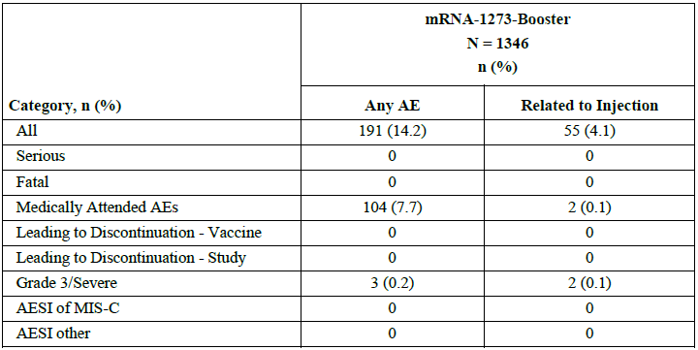
Abbreviations: AE = adverse events; AESI = adverse events of special interest; MIS-C = multisystem inflammatory syndrome in children; TEAE = treatment emergent adverse event
Percentages are based on the number of safety participants in Part 1C-1 (N)
A total of 191 participants in the booster group (14.2%) reported any unsolicited AE. Those assessed by the investigator as related to study treatment were reported by 4.1% of participants. These event rates were lower than those in the primary series (after any injection) where unsolicited AEs occurred in 510 out of 2486 participants (20.5%) and 312 out of 2486 participants (12.6%) were considered treatment related.
There were no SAEs, AESI or AEs leading to discontinuation from vaccine or study reported in the booster phase of the study.
Table 32: Overall unsolicited treatment emergent adverse events by MedDRA System Organ Class and Preferred Term (more than or equal to 2 participants) up to 28 days after booster dose safety set
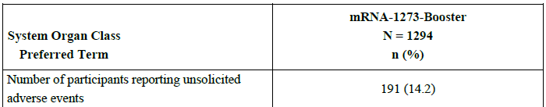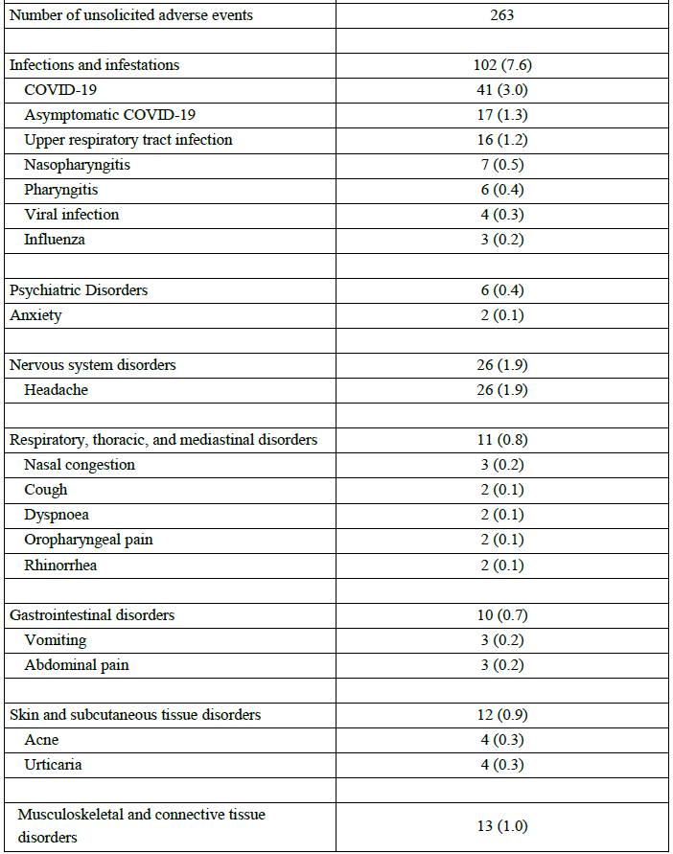
Table 32 (continued): Overall unsolicited treatment emergent adverse events by MedDRA System Organ Class and Preferred Term (more than or equal to 2 participants) up to 28 days after booster dose safety set
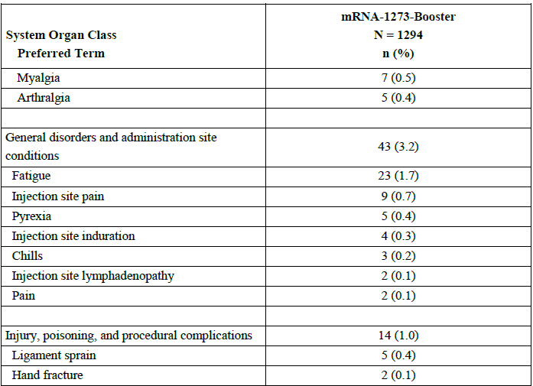
Abbreviations: MedDRA = Medical Dictionary of Regulatory Activities
A treatment emergent adverse event was defined as any event not present before exposure to study injection or any event already present that worsens in intensity or frequency after exposure.
Percentages are based on the number of safety participants in Part 1C-1 (N).
MedDRA version 23.0.

Unsolicited medically attended adverse events
At least one MAAE was reported by 12.2% of booster group participants throughout the duration of the safety follow up. Throughout the booster phase, the most reported AEs were in the infections and infestations System Organ Class (SOC) (9.4%); within the SOC, COVID-19 was the most reported event (68 participants, 5.1%), followed by other respiratory-related infections, symptoms, and reactogenicity-related events. No new trends or safety concerns were identified.
No unsolicited TEAEs leading to discontinuation from study vaccine or study participation were reported after booster dose. No SAEs were reported after booster dose.

Adverse events of special interest
No AESI (including multisystem inflammatory syndrome in children) were reported within 28 days after booster dose.

Hypersensitivity events
Nine participants experienced Hypersensitivity events. Four participants experienced events of urticaria and one participant each experienced an event of: asthma, dermatitis, hypersensitivity/allergic reaction, rash, and rhinitis allergic. None of the other events reported by single participants (asthma, dermatitis, rash, and rhinitis allergic) were considered related to vaccine. Two of the urticaria events were considered not related (starting on post-booster dose Days 15 and 17) and both resolved within 24 hours.
The other two events of urticaria were considered treatment-related events following administration of mRNA-1273-booster. A brief summary of these events are as follows:
- A 14-year-old white male experienced mild urticaria (verbatim urticaria on bilateral posterior hands) two days after receiving booster dose. Relevant medical history included seasonal allergies. The event was resolved the following day. No medical treatment or other concurrent AEs were reported. The participant had no previous events of urticaria or hypersensitivity reactions with the previous vaccinations.
- A 16-year-old white male experienced mild urticaria 15 days after receiving booster dose. There was no contributory medical history and no prior or concurrent AEs. The participant was treated with cetirizine as needed for the event. The event was ongoing (recovering/resolving) as of the cutoff date (16 May 2022).

Cases of clinical interest based on MedDRA cardiomyopathy SMQs
As a supplemental measure to search for unrecognised myocarditis/pericarditis cases, as per the sponsor the safety dataset was interrogated by searching for AEs compatible with signs, symptoms, laboratory investigations or procedural findings that might indicate unrecognised cases. Since these event terms are not specific for myocarditis and pericarditis, each of the identified cases was evaluated. Events were filtered for those occurring within 28 days of the most recent vaccine dose.
There were four participants in total in the mRNA-1273-booster dose group who reported events included within the cardiomyopathy standardised Medical Dictionary for Regulatory Activities queries, both narrow and broad. Three events of dyspnoea and one event of arrhythmia were reported.
One event of arrythmia, nonserious, was reported in one participant:
- A 14-year-old white female experienced mild cardiac arrythmia 101 days after receiving the booster dose. The participant had an ongoing medical condition of environmental allergy and asthma at the time of study entry and was being treated with loratadine and Symbicort. A concurrent AE of COVID-19 was reported. The participant began experiencing intermittent palpitations following symptomatic COVID-19 but did not seek medical attention. Approximately one month after the event, a physical examination by the site Investigator noted irregular heartbeat but the participant was otherwise asymptomatic, no work-up was conducted and no specific follow-up planned. The event was ongoing as of the cut-off date (16 May 2022). The Investigator considered the events not related to mRNA-1273-booster. Note: After the data cut-off, the investigator updated the AE to ‘Irregular heart rate’. On the follow-up visit of 14 July 2022, the rhythm was noted by the Investigator to be regular, and the AE was considered resolved.
Three events of dyspnoea, all nonserious, occurred in three participants:
- A 15-year-old white male experienced mild dyspnoea starting on the day of the booster dose. Potentially relevant medical history included depression, anxiety, post-traumatic stress disorder and attention deficient and hyperactivity disorder. The site reported that the participant experienced mild shortness of breath on the day of the booster dose and the day after which resolved without medical intervention or medication. There was no associated chest pain and no other concurrent AEs reported. The event was considered resolved the day following booster dose. The investigator considered the event related to mRNA-1273-booster.
- A 13-year-old white male experienced mild dyspnoea (shortness of breath) 26 days after receiving booster dose. A concurrent AE of COVID-19 was reported. According to the investigator, the event of dyspnoea was associated with a confirmed diagnosis of symptomatic COVID-19. The event was ongoing as of the cut-off date (16 May 2022). The investigator considered the event not related to mRNA-1273-booster.
- A 13-year-old white Asian male experienced mild dyspnoea (shortness of breath) 101 days after receiving booster dose. Potential contributory medical history included anxiety. No other AEs were reported concurrently, and no further details were available. The event was ongoing as of the cut-off date (16 May 2022) and was considered resolved on 19 May 2022. The investigator considered the event not related to mRNA-1273-booster.

Additional analysis of myocarditis and pericarditis events
There were no additional AEs reported within the myocarditis/pericarditis algorithm.

Post marketing experience
The sponsor confirms that based on current analyses of mRNA-1273 post-marketing AE reports, the risk of myocarditis and pericarditis appears to be lower after a third dose or booster dose than after second dose (Summary Safety Report 13). The reports represent cases in individuals 12 years of age and older; however, the vast majority of these reports are comprised of adult cases, and, of the relatively few in adolescents, most were 16 to 17 years of age. The reported events have typically been mild, with onset within a few days after vaccination, and individuals have generally recovered within a short time after standard clinical management. It is acknowledged that data after third dose or booster dose are limited by lower exposure at this time, and estimates may change with increased exposure and changes to the demographic characteristics for recipients of booster dosing.
The sponsor has confirmed two ongoing PASS that include children and adolescents using Spikevax in routine clinical practice, Study mRNA-1273-P903 in the USA, and Study mRNA-1273-P904 in Denmark, Norway, Italy, Spain, and the United Kingdom.
In Study mRNA-1273-P903, in the United States, where Spikevax has been approved in adults only. The usage in adolescents is only off-label. The sponsor confirmed that to date, no outcome that has completed the signal evaluation phase analyses has shown a statistically increased risk specific to adolescents, noting that sample size is small and use off-label.
The Study mRNA-1273-P904 is ongoing. However, the sponsor confirms that as the adolescent booster was only recently registered in the EU, comprehensive post-marketing data is not yet available.

Second risk-benefit analysis

Delegate’s considerations

Efficacy/Immunogenicity
The sponsor provided the results from the booster phase (Part 1C-1) of Study P203. The primary immunogenicity objective of the booster phase of Study P203 was to infer effectiveness of the 50 µg booster of mRNA-1273 by comparing post-booster immune responses (Day 29) in adolescents to those obtained post-Dose 2 of the primary series (Day 57) in young adults (18 to 25 years of age) in Study P301.
In the Booster Phase (Part 1C-1) of Study P203 it was demonstrated that administration of a 50 µg booster dose of mRNA-1273 effectively boosts serum neutralising antibody levels in adolescents from 12 to 17 years. Neutralising antibody responses measured on Day 29 after booster dose rose approximately 18-fold from pre-booster levels. The GMR of Study P203 booster dose-Day 29 GMC in adolescents compared with young adults in Study P301, Day 57 GMC was 5.1 (95% CI: 4.5, 5.8), meeting the non-inferiority criteria (that is lower bound of the 95% CI greater than 0.667; point estimate greater or equal to 0.8); the SRR difference was 0.7% (95% CI: -0.8, 2.4), meeting the non-inferiority criteria (lower bound of the 95% of the SRR difference greater than -10%). The sponsor claims that this increase in neutralising antibody responses anticipates that boosted adolescents (12 to 17 years) will derive similar benefits to those observed in boosted adults. This is considered acceptable.
The sponsor states that the EMA marketing authorisation application (MAA) filings and approval of Spikevax for use as booster dose in adolescents were based on extrapolation of immunogenicity and safety data from adult booster dose studies. These include:
- Study P201B demonstrated successful non-inferiority of the 50 µg booster dose against the original SARS-CoV-2 strain to that of the primary series in the pivotal efficacy study, with statistically higher antibody titres observed after the booster dose in adults 18 years of age and older.
- The DMID 21-0012 study also showed that the 50 µg mRNA-1273 booster dose effectively boosted neutralising antibody responses (greater than 4-fold rise over baseline) in individuals (greater or equal to 18 years of age) who were primed with other COVID-19 vaccines (heterologous boost approach).
- Successful immuno-bridging for primary vaccination responses in adolescents and young adults based on immunogenicity data from Study P203 (12 to younger than 18 years of age) and Study P301 (older or equal to 18 to 25 years of age). Vaccine effectiveness in adolescents aged older or equal to 12 to younger than 18 years was inferred by demonstrating non-inferiority of both serum neutralising antibody GMTs and SRR from adolescents compared with those from young adults enrolled in Study P301 (aged older or equal to 18 to younger or equal to 25 years). This concept/rationale was used to support the basis for the extrapolation of the immune response after applying a booster dose from young adults to adolescents.
The sponsor also mentions that appropriateness of this extrapolation from adults to adolescents is reinforced by the direct support of use of a Spikevax booster dose in adolescents as provided by the booster phase (Part 1C-1) of Study P203.

Safety
In the booster phase (Part 1C-1) of Study P203 the reactogenicity profile compared favourably with the primary series, particularly, solicited adverse reactions within seven days, with Grade 3 and higher events (11% in booster group versus 25.3% after any injection in primary series). Similarly, unsolicited AEs were reported less frequently after booster dose than after dosing in the primary series and demonstrated a similar safety profile. Injection related reactions and infection related events were the most commonly reported AEs, and rates of infection reflected an increase in cases of COVID-19. There were no SAEs, AESIs (including cases of myocarditis/pericarditis), or withdrawal from study participation reported after the booster dose.
Overall, the findings were consistent with the known safety profile of mRNA-1273 and events typically observed in an adolescent population during the COVID-19 pandemic. Review of the safety data after booster dose in the adolescent age group did not demonstrate any new safety concerns.
The sponsor reiterates that the EMA MAA filings and approval of Spikevax for use as booster dose in adolescents were based on extrapolation of safety data from adult booster dose studies, with no significant difference expected between the two populations.
The sponsor confirms that based on current analyses of mRNA-1273 post-marketing AE reports, the risk of myocarditis and pericarditis appears to be lower after a third dose or booster dose than after second dose. The reports represent cases in individuals 12 years of age and older; however, the vast majority of these reports are comprised of adult cases, and, of the relatively few in adolescents, most were 16 to17 years of age. The reported events have typically been mild, with onset within a few days after vaccination, and individuals have generally recovered within a short time after standard clinical management. It is acknowledged that data after third dose or booster dose are limited by lower exposure at this time, and estimates may change with increased exposure and changes to the demographic characteristics for recipients of booster dosing.

Proposed action
In the booster phase (Part 1C-1) of Study P203 it was demonstrated that administration of a 50 µg booster dose of Spikevax (mRNA-1273), in adolescents from 12 to 17 years, effectively boosts serum neutralising antibody levels, as compared with the pre-booster baseline meeting. The GMR of Study P203 booster dose-Day 29 GMC in adolescents compared with young adults in Study P301, Day 57 GMC was 5.1 (95% CI: 4.5, 5.8), meeting the prespecified non-inferiority criteria.
The safety data in adolescents from booster phase (Part 1C-1) of Study P203 was consistent with the known safety profile of mRNA-1273 (Spikevax) and suggests reduced reactogenicity of the 50 µg booster dose in adolescents as compared with the reactogenicity profile post-second dose in the same population. The sponsor confirms that the analyses from recent post-marketing reports also suggest no increased risk (relative to primary series) of myocarditis/pericarditis after booster dosing compared with doses in the primary series. The sponsor confirms that monitoring will continue in clinical studies, pharmacovigilance, and post-authorisation safety studies.
The benefit-risk balance of Spikevax in this submission as a booster in the adolescent appears favourable for its Provisional registration.

Second Advisory Committee considerations
The Advisory Committee on Vaccines (ACV), having considered the evaluations and the Delegate’s overview, as well as the sponsor’s response to these documents, advised the following.

Specific advice to the Delegate
- Please comment on the benefit risk of booster dose (at least 5 months after completing a primary series) for adolescents (12 years to < 18 years) for its Provisional registration.
The ACV advised that the benefit-risk balance of Spikevax as a 50 µg booster dose for adolescents aged 12 years to less than 18 years is consistent with provisional registration. The ACV highlighted the benefits from a booster dose will be highest in adolescents at highest risk of COVID-19 and/or in the context of new and emerging variants.
The ACV noted that additional immunogenicity and safety data had been provided, with the immunogenicity data meeting the prespecified non-inferiority criteria and the booster safety data demonstrating a similar profile to the primary series.
The ACV noted the ‘at least 5 month’ dosing interval for booster dose for adolescents is supported by data from the ongoing trial. However, the booster dose interval for adults is ‘at least 6 months’ and in practice this difference may result in confusion and/or non-compliance. Consideration should be given to aligning dose intervals where possible.
Reference to local guidelines/official recommendations on dose intervals was strongly supported.
The ACV noted that Study DMID 21-0012 showed that the Spikevax as a 50 µg booster dose effectively boosted neutralising antibody responses (> 4-fold rise over baseline) in individuals (≥ 18 years of age) who were primed with other COVID-19 vaccines (heterologous boost approach).44

Conclusion
The ACV considered Spikevax (50 µg/0.25 mL) to have an overall positive benefit-risk profile for use as a booster (third or subsequent) dose in persons aged 12 to less than 18 years of age when considered for provisional registration.
This does not imply a booster dose is necessary or desirable for use across the Australian population aged 12 to 18 years.
The use and timing of Spikevax booster in 12 to 18 years old should be in accordance with official recommendations.

Outcome
Based on a review of quality, safety, and efficacy, the TGA provisionally approved the registration of Spikevax (elasomeran) 0.2 mg/mL, suspension for injection, multidose vial, indicated for change in dose regime:
Booster dose of Spikevax COVID-19 vaccine in individuals aged ≥ 12 years and immunocompromised individuals aged ≥ 6 years, approve changes to product information

Specific conditions of registration applying to these goods
The Delegate of the Secretary of the Department of Health imposed the following conditions in relation to the new Spikevax medicine approval:
- conditions applicable to all registered therapeutic goods as specified in the document Standard Conditions Applying to Registered or Listed Therapeutic Goods under Section 28 of the Therapeutic Goods Act 1989 effective 1 July 1995, with the exception of Condition 11);
- conditions applicable to specific classes of registered therapeutic goods as specified in the Standard Conditions Applying to Registered or Listed Therapeutic Goods under Section 28 of the Therapeutic Goods Act 1989 effective 1 July 1995;
- subject to [the paragraph below], all conditions that have previously been imposed on the provisional registration of the existing Spikevax medicine, as in force at the date of this decision;
- the RMP condition of the notice of the provisional registration decision relating to the Existing Spikevax medicine, varied as below:
The Spikevax EU-Risk Management Plan (RMP) (version 3.0, dated 13 February 2022; DLP 31 December 2021), with Australian specific annex (version 2.0, dated 25 February 2022), and any subsequent revisions, as agreed with the TGA will be implemented in Australia. An obligatory component of risk management plans is routine pharmacovigilance. Routine pharmacovigilance includes the submission of periodic safety update reports (PSURs). Reports are to be provided in line with the current published list of EU reference dates and frequency of submission of PSURs until the period covered by such reports is not less than three years from the date of the approval letter, or the entire period of provisional registration, whichever is longer. The reports are to at least meet the requirements for PSURs as described in the European Medicines Agency’s Guideline on good pharmacovigilance practices (GVP) Module VII-periodic safety update report (Rev 1), Part VII.B Structures and processes. Note that submission of a PSUR does not constitute an application to vary the registration. Spikevax (elasomeran) is to be included in the Black Triangle Scheme. The PI and CMI for Spikevax must include the black triangle symbol and mandatory accompanying text for the products entire period of provisional registration.
- the following additional conditions:
  - Submit the final analysis of the booster phase (Part 1C-1) of Study P203 and the CSR (clinical study report) when available.
  - Confirmatory trial data (as identified in the sponsor’s plan to submit comprehensive clinical data on the safety and efficacy of the medicine before the end of the 6 years that would start on the day that registration would commence) must be provided.
As part of the standard conditions of registration applying to all registered therapeutic goods, it should be noted that no changes can be made to the goods without the prior approval of the Secretary.
In accordance with paragraph 30(2)(c) of the Act, refusal or failure to comply with a condition of registration to which inclusion of the New Medicine in the ARTG are subject may result in the suspension or cancellation of the provisional registration.

Attachment 1. Product Information
The PI for Spikevax approved with the submission which is described in this AusPAR is at Attachment 1. For the most recent PI, please refer to the TGA PI/CMI search facility.

Therapeutic Goods Administration
PO Box 100 Woden ACT 2606 Australia
Email: info@tga.gov.au Phone: 1800 020 653 Fax: 02 6232 8605
https://www.tga.gov.au

World Health Organization (2020) WHO Director-General speeches: WHO Director-General's opening remarks at the media briefing on COVID-19 - 11 March 2020. Available from the WHO website.
WHO COVID-19 (coronavirus) dashboard. World Health Organization. Available at: https://covid19.who.int/
CDC COVID Data Tracker: https://covid.cdc.gov/covid-data-tracker/#datatracker-home
CDC COVID Data Tracker: Multisystem Inflammatory Syndrome in Children (MIS-C) https://covid.cdc.gov/covid-data-tracker/#mis-national-surveillance
Australian Government Department of Health (last viewed 09 May 2022).
Available at: COVID-19 vaccine: Provisional registrations | Therapeutic Goods Administration (TGA). Last accessed on 19/08/2022.
As part of the provisional approval pathway, the provisional registration process will allow certain medicines to be provisionally registered in the Australian Register of Therapeutic Goods (ARTG) for a limited duration. These medicines are registered on the basis of preliminary clinical data, where there is the potential for a substantial benefit to Australian patients. The TGA will re-assess risks related to the absence of evidence through data provided at a later stage, as part of the confirmatory data. Confirmatory data should confirm the relationship between outcomes predicted by the surrogate endpoint, or other preliminary data, and the clinical benefit as demonstrated by direct clinical outcomes. The sponsor may apply to transition to full registration at any time up until the provisional registration lapse date, once they have completed the obligations outlined for the provisional registration period and complete confirmatory data on safety and efficacy are available.
Tozinameran, the active ingredient in the Comirnaty COVID-19 Vaccine was previously registered in Australia and overseas by the provisional drug name BNT162b2. Both the International non-proprietary name (INN) and the Australian Approved Name (AAN) is accepted as being tozinameran, and it is therefore referred to as Comirnaty (tozinameran) COVID-19 vaccine throughout this AusPAR. This is in contrast to the use of BNT162b2 as the name of the active ingredient in earlier AusPARs. The change is in name only; the composition of the active ingredient is unchanged in any way.
Comirnaty was first registered on the ARTG on 25 January 2021 (ARTG number: 346290).
AusPAR for Comirnaty (BNT162b2 (mRNA)) new biological entity, published on 25 January 2021. Available at: https://www.tga.gov.au/auspar/auspar-bnt162b2-mrna-comirnaty.
AusPAR for Comirnaty (BNT162b2 (mRNA)) extension of indications, published on 23 July 2021. Available at: https://www.tga.gov.au/auspar/auspar-bnt162b2-mrna.
AusPAR for Comirnaty (tozinameran) extension of indications, published on 1 November 2021. Available at: https://www.tga.gov.au/resources/auspar/auspar-bnt162b2-mrna-0
AusPAR for Comirnaty (tozinameran) extension of indications; change to formulation (excipients), published on 13 December 2021. Available at: https://www.tga.gov.au/auspar/auspar-tozinameran-mrna-covid-19-vaccine.
AusPAR for Comirnaty (tozinameran) major variation (change of dose regimen), published on 8 February 2022. Available at: https://www.tga.gov.au/resources/auspar/auspar-tozinameran
AusPAR for Comirnaty (tozinameran) major variation (change of dose regimen), published on 12 April 2022. Available at: https://www.tga.gov.au/resources/auspar/auspar-tozinameran-0
COVID-19 Vaccine AstraZeneca was first registered on the ARTG on 16 February 2021 (ARTG number: 349072).
AusPAR for COVID-19 Vaccine AstraZeneca (ChAdOx1-S) new biological entity, published on 16 February 2021. Available at: https://www.tga.gov.au/auspar/auspar-chadox1-s.
COVID-19 Vaccine Janssen was first registered on the ARTG on 25 June 2021 (ARTG number: 350150).
AusPAR for COVID-19 Vaccine Janssen (Ad26.COV2.S) new biological entity, published on 25 June 2021. Available at: https://www.tga.gov.au/auspar/auspar-ad26cov2s.
Spikevax was first registered on the ARTG on 9 August 2021 (ARTG number: 370599).
AusPAR for Spikevax (elasomeran) new biological entity, adult indication, published on 9 August 2021. Available at: https://www.tga.gov.au/auspar/auspar-elasomeran.
AusPAR for Spikevax (elasomeran) new biological entity, paediatric indication, published on 4 September 2021. Available at: https://www.tga.gov.au/auspar/auspar-elasomeran-0.
AusPAR for Spikevax (elasomeran) extension of indications, published on 23 February 2022. Available at: https://www.tga.gov.au/auspar/auspar-elasomeran-1.
AusPAR for Spikevax (elasomeran) extension of indications and major variation, paediatric indication for 6 months of age and above, published on 4 August 2022. Available at https://www.tga.gov.au/auspar/auspar-elasomeran-2
AusPAR for Spikevax Bivalent Original/Omicron (elasomeran and imelasomeran). Available at: https://www.tga.gov.au/resources/auspar/auspar-spikevax-bivalent-originalomicron
Nuvaxovid was first registered on the ARTG on 20 January 2022 (ARTG number: 355139).
AusPAR for Nuvaxovid (SARS-CoV-2 recombinant spike protein with Matrix-M adjuvant) new biological entity, published on 21 January 2022. Available at: https://www.tga.gov.au/auspar/auspar-sars-cov-2-rs-matrix-m-adjuvant.
AusPAR for Nuavxovid (SARS-CoV-2 recombinant spike protein with Matrix-M adjuvant) extension of indications, published on 29 July 2022. Available at https://www.tga.gov.au/auspar/auspar-sars-cov-2-rs-matrix-m-adjuvant-nvx-cov2373
mRNA-1273 is the development code used by sponsor for the Spikevax vaccine (elasomeran).
As stated by the report’s author, ‘The observed antibody titer was assumed to be produced by SLPC and LLPC at rate 𝑘_{m𝐴b}. The rate of antibody titer production varies between the two types of plasma cells. LLPCs have a higher antibody secretion rate compared to SLPC. 𝑘_{m𝐴b} is secretion rate of antibody by plasma cells and since SLPCs have a lower rate of antibody secretion we have reduced the secretion rate by multiplying it with a scalar 0.45 * 𝑘_{m𝐴b}, a value derived from our previous in-house work.’
Pajon, R, et al. Initial analysis of viral dynamics and circulating viral variants during the mRNA-1273 Phase 3 COVE trial. (2022) Nat Med 28, 823–830.
Also known as JCovden vaccine.
Bruxvoort KJ, et al. Real-world effectiveness of the mRNA-1273 vaccine against COVID-19: Interim results from a prospective observational cohort study. Lancet Reg Health Am. 2022 ;6:100134.
Accorsi EK, et al. Association Between 3 Doses of mRNA COVID-19 Vaccine and Symptomatic Infection Caused by the SARS-CoV-2 Omicron and Delta Variants. JAMA. 2022;327(7):639–651.
AusPAR for Spikevax (elasomeran) Moderna Australia Pty Ltd, submission: PM-2021-02994-1-2, available at https://www.tga.gov.au/resources/auspar/auspar-elasomeran-0
International Council for Harmonisation of Technical Requirements for Pharmaceuticals for Human Use (ICH) E11A EWG Clinical trials on paediatric population, paediatric extrapolation, available at https://www.ich.org/page/efficacy-guidelines
Boehmer, et al. Association Between COVID-19 and Myocarditis Using Hospital-Based Administrative Data - United States, March 2020-January 2021. MMWR. Morbidity and mortality weekly report, 2021; 70(35), 1228–1232
Hause, et al. Safety Monitoring of COVID-19 Vaccine Booster Doses Among Adults — United States, September 22, 2021–February 6, 2022. MMWR Morb Mortal Wkly Rep 2022;71:249–254.
AusPAR for Spikevax (elasomeran) Moderna Australia Pty Ltd, submission PM-2021-05131-1-2. Available at: https://www.tga.gov.au/resources/auspar/auspar-elasomeran-mrna-1273
Centers for Disease Control and Prevention (CDC). 2022b. "Omicron Variant: What You Need to Know. Available from: https://www.cdc.gov/coronavirus/2019-ncov/variants/omicron-variant.html?s_cid=11734:omicron%20vaccine:sem.ga:p:RG:GM:gen:PTN:FY22. (accessed 14 Mar 2022).
Wang, et al. Comparison of outcomes from COVID infection in pediatric and adult patients before and after the emergence of Omicron. medRxiv.2022
Pajon, et al. SARS-CoV-2 Omicron Variant Neutralization after mRNA-1273 Booster Vaccination. New England Journal of Medicine. 2022 Jan 26:1-4.
Tseng HF et al, medRxiv (peer review pending) January 10, 2022
Atmar RL, Lyke KE, Deming ME, Jackson LA, Branche AR, El Sahly HM, et al; DMID 21-0012 Study Group. Homologous and Heterologous Covid-19 Booster Vaccinations. N Engl J Med. 2022;386(11):1046-1057.

