October 2022

Australian Public Assessment Report for Rybelsus
  - Active ingredient: Semaglutide
  - Sponsor: Novo Nordisk Pharmaceuticals Pty Ltd

About the Therapeutic Goods Administration (TGA)
- The Therapeutic Goods Administration (TGA) is part of the Australian Government Department of Health and is responsible for regulating therapeutic goods, including medicines, medical devices, and biologicals.
- The TGA administers the Therapeutic Goods Act 1989 (the Act), applying a risk management approach designed to ensure therapeutic goods supplied in Australia meet acceptable standards of quality, safety, and efficacy.
- The work of the TGA is based on applying scientific and clinical expertise to decision-making, to ensure that the benefits to the Australian public outweigh any risks associated with the use of therapeutic goods.
- The TGA relies on the public, healthcare professionals and industry to report problems with therapeutic goods. The TGA investigates reports received to determine any necessary regulatory action.
- To report a problem with a therapeutic good, please see the information on the TGA website.

About AusPARs
- The Australian Public Assessment Report (AusPAR) provides information about the evaluation of a prescription medicine and the considerations that led the TGA to approve or not approve a prescription medicine submission. Further information can be found in Australian Public Assessment Report (AusPAR) guidance.
- AusPARs are prepared and published by the TGA.
- AusPARs are static documents that provide information that relates to a submission at a particular point in time. The publication of an AusPAR is an important part of the transparency of the TGA’s decision-making process.
- A new AusPAR may be provided to reflect changes to indications or major variations to a prescription medicine subject to evaluation by the TGA.

Copyright
© Commonwealth of Australia 2022
This work is copyright. You may reproduce the whole or part of this work in unaltered form for your own personal use or, if you are part of an organisation, for internal use within your organisation, but only if you or your organisation do not use the reproduction for any commercial purpose and retain this copyright notice and all disclaimer notices as part of that reproduction. Apart from rights to use as permitted by the Copyright Act 1968 or allowed by this copyright notice, all other rights are reserved, and you are not allowed to reproduce the whole or any part of this work in any way (electronic or otherwise) without first being given specific written permission from the Commonwealth to do so. Requests and inquiries concerning reproduction and rights are to be sent to the TGA Copyright Officer, Therapeutic Goods Administration, PO Box 100, Woden ACT 2606 or emailed to <tga.copyright@tga.gov.au>.

Contents
List of abbreviations 4
Product submission 6
Submission details 6
Product background 7
Regulatory status 10
Product Information 11
Registration timeline 11
Submission overview and risk/benefit assessment 12
Quality 13
Nonclinical 14
Clinical 16
Risk management plan 35
Risk-benefit analysis 36
Outcome 39
Specific conditions of registration applying to these goods 40
Attachment 1. Product Information 40

List of abbreviations
Abbreviation |  | Meaning
AACE | American Association of Clinical Endocrinologists (United States of America)
ABS | Australian Bureau of Statistics
ACM | Advisory Committee on Medicines
ADA | American Diabetes Association (United States of America)
AE | Adverse event
ARGPM | Australian Regulatory Guidelines for Prescription Medicines
ARTG | Australian Register of Therapeutic Goods
ASA | Australia specific annex
AUC | Area under the concentration-time curve
AUC_{0-24h} | Area under the concentration-time curve from time zero to 24 hours
AUC_{tau} | Area under the concentration-time curve over a dosing interval
CHMP | Committee for Human Medicinal Products (European Union)
CI | Confidence interval
C_{max} | Maximum plasma concentration
CMI | Consumer Medicines Information
CPD | Certified Product Details
CPMP | Committee for Proprietary Medicinal Products (European Union)
CV | Coefficient of variation
DLP | Data lock point
DNA | Deoxyribonucleic acid
DPP-4 | Dipeptidyl peptidase-4
eGFR | Estimated glomerular filtration rate
EMA | European medicines agency (European Union)
EU | European Union
GLP-1 | Glucagon like peptide-1
GMP | Good Manufacturing Practice
GVP | Good Pharmacovigilance Practices
HbA1c | Glycated haemoglobin A1c
NICE | National Institute for Health and Care excellence (United Kingdom)
PBS | Pharmaceutical Benefits Scheme
PI | Product Information
PK | Pharmacokinetic(s)
PopPK | Population pharmacokinetic(s)
PSUR | Periodic safety update reports
QTc | Corrected QT interval
RMP | Risk management plan
SAE | Serious adverse event
SGLT-2 | Sodium glucose co-transporter-2
SNAC | Sodium N-(8-(2-hydroxylbenzoyl) amino) caprylate (also known as salcaprozate sodium)
TEAE | Treatment-emergent adverse event
T_{max} | Time to maximum concentration
ULN | Upper limit of normal

Product submission

Submission details
Type of submission: | New biological entity
Product name: | Rybelsus
Active ingredient: | Semaglutide
Decision: | Approved
Date of decision: | 4 February 2022
Date of entry onto ARTG: | 7 February 2022
ARTG numbers: | 346198, 346199 and 346200
Black Triangle Scheme: | Yes.  This product will remain in the scheme for 5 years, starting on the date the product is first supplied in Australia.
Sponsor’s name and address: | Novo Nordisk Pharmaceuticals Pty Ltd  Level 10, 118 Mount Street  North Sydney, NSW 2060
Dose form: | Tablet
Strengths: | 3 mg, 7 mg and 14 mg
Container: | Blister pack
Pack sizes: | 30, 60 and 90
Approved therapeutic use: | Rybelsus is indicated for the treatment of adults with insufficiently controlled type 2 diabetes mellitus as an adjunct to diet and exercise:  - as monotherapy if metformin is considered inappropriate due to intolerance or contraindications; or  - in combination with other medicinal products for the treatment of type 2 diabetes mellitus.
Route of administration: | Oral
Dosage: | The starting dose of Rybelsus is 3 mg once daily for one month. After one month, the dose should be increased to a maintenance dose of 7 mg once daily. After at least one month on a dose of 7 mg once daily, the dose can be increased to a maintenance dose of 14 mg once daily to further improve glycaemic control.  The maximum recommended single daily dose of Rybelsus is 14 mg.  Taking two 7 mg tablets to achieve the effect of a 14 mg dose has not been studied and is therefore not recommended.  Rybelsus should be taken on an empty stomach. Rybelsus should be swallowed whole with up to half a glass of water equivalent to 120 ml. Do not split, crush or chew the tablet. Wait at least 30 minutes before the first meal or drink of the day or taking other oral medicinal products. Waiting less than 30 minutes may decrease the absorption of semaglutide.  Rybelsus can be used as monotherapy or in combination with one or more glucose lowering medicinal products (see Section 4.2 Dose and method of administration - Dosage adjustment of the Product Information).  For further information regarding dosage, refer to the Product Information.
Pregnancy category: | D  Drugs which have caused, are suspected to have caused or may be expected to cause, an increased incidence of human fetal malformations or irreversible damage. These drugs may also have adverse pharmacological effects. Accompanying texts should be consulted for further details.  The use of any medicine during pregnancy requires careful consideration of both risks and benefits by the treating health professional. This must not be used as the sole basis of decision making in the use of medicines during pregnancy. The TGA does not provide advice on the use of medicines in pregnancy for specific cases. More information is available from obstetric drug information services in your State or Territory.

Product background
This AusPAR describes the submission by Novo Nordisk Pharmaceuticals Pty Ltd (the sponsor) to register Rybelsus (semaglutide) 3 mg, 7 mg and 14 mg, tablets for the following proposed indication:
The treatment of adults with insufficiently controlled type 2 diabetes mellitus as an adjunct to diet and exercise
- as monotherapy when metformin is considered inappropriate due to intolerance or contraindications
- in combination with other medicinal products for the treatment of diabetes.
Diabetes mellitus is a chronic disease that occurs either when the pancreas does not produce enough insulin or when the body cannot effectively use the insulin it produces. Insulin is one of the hormones that regulates blood sugar concentrations. Insulin interacts with insulin receptors to reduce blood glucose concentrations. Type 2 diabetes, (formerly called non-insulin dependent, or adult onset diabetes) results from the body’s ineffective use of insulin. This is characterised by insulin resistance and impaired beta-cell function. Type 2 diabetes comprises the majority of people with diabetes around the world, and is largely the result of excess body weight and physical inactivity. The course of type 2 diabetes is marked by deteriorating beta-cell function and increasing insulin resistance.
Diabetes has long term complications due primarily to microangiopathy. These include retinopathy, nephropathy, coronary vascular disease, peripheral neuropathy and peripheral vascular disease. The risk of developing these complications increases with the duration of the illness, and with poor control of blood glucose concentrations. Because glucagon like peptide-1 (GLP-1) receptors are also expressed in the heart, vasculature, immune system and kidneys from where it may mediate cardiovascular and microvascular effects, it is proposed that GLP-1 receptor agonists will be cardioprotective, in addition to their role in improving glycaemic control.
The prevalence of type 2 diabetes in Australia is reported by the Australian Institute of Health and Welfare (2019) as:
‘An estimated one million Australian adults (5%) had type 2 diabetes in 2017-18, according to self-reported data from the ABS [Australian Bureau of Statistics] 2017-18 National Health Survey. Proportions were:
- slightly higher for men than women (6% and 4%). age-specific rates for males were higher than females from age 45 years onwards.
- relatively similar across major cities (5%), inner regional (4%) and outer regional and remote areas (6%).
- around twice as high in the lowest socioeconomic group (7%) compared with the highest socioeconomic group (3%).
Information based on self reported data only is likely to underestimate the prevalence of type 2 diabetes mellitus as many cases remain unreported, due to survey participants either not knowing or accurately reporting their diabetes status.’
The primary goal of treatment is to maximise the control of blood sugar concentrations, whilst minimising the risk of hypoglycaemia. Secondary goals are to manage cardiovascular risk factors and microvascular complications of diabetes.
Initial treatment of type 2 diabetes mellitus is lifestyle modification. This includes dietary advice with regard to weight loss and increased physical activity. For adults with type 2 diabetes managed either by lifestyle and diet, or by lifestyle and diet combined with a single drug not associated with hypoglycaemia, the United Kingdom’s National Institute for Health and Care Excellence (NICE) recommendation, is to support the patient to aim for an glycated haemoglobin A1c (HbA1c) level of 48 mmol/mol (6.5%). For adults on a drug associated with hypoglycaemia, support the patient to aim for an HbA1c level of 53 mmol/mol (7.0%); which is also the target in the Australian Type 2 Diabetes Guideline.
The initial drug treatment is as monotherapy with metformin or, if metformin is contraindicated or not tolerated, a sulfonylurea is the alternate approach. Less commonly used monotherapies are insulin, Pharmaceutical Benefits Scheme (PBS) approved acarbose or a TGA-approved (but not PBS approved for monotherapy) dipeptidyl peptidase-4 (DPP-4) inhibitor, a sodium glucose co-transporter-2 (SGLT-2) inhibitor, a glucagon-like peptide-1 (GLP-1) receptor agonist, or a thiazolidinedione.⁴
In adults with type 2 diabetes, if HbA1c levels are not adequately controlled by a single drug and rise to 58 mmol/mol (7.5%) or higher, a second drug should be added. Dual therapy can be considered with combinations of metformin, DPP-4 inhibitor, pioglitazone or a sulfonylurea. If dual therapy is not effective, metformin can be considered with two of DPP-4 inhibitor, pioglitazone or a sulfonylurea; alternatively, insulin therapy can be considered.
Choice of treatment is modified by comorbidity, for example, obesity, renal failure, pre-existing cardiac disease. In patients with obesity some treatments aid weight loss (metformin, GLP-1 receptor agonists and DPP-4 inhibitor) whereas others contribute to weight gain (insulin, sulfonylurea and thiazolidinediones). In severe renal failure some treatments may be contraindicated or less effective (for example, metformin and SGLT-2 inhibitors). In patients at higher risk of cardiovascular disease GLP-1 receptor agonists and/or SGLT-2 inhibitors may be preferred.
With regard to GLP-1 receptor agonist therapy, the NICE guidance states:
- ‘Only continue GLP-1 mimetic therapy if the person with type 2 diabetes has had a beneficial metabolic response (a reduction of at least 11 mmol/mol (1.0%) in HbA1c and a weight loss of at least 3% of initial body weight in 6 months).’
- ‘In adults with type 2 diabetes, only offer a GLP-1 mimetic in combination with insulin with specialist care advice and ongoing support from a consultant-led multidisciplinary team.’
When commencing insulin, the guidance states to continue to offer metformin to patients unless there are contraindications or intolerance. Insulin therapy should be initiated using insulin neutral protamine hagedorn, insulin detemir, or insulin glargine.
The American Diabetes Association (ADA) Guidance 2019; states ‘In most patients who need the greater glucose-lowering effect of an injectable medication, glucagon like peptide 1 [GLP-1] receptor agonists are preferred to insulin. B’
Semaglutide, in the form of a once-weekly subcutaneous injection with the tradename Ozempic, received approval in Australia in August 2019;, for the following indication:
Ozempic is indicated for the treatment of adults with insufficiently controlled type 2 diabetes mellitus as an adjunct to diet and exercise:
    - as monotherapy when metformin is not tolerated or contraindicated.
    - in addition to other medicinal products for the treatment of type 2 diabetes.
Rybelsus contains the same active ingredient, semaglutide, but in the form of a once daily oral tablet as opposed to an injection.
Semaglutide is GLP-1 analogue for the management of type 2 diabetes. Semaglutide acts as a GLP-1 receptor agonist that selectively binds to and activates the GLP-1 receptor, the target for native GLP-1.
Compared to human GLP-1, semaglutide has a prolonged half life and the principal mechanism of protraction is albumin binding, which results in decreased renal clearance and protection from metabolic degradation. Furthermore, semaglutide is stabilised against degradation by the DPP-4 enzyme by the amino acid substitution Ala8 to Aib8. Semaglutide reduces blood glucose through a mechanism where it stimulates insulin secretion and lowers glucagon secretion, both in a glucose-dependent manner.

Regulatory status
This product is considered a new biological entity for Australian regulatory purposes.
Semaglutide was approved in Australia in August 2019 as Ozempic, a once weekly subcutaneous injection for the management of type 2 diabetes.^{7,8} This submission (for Rybelsus) is for a different formulation, route of administration (oral tablet), and dosage, and therefore treated as a new biological entity.
At the time the TGA considered this submission, similar submissions had been approved in the European Union (EU) on 3 April 2020, United States of America on 20 September 2019, Canada on 30 March 2020, Singapore on 1 June 2021 and Switzerland on 24 March 2020.
The following table summarises these submissions and provides the indications where approved.
Table 1: International regulatory status
Region | Submission date | Status | Approved indications
European Union | 26 April 2019 | Approved on 3 April 2020 | Rybelsus is indicated for the treatment of adults with insufficiently controlled type 2 diabetes mellitus to improve glycaemic control as an adjunct to diet and exercise  - as monotherapy when metformin is considered inappropriate due to intolerance or contraindications  - in combination with other medicinal products
United States of America | 20 March 2019 | Approved on 20 September 2019 | Rybelsus is a glucagon-like peptide-1 (GLP-1) receptor agonist indicated as an adjunct to diet and exercise to improve glycemic control in adults with type 2 diabetes mellitus.
Canada | 17 April 2019 | Approved on 30 March 2020 | Rybelsus is indicated as an adjunct to diet and exercise to improve glycemic control in adults with type 2 diabetes mellitus:  - as monotherapy when metformin is considered inappropriate due to intolerance or contraindications  - in combination with other medicinal products for the treatment of diabetes (see Clinical trials for patient populations and drug combinations tested).
Singapore | 17 September 2020 | Approved on 1 June 2021 | Rybelsus is indicated for the treatment of adults with insufficiently controlled type 2 diabetes mellitus to improve glycaemic control as an adjunct to diet and exercise  - as monotherapy when metformin is considered inappropriate due to intolerance or contraindications  - in combination with other medicinal products for the treatment of diabetes.
Switzerland | 15 May 2019 | Approved on 24 March 2020 | Rybelsus is used in addition to diet and exercise to treat adults with inadequately controlled type 2 diabetes mellitus:  - as monotherapy in case of contraindication or intolerance of metformin (see Section Properties/effects).  - in combination with other blood glucose-lowering medicines. See Section Clinical efficacy for results on the combinations examined in clinical studies and on cardiovascular safety.

Product Information
The Product Information (PI) approved with the submission which is described in this AusPAR can be found as Attachment 1. For the most recent PI, please refer to the TGA PI/CMI search facility.

Registration timeline
The following table captures the key steps and dates for this submission.
Table 2: Timeline for Submission PM-2020-03921-1-5
Description | Date
Submission dossier accepted and first round evaluation commenced | 2 November 2020
First round evaluation completed | 31 March 2021
Sponsor provides responses on questions raised in first round evaluation | 1 June 2021
Second round evaluation completed | 15 July 2021
Delegate’s Overall benefit-risk assessment and request for Advisory Committee advice | 2 November 2021
Sponsor’s pre-Advisory Committee response | 10 November 2021
Advisory Committee meeting | 2 and 3 December 2021
Registration decision (Outcome) | 4 February 2022
Completion of administrative activities and registration on the ARTG | 7 February 2022
Number of working days from submission dossier acceptance to registration decision* | 203
*Statutory timeframe for standard submissions is 255 working days

Submission overview and risk/benefit assessment
A summary of the TGA’s assessment for this submission is provided below.
Relevant guidelines or guidance documents referred to by the Delegate are listed below:
- European medicines agency (EMA), Committee for Medicinal Products for Human Use (CHMP), Guideline on Clinical Investigation of Medicinal Products in the Treatment or Prevention of Diabetes Mellitus, CPMP/EWP/1080/00 Rev. 1, 14 May 2012.
- European medicines agency (EMA), Committee for Medicinal Products for Human Use (CHMP), ICH guideline S6 (R1) - Preclinical Safety Evaluation of Biotechnology-Derived Pharmaceuticals, EMA/CHMP/ICH/731268/1998, June 2011.
- European medicines agency (EMA), Committee for Proprietary Medicinal Products (CPMP), ICH Guideline M3(R2) on Non-clinical Safety Studies for the Conduct of Human Clinical Trials and Marketing Authorisation for Pharmaceuticals, EMA/CPMP/ICH/286/1995, December 2009.

Quality
Semaglutide is a GLP-1 analogue for patients with type 2 diabetes. The active ingredient was produced using recombinant deoxyribonucleic acid (DNA) technology.
Information about the manufacturing, storage and control facilities for the active substance has been provided in the dossier. Good Manufacturing Practice (GMP) compliance for the manufacturers has been demonstrated and is acceptable.
The proposed release specification for the active substance and the approach used in the proposed specification limits are found acceptable, with respect to test methods chosen.
The finished product is presented as tablets in blister cards containing 3, 7 or 14 mg of the active ingredient. There are 10 tablets per blister, and 3 blisters (30 tablets) in the secondary pack.
The real time data submitted support a drug product storage condition of 15 months when stored below 30℃ (protect from light and moisture).
The quality of this product is considered to be acceptable when used in accordance with the conditions defined in the PI, labels, consumer medicines information and the Australian Register of Therapeutic Goods (ARTG). Physicochemical and biological aspects relevant to the uniform clinical performance of the product have been investigated and are controlled in a satisfactory way. Information on development, manufacture and control of the active substance and finished product has been presented in a satisfactory manner. The results of tests carried out indicate consistency and uniformity of important product quality characteristics, and these in turn lead to the conclusion that the product should have a satisfactory and uniform performance in clinical use. From quality perspective, compliance with Therapeutic Goods Legislations (Therapeutic Goods Act/Regulations) and relevant Therapeutic Goods Orders as well as consistency with relevant guidelines and the Australian Regulatory Guidelines for Prescription Medicines (ARGPM) has been demonstrated.
There are no objections on quality grounds to the approval of Rybelsus (semaglutide) tablets.

Proposed conditions of registration
Laboratory testing and compliance with Certified Product Details (CPD)
- All batches of Rybelsus supplied in Australia must comply with the product details and specifications approved during evaluation and detailed in the Certified Product Details (CPD).
- When requested by the TGA, the sponsor should be prepared to provide product samples, specified reference materials and documentary evidence to enable the TGA to conduct laboratory testing on the product. Outcomes of laboratory testing are published biannually in the TGA Database of Laboratory Testing Results (http://www.tga.gov.au/ws-labs-index) and periodically in testing reports on the TGA website.
Certified Product Details
- The Certified Product Details (CPD), as described in Guidance 7: Certified Product Details of the Australian Regulatory Guidelines for Prescription Medicines (ARGPM) http://www.tga.gov.au/industry/pm-argpm-guidance-7.htm, in portable document format, for the above products should be provided upon registration of these therapeutic goods. In addition, an updated CPD should be provided when changes to finished product specifications and test methods are approved in a Category 3 application; or notified through a self-assessable change.

Nonclinical
Semaglutide is already registered as a solution for subcutaneous injection (under the tradename Ozempic),^{7,8} with a maximum recommended dose of 1 mg/week.
For oral administration, semaglutide is formulated with an absorption enhancer, sodium N-(8-(2-hydroxylbenzoyl) amino) caprylate (SNAC; also known as salcaprozate sodium), a novel excipient. The three proposed Rybelsus tablet strengths (3, 7 and 14 mg semaglutide) each contain the same amount of SNAC (300 mg).
Newly submitted nonclinical data mostly investigated SNAC, with further studies examining effects of semaglutide (formulated with SNAC) by the oral route. These are the focus of the nonclinical evaluation report. The nonclinical dossier also included studies with semaglutide submitted in the original application to register Ozempic.
The nonclinical dossier was of good quality, and suitably comprehensive, consistent with relevant TGA-adopted guidelines., All pivotal safety related studies were conducted according to Good Laboratory Practice.
Salcaprozate sodium (SNAC) acts to enhance absorption via the transcellular route (through membrane incorporation and permeabilisation). The stomach is the key site for SNAC action and semaglutide absorption. An up to approximate 7-fold increase in the apparent permeability of semaglutide was demonstrated in experiments with NCI-N87 (human gastric epithelial) cell monolayers in vitro, and with the absorption enhancing effect of SNAC seen to be quickly reversed.
No significant secondary pharmacological targets of SNAC were identified in screening assays.
Safety pharmacology studies do not indicate clinically relevant effects of SNAC on central nervous system, cardiovascular or respiratory function.
The oral bioavailability of semaglutide in a tablet formulation was < 1% in monkeys and humans. Greater metabolism of semaglutide and greater faecal excretion of semaglutide related material was seen in animals following oral dosing compared to subcutaneous dosing. As the metabolites were not well characterised, it is uncertain if the metabolite profile of semaglutide is the same following subcutaneous and oral dosing. After oral administration, SNAC was rapidly absorbed but only low bioavailability was seen due to extensive first pass metabolism. SNAC was highly (98%) bound to human plasma proteins. Protein binding of SNAC and its metabolites was generally higher in human plasma than in plasma from animal species. In rats, SNAC related material rapidly and widely distributed to all tissues, with high levels seen in the lungs and excretory and gastrointestinal systems. SNAC related radioactivity was observed in the central nervous system at very low levels. SNAC related material was primarily excreted in urine after oral administration in mice, rats and humans.
The potential for pharmacokinetic (PK) drug interactions involving SNAC (and its metabolites) is considered low.
Repeat dose toxicity studies with SNAC by the oral route were conducted in mice (up to 13 weeks), rats (up to 52 weeks) and rhesus monkeys (up to 39 weeks). Maximum exposures (area under the concentration-time curve (AUC)) were moderate to very high in animal studies. No clinically relevant toxicity findings were seen. Acute clinical signs observed at high doses included decreased activity, flat posture, lethargy, and, in monkeys, salivation and emesis. These clinical signs preceded death in some animals. Gastrointestinal tract irritation was seen in rats, correlating with high local concentrations of SNAC.
Mechanistic studies with SNAC indicated the inhibition of cellular respiration (mainly via inhibition of complex I in the electron transport chain on the inner mitochondrial membrane) is responsible for the mortality and clinical symptoms exhibited by the animals exposed to very high initial plasma concentration levels.
Repeat dose toxicity studies with semaglutide/SNAC by the oral route were conducted in rats (up to 26 weeks) and cynomolgus monkeys (up to 6 weeks). No new or exacerbated toxicities were evident. Toxicities observed could be attributed to either semaglutide or SNAC.
Peak and overall systemic exposure to semaglutide (maximum plasma concentration (C_{max}) and AUC) in patients at the maximum recommended dose of semaglutide with Rybelsus therapy (14 mg/day orally) is lower compared to Ozempic therapy (1 mg/week subcutaneously).
Salcaprozate sodium (SNAC) was shown to be non-genotoxic in the standard battery of tests, and not carcinogenic in a 6-month study in transgenic mice and a 2-year study in rats.
Salcaprozate sodium (SNAC) did not impair male or female fertility in rats, or cause adverse effects on embryofetal development in rats and rabbits. Increased stillbirths and decreased perinatal survival, accompanied by an increase in gestation duration, were observed with SNAC in a pre- and postnatal development study in rats, but no clinical relevance is seen considering the modest magnitude of the effect and the associated massive animal to human exposure ratio.
The impurity specification for the Rybelsus drug product has been adequately qualified by submitted toxicity data.

Conclusions and recommendations
The nonclinical dossier contained no major deficiencies.
The safety profile of orally administered semaglutide in animals was similar to that seen in animals treated by the subcutaneous route.
Safety of the absorption enhancer SNAC has been adequately demonstrated in nonclinical studies, along with a low potential for it to cause PK interactions with other medicines.
Pregnancy Category B3, as proposed by the sponsor, is not supported. This product should be assigned to Pregnancy Category D; instead due to demonstrated embryofetal lethality and toxicity, including malformations, observed with semaglutide at low or modest exposure margins in multiple laboratory animal species (and matching the existing categorisation for Ozempic).
There are no nonclinical objections to the registration of Rybelsus for the proposed indications.

Clinical

Summary of clinical studies
The clinical dossier consisted of:
- 22 Phase I studies: Studies ERP-23, NN9924-4247, NN9924-3691, NN9924-3692. NN9924-3991, NN9924-4079, NN9924-4082, NN9924-4140, NN9924-4267, NN9924-3794, NN9924-3957, NN9924-4065, NN9924-4141, NN9924-4145, NN9924-4154, NN9924-4249, NN9924-4250, NN9929-4279, NN9924-4394, NN9924-4247, NN9924-4248 and PopPK Analysis 1.
- 2 Phase II study: Study NN9924-3790 and PopPK Analysis 2.
- 11 Phase III studies: the PIONEER 1, PIONEER 2, PIONEER 3, PIONEER 4, PIONEER 5, PIONEER 6, PIONEER 7, PIONEER 8, PIONEER 9, PIONEER 10 trials and PopPK Analysis 3.
The application is for registration of a novel formulation of a currently approved active ingredient. The novel formulation includes an excipient, SNAC, which is not inert, and which has an action on the gastrointestinal system that aids permeability and absorption. Data for the PK, exposure and safety of SNAC have been provided. The sponsor has also determined the minimal effective dose that aids absorption.
The sponsor has provided a complete development program for oral semaglutide that includes Phase III studies. An overview of all relevant studies is shown in Table 3 (ongoing PK) studies 4427 and 4248, and the PIONEER 7 trial extension are not shown).
Additionally, three population pharmacokinetics (PopPK) analyses were conducted:
- PopPK Analysis 1 of Phase I studies.
- PopPK Analysis 2 of Phase II study.
- PopPK Analysis 3 of Phase III studies.
Table 3: Overview of the Rybelsus clinical trial program studies
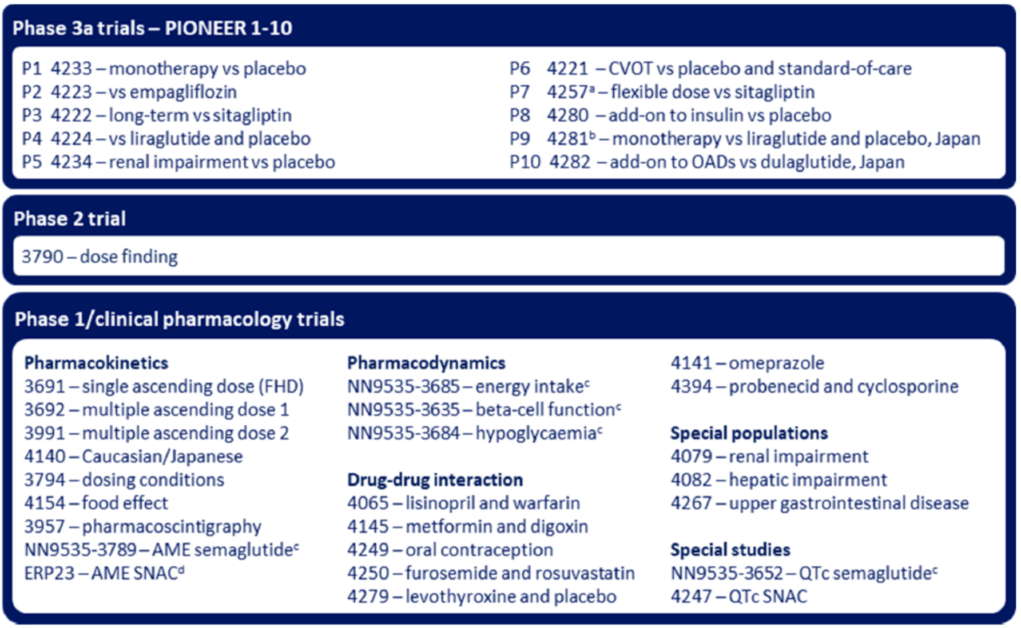
Abbreviations: AME = absorption, metabolism and excretion; CVOT = cardiovascular outcomes trial; FHD = first human dose; OAD = oral anti-diabetic drug; P = PIONEER trial; QTc = corrected QT interval; SNAC = salcaprozate sodium; vs = versus.
a Includes an ongoing extension trial.
b Phase II/III trial.
c Trials with subcutaneous semaglutide for type 2 diabetes (Ozempic). The sponsor’s project number NN9535 is included for these trials.
d Trial sponsored by Emisphere Technologies.

Pharmacology

Pharmacokinetics

Absorption

Semaglutide
The PK of oral semaglutide have been adequately characterised. Oral semaglutide appears to be dose proportional in the proposed dosing range. Semaglutide has a long half life and is degraded primarily by proteolytic cleavage.
Orally administered semaglutide has a low absolute bioavailability. Based on Phase I PopPK data (dosed with 120 mL water and 30 min post-dose fasting), absolute bioavailability was 0.76%, clearance was 0.03 L/h and half life was 158 hours. Absorption of semaglutide is decreased if taken with food or large volumes of water. A longer post-dose fasting period results in higher absorption.
Oral semaglutide has high variability in absorption/systemic exposure. In multiple dose Study NN9924-3692, inter-individual variability, although still high, was less than with single dosing: for area under the concentration-time curve over a dosing interval (AUC_{tau}) 63% to 140%. Intra-individual coefficient of variation (CV)% ranged from 23.6% to 102.6%. Inter-individual CV% ranged from 48.4% to 261.8%. Intra-individual and inter-individual variability for C_{max} were both high, particularly for the semaglutide 5 mg / SNAC 300 mg dose level.

Salcaprozate sodium
Salcaprozate sodium (SNAC) is rapidly and extensively absorbed, with a time to maximum concentration (T_{max}) of 0.58 hour (Study ERP-23).
Based on in vitro data, SNAC facilitates absorption of semaglutide which mainly occurs in the stomach. Exposure to SNAC decreased with increasing fasting time post-dosing. There was no significant effect for water volume. There was no accumulation of SNAC over time for any of the dose levels of SNAC.

Distribution

Semaglutide
Semaglutide is extensively bound to plasma proteins (> 99%). Semaglutide fits to a two compartmental PK, indicating extensive tissue distribution.
Based on Phase I PopPK data (orally dosed with 120 mL water and 30 min post-dose fasting), central volume of distribution was 3.4 L and peripheral volume of distribution was 3.9 L (8 L and 12.5L following intravenous and subcutaneous administration respectively).

Metabolism

Semaglutide
Three semaglutide isomers have been detected after subcutaneous administration in health male volunteers (in vitro Study 214379).
Metabolism of semaglutide is by proteolytic cleavage with sequential beta-oxidation of the di-fatty acid side chains (in vitro Study 214379). In total, 19 metabolites were structurally characterised following incubation with semaglutide and human neutral endopeptidase (in vitro Study 215514).

Salcaprozate sodium
Salcaprozate sodium (SNAC) is rapidly and extensively metabolised, and following a 300 mg oral dose < 50% of the parent remains after 0.5 hour and < 15% after 6 hours post-dose (Study 8288449). The most abundant metabolites were E506 and its glucuronide.

Excretion

Semaglutide
Semaglutide has a long half life and is degraded primarily by proteolytic cleavage. Half life values were determined to be between 153 and 168 hours (Studies NN9535-3789, NN9924-3991, and PopPK Analysis 1). With an elimination half life of approximately one week, semaglutide will be present in the circulation for about 5 weeks after the last dose.
The primary excretion routes of semaglutide related material are via the urine and faeces. Approximately 3% of the absorbed dose is excreted as intact semaglutide via the urine.
In Study NN9535-3789 after a single subcutaneous dose of 0.5 mg [3H]-semaglutide in healthy male volunteers, the mean (CV%) total excretion was 75.07% (5.19) of the administered dose: 52.96% (8.20) in urine, 18.56% (19.85) in faeces and 3.16% (8.95) in expired air. The blood/plasma radioactivity ratio ranged from 0.53 to 0.66, indicating semaglutide was primarily distributed in plasma. The geometric mean (CV) half life of semaglutide was 168.3 (6.3) hours.

Salcaprozate sodium
In Study NN9924-3991, the geometric mean half life of SNAC was 2.52 hours in healthy volunteers and 0.37 hour in patients with type 2 diabetes mellitus. SNAC metabolites also had short half life of ≤ 3 hours.
In Study ERP-23 for [¹⁴C]-SNAC in healthy male volunteers the mean (CV%) excretion of radioactivity was 82.31 (8.71%) % via urine and 3.75 (85.46%) % via faeces. SNAC was extensively metabolised and predominantly excreted as metabolites. SNAC was rapidly absorbed with a T_{max} of 0.58 hour. There were 18 metabolites identified in the metabolic profile.

Renal clearance

Semaglutide
There is minimal renal clearance of semaglutide.

Pharmacokinetics in the target population

Semaglutide
In Study NN9924-3991, exposure to semaglutide was similar between the healthy volunteers and patients with type 2 diabetes mellitus: the ratio (95% confidence interval (CI)) for area under the concentration-time curve from time zero to 24 hour (AUC_{0-24h}) was 1.00 (0.60, 1.66) and for C_{max} was 1.00 (0.61, 1.62) (see Table 4 below). Semaglutide half life ranged from 153 to 161 hours.
Table 4: Study NN9924-3991 Summary of semaglutide pharmacokinetic endpoints by treatment on last day of treatment (Day 69) (full analysis set)
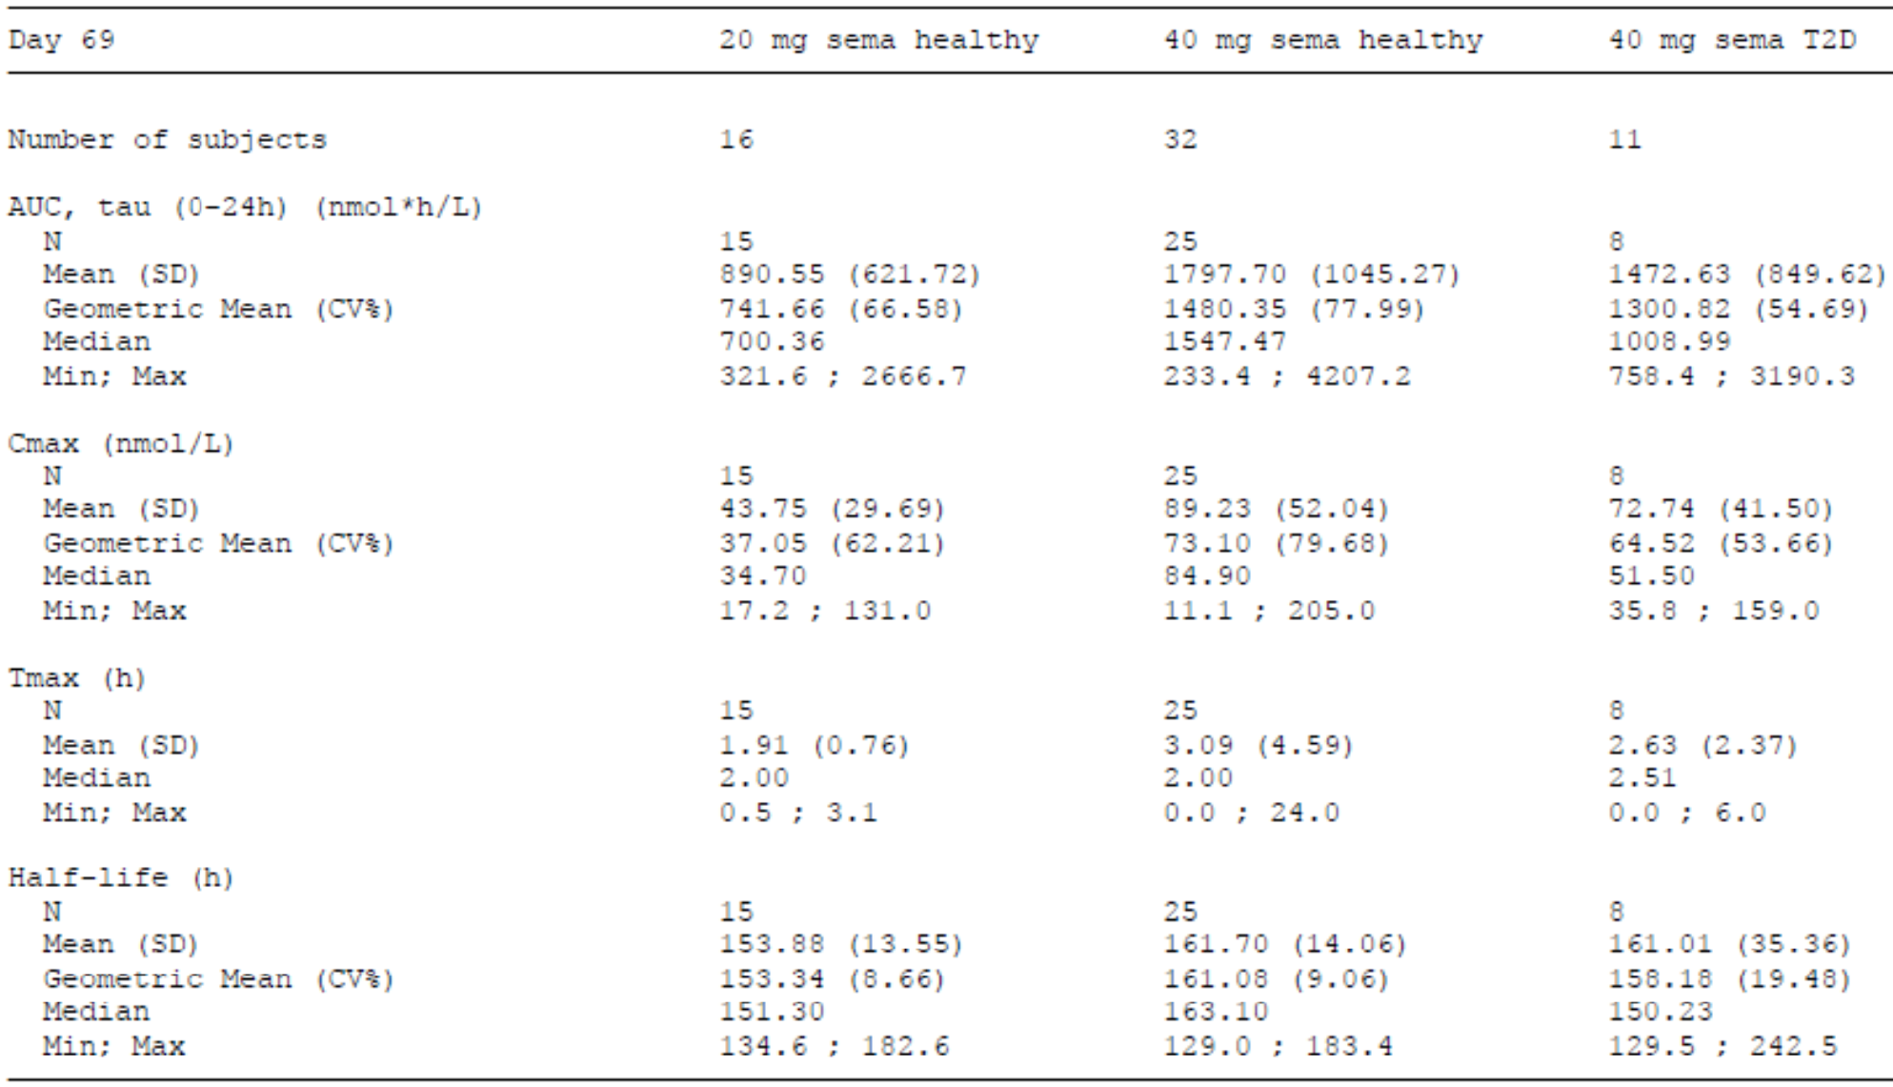
Abbreviations: AUC_{tau} = area under the concentration-time curve over a dosing interval; C_{max} = maximum plasma concentration; CV = Geometric coefficient of variation; Max = maximum; Min = minimum; N = number of subjects; SD = standard deviation; sema = semaglutide; T2D = subjects with type 2 diabetes; T_{max} = time to maximum concentration.
40 mg semaglutide treated subjects are pooled cohorts ‘oral 40’ and ‘oral 60’.
The salcaprozate sodium (SNAC) content in all tablets except placebo was 300 mg.
Steady state exposure was reached after 4 to 5 weeks of once daily administration. In patients with type 2 diabetes, the average steady-state concentrations were approximately 6.7 nmol/L (range in 90% of subjects: 1.7 to 22.7 nmol/L) and 14.6 nmol/L (range in 90% of subjects: 3.7 to 41.3 nmol/L) with semaglutide 7 mg and 14 mg, respectively.
Plasma concentrations were dose-proportional to in the range 3 mg to 14 mg (PopPK Analysis 3).
The clearance of semaglutide in patients with type 2 diabetes is approximately 0.04 L/h.

Pharmacokinetics in special populations

Semaglutide
Semaglutide exposure was not changed significantly in hepatic impairment, renal impairment or upper gastrointestinal disease. Age was not a significant covariate in the PopPK analyses. Haemodialysis had no significant effect on semaglutide clearance.

Salcaprozate sodium
Exposure to SNAC was significantly increased with hepatic impairment, but there was no accumulation with multiple dosing. Exposure to SNAC increased in renal impairment but this was not clinically significant. Hence, although there is systemic exposure and extensive metabolism, accumulation does not appear to occur under a range of clinical conditions.

Drug-drug interactions
There were no clinically significant drug-drug interactions with semaglutide. However, there was some increase in T3 exposure when co-administered with levothyroxine, and monitoring of thyroid function would be advisable with co-medication.

Population pharmacokinetics data

Population Pharmacokinetics Analysis 1
Participants who were dosed with semaglutide, 120 mL water, and 30 minute post-dose fasting. Under these dosing conditions, absolute bioavailability was 0.76%, clearance was 0.03 L/h and half life was 158 hours. Central volume of distribution was 3.4 L and peripheral volume of distribution was 3.9 L. The covariates with a significant influence on exposure to semaglutide were the volume of water ingested, and the length of fasting post-dose.
Semaglutide exposure increased with the duration of fasting post-dose, and with the volume of water ingested, up to 120 mL. The results of these studies are reflected in the administration advice for oral semaglutide: overnight fast, ingest at least 30 minutes prior to food or other medications, and ingest with up to 120 mL water. However, not adhering to these instructions would significantly decrease absorption and exposure to semaglutide.

Population Pharmacokinetics Analysis 2
Compared to the 1 mg weekly subcutaneously, there were higher plasma concentrations with 20 mg daily, and lower concentrations with 10 mg daily. The model predicted average plasma concentration indicated similar exposure for the 10 mg and 20 mg oral dose levels to the 1 mg subcutaneously but greater variability with oral dosing. Body weight had a significant effect on exposure. Exposure to oral semaglutide was dose dependent.
The concentration response relationship for HbA1c or weight loss indicated similar response for the 10 and 20 mg oral dose levels to the 1 mg subcutaneous dose level, but with greater variability.
Nausea improved over time, and was dose and time dependent, suggesting a low start dose and stepping up over 6 weeks, providing an acceptable balance between efficacy and adverse effects.

Population Pharmacokinetics Analysis 3
A confirmatory analysis of the Phase III studies, using the prior models, plasma concentrations were proportional to oral dose in the range 3 mg to 14 mg. Inter-individual variability was high and estimated at 84%.
Mean clearance was 0.039 L/h, central volume of distribution was 3.6 L and peripheral volume of distribution was 4.1 L. Bioavailability was 0.38%. The oral 14 mg daily dose regimen (likely the optimal dose for most patients) resulted in similar mean average plasma concentration compared to subcutaneous 0.5 mg, but with much greater variability. Body weight was the only covariate to have a significant effect on semaglutide exposure.
Concentration response relationships were similar for oral and subcutaneous dosing of semaglutide. Based on model predictions, to minimise the risk of a large increase in exposure when changing between routes of administration, the following switches are recommended:
- from oral semaglutide 7 mg to subcutaneous semaglutide 0.25 mg,
- from oral semaglutide 14 mg to subcutaneous semaglutide 0.5 mg,
- from subcutaneous semaglutide 0.5 mg to either oral semaglutide 7 or 14 mg,
- from subcutaneous semaglutide 1.0 mg to either oral semaglutide 7 or 14 mg.

Pharmacodynamics
The pharmacodynamics of oral semaglutide have been adequately characterised. Oral semaglutide increased insulin secretion, decreased glucagon secretion and improved glycaemic control. There was decreased caloric intake, and corresponding weight loss, decreased body mass index and decreased weight circumference. Weight loss increased with increasing dose (greater in females), with no apparent plateau effect. Nausea and vomiting were dose dependent (and occurred more frequently in females), but improved over time.
There was a dose dependent increase in serum lipase. There were no corrected QT interval (QTc) prolonging effects for either semaglutide or SNAC.

Dose finding
Data from the Phase I and Phase II studies were combined to simulate dosing regimens in PopPK Analyses 1 and 2. From these studies the 3 mg, 7 mg and 14 mg dose regimens was developed and subsequently tested in Phase III. PopPK Analysis 3 was a confirmatory analysis of this regimen.
The Phase III program explored the 3 mg, 7 mg and 14 mg dose regimens (the PIONEER 1 trial), investigated a titration regimen to the 14 mg dose level and also examined flexible dose adjustment (the PIONEER 7 trial). The dose of SNAC was fixed to 300 mg during the Phase III program. No clinical trials investigate oral semaglutide without SNAC.
The sponsor performed an extensive program of studies (including modelling and simulation studies) to select the final dosing regimen, and followed this up with appropriate confirmatory studies. This included selecting the optimal dose of SNAC and the optimal administration strategy. This program provides clinical support of the proposed dosing and administrations regimens.

Efficacy
There were seven pivotal Phase IIIa efficacy studies: the PIONEER 1, PIONEER 2, PIONEER 3, PIONEER 4, PIONEER 5, PIONEER 7 and PIONEER 8 trials. There were two supportive studies conducted in a Japanese population: the PIONEER 9 and PIONEER 10 trials. The PIONEER 6 trial was mainly a cardiovascular outcome safety study with some efficacy data. An overview is given in Table 5 below.
Table 5: The PIONEER trials Overview of efficacy trials
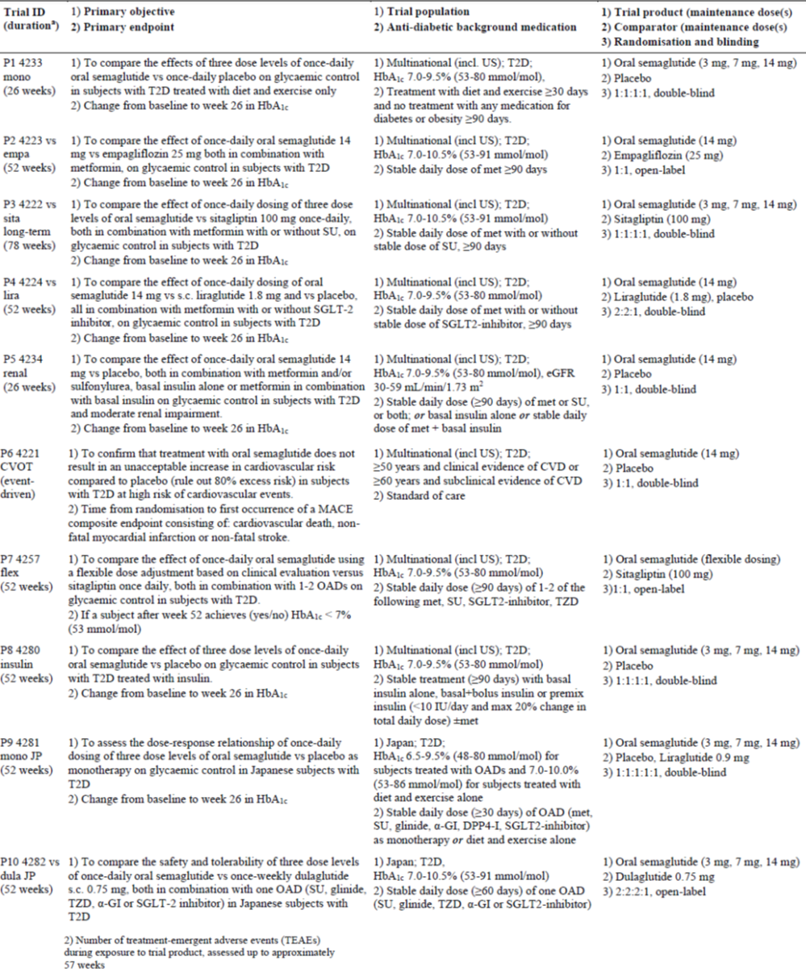
Abbreviations: CVD = cardiovascular disease; CVOT = cardiovascular outcomes trial; dula = dulaglutide; empa = empagliflozin; flex = flex = flexible dose; GI = gastrointestinal; HbA1c = haemoglobin A1c; lira = liraglutide; ID = identity; JP = Japanese; MACE = major adverse cardiovascular event; mono = monotherapy; OAD = oral anti-diabetic drug; P = PIONEER trial; s.c. = subcutaneous; SGLT-2 = Sodium glucose co-transporter-2; SU = sulfonylurea; T2D = type 2 diabetes; TEAE = treatment-emergent adverse event; US = United States; vs = versus.
a excluding follow-up period.
In the PIONEER 1, 2, 3, 4, 5, 8, and 9 trials, HbA1c at 26 weeks was the primary endpoint. Only the PIONEER 7 trial used the proportion of subjects achieving HbA1c < 7.0% (ADA target) as its primary endpoint, and PIONEER 6 was mainly a safety study, but both studies also reported on HbA1c at 26 weeks. An overview of endpoints is shown in Table 6 below.
Table 6: The PIONEER trials Overview of endpoints
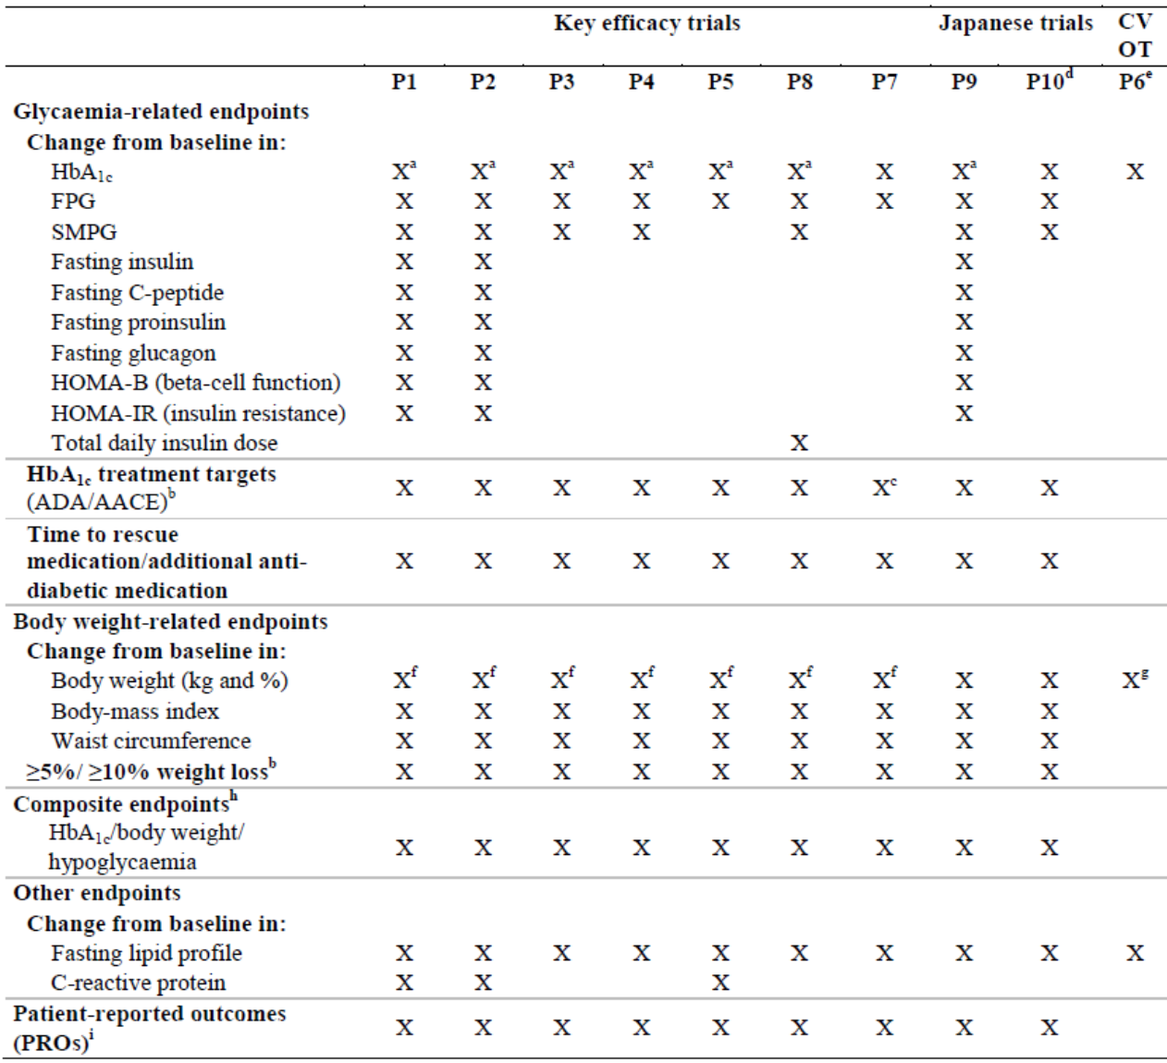
Abbreviations: AACE = American Association of Clinical Endocrinologists; ADA = American Diabetes Association; CVOT = cardiovascular outcomes trial; FPG = fasting plasma glucose; HbA1c = haemoglobin A1c; HOMA = homeostatic model assessment; IR = insulin resistance; PROs = patient reports outcomes; SMPG = self-measured plasma glucose.
a Primary endpoint: change from Baseline at Week 26.
b Binary endpoint. ADA: HbA1c < 7%, AACE: HbA1c ≤ 6.5%.
c. The primary endpoint in the PIONEER 7 trial evaluated the proportion of subjects achieving HbA1c < 7% (ADA target).
d In the PIONEER 10 trial, the primary objective and the associated endpoints were safety related endpoints; efficacy related endpoints were secondary and supportive.
e In the PIONEER 6 trial (CVOT), the primary endpoint was time to the first major adverse cardiovascular event.
f Confirmatory secondary endpoint: change from Baseline at Week 26 (confirmatory for kg only).
g In kg only.
h Composite binary endpoints evaluating combinations of categorical HbA1c and body weight outcomes and occurrence of hypoglycaemia.
I Generic and/or type 2 diabetes specific PRO instrument; not all PROs were included in all trials.

PIONEER trials (pivotal); PIONEER 1, 2, 3, 4, 5, 7, and 8

Design
The pivotal PIONEER trials (PIONEER 1, 2, 3, 4, 5, 7, and 8) were Phase IIIa, randomised, double-blind (PIONEER 2 and 7 were open label), multicentre, parallel group, controlled studies to assess the efficacy and safety of oral semaglutide in a combined total of 8572 adult patients (aged 18 to 92 years) with type 2 diabetes mellitus.
The primary endpoint in the PIONEER 1, 2, 3, 4, 5 and 8 was change in HbA1c (%) from Baseline to Week 26, and the confirmatory secondary endpoint was change in body weight (kg) from Baseline to Week 26.
Study objectives, endpoints, trial population, and study design are summarised in Table 5 above. The proportions of patients on background antidiabetic medication are summarised in Table 7 below.
Table 7: PIONEER trials (pivotal) Background antidiabetic medication (full analysis set)
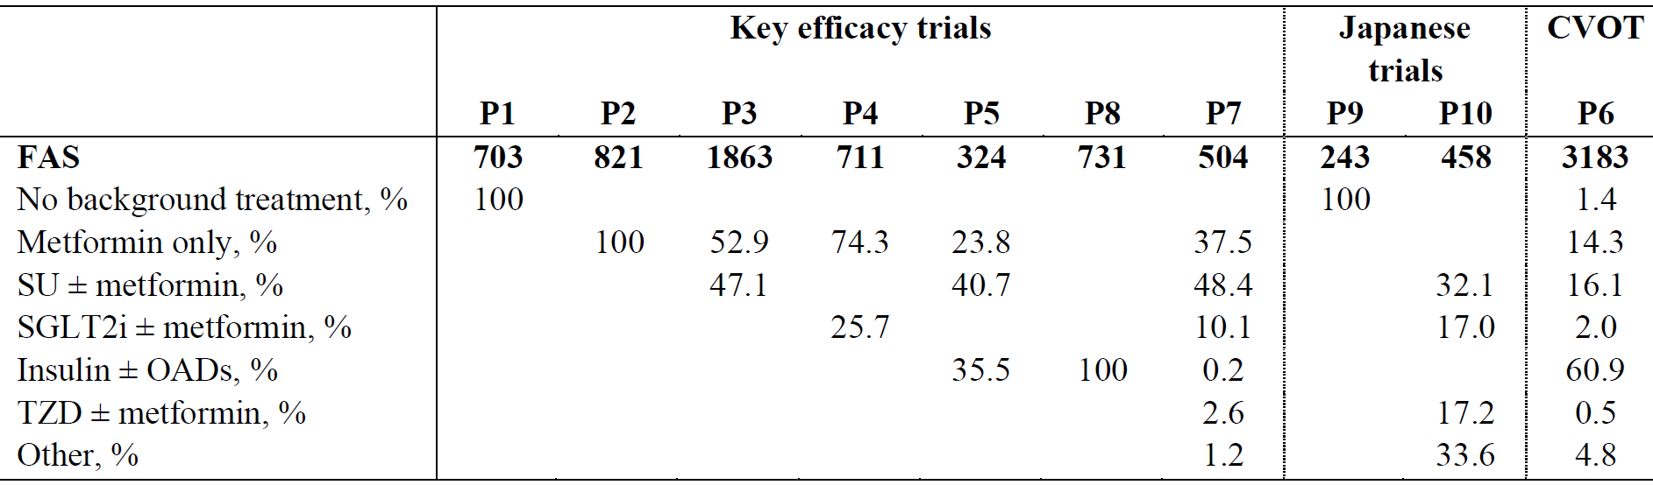
Abbreviations: CVOT = cardiovascular outcomes trial; FAS = number of subjects in full analysis set; OAD = oral anti-diabetic drug; P = PIONEER trials; SGLT2 = sodium glucose co-transporter-2; SU = sulfonylurea.
Percentages (%) refer to proportion of subjects.
The start and stop dates of the anti-diabetic medication were before and after the date of the screening visit, respectively. Insulin: basal insulin (the PIONEER 5 and 8 trials), basal bolus (the PIONEER 8 trial) or premix (the PIONEER 8 trial), various insulin regimens were used in the PIONEER 6 trial. For the evaluation of efficacy in subgroups, the following categories are used: No background treatment, metformin only, SU ± metformin, SGLT2 inhibitor ± metformin, insulin ± OADs, other.

Trial populations
Subject disposition and baseline characteristics are summarised in Table 8 and Table 9, respectively.
Table 8: PIONEER trials (pivotal) Subject disposition
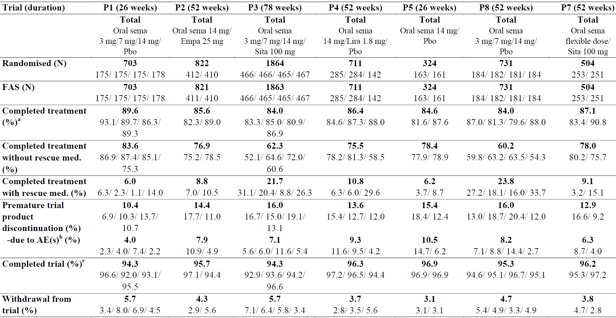
Abbreviations: AE = adverse event; Empa = empagliflozin; FAS = full analysis set; N = = number of subjects; P = PIONEER trials; Pbo = placebo; sema = semaglutide; sita = sitabliptin.
a. Subject completed treatment with trial product according to the end-of-trial form.
b. Exposed subjects.
c. Subjects who attended the final scheduled visit.
Table 9: PIONEER trials (pivotal) Baseline characteristics
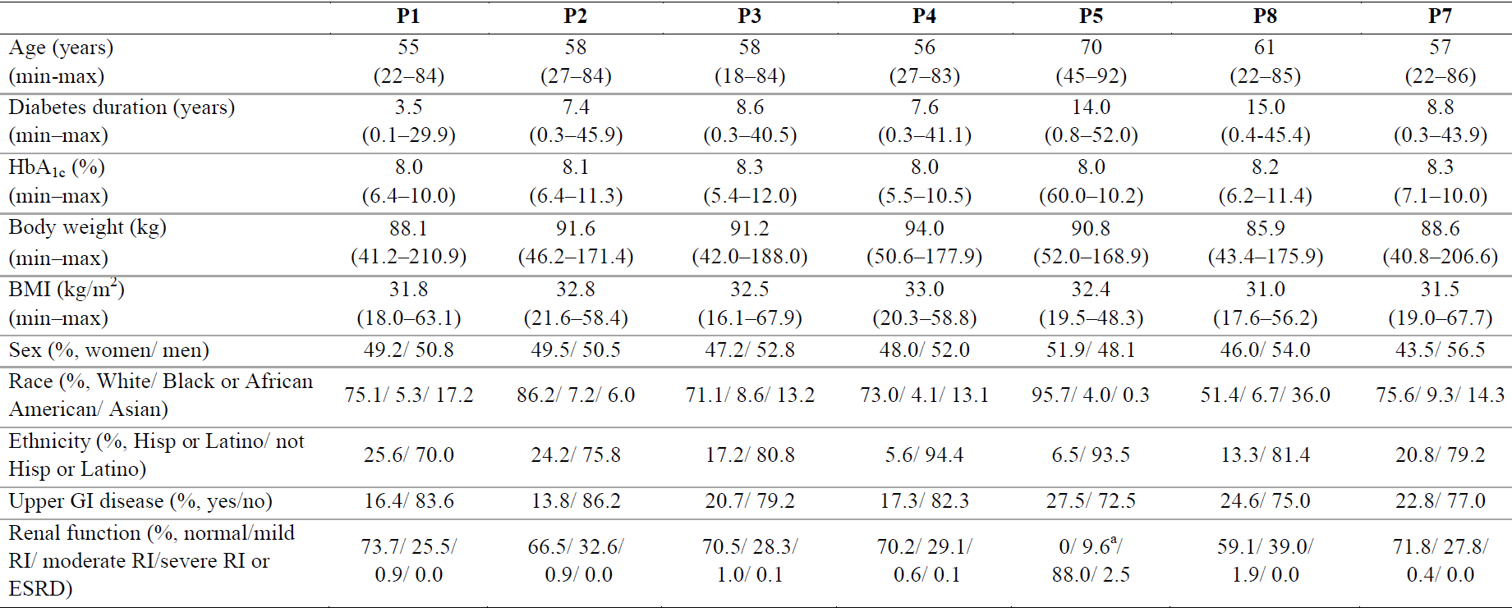
Abbreviations: BMI = body mass index; ESRD = end-stage renal disease; GI = gastrointestinal; HbA1c = haemoglobin A1c Hisp = Hispanic; RI = renal impairment; max = maximum; min = minimum; P1 to P7 = PIONEER trials 1 to 7.
a. In the PIONEER 5 trial, all subjects had moderate renal impairment at screening but for some subjects, estimated glomerular filtration rate (eGFR) had changed from screening to randomisation (Baseline).
Baseline: defined as the latest assessment at or prior to the randomisation visit. Some categories are omitted from this overview table; thus, proportions may not add up to 100%. Normal renal function: eGFR ≥ 90; mild RI: eGFR ≥ 60 to < 90; moderate RI: eGFR ≥ 30 to < 60; severe RI: eGFR ≥ 15 to < 30; ESRD: eGFR < 15 ml/min/1.73 m².
Estimated glomerular filtration rate (eGFR) was estimated using the chronic kidney disease epidemiology collaboration formula. Upper GI disease comprises gastroesophageal reflux, gastritis and gastric ulcer.
Treatment effects were estimated using a treatment policy estimand method (primary estimand; disregarding product discontinuation or use of additional antidiabetic medication), and a hypothetical estimand method (without the potentially confounding effects of discontinuation or use of additional antidiabetic medication). All superiority or non-inferiority claims are based on the treatment policy estimand.

Results: semaglutide as monotherapy
PIONEER 1 trial (comparison to treatment with diet and exercise only):
- There was a significantly greater reduction in HbA1c at Week 26 compared to placebo for all three semaglutide dose levels: mean (95% CI) difference, semaglutide/placebo, was -1.1 (-1.3, -0.91) %, p < 0.0001, for 14 mg; -0.9 (-1.1, -0.6) %, p < 0.0001, for 7 mg; and -0.6 (-0.8, -0.4), p < 0.0001, for 3 mg.
- There was a significantly greater reduction in body weight at Week 26 compared to placebo for the 14 mg dose level, but not for the 3 mg or 7 mg.

Results: semaglutide as add-on to metformin
- In patients treated with background metformin, semaglutide had superior glycaemic control and similar weight control to empagliflozin (SGLT-2 inhibitor).
- In patients treated with background metformin ± sulfonylurea, semaglutide at the 7 mg and 14 mg dose levels had superior glycaemic and weight control compared to sitagliptin (DPP-4 inhibitor).
PIONEER 2 trial (semaglutide in type 2 diabetes mellitus patients on metformin in comparison with empagliflozin):
- The change from Baseline in HbA1c was -1.3% for semaglutide and -0.9% for empagliflozin: treatment difference (95% CI) -0.4 (-0.6, -0.3) %, p < 0.0001.
- However, there was no significant difference between the treatments in the change from Baseline to Week 26 in body weight.
PIONEER 3 trial (semaglutide in type 2 diabetes mellitus inadequately controlled by metformin ± sulfonylurea in comparison with sitagliptin):
- The semaglutide 7 mg and 14 mg dose levels were superior to sitagliptin, but sitagliptin was superior to the 3 mg dose level. The treatment difference (95% CI) semaglutide - sitagliptin, for change in HbA1c to Week 26 was -0.5 (-0.6, -0.4) %, p < 0.0001 for 14 mg, -0.3 (-0.4, -0.1) %, p < 0.0001, for 7 mg and 0.2 (0.0, 0.3), p = 0.0080 for 3 mg.
- There was greater weight loss with semaglutide, that was clinically significant for the 7 mg and 14 mg dose levels: treatment difference (95% CI) semaglutide - sitagliptin, for change in body weight to Week 26 was -2.5 (-3.0, -2.0) kg, p < 0.0001 for 14 mg, -1.6 (-2.0, -1.1) kg, p < 0.0001, for 7 mg and -0.6 (-1.1, -0.1), p = 0.0185 for 3 mg.
PIONEER 4 trial (comparison to liraglutide in patients with type 2 diabetes mellitus inadequately controlled on metformin alone or in combination with a SGLT-2 inhibitor):
- All patients were treated with metformin and 25.7% were also treated with SGLT-2 inhibitors.
- For the primary efficacy outcome measure, there was superiority for semaglutide in comparison with placebo and non-inferiority in comparison with liraglutide.
- At Week 26, the decrease in HbA1c from Baseline was -1.2 % for semaglutide, -1.1 % for liraglutide and -0.2% for placebo. The difference (95% CI) in change from Baseline to Week 26 in HbA1c, semaglutide/comparator, was -1.1 (-1.2, -0.9) %, p < 0.0001, compared to placebo and -0.1 (-0.3, 0.0) %, non-inferiority p < 0.0001 and superiority p = 0.0645, compared to liraglutide.
- There was greater weight loss with semaglutide compared to either placebo or liraglutide. The difference (95% CI) in change from Baseline to Week 26 in weight, semaglutide/comparator, was -3.8 (-4.7, -3.0) %, p < 0.0001, compared to placebo and -1.2 (-0.3, 0.0) %, p = 0.0003, compared to liraglutide.

Results: semaglutide as add-on to insulin
Semaglutide was superior to placebo as add-on treatment to background insulin.
PIONEER 8 trial (patients with background insulin treatment):
- All three dose levels of semaglutide were superior to placebo for both the primary efficacy outcome measure and the confirmatory secondary efficacy outcome measure. The effect size increased with increasing dose.
- HbA1c decreased to Week 14 and was maintained to Week 52.
- The treatment difference (95% CI), semaglutide/placebo, for change in HbA1c from Baseline to Week 26 was -1.2 (-1.4, -1.0) %, p < 0.0001, for 14 mg; -0.9 (-1.1, -0.7) %, p < 0.0001, for 7 mg and -0.5 (-0.7, -0.3) %, p < 0.0001 for 3 mg.
- Body weight decreased to Week 20, and was maintained to Week 52. The treatment difference (95% CI), semaglutide - placebo, for change in body weight from Baseline to Week 26 was -3.3 (-4.2, -2.3) kg, p < 0.0001, for 14 mg; -2.0 (-3.0, -1.0) kg, p = 0.0001, for 7 mg and -0.9 (-1.8, 0.0) kg, p = 0.0392 for 3 mg.
- There was a decrease in insulin dose in the semaglutide groups at Week 26 and through to Week 52.

Results: semaglutide in patients with renal impairment
Semaglutide was superior to placebo in patients with renal impairment for both glycaemic and weight control.
PIONEER 5 trial (patients with type 2 diabetes mellitus with moderate renal impairment who are inadequately controlled on metformin and/or sulfonylurea; or basal insulin ± metformin):
- The mean (95% CI) difference, semaglutide/placebo, in change from Baseline to Week 26 in HbA1c was -0.8 (-1.0, -0.6) %, p < 0.0001.
- The mean (95% CI) difference, semaglutide - placebo, in change from Baseline to Week 26 in body weight was -2.5 (-3.2, -1.8) kg, p < 0.0001.

Results: semaglutide in flexible dosing regimens
Using a flexible dosing regimen, semaglutide was superior to sitagliptin.
PIONEER 7 trial (flexible dose-adjustment between semaglutide 3 mg, 7 mg and 14 mg, and sitagliptin 100 mg in patients with type 2 diabetes mellitus who were in inadequate glycaemic control with 1-2 oral anti-diabetic drugs):
- HbA1c < 7.0% at Week 52 was achieved by 134 (58.3%) patients in the semaglutide group and 60 (25.2%) in the sitagliptin group: odd ratio (95% CI) 4.40 (2.89, 6.70), p < 0.0001.
- HbA1c reduction ≥ 1% point (10.9 mmol/mol) and weight loss ≥ 3% at Week 52 was achieved by 80 (34.8%) patients in the semaglutide group and 25 (10.5%) in the sitagliptin group.
- The dosing data for semaglutide indicate that slightly over a third of patients could be controlled on lower doses (3 or 7 mg, but mainly 7 mg). From Week 48 to Week 52, 59.4% of patients on treatment were prescribed the 14 mg dose, while 30.2% were prescribed the 7 mg dose and 9.0% were prescribed the 3 mg dose. Hence it is feasible to titrate the dose to HbA1c target and gastrointestinal tolerability.

PIONEER trials (supportive); PIONEER 9 and 10

Results: semaglutide in Japanese populations
The PIONEER 9 and 10 trials were supportive studies in a Japanese population. Both studies had results consistent with those of the pivotal PIONEER trials.
PIONEER 9 trial (Japanese study; supportive of findings in the PIONEER 1 trial):
- There was superior glycaemic control with all the dose levels of oral semaglutide in comparison with placebo, with the effect size increasing with dose. Oral semaglutide 14 mg had superior glycaemic control to liraglutide but there was no significant difference for the 3 mg and 7 mg dose levels.
- Semaglutide 14 mg had superior weight control compared to placebo and liraglutide, but there was no significant difference for the 3 mg and 7 mg dose levels.
PIONEER 10 trial (Japanese study):
- The study supports the 14 mg dose level in comparison with dulaglutide, which is registered for use in Australia. It also supports efficacy in comparison with placebo in a patient group with background oral anti-diabetic medication.
Table 10: PIONEER trials (pivotal) Primary endpoint - change in haemoglobin A1C (%) from Baseline to Week 26 (treatment policy estimand; full analysis set)
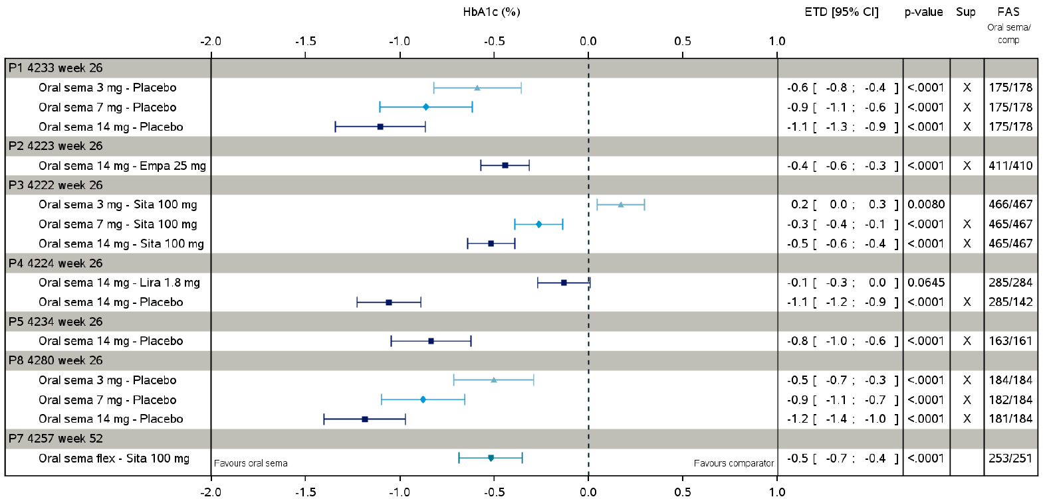
Abbreviations: CI = confidence interval; comp = comparator; Empa = empagliflozin; ETD = estimated treatment difference; FAS = full analysis set; flex = flexible dose; HbA1c = haemoglobin A1c; Lira = liraglutide; P = PIONEER trial; sema = semaglutide; sita = sitabliptin; Sup = superiority.
Table 11: PIONEER trials (pivotal) Confirmatory secondary endpoint - change in body weight (kg) from Baseline to Week 26 (treatment policy estimand; full analysis set)
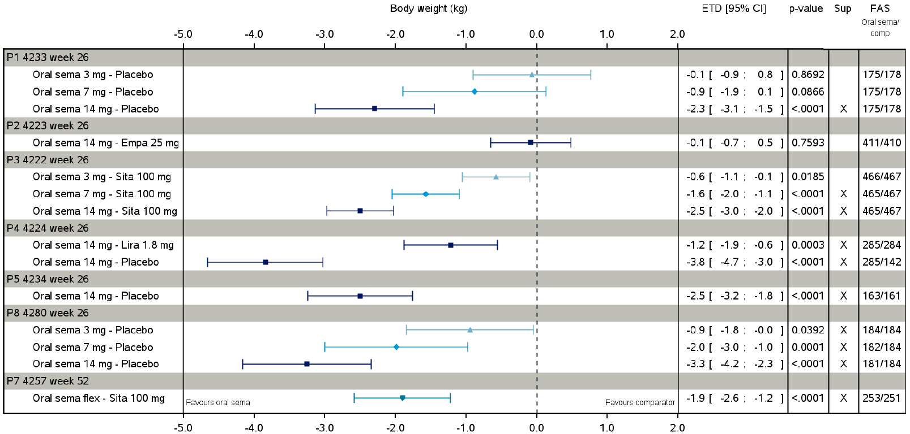
Abbreviations: CI = confidence interval; comp = comparator; Empa = empagliflozin; ETD = estimated treatment difference; FAS = full analysis set; flex = flexible dose; HbA1c = haemoglobin A1c; Lira = liraglutide; P = PIONEER trial; sema = semaglutide; sita = sitabliptin; Sup = superiority.

Safety

Pioneer 6 trial (cardiovascular outcomes trial)
The PIONEER 6 trial was a randomised, double blind, placebo controlled, multicentre, parallel group study of the cardiovascular safety of oral semaglutide compared to placebo when added to standard of care in 3183 patients with type 2 diabetes mellitus at high risk of cardiovascular events.
Patients received either semaglutide (oral, 3 mg daily for 4 weeks, then 7 mg daily for 4 weeks, then 14 mg daily for up to 74 weeks) or placebo. The primary safety outcome measure was the time from randomisation to first occurrence of a major cardiovascular event composite endpoint consisting of: cardiovascular death, non-fatal myocardial infarction or non-fatal stroke.

Results: semaglutide (cardiovascular outcomes)
For the time to first major cardiovascular event, the hazard ratio (95% CI) semaglutide/placebo, was 0.79 (0.57, 1.11), with a test of non-inferiority of p < 0.0001 (non-inferiority margin was the 95% CI upper bound of < 1.8).
In a population at increased risk of cardiovascular events, there was no increase in risk of major cardiovascular event, and a decrease in the risk of cardiovascular death and the risk of all-cause death.

Summary of safety

Exposure
A total of 11,100 patients were exposed to semaglutide (either subcutaneous or oral) in Phase III trials; equivalent to 12,360 patient years of exposure.
From the Phase IIIa (PIONEER) trials, 4,116 patients have been exposed to oral semaglutide, and a further 1,591 patients received semaglutide in the cardiovascular outcomes trial (the PIONEER 6 trial) (see Table 12 below). The dose range in the Phase IIIa trials was 3 mg to 14 mg. In Phase IIIa trials, 2.954 patients have been treated for ≥ 12 months and in cardiovascular outcomes trial, 1,385 patients have been treated for ≥ 12 months.
Table 12: PIONEER trials (pivotal) and PIONEER 6 trial Total exposure to oral semaglutide
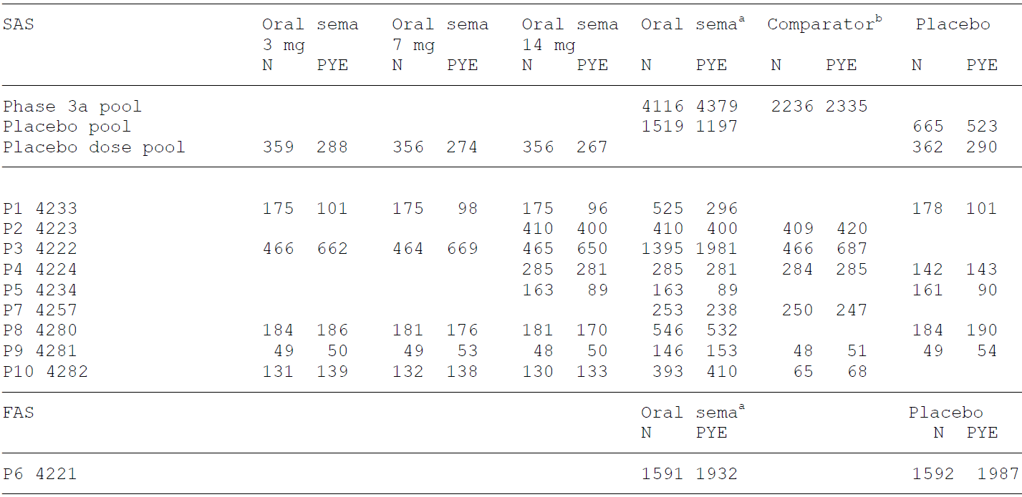
Abbreviations: FAS = full analysis set; N = number of subjects; P = PIONEER trial; PYE = patient years of exposure; SAS = safety analysis set.
Phase IIIa pool: the PIONEER 1 to 5 and 7 to 10. Placebo pool: the PIONEER 1, 4, 5 and 8 trials.
Placebo dose pool: the PIONEER 1 and 8 trials. 'Oral sema': data from all three oral semaglutide doses (3, 7 and 14 mg).
a In the PIONEER 1 to 5 and 8 to 10 trials this column is the pooled oral semaglutide data across the doses used in the individual trials. In the PIONEER 7 and 6 trials, subjects were allowed to delay dose escalation of oral semaglutide to 14 mg and to decrease the dose if experiencing unacceptable adverse events.
One subject in the placebo group of the PIONEER 6 trial was not exposed to trial product.
b 'Comparator' for the Phase IIIa pool: sitagliptin, empagliflozin, liraglutide and placebo; ‘comparator’ for the individual trials only includes the active comparator.

Adverse event overview
There were 302.2 events per 100 patient years of exposure occurred with oral semaglutide versus 259.0 events per 100 patient years of exposure with comparators (Phase IIIa pool). This was mainly driven by a greater occurrence of gastrointestinal adverse events (AEs) with oral semaglutide which also led to premature trial product discontinuations.
The most common treatment-emergent adverse events (TEAEs) were primarily gastrointestinal: nausea, vomiting, diarrhoea, constipation and anorexia (see Figure 1 below).
Figure 1: PIONEER trials (pivotal) Adverse events in ≥ 5% of subjects (pooled data)
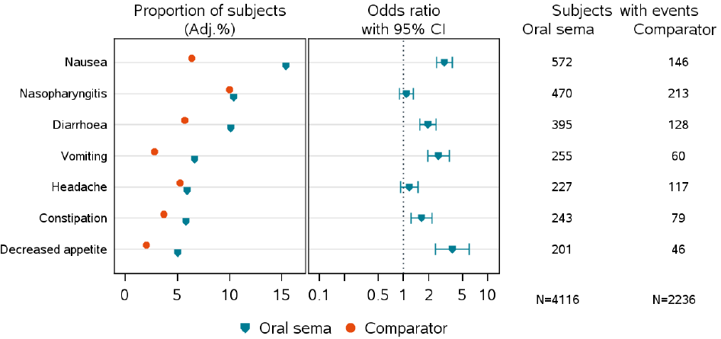
Abbreviations: Adj. = the % is the Cochran-Mantel-Haenszel adjusted proportion of subjects with at least one event; CI = confidence interval; N = number of subjects.
Phase IIIa pool: the PIONEER 1 to 5 and 7 to 10 trials.
‘Oral Sema’ data from all three oral semaglutide doses (3, 7 and 14 mg). ‘Comparator’: sitagliptin, empagliflozin, liraglutide, dulaglutide and placebo.
Sorted in descending order by Preferred Term based on the proportion of subjects with at least one event in the oral semaglutide group.
Less common AEs that were reported more frequently with oral semaglutide than comparator (by 0.1 to 1% of subjects) were mostly known GLP-1 receptor agonist class side effects (see Table 13 below).
Table 13: PIONEER trials (pivotal) Adverse events reported by 1% to 5% of subjects (pooled data)
Oral semaglutide vs comparator  (> 0.5% difference) | Oral semaglutide vs placebo  (> 0.5% difference)
Dyspepsia: 4.0% vs 1.6%  Abdominal pain: 3.3% vs 1.8%  Abdominal pain upper: 3.3% vs 1.8%  Abdominal discomfort: 2.7% vs 1.4%  Gastro-oesophageal reflux disease: 2.6% vs 0.8%  Gastroenteritis: 2.1% vs 1.0%  Abdominal distension: 1.9% vs 1.3%  Flatulence: 1.3% vs 0.7% | Lipase increased: 2.5% vs 0.6%  Asthenia:1.7% vs 0 subjects  Fatigue: 1.4% vs 0.5%  Blood creatinine phosphokinase increased: 1.3% vs 0.6%  Fall: 1.3% vs 0.7%  Eructation: 1.2% vs 0 subjects
Abbreviation: vs = versus.

Timing and dose dependency
In the dose finding studies, these TEAEs were dose-limiting. Nausea occurred in > 30% of patients at doses ≥ 10 mg oral. The rates of nausea decreased with duration of treatment. The trade-off between tolerability and efficacy in the Phase I and Phase II studies resulted in the proposed dosing regimen with a target dose of 7 mg or 14 mg depending on individual tolerability and efficacy.
Treatment emergent adverse events were dose-related, and also related to the speed of titration. The 4-week intervals for titration of dose were tolerated adequately. The prevalence and duration of nausea (as a representative gastrointestinal AE), coded through MedDRA (Medical Dictionary for Regulatory Activities) terminology is shown in Figure 2 below.
Figure 2: PIONEER trials (pivotal) Proportion of subjects by trial day prevalence plot for nausea (MedDRA search; pooled data)
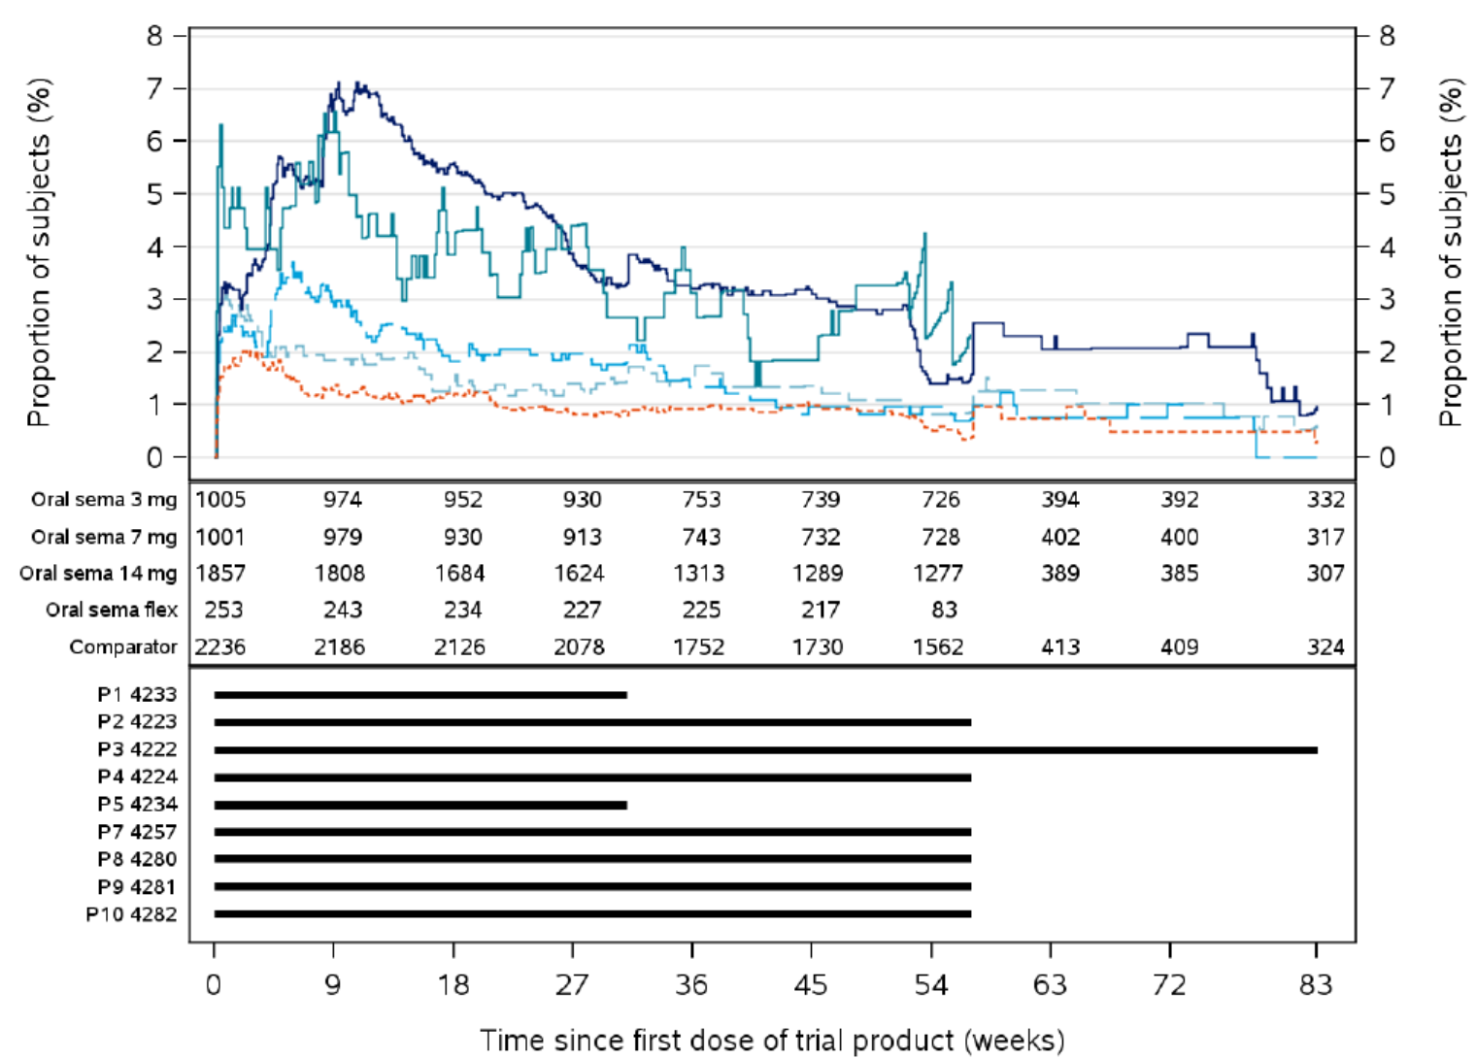
Abbreviations: flex = flexible dose; MedDRA = Medical Dictionary for Regulatory Activities; P = PIONEER trial; sema = semaglutide.
Phase IIIa pool: the PIONEER 1 to 5 and 7 to 10 trials.
Plot includes events with onset during the on-treatment observation period but no later than the week where the follow-up visit was scheduled to take place. Number in the middle panel represent number of subjects at risk.
While the horizontal bars in the lower panel represent the periods for which the individual trials contribute.

Deaths

Pooled Phase IIIa trials
Thirty (30) subjects exposed to trial product died (0.4% in the oral semaglutide versus 0.5% for comparators). The distribution of the causes of death did not differ between oral semaglutide and comparators.

PIONEER 6 trial
Seventy three (73) randomised subjects died. The proportion of subjects with fatal events was lower with oral semaglutide than with placebo (1.6% versus 2.9%). Oral semaglutide was associated with a statistically significantly 49% lower risk of all-cause death compared to placebo (estimated hazard ratio (95% CI) is 0.51 (0.31, 0.84); p = 0.0078).

Serious adverse events

Pooled Phase IIIa trials
Serious adverse events (SAEs) occurred 8.6% and 9.0% of the subjects, for semaglutide, and comparators, respectively. The most frequent SAEs were within the ‘cardiac disorders’, ‘neoplasms’ and ‘infections and infestations’ System Organ Classes. The frequency of SAEs was lower with oral semaglutide 14 mg (9.5% of the subjects in the PIONEER 3 trial) than with 3 and 7 mg (13.7% and 10.1%, respectively). In the PIONEER 6 trial, SAEs were less frequent with oral semaglutide than with placebo (18.9% and 22.5% of the subjects).
No SAE dose response relationship for oral semaglutide was observed, but was greater with fast titration of dose. Although the rate of gastrointestinal TEAEs was high this did not translate to a high rate of gastrointestinal SAEs. Hence, slow titration of dose is expected to minimise the risk of gastrointestinal SAE.

Discontinuations

Pooled Phase IIIa trials
The discontinuation frequency was greater with oral semaglutide than with comparators (8.7% and 4.2% of the subjects, respectively).
The rate of discontinuation due to an AE increased with semaglutide dose, and was greater with fast titration of dose and occurred more frequently in the dose escalation phase. The events leading to discontinuation were predominantly gastrointestinal, particularly nausea and vomiting.

Adverse events of special interest

Gastrointestinal adverse events
Gastrointestinal AEs were the most frequently reported AE type with oral semaglutide (nausea, diarrhoea, vomiting and constipation). Most of the events (> 70%) were mild, and most were reported during the dose escalation period.

Hepatobiliary adverse events
No subjects in the Phase IIIa pool had aspartate aminotransferase or alanine aminotransferase concentrations > 3 x upper limit of normal (ULN) with concurrent total bilirubin concentrations > 2 x ULN. In the PIONEER 6 trial, there were two cases (one with oral semaglutide and one with placebo), but not considered related to study drug.
Serum lipase concentrations increased in a dose dependent manner with oral semaglutide. However, this did not translate to a higher rate of acute pancreatitis.
The frequency of cholelithiasis was greater oral semaglutide than with placebo (10 events versus one event, corresponding to 0.6% and 0.1% of the subjects), in line with previous findings for other GLP-1 receptor agonists. An increased risk cannot be excluded, but the risk is rather low.

Renal adverse events
Comparing oral semaglutide versus comparators, the rates were 0.8% versus 0.5% (Phase IIIa pool) and 2.0% versus 2.3% (the PIONEER 6 trial). No decrease in estimated glomerular filtration rate (eGFR) or dose response relationship for eGFR or creatinine was observed. The rate of acute kidney injury was not elevated in relation to comparator or placebo (< 0.5% in each group). Calcitonin concentrations were stable during treatment.

Haematological adverse events
There was no increased risk of haematological toxicity with oral semaglutide.

Cardiovascular adverse events
In the PIONEER 6 trial, there was no increase in cardiovascular risk with oral semaglutide, and a decreased risk of cardiovascular death. Prolongation of the QT interval;¹⁵ was not demonstrated in thorough QT studies of semaglutide and SNAC. There were no significant changes in systolic blood pressure or diastolic blood pressure. However, mean pulse rate increased by 4 beats per minute during treatment with oral semaglutide (known effect of GLP-1 receptor agonists).

Immunogenicity
There were few patients who developed anti-semaglutide antibodies and there were no patients with antibodies that neutralised endogenous GLP-1.

Hypoglycaemia
In monotherapy or as add-on treatment to metformin, the rate of severe hypoglycaemia was similar to comparators (DPP-4 inhibitor or SGLT-2 inhibitor) or placebo. However, in patients who had background insulin treatment the rate of hypoglycaemia was increased relative to placebo. Semaglutide also decreased hypoglycaemia awareness in Study NN9535-3684.

Neoplasia
The rates were similar in the semaglutide, active comparator and placebo groups. The reported rates were too low to enable a statistical comparison between groups.

Diabetic retinopathy
The rates (mostly non-proliferative diabetic retinopathy not requiring treatment) were similar, but slightly greater with oral semaglutide compared to active comparators and placebo. This was not consistently observed, but should be documented as a warning in the PI.

Safety in special populations

Age
The overall safety profiles were comparable across the age subgroups. The proportion of premature discontinuations increased with age overall, but was more pronounced with oral semaglutide with the majority of the subjects being on the 14 mg semaglutide dose.

Pregnancy and lactation
Oral semaglutide has not been studied in pregnant or lactating women, and the potential risk with oral semaglutide treatment during pregnancy and lactation is unknown. Seven pregnancies had no known associated congenital anomalies, but given the limited information, potential risks during pregnancy and lactation cannot be excluded. Oral semaglutide should not be used when pregnant or breastfeeding, and women of childbearing potential are recommended to use contraception when treated with oral semaglutide.

Post-market experience
No data on Rybelsus (oral semaglutide) is available.

Pharmacology studies
The clinical pharmacology studies were primarily short-term and in volunteers and less informative for the target population on long-term semaglutide.

Risk management plan
The sponsor has submitted EU-RMP version 4.4 (dated 6 April 2020; data lock point (DLP) 31 May 2018 (semaglutide subcutaneous) and 2 November 2018 (oral semaglutide)) and Australia specific annex (ASA) version 1.1 (dated 28 August 2020) in support of this application. In response to a TGA request for information, the sponsor has submitted ASA version 1.2 (dated 12 May 2021), while the EU-RMP version 4.4 remains the same as the first round of evaluation. At the first round of evaluation the sponsor provided updated ASA version 1.2 (dated 30 August 2021).
The summary of safety concerns and their associated risk monitoring and mitigation strategies are summarised in Table 14. Further information regarding the TGA’s risk management approach can be found in risk management plans for medicines and biologicals and the TGA's risk management approach.
Table 14: Summary of safety concerns
Summary of safety concerns |  | Pharmacovigilance |  | Risk minimisation
 |  | Routine | Additional | Routine | Additional
Important identified risks | Diabetic retinopathy complications |  | * |  | –
Important potential risks | Neoplasms (malignant and non-malignant) |  | * | – | –
Important potential risks | Pancreatic cancer |  | * |  | –
Important potential risks | Medullary thyroid cancer |  | * |  | –
Important potential risks | Pregnancy and lactation† |  | – |  | –
Missing information | Patients with severe hepatic impairment |  | – |  | –
* Planned pharmacovigilance studies
† Requested by risk management plan (RMP) evaluator as an important potential risk (missing information in the European Union-RMP)
- The proposed summary of safety concerns is considered acceptable. Pregnancy and lactation are considered an important potential risk based on the embryo lethality and toxicity found in animal studies and the Category D classification.
- The sponsor has proposed routine pharmacovigilance activities only in Australia for all safety concerns. The sponsor has proposed international additional pharmacovigilance studies to address diabetic retinopathy complications, pancreatic cancer and medullary thyroid cancer. The important potential risk of neoplasms will be monitored through serious adverse event reporting in the post-market studies. This is acceptable.
- The sponsor has proposed routine risk minimisation activities for all safety concerns. The Consumer Medicines Information (CMI) will be included as a package insert. The sponsor has proposed no additional risk minimisation activities. This is considered acceptable.

Risk-benefit analysis

Delegate’s considerations

Pharmacology
Salcaprozate sodium (SNAC) is a novel excipient and an absorption enhancer. The three proposed Rybelsus tablet strengths (3, 7 and 14 mg) each contain the same amount of SNAC (300 mg). SNAC acts to enhance absorption via the transcellular route (through membrane incorporation and permeabilisation). The stomach is the key site for SNAC action and semaglutide absorption. An up to approximate 7-fold increase in the apparent permeability of semaglutide was demonstrated in vitro with the absorption enhancing effect of SNAC seen to be quickly reversed. Safety of SNAC has been adequately demonstrated in nonclinical studies, along with a low potential for it to cause PK interactions with other medicines.
The clinical PK profiles of oral semaglutide and SNAC were generally adequately characterised. SNAC and its metabolites do not appear to be pharmacologically active. No clinical trials with oral semaglutide were conducted without SNAC. Therefore, it is not known whether oral semaglutide on its own without SNAC would have had similar absorption characteristics.
The absorption of oral semaglutide is heavily dependent on drug intake conditions. The clinical data have shown that administration with food, large amounts of water, and potentially other tablets may reduce absorption and exposure, potentially leading to reduced effectiveness.
These results were reflected in the administration advice for oral semaglutide in the pivotal studies: overnight fast, ingest at least 30 minutes prior to food or other medications, and ingest with up to 120 mL water. Not adhering to these instructions would significantly decrease absorption and exposure to semaglutide.
This is reflected in the proposed Australian PI:
‘Rybelsus should be taken on an empty stomach. Rybelsus should be swallowed whole with up to half a glass of water equivalent to 120 mL. Do not split, crush or chew the tablet. Wait at least 30 minutes before the first meal or drink of the day or taking other oral medicinal products. Waiting less than 30 minutes may decrease the absorption of semaglutide.’
Furthermore, oral semaglutide absorption was highly variable with relevant data showing an intra-individual CV% from 23.6% to 102.6%, and an inter-individual CV% from 48.4% to 261.8%. This may be partly due to compliance issue (for example, related to the non-adherence to the strict dosing regimen, or gastrointestinal AEs such as nausea).

Efficacy
The sponsor has performed a Phase IIIa development program with 7 pivotal efficacy studies and 2 supportive studies.
The clinical studies in the program were designed and conducted in accordance with regulatory guidelines. In addition, the outcome measures used included accepted target endpoints from clinical guidelines, such as:
- HbA1c < 7.0% (53 mmol/mol) (American Diabetes Association target),
- HbA1c ≤ 6.5% (48 mmol/mol) (American Association of Clinical Endocrinologists (AACE) target),
- HbA1c reduction ≥ 1% point (10.9 mmol/mol) and weight loss ≥ 3%.
The comparator treatments were registered in Australia and used in accordance with dosing advice. The background treatments were also used in accordance with accepted clinical guidelines.
The statistical analyses were complex, and used multiple imputations of missing data. This means that there is some loss of transparency in the hypothesis testing procedures. However, the treatment differences apparent in the raw data, and the magnitude of the statistical significance, provide confidence that the findings are valid.
Consequently, the results can be translated to clinical practice. The sponsor has demonstrated efficacy for oral semaglutide compared to placebo and comparators (including DPP-4 inhibitors, SGLT-2 inhibitors and GLP-1 receptor agonists) both as monotherapy and as add-on therapy.

Safety
Treatment emergent adverse events were usually dose-related, and also related to the speed of titration. These TEAEs were primarily gastrointestinal: nausea, vomiting, diarrhoea, constipation and anorexia. In the dose finding studies, these TEAEs were dose limiting. The rates of nausea decreased with duration of treatment.
The rate of SAEs did not increase with semaglutide dose, but was greater with fast titration of dose. Slow titration of dose is expected to minimise the risk of gastrointestinal SAE.
The rate of discontinuations due to AEs increased with semaglutide dose, and was greater with fast titration of dose. The events leading to discontinuation were predominantly gastrointestinal, particularly nausea and vomiting.
Hypoglycaemia when used in combination with background insulin is identified as a risk in the safety data. In addition, there was decreased hypoglycaemia awareness with semaglutide. It is not clear that the sponsor has taken adequate steps to avoid hypoglycaemia occurring in this patient group by providing clear instructions on the reduction in dose of insulin or oral hypoglycaemic agents prior to commencing oral semaglutide.

Implications for dosing and administration
The effect size of oral semaglutide appears to increase with dose, and the benefits are primarily for the 7 mg and 14 mg dose levels. Consequently, the 3 mg dose level is primarily for titrating purposes. The flexible dosing strategy allows the tailoring of therapy to maximise benefit whilst minimising adverse effects.
The dosing recommendations in the product information are supported by the data, with the exception of commencing semaglutide on top of background insulin. The clinical trial data support decreasing the insulin dose by 20% prior to initiating oral semaglutide.
The efficacy data are dependent on strict adherence to the administration instructions for the product, and therefore the benefits seen in clinical trials may not translate to use in clinical practice.
The gastrointestinal AEs may be the limiting factor for some patients, but may be minimised by appropriate titration of the effective maintenance dose, and appropriate dose escalation timing.
All of the above should be adequately communicated in the PI, and to prescribers and patients.

Off-label use for weight loss
There is a potential for off-label use for weight loss outside the proposed indication. It is possible that the oral form of semaglutide in particular may be used off-label for such a purpose.

Pregnancy category
Oral semaglutide has not been clinically studied in pregnant or lactating women.
Pregnancy Category B3;¹³ as proposed by the sponsor, is not supported by the nonclinical evaluator. Pregnancy Category D;¹⁴ should be assigned due to demonstrated embryofetal lethality and toxicity, including malformations, observed with semaglutide at low or modest exposure margins in multiple laboratory animal species (and matching the existing categorisation for Ozempic).

Proposed action
Overall, the benefit-risk balance of Rybelsus (oral semaglutide) appears to be favourable. The benefits are improvements in glycaemic control and weight control that are in line with national and international treatment guidance.
The benefits of Rybelsus depend upon strict adherence to the administration regimen.
The tolerability of Rybelsus is limited by gastrointestinal adverse effects.
The risk of hypoglycaemia is increased when combined with background insulin treatment. This risk might be minimised by reducing the dose of insulin prior to initiating oral semaglutide.
The clinical evaluation had no objection to the authorisation of Rybelsus (semaglutide (rys)) 3 mg, 7 mg and 14 mg tablets for the indication:
The treatment of adults with insufficiently controlled type 2 diabetes mellitus as an adjunct to diet and exercise
- as monotherapy when metformin is considered inappropriate due to intolerance or contraindications
- in combination with other medicinal products for the treatment of diabetes.

Advisory Committee considerations
The Advisory Committee on Medicines (ACM), having considered the evaluations and the Delegate’s overview, as well as the sponsor’s response to these documents, advised the following.

Specific advice to the Delegate
- Can the ACM comment on the restrictions needed to maximise the benefit and minimise adverse effects for patients on semaglutide?
The ACM advised that semaglutide should be taken on an empty stomach, swallowed whole with a half a glass (120 mL) of water. The tablet should not be split, chewed or crushed. The dose should be separated from food, drink and other medicines by at least 30 minutes to maximise absorption. Dose titration should be gradual to minimise gastrointestinal adverse effects for the patient. The ACM also noted the sponsor will be providing patients with a pictorial card to remind them of how to ideally administer their dose.
The ACM commented on the potential risk of hypoglycaemia when used in combination with other anti-diabetic agents known to increase this risk (such as sulfonylurea and insulin). The ACM advised that the PI should not be prescriptive in detailing a specific dose reduction in such circumstances. Rather, it should be individualised by the prescribing physician based on patient’s specific circumstances. This information is also included in the Consumer Medicines Information (CMI).
- Can the ACM comment on the appropriate pregnancy category?
While the original submission proposed semaglutide to be classified as Pregnancy category B3 the sponsor has subsequently agreed to revise the category to be Pregnancy category D which aligns with the injectable formulation classification.
The ACM advised that semaglutide has not been studied in pregnant or lactating women. Therefore, it should not be used when pregnant or breastfeeding, and women of childbearing potential are recommended to use contraception when treated with oral semaglutide. Pregnancy should also be avoided for at least 2 months after their last dose in line with the EMA guidelines.
- The committee is also requested to provide advice on any other issues that it thinks may be relevant to a decision on whether or not to approve this application.
The ACM considered semaglutide to be favourable in terms of the benefit risk profile, provided the administration regimen was strictly followed as intended. The risk of hypoglycaemia is greater when combined with background insulin or sulfonylurea therapy, however, this is a well known risk that can be mitigated by appropriate dose adjustment and monitoring by the prescriber.

Conclusion
The ACM considered this product to have an overall positive benefit-risk profile for the indication:
The treatment of adults with insufficiently controlled type 2 diabetes mellitus as an adjunct to diet and exercise
- as monotherapy when metformin is considered inappropriate due to intolerance or contraindications
- in combination with other medicinal products for the treatment of diabetes.

Outcome
Based on a review of quality, safety, and efficacy, the TGA approved the registration of Rybelsus (semaglutide) 3 mg, 7 mg and 14 mg, tablet, blister pack, indicated for:
Rybelsus is indicated for the treatment of adults with insufficiently controlled type 2 diabetes mellitus as an adjunct to diet and exercise:
- as monotherapy if metformin is considered inappropriate due to intolerance or contraindications; or
- in combination with other medicinal products for the treatment of type 2 diabetes mellitus.

Specific conditions of registration applying to these goods
- Rybelsus (semaglutide) is to be included in the Black Triangle Scheme. The PI and CMI for Rybelsus must include the black triangle symbol and mandatory accompanying text for five years, which starts from the date that the sponsor notifies the TGA of supply of the product.
- The Rybelsus EU-risk management plan (RMP) (version 4.4, dated 6 April 2020, data lock point 2 November 2018), with Australian specific annex (version 1.2, dated 30 August 2021), included with Submission PM-2020-03921-1-5, and any subsequent revisions, as agreed with the TGA will be implemented in Australia.
An obligatory component of risk management plans is routine pharmacovigilance. Routine pharmacovigilance includes the submission of periodic safety update reports (PSURs).
Reports are to be provided in line with the current published list of EU reference dates and frequency of submission of PSURs until the period covered by such reports is not less than three years from the date of the approval letter.
The reports are to at least meet the requirements for PSURs as described in the European Medicines Agency’s guideline on Good Pharmacovigilance Practices (GVP) module VII-periodic safety update report ([revision] 1), part VII.B structures and processes. Note that submission of a PSUR does not constitute an application to vary the registration.

Attachment 1. Product Information
The PI for Rybelsus approved with the submission which is described in this AusPAR is at Attachment 1. For the most recent PI, please refer to the TGA PI/CMI search facility.

Therapeutic Goods Administration
PO Box 100 Woden ACT 2606 Australia
Email: info@tga.gov.au Phone: 1800 020 653 Fax: 02 6232 8605
https://www.tga.gov.au

Australia is reported by the Australian Institute of Health and Welfare (AIHW), Diabetes, published 2019. Available at: https://www.aihw.gov.au/reports/diabetes/diabetes/contents/how-many-australians-have-diabetes/type-2-diabetes.
National Institute for Health and Care Excellence (NICE) Type 2 Diabetes in Adults: Management, NICE Guideline, published 2 December 2015, updated 29 June 2022. Available at: https://www.nice.org.uk/guidance/ng28/chapter/Recommendations#:~:text=8%20In%20adults%20with%20type,intensify%20drug%20treatment.
Haemoglobin A1c or glycated haemoglobin (HbA1c) is a minor component of haemoglobin chemically linked to glucose. Levels of HbA1c vary and are relative to the overall blood glucose concentration. Unlike a blood glucose concentration, levels of HbA1c are not influenced by daily fluctuations in the blood glucose concentration but reflect the average glucose levels over the prior 6 to 8 weeks. Measurement of HbA1c is used in the diagnosis of diabetes mellitus and is useful indicator of how well the blood glucose level has been controlled in the recent past and may be used to monitor the effects of diet, exercise, and drug therapy on blood glucose in patients with diabetes. In healthy people without diabetes, the HbA1c level is generally less than 7 percent of total haemoglobin.
Royal Australian Collect of General Partitioners (RACGP), Diabetes Australia, Management of Type 2 Diabetes: A Handbook for General Practice. Available at: https://www.diabetesaustralia.com.au/wp-content/uploads/Available-here.pdf.
National Diabetes Services Scheme (NDSS), Australian Diabetes Society (ADS), Diabetes Australian, Australian, Type 2 Diabetes Glycaemic Management Algorithm. Available at: https://diabetessociety.com.au/downloads/20210412%20T2D%20Management%20Algorithm%2001032021.pdf.
American Diabetes Association Standards of Medical Care in Diabetes-2019 Abridged for Primary Care Providers, Clin Diabetes, 2019; 37(1): 11-34.
AusPAR for Ozempic (semaglutide (rys)) New biological entity, published on 2 December 2020. Available at: https://www.tga.gov.au/resources/auspar/auspar-semaglutide.
Ozempic was first registered on the ARTG on 28 August 2019 (ARTG number: 308324 and 315107).
A Category 3 application relates to updates to the quality data of medicines already included on the Australian Register of Therapeutic Goods (ARTG) which, in the opinion of the TGA, do not need to be supported by clinical, non-clinical or bioequivalence data.
European medicines agency (EMA), Committee for Medicinal Products for Human Use (CHMP), ICH guideline S6 (R1) - Preclinical Safety Evaluation of Biotechnology-Derived Pharmaceuticals, EMA/CHMP/ICH/731268/1998, June 2011.
European medicines agency (EMA), Committee for Proprietary Medicinal Products (CPMP), ICH Guideline M3(R2) on Non-clinical Safety Studies for the Conduct of Human Clinical Trials and Marketing Authorisation for Pharmaceuticals, EMA/CPMP/ICH/286/1995, December 2009.
Good Laboratory Practice (GLP) is a code of standards following the International Council on Harmonisation (ICH) relevant to testing of medicines in laboratories during drug development.
Pregnancy Category B3: Drugs which have been taken by only a limited number of pregnant women and women of childbearing age, without an increase in the frequency of malformation or other direct or indirect harmful effects on the human fetus having been observed. Studies in animals have shown evidence of an increased occurrence of fetal damage, the significance of which is considered uncertain in humans.
Pregnancy Category D: Drugs which have caused, are suspected to have caused or may be expected to cause, an increased incidence of human fetal malformations or irreversible damage. These drugs may also have adverse pharmacological effects. Accompanying texts should be consulted for further details.
The QT interval is the time from the start of the QRS wave complex to the end of the corresponding T wave. It approximates to the time taken for ventricular depolarisation and repolarisation, that is to say, the period of ventricular systole from ventricular isovolumetric contraction to isovolumetric relaxation. The corrected QT interval (QTc) estimates the QT interval at a standard heart rate. This allows comparison of QT values over time at different heart rates and improves detection of patients at increased risk of arrhythmias.
The Medical Dictionary for Regulatory Activities (MedDRA) is a single standardised international medical terminology, developed as a project of the International Council for Harmonisation of Technical Requirements for Pharmaceuticals for Human Use (ICH) which can be used for regulatory communication and evaluation of data pertaining to medicinal products for human use. As a result, MedDRA is designed for use in the registration, documentation and safety monitoring of medicinal products through all phases of the development cycle (that is, from clinical trials to post-marketing surveillance). Furthermore, MedDRA supports ICH electronic communication within the ICH’s Electronic Common Technical Document (eCTD) and the E2B Individual Case Safety Report.
Study NN9535-3684: A randomised, single-centre, double-blind, cross-over trial investigating the effect of semaglutide on hypoglycaemic counter-regulation compared to placebo in subjects with type 2 diabetes.

