October 2022

Australian Public Assessment Report for Ponvory
  - Active ingredient: Ponesimod
  - Sponsor: Janssen-Cilag Pty Ltd

About the Therapeutic Goods Administration (TGA)
- The Therapeutic Goods Administration (TGA) is part of the Australian Government Department of Health and is responsible for regulating therapeutic goods, including medicines, medical devices, and biologicals.
- The TGA administers the Therapeutic Goods Act 1989 (the Act), applying a risk management approach designed to ensure therapeutic goods supplied in Australia meet acceptable standards of quality, safety, and efficacy.
- The work of the TGA is based on applying scientific and clinical expertise to decision-making, to ensure that the benefits to the Australian public outweigh any risks associated with the use of therapeutic goods.
- The TGA relies on the public, healthcare professionals and industry to report problems with therapeutic goods. The TGA investigates reports received to determine any necessary regulatory action.
- To report a problem with a therapeutic good, please see the information on the TGA website.

About AusPARs
- The Australian Public Assessment Report (AusPAR) provides information about the evaluation of a prescription medicine and the considerations that led the TGA to approve or not approve a prescription medicine submission. Further information can be found in Australian Public Assessment Report (AusPAR) guidance.
- AusPARs are prepared and published by the TGA.
- AusPARs are static documents that provide information that relates to a submission at a particular point in time. The publication of an AusPAR is an important part of the transparency of the TGA’s decision-making process.
- A new AusPAR may be provided to reflect changes to indications or major variations to a prescription medicine subject to evaluation by the TGA.

Copyright
© Commonwealth of Australia 2022
This work is copyright. You may reproduce the whole or part of this work in unaltered form for your own personal use or, if you are part of an organisation, for internal use within your organisation, but only if you or your organisation do not use the reproduction for any commercial purpose and retain this copyright notice and all disclaimer notices as part of that reproduction. Apart from rights to use as permitted by the Copyright Act 1968 or allowed by this copyright notice, all other rights are reserved, and you are not allowed to reproduce the whole or any part of this work in any way (electronic or otherwise) without first being given specific written permission from the Commonwealth to do so. Requests and inquiries concerning reproduction and rights are to be sent to the TGA Copyright Officer, Therapeutic Goods Administration, PO Box 100, Woden ACT 2606 or emailed to <tga.copyright@tga.gov.au>.

Contents
List of abbreviations 4
Product submission 7
Submission details 7
Product background 8
Regulatory status 11
Product Information 11
Registration timeline 11
Submission overview and risk/benefit assessment 12
Quality 12
Nonclinical 13
Clinical 14
Risk management plan 36
Risk-benefit analysis 38
Outcome 41
Specific conditions of registration applying to these goods 41
Attachment 1. Product Information 42

List of abbreviations
Abbreviation |  | Meaning
ACM | Advisory Committee on Medicines
ACV | Advisory Committee on Vaccines
AE | Adverse event
AESI | Adverse event of special interest
ALT | Alanine aminotransferase
ARR | Annualised relapse rate
ARTG | Australian Register of Therapeutic Goods
ASA | Australia specific annex
AST | Aspartate aminotransferase
AUC | Area under the concentration-time curve
AUC_{inf} | Area under the concentration-time curve from time zero to infinity
bpm | Beats per minute
CDA | Confirmed disability accumulation
CHMP | Committee for Medicinal Products for Human Use (European Medicines Agency, European Union)
CI | Confidence interval
CIS | Clinically isolated syndrome
C_{max} | Maximum concentration
CMI | Consumer Medicines Information
COR-A | Comparable Overseas Regulator A
CPMP | Committee for Proprietary Medicinal Products (European Medicines Agency, European Union)
CUAL | Combined unique active lesion
DLCO | Diffusion lung capacity for carbon monoxide
DLP | Data lock point
DMT | Disease-modifying therapy
EC₅₀ | Half maximal effective concentration
EDSS | Expanded Disability Status Scale
EMA | European Medicines Agency (European Union)
EMEA | European Medicines Evaluation Agency (European Union)
EU | European Union
FEV₁ | Forced expiratory volume in one second
FSIQ | Fatigue Symptom and Impact Questionnaire
Gd+ | Gadolinium enhancing
GMP | Good Manufacturing Practice
GVP | Good Pharmacovigilance Practices
MRI | Magnetic resonance imaging
MS | Multiple sclerosis
PD | Pharmacodynamic(s)
PGI-S | Patient Global Impression of Severity
PI | Product Information
PK | Pharmacokinetic(s)
PML | Progressive multifocal leukoencephalopathy
PopPK | Population pharmacokinetic(s)
PPMS | Primary progressive multiple sclerosis
PSUR | Periodic safety update report
PT | Preferred Term
QTc | Corrected QT interval
QTcF | QT interval corrected according to Frederica’s formula
QTcI | Individually corrected QT interval
ΔΔQTcI | Change in individually corrected QT interval
RMP | Risk management plan
RMS | Relapsing forms of multiple sclerosis
RRMS | Relapsing remitting multiple sclerosis
SAE | Serious adverse event
SmPC | Summary of Product Characteristics (European Medicines Agency, European Union)
SOC | System Organ Class
S1P | Sphingosine-1-phosphate
S1P₁ | Sphingosine-1-phosphate type 1 receptor
S1PR | Sphingosine-1-phosphate receptor isoform
SPMS | Secondary progressive multiple sclerosis
TFUQ | Targeted Follow Up Questionnaire
TGA | Therapeutic Goods Administration
T_{max} | Time to reach maximum drug concentration
TEAE | Treatment-emergent adverse event
US(A) | United States (of America)

Product submission

Submission details
Type of submission: | New chemical entity
Product name: | Ponvory
Active ingredient: | Ponesimod
Decision: | Approved
Date of decision: | 7 March 2022
Date of entry onto ARTG: | 11 March 2022
ARTG numbers: | 370319 and 370320
Black Triangle Scheme: | Yes.  This product will remain in the scheme for 5 years, starting on the date the product is first supplied in Australia.
Sponsor’s name and address: | Janssen-Cilag Pty Ltd  1-5 Khartoum Road,  Macquarie Park, NSW 2113
Dose form: | Film-coated tablet
Strengths: | 2 mg, 3 mg, 4 mg, 5 mg, 6 mg, 7 mg, 8 mg, 9 mg, 10 mg and 20 mg
Containers: | Composite blister pack (treatment initiation pack) and blister pack (treatment maintenance pack)
Pack sizes: | Treatment initiation pack: 14 tablets; containing 2 x 2 mg, 2 x 3 mg, 2 x 4 mg, 1 x 5 mg, 1 x 6 mg, 1 x 7 mg, 1 x 8 mg, 1 x 9 mg, and 3 x 10 mg tablets  Treatment maintenance pack: 28 tablets (20 mg tablets)
Approved therapeutic use: | Ponvory is indicated for the treatment of adult patients with relapsing forms of multiple sclerosis (RMS) with active disease defined by clinical or imaging features.
Route of administration: | Oral
Dosage: | Treatment should be initiated under the supervision of a physician experienced in the management of multiple sclerosis. Multiple tests are required prior to starting treatment.  A treatment initiation pack must be used for patients starting treatment with Ponvory. Initiate Ponvory treatment following a 14-day titration schedule, with a starting dose of one 2 mg tablet orally. Progress with the titration schedule outlined in Product Information.  After dose titration schedule is complete, the recommended maintenance dosage of Ponvory is one 20 mg tablet taken orally once daily.  For further information regarding dosage, refer to the Product Information.
Pregnancy category: | D  Drugs which have caused, are suspected to have caused or may be expected to cause, an increased incidence of human fetal malformations or irreversible damage. These drugs may also have adverse pharmacological effects. Accompanying texts should be consulted for further details.  The use of any medicine during pregnancy requires careful consideration of both risks and benefits by the treating health professional. This must not be used as the sole basis of decision making in the use of medicines during pregnancy. The TGA does not provide advice on the use of medicines in pregnancy for specific cases. More information is available from obstetric drug information services in your State or Territory.

Product background
This AusPAR describes the submission by Janssen-Cilag Pty Ltd (the sponsor) to register Ponvory (ponesimod) 2 mg, 3 mg, 4 mg, 5 mg, 6 mg, 7 mg, 8 mg, 9 mg, 10 mg, and 20 mg film-coated tablets for the following proposed indication:
Ponvory is indicated for the treatment of adult patients with relapsing forms of multiple sclerosis (RMS) with active disease defined by clinical or imaging features.
Multiple sclerosis (MS) is an inflammatory, immune-mediated, neurodegenerative disorder of the central nervous system. MS is characterised by inflammation, demyelination, neuronal and oligodendrocyte loss, and disruption of the blood brain barrier, leading to irreversible deficits in physical function and cognition and an impaired quality of life.
The estimated prevalence of MS in Australia is 103.7 per 100,000 persons (estimated in 2017 as over 25,600 people in Australia). Onset of MS typically occurs between 20 to 40 years of age and predominantly affects females (2- to 3-fold higher frequency than males).
Multiple sclerosis (MS) is characterised by heterogeneous clinical expression, an unpredictable course, and a variable prognosis. The International Advisory Committee on Clinical Trials of Multiple Sclerosis describes four types of MS (revised in 2013), as follows:,
- Clinically isolated syndrome (CIS)
- Relapsing remitting MS (RRMS)
- Primary progressive MS (PPMS)
- Secondary progressive MS (SPMS)
Clinically isolated syndrome (CIS) describes the first clinical presentation of symptoms suggestive of MS. In CIS, the symptoms may be suggestive of an attack suggestive of demyelination, yet the patient does not fulfill the criteria for MS. It usually presents in younger patients, and involves the optic nerve, brainstem or spinal nerves. 30 to 70% of patients diagnosed with CIS go on to develop MS.
Relapsing multiple sclerosis (RMS) include patients with RRMS and those with SPMS with superimposed relapses.
Relapsing remitting multiple sclerosis (RRMS) is the most common form of MS, representing approximately 85% of patients at diagnosis. The course of RRMS is unpredictable, with variable periods of disease activity interspersed with periods of stability. Approximately 50% of patients with RRMS will, within the first 20 years after diagnosis, develop SPMS.
Primary progressive multiple sclerosis (PPMS) is the presenting form of approximately 15% patients at diagnosis, characterised by chronic worsening of disability early in the disease and in the absence of relapses.
Secondary progressive multiple sclerosis (SPMS) is characterised by worsening disability and progressive neurologic decline between acute attacks and the absence of definite periods of remission. Around 65% of patients diagnosed initially with RRMS go on to SPMS.⁷
There is no cure for MS. Therapies for MS include treatments for relapses (acute symptomatic attacks of MS) most commonly with intravenous corticosteroids such as methylprednisolone., Other therapies are directed at treating the symptoms of MS such as spasticity, paroxysmal symptoms, tremor, and urinary urgency.
Disease-modifying therapies (DMTs) are treatments which alter the course of MS. The aim of treating the relapsing forms of MS with DMTs is to modify the natural course of the disease by reducing the rate of relapses (or attacks) and the appearance of new focal inflammatory lesions in order to delay disability progression.
Parenteral DMTs include interferons beta-1a and 1b, glatiramer acetate, mitoxantrone and monoclonal antibodies such as alemtuzumab, ocrelizumab and natalizumab. Oral DMTs include sphingosine-1-phosphate (S1P) receptor modulators (fingolimod, siponimod and ozanimod), dimethyl fumarate, teriflunomide, and cladribine.¹⁰ Despite the availability of a number of DMTs, there remains a need for new therapies with high efficacy and a favourable safety and tolerability profile.
Sphingosine 1-phosphate (S1P) receptor modulators registered in Australia include fingolimod (non-selective); siponimod (selective for S1P subtypes 1 and 5); and ozanimod (selective for S1P subtypes 1 and 5):
- Fingolimod is indicated for the treatment of adult and paediatric patients of 10 years of age and above with RMS to reduce the frequency of relapses and to delay the progression of disability.
- Siponimod is indicated for the treatment of adult patients with SPMS.
- Ozanimod is indicated for the treatment of adult patients with RMS.
The safety profile of the approved S1P modulators includes cardiac effects at initiation of treatment (bradyarrhythmia and atrioventricular block) and QT; prolongation, infections including progressive multifocal leukoencephalopathy (PML), respiratory effects, increased liver enzymes and blood pressure, macular oedema, and malignancies.
Teriflunomide has demonstrated moderate efficacy in the treatment of RRMS. The safety profile for teriflunomide includes hepatotoxicity, bone marrow suppression, peripheral neuropathy, increased blood pressure, interstitial lung disease, hypersensitivity, serious skin reactions and teratogenicity.
Ponesimod is an orally active, selective modulator of the sphingosine-1-phosphate type 1 receptor (S1P₁). Ponesimod leads to internalisation of S1P₁ where it is degraded by the intracellular proteasomal system. As a consequence, lymphocytes (T- and B-cells) are deprived of the necessary signal to egress from lymphoid organs, leading to a reduction of circulating lymphocytes. T- and B-cells are most sensitive to ponesimod-mediated sequestration. In contrast, monocyte, natural killer cell, and neutrophil counts are not reduced by ponesimod. The mechanism by which ponesimod exerts therapeutic effects in MS is not certain, but may involve reduction of lymphocyte migration into the central nervous system.
Ponvory (ponesimod) is formulated as film-coated tablets to be dosed orally at a dose of 20 mg once daily following a 14-day up-titration regimen starting with 2 mg.
This submission was submitted through the TGA’s Comparable Overseas Regulator A (COR-A) process, using evaluation reports from the European Medicines Agency (EMA). The full dossier was submitted to the TGA.

Regulatory status
This product is considered a new chemical entity for Australian regulatory purposes.
At the time the TGA considered this submission, similar submissions had been approved in United States of America (USA) on 18 March 2021, European Union (EU) on 19 May 2021, and Canada on 28 April 2021. A similar submission was under consideration in Switzerland (submitted on 30 July 2020).
The following table summarises these submissions and provides the indications where approved.
Table 1: International regulatory status
Region | Submission date | Status | Approved indications
United States of America | 18 March 2020 | Approved on 18 March 2021 | Ponvory is indicated for the treatment of relapsing forms of multiple sclerosis (MS), to include clinically isolated syndrome, relapsing-remitting disease, and active secondary progressive disease, in adults.
European Union | 2 March 2020 | Approved on 19 May 2021 | Ponvory is indicated for the treatment of adult patients with relapsing forms of multiple sclerosis (RMS) with active disease defined by clinical or imaging features.
Canada | 15 May 2020 | Approved on 28 April 2021 | Ponvory is indicated for the treatment of adult patients with relapsing remitting multiple sclerosis (RRMS).
Switzerland | 30 July 2020 | Under consideration | Under consideration

Product Information
The Product Information (PI) approved with the submission which is described in this AusPAR can be found as Attachment 1. For the most recent PI, please refer to the TGA PI/CMI search facility.

Registration timeline
The following table captures the key steps and dates for this submission.
Table 2: Timeline for Submission PM-2021-02609-1-1
Description | Date
Submission dossier accepted and first round evaluation commenced | 26 July 2021
First round evaluation completed | 18 October 2021
Sponsor provides responses on questions raised in first round evaluation | 5 January 2022
Second round evaluation completed | 10 February 2022
Delegate’s Overall benefit-risk assessment | 10 February 2022
Sponsor’s pre-Advisory Committee response | Not applicable
Advisory Committee meeting | Not applicable
Registration decision (Outcome) | 7 March 2022
Completion of administrative activities and registration on the ARTG | 11 March 2022
Number of working days from submission dossier acceptance to registration decision* | 112
*The COR-A process has a 120 working day evaluation and decision timeframe.

Submission overview and risk/benefit assessment
A summary of the TGA’s assessment for this submission is provided below.
This section is a TGA summary of wording used in TGA’s evaluation report, which discussed numerous aspects of overseas evaluation reports and included some information that was commercial-in-confidence.
Relevant guidelines or guidance documents referred to by the Delegate are listed below:
- European Medicines Agency (EMA), Committee for Medicinal Products for Human Use (CHMP), Guideline on Clinical Investigation of Medicinal Products for the Treatment of Multiple Sclerosis, EMA/CHMP/771815/2011, Rev. 2, 26 March 2015.
- European Medicines Evaluation Agency (EMEA), Committee for Proprietary Medicinal Products (CPMP), Points to Consider on Application with 1. Meta-Analyses; 2. One Pivotal Study, CPMP/EWP/2330/99, 31 May 2001.

Quality
Each Ponvory tablet contains ponesimod as the active ingredient. The chemical structure of ponesimod is shown in Figure 1 below.
Figure 1: Ponesimod chemical structure
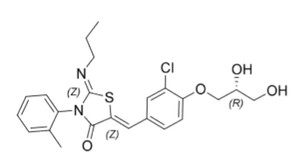
The finished product is presented as immediate release film-coated tablets containing 2 mg, 3 mg, 4 mg, 5 mg, 6 mg, 7 mg, 8 mg, 9 mg, 10 mg or 20 mg of ponesimod as active substance. The different strengths are distinguished by size, colour and debossing. The 2, 3, 4, 5, 6, 7, 8, 9 and 10 mg tablets are presented in a blister starter pack, and the 20 mg tablets are presented in a 28-tablet blister pack.
The application and the supporting data relating to the composition, development, manufacture, quality control, stability and bioavailability of the product have been assessed and checked for compliance with Australian legislation and requirements for new medicines and in accordance with pharmacopoeial standards and the technical guidelines adopted by the TGA. The EMA quality and bioavailability evaluation reports were reviewed by the TGA evaluator.
The quality evaluation found the drug substance and finished product specifications are acceptable.
The proposed shelf life of 36 months when stored below 30°C is acceptable. The storage directions direct that tablets should not be removed from blisters until use.
All Good Manufacturing Practice (GMP) clearances are valid.
The labels are acceptable. The draft PI is acceptable from a pharmaceutical chemistry perspective.
Approval for registration of the proposed product is recommended from a pharmaceutical chemistry perspective.

Nonclinical
The nonclinical pharmacology data support the use of ponesimod for the proposed indication. In vitro, ponesimod bound S1P₁ with nanomolar affinity with half maximal effective concentration (EC₅₀) value within expected clinical plasma concentrations. Ponesimod showed weaker or no binding to other S1P receptor isoforms (S1PR₂ to S1PR₅). Ponesimod was shown to induce a reduction in circulating lymphocytes in all species tested. Ponesimod showed therapeutic efficacy in a murine model of MS, experimental autoimmune encephalomyelitis. The major human metabolite M13 (and M12 as a minor metabolite) is expected to be pharmacologically inactive.
Safety pharmacology studies assessed effects on the cardiovascular, respiratory and central nervous systems. Observed transient bradyarrythmic effects (atrioventricular block, decreased heart rates) post first dose, increased blood pressure, and pulmonary effects are class effects of S1P receptor modulators. Given the intended chronic dosing with ponesimod, monitoring of pulmonary function would be advisable.
Ponesimod was not mutagenic in the bacterial mutation assay or clastogenic in vitro (in human lymphocytes) or in vivo (in the rat micronucleus test). In carcinogenicity studies, haemangiosarcoma and haemangioma were observed in mice. These tumours were also reported for other S1P₁ modulators and are possibly a species-specific effect. Ponesimod is not considered to pose a genotoxic or carcinogenic hazard in humans.
Fertility was unaffected in rats treated with ponesimod at exposure levels up to 18 and 31 times the clinical area under the concentration-time curve (AUC) in males and females, respectively. Increased post-implantation loss, decreased fetal weight and an increased incidence of skeletal and visceral malformations were seen in embryofetal development studies in rats and rabbits, without any evidence of significant maternal toxicity. The adverse embryofetal effects were observed at subclinical exposure levels. The sponsor has proposed Pregnancy Category D, which is acceptable and consistent with the nonclinical data and the previous categorisation of fingolimod, siponimod and ozanimod. A contraindication in pregnancy is supported.
Overall, the toxicology profile of ponesimod is very similar to the profiles of other S1P receptor modulators approved in Australia.
There are no nonclinical objections to the registration of ponesimod.

Clinical

Summary of clinical studies
The clinical dossier consisted of:
- 16 Phase I studies: Study AC-058-101, Study AC-058-102, Study AC-058-103, Study AC-058-104, Study AC-058-105, Study AC-058-106, Study AC-058-107, Study AC-058-108, Study AC-058-109, Study AC-058-110, Study AC-058-111, Study AC-058-112, Study AC-058-113, Study AC-058-114, Study AC-058-115 and Study AC-058-117.
The 16 Phase I studies were performed in healthy subjects, or otherwise healthy subjects with hepatic or renal impairment. Single oral doses of ponesimod ranged from 1 to 75 mg, and multiple oral doses ranged from 5 to 100 mg/day for up to 22 days.
- 2 Phase IIb study: Study AC-058B201 and Study AC-058B202
Study AC-058B201 evaluated repeated doses of 10 to 40 mg in subjects with RRMS.
- 2 Phase III study: Study AC-058B301 (also known as the OPTIMUM trial) and Study AC-058B303
Study AC-058B301 assessed a 20 mg maintenance dose (following an up-titration schedule) in subjects with RMS.

Pharmacology

Pharmacokinetics
Ponesimod is absorbed well after oral administration (absolute oral bioavailability 84%, time to reach maximum drug concentration (T_{max}) is approximately 4 hours). Maximum concentration (C_{max}) and AUC increased approximately dose proportionally in the dose range studied (1 to 75 mg). Steady state was reached in approximately 6 days, with an accumulation ratio of 2.0 to 2.6 for a daily dosing regimen. Food status did not affect the pharmacokinetics (PK) to a clinically relevant extent, so ponesimod can be taken with or without food. Bioequivalence studies in healthy subjects demonstrated the bioequivalence of different formulations and polymorphic forms of ponesimod evaluated in the clinical development program.
Ponesimod is widely distributed into tissues. The apparent volume of distribution in healthy subjects is 160 litres. Ponesimod is highly bound to plasma proteins (> 99%).
After a single oral dose, half-life of ponesimod ranged from 21.7 to 33.4 hours. Ponesimod is extensively metabolised in the liver via multiple pathways. The two main metabolites, M12 and M13, are not pharmacologically active. Ponesimod and its metabolites are excreted for the major part in faeces (57% to 80%) and for a minor part in urine (10% to 18%).
The PK of ponesimod was similar in healthy subjects and patients with MS. Age did not have a relevant effect on the PK of ponesimod (subjects < 18 years of age or > 65 years have not been evaluated).
Renal impairment did not affect the PK of ponesimod. In a single dose study in subjects with renal impairment (Study AC-058-113), ponesimod exposure did not significantly increase with the severity of renal impairment. No dose adjustment is required in patients with mild to severe renal impairment.
In a single dose study in subjects with hepatic impairment (Study AC-058-112), AUC and half-life of ponesimod were increased in subjects with hepatic impairment compared with healthy subjects. Ponesimod area under the concentration-time curve from time zero to infinity (AUC_{inf}) was increased 1.3-fold in subjects with Child-Pugh; Class A hepatic impairment, 2.0-fold for subjects with Child-Pugh Class B, and 3.1-fold for subjects with Child-Pugh Class C, compared with healthy subjects. The respective geometric mean ratios of elimination half-life were 1.5, 1.8, and 2.6, indicating reduced clearance of ponesimod. No dose adjustment is required in patients with mild hepatic impairment (Child-Pugh Class A).
Treatment with ponesimod is not recommended in patients with moderate or severe hepatic impairment (Child-Pugh Classes B or C). This is addressed in Section 4.2 of the Australian PI, in contrast to Section 4.3 of the EU Summary of Product Characteristics (SmPC), but this is consistent with the approach used for other S1P modulators registered in Australia. use in hepatic impairment should also be addressed as a precaution in Section 4.4 of the PI (see TGA guidance).
Ponesimod is a neutral, lipophilic molecule that passively permeates across cell membranes. The sponsor provided an adequate justification that no clinically relevant transporter interactions are expected. In vitro data, physiologically based pharmacokinetic simulations, and clinical drug-drug interaction studies support a low risk of PK drug interactions. Although ponesimod displays pH dependent dissolution, the Committee for Medicinal Products for Human Use (CHMP) agreed with the sponsor’s assessment that the potential drug-drug interaction risk of ponesimod with pH modulators is considered to be low and that no drug-drug interaction study with a drug that increases gastric pH is required.

Population pharmacokinetic data
The initial population pharmacokinetic (PopPK) model included data from the Phase I and II studies, and the updated model also included data from the Phase III study. The model was used to obtain estimates of PK parameters for ponesimod in patients with MS, and to investigate the potential effect of intrinsic and extrinsic factors (for example, demographic variables, different formulations, the presence of food, and the influence of disease) on ponesimod PK to evaluate the potential need for dose adjustments covariates.
The analyses found no relevant effect of age, gender, body weight, renal impairment, psoriasis, MS, food status, and formulation on the PK of ponesimod. The model predicted significantly increased exposure to ponesimod in subjects with hepatic impairment.

Pharmacodynamics
The submission included pharmacodynamic (PD) data on cardiac effects from four PK studies, and PD and PK/PD data from the Phase II dose finding study (Study AC-058B201) and the pivotal Phase III study (Study AC-058B301). PopPK/PD analyses were performed to investigate effects on peripheral lymphocytes counts, heart rate and corrected QT interval (QTc).¹⁴ Exposure response modelling based on data from the dose response Study AC-058B201 and Phase III Study AC-058B301 was also performed.
Ponesimod induced a dose related decrease in lymphocytes levels in the blood. These effects were confirmed in Studies AC-058B201 and AC-058B301 in patients with RMS, where a rapid decline in peripheral lymphocyte counts was observed, which remained thereafter stable until treatment withdrawal. Observed maximal reduction at 20 mg/day was 74%. The maximum predicted reduction in total lymphocytes in the PK/PD model was 87%. Lymphocyte counts returned close to baseline values within one month after stopping treatment. For the majority of subjects, lymphocyte counts returned to normal within 2 weeks.
Exposure response modelling on data from Study AC-058B201 demonstrated a clear exposure response relationship in terms of gadolinium enhancing (Gd+) lesions, with only a small additional benefit from doses higher than 20 mg. The modelling predicted an additional approximately 10% decrease in annualised relapse rate (ARR) with the 40 mg dose compared to 20 mg; however, based on the dose response relationship in adverse events (AEs), the additional benefit in ARR was not considered sufficient to justify the 40 mg dose. Exposure response modelling based on data from Study AC-058B301 suggested a clear exposure response in terms of combined unique active lesions (CUALs) within the exposure range observed for 20 mg maintenance dose of ponesimod.

Cardiac effects
Bradycardia and atrioventricular block are known secondary pharmacological effects of S1P modulators. Ponesimod induces a transient, dose dependent decrease in heart rate, which is more prominent on the first day of ponesimod dosing. The negative chronotropic effect disappears due to S1P₁ internalisation in cardiomyocytes induced by initial doses of ponesimod, resulting in tolerance.
To mitigate this risk, the sponsor investigated up-titration regimens in Study AC-058-115, and a PopPK/PD model was also used to substantiate the proposed up-titration regimen.
Study AC-058-115 was a double blind, randomised, placebo controlled, 2-way crossover study comparing two up-titration regimens: one starting at a 2 mg dose (Regimen A) and one starting at 10 mg (Regimen B). Thirty-two healthy subjects were randomised to active and placebo in a 3:1 ratio. The first dose of ponesimod (Day 2) resulted in a transient decrease in mean hourly heart rate from Baseline. The maximum mean decreases as assessed by Holter and 12-lead electrocardiogram was greater with Regimen B (12 beats per minute (bpm) and 13 bpm, respectively) than with Regimen A (6 bpm and 9 bpm, respectively) and placebo (0 bpm and 4 bpm, respectively). These maximum mean decreases occurred 2 to 3 hours post-dose and mean hourly heart rate had returned to pre-dose values by 4 to 5 hours post-dose. No further post-dose decrease in mean hourly heart rate was observed on Day 3 and later study days with either regimen. The proportion of subjects who experienced an atrioventricular block (defined as PR interval > 210 ms) was 25% for all treatment groups. However, the total number of occurrences of any atrioventricular block was largest during Regimen B (143) followed by Regimen A (79) and placebo (33). The up-titration regimen starting at 2 mg showed a more favourable safety profile with respect to heart rate than up-titration starting at 10 mg.
Studies evaluating the effect of concomitant administration of ponesimod and a beta-blocker confirmed an additive reduction of heart rate with concomitant treatment. Study AC-058-117 supported that a beta-blocker can be safely administered to a patient treated with the proposed dose of ponesimod.
A PopPK/PD model was developed to describe the effect of ponesimod on heart rate, and to support the up-titration regimen. The simulations showed that the maximal reduction of the heart rate was approximately 2 hours post first dose and normalised within 6 hours. The model showed that gradual up-titration was able to mitigate the risk of bradycardia, and that 2 mg was the preferred initial dose. With the exception of baseline heart rate, no clinically relevant effects of other covariates (age, sex, race, and body size) on ponesimod effects on heart rate were identified.
Simulation results also indicated that after treatment discontinuation lasting up to 3 days either during up-titration or at maintenance dosing, ponesimod dosing could be resumed without the need of reinitiating the up-titration, while if treatment is discontinued for 4 or more days, ponesimod up-titration should be reinitiated from the starting dose of 2 mg to minimise the heart rate effects.
In a thorough QT study (Study AC-058-110), treatment with multiple dose ponesimod at 40 mg and 100 mg (2- and 5-fold higher than the proposed maintenance dose) at steady state in healthy subjects resulted in mild prolongation of individually corrected QT interval (QTcI) with a mean peak effect on change in QTcI (ΔΔQTcI) of 6.9 ms (upper bound of 90% 2-sided confidence interval (CI): 11.3 ms) with 40 mg ponesimod, and 9.1 ms (upper bound of 90% CIs: 14.0 ms) with 100 mg ponesimod. Graphical exploration of the data indicated a lack of delayed effects. There was no consistent signal of increased incidence of QTcI outliers associated with ponesimod treatment, either as absolute values (QTcI > 480 ms) or change (QTcI increase > 60 ms) from Baseline. All incidences of QT prolongation reported during the study were considered not to be clinically significant.

Pulmonary effects
Ponesimod, administered at 20 mg daily dose in the Phase III Study AC-058B301, led to an exposure dependent reduction of forced expiratory volume in one second (FEV₁), mostly occurring in the first month after treatment initiation.

Efficacy
The efficacy of ponesimod in the proposed indication is based primarily on the Phase III Study AC-058B301, supported by the Phase II Study AC-058B201 (see Table 3 below). Interim data from ongoing long-term extensions of both studies were also presented.
Table 3: Summary of Ponesimod Phase II and Phase III studies
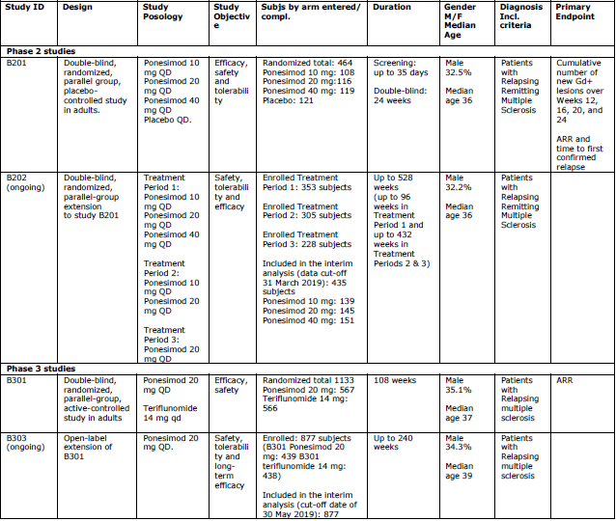
Abbreviations: ARR = annualised relapse rate; F = female; Gd+ = gadolinium enhancing; ID = identification; M = male; QD = once daily.

Study AC-058B201
Study AC-058B201 was a Phase II, prospective, multicentre, randomised, double blind, placebo controlled, parallel group, dose finding study evaluating the efficacy, safety and tolerability of 3 doses of ponesimod (10 mg, 20 mg, or 40 mg) administered for 24 weeks in subjects with RRMS.
Figure 2: Study AC-058B201 Study design
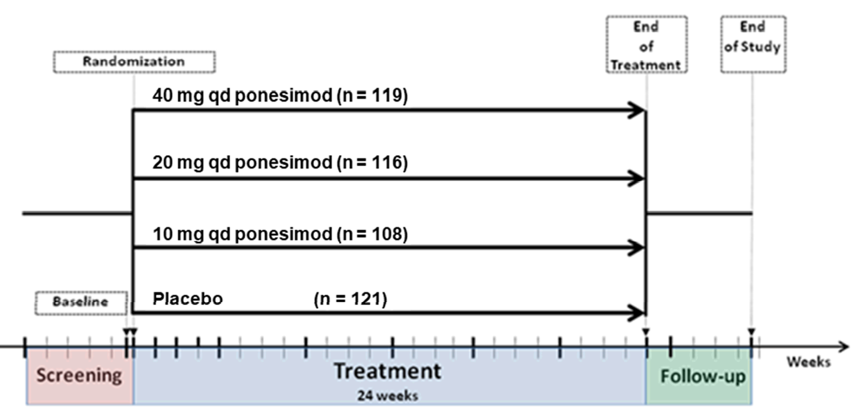
Abbreviations: n = number of subjects in group; qd = once daily.
Study AC-058B201 is a Phase IIb multicentre, double blind, randomised, 4-arm, parallel group, dose finding, placebo controlled superiority study to evaluate efficacy, safety, and tolerability of ponesimod in subjects with relapsing remitting multiple sclerosis.
Pre-randomisation period included screening and baseline visits.
At the start of treatment period, 464 subjects were randomised in a 1:1:1:1 ratio to treatment with 10 mg, 20 mg, or 40 mg ponesimod or placebo for 24 weeks.
Post-treatment period and end of study started on Day 169 (the day after the last intake of study drug) or earlier in the case of premature discontinuation of study drug and ended with an end of study visit.
The study included patients aged 18 to 55 years with RRMS. Patients were required to have documented relapses (at least one within 12 months prior to screening or at least 2 within 24 months prior to screening) or with at least one Gd+ lesion detected on T1-weighted magnetic resonance imaging (MRI) (central reading) at screening. In addition, patients were to be in a stable clinical condition and ambulatory, and with an Expanded Disability Status Scale (EDSS) score of 0 to 5.5 (inclusive) at screening. Both treatment naïve and patients previously treated with interferon beta-1a, interferon beta-1b, glatiramer acetate, or natalizumab, were eligible to enrol in the study.
Four hundred and sixty-four (464) subjects were randomised in a 1:1:1:1 ratio to treatment with 10 mg, 20 mg, or 40 mg ponesimod or placebo for 24 weeks. Study medication was administered orally, with a starting dose of 10 mg once daily in all ponesimod arms and with up-titration (or mock up-titration) to 20 mg and 40 mg on Days 8 and 15, respectively. The majority of patients were women (67.5%), < 40 years old (66.8%), and White (96.4%).
The primary efficacy endpoint was the cumulative number of new Gd+ lesions per patient on T1-weighted MRI scans from Weeks 12 to 24. Based on the EMA/CHMP guideline, a MRI outcome is acceptable as a primary endpoint for a dose finding study.
Secondary efficacy endpoints were: ARR for confirmed relapses within 24 weeks of study drug initiation; and time to first confirmed relapse within 24 weeks of study drug initiation.
Outcomes for the primary endpoint are shown in Table 4 below. All of the ponesimod groups demonstrated a statistically significant difference compared to placebo. The treatment effect appeared to be greater in the 20 mg arm compared to the 10 mg arm, and the 40 mg arm did not show an additional benefit over the 20 mg arm. Dose response modelling suggested that the effect of ponesimod plateaus after 20 mg.
Table 4: Study AC-058B201 Cumulative number of new T1 gadolinium enhancing lesions (magnetic resonance imaging) from Weeks 12 to 24 (imputation rule applied) (negative binomial regression analysis, per-protocol set)
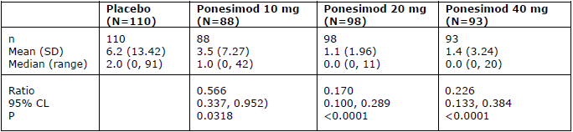
Abbreviations: CL = confidence limit; N = number of subjects; n = number of subjects in group; P = p-value; SD = standard deviation.
Annualised relapse rates (ARR) trended lower in the ponesimod groups compared to placebo (see Table 5 below), with only the 40 mg arm achieving nominal statistical significance. The study was not powered to show a significant effect on ARR, and the duration of the study was not sufficient to provide a reliable assessment of ARR. Outcomes for time to first confirmed relapse are shown in Figure 3 below.
Table 5: Study AC-058B201 Annualised relapse rate up to Week 24 (confirmed relapses) (negative binomial regression, all treated set)
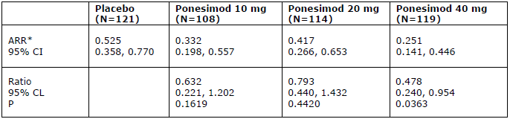
Abbreviations: ARR = annualised relapse rate; CI = confidence interval; CL = confidence limit; N = number of subjects; P = p-value.
* Negative binomial regression model
Figure 3: Study AC-058B201 Kaplan-Meier plot for time to first confirmed relapse (all treated set)
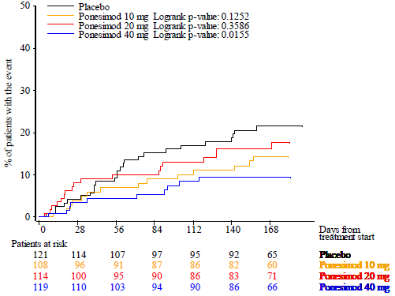

Study AC-058B202 (extension study)
This is an ongoing, multicentre, randomised, double blind, multiple doses, uncontrolled, parallel group extension study in subjects with RRMS who completed Study AC-058B201. The extension study included a transition period, 3 treatment periods (Treatment Periods 1, 2, and 3), and a post-treatment follow-up period (Figure 4). Treatment Periods 1 and 2 (blinded) were completed and Treatment Period 3 (open label) was ongoing. Study data were presented up to the interim data cut-off date 31 March 2019.
Figure 4: Pooled Studies AC-058B201 and AC-058B202 Study design
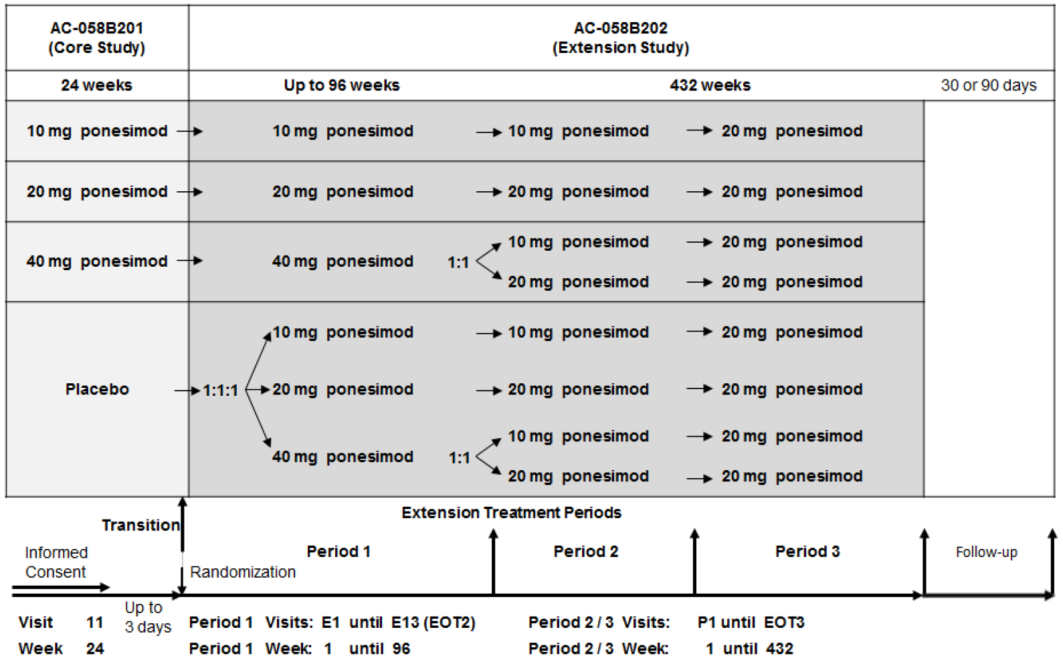
Abbreviation: EOT = end of treatment.
Three analysis periods were defined:
- Analysis Period 1: analysis of ponesimod treatment over the combined Study AC-058B201 period and Treatment Period 1 to explore the dose response relationship of 10, 20, and 40 mg ponesimod on efficacy and safety.
- Analysis Period 2: analysis of ponesimod treatment over the combined Study AC-058B201 period, Treatment Period 1 and 2 to explore the dose response relationship of 10 and 20 mg ponesimod on efficacy and safety over a longer time period, to confirm the recommendation to discontinue the 10 mg dose in Treatment Period 3.
- Analysis Period 3: analysis of ponesimod treatment over the combined Study AC-058B201 period / Treatment Period 1, 2 and 3 to investigate the long-term safety and efficacy of ponesimod.
Table 6: Pooled Studies AC-058B201 and AC-058B202 Summary of efficacy (ponesimod analysis set)
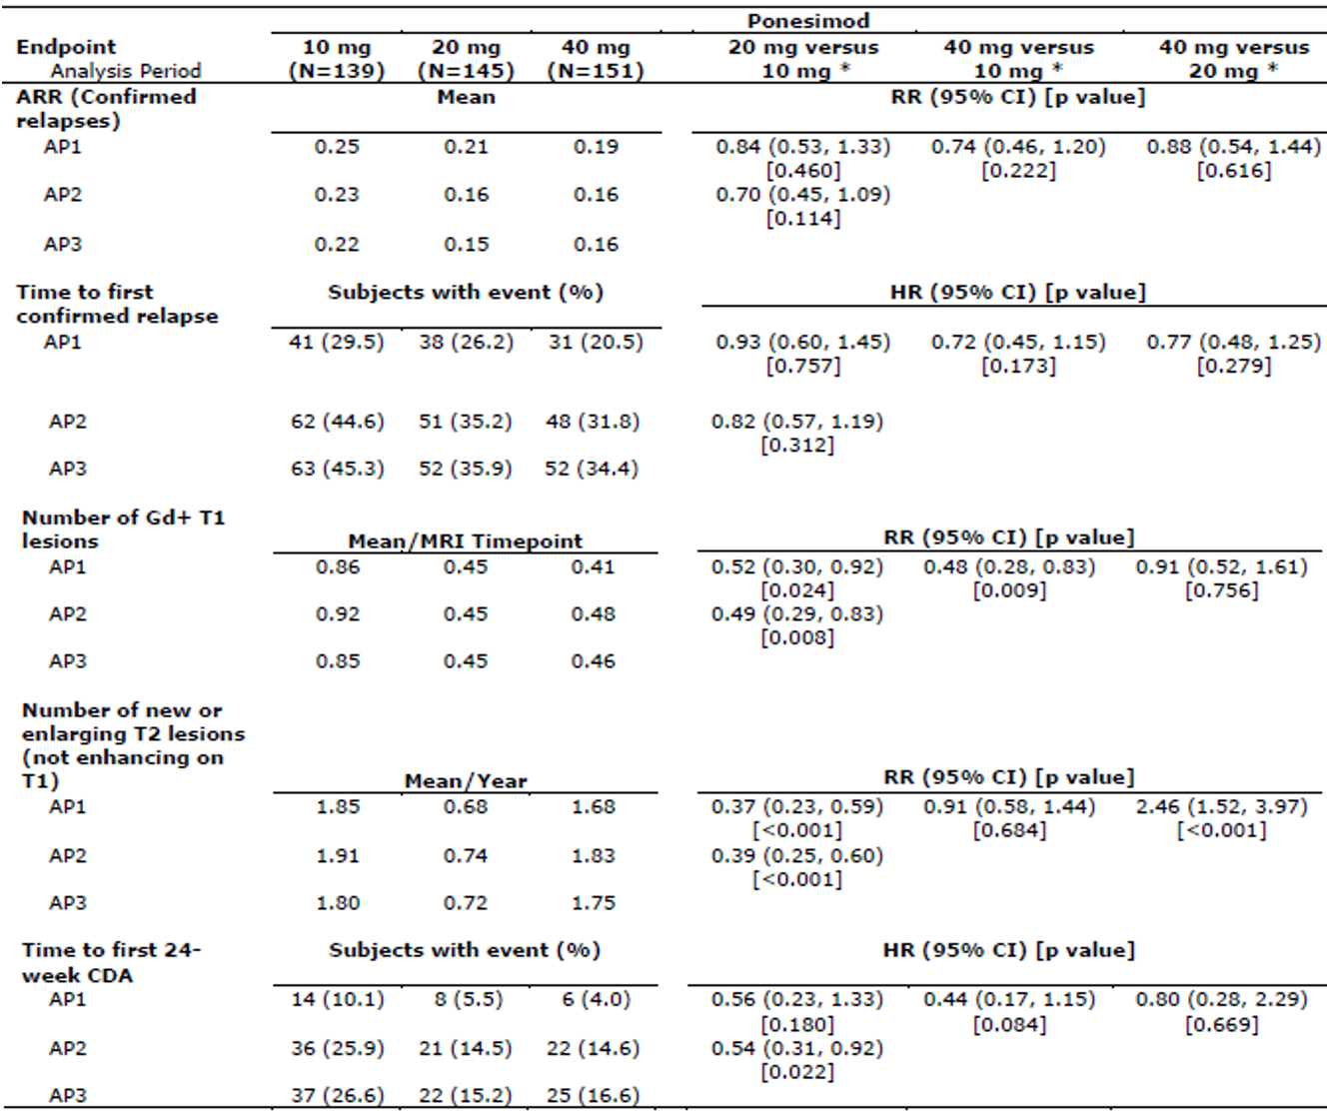
Abbreviations: AP = analysis period; ARR = annualised relapse period; CDA = confirmed disability accumulation; CI = confidence interval; Gd+ = gadolinium-enhancing; HR= hazard ratio; MRI = magnetic resonance imaging; N= number of subjects; RR= rate ratio.
AP1: from ponesimod Baseline to end of Extension Treatment Period 1; AP2: from ponesimod Baseline to end of Extension Treatment Period 2; AP3: from ponesimod Baseline to Extension Treatment Period 3 (up to data cut-off date).
* Effect size estimates are only provided between doses where there was no dose-switching during the period.
Assessment of dose response over longer term treatment focussed on Analysis Period 1 (that is, up to Week 96, before any dose switches occurred). A dose response effect was observed for relapses and disability progression.
The 20 mg dose was selected for evaluation in the pivotal Phase III study based on efficacy and safety findings from the Phase II studies.

Study AC-058B301 (the OPTIMUM trial)
Study AC-058B301 was a Phase III, multicentre, randomised, double blind, parallel group, active controlled, superiority study to compare the efficacy and safety of ponesimod to teriflunomide in subjects with RMS. The primary objective was to determine whether ponesimod is more efficacious than teriflunomide in terms of reducing relapses in subjects with RMS. Secondary objectives were to assess the effect of ponesimod on disability accumulation and on other aspects of MS disease control, and to assess the safety and tolerability of ponesimod in subjects with RMS.
The study included female and male subjects aged 18 to 55 years with a diagnosis of RMS (that is, RRMS, or SPMS with superimposed relapses). Subjects had to have experienced one or more documented MS attacks with onset 1 to 12 months prior to baseline EDSS assessment, or two or more documented MS attacks with onset 1 to 24 months prior to baseline EDSS assessment, or had one or more Gd+ lesions of the brain on MRI within 6 months prior to baseline EDSS assessment. Subjects could be treatment naïve or previously treated with interferon beta-1a, interferon beta-1b, glatiramer acetate, natalizumab, or dimethyl fumarate. Subjects were ambulatory with an EDSS score 0 to 5.5 at screening and Baseline. Subjects with PPMS or PRMS were excluded.
Subjects were randomised 1:1 to treatment with ponesimod (20 mg orally once daily following a 14-day up-titration schedule starting at 2 mg) or teriflunomide (14 mg orally once daily). To accelerate the reduction of teriflunomide plasma concentrations at the end of double blind treatment, all subjects underwent an accelerated teriflunomide elimination procedure at end-of-treatment, using either cholestyramine or activated charcoal. Due to blinding, all subjects, including those who had received ponesimod 20 mg treatment, underwent this procedure.
Figure 5: Study AC-058B301 Study design
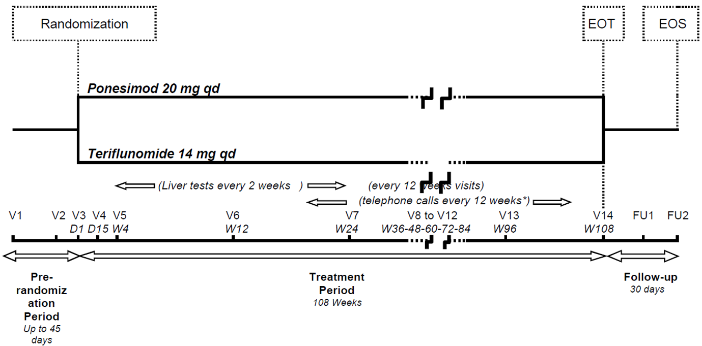
Abbreviations: D = Day; EOS = end of study; EOT = end of treatment; FU = follow-up; o.d. = once daily; V = Visit; W =Week.
* Telephone calls in between Visit 6 and Visit 14 (at Weeks 18, 30, 42, 54, 66, 78, 90 and 102)
The primary efficacy endpoint was ARR up to end-of-study. A relapse was defined as new, worsening or recurrent neurological symptoms that occurred at least 30 days after the onset of a preceding relapse, and that lasted at least 24 hours, in the absence of fever or infection.
The secondary efficacy outcomes were:
- change from Baseline to Week 108 in fatigue related symptoms as measured by the symptoms domain of the Fatigue Symptom and Impact Questionnaire (FSIQ)-RMS;
- combined unique active lesions (CUALs), defined as new gadolinium-positive T1 lesions plus new or enlarging T2 lesions from Baseline to Week 108;
- Time to 12-week confirmed disability accumulation (CDA) from Baseline to end of-study;
- Time to 24-week CDA from Baseline to end-of-study.
Fatigue Symptom and Impact Questionnaire (FSIQ)-RMS is a patient reported outcomes; questionnaire developed by the sponsor to evaluate fatigue related symptoms and the impacts of those symptoms on the lives of patients with RMS. An increase in FSIQ-RMS from Baseline indicates worsening in fatigue symptoms. The development and validation of FISQ-RMS as presented in this application was considered acceptable, but FISQ-RMS has not previously been used as a clinical study endpoint, so there is uncertainty regarding a clinically relevant change in this measure.
The hierarchy of secondary endpoints was not directly aligned to the study objectives. The key secondary endpoint was fatigue as measured by the symptoms domain of the FSIQ-RMS, rather than disability progression. Although fatigue is considered a relevant endpoint, disability progression is considered more important for assessment of efficacy. Based on the EMA/CHMP guideline,²¹ disability progression should be the key secondary endpoint when ARR is the primary endpoint. The testing hierarchy was discussed in CHMP Scientific Advice, where the sponsor was advised to place disability progression first after the primary endpoint. The CHMP advice also stated that the 24-week CDA is considered more important than the 12-week CDA, however it was acknowledged that success in the 24-week CDA would be less likely than in the 12-week CDA. CHMP Scientific Advice also addressed important considerations for an application based on a single pivotal study, including the level of significance, the need for internal consistency (similar effects in sub-populations), and high trial quality.
One thousand one hundred and thirty-three (1,133) subjects were randomised, 567 to ponesimod (565 treated), and 566 to teriflunomide. Demographic and disease characteristics were reasonably balanced between the treatment groups. Overall, 64.9% of subjects were female, 97.4% were White, and the mean age was 37 years (range 18 to 55 years). 97.4% of subjects had RRMS and 2.6% had SPMS. Mean baseline EDSS score was 2.6, median time since the most recent relapse was 4.27 months, and 42.6% had at least one Gd+ T1 lesion at Baseline. 35% of subjects were considered to have highly active disease at Baseline.
The primary statistical analysis was performed up to end-of-study on the full analysis set using a negative binomial regression model for confirmed relapses. An alpha level of 0.01 was used for conclusive evidence because the application is reliant on a single pivotal study.
For the primary endpoint, mean ARR (number of confirmed relapses per year) up to end-of-study was 0.202 in the ponesimod 20 mg group and 0.290 in the teriflunomide 14 mg group (see Table 7 below). ARR was 30.5% lower with ponesimod 20 mg compared to teriflunomide 14 mg (rate ratio 0.695; 99% CI: 0.536, 0.902; p = 0.0003). Sensitivity analyses were supportive of the primary analysis.
The EMA’s evaluation of secondary endpoints followed the testing hierarchy specified in the CHMP guideline (that is, disability progression assessed as the key secondary endpoint following the primary endpoint ARR).²¹
A 12-week CDA was observed in 10.1% and 12.4% of subjects in the ponesimod 20 mg and teriflunomide 14 mg groups, respectively. The risk for a 12-week CDA event was estimated to be 17% lower with ponesimod 20 mg compared to teriflunomide 14 mg, but the difference was not statistically significant (heart rate 0.83, 95% CI: 0.58, 1.18; p = 0.2939). Consequently, the formal testing procedure was stopped, and all subsequent endpoints were assessed as exploratory. A 24-week CDA was observed in 8.1% and 9.9% of subjects in the ponesimod 20 mg and teriflunomide 14 mg groups, respectively. The risk for a 24-week CDA event was estimated to be 16% lower for ponesimod 20 mg compared to teriflunomide 14 mg (heart rate 0.84, 95% CI: 0.57, 1.24; p = 0.3720).
Table 7: Study AC-058B301 Confirmed relapses up to end-of-study - annualised relapse rate from negative binomial regression (full analysis set)
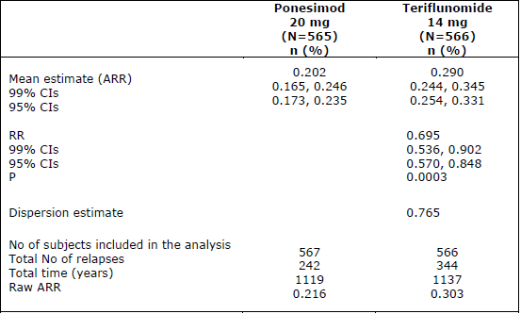
Abbreviations: ARR = annualised relapse rate; CI = confidence interval; N = number of subjects; n = number of subjects in group; P = p-value; RR = rate ratio.
The change from Baseline to Week 108 in fatigue related symptoms as measured by the symptoms domain of the FSIQ-RMS was lower in the ponesimod group compared to teriflunomide (Table 8 below). The FSIQ-RMS weekly symptoms score remained stable in the ponesimod group while the score increased in the teriflunomide group (Figure 6). Clinically meaningful change in the FSIQ-RMS was not pre-specified in the study protocol. Using data from this study, the sponsor performed a psychometric analysis for defining a clinically meaningful change in the FSIQ-RMS. This was done by anchoring the Patient Global Impression of Severity (PGI-S) score to the FSIQ-RMS score. For patients who reported a 3-category improvement on the PGI-S, considered a clinically meaningful improvement, the mean change on the FSIQ-RMS was -6.3. Based on this analysis, a clinically relevant improvement in fatigue related symptoms, as measured by the mean change in FSIQ-RMS, was not demonstrated. The sponsor performed post-hoc responder analyses to assess responses in fatigue related symptoms at an individual level. The evaluation considered these analyses but concluded that a clinically meaningful improvement in fatigue related symptoms has not been demonstrated and that the FSIQ-RMS findings should not be presented in Section 5.1 of the European SmPC.
Ponesimod reduced the number of CUALs on brain MRI from Baseline to Week 108 by 56% compared to teriflunomide (see Table 9 below). The mean number of CUALs on MRI per year was 1.405 for ponesimod 20 mg and 3.164 for teriflunomide 14 mg. Exploratory endpoints are summarised in Table 10 below.
Table 8: Study AC-058B301 Fatigue symptom and impact questionnaire-Relapsing Multiple Sclerosis Weekly Symptoms Score, change from Baseline to Week 108 (mixed effect model repeated measures)
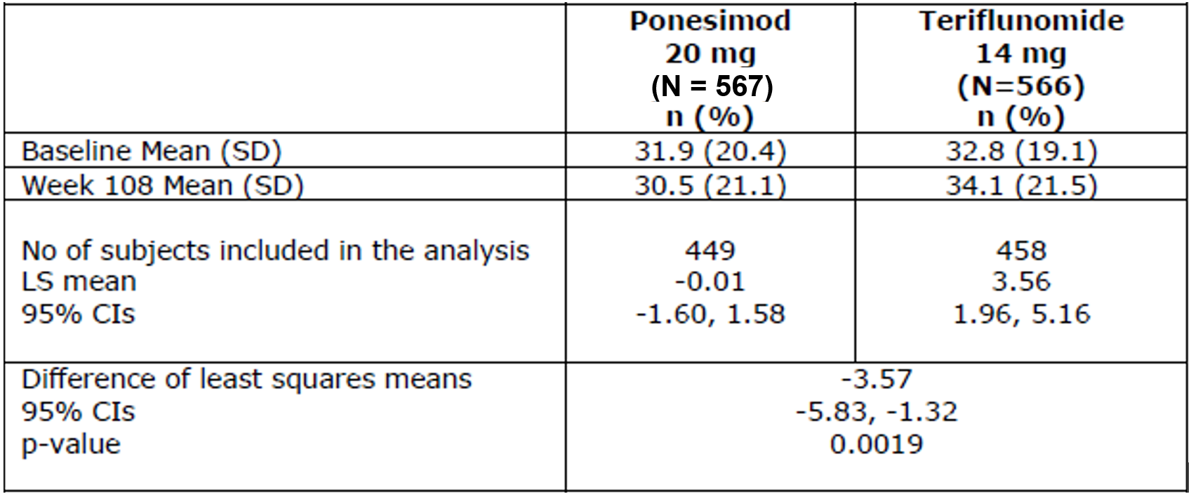
Abbreviations: CI = confidence interval; LS = least square; N = number of subjects; n = number of subjects in group; SD = standard deviation.
A negative change from Baseline indicates an improvement in fatigue symptoms.

Figure 6: Study AC-058B301 Fatigue Symptom and Impact Questionnaire-Relapsing Multiple Sclerosis Weekly Symptoms Score: mean (95% confidence intervals) change from Baseline up to Week 108 by visit - mixed effect model repeated measures (main analysis; full analysis set)
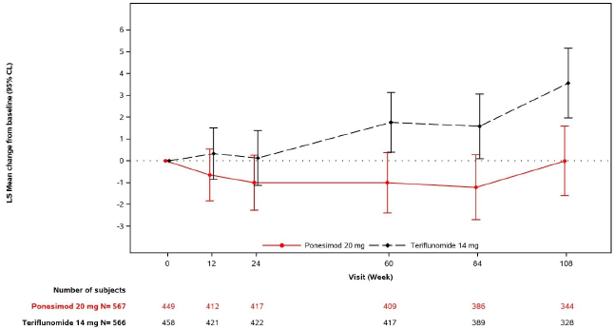
Abbreviations: CL = confidence limit; LS = least square; N = number of subjects.
Table 9: Study AC-058B301 Cumulative number of combined unique active lesions from Baseline to Week 108 - negative binomial regression of lesions per year
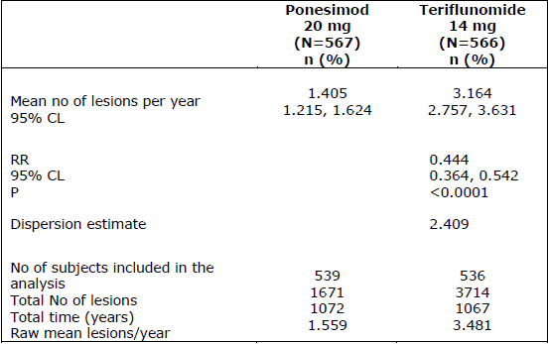
Abbreviations: CL = confidence limit; N = number of subjects; n = number of subjects in group; P = p-value; RR = rate ratio.
Table 10: Study AC-058B301 Summary of exploratory endpoints
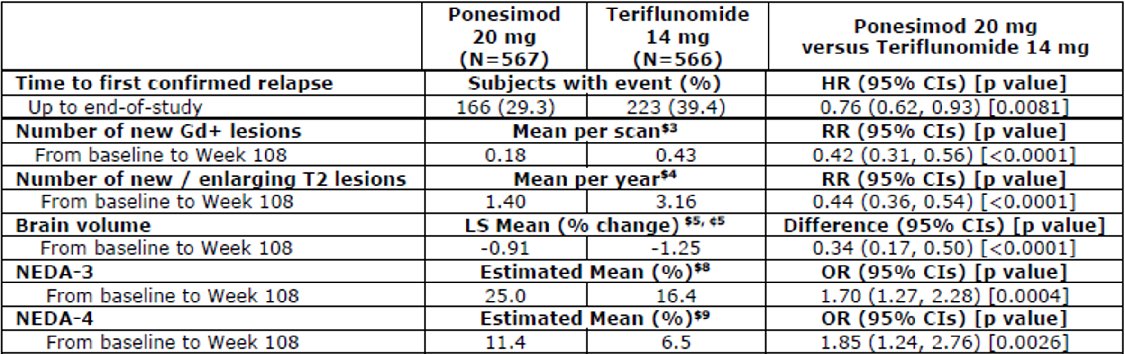
Abbreviations: CI = confidence interval; Gd+ = gadolinium-enhancing; HR = hazard ratio; LS = least square; N= number of subjects; NEDA = no evidence of disease activity; OR = add ratio; RR = rate ratio.
N (included in analysis) of ponesimod and teriflunomide: $3 (540 and 538), $4 (539 and 536), $5 (436 and 434), $8 (564 and 568), and $9 (526 and 532).
N (subjects with Week 108 result) for ponesimod and teriflunomide for mixed model for repeated measures (MMRM)/mixed model analysis: ₵5 (376 and 368).

Study AC-058B303 (extension study)
Study AC-058B303 is an ongoing, open label, non-comparative, long-term extension study following on from Study AC-058B301, to investigate the long-term safety, tolerability, and disease control with ponesimod 20 mg in subjects with RMS. Subjects who had completed the double blind treatment period until Week 108 in Study AC-058B301 were eligible to enrol into the extension study after completing the safety follow-up period, including the teriflunomide accelerated elimination procedure.
The planned treatment period was 240 weeks, and included a 14-day up-titration period followed by maintenance treatment of ponesimod 20 mg once daily. Three analysis sets were defined: combined analysis period (Study AC-058B301 plus Study AC-058B303), Extension analysis period (subjects who received at least one dose of ponesimod 20 mg in the extension study), and core analysis period (core analysis period for the 877 subjects who entered the extension study).
Of the 1,133 subjects randomised in Study AC-058B301, 877 (77.4%) subjects (439 on ponesimod 20 mg and 438 on teriflunomide 14 mg) were enrolled in the extension study. 6.4% of subjects (5.5% in ponesimod 20 mg/ponesimod 20 mg and 7.3% in teriflunomide 14 mg/ponesimod 20 mg) prematurely discontinued treatment during the extension study. 2.3% of subjects discontinued due to AEs (1.8% in ponesimod 20 mg/ponesimod 20 mg and 2.7% in teriflunomide 14 mg/ponesimod 20 mg), and 1.0% of subjects (0.7% in ponesimod 20 mg/ponesimod 20 mg and 1.4% in teriflunomide 14 mg/ponesimod 20 mg) discontinued due to lack of efficacy.
The evaluation assessed interim data up to 31 March 2019. All efficacy analyses were exploratory (see Table 11 below).
Table 11: Study AC-058B303 Summary of efficacy results
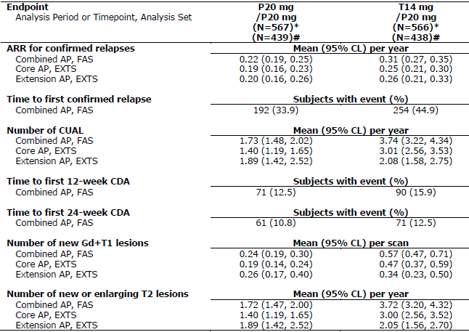
Abbreviations: AP = analysis period; ARR = annualised relapse rate; CDA = confirmed disability accumulation; CL = confidence limit; CUAL = combined unique active lesion; EXTS = extension set; FAS = full analysis set; Gd+ = gadolinium enhancing; P20 mg = ponesimod 20 mg; RR = rate ratio; T14 mg = teriflunomide 14 mg.
Combined AP: from core Baseline up to extension Week 48, core AP: from core Baseline up to core Week 108, extension AP: from extension Baseline up to extension Week 48.
Ponesimod 20 mg/ponesimod 20 mg refers to subjects who were randomised to the ponesimod 20 mg group in Study AC-058B301and were to continue receiving ponesimod 20 mg in the extension study; teriflunomide 14 mg/ponesimod 20 mg group refers to subjects who were randomised to teriflunomide 14 mg in Study AC-058B301 and were to receive ponesimod 20 mg in the extension study.
* For FAS, N = 567 and 566; # for EXTS, N = 439 and 438.

Safety

Exposure
As of the data cut-off dates, the safety dataset included 2,205 subjects exposed to ponesimod, including 1,438 subjects exposed to ponesimod in the multiple sclerosis clinical program. In the Phase I program, 462 subjects were exposed to single doses of ponesimod (up to 75 mg) or multiple doses of ponesimod up to 100 mg for up to 22 days. In the Phase II program, 435 subjects with MS were exposed to ponesimod (10 mg, 20 mg, or 40 mg) for up to 9 years and 304 subjects with chronic plaque psoriasis were exposed to ponesimod (20 or 40 mg) for up to 7 months. In the Phase III program, 565 subjects were exposed to ponesimod 20 mg for up to 2 years in Study AC-058B301, and 877 subjects were exposed to ponesimod 20 mg in the long-term extension Study AC-058B303, with 439 subjects newly exposed to ponesimod 20 mg following previous teriflunomide treatment in Study AC-058B301.

Pooled populations
Safety data from the Phase II and Phase III studies in MS patients were pooled in 3 different analysis periods: a 6-month pool to compare the short-term safety of ponesimod (10 mg, 20 mg, and 40 mg) with placebo and teriflunomide; a 2-year pool to compare the medium term safety of ponesimod (10 mg, 20 mg, and 40 mg) versus teriflunomide; and a long-term pool to characterise the long-term safety of ponesimod (see Table 12 below). In addition to the pooled safety analyses, the submission presented safety data of Studies AC-058B201 and AC-058B301 separately to inform the safety assessment of the first dose effect and the up-titration regimens, and the safety of ponesimod compared to the active comparator teriflunomide (Study AC-058B301), and placebo (Study AC-058B201).
Table 12: Summary of composition of safety data pools
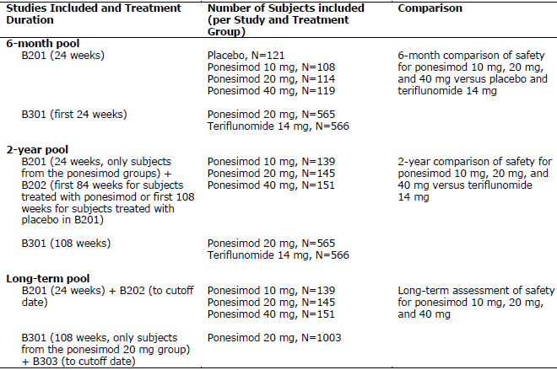
Abbreviation: N = number of subjects.

Treatment-emergent adverse events
Table 13: Overview of treatment-emergent adverse events (frequency) (6-month pool, 2-year pool and long-term pool analysis set)
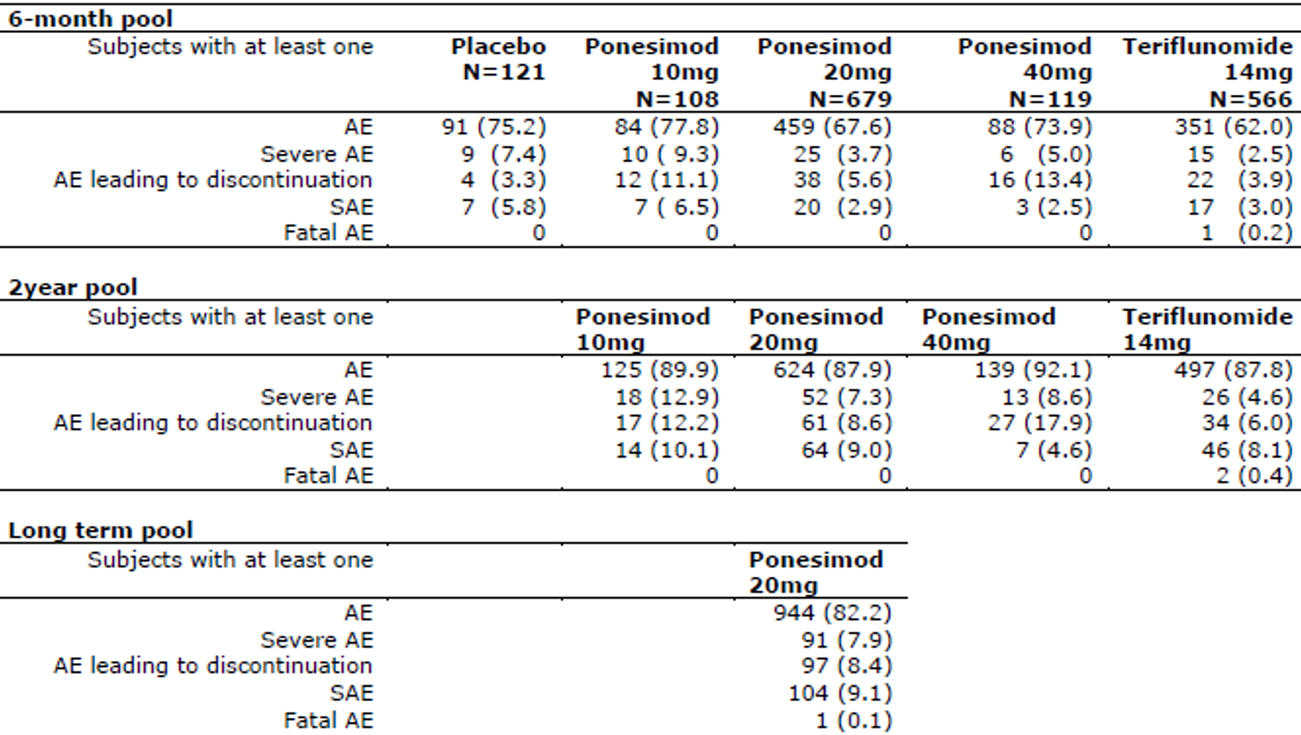
Abbreviations: AE = adverse event; N = number of subjects; SAE = serious adverse event.
Subjects in 6-month and 2-year pool are summarised under their first randomised treatment group.
In the pivotal study, Study AC-058B301, the overall frequency of treatment-emergent adverse events (TEAEs) was comparable between ponesimod 20 mg and teriflunomide 14 mg (see Table 14 below). Higher frequencies of TEAEs (> 2% difference) for ponesimod were reported for the following System Organ Classes (SOCs): investigations, nervous system disorders, musculoskeletal and connective tissue disorders, respiratory, thoracic and mediastinal disorders, and surgical and medical procedures. The most commonly reported TEAEs by Preferred Term (PT) (≥ 5% of subjects in any treatment group) are shown in Table 15 below. TEAEs reported with a higher frequency in the ponesimod group are known class effects of S1P modulators.
Table 14: Study AC-058B301 Treatment-emergent adverse events by primary System Organ Class (safety set)
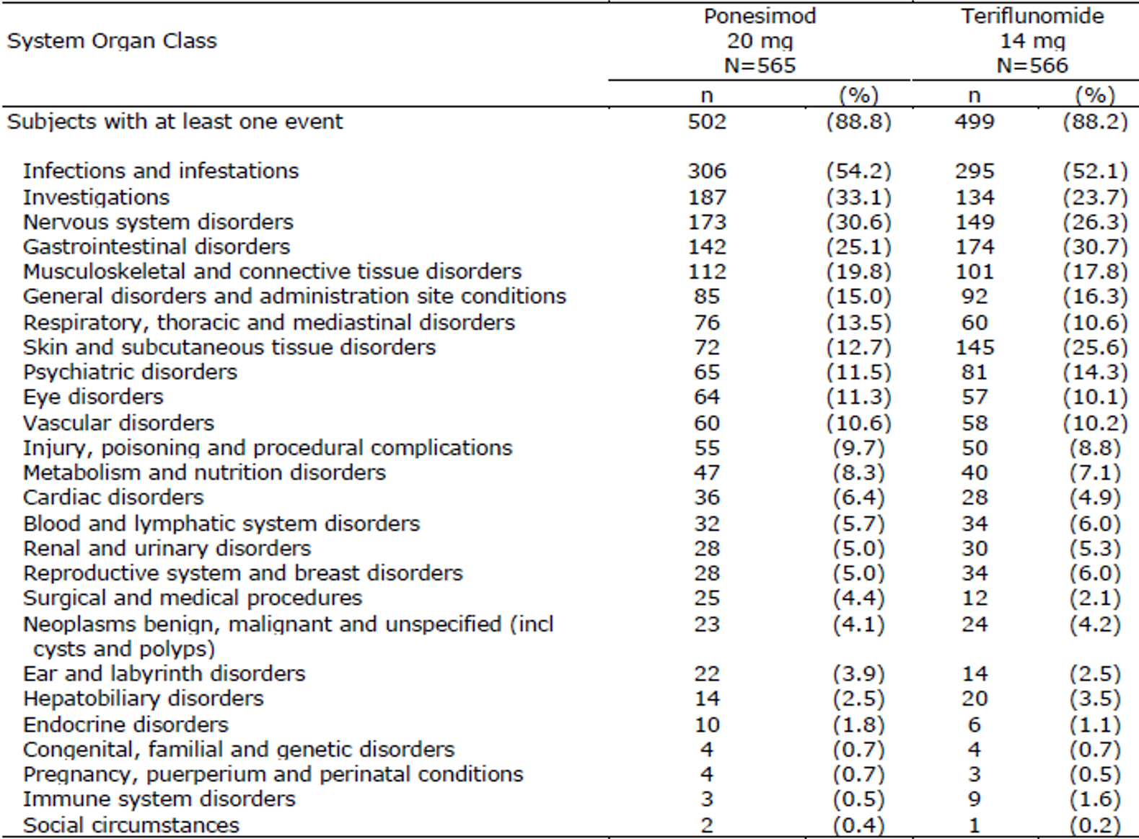
Abbreviations: N = number of subjects; n= number of subjected in group.
System Organ Classes (SOC) are based on Medical Dictionary for Regulatory Activities (MedDRA) version 21.0. SOC and sorted by descending order by frequency in the ponesimod 20 mg arm.
Table 15: Study AC-058B301 Treatment-emergent adverse events occurring in at least 5% of subjects in any treatment group by Preferred Term (safety set)
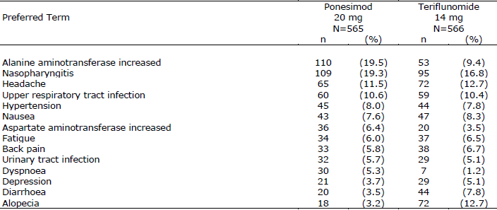
Abbreviations: N = number of subjects; n= number of subjected in group.
In Study AC-058B301, the most commonly reported serious adverse events (SAEs) by SOC in both treatment groups were nervous system disorders (1.6% ponesimod 20 mg versus 1.1% teriflunomide 14 mg) and infections and infestations (1.2% ponesimod 20 mg versus 0.7% teriflunomide 14 mg). SAEs occurring in > 2 subjects were appendicitis (n = 3 (0.5%) in ponesimod 20 mg group versus zero in teriflunomide group), abdominal pain (n = 3 (0.5%) in 20 mg ponesimod group versus zero in teriflunomide group) and cholelithiasis (n = 3 (0.5%) in teriflunomide 14 mg group versus zero in ponesimod 20 mg group).
In Study AC-058B301, TEAEs leading to premature discontinuation of study treatment were reported in a higher proportion of subjects in the ponesimod 20 mg group (8.7%) than the teriflunomide 14 mg group (6.0%), with the difference mostly due to dyspnoea and macular oedema.
Three deaths have been reported in Phase II and Phase III MS studies, one in the ponesimod 20 mg group and 2 in the teriflunomide 14 mg group. The death in the ponesimod group involved a 52-year old male subject who died suddenly approximately 6 years after the first dose of ponesimod 20 mg. The event was adjudicated as sudden cardiac death in a patient with multiple cardiovascular risk factors (hypertension, dyslipidaemia, and smoking) and a history of peripheral vascular disease and vascular surgery. 2 deaths were reported in non-MS studies. None of the AEs leading to death in any of the studies was assessed by the investigator as related to study treatment. No new deaths were reported in the updated safety report with the cut-off date March 2020.
Safety topics of special interest for ponesimod include effects on the immune system (lymphocyte count, infections and malignancies), first dose effects on heart rate and atrioventricular conduction, increase in blood pressure, QT, hepatic effects, pulmonary effects, macular oedema, and neurological events including seizures.

Immune system effects

Effect on peripheral lymphocyte count
Ponesimod treatment resulted in a rapid decrease in the estimated mean peripheral blood lymphocyte count from Baseline to Week 4 (reduced by 59% in ponesimod 20 mg group), which remained relatively stable through Week 468 (Figure 7). In Study AC-058B301, the mean percent reduction in lymphocyte count from Baseline was 59% at Week 4 and 61% at the last on-treatment timepoint (see Figure 8 below). The reduction in blood lymphocyte count was rapidly reversed following discontinuation of ponesimod (mean percent reduction from Baseline was 7% at Day 15 follow-up and 4% at Day 30 follow-up.
Figure 7: Study AC-058B301 Estimated mean percent change from Baseline for lymphocytes (long-term pool analysis set)
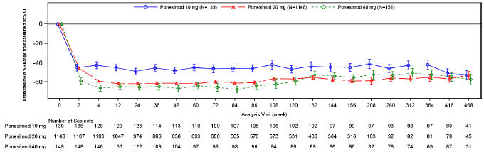
Abbreviations: CI = confidence interval; N = number of subjects in group.
Figure 8: Study AC-058B301 Mean peripheral blood lymphocyte count by visit (safety set)
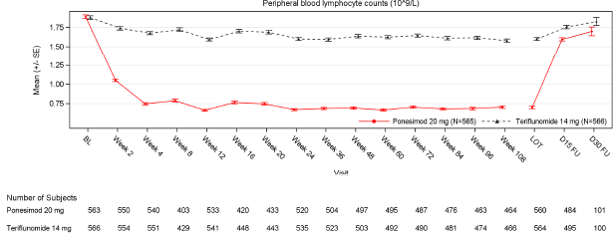
Abbreviations: B = Baseline; D= Day; FU = follow-up; LOT = length of treatment; SE = standard error.

Infections
The overall rate of infections was similar for ponesimod 20 mg and teriflunomide 14 mg (54.2% versus 52.1%, respectively). The most commonly reported infection TEAEs were nasopharyngitis (17.4%), upper respiratory tract infection (9.8%), and urinary tract infection (5.8%). Serious or severe AEs in the SOC of infections and infestations were identified as infection adverse events of special interest (AESIs). A total of 42 (out of 1438) ponesimod treated subjects, including 25 (2.2%) in the ponesimod 20 mg group, reported an infection AESI. In the ponesimod 20 mg group, 0.2% subjects had infection AESIs that led to treatment discontinuation. No case of fatal infection has been reported in ponesimod treated subjects.
No cases of PML, cryptococcal meningitis, or other opportunistic infections with fatal outcome were reported in any ponesimod dose group. In the long-term pool, 4.4% of subjects in the ponesimod 20 mg group had a herpetic infection AESI. In Study AC-058B301, the incidence of herpetic infection TEAEs (including oral herpes) was similar in the ponesimod 20 mg and teriflunomide 14 mg groups.

Malignancies
In the long-term pool, 0.6% of subjects in the ponesimod 20 mg group had a skin malignancy AESI. The only PTs that were reported in more than one subject in the ponesimod 20 mg group were basal cell carcinoma (4 subjects, 0.3%) and skin neoplasm excision (2 subjects, 0.2%).
In the long-term pool, 10 (0.7%) of 1,438 subjects in the total ponesimod group (including 5 in the ponesimod 20 mg group) had a non-skin malignancy AESI. The event rate per 100 subject years was 0.19 in the ponesimod 20 mg group. The only PT that was reported in more than one subject in the ponesimod 20 mg group was invasive ductal breast carcinoma (3 subjects, 0.3%).

Cardiac effects

First dose effect on heart rate
Two up-titration regimens were assessed in the ponesimod MS clinical development program: the Phase II Study AC-058B201 evaluated 10 mg daily for 7 days followed by the 20 mg maintenance dose, and the Phase III Study AC-058B301 evaluated a gradual 15-day up-titration regimen starting with 2 mg (2, 2, 3, 3, 4, 4, 5, 6, 7, 8, 9, 10, 10, 10 and 20 mg).
Safety outcomes were less favourable with the up-titration regimen starting at 10 mg (5 SAEs (1.1%) on Day 1, including 4 resulting in premature discontinuation). In Study AC-058B301, initiation of ponesimod was not associated with clinically significant bradyarrhythmia events. None of the reported bradyarrhythmia events was serious or led to discontinuation of treatment, and no second degree or higher atrioventricular blocks were reported.
The gradual up-titration regimen used the Phase III studies is proposed for registration.

Blood pressure
In the long-term pool, mean increases of < 5 mm of mercury from Baseline in systolic and diastolic blood pressure were observed during treatment with ponesimod 20 mg. Treatment-emergent increases of ≥ 20 mm of mercury from Baseline in systolic blood pressure were reported for 25.3% of subjects in the ponesimod 20 mg group. Both the time to detection of change in blood pressure and the frequency of hypertension, were comparable between ponesimod and teriflunomide. An increase in blood pressure was first detected after approximately one month of treatment initiation and persisted with continued treatment. The blood pressure values after discontinuation of ponesimod treatment indicate reversibility.

QT effect
QT effects were examined in a dedicated QT study (Study AC-058-110) evaluating supra-therapeutic doses of ponesimod. All incidences of QT prolongation reported during the study were considered not to be clinically significant. In Study AC-058B301, mean changes from Baseline to Week 108 in QT interval corrected according to Frederica’s formula (QTcF) ranged from 1.8 to 5.2 ms in the ponesimod 20 mg group. In the long-term pool, no TEAEs of torsade de pointes, ventricular tachycardia, or ventricular tachyarrhythmia were reported.

Echocardiography
Expert opinion following a review of echocardiography data in Studies AC-058B201 and AC-058B202 was that ponesimod did not result in clinically significant changes in cardiac structure or left ventricular ejection fraction. Findings of trace or mild regurgitation observed in the aortic, mitral, pulmonary, and tricuspid valves were not clinically significant.

Hepatic effects
Increases in alanine aminotransferase (ALT) and aspartate aminotransferase (AST) were observed following ponesimod treatment (see Table 16 below). In the ponesimod 20 mg group, the mean change in ALT and AST from Baseline to last on-treatment assessment was 11.4 U/L and 5.8 U/L, respectively, and mean change from Baseline to last follow-up assessment was 6.0 U/L and 2.9 U/L, respectively, indicating reversibility of the increase in ALT and AST upon treatment discontinuation.
Table 16: Study AC-058B301 Summary of absolute mean change from Baseline in alanine aminotransferase/aspartate aminotransferase (analysis set: long-term pool analysis set, ponesimod 20 mg group)
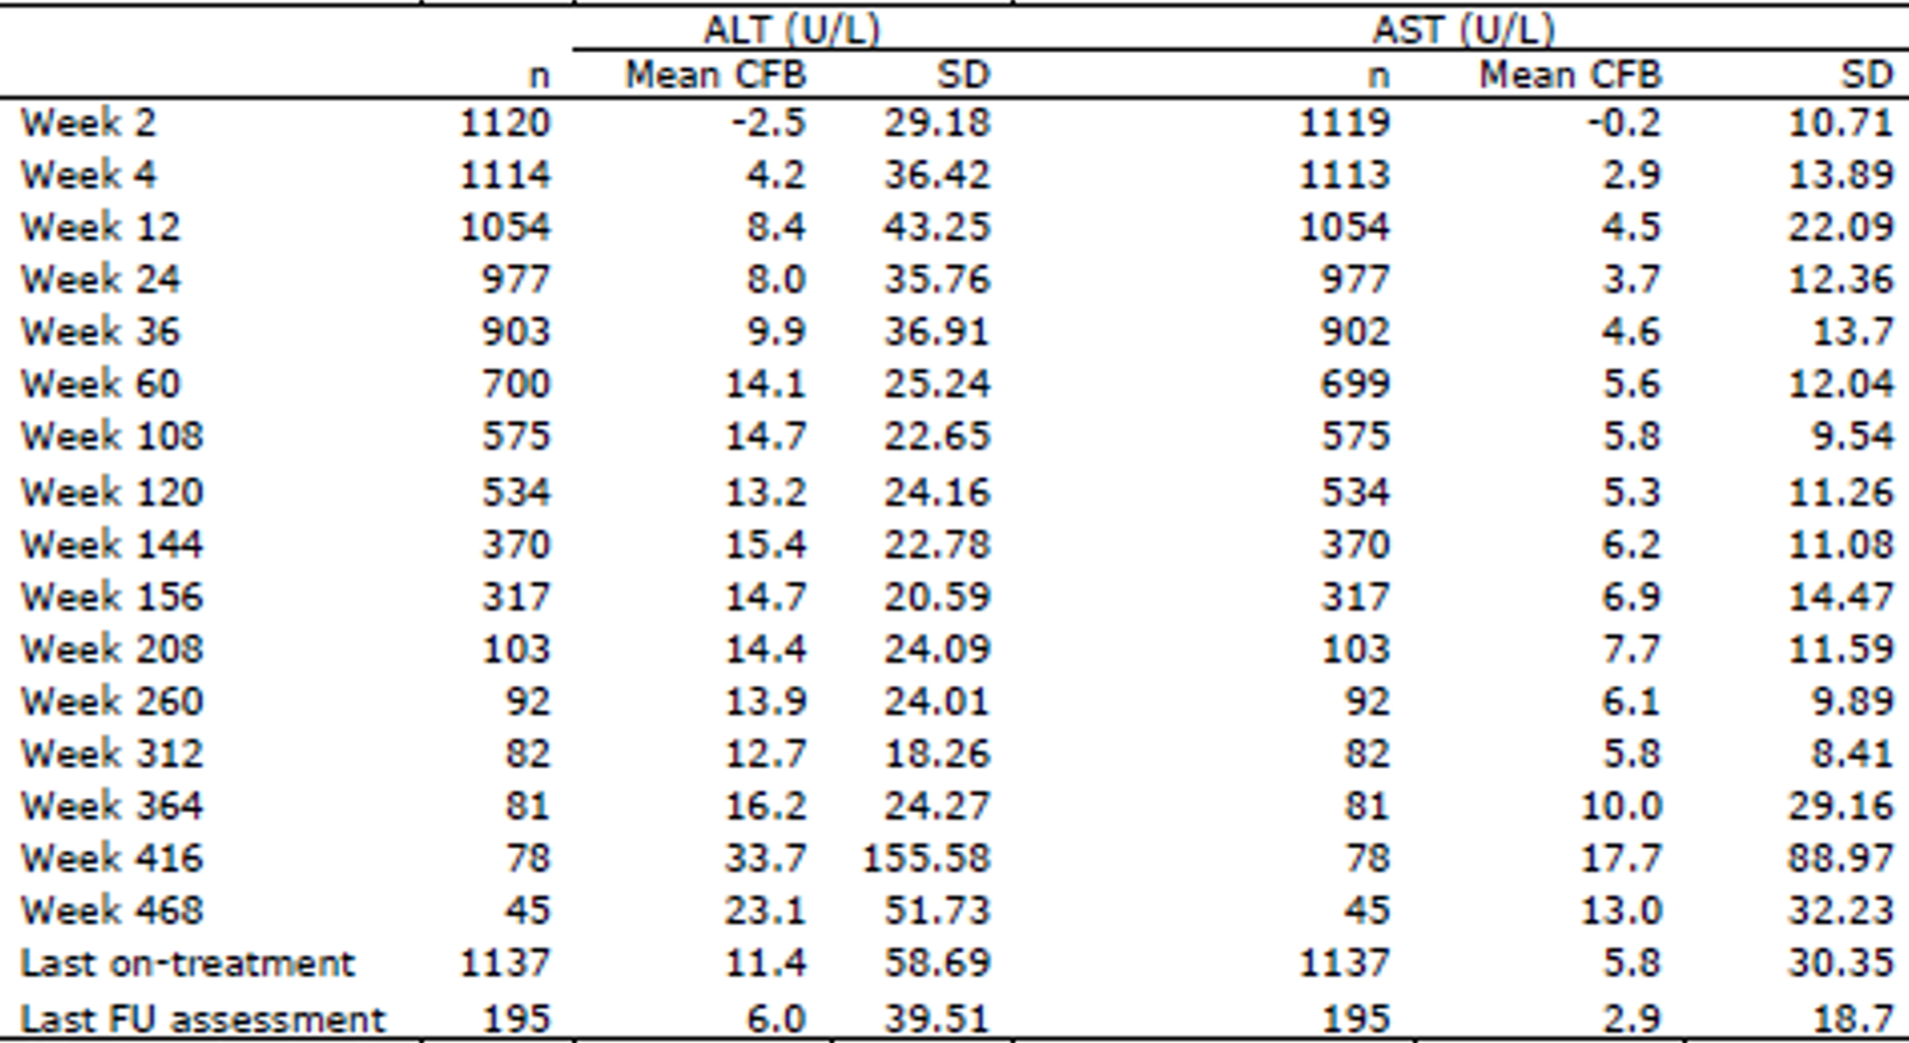
Abbreviations: ALT = alanine aminotransferase; AST = aspartate aminotransferase; CFB = change from Baseline; FU = follow-up; n = number of subjects in group; SD = standard deviation.
Subjects are summarised under their first randomised/allocated ponesimod dose group.
Baseline is the last value prior to or on the pool start date within the pool.
Except for data summarised under Baseline and follow-up, only treatment-emergent results are included.
Only subjects with a value at both Baseline and at post-Baseline analysis visit are included in the summary statistics for that timepoint.
Last follow-up visit is defined as the latest assessment available between end of treatment + 4 and end of treatment +97 days.
In Study AC-058B301, a higher proportion of subjects in the ponesimod 20 mg group (22.7%) compared to the teriflunomide 14 mg group (12.2%) had a hepatobiliary disorder/liver enzyme abnormality AESI. The proportion of subjects who discontinued study treatment due to a hepatobiliary disorder and liver abnormality AESI was 2.3% in the ponesimod 20 mg group and 1.9% in the teriflunomide 14 mg group.

Pulmonary function effects
Ponesimod has a dose related effect on predicted FEV₁ and diffusion lung capacity for carbon monoxide (DLCO). The effect on FEV₁ is improved by administration of a bronchodilator. The changes in FEV₁ and DLCO appear to be partially reversible after treatment discontinuation.
In the long-term pool, the proportion of subjects with at least one pulmonary AESI was 22.3%, 9.8% and 42.4%, for ponesimod 10mg, 20mg and 40mg, respectively. The PTs that were reported in more than one subject in the ponesimod 20 mg group were dyspnoea, obstructive airways disorder, forced expiratory volume decreased, asthma, pulmonary function tests decreased, dyspnoea at rest, forced vital capacity decreased, dyspnoea exertional, bronchial obstruction, and bronchospasm.

Macular oedema
Twenty (20) of 1,438 ponesimod-treated subjects in the MS program reported a suspected macular oedema AESI based on pre-defined PT search criteria. The independent Ophthalmology Safety Board confirmed a diagnosis of macular oedema in 12 subjects (11 subjects with the PT of macular oedema and one subject with the PT of cystoid macular oedema). The confirmed events of macular oedema resolved in all 12 subjects, 3 with sequelae (not specified).

Neurological events (including seizures)
In the long-term pool, 16 of 1,438 ponesimod treated subjects reported a seizure AESI, including 1.0% of subjects in the ponesimod 20 mg group. 3 subjects (0.3%) in the ponesimod 20 mg group had serious seizure AESIs and one subject had a seizure AESI that led to treatment discontinuation. The event rate per 100 subject years was 0.696 in the ponesimod 20 mg group.
In the long-term pool, no TEAEs of posterior reversible encephalopathy syndrome or reversible cerebral vasoconstriction syndrome were reported.

Safety in special populations
No specific safety related differences were observed based on sex, race or geographical region. Data for older patients is limited, as the clinical studies did not include patients older than 58 years. Ponesimod has not been studied in pregnant or breastfeeding women.

Risk management plan
The sponsor has submitted EU-risk management plan (RMP) version 1.5 (dated 25 May 2021; data lock point (DLP) 18 March 2020) and Australia specific annex (ASA) version 1.0 (dated 9 June 2021) in support of this application. At the second round of evaluation, the sponsor submitted ASA version 2.0 (dated 16 November 2021). At the third round of evaluation, the sponsor submitted ASA version 3.0 (dated 27 January 2022).
The summary of safety concerns and their associated risk monitoring and mitigation strategies are summarised in Table 17. Further information regarding the TGA’s risk management approach can be found in risk management plans for medicines and biologicals and the TGA's risk management approach.
Table 17: Summary of safety concerns
Summary of safety concerns |  | Pharmacovigilance |  | Risk minimisation
 |  | Routine | Additional | Routine | Additional
Important identified risks | Bradyarrhythmia occurring post-first dose |  | 𝛹Ϥ |  | ¶
Important identified risks | Macular oedema |  | Ϥ |  | ¶
Important identified risks | Bronchoconstriction |  | §Ϥ |  | ¶
Important potential risks | Severe liver injury |  | §Ϥ |  | ¶
Important potential risks | Serious opportunistic infections including progressive multifocal leukoencephalopathy | *† | §Ϥ |  | ¶
Important potential risks | Skin cancer |  | §Ϥ |  | ¶
Important potential risks | Non-skin malignancy |  | § |  | –
Important potential risks | Reproductive and embryofetal toxicity |  | ǁϤ |  | ¶Ϫ
Important potential risks | Convulsions | *‡ | §Ϥ |  | ¶
Important potential risks | Unexpected neurological or psychiatric symptoms/signs (posterior reversible encephalopathy syndrome, acute disseminated encephalomyelitis, atypical multiple sclerosis relapses) | * | §Ϥ |  | ¶
Missing information | Use in elderly patients | ‡ | – |  | –
Missing information | Long-term safety of ponesimod |  | § | – | –
* Targeted follow-up forms
† Independent review of suspected cases by external committee
‡ Cumulative review of reports in periodic benefit risk evaluation report
𝛹 Clinical trial: Study AC-058B303 (the OPTIMUM-LT trial)
§ Clinical trials: Study AC-058B303 (the OPTIMUM-LT trial) and Study AC-058B202
ǁ Ponesimod pregnancy outcomes enhanced monitoring
¶ Healthcare professional checklist and patient/caregiver guide
Ϫ Patient reminder card (European Union only)
Ϥ Healthcare professional survey
- The proposed summary of safety concerns aligns with the EU-RMP and includes a number of common safety concerns of other sphingosine-1-phosphate receptor modulators approved in Australia. No Australia specific safety concerns are identified. The summary of safety concerns is acceptable from an RMP perspective.
- The sponsor has proposed routine pharmacovigilance for all safety concerns. There are two ongoing long-term clinical trials. Targeted Follow Up Questionnaires (TFUQs) are proposed for the important potential risks ‘serious opportunistic infections including PML’, ‘convulsions’, and ‘unexpected neurological or psychiatric symptoms/signs’. The TFUQs will be used in conjunction with a standard global adverse event form, which will collect data on Aboriginal and Torres Strait Islander ethnicity. The forms align closely with the forms in the EU-RMP and are fit for intended purpose in the EU-RMP, the sponsor also commits to independent review of PML by external adjudication, and cumulative reviews of reports of convulsions and use in elderly patients in periodic benefit risk evaluation reports. Additional pharmacovigilance activities encompass most safety concerns. At the second round of evaluation, the sponsor has included a healthcare professional survey to evaluate the effectiveness of Australian additional risk minimisation materials for prescribers. The pharmacovigilance plan is acceptable.
- Routine risk minimisation activities are proposed for all safety concerns except the missing information ‘long-term safety of ponesimod’. At the first round of evaluation, additional risk minimisation activities including healthcare professional checklist, patient/caregiver guide and patient reminder card for pregnancy were included in the EU-RMP but not in the ASA. At the second round of evaluation, the sponsor has agreed to including the healthcare professional checklist and patient/prescriber guide, but not the patient reminder card for pregnancy, as additional risk minimisation activities in Australia. The Consumer Medicines Information (CMI) was revised as requested. The sponsor provided a report outlining the rationale for the design of the treatment initiation pack inner wallet and evidence of its suitability for guiding patient compliance with the initiation regimen, which was acceptable. The risk minimisation plan is acceptable subject to documentation of changes to the dissemination plan for the patient/caregiver guide in the ASA.

Risk-benefit analysis

Delegate’s considerations

Pharmacology
The pharmacology of ponesimod has been adequately assessed. The PK of ponesimod is similar in healthy subjects and patients with MS. Ponesimod is absorbed well after oral administration and the PK is dose proportional. Food status did not affect the PK to a clinically relevant extent, so ponesimod can be taken with or without food.
Ponesimod is extensively metabolised in the liver prior to excretion. Ponesimod exposure is increased 2.0-fold in subjects with Child-Pugh;¹⁸ class B hepatic impairment and 3.1-fold in subjects with Child-Pugh class C hepatic impairment, compared with healthy subjects. Treatment with ponesimod is not recommended in patients with moderate or severe hepatic impairment (Child-Pugh class B or C).
Ponesimod and its metabolites are excreted for the major part in faeces (57% to 80%) and for a minor part in urine (10% to 18%). Renal impairment does not affect the PK of ponesimod.
Ponesimod induces a transient, dose dependent decrease in heart rate, which is most prominent on the first day of ponesimod dosing. Gradual up-titration reduces the risk of bradycardia due to development of tolerance. The proposed gradual up-titration regimen starting at 2 mg showed a more favourable safety profile with respect to heart rate than a dosing regimen starting at 10 mg.

Efficacy
The efficacy of ponesimod in the treatment of patients with RMS was assessed in the Phase III study (Study AC-058B301). This was supported by the Phase II dose response study, Study AC-058B201, which demonstrated a dose dependent reduction in new Gd+ lesions with ponesimod, and a favourable trend in relapse outcomes. The design of the studies was consistent with the EMA/CHMP guideline,²¹ and the requirements for a single pivotal study were met.
Teriflunomide is acceptable as an active control in the pivotal study. Teriflunomide is registered for the treatment of RMS based on pivotal studies demonstrating 31% to 36% reduction in ARR compared to placebo. The pivotal study included only a limited number of patients with SPMS, but efficacy in relapses can be extrapolated from RRMS to SPMS, so the proposed indication for RMS would in principle be acceptable.
Annualised relapse rate (ARR) is acceptable as the primary endpoint. The hierarchy of secondary endpoints did not follow the study objectives and was not consistent with the EMA/CHMP guideline.²¹ Fatigue as measured by the symptoms domain of the FSIQ-RMS was chosen as the key secondary endpoint, rather than disability progression. Although fatigue is considered a relevant endpoint, disability progression is considered the more important for assessment of efficacy. Based on the EMA/CHMP guideline, disability progression should be the key secondary endpoint if ARR is the primary endpoint. The evaluation proceeded based on a hierarchy consistent with the CHMP guideline (that is, primary endpoint ARR followed by disability progression).
The pivotal study, Study AC-058B301, demonstrated superiority of ponesimod 20 mg over teriflunomide 14 mg for the primary endpoint, ARR. ARR was 30.5% lower with ponesimod compared to teriflunomide (rate ratio 0.695; 99% CI: 0.536, 0.902; p = 0.0003). The reduction in relapses with ponesimod compared to teriflunomide was statistically significant and clinically meaningful. Sensitivity analyses were consistent with the primary analysis.
There was no statistically significant difference between the treatment groups in disability progression, but there was a numerical trend in favour of ponesimod for both 12-week and 24-week CDA. CUALs on brain MRI were 56% lower with ponesimod compared to teriflunomide. Fatigue related symptoms, as measured by the symptoms domain of the FSIQ-RMS, were lower in the ponesimod group compared to teriflunomide, but the study did not demonstrate a clinically meaningful difference for this endpoint. There is some uncertainty regarding the threshold for a clinically meaningful change in FSIQ-RMS, and the effect of teriflunomide on this measure is uncertain, so the FSIQ-RMS outcomes from this study should not be included in the PI. Change in brain volume was an exploratory endpoint, so this outcome should not be included in the PI.

Safety
The safety dataset includes 2,205 subjects exposed to ponesimod, including 1,438 subjects exposed to ponesimod in the MS clinical program. Of the 1,438 subjects with MS, 1,027 (71.4%) had exposure of at least one year, 785 (54.6%) had exposure of at least 2 years, 253 (17.6%) had exposure of at least 5 years, and 41 (2.9%) had exposure of at least 9 years. In the long-term pool, the cumulative exposure with interruptions excluded was 4,094.28 subject years in the total ponesimod group. The submitted safety dataset is of sufficient size and duration to allow adequate characterisation of the safety profile.
In the pivotal study, the overall frequency of TEAEs was comparable between ponesimod 20 mg (88.8%) and teriflunomide 14 mg (88.2%). The majority of TEAEs were mild to moderate in severity. TEAEs leading to premature discontinuation of study treatment were reported more frequently in the ponesimod 20 mg group (8.7%) than the teriflunomide 14 mg group (6.0%), with the difference mostly due to dyspnoea and macular oedema.
Ponesimod 20 mg reduced the mean peripheral blood lymphocyte count by approximately 60% and this effect was rapidly reversed following cessation of treatment. This is a known class effect of S1P modulators.
No dose related effect was observed for infections or infestations. In line with other S1P modulators, serious opportunistic infections including PML have been assessed as important potential risks. The draft PI contains precautions regarding infection risk, including opportunistic infections. Skin cancer and non-skin malignancy are also identified as important potential risks in the RMP and will be actively monitored in the periodic safety update reports (PSURs). Precautionary guidance addressing skin malignancies should be added to Section 4.4 of the PI.
Bradycardia and atrioventricular conduction delay on initiation of treatment are known class effects of S1P modulators. Several up-titration regimens were evaluated in ponesimod clinical studies to assess the risk of first dose bradycardia and atrioventricular block. The proposed up-titration regimen, starting at 2 mg, was evaluated in the pivotal Study AC-058B301 and was well tolerated with no clinically significant bradyarrhythmia events. The draft PI contains detailed guidance for pre-treatment evaluation of bradycardia risk and post-treatment monitoring of heart rate and cardiac conduction.
Increases in ALT and AST were observed following ponesimod treatment. This is a known class effect for S1P modulators. A precaution is included in Section 4.4 of the PI describing the risk of liver injury. Liver function should be assessed prior to commencing treatment. Patients should be monitored during treatment for evidence of hepatotoxicity and treatment should be discontinued if significant liver injury is confirmed. Treatment with ponesimod is not recommended in patients with moderate or severe hepatic impairment.
Treatment with ponesimod is associated with effects on pulmonary function, which appear to be partially reversible following treatment discontinuation. This risk is addressed in the draft PI, including a precaution for patients with pre-existing respiratory disease.
Treatment with ponesimod is associated with an increased risk of macular oedema, particularly in subjects with a medical history or concomitant eye disorder. Most of the events occurred during the first 6 months of treatment. This risk is addressed in the PI.

Limitations of the data
Data for elderly patients are limited. The main efficacy and safety studies enrolled patients aged 18 to 55 years. The PI contains a precaution regarding use of ponesimod in patients aged 65 years and older.

Proposed indication
The proposed indication is:
Ponvory is indicated for the treatment of adult patients with relapsing forms of multiple sclerosis (RMS) with active disease defined by clinical or imaging features.
The proposed indication is the same as the approved EU indication and is consistent with the population evaluated in the pivotal study.

Proposed conditions of registration
- The Ponvory EU-RMP (version 1.5, dated 25 May 2021, DLP 18 March 2020), with ASA (version 3.0, dated 27 January 2022), included with Submission PM-2021-02609-1-1, to be revised to the satisfaction of the TGA, will be implemented in Australia.
- An obligatory component of risk management plans is routine pharmacovigilance. Routine pharmacovigilance includes the submission of PSURs.
Reports are to be provided in line with the current published list of EU reference dates and frequency of submission of PSURs until the period covered by such reports is not less than three years from the date of the approval letter.
The reports are to at least meet the requirements for PSURs as described in the European Medicines Agency’s Guideline on Good Pharmacovigilance Practices (GVP) Module VII-periodic safety update report (Rev 1), Part VII.B Structures and processes. Note that submission of a PSUR does not constitute an application to vary the registration.
- Ponvory (ponesimod) is to be included in the Black Triangle Scheme. The PI and CMI for Ponvory must include the black triangle symbol and mandatory accompanying text for five years, which starts from the date that the sponsor notifies the TGA of supply of the product.

Proposed action
The manufacturing quality of Ponvory is acceptable. The efficacy of ponesimod has been satisfactorily demonstrated in the proposed treatment population. The demonstrated benefits of ponesimod include a significant and clinically meaningful reduction in relapses compared to teriflunomide, as well as a significant reduction in CUALs on MRI. There are notable safety risks with ponesimod, but these risks appear similar to other S1P modulators and can be adequately managed with the proposed risk monitoring and mitigation strategies. The safety risks are acceptable in the context of the nature of the disease and the demonstrated benefits. There are no outstanding issues requiring expert advice.

Advisory Committee considerations
The Delegate did not refer this submission to the Advisory Committee on Medicines (ACM) for advice.

Outcome
Based on a review of quality, safety, and efficacy, the TGA approved the registration of Ponvory (ponesimod) 2 mg, 3 mg, 4 mg, 5 mg, 6 mg, 7 mg, 8 mg, 9 mg, 10 mg and 20 mg, film-coated tablet, composite blister pack and blister pack, indicated for:
Ponvory is indicated for the treatment of adult patients with relapsing forms of multiple sclerosis (RMS) with active disease defined by clinical or imaging features.

Specific conditions of registration applying to these goods
- Ponvory (ponesimod) is to be included in the Black Triangle Scheme. The PI and CMI for Ponvory must include the black triangle symbol and mandatory accompanying text for five years, which starts from the date that the sponsor notifies the TGA of supply of the product.
- The Ponvory EU-risk management plan (RMP) (version 1.5, dated 25 May 2021, data lock point 18 March 2020), with Australian specific annex (version 3.0, dated 27 January 2022), included with Submission PM-2021-02609-1-1, to be revised to the satisfaction of the TGA, will be implemented in Australia.
An obligatory component of risk management plans is routine pharmacovigilance. Routine pharmacovigilance includes the submission of periodic safety update reports (PSURs).
Reports are to be provided in line with the current published list of EU reference dates and frequency of submission of PSURs until the period covered by such reports is not less than three years from the date of the approval letter.
The reports are to at least meet the requirements for PSURs as described in the European Medicines Agency’s Guideline on Good Pharmacovigilance Practices (GVP) Module VII-periodic safety update report (Rev 1), Part VII.B Structures and processes. Note that submission of a PSUR does not constitute an application to vary the registration.

Attachment 1. Product Information
The PI for Ponvory approved with the submission which is described in this AusPAR is at Attachment 1. For the most recent PI, please refer to the TGA PI/CMI search facility.

Therapeutic Goods Administration
PO Box 100 Woden ACT 2606 Australia
Email: info@tga.gov.au Phone: 1800 020 653 Fax: 02 6232 8605
https://www.tga.gov.au

Campbell, J.A. et al. Change in Multiple Sclerosis Prevalence over Time in Australia 2010-2017 Utilising Disease-Modifying Therapy Prescription Data, Mult Scler, 2020; 26(11): 1315-1328.
Noseworthy, J.H. et al. Multiple Sclerosis, N Engl J Med, 2000; 343(13): 938-952.
Lublin, F.D. et al. Defining the Clinical Course of Multiple Sclerosis, the 2013 revisions, Neurology, 2014; 83(3): 278-286.
Lublin, F.D, et al. The 2013 Clinical Course Descriptors for Multiple Sclerosis: a clarification, Neurology, 2020; 94 (24): 1088-1092.
Miller, D.H. et al. Clinically Isolated Syndromes, Lancet Neurol, 2012; 11(2):157-169.
Miller, D. et al. Clinically Isolated Syndromes Suggestive of Multiple Sclerosis, Part I: Natural History, Pathogenesis, Diagnosis, and Prognosis. Lancet Neurol, 2005; 4(5): 281-288.
Compston, A. and Coles, A. Multiple Sclerosis, Lancet, 372 (9648): 1502-1517.
Miller, D.H. and Leary, S.M. Primary-Progressive Multiple Sclerosis, Lancet Neurol, 2007; 6(10): 903-912.
Berkovich, R. Treatment of Acute Relapses in Multiple Sclerosis, Neurotherapeutics, 2013; 10(1):97-105.
Travers, B.S. et al. Multiple sclerosis: Diagnosis, Disease-Modifying Therapy and Prognosis, Aust J Gen Pract. 2022; 51(4): 199-206.
AusPAR for Gilenya, Fynefta and Filosir (fingolimod) new chemical entity, published on 30 March 2011. Available at: https://www.tga.gov.au/resources/auspar/auspar-fingolimod.
AusPAR for Mayzent (siponimod) new chemical entity, published on 2 January 2020. Available at: https://www.tga.gov.au/resources/auspar/auspar-siponimod.
AusPAR for Zeposia (ozanimod hydrochloride) new chemical entity, published on 2 December 2020. Available at: https://www.tga.gov.au/resources/auspar/auspar-ozanimod-hydrochloride.
The QT interval is the time from the start of the QRS wave complex to the end of the corresponding T wave. It approximates to the time taken for ventricular depolarisation and repolarisation, that is to say, the period of ventricular systole from ventricular isovolumetric contraction to isovolumetric relaxation. The corrected QT interval (QTc) estimates the QT interval at a standard heart rate. This allows comparison of QT values over time at different heart rates and improves detection of patients at increased risk of arrhythmias. The QTcF is the QT interval corrected for heart rate according to Fridericia’s formula.
AusPAR for Aubagio, Teriflunomide Winthrop and Teriflunomide (teriflunomide) new chemical entity, published on 9 September 2013. Available at: https://www.tga.gov.au/resources/auspar/auspar-teriflunomide.
Good Manufacturing Practice (GMP) describes a set of principles and procedures that when followed helps ensure that therapeutic goods are of high quality.
Pregnancy Category D: Drugs which have caused, are suspected to have caused or may be expected to cause, an increased incidence of human fetal malformations or irreversible damage. These drugs may also have adverse pharmacological effects. Accompanying texts should be consulted for further details.
The Child-Pugh score is used to assess the prognosis of chronic liver disease. The score employs five clinical measures of liver disease. Each measure is scored 1 to 3, with 3 indicating most severe derangement. Class A: 5 to 6 points, least severe liver disease, one to five year survival rate of 95%. Class B: 7 to 9 points, moderately severe liver disease, one to five year survival of 75%. Class C: 10 to 15 points, most severe liver disease, one to five year survival rate 50%.
Therapeutic Goods Administration (TGA) Form for Providing Product Information, Australian Product Information - Trade Name (Active Ingredient), last updated 20 January 2021. Available at: https://www.tga.gov.au/form-providing-product-information.
The Expanded Disability Status Scale (EDSS) is a commonly used scale for assessing the level of disability in people with multiple sclerosis.
European Medicines Agency (EMA), Committee for Medicinal Products for Human Use (CHMP), Guideline on Clinical Investigation of Medicinal Products for the Treatment of Multiple Sclerosis, EMA/CHMP/771815/2011, Rev. 2, 26 March 2015.
The Fatigue Symptoms and Impacts Questionnaire (FSIQ)-Relapsing Multiple Sclerosis (RMS) is a patient-reported outcome instrument used to assess fatigue in patients with relapsing forms of multiple sclerosis.
12-week confirmed disability accumulation (CDA) was defined as an increase of at least 1.5 in Expanded Disability Status Scale (EDSS) for subjects with a baseline EDSS score of 0.0, or an increase of at least 1.0 in EDSS for subjects with a baseline EDSS score of 1.0 to 5.0, or an increase of at least 0.5 in EDSS for subjects with a baseline EDSS score ≥ 5.5, confirmed after 12 weeks. 24-week CDA used similar definitions, confirmed after 24 weeks.
Patient reported outcome measures capture a person's perception of their own health through questionnaires.
European Medicines Evaluation Agency (EMEA), Committee for Proprietary Medicinal Products (CPMP), Points to Consider on Application with 1. Meta-Analyses; 2. One Pivotal Study, CPMP/EWP/2330/99, 31 May 2001.
Patient Global Impression of Severity (PGI-S) is a global index that may be used to rate the severity of a specific condition. PGI-S is a single item scale designed to assess the patient's impression of changes in symptoms.
‘Ponesimod 20 mg/ponesimod 20 mg’ group refers to subjects who were randomised to the ponesimod 20 mg group in Study AC-058B301 and were to continue receiving ponesimod 20 mg in the extension study; ‘teriflunomide 14 mg/ponesimod 20 mg’ group refers to subjects who were randomised to teriflunomide 14 mg in Study AC-058B301 and were to receive ponesimod 20 mg in the extension study.
The Medical Dictionary for Regulatory Activities (MedDRA) is a single standardised international medical terminology, developed as a project of the International Council for Harmonisation of Technical Requirements for Pharmaceuticals for Human Use (ICH) which can be used for regulatory communication and evaluation of data pertaining to medicinal products for human use. As a result, MedDRA is designed for use in the registration, documentation and safety monitoring of medicinal products through all phases of the development cycle (that is, from clinical trials to post-marketing surveillance). Furthermore, MedDRA supports ICH electronic communication within the ICH’s Electronic Common Technical Document (eCTD) and the E2B Individual Case Safety Report.

