November 2022

Australian Public Assessment Report for Comirnaty Original/Omicron BA.1 COVID-19 Vaccine
  - Active ingredients: Tozinameran and riltozinameran
  - Sponsor: Pfizer Australia Pty Ltd

About the Therapeutic Goods Administration (TGA)
- The Therapeutic Goods Administration (TGA) is part of the Australian Government Department of Health and is responsible for regulating therapeutic goods, including medicines, medical devices, and biologicals.
- The TGA administers the Therapeutic Goods Act 1989 (the Act), applying a risk management approach designed to ensure therapeutic goods supplied in Australia meet acceptable standards of quality, safety, and efficacy.
- The work of the TGA is based on applying scientific and clinical expertise to decision-making, to ensure that the benefits to the Australian public outweigh any risks associated with the use of therapeutic goods.
- The TGA relies on the public, healthcare professionals and industry to report problems with therapeutic goods. The TGA investigates reports received to determine any necessary regulatory action.
- To report a problem with a therapeutic good, please see the information on the TGA website.

About AusPARs
- The Australian Public Assessment Report (AusPAR) provides information about the evaluation of a prescription medicine and the considerations that led the TGA to approve or not approve a prescription medicine submission. Further information can be found in Australian Public Assessment Report (AusPAR) guidance.
- AusPARs are prepared and published by the TGA.
- AusPARs are static documents that provide information that relates to a submission at a particular point in time. The publication of an AusPAR is an important part of the transparency of the TGA’s decision-making process.
- A new AusPAR may be provided to reflect changes to indications or major variations to a prescription medicine subject to evaluation by the TGA.

Copyright
© Commonwealth of Australia 2022
This work is copyright. You may reproduce the whole or part of this work in unaltered form for your own personal use or, if you are part of an organisation, for internal use within your organisation, but only if you or your organisation do not use the reproduction for any commercial purpose and retain this copyright notice and all disclaimer notices as part of that reproduction. Apart from rights to use as permitted by the Copyright Act 1968 or allowed by this copyright notice, all other rights are reserved, and you are not allowed to reproduce the whole or any part of this work in any way (electronic or otherwise) without first being given specific written permission from the Commonwealth to do so. Requests and inquiries concerning reproduction and rights are to be sent to the TGA Copyright Officer, Therapeutic Goods Administration, PO Box 100, Woden ACT 2606 or emailed to <tga.copyright@tga.gov.au>.

Contents
List of abbreviations 4
Product submission 6
Submission details 6
Product background 7
Regulatory status 11
Product Information 12
Registration timeline 12
Submission overview and risk/benefit assessment 13
Quality 13
Nonclinical 13
Clinical 14
Risk management plan 54
Risk-benefit analysis 56
Outcome 64
Specific conditions of registration applying to these goods 64
Attachment 1. Product Information 66

List of abbreviations
Abbreviation |  | Meaning
ACV | Advisory Committee on Vaccines
AE | Adverse event
AESI | Adverse event of special interest
ARTG | Australian Register of Therapeutic Goods
ASA | Australia specific annex
CI | Confidence interval
COVID-19 | Coronavirus disease 2019
DLP | Data lock point
GMFR | Geometric mean fold rise
GMR | Geometric mean ratio
GMT | Geometric mean titre
LLOQ | Lower limit of quantitation
LS | Least square
mRNA | Messenger ribonucleic acid
NAAT | Nucleic acid amplification test
nAb | Neutralising antibody
PI | Product Information
RMP | Risk management plan
SAE | Serious adverse event
SARS-CoV-2 | Severe acute respiratory syndrome coronavirus 2
SOC | System Organ Class
TGA | Therapeutic Goods Administration
US(A) | United States (of America)
VE | Vaccine efficacy
VOCs | Variants of concerns
WHO | World Health Organization

Product submission

Submission details
Type of submission: | New biological entity/new combination of a previously approved and a new active ingredient
Product name: | Comirnaty Original/Omicron BA.1 COVID-19 Vaccine
Active ingredients: | Tozinameran and riltozinameran
Decision: | Approved for provisional registration
Date of decision: | 27 October 2022
Date of entry onto ARTG: | 28 October 2022
ARTG number: | 394890
Black Triangle Scheme: | Yes  As a provisionally registered product, this medicine will remain in the Black Triangle Scheme for the duration of its provisional registration
Sponsor’s name and address: | Pfizer Australia Pty Ltd  Level 17, 151 Clarence Street  Sydney, NSW, 2000
Dose form: | Suspension for injection
Strength: | 30 µg/0.3 mL (15 µg tozinameran and 15 µg riltozinameran)
Container: | Multidose vial with grey cap
Pack sizes: | 10 vials, 195 vials
Approved therapeutic use: | Comirnaty Original/Omicron BA.1 vaccine has provisional approval for the indication below:  As a booster dose for active immunisation to prevent coronavirus disease 2019 (COVID-19) caused by SARS-CoV-2, in individuals 18 years of age and older.  The use of this vaccine should be in accordance with official recommendations.  The decision has been made on the basis of short term immunogenicity and safety data. Continued approval depends on the evidence of longer term efficacy and safety from ongoing clinical trials and post-market assessment.
Route of administration: | Intramuscular injection
Dosage: | Booster dose in individuals 18 years of age and older  A booster dose of Comirnaty Original/Omicron BA.1 may be administered intramuscularly at least 5 months after the completion of a COVID-19 vaccine primary series in individuals 18 years of age and older.  Comirnaty Original/Omicron BA.1 may also be given as a booster dose in individuals 18 years of age and older who have received a primary course comprised of another COVID-19 vaccine.  The decision of when and for whom to implement a booster dose should be made based on available vaccine safety and effectiveness data (see Sections 4.4 Special warnings and precautions for use and 5.1 Pharmacodynamic properties), in accordance with official recommendations.  For further information regarding dosage, refer to the Product Information.
Pregnancy category: | B1  Drugs which have been taken by only a limited number of pregnant women and women of childbearing age, without an increase in the frequency of malformation or other direct or indirect harmful effects on the human fetus having been observed.  Studies in animals have not shown evidence of an increased occurrence of fetal damage.  The use of any medicine during pregnancy requires careful consideration of both risks and benefits by the treating health professional. This must not be used as the sole basis of decision making in the use of medicines during pregnancy. The TGA does not provide advice on the use of medicines in pregnancy for specific cases. More information is available from obstetric drug information services in your State or Territory.

Product background
This AusPAR describes the submission by Pfizer Australia Pty Ltd (the sponsor) to register Comirnaty Original/Omicron BA.1 COVID-19 vaccine (tozinameran and riltozinameran) 30 µg/0.3 mL, suspension for injection for the following proposed indication:
As a booster dose for active immunisation to prevent coronavirus disease 2019 (COVID-19) caused by SARS-CoV-2, in individuals 12 years of age and older.
The use of this vaccine should be in accordance with official recommendations.

Condition
Severe acute respiratory syndrome coronavirus 2 (SARS-CoV-2) has spread rapidly and globally since its emergence, causing coronavirus disease 2019 (COVID-19). The World Health Organization (WHO) declared that the outbreak constituted a public health emergency of international concern on 30 January 2020 and declared the outbreak to be a pandemic on 11 March 2020. Globally, there have been approximately 627 million of confirmed cases of COVID-19, including 6.5 million deaths. In Australia, approximately 10.3 million COVID-19 cases have been reported, with more than 15,660 deaths.
In the absence of highly effective prophylactic or therapeutic medicines, active immunisation through vaccination represents the best means of preventing hospitalisation and deaths at an individual level and controlling the pandemic at a societal level.
Currently circulating mutated SARS-CoV-2 variants are posing challenges for current vaccination strategies, which are generally based on inducing immunity to the non-mutated spike protein that was sequenced in the original wild-type virus. Reported immune escape by the latest circulating sub-variants of the Omicron variant (BA.1, BA.2 and BA.4/5) has posed significant challenges in controlling the pandemic.,, The finding from in vitro assay suggest that Omicron variant may lead to more significant escape from immune protection elicited by previous SARS-CoV-2 infection and perhaps even by existing COVID-19 vaccines.

Comirnaty Original/Omicron BA.1 COVID-19 vaccine
The Comirnaty Original/Omicron BA.1 COVID-19 vaccine contains a combination of two active ingredients: tozinameran and riltozinameran. Tozinameran was developed based on the ancestral (or original/wild-type) COVID-19 strain. Riltozinameran has been developed based on the more recent Omicron COVID-19 variant (specifically the BA.1 sub-variant).
Tozinameran is a single-stranded, 5’-capped messenger ribonucleic acid (mRNA) produced using a cell free in vitro transcription from the corresponding DNA templates, encoding the viral spike (S) protein of SARS-CoV-2 (ancestral stain).
Tozinameran is also the active ingredient in the monovalent Comirnaty vaccine (see Table 1, below), that was first provisionally approved in January 2021.
Riltozinameran is a single stranded, 5’-capped mRNA produced using a cell free in vitro transcription from the corresponding DNA templates, encoding the viral spike (S) protein of Omicron BA.1 strain.
Both tozinameran and riltozinameran are embedded in lipid nanoparticles for the formulation of the Comirnaty Original/Omicron BA.1 COVID-19 vaccine.

Current COVID-19 vaccine options
There are currently six vaccines on the Australian Register of Therapeutic Goods (ARTG), and all are approved under the provisional pathway.,:
Table 1 and Table 2 summarise the approval history of the COVID-19 vaccines provisionally registered on the ARTG for use in Australia. Further information on an approval is available from the associated AusPAR.
Table 1 lists the monovalent COVID-19 vaccines that were provisionally approved for use in Australia at the time that this submission was considered. A monovalent COVID-19 vaccine targets one strain of SARS-CoV-2.
Table 1: Provisional approvals for monovalent COVID-19 vaccines in Australia
Monovalent COVID-19 vaccines provisionally approved in Australia
Comirnaty COVID-19 Vaccine
Active ingredient: tozinameran (mRNA); formerly known as BNT162b2
Sponsor: Pfizer Australia Pty Ltd
25 January 2021 (initial registration) | Primary series: for individuals aged 16 years and over (AusPAR).  New product: 30 µg/0.3 mL concentrated suspension for injection. ARTG number: 346290
22 July 2021 | Primary series: for individuals aged 12 years and over (AusPAR)
26 October 2021 | Booster dose: for individuals aged 18 years and over (AusPAR)
3 December 2021 | Primary series: for individuals aged 5 years and over (AusPAR)  New strength/formulation: (Tris/sucrose buffer formulation), 10 µg/0.2 mL, 30 µg/0.3 mL. ARTG numbers: 377110, 377111
27 January 2022 | Booster dose: for individuals aged 16 to 17 years old (AusPAR)
7 April 2022 | Booster dose: for individuals aged 12 to 15 years old (AusPAR)
20 September 2022 | Booster dose: for individuals aged 5 to 11 years old (AusPAR)
29 September 2022 | Primary series: individuals aged 6 months to ≤ 5 years old (AusPAR)  New strength: 3 µg/0.2 mL concentrated suspension for injection (Tris/sucrose formulation. ARTG number: 393433
Spikevax COVID-19 vaccine
Active ingredient: elasomeran (mRNA)
Sponsor: Moderna Australia Pty Ltd
9 August 2021 (initial registration) | Primary series: for individuals aged 18 years and over (AusPAR)  New product: 0.2 mg/mL, suspension for injection.  ARTG number: 370599
3 September 2021 | Primary series: for individuals aged 12 to 18 years (and over) (AusPAR)
7 December 2021 | Booster dose: for individuals aged 18 years and over(AusPAR)
17 February 2022 | Primary series: for individuals aged 6 to 12 years (and over) (AusPAR)
19 July 2022 | Primary series: for individuals aged 6 months to 6 years (AusPAR)  New strength: 0.1 mg/mL suspension for injection  ARTG numbers: 388244, 388245
19 October 2022 | Booster dose: for individuals aged 12 years and over (AusPAR)
Nuvaxovid COVID-19 vaccine
Active ingredient: SARS-CoV-2 rS vaccine with Matrix-M1 adjuvant (protein vaccine)
Sponsor: Biocelect Pty Ltd (on behalf of Novavax Inc)
19 January 2022 (initial registration) | Primary series: for individuals aged 18 years and over (AusPAR)  New product: 5 µg/0.5mL, suspension for injection  ARTG number: 355139
9 June 2022 | Booster dose: for individuals aged 18 years and over as homologous vaccination (AusPAR)
9 June 2022 | Booster dose: for indivudals aged 18 years and over, as heterologous vaccination (AusPAR)
22 July 2022 | Primary series: for individuals aged 12 years and over (AusPAR)
Vaxzevria COVID-19 vaccine (formerly AstraZeneca COVID-19 vaccine)
Active ingredient: ChAdOx1 (viral vector)
Sponsor: AstraZeneca Pty Ltd
15 February 2021 (initial registration) | Primary series: for individuals aged 18 years and over (AusPAR)  New product: 1 x 10¹¹ viral particles (vp)/mL, solution for injection. ARTG number: 349072
8 February 2022 | Booster dose: for individuals aged 18 years and over (AusPAR)
COVID-19 Vaccine Janssen
Active ingredient: Ad26.COV2.S (viral vector)
Sponsor: Janssen-Cilag Pty Ltd
25 June 2021 (initial registration) | Primary series: for individuals aged 18 years and over (AusPAR)  New product: 5 x 10¹⁰ virus particles (VP)/ 0.5 mL, suspension for intramuscular injection. ARTG number: 350150
A primary vaccine series involves the vaccine doses needed for initial protection against COVID-19 disease. Typically, a primary COVID-19 vaccine series of 2 doses of the vaccine given 8 to 12 weeks apart. In most situations, the primary course consists of two doses of the same vaccine. In certain age groups or situations, the number of vaccine doses in a primary series may vary. For people with severe immunocompromise, a primary course is defined as 3 doses of a COVID-19 vaccine. ‘Third’ doses are not booster doses, but an additional dose given such as to those considered to be severely immunocompromised.
A booster dose refers to an additional vaccine dose given after the primary vaccine course. The first booster will refer to the first additional vaccine dose given after completing a 2-dose (or sometimes 3-dose) primary vaccine course.
Note: The single dose COVID-19 Vaccine Janssen has been provisionally approved but isn’t currently being used in Australia.
Further information on vaccines can be found on the TGA website at COVID-19 vaccines, The Australian Immunisation Handbook or at the Australian Government Department of Health and Aged Care website.
Table 2 lists the bivalent COVID-19 vaccines approved in Australia at the time that this submission was considered. A bivalent vaccine targets two coronavirus strains, as opposed to a monovalent vaccine that targets only one variant.
Table 2: Provisional approvals for bivalent COVID-19 vaccines in Australia
Bivalent COVID-19 vaccines provisionally approved in Australia
Spikevax Bivalent Original/Omicron COVID-19 vaccine
Active ingredients: elasomeran and imelasomeran (mRNA)
Sponsor: Moderna Australia Pty Ltd
29 August 2022 (initial registration) | Booster dose: for individuals aged 18 years and over (AusPAR)  New product: 0.1 mg/mL suspension for injection. Each 0.5 mL dose contains 25 µg of elasomeran and 25 µg of imelasomeran. ARTG number: 389513

Regulatory status
This product is considered a new biological entity and new combination of active ingredients for Australian regulatory purposes.
At the time the TGA considered this submission, a similar submission was under consideration in the European Union (EU) (approved in September 2022), Canada (approved in October 2022), the United Kingdom (approved in September 2022) and Switzerland (approved in October 2022).

Product Information
The Product Information (PI) approved with the submission which is described in this AusPAR can be found as Attachment 1. For the most recent PI, please refer to the TGA PI/CMI search facility.

Registration timeline
The following table captures the key steps and dates for this submission.
Data were provided as a rolling submission. Under normal circumstances, TGA's assessment (for both provisional and general registration) begins once all information to support registration is available. As part of the Department of Health's response to the pandemic, the TGA has agreed to accept rolling data for COVID-19 vaccines and treatments, to enable early evaluation of data as it becomes available.
Table 3: Timeline for Submission PM-2022-03551-1-2
Description | Date
Determination (Provisional) | 5 July 2022
Submission dossier accepted and first round evaluation commenced | 30 August 2022
Evaluation completed | 4 October 2022
Delegate’s Overall benefit-risk assessment and request for Advisory Committee advice | 23 September 2022
Sponsor’s pre-Advisory Committee response | 29 September 2022
Advisory Committee meeting | 5 October 2022
Registration decision (Outcome) | 27 October 2022
Completion of administrative activities and registration on the ARTG | 28 October 2022
Number of working days from submission dossier acceptance to registration decision* | 41
*Statutory timeframe for standard submissions is 255 working days

Submission overview and risk/benefit assessment
A summary of the TGA’s assessment for this submission is provided below.

Quality
There are no significant issues identified from the quality evaluation of the submitted data that would indicate the product should not be provisionally registered on the basis of quality, or safety-related issues arising from the quality of the product. The manufacturing quality information submitted by the sponsor support the provisional registration of Comirnaty Original/Omicron BA.1 (tozinameran/riltozinameran) 30 µg/0.3 mL suspension for injection vial.

Nonclinical
The nonclinical dossier comprised of a complete pharmacological study in mice investigating the immunogenicity of the tozinameran + riltozinameran bivalent vaccine against the ancestral strain and variants of concerns (VOCs), namely Omicron (BA.1, and BA.2, BA.4/A.5 sub-variants), Beta and Delta when administered either as part of the primary series of immunisation or as boosters following the primary series of immunisation and interim immunogenicity data with monovalent Omicron BA.4/A.5 and tozinameran + Omicron BA.4/A.5 bivalent vaccines.
The tozinameran + Omicron BA.1 bivalent vaccine as primary series vaccination enhanced neutralisation response in mice against the VOCs (Delta, Omicron BA.1, BA.2, and low neutralising antibody (nAb) against Omicron BA.4/A.5 variants or subvariants). Tozinameran + riltozinameran bivalent booster doses to Comirnaty original vaccine (tozinameran) immunised mice induced greater cross-variant neutralisation (low neutralising titre against Omicron BA.4/BA.5), cross reactive B cells in the draining lymph nodes and CD4⁺ and CD8⁺ T cell responses. Overall, tozinameran + riltozinameran bivalent vaccine booster doses induced broader immunogenic responses than the tozinameran monovalent vaccine, although neutralising antibodies against Omicron BA.4/BA.5 were significantly lower than against other variants. Further data needs to be submitted to support the Th1 biased immune response of tozinameran + Omicron BA.1 bivalent vaccine.
There were no protection or long-term immunity studies for the tozinameran + riltozinameran bivalent vaccine. No toxicity studies on the bivalent vaccine were submitted. This is acceptable since the new mRNA (riltozinameran) uses the same backbone and manufacture platform as tozinameran and there are no changes to vaccine formulation except for the additional mRNA.

Conclusions and recommendation
The Comirnaty Original/Omicron BA.1 (tozinameran + riltozinameran) bivalent vaccine was found to be immunogenic in mice inducing both humoral and cellular immunity against the ancestral and Omicron BA.1 SARS-CoV-2 variants. It also induced moderate neutralising antibodies against the Omicron BA.2 sub-variant, and Delta and Beta variants, but low neutralising antibody against the Omicron BA.4/BA.5 sub-variant.
The booster doses of tozinameran + riltozinameran bivalent vaccine induced broader cross-variant immunity than the original tozinameran vaccine.
There are no nonclinical longer immunity or protection data for the bivalent vaccine.
Nonclinical immunogenicity data suggest a broader cross variant protection by the tozinameran + riltozinameran bivalent vaccine than by the original tozinameran vaccine, although the bivalent vaccine might not confer adequate protection against infection by the Omicron BA.4/BA.5 sub-variants.

Clinical
Clinical data to support the use of Comirnaty Original/Omicron BA.1 COVID-19 vaccine as a homologous (not for heterologous) booster is provided from Study C4591031, which was designed to evaluate tozinameran boosting strategies across different populations of participants (for example, age groups) for subjects participating in Study C4591001 (a pivotal Phase I, II and III study). The study is divided in several sub-studies and Substudy E is the pivotal source of data for this submission.
The present submission provides new clinical data in approximately 1840 participants greater than 55 years of age from the ongoing pivotal Study C4591031 Substudy E (tozinameran-experienced participants), including safety and immunogenicity data up to one month after receipt of a single dose (Dose 4) of original (tozinameran, 30 µg or 60 µg), monovalent Omicron BA.1 (riltozinameran, 30 µg or 60 µg), or bivalent Original/Omicron BA.1 COVID-19 vaccine (tozinameran/riltozinameran, 15/15 µg or 30/30 µg).
In supportive Substudy D, the riltozinameran dose was 30 µg, that is the same dose as for the initially approved Comirnaty monovalent vaccine (tozinameran; ancestral strain). A higher dose (60 µg) of the vaccine was also evaluated in Study C4591031 Substudy E. The bivalent Comirnaty vaccine was tested in two different doses: Original/Omicron BA.1 (tozinameran/riltozinameran) at 15/15 µg or 30/30 µg of each variant.
Additional descriptive analyses from Substudy E (expanded cohort) were performed to further characterise BA.4/BA.5 sub-variant neutralisation responses following a booster (fourth) dose of bivalent Comirnaty Original/Omicron BA.1 vaccine at 15/15 µg tozinameran/riltozinameran compared to the prototype vaccine (original 30 µg). However, the assay used for neutralisation titre against Omicron BA.4/BA.5 sub-variants is currently not validated.

Efficacy
Clinical efficacy for the booster dose for the Comirnaty bivalent vaccine was not assessed in any of the submitted studies.

Immunogenicity
The sponsor submitted the pivotal immunogenicity data generated from Substudy E (pivotal) and supportive data from the Substudy D of the Study C4591031.

Dose finding
No separate dose finding study was conducted. For individuals greater or equal to 12 years of age, the tozinameran 30 µg was selected following review of immunogenicity and safety data from Phase I of Study C4591001 as well as nonclinical data. This dose and construct provided the optimum combination of a favourable reactogenicity profile and an immune response likely to provide protection against COVID-19. This dose was used for assessments of administering third and fourth dose of the ‘parent’ (that is original, tozinameran) vaccine, monovalent riltozinameran and bivalent tozinameran + riltozinameran. The 60 µg dose level of the tozinameran as well as the monovalent and bivalent Omicron-modified vaccines was also included to evaluate whether halving the concentration of RNA for each component would negatively impact immune responses.

Study C4591031 Substudy E immunogenicity outcome

Study design
This is a randomised, observer blinded substudy of boosting Study C4591031 to evaluate the safety, tolerability, and immunogenicity of standard (30 µg) and high dose (60 µg) tozinameran and, riltozinameran as well as a combination of the two (at 15 or 30 µg each for a total mRNA amount of 30 or 60 µg), given as a single booster dose.

Primary immunogenicity objectives
There were four primary immunogenicity objectives, one for each of the Omicron variant vaccines (that is first variant vaccine of riltozinameran (30 µg); second variant vaccine of riltozinameran (60 µg); third variant vaccine tozinameran (15 µg) + riltozinameran (15 µg) and fourth variant vaccine of tozinameran (30 µg) + riltozinameran (30 µg)).
For each study vaccine above, the primary objective was:
‘To demonstrate the superiority with respect to level of neutralising titre and noninferiority with respect to seroresponse rate of anti-Omicron immune response after 1 dose of [study vaccine] compared to after 1 dose of BNT162b2 at 30 μg given as a fourth dose in BNT162b2-experienced participants greater than 55 years of age.’
The primary endpoints were based on SARS-CoV-2 Omicron neutralising titres.

Secondary immunogenicity objectives
For the two bivalent Omicron variant vaccines (that is variant vaccine tozinameran (15 µg) + riltozinameran (15 µg) and variant vaccine tozinameran (30 µg) + riltozinameran (30 µg)), a secondary objective was:
‘To demonstrate the noninferiority of anti-reference-strain immune response after 1 dose of [study vaccine] compared to after 1 dose of BNT162b2 at 30 µg given as a fourth dose in BNT162b2-experienced participants greater than 55 years of age.’
The secondary endpoints were based on SARS-CoV-2 reference strain neutralising titres.
For each of the four Omicron variant vaccines, an additional secondary objective was:
‘To demonstrate the ‘super’ superiority of anti-Omicron immune responses after 1 dose of [study vaccine] compared to after 1 dose of BNT162b2 at 30 µg given as a fourth dose in BNT162b2-experienced participants greater than 55 years of age.’
The secondary endpoints were based on SARS-CoV-2 Omicron neutralising titres.
Inclusion criteria includes:
- healthy (or stable disease) male or female participants within the defined age groups (that is either older than 55 years of age or 18 to 55 years of age) who have received three documented prior doses of tozinameran (30 µg) with the third prior dose being 5 to 12 months before Visit 601 (Day 1).
- sentinel participants 18 to 55 years of age must have a normal screening troponin level.
Exclusion criteria includes:
- participants with medical or psychiatric conditions,
- history of severe adverse reactions associated with a vaccine and/or severe allergic reaction to any component of the study vaccination,
- previous clinical or microbiological diagnosis of COVID-19,
- immunocompromised individuals or individuals receiving immunosuppressive therapy,
- participants with bleeding diathesis,
- recent receipt or planned receipt of antibody therapy or medications with activity against SARS-CoV-2,
- prior receipt of any COVID-19 vaccine other than tozinameran and women who are pregnant or breastfeeding.

Immunogenicity assessments
Immunogenicity analyses were conducted based on the evaluable and all available immunogenicity populations. Immunogenicity results were based on validated assays for 50% SARS-CoV-2 neutralising titres against the Omicron BA.1 variant and the reference strain from before study vaccination (fourth dose) to one month after dose of tozinameran (30 µg or 60 µg) riltozinameran (30 µg or 60 µg) or tozinameran + riltozinameran (30 µg or 60 µg), reported as:
- geometric mean titres (GMTs)
- geometric mean ratio (GMR) of GMTs
- percentages/difference in percentages with seroresponse
- geometric mean fold rises (GMFRs) in titres

Statistical methods

Superiority and non-inferiority of anti-Omicron BA.1 immune response analyses
‘Simple superiority’ was declared if the lower limit of the two sided 95% confidence interval (CI) for GMR was greater than 1 and ‘super superiority’ was declared if that lower limit was greater than 1.5, after adjustment for multiplicity.
Seroresponse was defined as a greater or equal to 4 fold increase in post-vaccination titres from Baseline, or greater or equal to 4 fold times lower limit of quantitation (LLOQ) if the baseline titre was less than LLOQ. Non-inferiority was declared if the lower limit of the two sided 95% CI for the difference in percentages of participants with seroresponse was greater than -5%, after adjustment for multiplicity.
As sensitivity approach, the model based GMR and associated 95% CI was calculated by exponentiating the difference in least square (LS) means and the corresponding CIs based on analysis of logarithmically transformed assay results using a linear regression model with terms of baseline assay results (log scale) and vaccine group.

Non-inferiority of anti-reference strain immune response analyses
Non-inferiority of anti-reference strain immune response will be declared if the lower limit of the two sided 95% CI for the GMR is greater than 0.67 (1.5 fold criterion) and the point estimate of the GMR is greater or equal to 0.8, after adjustment for multiplicity.

Multiplicity adjustment
As per the sponsor: ‘Multiple primary and secondary immunogenicity objectives in this study are being assessed in a sequential order as listed below using a 1-sided alpha of 0.025.’
In the list below:
- Primary immunogenicity objective
  - superiority in GMR and non-inferiority in seroresponse rate for Omicron response G4vG1A (Omicron-60), followed by G6vG1A (bivalent-60), then G5vG1A (bivalent-30).
  - simple superiority in GMR and non-inferiority in seroresponse rate for Omicron response G3vG1A (Omicron-30)
- Secondary immunogenicity objective:
  - Non-inferiority in GMR for reference strain response: G6vG1B (bivalent-60), followed by G5vG1B (bivalent-30)
  - super superiority in GMR for Omicron response: G4vG1B (Omicron-60), followed by G6vG1C (bivalent-60), then G5vG1C (bivalent-30).
  - super superiority in GMR and non-inferiority in seroresponse rate for Omicron response G3vG1B (Omicron-30)
As per the sponsor:
‘For objectives involving two hypotheses, hypotheses based on GMR and seroresponse rate difference are assessed sequentially in the order as stated. Both hypotheses within the objective must be established before assessing the next objective in the sequence. Therefore, the overall type I error is fully controlled.’

Additional analyses
The exploratory analyses were largely descriptive and based on GMTs and GMFRs. This facilitated subgroup analyses of immunogenicity based on demographic characteristics (age group, sex, race, ethnicity) and SARS-CoV-2 baseline status (positive or negative).

Disposition of participants
The disposition of the 1846 participants randomised in the expanded cohort is shown in Table 4.

Table 4: Study C4591031 (Substudy E) Disposition of all randomised participants expanded cohort including participants greater than 55 years of age (randomised population)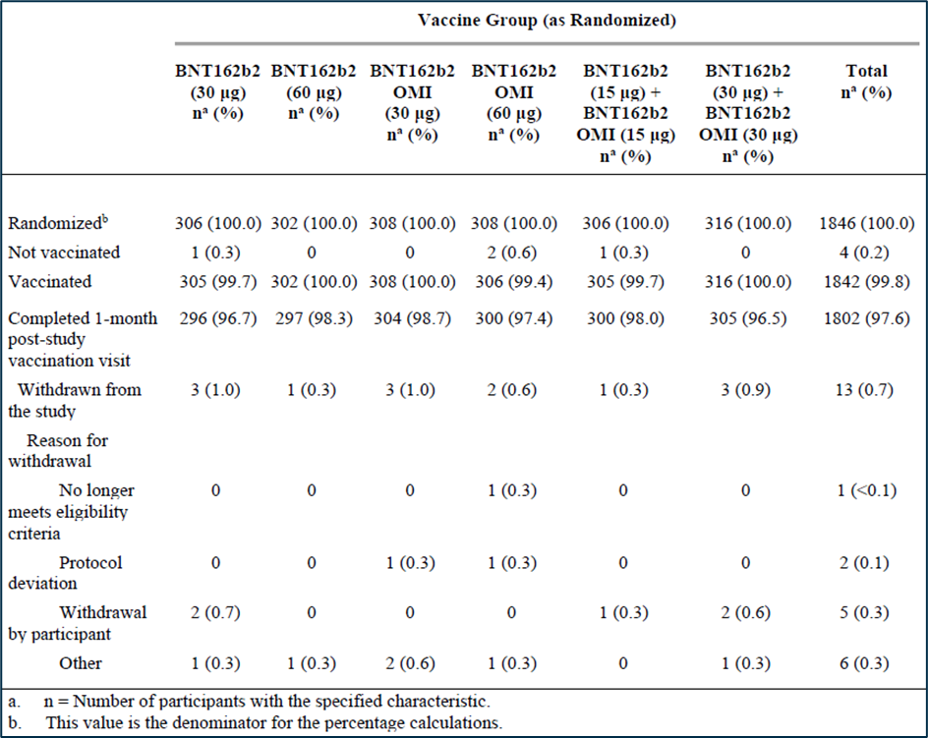

Disposition of participants for sentinel cohort
All 120 participants greater than 55 years of age in the sentinel cohort were randomised, vaccinated, and completed the one month post-study vaccination visit. There were no withdrawals. There were no important protocol deviations. All 120 participants were included in the safety population for the sentinel cohort.

Follow-up time after vaccination in the study cohort (Substudy E, expanded cohort)
Median follow up time after study vaccination to the cut-off or withdrawal date was 1.7 months overall and for each experimental study group; for the control tozinameran (30 µg) group it was 1.8 months. Follow up was for greater or equal to 1 month in 99.7% of participants, with 89.3% of participants being followed up for greater or equal to 1 month to less than 2 months. Only 10.4% had greater or equal to 2 months follow up.

Immunogenicity population (Substudy E, expanded cohort)
Subsets of 230 participants were randomly selected from each study group to evaluate the immunogenicity objectives. The disposition of these 1380 participants into the all available immunogenicity population (n = 1350), evaluable immunogenicity population (n = 1316) and those remaining without evidence of infection with SARS-CoV-2 up to one month after study vaccination (n = 1112).

Immunogenicity population (Substudy E, sentinel cohort)
Overall, six (5.0%) participants were excluded from the evaluable immunogenicity population because they did not have at least one valid and determinate immunogenicity result within 28 to 42 days after the study vaccination’ (one in the tozinameran (30 µg) group, four in the tozinameran (15 µg) + riltozinameran (15 µg) group, and one in the tozinameran (30 µg) + riltozinameran (30 µg) group).

Major protocol deviations
Important protocol deviations in the expanded cohort were mostly deviations related to inclusion/exclusion criteria (n = 7) and incorrect dosing (n = 9, eight of which occurred at one study site). There were no important protocol deviations in the sentinel cohort.

Results

Population characteristics
A random sample of 230 participants selected from each group in the expanded enrolment cohort constituted the immunogenicity subset to evaluate the primary and secondary immunogenicity objectives. More than 200 individuals were randomised into each subgroup and the majority (about 80%) of the population did not have signs of previous SARS-CoV-2 infection. The main reason for exclusion from the immunogenicity population was lack of immunogenicity result in 1 to 1.5 months after the booster dose (about 4%). Data from at least 181 SARS-CoV-2 negative individuals with immunogenicity result was recorded for the bivalent group.
Table 5: Study C4591031 (Substudy E) Immunogenicity population expanded cohort including participants greater than 55 years of age (immunogenicity subset)
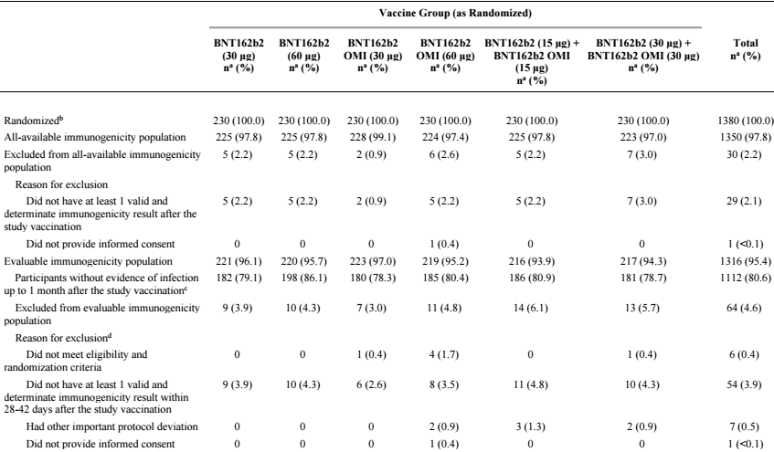
Abbreviations: N-binding = SARS-CoV-2 nucleoprotein–binding; NAAT = nucleic acid amplification test; SARS-CoV-2 = severe acute respiratory syndrome coronavirus 2.
a. n = Number of participants with the specified characteristic, or the total sample.
b. This value is the denominator for the percentage calculations.
c. Participants who had no serological or virological evidence (prior to the 1-month post–study vaccination blood sample collection) of past SARS-CoV-2 infection (that is, N-binding antibody (serum) result negative at the study vaccination and the 1-month post–study vaccination visits, negative NAAT (nasal swab) result at the study vaccination visit, and any unscheduled visit prior to the 1-month post–study vaccination blood sample collection) and had no medical history of COVID-19 were included in the analysis.
d. Participants may have been excluded for more than 1 reason.

Demographic and other baseline characteristics
Overall, most participants in the expanded cohort safety population were White (86.6%), with 5.5% Asian participants, 6.3% Black or African American participants, and other racial groups comprising less or equal to1.1% each. There were 14.9% Hispanic/Latino participants.
Baseline characteristics were reasonably balanced across the groups. The median age was 67 (minimum 56, maximum 87), 70% were overweight or obese and time from the third dose was median 6.3 months (range 4.7 to 12.9 months).

Extended cohort to study responses to Omicron BA.4/BA.5 sub-variants
A total of 100 participants (20 participants with baseline SARS-CoV-2 positive status and 80 participants with baseline SARS-CoV-2 negative status) were randomly selected from each vaccine group in the expanded cohort for the evaluable immunogenicity population Omicron BA.4/BA.5 sub-variant neutralisation assay subset. Demographic characteristics for participants in this subset were similar between the two vaccine groups.

Immunogenicity population (sentinel cohort)
In total, all 120 participants greater than 55 years of age in the sentinel cohort were randomised, received vaccination, and completed the one month post-vaccination visit. No participant in the sentinel cohort withdrew from the study. The median time from the first booster dose of tozinameran (received prior to the study C4591031 Substudy E) was 8 months.
Sentinel cohort was quite similar demographically and with respect to baseline SARS-CoV-2 exposure to the expanded cohort.

Primary and secondary immunogenicity outcomes
The primary immunogenicity objectives were to assess the superiority with respect to level of neutralising titre and noninferiority with respect to seroresponse rate of the anti-Omicron immune response induced by a dose of riltozinameran (30 µg or 60 µg) or bivalent tozinameran and riltozinameran (30 µg or 60 µg) relative to the anti-Omicron immune response elicited by a dose of tozinameran at 30 µg given as a fourth dose in tozinameran experienced participants greater than 55 years of age.

Geometric mean ratio of Omicron BA.1 neutralising titres and reference strain neutralising titres
In the evaluable immunogenicity population without prior evidence of infection up to one month after study vaccination, GMRs for the two bivalent vaccine groups tozinameran + riltozinameran (15/15 µg) and tozinameran + riltozinameran (30/30 µg) to tozinameran (30 µg) group was 1.56 (two sided 95% CI: 1.17, 2.08) and 1.97 (two sided 95% CI: 1.45, 2.68), respectively (see Table 6).
Geometric mean ratios for the riltozinameran 30 µg group and riltozinameran 60 µg to tozinameran 30 µg group (GMR) was 2.23 ( two sided 95% CI: 1.65, 3.00) and 3.15 (two sided 95% CI: 2.38, 4.16), respectively (see Table 6).
As the lower bound of the 95% CIs in each instance were greater than one, superiority was demonstrated, and these three primary outcomes were achieved.
Table 6: Study C4591031 (Substudy E) Geometric mean ratios for between vaccine group comparison in participants without evidence of infection up to one month after the study vaccination
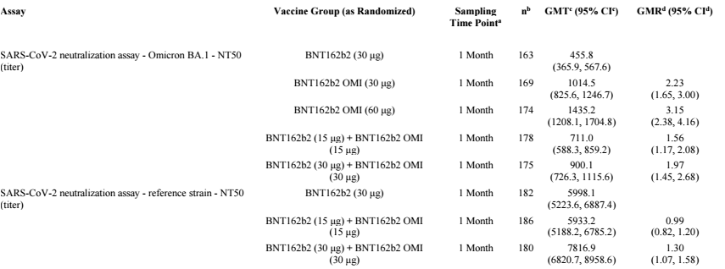Abbreviations: GMR = geometric mean ratio; GMT = geometric mean titre; LLOQ = lower limit of quantitation; N-binding = SARS-CoV-2 nucleoprotein–binding; NAAT = nucleic acid amplification test; NT50 = 50% neutralising titre; SARS-CoV-2 = severe acute respiratory syndrome coronavirus 2.
Note: Immunogenicity subset = a random sample of 230 participants in each vaccine group selected from the expanded cohort.
Note: Participants who had no serological or virological evidence (prior to the 1-month post–study vaccination blood sample collection) of past SARS-CoV-2 infection (that is, N-binding antibody (serum) result negative at the study vaccination and the 1-month post–study vaccination visits, negative NAAT (nasal swab) result at the study vaccination visit, and any unscheduled visit prior to the 1-month post–study vaccination blood sample collection) and had no medical history of COVID-19 were included in the analysis.
a. Protocol-specified timing for blood sample collection.
b. n = number of participants with valid and determinate assay results for the specified assay at the given sampling time point.
c. GMTs and 2-sided 95% CIs were calculated by exponentiating the mean logarithm of the titres and the corresponding CIs (based on the Student t distribution). Assay results below the LLOQ were set to 0.5 × LLOQ.
d. GMRs and 2-sided 95% CIs were calculated by exponentiating the mean difference of the logarithms of the titres (vaccine group in the corresponding row - BNT162b2 [30 μg]) and the corresponding CI (based on the Student t distribution).
In relation to secondary outcomes, non-inferiority of the tozinameran (15 µg) + riltozinameran (15 µg) and tozinameran (30 µg) + riltozinameran (30 µg) responses to reference strain was examined. Point estimates for the GMRs were greater or equal to 0.8 for both bivalent Omicron vaccines and the lower bounds of the 95% CIs were greater than 0.67, hence, these non-inferiority criteria were met.
In relation to the third secondary immunogenicity objective, ‘super superiority’ was demonstrated for the two monovalent vaccines (that is, lower bound of 95% CI for the GMR greater than 1.5) but not for the two bivalent vaccines.
Of note, it was pre-specified in the multiplicity adjustment rules that responses to riltozinameran (30 µg) (one of the four primary objectives) were only to be assessed for superiority (and super superiority) if both bivalent Omicron variant vaccines demonstrated super-superiority, which they did not.

Seroresponse rate to Omicron BA.1 variant
Seroresponse rates for each of the four Omicron variant vaccines were higher than those for the control vaccine (tozinameran (30 µg)) and in each instance, the lower bound of the 95% CI for the difference in seroresponse rate was greater than -5% (see Table 7). Thus, non-inferiority criteria were met. There were no material differences in the sensitivity analysis (stratified by baseline response category (less than median, greater or equal to median)
Table 7: Study C4591031 (Substudy E) Difference in percentages of participants with seroresponse in participants without evidence of infection up to one month after the study vaccination
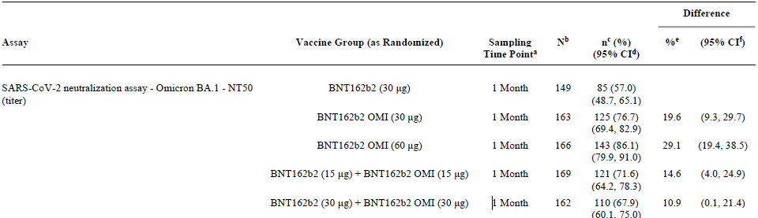 Abbreviations: LLOQ = lower limit of quantitation; N-binding = SARS-CoV-2 nucleoprotein-binding; NAAT = nucleic acid amplification test; NT50 = 50% neutralising titre; SARS-CoV-2 = severe acute respiratory syndrome coronavirus 2.
Note: Immunogenicity subset = a random sample of 230 participants in each vaccine group selected from the expanded cohort.
Note: Seroresponse is defined as achieving greater or equal to 4 fold rise from baseline (before the study vaccination). If the baseline measurement is below the LLOQ, the postvaccination measure of greater or equal to 4 times LLOQ is considered a seroresponse.
Note: Participants who had no serological or virological evidence (prior to the one month post-study vaccination blood sample collection) of past SARS-CoV-2 infection (that is, N-binding antibody (serum) result negative at the study vaccination and the one month post–study vaccination visits, negative NAAT (nasal swab) result at the study vaccination visit, and any unscheduled visit prior to the 1-month post–study vaccination blood sample collection) and had no medical history of COVID-19 were included in the analysis.
a. Protocol-specified timing for blood sample collection.
b. N = number of participants with valid and determinate assay results for the specified assay at both the prevaccination time point and the given sampling time point. This value is the denominator for the percentage calculation.
c. n = Number of participants with seroresponse at 1 month after vaccination for the given assay.
d. Exact two sided CI based on the Clopper and Pearson method.
e. Difference in proportions, expressed as a percentage (vaccine group in the corresponding row - BNT162b2 (30 µg)).
f. Two sided CI based on the Miettinen and Nurminen method for the difference in proportions, expressed as a percentage.
Considering the multiplicity adjustment rules, non-inferiority of seroresponse relative to a fourth dose of tozinameran (30 µg) (a primary immunogenicity objective) has been demonstrated for the three vaccines riltozinameran (60 µg), tozinameran (15 µg) + riltozinameran (15 µg) and tozinameran (30 µg) + riltozinameran (30 µg). As the lower limit of the 95% CI for the difference in seroresponse rates in each of those instances was greater than 0, these seroresponses can be considered superior to tozinameran (30 µg).
As the multiplicity criteria for examination of the seroresponse rate for riltozinameran (30 µg) were not met, non-inferiority cannot be claimed in that instance.

Exploratory efficacy outcomes

Omicron BA.1 neutralising titres (Substudy E, expanded cohort)
Omicron BA.1-neutralising titres in the evaluable immunogenicity population without evidence of infection up to 1 month after study vaccination are shown in Figure 1 and Table 8.
Figure 1: Study C4591031 (Substudy E) Geometric mean titres and 95% confidence interval for Omicron BA.1 SARS-CoV-2 neutralisation assay in evaluable immunogenicity population
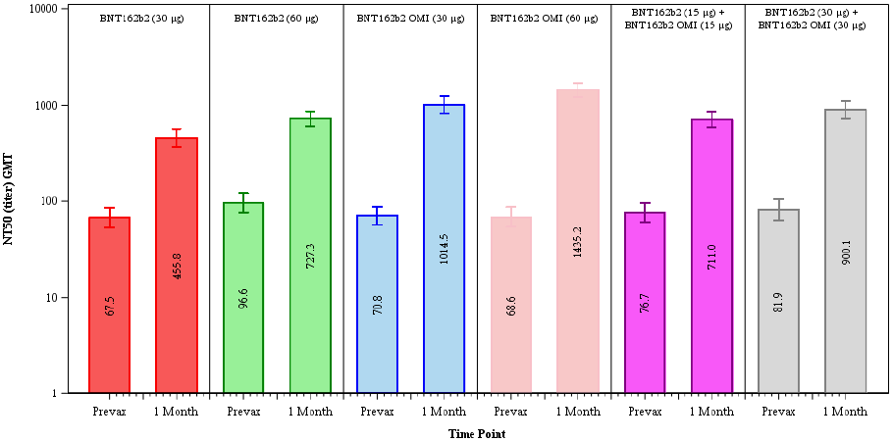
Abbreviations: GMT = geometric mean titer, N-binding = SARS-CoV-2 nucleoprotein-binding; NAAT = nucleic acid amplification test; NT50 = 50% neutralising titre; SARS-CoV-2 = severe acute respiratory syndrome coronavirus 2.
Note: Immunogenicity subset = a random sample of 230 participants in each vaccine group selected from the expanded cohort
Note: Participants who had no serological or virological evidence (prior to the one month post-study vaccination blood sample collection) of past SARS-CoV-2 infection (that is, N-binding antibody (serum) result negative at the study vaccination and the one month post–study vaccination visits, negative NAAT (nasal swab) result at the study vaccination visit, and any unscheduled visit prior to the one month post-study vaccination blood sample collection) and had no medical history of COVID-19 were included in the analysis.
Note: Number within each bar denotes geometric mean
Table 8: Study C4591031 (Substudy E) Geometric mean titres in evaluable immunogenicity population
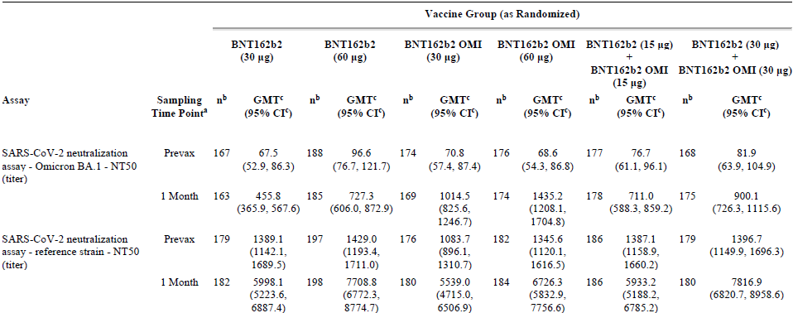Abbreviations: GMT = geometric mean titre; LLOQ = lower limit of quantitation; N-binding = SARS-CoV-2 nucleoprotein-binding; NAAT = nucleic acid amplification test; NT50 = 50% neutralising titre; SARS-CoV-2 = severe acute respiratory syndrome coronavirus 2.
Note: Immunogenicity subset = a random sample of 230 participants in each vaccine group selected from the expanded cohort.
Note: Participants who had no serological or virological evidence (prior to the 1-month post–study vaccination blood sample collection) of past SARS-CoV-2 infection (that is, N-binding antibody [serum] result negative at the study vaccination and the 1-month post–study vaccination visits, negative NAAT (nasal swab) result at the study vaccination visit, and any unscheduled visit prior to the 1-month post–study vaccination blood sample collection) and had no medical history of COVID-19 were included in the analysis.
a. Protocol-specified timing for blood sample collection.
b. n = Number of participants with valid and determinate assay results for the specified assay at the given sampling time point.
c. GMTs and 2-sided 95% CIs were calculated by exponentiating the mean logarithm of the titres and the corresponding CIs (based on the Student t distribution). Assay results below the LLOQ were set to 0.5 × LLOQ

Omicron BA.1 neutralising titres (Substudy E, sentinel cohort)
Omicron BA.1-neutralising titres in the evaluable immunogenicity population without evidence of infection up to one month after study vaccination are shown in Figure 2.
Figure 2: Study C4591031 (Substudy E) Geometric mean titres and 95% confidence intervals in Omicron BA.1 variant SARS-CoV-2 neutralisation assay in sentinel cohort (evaluable immunogenicity population)
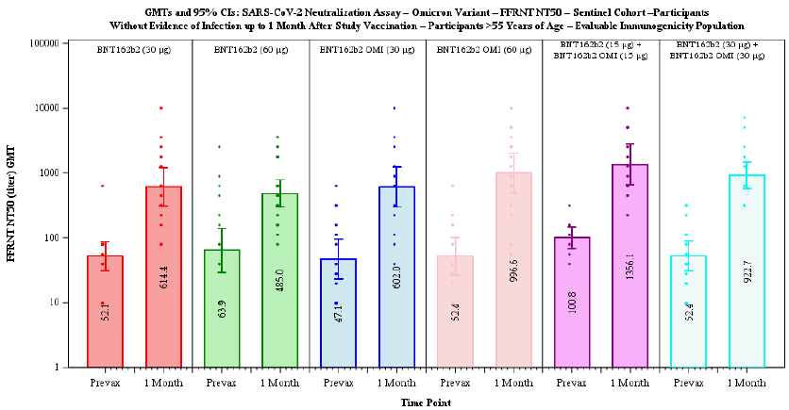Abbreviations: FFRNT = fluroscent focus reduction neutralisaion test; GMT = geometric mean titer; N-binding = SARS-CoV-2 nucleoprotein-binding; NAAT = nucleic acid amplification test; NT50 = 50% neutralising titre; SARS-CoV-2 = severe acute respiratory syndrome coronavirus 2.
Note: Participants who had no serological or virological evidence (prior to the one month post–study vaccination blood sample collection) of past SARS-CoV-2 infection (that is , N-binding antibody (serum) negative at the study vaccination, 7 days post–study vaccination visits and the one month post-study vaccination visits, negative NAAT (nasal swab) at the study vaccination visit, and any unscheduled visit prior to the one month post–study vaccination blood sample collection) and had no medical history of COVID-19 were included in the analysis.
Note: Dots present individual antibody levels
Note: Number within each bar denotes geometric mean
The Delegate noted that different assay was used (fluroscent focus reduction neutralisaion test) compared to the expanded cohort (so results are not directly comparable). The general pattern of neutralising responses to Omicron BA.1 is similar to that seen in the expanded cohort, with higher GMTs for each of the four Omicron variant vaccines relative to tozinameran (30 µg). These results support the conclusions from the expanded cohort.

Reference strain neutralising titres (Substudy E, expanded cohort)
Reference strain-neutralising titres in the evaluable immunogenicity population without evidence of infection up to one month after study vaccination are shown in Figure 3. Post-vaccination titres for the bivalent Omicron vaccine tozinameran (15 µg) + riltozinameran (15 µg) were slightly lower than for the higher strength reference strain vaccine tozinameran (60 µg) (GMTs of 711 versus 727.3 respectively) although the GMR was slightly higher (GMRs of 9.3 versus 7.5 respectively).
Pre-vaccination neutralising titres (that is at a median of 6.3 months post-dose 3) were substantially lower against Omicron BA.1 (range across vaccine subgroups 67.5 to 96.6) than for the reference strain (range 1083.7 to 1429.0).
For the proposed tozinameran (15 µg) + riltozinameran (15 µg) vaccine, GMTs against the reference strain following vaccination (5933.2) were 8.3-fold higher than those against Omicron BA.1 (711).
Against reference strain, the fold rise in GMTs post-vaccination for tozinameran (15 µg) + riltozinameran (15 µg) (GMFR of 4.3) was similar to that for tozinameran (30 µg) (GMFR of 4.3) and tozinameran (60 µg) (GMFR of 5.4).
Results from the sentinel cohort were in line with these results and can be considered supportive.
Figure 3: Study C4591031 (Substudy E) Geometric mean titres and 95% confidence interval in reference strain SARS-CoV-2 neutralisation assay in evaluable immunogenicity population
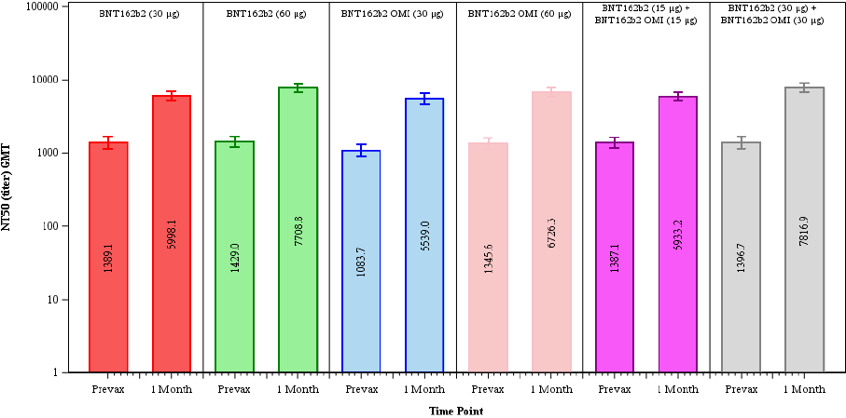
Abbreviations: GMT = geometric mean titer; N-binding = SARS-CoV-2 nucleoprotein-binding; NAAT = nucleic acid amplification test; NT50 = 50% neutralising titre; SARS-CoV-2 = severe acute respiratory syndrome coronavirus 2.
Note: Participants who had no serological or virological evidence (prior to the one month post–study vaccination blood sample collection) of past SARS-CoV-2 infection (that is , N-binding antibody (serum) result negative at the study vaccination and the one month post-study vaccination visits, negative NAAT (nasal swab) at the study vaccination visit, and any unscheduled visit prior to the one month post-study vaccination blood sample collection) and had no medical history of COVID-19 were included in the analysis.
Note: Number within each bar denotes geometric mean

Reference, Omicron BA4/BA5 sub-variant and Delta variant neutralising titres (Substudy E, sentinel cohort)
The sentinel cohort consists of very limited (below 20 individuals) subgroups. Bivalent tozinameran/riltozinameran 15 µg /15 µg induce about twice as high level of neutralising antibodies against Omicron BA4/BA5 in comparison to the approved Comirnaty 30 µg (see Table 9). As the minimal protective level of antibodies is unknown, it is not clear if lower antibody response translates into lower protection. As the assay range for Omicron BA4/BA5 sub-variants is unknown it is impossible to say if GMT 200 is a low or a high titre.
Table 9: Study C4591031 (Substudy E) Geometric mean titres in sentinel cohort (evaluable immunogenicity population)
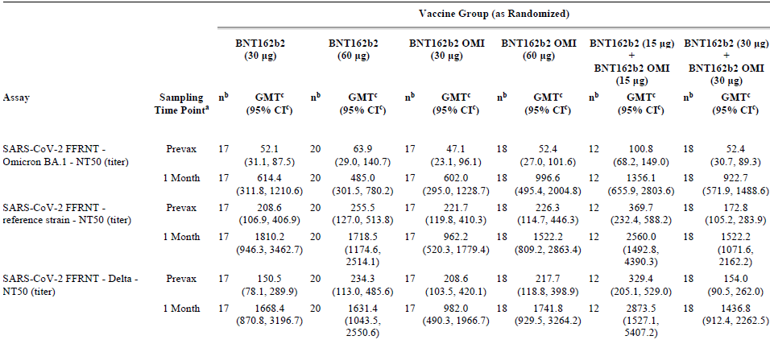 Abbreviations: FFRNT = fluorescent focus reduction neutralisation test; GMT = geometric mean titre; LLOQ = lower limit of quantitation;
N-binding = SARS-CoV-2 nucleoprotein-binding; NAAT = nucleic acid amplification test; NT50 = 50% neutralising titre; SARS-CoV-2 = severe acute respiratory syndrome coronavirus 2.
Note: Participants who had no serological or virological evidence (prior to the 1-month post-study vaccination blood sample collection) of past SARS-CoV-2 infection (that is, N-binding antibody [serum] negative at the study vaccination, 7-days post-study vaccination and the 1-month post-study vaccination visits, negative NAAT (nasal swab) at the study vaccination visit, and any unscheduled visit prior to the 1-month post-study vaccination blood sample collection) and had no medical history of COVID-19 were included in the analysis.
a. Protocol-specified timing for blood sample collection.
b. n = Number of participants with valid and determinate assay results for the specified assay at the given sampling time point.
c. GMTs and 2-sided 95% CIs were calculated by exponentiating the mean logarithm of the titres and the corresponding CIs (based on the Student t distribution). Assay results below the LLOQ were set to 0.5 × LLOQ.

Seroresponse to the Omicron BA.1, Delta variants and reference strain (sentinel cohort)
Seroresponses for participants greater than 55 years of age in the sentinel cohort without evidence of prior SARS-CoV-2 infection up to one month after vaccination, in the evaluable immunogenicity population, are shown in Table 10.
These data on seroresponses in the sentinel cohort appear to show fluctuation across the study groups because of low numbers and add little to the overall interpretation of immunogenicity from the expanded cohort.
Table 10: Study C4591031 (Substudy E) Number (%) of participants achieving seroresponse in sentinel cohort (evaluable immunogenicity population)
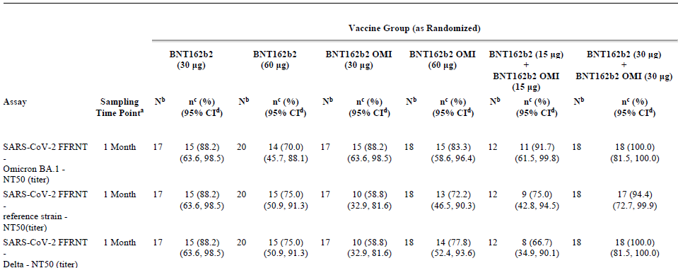Abbreviations: FFRNT = fluorescent focus reduction neutralisation test; LLOQ = lower limit of quantitation; N-binding = SARS-CoV-2 nucleoprotein-binding; NAAT = nucleic acid amplification test; NT50 = 50% neutralising titre; SARS-CoV-2 = severe acute respiratory syndrome coronavirus 2.
Note: Seroresponse is defined as achieving greater or equal to 4 fold rise from Baseline (before the first dose of study vaccination). If the baseline measurement is below the LLOQ, the postvaccination measure of greater or equal 4 times LLOQ is considered a seroresponse.
Note: Participants who had no serological or virological evidence (prior to the one month post-study vaccination blood sample collection) of past SARS-CoV-2 infection (that is, N-binding antibody (serum) negative at the study vaccination, 7-days post-study vaccination and the 1-month post-study vaccination visits, negative NAAT (nasal swab) at the study vaccination visit, and any unscheduled visit prior to the one month post-study vaccination blood sample collection) and had no medical history of COVID-19 were included in the analysis.
a. Protocol-specified timing for blood sample collection.
b. N = number of participants with valid and determinate assay results for the specified assay at both the prevaccination time point and the given sampling time point. This value is the denominator for the percentage calculation.
c. n = Number of participants with seroresponse for the given assay at the given sampling time point.
d. Exact 2-sided CI, based on the Clopper and Pearson method.

Subgroup analyses
Overall, for all tozinameran, riltozinameran and riltozinameran + tozinameran recipients, there were no clinically meaningful differences between subgroups for neutralising GMTs and seroresponse rates, for the Omicron variant and reference strain except for baseline SARS-CoV-2 status. As several subgroups (for example, younger age group, Black or African American, Asian, Hispanic/Latino, SARS-CoV-2 baseline positive or NAAT positive participants) included a limited number of participants, their results should be interpreted with caution.
Geometric mean titre at one month post-dose were substantially higher for participants who were baseline positive compared to those who were baseline negative for SARS-CoV-2.
Geometric mean fold rises at one month post-dose were generally lower for participants who were baseline positive as the baseline titres compared to those who were baseline negative for SARS-CoV-2.
Seroresponse rates at one month post-dose were generally lower for participants who were baseline positive compared to those who were baseline negative for SARS-CoV-2.

Study C4591031 Substudy D
This is the ongoing supportive (sub)study and only provides immunogenicity data related to the monovalent Omicron BA.1 vaccine (that is, riltozinameran) in comparison to the original. Substudy D, which started earlier than Substudy E, recruited adults 18 to 55 years and used the same amount of Omicron BA.1 mRNA as the approved Comirnaty vaccine (tozinameran), 30 µg of mRNA encoding ancestral strain S1 protein. Substudy D is considered to provide support for immunogenicity and safety of Omicron in younger adults, as pivotal Substudy E does not provide any data for bivalent vaccine formulation in younger than 55 years of age subjects.
The submission includes clinical data from approximately 640 participants greater or equal to 18 years of age to younger or equal to 55 years of age from ongoing Study C4591031, Substudy D (cohort 2: tozinameran experienced participants), including safety and immunogenicity to one month after receipt of an additional booster (fourth) dose of an Omicron variant specific vaccine, riltozinameran 30 µg.
Table 11: Study C4591031 Substudy D summary
Note: study information relevant to the scope of data presented in the clinical overview are summarised in the table. G-group nr. BNT162b22 = original; BNT162b22 Omi = Omicron BA.1

Study design
This is a Phase III, randomised substudy composed of open labelled and observer blinded groups to evaluate the safety, tolerability, and immunogenicity of a two dose primary series of riltozinameran, and as a booster (third, fourth, or fifth) dose in participants greater than or equal to18 years of age to younger or equal to 55 years of age. There are three study cohorts, divided in to five groups of subjects. The submitted report provides interim data for participants in cohort 2 (group 3 and group 4), who were enrolled from Study C4591001 and C4591031.
Approximately 600 participants were to be randomised at a ratio of 1:1 to receive a fourth dose (that is first study vaccination booster) of either tozinameran or riltozinameran. Randomisation was stratified by age (18 to 30, 31 to 55 years of age).

Primary objective and endpoints
The primary immunogenicity objective for cohort 2 (riltozinameran versus tozinameran) was to demonstrate superiority with respect to level of neutralising titre and noninferiority with respect to seroresponse rate of the anti-Omicron immune response after one dose of riltozinameran compared to after one dose of tozinameran given as the fourth dose (90 to 180 days after third dose) in participants without serological or virological evidence of past SARS-CoV-2 infection up to one month after fourth dose. Results were reported as a GMR of the SARS-CoV-2 50% neutralising titres and the difference in percentages of participants with seroresponse, at one month after fourth dose.
Table 12: Study C4591031 (Substudy D) immunogenicity objectives, estimands and endpoints
Study immunogenicity objective | Estimands | Endpoint
G3vG4A: To demonstrate the superiority with respect to level of neutralising titre and non-inferiority with respect to seroresponse rate of the anti-Omicron immune response after 1 dose of riltozinameran compared to after one dose of tozinameran given as the fourth dose in tozinameran experienced participants. | In participants complying with key protocol criteria (evaluable participants) and no serological or virological evidence (up to one month after receipt of one dose of study intervention) of past SARS-CoV-2 infection:  - GMR of the Omicron-neutralising titres at one month after one dose of riltozinameran to those at one month after one dose of tozinameran given as the fourth dose in tozinameran experienced participants.  - The difference in percentage of participants with seroresponse to the Omicron variant at one month after one dose of riltozinameran and at one month one dose of tozinameran given as the fourth dose in tozinameran experienced participants. | SARS-CoV-2 Omicron neutralising titres
G3vG4B: To demonstrate the ‘super superiority of the anti-omicorfn immune response after one dose of riltozinameran compared to after 1 dose of tozinameran given as fourth dose in tozinameran experienced participants. | Same as GMR estimand of G3vG4A | Same as G3vG4A

Sample size
For each group (group 3 and 4) of cohort 2, a subset of 30 participants out of 300 participants total was to be selected as a sentinel group for separate assessment of immune response defined in an exploratory objective. The subset was to comprise the first 30 participants from each group with immunogenicity samples received by the central laboratory. A random sample of 175 participants from each of group 3 and 4 selected from the remaining approximately 270 participants was used for evaluation of the primary and secondary immunogenicity objectives in each group.

Inclusion and exclusion criteria
Inclusion criteria include healthy (pre-existing stable disease could include human immunodeficiency virus, hepatitis C virus, or hepatitis B virus); greater or equal to 18 years of age, to younger or equal to 55 years of age enrolled from Studies C4591001 and C4591031 Substudy A who, for cohort 2, received three prior doses of 30 µg tozinameran, with the third dose being 90 to 180 days before Visit 401 (Day 1) in Study C4591031 Substudy D, and provided a serum sample at visit 3 in Study C4591001, with visit 3 occurring within the protocol specified window.
Exclusion criteria include medical or psychiatric conditions, including previous diagnosis of COVID-19, that may have increased the risk of study participation or, in the investigator’s judgment, made the participant inappropriate for the study (including immunocompromised individuals with known or suspected immunodeficiency); receipt of certain prior/concomitant therapies, which included radiotherapy, immunosuppressive therapy, prior COVID-19 vaccine other than tozinameran (for cohort 2), or medication intended to treat or prevent COVID-19, as well as blood/plasma products, immunoglobulin, or monoclonal antibodies, from 60 days prior to study administration, or antibody therapy specific to COVID-19, from 90 days prior to study intervention, or planned during the study.

Immunogenicity evaluation
Immunogenicity evaluation for Substudy D was identical as described for Substudy E. Shortly, immunogenicity results for non-sentinel analyses were based on validated assays for 50% SARS-CoV-2 neutralising titres on a newly developed 384-well assay platform (reference strain (SARS-CoV-2/human/USA/USA-WA1/2020), isolated in January 2020) and the Omicron variant (BA.1, lineage: B.1.1.529) at before first study (fourth dose) vaccination and one month after first study (fourth dose) vaccination with riltozinameran or tozinameran, reported as GMTs, GMRs, percentages/difference in percentages with seroresponse, GMFRs.
A non-validated assay (fluorescent focus reduction neutralisation test) was used to obtain sentinel SARS-CoV-2 serum neutralisation titres from a subset of 60 participants in groups 3 and 4 of cohort 2, before fourth dose and at one month post-fourth dose.

Immunogenicity endpoints and analysis methods
Immunogenicity analyses were conducted based on the evaluable and all available immunogenicity populations. Immunogenicity results were based on validated assays for 50% SARS-CoV-2 neutralising titres from before fourth dose to one month after fourth dose of riltozinameran or tozinameran, reported as:
- Geometric mean titres
- Geometric mean ratio of geometric mean titres (riltozinameran/tozinameran)
- Percentages/difference in percentages with seroresponse (riltozinameran minus tozinameran)
- Geometric mean fold rises in titres
A supportive fluorescent focus reduction neutralisation test assay was used to obtain sentinel Omicron neutralisation titres from a subset of participants in Study C4591031 Substudy D.
The primary immunogenicity objective for cohort 2 (riltozinameran versus tozinameran) was to demonstrate superiority with respect to level of neutralising titre and noninferiority with respect to seroresponse rate of the anti-Omicron immune response after one dose of riltozinameran compared to after one dose of tozinameran given as the fourth dose in participants without serological or virological evidence of past SARS-CoV-2 infection up to one month after fourth dose. Results were reported as a GMR of the SARS-CoV-2 50% neutralising titres and the difference in percentages of participants with seroresponse, at one month after fourth dose.

Statistical methods for immunogenicity assessment

Superiority analyses
The GMR was calculated as the mean of the difference of logarithmically transformed assay results and exponentiating the mean. Two sided 95% CIs were obtained by calculating CIs using Student’s t-distribution for the mean difference on the logarithmically transformed assay results and exponentiating the confidence limits.
Superiority based on GMR was declared if the lower limit of the two sided 95% CI for the GMR is greater than greater than one.
The secondary objective of ‘super’ superiority was evaluated using a 1.5-fold margin for GMR. ‘Super’ superiority for GMR was established if the lower limit of the two sided 95% CI for the GMR is greater than 1.5.

Non-inferiority analyses
Seroresponse is defined as achieving a greater or equal to 4-fold increase in SARS CoV-2 neutralising titres over pre-booster (that is pre-fourth dose) titres. The difference in percentages and the associated two sided 95% CI calculated using the Miettinen and Nurminen method were provided.
Non-inferiority based on seroresponse rate was declared if the lower bound of the two sided 95% CI for the difference in seroresponse rate was greater than -5%.

Additional analyses
Geometric mean titre is calculated as the mean of the assay results after making the logarithm transformation and then exponentiating the mean to express results on the original scale. Two sided 95% CIs will be obtained by taking log transforms of assay results, calculating the 95% CI with reference to Student’s t-distribution, and then exponentiating the confidence limits.
Geometric mean-fold rise is calculated as the mean of the difference of logarithmically transformed assay results (later time point minus earlier time point) and exponentiating the mean. The associated two sided 95% CIs will be obtained by constructing CIs using Student’s t distribution for the mean difference on the logarithm scale and exponentiating the confidence limits.
Subgroup analyses of immunogenicity were conducted based on demographic characteristics (age, sex, race, ethnicity) and SARS-CoV-2 baseline status (positive or negative).

Multiplicity
The three cohorts (two dose tozinameran experienced, three dose tozinameran experienced, and COVID-19 vaccine naïve individuals) are different populations with different objectives. The three populations are included in the same study to improve operational efficiency. Therefore, no type I error adjustments was applied to between the immunogenicity assessments of the three populations. However, in the context of this application where cohort 2 in Substudy D is used as supportive data, this is acceptable.
For cohort 2 the objectives will be evaluated in sequential order as listed below using a one sided alpha of 0.025:
- G3vG4A: to demonstrate the superiority with respect to the level of neutralising titres and the noninferiority with respect to the seroresponse rate of the anti-Omicron immune response after one dose of riltozinameran compared to after one dose of tozinameran given as the fourth dose in tozinameran experienced participants
- G3vG4B: to demonstrate the ‘super’ superiority of the anti-Omicron immune response after one dose of riltozinameran compared to after one dose of tozinameran given as the fourth dose in tozinameran experienced participants given as the fourth dose in tozinameran experienced participants.

Results
The primary immunogenicity subset was used to evaluate the superiority and non-inferiority primary and secondary objectives and comprised a random sample of 175 participants in each vaccine group selected from the full-expanded set. Other descriptive immunogenicity summaries used the full expanded set.
For the full-expanded set, the evaluable immunogenicity population included 263 participants (92.6%) in the riltozinameran group and 280 participants (94.6%) in the tozinameran group (see Table 13). Exclusions from the evaluable immunogenicity population were generally balanced across vaccine groups; the most common reason for exclusion was participants not having at least one valid and determinate immunogenicity result within 28 to 42 days after first study (fourth dose) vaccination (3.4%) (see Table 13).
For the full expanded set, the evaluable immunogenicity population for participants without evidence of infection prior to 1 month after fourth dose included a total of 436 participants; 208 participants (73.2%) in the riltozinameran group and 228 participants (77%) in the tozinameran group (see Table 13).
Table 13: Study C4591031 (Substudy D) Immunogenicity populations in Cohort 2 (full expanded set)
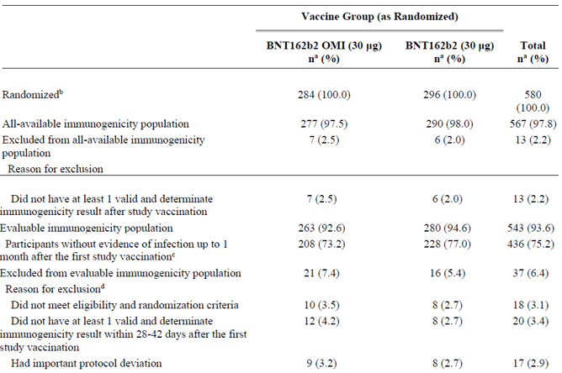 Abbreviations: BNT162b2 = tozinameran, BNT162b2 OMI = riltozinameran, N-binding = SARS-CoV-2 nucleoprotein-binding; NAAT = nucleic acid amplification test; SARS-CoV-2 = severe acute respiratory syndrome coronavirus 2.
Note: Full expanded set = Cohort 2 excluding the sentinel group.
a. n = Number of participants with the specified characteristic, or the total sample.
b. These values are the denominators for the percentage calculations.
c. Participants who had no serological or virological evidence (prior to the 1-month post–first study vaccination blood sample collection) of past SARS-CoV-2 infection (that is, N-binding antibody (serum) negative at the first study vaccination and the 1-month post–first study vaccination visits, negative NAAT (nasal swab) at the first study vaccination visit, and any unscheduled visit prior to the one-month post-first study vaccination blood sample collection) and had no medical history of COVID-19 were included in the analysis.
d. Participants may have been excluded for more than one reason.

Baseline Characteristics
For the full expanded set, demographics of participants without evidence of infection prior to one month post-fourth dose (N = 436) in the evaluable immunogenicity population were similar in the riltozinameran and tozinameran groups. This analysis population had similar demographics compared to the safety population.
Most participants were White (73.9%), with 15.6% Asian participants, 5% Black or African American participants, 3.4% multiracial participants, and other racial groups comprising less than 1% each. There were 13.8% Hispanic/Latino participants.
Age group 18 to 30 years was around 13% in both groups and 31 to 55 years constituted more than 86%. The median age at the time of study vaccination was 44 years, and 53.2% of participants were male. All (100%) study participants were enrolled in the United States of America (USA).
Obese participants made up 37.8% of this analysis population. The median time from the first booster dose of tozinameran (received prior to C4591031 Substudy D) was 3.9 months.

Primary immunogenicity analyses
Superiority analysis - GMR of omicron neutralising titres in riltozinameran fourth dose recipients compared to tozinameran fourth dose recipients
In the primary immunogenicity subset of participants without prior evidence of infection up to 1 month after first study (fourth dose) vaccination, the ratio of GMTs for the riltozinameran group to tozinameran group (GMR) was 1.75 (two sided 95% CI: 1.39, 2.22) (see Table 14).
The lower bound of the two sided 95% CI for GMR was greater than 1, which meets the prespecified simple superiority criterion. Therefore, simple superiority of riltozinameran to tozinameran for the Omicron variant was achieved based on GMR at one month after fourth dose.
Table 14: Study C4591031 (Substudy D) Geometric mean ratios for between vaccine group comparison (evaluable immunogenicity population)
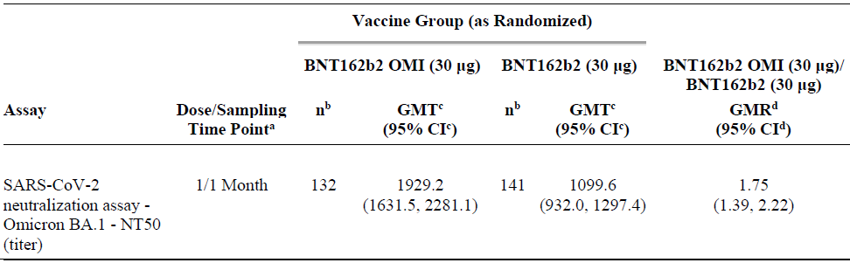
Abbreviations: BNT162b2 = tozinameran, BNT162b2 OMI = riltozinameran, GMT = geometric mean titre; GMR = geometric mean ratio; LLOQ = lower limit of quantitation; N-binding = SARS-CoV-2 nucleoprotein–binding; NAAT = nucleic acid amplification test; NT50 = 50% neutralising titre; SARS-CoV-2 = severe acute respiratory syndrome coronavirus 2.
Note: Primary immunogenicity subset = a random sample of 175 participants in each vaccine group selected from the full expanded set.
Note: Participants who had no serological or virological evidence (prior to the one month post–first study vaccination blood sample collection) of past SARS-CoV-2 infection (that is, N-binding antibody (serum) negative at the first study vaccination and the 1-month post–first study vaccination visits, negative NAAT (nasal swab) at the first study vaccination visit, and any unscheduled visit prior to the one month post–first study vaccination blood sample collection) and had no medical history of COVID-19 were included in the analysis.
a. Protocol-specified timing for blood sample collection.
b. n = Number of participants with valid and determinate assay results for the specified assay at the given sampling time point.
c. GMTs and 2-sided 95% CIs were calculated by exponentiating the mean logarithm of the titres and the corresponding CIs (based on the Student t distribution). Assay results below the LLOQ were set to 0.5 × LLOQ.
d. GMRs and 2-sided 95% CIs were calculated by exponentiating the mean difference of the logarithms of the titres (BNT162b2 Omicron 30 μg minus BNT162b2 (30 μg)) and the corresponding CI (based on the Student t-distribution)

Non-inferiority analysis
The data indicate that novel Omicron containing vaccine formulations induce higher seroresponse rate compared to the approved Comirnaty 30 µg. The non-inferiority criteria (seroresponse rate of novel vaccine formulations in comparison to the approved one) was fulfilled.
In the primary immunogenicity subset of participants without prior evidence of infection up to one month after first study (fourth dose) vaccination, 62.3% of participants in the riltozinameran group and 39.3% of participants in the tozinameran group achieved seroresponse to Omicron variant at one month after the study vaccination. The difference in proportions of participants who achieved seroresponse to Omicron variant between the two vaccine groups was 23% (two sided 95% CI: 11.1%, 34.3%) (See Table 15).
Non-inferiority of riltozinameran to tozinameran for the Omicron variant was achieved based on seroresponse rates at one month after fourth dose. The lower bound of the two sided 95% CI was greater than 0%, suggesting higher seroresponse to Omicron variant in riltozinameran recipients than tozinameran recipients.
Table 15: Study C4591031 (Substudy D) Difference in percentages of participants with seroresponse (evaluable immunogenicity population)
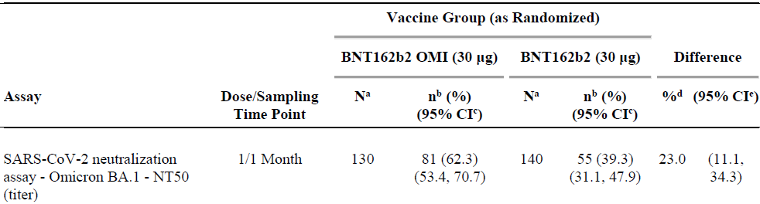 Abbreviations: BNT162b2 = tozinameran, BNT162b2 OMI = riltozinameran, LLOQ = lower limit of quantitation; N-binding = SARS-CoV-2 nucleoprotein–binding; NAAT = nucleic acid amplification test; NT50 = 50% neutralising titre; SARS-CoV-2 = severe acute respiratory syndrome coronavirus 2.
Note: Seroresponse is defined as achieving a greater than 4-fold rise from baseline (before the first dose of study vaccination). If the baseline measurement is below the LLOQ, the postvaccination measure of greater than or equal 4 times LLOQ is considered seroresponse.
Note: Primary immunogenicity subset = a random sample of 175 participants in each vaccine group selected from the full expanded set.
Note: Participants who had no serological or virological evidence (prior to the one month post–first study vaccination blood sample collection) of past SARS-CoV-2 infection (that is, N-binding antibody (serum) negative at the first study vaccination and the one month post–first study vaccination visits, negative NAAT (nasal swab) at the first study vaccination visit, and any unscheduled visit prior to the one month post–first study vaccination blood sample collection) and had no medical history of COVID-19 were included in the analysis.
a. N = number of participants with valid and determinate assay results for the specified assay at both the prevaccination time point and the given sampling time point. This value is the denominator for the percentage calculations.
b. n = Number of participants with seroresponse for the given assay at the given sampling time point.
c. Exact two sided CI based on the Clopper and Pearson method.
d. Difference in proportions, expressed as a percentage (BNT162b2 Omicron (30 µg) minus BNT162b2 (30 µg)).
e. Two sided CI based on the Miettinen and Nurminen method for the difference in proportions, expressed as a percentage.

Secondary immunogenicity analysis – primary immunogenicity subset

Super superiority analysis
As shown in Table 16 for the superiority analysis, in the primary immunogenicity subset of participants without prior evidence of infection up to one month after first study (fourth dose). vaccination, the GMR (riltozinameran / tozinameran) was 1.75 (two sided 95% CI: 1.39, 2.22).
As the lower bound of the two sided 95% CI for GMR was not greater than 1.5 (1.39), ‘super’ superiority of riltozinameran to tozinameran for the Omicron variant was not achieved based on the prespecified criterion.

Descriptive immunogenicity analyses
The full expanded set comprised cohort 2 participants excluding the 60 participants across both vaccine groups included in the sentinel group.
Immunogenicity evaluations presented for the full expanded set include descriptive summary of immune response to Omicron variant and reference strain for each vaccine group and post hoc analyses of GMR and difference in seroresponse between the two vaccine groups, corresponding to the primary immunogenicity analyses in the primary immunogenicity subset.

Geometric mean ratios of Omicron neutralising titres in riltozinameran fourth dose recipients compared to tozinameran fourth dose recipients
The full expanded set gave similar result as was observed for primary immunogenicity set. In the subjects without prior evidence of infection up to one month after first study (fourth dose) vaccination, the post hoc analysis of the ratio of GMTs for the riltozinameran group to tozinameran group (GMR) was 1.96 (two sided 95% CI: 1.62, 2.37) (Table 16), consistent with the results in the primary immunogenicity subset in which the simple superiority criterion (lower bound of the two sided 95% CI greater than 1) was met. Furthermore, this would meet the ‘super’ superiority criterion (lower bound of the two sided 95% CI greater than 1.5).
Table 16: Study C4591031 (Substudy D) Geometric mean ratios for between vaccine group comparison (evaluable immunogenicity population)
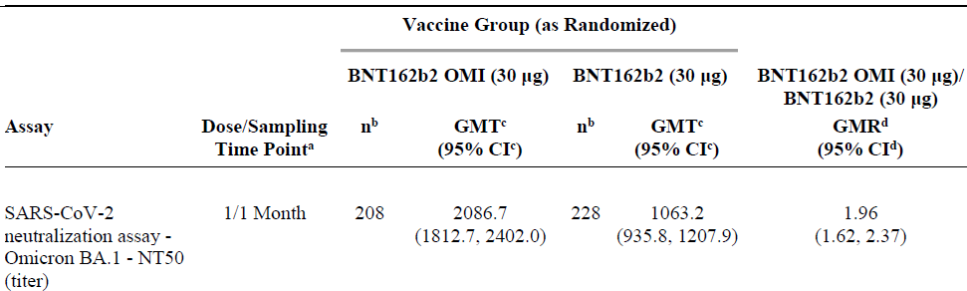
Abbreviations: BNT162b2 = tozinameran, BNT162b2 OMI = riltozinameran, GMT = geometric mean titre; GMR = geometric mean ratio; LLOQ = lower limit of quantitation; Nbinding = SARS-CoV-2 nucleoprotein–binding; NAAT = nucleic acid amplification test; NT50 = 50% neutralising titre; SARS-CoV-2 = severe acute respiratory syndrome coronavirus 2.
Note: Full expanded set = Cohort 2 excluding the sentinel group.
Note: Participants who had no serological or virological evidence (prior to the one month post–first study vaccination blood sample collection) of past SARS-CoV-2 infection (that is N-binding antibody (serum) negative at the first study vaccination and the one month post–first study vaccination visits, negative NAAT (nasal swab) at the first study vaccination visit, and any unscheduled visit prior to the one month post–first study vaccination blood sample collection) and had no medical history of COVID-19 were included in the analysis.
a. Protocol-specified timing for blood sample collection.
b. n = Number of participants with valid and determinate assay results for the specified assay at the given sampling time point.
c. GMTs and two sided 95% CIs were calculated by exponentiating the mean logarithm of the titres and the corresponding CIs (based on the Student t-distribution). Assay results below the LLOQ were set to 0.5 times LLOQ.
d. GMRs and two sided 95% CIs were calculated by exponentiating the mean difference of the logarithms of the titres (BNT162b2 Omicron [30 µg] minus BNT162b2 [30 µg]) and the corresponding CI (based on the Student t distribution).

Difference in seroresponse rates to Omicron variant in riltozinameran fourth dose recipients compared to tozinameran fourth dose recipients
Seroresponse rate to Omicron variant was higher in arm receiving novel Omicron formulation in comparison to the arm receiving approved Comirnaty. In the subjects without prior evidence of infection up to one month after first study (fourth dose) vaccination, the post hoc analysis of the difference in proportions of participants who achieved seroresponse between the riltozinameran and tozinameran groups was 21.4% (two sided 95% CI: 12%, 30.4%) (Table 17), similar to the results in the primary immunogenicity subset in which the non-inferiority criterion (lower bound of the two sided 95% CI greater than -5%) was achieved.
Table 17: Study C4591031 (Substudy D) Difference in percentages of participants with seroresponse (evaluable immunogenicity population)
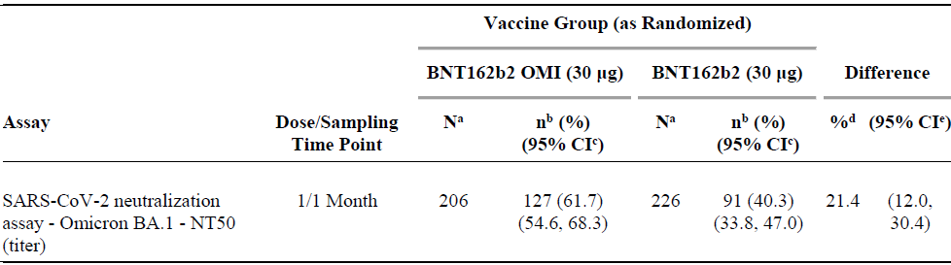
Abbreviations: BNT162b2 = tozinameran, BNT162b2 OMI = riltozinameran, LLOQ = lower limit of quantitation; N-binding = SARS-CoV-2 nucleoprotein–binding; NAAT = nucleic acid amplification test; NT50 = 50% neutralising titre; SARS-CoV-2 = severe acute respiratory syndrome coronavirus 2.
Note: Seroresponse is defined as achieving a greater than or equal to 4-fold rise from Baseline (before the first dose of study vaccination). If the baseline measurement is below the LLOQ, the postvaccination measure of greater than or equal to 4 times LLOQ is considered seroresponse.
Note: Full expanded set = Cohort 2 excluding the sentinel group.
Note: Participants who had no serological or virological evidence (prior to the 1-month post–first study vaccination blood sample collection) of past SARS-CoV-2 infection (that is N-binding antibody [serum] negative at the first study vaccination and the one month post–first study vaccination visits, negative NAAT [nasal swab] at the first study vaccination visit, and any unscheduled visit prior to the one month post–first study vaccination blood sample collection) and had no medical history of COVID-19 were included in the analysis.
a. N = number of participants with valid and determinate assay results for the specified assay at both the prevaccination time point and the given sampling time point. This value is the denominator for the percentage calculations.
b. n = Number of participants with seroresponse for the given assay at the given sampling time point.
c. Exact two sided CI based on the Clopper and Pearson method.
d. Difference in proportions, expressed as a percentage (BNT162b2 Omicron [30 µg] minus BNT162b2 [30 µg]).
e. Two sided CI based on the Miettinen and Nurminen method for the difference in proportions, expressed as a percentage.

Geometric mean titres for Omicron variant and reference strain
In the full expanded set of participants without prior evidence of infection up to one month after first study (fourth dose) vaccination, for both the riltozinameran and tozinameran groups there was a substantial increase in SARS-CoV-2 50% neutralising GMTs for the Omicron (BA.1) variant and reference strains at one month post-fourth dose compared to the pre-vaccination baseline (see Table 18, Figure 4, Figure 5).
At one month post-fourth dose, for the Omicron variant, GMTs were higher for the riltozinameran group (2086.7; two sided 95% CI: 1812.7, 2402) than the tozinameran group (1063.2; two sided 95% CI: 935.8, 1207.9) (Table 18). For the reference strain, GMTs were similar for the riltozinameran and tozinameran groups.
Geometric mean titres against reference strain were similar in both arms, but anti-Omicron variant antibodies were about twice as high in Omicron vaccine arm compared to the approved vaccine. It is noted, that in this younger adult population, who received fourth dose about four months from third dose, the baseline antibody levels for reference strain are very high and relatively high also against Omicron strain. This indicates that repeatedly administrated Comirnaty can elicit cross-neutralising antibodies.
Table 18: Study C4591031 (Substudy D) Geometric mean titres (evaluable immunogenicity population)
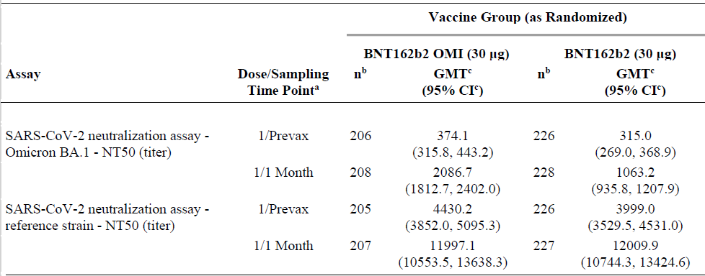
Abbreviations: BNT162b2 = tozinameran, BNT162b2 OMI = riltozinameran, GMT = geometric mean titre; NT50 = 50% neutralising titre; SARS-CoV-2 = severe acute respiratory syndrome coronavirus 2.
Figure 4: Study C4591031 (Substudy D) Geometric mean titres and 95% confidence interval for Omicron variant SARS-CoV-2 neutralisation assay (full expanded set, evaluable immunogenicity population)
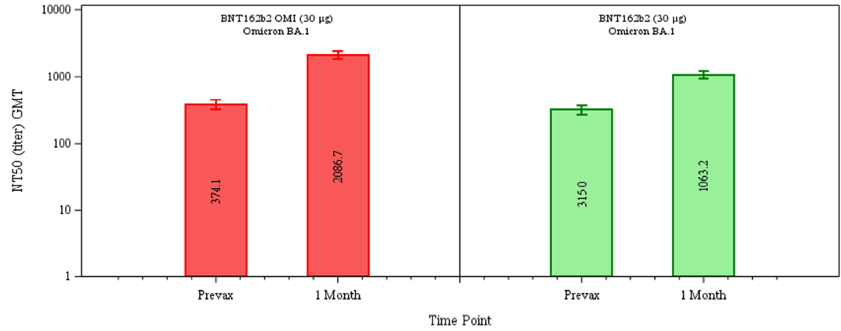
Abbreviations: BNT162b2 = tozinameran, BNT162b2 OMI = riltozinameran, GMT = geometric mean titre; GMT = geometric mean titre, N-binding = SARS-CoV-2 nucleoprotein binding; NAAT = nucleic acid amplification test, NT50 = 50% neutralising titre; SARS-CoV-2 = severe acute respiratory syndrome coronavirus 2.
Note: Full expanded set = Cohort 2 excluding the sentinel group
Note: Participants who no serological or virological evidence (prior to the one month post-first study vaccination blood sample collection) of past SARS-CoV-2 (that is N-binding antibody (serum) negative at the first study vaccination and the one month post-first study vaccination visits, negative NAAT (nasal swab) at the first study vaccination visit, and any unscheduled visit prior to the one month post-first study vaccination blood sample collection) and had no medical history of COVID-19 were included in the analysis.
Note: Number within each bar denotes geometric mean
Figure 5: Study C4591031 (Substudy D) Geometric mean titres and 95% confidence interval reference strain SARS-CoV-2 neutralisation assay (full expanded set, evaluable immunogenicity population)
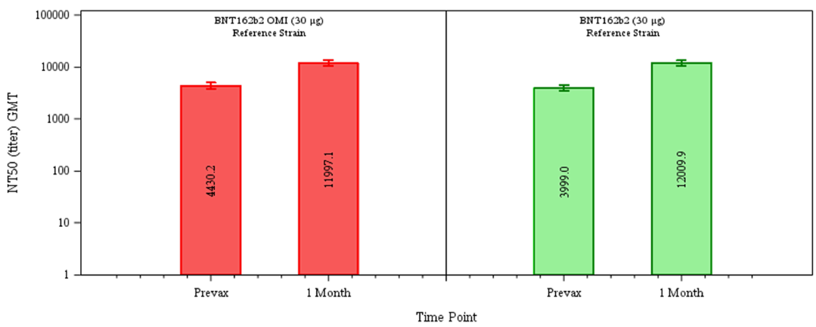
Abbreviations: BNT162b2 = tozinameran, BNT162b2 OMI = riltozinameran, GMT = geometric mean titer; GMT = geometric mean titre, N-binding = SARS-CoV-2 nucleoprotein binding; NAAT = nucleic acid amplification test, NT50 = 50% neutralising titre; SARS-CoV-2 = severe acute respiratory syndrome coronavirus 2.
Note: Full expanded set = Cohort 2 excluding the sentinel group
Note: Participants who no serological or virological evidence (prior to the one month post-first study vaccination blood sample collection) of past SARS-CoV-2 (that is N-binding antibody (serum) negative at the first study vaccination and the one month post-first study vaccination visits, negative NAAT (nasal swab) at the first study vaccination visit, and any unscheduled visit prior to the one month post-first study vaccination blood sample collection) and had no medical history of COVID-19 were included in the analysis.
Note: Number within each bar denotes geometric mean

Geometric mean fold rises for Omicron variant and reference strain
In the full expanded set without prior evidence of infection up to one month after first study (fourth dose) vaccination, the GMFRs from fourth dose to one month post-fourth dose for the Omicron variant were higher for the riltozinameran group (5.6; two sided 95% CI: 4.9, 6.4) than the tozinameran group (3.4; two sided 95% CI: 3.0, 3.8) (Table 19). For the reference strain, the GMFRs were similar for the two groups, and similar to the tozinameran group GMFRs for the Omicron variant.
Table 19: Study C4591031 (Substudy D) Geometric mean fold rises from before first study vaccination to each subsequent time point (full expanded set, evaluable immunogenicity population)
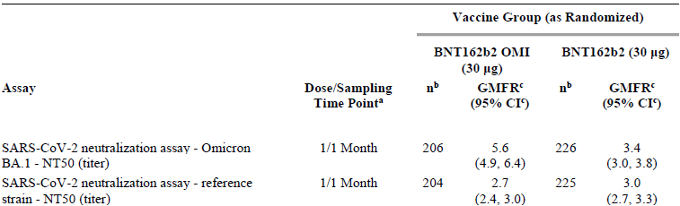
Abbreviations: BNT162b2 = tozinameran, BNT162b2 OMI = riltozinameran, GMFR = geometric mean fold rise; LLOQ = lower limit of quantitation; N-binding = SARS-CoV-2 nucleoprotein–binding; NAAT = nucleic acid amplification test; NT50 = 50% neutralising titre; SARS-CoV-2 = severe acute respiratory syndrome coronavirus 2.
Note: Full expanded set = Cohort 2 excluding the sentinel group.
Note: Participants who had no serological or virological evidence (prior to the one month post–first study vaccination blood sample collection) of past SARS-CoV-2 infection (that is N-binding antibody [serum] negative at the first study vaccination and the one month post–first study vaccination visits, negative NAAT [nasal swab] at the first study vaccination visit, and any unscheduled visit prior to the one month post–first study vaccination blood sample collection) and had no medical history of COVID-19 were included in the analysis.
a. Protocol-specified timing for blood sample collection
b. n = Number of participants with valid and determinate assay results for the specified assay at both the prevaccination time point and the given sampling time point.
c. GMFRs and two sided 95% CIs were calculated by exponentiating the mean logarithm of fold rises and the corresponding CIs (based on the Student t distribution). Assay results below the LLOQ were set to 0.5 times LLOQ in the analysis.

Subgroup analyses
Overall, for all tozinameran and riltozinameran recipients, there were no clinically meaningful differences between subgroups for neutralising GMTs and seroresponse rates, for the Omicron variant except for baseline SARS-CoV-2 status. As several subgroups (for example, younger age group, Black or African American, Asian, Hispanic/Latino, SARS-CoV-2 baseline positive or nucleic acid amplification test (NAAT) positive participants) included a limited number of participants, their results should be interpreted with caution.
- GMTs at one month post-fourth dose for both riltozinameran and tozinameran recipients were generally higher for participants who were baseline positive and the subset of those who were NAAT positive at Baseline which, in light of the study timeframe, can be inferred to be an Omicron infection, compared to those who were baseline negative for SARS-CoV-2.
- GMFRs for both riltozinameran and tozinameran recipients were generally higher for the participants in the subgroup for baseline positive by NAAT compared to those for participants who were baseline positive and baseline negative for SARS-CoV-2.
- Seroresponse rates at one month post-fourth dose for both riltozinameran and tozinameran recipients were generally higher for participants who were NAAT positive at baseline compared to those who were baseline positive or baseline negative for both Omicron variant and reference strain.

Safety
The safety objective and endpoints for Substudy E is listed in Table 20.
Table 20: Study C4591031 (Substudy E) Safety objective and endpoints
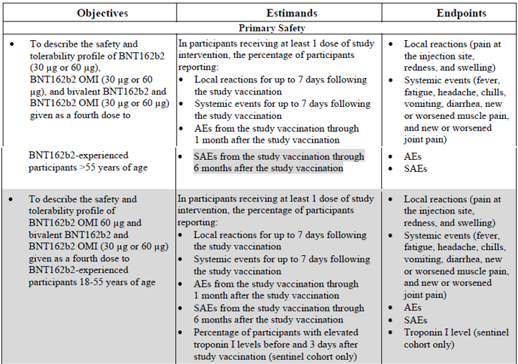
Abbreviations: BNT162b2 = tozinameran, BNT162b2 OMI = riltozinameran
Note: G1: BNT162b2 (30 µg); G2: BNT162b2 (60 µg); G3: BNT162b2 Omicron (30 µg); G4: BNT162b2 Omicron (60 µg); G5: BNT162b2 (15 µg) + BNT162b2 Omicron (15 µg) (Total 30 µg); G6: BNT162b2 (30 µg) + BNT162b2 Omicron (30 µg) (Total 60 µg)
All doses were administered as a fourth dose to subjects that have already received three doses of original 30 µg. Only data for subjects aged greater than 55 years of age is presented in this report.
Reactogenicity (systemic and local events) and use of antipyretic/pain medication was recorded for seven days (e-diary). Adverse events (AEs) were collected for 1 month and serious adverse events (SAEs) to be collected for six months. Acute reactions were recorded as immediate if they occurred within 30 min after administration of the vaccine.
Adverse events of myocarditis and pericarditis were collected for all participants as adverse events of special interest (AESIs). Potential COVID-19 illnesses and their sequelae that were consistent with the clinical endpoint definition were not recorded as AEs or considered AESIs.

Study C4591031 Substudy E disposition and the follow up
In expanded cohort (greater than 55 years of age) a total of 1846 subjects aged greater than 55 years were randomised to receive one dose of the six study vaccines. The compliance was very high, almost all subjects (1842) received one dose of vaccine. In total were 13 subjects withdrawn from the study, there were no differences in frequency of withdrawal between the study arms.
In the sentinel cohort, all 120 subjects received one dose of vaccine and no withdrawals occurred. Most of the participants (89%) in the expanded cohort had a follow-up time greater or equal to 1 month to less than 2 months after vaccination, 10% of the participants had a duration of follow up greater than 2 months.
All participants, except one subject in the 15 µg tozinameran/15 µg riltozinameran group, received their booster dose at least five months after their last vaccination. The median time from third dose to study vaccination in expanded cohort, was 6.3 months (range 5 to 13 months). In total, there were a limited number of SARS-CoV-2 positive subjects (n = 9) at Baseline. On a daily basis greater than or equal to 87% of the participants reported their status in the e-diary, there were no notable differences between study arms. In total, 65 to 72% of the subjects in the different study arms had reported their status for all seven days.
A subset from the study, 305 adults greater than 55 years of age who had completed three doses of Comirnaty, received a booster (fourth dose) of Comirnaty original/Omicron BA.1 (15 µg tozinameran/15 µg riltozinameran) 4.7 to 11.5 months after receiving third dose. Participants who received a booster (fourth dose) of Comirnaty original/Omicron BA.1 had a median follow up time of at least 1.7 months.

Local reactogenicity (expanded cohort)
The median onset for all local reactions across vaccine groups evaluated was two days, and all events resolved within a median duration of 1 to 2 days after onset. Severe local reactions were rare, with no Grade 4 events and a low frequency of Grade 3 events. Across all groups these were injection site pain (0.3%), swelling (0.2%) and redness (0.4%) (see Figure 6).
Figure 6: Study C4591031 (Substudy E) Participants reporting local reactions by maximum severity within seven days after the study vaccination (safety population)
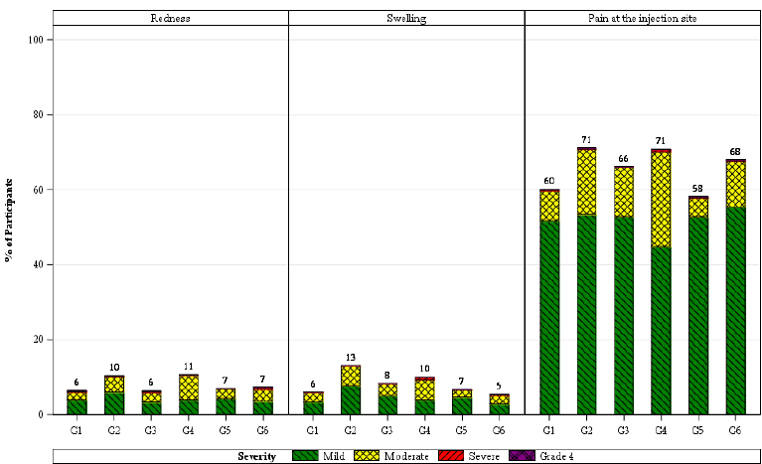
Abbreviations: BNT162b2 = tozinameran, BNT162b2 OMI = riltozinameran
Note: G1: BNT162b2 (30 µg); G2: BNT162b2 (60 µg); G3: BNT162b2 Omicron (30 µg); G4: BNT162b2 Omicron (60 µg); G5: BNT162b2 (15 µg) + BNT162b2 Omicron (15 µg); G6: BNT162b2 (30 µg) + BNT162b2 Omicron (30 µg)
Note: Number above each bar denotes percentage of participants reporting the reaction with any severity.
For the bivalent vaccine (Comirnaty Original/Omircon BA.1 vaccine at 15 µg tozinameran/15 µg riltozinameran) the frequency of pain at injection site was 58%, which is in line with the frequency of 60% reported in the group that received Comirnaty original at 30 µg of tozinameran, whereas for the Comirnaty Original/Omicorn BA.1 vaccine at 30 µg tozinameran/30 µg riltozinameran the frequency was 68%. Most of the local reactions were mild to moderate in severity, no Grade 4 reaction were reported. Time to onset for the local reactions was 1 to 4 days (median of 2 days) and all events resolved within 1 to 9 days (median of 2 days) after onset for all study arms.
No clinically relevant differences were noted in terms of local reactions, across all vaccine groups when evaluated by subgroups of race, ethnicity and baseline SARS-CoV-2 status.

Local reactogenicity (sentinel cohort)
The overall patterns, severities and durations were within the range of those discussed for the expanded cohort. There were no Grade 4 local reactions reported.

Systemic reactogenicity (expanded cohort)
The following frequencies of adverse events are reported for the Comirnaty Original/Omicron BA.1 bivalent vaccine (15 µg tozinameran/15 µg riltozinameran, as proposed); Comirnaty original vaccine (30 µg tozinameran); and the bivalent vaccine at twice the proposed dose (30 µg tozinameran/30 µg riltozinameran) respectively:
- Fatigue was the most common adverse event (49%, 45%, and 57% (see Figure 7)).
- Headache was reported as the second most common systemic reaction (34%, 27%, and 37%); followed by
- Muscle pain (22% , 20% and 28%);
- Joint pain (11%, 9%, and 19%); and
- Fever (5%, 4% and 8%) (see Figure 7).
Four events of fever greater than 38.9 to 40°C was reported in the group that received 15 µg vaccine. Four events of fever greater than 38.9 to 40°C were reported in the group that received Comirnaty original/Omicron BA.1 at 15 µg/15 µg vaccine, whereas none in the Comirnaty original 30 µg reported fever greater than 38.9°C (see Figure 7). In general, systemic events were reported at slightly higher frequencies for participants in the 60 µg dose groups.
Most systemic events were mild or moderate in severity. Severe systemic reactions were rare, with no Grade 4 events and a low frequency of Grade 3 events. Across all groups these were fatigue (2.2%), headache (0.9%), chills (0.6%), muscle pain (0.6%), diarrhoea (0.3%) and joint pain (0.2%). Severe events were relatively more frequent in the Comirnaty Omicron BA.1 (riltozinameran) 60 μg group (see Figure 7).
The median onset for all systemic events across vaccine groups evaluated was 2 to 3 days, and all events resolved within a median duration of 1 to 2 days after onset.
Overall, there is a tendency for numerically slightly higher frequencies of systemic-related events with Omicron BA.1 containing vaccines. However, these differences are marginal and not deemed clinically meaningful.
No clinically relevant differences were noted in terms of systemic reactions across all vaccine groups when evaluated by subgroups of race, ethnicity and baseline SARS-CoV-2 status.
Figure 7: Study C4591031 (Substudy E) Participants reporting systemic events by maximum severity within seven days after the study vaccination (safety population)
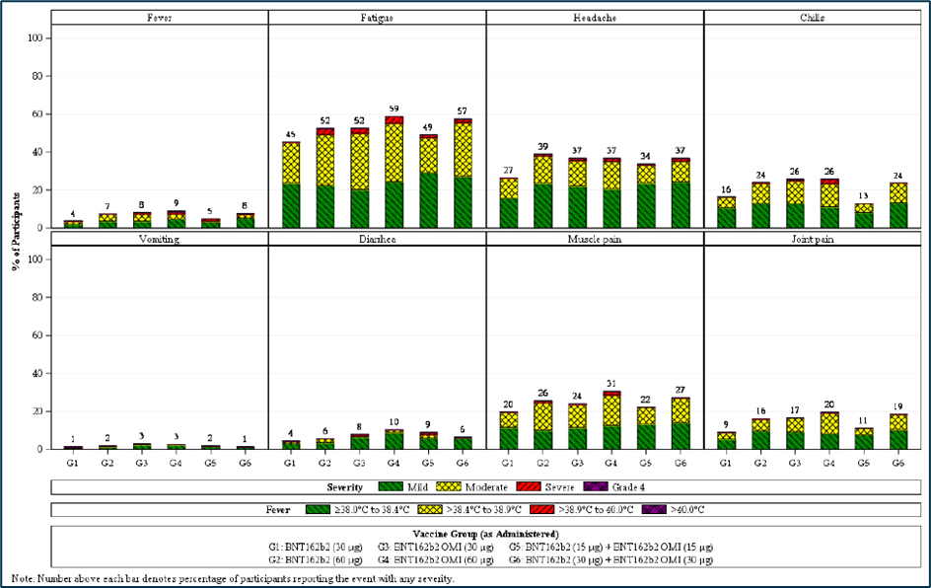
Abbreviations: BNT162b2 = tozinameran, BNT162b2 OMI = riltozinameran
Note: G1: BNT162b2 (30 µg); G2: BNT162b2 (60 µg); G3: BNT162b2 Omicron (30 µg); G4: BNT162b2 Omicron (60 µg); G5: BNT162b2 (15 µg) + BNT162b2 Omicron (15 µg); G6: BNT162b2 (30 µg) + BNT162b2 Omicron (30 µg)
Note: Number above each bar denotes percentage of participants reporting the reaction with any severity.
Note: G5 - BNT162b2 (15 µg) + BNT162b2 Omicron (15 µg) is encircled red

Adverse events from study vaccination to data cut-off date
Median follow up to the cut-off date (16 May 2022) was 1.7 months and an overview of AEs is shown in Table 21. In addition to events already reported up to one month post-dose, a limited number of additional events were reported up to the data cutoff date. Additional severe AEs and/or SAEs were reported only in the control group (that is tozinameran at 30 µg); n = 2). As of the data cut-off date, any related or any severe AEs were reported across the vaccine groups by less than or equal to 5.1% or less than or equal to 0.9% of participants, respectively. Two additional severe AEs also reported as SAEs (pneumonia, ischaemic stroke) were reported in the Comirnaty original 30 µg group. No withdrawals due to AEs were reported in any of the groups beyond one month post-dose. No study participants died.
Table 21: Study C4591031 (Substudy E) Number (%) of participants reporting at least one adverse event from the study vaccination through cut-off date (safety population)
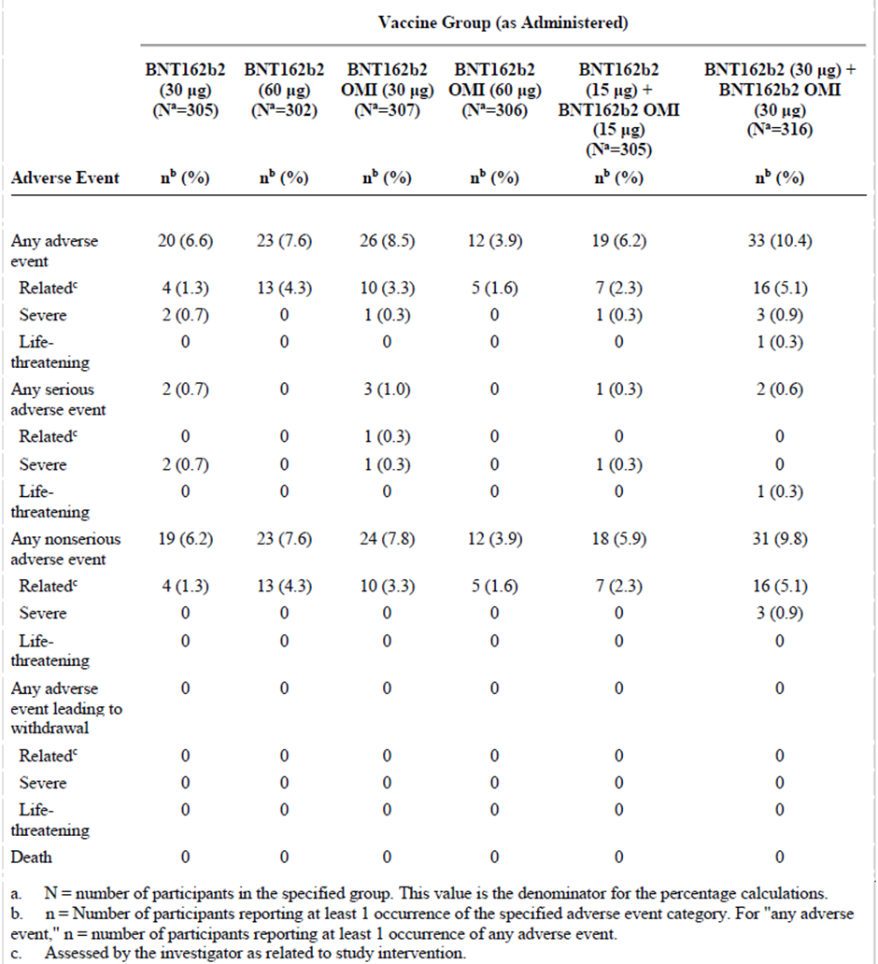
Abbreviations: BNT162b2 = tozinameran, BNT162b2 OMI = riltozinameran
a. N = number of participants in the specified group. This value is the denominator for the percentage calculations.
b. n = Number of participants reporting at least 1 occurrence of the specified adverse event category. For ‘any adverse event’, n = number of participants reporting at least 1 occurrence of any adverse event.
c. Assessed by the investigator as related to study intervention.

Adverse events from study vaccination to one month post-dose
There were more AEs seen in the Comirnaty Omicron BA.1 vaccine (30 µg riltozinameran) and Comirnaty original/Omicron BA.1 bivalent vaccine (30 µg tozinameran + 30 µg riltozinameran) groups than in other groups (see Table 22). Frequencies, relatedness and severity were similar between the Comirnaty original/Omicron BA.1 bivalent vaccine (15 µg tozinameran + 15 µg riltozinameran) group and the control group (Comirnaty original vaccine at 30 µg). In the Comirnaty original/Omicron BA.1 bivalent vaccine (15 µg tozinameran + 15 µg riltozinameran) group, there were no life-threatening AEs, no AEs leading to study withdrawal and no deaths; however, there was one severe SAE in the Comirnaty original/Omicron BA.1 bivalent vaccine 30 µg tozinameran + 30 µg riltozinameran group (life threatening Grade 4 AE of atrial fibrillation). Some additional SAEs were seen among the other Omicron variant vaccine groups. While there were some differences seen in frequencies of AEs between subgroups (including the baseline SARS-CoV-2 status subgroups), these appeared to be fairly randomly distributed and did not appear to follow any clinically meaningful patterns.
Table 22: Study C4591031 (Substudy E) Number (%) of participants reporting at least 1 adverse event from the study vaccination through one month after the study vaccination (safety population)
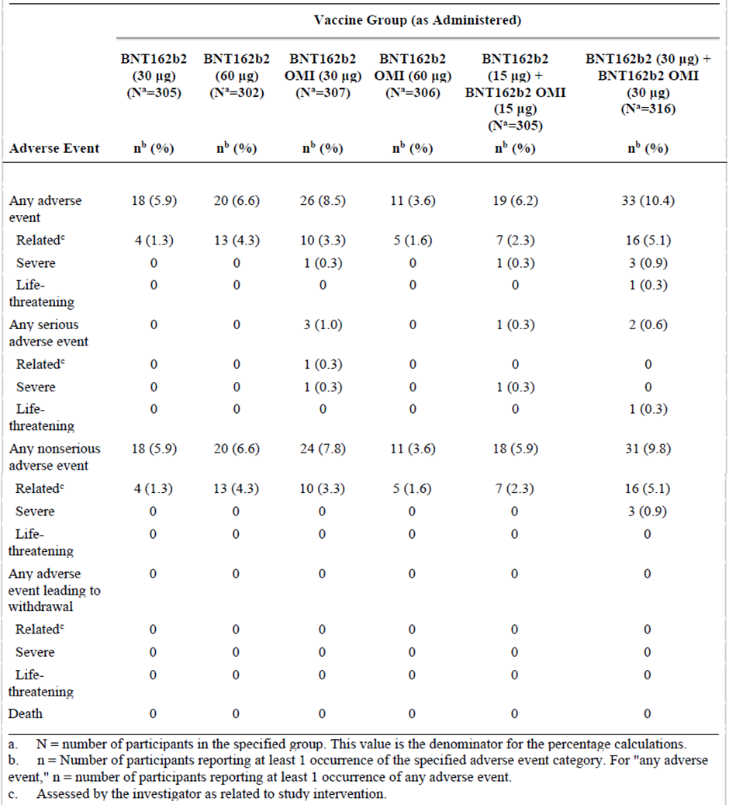
Abbreviations: BNT162b2 = tozinameran, BNT162b2 OMI = riltozinameran
a. N = number of participants in the specified group. This value is the denominator for the percentage calculations.
b. n = Number of participants reporting at least one occurrence of the specified adverse event category. For ‘any adverse event’, n = number of participants reporting at least one occurrence of any adverse event.
c. Assessed by the investigator as related to study intervention.

Subgroup analysis
No clinically relevant differences were noted in for the frequencies of AEs, across all vaccine groups when considering the subgroups race/ethnicity, baseline SARS-CoV-2 status. A tendency towards slightly higher frequencies of any AEs and related AEs is observed through almost all study arms for female participants, for example, 3.7% versus 9.1% and 0.6% versus 4.2% (male versus female) for the bivalent vaccine (Comirnaty original/Omicron BA.1 at 15 µg/15 µg). No sex dependent differences are seen for serious or severe events.

Adverse events by System Organ Class and Preferred Term one month post-dose
Overall, frequencies of any AEs reported after study vaccination up to one month post-dose were generally similar between groups (range: 3.6% to 10.4%), with AEs generally reported at similar frequencies in the vaccine groups, except for participants in the Comirnaty Omicron BA.1 (riltozinameran) at 30 µg and Comirnaty original/Omicron BA.1 (tozinameran/riltozinameran) at 30/30 µg groups who reported AEs more frequently (8.5% and 10.4%).
Many AEs were consistent with reactogenicity events that were reported as AEs (for example, injection site pain, diarrhea, and pyrexia), which showed no clinically meaningful imbalance between groups. In the general disorders and administration site conditions System Organ Class (SOC), AEs were reported at numerically higher incidence in most of the vaccine groups than the Comirnaty original (tozinameran) 30 µg group (range: 0.3% to 2.8%), with the highest increases reported in participants in the Comirnaty original 60 µg and bivalent Comirnaty original/Omicron BA.1 at 30/30 µg groups, largely attributable to injection site reactions and fatigue.
There were no reported events of myocarditis or pericarditis (protocol defined AESIs). Infections and illnesses typical of this age group were also reported with no clinically meaningful imbalance between groups. This AE profile is generally consistent with the known safety profile of Comirnaty original 30 µg.
In the bivalent vaccine (Comirnaty original/Omicron BA.1 at 15/15 µg) group, one male 65 years of age, experienced palpitations on Day 1 post-study vaccination which resolved within four days. The event was mild in severity and considered related to study intervention by the investigator. The assessment is agreed, and no new safety concern is detected.
One case of tremor and one case of spondylitis are noted in the bivalent vaccine (Comirnaty original/Omicron BA.1 at 15/15 µg). The case with tremor is described by the study physician as a non-related and mild AE. The case reported with spondylitis is also mentioned in the section AEs of special interest.
One participant in the Comirnaty original 60 µg group reported a SAE of atrial fibrillation within the four weeks interval (three participants altogether up to one month and cutoff, respectively). These cases are further described in the section SAEs.

Related adverse events one month post-dose
From study vaccination to one month post-dose, AEs assessed by the investigator as related to study intervention were reported with generally similar frequencies between groups. Incidence of related AEs were numerically higher in the tozinameran 60 µg (4.3%), riltozinameran 30 µg (3.3%), and tozinameran +riltozinameran 60 µg (5.1%) groups than in the tozinameran 30 µg group.
Most related AEs were consistent with reactogenicity events and in the SOC of general disorders and administration site conditions (range: 0.3% to 2.3%). Related AEs of clinical interest (for example, lymphadenopathy, rashes, arthritis) are included in the AESI analysis.

Immediate adverse events
No immediate AEs (occurring within 30 minutes post-vaccination) were reported after study vaccination for any of the vaccine groups.

Severe and life threatening adverse events
No participants in the tozinameran 30 µg or 60 µg groups reported severe AEs from study vaccination through one month post-dose.
From study vaccination through one month post-dose, one (0.3%) participant in the riltozinameran 30 µg group reported a severe AE of dehydration. This event was also reported as a SAE and considered related to study intervention by the investigator. No participant in the riltozinameran 60µg group reported a severe AE.
From study vaccination through one month post-dose, one (0.3%) participant in the 15 µg tozinameran + 15 µg riltozinameran group reported a severe AE of gastroesophageal reflux disease (reported unrelated) and three (0.9%) participants in the 15 µg tozinameran + 15 µg riltozinameran group reported severe AEs of injection site swelling, headache, and muscle weakness (one participant each).
A life-threatening (that is Grade 4) AE of atrial fibrillation was reported in one (0.3%) participant after study vaccination in 30 µg tozinameran + 30 µg riltozinameran group. This event was also reported as a SAE and considered not related to study intervention by the investigator.

Deaths and serious adverse events
No participants died between study vaccination to the data cut-off date of 16 May 2022.

Adverse events leading to withdrawal
No participants in the study discontinued due to AEs from study vaccination to the data cut-off date of 16 May 2022.

Adverse events of special interest
As of the data cut-off date (16 May 2022) there were no cases reported of myocarditis/pericarditis, Bell’s palsy (or facial paralysis/paresis), appendicitis, or vaccine related anaphylaxis. There was one (0.3%) participant in the tozinameran 30 µg group that reported a non-serious AE of chest discomfort.
Adverse events of clinical interest that were identified in the safety database as of the data cutoff date included lymphadenopathy, arthritis, and rash, which are summarised below.

Lymphadenopathy
Till the data cut-off date, the incidence of lymphadenopathy was 0.4% (range 0 to 1.0%) across vaccine groups evaluated. All eight events were considered by the investigator as related to study intervention. All cases were mild to moderate in severity, occurred generally within 1 to 4 days post-dose, were in the axillae and most resolved within 2 to 8 days. Additionally, 1 (0.3%) participant in the Comirnaty original/Omicron BA.1 (at 30 µg tozinameran + 30 µg riltozinameran) group reported axillary pain (Grade 1, assessed as related). This event occurred on Day 2 post-dose and was resolved within three days.

Rash
From study vaccination to data cut-off date, four participants reported a rash after study vaccination. All events of rash were mild and considered by the investigator as related to study intervention, most events occurred on Day 2 or 3 post vaccination and resolved within 2 to 9 days after onset.

Arthritis
Arthritis (joint inflammation, mild in severity) was reported in a male in the with onset at Day 10 post-dose in the Comirnaty original (tozinameran at 30 µg) group. This subject had history of arthritis and was engaged in rock climbing, cross-country skiing, and digging of snow shelters a week prior to the onset of the arthritis.

Angioeodema
A female with a history of hypercholesterolemia, developed angioedema of the face, 17 days after receiving first dose of Comirnaty Omicron BA.1 (riltozinameran at 30 µg). It resolved by Day 25. On Day 28 after dose, the participant again developed swelling, which was ongoing at the time of the last available report. This was reported unrelated by the study investigator.

Study C4591031 Substudy D disposition and demographics
All included 640 subjects received their fourth dose and none of them were excluded from the safety population (315 in the Comirnaty Omicron BA.1 (30 µg riltozinameran) group and 325 in the Comirnaty original (30 µg tozinameran) group, (see Table 23).
Table 23: Study C4591031 (Substudy D) Safety population, cohort 2
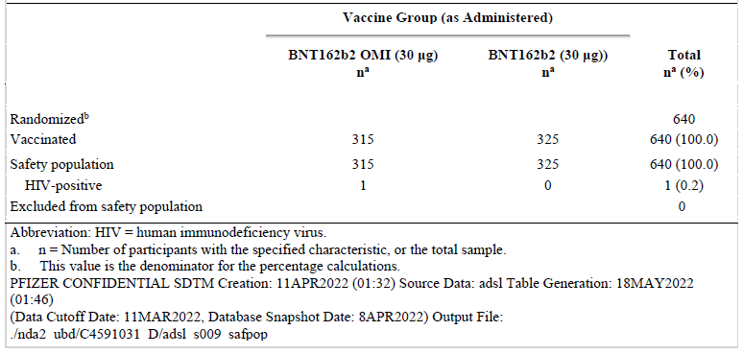
Abbreviations: BNT162b2 = tozinameran, BNT162b2 OMI = riltozinameran; HIV = human immunodeficiency virus
a n = number of participants with special characteristic, or the total sample.
b This value is the denominator for the percentage calculations.
The study was executed in the US, the majority were white and 71% of the subjects were overweighted or obese. The distribution between gender were similar. Half of the subjects received their fourth dose, 3 to 4 months after third dose. The study included subjects aged 18 to 55 years, however, the majority of them was greater than 30 years of age and only 13% (n = 84) of the entire study population were 18 to 30 years old.

Local reactogenicity
Pain at the injection site was the most frequently reported local reaction in the Comrinaty Omicron BA.1 (riltozinameran) 30 µg and the Comirnaty original (tozinameran) 30 µg (78% each). Most events were mild or moderate in severity and no Grade 4 local reactions were reported. For both groups, the median onset for all local reactions was 1 to 2 days, and all events resolved within a median duration of 1 to 2 days after onset.
Figure 8: Study C4591031 (Substudy D) Participants reporting local reactions by maximum severity within 7 days after first study vaccination (safety population, cohort 2)
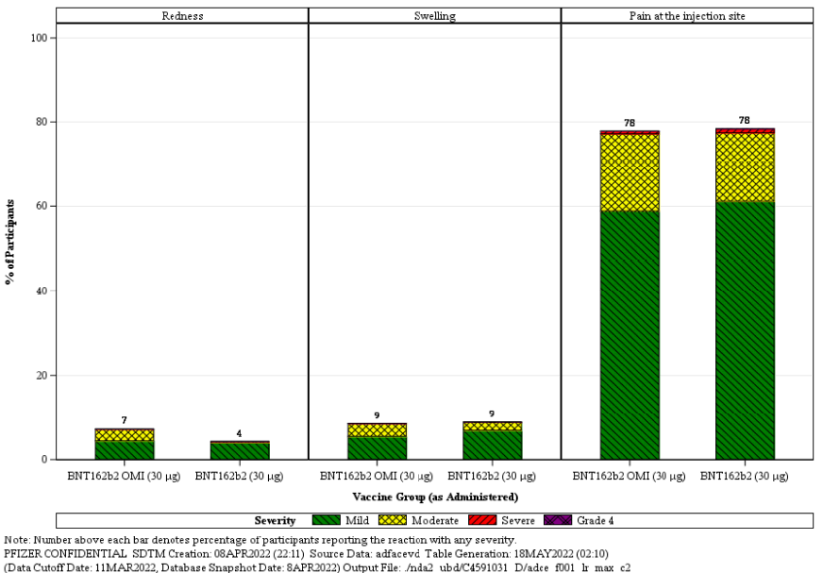
Note: Number above each bar denotes percentage of participants reporting the reaction with any severity

Systemic reactions
In both groups, there was one participant (0.3%) with fever greater than 38.9°C to 40°C; there were no participants in either group with fever greater than 40°C. For both groups, the median onset for most systemic events was 1 to 2 days, and all events resolved within a median duration of 1 to 2 days after onset. Most of the events were mild or moderate in severity and no Grade 4 systemic events were reported.
There is a tendency for numerically slightly higher frequencies of systemic related events with the riltozinameran containing vaccine.
Table 24: Study C4591031 (Substudy D) Systemic events reported in the riltozinameran and tozinameran groups
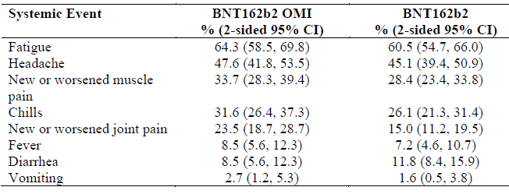
Abbreviations: BNT162b2 = tozinameran, BNT162b2 OMI = riltozinameran

Adverse events
From first study (fourth dose) vaccination to one month after fourth dose, few participants (n = 30) reported AEs in the safety population comprised of 315 riltozinameran and 325 tozinameran recipients. The proportion of participants reporting any AE was similar in the riltozinameran (5.7%) and the tozinameran (3.7%) groups (see Table 25). Any related, severe, or serious AEs were reported in the riltozinameran and tozinameran groups by 3.2% versus 1.5%, 1.3% versus 0.6%, and 0.3% versus 0.3%, respectively (see Table 25).
No life-threatening AEs were reported in either group. No study participants had any AEs leading to withdrawal and no participants died from fourth dose to one month after fourth dose (see Table 25).
Table 25: Study C4591031 (Substudy D) Number (%) of participants reporting at least one adverse event from first study vaccination through one month after first study vaccination (safety population, cohort 2)
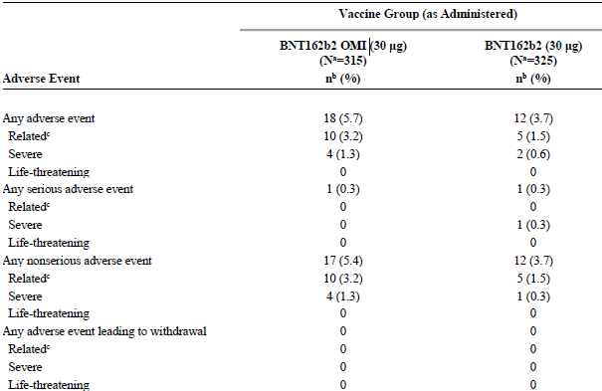
a. N = number of participants in the specified group. This value is the denominator for the percentage calculations.
b. n = Number of participants reporting at least one occurrence of the specified event category. For ‘any event,’ n = number of participants reporting at least one occurrence of any event.
c. Assessed by the investigator as related to study intervention.

Adverse events by System Organ Class and Preferred Term
Most AEs reported during this period reflect reactogenicity events (that is, fatigue, chills, myalgia, pyrexia, headache, injection site pain), which accounted for the majority of severe AEs. The SOCs in which the reactogenicity terms are included had the following overall AE frequencies in the riltozinameran 30 µg group versus Comirnaty original monovalent (tozinameran) 30 µg group:
- general disorders and administration site conditions: 9 (2.9%) versus 0
- musculoskeletal and connective tissue disorders: 5 (1.6%) versus 2 (0.6%)
- nervous system disorders: 4 (1.3%) versus 1 (0.3%)
- gastrointestinal disorders: 0 versus 2 (0.6%)
Adverse events reflecting lymphadenopathy included lymphadenopathy in one participant (0.3%) and three participants (0.9%) in the riltozinameran and tozinameran groups, respectively, and axillary pain (0.3%) in one participant in the riltozinameran group; all other AEs were reported in less than or equal to three participants across vaccine groups. Lymphadenopathy has previously been identified as a reaction caused by tozinameran.

Related adverse events
From first study (fourth dose) vaccination to one month after fourth dose, few AEs reported were assessed by the investigator as related to study intervention in the riltozinameran (ten participants (3.2%)) and tozinameran groups (five participants (1.5%)).
- Most related AEs were consistent with reactogenicity events and in the SOC of general disorders and administration site conditions, reported in nine participants (2.9%) and zero participants in the riltozinameran and tozinameran groups, respectively.
- Additionally, lymphadenopathy assessed as related was reported in one participant (0.3%) and three participants (0.9%) in the riltozinameran and tozinameran groups, respectively. Chest pain and myalgia were reported by two participants (0.6%) each in the riltozinameran group.
- All other AEs assessed as related were reported by one participant each. No events in the immune system disorders SOC were reported as related.

Immediate adverse events
No immediate AEs (occurring within 30 minutes post-vaccination) were reported after first study (fourth dose) vaccination for either vaccine groups.

Severe and life threatening adverse events
From first study (fourth dose) vaccination to one month after fourth dose, the frequency of severe AEs was low for the riltozinameran 30 µg (four participants (1.3%)) and the tozinameran 30 µg groups (two participants (0.6%)). In the riltozinameran 30 µg group, all were severe reactogenicity events: fatigue, chills, arthralgia, and headache. Severe AEs reported in the Comirnaty original 30 µg group were fluid retention (SAE, assessed as not related) and diarrhoea. No life threatening (that is Grade 4) AEs were reported after fourth dose in either vaccine group.

Serious adverse events
From first study (fourth dose) vaccination to one month after fourth dose, two participants, one in each group, reported one SAE each, both of which were assessed as not related:
- In the riltozinameran 30 µg group, there was one event of migraine (unrelated) reported 22 days after fourth dose that was ongoing as of the data cutoff date.
- In the tozinameran 30 µg group, there was one event of fluid retention (unrelated) reported 25 days after fourth dose and resolved within six days.

Discontinuations from study intervention or study due to adverse events
No participants in the study were withdrawn due to AEs from first study (fourth dose) vaccination to the data cutoff date of 11 March 2022.

Adverse events of specific clinical interest
No cases of anaphylaxis, hypersensitivity, myocarditis, pericarditis, appendicitis, Bell’s Palsy, or rash were reported in either group in Study C4591031 Substudy D from first study (fourth dose) vaccination to up to one month post-fourth dose or to the data cutoff date. Lymphadenopathy is considered an adverse reaction to tozinameran, and events are discussed below. AESIs of chest pain and herpes zoster are discussed below. No cases of additional AESI, such as thrombocytopenic events, autoimmune events, pericarditis, myocarditis were reported. It is however important to have in mind that due to the limited sample size, this study was not designed to detect rare AEs.

Lymphadenopathy
From fourth dose to the data cut-off date, mild to moderate lymphadenopathy (reported as AEs) was reported in one participant (0.3%) and three participants (0.9%) in the riltozinameran and tozinameran groups, respectively and it recovered/resolved within 3 to 8 days (with sequalae for the participant in the tozinameran group). All four events were considered by the investigator as related to study intervention and occurred in the older (31 to 55 years) age group. Additionally, one participant (0.3%) in the riltozinameran group reported axillary pain (Grade 1, assessed as related). The event occurred three days after fourth dose and was resolved within six days.

Chest pain
In the riltozinameran 30 µg group, there were two events of chest pain, both Grade 1 and assessed as related.
- In a 34 year old female, chest pain was reported four days after fourth dose and was resolved within three hours. The investigator considered the event as stress related and did not think it met criteria for cardiac illness; no further investigations were performed.
- In a 39 year old male, chest pain was reported two days after fourth dose and was resolved within ten days. At a cardiac illness visit five days after the event onset, the participant had no elevation in troponin, mean heart rate was 78 beats per minute, ECG was normal, and echocardiography was normal.

Herpes zoster
In one participant in the tozinameran group, an AE of herpes zoster (mild, resolved, assessed as unrelated) was reported one day after fourth dose. No other AEs were reported for the participant.

Risk management plan
The sponsor has submitted EU-risk management plan (RMP) version 6.1 (date 18 July 2022; data lock point (DLP) for bivalent Omicron BA.1 Vaccine - DLP Module SIII: 5 April 2022, Study C4591031 Substudy E; 11 March 2022 (Study C4591031 Substudy D, Cohort 2). Module SVII.3. 5 April 2022 (Pfizer Clinical Database C4591031 Substudy E; 11 March 2022 (Pfizer Clinical Database C4591031 Substudy D, Cohort 2; 30 June 2022 (Pfizer safety Database) and Australia specific annex (ASA) version 0.6 (date 6 September 2022) in support of this application.
The summary of safety concerns and their associated risk monitoring and mitigation strategies are summarised in Table 26. Further information regarding the TGA’s risk management approach can be found in risk management plans for medicines and biologicals and the TGA's risk management approach.
Table 26: Summary of safety concerns
Summary of safety concerns |  | Pharmacovigilance |  | Risk Minimisation
 |  | Routine | Additional | Routine | Additional
Important identified risks | Myocarditis and pericarditis |  | * |  | –
Important potential risks | Vaccine-associated enhanced disease (VAED) including Vaccine-associated enhanced respiratory disease (VAERD) | † | * | – | –
Missing information | Use in pregnancy and while breast feeding |  | *≠ |  | –
Missing information | Use in immunocompromised patients |  | * |  | –
Missing information | Use in frail patients with co-morbidities (e.g. chronic obstructive pulmonary disease (COPD), diabetes, chronic neurological disease, cardiovascular disorders) |  | * |  | –
Missing information | Use in patients with autoimmune or inflammatory disorders |  | * | – | –
Missing information | Interaction with other vaccines |  | * |  | –
Missing information | Long term safety data |  | * | – | –
†Data Capture Aid (Adverse drug reaction follow-up forms)
≠Post-authorisation safety study
*Clinical trial
The clinical evaluator has made recommendations regarding the missing information in the summary of safety concerns. The sponsor should address these recommendations in an updated ASA.
The proposed pharmacovigilance plan is acceptable from an RMP perspective. The acceptability of the clinical study plan is assessed by the Delegate.
Only routine risk minimisation measures are proposed by the sponsor. There are risk minimisation measures implemented for COVID-19 vaccines by the Department of Health and Aged Care and State Governments. The introduction of this bivalent vaccine is not expected to warrant additional risk minimisation measures as part of the RMP.

Risk-benefit analysis

Delegate’s considerations

Overview
Detailed data on immunogenicity and safety profiles by vaccine type are valuable to make informed decisions on booster regimens. Immunogenicity and safety data from Study C4591031 Substudy E provides important insight regarding this. Study C4591031 Substudy D used a monovalent Omicron vaccine (riltozinameran) and provided supportive data for use in younger population (18 years to 55 years), as the pivotal study only includes subjects over 55 years.

Public health need
Australia is currently experiencing ongoing major COVID-19 outbreaks, which is causing significant disruption to the normal way of life. NSW and Victoria states are still having high number of COVID-19 cases, caused by the currently dominant Omicron variant (BA.1) and its subvariants BA.4 and BA.5.
Currently provisionally approved COVID-19 vaccines for booster dose are Comirnaty (monovalent original), Vaxzevria (monovalent original) Spikevax monovalent (original) and Spikevax bivalent (original + Omicron BA.1 (tozinameran/riltozinameran)). There is a need for a booster vaccine which provided broader range of immunity, covering the currently circulating variants/subvariants for the of Australian population.

Immunogenicity and safety
Study C4591031 Substudy E was randomised, observer blinded boosting study to evaluate the safety, tolerability, and immunogenicity, providing acceptable evidence that studied vaccine booster dose for the Comirnaty Original/Omicron BA.1 COVID-19 vaccine is immunogenic and safe, in a trial context, among relatively healthy adult subjects of 55 years age and above.

Immunogenicity
Immunogenicity data is derived primarily from the Study C4591031 Substudy E investigating the immune responses and safety, following a fourth dose of bivalent vaccine (following three previous doses of the Comirnaty original vaccine (tozinameran)) in approximately 1840 older adult (greater than 55 years of age) participants. Comirnaty Original/Omicron BA.1 vaccine (tozinameran/riltozinameran) 15/15 µg was compared to the same product at 60 µg; to BA.1 (riltozinameran) at 30 µg and 60 µg; and to Comirnaty original (tozinameran) at 30 µg and 60 µg.
Supportive data for younger than 55 years age are provided from Study C4591031 Substudy D investigating safety and immunogenicity of an investigational monovalent Omicron BA.1 vaccine, where 640 subjects aged 18 to 55 years (majority 30 to 55 years, 13% were 18 to younger than or equal to 30 years old) were randomised to receive either the monovalent Comirnaty Omicron BA.1 30 µg (n = 315) or the authorised Comirnaty original (tozinameran) 30 µg (n = 325) as a fourth dose. In this substudy, all subjects had previously received three doses of Comirnaty original (tozinameran) at 30 µg per dose.
Both substudies had as its primary objective investigation of the immunogenicity of different Omicron containing vaccine formulations as a fourth dose compared to a fourth dose of Comirnaty original at 30 µg.
The primary endpoint of these studies was to show that the novel vaccine formulations, containing the Omicron strain can induce superior immune responses to the Omicron BA.1 virus variant, and induce non-inferior response to the reference strain compared to original Comirnaty at 30 µg.
There is currently no immunological correlate of protection established for COVID-19, and therefore the relevance of numerical titre differences, in terms of impact on protection against severe disease or any clinical disease, cannot be determined.
The serological comparison is considered acceptable as efficacy has been demonstrated in clinical studies and neutralising antibodies are considered an acceptable surrogate endpoint for efficacy. As stated above, it is assumed that efficacy against a new variant will be at least comparable and possibly superior, if superior levels of neutralising antibodies are detected following booster with a variant vaccine compared to the original vaccine. The quantification of such incremental effects, however, will need to be based on real world evidence, given that no randomised controlled trial of the variant adapted vaccine against the original vaccine is required, according to generally agreed regulatory policy. For further details, see International Coalition of Medicines Regulatory Authorities (ICMRA) | Therapeutic Goods Administration (TGA).
Study C4591031 Substudy E contained six study arms. In each arm approximately 230 individuals received either one of the following formulations:
- tozinameran (original) 30 µg
- tozinameran (original) 60 µg
- riltozinameran (Omicron BA.1) 30 µg
- riltozinameran (Omicron BA.1) 60 µg
- bivalent vaccine, tozinameran 15 µg + riltozinameran 15 µg (Comirnaty Original/Omicron BA.1 COVID-19 vaccine) 15 µg /15 µg). Note this is the dosage as proposed in this submission.
- bivalent vaccine, tozinameran 30 µg + riltozinameran 30 µg. (Comirnaty Original/Omicron BA.1 COVID-19 vaccine ) 30 µg /30 µg)
The fourth dose was given median 6.3 months (4.7 to 12.9) from the third dose. Blood samples for immunogenicity evaluations were collected on the vaccination day (baseline) and 1 month after four dose.
For Substudy D, results have been reported for two study interventions with monovalent vaccines: Comirnaty (original, tozinameran) 30 µg, and Omicron BA.1 (riltozinameran) 30 µg.
Neutralisation of Omicron variant BA.4/BA.5 was studied using in a smaller study population including 100 individuals in both original/BA.1 at 15 µg /15 µg and original 30 µg using non-validated assay method (fluorescent focus reduction neutralisation test).
The majority (80%) of the study population did not have signs of previous SARS-COV-2 infection. The majority of participants had high levels of antibodies against the reference strain at Baseline and also low, but detectable levels of anti-Omicron antibodies at Baseline.
In Substudy E superior immune responses (lower limit of the two sided 95% CI for the GMR greater than 1) to the Omicron BA.1 strain was demonstrated for all four novel Omicron strain containing vaccine formulations in comparison to the approved Comirnaty 30 µg one months after fourth dose. The GMR for Comirnaty Original/Omicron BA.1 vaccine (tozinameran/riltozinameran) 15 µg/15 µg versus. The approved Comirnaty original (tozinameran) 30 µg was 1.56 (95% CI 1.45, 2.68). Compared to the pre-boost titre, the antibody titre against Omicron BA.1. strain increased 9.1-fold (7.3,11.2) after bivalent original/Omicron BA.1 15 µg/15 µg vaccine and 5.8-fold (4.6, 7.2) after Original 30 µg vaccine.
The seroresponse rate against the omicron BA.1 strain, for original/Omicron BA.1 30 µg was 71.6 % versus 57 % for original 30 µg, demonstrating statistically significant superiority (difference 14.6 % (4.0, 24.9), pre-defined criteria greater or equal to 5%).
Non-inferiority based on the GMR for the reference ancestral strain response was met by both bivalent vaccine groups as the lower limit of the two sided 95% CI for the GMR is greater than 0.67 (1.5-fold criterion). The GMR for Comirnaty original/Omicron BA.1 30 µg versus. the approved original vaccine was 0.99 (0.82, 1.2). Compared to pre-boost titres, the antibody titre against ancestral strain increased 4.3-fold after both vaccines.
The sero-response rate for Comirnaty original/Omicron BA.1 30 µg against the ancestral strain was 50% versus 49.2% for Comirnaty original vaccine at 30 µg.
All study arms had about 230 individuals and a short follow up, which is too low to evaluate vaccine efficacy (VE) against COVID-19. Breakthrough infections, presumably due to Omicron BA.1 or BA.2, were seen in all study arms. There is no statistical basis to infer different efficacy between variant vaccines.
Additional descriptive analyses from Substudy E were performed to further characterise Omicron BA.4/BA.5 neutralisation responses following a booster (fourth) dose. A total of 100 participants were randomly selected from each vaccine group in the expanded cohort. Demographic characteristics for participants in this subset were similar between the two vaccine groups. The observed Omicron BA.4/BA.5 neutralising GMTs at one month post-dose were numerically slightly higher for the bivalent Comirnaty original/Omicron BA.1 group compared to original vaccine at 30 µg group (167.4 versus 155.1). Overall, GMFRs (4.5 versus 3.3) and seroresponse (56% versus 42%) followed this trend. The data on immunogenicity against Omicron BA.5. were obtained with non-validated fluorescent focus reduction neutralisation test assay Moreover, it is not known if the numerically small increase in neutralising titres compared to that of the original product will be associated with improved relative efficacy.
Also, immunological response to Omicron BA.2.75 strain was investigated in 30 randomly selected individuals from both Comirnaty original/Omicron BA1 at 15 µg/15 µg and original vaccine arms from Substudy E. Overall, the observed Omicron BA.2.75 neutralising GMTs at one month post-dose in participants without evidence of infection were numerically slightly higher for the bivalent original/Omicron BA.1 at 15 µg/15 µg group compared to original vaccine group (108 versus 88.8).
In Substudy D approximately 640 participants older or equal to 18 to younger of equal to 55 years of age received a fourth dose of either approved Comirnaty original vaccine (tozinameran) at 30 µg or monovalent Omicron BA.1 vaccine (riltozinameran) at 30 µg about four month after the third dose. Superior immunogenicity to Omicron BA.1 and non-inferior response to reference ancestral strain were demonstrated for Omicron BA.1 at 30 µg vaccine compared to the original vaccine.
Numerically, the highest GMR against Omicron BA.1 was achieved for the monovalent Omicron BA.1 at 60 µg vaccine candidate and the lowest GMR for the bivalent original/BA.1 at 15 µg/15 µg variant. This is as can be expected, since the magnitude of the immune response depends on the dose. Interestingly, Comirnaty original at 60 µg elicited numerically the same level of anti-Omicron antibodies as bivalent 15 µg /15 µg vaccine group, which indicates an ability of Comirnaty original to elicit cross-neutralising antibodies.
The sponsor seeks approval for a bivalent vaccine at tozinameran/riltozinameran 15 µg/15 µg formulation as a booster dose. Choosing the smallest effective dose is endorsed; moreover, an extrapolation of safety to younger adults would not be possible if the total dose is higher than 30 µg.
It is unknown to what extent the increase in neutralising titres against Omicron BA.1 would translate into increased protection against severe disease; against clinical disease; or against transmission, compared to the presently approved vaccine.
Immune responses are generally stronger in younger people compared to older. Therefore, it can be extrapolated that the booster effect of original/Omicron BA.1 30 µg against the Omicron BA.1 strain will be seen also in younger people, although data are only available from the abovementioned Substudy D. In this study a monovalent Omicron BA.1 vaccine at 30 µg elicited stronger responses against Omicron BA.1, compared to original 30 μg. Whether the relative numerical increment in efficacy of bivalent original/Omicron BA.1 vaccine compared to original vaccine will be seen also for adults younger than 55, is unknown. These considerations are relevant also for adolescents 12 to 18 years of age.
No information about antibody kinetics over time after the fourth dose has been submitted.
The sponsor seeks approval of the bivalent vaccine as a booster dose, that is third or fourth dose after a two dose primary series, although the current application only contains data for a fourth dose. However, it is not anticipated that it would be in any way inferior to use the bivalent vaccine instead of the monovalent original vaccine for the third dose.
There is no immunogenicity data provided by the sponsor for use of proposed bivalent vaccine as heterologous booster. Limited immunogenicity data available for Comirnaty, from a CoV-BOOST study (use with AstraZeneca vaccine) and National Institutes of Health (NIH) study Phase I/II open label clinical trial (NCT04889209) conducted in the United States (after Spikevax, primary series). The CoV-BOOST Study 2021-002175, a multicentre, randomised, controlled, Phase II trial of third dose booster vaccination (median age 71 years of age, interquartile range 54 to 77 years of age) showed neutralising antibody NT₅₀ GMR-fold change increased 21.6-fold with heterologous Comirnaty booster (n = 95).
In conclusion, the submitted immunogenicity data support the use of bivalent Comirnaty Original/Omicron BA.1 vaccine (tozinameran/riltozinameran) at 15 µg/15 µg formulation as homologous booster dose for 18 years and above, as the immune responses against Omicron BA.1 were superior for the bivalent vaccine and Omicron (monovalent) compared to the Comirnaty original (tozinameran) vaccine and the immune responses to the original reference strain were non-inferior.

Safety
The sponsor has submitted one month interim data from Study C4591031 Substudy E in which the already authorised ‘Comirnaty original at 30 µg’ was compared with five different vaccines of different composition: Comirnaty original at 60 µg, Omicron BA.1 at 30 µg, Omicron BA.1 at 60 µg and two bivalent combinations of Comirnaty original/Omicron BA.1 (at 15 µg/15 µg and 30 µg/30 µg formulation).
Only data for subjects aged greater than 55 years of age have been presented by the sponsor. This study included 1841 such subjects. Of these 305 received Comirnaty original/Omicron BA.1 at 15 µg/15 µg. Most of these (89%) had a follow up time of greater than or equal to one month to less than 2 months after vaccination.
All doses were administered as a fourth dose, and all subjects had already received three doses of Comirnaty original at 30 µg.
Data from Study C4591031 Substudy D has also been provided. In this dataset, 640 subjects aged 18 to 55 years were randomised to receive either the monovalent Omicron BA.1 vaccine at 30 µg (n = 315) or the authorised Comirnaty original vaccine at 30 µg (n = 325) as a fourth dose. All 640 subjects received one dose of either vaccine.
Thus, the safety data for the bivalent Comirnaty Original/Omicron BA.1 at 15 µg/15 µg vaccine are available only in subjects aged 55 and higher. For subjects younger than 55 years age, data are only available for a monovalent Omicron BA.1 vaccine variant (at 30 µg).
In Substudy E, all participants, except one subject in the Comirnaty original/Omicron BA.1 15 µg/15 µg group, received their booster dose at least five months after their last vaccination (median time 6.3 months, range 5 to 13 months).
In Substudy E the median age was 67 years. In Substudy D, all subjects received their booster dose at a median time of four months after their last vaccination (range 3.3 to 6.8 months) and the median age was 43 years, and only 13% (n = 84) of the entire study population were 18 to 30 years old.

Reactogenicity
The majority of the local reactions were mild to moderate in severity, no Grade 4 reaction were reported. Pain at injection site was the most frequently reported local reaction in all study groups in Substudy E. (58% Comirnaty original/Omicron BA.1 at 15 µg/15 µg; 60% Comirnaty original at 30 µg; 68% Comirnaty original/Omicron BA.1 at 30 µg/30 µg).
In Substudy D, most of the local reactions were mild or moderate in severity and no Grade 4 local reactions were reported. Pain at the injection site was the most common local reaction in both Omicron BA.1 at 30 µg and Comirnaty original at 30 µg (78% each).
In Substudy E, the following frequencies of adverse events are reported for the Comirnaty Original/Omicron BA.1 bivalent vaccine (15 µg tozinameran/15 µg riltozinameran, as proposed); Comirnaty original vaccine (30 µg tozinameran); and the bivalent vaccine at twice the proposed dose (30 µg tozinameran/30 µg riltozinameran) respectively:
- Fatigue was the most common adverse event (49%, 45%, and 57% (see Figure 7)).
- Headache was reported as the second most common systemic reaction (34%, 27%, and 37%); followed by
- Muscle pain (22% , 20% and 28%);
- Joint pain (11%, 9%, and 19%); and
- Fever (5%, 4% and 8%) (see Figure 7).
In Substudy D, fatigue was the most reported systemic reaction (64% Omicron BA.1 at 30 µg; 60% Comirnaty original at 30 µg), followed by headache (48% Omicron BA.1 at 30 µg; 45% Comirnaty original at 30 µg), muscle pain (34% Omicron BA.1 at 30 µg; 28% Comirnaty original at 30 µg) and fever (9% Omicron BA.1 at 30 µg; 6% Comirnaty original 30 µg).
Overall, most of the events were mild or moderate in severity and no Grade 4 systemic events were reported.
The frequency of local reactions was slightly higher among the younger subjects included in Substudy D compared with the older adults included in Substudy E. This would be anticipated, as reactogenicity is generally higher in younger compared to older subjects. Yet higher rates are anticipated in adolescents aged 12 to 18, as is the case for the Comirnaty original 30 µg vaccine. Moreover, similar to Substudy E, the rate of systemic reactions tended to be numerically higher with the Omicron BA.1 vaccine construct compared to the original vaccine.
Thus, across the two trials, there is a tendency for numerically slightly higher frequencies of reactogenicity-related events with Omicron BA.1 containing vaccines. However, these differences are marginal.

Overall adverse events
Adverse events in Substudy E were reported for the time period up to 1 month after dosing and up to cut-off date (16 May 2022) which represents a median follow up of at least 1.7 months after study vaccination.
The rate for any AEs up to the cut-off date for Comirnaty Original/Omicron BA.1 at 15 µg/15 µg in Substudy E was roughly similar across treatment arms (range; 3.9% (Omicron BA.1 at 60 µg) at 10.4% (Comirnaty Original/Omicron BA.1 at 30 µg/30 µg)).
Severe AEs were uncommonly reported in the groups Comirnaty original at 30 µg, Omicron BA.1 at 30 µg, Comirnaty original/Omicron BA.1 at 15 µg/15 µg and Comirnaty Original/Omicron BA.1 at 30 µg/30 µg).
No additional safety concern was observed regarding AEs in Substudy D, (The number of any reported AE was overall low (5.7%, Omicron BA.1 30 µg; 3.7%, Comirnaty original 30 µg).
Though a slightly higher rates of adverse events were noted among females, there were no meaningful differences in reactogenicity or other adverse events between subgroups based on race, ethnicity or evidence of prior SARS-CoV-2 infection.
There were no cases reported of myocarditis/pericarditis, Bell’s palsy (or facial paralysis/paresis), or vaccine-related anaphylaxis, in either study. However, the sample size was too small to detect these AEs.

Overall data limitations
The data limitations of submitted studies are listed below:
- Safety and immunogenicity data for bivalent vaccine available only for above 55 years age.
- No safety and immunogenicity data after second or the fourth dose.
- Immunogenicity data from booster dose against the currently circulating variants in only available for the Omicron BA.1 variant (not for the Omicron BA.4/BA.5 subvariant). Of note, the assay method for the Omicron BA.4/5 subvariants that were used in the Substudy E booster trial, is not validated at this stage.
- Data related to persistence of immune response was not available in the submitted study.
- Safety sample size was small.
- No supportive data from the sponsor for use as heterologous booster.
- 12 to 18 years age, no data was provided.
- Insufficient safety and immunogenicity data in immunocompromised patients or patients with background autoimmune disease.
- No safety data on pregnant women and breastfeeding women.
- Short-term safety data, which may not provide information on rare AEs and there may be AEs that have a long latency period including AEs of special interest.
- Data on vaccine efficacy of the booster are lacking. Booster efficacy in the real world cannot be extrapolated with certainty, especially in view of currently circulating Omicron variant and its subvariants exhibiting significant change in the viral morphology, immune escape and clinical presentation.
- Data in frail elderly with unstable health conditions and co-morbidities are not available.

Proposed action
There is existing public health need for a bivalent COVID-19 vaccines to increase the breadth of the immune response and to offer better protection against the currently circulating SARS-CoV-2 variants. Based on the acceptable immunogenicity and safety demonstrated by the submitted data, the Delegate is primarily of the view that provisional approval for Comirnaty Original/Omicron BA.1 (tozinameran/riltozinameran) COVID-19 vaccine to be used as a booster for above 18 years age who are primed with an mRNA COVID-19 vaccine, is appropriate. There are multiple issues raised in this overview, which will be discussed with the Advisory Committee on Vaccine (ACV) and a final decision will be taken only after that.

Questions for the sponsor
The sponsor provided the following response to questions from the Delegate.
- Can the sponsor confirm if the assays used for Omicron BA.4/5 are validated now?
A separate Omicron BA.4/5 neutralisation assay, based on the same platform as the Omicron BA.1 assay, is currently under validation.

Advisory Committee considerations
The Advisory Committee on Vaccines (ACV), having considered the evaluations and the Delegate’s overview, as well as the sponsor’s response to these documents, advised the following.

Specific advice to the Delegate
- Based on the overall evidence from the Substudy E and supportive Substudy D, can the ACV advise whether the benefits-risks balance of Comirnaty Original/Omicron BA.1 COVID-19 vaccine as a homologous and heterologous booster in individuals 12 years and older is positive in the current pandemic situation?
The ACV advised that the benefit-risk balance of Comirnaty Original/Omicron BA.1 COVID-19 vaccine as homologous and heterologous booster in individuals 18 years and older is positive.
The ACV advised that it was unable to assess the benefit-risk balance of Comirnaty Original/Omicron BA.1 COVID-19 vaccine in individuals aged 12 to 18 years, as no immunogenicity or safety data were available for this age group. The ACV noted that original Comirnaty is approved as a booster dose in the 12 to 18 year age group.
- Does the ACV support the proposed indication for use of Comirnaty Original/Omicron BA.1 as a homologous and heterologous booster in general population above 12 years, based on the submitted immunogenicity/safety data, especially in the view of no immunogenicity/safety data for bivalent vaccine in subjects under 55 years? Also, there is no immunogenicity data for subjects after primary series (post dose 2) or the fourth dose or subjects with natural infection after primary series and no validated immunogenicity data against the Omicron BA.4/5 subvariants?
The ACV advised that it did not support the proposed indication for use from 12 years of age. While immunogenicity bridging from older adults to younger adults (that is, those from the age of 18 years) was reasonable, bridging of reactogenicity and safety from older adults to adolescents was not supported.
Reactogenicity is known to be higher in adolescents and young adults than older adults following original Comirnaty administration. As all safety data are from individuals aged over 55 years, it is not appropriate to use Comirnaty Original/Omicron BA.1 COVID-19 vaccine in the 12 to 18 years of age group.
Limitations in the submission are the absence of data on use of Comirnaty Original/Omicron BA.1 COVID-19 vaccine for primary vaccination, after fourth doses of original Comirnaty, after natural infection after primary series, and validated immunogenicity against Omicron BA.4/5 subvariants. While the submitted data were solely in participants who had previous doses of Comirnaty, ACV agreed it would be reasonable to permit the use as a heterologous booster after other primary vaccines. However, the lack of data for this group should be highlighted.
- Can the ACV comment if overall safety is acceptable, as the sample size was small, pivotal study only included subjects above 55 years and the follow up was only 4 weeks? There are no safety data for proposed booster dose after the primary series or the fourth booster dose.
The ACV advised that the overall safety profile for adults was acceptable, noting the identified data limitations.
Adverse events occurring beyond 4 weeks are part of the ‘long term safety data’ identified as ‘missing information’ in the risk management plan.
- Can the ACV comment on any specific risk mitigation strategies required for the booster dose?
The ACV advised that the limitations on the available information on this vaccine need to be adequately communicated to potential recipients of the vaccine.
- The committee is also requested to provide advice on any other issues that it thinks may be relevant to a decision on whether or not to approve this application.
The ACV highlighted that Comirnaty (tozinameran 30 µg/0.3 mL for individuals 12 years and older) and Comirnaty Original/Omicron BA.1 COVID-19 vaccine are each to be supplied in a multidose vial with a grey cap and as a formulation that does not require dilution prior to use. The committee was concerned that product differentiation may be inadequate for selection and safe administration of the appropriate vaccine. The ACV also highlighted the need for accurate record keeping given the enlarging range of COVID-19 vaccines.

Conclusion
The ACV considered this product to have an overall positive benefit-risk profile for the indication:
Comirnaty Original/Omicron BA.1 Vaccine has provisional approval for the indication below:
As a booster dose for active immunisation to prevent coronavirus disease 2019 (COVID-19) caused by SARS-CoV-2, in individuals 18 years of age and older.
The use of this vaccine should be in accordance with official recommendations.
The decision has been made on the basis of immunogenicity and short-term safety data. Continued approval depends on the evidence of longer term benefits and safety from ongoing clinical trials and post-market assessment.

Outcome
Based on a review of quality, safety, and efficacy, the TGA approved the registration of Comirnaty Original/Omicron BA.1 COVID-19 Vaccine (tozinameran and riltozinameran) 30 µg/0.3 mL, suspension for injection, multidose vials, indicated for:
Comirnaty Original/Omicron BA.1 vaccine has provisional approval for the indication below:
As a booster dose for active immunisation to prevent coronavirus disease 2019 (COVID-19) caused by SARS-CoV-2, in individuals 18 years of age and older.
The use of this vaccine should be in accordance with official recommendations.
The decision has been made on the basis of short term immunogenicity and safety data. Continued approval depends on the evidence of longer term efficacy and safety from ongoing clinical trials and post-market assessment.

Specific conditions of registration applying to these goods
- Comirnaty Original/Omicron BA.1 Vaccine (tozinameran/ riltozinameran) is to be included in the Black Triangle Scheme. The PI and Consumer Medicines Information (CMI) for Comirnaty Original/Omicron BA.1 Vaccine must include the black triangle symbol and mandatory accompanying text for the products entire period of provisional registration.
- The Comirnaty Original/Omicron BA.1 Vaccine EU-RMP (version 6.1, dated 24 August 2022, DLP; Module SIII: 5 April 2022 C4591031 Substudy E; 11 March 2022 (C4591031 Substudy D – Cohort 2). Module SVII.3. 5 April 2022 (Pfizer Clinical Database C4591031 Substudy E; 11 March 2022 (Pfizer Clinical Database C4591031 Substudy D – Cohort 2; 30 June 2022 (Pfizer safety Database)), with ASA (version 0.6, dated 6 September 2022), included with submission PM-2022-03551-1-2, and any subsequent revisions, as agreed with the TGA will be implemented in Australia.
An obligatory component of risk management plans is routine pharmacovigilance. Routine pharmacovigilance includes the submission of periodic safety update reports (PSURs).
Unless agreed separately between the supplier who is the recipient of the approval and the TGA, the first report must be submitted to TGA no later than 15 calendar months after the date of the approval letter. The subsequent reports must be submitted no less frequently than annually from the date of the first submitted report until the period covered by such reports is not less than three years from the date of this approval letter, or the entire period of provisional registration, whichever is longer.
The reports are to at least meet the requirements for PSURs as described in the European Medicines Agency’s Guideline on good pharmacovigilance practices (GVP) Module VII-periodic safety update report (Rev 1), Part VII.B Structures and processes. Note that submission of a PSUR does not constitute an application to vary the registration. Each report must have been prepared within ninety calendar days of the data lock point for that report.
Additional to the submission of routine PSURs, expedited monthly summary safety reports (including safety data for patients in Australia) are to be provided for the first 6 months post registration, and thereafter at intervals specified by the TGA.
- Batch Release Testing and Compliance
It is a condition of registration that all independent manufacturing batches of Comirnaty Original/Omicron BA.1 tozinameran/riltozinameran 30 µg/0.3 mL suspension for injection vial to be supplied in Australia are not released for supply by or on behalf of the sponsor until the manufacturer’s release data have been assessed by, and sponsor have received notification acknowledging authorisation to release from, the Laboratories Branch, TGA.
In complying with the above, the sponsor must supply the following for each independent batch of the product imported or proposed to be imported into Australia:
  - a completed Request for Release Form, available from vaccines@health.gov.au; and
  - complete summary protocols for manufacture and QC, including all steps in production in the agreed format
  - at least 10 (ten) vials (samples) of each manufacturing batch Comirnaty Original/Omicron BA.1 tozinameran/riltozinameran 30 µg/ 0.3 mL suspension for injection vial with the Australian approved labels, PI, and packaging (unless an exemption to supply these has been granted) representative of all batches of product seeking distribution in Australia.
  - at least 5 (five) vials (samples) of any further consignments of a manufacturing batch of Comirnaty Original/Omicron BA.1 tozinameran/riltozinameran 30 µg/ 0.3 mL suspension for injection vial with the Australian approved labels, PI, and packaging (unless an exemption to supply these has been granted). Further consignments cover batches previously supplied to TGA for the purposes of batch release testing but are seeking to be supplied again.
  - if the manufacturing batch has been released in Europe or United Kingdom, a copy of the EU Official Control Authority Batch Release (OCABR) certificate (or equivalent from the UK) must also be provided; and
  - any reagents, reference material and standards required to undertake testing as requested by Laboratories Branch, TGA.
Sponsors must provide all requested samples and data in sufficient time (at least 5 business days) prior to any distribution date to allow the TGA to perform testing and review. Distribution of each batch of vaccine is conditional upon fulfilment of these conditions and receipt of a letter from the Laboratories Branch acknowledging release.
Samples and data should be forwarded to the Biotherapeutics Section, Laboratories Branch before release of each batch and with sufficient lead time to allow for Laboratories Branch testing.
Clinical Conditions
- Submit the final report for Sub studies E and D of the Study C4591031
Quality Conditions
- Post-approval stability protocol and stability commitment: The sponsor is required to provide the results of the ongoing stability studies on the Omicron drug substance to confirm the shelf-life of 6 months when stored at the long-term storage condition of -20 ± 5 °C. The sponsor is required to provide commitment to continue the ongoing stability studies presented in the stability studies protocol. Additionally, one batch of drug product per year for all relevant products will be placed on long-term stability program and on accelerated stability testing where significant changes are made to the manufacturing process. The sponsor should commit to communicate any out of specifications stability test results to the TGA.
Nonclinical Conditions
- Levels of IL-2, TNF-α, IFN- γ and IL-4 or IL-10 producing CD4⁺ T cells in both naı̈ve and BNT162b2-immunised mice to support Th1 biased T cell responses (Study PRL-COVID-Ms-2022-01).
- The kinetics of total spike-specific B cells and the strain-specific B-cell responses over time in spleen in both vaccine-naı̈ve and BNT162b2-experienced mice (Study PRL-COVID-Ms-2022-01).

Attachment 1. Product Information
The PI for Comirnaty Original/Omicron BA.1 COVID-19 vaccine approved with the submission which is described in this AusPAR is at Attachment 1. For the most recent PI, please refer to the TGA PI/CMI search facility.

Therapeutic Goods Administration
PO Box 100 Woden ACT 2606 Australia
Email: info@tga.gov.au Phone: 1800 020 653 Fax: 02 6232 8605
https://www.tga.gov.au

World Health Organization (2020) WHO Director-General speeches: WHO Director-General's opening remarks at the media briefing on COVID-19 - 11 March 2020. Available from the WHO website.
WHO COVID-19 (coronavirus) dashboard. World Health Organization. Available at: https://covid19.who.int/ (assessed on 1 November 2022)
Coronavirus (COVID-19) case numbers and statistics. Australian Government Department of Health and Aged Care. Available at: https://www.health.gov.au/health-alerts/covid-19/case-numbers-and-statistics
Global Initiative on Sharing Avian Influenza Data database accessible via https://gisaid.org/
van der Straten, et al. Mapping the antigenic diversification of SARS-CoV-2. medRxiv, 2022: 2022.01.03.21268582
Wilks, et al. Mapping SARS-CoV-2 antigenic relationships and serological responses. bioRxiv, 2022: 2022.01.28.477987
Zhang L, et al. The significant immune escape of pseudotyped SARS-CoV-2 variant Omicron. Emerg Microbes Infect. 2022;11(1):1-5.
Available at: COVID-19 vaccine: Provisional registrations | Therapeutic Goods Administration (TGA). Last accessed on 19/08/2022.
As part of the provisional approval pathway, the provisional registration process will allow certain medicines to be provisionally registered in the Australian Register of Therapeutic Goods (ARTG) for a limited duration. These medicines are registered on the basis of preliminary clinical data, where there is the potential for a substantial benefit to Australian patients. The TGA will re-assess risks related to the absence of evidence through data provided at a later stage, as part of the confirmatory data. Confirmatory data should confirm the relationship between outcomes predicted by the surrogate endpoint, or other preliminary data, and the clinical benefit as demonstrated by direct clinical outcomes. The sponsor may apply to transition to full registration at any time up until the provisional registration lapse date, once they have completed the obligations outlined for the provisional registration period and complete confirmatory data on safety and efficacy are available.

