Guidance for viewing and responding to notifications on the Consent for Non-compliance Dashboard on the TGA Business Services (TBS) Portal
  - Guidance for viewing and responding to notifications for devices that are part of a consent application.

  - Version 1.0, September 2022

Copyright
© Commonwealth of Australia 2022
This work is copyright. You may reproduce the whole or part of this work in unaltered form for your own personal use or, if you are part of an organisation, for internal use within your organisation, but only if you or your organisation do not use the reproduction for any commercial purpose and retain this copyright notice and all disclaimer notices as part of that reproduction. Apart from rights to use as permitted by the Copyright Act 1968 or allowed by this copyright notice, all other rights are reserved and you are not allowed to reproduce the whole or any part of this work in any way (electronic or otherwise) without first being given specific written permission from the Commonwealth to do so. Requests and inquiries concerning reproduction and rights are to be sent to the TGA Copyright Officer, Therapeutic Goods Administration, PO Box 100, Woden ACT 2606 or emailed to <tga.copyright@tga.gov.au>.

Contents
Introduction 4
The Consent for Non-compliance Dashboard 4
Viewing a notification 5
Responding to a notification 8
Consent approved notification 8
Additional information notification 15
Other Notifications 17
Request an extension to a notification response 19

Introduction
This document provides guidance on how to view and respond to notifications related to devices that are part of an application for consent to import, supply, or export a medical device that does not comply with the Essential Principles (EPs). There is a separate guidance document for drafting and submitting an application for consent.
Notifications can include an informal request for additional information regarding a submitted application, letters advising of the outcome of an application submission, and regulatory letters related to devices that are part of an approved consent application.

The Consent for Non-compliance Dashboard
Once you log-in to the TBS portal, in the ‘Applications’ drop-down menu, select the ‘Medical Device Post Market Compliance’ option under the ‘Regulatory Compliance’ heading.
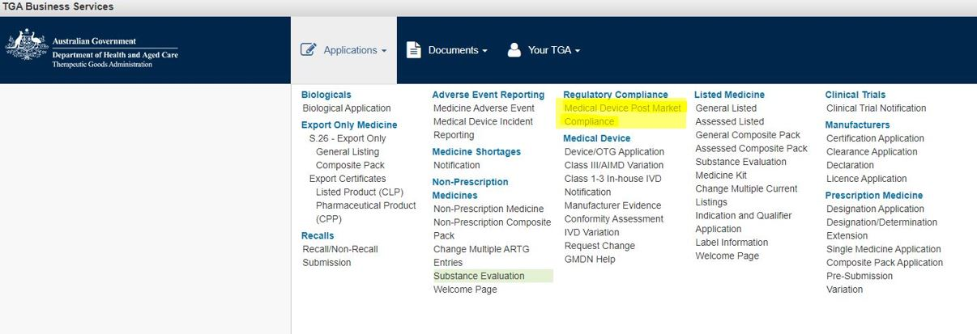
On the ‘PMR Compliance Dashboard’, select the ‘Consent for Non-compliance Applications’ tile to access the ‘Consent for Non-compliance Dashboard’.
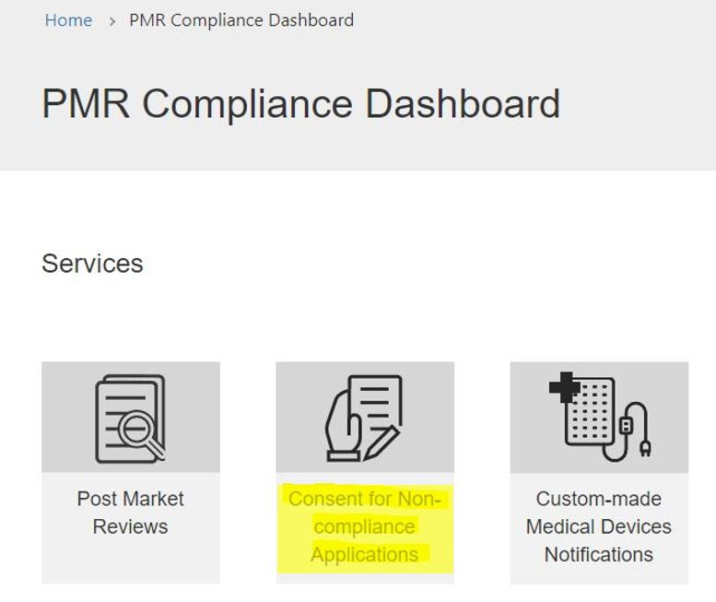

On the ‘Consent for Non-compliance Dashboard’, you will find three tabs to:
- view and edit ‘Draft’ consent applications;
- view ‘Submitted’ consent applications; and
- view, edit, and respond to ‘Notifications’ related to consent applications.
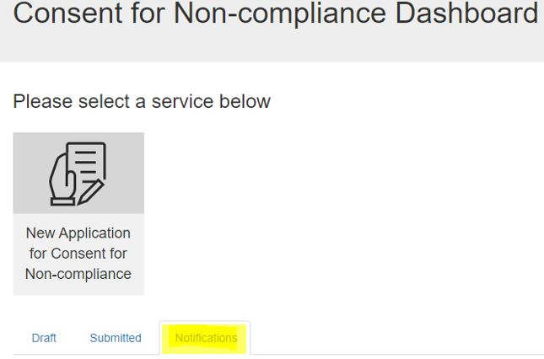
This guidance document only relates to the features found in the ‘Notifications’ tab.
Click on the ‘Notifications’ tab to view notifications related to submitted consent applications. You can search for a notification using the search box (indicated by the magnifying glass symbol) by the name (title) of the application, consent application ID and notification ID. The search function will also allow for partial text searches by typing an asterisk (*) as the wildcard character. You can also sort the table by clicking on the column heading to change the order by Notification ID, Application name, Notification type, Notification status, Response due date, and Received date.
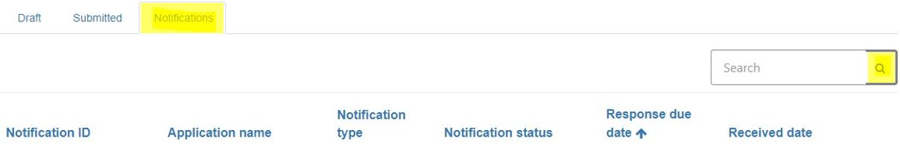

Viewing a notification
On the ‘Notifications’ tab, you will see a list of notifications for the submitted consent applications. The notifications table is by default set-up in ascending order of ‘Response due date’. The notification with earliest response due date will appear on top of the list. For example, a notification with response due date of 31 January 2023 will appear above a notification with the response due date of 19 August 2023.
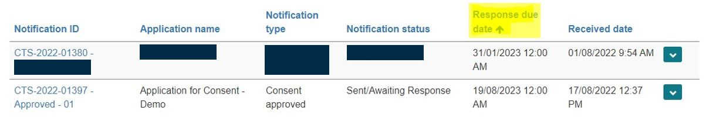

To view a notification, click on the down-arrow on the right-hand side of the row and select ‘View details’.
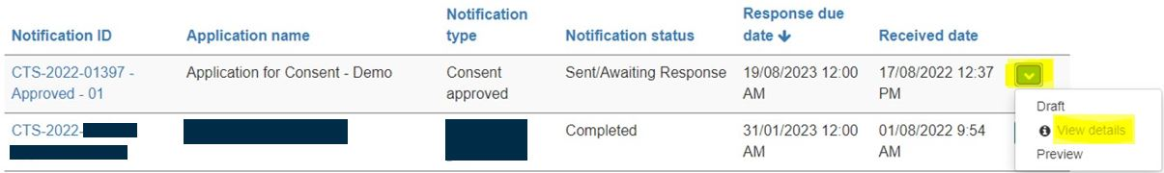
This will display the ‘Consent for Non-compliance – Notification View’ page where there are five non-editable sections related to the notification.
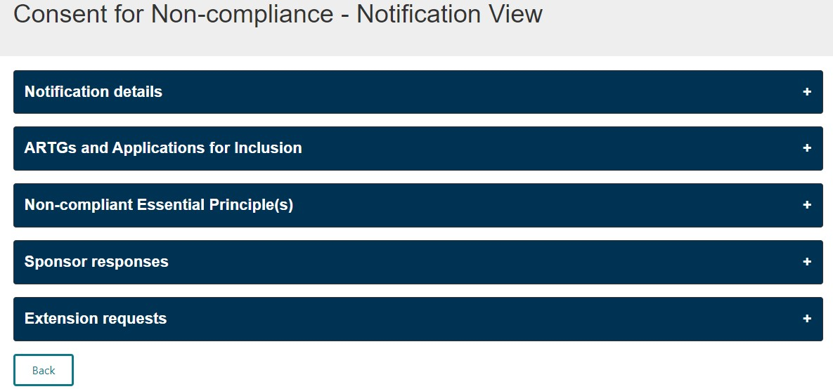
Click on the ‘Notification details’ section to view the notification ID and type, and Consent to Supply (CTS) application number, which can be quoted in communication with the TGA regarding this notification.
Click on the ‘Emails’ folder at the bottom of this section to view the email and letter associated with the notification sent by the TGA.
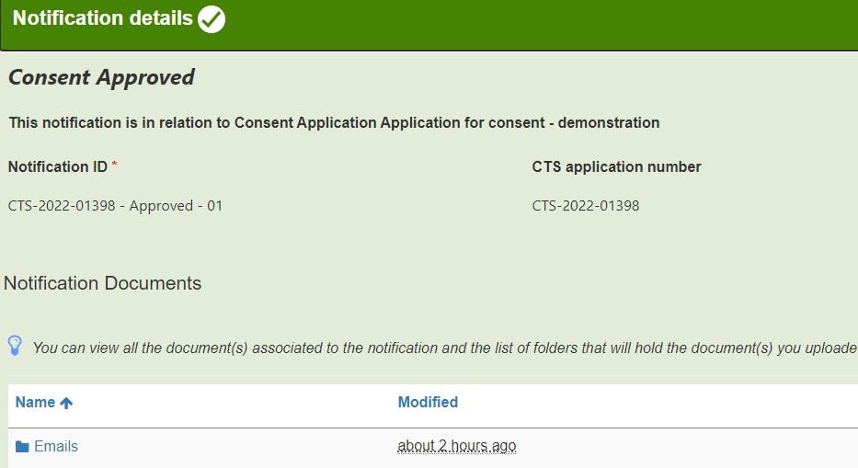
Please note, any documents that you upload as part of a response to a notification will be listed under the ‘Notification Documents’ section once the response is saved.
This ‘Notifications details’ section will change colour from blue to green when clicked upon, indicating that all mandatory information in this section is auto populated and complete.

Click on the ‘ARTGs and Applications for Inclusion’ section to view the devices (ARTG entries and/or Applications for Inclusion) related to the notification.
A notification may be related to all or only some of the devices in the consent application.
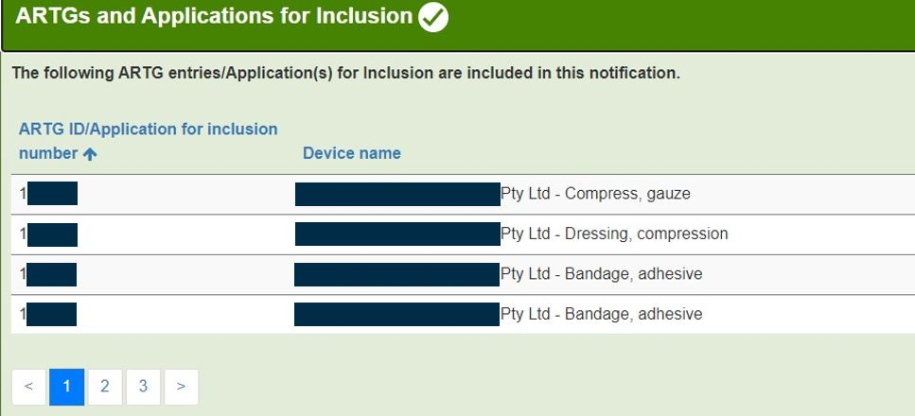
This section will change colour from blue to green when clicked upon, indicating that all mandatory information in this section is auto populated and complete.
Click on the ‘Non-compliant Essential Principle(s)’ section to view the Essential Principles (EPs) related to the notification.
The EPs appearing in this section may be different to the EPs selected as part of the application for consent and is populated by the Therapeutic Goods Administration (TGA).
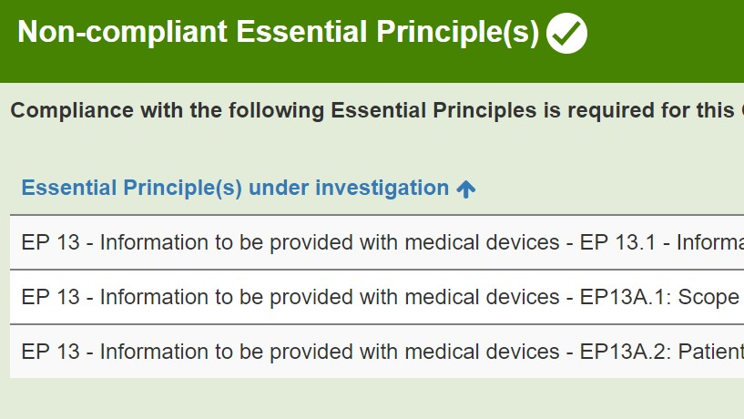
This section will change colour from blue to green when clicked upon, indicating that all mandatory information in this section is auto populated and complete.
Some notifications will require a response from the sponsor and some notifications will not. Examples of notifications requiring a response include, but are not limited to, a consent approved notification (you will need to submit evidence of compliance with the EPs before the end of the consent period), a section 41JA request for information, a proposal to cancel, or a proposal to suspend a device. Other notifications that do not require a response from the sponsor include, but are not limited to, a consent not-approved, consent withdrawal, consent expiry or consent revoked notification, or a device cancellation notification.

The ‘Sponsor responses’ and ‘Extension requests’ sections will change colour from blue to amber when clicked upon. These sections will remain amber in colour even when all mandatory information has been provided in a response.
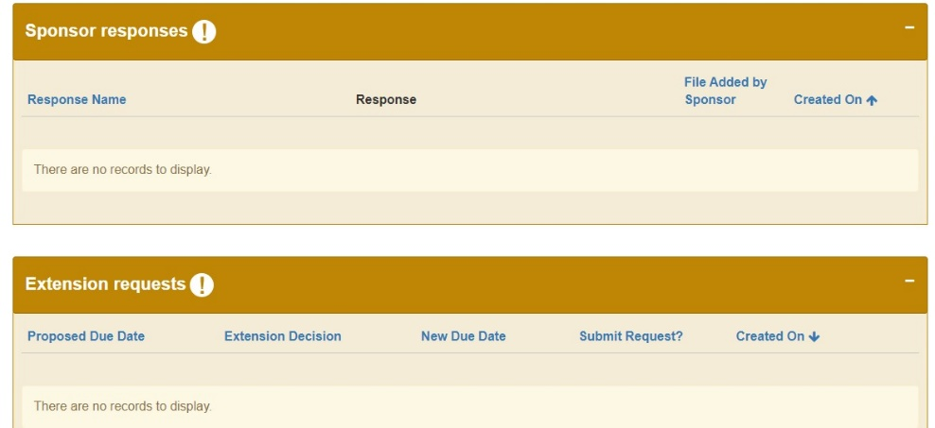
After viewing the notification, you can click on the ‘Back’ button on the bottom of the page to go back to the ‘Notifications’ tab.
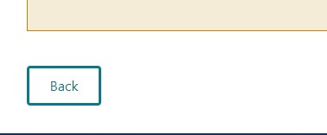

Responding to a notification
Responses to notifications can only be submitted by an authorised user, with submitter access for the TBS sponsor portal. Users with drafter access can draft and save a response to a notification but are not authorised to submit a response through the TBS portal.

Consent approved notification
When a consent application is approved, a notification and letter of approval is issued and will be able to be viewed on the ‘Notification’ table. As part of the consent process, sponsors are required to provide evidence of compliance with the EPs before the end of the consent period. This evidence is provided as a part of your response to the ‘Consent approved’ notification. You may provide compliance evidence multiple times during the consent period if devices become compliant with the EPs at different times throughout the consent period.
Please note that you can only respond to a ‘Consent approved’ notification if the ‘Notification status’ is ‘Sent/Awaiting Response’ in the ‘Consent for Non-compliance – Notification View’ table. If you have evidence of compliance to submit, and the ‘Consent approved’ notification shows ‘Complete’ status, please contact the TGA at mdconsent@health.gov.au to discuss.

To respond to the ‘Consent approved’ notification, click on the down-arrow on the right-hand side of the row and select the ‘Draft’ option.
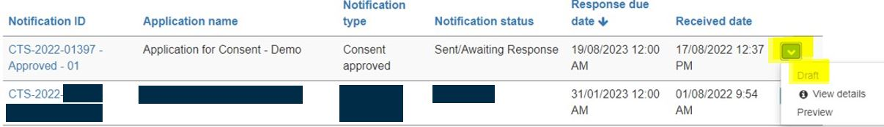
On the ‘Consent for Non-compliance – Notification Draft’ page there are five sections related to the notification. There is an option to ‘Expand All’ sections at once, or you can expand one section at a time by clicking on the section you wish to expand.
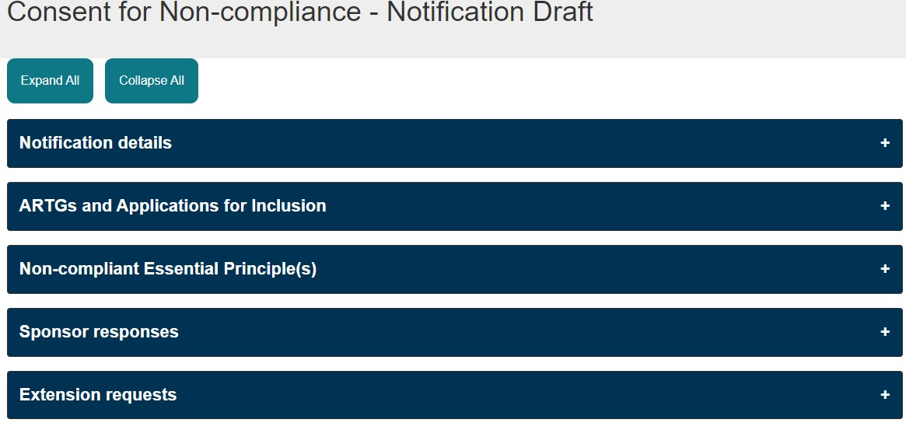
The ‘Notification details’, ‘ARTGs and Applications for Inclusion’ and ‘Non-compliant Essential Principle(s)’ sections are non-editable. These sections will change colour to green when selected, indicating that all mandatory information in this section is auto-populated and complete.
Please follow the steps below to create and submit your response to the notification.
- To create a response for this notification, click on the ‘Sponsor responses’ section and click on the ‘Add response’.
You can include multiple ARTG entries/Applications for Inclusion and EPs in one response if the evidence of compliance is relevant to these devices. For example, you can add evidence of compliance for EP 13A.2 and 13A.3 by providing a copy of the compliant Patient Implant Card (PIC) and Patient Information Leaflet (PIL) for multiple ARTG entries, if relevant, in one response.
- Provide a relevant name for the response, so you can identify different responses within the notification. Click ‘Save and Close’ after you enter the response name.
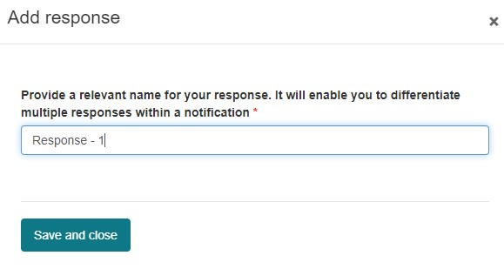
- Now that you have created and named the response, it will be ready for you edit and add evidence of compliance. Click the down-arrow on the right side of the row and select ‘Edit’.
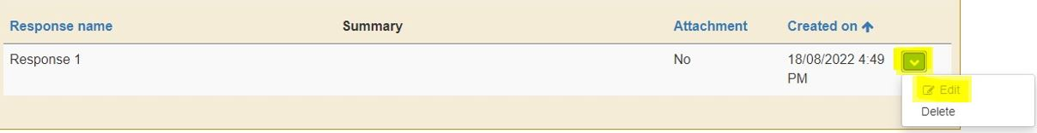
By default, the ARTG number(s)/Application(s) for Inclusion and EP(s) displayed for this notification will be included in the response.
Note: if the ARTG number(s)/Application(s) for Inclusion or EP(s) do not appear in the tables when you begin to edit the response, press on the blue column header of the table and this will refresh the page and the information should appear.
- If you are not providing compliance evidence for all devices within the consent at this time, or you wish to submit your evidence in multiple responses, you will need to exclude the devices that you are not including in the response. To exclude an ARTG entry/Application for Inclusion, click the down-arrow next to the device name and select ‘Exclude’.
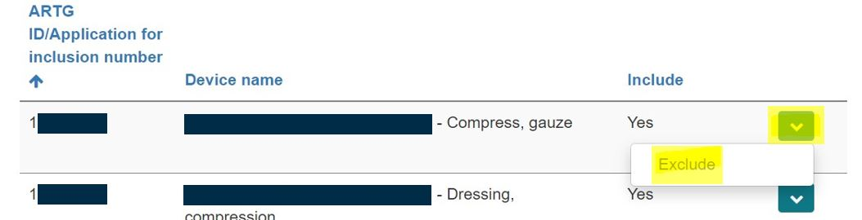
- Similarly, if you are not providing evidence of compliance with all of the EPs in this response, you can exclude an EP from the response by clicking the down-arrow next to the EP you wish to exclude and select ‘Exclude’.
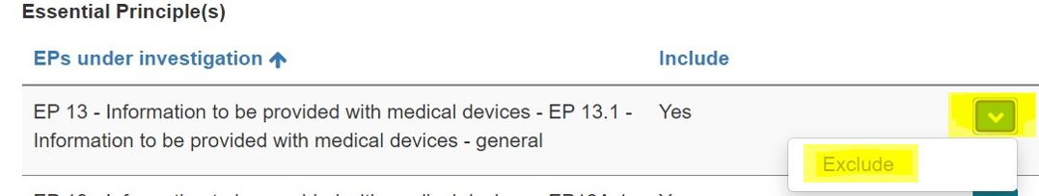
- Select how you wish to provide a response. Responses can be provided by typing a summary in the free text box provided, or by attaching relevant documents, or by providing both a summary and documents. Microsoft Word, Excel, and Adobe Acrobat documents with a file size of up to 50MB can be uploaded.
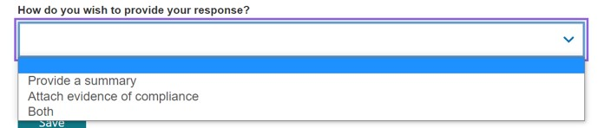

- Provide a summary in the text box available if you selected the ‘Provide a summary’ or the ‘Both’ option.
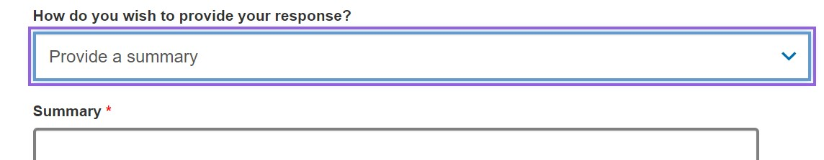
- If you are providing a document as part of the response, select the ‘Attach evidence of compliance’ option. Click on the ‘Add files’ button then click on ‘Choose files’ to upload a document from your computer.
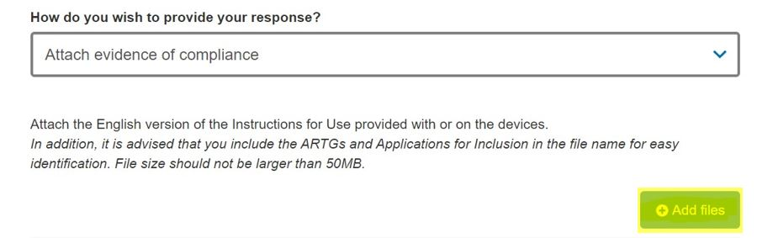

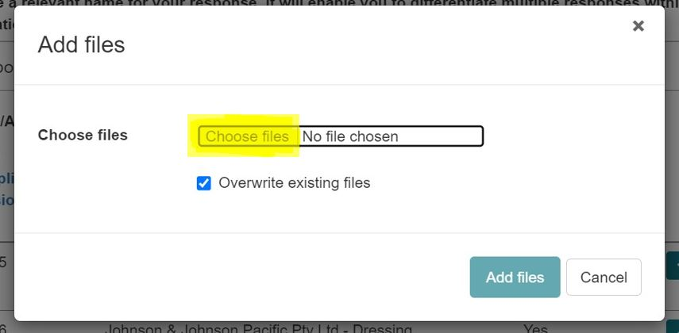
Once you have selected the document from your computer, click on ‘Add files’ button to attach the document to the response.
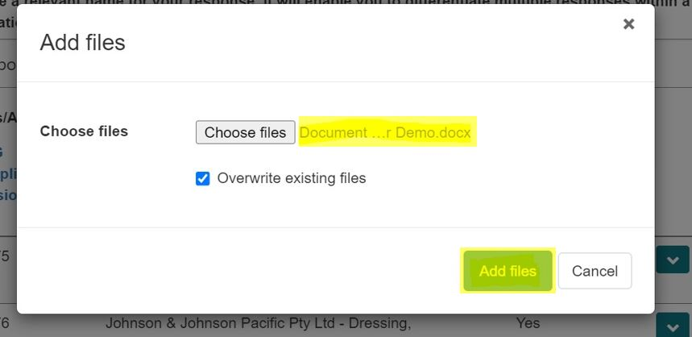
The uploaded file will be displayed. You may add more files to this response by repeating the steps above.
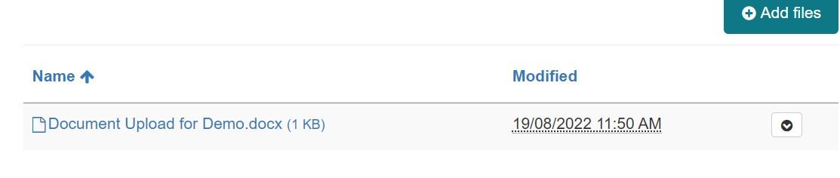
- Select the checkbox to acknowledge that at least one file has been uploaded and click ‘Save’ to complete the response.

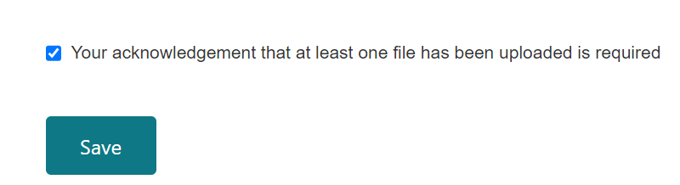

The added response will be displayed in the ‘Sponsor responses’ section. You may edit or delete a response by clicking the down-arrow on the right side and selecting relevant option.

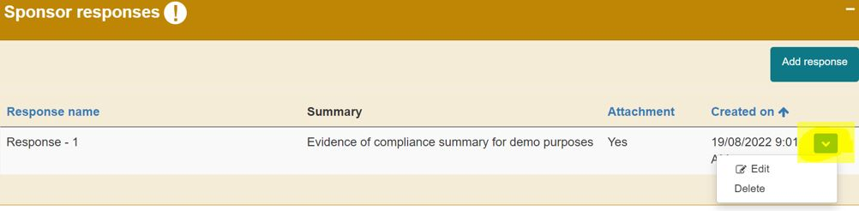

To provide evidence of compliance for any remaining ARTG entries/Applications for Inclusion, select ‘Add response’ button and repeat steps 1-9 above.

- To view the documents uploaded in a response, click on the ‘Notification details’ sections from ‘Consent for Non-compliance - Notification Draft’ page. A SharePoint folder is created for each response created for this notification and is listed on the table in chronological order (i.e. the first response created will be ‘Response-01’ and the second response folder will end in ‘Response-02’). The documents uploaded for each response can be viewed by clicking on the relevant response folder.

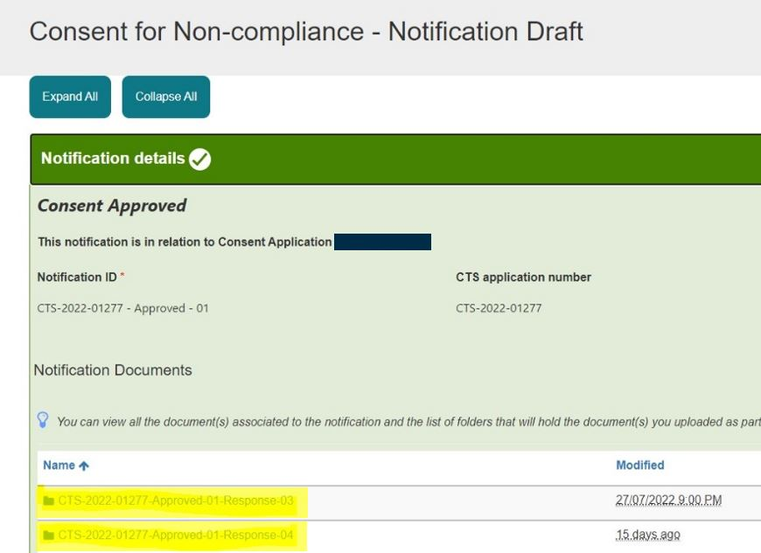

A response to a notification can only be submitted by an authorised user, with submitter access for the TBS sponsor portal. If you have drafter access and are not authorised to submit a response, then you will only be able to draft and save a response.

- Once you are ready to submit your response, click the ‘Validate’ button at the bottom of the ‘Consent for Non-compliance - Notification Draft’ page. Only users with submitter access will have a ‘Validate’ button.

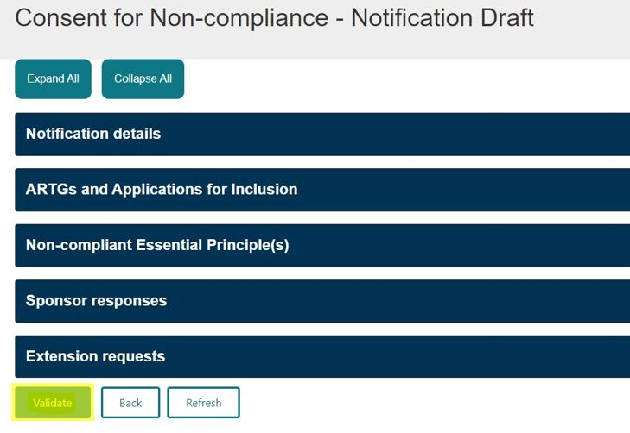

Select ‘OK’ to complete your action.
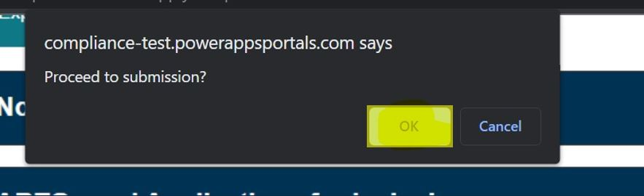

- Select either ‘Preview’ to preview the response or ‘Declare’ to submit the response.

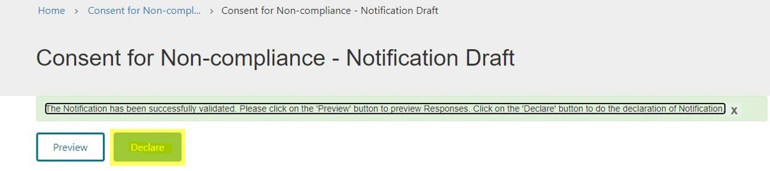

When you are ready to submit the response, select ‘Declare’ to submit the response. On the ‘Declaration’ page select ‘Yes’ and click ‘Submit’.

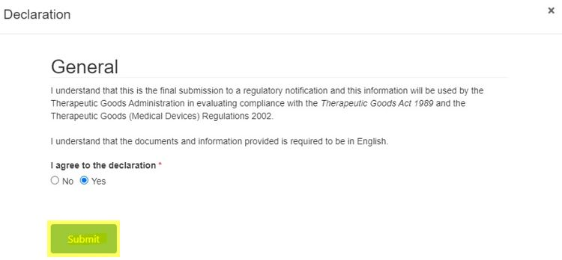

Click ‘OK’ to complete your action and submit the response.

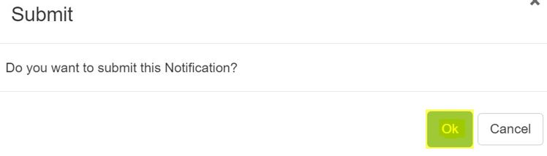

After you submit the response, the notification status of the approved notification should display as ‘Completed’ on the ‘Notification’ page.
Note: if your response does not provide evidence of compliance for all devices and EPs in the consent application, the TGA will reopen the notification, after reviewing the response, to allow you to provide additional responses to cover the remaining devices and EPs. TGA staff will change the status of the notification from ‘Completed’ to ‘Sent/Awaiting Response’ to reopen the portal and allow additional responses.
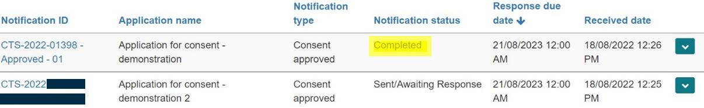

- To save or print your response, on the ‘Notification’ page click on the down-arrow on the right side and selecting the ‘Preview’ option. This will open a new window showing the preview of the notification.
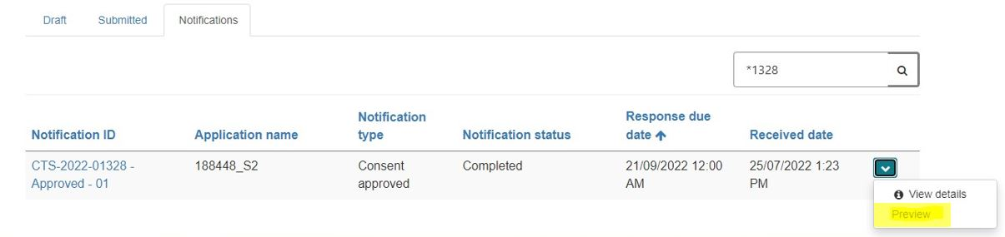
Click on the ‘Print’ button, which will open a new window in the current view.
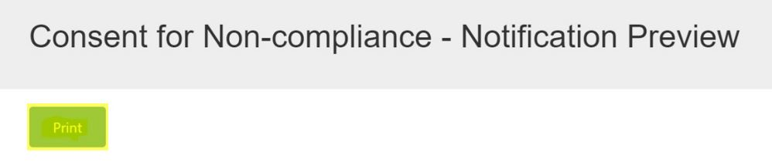
- To save a copy of your response, in the ‘Destination’ section on this window, select ‘Save as PDF’ and click ‘Save’ at the bottom of the window. This will give you the option to save the document to a desired folder on your computer.
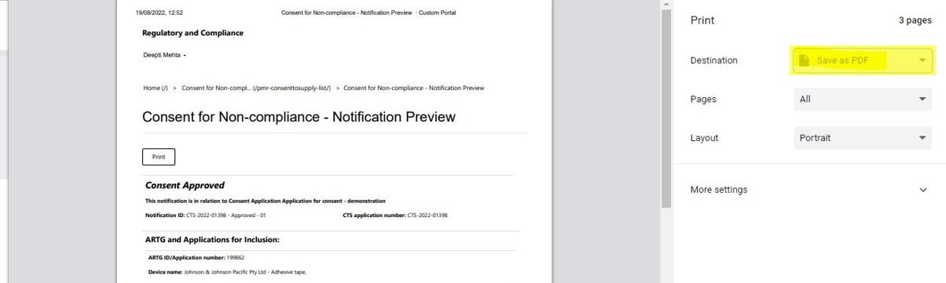
- To print the response, in the ‘Destination’ section of the window, select the appropriate printer and click the ‘Print’ button at the bottom of the window.

Additional information notification
If the TGA requires further information for the review of your consent application or for a response to a notification, you will receive an ‘Additional information’ notification. Unlike a ‘Consent approved’ notification, you can only respond once to this notification. This notification is different to a formal request for information under section 41JA of the Therapeutic Goods Act 1989, and has no regulatory letter attached to the notification.
To respond to an ‘Additional information’ notification, click on the down-arrow on the right side and select ‘Draft’.
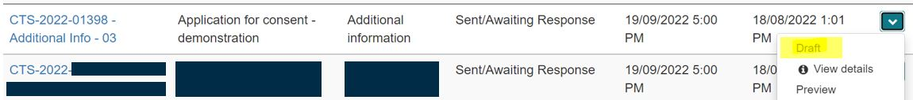
On the ‘Consent for Non-compliance – Notification Draft’ page there are five sections related to the notification. There is an option to ‘Expand All’ sections at once, or you can expand one section, at a time, by clicking on the section you wish to expand.
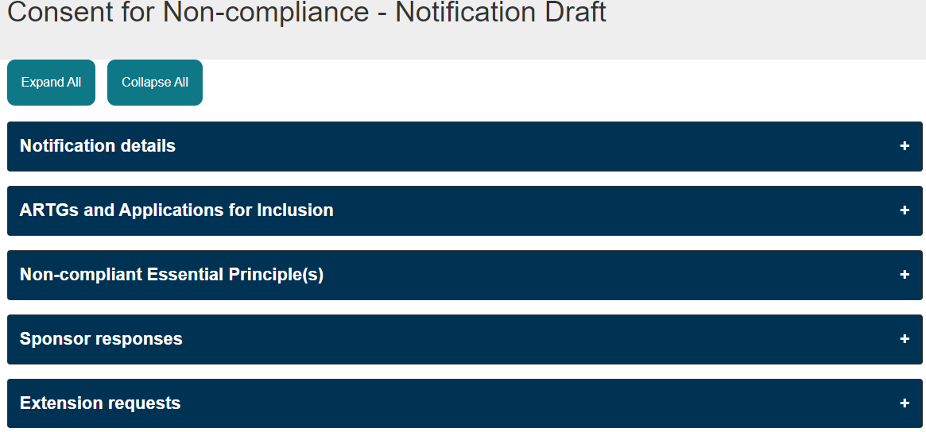
The ‘Notification details’, ARTGs and Applications for Inclusion’ and ‘Non-compliant Essential Principle(s)’ sections are non-editable. These sections will change colour to green when clicked, indicating that all mandatory information in this section is auto-populated and complete.
The email related to this notification can be accessed by clicking on the ‘Emails’ folder situated in the ‘Notification details’ section.
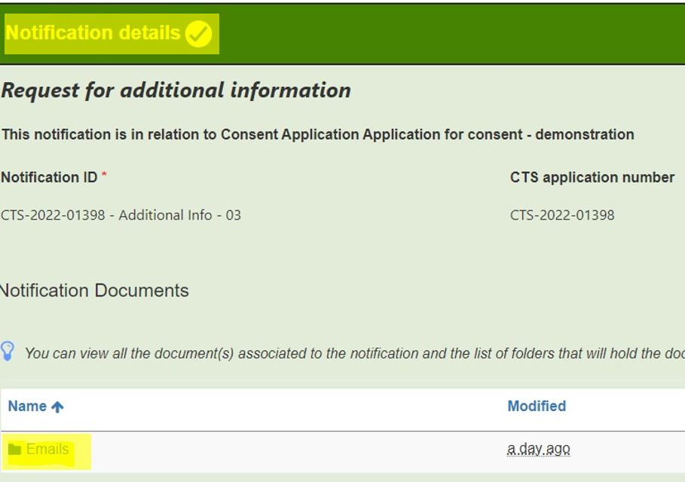

To create a response for this notification, click on ‘Add response’ button on the ‘Sponsor responses’ section.
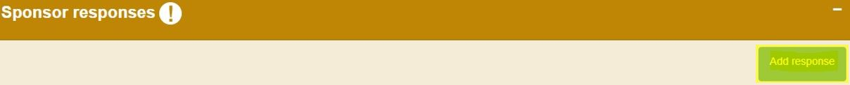
Your response to the ‘Additional information’ notification is created and submitted in the same process as a response to the ‘Consent approved’ notification, which can be found in steps 1-12 of this guidance document (previous section). However, the consent approved notification is the only notification type that you can submit a response more than once; a single response can only be submitted for every other notification type requiring a response. You can still create multiple response ‘groups’ within your notification response, but you must ensure they have covered all devices and EPs in the notification before you submit the response to the TGA.

Other Notifications
The TGA will send the sponsor information relating to the status of a consent application as a notification. This includes consent approved, consent not-approved, consent withdrawn, consent revoked, and consent expired notifications.
Additionally, for devices that are part of an approved consent application, the TGA may send notifications related to a regulatory action, such as request for information under section 41JA of the Act, or proposal to cancel a device under section 41GN(2). Such regulatory notifications will have a regulatory letter attached to the email that is sent by the TGA.
Regulatory notifications that do not require a response
For notifications that do not require a response, the ‘Notification status’ will be displayed as ‘Completed’. To view the notification, click on the down-arrow on the right-hand side and select ‘View details’.
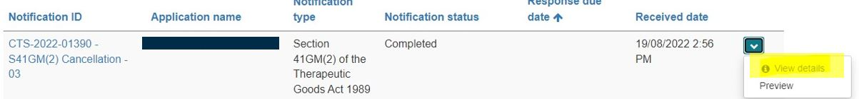
The regulatory letter and email related to this notification can be viewed by clicking on the ‘Emails’ folder situated in the ‘Notification details’ section.
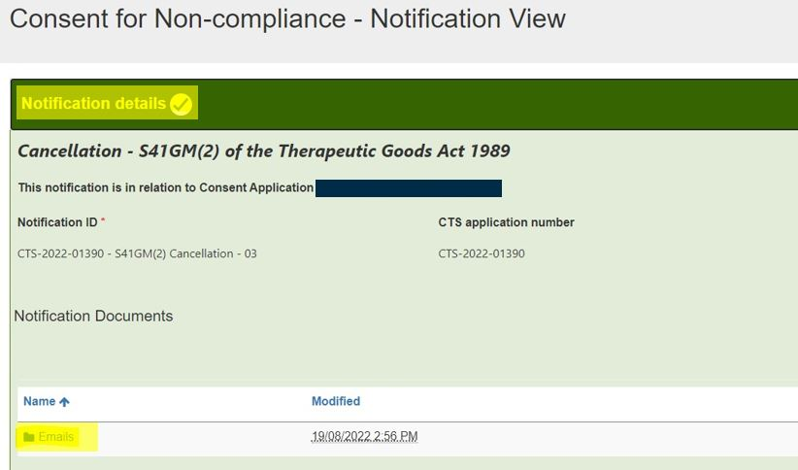
Regulatory notifications that require a response
For notifications where a response is required, the ‘Notification status’ will be displayed as ‘Sent/Awaiting Response’. To respond to a notification, click on the down-arrow on the right-hand side and select ‘Draft’.
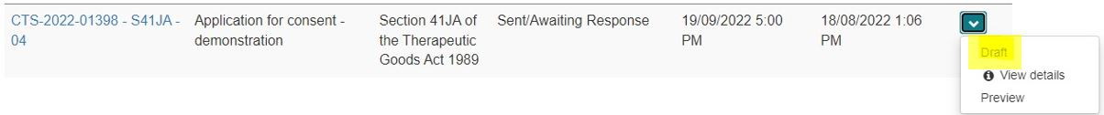
On the ‘Consent for Non-compliance – Notification Draft’ page there are five sections related to the notification. There is an option to ‘Expand All’ sections at once, or you can expand one section, at a time, by clicking on the section you wish to expand.
The ‘Notification details’, ARTGs and Applications for Inclusion’ and ‘Non-compliant Essential Principle(s)’ sections are non-editable. These sections will change colour to green when clicked indicating that all mandatory information in this section is auto-populated and complete.
The regulatory letter and email related to this notification can be accessed by clicking on the ‘Emails’ folder in the ‘Notification details’ section.
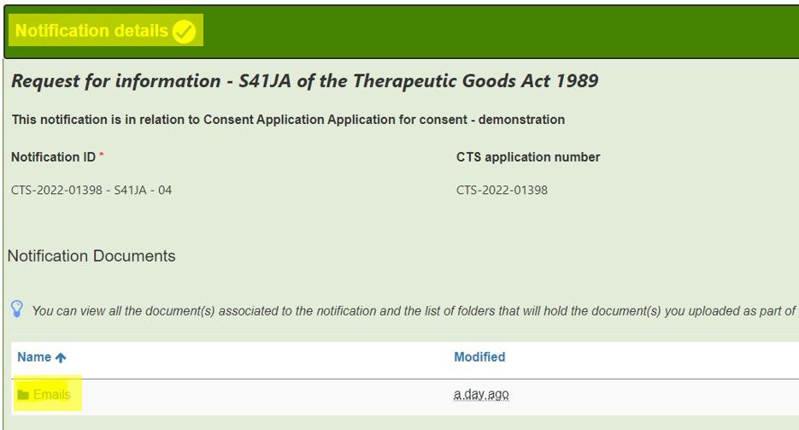

To create a response for this notification, click on the ‘Add response’ button on the ‘Sponsor responses’ section.
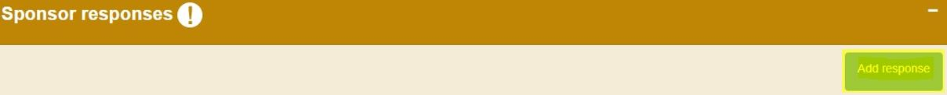
Your response to the notification is created using the same process as the response to the ‘Consent approved’ notification. You can follow steps 1-12 in the consent approved section of this guidance document to draft and submit your response. However, the consent approved notification is the only notification type that you can submit a response more than once; only one response can be submitted for every other notification type requiring a response. You can create multiple response ‘groups’ within your notification response, but you must ensure they have covered all devices and EPs in the notification before you submit the response to the TGA.

Request an extension to a notification response
If you are having difficulty providing the information to a notification in the required timeframe you can submit a request for an extension to the due date. All requests for extensions will be considered by the TGA on a case-by-case basis. A response due date extension request can only be submitted for notifications that are current and have not expired. The notification status of a current notification will be displayed ‘Sent/Awaiting Response’.
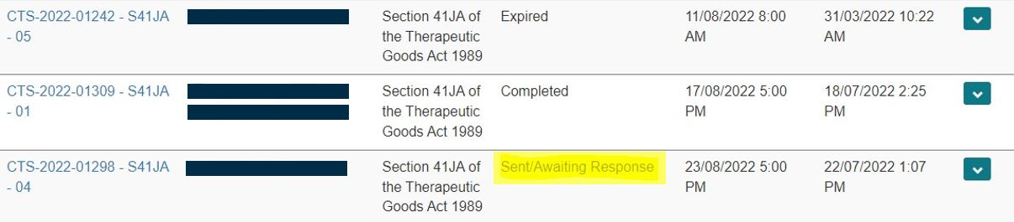
Note: only authorised users, with submitter access for the TBS sponsor portal will be able to draft and submit an extension request. Users with ‘drafter’ access cannot draft or request an extension to a notification.
To request an extension, click on the arrow down button situated along the right-hand side of the notification that you are requesting extension for and select ‘Draft’.
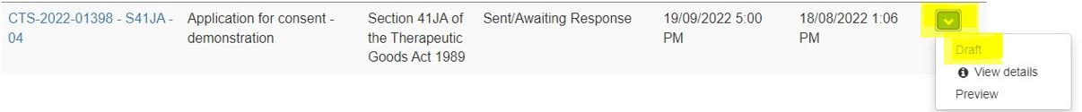

Expand the ‘Extension requests’ section on the ‘Consent for Non-compliance – Notification Draft’ page.
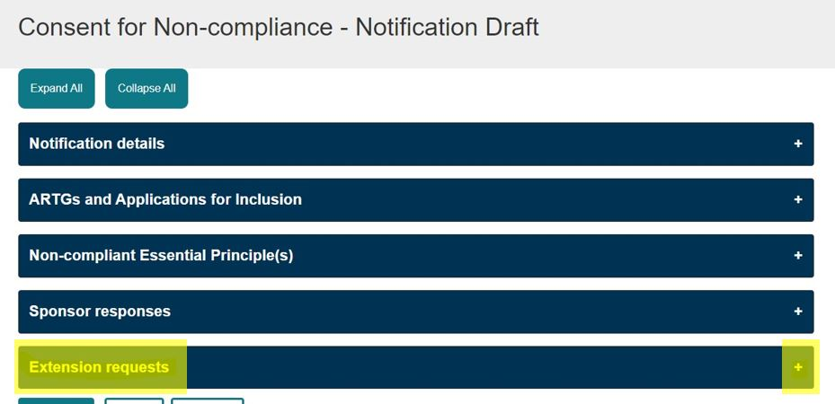
Click on the ‘Request Extension’ button on the right-hand side of this section.
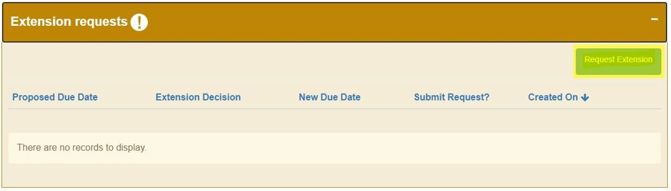
Complete the following fields on the ‘Extension Request’ window:
- ‘Proposed Due Date’ field - select a new proposed due date for this notification by clicking on the calendar icon along the field.
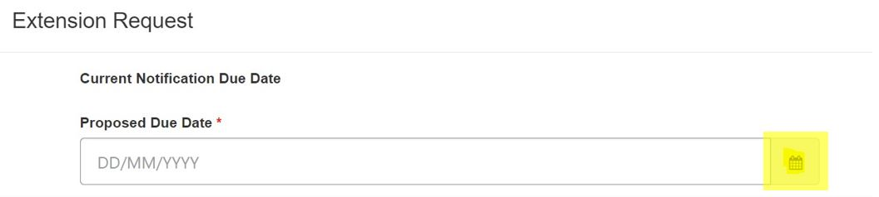
- ‘Extension Request’ field – enter the reason for requesting an extension to this notification. The text provided must be at least 20 characters to be valid.
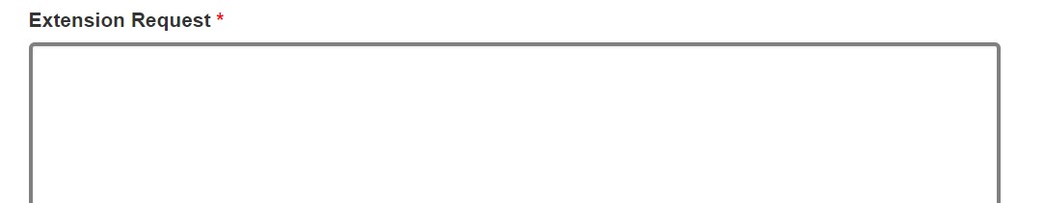
- ‘Submit Request’ field – Select ‘Yes’ if the request is ready to be submitted, select ‘No’ if you wish to save this request and submit it at a later date.
Click on the ‘Save’ button at the bottom of the ‘Extension Request’ window and click on ‘OK’ to finalise and submit your request.
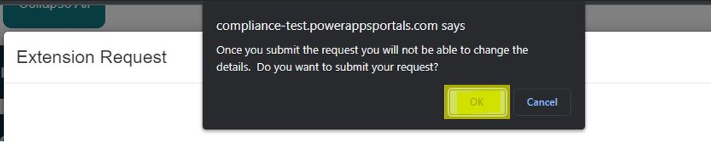
Once submitted, the extension request decision will display as ‘Pending’ until a decision has been made by the TGA.
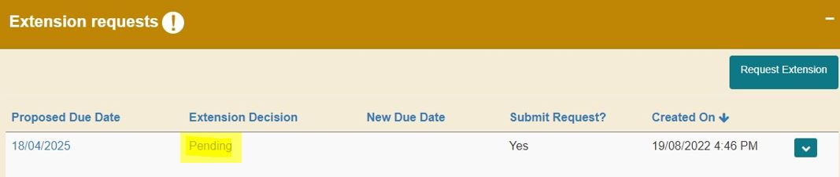
If the extension request has been accepted by the TGA, the extension decision will display as ‘Approved’ and the notification response due date will be updated with the new due date. The TGA may select a due date that is different to the one proposed by you.
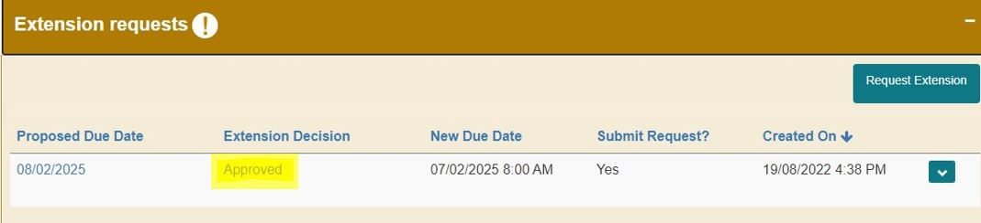
If the request has been rejected, the extension decision will display as ‘Disapproved’ and the notification response due date will remain the same as before.
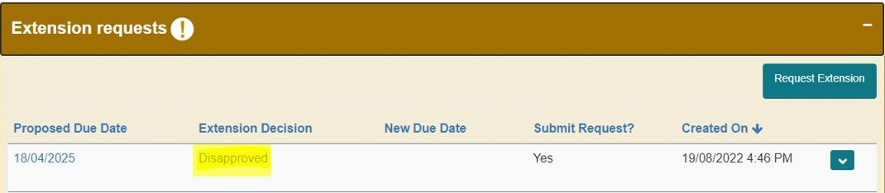

Version history
Version | Description of change | Author | Effective date
V1.0 | New guidance document | Dipti Mehta / Kathryn Fuller | September 2022

Therapeutic Goods Administration
PO Box 100 Woden ACT 2606 Australia
Email: info@tga.gov.au Phone: 1800 020 653 Fax: 02 6203 1605
https://www.tga.gov.au
Reference/Publication #

