Guidance for completing a notification form for lapses in medical device conformity assessment certification
  - TGA Consultation Hub
Version 1.1, June 2023

Copyright
© Commonwealth of Australia 2023
This work is copyright. You may reproduce the whole or part of this work in unaltered form for your own personal use or, if you are part of an organisation, for internal use within your organisation, but only if you or your organisation do not use the reproduction for any commercial purpose and retain this copyright notice and all disclaimer notices as part of that reproduction. Apart from rights to use as permitted by the Copyright Act 1968 or allowed by this copyright notice, all other rights are reserved and you are not allowed to reproduce the whole or any part of this work in any way (electronic or otherwise) without first being given specific written permission from the Commonwealth to do so. Requests and inquiries concerning reproduction and rights are to be sent to the TGA Copyright Officer, Therapeutic Goods Administration, PO Box 100, Woden ACT 2606 or emailed to <tga.copyright@tga.gov.au>.

Contents
Introduction 4
Multiple devices included in one application 4
Notification Form 5
Overview Page 5
Contents Page 5
About the Submitter Page 5
Information Related to the Medical Device(s) Page 7
ARTG Entry - 1 Page 9
ARTG Entry - 2 Page 12
Documents Upload Page 13
Declaration Page 15
Final Step 16

Introduction
This guidance document provides advice on how to submit a notification for lapsing or lapsed manufacturer’s conformity assessment certification for your medical device(s). The notification form is located on the Therapeutic Goods Administration (TGA) Consultation Hub.
Conformity assessment certification may no longer be valid due to the certification expiring, or if it has been suspended or revoked. Notifying the TGA of any lapse in certification is a legal requirement.
Changes to the medical device directive (93/42/EEC) and the IVD Directive (98/79/EC) along with disruptions because of the COVID-19 pandemic, has resulted in difficulty for some medical device manufacturers to maintain the currency of their conformity assessment certification used to support their medical device entry in the Australian Register of Therapeutic Goods (ARTG).
Under the Australian legislation, sponsors of medical devices included in the ARTG must be able to demonstrate that the manufacturer holds, and has applied, appropriate conformity assessment processes to their devices. There are criminal and civil penalty sanctions if a sponsor fails to notify the TGA within 60 days of becoming aware that their conformity assessment certificate used to support the application for inclusion in the ARTG (other than a conformity assessment certificate issued by the TGA) has been restricted, suspended, revoked, or is no longer in effect.

Multiple devices included in one application
A notification form for lapses in manufacturer’s conformity assessment certification can include multiple medical device ARTG entries. You can use one form to notify the TGA for up to 20 ARTG entries only if each ARTG entry has the same manufacturer, sponsor, and conformity assessment certification. Each ARTG entry page has space to list up to 20 models. If an affected ARTG entry has more than 20 models, you can list these extra models on the subsequent ARTG entry page(s).
If you need to notify the TGA of lapsing/lapsed conformity assessment certification for more than 20 ARTG entries, please submit multiple notification forms or contact the TGA at dvs@health.gov.au to discuss.

Notification Form

Overview Page
The overview page provides you with an introductory overview on lapsing medical device conformity assessment certification and the use of the notification form.
The overview also includes a note that while this notification form is hosted on a consultation platform, any information submitted through the form will not be published and will be classified as 'For official use only'. For more information please read Treatment of information provided to the TGA on the TGA website.
Starting the notification form
Step 1: At the bottom of the ‘Overview’ page, click on the link ‘Lapsing conformity assessment certification’ to start the notification form. This will take you to the ‘Contents’ page.
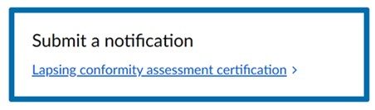

Contents Page
The ‘Contents’ page contains links to the different sections (or pages) of the form required to be completed as part of the notification. When you complete a page, you will be returned to the ‘Contents’ page from where you can select the next page to complete. You must respond to all mandatory fields to be able to proceed to the next page. You can complete any section or page of the notification form, irrespective of the order, by clicking on the relevant link to the page.
Click on the ‘About the submitter’ page link to start the notification.


About the Submitter Page
This section of the form contains mandatory fields, which are identified by the text ‘Required’.
1 – Submitter’s name: fill in your full name in the field provided. Only a sponsor, manufacturer or an authorised representative of the sponsor should complete the notification form.
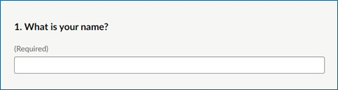
2 - Submitter’s email address: provide and confirm your email address in the fields provided.
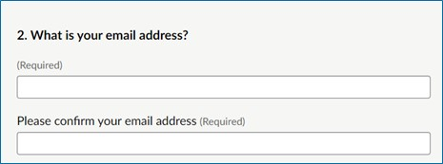
3- Submitter’s organisation: provide the name of your organisation here.
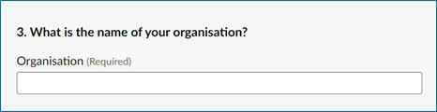
4 - Role of submitter: select the option that best describes your role in relation to the medical device(s) for which the notification is being submitted. You can only select one (most applicable) option for this question.
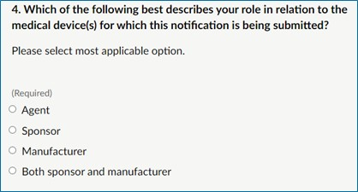
Next page: Please note this notification form does not automatically save. You must choose 'Save and come back later' to save the information completed so far if you intend to close the form to complete at another time. Press ‘Continue’ to continue completing the notification form.

If you choose the ‘Save and come back later’ button you will be directed to a page that requires you to enter an email address. A link to the partially completed form will be sent to that email address. To continue completing the form, click on the link provided in the email.
If you choose ‘Continue’, you will be returned to the ‘Contents’ page where you can click on the link to next page ‘Information Related to the Medical Device(s)’ to continue completing the notification form.
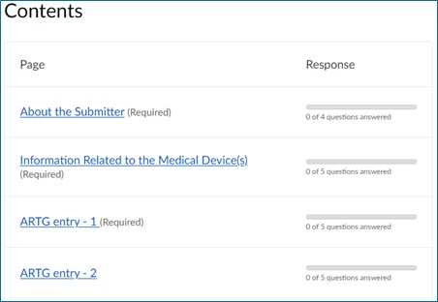

Information Related to the Medical Device(s) Page
This section of the form contains some mandatory fields, which can be identified by the text ‘Required’.
The ‘Information Related to the Medical Device(s)’ page has questions related to the medical device(s) with lapsing or lapsed conformity assessment certification. On this page you must specify the reason why the conformity assessment certification is lapsing or has lapsed.
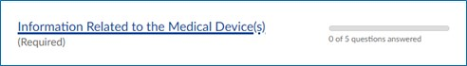
1- Sponsor details: fill in the medical device sponsor details including name, email address and phone number in the relevant fields. There can be no spaces or brackets between numbers when providing contact numbers, for example, 0444xxxxxx.
If you are a sponsor, please also check that the sponsor contact details in the TGA e-Business System are up to date.
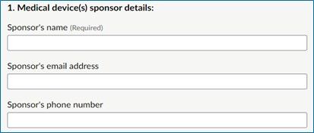
2- Manufacturer name: fill in the medical device manufacturer’s name in the field provided.
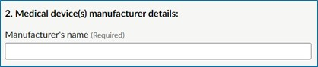
3- Date of lapses in conformity assessment certification: provide the date when the conformity assessment certification will lapse or has lapsed.
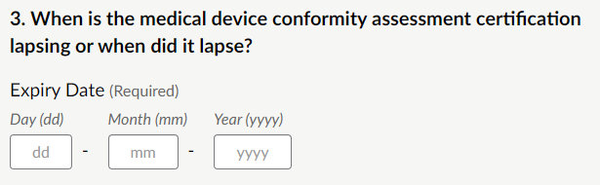
4- New valid conformity assessment certification: select if the medical device manufacturer is seeking new conformity assessment certification.
If you select ‘Yes’, provide an estimated date for the new valid conformity assessment certification. The TGA appreciates that the manufacturer may not have an exact date, therefore an estimate is sufficient. Enter the first day of the estimated month and year.
If you select ‘No’, proceed to question five.
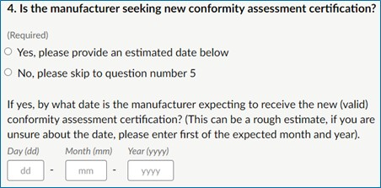
5- Reason for lapses in conformity assessment certification: Select the most appropriate reason for the lapsing or lapsed conformity assessment certification.
If you select ‘Expiry due to other reasons’, provide an explanation in the free-text field. You may also use this text field to provide more information in support of your notification for the TGA’s consideration.
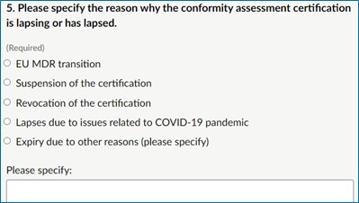
Next page: this notification form does not automatically save. You must choose 'Save and come back later' to save the information completed so far if you intend to close the form to complete at another time. Press ‘Continue’ to continue completing the notification form.
If you choose the ‘Save and come back later’ button you will be directed to a page that requires you to enter an email address. A link to the partially completed form will be sent to that email address. To continue completing the form, click on the link provided.
If you select ‘Continue’, you will be returned to the ‘Contents’ page where you can click on the link to next page ‘ARTG Entry - 1’ to continue filling the notification form.

ARTG Entry - 1 Page
This section of the form contains some mandatory fields, which can be identified by the text ‘Required’.
On the ‘ARTG Entry – 1’ page you must provide details for the first affected ARTG entry with lapsing or lapsed conformity assessment certification. To successfully submit the notification form, you must provide information on at least one ARTG entry and one model included under this ARTG entry.
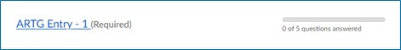
On this page you can add information for up to 20 models included under this ARTG entry.
If the ARTG entry has more than 20 models, you can use the next ARTG entry page(s) to list the remaining models. If doing so, ensure that you provide the ARTG entry number and name on all pages with model details related to the ARTG entry. For example, ARTG entry – 1 is ‘777888 – Human sample device’ and has 30 models, you can add information related to 20 models on ‘ARTG Entry – 1’ page. From the bottom of the page, click on ‘Continue’ and you will be returned to the ‘Contents’ page. From the ‘Contents’ page, click on ‘ARTG Entry – 2’ page. On the ‘ARTG Entry – 2’ page, fill in the ARTG number and name: ‘777888 – Human sample device’ in the relevant fields and provide information on the remaining 10 models included under this ARTG entry.
If you have more than 20 ARTG entries to notify the TGA about, you may submit multiple notification forms or contact the TGA at dvs@health.gov.au to discuss further.
1- First affected ARTG entry: Provide the ARTG entry number and name in the relevant fields. Select the current classification of this ARTG entry from the drop-down list.
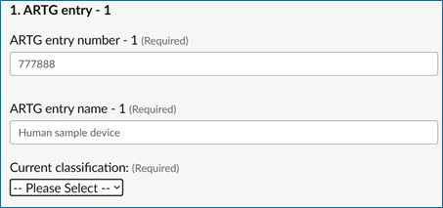
2- Cancelling the ARTG entry: You may intend to cancel the ARTG entry with lapsing or lapsed conformity assessment certification. Select the most appropriate option related to your intentions to cancel the ARTG entry.
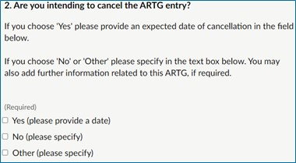
If you select the ‘Yes’ option, please provide an estimated date by when you will submit a device cancellation request to the TGA.
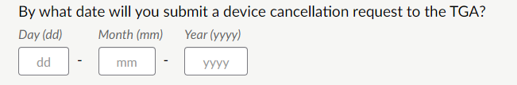
If you select the ‘No’ or ‘Other’ option, provide an explanation in the text box. This can include information such as why the ARTG entry is not being cancelled if the manufacturer is not intending to seek new conformity assessment certification.
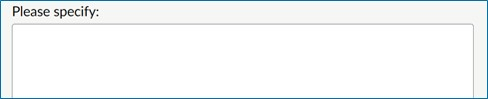
3- Supplying devices under the ARTG entry: If you are intending to supply devices included under the ARTG entry after the conformity assessment certification has lapsed, choose ‘Yes’. If you do not intend to supply any devices after the lapse of the conformity assessment certificate, choose the ‘No’ option.
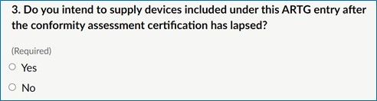
4- Devices manufactured before the lapse: If the devices you intend on supplying under this ARTG entry were manufactured while the conformity assessment certification was current and valid, select ‘Yes’ option, otherwise select ‘No’.
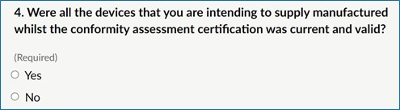
Devices manufactured after the conformity assessment certification has lapsed cannot be supplied in Australia and may lead to the TGA taking legal action.
5- Device supply information: There are several components to this question related to the different models under the ARTG entry. Provide the model’s name, the number supplied in Australia in the last 12 months, and the number of this model of device you are expecting to supply (if any) in Australia during the lapsed conformity assessment certification time frame.
You can supply the information for a group of models/UPIs in a single field if they are similar, such as a device that comes in different sizes, and there is no issue you wish to make the TGA aware of. For example, if one model is prone to device shortage, then you may wish to identify that model apart from other similar models supplied under the same ARTG entry.
Note: Information related to the first model of the first ARTG entry is required to successfully submit the notification form.
For supply information, provide the requested data as per unit of device model supplied or expected to be supplied in Australia for example if you have supplied 10 units of Model – 1 in the previous 12 months, enter 10 in the relevant field. If you are expecting to supply 5 units of Model – 1 during the upcoming lapsed conformity assessment certification timeframe, enter 5 in the relevant field provided.
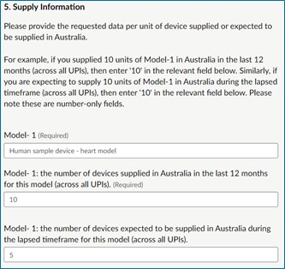
Complete the device name and supply information for all models supplied under this ARTG entry.
Next page: this notification form does not automatically save. You must choose 'Save and come back later' to save the information completed so far if you intend to close the form to complete at another time. Press ‘Continue’ to continue completing the notification form.
If you choose the ‘Save and come back later’ button you will be directed to a page that requires you to enter an email address. A link to the partially completed form will be sent to that email address. To continue completing the form, click on the link provided.
If you select ‘Continue’, you will be returned to the ‘Contents’ page where you can select the link to the next page ‘ARTG Entry - 2’ if you have more ARTGs to notify for, otherwise select the ‘Documents Upload’ link to attach relevant documents in support of this notification.

ARTG Entry - 2 Page
If you have another ARTG entry to include in this notification, provide the requested information related to the ARTG entry on the ‘ARTG Entry – 2’ page. Form fields on this page are not mandatory however it is expected that all the relevant information related to the ARTG is provided for the TGA to make an informed decision when assessing the notification form.
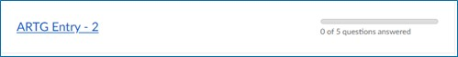
If you are providing information for remaining device models included under the ARTG entry from the previous page, ensure that the relevant ARTG number and name is entered on this page as well.
Next page: this notification form does not automatically save. You must choose 'Save and come back later' to save the information completed so far if you intend to close the form to complete at another time. Press ‘Continue’ to continue completing the notification form.
If you choose the ‘Save and come back later’ button you will be directed to a page that requires you to enter an email address. A link to the saved form will be sent to that email address. To continue completing the form, click on the link provided.
If you select ‘Continue’, you will be returned to the ‘Contents’ page where you can select the link to next page ‘ARTG Entry - 3’ if you have more ARTGs to notify for, otherwise select the ‘Documents Upload’ link to attach relevant documents in support of this notification.

Documents Upload Page
On this page, attach all supporting documents relevant to the notification. These documents will be important for the assessment of the notification. Please ensure the documents uploaded on this page are either in Adobe PDF, Microsoft Word or Excel formats and the file size is under 25MB. If your file size is more than 25MB, consider splitting the document and uploading in two fields or contact the TGA at dvs@health.gov.au to discuss further.
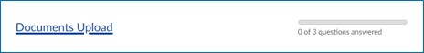
1- Documents related to non-conformities found in the last audit: If the device(s) included in this notification form has undergone a previous audit, attach document(s) related to the non-conformities found in the audit.
To upload a document, click on the ‘Choose file’ option and select the document to be uploaded from your computer.
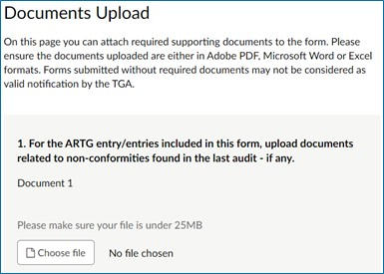
Click ‘Open’ from the bottom of the window to upload the selected document.
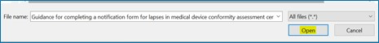
If required, provide a description of the uploaded document in the available text field.
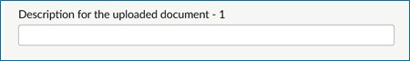
You can upload up to five documents related to the non-conformities found in last audit, one in each field provided on the form.
2- Approval to continue supply during lapsed timeframe by other regulators: Upload evidence if another comparable regulator has approved continued supply of the device(s) included in this notification form during lapsed conformity assessment timeframe. If required, provide a description of the uploaded document in the available text field.
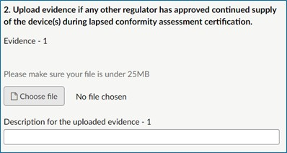
You can upload up to three documents one in each field provided on the form.
3- Any other supporting documents: You can upload up to three relevant supporting documents on in each field provided. If required, provide a description of the uploaded document in the available text field.
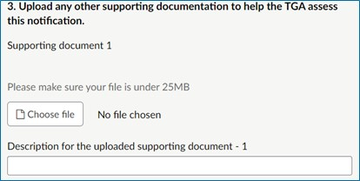
Next page: this notification form does not automatically save. You must choose 'Save and come back later' to save the information completed so far if you intend to close the form to complete at another time. Press ‘Continue’ to continue completing the notification form.
If you select the ‘Save and come back later’ button you will be directed to a page that requires you to enter an email address. A link to the saved form with progress so far will be sent to that email address. To continue completing the form, click on the link provided.
If you choose ‘Continue’, you will be returned to the ‘Contents’ page where you can select the link to next page ‘Declaration’ to finalise and submit the notification form.

Declaration Page
This section of the form contains mandatory fields, which can be identified by the text ‘Required’.
Once you have finished entering details of all (or up to) 20 ARTG entries, select the ‘Declaration page’ to declare and finalise the notification.
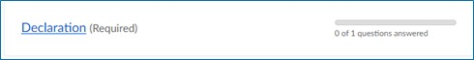
At the bottom of this page, check the ‘Yes’ box, to approve the declaration and enter your name and date in the fields provided.
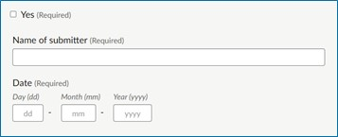
This notification form does not automatically save. You must choose 'Save and come back later' to save the information completed so far if you intend to close the form to complete at another time. Press ‘Continue’ to continue completing the notification form. If you choose the ‘Save and come back later’ button you will be directed to a page that requires you to enter an email address. A link to the saved form with progress so far will be sent to that email address. To continue completing the form, click on the link provided.
Selecting ‘Continue’ will take you to the ‘Contents’ page, where you can select ‘Finish’, located at the bottom of the page, to submit your notification.
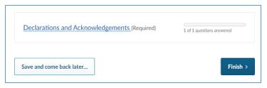

Final Step
After you select ‘Finish’ you will be directed to the ‘Almost done…’ page. On this page you can select ‘Submit Response’ to submit the notification or ‘Back’ to amend the notification. Selecting ‘Back’ will take you to the ‘Contents’ page.
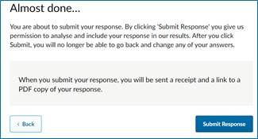
After you submit the notification, an acknowledgement email is sent to your nominated email address with a copy of the submission, including the response ID number of the notification form. You must keep a record of this response ID for future reference.
If you have more than 20 ARTG entries to notify the TGA about, you can submit multiple notification forms or contact the TGA at dvs@health.gov.au to discuss further.

Version history
Version | Description of change | Author | Effective date
V1.0 | Original publication | Medical Devices Surveillance Branch | October 2022
V1.1 | Minor update to text to clarify legislated requirements | Medical Devices Surveillance Branch | June 2023

Therapeutic Goods Administration
PO Box 100 Woden ACT 2606 Australia
Email: info@tga.gov.au Phone: 1800 020 653 Fax: 02 6203 1605
https://www.tga.gov.au
Reference/Publication #

