October 2022

Australian Public Assessment Report for Vaxneuvance
  - Active ingredient: Pneumococcal 15-valent conjugate vaccine (CRM₁₉₇ protein), adsorbed
  - Sponsor: Merck Sharp & Dohme (Australia) Pty Ltd

About the Therapeutic Goods Administration (TGA)
- The Therapeutic Goods Administration (TGA) is part of the Australian Government Department of Health and is responsible for regulating therapeutic goods, including medicines, medical devices, and biologicals.
- The TGA administers the Therapeutic Goods Act 1989 (the Act), applying a risk management approach designed to ensure therapeutic goods supplied in Australia meet acceptable standards of quality, safety, and efficacy.
- The work of the TGA is based on applying scientific and clinical expertise to decision-making, to ensure that the benefits to the Australian public outweigh any risks associated with the use of therapeutic goods.
- The TGA relies on the public, healthcare professionals and industry to report problems with therapeutic goods. The TGA investigates reports received to determine any necessary regulatory action.
- To report a problem with a therapeutic good, please see the information on the TGA website.

About AusPARs
- The Australian Public Assessment Report (AusPAR) provides information about the evaluation of a prescription medicine and the considerations that led the TGA to approve or not approve a prescription medicine submission. Further information can be found in Australian Public Assessment Report (AusPAR) guidance.
- AusPARs are prepared and published by the TGA.
- AusPARs are static documents that provide information that relates to a submission at a particular point in time. The publication of an AusPAR is an important part of the transparency of the TGA’s decision-making process.
- A new AusPAR may be provided to reflect changes to indications or major variations to a prescription medicine subject to evaluation by the TGA.

Copyright
© Commonwealth of Australia 2022
This work is copyright. You may reproduce the whole or part of this work in unaltered form for your own personal use or, if you are part of an organisation, for internal use within your organisation, but only if you or your organisation do not use the reproduction for any commercial purpose and retain this copyright notice and all disclaimer notices as part of that reproduction. Apart from rights to use as permitted by the Copyright Act 1968 or allowed by this copyright notice, all other rights are reserved, and you are not allowed to reproduce the whole or any part of this work in any way (electronic or otherwise) without first being given specific written permission from the Commonwealth to do so. Requests and inquiries concerning reproduction and rights are to be sent to the TGA Copyright Officer, Therapeutic Goods Administration, PO Box 100, Woden ACT 2606 or emailed to <tga.copyright@tga.gov.au>.

Contents
List of abbreviations 4
Product submission 6
Submission details 6
Product background 7
Regulatory status 8
Product Information 9
Registration timeline 9
Submission overview and risk/benefit assessment 10
Quality 10
Nonclinical 12
Clinical 13
Risk management plan 62
Risk-benefit analysis 63
Outcome 65
Specific conditions of registration applying to these goods 65
Attachment 1. Product Information 67

List of abbreviations
Abbreviation |  | Meaning
ACV | Advisory Committee on Vaccines
AE | Adverse event
ARGPM | Australian Regulatory Guidelines for Prescription Medicines
ARTG | Australian Register of Therapeutic Goods
ASA | Australia specific annex
CAIH | (John Hopkins) Center for American Indian Health (United States of America)
CD4 | Cluster of differentiation 4
CHMP | Committee for Medicinal Products for Human Use (European Union)
CI | Confidence interval
CMI | Consumer Medicines Information
CPD | Certified Product Details
CRM₁₉₇ | Cross reactive material 197
DLP | Data lock point
EMA | European Medicines Agency (European Union)
EMEA | European Medicines Evaluation Agency (European Union)
EU | European Union
FDA | Food and Drug Administration (United States of America)
GLP | Good Laboratory Practice(s)
GMC | Geometric mean concentration
GMFR | Geometric mean fold rise
GMT | Geometric mean titre
GVP | Good Pharmacovigilance Practice(s)
HIV | Human immunodeficiency virus
ICH | International Council for Harmonisation
IgG | Immunoglobulin G
OCABR | Official Control Authority Batch Release (European Union)
OPA | Opsonophagocytic activity
PDF | Portable document format
PI | Product Information
PSUR | Periodic safety update report
RMP | Risk management plan
SAE | Serious adverse event
TGA | Therapeutic Goods Administration
US(A) | United States (of America)
V114 | Sponsor’s product development code for Vaxneuvance (pneumococcal 15-valent conjugate vaccine (CRM₁₉₇ protein), adsorbed (serotypes 1, 3, 4, 5, 6A, 6B, 7F, 9V, 14, 18C, 19A, 19F, 22F, 23F, 33F))

Product submission

Submission details
Type of submission: | New biological entity
Product name: | Vaxneuvance
Active ingredient: | Pneumococcal 15-valent conjugate vaccine (CRM₁₉₇ protein), adsorbed
Decision: | Approved
Date of decision: | 12 January 2022
Date of entry onto ARTG: | 17 January 2022
ARTG number: | 350791
Black Triangle Scheme: | Yes.  This product will remain in the scheme for 5 years, starting on the date the product is first supplied in Australia.
Sponsor’s name and address: | Merck Sharp & Dohme (Australia) Pty Ltd  Level 1, Building A, 26 Talavera Road  Macquarie Park, NSW, 2113
Dose form: | Suspension for injection
Strength: | Each 0.5 mL dose contains 32 µg of total pneumococcal purified capsular polysaccharide.  Each dose comprises of 2 µg each of serotypes 1, 3, 4, 5, 6A, 7F, 9V, 14, 18C, 19A, 19F, 22F, 23F, and 33F, and 4 µg of serotype 6B.
Container: | Prefilled syringe
Pack size: | 1 and 10
Approved therapeutic use: | Vaxneuvance is indicated for active immunisation for the prevention of pneumococcal disease caused by Streptococcus pneumoniae serotypes (1, 3, 4, 5, 6A, 6B, 7F, 9V, 14, 18C, 19A, 19F, 22F, 23F and 33F) in adults 18 years of age and older.  Vaxneuvance may not prevent disease caused by S. pneumoniae serotypes that are not contained in the vaccine.  The use of Vaxneuvance should be guided by official recommendations.
Route of administration: | Intramuscular
Dosage: | Adults should be administered a single dose (0.5 mL) of Vaxneuvance intramuscularly. Do not inject intravascularly.  Vaxneuvance should not be diluted or mixed with other vaccines (see Section 4.5 Interactions with other medicines and other forms of interactions of the Product Information).  The dosing schedule of Vaxneuvance in special populations should be guided by official recommendations.  For further information regarding dosage, refer to the Product Information.
Pregnancy category: | B1  Drugs which have been taken by only a limited number of pregnant women and women of childbearing age, without an increase in the frequency of malformation or other direct or indirect harmful effects on the human fetus having been observed.  Studies in animals have not shown evidence of an increased occurrence of fetal damage.  The use of any medicine during pregnancy requires careful consideration of both risks and benefits by the treating health professional. This must not be used as the sole basis of decision making in the use of medicines during pregnancy. The TGA does not provide advice on the use of medicines in pregnancy for specific cases. More information is available from obstetric drug information services in your State or Territory.

Product background
This AusPAR describes the submission by Merck Sharp & Dohme (Australia) Pty Ltd (the sponsor) to register Vaxneuvance (pneumococcal 15-valent conjugate vaccine (CRM₁₉₇ protein), adsorbed) 0.5 ml, suspension for intramuscular injection for the following proposed indication:
Vaxneuvance is indicated for active immunisation for the prevention of pneumococcal disease caused by Streptococcus pneumoniae serotypes (1, 3, 4, 5, 6A, 6B, 7F, 9V, 14, 18C, 19A, 19F, 22F, 23F and 33F) in adults 18 years of age and older.
Vaxneuvance may not prevent disease caused by S. pneumoniae serotypes that are not contained in the vaccine.
The use of Vaxneuvance should be guided by official recommendations.
Streptococcus pneumoniae is a major cause of respiratory illness resulting in morbidity and mortality, particularly in older adults (those 65 years of age and older), adults (those 18 years and older) with other co-morbidities (for example, chronic lung disease, chronic liver disease, chronic heart disease, diabetes mellitus and asthma) and in immunocompromised subjects (for example, human immunodeficiency virus (HIV) and post-haematopoietic stem cell transplantation). In 2018, about 44.6% invasive pneumococcal diseases in Australian adults aged 65 years and older are due to serotypes included in the Vaxneuvance vaccine.
In addition to pneumonia, S. pneumoniae can lead to meningitis. bacteraemia, and septic arthritis. The case fatality rate of invasive pneumococcal disease in the United States of America (USA) is approximately 1%. Mortality rates are higher in older adults and in other adults with co-morbidities. particularly in immunocompromised individuals.
Treatment is with broad-spectrum antibiotics to cover S. pneumoniae and other possible pathogens; these include penicillin-based treatments although there is increasing resistance to penicillin and other antibiotics seen in the USA and Europe. Prevention of pneumococcal disease includes vaccination with pneumococcal conjugate vaccines and pneumococcal polysaccharide vaccines, as well as the prophylactic use of antibiotics in exposed populations.
The registered pneumococcal vaccines in use in Australia are Pneumovax 23, a polyvalent vaccine and Prevenar 13, a pneumococcal conjugate vaccine. The two serotypes, 22F and 33F, are not included in any of the currently licensed pneumococcal conjugate vaccines. These two serotypes have been shown to have increased disease frequency globally and are represented in the 10 commonest serotypes associated with invasive pneumococcal disease in adults 65 years of age and older, and in children under 5 years of age. A higher valent pneumococcal conjugate vaccine has been presented in the proposed submission, could potentially reduce cases of invasive pneumococcal disease involving these two additional serotypes. Vaxneuvance is a pneumococcal conjugate vaccine that comprises of 15 pneumococcal polysaccharide serotypes (serotypes 1, 3, 4, 5, 6A, 6B, 7F, 9V, 14, 18C, 19A, 19F, 22F, 23F, and 33F) individually conjugated to the cross-reactive material 197 (CRM₁₉₇) carrier protein, indicated for active immunisation to prevent pneumococcal disease caused by S. pneumoniae in adults 18 years of age and older.

Regulatory status
This product is considered a new biological entity for Australian regulatory purposes.
At the time the TGA considered this submission, a similar submission had been approved in the USA on 16 July 2021. Similar submissions were under consideration in the European Union (EU) (submitted on 18 November 2020), Canada (submitted on 4 December 2020), the United Kingdom (submitted on 18 October 2021) and Japan (submitted on 26 October 2021).
The following table summarises these submissions and provides the indications where approved.
Table 1: International regulatory status
Region | Submission date | Status | Approved indications
United States of America | 17 November 2020 | Approved on 16 July 2021 | Active immunization for the prevention of invasive pneumococcal disease caused by Streptococcus pneumoniae serotypes (1, 3, 4, 5, 6A, 6B, 7F, 9V, 14, 18C, 19A, 19F, 22F, 23F and 33F) in adults 18 years of age and older.
European Union | 18 November 2020 | Under consideration | Under consideration
Canada | 4 December 2020 | Under consideration | Under consideration
United Kingdom | 18 October 2021 | Under consideration | Under consideration
Japan | 26 October 2021 | Under consideration | Under consideration

Product Information
The Product Information (PI) approved with the submission which is described in this AusPAR can be found as Attachment 1. For the most recent PI, please refer to the TGA PI/CMI search facility.

Registration timeline
The following table captures the key steps and dates for this submission.
Table 2: Timeline for Submission PM-2020-06364-1-2
Description | Date
Submission dossier accepted and first round evaluation commenced | 1 February 2021
First round evaluation completed | 5 July 2021
Sponsor provides responses on questions raised in first round evaluation | 30 August 2021
Second round evaluation completed | 7 October 2021
Delegate’s Overall benefit-risk assessment and request for Advisory Committee advice | 1 November 2021
Sponsor’s pre-Advisory Committee response | 16 November 2021
Advisory Committee meeting | 1 December 2021
Registration decision (Outcome) | 12 January 2022
Completion of administrative activities and registration on the ARTG | 17 January 2022
Number of working days from submission dossier acceptance to registration decision* | 194
*Statutory timeframe for standard submissions is 255 working days

Submission overview and risk/benefit assessment
A summary of the TGA’s assessment for this submission is provided below.
The following guideline was referred to by the Delegate as being relevant to this submission:
- European Medicines Evaluation Agency (EMEA), Committee for Medicinal Products for Human Use (CHMP), Guideline on Clinical Evaluation of New Vaccines, EMEA/CHMP/VWP/164653/2005, 18 October 2006.

Quality
The drug substance polysaccharides in Vaxneuvance comprises of purified pneumococcal polysaccharide from 15 serotypes of Streptococcus pneumoniae. The 15 structurally distinctive pneumococcal polysaccharides are conjugated to the CRM₁₉₇ carrier protein to create 15 distinct serotype specific drug substance monovalent bulk conjugates. The monovalent bulk conjugates are formulated with aluminium phosphate adjuvant and excipients to form the drug product.
The physicochemical and biological properties of Vaxneuvance drug product relevant to the safety, clinical performance and manufacturability of the drug product were identified and appropriately characterised or controlled in accordance with International Council for Harmonisation (ICH) guidelines, which is acceptable.
The final product consists of the drug product aseptically filled into a 1.5 mL glass syringe barrel assembly and closed with a plunger stopper and final device assembly includes the addition of the plunger rod to the filled and stoppered syringe container.
Based upon stability data submitted by the sponsor, the recommended shelf life is 18 months and storage conditions are 2 to 8°C.
There are no issues identified from the quality evaluation of the submitted data in support of the registration of Vaxneuvance vaccine that would indicate the product should not be registered on the basis of quality, or safety related issues arising from the quality of the product.
However, it should be noted that there are some issues that need to be fully resolved before it is possible to provide assurances that the product is able to meet all of the requirements of the Therapeutics Goods Act 1989 and its associated instruments.

Quality related proposed conditions of registration
- Batch release testing and compliance
It is a condition of registration that all independent batches of Vaxneuvance vaccine imported into Australia are not released for sale until samples and the manufacturer’s release data have been assessed and you have received notification acknowledging release from the Laboratories Branch, TGA.
For each independent batch of the product imported into Australia, the sponsor must supply the following:
  - A completed request for release form, available from vaccines@health.gov.au.
  - Complete summary protocols for manufacture and quality control, including all steps in production in the agreed format.
  - At least 20 (twenty) vials (samples) of each manufacturing batch of Vaxneuvance vaccine with the Australian approved labels, PI and packaging (unless an exemption to supply these has been granted) representative of all batches of product seeking distribution in Australia.
  - At least 5 (five) vials (samples) of any further consignments of a manufacturing batch of Vaxneuvance vaccine with the Australian approved labels, PI and packaging (unless an exemption to supply these has been granted). Further consignments cover batches previously supplied to TGA for the purposes of batch release testing but are seeking to be supplied again.
  - If the manufacturing batch has been released in Europe or United Kingdom a copy of the EU Official Control Authority Batch Release (OCABR) certificate (or equivalent from the UK) must be provided.
  - Any reagents, reference material and standards required to undertake testing, as requested by Laboratories Branch, TGA.
Sponsors must provide all requested samples and data in sufficient time (at least 5 business days) prior to any distribution date to allow the TGA to perform testing and review. Distribution of each batch of vaccine is conditional upon fulfilment of these conditions and receipt of a letter from the Laboratories Branch acknowledging release.
Samples and data should be forwarded to the Biotherapeutics Section, Laboratories Branch before release of each batch and with sufficient lead time to allow for Laboratories Branch testing.
The shipments (including reagents) to TGA are the responsibility of the Australian sponsor/agent who will be required to facilitate the import and customs clearance process.
- Certified Product Details
An electronic copy of the Certified Product Details (CPD) as described in Guidance 7: Certified Product Details of the Australian Regulatory Guidelines for Prescription Medicines (ARGPM) https://www.tga.gov.au/guidance-7-certified-product-details should be provided upon registration of the therapeutic good. In addition, an updated CPD, for the above products incorporating the approved changes is to be provided within one month of the date of approval letter. A template for preparation of CPD for biological prescription medicines and vaccines can be obtained from the TGA website https://www.tga.gov.au/form/certified-product-details-cpd-biological-prescription-medicines. The CPD should be sent as a single bookmarked portable document format (PDF) document to vaccines@health.gov.au as soon as possible after registration/approval of the product or any subsequent changes as indicated above.

Nonclinical
Nonclinical studies were conducted and submitted for 5 different formulations of pneumococcal 15-valent conjugate vaccine (Streptococcus pneumoniae serotypes 1, 3, 4, 5, 6A, 6B, 7F, 9V, 14, 18C, 19A, 19F, 22F, 23F, and 33F), including the clinical formulation for marketing with this submission. These nonclinical studies comprised of Good Laboratory Practice (GLP) compliant studies evaluating repeat dose toxicity and reproductive and non-GLP immunogenicity part of toxicity studies in rats and immunogenicity studies in rabbits and juvenile rhesus monkeys.
Vaccine immunogenicity (functional antibody titres and/or immunoglobulin G (IgG) titres) was observed for all 15 serotypes after 2 doses in rabbits, 2 or 3 doses in infant macaques in immunogenicity studies and after 5 doses in rats in the toxicity studies. In rats, antibody titres were very low for most serotypes after a single dose. The proposed clinical formulation of vaccine (that is, the Vaxneuvance vaccine in this submission) showed similar immune response for 13 serotypes to that of Prevnar 13 after 2 or more doses.
No evidence of systemic toxicity was observed in the repeat dose toxicity studies with vaccine administered intramuscularly or subcutaneously.
Two reproductive studies were completed in female rats with intramuscular dosing of vaccine on Day 28 and 7 days prior to mating and on Day 6 of gestation as well as on Day 7 of lactation. No vaccine related effects on fertility, fetal development or malformations were observed. The proposed Pregnancy Category B1; is acceptable.
Animal immunogenicity data suggest a single dose vaccination may not induce an immune response sufficient to protect from pneumococcal infection. The ability to elicit an adequate immune response from a single dose vaccination schedule in humans will rely upon clinical data.
There are no nonclinical objections to the registration of Vaxneuvance pneumococcal vaccine based on the evaluation of nonclinical data.

Clinical

Summary of clinical studies
The clinical dossier consisted of:
- one Phase II study: Study V114-007
- six Phase III studies: Studies V114-016, V114-017, V114-018, V114-019, V114-020 and V114-021.
These studies examined the tolerability and immunogenicity of the proposed pneumococcal vaccine versus a comparator Prevnar 13 vaccine in healthy and immunosuppressed (HIV) subjects, either being pneumococcal vaccine naïve or previously vaccine exposed, or in conjunction with an influenza vaccine.
Note that Prevnar 13 is the trade name in the USA of a pneumococcal vaccine marketed in Australia as Prevenar 13.^{4,}
Evaluation of serotype specific opsonophagocytic activity (OPA) responses was the primary objective of the Vaxneuvance Phase III studies supporting licensure; evaluation of serotype specific total IgG responses was generally a key secondary objective. In the Vaxneuvance adult clinical program, vaccine induced, serotype specific immune responses (OPA and IgG) for all 15 serotypes; included in Vaxneuvance were measured using validated multiplexed OPA and pneumococcal electrochemiluminescence assays, respectively. There is no immunological threshold level of antibody concentration that correlates with protection against pneumococcal disease in adults.
The early clinical development program for Vaxneuvance involved Phase I and Phase II clinical studies in adult and paediatric populations. A Phase I study in younger adults (Study V114-001, using Prevnar as a comparator) and a proof-of-concept Phase II study in adults 50 years of age and older (Study V114-002, using Prevnar 13 and Pneumovax 23 as comparators) demonstrated that an aluminium adjuvanted formulation of investigational vaccine had an acceptable safety profile and elicited serotype specific immune responses to all 15 serotypes included in the vaccine.
Study V114-003 evaluated a 4-dose series of adjuvanted and nonadjuvanted formulations of investigational vaccine in healthy infants at 2, 4, 6, and 12 to 15 months of age with Prevnar 13 as the comparator. The immune response to the investigational vaccine in infants was lower compared with the immune response to Prevnar 13 for most of the 13 shared serotypes. Several modifications were made to the drug substance manufacturing of a subset of serotypes and final formulation of the drug product to improve the clinical performance of the investigational vaccine.
New formulations (formulations A and B) were tested in 2 Phase I/II clinical studies (Studies V114-004 and V114-005) where the investigational vaccine was administered as a single dose in younger adults (18 to 49 years of age) and as a 4-dose regimen in infants at 2, 4, 6, and 12 to 15 months of age. Formulation B was selected for further clinical development.
Study V114-006 was conducted in adults 50 years of age and older to immunologically bridge the prior investigational vaccine formulation used to show proof of concept in adults (Study V114-002) and the optimised vaccine formulation used in Studies V114-004 and V114-005. Immune responses to both vaccine formulations were noninferior to Prevnar 13 for all 13 shared serotypes and superior to Prevnar 13 for the 2 serotypes unique to Vaxneuvance based on serotype specific OPA geometric mean titres (GMTs) and IgG geometric mean concentrations (GMCs) assessed at 30 days postvaccination. Both vaccine formulations were generally well tolerated with a safety profile comparable to Prevnar 13.

Clinical efficacy (formulation proposed for marketing)

Study V114-019
Study V114-019 was a multicentre, randomised, active controlled, parallel group, double blind study which evaluated safety and immunogenicity of Vaxneuvance in adults 50 years of age and older who had no history of invasive pneumococcal disease or prior administration of any pneumococcal vaccine.
In terms of overall study design, approximately 1200 individuals were to be randomly assigned in a 1:1 ratio to receive either Vaxneuvance (600 subjects) or Prevnar 13 (600 subjects) at visit 1 (Day 1). Randomisation was stratified by participant age and at least 800 subjects were to be 65 years of age and older.
Study V114-019 objectives and endpoints are described in Table 3.
Table 3: Study V114-019 Objectives and endpoints
Abbreviations: AE = adverse event; CI = confidence interval; GMT = geometric mean titre; H = hypothesis; OPA = opsonophagocytic activity; SAE = serious adverse event; V114 = sponsor’s product development code for Vaxneuvance.
Table 3 continued: Study V114-019 Objectives and endpoints
Abbreviations: CI = confidence interval; GMT = geometric mean titre; H = hypothesis; OPA = opsonophagocytic activity; V114 = sponsor’s product development code for Vaxneuvance.
Table 3 continued: Study V114-019 Objectives and endpoints
Abbreviations: CI = confidence interval; GMFR = geometric mean fold rise; H = hypothesis; IgG = immunoglobulin G; OPA = opsonophagocytic activity; V114 = sponsor’s product development code for Vaxneuvance.
Immunogenicity responses assessed were:
- serotype specific OPA GMT ratios (Vaxneuvance/Prevnar 13)
- proportions of subjects with at least 4-fold rise from pre-vaccination to 30 days post-vaccination for OPA responses.
The statistical criterion for non-inferiority for the 13 shared serotypes and superiority for 2 unique serotypes in Vaxneuvance require the lower bound of the 2-sided 95% confidence interval (CI) of the OPA GMT ratio (Vaxneuvance/Prevnar 13) to be greater than 0.50 and greater than 2.0, respectively. The statistical criterion for superiority for serotype 3 requires the lower bound of the 2-sided 95% CI of the OPA GMT ratio (Vaxneuvance/Prevnar 13) to be greater than 1.2. The statistical criterion for superiority requires the lower bound of the 2-sided 95% of a difference between the vaccines in the proportion of participants with an at least 4-fold rise in OPA response to be greater than 0.1 for the serotypes unique to Vaxneuvance and above zero for serotype 3.
A total of 602 subjects were in the Vaxneuvance per protocol population and 600 subjects in the Prevnar 13 were randomised and 598 subjects in each group were in the per protocol population. Subject characteristics are summarised in Table 4 below. Demographic characteristics were generally comparable for the treatment groups. The median age of patients being 66 years (range 50 to 92 years) and approximately 69% were over 65 years of age and 12% over 75 years of age. The majority of subjects were female, White and of non-Hispanic or Latino ethnicity. Past medical histories were broadly comparable across intervention groups.
Table 4: Study V114-019 Subject characteristics
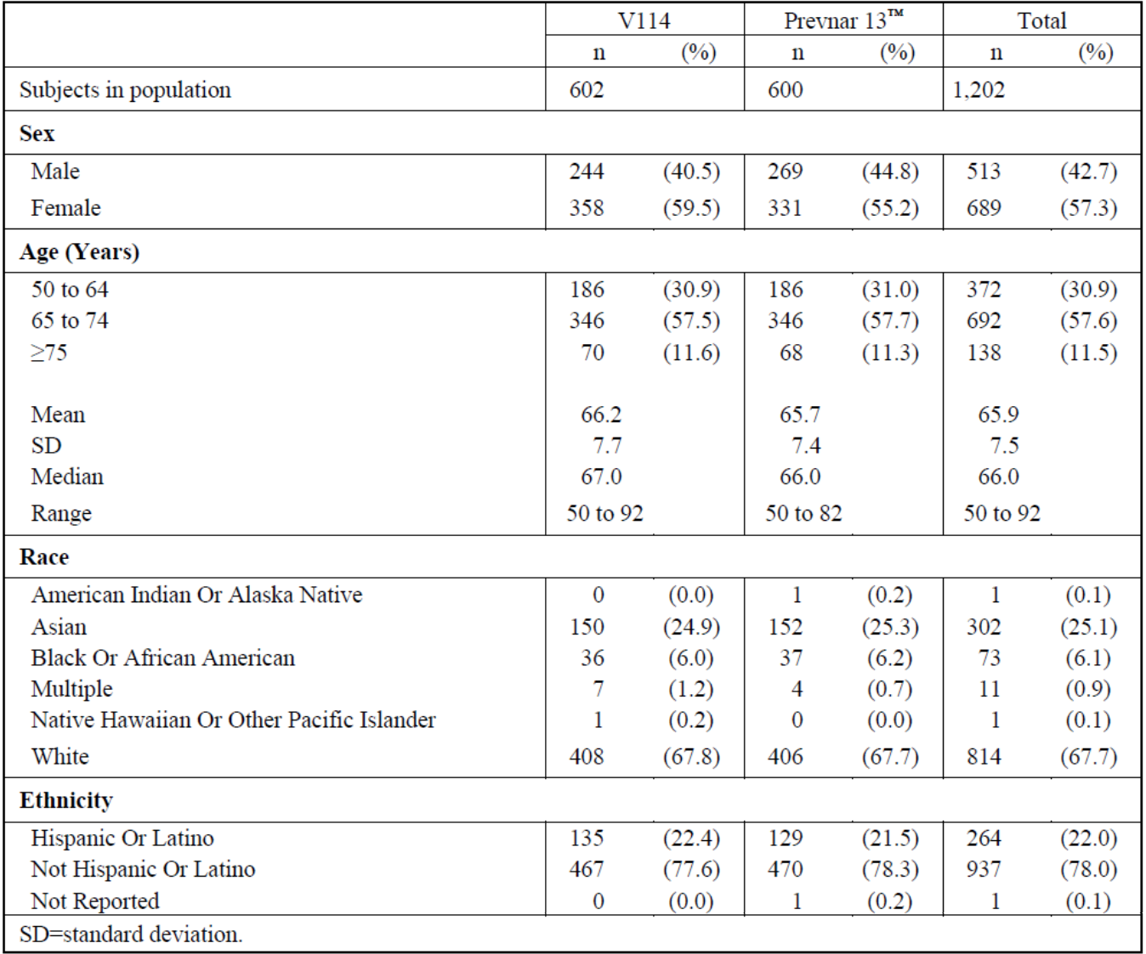
Abbreviations: n = number of subjects contributing to the analysis; SD = standard deviation; V114 = sponsor’s product development code for Vaxneuvance.
In terms of the primary immunogenicity results, OPA GMTs at Day 30 are presented in Table 5. Assessed by serotype specific OPA GMTs ratio at 30 days post-vaccination, Vaxneuvance was found to be non-inferior to Prevnar 13 for the 13 shared serotypes. The lower bound of the 95% CI of the estimated OPA GMT ratio (Vaxneuvance/Prevnar 13) was greater than 0.5 for all shared serotypes. As expected, Vaxneuvance met superiority criteria for the 2 serotypes unique to Vaxneuvance, as measured by serotype specific OPA GMTs at 30 days post-vaccination. The lower bound of the 95% CI of the estimated OPA GMT ratio (Vaxneuvance/Prevnar 13) was greater than 2.0 for both unique serotypes (Table 5 and Figure 1). Vaxneuvance also met superiority criteria for the 2 serotypes unique to Vaxneuvance as assessed by the proportions of subjects with an at least 4-fold rise from pre-vaccination to 30 days post-vaccination, for serotype specific OPA responses (Table 6).
Table 5: Study V114-019 Analysis of opsonophagocytic activity geometric mean titres at Day 30 (per-protocol population)
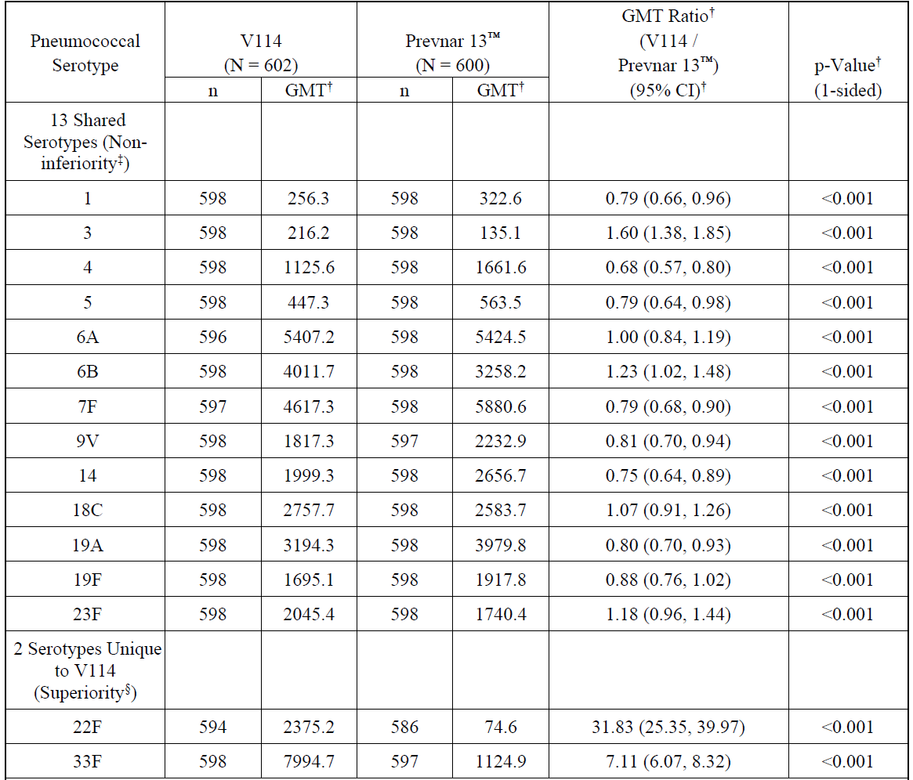
Abbreviations: CI = confidence interval; GMT = geometric mean titre; N = number of subjects randomised and vaccinated; n = number of subjects contributing to the analysis; V114 = sponsor’s product development code for Vaxneuvance.
† Geometric mean titres (GMTs), GMT ratio, 95% CI, and p-value are estimated from a constrained longitudinal data analysis (cLDA) model.
‡ A conclusion of non-inferiority is based on the lower bound of the 95% CI for the estimated GMT ratio (Vaxneuvance/Prevnar 13) being greater than 0.5 (one-sided p-value < 0.025).
§ A conclusion of superiority is based on the lower bound of the 95% CI for the estimated GMT ratio (Vaxneuvance/Prevnar 13) being greater than 2.0 (one-sided p-value < 0.025).
Per-protocol, Day 30 is 30 days following vaccination with pneumococcal conjugate vaccine (Vaxneuvance or Prevnar 13) (PCV).
Figure 1: Study V114-019 Forest plot of opsonophagocytic activity geometric mean titres ratios at Day 30 (per-protocol population)
Abbreviations: CI = confidence interval; GMT = geometric mean titre; n=number of subjects contributing to the analysis; V114 = sponsor’s product development code for Vaxneuvance.
Table 6: Study V114-019 Analysis of the proportions of subjects with an at least 4-fold rise in opsonophagocytic activity response at Day 30 (serotypes 22F and 33F; per-protocol population)
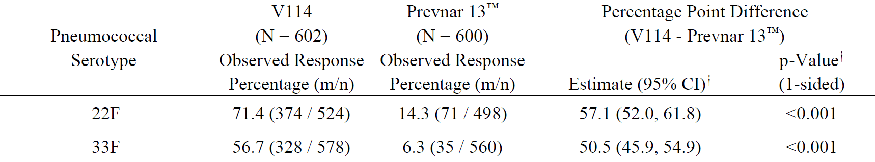
Abbreviations: CI = confidence interval; m = number of subjects with the indicated response. N = number of subjects randomised and vaccinated; n = number of subjects contributing to the analysis; V114 = sponsor’s product development code for Vaxneuvance.
† Estimated difference, 95% CI, and p-value are based on the stratified Miettinen and Nurminen method.
A conclusion of superiority is based on the lower bound of the 95% CI for the difference in percentages (Vaxneuvance - Prevnar 13) being greater than 10 percentage points (one-sided p-value < 0.025).
Per-protocol, Day 30 is 30 days following vaccination with pneumococcal conjugate vaccine (V114 or Prevnar 13) (PCV).
Proportion of participants with an at least 4-fold rise is calculated from Day 1 to Day 30.
In terms of secondary immunogenicity endpoints, Vaxneuvance met the superiority criterion for serotype 3 as assessed by the OPA GMTs at 30 days post-vaccination, the lower bound of the 95% CI of the OPA GMT ratio (Vaxneuvance/Prevnar 13) being greater than 1.2 (Table 7). Similarly, Vaxneuvance met the superiority criterion for serotype 3 as assessed by the proportions of subjects with an at least 4-fold rise from pre-vaccination to 30 days post vaccination for OPA responses (Table 8).
Table 7: Study V114-019 Analysis of opsonophagocytic activity geometric mean titres at Day 30 (serotype 3; per-protocol population)
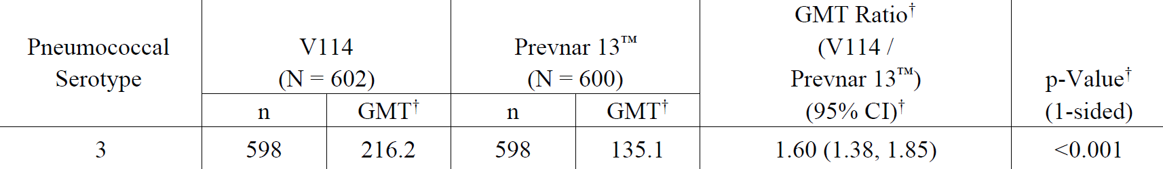
Abbreviations: CI = confidence interval; GMT = geometric mean titre; N = number of subjects randomised and vaccinated; n = number of subjects contributing to the analysis; V114 = sponsor’s product development code for Vaxneuvance.
† Geometric mean titres (GMTs), GMT ratio, 95% CI, and p-value are estimated from a constrained longitudinal data analysis (cLDA) model.
A conclusion of superiority is based on the lower bound of the 95% CI for the estimated GMT ratio (Vaxneuvance/Prevnar 13) being greater than 1.2 (one-sided p-value < 0.025).
Per-protocol, Day 30 is 30 days following vaccination with pneumococcal conjugate vaccine (Vaxneuvance or Prevnar 13) (PCV).
Table 8: Study V114-019 Analysis of the proportions of subjects with an at least 4-fold rise in opsonophagocytic activity responses at Day 30 (serotype 3; per-protocol population)
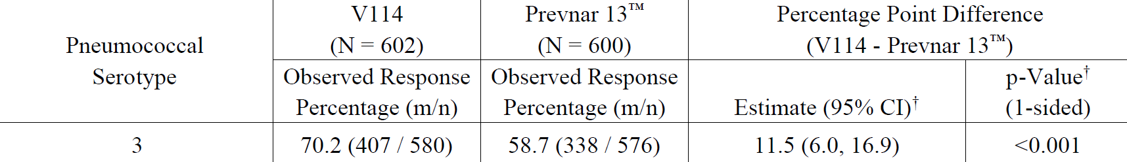
Abbreviations: CI = confidence interval; GMT = geometric mean titre; m = number of subjects with the indicated response; N = number of subjects randomised and vaccinated; n = number of subjects contributing to the analysis; V114 = sponsor’s product development code for Vaxneuvance.
† Estimated difference, 95% CI, and p-value are based on the stratified Miettinen and Nurminen method.
A conclusion of superiority is based on the lower bound of the 95% CI for the difference in percentages (Vaxneuvance minus Prevnar 13) being greater than 0 percentage points (one-sided p-value < 0.025).
Per-protocol, Day 30 is 30 days following vaccination with pneumococcal conjugate vaccine (Vaxneuvance or Prevnar 13) (PCV).
Proportion of participants with an at least 4-fold rise is calculated from Day 1 to Day 30.
Serotype-specific IgG responses at 30 days post-vaccination were consistent with the primary analyses of OPA GMTs (Table 9 and Figure 2).
Table 9: Study V114-019 Analysis of immunoglobulin G geometric mean concentrations at Day 30 (per-protocol population)
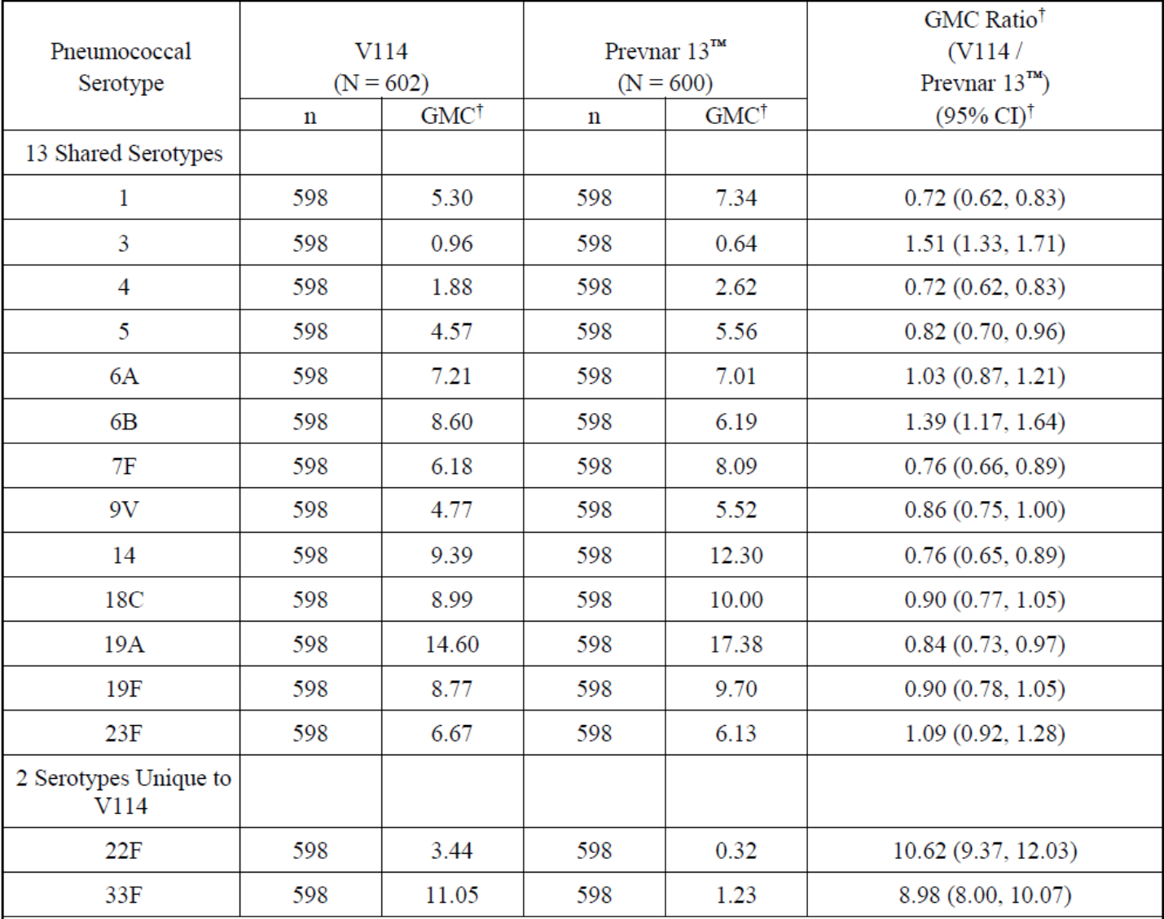
Abbreviations: CI = confidence interval; GMC = geometric mean concentration; N = number of subjects randomised and vaccinated; n = number of subjects contributing to the analysis; V114 = sponsor’s product development code for Vaxneuvance.
† Geometric mean concentrations (GMCs), GMC ratio, 95% CI, and p-value are estimated from a constrained longitudinal data analysis (cLDA) model.
Per-protocol, Day 30 is 30 days following vaccination with pneumococcal conjugate vaccine (Vaxneuvance or Prevnar 13) (PCV).
Figure 2: Study V114-019 Forest plot of immunoglobulin G geometric mean concentration ratios at Day 30 (per-protocol population)
Abbreviations: CI = confidence interval; GMC = geometric mean concentration; n = number of subjects contributing to the analysis; V114 = sponsor’s product development code for Vaxneuvance.
In terms of sub-group analyses in different age groups (from 50 years to 75 years of age and older), these were generally consistent with the ratios seen for the overall population. Similarly, there were no significant differences across groups for gender, race or ethnicity.

Study V114-020
Study V114-020 was a Phase III, multicentre, randomised, double blind, active comparator controlled, lot to lot consistency study to evaluate safety and immunogenicity of Vaxneuvance in healthy adults 50 years of age or older.
The study objectives and endpoints and are shown in Table 10.
Table 10: Study V114-020 Study objectives and endpoints
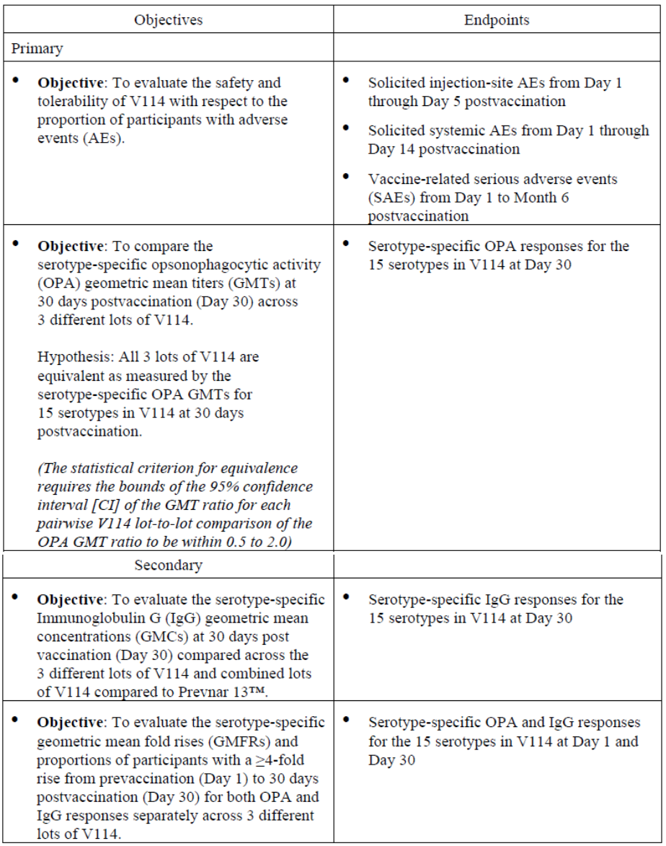
Abbreviations: AE = adverse event; CI = confidence interval; GMC = geometric mean concentration; GMFR = geometric mean fold rise; IgG = immunoglobulin G; OPA = opsonophagocytic activity; SAE = serious adverse event; V114 = sponsor’s product development code for Vaxneuvance.
A total of 2337 subjects were randomised and a total of 2299 subjects were included in the per-protocol; immunogenicity population. Demographic characteristics are summarised in Table 11. Demographic characteristics were generally comparable for the treatment groups. The median age of patients being 65 years with approximately 65% were over 65 years of age and approximately 10% over 75 years of age. The majority of subjects were female, White and of non-Hispanic or Latino ethnicity.
Table 11: Study V114-020 Subject characteristics
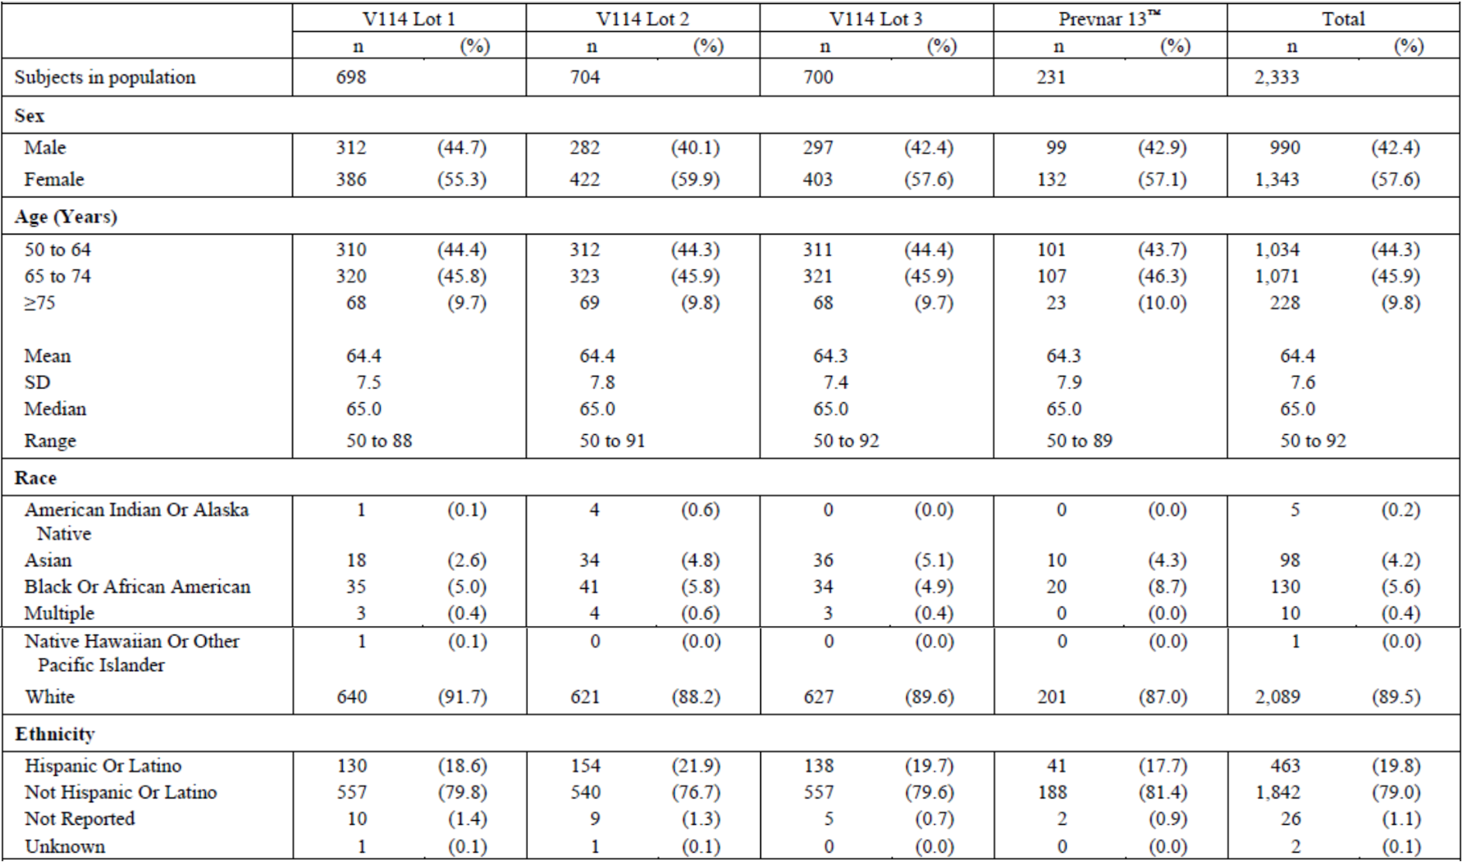
Abbreviations: n = number of subjects contributing to the analysis; SD = standard deviation; V114 = sponsor’s product development code for Vaxneuvance.
Analysis of OPA GMTs at Day 30 and GMT ratios across Vaxneuvance lots is shown in Table 12 and Figure 3. The 3 lots of Vaxneuvance met criteria for equivalence as assessed by serotype specific OPA GMTs for the 15 serotypes in Vaxneuvance at 30 days post-vaccination. The lower and upper limits of the 95% CI of the serotype specific OPA GMT ratios between any 2 lots were within the equivalence margin (0.5 to 2.0).
Table 12: Study V114-020 Analysis of opsonophagocytic activity geometric mean titres at Day 30 (comparison across V114 lots; per-protocol population)
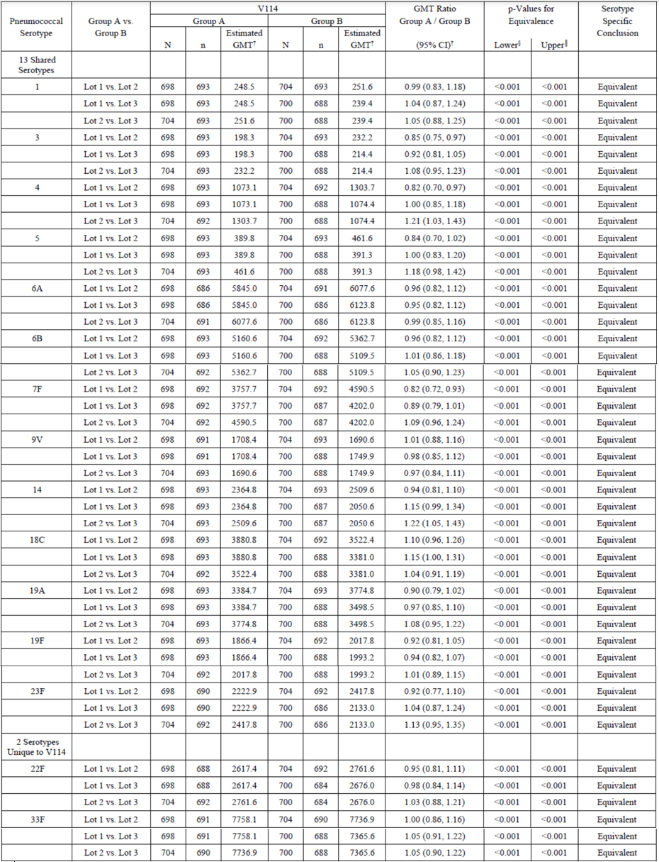
Abbreviations: CI = confidence interval; GMT = geometric mean titre; N = number of subjects randomised and vaccinated; n = number of subjects contributing to the analysis; V114 = sponsor’s product development code for Vaxneuvance.
† Geometric mean titres (GMTs), GMT ratio, 95% CI, and p-value are estimated from a constrained longitudinal data analysis (cLDA) model.
§P-value for the comparison of the GMT ratio to the lower bound (0.5).
‖ P-value for the comparison of the GMT ratio to the upper bound (2.0).
A p-value (lower) ≤ 0.025 and a p-value (upper) ≤ 0.025 together support a conclusion of equivalence. If equivalence can be established in all 3 pairwise comparisons for a given serotype, the 3 lots will be considered consistent for a given serotype.
Per-protocol, Day 30 is 30 days following vaccination with pneumococcal conjugate vaccine (Vaxneuvance or Prevnar 13) (PCV).
Figure 3: Study V114-020 Forest plot of opsonophagocytic activity geometric mean titre ratios at Day 30 (comparison across V114 lots; per-protocol population)
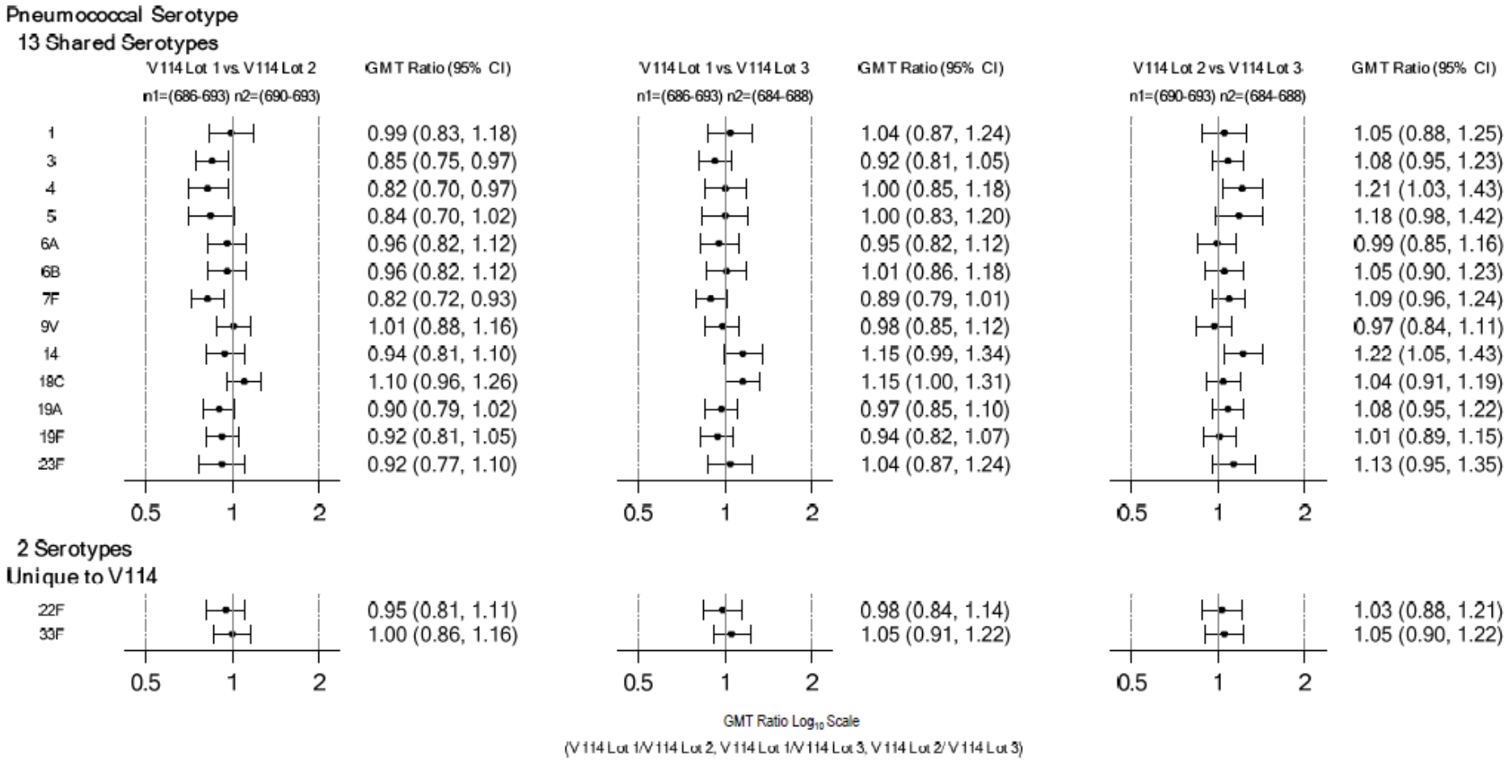
Abbreviations: CI = confidence interval; GMT = geometric mean titre; n1 = number of subjects contributing to the analysis from V114 Lot 1, V114 Lot 1, V114 Lot 2 respectively across all 15 serotypes; n2 = number of subjects contributing to the analysis from V114 Lot 2, V114 Lot 3, V114 Lot 3 respectively across all 15 serotypes; V114 = sponsor’s product development code for Vaxneuvance.
The IgG GMCs at 30 days post-vaccination with Vaxneuvance were consistent with results of the primary analysis of OPA GMTs and serotype specific IgG GMCs at 30 days post-vaccination were comparable for Vaxneuvance (combined lots) and Prevnar 13 intervention groups for the 13 shared serotypes and higher in the Vaxneuvance (combined lots) compared with the Prevnar 13 groups for the 2 serotypes unique to Vaxneuvance.
Subgroup analyses of serotype specific OPA GMT ratios at 30 days postvaccination within each age subgroup, sex, race, and ethnicity were generally consistent with the OPA GMT ratios observed in the overall population.

Study V114-017
Study V114-017 was a Phase III, multicentre, randomised, double blind, active comparator, controlled study to evaluate safety and immunogenicity of Vaxneuvance in pneumococcal vaccine naïve, immunocompetent subjects aged 18 to 49 years with or without risk factors for pneumococcal disease.
The study objectives are shown in Table 13. Subjects were randomised in a 3:1 ratio to receive either Vaxneuvance (1125 subjects) or Prevnar 13 (375 subjects) at Day 1. All subjects were also to receive a single dose of Pneumovax 23 vaccine at Month 6.
Table 13: Study V114-017 Study objectives
Abbreviations: AE = adverse event; GMT = geometric mean titre; IgG = immunoglobulin G; OPA = opsonophagocytic activity; SAE = serious adverse event; V114 = sponsor’s product development code for Vaxneuvance.
Table 13 continued: Study V114-017 Study objectives
Abbreviations: GMC = geometric mean concentration; GMT = geometric mean titre; IgG = immunoglobulin G; OPA = opsonophagocytic activity; V114 = sponsor’s product development code for Vaxneuvance.
A total of 1515 participants were randomised across 77 study sites. All but 3 randomised subjects received Vaxneuvance or Prevnar 13. The majority of subjects also received Pneumovax 23. Demographic characteristics are summarised in Table 14. Approximately 40% of participants were American Indian or Alaska Native, nearly all of whom (587 of 593) were enrolled at John Hopkins Center for American Indian Health (CAIH) sites. Participants from sites other than the CAIH had more than one of the risk factors for pneumococcal disease. The most common single risk factors were tobacco use (14.6%), chronic lung disease (14.3%) and diabetes mellitus (13.8%). Approximately 25% of subjects had no risk factors, all of whom were enrolled at CAIH sites.
Table 14: Study V114-017 Subject characteristics (all vaccinated subjects)
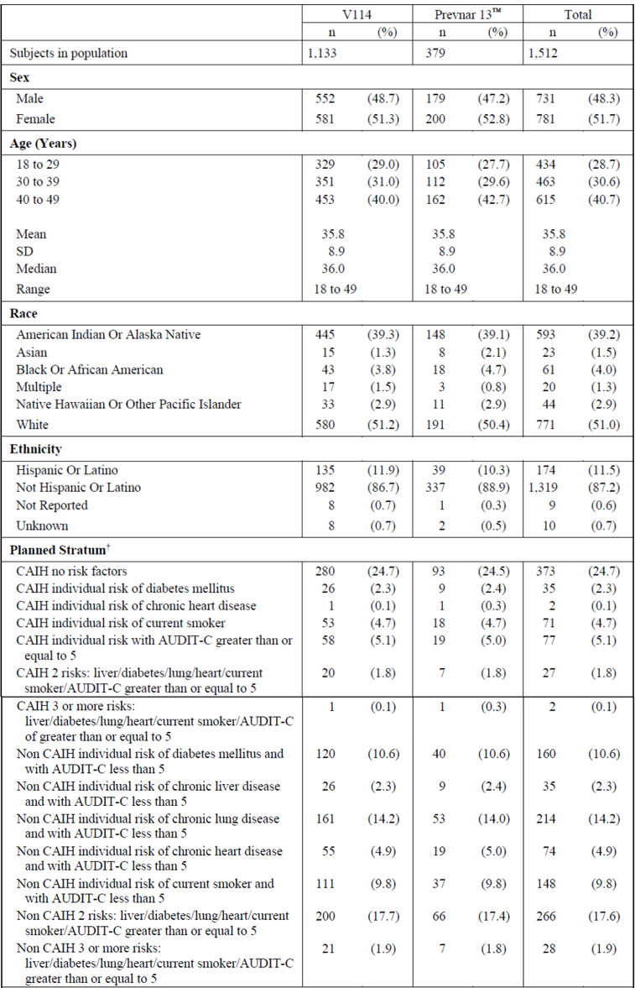
Abbreviations: AUDIT-C = alcohol use disorders identification test-consumption; CAIH = Center for American Indian Health; n = number of subjects contributing to the analysis; SD = standard deviation; V114 = sponsor’s product development code for Vaxneuvance.
†Randomisation is stratified based on (1) whether a participant is enrolled at CAIH or not and (2) the type/number of risk factors for pneumococcal disease a participant has the time of randomisation. Risk factors for pneumococcal disease include chronic lung disease, tobacco use, diabetes mellitus, chronic liver disease, chronic heart disease, or alcohol consumption as described in detail under Include Criteria 1a-1f (Section 5.1 of the protocol). The risk factor of alcohol consumption is defined as the AUDIT-C score at least 5. The AUDIT-C is a 3-item alcohol screening instrument that can help identify patients who are hazardous drinkers or have active alcohol use disorder (including alcohol abuse or dependence).
In terms of immunogenicity results for the primary immunogenicity endpoint (serotype specific OPA GMTs at 30 days post-vaccination with pneumococcal conjugate vaccine), results are shown in Table 15. Vaxneuvance was immunogenic in pneumococcal vaccine naïve immunocompetent adults in the population studied, for all 15 serotypes contained in the vaccine. Prevnar 13 was immunogenic for the 13 serotypes contained in the vaccine.
Table 15: Study V114-017 Summary of opsonophagocytic activity geometric mean titres at Day 30 (per-protocol population)
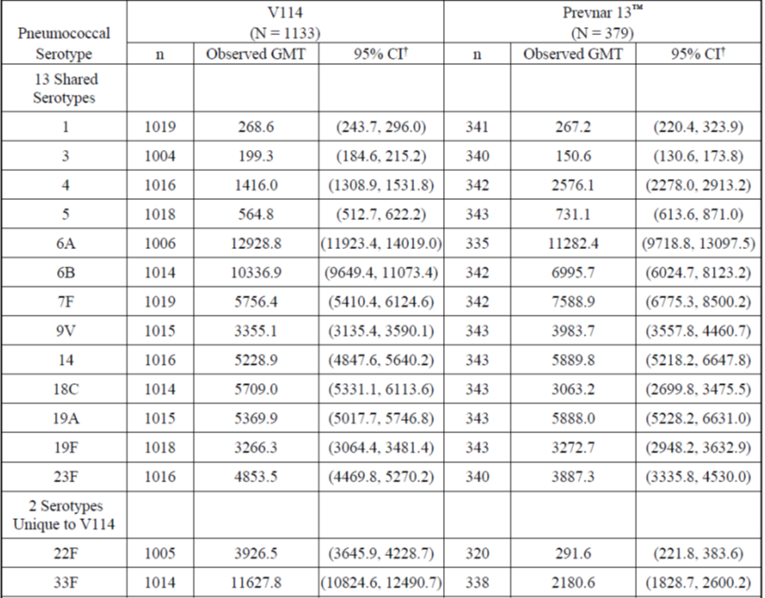
Abbreviations: CI = confidence interval; GMT = geometric mean titre; N = number of subjects randomised and vaccinated; n = number of subjects contributing to the analysis; V114 = sponsor’s product development code for Vaxneuvance.
†The within group 95% Cis are obtained by exponentiating the CIs of the mean of the natural log values based on the t-distribution.
Per-protocol, Day 30 is 30 days following vaccination with pneumococcal conjugate vaccine (Vaxneuvance or Prevnar 13) (PCV).
In terms of secondary immunogenicity endpoints, following sequential vaccination with Pneumovax 23, serotype specific OPA titres were measured for the 15 serotypes in Vaxneuvance, including 14 shared serotypes between Vaxneuvance and Pneumovax 23 and one serotype unique to Vaxneuvance (serotype 6A). Table 16 shows OPA GMTs at 30 days after Pneumovax 23 (Month 7) were immunogenic for all 15 serotypes contained in Vaxneuvance and all 13 serotypes contained in Prevnar 13. The magnitude of serotype specific OPA geometric mean fold rises (GMFRs) and proportions of participants with at least 4-fold rise in OPA titres were higher for all 13 shared serotypes between Day 1 and Day 30 than levels seen between Months 6 and 7 in both intervention groups.
Table 16: Study V114-017 Summary of opsonophagocytic activity antibody responses (per-protocol population)
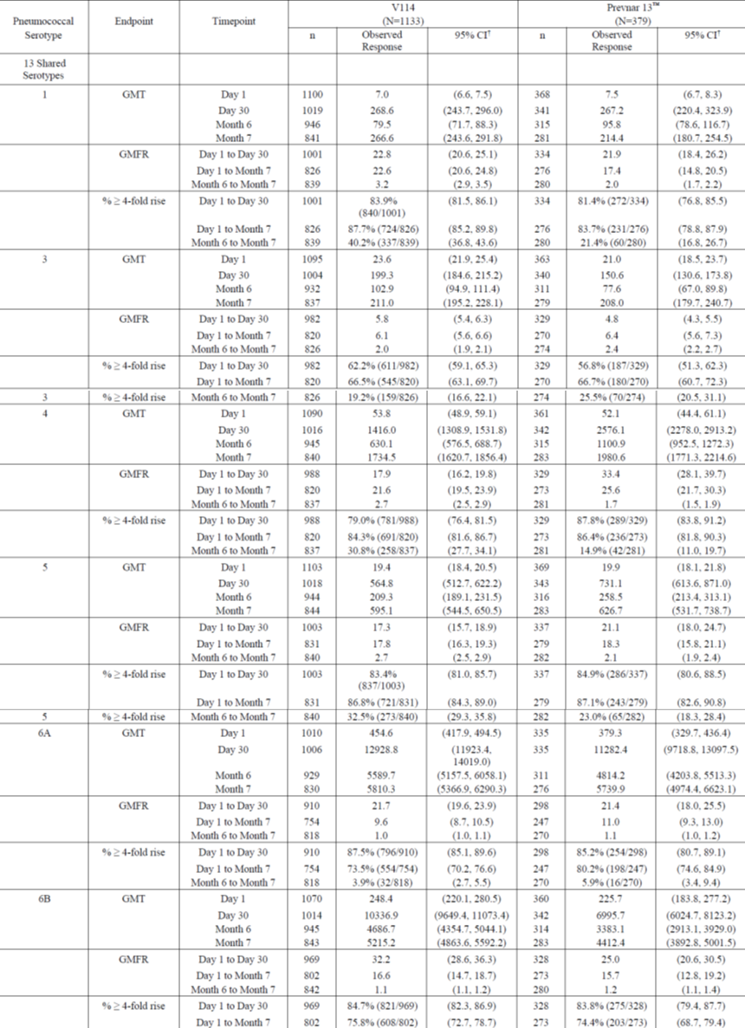
Abbreviations: CI = confidence interval; GMFR = geometric mean fold rise; GMT = geometric mean titre; N = number of subjects randomised and vaccinated; n = number of subjects contributing to the analysis; V114 = sponsor’s product development code for Vaxneuvance.
Table 16 continued: Study V114-017 Summary of opsonophagocytic activity antibody responses (per-protocol population)
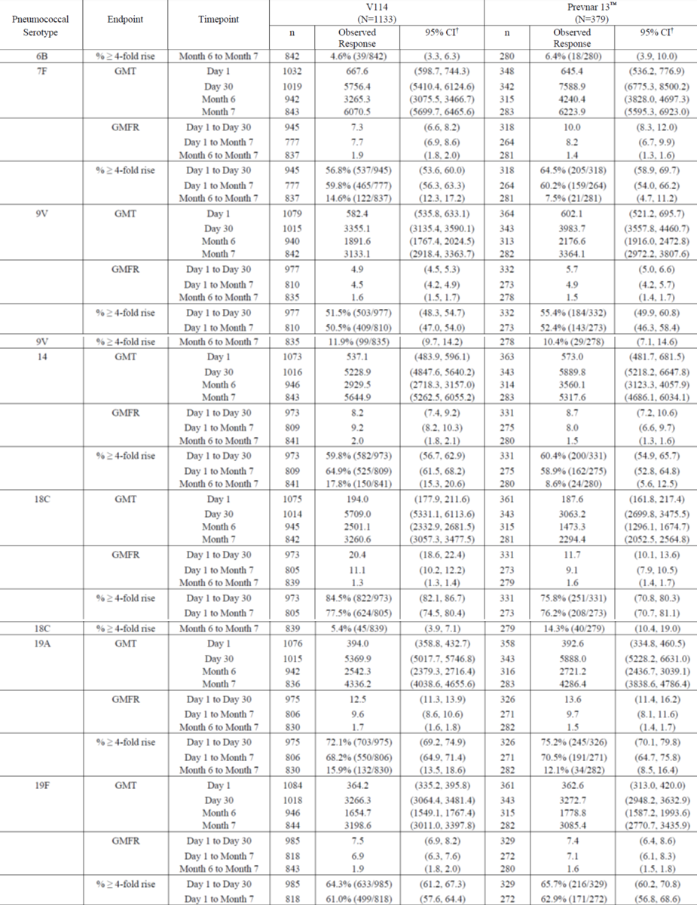
Abbreviations: CI = confidence interval; GMFR = geometric mean fold rise; GMT = geometric mean titre; N = number of subjects randomised and vaccinated; n = number of subjects contributing to the analysis; V114 = sponsor’s product development code for Vaxneuvance.
Table 16 continued: Study V114-017 Summary of opsonophagocytic activity antibody responses (per-protocol population)
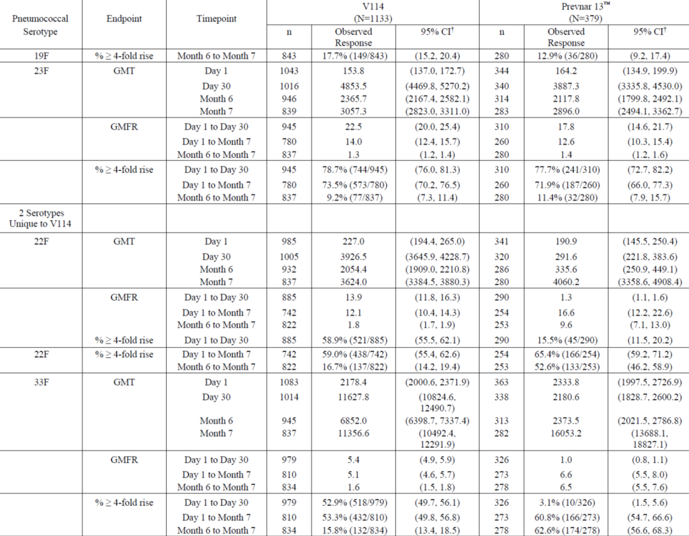
Abbreviations: CI = confidence interval; GMFR = geometric mean fold rise; GMT = geometric mean titre; N = number of subjects randomised and vaccinated; n = number of subjects contributing to the analysis; V114 = sponsor’s product development code for Vaxneuvance.
† For the continuous endpoints, the within-group 95% CIs are obtained by exponentiating the CIs of the mean of the natural log values based on the t-distribution. For the dichotomous endpoints, the within group 95% CIs are based on the exact binomial method proposed by Clopper and Pearson.
Per-protocol, Day 1 is pre-vaccination with pneumococcal conjugate vaccine (Vaxneuvance or Prevnar 13) (PCV), and Day 30 is 30 days following vaccination with PCV, Month 6 is 6 months following vaccination with PCV and pre-vaccination with pneumococcal polysaccharide vaccine (Pneumovax 23) (PPV23), and Month 7 is 30 days following vaccination with PPV23.
Serotype specific OPA GMTs and IgG GMCs seen in subjects with no risk factors (approximately 25% of the overall population) were consistent with those seen in the overall study population.
Results in Study V114-017 were consistent with those seen in the pivotal Study V114-019 that demonstrated non-inferiority of Vaxneuvance to Prevnar 13 for the 13 shared serotypes and superiority of Vaxneuvance to Prevnar 13 for serotypes 22F and 33F.

Study V114-018
Study V114-018 was a Phase III, multicentre, randomised, double blind study evaluating safety and immunogenicity of Vaxneuvance or Prevnar 13 followed by Pneumovax 23, 8 weeks later in immunocompromised adults (with HIV).
Similar study objectives and endpoints were applied as for the earlier studies as shown in Table 17.
Table 17: Study V114-018 Study objectives and endpoints
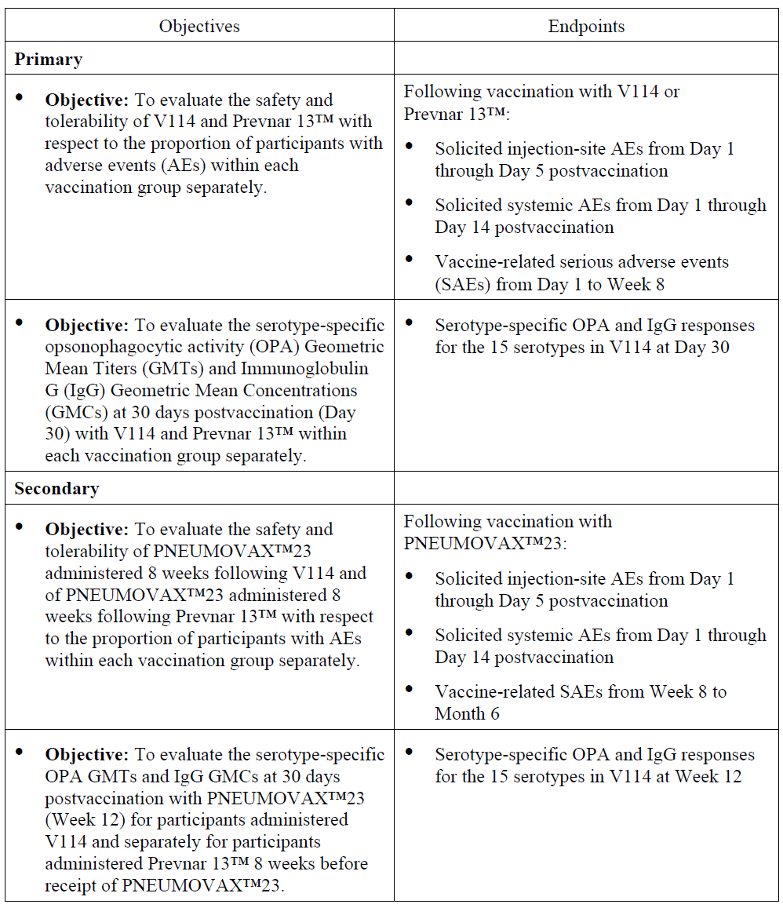
Abbreviations: AE = adverse event; GMC = geometric mean concentration; GMT = geometric mean titre; IgG = immunoglobulin G; OPA = opsonophagocytic activity; SAE = serious adverse event; V114 = sponsor’s product development code for Vaxneuvance.
Table 17 continued: Study V114-018 Study objectives and endpoints
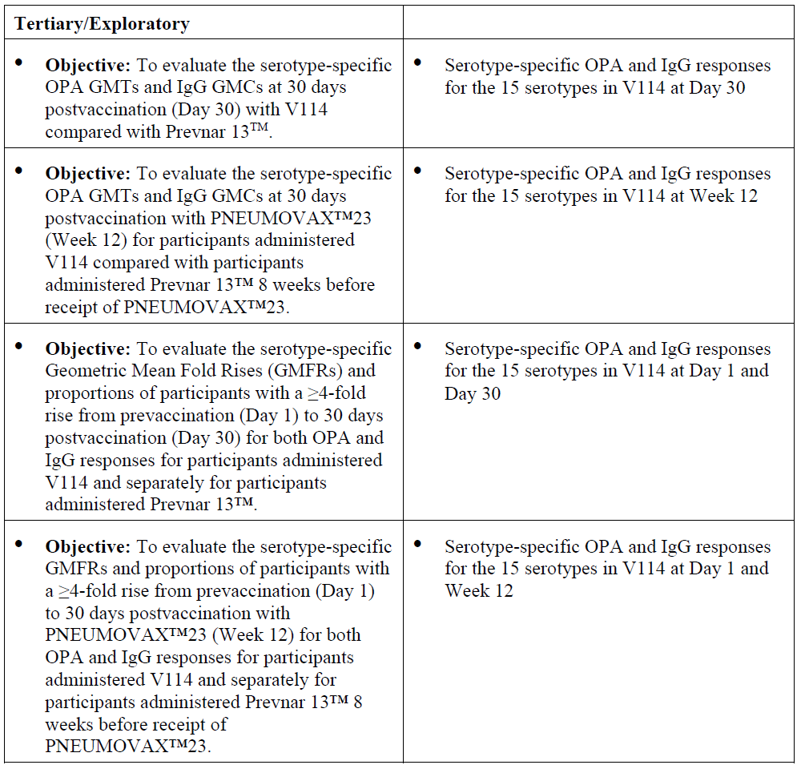
Abbreviations: GMC = geometric mean concentration; GMFR = geometric mean fold rise; GMT = geometric mean titre; IgG = immunoglobulin G; OPA = opsonophagocytic activity; V114 = sponsor’s product development code for Vaxneuvance.
Approximately 300 individuals were to be randomly assigned in a 1:1 ratio to receive either Vaxneuvance or Prevnar 13 at Day 1. Randomisation was stratified by cluster of differentiation 4 (CD4)+ T-cell count. Inclusion criteria were subjects with HIV and CD4+ T-cell count at least 50 cells/µL and plasma HIV ribonucleic acid less than 50000 copies/mL at screening, being 18 years of age and older, on stable combination antiretroviral therapy.
A total of 302 subjects were randomised across 13 study sites, all randomised subjects receiving either Vaxneuvance or Prevnar 13 and nearly all receiving Pneumovax 23. Demographic characteristics are summarised in Table 18. The majority of subjects were male and aged between 18 to 49 years of age. Nearly all participants had CD4+ T-cell count at least 200 cells/µL at screening in both intervention groups and more than half had CD4+ T-cell counts of less than 500 cells/µL at screening in both groups.
Table 18: Study V114-018 Subject characteristics (all vaccinated subjects)
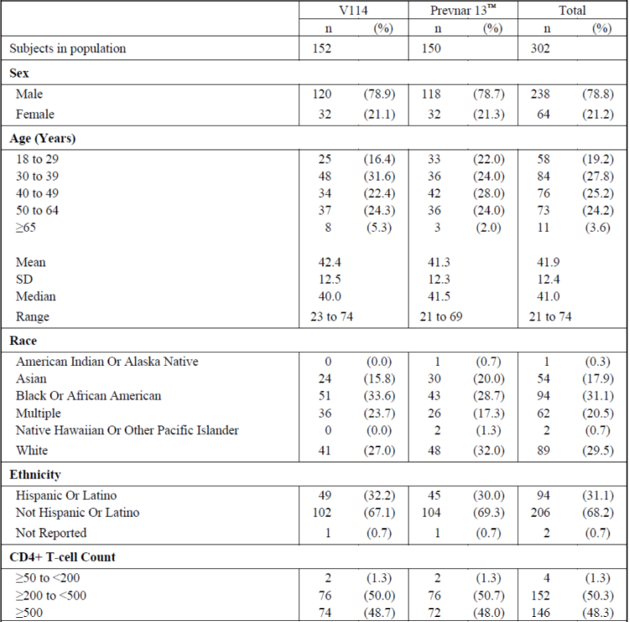
Abbreviations: CD4 = cluster of differentiation 4; n = number of subjects contributing to the analysis; SD = standard deviation.
For the primary endpoint, Vaxneuvance was found to be immunogenic in pneumococcal vaccine naïve patients infected with HIV (assessed by OPA GMTs 30 days post-vaccination) for all 15 serotypes contained in the vaccine as shown in Table 19. Prevnar 13 was immunogenic at Day 30 for all 13 serotypes contained in the vaccine.
Table 19: Study V114-018 Summary of opsonophagocytic activity geometric mean titres at Day 30 (per-protocol population)
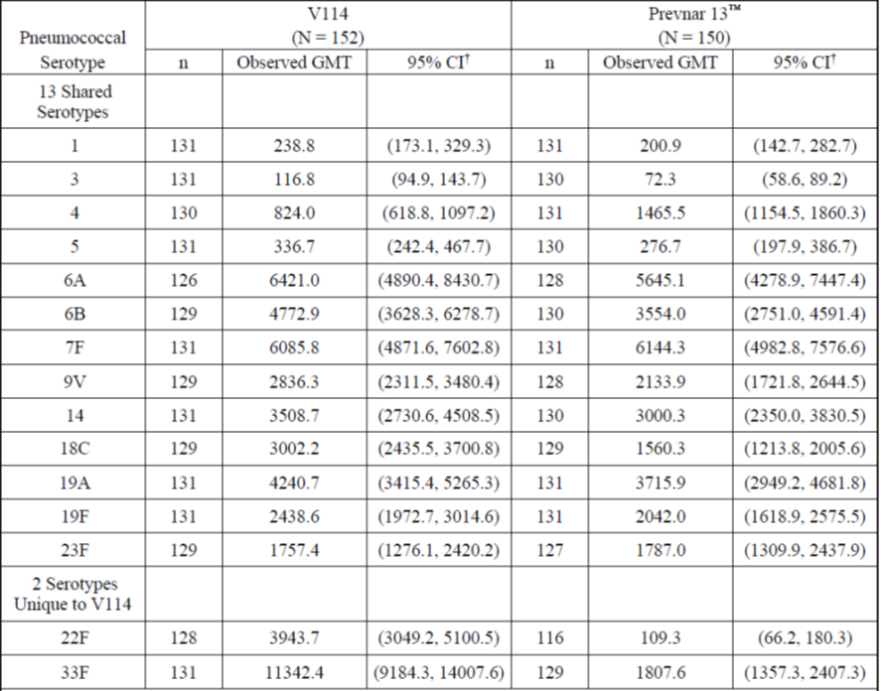
Abbreviations: CI = confidence interval; GMT = geometric mean titre; N = number of subjects randomised and vaccinated; n = number of subjects contributing to the analysis; V114 = sponsor’s product development code for Vaxneuvance.
†The within group 95% CIs are obtained by exponentiating the CIs of the mean of the natural log values based on the t-distribution.
Per-protocol, Day 30 is 30 days following vaccination with pneumococcal conjugate vaccine (Vaxneuvance or Prevnar 13) (PCV).
In terms of secondary immunogenicity endpoints, serotype specific OPA GMTs and IgG GMCs at 30 days post-vaccination with Pneumovax 23 were generally comparable with those seen at 30 days post-vaccination with the Vaxneuvance group for all 15 serotypes and the Prevnar 13 group for all 13 serotypes contained in the vaccine. Pneumovax 23 elicited an immune response for serotypes 22F and 33F at 30 days post-vaccination with Pneumovax 23 in the Prevnar 13 group.
In terms of exploratory immunogenicity endpoints, serotype specific OPA GMTs and IgG GMCs at 30 days post-vaccination were generally comparable across intervention groups for the 13 shared serotypes between Vaxneuvance and Prevnar 13. OPA GMTs and IgG GMCs for the 2 serotypes unique to Vaxneuvance (serotypes 22F and 33F) at 30 days post-vaccination were higher in the Vaxneuvance group compared to the Prevnar 13 group. Serotype specific OPA GMTs and IgG GMCs for all 15 serotypes at 30 days post-vaccination with Pneumovax 23 were generally comparable across intervention groups.

Other efficacy studies

Study V114-016
Study V114-016 was a Phase III multicentre, randomised, double blind, active comparator study to evaluate safety and immunogenicity of Vaxneuvance or Prevnar 13 followed by administration of Pneumovax 23, one year later in healthy adults 50 years of age or older.
Study objectives and endpoints are shown in Table 20.
Table 20: Study V114-016 Study objectives and endpoints
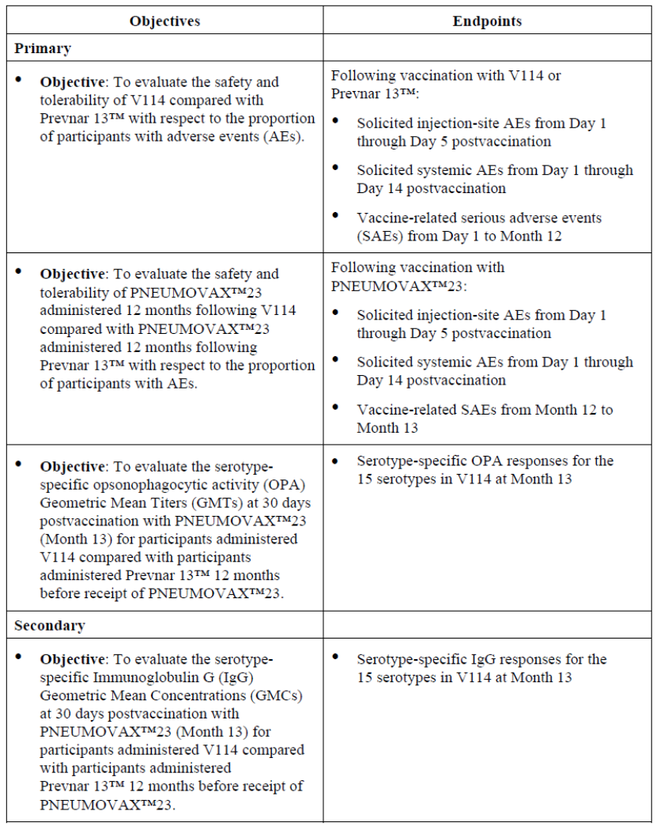
Abbreviations: AE = adverse event; GMC = geometric mean concentration; GMT = geometric mean titre; IgG = immunoglobulin G; OPA = opsonophagocytic activity; SAE = serious adverse event; V114 = sponsor’s product development code for Vaxneuvance.
Table 20 continued: Study V114-016 Study objectives and endpoints
Abbreviations: GMC = geometric mean concentration; GMFR = geometric mean fold rise; GMT = geometric mean titre; IgG = immunoglobulin G; OPA = opsonophagocytic activity; V114 = sponsor’s product development code for Vaxneuvance.
A total of 600 subjects were planned to be randomised in a 1:1 ratio to receive either Vaxneuvance or Prevnar 13 on Day 1 and Pneumovax 23 at Month 12. A total of 652 subjects were randomised across 22 study sites and all but one subject received either Vaxneuvance or Prevnar 13. A total of 96.8% were included in OPA analyses at Day 30 and 84.2% at Month 13.
Demographic characteristics are summarised in Table 21. Characteristics were balanced across interventions groups. The median age was 65 years, and the majority of participants were female, white and of non-Hispanic or Latino ethnicity. Serotype specific OPA GMTs at 30 days following vaccination with Pneumovax 23 (Month 13) were comparable between participants given Vaxneuvance or Prevnar 13 vaccine, 12 months earlier, for the 13 shared serotypes as shown in Table 22 and in Figure 4.
Table 21: Study V114-016 Subject characteristics (all vaccinated subjects)
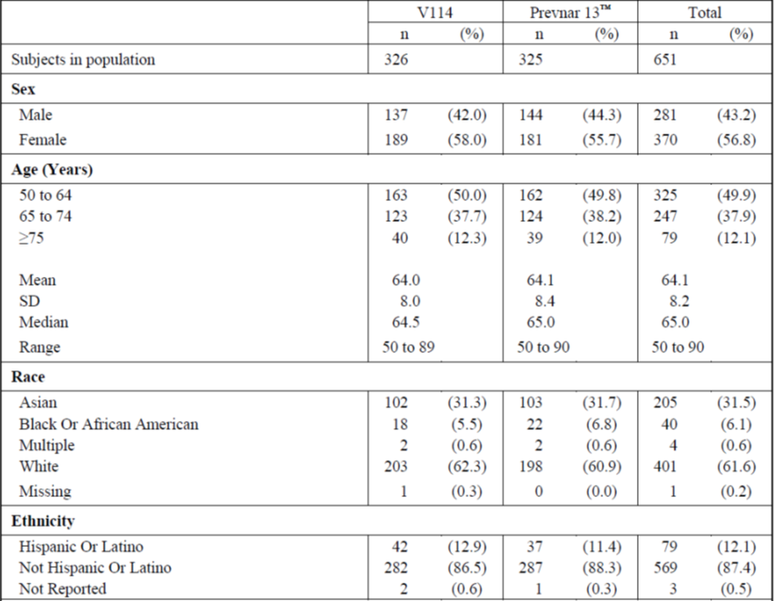
Abbreviations: n = number of subjects contributing to the analysis; SD = standard deviation; V114 = sponsor’s product development code for Vaxneuvance.
Table 22: Study V114-016 Analysis of opsonophagocytic activity geometric mean titres at Month 13 (per-protocol population)
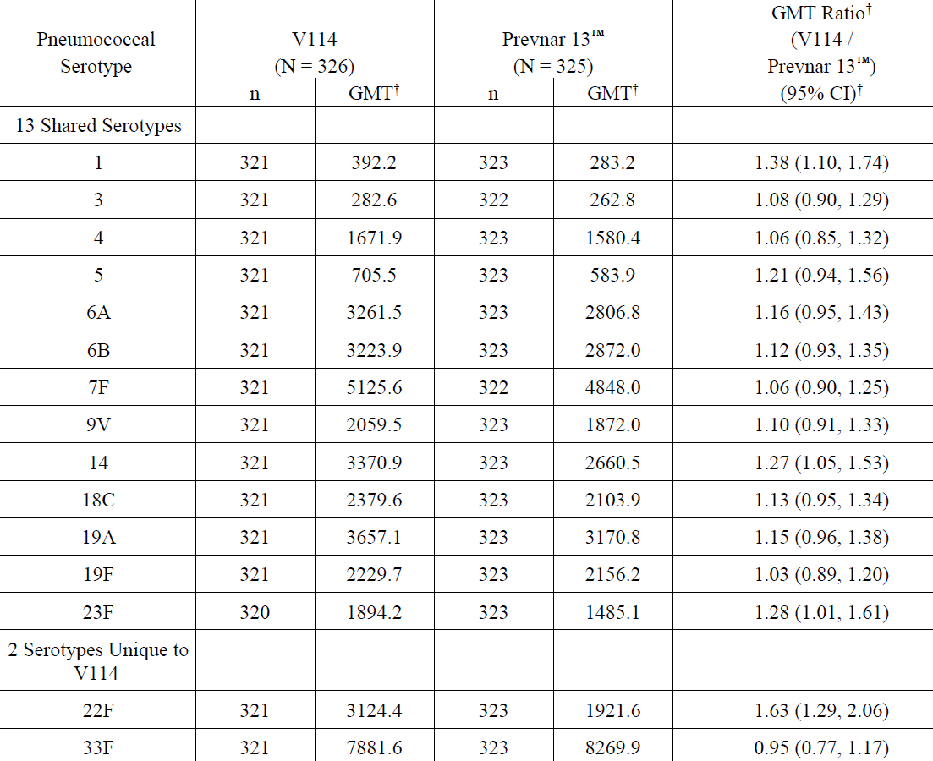
Abbreviations: CI = confidence interval; cLDA=constrained longitudinal data analysis; GMT = geometric mean titre; N = number of subjects randomised and vaccinated; n = number of subjects contributing to the analysis.
† Geometric mean titres (GMTs), GMT ratio and 95% CI are estimated from a constrained longitudinal data analysis (cLDA) model.
Per-protocol, Month 13 is 30 days following vaccination with pneumococcal polysaccharide vaccine (Pneumovax 23) (PPV23).
Figure 4: Study V114-016 Forest plot of opsonophagocytic activity geometric mean titre ratios at Month 13 (per-protocol population)
Abbreviations: CI = confidence interval; GMT = geometric mean titre; n=number of subjects contributing to the analysis; V114 = sponsor’s product development code for Vaxneuvance.
Serotype specific IgG GMCs at 30 days post-vaccination with Pneumovax 23, between group comparisons at 30 days following the Pneumovax 23 vaccination at Month 13 were consistent with the OPA GMTs, as shown in Table 23 and Figure 5.
Table 23: Study V114-016 Analysis of immunoglobulin G geometric mean concentrations at Month 13 (per-protocol population)
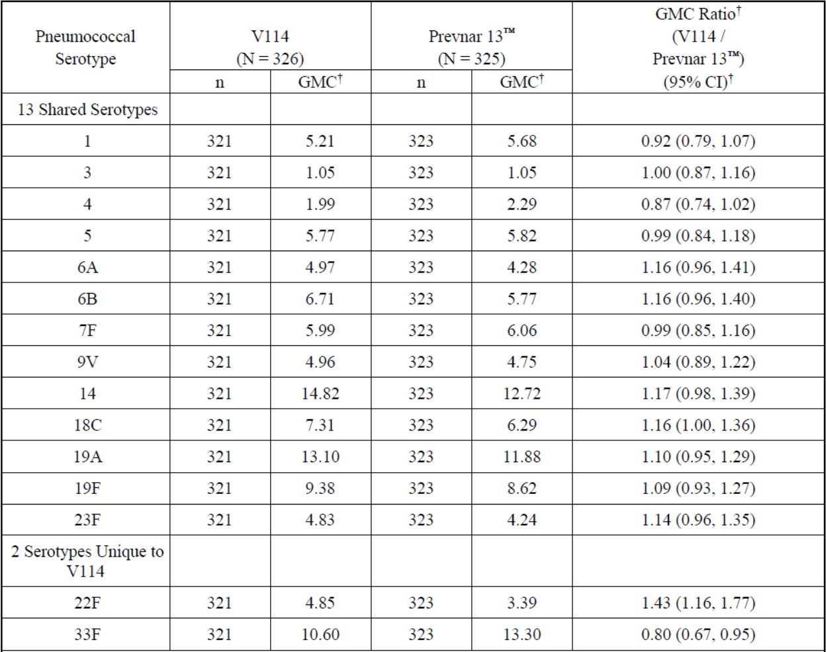
Abbreviations: CI = confidence interval; GMC = geometric mean concentration; N = number of subjects randomised and vaccinated; n = number of subjects contributing to the analysis; V114 = sponsor’s product development code for Vaxneuvance.
† Geometric mean concentrations (GMCs), GMC ratio and 95% CI are estimated from a constrained longitudinal data analysis (cLDA) model.
Per-protocol, Month 13 is 13 months following vaccination with pneumococcal polysaccharide vaccine (Pneumovax 23) (PPV23).
Figure 5: Study V114-016 Forest plot of immunoglobulin G geometric mean concentration ratios at Month 13 (per-protocol population)
Abbreviations: CI = confidence interval; GMT = geometric mean titre; n=number of subjects contributing to the analysis; V114 = sponsor’s product development code for Vaxneuvance.
Serotype specific OPA GMTs and IgG geometric mean concentrations at 30 days after vaccinations with Vaxneuvance or Prevnar 13 (Day 30) were comparable across intervention groups for the 13 shared serotypes and higher values for the 2 serotypes unique for Vaxneuvance , as shown in Table 24 and Table 25.
Table 24: Study V114-016 Analysis of opsonophagocytic activity geometric mean titres at Month 12 (per-protocol population)
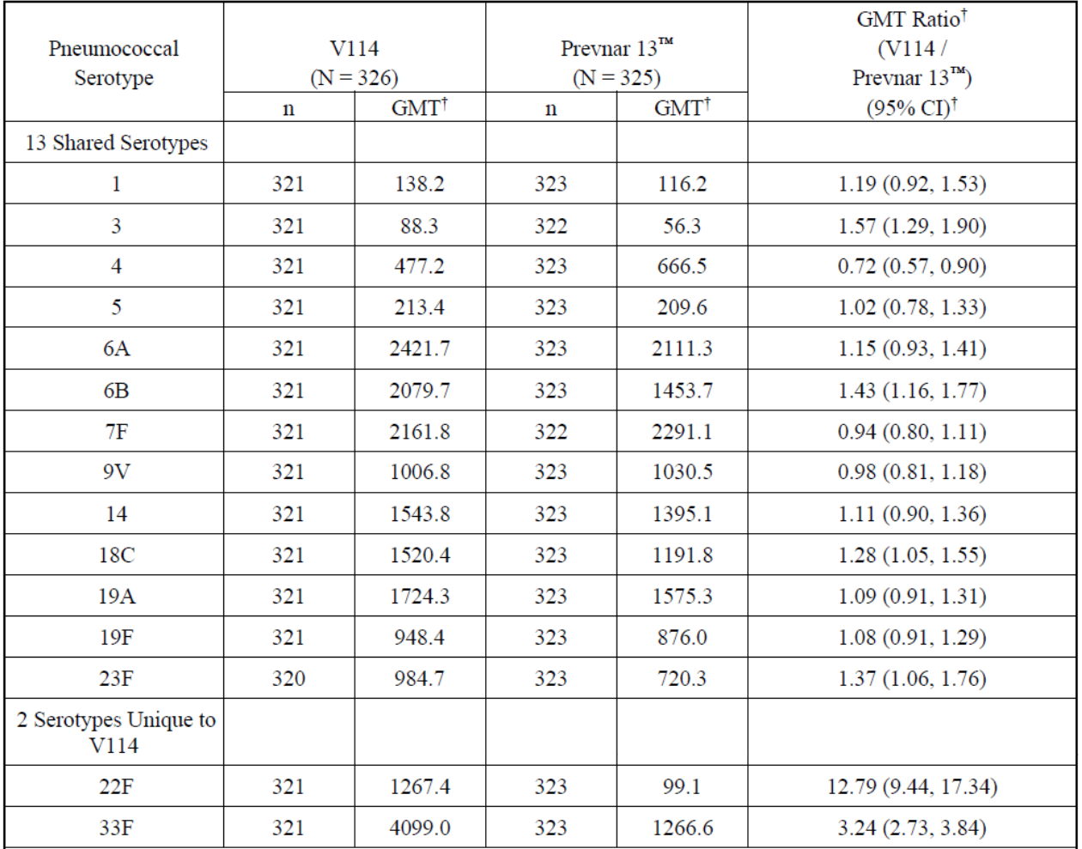
Abbreviations: CI = confidence interval; GMT = geometric mean titre; N = number of subjects randomised and vaccinated; n = number of subjects contributing to the analysis; V114 = sponsor’s product development code for Vaxneuvance.
† Geometric mean titres (GMTs), GMT ratio and 95% CI are estimated from a constrained longitudinal data analysis (cLDA) model.
Per-protocol, Month 12 is 12 months following vaccination with pneumococcal conjugate vaccine (Vaxneuvance or Prevnar 13) (PCV) and pre-vaccination with pneumococcal polysaccharide vaccine (Pneumovax 23) (PPV23).
Table 25: Study V114-016 Analysis of immunoglobulin G geometric mean concentrations at Month 12 (per-protocol population)
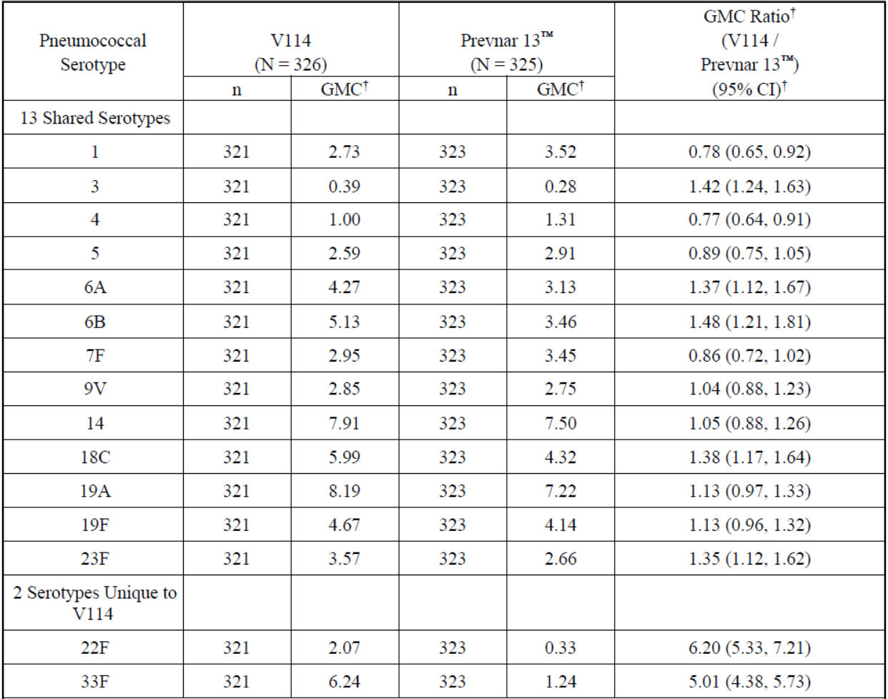
Abbreviations: CI = confidence interval; GMC = geometric mean concentration; N = number of subjects randomised and vaccinated; n = number of subjects contributing to the analysis; V114 = sponsor’s product development code for Vaxneuvance.
† Geometric mean concentrations (GMCs), GMC ratio and 95% CI are estimated from a constrained longitudinal data analysis (cLDA) model.
Per-protocol, Month 12 is 12 months following vaccination with pneumococcal conjugate vaccine (Vaxneuvance or Prevnar 13) (PCV) and pre-vaccination with pneumococcal polysaccharide vaccine (Pneumovax 23) (PPV23).
Subgroup analyses of OPA GMT ratios by age were generally consistent with ratios observed in the overall population, as were subgroup analyses for sex, race and ethnicity.

Study V114-021
Study V114-021 was a Phase III multicentre, randomised, double blind, placebo controlled study which assessed safety and immunogenicity of Vaxneuvance given with influenza vaccine in healthy adults aged 50 years or older.
The efficacy objective was to compare the serotype specific OPA GMTs at 30 days post-vaccination with Vaxneuvance given concurrently or non-concurrently with influenza vaccine. The other primary endpoint was to demonstrate non-inferiority of strain specific haemagglutination inhibition GMTs at 30-days post-vaccination of the 4 influenza strains in the influenza vaccine at 30 days, for concomitant versus non-concomitant administration with Vaxneuvance.
Six hundred (600) subjects were randomised to the concomitant group and 600 subjects were randomised to non-concomitant groups. 97.2% completed the study. Randomisation was stratified by age and history of prior Pneumovax 23.
Demographic and baseline characteristics were comparable for vaccinated participants across treatment groups, as shown in Table 26.
Table 26: Study V114-021 Subject characteristics (all vaccinated subjects)
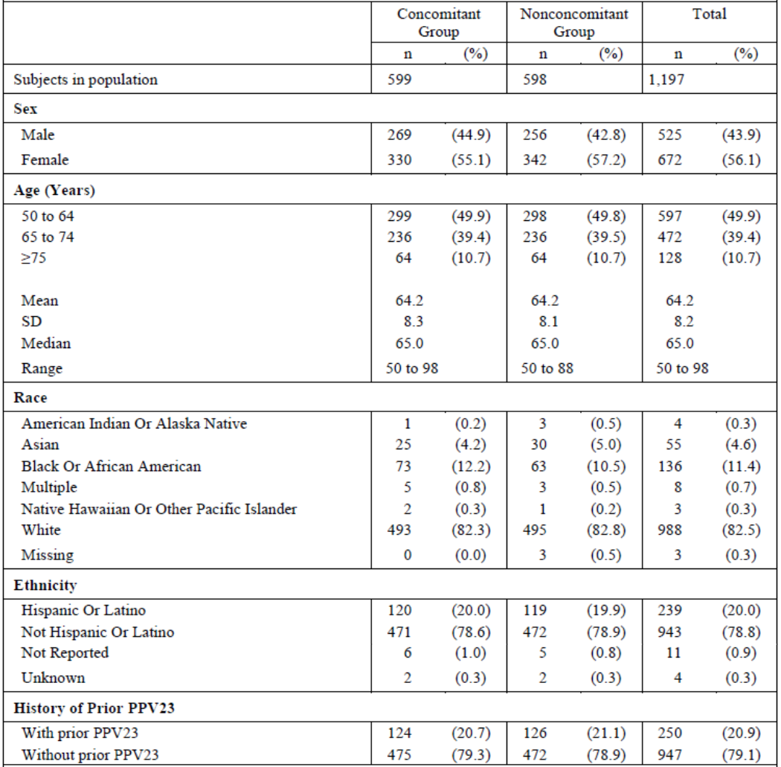
Abbreviations: n = number of subjects contributing to the analysis; SD = standard deviation; PPV23 = pneumococcal polysaccharide vaccine (Pneumovax 23).
Vaxneuvance given concomitantly with quadrivalent influenza vaccine was found to be non-inferior to Vaxneuvance given non-concomitantly with quadrivalent influenza vaccine as assessed by serotype specific OPA GMTs at 30 days post-vaccination with Vaxneuvance, as shown in Table 27 and Figure 6.
Table 27: Study V114-021 Analysis of post-vaccination opsonophagocytic activity geometric mean titres (per-protocol population)
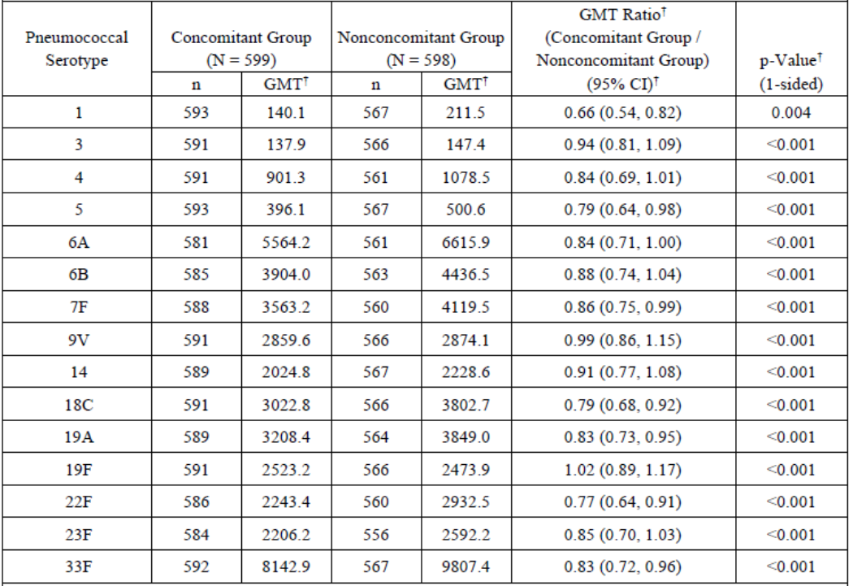
Abbreviations: CI = confidence interval; GMT = geometric mean titre; N = number of subjects randomised and vaccinated; n = number of subjects contributing to the analysis.
† Geometric mean titres (GMTs), GMT ratio, 95% CI, and p-value are estimated from a constrained longitudinal data analysis (cLDA) model.
A conclusion of non-inferiority is based on the lower bound of the 95% CI for the estimated GMT ratio (concomitant group/non-concomitant group) being greater than 0.5 (one-sided p-value < 0.025).
Post-vaccination = 30 days following vaccination with Vaxneuvance (V114) (Day 30 for concomitant group and Day 60 for non-concomitant group).
Figure 6: Study V114-021 Forest plot of post-vaccination opsonophagocytic activity geometric mean titre ratios (per-protocol population)
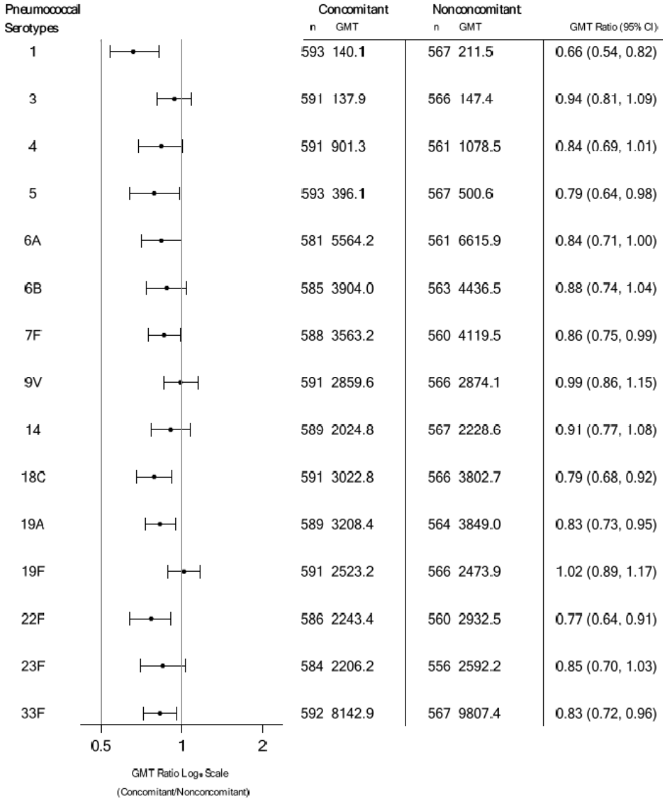
Abbreviations: CI = confidence interval; GMT = geometric mean titre; n=number of subjects contributing to the analysis.
Similarly, quadrivalent influenza vaccine given concomitantly with Vaxneuvance was found to be non-inferior to quadrivalent influenza vaccine given non-concomitantly with Vaxneuvance as assessed by strain specific haemagglutination inhibition GMTs at 30 days post-vaccination with quadrivalent influenza vaccine for all 4 strains, as shown in Table 28 and Figure 7.
Table 28: Study V114-021 Analysis of post-vaccination haemagglutination inhibition geometric mean titres (per-protocol population)
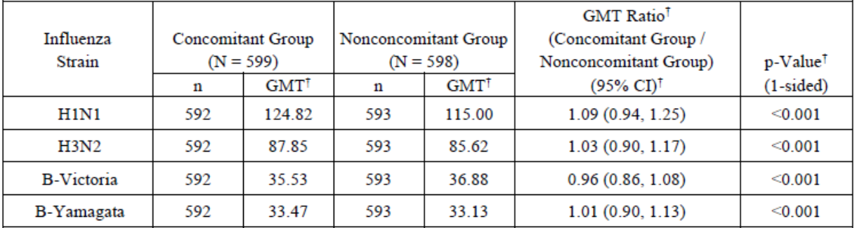
Abbreviations: CI = confidence interval; GMT = geometric mean titre; N = number of subjects randomised and vaccinated; n = number of subjects contributing to the analysis.
† Geometric mean titres (GMTs), GMT ratio, 95% CI, and p-value are estimated from a constrained longitudinal data analysis (cLDA) model.
A conclusion of non-inferiority is based on the lower bound of the 95% CI for the estimated GMT ratio (concomitant group/non-concomitant group) being greater than 0.5 (one-sided p-value < 0.025).
Post-vaccination = 30 days following vaccination with quadrivalent influenza vaccine (QIV) (Day 30 for concomitant group and non-concomitant group).
Figure 7: Study V114-021 Forest plot of post-vaccination haemagglutination inhibition geometric mean titres (per-protocol population)
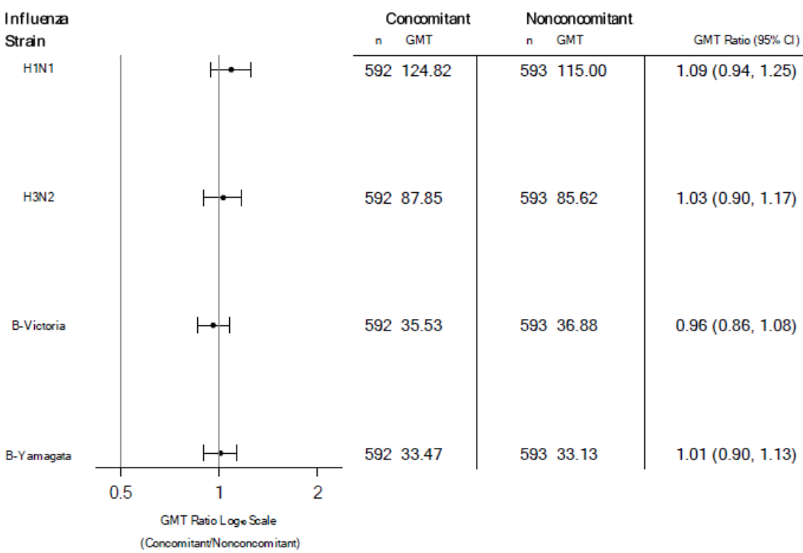
Abbreviations: CI = confidence interval; GMT = geometric mean titre; n=number of subjects contributing to the analysis.
In terms of secondary immunogenicity endpoints, serotype-specific IgG GMCs at 30 days post-vaccination with Vaxneuvance were consistent with trends seen for the primary analysis of OPA GMTs, as shown in Table 29.
Table 29: Study V114-021 Analysis of post-vaccination immunoglobulin G geometric mean concentrations (per-protocol population)
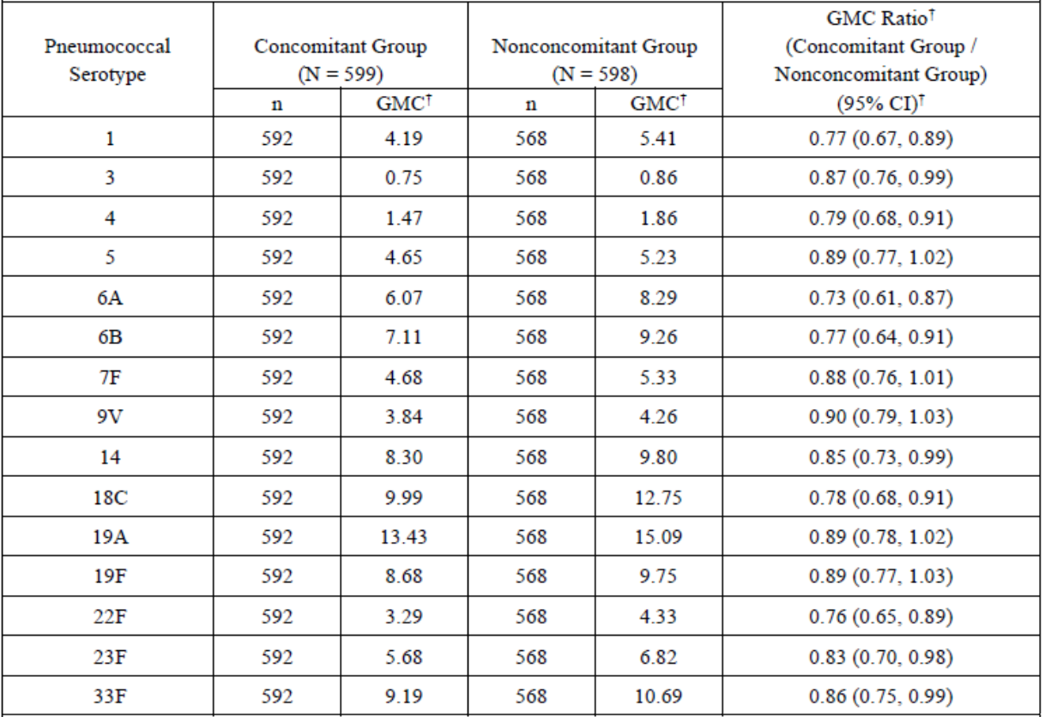
Abbreviations: CI = confidence interval; GMC = geometric mean concentration; N = number of subjects randomised and vaccinated; n = number of subjects contributing to the analysis.
† Geometric mean concentrations (GMCs), GMC ratio, 95% CI are estimated from a constrained longitudinal data analysis (cLDA) model.
Post-vaccination = 30 days following vaccination with Vaxneuvance (V114) (Day 30 for concomitant group and Day 60 for non-concomitant group).
Opsonophagocytic activity (OPA) GMFRs and proportions of subjects with an at least 4-fold rise in OPA with Vaxneuvance were generally comparable between the concomitant and non-concomitant groups. haemagglutination inhibition GMTs, GMFRs, proportions of subjects with haemagglutination inhibition titre greater than 1:40 and proportions of participants who seroconverted at 30 days post-vaccination with quadrivalent influenza vaccine were generally comparable between the concomitant and non-concomitant groups.
Subgroup analyses by age, sex, race and ethnicity were consistent with the overall population for serotype specific OPA GMT ratios and strain specific haemagglutination inhibition GMT ratios at 30 days post-vaccination. Similarly, subgroup analyses by history of Pneumovax 23 administration was consistent with the overall population.

Study V114-007
Study V114-007 was a Phase II, multicentre, double blind study of the safety and immunogenicity of Vaxneuvance compared to Prevnar 13 in healthy adults 65 years of age or older previously vaccinated with a 23-valent pneumococcal polysaccharide vaccine.
The primary objectives were to demonstrate safety and tolerability of both vaccinations and to summarise the serotype specific IgG response measured at Day 1 and Day 30 post-vaccination.
A total of 253 subjects were randomised in the study (127 in the Vaxneuvance group and 126 in the Prevnar 13 group). Baseline demographic characteristics were similar in both treatment groups.
Baseline antibody levels were similar across the 2 vaccination groups and observed values were similar in subjects given Vaxneuvance compared to Prevnar 13 recipients for IgG GMCs at Day 30, GMFRs and percentages of subjects with an at least 4-fold rise from Baseline for the shared serotypes in the 2 vaccines, as shown in Table 30.
Table 30: Study V114-007 Summary of immunoglobulin G antibody responses (per-protocol population)
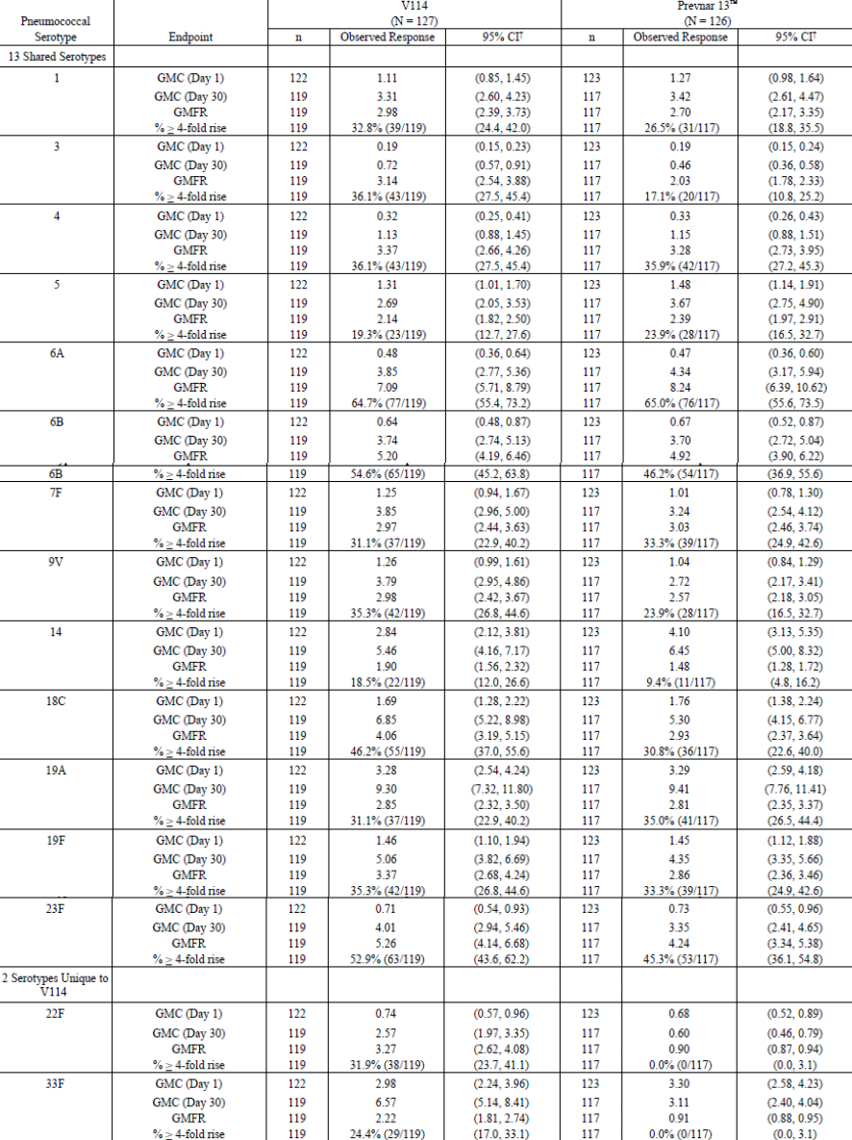
Abbreviations: CI = confidence interval; GMC = geometric mean concentration; GMFR = geometric mean fold rise; N = number of subjects randomised and vaccinated; n = number of subjects contributing to the analysis; V114 = sponsor’s product development code for Vaxneuvance.
† For the continuous endpoints, the within group 95% CIs are obtained by exponentiating the CIs of the mean of the natural log values based on the t-distribution. For the dichotomous endpoints, the within group 95% CIs are based on the exact binomial method proposed by clopper and Pearson.
Day 1 is pre-vaccination with pneumococcal conjugate vaccine (Vaxneuvance or Prevnar 13) (PCV). Day 30 is 30 days following vaccination with PCV.
Serotype specific OPA responses were a secondary immunogenicity objective. Observed values were similar in subjects given Vaxneuvance versus Prevnar 13 for OPA GMTs at Day 30, GMFRs and percentages of subjects with an at least 4-fold rise from Baseline in OPA responses for the 13 shared serotypes from both vaccines, whilst being higher after Vaxneuvance versus Prevnar 13 for the unique serotypes 22F and 33 F (Table 31).
Table 31: Study V114-007 Summary of opsonophagocytic activity antibody responses (per-protocol population)
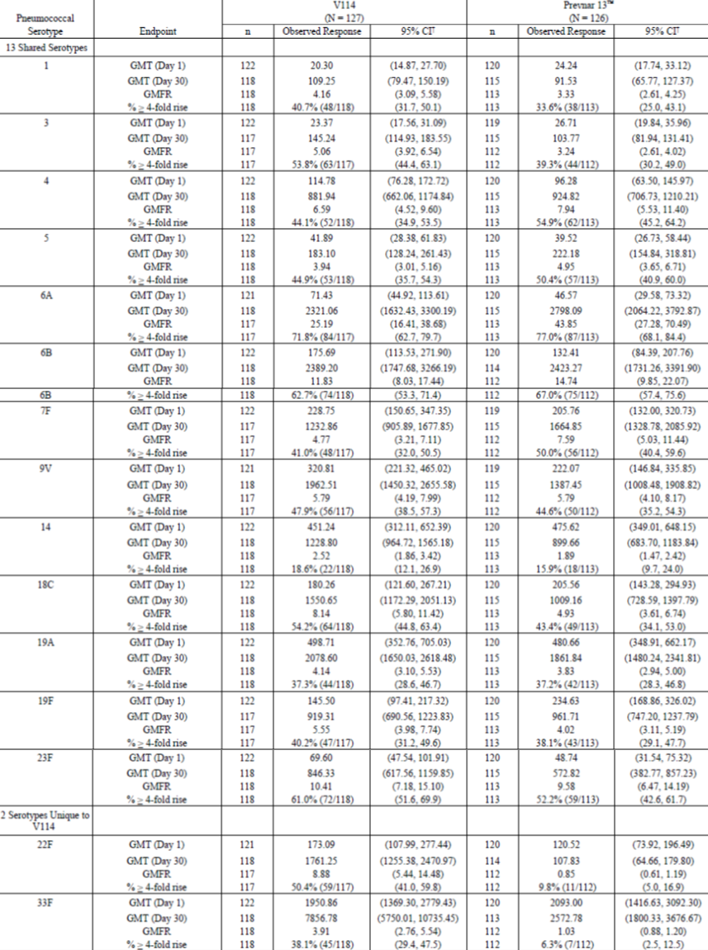
Abbreviations: CI = confidence interval; GMC = geometric mean concentration; GMFR = geometric mean fold rise; N = number of subjects randomised and vaccinated; n = number of subjects contributing to the analysis; V114 = sponsor’s product development code for Vaxneuvance.
† For the continuous endpoints, the within group 95% CIs are obtained by exponentiating the CIs of the mean of the natural log values based on the t-distribution. For the dichotomous endpoints, the within group 95% CIs are based on the exact binomial method proposed by clopper and Pearson.
Day 1 is pre-vaccination with pneumococcal conjugate vaccine (Vaxneuvance or Prevnar 13) (PCV). Day 30 is 30 days following vaccination with PCV.

Safety
A summary of clinical safety was provided from the 7 main clinical studies (Phase II clinical Study V114-007 and the 6 Phase III studies (Studies V114-016, V114-017, V114-018, V114-019, V114-020 and V114-021). Over 5,600 adults received Vaxneuvance in these studies. The integrated population was based on 3 studies (Studies V114-016, V114-019 and V114-020).
Table 32 summarises participant exposure in the 7 studies and Table 33 summaries disposition. A total of 5630 participants received Vaxneuvance and 1808 participants received Prevnar 13. Overall, 96.5% participants completed studies.
Table 32: Studies V114-007, V114-016, V114-017, V114-018, V114-019, V114-020 and V114-021 Number of participants who received Vaxneuvance or Prevnar 13
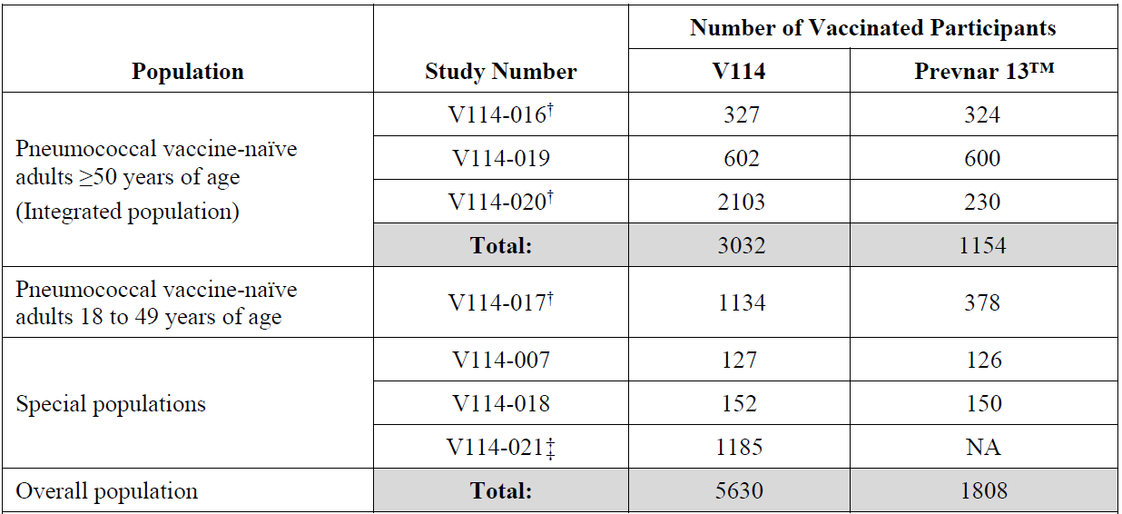
Abbreviations: NA=not applicable; V114 = sponsor’s product development code for Vaxneuvance.
† Participants were included in the intervention group according to the intervention they actually received. One participant randomised to the Prevnar 13 group inadvertently received Vaxneuvance in each of the following studies: Studies V114-016, V114-017, and V114-020 (Lot 1).
‡ One participant in Study V114-021 in the non-concomitant group who received Vaxneuvance at both vaccination timepoints was excluded from the safety population and is therefore not represented in this table.
Table 33: Studies V114-007, V114-016, V114-017, V114-018, V114-019, V114-020 and V114-021 Disposition of subjects (all participants versus treated population)
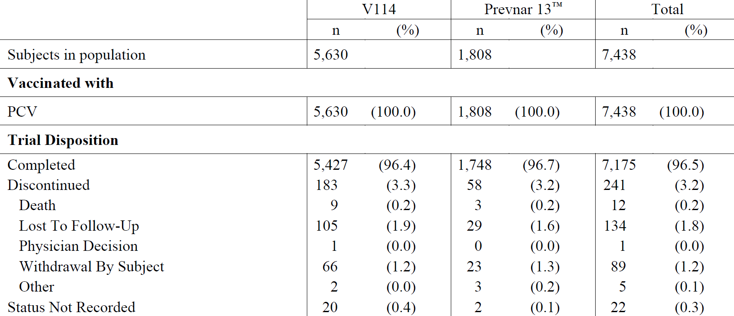
Abbreviations: n = number of subjects contributing to the analysis; PCV = pneumococcal conjugate vaccine (Vaxneuvance or Prevnar 13); V114 = sponsor’s product development code for Vaxneuvance.
Each subject is counted once for trial disposition based on the latest corresponding disposition record.
Subjects with status not recorded were all from Study V114-020 and were unable to complete the Month 6 follow-up telephone contact due to coronavirus disease 2019 (COVID-19).
† Subjects from Study V114-021 vaccinated with Vaxneuvance are included in the Vaxneuvance group.
Demographic characteristics of subjects in the 7 studies were broadly comparable across treatment groups. The median age was 62 years (range 18 to 98 years); overall, 54.6% of subjects were female, the majority (72.3%) of subjects being White. 302 (4.1%) were immunocompromised due to HIV infection (in Study V114-018).
Adverse events in pneumococcal vaccine naïve adults older than 50 years of age (Studies V114-016, V114-019 and V114-020) of integrated population are shown in Table 34. Of the 3032 subjects who received Vaxneuvance, 72.3% experienced one or more adverse events (AEs), 63.7% local AEs and 45.1% systemic AEs. Of the 1154 subjects who received Prevnar 13, 62.2% experienced one or more AE, 51.4% local AEs and 39.1% systemic AEs. Vaccine-related AEs were reported in 68% in the Vaxneuvance group and 57.7% in the Prevnar 13 group.
Table 34: Studies V114-016, V114-019 and V114-020 Analysis of adverse event summary (all participants as treated population; following pneumococcal conjugate vaccine)
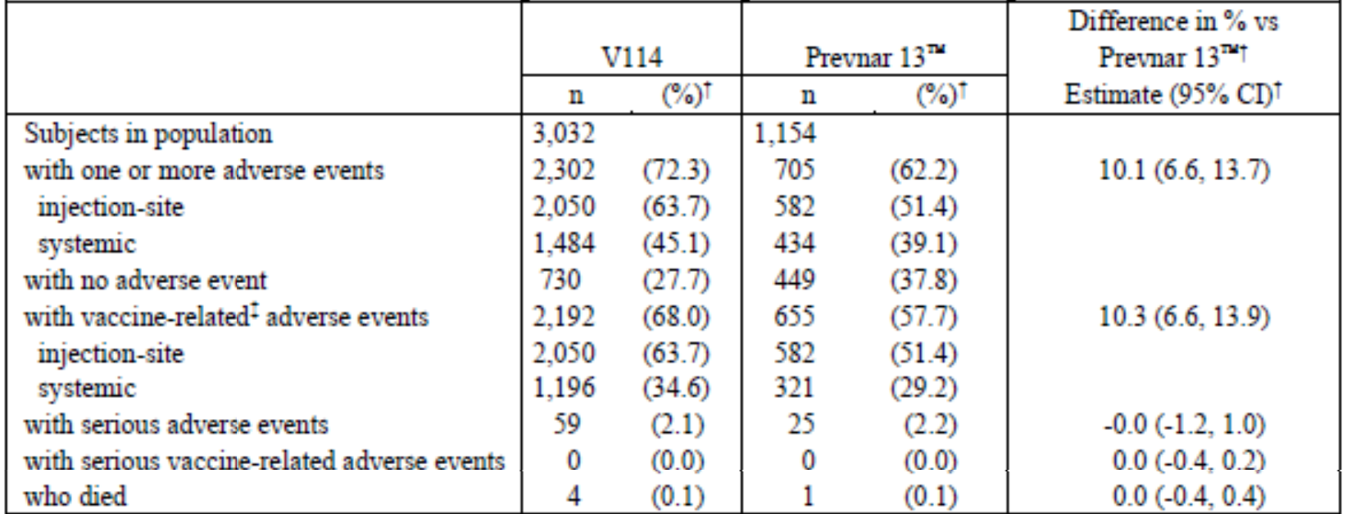
Abbreviations: CI = confidence interval; n = number of subjects contributing to the analysis; V114 = sponsor’s product development code for Vaxneuvance; vs = versus.
†Percentages, differences, and confidence intervals are calculated base don stratified Miettinen and Murminen method with Cochran-Mantel-Haenszel weights. Differences and confidence intervals are provided in accordance with the integrated statistical analysis plan.
‡Determined by the investigator to be related to the vaccine.
Reported adverse event including non-serious adverse events within 14 days of vaccination and serious adverse events occurring Day 1 through Month 6.
There was a higher rate of local injection site reactions with Vaxneuvance versus Prevnar 13. Most events were considered mild and comparable across intervention groups and of short duration. The 3 most common AEs following Vaxneuvance vaccination were injection-site pain, fatigue and myalgia.
There were 5 deaths in the integrated population, all occurring more than 50 days following vaccination. None were considered to be related to study vaccine. In the Vaxneuvance group there were 4 deaths (0.1%) due to acute respiratory failure, cardiac failure congestive, chronic obstructive pulmonary disease (n = 1), pancreatic carcinoma (n = 1), death (specific cause of death not reported; n = 2). In the Prevnar 13 group there was one death (0.1%) due to arrhythmia.
Serious adverse events (SAEs) were reported across multiple System Organ Classes in these studies. SAE Preferred Terms reported in more than 2 participants in the Vaxneuvance group were cellulitis (n = 3 (0.1%)), pneumonia (n = 3 (0.1%)), and acute respiratory failure (n = 3 (0.1%)). No SAE preferred terms were reported in more than 2 participants in the Prevnar 13 groups. In Study V114-016, 3 participants discontinued study intervention (that is, did not receive Pneumovax 23 at Month 12) due to AEs. Two participants in the Vaxneuvance group had events that were nonserious and considered vaccine related by the investigator (vertigo, injection site pain). One participant in the Prevnar 13 group had a serious event not considered to be vaccine related (squamous cell carcinoma of the hypopharynx).
In terms of laboratory evaluations, these were provided only for the HIV Study V114-018 and a Phase I study (Study V114-001). In terms of vital signs and physical findings, these were comparable across treatment groups and across age, sex and racial groups.
In immunocompetent adults 18 to 49 years of age (Study V114-017) with a single or at least 2 risk factors for pneumococcal disease, safety results were consistent with those seen in the overall study population as shown in Table 35 and Table 36. In immunocompromised adults 18 years of age and older with HIV, in Study V114-018, safety results were consistent with those seen in immunocompetent pneumococcal vaccine naïve adults as shown in Table 37.
Table 35: Study V114-017 Adverse event summary by number of risk factors (all participants as treated population; following pneumococcal conjugate vaccine)
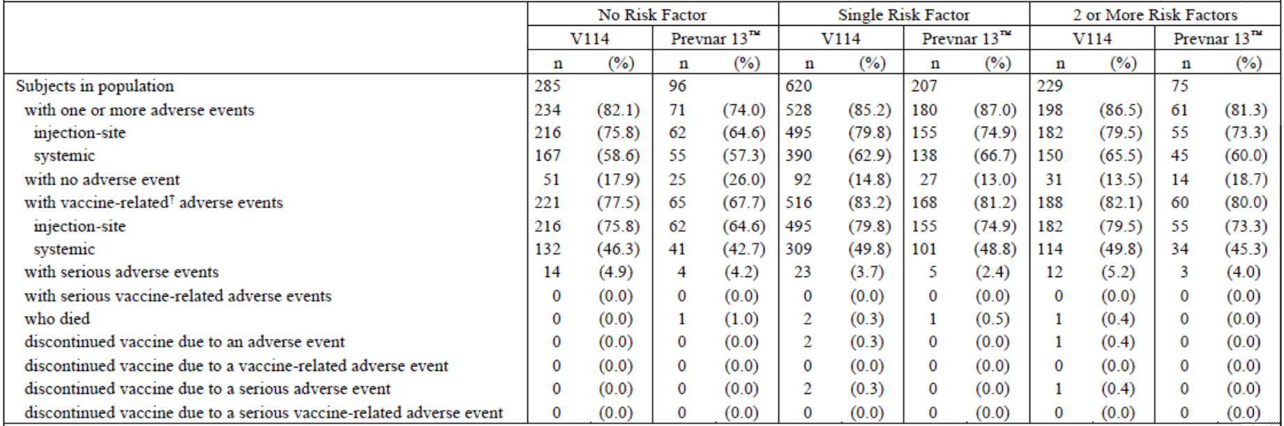
Abbreviations: n = number of subjects contributing to the analysis; V114 = sponsor’s product development code for Vaxneuvance.
†Determined by the investigator to be related to the vaccine.
Reported adverse events include non-serious adverse events within 14 days of vaccination and serious adverse events occurring Day 1 through Month 6.
Risk factors include chronic lung disease, tobacco use, diabetes mellitus, chronic liver disease, chronic heart disease, or alcohol consumption. The risk factor of alcohol consumption is defined as the alcohol use disorders identification test-consumption (AUDIT-C) score at least 5.
All subjects with no risk factors and subjects with a single risk factor of alcohol consumption were enrolled at Center for American Indian Health (CAIH) sites.
Table 36: Study V114-017 Subjects with solicited adverse events by number of risk factors (incidence more than 0% in any column; all participants as treated population; following pneumococcal conjugate vaccine)
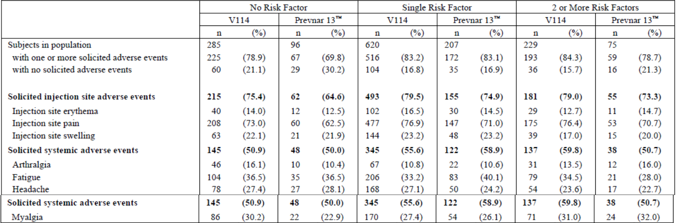
Abbreviations: n = number of subjects contributing to the analysis; V114 = sponsor’s product development code for Vaxneuvance.
Every subject is counted a single time for each application row and column.
Injection site erythema, injection site pain, and injection site swelling were solicited from Day 1 to Day 5 following vaccination. Arthralgia, fatigue, headache, and myalgia were solicited from Day 1 to Day 14 following vaccination.
Medical Dictionary for Regulatory Activities (MedDRA) version 23.0 was used in the reporting of this study.
Risk factors include chronic lung disease, tobacco use, diabetes mellitus, chronic liver disease, chronic heart disease, or alcohol consumption. The risk factor of alcohol consumption is defined as the alcohol use disorders identification test-consumption (AUDIT-C) score at least 5.
All subjects with no risk factors and subjects with a single risk factor of alcohol consumption were enrolled at Center for American Indian Health (CAIH) sites.
Table 37: Study V114-018 Summary of adverse events (all participants as treated population; following pneumococcal conjugate vaccine)
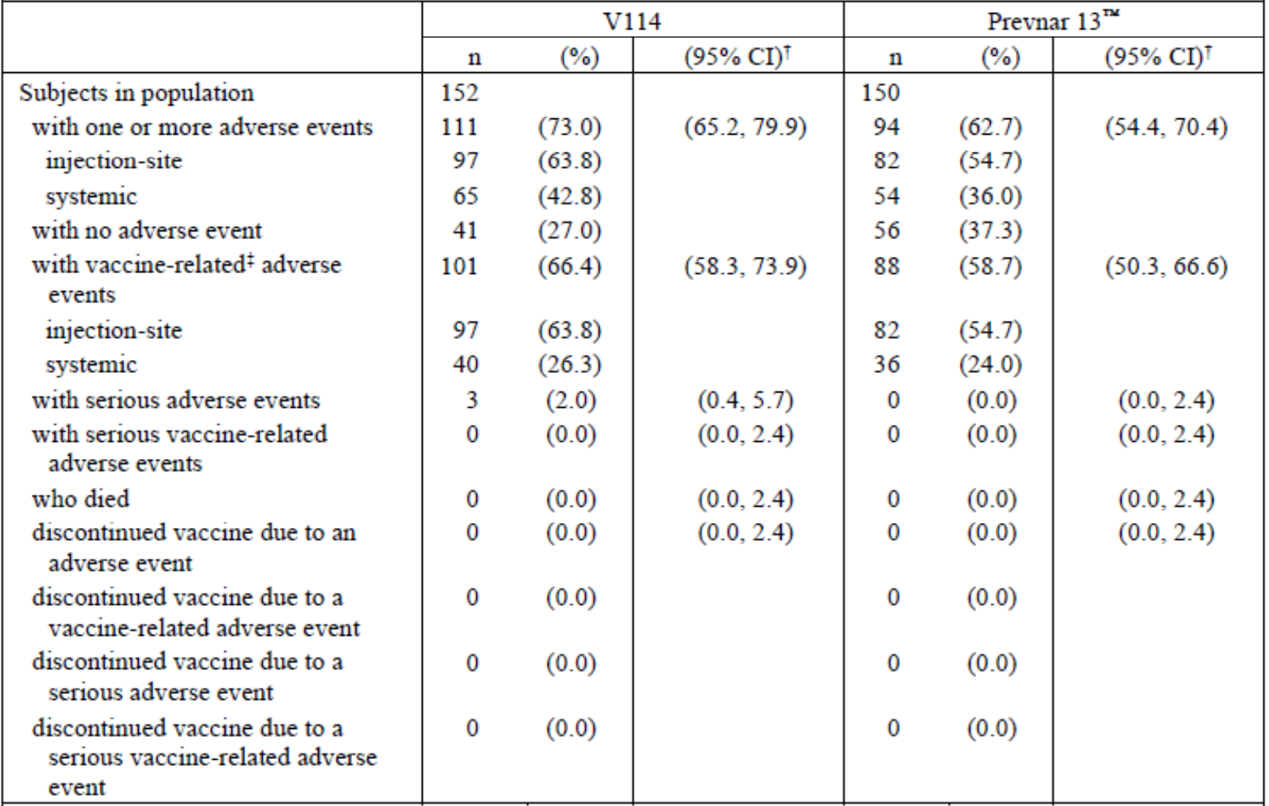
Abbreviations: CI = confidence interval; n = number of subjects contributing to the analysis; V114 = sponsor’s product development code for Vaxneuvance.
†Based on the exact binomial method proposed by Clopper and Pearson for the percentages. CIs are provided in accordance with the statistical analysis plan.
‡Determined by the investigator to be related to the vaccine.
Reported adverse events include non-serious adverse events within 14 days of vaccination and serious adverse events occurring Day 1 through Week 8.
Vaxneuvance was well tolerated in adults 65 years of age and older previously vaccinated with Pneumovax 23 (Study V114-007), more than one year prior to study entry. Safety results were consistent with those seen in pneumococcal vaccine naïve adults 50 years of age and older, as shown in Table 38.
Table 38: Study V114-007 Analysis of adverse event summary (all subjects as treated population; following pneumococcal conjugate vaccine)
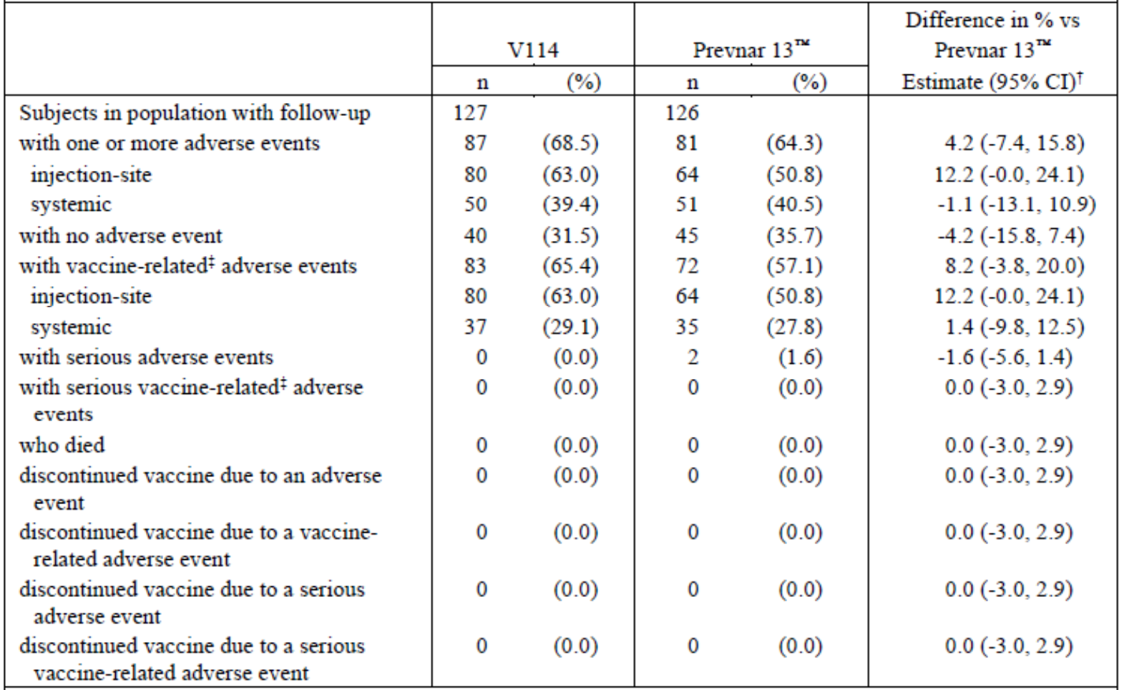
Abbreviations: CI = confidence interval; n = number of subjects contributing to the analysis; V114 = sponsor’s product development code for Vaxneuvance; vs = versus.
†Based on Miettinen and Nurminen method.
‡Determined by the investigator to be related to the vaccine.
Reported adverse events include non-serious adverse events within 14 days of vaccination and serious adverse events occurring Day 1 through Day 30.
Study V114-016 assessed Vaxneuvance or Prevnar 13 given sequential administration of Pneumovax 23, 12 months after Vaxneuvance or Prevnar 13. This was well tolerated in adults (50 years of age and older) and AE proportions were comparable across treatment groups (Table 39). There were low proportions of subjects experiencing SAEs, which were comparable across treatment groups. No participant died during the study.
Table 39: Study V114-016 Analysis of adverse event summary (all participants as treated population; following Pneumovax 23)
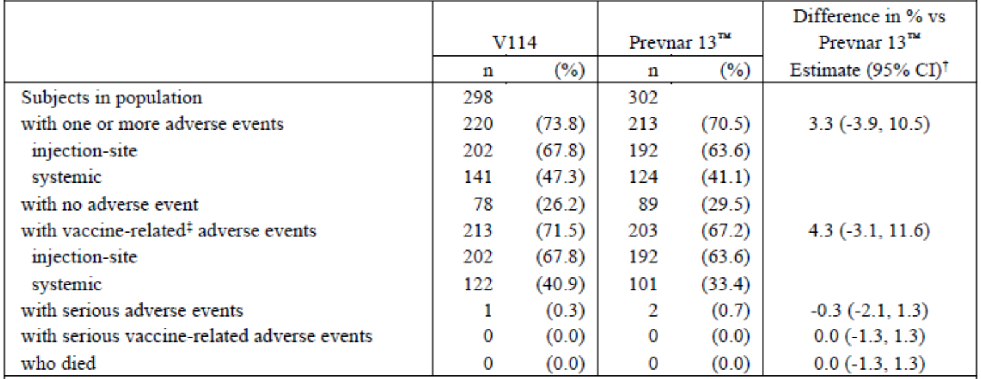
Abbreviations: CI = confidence interval; n = number of subjects contributing to the analysis; V114 = sponsor’s product development code for Vaxneuvance; vs = versus.
†Estimated differences and CIs are calculated based on the Miettinen and Nurminen method and are provided in accordance with the statistical analysis plan.
‡Determined by the investigator to be related to the vaccine.
Reported adverse events include non-serious adverse events within 14 days of vaccination and serious adverse events occurring Month 12 (Day 1 relative to vaccination with Pneumovax 23) through Month 13.
In Study V114-021, Vaxneuvance was well-tolerated when concomitantly administered with quadrivalent influenza vaccine in adults 50 years of age and older. The proportions of subjects with local and systemic AEs were comparable across concomitant and non-concomitant treatment groups with low SAE rates.
Although pregnant subjects were excluded, across the 7 studies, a total of 14 subjects (10 in the Vaxneuvance and 4 in the Prevnar 13 group) reported 15 pregnancies (10 in the Vaxneuvance and 5 in the Prevnar 13 group), all being in Study V114-017. In the Vaxneuvance group, 4 of the 10 subjects were vaccinated within 6 weeks prior to conception. Pregnancy outcomes included 8 live births, one spontaneous abortion and one elective abortion in the Vaxneuvance group. No other congenital abnormalities were reported.
Post-marketing experience data were not available when the dossier was submitted.

Benefit-risk balance
The benefit-risk balance is favourable in terms of demonstrating appropriate immunogenic responses which are non-inferior to the 13 shared pneumococcal serotypes of the Prevnar 13 vaccine and superior for the Vaxneuvance vaccine which covers the additional serotypes 22F and 33F. No outcome data on differential patterns of severe pneumococcal disease following the Vaxneuvance vaccine have been provided. The safety profile, other than an increase in local injection site reactions with Vaxneuvance versus Prevnar 13, is acceptable in all patients exposed.

Risk management plan
The sponsor has submitted EU-RMP version 0.1 (dated 2 November 2020; data lock point (DLP) 16 September 2020) and Australia specific annex (ASA) version 0.1 (dated 01 December 2020) in support of this application.
The summary of safety concerns and their associated risk monitoring and mitigation strategies are summarised in Figure 2. Further information regarding the TGA’s risk management approach can be found in risk management plans for medicines and biologicals and the TGA's risk management approach.
Table 40: Summary of safety concerns
Summary of safety concerns |  | Pharmacovigilance |  | Risk minimisation
 |  | Routine | Additional | Routine | Additional
Important identified risks | None | – | – | – | –
Important potential risks | None | – | – | – | –
Missing information | Safety of more than one dose administered less than one year apart to immunocompromised adults | ✓ | ✓* | – | –
*Clinical study
- No important potential or identified risks have been proposed in the summary of safety concerns. Safety of administration of more than one dose, less than one year apart, in immunocompromised adults is proposed as missing information. The summary of safety concerns is considered acceptable.
- Routine pharmacovigilance and one additional pharmacovigilance activity has been proposed. This is acceptable.
- No risk minimisation activities have been proposed in the risk management plan which is acceptable considering the summary of safety concerns.

Risk-benefit analysis

Delegate’s considerations
Vaxneuvance is similar to the pneumococcal 13-valent conjugate vaccine (CRM₁₉₇ protein) Prevenar 13.^{4,} Synflorix;, contains different conjugation proteins.
There is no immunological threshold level of antibody concentration that correlates with protection against pneumococcal disease in adults. Vaccination of adults with Prevnar 13 elicited serotype specific OPA titres that were found to be concordant to those in children, the population in which efficacy against invasive pneumococcal disease had been demonstrated. Licensure of Prevnar 13 in adults was based on demonstration of noninferiority of OPA responses to those elicited by Pneumovax 23. The community acquired pneumonia immunisation trial in adults study subsequently confirmed protective efficacy of Prevnar 13 for the prevention of invasive pneumococcal disease and pneumococcal pneumonia, validating the results of immunobridging. Based on this precedent and the lack of feasibility of conducting efficacy studies for new pneumococcal vaccines in settings where uptake of currently approved vaccines is high, immunobridging to Prevnar 13 for shared serotypes and demonstration of superior OPA responses to serotypes 22F and 33F has been proposed to regulatory agencies (US Food and Drug Administration (FDA), European Medicines Agency (EMA)) and accepted as basis for Vaxneuvance licensure.
A deficiency in the submission was that there were no clinical trial data provided to confirm differences in pneumococcal disease rates caused by the two novel serotypes (serotypes 22F and 33F) found in the Vaxneuvance versus Prevnar 13 vaccine.
Adverse event experience in the clinical development program was acceptable. Higher proportions of AEs were seen in the Vaxneuvance groups versus Prevnar 13 mostly due to higher proportions of subjects with injection site AEs following Vaxneuvance. Most of these reactions were mild in intensity and short lived.
In subjects with increased risk for pneumococcal disease (immunocompetent adults from 18 to 49 years of age in Study V114-017 with risk factors and immunocompromised adults from 18 years of age with HIV in Study V114-018, safety profiles were comparable to those seen in the overall population.
Safety profiles in subjects with prior pneumococcal vaccine (Studies V114-007 and V114-021) showed comparable AE profiles across treatment groups and were comparable to those seen in vaccine naïve subjects.
Comparable vaccine profiles were seen in subjects given sequential administration of pneumococcal vaccine (Study V114-016: Pneumovax 23 given 12 months after Vaxneuvance or Prevnar 13 vaccination).
The proportion of subjects with AEs with concomitant or non-concomitant treatment with influenza vaccine were comparable in both groups of timing of influenza vaccine with Vaxneuvance.
Post-marketing experience data were not available when the dossier was submitted.

Proposed action
It was found that the Vaxneuvance pneumococcal vaccine induces an immune response to all 15 serotypes in the vaccine in adults 18 years of age and older and was found to be non-inferior to Prevnar 13 for the 13 shared epitopes and superior to Prevnar 13 for the 2 serotypes uniquely found in Vaxneuvance (as well as for serotype 3, only seen in Study V114-019, involving subjects 50 years of age and older).
Similar patterns of immunogenicity changes for Vaxneuvance were seen across different manufacturing lots, in immunocompetent adults 18 to 49 years of age (including subjects with or without risk factors for pneumococcal disease) and in immunosuppressed subjects with HIV. It was also found that Vaxneuvance could be given concomitantly with a quadrivalent, inactivated influenza vaccine.
It was shown that Vaxneuvance or Prevnar 13 vaccines followed 12 months later by Pneumovax 23 induces comparable immune responses after Vaxneuvance or Prevnar 13.
Vaxneuvance also induced immune responses for at least 12 months and was immunogenic with or without prior Pneumovax 23 vaccination.
Adverse event experience in the clinical development program was acceptable.

Advisory Committee considerations
The Advisory Committee on Vaccines (ACV), having considered the evaluations and the Delegate’s overview, as well as the sponsor’s response to these documents, advised the following.

Specific advice to the Delegate
- The ACV is requested to advise on whether the clinical data are adequate to support the registration of Vaxneuvance pneumococcal 15-valent conjugate vaccine (CRM₁₉₇ protein), adsorbed, specifically in relation to the immunobridging approach.
The ACV advised that that immunobridging approach is acceptable and clinical data adequate to support registration.
The ACV noted that no clinical outcomes data were available and there was no proposal to conduct either efficacy or effectiveness studies. The ACV agreed that it is not feasible to conduct efficacy studies for a new pneumococcal vaccine where uptake of currently approved vaccines is high. The ACV accepted that immunobridging to Prevenar 13 for shared serotypes and demonstration of superior OPA response to serotypes 22F/33F was a valid approach.

Conclusion
The ACV considered this product to have an overall positive benefit-risk profile for the indication:
Vaxneuvance is indicated for active immunisation for the prevention of pneumococcal disease caused by Streptococcus pneumoniae serotypes (1, 3, 4, 5, 6A, 6B, 7F, 9V, 14, 18C, 19A, 19F, 22F, 23F and 33F) in adults 18 years of age and older.
Vaxneuvance may not prevent disease caused by S. pneumoniae serotypes that are not contained in the vaccine.
The use of Vaxneuvance should be guided by official recommendations.

Outcome
Based on a review of quality, safety, and efficacy, the TGA approved the registration of Vaxneuvance (pneumococcal 15-valent conjugate vaccine (CRM₁₉₇ protein), adsorbed) 0.5 mL, suspension for injection, prefilled syringe, indicated for:
Vaxneuvance is indicated for active immunisation for the prevention of pneumococcal disease caused by Streptococcus pneumoniae serotypes (1, 3, 4, 5, 6A, 6B, 7F, 9V, 14, 18C, 19A, 19F, 22F, 23F and 33F) in adults 18 years of age and older.
Vaxneuvance may not prevent disease caused by S. pneumoniae serotypes that are not contained in the vaccine.
The use of Vaxneuvance should be guided by official recommendations.

Specific conditions of registration applying to these goods
- Vaxneuvance (pneumococcal 15-valent conjugate vaccine (CRM₁₉₇ protein), adsorbed) is to be included in the Black Triangle Scheme. The PI and CMI [Consumer Medicines Information) for Vaxneuvance must include the black triangle symbol and mandatory accompanying text for five years, which starts from the date that the sponsor notifies the TGA of supply of the product.
- The Vaxneuvance EU-risk management plan (RMP) (version 0.1, dated 2 November 2020, data lock point 16 September 2020), with Australian specific annex (version 0.1, dated 01 December 2020), included with Submission PM-2020-06364 1-2, and any subsequent revisions, as agreed with the TGA will be implemented in Australia.
An obligatory component of risk management plans is routine pharmacovigilance. Routine pharmacovigilance includes the submission of periodic safety update reports (PSURs).
Unless agreed separately between the supplier who is the recipient of the approval and the TGA, the first report must be submitted to TGA no later than 15 calendar months after the date of the approval letter. The subsequent reports must be submitted no less frequently than annually from the date of the first submitted report until the period covered by such reports is not less than three years from the date of the approval letter. The annual submission may be made up of two PSURs each covering six months. If the sponsor wishes, the six monthly reports may be submitted separately as they become available.
If the product is approved in the EU during the three years period, reports can be provided in line with the published list of EU reference dates no less frequently than annually from the date of the first submitted report until the period covered by such reports is not less than three years from the date of the approval letter.
The reports are to at least meet the requirements for PSURs as described in the European Medicines Agency’s Guideline on Good Pharmacovigilance Practices (GVP) Module VII-periodic safety update report (Rev 1), Part VII.B Structures and processes. Note that submission of a PSUR does not constitute an application to vary the registration. Each report must have been prepared within ninety calendar days of the data lock point for that report.
- Quality
Batch release testing and compliance
It is a condition of registration that all independent batches of Vaxneuvance vaccine imported into Australia are not released for sale until samples and the manufacturer’s release data have been assessed and you have received notification acknowledging release from the Laboratories Branch, TGA.
For each independent batch of the product imported into Australia, the sponsor must supply the following:
  - A completed request for release form, available from vaccines@health.gov.au.
  - Complete summary protocols for manufacture and QC [quality control], including all steps in production in the agreed format.
  - At least 20 (twenty) vials (Samples) of each manufacturing batch of Vaxneuvance vaccine with the Australian approved labels, PI and packaging (unless an exemption to supply these has been granted) representative of all batches of product seeking distribution in Australia.
  - At least 5 (five) vials (samples) of any further consignments of a manufacturing batch of Vaxneuvance vaccine with the Australian approved labels, PI and packaging (unless an exemption to supply these has been granted). Further consignments cover batches previously supplied to TGA for the purposes of batch release testing but are seeking to be supplied again.
  - If the manufacturing batch has been released in Europe or United Kingdom a copy of the EU Official Control Authority Batch Release (OCABR) certificate (or equivalent from the UK) must be provided.
  - Any reagents, reference material and standards required to undertake testing, as requested by Laboratories Branch, TGA.
Sponsors must provide all requested Samples and data in sufficient time (at least 5 business days) prior to any distribution date to allow the TGA to perform testing and review. Distribution of each batch of vaccine is conditional upon fulfilment of these conditions and receipt of a letter from the Laboratories Branch acknowledging release.
Samples and data should be forwarded to the Biotherapeutics Section, Laboratories Branch before release of each batch and with sufficient lead time to allow for Laboratories Branch testing.
The shipments (including reagents) to TGA are the responsibility of the Australian sponsor/agent who will be required to facilitate the import and customs clearance process.
Certified Product Details
An electronic copy of the Certified Product Details (CPD) as described in Guidance 7: Certified Product Details of the Australian Regulatory Guidelines for Prescription Medicines (ARGPM) https://www.tga.gov.au/guidance-7-certified-product-details should be provided upon registration of the therapeutic good. In addition, an updated CPD, for the above products incorporating the approved changes is to be provided within one month of the date of approval letter. A template for preparation of CPD for biological prescription medicines and Vaccines can be obtained from the TGA website https://www.tga.gov.au/form/certified-product-details-cpd-biologicalprescriptionmedicines).
The CPD should be sent as a single bookmarked PDF document to vaccines@health.gov.au as soon as possible after registration/approval of the product or any subsequent changes as indicated above.
- For all injectable products the Product Information must be included with the product as a package insert.

Attachment 1. Product Information
The PI for Vaxneuvance approved with the submission which is described in this AusPAR is at Attachment 1. For the most recent PI, please refer to the TGA PI/CMI search facility.

Therapeutic Goods Administration
PO Box 100 Woden ACT 2606 Australia
Email: info@tga.gov.au Phone: 1800 020 653 Fax: 02 6232 8605
https://www.tga.gov.au

Pennington, K. and the Enhanced Invasive Pneumococcal Disease Surveillance Working Group, for the Communicable Diseases Network Australia Invasive Pneumococcal Disease Surveillance, 1 July to 30 September 2018, Commun Dis Intell (2018), 2019; 43. Available at: https://www1.health.gov.au/internet/main/publishing.nsf/Content/75F30C0D2C126CAECA2583940015EDE3/$File/invasive_pneumococcal_disease_surveillance_1_july_to_30_september_2018.pdf.
Lexau, C.A. et al. Changing Epidemiology of Invasive Pneumococcal Disease among Older Adults in the Era of Pediatric Pneumococcal Conjugate Vaccine, JAMA, 2005; 294(16): 2043-2051.
Pneumovax 23 (pneumococcal purified capsular polysaccharides) was first registered on the ARTG on 22 July 1991 (ARTG number: 10507); and Pneumovax 23 (in current use) was first registered on the ARTG on 4 June 2014 (ARTG number: 222235).
Prevenar 13 (pneumococcal purified capsular polysaccharides) was first registered on the ARTG on 29 March 2010 (ARTG number: 158450).
Pilishvili. Advisory Committee on Immunisation (meeting) 2018 October 24 to 25; Atlanta GA, USA.
The International Council for Harmonisation of Technical Requirements for Registration of Pharmaceuticals for Human Use (ICH) brings together regulatory authorities and the pharmaceutical industry. It makes recommendations towards achieving greater harmonisation in the interpretation and application of technical guidelines and requirements for pharmaceutical product registration.
European Medicines Agency (EMA), Committee for Human Medicinal Products (CHMP), ICH Guideline Q8 (R2) on Pharmaceutical Development, EMA/CHMP/ICH/167068/2004, 22 June 2017.
Good Laboratory Practice (GLP) is a code of standards following the International Council on Harmonisation (ICH) relevant to testing of medicines in laboratories during drug development.
Pregnancy Category B1: Drugs which have been taken by only a limited number of pregnant women and women of childbearing age, without an increase in the frequency of malformation or other direct or indirect harmful effects on the human fetus having been observed. Studies in animals have not shown evidence of an increased occurrence of fetal damage.
Prevnar 13 pneumococcal 13-valent conjugate vaccine (diphtheria CRM₁₉₇ protein), suspension for intramuscular injection. Wyeth Pharmaceuticals LLC / Pfizer Inc. Initial US Approval: 2010. Streptococcus pneumoniae serotypes 1, 3, 4, 5, 6A, 6B, 7F, 9V, 14, 18C, 19A, 19F and 23F.
Streptococcus pneumoniae serotypes 1, 3, 4, 5, 6A, 6B, 7F, 9V, 14, 18C, 19A, 19F, 22F, 23F, 33F.
The per-protocol (PP) analysis is restricted to the participants who strictly adhered to the protocol. Also known as ‘on-treatment’ analysis.
The Medical Dictionary for Regulatory Activities (MedDRA) is a single standardised international medical terminology, developed as a project of the International Council for Harmonisation of Technical Requirements for Pharmaceuticals for Human Use (ICH) which can be used for regulatory communication and evaluation of data pertaining to medicinal products for human use. As a result, MedDRA is designed for use in the registration, documentation and safety monitoring of medicinal products through all phases of the development cycle (that is, from clinical trials to post-marketing surveillance). Furthermore, MedDRA supports ICH electronic communication within the ICH’s Electronic Common Technical Document (eCTD) and the E2B Individual Case Safety Report.
Pneumococcal purified capsular polysaccharides for Streptococcus pneumoniae serotypes (Vaxneuvance, 15 serotypes, Prevenar 13, 13 serotypes) individually conjugated to non-toxic diphtheria CRM₁₉₇ protein and adsorbed on aluminium phosphate.
Synflorix (pneumococcal polysaccharide conjugate vaccine, 10-valent adsorbed) was previously registered on the ARTG (ARTG numbers: 149004 and 148981).
Synflorix is a 10-valent pneumococcal conjugate vaccine containing polysaccharides of 8 pneumococcal serotypes (1, 4, 5, 6B, 7F, 9V, 14 and 23F serotypes) conjugated individually to protein D (a highly conserved protein of non-ypeable Haemophilus influenzae (NTHi)), one serotype (18C) conjugated to tetanus toxoid and one serotype (19F) conjugated to diphtheria toxoid, absorbed on aluminium phosphate.

