October 2022

Australian Public Assessment Report for Isturisa
  - Active ingredient: Osilodrostat
  - Sponsor: Recordati Rare Diseases Australia Pty Ltd

About the Therapeutic Goods Administration (TGA)
- The Therapeutic Goods Administration (TGA) is part of the Australian Government Department of Health and is responsible for regulating therapeutic goods, including medicines, medical devices, and biologicals.
- The TGA administers the Therapeutic Goods Act 1989 (the Act), applying a risk management approach designed to ensure therapeutic goods supplied in Australia meet acceptable standards of quality, safety, and efficacy.
- The work of the TGA is based on applying scientific and clinical expertise to decision-making, to ensure that the benefits to the Australian public outweigh any risks associated with the use of therapeutic goods.
- The TGA relies on the public, healthcare professionals and industry to report problems with therapeutic goods. The TGA investigates reports received to determine any necessary regulatory action.
- To report a problem with a therapeutic good, please see the information on the TGA website.

About AusPARs
- The Australian Public Assessment Report (AusPAR) provides information about the evaluation of a prescription medicine and the considerations that led the TGA to approve or not approve a prescription medicine submission. Further information can be found in Australian Public Assessment Report (AusPAR) guidance.
- AusPARs are prepared and published by the TGA.
- AusPARs are static documents that provide information that relates to a submission at a particular point in time. The publication of an AusPAR is an important part of the transparency of the TGA’s decision-making process.
- A new AusPAR may be provided to reflect changes to indications or major variations to a prescription medicine subject to evaluation by the TGA.

Copyright
© Commonwealth of Australia 2022
This work is copyright. You may reproduce the whole or part of this work in unaltered form for your own personal use or, if you are part of an organisation, for internal use within your organisation, but only if you or your organisation do not use the reproduction for any commercial purpose and retain this copyright notice and all disclaimer notices as part of that reproduction. Apart from rights to use as permitted by the Copyright Act 1968 or allowed by this copyright notice, all other rights are reserved, and you are not allowed to reproduce the whole or any part of this work in any way (electronic or otherwise) without first being given specific written permission from the Commonwealth to do so. Requests and inquiries concerning reproduction and rights are to be sent to the TGA Copyright Officer, Therapeutic Goods Administration, PO Box 100, Woden ACT 2606 or emailed to <tga.copyright@tga.gov.au>.

Contents
List of abbreviations 4
Product submission 7
Submission details 7
Product background 8
Regulatory status 10
Product Information 11
Registration timeline 11
Submission overview and risk/benefit assessment 11
Quality 12
Nonclinical 13
Clinical 15
Risk management plan 50
Risk-benefit analysis 51
Outcome 54
Specific conditions of registration applying to these goods 54
Attachment 1. Product Information 55

List of abbreviations
Abbreviation | Meaning
ACM | Advisory Committee on Medicines
ACTH | Adrenocorticotropic hormone
AE | Adverse event
AESI | Adverse events of special interest
ALT | Alanine aminotransferase
ARTG | Australian Register of Therapeutic Goods
ASA | Australia specific annex
AST | Aspartate aminotransferase
AUC | Area under the concentration-time curve
BCS | Biopharmaceutics Classification System
BDI | Beck Depression Inventory
CHMP | Committee for Medicinal Products for Human Use (European Medicine Agency, European Union)
CI | Confidence interval
C_{max} | Maximum concentration
CMI | Consumer Medicines Information
CNS | Central nervous system
CPK | Creatine phosphokinase
COR-B | Comparable Overseas Regulator B
CV | Coefficient of variation
DLP | Data lock point
DNA | Deoxyribonucleic acid
EDTA | Ethylenediaminetetraacetic acid
EMA | European Medicine Agency (European Union)
ERAUC | Exposure ratio based on area under the concentration-time curve
EU | European Union
FAS | Full analysis set
GVP | Good Pharmacovigilance Practices
HbA1c | Haemoglobin A1c
HPA | Hypothalamus-pituitary-adrenal
HPLC | High-performance liquid chromatography
IC₅₀ | Half (50%) maximal inhibitory concentration
ICH | International Council for Harmonisation (European Medicine Agency, European Union)
ITT | Intent(ion)-to-treat
LC | Liquid chromatography
LCI699 | Sponsor’s development code for osilodrostat
LLN | Lower limit of normal
MATE1 | Multidrug and toxin extrusion protein 1
MBq | Megabecquerel
MS | Mass spectrometry
NOAEL | No observed adverse effect level
OAT | Organic anion transporter
OCT | Organic cation transporter
PASS | Post-authorisation safety study
PBPK | Physiologically based pharmacokinetic(s)
PD | Pharmacodynamic(s)
PI | Product Information
PK | Pharmacokinetic(s)
PopPK | Population pharmacokinetic(s)
PPFAS | Per-protocol set for full analysis set
PPRAS | Per-protocol set for randomised analysis set
PSUR | Periodic safety update report
PT | Preferred Term
PXR | Pregnane X receptor
QTc | Corrected QT interval
QTcF | QT interval corrected using Fridericia’s formula
RAS | Randomised analysis set
RMP | Risk management plan
SAE | Serious adverse event
SD | Standard deviation
SOC | System Organ Class
t_{1/2} | Terminal drug half life
TGA | Therapeutic Goods Administration
T_{max} | Time at maximum concentration
UFC | Urinary free cortisol
UGT | Uridine 5'-diphospho-glucuronosyltransferase
ULN | Upper limit of normal

Product submission

Submission details
Type of submission: | New chemical entity
Product name: | Isturisa
Active ingredient: | Osilodrostat (as phosphate)
Decision: | Approved
Date of decision: | 6 May 2022
Date of entry onto ARTG: | 12 May 2022
ARTG numbers: | 369218, 369219 and 369220
Black Triangle Scheme: | Yes.  This product will remain in the scheme for 5 years, starting on the date the product is first supplied in Australia.
Sponsor’s name and address: | Recordati Rare Diseases Australia Pty Ltd  Level 6, 69 Reservoir Street  Surry Hills, NSW 2010
Dose form: | Film-coated tablet
Strengths: | 1 mg, 5 mg and 10 mg
Container: | Blister pack
Pack size: | 60 tablets
Approved therapeutic use: | Isturisa is indicated for the treatment of endogenous Cushing’s syndrome in adults.
Route of administration: | Oral
Dosage: | The recommended starting dose is 2 mg osilodrostat twice daily.  For patients of Asian ancestry, a reduced starting dose of 1 mg twice daily is recommended (see Section 5.2 Pharmacokinetic properties of the Product Information).  The dose can be gradually titrated (initially by dose increments of 1 or 2 mg) based on individual response and tolerability, with the aim to achieve normal cortisol levels.  The maximum recommended dose of Isturisa is 30 mg twice daily.  For further information regarding dosage, refer to the Product Information.
Pregnancy category: | D  Drugs which have caused, are suspected to have caused or may be expected to cause, an increased incidence of human fetal malformations or irreversible damage. These drugs may also have adverse pharmacological effects. Accompanying texts should be consulted for further details.  The use of any medicine during pregnancy requires careful consideration of both risks and benefits by the treating health professional. This must not be used as the sole basis of decision making in the use of medicines during pregnancy. The TGA does not provide advice on the use of medicines in pregnancy for specific cases. More information is available from obstetric drug information services in your State or Territory.

Product background
This AusPAR describes the submission by Recordati Rare Diseases Australia Pty Ltd (the sponsor) to register Isturisa (osilodrostat) 1 mg, 5 mg and 10 mg, film-coated tablet for the following proposed indication:
Isturisa is indicated for the treatment of endogenous Cushing’s syndrome in adults.
Cushing's syndrome describes a collection of signs and symptoms arising from prolonged exposure to an excess of cortisol, a steroid hormone normally produced by the adrenal glands. Endogenous Cushing’s syndrome denotes a group of rare diseases resulting from the body’s over-excretion of cortisol. It most commonly affects adults aged 20 to 50 years, with a marked female preponderance. Endogenous Cushing’s syndrome can be further categorised as either adrenocorticotropic hormone (ACTH)-dependent Cushing’s syndrome, or ACTH-independent Cushing’s syndrome, accounting for 80% and 20% of all cases of Cushing’s syndrome respectively.
Adenocorticotropic hormone is normally synthesised and released by the anterior pituitary gland. ACTH stimulates the synthesis and secretion of glucocorticoid steroid hormones, including cortisol, from adrenal cortex cells in the adrenal glands.
Adenocorticotropic hormone-dependent Cushing’s syndrome results from an over-excretion of ACTH, resulting in an excess of cortisol production and release. The most common cause is by ACTH-secreting pituitary adenoma (also referred to as Cushing’s disease), and overall makes up about 70% cases of Cushing’s syndrome overall.² Other ACTH-dependent causes include ectopic ACTH secretion by a non-pituitary tumour (10% cases of Cushing’s syndrome), including neuroendocrine tumours, small cell lung cancers, pheochromocytomas and medullary thyroid carcinomas.²
Adenocorticotropic hormone-independent Cushing’s syndrome is most frequently caused by a unilateral cortisol-producing adrenal adenoma (10%) or carcinoma (8%), and less commonly by bilateral adrenal hyperplasia (1 to 2%).
Cushing’s syndrome is characterised by chronic hypercortisolism (or excess cortisol expose) which is associated with multiple comorbidities that increase the risk of cardiovascular disease and mortality., Clinical manifestations of chronic hypercortisolism include metabolic syndrome, insulin resistance, visceral obesity, glucose intolerance, hypertension, dyslipidaemia, and hypercoagulable state. Other clinical signs and symptoms of Cushing’s syndrome include osteoporosis with increased risk of fractures, impaired immune function with increased risk of infection, skin changes, neuropsychiatric disorders (depression, cognitive impairment) and hypogonadism.^{3,4}
The clinical spectrum can vary with the underlying cause of Cushing’s syndrome. For patients with Cushing’s disease, the diagnosis can be difficult and often delayed due to the slow progression of the clinical symptoms, whilst patients with ectopic ACTH with underlying malignancy, or adrenocortical carcinoma, may develop florid Cushing’s syndrome more rapidly. Patients with Cushing’s syndrome have a 4-fold higher mortality rate than age and gender matched control patients. Cardiovascular disease, venous thrombosis, and infections are the primary causes of the excess mortality rate seen in Cushing’s syndrome.
In Australia, the current treatment options for those with Cushing’s disease are:
- surgery to remove tumour,
- radiotherapy to control or eradicate tumour,
- bilateral adrenalectomy (removal of adrenal glands; this is performed rarely), and
- medication.
Surgery is the first line treatment for Cushing’s disease, and in the hands of an experienced pituitary surgeon, surgical remission can be achieved for 65 to 100% of patients. Remission rates are considerably lower in patients with a non-visible adenoma, a microadenoma with unfavourable localisation (for example, the parasellar region), or a macroadenoma
A range of medical therapies are available to treat Cushing’s syndrome. Most drugs inhibit adrenal synthesis of cortisol. However, only Signifor (pasireotide), is registered in Australia for use in Cushing’s disease, for those whom surgery is not an option or has failed (not for ACTH-independent forms of Cushing’s syndrome).
Osilodrostat (sponsor’s development code: LCI699) is a potent, inhibitor of 11β-hydroxylase (cytochrome P450 (CYP) 11B1), the enzyme that catalyses the last step in the biosynthesis of cortisol in the adrenal gland. Due to the mechanism of action (that is, inhibition of cortisol synthesis), osilodrostat is expected to be effective in all types of endogenous Cushing’s syndrome.
This submission was submitted through the TGA’s Comparable Overseas Regulator B (COR-B) process, using evaluation reports from the European Medicine Agency (EMA). The full dossier was submitted to the Therapeutic Goods Administration (TGA).

Regulatory status
This product is considered a new chemical entity for Australian regulatory purposes.
This product received orphan drug designation on 14 April 2020, with extensions to this designation granted on 14 October 2020 and 29 April 2021 for the following indication:
For the treatment of endogenous Cushing's syndrome in adults.
At the time the TGA considered this submission, similar submissions had been approved in the European Union (EU) on 9 January 2020, the United States of America on 6 March 2020, Switzerland on 12 October 2020 and Japan on 23 March 2021.
The following table summarises these submissions and provides the indications where approved.
Table 1: International regulatory status
Region | Submission date | Status | Approved indications
European Union | 9 November 2018 | Approved on 9 January 2020 | Isturisa is indicated for the treatment of endogenous Cushing’s syndrome in adults
United States of America | 7 March 2019 | Approved on 6 March 2020 | Isturisa is a cortisol synthesis inhibitor indicated for the treatment of adult patients with Cushing’s disease for whom pituitary surgery is not an option or has not been curative.
Switzerland | 30 November 2018 | Approved on 12 October 2020 | Isturisa is indicated for the treatment of Cushing's syndrome and other causes of endogenous hypercortisolism (e.g. adrenal adenoma, bilateral adrenal hyperplasia, ectopic ACTH secretion) in adults provided that pharmacotherapy is indicated.
Japan | 26 March 2020 | Approved on 23 March 2021 | Cushing’s syndrome (when surgical treatment is insufficiently effective or difficult to perform.

Product Information
The Product Information (PI) approved with the submission which is described in this AusPAR can be found as Attachment 1. For the most recent PI, please refer to the TGA PI/CMI search facility.

Registration timeline
The following table captures the key steps and dates for this submission.
Table 2: Timeline for Submission PM-2021-02641-1-5
Description | Date
Designation (Orphan)  First extension  Second extension | 14 April 2020  14 October 2020  29 April 2021
Submission dossier accepted and first round evaluation commenced | 2 August 2021
First round evaluation completed | 6 December 2021
Sponsor provides responses on questions raised in first round evaluation | 9 February 2022
Second round evaluation completed | 11 April 2022
Delegate’s Overall benefit-risk assessment | 21 April 2022
Sponsor’s pre-Advisory Committee response | Not Applicable
Advisory Committee meeting | Not Applicable
Registration decision (Outcome) | 6 May 2022
Completion of administrative activities and registration on the ARTG | 12 May 2022
Number of working days from submission dossier acceptance to registration decision* | 122
*The COR-B process has a 175 working day evaluation and decision timeframe.

Submission overview and risk/benefit assessment
A summary of the TGA’s assessment for this submission is provided below.
This section is a TGA summary of wording used in TGA’s evaluation report, which discussed numerous aspects of overseas evaluation reports and included some information that was commercial-in-confidence.
Relevant guidelines or guidance documents referred to by the Delegate are listed below:
- European Medicine Agency (EMA), Committee for Medicinal Products for Human Use (CHMP), Guideline on the Reporting of Physiologically Based Pharmacokinetic (PBPK) Modelling and Simulation, EMA/CHMP/458101/2016, 13 December 2018.
- European Medicine Agency (EMA), Committee for Proprietary Medicinal Products (CPMP), ICH Guideline M3(R2) on Nonclinical Safety Studies for the Conduct of Human Clinical Trials and Marketing Authorisation for Pharmaceuticals, EMA/CPMP/ICH/286/1995, December 2009.

Quality
The chemical structure of osilodrostat phosphate (active ingredient of Isturisa) is shown in Figure 1 below.
Figure 1: Chemical structure of osilodrostat phosphate
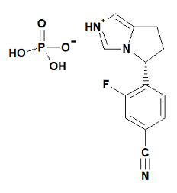
Osilodrostat drug product was initially formulated as 0.25 mg, 0.5 mg, 1 mg, 5 mg and 50 mg hard gelatin capsules (clinical service form) which were used in first Phase I and Phase II clinical studies. They were later (in 2014) replaced by 1 mg, 5 mg, 10 mg and 20 mg film-coated tablets (final market image). The film-coated tablets contain compendial excipients, and the manufacturing process consists of standard operations commonly used in the manufacture of oral solid dosage forms. The intended commercial formulation of 1 mg, 5 mg and 10 mg film-coated tablets is identical to the formulation used in late Phase I, Phase II and the pivotal Phase III clinical trials. They have the same qualitative and quantitative composition and appearance. They represent an immediate release dosage form for oral administration.
The storage condition has been revised during evaluation from ‘Store below 25°C. Store in the original package in order to protect from moisture’ to ‘Store below 30°C. Store in the original package in order to protect from moisture’.
Based on the supplied data a shelf-life of 36 months when stored below 30°C. Store in the original packaging in order to protect from moisture is acceptable.
The proposed commercial primary packaging configuration for osilodrostat 1 mg, 5 mg and 10 mg film-coated tablets consist of double-sided aluminium blisters with PA/aluminium/polyvinyl chloride foil as forming foil and aluminium foil with a heat seal lacquer as backing foil.
The application and the supporting data relating to the composition, development, manufacture, quality control, stability and bioavailability of the product have been assessed and checked for compliance, as applicable, with Australian legislation and requirements for new medicines and in accordance with pharmacopoeial standards and the technical guidelines adopted by the TGA.
A number of significant deficiencies in the application data were identified during the first round of evaluation. Questions raised by the TGA were satisfactorily resolved by the sponsor. Minor questions raised by the TGA during the second round of evaluation have also been resolved.
There are no outstanding quality issues. Approval is recommended for registration of the proposed product from a pharmaceutical chemistry perspective.

Nonclinical
The proposed dosing regimen involves a starting oral dose of 2 mg twice daily (except for patients of Asian ancestry, in whom the proposed starting dose is 1 mg twice daily) up to a maximum oral dose of 30 mg twice daily. The dose is recommended to be titrated with the aim to achieve normal cortisol levels and treatment is expected to be ongoing.
The submitted nonclinical dossier was in accordance with the relevant International Council for Harmonisation (ICH) guideline. The overall quality of the nonclinical dossier was adequate. All pivotal safety-related studies were Good Laboratory Practice; compliant.
The nonclinical data are broadly supportive of the proposed use. The half (50%) maximal inhibitory concentration (IC₅₀) for inhibition of human recombinant CYP11B1 was 2.5 nM for osilodrostat and within expected clinical plasma concentrations. Osilodrostat was active in a relevant rat model of Cushing’s syndrome.
Clinically relevant off-target inhibition of aldosterone synthase (CYP11B2) is also anticipated (with an IC₅₀ of 0.7 to 17 nM). Osilodrostat and its S-enantiomer (LCI698); also inhibit aromatase, which catalyses the conversion of androstenedione to estrone and testosterone to estradiol (IC₅₀ = 1.7 μM and 9 nM, respectively). Aromatase inhibition by osilodrostat and its enantiomer may be clinically significant. Osilodrostat activity at histamine H1 receptors is also of potential clinical relevance, but no functional studies were submitted.
Safety pharmacology studies assessed effects on the cardiovascular, central nervous and respiratory systems. The main nonclinical concern arising from the safety pharmacology studies is the potential for QT; prolongation, which has been observed clinically. The mechanism underlying this effect of osilodrostat is uncertain but may involve inhibition of multiple cardiac ion channels. Inhibition of hERG, Kir6.2/SUR2A and hKvLQT1/hminK channels was seen at high concentrations (IC₅₀ = 54.0 μM, 103.6 μM and 95.0 μM respectively (estimated exposure ratio at maximum concentration (C_{max}) = 84 to 150)). No adverse effects were seen on respiratory or central nervous system (CNS) function in rats, but adverse CNS effects were seen in a cardiovascular safety study in monkeys and in repeat dose toxicity studies in rodents and dogs.
Overall, the pharmacokinetic profile in animals was qualitatively similar to that of humans. Osilodrostat was readily and rapidly absorbed with a similar time at maximum concentration (T_{max}) in all species. Half-life values were similar in rats, dogs and humans. Plasma protein binding of osilodrostat was low in all animal species and humans. Tissue distribution of osilodrostat was rapid and wide including penetration into brain and spinal cord. Osilodrostat shows affinity toward melanin containing tissues, but it does not show relevant light absorption properties. Metabolism is primarily via oxidation and glucuronidation (25 % by CYP3A4, CYP2B6, CYP2D6 and 17% by uridine 5'-diphospho-glucuronosyltransferases (UGTs)). The main (pharmacologically inactive) human metabolite M34.5 was a significant metabolite in rats but was not detected in dogs. Drug-related material was excreted via urine and faeces, with urine as the predominant route of excretion in all species.
Based on in vitro studies, osilodrostat and its major metabolite M34.5 show a potential for both inhibition and induction of CYP1A2, CYP2B6 and CYP3A4/5, a potential for time-dependent inhibition of CYP2C19, as well as inhibitory potential for CYP2D6, CYP2E1 and UGT1A1. Osilodrostat may be expected to affect the exposure of co-administered drugs that are substrates for these enzymes. Osilodrostat and/or M34.5 are inhibitors of organic anion transporter (OAT)P1B1, organic cation transporter (OCT)1, OCT2, OAT1 and OAT3. Osilodrostat may alter exposures of co-administered substrates of OCT1 and multidrug and toxin extrusion protein 1 (MATE1).
Osilodrostat had a moderate order of acute oral toxicity in mice. Repeat-dose toxicity studies by the clinical route (oral) were conducted in mice (up to 13 weeks), rats (up to 6 months) and dogs (up to 39 weeks). Maximum exposures (area under the concentration-time curve (AUC)) in plasma were moderate to high. Toxicity associated with reduced cortisol or corticosterone levels was not assessed in the animal studies.
Targets organs for toxicity were the adrenal gland (increased adrenal weights; cortical hypertrophy of the zona fasciculata and/or vacuolation in rats, zona glomerulosa atrophy and increased vacuolation in dogs), female reproductive tissues in rodents (increased ovarian weights, follicular degeneration, prominent corpora lutea; increased vaginal mucification; uterine atrophy) rodent liver (increased weight, hypertrophy and vacuolation) and CNS (dilated pupils, disorientation, ataxia, ptosis, altered locomotor activity, muscle twitches, aggression and convulsions or tremors).
Osilodrostat was not mutagenic in the bacterial mutation assay. An in vitro clastogenicity assay in mammalian cells was negative, but osilodrostat induced structural chromosome aberrations in cultured human peripheral blood lymphocytes. Osilodrostat was not mutagenic in two in vivo assays (rat bone marrow micronucleus test and a comet assay for deoxyribonucleic acid (DNA) damage in hepatocytes and leukocytes). On balance, osilodrostat does not pose a genotoxic risk in humans.
An increase in liver adenomas and/or carcinoma was seen in male mice (exposure ratios, based on AUC (ERAUC) = 6) and at high exposures in rats (ERAUC =23 and 74 in males and females, respectively). Thyroid follicular cell adenomas and/or combined adenoma and carcinoma were seen in male rats (ERAUC = 23). The tumour development in rodents is likely to be a species-specific effect mediated by constitutive androstane receptor activation, and not relevant to humans.
Adverse effects on female fertility and maintenance of pregnancy were seen at exposures 92-fold the clinical AUC (ERAUC at the no observed adverse effect level (NOAEL) = 8). Osilodrostat exhibited embryofetal toxicity in rats and rabbits (ERAUC at the NOAEL = 0.5 to 0.6). Osilodrostat was teratogenic in rats at high exposures, and developmental variations were associated with maternotoxicity in rats and rabbits at ERAUC values of 86 and 10, respectively (ERAUC at the NOAEL = 9 and 0.6, respectively). The pre-and postnatal toxicity study revealed prolonged gestation, dystocia and adverse effects on fetal viability (38-fold the clinical AUC).
The proposed limits for impurities in the drug substance and drug product have been adequately qualified by submitted toxicity data.

Conclusions and recommendation
The pharmacology studies are generally supportive of the proposed use.
Clinically relevant reduction of aldosterone levels is likely. Osilodrostat may also lower estrogen concentrations secondary to aromatase inhibition. Activity at histamine H1 receptors is also of potential clinical relevance but was not fully investigated.
Safety pharmacology studies raise concerns for QT prolongation and arrhythmogenic potential in patients.
Target organs for toxicity identified animal studies include the adrenal gland, female reproductive tract, liver, and CNS.
Osilodrostat was not considered genotoxic based on a battery of genotoxicity assays, and tumour findings in animals are considered unlikely to be clinically relevant.
Osilodrostat adversely affected female fertility and displayed embryofetal toxicity and teratogenicity.
There are no objections on nonclinical grounds to the proposed registration of Isturisa
The draft PI should be amended as directed in the report. The sponsor has made these recommended changes to the PI.

Clinical

Summary of clinical studies
The clinical dossier consisted of:
- four Phase II studies: Study A2101, Study A2102, Study C2201 (Parts I and II) and Study C1201; and
- one Phase III study: Study C2301 (pivotal study).
In addition, the sponsor supplied a number of studies supplying data in populations or at doses different to those for the indication with this submission.

Pharmacology

Pharmacokinetics

Bioanalysis
Plasma concentrations of osilodrostat were determined, after protein precipitation, using a high-performance liquid chromatography (HPLC)-mass spectrometry (MS)/MS method. The calibration range was 1 to 1000 ng/mL using 50 μL Na-ethylenediaminetetraacetic acid (EDTA) plasma. (13C)2H4(15N)-osilodrostat was used as internal standard. The assay was pre- and within study validated. The assay was further developed and cross-validated in the calibration range of 0.5 to 50 ng/mL.
The assay was further developed and validated in the concentration range of 0.1 to 100 ng/mL osilodrostat, using K₂-EDTA plasma and a sample volume of 100 μL.
A chiral liquid chromatography (LC)-MS/MS method was used for explorative determination of S-osilodrostat in plasma. The assay consisted of protein precipitation followed by evaporation and analysis of reconstituted extracts. The calibration range was 0.5 to 500 ng/mL using 100 μL sample volumes. The method was qualified with a mean bias of ±30% and a precision of ≤ 30%.
Osilodrostat in the urine was determined after dilution and followed by analysis of the reconstituted samples by LC-MS/MS. The calibration range was 1 to 1000 ng/mL using a sample volume of 20 μL.
Liquid chromatography (LC)-MS/MS methods for determination of caffeine and paraxanthine, dextromethorphan and dextrophan, omeprazole and 5-hydroxy-omeprazole and midazolam, hydroxy-midazolam, ethinyl-estradiol and levonorgestrel were also developed and validated for intended purposes.

Absorption
Osilodrostat demonstrated a high permeability in caco-2 cells and a high solubility and is characterised as a Biopharmaceutics Classification System (BCS) Class I compound. Active P-glycoprotein and multidrug resistance associated protein transport seem to be only marginally involved.
An absolute bioavailability study was not performed.
Osilodrostat was rapidly absorbed with a T_{max} of approximately one to two hours, consistent at all doses studied. The majority of dose administered was eliminated in urine (91%), suggesting that osilodrostat oral absorption is nearly complete, as expected for BCS Class I compounds.
Concentration-dependent pharmacokinetics (PK), with a more than dose-proportional increase in exposure, was seen following single oral doses of 0.5 to 200 mg. A fairly dose proportional increase in exposure was seen after 0.5 to 3 mg once daily.
Steady state concentrations were reached at Day 2 following repeated dosing and the accumulation was 0.9 to 1.3 after once daily dosing. An accumulation ratio of 1.3 was determined based on population pharmacokinetic (PopPK) analysis following 2 to 30 mg twice daily.
A small decrease in exposure of osilodrostat was seen when co-administered with food (high fat meal), with a C_{max} of 0.8-fold and an AUC of 0.9-fold compared to when dosed alone.
A relative bioavailability comparison between the early capsule and the investigational tablet used in Phase III (equal to the to-be-marketed formulation) showed comparable exposure but with a lightly higher C_{max} after the capsule.

Distribution
The median apparent volume of distribution was approximately 100 L. Based on PopPK analysis, the apparent volume of distribution was estimated to be 107 L for the central compartment and to 326 L for the peripheral compartment.
The unbound fraction for osilodrostat was 0.63 and independent of plasma concentration in the studied concentration range 0.02 to 100 μg/mL (0.09 to 440 μM). The blood concentration of compound to plasma concentration of compound ratio was determined to 0.85 and consistent with the blood-to-plasma ratio for total radioactivity 0.88 after an oral dose of [¹⁴C]osilodrostat.
The unbound fraction for M34.5 was determined to 0.64.

Metabolism
No inter-conversion from administered R-osilodrostat (active) to S-osilodrostat was seen.¹³
Thirteen metabolites were characterised in the urine. Three large metabolites M16.5, M22 and M24.9 were identified with 17, 13 and 11% of the dose, respectively. Metabolite M22 was identified as M34.5-glucuronide.
Osilodrostat represents approximately 20% of the total radioactivity in plasma following a single oral dose of [¹⁴C]osilodrostat 50 mg (3.7 megabecquerel (MBq)). Three large metabolites were identified, metabolites M34.5, M16.5 and M24.9 with about 51, 9 and 7% of total exposure of radioactivity, respectively.
The current data indicate a longer terminal drug half-life (t_{1/2}) of both metabolites M34.5 and M24.9 compared to osilodrostat, thus accumulation is expected at twice daily dosing. (metabolites M34.5 and M16.5 showed weak/no inhibitory activity in vitro but metabolite M24.9 was active with an IC₅₀ of less than 12-fold as potent as osilodrostat (compares to nonclinical assessment).
The formation of the largest metabolite in the urine, metabolite M16.5 (direct N-glucuronide) was catalysed by UGT1A4, UGT2B7 and UGT2B10.
Twenty-four percent of the dose excreted in the urine as metabolite M24.9 (OH-osilodrostat) and its secondary metabolites M15 and M19.9 (11, 7 and 6% of the dose, respectively) was formed via CYP3A4, CYP2B6 and CYP2D6-mediated metabolism.
Less than 1% of the dose was excreted as metabolite M34.5 (di-oxygenated osilodrostat) in the urine but 13% of the dose was identified as metabolite M22 (M34.5-glucuronide). The formation of metabolite M34.5 was concluded to be non-CYP-mediated as the metabolite was not identified in vitro. Thus 14% of the dose was eliminated via non-CYP-mediated metabolism that way.
Six metabolites in the urine were identified as oxidative metabolites (metabolites M18B, M23.1, M16.4B, M6, M16 and M10), altogether 20% of the dose, but not identified in vitro and were concluded to be formed via non-CYP-metabolism.

Elimination
The elimination t_{1/2} was calculated to about 4 hours.
Ninety-one percent of a [¹⁴C]osilodrostat dose was excreted in the urine and < 2% in faeces. Approximately 5% of the dose was excreted as parent compound in the urine.

Time-dependency
Based on population PK results, mean accumulation ratio (based on AUC) between single dose and steady state was approximately 1.3 and similar for all doses within therapeutic dose range 2 to 30 mg twice daily.

Pharmacokinetics in the target population
Between subject variability at steady state AUC and steady state C_{max} were approximately 33 coefficient of variation (CV)% and 22 CV%, respectively, over the range of 2 to 30 mg.
The systemic exposure of osilodrostat was about 1.3-fold higher in Caucasian subjects compared to those of Japanese ethnicity at steady state.

Special populations

Renal impairment
Comparable systemic exposure of osilodrostat was seen in subjects with severe renal impairment, end stage renal disease and normal renal function following a single dose of osilodrostat 30 mg.

Hepatic impairment
Total systemic exposure increased with decreasing liver function with an AUC of approximately 1.4- and 2.7-fold in moderate and severe hepatic impairment compared to in healthy subjects. C_{max} was approximately 0.8-fold for mild, moderate and severe hepatic impairment compared to subjects with normal liver function.

Co-variates
Based on PopPK, no dose adjustment is required based on gender, age and weight factor. But an effect of the race has been identified. The drug has mainly been studied in the Caucasian and Asian populations.

Population pharmacokinetic data
In addition to the PK analyses presented in the individual clinical study reports, a separate population PK analysis and dose response analyses were performed.
Population PK analysis suggested similar PK between healthy subjects and patients with Cushing’s disease.
The clinical consequences of osilodrostat when co-administered with other products and the risk of changing their PK and effect have not been completely investigated. Physiologically based pharmacokinetic (PBPK) modelling and simulation have been used to predict potential in vivo interactions with osilodrostat. This approach is acceptable; however, the platform cannot be considered qualified according to the EMA PBPK guideline.
Cytochrome P450 (CYP) 3A4-mediated metabolism is very common, and polypharmacy is common in the targeted patient population. Potential clinical consequences following co-treatment with osilodrostat and sensitive CYP3A4 substrates should be able to predict. A small increase (1.5-fold) was seen in systemic exposure of midazolam (sensitive CYP3A4 substrate) when dosed together with osilodrostat compared to when dosed alone. However, the single dose drug-drug interaction study is not predictable for the potential induction signal on CYP3A4 (pregnane X receptor (PXR) coupled enzymes). Osilodrostat did not show any clinically relevant effect on a combined oral contraceptive (estradiol or levonorgestrel CYP3A4 or UGT substrate) following osilodrostat 30 mg twice daily for 7 days. Thus, it can be concluded that osilodrostat is not a potent PXR-inducer (not a sensitive substrate) but it’s status as a weak PXR-inducer is unknown.
Table 3: Study A2101 Overall predicted exposure metrics (area under the plasma concentration time curve; and maximum concentration, at steady state) for patients included in the population pharmacokinetic analysis (analysis dataset)
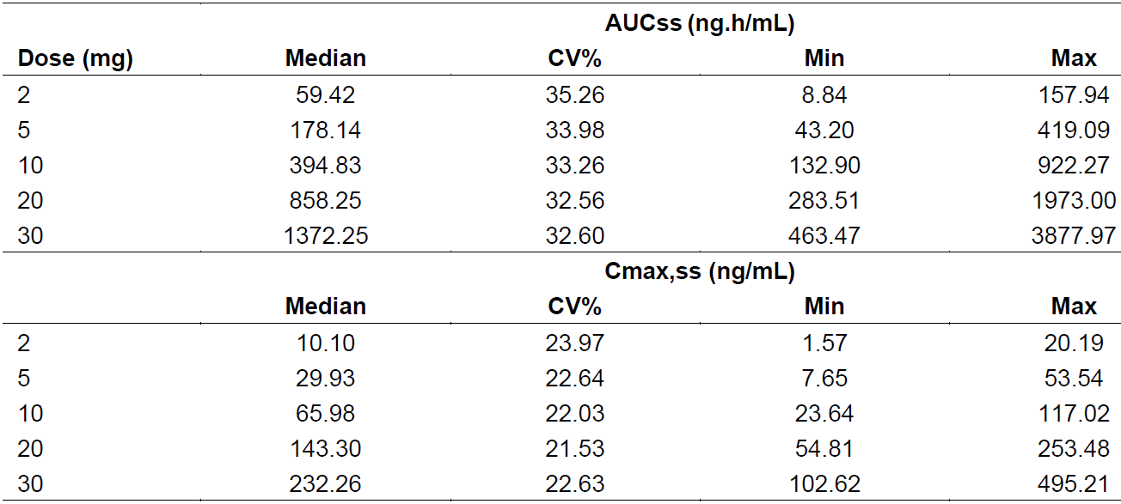
Abbreviations: AUCss = area under the plasma concentration time curve at steady state; Cmax,ss = maximum concentration at steady state; CV = coefficient of variation; Max = maximum; Min = minimum.

Pharmacodynamics
The pharmacodynamics (PD) of osilodrostat was investigated in healthy volunteers (Studies A2101 and A2102, the latter compared the PD in Japanese and Caucasian subjects) and in patients with Cushing’s disease (Study C2201). In addition, a thorough QT study (Study C2105) was conducted.

Mechanism of action
Osilodrostat is a potent, oral inhibitor of 11β-hydroxylase (CYP11B1), the enzyme that catalyses the last step in the biosynthesis of cortisol in the adrenal gland, thereby inhibiting cortisol synthesis.
Osilodrostat blocks both the synthesis of cortisol and aldosterone and was originally developed to treat patients with hyperaldosteronism but showed a larger effect on the hypothalamus-pituitary-adrenal (HPA) axis and was further developed for the treatment of endogenous hypercortisolism. Due to the mechanism of action, a build-up of precursor may be expected. The mechanism of action for osilodrostat has been adequately described.
In healthy subjects (Study A2101), single doses of osilodrostat ≥ 30 mg resulted in a reduction in urine cortisol, notably the urine cortisol increased in the placebo-treated group. The diurnal rhythm of cortisol was not affected. An increase in the precursor 11-deoxycortisol was increased. In the multiple ascending dose part of Study A2101, repeated doses of 10 mg osilodrostat resulted in a decrease in the diurnal cortisol pattern. At the 1 mg dose, there was an attenuated response to adrenocorticotropic hormone (ACTH) stimulation. This was observed although osilodrostat was given once daily. A build-up of 11-deoxycortisol was observed as well as an increase in ACTH at a dose of 10 mg.
In Study A2102, the doses were lower than in Study A2101. There appeared to be a stronger effect of osilodrostat in Japanese subjects than in Caucasian subjects, otherwise the results were in line with the data obtained in Study A2101. This is in line with the higher exposure observed in Japanese subjects.
Effects on aldosterone and the renin-angiotensin system as well as effects on the hypothalamic pituitary gonadal axis are considered as secondary pharmacology effects.
In the single dose part of Study A2101, plasma aldosterone levels were decreased in both actively and placebo-treated groups, but to a larger extent in subjects treated with osilodrostat. There was no apparent dose response. In the multiple ascending dose part of the study, osilodrostat was given once daily. With this regimen, aldosterone was decreased over the 12-hour post-dose period and then subsequently rose above the baseline level at Day 7. A significant increase in plasma renin activity levels was observed. There was a modest increase in sodium excretion. A build-up of precursors, both 11-deoxycorticosterone and 11-deoxycortisol, was observed at doses exceeding 3 mg. ACTH was also increased at doses above 3 mg.
Study C2201 Part I was the proof-of-concept study in patients with Cushing’s disease, the efficacy data from this study is further discussed in the efficacy part of this report. In this study, the effect of osilodrostat on the HPA-axis, thyroid hormones and sex hormones was evaluated. There was a marked decrease in aldosterone and renin. Due to the blocked cortisol synthesis, a build-up of precursors is expected and was indeed observed.
The exposure efficacy and safety analyses based on data from Study C2301 is of limited value as the exposure is conditioned on the cortisol response, and the exposure can thereby not be considered independent to the responses. Due to this limitation, the exposure response analyses of cortisol response and ACTH are not assessed.
Overall, ACTH levels were increased and although mean levels show modest increases below the threshold of clinical concern, individual patients may have ACTH values that are above the upper limit of normal (ULN). The data further indicate an increase in testosterone in both males and females whereas there was a decrease in estrogen in females and an increase in estrogen in males. In male patients the increase in testosterone rather represents a normalisation of testosterone levels, whereas in female patients the increase in testosterone resulted in a mean level above ULN and associated events such as hirsutism and acne. These adverse drug reactions did not lead to discontinuations during the study.

Efficacy

Dose response studies
No formal dose response study was conducted. Modelling of PK exposure estimated that a dose of 4 to 5 mg twice daily is expected to achieve a plasma concentration above the in vitro IC₅₀ for CYP11B1 inhibition (2.5 nM) for a full 24 hours for efficacy consideration. However, in Study C2201, a starting dose of 2 mg twice daily followed by individual dose titration was chosen based on mean urinary free cortisol (UFC) response, tolerability, and safety considerations, that is, to reduce the risks associated with potential hypocortisolism-related adverse events (AEs). This starting dose was also supported by the observations in the initial studies with normo-cortisolaemic subjects, where a notable reduction of ACTH-stimulated cortisol secretion was seen already at 2 mg/day (given as either 2 mg once daily or 1 mg twice daily).
The rationale for twice daily dosing of osilodrostat is based on its half-life of 3 to 5 hours. The 10-week analysis of Study C2201 showed that the dose of osilodrostat required for normalisation of mean UFC ranged from 2 mg twice daily to 50 mg twice daily after individual dose titration, with nearly all patients (11 of 12) achieving mean UFC normalisation at > 2 mg twice daily. Trough concentrations at mean UFC normalisation also varied widely, ranging from 0.336 to 204 ng/mL. This indicated that there was a broad range (up to 25-fold in osilodrostat dose) of inter-patient sensitivity to osilodrostat with respect to normalisation of mean UFC, and there was no apparent relation between the therapeutic dose or exposure (trough concentrations) needed for UFC normalisation and the baseline mean UFC. Thus, individual dose titration was required due to high inter-patient variability in effective dose and the potential for resulting AEs in sensitive patients (potential risk of hypocortisolism or acute adrenal insufficiency). Based on the available data, an individual dose titration starting at 2 mg twice daily was an appropriate method to assess the efficacy and safety of osilodrostat. The original titration plan was to escalate to a maximum of 50 mg twice daily in Study C2201. An exploratory post-hoc analysis of QT interval corrected using Fridericia’s formula (QTcF);¹⁴ in relation to osilodrostat dose from an earlier Phase I study (Study A2101) found substantial QTcF changes (some patients with QTcF prolongation > 30 ms) at single doses of 100 and 200 mg. As a precaution, the maxim dose was lowered from 50 mg twice daily dose to 30 mg twice daily.
In Study C2301, the osilodrostat dosing regimen was up titrated following a 2 mg twice daily, 5 mg twice daily, 10 mg twice daily, 20 mg twice daily, and 30 mg twice daily escalation sequence with the maximum dose of osilodrostat being 30 mg twice daily. The individual dose titration was required for the same reasons of high inter-patient variability seen in Study C2201. Dose increases were determined by the mean UFC based on three 24-hour UFC values collected every two weeks during the dose titration period. The up-titration scheme was also governed by the desire to apply a limited number of uniform dose escalation steps in the confirmatory clinical trial setting while still allowing all patients the possibility to reach the 30 mg maximum dose if needed as well as the goal to achieve UFC control in all patients by Week 12 while still allowing up titration to be based on central laboratory UFC values.

Study C2301 (pivotal clinical study)
Study C2301 is a Phase III, multi-centre, double-blind, randomised withdrawal study of osilodrostat following a 24-week, single arm, open label dose titration and treatment period to evaluate the safety and efficacy of osilodrostat for the treatment of patients with Cushing’s disease.
Figure 2: Study C2301 Schematic of core study design
Abbreviation: W = Week.
* To be eligible for randomisation, the patient must have mean urinary free cortisol ≤ upper limit of normal at Week 24, and no further dose increase after Week 12.
** Strata were determined by the combination of two stratification factors at randomisation. Osilodrostat dose at Week 24 (≤ 5 mg twice a day versus > 5 mg twice a day) and history of pituitary irradiation (yes/no).

Study periods

Period 1 (Week 1 to Week 12) (dose titration period)
Patients were assessed for mean UFC during the first two weeks of the dose titration period and the dose of osilodrostat was adjusted accordingly. The dose was increased if mean UFC was above the > ULN and was reduced if mean UFC was below the lower limit of normal (LLN), or if the patient was symptomatic and mean UFC was in the lower part of the normal range. The dose was maintained if mean UFC was within the normal range and the patient did not have signs or symptoms of hypocortisolism or adrenal insufficiency. At Week 0 and Week 2, dose increases were not permitted.

Period 2 (Week 13 to Week 24) (dose titration and treatment period)
During this period, the efficacy and safety of osilodrostat were assessed at the therapeutic dose as determined for attaining mean UFC ≤ ULN during the dose titration period in Period 1. Patients with mean UFC > ULN had their osilodrostat dose increased as tolerated and the maximum dose of 30 mg twice daily had not yet been reached. These patients were followed for long-term efficacy and were not considered responders for the key secondary endpoint, hence were not randomised in Study Period 3.

Period 3 (Week 26 to Week 34) (randomisation withdrawal period)
Patients were eligible for randomisation (either to continue with osilodrostat or to switch to placebo) if they had completed the dose titration during study Period 1 and were classified as complete responders at Week 24 with no dose increase between Week 13 and Week 24. Randomisation was implemented at the Week 26 visit. Patients not eligible for randomisation received open label osilodrostat until the end of the core period (Week 48), unless there was a reason to discontinue from the study prematurely.

Period 4 (Week 34 to Week 48)
At the end of Week 34, all patients received open label osilodrostat treatment at a dose selected at the discretion of the investigator. Dosing could also be adjusted based on the mean UFC levels during this treatment period.

Open extension period
Patients who continued to receive clinical benefit, as assessed by the study investigator and who wished to enter the extension period, had to be re-consented at Week 48. Patients who entered the extension period did so without interruption of study drug or scheduled assessments. The optional extension period will end after all patients have completed Week 72 or discontinued prior to Week 72.

Methods
Study C2301 is a Phase III, multi-centre, double blind, randomisation withdrawal study of osilodrostat following a 24-week, single arm, open label dose titration and treatment period to evaluate the efficacy and safety of osilodrostat for the treatment of patients with Cushing’s disease.

Key inclusion criteria
Key inclusion criteria were, male or female patients 18 to 75 years old with confirmed persistent or recurrent Cushing’s disease as evidenced by mean UFC > 1.5 x ULN at screening, morning plasma ACTH above the LLN and confirmed pituitary source of excess ACTH were included.
Patients with de novo Cushing’s disease were included only if they were not considered candidates for surgery (for example, poor surgical candidates, surgically unapproachable tumours, patients who refuse to have surgical treatment, or surgical treatment was not available).
Patients with a history of pituitary irradiation were included, provided that at least 2 years (for stereotactic radiosurgery) or 3 years (for conventional radiation) had elapsed from the time of last radiation treatment to the time of enrolment into this study.
Patients were permitted to washout current drug therapy to meet these entry criteria if they had known diagnosis of Cushing’s disease. Rescreening was used as needed to ensure washout was complete.

Key exclusion criteria
The following were excluded at enrolment:
- Patients with compression of the optic chiasm due to a macroadenoma or patients at high risk of compression of the optic chiasm were excluded.
- Patients who had a known inherited syndrome as the cause for hormone over secretion and patients with Cushing’s syndrome due to ectopic ACTH secretion or ACTH-independent (adrenal) Cushing’s syndrome were excluded.
- Patients who had risk factors for corrected QT interval (QTc)¹⁴ prolongation or Torsade de Pointes; were excluded.
- Hypertensive patients with uncontrolled blood pressure; diabetic patients with poorly controlled diabetes; and patients who were not euthyroid were to be excluded.
- Patients with a history of significant cardiovascular disease, moderate to severe renal impairment or significant liver disease were also excluded.

Primary objective
The primary objective was to compare the complete response rate at the end of the 8-week period of randomisation withdrawal (Week 34) between patients randomised to continued osilodrostat therapy versus placebo.

Key secondary objective
To assess the complete response rate at the end of individual dose titration and treatment with osilodrostat in the initial single arm, open label period (Week 24).

Study endpoints
Study efficacy assessments and endpoints are given in Table 4, below.
Table 4: Study C2301 Description of efficacy assessments and endpoints
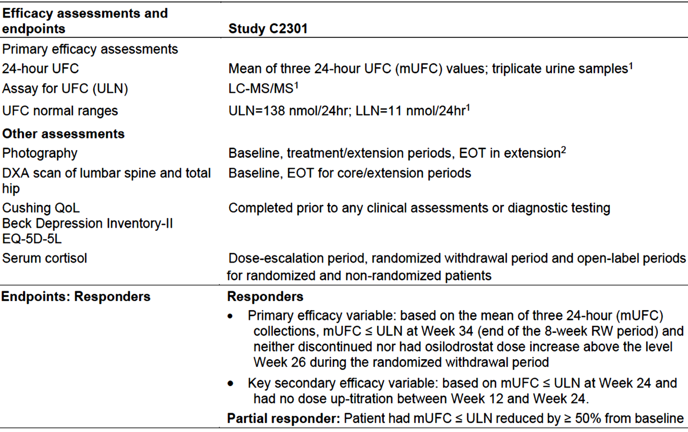
Abbreviations: EOT = end of treatment; LC-MS/MS = liquid chromatography-tandem mass spectrometry assay; LLN = lower limit of normal; mUFC = mean urinary free cortisol; QoL = quality of life; ULN = upper limit of normal; RW = randomised withdrawal.
1. Also apply to the key secondary endpoint
2. Two photographs, one frontal and one lateral from the shoulders up will be taken to assess facial plethora (rubor), supraclavicular and dorsal fat pads. Two photographs, frontal and dorsal of the trunk with patient in standing position will be taken to assess hirsutism (females only), striae, proximal muscle wasting (atrophy), central (abdominal) obesity, and ecchymoses (bruising).

Statistical methods

Analysis populations
The following analysis populations were defined:

Randomised analysis set
Randomised analysis set (RAS) comprised all randomised patients who had received at least one dose of randomised drug (osilodrostat or placebo). Following the intent-to-treat (ITT) principle, patients were analysed according to the treatment and stratum they have been assigned to during the randomisation.

Full analysis set
Full analysis set (FAS) comprises all enrolled patients who received at least one dose of osilodrostat.

Safety set
There were two safety sets defined in this study.
- Safety analysis set comprises all enrolled patients who received at least one dose of osilodrostat and had at least one valid post-baseline safety assessment.
- Safety analysis set for randomised withdrawal period comprises only randomised patients who received at least one dose of randomised treatment (osilodrostat or placebo) and had at least one valid safety assessment during the randomised withdrawal period.

Per-protocol set
There were two per-protocol sets defined in this study.
- Per-protocol; set for randomised analysis set (PPRAS) consists of a subset of the patients in the RAS who had no selected clinical study report-reportable protocol deviation.
- Per-protocol set for full analysis set (PPFAS) of a subset of the patients in the FAS who had no selected clinical study report-reportable protocol deviation.

Pharmacokinetic analysis set
Pharmacokinetic analysis set consists of all enrolled patients who receive at least one dose of osilodrostat and have at least one evaluable post-dosing PK assessment.
Analysis of the primary endpoint: The primary efficacy variable was the proportion of randomised patients in each treatment arm that are complete responders at the end of the 8 weeks of the randomised withdrawal period (Week 34). A Cochran–Mantel–Haenszel exact test stratified by the two stratification factors at randomisation was performed using the RAS following the ITT principle. The test was performed at a 2-sided alpha of 0.05. Patients who discontinued during the randomised withdrawal period will be counted as non-responders for the primary endpoint. Patients with mean UFC > 1.5 x ULN (with at least 2 of the 3 individual UFC levels > 1.5 x ULN) during the randomised withdrawal period were to be discontinued from randomised withdrawal and changed to open label treatment with osilodrostat. The applicant was asked to provide more information on patients that fulfilled these criteria and clarified that two patients (one was withdrawn, and one was not) randomised to osilodrostat and 21 patients (10 were withdrawn (including one patient who withdrew from the study) and 11 were not) randomised to placebo met the criteria.
Key secondary endpoint: The key secondary efficacy variable was the proportion of complete responders at the end of 24 weeks of dose titration and treatment with osilodrostat in the initial single arm, open label part of the trial, using the FAS. The analysis of the key secondary objective was based on the 2-sided 95% exact confidence interval (Clopper-Pearson method), which was compared with the limit 30%, to be able to state that the complete response rate is considered at least 30% after 24 weeks of treatment with osilodrostat. This endpoint was tested sequentially after the primary endpoint, to preserve of the overall 2-sided Type 1 error at 5%.
Supportive and sensitivity analyses: An un-stratified Fisher’s exact test of the primary endpoint using RAS was performed as a supportive analysis to the primary analysis. In addition, both stratified Cochran-Mantel-Haenszel exact test and un-stratified Fisher’s exact test of the primary endpoint were performed using PPRAS. The key secondary endpoint was also analysed using PPFAS.
Interim analyses: The current study report is based on interim data, with long term safety follow up still ongoing. The study had no interim analysis for purpose of adaptation of the study.

Participant flow
This study was conducted in 66 centres across 19 countries. A total of 202 patients were screened for the study, of which 137 were enrolled and 65 patients were screening failures. Nineteen patients discontinued at or prior to Week 26. Of the remaining 118 patients, 71 patients were randomised (36 to osilodrostat and 35 to placebo) and 47 patients who were not randomised continued on the open label osilodrostat treatment.
Patients were not randomised for the following reasons:
- 19 patients had their dose increased beyond the established one at Week 12 (that is, the end of the dose titration period) although they met the mean UFC normalisation criteria,
- 20 patients did not meet the mean UFC normalisation criteria at Week 26,
- 7 patients did not meet both previous criteria, and
- one patient was not randomised due to investigator decision.
At the time of data cut-off date, 35 patients had discontinued the study (24 during the core period and 11 during the extension period).
During the core period, 5 patients discontinued after Week 26 but prior to Week 48. Of note, only one patient, who was randomised to placebo, withdrew from study during the randomisation withdrawal period on Day 220. The most common reasons for discontinuation during the core period were, due to an AE (10.9%, 15 of 137), followed by patient withdrew consent (2.9%, 4 of 137), and physician’s decision (2.2%, 3 of 137) (see Table 15). A total of 106 patients (77.4%) entered the optional extension, of which 95 (69.3%) patients were still on treatment at the time of the data cut-off date.
Figure 3: Study C2301 Patient disposition by randomised treatment group (full analysis set)
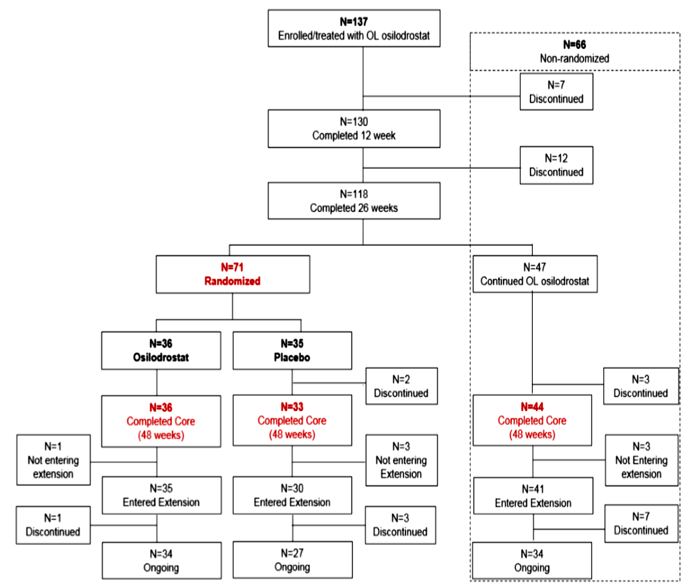
Abbreviations: N = number of subjects; OL = open label.

Patient disposition
Table 5: Study C2301 Patient disposition by randomised treatment group (full analysis set)
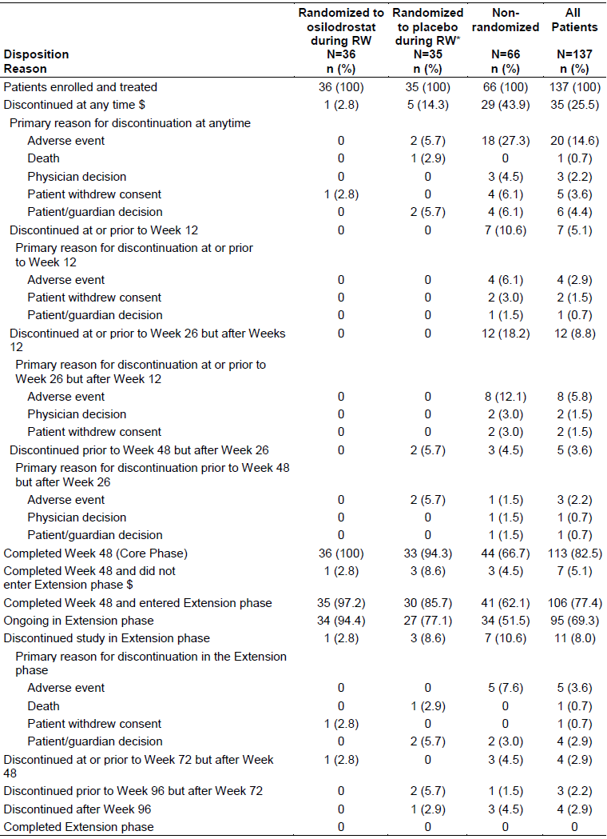
Abbreviations: N = total number of patients enrolled and treated; n = number of subjects in subgroups; RW = randomised withdrawal.
% is based on the total number of patients enrolled and treated.
$ Patients who completed Week 48 and did not enter extension phase are not counted as discontinuations.
* For patients randomised to placebo during the randomised withdrawal period and including all data while on either osilodrostat or placebo.

Baseline data
A total of 137 patients were enrolled, consisting of 106 female and 31 male patients. Most patients were Caucasian (65.0%) or Asian (28.5%). The median patient age was 40 years (range: 19.0 to 70.0 years); and the median body-mass index was 28.8 (range: 18.8 to 56.4). The median time to first osilodrostat dose since initial Cushing’s disease diagnosis was 47.2 months (range: 2.1 to 286.7 months) and most patients (87.6%) had persistent or recurrent Cushing’s disease. The mean standard deviation (SD) mean UFC was 1006.0 nmol/24 h (1589.86); this corresponds to approximately 7 x ULN. The median mean UFC at Baseline was 476.4 nmol/24 h (range: 35.6 to 9611.6); this corresponds to approximately 3.5 x ULN. The demographic and baseline disease characteristics were representative of a patient population with Cushing’s disease. The disease history and other baseline characteristics were generally well balanced in the patients who were later randomised to osilodrostat or placebo treatment groups during the randomisation withdrawal period.
Further baseline data is shown in Table 6, below.
Table 6: Study C2301 Demographics summary by randomised treatment group (full analysis set)
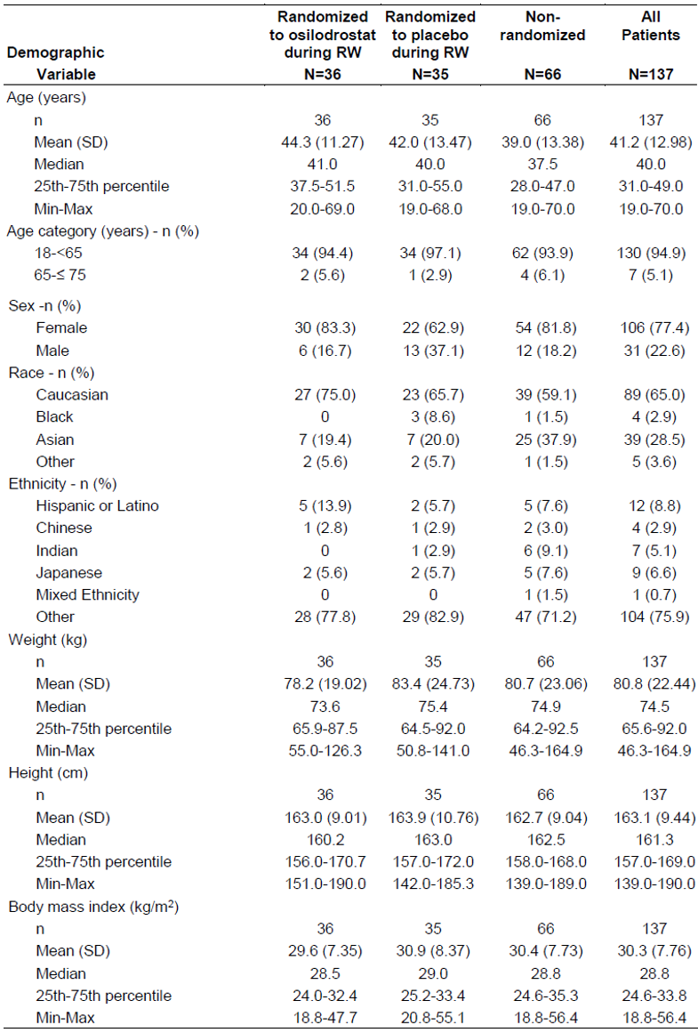
Abbreviations: N = total number of patients enrolled and treated; Max = maximum; Min = minimum; n = number of subjects in subgroups; RW = randomised withdrawal; SD = standard deviation.

Disease history characteristics
The median time to the first osilodrostat dose since initial Cushing’s disease diagnosis was 47.2 months (range: 2.1 to 286.7) and most patients (87.6%) had persistent or recurrent Cushing’s disease.
Overall, 95.6% had received treatment for Cushing’s disease prior to study entry, and 87.6% of patients had previously undergone surgery. For related surgical history, 45 patients (32.85%) had at least two previous neurosurgeries and 9 patients (6.57%) had at least three previous neurosurgeries. A large proportion of patients (74.5%) had been treated with other medication for Cushing’s disease prior to study entry (such as ketoconazole, metyrapone, cabergoline and pasireotide.
The mean (SD) mean UFC at Baseline was 1006.0 nmol/24 h (1589.86); this corresponds to approximately 7 x ULN. The median mean UFC at Baseline was 476.4 nmol/24 h (range: 35.6 to 9611.6); this corresponds to approximately 3.5 x ULN.

Relevant medical history and current medical conditions
All patients (N = 137) reported at least one relevant medical history or current medical condition. Overall, the most common conditions were hypertension (93 of 137, 67.9%), obesity (41 of 137, 29.9%), osteoporosis (38 of 137, 27.7%), diabetes mellitus (30 of 137, 21.9%), depression (27 of 137, 19.7%) and hypothyroidism (25 of 137, 18.2%).
Relevant medical histories and current medical conditions were similar in the patients who were later randomised to osilodrostat or placebo treatment groups during the randomisation withdrawal period.

Numbers analysed
Table 7: Study C2301 Analysis patient sets by stratum and randomised treatment group (all randomised patients)
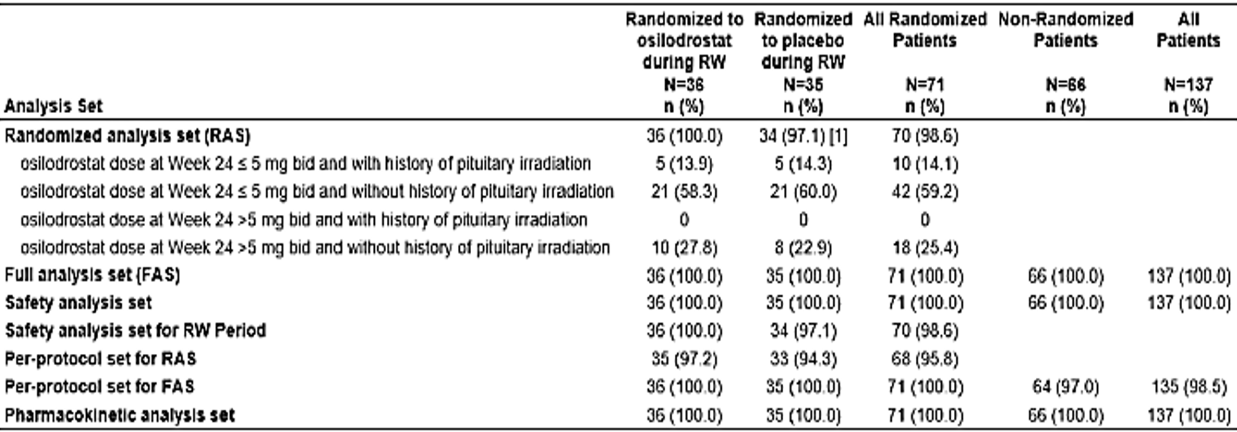
Abbreviations: FAS = full analysis set; N = total number of patients enrolled and treated; n = number of subjects in subgroups; RAS = randomised analysis set; RW = randomised withdrawal.
One patient was randomised to placebo, never received treatment and withdrew from the study during the randomised withdrawal period on Day 220.
Randomised strata are based on assignment from interactive voice response.

Primary efficacy results (Week 34 complete response rate of Study C2301)
The primary efficacy endpoint was met. The null hypothesis that the complete response rates at the end of 8-week randomisation withdrawal period (that is, at Week 34) were the same between the two randomised groups was rejected.
Osilodrostat was superior to placebo at Week 34, the end of the randomisation withdrawal period, in maintaining biochemical control (mean UFC to ≤ ULN) in patients with Cushing’s disease showing statistical significance (Cochran-Mantel-Haenszel exact test 2-sided p < 0.001). The complete response rate in the osilodrostat arm was higher at 86.1% (95% confidence interval (CI): 70.5, 95.3) than that in the placebo arm at 29.4% (95% CI: 15.1, 47.5) (odds ratio of osilodrostat versus placebo = 13.7; 95% CI: 3.7, 53.4). Ten patients in the placebo arm (29.4%) did not lose mean UFC control at the end of the randomisation withdrawal period. In 9 of 10 patients, mean UFC increased at the end of Week 34 close to the ULN. This finding was expected considering the individual response in mean UFC. This is also consistent with the observation in Study C2201 where mean mean UFC returned to Baseline after 2 weeks following discontinuation of osilodrostat, although some patients-maintained UFC < ULN for a longer period.
Table 8: Study C2301 Proportion of primary efficacy responder at Week 34 (end of randomised withdrawal) by randomised treatment and strata (randomised analysis set)
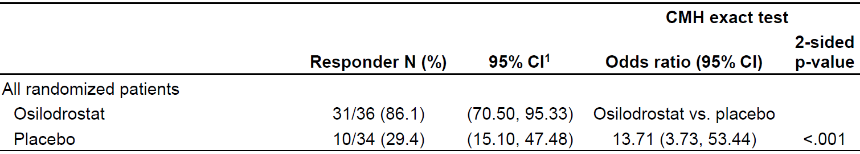
Abbreviations: CI = confidence interval; CMH = Cochran-Mantel-Haenszel; N = number of subjects; RAS = randomised analysis set.
1. Two-sided 95% CIs are based on the exact (Clopper-Pearson) method.
A primary efficacy responder is defined as a randomised patient who has mean urinary free cortisol ≤ upper limit of normal at Week 34 and who was neither discontinued (study or randomised withdrawal treatment) nor had osilodrostat dose increase above the level at Week 26 during the randomised withdrawal period of the study. Patients who discontinued during the randomised withdrawal period were counted as non-responders for primary efficacy.

Supportive analysis for the primary endpoint
The robustness of the primary analysis was confirmed by the predefined supportive analyses, one based on the RAS and one based on the PPRAS, further supporting the efficacy of osilodrostat in controlling the notably high mean UFC values in patients with Cushing’s disease.

Key secondary results (Week 24 complete response rate of Study C2301)
The study also met its key secondary objective. At Week 24, 72 patients (52.6%) were responders in the FAS (95% 2-sided CI: 43.9, 61.1). The lower bound of the 95% CI was above the pre-specified threshold for significant clinical benefit (that is, ≥ 30%). However, the number of controlled patients at Week 24 was 93 of 137 (67.9%). Hence an additional 21 patients had normal mean UFC at Week 24, but they were not considered eligible for randomisation.

Main secondary efficacy results (Study C2301)

Proportion of mean urinary free cortisol responders over time
The proportion of patients with mean UFC ≤ ULN responding to treatment with osilodrostat remained consistent over time for ‘all patients’, patients without prior surgery and patients in the non-randomised arm.
Table 9: Study C2301 Proportion of mean urinary free cortisol responders over time
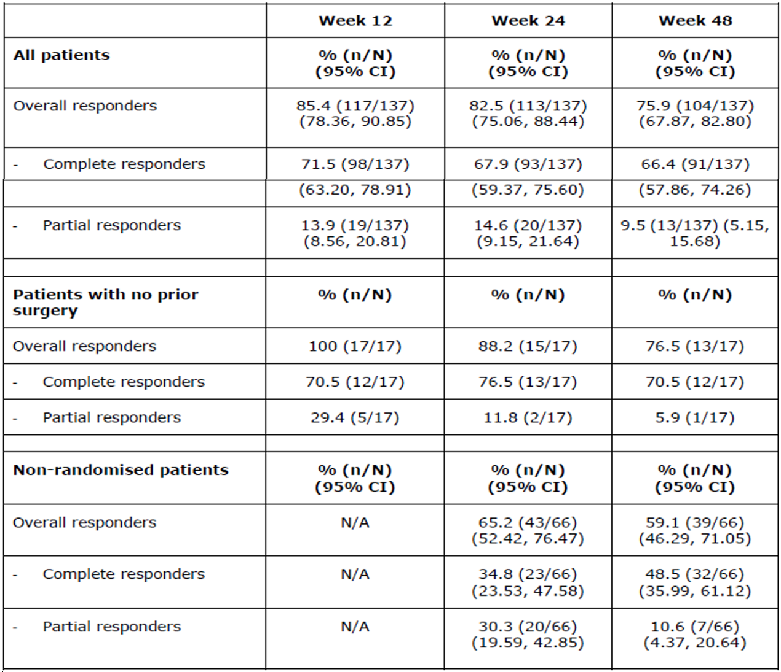
Abbreviations: CI = confidence interval; N = total number of patients enrolled and treated; n = number of subjects in subgroups; N/A = not available.
Up to the time of the last available assessment, response rates were consistent with those for ‘all patients’ at Week 12. An overall response rate of 88.3% (95% CI: 81.73, 93.18) with 71.5% (98 of 137) (95% CI: 63.20, 78.91) being complete responders and 16.8% (23 of 137) being partial responders (95% CI: 10.95, 24.12).
The durability of response rate was evident with 64 patients (66.0%) in the FAS who had initial normalisation of mean UFC were still considered to be responders after at least 6 months (95%: 55.7, 75.3).

Change in mean urinary free cortisol from Baseline during the study
In Study C2301, mean UFC levels (≤ ULN) were maintained without any consistent dose increase as evidenced by the total daily dose of osilodrostat with the range of doses consistent between 10 mg/day to 12 mg/day.
During treatment with osilodrostat, the mean UFC levels decreased from high baseline values stabilising to a normal level (mean UFC ≤ UFC) around Week 6 in most patients at an average total daily dose of 8.6 mg/day. After Week 6, normal mean UFC (≤ ULN) levels were observed in most patients except for non-randomised patients at Week 20 to Week 24 and patients randomised to placebo at Week 28 to Week 34. Normalised mean UFC (≤ ULN) levels were maintained at Week 24 at an average total daily dose of 10.7 mg/day and at Week 48 at 11.0 mg/day.
A repeated measures analysis of mean UFC shows a consistent biochemical effect of osilodrostat during the study. At Week 2, there was approximately a 42% reduction in the adjusted mean UFC value from Baseline. After the dose titration period (Week 12), there was approximately an 85% reduction that was maintained until the end of the core period (89%).

Change in mean urinary free cortisol from randomisation during the randomisation withdrawal period
At randomisation (Week 26), mean (SD) mean UFC levels were similar in the osilodrostat arm (70.9 nmol/24 h, SD = 43.53) and placebo arm (79.1 nmol/24 h (57.90). Once patients stopped treatment with osilodrostat at Week 26 and were randomised to receive placebo, mean UFC levels increased rapidly. Only data while the patients were on randomisation withdrawal medication are included. At the end the randomisation withdrawal period and when patients resumed treatment with osilodrostat, mean UFC levels decreased quickly.
At the end of the 8-week randomisation withdrawal period (Week 34), the median mean UFC levels were lower in the osilodrostat arm (50.1 nmol/24 h; range: 11.9 to 610.8) compared with the placebo arm (139.7 nmol/24 h; range: 29.8 to 849.5). This corresponded to a median percent change from randomisation of -13.9% (-70.1 to 1019.9) in the osilodrostat arm and 174.6% (-58.1 to 2588.8) in the placebo arm.
The repeated measures analysis of change in mean UFC shows a consistent biochemical effect of osilodrostat over placebo during the randomisation withdrawal period. In the osilodrostat arm there was approximately a 10% reduction from the mean UFC at randomisation Baseline during the randomisation withdrawal period. However, in the placebo arm, there was up to a 200% increase in the mean UFC from randomisation during the same period.

Time to first controlled mean urinary free cortisol response
During the study, 132 patients of 137 (96.4%) achieved biochemical control (mean UFC ≤ ULN) at least once while on study treatment. The median time from the start of treatment with osilodrostat to the first-controlled mean UFC response was 41 days (95% CI: 30.0, 42.0) for all patients with similar first-control in patients in the osilodrostat arm (41.0 days, 95% CI: 28.0, 47.0) and in the non-randomised arm (42.0 days, 95% CI: 37.0, 55.0).

Time to loss of control during the randomised withdrawal period
During the randomisation withdrawal period, two (5.6%) patients of 36 in the osilodrostat arm had a loss of mean UFC control (of the two patients, one patient required a dose interruption due to AEs) compared with 20 patients (58.8%) of 34 in the placebo arm. The median time to loss of control of mean UFC was not estimable in the osilodrostat arm and was 28 days in the placebo arm.
There was a 94% lower risk of losing mean UFC control in the osilodrostat group compared with the placebo group (hazard rate ratio = 0.06; 95% CI: 0.01, 0.28) during the randomisation withdrawal period.

Other efficacy results
Based on the Kaplan-Meier event probability estimates, the probability of escape at approximately 1.5 years is 48.8%. At a median follow up of 253 days, the median time to escape was 560 days (95% CI: 212.0, not estimable). In the analysis, 46 patients out of 97 patients (47.4%) had an on-treatment ‘escape’ event. Many of the patients who had an ‘escape’ event regain mean UFC control with or without osilodrostat dose increase.
Osilodrostat treatment led to an improvement in most cardiovascular-related metabolic parameters associated with Cushing’s disease at Week 48 with improvements seen in some patients as early as Week 12. These improvements were maintained over time.
At the end of the core period (Week 48), 83 of 97 patients (85.6%) had improvement in at least one physical feature in Cushing’s disease. The favourable improvements were evident already during the dose titration period and were generally maintained throughout the study.
A mean (SD) percentage change from Baseline of 3.0% (6.45) was reported for L1 to L4 lumbar spine and of 0.4% (5.48) for total hip at Week 48 (based on bone mineral density; g/cm²). The change in bone mineral density seems more pronounced in the male patients compared to female patients.

Supportive studies

Study C2201
Part I was a sequential dose escalation study assessed the short-term safety or tolerability and the efficacy of osilodrostat after a 10-week treatment period in patients with Cushing’s disease.
Part II (long-term extension) core was a 22-week treatment period (10 weeks followed by additional 12 weeks) after which the long-term efficacy and safety of osilodrostat were further investigated in an optional 48-week extension (Extension 1). The extension phase was continued as Extension 2 to provide continued access to osilodrostat for patients who completed Extension 1. The study remains ongoing.

Part I efficacy results
Twelve patients were enrolled and treated with up-titrated doses of osilodrostat. All 12 patients completed the study.
At the time of the completed Part I of the 10-week core study, a notable decrease in UFC was seen after 28 days of dosing (when most subjects had completed dosing with 5 mg twice daily) and continued to decline to Day 70 when treatment stopped. Although mean UFC levels increased again upon stopping osilodrostat at the end of the 10-week study, once treatment was resumed for patients who continued in Part II of the study, reduction in mean UFC (≤ ULN) levels were achieved.
While mean fold ULN declined to < 1 (ULN) by Day 56, the mean time to response (UFC normalisation or 50% reduction) was 34.3 days (SD = 14.1 days. Furthermore, 9 of the 12 patients had three UFC measurements at both Baseline and Week 10 (Day 70) and were therefore included in the primary analysis set.
All 9 patients were responders achieving either a mean UFC ≤ ULN or ≥ 50% decrease in mean UFC at Day 70, so the response rate was 100% (95% CI: 66%, 100%).

Part II efficacy results
A total of 19 patients were enrolled (4 patients from Part I and 15 newly enrolled patients) between January and July of 2013. After Week 22, 16 patients entered the extension phase of the 16 patients that entered the extension phase, 10 are still ongoing as of the data cut-off date (14 November 2017).
Efficacy results showed decrease in UFC after 28 days of dosing (when most subjects had completed dosing with 5 mg twice daily) and continued to decline to Day 70 when treatment stopped. The total daily dose required for UFC normalisation was ≤ 20 mg/day in 75% of the patients, with at least 50% of the patients requiring 10 to 20 mg/day.
In Study C2201 Part II, mean UFC levels (≤ ULN) were maintained without any consistent dose increase as evidenced by the total daily dose of osilodrostat with the range of doses consistent between 10 mg/day to 12 mg/day mean UFC levels (≤ ULN) and some patients had dose decreases as evidenced by mean UFC response and total daily dose of osilodrostat. Reduction of mean UFC ≤ ULN with osilodrostat is evident by mean UFC responses over time.
The median mean UFC level at Baseline was 2.9 x ULN (404.97 nmol/24 h) and mean UFC ≤ ULN is evident with osilodrostat at various time points throughout the study. Mean UFC levels during the study are as follows: 43.96 nmol/24 h (95% CI for percentage change from Baseline: -92.69, - 78.25) at the end of Week 10; 59.78 nmol/24 h (95% CI for percentage change from Baseline: -88.86, -71.71) at the end of Week 22; and 86.90 nmol/24 h (95% CI for percentage change from Baseline: -81.92, -52.33) at the time of the last available assessment.

Study C1201
Study C1201 is an ongoing Phase II, single arm, open label, dose titration study to assess the safety or tolerability and efficacy of osilodrostat in 9 Japanese patients with endogenous Cushing’s syndrome except Cushing’s disease (hereafter referred to non-Cushing’s disease Cushing’s syndrome). The study consists of two distinct study periods plus an optional extension period.
Study period I (12-week duration) is the dose titration period achieved an individual stable therapeutic dose and assessed the efficacy and safety.
In this Phase II study in patients with non-Cushing’s disease Cushing’s syndrome, a limited number of patients were enrolled due to the rarity of the disease. Seven patients of the nine enrolled in Period 1 completed the study, and all seven patients had reductions in mean UFC levels at Week 12; two patients discontinued prior to Week 12. The mean percent change from Baseline at Week 12 ranged from -52.6% to -99.0%. Reduction in mean UFC (≤ ULN) were evident based on the median percent change in mean UFC from Baseline as follows: Week 4, -83.3%; Week 8, -94.4%; and Week 12, -94.5%. The median decrease in (mean UFC from Baseline at Week 12 was - 94.47% (-103.49%, -72.55%). The response rate was similar with that reported in Study C2301 and Study C2201 Part II core. An overall response rate of 77.8% (7 of 9) was achieved in patients at Week 12 with 66.7% of patients (6 of 9) being complete responders and 11.1% (1 of 9) being partial responders.

Safety
The submitted safety data mainly derived from the from the pivotal Study C2301 conducted in patients with Cushing disease (Cushing’s syndrome due to ACTH-producing pituitary adenoma) and Study C2201 provided supportive safety data. To support the proposed indication of endogenous Cushing syndrome caused by diseases other than ACTH-producing pituitary adenoma, data from the Japanese study (Study C1201) has been submitted.
Study C2108, performed in 24 healthy female receiving cortisol supplementation (30 mg for 12 days) conducted to study PK of use of oral contraceptive together with osilodrostat, was also submitted.
Orlidostat was initially developed for the treatment of hypertension and hyperaldosteronism. The clinical studies in these indications used lower doses (0.25 mg/day to 2 mg/per day) of osilodrostat used for shorter durations (4 to 8 weeks). Even though these studies are not included in the safety data set for use of osilodrostat in intended population, the sponsor has summarised and submitted safety data and experience from these studies (Studies A2201, A2206, A2215 and A2216).

Exposure

Overall exposure
Three studies (Studies C2301, C2201 and C1201) were performed in subjects covering the intended population. Cut-off dates for Study C2301 was 21 February 2018 (ongoing), 14 November 2017 for Study C2201 Part II (ongoing), 6 March 2012 for Study C2201 Part I and 7 June 2018 for Study C1201(ongoing). Median exposures in the pivotal study (Study C2301) were 74.7 weeks and overall, across studies the median lengths ranged from 80 days to 226 weeks.
In total, 134 subjects have been treated with osilodrostat in more than 6 months and 107 subjects have been treated more than 12 months (Study C2301 and Study C2201 Part II). At time of cut-off date, 11 subjects had been treated for 48 months or more (all in Study C2201 Part II). Thus, long-term experience is limited, and further long-term safety date is pending from all three studies.
For Study C2301 the median exposure to treatment was 104.1 weeks (range 0.9 to 199.0) weeks with some patients being treated for more than 192 weeks. One hundred and ten patients were exposed to osilodrostat for at least 156 weeks. The additional median exposure compared to the primary cut-off date was approximately 30 weeks.
The safety database is not representative for the full target population of endogenous Cushing’s syndrome as for the non-Cushing’s disease form of Cushing’s syndrome, only 9 patients were included (5 with adrenal adenoma, 3 with ectopic corticotropin syndrome and one with ACTH-independent macronodular adrenal hyperplasia) which were all in Japanese patients, and of which only 4 patients continued after Week 12 and only 2 patients completed the study period II at Week 48.
Moreover, the Cushing’s disease population primarily consisted of second line patients with persistent or recurrent disease after pituitary surgery. In total, only 17 subjects were de novo treated patients without any history of pituitary surgery (all in Study C2301). Thus, safety data in the de novo patients is limited. A subgroup analyses comparing the subjects without previous pituitary surgery (de novo) and subjects with prior surgery did not raise any new safety concern for the de novo subjects. It is therefore considered acceptable to extrapolate safety information from the prior surgery to the subjects with no prior surgery.
Among all subjects, six subjects (all in Study C2301) had not received any previous treatments for Cushing’s disease.
In addition to data in subjects with Cushing syndrome, 520 subjects with hypertension have been exposed to osilodrostat in low dose 0.25 mg/day to 2 mg/per day) in the four Phase II hypertension short-term (4 to 8 weeks) studies (Studies A2201, A2206, A2215 and A2216).

Adverse events
An overview of adverse events (AEs) and deaths in Study C2301 and Study C2201 Part II is presented in Table 10. For Study C2301, events experienced by patient randomised to placebo while on placebo are not included in the analysis.
Table 10: Study C2301 and Study C2201 Part II Overview of adverse events and deaths (safety set)
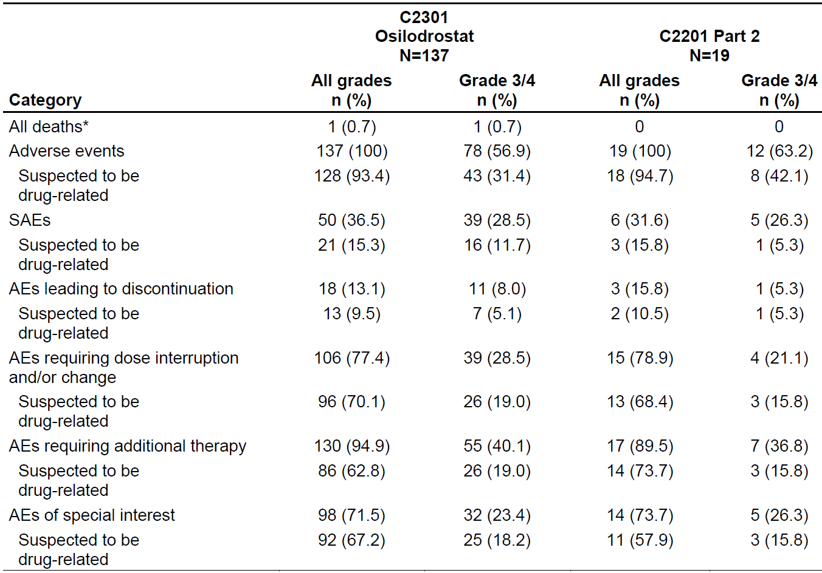
Abbreviations: AE = adverse events; N = number of subjects; n = number of subjects in subgroups; SAE = serious adverse events.
Categories are not mutually exclusive. Patients with multiple events in the same category are counted only once in that category. Patients with events in more than one category are counted once in each of those categories.
* All deaths occurring up to 28 days after end of study treatment.
Medical Dictionary for Regulatory Activities (MedDRA) version 20.1, Common Terminology Criteria for Adverse Events (CTCAE) version 4.0 (Study C2201) and 4.03 (Study C2301).
Study C2201 data cut-off date: 14 November 2017; Study C2301 data cut-off date: 21 February 2018.

Common adverse events

Adverse events by System Organ Class
All subjects (100%) included in the studies experienced at least one AE. In the pivotal study (Study C2301) and the supportive Study C2201 Part II AEs were most commonly reported within the System Organ Classes (SOCs) gastrointestinal disorders (67% and 68% respectively), infections and infestations (67% and 74%, respectively) and general disorders and administration site conditions (65% and 79%, respectively). The reported SOC pattern in Study C1201 and Study C2201 Part I were in line with the most common SOCs reported in the safety set of subjects with Cushing’s syndrome (Study C2301 and Study C2201 Part II).
Adverse events (AEs) by SOC regardless of study drug relationship (Study C2301) were similar in the updated safety data set (cut-off date15 October 2019) as to those reported in the primary analysis with regard to the nature, severity and frequency of event.
Table 11: Study C2301 and Study C2201 Part II Adverse events regardless of study drug relationship by System Organ Class and Grade (severity) (safety set)
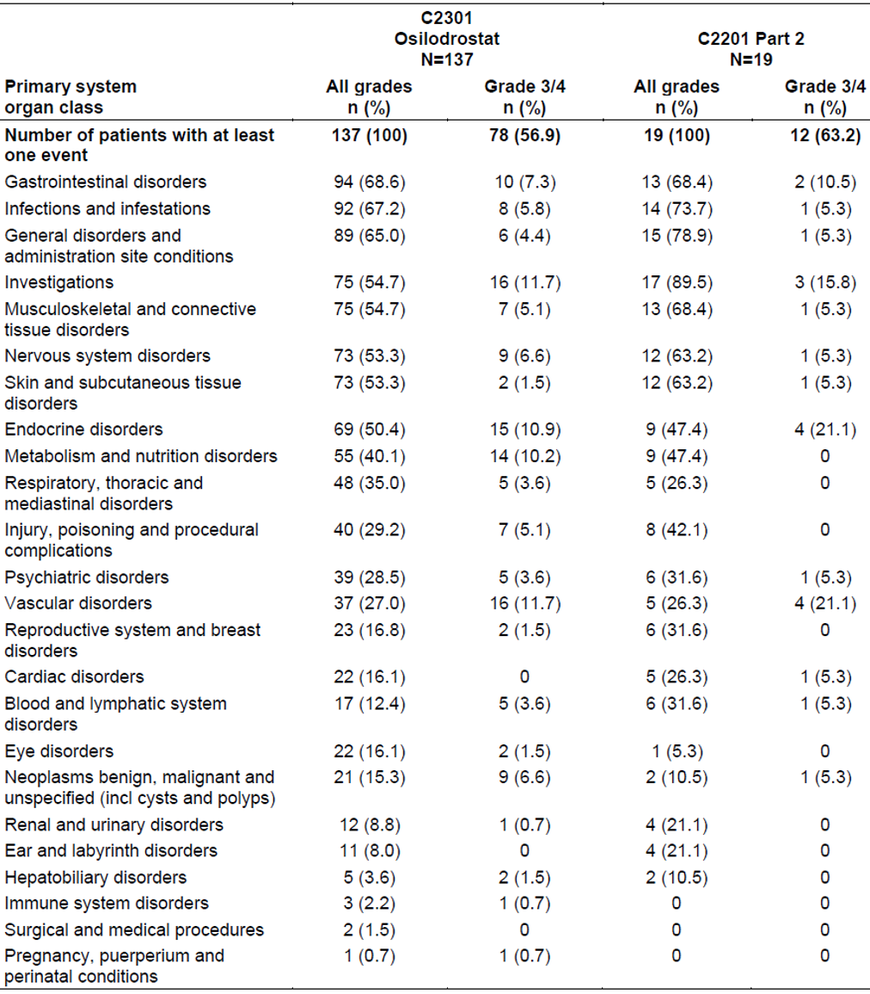
Abbreviations: N = number of subjects; n = number of subjects in subgroups.
System Organ classes (SOCs) are sorted in descending frequency, as reported in the all grades total column.
A patient with multiple severity grades for a SOC is only counted under the maximum grade.
For Study C2301, any events experienced by patient randomised to placebo while on placebo are not included in this analysis.
Medical Dictionary for Regulatory Activities (MedDRA)²⁰ version 20.1, Common Terminology Criteria for Adverse Events (CTCAE) version 4.0 (Study C2201) and 4.03 (Study C2301).
Study C2201 data cut-off date: 14 November 2017; Study C2301 data cut-off date: 21 February 2018.

Adverse events over time
The AE profile over time derived from each of the three observation periods in the core phase (Weeks 1 to 12, Weeks 12 to 26 and > 26 weeks). There was no trend of increasing AEs over time as treatment with osilodrostat proceeded. However, it must be noted that the observation periods have varied duration in the different studies (12 weeks, 14 weeks, and up to approximately 3 years, respectively).

Common adverse events by Preferred Term
The overall most common AE was nausea experienced in 41%-58% among all studies. Headache and fatigue were also frequently reported both in Study C2301 (34% and 28%) and Part II of Study C2201 (42% and 26%). Adrenal insufficiency was reported in 28 to 32% of the subjects. In Study C2201 Part II, high blood corticotrophin levels were reported in 8 of 19 (42%) of the patients. As discussed by the sponsor the frequencies of individual AEs differ, sometimes a lot, between the two studies included in the safety set (Study C2301 and Study C201 Part II). However, this could most probably be explained by the different duration of exposure between the two studies and the low number of subjects in Study C2201.
The AE profile in the placebo group during the randomised withdrawal phase in Study C2301 demonstrates a slightly higher incidence of AEs for subjects in the osilodrostat group (72%) compared to the placebo group (66%). The most conspicuous differences between the two groups are a higher frequency of subjects reporting nausea in the osilodrostat treatment group (n = 4/36) compared to the placebo group (n = 0). An imbalance was also noted for arthralgia and headache with 3 cases reported in the osilodrostat group compared to none in the placebo group.
Adverse events reported in the safety update (Study C2301) with cut-off date 15 October 2018 were similar to those reported in the primary analysis with regard to the nature, severity and frequency of events.
Table 12: Study C2301 and Study C2201 Part II Adverse events regardless of study drug relationship by Preferred Term and Grade (severity) in at least 15% patients in any study (safety set)
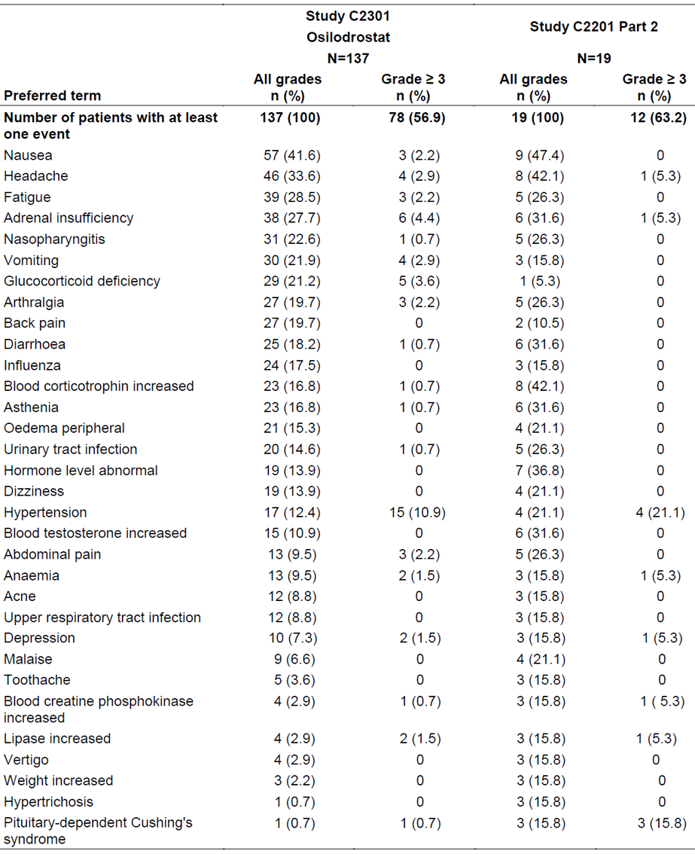
Abbreviations: N = number of subjects; n = number of subjects in subgroups.
Preferred Terms are sorted in descending frequency in the all grades column in Study C2301.
A patient with multiple severity grades for an adverse event is only counted under the maximum grade.
For Study C2301, any event experienced by patients randomised to placebo while on placebo are not included in this analysis.
Medical Dictionary for Regulatory Activities (MedDRA)²⁰ version 20.1, Common Terminology Criteria for Adverse Events (CTCAE) version 4.0 (Study C2201) and 4.03 (Study C2301).

Common adverse events with osilodrostat in other indications (hypertension)
Osilodrostat was previously studied in patients with hypertension. The clinical studies in this indication used low doses (0.25 mg/day to 2 mg/per day) for shorter durations (4 to 8 weeks). Overall, besides in general lower frequencies of reported AEs, no new safety finding has been identified regarding the AE profile when comparing treatment with low dose osilodrostat in subjects with hypertension with higher doses in the subjects with endogenous Cushing syndrome.
Table 13: Studies A2201, A2216 and C2301 Summary of adverse events regardless of study drug relationship by System Organ Class (safety set)
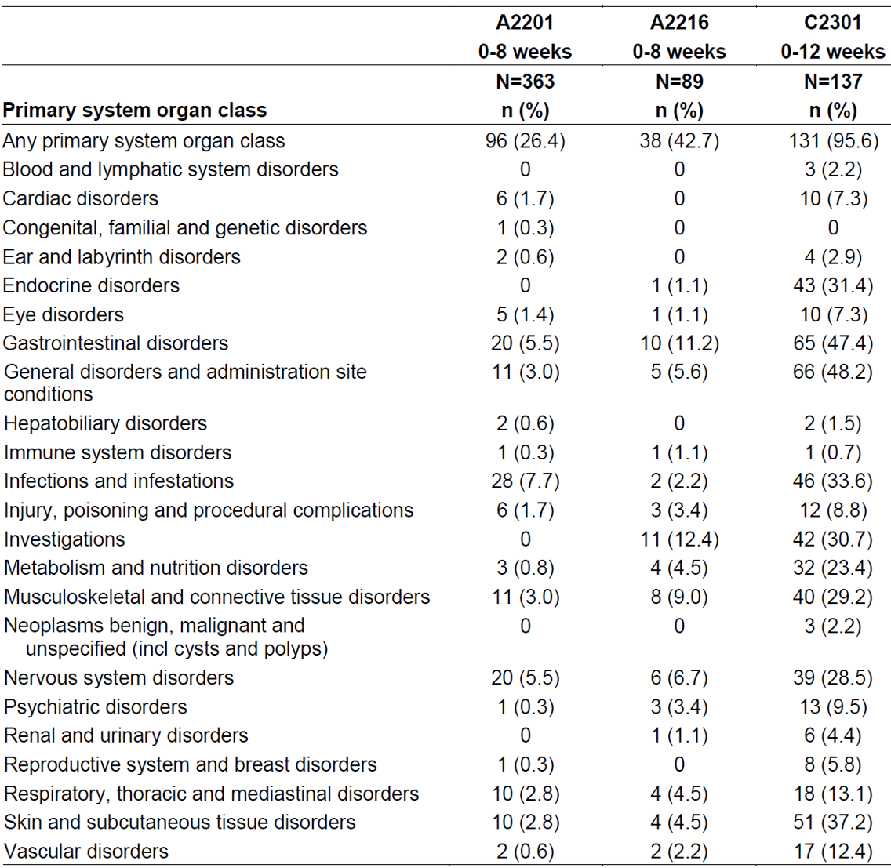
Abbreviations: N = number of subjects; n = number of subjects in subgroups.
System Organ Classes are sorted in alphabetical order.

Adverse events suspected to be drug-related
Overall, 93 to 95% of the subjects in Study C2301 and Study C2201 Part II (in Cushing’s syndrome) experienced at least one AE that was judged as related to study drug by the investigators. Of these, 30 to 40% were either Grade 3 or 4 AEs. The most common Preferred Terms (PTs) judged as related to study drug was adrenal insufficiency and nausea (37 of 137 (27%) and 6 of 16 (32%) in Study C2301 and Study C2291 respectively) and fatigue (29 of 137 (21%) and 4 of 19 (21%)).

Adverse events leading to dose interruption or adjustment
Overall, most subjects (78%) in the pivotal study (Study C2301) experienced at least one AE that led to a dose interruption or adjustment. Most commonly (> 6% of patients) reported AEs requiring dose adjustment of interruption regardless of study drug relationship were adrenal insufficiency (25%), glucocorticoid deficiency (18%), nausea (15%), fatigue (12%) and asthenia (9.5%).

Adverse events of special interest
The adverse events of special interest (AESI) considered for osilodrostat are:
- hypocortisolism-related AEs,
- adrenal hormone precursor accumulation-related AEs,
- pituitary tumour enlargement-related AEs,
- QT prolongation-related AEs,
- arrhythmogenic potential AEs.
Table 14: Study C2301 Adverse events of special interest, regardless of study drug relationship by group name, severity and randomised treatment group up to data cut-off date
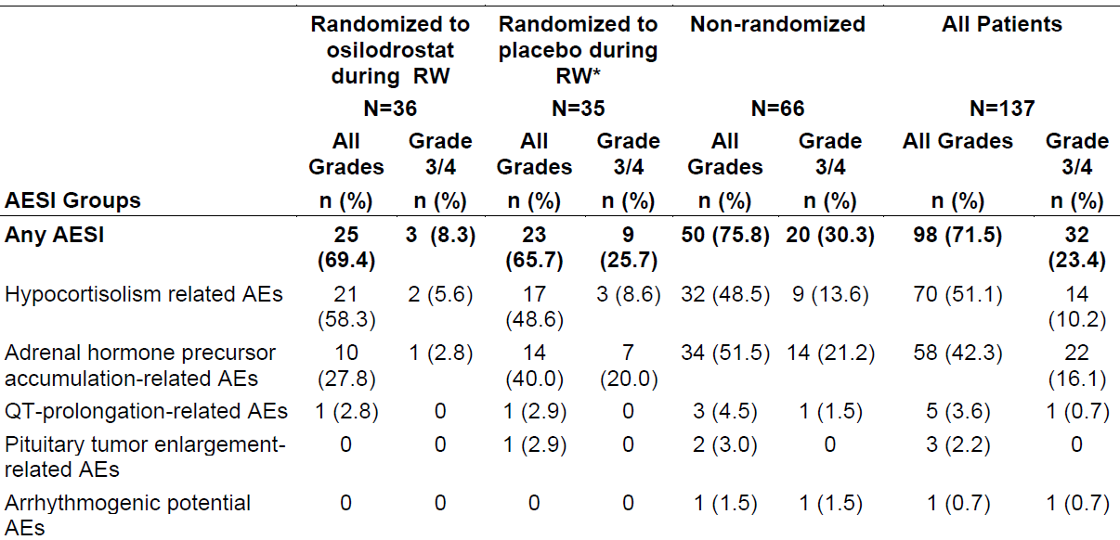
Abbreviations: AE = adverse event; N = number of subjects; n = number of subjects in subgroups.
A patient with multiple occurrences of an AE under one treatment is counted only once for that treatment.
* For patients receiving placebo during the randomised withdrawal period and excluding data while on placebo.
Table 15: Study C2201 Part II Adverse events of special interest regardless of study drug relationship by category and maximum Common Terminology Criteria grade, up to data cut-off date (safety analysis set)
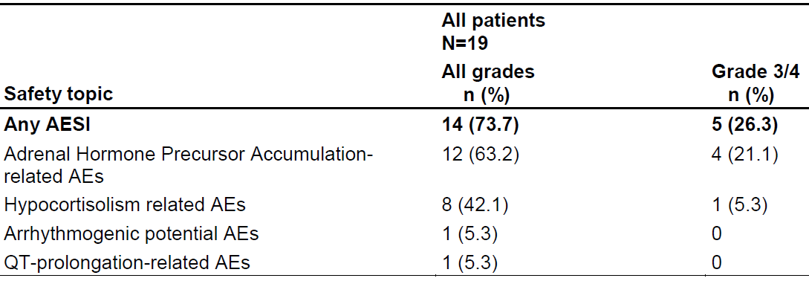
Abbreviations: AE = adverse event; AESI = adverse events of special interest; N = number of subjects; n = number of subjects in subgroups.
A patient with multiple severity grades for an adverse event is only counted under the maximum grade.
Medical Dictionary for Regulatory Activities (MedDRA)²⁰ version 20.1, Common Terminology Criteria for Adverse Events (CTCAE) version 4, Case Retrieval Strategy version released 12 November 2017.
Data cut-off date: 14 November 2017.

Serious adverse events and deaths

Death
Within all studies, one death (suicide) was reported (Study C2301). The patient, a 55-year-old female, committed suicide during the extension period on Day 551. The patient’s active medical conditions included depression of Grade 2 severity, since 2010. It is agreed with the sponsor that most probably the fatal case was due to a medical history of depression. However, a worsening of symptoms related to depression while on treatment could not be excluded.
In total, events of depression were reported in 10 cases (7.3%) of the subjects in Study C2301 and 3 subjects (16%) in Study C2201. In total, one event of depression was reported as serious.
In the safety update (cut-off date 15 October 2018) no additional deaths occurred until the database lock for the safety update, but one additional death was reported after the database lock (fatal viral gastroenteritis and cardiopulmonary failure; assessed as not related to study drug by the investigator).

Other serious adverse events
In the studies performed in subjects with Cushing disease (Study C2301 and Study C2201 Part II) approximately one third of the subjects experienced a serious adverse event (SAE), 36% (50 of 137) in Study C2301 and 32% (6 of 19) in Study C2201 Part II.
In Study C2301, the most common SAEs were adrenal insufficiency or adrenocortical insufficiency acute (11 of 50 cases; 22%) and pituitary tumour or pituitary tumour benign (7 of 50 cases; 14%) respectively. In the safety update, with cut-off date 15 October 2018, there are 2 additional patients with the first occurrence of a SAE after the primary clinical study report cut-off date, 7 other patients also reported a SAE but had already reported another one in the primary analysis period. Thus, the number of patients that reported a SAE has increased from 50 to 52, and the number of those in whom they were considered drug-related has increased from 21 to 22.
The nature and frequency of SAEs in the safety update with cut-off date 15 October 2018, was similar to those reported in the primary clinical study report.
Table 16: Study C2301 and Study C2201 Part II Serious adverse events regardless of study drug relationship by Preferred Term and severity in at least 2 patients in any study (safety set)
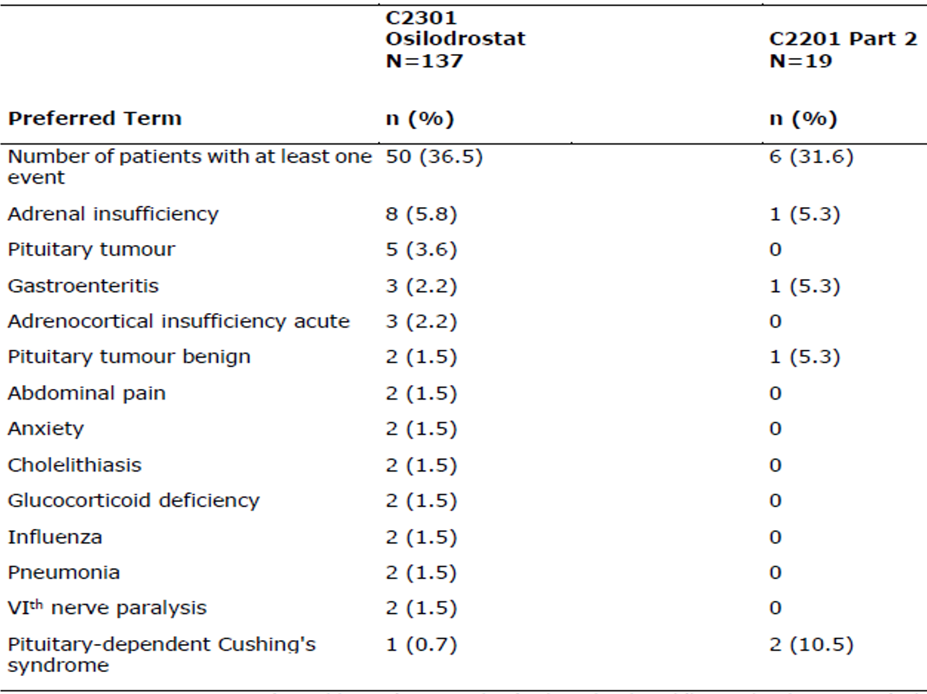
Abbreviations: N = number of subjects; n = number of subjects in subgroups.
Preferred terms are sorted in descending frequency, as reported in the all grades column for Study C2301.
A patient with multiple severity grades for an adverse event is only counted under the maximum grade.
For Study C2301, any events experienced by patients randomised to placebo while on placebo are not included in this analysis.
Medical Dictionary for Regulatory Activities (MedDRA)²⁰ version 20.1, Common Terminology Criteria for Adverse Events (CTCAE) version 4.0 (Study C2201) and 4.03 (Study C2301).
Study C2201 data cut-off date: 14 November 2017; Study 2301 data cut-off date: 21 February 2018.

Laboratory findings
Abnormal laboratory values are summarised for hematology and clinical chemistry parameters, as well as for hormones of interest related to the disease.

Haematology
At the time of the data cut-off date, no patients had newly occurring Grade 4 haematology abnormalities or worsening haematology abnormalities to Grade 4. Newly occurring or worsening to Grade 3 haematology abnormalities were infrequent and were reported for haemoglobin decrease and absolute neutrophils decrease (in 3 patients, for each) and leucocyte increase and platelets decrease (in one patient, each).

Haemoglobin decreases
Anaemia or haemoglobin decreased is a known effect of related to the intended normalisation of chronic cortisol excess, has been documented with other therapies (including surgical treatment), and is not considered a direct toxic effect of the drug.
In total, a decrease in haemoglobin (Common Terminology Criteria Grade 1 to 3) was reported in 38% of the patients in the pivotal study (Study C2301). including three cases of newly occurring or worsening to Grade 3 The mean haemoglobin value slightly decreased over time (137 ± 18.03 g/L at Baseline compared to 132.2 ± 16.68 g/L after 12 weeks, 129.5 ± 17.39g/L after 26 weeks and 133.0 ± 16.94 g/L after 44 weeks).
In parallel, anaemia or iron deficiency anaemia or haemoglobin decreased was reported as an AE in 18 of 137 (13%) patients in Study C2301 as of 15 October 2018, in 5 of 19 (26%) patients in Study C2201 (as of 14 November 2017), and one patient in Study C1201. Across the 4 hypertension studies, there was a single case of non-serious ‘mild anaemia’ reported. Most of the relevant cases reported with anaemia had confounding factors of which several were present already at Baseline.
Normalisation of chronic cortisol excess in subjects with Cushing’s syndrome is associated with a decrease haemoglobin, that the mean haemoglobin value in Study C2301 had a modest decreased over time and that a substantial amount of the cases with anaemia were confounded.

Neutrophil decrease
Treatment with osilodrostat can potentially be associated with neutropenia which is considered to be an indirect effect of cortisol reduction, regardless of the treatment. In Study C2301, a Grade 3 absolute neutrophils decrease was noted in 3 subjects (including one SAE). In addition, Grade 1 to 2 decreased was noted in 15 of 137 subjects (11%). In the cases observed, neutropenia rapidly was reversed with interruption of osilodrostat, and reversed when osilodrostat was continued, typically with decreasing doses. According to information in the summary of clinical safety, osilodrostat was dos adjusted, interrupt or discontinued due to AEs of the PT neutrophil decrease. It is, in clinical practice, of importance to consider that a decrease of neutrophils is a ‘natural’ reaction to treatment reducing cortisol levels and that a decrease in neutrophils per see not should lead to a reduced dose or interruption of osilodrostat unless there is a risk for an associated AE or SAE.

Basophile increase
The sponsor describes that relatively high mean changes were observed for basophils with a highest mean change from Baseline of 130%. An explanation given by the sponsor is that this phenomenon may be due to an ‘immune rebound’ often seen after disease remission in Cushing syndrome.

Clinical chemistry
Overall, biochemistry laboratory values including the pattern of newly occurring or worsening abnormalities in Study C2201 Part II were in line with the results in Study C2301 and did not warrant any further safety issues.
In Study C2301 newly occurring or worsening biochemistry abnormalities to Grade 3 or 4 were reported as below.

Hypokalaemia
Hypokalaemia is a comorbidity of Cushing disease but also considered as adrenal hormone precursor accumulation potentially related AEs.
In total low potassium values were reported in 32 of 137(23%) of which 9 reported newly occurring or worsening abnormalities Grade 3 (8 subjects) or 4 (one subject).

Hyperkalaemia
Hyperkalaemia could be a direct effect of osilodrostat due to accumulation of mineralocorticoid precursors and is included as a symptom of hypocortisolism.
Hyperkalaemia was reported in total in 16 of 137(12%) of the subjects of which 3 reported newly occurring or worsening abnormalities Grade 3. In total, three AEs (all non-serious) of hyperkalaemia were reported in Study C2301 and one in Study C2201. Three of the four patients were taking concomitant spironolactone, with additional antihypertensive agents throughout the study, the fourth patient had a first episode after more than 2 years of osilodrostat. The cases were all resolved without any action taken with osilodrostat. Thus, even if a potential causal relationship could be present with osilodrostat and hyperkalaemia this safety concern which is mentioned adequately in the PI.

Triglycerides increase
Hyperlipidaemia is a known co-morbidity for Cushing disease. ‘Triglycerides increase’ was reported in total 52 of 137 (38%) of the subjects of which 4 reported newly occurring or worsening abnormalities Grade 3.

Hypermagnesemia
Overall, laboratory values (Grade 1 to 3) reported in total in 18 of 137 (13%) of the subjects. Grade 3 hypermagnesemia laboratory elevations (> 3.0 to 8.0 mg/dL; > 1.23 to 3.30 mmol/L) was noted in four subjects. The values were resolved at the next evaluation with no dose adjustments and none of the elevations were temporarily associated with hypokalaemia or AEs of neuromuscular or conduction system abnormalities.

Hypomagnesemia
Hypomagnesemia was reported in total in 2 of 137 subjects (1.4%) of which one reported newly occurring or worsening abnormalities Grade 3.

Hyperphosphatemia
Hyperphosphatemia was reported in total in 12 of 137 (8.7%) of the subjects of which four were reported newly occurring or worsening abnormalities Grade 3. Only one of these four subjects presented repeated Grade 3 values without any increase at Baseline. The remaining subjects had occasional Grade 3 values or an increased level at Baseline. No AE was reported in association with the increased values.

Activated partial prothrombin time
Prolonged activated partial prothrombin time was reported in total in 35 of 137 (25%) of which one reported a newly occurring or worsening abnormalities Grade 3 (without any associated AEs).

Creatine kinase increase
In Study C2301, increased creatine phosphokinase (CPK) was reported in total in 32 of 137 (23%) of subjects of which one reported newly occurring or worsening abnormalities Grade 3 (a single value) and one Grade 4 (increased also at Baseline). In total, seven cases with (non-serious) AEs of ‘increased CPK’ was reported in Studies C2301 and C2201. The sponsor states that no clear evidence of a causal relationship between osilodrostat (4 of 7 subjects with AEs had confounding factors) and increase in CPK.

Hyperglycaemia and haemoglobin A1c
Impaired glucose intolerance is a known co-morbidity for Cushing disease and at Baseline 22% (30 of 137) of the subjects in Study C2301, presented with a medical history related to increased fasting blood glucose. In total 26 subjects (19%) of the 137 included subjects reported a newly or worsening increase in fasting blood glucose compared to Baseline and of these 22 were confounded by disease with a medical history of for example diabetes mellitus, hyperglycaemia, or diabetes insipidus. The four remaining cases (classified as mild in severity) had a body mass index > 25 < 30 kg/m².increased fasting glucose was reported in 21 of 137 (23%) of subjects of which one was reported as newly occurring or worsening abnormalities Grade 3.
It is noted that a shift to a worsening in haemoglobin A1c (HbA1c) (divided by HbA1c groups) from Baseline to last post-baseline value during the first 26 weeks was reported in 9 of 137 subjects (6.5%). An HbA1c improvement on the other hand was reported in 36 of 137 (26%) of the subjects.

Uric acid
In Study C2301 increase in uric acid from Baseline was noted in 20% (n = 28) of the subjects of which 13 of 137 (9.5%) reported newly occurring or worsening abnormalities Grade 4. The increase included 5 related AEs. No AEs of gout was reported. Confounding factors was present in 12 of the 13 subjects with a Grade 4 uric acid increase. The sponsor claim that that there was no dose relationship between use of osilodrostat and the increase of uric acid and that the cases appeared without any pattern after initiation of osilodrostat. It is not possible to determine if the increase in uric acid in is related to the underlying disease or a consequence related to initiation of treatment with osilodrostat. Most of the cases with potential clinically significant increases had confounding factors.

Liver chemistry
In the pivotal study the overall number of patients with elevations of liver chemistry tests (that is, alanine aminotransferase (ALT) or aspartate aminotransferase (AST) > ULN but ≤ 3.0 x ULN) during the up to data cut-off was 47 of 137 (34%). Most liver abnormal parameters occurred during the dose titration period. The number of patients with ALT or AST > ULN but ≤ 3.0 x ULN during the first 26 weeks was 35 of 137 (25.5%) and in 5 of 137 (13%) during the randomisation withdrawal phase (all five in the osilodrostat treatment group). Five subjects had an increase in AST and/or ALT above 3 x ULN. All these cases were confounded by disease or concomitant medication.
Overall, it is agreed that based on the data provided no clinically relevant relationship was observed between osilodrostat exposure and liver function test parameters.

Safety in special populations

Subjects with hepatic impairment
A single 30 mg osilodrostat dose was generally safe and well-tolerated in subjects with hepatic impairment and comparable in terms of safety to other populations exposed to osilodrostat (Study C2103). AEs occurred in approximately 27.3% of all subjects and were mostly mild or moderate in severity. AEs were not grouped to a particular PT with each PT being reported in one subject only.
There were no significant changes in mean values of haematocrits, haemoglobin, platelet count, red blood cell and haematological parameters from Baseline until end of study. All electrocardiogram findings were reported as not clinically relevant.

Subjects with renal impairment
A single 30 mg osilodrostat dose was generally safe and well tolerated in subjects with renal impairment and comparable in terms of safety to other populations exposed to osilodrostat (Study C2104). AEs occurred in approximately 26.7% of all subjects and were mild in severity (all AEs were reported as Grade 1). No SAEs and no deaths were reported. Except for blood creatinine increased AE which was reported in two subjects each PT was reported in one subject only. No clinically meaningful changes in hematology, clinical chemistry, vital signs, and electrocardiogram from Baseline were noted in any subjects.

Safety related to drug-drug interactions and other interactions

Oral contraceptives
No clinically significant drug-drug interaction was observed when oral contraceptives (containing ethinyl estradiol and levonorgestrel) was co-administered with osilodrostat (40 mg for 12 days) in 24 healthy female subjects receiving cortisol replacement therapy (Study C2108), suggesting that oral contraceptives can be co-administered with osilodrostat and provide adequate contraception.

Cytochrome P450 enzymes
Osilodrostat is a moderate inhibitor of CYP1A2, a weak to moderate inhibitor of CYP2C19, and a weak inhibitor of CYP2D6 and CYP3A4/5 at a single dose of 50 mg. Co-administration of osilodrostat was studied (Study C2102) and resulted in:
- a 2.54-fold increase in exposure of caffeine (a CYP1A2 substrate); there was no change in the rate of absorption of caffeine,
- a 1.86-fold increase in exposure of omeprazole (a CYP2C19 substrate),
- a 1.54-fold increase in exposure (area under the plasma concentration time curve from time zero to infinity) of dextromethorphan (a CYP2D6 substrate),
- a 1.50-fold increase in exposure of midazolam (a CYP3A4/5 substrate).

Discontinuation due to adverse events
Discontinuations of study drug due to AEs were reported in 18 of 137 (13%) in Study C2301 and 3 of 19 (16%) in Study C2201 Part II. As for AEs leading to dose interruption or adjustment, the most common PT reported was adrenal insufficiency (n = 4 in Study C2301). Besides this PT and pituitary tumour or pituitary tumour benign, no PT was reported in more than one subject.
Three additional discontinuations because of AEs were grouped in the ‘patient withdrawals’ instead of in the ‘discontinuations for AEs’ reasons. Additionally, in the safety update, with cut-off date 15 October 2018, the number of patients with discontinuations due to AEs has increased from 18 to 24 patients, so in total there were 27.

Use in pregnancy
One patient had an unintended pregnancy AE on Day 326 in Study C2301. The patient requested and had an induced abortion for social reasons on Day 367 and no fetal abnormality was reported. Another patient in Study C2108 had a positive pregnancy test, although pregnancy was unconfirmed by ultrasound scan.
Based on findings from animal studies and on its mechanism of action, osilodrostat could cause fetal harm when administered to a pregnant woman. Females of reproductive potential should use effective contraception during treatment with osilodrostat. Osilodrostat should only be used during pregnancy if the expected benefit to the mother outweighs the potential risk to the fetus.

Risk management plan
The sponsor has submitted approved EU-risk management plan (RMP) version 1.1 (15 November 2019; data lock point (DLP) 21 February 2018) and Australia specific annex (ASA) version 1.1 (16 August 2021) in support of this application. At the second round of evaluation, the sponsor submitted EU-RMP version 1.2 (25 November 2021; DLP 8 July 2021) and ASA version 1.2 (20 January 2022). At the third round of evaluation, the sponsor submitted ASA version 1.3 (9 March 2022).
The current COR-B evaluation is supported by a complete set of unredacted EMA assessment reports, as a similar submission for the same indication was considered under the EU’s-Centralised Procedure. The focus of the current assessment is ensuring the RMP-ASA is appropriate for the healthcare setting of use in Australia. At the second round of evaluation, the sponsor also provided the final Committee for Medicinal Products for Human Use (CHMP) assessment report.
The summary of safety concerns and their associated risk monitoring and mitigation strategies are summarised in Table 17. Further information regarding the TGA’s risk management approach can be found in risk management plans for medicines and biologicals and the TGA's risk management approach.
Table 17: Summary of safety concerns
Summary of safety concerns |  | Pharmacovigilance |  | Risk Minimisation
 |  | Routine | Additional | Routine | Additional
Important identified risks | Hypocortisolism | ¹ |  |  | -
Important identified risks | QT prolongation | ¹ |  |  | -
Important potential risks | Reproductive toxicity/Embryofetal development | ¹ | - |  | -
Missing information | Breast-feeding women |  | - |  | -
Missing information | Long-term safety (including hypocortisolism, cardiovascular safety and QT prolongation, hormones of the hypothalamus pituitary adrenal axis including adrenocorticotropic hormone increase, and clinical consequences of increased sexual hormones) |  | ² | - | -
Missing information | Use in non-Cushing disease Cushing syndrome patients including long-term effects |  | - | - | -
¹ Adverse-event follow-up checklist
² Ongoing clinical trial Study CLCI699C2X01B and planned registry Study LCI699-RECAG-PASS-0572
- The summary of safety concerns in EU-RMP and ASA are the same. There are no Australia-specific safety concerns, additional to those in the EU-RMP. The summary of safety concerns is acceptable.
- Routine pharmacovigilance activities are proposed for all safety concerns. Pharmacovigilance data collection based upon use of AE follow-up checklist for all important risks will be in place as an enhanced routine activity. There is an ongoing clinical trial study to address long-term safety risks, including hypocortisolism and QT prolongation risks. There is a planned multinational registry study to investigate long-term safety of osilodrostat under normal clinical practice conditions. The RMP-ASA plan aligns with EU-RMP and is acceptable based on what is currently known on Istrurisa’s safety profile and the steroidogenesis inhibitor class of medicines.
- Only routine risk minimisation activities (prescription only medicine status, labelling, PI, Consumer Medicines Information (CMI)) are proposed for all safety concerns. The RMP-ASA plan aligns with EU-RMP and in generally considered appropriate for the Australian health setting and setting of use. Isturisa meets the criteria for inclusion in the Black Triangle Scheme. The sponsor has amended the PI and CMI to include the Black Triangle Scheme symbol and statement. At the third round of evaluation, the sponsor has revised the CMI as requested. The risk minimisation plan is acceptable.

Risk-benefit analysis

Delegate’s considerations

Efficacy
The mechanism of action has been adequately characterised in the development program. Since osilodrostat blocks the synthesis of cortisol, it is expected to be efficient in all forms of endogenous Cushing’s syndrome.
The pivotal Study C2301 met its primary and key secondary objectives and results demonstrate that osilodrostat is effective in rapidly achieving biochemical control of the Cushing’s disease. Responder rates in the Cushing’s disease population was high and clinically relevant with 52.6% of patients being complete responders at Week 24. This may be compared with data for pasireotide in a comparable study population where 26.3 % in the 900 μg twice daily group were responders at 6 months. The data from the randomised withdrawal phase of the study further support that the effect observed can be contributed to osilodrostat.
Mean urinary free cortisol (UFC) decrease to the normal range was fast and the mean UFC levels achieved normal levels around Week 8 in most patients and stabilised thereafter. The median time to the first normal mean UFC was 41 days. The high efficacy in reducing the biochemical parameters of hypercortisolism was maintained long term. Almost all patients treated with osilodrostat had mean UFC ≤ upper limit of normal (ULN) at least once at some stage during the study.
The reduction in mean UFC levels was accompanied by reductions in serum morning cortisol and late night salivary cortisol. The decrease in cortisol levels is accompanied by an improvement in key cardiovascular-related metabolic parameters associated with Cushing’s disease at Week 24 (fasting glucose, HbA1C, cholesterol, systolic blood pressure, diastolic blood pressure, weight, body mass index, and waist circumference). Improvement in clinical signs, symptoms of hypercortisolism, cardiovascular parameters, comorbidities (bone mineral density, depression and so on) and quality of life was demonstrated and was generally maintained throughout the study in the overall study population. A clinically meaningful improvement in depression was also seen with change in Beck Depression Inventory (BDI)-II scores; reaching minimal important difference values (> 17.5% reduction in scores from Baseline) at as early as Week 24.
The efficacy results were observed to be consistent in the supportive efficacy studies.
Osilodrostat effect on cortisol reduction is reversible, evidenced by the rapid increase in mean UFC upon discontinuation of osilodrostat treatment.
Furthermore, limited, the long-term data indicate that the effect is maintained up to 46 months. This is particularly importance as loss of efficacy (or ‘escape’) is frequently observed with currently available medical treatments.

Safety
Based on available data, and apart from hypocortisolism, the overall tolerability of osilodrostat appears satisfactory.
Osilodrostat has been studied in prospective clinical studies with over 1300 participants, over 1000 of whom received at least one dose of osilodrostat (including 137 patients with Cushing’s disease in the pivotal Phase III study) and for durations of over 5 years in some cases.
Demographic, disease, and other baseline characteristics were representative of the intended patient population and allow the resultant data to be extrapolated to patients with endogenous Cushing’s syndrome.
Osilodrostat was generally well tolerated, and no new or unexpected safety findings were reported.
Anticipated AESI based on the mechanism of action of osilodrostat, were generally managed with dose reduction or interruption and/or concomitant medication.
Hypocortisolism and precursor accumulation events were the most reported AESI:
- Hypocortisolism occurred mostly as a single episode during the up-titration period and was successfully managed by dose reduction or interruption with or without administration of glucocorticoid replacement therapy; may be explained in part by its high efficacy and the protocol-defined titration process.
- Hypokalaemia was infrequently reported and was managed with additional therapy.
- Worsening of hypertension occurred in few patients with pre-existing medical history of hypertension and was managed by modification of hypertensive therapy. At the same time, in the overall study population, a decrease in systolic blood pressure and diastolic blood pressure was reported at the end of the core period.
Median pituitary tumour volume remained stable during the core period in patients with measurable tumour at Baseline.
There were no clinically relevant changes from Baseline in mean QTcF or in other mean electrocardiogram intervals.
Liver enzyme elevations (> 3 x ULN) were infrequent, transient, reversed spontaneously or following dose adjustment and none led to treatment discontinuation. No Hy’s law cases occurred.
Study data in non-Cushing disease Cushing syndrome patients is still very limited but in combination with an acceptable mechanistic reasoning and a high unmet medical need currently results in a positive benefit-risk analysis. Safety in this population will be further studied in the post-authorisation safety study (PASS).
The risk for ‘objective’ events of hypocortisolism based on laboratory values and the frequency of these events including serious cases (like Addison crisis) in a real-life setting is uncertain. Hypocortisolism could lead to a fatal outcome if left untreated. The risk of hypocortisolism is considered manageable through careful titration, monitoring of cortisol levels and with osilodrostat dose decrease or interruption if necessary.
Osilodrostat has been shown to cause QT prolongation, although the overall incidence of clinically significant prolongations in the QT interval in the clinical studies was low and only one patient discontinued the study drug due to prolonged QT interval events (on electrocardiogram), while for 4 events osilodrostat was temporarily interrupted but re-initiated at the same or at reduced dose after which no new QT-related event was reported. The risk of QT prolongation is manageable through electrocardiogram and electrolyte monitoring, and cardiology consultation if QTc > 480 ms.
There are still some uncertainties of importance regarding the secondary pharmacology effects of osilodrostat, for example, effects on other hormones such as sex hormones. These effects together with the fact that osilodrostat has been shown to be teratogenic in nonclinical studies, has implications for the risk if osilodrostat is used in pregnancy. The Isturisa PI adequately addresses to mitigate the risk of negative effects on the fetus and the risk increased levels of testosterone. In addition, hormones of the hypothalamus-pituitary-adrenal axis including clinical consequences of increased sexual hormones will be followed up in the PASS. Overall, adrenocorticotropic hormone (ACTH) levels were increased and although mean levels show modest increases below the threshold of clinical concern, individual patients may have ACTH values that are above the ULN.

Proposed action
Overall, the pharmacokinetics of osilodrostat have been well described but data are missing following repeated dosing on major metabolites. The data on osilodrostat as a potential perpetrator with respect to drug-drug interactions are very limited. The mechanism of action and the primary pharmacology for osilodrostat have been adequately described and the primary pharmacology data are further supported by the clinical data. The secondary pharmacology and its implications for safety is adequately reflected in the PI.
The results efficacy results from the submitted data demonstrate that osilodrostat is effective in rapidly achieving biochemical control of the disease, which was associated with improvement in clinical signs, symptoms of hypercortisolism, cardiovascular parameters, comorbidities (bone mineral density, depression and so on) and quality of life The data from the pivotal study show that osilodrostat is efficient in lowering the mean UFC in patients with Cushing’s disease and that the effect is maintained up to at least 48 weeks without indications of ‘escape’ (that is, loss of treatment effect). The response rate of about 70% is considered clinically relevant. Secondary endpoints on cardiovascular-related metabolic parameters, physical features of hypercortisolism and bone mineral density indicate further beneficial effects of treatment. Limited long-term data indicate that the effect of osilodrostat can be maintained over time.
The small study in non-Cushing’s disease Cushing’s syndrome provide support for the adequacy of extrapolating efficacy data from patients with Cushing’s disease to patients with non-Cushing’s disease Cushing’s syndrome, taking the knowledge on the mechanism of action into account. Thus, the overall data support the use of osilodrostat in the proposed target population.
The population with Cushing’s disease has several co-morbidities and it can be challenging to distinguish these symptoms from AEs related to treatment. Adverse events were reported in almost all subjects and most reported were PTs related to gastrointestinal events. The most common reported events were nausea, fatigue, and headache.
Hypocortisolism-related AEs which were reported in high frequencies (51% in the pivotal study) especially during the titration phase. QT prolongations and AEs related to adrenal precursor accumulation were also reported. Notably, subjects with risk factors for QT prolongations including several cardiovascular diseases were excluded in the clinical trials. These two major safety concerns (hypocortisolism and QT prolongations) can be serious and potentially life-threatening, if not adequately managed. Specific monitoring and in some cases temporary dose reduction or interruption, or discontinuation of osilodrostat is required in these cases. Patients will be further followed up in a real-life post-marketing setting in the form of post-authorisation safety studies (PASS), also including a specific follow-up of hormones of the hypothalamus pituitary adrenal axis (including adrenocorticotropic hormone increase) and clinical consequences of increased sexual hormones. Use in non-Cushing’s disease Cushing’s syndrome subjects is limited and will also be further evaluated and followed in the PASS studies.
Based on the overall review of data on nonclinical, quality, safety and efficacy, the Delegate considers that the benefit-risk balance of Isturisa is favourable, and approval can be granted for the following indication:
Isturisa is indicated for the treatment of endogenous Cushing’s syndrome in adults.

Advisory Committee considerations
The Delegate did not refer this submission to the Advisory Committee on Medicines (ACM) for advice.

Outcome
Based on a review of quality, safety, and efficacy, the TGA approved the registration of Isturisa (Osilodrostat) 1 mg, 5 mg and 10 mg, film-coated tablet, blister pack, indicated for:
Isturisa is indicated for the treatment of endogenous Cushing’s syndrome in adults.

Specific conditions of registration applying to these goods
- Osilodrostat (Isturisa) is to be included in the Black Triangle Scheme. The PI and CMI for Isturisa must include the black triangle symbol and mandatory accompanying text for five years, which starts from the date that the sponsor notifies the TGA of supply of the product.
- The Isturisa EU-risk management plan (RMP) (version 1.2, dated 25 November 2021, data lock point 8 July 2021), with Australian specific annex (version 1.3, dated 9 March 2022), included with Submission PM-2021-02641-1-5, and any subsequent revisions, as agreed with the TGA will be implemented in Australia.
An obligatory component of risk management plans is routine pharmacovigilance. Routine pharmacovigilance includes the submission of periodic safety update reports (PSURs).
Reports are to be provided in line with the current published list of EU reference dates and frequency of submission of PSURs until the period covered by such reports is not less than three years from the date of the approval letter.
The reports are to at least meet the requirements for PSURs as described in the European Medicines Agency’s Guideline on Good Pharmacovigilance Practices (GVP) Module VII-periodic safety update report (Rev 1), Part VII.B Structures and processes. Note that submission of a PSUR does not constitute an application to vary the registration.
- The sponsor should submit the data from PASS study when available. This should be submitted as a new application.

Attachment 1. Product Information
The PI for Isturisa approved with the submission which is described in this AusPAR is at Attachment 1. For the most recent PI, please refer to the TGA PI/CMI search facility.

Therapeutic Goods Administration
PO Box 100 Woden ACT 2606 Australia
Email: info@tga.gov.au Phone: 1800 020 653 Fax: 02 6232 8605
https://www.tga.gov.au

Lacroix, A. et al. G-Protein Coupled Receptor Expression in Relation to Adrenocortical Overfunction, Clin Endocrinol. 2010; 73(1): 1-15.
Biller B. et al. Treatment of Adrenocorticotropin-Dependent Cushing’s Syndrome: a Consensus Statement, J Clin Endocrinol Metab, 2008; 93(7): 2454-2462.
Newell-Price, J. et al. Cushing’s Syndrome, Lancet, 2006; 367: 1605-1617.
Sharma, S.T. et al. Comorbidities in Cushing’s Disease, Pituitary, 2015; 18: 188-194.
Lindholm, J. et al. Incidence and Late Prognosis of Cushing’s Syndrome: a Population-Based Study, J Clin Endrocrinol Metab, 2001; 86:117-123.
Nieman, L.K.et al. The Diagnosis of Cushing's Syndrome: an Endocrine Society Clinical Practice Guideline, J Clin Endocrinol Metab, 2008; 93(5):1526-1540.
Signifor was first registered on the ARTG on 1 November 2013 (ARTG numbers: 201484, 201485 and 201486).
AusPAR for Signifor (pasireotide as diaspartate), new chemical entity, published on 2 June 2014. Available at: https://www.tga.gov.au/resources/auspar/auspar-pasireotide-diaspartate.
Cytochrome P450 (CYP) enzymes: CYPs are the major enzymes involved in drug metabolism, accounting for large part of the total metabolism. Most drugs undergo deactivation by CYPs, either directly or by facilitated excretion from the body. Also, many substances are bioactivated by CYPs to form their active compounds. Many drugs may increase or decrease the activity of various CYP isozymes either by inducing the biosynthesis of an isozyme (enzyme induction) or by directly inhibiting the activity of the CYP (enzyme inhibition). This is a major source of adverse drug interactions, since changes in CYP enzyme activity may affect the metabolism and clearance of various drugs. Such drug interactions are especially important to take into account when using drugs of vital importance to the patient, drugs with important side-effects and drugs with small therapeutic windows, but any drug may be subject to an altered plasma concentration due to altered drug metabolism.
The International Council for Harmonisation of Technical Requirements for Registration of Pharmaceuticals for Human Use (ICH) brings together regulatory authorities and the pharmaceutical industry. It makes recommendations towards achieving greater harmonisation in the interpretation and application of technical guidelines and requirements for pharmaceutical product registration.
European Medicine Agency (EMA), Committee for Proprietary Medicinal Products (CPMP), ICH Guideline M3(R2) on Nonclinical Safety Studies for the Conduct of Human Clinical Trials and Marketing Authorisation for Pharmaceuticals, EMA/CPMP/ICH/286/1995, December 2009.
Good Laboratory Practice is a code of standards following the International Council on Harmonisation (ICH) relevant to testing of medicines in laboratories during drug development.
Osilodrostat exhibits stereoisomerism due to the presence of one chiral centre. Only the R-enantiomer is found in Isturisa. The manufacturing process consistently produces a single isomer (the R-enantiomer), with enantiomeric purity controlled routinely by chiral high-performance liquid chromatography. LCI698 is the investigational drug code for the S-enantiomer of osilodrostat, not present in Isturisa (osilodrostat) film-coated tablets.
The QT interval is the time from the start of the QRS wave complex to the end of the corresponding T wave. It approximates to the time taken for ventricular depolarisation and repolarisation, that is to say, the period of ventricular systole from ventricular isovolumetric contraction to isovolumetric relaxation. The corrected QT interval (QTc) estimates the QT interval at a standard heart rate. This allows comparison of QT values over time at different heart rates and improves detection of patients at increased risk of arrhythmias. The QTcF is the QT interval corrected for heart rate according to Fridericia’s formula.
The Biopharmaceutics Classification System (BCS) is a guidance for predicting the intestinal drug absorption provided by the U.S. Food and Drug Administration. According to the BCS, drug substances are classified as follows: Class I: high permeability, high solubility; Class II: high permeability, low solubility; Class III: low permeability, high solubility; Class IV: low permeability, low solubility.
European Medicine Agency (EMA), Committee for Medicinal Products for Human Use (CHMP), Guideline on the Reporting of Physiologically Based Pharmacokinetic (PBPK) Modelling and Simulation, EMA/CHMP/458101/2016, 13 December 2018.
Torsade de pointes is an uncommon and distinctive form of polymorphic ventricular tachycardia characterised by a gradual change in the amplitude and twisting of the QRS complexes around the isoelectric line.
The randomised clinical trials analysed by the intention-to-treat (ITT) approach provide unbiased comparisons among the treatment groups. In the ITT population, none of the subjects are excluded, regardless of treatment compliance or attrition due to dropout or crossover, and the subjects are analysed according to the randomisation scheme.
The per-protocol (PP) analysis is restricted to the participants who strictly adhered to the protocol. Also known as ‘on-treatment’ analysis.
The Medical Dictionary for Regulatory Activities (MedDRA) is a single standardised international medical terminology, developed as a project of the International Council for Harmonisation of Technical Requirements for Pharmaceuticals for Human Use (ICH) which can be used for regulatory communication and evaluation of data pertaining to medicinal products for human use. As a result, MedDRA is designed for use in the registration, documentation and safety monitoring of medicinal products through all phases of the development cycle (that is, from clinical trials to post-marketing surveillance). Furthermore, MedDRA supports ICH electronic communication within the ICH’s Electronic Common Technical Document (eCTD) and the E2B Individual Case Safety Report.
Common Terminology Criteria (CTC) is a standardised classification of side effects used in assessing drugs for cancer therapy, in particular. Specific conditions and symptoms may have values or descriptive comment for each level, but the general guideline is 1 – Mild, 2 – Moderate, 3 – Severe, 4 - Life threatening, 5 - Death.
Haemoglobin A1c or glycated haemoglobin (HbA1c) is a minor component of haemoglobin chemically linked to glucose. Levels of HbA1c vary and are relative to the overall blood glucose concentration. Unlike a blood glucose concentration, levels of HbA1c are not influenced by daily fluctuations in the blood glucose concentration but reflect the average glucose levels over the prior 6 to 8 weeks. Measurement of HbA1c is used in the diagnosis of diabetes mellitus and is useful indicator of how well the blood glucose level has been controlled in the recent past and may be used to monitor the effects of diet, exercise, and drug therapy on blood glucose in patients with diabetes. In healthy people without diabetes, the HbA1c level is less than 7 percent of total haemoglobin.
The Beck Depression Inventory (BDI) is a 21-item self-administered survey and is scored on a scale of 0 to 3 in a list of four statements arranged in increasing severity about a particular symptom of depression. Each of the 21 items corresponding to a symptom of depression is summed to give a single score for the BDI-II. Total score of 0 to 13 is considered minimal range, 14 to 19 is mild, 20 to 28 is moderate, and 29 to 63 is severe.

