Post market review compliance dashboard
  - User guide for sponsors of medical devices
Version 1.2, March 2021

Copyright
© Commonwealth of Australia 2021
This work is copyright. You may reproduce the whole or part of this work in unaltered form for your own personal use or, if you are part of an organisation, for internal use within your organisation, but only if you or your organisation do not use the reproduction for any commercial purpose and retain this copyright notice and all disclaimer notices as part of that reproduction. Apart from rights to use as permitted by the Copyright Act 1968 or allowed by this copyright notice, all other rights are reserved and you are not allowed to reproduce the whole or any part of this work in any way (electronic or otherwise) without first being given specific written permission from the Commonwealth to do so. Requests and inquiries concerning reproduction and rights are to be sent to the TGA Copyright Officer, Therapeutic Goods Administration, PO Box 100, Woden ACT 2606 or emailed to <tga.copyright@tga.gov.au>.
The purpose of this guidance is to help sponsors and manufacturers understand the process in which the TGA expects sponsor and manufacturer to respond to notifications relating to post-market reviews of medical devices.
This is a guide only, and sponsors and manufacturers are encouraged to familiarise themselves with the legislative and regulatory requirements in Australia. If necessary, seek professional advice as it is the responsibility of each sponsor and/or manufacturer to understand and comply with these requirements.
This document will evolve over time and updates and clarifications will be included as required. Feedback on the guidance is always welcome.

Contents
Introduction 4
Role types 4
How to login to the PMR compliance dashboard 5
How to view your notifications 6
Preview your notification 6
Draft a response to your notification 8
How to respond to a notification 12
How to edit and add ARTGs and Model Details 13
How to provide evidence of compliance with requirements 36
How to respond to additional information request 39
How to submit the information 41
How to request for an extension 43
How to respond to a “Proposal to cancel” or “Proposal to suspend” 45

Introduction
This Post Market Review Compliance Dashboard User Guide provides step-by-step instructions on how to respond to a medical device post-market review notification from the Therapeutic Goods Administration (TGA) through the Post Market Review (PMR) compliance dashboard.
The dashboard is designed to allow sponsors to view any requests or notifications from the TGA, and to respond to them. Requests and notifications may include:
- requirement to provide information and documents;
- requirement to provide samples; and
- proposal to suspend or cancel entries from the Australian Register of Therapeutic Goods (ARTG).

Role types
In the PMR compliance environment, there are two role types:
- Drafter: The drafter can review, upload documents, and edit responses to a notification.
- Submitter: The submitter can review, upload documents, edit, and submit responses to a notification.
These roles have been designated by your TGA Business Services (TBS) administrator.

How to login to the PMR compliance dashboard
The PMR compliance dashboard is found within the TGA Business Services (TBS) website. Once you log-in with your sponsor user name and password, follow the instructions below:
Instructions
- Login to TBS; in the Applications section select Medical Device Post Market Compliance.
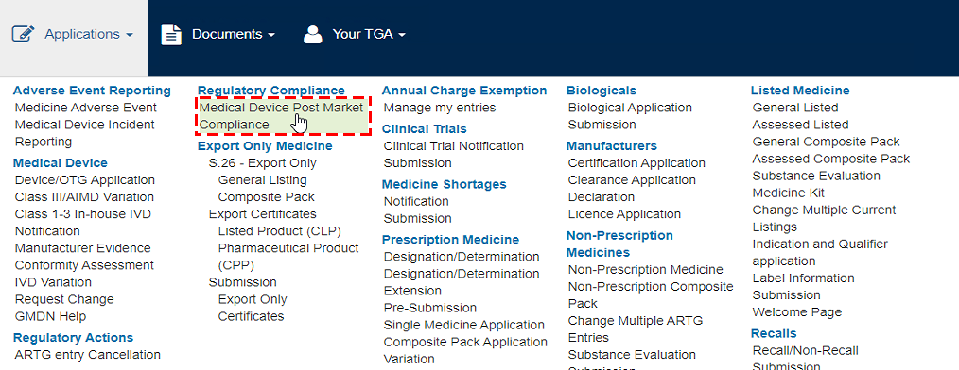
- You will be directed to the PMR Compliance Dashboard where the Request For Information (RFIs) will be displayed.
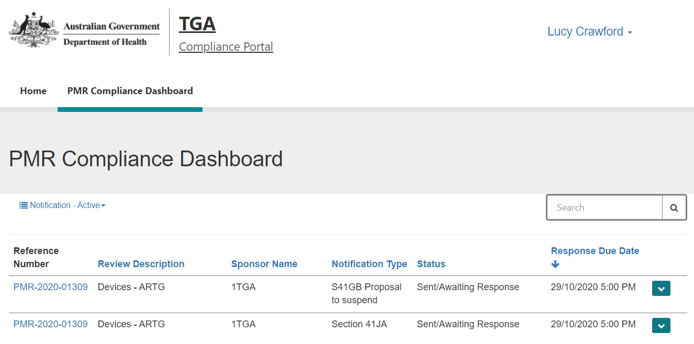

How to view your notifications
You can sort and view your notifications by the following status:
- Notification – Active: Select this option to view for notifications you need to review and submit a response to.
- Notification – All Notifications older than 32 days: Select this option to view notifications older than 32 days.
- Notification – Submitted: Select this option to view those notifications that a response has already been provided.
- Notification – View Action: Select this option to view notifications which provide information on actions being taken by the TGA.
- Notification – View Migrated Notifications: Select this option to view notifications which were sent from the TGA prior to the portal being deployed, but are currently in progress.
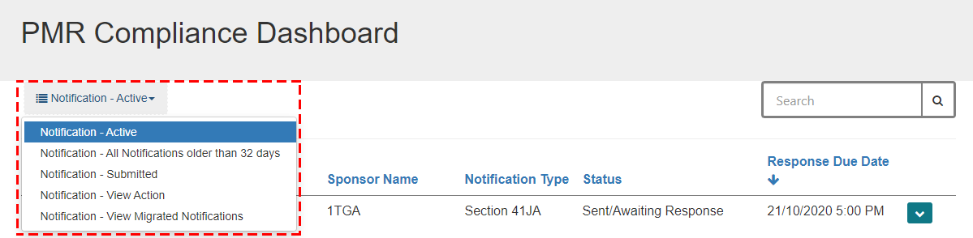
There are two ways you can view your notifications:
- Preview your notification
- Draft a response to your notification

Preview your notification
You can view your notification from the Preview screen. You cannot add a response from this view. Additionally, selecting View Details or the reference number will show a ‘read-only’ preview.
Instructions
- Click on the drop-down arrow and click on Preview.
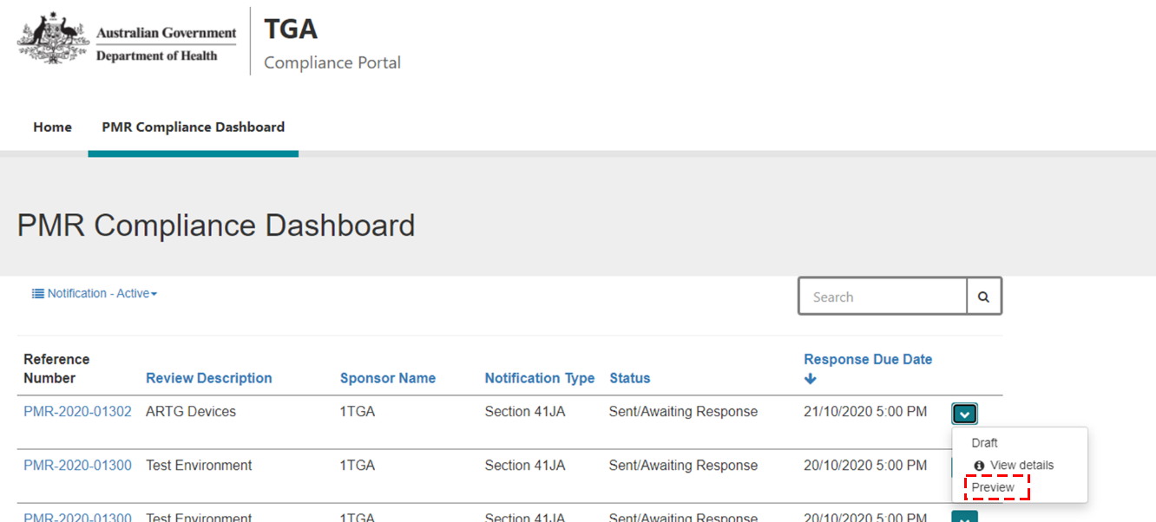
- On the PMR Notification Preview screen, you can view the details for the notification and you have the option to print a copy of the notification by clicking on the Print button.
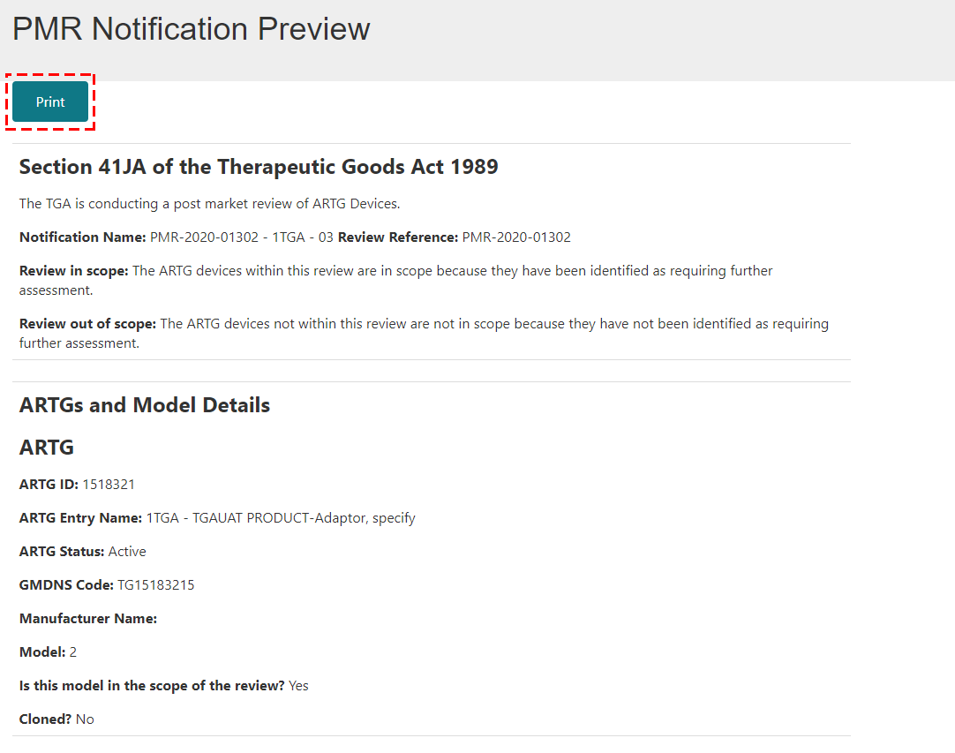
- Once you have viewed your notification, click on the back-browser button to go back to the PMR Compliance Dashboard.
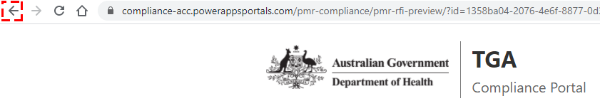

Draft a response to your notification

The second way you can view your notification is when you respond to a notification. This is the only view in which you can add a response.
Instructions
- Click on the drop-down arrow and click on Draft.
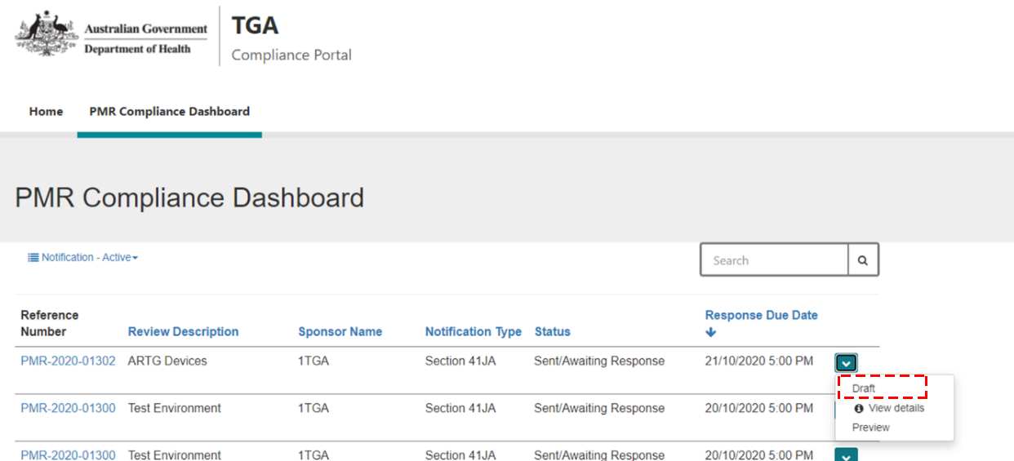
- In the Notification Details section, you can view the details for the notification.
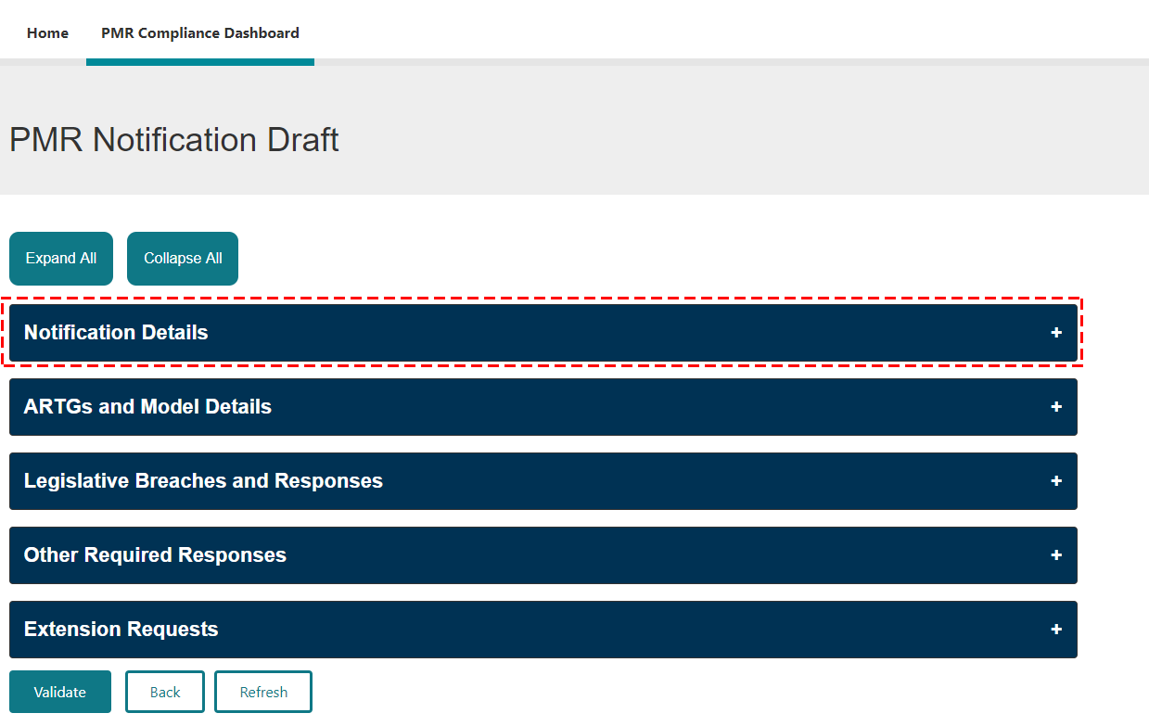
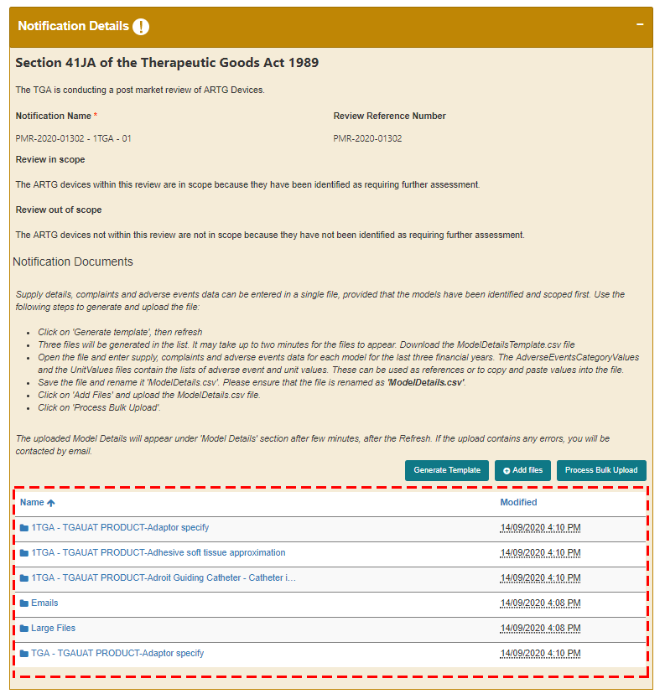

You can view all the document(s) associated to the notification and the list of folders that will hold the document(s) you uploaded as part of your submission.
- Click on the notification to download and open a copy of the letter. The notification will appear as a download at the bottom left of the screen.
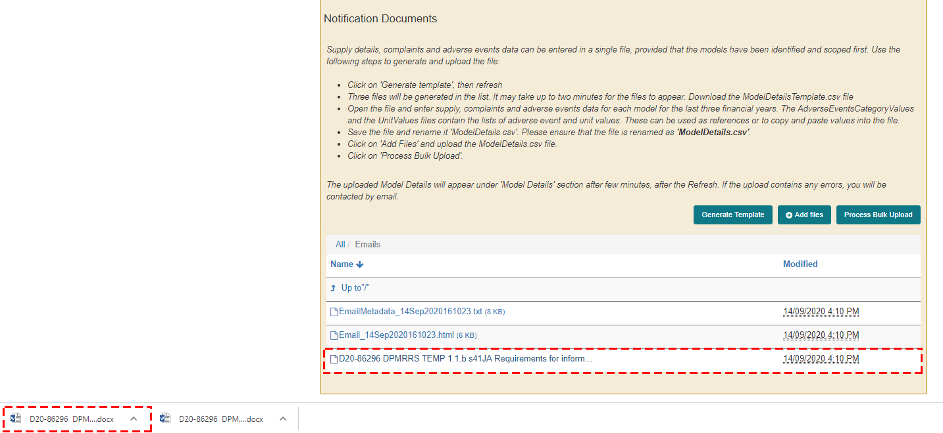

How to respond to a notification
Instructions
- Click on the drop down arrow and click on Draft.
Click on the Expand All button to expand all the sections or the + button to expand each section.
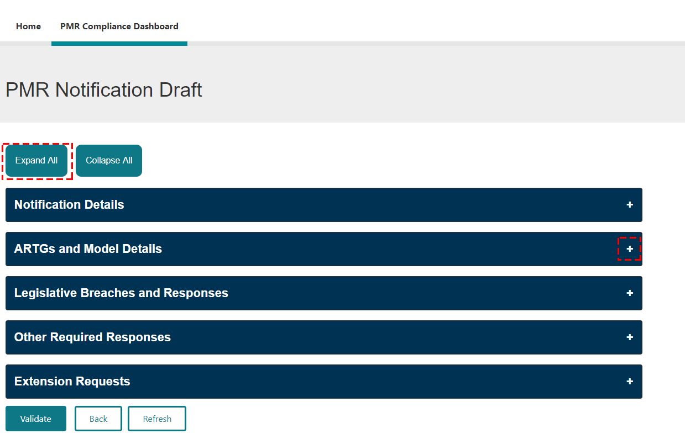

How to edit and add ARTGs and Model Details
In the ARTGs and Model Details section, you can view the Australian Register of Therapeutic Goods (ARTG) entries that have been included in the notification.
If this notification is an intial request for information (section 41JA or section 31 notification) you may add model details and additional ARTG entries that may be in scope of the post-market review.
Adding ARTG entries, model details, and supply information is only available when responding to initial requests for information. For all other notifications you can skip this section and go to the ‘How to provide evidence of compliance with requirements’ section.
Instructions
- Click on the + button in the ARTGs and Model Details section.
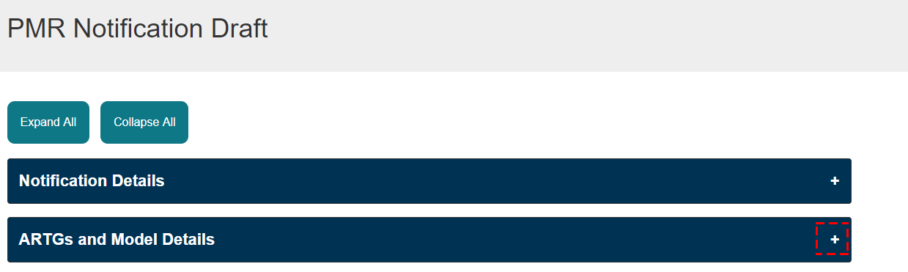
- If you are a sponsor of an ARTG entry that should be included in the post-market review, you can add an additional ARTG entry by clicking on Add ARTG.
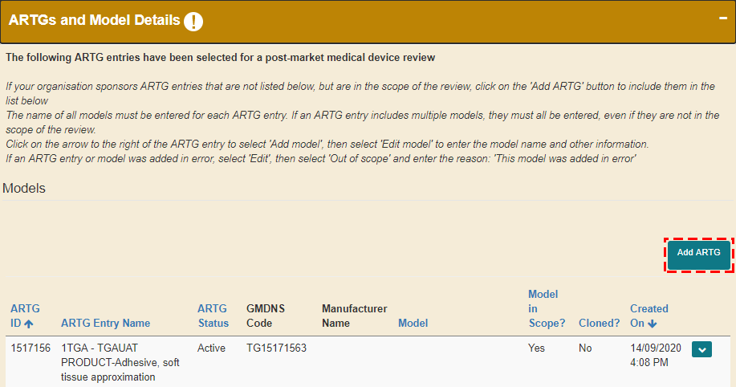
- Click on the search icon.
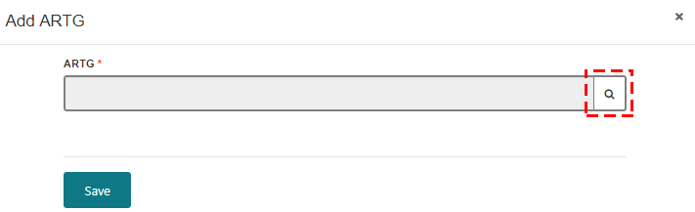
- A list of the ARTG entries associated with your sponsor log in (both active and revoked entries) will be available for you to select.
- Select the ARTG that is related to this post-market review.
- Click Select.
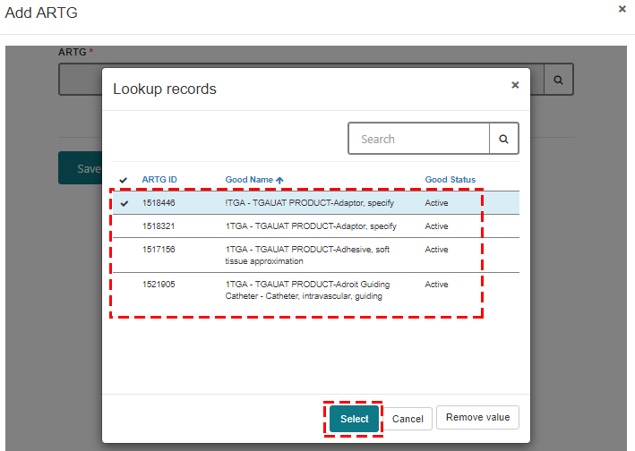
The list will only contain ARTG entries associated with your login.
- Click Save.
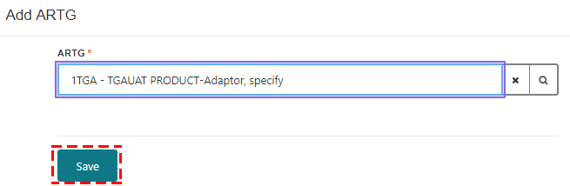
- To enter the model details and other information for your ARTG entry:
  - Click Edit Model.
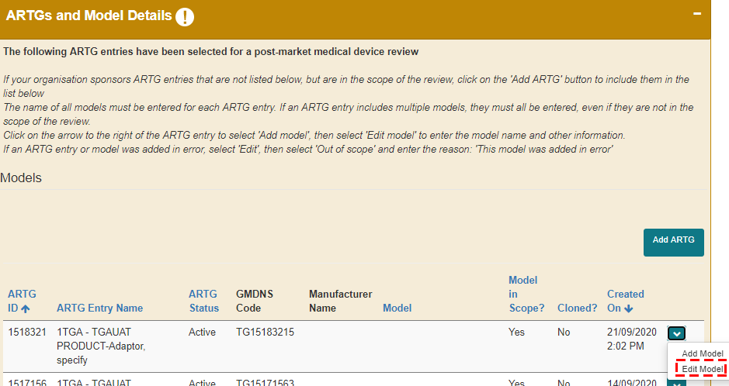
  - Enter the model details in the Model field.
  - Select No or Yes if the model is in-scope of the post-market review. You should refer to the notification for details of the scope of the post-market review. If you select No, you need to provide a reason why you consider the ARTG entry/model is not within the scope of the post-market review.
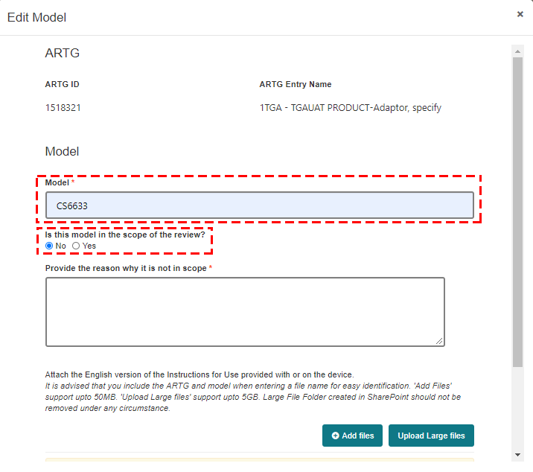
- If there are multiple Models under the one ARTG entry, select Add model. This will clone the ARTG entry and cannot be deleted, but can be marked out of scope with N/A in the model number field if added in error.
  - Click Add Model
The name of all models must be entered for each ARTG entry. If an ARTG entry includes multiple models, they must all be entered, even if they are not in the scope of the review.
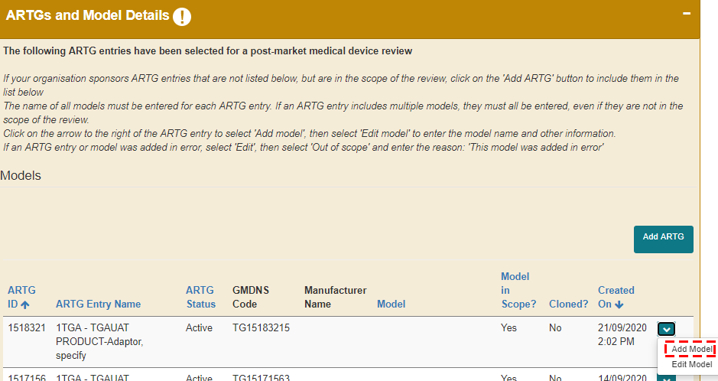
  - Click Proceed.
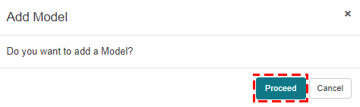
A copy of the ARTG entry for the selected model is created.
Repeat step 6 and edit the model details.
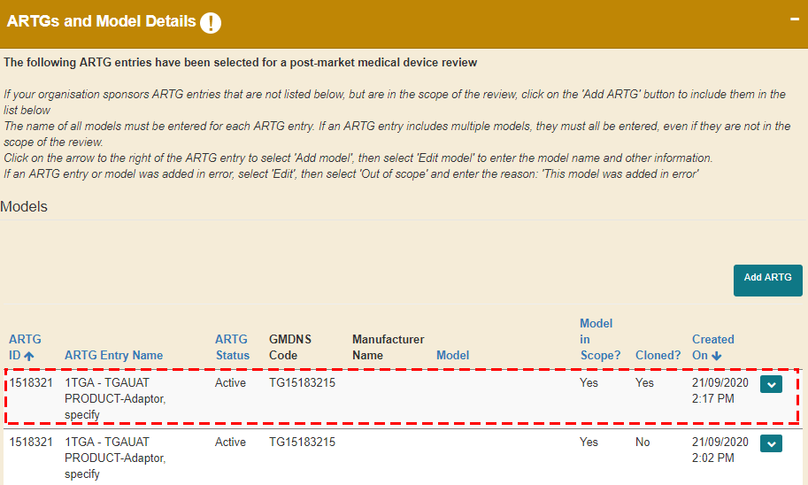
For each model of device (both those that you consider to be in-scope and out-of-scope of the post-market review) you will need to upload a copy of the Instructions For Use (IFU). There are two options dependent upon the size of the document:
- “Add files” button to upload documents less than 50MB size.
- “Upload Large files” button to upload documents more than 50MB size.
Please note, folders are created in the background during this process to store the information so it may take 1 to 2 minutes for the “Add files” and “Upload Large files” buttons to appear.
- To add files less than 50MB size:
- Click on Add files.
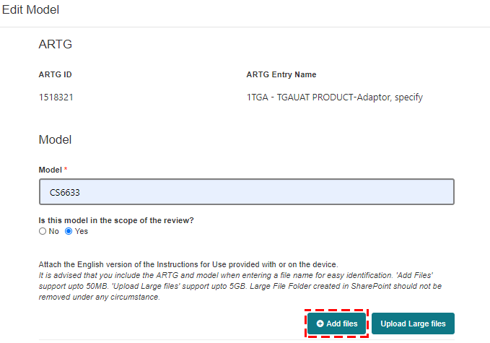
- Click Choose files and select the file you want to upload. Once you have selected your file, click on Add files button.
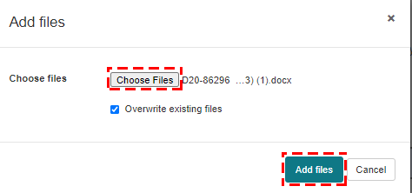
The file you uploaded will be displayed.
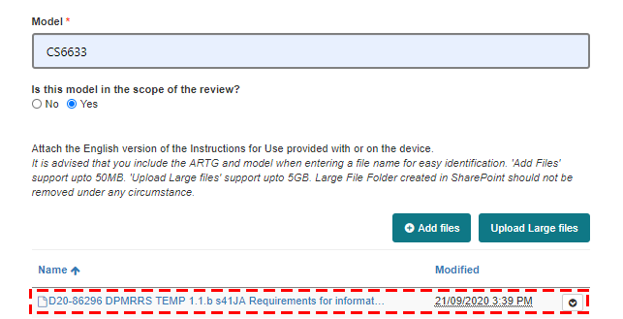
- Select the check-box to acknowledge that at least one file has been uploaded and click Save.
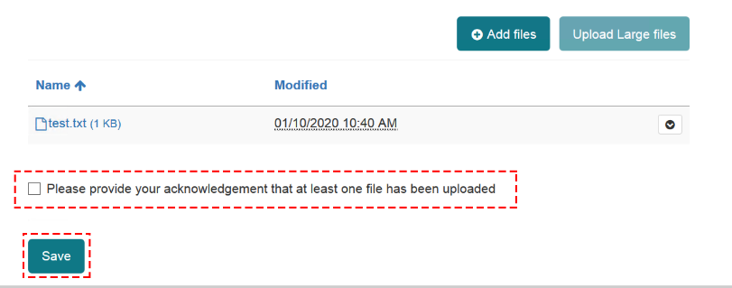
- To add files more than 50MB size:
- Click on Upload Large file.
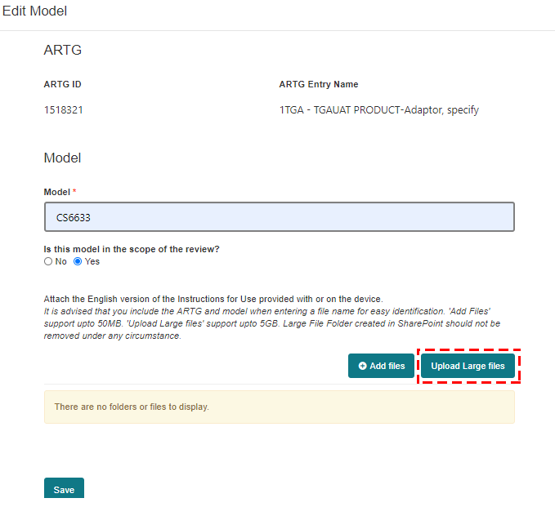
- A new window will open directing you to the SharePoint site. Click Next.
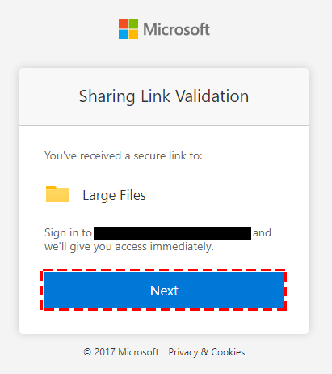
- Click Upload and then Files.
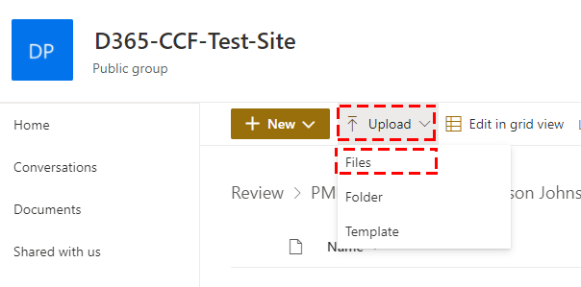
- Upload your file and close the window once you have uploaded the large file(s).
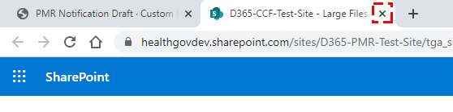
- Select the check-box to acknowledge that at least one file has been uploaded and click Save.
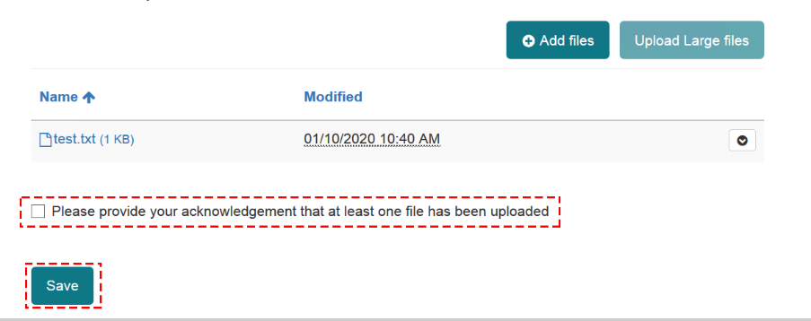
The new model is updated against the ARTG.
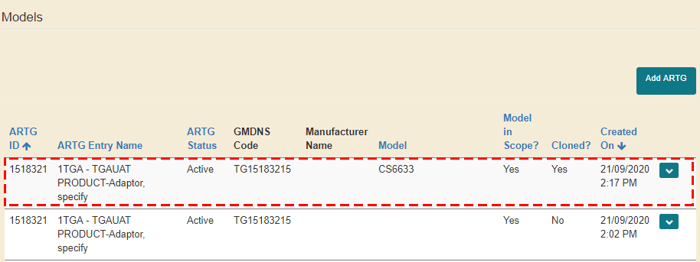
For each of the models of devices you will be required to provide supply, complaint, and adverse event details. Please check the notification letter for details on how many financial years you are required to provide data for.
The supply, complaint, and adverse event data can be completed in the Model Details section. You can update the model details for each individual financial year or you can enter the supply details, complaints and adverse events data for all models in a single file using the bulk upload functionality.
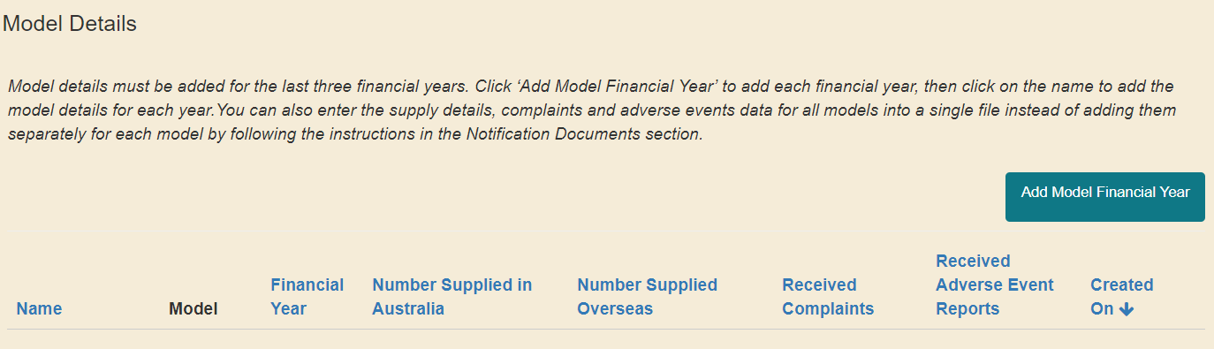
Refer to:
- Instructions numbers 10-15 on how to update the model details for each individual financial year.
- Instruction number 16 for instructions on how to use the bulk upload functionality to enter the supply details, complaints and adverse events data for all models in a single file.
- To update the model details for each individual financial year:
- Click on Add Model Financial Year button to select which model you are going to add the financial year data against.
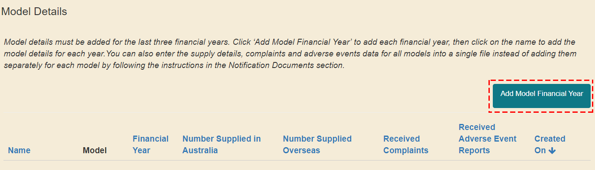
- Click on the magnifying glass to search for the model.
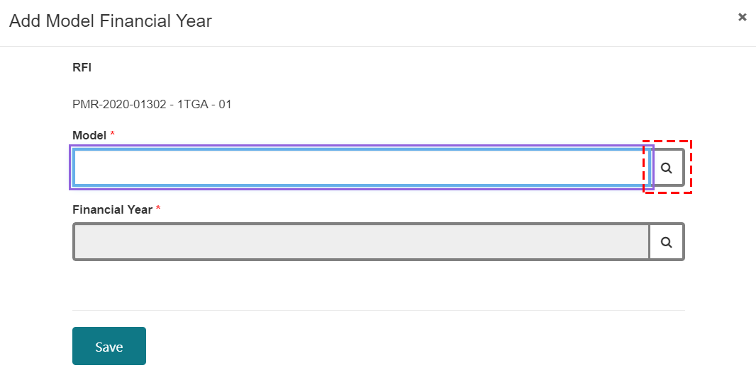
- Select the model and click Select.
Only the models in scope will be displayed.
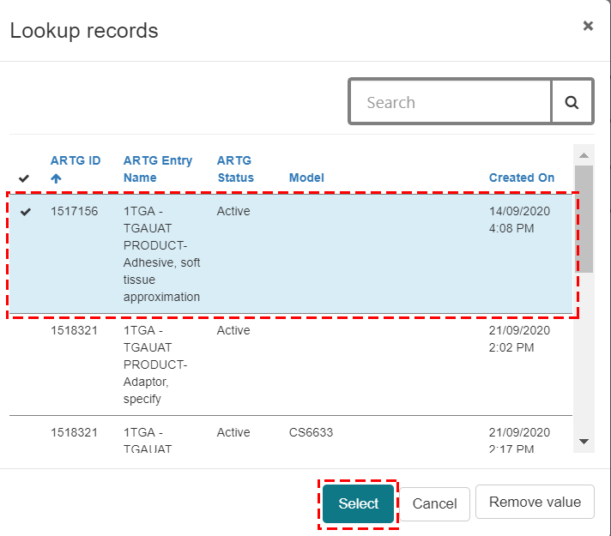
- Select the financial year and click Select.
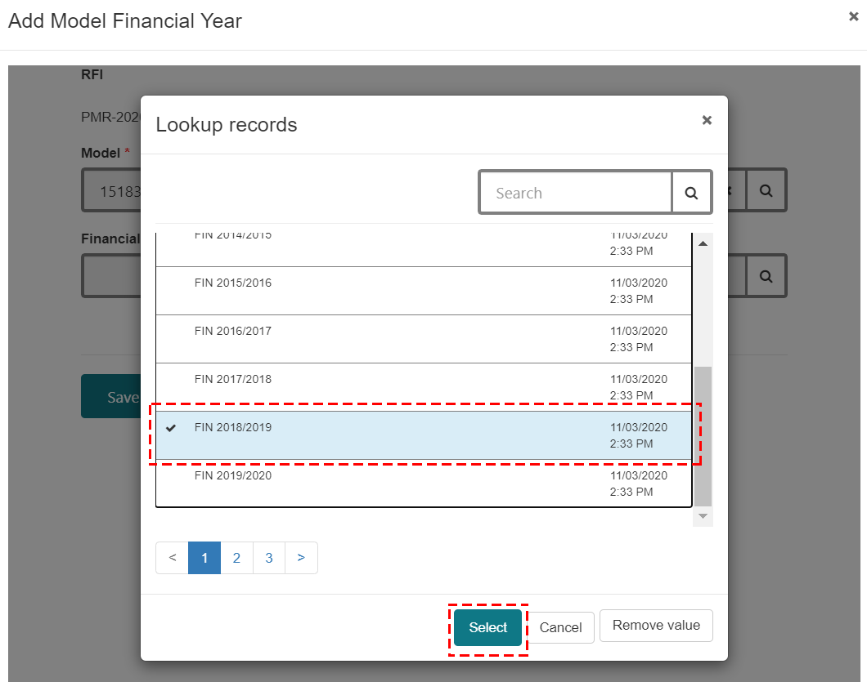
- Click Save.
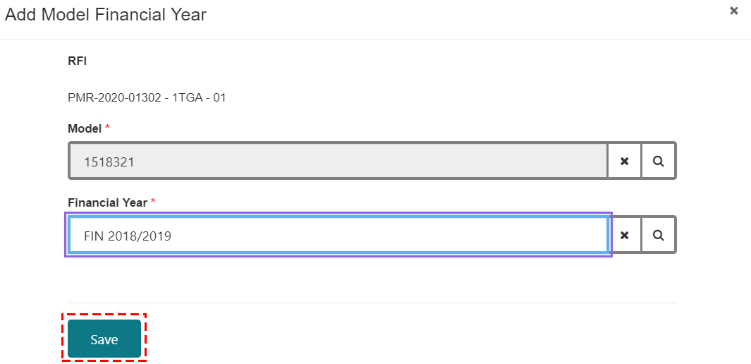
The financial year details are updated.
If you select the incorrect financial year, you can remove the financial year by clicking on Remove.
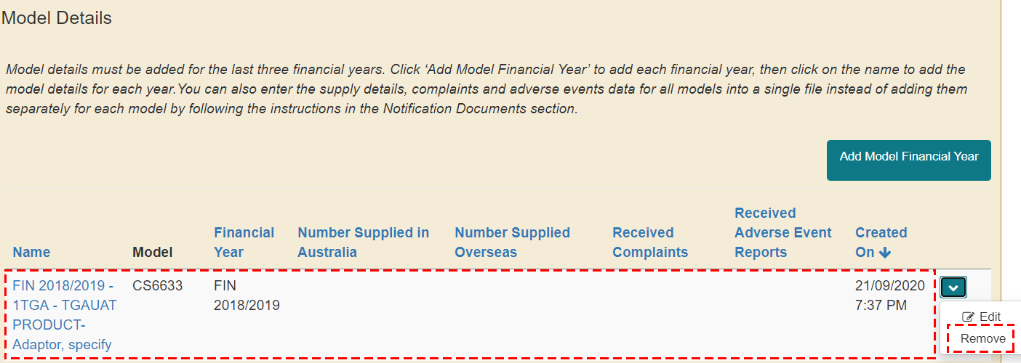
- The following instructions outline how to add the supply details, complaints and adverse events data. Please check the notification for details on how many financial years you are required to provide data for.
- Click Edit.
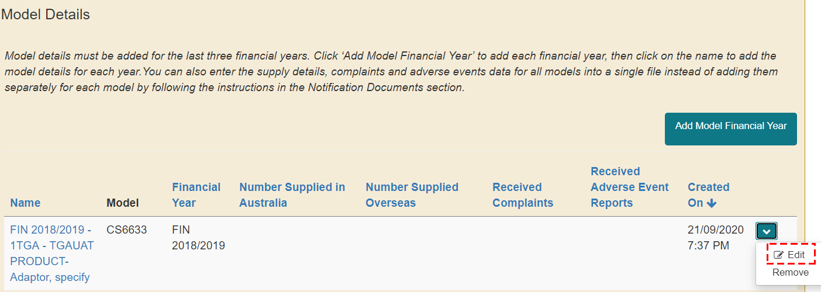
This is the overarching screen that will appear.
Each screen will turn green as you complete each section.
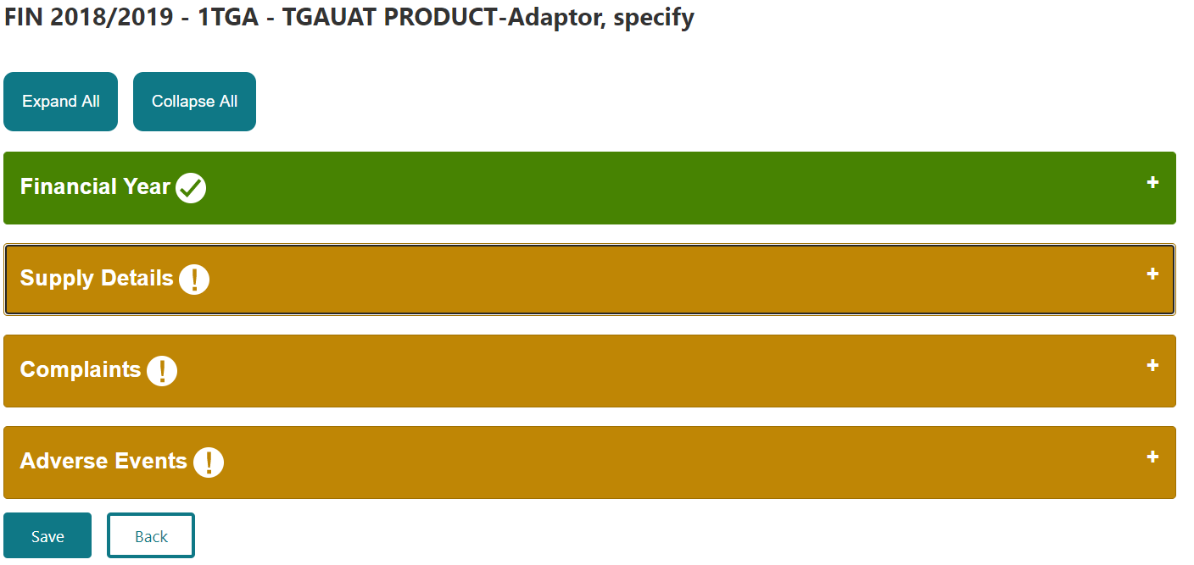
- In the Supply Details section:
- Enter the Number Supplied in Australia. To select the unit measurement in the Number Supplied Australia – Unit Measurement field for that financial year, click on the magnifying glass and select one of the options:
- Box
- Each
- Pack
- Other
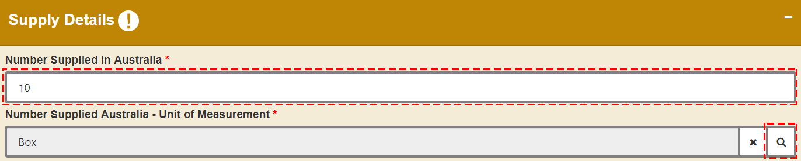
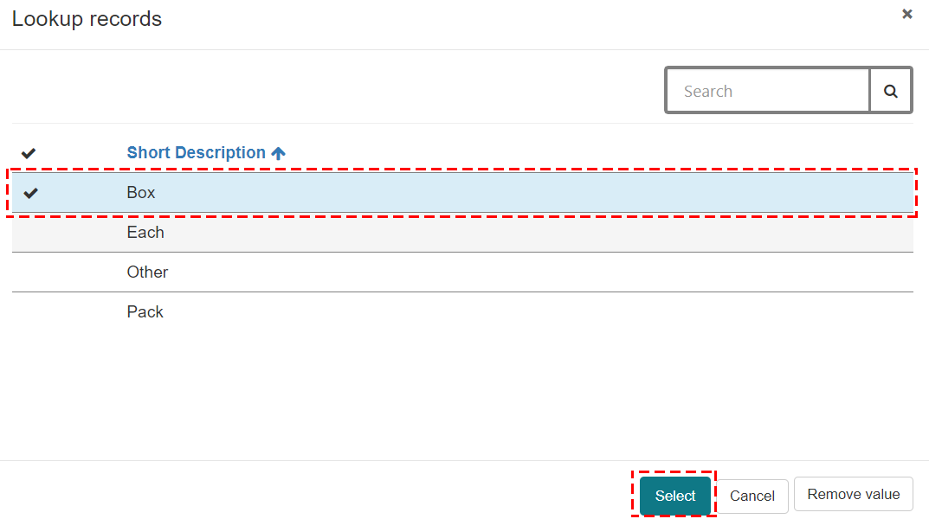
- Enter the number of devices supplied overseas in that financial year.
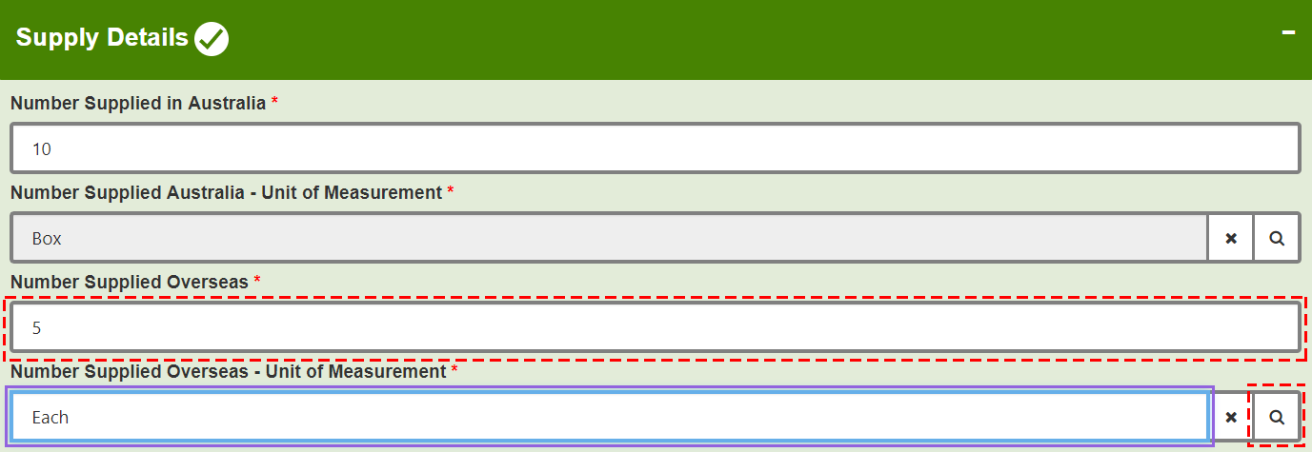
- In the Complaints section:
You have the option to select Yes or No if any complaints were received in the selected financial year.
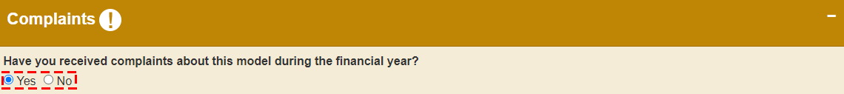
- If you select No, complete the Adverse Events section in step 14.
- If you select Yes, complete the following steps:
- Enter the Total number of complaints that came from Australia in the financial year.
- Enter the Total number of complaints that came from overseas in the financial year.
- Enter at least one Type of complaint received and Number received.
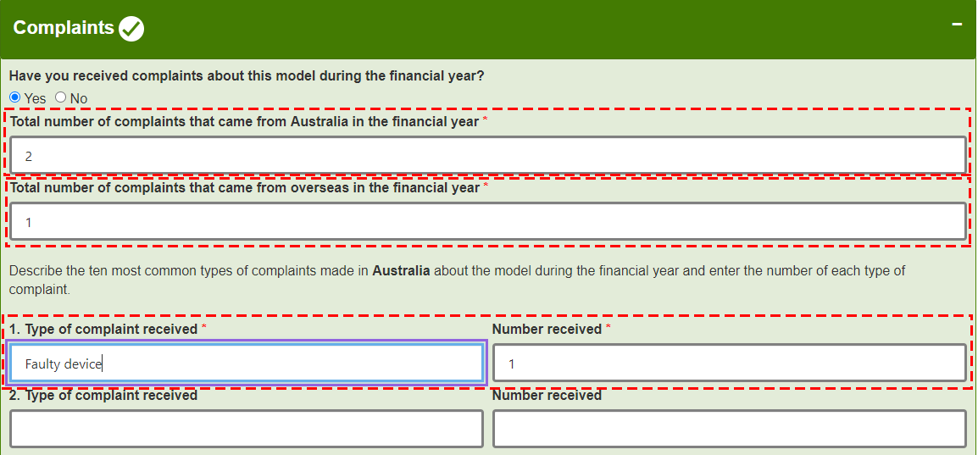
- You have the option to upload supporting documents using the Add files and Upload Large files function. Refer to step 8 for small files (less than 50MB size) or 10 for large files (more than 50MB size) for step by step instructions on how to upload files.
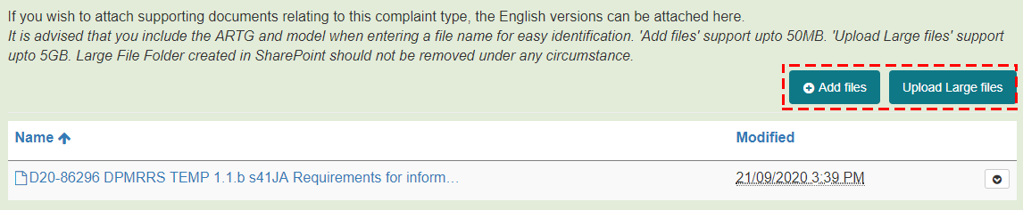
Any files that have already been uploaded relating to this ARTG entry will be displayed in the list of files.
- In the Adverse Events section:
You have the option to select Yes or No if any adverse event reports were received about this model in the selected financial year.
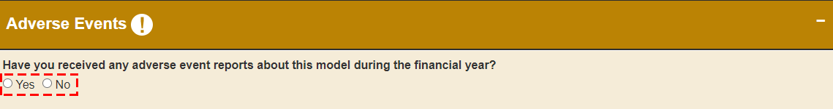
- If you select No, click Save and refer to step 15.
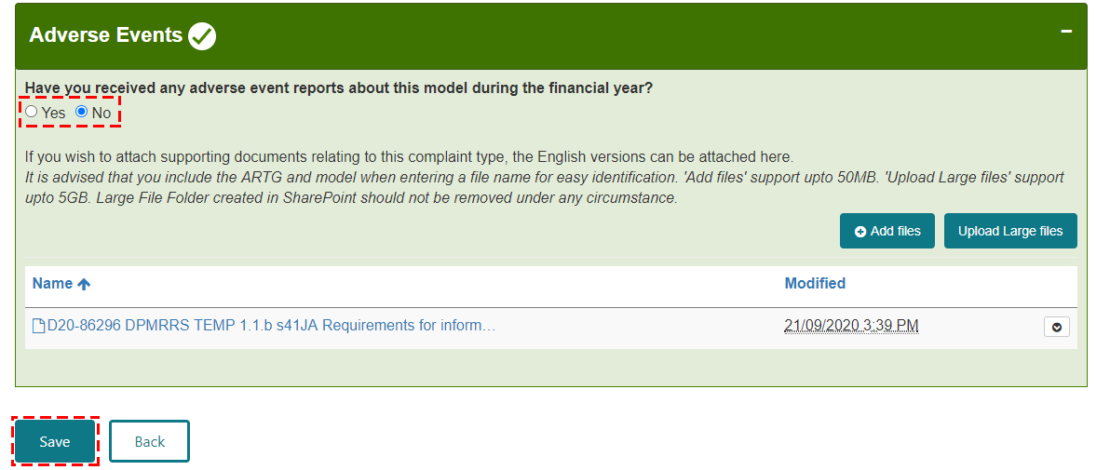
- If you select Yes, complete the following steps:
- Enter the Total number of adverse events that came from Australia in the financial year.
- Enter the Total number of adverse events that came from overseas in the financial year.
- Provide a breakdown of the adverse events by type of adverse event (derived from the International Medical Device Regulators Forum Adverse Event Codes http://www.imdrf.org/documents/documents.asp). Select at least one common Category of adverse event and Number reported for that adverse event type, for that particular model, during that financial year. The ten most prevalent adverse event types can be provided.
- If there were adverse events reported in Australia, the adverse event types are related to the Australian adverse events. If there were no adverse events reported in Australia, the adverse event types are related to the worldwide adverse events. The region is identified in the heading.
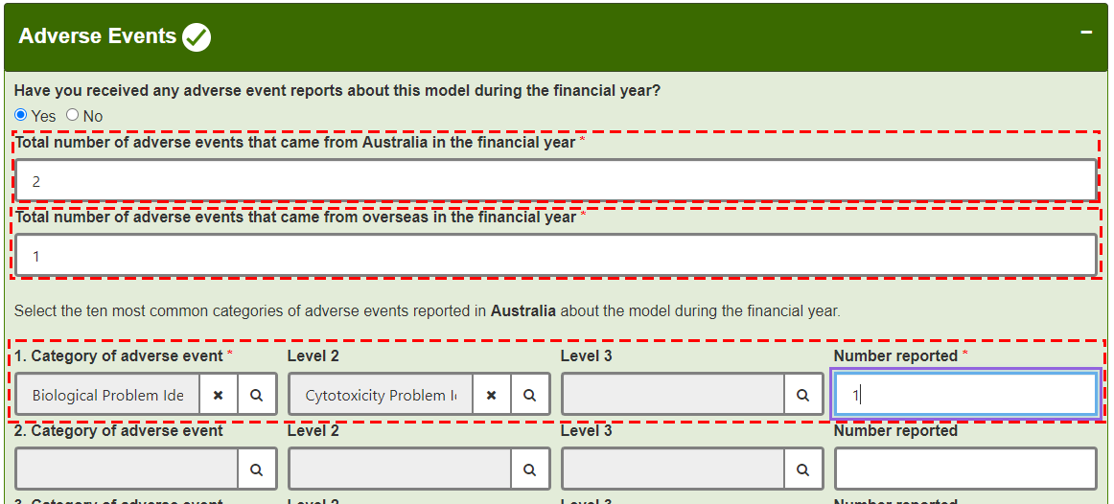
- You have the option to upload supporting documents relating to this complaint type using the Add files and Upload Large files function. Refer to step 8 for small files (less than 50MB size) or 10 for large files (more than 50MB size) for step by step instructions on how to upload files.
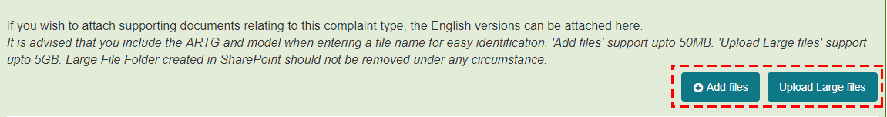
Any files that have already been uploaded relating to this ARTG entry will be displayed in the list of files.
- Click Save and the following message will appear and click on the Back button to go back to the previous page.
“Model Details has been successfully saved. Please click on the ‘Back’ button to go back to the previous page”
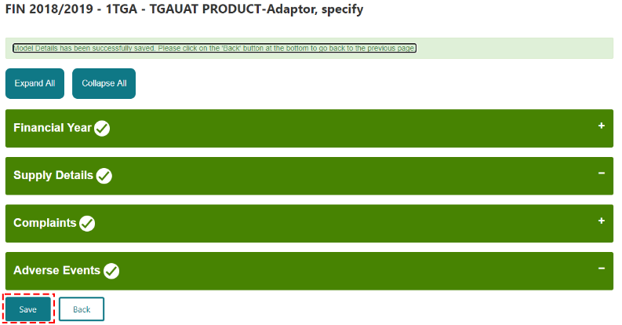
The model details for the selected financial year are updated.
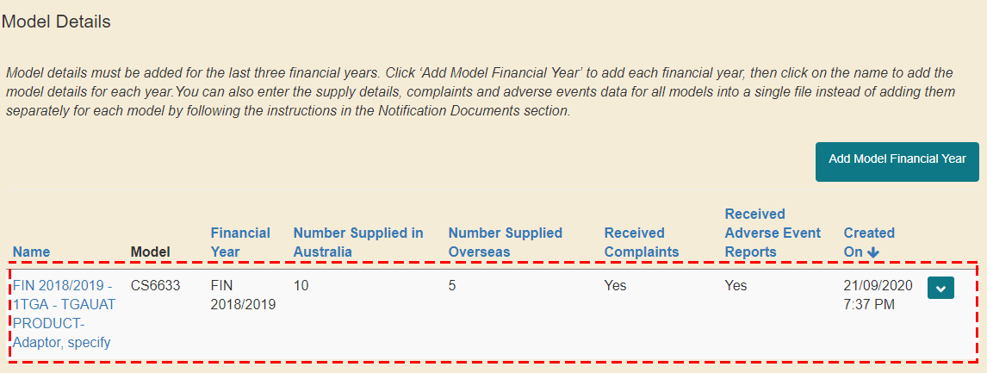
- To update the supply details, complaints and adverse events data for all models, for multiple financial years, in a single file, you can use the bulk upload functionality:
- You need to generate the bulk upload template from the Notification Details section.
- Click on Generate Template.
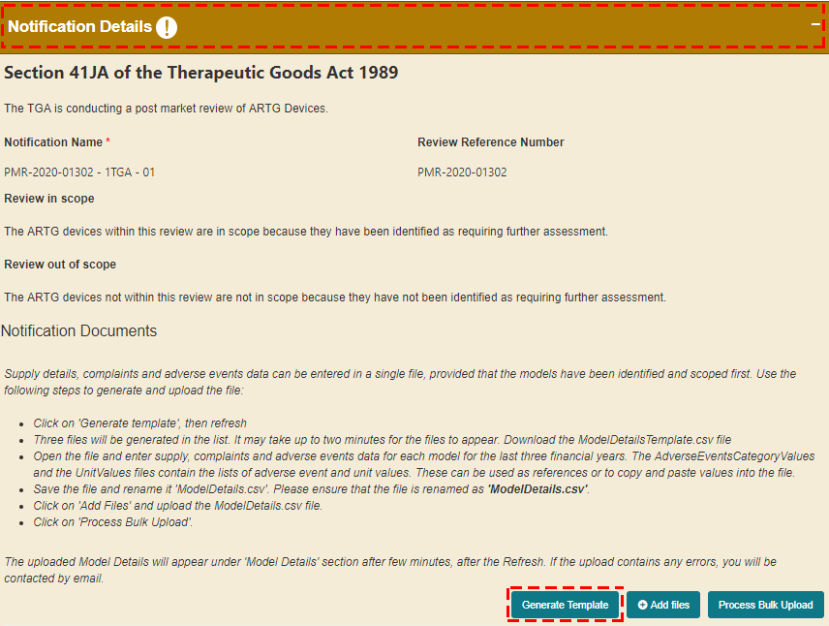
- Click OK.
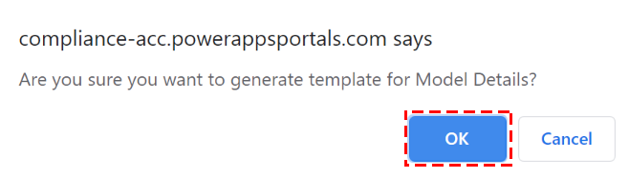
You may need to click on Refresh at the bottom of your screen to view the new template.
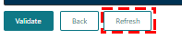
- You may need to go to page 2 to access the bulk upload templates.
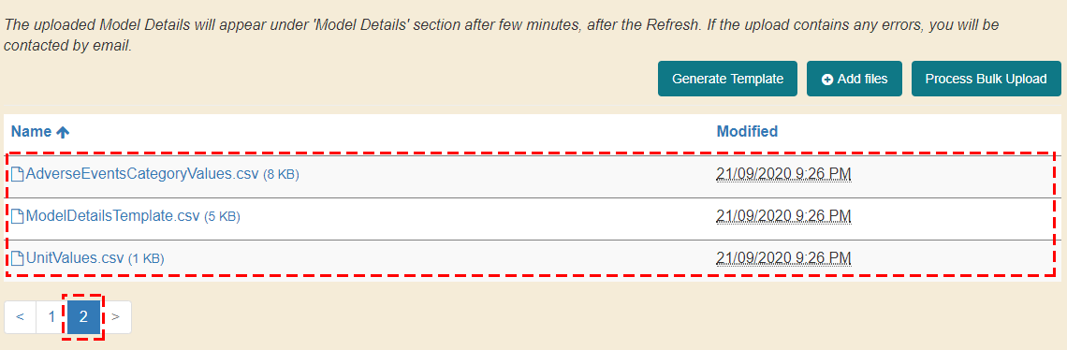
- Open the ModelDetailsTemplate file to enter the supply, complaints and adverse events data for each model for the last three financial years.
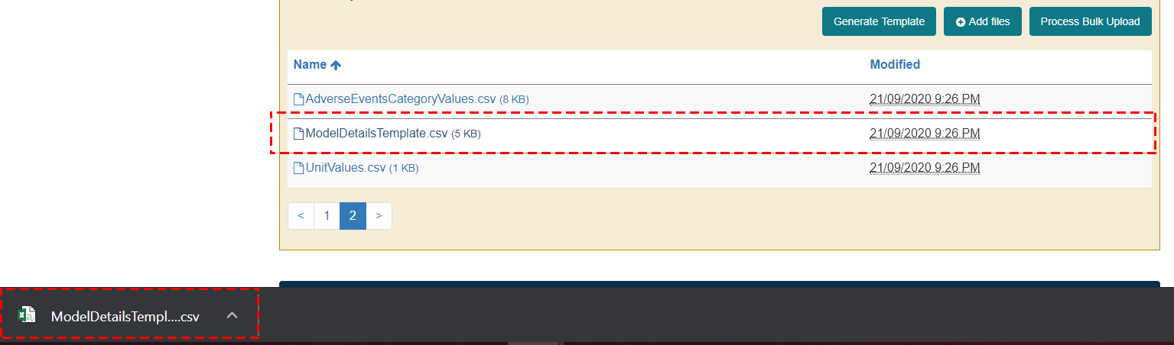
You can download and refer to the AdverseEventsCategoryValues and UnitValues files as references or to copy and paste the values into your ModelDetailsTemplate file as part of the next step.
AdverseEventsCategoryValues file:
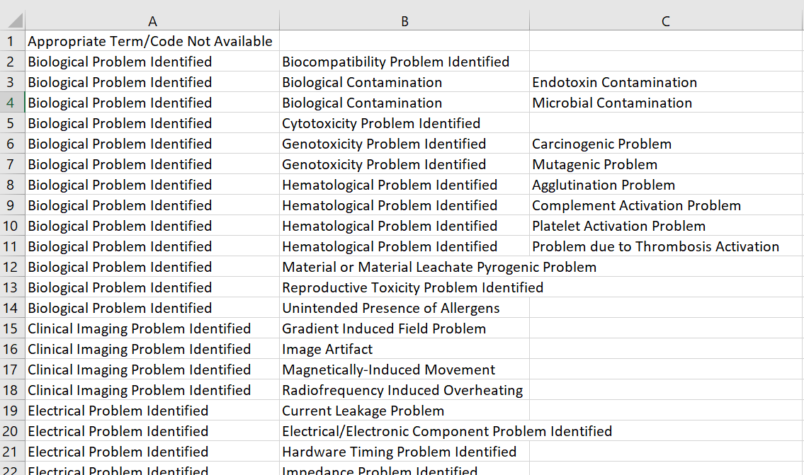
UnitValues file:
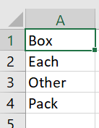
- Enter the supply, complaints and adverse events data for each model for the last three financial years
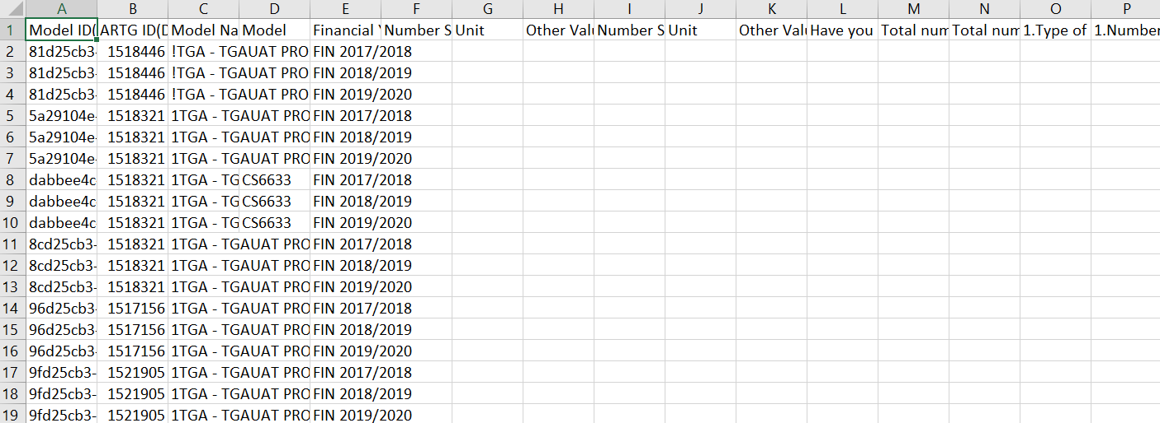
Please note:
- You must complete all rows or delete the rows you don’t need to enter data.
- The following columns are mandatory to complete:
  - Column E: Financial Year
  - Column F: Number Supplied in Australia
  - Column G: Unit
  - Column I: Number Supplied Overseas
  - Column J: Unit
  - Column L: Have you received complaints about this model during the financial year? (Yes/No)
  - Column M: Total number of complaints that came from Australia in the financial year
  - Column N: Total number of complaints that came from overseas in the financial year
  - Column O: type of Complaint Received
  - Column P: Number Received
  - Column AI: Have you received any adverse event reports about this model during the financial year? (Yes/No)
  - Column AJ: Total number of adverse events that came from Australia in the financial year
  - Column AK: Total number of adverse events that came from overseas in the financial year
  - Column AL: Category of Adverse Event Level 1
  - Column AO: Category of Advser Event Number Reported
Once you have completed the required information in the ModelDetailsTemplate file, you need to save the file as “ModelDetails.csv”. Note: it is important to save the file as “ModelDetails.csv” for the system to identify the document.
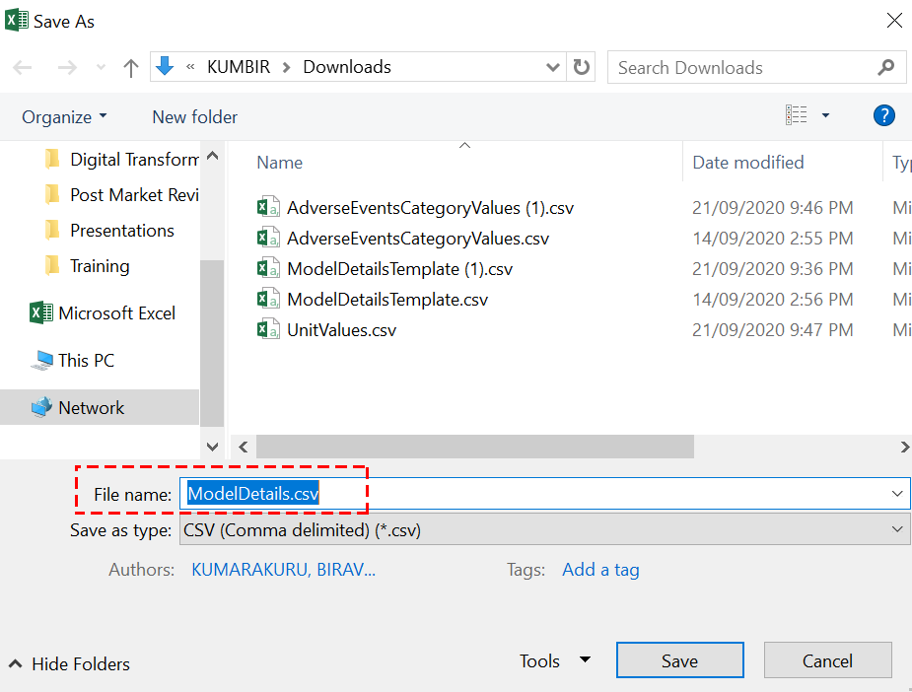
- To upload the file, click on Add files and the new file you uploaded will be saved in the documents section.
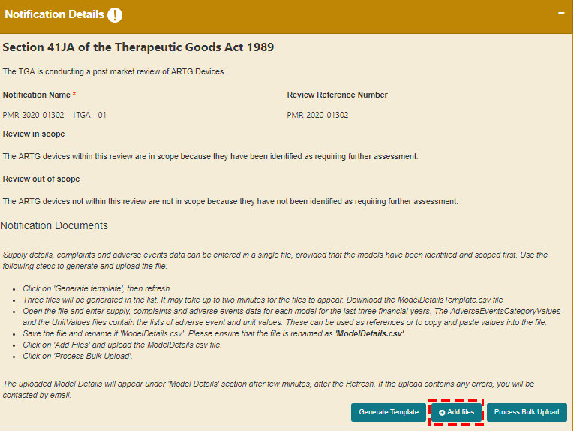
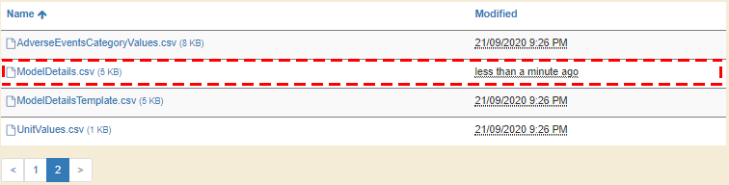
- Click on Process Bulk Upload to upload your files.
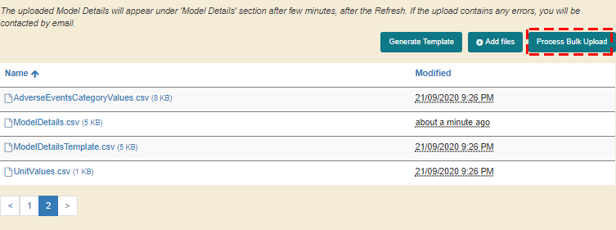
The model details will be uploaded in the ARTGs and Model Details section. If the model details are not uploaded in this section then there was an error when updating the bulk upload file in step 17f. Please make sure you enter all mandatory fields and the right information is entered. If you still have issues, please contact the Post Market Devices Team (postmarketdevices@health.gov.au).
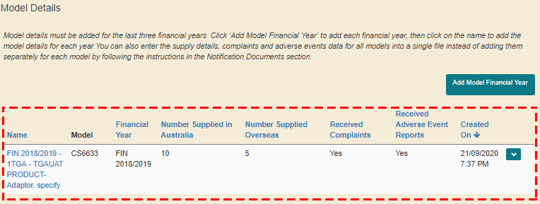
Please note the following relating to the bulk upload functionality:
- If you have any documents associated to the model details you entered in the large file bulk upload, you can upload it at a candidate level by following steps 8 and 9.
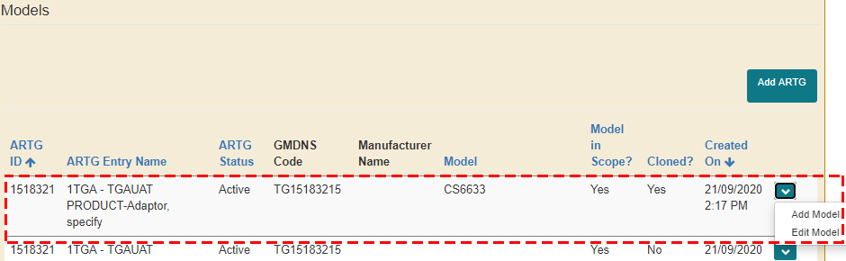
- If you need to make any amendments to the saved bulk upload file, it is easier to manually update it from the Model Details section by clicking on Edit.
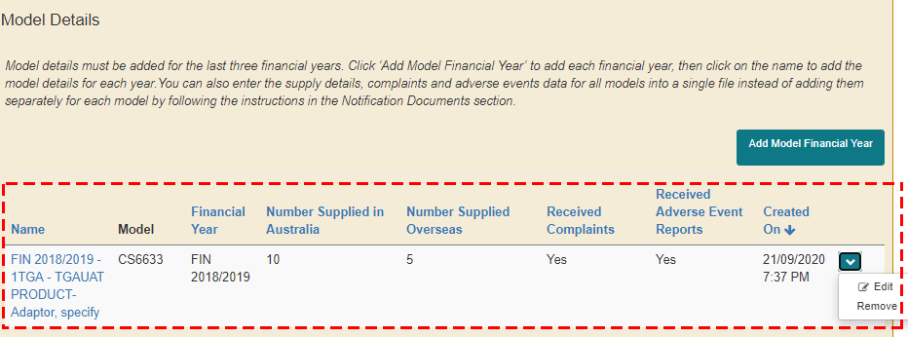
Make the changes in the relevant section.
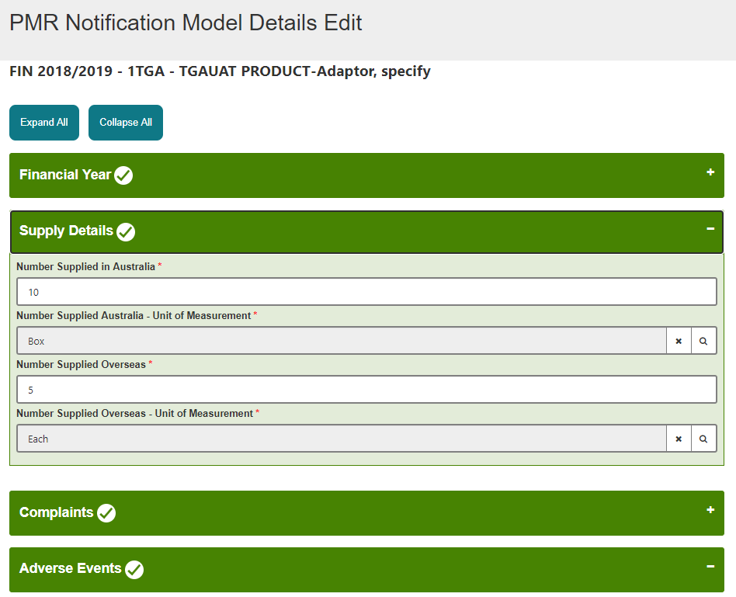
- If you need to make several changes to the bulk upload file, it will be easier to remove the file you saved, create a new file and upload the new file. You can remove the document by clicking on Remove and follow step 16 again.
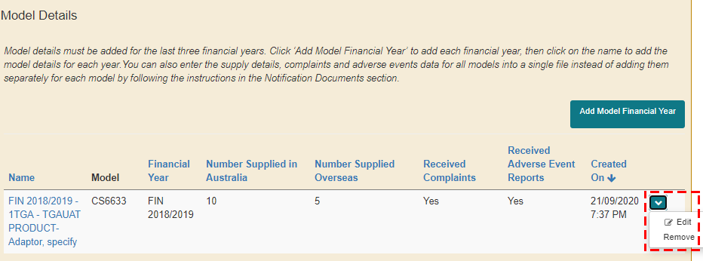
If you have a large number of bulk upload files that you need to make changes to, it will be easier to contact the Post Market team by sending an email to the Post Market devices (postmarketdevices@health.gov.au) mailbox. The team will be able to run a bulk removal of your selected files.

How to provide evidence of compliance with requirements
The following instructions outline how to upload the information and documents to demonstrate compliance with the specific areas of the legislation that have been identified in the notification letter.
Instructions
- Click Add Response in the drop down option against the specified ‘Breaches under investigation’.
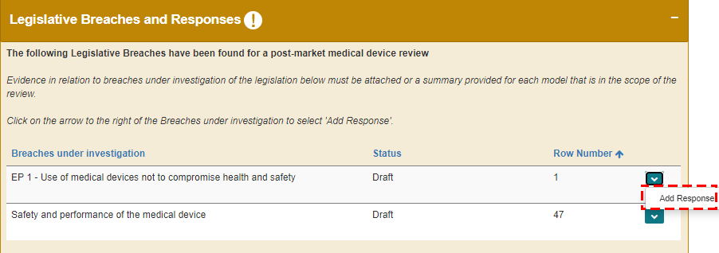
- Click Proceed.
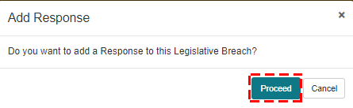
- Click Refresh.
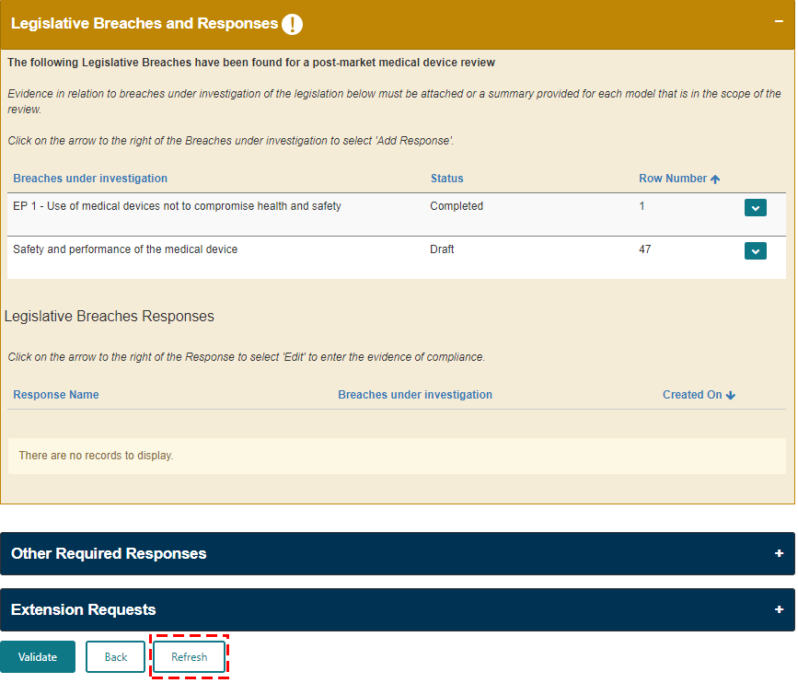
- Click Edit next to the generated response area.
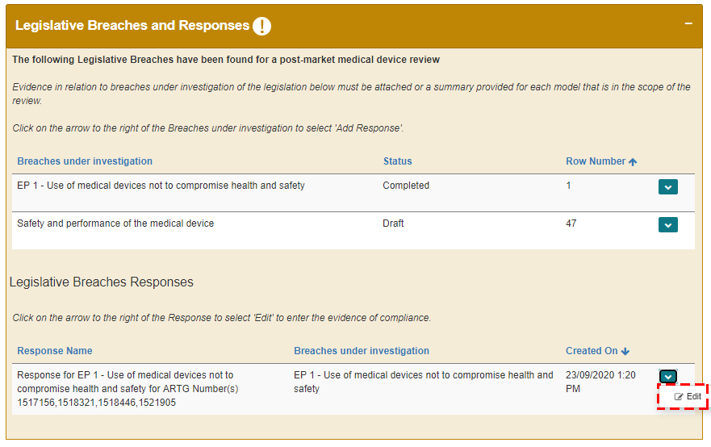
- Select how you wish to provide your response.
- You can choose from one of the three options:
- Provide a summary
- Attach evidence of compliance
- Both
If you select “Attach evidence of compliance” or “Both”, you must attach minimum one file.
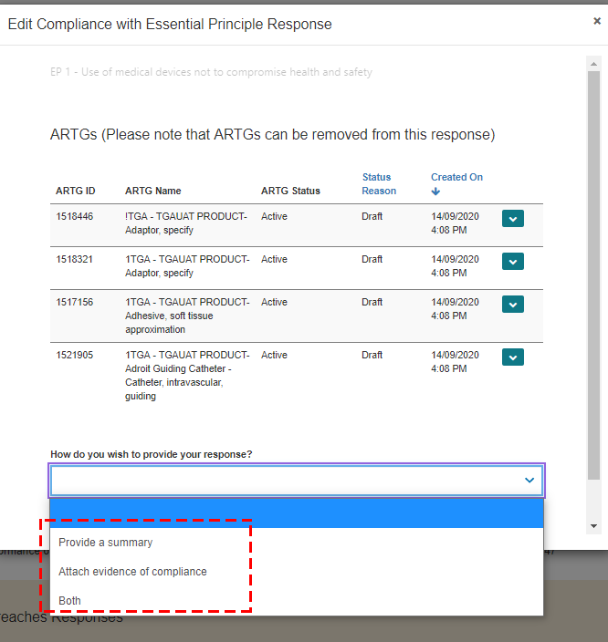
- In the Summary section, provide your response. Note: the summary must be minimum 20 characters.
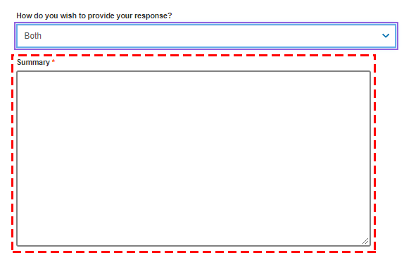
- Refer to steps 8 and 9 for instructions on how to Add files and Upload Large Files.
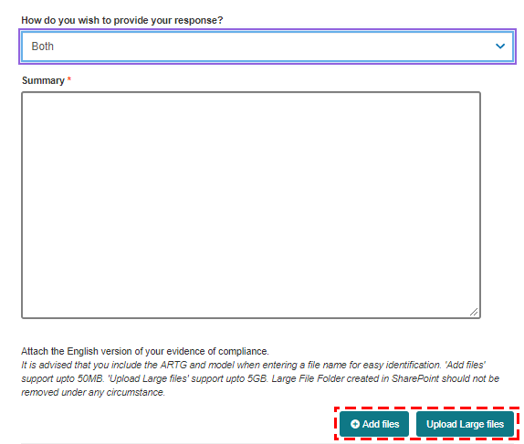
- Select the check-box to acknowledge that at least one file has been uploaded and click Save.
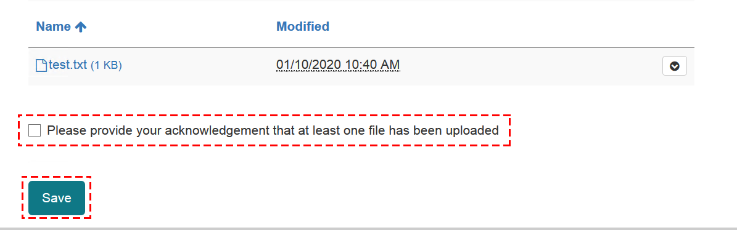

How to respond to additional information request
If a notification requires additional information on another specific matter, this is where you can provide a response.
Instructions
- Click Edit to provide a response to a specific request.
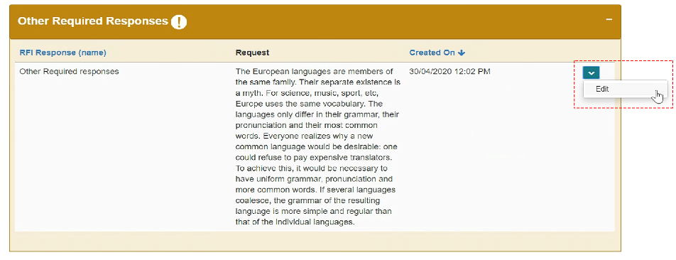
- Select how you wish to provide your response and complete the details
- Select one of the following:
- Provide a summary
- Attach evidence of compliance
- Both
If you select “Attach evidence of compliance” or “Both”, you must attach minimum one file.
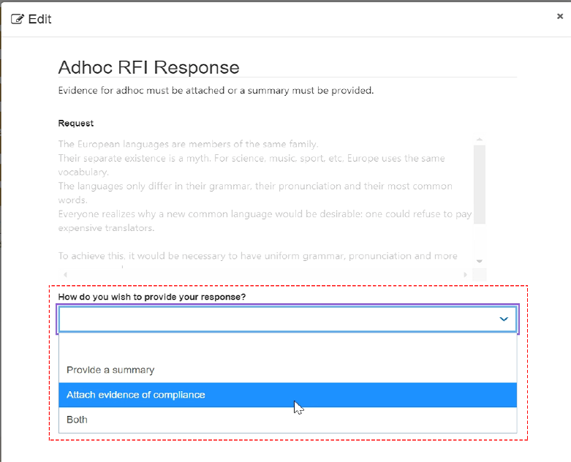
- In the Summary section, provide your response. Note: the summary must be minimum 50 characters.
- If you wish to attach a document, refer to steps 9 and 10 for instructions on how to Add files and Upload Large Files.
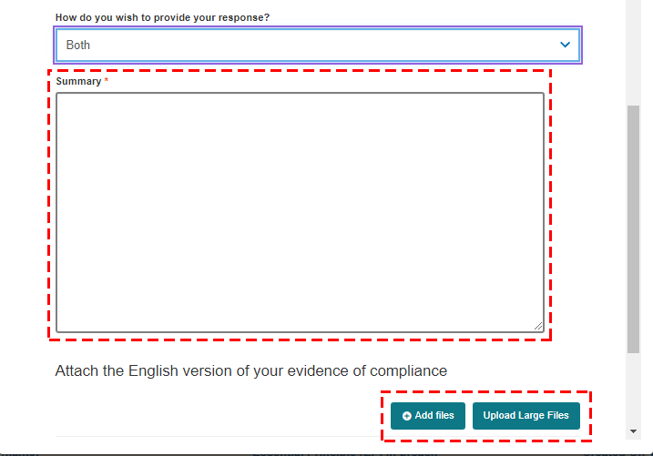
- Select the check-box to acknowledge that at least one file has been uploaded and click Save.
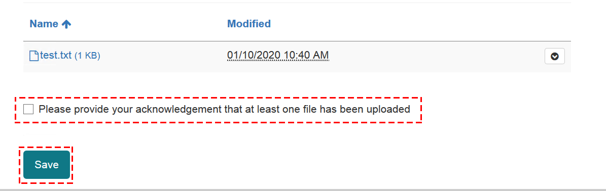

How to submit the information
Instructions
- If you are ready to submit your response, click Validate.
Only the Submitter will be able complete the following steps to submit the response.
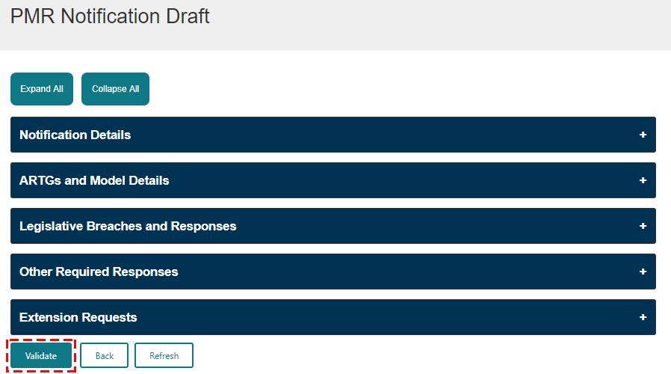
- Once the response has been successfully validated, click Preview to preview your responses.
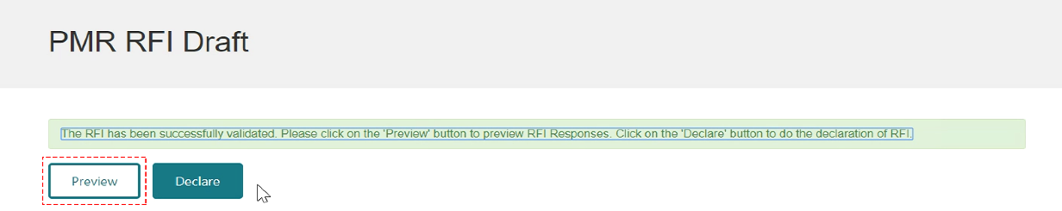
You can preview the notification before you submit it.
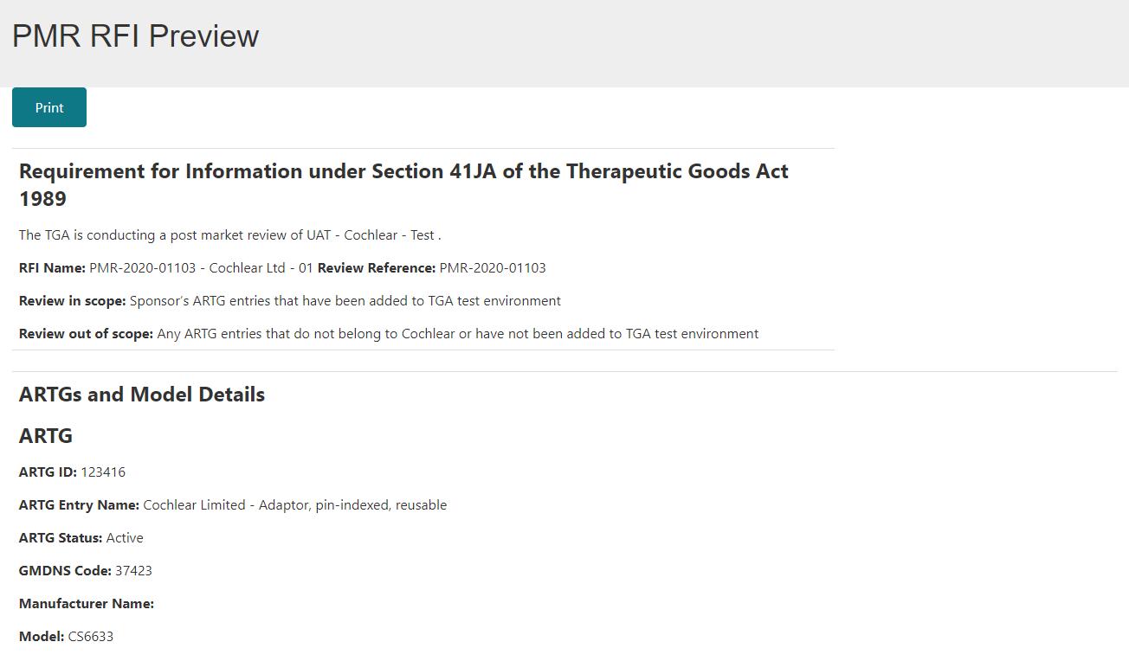
- Click Declare.
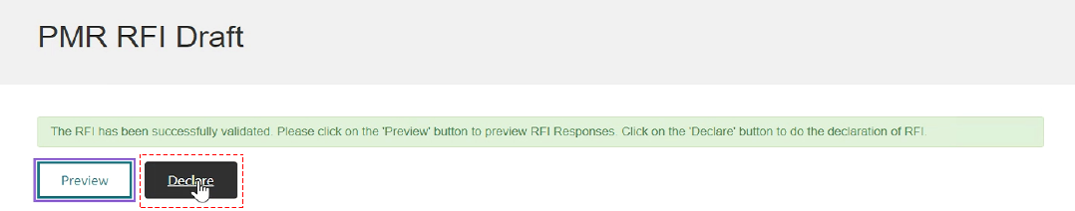
- Select Yes if you agree to the declaration.
- Click Submit.
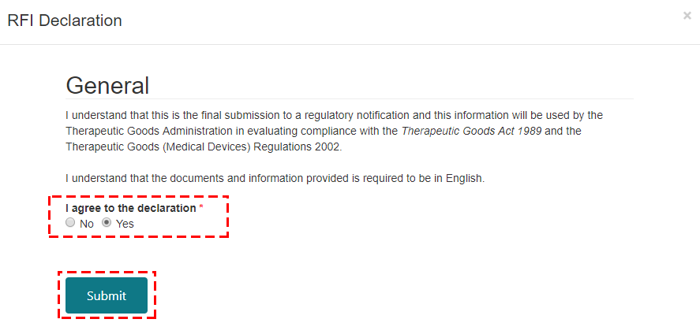
- Click OK.
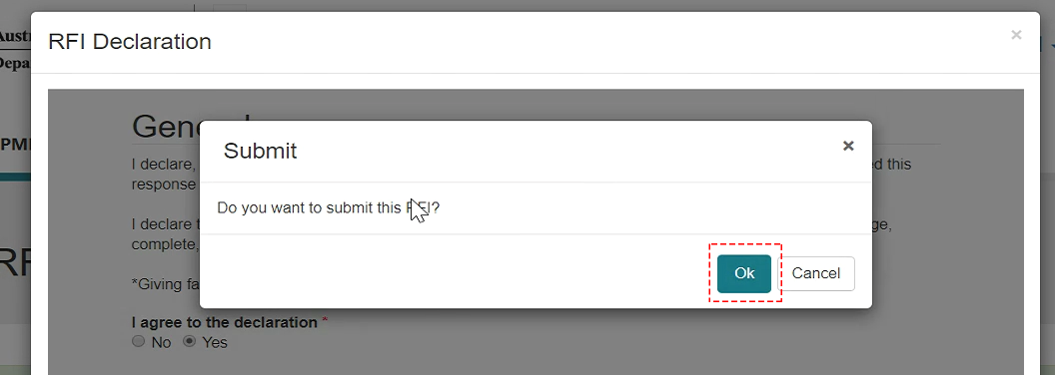

How to request for an extension
If you are having difficulty providing the information in the required timeframe and need an extension, you can submit a request. Please note, that a request for extension may not be able to be provided in all cases.
Instructions
- Click Draft.
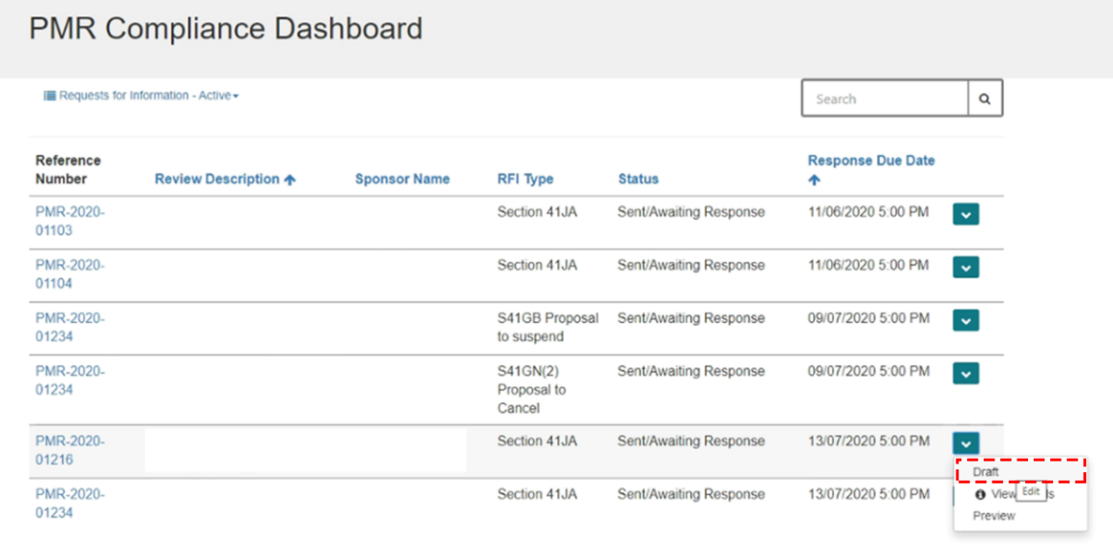
- Click on the + button to expand the Extension Requests section.
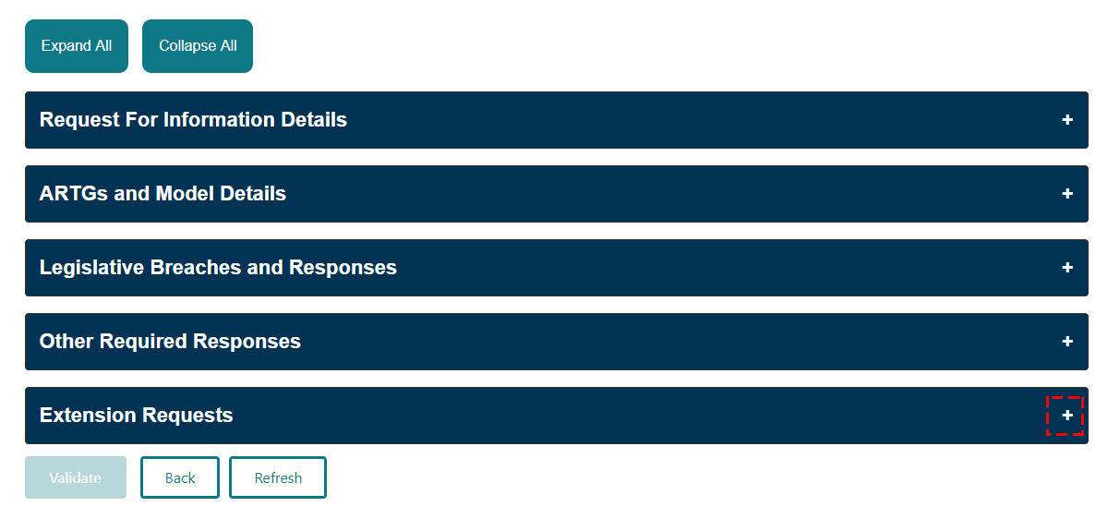
- Click Request Extension.
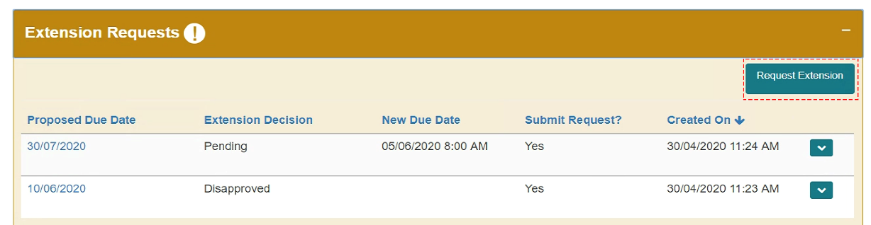
- Complete the fields.
- In the Proposed Due Date field, enter the new date. Note: this date must be later than the current RFI date.
- In the Extension Request field, enter the reason for requesting for an extension.
- If you’re ready to submit the request, select Yes. If not, select No to save the request and submit at a later date.
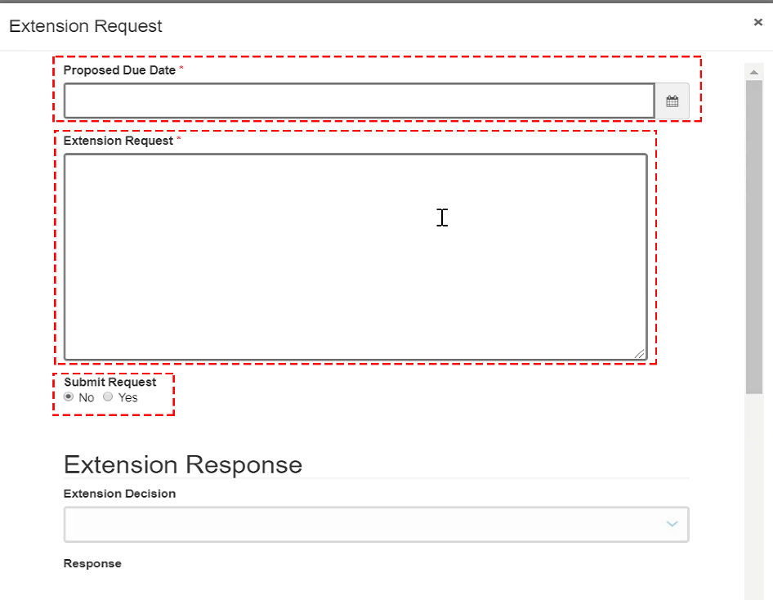
- Click Save.
- Click OK.
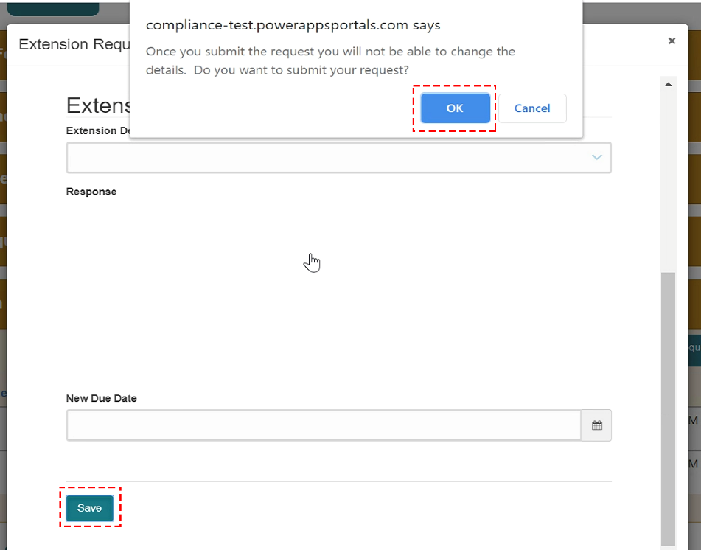

How to respond to a “Proposal to cancel” or “Proposal to suspend”
You can view and respond to these types of notifications by following the instructions below.
Instructions
- Click Draft.
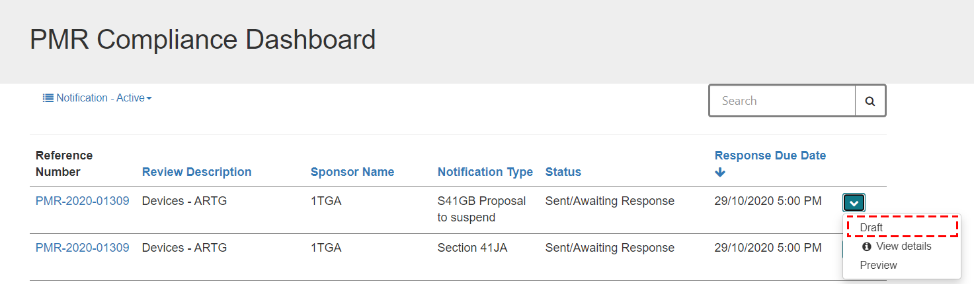
- You can view the notification details in the Notification Details section.
In the Notification Documents section, you can view all the documents associated to this notification.
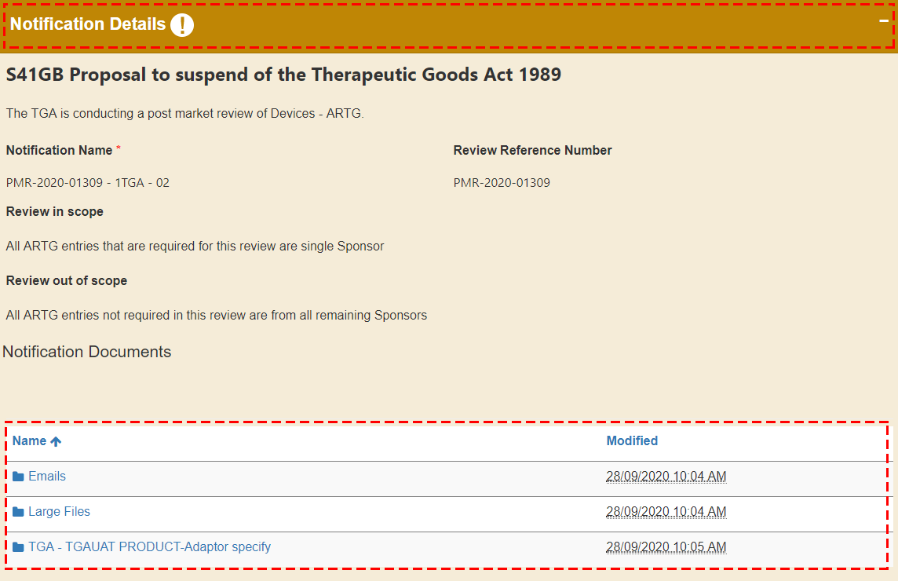
- In the ARTGs and Model Details section, click on Add Response to respond to the selected ARTG.
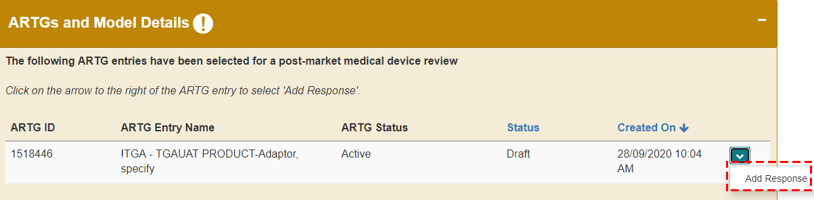
- Click Proceed.
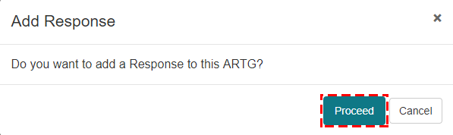
- Click on Created On to enter the evidence of compliance for the selected ARTG.
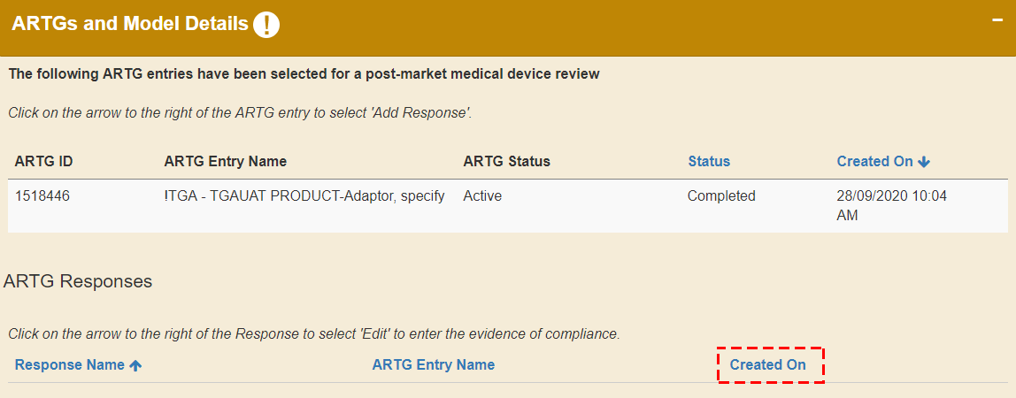
- Click Edit.
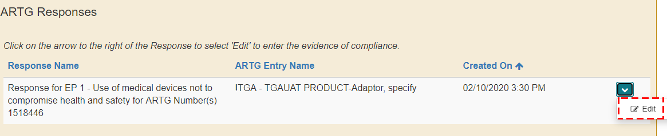
- Select how you wish to respond.
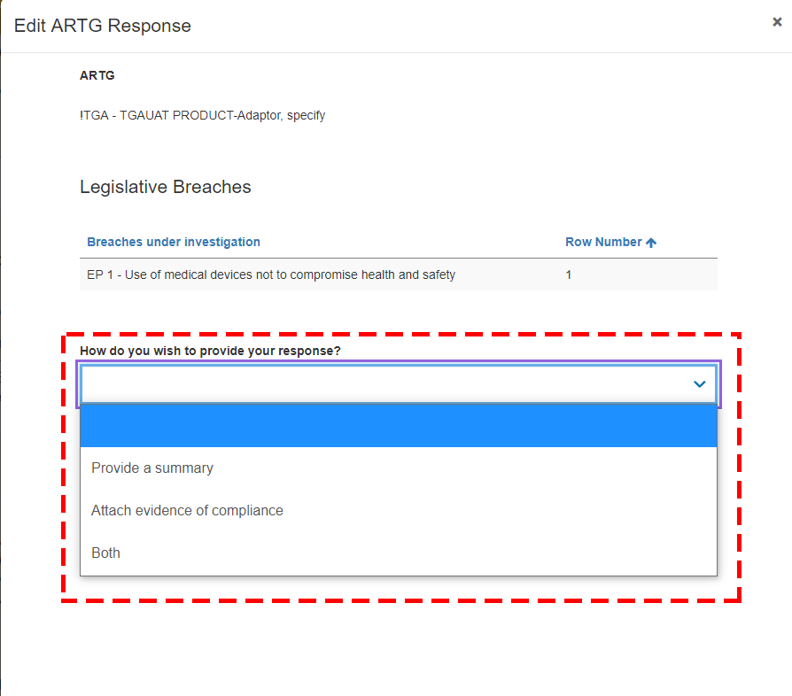
- Enter your summary.
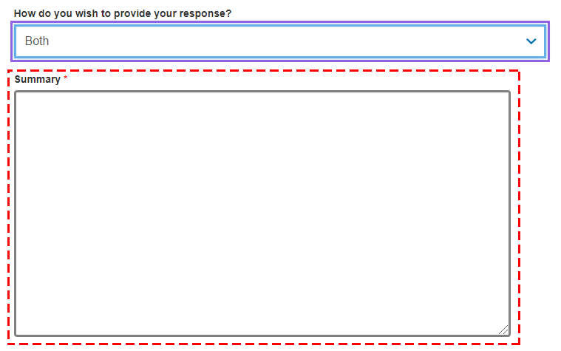
- Upload your files. You have two options (“Add files” and “Upload Large files”) to upload a copy of the Instructions For Use (IFU), for both in scope and out of scope devices. Refer to instructions:
- 9a to use the “Add files” button to upload documents less than 50MB size.
- 9b to use the “Upload Large files” button to upload documents more than 50MB size.
Please note, folders are being created in the background to store information so it may take 1 to 2 minutes for the “Add files” and “Upload Large files” buttons to appear.
- Click on Add files button to upload files less than 50MB size.
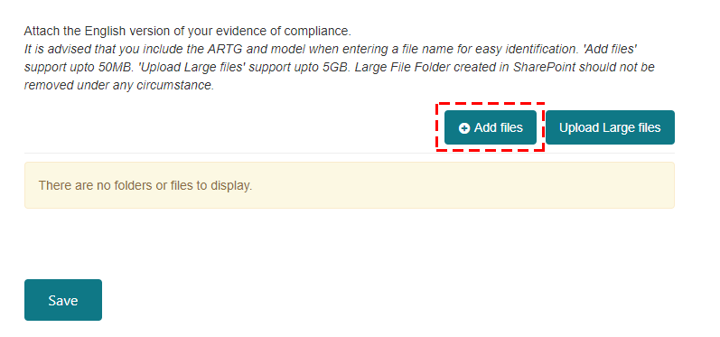
Click Choose files and select the file you want to upload. Once you have selected your file, click on Add files button.
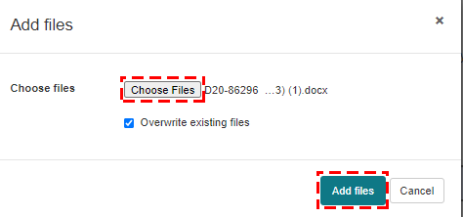
The file you uploaded will be displayed.
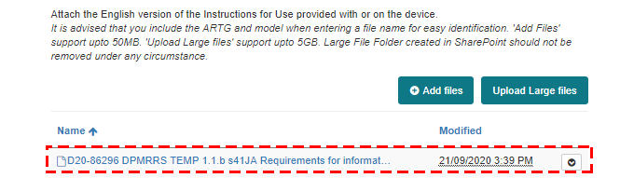
Select the check-box to acknowledge that at least one file has been uploaded and click Save.
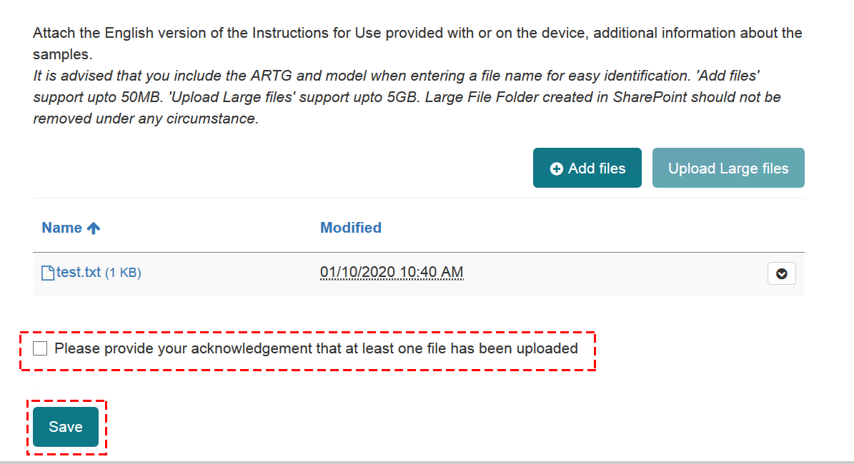
- Click on Upload Large files button to upload files more than 50MB size.
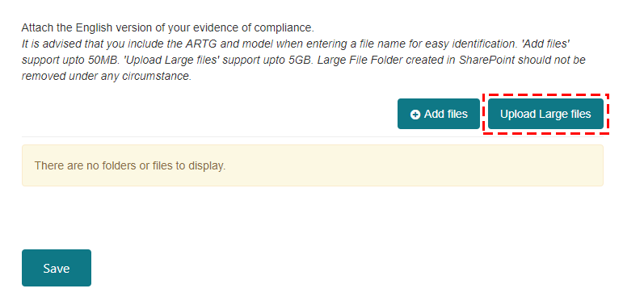
A new window will open directing you to the SharePoint site. Click Next.
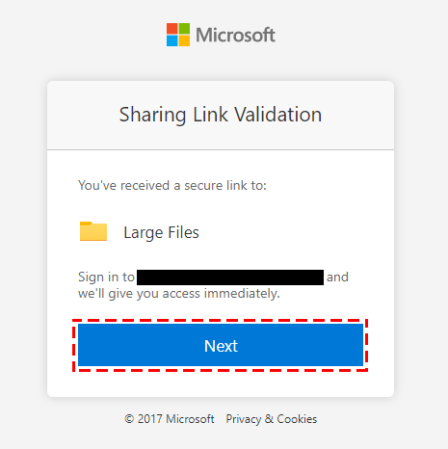
Click Upload and then Files.
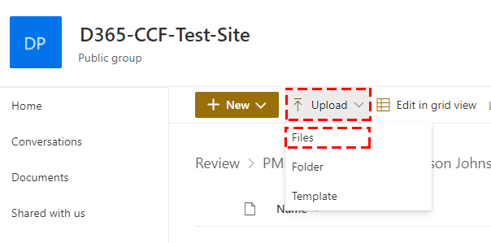
Close the window once you have uploaded the large file(s).
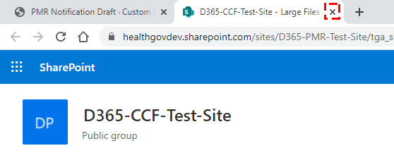
Select the check-box to acknowledge that at least one file has been uploaded and click Save.
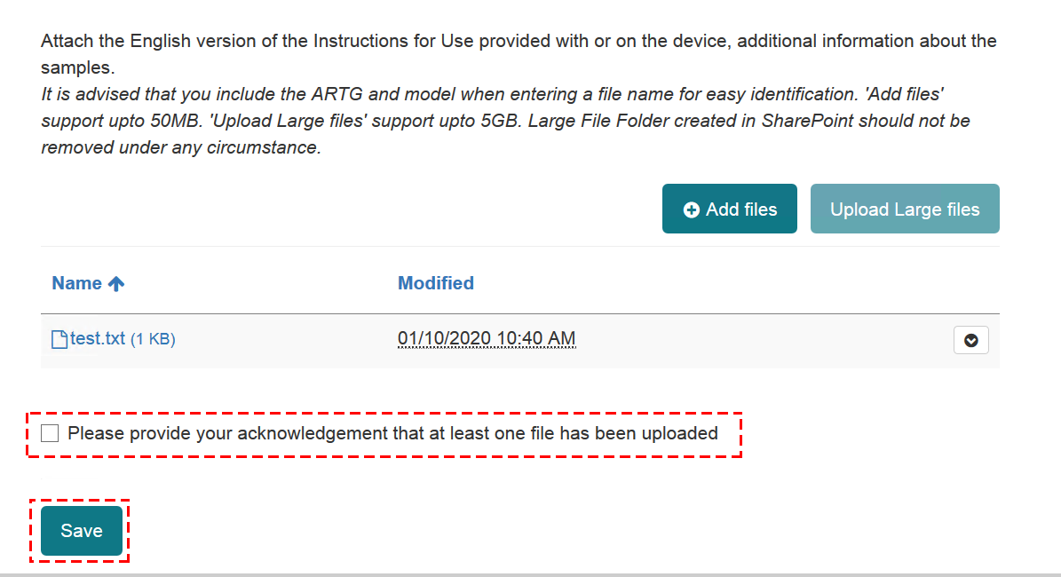
- Click on Validate.
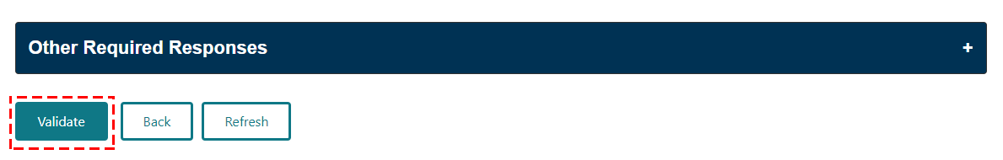
- Click Preview to view your responses.
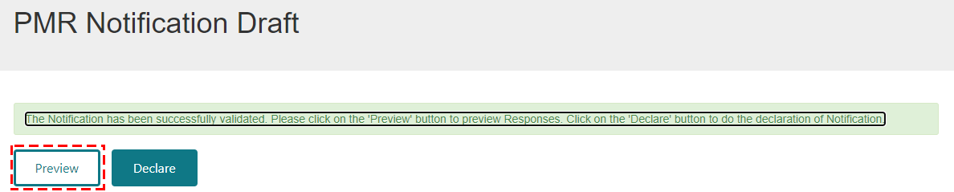
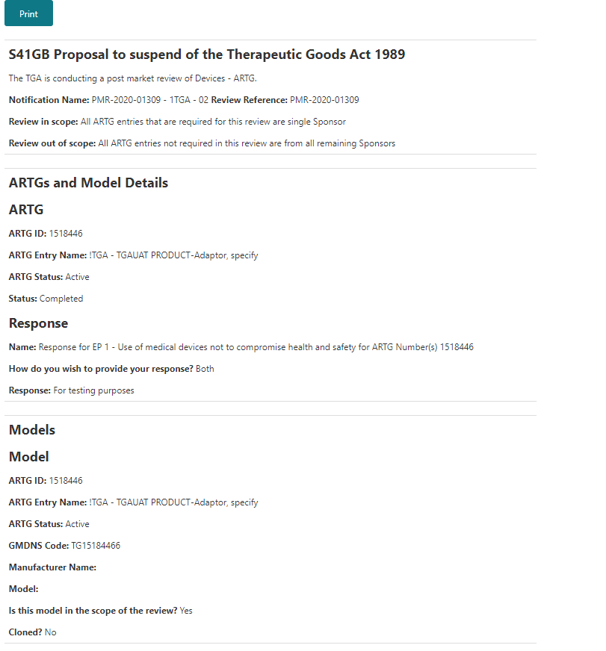
- If no further changes needs to be made, click Declare.
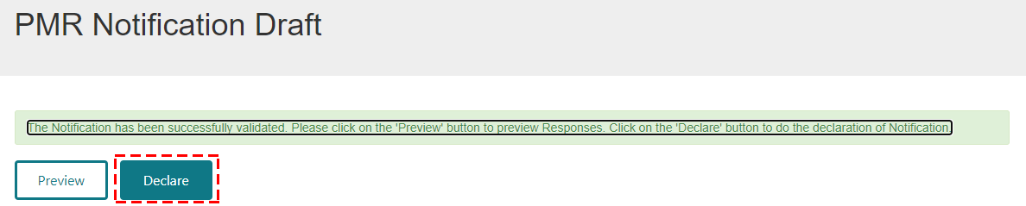
- Select No or Yes if you agree to the declaration and click Submit.
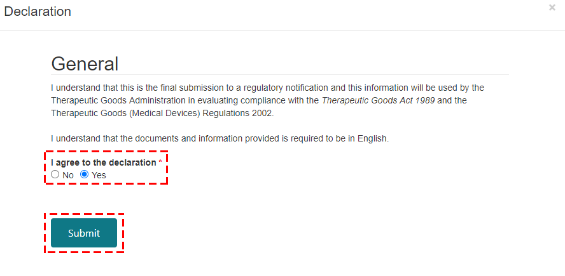
- Click OK.
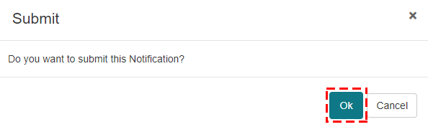

Version history
Version | Description of change | Author | Effective date
V1.0 | Original publication | Medical Devices Surveillance Branch | October 2020
V1.1 | Minor additions to clarify drafting of responses process | Medical Devices Surveillance Branch | December 2020
V1.2 | Minor additions to clarify drafting process and order of processes | Medical Devices Surveillance Branch | March 2021

Therapeutic Goods Administration
PO Box 100 Woden ACT 2606 Australia
Email: info@tga.gov.au Phone: 1800 020 653 Fax: 02 6203 1605
https://www.tga.gov.au
Reference/Publication #

