July 2022

Australian Public Assessment Report for Nuvaxovid
  - Active ingredients: SARS-CoV-2 rS with Matrix M adjuvant (NVX-CoV2373)
  - Sponsor: Biocelect Pty Ltd

About the Therapeutic Goods Administration (TGA)
- The Therapeutic Goods Administration (TGA) is part of the Australian Government Department of Health and is responsible for regulating therapeutic goods, including medicines, medical devices, and biologicals.
- The TGA administers the Therapeutic Goods Act 1989 (the Act), applying a risk management approach designed to ensure therapeutic goods supplied in Australia meet acceptable standards of quality, safety, and efficacy.
- The work of the TGA is based on applying scientific and clinical expertise to decision-making, to ensure that the benefits to the Australian public outweigh any risks associated with the use of therapeutic goods.
- The TGA relies on the public, healthcare professionals and industry to report problems with therapeutic goods. The TGA investigates reports received to determine any necessary regulatory action.
- To report a problem with a therapeutic good, please see the information on the TGA website.

About AusPARs
- The Australian Public Assessment Report (AusPAR) provides information about the evaluation of a prescription medicine and the considerations that led the TGA to approve or not approve a prescription medicine submission. Further information can be found in Australian Public Assessment Report (AusPAR) guidance.
- AusPARs are prepared and published by the TGA.
- AusPARs are static documents that provide information that relates to a submission at a particular point in time. The publication of an AusPAR is an important part of the transparency of the TGA’s decision-making process.
- A new AusPAR may be provided to reflect changes to indications or major variations to a prescription medicine subject to evaluation by the TGA.

Copyright
© Commonwealth of Australia 2022
This work is copyright. You may reproduce the whole or part of this work in unaltered form for your own personal use or, if you are part of an organisation, for internal use within your organisation, but only if you or your organisation do not use the reproduction for any commercial purpose and retain this copyright notice and all disclaimer notices as part of that reproduction. Apart from rights to use as permitted by the Copyright Act 1968 or allowed by this copyright notice, all other rights are reserved, and you are not allowed to reproduce the whole or any part of this work in any way (electronic or otherwise) without first being given specific written permission from the Commonwealth to do so. Requests and inquiries concerning reproduction and rights are to be sent to the TGA Copyright Officer, Therapeutic Goods Administration, PO Box 100, Woden ACT 2606 or emailed to <tga.copyright@tga.gov.au>.

Contents
List of abbreviations 4
Product submission 6
Submission details 6
Product background 8
Regulatory status 10
Product Information 11
Registration timeline 11
Submission overview and risk/benefit assessment 12
Quality 12
Nonclinical 12
Clinical 13
Risk management plan 27
Risk-benefit analysis 34
Outcome 40
Specific conditions of registration applying to these goods 40
Attachment 1. Product Information 42

List of abbreviations
Abbreviation |  | Meaning
ACE2 | Angiotensin converting enzyme 2
ACV | Advisory Committee on Vaccines
AE | Adverse event
ARTG | Australian Register of Therapeutic Goods
ASA | Australia specific annex
BMI | Body mass index
CBER | Center for Biologics Evaluation and Research (Food and Drug Administration, United States of America)
CHMP | Committee for Medicinal Products for Human Use
CI | Confidence interval
COVID-19 | Coronavirus disease 2019
DLP | Data lock point
EMA | European Medicines Agency (European Union)
EMEA | European Medicines Evaluation Agency
EU | European Union
EUA | Emergency Use Authorisation
FAS | Full analysis set
FDA | Food and Drug Administration (United States)
GMEU | Geometric means enzyme linked immunosorbent assay units
GMFR | Geometric mean fold rise
GMR | Geometric mean ratio
GMT | Geometric mean titre
ICU | Intensive care unit
PCR | Polymerase chain reaction
PI | Product Information
RMP | Risk management plan
SAE | Serious adverse event
SARS-CoV-2 | Severe acute respiratory syndrome coronavirus-2
SARS-CoV-2 rS | Severe acute respiratory syndrome coronavirus-2 recombinant spike protein nanoparticle vaccine
SCR | Seroconversion rates
TEAE | Treatment emergent adverse event
TGA | Therapeutic Goods Administration
USA | United States (of America)
VE | Vaccine efficacy
VOC | Variant of concern
WHO | World Health Organization

Product submission

Submission details
Type of submission: | Extension of indications
Product name: | Nuvaxovid
Active ingredient: | SARS-CoV-2 rS with Matrix M adjuvant (NVX-CoV2373)
Decision: | Approved for provisional registration
Date of decision: | 22 July 2022
Date of entry onto ARTG: | 25 July 2022
ARTG number: | 351139
Black Triangle Scheme: | Yes.  As a provisionally registered product, this medicine will remain in the Black Triangle Scheme for the duration of its provisional registration
Sponsor’s name and address: | Biocelect Pty Ltd  Suite 502 Level 5  139 Macquarie Street, NSW 2000
Dose form: | Suspension for injection
Strength: | 5 µg/0.5mL
Container: | Multidose vial
Pack size: | Ten vials
Approved therapeutic use: | Nuvaxovid has provisional approval for the indication:  Active immunisation to prevent coronavirus disease 2019 (COVID-19) caused by SARS-CoV-2 in individuals 12 years of age and older.  The use of this vaccine should be in accordance with official recommendations.  The decision has been made on the basis of short-term efficacy and safety data. Continued approval depends on the evidence of longer term efficacy and safety from ongoing clinical trials and post-market assessment.
Route of administration: | Intramuscular injection
Dosage: | Primary series  Nuvaxovid is administered intramuscularly as a course of two doses of 0.5 mL each. It is recommended that the second dose is to be administered three weeks after the first dose, see section 5.1 Pharmacodynamic Properties of Product Information.  Booster Dose  A booster dose of Nuvaxovid (0.5 mL) may be administered intramuscularly approximately six months after completion of a primary series in individuals 18 years of age and older.  The decision when and for whom to implement a booster dose of Nuvaxovid should be made based on available vaccine safety and effectiveness data (see sections 4.8 Adverse Effects and 5.1 Pharmacodynamic Properties in Product Information), in accordance with official recommendations.  Interchangeability  There are no data available on the interchangeability of Nuvaxovid with other COVID-19 vaccines to complete the primary vaccination course. Individuals who have received a first dose of Nuvaxovid should receive the second dose of Nuvaxovid to complete the vaccination course, see section 4.4 Special Warnings and Precautions for Use of Product Information.  For precautions for administering the vaccine, see section 4.4 Special Warnings and Precautions for Use of Product Information.  For further information regarding dosage, refer to the Product Information.
Pregnancy category: | B1  Drugs which have been taken by only a limited number of pregnant women and women of childbearing age, without an increase in the frequency of malformation or other direct or indirect harmful effects on the human fetus having been observed.  Studies in animals have not shown evidence of an increased occurrence of fetal damage.  The use of any medicine during pregnancy requires careful consideration of both risks and benefits by the treating health professional. This must not be used as the sole basis of decision making in the use of medicines during pregnancy. The TGA does not provide advice on the use of medicines in pregnancy for specific cases. More information is available from obstetric drug information services in your State or Territory.

Product background
This AusPAR describes the submission by Biocelect Pty Ltd (the sponsor) to register Nuvaxovid (SARS-CoV-2 rS with Matrix M adjuvant (NVX-CoV2373)) 5 µg/0.5mL, suspension for injection, multidose vials for the following extension of indications:
Active immunisation to prevent coronavirus disease 2019 (COVID-19) caused by SARS-CoV-2 in individuals 12 years of age and older.
Coronavirus disease 2019 (COVID-19) is the disease caused by novel coronavirus, severe acute respiratory syndrome coronavirus-2 (SARS-CoV-2), which is an enveloped, positive sense, single stranded RNA virus. The World Health Organization (WHO) declared COVID-19 as a pandemic on 11 March 2020., The virus causes a respiratory illness in people known as COVID-19, which spreads primarily via respiratory droplets and aerosol transmission.
Since the beginning of the COVID-19 outbreak, the disease has spread rapidly despite stringent public health efforts. COVID-19 has spread worldwide affecting more than 200 countries and territories, with an unprecedented effect on public health, as well as on social and economic activities. As of 14 July 2022, there have been over 557 million cases confirmed globally and 6.35 million deaths; while in Australia, there have been almost 8.6 million confirmed cases and 10,518 recorded deaths. Thus, while several effective COVID-19 vaccines have been developed and approved (under the provisional approval pathway in Australia; the United States (US) Food and Drug Administration’s Emergency Use Authorization (EUA); and conditional marketing authorisation use by the European Medicines Agency (for the European Union)); the spread and emergence of variants continues to fuel the ongoing pandemic.
All ages may present with the disease, but notably, case fatality rates are elevated in persons older than 60 years of age. Comorbidities are also associated with increased case fatality rates, including cardiovascular disease, diabetes, hypertension, and chronic respiratory disease.
Whilst COVID-19 disease in children and adolescents is often asymptomatic or causes only mild disease, severe disease and death may occur. Poor outcomes are more likely in children with pre-existing health conditions, disadvantage, and low socioeconomic or ethnic minority status. As of 14 July 2022, almost one million Australians aged 19 years or less, have contracted COVID-19, and there have been 20 deaths in this age group.4 A study in New South Wales between June and October 2021, of 17,474 children estimates the hospitalisation rate to be 1.38 per 100 SARS-CoV-2 infections, and the intensive care unit (ICU) admission rate to be 0.09 per 100 infections. Furthermore, there have been cases of multisystem inflammatory syndrome, a rare but serious complication in Australian children. As of September 2021, there were four confirmed cases, and the study in New South Wales identified published in late 2021, seven cases (two requiring ICU admission) were identified, with an estimated occurrence rate of 1 per 2496 infections.5
Active immunisation through vaccination represents the best means of preventing hospitalisation and deaths at an individual level and controlling the pandemic at a societal level. Nuvaxovid, the vaccine covered in this AusPAR, induces active immunity to the spike protein of SARS-CoV-2, the causative virus of COVID-19. Nuvaxovid will be administered intramuscularly as a two-dose regimen in the 12 to 18 years of age group, as per adult regimen, with doses being administered on Day 0 and Day 21.
Nuvaxovid is a SARS-CoV-2 recombinant spike (rS) protein nanoparticle vaccine based on the full length, wild type SARS-CoV-2 spike glycoprotein. The SARS-CoV-2 rS vaccine is formulated with Matrix-M, a proprietary saponin based adjuvant that has been shown to enhance the immunogenicity of nanoparticle vaccines. It is anticipated that the vaccine will induce both a humoral and a cell-mediated immune response.
The two-dose regimen of Nuvaxovid (5 μg SARS-CoV-2 rS with 50 μg Matrix-M adjuvant), administered 21 days (plus seven days) apart as a co-formulation was selected following nonclinical and clinical data comparing doses of 5 and 25 µg of vaccine.7 The formulation used in all adult and adolescent clinical studies was the same and is the formulation for commercial product.

Current options for COVID-19 vaccine booster
There are currently five vaccines on the Australian Register of Therapeutic Goods (ARTG), and all are approved under the provisional pathway:
  - Comirnaty (BNT162b2 (mRNA)/tozinameran), also known as the Pfizer/BioNTech (mRNA) vaccine, provisionally approved for active immunisation to prevent COVID-19 caused by SARS-CoV-2, in individuals 5 years of age and older.,,,
  - COVID-19 Vaccine AstraZeneca (ChAdOx1-S), an adenoviral vectored vaccine, provisionally approved for active immunisation to prevent COVID-19 caused by SARS-CoV-2, in individuals 18 years of age and older.,
  - COVID-19 Vaccine Janssen (Ad26.COV2.S), an adenoviral vectored vaccine, provisionally approved for active immunisation to prevent COVID-19 caused by SARS-CoV-2, in individuals 18 years of age and older.,
  - Spikevax (elasomeran) COVID-19 vaccine, also known as the Moderna (mRNA) vaccine, provisionally approved for active immunisation to prevent COVID-19 caused by SARS-CoV-2, in individuals 6 years of age and older.,,,
  - Nuvaxovid (SARS-CoV-2 recombinant spike protein with Matrix-M adjuvant) COVID-19 vaccine, also known as the Novavax recombinant spike protein vaccine, provisionally approved for active immunisation to prevent COVID-19 caused by SARS-CoV-2 in individuals 18 years of age and older.,

Regulatory status
Nuvaxovid (SARS-CoV-2 rS with Matrix M adjuvant (NVX-CoV2373)) 5 µg/0.5mL, suspension for injection received initial registration on the Australian Register of Therapeutic Goods (ARTG) on 20 January 2022;^{26,27} for the following indication:
Active immunisation to prevent coronavirus disease 2019 (COVID-19) caused by SARS-CoV-2 in individuals 18 years of age and older.
The use of this vaccine should be in accordance with official recommendations.
The decision has been made on the basis of short-term efficacy and safety data. Continued approval depends on the evidence of longer term efficacy and safety from ongoing clinical trials post-market assessment.
At the time the TGA considered this submission similar submissions were under consideration in the United Kingdom, United States of America, Canada, Switzerland and New Zealand.
In the European Union, the Committee for Medicinal Products for Human Use (CHMP) of European Medicines Agency (EMA) adopted a positive opinion on 23 June 2022; recommending an extension to the existing indication (active immunisation in individuals 18 years of age and older) to the following:
Nuvaxovid is indicated for active immunisation to prevent COVID-19 caused by SARS-CoV-2 in individuals 12 years of age and older
The sponsor has stated that a parallel application has not been rejected or deferred by any overseas authorities.

Product Information
The Product Information (PI) approved with the submission which is described in this AusPAR can be found as Attachment 1. For the most recent PI, please refer to the TGA PI/CMI search facility.

Registration timeline
Data were provided as a rolling submission. Under normal circumstances, TGA's assessment (for both provisional and general registration) begins once all information to support registration is available. As part of the Department of Health's response to the pandemic, the TGA has agreed to accept rolling data for COVID-19 vaccines and treatments, to enable early evaluation of data as it becomes available.
The following table captures the key steps and dates for this submission.
Table 1: Timeline for Submission PM-2022-01431-1-2
Description | Date
Submission dossier accepted and first round evaluation commenced | 27 April 2022
Evaluation completed | 7 July 2022
Delegate’s Overall benefit-risk assessment and request for Advisory Committee advice | 21 June 2022
Sponsor’s pre-Advisory Committee response | 27 June 2022
Advisory Committee meeting | 6 July 2022
Registration decision (Outcome) | 22 July 2022
Completion of administrative activities and registration on the ARTG | 25 July 2022
Number of working days from submission dossier acceptance to registration decision* | 61
*Statutory timeframe for standard submissions is 255 working days

Submission overview and risk/benefit assessment
A summary of the TGA’s assessment for this submission is provided below.
The Delegate referred to the following as guidance applicable to this submission:
- European Medicines Evaluation Agency (EMEA), Committee for Medicinal Products for Human Use (CHMP), Guideline on Clinical Evaluation of New Vaccines, EMEA/CHMP/VMP/164653/2005.
- Therapeutic Goods Administration (TGA) (2021) Access Consortium Statement on COVID-19 Vaccines Evidence. Available at: https://www.tga.gov.au/access-consortium-statement-covid-19-vaccines-evidence.
- Food and Drug Administration (FDA), Center for Biologics Evaluation and Research (CBER), Emergency Use Authorization for Vaccines to Prevent COVID-19, Guidance for Industry, February 2021. Available from the FDA website.
- FDA, CBER, Development and Licensure of Vaccines to Prevent COVID-19, Guidance for Industry, June 2020. Available from the FDA website.
- European Medicines Agency (EMA), CHMP, EMA considerations on COVID-19 vaccine approval, EMA/592928/2020, 16 November 2020.

Quality
A full quality evaluation was conducted at the time this product received initial registration (provisional approval).²⁷

Nonclinical
A full nonclinical evaluation was conducted at the time this product received initial registration (provisional approval).²⁷

Clinical
The initial application for provisional registration (submission PM-2021-00623-1);²⁷ of Nuvaxovid in adults (aged older than or equal to 18 years of age) included interim study reports for the following five studies as shown in Figure 1.
Figure 1: Nuvaxovid development program in adults
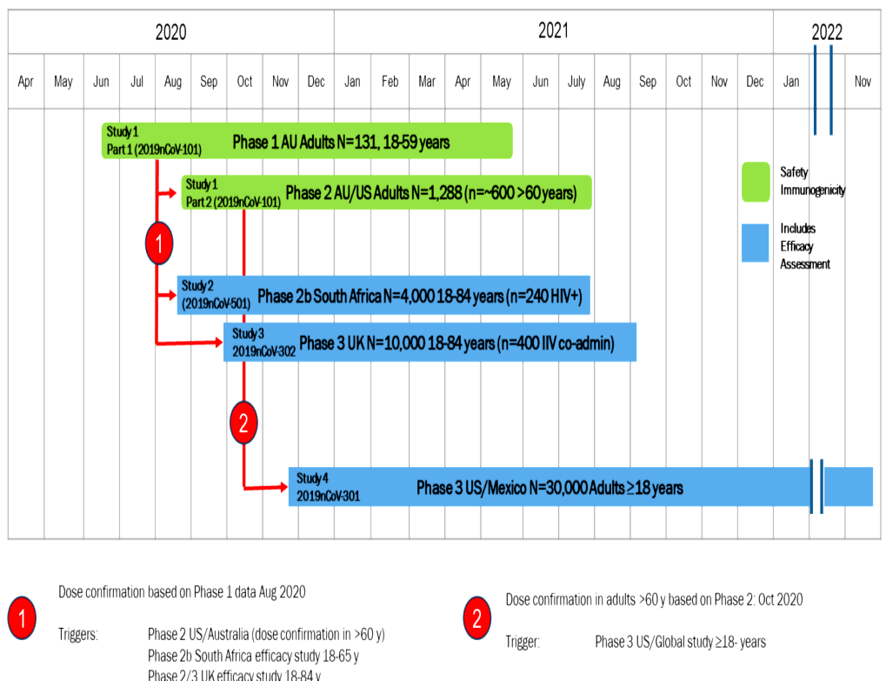
For adult participants, enrolment, and primary vaccination (that is Days 0 and 21 (plus 7 days)) have been completed in all studies. Six month safety and immunogenicity data are available in Part 1 of Study 2019nCoV-101, and Day 35 safety and immunogenicity data are available in Part 2 of Study 2019nCoV-101. Final primary efficacy endpoint and safety analyses have been conducted in Studies 2019nCoV-501, 2019nCoV-302, and 2019nCoV-301, with a median duration 60 days of safety follow up in Studies 2019nCoV-302 and 2019nCoV-301. Immunogenicity data through Day 35 are also available for Studies 2019nCoV-501, 2019nCoV-301, and 2019nCoV-302.
The per protocol efficacy analysis population is comprised of participants who were randomised; received both doses as assigned; had no evidence of SARS-CoV-2 infection prior to Dose 1; and did not have a COVID-19 event at any time in the seven days after the second injection. For the per protocol efficacy analysis population, in participants older than or equal to 18 years of age, the studies to date have shown about 90% overall vaccine efficacy (VE) in two Phase III studies (Studies 2019nCoV-301 and 2019nCoV-302) and 100% efficacy against severe disease. Data pertaining to Nuvaxovid use in adults (that is, above 18 years age), showed a robust immunogenicity response in the target age group. Immunogenicity response was consistent across relevant subgroups.
The clinical development program in adolescent participants aged from 12 years to under 18 years of age comprises the ongoing paediatric expansion of clinical Study 2019nCoV-301.
For adolescent participants 12 years to under 18 years of age, enrolment, and primary vaccination (that is Days 0 and 21 (plus 7 days)) have been completed and follow up is ongoing. Final primary effectiveness and efficacy endpoint and safety analyses have been conducted in this study, with a median duration of at least 60 days of safety follow up. Immunogenicity data through Day 35 are available. Data from the blinded crossover and subsequent follow up are not yet available; these additional data will be filed at a later date, including additional safety, immunogenicity, and efficacy data (at six months and one year).

Study 2019nCoV-301: Paediatric expansion

Study overview
This is a Phase III, multicentre, randomised, observer blinded, placebo-controlled study aiming to evaluate the efficacy, safety, and immunogenicity of Nuvaxovid in 3000 participants. The main driver of sample size was the availability of sufficient safety data.
Participants were healthy or medically stable adolescent participants 12 years to younger than 18 years of age without a previous laboratory confirmed diagnosis of SARS-CoV-2 infection/COVID-19.
The study is being conducted in 73 sites in the United States of America (USA)
Table 2, shown below, outlines the study treatments in this study.
Table 2: Study 2019nCoV-301 Paediatric program expansion
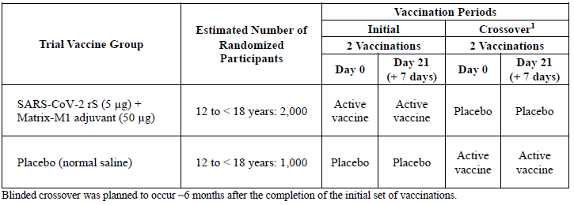
Blinded crossover was planned to occur about 6 months after the completion of the initial set of vaccinations.
Key dates for this study are as follows:
- 26 April 2021: Study recruitment commenced
- 5 June 2021: Completion of enrolment
- 27 September 2021: Date for data cut off for this interim analysis.
This study is ongoing, and will provide two years of follow up from the Day 21 injection.
Whilst not stratified; sites were instructed to recruit a diverse population, and similar numbers in the 12 to younger than 15 year of age and 15 to younger than 18 year of age subgroups.
At the time of this analysis, the Delta variant of concern (VOC) (B.1.617.2 and AY lineages) was the predominant variant circulating in the USA.

Main objectives
The main objectives of this study are as follows:
- To evaluate the efficacy of a two dose regimen of SARS-CoV-2 rS vaccine adjuvanted with Matrix-M1 compared to placebo against polymerase chain reaction (PCR)-confirmed symptomatic COVID-19 illness diagnosed more than or equal to 7 days after completion of the second injection in the initial set of vaccinations of adolescent participants aged from 12 to younger than 18 years.
- To assess non-inferiority of the neutralising antibody response for all adolescent participants seronegative to anti-SARS-CoV-2 nucleoprotein antibodies at Baseline, compared with that observed in seronegative adult participants aged 18 to younger than 26 years from the adult main study (immunogenicity population participants before crossover).
- To describe the safety experience for the vaccine versus placebo in adolescent participants (aged 12 to younger than 18 years) based on solicited short term reactogenicity and overall safety through 49 days (28 days after second injection of each set of vaccinations (initial and crossover)) by comparing vaccine versus placebo for all unsolicited adverse events (AE).
The primary efficacy endpoint was the same as that in the adult part of the study but is descriptive with no formal statistical hypothesis tested. The primary endpoint was analysed on the per protocol efficacy population and by analysis of the full analysis set (FAS).
Vaccine efficacy was defined as:
$$VE (\%) = (1 – RR) × 100$$
where RR = relative risk of incidence rates between the two trial vaccine groups (Nuvaxovid and placebo).

Data sets analysed
There were seven main analysis sets used. The distribution of participants in the analysis sets is shown in Table 3, below.
- The commonest reason for exclusion from the per protocol efficacy set was baseline anti-nucleoprotein seropositivity (15.2% Nuvaxovid versus 16% placebo).
- The commonest reasons for exclusion from the per protocol immunogenicity population set was ‘SARS-CoV-2 exposure at Baseline’ (14.1% Nuvaxovid versus 14.6% placebo), ‘sample not collected’ (5.7% versus 8.3% respectively) and ‘protocol deviation’ (4.6% versus 5.7% respectively). The latter two reasons applied to the per protocol immunogenicity population 2 set.
Table 3: Study 2019nCoV-301 Analysis sets (all randomised participants)
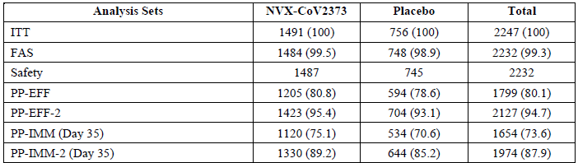
Abbreviations: FAS = full analysis set; ITT = intent to treat; NVX-CoV2373 = 5 µg SARS-CoV-2 rS with 50 µg Matrix-M1 adjuvant; PP-EFF = per protocol efficacy set; PP-EFF-2 = per protocol efficacy set two; PP-IMM = per protocol immunogenicity set; PP-IMM-2 = per protocol immunogenicity set 2; SARS-CoV-2 rS = severe acute respiratory syndrome coronavirus 2 recombinant spike protein nanoparticle vaccine (Nuvaxovid).

Participants
Recruitment was slower than anticipated, due to an Emergency Use Authorization (EUA) for COVID-19 vaccines becoming available in the USA for those of 16 and 17 years of age during study recruitment. Thus 2247 (75%) of the intended 3000 participants were randomised by the recruitment cut-off date, (5 June 2021) and a lower proportion of older adolescents were enrolled. (12 years to younger than 15 years old, n = 1498; 67%, 15 years to younger than 18 years old, n = 734; 33%). Disposition of participants is shown in Table 4. There were no discontinuations due to adverse events or death, 94% of participants remained in the study, with no completions.
Study unblinding occurred in 141 (6.3%) participants, with 100 of these occurring due to a request for EUA-approved vaccines.
Table 4: Study 2019nCoV-301 Participant disposition (all randomised participants)
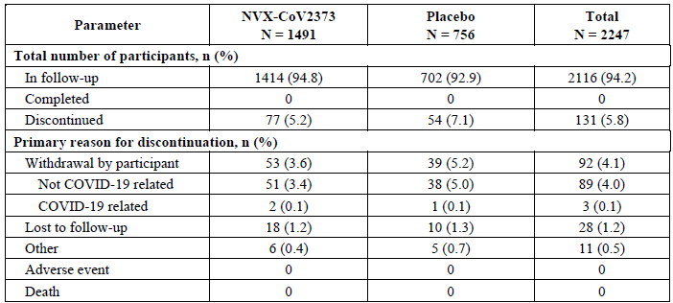
Abbreviations: COVID-19 = coronavirus disease 2019; NVX-CoV2373 = 5 µg SARS-CoV-2 rS with 50 µg Matrix-M1 adjuvant; SARS-CoV-2 rS = severe acute respiratory syndrome coronavirus 2 recombinant spike protein nanoparticle vaccine.

Participant demographics
Participants had a median age (range) of 14 years, (12 to 17 years) with 67.1% of adolescent participants being 12 to younger than 15 years of age. Just over half (52.5%) were male, and most were White (74.4%), and had a median body mass index (BMI) of 22.3, and median weight of 61 kg. Approximately 27% of participants were classified as obese. A total of 348 (15.6%) participants were anti-nucleoprotein positive, 21 (0.9%) were PCR-positive, with 359 (16.1%) being either/both anti- nucleoprotein and PCR-positive. Comorbidities of relevance included asthma (7.7% of participants), diabetes (< 0.1%) and cardiac disorders (0.4%).
The demographics and baseline characteristics were well balanced between Nuvaxovid and placebo treatment groups.

Primary efficacy outcome results
The primary efficacy outcome was examined in the per protocol efficacy analysis set. This included participants who had received both doses of vaccine and were not excluded (participants were excluded if there was evidence at Baseline of exposure to SARS-CoV-2 on serology or PCR, or if they developed COVID-19 occurring prior to seven days after Dose 2).
In the per protocol efficacy analysis set, there were six cases of COVID-19 infection in the Nuvaxovid group and 14 cases in the placebo group. This gave a VE of 79.54% (95% confidence interval (CI): 46.83, 92.13) (see Table 5, below). Of note, all cases of COVID-19 were of mild severity.
Point estimates of VE for the primary endpoint across age, sex and ethnicity subgroups consistently trended in the same direction as the overall study groups, with 95% CIs reflecting numbers of incident cases. Given the reasonably balanced enrolment for these subgroups, the clinical evaluator considers there are no concerns about lack of efficacy in a particular subgroup.
Table 5: Study 2019nCoV-301 Vaccine efficacy against polymerase chain reaction confirmed COVID-19 with onset from at least seven days after second vaccination in baseline serologically negative/PCR-negative adolescent participants (per protocol efficacy analysis set)
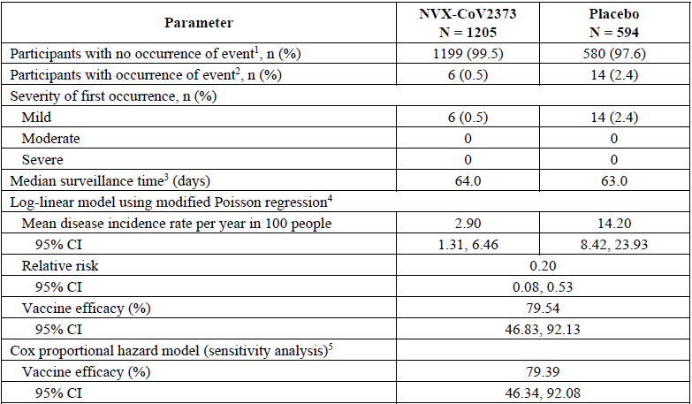
Abbreviations: CI = confidence interval; COVID-19 = coronavirus disease 2019; NVX-CoV2373 = 5 µg SARS-CoV-2 rS with 50 µg Matrix-M1 adjuvant; PCR = polymerase chain reaction; PP-EFF = per protocol efficacy; SARS-CoV-2 rS = severe acute respiratory syndrome coronavirus 2 recombinant spike protein nanoparticle vaccine; VE = vaccine efficacy.
1: Includes participants with PCR confirmed infection who did not meet mild, moderate, or severe COVID-19 criteria.
2: Event = first occurrence of PCR confirmed mild, moderate, or severe COVID-19 with onset of illness episode from at least 7 days after second vaccination within the surveillance period.
3: Surveillance time was defined as the difference between the date at end of surveillance period (onset of first occurrence of event, or follow up contact at 12 months after last vaccination, or censoring and date at start of surveillance period (from at least 7 days after second vaccination) + 1
4: Modified Poisson regression with logarithmic link function, treatment group, and strata as fixed effects and robust error variance
5: Cox-proportional hazard model with Efron’s method for tie handling with vaccine group and age strata. Hazard ratio was used to estimate relative risk.
In the per protocol efficacy 2 analysis set (inclusive of participants with baseline seropositivity to SARS-CoV-2 or a positive SARS-CoV-2 PCR), there were six cases in the Nuvaxovid group versus 15 cases in the placebo group (all 21 cases were mild); VE of 80.79% (95% CI: 50.52, 92.54).
There were 29 cases (11 Nuvaxovid versus 18 placebo; all cases mild) in participants receiving at least one dose of study vaccine, giving a VE of 69.74% (95% CI: 36.00, 85.69). Cumulative rates of PCR-confirmed symptomatic mild, moderate, and severe COVID-19 began to diverge between 20 and 40 days after first vaccination. (see Figure 2, below).
Of the 20 COVID-19 cases in the per protocol efficacy analysis set, viral sequencing was available for 11 cases (3 out of 6 in the Nuvaxovid group and 8 out of 14 in the placebo group). All viruses sequenced were Delta variant (10 out of 11 were B.1.617.2 and 1 out of 11 (in the Nuvaxovid group) was AY.3 lineage). The resultant VE against Delta variant was 82.04% (95% CI: 32.42, 95.23). The per protocol efficacy 2 analysis set included the same 11 cases and the resultant VE was 81.91% (95% CI: 31.91, 95.19).
Figure 2: Study 2019nCoV-301 Cumulative incidence curve of polymerase chain reaction confirmed COVID-19 disease with onset from first vaccination in adolescent participants who received at least one dose of study vaccine regardless of baseline serostatus (full analysis set)
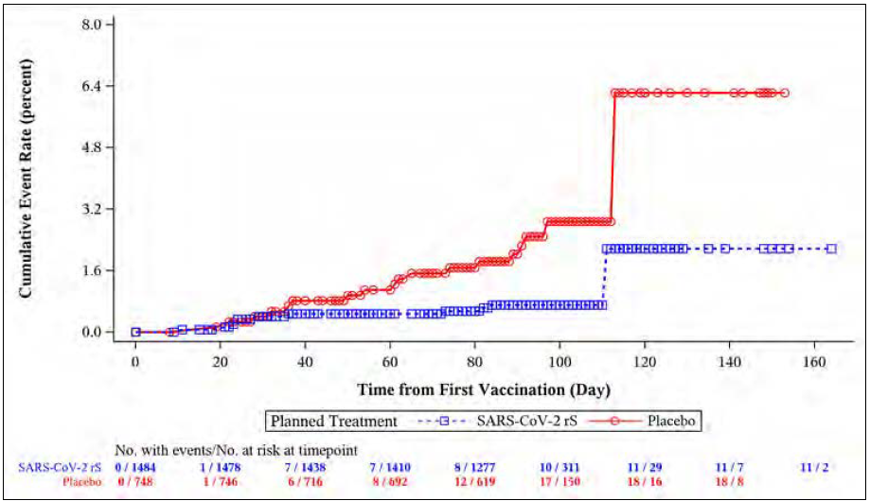
Abbreviations: COVID-19 = coronavirus disease 2019; FAS = full analysis set; NVX-CoV2373 = 5 µg SARS-CoV-2 rS with 50 µg Matrix-M1 adjuvant (Nuvaxovid); PCR = polymerase chain reaction; SARS-CoV-2 rS = severe acute respiratory syndrome coronavirus 2 recombinant spike protein nanoparticle vaccine (Nuvaxovid).

Primary effectiveness endpoint
The primary immunogenicity outcome (neutralising antibody responses) was examined in the per protocol immunogenicity analysis set, which was similar in intent to the per protocol efficacy analysis set but required availability of a baseline serum sample and another following vaccination. Those participants were SARS-CoV-2 naïve based on baseline seronegativity and a negative PCR for SARS-CoV-2. Like the per protocol efficacy population 2 analysis set, the per protocol immunogenicity population 2 analysis set used for the supportive analysis did not require participants to be SARS-CoV-2-naïve.
The primary effectiveness endpoint required demonstration of non-inferiority of the neutralising antibody to SARS-CoV-2 at Day 35, compared to a randomly selected group of young adults between 18 years to younger than 26 years of age from the adult main study immunogenicity population using three simultaneous criteria. Non-inferiority was demonstrated for all three criteria, as shown in Table 6.
- The upper bound of two-sided 95% CI for the ratio of geometric mean titre (GMTs) (GMT in 18 to under 26 years of age / GMT in 12 to under 18 years of age) was < 1.5: geometric mean ratio (GMR) 0.7, 95% CI: 0.6, 0.8.
- The point estimate of the ratio of GMTs was ≤ 1.22 (estimated as square root of 1.5): GMR 0.7 (95% CI: 0.6, 0.8).
- The upper bound of the two sided 95% CI for difference of seroconversion rates (SCR) (SCR 18 to under 26 years of age to SCR in 12 to under 18 years of age) was < 10%: SCR difference 1.1, 95% CI: -0.2, 2.8
Table 6: Study 2019nCoV-301 Adjusted ratio of geometric mean and difference in seroconversion rate of micro-neutralisation assay neutralising antibody titres for SARS-CoV-2 S wild type virus at Day 35 overall and stratified by age group (per protocol immunogenicity analysis set)
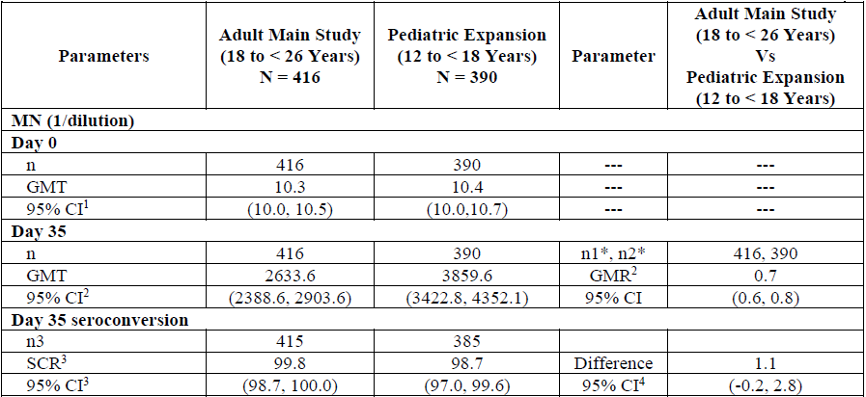
Abbreviation: ANCOVA = analysis of covariance; CI = confidence interval; GMR = ratio of geometric mean titer; which is defined as the ratio of 2 GMTs for comparison of two age cohorts; GMT = geometric mean titer; LLOQ = lower limits of quantitation; MN = microneutralisation; N = number of participants in assay specific PP-IMM analysis set in each part of study; n = number of participants with non-missing response at each visit; n1* = number of participants in adult part of study (18 to < 26 years) with non-missing neutralising antibodies result at both Day 0 and Day 35; n3 = number of participants who reported a ≥ 4-fold increase; PP-IMM = per protocol immunogenicity; SARS-CoV-2 = severe acute respiratory syndrome coronavirus 2; SCR = seroconversion rate.
1 The 95% CI for GMT was calculated based on the t-distribution of the log-transformed values, than back transformed to the original scale for presentation.
2 An ANCOVA with age cohort as main effect and baseline MN assay neutralising antibodies as covariate was performed to estimate the GMR. Individual response values recorded as below the LLOQ were set to LLOQ.
3 SCR is defined as percentage of participants with a ≥ 4 fold difference in titers between Day 35 and Day 0. The 95% CI for SCR was calculated using the Clopper-Pearson exact method.
4 Difference in SCR in the adult part of the study 18 to < 26 year olds minus SCR in the pediatric expansion. The 95% CI for the difference of SR between groups was calculated with the method of Mietinen and Nurminen.
Note: table includes participants in the active vaccine group only.
Age subgroup analyses for the primary endpoint in participants 12 years to younger than 15 years of age, and participants 15 years to younger than 18 years of age, showed similar point estimates to the entire study group with widening of 95% CIs in some instances; however, all three non-inferiority criteria were met in both age groups.
Two weeks following second vaccination (Day 35), neutralising antibody GMTs in the Nuvaxovid group were markedly increased relative to placebo across the age groups (3859.6 versus 12.2, respectively, for adolescent participants 12 years to younger than 18 years of age; 4160.8 versus 13.3 for adolescent participants 12 years to younger than 15 years of age; and 3231.8 versus 10 for adolescent participants 15 years to younger than 18 years of age). Neutralising antibody GMTs in the Nuvaxovid group were approximately 1.3-fold higher in the younger age cohort (12 years to younger than 15 years of age) than in the older age cohort (15 years to younger than 18 years of age).
These immune responses equated to neutralising antibody geometric mean fold rise (GMFRs) relative to baseline (Day 0) of 372.5, 406.7, and 302.6, respectively, across the three age groups in the Nuvaxovid group versus 1.2, 1.3, and 1, respectively, in the placebo group. Seroconversion rates in the Nuvaxovid groups were markedly increased relative to placebo across all age groups (98.7% versus 2.9% for adolescent participants 12 years to younger than 18 years of age; 99.3% versus 4.2% for adolescent participants 12 years to younger than 15 years of age; and 97.4% versus 0% for adolescent participants 15 years to younger than 18 years of age).

Results for secondary immunogenicity outcomes

Neutralising antibody responses
Neutralising antibody levels for SARS-CoV-2 wild type virus in adolescent participants regardless of baseline serostatus at Day 35 were increased relative to placebo in all adolescent participants (12 years to younger than 18 years of age) and in adolescent participants 12 years to younger than 15 years and 15 to younger than 18 years. Neutralising antibody GMTs in the Nuvaxovid group were approximately 1.2-fold higher in the younger age cohort (12 years to younger than 15 years of age) than in the older age cohort (15 years to younger than 18 years of age).
Baseline seropositive participants had more robust neutralising responses than baseline seronegative participants both at Day 0 and Day 35 in both the Nuvaxovid and placebo groups.

Serum IgG antibody concentrations to SARS-CoV-2 spike protein
Anti-spike protein IgG antibody responses and human angiotensin converting enzyme 2 (ACE2) receptor binding inhibition antibody responses were assessed in the totality of the adolescent participants that were part of the per protocol immunogenicity population and the per protocol immunogenicity population 2 analysis set (all participants regardless of serology and PCR status at Baseline).

Per protocol immunogenicity population analysis set
Overall, results in Nuvaxovid vaccinated participants followed a very similar pattern to that of neutralising antibody responses, notably:
- Geometric means enzyme linked immunosorbent assay units (GMEU) were approximately 20% higher in the 12 years to younger than 15 years of age subgroup than the 15 years to younger than 18 years of age subgroup (for neutralising titres, this difference was about 29%). Baseline GMEUs in Nuvaxovid and placebo recipients were close to the lower limit of quantification.
- The SCR in adolescents 12 years to younger than 18 years of age was 98.7% (95% CI: 97.9, 99.3) using IgG concentrations, very similar to the SCR using neutralising responses of 98.7% (95% CI: 97, 99.6). Using IgG concentrations, SCRs were 99.3% and 97.5% in the 12 years to younger than 15 years of age and 15 years to younger than 18 years of age subgroups respectively (point estimates using neutralising titres were 99.3% and 97.4% respectively).

Per protocol immunogenicity population 2 analysis set
These results followed a very similar pattern to what was seen for neutralising responses. There were higher GMEUs at Baseline in both the Nuvaxovid and placebo groups and responses were boosted by the addition of participants with prior immunity in both age subgroups. Comparative patterns of GMEUs, GMFRs and SCRs in the 12 years to younger than 15s year of age and 15 years to younger than 18 years of age subgroups were very similar to those described immediately above under ‘per protocol immunogenicity population analysis set’.
Likewise, response in participants who were seropositive at Baseline had boosted IgG concentrations relative to those in participants who were seronegative at Baseline. When the effect of baseline exposure to SARS-CoV-2 was examined, it showed that Day 35 neutralising GMTs in the Nuvaxovid group were slightly lower in seronegative participants (3859.6 (95% CI: 3422.8, 4352.1)) than in all participants (4429.3 (95% CI: 3964.9, 4948.2)); however, SCRs were 98.7% in both groups.

Human angiotensin converting enzyme 2 receptor binding inhibition antibodies to SARS-CoV-2 spike protein

Per protocol immunogenicity population analysis set
Overall, results in Nuvaxovid vaccinated participants followed a similar pattern to that of neutralising antibody responses and IgG concentrations, notably:
- GMTs were approximately 12% higher in the 12 years to younger than 15 years of age subgroup than the 15 years to younger than 18 years of age subgroup (for neutralising titres, this difference was about 29% and for IgG concentrations it was about 20%). Baseline GMTs in Nuvaxovid and placebo recipients were close to the lower limits of quantitation.
- The SCR in adolescents 12 years to younger than 18 years of age was 98.6% (95% CI: 97.7, 99.2), very similar to the SCR using neutralising responses of 98.7% (95% CI: 97, 99.6) and the SCR using IgG concentrations of 98.7% (95% CI: 97.9, 99.3). Using human ACE2 inhibition, SCRs were 99.2% and 97.2% in the 12 years to younger than 15 years of age and 15 years to younger than 18 years of age subgroups respectively (point estimates using neutralising titres were 99.3% and 97.4% respectively, and for IgG concentrations were 99.3% and 97.5% respectively).

Per protocol immunogenicity population 2 analysis set
Again, the general pattern of these results was similar to those seen for neutralising responses and for IgG concentrations. This held for GMTs, GMFRs and SCRs.

Safety

Safety in adults
Summary safety data for adults have been included for reference.

Exposure
The safety of Nuvaxovid in adults (median age was 48 years; range 18 to 95 years) was evaluated in pooled data from five ongoing clinical trials conducted in Australia, South Africa, the United Kingdom, the USA and Mexico. At the time of the analysis, a total of 49,950 participants aged 18 years and older received at least one dose of Nuvaxovid (n = 30,058) or placebo (n = 19,892). Over 96% of Nuvaxovid and placebo recipients receiving both doses of trial vaccine/placebo.

Treatment-emergent adverse events
Overall, there were higher frequencies of local site reactions and solicited systemic treatment-emergent adverse events (TEAE) among Nuvaxovid recipients than among placebo recipients following each vaccination. In the Nuvaxovid group, the frequency and intensity of solicited local and systemic TEAEs increased after second vaccination relative to the first vaccination. Most participants in the Nuvaxovid group reported Grade 1 or Grade 2 local and systemic events following each vaccination. Frequencies of Grade 3 events were relatively low (less than 10% for local and less than 15% for systemic), but such events did generally occur more frequently in the Nuvaxovid group than in the placebo group; Grade 4 events were reported in relatively few participants.
The most frequent adverse reactions in adults were injection site tenderness (75%), site pain (62%), fatigue (53%), myalgia (51%), headache (50%), malaise (41%), arthralgia (24%), and nausea or vomiting (15%). Adverse reactions were usually mild to moderate in severity with a median duration of less than or equal to two days for local events and less than or equal to one day for systemic events following vaccination. Overall, there was a higher incidence of adverse reactions in younger age groups. No specific treatment related TEAEs led to study discontinuation in either group.
Potential immune-mediated medical conditions were numerically higher in the Nuvaxovid group than in the placebo group in participants 18 to 64 years of age but numerically lower in the Nuvaxovid than in the placebo group in participants older than or equal to 65 years of age.
Fatal events occurred rarely (frequency: 0.04%) and equally between groups. No fatal event was assessed as being related to Nuvaxovid, and the events were mostly consistent with the morbidity associated with age and underlying medical conditions in the study population.

Safety in adolescent participants (12 years to younger than 18 years of age)

Exposure
In the safety analysis plan, the sample size for the paediatric expansion was predicated on obtaining an adequately sized safety database of greater and equal to 2000 adolescent recipients of the licensed product, which would mean a greater than 90% probability of observing at least one participant with an adverse event (AE) if the true incidence of the AE was 0.12% and a 99% probability if the true incidence of the AE was 0.23%.
There were 2232 adolescent participants who received at least or more than one dose of Nuvaxovid (n = 1487) or placebo (n = 745), with 2198 (98.5%) receiving both doses of study vaccine (see Table 7, below). Of the 34 who did not receive a second dose, 19 (1.3%) were in the Nuvaxovid group and 25 (2%) in the placebo group.
A total of 60 (2.7%) participants received Dose 2 outside the seven day dosing window, with a small number of outliers as long as 49 days between doses.
Table 7: Study 2019nCoV-301 Summary of adolescent participant exposure (safety analysis set)
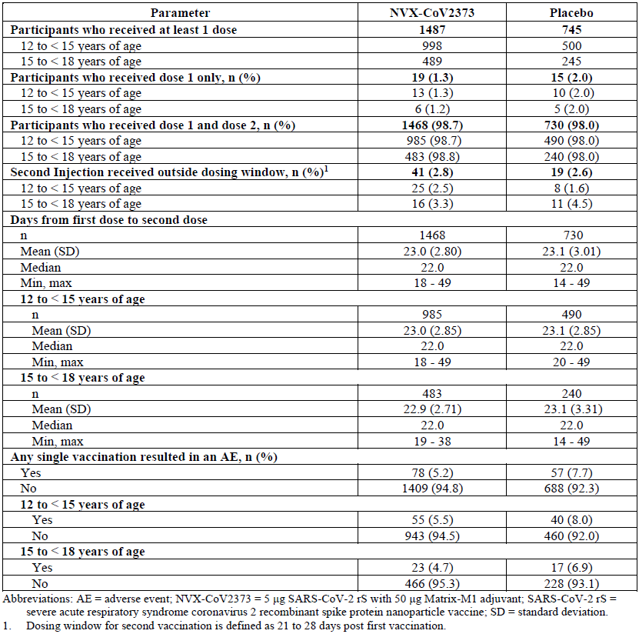
Abbreviations: AE = adverse event; NVX-CoV2373 = 5 µg SARS-CoV-2 rS with 50 µg Matrix-M1 adjuvant (Nuvaxovid); SARS-CoV-2 rS = severe acute respiratory syndrome coronavirus 2 recombinant spike protein nanoparticle vaccine (Nuvaxovid); SD= standard deviation.
1: Dosing window for second vaccination is defined as 21 to 28 days post first vaccination.
Median duration of the safety follow up period after first and second vaccinations were 94 and 71 days, respectively, in the Nuvaxovid group and 93 and 71 days, respectively, in the placebo group. Of the 1468 and 730 participants in the Nuvaxovid and placebo groups, respectively, who received both vaccinations, 1277 (87%) and 618 (84.7%), respectively, had at least 60 days of follow up after their second vaccination.

Solicited adverse events
Overall and similar to adult participants older than or equal to 18 years of age, there were higher frequencies of solicited local and systemic treatment-emergent adverse events (TEAEs) among adolescent Nuvaxovid recipients than among adolescent placebo recipients following each vaccination (see Tables 8 and 9, below). There were minor differences in frequencies in various demographic subgroups, but these were not clinically meaningful.
For local events, (Table 8) frequencies were higher in the Nuvaxovid group than the placebo group, and in the Nuvaxovid group they increased after Dose 2. Pain and tenderness were more common than erythema or swelling. Most reactions were Grades 1 or 2 in severity; Grade 3 events were uncommon, and again the frequency was higher after Dose 2. There were no Grade 4 local events. Median event durations were longer in the Nuvaxovid than in the placebo group, but overall medians were within two days for all events after both doses.
Table 8: Study 2019nCoV-301 Summary of solicited local adverse events within 7 days after Dose 1 and Dose 2 by age group (safety analysis set)
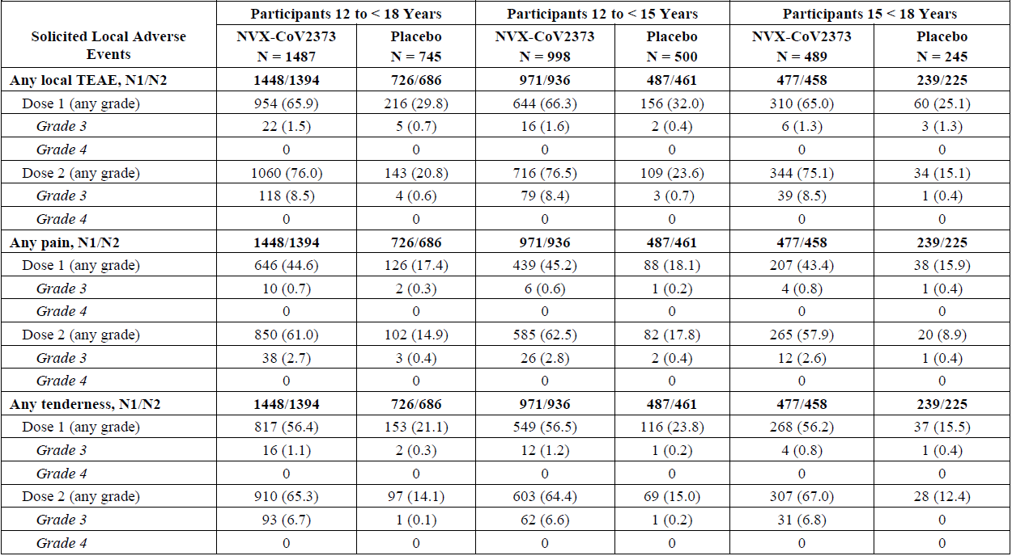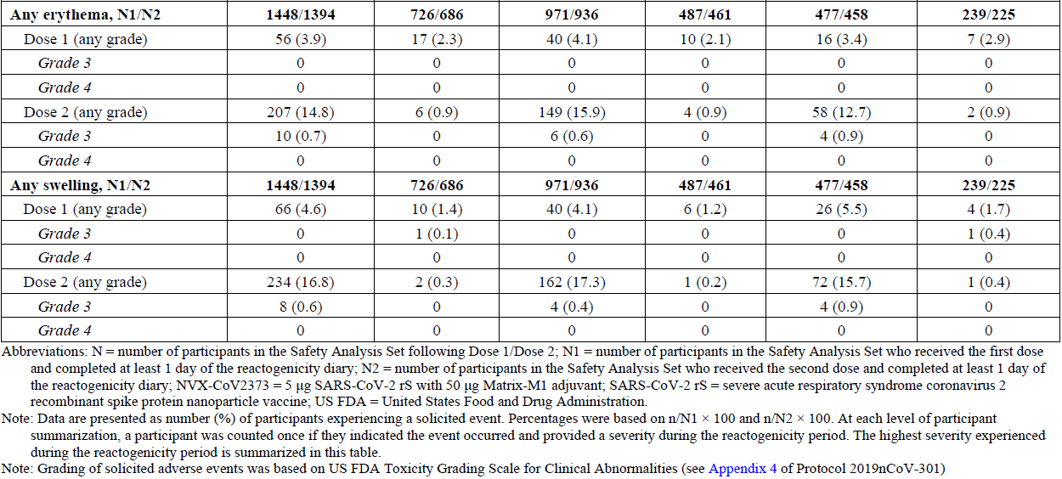
Abbreviations: N = number of participants in the safety analysis set following Dose 1/Dose 2; N1 = number of participants in the Safety Analysis Set who received the first dose and completed at least 1 day of reactogenicity dairy; N2 = number of participants in the safety analysis set who received the second dose and completed at least 1 day of the reactogenicity diary; NVX-CoV2373 = 5 µg SARS-CoV-2 rS with 50 µg Matrix-M1 adjuvant (Nuvaxovid); SARS-CoV-2 rS = severe acute respiratory syndrome coronavirus 2 recombinant spike protein nanoparticle vaccine (Nuvaxovid); FDA = Food and Drug Administration (United States of America).
Note: Data are presented as number (%) of participant experiencing a solicited event. Percentages were based on n/N1 x 100 and n/N2 x 100. At each level of participant summarisation, a participant was counted once if they indicated the event occurred and provided a severity during the reactogenicity period. The highest severity experienced during the reactogenicity period is summarised in this table.
Note: Grading of solicited adverse events was based on FDA toxicity grading scale for clinical abnormalities.
Systemic adverse event frequencies were higher in the Nuvaxovid than the placebo group, and in the Nuvaxovid group, they were higher after Dose 2 (see Table 9). Most reactions were Grade 1 or 2; the frequency of Grade 3 events was low, and there was only one correctly recorded Grade 4 event (a case of headache following Dose 2 in the Nuvaxovid group). Median durations were one day for each event after both doses and the same for the Nuvaxovid and placebo groups, with the exception being a median duration of muscle pain of two days in the Nuvaxovid versus one day in the placebo group. Similar frequencies and intensities of systemic TEAEs were reported across the two age strata (12 to younger than 15 year of age and 15 to younger than 18 year of age).
Table 9: Study 2019nCoV-301 Summary of solicited systemic adverse events within seven days after Dose 1 and Dose 2 by age group (safety analysis set)
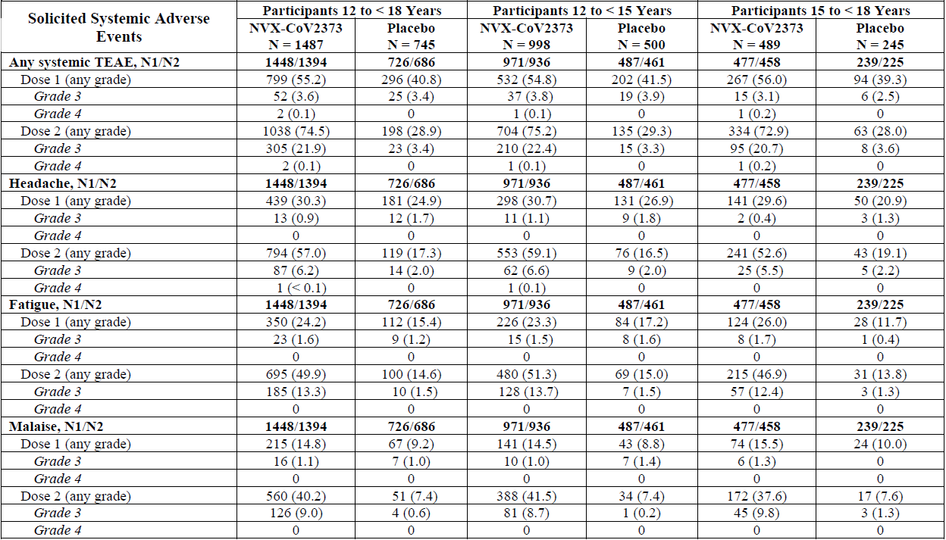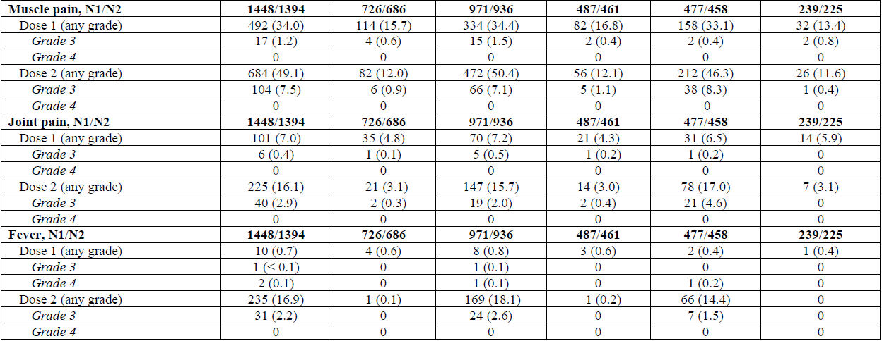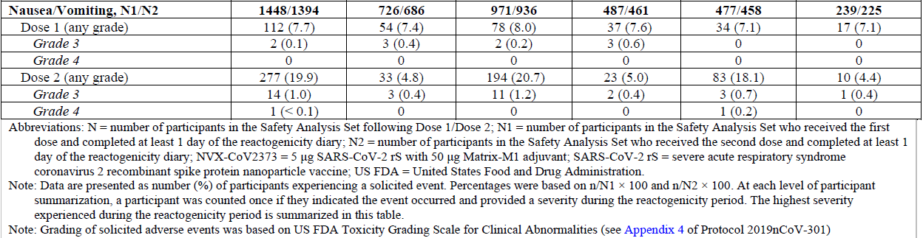
Abbreviations: N = number of participants in the safety analysis set following Dose 1/Dose 2; N1 = number of participants in the safety analysis set who received the first dose and completed at least 1 day of reactogenicity dairy; N2 = number of participants in the safety analysis set who received the second dose and completed at least 1 day of the reactogenicity diary; NVX-CoV2373 = 5 µg SARS-CoV-2 rS with 50 µg Matrix-M1 adjuvant (Nuvaxovid); SARS-CoV-2 rS = severe acute respiratory syndrome coronavirus 2 recombinant spike protein nanoparticle vaccine (Nuvaxovid); FDA = Food and Drug Administration (United States of America).
Note: Data are presented as number (%) of participant experiencing a solicited event. Percentages were based on n/N1 x 100 and n/N2 x 100. At each level of participant summarisation, a participant was counted once if they indicated the event occurred and provided a severity during the reactogenicity period. The highest severity experienced during the reactogenicity period is summarised in this table.
Note: Grading of solicited adverse events was based on FDA toxicity grading scale for clinical abnormalities.

Unsolicited treatment-emergent adverse events
Frequencies of unsolicited TEAEs from first day of vaccination until Day 49 were similar between the Nuvaxovid and placebo groups, (see Table 10, below) with unsolicited treatment related TEAEs reported at a higher frequency in the Nuvaxovid group (3.4%) than in the placebo group (1.1%). This difference results in a number needed to vaccinate to observe one excess event in the Nuvaxovid group of approximately 43 participants. The corresponding number needed to vaccinate in the 12 years to younger than 15 years of age group was 38 participants; and in the 15 years to younger than 18 years of age group was 53 participants. The imbalance was largely driven by reactogenicity related events, most of which were only experienced in the Nuvaxovid group.
Most unsolicited TEAEs were mild or moderate in severity. Severe TEAEs, and serious adverse events (SAEs), and TEAEs leading to vaccination discontinuation were reported infrequently and at similar frequencies between the two treatment groups. Frequencies of medical attended AEs (overall and treatment related) were also similar between the two treatment groups. There were no potential immune mediated medical conditions reported (one SAE of ‘seizure’ was reported in the Nuvaxovid group that met the protocol defined criteria for a potential immune mediated medical conditions, but this event was due to an overdose of fluoxetine, and thus not considered a potential immune-mediated medical conditions by the investigator). Whilst in the study in adults few cases of pericarditis/myocarditis had been observed following vaccination with Nuvaxovid, none were observed in the paediatric expansion.
There were no deaths among the adolescent participants in the paediatric expansion at the time of this data extraction.
Table 10: Study 2019nCoV-301 Overall summary of unsolicited adverse events in adolescent participants in the paediatric expansion
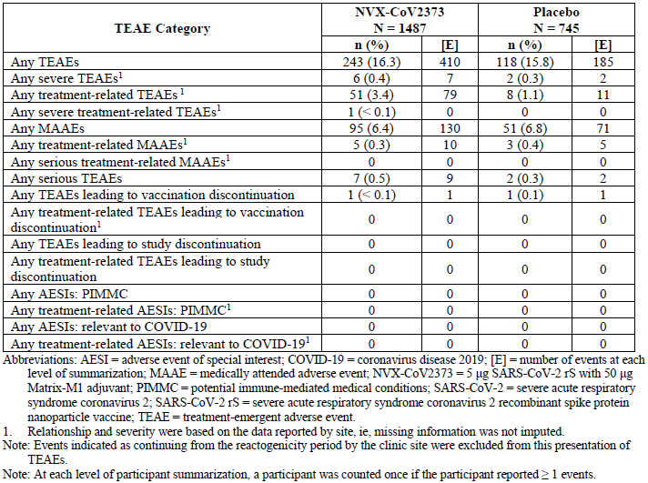
Abbreviations: AESI = adverse event of special interest; COVID-19 = coronavirus disease 2019; [E] = number of events at each level of summarisation; MAAE = medically attended adverse event; NVX-CoV2373 = 5 µg SARS-CoV-2 rS with 50 µg Matrix-M1 adjuvant (Nuvaxovid); PIMMC = potential immune mediated medical conditions; SARS-CoV-2 = severe acute respiratory syndrome coronavirus 2 ; SARS-CoV-2 rS = severe acute respiratory syndrome coronavirus 2 recombinant spike protein nanoparticle vaccine (Nuvaxovid); TEAE = treatment emergent adverse event.
1: Relationship and severity were based on the data reported by site, that is missing information was not imputed.
Note: Event indicated as continuing from the reactogenicity period by the clinic site were excluded from this presentation of TEAEs.
Note: At each level of participant summarisation, a participant was counted once if the participant reported ≥ 1 events.

Risk management plan
The sponsor submitted European Union (EU)-risk management plan (RMP) was version 1.0 (18 December 2021; data lock point (DLP) 20 December 2021) and Australia specific annex (ASA) version 0.4 (29 December 2021) with submission PM-2021-00623-1-2.²⁷ In support of current submission (extended indications), the sponsor has submitted EU-RMP version 1.1 (23 March 2022; DLP 18 February 2022) and ASA version 1.2 (18 April 2022). The sponsor has not provided any further EU-RMP or ASA versions during second round of RMP evaluation.
The summary of safety concerns and their associated risk monitoring and mitigation strategies are summarised in Table 11. Further information regarding the TGA’s risk management approach can be found in risk management plans for medicines and biologicals and the TGA's risk management approach.
Table 11: Summary of safety concerns
Summary of safety concerns |  | Pharmacovigilance |  | Risk Minimisation
 |  | Routine | Additional | Routine | Additional
Important identified risks | None
Important potential risks | Vaccine-associated enhanced disease (VAED), including vaccine-associated enhanced respiratory disease (VAERD) | ✓* | ✓†‡ | – | –
Important potential risks | Myocarditis and pericarditis | ✓* | ✓†‡ | – | –
Missing information | Use in pregnancy and while breastfeeding | ✓ | ✓§ | ✓ | –
Missing information | Use in immunocompromised patients | ✓ | ✓†‡ | ✓ | –
Missing information | Use in frail patients with comorbidities (e.g., chronic obstructive pulmonary disease (COPD), diabetes, chronic neurological disease, cardiovascular disorders) | ✓ | ✓‡ | – | –
Missing information | Use in patients with autoimmune or inflammatory disorders | ✓ | ✓‡ | ✓ | –
Missing information | Interaction with other vaccines | ✓ | ✓†‡ | ✓ | –
Missing information | Long-term safety | ✓ | ✓†‡ | – | –
*Follow-up form; †Clinical trials ; ‡PASS; § Pregnancy registry (C-VIPER)
The summary of safety concerns remains the same as the summary that was evaluated and considered acceptable for the previous submission (PM-2021-00623-1-2);²⁷ with the exception of anaphylaxis. The important potential risk of anaphylaxis has been removed with justification that it is a known risk that does not impact the risk-benefit profile. This is acceptable and the changes proposed by the current submission are not expected to change the summary of safety concerns from an RMP perspective.
Routine pharmacovigilance includes the submission of monthly summary safety reports for the first 6 months, post registration, and thereafter at intervals specified by the TGA. The pharmacovigilance plan was deemed acceptable during the previous evaluations and continues to be acceptable for the current submission. The acceptability of the clinical study plan will be assessed by the clinical evaluator/Delegate.
Only routine risk minimisation measures have been proposed by the sponsor. This approach was deemed acceptable during the previous evaluations as there are risk minimisation measures are implemented by the Australian Government Department of Health. The changes proposed by the current submission are not expected to require additional risk minimisation measures as part of the RMP.
The completion of the five initial clinical studies in adult populations is currently estimated as occurring in late 2022, with the planned paediatric studies expected to be complete in 2025. A comprehensive clinical trial data plan on the safety and efficacy was submitted by the sponsor (see Table 12, below). If these data are provided as outline in the plan, the Delegate considers this acceptable.
In addition to the four ongoing clinical trials, there are five planned post-authorisation studies which are non-interventional studies. These include two post-authorisation safety studies in the United Kingdom and the USA, a global pregnancy registry and two post authorisation effectiveness studies (European Union/European Economic Area and USA). These activities are intended to be conducted in the UK, EU and USA that will be initiated after initial (respective) regulatory approval.

Proposed wording for conditions of registration
- The Nuvaxovid COVID-19 Vaccine (adjuvanted) EU- RMP (version 1.1, dated 23 March 2022, data lock point 18 February 2022), with Australian Specific Annex (version 1.2, dated 18 April 2022), included with Submission PM-2022-01431-1-2, and any subsequent revisions, as agreed with the TGA will be implemented in Australia.
An obligatory component of risk management plans is routine pharmacovigilance. Routine pharmacovigilance includes the submission of periodic safety update reports (PSURs).
Reports are to be provided in line with the current published list of EU reference dates and frequency of submission of PSURs until the period covered by such reports is not less than three years from the date of the approval letter, or the entire period of provisional registration, whichever is longer.
The reports are to at least meet the requirements for PSURs as described in the European Medicines Agency’s Guideline on good pharmacovigilance practices (GVP) Module VII-periodic safety update report (Rev 1), Part VII.B Structures and processes. Note that submission of a PSUR does not constitute an application to vary the registration. Each report must have been prepared within ninety calendar days of the data lock point for that report.
Additional to the routine submission of the routine PSURs, expedited monthly safety summary reports (including safety data for patients in Australia) are to be provided for the first 6 months post registration, and thereafter at intervals specified by the TGA.
- Nuvaxovid COVID-19 Vaccine (adjuvanted) (SARS-CoV-2-rs (NVX-CoV-2373)) is to be included in the Black Triangle Scheme. The PI and CMI for Nuvaxovid must include the black triangle symbol and mandatory accompanying text for five years, or the product’s entire period of provisional registration, whichever is longer.
- Confirmatory trial data (as identified in the sponsor’s plan to submit comprehensive clinical data on the safety and efficacy of the medicine before the end of the 6 years that would start on the day that registration would commence, see Table 12 for further information) must be provided.
- Specifically, the sponsor must conduct studies as described in the clinical study plan in version 1.2 (dated 18 April 2022) of the Australia-Specific Annex (For more details, see Table 12). The following study report(s) should be submitted to TGA:
  - Study 2019nCoV-101: Phase I: A 2-Part, Phase I/II, randomised, observer-blinded study to evaluate the safety and immunogenicity of SARS-CoV-2 rS vaccine with or without Matrix-MI adjuvant in healthy subjects (conducted in Australia, USA) (Part 1 due: 31 March 2022; Part 2 due: 31 December 2022).
  - Study 2019nCoV-501: A Phase IIa/b, randomised, observer-blinded, placebo-controlled study to evaluate the efficacy, immunogenicity, and safety of SARS CoV 2 rS vaccine with Matrix-M1 adjuvant in South African adult subjects living without HIV; and safety and immunogenicity in adults living with HIV (conducted in South Africa) (Due: 31 December 2022).
  - Study 2019nCoV-302: A Phase III, randomised, observer-blinded, placebo- controlled trial to evaluate the efficacy and safety of a SARS-CoV-2 recombinant spike protein nanoparticle vaccine (SARS-CoV-2 rS) with Matrix- M1 adjuvant in adult participants 18 to 84 years of age in the United Kingdom. (Due: 31 December 2022).
  - Study 2019nCoV-301: A Phase III, randomised, observer-blinded, placebo-controlled study to evaluate the efficacy, safety, and immunogenicity of a SARS-CoV-2 recombinant spike protein nanoparticle vaccine (SARS-CoV-2 rS) with Matrix-M Adjuvant in adult participants ≥ 18 years with a pediatric expansion in adolescents (12 to 17 years) (conducted in the USA and Mexico) (Due: 31 December 2023).
Further guidance for sponsors is available on the TGA website.

Sponsor proposed clinical study plan
Table 12: Ongoing and planned additional pharmacovigilance activities as outlined by the sponsor
Study/  Status | Summary of objectives | Safety concerns addressed | Milestones | Due dates
Study 2019nCoV-101 (Part 1)  Ongoing | To evaluate the safety and immunogenicity of a SARS-CoV-2 recombinant spike protein nanoparticle vaccine (SARS-CoV-2 rS) with or without Matrix-M adjuvant in healthy subjects. | Vaccine-associated enhanced disease (VAED), including vaccine-associated enhanced respiratory disease (VAERD)  Myocarditis and pericarditis  Long-term safety | Final clinical study report | First quarter of 2022
Study 2019nCoV-101 (Part 2)  Ongoing | To identify the optimal dose across age strata based on immune response (IgG antibody to SARS-CoV-2 rS) at Day 35 and whether baseline immune status has an impact.  To accumulate a safety experience for the candidate vaccine in healthy adult participants based on solicited short-term reactogenicity across a broad age spectrum (by toxicity grade) and by adverse event profile for primary vaccination (through Day 35).  Identify dose(s) to potentially take forward in an Emergency Use Authorization (EUA) setting and/or for Phase III efficacy or effectiveness trial(s). | Vaccine-associated enhanced disease (VAED), including vaccine-associated enhanced respiratory disease (VAERD)  Myocarditis and pericarditis  Long-term safety | Final clinical study report | Fourth quarter of 2022
Study 2019nCoV-501  Ongoing | To evaluate the efficacy, immunogenicity, and safety of a SARS-CoV-2 recombinant spike protein nanoparticle vaccine (SARS-CoV-2 rS) with Matrix-M adjuvant in South African adult subjects living without HIV; and safety and immunogenicity in adults living with HIV. | Vaccine-associated enhanced disease (VAED), including vaccine-associated enhanced respiratory disease (VAERD)  Myocarditis and pericarditis  Use in immunocompromised patients  Long-term safety | Final clinical study report | Fourth quarter of 2022
Study 2019nCoV-302  Ongoing | To evaluate the efficacy and safety of a SARS-CoV-2 recombinant spike protein nanoparticle vaccine (SARS-CoV-2 rS) with Matrix-M adjuvant in adult participants 18 to 84 years of age in the UK. | Vaccine-associated enhanced disease (VAED), including vaccine-associated enhanced respiratory disease (VAERD)  Myocarditis and pericarditis  Use in immunocompromised patients  Interaction with other vaccines  Long term safety | Final clinical study report | Fourth quarter of 2022
Study 2019nCoV-301  Ongoing | To evaluate the efficacy, safety, and immunogenicity of a SARS-CoV-2 recombinant spike protein nanoparticle vaccine (SARS-CoV-2 rS) with Matrix-M adjuvant in adult participants ≥ 18 years of age with a paediatric expansion study in paediatric participants (12 to < 18 years of age). | Vaccine-associated enhanced disease (VAED), including vaccine-associated enhanced respiratory disease (VAERD)  Myocarditis and pericarditis  Use in immunocompromised patients  Use in patients with autoimmune or inflammatory disorders  Long-term safety | Final CSR | Fourth quarter of 2022
Study 2019nCoV-402  UK Post-Authorisation Safety Study Using the Clinical Practice Research Datalink (CPRD)  Planned | Evaluate any increased risk of select safety outcomes of interest following vaccination.  Describe and characterise the safety profile of Nuvaxovid.  Evaluate any differences in the risk of safety outcomes by characteristics such as age, sex, race/ethnicity, comorbidities/ coinfections, prior COVID-19 infection, concomitant vaccinations, concomitant medications, and/or other characteristics. | Vaccine-associated enhanced disease (VAED), including vaccine-associated enhanced respiratory disease (VAERD)  Myocarditis and pericarditis  Use in immunocompromised patients  Use in frail patients with co-morbidities (e.g., chronic obstructive pulmonary disease (COPD), diabetes, chronic neurological disease, cardiovascular disorders)  Use in patients with autoimmune or inflammatory disorders  Interaction with other vaccines  Long-term safety | Protocol submission | First quarter of 2022
 |  |  | Progress reports | Second quarter of 2023 and 2024
 |  |  | Final study report | Second quarter of 2025
Study 2019nCoV-405  Global Safety Surveillance Study of Pregnancy and Infant Outcomes Study Using C-VIPER  Planned | Describe and characterise the population of pregnant women who are vaccinated with Nuvaxovid.  Estimate the frequency of select adverse pregnancy outcomes  Estimate the frequency of select adverse foetal/neonatal/infant outcomes at birth and up to the first 12 months of life  Compare the frequency of each safety event of interest between pregnant women (or infants born to these pregnancies) who were exposed to Nuvaxovid and those who were not exposed.  Assess whether the frequency of pregnancy and infant outcomes following vaccination with Nuvaxovid differs by age, sex, race/ethnicity, comorbidities/ coinfections, prior COVID-19 infection, concomitant vaccinations, concomitant medications, and/or other characteristics. | Use in pregnancy and while breastfeeding | Protocol submission | First quarter of 2022
 |  | Use in pregnancy and while breastfeeding | Progress reports | Second quarter of 2023, 2024, 2025 and 2026
 |  | Use in pregnancy and while breastfeeding | Final study report | Second quarter of 2027
Study 2019nCoV-404  US Post-authorisation safety study using a claim and/or electronic health record database  Planned | To evaluate the pooled risk of select adverse events of special interest within specified time periods after vaccination with the Novavax COVID-19 vaccine, compared to risk during all other times after COVID-19 vaccination within the same individual (self-controlled design), or compared to unvaccinated individuals or those who received an alternative COVID-19 vaccine (comparative cohort study design)  To evaluate whether the risk of adverse events of special interest following vaccination with the Novavax COVID-19 vaccine differs by vaccine dose and characteristics such as age, sex, race/ethnicity, comorbidities/ coinfections, prior SARS-CoV-2 infection, concomitant vaccinations, concomitant medications, and/or other characteristics. | Vaccine-associated enhanced disease (VAED), including vaccine-associated enhanced respiratory disease (VAERD)  Myocarditis and pericarditis  Use in immunocompromised patients  Use in frail patients with co-morbidities (e.g., chronic obstructive pulmonary disease (COPD), diabetes, chronic neurological disease, cardiovascular disorders)  Use in patients with autoimmune or inflammatory disorders  Interaction with other vaccines  Long-term safety | Protocol submission | Second quarter of 2022
 |  |  | Progress reports | Third quarter of 2023 and 2024
 |  |  | Final study report | Third quarter of 2025

Risk-benefit analysis

Delegate’s considerations
Nuvaxovid (SARS-CoV-2 rS (NVX-CoV2373)) COVID-19 vaccine has been provisionally approved by the TGA on 20 January 2022 for the following indication:
‘active immunisation to prevent COVID-19 disease in individuals 18 years of age and older on the basis of short-term efficacy and safety data’.11
A provisional determination for expansion into the paediatric population occurred on 8 March 2022. The sponsor has now submitted the data to support the indication extension to include the adolescent group, aged 12 to 17 years of age. The submitted data include immunogenicity, efficacy, and safety analysis for adolescents aged 12 years to 17 years old from Study 2019nCoV-301 (paediatric extension) to a data cut-off date of 27 September 2021.
To infer efficacy in adolescents, the most relevant objective of primary interest in this study is the immunogenicity objective in which the neutralising antibody response is bridged to the clinical efficacy demonstrated in adults. The primary clinical efficacy objective which aims to demonstrate efficacy against COVID-19 is considered of supportive value, given these analyses were not powered for. These objectives and measures are acceptable for the study of COVID vaccination in the paediatric population.
Immunobridging was based on the neutralising antibody levels for SARS-CoV-2 wild type virus as measured two weeks after the second dose in a randomly selected subset of baseline seronegative participants. There is currently no serological correlate of protection for COVID-19. However, considering that neutralising antibodies are crucial for protection, immunobridging based on this marker to a population where efficacy has been demonstrated is a reasonable strategy for evaluating efficacy in adolescents.

Vaccine efficacy
Both the EMA;35 and FDA;33,34 guidelines for licensure of COVID-19 vaccines consider a point estimate for the primary endpoint of vaccine efficacy (VE) of ‘≥ 50%, with a lower bound of the 95% CI above 20% and preferably above 30%’ (EMA) or ‘> 30%’ (FDA), as being acceptable in demonstrating efficacy. These criteria were met for the primary endpoint, with VE in the per protocol efficacy analysis set of 79.54% (95% CI: 46.83, 92.13). This was supported by a sensitivity analysis. The estimated VE is broadly in line with the efficacy as estimated in adults (90% in Studies 2019nCoV-301 and -302). However, the epidemiology of variants differed, with the efficacy in adults estimated at the time of predominance of the Alpha variant, and that in adolescents occurring at the time of predominance of the Delta variant with all sequenced cases in the study due being the Delta variant. Therefore, direct comparisons should be interpreted cautiously. Of note, all COVID-19 cases in the adolescent study were of mild severity.
In the key supporting analysis (that is in the per protocol efficacy 2 analysis set, which includes participants with prior exposure to SARS-CoV-2) results were similar to the primary analysis, both overall (VE = 80.79%: 95% CI: 50.52, 92.54) and in subgroups. This analysis set is likely more reflective of the population likely to be offered vaccination.

Immunogenicity
The pre-specified non-inferiority criteria comparing neutralising antibody responses in adolescents to young adults 18 to 26 year of age from the main study were comfortably met, overall and separately in both age subgroups (12 to younger than 15 years of age, and 15 to younger than 18 years of age). Nuvaxovid elicited robust neutralising immune responses in adolescents that were approximately 46% higher than those seen in the young adult group 18 to younger than 26 year of age from the main study (with similar SCRs of 98.7% and 99.8% respectively). The choice of non-inferiority margins was in line with the FDA’s document, Emergency Use Authorization for vaccines to prevent COVID-19: Guidance for Industry.33
A slightly higher neutralising antibody response is observed in the younger age group of 12 to younger than15 year of age, in comparison with 15 to younger than 18 year of age, however differences are small, 95% confidence intervals (95% CIs) overlap and the relevance of observed numerical differences in geometric mean titres (GMTs) and seroconversion rates (SCRs) is unknown yet unlikely to be clinically relevant. This might be expected given the observed higher immunogenicity in adolescents compared to young adults observed for other vaccines against COVID-19 as well as those against other infectious diseases.
When the effect of baseline exposure to SARS-CoV-2 was examined, Day 35 neutralising GMTs in the Nuvaxovid group were slightly lower in seronegative participants (3859.6 (95% CI: 3422.8, 4352.1)) than in all participants (4429.3 (95% CI: 3964.9, 4948.2)); however, SCRs were 98.7% in both groups. This more pronounced immunogenicity in individuals who have previously undergone natural COVID-19 infection has generally been observed for COVID-19 vaccines and has also been observed for Nuvaxovid in the adult studies.
In terms of the secondary and exploratory immunogenicity analyses Nuvaxovid also elicited robust immune responses in adolescents for, anti-spike immunoglobulin G (IgG) concentrations and human angiotensin converting enzyme-2 (ACE2) inhibition which were similar to those of neutralising antibody responses. The immunogenicity endpoints neutralisation of virus in vitro, spike binding antibodies, ability of antibodies to block the interaction between the spike protein and the virus receptor, ACE2) are known to be predictive for the efficacy of COVID-19 vaccines.,,,,,,,,

Safety
The safety evaluation is based on a paediatric expansion in an ongoing Phase III study (Study 2019nCoV-301) that has included 2232 adolescents aged from 12 years to younger than 18 years. The same dose and dose regimen as for the adult population has been used. Overall, and similar to adult participants older than or equal 18 years of age, there were higher frequencies of solicited local and systemic treatment-emergent adverse events (TEAEs) among adolescent Nuvaxovid recipients, compared to adolescent placebo recipients, especially after the second dose. Although there were higher frequencies the majority of solicited local TEAEs were of Grade 1 or Grade 2 severity, of short duration (less than or equal to 2 days). There were very few severe solicited or unsolicited adverse events (AEs) and none of the reported serious adverse events (SAEs; low frequency overall) appeared related to study vaccination. There were no deaths, adverse events of special interest (such as myocarditis and pericarditis which have been associated with other COVID-19 vaccinations) or potential immune mediated medical conditions reported among the adolescent participants in the paediatric expansion at the time of data extraction. No new safety signals were observed.
Compared to adult participants in the same trial, (Study 2019nCoV-301) the reactogenicity profile in adolescents 12 to younger than 18 years is similar. In adolescents following the first dose 66% reported a local reaction compared to 58% of adults, after the second dose this was 76% compared to 79% respectively. Systemic reactions were also similar; after the first dose these were reported by 55% of adolescents compared to 48% of adults, after the second dose by 75% of adolescents and 70% of adults. The only exception is fever, which was reported more frequently by adolescents: 1% after the first dose, 17% after the second dose (2% Grade 3), compared with 0.4% of adults after first dose and 6% of adults after second dose (0.4% Grade 3).
The reactogenicity profile in adolescents in the trial is considered acceptable. The frequency of reported AEs and SAEs in adolescents were low. The sample size is small and is not sufficient for the detection of rare adverse reactions. The safety data for adults is more extensive and provides some reassurance for the use of this vaccine in the adolescent population.

Data limitation and uncertainties
- The number of adolescents studied may not detect less common and rare adverse events. In the statistical analysis plan more than or equal to 2000 participants were to be targeted to receive Nuvaxovid to create a safety database that would give greater than 90% probability of observing at least one participant with an adverse event (AE) if the true incidence of the AE is 0.12%. However, only 2247 adolescents were enrolled, with 1491 participants given Nuvaxovid, so the power to detect AEs at specified frequencies will be more limited than if a higher number of participants had been enrolled.
- The longer-term safety of Nuvaxovid is unknown, given short follow up durations so far in adolescent and adult studies. Short-term safety data may not provide information on rare AEs, risk of vaccine associated enhanced disease or vaccine associated enhanced respiratory disease as the antibodies wane over time, and there may be AEs that have a long latency period including AEs of special interest. Studies are ongoing.
- The duration of protection from vaccination with Nuvaxovid is currently unknown. In Part 1 of Study 2019nCoV-101, in adults, immune response (IgG titre and neutralising antibodies) gradually decreased through Day 189. The durability of protection beyond the intended crossover period is intended to be studied. There is a plan to examine symptomatic and asymptomatic infections out to two years (by measuring anti-nucleoprotein antibodies).
- Adolescents with immunodeficiency/significant medical conditions are not specifically assessed so far by the available data given participants were medically stable adolescents, specifically adolescents with immunosuppression, autoimmune disease, cancer, cardiovascular and other serious and/or unstable illness were excluded. Individuals with significant illness are at an increased risk of severe disease/death from SARS-CoV-2 infection. A study in immunocompromised children is planned.
- The impact on transmission is unknown.
- There is no data against the currently circulating variants of concern (Omicron) which reduces the applicability of the result in today's pandemic situation. Post-authorisation experience with other COVID-19 vaccines has demonstrated substantially decreased effectiveness of a primary series against the currently circulating Omicron variant and sub lineages, in particular against milder COVID-19, than was demonstrated in pre-authorisation clinical trials conducted when the ancestral strain was circulating.
- No data available on the co-administration with quadrivalent seasonal influenza vaccine in adolescents. In adults enrolled in Study 2019nCoV-302 who received co-administered influenza vaccines, there was no statistically significant effect of Nuvaxovid on GMTs of four influenza strains following first vaccination (Day 21). In a post-hoc analysis, a two dose regimen of Nuvaxovid, administered 21 days (plus 7 days) apart, elicited a robust anti-spike protein IgG response versus placebo at Day 35 that was diminished by 30%; however, SCRs remained similar.
These limitations are similar to those identified for individuals older than 18 years in the previous Nuvaxovid submission, and also in other COVID-19 vaccination submissions for adults and children. The submitted efficacy and safety data is short term at this stage, but the data have fulfilled the requirement as set out in the ‘Access Consortium statement on COVID-19 vaccines evidence’.32 The statement specified the minimum requirement is that trial participants must be followed for a median of at least two months the final vaccine dose.

Proposed action
From the currently available data, it can be concluded that Nuvaxovid is efficacious in protecting individuals 12 to younger than 18 years of age against symptomatic COVID-19 based on non-inferior immune responses, which is supported by descriptive efficacy analyses. The safety profile is in line with what has been observed in adults, and no new safety signals have been identified.
The benefits of vaccinating adolescents include prevention of COVID-19 cases, the likely prevention of hospitalisations, ICU visits, multisystem inflammatory syndrome and deaths and the potential long-term sequelae of COVID-19 illness. However, in adolescents SARS-CoV-2 infections cause mostly asymptomatic or mild disease. Severe COVID-19 cases occur rarely, and predominantly in subjects with comorbidities. In the paediatric extension of Study 2019nCoV-301 only mild COVID occurred, including this being the case in placebo participants. However, participants were healthy, and those with medical conditions were excluded. While two vaccines for the prevention of COVID-19 are authorised for use in adolescents, there is a likely need for additional vaccines to meet sustained demand and to successfully protect the global community from SARS-CoV-2.
Considering the public health need and noting the high short-term efficacy with acceptable safety demonstrated in the submitted studies, the Delegate is of the view that provisional registration of Nuvaxovid is appropriate for the use of this vaccine to prevent COVID-19 disease caused by SARS-CoV-2 virus in individuals aged 12 to 17 years of age. The longer-term efficacy and safety data are to be submitted to the TGA for evaluation before a full registration can be considered.
Pending the advice from the Advisory Committee of Vaccine (ACV) and further review of the Product Information, the Delegate proposes the provisional approval of this vaccine for the indication below:
Nuvaxovid (NVX-CoV2373) has provisional approval for the following indication:
Active immunisation to prevent coronavirus disease 2019 (COVID-19) caused by SARS-CoV-2 in individuals 12 years of age and older.
The use of this vaccine should be in accordance with official recommendations.
The decision has been made on the basis of short-term efficacy and safety data. Continued approval depends on the evidence of longer-term efficacy and safety from ongoing clinical trials and post market assessment.
The final decision will be made following the ACV discussion and the satisfactory negotiation of the Product Information and the conditions of provisional registration.

Advisory Committee considerations
The Advisory Committee on Vaccines (ACV), having considered the evaluations and the Delegate’s overview, as well as the sponsor’s response to these documents, advised the following.

Specific advice to the Delegate
- Does ACV consider that there is a favourable benefit-risk balance for the extension of provisional registration to individuals 12 to 17 years of age?
The ACV advised that there is a favourable benefit-risk balance for the extension of provisional registration of Nuvaxovid to individuals 12 to 17 years of age.
Vaccine efficacy and immunogenicity against Delta variant has been demonstrated and there was no safety signal of concern in the provided data.
The ACV noted limitations of the available data:
- the number of adolescents studied may not be sufficient to detect less common and rare adverse events
- adolescents with immunodeficiency/significant medical conditions were not included in the trial
- longer-term safety of the vaccine is unknown
- duration of protection is unknown
- impact on transmission of SARS-CoV-2 is unknown
- no data were available on protection from the vaccine against the currently circulating Omicron variant.
- no data were available on co-administration with seasonal influenza or other vaccines in adolescents.
- There are rare cases of myocarditis and pericarditis reported following COVID-19 vaccination in young people in the global post-market setting, with other COVID-19 vaccinations, including in adults following Nuvaxovid. Could the ACV please advise:
- Whether these rare events would change the benefit-risk balance for the use of this vaccine in the adolescent population?
- Whether any regulatory action, (for example, adding relevant statements in the Product Information), should be taken?
- Any other specific advice pertaining to this issue?
The ACV noted that no case of myocarditis was reported in Study 2019nCoV-301 (1491 participants receiving Nuvaxovid, 756 receiving placebo).
The ACV noted that with current knowledge of the known risk of myocarditis associated with mRNA vaccines, particularly in younger males, the benefits of COVID-19 vaccination in adolescents and young adults outweighs the risks.
It was also noted that the potential availability of Nuvaxovid for primary vaccination of 12 to 17 year olds would provide an alternative option if mRNA vaccines were contraindicated or not accepted for use.
If myocarditis is found to be associated with Nuvaxoid as an adverse event, there would need to be a careful assessment of the frequency as this may change the benefit-risk balance given that there are other vaccine options available for 12 to 17 year olds and COVID-19 causes a relatively milder (or asymptomatic) infection in the majority of individuals in this age group than in adults.
The ACV advised that addition of relevant statements on myocarditis and pericarditis to the Product Information (PI) is warranted.
The ACV advised that while no rare or very rare adverse reaction was reported in follow-up to 60 days in the 12 to 18 years of age group, Table 1 in Section 4.8 of the draft PI could be annotated ‘participant numbers were too low to reliably identify rare and very rare events’ or similar.
- The committee is also requested to provide advice on any other issues that may be relevant to a decision on whether or not to approve this application.
Although Nuvaxovid has been shown to produce immune responses against Omicron variants, vaccine effectiveness against Omicron associated severe disease and hospitalisation is not known.
The ACV noted that a study in immunocompromised children is planned. Results from this study, Study 2019nCov-504, should be considered by the TGA [when available].
The ACV noted the absence of co-administration studies with influenza and other vaccines and supported the conduct of such studies for all COVID-19 vaccines.

Conclusion
The ACV considered this vaccine to have an overall positive benefit-risk profile for the extension of indication to:
Nuvaxovid has provisional approval for the indication:
Active immunisation to prevent coronavirus disease 2019 (COVID-19) caused by SARS-CoV-2 in individuals 12 years of age and older.
The use of this vaccine should be in accordance with official recommendations.
The decision has been made on the basis of short-term efficacy and safety data.

Outcome
Based on a review of quality, safety, and efficacy, the TGA approved the registration of Nuvaxovid (SARS-CoV-2 rS with Matrix M adjuvant (NVX-CoV2373)) 5 µg/0.5mL, suspension for injection, multidose vials, for the following extension of indications:

Nuvaxovid has provisional approval for the indication:
Active immunisation to prevent coronavirus disease 2019 (COVID-19) caused by SARS-CoV-2 in individuals 12 years of age and older.
The use of this vaccine should be in accordance with official recommendations.
The decision has been made on the basis of short-term efficacy and safety data. Continued approval depends on the evidence of longer term efficacy and safety from ongoing clinical trials and post-market assessment.
The above extension of indications are inclusive of the previous approved indications.

Specific conditions of registration applying to these goods
[The Delegate of the Secretary of the Department of Health imposed the following conditions in relation to the extension of indications of Nuvaxovid medicine:]
- conditions applicable to all registered therapeutic goods as specified in the document Standard Conditions Applying to Registered or Listed Therapeutic Goods under Section 28 of the Therapeutic Goods Act 1989 effective 1 July 1995, with the exception of Condition 11;
- conditions applicable to specific classes of registered therapeutic goods as specified in the Standard Conditions Applying to Registered or Listed Therapeutic Goods under Section 28 of the Therapeutic Goods Act 1989 effective 1 July 1995;
- subject to [the paragraph below], all conditions that have previously been imposed on the provisional registration of the existing Nuvaxovid medicine, as in force at the date of this decision;
- The Nuvaxovid COVID-19 Vaccine (adjuvanted) EU-Risk Management Plan (RMP) (version 1.1, dated 23 March 2022, data lock point 18 February 2022), with Australian specific annex (version 1.2, dated 18 April 2022), included with submission PM-2022-01431-1-2, and any subsequent revisions, as agreed with the TGA will be implemented in Australia.
An obligatory component of risk management plans is routine pharmacovigilance. Routine pharmacovigilance includes the submission of periodic safety update reports (PSURs).
Reports are to be provided in line with the current published list of EU reference dates and frequency of submission of PSURs until the period covered by such reports is not less than three years from the date of the approval letter, or the entire period of provisional registration, whichever is longer.
The reports are to at least meet the requirements for PSURs as described in the European Medicines Agency’s Guideline on good pharmacovigilance practices (GVP) Module VII-periodic safety update report (Rev 1), Part VII.B Structures and processes. Note that submission of a PSUR does not constitute an application to vary the registration. Each report must have been prepared within ninety calendar days of the data lock point for that report.
Additional to the routine submission of the routine PSURs, expedited monthly safety summary reports (including safety data for patients in Australia) are to be provided for the first 6 months post registration, and thereafter at intervals specified by the TGA.
Nuvaxovid COVID-19 Vaccine (adjuvanted) (SARS-CoV-2-rs (NVX-CoV-2373)) is to be included in the Black Triangle Scheme. The PI and CMI for Nuvaxovid must include the black triangle symbol and mandatory accompanying text for five years, or the product’s entire period of provisional registration, whichever is longer.
- Confirmatory trial data (as identified in the sponsor’s plan to submit comprehensive clinical data on the safety and efficacy of the medicine before the end of the 6 years that would start on the day that registration would commence) - must be provided.
Specifically, the sponsor must conduct studies as described in the clinical study plan in version 1.2 (dated 18 April 2022) of the Australia-Specific Annex.
The following study report(s) should be submitted to TGA:
  - [Study] 2019nCoV-101: Phase I: A 2-Part, Phase I/II, Randomized, Observer-Blinded Study to Evaluate the Safety and Immunogenicity of SARS-CoV-2 rS Vaccine With or Without Matrix-MI Adjuvant in Healthy Subjects [conducted in Australia, US] (Part 1 due: [first quarter of] 2022; Part 2 due: [fourth quarter of] 2022)
  - 2019nCoV-501: A Phase IIa/b, Randomized, Observer-Blinded, Placebo-Controlled Study to Evaluate the Efficacy, Immunogenicity, and Safety of SARS CoV 2 rS Vaccine With Matrix-M1 Adjuvant in South African Adult Subjects Living Without HIV; and Safety and Immunogenicity in Adults living with HIV [conducted in South Africa] (Due [fourth quarter of] 2022)
  - 2019nCoV-302: Phase III, Randomised, Observer-Blinded, Placebo- Controlled Trial to Evaluate the Efficacy and Safety of a SARS-CoV-2 Recombinant Spike Protein Nanoparticle Vaccine (SARS-CoV-2 rS) with Matrix- M1™ Adjuvant in Adult Participants 18 to 84 Years of Age in the United Kingdom. (Due [fourth quarter of] 2022)
  - 2019nCoV-301: A Phase III, Randomized, Observer-Blinded, Placebo-Controlled Study to Evaluate the Efficacy, Safety, and Immunogenicity of a SARS-CoV-2 Recombinant Spike Protein Nanoparticle Vaccine (SARS-CoV-2 rS) with Matrix-M1™ Adjuvant in Adult Participants ≥ 18 Years with a Pediatric Expansion in Adolescents (12 to 17 Years) [conducted in US and Mexico] (Due [fourth quarter of] 2023)
Further guidance for sponsors is available on the TGA website.
As part of the standard conditions of registration applying to all registered therapeutic goods, it should be noted that, no changes can be made to the goods without the prior approval of the Secretary.
Under paragraph 30(2)(c) of the Act, refusal or failure to comply with a condition of registration to which inclusion of the medicine(s) in the ARTG is subject may result in the suspension or cancellation of registration.

Attachment 1. Product Information
The PI for Nuvaxovid approved with the submission which is described in this AusPAR is at Attachment 1. For the most recent PI, please refer to the TGA PI/CMI search facility.

Therapeutic Goods Administration
PO Box 100 Woden ACT 2606 Australia
Email: info@tga.gov.au Phone: 1800 020 653 Fax: 02 6232 8605
https://www.tga.gov.au

World Health Organization: Statement on the second meeting of the International Health Regulations (2005) Emergency Committee regarding the outbreak of novel coronavirus (2019-nCoV). 30 January 2020. Available at: https://www.who.int/news/item/30-01-2020-statement-on-the-second-meeting-of-the-international-health-regulations-(2005)-emergency-committee-regarding-the-outbreak-of-novel-coronavirus-(2019-ncov)
World Health Organization: WHO Director-General's opening remarks at the media briefing on COVID-19. 11 March 2020. Available at: https://www.who.int/director-general/speeches/detail/who-director-general-s-opening-remarks-at-the-media-briefing-on-covid-19---11-march-2020
World Health Organization: WHO COVID-19 Dashboard. Data as of 14 July 2022 Available at: https://covid19.who.int/
Australian Government Department of Health: Coronavirus (COVID-19) case numbers and statistics (as of 14 July 2022. Available at: https://www.health.gov.au/health-alerts/covid-19/case-numbers-and-statistics#total-covid19-cases-by-source-of-infection
What is the provisional approval pathway? COVID-19 vaccine: Information for consumers and health professionals; Therapeutic Goods Association, Australia. Available at: https://www.tga.gov.au/covid-19-vaccine-information-consumers-and-health-professionals#provisional
United States Food and Drug Administration: Emergency Use Authorization. Available at: https://www.fda.gov/emergency-preparedness-and-response/mcm-legal-regulatory-and-policy-framework/emergency-use-authorization
Conditional marketing authorisation; European Medicines Agency. Available at: https://www.ema.europa.eu/en/human-regulatory/marketing-authorisation/conditional-marketing-authorisation
Williams et al. COVID-19 in children in NSW, Australia, during the 2021 Delta outbreak: Severity and Disease spectrum. medRxiv 2021.12.27.21268348.
Murdoch Children’s Research Institute COVID-19 Governance Group. Research Brief: COVID-19 and Child and Adolescent Health. Available at www.mcri.edu.au
Isolate: Wuhan-Hu-1 isolate
AusPAR for Nuvaxovid - SARS-CoV-2 rS with Matrix M adjuvant (NVX-CoV2373) - Biocelect Pty Ltd - PM-2021-00623-1-2. Available at https://www.tga.gov.au/auspar/auspar-sars-cov-2-rs-matrix-m-adjuvant.
As part of the provisional approval pathway, the provisional registration process will allow certain medicines to be provisionally registered in the Australian Register of Therapeutic Goods (ARTG) for a limited duration. These medicines are registered on the basis of preliminary clinical data, where there is the potential for a substantial benefit to Australian patients. The TGA will re-assess risks related to the absence of evidence through data provided at a later stage, as part of the confirmatory data. Confirmatory data should confirm the relationship between outcomes predicted by the surrogate endpoint, or other preliminary data, and the clinical benefit as demonstrated by direct clinical outcomes. The sponsor may apply to transition to full registration at any time up until the provisional registration lapse date, once they have completed the obligations outlined for the provisional registration period and complete confirmatory data on safety and efficacy are available.
Tozinameran, the active ingredient in the Comirnaty COVID-19 Vaccine was previously registered in Australia and overseas by the provisional drug name BNT162b2. Both the International non-proprietary name (INN) and the Australian Approved Name (AAN) is accepted as being tozinameran, and it is therefore referred to as Comirnaty (tozinameran) COVID-19 vaccine throughout this AusPAR. This is in contrast to the use of BNT162b2 as the name of the active ingredient in earlier AusPARs. The change is in name only; the composition of the active ingredient is unchanged in any way.
Comirnaty was first registered on the ARTG on 25 January 2021 (ARTG number: 346290).
AusPAR for Comirnaty (BNT162b2 (mRNA)) new biological entity, published on 25 January 2021. Available at: https://www.tga.gov.au/auspar/auspar-bnt162b2-mrna-comirnaty.
AusPAR for Comirnaty (BNT162b2 (mRNA)) extension of indications, published on 23 July 2021. Available at: https://www.tga.gov.au/auspar/auspar-bnt162b2-mrna.
AusPAR for Comirnaty (tozinameran) extension of indications; change to formulation (excipients), published on 13 December 2021. Available at: https://www.tga.gov.au/auspar/auspar-tozinameran-mrna-covid-19-vaccine.
COVID-19 Vaccine AstraZeneca was first registered on the ARTG on 16 February 2021. (ARTG number: 349072).
AusPAR for COVID-19 Vaccine AstraZeneca (ChAdOx1-S) new biological entity, published on 16 February 2021. Available at: https://www.tga.gov.au/auspar/auspar-chadox1-s.
COVID-19 Vaccine Janssen was first registered on the ARTG on 25 June 2021 (ARTG number: 350150).
AusPAR for COVID-19 Vaccine Janssen (Ad26.COV2.S) new biological entity, published on 25 June 2021. Available at: https://www.tga.gov.au/auspar/auspar-ad26cov2s.
Spikevax was first registered on the ARTG on 9 August 2021 (ARTG number: 370599).
AusPAR for Spikevax (elasomeran) new biological entity, adult indication, published on 9 August 2021. Available at: https://www.tga.gov.au/auspar/auspar-elasomeran.
AusPAR for Spikevax (elasomeran) new biological entity, paediatric indication, published on 4 September 2021. Available at: https://www.tga.gov.au/auspar/auspar-elasomeran-0.
AusPAR for Spikevax (elasomeran) extension of indications, published on 23 February 2022. Available at: https://www.tga.gov.au/auspar/auspar-elasomeran-1.
Nuvaxovid was first registered on the ARTG on 20 January 2022 (ARTG number: 355139).
AusPAR for Nuvaxovid (SARS-CoV-2 recombinant spike protein with Matrix-M adjuvant) new biological entity (submission PM-2021-00623-1-2) published on 21 January 2022. Available at: https://www.tga.gov.au/auspar/auspar-sars-cov-2-rs-matrix-m-adjuvant
CHMP post-authorisation summary of positive opinion for Nuvaxovid (II-09) (EMA/604944/2022) First published: 23 June 2022. Available at: https://www.ema.europa.eu/en/documents/smop/chmp-post-authorisation-summary-positive-opinion-nuvaxovid-ii-09_en.pdf
European Medicines Evaluation Agency (EMEA), Committee for Medicinal Products for Human Use (CHMP), Guideline on Clinical Evaluation of New Vaccines, EMEA/CHMP/VMP/164653/2005.
Therapeutic Goods Administration (TGA) (2021) Access Consortium Statement on COVID-19 Vaccines Evidence. Available at: https://www.tga.gov.au/access-consortium-statement-covid-19-vaccines-evidence
Food and Drug Administration (FDA), Center for Biologics Evaluation and Research (CBER), Emergency Use Authorization for Vaccines to Prevent COVID-19, Guidance for Industry, February 2021. Available from the FDA website
FDA, CBER, Development and Licensure of Vaccines to Prevent COVID-19, Guidance for Industry, June 2020. Available from the FDA website.
European Medicines Agency (EMA), CHMP, EMA considerations on COVID-19 vaccine approval, EMA/592928/2020, 16 November 2020.
Goldblatt, et al. Towards a population-based threshold of protection for COVID-19 vaccines, Vaccine. 2022; 40 (2): 306-315.
Kent, et al. Disentangling the relative importance of T cell responses in COVID-19: leading actors or supporting cast?. Nat Rev Immunol. 2022; 22, 387–397.
Winkler, et al. SARS-CoV-2 infection of human ACE2-transgenic mice causes severe lung inflammation and impaired function. Nat Immunol. 2020; 21, 1327–1335.
Cromer, et al. Neutralising antibody titres as predictors of protection against SARS-CoV-2 variants and the impact of boosting: a meta-analysis. Lancet Microbe. 2022;3, 52-61.
Voysey, et al. Safety and efficacy of the ChAdOx1 nCoV-19 vaccine (AZD1222) against SARS-CoV-2: an interim analysis of four randomised controlled trials in Brazil, South Africa, and the UK. Lancet. 2021;397(10269):99-111.
Earle, et al. Evidence for antibody as a protective correlate for COVID-19 vaccines. Vaccine. 2021;39(32):4423-4428.
Khoury, et al. Neutralizing antibody levels are highly predictive of immune protection from symptomatic SARS-CoV-2 infection. Nat Med. 2021;27, 1205–1211.
Feng, et al. Correlates of protection against symptomatic and asymptomatic SARS-CoV-2 infection medRxiv 2021;06.21.21258528.
Alter, et al. Collaboration between the Fab and Fc contribute to maximal protection against SARS-CoV-2 following NVX-CoV2373 subunit vaccine with Matrix-M™ vaccination. Preprint. Res Sq. 2021.

