July 2022

Australian Public Assessment Report for Nextstellis
  - Active ingredients: Estetrol monohydrate / drospirenone
  - Sponsor: Mayne Pharma International Pty Ltd

About the Therapeutic Goods Administration (TGA)
- The Therapeutic Goods Administration (TGA) is part of the Australian Government Department of Health and is responsible for regulating therapeutic goods, including medicines, medical devices, and biologicals.
- The TGA administers the Therapeutic Goods Act 1989 (the Act), applying a risk management approach designed to ensure therapeutic goods supplied in Australia meet acceptable standards of quality, safety, and efficacy.
- The work of the TGA is based on applying scientific and clinical expertise to decision-making, to ensure that the benefits to the Australian public outweigh any risks associated with the use of therapeutic goods.
- The TGA relies on the public, healthcare professionals and industry to report problems with therapeutic goods. The TGA investigates reports received to determine any necessary regulatory action.
- To report a problem with a therapeutic good, please see the information on the TGA website.

About AusPARs
- The Australian Public Assessment Report (AusPAR) provides information about the evaluation of a prescription medicine and the considerations that led the TGA to approve or not approve a prescription medicine submission. Further information can be found in Australian Public Assessment Report (AusPAR) guidance.
- AusPARs are prepared and published by the TGA.
- AusPARs are static documents that provide information that relates to a submission at a particular point in time. The publication of an AusPAR is an important part of the transparency of the TGA’s decision-making process.
- A new AusPAR may be provided to reflect changes to indications or major variations to a prescription medicine subject to evaluation by the TGA.

Copyright
© Commonwealth of Australia 2022
This work is copyright. You may reproduce the whole or part of this work in unaltered form for your own personal use or, if you are part of an organisation, for internal use within your organisation, but only if you or your organisation do not use the reproduction for any commercial purpose and retain this copyright notice and all disclaimer notices as part of that reproduction. Apart from rights to use as permitted by the Copyright Act 1968 or allowed by this copyright notice, all other rights are reserved, and you are not allowed to reproduce the whole or any part of this work in any way (electronic or otherwise) without first being given specific written permission from the Commonwealth to do so. Requests and inquiries concerning reproduction and rights are to be sent to the TGA Copyright Officer, Therapeutic Goods Administration, PO Box 100, Woden ACT 2606 or emailed to <tga.copyright@tga.gov.au>.

Contents
List of abbreviations 4
Product submission 6
Submission details 6
Product background 8
Regulatory status 10
Product Information 11
Registration timeline 11
Submission overview and risk/benefit assessment 12
Quality 12
Nonclinical 13
Clinical 14
Risk management plan 36
Risk-benefit analysis 37
Outcome 41
Specific conditions of registration applying to these goods 41
Attachment 1. Product Information 42

List of abbreviations
Abbreviation |  | Meaning
ACM | Advisory Committee on Medicines
AE | Adverse event
ARTG | Australian Register of Therapeutic Goods
ASA | Australia specific annex
ATE | Arterial thromboembolism
AUC | Area under the concentration-time curve
BMI | Body mass index
[¹⁴C] | Carbon-14
CDER | Center for Drug Evaluation and Research (Food and Drug Administration, United States of America)
CHC | Combined hormonal contraceptive
CHMP | Committee for Medicinal Products for Human Use (European Union)
CI | Confidence interval
C_{max} | Maximum plasma concentration
CMI | Consumer Medicines Information
COC | Combined oral contraceptive
CYP | Cytochrome P450
DLP | Data lock point
DNG | Dienogest
E4 | Estetrol
ER | Estrogen receptor
E2V | Estradiol valerate
EMA | European Medicines Agency (European Union)
EMEA | European Medicines Evaluation Agency (European Union)
EU | European Union
FDA | Food and Drug Administration (United States of America)
FSH | Follicle stimulating hormone
GVP | Good Pharmacovigilance Practices
ITT | Intention-to-treat
LH | Luteinising hormone
HbA1c | Haemoglobin A1c
MDQ | Menstrual Distress Questionnaire
PI | Product Information
PK | Pharmacokinetic(s)
popPK | Population pharmacokinetic(s)
PSUR | Periodic safety update report
PT | Preferred Term
QTc | Corrected QT interval
QTcF | QT interval corrected for heart rate
RMP | Risk management plan
TEAE | Treatment-emergent adverse event
TGA | Therapeutic Goods Administration
T_{max} | Time to maximum plasma concentration
US(A) | United States (of America)
VTE | Venous thromboembolism

Product submission

Submission details
Type of submission: | New chemical entity
Product name: | Nextstellis
Active ingredients: | Estetrol monohydrate/drospirenone
Decision: | Approved
Date of decision: | 10 November 2021
Date of entry onto ARTG: | 26 November 2021
ARTG number: | 341876
Black Triangle Scheme: | Yes  This product will remain in the scheme for 5 years, starting on the date the product is first supplied in Australia.
Sponsor’s name and address: | Mayne Pharma International Pty Ltd  1538 Main North Road  Salisbury South, SA 5106
Dose form: | Film coated tablet
Strengths: | 14.2 mg estetrol and 3 mg drospirenone
Container: | Blister pack
Pack sizes: | 1 x 28 tablets (24 active and 4 placebo tablets)  3 x 28 tablets (72 active and 12 placebo tablets)  6 x 28 tablets (144 active and 24 placebo tablets)
Approved therapeutic use: | Nextstellis is indicated for use by women of reproductive potential to prevent pregnancy.
Route of administration: | Oral
Dosage: | Method of administration  Nextstellis (pink active and white inactive tablets) is swallowed whole once a day. Take one tablet daily for 28 consecutive days. Once established on Nextstellis, the administration cycle will involve 24 active pink tablets taken consecutively followed by 4 inactive white tablets. This may be across different blister packs. Tablets must be taken every day at about the same time of the day so that the interval between consecutive tablets is the same.  Missed doses  Instructions for how to take Nextstellis when doses are missed or how to take Nextstellis in case of gastrointestinal disturbance vary. See Section 4.2 Dosage and administration of the Product Information for further details.  Starting Nextstellis with no current use of hormonal contraception  Consider the possibility of pregnancy prior to initiation of this product. Tablet-taking has to start on Day 1 of the woman’s natural cycle (that is, the first day of her menstrual bleeding). If not starting on the first day of menses for any reason, use a non-hormonal contraceptive (condom) as back-up until active (pink) tablets have been taken for 7 days in a row.  See Section 4.2 Dosage and administration of the Product Information for further details.  Switching from another hormonal contraceptive method to Nextstellis  Instructions for switching to Nextstellis vary depending on the current hormonal contraceptive method in use. See Section 4.2 Dosage and administration of the Product Information for further details.  Starting Nextstellis after abortion or miscarriage  Starting instructions vary depending on first or second trimester abortion or miscarriage.  Do not start until 4 weeks after a second-trimester abortion or miscarriage.  See Sections 4.2 Dosage and administration; 4.3 Contraindications; and 4.4 Special warnings and precautions for use of the Product Information for further details.  Starting Nextstellis after childbirth  Do not start until 4 weeks after delivery. Start Nextstellis after having ruled out pregnancy. Use of a non-hormonal contraceptive (condom) is recommended until active (pink) tablets have been taken for 7 days in a row.  If breastfeeding the use of a non-hormonal contraceptive is recommended until discontinuation of breastfeeding.  See Sections 4.2 Dosage and administration; 4.3 Contraindications; 4.4 Special warnings and precautions for use; and 4.6 Fertility, pregnancy and lactation of the Product Information for further details.  For further information regarding dosage, refer to the Product Information.
Pregnancy category: | B3  Drugs which have been taken by only a limited number of pregnant women and women of childbearing age, without an increase in the frequency of malformation or other direct or indirect harmful effects on the human fetus having been observed.  Studies in animals have shown evidence of an increased occurrence of fetal damage, the significance of which is considered uncertain in humans.  The use of any medicine during pregnancy requires careful consideration of both risks and benefits by the treating health professional. This must not be used as the sole basis of decision making in the use of medicines during pregnancy. The TGA does not provide advice on the use of medicines in pregnancy for specific cases. More information is available from obstetric drug information services in your State or Territory.

Product background
This AusPAR describes the submission by Mayne Pharma International Pty Ltd (the sponsor) to register Nextstellis (estetrol monohydrate / drospirenone) film-coated tablets containing 14.2 mg estetrol and 3 mg drospirenone; for the following proposed indication:
For use by women of reproductive potential to prevent pregnancy.
Combined oral contraceptives are oral medications that include a progestin and an estrogen. The progestin prevents pregnancy by decreasing luteinising hormone (LH) secretion by the pituitary gland which results in ovulation inhibition, and by making cervical mucus inhospitable to sperm, decreasing the likelihood that sperm will reach the upper reproductive tract. The estrogen component contributes to contraceptive activity by inhibiting follicle stimulating hormone (FSH) secretion, thereby impacting ovarian follicle development; however, its major function is to provide stability to the endometrium (in balance with the progestin) and consequently to provide acceptable cycle control and bleeding pattern. Combined oral contraceptives have been demonstrated to be an effective method of pregnancy prevention and are widely used.
Access to contraceptive choice is important for women and their partners to control number and spacing of their children. Nearly 70% of Australian women of reproductive age are using a contraceptive method consistent with studies in this submission conducted in North America and Europe. The combined pill remains the most commonly used method by Australian women with prescribing rates ranging between 63 to 70%. This is despite availability of the long-acting reversible contraception methods, namely implants, intrauterine methods and depot injections, which may offer highly effective and cost-effective pregnancy prevention across the reproductive lifespan. Reasons for the relatively high use of the combined oral contraceptives and low use of long acting reversible contraception, compared to similar developed countries appear to include lack of awareness and misconceptions by women and their healthcare providers, habitual prescribing by general practitioners and an ability to stop and start use without medical intervention. Additional non-contraceptive benefits of the combined oral contraceptive, including acne control and an ability to manipulate bleeding patterns, can be attractive attributes for some women.
Combined hormonal contraceptives, available as the combined oral pill and the vaginal ring, are preparations of an estrogen and a progestogen. These contain ethinylestradiol, estradiol valerate, or estradiol and one of a range of progestogens. There are a number of different combined oral contraceptive formulations and brands. Packaging regimens for pills consist of a minimum of 21 days of hormone pills followed by up to 7 days of placebo.
Combined oral contraceptive pill formulations are either monophasic (all active tablets have an identical formulation) or multiphasic (there are two or more formulations within the active pills).
The pills available in Australia are mostly in 28-day packs with 21 active and seven inactive pills, for use as a 21/7-day regimen to mimic the menstrual cycle. Some formulations contain 24 active and four inactive pills (24/4-day regimen) which may reduce the chance of contraceptive failure and breakthrough ovulation.
Until recently, the only estrogen used in Australian combined hormonal contraceptives was ethinylestradiol. The active estrogen in the recent estradiol and estradiol valerate pills is structurally identical to the estradiol produced by the ovaries. Newer progestogens, cyproterone acetate, etonogestrel, drospirenone, dienogest and nomogestrel acetate, have been developed over recent decades to avoid androgenic side effects and to have a minimal negative impact on ethinylestradiol-induced changes to lipids. For women with a pre-existing condition such as acne, pre-menstrual dysphoric disorder, or heavy menstrual bleeding, selecting a progestogen type other than levonorgestrel or norethisterone may be considered.
The clinical rationale as stated by the sponsor was:
‘Early contraceptive preparations contained high doses of synthetic estrogen 17-α ethinylestradiol or mestranol (the pro-drug for ethinylestradiol) with increased oral bioavailability, in combination with a high dose of a 19-nortestosterone derived progestin. Due to side effects including some rare but serious venous thrombotic effects associated with the high ethinylestradiol-dose oral contraceptives, the ethinylestradiol dose was reduced and more selective progestins developed. The newer CHCs [combined hormonal contraceptives] used more natural hormones including 17β-estradiol (-valerate) (E2V) and either nomegestrol acetate or dienogest (DNG) which potentially reduced adverse effects on haemostasis, lipid and carbohydrate metabolism compared to their synthetic analogues.,
Another natural hormone, estetrol (E4), is produced by the human fetal liver. It is produced only during human pregnancy and reaches the maternal circulation through the placenta. E4 binds very specifically to estrogen receptors (ER) α and β, with a 4- to 5-fold preference for ERα, and displays a variety of estrogenic activities.,. Human maternal plasma levels increase during pregnancy to achieve a plasma concentration ranging from 0.4 to 1.2 ng/mL towards the end of gestation, while fetal plasma levels have been reported to be over 10 times higher than maternal plasma levels at parturition.⁹ Being a natural estrogen, tolerated in very high concentrations in fetal and maternal tissue, E4 was considered an attractive candidate for use in CHCs.
Identification of a regimen that includes the proper type and dose of progestin was one of the main aspects of an E4-based COC [combined oral contraceptive] to ensure strong suppression of ovarian function (and therefore good contraceptive efficacy), predictable and acceptable vaginal bleeding profile, good overall safety and tolerability including less pronounced effects on metabolic parameters than currently available CHCs. The progestin drospirenone possesses antigonadotropic, antiandrogenic and mild antimineralocorticoid properties and has no estrogenic, glucocorticoid or antiglucocorticoid activity. These properties are pharmacologically similar to the natural hormone progesterone.’

Regulatory status
This product is considered a new chemical medicine for Australian regulatory purposes.
At the time the TGA considered this submission, similar submissions had been approved in Canada on 5 March 2021, European Union (EU) on 19 May 2021 and United States of America (USA) on 15 April 2021. Similar submissions were under consideration in Brazil (submitted on 29 October 2020) and Switzerland (submitted on 12 October 2020).
The following table summarises these submissions and provides the indications where approved.
Table 1: International regulatory status
Region | Submission date | Status | Approved indications
Canada | 17 February 2020 | Approved on 5 March 2021 | Nextstellis (estetrol monohydrate and drospirenone) is indicated for: prevention of pregnancy.
European Union | 24 January 2020 | Approved on 19 May 2021 | Oral contraception.  The decision to prescribe Nextstellis should take into consideration the individual woman’s current risk factors, particularly those for venous thromboembolism (VTE), and how the risk of VTE with Nextstellis compares with other combined hormonal contraceptives (CHCs).
United States of America | 15 April 2020 | Approved on 15 April 2021 | Nextstellis is indicated for use by women of reproductive potential to prevent pregnancy.
Brazil | 29 October 2020 | Under consideration | Under consideration
Switzerland | 12 October 2020 | Under consideration | Under consideration

Product Information
The Product Information (PI) approved with the submission which is described in this AusPAR can be found as Attachment 1. For the most recent PI, please refer to the TGA PI/CMI search facility.

Registration timeline
The following table captures the key steps and dates for this submission.
Table 2: Timeline for Submission PM-2020-04185-1-5
Description | Date
Submission dossier accepted and first round evaluation commenced | 30 September 2020
First round evaluation completed | 6 May 2021
Sponsor provides responses on questions raised in first round evaluation | 1 June 2021
Second round evaluation completed | 16 June 2021
Delegate’s Overall benefit-risk assessment and request for Advisory Committee advice | 30 August 2021
Sponsor’s pre-Advisory Committee response | 14 September 2021
Advisory Committee meeting | 30 September and 1 October 2021
Registration decision (Outcome) | 10 November 2021
Completion of administrative activities and registration on the ARTG | 26 November 2021
Number of working days from submission dossier acceptance to registration decision* | 200
*Statutory timeframe for standard submissions is 255 working days

Submission overview and risk/benefit assessment
A summary of the TGA’s assessment for this submission is provided below.
Relevant guidelines or guidance documents referred to by the Delegate are listed below:
- European Medicines Evaluation Agency (EMEA), Committee for Medicinal Products for Human Use (CHMP), Guideline on Clinical Investigation of Steroid Contraceptives in Women, EMEA/CPMP/EWP/519/98 Revision 1, 27 July 2005.
- Food and Drug Administration (FDA), Center for Drug Evaluation and Research (CDER), Establishing Effectiveness and Safety for Hormonal Drug Products Intended to Prevent Pregnancy Guidance for Industry, July 2019.

Quality
The structures drug of Nextstellis’ drug substance estetrol monohydrate and drospirenone are shown in Figure 1 and Figure 2, respectively.
Figure 1: Chemical structure of estetrol monohydrate
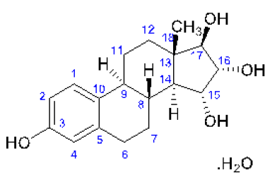
Figure 2: Chemical structure of drospirenone
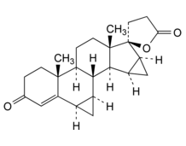
The proposed specifications, which control identity, potency, purity and other chemical and physical properties of the drug substance relevant to the dose form and its intended clinical use. Appropriate validation data have been submitted in support of the test procedures.
The product has two components, an active tablet and a placebo tablet. The active tablet is a fixed dose combination film-coated pink coloured tablet embossed with a drop-shaped logo on one side. This is available as a single strength of 14.2 mg estetrol (added as 15 mg estetrol monohydrate) and 3 mg drospirenone. The inactive tablets are simply a filler with a film coat, white in appearance, also embossed with a drop-shaped logo on one side.
The polyvinyl chloride aluminium blisters are packed into cardboard cartons in packs of one, 3 or 6 blister strips containing 28 tablets (24 active and 4 placebo), 84 tablets (72 active and 12 placebo), or 168 tablets (144 active and 24 placebo) respectively.
The proposed storage conditions and shelf life are store below 30°C for 36 months.
The evaluator provided quality clearance for approval and confirmed that there are no outstanding matters form a pharmaceutical chemistry perspective.

Nonclinical
The sponsor has applied to register Nextstellis, a new fixed dose combination of estetrol (as monohydrate) and drospirenone. The product is proposed to be used by women of reproductive potential to prevent pregnancy, with treatment involving once daily oral administration of 14.2 mg estradiol and 3 mg drospirenone for 24 days followed by 4 days of inactive tablets on a 28-day cycle.
Estetrol is a new chemical entity while drospirenone is a well-established agent, used here at the same dosage as in existing combined oral contraceptive products.
The nonclinical dossier was of high overall quality and contained no critical deficiencies. All pivotal safety-related studies were conducted according to Good Laboratory Practice.
In vitro studies established that estetrol acts as an estrogen receptor agonist, displaying considerably weaker potency than estradiol. Estrogenic activity was demonstrated for estetrol in vivo in various animal models, with inhibition of ovulation (as the key mechanism for contraception) shown in all laboratory animal species examined.
No significant secondary pharmacological targets of estetrol were identified in screening assays.
Estetrol stimulated breast cell proliferation alone and could attenuate the effects of estradiol when given in combination.
Safety pharmacology studies do not indicate adverse effects on central nervous system, cardiovascular or respiratory function with estetrol in patients.
Rapid absorption of estetrol after oral administration was seen in laboratory animal species and humans. The plasma half-life was significantly shorter in mice and rats cf. humans, but closer to humans in non-rodent species (rabbits and monkeys). Plasma protein binding was low to moderate, and chiefly to albumin. Estetrol does not bind to sex hormone binding globulin. Rapid and wide tissue distribution of carbon-14 [¹⁴C] estetrol derived was demonstrated in rats. Penetration of the blood brain barrier was limited, and prolonged retention was not seen in any tissue (including ones containing melanin).
Metabolism of estetrol involved glucuronidation, sulfation, hydroxylation and methylation, with little contribution by cytochrome P450 (CYPs) enzymes. Esterol-3-glucuronide and estetrol-16-glucuronide were identified as major circulating metabolites in humans. These were also formed in rodents, and they show negligible pharmacological activity. Excretion of estetrol and/or its metabolites was predominately via the faeces in mice and rats and via the urine in humans. Biliary excretion was demonstrated in rats.
Estetrol is a substrate of P-glycoprotein and breast cancer resistance protein. In vitro studies revealed no clinically relevant CYP inhibition/induction or transporter inhibition with estetrol that would give rise to pharmacokinetic (PK) interactions in patients.
Estetrol had a low order of acute toxicity by the oral route in rats and monkeys.
Repeat dose toxicity studies by the oral route were conducted with estetrol in mice (up to 3 months duration), rats (up to 6 months) and cynomolgus monkeys (up to 9 months). Findings in these studies (involving microscopic changes in the reproductive tract, mammary gland, pituitary, liver, kidney, adrenal gland, lymphoid organs, skin/hair and bone) were typical of the class, and consistent with the drug’s estrogenic activity.
A 3-month study in monkeys revealed hyperglycaemia and pancreatic islet cell vacuolation as the only notable findings denoting novel or synergistic toxicity with estetrol and drospirenone in combination. Altered glucose tolerance/induction of insulin resistance is a known estrogen/progestogen class interaction.
Estetrol is not considered to be genotoxic.
Estetrol was shown to be carcinogenic in rodents, producing tumours in the uterus, cervix and pituitary in mice, and in the mammary gland in both mice and rats, at doses yielding subclinical systemic exposure. The observed carcinogenicity of estetrol is consistent with its hormonal activity. Rodents are recognised to be particularly sensitive to the development of tumours following hormonal disruption.
Full restoration of fertility after withdrawal of estetrol treatment was demonstrated in rats.
Embryofetal lethality was observed with estetrol in rats and rabbits, and fetal skeletal malformations in rats. Assignment to Pregnancy Category B3; is recommended.
There are no nonclinical objections to the registration of Nextstellis for the proposed indications.

Clinical

Summary of clinical studies
The clinical dossier consisted of:
- One Phase I study: Study MIT-Es0001-C201
- Five Phase II studies: Study ES-C01, Study ES-C02, Study MIT-Es0001-C201, Study MIT-Es0001-C202 and Study PR3081
- Two Phase III studies: Study MIT-Es0001-C301 and Study MIT-Es0001-C302

Pharmacology

Pharmacokinetics
The conduct of the studies that were provided in support of the current submission was satisfactory, the data analyses undertaken were appropriate and the analytical methods used to measure exposure levels were validated.
Drospirenone has been previously approved for use in Australia as part of a combined oral contraceptive also containing ethinylestradiol.
A single dosage form and strength of the film-coated tablet is proposed for marketing, which contains 15 mg estetrol/3 mg drospirenone.

Absorption, distribution, metabolism and excretion
- Following a single dose of the film-coated tablet containing 15 mg estetrol/3 mg drospirenone absorption was rapid with estetrol and drospirenone time to maximum plasma concentration (T_{max}) values of 0.75 h and 1.67 h, respectively.
- Based on the recovery of total administered radioactivity in urine following a single oral dose of [¹⁴C]-estetrol 15 mg the bioavailability of estetrol was estimated to be approximately 69%. Following a 2 mg dose of oral drospirenone, the bioavailability was 76%.
- The formulations of the Phase III and to be marketed film-coated tablet containing Nextstellis are identical.
- There are no clinically relevant differences in the PKs of estetrol/drospirenone following administration of the film-coated tablet tablets containing 15 mg estetrol/3 mg drospirenone and the free tablet combination used in the initial Phase II studies.
- Although food significantly reduced the peak absorption (maximum plasma concentration (C_{max})) of estetrol and drospirenone, the overall extent of absorption (area under the concentration-time curve (AUC)) was not affected; therefore, food is unlikely to have clinically relevant effects on estetrol/drospirenone PK.
- Given that the current application is for a contraceptive, the target population would include healthy pre-menopausal women. This population has been included in many of the studies described thus far as part of the current clinical study report.
- Following single and multiple doses of the film-coated tablet at one to five times the therapeutic dose in healthy women, C_{max} and AUC values for estetrol and drospirenone increased with dose. Moreover, dose-normalised C_{max} and dose-normalised area under the concentration-time curve from time zero to 24 hours values for estetrol and drospirenone were similar after single and following multiple doses indicating that the increases in estetrol and drospirenone exposure across the tested dose range (15 mg to 75 mg for estetrol and 3 mg to 15 mg for drospirenone) were dose proportional.
- Following multiple administrations of the film-coated tablet, estetrol steady state was achieved by the fifth day of dosing and steady state drospirenone was attained following approximately 10 days of dosing. The geometric mean accumulation ratio for the area under the concentration-time curve for estetrol was 1.62 and for drospirenone was 2.32.
- Following oral administration of estetrol 15 mg alone or in combination with drospirenone, the apparent volume of distribution of estetrol was high ranging from 4450 to 7460 L indicating that estetrol is widely distributed in tissues.
- In human plasma, estetrol plasma protein binding ranged from 45.4% to 50.4%. estetrol distribution to red blood cells was limited.
- Unlike other estrogens, the liver plays little role in estetrol metabolism and instead estetrol undergoes significant Phase II metabolism to form glucuronide and sulphate conjugates, which have little to no estrogenic activity. Moreover, it is primarily excreted as metabolites via the urine.
- Following administration of the film-coated tablet, the T_{max}, C_{max} and AUC from time zero to infinity values for estetrol were 0.5 h, 12.5 ng/mL and 76.7 ng h/mL, respectively, the corresponding values for the estetrol-3-glucuronide were 0.75 h, 44.6 ng/mL and 311 ng h/mL, respectively and for estetrol-16-glucuronide were 0.75 h, 219 ng/mL and 570 ng h/mL, respectively. The glucuronide estetrol metabolites demonstrated 409 to 3793 fold lower potency than estetrol at estrogen receptor-alpha and -beta (ERα, ERβ).
- Following a single oral dose of [¹⁴C]-estetrol 15 mg, 90.85% of the total administered dose of radioactivity was recovered up to 312 h post-dose, with 68.97% of radioactivity identified in the urine and a further 21.88% in faeces. Although the parent compound estetrol was not present in the urine, both of the glucuronide isomers and the estetrol glucuronide sulfate conjugate metabolites could be detected. Whereas, unchanged estetrol was only identified in the faeces.
- Estetrol renal clearance following a single oral dose of [¹⁴C]-estetrol 15 mg was estimated to be 8.1 mL/min.

Variability
- The estimated inter-individual variability on estetrol fractional clearance, apparent volume and absorption rate constant was 54.5%, 51.7% and 1.07%, respectively and an inter-occasion variability on estetrol relative bioavailability was 66.5%.

Special populations
- No studies were conducted to evaluate the effect of renal or hepatic disease on the PK of estetrol. Estetrol/drospirenone is contraindicated in subjects with severe renal impairment and liver disease.
- Race, smoking status and body weight appeared to have little effect on estetrol PK.

Pharmacokinetic interactions
- Estetrol exposure was similar in the presence and absence of drospirenone.
- Estetrol C_{max} and AUC were significantly increased following co-administration of the film-coated tablet with valproic acid compared to when it was administered alone, with increases in adjusted geometric means of approximately 36%, 25% and 13% for C_{max}, area under the plasma concentration versus AUC to the last measured dose, and AUC to infinity, respectively. By contrast, co-administration of drospirenone with valproic acid did not affect drospirenone PK.
- In vitro studies indicated that estetrol was a weak inhibitor of CYP3A4, whereas, it did not inhibit CYP1A2, CYP2B6, CYP2C8, CYP2C9, CYP2C19, CYP2D6 and CYP2E1.¹¹ In addition, estetrol displayed no clinically relevant inhibition of uridine diphosphate glucuronyltransferase, P-glycoprotein or breast cancer resistance protein. Estetrol did not induce CYP1A2, CYP2B6 or CYP3A4 in human hepatocytes.
- The proposed PI appears to accurately describe the results of the PK studies undertaken with estetrol and the estetrol/drospirenone combination.

Population pharmacokinetic data
An exploratory model based on an approximation to a two-compartment model with first order absorption was used to describe estetrol PK based on the results of three clinical trials; however, possibly as a result of entero-hepatic recirculation, a reliable population pharmacokinetic (popPK) model could not be generated.

Pharmacodynamics
Combined oral contraceptives prevent pregnancy primarily by suppressing ovulation.

Primary pharmacodynamics
- Following the first cycle of treatment with 15 mg estetrol/3 mg drospirenone, ovulation was inhibited in healthy female subjects aged 18 to 35 years as evidenced by a decrease in Hoogland scores (a measure of ovulation inhibition) compared to pre-treatment, a decrease in maximum follicle size and frequency and slightly lower LH and FSH levels.
- In contrast, to the pre-treatment and post-treatment cycles, mean endometrial thickness was constant following both active treatments and below 5 mm.
- Most subjects recommenced ovulation between 12 and 15 days after the last active tablet intake of estetrol/drospirenone, whereas, ovulation recommenced generally later, at 15 and 18 days, following the last active tablet dose of estetrol/drospirenone.

Concentration and effect
- Estetrol induced a clear dose dependent inhibition of plasma LH and FSH following single and multiple doses in healthy post-menopausal women. By contrast, following Once daily doses of 10 mg or 20 mg estetrol in healthy women aged 18 to 40 years, both LH and FSH levels increased.

Secondary phamacodynamics
- Multiple therapeutic (15 mg estetrol/3 mg drospirenone) and supratherapeutic-doses (75 mg estetrol/15 mg drospirenone) had little effect on the corrected QT interval (QTc); and heart rate.
- Following administration of 15 mg estetrol/3 mg drospirenone, 30 µg ethinylestradiol/150 µg levonorgestrel or 20 µg ethinylestradiol/3 mg drospirenone to healthy women aged 18 to 47 years, the three oral contraceptives had little to no effect on the following haemostatic parameters including fibrinogen, factor VIII activity, von Willebrand factor, plasminogen activator inhibitor-1, soluble E-selectin, prothrombin fragments 1 + 2, prothrombin activity (factor II), antithrombin, protein C activity, free tissue factor pathway inhibitor, activated protein C resistance, D-dimer and activated coagulation time. Moreover, treatment with estetrol/drospirenone, unlike the other combined oral contraceptives, did not result in any apparent changes in factor VII, protein S activity, protein (S) free, plasminogen, tissue plasminogen activator, or activated protein C resistance (endogenous thrombin potential).
- The three combined oral contraceptives had little to no effect on dehydroepiandrosterone sulphate, dihydrotestosterone, testosterone, prolactin, free triiodothyronine, free thyroxine or thyrotropin levels. By contrast, androstenedione, progesterone, free testosterone and estradiol levels decreased following treatment with all three combined contraceptives. FSH and LH also increased following treatment with estetrol/drospirenone, whereas they decreased with ethinylestradiol/levonorgestrel and ethinylestradiol/drospirenone. Aldosterone levels were increased after estetrol/drospirenone and ethinylestradiol/drospirenone, whereas they were slightly decreased following ethinylestradiol/levonorgestrel treatment. Cortisol levels were also increased after ethinylestradiol/levonorgestrel and ethinylestradiol/drospirenone, whereas, they were relatively unchanged following estetrol/drospirenone.
- C-reactive protein levels were unchanged with all three combined oral contraceptives, whereas, angiotensinogen and cortisol binding globulin, sex hormone binding globulin and thyroxine binding globulin levels were increased.
- All three combined oral contraceptives induced no clear changes in apolipoprotein B1, cholesterol, low density lipoprotein cholesterol, high density lipoprotein/low density lipoprotein cholesterol and lipoprotein a levels. By contrast, triglycerides were increased after ethinylestradiol/drospirenone and but not with estetrol/drospirenone and ethinylestradiol/levonorgestrel.
- The three combined oral contraceptives had little to no effect on insulin, glucose, C-peptide and glycated haemoglobin A1C (HbA1c).

Efficacy

Dosage selection for the pivotal studies
The selected daily dose of 3 mg drospirenone combined with 14.2 mg estetrol for the Phase III studies was based on adequate ovulation inhibition and optimal cycle control.

The feasibility study
Study PR3081 showed that estetrol suppressed ovarian activity in a dose dependent manner. However, estetrol alone in daily doses of up to 18.9 mg was not capable of consistently inhibiting ovulation. Therefore, the sponsor conducted 2 additional pharmacodynamic studies (Studies ES-C01 and ES-C02) using different doses of estetrol in combination with approved progestins, that is, drospirenone at 3 mg or levonorgestrel at 0.15 mg.

Ovulation inhibition
Study ES-C01 showed that 4.7 and 9.5 mg estetrol combined with 3 mg drospirenone, and 4.7, 9.5 and 18.9 mg estetrol combined with 0.15 mg levonorgestrel inhibited ovulation in all cycles and the most significant effect on ovarian suppression was achieved with 0.15 mg levonorgestrel/18.9 mg estetrol.

Cycle control
Study ES-C02 assessed the cycle control of 3 mg drospirenone/14.2 mg estetrol and 0.15 mg levonorgestrel/18.9 mg estetrol in a 24/4-day regimen for 6 cycles compared to marketed combined oral contraceptives containing estradiol valerate and dienogest (Qlaira). Of the studied groups, 3 mg drospirenone/14.2 mg estetrol showed the lowest incidence of unscheduled bleeding (16.9% subjects in Cycle 6) and the lowest incidence (3.5% subjects in Cycle 6) of an absence of withdrawal bleeding.

Dose confirmation study
Study MIT-Es0001-C202 confirmed the ovulation inhibition from the selected dose combination of 3 mg drospirenone/14.2 mg estetrol using Yaz, a marketed combined oral contraceptive containing 3 mg drospirenone/20 µg ethinylestradiol, as a comparator.
In addition, the estetrol/drospirenone combinations demonstrated a good safety and tolerability profile. A low frequency of adverse events (AEs) with the 15 mg estetrol/3 mg drospirenone combination was recorded and all AEs were similar to those classically observed with oral contraceptives.
Based on the results for minimum effective dose for inhibition of ovulation, acceptable vaginal bleeding patterns and safety/tolerability observed from the Phase II studies, the regimen of 15 mg estetrol combined with 3 mg drospirenone was selected for the Phase III program.

Study MIT-Es0001-C301 (pivotal study)
This was a Phase III, multicentre, open label, single arm study to evaluate the contraceptive efficacy and safety of a combined oral contraceptives containing 14.2 mg estetrol and 3 mg drospirenone; also known as the E4 FREEDOM trial, study title: female response concerning efficacy and safety of estetrol/drospirenone as oral contraceptive in a multicentre study.

Primary objective
The primary objective of this study was to evaluate the contraceptive efficacy of 15 mg estetrol/3 mg drospirenone using the Pearl Index; in subjects aged 18 to 35 years, inclusive, at the time of screening.

Secondary objectives
- To evaluate the contraceptive efficacy of 15 mg estetrol/3 mg drospirenone using the method failure Pearl Index and life table analysis in subjects aged 18 to 35 years, inclusive, at the time of screening.
- To evaluate the contraceptive efficacy of 15 mg estetrol/3 mg drospirenone using the Pearl Index, the method failure Pearl Index and life table analysis in the overall study population.
- To evaluate cycle control and bleeding pattern associated with 15 mg estetrol/3 mg drospirenone.
- To evaluate general safety of 15 mg estetrol/3 mg drospirenone.
- To evaluate the impact of 15 mg estetrol/3 mg drospirenone on physical, psychological, and social functioning and wellbeing.
- To evaluate the endometrial safety using histological assessment of endometrial biopsy samples in a subset of subjects aged 18 to 50 years, inclusive, at the time of screening (endometrial safety sub-study).
Eligible subjects were to be treated with 15 mg estetrol/3 mg drospirenone for a maximum of 13 consecutive cycles. The investigational product was supplied as tablets in blister packs with 24 active pink tablets containing 15 mg estetrol/3 mg drospirenone and 4 white placebo tablets. The treatment was to be taken once daily at approximately the same time of the day in a 24/4-day regimen, that is, 24 active tablets followed by 4 placebo tablets (4 day hormone free interval).
Those subjects who discontinued due to a pregnancy wish were to be followed-up for a maximum of one year after study discontinuation for return of post-treatment spontaneous menstruation and until pregnancy or initiation of a new contraceptive method, whichever occurred first.
An endometrial safety sub-study was performed in subjects from selected sites in Finland, Germany and Poland and endometrial biopsies were obtained from these subjects at the screening visit and at Visit 7a if the subject had completed at least 10 cycles of treatment.
This study was conducted at 69 centres in Europe and Russia.

Key inclusion criteria
- Heterosexually active female at risk for pregnancy and requesting contraception.
- Negative serum pregnancy test at subject enrolment.
- Aged 18 to 50 years (inclusive) at the time of signing the informed consent.
- Willing to use the investigational product as the primary method of contraception for 13 consecutive cycles.
- Body mass index (BMI) ≤ 35.0 kg/m²

Key inclusion criteria for the endometrial safety sub-study
- Subjects from the main study willing to participate in the endometrial safety sub-study by giving their consent.
- Endometrial biopsy taken at screening revealed no abnormal results, that is, presence of hyperplasia (simple or complex, with or without atypia) or presence of carcinoma.

Key exclusion criteria
- For subjects who were not using hormonal contraception at screening, a menstrual cycle length shorter than 21 days or longer than 35 days
- Smoking nicotine containing products if ≥ 35 years old.
- Dyslipoproteinemia requiring active treatment with antilipidemic agent, diabetes mellitus with vascular involvement, any arterial hypertension.
- Personal history of deep vein thrombosis or pulmonary embolism, known hypercoagulopathies.
- Within the past 6 months, had undiagnosed (unexplained) abnormal vaginal bleeding.
- Presence or history of hormone-related malignancy.
- Renal or hepatic impairment.

Key exclusion criteria for the endometrial safety sub-study
- The use of hormone releasing intrauterine system immediately prior to the study treatment.
- Acute genital infection as diagnosed at the discretion of the investigator.
Sample size was based on needing a sufficient number of cycles such that the difference between the Pearl Index and the upper limit of the two-sided 95% confidence intervals (CIs) for the Pearl Index did not exceed one. Assuming that the true Pearl Index was 1.0 and that a Poisson model was used to derive the CIs, then at least 12,337 at-risk cycles were required for a power of 90% in the 18 to 35 year old population. Assuming a not at-risk cycle rate of 10% and a dropout rate of approximately 30% (assuming that there was an average of 4 cycles for subjects that discontinued), approximately 1,350 subjects aged 18 to 35 years needed to be enrolled. Additionally, it was planned to enrol a maximum of 200 subjects aged 36 to 50 years. Hence, overall 1,550 subjects were planned to be enrolled in the study.
As this was a single arm study, no formal statistical analyses were performed. Descriptive statistics presented for all continuous variables.
The primary variable was summarised using the Pearl Index in the intention-to-treat (ITT) population of women aged 18 to 35 years with at-risk cycles. The Pearl Index was presented with corresponding 95% CIs, using a Poisson distribution. The same method was used for the secondary variables in which the Pearl Index and the method failure Pearl Index were presented in all subjects and with different definitions of cycles in the denominator (all cycles, modified at-risk cycles, protocol compliant at-risk cycles). Life table analyses with one year life table pregnancy rates were presented for each efficacy variable (that is, for all pregnancies as used in the Pearl Index and for all method failure pregnancies as used in the method failure Pearl Index). The rate of pregnancy and 95% CIs were calculated based on Kaplan-Meier estimates for each cycle and the estimated survival function against time (cycle) was also provided.

Results
A total of 1,744 subjects were screened. Of whom 1,577 were enrolled in the study: 1,373 subjects aged 18 to 35 years and 204 subjects aged over 35 years. Overall, 1,553 of 1,577 (98.5%) enrolled subjects took study medication (that is, subjects in the safety and ITT populations). The most common reasons for study discontinuation were AEs not related to bleeding (104 subjects, 6.6%), consent withdrawal (86 subjects, 5.5%), AEs related to bleeding (54 subjects, 3.4%) and loss to follow-up (41 subjects, 2.6%).
Figure 3: Study MIT-Es0001-C301 Subject disposition
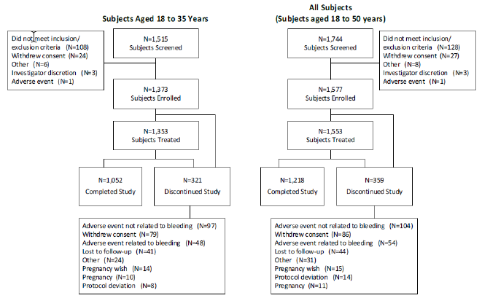
Abbreviation: N = population size.
Subjects’ demographics and baseline characteristics in the ITT population; 98.6% of the subjects were white (98.6% in subjects aged 18 to 35 years), and 0.5% were black or African American (0.6% in subjects aged 18 to 35 years). The subjects’ mean age was 27.1 years old (25.0 in subjects aged 18 to 35 years). Mean BMI was 23.0 kg/m² (22.9 in subjects 18 to 35 years of age).
About two thirds (61%) were ‘switchers’ (that is subjects who had used hormonal contraceptives within the 3 months prior to the date of first dose of investigational product.), while 39% were ‘starters’ (subjects who had not used hormonal contraceptive(s) within the 3 months prior to the date of first dose of investigational product). Approximately 25% of subjects were true new users (subjects who had never been using hormonal contraception; that is a subset of the starter subgroup). The proportion of switchers and starters are generally equal among the groups and therefore it is not considered that this has impacted the overall study outcomes/primary endpoints.

Primary endpoint
During the study, five on-treatment pregnancies were reported, all of which occurred in subjects aged 18 to 35 years at screening. 1,313 subjects aged 18 to 35 years with at least one at-risk cycle reported 13,692 at-risk cycles. The Pearl Index was 0.47 per 100 women year (95% CI: 0.15, 1.11) (see Table 3 below).
Table 3: Study MIT-Es0001-C301 Summary and analysis of Pearl Index in subjects aged 18 to 35 years with at-risk cycles (intention-to-treat population)
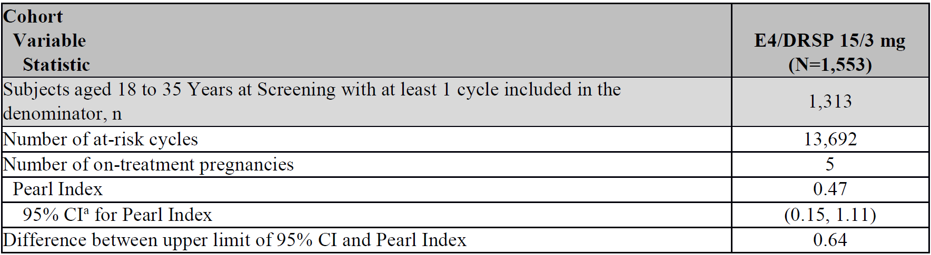
Abbreviations: CI= confidence intervals; DRSP = drospirenone; E4 = estetrol; ITT= intention-to-treat; N = number of subjects; n = number of subjects aged 18 to 25 years at screening with at least one cycle included in the denominator.
a Confidence intervals are calculated using a Poisson distribution. At-risk cycles are defined as cycles with no other methods of birth control (including condoms) and confirmed sexual intercourse.
On-treatment pregnancy: a pregnancy with estimated date of conception after the date of the first dose of investigational product to 2 days after the last dose investigational product (regardless of whether the last dose was an active or inactive tablet) inclusive.
This fulfilled the criterion on the precision of the estimate in the EMA guideline;²⁰ that the difference between the upper limit of the corresponding two-sided 95% CI for the Pearl Index (1.11) and the point estimate (0.47) did not exceed one (1.11 - 0.47 = 0.64).

Subgroup analysis of primary endpoint

Age
For subjects aged ≥ 18 to ≤ 25 years at screening, there were three on-treatment pregnancies, giving a slightly higher Pearl Index of 0.50 (95% CI: 0.10, 1.46). For subjects aged > 25 to ≤ 35 years, there were two on-treatment pregnancies (Pearl Index of 0.44 (95% CI: 0.05, 1.60)). No on-treatment pregnancies occurred among the 197 subjects with at-risk cycles aged > 35 to ≤ 50 years (Pearl Index of zero (95% CI: 0.00, 2.22)).

Body mass index
No comparison for the BMI subgroups could be made as there were no on-treatment pregnancies reported in subjects aged 18 to 35 years with a BMI ≥ 30 mg/kg² (Pearl Index of zero (95% CI: 0.00, 5.28)), whereas the Pearl Index in subjects with a BMI < 30 mg/kg², with 5 reported on-treatment pregnancies, was 0.50 (95% CI: 0.16, 1.18).

Race
Although 2 of the 5 pregnancies were reported in Black women aged 18 to 35 years (Pearl Index = 57.78 (95% CI: 7.00, 208.71)), interpretation was limited due to the low number of enrolled Black or African American subjects with at least one at-risk cycle (6 subjects with 45 at-risk cycles) in this study. No pregnancies were reported in the ‘other race’ subgroups.

Starters versus switchers
In subjects aged 18 to 35 years, there was one on-treatment pregnancy in starters (Pearl Index of 0.25 (95% CI: 0.01, 1.42)) whereas there were four on-treatment pregnancies in ‘switchers’ (Pearl Index of 0.61 (95% CI: 0.17, 1.55)).

Smoking
The Pearl Index was much higher in smokers compared to non-smokers: For smokers aged 18 to < 35 years (smokers aged > 35 years were not enrolled in study), there were two on-treatment pregnancies, giving a Pearl Index of 1.04 (95% CI: 0.13, 3.76) whereas there were three on-treatment pregnancies in non-smokers (Pearl Index of 0.35 (95% CI: 0.07, 1.02)).

Secondary efficacy endpoints
The modified at-risk Pearl Index (EU definition), for which only cycles with use of other methods of birth control are excluded from the denominator but cycles without confirmed sexual intercourse are included, was 0.44 (95% CI: 0.14, 1.03) in subjects aged 18 to 35 years (See Table 4 below).

Secondary efficacy variables
Pearl Index in all subjects/Pearl Index calculated with alternative methods.
Table 4: Study MIT-Es0001-C301 Summary and analysis of Pearl Index for all subjects and Pearl Indices calculated with different methods in subjects with at-risk cycles (intention-to-treat population)
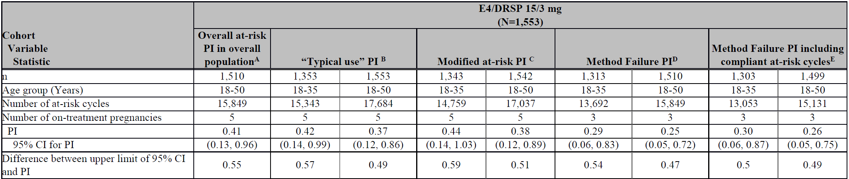
Abbreviations: CI = confidence interval; DRSP = drospirenone; E4 = estetrol; ITT = intention-to-treat; n = number of subjects with at least one cycle included; PI = Pearl Index.
A Pearl Index: at-risk cycles are defined as cycles with no other methods of birth control (including condoms) and confirmed sexual intercourse.
B ‘Typical use’ Pearl Index: all cycles are included in the denominator regardless of other methods of birth control, occurrence of sexual intercourse or compliance with the protocol.
C Modified at-risk Pearl Index: at-risk cycles are those where no other methods of birth control are used (modified risk). Cycles without confirmed sexual intercourse are not excluded.
D Method failure Pearl Index: uses the same method used for the Pearl Index, but excludes those pregnancies due to user failures from the numerator, that is, subject did not take the study medication correctly during the cycle in which the estimated conception occurred or used drugs that have the potential to trigger interactions with combined oral contraceptive.
E Only compliant modified at-risk cycles are included in the denominator of the Pearl Index calculation. Compliant modified at-risk cycle = a cycle where no other methods of birth control (including condoms) was used, the subject did not have a user failure pregnancy and the subject had no adverse event of vomiting and/or diarrhea.
Confidence intervals are calculated using a Poisson distribution. Any cycles after the cycle of conception in the case of pregnancy were excluded.
Also, in the whole group (up to 50 years of age) and with alternative calculation methods, the Pearl Indices ranged from 0.25 to 0.44 and the difference between the point estimates and the upper limits of the corresponding 2 sided 95% CIs was below one for all Pearl Indices. The Pearl Index for method failure was 0.29 (95% CI: 0.06, 0.83) for the age group 18 to 35 years and 0.25 (95% CI: 0.05, 0.72) for the whole study population.
There were no on-treatment pregnancies in women aged 35 to 50 years and so the Pearl Index in subjects aged 18 to 50 years was similar to the primary endpoint in women aged 18 to 35 years: 0.41 (95% CI: 0.13, 0.96) for 15 mg estetrol/3 mg drospirenone (based on 1,510 subjects with at least one at-risk cycle who reported 15,849 at-risk cycles).

Life table rates
Life table analyses (based on Kaplan-Meier estimates) were consistent with the Pearl Index results.

Cumulative on-treatment pregnancy rate
After 13 cycles, the cumulative on-treatment pregnancy rate was 0.45% (95% CI: 0.19, 1.09) for subjects aged 18 to 35 years and 0.39% (95% CI: 0.16, 0.94) for subjects aged 18 to 50 years, that is, the probability of contraceptive protection after up to one year of treatment was estimated to be 99.6%.

Cumulative on-treatment method failure pregnancy rate
After 13 cycles, the cumulative on-treatment method failure pregnancy rate was 0.28% (95% CI: 0.09%, 0.86%) for subjects aged 18 to 35 years and 0.24% (95% CI: 0.08%, 0.74%) for subjects aged 18 to 50 years that is, the probability of contraceptive protection during up to one year of treatment was approximately 99.7%.
The rate of women recording unscheduled bleeding/spotting was well below 20% except during the first treatment cycle. The mean number of bleeding/spotting days recorded was just under four throughout the treatment year, mostly spotting. Absence of scheduled bleeding was reported in 5.6% to 8.1% of subjects per cycle, implying that 91.9% to 94.4% of the women did have their scheduled withdrawal bleeding.
Results for the primary efficacy endpoint, ‘typical use’ and ‘method failure’ Pearl Index as well as all sensitivity analyses fulfilled the criterion on the precision of the estimate in the EMA guideline;²⁰ that the difference between the upper limit of the corresponding 2 sided 95% CI for the Pearl Index and the point estimate did not exceed one. Hence, there was robust evidence for contraceptive efficacy of 15 mg estetrol/3 mg drospirenone in this study.
The life table analysis also confirmed the adequate contraceptive efficacy of 15 mg estetrol/3 mg drospirenone. Subgroup analyses of the Pearl Index did not reveal significant differences by previous contraceptive use, smoking status and age while interpretation of effect of BMI and race was limited by different sample sizes these subgroups. Over one year of treatment, the probability of contraceptive protection was 99.55% and 99.61% in subjects 18 to 35 years and 18 to 50 years, respectively.

Study MIT-Es0001-C302 (pivotal study)
The study design and objectives were identical to those described for the other pivotal study, Study MIT-Es0001-C301 (pivotal study). However, this study was conducted at 77 sites in North America: 70 sites in the USA and 7 sites in Canada.
The study treatments, efficacy variables and outcomes, randomisation and blinding methods, the analysis populations and the statistical methods were identical to Study MIT-Es0001-C301.
Assuming 80% of the study cycles would be at-risk cycles and a dropout rate of approximately 45% (assuming that there was an average of 4 cycles for subjects that discontinued- assumption was 30% in Study MIT-Es0001-C301) approximately 1,800 subjects aged 16 to 35 years needed to be enrolled. Additionally, it was planned to enrol a maximum of 200 subjects aged 36 to 50 years. Therefore, in total, approximately 2,000 subjects were planned to be enrolled in the study. Additionally, a subset of approximately 500 subjects were planned to be enrolled in the PK sub-study.

Results
A total of 2,918 subjects were screened for the study, of whom 2,148 were enrolled: 1,939 subjects aged 16 to 35 years and 209 subjects aged 36 to 50 years. Overall, 1,864 of 2,148 (86.7%) enrolled subjects took study medication (that is, subjects in the safety and ITT population), including 1,674 of 1,939 (86.3%) subjects aged 16 to 35 years in the ITT population. For all subjects enrolled in the study, 1,016 of 2,148 (47.3%) subjects completed the study. The most common reasons for study discontinuation were lost to follow-up (453 subjects, 21.1%), consent withdrawal (214 subjects, 10.0%), AEs not related to bleeding (136 subjects, 6.3%), protocol deviations (125 subjects, 5.8%), and AEs related to bleeding (53 subjects, 2.5%).
Figure 4: Study MIT-Es0001-C302 Subject disposition (screened population)
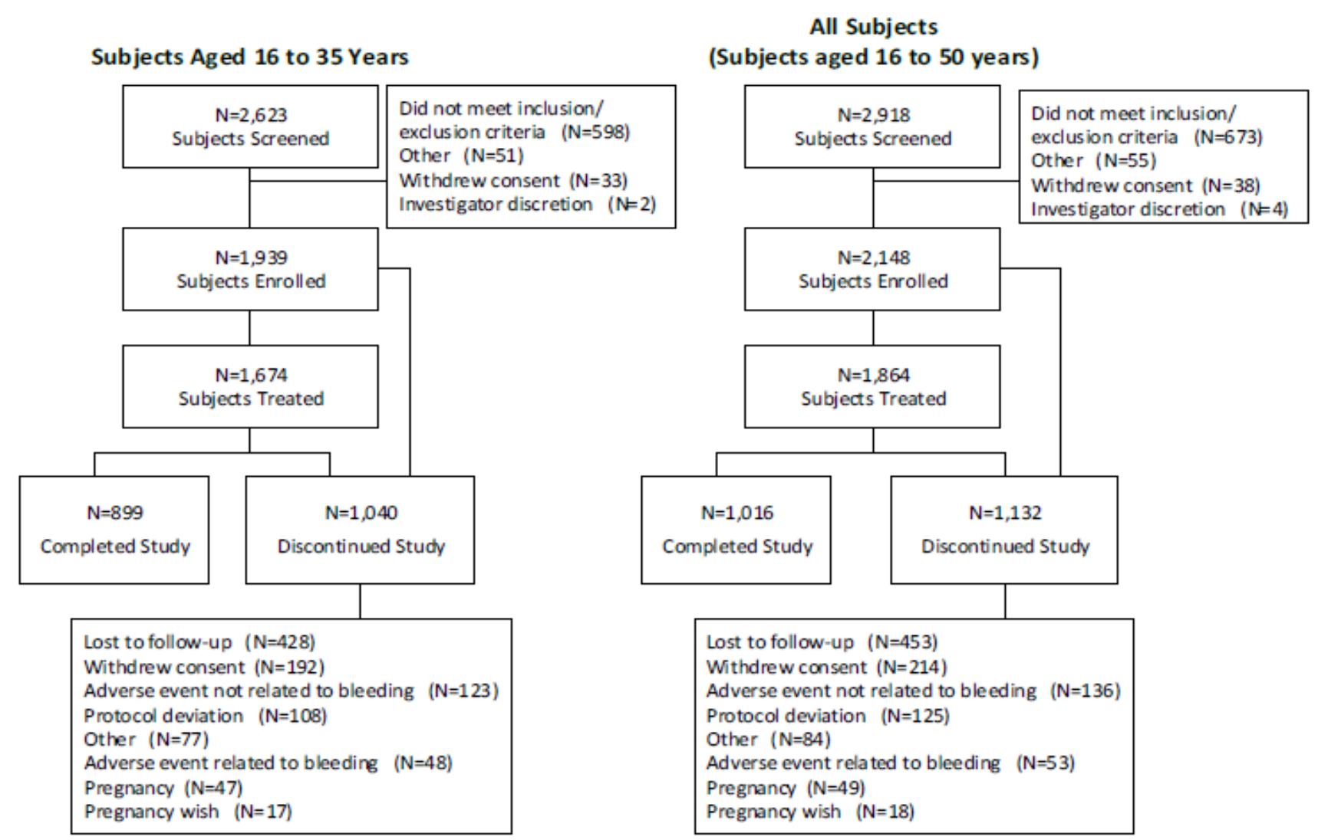
Abbreviation: N = population size.
Reasons for discontinuation are based on the end of study form.
Correction in the number of subjects with reasons for screen failure in the 16 to 35 years group made after clinical study report approval date: subjects who did not meet inclusion/exclusion criteria: it stated 600, whereas there were 598 subjects; subjects who withdrew consent: it stated 31, whereas there were 33 subjects; the other reasons had the correct number of subjects. This correction has no impact in the interpretation of results.

Subjects’ demographics and baseline characteristics in the ITT population
69.7% of the subjects were white (70.1% in subjects aged 16 to 35 years), and 19.8% were black or African American (19.5% in subjects aged 16 to 35 years). 26.2% of subjects (25.6% in subjects aged 16 to 35 years of age) were Hispanic or Latino origin. The subjects’ mean age was 27.3 years old (25.8 in subjects aged 16 to 35 years). Mean BMI was 25.9 kg/m² (25.8 in subjects 16 to 35 years of age). More than half of the subjects (58%) were ‘starters’ with approximately 17% of subjects classified as true new users; approximately 42% of subjects were switchers from a previous hormonal contraceptive method.
The baseline demographics in this study were different to Study MIT-Es0001-C301. Major differences between Study MIT-Es0001-C301 and Study MIT-Es0001-C302 included:
- race: White/Caucasian participants comprised over 98% of the Study MIT-Es0001-C301 (Europe/Russia) population, compared to 70% of the Study MIT-Es0001-C302 (US/Canada) population;
- body mass index (BMI): obese individuals, defined as BMI ≥ 30 kg/m² comprised only 5.7% of the study population in Study MIT-Es0001-C301 (Europe/Russia) compared to approximately 23% of the study population in Study MIT-Es0001-C302 (US/Canada).
- the use of previous contraceptive measures was lower in this study (45% with combined oral contraceptives taken by 36.6%) compared to Study MIT-Es0001-C301 (72% with 60% having used prior combined oral contraceptives);
- the cumulative discontinuation rates in this North American study (45 to 46%) were higher than those observed in the European Study MIT-Es0001-C301 (32%).

Primary endpoint

Pregnancies
In Study MIT-Es0001-C302, 28 on-treatment pregnancies were reported. Of those pregnancies, 26 (12 user failure and 14 method failure) of 28 occurred during the treatment period in subjects between 16 to 35 years of age, inclusive, at initial screening (ITT population). 1,524 subjects aged 16 to 35 years with at least one at-risk cycle in the study reported 12,763 at-risk cycles.

Pearl Index

Primary efficacy variable (Pearl Index in subjects aged 16 to 35 years with at-risk cycles)
The Pearl Index was 2.65 per 100 women year (95% CI: 1.73, 3.88).
Table 5: Study MIT-Es0001-C302 Summary and analysis of Pearl Index in subjects aged 16 to 35 years with at-risk cycles (intention-to-treat population)
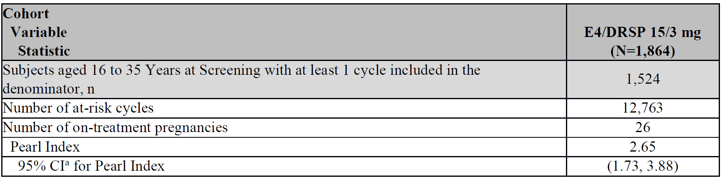
Abbreviations: DRSP = drospirenone; E4 = estetrol; ITT = intention-to-treat; N= number of subject in the intention-to-treat population, n = number of subjects aged 16 to 25 years at screening with at least one cycle included in the denominator.
a Confidence intervals are calculated using a Poisson distribution.
The Pearl Index, defined as the number pregnancies per 100 women years of treatment was calculated as: Pearl Index = (1300 x number of on-treatment pregnancies) / number of women 28 day equivalent cycles treatment.
Only at-risk cycles were included in the denominator of the Pearl Index calculation, unless a conception occurred during a cycle.

Subgroup analysis of primary endpoint
Table 6: Study MIT-Es0001-C302 Pearl Index by subgroup for subjects aged 16 to 35 years
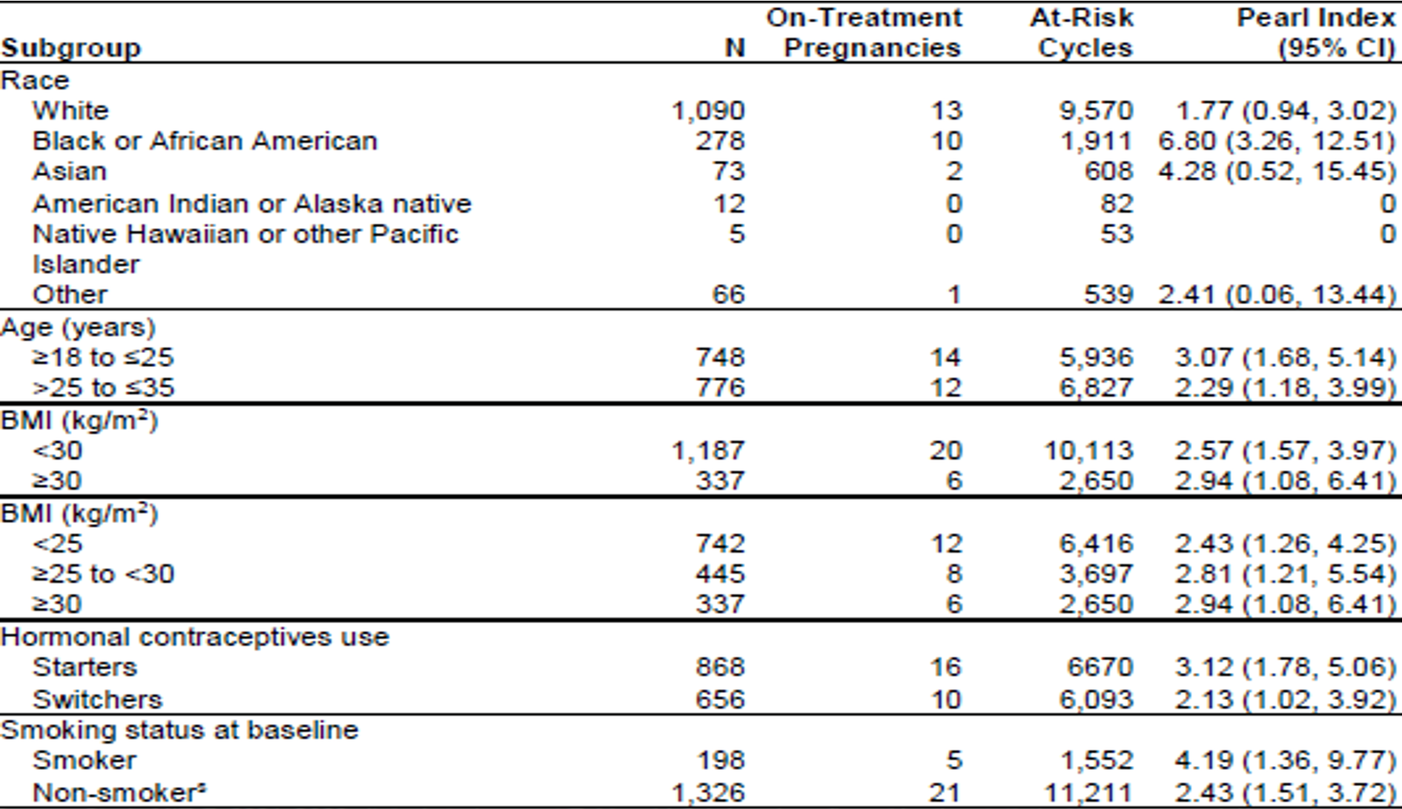
Abbreviations: BMI = body mass index; CI = confidence interval; N = number of participants.
The Pearl Indices were higher in Blacks (6.8, 4.28 and 1.77 in Blacks, Asians and Whites), smokers (4.19 versus non-smokers: 2.44), starters (3.12 versus switchers: 2.13) and the youngest age group (3.07, 2.29 and 1.55 in the 16 to ≤ 25, > 25 to < 35, and ≥ 35 year age groups, respectively).
The requirement for precision of the Pearl Index was not met in accordance with the EMA guideline,²⁰ since the difference between the upper limit of the corresponding two-sided 95% CI for the Pearl Index and the point estimate was greater than one. None of these subgroups fulfilled the criterion. However, with the upper limit of the 95% CI well below 5, 15 mg estetrol/3 mg drospirenone fulfils the FDA criterion of an effective combined oral contraceptive.²⁴

Secondary efficacy endpoints
The Pearl Index in subjects aged 16 to 50 years with at-risk cycles analysis were based on 1,705 subjects with at least one at-risk cycle who reported 14,437 at-risk cycles. There were 28 on-treatment pregnancies, resulting in a Pearl Index of 2.52 (95% CI: 1.68, 3.64) for 15 mg estetrol/3 mg drospirenone in subjects aged 16 to 50 years.
The modified at-risk Pearl Index (EU definition), for which only cycles with use of other methods of birth control are excluded from the denominator but cycles without confirmed sexual intercourse are included, was 2.42 (95% CI: 1.58, 3.54) in subjects aged 18 to 35 years (see Table 7 below).
Table 7: Study MIT-Es0001-C302 Summary and analysis of Pearl Indices calculated with different methods in subjects with at-risk cycles (intention-to-treat population)
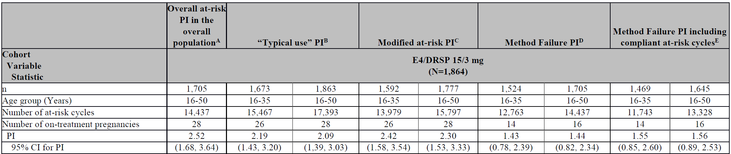
Abbreviations: CI = confidence interval; DRSP = drospirenone; E4 = estetrol; ITT = intention-to-treat; n = number of subjects with at least 1 cycle included; PI = Pearl Index.
A Pearl Index: at-risk cycles are defined as cycles with no other methods of birth control (including condoms) and confirmed sexual intercourse.
B ‘Typical use’ Pearl Index: all cycles are included in the denominator regardless of other methods of birth control, occurrence of sexual intercourse or compliance with the protocol.
C Modified at-risk Pearl Index: at-risk cycles are those where no other methods of birth control are used (modified risk). Cycles without confirmed sexual intercourse are not excluded.
D Method failure Pearl Index: uses the same method used for the Pearl Index but excludes those pregnancies due to user failures from the numerator, that is, subject did not take the study medication correctly during the cycle in which the estimated conception occurred or used drugs that have the potential to trigger interactions with combined oral contraceptive.
E Only compliant modified at-risk cycles are included in the denominator of the Pearl Index calculation. Compliant modified at-risk cycle = a cycle where no other methods of birth control (including condoms) were used, the subject does not have a user failure pregnancy and the subject had no adverse event of vomiting and/or diarrhoea.
Confidence intervals are calculated using a Poisson distribution. Any cycles after the cycle of conception in the case of pregnancy were excluded.
In the whole group (up to 50 years of age) and with alternative calculation methods, the Pearl Indices ranged from 2.09 to 2.52 and the difference between the point estimates and the upper limit of the corresponding two-sided 95% CIs was in most cases above one.
The secondary endpoint did not fulfill the criterion on the precision of the estimate in the EMA Guideline; that is, the difference between the upper limit of the corresponding two- sided 95% CI for the Pearl Index (3.88) and the point estimate (2.65) exceeded one (3.88 - 2.65 = 1.23).
The Pearl Index for method failure was 1.43 (95% CI: 0.78, 2.39) for the age group 16 to 35 years and 1.44 (95% CI: 0.82, 2.34) for the whole study population, both with acceptable precision according to the EMA guideline.²⁰
It is also possible that differences in compliance with regular use of combined hormonal contraceptives and investigator site type may also play a role in the differences reported in Pearl Index between these Phase III studies.
The life table analyses (based on Kaplan-Meier estimates) were consistent with the Pearl Index results. The Kaplan-Meier curves are fully in line with the Pearl Indices with larger decrease in this US study as expected.
The percentage of subjects with an absence of scheduled bleeding and/or spotting episodes by cycle was higher in this North American study (6.2%) compared to that observed in Study MIT-Es0001-C301 (3.6%).

Integrated summary of efficacy
Pregnancy data, bleeding data, the Menstrual Distress Questionnaire (MDQ) and the Quality of Life Enjoyment and Satisfaction Questionnaire Short Form (Q-LES-Q-SF) data from the two pivotal Phase III studies (Studies MIT-Es0001-C301 and MIT-Es0001-C302) was pooled to provide an integrated summary of efficacy. Other efficacy parameters were collected differently in single trials and pooling was not possible.
The pooled ITT population included 3,417 subjects, with 3,027 aged 16 to 35 years and 390 aged 36 to 50 years. The pooled per-protocol; population included 3,262 subjects, 2,881 of them aged 16 to 35 years and 381 aged 36 to 50 years.
Contraceptive efficacy was based on the Pearl Index, the method failure Pearl Index and the cumulative pregnancy rate by life table analysis. All analyses of the Pearl Index/ pregnancy rate (primary and secondary efficacy variables) were performed in the ITT population.

Pearl Index for the intention-to-treat population aged 16 to 35 years (primary efficacy outcome)
The primary outcome was based on 31 on-treatment pregnancies among 2,837 subjects aged 16 to 35 years who provided 26,455 at-risk cycles, resulting in a Pearl Index of 1.52 (95% CI: 1.035, 2.162).
The difference between the upper limit of the corresponding two-sided 95% CI and the Pearl Index (point estimate) is 0.64 and fulfils the criterion on the precision of the estimate as claimed in the EMA guideline;²⁰ that this difference does not exceed one. The upper limit of the 95% CI is below five as claimed in the FDA guidance; for combined hormonal contraceptives as being effective at preventing pregnancy.
Table 8: Study MIT-Es0001-C302 Summary and analysis of Pearl Index in subjects aged 16 to 35 years with at-risk cycles (primary efficacy variable; intention-to-treat population)
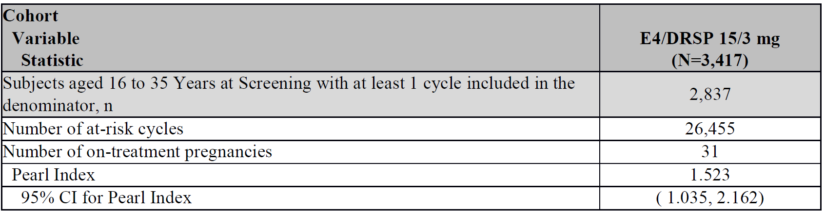
Abbreviations: DRSP = drospirenone; E4 = estetrol; N = number of subjects in the intention-to-treat population; number of subjects aged 18 to 25 years at screening with at least one cycle included in the denominator.
Confidence intervals are calculated using a Poisson distribution.
Secondary efficacy variables, for example, the method failure Pearl Index, ‘Typical Use Pearl Index’ are depicted in Table 9 below.
The method failure Pearl Index was similar for women aged 16 to 35 years (0.84, 95% CI: 0.487, 1.338) and for women aged 16 to 50 years (0.82, 95% CI: 0.49, 1.27).
Table 9: Study MIT-Es0001-C302 Summary and analysis of the Pearl Index for the overall population, method failure Pearl Index and Pearl Index and method failure Pearl Index determined with alternative methods (intention-to-treat population)
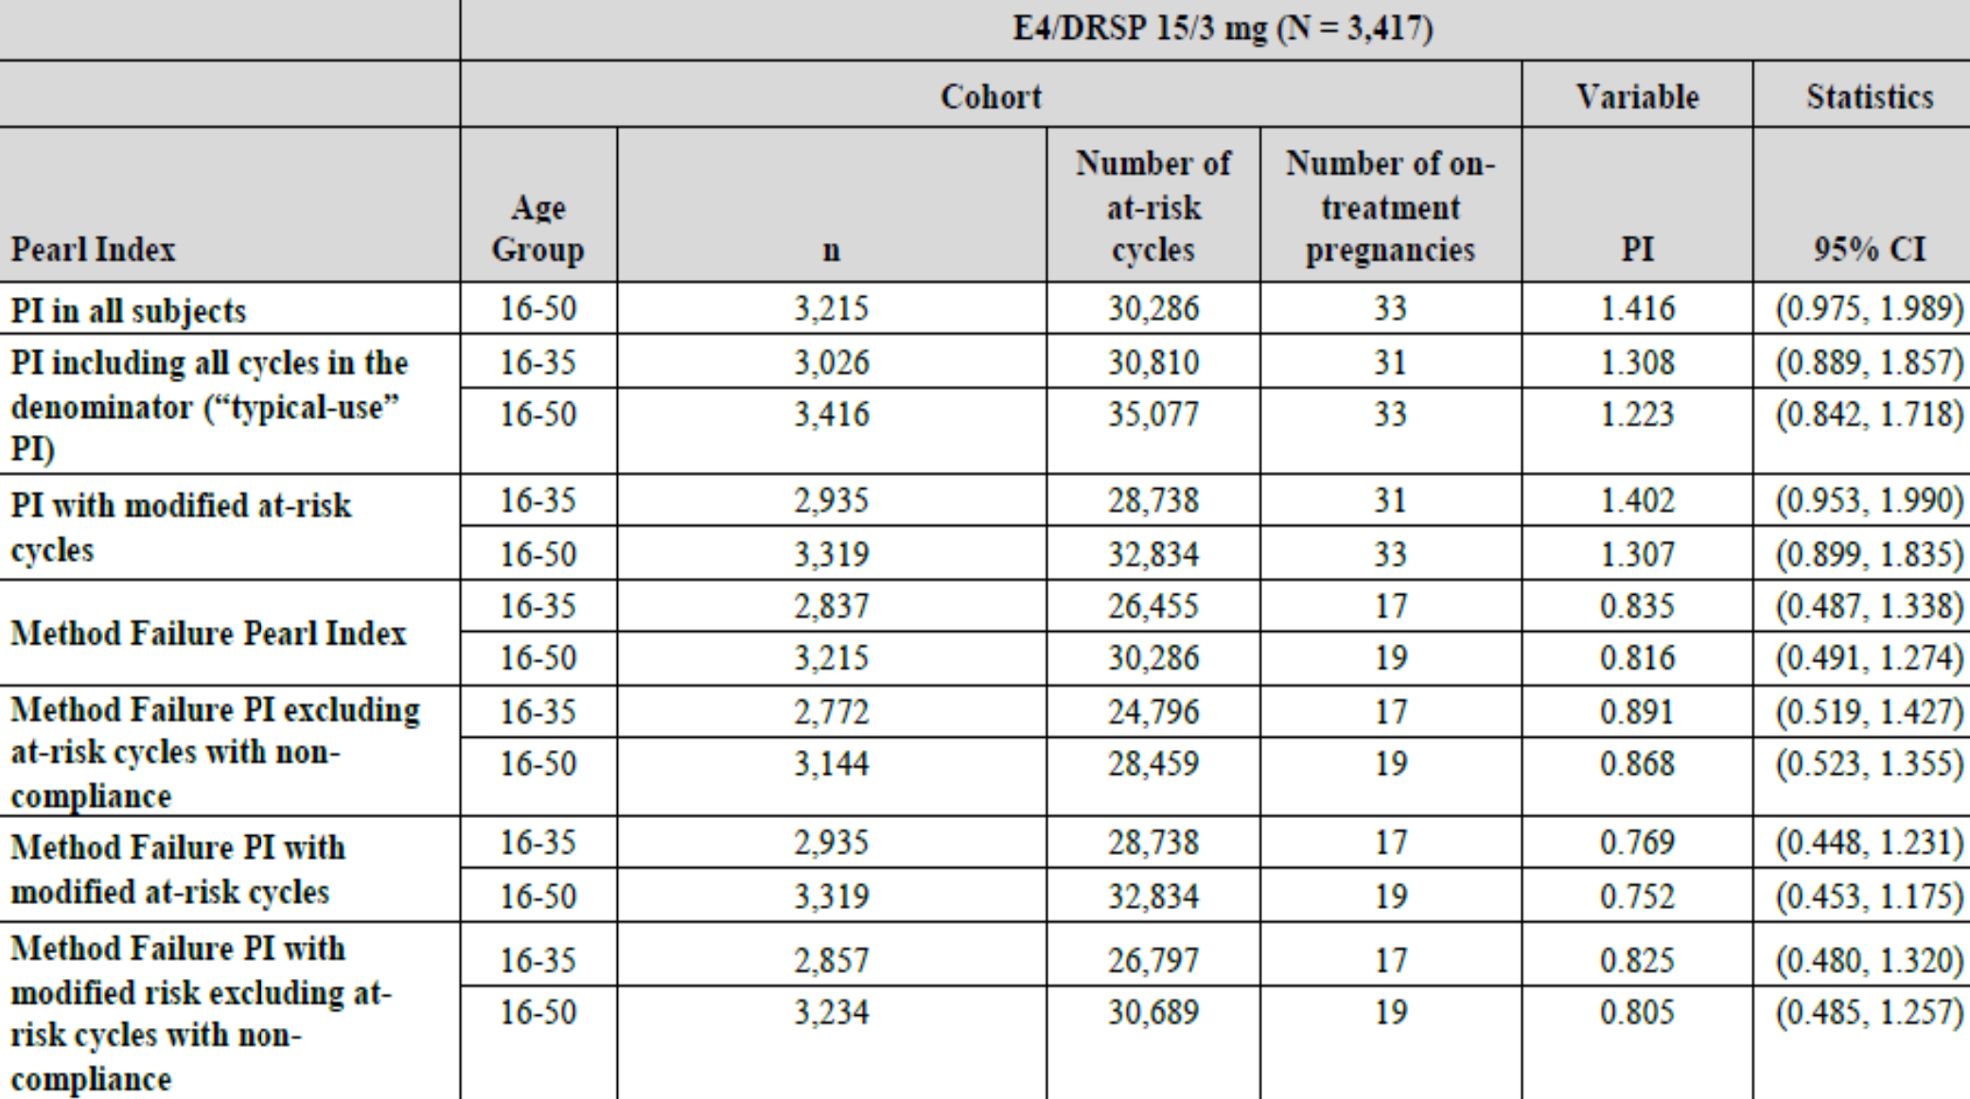
Abbreviations: CI = confidence interval; DRSP = drospirenone; E4 = estetrol; ITT = intention-to-treat; N = number of subjects in the intention-to-treat population; n = number of subjects with at least one at-risk cycle included in the denominator; PI = Pearl Index.
Similar results were observed in two sensitivity analyses of the Pearl Index (in which all on-treatment pregnancies were defined as pregnancies which were possible to detect, with an estimated date of conception after the date of the first dose of study medication to seven days after the last dose of study medication inclusive. Each subjects’ last cycle was only included in the calculation of the Pearl Index if the last follow-up visit allowed a detection of pregnancy).
Cumulative pregnancy rates by life table method for the ITT population aged 16 to 35 years: In subjects aged 16 to 35 years, 31 on-treatment pregnancies were reported, of which 14 pregnancies were considered user failure. Among women aged 36 to 50 years, two on-treatment pregnancies were reported, neither of which were considered user failure.
After 13 cycles, the cumulative on-treatment pregnancy rate was 1.28% (95% CI: 0.83%, 1.73%) for subjects aged 16 to 35 years and 1.20% (95% CI: 0.79%, 1.62%) for subjects aged 16 to 50 years, that is, the probability of contraceptive protection up to one year of treatment was approximately 98.8%.
After 13 cycles, the cumulative on-treatment method failure pregnancy rate was 0.73% (95% CI: 0.38, 1.08%) for subjects aged 16 to 35 years and 0.72% (95% CI: 0.40%, 1.05%) for subjects aged 16 to 50 years, that is, the probability of contraceptive protection during up to one year of treatment was approximately 99%.

Pearl Index and method failure Pearl Index by subgroups
Sub-group analyses based on integrated data for the two studies as well as for each study separately showed that for BMI, a trend was observed for an increase of the Pearl Index with increasing BMI. Smokers also tended to have higher Pearl Index versus non-smokers. Black and Asian women had higher Pearl Index compared to white women and a higher Pearl Index was observed in starters compared to switchers. Firm conclusions are difficult to make due to small sample sizes for some subgroups resulting in wide CIs.

Vaginal bleeding pattern
In comparative Study ES-C02, comparing 15 mg estetrol/3 mg drospirenone with 4 other combinations (20 mg estetrol/3 mg drospirenone, 15 mg estetrol/0.15 mg levonorgestrel, 20 mg estetrol/0.15 mg levonorgestrel and estradiol valerate/dienogest (Qlaira)),¹⁵ 15 mg estetrol/3 mg drospirenone had a lower incidence of unscheduled bleeding/spotting than the other combinations. The rate of absence of withdrawal bleeding was also low for 15 mg estetrol/3 mg drospirenone, thus suggesting a reasonably predictable bleeding pattern.
In non-comparative Study MIT-Es0001-C301, the rate of women recording unscheduled bleeding/spotting was well below 20% except during the first treatment cycle. The mean number of bleeding/spotting days recorded was just under four throughout the treatment year, mostly spotting. Absence of scheduled bleeding was reported in 5.6% to 8.1% of subjects per cycle.
In non-comparative Study MIT-Es0001-C302, the rate of women recording unscheduled bleeding/spotting was close to or slightly below 20% except during the first treatment cycle. In comparison with data from Study MIT-Es0001-C301, data from the USA and Canada included more women with unscheduled bleeding. The number of bleeding/spotting days recorded was just above or around four throughout the treatment year. Absence of scheduled bleeding occurred in 13.0% to 17.1% of subjects per cycle.
Discontinuation due to bleeding pattern-related treatment emergent adverse events (TEAEs) was low in both Studies MIT-Es0001-C301 and MIT-Es0001-C302, reflecting good tolerability in the majority of women.
Sub-group analyses have been performed based on integrated data for the two studies as well as for each study separately. Concerning BMI, a trend was observed for an increase of the Pearl Index with increasing BMI. Smokers also tended to have higher Pearl Index versus non-smokers. Black and Asian women had higher Pearl Index compared to white women and a higher Pearl Index was observed in starters compared to switchers. No major causes for concern are observed based on the data, although firm conclusions are difficult to make due to small sample sizes for some subgroups.

Safety
The main evidence for safety of the proposed combined oral contraceptive containing estetrol monohydrate 15 mg/drospirenone 3mg was provided by two pivotal Phase III studies (Studies MIT-Es0001-C301 and MIT-Es0001-C302) and three Phase II Studies (Studies MIT-Es0001-C201, MIT-Es0001-C202 and ES-C02). Safety data from these five studies was pooled as they shared the following relevant criteria:
- conducted in the target population: healthy pre-menopausal women 16 to 50 years old;
- duration of treatment with 15 mg estetrol/3 mg drospirenone for at least three 28-day cycles;
- dosage and regimen of 15 mg estetrol/3 mg drospirenone (24/4-day regimen including 24 days of active tablets followed by 4 days of placebo tablets).
The selection of studies and pooling strategy were agreed upon by the FDA in a meeting with the sponsor on 29 April 2019.

Exposure
Safety of the proposed 15 mg estetrol/3 mg drospirenone was evaluated in 3790 women from the two Phase III and three Phase II studies (the integrated safety dataset). Overall, the safety dataset met the requirements of EMA and FDA with 35,677 confirmed treated 28-day cycles, including 2,212 women completing thirteen 28-day cycles and 394 women older than 35 years of age.

Treatment-emergent adverse events
In the Integrated safety database, the most frequently reported treatment emergent adverse events (TEAEs) by Preferred Term (PT) were headache (6.4%), metrorrhagia (4.6%), viral upper respiratory tract infection (3.9%), acne (3.7%), dysmenorrhea (3.3%), vaginal haemorrhage (3.1%), nausea (2.7%), urinary tract infection (2.5%), weight increased (2.6%), breast pain (2.3%) and abdominal pain (2.1%).
Table 10: Treatment-emergent adverse events reported in ≥ 2% of the subjects by System Organ Class and Preferred Term (safety population)
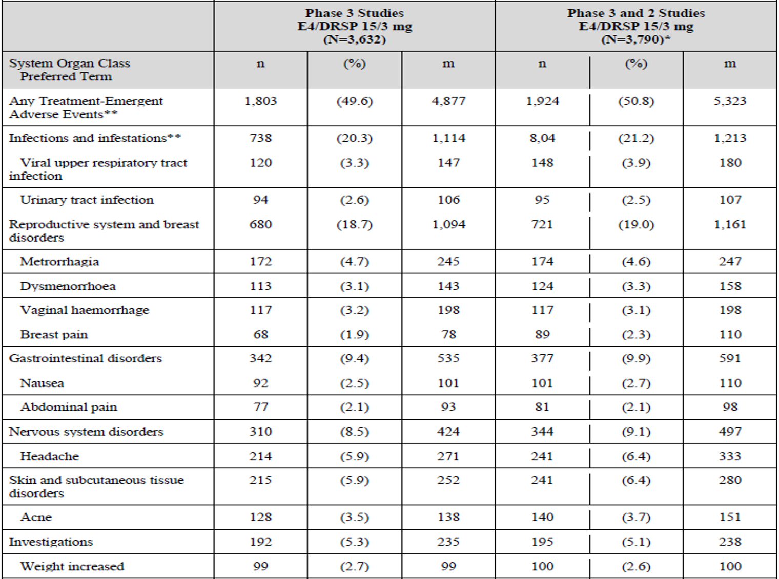
Abbreviations: DRSP = drospirenone; E4 = estetrol; m = number of events; N = number of subjects in the safety population and is the denominator for the percentages; n = number of subjects.
* The integrated summary of safety (safety population) includes 3,575 subjects with confirmed exposure to 15 mg estetrol/3 mg drospirenone and 215 subjects for whom neither exposure nor non-exposure could be confirmed. All 215 subjects were included in Phase III studies.
** This table includes one subject who never started the treatment. Two adverse events occurring to this subject should not have been accounted in the treatment emergent adverse events.
The most frequently reported treatment-related AEs by PT (drug-related TEAEs) were metrorrhagia (4.3%), headache (3.2%), acne (3.2%), vaginal haemorrhage (2.7%), dysmenorrhea (2.4%), breast pain (2.1%) and weight increased (2.0%).
Table 11: Drug-related treatment-emergent adverse events reported in ≥ 2% of subjects by System Organ Class and Preferred Term (safety population)
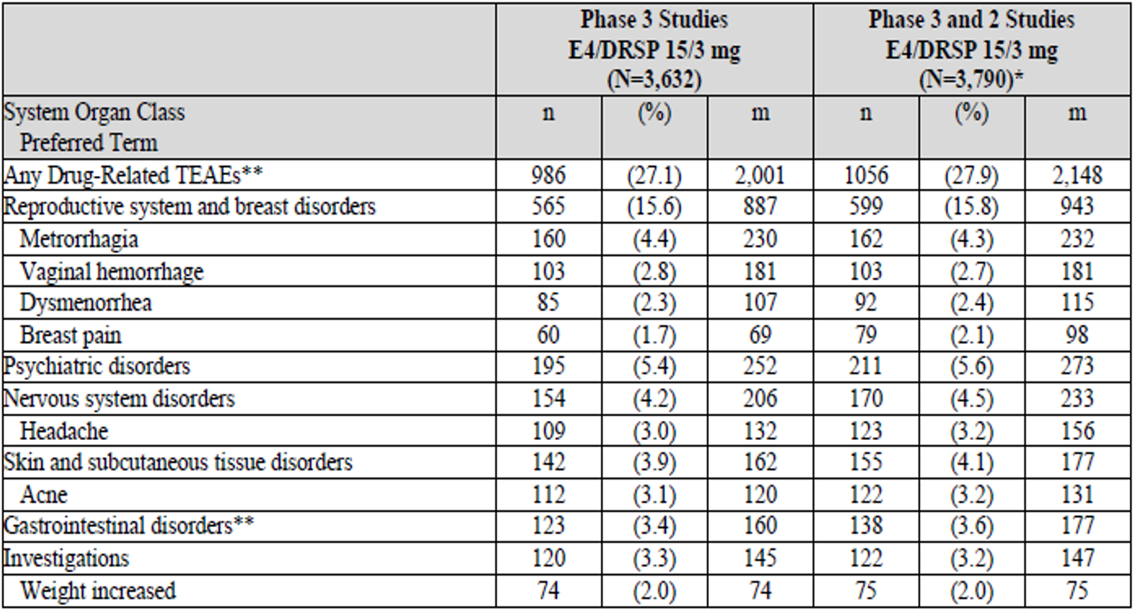
Abbreviations: DRSP = drospirenone; E4 = estetrol; m = number of events; N = number of subjects in the safety population and is the denominator for the percentages; n = number of subjects, TEAE = treatment emergent adverse event.
* The integrated summary of safety (safety population) includes 3,575 subjects with confirmed exposure to 15 mg estetrol/3 mg drospirenone and 215 subjects for whom neither exposure nor non-exposure could be confirmed. All 215 subjects were included in Phase III studies.
** Including one event of acute pancreatitis which was subsequently considered as not related to the study drug.

Serious adverse events
Of the 45 serious adverse events reported in the Integrated safety dataset, only 3 were considered related to study treatment venous thromboembolism (VTE), worsening depression and ectopic pregnancy all of which led to withdrawal of study drug and resolved without sequelae). These events do not affect the overall assessment of the safety profile. There was a total of one death in all clinical studies performed with estetrol (with or without progestin). It was reported in Study MIT-Es0001-C302 (with 15 mg estetrol/3 mg drospirenone). It was attributed to an accidental overdose of fentanyl and alprazolam and was evaluated as not related to the study drug.
Overall, 9.4% of subjects discontinued the study due to a TEAE; the most frequent AEs leading to study discontinuation were metrorrhagia (1.1%), acne (0.9%), vaginal haemorrhage (0.7%) and menorrhagia (0.6%).

Adverse events of special interest

Venous thromboembolic events
Over the clinical program of estetrol, including 4,319 subjects treated with at least one dose of estetrol, 2 cases of venous thromboembolism (VTE) were reported (0.05% of subjects). These have already been mentioned above.
- One case of venous thrombosis of vena fibularis was reported in a subject while being on her fourth cycle of 15 mg estetrol/3 mg drospirenone. This event was considered by the investigator as moderate in intensity and probably related to the study drug, required withdrawal from the study drug and resolved without any sequelae.
- The second event was a deep vein thrombosis of the lower right extremity reported in a subject who received 15 mg estetrol/3 mg drospirenone for 10 days and then a supratherapeutic dose with 75 mg estetrol/3 mg drospirenone for another 10 days. This event was considered by the investigator to be severe, likely related to study drug, and resolved without any sequelae.
The sponsor attempted to calculate the incidence of VTE observed in the pooled clinical Phase II and III studies (one event). The proposed incident amounted to 2.80 (95% CI: 0.68, 15.59) per 10,000 women and the incidence rate, in view of 2,735 woman years of (confirmed) exposure, was 3.66 (0.89, 20.37) per 10,000 woman years. These numbers must be interpreted with extreme caution.
However, European regulatory authorities demand an assessment of the VTE risk relative to ethinylestradiol/levonorgestrel for new hormonal contraceptives. In view of the low VTE incidence in the target population (several cases per 10,000 woman years), a dedicated pharmacodynamic clinical study has become imperative instead. This pharmacodynamic study must assess the effects on parameters potentially reflecting VTE risk, as suggested by the EMA, and should be conducted in a comparative fashion versus the standard combined oral contraceptive 0.03 mg ethinylestradiol / 0.15 mg levonorgestrel.²⁰ Such a pharmacodynamic study was conducted in the clinical development program of 15 mg estetrol/3 mg drospirenone. In this study, in addition to the required comparator 0.03 mg ethinylestradiol/0.15 mg levonorgestrel, a group of women using 0.02 mg ethinylestradiol/3 mg drospirenone was also included, to also allow the comparison between estetrol and ethinylestradiol in a drospirenone-containing combined oral contraceptive (Study MIT-Es0001-C201). Results from this study showed that the proposed 15 mg estetrol/3 mg drospirenone has little impact on haemostasis parameters relative to both the contraceptives 0.03 mg ethinylestradiol/0.15 mg levonorgestrel and 0.02 mg ethinylestradiol/3 mg drospirenone.

Safety in pregnancy
In the pooled Phase III studies, 38 pregnancies were exposed to 15 mg estetrol / 3 mg drospirenone (either on-treatment pregnancies or pre-treatment). Amongst those, 9 subjects (27.3%) carried the pregnancy to term and delivered a healthy child; 4 subjects (12.1%) had a late preterm delivery of a healthy child; 12 subjects (36.4%) had an elective abortion; 7 subjects (21.2%) had a spontaneous abortion; 2 subjects (6.1%) an ectopic pregnancy; and 4 subjects (12.1%) were lost to follow-up. In the specific evaluation of endometrial safety, the findings were as expected for a combined hormonal contraceptive, with mostly atrophic or inactive endometrium.

Laboratory and vital findings
No significant changes in carbohydrate metabolism, lipid, liver protein or haemostatic parameters were observed in the Nextstellis clinical studies. Hyperkalaemia (defined as a potassium level > 5.3 mmol/L) and was reported in 3.2% (120/3790) of the subjects. Overall, hyperkalaemia was mild and transient in the majority of subjects, having resolved prior to the end of their study treatment; Only 4 subjects (3.3%) had a potassium level 8.0 mmol/L or greater and no adverse reactions were attributed to hyperkalaemia and no subjects were discontinued due to elevated potassium levels.
No meaningful changes in mean blood pressure or heart rate were observed. No electrocardiogram or echocardiography was performed in the Phase III studies and in Study ES-C02. Specific analysis of cardiac safety was performed in Studies MIT-Es0001-C103 and MIT-Es0001-C106. In Studies MIT-Es0001-C201 and MIT-Es0001-C202, no clinically significant changes or trends were observed for heart rate, PR-interval, QRS duration, QT-interval;¹³ and QT-interval corrected for heart rate (QTcF) interval.¹³

Special populations
The pivotal Phase III studies included women from 18 years (Study MIT-Es0001-C301) or 16 years (Study MIT-Es0001-C302).
When safety data from the integrated summary of safety population was analysed based on age, there were no apparent differences in distribution of TEAEs between subjects aged ≥ 16 to ≤ 35 years and subjects aged > 35 to ≤ 50 years. Data are considered too limited to draw firm conclusions on the effect of weight/BMI, smoking status or race on the safety of estetrol/drospirenone.
The currently proposed Product Information includes that safety and efficacy of Nextstellis have been established in women of reproductive potential, 16 to 50 years of age.
Known risks with combined hormonal contraceptive in hepatic impairment and the potentially increased risk of hyperkalaemia from drospirenone in patients with renal impairment are handled by standard contraindications and warnings in the Product Information.

Risk management plan
The sponsor has submitted EU-risk management plan (RMP) version 0.2 (dated 20 February 2020; data lock point (DLP) 31 October 2019) and Australia specific annex (ASA) version 0.1 (dated 26 August 2020) in support of this application. At the second round of evaluation, the sponsor has submitted EU-RMP version 0.7 (dated 17 March 2021; DLP 31 October 2019) and ASA version 0.2 (dated 28 April 2021) in support of this submission.
The summary of safety concerns and their associated risk monitoring and mitigation strategies are summarised in Table 12. Further information regarding the TGA’s risk management approach can be found in risk management plans for medicines and biologicals and the TGA's risk management approach.
Table 12: Summary of safety concerns
Summary of safety concerns |  | Pharmacovigilance |  | Risk Minimisation
 |  | Routine | Additional | Routine | Additional
Important identified risks | Venous thromboembolism | ✓ | ✓* | ✓ | ✓*
Important identified risks | Arterial thromboembolism | ✓ | ✓** | ✓ | ✓*
Important potential risks | None
Missing information | Exposure during pregnancy | ✓ | ✓** | ✓ | –
*Additional Risk Minimisation activities include a Checklist for Prescribers and an Information Card for consumers. All the educational material will be available on the sponsor’s website (yet to be developed) and the Information Card for consumers will also be available on the TGA website attached to the Consumer Medicines Information.
** International Active Surveillance Study
- The summary of safety concerns includes only two important identified risks including venous thromboembolism (VTE) and arterial thromboembolism (ATE). There are no important potential risks listed. This is acceptable as safety concerns for similar products listed on the EMA site of approved safety concerns now only list VTE and ATE as important identified risks with no other risks listed. The most recent EU-RMP version 0.7 and ASA version 0.2 includes ‘Exposure during pregnancy’ as missing information.
- Only routine pharmacovigilance activities are proposed which is sufficient to capture any risk which may not yet be identified with this product. Routine pharmacovigilance will also monitor the efficacy of the additional risk minimisation activities which is acceptable. At the second round of evaluation, the EU-RMP includes an international active surveillance study as additional pharmacovigilance applicable to all the safety concerns. The results will be applicable to Australia, but the study will only include Europeans.
- Routine and additional risk minimisation activities have been proposed. Additional risk minimisation activities include a Checklist for Prescribers and an Information Card and Questions and Answers for Women. These will be available on the sponsor’s website. The additional activities are consistent with those described in the EU-RMP and are adequate to address the risks associated with the development of VTE and ATE. At the second round of evaluation, the EU-RMP no longer requires the questions and answers for women (the Consumer Medicines Information (CMI) and Information for women should be adequate to address any safety issues). In addition, the sponsor states that the Information for Women will also be available on the TGA website attached to the CMI.

Risk-benefit analysis

Delegate’s considerations
Several contraceptive methods for use by females are already available, both hormonal and non-hormonal. However, since women have different needs and experiences (for example, side effects, and poor bleeding patterns) with some methods, there can still be a place for a new combined hormonal contraceptive even if there is no large unmet medical need.

Quality
Outstanding quality (Good Manufacturing Practice clearance) issues have been resolved prior to registration of the product.

Efficacy
The submission includes several clinical studies addressing the pharmacokinetics (PK) of estetrol alone, as well as the clinical studies addressing the PK of estetrol with co-administration of drospirenone. In general, sufficient PK information of estetrol has been provided. The clinical results of the above mentioned clinical pharmacology programme generally appear to be sufficient for the proposed dose range and regimen (15 mg estetrol/3 mg drospirenone 24/4-day regimen). An appropriate well-tolerated contraceptive treatment effect has been observed with 15 mg estetrol/3 mg drospirenone; as well as an adequate bleeding pattern, in comparison with Qlaira.¹⁵
The application for estetrol/drospirenone is supported by two Phase III, multicentre, open label, single arm studies; Study MIT-Es0001-C301 (conducted in Europe/Russia) and Study MIT-Es0001-C302 (conducted in the US/Canada). The selection of 15 mg estetrol/3 mg drospirenone dose for the Phase III studies was adequately justified.
Overall, the pivotal studies have been designed in accordance with the requirements in the EMA guideline.²⁰
The two pivotal studies did not include an active comparator for comparison of bleeding patterns, which is a deficiency. However, earlier studies (for example, Study ES-C02 which included Qlaira (estradiol valerate/dienogest));¹⁵ have included comparators that can contribute to assessment of the bleeding pattern. This is considered acceptable.
The studies included heterosexually active females, at risk of pregnancy and requesting contraception, and who were willing to use the investigational product as the primary method of contraception for 13 consecutive cycles. The women were aged 18 to 50 years (inclusive) in Study MIT-Es0001-C301 and 16 to 50 years in Study MIT-Es0001-C302. Eligible subjects were treated with 15 mg estetrol/3 mg drospirenone for a maximum of 13 consecutive cycles. The treatment was to be taken once daily in a 24/4-day regimen, that is, 24 active tablets followed by 4 placebo tablets (4 day hormone free interval). The ITT population comprised 1,553 subjects in Study MIT-Es0001-C301 and 1,864 subjects in Study MIT-Es0001-C302. The studies had a non-comparative, open label single arm design, hence, there were no objectives related to superiority or non-inferiority and randomisation and blinding were not necessary. The use of a single arm, non-comparative study design is considered acceptable for the evaluation of a new hormonal contraceptive, in accordance with the EMA guideline.²⁰
The lack of an active comparator for the studies evaluating the contraceptive efficacy of a new contraceptive method is acceptable according to this guideline, as long as the number of cycles studied are sufficient to obtain the desired precision of the estimate of contraceptive efficacy and unless the expected Pearl Index is high (Pearl Index greater than one). The earlier studies (for example, Study ES-C02 which included Qlaira (estradiol valerate/dienogest)¹⁵ have included comparators that can contribute to assessment of the bleeding pattern. The sample size and statistical methods are overall considered acceptable.
The inclusion and exclusion criteria were in line with those applied in other hormonal contraception studies and generally acceptable to identify the population using contraceptives.
The primary objective of both studies was to evaluate the contraceptive efficacy of 15 mg estetrol/3 mg drospirenone using the Pearl Index in subjects aged 18 to 35 years (16 to 35 years in Study MIT-Es0001-C302), inclusive, at the time of screening. The corresponding primary efficacy variable was the number of on-treatment pregnancies assessed by the Pearl Index in the ITT population of women aged 18 to 35 years (16 to 35 years in Study MIT-Es0001-C302), inclusive, at the time of screening with at-risk cycles. This is the overall (method plus user failure) Pearl Index determined (according to the FDA definition) and can be considered the strictest determined Pearl Index. The study objectives and outcomes are adequate for studies evaluating a new contraceptive.
There were no remarkable findings with respect to medical history, or prior and concomitant medications in either of the studies, reflecting a relatively young and healthy population.
In Study MIT-Es0001-C301, five on-treatment pregnancies resulted in a Pearl Index of 0.44 (95% CI: 0.14, 1.03) in subjects aged 18 to 35 years with at-risk cycles; the primary efficacy variable. The corresponding Pearl Index in the whole age group (18 to 50 years) was 0.38 (95% CI: 0.12, 0.89).
Several other Pearl Index values were also presented. The ‘typical use’ Pearl Index (in which all cycles are included in the denominator regardless of other methods of birth control, occurrence of sexual intercourse or compliance with the protocol) in the 18 to 35 year old age group was 0.42 (95% CI: 0.14, 0.99). These Pearl Index values were all low and comply with the requirement for precision in accordance with the EMA guideline,²⁰ since the difference between the upper limit of the corresponding two-sided 95% CI for the Pearl Index and the point estimate was less than one.
Life table analyses (based on Kaplan-Meier estimates) were consistent with the Pearl Index results.
In Study MIT-Es0001-C302, 28 on-treatment pregnancies resulted in a Pearl Index in subjects aged 16 to 35 years with at-risk cycles, of 2.42 (95% CI: 1.58, 3.54). In the whole group (up to 50 years of age) and with alternative calculation methods, the Pearl Indices ranged from 2.09 to 2.52. These Pearl Index did not comply with the requirement for precision in accordance with the EMA guideline,²⁰ since the difference between the upper limit of the corresponding two-sided 95% CI for the Pearl Index and the point estimate was greater than one. However, the upper limit of the 95% CI was below five as claimed in the FDA guidance.²⁴
The Pearl Index for method failure was 1.43 (95% CI 0.78, 2.39) for the age group 16 to 35 years and 1.44 (95% CI 0.82, 2.34) for the whole study population, both with acceptable precision according to the EMA guideline.²⁰
The bleeding pattern was overall acceptable and as expected for combined hormonal contraceptives. Less than 20% of women reported unscheduled bleeding with a tendency of improvement over the year. The vast majority of women reported scheduled bleeding, occurring in association with the hormone free days. Few women (around 3%) discontinued for bleeding/spotting-related AEs.
The results were not consistent across both pivotal studies. In the US/Canadian Study MIT-Es0001-C302, the total number of pregnancies was higher than in Study MIT-Es0001-C301. Of the 28 on-treatment pregnancies, twelve pregnancies were considered user failures and 16 method failures. The requirement for precision of the Pearl Index (2.42, 95% CI: 1.58, 3.54) was not met in accordance with the EMA guideline.²⁰ The defined primary Pearl Index value as well as the secondary Pearl Indices were higher in the US/Canadian Study MIT-Es0001-C302 compared with the European/Russian Study MIT-Es0001-C301.
It is acknowledged that higher Pearl Index estimates observed in US versus EU (non-US) studies is a common phenomenon found for several contraceptives and non-compliance was identified as one of the main factors impacting the efficacy of oral contraceptives in clinical trials. This would fit with the observation that for user independent contraceptive methods (for example, intrauterine devices), the Pearl Index difference was small or absent. A slightly lower compliance was observed in the US/Canada Study MIT-Es0001-C302 versus the EU/Russia Study MIT-Es0001-C301, although it is unclear if this difference would be large enough to lead to the observed Pearl Index difference.
The sponsor has presented pooled Pearl Index results for the two pivotal studies. The studies are both large and the European study (Study MIT-Es0001-C301) provided a Pearl Index with an acceptable precision and also given the differences in both the studies, including inconsistent results, the Delegate does not consider a need for pooling.

Safety
The safety profile of Nextstellis was acceptable. The most common AEs were headache (6.4%), metrorrhagia (4.6%), viral upper respiratory tract infection (3.9%), acne (3.7%), dysmenorrhea (3.3%), vaginal haemorrhage (3.1%), nausea (2.7%), urinary tract infection (2.5%), weight increased (2.6%), breast pain (2.3%) and abdominal pain (2.1%). The AE profile appears similar to other combined hormonal contraceptives and the clinical safety profile is overall not concerning. The known risks with these contraceptives can be managed by pharmacovigilance measures under the RMP.
The two events of venous thromboembolism (VTE) were both considered related to study treatment. The currently available clinical safety database is too small to draw conclusions regarding the magnitude of the risk for/incidence of VTEs at treatment with estetrol/drospirenone, and the sponsor’s attempt to calculate an incidence based on the integrated summary of safety population is not considered conclusive. Treatment with 15 mg estetrol/ 3 mg drospirenone resulted in the least apparent changes from Baseline in the haemostatic parameters compared to ethinylestradiol/levonorgestrel and ethinylestradiol/drospirenone, which is considered reassuring. The clinical significance of the effects on haemostatic parameters with regard to VTE risk can, however, only be hypothetical. The association with laboratory results, which are surrogate biomarkers, and VTE risk is weak. VTE is an established risk during use of a hormonal contraceptive and usually associated with the estrogen content of the combined hormonal contraceptive. Altogether, no claims regarding the relative risk for VTE with Nextstellis in comparison with other combined hormonal contraceptives can be made based on the currently available data.
The incidence of VTE in the studies was low, and most of the risks associated with combined oral contraceptives, including Nextstellis, are addressed with appropriate precautionary text in the Product Information/CMI. In addition, this is adequately addressed in the RMP. This is considered acceptable.

Proposed action
Unintended pregnancy negatively affects personal, societal, and maternal and infant health in numerous ways. Providing females of reproductive potential with contraceptive options to prevent unintended pregnancy will have a significant positive impact on maternal and child health.
An adequate ovulation inhibitory effect and cycle control has been observed for the proposed dose regimen of 15 mg estetrol/3 mg drospirenone in the clinical pharmacology programme.
The contraceptive efficacy results in Study MIT-Es0001-C301 show that estetrol/drospirenone is a combined hormonal contraceptive with low Pearl Index. This was true for all definitions of Pearl Index, including the method failure Pearl Index, as well as for the group of women aged 18 to 35 years and the whole study population up to 50 years of age. The precision in the Pearl Index estimates was high, thus, fulfilling the requirements in the EMA guideline.²⁰ The Study MIT-Es0001-C301 was sufficiently large to demonstrate a Pearl Index of adequate precision to support this application.
In Study MIT-Es0001-C302 on the other hand, the primary Pearl Index as well as other Pearl Indices were much higher and had lower precision, not fulfilling the EMA guideline;²⁰ requirements. These details can merely be noted in the PI.
Overall, Nextstellis (15 mg estetrol monohydrate/3 mg drospirenone) provided good contraceptive efficacy, predictable vaginal bleeding patterns. Overall, the safety profile of 15 mg estetrol/3 mg drospirenone was as expected for an estrogen/progestin oral contraceptive combination.
Post-ACM meeting, the quality evaluator provided chemistry, quality and control clearance for approval and confirmed that there are no outstanding matters form a chemistry perspective.
Overall, based on the review of data on quality, safety and efficacy, the Delegate considers that the benefit-risk balance of Nextstellis is favourable in the following indication:
For use by women of reproductive potential to prevent pregnancy.

Advisory Committee considerations
The Advisory Committee on Medicines (ACM), having considered the evaluations and the Delegate’s overview, as well as the sponsor’s response to these documents, advised the following.

Specific advice to the Delegate
- Please comment on the benefit-risk balance of Nextstellis in the proposed indication:
For use by women of reproductive potential to prevent pregnancy.
From the clinical data provided to the ACM and in the context of widespread, long-term use of combined oral contraceptives, the ACM considered Nextstellis (estetrol monohydrate/drospirenone) in the relevant dosage to have a positive benefit-risk profile for the prevention of pregnancy, subject to ongoing supervision by the patient’s primary healthcare provider. The risk profile for Nextstellis was not considered to be higher than for other available combined oral contraceptives.
The ACM was of the view that while there are uncommon serious risks that may materialise from any combined oral contraceptive, including Nextstellis, the overall risk of pregnancy is higher than the risk of the adverse events from the combined oral contraceptive. The ACM commented that both emotional and physical adverse effects should be recognised in this context.
As women have different needs and experiences, the ACM advised that it is important to have a range of contraceptive options available.
- The committee is also requested to provide advice on any other issues that it thinks may be relevant to a decision on whether or not to approve this application.
No further advice.

Conclusion
The ACM considered this product to have an overall positive benefit-risk profile for the indication:
For use by women of reproductive potential to prevent pregnancy.

Outcome
Based on a review of quality, safety, and efficacy, the TGA approved the registration of (Nextstellis (estetrol monohydrate / drospirenone) 14.2 mg estetrol and 3 mg drospirenone, film-coated tablet, blister pack, indicated for:
Nextstellis is indicated for use by women of reproductive potential to prevent pregnancy

Specific conditions of registration applying to these goods
- Nextstellis (estetrol monohydrate and drospirenone) is to be included in the Black Triangle Scheme. The PI and CMI for Nextstellis must include the black triangle symbol and mandatory accompanying text for five years, which starts from the date that the sponsor notifies the TGA of supply of the product.
- The Nextstellis EU-risk management plan (RMP) (version 0.7, dated 17 March 2021, data lock point 31 October 2019), with Australian specific annex (version 0.2, dated 28 April 2021), included with Submission PM-2020-04185-1-5, and any subsequent revisions, as agreed with the TGA will be implemented in Australia.
An obligatory component of risk management plans is routine pharmacovigilance. Routine pharmacovigilance includes the submission of periodic safety update reports (PSURs).
Reports are to be provided in line with the current published list of EU reference dates and frequency of submission of PSURs until the period covered by such reports is not less than three years from the date of the approval letter.
The reports are to at least meet the requirements for PSURs as described in the European Medicines Agency’s Guideline on Good Pharmacovigilance Practices (GVP) Module VII-periodic safety update report (Rev 1), Part VII.B Structures and processes. Note that submission of a PSUR does not constitute an application to vary the registration.

Attachment 1. Product Information
The PI for Nextstellis approved with the submission which is described in this AusPAR is at Attachment 1. For the most recent PI, please refer to the TGA PI/CMI search facility.

Therapeutic Goods Administration
PO Box 100 Woden ACT 2606 Australia
Email: info@tga.gov.au Phone: 1800 020 653 Fax: 02 6232 8605
https://www.tga.gov.au

Each Nexstellis blister pack of 28 film-coated tablets is comprised of 24 active pink-coloured tablets containing 14.2 mg estetrol and 3 mg of drospirenone; and 4 inactive white-coloured tablets as placebo.
Richters, J. et al. Sex in Australia: Contraceptive Practices among a Representative Sample of Women, Aust N Z J Public Health, 2003; 27(2): 210-216.
Skiba, M.A. et al. Hormonal Contraceptive Use in Australian Women: Who is Using What?, Aust N Z J Obstet Gynaecol, 2019; 59(5): 717-724.
Bateson, D. et al. Contraception: an Australian Clinical Practice Handbook, third edition, Brisbane, 2012.
Kuhl, H. Comparative Pharmacology of Newer Progestogens, Drugs, 1996; 51(2): 188-215.
Ågren, U.M. et al. et al. Effects of a Monophasic Combined Oral Contraceptive Containing Nomegestrol Acetate and 17 Β -Oestradiol Compared With One Containing Levonorgestrel And Ethinylestradiol On Haemostasis, Lipids And Carbohydrate Metabolism, Eur J Contracept Reprod Health Care, 2011; 16: 444–457.
Junge, W. et al. Metabolic and Haemostatic Effects of Estradiol Valerate/Dienogest, a Novel Oral Contraceptive. a Randomized, Open-Label, Single-Centre Study, Clin Drug Investig, 2011; 31: 573-584.
Visser, M. et al. In Vitro Effects of Estetrol on Receptor Binding, Drug Targets and Human Liver Cell Metabolism, Climacteric, 2008; 11(Suppl 1): 64-68.
Coelingh Bennink, H.J.T. et al. Estetrol Review: Profile and Potential Clinical Applications, Climacteric, 2008a; 11(Suppl 1): 47-58.
Good Laboratory Practice is a code of standards following the International Council on Harmonisation (ICH) relevant to testing of medicines in laboratories during drug development.
Cytochrome P450 (CYP) enzymes: CYPs are the major enzymes involved in drug metabolism, accounting for large part of the total metabolism. Most drugs undergo deactivation by CYPs, either directly or by facilitated excretion from the body. Also, many substances are bioactivated by CYPs to form their active compounds. Many drugs may increase or decrease the activity of various CYP isozymes either by inducing the biosynthesis of an isozyme (enzyme induction) or by directly inhibiting the activity of the CYP (enzyme inhibition). This is a major source of adverse drug interactions, since changes in CYP enzyme activity may affect the metabolism and clearance of various drugs. Such drug interactions are especially important to take into account when using drugs of vital importance to the patient, drugs with important side-effects and drugs with small therapeutic windows, but any drug may be subject to an altered plasma concentration due to altered drug metabolism.
Pregnancy Category B3: Drugs which have been taken by only a limited number of pregnant women and women of childbearing age, without an increase in the frequency of malformation or other direct or indirect harmful effects on the human fetus having been observed. Studies in animals have shown evidence of an increased occurrence of fetal damage, the significance of which is considered uncertain in humans.
The QT interval is the time from the start of the QRS wave complex to the end of the corresponding T wave. It approximates to the time taken for ventricular depolarisation and repolarisation, that is to say, the period of ventricular systole from ventricular isovolumetric contraction to isovolumetric relaxation. The corrected QT interval (QTc) estimates the QT interval at a standard heart rate. This allows comparison of QT values over time at different heart rates and improves detection of patients at increased risk of arrhythmias. The QTcF is the QT interval corrected for heart rate according to Fridericia’s formula.
Haemoglobin A1c or glycated haemoglobin (HbA1c) is a minor component of haemoglobin chemically linked to glucose. Levels of HbA1c vary and are relative to the overall blood glucose concentration. Unlike a blood glucose concentration, levels of HbA1c are not influenced by daily fluctuations in the blood glucose concentration but reflect the average glucose levels over the prior 6 to 8 weeks. Measurement of HbA1c is used in the diagnosis of diabetes mellitus and is useful indicator of how well the blood glucose level has been controlled in the recent past and may be used to monitor the effects of diet, exercise, and drug therapy on blood glucose in patients with diabetes. In healthy people without diabetes, the HbA1c level is less than 7 percent of total haemoglobin.
Qlaira (estradiol valerate/dienogest) was first registered on the ARTG on 14 May 2009 (ARTG number: 149319).
Yaz was first registered on the ARTG on 4 August 2014 (ARTG number: 226241).
Pearl Index is a technique used in clinical trials for reporting contraceptive effectiveness. It is defined as the number of contraceptive failures per 100 women years of exposure, and uses as the denominator the total months or cycles of exposure from the initiation of the product to the end of the study or the discontinuation of the product.
Gerlinger, C. et al. Recommendation for Confidence Interval and Sample Size Calculation for the Pearl Index, Eur J Contracept Reprod Health Care, 2003; 8(2): 87-92.
Randomised clinical trials analysed by the intent-to-treat (ITT) approach provide the unbiased comparisons among the treatment groups. In the ITT population, none of the patients are excluded and the patients are analysed according to the randomisation scheme.
European Medicines Evaluation Agency (EMEA), Committee for Medicinal Products for Human Use (CHMP), Guideline on Clinical Investigation of Steroid Contraceptives in Women, EMEA/CPMP/EWP/519/98 Revision 1, 27 July 2005.
The Menstrual Distress Questionnaire (MDQ) measures cyclical perimenstrual symptoms.
The Quality of Life Enjoyment and Satisfaction Questionnaire (Q-LES-Q) measures quality-of-life in key domains.
The per-protocol (PP) analysis is restricted to the participants who strictly adhered to the protocol. Also known as ‘on-treatment’ analysis.
Food and Drug Administration (FDA), Centre for Drug Evaluation and Research (CDER), Establishing Effectiveness and Safety for Hormonal Drug Products Intended to Prevent Pregnancy Guidance for Industry, July 2019.

