July 2022

Australian Public Assessment Report for Spikevax
  - Active ingredients: Elasomeran
  - Sponsor: Moderna Australia Pty Ltd

About the Therapeutic Goods Administration (TGA)
- The Therapeutic Goods Administration (TGA) is part of the Australian Government Department of Health and is responsible for regulating therapeutic goods, including medicines, medical devices, and biologicals.
- The TGA administers the Therapeutic Goods Act 1989 (the Act), applying a risk management approach designed to ensure therapeutic goods supplied in Australia meet acceptable standards of quality, safety, and efficacy.
- The work of the TGA is based on applying scientific and clinical expertise to decision-making, to ensure that the benefits to the Australian public outweigh any risks associated with the use of therapeutic goods.
- The TGA relies on the public, healthcare professionals and industry to report problems with therapeutic goods. The TGA investigates reports received to determine any necessary regulatory action.
- To report a problem with a therapeutic good, please see the information on the TGA website.

About AusPARs
- The Australian Public Assessment Report (AusPAR) provides information about the evaluation of a prescription medicine and the considerations that led the TGA to approve or not approve a prescription medicine submission. Further information can be found in Australian Public Assessment Report (AusPAR) guidance.
- AusPARs are prepared and published by the TGA.
- AusPARs are static documents that provide information that relates to a submission at a particular point in time. The publication of an AusPAR is an important part of the transparency of the TGA’s decision-making process.
- A new AusPAR may be provided to reflect changes to indications or major variations to a prescription medicine subject to evaluation by the TGA.

Copyright
© Commonwealth of Australia 2022
This work is copyright. You may reproduce the whole or part of this work in unaltered form for your own personal use or, if you are part of an organisation, for internal use within your organisation, but only if you or your organisation do not use the reproduction for any commercial purpose and retain this copyright notice and all disclaimer notices as part of that reproduction. Apart from rights to use as permitted by the Copyright Act 1968 or allowed by this copyright notice, all other rights are reserved, and you are not allowed to reproduce the whole or any part of this work in any way (electronic or otherwise) without first being given specific written permission from the Commonwealth to do so. Requests and inquiries concerning reproduction and rights are to be sent to the TGA Copyright Officer, Therapeutic Goods Administration, PO Box 100, Woden ACT 2606 or emailed to <tga.copyright@tga.gov.au>.

Contents
List of abbreviations 4
Product submission 6
Submission details 6
Product background 8
Regulatory status 11
Product Information 12
Registration timeline 12
Submission overview and risk/benefit assessment 13
Quality 13
Nonclinical 14
Clinical 14
Risk management plan 22
Risk-benefit analysis 24
Outcome 27
Specific conditions of registration applying to these goods 28
Attachment 1. Product Information 30

List of abbreviations
Abbreviation | Meaning
ACV | Advisory Committee on Vaccines
ARGPM | Australian Regulatory Guidelines for Prescription Medicines
ARTG | Australian Register of Therapeutic Goods
ASA | Australia specific annex
ATAGI | Australian Technical Advisory Group on Immunisation
CI | Confidence interval
COVID-19 | Coronavirus disease 2019
CPD | Certified Product Details
DLP | Data lock point
EU | European Union
FDA | Food and Drug Administration (United States of America)
GMR | Geometric mean ratio
GMT | Geometric mean titre
GVP | Good Pharmacovigilance Practices
MIS | Multi-system inflammatory syndrome
MIS-C | Multi-system inflammatory syndrome in children
mRNA | Messenger ribonucleic acid
mRNA-1273 | Spikevax (elasomeran) COVID-19 vaccine drug development name
PI | Product Information
PSUR | Periodic safety update report
QC | Quality control
OCABR | Official Control Authority Batch Release (European Union)
RMP | Risk management plan
SARS-CoV-2 | Severe acute respiratory syndrome coronavirus-2
Study P204 | Study mRNA-1273-P204
Study P301 | Study mRNA-1273-P301
TGA | Therapeutic Goods Administration
UK | United Kingdom
US(A) | United States (of America)
VE | Vaccine efficacy

Product submission

Submission details
Type of submission: | Extension of indication and major variation (new strength)
Product name: | Spikevax
Active ingredient: | Elasomeran
Decision: | Approved for provisional registration
Date of decision: | 19 July 2022
Date of entry onto ARTG: | 19 July 2022
ARTG numbers: | 370599, 388244 and 388245
Black Triangle Scheme: | Yes.  This product will remain in the scheme for 5 years, starting on the date the new indication was approved.
Sponsor’s name and address: | Moderna Australia Pty Ltd  Level 6, 60 Martin Place  Sydney NSW, 2000
Dose form: | Suspension for injection
Strengths: | 0.2 mg/mL and 0.1 mg/mL
Containers: | Vial and pre-filled syringe
Pack size: | 10 x 5 mL multidose vials (0.2 mg/mL)  10 x 2.5 mL multidose vials (0.1 mg/mL)  10 x pre-filled syringes (as 5 packs of 2 pre-filled syringes) (0.1 mg/mL)
Approved therapeutic use: | Spikevax (elasomeran) COVID-19 vaccine has provisional approval for the indication below:  Active immunisation to prevent coronavirus disease 2019 (COVID-19) caused by SARS-CoV-2 in individuals 6 months of age and older.  The use of this vaccine should be in accordance with official recommendations.  The decision has been made on the basis of short-term efficacy and safety data. Continued approval depends on the evidence of longer term efficacy and safety from ongoing clinical trials and post-market assessment.
Route of administration: | Intramuscular
Dosage: | Dosage is based on multiple factors, including the vaccination type (primary series, booster dose and immunocompromised individuals), and the age group of the patient.  Primary series  It is recommended to administer the second dose 28 days after the first dose.  Individuals 6 months to less than 6 years of age  Spikevax is administered as a course of 2 doses of Spikevax 0.1 mg/mL solution via intramuscular injection.  Each 0.25 mL dose of Spikevax 0.1 mg/mL contains 25 µg elasomeran.  Individuals 6 years to less than 12 years of age  Spikevax is administered as a course of 2 doses of either Spikevax 0.1 mg/mL; or Spikevax 0.2 mg/mL solution via intramuscular injection.  Each 0.5 mL dose of Spikevax 0.1 mg/mL contains 50 µg elasomeran.  Each 0.25 mL dose of Spikevax 0.2 mg/mL contains 50 µg elasomeran  Individuals 12 years of age and older  Spikevax is administered as a course of 2 doses of Spikevax 0.2 mg/mL solution via intramuscular injection.  Each 0.5 mL dose of Spikevax 0.2 mg/mL contains 100 µg elasomeran.  Immunocompromised individuals  Individuals 6 months to less than 6 years of age  A third dose of Spikevax 0.1 mg/mL solution for intramuscular injection may be given at least 28 days after the second dose of the primary series of vaccination.  Each 0.25 mL dose of Spikevax 0.1 mg/mL contains 25 µg elasomeran.  Individuals 12 years of age and older  A third dose of Spikevax 0.2 mg/mL solution for intramuscular injection may be given at least 28 days after the second dose of the primary series of vaccination.  Each 0.5 mL dose of Spikevax 0.2 mg/mL contains 100 µg elasomeran.  Booster dose  The decision when and for whom to implement a booster (third dose) of Spikevax should be made based on available vaccine safety and effectiveness data in accordance with official recommendations.  Individuals 18 years of age and older  A third dose of either Spikevax 0.1 mg/mL; or Spikevax 0.2 mg/mL solution for intramuscular injection is administered at least 6 months after the second dose of the primary series of vaccination.  Each 0.5 mL dose of Spikevax 0.1 mg/mL contains 50 µg elasomeran.  Each 0.25 mL dose of Spikevax 0.2 mg/mL contains 50 µg elasomeran.  For further information regarding dosage (including the interchangeability of Spikevax with other COVID-19 vaccines), refer to the Product Information.
Pregnancy category: | B1  Drugs which have been taken by only a limited number of pregnant women and women of childbearing age, without an increase in the frequency of malformation or other direct or indirect harmful effects on the human fetus having been observed.  Studies in animals have not shown evidence of an increased occurrence of fetal damage.  The use of any medicine during pregnancy requires careful consideration of both risks and benefits by the treating health professional. This must not be used as the sole basis of decision making in the use of medicines during pregnancy. The TGA does not provide advice on the use of medicines in pregnancy for specific cases. More information is available from obstetric drug information services in your State or Territory.

Product background
This AusPAR describes the submission by Moderna Australia Pty Ltd (the sponsor) to register Spikevax (elasomeran) 0.1 mg/mL and 0.2 mg/mL solution (suspension) for intramuscular injection for the following proposed extension of indications (under Submission PM-2022-01792-1-2):
Spikevax (elasomeran) COVID-19 vaccine has provisional approval for the indication below:
Active immunisation to prevent coronavirus disease 2019 (COVID-19) caused by SARS-CoV-2 in individuals 6 months of age and older.
The use of this vaccine should be in accordance with official recommendations.
The decision has been made on the basis of short-term efficacy and safety data. Continued approval depends on the evidence of longer term efficacy and safety from ongoing clinical trials and post-market assessment.
The sponsor also seeks to register a new strength (0.1 mg/mL) of Spikevax (elasomeran). At the time this submission was considered Spikevax (elasomeran) was available in a single strength of 0.2 mg/mL only, receiving provisional approval in August 2021.
For the proposed new strength (0.1 mg/mL), the sponsor has proposed new pack presentations of 2.5 mL multi-dose vials and multipacks of pre-filled syringes. The previously approved 0.2 mg/mL Spikevax presentation is supplied as 5 mL multi-dose vials.
The proposed change to the dose regimen (under Submission PM-2022-01760-1-2) are as follows:
Primary series - children 6 months through 5 years of age
Two doses (0.25 mL each), containing 25 µg elasomeran. It is recommended to administer the second dose 28 days after the first dose.
If a child turns 6 years old between his/her first and second dose, the second dose of Spikevax should be the same as the first dose.
Immunocompromised individuals - children 6 months through 5 years of age
A third dose of Spikevax (0.25 mL containing 25 µg elasomeran) may be given at least 28 days following the second dose.
Individuals who have undergone solid organ transplantation, or who are diagnosed with conditions that are considered to have an equivalent level of immunocompromise.
Severe acute respiratory syndrome coronavirus-2 (SARS-CoV-2) is a coronavirus that has circulated at pandemic levels since early 2020, with the observed virulence of infections having changed several times as different variants of the virus have evolved. SARS-CoV-2 can cause severe disease typified by both respiratory and systemic inflammatory manifestations. The propensity of a person infected with SARS-CoV-2 to develop severe disease depends partly on pre-disposing risk factors (for example, age, diabetes, obesity, chronic cardiovascular disease), but healthy individuals are also affected. Children are less likely to develop severe coronavirus disease 2019 (COVID-19) overall than adults and are less likely to develop primary respiratory pathology from SARS-CoV-2 infections. Children with pre-existing illness are, however, likely to be at increased risk of severe COVID-19 than healthy age peers and can develop life threatening multi-system inflammatory syndrome (MIS). As with adults, vaccination is likely to reduce the propensity of children to develop severe disease and so provides an important preventative therapy.
Treatments for severe COVID-19 include anti-viral and anti-inflammatory medications in addition to standard supportive care. Preventive therapy can be used post-infection in individuals at high risk of developing severe disease and includes antibody and anti-viral therapies. Vaccination is the only therapy that reduces the chance of acquiring COVID-19, and which can be given prior to infection to reduce the chance of a person developing severe disease.
There are currently five vaccines on the Australian Register of Therapeutic Goods (ARTG), and all are approved under the provisional pathway:
  - Comirnaty (BNT162b2 (mRNA) or tozinameran); also known as the Pfizer/BioNTech (mRNA) vaccine, provisionally approved for active immunisation to prevent COVID-19 caused by SARS-CoV-2, in individuals 5 years of age and older.,,,
  - COVID-19 Vaccine AstraZeneca (ChAdOx1-S), an adenoviral vectored vaccine, provisionally approved for active immunisation to prevent COVID-19 caused by SARS-CoV-2, in individuals 18 years of age and older.,
  - COVID-19 Vaccine Janssen (Ad26.COV2.S), an adenoviral vectored vaccine, provisionally approved for active immunisation to prevent COVID-19 caused by SARS-CoV-2, in individuals 18 years of age and older.,
  - Spikevax (elasomeran) COVID-19 vaccine, also known as the Moderna (mRNA) vaccine, provisionally approved for active immunisation to prevent COVID-19 caused by SARS-CoV-2, in individuals 6 years of age and older.,,,
  - Nuvaxovid (SARS-CoV-2 recombinant spike protein with Matrix-M adjuvant) COVID-19 vaccine, also known as the Novavax recombinant spike protein vaccine, provisionally approved for active immunisation to prevent COVID-19 caused by SARS-CoV-2 in individuals 18 years of age and older.,
There are currently no provisionally approved COVID-19 vaccines with a therapeutic indication that extends to children aged less than 5 years of age on the ARTG.
Spikevax is a vaccine comprised of synthetic mRNA (messenger ribonucleic acid) that is taken up by antigen presenting cells and translated to produce SARS-CoV-2 viral spike protein. When spike protein is expressed the formation of neutralising antibodies is stimulated, as well as recruitment of T-cells directed against SARS-CoV-2 infected cells.
The sponsor has established a clinical rationale for vaccinating young children in the context of data sourced from international epidemics including the United States of America (USA) and Hong Kong. The sponsor stated that:
‘In the US, peak incidences of COVID-19 and hospitalisations of children due to COVID-19 were higher in the Omicron wave than in the Delta wave. In Hong Kong, children 0 to 5 years of age comprised 80.2% of children’s admissions during the Omicron wave compared to 54.2% prior to Omicron. There was a higher incidence of death in admitted children during the Omicron wave, with 3 of the 4 deaths in children aged 0 to 5 years. Children with underlying conditions and/or immune deficiency or immunocompromised status, as well as infants (that is less than one year of age), may be at higher risk for severe disease due to SARS-CoV-2 infection.’
In their conclusions, the sponsor made the following points:
- Currently, there is no authorised or licensed vaccine available for children aged less than 5 years of age.
- Overall, the evidence suggests that the burden of COVID-19 has increased in younger age groups over time based on the number and proportion of cases.
- Only vaccination can effectively prevent most of the morbidity and mortality in children between 6 months to less than 6 years of age.

Regulatory status
The product received initial registration on the Australian Register of Therapeutic Goods (ARTG) on 9 August 2021. At the time of this submission, the approved indications are:
Spikevax (elasomeran) COVID-19 vaccine has provisional approval for the indication below:
Active immunisation to prevent coronavirus disease 2019 (COVID-19) caused by SARS-CoV-2 in individuals 6 years of age and older.
The use of this vaccine should be in accordance with official recommendations.
The decision has been made on the basis of short-term efficacy and safety data. Continued approval depends on the evidence of longer term efficacy and safety from ongoing clinical trials and post-market assessment.
At the time the TGA considered this submission, similar submissions had been approved in the USA on 17 June 2022 and Canada on 14 July 2022. Similar submissions were under consideration in the European Union (EU) (submitted on 29 April 2022) and the Great Britain (submitted on 29 April 2022).
The following table summarises these submissions and provides the indications where approved.
Table 1: International regulatory status
Region | Submission date | Status | Approved indications
United States of America | 28 April 2022 | Approved on 17 June 2022 | For active immunization to prevent COVID-19 in individuals 6 months of age and older
Canada | 29 April 2022 | Approved on 14 July 2022 | For active immunization to prevent COVID-19 in individuals 6 months of age and older
European Union | 29 April 2022 | Under consideration | Under consideration
Great Britain | 29 April 2022 | Under consideration | Under consideration

Product Information
The Product Information (PI) approved with the submission which is described in this AusPAR can be found as Attachment 1. For the most recent PI, please refer to the TGA PI/CMI search facility.

Registration timeline
The following table captures the key steps and dates for this submission.
Table 2: Timeline for Submissions PM-2022-01792-1-2 and PM-2022-01760-1-2
Data were provided as a rolling submission. Under normal circumstances, TGA's assessment (for both provisional and general registration) begins once all information to support registration is available. As part of the Department of Health's response to the pandemic, the TGA has agreed to accept rolling data for COVID-19 vaccines and treatments, to enable early evaluation of data as it becomes available.
Description | Date
Determination (Provisional) | 9 November 2021
Submission dossier accepted and first round evaluation commenced | 12 May 2022
Evaluation completed | 7 July 2022
Delegate’s Overall benefit-risk assessment and request for Advisory Committee advice | 20 June 2022
Sponsor’s pre-Advisory Committee response | 23 June 2022
Advisory Committee meeting | 6 July 2022
Registration decision (Outcome) | 19 July 2022
Completion of administrative activities and registration on the ARTG | 19 July 2022
Number of working days from submission dossier acceptance to registration decision* | 47
*Statutory timeframe for standard submissions is 255 working days

Submission overview and risk/benefit assessment
A summary of the TGA’s assessment for this submission is provided below.
The following guideline was referred to by the Delegate as being relevant to this submission:
- United States (US) Food and Drug Administration (FDA), Development and Licensure of Vaccines to Prevent COVID-19, Guidance for Industry, June 2020.

Quality
The sponsor has submitted application to register a new strength (0.1 mg/mL) and new pack presentations (2.5 mL multi-dose vial and multipacks of pre-filled syringes) for Spikevax (elasomeran). Additionally, a new finished product manufacturing site [information redacted] is proposed to be registered with this submission for the new strength (0.1 mg/mL; 2.5 mL vial) and the existing strength (0.2 mg/mL; 5.0 mL vial).
The active drug substance of the Spikevax vaccine is elasomeran (previously known by the compound name mRNA-1273). Elasomeran is a single strand of nucleoside-modified mRNA encoding a pre-fusion stabilised spike protein of SARS-CoV-2 encapsulated in lipid nanoparticles in a mRNA-lipid complex dispersion.
The physicochemical properties of the elasomeran mRNA-lipid complex dispersion and the Spikevax drug product solutions have previously been evaluated for the initial provisional registration of the 0.2 mg/mL strength. The sponsor has updated the data submitted to include the 0.1 mg/mL strength, which is acceptable.
Spikevax is supplied as a ready-to-use solution, frozen at -50°C to -15°C. Once thawed, the vaccine should not be re-frozen.
The previously approved and proposed pack presentations are as follows:
- 10 x 5 mL multi-dose vials (0.2 mg/mL strength);
- 10 x 2.5 mL multi-dose vials (0.1 mg/mL strength);
- 10 pre-filled syringes (supplied as 5 packs of 2 pre-filled syringed) (0.1 mg/mL strength).
Based upon stability data submitted by the sponsor, the recommended shelf-life and storage conditions for elasomeran (drug substance) are 12 months from the date of manufacture, and stored at -90°C to -60°C.
The recommended shelf-life and storage conditions for the finalised Spikevax drug products are as follows:
- For the 0.1 mg/mL and 0.2 mg/mL suspension for injection vials:
  - The recommended shelf-life is 9 months.
  - Storage conditions:
    - For long-term storage, store at -50°C to -15°C.
    - This may include storage (as an unopened/unpunctured vial) for up to one month (30 days) at 2°C to 8°C at the point of care site.
    - Can be stored (as an unopened/unpunctured vial) for an additional in-use time of up to 24 hours at 8°C to 25°C on the day of dose administration.
  - Important note: Once thawed, the vaccine should not be re-frozen.
- For the 0.1 mg/mL suspension for injection pre-filled syringe:
  - The recommended shelf-life is 9 months.
  - Storage conditions:
    - For long-term storage, store at -50°C to -15°C.
    - This may include storage for up to one month (30 days) at 2°C to 8°C at the point of care site.
    - Can be stored for an in-use time of up to 24 hours at 8°C to 25°C on the day of dose administration.
    - The product should be thawed at 2°C to 8°C or alternatively at room temperature (15°C to 25°C) on the day of dose administration.
  - Important note: Once thawed, the vaccine should note be refrozen.
There are no significant issues identified from the quality evaluation of the submitted data that would indicate the products should not be provisionally registered on the basis of quality, or safety-related issues arising from the quality of the products. The manufacturing quality information submitted by the sponsor support the provisional registration of Spikevax.
The sponsor has provided adequate information to ensure the products’ quality under the provisional registration. It is recommended that the Spikevax (elasomeran) 0.1 mg/mL suspension for injection (vial); and 0.1 mg/mL suspension for injection (pre-filled syringe) products are suitable for provisional approval with regard to quality.

Nonclinical
A full nonclinical evaluation was conducted at the time this product received initial provisional registration.
Further information on the nonclinical evaluation of Spikevax (elasomeran) can be found in the AusPAR for the relevant submission.¹

Clinical

Summary of clinical studies
The clinical dossier consisted of:
- One Phase II/III study: Study mRNA-1273-P204 (also known as Study P204).
Study P204 provided both efficacy and safety data in support of the proposed extension of indications, and the clinical evaluator has considered these aspects of the data separately. Since the proposed indication for children 6 months to less than 6 years of age includes two of the study strata, and enrolment in Part 2 of this study is ongoing, the data currently presented is from patients in different arms of the study as of February 2022.
Immunogenicity results in Study P204 have been compared to Study mRNA-1273-P301 (also known as Study P301), which was a study in adults evaluated in the original registration of Spikevax. ¹

Efficacy

Study P204

Methodology
Study 204 in an ongoing study that examined the immunogenicity and safety of Spikevax administered as a two dose schedule at Days 0 and 28 ±7 days to children.
The enrolled subjects in three age cohorts: 6 to 12 years of age; 2 years to less than 6 years of age; and 6 months to less than 2 years of age. Of these, only the cohorts of children 6 months to less than 2 years of age; and 2 years to less than 6 years of age are relevant to these submissions.
The study was conducted sequentially in three parts, and subjects were only enrolled once.
- Part 1 was an open label dose finding stage which included children who received the Spikevax vaccine (25 to 100 µg elasomeran) in a two dose schedule.
- Part 2 was a randomised, placebo controlled expansion stage that used the dose selected for each age cohort based on reactogenicity observed in Part 1 and included a large group of up to 3000 children in each age cohort.
- Part 3 will be a study of a 25 µg elasomeran, three vaccine dose series in 300 children aged 6 to 12 years of age.
Table 3: Study P204 Enrolled subjects for analysis in the cohort of children from 6 months to less than 6 years of age
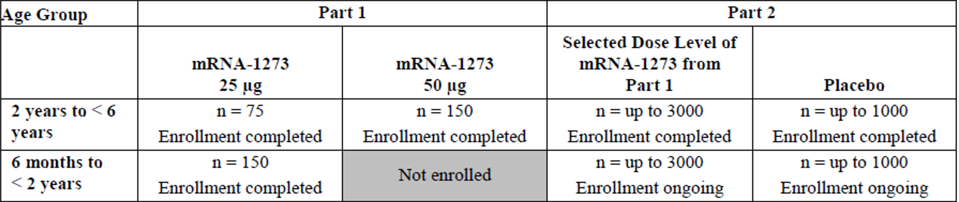
Abbreviations: mRNA-1273 = Spikevax COVID-19 mRNA-1273 (elasomeran) vaccine; n = number of subjects in groups.
Completed and planned enrolment number shown.
All subjects aged between 6 months to less than 2 years of age received 25 µg of vaccine whether enrolled in in Part 1 or Part 2 of the study. Subjects aged between 2 years to less than 6 years of age received a dose of either 25 µg elasomeran (n = 75) or 50 µg elasomeran (n = 150) in Part 1 of the study, but those enrolled in Part 2 only received 25 µg.
A total of 2350 children aged between 6 months to less than 2 years were included in Part 2 of the study, of whom 1760 received Spikevax vaccine (a dose of 25 µg of elasomeran) and 590 received placebo. Of these, 302 subjects were included in the immunogenicity analysis.
A total of 3930 children aged between 2 to less than 6 years of age were included in Part 2 of the study, of whom 3040 received the Spikevax vaccine (25 µg elasomeran) and 907 received placebo. Of these, 274 subjects were included in the immunogenicity analysis.
Included subjects were healthy children with no prior history of COVID-19 infection or exposure to other COVID-19 vaccines. Of note, children with a history of febrile convulsions were excluded from the study.
The primary endpoints of the study were:
- to measure adverse events following vaccination; and
- to assess immunogenicity at Day 57 following vaccination (more than 28 days post-Dose 2).
Vaccine efficacy (VE) against symptomatic COVID-19 was assessed as a secondary endpoint.
Analysis was provided separately for patients in both Parts 1 and 2, although enrolment for the younger cohort in Part 2 was not complete. There are, therefore, four immunogenicity analyses from two age cohorts in two parts of the study.
The clinical evaluation presented the data in two age groups, with Part 1 and Part 2 results presented under each age groups (ages 2 to less than 6 years, and ages 6 months to less than 2 years, respectively).

Results
Table 4: Study P204 and P301 Comparative geometric mean titre in children from 2 to less than 6 years of age (Study P204, Part 2) with adults between 18 to 25 years of age (Study P301)
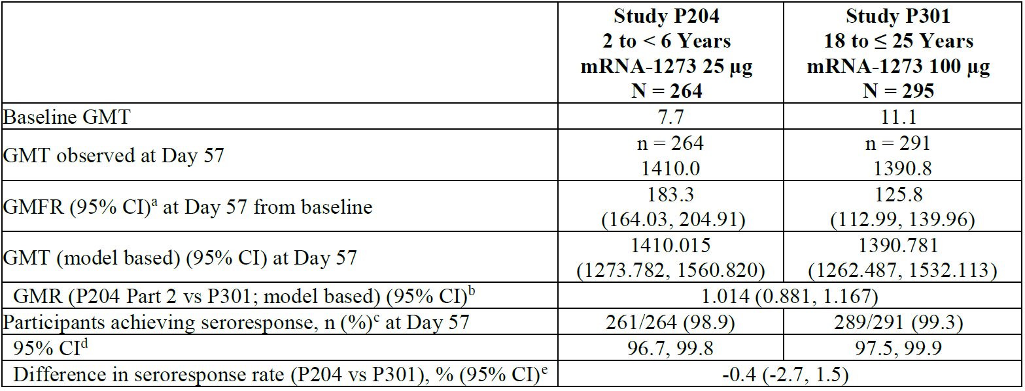
Abbreviations: CI = confidence interval; GMFR = geometric mean fold rise; GMR = geometric mean ratio; GMT = geometric mean titre (noted as observed or model based, which is estimated by geometric least squares mean); mRNA-1273 = Spikevax COVID-19 mRNA-1273 (elasomeran) vaccine; N = number of subjects; n = number of subjects in groups.
Based on pseudovirus neutralisation assay (PsVNA) by PPD vaccine (VAC62). Antibody values reported as below the lower limit of quantification (LLOQ) are replaced by 0.5 x LLOQ. Values greater than upper limit of quantification (ULOQ) are replaced by the ULOQ if actual values are not available.
Study P301 mRNA-1273 group includes young adults (18 to 25 years of age).
a 95% CI is calculated based on the t-distribution of the log transformed values or the difference in the log transformed values for GMT and GMFR, respectively, then back transformed to the original scale for presentation.
b The log transformed antibody levels are analysed using an analysis of covariance (ANCOVA) model with the group variable (children in Study P204 Part 2 and young adults in Study P301) as fixed effect. The resulted least squares (LS) means, difference of LS means, and 95% CI are back transformed to the original scale for presentation.
c Seroresponse at a participant level is defined as a change from below the LLOQ to equal or above 4 x LLOQ, or at least a 4-fold rise if Baseline is equal to or above the LLOQ. Percentages are based on the number of participants with non-missing data at Baseline and the corresponding timepoint.
d 95% CI is calculated using the Clopper-Pearson method.
e 95% CI is calculated using the Miettinen-Nurminen (score) confidence limits.
The comparison of the geometric mean titre (GMT) of antibody levels assessed at Day 57 post-Dose 1 of vaccination in children between 2 to 6 years of age with those in adults 18 to 25 years of age found equivalence using the pre-specified criteria of geometric mean ratio (GMR) point estimate of > 0.8 with a lower bound to the 95% confidence interval (CI) of 0.67.
Table 5: Study P204 and P301 Comparative geometric mean titre in children from 6 months to less than 2 years of age (Study P204, Part 2) with adults between 18 and 25 years of age (Study P301)
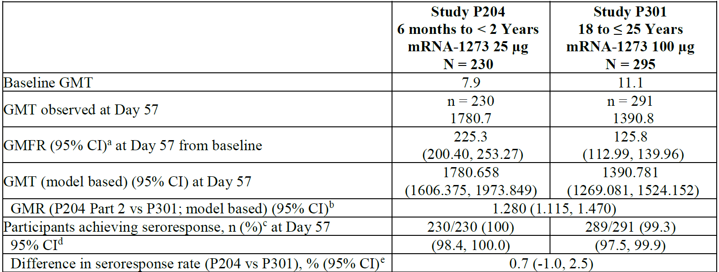
Abbreviations: CI = confidence interval; GMFR = geometric mean fold ratio; GMR = geometric mean ratio; GMT = geometric mean titre (noted as observed or model based, which is estimated by geometric least squares mean); mRNA-1273 = Spikevax COVID-19 mRNA-1273 (elasomeran) vaccine; N = number of subjects; n = number of subjects in groups.
Based on pseudovirus neutralisation assay (PsVNA) by PPD vaccine (VAC62). Antibody values reported as below the lower limit of quantification (LLOQ) are replaced by 0.5 x LLOQ. Values greater than upper limit of quantification (ULOQ) are replaced by the ULOQ if actual values are not available.
Study P301 mRNA-1273 group includes young adults (18 to 25 years of age).
a 95% CI is calculated based on the t-distribution of the log transformed values or the difference in the log transformed values for GMT and GMFR, respectively, then back transformed to the original scale for presentation.
b The log transformed antibody levels are analysed using an analysis of covariance (ANCOVA) model with the group variable (children in Study P204 Part 2 and young adults in Study P301) as fixed effect. The resulted least squares (LS) means, difference of LS means, and 95% CI are back transformed to the original scale for presentation.
c Seroresponse at a participant level is defined as a change from below the LLOQ to equal or above 4 x LLOQ, or at least a 4-fold rise if Baseline is equal to or above the LLOQ. Percentages are based on the number of participants with non-missing data at Baseline and the corresponding timepoint.
d 95% CI is calculated using the Clopper-Pearson method.
e 95% CI is calculated using the Miettinen-Nurminen (score) confidence limits.
Table 6: Study P204 Vaccine efficacy in children between 2 and less than 6 years of age, from 14 days after second dose of vaccine
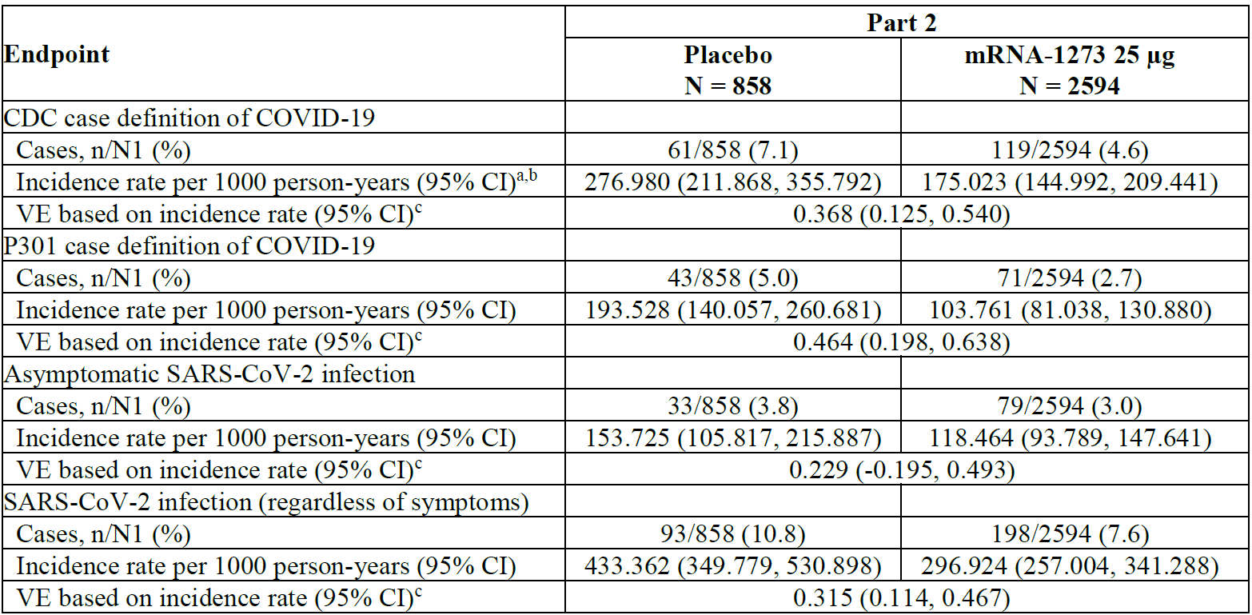
Abbreviations: CDC = Centers for Disease Control and Prevention (United States of America); CI = confidence interval; COVID-19 = coronavirus disease 2019; N = number of subjects; n = number of subjects in groups; N1 = number of participants at risk at 14 days after Dose 2 for specific efficacy endpoint; SARS-CoV-2 = severe acute respiratory syndrome coronavirus-2; VE = vaccine efficacy.
a Person-years is defined as the total years from the randomisation date for Part 2 to the date of event (CDC case definition of COVID-19, Study P301 case definition of COVID-19, asymptomatic SARS-CoV-2 infection, or SARS-CoV-2 infection, depending upon endpoint), last date of study participation, or efficacy data snapshot date, whichever is the earliest.
b Incidence rate is defined as the number of participants with an event divided by the number of participants at risk and adjusted by person years (total time at risk) in each treatment group. The 95% CI is calculated using the exact method (Poisson distribution) and adjusted by person years.
c Vaccine efficacy (VE) is defined as 1 - ratio of incidence rate (mRNA-1273 versus placebo). The 95% CI of the ratio is calculated using the exact method conditional upon the total number of cases, adjusting for person years.
Table 7: Study P204 Vaccine efficacy in children between 6 months and less than 2 years of age, from 14 days after second dose of vaccine
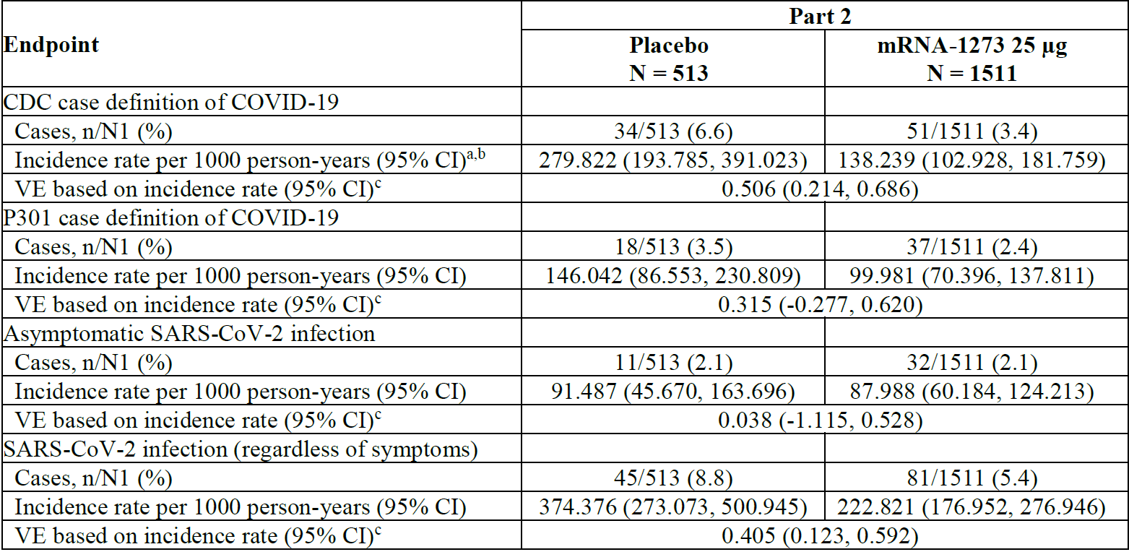
Abbreviations: CDC = Centers for Disease Control and Prevention (United States of America); CI = confidence interval; COVID-19 = coronavirus disease 2019; N = number of subjects; n = number of subjects in groups; N1 = number of participants at risk at 14 days after Dose 2 for specific efficacy endpoint; SARS-CoV-2 = severe acute respiratory syndrome coronavirus-2; VE = vaccine efficacy.
a Person-years is defined as the total years from the first injection date for Part 1 and the randomisation date for Part 2 to the date of event (CDC case definition of COVID-19, Study P301 case definition of COVID-19, asymptomatic SARS-CoV-2 infection, or SARS-CoV-2 infection, depending upon endpoint), last date of study participation, or efficacy data snapshot date, whichever is the earliest.
b Incidence rate is defined as the number of participants with an event divided by the number of participants at risk and adjusted by person years (total time at risk) in each treatment group. The 95% CI is calculated using the exact method (Poisson distribution) and adjusted by person years.
c Vaccine efficacy (VE) is defined as 1 - ratio of incidence rate (mRNA-1273 versus placebo). The 95% CI of the ratio is calculated using the exact method conditional upon the total number of cases, adjusting for person years.
Overall, the vaccine demonstrated a low level of protective efficacy against infection, including using the case definition applied in Study P301. The Delegate notes that this assessment is largely is indicative of exposure to Delta variant in 2021, although contemporaneous with the emergence of Omicron variant in early 2022.
The clinical evaluator has noted that the US Food and Drug Administration (FDA) guidelines; state that VE should be at least 50%, with a CI that has a lower bound > 30%. Spikevax did not demonstrate this level of efficacy in all analyses.

Efficacy against the Omicron variant
The clinical evaluator requested Omicron variant specific immunogenicity data, and the sponsor has confirmed that there is no neutralising antibody data against this variant.
The sponsor has provided a MesoScale assay based study of 20 randomly selected patients from each cohort in Study P204 to detect antibodies against variant of concern. The Delegates understanding of the MesoScale assay is that it is an electro-luminescent assay similar to an enzyme-linked immunosorbent assay except in its staining technology, which detects antibody binding against a specified antigen but not necessarily neutralising antibodies.
Figure 1: Study P204 Post-hoc analysis of MesoScale assay data against coronavirus disease 2019 variants of concern (randomly selected patients)
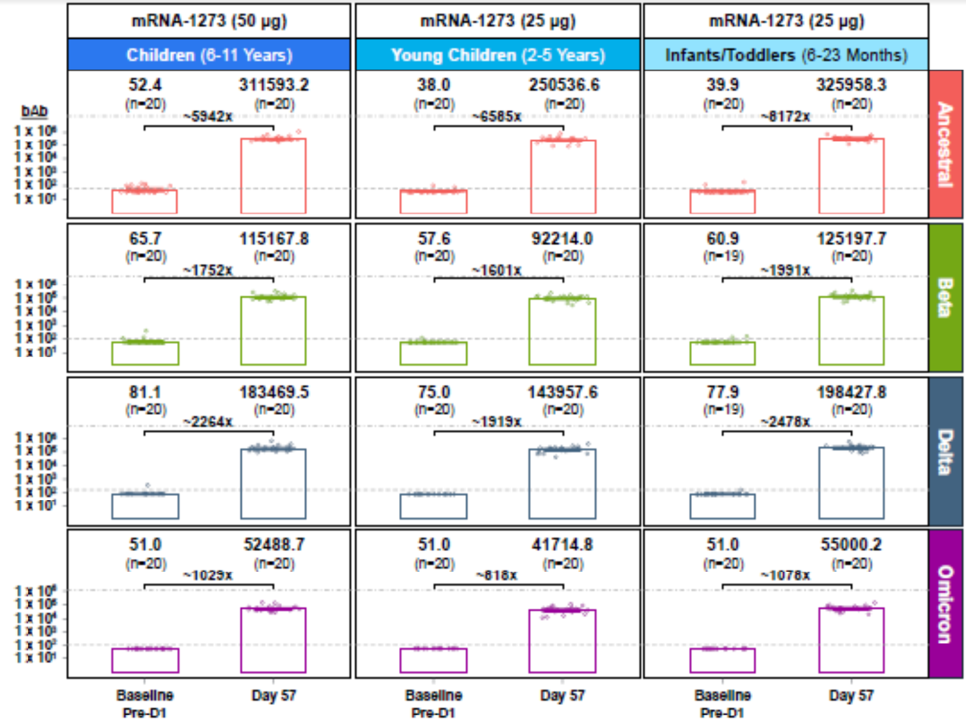
Abbreviations: bAb = binding antibody; D1 = Dose 1; mRNA-1273 = Spikevax COVID-19 mRNA-1273 (elasomeran) vaccine; n = number of subjects in groups.
This assay suggests that the binding of antibodies generated by Spikevax (elasomeran) against the Omicron variant is less than that observed against the Delta variant that was circulating during the study. The Delegate notes that this pattern of reduced activity of vaccine elicited antibodies against the Omicron variant has been observed in other age groups and vaccines and so is not unexpected.

Safety
The clinical evaluation provided a thorough review of the safety data for this vaccine, which follows the division of age cohorts and parts of Study P204 in the efficacy analysis starting on the clinical evaluation report.
The Delegate notes that the assessment provided in the clinical study report includes additional analysis and information provided in response to questions to the sponsor.¹⁹
The safety data is provided by Study P204, which constitutes the relevant patient exposure.
Post-market summaries were provided for the extensive exposure to Spikevax since 2020, although as the clinical evaluator has noted there is limited exposure in children of less than 6 years of age in that data.
Table 8: Summary of exposure (doses) of Spikevax (elasomeran) vaccine administered up until 15 April 2022 (by age group)
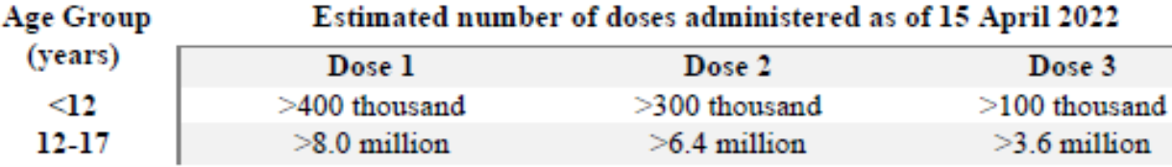
Table 9: Study P204 Summary of solicited adverse events in children between 24 and 36 months of age; and between 37 months and less than 6 years of age
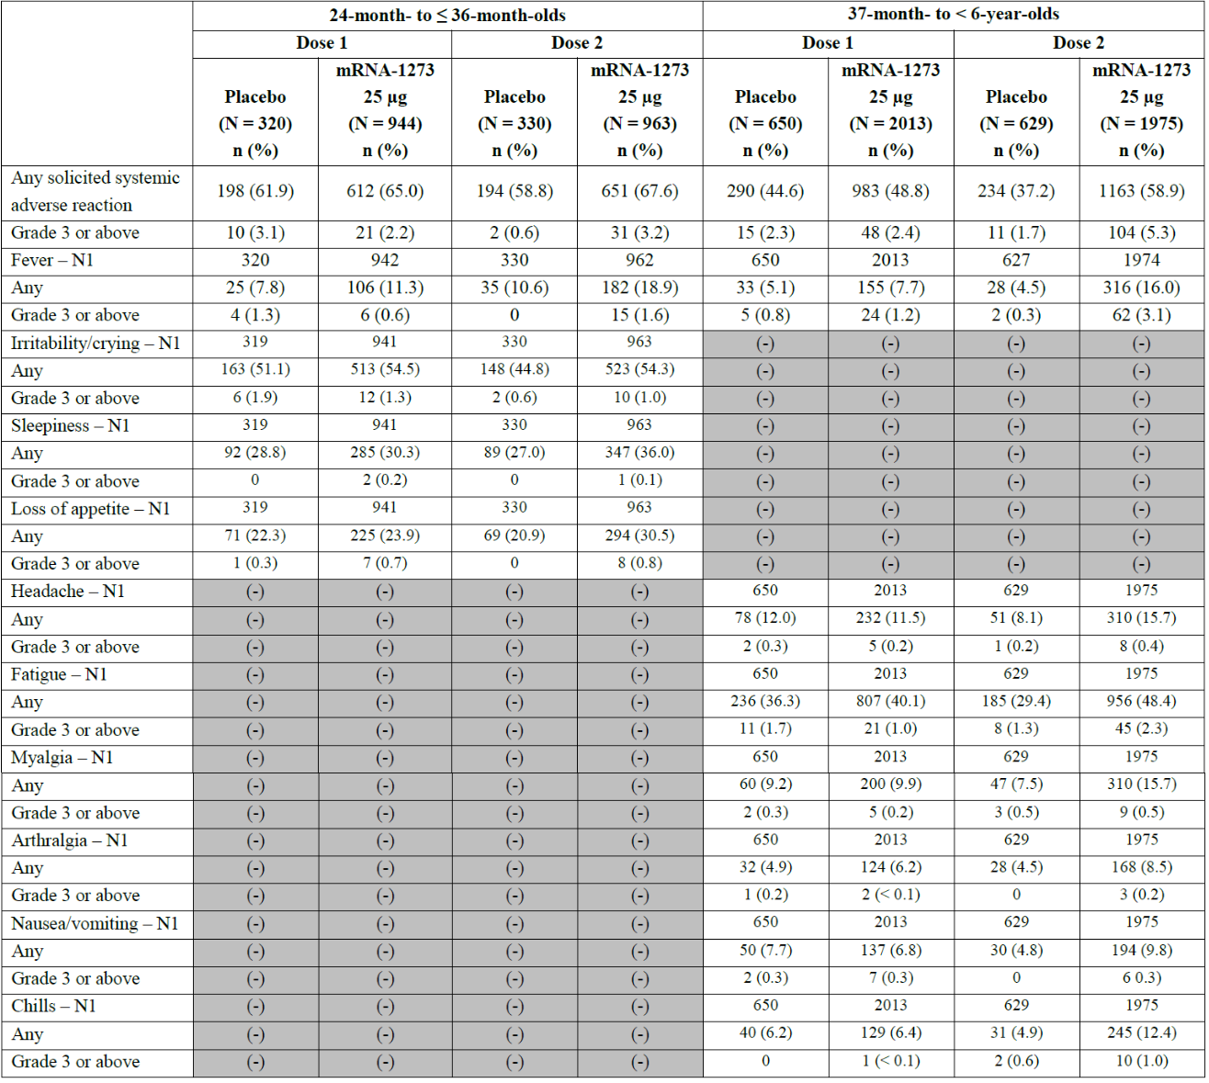
Abbreviations: Any = any solicited Grade 1 or higher systemic adverse reaction; mRNA-1273 = Spikevax COVID-19 mRNA-1273 (elasomeran) vaccine; N = number of subjects; n = number of subjects in groups; N1 = number of participants who submitted any data for the event.
(-) indicates that this assessment is not applicable to participants in this age group.
Toxicity grade for solicited systemic adverse reactions other than fever is defined as: Grade 1 = no interference with activity (or, for nausea/vomiting: 1 to 2 episodes/24 hours); Grade 2 = some interference with activity (or, for nausea/vomiting: > 2 episodes/24 hours); Grade 3 = prevents daily activity; Grade 4 = emergency room visit or hospitalisation. Toxicity grades for fever based on age group (2 years to ≤ 36 months or 37 months to < 6 years). Protocol defined fever grades in participants aged 37 months to < 6 years were the following: Grade 1 = 38°C to 38.4°C, Grade 2 = 38.5°C to 38.9°C, Grade 3 = 39°C to 40°C, and Grade 4 > 40°C. Protocol-defined fever grades in participants 2 years to ≤ 36 months were the following: Grade 1 = 38°C to 38.5°C, Grade 2 = 38.6°C to 39.5°C, Grade 3 = 39.6°C to 40°C, and Grade 4 > 40.0°C.
Table 10: Study P204 Summary of solicited adverse events in children between 6 months and less than 2 years of age
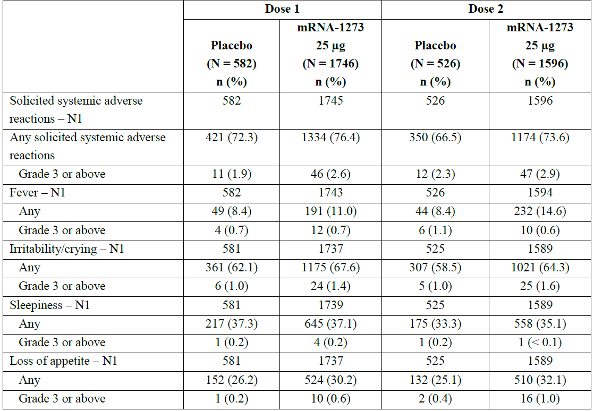
Abbreviations: Any = any solicited Grade 1 or higher systemic adverse reaction; mRNA-1273 = Spikevax COVID-19 mRNA-1273 (elasomeran) vaccine; N = number of subjects; n = number of subjects in groups; N1 = number of participants who submitted any data for the event.
Percentages are based on the number of exposed participants who submitted any data for the event (N1).
Toxicity grade for solicited systemic adverse reactions other than fever is defined as: Grade 1 = no interference with activity (or, for nausea/vomiting: 1 to 2 episodes/24 hours); Grade 2 = some interference with activity (or, for nausea/vomiting: > 2 episodes/24 hours); Grade 3 = prevents daily activity; Grade 4 = emergency room visit or hospitalisation.
The clinical evaluation concluded that solicited adverse events were more common after Dose 2 than Dose 1 of the vaccine.
The clinical evaluation noted that fever was common (with a number needed to vaccinate of 9 overall, and 43 to produce a Grade 3 fever).
The clinical evaluation noted a case of possible febrile convulsion which the sponsor has considered unrelated to treatment [subjects identification redacted] but has concluded this is possibly related to treatment. The Delegate notes that the sponsor has proposed potential alternative causes of fever in this patient, but none were definitively established. That the patient received Spikevax, they developed a fever, and had a seizure is established by the narrative provided.
The clinical evaluator has recommended the inclusion of erythema multiforme and febrile convulsion in the tabulated summary of potential adverse events in the PI.

Risk management plan
In support of the extended indications, the sponsor provided EU-risk management plan (RMP) version 4.1 (dated 22 April 2022; data lock point (DLP) of 21 February 2022 and Australia specific annex (ASA) version 2.1 (dated 2 May 2022) for this submission.The summary of safety concerns and their associated risk monitoring and mitigation strategies are summarised in Table 11. Further information regarding the TGA’s risk management approach can be found in risk management plans for medicines and biologicals and the TGA's risk management approach.
Table 11: Summary of safety concerns
Summary of safety concerns |  | Pharmacovigilance |  | Risk minimisation
 |  | Routine | Additional | Routine | Additional
Important identified risks | Anaphylaxis | * | † |  | –
Important identified risks | Myocarditis | * | † |  | –
Important identified risks | Pericarditis | * | † |  | –
Important potential risks | Vaccine-associated enhanced disease (VAED) including vaccine-associated enhanced respiratory disease (VAERD) | * | † | – | –
Missing information | Use in pregnancy and while breast-feeding |  | ^{µ} |  | –
Missing information | Long-term safety |  | † | – | –
Missing information | Use in immunocompromised subjects |  | † |  | –
Missing information | Interaction with other vaccines |  | † |  | –
Missing information | Use in frail subjects with unstable health conditions and co-morbidities (for example, chronic obstructive pulmonary disease (COPD), diabetes, chronic neurological disease, cardiovascular disorders) |  | † |  | –
Missing information | Use in subjects with autoimmune or inflammatory disorders |  | † |  | –
* Follow-up questionnaires
† Clinical studies
µ Observational pregnancy outcome study
- This summary of safety concerns is the same as the summary that has been evaluated and currently considered to be acceptable. The sponsor should address any concerns regarding the safety specification raised by the clinical evaluator, the Delegate and/or the Advisory Committee on Vaccines.
- The pharmacovigilance plan was deemed acceptable during the previous evaluations and continues to be acceptable for the current submission. The acceptability of the clinical study plan will be assessed by the Delegate.
- Only routine risk minimisation measures are proposed by the sponsor. This approach was deemed acceptable during the previous evaluations as there are risk minimisation measures are implemented by the Australian Government Department of Health. The changes proposed by the current submission are not expected to require additional risk minimisation measures as part of the RMP.

Risk-benefit analysis

Delegate’s considerations
Study P204 provides evidence that Spikevax produces a similar level of neutralising antibody response in the 6 months to less than 6 years of age group to the response it produces in older children and adults. The likely efficacy of the product in the proposed young age group is largely based on an extrapolation of equivalence between these age cohorts. The Delegate notes that this extrapolation is not simple because the COVID-19 experienced by young children differs somewhat from that which occurs in older children and adults.
The vaccine efficacy (VE) data in Study P204 demonstrates a low level of protective effect against symptomatic infection. The VE against Omicron variant is likely to be lower than that reported in Study P204. The duration over which cases were acquired following Dose 2 of vaccine was not reported, but given the Study P204 data was locked in February 2022, it is no longer than about 3 months. Therefore, longer term protective efficacy provided by the Spikevax vaccine in children aged less than 6 months has not been established.
The sponsor has reported an overall VE of between 31% and 46% in its draft PI. Using the Study P301 case definition (the comparative adult trial) the VE is 31% in the 6 month to less than 2 years of age cohort, and 46% in the 2 to less than 6 years of age cohort. The Delegate considers the Study P301 case definition to be the most relevant as the paediatric data has been presented in comparison to the clinical efficacy demonstrated using this case definition in the larger adult trials.
The low protective efficacy suggests that the main use of Spikevax in the population of less than 6 years of age is likely to be to prevent severe disease, rather than infection per se, but there is no clinical data on severe disease endpoints in this age group. However, Delegate concludes that VE against severe disease is likely to be higher than that against symptomatic infection given the generally more positive correlation between neutralising antibody titres and severe COVID-19 outcomes.
The clinical evaluator has noted that FDA guidelines;¹⁸ state that VE should be at least 50%, with a confidence interval (CI) that has a lower bound > 30%. Spikevax did not demonstrate this level of efficacy in all analyses. The Delegate notes that this guideline is not formally adopted by TGA although it would be expected to be known to the sponsor as a publicly available regulatory document from a major international agency.
The Delegate notes that VE against infection is only relevant if the primary use of the vaccine is to prevent infection. This does not preclude the use of Spikevax as protection against severe manifestations of infection. The Delegate has not concluded that this guideline is determinative in the decision whether to approve the use of Spikevax in children from 6 months to less than 6 years of age. However, the Delegate considers the FDA guideline;¹⁸ to be a relevant regulatory benchmark of VE against infection that could become materially relevant to the decision if VE against infection was the major clinical use of Spikevax in this age group; and the Advisory Committee on Vaccines (ACV) advised that the level of protective efficacy demonstrated was insufficient to support this use in Australia.
The clinical evaluation has noted that the level of immune response appears to be higher in the 6 month to less than 2 years of age cohort than in the 2 years to less than 6 years of age cohort. The older cohorts response is comparable to that observed in previously evaluated data in the 6 to 12 years of age population, noting that this group received a higher dose of vaccine. The clinical evaluator has noted that it is possible that immune response to the vaccine is related to age, and that a lower dose of vaccine could have been examined in the 6 month to less than 2 years old cohort. The Delegate agrees that this data on 12.5 µg doses of Spikevax vaccine (elasomeran) may be useful in the youngest cohort, but has concluded that it is not necessary to resolve this submission.
The clinical evaluation has disagreed with the sponsor on the attribution of case of febrile convulsion [subject identification redacted]. The Delegate’s understanding is that most causes a high fever will increase the propensity to febrile convulsion in a population of healthy children aged from 6 month to less than 6 year, with a relatively greater increase in those with pro-seizure conditions, for example, Dravet syndrome. Since Study P204 demonstrates that Spikevax causes fevers in a proportion of recipients, the residual safety issue is whether it causes a higher proportion of severe fevers than acceptable; or has another pro-convulsant action which is not represented in the trial population. The clinical evaluator has noted that Study P204 excluded children with a prior history of febrile convulsion. However, the clinical evaluator has also noted that Spikevax vaccine does not produce a high level of high fevers overall and the Delegate concurs that the reactogenicity data is unremarkable.
The Delegate is of the view that [subject identification redacted] was a normal stochastic event given the known propensity of the Spikevax vaccine to induce fevers. That being so, the Delegate has also concluded that the event reported in patient [subject identification redacted] was a febrile convulsion. This is based on the Delegate’s understanding that this a clinical diagnosis of exclusion. Therefore, the Delegate agrees with the clinical evaluation that this adverse event should be listed in the PI. Regardless of case [subject identification redacted] there would be very little reason not to alert patients, parents, and clinicians that this is a recognised possibility with the use of vaccine in young children.

Proposed action
The Delegate is currently minded to approve the extension of indications of Spikevax to include children from 6 months to less than 6 years of age, having the effect that Spikevax will be indicated for children aged 6 months and older.
The Delegate notes that this extension of indication will only be approved concurrently with Submission PM-2022-01792-1-2 [also covered by this AusPAR] which relates to the dose presentation that will give effect to the proposed new indication.
The Delegate will amend the PI from that provided by the sponsor in its submission subject to the advice of the ACV and including:
- amendments as proposed in the clinical evaluation;
- the clinical trials description of Study P204 will state as a separate sentence that ‘No clinical data for efficacy against the Omicron variant has been assessed’;
- the tabulated summary of VE will only include the data relevant to the Study P301 case definition.

Advisory Committee considerations
The Advisory Committee on Vaccines (ACV), having considered the evaluations and the Delegate’s overview, as well as the sponsor’s response to these documents, advised the following.

Specific advice to the Delegate
- Whether the quality, safety and efficacy of Spikevax 0.1 mg/mL is sufficient to warrant provisional registration for use in children aged 6 months of age and older.
The ACV advised that the quality, safety and efficacy is sufficient to warrant provisional registration of Spikevax 0.1 mg/mL for use in children from 6 months of age and older.
On balance, the ACV was of the view that the Spikevax vaccine is an immunogenic vaccine with modest efficacy for the 6 month to less than 6 years age group. The ACV noted that VE was between 32% and 51% against Omicron variant and the main benefit of vaccination is likely to be protection against severe COVID-19. In noting this the ACV highlighted that children at higher risk (that is, immunosuppression) were excluded from the study.
The ACV advised that based on the data provided the safety profile appears reasonable. The ACV did however note that the study was not powered to detect rare events such as myocarditis and was supportive of robust post-marketing safety monitoring.
The ACV discussed the risk of fever and febrile convulsions noting that fever was seen following vaccination and one case of febrile convulsions likely attributable to the vaccine was identified. The ACV further noted the higher frequencies of fever, including Grade 3 fever, among baseline seropositive participants compared to seronegative vaccine recipients. Giving consideration to the current Australian context, where potentially 40% of children are seropositive, the ACV strongly advised that the risk of fever giving rise to febrile convulsions should be included within the PI and that surveillance strategies are put in place.
The ACV also noted the Study P204 exclusion criteria of administration of other early childhood vaccines within 14 days. The ACV highlighted the potential for administration of a COVID-19 vaccine to disrupt the well-established early childhood vaccination schedules for other childhood diseases. In the absence of co-administration trials, studies monitoring potential interactions should be undertaken.
The ACV discussed dosing and administration and noted the potential for administration errors with the introduction of a new strength vaccine. The ACV noted the use of different colour caps to highlight different strengths and supported that product differentiation should be clearly outlined within the PI. The ACV also advised that the PI should clearly highlight the importance of education and training on drawing up the correct volume of vaccine and ensure a check for the correct dose prior to administration.
On balance, the ACV was of the view that the benefit risk balance is positive, with the greatest benefit anticipated to be in children who are at high risk of developing severe disease (that is, children with severe immunocompromise or significant respiratory/cardiac disease). The ACV further advised that the use of this vaccine should be in line with official guidelines, such as developed by the Australian Technical Advisory Group on Immunisation (ATAGI).

Conclusion
The ACV recommended the extension of indication to the use of Spikevax (0.1 mg/mL) as a primary series for children from 6 months of age.
Spikevax (elasomeran) COVID-19 vaccine has provisional approval for the indication below:
Active immunisation to prevent coronavirus disease 2019 (COVID-19) caused by SARS-CoV-2 in individuals 6 months of age and older.
The use of this vaccine should be in accordance with official recommendations.
The decision has been made on the basis of short-term efficacy and safety data. Continued approval depends on the evidence of longer term efficacy and safety from ongoing clinical trials and post-market assessment.

Outcome
Based on a review of quality, safety, and efficacy, the TGA approved the registration of Spikevax (elasomeran) 0.1 mg/mL (suspension for injection; vial and pre-filled syringe) and 0.2 mg/mL (suspension for injection, vial) for the following extension of indications:
Spikevax (elasomeran) COVID-19 vaccine has provisional approval for the indication below:
Active immunisation to prevent coronavirus disease 2019 (COVID-19) caused by SARS-CoV-2 in individuals 6 months of age and older.
The use of this vaccine should be in accordance with official recommendations.
The decision has been made on the basis of short-term efficacy and safety data. Continued approval depends on the evidence of longer term efficacy and safety from ongoing clinical trials and post-market assessment.
The above extension of indications are inclusive of the previous approved indications.
For the following change in dose regimen (summary):
Dosage is based on multiple factors, including the vaccination type (primary series, booster dose and immunocompromised individuals), and the age group of the patient.
Primary series
It is recommended to administer the second dose 28 days after the first dose.
Individuals 6 months to less than 6 years of age
Spikevax is administered as a course of 2 doses of Spikevax 0.1 mg/mL solution via intramuscular injection.
Each 0.25 mL dose of Spikevax 0.1 mg/mL contains 25 µg elasomeran.
Individuals 6 years to less than 12 years of age
Spikevax is administered as a course of 2 doses of either Spikevax 0.1 mg/mL; or Spikevax 0.2 mg/mL solution via intramuscular injection.
Each 0.5 mL dose of Spikevax 0.1 mg/mL contains 50 µg elasomeran.
Each 0.25 mL dose of Spikevax 0.2 mg/mL contains 50 µg elasomeran
Individuals 12 years of age and older
Spikevax is administered as a course of 2 doses of Spikevax 0.2 mg/mL solution via intramuscular injection.
Each 0.5 mL dose of Spikevax 0.2 mg/mL contains 100 µg elasomeran.
Immunocompromised individuals
Individuals 6 months to less than 6 years of age
A third dose of Spikevax 0.1 mg/mL solution for intramuscular injection may be given at least 28 days after the second dose of the primary series of vaccination.
Each 0.25 mL dose of Spikevax 0.1 mg/mL contains 25 µg elasomeran.
Individuals 12 years of age and older
A third dose of Spikevax 0.2 mg/mL solution for intramuscular injection may be given at least 28 days after the second dose of the primary series of vaccination.
Each 0.5 mL dose of Spikevax 0.2 mg/mL contains 100 µg elasomeran.
Booster dose
The decision when and for whom to implement a booster (third dose) of Spikevax should be made based on available vaccine safety and effectiveness data in accordance with official recommendations.
Individuals 18 years of age and older
A third dose of either Spikevax 0.1 mg/mL; or Spikevax 0.2 mg/mL solution for intramuscular injection is administered at least 6 months after the second dose of the primary series of vaccination.
Each 0.5 mL dose of Spikevax 0.1 mg/mL contains 50 µg elasomeran.
Each 0.25 mL dose of Spikevax 0.2 mg/mL contains 50 µg elasomeran.
For further information regarding dosage (including the interchangeability of Spikevax with other COVID-19 vaccines), refer to the Product Information.

Specific conditions of registration applying to these goods
For Submission PM-2022-01792-1-2
[The Delegate of the Secretary of the Department of Health imposed the following conditions in relation to the new Spikevax medicine:]
- conditions applicable to all registered therapeutic goods as specified in the document Standard Conditions Applying to Registered or Listed Therapeutic Goods under Section 28 of the Therapeutic Goods Act 1989 effective 1 July 1995, with the exception of Condition 11;
- conditions applicable to specific classes of registered therapeutic goods as specified in the Standard Conditions Applying to Registered or Listed Therapeutic Goods under Section 28 of the Therapeutic Goods Act 1989 effective 1 July 1995; and
- subject to [the paragraph below], all conditions that have previously been imposed on the provisional registration of the existing Spikevax medicine, as in force at the date of this decision;
- the RMP condition of the provisional registration decision relating to the existing Spikevax medicines, varied as underlined below:
The Spikevax EU-risk management plan (RMP) (version 4.1, dated 22 April 2022, data lock point 21 February 2022), with Australian specific annex (version 2.1, dated 2 May 2022), included with Submission PM-2022-01792-1-2, and any subsequent revisions, as agreed with the TGA will be implemented in Australia.
An obligatory component of risk management plans is routine pharmacovigilance. Routine pharmacovigilance includes the submission of periodic safety update reports (PSURs).
Unless agreed separately between the supplier who is the recipient of the approval and the TGA, the first report must be submitted to TGA no later than 15 calendar months after the date of the approval letter. The subsequent reports must be submitted no less frequently than annually from the date of the first submitted report until the period covered by such reports is not less than three years from the date of the approval letter, or the entire period of provisional registration, whichever is longer.
The reports are to at least meet the requirements for PSURs as described in the European Medicines Agency’s Guideline on Good Pharmacovigilance Practices (GVP) Module VII-periodic safety update report (Rev 1), Part VII.B Structures and processes. Note that submission of a PSUR does not constitute an application to vary the registration. Each report must have been prepared within ninety calendar days of the data lock point for that report.
Spikevax (elasomeran) is to be included in the Black Triangle Scheme. The PI and CMI [Consumer Medicines Information] for Spikevax must include the black triangle symbol and mandatory accompanying text for five years, or the product’s entire period of provisional registration, whichever is longer.
As part of the standard conditions of registration applying to all registered therapeutic goods, it should be noted that, no changes can be made to the goods without the prior approval of the Secretary.
Under paragraph 30(2)(c) of the Act [Therapeutic Goods Act], refusal or failure to comply with a condition of registration to which inclusion of the medicine(s) in the ARTG is subject may result in the suspension or cancellation of registration.
For Submission PM-2022-01760-1-2
- Spikevax (elasomeran) is to be included in the Black Triangle Scheme. The PI and CMI for Spikevax must include the black triangle symbol and mandatory accompanying text for five years, which starts from the date that the sponsor notifies the TGA of supply of the product.
- Batch release testing and compliance
It is a condition of registration that all independent batches of Spikevax elasomeran 0.2 mg/mL and 0.1 mg/mL suspension for injection vial, as well as the 0.1 mg/mL pre-filled syringe, imported into Australia are not released for sale until samples and the manufacturer’s release data have been assessed and you have received notification acknowledging release from the Laboratories Branch, TGA.
For each independent batch of the product imported into Australia, the sponsor must supply the following:
  - A completed request for release form, available from vaccines@health.gov.au.
  - Complete summary protocols for manufacture and QC [quality control], including all steps in production in the agreed format.
  - At least 10 (ten) vials and/or pre-filled syringes (samples) of each manufacturing batch of Spikevax elasomeran 0.2 mg/mL suspension for injection vial and/or 0.1 mg/mL suspension for injection vial and/or 0.1 mg/mL pre-filled syringe with the Australian approved labels, PI and packaging (unless an exemption to supply these has been granted) representative of all batches of product seeking distribution in Australia.
  - At least 5 (five) vials (samples) of any further consignments of a manufacturing batch of Spikevax elasomeran 0.2 mg/mL suspension for injection vial and/or 0.1 mg/mL suspension for injection vial and/or 0.1 mg/mL pre-filled syringe with the Australian approved labels, PI and packaging (unless an exemption to supply these has been granted). Further consignments cover batches previously supplied to TGA for the purposes of batch release testing but are seeking to be supplied again.
  - If the manufacturing batch has been released in Europe or United Kingdom [UK] a copy of the EU Official Control Authority Batch Release (OCABR) certificate (or equivalent from the UK) must be provided.
  - Any reagents, reference material and standards required to undertake testing, as requested by Laboratories Branch, TGA.
Sponsors must provide all requested samples and data in sufficient time (at least 5 business days) prior to any distribution date to allow the TGA to perform testing and review. Distribution of each batch of vaccine is conditional upon fulfilment of these conditions and receipt of a letter from the Laboratories Branch acknowledging release.
Samples and data should be forwarded to the Biotherapeutics Section, Laboratories Branch before release of each batch and with sufficient lead time to allow for Laboratories Branch testing.
The shipments (including reagents) to TGA are the responsibility of the Australian sponsor/agent who will be required to facilitate the import and customs clearance process.
Certified Product Details
An electronic copy of the Certified Product Details (CPD) as described in Guidance 7: Certified Product Details of the Australian Regulatory Guidelines for Prescription Medicines (ARGPM) https://www.tga.gov.au/guidance-7-certified-product-details should be provided upon registration of the therapeutic good. In addition, an updated CPD, for the above products incorporating the approved changes is to be provided within one month of the date of approval letter. A template for preparation of CPD for biological prescription medicines and vaccines can be obtained from the TGA website https://www.tga.gov.au/form/certified-product-details-cpd-biological-prescriptionmedicines. The CPD should be sent as a single bookmarked [Portable Document Format] to vaccines@health.gov.au as soon as possible after registration/approval of the product or any subsequent changes as indicated above.
- This approval does not impose any requirement for the submission of periodic safety update reports. You should note that it is a requirement that all existing requirements for the submission of PSURs as a consequence of the initial registration or subsequent changes must be completed.

Attachment 1. Product Information
The PI for Spikevax approved with the submission which is described in this AusPAR is at Attachment 1. For the most recent PI, please refer to the TGA PI/CMI search facility.

Therapeutic Goods Administration
PO Box 100 Woden ACT 2606 Australia
Email: info@tga.gov.au Phone: 1800 020 653 Fax: 02 6232 8605
https://www.tga.gov.au

AusPAR for Spikevax (elasomeran) Moderna Australia Pty Ltd, Submission PM-2021-02994-1-2. Available at: https://www.tga.gov.au/auspar/auspar-elasomeran.
As part of the provisional approval pathway, the provisional registration process will allow certain medicines to be provisionally registered in the Australian Register of Therapeutic Goods (ARTG) for a limited duration. These medicines are registered on the basis of preliminary clinical data, where there is the potential for a substantial benefit to Australian patients. The TGA will re-assess risks related to the absence of evidence through data provided at a later stage, as part of the confirmatory data. Confirmatory data should confirm the relationship between outcomes predicted by the surrogate endpoint, or other preliminary data, and the clinical benefit as demonstrated by direct clinical outcomes. The sponsor may apply to transition to full registration at any time up until the provisional registration lapse date, once they have completed the obligations outlined for the provisional registration period and complete confirmatory data on safety and efficacy are available.
Tozinameran, the active ingredient in the Comirnaty COVID-19 Vaccine was previously registered in Australia and overseas by the provisional drug name BNT162b2. Both the International non-proprietary name (INN) and the Australian Approved Name (AAN) is accepted as being tozinameran, and it is therefore referred to as Comirnaty (tozinameran) COVID-19 vaccine throughout this AusPAR. This is in contrast to the use of BNT162b2 as the name of the active ingredient in earlier AusPARs. The change is in name only; the composition of the active ingredient is unchanged in any way.
Comirnaty was first registered on the ARTG on 25 January 2021 (ARTG number: 346290).
AusPAR for Comirnaty (BNT162b2 (mRNA)) new biological entity, published on 25 January 2021. Available at: https://www.tga.gov.au/auspar/auspar-bnt162b2-mrna-comirnaty.
AusPAR for Comirnaty (BNT162b2 (mRNA)) extension of indications, published on 23 July 2021. Available at: https://www.tga.gov.au/auspar/auspar-bnt162b2-mrna.
AusPAR for Comirnaty (tozinameran) extension of indications; change to formulation (excipients), published on 13 December 2021. Available at: https://www.tga.gov.au/auspar/auspar-tozinameran-mrna-covid-19-vaccine.
COVID-19 Vaccine AstraZeneca was first registered on the ARTG on 16 February 2021 (ARTG number: 349072).
AusPAR for COVID-19 Vaccine AstraZeneca (ChAdOx1-S) new biological entity, published on 16 February 2021. Available at: https://www.tga.gov.au/auspar/auspar-chadox1-s.
COVID-19 Vaccine Janssen was first registered on the ARTG on 25 June 2021 (ARTG number: 350150).
AusPAR for COVID-19 Vaccine Janssen (Ad26.COV2.S) new biological entity, published on 25 June 2021. Available at: https://www.tga.gov.au/auspar/auspar-ad26cov2s.
Spikevax was first registered on the ARTG on 9 August 2021 (ARTG number: 370599).
AusPAR for Spikevax (elasomeran) new biological entity, adult indication, published on 9 August 2021. Available at: https://www.tga.gov.au/auspar/auspar-elasomeran.
AusPAR for Spikevax (elasomeran) new biological entity, paediatric indication, published on 4 September 2021. Available at: https://www.tga.gov.au/auspar/auspar-elasomeran-0.
AusPAR for Spikevax (elasomeran) extension of indications, published on 23 February 2022. Available at: https://www.tga.gov.au/auspar/auspar-elasomeran-1.
Nuvaxovid was first registered on the ARTG on 20 January 2022 (ARTG number: 355139).
AusPAR for Nuvaxovid (SARS-CoV-2 recombinant spike protein with Matrix-M adjuvant) new biological entity, published on 21 January 2022. Available at: https://www.tga.gov.au/auspar/auspar-sars-cov-2-rs-matrix-m-adjuvant.
Food and Drug Administration (FDA), Development and Licensure of Vaccines to Prevent COVID-19, Guidance for Industry, June 2020.
Inclusion of this information is beyond the scope of the AusPAR.

