Authorised Prescriber (AP) Applications - Quick Reference Guide
  - Medicinal cannabis
Version 1.1, June 2022

Copyright
© Commonwealth of Australia 2022
This work is copyright. You may reproduce the whole or part of this work in unaltered form for your own personal use or, if you are part of an organisation, for internal use within your organisation, but only if you or your organisation do not use the reproduction for any commercial purpose and retain this copyright notice and all disclaimer notices as part of that reproduction. Apart from rights to use as permitted by the Copyright Act 1968 or allowed by this copyright notice, all other rights are reserved and you are not allowed to reproduce the whole or any part of this work in any way (electronic or otherwise) without first being given specific written permission from the Commonwealth to do so. Requests and inquiries concerning reproduction and rights are to be sent to the TGA Copyright Officer, Therapeutic Goods Administration, PO Box 100, Woden ACT 2606 or emailed to <tga.copyright@tga.gov.au>.

Introduction
The Authorised Prescriber (AP) quick reference guide is a tool to assist medical practitioners in using the Special Access Scheme (SAS) and AP online system to submit AP applications to access an unapproved medicinal cannabis product.
This guide is to be read in conjunction with the Authorised Prescriber Scheme online system guidance document available on the TGA website.
From 22 November 2021, AP applications for medicinal cannabis products are only accepted by active ingredient category rather than by trade names for products. For general information on access pathways available for medicinal cannabis, refer to ‘Accessing medicinal cannabis for a patient’ on the TGA website.
Is the product included in the Established History of Use list?
(Note: The Active ingredient category, Dosage form, Route of administration and Indication must exactly match that on the Established History of use list)
Access the SAS dashboard on the SAS & AP online system and submit a new SAS application.
Refer to the SAS quick reference guide
Special Access Scheme (SAS)
Application for an individual patient
Authorised Prescriber (AP) Scheme
Application for a class of patients for a particular condition

Refer to AP Established History of use pathway flowchart on page 4 of this document
Two pathways for accessing medicinal cannabis products

Any other unapproved product
Refer to the Standard AP pathway flowchart on page 5 of this document.
HREC approval not required
NO
YES
Established History of Use Pathway
Standard Pathway (HREC Pathway)
HREC approval required




Log-in to the SAS & AP online system, go to ‘Authorised Prescriber Dashboard’ and click on
‘+New AP application’
- Therapeutic Good Type – Select Medicine
- Is the product – Select Included in the TGA’s Established History of Use list
- Active ingredient/product name - Select one of the three AP active ingredient categories
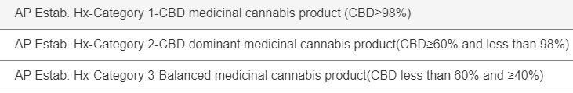
- Dosage form – Select oral liquid or capsule
Note: Product Strength, Trade name, Sponsor/supplier details & Additional information sections are non-mandatory fields.

Indication
This is a free text section. Please type the indication for which you are seeking approval.
Note: The indication must be included in the established history of use specified list for the selected product category.
ARTG product consideration- Select Yes or NO
Acknowledge that you have read and understood the privacy statement and click on ‘submit’ to send the application to TGA for review.
The prescriber details will be pre-populated from the account information.
Note: The contact details can be amended before continuing.
On SAS & AP online system, go to ‘Authorised Prescriber Dashboard’ and click on
‘+New AP application’
- Human Research Ethics Committee (HREC) approval/Specialist College-Enter the HREC or endorsing college details
- Indications- Enter indication(s) exactly as the corresponding indication approved/endorsed by the HREC/Specialist College in their letter.
- Therapeutic Good Type – Select Medicine
- Is the product – Select Any other product
- Active ingredient/product name – select from one of the five active ingredient categories
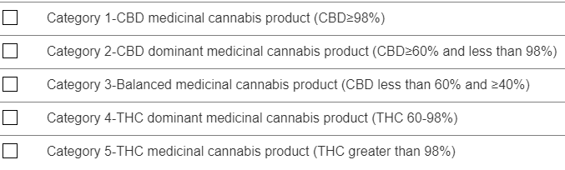

- Dosage form – Select from the available options
- Additional Information- Attach the relevant Human Research Ethics Committee (HREC) documentation.
Note: Product Strength, Trade name and Sponsor/supplier details are non-mandatory fields.

ARTG product consideration- Select Yes or NO
Acknowledge that you have read and understood the privacy statement and click on ‘submit’ to send the application to TGA for review.
The prescriber details will be pre-populated from the account information.
Note: The contact details can be amended before continuing.

Version history
Version | Description of change | Author | Effective date
V1.0 | Original publication | International Regulatory Branch | March 2022
V1.1 | Guidance updated based on system changes. | Special Access Section (SAS);  International Regulatory Branch (IRB) | June 2022

Therapeutic Goods Administration
PO Box 100 Woden ACT 2606 Australia
Email: info@tga.gov.au Phone: 1800 020 653 Fax: 02 6203 1605
https://www.tga.gov.au
Reference/Publication #

