May 2022

Australian Public Assessment Report for Bevacizumab
  - Proprietary Product Name: Bevacip/Bevaciptin
  - Sponsor: Cipla Australia Pty Ltd

About the Therapeutic Goods Administration (TGA)
- The Therapeutic Goods Administration (TGA) is part of the Australian Government Department of Health and is responsible for regulating medicines and medical devices.
- The TGA administers the Therapeutic Goods Act 1989 (the Act), applying a risk management approach designed to ensure therapeutic goods supplied in Australia meet acceptable standards of quality, safety and efficacy (performance) when necessary.
- The work of the TGA is based on applying scientific and clinical expertise to decision-making, to ensure that the benefits to consumers outweigh any risks associated with the use of medicines and medical devices.
- The TGA relies on the public, healthcare professionals and industry to report problems with medicines or medical devices. TGA investigates reports received by it to determine any necessary regulatory action.
- To report a problem with a medicine or medical device, please see the information on the TGA website <https://www.tga.gov.au>.

About AusPARs
- An Australian Public Assessment Report (AusPAR) provides information about the evaluation of a prescription medicine and the considerations that led the TGA to approve or not approve a prescription medicine submission.
- AusPARs are prepared and published by the TGA.
- An AusPAR is prepared for submissions that relate to new chemical entities, generic medicines, major variations and extensions of indications.
- An AusPAR is a static document; it provides information that relates to a submission at a particular point in time.
- A new AusPAR will be developed to reflect changes to indications and/or major variations to a prescription medicine subject to evaluation by the TGA.

Copyright
© Commonwealth of Australia 2022
This work is copyright. You may reproduce the whole or part of this work in unaltered form for your own personal use or, if you are part of an organisation, for internal use within your organisation, but only if you or your organisation do not use the reproduction for any commercial purpose and retain this copyright notice and all disclaimer notices as part of that reproduction. Apart from rights to use as permitted by the Copyright Act 1968 or allowed by this copyright notice, all other rights are reserved and you are not allowed to reproduce the whole or any part of this work in any way (electronic or otherwise) without first being given specific written permission from the Commonwealth to do so. Requests and inquiries concerning reproduction and rights are to be sent to the TGA Copyright Officer, Therapeutic Goods Administration, PO Box 100, Woden ACT 2606 or emailed to <tga.copyright@tga.gov.au>.

Contents
List of abbreviations 4
I. Introduction to product submission 6
Submission details 6
Product background 8
Regulatory status 9
Product Information 10
II. Registration timeline 10
III. Submission overview and risk/benefit assessment 10
Quality 10
Nonclinical 12
Clinical 12
Risk management plan 16
Risk-benefit analysis 17
Outcome 17
Attachment 1. Product Information 18

List of abbreviations
Abbreviation | Meaning
ACM | Advisory Committee on Medicines
ARGPM | Australian Regulatory Guidelines for Prescription Medicines
ARTG | Australian Register of Therapeutic Goods
AUC_{0-inf} | Area under concentration-time curve from time zero to infinity
AUC_{0-t} | Area under concentration-time curve from time zero to the time of last measurable concentration
CI | Confidence interval
C_{max} | Maximum observed serum concentration
CPD | Certified Product Details
CV | Coefficient of variation
DP | Drug product
DS | Drug substance
EMA | European Medicines Agency (European Union)
EU | European Union
FDA | Food and Drug Administration (United States of America)
MB02 | Drug development code for bevacizumab (biosimilar)
NSCLC | Non-small cell lung cancer
ORR | Objective response rate
PDF | Portable document format
PI | Product Information
PK | Pharmacokinetic(s)
PSUR | Periodic safety update report
RECIST | Response Evaluation Criteria in Solid Tumours
t_{½} | Apparent serum terminal half-life
TGA | Therapeutic Goods Administration
T_{max} | Time of maximum observed serum concentration
US(A) | United States of (America)
VEGF | Vascular endothelial growth factor

I. Introduction to product submission

Submission details
Type of submission: | New biosimilar medicine
Product names: | Bevacip/Bevaciptin
Active ingredient: | Bevacizumab
Decision: | Approved
Date of decision: | 13 October 2021
Date of entry onto ARTG: | 2 November 2021
ARTG numbers: | 347290, 347291, 347292 and 347293
Black Triangle Scheme: | No
Sponsor’s name and address: | Cipla Australia Pty Ltd  Level 1/132-136 Albert Road,  South Melbourne, VIC 3205
Dose form: | Concentrated solution for infusion
Strengths: | 25 mg/mL (100 mg/4 mL or 400 mg/16 mL)
Container: | Vial
Pack size: | One
Approved therapeutic use: | Metastatic colorectal cancer  Bevacip/Bevaciptin (bevacizumab) in combination with fluoropyrimidine-based chemotherapy is indicated for the treatment of patients with metastatic colorectal cancer.  Locally recurrent or metastatic breast cancer  Bevacip/Bevaciptin (bevacizumab) in combination with paclitaxel is indicated for the first-line treatment of metastatic breast cancer in patients in whom an anthracycline-based therapy is contraindicated (see Section 5.1 Clinical trials).  Advanced, metastatic or recurrent non-squamous non-small cell lung cancer (NSCLC)  Bevacip/Bevaciptin (bevacizumab), in combination with carboplatin and paclitaxel, is indicated for first-line treatment of patients with unresectable advanced, metastatic or recurrent, non-squamous, non-small cell lung cancer.  Advanced and/or metastatic renal cell cancer  Bevacip/Bevaciptin (bevacizumab) in combination with interferon alfa-2a is indicated for treatment of patients with advanced and/or metastatic renal cell cancer.  Grade IV glioma  Bevacip/Bevaciptin (bevacizumab) as a single agent, is indicated for the treatment of patients with Grade IV glioma after relapse or disease progression after standard therapy, including chemotherapy.  Epithelial ovarian, fallopian tube or primary peritoneal cancer  Bevacip/Bevaciptin (bevacizumab) in combination with carboplatin and paclitaxel, is indicated for first-line treatment of patients with advanced (FIGO stages IIIB, IIIC and IV) epithelial ovarian, fallopian tube, or primary peritoneal cancer.  Recurrent epithelial ovarian, fallopian tube or primary peritoneal cancer  Bevacip/Bevaciptin (bevacizumab) in combination with carboplatin and paclitaxel or in combination with carboplatin and gemcitabine, is indicated for the treatment of patients with first recurrence of platinum-sensitive, epithelial ovarian, fallopian tube, or primary peritoneal cancer who have not received prior bevacizumab or other VEGF-targeted angiogenesis inhibitors.  Bevacip/Bevaciptin (bevacizumab) in combination with paclitaxel, topotecan or pegylated liposomal doxorubicin is indicated for the treatment of patients with recurrent, platinum-resistant epithelial ovarian, fallopian tube, or primary peritoneal cancer who have received no more than two prior chemotherapy regimens, and have not received any prior anti-angiogenic therapy including bevacizumab.  Cervical cancer  Bevacip/Bevaciptin (bevacizumab) in combination with paclitaxel and cisplatin is indicated for the treatment of persistent, recurrent or metastatic carcinoma of the cervix. Bevacip/Bevaciptin (bevacizumab) in combination with paclitaxel and topotecan is an acceptable alternative where cisplatin is not tolerated or not indicated.
Route of administration: | Intravenous
Dosage: | The recommended dosage of Bevacip/Bevaciptin is based on multiple factors, including the condition being treated, the body weight and the age of the patient.  Bevacip/Bevaciptin should be administered under the supervision of a physician experienced in the use of anti-neoplastic medicinal products.  For further information regarding dosage, refer to the Product Information.
Pregnancy category: | D  Drugs which have caused, are suspected to have caused or may be expected to cause, an increased incidence of human fetal malformations or irreversible damage. These drugs may also have adverse pharmacological effects. Accompanying texts should be consulted for further details.  The use of any medicine during pregnancy requires careful consideration of both risks and benefits by the treating health professional. This must not be used as the sole basis of decision making in the use of medicines during pregnancy. The TGA does not provide advice on the use of medicines in pregnancy for specific cases. More information is available from obstetric drug information services in your State or Territory.

Product background
This AusPAR describes the application by Cipla Australia Pty Ltd (the sponsor) to register Bevacip/Bevaciptin (bevacizumab) 25 mg/mL, concentrated solution for infusion for the following proposed indications:
Metastatic colorectal cancer
Bevacizumab in combination with fluoropyrimidine-based chemotherapy is indicated for the treatment of patients with metastatic colorectal cancer.
Locally recurrent or metastatic breast cancer
Bevacizumab in combination with paclitaxel is indicated for the first-line treatment of metastatic breast cancer in patients in whom an anthracycline-based therapy is contraindicated.
Advanced, metastatic or recurrent non-squamous non-small cell lung cancer (NSCLC)
Bevacizumab in combination with carboplatin and paclitaxel, is indicated for first-line treatment of patients with unresectable advanced, metastatic or recurrent, non-squamous, non-small cell lung cancer.
Advanced and/or metastatic renal cell cancer
Bevacizumab in combination with interferon alfa-2a is indicated for treatment of patients with advanced and/or metastatic renal cell cancer.
Grade IV glioma
Avastin (bevacizumab) as a single agent, is indicated for the treatment of patients with Grade IV glioma after relapse or disease progression after standard therapy, including chemotherapy.
Epithelial ovarian, fallopian tube or primary peritoneal cancer
Bevacizumab in combination with carboplatin and paclitaxel, is indicated for first-line treatment of patients with advanced (FIGO stages IIIB, IIIC and IV) epithelial ovarian, fallopian tube, or primary peritoneal cancer.
Recurrent epithelial ovarian, fallopian tube or primary peritoneal cancer
Bevacizumab in combination with carboplatin and paclitaxel or in combination with carboplatin and gemcitabine, is indicated for the treatment of patients with first recurrence of platinum-sensitive, epithelial ovarian, fallopian tube, or primary peritoneal cancer who have not received prior bevacizumab or other VEGF-targeted angiogenesis inhibitors.
Bevacizumab in combination with paclitaxel, topotecan or pegylated liposomal doxorubicin is indicated for the treatment of patients with recurrent, platinum-resistant epithelial ovarian, fallopian tube, or primary peritoneal cancer who have received no more than two prior chemotherapy regimens, and have not received any prior anti-angiogenic therapy including bevacizumab.
Cervical cancer
Bevacizumab in combination with paclitaxel and cisplatin is indicated for the treatment of persistent, recurrent or metastatic carcinoma of the cervix. Avastin (bevacizumab) in combination with paclitaxel and topotecan is an acceptable alternative where cisplatin is not tolerated or not indicated.
Bevacizumab is a humanised, monoclonal antibody that binds to vascular endothelial growth factor (VEGF) and prevents its interaction with its receptor on the endothelial cell surface. This results in the inhibition of the pathway that signals angiogenesis. Tumour growth is therefore reduced due to the inhibition of new tumour blood vessel formation. Bevacizumab, frequently in combination with other agents, is used in the treatment of advanced cancer.
Bevacizumab is approved for use in a range of solid tumour indications. Initially it was approved for treatment of metastatic colorectal cancer in combination with chemotherapy. Indications now include metastatic breast cancer, non-small cell lung cancer (NSCLC), glioblastoma, renal cell carcinoma, ovarian cancer and cervical cancer. It is recognised as an important part of the standard of care in oncology.
Through its antiangiogenic activity, bevacizumab can slow the growth of new blood vessels in solid tumours. Randomised Phase III trials have shown that progression free survival and/or overall survival in patients with these solid tumours can be prolonged with treatment combining bevacizumab with standard chemotherapy.
The originator product, Avastin; (bevacizumab), was approved by the United States (US) Food and Drug Administration (FDA) in 2004 and by the European Medicines Agency (EMA) and the Therapeutic Goods Administration (TGA) in 2005. With patent expiry there are many biosimilars of bevacizumab in development and two, Zirabev; and Mvasi; , have been approved in Australia to date.
The introduction of such biosimilars is anticipated to bring cost savings to healthcare budgets and increased patient access across a number of oncologic indications.

Regulatory status
This product is considered a new biosimilar medicine for Australian regulatory purposes.
At the time the TGA considered this application, a similar application was under consideration in the European Union (EU) (submitted on 9 January 2020).

Product Information
The Product Information (PI) approved with the submission which is described in this AusPAR can be found as Attachment 1. For the most recent PI, please refer to the TGA website at <https://www.tga.gov.au/product-information-pi>.

II. Registration timeline
The following table captures the key steps and dates for this application and which are detailed and discussed in this AusPAR.
Table 2: Timeline for Submission PM-2020-05373-1-4
Description | Date
Submission dossier accepted and first round evaluation commenced | 30 November 2020
First round evaluation completed | 30 April 2021
Sponsor provides responses on questions raised in first round evaluation | 30 June 2021
Second round evaluation completed | 9 August 2021
Delegate’s Overall benefit-risk assessment | 6 October 2021
Sponsor’s pre-Advisory Committee response | Not applicable
Advisory Committee meeting | Not applicable
Registration decision (Outcome) | 13 October 2021
Completion of administrative activities and registration on the ARTG | 2 November 2021
Number of working days from submission dossier acceptance to registration decision* | 172
*Statutory timeframe for standard applications is 255 working days

III. Submission overview and risk/benefit assessment
The submission was summarised in the following Delegate’s overview and recommendations.

Quality
Bevacizumab (MB02: drug development code for bevacizumab) drug substance is a humanised monoclonal antibody of the immunoglobulin G1 kappa with a total molecular weight of approximately 149 kDa. There are two identical heavy chains and two identical light chains linked via four disulphide bonds. The schematic structure is shown in Figure 1 below.
Figure 1: Schematic structure of bevacizumab
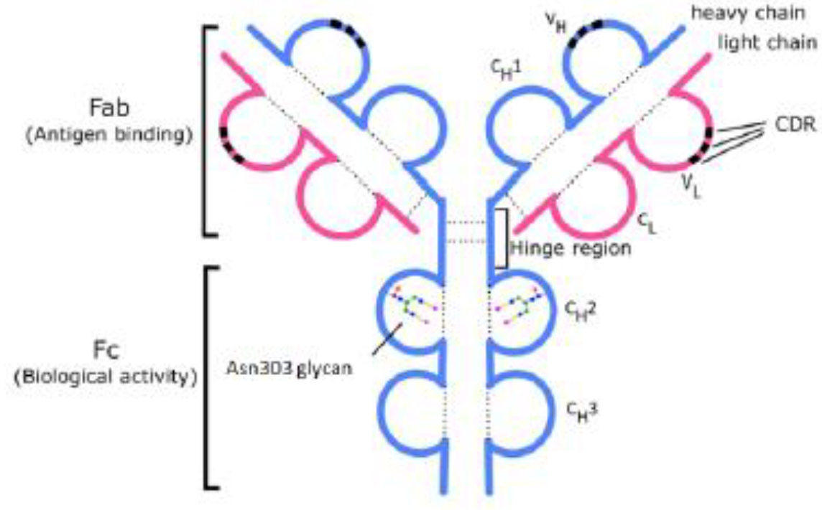
CDR = complementarity determining regions, Fab = fragment antigen binding, Fc = fragment crystallizable.
Upper image shows the light chain in pink and the heavy chain in blue, also displaying the N-glycans location in Asn303 site and complementarity determining regions.
Bevacip/Bevaciptin is available in 100 mg and 400 mg single dose vials containing 4 mL and 16 mL, respectively, of bevacizumab (25 mg/mL). It is a clear to slightly opalescent solution for intravenous infusion supplied in clear glass vials. The instructions for use recommend that Bevacip/Bevaciptin be diluted with 0.9% sodium chloride solution to a final concentration of 1.4 to 16.5 mg/mL and infused over a 60 to 90 minute window.
Bevacip/Bevaciptin drug substance is stored and shipped in ready-to-use sterile bottles screw cap closures. The selection of the primary packaging materials for use with Bevacip/Bevaciptin drug product was made on the basis of various physicochemical, biological and functional tests of the primary packaging components, which meet European Pharmacopoeia, US Pharmacopeia and Japanese Pharmacopoeia requirements.
There are no objections on quality grounds to the approval of Bevacip/Bevaciptin.
Overall, the sponsor has demonstrated that Bevacip/Bevaciptin (bevacizumab) is comparable to Avastin (bevacizumab) in terms of structure, species, function, and degradation profile (that is, physicochemically and biologically).

Proposed conditions of registration
- Condition(s) of registration resulting from primary evaluation
- Drug substance (DS) and drug product (DP) stability studies supporting the revised MB02 DS manufacturing process should be completed out to the shelf life, and the sponsor should immediately report any out of specification stability results to the TGA post-approval.
- Laboratory testing and compliance with Certified Product Details (CPD)
- All batches of Bevacip/Bevaciptin supplied in Australia must comply with the product details and specifications approved during evaluation and detailed in the Certified Product Details (CPD).
- When requested by the TGA, the sponsor should be prepared to provide product samples, specified reference materials and documentary evidence to enable the TGA to conduct laboratory testing on the product. Outcomes of laboratory testing are published biannually in the TGA Database of Laboratory Testing Results http://www.tga.gov.au/ws-labs-index and periodically in testing reports on the TGA website.
Certified Product Details
The Certified Product Details (CPD), as described in Guidance 7: Certified Product Details of the Australian Regulatory Guidelines for Prescription Medicines (ARGPM) (http://www.tga.gov.au/industry/pm-argpm-guidance-7.htm), in portable document format (PDF) format, for the above products should be provided upon registration of these therapeutic goods. In addition, an updated CPD should be provided when changes to finished product specifications and test methods are approved in a Category 3 application or notified through a self-assessable change. The CPD should be emailed to biochemistry.testing@health.gov.au as a single PDF document.

Nonclinical
The nonclinical evaluation encompassed comparative in vitro pharmacology studies, and a repeat dose toxicity study in monkeys, from which the pharmacokinetic data was derived. The scope of the nonclinical program is adequate under relevant EU guidelines. The pharmacology studies were conducted using either, European-, US- and/or Australian-sourced Avastin as the reference product; only European-sourced Avastin was used as the comparator in all studies, including the repeat dose toxicity study. No data was provided in nonclinical module to verify the comparability of European-, US- or Australian-sourced Avastin.
No meaningful differences were observed between Bevaciptin/Bevacip and European-, US- or Australian-sourced Avastin in the comparative pharmacology, pharmacokinetic and toxicity studies.
The ability of the nonclinical studies to support comparability to Australian Avastin depends on the conclusion of the quality evaluator regarding the identity of European-sourced Avastin products across jurisdictions. Provided that the European-sourced Avastin is identical or highly comparable to the Australian product, there are no nonclinical objections to the registration of Bevaciptin/Bevacip.

Clinical
The clinical dossier consisted of the following studies:
- Four Phase I studies: Study MB02-A-02-17, Study MB02-A-05-18, Study MB02-A-04-18 and Study BEVZ92-A-01-13.
- One Phase III study: Study MB02-C-02-17.
The dossier was a standard biosimilar dossier with focus on demonstrating similar profiles for pharmacokinetics (PK), efficacy, safety and immunogenicity with respect to the reference product Avastin.²
One early PK study (Study BEVZ92-A-01-13) is not deemed relevant from a comparability point of view as the product was manufactured at a different facility to the product proposed for marketing and there were no bridging data.
The clinical development program has used European-sourced Avastin. The quality module includes an analytical report on a head-to-head comparison between the European-sourced Avastin and Australian-sourced Avastin. While the proposed biosimilar has the same formulation, dosage and route of administration as the reference product (European-sourced Avastin), approval of Brevacip/Bevaciptin will need the physiochemical comparability data in quality module to be positive.
The Phase III efficacy study uses the same patient population (advanced non-small cell lung cancer; NSCLC) as other approved bevacizumab biosimilars (Zirabev;³ and Mvasi;⁴) and this is an appropriate population.
The clinical module contained three bioanalytical method validation reports which have not been evaluated by this reviewer.
Bevaciptin is referred to as MB02 where it is manufactured at the same facility as the to-be-marketed product and as BEVZ92 where it is manufactured at a different facility.

Bioequivalence to innovator product
Study MB02-A-02-17, was a randomised, double blind, three arm, single dose, parallel group study that compared the PK of the sponsor’s MB02 (bevacizumab) to US-sourced Avastin and EU-sourced Avastin in healthy male volunteers. There were 114 subjects who received a single intravenous infusion over 90 minutes of 3 mg/kg and data were available from 113 subjects. PK sampling was undertaken to Day 100 (5 times the approximate 20 day half life of bevacizumab).
Serum concentrations showed the median time to time of maximum observed serum concentration (T_{max}) was 2.51 and 3.00 hours in the MB02 and EU-sourced Avastin treated groups, respectively, and longer at 4.00 hours in the US-sourced Avastin treated group. There was slow terminal elimination and apparent serum terminal half-life (t_{½}) ranged from 437 to 451 hours (Table 1).
Table 1: Study MB02-A-02-17. Summary of secondary pharmacokinetic parameters for bevacizumab (pharmacokinetic population)
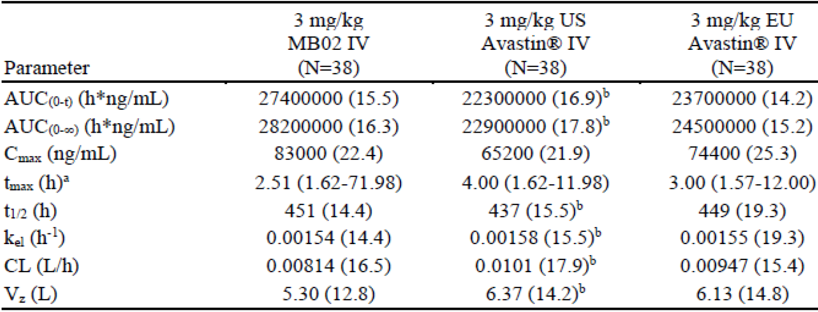
AUC_{(0-t)} = area under the serum concertation time curve from time zero to the time of the last observable concentration; AUC_{(0-∞)} = area under the serum concentration time curve from time zero to infinity; CL = total body clearance of drug after intravenous administration; C_{max} = maximum observed serum concertation; CV = coefficient of variation; k_{el} = elimination rate constant of the terminal phase; N = number of subjects; t_{1/2} = apparent serum terminal elimination half life; t_{max} = time of maximum observed serum concentration; V_{z} = volume of distribution during terminal phase after intravenous administration.
Geometric mean (CV%) data are presented
a Medium (minimum to maximum)
b N = 37
Bioequivalence was demonstrated as the 90% confidence interval (CI) for the ratio of geometric means of area under concentration time curve from time zero to infinity (AUC_{0-inf}) and maximum observed serum concentration (C_{max}) fell within the 0.8 to 1.25 margin criteria. MB02 was found to be bioequivalent to the EU-sourced Avastin (see Table 2 below) but not to the US-sourced Avastin (see Table 3 below). Between subject variability, as measured by geometric coefficient of variation (CV)%, ranged from 14.2% to 17.8% for area under concentration-time curve from time zero to the time of last measurable concentration (AUC_{0-t}) and AUC_{0-inf} respectively, and was higher for C_{max}, ranging from 21.9% to 25.3%.
Table 2: Study MB02-A-02-17 Statistical comparison of pharmacokinetic parameters for MB02 and EU-sourced Avastin (pharmacokinetic populations)
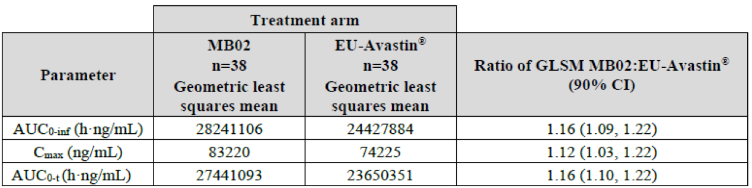
AUC_{0-inf} = area under the serum concentration time curve from time zero to infinity; AUC_{0-t} = area under the serum concertation time curve from time zero to the time of the last quantifiable concentration; CI = confidence interval; C_{max} = maximum observed serum concertation; EU = European; GLSM = geometric least squares mean; n = number of subjects with data available.
Table 3: Study MB02-A-02-17 Statistical comparison of pharmacokinetic parameters for MB02 and US-sourced Avastin (pharmacokinetic population)
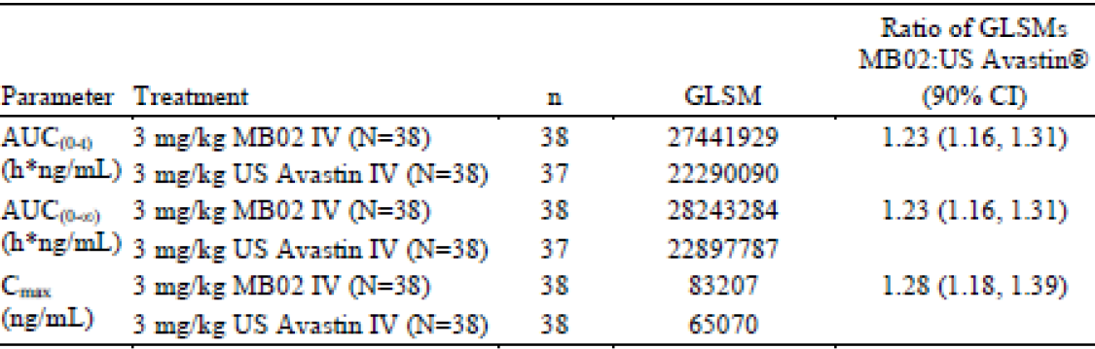
AUC_{(0-t)} = area under the serum concertation time curve from time zero to the time of the last quantifiable concentration; AUC_{(0-∞)} = area under the serum concentration time curve from time zero extrapolated to infinity; CI = confidence interval; C_{max} = maximum observed serum concertation; GLSM = geometric least squares mean; N = number of subjects in pharmacokinetic population per treatment; n = number of subjects with data available; US = United States.
Clinical comparison with innovator product
Study MB02-C-02-17 (the STELLA trial), was a randomised, multicentre, multinational, double blind study to assess the efficacy and safety of MB02 versus Avastin in combination with carboplatin and paclitaxel for the treatment of subjects with Stage IIIB/IV non-squamous NSCLC.
The study was conducted between February 2018 and February 2020 at 102 sites (93 of these randomised subjects) in 16 countries (Brazil, Bulgaria, Chile, Georgia, Greece, Hungary, India, Lebanon, Malaysia, Mexico, Philippines, Russia, Serbia, Thailand, Turkey and Ukraine).
The primary objective was to compare the objective response rate (ORR) of MB02 and EU-sourced Avastin when administered in combination with carboplatin and paclitaxel in subjects with stage IIIB/IV non-squamous NSCLC as assessed according to Response Evaluation Criteria in Solid Tumours (RECIST) version 1.1. Secondary objectives included assessment of safety, immunogenicity, progression free survival and overall survival compared to Avastin at Weeks 18 and 52.
There were 804 subjects screened, 627 randomised (315 MB02 and 312 Avastin) and 621 treated (311 MB02 and 310 Avastin). There were 68 (32.9%) and 74 (33.6%) subjects who completed treatment to Week 52 in the MB02 and Avastin groups, respectively.
As assessed by the Independent Review Committee, at Week 18 in the intention-to-treat; population, the rate of partial response was 38.4% and 43.6% in the MB02 and Avastin groups, respectively, and the rate of complete response was low (1.9% versus 1.0%). The ORR was 40.3% and 44.6% in the MB02 and Avastin groups, respectively. The risk ratio of the ORR was 0.91 (90% CI: 0.78, 1.06) and this confidence interval lies within the FDA specified equivalence margin (0.73, 1.36). The risk difference of the ORR was -4.02 (90% CI: -10.51, 2.47) and this CI also lies within the EMA specified margin of ±12% (see Table 4 below). The ORR estimate was adjusted for stratification factors of sex (male/female), smoking status (smoker/non-smoker), disease diagnosis (newly diagnosed/recurrent disease) and disease stage (Stage IIIB/IV).
Table 4: Study MB02-C-02-17 Objective response rate, per Independent Radiological Committee (intention-to-treat population)
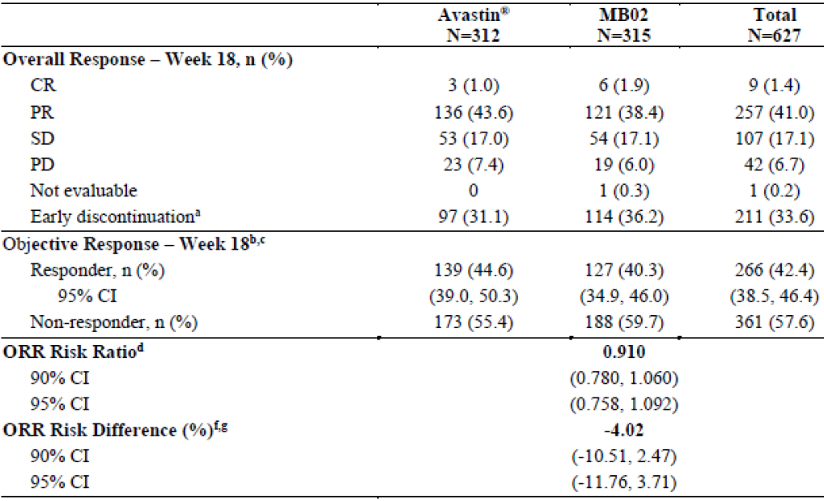
CI = confidence interval; CR = complete response; N = number of subjects in the intended set; n = number of subjects with data available; ORR = objective response rate; PD = progressive disease; PR = partial response; SD = stable disease.
Percentages are based on N.
a Early discontinuation include subjects at Week 18 classified as ‘Non-complete response/non-progressive disease’ (8 subjects in MB02 group, 9 subjects in Avastin group) and missing (106 subjects in MB02 group and 88 subjects in Avastin group).
b In case of missing evaluation, that is, in case the subject were withdrawn from study before Week 18, the subject was classified as a non-responder.
c Objective response was assigned if the subject displays either CR or PR per response evaluation criteria in solid tumours (RECIST) version 1.1
d The ORR estimate was adjusted for the actual randomisation strata sex (male/female), smoking status (smoker/non-smoker), disease diagnosis (newly diagnosed/recurrent disease) and disease stage (Stage IIIB/IV) using the Cochran-Mantel-Haenszel estimate of the risk ratio and corresponding 2-sided 90% CI.
e Equivalence is shown if the 90% CI is contained fully within (0.73, 1.36). Confidence intervals calculated with the Mantel-Haenszel method.
f The ORR estimate was adjusted for the actual randomisation strata sex (male/female), smoking status (smoker/non-smoker), disease diagnosis (newly diagnosed/recurrent disease) and stage (Stage IIIB/IV) using the Cochran-Mantel-Haenszel estimate of the risk difference and corresponding 2-sided 90% CI.
g Equivalence is shown if the 90% CI is contained fully within (-12.0%; 12.0%). Wald asymptotic CIs are specified.
The results were supported by analysis of the modified intention-to-treat;⁶ and per-protocol; populations and of unstratified data. Efficacy in terms of progression free survival and overall survival at Week 52 also demonstrated comparability between MB02 and EU-sourced Avastin.
Safety
In the clinical development program, there were 480 subjects exposed to MB02 of whom 311 were patients with NSCLC. There were an additional 69 patients with metastatic colorectal cancer in a PK study who received BEVZ92 from a different manufacturing facility. Studies were designed to have direct comparison with the EU-sourced Avastin and in two healthy volunteer PK studies there was a third arm with US-sourced Avastin.
In the Phase III study, treatment was with the proposed dose of 15 mg/kg for a mean duration of 186 days or 9.4 cycles. Treatment was in combination with carboplatin and paclitaxel chemotherapy.
Overall, there were no evident safety signals identified for MB02 and the submitted safety data showed a similar profile to EU-sourced Avastin.

Risk management plan
There was no requirement for a risk management plan evaluation for a submission of this type.

Risk-benefit analysis

Delegate’s considerations and proposed action
Bevaciptin/Bevacip are to be approved with the PI version dated 8 September 2021. The corresponding Consumer Medicines Information are also satisfactory.

Advisory Committee considerations
The Delegate did not refer this application to the Advisory Committee on Medicines (ACM) for advice.

Outcome
Based on a review of quality, safety and efficacy, the TGA approved the registration of Bevacip/Bevaciptin (bevacizumab) 25 mg/mL, concentrated solution for infusion, vial, indicated for:
Metastatic colorectal cancer
Bevacip/Bevaciptin (bevacizumab) in combination with fluoropyrimidine-based chemotherapy is indicated for the treatment of patients with metastatic colorectal cancer.
Locally recurrent or metastatic breast cancer
Bevacip/Bevaciptin (bevacizumab) in combination with paclitaxel is indicated for the first-line treatment of metastatic breast cancer in patients in whom an anthracycline-based therapy is contraindicated (see section 5.1 Clinical trials).
Advanced, metastatic or recurrent non-squamous non-small cell lung cancer (NSCLC)
Bevacip/Bevaciptin (bevacizumab), in combination with carboplatin and paclitaxel, is indicated for first-line treatment of patients with unresectable advanced, metastatic or recurrent, non-squamous, non-small cell lung cancer.
Advanced and/or metastatic renal cell cancer
Bevacip/Bevaciptin (bevacizumab) in combination with interferon alfa-2a is indicated for treatment of patients with advanced and/or metastatic renal cell cancer.
Grade IV glioma
Bevacip/Bevaciptin (bevacizumab) as a single agent, is indicated for the treatment of patients with Grade IV glioma after relapse or disease progression after standard therapy, including chemotherapy.
Epithelial ovarian, fallopian tube or primary peritoneal cancer
Bevacip/Bevaciptin (bevacizumab) in combination with carboplatin and paclitaxel, is indicated for first-line treatment of patients with advanced (FIGO stages IIIB, IIIC and IV) epithelial ovarian, fallopian tube, or primary peritoneal cancer.
Recurrent epithelial ovarian, fallopian tube or primary peritoneal cancer
Bevacip/Bevaciptin (bevacizumab) in combination with carboplatin and paclitaxel or in combination with carboplatin and gemcitabine, is indicated for the treatment of patients with first recurrence of platinum-sensitive, epithelial ovarian, fallopian tube, or primary peritoneal cancer who have not received prior bevacizumab or other VEGF-targeted angiogenesis inhibitors.
Bevacip/Bevaciptin (bevacizumab) in combination with paclitaxel, topotecan or pegylated liposomal doxorubicin is indicated for the treatment of patients with recurrent, platinum-resistant epithelial ovarian, fallopian tube, or primary peritoneal cancer who have received no more than two prior chemotherapy regimens, and have not received any prior anti-angiogenic therapy including bevacizumab.
Cervical cancer
Bevacip/Bevaciptin (bevacizumab) in combination with paclitaxel and cisplatin is indicated for the treatment of persistent, recurrent or metastatic carcinoma of the cervix. Bevacip/Bevaciptin (bevacizumab) in combination with paclitaxel and topotecan is an acceptable alternative where cisplatin is not tolerated or not indicated.

Specific conditions of registration applying to these goods
- This approval does not impose any requirement for the submission of periodic safety update reports (PSURs). The sponsor should note that it is a requirement that all existing requirements for the submission of PSURs as a consequence of the initial registration or subsequent changes must be completed.
- For all injectable products the Product Information must be included with the product as a package insert.

Attachment 1. Product Information
The PI for Bevacip/Bevaciptin approved with the submission which is described in this AusPAR is at Attachment 1. For the most recent PI, please refer to the TGA website at <https://www.tga.gov.au/product-information-pi>.

Therapeutic Goods Administration
PO Box 100 Woden ACT 2606 Australia
Email: info@tga.gov.au Phone: 1800 020 653 Fax: 02 6232 8605
https://www.tga.gov.au

The Black Triangle Scheme provides a simple means for practitioners and patients to identify certain types of new prescription medicines, including those being used in new ways and to encourage the reporting of adverse events associated with their use. The Black Triangle does not denote that there are known safety problems, just that the TGA is encouraging adverse event reporting to help us build up the full picture of a medicine's safety profile.
Avastin was first registered on the ARTG on 24 February 2005 (ARTG number: 99755 and 99757).
Zirabev was first registered on the ARTG on 21 November 2019 (ARTG number: 309320 and 309321).
Mvasi was first registered on the ARTG on 30 June 2020 (ARTG number: 297455 and 297456).
The Response Evaluation Criteria in Solid Tumours (RECIST) is a voluntary international standard with unified and easily applicable criteria to define when a patient's tumour has improved ('respond'), stayed the same ('stabilise'), or worsened ('progress') during treatment. The criteria were published in February 2000 by an international collaboration including the European Organisation for Research and Treatment of Cancer (EORTC), National Cancer Institute (NCI) of the United States, and the National Cancer Institute of Canada Clinical Trials Group. Today, the majority of clinical trials evaluating cancer treatments for objective response in solid tumours use RECIST. These criteria were developed and published in February 2000, and subsequently updated in 2009.
Intention-to-treat (ITT): the randomised clinical trials analysed by the ITT approach provide unbiased comparisons among the treatment groups. In the ITT population, none of the subjects are excluded, regardless of treatment compliance or attrition due to dropout or crossover, and the subjects are analysed according to the randomisation scheme. A modified intention-to-treat analysis (mITT) may sometimes be conducted excluding subjects post-randomisation.
The per-protocol (PP) analysis is restricted to the participants who strictly adhered to the protocol. Also known as ‘on-treatment’ analysis.
The sponsor must still comply with routine product vigilance and risk minimisation requirements.
The ACM provides independent medical and scientific advice to the Minister for Health and the TGA on issues relating to the safety, quality and efficacy of medicines supplied in Australia including issues relating to pre market and post-market functions for medicines. Further information can be found here: https://www.tga.gov.au/committee/advisory-committee-medicines-acm.

