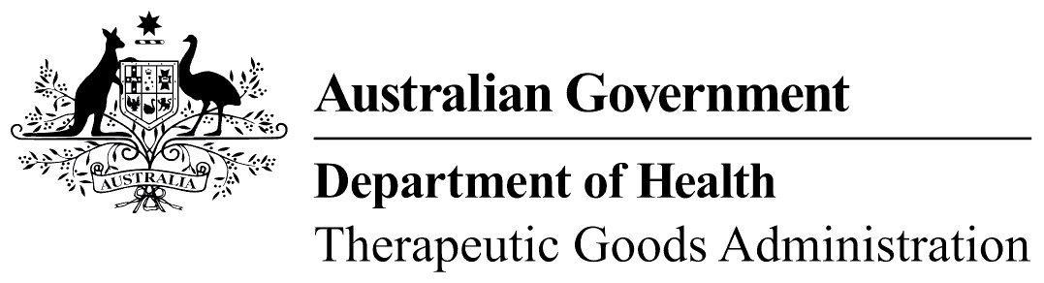
TGA use only

This form, when completed, will be classified as 'For official use only'.
For guidance on how your information will be treated by the TGA see: Treatment of information provided to the TGA at <http://www.tga.gov.au/about/tga-information-to.htm>.

Special Access Scheme

Consent to treatment and indemnity for use of products derived from biological tissues including human blood or plasma
I,
(name of patient or parent/guardian)
understand that the Commonwealth can give no guarantee as to the quality, safety or efficacy of
(name of product),
particularly as regards any prion or viral inactivation procedures used in its manufacture. Accordingly, the Commonwealth can accept no liability for its safety, quality or efficacy.
I understand that this product is not registered for use in Australia but that use of the product may be approved under the provisions of the Special Access Scheme.
I confirm that the above statements have been explained to me and with this knowledge agree to administration of the product to me/my ward.
Patient's name:
Signature of patient:  (or parent/guardian) |  | Date:
Signature of witness: |  | Date:
I have explained the above statements to the patient or the patient's parent/guardian.
Treating physician:
Signature: |  | Date:
Do not send to TGA.
Should be kept on patient’s file.

